A PROJECT REPORT
ON
PROPOSED CASSAVA PROCESSING FACTORY
FOR
OWU ISIN LOCAL GOVERNMENT AREA. KWARA STATE.
BY
IBRAHIM AYODEJI IBRAHIM
HND/23/ARC/FT/0019
SUBMITTED TO:

THE DEPARTMENT OF ARCHITECTURAL TECHNOLOGY
INSTITUTE OF ENVIRONMENTAL STUDIES (I.E.S)
KWARA STATE POLYTECHNIC, ILORIN.

IN PARTIAL FULFILMENT OF THE REQUIREMENTS FOR THE AWARD OF HIGHER NATIONAL DEPLOMA (HND) IN ARCHITECTURAL TECHNOLOGY

JULY, 2025.

DECLARATION
I Ibrahim Ayodeji Ibrahim with matric no. HND/23/ARC/FT/0019 of the department of Architectural technology hereby declare that this project ‘MODERN CASSAVA PROCESSING FACTORY’ was compiled by me

CERTIFICATION
I certify that this research project Modern Cassava Processing Factory has been read and approved as meeting the requirement for the Award of Higher National Diploma (HND) in Architectural technology, Institute of Environmental Studies (I.E.S), Kwara State Polytechnic, under the supervision of Arc. Olarewaju F.A.

ARC. OLAREWAJU F.A
(Project supervisor) SIGNATURE/DATE

ARC. OLAREWAJU F.A
(Project Coordinator) SIGNATURE/DATE

ARC. MRS. J.M TOMORI
(Head of Department) SIGNATURE/DATE

EXTERNAL SUPERVISOR SIGNATURE/DATE

DEDICATION
I hereby dedicate this research to the Almighty God for His faithfulness and favour upon me, and to my lovely parents: Mr. Jamiu Ibrahim and my late mother, Mrs. Fatimah Ibrahim, for their love and support throughout this project

ACKNOWLEDGEMENT
I humbly acknowledge God Almighty for his grace, the author of life and grace, that gave me the opportunity to complete this project, he made everything workout perfectly in his own time.
I would like to say thank you to Arc. Olarewaju F.A who thoughly supervise this work.
To the head of department, Mrs Tomori J. M, I say a big thank you for the leadership role played in the department which lead to this timely completion of this program. God bless you all abundantly.
I cannot but appreciate my lovely family: Mr Jamiu Ibrahim and my late mum Mrs Fatimah Ibrahim for your love, support and care during the course of study. Thanks to my siblings Ibrahim hazeem, Ibrahim azeezat, Ibrahim rukayat, and Ibrahim mariam.
To my friends that supported me, Iseoluwa grace, Faruq Mujaheed and other that I didn’t mention, I say a big thanks you for the time and I value time I have with you all.

TABLE OF CONTENT
Title Page
Declaration…………………………………………………….………………. ii
Certification ………………………………………………….………………...iii
Dedication ……………………………………………………………………...iv
Acknowledgment ……………………………………………….………………v
Table of content …………………………………………………...………...vi-vii
List of plates………………………………………………………………...…viii
List of Figures …………………………………………..……………………....ix
List of Appendix………………………………………………...…………….…x
Abstract ………………………………………………….……………………. xi
CHAPTER ONE:
1.0 General Introduction ………………………………..……….……….….1-3
1.1 Historical background of the project……………………...………..……3-4
1.2 Definition………………….………………………………….....……….4-5
1.3 Statement of design problem ………………………………..……..……5-6
1.4 Aim and Objectives of the study………………………….…….……….…6
1.5 Project justification …………………………………….…..……………6-7
1.6 Clients background……………………………………………...……….7-8
1.7 Scope of the study…………………………………………….....………8-9
1.8 Limitation of design…………………………………….………..….…9-10
1.9 Research Methodology …………………………..…………..……….10-11
CHAPTER TWO:
2.0 Review of relevant Literature…………………………...…………...12-18
CHAPTER THREE
3.0 Case studies………………………………………………….………….19
3.1 Case study one……………………………………....……..………...19-21
3.2 Case study two…………………………………….………...………22-24
3.3 Case study three………………………………….…………….……25-27
3.4 Case study four………………………………………..………….….28-30
3.5 Case study five (online case study) …………………...…….………31-33
3.6 Deduction from Case study …………………………...…………...…...34
CHAPTER FOUR
4.0 Introduction to study area …………………………………….………...35
4.1 Historical background of Owu Isin………………….………………35-36
4.2 Physical feature of the location ……………………………...…………36
4.3 Population of kwara State (and Owu Isin) ………………..…………….36
4.4 Social service …………………………………………….…….……36-37
4.4.1 Road Network ………………………………………….………..……...37
4.4.2 Health service …………………………………….…………….………37
4.4.3 Water and electricity ………………………………………….………...38
4.5 General climatic condition ……………………………………..……….38
4.5.1 Wind………………………………………………………..…….……..38
4.5.2 Temperature………………………………………………………….….39
4.5.3 Vegetation………………………………………………………….……39
4.6 Site analysis ………………………………………………………….…39
4.6.1 Site selection/justification ……………………………………………....39
4.7 Design Concept/Planning principle………………………………….42-43
CHAPTER FIVE
5.0 Design report……………..……………………………………………..44
5.1 Design brief …………………………………………….………......44-45
5.2 Design appraisal ……………………………………...…………………45
5.3 Design characteristics ……………………………...………………..45-46
5.4 Building structure…………………………………………………...…..46
5.5 Service ………………….……………………..………………….....46-47
5.6 General requirement ………………………………………………...47-48
5.7 Material and finishes ……………………………………………..…48-49
5.8 Summary and conclusion ………………………………………….……49
5.8.1 Summary …………………………………………………………...…...49
5.8.2 Conclusion ………………………………………………………...……49
Recommendation…………………….…………………………………..…50-51
References …………………..…………………………………………………52
Appendix………………………...…………………………………………53-61
LIST OF PLATES
Plate 1.1-1.2: Approach And Side View Of Case Study One…………....…….21
Plate 1.3-1.5: Approach View Of Case Study Two………………....…...…23-24
Plate 1.6-1.8:Garri Frying And Cassava Drying Area Of Case Two…...….26-27
Plate 1.9-2.1: Approach View Of Case Study Three………………..……...29-30
Plate 2.3-2.4: Approach And Side View If Case Study Three……………..32-33
Plate 1.9: Location Plan Of Case Study Four ( Online )……………………….29
Plate 2.0-2.1: Aerial And Approach View Of Case Study Four ( Online)…….30
Plate 2.3: Location Plan Of Case Study Five ( Online )………………..….…..32
Plate 2.4-2.5: Aerial And Approach View Of Case Study Five ( Online)……..33

LIST OF FIGURES
Figure 1.1-1.2: Showing Location Plan And Floor Plan of Case Study One…20
Figure 1.3: Showing Floor Plan Of Case Study Two…………………….……22
Figure 1.4: Showing Floor Plan Of Case Study Three………………….……..25

LIST OF APPENDIX
Appendix 1: Profile and location map ………………………………………… 53
Appendix 2: Locational plan and site inventory…………………………….... 54
Appendix 3: Site analysis and site plan………………………..……….....….. 55
Appendix 4: Bubble diagram and Functional relationship……………...……. 56
Appendix 5: Floor plan and Roof plan…………………………….…….…… 57
Appendix 6: Section and elevations ……………………….………….…....… 58
Appendix 7: Staff area floor and Admin floor plan………………….......…… 59
Appendix 8: Production Flowchart …………………………………..………. 60
Appendix 9: Details …………..……………………………………....……… 61

ABSTRACT

The increasing demand for cassava-based products in Nigeria and the inefficiency of traditional processing methods present a significant challenge in meeting both local consumption and export needs. This project aims to design a modern cassava processing factory that incorporates efficient architectural planning, hygienic workflow systems, and energy-saving technologies to enhance productivity, reduce post-harvest losses, and improve product quality.

The study employed a mixed-methods approach, including field surveys, literature reviews, and case studies of existing cassava processing facilities. Site analysis and environmental considerations were integrated into the architectural design process, alongside 3D modeling and spatial planning software to ensure functional flow and compliance with industrial and safety standards.

The findings revealed that integrating modern mechanical processing units with a well-zoned factory layout significantly improves processing speed, reduces contamination risks, and enhances worker safety. The proposed design allows for a continuous production line—from raw cassava intake, washing, peeling, grating, pressing, drying, to final packaging—within a controlled and hygienic environment.

The project concludes that a purpose-built, modern cassava processing facility can greatly contribute to the agro-industrial sector by improving efficiency, encouraging rural industrialization, and supporting food security. It is recommended that future cassava factories adopt sustainable materials, renewable energy sources, and adaptable designs that can evolve with technological advancements.

CHAPTER ONE
1.0 INTRODUCTION
A modern cassava processing factory can be described as a purpose-built industrial facility that serves as the central space for the efficient transformation, production, and value addition of cassava roots. According to agricultural studies (FAO, 2020), such agro-industrial institutions often form part of the broader food security and economic development center, designed to be focal points within rural and industrial landscapes, housing dominant processing functions. Traditionally, these factories reflect technological authority, but more recently, the concept of industrial design has evolved to encompass not only advanced machinery but also strategic organization, automated systems, and sustainable practices for operational and environmental effectiveness (Smith, 2022). In the context of a modern cassava processing factory, special attention must be paid to the Internal organization of production lines and public spaces, alongside critical design aspects such as processing efficiency and waste management.
Processing efficiency is a branch of industrial engineering that deals with the optimization of production, including its planning, execution, and output. In factory design, it is concerned with the planning, layout, and construction of facilities to achieve desirable processing conditions within and around the operational environment. Proper efficiency design plays a vital role in correcting production-related deficiencies in factory components, improving output quality, controlling spoilage, and minimizing resource waste. Specifically, in a modern cassava processing factory where root transformation, product diversification, and market readiness are central to its function, processing performance becomes an essential design priority. This include both the streamlining of internal production stages as well as the management of external factors like raw material perishability.
The application of processing optimization In industrial design ensures optimal production conditions in areas such as washing units, drying zones, packaging lines, and storage facilities. As factories become increasingly automated with the use of conveyor systems, temperature controls, and other technological devices, the need for efficiency control intensifies. Without proper process management, these technologies can contribute to a production environment that impairs yield and sustainability.
Cassava (Manihot esculenta) is a staple crop for millions of people, known for its high carbohydrate content and adaptability to varying climates and soil types. However, the post-harvest handling of cassava presents significant challenges. Fresh cassava roots are highly perishable, typically beginning to deteriorate within 24 to 48 hours of harvesting. This short shelf life necessitates rapid and efficient processing to prevent spoilage and economic loss.
Modern cassava processing factories address these challenges through mechanization and innovation. Key stages in the processing line typically include washing, peeling, grating, dewatering, drying, fermenting (for gari or starch), milling, sieving, and packaging. These steps are performed using advanced equipment such as rotary washers, hammer mills, flash dryers, pneumatic conveyors, and automated packaging systems. The use of such equipment increases processing efficiency, reduces labor dependency, ensures consistent quality, and minimizes contamination risks.
Cassava can be processed into a wide variety of value-added products, including:
- Gari – a fermented and roasted granular flour used as a staple in many West African diets.
- High Quality Cassava Flour (HQCF) – used in baking, pastries, and as a partial substitute for wheat flour.
- Starch – utilized in the food industry as a thickener, binder, and stabilizer, and also in non-food industries such as textiles, paper, and adhesives.
- Cassava Chips and Pellets – used in animal feed and as raw material for ethanol production.
- Ethanol and Biofuel – derived from cassava fermentation, contributing to the renewable energy sector.
- Modified Starches and Sweeteners – for industrial and pharmaceutical applications.
In conclusion, modern cassava processing factories represent a fusion of agriculture, technology, and industrialization. They are not only transforming cassava from a subsistence crop to a commercial commodity but also fostering rural development, job creation, and industrial diversification. As global interest in food security, renewable energy, and agro-industrial development continues to grow, cassava’s role in these sectors is set to become even more prominent, and modern processing facilities will remain at the heart of this transformation..
1.1 HISTORICAL BACKROUND
The journey from traditional to modern cassava processing began with small-scale manual method where cassava roots where peeled, grated and fermented by hand. By the late 20th century, technological advancement brought mechanized equipment into the picture, significantly increasing efficiency and production capacity. This period marked the birth of modern cassava processing factory characterized by larger, more sophisticated facilities.
Countries such as Nigeria, Vietnam and Thailand led to the change in adopting these new technologies, transforming cassava processing landscape. The early 21st century saw a surge in the implementation of sustainable practice and innovation making factories more environmental friendly and economically viable. These development not only boost local economies but also enhanced food security and product quality.

The 21st century saw a significant improvement in cassava processing technology. Modern factories embraced automation with processing lines that could peel, grate, mill and dry cassava with minimum human intervention. These innovation drastically reduced labor cost, Increased production and enhanced product consistency. The introduction of continuous processing system also led to more streamlined operations, making it possible to process larger quantities of cassava in shorter timeframe.
As environmental concern became more prominent cassava processor began adopting more sustainable practices, energy efficient systems, waste reduction, technologies and the conversion of cassava by-product into bio-fuel and animal feed became common.
1.2 DEFINITION OF TERMS
- Modern :
Refers to something contemporary, up-to-date, or relevant to the present time.
- Cassava:
A tropical root crop (Manihot esculenta) that serves as a major source of carbohydrates. It is widely cultivated for its starchy tuberous roots, which are a staple food in many developing countries.
- Factory :
A building or complex where goods are manufactured or assembled, primarily using machinery.
- Modern Cassava Processing Factory :
A contemporary industrial facility designed for the efficient processing of cassava roots into various end-products using advanced machinery and technology. It aims to enhance productivity, ensure product quality, meet food safety regulations, and promote environmental sustainability.
- Processing Line :
An arrangement of machines for sequential cassava processing operations.
- High Quality Cassava Flour (Hqcf) :
Finely processed cassava flour used as a wheat substitute in food and industry.
- Waste Management System :
A facility-integrated system for handling cassava peels and wastewater sustainably.
- Automation :
The use of advanced control systems to operate machines with minimal human input, increasing efficiency.
1.3 STATEMENT OF DESIGN PROBLEM
Kwara State, like many regions in Nigeria, continues to face challenges in cassava processing due to the absence of a modern, well-structured cassava processing facility. The current system relies heavily on outdated, small-scale, and often unhygienic processing methods that not only limit production capacity but also compromise the quality of the final product. These limitations affect food security, reduce potential economic gains for local farmers, and hinder the expansion of cassava-based industries.
Despite cassava being a staple crop with high industrial value, many communities still lack access to modern processing infrastructure that incorporates efficient layout planning, sanitary workspaces, proper storage conditions, and appropriate waste management systems. In many cases, the absence of integrated design considerations, such as adequate ventilation, efficient circulation, and separation of processing zones, results in overcrowded, poorly ventilated, and environmentally unsafe working environments.
Furthermore, poorly designed processing spaces often lead to cross-contamination, product spoilage, and health hazards for workers. Noise pollution from processing machines, lack of natural lighting, poor drainage, and improper waste disposal are common problems arising from inadequately designed or unplanned processing environments. These issues contribute to the inefficiency and unsustainability of cassava processing operations.
This project proposes the design of a modern cassava processing factory that prioritizes hygiene, functionality, scalability, and environmental responsibility. The factory will be equipped with appropriate acoustic and ventilation systems to ensure user comfort, efficient workflow layouts to enhance productivity, and designated areas for cleaning, processing, packaging, and storage. This facility is intended to serve as a model for sustainable agro-industrial development in the state, thereby improving local economic development, employment opportunities, and food production standards
1.4 AIM AND OBJECTIVES
1.4.1 AIM
The aim of this project is to design a befitting Modern Cassava Processing Factory that will optimize cassava processing operations, ensuring efficient workflows, minimize waste and incorporate sustainable practice by promoting eco-friendliness
1.4.2 OBJECTIVES
- Design a fundamental And efficient building/structure layout that accommodate various processing stage.
- Incorporate energy- efficient system and technologies.
- Design a waste Management System that minimize waste and promote recycling.
- Design the factory to be flexible and scalable.
- Provide amenities and facilities that promotes employees well being.
1.5 JUSTIFICATION
Even though, the people of OWU-ISIN LOCAL GOVERNMENT AREA are mostly farmers. There are no modern cassava processing factory to process Cassava roots in the area. So this compelled me to design a state-of-the-art Modern Cassava Processing Factory that will add value to raw materials, ensuring better market opportunity for the farmers in the area and promoting economic growth through job creation and industrialization in the area
1.6 CLIENTS BACKGROUND
Owu-Isin Local Government Area is one of the sixteen (16) administrative divisions in Kwara State, Nigeria. Located in the southwestern region of the state, it is predominantly occupied by the Yoruba-speaking Isin people. The local government headquarters is situated in Owu-Isin town, with other notable communities including Ijara-Isin, Alla, Iwo, Oke-Onigbin, and Igbesi. The area is largely rural, with agriculture forming the backbone of the local economy. Cassava, being a staple crop, is widely cultivated by smallholder farmers across the LGA due to its resilience and multiple end-uses.
Despite the abundance of cassava production in Owu-Isin, the region suffers from a lack of modern processing infrastructure. The majority of cassava harvested is processed through traditional and inefficient methods, resulting in substantial post-harvest losses, limited value addition, and suppressed income potential for local farmers. Consequently, the community remains economically underdeveloped, with limited opportunities for industrial growth and employment.
The proposal to establish a modern cassava processing factory within Owu-Isin LGA is conceived as a strategic intervention to address these challenges. The facility is intended to serve as a landmark project that reflects the community’s aspiration for industrialization, food security, and rural transformation. Architecturally, the project aims to integrate functional design with context-sensitive planning that reflects local identity, enhances efficiency, and encourages sustainability.
The philosophy of the proposal is grounded in the belief that agriculture, when properly harnessed through modern technology and industrial design, can drive local economic development and social progress. By transforming raw cassava into a range of value-added products such as garri, fufu, high-quality cassava flour, industrial starch, ethanol, and animal feed, the proposed facility will act as a processing and distribution hub for the region.
The operational structure of the factory is envisioned as a hybrid model involving partnerships between the local government, private investors, farmer cooperatives, and relevant development agencies. The facility will comprise processing units, administrative offices, storage and packaging areas, quality control laboratories, and training spaces. The design will incorporate modular and scalable components to accommodate future expansion, and will prioritize energy-efficient systems and waste recycling methods.
The primary goal of the project is to validate the need for a modern cassava processing factory within Owu-Isin LGA, and to articulate the design, spatial, and functional requirements necessary for its realization. Through this project, the community seeks not only to reduce cassava wastage and improve agricultural income but also to establish Owu-Isin as a model for agro-industrial development in Kwara State and Nigeria at large
  - SCOPE OF THE STUDY
The modern cassava processing factory will be designed to provide adequate and purpose-built facilities for its intended users, structured into three (2) primary sections : Production Section and Administrative & Support Section. Each section will be thoughtfully planned to support efficient workflow, user comfort, and sustainability in line with contemporary agro-industrial design standards.
- The Production Section : will house core processing activities, including raw material intake bays, washing and peeling units, grating and pressing lines, drying areas, fermentation chambers, packaging units, and storage silos. It will also include specialized units for the production of value-added cassava products such as garri, high-quality cassava flour (HQCF), starch, ethanol, and animal feed from cassava by-products.
- The Administrative & Support Section :will comprise the operational and management offices, control rooms, staff changing rooms, maintenance workshops, security posts, and utility areas (e.g. water treatment and power generation rooms). It will also include a staff cafeteria, restrooms, and a logistics management area to support internal operations and external distribution activities.
The design of the factory will incorporate green spaces, internal courtyards for ventilation and relaxation, vehicular circulation routes, and clearly defined zoning to promote hygiene, safety, and operational efficiency. This integrated approach will ensure that the facility not only serves as a processing hub but also as a center for learning, community development, and agro-industrial
1.8 LIMITATION TO DESIGN
This study will be limited to the architectural design aspects of a modern cassava processing factory, with emphasis on spatial planning, workflow efficiency, hygiene, and environmental considerations. The focus will be on providing functional spaces necessary for the processing stages—such as washing, peeling, grating, fermenting, drying, packaging, and storage—while ensuring adequate ventilation, lighting, and circulation.
However, the study will not delve deeply into the technical engineering details of the processing machinery, biochemical processes involved in cassava transformation, or large-scale industrial automation systems. The scope will also not cover in-depth economic feasibility studies or nationwide agricultural policy implementation. Instead, the design proposal will be limited to satisfactorily providing architectural solutions that enhance productivity, promote hygiene, and support the efficient movement of both people and materials within the factory.
1.9 RESEARCH METHODOLOGY
The methodology adopted for this study includes a combination of both qualitative and observational research techniques. These methods were selected to ensure a comprehensive understanding of modern cassava processing factories in the Nigerian context. The methodologies employed are as follows:
- Internet Research: Online resources were utilized to access up-to-date information, technological advancements, and global best practices in cassava processing. This included academic articles, industrial reports, and architectural design references.
- Case Studies: Existing cassava processing factories in different parts of the country were examined to understand their spatial organization, functional requirements, and technological integration. These case studies provided valuable insights into practical applications and design strategies.
- Oral Interviews: Interviews were conducted with factory workers, operators, agricultural extension officers, and other stakeholders. This method provided firsthand information on user needs, challenges faced, and opportunities for improvement in cassava processing facilities.
- Photography: Photographic documentation was carried out during site visits to record architectural features, machinery layout, and environmental context. These visual references aided in the analysis and design process.
- Literature Review: Relevant textbooks, journals, and publications were reviewed to establish a theoretical foundation for the study. The literature helped in identifying key issues, design considerations, and innovations in cassava processing.
DEDUCTION
Based on the analysis of the proposed design and operations of the modern cassava processing factory, the following deductions were made:
1. Efficient Workflow:
The layout of the factory, incorporating sequential placement of machinery—from washing and peeling to drying and packaging—promotes smooth workflow and reduces production time.
2. Product Quality Assurance:
The inclusion of quality control measures and modern equipment ensures that the final cassava products (gari, flour, starch) meet food safety and industrial standards.
3. Safety and Hygiene:
The use of stainless-steel food-grade equipment and proper drainage systems minimizes contamination risks, ensuring hygienic processing conditions.
4. Environmental Sustainability:
The implementation of an effluent treatment system and reuse of cassava waste (e.g., for animal feed or biogas) supports eco-friendly and sustainable operations.
5. Economic Viability:
The mechanized approach increases productivity and reduces manual labor, making the factory economically viable and scalable for commercial purposes.

CHAPTER TWO
2.0 REVIEW OF RELEVANT LITERATURE
Review of Literature on the Building Type
Building typology is a foundational concept in architectural theory and practice. It refers to the systematic classification of buildings based on their form, function, spatial configuration, materiality, and cultural or historical relevance. Typologies help architects understand precedents and inform design decisions that balance user needs with aesthetic and environmental performance.
In the context of agro-industrial development, typologies are especially important as they align architectural decisions with economic functions such as processing, storage, logistics, and training. Agro-industrial and vocational buildings are not merely service infrastructures but are strategic tools in national development, especially in agrarian economies like Nigeria’s.
These building types support agricultural value chains and skill acquisition, hence their dual role in production and human capital development. Their design must consider not only operational efficiency but also social equity, climate resilience, and community empowerment.
2.1 EVOLUTION OF AGRO-INDUSTRIAL AND VOCATIONAL ARCHITECTURE
Over the past century, agro-industrial architecture has transitioned from basic, informal structures into sophisticated, multi-functional facilities equipped with automation and digital technologies. Traditionally, rural cassava processors used thatched sheds, local wood, and open-air fermentation pits. These lacked hygiene control, mechanization, or protection from weather, which significantly limited productivity and product quality.
With globalization and policy shifts toward industrial agriculture, there has been increasing emphasis on modernized agro-processing facilities. Today, integrated factories incorporate features such as stainless steel food-grade equipment, cold chains, food laboratories, and waste management systems. This evolution responds to both internal policy drivers—like the Agricultural Transformation Agenda—and external market demands such as food safety standards for exports.
Likewise, vocational buildings evolved from informal “learning-by-doing” workshops to structured institutions integrated into technical education systems. In Nigeria, this is reflected in institutions like the National Board for Technical Education (NBTE) and Industrial Training Fund (ITF). The architectural evolution reflects a growing understanding of how built environments influence learning outcomes, productivity, and inclusion.
2.2 CLASSIFICATION OF AGRO-INDUSTRIAL AND VOCATIONAL BUILDING TYPOLOGIES
These building types are typically classified according to function, capacity, specialization, and governance model. Examples include:
Function-Based Typologies:
Processing plants (e.g., cassava, rice, oil palm)
Training centres (agricultural extension, mechanical skills)
Hybrid models combining processing, training, and entrepreneurship incubation
Capacity-Based Typologies:
- Small-scale cottage units (manual, family-owned)
- Medium-scale processing centres (cooperatives, clusters)
- Large-scale industrial factories (private or PPP-led)
Ownership-Based Typologies:
Public: Government-owned vocational institutions
- Private: Commercial agro-processors
- Public-Private Partnership (PPP):Joint initiatives for rural Industrialization
Structural Typologies:
- Modular and prefabricated systems
- Campus-style clusters
- Single-building vertical integration
The type of structure selected impacts design choices related to space planning, sustainability, equipment layout, and expansion flexibility.
2.3 FUNCTIONAL SPACE RELATIONSHIPS IN CASSAVA PROCESSING FACILITIES
Cassava processing requires a logical, linear arrangement of spaces to facilitate a seamless flow of raw materials to finished goods. Misalignment in spatial planning can result in inefficiencies, contamination, and occupational hazards.
- A typical workflow includes:
- Raw Material Reception Bay
- Washing and Peeling Section
- Grating and Dewatering Zones
- Fermentation Chambers
- Drying Platforms (open sun or solar)
- Milling, Sieving and Packaging Units
- Storage and Dispatch Units
- Administrative and Training Areas
- Support Facilities
Clear demarcation between wet and dry zones, good ventilation, and access for vehicles and personnel are critical in efficient design. Workflow design must support both continuous flow production and batch processing options.
2.4 INNOVATIVE AND CONTEXTUAL DESIGN STRATEGIES
Due to resource constraints and environmental conditions in rural Nigeria, particularly Ogun State, context-specific design adaptations are essential:
- Raised concrete platforms to prevent flooding
- Solar drying courts for hygiene and energy efficiency
- Natural cross ventilation to reduce energy needs
- Use of locally sourced materials such as bamboo or stabilized earth
- Sound and vibration insulation near training areas
- Rainwater harvesting and greywater reuse systems
Such design strategies increase the sustainability, affordability, and maintainability of processing buildings in low-resource environments.
2.5 TECHNOLOGICAL AND ENVIRONMENTAL DESIGN TRENDS
- Technological integration into agro-industrial buildings is increasingly necessary for competitiveness and food safety compliance.
- Digital Controls for monitoring fermentation and drying
- Solar Energy and LED lighting for cost-effective power
- Biogas Units using cassava peels and waste
- Composting and organic reuse systems
2.5.1 ENVIRONMENTAL RESPONSES INCLUDE:
- thermal insulation,
- daylighting,
- energy zoning, and
- the use of green buffers for Ogun’s tropical conditions.
Case Studies of Similar Facilities
2.6 FACILITY LOCATION KEY FEATURES
- Niji Farms Oyo State Modular layout, solar dryers, and biogas systems
- IITA Cassava Centre Ibadan Research, training, and high-tech
processing
- Kwara Vocational Institute Kwara Integrated vocational-agricultural
skills hub
- Dangote Agro-Industry Nationwide Full production chain with export
readiness
These case studies highlight spatial efficiency, climate-responsiveness, and community empowerment.
2.7 CHALLENGES IN IMPLEMENTATION OF AGRO-VOCATIONAL BUILDINGS
- Chronic underfunding of rural industrial projects
- Imported building templates that ignore local context
- Poor infrastructure such as roads and electricity
- Limited representation of women and youth
- Bureaucratic and political delays in public projects

2.8 REVIEW OF LITERATURE ON CASSAVA PROCESSING IN OGUN STATE
Production Status and Constraints
Ogun State is among Nigeria’s top cassava producers, yet the majority of processing remains small-scale and informal. According to the National Bureau of Statistics, over 80% of cassava from the state is processed using traditional, low-efficiency methods.
This leads to:
- Low output quality and market competitiveness
- High post-harvest losses
- Inadequate hygiene and food safety standards
- Wasteful use of energy and biomass
2.9 INFRASTRUCTURE DEVELOPMENT GAPS
Efforts such as the Anchor Borrowers' Programme and Ogun Agro-Hub have made some progress, but structural problems persist:
- Poor feeder roads and lack of rural electrification
- Absence of clustered processing zones
- Scarcity of cold chains and quality control facilities
- Minimal training in advanced machinery operation
2.9.1 DESIGN PRIORITIES FOR OGUN STATE CONTEXT
Considering the region’s climate and terrain, responsive design should include:
- Elevated foundations to manage flooding
- Easy access for trucks and farm produce
- Shade structures and green buffers
- Use of local construction materials and skills
- Modular rooms that can adapt to changing needs
- Shared utility cores to optimize cost and maintenance
Gender, Youth, and Inclusion in Design
Involving women and youth—who form the bulk of the processing labor force is crucial for sustainability and equity. Architectural strategies should include:
- Ergonomically friendly tools and spaces
- Childcare rooms and health bays
- Inclusive training schedules and accessible pathways
- Entrepreneurial workspaces for youth cooperatives
2.9.2 ENVIRONMENTAL MANAGEMENT IN OGUN’S PROCESSING LANDSCAPE
Waste from cassava processing—peels, water, and effluents—can cause environmental degradation. Design approaches to mitigate this include:
- Solar dryers to replace firewood
- Bio-digesters for renewable energy
- Composting systems for agricultural reuse
- Landscaped buffers to absorb runoff and protect water bodies
Future Design Trends
- Recent literature and pilot programs suggest forward-looking strategies:
- Blockchain systems for tracking farm-to-factory processes
- Smart sensors for moisture, pH, and fermentation control
- Modular, mobile units for decentralized rural processing
- AI systems for grading, sorting, and quality assurance
- Circular systems integrating waste reuse into inputs

SUMMARY OF LITERATURE GAPS
Minimal architectural evaluations of existing processing facilities in Ogun
Lack of localized design guidelines for hybrid agro-vocational buildings
Poor documentation of inclusive architectural practices
Weak data on gender and youth in spatial planning for agro-industry

CONCLUSION
The review highlights the urgent need for purpose-built cassava processing factories in Ogun State that combine processing with training, entrepreneurship, and environmental stewardship. A hybrid approach—integrating local building traditions, new technologies, and inclusive planning—is key to addressing economic, educational, and climate-related challenges. Further research involving field surveys, participatory design, and pilot implementation is necessary to develop replicable and scalable models.

CHAPTER THREE
3.0 CASE STUDIES
INTRODUCTION
This chapter is aimed at highlighting the various elements that could make up a modern cassava processing factory. It focuses on identifying the basic concepts employed in the design, such as functional layout, workflow optimization, and building topology. Various examples were studied from within and outside the country to understand best practices in modern cassava processing and how these influence the architectural and operational planning of such facilities.
3.1 CASE STUDY ONE
PSALTRY INTERNATIONAL COMPANY LIMITED
LOCATION: PLOT 1, PSALTRY ROAD, ALAYIDE VILLAGE, ADO – AWAYE, ISEYIN LOCAL GOVERNMENT OYO STATE.
DESCRIPTION
Psaltry International Company Limited was established in 2005 by Mrs. Oluyemisi Iranloye, a biochemist and entrepreneur, with the aim of transforming Nigeria’s cassava value chain and improving rural livelihoods through agribusiness.
The company began operations as a cassava farming initiative in Alayide Village, Iseyin Local Government Area of Oyo State, Nigeria. Initially focused on cassava cultivation and small-scale processing, Psaltry grew steadily by integrating farmers into its supply chain through an out-grower scheme, helping thousands of rural farmers become key stakeholders in the company’s success.
In 2012, Psaltry commissioned its first industrial starch processing factory, followed by a high-quality cassava flour (HQCF) plant in 2015, becoming a major supplier to food and beverage companies in Nigeria.
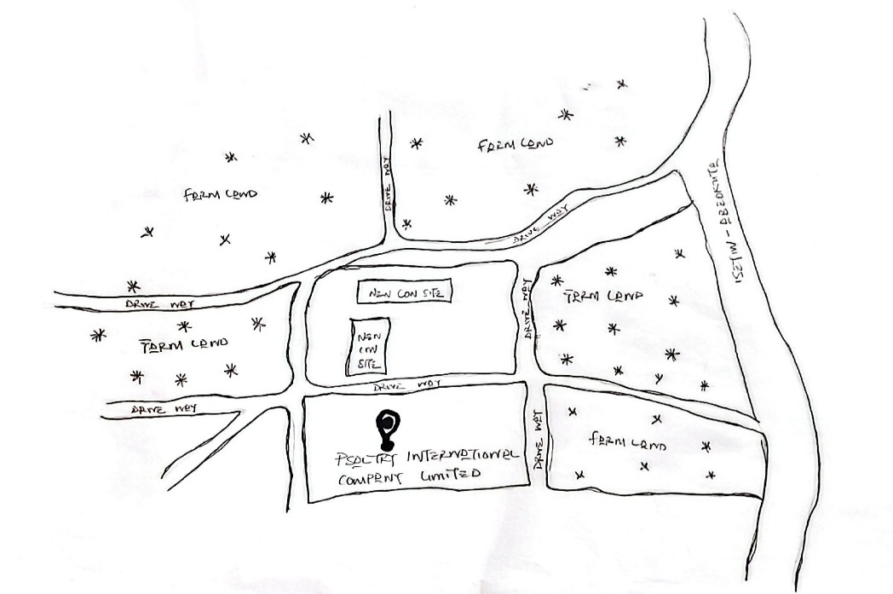
A major milestone came in 2022, when Psaltry launched Africa’s first cassava-based sorbitol factory, in partnership with Unilever Nigeria and FCMB, drastically reducing Nigeria’s reliance on imported sorbitol used in foods, pharmaceuticals, and cosmetics.

FIG 1.1:-LOCATION PLAN
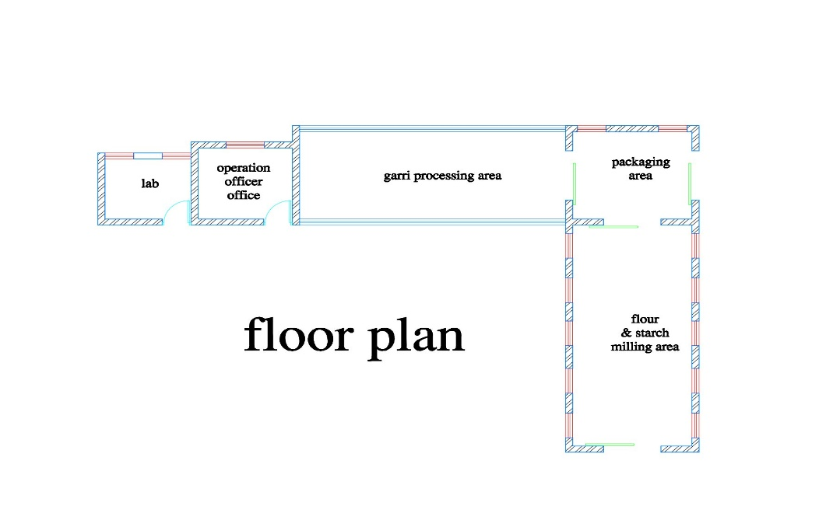
SOURCE:- Researcher Field Work, 2025

FIG 1.2:-FLOOR PLAN
SOURCE:- Researcher Field Work, 2025

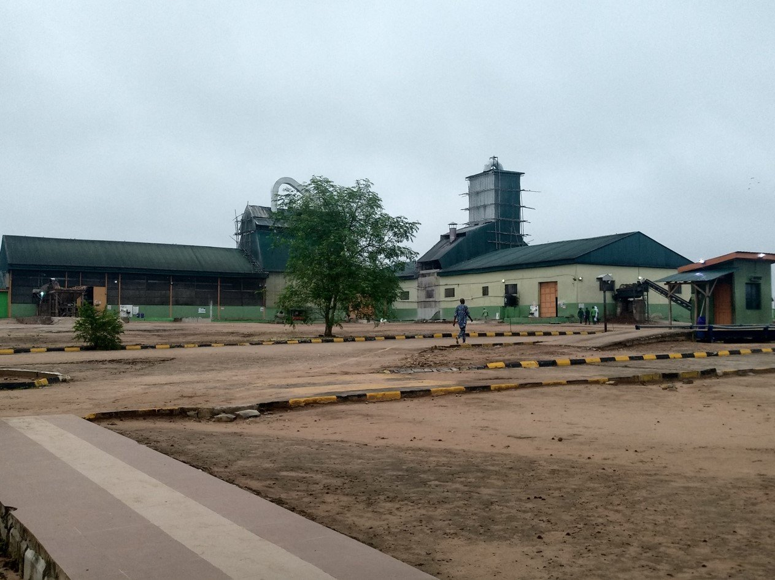

PLATE 1.1:- APPROACH VIEW
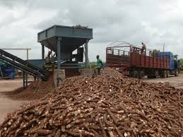
SOURCE:- Researcher Field Work, 2025

PLATE 1.2:-SIDE VIEW
SOURCE:- Researcher Field Work, 2025
3.1.1 MERITS
- Accessibility and universal design.
- Adequate natural lightning and ventilation.
- Safety hazard and code regulations in compliance.
- Well secure structure.

3.1.2 DEMERITS
- Building maintenance and challenges.
- No shed for cassava root storage
3.2 CASE STUDY TWO AYOSIFARM INTEGRATED SERVICE.
LOCATION: KAJOLA KODIJIALE JUNCTION, OFF ESTATE ROAD, ILORIN.
DESCRIPTION
Founded in 2018 and registered with Nigeria’s Corporate Affairs Commission as a youth-led, women-owned agribusiness based in Ilorin, Kwara State .
Established with the mission to support smallholder cassava (and later potato) farmers—especially women—by delivering agro-processing services, market access, and farm-level support .

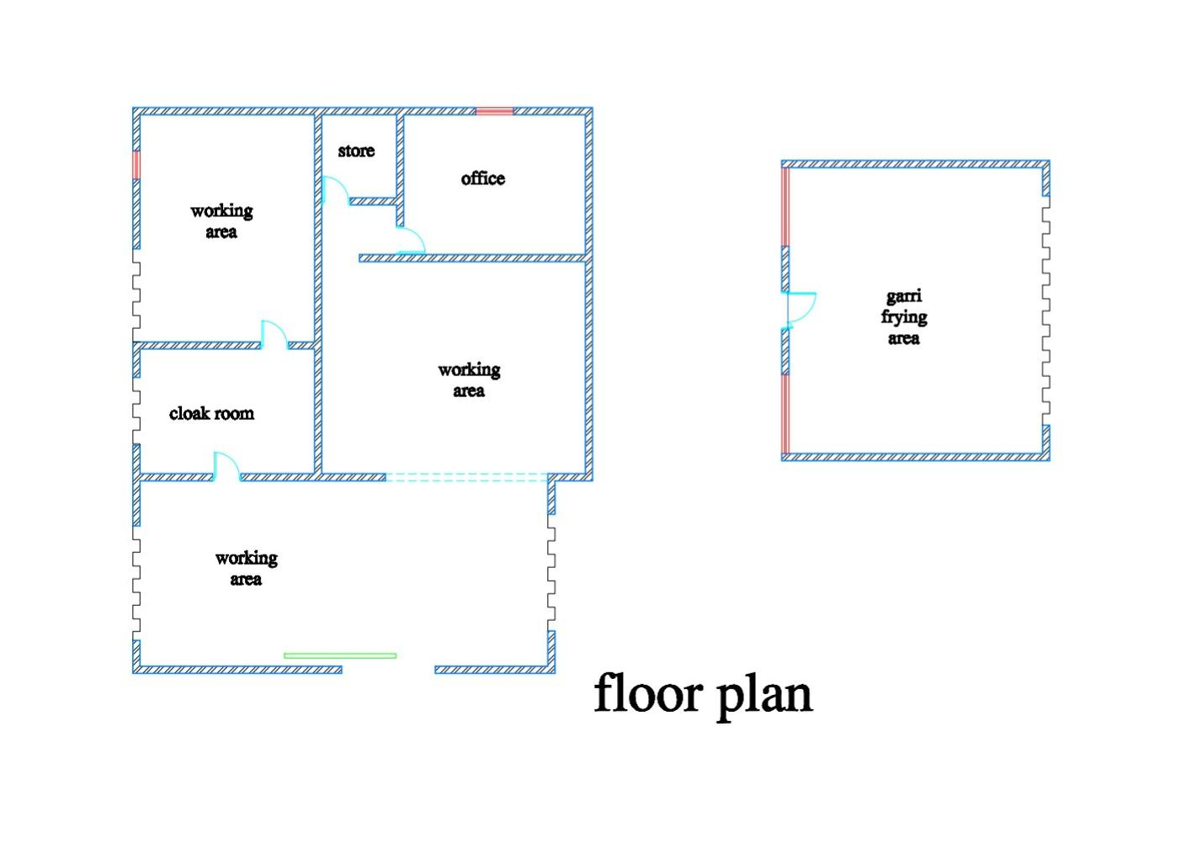

FIG 1.3:- FLOOR PLAN
SOURCE:- Researcher Field Work, 2025

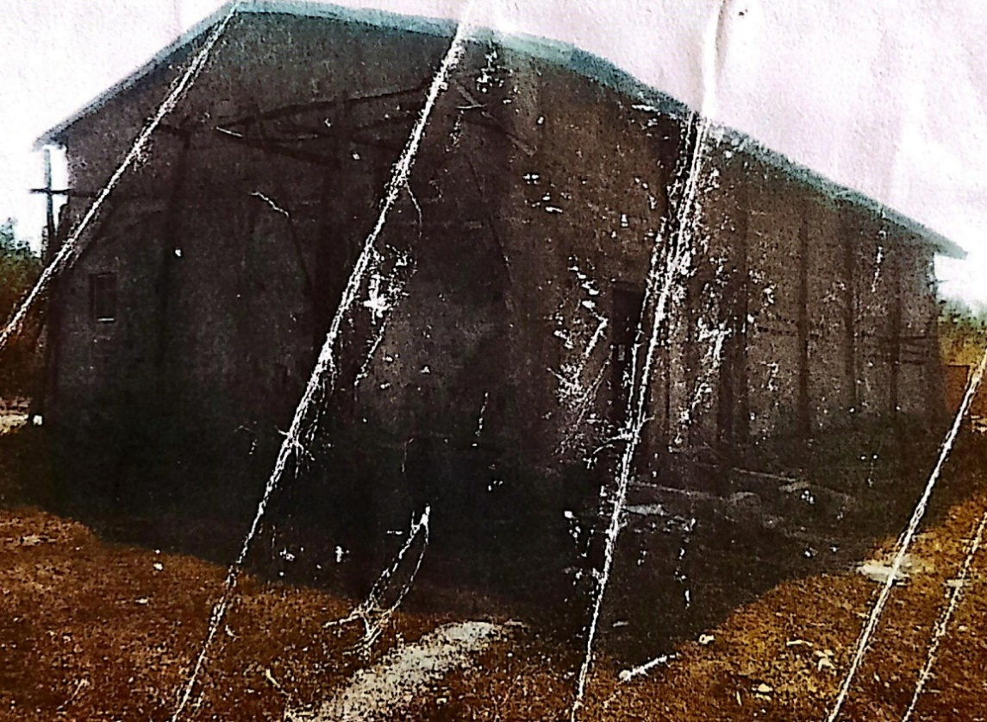

PLATE 1.3:-APPROACH VIEW
SOURCE:- Researcher Field Work, 2025

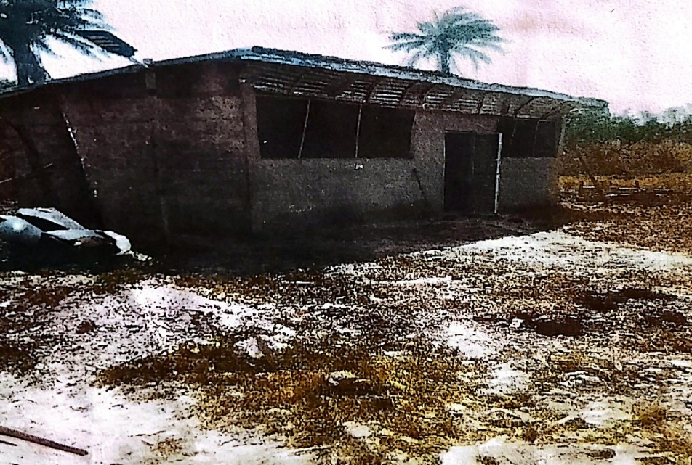

PLATE 1.4:-GARRI FRYING AREA
SOURCE:- Researcher Field Work, 2025
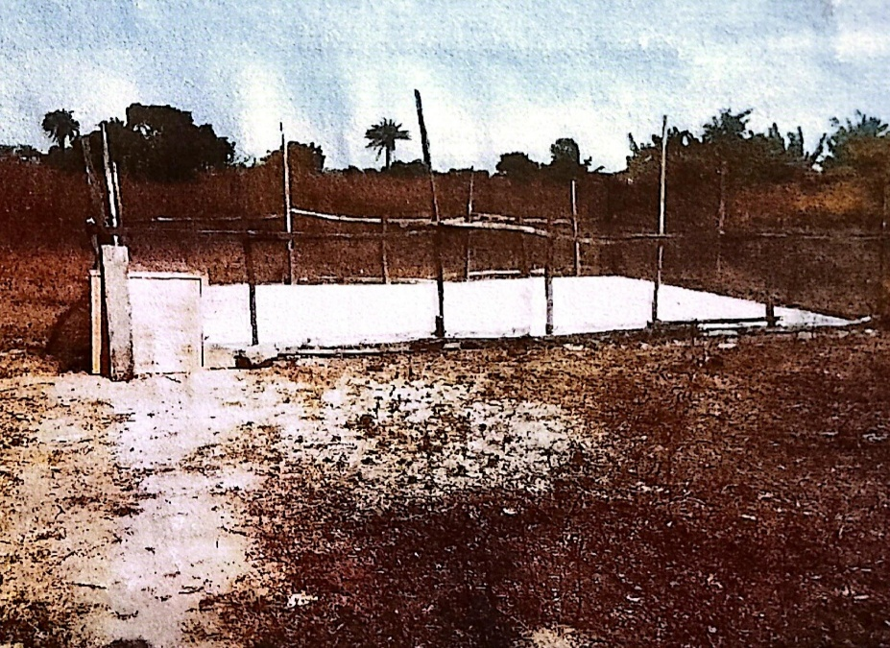
PLATE 1.5:-CASSAVA DRYING AREA
SOURCE:- Researcher Field Work, 2025

3.2.1 DEMERITS
  - Vulnerable to natural disasters.
  - Poorly erected structure.
  - Safety and hazard code regulations not in compliance.
  - Not a functional structure.

3.3 CASE STUDY THREE
PREMIUM CASSAVA PLC.
LOCATION: OSOSA 120101, OGUN STATE.
DESCRIPTION
Founded in 2006 as Thai Farm International Ltd by Asian and Nigerian investors; acquired by Flour Mills in 2012 and rebranded to Premium Cassava Products Ltd in April 2019 to align with FMN’s agro‑allied operations.
Mission: To process locally grown cassava into staple and industrial products, promoting self‑sufficiency and reducing import dependence.

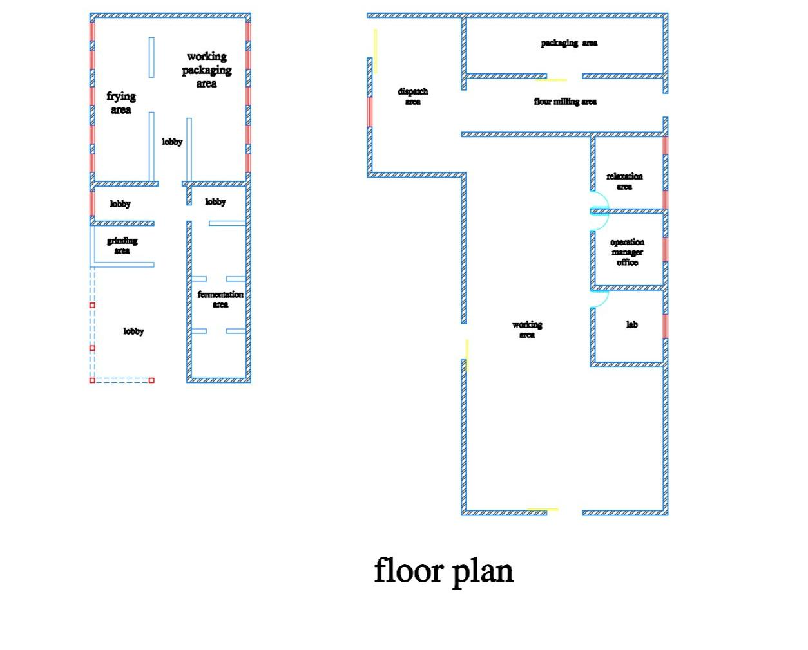

FIG 1.4:- FLOOR PLAN
SOURCE:- Researcher Field Work, 2025

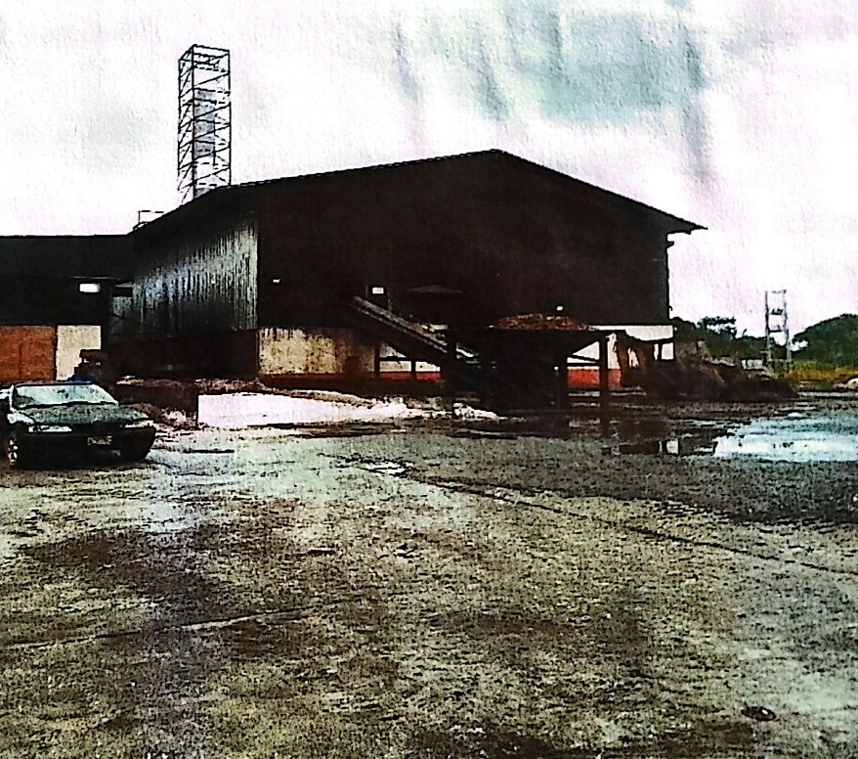
PLATE 1.6:-APPROACH VIEW
SOURCE:- Researcher Field Work, 2025

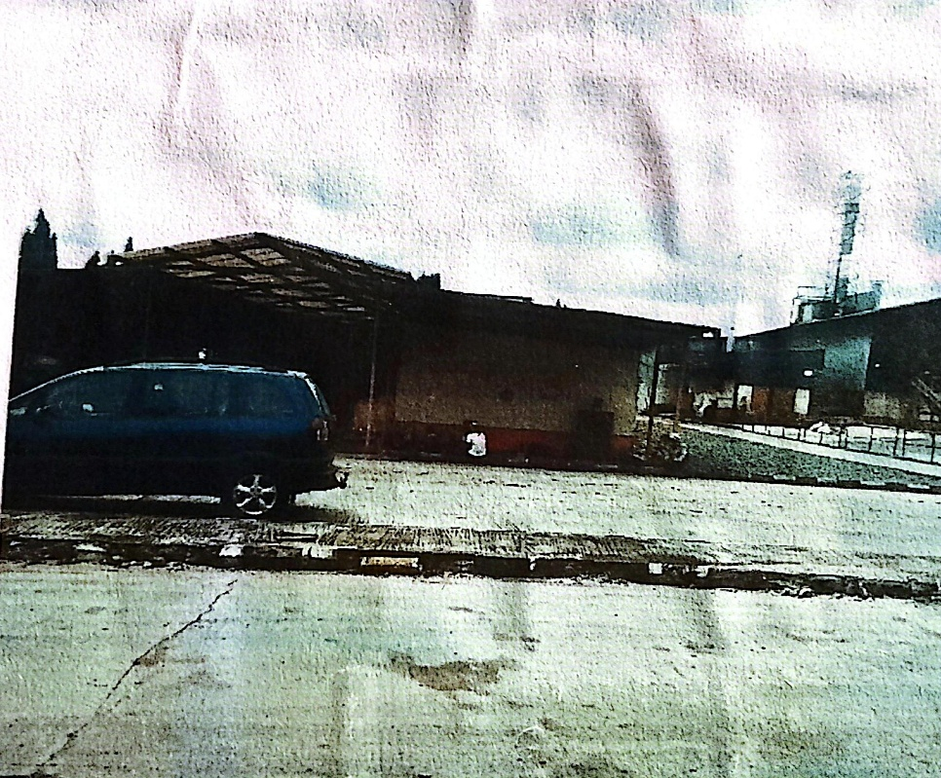
PLATE 1.7:-APPROACH VIEW
SOURCE:- Researcher Field Work, 2025
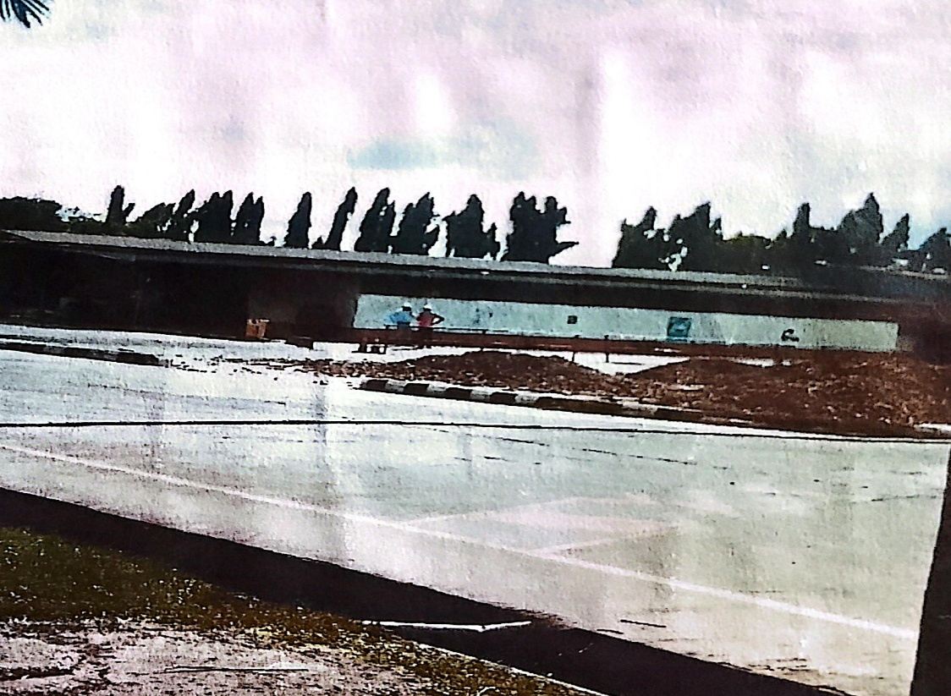

PLATE 1.8:-RIGHT SIDE VIEW
SOURCE:- Researcher Field Work, 2025

3.3.1 MERITS
  - Efficient floor plan layout.
  - Adequate natural lightning and ventilation.
  - Safety hazard and code regulations in compliance.
  - Well equipped with necessary machineries.
  - Well and conducive working area for workers.
3.3.2 DEMERITS
  - Slippery floors when there is water spillage.
  - Wall cracks.
  - No shed for cassava root storage.

3.4 CASE STUDY FOUR [ONLINE CASE STUDY
ASIA MODIFIED STARCH CO. LTD..

LOCATION: 8 THEENANON RD, PHON THONG, MUEANG KALASIN DISTRICT, KALASIN 46000, THAILAND.

DESCRIPTION
Established in 1987 as a Thai–Japanese joint venture—legally incorporated on September 24, 1987. Founded by Nihon Shokuhin Kako Co., Ltd. And Mitsubishi Corporation, combining starch-processing expertise with global marketing support

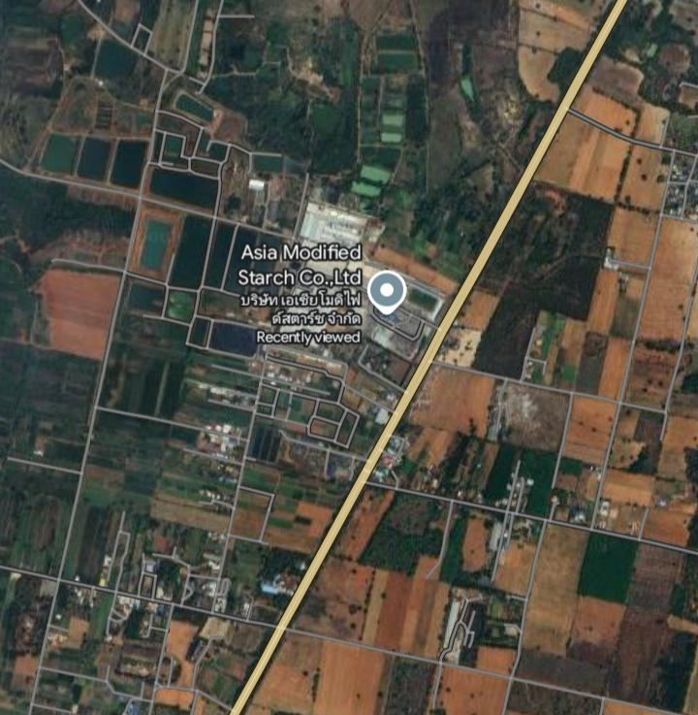

PLATE 1.9:-LOCATION PLAN
SOURCE:- Researcher Online (Google), 2025

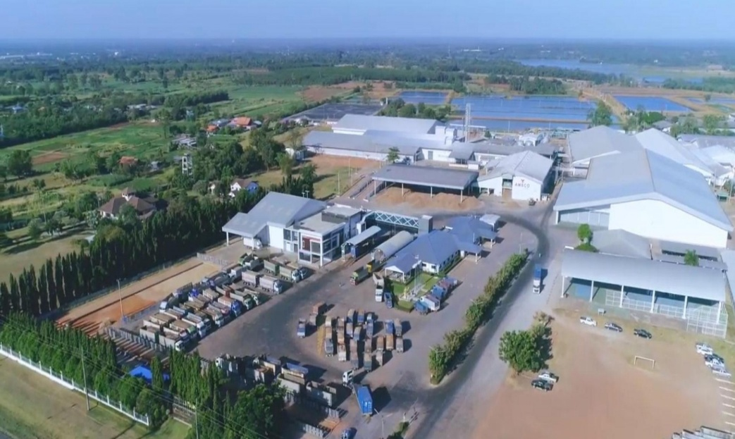

PLATE 2.0:-AERIAL VIEW

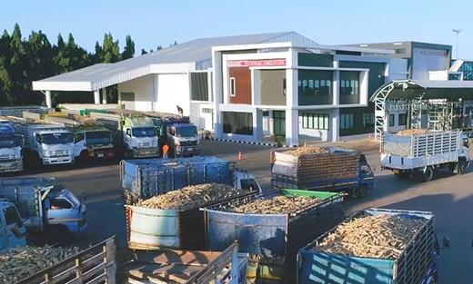

PLATE 2.1:-APPROACH VIEW
SOURCE:- Researcher Online (Google), 2025

3.5 CASE STUDY FIVE [ONLINE CASE STUDY 2]
GENERAL STARCH LIMITED.
LOCATION: 99–100 MOO 6, CHOKCHAI–KHON BURI ROAD (K.M.19), TAMBON ORAPHIM, AMPHOE KHON BURI, NAKHON RATCHASIMA 30250, THAILAND.

DESCRIPTION
Established in August 1992 in Thailand with an initial paid-up capital of 10 million Baht, later increased to 300 million Baht in 2007.
Received investment promotion from Thailand’s Board of Investment (BOI) with a project budget of 1 billion Baht.

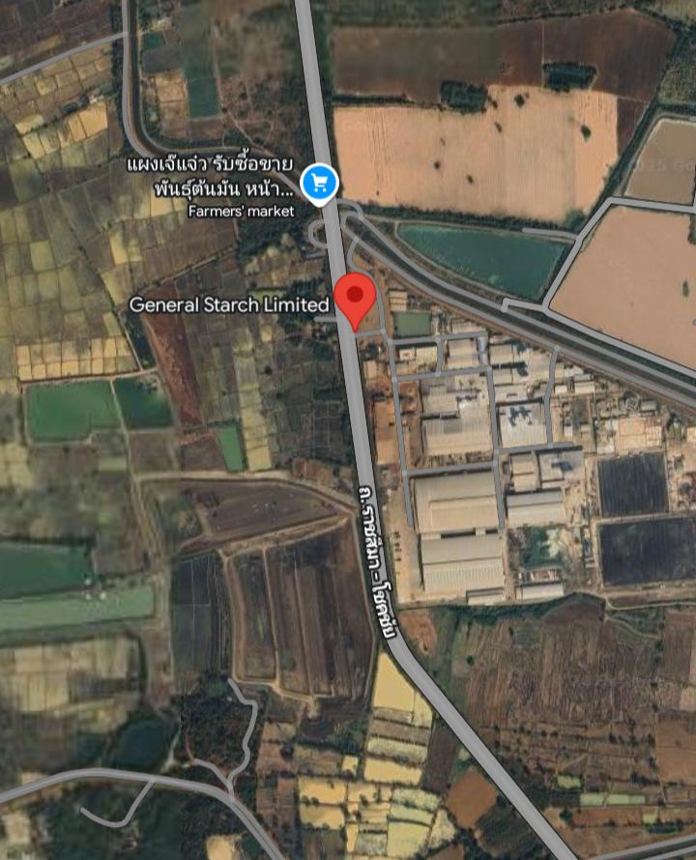

PLATE 2.3:-LOCATION PLAN
SOURCE:- Researcher Online (Google), 2025

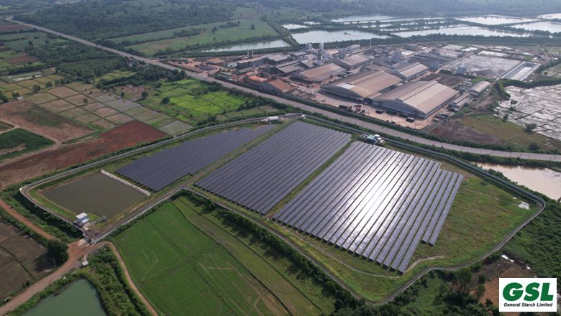

PLATE 2.4:-AERIAL VIEW



PLATE 2.5:-APPROACH VIEW
SOURCE:- Researcher Online (Google), 2025

3.6 DEDUCTION FROM CASE STUDIES:
These are the common similar knowledge or information derived from the aforementioned case studies. Some of which are:

- Choice of location should be in a developing or already developed area for easy access to the trainings offered.
- Segregation of each department form one another
- Well designed and well positioned landscapes
- Separation of noisy departments from departments with less noise
- Provision of required ventilation and fenestration into each units to serve the spaces well

CHAPTER FOUR
ANALYSIS OF THE ENVIRONMENTAL AND TOPOGRAPHICAL CONDITIONS OF THE SITE

4.0 INTRODUCTION TO STUDY AREA
This chapter presents an in-depth analysis of the environmental, topographical, and climatic characteristics of the site selected for the proposed project, located in Owu Isin, a community in Isin Local Government Area of Kwara State, Nigeria. Understanding the physical and social characteristics of the site is crucial for ensuring an environmentally responsive and sustainable design.
4.1 HISTORICAL BACKGROUND OF OWU ISIN
Owu Isin is a traditional Yoruba town in Isin Local Government Area, Kwara State, located in the southern part of the state. It is known for its strong cultural heritage, traditional governance, and predominantly agrarian lifestyle.

Pre-Colonial Era:
Owu Isin was established by the Yoruba people, specifically the Igbomina subgroup, known for their rich traditions and hierarchical leadership systems.
The town operated a traditional monarchy and was primarily an agrarian society, cultivating crops and engaging in local crafts and trade.
Colonial Era (1900 – 1960):
Under British colonial rule, Owu Isin was administered through indirect rule via local chiefs.
The colonial period brought missionary influence, including the introduction of Christianity, Western education, and rudimentary health and administrative structures.
Post-Colonial Era (1960 – Present);
Since Nigeria’s independence, Owu Isin has grown moderately in population and infrastructure while retaining its cultural values.
The town is still predominantly rural but has benefited from government and private investments in education, road networks, and healthcare.
Key Features and Landmarks in Owu Isin:
- Traditional palaces and compounds
- Central town square and weekly market
- Forest reserves and farmland
- Access to major local government headquarters like Omu-Aran
4.2 PHYSICAL FEATURES OF THE LOCATION
The physical setting of Owu Isin makes it ideal for institutional and agricultural development. Its relatively flat terrain, low population density, and availability of land contribute to its suitability for a vocational education and training (VET) center. The town’s peaceful environment also supports focused academic and skills-based learning.
4.3 POPULATION OF KWARA STATE (AND OWU ISIN)
Kwara State had an estimated population of about 3.6 million as of 2022.
Isin Local Government Area, being one of the smaller LGAs in the state, is less densely populated, with Owu Isin estimated to have a population between 15,000 and 25,000 people. The residents are mainly farmers, teachers, traders, and civil servants.
4.4 SOCIAL SERVICES
Owu Isin is gradually developing with various basic social services available to the community:
- Healthcare
- A Primary Health Care Center serves the town.
- Access to general hospitals in Omu-Aran and private clinics in nearby towns.
- Education
- Presence of public primary and secondary schools.
- Close proximity to tertiary institutions such as Kwara State University (Molete campus) and Landmark University (Omu-Aran).
- Transportation
- The town is accessible via paved rural roads connecting to major roads like the Omu-Aran–Ilofa road.
- Housing and Utilities
- Housing comprises traditional buildings and new modern structures.
- Electricity is supplied by the Ibadan Electricity Distribution Company (IBEDC).
- Water Supply
- Boreholes, rainwater collection, and hand-dug wells are primary water sources.
4.4.1 ROAD NETWORK
Owu Isin is connected to nearby towns through a network of state-maintained rural roads, including direct access to Omu-Aran and Ilofa. The proposed site is accessible via the Omu-Aran–Owu Isin road, allowing for movement of people and goods.
4.4.2 HEALTH SERVICE
Healthcare in the area is supported by:
- Owu Isin Primary Health Centre
- Access to General Hospital Omu-Aran
- Community-based private clinics and maternity homes

4.4.3 WATER AND ELECTRICITY
Water Supply: Boreholes, open wells, and seasonal streams.
Electricity: Provided by IBEDC, with stable service in the area.
4.5 GENERAL CLIMATIC CONDITIONS
Kwara State lies within the tropical savannah climate zone, and Owu Isin shares the general climate features of the southern part of the state.
Wet Season (April – October):
Temperatures: 23°C – 31°C
Rainfall: 1,200 – 1,600 mm annually
High humidity levels: 65–85%
Dry Season (November – March):
Temperatures: 21°C – 34°C
Lower humidity: 30–50%
Harmattan winds prevalent from December to February
Other Features:
Average annual temperature: ~27°C
Sunshine hours: ~2,400 hours annually
Elevation: 320–360 meters above sea level
Relative Humidity
Annual average: ~78%
Highest in September (~85%), lowest in February (~60%)
4.5.1 Wind
Mild to moderate winds throughout the year
Stronger wind activity during the harmattan season
4.5.2 Temperature
Day: 28–33°C, Night: 18–24°C
Coolest months: December – January
Hottest months: March – April
4.5.3 Vegetation
The vegetation is characteristic of Guinea Savannah, with tall grasses, shrubs, and scattered deciduous trees. Some vegetation will be cleared for development, while others will be preserved for landscaping and ecological balance.

4.6 SITE ANALYSIS

4.6.1 SITE SELECTION / JUSTIFICATION
The proposed site lies within Owu Isin community, along a minor arterial road that connects to major regional routes like the Omu-Aran – Ilofa highway.
Key factors influencing site selection:
- Accessibility: Easy access via rural and inter-town roads
- Location: Rural but centrally placed for outreach to nearby communities
- Infrastructure: Basic utility services (electricity, water, and road) already in place
- Topography: Gently sloping terrain suitable for building development
- Soil: Red laterite soil with good load-bearing capacity

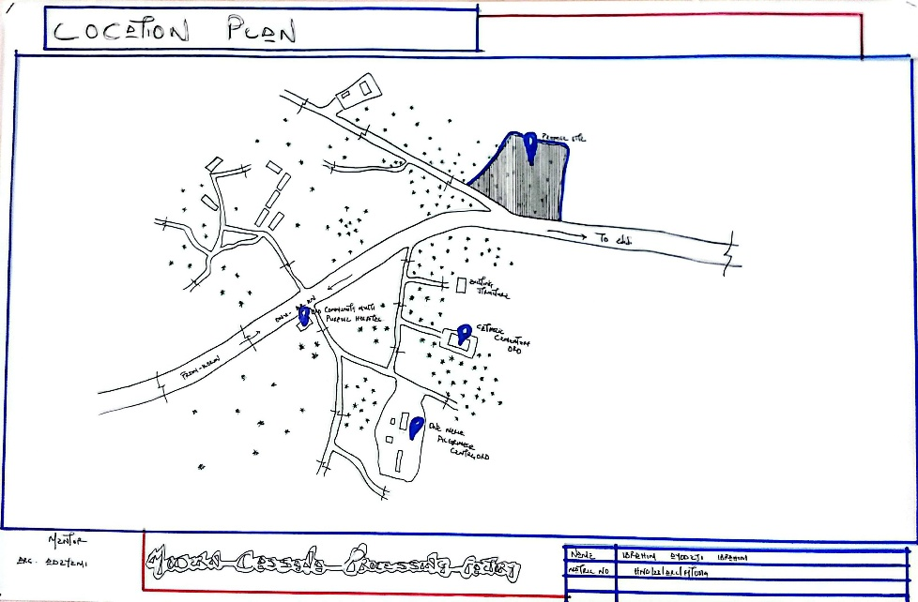

LOCATION PLAN
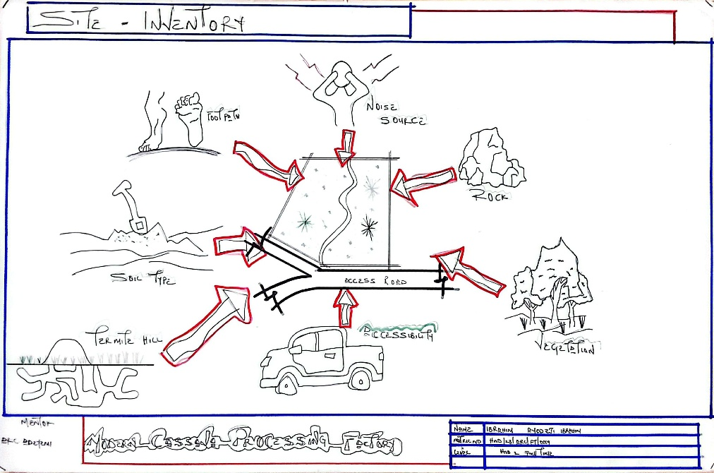

SITE INVENTORY

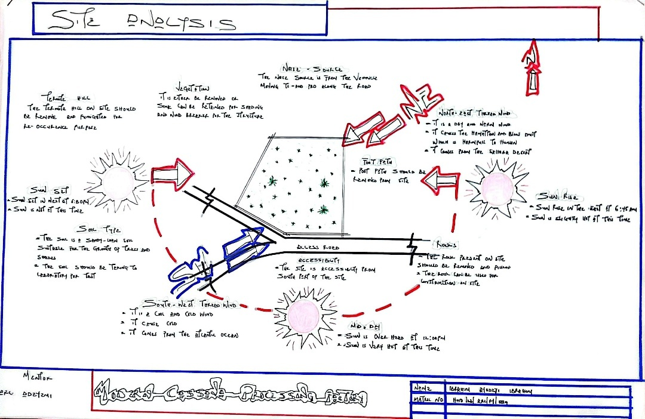

SITE ANALYSIS
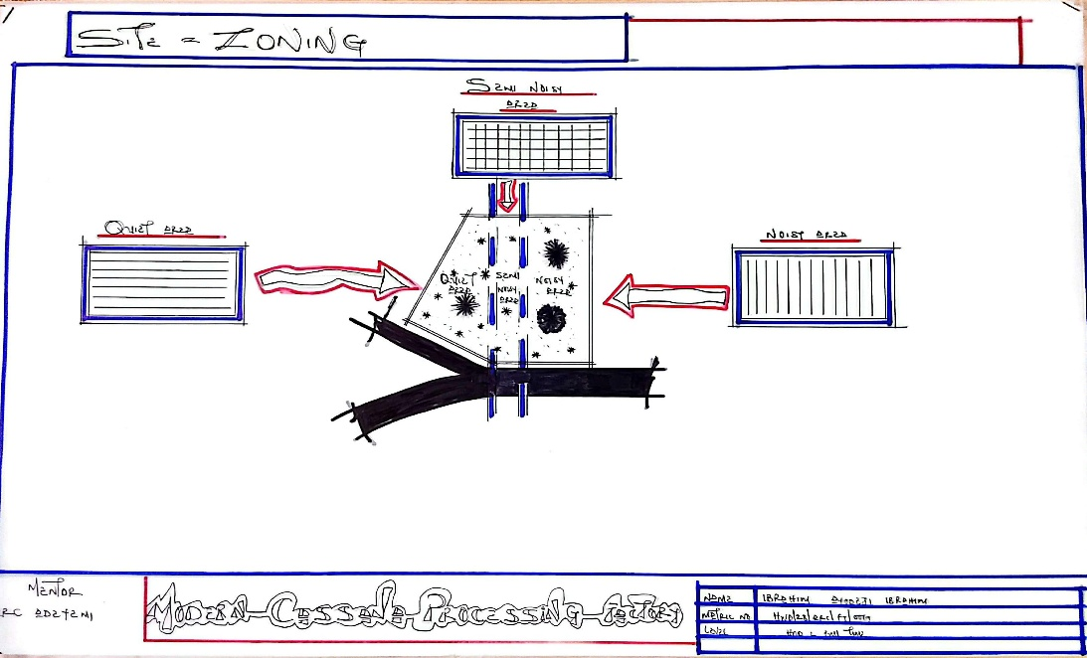

SITE ZONING

4.7 DESIGN CONCEPT/PLANNING PRINCIPLE
4.7.1 DESIGN PLANNING
Firstly, the design planning began with a comprehensive analysis of the requirements for a modern cassava processing facility. This was guided by data collected through research, including case studies of similar factories, consultation with industry professionals, and technical literature related to food processing layouts and flow systems.
Secondly, the various functional units—such as raw material reception, peeling and washing, grating, pressing, drying, milling, packaging, and storage—were grouped according to their functional relationships. These groupings were determined by the flow of production processes and the need for efficient material handling and hygiene control, which are crucial in food-grade industrial design.
The concept of the factory was developed from the functional flowchart and bubble diagrams created from the design brief, ensuring smooth transitions between processing stages and minimizing contamination risks. Special attention was given to the zoning of activities based on the nature and intensity of operations, especially considering moisture, heat, and noise levels in each area.
4.7.2 PLANNING PRINCIPLE
The planning principle is central to ensuring a functional, efficient, and hygienic cassava processing facility. Each unit in the factory is planned in direct relation to its operational function, proximity to supporting units, and the safety and comfort of users (factory workers and supervisors). In alignment with these principles, the factory is divided into two primary zones:
The Administrative Block, which includes offices, meeting rooms, reception, staff amenities, and laboratory/testing areas.
The Processing Block, which houses all production operations—from reception of cassava tubers to the final packaging of cassava products like flour, garri, and starch.
Site zoning was carefully considered to separate clean and unclean processes, dry and wet zones, and noisy and quiet areas. The site is divided into three major zones:
- Zone A: Semi-quiet Area – Includes the administrative building and staff welfare areas.
- Zone B: Processing Zone – A transitional zone with moderate activity, including cleaning, peeling, and grating areas.
- Zone C: High-activity/Noisy Zone – Includes pressing, drying, milling, and packaging units, where mechanical operations and equipment generate higher noise levels.
- This zoning system not only enhances operational efficiency and safety but also aligns with environmental and industrial standards for food processing plant design..

CHAPTER FIVE
5.0 DESIGN REPORT
5.1 DESIGN BRIEF
Following extensive research and planning, the next critical stage in the project development is the design process. For a functional, efficient, and aesthetically pleasing facility, it is essential to begin with a clear and detailed design brief. The nature of this brief depends largely on the scope and specific operational requirements of the proposed project.
In the case of this project, the design brief is developed based on the comprehensive understanding of activities involved in a modern cassava processing factory. This includes the entire production chain—from the reception of raw cassava tubers to the final packaging and storage of processed cassava products.
To develop an effective and practical brief, detailed case studies were conducted on existing cassava processing facilities within Nigeria and abroad. These studies provided valuable insights into the layout, workflow, hygiene requirements, equipment needs, and functional relationships between the various units in a standard processing factory.
The proposed cassava processing facility is designed to handle multiple product lines such as cassava flour, garri, fufu, and industrial starch. Accordingly, the factory is structured to include essential departments such as:
- Cassava Reception and Inspection Area
- Production Area
- Storage (raw material and finished goods)
- Waste Treatment Area
- Administrative Offices and Staff Welfare Facilities
Each of these units was considered in the design based on their functional relationships, environmental impact, and safety standards. The aim is to ensure a seamless production flow, minimize contamination risks, and comply with modern food processing and safety guidelines.
5.2 DESIGN APPRAISAL
In any industrial project design, two fundamental factors are always prioritized: functionality and aesthetics. While these may seem incompatible, in the design of this modern cassava processing factory, both have been harmoniously integrated. The result is a facility that not only meets demanding functional and production requirements but also presents an aesthetically pleasing and proportionally balanced industrial environment.
The functional efficiency of this factory relies largely on the spatial arrangement of processing units that are strongly related in function. These have been carefully planned, as reflected in the site layout and floor plans.
5.3 DESIGN CHARACTERISTICS
The planning of a modern cassava processing factory must begin with the production flow, hygiene, and efficiency. At the same time, creating a healthy and pleasant environment for workers is essential. The following design elements were incorporated:
- LANDFORM:
The factory site lies on gently sloping terrain, which aids water drainage and makes for efficient site planning and building orientation.
- TREES AND LANDSCAPE BUFFERING:
Shade trees and controlled landscaping are used to break the intensity of sun and wind. Trees such as flamboyant and neem are planted around staff relaxation areas and along fence lines to enhance natural cooling.
- GRASSES AND OPEN SPACES:
Bahama and Kikuyu grasses are used in green zones for aesthetics and erosion control. Lawns also surround administrative offices and worker rest areas.
- FLOWER BEDS AND HEDGES:
Ornamental plants are used along walkways and near office entrances to improve aesthetics and worker morale. Hedges also provide visual boundaries between processing zones and administrative areas.
- PARKING SPACE:
Ample parking is provided for delivery trucks, staff vehicles, and visitors. The truck loading zone is well paved and strategically located for easy movement of raw materials and finished products.
5.4 BUILDING STRUCTURE
The facility comprises key components: raw material reception, peeling and washing units, processing and drying sections, packaging unit, storage warehouses, and administrative offices. The structural layout employs a structural grid system, enhancing flexibility and load-bearing capacity.
The buildings are constructed using sandcrete blocks, reinforced concrete columns, and beams. Steel trusses are used in the roofing of the production hall for wide-span coverage and ventilation. Areas prone to pest damage are treated with termiticides like Solignum.
5.5 SERVICES
- Power Supply:
The factory connects to the national grid with provisions for an industrial generator to support uninterrupted operation.
- Water Supply:
An industrial borehole system with overhead tanks ensures a constant supply of clean water for processing and cleaning.
- Waste Management:
Solid waste from cassava peels and fiber are processed into animal feed or compost. Liquid waste is directed into treatment pits and soak-away systems. There are provisions for future biogas integration.
- Ventilation and Air Conditioning:
Natural ventilation is encouraged through strategic openings. Forced ventilation (industrial fans) is used in processing zones. Offices are air-conditioned for worker comfort.
5.6 GENERAL REQUIREMENTS
5.6.1 LIGHTING:
Natural lighting is prioritized in production and storage zones with skylights and high-level windows. Artificial lighting (LED and fluorescent fixtures) are installed for 24/7 operations.
5.6.2 ORIENTATION:
The factory is oriented to take advantage of prevailing winds and minimize solar heat gain. Production zones face away from direct sun exposure to maintain moderate indoor temperatures.
5.6.3 RAIN PROTECTION:
Simple sloped roofing is adopted for quick drainage. Gutters and downspouts direct rainwater to collection points for reuse in non-critical processes. Damp-proof membranes are used in wall and floor junctions to resist water ingress.
5.6.4 NOISE CONTROL:
Machinery zones are acoustically insulated. Buffer zones with trees and sound-absorbing materials separate noisy equipment from administrative offices and staff areas.
5.7 MATERIALS AND FINISHES
Material Selection Factors:
- Suitability and durability for industrial use
- Resistance to moisture, pests, and chemical exposure
- Availability and cost of materials locally
- Low-maintenance surfaces

5.7.1 ROOFING:
Long-span galvanized aluminum sheets with reinforced concrete gutters are used. The processing areas have steel roof structures; other blocks use timber trusses treated against termites.
5.7.2 CEILING:
Suspended ceilings (e.g., Celotex) in office areas; acoustic panels used where necessary.
5.7.3 WALLS:
225mm sandcrete blocks with smooth internal and external plaster finishes. Walls in processing zones have ceramic tiles up to 1.8–2.1 meters high for easy cleaning.
5.7.4 DOORS:
Wide industrial metal doors for equipment zones; wooden or aluminum doors for administrative sections.
5.7.5 WINDOWS:
Louvered and aluminum-framed pivot windows for ventilation and ease of maintenance.
5.7.6 WALKWAYS:
All pedestrian and loading paths are paved with concrete slabs for durability. Covered walkways connect key buildings.

5.8 SUMMARY AND CONCLUSION
5.8.1 SUMMARY
From concept to detailed drawings, the design of this modern cassava processing factory was guided by principles of functionality, safety, hygiene, and efficiency. The layout supports linear production flow, minimizes cross-contamination, and integrates sustainable elements such as landscaping and waste management strategies.

5.8.2 CONCLUSION
The design reflects insights gained from research into cassava processing facilities across Nigeria and beyond. It showcases a model layout that meets the economic, functional, and environmental needs of a modern agro-industrial facility. With this project, I have contributed to the advancement of sustainable agricultural processing infrastructure, creating a benchmark for future factory developments in Nigeria.

RECOMMENDATIONS
- Policy Support and Implementation: Government should prioritize the cassava value chain by strengthening existing agricultural policies that promote cassava processing. This includes tax incentives, access to subsidized equipment, and infrastructure development.
- Access to Finance: Banks and microfinance institutions should develop tailored loan products to support cassava processors, especially small and medium-scale enterprises, in acquiring modern machinery and expanding operations.
- Capacity Building and Training: Continuous training programs should be organized for workers, farmers, and factory managers on modern cassava processing techniques, quality control, and business development.
- Research and Development (R&D): Collaboration with research institutions such as IITA should be strengthened to introduce improved cassava varieties and processing technologies that increase yield and reduce processing time.
- Sustainable Waste Management: The factory should invest in circular economy strategies such as converting cassava peels into animal feed, biogas, or compost to reduce environmental impact and enhance profitability.
- Market Linkages and Export Promotion: Government and industry stakeholders should work to create domestic and international markets for cassava products, supported by trade fairs, export grants, and product certification.
- Quality Assurance and Standards Compliance: A robust quality control unit should be incorporated into the factory to ensure that all products meet regulatory standards, especially for food-grade and pharmaceutical-grade outputs.
- Digital Integration: Implementing digital systems for production tracking, inventory management, and logistics will improve factory efficiency and transparency.
- Inclusive Employment: Employment strategies should ensure gender equity and youth inclusion through targeted recruitment, on-the-job training, and leadership development within the factory.
- Infrastructure Development: Governments should facilitate road access, electricity, water supply, and storage facilities in rural cassava-producing areas to attract investors and ensure factory sustainability.
By adopting these recommendations, the proposed modern cassava processing factory can operate efficiently, deliver economic value, and serve as a replicable model for other agro-processing initiatives in Nigeria.
The recommendations have now been updated to align with the modern cassava processing factory focus. They cover policy, finance, training, sustainability, market access, and infrastructure. Let me know if you need a version tailored for a government proposal, business plan, or investor presentation.

REFERENCES
Adegeye, A.J. & Dittoh, J.S. (1985). Essentials of Agricultural Economics. Ibadan: Impact Publishers.
Adebayo, K. (2009). Dynamics of Technology Adoption in Rural-Based Cassava Processing Enterprises in Southwest Nigeria. International Journal of Agricultural Economics & Rural Development, 2(1), 15-24.
Akinrele, I.A. (1990). Fermentation of Cassava. Nigerian Food Journal, 8(1), 24-27.
Ezedinma, C. & Kormawa, P. (2007). Value Chain Analysis for the Cassava Sub-sector in Nigeria. International Institute of Tropical Agriculture (IITA), Ibadan.
FAO (2013). Processing of Cassava: Post-Harvest Operations. Food and Agriculture Organization of the United Nations. Retrieved from: www.fao.org
IITA (2005). Cassava: Transformation in Africa. International Institute of Tropical Agriculture, Ibadan, Nigeria.
Kolawole, O.M. & Olayemi, A.B. (2010). Effect of Drying Methods on the Quality Attributes of Cassava Product (Garri). International Food Research Journal, 17(2), 377-382.
National Bureau of Statistics (2006). 2006 Population and Housing Census of Nigeria. Abuja: Federal Republic of Nigeria.
Nweke, F.I., Spencer, D.S.C. & Lynam, J.K. (2002). The Cassava Transformation: Africa's Best-Kept Secret. East Lansing: Michigan State University Press.
Obayelu, A.E., Okoruwa, V.O., & Ajani, O.I.Y. (2006). Cross-sectional Analysis of Food Demand in the North Central, Nigeria: The Quadratic Almost Ideal Demand System (QUAIDS) Approach. Journal of Agriculture and Social Sciences, 2(2), 18–23.
Ogunniyi, L.T. (2011). Profit Efficiency among Cassava Producers: Empirical Evidence from South Western Nigeria. Journal of Agricultural Economics and Development, 1(1), 1-7.
Phillips, T.P., Taylor, D.S., Sanni, L. & Akoroda, M.O. (2004). A Cassava Industrial Revolution in Nigeria. The International Institute of Tropical Agriculture (IITA) & FAO.
APPENDICES
