PROJECT REPORT
ON
FASHION HOME
FOR
ILORIN EAST KWARA STATE.

By:
HAMMED IBRAHIM OLUWADAMILARE
ND/23/ARC/FT/0038

Submitted to:
THE DEPARTMENT OF ARCHITECTURAL TECHNOLOGY INSTITUTE OF ENVIRONMENTAL STUDIES (IES) KWARA STATE POLYTECHNIC, ILORIN

IN PARTIAL FULFILMENT OF THE REQUIREMENTS FOR THE AWARD OF NATIONAL DIPLOMA (ND) IN ARCHITECTURAL TECHNOLOGY

JULY, 2025.
DECLARATION
I declare that this Project/Dissertation is a product of my personal research work. It has not been presented for the award of any degree in any Polytechnic. The ideas, observations, comments, and suggestions herein represent my own convictions, except quotations, which have been acknowledged in accordance with conventional academic traditions.

HAMMED IBRAHIM OLUWADAMILARE __________________________

ND/23/ARC/FT/0038 DATE/SIGNATURE

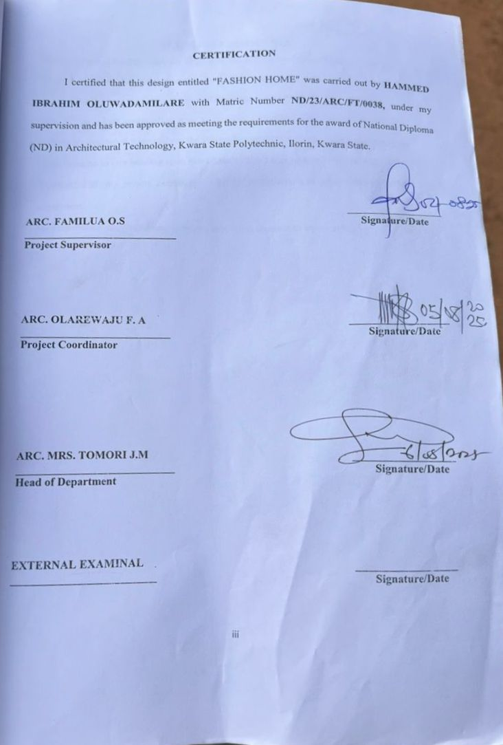

ACKNOWLEDGEMENTS
Firstly, I thank Almighty Allah for all what he has done in my life and what he is still going to do. It is expected on my part to give glory, honor and adoration to Almighty Allah who has seen me through the turbulent waves of challenges and difficulties.
Special thanks and appreciation goes to my able supervisor ARC SOLOMON who brilliantly contributed immensely to the successful completion of this project may Almighty Allah continue to rain blessing upon him (Amen). Also I appreciate my H.O.D. ARC. MRS. TOMORI J.M. my project coordinator ARC ADEYEMI And other lecturers in My department.
My appreciation also goes to my sponsors, may Allah continue to enrich you all.

DEDICATION
This design project is dedicated to Almighty Allah for making it possible for me to Start and completion of my ND program. I will forever remain grateful inshallah.

ABSTRACT
The report write up comprises of the following location fashion home. Brief History on fashion home, aim and objectives of the project , case studies drawing and pictures of each case study. This Proposed project is located in Ilorin East Ilorin Kwara state in order to play a catalyst role in
establishing more suitable place. The important construction consideration in term of aesthetics and luxury as a factor considered in design of multi purpose hall and conclusion.

That, this project will be of great benefit to whoever that read it. Particularly those who want to embark on the project of the type.

TABLE OF CONTENTS
TITLE PAGE…………………………………………………………………..........i
DECLERATION………………………………………………………………...…. ii
CERTIFICATION………………………………………………………………….. iii
DEDICATION……………………………………………………………………… iv
ACKNOLEDGMENT ………………………………………………………………..v
TABLE OF CONTENTS…………………………………………………………… vi
LIST OF TABLES……………………………………………………………….…. vii
LIST OF FIGURES………………………………………………………………… viii
LIST OF PLATES………………………………………………………………… .ix
LIST OF APPENDICES………………………………………………………………x
ABSTRACT……………………………………………………………………...…. xi

CHAPTER ONE
1.0 INTRODUCTION………………………………….………….………………………1
1.1 HISTORICAL BACKGROUND…………………………….………………..………2
1.2 DEFINITION…………………………….…………………….…...…………………3
1.3 STATEMENT O F THE RESEARCH PROBLEM. ………………………………….3
1.4 AIM AND OBJECTIVES………………………………………..………………..…..3
1.5 JUSTIFICATION………………………………………………………………….…..4
1.6 SCOPE OF STUDY………………………………………………………………..…4
1.7 LIMITATIONS OF STUDY………………………………………………………..…4
1.8 RESEARCH METHODOLOGY…………………………………………………...…5

CHAPTER TWO

2.1 LITERATURE REVIEW …………………………….…………………………………. 6
2.1.1 INTRODUCTION………………………………………………………………………...6
2.1.2 IMPORTANT ISSUES AND PROBLEMS PECULIAR TO FASHION HOME TYPOLOGY………………………………………………………………………....7
2.1.3 TECHNOLOGICAL AND ENVIRONMENTAL APPROACHES FOR DESIGNING A FASHION HOME……………………………...……………………………….………..8
2.2 MERIT OF STUDYING……………………………………………………….…10
2.3 CONCLUSION ………………………………………………………………….10

CHAPTER THREE
3.0 CASE STUDY………………………………………………………….…..…. 11
3.1 OUTLINES OF THE CASE STUDIES……………………………...…….….. 11
3.1.1 CASE STUDY ONE (1): Mukhad Couture …………………..……………..….11
3.1.2 CASE STUDY TWO (2): Loffy Peng Fashion Home………….................…….16
3.1.3 CASE STUDY ONE (3): Trumie Academy of Fashion Home….……………....19

CHAPTER FOUR
4.1 ANALYTICAL STUDY OF THE PROJECT LOCATION…………………………24
4.1.1 INTRODUCTION…………………………………………………………………….24
4.1.2 SITE LOCATION…………………………………………………………………….24
4.1.3 SITE INVENTORY…………..…...…………………………………………………26
4.1.4 SITE ANALYSIS………………...…………………………………………………..26
4.1.5 GENERAL GEOGRAPHICAL CONDITION…………………….……………..….27
4.1.6 CLIMATE …………………………………………………………………………………...27
4.1.7 VEGETATION………………...………………………………………………..…..29
4.1.8 TOPOGRAPHY………………...……………………………………………… …..29
4.1.9 NATURAL RESOURCES………………...…………………………………….… 29
4.1.10 ENVIRONMENTAL CHALLENGES…………………………………………… ..29
4.1.11 SITE SERVICES………………………………………………………………… …30
4.1.12 SITE UNIQUENESS AND BENEFIT………………………………………………30
4.1.13 SITE SUITABILITY……………………………………………………………….30
4.2. DESIGN CRITERIA……………………………………………………………….30
4.2.1 SITE SELECTION………………………………………………………...……….30
4.2.2 BUILDING ARRANGEMENT…………………………………………………….31
4.2.3 DESIGN SCOPE…………………………………………...……………………….31
4.2.4 DESIGN BRIEF 9ANALYSIS…………………………………………………….31
4.2.5 SPACES DERIVATION ANALYSIS/SCHEDULE FOR ADMINBLOCK………32
4.2.6 FUCTIONAL ANALYSIS AND RELATIONSHIP………………………………32

CHAPTER FIVE
5.1 APPRAISAL OF PROPOSED SCHEME………………………………………….34
5.2 CONSTRUCTION METHODOLOGY AND MATERIALS. …………………….34
5.21 MATERIALS FOR CONSTRUCTION……………………………………………34
5.2.2 CONSTRUCTION METHODOLOGIES………………………………………….34
5.2.1 SERVICE……………………………………………………………………….….36
5.2.2 CIRCULATION……………………………….……………………………….….36
5.2.3 VENTILATION……………………………………….……………………….….36
5.2.4 LIGHTING……………………………………….……………………………….37
5.2.5 PLUMBING ……………………………………….……………….…………….37
5.2.6 ELECTRICAL INSTALLATION……………………………..………………….37
5.2.7 WASTE DISPOSAL……………………………………….…….……………….37
5.2.8 FIRE PROTECTION……………………………………………………………..38
5.2.9 EXTERNAL WORKS……………………………………………..……………..38
5.3 CONCLUSION AND RECOMMENDATION………………………………….38
REFERENCES………………………………………………………………………….39

LIST OF PLATES
CASE STUDY 1
PLATE 3:1.1 LOCATION MAP………………………………………………………….13
PLATE 3.1.2 ELEVATION ……………………………………………..……………….14
PLATE 3.1.3 ELEVATION……………… ……………………………………………….15
PLATE 3.1.4 ELEVATION……………..……………………………………...………….15
CASE STUDY 2
PLATE 3.2.1 ELEVATION………………………………………………………………18
PLATE 3.2.2 STAFF OFFICE. ………………………………………………………….18
CASE STUDY 3
PLATE 3.3.1 LOCATION MAP………………………………………………………….20
PLATE 3.3.2 ELEVATION……………………………………………………………….21
PLATE 3.3.3 ELEVATION…..…………...……………………………………...……….22
PLATE 3.3.4 ELEVATION…...…………...……………………………………….……...22

LIST OF FIGURES
FIGURE 3:1:1 LOCATION PLAN CASE STUDY 1…………………………..………12
FIGURE 3.1.2 FLOOR PLANS CASE STUDY 1…….………………………….…..…13
FIGURE 3:1.3 SITE PLAN CASE STUDY 1 ……………………...……………………14
FIGURE 3.2.1 LOCATION PLAN CASE STUDY 2……………………………………15
FIGURE 3.2.2 FLOOR PLANS CASE STUDY 2……………………………….…….…15
FIGURE 3.3.1 LOCATION PLAN CASE STUDY 3……………………………….……20
FIGURE 3.3.2 FLOOR PLAN. CASE STUDY 3…………………..…………………..…21
FIGURE 4.1.11.1 MAP OF NIGERIA, 36 STATES AND FCT. ……………..………….24
FIGURE 4.1.11.2 KWARA STATE MAP………..……………………………..……………...25
FIGURE 4.1.11.1 LOCATION PLAN …………………………………..………….……...25
FIGURE 4.1.12.1 SITE INVENTORY …………………………………….……….………26
FIGURE 4.1.12.2 SITE ANALYSIS ……………………………..………..……….………27
FIGURE 4.1.3.1 AVERAGE MONTHLY RAINFALL IN ILORIN. …….….…………….28
FIGURE 4.1.3.2 SUNSHINE DURATION IN ILORIN. ………………………..………….28
FIGURE 4.1.3.3 RELATIVE HUMIDITY IN ILORIN. ………………………..…………..29
FIGURE 4.2.6.1: FUNCTIONAL ANALYSIS 1 ……………………………………………32
FIGURE 4.2.6.2: FUNCTIONAL ANALYSIS 2 ……………………………………………32
FIGURE 4.2.6.3: FUNCTIONAL RELATIONSHIP 1 …………………………….………..33
FIGURE 4.2.6.4: FUNCTIONAL RELATIONSHIP 2 ………………………………………33

LIST OF TABLES

TABLE 4.2.5: SPACE ALLOCATION………………………………………………32

LIST OF APPENDICES
APPENDICES 5.1: GROUND FLOOR PLAN…………………………………………..40
APPENDICES 5.2: FIRST FLOOR PLAN. ……………………………………………..40
APPENDICES 5.3: SECON FLOOR……………………………………………………..41
APPENDICES 5.4: ROOF PLAN ………………………………………………………..41
APPENDICES 5.5: SITE PLAN……………………………………………………..…..42
APPENDICES 5.6: SECTIONS……………………………………………………..…..42
APPENDICES 5.7: ELEVATION……………………………………………….…..…..43
APPENDICES 5.8: EXTERNAL PERSPECTIVE. …………………………………….43

CHAPTER ONE

INTRODUCTION

The concept of fashion home in arcatecture represents the intersection of two creative disciplines: fashion design and architectural design. Just as fashion focuses on the personal expression. Aesthetics, and functionality of clothing fashion home architecture extends these principles to design of living spaces. It involves the use of innovative mater-tals. Color palettes, jextures and concept of fashion home in arcatecture represents the intersection of two creative disciplines: fashion design and architectural design. Just as fashion foluses on the personal expression. Aesthetics, and functionality of clothing fashion home architecture extends these principles to design of living spaces. It involves the use of innovative materials, color palettes, jextures and styles to create environments that are both visually striking and highly functional...

Are to create environments that are both visually striking and highly functional.

1.1 HISTORICAL BACKGROUND OF THE PROJECT
The concept of a Fashion Home stems from the evolution of the fashion industry, which has gradually shifted from scattered production and retail points to more centralized, creative spaces that combine design, tailoring, exhibition, and sales. Historically, fashion design and production were confined to small tailoring shops or home-based businesses. As fashion gained recognition as a commercial art and cultural expression, there arose a need for specialized spaces that could support creativity, craftsmanship, and customer interaction under one roof.
In Nigeria, fashion has always been a vibrant part of culture and identity, with traditional garments such as agbada, aso-oke, ankara, and lace materials serving not just as clothing but as symbols of heritage and pride. Over the decades, the growth of local fashion designers and increased global exposure have fueled a boom in the fashion sector, particularly in urban centers like Lagos, Abuja, and Ibadan.
As the industry matured, the limitations of traditional tailoring shops became more apparent—lack of space for design and production, poor lighting, inadequate customer service areas, and unappealing aesthetics. This led to the idea of a “Fashion Home” — a modern, well-planned facility that blends functionality with beauty. It typically includes sections for design, production, storage, fittings, photography, display/showroom, and sometimes even training.
This project aims to reflect the evolution of fashion spaces by designing a Fashion Home that is not only a center for creativity and commerce but also a landmark that uplifts the aesthetics and functionality of fashion architecture in Nigeria.
1.2 DEFINITION
A Fashion Home is a purpose-built facility designed to accommodate all essential activities related to fashion design, garment production, exhibition, and retail under one roof. It serves as a multifunctional space where fashion ideas are conceived, designed, created, and showcased.
Unlike traditional tailoring shops or clothing stores, a Fashion Home combines creativity, professionalism, and modern infrastructure to support the full fashion process—from sketching and cutting to sewing, fitting, and final display. It often includes specialized spaces such as design studios, sewing rooms, fabric storage, fitting rooms, photo studios, training areas, and a fashion showroom or boutique for customer interaction.
In architectural terms, a Fashion Home is a creative environment that enhances workflow efficiency, promotes visual appeal, and reflects the identity and style of the fashion brand or designer.
1.3 STATEMENT O F THE RESEARCH PROBLEM.
In many urban and semi-urban areas of Nigeria, especially among upcoming fashion designers and entrepreneurs, fashion-related activities are often carried out in poorly planned or inadequately equipped spaces. These makeshift environments—usually small rented shops or converted rooms—lack the spatial organization, lighting, ventilation, and functional zoning needed to support modern fashion operations effectively.
This situation results in several challenges, including inefficient workflow, overcrowding, poor customer experience, low aesthetic appeal, and limited capacity for training or expansion. As the Nigerian fashion industry continues to grow both locally and internationally, there is a rising demand for professionally designed spaces that can support not just tailoring but the full spectrum of fashion-related activities such as creative design, branding, production, modeling, and client interaction.
Despite this demand, there is limited architectural attention given to the design of Fashion Homes—facilities that blend creativity, functionality, and branding in one environment. The lack of a well-thought-out architectural solution limits the growth potential and professional image of many fashion businesses.
1.4 AIM AND OBJECTIVES
1.4.1 AIM OF THE STUDY
The aim of this project is to design a modern, functional, and aesthetically appealing Fashion Home that provides a conducive environment for fashion design, tailoring, exhibition, training, and customer interaction, while promoting efficiency, creativity, and business growth within the fashion industry.
1.4.2 OBJECTIVES
To achieve this aim, the project will pursue the following specific objectives:
- To study the functional requirements of a Fashion Home, including spaces for design, production, fitting, display, storage, and training.
- To create a spatial layout that enhances workflow efficiency and clear separation between public, semi-public, and private zones.
- To ensure adequate natural lighting and ventilation in all workspaces to improve comfort and productivity.
- To incorporate aesthetics and branding elements that reflect the creative nature of the fashion industry.
- To apply sustainable design principles such as energy efficiency, use of local materials, and climate-responsive architecture.
1.5 JUSTIFICATION.
The need for a professionally designed Fashion Home has become increasingly important due to the rapid growth of the fashion industry in Nigeria and other parts of Africa. Fashion is no longer just a small-scale tailoring activity; it has evolved into a structured and profitable creative business that demands appropriate infrastructure to thrive.
Most existing fashion designers operate in cramped, poorly ventilated shops or home-based spaces that are not conducive to professional work, customer service, or brand development. These limitations often affect productivity, organization, comfort, creativity, and the ability to scale operations or train apprentices effectively.
Designing a Fashion Home provides a sustainable architectural solution that brings together all key functions—design, production, training, showcasing, and customer service—under one roof. It supports better workflow, enhances the working environment, improves client experience, and promotes the identity of fashion brands

1.6 SCOPE OF THE STUDY
1. Spatial Planning: Development of a functional layout that includes design studios, sewing and cutting rooms, fitting rooms, display/showroom, storage, reception area, administrative office, photography/media corner, and possibly a small training or workshop space.

2. Architectural Design: Production of all relevant drawings including site plan, floor plans, elevations, sections, roof plan, and 3D views to express the complete design idea.

3. Environmental Considerations: Application of passive design strategies like natural lighting, ventilation, sun shading, and orientation based on local climate conditions.

4. Material Selection: Proposal of appropriate building materials that are cost-effective, durable, and suited to the local context.

5. Interior and Exterior Aesthetics: Consideration of finishes, furniture layout, color themes, and exterior appearance that align with fashion and creativity.

1.7 LIMITATIONS OF STUDY
While this project aims to provide a comprehensive and functional architectural design for a Fashion Home, certain limitations are acknowledged:

1. Engineering Details: The project does not include detailed structural, mechanical, and electrical engineering drawings. These would typically require collaboration with specialists and go beyond the architectural design scope at the ND level.

2. Budget Constraints: Actual cost estimation and detailed bill of quantities are not covered, as the focus is on spatial and architectural planning, not financial analysis.

3. Construction Implementation: The study is academic and theoretical; therefore, it does not involve the physical construction or real-world testing of the design.

1.8 RESEARCH METHODOLOGY
The research methodology for this project involves a combination of qualitative and architectural research methods aimed at understanding the functional and spatial requirements for designing an effective Fashion Home. The methods used include:

- Case Studies
A review of existing fashion studios, tailoring shops, and fashion houses—both local and international—was carried out to understand space usage, functional zoning, circulation patterns, aesthetics, and design approaches. This helps identify successful elements and common challenges in such facilities.

- Site Analysis
The proposed site was studied in terms of location, climatic conditions, orientation, topography, accessibility, and surrounding land use. This helped inform design decisions like building orientation, natural lighting, ventilation, and landscape design.

- Literature Review
Relevant literature on fashion design, creative workspace design, architecture for commercial use, and sustainable building techniques was reviewed. Textbooks, journals, online articles, and design guidelines provided theoretical knowledge and industry standards

CHAPTER TWO
2.1LITERATURE REVIEW OF FASHION HOME
2.1.1 Introduction
Architecture plays a significant role in shaping the functionality and identity of commercial and creative spaces, including those used in the fashion industry. A Fashion Home, as a relatively modern concept, demands a blend of creativity, functionality, and comfort to support fashion designers, tailors, and clients. To create a relevant and effective design, it is important to study previous works and academic findings related to fashion spaces, creative studios, commercial buildings, and interior design.

This literature review examines scholarly texts, journals, design standards, case studies, and architectural publications that discuss key concepts relevant to the design of a Fashion Home. These include spatial organization, functional zoning, lighting and ventilation needs, aesthetics in fashion-related buildings, sustainability, and the user experience within fashion spaces.

2.1.2 IMPORTANT ISSUES AND PROBLEMS PECULIAR TO PRIMARY SCHOOL TYPOLOGY
Designing a Fashion Home comes with unique challenges that are different from other commercial or residential building types. These issues must be identified and addressed in order to create a space that is functional, comfortable, and supportive of creative work. The major problems peculiar to fashion home design include:

- Space Management and Functional Zoning
Fashion involves multiple activities like designing, cutting, sewing, fitting, ironing, and displaying finished products. Poor zoning can lead to disorganization, noise interference, and workflow disruption. A Fashion Home must clearly separate public areas (e.g., reception, showroom) from semi-public (e.g., fitting rooms) and private zones (e.g., production area).

- Lighting and Ventilation
Fashion work is detailed and requires good visibility. Inadequate natural lighting and poor ventilation can affect productivity and comfort, especially for tailors and designers who spend long hours indoors.

- Noise and Distraction
Sewing machines, generators, and human activity generate noise. Without proper acoustic planning, noise can disturb concentration and customer experience.
- Material Storage and Organization
Fashion requires storage for fabrics, tools, threads, accessories, and finished clothes. Without dedicated and well-designed storage, materials can become scattered, causing clutter and reducing workspace efficiency.

2.1.3 TECHNOLOGICAL AND ENVIRONMENTAL APPROACHES FOR DESIGNING A FASHION HOME.
Technological and Environmental Approaches for Designing a Fashion Home

Modern architecture demands not just functionality, but also sustainability and the integration of technology. A well-designed Fashion Home should adopt smart technological solutions and environmentally responsive strategies to create a comfortable, efficient, and future-ready space. Below are key approaches to consider:

- TECHNOLOGICAL APPROACHES
- Energy-efficient Lighting and Equipment
Use of LED lights and energy-saving sewing equipment can reduce power consumption. Task lighting should be integrated into workstations to provide adequate brightness for cutting, stitching, and detailing.

- Smart Power Management Systems
Installation of inverters, solar panels, or hybrid systems ensures uninterrupted power supply for lighting, sewing machines, and ironing tools in areas with unstable electricity.

- Digital Design Tools
Provision for computer-aided design (CAD) stations where designers can use fashion software to create patterns, visualize styles, and speed up workflow.

- Security Systems
Use of surveillance cameras (CCTV), access control for production areas, and fire alarm systems ensures safety for people, equipment, and stored materials.

- E-commerce Integration Points
Provision of media corners with internet access for photography, content creation, and online marketing to support the digital aspect of modern fashion businesses.

- ENVIRONMENTAL APPROACHES

- Natural Lighting and Ventilation
Large windows, skylights, and cross-ventilation designs reduce the need for artificial lighting and cooling. This enhances indoor comfort and reduces energy costs.

- Climate-responsive Design
Orienting the building to take advantage of prevailing winds and minimizing direct sunlight on heat-prone surfaces reduces thermal discomfort. Shading devices, overhangs, and ventilation blocks can help.

- Use of Local and Sustainable Materials
Incorporating locally available, eco-friendly materials such as compressed earth blocks, bamboo, or recycled wood reduces environmental impact and supports local economies.

- Water Management
Rainwater harvesting systems can provide water for cleaning and toilet use. Low-flow taps and water-efficient toilets reduce water wastage.

- Green Landscaping
Planting trees and using green cover around the site not only beautifies the surroundings but also cools the environment and improves air quality.

CHAPTER THREE

3.0 CASE STUDY
A case study involves an up-close, in-depth, and detailed examination of a particular case or cases, within a real-world context. Case study research is to establish a firm research focus to which the research can refer over the course of a complex phenomenon or object.
Case study can be view as the study of an existing project for a reference purpose in order to determine adjustment point of that particular building. Case study research is to establish a firm research focus to which the research can refer over the course of a complex phenomenon or object.
According to researcher Robert K. Yin, defined case study method as an empirical inquiry that investigate a contemporary phenomenon within its real-life context,

3.1 OUTLINES OF THE CASE STUDIES
- CASE STUDY 1: Ilorin Kwara State
- CASE STUDY 2: Oyo State
- CASE STUDY 3: Lagos State

3.1.1 CASE STUDY ONE (1): Ilorin Kwara State
Location:
Tanke, Ilorin, Kwara State, Nigeria
Function: Fashion design, tailoring, training, and custom fittings
Type: Medium-scale fashion workshop and brand

Overview:
Mukhad is a growing fashion brand based in Ilorin, known for producing bespoke outfits for men and women. It operates from a purpose-rented building adapted for fashion design, tailoring, and client service. The brand is popular among young adults and students in Ilorin due to its creativity and modern fashion style.

Merits:
1. Functional Integration:
A Fashion Home brings all fashion-related activities—design, tailoring, fitting, display, and sales—into one building, making workflow more efficient.

2. Improved Brand Image:
A well-designed space boosts the professionalism and identity of a fashion brand, attracting more clients and building trust.

3. Better Customer Experience:
Clients enjoy a clean, stylish, and organized environment with dedicated reception, fitting, and showroom areas.

Demerits:
1. High Initial Cost:
Building or renting a well-designed Fashion Home can be expensive, especially for small fashion startups.

2. Maintenance Requirements:
Larger and more complex spaces require more frequent maintenance (cleaning, repairs, electricity, etc.).

3. Space Management Issues:
If not properly planned, the space can quickly become overcrowded or inefficient, especially during peak periods or with many apprentices.

LOCATION PLAN
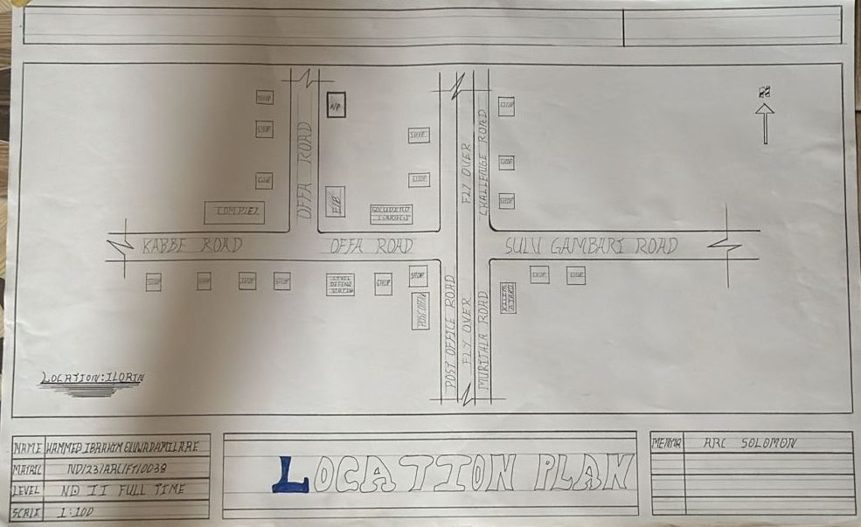Figure 3:1:1 Location Plan
SITE PLAN
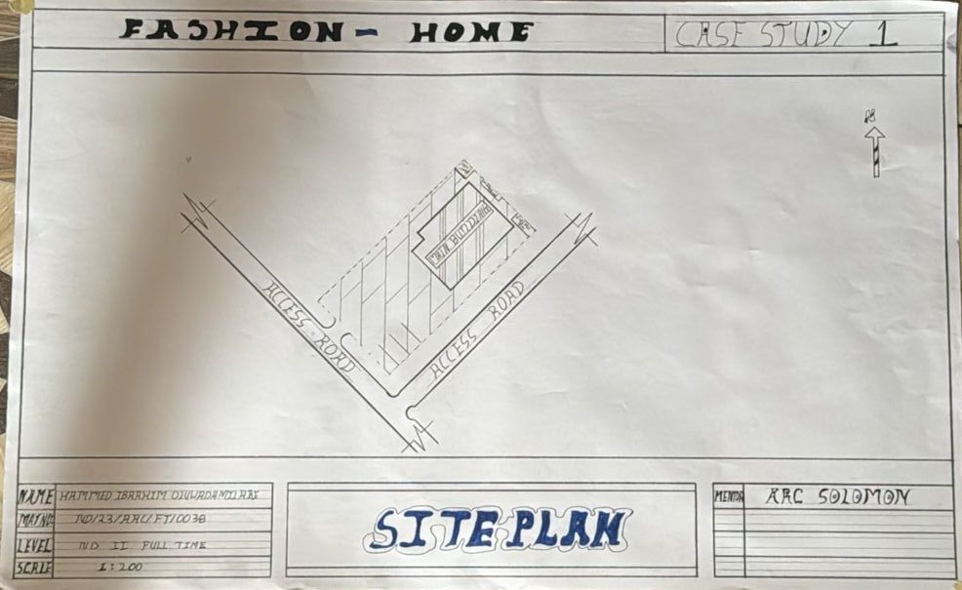
Figure 3.1.2Site Plan
FLOOR PLAN
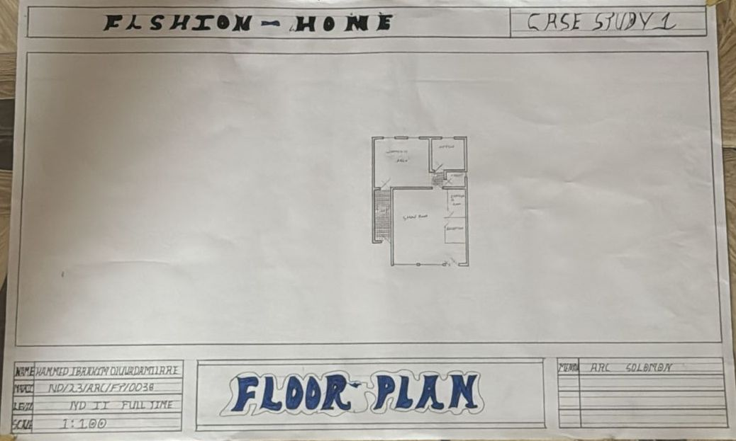
Figure 3:1.3Floor Plans

PICTURES
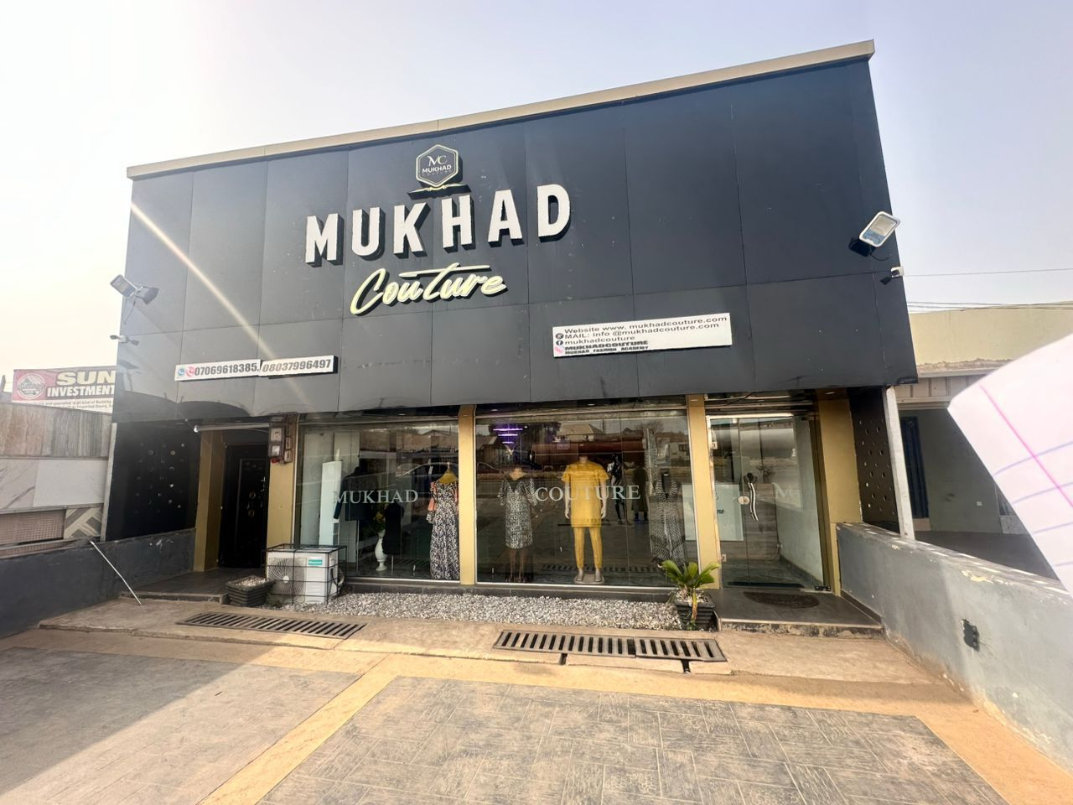
Plate 3.1.2Elevation


Plate 3.1.3 Elevation
3.1.2 CASE STUDY TWO (2): Loffy Peng Fashion Store Oyo State
Location: Ibadan, Oyo State
Function: Fashion design, tailoring, retail sales, and branding
Business Type: Small-to-medium scale ready-to-wear and custom fashion brand

Overview:
Loffy Peng Store is a fast-rising fashion brand in Ibadan, known for creating stylish urban wear, ready-to-wear outfits, and custom clothing for both male and female clients. It operates in a rented commercial space that has been modified to suit fashion production and retail activities.

Merits
Good branding and fashion identity both physically and on social media.

Functional separation of production and reception spaces.

Clean and modern interior layout that appeals to younger clients.

Focus on ready-to-wear, which increases sales volume

Demerits
Limited space restricts staff movement and expansion.

Poor natural lighting affects some areas of the workspace.

Lack of in-house training space for apprentices.

Noise and heat during busy hours due to machine operation in a tight space.

LOCATION PLAN
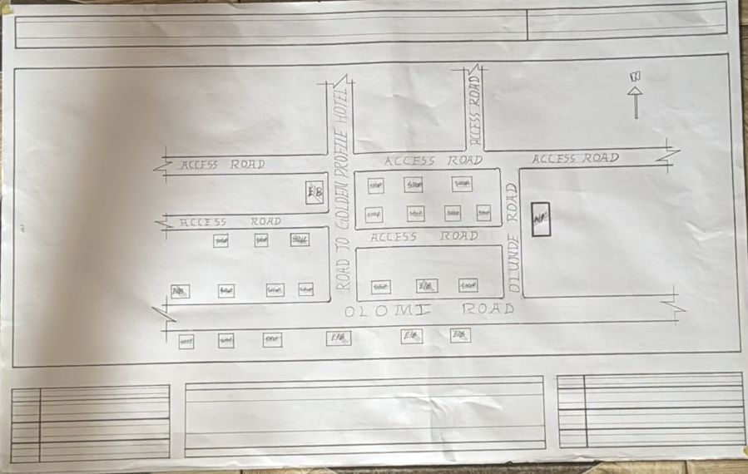
Figure 3.2.1Location Plan
FLOOR PLAN
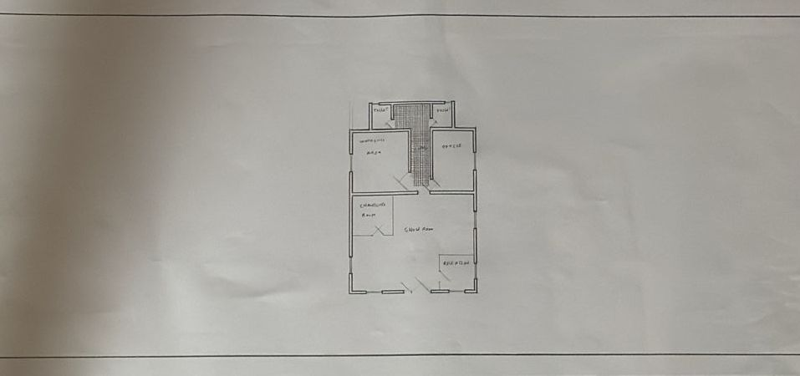
Figure 3.2.2 Floor Plans
PICTURES
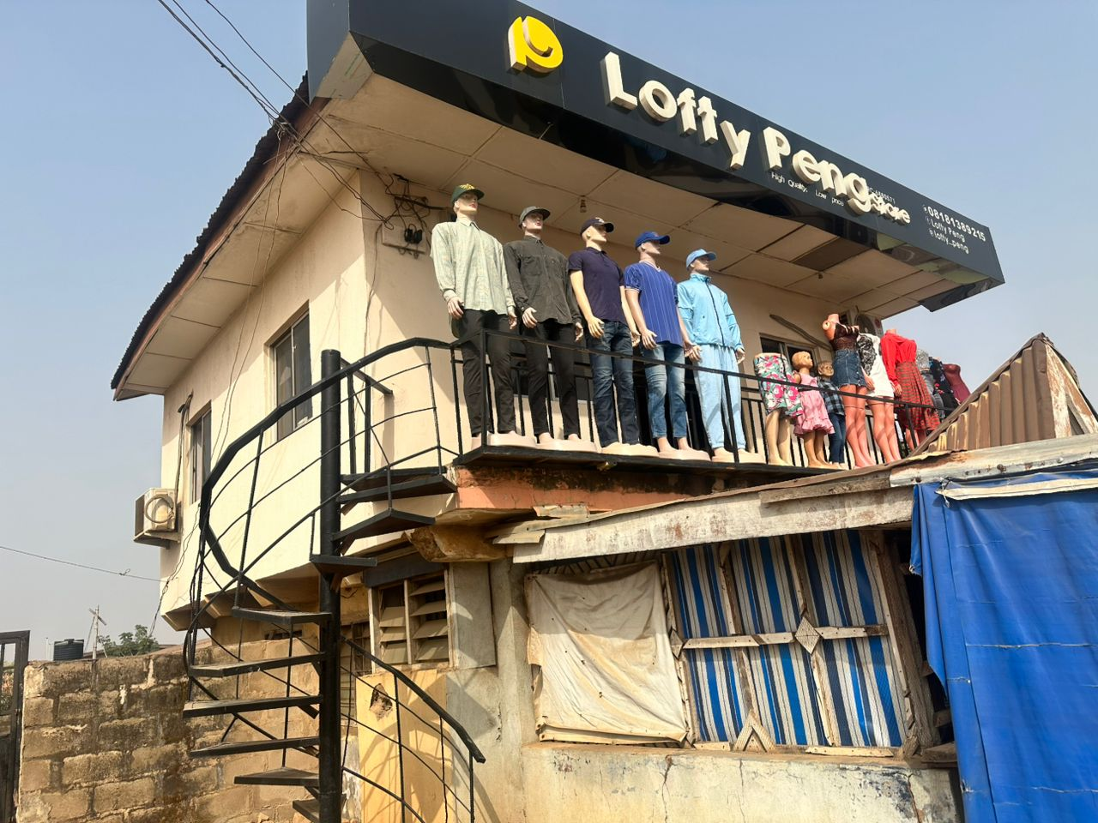
Plate 3.2.2 Back Elevation
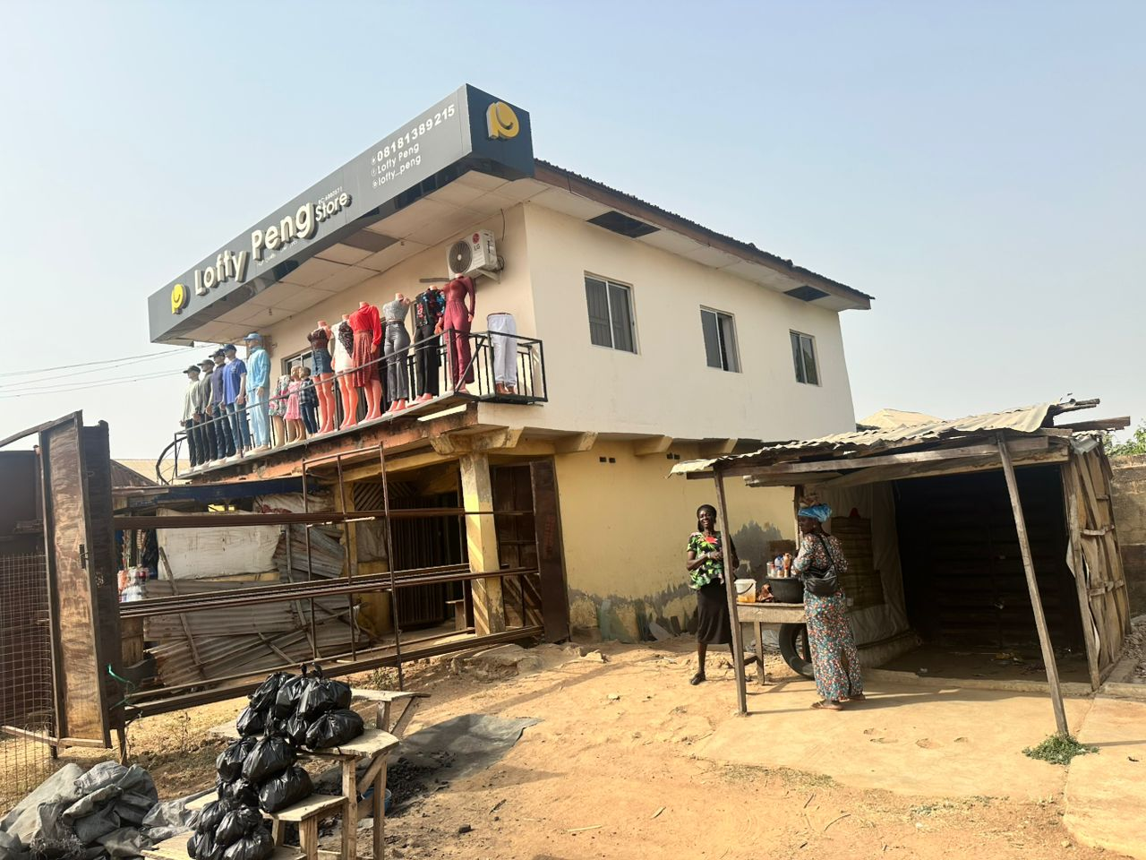
Plate 3.2.3 Front Elevation
3.1.3 CASE STUDY ONE (3): Trumie Academy of Fashion Home Lagos State.
Location: Egbeda, Lagos State
Function: Fashion training, tailoring, design, and ready-to-wear production
Business Type: Fashion school and commercial atelier

Overview:
Trumie Academy of Fashion Home is a modern fashion institution in Lagos offering both professional fashion training and fashion business services. The academy functions as both a fashion school and a production house, training students while also delivering custom and ready-made fashion products.

It serves as a model of how a Fashion Home can combine learning, production, branding, and client service in one unified space.

Merits:
- Dual-purpose design supports both training and production.

- Professional branding and interior design appeal to clients and students.

- Clear zoning of teaching, production, and customer areas.

- Promotes fashion entrepreneurship by helping students build brands.

- Use of social media and media space shows modern marketing integration.

Demerits:
- Space limitations: As the business grows, the facility may need more space to avoid crowding.

- Power dependency: Frequent power cuts in Lagos require constant generator use.

- Noise: Multiple sewing machines operating simultaneously can create a noisy learning environment if not properly managed.

- Heat and ventilation: Some workshop areas become hot during peak hours if mechanical cooling is unavailable.

LOCATION PLAN
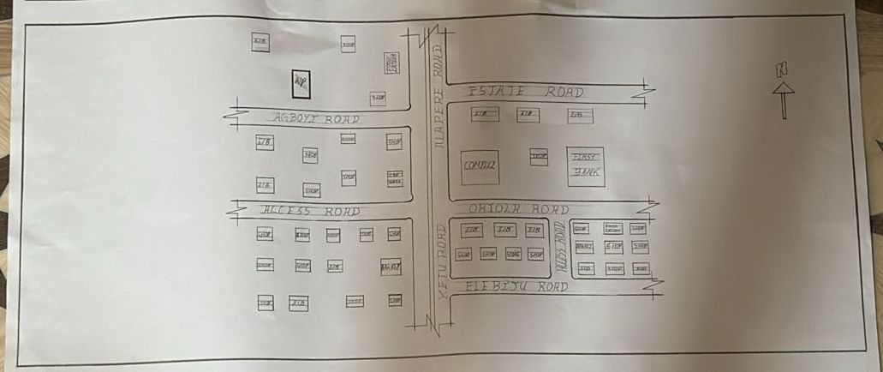
Figure 3.3.1 Location Plan

FLOOR PLAN
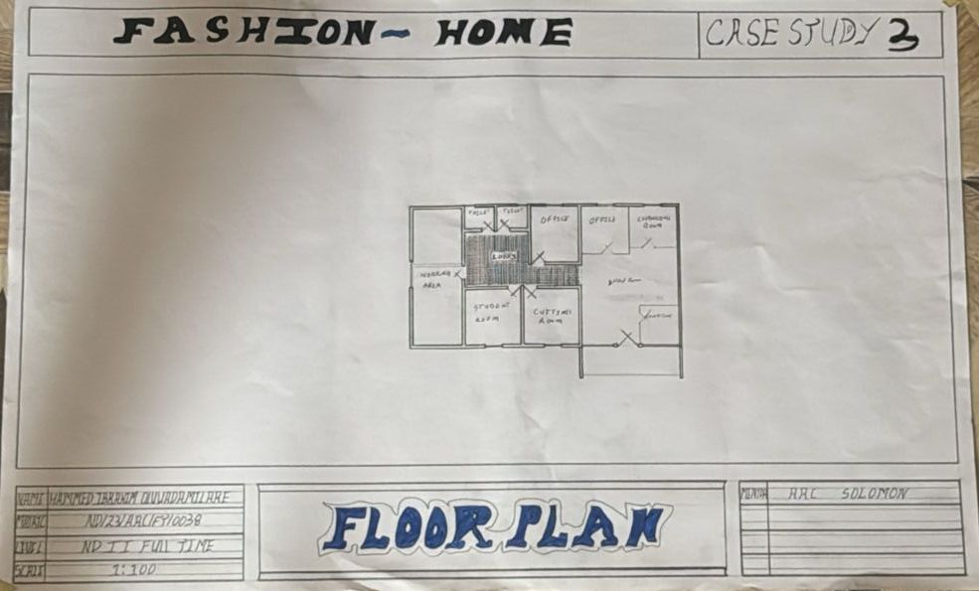Figure 3.3.2 Floor Plan.
CHAPTER FOUR
4.1 ANALYTICAL STUDY OF THE PROJECT LOCATION
4.1.1 INTRODUCTION
Ilorin is one of 36 states of federal of republic of Nigeria. Ilorin, the capital city of Kwara State, Nigeria, is a city with a rich historical, cultural, and economic background. Ilorin was founded in 1450 and has a significant historical legacy as a prominent center in the Yoruba and Fulani empires. Ilorin is a city with a rich historical heritage and cultural diversity, serving as an economic and educational hub in Kwara State. Its strategic location, coupled with ongoing development efforts, positions it as a key city in Nigeria’s socio-economic landscape.
4.1.2 SITE LOCATION
This is very important point to be considered before establishing the setting of houses, should take advantage of topographical features speeds and directions should be studied to ensure the best orientation to take advantage of the prevailing wind. Avoiding site prone to water logging and rain and draught which depends on wind direction and speed in the raining season placement of a building so that the length extends along the East and West direction. The proposed project is sited at Adewole, Atiku Abubakar Road Ilorin, Kwara State. It is surrounded with built up environment with various commercial activities being taken up in the area.
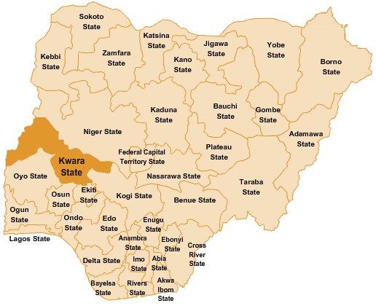

Figure 4.1.11.1 Map of Nigeria, 36 States and FCT.
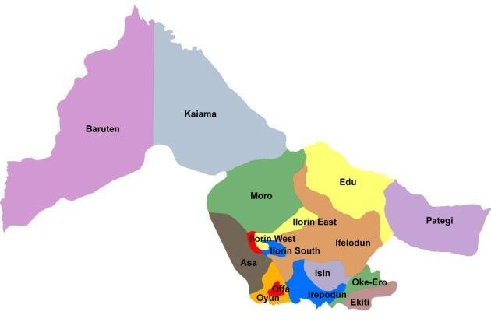
Figure 4.1.11.2 Kwara State Map
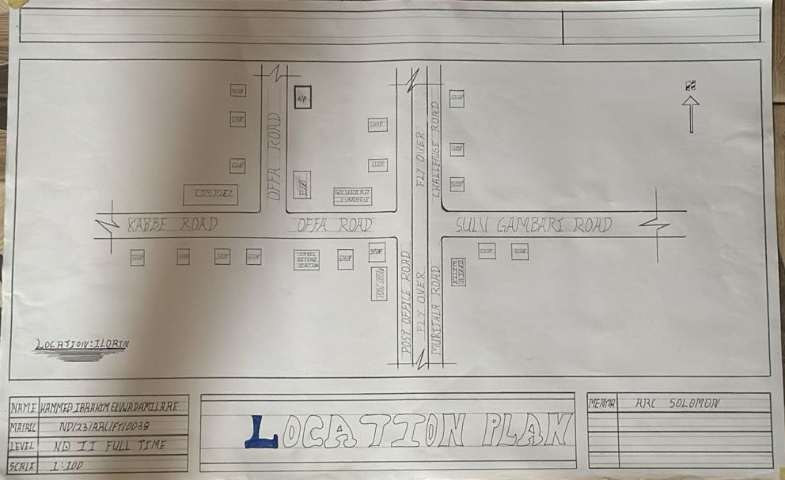
Figure 4.1.11.1 Location Plan

4.1.3 SITE INVENTORY
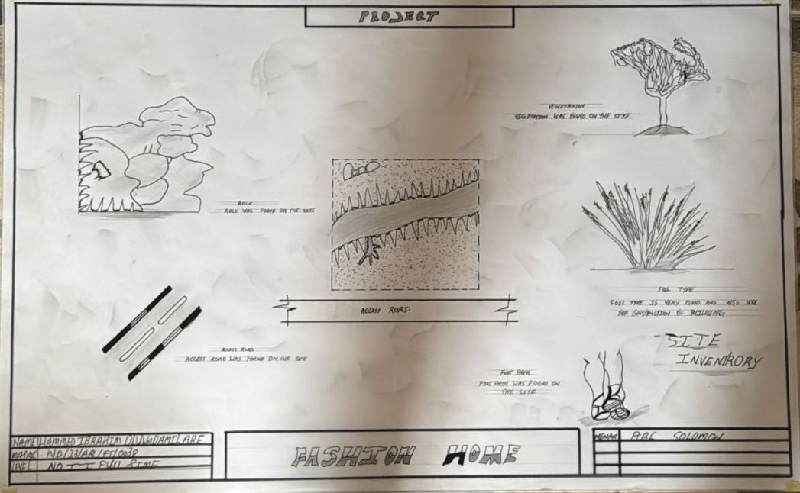
Figure 4.1.12.1 Site Inventory

Site inventory is the synthesis of the physical feature and facilities that are present on the site and over the site such as trees, footpath, soil, topography, vegetation, stream and shrubs etc.

4.1.4 SITE ANALYSIS
Site Analysis is the process of evaluating how a proposed site system will integrate with the existing site infrastructure by assessing physical obstructions, electrical interference, and noise to identify suitable interrogation zones for coexistence with the infrastructure.

The site selected for the project is a very gentle slope, it is a site that has never been used for any form of building construction i.e. it has not been developed in the past which make it an abode for several trees and shrubs, it is also observed during the course of inventory that some of the trees are to be removed as it could obstruct the construction process during the project, while some are to be retained to help control the adverse of the wind storm.

The soil is well compacted Soil in nature with good soil texture. The sun rises from the eastern part of the site and sets on the western part. The Construction does not need a special type of foundation due to the fact that the site is having a good bearing capacity and strength.

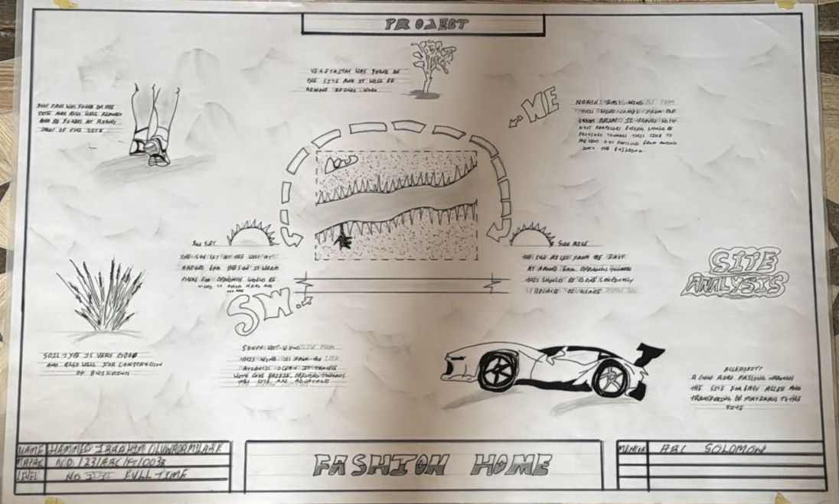
Figure 4.1.12.2 Site Analysis

4.1.5 GENERAL GEOGRAPHICAL CONDITION
Kwara State is located in the North-Central region of Nigeria. It shares boundaries with Kogi State to the east, Ekiti and Osun States to the south, Oyo State to the southwest, Niger State to the north, and an international border with Benin Republic to the west.

- Terrain: The state has a generally flat to gently undulating terrain, with some scattered hills especially in areas like Baruten and Kaiama. The land is a mix of savanna grasslands and wooded areas.

- Soil and Vegetation: The soils are mostly loamy and lateritic, suitable for farming. Vegetation varies from Guinea Savannah in the north to forest-savannah in the south.

Natural Features:
- Rivers like River Niger, Asa River, and Awon River are notable.
- There are also rock formations like Owu Falls and Imoleboja Rock Shelter.

4.1.6 CLIMATE:
Tropical savanna climate (Aw) according to the Köppen classification.
Temperature:
- Average annual temperature ranges between 25°C and 35°C.
- Hottest months: March to April (can reach up to 38°C).
- Coolest months: December to January (due to Harmattan winds).

Rainy Season:
- Starts around April and ends in October.
- Peak rainfall is usually in June and September.
- Annual rainfall ranges from 1,000 mm to 1,500 mm.

Dry Season:
- Runs from November to March.
- Influenced by Harmattan, a dry and dusty wind from the Sahara.
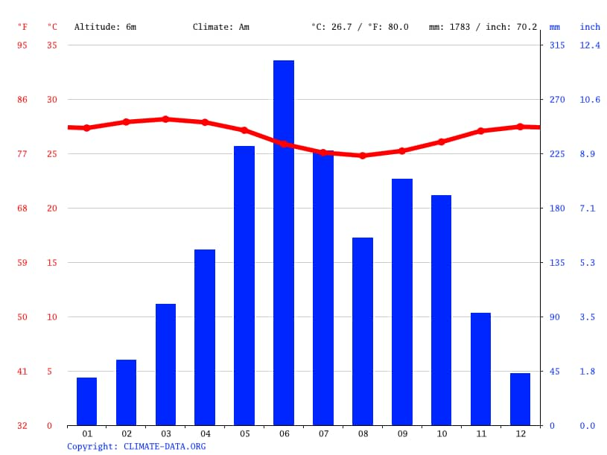
Figure 4.1.3.1 Average Monthly Rainfall in Kwara State.

Dry Season: The dry season in Kwara State usually spans from November to March. This period is marked by little to no rainfall, high daytime temperatures, and significantly lower humidity compared to the rainy season. A key feature of the dry season is the Harmattan, a dry and dusty wind that blows from the northeast, usually between December and February.

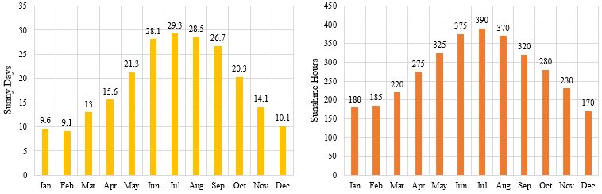

Figure 4.1.3.2 Sunshine Duration in Kwara State.
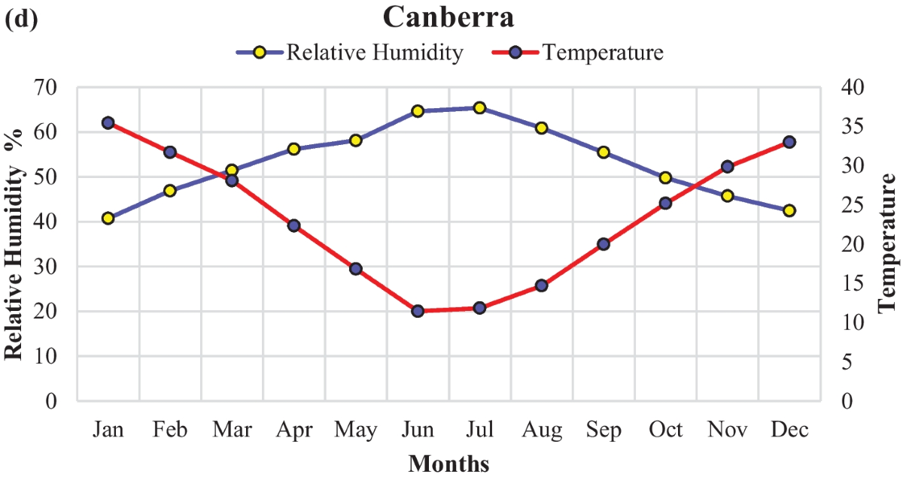

Figure 4.1.3.3 Relative Humidity in Kwara State.

4.1.7 VEGETATION
Guinea Savanna: The predominant vegetation type in Kwara State is the Guinea Savanna, characterized by a mix of grassland and scattered trees. This vegetation type is typical of the transitional zone between the forest regions in the south and the Sahel in the north.
Flora: Common plant species include acacia, baobab, shea butter trees, and various grasses and shrubs adapted to the savanna climate.

4.1.8 TOPOGRAPHY
Gently Undulating Plains: Kwara State. topography consists mainly of gently undulating plains, with occasional hills and low-lying areas.

4.1.9 NATURAL RESOURCES
Kwara State is rich in both metallic and non-metallic mineral resources, which support small- to medium-scale mining and industrial activities.
- Limestone
- Location: Found in large deposits in areas like Ogunreke, Patigi, and Share.
- Uses: Cement production, construction, and road building.
- Granite
- Location: Common in Ilorin, Asa, and Moro local government areas.
- Uses: Building and construction (used as crushed stone).
- Kaolin
- Location: Found in Edu, Ifelodun, and Offa.

4.1.10 ENVIRONMENTAL CHALLENGES
Urbanization: Rapid urbanization in Kwara State has led to challenges such as deforestation, waste management issues, and pressure on infrastructure and services.
Climate Change: Like many regions, Kwara State faces the impacts of climate change, including variability in rainfall patterns and increased frequency of extreme weather even.

4.1.11 SITE SERVICES
There are good services around the site, which include good access road, for students coming to school, availability of electricity very close to the site which will be useful before and after construction. Also, availability of pipe born water at the chosen site.

4.1.12 SITE UNIQUENESS AND BENEFIT
- The site is accessible
- Natural factor like, is very useful
- Utility services such as water, electricity, telephone, etc. cause no problem to the inhabitants.

4.1.13 SITE SUITABILITY
The appropriateness or suitability of the site for the construction and planning of the proposed project is based on the fact that is possesses and meets the entire requirements. All the existing features were strictly considered with the intension of making advantage of them to maximum level most especially the geographical, topographical features of the site.
Types of Forest Region
- Mangrove (Salt Quarter) Swamp Forest
- Fresh water swamp forest
- High forest

4.2. DESIGN CRITERIA
The design of the fashion home is guided by key criteria that ensure the building functions effectively and supports both creative and commercial activities
4.2.1 SITE SELECTION
A number of factors necessary for site selection for a farmstead are outlined below:
  - ﻿﻿﻿Access Road
  - ﻿﻿﻿Water
  - ﻿﻿﻿Utilizes and services (electricity, telephone, access drives etc.)
  - ﻿﻿﻿Orientation (air drainage and maximum sunshine may require orientation on a gentle Southerly slope).
  - ﻿﻿﻿Expansion.

4.2.2 BUILDING ARRANGEMENT
The arrangement of facilities for maximum efficiency of operation should be a prime concern. Proper arrangement increase efficiency by reducing walking distance to a minimum and providing adequate drive ways and turn around. It is important to note that five protections, safely and security and all influenced by the design planning.

4.2.3 DESIGN SCOPE
The design scope of this fashion home project focuses on creating a functional and well-organized space for fashion-related activities. The project covers the architectural planning and arrangement of all necessary spaces including:

- Reception and entrance area
- Exhibition/showroom
- Sewing and cutting rooms
- Weaving and finishing areas
- Design studio and classroom
- Offices for manager and supervisor
- Fitting/measuring room
- Massage and pedicure rooms
- First aid and store rooms
- Toilets (conveniences) and staff support areas

4.2.4 DESIGN BRIEF9ANALYSIS
The proposed fashion home is a purpose-built facility intended to support the full cycle of fashion activities—design, production, display, customer service, and training. The client requires a modern, functional, and culturally inspired building that reflects the identity of a creative fashion brand while providing comfort and efficiency for both staff and customers.

The building must include key spaces such as a reception area, showroom, sewing and cutting rooms, design studio, classroom, offices, store rooms, fitting/measuring rooms, and restrooms. Supportive wellness spaces such as a massage room, pedicure room, and first aid room are also required to promote staff well-being.

Special consideration is given to natural lighting, ventilation, good circulation, zoning, flexibility, and environmental sustainability. The layout must ensure smooth workflow from raw fabric intake to final product display, with areas clearly zoned as public, semi-private, and private.

This design aims to meet both functional and aesthetic goals, supporting fashion entrepreneurship, skill development, and brand growth in a comfortable and professional environment.

4.2.5 SPACES DERIVATION ANALYSIS/SCHEDULE FOR ADMINBLOCK
S/N | UNITS | NO REQ. | LENGTH | BREADTH | AREA (m²)
 | Main Entrance |  | 2000mm | 13,300mm | 26,600,000m²
 | Reception Area |  | 2500mm | 6,000mm | 15,000,000m²
 | Cashia |  | 2,500mm | 2,800mm | 6,000,000m²
 | Show Room |  | 9,500mm | 10,000mm | 95,000,000m²
 | Changing Room |  | 2,000mm | 1,800mm | 3,600,000m²
 | Secretary Office |  | 2,800mm | 3,000mm | 9,400,000m²
 | Manager Office |  | 2,800mm | 3,000mm | 8,400,000m²
 | Administrative Office |  | 3,000mm | 4,000mm | 12,000,000m²
 | First Aid Room |  | 2,300mm | 3,000mm | 6,900,000m²
 | Cutting & Iron Area |  | 3,000mm | 5,000mm | 15,000,000m²
 | Store Area |  | 3,000mm | 4,000mm | 12,000,000m²
 | Working Area |  | 5,300mm | 6,000mm | 31,800,000m²
 | Toilets |  | 4,300mm | 2,000mm | 2,600,000m²
 | Kitchen |  | 2,500mm | 2,800mm | 7,000,000m²
 | Exit |  | 2,500mm | 1500mm | 3,750,000m²

Table 4.2.5: Space Allocation

    - FUCTIONAL ANALYSIS AND RELATIONSHIP
The Main Building plan is well function, the unit are so well related to each other,
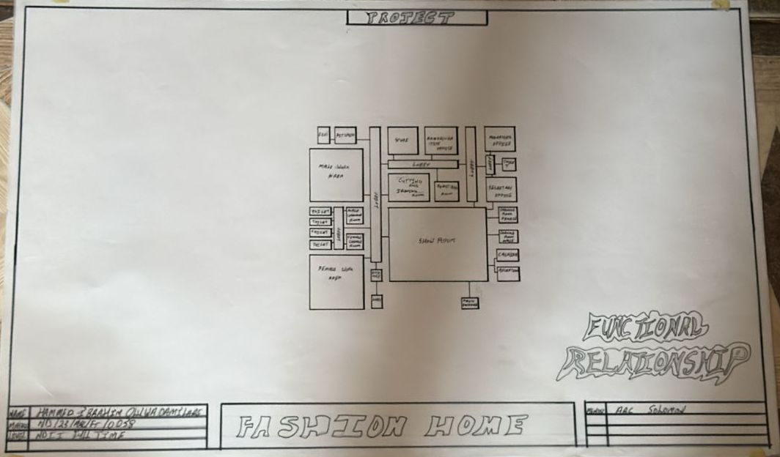

Figure 4.2.6.1 Functional Analysis
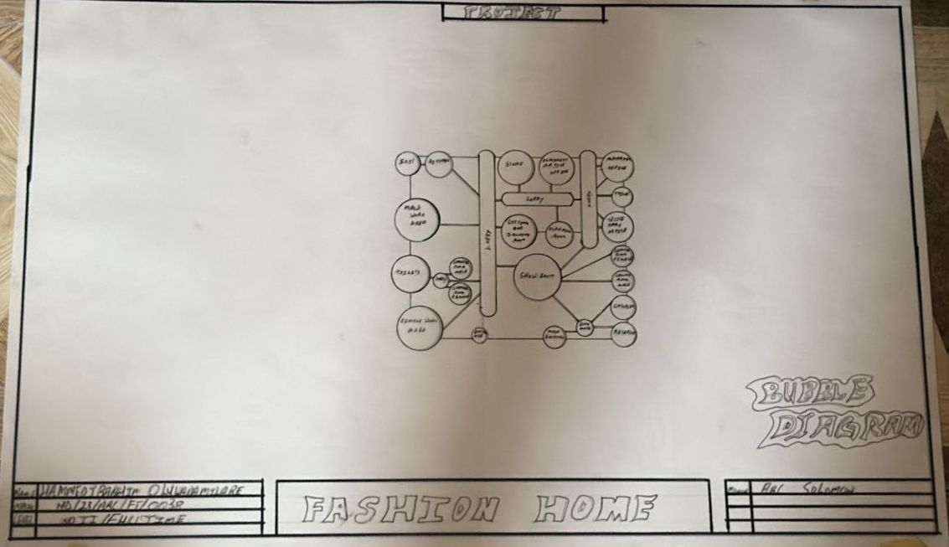

Figure 4.2.6.2 Bubble Diagram.

CHAPTER FIVE
5.1 APPRAISAL OF PROPOSED SCHEME
The proposed Project is to satisfy the appropriate building regulations. The design is to confirm the aid intended use of building taking into consideration with both natural factors and human factors that earn us a threat on the validity and stability of the building.

5.2 CONSTRUCTION METHODOLOGY AND MATERIALS.
The construction is to be carried out following the due process of construction ranging from:
- Preliminary: This involves the clearing of the site, setting out and excavation of foundation trench and foundation works.
- Sub-Structure: This process also entails the positioning and erection of Columns and beans, masonry works etc.
- Post Structure Stage: Is the stage which has to do with the application and installation of the paints, tiles, other finishes and construction of external works etc.

5.21 MATERIALS FOR CONSTRUCTION
1. Sustainable and Eco-Friendly Materials
- Bamboo and Timber: These materials are renewable, have a low carbon footprint, and can be sourced sustainably. Bamboo, in particular, grows quickly and has strong tensile properties.
- Recycled Materials: Using recycled steel, concrete, and glass can reduce the environmental impact of the construction process.
- Insulating Materials: Materials like sheep wool, cellulose, and hemp provide excellent thermal insulation and are environmentally friendly.

2. Traditional and Cultural Materials
- Clay and Adobe: Traditional building materials that offer good thermal mass, keeping buildings cool in hot climates. These materials can be locally sourced and are culturally significant in many regions.
- Stone: Using locally available stone can provide durability and cultural relevance, reflecting traditional architecture.
- Tiles and Ceramics: Decorative tiles and ceramics are often used in architecture for aesthetic purposes, featuring intricate geometric patterns and calligraphy.

3. Modern Materials
- Concrete: Widely used for its strength and versatility. It can be enhanced with additives to improve its sustainability.
- Steel: Provides structural strength and flexibility. Recycled steel can be a more sustainable option.
- Glass: Used for windows and facades to allow natural light. Double or triple-glazed glass can improve energy efficiency.

5.2.2 CONSTRUCTION METHODOLOGIES
1. Green Building Practices
- Passive Solar Design: Orienting the building to maximize natural light and heat from the sun, reducing the need for artificial lighting and heating.
- Green Roofs and Walls: Planting vegetation on roofs and walls to improve insulation, reduce heat island effects, and provide green spaces.
- Rainwater Harvesting Systems: Collecting and using rainwater for irrigation and non-potable uses within the school.

2. Energy-Efficient Construction
- Insulation: Using high-quality insulation materials to reduce energy consumption for heating and cooling.
- LED Lighting: Implementing energy-efficient LED lighting throughout the school.
- Solar Panels: Installing solar panels to generate renewable energy, reducing dependence on non-renewable energy sources.

3. Cultural and Religious Considerations
- Orientation: Provision of natural, quiet spaces that can be used for individual or group prayer during break periods.
- Architectural Elements: In the design of a functional and child-centered primary school, several architectural elements must be thoughtfully considered to ensure safety, comfort, and effective learning.
- Community Involvement: Engaging local communities in the design and construction process to ensure that the school meets cultural and social needs.

5.2.1 SERVICE
A building can be said to be good when it performs the service required by it. In order to have well-functioning building. There calls for an installation of underground water pipes in other to provide water to all the restrooms and other necessary units in the building. A borehole system of water supply is to be adopted alongside the government supplied services and a storage facility is to be provided for effective management of water supply.

5.2.2 CIRCULATION
In my primary school project, circulation is carefully planned to make movement around the school safe, easy, and comfortable for both pupils and staff. Since children are the main users, all circulation paths are designed to be wide, open, and easy to understand.

5.2.3 VENTILATION
As it relates to architecture, is the intentional introduction of outside air into a space. It is mainly used to control indoor air quality by diluting and displacing indoor pollutants. It can also be used for purpose of thermal comfort of dehumidification when the introduction of outside air will help to achieve desired indoor psychometric condition.

This could be either mechanical or natural ventilation. As a regard the proposed project design, there is an introduction of a very spacious courtyard in other to make cross ventilation in most of the building units. There should also a provision of wide passage to allow free movement of air, students and materials. Artificial ventilation is also provided through the installation of air conditioning system and fans.

5.2.4 LIGHTING
Lighting is one of the most important elements in my primary school project because it affects how well pupils can see, learn, and stay alert in class. In my design, I considered both natural and artificial lighting to create a bright, healthy, and energy-efficient learning environment.

5.2.5 PLUMBING
The plumbing system in this proposed building is made easy since the building has a courtyard. Water drained pipes are to be installed underground right from the courtyard to the soak away in other to discharge rainwater.

All water or sewage from the toilets are also channeled into their various inspection chambers using good and appropriate diameter PVC pipes, and taken from the inspection chamber to septic tanka and soak away pit.

Rain water is also collected from gutter if the roof using 100mm diameter PVC rain water pipes and channeled into various drainage or soak away pits. There shall be no ponding; the size of any channel shall effectively discharge rain and water without causing any over lowing stagnation and mosquito breeding. All rain water channeled shall be laid to fall and shall not cause any pounding or splashing unto the committers neighboring area.

5.2.6 ELECTRICAL INSTALLATION
The type of wiring system chosen should be full conduit system of wiring. Classrooms and other students’ technical areas should be wired with strong, durable and light current resistance cable because of the careless operate by the students. Also, electrical installation is to be done to allow for the use of quality electrical fittings and fixtures in the whole building.

5.2.7 WASTE DISPOSAL
Waste disposal bins are to put every office of the building and also in some specific necessary area. These water bins should dispose in the incinerator which will be provided within the compound of the station. The waste should therefore be burnt in the incinerator.

5.2.8 FIRE PROTECTION
Electrically, fire alarms and sensors are to be installed in the school building. This should be done in case of fire occurrence; fire extinguisher is to be placed at certain distances in the cobbles and some other necessary area. It is also serving as protector in case of fire.

5.2.9 EXTERNAL WORKS
The external works are to be carned out uncrate Krebs laid and shrubs, flowers grasses and trees planted.
Concrete interlocking tiles to be adopted of hard landscape and parking spaces both for visitors and staffs have been provided on the site.

5.3 CONCLUSION AND RECOMMENDATION
Conclusion
This project has explored the design of a functional, inclusive, and sustainable primary school that meets the educational and developmental needs of young learners. Based on the study of site conditions, cultural context, environmental factors, and case studies, the design integrates key features such as proper circulation, effective lighting, safe classrooms, and outdoor play areas.

The goal is to create a school environment that encourages learning, comfort, creativity, and security for pupils and staff. Special consideration was given to community involvement, accessibility, and the use of local materials to make the project practical and culturally relevant, especially for a location like Kwara State.

Recommendation
- Government and private bodies should invest more in early education infrastructure, especially in rural communities like those in Kwara State.
- Architects and planners should always consider child safety, local climate, and cultural background when designing for schools.
- School authorities should involve the community during planning and decision-making to ensure the school meets local expectations and is well maintained.
- Use of sustainable design (e.g., natural lighting, cross-ventilation, rainwater harvesting) should be encouraged to reduce operational costs.
- Future expansion should be considered in the design, with room for adding more classrooms or facilities as the population grows.

REFERENCES
- Olumide, A. (2020). Designing Creative Spaces for Tailoring and Fashion Production. Nigerian Journal of Architecture and Design, 5(2), 45-53.

- Nwosu, T. & Adebayo, M. (2019). Small-Scale Fashion Business in Urban Nigeria: Challenges and Opportunities. Journal of Entrepreneurship and Business Innovation, 7(1), 22–31

- Oluwole, K. (2021). The Architecture of Fashion Homes: Function, Branding, and Client Experience. African Design Review, 3(4), 60–68.

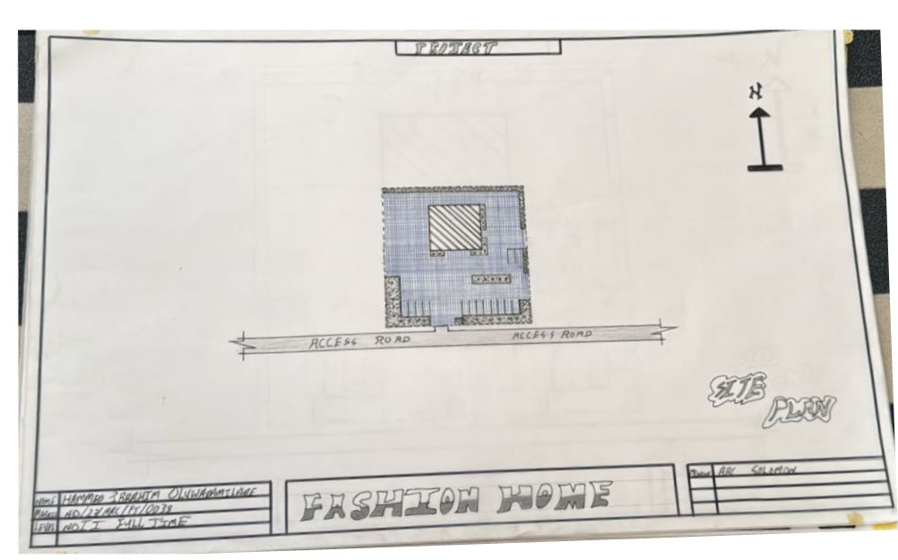

Appendix5.1: Site Plan.
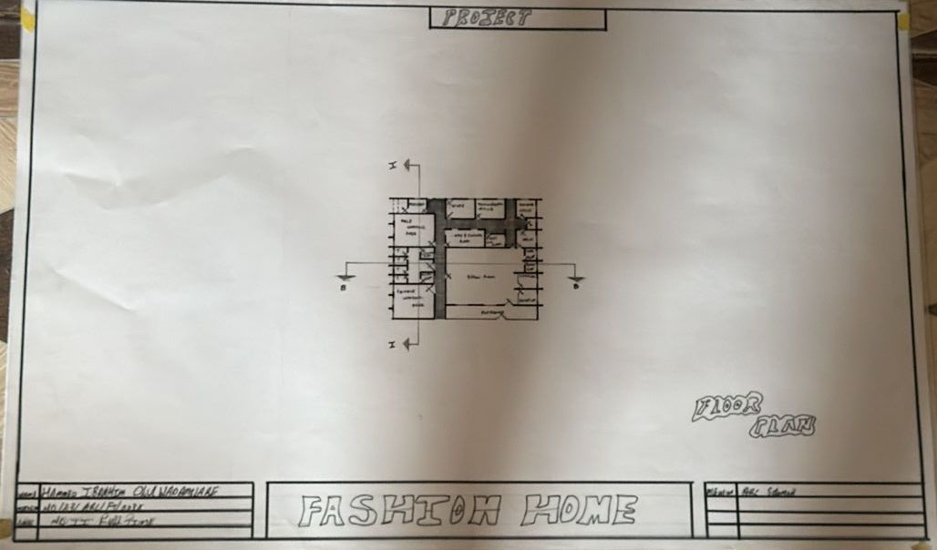

Appendix5.2: Floor Plan.

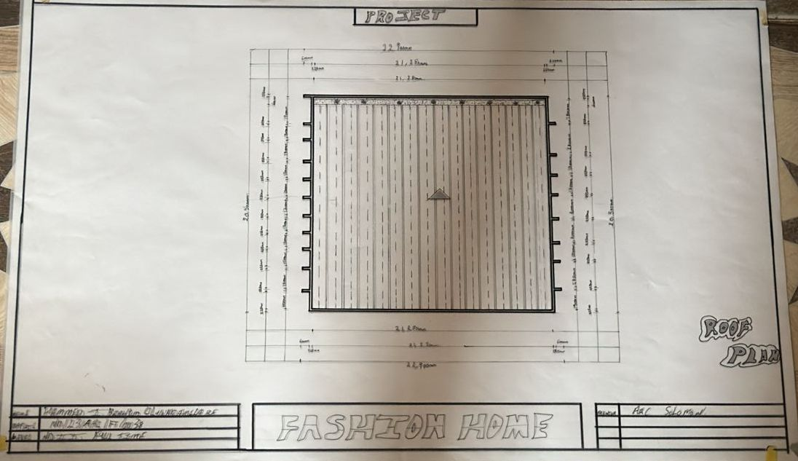

Appendix 5.5: Roof Plan

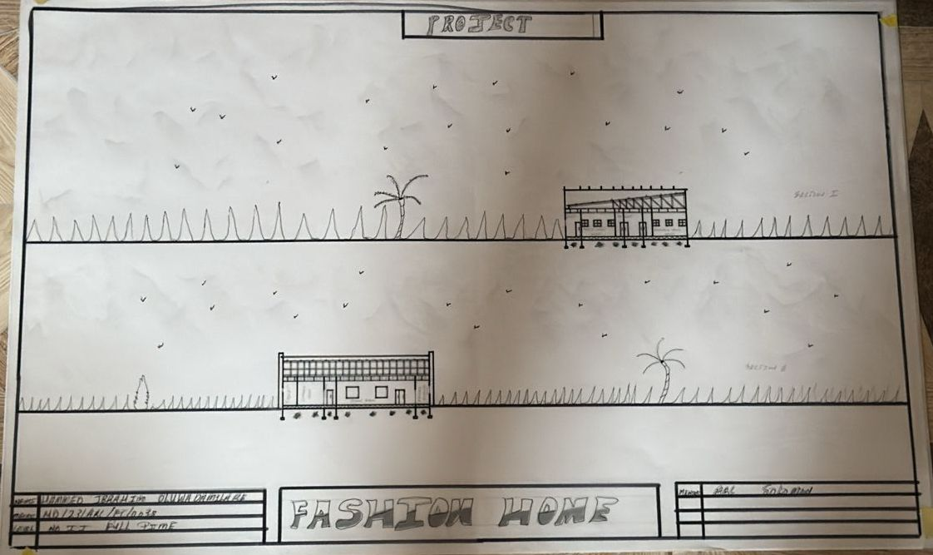

Appendix5.6: Section

Appendix5.7: Elevation

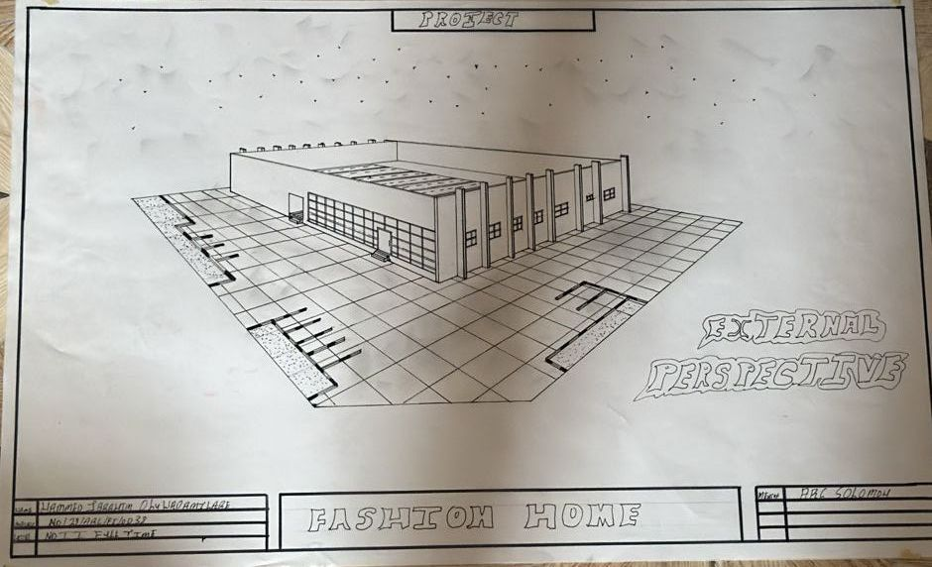

Appendix5.8: External Perspective.

