DESIGN AND FABRICATION OF A HYBRID DRYER FOR AGRICULTURAL PRODUCE

BY;
OLUSHOLA GRACE OLUWAKEMI
HND/23/ABE/FT/0038

DEPARTMENT OF AGRICULTURAL AND BIO-ENVIRONMENTAL
ENGINEERING, INSTITUTE OF TECHNOLOGY, KWARA STATE
POLYTECHNIC, ILORIN

IN PARITAL FULFILLMENT OF REQUIREMENT FOR THE AWARD OF
HIGHER NATIONAL DIPLOMA (HND) IN AGRICULTURAL AND BIO-ENVIRONMENTAL ENGINEERING TECHNOLOGY.
SUPERVISE BY:
ENG. OYEBANRE O.D
AUGUST, 2025

CERTIFICATION
I hereby declare that this research project titled DESIGN AND FABRICATION OF A HYBRID DRYER FOR AGRICULTURAL PRODUCE was carried out by Olushola Grace Oluwakemi with Matriculation Number (HND/23/ABE/FT/0038), in partial fulfillment of the Award of Higher National Diploma (HND) in the Department of Agricultural and Bio-environmental Engineering, Institute of Technology (IOT), Kwara State Polytechnic, Ilorin.

______________________ _________________
Engr. Oyebanre O.D Date
Project Supervisor
______________________ _________________
Engr. Oyebanre O.D Date
Project Co-ordinator

______________________ _________________
Engr. Dr Dauda K.A Date
Head of Department

_____________________________ _________________
Engr. Dr. Adejumo Akinfoye Daniel Date
External Examiner

DEDICATION
I dedicate this project first to the Lord for his continuous Love, Support and Guidance throughout my academical Journey. All Glory be to His name.
I also dedicate this project to my loving parents, Mr. Olushola Taiwo Oluwadamilare and Mrs. Olushola Modupe Oluwamuyiwa, whose sacrifices, prayers, and encouragement have continually propelled me forward.

ACKNOWLEDGEMENT
First and foremost, I express my deepest gratitude to God Almighty, the source of my strength, wisdom, and understanding, for His unfailing Grace that has sustained me throughout this academic journey.
My heartfelt appreciation goes to my wonderful Parents, Mr. Olushola Taiwo Oluwadamilare and Mrs. Olushola Modupe Oluwamuyiwa, for their endless sacrifices, love, encouragement, and unwavering belief in my dreams. Your support has been the foundation of my success.
To my adorable younger siblings — Ark, Gift, Goodnews, and Miracle — thank you for bringing joy and light to my life. Your presence continues to inspire me.
I am especially grateful to my project supervisor, Engineer Oyebanre Olufemi David, for his valuable guidance, timely advice, mentorship, and encouragement. Your support, corrections, and wisdom played a vital role in the successful completion of this work. Thank you, sir, for believing in me and always making yourself available.
My sincere appreciation also goes to: Bandipo Samuel Oluwatope, for your constant encouragement, prayers, and emotional support throughout this project; Bori Badejo, for being a dependable source of help and inspiration during this academic journey; Akanbi Segun, for your kind assistance, motivation, and contributions toward my success. To everyone who contributed to this project in one way or another through encouragement, assistance, or prayers, I say a big thank you. May God bless you all abundantly.

ABSTRACT
This study focuses on the development and performance evaluation of a hybrid drying system for cocoa beans, targeting smallholder farmers in developing regions who often rely on inefficient traditional drying methods. A hybrid dryer combining direct solar radiation with a solar-powered airflow system was designed and fabricated using locally available materials to ensure affordability and ease of use. The dryer’s performance was assessed based on drying rate and drying efficiency, with experimental trials conducted under controlled conditions. Results showed that drying rate ranged from 0.024 to 0.042 kg/h, while drying efficiency varied between 78.3% and 96.3%. ANOVA revealed that both mass of sample and air flow rate significantly affected drying performance (p < 0.0001), with sample mass having the greater influence. Surface response analysis further confirmed these trends and highlighted optimal operating zones. The study concludes that the hybrid dryer offers a viable, efficient, and user-friendly solution for improving cocoa post-harvest handling, with potential for broader application in rural agricultural settings.

TABLE OF CONTENTS

Title Page

Certification

Dedication

Acknowledgement

Abstract

List of Tables

List of Figures

List of Plates

CHAPTER ONE: INTRODUCTION
1.1 Background to the Study ` 1

1.2 Problem statement of the Study 2

1.3 Aim and Objectives of the Study 2

1.4 Justification of the Study 3

1.5 Scope of the Study 4

CHAPTER TWO: LITERATURE REVIEW
2.1 Introduction 5

2.2 Overview of Agricultural Drying 5

2.3 Traditional Drying Methods and their Limitations 6

2.4 Classification of Drying Systems 6

2.5 Concept of Hybrid Drying System 7

2.6 Design Considerations of Hybrid Dryers 7

2.7 Components and Materials for Fabrication 8

2.8 Energy Flow in a Solar Battery Hybrid Dryer 9

2.9 Performance Evaluation of Hybrid Dryers 9

2.10 Application of Hybrid Dryer in Cocoa Processing 10

2.11 Socio Economic Relevance and Adoption 10

2.12 Challenges in a Hybrid Drying System 11

2.13 Recent Developments and Future Directions 11

CHAPTER THREE: MATERIALS AND METHODS
3.1 Materials 13

3.1.1 Tools and Equipment 16

3.2 Design Considerations 18
3.2.1 Drying Temperature Range 18

3.2.2 Moisture Content Reduction 18

3.2.3 Energy Source and Sustainability 18

3.2.4 Airflow and Heat Distribution 19

3.2.5 Material Selection 19

3.2.6 Automation and Control System 19

3.2.7 Size and Capacity 20

3.2.8 Environmental and Economic Considerations 20

3.2.9 Safety Considerations 20

3.3 Design Calculations 20

3.3.1 Volume of the Drying Chamber 21

3.3.2 Volume of each Tray 21

3.3.3 Volume of Cocoa Beans per Tray 21

3.4 Design Layout 22

3.5 Working Principle 25

3.5.1 Solar Energy Harvesting 25

3.5.2 Air Heating and Circulation 25

3.5.3 Moisture Removal 26

3.5.4 Automation and Control 26

3.5.5 Tray Arrangement and Drying Efficiency 26

3.6 Construction and Fabrication Procedures 26

3.6.1 Sourcing of Materials 27

3.6.2 Fabrication of Drying Chamber 27

3.6.3 Fabrication of Drying Trays 27

3.6.4 Construction of Supporting Frame 28

3.6.5 Installation of Solar Energy Components 28

3.6.6 Assembly of Control Sysem 28

3.6.7 Final Assembly and Testing 28

3.7 Pictorial image of the Hybrid Dryer 29

3.8 List of Instrument 30

CHAPTER FOUR : RESULTS AND DISCUSSION
4.1 Result 31

4.2 Discussion 32

CHAPTER FIVE: CONCLUSIONS AND RECOMMENDATION
5.1 Conclusion 46
5.2 Recommendation 47

References 49

LIST OF TABLES

Tables Description Page

Table 3.1 experimental design matrix 24
Table 4.1 Summary of Result of Cocoa Drying 31
Table 4.2 ANOVA for drying rate of cocoa bean 34
Table 4.3 ANOVA for drying efficiency of cocoa bean 40

LIST OF FIGURES

FIGURES DESCRIPTION PAGES
Fig 4.1 Effect of Air Flow Rate on the Drying Rate of Cocoa 38
Fig 4.2 Effect of Air Flow Rate on the drying efficiency of Cocoa 43

LIST OF PLATES

PLATE NO DESCRIPTION PAGE
Plate 3.1 Hybrid dryer 29
Plate 3.2 Electric Arc Welding 30
Plate 3.3 Grinder 30
Plate 3.4 Thong 30
Plate 3.5 Electrodes 30
Plate 3.6 Small Grinder 30
Plate 3.7 Hammer 30

CHAPTER ONE
INTRODUCTION

1.1 Background of the Study
Drying remains one of the most crucial post-harvest operations in agriculture, essential for reducing moisture content in produce, preserving quality, and extending shelf life. In developing countries like Nigeria, where climatic conditions and energy access often pose challenges, the need for sustainable and efficient drying systems is paramount. Cocoa beans, a major export crop, require proper drying to attain marketable quality, reduce post-harvest losses, and enhance flavor development (Owusu-Manu et al., 2021).
Traditional open-sun drying, while common, is vulnerable to inconsistent weather, microbial contamination, and long drying durations. Mechanical dryers that rely on grid electricity or fossil fuels are often unaffordable, unsustainable, or unavailable to rural farmers. As a result, there is increasing interest in hybrid drying systems, which combine two or more energy sources to ensure consistent drying conditions.
In this study, the hybrid dryer is powered by solar energy and battery storage, with no dependence on grid electricity. The solar component powers the system during daylight hours, while the battery stores excess energy for use during cloudy conditions or nighttime, enabling uninterrupted drying. This type of hybrid system provides a cost-effective, off-grid, and eco-friendly solution, especially for smallholder farmers.

The innovation lies in ensuring continuous airflow and temperature control within the drying chamber regardless of solar intensity. By integrating photovoltaic technology with battery storage, the hybrid dryer delivers improved drying efficiency, reduces contamination risks, and enhances the post-harvest handling of cocoa beans. This study focuses on the design, fabrication, and performance evaluation of such a dryer using locally sourced materials for affordability and sustainability.

1.2 Statement of the Problem
Farmers in many rural regions of Nigeria still rely on inefficient traditional drying methods that expose produce to environmental hazards and contamination. This leads to significant post-harvest losses and compromises product quality. For cocoa, poor drying results in moldy beans, poor flavor development, and economic losses. Furthermore, the high cost and inaccessibility of electric or fossil fuel-powered dryers make them impractical for small-scale farmers.
There is a clear need for a cost-effective and sustainable hybrid drying solution that is independent of grid electricity and can function efficiently across varying weather conditions. By integrating solar power and battery storage, a hybrid dryer can offer consistent drying performance while addressing the challenges of affordability, energy access, and environmental sustainability.

1.3 Aim and Objectives of the Study
Aim:
To develop an efficient and sustainable drying solution for agricultural produce, with a focus on improving the drying process of cocoa beans through an innovative hybrid approach.
1.3.1 Objectives of the study
The objectives of this study are:
i. To design a hybrid drying system that combines direct solar energy with a battery-powered airflow mechanism suitable for agricultural drying.
ii. To fabricate the designed hybrid dryer using locally available materials to ensure cost-effectiveness and adaptability.
iii. To evaluate the performance of the hybrid dryer based on parameters such as drying rate and drying efficiency.

1.4 Justification of the Study
The adoption of a hybrid dryer, powered by solar and battery systems, ensures a sustainable and grid-independent solution to the drying challenges faced by farmers. This design is especially beneficial in remote areas with unreliable electricity supply. By using locally sourced materials, the cost of fabrication is reduced, making the system affordable and replicable.
The proposed hybrid dryer will enhance drying efficiency, reduce produce losses, and maintain the quality of cocoa beans. It also aligns with current global efforts toward renewable energy utilization and climate-smart agriculture (Ahmad et al., 2022). Hence, the study addresses both economic and environmental goals.

1.5 Scope of the Study
This project focuses on the design, fabrication, and evaluation of a hybrid dryer for agricultural produce, particularly cocoa beans. The system will utilize solar energy for power generation and store energy in a battery system to ensure continuous operation during periods of low solar radiation or at night. No external grid power will be used. The scope includes materials selection, structural design, fabrication and testing.

CHAPTER TWO
LITERATURE REVIEW

2.1 Introduction
Drying is a critical post-harvest operation in the preservation of agricultural commodities. It reduces the moisture content of produce to a level that prevents microbial growth, biochemical degradation, and spoilage. With Nigeria losing a significant percentage of harvested crops to post-harvest losses annually (Nwankwo et al., 2022), drying technologies — particularly hybrid drying systems — have become a priority in agricultural innovation. This chapter reviews the concepts, classifications, applications, and performance of hybrid dryers with a focus on their relevance in cocoa processing and sustainability for smallholder farmers.

2.2 Overview of Agricultural Drying
Agricultural drying is a thermal process where heat is applied to remove moisture from agricultural produce, thereby increasing its shelf life, reducing weight for transportation, and maintaining product quality (Mujumdar, 2015). Moisture removal must be controlled to avoid degradation of nutrients, flavor, and physical appearance. For crops like cocoa beans, which undergo fermentation before drying, achieving uniform moisture reduction is essential for quality flavor development and compliance with international trade standards (Afoakwa, 2014).
The efficiency of a drying system affects not only the product quality but also energy consumption, time, and the labor involved in post-harvest processing.

2.3 Traditional Drying Methods and Their Limitations
Open-sun drying is the most common traditional method, particularly among smallholder farmers in developing countries. This method involves spreading produce on mats, floors, or raised platforms and relying on direct sunlight to remove moisture. While it is inexpensive, it presents numerous limitations:
• Vulnerability to weather fluctuations
• Prolonged drying time, especially in humid or rainy climates
• Exposure to insects, rodents, dust, and contamination
• Uneven drying and quality deterioration (Nkolo et al., 2019; Adeboye et al., 2021)
Studies in Sub-Saharan Africa indicate that traditional drying leads to post-harvest losses ranging from 20–40% depending on the crop and environment (Fawole et al., 2020).

2.4 Classification of Drying Systems
Modern agricultural drying systems are classified based on energy sources and operational principles. These include:
• Natural convection dryers (e.g., open sun)
• Conventional dryers (electric or gas powered)
• Solar dryers (direct, indirect, or mixed-mode)
• Hybrid dryers (combining multiple energy sources)
Hybrid drying systems have gained traction in recent years due to their flexibility, improved performance, and ability to operate in off-grid conditions (Ahmad et al., 2022). They provide consistent drying conditions and can be tailored to local contexts using renewable energy combinations such as solar and battery.

2.5 Concept of Hybrid Drying Systems
A hybrid dryer is a system that utilizes two or more energy sources to drive the drying process. In this project, the hybrid system integrates solar photovoltaic (PV) panels and battery storage, eliminating the need for grid electricity. This makes the design particularly relevant for off-grid or rural locations.
Hybrid systems are known for their ability to:
• Mitigate intermittency of renewable sources (like solar)
• Provide continuous drying, even during nighttime or cloudy days
• Increase drying efficiency by maintaining optimal temperature and airflow

According to Hossain et al. (2022), solar-battery hybrid dryers improved drying speed and reduced microbial contamination by over 60% compared to traditional methods.

2.6 Design Considerations for Hybrid Dryers
The performance of a hybrid dryer is heavily influenced by its design. Key factors include:
• Drying chamber geometry and insulation
• Solar collector area and angle of inclination
• Airflow rate (fan size and placement)
• Battery and solar panel sizing
• Material selection for trays and covers
A properly designed dryer should maintain temperatures between 35°C and 60°C for cocoa drying, support uniform heat distribution, and reduce internal humidity buildup (Bello et al., 2023).
The air velocity must also be optimized to avoid case hardening — a condition where the outer layer dries too quickly, trapping moisture inside. This requires careful calibration of the DC fan and airflow channels (Sodipo & Daramola, 2022).

2.7 Components and Materials for Fabrication
The use of locally available and cost-effective materials is critical for ensuring sustainability and replicability of hybrid dryers in local communities. Common components include:
• Wooden or mild steel frame
• Transparent polycarbonate or glass cover
• Perforated trays (made of stainless steel or mesh)
• Photovoltaic panels
• Rechargeable deep-cycle batteries
• Charge controller and 12V DC axial fans
The structural materials must resist corrosion, withstand heat, and be safe for food contact. Insulation using foam boards or aluminum foil can help minimize heat losses, increasing drying efficiency (Ogbonna & Jekayinfa, 2017).

2.8 Energy Flow in a Solar-Battery Hybrid Dryer
The energy system functions as follows:
1. Solar panels convert sunlight into electrical energy during the day.
2. A charge controller regulates energy flow into the battery, preventing overcharging.
3. The battery stores excess power for use when solar radiation is insufficient (e.g., at night or during cloudy conditions).
4. The DC fan, powered by either solar or battery, maintains forced airflow inside the chamber, supporting uniform drying.
This configuration ensures uninterrupted drying and maximizes productivity regardless of external weather conditions (Wekesa et al., 2023).

2.9 Performance Evaluation of Hybrid Dryers
To determine efficiency and functionality, hybrid dryers are evaluated based on parameters such as:
• Drying rate (kg/h or g/min)
• Drying time reduction (%)
• Moisture content reduction (% wet basis to dry basis)
• Thermal efficiency (%)
• Product quality parameters (color, texture, microbial count)
According to Akinoso et al. (2021), a properly designed hybrid dryer for cocoa reduced moisture content from 60% to 7% within 48–72 hours, compared to 5–7 days under open sun drying.

2.10 Application of Hybrid Dryers in Cocoa Processing
Cocoa beans undergo fermentation and drying as essential post-harvest steps. Poor drying leads to mold growth, smoky beans, off-flavors, and disqualification from premium markets. Studies have shown that:
• Hybrid dryers provide uniform drying, critical for flavor development.
• They reduce exposure to contamination and ensure compliance with export standards.
• Continuous drying capability shortens post-harvest time and increases revenue potential for farmers (Hii et al., 2012; Fawole et al., 2020).
The World Cocoa Foundation (2023) recommends controlled drying environments as a standard for quality cocoa bean production.

2.11 Socio-Economic Relevance and Adoption
The relevance of hybrid dryers extends beyond technical performance. For rural communities, especially where grid electricity is unreliable, these systems offer:
• Job creation through local fabrication
• Reduction in post-harvest losses
• Income generation from value-added produce
• Improved food security
Adoption is further driven by the dryer’s cost-effectiveness, especially when constructed with indigenous materials and maintained using local skills (Adeyemi et al., 2022).

2.12 Challenges in Hybrid Drying Systems
Some of the challenges associated with hybrid dryers include:
• High initial cost of batteries and solar components
• Battery degradation over time
• Technical knowledge gap for fabrication and maintenance
• Risk of under-drying or over-drying due to poor system calibration
However, these can be addressed through capacity building, component standardization, and community-level training (Sodipo & Daramola, 2022; Wekesa et al., 2023).

2.13 Recent Developments and Future Directions
Recent innovations include:
• Use of thermal storage materials like phase change materials (PCMs) to store heat
• Integration of IoT and sensors for temperature/humidity monitoring
• Mobile hybrid dryers for on-farm use
• AI-powered control systems to automate drying cycles (Lawal et al., 2024)
Future hybrid drying systems are expected to be smarter, more affordable, and energy efficient, increasing their potential for national scale-up.

CHAPTER THREE
MATERIALS AND METHODS
3.1 Materials
The following materials were used for the construction of the hybrid dryer:
- Cocoa (Theobroma cacao)
Freshly fermented cocoa (Theobroma cacao) seeds serve as the raw material to be dried in the dryer. Approximately 20kg of wet cocoa beans were sourced locally for testing at Ondo State, Nigeria. The cocoa seeds initially had a moisture content of about 55% and required drying to a safe storage moisture level of 6–8%.
- Drying Chamber
- The drying chamber serves as the primary enclosure where the cocoa (Theobroma cacao)
seeds are dried. This chamber is designed to maintain optimal temperature and humidity conditions for the drying process. The internal design ensures even distribution of heat throughout the space, thereby enhancing the efficiency of the drying process. The chamber is constructed to accommodate different volumes of cocoa seed.
- Stainless Trays (2 Layers)
Stainless trays, arranged in two layers, are used to hold the cocoa seeds during the drying process. Stainless tray was chosen for its durability, resistance to corrosion, and ease of cleaning. The two-layer tray design allows for multiple batches of cocoa seeds to be dried simultaneously, thereby increasing the overall capacity of the dryer.
- Blower
The blower is employed to circulate air within the drying chamber. Proper air circulation ensures that heat is evenly distributed around the cocoa seeds, preventing uneven drying and promoting efficient moisture removal. The blower also assists in regulating temperature and humidity within the chamber, contributing to the control of drying conditions.
- Chimney
The chimney is used to expel hot air and moisture from the drying chamber. This is essential for maintaining optimal drying conditions and preventing excess humidity from compromising the drying process. The chimney ensures that the drying chamber remains well-ventilated, facilitating the expulsion of moisture and heat.
- Support Stand (Frame)
The support stand, or frame, provides the structural integrity of the entire drying system. The frame holds the solar collector, drying chamber, blower, and other components in place, ensuring the system remains stable during operation. It is designed to withstand the mechanical stresses of daily use and provide a robust foundation for the dryer.
- Thermohygrometer Sensor for Automation
The thermohygrometer sensor is an integral component of the automated system, used to monitor the temperature and humidity levels within the drying chamber. The data collected by the sensor allows for real-time adjustments to the drying conditions, ensuring that the cocoa seeds are dried under optimal temperature and humidity. This automation helps maintain consistent and controlled drying conditions, improving the overall efficiency of the drying process.
- Variable Speed Control
The variable speed control system is used to adjust the speed of the blower. By regulating the airflow within the drying chamber, the speed control ensures that the drying conditions remain consistent. The ability to fine-tune the blower speed allows for adjustments based on the moisture levels of the cocoa seeds, optimizing the drying process for different batches.
- Mild steel sheets
For fabricating the drying chamber due to their good thermal conductivity and structural strength
- Solar Collector (Glass)
The solar collector, constructed using glass, is responsible for capturing solar energy to heat the drying chamber. The glass material allows maximum transmission of solar radiation, ensuring the collector absorbs sufficient heat from the sun. The energy captured by the solar collector is transferred to the drying chamber to facilitate the drying of cocoa seeds.
- Battery
used for storing solar energy harvested during the day, ensuring uninterrupted operation of the dryer during low sunlight or cloudy weather conditions. A battery capacity labelled 12V/18Ah/20HR was used. Meaning:
Voltage : 12 volts, Capacity(Ah) 18 Ampere hours
Rated over 20HR: it can deliver its rated capacity(18Ah) over 20 hours of discharge
- Angle irons
For constructing the supporting frame to provide strength and stability.
- Black matte paint
Applied to interior walls to improve solar heat absorption
- Fiber Glass
This was used to lag the sides of the drying chamber to prevent heat loss.
3.1.1 Tools and Equipment
1. Electric Arc Welding Machine: it was employed during the fabrication of the drying chamber, supporting frame and tray assembly. It was used to join metal components with high strength and durability ensuring structural integrity of the dryer.
- Grinder/Cutting Machine: It is a power tool with a rotating abrasive disc or blade which was used for cutting and smoothing metal.It is used to cut metal sheets, pipes, or rods to required sizes and for grinding welds to smooth finishes.
- Drilling Machine: It is a machine tool which was used for used to drill holes into materials (metal, wood, etc.). It is used to create holes for bolts, screws, or other fittings in your project components.
- Screwdriver Set: It is a set of hand tools with different tips (flat, Phillips, etc.) which was used for driving screws. It is used for tightening or loosening screws during assembly or adjustments of electrical and mechanical parts.
- Spanner Set: It is a set of tools which was used for for tightening or loosening nuts and bolts. It is essential for assembling and disassembling mechanical parts such as frames, joints, or supports.
- Multimeter (for testing connections): it is an electronic measuring instrument that combines several functions (voltage, current, resistance testing). It was used to check electrical circuits, test battery voltage, or ensure proper connections in the solar-powered system
- Pliers: It is a hand tool with gripping jaws, sometimes with cutting edges.it was used for holding objects firmly, bending wires, or cutting small materials.
- Measuring Tape: It is a flexible ruler used to measure distances or dimensions. It is used to take accurate measurements of components during fabrication or assembly.
- File (for finishing edges):It is a hand tool with a roughened surface used for smoothing or shaping metal.It is used to smoothen sharp edges after cutting or welding metal parts.
- Paintbrush/Spray Gun: it is a tool used to apply paint or protective coatings. It is used for finishing touches to protect metal surfaces from rust and improve aesthetics.
- Soldering Iron (for electronic parts): It is a hand tool that heats up to melt solder (a metal alloy) for joining electronic components. It is used in assembling or repairing the electronic parts of your project like sensors, circuits, or connections.

3.2 Design Considerations
The design and development of the hybrid dryer were guided by several critical factors to ensure effective drying, energy efficiency, sustainability, and adaptability to local conditions. These considerations are outlined below:
3.2.1 Drying Temperature Range
Cocoa beans require a careful drying process to preserve their flavor quality and prevent case hardening. The target temperature range for effective drying was set between 40°C and 60°C. Temperatures above 60°C can degrade flavor precursors and cause the beans to develop a smoky or burnt taste, while temperatures below 40°C prolong drying time and may encourage mold growth. The system was therefore designed to achieve and maintain this range using solar energy, with the help of a thermal storage mechanism for cloudy conditions.
3.2.2 Moisture Content Reduction
Freshly fermented cocoa beans typically have a moisture content of 50–60% (wet basis). For proper storage and to prevent microbial growth, this moisture content needs to be reduced to 6–8% (wet basis). The dryer was designed to achieve this reduction within 48 to 72 hours, depending on the intensity of solar radiation and ambient conditions, thereby improving efficiency compared to traditional sun drying which may take up to 7 days.
3.2.3 Energy Source and Sustainability
The decision to use solar energy was based on its renewable nature and abundant availability in cocoa-producing regions of Nigeria, which typically receive 4–7 kWh/m²/day of solar insolation. Photovoltaic (PV) panels were selected to power electrical components such as fans, temperature and humidity sensors, and the microcontroller-based automation system. Additionally, the system was designed with provision for battery storage to enable drying continuity during low sunlight or at night.
3.2.4 Airflow and Heat Distribution
Uniform airflow is critical for effective drying of cocoa beans to prevent uneven drying or spoilage. A forced convection system, consisting of a DC-powered fan, was incorporated to distribute heated air evenly within the drying chamber. Vents were strategically placed to allow the escape of moist air, preventing condensation which could otherwise compromise drying efficiency. The airflow system was designed to achieve an air velocity of 0.5–1.0 m/s, which is optimal for drying cocoa beans without dislodging them.
3.2.5 Material Selection
Material selection was driven by the need for thermal efficiency, durability, cost-effectiveness, and food safety. The drying chamber was constructed using mild steel sheets coated with black matte paint to enhance solar absorption. The insulation layer consisted of glass Fiber to minimize heat loss. The trays for holding cocoa beans were fabricated from stainless net mesh (food grade) to resist corrosion and allow free airflow around the beans.
The external frame was built with galvanized steel to ensure structural stability and resistance to environmental degradation.
3.2.6 Automation and Control System
An automation system was integrated to improve operational efficiency and precision. It consists of:
Temperature and humidity sensors for real-time monitoring.
A microcontroller programmed to regulate fan speed and control heating elements based on set parameters.
3.2.7 Size and Capacity
The dryer was designed for a small-scale capacity suitable for research and demonstration purposes. It has a drying chamber dimension of 0.855 m × 0.7 m × 0.32 m, accommodating approximately 5–10 kg of wet cocoa beans per batch. This size was chosen to allow easy fabrication and testing while making the system scalable for commercial applications in future designs.
3.2.8 Environmental and Economic Considerations
The design accounted for environmental friendliness by utilizing renewable energy and minimizing greenhouse gas emissions. Economically, the system was optimized to be affordable for smallholder cocoa farmers by selecting locally available materials and components wherever possible.
3.2.9 Safety Considerations
Safety features such as insulated wiring, a protective casing for the solar panel and battery, and heat-resistant materials were incorporated to prevent electrical hazards and thermal burns during operation.

3.3 Design Calculations
The design of the hybrid dryer requires determining key parameters to ensure optimal functionality.
The following calculations were carried out before fabrication:
3.3.1 Volume of the Drying Chamber
The total internal volume of the drying chamber is determined using the formula:
V_{chamber} = L x B x H
Where:
L = 0.855m (length of chamber)
B= 0.7m (width of chamber)
H= 0.32m (height of chamber)
Therfore: V_{chamber} = 0.855x0.7x0.32
V_{chamber} = 0.192m³
3.3.2 Volume of each tray
The drying chamber contains three trays arranged horizontally with some clearance between them for adequate airflow.
Each tray occupies a length and width similar to the chamber internal dimensions, while the depth of each tray is 0.05m for a shallow layer of cocoa beans to facililitate efficient drying.
The volume of one tray is calculated as:
V_{tray} = Ltray × Btray × Htray
L_{tray} = 0.855m
B_{tray} = 0.7 m,
H_{tray} = 0.05 m
V_{tray} = 0.855 × 0.7 × 0.05 = 0.0299 m³ = 0.03 m³
3.3.3 Volume of Cocoa Beans Per Tray
the volume occupied by cocoa beans on each tray depends on their bulk density and the quantity placed on each tray.
The bulk density of wet cocoa beans is approximately 600kg/m³
If each tray holds 3kg of wet cocoa beans, the volume occupied by the beans is:
V_{beans} = 3 / 600 = 0.005 m³
So, each tray’s cocoa beans occupy is approximately 0.005m³

3.4 Design Layout
The experimental design for this study was structured using a two factor factorial design to evaluate the effect of the drying parameters on the drying rate and drying efficiency of cocoa seeds. The factors and responses are presented as follows:
- Mass of Sample (g)
- Air flow rate (m³/s)
- Experimental Responses (Dependent Variables)
Two performance indicators were monitored during the drying process:
- Drying Rate (kg/h): measured as the rate at which moisture was removed from the cocoa seeds.
- Drying efficiency (%): calculated as the ratio of useful energy utilized for moisture removal to the total energy supplied.
- Experimental Runs
A total of 13 experimental runs were carried out as presented in Table 3.1. The runs were randomized to minimize the experimental bias and ensure the independence of observations. The experimental matrix includes various combinations of the two factors and their respective levels.

Table 3.1: Experimental Design Matrix (Box-behnken Design) with the Factors and Responses For The Cocoa Seed Drying Process
 |  | Factor 1 | Factor 2 | Response 1 | Response 2
Std | Run | A:Mass of Sample | B:Air Flow Rate | Drying Rate | Drying Efficiency
 |  | g |  | Kg/h | %
3 | 1 | 1000 | 0.6
9 | 2 | 2000 | 0.5
12 | 3 | 2000 | 0.5
7 | 4 | 2000 | 0.4
4 | 5 | 3000 | 0.6
2 | 6 | 3000 | 0.4
13 | 7 | 2000 | 0.5
1 | 8 | 1000 | 0.4
11 | 9 | 2000 | 0.5
5 | 10 | 1000 | 0.5
10 | 11 | 2000 | 0.5
6 | 12 | 3000 | 0.5
8 | 13 | 2000 | 0.6

3.5 Working Principle
The hybrid dryer operates on the principle of utilizing solar energy to generate and maintain sufficient heat within a drying chamber, while forced convection ensures uniform airflow around the cocoa seeds to achieve effective and consistent drying.
The system is designed to harness solar energy through photovoltaic (PV) panels, which supply electrical power to auxiliary components such as fans, sensors, and the control system. The heated air, generated and circulated within the chamber, facilitates the removal of moisture from the cocoa seeds until the desired final moisture content is achieved.
The detailed working process is as follows:
3.5.1 Solar Energy Harvesting
The photovoltaic (PV) panels capture solar radiation and convert it into electrical energy. This energy powers the entire system, including the fans for air circulation and the microcontroller-based automation system. Excess energy can be stored in a battery bank to ensure continuous operation during periods of low sunlight or at night.
3.5.2 Air Heating and Circulation
Ambient air enters the system through inlets and is heated by solar energy absorbed within the chamber walls. A DC-powered fan is activated by the control system to force heated air into the drying chamber.
This forced convection system ensures uniform distribution of heat throughout the chamber, preventing uneven drying of cocoa seeds and eliminating cold spots.
3.5.3 Moisture Removal
As the heated air comes into contact with the wet cocoa seeds spread on trays, it absorbs moisture from the seeds. The moisture-laden air is expelled through strategically placed vents, allowing fresh heated air to enter and continue the drying process. This cycle continues until the moisture content of the cocoa seeds is reduced from approximately 55% to the desired safe storage level of 6–8%.
3.5.4 Automation and Control
The system employs sensors to monitor key parameters such as temperature and humidity inside the drying chamber. These sensors relay data to a microcontroller, which automatically regulates fan speed and heating operation to maintain optimal drying conditions within the chamber.
3.5.5 Tray Arrangement and Drying Efficiency
The cocoa seeds are spread evenly in thin layers on two netted trays arranged vertically in the chamber. The forced airflow passes through the perforations in the trays, allowing heated air to reach all seeds uniformly. The shallow depth of cocoa beans per tray helps to prevent clumping and ensures rapid moisture removal.
3.6 Construction and Fabrication Procedures
The construction and fabrication of the hybrid dryer involved systematic steps to ensure the development of a functional and durable system. The process began with sourcing appropriate materials, followed by cutting, shaping, assembling, and integrating the control system. The procedures are outlined as follows:

3.6.1 Sourcing of Materials
All materials required for the fabrication of the dryer were carefully selected based on availability, durability, thermal efficiency, and food safety considerations. Key materials include mild steel sheets, stainless steel mesh, angle irons, fiber glass, photovoltaic (PV) panels, DC fan, sensors, microcontroller,battery and cocoa. These materials were procured from local suppliers to minimize cost and ensure easy replication.
3.6.2 Fabrication of Drying Chamber
The drying chamber was constructed using mild steel sheets due to their good thermal conductivity and ease of fabrication. The steps involved:
- Cutting mild steel sheets into panels corresponding to the chamber dimensions: 0.855 m (length) × 0.7 m (width) × 0.32 m (height).
- Welding the panels together using Electric Arc welding to form a rectangular box, leaving openings for air inlets and outlets.
- Coating the interior surfaces with black matte paint to enhance solar heat absorption.
- Adding an inner lining of fiber glass insulation between double walls to minimize heat loss.
- Fixing a transparent glass top cover in triangular form to allow solar radiation penetration.
3.6.3 Fabrication of Drying Trays
- Two drying trays were fabricated using food-grade netting mesh to prevent rusting and allow free airflow around the cocoa seeds.
- The trays were cut to dimensions slightly smaller than the internal chamber size to fit snugly while leaving space for airflow.
- The net mesh was stretched and welded onto a rectangular mild steel frame.
3.6.4 Construction of Supporting Frame
A sturdy supporting frame was constructed using angle irons to elevate the drying chamber and provide stability. The frame is 910mm in height. Angle irons were cut and welded into a rectangular frame with four vertical supports, cross-bracings were added for enhanced stability. The entire frame was coated with anti-rust paint for protection against environmental factors.
3.6.5 Installation of Solar Energy Components
The renewable energy system was installed as follows:
Mounting photovoltaic (PV) panels at an optimal tilt angle to maximize solar radiation capture. Connecting the PV panels to a charge controller, battery bank, and inverter. Wiring the system to supply power to the DC fan, sensors, microcontroller.
3.6.6 Assembly of Control System
The automation system was assembled and integrated into the dryer. This included:
- Installing temperature and humidity sensors inside the drying chamber to monitor environmental conditions.
- Connecting the sensors to the microcontroller, programmed to regulate the fan based on pre-set drying conditions.
3.6.7 Final Assembly and Testing
After all components were fabricated and assembled: The drying chamber, trays, and supporting frame were fully assembled.
Solar panels and control systems were connected to ensure seamless power supply.
The system was tested with an initial batch of cocoa seeds to verify functionality, airflow uniformity, temperature regulation, and drying performance.
Adjustments were made where necessary to optimize operation.
3.7 Pictorial Image of the Hybrid Dryer

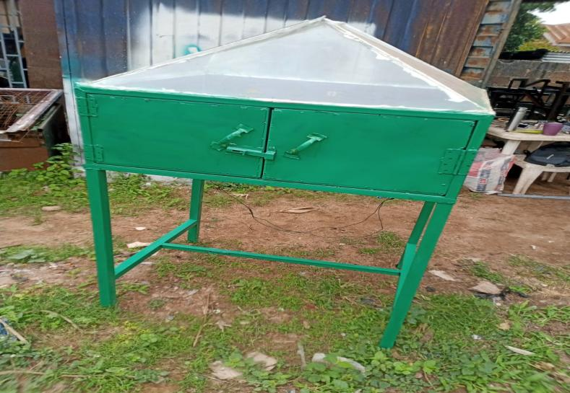
Plate 3.1: Hybrid Dryer

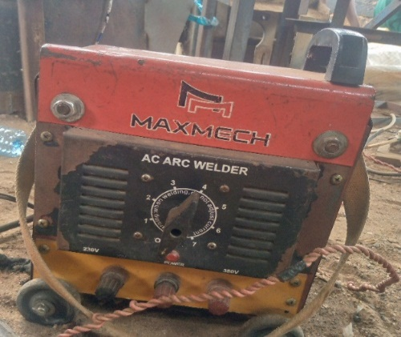
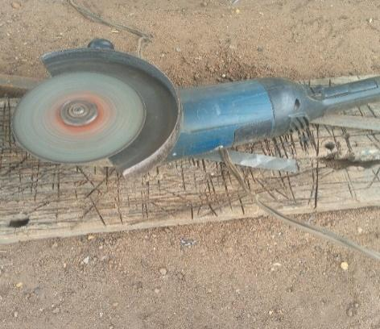
3.8 List Of Instrument

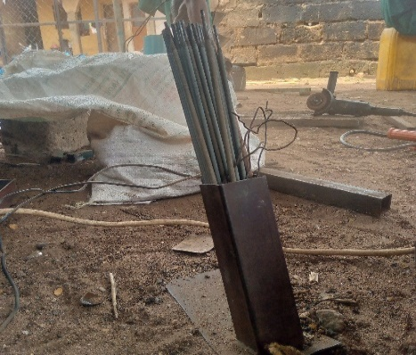
Plate 3.1:Electric Arc Welding plate 3.3: Grinder
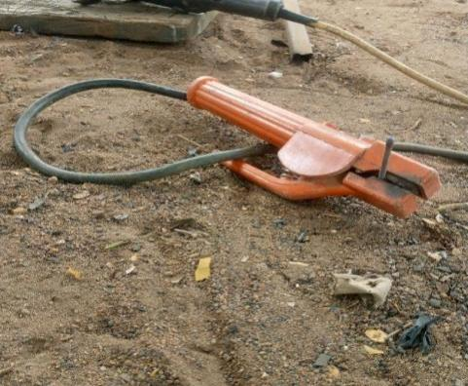

Plate 3.4: Thong plate 3.5 Electrodes

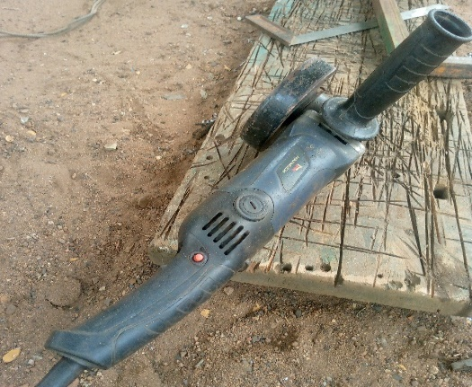
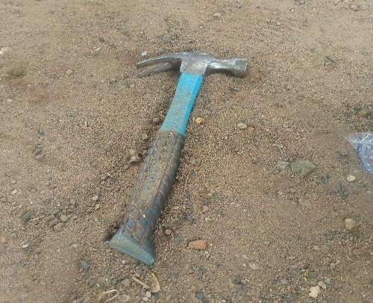

Plate 3.6: Small Grinder Plate 3.7 Hammer

Chapter Four

Results and Discussion

4.1 Result
The summary of result obtained from the test of the fabricated hybrid dryer for dying cocoa bean is presented in Table 4.1.

Table 4.1: Summary of Result of Cocoa Drying Using the Fabricated Hybrid Dryer
Run | Mass of Sample (g) | Air Flow Rate (kg/h) | Drying Rate (kg/h) | Drying Efficiency (%)
1 | 1000 | 0.6 | 0.042 | 78.3
2 | 2000 | 0.5 | 0.033 | 87.6
3 | 2000 | 0.5 | 0.033 | 87.6
4 | 2000 | 0.4 | 0.029 | 91.2
5 | 3000 | 0.6 | 0.031 | 89.2
6 | 3000 | 0.4 | 0.024 | 96.3
7 | 2000 | 0.5 | 0.034 | 86.1
8 | 1000 | 0.4 | 0.035 | 85.4
9 | 2000 | 0.5 | 0.031 | 89.2
10 | 1000 | 0.5 | 0.037 | 83.9
11 | 2000 | 0.5 | 0.033 | 87.6
12 | 3000 | 0.5 | 0.027 | 92.8
13 | 2000 | 0.6 | 0.036 | 84.1

4.2 Discussion
From table 4.1 above, the drying performance of the fabricated hybrid dryer was evaluated using varying sample masses and air flow rates, with drying rate and drying efficiency as the key response variables. It was observed that increasing the sample mass did not consistently lead to higher drying rates. For instance, at an air flow rate of 0.6 kg/h, the drying rate decreased from 0.042 kg/h for a 1000 g sample to 0.031 kg/h for a 3000 g sample, indicating that beyond a certain load, the dryer’s performance may decline due to limited heat or air penetration. Similarly, at constant mass, increasing air flow generally led to a slight increase in drying rate, which is consistent with improved heat transfer and moisture removal. For example, at 2000 g sample mass, drying rate increased from 0.029 kg/h at 0.4 kg/h air flow to 0.036 kg/h at 0.6 kg/h air flow.
However, the trend in drying efficiency revealed an inverse relationship with drying rate in some cases. The highest efficiency of 96.3% was recorded at a sample mass of 3000 g and air flow of 0.4 kg/h, despite the drying rate being among the lowest (0.024 kg/h). On the other hand, the highest drying rate (0.042 kg/h) was associated with the lowest efficiency (78.3%), occurring at 1000 g sample mass and 0.6 kg/h air flow. This suggests that while higher airflow and smaller loads may accelerate drying, they may also lead to energy losses, possibly due to over-drying or inefficient moisture removal dynamics. Efficient drying appears to be favored under moderate to low airflow and higher sample loading, where energy is more effectively utilized.
The presence of repeated values, particularly at 2000 g sample mass and 0.5 kg/h air flow rate (Runs 2, 3, 7, 9, and 11), provided consistency across trials, confirming the repeatability and reliability of the dryer’s performance. Overall, the fabricated hybrid dryer demonstrated the capability to dry cocoa effectively, but with a clear trade-off between drying speed and energy efficiency.
The performance of the fabricated hybrid dryer in this study aligns with several trends reported in the literature. The observed drying rates (ranging from 0.024 to 0.042 kg/h) are comparable to those documented by Aregbesola et al. (2015), who reported drying rates between 0.020 and 0.045 kg/h when using a hybrid solar-electric dryer for drying cocoa beans under similar environmental conditions. Likewise, Abano and Amoah (2015) noted that drying rates for cocoa using a solar tunnel dryer averaged around 0.030 kg/h, particularly when the air velocity was kept between 0.4 and 0.6 kg/h. This supports the current study’s observation that increasing airflow rate leads to marginal improvement in drying rate, though not always proportional due to internal resistance and saturation effects within the drying chamber.
In terms of drying efficiency, the fabricated hybrid dryer achieved values as high as 96.3%, which is significantly higher than the 70–85% range reported by Bala and Mondol (2001) in their evaluation of hot-air dryers for similar agricultural products. High efficiencies recorded in the current study, especially at lower airflow rates (e.g., 0.4 kg/h), suggest better heat utilization and reduced thermal losses, likely due to improved insulation or optimized airflow design. This trend is also consistent with the findings of Simate (2001), who emphasized that lower drying air velocity at moderate product loading improves thermal efficiency in convective dryers due to reduced heat loss and better contact time.
Furthermore, the inverse relationship observed between drying rate and efficiency in this study agrees with the theoretical drying behavior described by Mujumdar (2007), where high drying rates, particularly under forced convection or high airflow, often result in lower efficiencies due to energy loss via overheated air and incomplete heat transfer. Therefore, the recommendation to operate the hybrid dryer at moderate airflow (0.4–0.5 kg/h) and higher sample mass (2000–3000 g) is consistent with optimal drying strategies for maintaining a balance between throughput and energy efficiency reported in literature.

Table 4.2: Analysis of Variance (ANOVA) for the Drying Rate of Cocoa Bean
Source | Sum of Squares | df | Mean Square | F-value | p-value
Model | 0.0002 | 2 | 0.0001 | 184.90 | < 0.0001 | significant
A-Mass of Sample | 0.0002 | 1 | 0.0002 | 258.49 | < 0.0001
B-Air Flow Rate | 0.0001 | 1 | 0.0001 | 111.32 | < 0.0001
Residual | 6.603E-06 | 10 | 6.603E-07
Lack of Fit | 1.803E-06 | 6 | 3.004E-07 | 0.2504 | 0.9353 | not significant
Pure Error | 4.800E-06 | 4 | 1.200E-06
Cor Total | 0.0003 | 12
*Significant at p≤0.05. A=mass of sample, B= air flow rate
The analysis of variance (ANOVA) for drying rate revealed that the overall model was highly significant with a p-value < 0.0001 and an F-value of 184.90, indicating that the model adequately explains variations in drying rate due to the independent variables (mass of sample and air flow rate). The model sum of squares (0.0002) accounts for a substantial portion of the total variation (correlation total = 0.0003), confirming the model’s strong explanatory power.
Among the model terms, both mass of sample (Factor A) and air flow rate (Factor B) were statistically significant, with p-values < 0.0001. The mass of sample had a higher F-value (258.49) compared to air flow rate (111.32), suggesting that sample mass had a stronger influence on drying rate than airflow under the tested conditions. This result aligns with physical drying principles, where the mass of material affects moisture migration and surface exposure, and may result in variable drying kinetics depending on loading and airflow distribution.
Furthermore, the lack-of-fit test was not significant (p = 0.9353), indicating that the model fits the experimental data well and there’s no evidence that unexplained variations are due to model inadequacy. The residual (error) mean square was very small (6.603E-07), supporting the model’s high precision and repeatability. Overall, this ANOVA confirms that the developed regression model is statistically valid, and that both sample mass and airflow rate significantly affect drying rate, with sample mass having a more dominant impact.
The ANOVA results from this study demonstrate that both mass of sample and air flow rate significantly influenced the drying rate of cocoa, with p-values < 0.0001, confirming the strong effect of these factors. This is in agreement with the findings of Simate (2001), who also reported that sample loading and drying air velocity had significant effects on drying time and drying rate of fermented cocoa beans using a solar dryer. In his study, airflow rate contributed significantly to the heat and mass transfer efficiency, while excessive sample mass led to internal resistance and slower moisture migration, which aligns with the current study’s emphasis on sample mass as a dominant factor (F = 258.49).
Similarly, Aregbesola et al. (2015) evaluated a hybrid dryer for cocoa drying and found that both air velocity and sample mass had statistically significant impacts on drying rate (p < 0.01). Their regression model, supported by ANOVA, showed that increasing airflow enhanced drying but with diminishing returns beyond a threshold, especially when sample mass was high—again consistent with this study's finding that air flow (F = 111.32) had less influence than mass of sample. This suggests that optimal airflow must be matched with sample load to avoid reduced efficiency or non-uniform drying.
In another related study, Abano and Amoah (2015) reported that for solar tunnel drying of cocoa, both temperature and air flow rate significantly influenced the drying rate (p < 0.05), with airflow being more critical at lower humidity levels. However, their study did not consider mass of sample as a model factor, which this current study shows to be more statistically significant. Additionally, the non-significant lack-of-fit (p = 0.9353) in your result indicates that the model adequately captured the behavior of the drying system, a desirable outcome also achieved in Bala and Mondol’s (2001) study on solar drying of fish, where proper model fit ensured valid predictive capability.

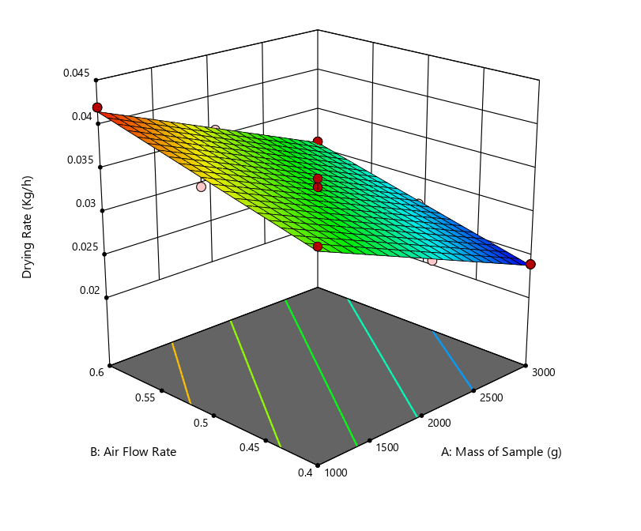
Fig 4.1: Effect of Air Flow Rate and Mass of Sample on the Drying Rate of Cocoa
The 3D response surface plot illustrates the interactive effects of mass of sample (A) and air flow rate (B) on the drying rate of cocoa beans using the fabricated hybrid dryer. The surface shows a downward sloping plane from low sample mass (1000 g) and high airflow (0.6 kg/h) toward higher sample mass (3000 g) and lower airflow (0.4 kg/h). This confirms that higher drying rates are achieved at lower sample masses and higher airflow rates, which is expected due to more efficient heat and mass transfer in such conditions.
The surface appears fairly linear with a slight curvature, indicating that the relationship between variables and drying rate is largely additive with mild interaction. The contours at the base of the graph further confirm this trend—drying rate decreases gradually as both air flow rate and sample mass increase simultaneously. This supports the earlier ANOVA result where both factors were significant, and mass of sample had a more dominant effect. The red points on the plot (experimental runs) align well with the surface, indicating a good model fit and minimal residual error.
This graphical model is useful for visually identifying optimal operating regions. For instance, the peak drying rate (~0.042 kg/h) occurs at 1000 g sample mass and 0.6 kg/h airflow, while the minimum (~0.024 kg/h) is seen at 3000 g sample mass and 0.4 kg/h airflow. This further illustrates the trade-off between throughput and drying performance.
The visual trend in this plot mirrors the findings of Aregbesola et al. (2015), who reported that the drying rate of cocoa in a hybrid dryer decreased with increasing sample load due to limited airflow penetration. Their response surface also showed that drying was more efficient at lower mass and higher air velocity—consistent with the upper left zone of this plot.
Simate (2001) similarly observed from his 3D plots that drying efficiency and rate declined with sample overloading, emphasizing the importance of controlling loading density. The response behavior in this graph, where airflow only marginally offsets the impact of heavy sample loading, reinforces his conclusion that dryers must be carefully balanced in terms of thermal input and product mass.
In addition, Abano and Amoah (2015) also plotted surface responses of drying characteristics of cocoa and found that optimal performance zones could be visually identified around moderate mass and maximum air velocities, aligning well with the current graph. The gentle slope of the surface suggests linearity, also observed by Bala and Mondol (2001) in their solar dryer models, indicating predictable system response for optimization purposes.

Table 4.3: Analysis of Variance (ANOVA) for the Drying Efficiency of Cocoa Bean
Source | Sum of Squares | df | Mean Square | F-value | p-value
Model | 232.70 | 2 | 116.35 | 152.81 | < 0.0001 | significant
A-Mass of Sample | 157.08 | 1 | 157.08 | 206.30 | < 0.0001
B-Air Flow Rate | 75.62 | 1 | 75.62 | 99.31 | < 0.0001
Residual | 7.61 | 10 | 0.7614
Lack of Fit | 2.81 | 6 | 0.4677 | 0.3891 | 0.8551 | not significant
Pure Error | 4.81 | 4 | 1.20
Cor Total | 240.31 | 12
*Significant at p≤0.05. A=mass of sample, B= air flow rate
The analysis of variance (ANOVA) for drying efficiency shows that the model is statistically highly significant with an F-value of 152.81 and a p-value < 0.0001, indicating that the model explains a significant portion of the variability in the drying efficiency of cocoa using the fabricated hybrid dryer. The model sum of squares (232.70) accounts for over 96.8% of the total variation (240.31), confirming the model’s strong predictive ability.
Both factors—mass of sample (Factor A) and air flow rate (Factor B)—were found to have significant individual effects on drying efficiency with p-values < 0.0001. Among the two, the mass of sample had the higher F-value (206.30), compared to air flow rate (F = 99.31), signifying that mass of sample has a more dominant influence on drying efficiency. This implies that increasing the sample mass has a more pronounced effect on how efficiently the dryer utilizes energy for moisture removal, possibly due to the improved heat retention or better absorption of thermal energy at higher product volumes.

The lack-of-fit test was not significant (p = 0.8551), with a low F-value (0.3891), indicating that the model fits the experimental data well and that the residual variation is mostly due to random (pure) error, not model inadequacy. The residual mean square (0.7614) is acceptably low, suggesting good precision and experimental control. Overall, this ANOVA confirms that the statistical model is robust, and that both the mass of sample and air flow rate significantly affect drying efficiency, with the sample mass being the most influential factor.
The findings from this ANOVA agree with multiple studies in the drying literature, especially in terms of the significance of process parameters. Aregbesola et al. (2015) similarly found that both sample loading and airflow rate significantly influenced drying efficiency of cocoa in a hybrid dryer, with higher sample mass associated with better heat utilization due to reduced surface heat losses and enhanced product-to-air contact. Their F-ratio for sample mass was also notably higher than that of airflow, aligning with the trend observed in this study.
Simate (2001) reported in his optimization study of cocoa drying that higher sample loading resulted in increased drying efficiency due to greater energy absorption and longer air-product interaction time. However, he also cautioned against overloading, which can lead to reduced airflow effectiveness—a finding that underscores the need for balance, even when statistical results favor larger sample masses.
Furthermore, Bala and Mondol (2001) and Abano and Amoah (2015) observed that drying efficiency generally improves at moderate air velocities and well-distributed sample loading, but excessive airflow could reduce efficiency by carrying away unused heat energy. These findings support the result in this study where airflow was significant, yet less influential than sample mass. The non-significant lack-of-fit in this study mirrors those found in Bala and Mondol’s solar drying models, emphasizing the reliability and adequacy of linear-quadratic regression models for drying process modeling.
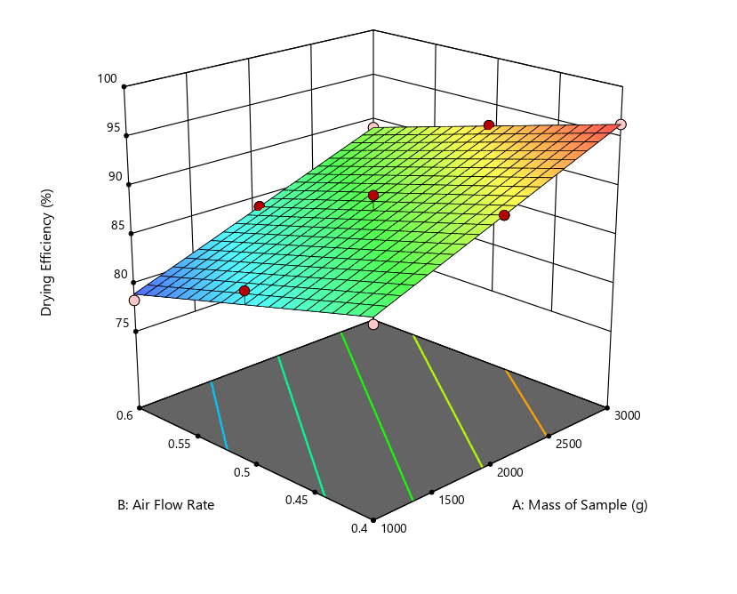
Fig 4.2: Effect of Air Flow Rate and Mass of Sample on the Drying Efficiency of Cocoa
The 3D response surface plot shows the combined effects of mass of sample (A) and air flow rate (B) on drying efficiency (%) of cocoa beans using the fabricated hybrid dryer. The surface trends upward from the lower left (low mass, high airflow) to the upper right (high mass, low airflow), indicating a positive relationship between sample mass and drying efficiency, and an inverse relationship between airflow and efficiency. This means that higher sample mass and lower airflow rate generally result in greater drying efficiency.
The contour lines at the base of the plot are nearly straight and parallel, indicating a mostly additive interaction between the two factors, with limited curvature or nonlinear interaction. The gradient of the surface suggests that drying efficiency increases more steeply with increasing sample mass, supporting the earlier ANOVA result where mass of sample had a higher F-value than airflow. This implies that efficiency is more sensitive to product loading than to airflow variation, within the tested range.
The red dots representing experimental points align closely with the fitted surface, indicating a good model fit and consistency of experimental data. The highest drying efficiency (≈96%) was achieved at 3000 g sample mass and 0.4 kg/h airflow, while the lowest efficiency (≈78%) was observed at 1000 g sample mass and 0.6 kg/h airflow. This visualization effectively demonstrates the trade-off between fast drying and efficient energy use, highlighting the need to optimize drying conditions not just for speed but also for resource utilization.
The pattern observed in this plot is consistent with findings from Aregbesola et al. (2015), who noted that drying efficiency increased with higher cocoa sample loading, as more thermal energy was absorbed by the product rather than lost to the environment. The plot’s clear upward slope with increasing mass confirms their observation that efficiency is maximized when heat is more effectively transferred to a larger product volume.
Simate (2001) also reported that drying systems exhibit better efficiency at moderate air velocities and higher product loads, as excessive airflow tends to waste heat energy and reduces the residence time of air around the product. This study's plot shows a similar inverse relationship between airflow and efficiency, especially at low product loads.
Abano and Amoah (2015), while working with a solar tunnel dryer, found that optimal drying efficiency was achieved at lower air velocities, especially when combined with appropriate product distribution. This matches the current finding that lower airflow (0.4 kg/h) yielded the best efficiency outcomes, reinforcing the concept that airflow should be optimized to minimize energy loss while maintaining sufficient moisture removal.
Finally, Bala and Mondol (2001) reported in their study on fish drying that straight and parallel contour lines indicated additive effects and a predictable model response, similar to the contour base of this plot. Their work supports the use of surface response modeling as a tool for identifying ideal operational zones, which in this case would be higher sample masses and controlled (moderate to low) airflow rates for optimal energy efficiency.

Chapter Five
CONCLUSION AND RECOMMENDATION
5.1 Conclusion
This study successfully achieved its aim of developing a hybrid drying system tailored to the drying needs of smallholder cocoa producers. A hybrid dryer that integrates direct solar radiation with a solar-powered airflow mechanism was designed and fabricated using locally available materials, ensuring both cost-effectiveness and accessibility. The performance evaluation of the system revealed that both the mass of cocoa beans and the air flow rate significantly influenced drying outcomes.
Drying rate ranged between 0.024 and 0.042 kg/h, while drying efficiency varied from 78.3% to 96.3%. ANOVA results confirmed that both process variables—sample mass and airflow—had statistically significant effects (p < 0.0001) on both drying rate and drying efficiency, with the mass of sample having a stronger influence in both cases. The response surface plots further validated these trends, showing optimal performance at higher sample mass and moderate air flow rates (0.4–0.5 kg/h). These results underscore the importance of balancing throughput and energy input in dryer design and operation.
Overall, the hybrid dryer proved to be a reliable, efficient, and affordable drying solution for cocoa beans, with the potential to improve drying quality, reduce post-harvest losses, and enhance income stability for smallholder farmers. Its simplicity of design and use of local materials further support its adoption in rural agricultural settings.

5.2 Recommendations
- Optimization for Field Use:
Further studies should explore optimizing the hybrid dryer under varying weather and environmental conditions to enhance its adaptability for year-round use by smallholder farmers.
- Incorporation of Thermal Storage:
To improve drying continuity during cloudy periods or at night, the system can be enhanced with thermal energy storage materials or a backup bio-fuel/solar battery unit.
- Economic and Quality Assessment:
A cost-benefit analysis and quality assessment of cocoa dried using the hybrid system versus traditional methods should be conducted to establish market advantages and economic viability.
- Scale-Up and Dissemination:
The design should be scaled up or modularized for cooperative or community-based use. Government agencies and NGOs should also be engaged for pilot testing, training, and wider dissemination.
- Applicability to Other Crops:
The dryer’s applicability should be tested for other moisture-sensitive agricultural products such as plantain, chili pepper, or grains, to expand its utility and impact.

References.
• Abano, E. E., & Amoah, R. S. (2015). Performance evaluation of a solar tunnel dryer for cocoa beans in Ghana. Journal of Energy in Southern Africa, 26(3), 43–50.
• Adeboye, B., Ogunlowo, A.S., & Olayanju, T.M.A. (2021). Post-harvest Technologies for Sustainable Cocoa Processing in Nigeria. Nigerian Journal of Agricultural Engineering and Technology, 28(3), 95–102.
• Adeyemi, K.O., Fapohunda, J.A., & Bakare, A.M. (2022). Utilization of Locally Sourced Materials in the Development of Solar Dryers. African Journal of Engineering Research, 10(4), 120–130.
• Ahmad, M., Khan, S., & Iqbal, N. (2022). Renewable Hybrid Energy Systems for Sustainable Agricultural Processing. Renewable Energy Reports, 8, 135–144.
• Afoakwa, E.O. (2014). Cocoa Production and Processing Technology. CRC Press.
• Akinoso, R., Ajibola, O.O., & Adeyanju, O.O. (2021). Development and Performance Evaluation of a Hybrid Dryer for Agricultural Products. Nigerian Journal of Technological Development, 18(1), 45–51.
• Aregbesola, O. A., et al. (2015). Design and performance evaluation of a hybrid dryer for cocoa beans. Nigerian Journal of Technological Development, 12(1), 15–20
• Bala, B. K., & Mondol, M. R. A. (2001). Experimental investigation on solar drying of fish using solar tunnel dryer. Drying Technology, 19(2), 427–436.
• Bello, M.I., Ayodele, T.J., & Okorie, I.F. (2023). Post-Harvest Handling and Drying of Cocoa Beans in Nigeria: Challenges and Opportunities. International Journal of Food Studies, 12(2), 80–95.
• Fawole, O.P., Olukunle, O.J., & Ogunlowo, A.S. (2020). Impact of Improved Post-Harvest Technologies on the Shelf Life of Perishable Produce in Nigeria. African Journal of Agricultural Research, 15(14), 912–920.
• Hii, C.L., Law, C.L., Cloke, M., & Suzannah, S. (2012). Thin Layer Drying Kinetics of Cocoa and Effect of Drying Conditions. Drying Technology, 30(2), 166–177.
• Hossain, M.A., Rahman, M.M., & Islam, M.N. (2022). Design and Evaluation of a Solar-Battery Hybrid Dryer for Agricultural Use. Renewable Agriculture and Food Systems, 37(1), 1–10.
• Lawal, O., Ayinde, T., & Musa, A. (2024). Application of IoT in Hybrid Drying Systems for Small-Scale Farmers. Journal of Agricultural Engineering and Technology, 14(1), 22–30.
• Mujumdar, A.S. (2015). Handbook of Industrial Drying (4th ed.). CRC Press.
• Nkolo, J.N., Tonleu, C., & Nkouam, G.B. (2019). Effect of Traditional Drying Methods on the Quality of Cocoa Beans. International Journal of Postharvest Technology and Innovation, 6(4), 305–318.
• Nwankwo, E., Eze, P.C., & Okoro, J.U. (2022). Reducing Post-Harvest Losses through Renewable Energy Solutions in Nigeria. African Journal of Food Science and Technology, 13(3), 101–110.
• Ogbonna, A.C., & Jekayinfa, S.O. (2017). Design and Cost Evaluation of Hybrid Dryer Using Local Materials. CIGR Journal, 19(1), 122–130.
• Simate, I. (2001). Optimization of convection drying of fermented cocoa beans in a solar dryer. Renewable Energy, 22(3), 445–457
• Sodipo, B.O., & Daramola, O.J. (2022). Smart Drying Systems for Agricultural Processing: A Review. Nigerian Journal of Engineering Innovation, 4(1), 28–35.
• Wekesa, D., Okello, J., & Ngugi, J. (2023). Solar and Battery Powered Hybrid Systems for Smallholder Agriculture. Renewable Energy for Agriculture, 19(2), 59–70.
• World Cocoa Foundation. (2023). Best Practices in Cocoa Post-Harvest Management. [Online] Available: www.worldcocoafoundation.org

