DESIGN AND IMPLEMENTATION OF MALARIA PREDICTION SYSTEM USING DEEP LEARNING ALGORITHM

BY`

IKUEJUYONE IYINOLUWA ADEDOYIN
ND/23/COM/PT/0224

SUBMITTED TO THE DEPARTMENT OF COMPUTER SCIENCE,
INSTITUTE OF INFORMATION AND COMMUNICATION TECHNOLOGY
KWARA STATE POLYTECHNIC, ILORIN.

IN PARTIAL FULFILLMENT OF THE REQUIREMENTS FOR THE AWARD OF HIGHER NATIONAL DIPLOMA (HND) IN
COMPUTER SCIENCE

JUNE, 2025.

CERTIFICATION
This is to certify that this project was carried out by IKUEJUYONE IYINOLUWA ADEDOYIN of Matriculation Number: ND/23/COM/PT/0224 as part of requirement for the award of National Diploma (ND) in Computer Science.

…………………………………. ….………………………
MR. OLAJIDE A.T. Date
Project Supervisor

…………………………………. ….………………………
MR OYEDEPO F.S Date
Head of Department

…………………………………. ….………………………
External Examiner Date

DEDICATION
I dedicate this project work to Almighty God who inspired me and directed my ways during my academic stay in the polytechnic.

ACKNOWLEDGEMENT
All praise is due to Almighty God the Lord of universe. I praise him and thank him for giving me the strength and knowledge to complete my ND programand also for our continued existence on the earth.
I appreciate the utmost effort of our supervisor, Mr. Olajide, A.T whose patience, support and encouragement have been the driving force behind the success of this research work. He gave useful corrections, constructive criticisms, comments, recommendations, advice and always ensures that an excellent research is done. My sincere gratitude goes to Head of Department and other members of staff of the Department of Computer Science, Kwara State Polytechnic, Ilorin, for their constant cooperation, constructive criticisms and encouragements throughout the programme.
Special gratitude to my parents, who exhibited immeasurable financial, patience, support, prayers and understanding during the period in which I was busy tirelessly on mystudies, special thanks go to my lovely siblings
My sincere appreciation goes to my friends and classmates.

TABLE OF CONTENTS
Title page i
Certification ii
Dedication iii
Acknowledgements iv
Table of contents v
Abstract vi
CHAPTER ONE: GENERAL INTRODUCTION
1.1 Background to the Study 1
1.2 Statement of the Problem 2
1.3 Aim and Objectives 3
1.4 Significance of the Study 3
1.5 Scope of the Study 4
1.6 Organization of the Report 4
1.7 Definition of Some Technical Terms 4
CHAPTER TWO: LITERATURE REVIEW
2.1 Review of Related Past Works 6
2.2 Review of Related Concept 10
2.2.1 Artificial Intelligence and Expert Systems 11
2.2.2 Epidemiology and Transmission of Measles 12
2.2.3 Decision Tree 13
CHAPTER THREE: RESEARCH METHODOLOGY AND ANALYSIS OF THE SYSTEM
  - Research Methodology 15
  - Problem of the Existing System 16
  - Analysis of the Existing System 16
  - Analysis of the Proposed System 17
  - Advantage of the Propose System 17

CHAPTER FOUR: DESIGN, IMPLEMENTATION AND DOCUMENTATION OF THE SYSTEM
  - Design of the System 19
    - Output Design 19
    - Input Design 20
    - Database Design 23
    - Procedure Design 25
  - Implementation of the System 25
    - Choice of programming language 26
    - Hardware support 26
    - Software Support 27
  - System Documentation 27
    - Operating the System 27
    - Maintaining of the System 27
CHAPTER FIVE: SUMMARY CONCLUSION AND RECOMMENDATION
5.1 Summary 29
5.2 Conclusion 29
5.4 Recommendations 29
References 30

ABSTRACT
An Expert System (ES) is a computer program that uses artificial intelligence (AI) technologies to simulate the judgment and behavior of a human or an organization that has expert knowledge and experience in a particular field. It is an intelligent computer program that helps to systematize, store and obtain appropriate medical knowledge needed by the practitioner/doctors in dealing with each complicated case and suggesting suitable diagnosis for decision-making procedure. It would be of great necessity to provide a computerized system that will provide complementary medical service, like medical disease diagnosis in places that are difficult to access and health care facilities where qualified experts are lacking. This develops a system that will aid the diagnosis of typhoid fever and measles using decision tree techniques.In the current marketplace there are several apps for communication between doctors and patients but most of their functionalities are commercial, and not really helpful to the patient. There are no apps which actually meet the patient’s basic needs and no such apps that fulfill the patient’s expectations from the doctors. This project aims at changing this kind of misleading and unnecessary interaction between doctors and patients, with a new initiative which focuses more on patient benefits relating to his/her health treatment on typhoid and measles and facilitating the doctors with an easy and optimal way to prescribe drugs to the patients. The cornerstone of any development project is a thorough understanding of the business requirements. Therefore, the first step was to explore and develop a good working knowledge of the problem which in this case is to develop a system which can diagnose and prescribe drug far hospitalized patient accurately to ease children medical treatment which are shared across the different ailment is accomplish this by mimicking human reasoning with computer accuracy.

CHAPTER ONE
GENERAL INTRODUCTION
  - BACKGROUND TO THE STUDY
An Expert System (ES) is a computer program that uses Artificial Intelligence (AI) technologies to simulate the judgment and behavior of a human or an organization that has expert knowledge and experience in a particular field. It is an intelligent computer program that helps to systematize, store and obtain appropriate medical knowledge needed by the practitioner/doctors in dealing with each complicated case and suggesting suitable diagnosis for decision-making procedure. It would be of great necessity to provide a computerized system that will provide complementary medical service, like medical disease diagnosis in places that are difficult to access and health care facilities where qualified experts are lacking. This develops a system that will aid the diagnosis of measles disease and measles using decision tree techniques (Oguntimilehin, 2017).
Measles disease remains a major public health problem in developing countries of the world even in the twenty first century. Unacceptable morbidity and mortality are still recorded in developing countries in spite of the availability of several drugs over the years for the treatment of measles disease. Measles disease also has both social and economic impact because of hospitalization of patients. Prevalence of Measles disease in developing countries constitutes a major threat to the existence of humans due to inaccurate and untimely diagnosis procedures employed by medical practitioners in the region. In most parts of the tropics, the diagnosis of measles disease is based on smear microscopy and widal test, while in rare cases, it includes bacterial culture (Olatunji, 2015).
Providing efficient management service become the main focus for every organization nowadays. One of the ways to move towards efficient management is moving from the manual task to the electronic system. In the government hospital, majority of the management task are done manually such as registration process, doctors' prescription for patients, and beds arrangement in the wards as well as the drug references for doctors and pharmacists to refer to. The same scenario happens at every hospital. The quality service at the hospitals can be improved by transforming manual task into the computerize system. The Medical diagnostic Systems comprise undergone lots of changes and are using innovative techniques to generate enhanced results.

1.2 STATEMENT OF THE PROBLEM
In the current hospital there are several applications for communication between doctors and patients but most of their functionalities are commercial, and not really helpful to the patient. There are no apps which actually meet the patient’s basic needs and no such apps that fulfill the patient’s expectations from the doctors. This project aims at changing this kind of misleading and unnecessary interaction between doctors and patients, with a new initiative which focuses more on patient benefits relating to his/her health treatment on measles disease and facilitating the doctors with an easy and optimal way to prescribe drugs to the patients.
1.3 AIM AND OBJECTIVES
The aim of the research work is develop an expert system that will diagnosed measles diseases using decision tree technique with the following objective:
i. To acquire the data from online source
ii. Develop asystem that shall diagnosemeaslesdiseases
iii. Implementation of the developed system using visual C#
1.4 SIGNIFICANCE OF THE STUDY
In view of the rapid usage of computer technology in almost all the fields of operation and its use in relation to information management, it has become important to look into the development of an expert system for diagnosing patients under diseases of measles disease and measles with doctor’s prescription for hospitals to meet up with demands of their patients. Therefore, the proposed system has some benefits to individuals, organizations and society at large:
To the Individuals:
The system will provide an ease and comfort to patients while taken appointment from the doctors and also allow the patients to ask questions and state their concerns to doctors regarding their health condition.
To the Organizations:
It will provide a system for the clinic that is capable of handling patient that needs medical help and attention but cannot meet the doctor in person.
To the Society:
Due to the fact that many individuals are shy of asking some important questions about their health issue, the system will makes it possible for such individuals to have one to one conversation with the system.
1.5 SCOPE AND LIMITATION OF THE STUDY
The scope of this project will be focus mainly on the implementing an Expert system on Measles disease and measles diagnosis using decision trees technique that will cater for the analysis and prescription of drug in an organization. This project does not cover any mode of payment of drugs and services transacted between any patient and the hospitals outside its business premises.
1.6 ORGANIZATION OF THE REPORT
This is the overall organizational structure of the work as presented in this project. Chapter One of this project deals with the introduction to the general work in the project. It also entails statement of the problems, aim and objectives of this project, significance, the scope of the study, and report organization. Chapter Two deals with the literature review, review of general text and other typical issues related to the research field of study. Chapter Three deals with methods used for data collection, Analysis of the existing system, Description of the current procedure, problems of existing system (procedure) itemized description of the proposed system and the basic advantages of the proposed system. Chapter Four deal with design, implementation and documentation of the system. The design involves the system design, output design from, input design form, file structure and the procedure of the system. The implementation involves the hardware and software requirements for the proposed system perform its target aim. The documentation of the system involves the operation of the system and the maintenance of the system. Chapter Five deals with the summary, the conclusion, recommendation and references

CHAPTER TWO
LITERATURE REVIEW
2.1 REVIEW OF RELATED WORK
Omairul, et al (2022) write and presented a journal titled “A Rare Coincidence of Measles with Measles disease”, which they discus on Typhoid, otherwise known as enteric fever, and measles both have a high incidence worldwide. However, a coincidence of both has been only documented twice previously in 1866 and 1949. We present a case of a 24-year-old male who presented with high-grade fever and diffuse abdominal tenderness. This highlights the importance of further comprehensive investigations even in diagnosed cases, and that overlapping symptoms should raise the clinical suspicion of concurrent diseases. One should always keep an open mind when assessing a patient, not just at the time of making a diagnosis but throughout the course of illness.

Kemi&Olutomilayo, (2022) research on an Expert System for Diagnosis of Malaria and Measles disease was carried out, in Nigeria today, one of the most common forms of fever are malaria and typhoid. Malaria results in anemia meaning decrease in red blood cells. This study considers developing an expert system that could assist in diagnosing malaria, the system was developed using Visual Basic.Net and top-down approach was used for the system design. The data collected from the Federal Polytechnic Medical Centre covers seven months period. The total prescriptions issued for this period was 7525 and over 4117 patients out of these are affected by malaria and Measles disease and this represents 54.71% of prescription issued.

Adewaleet al (2023) also write and presented a journal titled “The Design and Creation of a Malaria Diagnosing Expert System”, Malaria kills about one million, two hundred thousand (1.2 million) people every year. Medical doctors are in limited supply, and provide somewhat expensive services. There is, therefore, the need to build computer-based systems that can assist doctors in diagnosing and recommending treatment for malaria to fill the supply gap and reduce the attendant costs, upon which this research is focused. The expert system would diagnose and recommend treatment of malaria from symptoms and blood test result provided by user patient. The system is towards reducing deaths associated with malaria and towards improved health care services, and is a guide to designing similar systems.

Considered Fatumo, Emmanuel &Onaolapo, (2023) Implementation of XpertMalTyph an Expert System for Medical Diagnosis of the Complications of Malaria and Typhoid, the dearth of medical experts in the developing world has subjected a large percentage of its populace to preventable ailments and deaths. In this work, we designed and implemented XpertMalTyph; a novel medical diagnostic expert system for the various kinds of malaria and typhoid complications. A medical diagnostic expert system uses computer(s) to simulate medical doctor skills in diagnosis of ailments and prescription of treatments, hence can be used to provide the same service in the absence of the experts. XpertMalTyph is based on JESS (Java Expert System Shell) programming because of its robust inference engine and rules for implementing expert systems.

Oguntimilehin, Abiola&Olatunji, (2024) presented a paper titled “Computer Aided Diagnostic Systems for Managing Measles disease: Measles disease has been identified as one of the major killers and common diseases which kill more than the dreaded Acquired Immune Deficiency Syndrome (AIDS). It was observed in this work that some of the available computer aided diagnostic systems on Measles disease are mere software development exercise without any consultation with medical experts, strong diagnosis background and deployment of computational tools or predictive algorithms. Six basic stages or elements that can make a diagnostic system reliable were suggested in this work for researchers working in the area of developing Computer Aided Diagnostic and Therapy Systems.

Sunday et al(2022) write on a rule based expert system for Diagnosis of Fever”, this paper deals with the design and development of a rule based expert system for diagnosis of fever, a common health disorder among Africans. This system interacts with users with plain English language based on some arranged rules. These rules, which are a typical collection of if/then rules, are extracted from experts in the medical fields in Nigeria. Using these rules, a knowledge base was designed for the expert system. Some programming codes were also written in VB.Net for making deduction of new facts from rules in the knowledge base. It is believed that this design can help to reduce the congestion we often see in our hospitals by providing solution for sick patients, irrespective of their locations.

Okpokpong, Umar &Itoro (2019) writes and presented a paper titled “Fuzzy Expert Framework for Diagnosis of Typhoid Fever”, Typhoid fever is a disease that is caused by bacteria called salmonella typhi. This paper proposes a method of diagnosis of Typhoid Fever using Fuzzy Logic. The system was built with twenty input membership functions, one output membership function and about two hundred inference rules which was simulated with MATLAB R2013 and therefore 97.5 % accuracy was obtained. The centroid method was used for the defuzzification. Although there are many systems in existence, this work is however based on the assumption that a system with a higher number of inference rules will make diagnosis a better.

According to Abad &Safdar, (2020) the reemergence of measles Measles, or rubeola, is a highly infectious, acuteviral illness of childhood that is considered eliminated in the USA but has reemerged in the past few years. Globally, an estimated 20 million cases of measles continue to occur, and it remains a leading cause of death among young children. It is rare in the USA and other first world countries, but numerous outbreaks have occurred in the USA recently, due to a combination of factors including poor vaccine coverage and importation of cases among travelers returning from endemic areas. The diagnosis of measles is usually made clinically, when an individual presents with a constellation of symptoms including cough, coryza, conjunctivitis, high fever, and an erythematous maculopapular rash in a cephalocaudal distribution. Complications are common and include otitis media, pneumonia, encephalitis, and rarely death.

Also Mohammed & Husain (2023) writes a paper on “A Proposed Model for Health Management and Expert Diagnosis System for the Prediction of Common Diseases for Ethiopia (East Africa)”, many rural & pastoral communities in Ethiopia have extremely limited access to medical advice. This results in slow service, and ends up waiting long hours without receiving any attention for the patient. Hence medical expert systems can play a significant role in such scenarios where medical experts are not readily available. This work presents the patients registration system and design of a knowledge-based expert system that aims to provide the prediction of the diseases to the patients and medical advisors to expedite their non-surgical diagnostic system.
Samuel & Andrew (2020) review paper on “Economic evaluation of typhoid- a review” To evaluate the potential economic value and likely impact of a hypothetical rapid test in its early stages of development requires the use of models. The model structure and the type of model (dynamic/static) to employ are key considerations. The aim of the review was to explore the literature on typhoid economic evaluations and to explore the types of models that have been previously adopted in this setting for test-treat evaluations and to capture data on model inputs that may be useful for a de novo model. A systematic review was conducted to identify economic evaluations focused on typhoid in established literature databases. Eight studies were identified and included for narrative synthesis. The review has revealed that there have been relatively few economic evaluations that have focused on typhoid fever, all of which have focused on the impact of interventions at the population level (vaccination) but not the individual level (test-treat strategies). Typhoid test-treat modeling represents a gray area where further work is needed.

2.2 OVERVIEW OF MEDICAL DIGNOSIS SYSTEM
Intelligence can be defined as the ability to learn and understand, to solve problems and to make decisions. However, Artificial Intelligence (AI) is the display of intelligence by machines, and its main goal as a field is to make machines do things that would require intelligence if done by humans. The central problems of AI include such traits as reasoning, knowledge, planning, learning, communication, perception and the ability to move and manipulate objects. In the early 90s, AI achieved its greatest feats in practical application despite all its previous setbacks. It was successfully applied in logistics, data mining and medical diagnosis. However, AI success started being revived with the commercial success of expert systems (Mohammed & Husain, 2019).
Expert System is a form of Artificial Intelligence program that simulates the knowledge and analytical skills of one or more human experts. Conventional expert systems are built for a very narrow domain with clearly defined expertise. It makes the system performance fully dependent on the right choice of experts. Although a common strategy is to find just one expert, when a more complex expert system is being built or when expertise is not well defined, multiple experts might be needed. Fig. 1 shows the generic block diagram of medical expert systems. XpertMalTyph is a medical expert system for diagnosis of the complications of malaria and Measles disease(Samuel & Andrew, 2019).

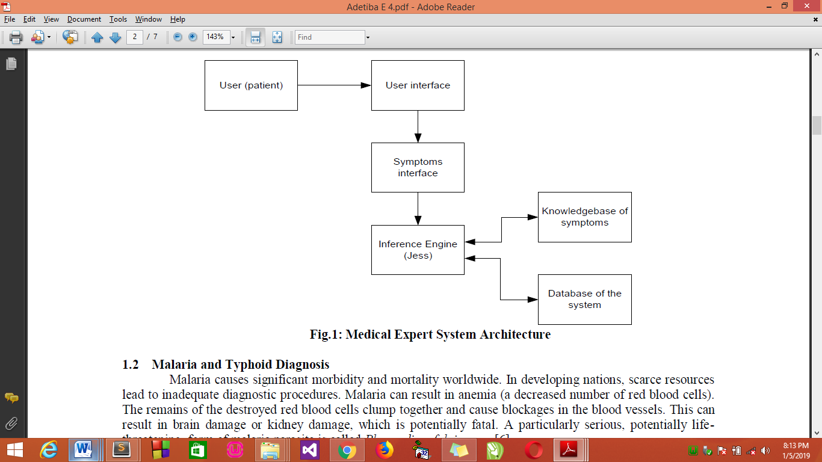
Figure 2.1: Medical Expert System Architecture.
Source: (Fatumo, Emmanuel &Onaolapo, 2013)

2.3 CONCEPT OF DECISION TREE ALGORITHM
Measles is one of the most contagious of the vaccine preventable diseases, with reproduction rates (R0) estimated at 12 to 18 meaning that the average person with measles is capable of infecting 12 to 18 other people if all close contacts are susceptible. It has a secondary attack rate among susceptible individuals higher than 90 %. The virus can be transmitted in the air (aerosolized) in respiratory droplets or by direct or indirect contact with the nasal and throat secretions of infected persons when an infected person breathes, coughs, or sneezes.
Despite being declared eliminated in the USA, there have been several measles outbreaks in the USA in the past few years. Most recently, during January 4–April 2, 2015, a total of 159 measles cases (in 155 US residents and four foreign visitors) from 18 states were reported to the Centers for Disease Control (CDC). Of those infected, 55 % were adults [58 (36 %) were aged 20–39 years, and 30 (19 %) were aged ≥40 years]. Twenty-two patients (14 %) were hospitalized, including five with pneumonia. The majority of the 159 patients with reported measles were either unvaccinated (71 [45 %]) or had unknown vaccination status (60 [38 %]). The bulk of cases (96 %) were import-associated cases, belying the importance of vaccine coverage and herd immunity (discussed later).
France was the most affected country, with 47 % of cases in Europe in 2011, while several other countries have also reported a considerable number of cases including Bulgaria, Germany, Italy, Romania, Spain, Ukraine, and the UK. More recently, over a period of 1 year, over a thousand suspected measles cases (n=1073) were reported across the UK. Most confirmed and probable cases occurred within two age groups infants (too young to be eligible for measles-mumps-rubella (MMR) vaccination) and children aged 10–19 years. This resurgence of measles in countries without endemic transmission of disease and prior control is thought to result from poor vaccination rates (Safdar N., 2015).

2.4 DECISION TREE
A decision tree is a flow-chart-like tree structure, where each internal node is denoted by rectangles, and leaf nodes are denoted by ovals. All internal nodes have two or more child nodes. All internal nodes contain splits, which test the value of an expression of the attributes. Arcs from an internal node to its children are labelled with distinct outcomes of the test. Each leaf node has a class label associated with it. Decision tree are commonly used for gaining information for the purpose of decision -making. Decision tree starts with a root node on which it is for users to take actions. From this node, users split each node recursively according to decision tree learning algorithm. The final result is a decision tree in which each branch represents a possible scenario of decision and its outcome.
The three widely used decision tree learning algorithms are: ID3, C4.5and CART.
    - Iterative Dichotomiser 3 (ID3)
This is a decision tree algorithm introduced in 1986 by Quinlan Ross. It is based on Hunts algorithm. The tree is constructed in two phases. The two phases are tree building and pruning.ID3 uses information gain measure to choose the splitting attribute. It only accepts categorical attributes in building a tree model. It does not give accurate result when there is noise. To remove the noise pre-processing technique has to be used. To build decision tree, information gain is calculated for each and every attribute and select the attribute with the highest information gain to designate as a root node. Label the attribute as a root node and the possible values of the attribute are represented as arcs. Then all possible outcome instances are tested to check whether they are falling under the same class or not. If all the instances are falling under the same class, the node is represented with single class name, otherwise choose the splitting attribute to classify the instances. Continuous attributes can be handled using the ID3 algorithm by discretizing or directly, by considering the values to find the best split point by taking a threshold on the attribute values. ID3 does not support pruning.

2.4.2 C4.5 Algorithm
This algorithm is a successor to ID3 developed by Quinlan Ross. It is also based on Hunt’s algorithm.C4.5 handles both categorical and continuous attributes to build a decision tree. In order to handle continuous attributes, C4.5 splits the attribute values into two partitions based on the selected threshold such that all the values above the threshold as one child and the remaining as another child. It also handles missing attribute values. C4.5 uses Gain Ratio as an attribute selection measure to build a decision tree. It removes the biasness of information gain when there are many outcome values of an attribute. At first, calculate the gain ratio of each attribute. The root node will be the attribute whose gain ratio is maximum. C4.5 uses pessimistic pruning to remove unnecessary branches in the decision tree to improve the accuracy of classification.
2.4.3 Classification and RegressionTrees (CART)
CART stands for Classification and Regression Trees introduced by Breiman. It is also based on Hunt’s algorithm. CART handles both categorical and continuous attributes to build a decision tree. It handles missing values. CART uses Gini Index as an attribute selection measure to build a decision tree .Unlike ID3 and C4.5 algorithms, CART produces binary splits. Hence, it produces binary trees. Gini Index measure does not use probabilistic assumptions like ID3, C4.5. CART uses cost complexity pruning to remove the unreliable branches from the decision tree to improve the accuracy.

CHAPTER THREE
RESEARCH METHODOLOGY AND ANALYSIS OF THE EXISTING SYSTEM
3.1 RESEARCHMETHODOLOGY
The cornerstone of any development project is a thorough understanding of the business requirements. Therefore, the first step was to explore and develop a good working knowledge of the problem which in this case is to develop a system which can diagnose Measles disease accurately. Measles disease, like most other diseases, has symptoms which are peculiar to itself and others which are shared across the different diseases and other ailments accomplish this by mimicking human reasoning with computer accuracy.
3.1.1 Steps to diagnosed using decision tree techniques are as follow:
Step 1 Start
Step 2 Accept patient data
Step 3 Select the data form file
Step 4 preprocess selected data using Arff Converter
Step 5 Classify the data using the algorithms ID3, C4, MLP (using C#)
Step 6 Choose the best node has a class label associated with it
Step 7 Process the result
Step 8 Repeat to check for errors
Step 9 Display result and select possible treatment from the database
Step 10 Stop
3.1.2 ADAPTATION IN INITIAL DECISION TREE TECHNIQUES
For I= number of root nodes do
For S= I to number of nodes child do
Split the value of all attribute
End for S
Compute the nodes using Arff Converter
Repeat
End for I
Iterative Dichotomiser 3(ID3)
For I= number of root nodes do
For S=I to number of nodes child do
Classify values using ID3,C4 and MLP
Choose the best node has a class label associated with it
End for S
Compute the diagnosis for patient
Display the result of the prediction from the name table and process the possible solution
Repeat
End for I.
Program Modules
This project will be developed in modules in such a way that each module are linked together to carry out the full functional part of the patient information management system.
- LOGIN FORM: This serves as an introductory screen to the application where user is expected to supply username and password for authentication.
- REGISTRATION FORM: This allows user to enter information about the patient’s bio-data with reference to patient identity.
- DIAGNOSIS PAGE: This allows user to enter information about the patient’s illness i.e. the symptoms, diagnose the symptoms, prescribed drugs and print the report.
- REPORTS PAGE: This displays the results of the diagnosis and also prescribes the necessary drugs.

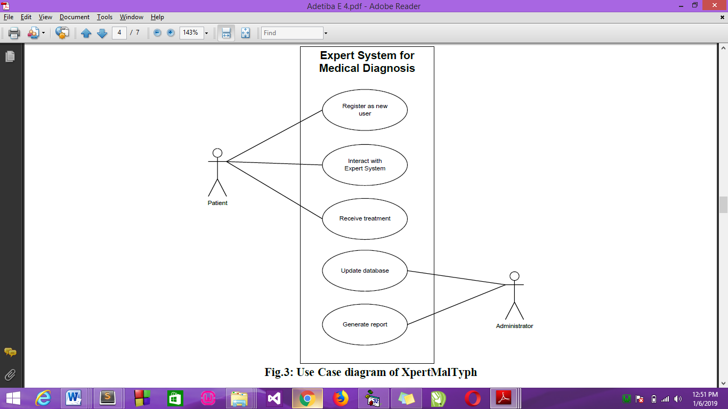

Fig 3.1 Expert System Diagram
Source: (Fatumo, Emmanuel &Onaolapo, 2024)
3.2 ANALYSIS OF THE EXISTING SYSTEM
Measles disease is a disease that is caused by bacteria called salmonella typhi. Measles disease is characterized by high disease, constipation, diarrhoea, abdominal pain, etc. It is very common in developing countries like Ghana, it has caused an estimated 21.7million illnesses and 217,000 deaths. In 2013, there were 161,000 reported deaths from Measles disease. Measles disease is often treatable when diagnosed early, but if left untreated could lead to other medical complications like intestinal haemorrhaging which may require major surgeries and could even lead to death. Diagnosing of Measles disease and measles in hospitals is done manually which is stressful and time consuming. Therefore we are proposed to the development of an efficient and effective expert system that will handle the diagnosing of Measles diseaseand measles.

3.3 PROBLEMS OF THE EXISTING SYSTEM
The problems of the existing system are:
- Existing system is time consuming and patients will need to see a qualified doctor before his/her problem can be solved.
- There is no efficient technique to carry out measles disease diagnosing.
- Lack of efficiency: keeping record of patients in paper and diagnosing is very slow due to transfer of file ups and down
- The manual method is stressful: Taking file from one desk to another lead stress for nurses in charge.
- It is time Consuming: patients wait for long time before getting their results
- Prone to lots of errors:

3.4 ANALYSIS OF THE PROPOSED SYSTEM
Technical aspects of our methodology involved the design and implementation of a 4-agent architectural model namely, the user interface component, inference engine, knowledge base and system database. The system was developed using C#(CSHARP) and Microsoft SQL Server 2005 was used as the Database. Fig. 3.2 shows the interconnection of the components. Medical record unit of the Federal Polytechnic Ede Medical Center was consulted to gather required data, this data was collected from available records, the records were perused for the purpose of extraction, malaria prescription details for the period of seven months (February-August 2017) were extracted.
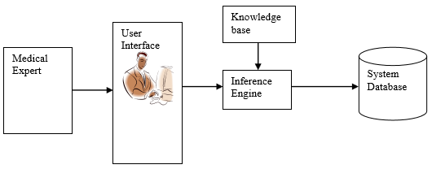

Fig. 3.2: Architectural design for Measles disease Expert System
Source(Kemi&Olutomilayo, 2017)

3.5 ADVANTAGES OF THE PROPOSED SYSTEM OVER THE EXISTING SYSTEM
- Keeps One Financially Protected: One of the greatest advantages of taking a health insurance policy is that it protects the savings of a person which one does for other purposes. It prevents in depletion of savings in case of a medical emergency. One may be saving and contributing for other objectives like purchasing a property or kid’s schooling, however, in case of a medical emergency such savings are utilized and one is not able to fulfill their other objectives.
- A vast variety of options: Health insurance is no longer restricted to covering a few medical problems and complexities. Many benefits are now available in the health insurance policy. One can buy single insurance for the entire family. That policy will cover all the risks to the people in the family according to their age and medical and family history. The policies that are available nowadays may have lifetime renewability as well. The terms and conditions have gotten simpler.
- Peace of mind: Another huge advantage of health care coverage is the true serenity it offers. Buying medical coverage gets a massive sensation of security, particularly if one has bought a family insurance plan. The satisfaction that one gets with worrying about the safety of their members is surreal. People can be at ease and secure that their family members are safe and in case of emergencies, the policy is there to help them out for getting proper treatment.
- Covers the whole family: There are insurance policies that cover the well-being of the whole family. Thus, one can take a consolidated policy for their maturing guardians, for themselves, and their partners and children. Carrying on with a pressure-free life is valuable. With medical coverage, one can feel free and stress less over the costs of their wellbeing. Savings are extremely fundamental for any individual. Waste of investment funds is something everybody fears.

CHAPTER FOUR
DESIGN, IMPLEMENTATION AND DOCUMENTATION OF THE SYSTEM
4.1 DESIGN OF THE SYSTEM
System design and specification is very important in every software development. At this stage, the developer puts every factor into consideration while making this design. In the course of the design, the system has to be designed in a way that there will be a close relationship between the inputs and outputs. Also, the design format must be made in a way that it will be acceptable to the end users.
4.1.1 OUTPUT DESIGN
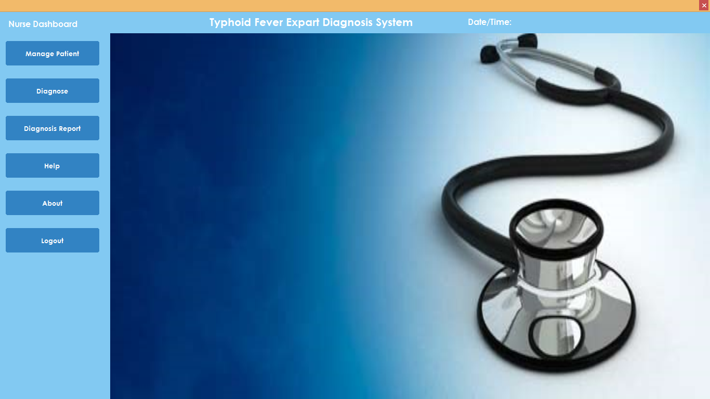
Figure 4.1: Index Page Interface
Show information about the welcome page to tell user about Measles diseaseDiagnostic system

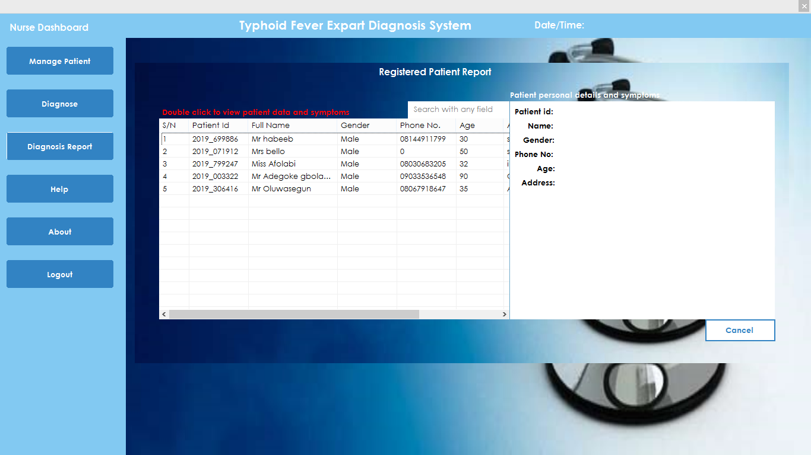
Figure 4.2: Registered Patient Report Module
This is where registered patient report are displayed
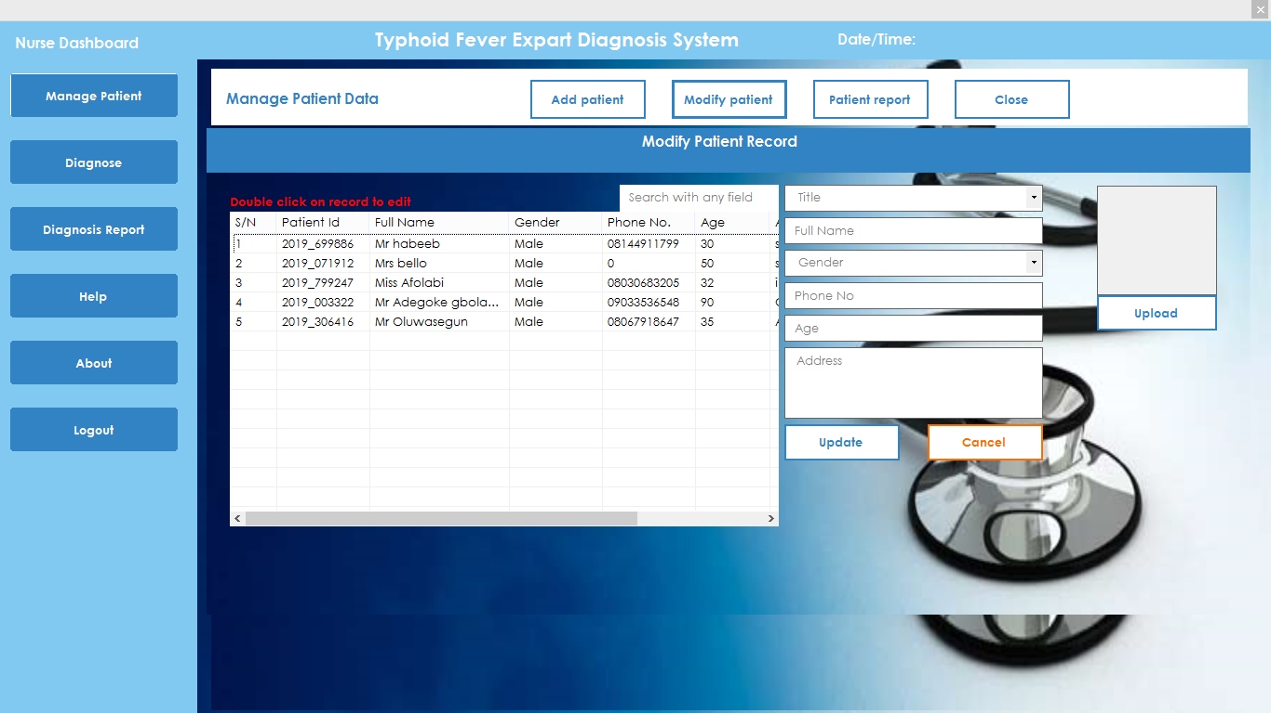
Figure 4.3: Modify Patient Record Module
This is where patient record are modified or update

4.1.2 INPUT DESIGN
It is also necessary to denote that data inputted in the computer for processing determines what the output will be. The inputs are use in collecting information the student through the keyboard. Inputs are necessary information needed for processing so as to produce the expected outputs; which are supplied through the keyboard.
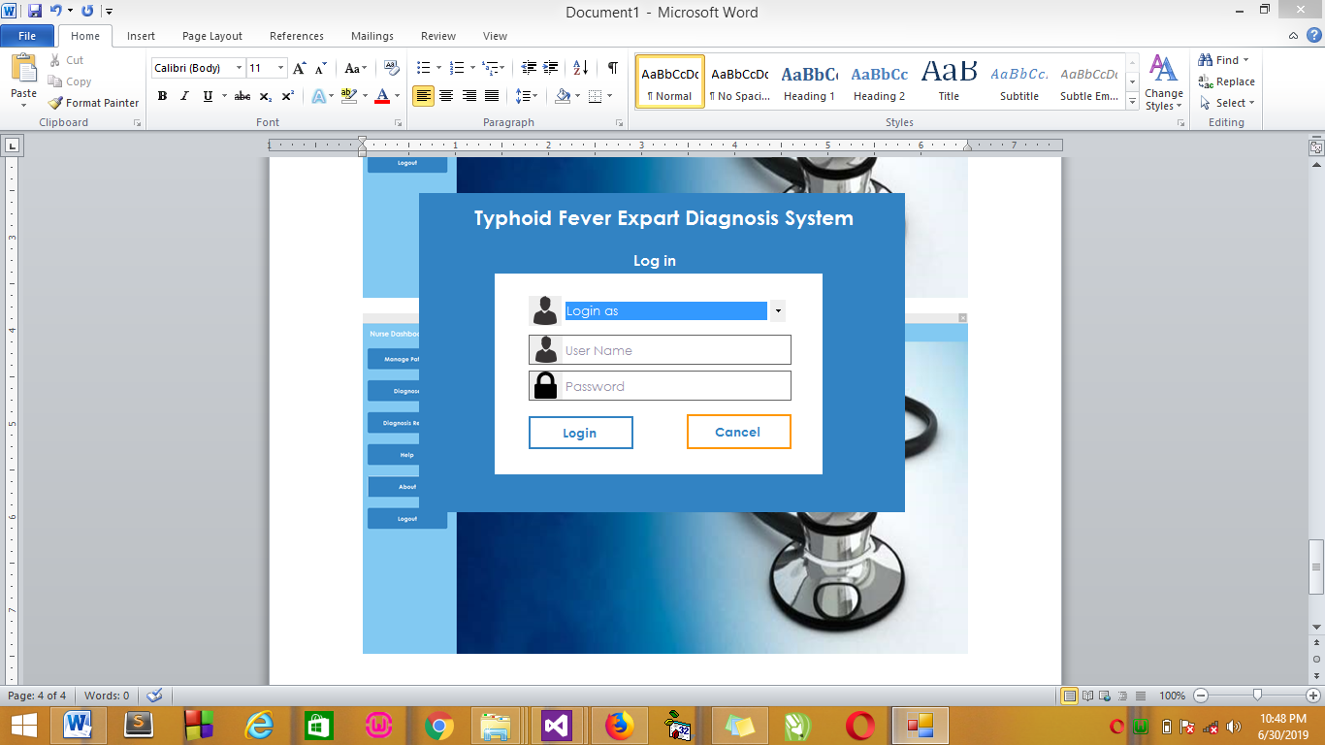
Figure 4.5: Input Interface for Admin login.

The login environment for users

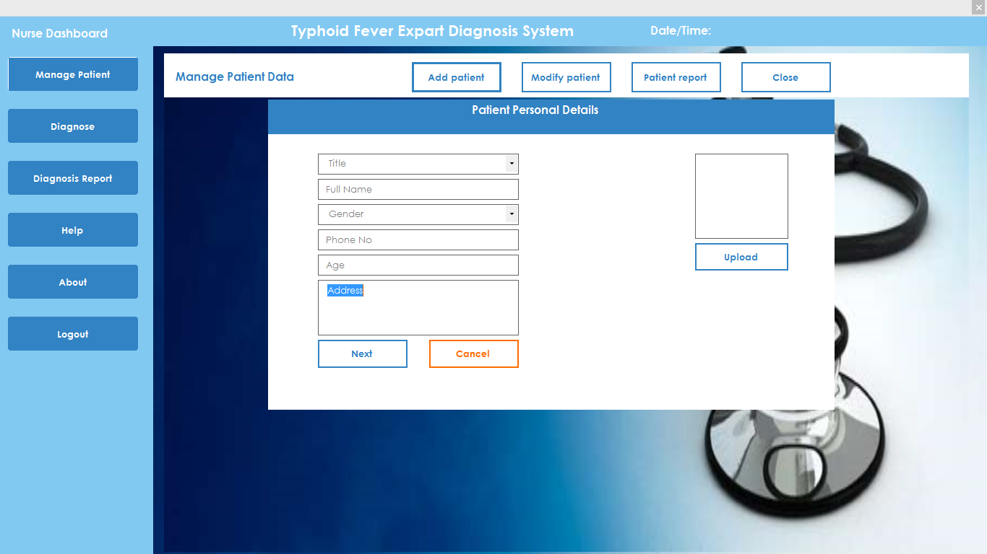
Figure 4.6: Patient Personal Details Page
This is where patient personal details are entered.
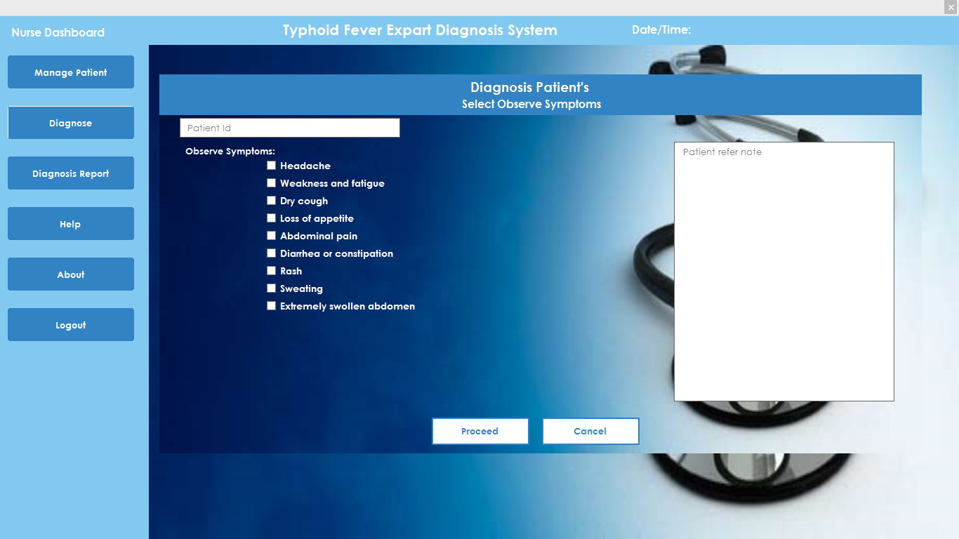
Figure 4.7: Diagnosis Patient Page
This is where the nurse select observe symptoms for patients.
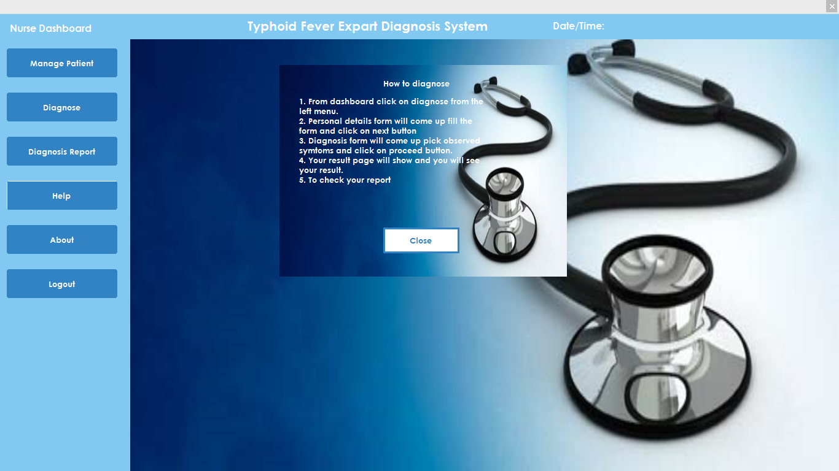
Figure 4.8: Help Module
This is where how to operate the system is displayed.
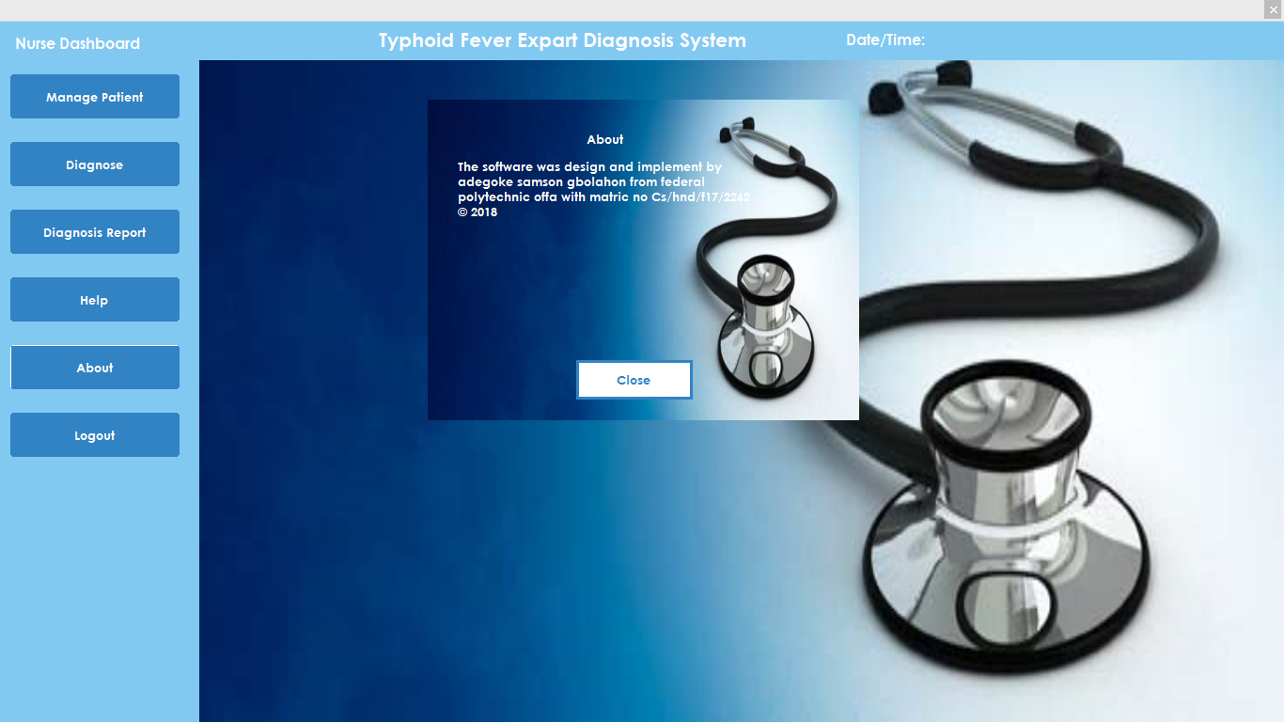
Figure 4.8: About Module
This is where the about page is displayed

Table 4.1: Table showing various symptoms and the sickness prediction
RESULT
Numbers of Patients | Symptoms | Arff Converter Process Time | Sickness Prediction | Prediction Process Time
Patient 1 | Headache, Weakness and fatigue, Abdominal pain | 0.9654455444 | Typhoid | 0.5768
Patient 2 | Rash, Sweating, Dry cough, Diarrhea or constipation | 0.865898899 | Measles | 0.4998
Patient 3 | Headache, Weakness and fatigue, Abdominal pain, Dry cough, Diarrhea or constipation | 1.9867376635 | Typhoid | 0.9876
Patient 4 | Rash, Sweating, Diarrhea or constipation, Extremely swollen abdomen | 0.7654321879 | Measles | 0.3236
Patient 5 | Headache, Weakness and fatigue, Abdominal pain, Dry cough, Diarrhea or constipation, Extremely swollen abdomen | 1.9987654923 | Typhoid | 0.9765

DISCUSSION
The decision tree method is a powerful statistical tool for classification, prediction, interpretation, and data manipulation that has several potential applications in medical research.
A decision tree is a flow-chart-like tree structure, where each internal node is denoted by rectangles, and leaf nodes are denoted by ovals. All internal nodes have two or more child nodes. All internal nodes contain splits, which test the value of an expression of the attributes. Arcs from an internal node to its children are labelled with distinct outcomes of the test. Each leaf node has a class label associated with it. Decision tree are commonly used for gaining information for the purpose of decision -making. Decision tree starts with a root node on which it is for users to take actions. From this node, users split each node recursively according to decision tree learning algorithm. The final result is a decision tree in which each branch represents a possible scenario of decision and its outcome.
4.1.3 DATABASE DESIGN
A database table is used for storing information about the files. The database use for this application is mysql database. The files and their respective modes of access as well as information they hold are given below;

Table 4.1: Users Datatable
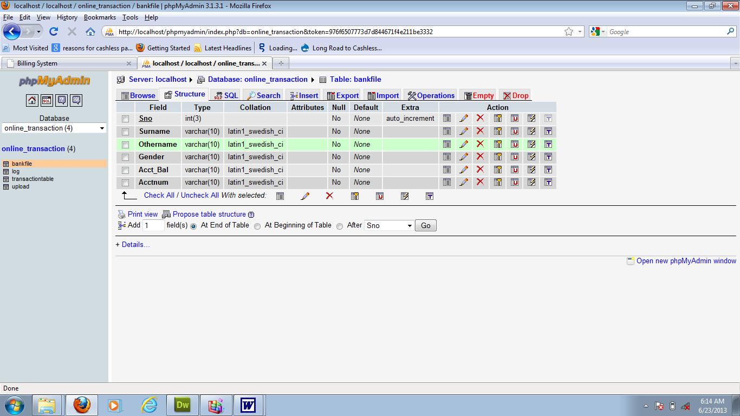

This is users data table where data are stored and retrieved

Table 4.2: Patient Details Datatable
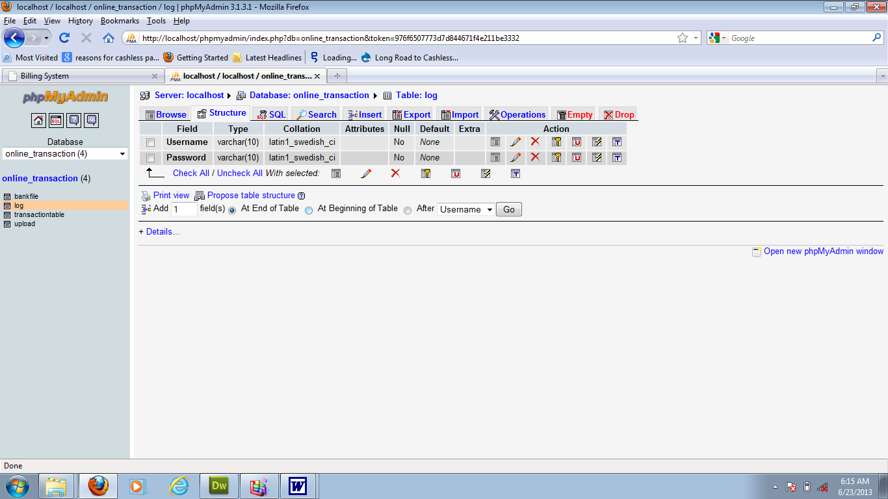

This is where patients data are stored and retrieved
Table 4.3: Diagnosis Datatable
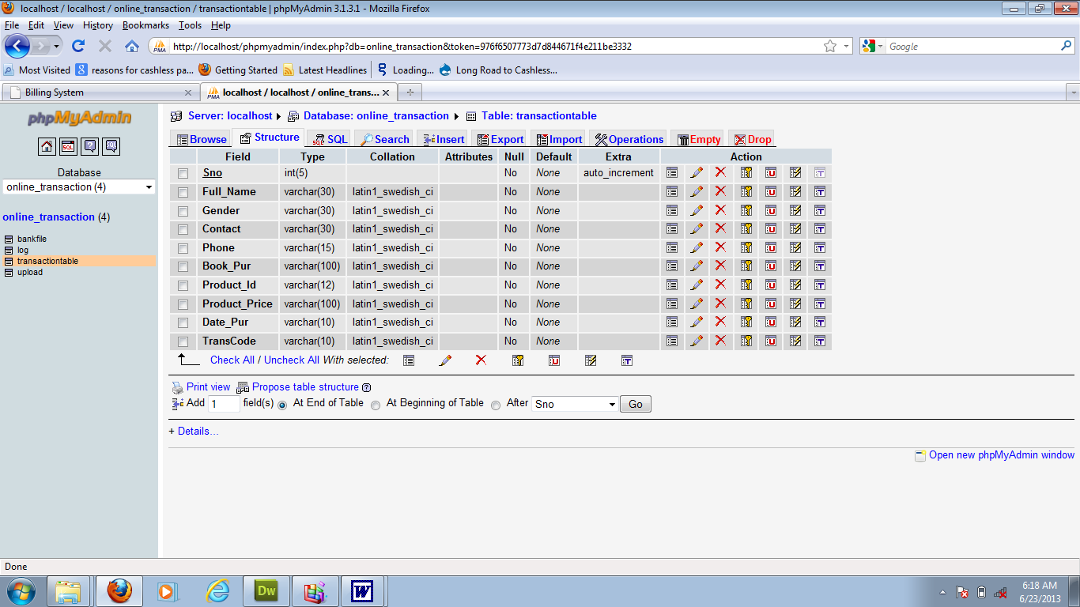
This is where patients selected symptoms are stored and retrieved
4.1.4 PROCEDURE DESIGN
Procedures are steps which verify the whole process i.e which are everything put together to produce the desired output. This involves the organization of the source document and end with the output result.
Documents are sent to various departments to be filled by the employees and later returned to the personnel department which are analyzed to determine which record goes into the computer.
After selecting the necessary data, this serves as input to the computer system.
4.2 IMPLEMENTATION OF THE SYSTEM
It is always good to develop new ideas, to implement them on a computer and eventually to relish the satisfaction of achieving a successful result. The implementation process involves converting the system design into a complete and tested EDP that is fully operational and that can be used by the system users to meet their business needs. During implementation phase, the hardware and the software must be implemented.

Implementation of a system can be explained in six steps:-
- Review design specification
- Code, test and document programs
- Train users
- Perform system test
- Convert to new system
- Evaluate and maintain the new system

4.2.1 CHOICE OF PROGRAMMING LANGUAGE
The application is designed using C# as the programming language and MYSQL for database management. Hence, the database testing simply involves running it directly from a Mozilla Firefox web browser on local host server provided by Apache 2.0 in WampServer 2.0 application.
In preparation for the installation of the new system, the method of changeover is given serious consideration to determine the success of the new system. Suitable changeover technique for this system is pilot changeover. The pilot changeover operates by applying the new system bit-by-bit until it covers the whole of the operations. The result obtained from using the pilot method on a small portion of the operations would be used in determining the suitability of the need system for the rest of the operations. This method is similar to testing small sample of a distribution if the test yields a good result then the whole system because fully operational and the manual/existing system is eliminated.

4.2.2 HARDWARE SUPPORT
The computer configuration required to run the software is;
Computer/memory processor PC with a 48dx, MHZ or Pentium, Intel or higher processor required.
Memory: 2GB of RAM
Cache memory: 512KB
Hard disk Minimum size 500GB
Recommended 200GB
Virtual Memory 32Bits
Cache memory 512KB
4.2.3 SOFTWARE
I. Microsoft Visual Studio
ii. MY SQL Database Management Software
iii. Operating system window 07 professional
v. Graphic software paint shop and choosing these two formats GIF (Graphic Image Format)
vi. Scanner software, Mira scans
vii. Web browser software MOZILLA

4.3 PROGRAM DOCUMENTATION
4.3.1 OPERATING THE SYSTEM
Step 1: Boot your computer and click on start button on task bar
Step 2: Click on document
Step 3: Locate Visual Studio and click it
Step 4: Locate your application and click it
Step 5: Choose user and enter the password
Step 6: Click on Options
6.1 Click on Manage Patient (to manage patient)
4.3 Click on Diagnose (to diagnose a patient)
4.4 Click on Diagnose Report (to view diagnose report)
4.5 Click on Help (to view the help page)
4.5 Click on About (to view the about page)
Step 5: Logout

4.3.2 MAINTAINING THE SYSTEM
The use of the term maintenance for software is different from other references to maintenance. Unlike the tires on your car, software does not “wear out”. If this is the case, then why does software maintenance account for such a high percentage of the Total Cost of Ownership for software?
The software maintenance definition refers to changes for defect correction, performance improvements, or adaptations to a changed environment (enhancements). According to this definition, if we build software that is defect-free, performs well, and contains user-controlled parameters to adjust processing rules in response to changing requirements then most maintenance would not be necessary.
Why does this happen? There are many reasons but the most common reasons are time constraints and lack of experience. Adding validation logic takes time. So, people make assumptions about the quality of in-bound data. Assumptions are also made about the volume of transactions and the impact on performance and the stability of the automated business processes. Finally, it is common for new software to be developed by younger developers who don’t understand the maintenance impacts of their designs.
The reality is that business requirements change and most of these assumptions are flawed. Transaction volumes increase, changing business processes require new transactions or new validation criteria, and software users will use the software incorrectly. The cost of software maintenance and the total cost of ownership can dramatically be reduced if developers build software that adjusted to changes in transaction volumes; validated all inbound data and provide user-configurable options for decision logic and data validation.

CHAPTER FIVE
SUMMARY, CONCLUSION AND RECOMMENDATIONS
5.1 SUMMARY
In summary, the dearth of medical experts in the developing world has subjected a large percentage of its populace to preventable ailments and deaths. Also, because of the predominant rural communities, the few medical experts that are available always opt for practice in the few urban cities. This consequently puts the rural communities at a disadvantage with respect to access to quality health care services. In this work, we designed and implemented an expert system for diagnosing various kinds of measles and Measles diseasecomplications. A medical diagnostic expert system uses computer(s) to simulate medical doctor skills in diagnosis of ailments and prescription of treatments, hence can be used to provide the same service in the absence of the experts. Among other sectors such as academic, banking and finance, medical sector is not an exception in experiencing cyber-attack as patient health data are also stored and shared electronically through the internet. The intrusion and stealing of patient data automatically affects the service offered at the health care centres and thus, poses threat to life of the patient.
5.2 CONCLUSION
The medical diagnostic expert system for the various complications of Measles diseaseand measles has been designed to help patients and assist doctors not to replace them. There are times that some symptoms that an individual has might be taken for granted, that is, they might just be overlooked and the individual will not see a need to visit the hospital. This means that instead of a patient consulting the doctor for mild cases of measles and Measles diseasecomplications, the patient can receive treatment even from the house through the Medical Diagnostic Expert system. . In the government hospital, majority of the management task are done manually such as registration process, doctors' prescription for patients, and beds arrangement in the wards as well as the drug references for doctors and pharmacists to refer to. The same scenario happens at every hospital. The quality service at the hospitals can be improved by transforming manual task into the computerize system. The Medical diagnostic Systems comprise undergone lots of changes and are using innovative techniques to generate enhanced results.

5.3 RECCOMENDATIONS
I recommend that we enhance this expert system by implementing the system with the hybrid of expert system and Artificial Neural Networks (ANN). In future, a faster and secure technique should be investigated because health organisation is a very critical section that deals with life and therefore secured but too slow security technique might cause more havoc than the advantage it offers.

REFERENCE
Abad, C. L. and Safdar, N. (2015).“The Reemergence of Measles”.Curr Infect Dis Rep (2015) 17:51. DOI 10.1007/s11908-015-0506-5.# Springer Science+Business Media New York 2015.

Adewale, O A., Mayowa, F., Uchechi, N. and Oke, G. O. (2013).“THE DESIGN AND CREATION OF A MALARIA DIAGNOSING EXPERT SYSTEM” COMPUSOFT, An international journal of advanced computer technology, 2 (12), December-2013 (Volume-II, Issue-XII).

Brennan, A., Chick, S.E., Davies, R. A. taxonomy of model structures for economic evaluation of health technologies. Health Econ. 2006 Dec 1;15:(12)1295–1310.

Fatumo, S.A., Emmanuel, A., Onaolapo, J.O. (2013). “Implementation of XpertMalTyph: An Expert System for Medical Diagnosis of the Complications of Malaria and Typhoid” IOSR Journal of Computer Engineering (IOSR-JCE) e-ISSN: 2278-0661, p- ISSN: 2278-8727Volume 8, Issue 5 (Jan. - Feb. 2013), PP 34-40www.iosrjournals.org.

Felgner, J., Jain, A. and Nakajima, R, et al. Development of ELISAs for diagnosis of acute typhoid in Nigerian children. PLoSNegl Trop Dis. 2017;11(6):e0005679.

Howick J, Cals, J.W., Jones, C. et al. Current and future use of point-ofcare tests in primary care: an international survey in Australia, Belgium, The Netherlands, the UK and the USA. BMJ Open. 2014 Aug 1;4(8):e005611.

Kemi, O. and Olutomilayo, O. P. (2017).“ Expert System for Diagnosis of Malaria and Typhoid Fever” International Conference of Science, Engineering & Environmental Technology (ICONSEET), 2(44): 341-346, 2017. ISSN 0794-9650.

Mohammed, Y. and Husain, S. (2018). “A Proposed Model for Health Management and Expert Diagnosis System for the Prediction of Common Diseases for Ethiopia (East Africa)”. SSRG International Journal of Medical Science (SSRG-IJMS) – Volume 5 Issue 2 – February 2018.

Oguntimilehin, A., Abiola, O.B. and Olatunji, K.A. (2015).“ Computer Aided Diagnostic Systems for Managing Typhoid Fever: A Review of Diagnosis Techniques” International Journal of Computer Applications (0975 – 8887) Volume 126 – No.6, September 2015.

Okpokpong, N. and Umar, F. &Itoro A. (2017).“Fuzzy Expert Framework for Diagnosis of Typhoid Fever”. Circulation in Computer Science Vol.2, No.9, pp: (13-16), October 2017 https://doi.org/10.22632/ccs-2017-252-53.
Omair, L., Syed, F. I., Mahad, U. and Rizwan, Z. (2017). “A Rare Coincidence of Measles with Typhoid Fever” Open Access Case Report. DOI: 10.7759/cureus.1630.

Samuel, N. F. and Andrew, J. S. (2018).“Economic evaluation of typhoid- a review”. ISSN: 1473-7167 (Print) 1744-8379 (Online) Journal homepage: http://www.tandfonline.com/loi/ierp20.

Sunday, T. and Ayooluwa, A. (2013). “A RULE BASED EXPERT SYSTEM FOR DIAGNOSIS OF FEVER” ISSN NO 2320-5407 International Journal of Advanced Research (2013), Volume 1, Issue 7, 343-348. Journal homepage: http://www.journalijar.com

Tilahun, G.T., Makinde O.D. and Malonza D. (2016) Modelling and optimal control of typhoid fever disease with cost-effective strategies.Comput Math Methods Med. 2017;1–16. Article ID 2324518.

Trikalinos, T.A., Siebert, U., Lau, J. (2017) Decision-analytic modeling to evaluate benefits and harms of medical tests: uses and limitations. Med Decis Making. 2009 Sep;29(5):E22–9.

Tyndal, A., Wenny, D., Breder, C.D. (2018) Regulatory watch: the target product profile as a tool for regulatory communication: advantageous but underused. Nat Rev Drug Discov. 2017 Mar;16(3):156.

