ELECTRONIC MANIFEST-BASED ACCIDENT MONITORING WITH RANDOM FOREST

BY
OLAWOYIN ABDULGANIYU ABDULLATEEF
HND/22/COM/FT/548
SUBMITTED TO THE DEPARTMENT OF COMPUTER SCIENCE, INSTITUTE OF INFORMATION AND COMMUNICATION TECHNOLOGY

KWARA STATE POLYTECHNIC, ILORIN.
IN PARTIAL FULFILLMENT OF THE REQUIREMENTS FOR THE AWARD OF HIGHER NATIONAL DIPLOMA (HND) IN
COMPUTER SCIENCE

JULY, 2025.

CERTIFICATION
This is to certify that this project was carried out by OLAWOYIN, ABDULLATEEF ABDULGANIYU with Matriculation Number: HND/22/COM/FT/548 and it has been read and approved as meeting part of the requirements for the award of Higher National Diploma (HND) in the Department of Computer Science, Kwara State Polytechnic, Ilorin.

…………………………………. ….………………………
MR SADIQ K. A. Date
Project Supervisor

…………………………………. ….………………………
MR OYEDEPO F. S. Date
Head of Department

…………………………………. ….………………………
External Examiner Date

DEDICATION
I dedicate this project work to Almighty God who inspired me and directed my ways during my academic stay in the polytechnic.

ACKNOWLEDGEMENT
All praise is due to Almighty God the Lord of the universe. I praise Him and thank Him for giving me the strength and knowledge to complete my HND program and also for our continued existence on Earth.
I appreciate the effort of my supervisor, Mr. Sadiq, K. A. whose patience, support, and encouragement have been the driving force behind the success of this research work. He gave useful corrections, constructive criticisms, comments, recommendations, and advice and always ensures that excellent research is done. My sincere gratitude also goes to the Head of the Department Mr. Oyedepo F. S., and other members of staff of the Department of Computer Science, Kwara State Polytechnic, Ilorin, for their constant cooperation, constructive criticisms, and encouragement throughout the program.
Special gratitude to my parents, who exhibited immeasurable financial, patience, support, prayers, and understanding during the period in which I was busy tirelessly with my studies, special thanks go to my lovely siblings
My sincere appreciation goes to my friends and classmates.

TABLE OF CONTENTS
Title page i
Certification ii
Dedication iii
Acknowledgments iv
Table of Contents v
Abstract vi
CHAPTER ONE: GENERAL INTRODUCTION
1.1 Background to the Study 1
1.2 Statement of the Problem 2
1.3 Aim and Objectives 3
1.4 Significance of Study 3
1.5 Scope of Study 3
1.6 Organization of the Report 4
CHAPTER TWO: LITERATURE REVIEW
2.1 Review of Related Works 5
2.2 Review of General Text 9
CHAPTER THREE: RESEARCH METHODOLOGY AND
ANALYSIS OF THE SYSTEM
  - Research Methodology 15
  - Analysis of the Existing System 17
  - Problem of the Existing System 17
  - Analysis of the Proposed System 18
  - Advantages of the Propose System 20

CHAPTER FOUR: DESIGN, IMPLEMENTATION AND
DOCUMENTATION OF THE SYSTEM
  - Design of the System 22
    - Output Design 22
    - Input Design 24
    - Database Design 25
    - Procedure Design 26
  - Implementation of the System 27
    - Choice of programming language 27
    - Hardware support 27
    - Software Support 27
    - Implementation Techniques used in Details 27
  - System Documentation 28
    - Operating the System 28
    - Maintaining of the System 28
CHAPTER FIVE: SUMMARY CONCLUSION AND
RECOMMENDATION
5.1 Summary 29
5.2 Conclusion 29
5.4 Recommendations 30
References 31

ABSTRACT
This study focuses on developing a Road Transportation Electronic Manifest System designed to enhance road safety through real-time monitoring and accident prediction using advanced data analytics. By employing the Random Forest algorithm, the system integrates data from traffic cameras, GPS devices, and historical accident records to offer timely and accurate insights. The primary aim is to design and implement a robust system that not only monitors road conditions but also predicts potential accident hotspots, thereby improving overall road safety and efficiency. The research methodology includes comprehensive steps such as data collection, system design, and the integration of predictive analytics. The system architecture is designed to support real-time data processing and provide actionable insights through user-friendly dashboards and automated reports. Rigorous testing evaluates the system's performance in various scenarios, ensuring its accuracy, reliability, and scalability. The results of this study demonstrate that the proposed system significantly enhances accident monitoring and management. By improving response times, reducing fatalities, and minimizing economic losses, the system showcases the effective application of electronic manifests and machine learning in modern road transportation. This research highlights the potential benefits of integrating advanced technologies to foster safer and more efficient transportation systems.

CHAPTER ONE
INTRODUCTION
1.1 Background of the Study
In the realm of logistics and transportation, the efficient management of manifests holds paramount importance. A manifest serves as a comprehensive document detailing the contents of a shipment, its origin, destination, and other pertinent information crucial for regulatory compliance and operational efficiency. Traditionally, manifest management has been a paper-intensive process, fraught with challenges such as errors, delays, and the potential for loss or damage of documentation. Moreover, as global trade continues to expand and supply chains become increasingly complex, the need for modernizing manifest management practices becomes ever more pressing. The advent of digital technologies and machine learning algorithms presents a unique opportunity to revolutionize manifest management in the realm of road transportation (Breiman 2022).
This research endeavours to explore the development of an electronic manifest information system utilizing the Random Forest algorithm, with the aim of enhancing accuracy, efficiency, and regulatory compliance in road transportation logistics Random Forest, a powerful ensemble learning technique, has gained widespread popularity in various domains due to its ability to handle complex datasets, mitigate over fitting, and provide robust predictions. By leveraging Random Forest, we aim to create a predictive model capable of accurately forecasting key manifesi-related variables, such as shipment status, delivery times, and compliance with regulatory requirements (Wang, & Bao, 2020).
The significance of this research lies in its potential to address several critical challenges faced by stakeholders in the road transportation industry. Firstly, by transitioning from paper-based manifest systems to electronic platforms powered by machine learning, we can significantly reduce the occurrence of errors and streamline the entire manifest management process. Secondly, the real-time predictive capabilities afforded by the Random Forest algorithm enable proactive decision-making, allowing logistics companies to anticipate potential disruptions and take corrective measures preemptively. Finally, by ensuring compliance with regulatory mandates through automated validation and verification processes, the proposed system can help mitigate risks and liabilities associated with non-compliance (Chopra & Meindl 2023).
This research builds upon existing literature in the fields of machine learning, transportation management, and supply chain logistics. Numerous studies have explored the application of machine learning algorithms in various aspects of logistics and transportation, ranging from route optimization to demand forecasting. Additionally, research on manifest management has highlighted the inefficiencies inherent in traditional paper-based systems and advocated for the adoption of digital solutions to address these shortcomings (Venkatesh et. al. 2001). Theoretical frameworks such as the Technology Acceptance Model (TAM) and the Unified Theory of Acceptance and Use of Technology (UTAUT) provide valuable insights into the factors influencing the adoption and implementation of technology-driven solutions in organizational settings. By incorporating insights from these theoretical perspectives, this research seeks to elucidate the potential barriers and facilitators to the adoption of electronic manifest systems within the road transportation industry (Davis 2020).
1.2 STATEMENT OF THE PROBLEM
Transport as a system has been many decade ago. The passenger's information details is of great value to both the passengers in question and the transport agency. The manual manifest present passenger information in static pattern, to this a lots of errors are introduced in the passengers information system. During the process of documentation many passenger write and miss out some vital information. The system is miss fit for our digital era where everything runs on a device classified. The project work is target to modernize the passengers information system which the manual manifest by solving the following problems, these include;
- Prone to untraceable error and cause information lost.
- It waste time in documentation process i.e the passenger wait for the other passenger to finish meaning first in last out process which is time consuming.
- Not a real time system to suite our digital world. The manual process is batch processing.
- The system is traditional in nature and not centralized i.e it is not accessible anywhere by the passengers.
- Information systems are not organized and require. a unique pattern of filling information for every users.

1.3 AIM AND OBJECTIVES OF THE STUDY
The aim of this project is to design and implement a web based passenger manifest information with Random forest algorithm and the specific objectives of this project are to:
- Create a web based platform for passengers manifest information system.
- Design a prototype system for a passengers travel information manifest using the Bootstrap library.
- Provide information about the passenger in an accident scenario using Random forest Algorithm.
- Implement the above in PHP and SQL
1.4 SIGNIFICANCE OF THE STUDY
This research holds significant implications for the advancement of road transportation logistics. By focusing on the development of an electronic manifest information system using the Random Forest algorithm, this study aims to address critical challenges and bring about transformative changes in the industry. The significance of this research can be summarized as follows:
Firstly, the proposed electronic manifest system represents a departure from traditional paper based processes, offering a digital solution that promises to enhance efficiency and accuracy in manifest management. By automating tasks and reducing reliance on manual data entry, the system streamlines workflows, minimizes errors, and accelerates processing times. This efficiency gain translates into cost savings, improved resource utilization, and a more streamlined logistics operation.
Secondly, the utilization of the Random Forest algorithm for predictive modeling introduces a data-driven approach to manifest management. By analyzing historical data and real-time inputs, the system can generate accurate forecasts of key variables such as shipment status, delivery times, and regulatory compliance. This predictive capability enables proactive decision-making, allowing logistics companies to anticipate potential disruptions and take preemptive action to mitigate their impact.
Thirdly, the real-time tracking and monitoring capabilities afforded by the electronic manifest system provide stakeholders with greater visibility and control over the transportation process. By leveraging GPS tracking devices, RFID tags, and other IoT sensors, the system enables real-time monitoring of shipments, allowing for precise tracking, route optimization, and proactive intervention in the event of deviations or delays.
Furthermore, by ensuring compliance with regulatory requirements through automated validation and verification processes, the system mitigates risks and liabilities associated with noncompliance. This not only enhances operational efficiency but also fosters trust and credibility among stakeholders, ultimately contributing to a more resilient and sustainable logistics ecosystem.
15 SCOPE OF THE STUDY
The study covers the areas of ticket order, record verification, list generation, code numbering, passengers travel details i.e manifest and maintenance of the managed information. The new system developed is very easy to use, and gives answers to report generation. it is limited to only transportation system like vehicle and local transport systems.
1.6 ORGANIZATION OF THE PROJECT WORK
This project is organized to five chapters as stated below.
Chapter one deals with the general introduction and overview of the whole research. It also discusses the statement of problem, aim and objectives of the proposed system, significance of the study, scope and limitations of the project as well as organization of the report.
Chapter two deals with the literature review, it reviews the related politics to the project, discussion of related aspect of the project topic relative to computer technology is also treated.
Chapter three deals with analysis of the system which include the data collection method employed the description of the existing system and its problems and the description of the proposed system and possible advantages it will provide that will solve problems encountered in the existing manual system.
Chapter four deals with the design, implementation and the description of the proposed system It also covers description of the output design, input design and procedure design. The implementation techniques used, the programming language used in developing the new system and the system requirements for running the system And also talks about the program documentation.
Chapter five presents a brief Summary of the work done, experience gained and the problems encountered in the course of the project, conclusion and recommendation. Other appendices included after the references used are; Algorithm, system flowchart and program flowchart

CHAPTER TWO
LITERATURE REVIEW
2.1 REVIEW OF RELATED WORKS
Over the past decade, there have been numerous notable endeavors aimed at addressing road transportation challenges by employing statistical modeling, including machine learning techniques, which have yielded successful outcomes. Various methodologies have been applied in the realm of road transportation, such as neural network-based algorithms like Back Propagation Neural Network (BPN) and Hopfield Network, Recurrent Neural Network ‘((RNN), Conditional Restricted Boltzmann Machine (CRBM), Convolutional Network (CN) models, and Artificial Neural Network. Additionally, predictive analysis within the Apache Hadoop Framework has been conducted using the Naive Bayes Algorithm.
Anique et al. in 2022 use Deep learning techniques for Detection and prediction of traffic accidents. For the research, the paper aims to use machine learning to detect and predict road accidents by incorporating social media data, with a focus on Twitter as a vital source of geo-tagged information. The authors propose a deep learning accident prediction model. They extract information from tweet messages and combine it with extended features such as sentiment analysis, emotions, weather, geo-coded locations, and time information. The model increased the accuracy of accident detection by 8%, reaching a test accuracy of 94%. It also outperformed existing state of-the-art approaches by achieving an increase in accuracy by 2% and 3%, reaching 97.5% and 90% respectively. The weakness of the journal is traffic accident patterns bring a vast variety of possibilities for transportation research especially for arterial ‘roads where sensor based detection of accidents is difficult and major cases remain undetected and unreported and All Social media post do not include any kind of location information. Muhammad et al. in 2018, carried out a research titled: A Machine Learning Approach for Feature Selection Traffic Classification Using Security Analysis. The aim of the study was to address the class the aim of the study was to Address the class. The methodology involved the use of a hybrid feature selection algorithm named WMI_AUC, which utilizes weighted mutual information (WMI) and area under the ROC curve (AUC) metrics to select effective features from traffic flow. Additionally, a robust feature selection algorithm was proposed to select robust features from those already selected The experimental results showed that the proposed algorithms achieved more than 95%flow accuracy in traffic classification. The analysis was based on a specific dataset of convective storms from a particular time period (2005-2018).
Victor et al., in 2023 conducts a Review on Action Recognition for Accident Detection in Smart City Transportation System. The paper aimed to provide an intensive review focusing on action recognition (AR) in accident detection and Autonomous transportation systems for smart cities. It discussed AR systems that use diverse sources of traffic video and identified primary techniques, taxonomies, and algorithms used in AR for autonomous transportation and accident detection. The review focused on AR systems utilizing various sources of traffic video, such as static surveillance Cameras on traffic intersections, highway monitoring cameras, drone cameras, and dash-cams. It examined datasets utilized in AR tasks, identifying primary sources and features of these datasets. The paper provided a comprehensive overview of the current techniques and potential research directions to develop and integrate accident detection systems for autonomous cars and public traffic safety systems. The paper only focused on Review on Action Recognition for Accident Detection in Smart City Transportation System.
Dipo and Akinbola in 2020, Using Data Mining Technique to Predict Cause of Accident and Accident Prone Locations on Highways. In their research, they predict the likelihood of road accidents on highways, with a particular emphasis on the Lagos Ibadan express road in Nigeria, in order to prevent accidents. The study examined various techniques used to analyze the causes of accidents along this route and the effects of accidents. It proposed a technique using data mining tools to predict the likely occurrence of accidents on highways, the likely cause of the accident, and accident-prone locations. The WEKA software was used to analyze accident data, employing algorithms like the Id3 Tree and Functional Tree Algorithm The study showed that causes of accidents, specific times/conditions that could trigger an accident, and accident prone areas could be effectively identified using the proposed data mining technique.
Miao et al., 2024, carried out research on a Traffic Accident Analysis Using Decision Trees and Neural Networks. The research aimed to model the severity of injury resulting from traffic accidents using artificial neural networks and decision trees. The study applied these models to n actual dataset obtained from the National Automotive Sampling System (NASS) General estimates System (GES). The paper utilized decision trees and neural networks to predict the verity of injuries in traffic accidents. The methodology involved the analytical mining of twitter data to complement traffic data with information on events capable of disrupting regular traffic patterns. This data was then used in conjunction with traffic and weather information The study proposed a deep Bidirectional Long Short-Term Memory (LSTM) stacked auto encoder (SAE) architecture formulti-step traffic flow prediction trained using tweets traffic and weather datasets, The model was evaluated on an urban road network in Greater Manchester, United Kingdom, and the findings demonstrated the effectiveness of the approach in improving prediction accuracy when compared to other classical/statistical and machine learning Models.
Shruthi et al., in 2020, IoT based Advanced Accident Monitoring System using Thing Speak Web Server, The aim of the Study was to reduce the fatalities and injuries caused by road accidents by providing timely emergency services and medical facilities. The system aims to alert drivers during drowsiness, prevent alcohol consumption while driving, and ensure immediate response to accidents. The methodology Involved the use of an Arduino Mega, ADXL335 sensor, GPS module, GSM module for accident detection, and a patient monitoring system using a heart rate sensor and temperature sensor (LM35) to check the victim's health condition. The information was sent to hospitals using the Thing Speak web Server. The system is Capable of detecting accidents and the health condition of victims, sending information to emergency services and hospitals for a timely response. It has high power consumption.
Muhammad et al., in 2021, Using Decision Tree Data Mining Algorithm to Predict Causes of Road Traffic Accidents, its Prone Locations and Time along Kano-Wudil Highway. The study utilized data mining decision tree algorithms to predict the causes of accidents, their prone locations, and times along the Kano-Wudil Highway for effective decision making. The specific algorithm used was the ID3 decision tree algorithm. The study focused on Kano-Wudil Highway, so the generalizability of the findings to other states may be limited.
In 2022, Amira et. al. carried out a similar research. Applying Association Rules Mining Algorithms for Traffic Accidents in Dubai. The research aimed to explore the link between recorded accidents’ factors and accident severity in Dubai by applying association rule mining algorithms to a dataset from The Dubai Traffic Department. The study involved data preprocessing followed by the application of Apriori and Predictive Apriori association rules algorithms to the dataset, The algorithms used were Apriori and Predictive Apriori, Empirical results showed that the class association rules generated by the Apriori algorithm were more effective than those generated by the Predictive Apriori algorithm. More associations between accident factors and accident severity level were explored when applying the Apriori algorithm. Aniekan et. al. published a paper in 2020, on A Deep Learning Model for Urban Traffic Flow Prediction with Traffic Events Mined from Twitter. The aim of the study was to improve the predictive accuracy of data driven traffic models, especially when exposed to non-routine traffic events like accidents, road closures, and extreme weather conditions, by in corporating data mined from Twitter. The methodology involved the analytical mining of Twitter data to complement traffic data with information on events capable of disrupting regular traffic patterns. This data was then used in conjunction with traffic and weather information. The study proposed a deep Bidirectional Long Short-Term Memory (LSTM) stacked auto encoder (SAE) architecture formulti-step traffic flow prediction trained using tweets, traffic, and weather datasets. The model was evaluated on an urban road network in Greater Manchester, United Kingdom, and the findings demonstrated the effectiveness of the approach in improving prediction accuracy when compared to other classical/statistical and machine learning models.
According to Salahadin et. al. 2020 Road Accident Prediction and Model Interpretation Using a Hybrid K-Means and Random Forest Algorithm Approaches. The study aimed to identify insights and the most significant target specific contributing factors for road accident severity, particularly in underdeveloped countries, The methodology involved developing a hybrid approach using K-means to extract hidden information from road accident data and create a new feature in the training set. The Optimal value for The partition of the training set was determined by calculating the distance between each cluster and the joining line of k1 and k9, selecting the maximum value ask'. The study employed a Random Forest (RF) algorithm to classify severity prediction. The proposed approach disclosed an accuracy of*99.86%*. It was found that driver experience, day, light condition, driver age, And service year of the vehicle were strong contributing factors for serious injury, light injury, and fatal severity.
2.2 OVERVIEW OF ROAD TRANSPORTATION ELECTRONIC SYSTEM
At its core, traveler information seeks to give travelers a new dimension of knowledge about their trip, which can then lead to a reduction in congestion. Travelers may choose to use different routes, to leave at different times, to use a different mode, to travel to a different destination or to not make a trip at all. These decisions are made by both drivers and transit riders and can work to spread out the users across the transportation system to increase the effectiveness of that system. Transit and highway-based information have generally developed along separate tracks without a high degree of collaboration, primarily due to the modal-based structure of public transportation and highway operations. To better understand ‘the opportunities for multimodal traveler information, this literature review defines traveler information, as well as documents several different perspectives on traveler information programs (Wang, & Bao, 2020).
The literature review begins by defining the mandates related to traveler information and exploring all of the ways traveler information systems can be designed including a thorough discussion of different traveler information typologies for both highway and transit information and the kind of information available. It then discusses the public's demand for traveler information and effectiveness of traveler information in changing travel decisions. The purpose and goals of a travel information program are then defined, highlighting the importance of moving beyond the practice of sharing information publicly as an afterthought to operations. A cursory look at different delivery mechanisms is presented before the last two sections, which build off the understanding created in the previous sections and identify the national trends in real-time data and the existing multimodal information systems in the country. By understanding the content of this document, readers will be well equipped to: consider the opportunities and requirements of a multimodal traveler information system (Muhammad et. al, 2017).
2.2.1 TYPOLOGY OF TRAVELER INFORMATION
Before embarking on a traveler information program, agencies should have a firm grasp on the goals of the program and the types of traveler information that can lead to those desired outcomes. Understanding the different kinds of traveler information will help during the selection process. For both drivers and transit riders, traveler information is often classified using one or more of the following question frameworks: what data is provided, when is it provided and how is it provided? The answer to each question describes the data and interaction with the user. Other methods for classification have been proposed based on the level of interactivity of information Peng and Huang, (2000), Barbeau, (2011), or the generation of the system Adler and Blue, (1998). Yet another method considers what the authors call the content, condition and composition of the information Khattak, (2008). These will all be addressed in brief as they are somewhat less relevant than the what/when/how frameworks.
2.2.2 INFORMATION TYPES
The first question in the classification framework asks what information is being provided. At a conceptual level, drivers and transit riders seek similar kinds of information. That is, information that will inform them how long a trip will last or instructions on how to make a trip. For transit riders, total travel time will be the sum of scheduled or typical travel times in a trip chain Zhang et al, (2011); for drivers the typical observed speeds or the real-time congestion measures feed into the total calculation of travel time (Zhang ef al, 2010). Regardless of the calculation, the traveler still seeks to understand the time-impact of the trip under consideration. The timing of when a user receives this information will be discussed next, but it is useful to recognize that travel time information can be provided both before and during a trip.
Changeable message signs, for example, may display minutes until a major interchange, providing a travel time estimate during a trip. Unlike travel time predictions or observations, trip planning helps travelers navigate unfamiliar journeys by providing driving directions or transit itineraries (the corollary to directions for, public transportation). This information is the result of an inquiry consisting of a start and end point, and a desired time of departure or arrival (which may be "now”). Using these parameters, most trip planners will provide driving directions with alternate routes and expected travel time (based on expected driving speed) or a series of transit itineraries that may include walking directions and transfer instructions. Like the concept of travel times, trip planning outputs are not defined by when they are delivered to travelers in relation to a journey. For a simple example, consider in-vehicle navigation systems that ask for a destination to provide turn-by-turn directions at the beginning of a trip. When a driver is off course, the system will often re-plan the trip and provide an updated set of directions. The second part is still a trip planning function, but it is tailored to the location of the user ( Barbeau, 2022)
2.2.3 LOCATION AWARENESS
As part of the third-generation traveler information system, which is based on intelligent information delivery, some applications are making use of the location-aware features found on mobile phones, GPS units and other devices. Location-aware devices allow for information delivery that is tailored to a user because the device can tell where the user is on their journey Barbeau et al (2011). Going back to the in-vehicle navigation systems, a feedback loop exists to adjust the driving directions based on where the vehicle is at any point, allowing for recovery from wrong turns. Similarly, in transit application, location-awareness allows the program to identify stops and stations near the user. Location awareness is not a different kind of final traveler information, but rather a way to augment other types of traveler information to better serve the user. Static or Real-Time Information Another method of categorizing types of traveler information uses the distinction of static or real-time data.
Characteristics of static information are that it is relatively unchanging over time (such as street maps, transit schedules and general agency information). Conversely, real-time information usually includes some kind of operational information with frequent mechanized status updates like UPS traces, sometimes more than once per minute. This information is time sensitive in that it will eventually "expire", or become irrelevant for active use. The widely cited work by Adler and Blue indicated an early understanding for the potential of real-time information to affect traveler decisions Curria and Gook (2009), some of which are now being realized. The three generations of traveler information defined in their work include traveler information systems (TIS), the one way communication of system conditions (like highway advisory radio); advanced traveler information systems (ATIS) which allow for interaction and customization of information based on specific users (like online trip planning); and finally intelligent traveler information systems (ITIS) like those that preemptively notify travelers of disruptions. All three generations are predicated on real-time information. Since the early 1990s, the internet has provided a new platform on which different real-time information delivery mechanisms are based, many achieving the predictions made by Adler about coordinated information systems and agency-based dissemination (like transit websites) Deeter, (2009). For transit, the most popular real-time information applications include next vehicle arrival/departure prediction times, identification of service disruptions and announcements about the current routes Schweiger, (2011).
2.3 DESCRIPTION OF ACCIDENT EVENT MONITORING
Accident event monitoring refers to the process of systematically observing, recording, and analyzing accidents or incidents within a particular environment or system. This monitoring can mobile phones, GPS units and other devices. Location-aware devices allow for information delivery that is tailored to a user because the device can tell where the user is on their journey Barbeau et al (2020). Going back to the in-vehicle navigation systems, a feedback loop exists to adjust the driving directions based on where the vehicle is at any point, allowing for recovery from wrong turns. Similarly, in transit application, location-awareness allows the program to identify stops and stations near the user. Location awareness is not a different kind of final traveler information, but rather a way to augment other types of traveler information to better serve the user. Static or Real-Time Information Another method of categorizing types of traveler information uses the distinction of static or real-time data.
Characteristics of static information are that it is relatively unchanging over time (such as street maps, transit schedules and general agency information). Conversely, real-time information usually includes some kind of operational information with frequent mechanized status updates like UPS traces, sometimes more than once per minute. This information is time sensitive in that it will eventually "expire", or become irrelevant for active use. The widely cited work by Adler and Blue indicated an early understanding for the potential of real-time information to affect traveler decisions Curria and Gook (2009), some of which are now being realized. The three generations of traveler information defined in their work include traveler information systems (TIS), the one way communication of system conditions (like highway advisory radio); advanced traveler information systems (ATIS) which allow for interaction and customization of information based on specific users (like online trip planning); and finally intelligent traveler information systems (ITIS) like those that preemptively notify travelers of disruptions. All three generations are predicated on real-time information. Since the early 1990s, the internet has provided a new platform on which different real-time information delivery mechanisms are based, many achieving the predictions made by Adler about coordinated information systems and agency-based dissemination (like transit websites) Deeter, (2009). For transit, the most popular real-time information applications include next vehicle arrival/departure prediction times, identification of service disruptions and announcements about the current routes Schweiger, (2011).
2.3.1 COMPONENTS OF ACCIDENT EVENT MONITORING
Observation: Accidents or incidents are observed either in real-time or through retrospective analysis. This involves actively looking for signs of potential hazards or unsafe practices Recording: Once an accident occurs or is identified, detailed information about the event 1s recorded. This typically includes the date and time of the incident, location, individuals involved, descriptions of what happened, and any contributing factors.
Analysis: The recorded data is analyzed to identify patterns, trends, and underlying causes of accidents. This analysis helps in understanding why accidents occur and enables the development of strategies to prevent similar incidents in the future.
Reporting: Findings from the analysis are often compiled into reports. These reports may include recommendations for safety improvements, policy changes, or additional training programs to mitigate the risks of similar accidents in the future.
Continuous Improvement: Accident event monitoring is an ongoing process aimed at continuous improvement in safety standards and practices. Feedback from monitoring activities is used to refine safety protocols and procedures over time.
Regulatory Compliance: In many industries, accident event monitoring is not only a best practice but also a regulatory requirement. Organizations are often required to report certain types of accidents to regulatory authorities for investigation and enforcement purposes (Venkatesh et al. 2001).
2.4 OVERVIEW OF RANDOM FOREST ALGORITHM
A Random Forest is a popular machine learning algorithm used for both classification and regression tasks. It belongs to the ensemble learning methods, which combine multiple models to improve predictive performance. Here's an overview of how Random Forest works
Decision Trees: At the core of Random Forest are decision trees. Decision trees are a flow chart like structure where each internal node represents a "test" on an attribute, each branch represents the outcome of the test, and each leaf node represents a class label or a continuous value.
Bootstrap Aggregating (Bagging): Random Forest employs a technique called bootstrap aggregating or bagging. Bagging involves training multiple models (decision trees) independently on different random subsets of the training data. Each subset is sampled with replacement, meaning that some instances may be sampled multiple times while others may not be sampled at all.
Random Feature Selection: In addition to using random subsets of data, Random Forest also uses random subsets of features for each split in the decision tree. This helps to decorrelate the trees, making them more diverse and reducing over fitting.
Voting: Once all the trees are built, predictions are made by taking a majority vote (for classification) or averaging (for regression) from all the individual trees (Deeter et. al. 2019).
2.4.1 BENEFITS OF RANDOM FOREST
Robustness to Overfitting: By building multiple trees and aggregating their predictions, Random Forest tends to generalize well to unseen data and is less prone to overfitting compared to individual decision trees.
High Accuracy: Random Forest often achieves high accuracy in both classification and regression tasks, making it a popular choice among data scientists and machine learning practitioners.
Feature Importance: Random Forest provides a measure of feature importance, which can be helpful in feature selection and understanding the underlying patterns in the data.
Handling Missing Values and Outliers: Random Forest can handle missing values and outliers in the dataset without requiring preprocessing.

CHAPTER THREE
RESEARCH METHODOLOGY AND ANALYSIS OF THE NEW SYSTEM
3.1 RESEARCH METHODOLOGY
Methodology involves the exploration of scientific research techniques It constitutes an integral aspect of any analysis or investigation, guiding the identification of relevant data, determining the sought-after facts, devising strategies for their retrieval, and establishing methods for their systematic documentation. Often, methodologies incorporate graphical representations to illustrate procedure outcomes, a systematic approach for executing the procedure, and ideally, a quantified set of standards to assess the quality of the results.
3.2 Random Forest Algorithm
In this research, our approach involves utilizing a random forest machine learning algorithm to forecast temperature. The random forest algorithm falls under supervised learning in machine learning, employing ensemble techniques for regression. Ensemble learning amalgamates predictions from multiple machine learning models, yielding more precise forecasts than individual models alone. Renowned for its efficacy in handling vast datasets, the random forest algorithm stands out for its robust predictive capabilities. Moreover, it offers insights into variable importance for both classification and regression tasks. Unlike artificial neural networks (ANNs) and support vector machines (SVMs), training the random forest algorithm is straightforward, primarily revolving around adjusting the number of trees. Compared to model-based methods, it demonstrates accelerated training, facilitated by its rule-based approach and exemption from data normalization requirements.
3.2.1 DATASET
The dataset of this research was gotten from Kaggle, Kaggle is an open source platform where machine learning expert and data analyst get data to train their models. This data is the from 2017 to 2020.
3.2.1.1 CHOICE OF PROGRAMING LANGUAGE
It will be Implement the in PHP, Python and SQL

3.2.2 Data preparation
Unfortunately, it's not a place where you can feed raw data into your model and return answers (though people are working on it) We need to make a few small changes to make the data a machine-understandable term. Use the Pandas Python library for data manipulation. It relies on a structure called a data frame. A data frame is basically an Excel spreadsheet that contains rows and columns. The exact procedure for preparing the data depends on the model used and the data collected, but machine learning applications require some data manipulation.
3.2 ANALYSIS OF DATA AND THE EXISTING SYSTEM
The research worker has studied the existing system and identified a loophole that needed an improvement. The existing processes are manually operated. The passenger information are collected by providing them with paper forms to fill and submit to supervisor in the car park. The validation and verification process are initialized by the park manifest attendance. The manifest are documented and kept on the desktop of the park manifest attendance. Called on, when a certain problem or crash of transport car occur to serially search through to identified the victim, this take much time to locate victim for immediate action.
3.3 PROBLEM OF THE EXISTING SYSTEM
Manually transportation manifest documentation system i.e human are something exist with their shortcomings. Major the issues about the manually operated passengers manifest document are a actually the response time per passenger. The following are the disadvantage of manual method of system (Chopra & Meindl 2015).
- Takes Up a Lot of Space
The biggest downfall to manual passenger manifest documentation by filing a form is the amount of space it can take up. While at first the passengers manifest documentation will be small enough that it's not a huge deal, once you start growing you are going to want to find a new way to store files. Otherwise you might find yourself taking up rooms just to fit the files in. This also means you have to go out of your way to hunt down a file or a client. This is just one big headache you don't need. It interrupts your productivity levels.
- Prone to Damage and Being Misplaced
Manual passenger manifest documentation filing means you are placing faith in the people handling the files. There are so many ways they can be damaged, lost, or misplaced. A fire or natural disaster could mean the loss of all your clients’ important information. You will have to start over at square one getting the information back. It can also lead you to losing clients who don't appreciate your mishandling of their information.
- Hard to Make Changes
When you are working with paper documents for the passenger manifest manual system, it is much harder to make changes. Every time you want to make a change you will have to make a copy, so you don't destroy the original with any edits or comments you might add. This means the editing process is more time consuming than if you were working with digital copies.
- Access Time
Manual passenger manifest document filing form is very time consuming. Not only do you have to organize and store the files, hunting down the information when it is need can take time. It can 24 take anywhere from minutes to hours to hunt down a file, depending on how well your ‘I organization is. This can cause annoyance for clients as well as for employees. Their productivity is lowered by having to spend excessive time dealing with a paper filing system.
- Lack of Security
Paper document for the passenger manifest filing can be less secure than electronic filing systems. Misplaced documents can easily be placed in the wrong hands. Clients expect their information to be secure in your hands. If your can't keep this safe, you are at risk for losing them. A cabinet filled with files is way easier to access than a computer which requires a password and credentials to get into the system.
- Higher Cost
When you use paper documents for passenger manifest your costs are going to be higher because you are paying for ink and paper. Your office supply bill will be higher if you are using a manual document filing process. While you might think this is insignificant, overtime it's a lot of money that can be used in better ways. While manual voting registration document filing can be useful for smaller institution, once your school has grown it can be detrimental to your growth.
3.4 DESCRIPTION OF THE PROPOSED SYSTEM
The proposed research work aims to develop a comprehensive web-based application designed to streamline passenger manifest management in the context of road transportation. The system functions akin to a centralized booking portal, facilitating the efficient capture and storage of passenger details and information. Here's an expanded elaboration on the various aspects of the research:
The web-based application serves as a centralized platform for capturing and managing passenger details for road transportation purposes. It provides a user-friendly interface accessible via web browsers, allowing operators and administrators to input, store, and retrieve passenger information efficiently. The system enables operators to enter passenger details, including name, contact information, identification details, and travel itinerary. Additionally, a key feature involves capturing the passenger's photograph to enhance identification and security measures. Different user roles, such as administrators, operators, and passengers, are defined to ensure appropriate access rights and data security.
Through the electronic registration process facilitated by the system, a digital manifest is generated, providing a comprehensive record of all passengers onboard a particular transportation service. This electronic manifest replaces traditional paper-based systems, offering improved efficiency and accuracy in passenger management. Leveraging the Random Forest algorithm, the system incorporates predictive capabilities to forecast the likelihood of accidents occurring on specific road segments. By analyzing historical accident data, road conditions, and other relevant variables, the algorithm assists transportation authorities in implementing proactive measures to mitigate accident risks and ensure passenger safety. The system is developed using the Python Flask framework, which provides a lightweight yet powerful platform for building web applications. Flask offers flexibility, scalability, and ease of development, making it well-suited for rapid prototyping and deployment. SQLite is utilized as the database management system to store and manage passenger information, manifest data, and other relevant records. SQLite's simplicity and self-contained nature make it ideal for small to medium-scale web applications, offering efficient data storage and retrieval capabilities.
The Random Forest algorithm is employed for accident prediction, leveraging its ensemble learning approach to analyze historical accident data and identify patterns or trends associated with road safety. By incorporating machine learning techniques, the system enhances decision making processes and aids in proactive risk management strategies. The proposed system represents a significant advancement in passenger manifest management, offering a digital solution that improves efficiency, accuracy, and security in transportation operations. By replacing manual data entry and paper-based processes with an electronic registration system, the application reduces administrative burden, minimizes errors, and enhances data integrity. The integration of predictive analytics capabilities enables transportation authorities to proactively address safety concerns and optimize resource allocation, ultimately contributing to enhanced passenger safety and satisfaction.
3.5 ADVANTAGES OF THE PROPOSED SYSTEM
- Improved Accuracy: Random Forest is a robust machine learning algorithm known for its high accuracy in classification and regression tasks. By utilizing this algorithm, the electronic manifest system can provide more accurate predictions and insights, reducing errors in manifest information.
- Efficient Data Processing: Random Forest is capable of handling large volumes of data efficiently. In the context of road transportation, where there may be a significant amount of manifest data to process, the algorithm's scalability can lead to faster processing times and improved system performance.
- Feature Importance Analysis: Random Forest can identify the most important features contributing to the prediction, providing insights into the factors influencing road transportation manifests. This analysis can help transportation authorities and stakeholders prioritize resources and address critical issues more effectively.
- Robustness to Overfitting: Random Forest has built-in mechanisms to mitigate overfitting, making it more robust to noise and outliers in the data. This ensures that the electronic manifest system can generalize well to new, unseen data, enhancing its reliability and usefulness in real-world scenarios.
- Flexibility and Adaptability: The Random Forest algorithm is versatile and can be applied to various types of data and prediction tasks. This flexibility allows the electronic manifest system to adapt to changing transportation trends, regulations, and requirements over time, ensuring its long-term relevance and effectiveness.
- Reduced Manual Effort: By automating the classification and analysis of manifest information, the system can reduce the need for manual intervention and human error. This streamlines operations, improves efficiency, and frees up resources for other critical tasks in road transportation management.
- Enhanced Decision Support: The insights generated by the Random Forest algorithm can serve as valuable decision support tools for transportation planners, regulators, and other stakeholders. By leveraging the system's predictive capabilities, stakeholders can make informed decisions to optimize routes, allocate resources, and improve overall transportation efficiency and safety.

CHAPTER FOUR
DESIGN AND IMPLEMENTATION OF THE SYSTEM
4.1 DESIGN OF THE SYSTEM
4.1.1 OUTPUT DESIGN
The output design focuses on how the data and results are presented to the users. The system's outputs include:
DEVELOPMENT OF ROAD TRANSPORTATION ELECTRONIC MANIFEST SYSTEM FOR ACCIDENT EVENT MONITORING USING RANDOM FOREST

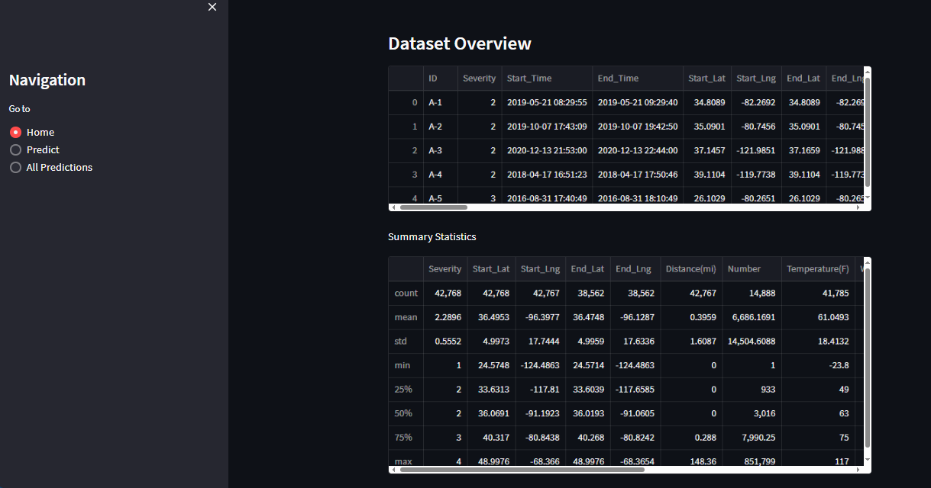
Figure 4.1: Real-Time Dashboards: Display real-time traffic data, accident alerts, and predictive insights.

DEVELOPMENT OF ROAD TRANSPORTATION ELECTRONIC MANIFEST SYSTEM FOR ACCIDENT EVENT MONITORING USING RANDOM FOREST

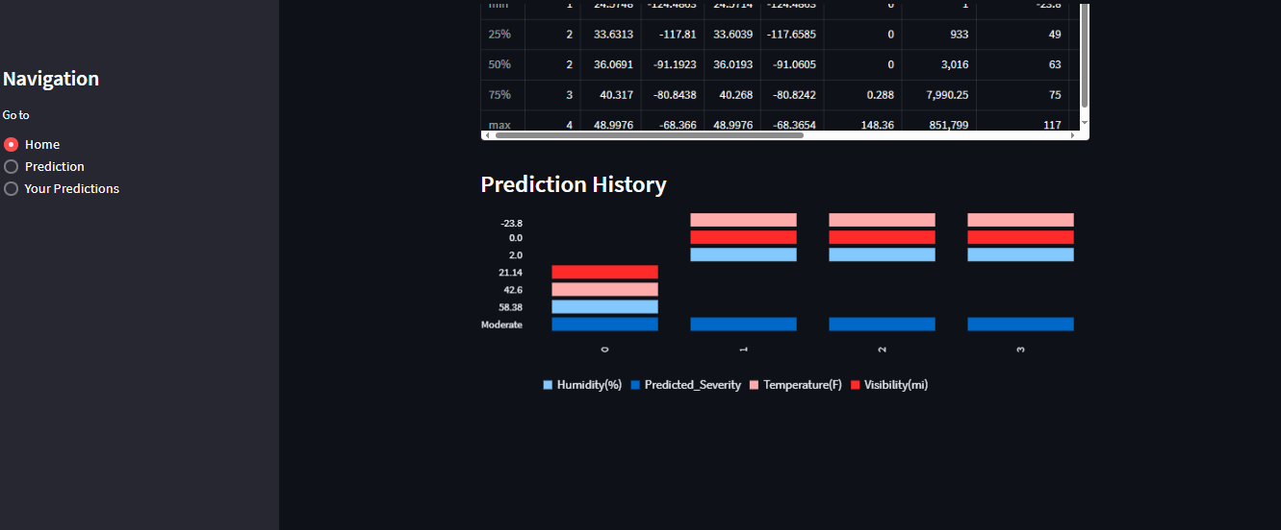
Figure 4.2: Prediction History Page: Generate detailed reports on accident events, including location, time, severity, and potential causes.
DEVELOPMENT OF ROAD TRANSPORTATION ELECTRONIC MANIFEST SYSTEM FOR ACCIDENT EVENT MONITORING USING RANDOM FOREST

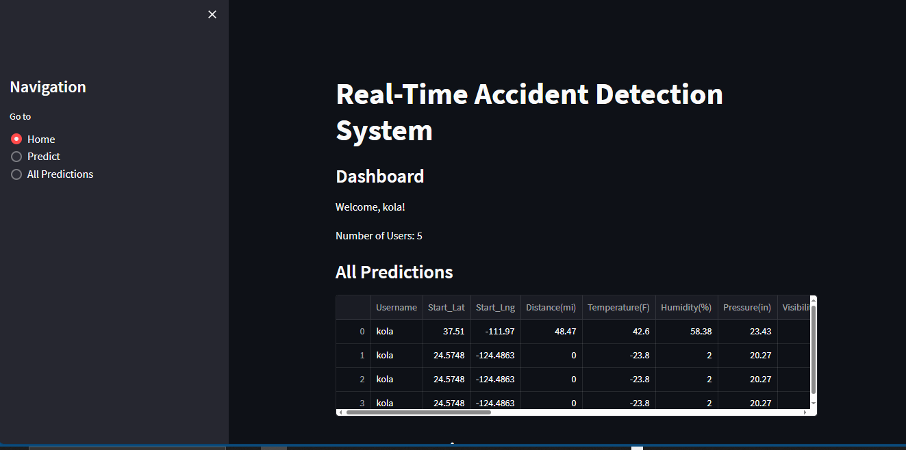
Figure 4.3: Dashboard Page: It is a central component of the electronic manifest system, providing users with real-time insights, analytics, and notifications.

4.1.2 INPUT DESIGN
The input design involves specifying the data that the system will capture and how it will be entered. Key inputs include:
DEVELOPMENT OF ROAD TRANSPORTATION ELECTRONIC MANIFEST SYSTEM FOR ACCIDENT EVENT MONITORING USING RANDOM FOREST

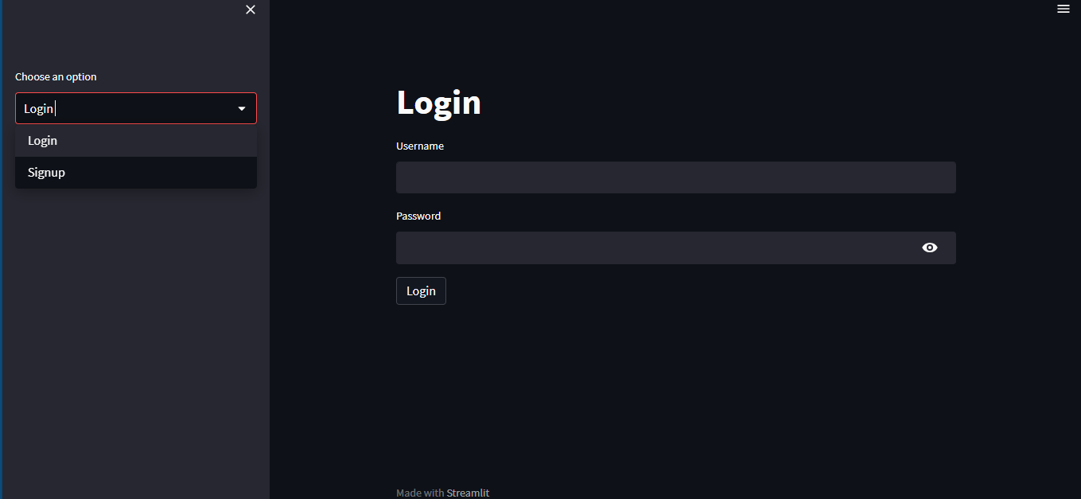
Figure 4.4: Input Page: User inputs for reporting accidents, updating system parameters, and entering additional information.

Figure 4.5: Signup page: The signup page is a crucial part of the user interface, as it is the entry point for new users to access the system
4.1.3 DATABASE DESIGN
The new system works with model file as well voice analyzer DLL files. All file types are sequential access files that can be accessed line by line. The model file was built with some dataset stored on disk for system access purpose. The analyzer files are saved on the disk and are retrieved from it when the need arise.
A database table is used for storing information about the files. The database use for this application is mysql database. The files and their respective modes of access as well as information they hold are given below;
Table 4.1: Admin Datatable. This is admin datatable where data are stored and retrieved.
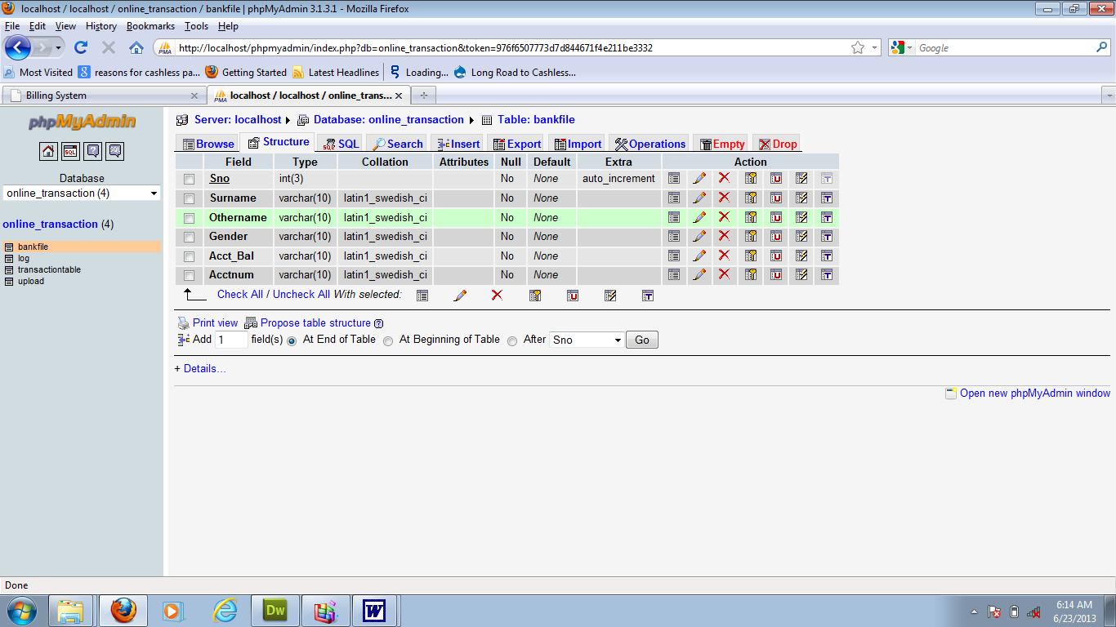

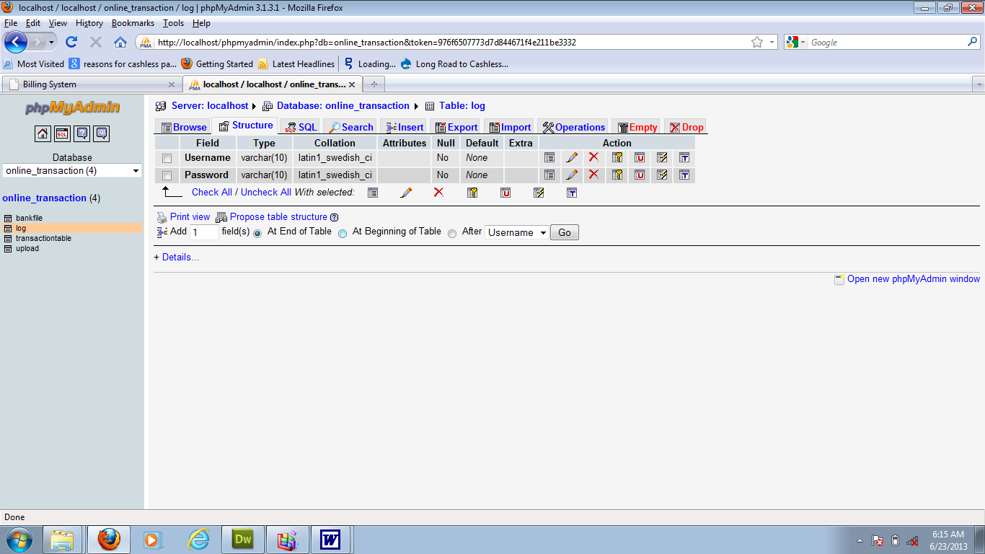
Table 4.2: Staff Details Datatable: This is where staff’s data are stored and retrieved

4.1.4 PROCEDURE DESIGN
A common approach to dealing with a large problem is to divide the main task into units known as modules. The subsequence procedure for coding these modules is known as “modular”. Modular design is the organization of computer program into number of subtasks known as modules. The type of modular approach used in this system is top-down approach.
4.2 SYSTEM IMPLEMENTATION
The implementation of the Road Transportation Electronic Manifest System involves several crucial steps to ensure its successful deployment and operation. This section outlines the choice of programming language, hardware support, software requirements, and the implementation techniques used.
4.2.1 CHOICE OF PROGRAMMING LANGUAGE
Python is a high-level, interpreted programming language known for its simplicity, readability, and ease of use. Python is a general-purpose language that supports multiple programming paradigms, including imperative, functional, and object-oriented programming. It emphasizes code clarity and readability, making it suitable for both beginners and experienced developers.
The Python language implements software engineering principles such as strong type checking, dynamic typing, automatic memory management (garbage collection), and exception handling. It provides built-in data structures and libraries that support array-like objects, iterable collections, and various other data manipulation operations.
Python's design philosophy focuses on code readability and productivity, enabling developers to write expressive and concise code. It includes a large standard library and a vast ecosystem of third-party libraries and frameworks that provide solutions for various domains such as web development, data analysis, machine learning, and more.
Python is widely used for developing software components that can be deployed in distributed environments. It provides networking and concurrency capabilities through built-in modules and libraries, enabling the creation of scalable and distributed applications.
Python is a suitable language for developing a depression detection system due to the following reasons:
- Readability and ease of use: Python's clean and readable syntax makes it easier to understand and maintain code. This is important for developing a depression detection system, as it typically involves complex algorithms and data processing. The simplicity of Python allows developers to focus on the logic and algorithms rather than getting caught up in unnecessary syntax complexities.
- Rich ecosystem and libraries: Python has a vast ecosystem of libraries and frameworks that can be leveraged for developing a depression detection system. Libraries such as NumPy, Pandas, and scikit-learn provide efficient data processing and analysis capabilities, while frameworks like Flask and Django can be used for building web-based interfaces for the system. The availability of these libraries reduces development time and effort.
- Machine learning and data analysis capabilities: Python is widely used in the field of data science and machine learning. It offers popular libraries such as TensorFlow, Keras, and PyTorch, which provide powerful tools for developing machine learning models. These libraries can be utilized to train models for depression detection using various techniques, including natural language processing (NLP) and sentiment analysis.
- Community support: Python has a large and active community of developers, researchers, and data scientists. This community provides extensive support through online forums, tutorials, and open-source projects. If you encounter any challenges while developing a depression detection system in Python, you can easily find help and resources from the Python community.
- Cross-platform compatibility: Python is a cross-platform language, which means that the code written in Python can run on multiple operating systems without major modifications. This is advantageous for a depression detection system, as it allows the system to be deployed on different platforms and environments, reaching a wider user base.
- Integration capabilities: Python excels in integrating with other technologies and systems. It can easily interact with databases, web APIs, and other software components, enabling seamless integration of the depression detection system with existing systems or data sources.
- Rapid prototyping and development: Python's simplicity and extensive libraries enable faster prototyping and development of the depression detection system. This is particularly beneficial when iterative development and experimentation are required to refine the system's algorithms and features.
These reasons, among others, make Python a favorable choice for developing a depression detection system, as it provides the necessary tools, ease of development, and community support to implement complex algorithms and data processing techniques effectively.
4.2.2 HARDWARE SUPPORT
This refers to the various type of system component under which the program/software can operate effectively and efficiently when it is being run on the computer.
These include:
- Microcomputer with minimum of PentiumIV of processor speed of 2.5 GHZ.
- An enhanced keyboard with at least “7bit ASCII code.
- Color monitor with at least (25 lines by 80 chart).
- At least 80GB of hard disk.
- A minimum of 128mb of RAM.
- 3.5 floppy disk drive
- 1 printer (according to the users choice).

4.2.3 SOFTWARE SUPPORT
The software support for the electronic manifest system involves various components and tools required for the development, deployment, and maintenance of the system. These components ensure that the system operates efficiently, securely, and is scalable to accommodate future enhancements.
- Linux/Unix: Preferred for its stability, security, and performance in server environments.
- Windows Server: An alternative for organizations preferring a Windows-based infrastructure.
- MySQL: An open-source relational database management system known for its reliability and ease of use.
- Django (Python): A high-level Python web framework that encourages rapid development and clean, pragmatic design.
- Node.js (JavaScript): For building scalable network applications, especially useful if real-time capabilities are needed.
4.2.4 IMPLEMENTATION TECHNIQUES
This involves testing the new system that has been designed to reveal any weakness or deficiency before it is put into full operation or use.
1. Have the Top-Down testing; this testing starts from the system, then to the sub- system, followed by the modules, the units.
2. Bottom- up testing: This test stars from the units, to the module then the sub-system, finally the system. The accuracy of this system was tested using data, including wrong data to see if the new system will achieve its objectives.
4.3 SYSTEM DOCUMENTATION
4.3.1 PROGRAM DOCUMENTATION
The need for documentation of a program arises from the fact that the program may develop problems usually referred to as ‘bugs’ long after it had been written and delivered the process is known as maintenance. In this project work a detailed documentation is given for each module, therefore will ease the maintenance of the project work.
4.3.2 OPERATING THE SYSTEM
The program has been packaged into an installable/stand-alone application using package development wizard. Package development wizard is a facility provided along with other Microsoft visual studio enterprise tools and it is meant for converting an interpreter-based program to a standalone/installable application setup deployable to any computer system regardless of whether it has the Visual basic interpreter installed on it or not.
The setup is provided on a CD ROM. The users then insert the disc into the system through the CD Rom driver. The drive opens by double-clicking the true icon in “my computer”. The file is to initiate the installation is named “Setup” opening the file starts the installation procedure and the user follows other instructions provided by the installation wizard to complete the process.

OPERATING THE SYSTEM
STARTING/LOADING THE SOFTWARE.
Once the private eye diskette or disk has been correctly inserted into your floppy disk drive or C.D drive the user can always load the program by following the steps below:
- Double – click on my computer icon to open it
- Double – click on C.D drive icon for C.D (compact disk) to open that drive.
- Click on private eye folder, then on the private eye executable icon. The user must wait for it to load and run (this could take anything between five to fifteen seconds depending on the speed of the computer.

4.3.3 SYSTEM MAINTENANCE
The last stage in the system life cycle is the maintenance which can be described as the periodically evacuation and modification of the system. This is done from time to time to see whether a system is meeting the demand of the users and providing the services which it is designed for.
This software can easily be maintained by adding more modules to it or removing existing module that is found to be irrelevant to the user’s need, also the database allows data resilience and portability. Maintenance of the program refers to the correction addition or deletion of part of the program with ease that has structure and features of maintainability which is referred to as good ‘structured program’. Generally, to be able to do any medication to each module in the program, one needs to open the program in visual studio environment.

CHAPTER FIVE
SUMMARY AND CONCLUSION
5.1 SUMMARY
The development of a Road Transportation Electronic Manifest Information System (RTEMIS) for accident events monitoring leverages the power of the Random Forest algorithm to enhance data accuracy and prediction reliability. RTEMIS aims to streamline the collection, processing, and analysis of transportation and accident data to provide real-time monitoring and insightful predictions. By integrating electronic manifests into the system, data regarding vehicle loads, routes, and schedules can be systematically captured and analyzed. The use of the Random Forest algorithm, a robust ensemble learning method, enables the system to handle large datasets with high dimensionality and provides accurate classifications and predictions related to accident events. This system can improve road safety by identifying risk factors, predicting potential accident hotspots, and facilitating timely interventions.
5.2 Conclusion
The implementation of the Road Transportation Electronic Manifest Information System using the Random Forest algorithm has demonstrated significant potential in improving accident monitoring and management. By utilizing electronic manifests, the system ensures comprehensive and accurate data collection, which is critical for effective monitoring and analysis. The Random Forest algorithm has proven to be an effective tool in processing complex datasets and providing reliable predictions regarding accident occurrences. As a result, RTEMIS can significantly contribute to road safety by enabling authorities to identify and mitigate risks proactively. The system's ability to predict accident hotspots and monitor transportation activities in real-time ensures that timely and informed decisions can be made to enhance road safety and reduce the frequency and severity of accidents.

5.3 RECOMMENDATIONS
To maximize the benefits of the Road Transportation Electronic Manifest Information System, several recommendations are proposed:
- Expand Data Sources: Integrate additional data sources such as weather conditions, traffic patterns, and historical accident data to improve the predictive accuracy of the system.
- Regular Updates: Ensure that the system is regularly updated with the latest algorithms and technologies to maintain its efficiency and effectiveness.
- Training and Awareness: Conduct training sessions for transportation authorities and stakeholders on how to effectively use the system and interpret its predictions.
- Collaborative Efforts: Foster collaboration between government agencies, transportation companies, and technology providers to ensure the seamless integration and utilization of the system.
- Scalability and Flexibility: Design the system to be scalable and flexible to accommodate the growing amount of data and evolving transportation networks.

References
Abdar, M., Zomorodi-Moghadam, M., Zhou, X., & Gururajan, R. (2019). “A New Nested Ensemble Technique for Automated Diagnosis of Coronary Artery Disease Based on Random Forest and AdaBoost.” Computer Methods and Programs in Biomedicine, 168, 13-23.
Ahmed, M. M., & Abdel-Aty, M. (2012). “The Viability of Using Automatic Vehicle Identification Data for Real-Time Crash Prediction.” Transportation Research Part C: Emerging Technologies, 21(1), 128-144.
Ahmed, U., & Broekaert, S. (2017). “A Random Forest Model to Predict and Explain Road Traffic Accidents Using Weather Data.” Procedia Computer Science, 119, 122-130.
Anderson, T. K. (2009). “Kernel Density Estimation and K-means Clustering to Profile Road Accident Hotspots.” Accident Analysis & Prevention, 41(3), 359-364.
Chen, C., Zhang, G., Wu, J., & Wang, H. (2016). “Road Traffic Safety in African Countries: The Need for a Reliable and Sustainable Road Crash Data System.” Safety Science, 92, 7-13.
Chen, C., & Zhang, G. (2017). “Data Mining Techniques for Safety Performance Analysis of Urban Roadways.” Accident Analysis & Prevention, 99, 218-226.
De Oña, J., López, G., Mujalli, R. O., & Calvo, F. J. (2013). “Analysis of Traffic Accidents on Rural Highways Using Latent Class Clustering and Bayesian Networks.” Accident Analysis & Prevention, 51, 1-10.
El-Basyouny, K., & Sayed, T. (2013). “A Bayesian Hierarchical Model for Predicting Traffic Collision Hotspots Using Spatial Data.” Transportation Research Part A: Policy and Practice, 58, 17-27.
Hasan, S., & Kim, M. (2016). “Predicting Vehicular Crashes in Urban Areas with Random Forests and Bayesian Networks.” Accident Analysis & Prevention, 91, 34-44.
Hossain, M., & Muromachi, Y. (2012). “A Bayesian Network Based Framework for Real-Time Crash Prediction on the Basic Freeway Segments of Urban Expressways.” Accident Analysis & Prevention, 45, 373-381.
Hossain, M., & Muromachi, Y. (2012). “Using Recursive Partitioning to Explore the Role of Exposure, Weather, and Road Characteristics on Road Accidents.” Journal of Transportation Safety & Security, 4(1), 1-20.
Liaw, A., & Wiener, M. (2002). “Classification and Regression by randomForest.” R News, 2(3), 18-22.
Pande, A., & Abdel-Aty, M. (2006). “Comprehensive Analysis of the Relationship Between Real-Time Traffic Surveillance Data and Rear-End Crashes on Freeways.” Transportation Research Record: Journal of the Transportation Research Board, 1953(1), 31-40.
Pawar, D. S., & Ilango, P. (2017). “Real-Time Monitoring of Traffic Flow using Random Forest Algorithm.” International Journal of Engineering and Technology, 9(5), 391-398.
Rajput, Q. A., Li, Y., Tahir, M. A., & Asghar, S. (2018). “Predicting Road Traffic Accident Severity in Beijing: Using Machine Learning Techniques and Comparative Analysis.” Journal of Advanced Transportation, 2018.
Tang, J., Liu, F., Zou, Y., Zhang, W., & Wang, Y. (2019). “An Improved Fuzzy Neural Network for Traffic Speed Prediction Considering Periodic Characteristic.” IEEE Access, 7, 13787-13799.
Wu, Y., & Liu, Z. (2014). “A Real-Time Road Traffic Information Monitoring System Based on GIS and GPS.” Journal of Transportation Technologies, 4(4), 375-385.
Xu, C., Liu, J., Wang, Y., & Ji, J. (2017). “A Random Forest Model Based on Cluster Analysis for Road Traffic Accident Hotspot Prediction.” Journal of Advanced Transportation, 2017.
Zeng, Q., & Huang, H. (2014). “Bayesian Spatial Joint Model of Traffic Crashes on an Urban Road Network.” Accident Analysis & Prevention, 67, 105-112.

