A PROJECT REPORT

ON
PROPOSED PRIMARY SCHOOL
FOR
IKKENE COMMUNITY , ISORO LOCAL
GOVERNMENT OGUN STATE
BY
ARIYO BLESSING OLUWATIMILEYIN
ND/23/ARC/FT/0005

SUBMITTED TO
THE DEPARTMENT OF ARCHITECTURAL TECHNOLOGY, INSTITUTE OF ENVIRONMENT STUDIES (IES), KWARA STATE POLYTECHNIC, ILORIN

IN PARTIAL FULFILLMENT OF THE REQUIREMENTS FOR THE AWARD OF NATIONAL DIPLOMA [ND] IN ARCHITECTURAL TECHNOLOGY KWARA STATE POLYTECHNIC, ILORN KWARA STATE.

JULY,2025

DECLARATION
I declare that this project/dissertation is a Product of my personal research work. It has not been Presented to the award of any degree in any polytechnic. These ideas, Observations, comments , Suggestions, herein represent my own convictions except quotation, which have been acknowledged in accordance with conventional academic tradition.

NAME: ARIYO BLESSING OLUWATIMILEYIN

MATIC NO: ND/23/ARC/FT/0005

_________________________ __________________
Signature Date

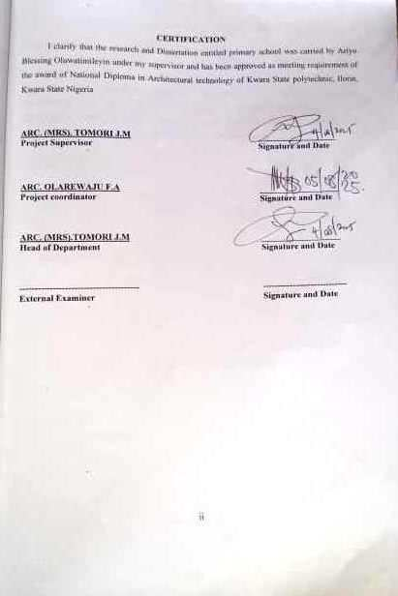

ACKNOWLEDEMENT
My Profound gratitude goes to Almighty Allah who has always be in existents for taking control of this proper for is infinite, mercy and giving me the privilege to write the report.
My Special gratitude goes to the Department of Architectural Technology the entire staff and my Supervisor ARC MRS J.M TOMORI and also to the HOD of the Department in person of ARC MRS MULIKAT JUMOKE TOMORI who has been supportive throughout this Project may Allah Continue to reward you and your family.
My Sincere appreciation goes to my dearest, lovely and coming parents, my mum and my late DAD Mr. & Mrs. Folashade Ariyo, Lukmon Ariyo for the Financial and moral Support to making my dream a reality,
I Sincerely appreciate the Support and assistance of everyone who contributed to this project, especially those who offered helps.
I appreciate my course mate, my sweet good Friends Oladimeji Abdul, Aishat, Fatimah, Uncle Sunday, My Rep and Assistant Rep, and the rest for their support, encouragement, and collaboration throughout the course of this project.

DEDICATION
This report is dedicated to Almighty Allah, the Universal, the Creator of all creator, and the source of mankind who has always be my strength throughout the project and also for his unconditional and Infinite mercy showered upon me though my study.
Also I dedicate this project to my parent MR. & MRS ARIYO for their parental, Financial and moral Support
Finally to my brothers and Sisters and my colleagues and other for their contribution to attain great achievement I pray Almighty Allah reward Everyone abundantly.

ABSTRACT
The Project envisage the establishment of primary school project present a Pioneering architecture design for an educational institution prioritizing Sustainable, Inclusive, and academic excellence, the project will offer a unique environment that foster Social interaction creativity and community engagement by combining innovating design, Sustainable practices and Community focused feature the model college sets a news, Standard for education architecture, providing a thriving environment for students to learn and succeed academically.

TABLE OF CONTENTS
TITLEPAGE……………………………………………………………………………… i
Declaration………………………………………………………..…………………………ii
Certification……………………………………………………….………………………..iii
Dedication…………………………………………………………………………………..iv
Acknowledgement……………………………………………………….…………………v
Table of Content……………………………………………………………………………vi
List of Tables………………………………………………..……………………………….vii
List of Figures……………………..……………………….……………………….……....viii
List of plates………………………………………………………………….……...……..xi
List of Appendices………………………………………………………………….……....x
Abstract………………………………………………………………………..…………....xii
CHAPTER ONE
1.0 Introduction………………………………….………….……………….………….1
1.1 Historical background………...………………….…………………………………1
1.2 Statement of institutional hostel …………..……………………….……………….1
1.3 Aim and objectives………………………………………..……………………..….2
1.4 Justification………………………………………………………………..…..…….2
1.5 Client’s background…………………………………………………………….…...2
1.6 Scope of study…………………………………………………………………….…3
1.7 Limitations of constraints ………………………..…....……………..…………,….3
1.8 Research methodology……………………………………………………………….4
1.9 Definition…………………………………………………………………………….4

CHAPTER TWO
2.1 Literature Review …………………………………… ……………………………5
2.2 Introduction………………………………………...…………………………..…...5
2.3 Purpose and Importance of Primary Education …………………………..………..5
2.4 Functions and Relationships Between Spaces in a Primary School……………………7
2.5 Unique Solutions to Specific Problems Peculiar to the Primary School Archetype …………………………………………………………………………………….9
2.6 Technological and environmental approaches for designing a primary school building….10
2.7 Technological and Environmental Approaches for Designing Primary School Typology..11
CHAPTER THREE
3.0 Case study………………………………………………………………..…….……14
3.1 Case study 1 one (Olohushogo Nursey and primary School, Ilorin)……..………....14
3.2 Case study two (St. David’s Anglican primary school)……..…………………. ..….17
3.3 Case study three (Winsome private school)………………………………………..20
3.4 Case study four (Online case study) primary school…………………………… …22
CHAPTER FOUR
4.1 Introduction to study area / selection site………………….........…………….……26
4.2 Site location …………….……………………………………………………….…. 27
4.3 Site location map………….………………………………………...……………….28
4.4 Site analysis. ……………………...……….………………………………………...29
4.5 Geographical/ climatic data…………………………………………………………..29
4.6 Design concept………………………………………………………………………….33

CHAPTER FIVE
5.1 Design concept ………………………………………………..……………..… …..35
5.2 Conclusion…………………………………………………………………………………..45
5.3 Recommendations………………………………………………………………………..46
References……………………………………………………………………………………48

LIST OF PLATES
CASE STUDY 1
Plate 3.1.1 (Front view of Olohunshogo Nursery and Primary school)………………. 16
Plate 3.1.2 (Side view of Olounshogo Nursery and Primary school, Ilorin)………….. 16
CASE STUDY 2
Plate 3.2.1 (Front view of St. davids Anglican Primary School) ……………………. 19
Plate 3.2.2 (Interior view of St. davids Anglican Primary School)……………………. 19
CASE STUDY 3
Plate 3.3.1 (Front view of Wisome Private School)………………………………….. 22
Plate 3.3.2 (Side view of Wisome Private School)……………………………………. 22
ONLINE CASE STUDY 4
Plate 3.4.1 (Front view of the Queens bridge school)…………………………………. 23
Plate 3.4.2 (Back view of the Queens Bridge school)……………………………….. 23

LIST OF FIGURES
Figure 3.1.1 (Site plan of the proposed primary school)……………………………….. 14
Figure 3.1.2 (location Map of the proposed primary school)………………………….. 15
Figure 3.1.3 (floor plan of the proposed primary school)……………………………. 15
Figure 3.2.1 (Site plan of St. David’s primary school)…………………………………. 17
Figure 3.2.2 (floor plan of St David Anglican Primary school)………………………… 18
Figure 3.2.3 (Location plan of St. David’s primary school)………………………………18
Figure 3.3.1 (Site plan of winsome private school lagos)…………………………………20
Figure 3.3.2 ( location plan of winsome private school Lagos) …………………………..21
Figure 4.1.1 (Location map)……………………………………………………………….28.
Figure 4.1.2 (Site analysis)…………………………………………………………………29
Figure 4.1.3 (Geographical/climatic data)…………………………………………………30
Figure 4.1.4 (Design concept)……………………………………………………………...34
Figure 4.1.5 (Site Inventory)……………………………………………………………….51

LIST OF TABLE
Table 4.1.1: Space Allocation ……………………………………………………………32

LIST OF APENDICES
Appendices 5.1: Side Plan ………………………………………………………………..51
Appendices 5.2: Floor Plan………………………………………………………………..52
Appendices 5.3: Roof Plan………………………………………………………………..53
Appendices 5.4: Section ………………………………………………………………….54
Appendices 5.5: Elevation ………………………………………………………………..55
Appendices 5.6: External Perspective …………………………………………………….56

CHAPTER ONE
- Introduction
Primary school is known as educational institution that provide elementary education to children to gain or acquire knowledge skills, value, formation and good attitude to improve and achieve their aims.
1.1 HISTORICAL BACKGROUND OF THE STUDY
Primary School education has long been recognize has the Foundation of Formal leaning, The origin of primary Schools dates back to ancient civilization Such as Egypt, Greece, and Rome where basic education were provided to young children’s manly boys, and girls to prepare them for civic life, however the modern concept of Primary school emerged during the 18th and 19th century’s in Europe in the rise of formalized public education system.

In Nigeria western-style primary education began in the early 1840s through missionary efforts, particularly by the Church Missionary Society (CMS) in the southern part of the country', the first known primary school is St, Thomas Anglican primary school was established in Badagry, Lagos state, in 1843.
Over time the colonial government and local authorities began to support and expand the primary school system after Nigeria gain independence in 1960, primary education was made apriority in National development education program was launched in 1976, and later evolved until universal basic education (UBE) program in 1999, aiming to provide Free compulsory and quality education for all Nigeria children.

Today primary schools serve as the first stage of formal education for children typically from age 6 to 12 and play a critical role in literacy, numeracy and Social development, the growth of public and private primary schools across the country reflects a continue commitment to accessible and inclusive education
1.2 Statement of the study
Many primary face challenges related to the design condition of their learning environment inadequate classroom, space, poor lightning and ventilation, lack of modern teaching tools over crowded class room and insufficient furniture can negatively affect the learning experience of young children. Those issue makes it difficult for teachers to deliver effective teaching and for students to concentrate explore and developed critical skills.
The design of primary school should support a child friendly, safety and engaging environment.
However, in many cases especially in rural or under founded area, the exiting infrastructure fails to meet basic standard for comfort, accessibility and education innovation.
Therefore the problem is to design a primary school environment that is inclusive functional, safe, and stimulating especially in Ikenne local government Ogun state.
1.3 AIMS AND OBJECTIVES
1.3.1 AIM OF THE STUDY
The aim of the study is to design a functional, inclusive, and sustainable primary school that provides a safe, child-friendly, and stimulating learning environment, while addressing the architectural, educational, and environmental challenges currently facing basic education.
1.3.2 OBJECTIVES
- To design a functional and flexible learning environment that supports effective teaching and accommodates modern educational methods .
- To create a child-friendly architectural design that promotes comfort, safety, and psychological development for young learners.
- To provide adequate academic and non-academic facilities, including classrooms, administrative offices, library, ICT room, toilets, playgrounds, and a multipurpose hall.
- To ensure proper spatial planning for efficient circulation, security, and accessibility within the school premises.
1.4 JUSTIFICATION
The justification for this project is rooted in the pressing need for accessible, safe, and modern educational infrastructure within Ikenne LGA. This study proposes the design and development of a purpose-built primary school to address multiple challenges facing the local education system and support national development goals.
1.5 CLIENT BACKGROUND
The client for this project is the Ikenne Local Government Council, acting through its Department of Education and Social Development. As a public administrative body, the council is responsible for the welfare, education, and infrastructural development of communities within its jurisdiction.
Vision and Mission
- Vision: Empowering communities through inclusive education, child welfare, and sustainable infrastructure.
- Mission: "To provide a nurturing and inclusive learning environment that fosters academic excellence, character development, and creativity in every child, empowering them to become responsible, confident, and lifelong learners who contribute positively to their community and the world."
1.6 SCOPE OF THE STUDY
This study focuses on the architectural, functional, and cultural significance of the Ikenne primary school located in Ikenne, Isoro Local Government Area, Ogun State, Nigeria. It examines the School’s role as an educational, and social hub for the communities in the region. The study covers the historical background, architectural design, spatial organization, materials used, and the primary school influence on community development. It also explores the school vision, mission, and the client’s expectations for its continued relevance and functionality.
  - LIMITATION OF CONSTRAINTS
Limitation to the research are not but some was overcome by the course of the study. The following limitation are experienced during the research.
Photograph restricted in some area which could have been used to explain some features seen during the case study.
Restriction of movement be securities and the authorities of the industrial used for study research.
1.8 RESEARCH METHODOLOGY
Research is been carried out on the proposed project for a better option and aesthetics design to the proper functionality of the building in relation to the site and landscape.
Case study: This is done by close study of existing modern structure or building which is similar to functional of project
1.9 DEFINITION
Primary school is the first formal stage of a child education and plays a vital role in their early development. It typically begins around the age of four or six and continues until the age of eleven of twelve depending on the country.
During these Important years, children are Introduced to the basic building blocks of education Including literacy, numeracy, Science, Social Studies, moral values.
Primary School is not just about academic learning. It also focuses on the overall development of the child. It helps Students build essential life skills such as communication, Cooperation, critical thinking and problem-solving. Children also learn to interact with each others, follow rules, and understand the importance of respect and responsibility.
Overall, primary School is a key part of child's education journey, Shaping not only their knowledge but also their attitudes values and Character For life.

CHAPTER TWO
2.1 LITERATURE REVIEW ON PRIMARY SCHOOL EDUCATION
Introduction
Primary education, also known as elementary education, is the foundation of a child's educational journey. It typically caters to children aged 5 to 11 and serves as a crucial stage for cognitive, emotional, social, and physical development. Scholars and educators agree that the quality of primary education has a lasting impact on an individual’s future learning and development.
2.2 Historical Perspective
Historically, primary education began as informal instruction within the home or community. With the industrial revolution and rise of modern nation-states, governments began establishing formal school systems. In Nigeria, for example, the introduction of Western-style education dates back to the mid-19th century through missionary efforts, with the first primary school founded in Badagry in 1843.
2.3 Purpose and Importance of Primary Education
The United Nations Educational, Scientific and Cultural Organization (UNESCO) emphasizes that primary education should be free and compulsory for all children. It aims to:
Equip children with basic literacy and numeracy skills.
Lay a foundation for lifelong learning and personal development.
Foster values such as discipline, cooperation, and civic responsibility.
Studies (e.g., Lockheed & Verspoor, 1991) have shown that children who complete quality primary education are more likely to continue into secondary education and perform better economically and socially.
2.3.1Curriculum and Pedagogy
The primary school curriculum typically includes:
English Language
Mathematics
Science and Technology
Civic Education
Cultural and Creative Arts
2.3.2 Physical and Health Education
Modern pedagogy encourages learner-centered approaches, active learning, and integration of play, especially in lower primary classes. Vygotsky’s Social Development Theory and Piaget’s Cognitive Development Theory heavily influence primary education methods.
2.3.3 School Infrastructure and Learning Environment
Researchers like Earthman (2002) and UNICEF have emphasized the impact of the learning environment on educational outcomes. A well-designed primary school should provide:
2.3.4 Adequate lighting and ventilation
Age-appropriate furniture
Safe playgrounds
Sanitation facilities
Inclusive access for children with disabilities
In developing countries, infrastructural deficits remain a significant challenge. Poor classroom conditions, overcrowding, and inadequate resources negatively affect students' academic performance and attendance.
2.3.5 Challenges in Primary Education
Some persistent challenges in primary school systems, especially in Africa and Asia, include:
Low teacher-to-pupil ratio
Inadequate training for teachers
Poor school funding
High dropout rates, especially among girls
Lack of digital learning tools
Government policies like Nigeria’s Universal Basic Education (UBE) Program aim to tackle these challenges by providing free, compulsory education and improving school infrastructure.
2.3.6 Emerging Trends
Recent literature shows a shift toward:
Technology integration in the classroom (e.g., digital whiteboards, tablets)
Inclusive education for children with special needs
Child-friendly school design that considers safety, color, flexibility, and interactive spaces
Sustainable and green architecture to enhance learning environments and reduce ecological footprints.
2.4 Functions and Relationships Between Spaces in a Primary School
Primary schools are educational facilities designed to support the cognitive, social, and physical development of children aged approximately 5 to 11 years. Each space within the building has a specific function and is designed in relation to others to encourage safety, learning, interaction, and movement.
A. Core Educational Spaces
i. Classrooms
Function: Serve as the main learning environment.
Relationship: Centrally located and easily accessible from circulation corridors.
Should be grouped by age level or grade, often in clusters.
ii. Staff/Teachers' Room
Function: Space for teacher planning, rest, and collaboration.
Relationship: Should be near the classrooms and administrative area.
iii. Library/Resource Centre
Function: Enhances learning with books and media.
Relationship: Centrally located or close to classrooms for easy access.
B. Administrative Spaces
i. Head Teacher’s Office
Function: Leadership and management.
Relationship: Near the main entrance for accessibility to visitors and oversight.
ii. Reception / Waiting Area
Function: For visitors, parents, and administrative control.
Relationship: Adjacent to administrative offices and entrance for supervision.
C. Auxiliary Learning & Activity Spaces
i. Computer Room / ICT Lab
Function: For digital learning and skill development.
Relationship: Should be secure, quiet, and close to classrooms.
ii. Art and Music Rooms
Function: Creative expression.
Relationship: Can be in quieter zones or even open-plan with flexible partitioning.
iii. Multipurpose Hall / Assembly Area
Function: For events, indoor sports, and community activities.
Relationship: Should be easily accessible to all and often located near the entrance or central area.
D. Circulation and Social Spaces
Corridors, Lobbies, and Verandas facilitate movement between classrooms and facilities, Should be wide, well-lit, and child-safe, Allow passive supervision and natural ventilation.
E. Sanitary and Utility Spaces
Toilets: Age-appropriate, gender-separated, and accessible to all, including children with disabilities.
Water Points: Located near toilets and playgrounds for hygiene and hydration.
F. Outdoor Spaces
i. Playground / Sports Field
Function: Physical activity and play.
Relationship: Located away from classrooms to reduce noise but accessible during breaks.
ii. Gardens / Outdoor Learning Areas
Function: For environmental education and relaxation.
Relationship: Near lower-grade classrooms and communal spaces.
2.5 Unique Solutions to Specific Problems Peculiar to the Primary School Archetype
Problem 1: Noise Control
Solution: Use of buffer zones like corridors, green spaces, or walls between classrooms and noisy areas like playgrounds or assembly halls.
Problem 2: Child Safety and Supervision
Solution: Design with passive surveillance in mind – long sightlines, transparent partitions, and strategically placed staff rooms.
Use of secure fencing, gates, and drop-off areas.
Problem 3: Age-Specific Needs
Solution: Design different classroom furniture, toilets, and blackboard heights for lower and upper primary students.
Create cluster arrangements with shared breakout or play zones.
Problem 4: Natural Lighting and Ventilation
Solution: Large windows with child-safe louvered openings, use of courtyards for airflow, and cross-ventilation in classrooms.
Problem 5: Flexibility in Learning Spaces
Solution: Use of movable partitions to convert spaces into multipurpose learning zones.
Outdoor classrooms for environmental and experiential learning.
Problem 6: Overpopulation in Urban Schools
Solution: Vertical expansion with open-air corridors and rooftop play areas.
Compact designs with efficient circulation and multi-use spaces.
Problem 7: Climate and Sustainability
Solution: Use of local, passive design strategies like overhangs, shading, water harvesting, and materials with low thermal mass.
2.6 Technological and environmental approaches for designing a primary school building
Here is a detailed guide on technological and environmental approaches for designing a primary school building, with focus on structures, materials, lighting, ventilation, mechanical systems, and services. This is especially useful for design projects in tropical regions like Nigeria and other similar contexts:
2.7 Technological and Environmental Approaches for Designing Primary School Typology
- Structural Systems
Types of Structures Suitable for Primary Schools
Reinforced Concrete Frame Structures: Most common in Nigeria for durability, fire resistance, and strength. Allows flexibility in space arrangement and vertical expansion.
Load-Bearing Masonry (Blockwork): Suitable for low-cost single-storey schools. Less flexible but easy to construct with local skills.
Steel Frame Structures: Lightweight and fast to erect. Ideal for modular or temporary classroom blocks.
Timber or Hybrid Structures: More common in rural or eco-focused schools. Can be combined with steel or concrete for roofs and framing.
ii. Building Materials
Recommended Materials
Cement Hollow Blocks or Compressed Earth Blocks (CEB): Affordable and accessible.
CEBs are sustainable, low-carbon, and thermally efficient.
Aluminum or UPVC Windows: For durability and low maintenance.
Corrugated Zinc or Aluminum Roofing Sheets: Light, cost-effective roofing for rural or urban schools. Should include insulation or false ceiling in hot climates.
Recycled Materials: For floors or partitions, e.g., recycled plastic tiles or wooden pallets.
Environmental Consideration
Use local materials to reduce transport costs and promote sustainability.
Ensure non-toxic finishes to protect children's health.
- Natural Lighting Design
Strategies for Effective Lighting
- Large Windows (Above Desk Height)
- Use clear glazing or louvered windows to maximize daylight.
- Windows on both sides of classrooms provide balanced light.
- Skylights or Roof Monitors
- Used in large halls or deep classrooms to bring in daylight.
- Light-Colored Interior Finishes
- Reflect light and reduce the need for artificial lighting.
- Shading Devices (Sun Breakers or Louvers)
- Prevent glare and heat gain while allowing soft natural light.
- Natural and Mechanical Ventilation
- Passive Ventilation Techniques
- Cross Ventilation
- Windows and ventilators on opposite walls enhance air movement.
- Vent Blocks or High-Level Openings
- Help expel warm air and maintain air circulation.
- Courtyards or Breezeways
- Act as air corridors to cool buildings naturally.
- Roof Vents or Ridge Vents
- Allow hot air to escape through the top.
- Mechanical Backup (where necessary)
- Ceiling or Wall Fans
- Provide comfort during extreme heat.
- Low-Energy Extractor Fans
- For toilets, kitchens, and laboratories.
- Water, Sanitation, and Electrical Services
Water Supply
- Boreholes or Rainwater Harvesting Systems
- Use storage tanks and filtration systems for clean water.
Sanitation
- Ventilated Improved Pit (VIP) Latrines
- In rural settings, hygienic and low-cost.
- Flush Toilets with Septic Systems
- For urban schools with adequate water supply.
- Handwashing Stations
- Located near toilets and playgrounds to promote hygiene.
Electricity
- Solar Panels with Inverters
- Ideal for lighting, powering fans, and basic ICT tools.
- Supports sustainable energy goals (especially off-grid schools).
- LED Lighting
- Energy-efficient and long-lasting.
Other Services and Technologies
- ICT Integration
- Provision for Computer Rooms or Smart Classrooms
- Raised flooring or trunking systems for cable management.
- Wi-Fi Access Points Located in administrative areas or libraries.
Security and Safety Systems
Fire Extinguishers and Alarm Systems
Accessible Exits and Emergency Routes
Child-Safe Electrical Outlets and Non-slip Flooring

CHAPTER THREE
3.0 CASE STUDY:
According to JSTOR (January 2019), a case study is about a person, group, or situation that has been studied over time. It can be defined as an intensive, systematic investigation about a person, group of people, or a unit in which the researcher examines in depth data relating to several variables. Case studies can be produced by following a formal research method. These case studies are likely to appear in formal research venues, as journals and professional conferences, rather than popular works.
Outline of case study
- Olohushogo Nursey and primary School, Ilorin
- St. David Akure Oke Ijebu
- Winsom Private School Lagos
- Online case study London primary school
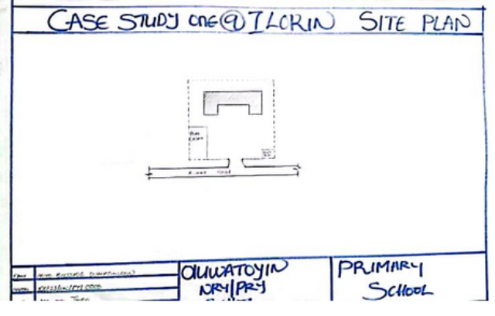
3.1 Case study 1: Olohushogo Nursey and primary School, Ilorin.

Figure 3.1.1: Site plan of the proposed primary school
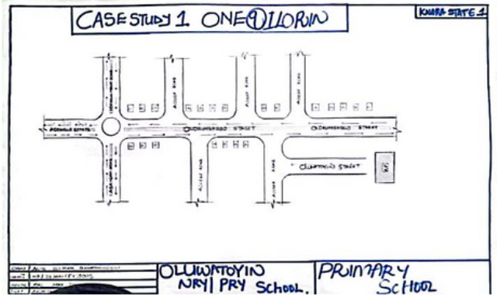
Figure 3.1.2: location Map of the proposed primary school

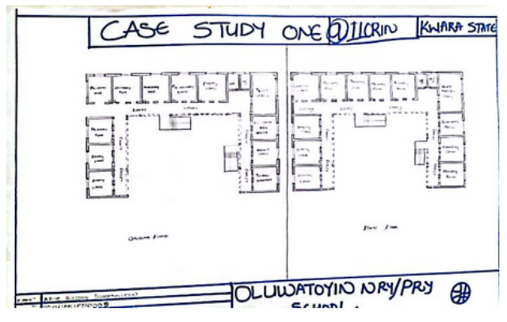
Figure 3.1.3: floor plan of the proposed primary school
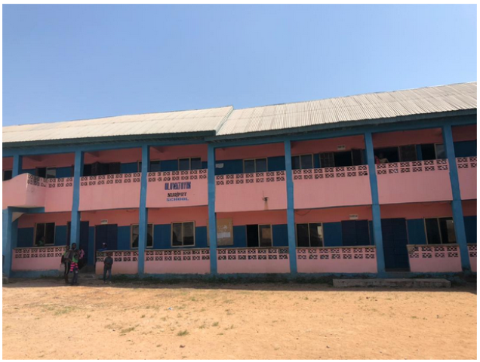
Plate 3.1.1: Front view of Olounshogo Nursery and Primary school, Ilorin.
Source: Research field work 2025
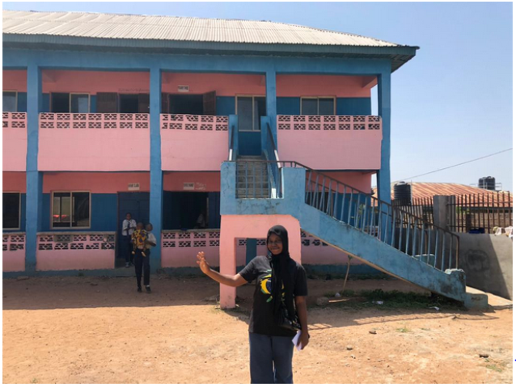

Plate 3.1.2: Side view of Olounshogo Nursery and Primary school, Ilorin.
Source: Research field work 2025
Merits
- It has an adequate ventilation
- Its easily accessible
- It has adequate lightning
Demerits
- The building are old
- Most of the class are empty
- Availability of some unit like bookshop, clinic and some other unit
Case study 2: St. David’s Anglican primary school
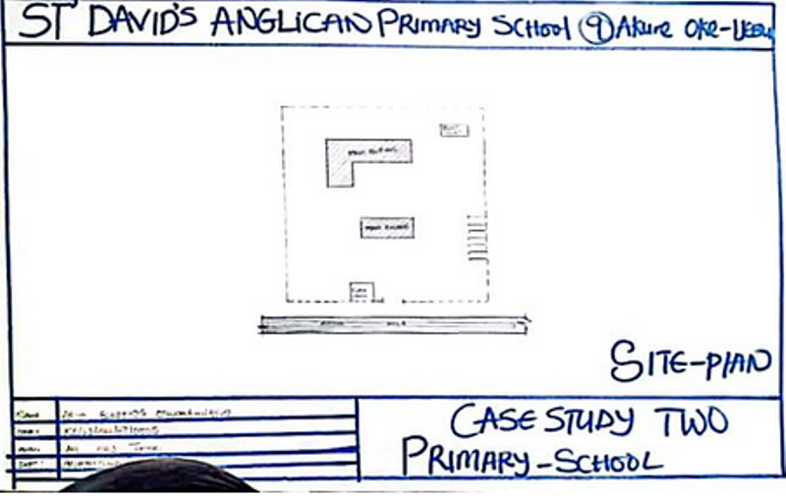Figure 3.2.1: Site plan of St. David’s primary school

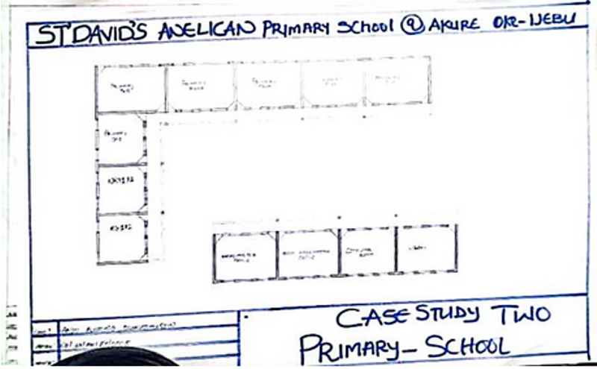
Figure 3.2.2: floor plan of St David Anglican Primary school
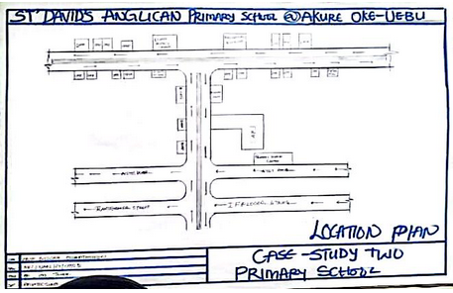
Figure 3.2.3: Location plan of St. David’s primary school

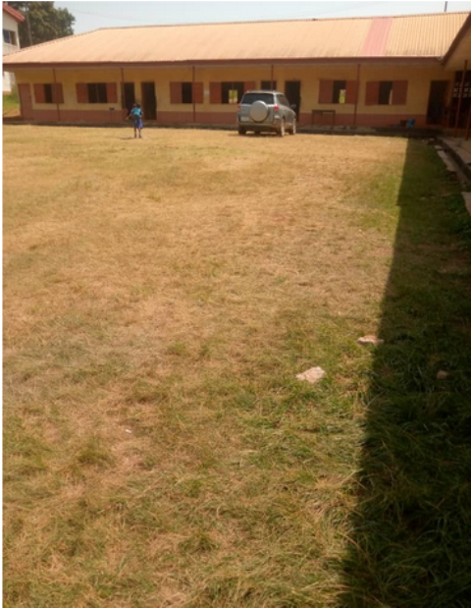
Plate 3.2.1: Front view of St David’s Anglican Primary school
Source: Research field work 2025
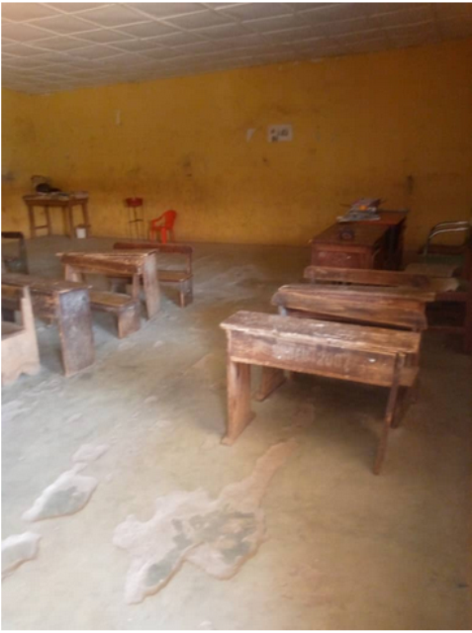

Plate 3.2.2: Interior view of St David’s Anglican Primary school
Source: Research field work 2025
Merits
- It has an adequate Ventilation
- The compounds are neat
- Easy to locate
Demerits
- The Buildings are old
- They have poor class room
- they have a good landscape in some area
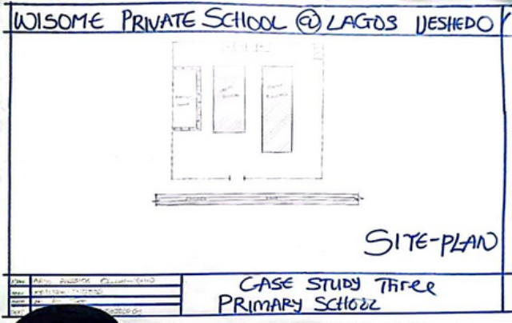
Case study 3: Winsome private school
Figure 3.3.1: Site plan of winsome private school lagos
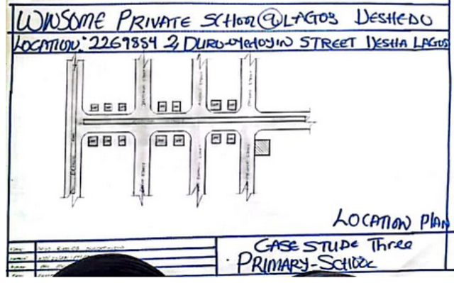
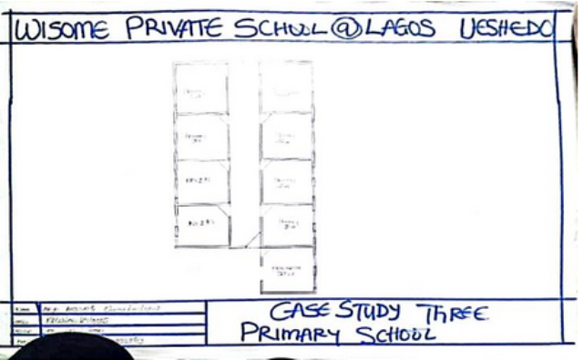
Figure 3.3.1: Floor plan of winsome private school Lagos
Figure 3.3.2: location plan of winsome private school Lagos
Merits
- It’s easy to locate
- The toilet are clean
Demerits
- It has no Ventilation
- It has a poor landscape
- They have no unit like computer Unit and some other unit
- It has no adequate lightning
Case study 4: Online case study
Date of establishment:
Founded (original school structure): 1898
Renamed to Queens bridge Road: 1939
Functioning as a primary school (name Queens bridge): from ~1951
Location:
Queens bridge Primary School is located at:
Queens bridge Road, Haggerston, Hackney, London, E8 4ET

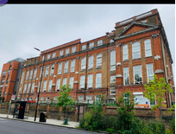
Plate 3.4.1: Front view of the Queens bridge school
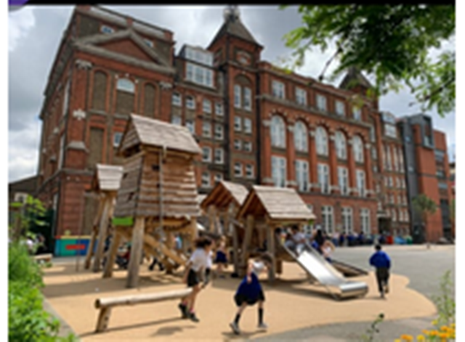

Plate 3.4.2: Back view of the Queens Bridge school
Brief Description
Queens bridge Primary School is a long-established community primary school located in Haggerston, Hackney, London. It caters to children aged 3 to 11 years and offers both nursery and full-time primary education. The school is well known for its commitment to inclusive learning, creativity, and environmental awareness.
Climate
Climate of London (Queens bridge Primary School Area – Hackney, London, UK)
Queens bridge Primary School is located in Hackney, East London — an area that experiences a temperate maritime climate, typical of much of the United Kingdom.
- General Climate Overview
Season | Temperature Range | Characteristics
Spring | 9°C – 16°C (48°F – 61°F) | Mild, increasing sunshine, occasional showers.
Summer | 15°C – 25°C (59°F – 77°F) | Warmest months (June–August), with longer daylight.
Autumn | 10°C – 18°C (50°F – 64°F) | Cooler, windier, leaves falling, more rain
Winter | 2°C – 9°C (36°F – 48°F) | Coldest months (Dec–Feb), rare snow, damp conditions.

Topographical Features
Elevation: Typically ranges between 10 to 30 meters above sea level
Terrain Type: Mostly flat to gently sloping ground
Soil and Substrate: Made up of London Clay and alluvial deposits from the River Thames
Nearby Water Bodies: Close to the Regent’s Canal and a short distance from the River Thames
Urban Influence: The natural land has been highly modified by urban development, including buildings, roads, and canals
Topography
Landscape Context Around Queens bridge School
The area around Queens bridge Road is densely urban, with pavemented streets, Victorian buildings, parks, and public infrastructure. Nearby green spaces include London Fields, Haggerston Park, and Albion Square Gardens, which offer relatively flat grassy terrains and scattered trees.
Merits of Queens bridge Primary School
- Outstanding Ofsted Rating: Rated "Outstanding" by Ofsted in 2023—indicating exceptional teaching, leadership, and pupil achievement.
- Rich Historical Architecture The school retains beautiful Victorian red-brick architecture, offering character and heritage.
Demerits of Queens bridge Primary School
- Urban Pollution Risks Being located in central Hackney, the school is exposed to traffic pollution, although mitigated with green screens.
- Limited Expansion Space Urban setting may limit outdoor space and the ability to expand school grounds or facilities.

CHAPTER FOUR
4.1 Historical Background
Ikenne is a historically significant town located in Ikenne Local Government Area of Ogun State, in southwestern Nigeria. It is one of the oldest and most respected Yoruba towns, known for its contributions to education, politics, and religious movements in Nigeria. Ikenne Local Government Area in Ogun State was created in September 1991, carved out of the defunct Remo Local Government. It is known for its semi-urban character, comprising five major towns: Ikenne (the headquarters), Iperu, Ilisan, Ogere, and Ironu.
Ikenne was founded by Yoruba migrants, believed to be descendants of Oduduwa, the progenitor of the Yoruba people. The town is traditionally ruled by the Oba of Ikenne, and it has a strong chieftaincy system and rich cultural heritage.
The people of Ikenne were mainly farmers, hunters, and traders, with crops like yam, cassava, and kolanut playing a key role in the economy.
Community & Infrastructure
Ikenne is a vibrant and culturally rich town in Ikenne Local Government Area, located in Ogun State, southwestern Nigeria. Known for its deep educational roots and strong Yoruba heritage, the community continues to grow both socially and physically through ongoing infrastructure development and community participation.
Ikenne, located in Ogun State in southwestern Nigeria, is a historically rich town with a strong Yoruba ethnic identity. The town is known not only for its deep-rooted cultural traditions, but also for its influence in politics, religion, and education, particularly due to its association with Nigerian statesman Chief Obafemi Awolowo.
Ethnic and Cultural Identity
Cultural Aspect
Festivals: Popular festivals include:
Oro Festival (male-only sacred ritual),
Egungun Festival (ancestral masquerade),
Ikenne Day (community celebration and fundraising).
Music & Dance: Traditional Yoruba drums like bàtá, dùndún, and gángan are central to cultural ceremonies, along with chanting (ewì) and folk dance.
Dressing: Traditional attire includes:
Men: Bùbá, Sọ̀rọ̀, Fìlà (cap)
Women: Ìró, Bùbá, Gèlè (head tie), ìpèlé
Chieftaincy Titles Titles such as Oba, Balogun, Otunba, Iyalode are used to honor respected individuals and uphold traditional governance.
  - SITE LOCATION
Ikenne is a town in the southwestern region of Nigeria, situated within Ikenne Local Government Area (LGA) of Ogun State. It is a notable town both historically and culturally, and it is well-suited for educational development such as the siting of a primary school due to its accessibility, peaceful environment, and community support.
Coordinates & Altitude: It lies approximately at latitude 6.87° N, longitude 3.71° E, and has an proximity of about 12km from sagamu.

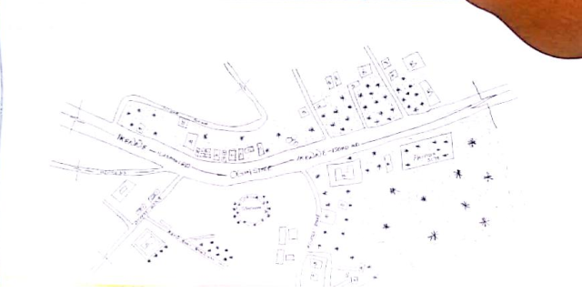
4.3 Site location map
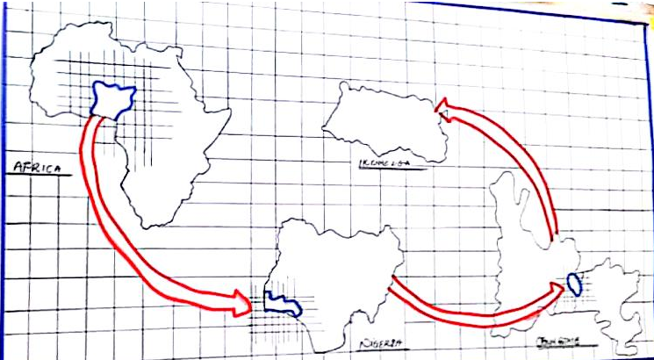
Figure 4.1.1: Location map

4.4 SITE ANALYSIS.
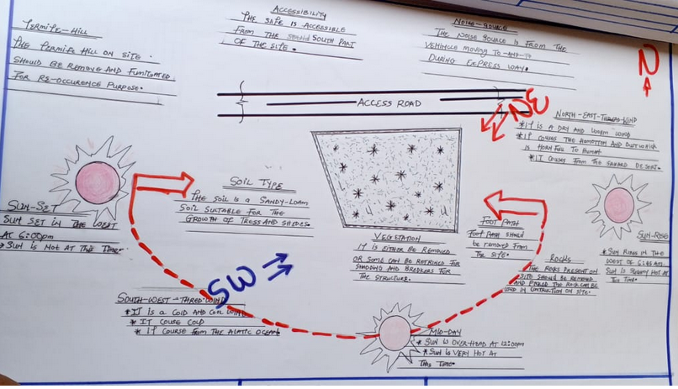
A site analysis involving a study of the site is carried out, it takes into consideration natural and man-made components present in and around the site, as well as climatic conditions of Ogun state. The plate below shows a schematic summary of the analysis of the proposed site.

Figure 4.1.2: Site analysis
4.5 Geographical/climatic Data
Here is the geographic and climatic data for Ikenne Local Government Area, Ogun State, Nigeria — particularly useful for planning construction, educational facilities, or environmental studies:
Geographic Data of Ikenne LGA
Location Coordinates: Latitude 6.870°N, Longitude 3.710°E
Region: Southwestern Nigeria
Elevation: Approx. 235 meters (771 feet) above sea level
Total Area: Around 137–144 square kilometers
Topography: Mostly flat to gently undulating, with some slight elevations inland
Soil Type: Loamy and sandy soils, good for agriculture and construction
Vegetation: Transitional between rainforest and Guinea savanna
Climatic Data of Ikenne LGA
Temperature: Average annual temperature: 26°C to 32°C
Seasons: - Rainy Season: March–October
Dry Season: November–February
Rainfall: Annual average: 1,200 mm to 1,500 mm (rain peaks in June and September)
Humidity: Average 60% to 85%, highest during the rainy season
Winds: Light to moderate southwest monsoon (rainy season)
Harmattan: winds in dry season (from Sahara)
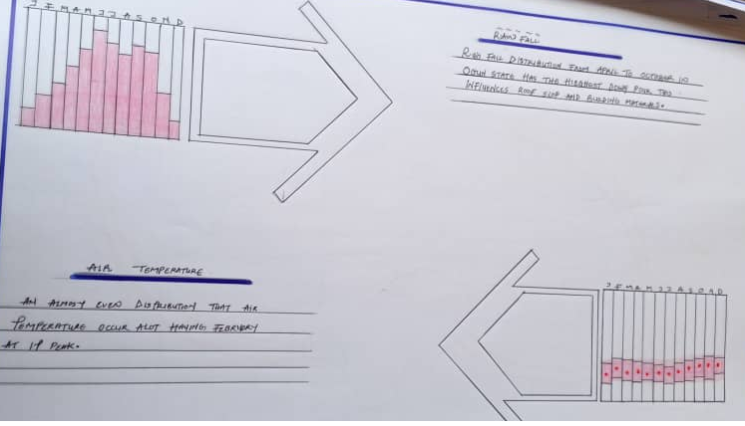
Sunshine: Hours Approximately 5 to 7 hours/day on average throughout the year

Figure 4.1.3: Geographical/climatic data

Project Goal
The goal of this project is to design and propose a functional, safe, and child-centered primary school building in Ikenne, Ogun State. The project aims to provide an effective learning environment by integrating well-planned classrooms, administrative spaces, recreational areas, and essential support facilities. It emphasizes climate-responsive design, accessibility, sustainability, and community relevance, using appropriate local materials and construction methods suitable for the region.
The facilities Includes:
Design Brief
- Entrance
- Reception
- Assistant head mistress office
- Head mistress office
- Bursary office
- Staff hall
- Clinic hall
- Library class
- Computer class
- Primary 1-6
- Art class
- Music class
- General store
- KG 1-2
- Nursery1-2
- Wash room
- Toilets
- Clinic store
- Multi-purpose hall
- lobby
- Day care
Scope
- Main building
- Security post
- Entrance
- Play ground
- Football field
- Basket ball field
- Tennis field
- Car pack
- Water supply
- Generator house
- Carteen
- Garden
4.6 Design concept
1. Conceptual Foundation
The design concept is based on child-centered, climate-responsive, and community-integrated architecture. It seeks to create a safe, stimulating, and flexible learning environment that supports academic, social, and emotional development in children.
2. Spatial Concept
The school layout follows a courtyard model: buildings are arranged in a U- or L-shaped pattern around a central open space. The courtyard functions as a play and assembly area, and serves as a focal point for social interaction, visibility, and ventilation.
The site is zoned into academic (classrooms), administrative (staff rooms, offices), and auxiliary/support areas (toilets, library, playground).
3. Climate-Responsive Design
Classrooms are oriented east-west to reduce direct solar exposure and enhance natural lighting.
Cross-ventilation is achieved using louvered windows on opposite walls and ventilation blocks.
Roofs feature extended eaves to provide sun shading and protect against rainfall.
Landscaping includes shade trees around walkways and outdoor learning zones.
4. Aesthetic and Functional Design
The building’s appearance uses earth-tone colors and natural textures to blend with the environment and promote calmness.
Facades may incorporate local patterns, murals, or motifs to reflect community identity.
Internal spaces are designed to be flexible and adaptable, allowing for group or individual learning, art, storytelling, and ICT use.
5. Material and Construction Concept
Use of locally available, low-cost, and durable materials like sandcrete blocks, galvanized iron roofing, terrazzo or concrete floors.
A focus on simple construction techniques that allow for local labor participation and ease of maintenance.
6. Child-Centered Design Features
Furniture and fittings are scaled to children’s height and safety.
Provision of safe, enclosed play areas, painted walkways, and shaded waiting spaces.
Use of vivid colors, textures, and interactive elements (e.g., educational murals, chalk walls, planting boxes) to engage young minds

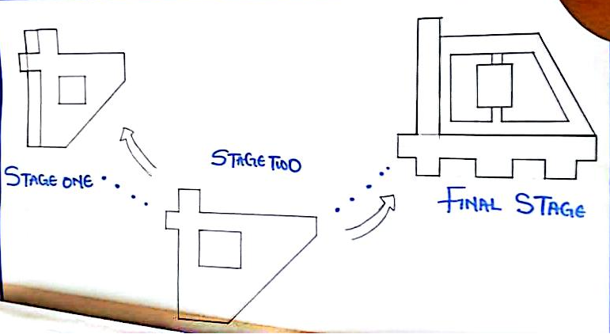
Figure 4.1.4: Design concept

CHAPTER FIVE
5.1 Approach to Design / Design Realization
5.1.1 Design Approach Overview
The design of the proposed primary school at Ikenne Local Government is user-centered, climate-responsive, cost-effective, and scalable. It focuses on creating a safe, flexible, and stimulating learning environment that supports the educational and social needs of pupils aged 6–12 years.
5.1.2 Design Philosophy
The design is based on the following core principles:
Functionality: Spaces are laid out to support teaching, learning, and play in a logical, efficient manner.
Sustainability: Use of passive cooling techniques and locally available materials.
Flexibility: Modular layout allows future expansion without disrupting current operations.
Inclusivity: Design is accessible for all, including pupils with physical challenges.
Child-Friendliness: Bright, engaging, and safe spaces that promote creativity and concentration.
5.1.3 DESIGN REALIZATION STRATEGY
a. Site Planning
The school is arranged in a courtyard layout, which provides:
- A central assembly/play space
- Visual connectivity between blocks
- Good airflow and lighting
Buildings are oriented East–West to reduce solar heat gain and allow for natural day lighting and cross ventilation.
b. Zoning and Circulation
Zoning separates academic areas (classrooms), administrative zones (staff, head teacher’s office), and support spaces (toilets, playground).
Clear circulation paths guide movement between classrooms and common areas, ensuring safety and ease of navigation.
c. Spatial Design
Each classroom is sized to accommodate 20–30 pupils comfortably, with:
- Proper cross-ventilation (louvered windows on opposite sides)
- High ceilings to reduce internal heat
- Blackboard area, storage niche, and space for flexible seating arrangements
- Multipurpose hall and library/ICT rooms are designed with multi-functionality in mind.
d. Material Selection
- Walls: Sandcrete blocks for durability and thermal mass
- Roofing: Long-span aluminum or zinc roofing sheets with extended eaves
- Floors: Terrazzo or smooth concrete finishes for durability
- Windows: Steel casement or aluminum-framed louver windows
- Shading devices: Sun breakers or screens to minimize glare and heat
e. Sustainability Features
- Natural lighting reduces reliance on artificial sources
- Rainwater harvesting system can be added
- Trees and landscaping provide shade and enhance environmental quality
f. Structural System
- Conventional reinforced concrete foundations
- Load-bearing block walls or reinforced concrete frame (depending on soil report)
- Trussed roof with adequate pitch for water runoff
4. DEVELOPMENT STAGES
Stage 1: Needs Assessment and Site Analysis
Understanding user requirements and environmental constraints
Stage 2: Concept Development
Sketches, zoning, and preliminary space planning
Stage 3: Design Development
Floor plans, elevations, 3D views, material selection
Stage 4: Working Drawings and Documentation
Construction drawings, specifications, and schedules
Stage 5: Implementation Supervision
On-site monitoring for compliance with design intent
1. TECHNOLOGICAL CRITERIA
The design and construction of the primary school adopt appropriate and cost-effective technologies that align with the local context, construction capacity, and long-term maintenance capabilities.
a. Construction Technology
Foundation: Reinforced concrete strip or pad foundation depending on soil bearing capacity (lateritic soil).
Superstructure: Sandcrete block walls (150mm–225mm thick), durable and easy to maintain.
Framing: Reinforced concrete columns and beams or load-bearing block system.
Roofing System: Lightweight steel or timber trusses with aluminum or galvanized roofing sheets.
Ceiling: Suspended PVC or gypsum boards to reduce internal heat.
Finishes: Building finishes refer to the final touches and surface treatments applied to a building after the main structure is complete. These finishes enhance both the aesthetic appeal and functionality of a building, offering protection against the elements and contributing to a visually pleasing environment. They encompass a wide range of materials and techniques, including plastering, painting, tiling, and more.
Internal: Emulsion paint, terrazzo or polished concrete floors.
External: Weather-resistant paint; plastered and screeded walls.
b. Building Services: Building services encompass the mechanical, electrical, and plumbing systems that ensure a building is safe, comfortable, and functional for occupants. These systems, often referred to as MEP (mechanical, electrical, and plumbing), include HVAC (heating, ventilation, and air conditioning), lighting, fire safety, security, and communication systems. They are crucial for a building's operation and contribute significantly to its overall efficiency, sustainability, and the well-being of those who use it. These services are analyze below:
- Electrical System: Basic lighting and socket outlets per room, with provision for solar PV upgrade.
- Water Supply: Borehole or community water connection; provision for overhead tank.
- Sanitation: Ventilated Improved Pit (VIP) toilets or water-closet system with septic tank.
c. Information and Communication Technology (ICT): It plays a vital role in modern building construction, enhancing efficiency, accuracy, and collaboration across various stages. From design and planning to construction and management, ICT tools and technologies are transforming the industry. Publications on ICT in Construction highlight its potential to streamline processes and improve project outcomes. The service includes:
- Conduit piping installed for future network cabling.
- Library/ICT room equipped for e-learning integration and basic computing resources.

2. ENVIRONMENTAL CRITERIA
The environmental approach to the project emphasizes sustainability, climate responsiveness, and minimal ecological impact.
a. Site Orientation and Ventilation
- East–West orientation to reduce heat gain on building facades.
- Use of cross-ventilation techniques: opposite-facing windows and ventilated gable ends.
- High ceilings and shaded openings improve thermal comfort naturally.
b. Lighting
- Maximized daylighting via large louvered windows and clerestory openings.
- Reduces reliance on artificial lighting during school hours.
c. Water Management
- Rainwater harvesting system provisioned for future use.
- Drainage system designed to prevent erosion and stagnation, particularly during rainy season.
d. Landscaping and Vegetation
- Indigenous trees and shrubs planted around the perimeter for:
- Shading
- Wind protection
- Dust reduction
- Aesthetic enhancement and outdoor learning
e. Sustainable Materials
- Use of locally sourced materials (e.g., laterite, sandcrete, timber).
- Reduced embodied energy and transportation costs.
f. Waste Management
- On-site waste segregation points for recyclables and non-recyclables.
- Composting of organic waste encouraged using vegetation from the landscape.

Environmental Conditions to Be Achieved
The design of the school aims to create a healthy, comfortable, safe, and sustainable learning environment through deliberate environmental planning. The following conditions are targeted:
1. THERMAL COMFORT
Maintain indoor temperatures within acceptable thermal comfort range (22°C – 30°C) through:
- Natural cross-ventilation
- High ceilings to allow hot air rise and escape
- Use of shaded openings and extended roof eaves
- Appropriate building orientation (east–west)
2. NATURAL DAYLIGHTING
- Ensure that 80–90% of all indoor learning spaces receive sufficient natural light during the day.
- Large louvered windows positioned to minimize glare
- Clerestory or high-level windows in multipurpose areas
- Reduced dependence on artificial lighting
3. INDOOR AIR QUALITY
- Achieve a clean and well-ventilated indoor environment by:
- Using low-VOC (volatile organic compound) paints and finishes
- Providing ample windows and ventilation blocks
- Avoiding mold-prone materials

4. NOISE CONTROL
Maintain a quiet, focused academic atmosphere by:
- Locating the school away from noisy roads or industrial areas
- Planting trees/shrubs as natural sound buffers
- Separating activity zones (playground, classrooms) appropriately
5. SAFETY AND HYGIENE
Provide a secure and hygienic environment through:
- Adequate toilet facilities with proper waste disposal
- Safe pedestrian paths and clear circulation routes
- Well-lit outdoor and indoor areas
- Fenced and gated school boundary for controlled access
6. WATER AVAILABILITY AND QUALITY
Ensure constant supply of clean water for drinking and sanitation by:
- Installing a borehole or connecting to a community source
- Provision for rainwater harvesting
- Water storage tanks for backup
7. SUSTAINABLE LANDSCAPE
Create a pleasant and eco-friendly outdoor environment with:
- Shaded play areas and green buffers
- Native trees and plants to reduce heat and dust
- Use of permeable paving to reduce surface runoff
8. LOW ENVIRONMENTAL IMPACT
Promote sustainability by:
- Using locally sourced and eco-friendly materials
- Managing construction waste responsibly
- Encouraging environmental education through school gardens or eco-clubs
Performance Standards of the Proposed Primary School – Ikenne Local Government, Ogun State
The performance standards for the proposed primary school are established to ensure functional efficiency, safety, sustainability, and comfort in line with national and international best practices for basic education infrastructure. The performance includes structural performance, thermal performance, lightning performance, acoustic performance, etc. the performance of the proposed building are analyzed below.
1. STRUCTURAL PERFORMANCE
The building must withstand minimum live and dead loads as defined by Nigeria Building Code (NBC) and relevant local standards. Reinforced concrete and load-bearing blockwork designed to prevent structural failure. Roof structures must resist wind uplift and heavy rainfall loads typical of the Ogun climate.
2. THERMAL PERFORMANCE
Indoor learning spaces should maintain a thermal comfort range of 22°C–30°C through Passive cooling techniques (cross-ventilation, shaded windows), Use of insulating roofing materials to reduce heat gain, No reliance on air conditioning—design must be naturally ventilated and comfortable.
3. LIGHTING PERFORMANCE
At least 300 lux of natural light must be provided in all classrooms during school hours. There should be Glare-free lighting through proper window orientation and shading devices. There is availability of Night-time illumination through energy-efficient bulbs (e.g., LED) with provision for solar backup.
4. ACOUSTIC PERFORMANCE
Classroom walls and doors must provide sufficient sound insulation to block outside noise.
Internal noise levels should not exceed 40–50 decibels to allow effective communication and concentration.
5. ENVIRONMENTAL SUSTAINABILITY
At least 50% of materials to be locally sourced (e.g., sandcrete blocks, timber).
Minimized environmental footprint during construction and operation.
Encourage rainwater collection and potential use of solar energy systems.
6. SAFETY AND HYGIENE STANDARDS
Non-slip flooring and safe stair/ramp gradients.
Provision of fire extinguishers, emergency exits, and signage.
All toilets to be water-flush or VIP latrine type, easily cleaned and maintained.
8. ACCESSIBILITY
Facilities to comply with universal design standards:
Wheelchair ramps, wide doorways, and handrails where required
Clear signage in text and symbols for ease of navigation
9. OPERATIONAL PERFORMANCE
The Building lifespan is in the range of 25–40 years with regular maintenance. It target 80–90% functionality during school hours without active mechanical systems (e.g., fans or lights). Low maintenance materials to reduce long-term costs.
10. EDUCATIONAL OUTCOME SUPPORT
The learning environment should supports Cognitive development through quiet, well-lit, and thermally comfortable spaces, Social interaction through open courtyards and shared multipurpose areas, Flexibility in teaching methods (group, digital, outdoor).

Behavioural Pattern and Consideration
Understanding user behavior especially that of children helps to inform a design that enhances learning, safety, comfort, and social development. The school’s layout, circulation, safety, and play areas are all influenced by anticipated behavioral patterns.
1. USER GROUP BEHAVIOR
a. Pupils (Ages 5–12)
Pupils with the age range are highly energetic, curious, and social. They require safe, stimulating, and adaptable spaces. They also prefer colorful, interactive environments that support group and individual activities
b. Teachers and Staff
The staff need privacy for administration and relaxation during breaks, Require calm, organized, and secure spaces to manage students and materials.
c. Parents/Visitors
Need clear, easy access to the school’s reception/administrative block
Expect a secure and welcoming environment
3. DESIGN ELEMENTS BASED ON BEHAVIOR
Color Psychology: Use of calm, natural, or soft bright colors in classrooms to enhance focus and reduce stress.
Visual Connection: Strategic window placement to allow children to see outside and feel connected to nature.
Noise Management: Classrooms positioned away from noisy areas like roads or playgrounds
Furniture Size: Desks and chairs scaled to age groups to support posture and minimize fatigue
Way finding: Use of symbols, bright colors, and murals to help younger children navigate the school independently.
4. SOCIAL AND EMOTIONAL DEVELOPMENT
Courtyard layout fosters inclusion, teamwork, and sense of community. Provision of opportunities for quiet zones (e.g., library corners or shaded outdoor benches) where children can relax. Mixed indoor/outdoor learning supports flexibility and student autonomy.
5. CULTURAL AND COMMUNITY CONSIDERATIONS
Respect for local customs in play, dress, and gathering
Space for morning assembly and community events
Consideration for religious or gender sensitivities in toilet locations and uniform access
5.2 Conclusion
The proposed primary school project at Ikenne is a significant step toward improving educational infrastructure and access for children in the region. The design is intentionally structured to meet the functional, psychological, and environmental needs of young learners, while complying with all relevant building codes, planning regulations, and educational standards.
The design of the proposed school is intentionally responsive to the behavioral patterns of children, teachers, and visitors. It encourages safe movement, supports learning, promotes social interaction, and fosters emotional well-being ensuring a holistic educational experience.
Through careful site planning, responsive architecture, and behavior-driven design, the school will not only support learning outcomes but also foster a sense of belonging and community pride. Upon completion, it is expected to serve as a model for functional, child-friendly, and environmentally conscious school design in semi-urban and rural Nigerian contexts. It reflects that the school is not just a building, but a solution to a social challenge access to quality basic education and also emphasizes how the architectural design directly supports the needs and behavior of the users, especially young learners.
The school serves as a model for other rural or semi-urban locations showing how design can solve educational challenges.

5.3 Recommendations
1. Community Involvement
- Involve local residents, parents, and community leaders in both planning and construction to foster a sense of ownership.
- Organize sensitization campaigns on the importance of education and school maintenance.
2. Phased Development
- Begin with core facilities (classrooms, admin block, toilets), and plan future phases for ICT room, library, and multipurpose hall based on funding.
- Provide structural provisions (e.g., stub columns) for vertical or lateral expansion.
3. Alternative Energy Integration
- Integrate solar panels to power lighting and basic ICT needs.
- Use energy-efficient bulbs and appliances to minimize operating costs.
4. Environmental Education
- Include a school garden, tree-planting days, or composting zones to teach sustainability in practice.
- Create murals or learning walls around the school illustrating environmental messages.
5. Maintenance Strategy
- Develop a school maintenance manual and assign simple roles to staff and pupils.
- Train selected staff on basic electrical, plumbing, and landscaping upkeep.
6. Flexible Furniture and Layout
- Recommend use of modular or movable furniture that adapts to changing teaching methods and group sizes.
- Allow some classrooms to be reconfigured into larger spaces for shared activities.
7. Policy and Funding Support
- Engage with UBEC, SUBEB, NGOs, and corporate sponsors for funding support or facility donation.
- Seek public-private partnerships to sustain facilities like libraries or computer labs.
8. Monitoring and Feedback System
- Install a simple feedback and suggestion box for teachers and parents.
- Conduct yearly reviews of space utilization, facility performance, and student comfort.
9. Inclusive Design Enhancement
- Add sensory-friendly elements (e.g., quiet zones, soft lighting in some areas) to support children with neurodiverse needs.
- Provide gender-sensitive WASH facilities with privacy and hygiene supplies.
10. Celebrate Local Culture
- Incorporate local art, language (Yoruba), and motifs into the design to foster identity and pride.
- Host cultural days and community use of multipurpose spaces

REFERENCES
Abdul Wahid, W.M. et al. (2015). “Design Considerations for Contemporary Mosque Architecture.” International Journal of Built Environment and Sustainability.
Al-Mufleh, M. (2020). “Designing Mosques for Community Development.” International Journal of Architecture and Urban Development, Vol. 10(3).
ARCON / COREN Guidelines – Architects Registration Council of Nigeria / Council for the Regulation of Engineering in Nigeria (Various Editions).
ASHRAE Standards – Standard 55: Thermal Environmental Conditions for Human Occupancy.
Beryl Menzies (1999); Metric handbook planning and design data, second edition, edited by David Adler, Architectural press. Linacre House, Jordan Hill, Oxford OX2 8DP.
Brembeck, C.S, (1971); Social foundation of education: environmental factors inteaching and ​learning. London: john: Herper and Roy publishers
Coburn, Oliver (1950). Youth Hostel Story. London: National Council of Social Service.
David V. Chadderton, Building Service Engineering, fifth edition (2007), Taylor & Francis, 2 ​Park Square, Milton Park, Abingdon, Oxon OX14 4RN.
D. Michell (1978) – Architecture of the Islamic World. Thames & Hudson.
Ernst and peter Neufert (1993); Architects’ data, third edition, Blackwell science publishers.
FEMA - Federal Emergency Management Agency, 1999, Fire in the United States 1987-1996, ​11th Edition, US Fire Administration, Federal Emergency Management Agency, ​Maryland, 21727
Fred Malven (1997); Time savers standards, for architectural design standards, seventh ​edition, McGraw-Hill, Inc.
Federal Republic of Nigeria (2006) – National Building Code.
Frishman, M., & Khan, H.-U. (1994) – The Mosque: History, Architectural Development & Regional Diversity. Thames & Hudson.
Hillenbrand, R. (1994) – Islamic Architecture: Form, Function, and Meaning. Edinburgh University Press.
Kuban, D. (2010) – The Mosque and Its Early Development. Brill Academic Publishers.
Kwara State Town Planning and Development Authority – Planning Approval Guidelines and Zoning Regulations (Latest version).
JOURNALS, NEWSPAPERS AND ARTICLES.
Odeleye A. (1983) Fire protection in buildings: Nigerian Institute of Architects Journal; edited ​by Aku Omokhodion.
Olaitan P. B, Dairo M. D, (Feb. 2009) Journal of Rescue and Disaster Medicine™ ISSN: 1531-​2992, Domestic Fire Accidents In A Developing Country: Reducing Morbidity / ​Mortality By Modifying The "Burglar Proofs".
Oliver, P. (1997) – Encyclopedia of Vernacular Architecture of the World. Cambridge University Press.
Salama, A. (2018). “Mosque Architecture in the Contemporary Urban Context.” Journal of Islamic Architecture, Vol. 5(1).
Ger Herbert (1999), Fire safety in hostels. McGraw-Hill, Inc.
James Patterson, (1993); Simplified design for building fire safety. John Wiley and sons Inc.
Neal, Tim; Neal, Simon (1993). Youth Hostels of England and Wales 1931-1993. St Albans: ​YHA. ISBN 0952225409.
Nikolas Davies, Erkki Jokiniemi (2008); Dictionary of Architecture and buildingconstruction, ​first edition; Architectural press. Linacre House, Jordan Hill, Oxford OX2 8DP.
Perkin & Will (2001); Time savers standards, Building types, fourth edition, McGraw-Hill, Inc.
Schmerts H.T. (1972); Institutional Housing Strategies Educational andRealisation. London: ​Patrick Wakely.
Schneider, T., & Till, J. (2007). Flexible Housing. Oxford, United Kingdom: Architectural ​Press.
The Guardian (2006). Nigerians Fire Incidents and Safety at Workplace. The Guardian ​Newspaper, May 2006

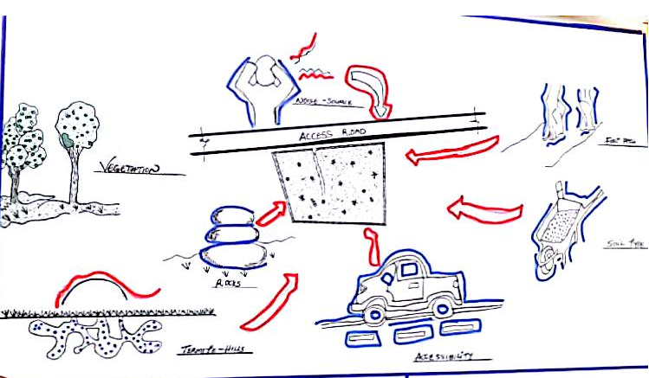
Appendix 1: Site Inventory

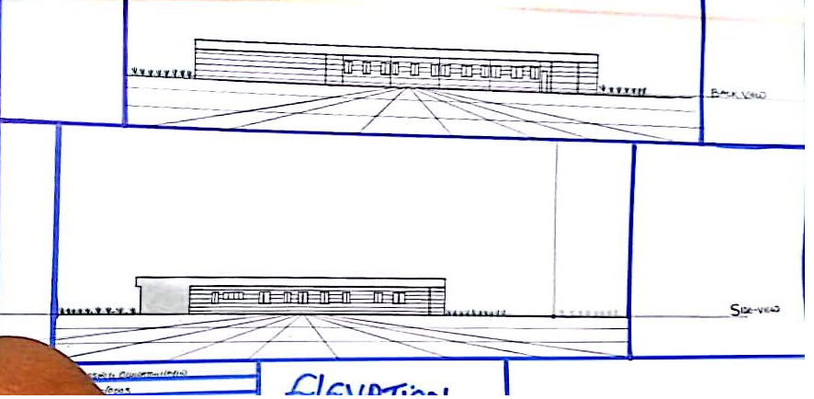
Appendix 2: elevation

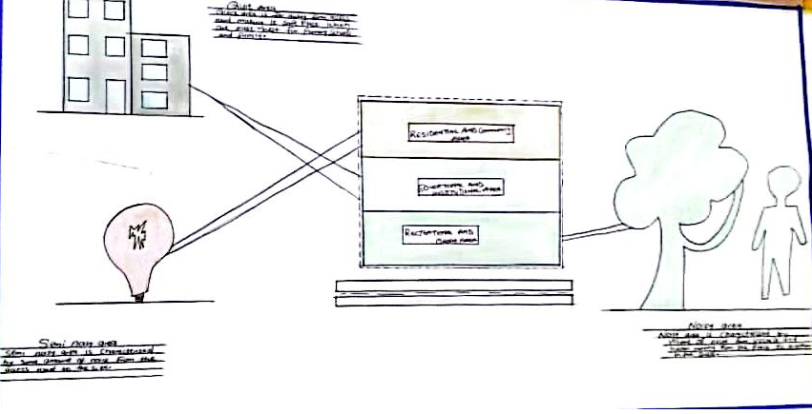
Appendix 3: Zoning

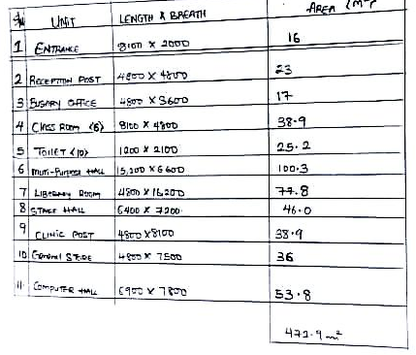
Appendix 4: Space calculation

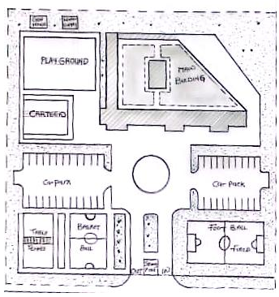
Appendix 5: Site Plan
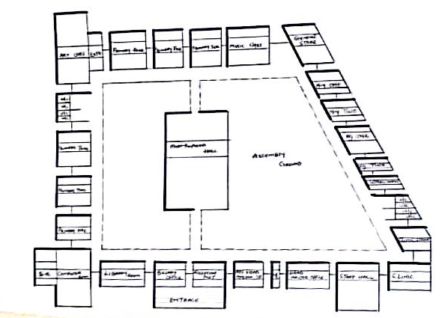
Appendix 6: Functional relationship

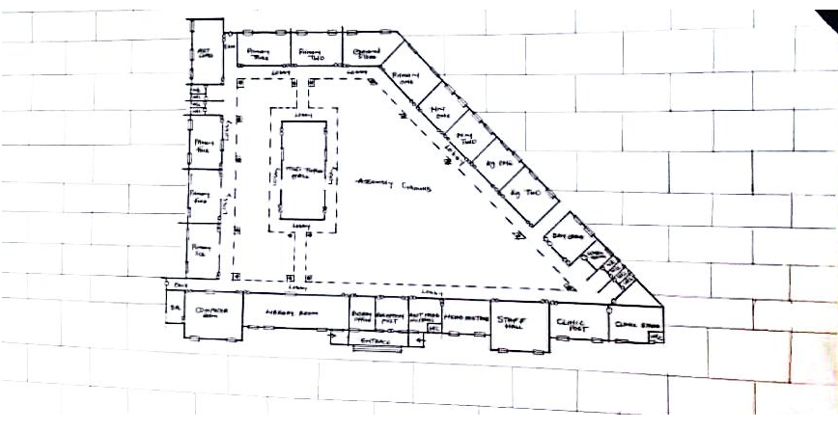
Appendix 7: Ground floor
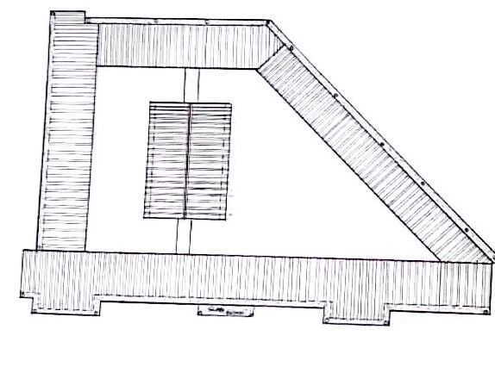
Appendix 8: Roof plan

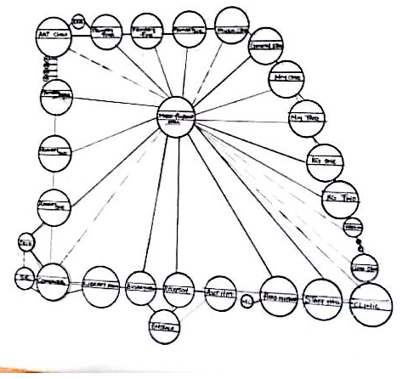

Appendix 9: Bubble diagram

