KWARA STATE POLYTECHNIC, ILORIN
FABRICATION OF WHEELBARROW

BY

OLUWASEGUN OLAWALE
ND/23/WEC/FT/0013

A PROJECT REPORT SUBMITTED TO DEPARTMENT OF WELDING AND FABRICATION ENGINEERING IN PARTIAL FULFILMENT OF THE REQUIREMENTS FOR THE AWARD OF NATIONAL
DIPLOMA (ND) IN WELDING AND FABRICATION ENGINEERING

MAY, 2025

CERTIFICATION
The undersigned certify that this project report titled FABRICATION OF WHEELBARROW was prepared by ND/23/WEC/FT/0013, , meets the requirement for the award of National Diploma (ND) in the department of Welding and Fabrication Engineering, Kwara State Polytechnic, Ilorin, and was approved for its contribution to knowledge and literacy presentation.

Engr. Adedoye Emmanuel Ayobami, FNSE Date
Project Supervisor

Engr. M. A Salahudeen Date
Head of Department

Engr. Bello Arafat O. Date
Project Coordinator

Engr. M.O Agaja Date
External Examiner

DEDICATION
This project is dedicated to the Almighty God, the most Beneficient and the most merciful, for His protection right from the commencement of our ND Programme to this moment. May His name be forever praised. The project is also dedicated to our Parents for their moral and financial supports.

ACKNOWLEDGEMENT
All thanks and adorations are due to God, for His mercy in seeing me through National Diploma (ND) programme, I give glory to God the Greatest.
Our profound gratitude goes to my Parents, for their prayers and understanding at all times. I also acknowledge their moral and financial supports. I pray that may you live long in good health and wealth to reap the fruit of your labour (Amen).
In writing this project we have drawn a lot of inspirations from many people, especially from our project Supervisor ENGR. E.A ADEDOYE and the entire staff in the Department of Mechanical Engineering, Kwara State Polytechnic, Ilorin. They have equipped me with the academic and technical knowledge that have enabled me accomplish this task. To them, we wish to express my unreserved appreciations.
Finally, our thanks and regards go to my friends, colleagues, course mates and others, for their co-operation, support, friendly advice and encouragement towards the progress of my study in school. Thank you and God bless you all.

ABSTRACT
Wheelbarrow is a mechanical device/implement that is designed to help in transporting goods and materials from one place to another destination. It helps to solve the problem encountered by humans in moving some heavy loads, thereby eliminating the stress and fatigue that may be sustained while using strength to carry such heavy loads. It is a durable and affordable means of transportation that requires lesser effort. It can carry a load of 160kg at a time without shortening its life span. Wheelbarrow belongs to second order of lever and has a mechanical advantage of 3.98.

TABLE OF CONTENTS
Title page
Approval page
Dedication
Acknowledgement
Abstract
Table of Contents
CHAPTER ONE
1.0 Introduction
1.1 Wheelbarrow
1.2 Literature Review
1.3 Objective of Fabricating the Wheelbarrow
1.4 Need for Wheelbarrow
CHAPTER TWO
2.0 Analysis of other Alternative Methods of Transporting Good
2.1 Motorcycle
2.2 Bicycle
2.3 Trolley.
2.4 Cart
CHAPTER THREE
3.0 General Description and Working Principles
3.1 Description of Component Parts
3.2 Material Consideration
3.3 Fabrication Details
3.4 Bill of Material
3.5 Testing of the Wheelbarrow
3.6 Maintenance
3.7 Safety Precautions
3.8 Problems Encountered
CHAPTER FOUR
4.0 Calculations
4.1 Basic Calculations
CHAPTER FIVE
5.0 Conclusion and Recommendations
5.1 Conclusion
5.2 Recommendations
References

CHAPTER ONE
INTRODUCTION
  - Background to the Study
The wheelbarrow, a simple yet indispensable piece of equipment, has played a crucial role in easing the burden of manual labor in various sectors, especially in agriculture, construction, and domestic settings. Its design allows for the transportation of materials with greater efficiency, reducing the physical strain on workers. In Nigeria and other developing countries, where mechanized systems are either unaffordable or impractical for small-scale users, wheelbarrows remain a vital tool for day-to-day activities (Adeniyi & Olowu, 2017). Despite their simplicity, the effectiveness of a wheelbarrow lies in its proper fabrication and ergonomic design.
Historically, the concept of the wheelbarrow can be traced back to ancient civilizations such as China and Greece, where it was employed in agricultural and military operations (Sutherland, 2011). Over time, this tool has evolved in terms of structure and material composition, transitioning from wood to more durable metals like steel. In contemporary settings, especially in local markets and farms, the wheelbarrow is often fabricated with available resources and adapted to suit specific terrain or workload requirements (Okafor & Yusuf, 2019). This adaptability underscores its relevance in developing regions where modern technology may not be readily accessible.
The fabrication process itself involves various stages including cutting, welding, assembling, and finishing. These processes are not only technical but also creative, as the artisan must take into consideration the weight distribution, durability, and maneuverability of the final product (Usman et al., 2020). The ability to fabricate a wheelbarrow locally reduces dependency on imported products and promotes local craftsmanship. It also empowers young technicians and engineering students to apply theoretical knowledge to practical, real-world applications.
In recent years, there has been a growing emphasis on vocational and technical education, which includes training in the fabrication of basic tools like the wheelbarrow. Institutions and workshops now prioritize hands-on skills that can contribute directly to economic development (Nwachukwu, 2018). The fabrication of a wheelbarrow, therefore, serves not only as an academic project but also as a practical endeavor that demonstrates competence in metalwork, design, and mechanics.
Ultimately, the relevance of this study lies in its real-life application. Fabricating a wheelbarrow is more than just an exercise in welding and assembling metal parts; it is a solution to everyday transportation needs for people working in physically demanding environments. By understanding the principles behind its design and construction, this project contributes to the broader goal of promoting innovation and self-reliance in our communities (Eze & Chinedu, 2020).
1.2 Aim and Objectives
Aim
The primary aim of this study is to design a fabricated wheel barrow for use.
Objectives
The objectives of this project are:
- To produce a wheelbarrow (a source of transportation) which is strong and durable enough to carry loads from one place to another.
- To reduce stress and fatigue as well as to save time and energy.
- To reduce the risk of human lives.
- To be acquainted with the uses of some tools and facilities in a fabrication workshop.
1.3 Need for Wheelbarrow
The wheelbarrow is designed to distribute the weight of its load between the wheel and the operator, thereby enabling the carrier to lift and move both the wheelbarrow and load with less force.
Wheelbarrow is used in carry cement, sand, gravel and many other items used in construction works. It can also be used in short-distance transportation of goods or loads from one place to another in an industry. Wheelbarrow is also used in markets to hawk commodities. In brief, wheelbarrow is very useful as it is employed in different places to carry out several tasks.

CHAPTER TWO
LITERATURE REVIEW
2.1 Conceptualization
A wheelbarrow is a small hand-propelled vehicle, usually with just one wheel, designed to be pushed and guided by a single person using two handles at the rear. The term "wheelbarrow" is made of two words. "Wheel" and "barrow". "Barrow is a derivation of the old English "bearwe" which was a device used for carrying loads.
The earliest wheelbarrows with archeological evidence in the form of a one-wheel cart come from second century. Han Dynasty Emperor Hui's tomb murals and brick tomb reliefs. However, there are even earlier accounts than this that date back to the first century BCE and 1st century CE.
Nevertheless, the Chinese historical text of the Sanguozhi (Records of Three Kingdoms), compiled by the ancient historian Chen Shou (233-297CE), credits the invention of the wheelbarrow to Prime Minister Zhuge Liang (181-234CE) of Shu Han from 197-234CE. It was written that in 231CE, Zhuge Liang developed the vehicle of the wooden ox and used it as a transport for military supplies in a campaign against Cao Wei. Further annotations of the text by Pei Songzhi (430CE) described the design in detail as a large single central wheel and axle around which a wooden frame was constructed in representation of an ox.
The first wheelbarrow in Europe appeared sometime between 1170 and 1250. Medieval wheelbarrows universally featured a wheel at or near the front in contrast to their Chinese counterparts, which typically had a wheel in the center of the barrow), the arrangement now universally found on wheelbarrows.
According to the medieval art historian Andrea Matthies, the first archival reference to a wheelbarrow in medieval Europe is dated 1222 in English manuscript, Mathew Paris's Vitae duorum Offarum completed in 1250.
By 13th century, the wheelbarrow proved useful in building construction, mining operations and agriculture. However, going by the surviving documents and illustrations, the wheelbarrow remained a relative rarity until the 15th century.
Modern variation edit was built by a British inventor, James Dyson in 1970s. He introduced the Ballbarrow, an injection molded plastic wheelbarrow with a spherical ball on the front end instead of a wheel. Compared to a conventional design, the larger surface area of the ball made the wheelbarrow easier to use in soft soil, and more laterally stable with heavy loads on uneven ground. However, power-assisted wheelbarrows are now widely available from a number of different manufacturers. The technology of wheelbarrow has improved to enable them to take much heavier loads, beyond weights that a human could transport alone without assistance. They are also known as motorized wheelbarrow.
2.2 Analysis Of Alternative Methods Of Transporting Goods
Wheelbarrow as a means of moving loads from one destination to another has many alternatives. The following are other alternative means of conveying goods.
2.2.1 Motorcycle
This is an alternative to wheelbarrow. It has two wheels, one at the front and the other at the back. It is more expensive than wheelbarrow and its cost of maintenance is high compared to wheelbarrow.
2.2.2 Bicycle
This is also an alternative. It also has two wheels just like motorcycle but it has no engine because it is driven manually using ones legs to pedal it and this result to a lot of stress and pain to the rider. More so, it can carry lesser load at a time.
2.2.3 Trolley
It is a vital device for conveying load from one place to another. It can carry less bulky goods but it is not as strong as wheelbarrow. It is used in supermarkets and stores. It is also operated with one or both hands.
2.2.4 Cart
Cart is a carrier with two or four legs which is pulled by hands to move loads from one place to another.
However, wheelbarrow is selected as best alternative of transporting or moving goods and loads among the above listed alternatives of transporting goods because it is durable, cheap and affordable.
CHAPTER THREE
3.0 GENERAL DESCRIPTION AND WORKING PRINCIPLES
3.1 Description of Component Parts
3.1.1 Body (tray)
Wheelbarrow tray is produced in the form of mild steel of thickness 1mm. The mild steel is then shaped into a trapezium - like shape at each side.
3.1.2 Handle and Supporting Frame
The handle is made up of mild steel pipe that is bent so as to have two handles with hard plastic at both ends as grips. The pipe is of 30mm diameter and 2mm thickness.
3.1.3 Rotating Shaft
The shaft is situated between the tyre and bearings that are fixed to the end of frame. It connects the tyre and bearings together. The shaft will be constantly under axial force and bending moment so it requires tensile strength.
3.1.4 Tyre
This is a small size tyre that fits around a wheel to protect it and enable better performance by providing a flexible cushion that absorbs shock while using the wheelbarrow to carry loads. The tyre is made of vulcanized rubber and other materials like metal wire e.t.c. Tyre is majorly of two types, the tube type and the tubeless type. The tubeless is the best to use.
3.1.5 Ball bearings
This material allows constrained relative motion between two or more moving parts. It thus makes rotation easier, reduces the friction between the wheel and shaft and also reduce the rate of wear.
3.1.6 Shaft Housing
In this case, mild steel is used due to its toughness and hardness so that it can withstand the shock and wear due to the rotation of the shaft.
3.1.7 Stand
This part helps in supporting the entire wheelbarrow with or without load. It is made of mild steel.

3.1.8 Cross Brace
The steel brace holds both leg and stand. It helps to support the stand as well as balancing it.
3.1.9 Grip
This is made of synthetic plastic so that it can withstand stress.
3.2 Material Considerations
Consideration of materials for construction of project in the field of engineering is a major task of an engineer. There are factors to be considered in achieving this which include:
- Availability of such material.
- Affordability of the materials
- Maintainability of the materials
- Properties like; physical properties, mechanical properties (strength, hardness, thickness e.t.c.) thermal property e.t.c.
3.3. Fabrication Details
Component | Description of Job/work done | Tools used
Development | Drawing of component Parts of the wheelbarrow | Drawing sheet and drawing sets
Marking out | Marking out the division on the marking table | Measuring tape, steel rule, scriber, center punch
Cutting process | Cutting out of the marked area | Guillotine machine, chisel and hammer
Bending process | Bending of the plate to the specific shape required | Bending machine anvil and mallet
Welding process | Welding the cut out area of the plate together to form precise shape | Arc welding machine, grade 12 electrode, face shield, chipping hammer
Drilling process | Drill the metal plate where necessary to accommodate bolt and nuts | Drilling machine, center punch and hammer
Turning of shaft | The shaft is held firmly in  the jaw of the lathe  machine and turned  parallel | Lathe machine, cutting fluid
Packing operation | Fettling and cleaning of  metal surface with  abrasive and wire brush to  remove rusts, then  painting of the whole body  of the wheelbarrow | Wire brush, abrasive, painting brush and paint

3.4 Bill of Engineering Measurements and Evaluation (B.E.M.E)
S/N | Description of Material | Size / Thickness | Quantity | Total Cost (₦)
1 | Guage 18m/s plate | 2mm | 1 | 6,000
2 | Flat bar | 30mm by 6mm | 1 | 4,000
3 | Pipe | 30mm diameter | 1 | 4,000
4 | Bearing | 20mm | 2 | 2,000
5 | Tyre/wheel | 50mm | 1 | 4,900
6 | Bolt and nut | 8mm | 12 | 1200
7 | Electrode | Grade 12 & 10 | 3 dozen | 1,200
8 | Paint | 1 |  | 2,400
9 | Shaft | 20mm | 1 | 2,800
10 | Bearing housing | 50mm | 2 | 2,000
11 | Transportation |  |  | 2,000
 | TOTAL |  |  | 33,4000

3.5 Testing of the Wheelbarrow
It is important to have a good knowledge of its usage because this contributes to the life span of the machine.
The wheelbarrow was tested as thus:
- The wheelbarrow was allowed to rest on the ground with the stand and tyre.
- It was then filled with loads.
- The handles were gripped firmly and was lifted up so that only the wheel is on the ground.
- The wheelbarrow was pushed on the ground to a particular destination for a short transportation exercise.
- After these, the loads were removed and the wheelbarrow was pushed on the ground again without load.
After the above test, it was discovered that the wheelbarrow can maintain balance both with loads and without loads.
3.6 Maintenance
Proper maintenance of the wheelbarrow has to be taken in order to make it last longer. Few maintenance tasks are listed below:
- Adequate lubrication of all the moving parts.
- Replacement of worn-out parts to prevent total breakdown.
- The wheelbarrow should be properly cleaned and kept in a proper position after use.
3.7 Safety Precautions
In the fabrication aspect of this wheelbarrow, there are some safety measures that need to be considered. These include the following:
- The grade of the electrode to be used should be considered to avoid partial welding which could cause accident during use.
- Welding goggles, face shield, workshop overall, leather boots and other safety wears must be used accordingly.
- Riveting should be done properly.
- The wheel is also one of the factors to be considered. It should be a durable and quality type such as vesper motorcycle tyre.
3.8 Problems Encountered
This project work entails a lot of welding operations which take about sixty percent (60%) of the total period spent on the project.
The major problem encountered was that of unstable power supply. Electricity played a vital role in the actualization of this project simply because without electricity some operations like welding, cutting of plate metal using guillotine machine, drilling e.t. will be practically impossible.
Moreover, another problem faced during this project was unavailability of space and equipment in the workshop due to the congestion of co-students in the fabrication workshop.

CHAPTER FOUR
4.0 CALCULATIONS
4.1 Basic Calculations
The step by step calculations involved in the fabrication of this project are stated below. These calculations were done to determine the weight and mass of the parts of the project. Volume of the weight and handle
V₁ L x B × T; where L = Length, B = Diameter and T
= Thickness [Adu D. B. (1996)]
L = 2270mm - 2.27m
B = 50mm - 0.05m
T = 3mm - 0.003m
V₁ = 2.27 × 0.05 × 0.003
V₁ = 3.405 × 10-⁴m³
Mass of the frame and handle Mass
Mass = Density × Volume (from Densit = Volume)
[Olumuyiwa A., Okunola 0. 0. (1996)]
M₁ = PXV
M₁ = 7850 × 3.405 × 10-⁴
M₁ = 2.67kg x 2
M₁ = 5.35kg
Volume of flat support bar
V₁ = Lx BxT
L = 450mm - 0.45m
B = 40mm - 0.04m
T = 4mm - 0.004m
V₂ = 0.45 × 0.04 × 0.004
V₂ = 7.2 × 10-5 m3
Mass of the flat support bar
M₂ = PXV
Мг = 7850 × 7.2 × 10-5
M₂ = 0.565kg x 2
M₂ = 1.13kg
Volume of knee stand
V₃ = L X B X T
L = 500mm → 0.5m
B = 50mm → 0.05m
T = 4mm → 0.004m
V₃ = 0.5 × 0.05 × 0.004
V₃ = 1 × 10-⁴m³
Mass of knee stand
Mass = Px V
M₃ = 7850 x 1.× 10-4
M₃ = 0.785kg x 2
M₃ = 1.57kg
Volume of knee stand brace
V₄ = LxBxT
L = 350mm → 0.35m
B = 50mm → 0.05m
T = 3mm - 0.003m
V₄ = 0.35 × 0.05 × 0.003
V₄ = 5 × 25 × 10-⁵m³
Mass of knee stand brace
M₄ = PXV
M₄ = 7850 × 5.25 × 10-⁵
M₄ = 0.412kg
M₄ = 0.4kg
Volume of the front cover
V₅ = LxB xT
L = 500mm → 0.5m
B = 500mm → 0.5m
T = 2mm - 0.002m
V₅ = 0.5 × 0.5 × 0.002
V₄ = 5 × 10-⁴m³
Mass of the front cover
M₅ = PxV
M₅ = 7850 × 5 × 10-⁴
M₅ = 3.925kg
_{M5} = 3.93kg
Volume of the back cover
L = 300mm → 0.3m
B = 400mm → 0.4m
T = 2mm - 0.002m
V₆ = 0.3 × 0.4 × 0.002
V₆ = 2.4 × 10-⁴m³
Mass of the back cover
M6 = PXV
M₆ = 7850 × 2.0 × 10-⁴
M₆ = 1.884kg
M₆ = 1.88kg
Volume of side cover
V₇ = L xB xT
L = 1150mm → 1.15m
B = 400mm → 0.4m
1 T = 2mm - 0.002m
V₇ = 1.15 × 0.4 × 0.002
V₇ = 9.2 × 10-⁴m³
Mass of the side cover
M, = PX V
M₇ = 7850 × 9.2 × 10-⁴
M₇ = 7.22 x 2
M₇ = 14.44kg
Volume of the shaft
L = 30mm → 0.03m
B = 10mm → 0.01m
T = 15mm - 0.015m
V₈ = 0.03 × 0.01 × 0.015
V₈ = 4.8 × 10-⁶
Mass of the shaft
Mg = PX V
1 = 7850 × 4.5 × 10-⁶
= 0.034kg
= 0.034kg
Volume of the wheel
V₉ = d₁ X d₂ x T - - - - (3) [O lumuyiwa A, Okunola 0. 0 (1990)]
Thickness = 55mm → 0.055
D₁ = 50mm → 0.05
D₂ = 35mm → 0.035
Therefore, V = d1 X d2 x T
= 0.05 x 0.035 x 0.055
= 9.63 × 10-5
Mass of wheel
M₉ = P XV
= 1100 x 9.63 x 10-5
= 0.106kg
Thus, total mass (MT)
= (M₁ + M₂ + M₃ + M₄ + M₅ + M₇ + M₈
+ M₉ ... (4) Nelson M. (1977)
= 5.35 + 1.13 + 1.57 + 0.4 + 3.93 + 1.88 + 14.44 + 0.035 + 0.106
= 28.8kg
The weight of the project
W = M, X g
= 28.8 x 9.81
= 282.5N

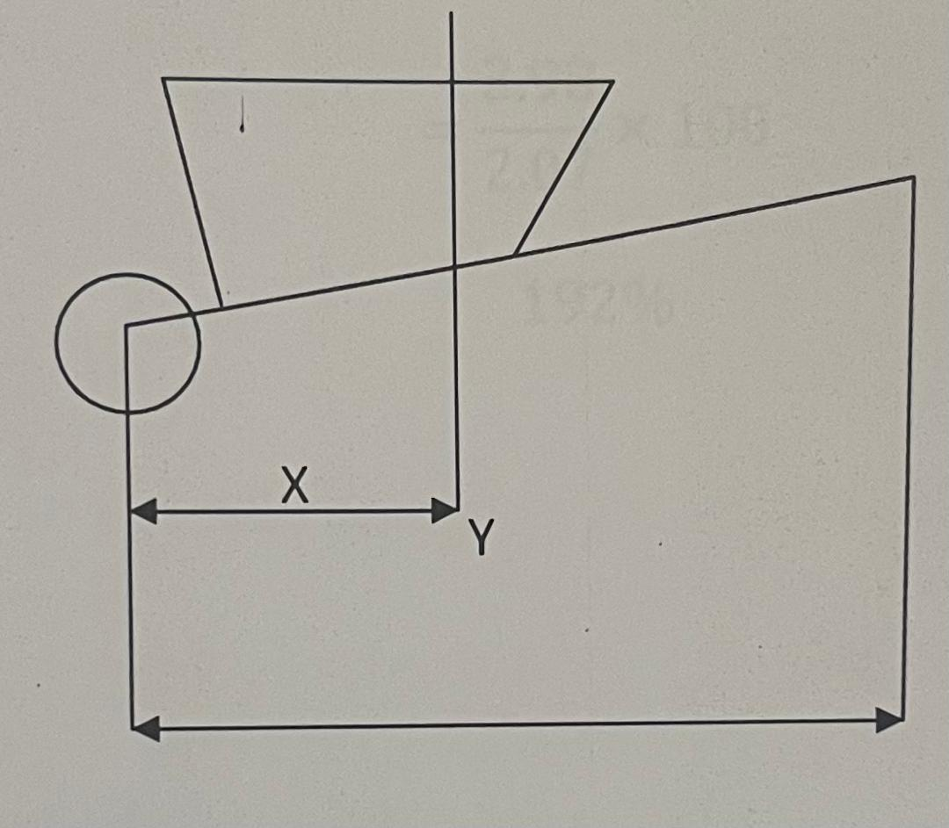
Using Principle Moment
Clockwise moment = Anti - clockwise
L xX = Ex Y
(150x10)302 = E × 1204
E 1500 x 203 = 453000
1204 1204
= 376.2N
Mechanical Advantage (M.A) = Load = 1500
Effort 376 = 3.98
Velocity Ratio (V. R) = Distance of effort from fulcrum
Distance of load from fulcrum
= 1204 = 2.07
500
Efficiency = M. A × 100
V.R
= 3.98 × 100
2.07
192%

CHAPTER FIVE
5.0 CONCLUSION AND RECOMMENDATIONS
5.1 Conclusion
The fabrication of wheelbarrow has really helped the students to improve their technical knowhow and eventually boost the confidence if students on how to handle projects independently with creative thinking. It also prepare students for challenges ahead, team work and technical advancement.
The aim of the project which is to fabricate a wheel barrow as a means of short distance transportation is achieved.
5.2 Recommendations
Due to different innovations in the world of technology, improvement has been done on some parts of the present work e.g. strength, thickness e.t.c. and further research work can be done in the regard.
The wheelbarrow was fabricated with a view to aid people in carrying load from one place to another, it is pulled at the rear end. Technological advancement, has given rise to motorized wheelbarrow that moves without pulling and this has better advantages and mechanical accuracy.

References
Adu D.B. (1996), "Comprehensive Mathematics for SSCE", New Edition, Nigeria.
Anyakoha M.W. (2013), "New School Physics", 2nd Edition, Nigeria.
Lewis M.J.T (1994), "Origin of the wheelbarrow, Technology and Culture", First Edition, Chicago, pp. 453-475.
Mathies A. L. (1991), "The Medieval Wheelbarrow, Technology and Culture", 2nd Edition, Chicago, pp. 356-364.
Shelton A. R and Will, K.J. (1998), "Wheels Indestructible Weekend barrow, Mother Earth News", 2nd Edition, London, pp. 76-77.
Temple R. (1986), "The Genius of China, Discovery and Invention", by Joseph Needham, Ist Edition, New York.
http://"wheelbarrow" www.wikipedia.com
http://"The medieval wheelbarrow" en. wikipedia.org/wiki/wheelbarr

