A PROJECT REPORT
ON
PROPOSED MUSIC STUDIO
For
SARAKY
AT
EJIGBO OSUN STATE
BY
OWADOKUN MUSTAPHA
HND/23/ARC/FT/0005

SUBMITTED TO
DEPARTMENT OF ARCHITECTURAL TECHNOLOGY, INSTITUTE OF ENVIRONMENT STUDIES, KWARA STATE POLYTECHNIC, ILORIN

IN PARTIAL FULFILMENT OF THE REQUIREMENTS FOR THE AWARD OF

HIGHER NATIONAL DIPLOMA [HND] IN ARCHITECTURAL TECHNOLOGY KWARA STATE POLYTECHNIC, ILORIN KWARA STATE

JULY, 2025

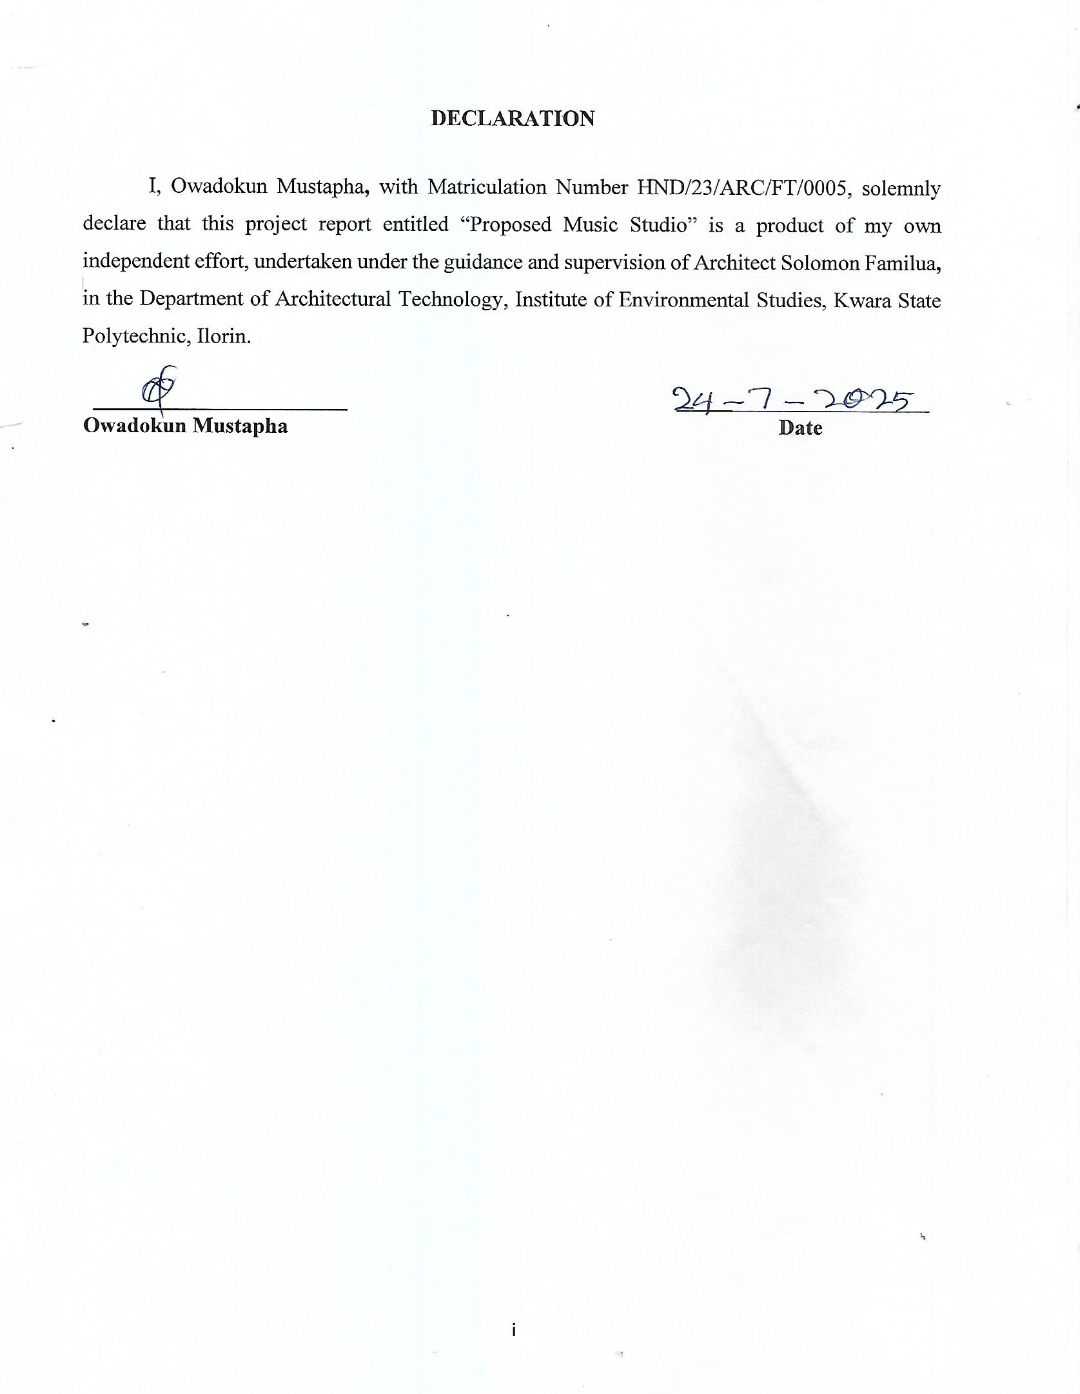

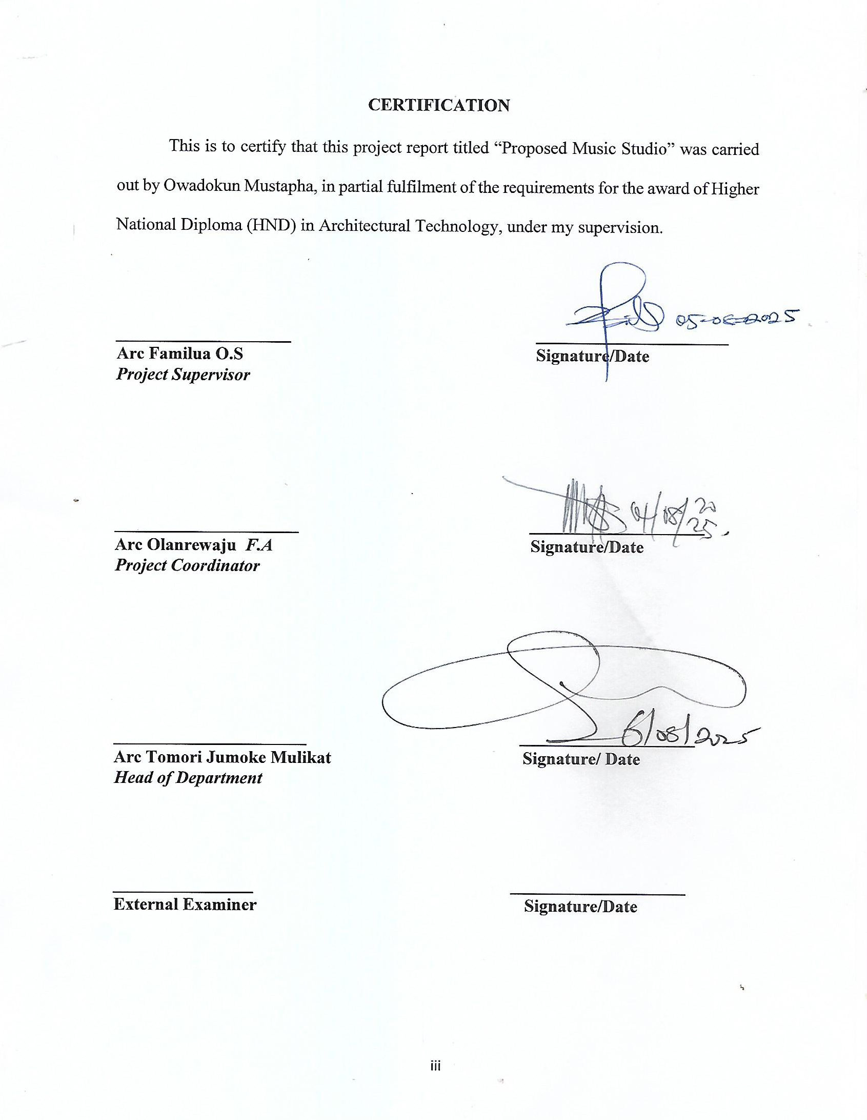

DEDICATION
This project is dedicated to Almighty God for His grace, wisdom, and strength throughout the course of my studies, and to my beloved parents and family members for their unwavering love, encouragement, and support.

ACKNOWLEDGEMENT
I sincerely express my profound gratitude to God Almighty for His guidance, provision, and protection throughout the period of this project and my academic pursuit.
My heartfelt appreciation goes to my supervisor, Architect O.S Familua, and to the Head of Department Arc. Tomori, for their invaluable guidance, corrections, and constructive criticism which shaped this work.
I also wish to thank all my lecturers in the Department of Architectural Technology for their impact in my academic journey.
Special thanks to my parents, siblings, and friends for their continuous support, prayers, and encouragement throughout my program.
Finally, I appreciate my colleagues and course mates for their contributions and the moments we shared together in the pursuit of our academic goals.

ABSTRACT
This project report focuses on the design of a music studio facility, addressing the spatial, functional, and acoustic requirements essential for music production. The research explores existing music studios to understand standard design practices and acoustic treatment techniques. The design incorporates a reception area, control room, vocal booth, live recording room, editing suite, waiting lounge, and restroom arranged to enhance functional flow and acoustic performance. Key considerations included soundproofing, sound absorption, diffusion, ergonomic layout, and aesthetic appeal to create a conducive environment for artists, producers, and sound engineers. The outcome is a proposed design that meets standard requirements for music studio facilities, offering functionality, comfort, and creativity-enhancing spaces suitable for Nigeria’s growing music industry.

TABLE OF CONTENTS
DECLARATION ii
CERTIFICATION iii
DEDICATION iv
ACKNOWLEDGEMENT v
ABSTRACT vi
CHAPTER ONE 1
INTRODUCTION 1
1.1 BACKGROUND OF THE STUDY 1
1.2 STATEMENT OF DESIGN PROBLEM 2
1.3 AIM AND OBJECTIVES 2
1.3.1 AIM 2
1.3.2 OBJECTIVES 2
1.4 JUSTIFICATION OF THE STUDY 3
1.5 SCOPE OF THE STUDY 3
1.6 CLIENT BACKGROUND 4
1.7 LIMITATIONS OF THE STUDY 4
1.8 RESEARCH METHODOLOGY 4
CHAPTER TWO 6
2.1 LITERATURE REVIEW 6
2.2 DEFINITION AND HISTORICAL BACKGROUND OF MUSIC STUDIO 7
2.2.1 DEFINITION OF MUSIC STUDIO 7
2.2.2 HISTORICAL BACKGROUND OF MUSIC STUDIO 8
2.3 FUNCTIONS OF MUSIC STUDIO 8
2.4 CLASSIFICATION AND TYPES OF MUSIC STUDIO 9
2.5 DESIGN CONSIDERATIONS FOR MUSIC STUDIO 9
CHAPTER THREE 11
3.1 CASE STUDIES 11
3.3 CASE STUDIES 17
3.4 DATA COLLECTION METHODS 23
3.4 DATA COLLECTION INSTRUMENTS 23
3.6 METHOD OF DATA ANALYSIS 24
3.6.2 QUANTITATIVE DATA ANALYSIS 25
CHAPTER FOUR 26
PROJECT SITE AND ENVIRONMENTAL ANALYSIS 26
4.1 INTRODUCTION TO PROJECT SITE ANALYSIS 26
4.2 SITE LOCATION, SELECTION CRITERIA AND DESCRIPTION 26
4.2.1 SITE LOCATION 26
4.2.2 SITE SELECTION CRITERIA 27
4.2.3 SITE DESCRIPTION 28
4.3 SITE ANALYSIS 28
4.4 CLIMATIC DATA 30
4.5 DESIGN PRELIMINARIES 31
4.5.1 BUBBLE DIAGRAM 31
4.5.2 FUNCTIONAL RELATIONSHIP 32
4.5.3 SPATIAL ALLOCATION 33
4.5.4 DESIGN ZONING 34
4.6 DESIGN CRITERIA 35
4.7 CONCEPTUAL DEVELOPMENT 35
CHAPTER FIVE 36
DESIGN APPROACH AND REALIZATION 36
5.1 DESIGN CONCEPT 36
5.2 BEHAVIOURAL PATTERNS AND CONSIDERATIONS 36
5.3 LEGAL ISSUES AND PLANNING REGULATIONS 36
5.4 TECHNOLOGICAL AND ENVIRONMENTAL CRITERIA 36
5.5 CONCLUSION 36
5.6 RECOMMENDATIONS 37
REFERENCES 38
APPENDIX 40

LISTS OF FIGURE
FIGURE 3.2.1: CASE STUDY ONE | 10
FIGURE 3.2.2: SHOWING THE LOCATION PLAN OF THE CASE STUDY ONE | 10
FIGURE 3.2.3: SHOWING THE FLOOR PLAN OF THE CASE STUD ONE | 11
FIGURE 3.2.4: CASE STUDY TWO | 12
FIGURE 3.2.5: SHOWING THE LOCATION PLAN OF THE CASE STUDY TWO | 12
FIGURE 3.2.6: SHOWING THE FLOOR PLAN OF THE CASE STUDY TWO | 13
FIGURE 3.2.7: CASE STUDY THREE | 14
FIGURE 3.2.8: SHOWING THE LOCATION PLAN OF THE CASE STUDY THREE | 15
FIGURE 3.2.10: CASE STUDY FOUR | 16
FIGURE 3.2.11: CASE STUDY FIVE | 17
FIGURE 4.2.1.1: LOCATIONAL PLAN | 21
FIGURE 4.3.1: SITE ANALYSIS | 23
FIGURE 4.3.2: SITE INVENTORY | 23
FIGURE 4.4.1: CLIMATIC DATA | 24
FIGURE 4.5.2.1: BUBBLE DIAGRAM AND FUNCTIONAL RELATIONSHIP | 26
FIGURE 5.51.1: SITE PLAN | 30
FIGURE 5.5.5.1: ELEVATION PLAN | 34
FIGURE 5.6.1.1: INTERNAL PERSPECTIVE VIEW | 35
FIGURE 5.6.2.1: EXTERNAL PERSPECTIVE VIEW | 36

CHAPTER ONE

INTRODUCTION

1.1 BACKGROUND OF THE STUDY
Music is a universal language that transcends cultural and social barriers, playing a critical role in entertainment, education, cultural preservation, and societal development. In recent decades, the music industry has evolved significantly, with technological advancements enhancing the quality of music production globally. In Nigeria, the rapid growth of the music industry has resulted in a heightened demand for professional music production environments that meet international standards.
A music studio, also known as a recording studio, is a purpose-built facility designed for the recording, editing, mixing, and mastering of audio tracks. It is an acoustically treated environment that ensures sound clarity, purity, and fidelity, which are essential for the production of high-quality music. The importance of proper studio design cannot be overemphasized as it directly influences the quality of sound production and the productivity of the artists and sound engineers using the facility.
The design of a music studio involves consideration of acoustic performance, functional space planning, ergonomic requirements, aesthetics, and environmental comfort. These factors work together to create an enabling environment that supports creativity, concentration, and effective workflow during music production processes.
Moreover, as the Nigerian music industry becomes more competitive, artists and producers now seek studios that not only meet technical standards but also provide comfortable and inspiring environments. Designing a music studio today goes beyond creating functional rooms; it involves developing spaces that combine modern technology, effective acoustic treatment, and aesthetic appeal to support creativity and deliver highquality music production.

1.2 STATEMENT OF DESIGN PROBLEM
Designing a music studio facility presents unique challenges that require careful consideration. Many existing studios are set up in spaces not originally designed for recording purposes, leading to problems such as poor acoustic performance, where external noise interferes with recordings and internal sounds become distorted due to lack of proper treatment.
Additionally, these studios often suffer from poor space planning, resulting in cramped rooms and inefficient workflows between the control room, vocal booth, and recording areas. Ergonomic factors are also neglected, causing discomfort for users during long working hours. Lighting and ventilation are commonly inadequate, leading to heat build-up and poor air quality, which affect users’ comfort and productivity.
The main design problem, therefore, is to create a purpose-built music studio that ensures effective soundproofing and acoustic treatment, provides well-planned functional spaces, incorporates ergonomic designs, and offers adequate lighting, ventilation, and aesthetic appeal to support creativity and enhance the overall user experience.

1.3 AIM AND OBJECTIVES

1.3.1 AIM
The aim of this project is to design a functional and acoustically efficient music studio facility that meets the needs of artists, producers, and sound engineers while promoting creativity and productivity.

1.3.2 OBJECTIVES
The specific objectives of this study are:
- To analyze the spatial and functional requirements of a standard music studio.
- To incorporate effective acoustic treatment techniques to ensure sound quality and minimize noise interference.
- To develop a design that integrates ergonomic considerations for user comfort and efficient workflow.
- To create an aesthetically pleasing environment that inspires creativity among users.
- To produce detailed architectural drawings and visual presentations of the proposed music studio facility.

1.4 JUSTIFICATION OF THE STUDY
The design of a standard music studio facility is justified by the increasing demand for professional and acoustically sound environments in Nigeria’s growing music industry. Many existing studios operate in spaces that were not originally intended for recording, resulting in poor sound quality, discomfort, and inefficient workflows. A well-designed music studio will address these issues by providing proper acoustic treatment to enhance sound clarity, functional space planning to improve operations, and ergonomic features to ensure user comfort.
Furthermore, the project will contribute to academic knowledge by applying architectural and acoustic design principles to solve real-life problems in the creative industry. It will also serve as a reference for future designs, supporting the development of modern music production facilities that meet both local and international standards, while creating an environment that encourages creativity and professional excellence among artists and producers.

1.5 SCOPE OF THE STUDY
This study focuses on the architectural design of a music studio facility. It covers the planning of spaces such as the control room, vocal booth, live recording room, reception, and supporting areas. It also includes basic acoustic considerations, lighting, ventilation, and aesthetic design to create a functional and comfortable environment suitable for music production activities.

1.6 CLIENT BACKGROUND
The client for this project is Alhaji Saheed Olohunkemi Saraky, a respected individual based in Ejigbo, Osun State. He is an influential personality within his community with a keen interest in promoting the Nigerian music industry. The client desires the development of a standard music studio facility that will support professional recording, production, and rehearsal activities for upcoming and established artists in the region. His vision is to create a studio environment that meets international standards, enhances creativity, and contributes to the growth of music talent within Ejigbo and its environs.

1.7 LIMITATIONS OF THE STUDY
This study will focus on the design of a medium-scale recording studio suitable for independent artists and small production teams. Budget constraints and local building codes will influence certain design decisions, limiting the inclusion of some advanced materials or technologies. Additionally, advanced technical equipment specifications required for recording and sound production are beyond the scope of this architectural study. The project will also not include detailed structural engineering calculations, as it is primarily concerned with the spatial planning, acoustic considerations, and architectural design aspects of the facility.

1.8 RESEARCH METHODOLOGY
The methodology adopted for this study involves a combination of qualitative approaches to obtain relevant data and insights. Firstly, qualitative research was conducted to understand the needs, functions, and design requirements of a music studio from both user and professional perspectives. Questionnaires and interviews were administered to music producers, sound engineers, and regular users of studios to gather detailed information about their preferences, challenges, and suggestions regarding studio spaces.
Additionally, physical case studies of existing music studios were carried out to observe their spatial layout, acoustic treatment, lighting, and general design considerations, providing practical insights for the design. Furthermore, consultation of books, libraries, and other academic and professional sources was undertaken to gather theoretical data, standard dimensions, and recommended practices in music studio design and construction.
This combined methodology ensured a comprehensive understanding of the topic to inform an effective and functional design proposal.
Moreover, site analysis and environmental studies were also conducted to assess the context and location factors such as accessibility, noise control, ventilation, and security considerations. This helped to integrate contextual data into the design proposal to achieve sustainability, functionality, and harmony with the surrounding environment.

CHAPTER TWO

2.1 LITERATURE REVIEW
The literature review focuses on understanding the concept, design requirements, and functional considerations of music studios as discussed by various authors and professionals in architecture, acoustic design, and building technology.
According to Neufert (2012), a music studio is a purpose-built facility specifically designed for recording, mixing, editing, and mastering audio tracks to achieve professional sound quality. It consists of spaces such as the control room, where mixing consoles and audio monitors are used for sound editing; the vocal booth, an isolated and acoustically treated space for recording vocals or single instruments; and the live room, a larger recording area for groups or instruments requiring more spatial acoustics. Neufert emphasizes the importance of space zoning to separate noisy areas from quiet zones, as well as adequate room dimensions to achieve acoustic balance.
Ching (2015) further states that studio design must prioritize acoustic treatment to control reverberation, echoes, and standing waves, which can affect sound purity. This includes the use of materials such as acoustic foam, bass traps, diffusers, and soundinsulating panels. He highlights that the room shape influences sound behavior, recommending that parallel walls be avoided where possible to minimize sound reflections.
Olotuah (2006) explains that the design of specialized facilities such as studios must consider the primary function they serve, ensuring that space arrangement, circulation, and environmental comfort align with user needs. In the context of music studios, this includes ergonomic considerations such as suitable seating, console height, equipment placement, and free movement within the workspace to prevent fatigue during long recording or mixing sessions.
Uji (2003) highlights that effective acoustic performance in studios requires a combination of soundproofing to block external noise and acoustic treatment to manage internal sound behavior. He further explains that good ventilation, lighting, and aesthetic design contribute significantly to user comfort and creativity, making the environment not only functional but also inspiring.
In Nigeria, many existing music studios operate in spaces not originally designed for sound recording. As a result, they face challenges such as poor acoustic performance, inadequate space planning, and lack of ergonomic considerations. This affects the quality of music produced and limits the creative potential of artists and producers. Olotuah (2006) notes that proper design tailored to the intended use of a facility enhances productivity and satisfaction among users.
Furthermore, Architects’ Data (Neufert, 2012) provides standard room sizes and functional relationships to guide studio design, stating that the control room should have a minimum area of 20-30 sqm, vocal booths should range between 4-6 sqm, and live rooms should be between 15-25 sqm for small to medium studios. These standards ensure functionality, comfort, and acoustic effectiveness.
Overall, the literature reviewed shows that the design of a music studio facility requires a holistic approach, integrating acoustic engineering, architectural planning, ergonomic considerations, and interior design to create a functional, comfortable, and inspiring environment for music production. This understanding forms the basis for developing a design proposal that addresses the unique challenges of studio facilities in Nigeria and aligns with global best practices in music studio architecture.

2.2 DEFINITION AND HISTORICAL BACKGROUND OF MUSIC STUDIO

2.2.1 DEFINITION OF MUSIC STUDIO
A music studio, also known as a recording studio, is a specialized facility designed for recording, editing, and producing music. It typically consists of professional audio equipment, instruments, and production tools that enable musicians, producers, and engineers to create highquality music recordings.

2.2.2 HISTORICAL BACKGROUND OF MUSIC STUDIO
Historically, music studios began as essential parts of film production. As soundtracks became an integral part of movies, distinct areas within film studios were used to record sound. Over time, dedicated music studios were established to cater solely to music recording and production needs.
With technological advancements, particularly the widespread use of digital audio workstations (DAWs), the music production process has been revolutionized. Musicians can now record, edit, and produce music with greater ease, flexibility, and creativity, leading to a significant rise in the number of independent music producers and home studios.
Globally, the evolution of music studios has opened up opportunities for diverse music genres to thrive, encouraging innovation within the music industry. In Nigeria, many prominent music studios reflect the country’s vibrant musical culture, with numerous studios working with leading artists to produce quality music used daily in radio, media, and live performances. This development has significantly contributed to the growth of the Nigerian music industry, making it one of the most influential in Africa and gaining recognition worldwide.
Additionally, the emergence of online streaming platforms has transformed how studios operate and distribute music. Artists now prioritize producing radio-ready and streamingoptimized tracks to reach a global audience instantly. This shift has increased the demand for highstandard studios equipped with modern technology to meet international production standards.

2.3 FUNCTIONS OF MUSIC STUDIO
Music studios support the creative and technical processes of music production through:
- Recording: Capturing vocals and instruments with high-quality equipment in an acoustically treated space.
- Editing: Removing errors and arranging tracks to enhance clarity and structure.
- Mixing: Balancing and blending tracks to produce a polished final sound.
- Mastering: Finalizing audio to meet distribution standards.
- Sound Design: Creating beats, effects, and unique audio elements.
- Rehearsals: Providing space for practice before recording or performances.
- Collaboration: Enabling artists, producers, and engineers to work together creatively.
- Archiving: Safely storing recorded works for future use.

2.4 CLASSIFICATION AND TYPES OF MUSIC STUDIO
Music studios can be classified based on their purpose, size, and facilities available. The major types include:
- Home Studios: Small-scale studios set up in residential spaces for personal or demo recordings. They often use affordable digital audio interfaces, microphones, and DAWs.
- Project Studios: Mid-level studios designed for independent artists or producers working on commercial or semi-professional projects. They have better acoustic treatment and equipment than home studios.
- Professional Recording Studios: Large studios equipped with high-end gear, multiple recording rooms, vocal booths, and advanced mixing and mastering suites. They handle professional albums, advertisements, and media productions.
- Broadcast Studios: Designed for radio or television broadcasts, focusing on voice clarity, live streaming capabilities, and integration with broadcast systems.
- Rehearsal Studios: Spaces designed for musicians to practice before recording or performances, usually with soundproofing but minimal recording equipment.
- Mobile Studios: Portable setups used to record live events, concerts, or on-location sessions, equipped with mobile recording gear and interfaces.

2.5 DESIGN CONSIDERATIONS FOR MUSIC STUDIO
Music studio design considers acoustic treatment, proper room layout, soundproofing, and equipment placement to achieve clear recordings. Good ventilation, organized electrical wiring, and comfortable lighting also enhance productivity and creativity in the studio. Additionally, providing ergonomic furniture for long sessions and ensuring adequate space for both performers and engineers are important. The overall design should create a calm and inspiring environment suitable for music production.

CHAPTER THREE

3.1 CASE STUDIES
CASE STUDY ONE: IKORODU MUSIC VILLAGE
Name: Ikorodu Music Village
Location: 81, Obafemi Awolowo Road, Ota-Ona, Ikorodu, Lagos State
MERITS:
- Efficient space for performances, rehearsals, and exhibitions
- Well-landscaped surroundings that are easy to maintain
- Flexible design allowing for future expansion
DEMERITS:
- Congested corridors that may hinder movement
- Limited storage space for musical equipment
- Poor navigation for visitors within the facility

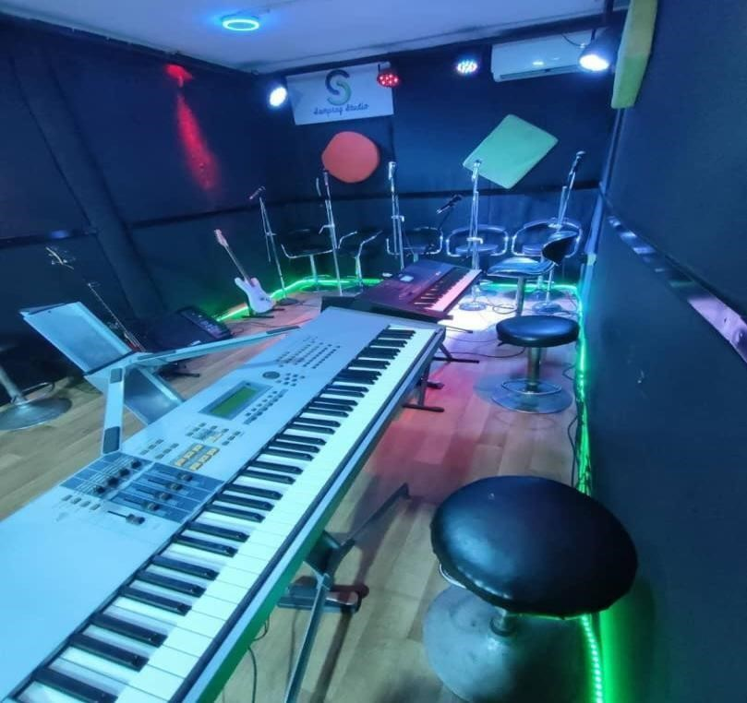

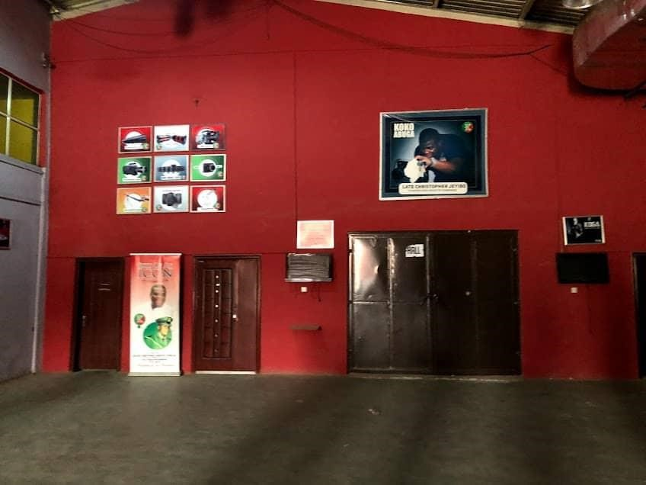

FIGURE 3.2.1: CASE STUDY ONE

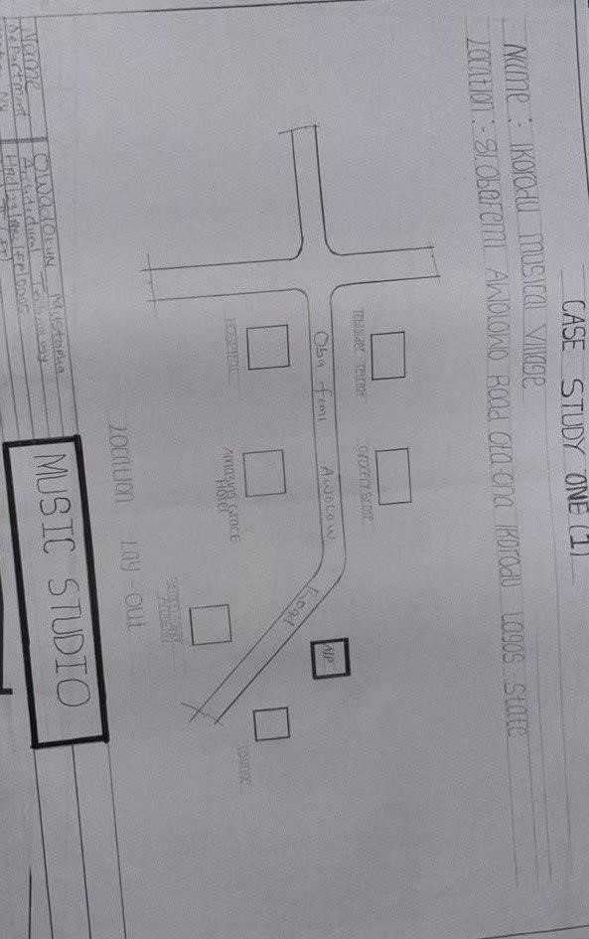

FIGURE 3.2.2: SHOWING THE LOCATION PLAN OF THE CASE STUDY ONE
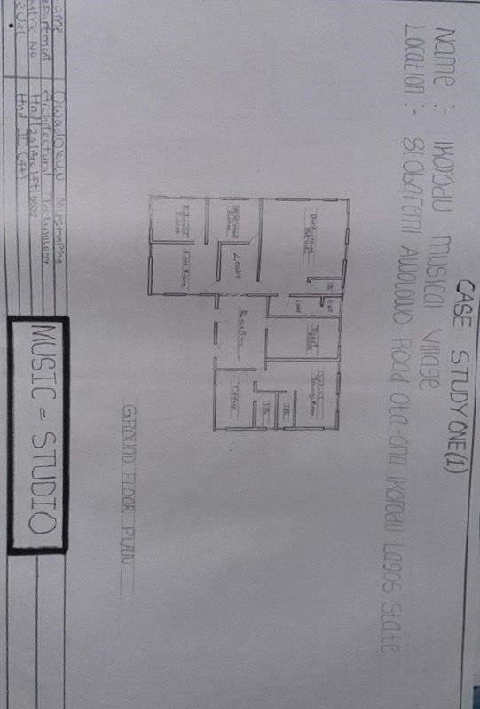
FIGURE 3.2.3: SHOWING THE FLOOR PLAN OF THE CASE STUD ONE

CASE STUDY TWO: AM STUDIO
Name: AM Studio
Location: Road 8, PDCOS Estate, General Gas, Iyana Church Road, Akobo, Ibadan MERITS:
- Designed with acoustic considerations, providing optimal sound quality and minimizing echo and reverberation
- Building design inspires creativity with features such as natural lighting and ventilation
DEMERITS:

- Limited space for circulation within the building No dedicated space for parking lot.

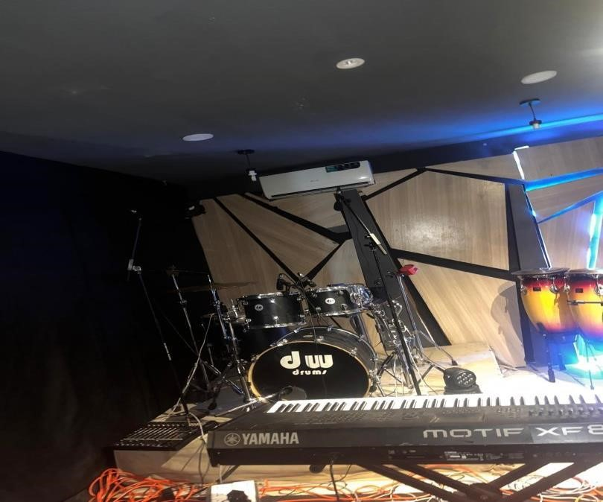

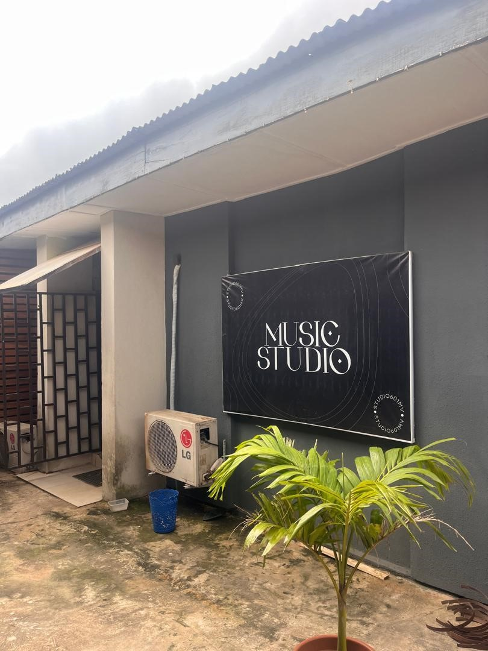

FIGURE 3.2.4: CASE STUDY TWO

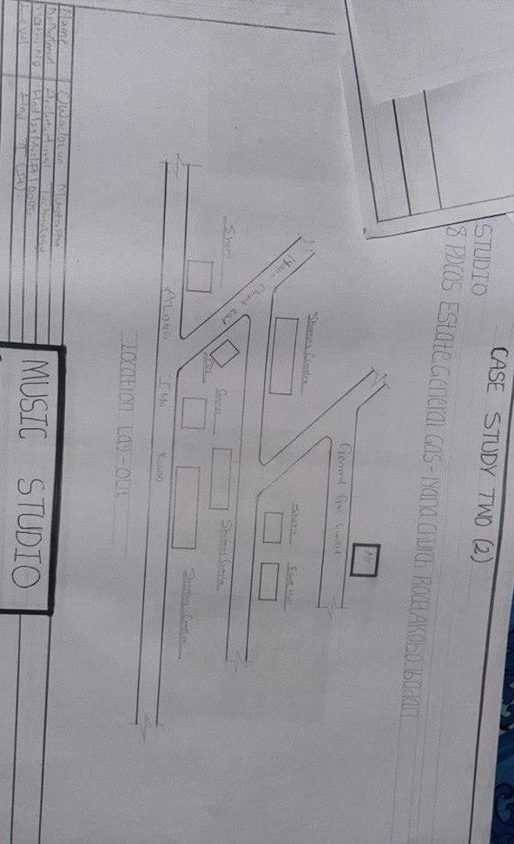

FIGURE 3.2.5: SHOWING THE LOCATION PLAN OF THE CASE STUDY TWO
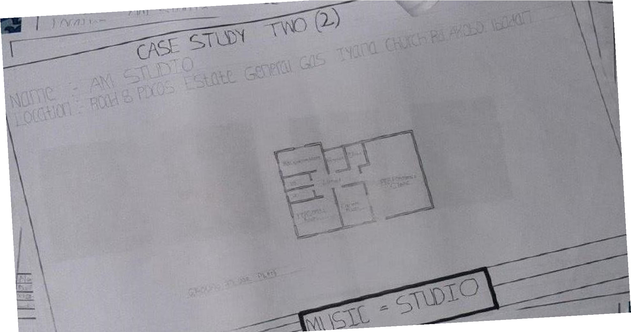

FIGURE 3.2.6: SHOWING THE FLOOR PLAN OF THE CASE STUDY TWO

CASE STUDY THREE: DAMMY CROWN STUDIO
Name: Dammy Crown Studio
Location: Off Aba Nla Road, Eleyele Ologuneru Road, Ibadan
MERITS:
- Spacious area for storage of equipment and musical tools
- Affordable studio rates that attract upcoming artists and producers
DEMERITS:
- No consideration of security measures for the structure
- Located in a residential area, causing disturbance due to sound echoes affecting building occupants

3.3 CASE STUDIES
This section analyses selected international music studios from online research to understand their design standards, acoustic treatments, and innovative features, providing insights to guide the proposed studio design.

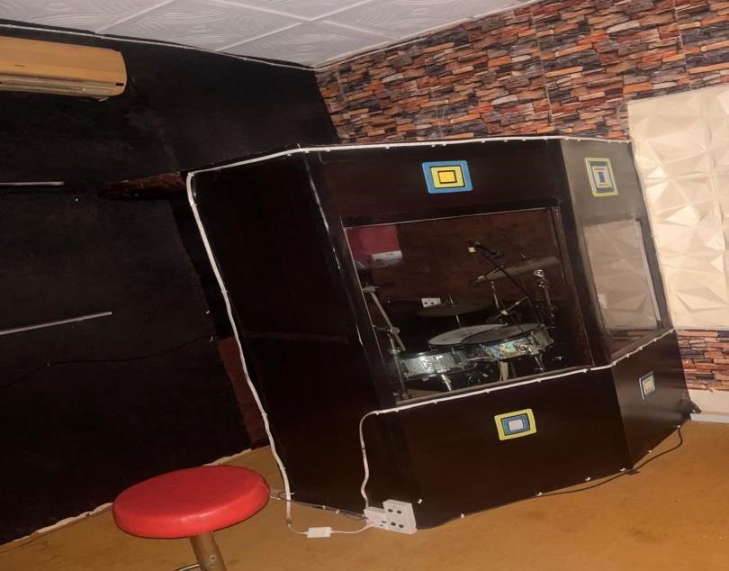
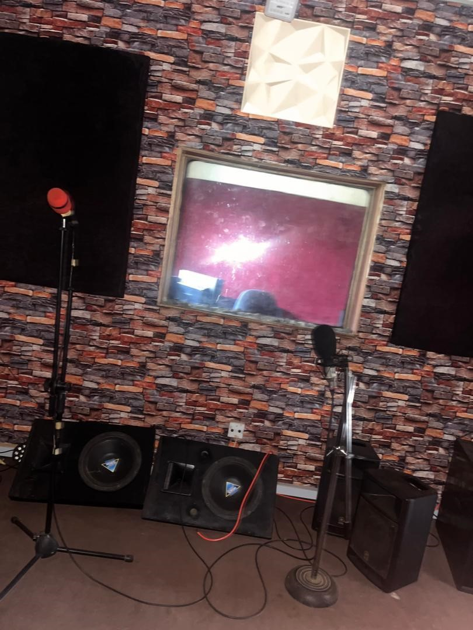

FIGURE 3.2.7: CASE STUDY THREE

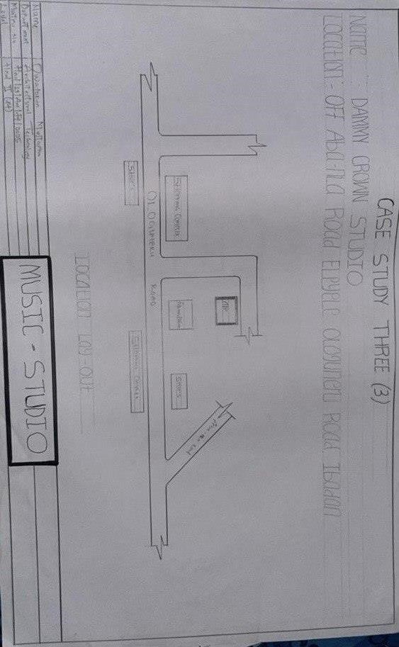

FIGURE 3.2.8: SHOWING THE LOCATION PLAN OF THE CASE STUDY THREE
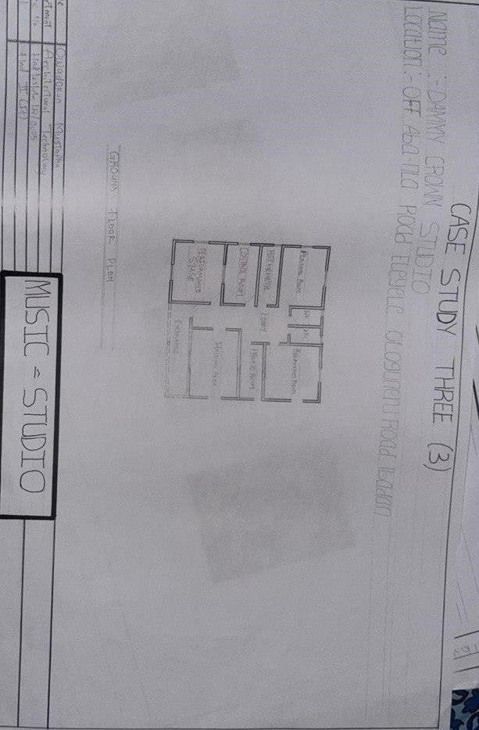
FIGURE 3.2.9: SHOWING THE FLOOR PLAN OF THE CASE STUDY THREE

CASE STUDY FOUR
Name: Milestone Recording Studio
Location: 21 Bloem Street, Cape Town City Center, Cape Town, 8000, South Africa
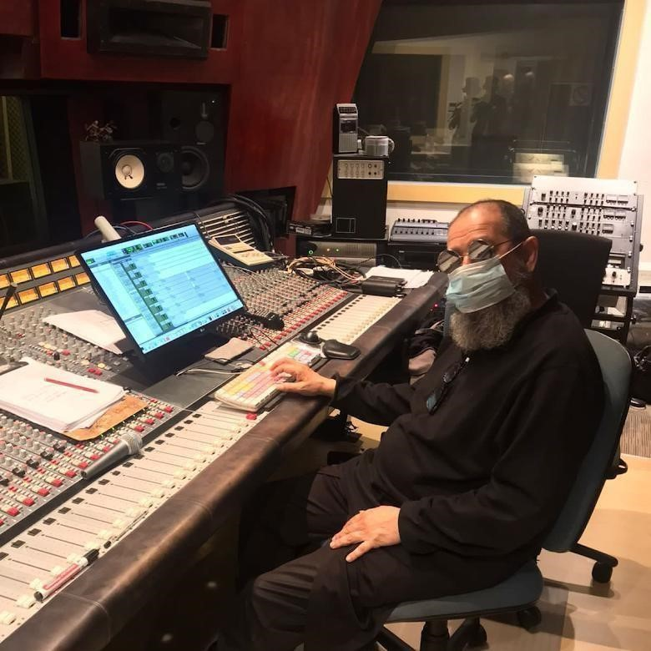
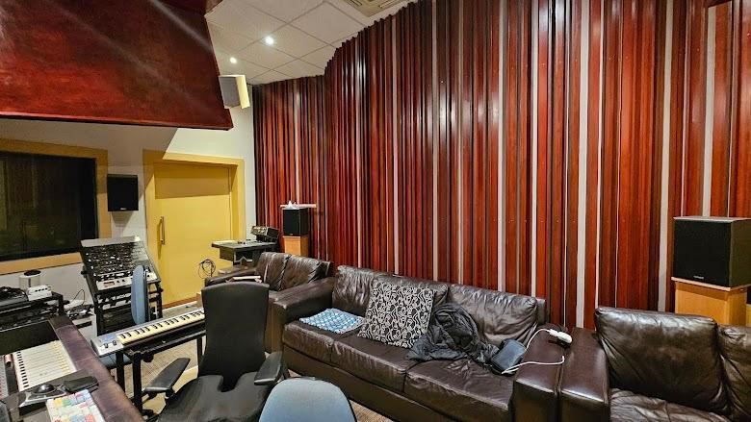

FIGURE 3.2.10: CASE STUDY FOUR

MERITS:
- Equipped with modern recording technology for professional sound production
- Strategically located in the city center, making it accessible for artists and producers  Designed with quality acoustic treatment to enhance recording output
DEMERITS:
- High operational costs due to its prime location and advanced facilities
- Limited parking space for visitors and staff

CASE STUDY FIVE
Name: Paramount Recording Studios
Location: Los Angeles, CA, United States

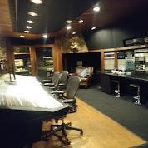

FIGURE 3.2.11: CASE STUDY FIVE

MERITS:
- Internationally recognized with a rich history of working with top artists
- Provides multiple studio rooms with advanced equipment for different production needs Offers professional mixing and mastering services within the facility
DEMERITS:
- Very expensive to book for independent or upcoming artists
- High demand and tight booking schedules can limit access for some clients

3.4 DATA COLLECTION METHODS
The data collection methods used for this study include both primary and secondary sources to ensure comprehensive understanding and accuracy. Primary data was collected through questionnaires and interviews administered to music producers, sound engineers, and studio users to gather their experiences, preferences, and expectations for a functional music studio. Physical case studies were conducted by visiting existing studios to observe their spatial arrangements, acoustic treatments, lighting, and material finishes.
Additionally, secondary data was gathered through extensive literature review, including books, journals, and online resources, to understand standard practices, design guidelines, and historical evolution of music studios. Online case studies of international studios were also reviewed to gain insights into global best practices and innovative design approaches. This combination of methods ensured that the research is grounded in both theoretical knowledge and practical realities.

3.4 DATA COLLECTION INSTRUMENTS
The instruments used for data collection in this study include:
- Questionnaires: Designed and distributed to music producers, sound engineers, and regular users to gather structured data on their experiences, preferences, and expectations for music studio design.
- Interviews: Conducted with selected professionals in the music and sound production industry to gain in-depth insights into functional requirements, design considerations, and operational challenges within studios.
- Observation Checklist: Used during physical case studies to systematically record spatial arrangements, acoustic treatments, lighting conditions, and general design features of existing music studios.
- Measuring Tape and Camera: Measuring tape was employed to obtain accurate dimensions of spaces during site visits, while a camera was used to document spatial layouts, materials, and other relevant design elements.
- Literature Review Materials: Books, journals, and online publications were used to gather theoretical data, standard dimensions, and best practices in the design and construction of music studios.

3.6 METHOD OF DATA ANALYSIS
The data collected for this study was analyzed using qualitative methods to derive meaningful insights that informed the design proposal. Responses from interviews and questionnaires were reviewed to identify recurring themes, user preferences, and design requirements. Additionally, findings from physical and online case studies were compared to establish design standards, spatial relationships, and functional considerations suitable for a modern music studio. This combined analysis ensured that the final design aligns with both user expectations and professional best practices.

3.6.1 QUALITATIVE DATA ANALYSIS
The qualitative data gathered from interviews, questionnaires, and observations were systematically reviewed and categorized to identify common themes, user preferences, functional requirements, and design challenges. This analysis enabled the extraction of key information necessary for creating a music studio design that meets user needs and aligns with standard design practices.

3.6.2 QUANTITATIVE DATA ANALYSIS
Quantitative data analysis involved the use of numerical data obtained from questionnaires to generate statistical information such as frequency counts and percentages.
This helped in summarizing users’ responses on specific aspects of music studio design, such as preferred room sizes, acoustic treatment options, and equipment needs. The analysis provided measurable data to support design decisions and ensure that the proposed studio meets user requirements effectively.

CHAPTER FOUR

PROJECT SITE AND ENVIRONMENTAL ANALYSIS

4.1 INTRODUCTION TO PROJECT SITE ANALYSIS
Project site analysis is a crucial stage in architectural design as it involves studying the physical, environmental, and socio-economic characteristics of the proposed site to inform appropriate design decisions. This section examines the site selected for the music studio, evaluating its location, accessibility, climate, topography, surrounding land uses, and other contextual factors. Understanding these aspects ensures that the design proposal responds effectively to its environment, enhances user comfort, and integrates seamlessly within its surroundings.

4.2 SITE LOCATION, SELECTION CRITERIA AND DESCRIPTION
This section presents the location, selection criteria, and a brief description of the chosen site for the proposed music studio project to establish its suitability and relevance for the design.
The assessment includes factors such as accessibility, proximity to target users, availability of utilities, and the surrounding environmental conditions. Understanding these aspects is essential to ensure that the selected site can support functional, acoustic, and operational requirements while enhancing the overall user experience and project objectives.

4.2.1 SITE LOCATION
The proposed site for the music studio is located in Ejigbo Local Government Area, Osun State, Nigeria. Osun State is situated in the southwestern region of Nigeria, known for its rich cultural heritage and growing creative arts industry. The site is accessible via major roads within Ejigbo, providing ease of connection to nearby communities and supporting potential patronage by musicians, producers, and artists across the state.

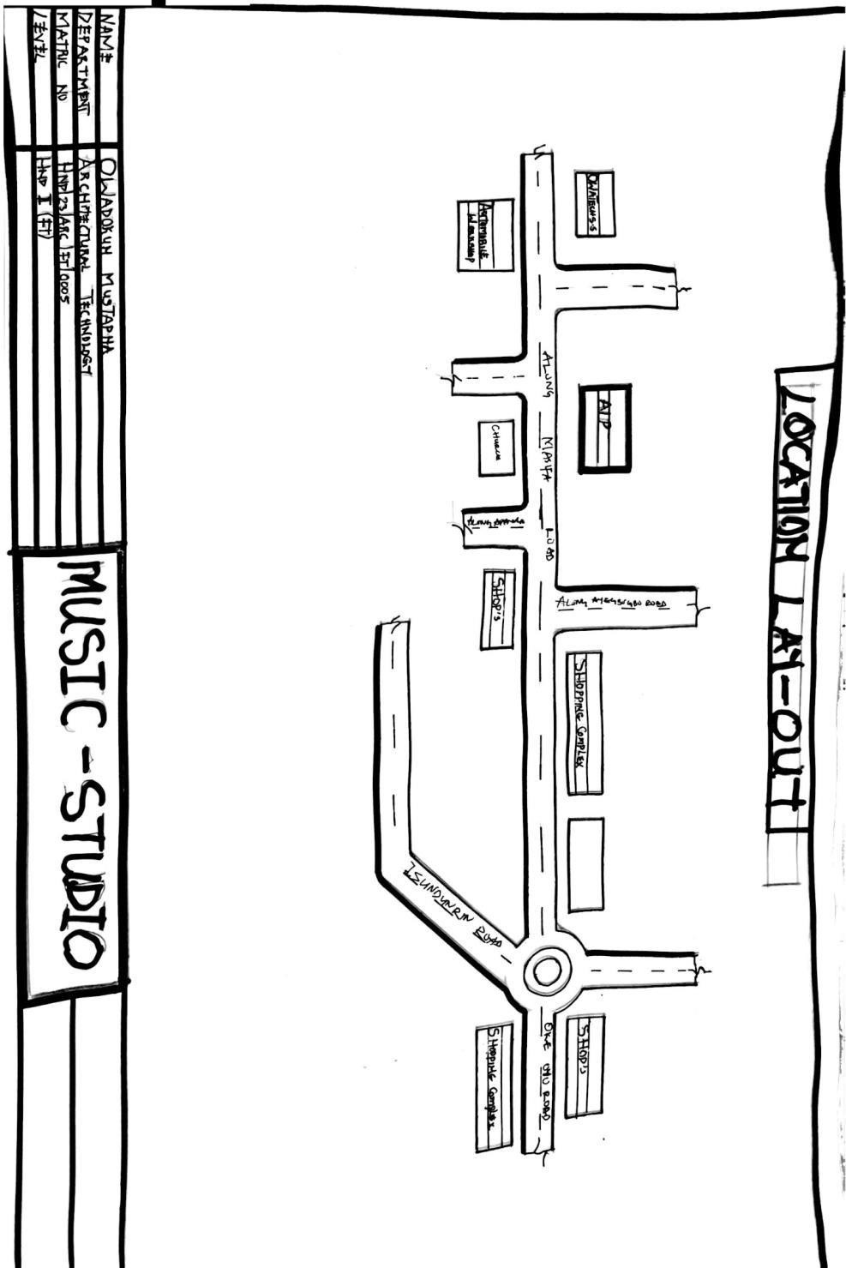

FIGURE 4.2.1.1: LOCATIONAL PLAN

4.2.2 SITE SELECTION CRITERIA
The site was selected based on several key criteria to ensure its suitability for the proposed music studio project. These criteria include accessibility for users and staff, availability of adequate space for the studio and possible future expansion, and proximity to urban areas where potential clients and musicians are located. The site was also chosen for its relatively quiet environment, which supports effective acoustic design and reduces external noise interference. Additionally, the presence of essential infrastructure such as electricity, road network, and water supply was considered important for the smooth operation of the studio.

4.2.3 SITE DESCRIPTION
The chosen site is located in Ejigbo Local Government Area of Osun State. It is a relatively flat piece of land with minimal vegetation, making it suitable for development without extensive clearing or grading. The site is accessible via a tarred road that connects it to nearby communities and the main town center, ensuring easy transportation of musical equipment and user access. Surrounding the site are residential buildings and a few commercial outlets, creating a balanced environment for creative activities. The site enjoys natural ventilation and adequate sunlight, which will enhance the indoor environment when properly integrated into the design. Its size is sufficient to accommodate the proposed music studio, ancillary spaces, parking, and possible future expansion.

4.3 SITE ANALYSIS
A site analysis was conducted to understand the physical, environmental, and contextual characteriztics of the chosen location in Ejigbo Local Government, Osun State. The analysis revealed that the site has relatively flat topography, reducing the need for extensive grading during construction. The soil type is predominantly laterite, which is good for foundation stability.
The climate in the area is tropical with distinct wet and dry seasons, which will influence material selection and design to ensure durability and thermal comfort. There is adequate access to sunlight throughout the day, which can be harnessed for natural lighting and possible solar energy integration.
The surrounding land use is mainly residential with some small-scale commercial activities, providing a calm and secure environment suitable for creative and recording activities. The site is accessible by motorable roads, ensuring easy transportation of materials and mobility for users.
Additionally, noise levels around the site are moderate, but acoustic design will be essential to prevent sound leakage and maintain studio quality. The site has no major physical obstructions, making it suitable for flexible spatial planning in the proposed music studio design.

SITE INVENTORY
The site has an access road for easy entry, nearby electricity supply, and minimal vegetation with grasses and small trees. The soil is suitable for construction, and there is an anthill to be cleared. Noise from the road needs to be considered in the design.

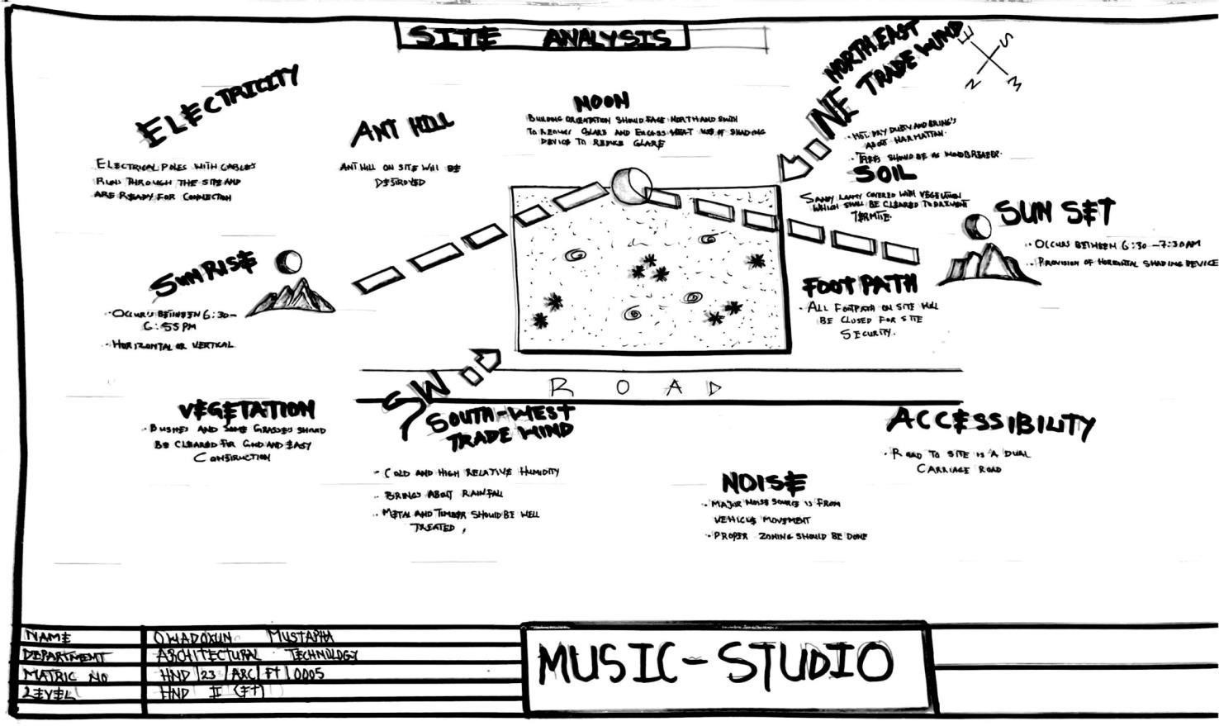

FIGURE 4.3.1: SITE ANALYSIS
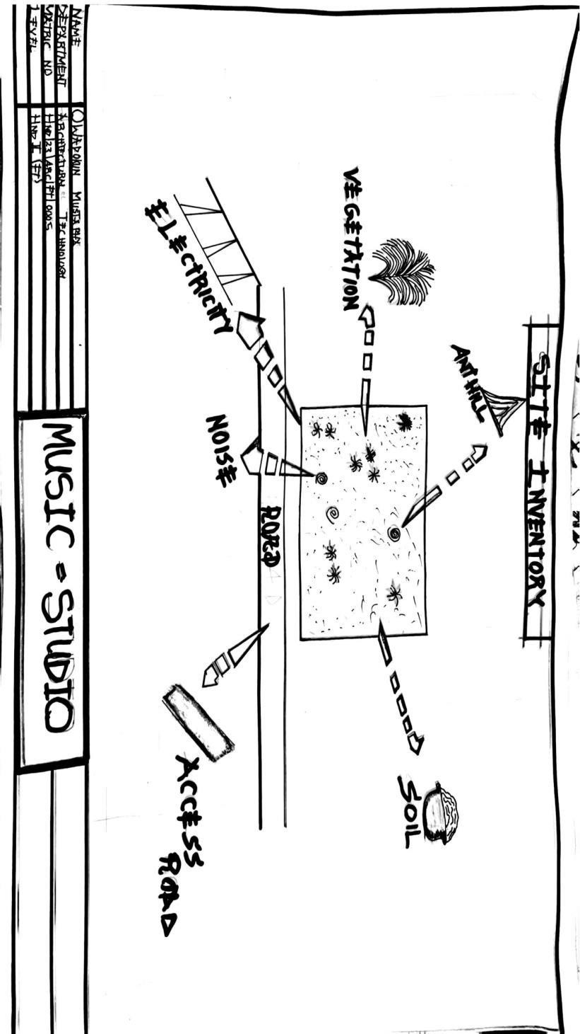

FIGURE 4.3.2: SITE INVENTORY

4.4 CLIMATIC DATA
The climatic data of the project site in Ejigbo, Osun State, indicates a tropical climate characterized by two main seasons: the rainy season and the dry season. The area experiences an average annual temperature ranging between 25°C to 32°C, with high humidity levels, especially during the rainy months between April and October.
Rainfall is significant, with an annual average of approximately 1200mm to 1500mm, which necessitates proper drainage and roofing design to prevent water accumulation and leakages. The dry season extends from November to March, with Harmattan winds sometimes reducing visibility and increasing dust levels.
Prevailing wind direction is mainly from the southwest, which should be considered in the orientation of openings and ventilation planning for effective cross ventilation. Sunshine hours are adequate, averaging 6 to 8 hours daily, which supports the integration of natural lighting strategies and potential solar energy systems in the design.
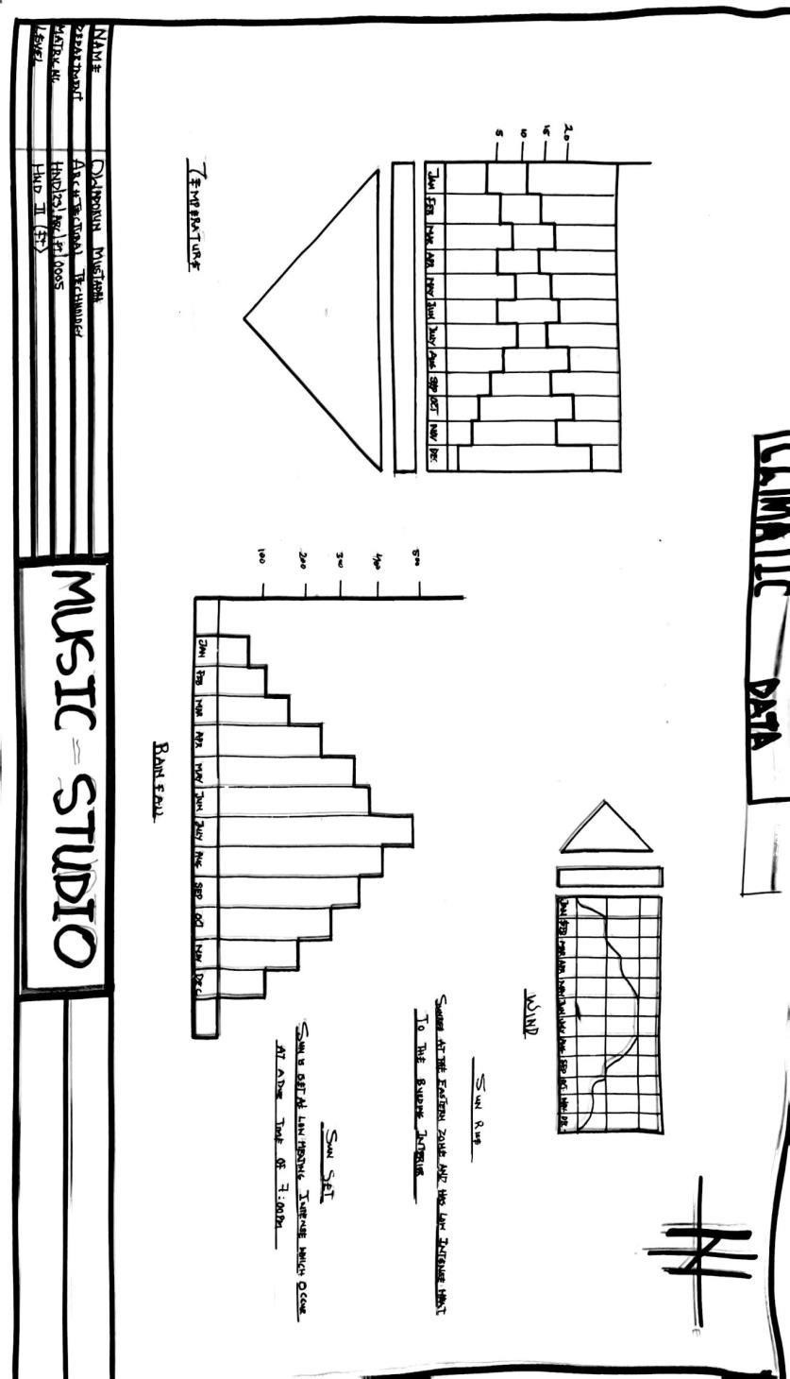

FIGURE 4.4.1: CLIMATIC DATA

4.5 DESIGN PRELIMINARIES
Design preliminaries involve all the initial considerations, analyses, and preparations undertaken before the actual design process begins. It includes understanding the client’s needs, interpreting research data, establishing design objectives, developing spatial requirements, and reviewing standards and regulations relevant to music studio design. This stage ensures that the design proposal is functional, feasible, and tailored to the intended users while aligning with architectural and acoustic principles.

4.5.1 BUBBLE DIAGRAM
A bubble diagram is a planning tool used to show the spatial relationships between different areas of the music studio, such as the control room, recording booth, and waiting area. It helps the designer arrange spaces logically for efficient flow before creating detailed layouts.

4.5.2 FUNCTIONAL RELATIONSHIP
The functional relationship outlines how different spaces within the music studio relate and connect to each other to ensure smooth operations. For example, the recording booth should be directly connected to the control room for easy communication and monitoring, while waiting and reception areas should be near the entrance to welcome clients efficiently. Storage spaces should be accessible from both the recording and control rooms for quick equipment retrieval. Establishing these relationships ensures that the design supports workflow, enhances productivity, and provides a comfortable environment for users.

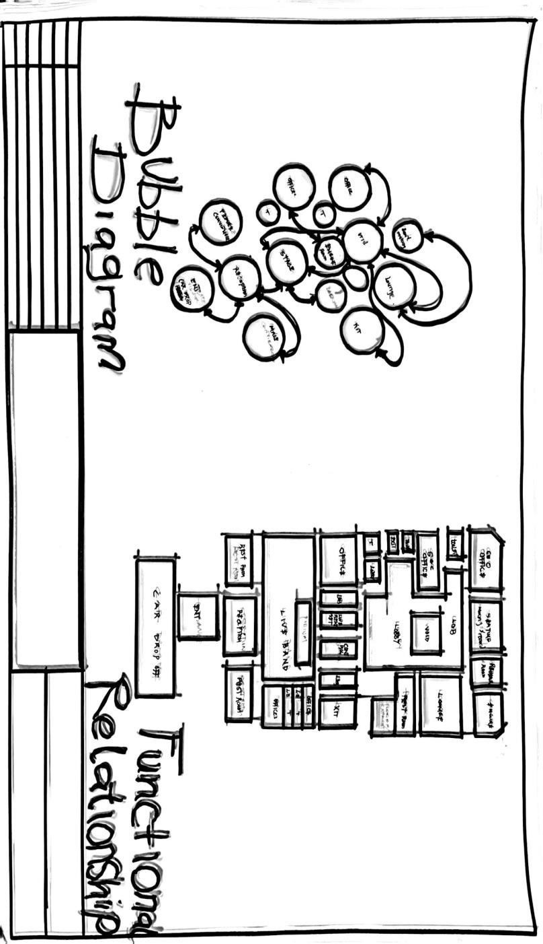

FIGURE 4.5.2.1: BUBBLE DIAGRAM AND FUNCTIONAL RELATIONSHIP

4.5.3 SPATIAL ALLOCATION
Space allocation involves assigning adequate sizes to each functional area in the music studio for effective use. The control room is given the largest space for equipment and mixing activities. The vocal booth is small but fully soundproofed for recording vocals, while the live room is spacious enough for instruments and group recordings. Other areas like the reception, lounge, and restroom are also allocated appropriate spaces to ensure comfort, smooth workflow, and functionality within the facility.
S/N | Units | Dimensions(mm)
1 | Entrance | 9.5 x 2.1
2 | Reception | 6.7 x 2.9
3 | Toilets | 1.2 x 1.8
4 | Lobby | 4.8 x 1.0
5 | Live Session | 13.0 x 8.0
6 | Store Room | 3.6 x 3.0
7 | Financial Room | 3.6 x 2.1
8 | Control Room | 3.6 x 3.0
9 | Office | 5.3 x 2.8
10 | Kitchenette | 5.0 x 3.6
11 | Lounge | 5.0 x 4.2
12 | Rehearsal Room | 5.6 x 5.1
13 | Seminar/Recording | 5..6 x 9.1
14 | Courtyard | 4.8 x 2.4
15 | Exit | 2.1 x 1.2

4.5.4 DESIGN ZONING
Design zoning involves the arrangement and grouping of spaces within the music studio facility based on their functions to enhance efficiency and workflow. In this project, zoning is divided into three main areas:
Public Zone  Entrance  Reception  Lounge  Waiting Area | Semi Public Zone  Office  Kitchenette  Rehearsal Room  Seminar/Recording Rooms | Private Zone  Control Room  Vocal Room  Live Session Room  Serving/staff room

4.6 DESIGN CRITERIA

CLIENT’S BRIEF
The client requires a modern music studio facility that meets international standards and supports professional music production activities. The facility should include:
- A well-designed control room with adequate acoustic treatment and space for mixing consoles and equipment.
- A vocal booth that is fully soundproofed for recording vocals and instruments.
- A spacious live session room for group recordings and instrumentals.
- Reception and lounge areas to welcome artists and visitors comfortably.
- Offices for administrative functions and management.
- Supporting spaces such as toilets, kitchenette, store room, and rehearsal room for convenience and effective operation.
The client also emphasizes the need for proper acoustic design, ventilation, lighting, and aesthetic appeal to create an environment that promotes creativity, productivity, and user comfort.

4.7 CONCEPTUAL DEVELOPMENT
The conceptual development for the music studio design focuses on creating a functional, acoustically effective, and aesthetically pleasing environment that supports professional music production. The concept is inspired by the fluidity of sound waves, which is reflected in the spatial arrangement and form of the building. Spaces are zoned to enhance workflow, with public areas positioned towards the entrance and private recording spaces located deeper within the facility to minimize noise interference. The design also integrates natural lighting, ventilation, and acoustic treatments to ensure user comfort and high-quality sound production. Overall, the concept aims to create a studio environment that is both practical and inspiring, fostering creativity and productivity for artists and producers.

CHAPTER FIVE

DESIGN APPROACH AND REALIZATION

5.1 DESIGN CONCEPT

5.2 BEHAVIOURAL PATTERNS AND CONSIDERATIONS
The design considers the behavioral patterns of users, including music producers, artists, and visitors, to ensure smooth workflow and comfort within the studio. Movement patterns between the control room, recording booth, and waiting area are designed for easy access and minimal disturbance. Additionally, considerations such as privacy for recording artists, comfortable waiting spaces for guests, and efficient placement of equipment were incorporated to enhance user experience and productivity within the studio environment.

5.3 LEGAL ISSUES AND PLANNING REGULATIONS
The design adheres to relevant legal requirements and planning regulations, including zoning laws, building codes, and safety standards set by local authorities. Approvals for land use and development were considered to ensure compliance. Additionally, regulations regarding acoustic control, fire safety, ventilation, and accessibility for all users were integrated into the planning to achieve a safe, legal, and professionally acceptable music studio facility.

5.4 TECHNOLOGICAL AND ENVIRONMENTAL CRITERIA
The design incorporates modern technological requirements such as high-quality acoustic insulation, soundproofing materials, and digital recording equipment integration to ensure optimal functionality. Environmentally, considerations include natural lighting, effective ventilation, and the use of sustainable materials to reduce energy consumption and promote user comfort, while minimizing environmental impact within the studio space.

5.5 CONCLUSION
The design of a music studio facility requires a deep understanding of acoustic principles, functional space planning, and aesthetic considerations to achieve a standard environment suitable for professional music production. This project has addressed the spatial requirements, zoning, circulation, and technical considerations essential for creating an effective and comfortable music studio. Through careful analysis of existing literature, case studies, and design standards, it has been established that studios must prioritize acoustic treatment to prevent sound distortion, ergonomic layouts to enhance productivity, and an inspiring atmosphere to foster creativity among users.
The proposed design ensures that each functional space is adequately sized and positioned to support seamless workflow within the facility. The zoning strategy separates public, semiprivate, and private areas to maintain operational efficiency and security. Additionally, the design considers natural ventilation, artificial lighting, and modern finishes to enhance user comfort. By meeting the client’s brief and aligning with global best practices, this project will contribute to the development of standard music studio facilities in Nigeria, supporting the growth of the nation’s music industry and providing a conducive environment for artists, producers, and sound engineers.

5.6 RECOMMENDATIONS
Based on this project on the Design of a Music Studio Facility, the following are recommended:
High-quality acoustic materials such as foam panels, diffusers, and bass traps should be used to achieve clear sound production. Regular maintenance of equipment and finishes is needed for durability. The studio should integrate modern recording technologies to meet professional standards. For user comfort, ergonomic furniture, proper lighting, and air conditioning should be provided. The design should also allow for future expansion when needed. All construction works must comply with building regulations and safety standards. Lastly, continuous training of staff on equipment use and acoustic management is essential to maintain efficiency.

REFERENCES
Ashby, M. F., & Johnson, K. (2014). Materials and design: The art and science of material selection in product design (3rd ed.). Oxford, UK: ButterworthHeinemann. ISBN 9780080993690
Ching, F. D. K. (2015). Building construction illustrated (5th ed.). Hoboken, NJ: John Wiley &
Sons. https://doi.org/10.1002/9781119148674
Ching, F. D. K., Jarzombek, M., & Prakash, V. (2011). A global history of architecture (2nd ed.).
Hoboken, NJ: John Wiley & Sons. ISBN 9780470402573
Chudley, R., & Greeno, R. (2008). Building construction handbook (7th ed.). Oxford, UK:
Butterworth-Heinemann. ISBN 9780750686228
Emmitt, S., & Gorse, C. (2010). Barry’s introduction to construction of buildings (2nd ed.).
Oxford, UK: Wiley-Blackwell. ISBN 9781405195027
Emmitt, S., & Gorse, C. (2014). Barry’s advanced construction of buildings (3rd ed.). Oxford, UK: Wiley-Blackwell. ISBN 9781118255496
Everest, F. A., & Pohlmann, K. C. (2015). Master handbook of acoustics (6th ed.). New York, NY: McGraw-Hill Education. ISBN 9780071841047
Ezeagu, C. A. (2016). Building acoustics and noise control. Enugu, Nigeria: Goodness Press. ISBN 9789785517253
Geetha, N., & Ambika, R. (2013). Sound insulation in buildings. International Journal of Engineering Research & Technology, 2(9), 1703-1709.
Neufert, E. (2000). Architects’ data (3rd ed.). Oxford, UK: Blackwell Science Ltd. ISBN 9780632038542
Neufert, E., & Neufert, P. (2012). Architects’ data (4th ed.). Oxford, UK: Wiley-Blackwell. ISBN 9781405192538
Olotuah, A. O. (1997). Principles of architectural design. Akure, Nigeria: Adeyemi
Printing Press. ISBN 9783529887
Olotuah, A. O. (2006). Design of specialised building facilities. Lecture notes, Department of Architecture, Federal University of Technology, Akure, Nigeria.
Olotuah, A. O., & Taiwo, A. A. (2006). Housing delivery and housing finance in Nigeria: Bottlenecks and recent initiatives. Housing Finance International, 20(1), 21-26.
Olusanya, O. (2011). Acoustics and sound control in buildings. Lagos, Nigeria: University of Lagos Press. ISBN 9789785453490
Onwuka, D. O. (2018). Architectural acoustics: Principles and practice. Owerri, Nigeria: Manson Publishers. ISBN 9789785326046
Singh, R., & Garg, S. (2012). Acoustics in building design. International Journal of Engineering Research and Applications, 2(4), 605-610.
Uji, Z. A. (2003). Understanding architecture: The elements of building design. Zaria, Nigeria:
Tamaza Publishing Co. Ltd. ISBN 9780582981
Uji, Z. A. (2011). Fundamentals of architectural design: Theory and practice. Zaria, Nigeria:
Ahmadu Bello University Press. ISBN 9789789053344
Uji, Z. A., & Nmadu, T. M. (2007). Architectural acoustics and building services. Zaria, Nigeria: Ahmadu Bello University Press. ISBN 9781253559
Watkinson, J. (2013). The art of sound reproduction (3rd ed.). Oxford, UK: Focal Press. ISBN 9780240521756
Whitaker, R. (2012). Acoustic design for the home studio. Oxford, UK: Focal Press. ISBN 9780240522302

APPENDIX
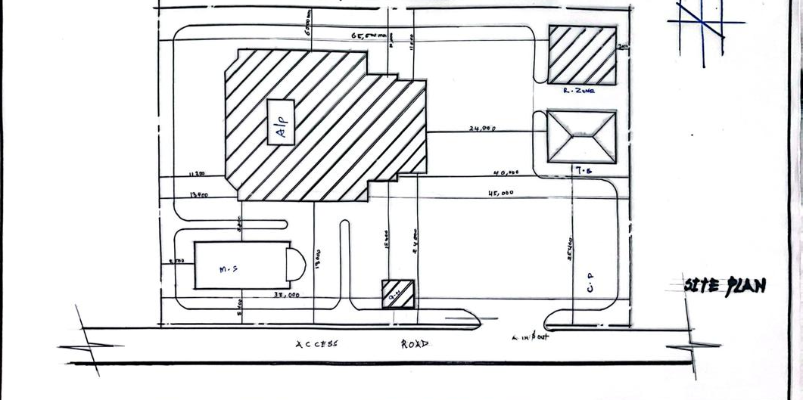

FIGURE 5.51.1: SITE PLAN

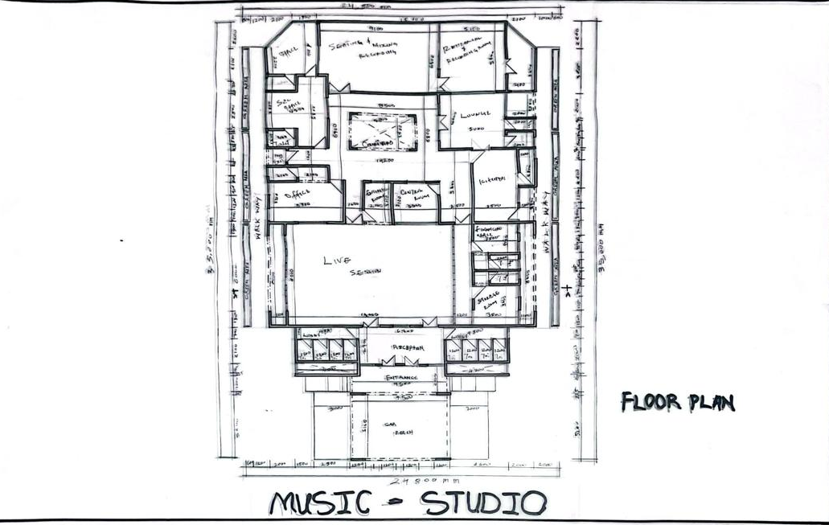

FIGURE 5.5.2.1: FLOOR PLAN

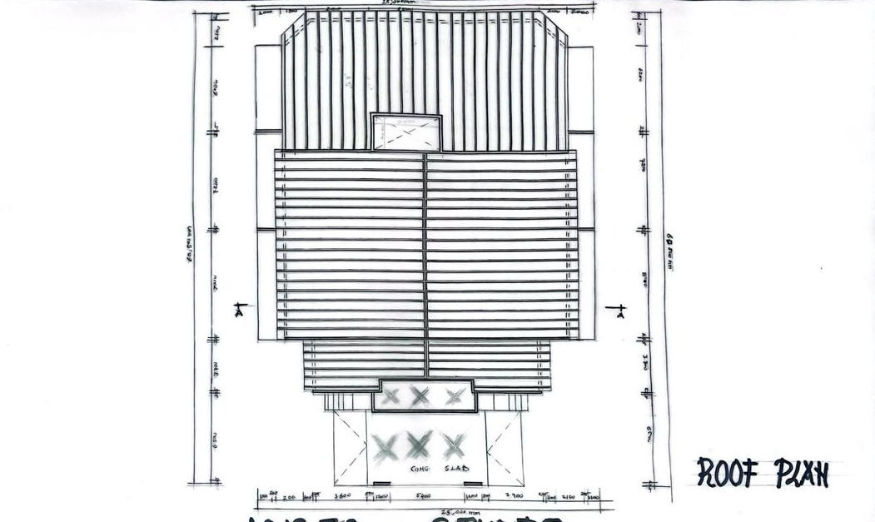

FIGURE 5.5.3.1: ROOF PLAN

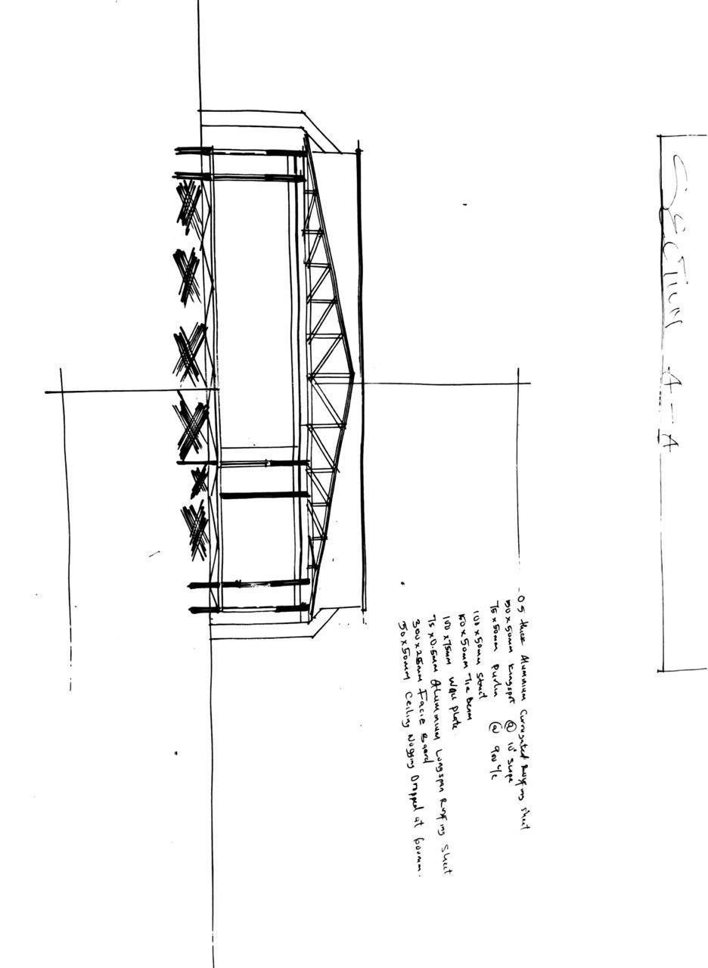

FIGURE 5.5.4.1: SECTION PLAN

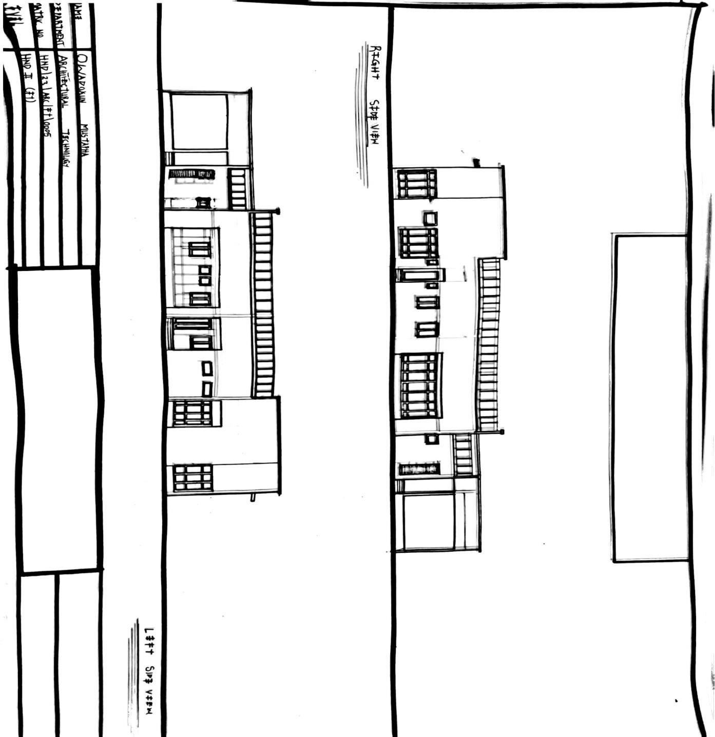

FIGURE 5.5.5.1: ELEVATION PLAN

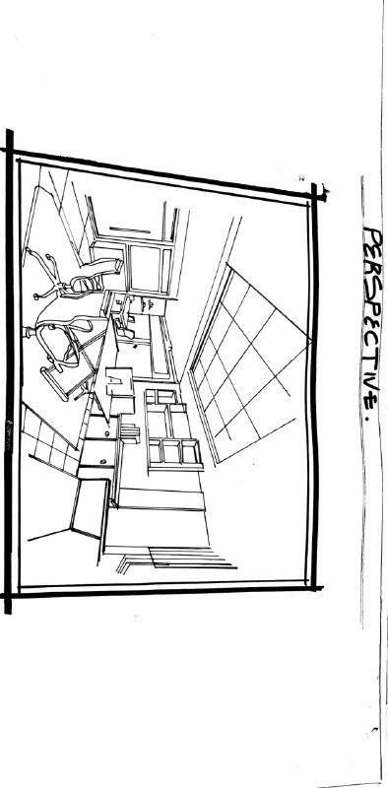

FIGURE 5.6.1.1: INTERNAL PERSPECTIVE VIEW

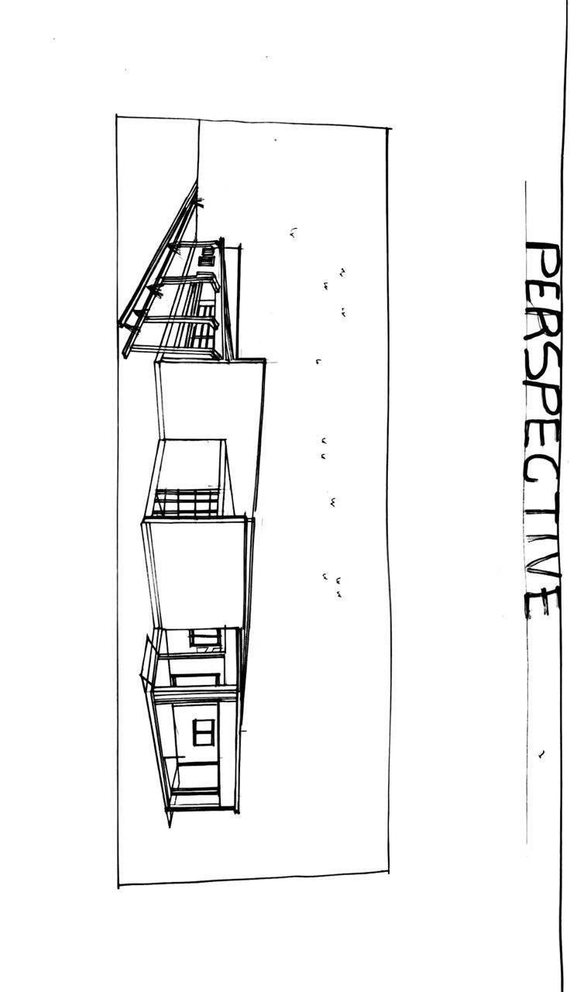

FIGURE 5.6.2.1: EXTERNAL PERSPECTIVE VIEW

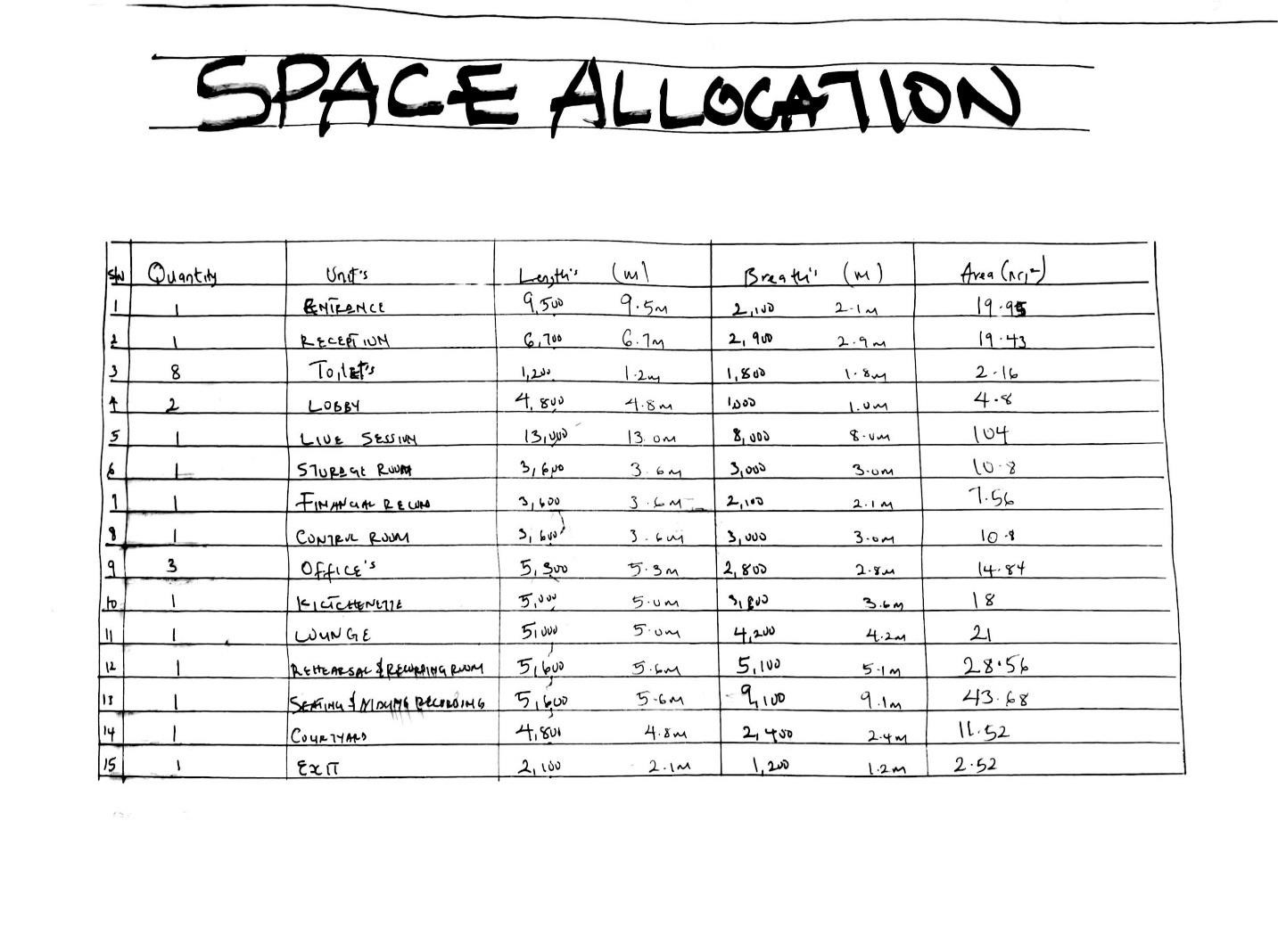
SPACE ALLOCATION

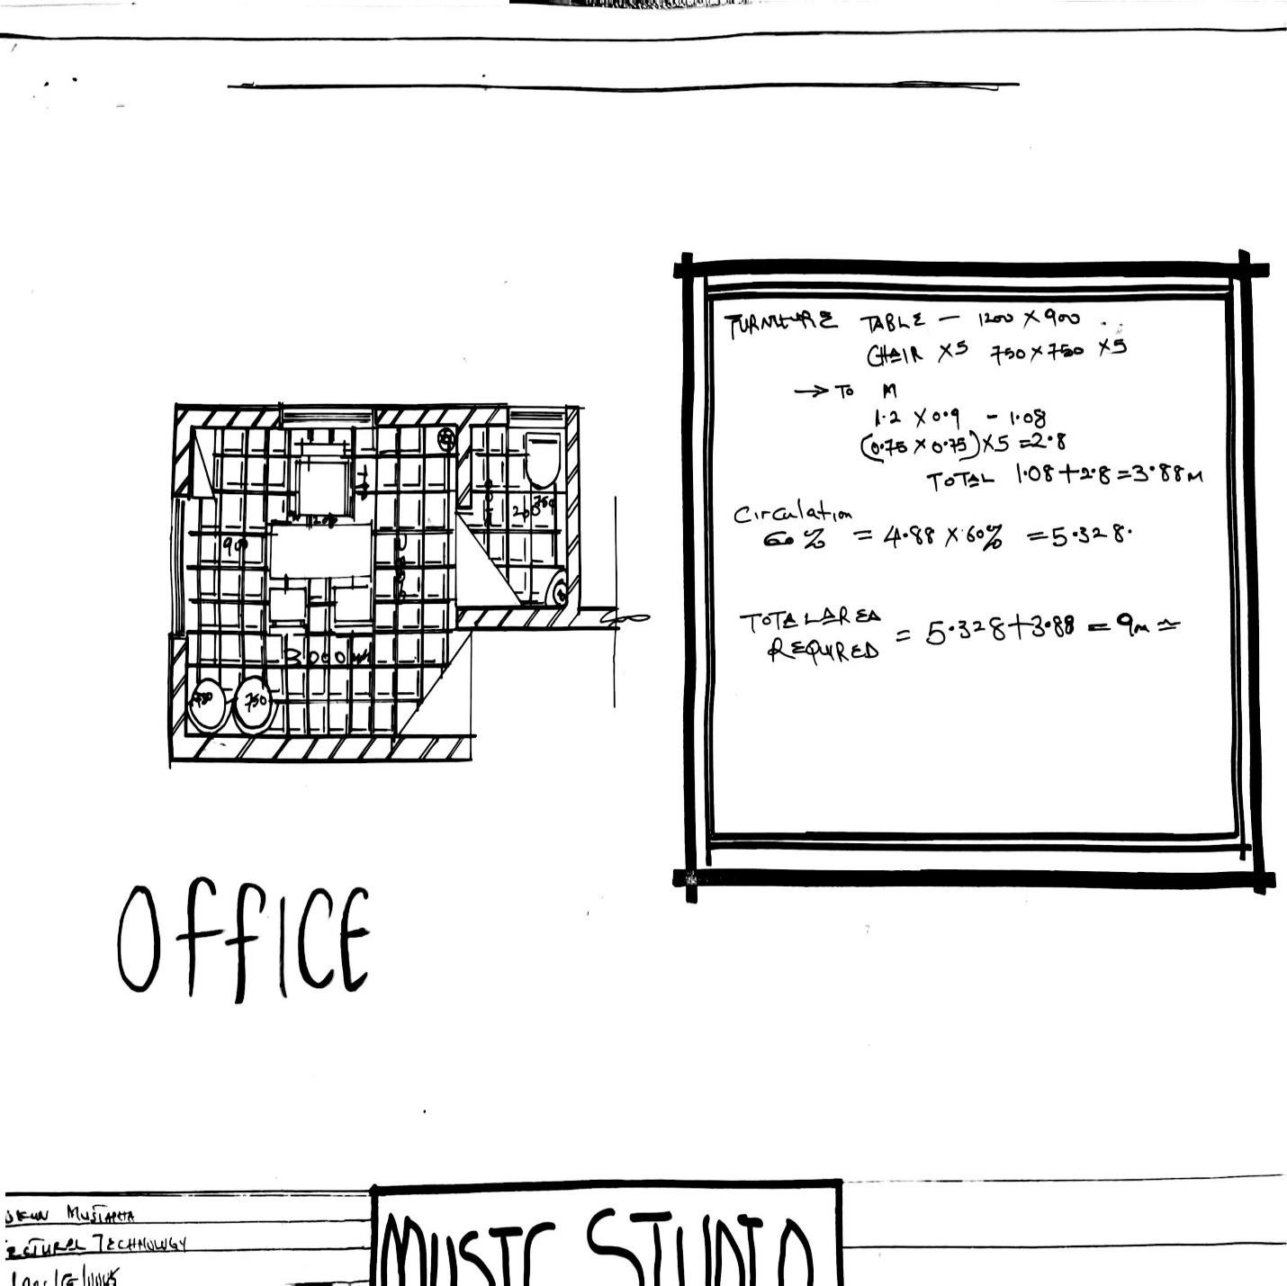
SPACE ANALYSIS

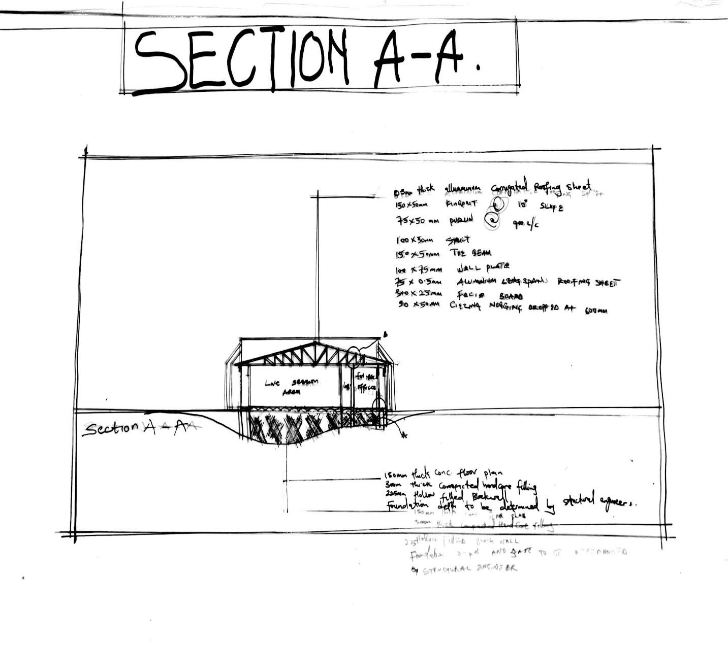
SECTION A – A

