A PROJECT REPORT
ON
PROPOSED VOCATIONAL CENTER
FOR
ILORIN EAST LOCAL GOVERNMENT, OKE-OYI. KWARA STATE.
BY
SULYMAN AWWAL TAIYE
HND/23/ARC/FT/0023
SUBMITTED TO:

THE DEPARTMENT OF ARCHITECTURAL TECHNOLOGY
INSTITUTE OF ENVIRONMENTAL STUDIES (I.E.S)
KWARA STATE POLYTECHNIC, ILORIN.

IN PARTIAL FULFILMENT OF THE REQUIREMENTS FOR THE AWARD OF HIGHER NATIONAL DEPLOMA (HND) IN ARCHITECTURAL TECHNOLOGY

JULY, 2025.

DECLARATION
This is a work carried out by me Sulyman Awwal Taiye, with the matriculation number HND/23/ARC/FT/0023 of the department of Architectural Technology, Kwara State Polytechnic, Ilorin under the supervision of ARC. OLAREWAJU F.A.
All the sources of information are specifically acknowledged by means of reference.



CERTIFICATION
This project report on the proposed Vocational Center for Ilorin east Local Government, oke-oyi, Kwara state by Sulyman awwal taiye with the matriculation number HND/23/ARC/FT/0023 has been certified as meeting the requirement for the award of Higher National Diploma (HND) in Architectural Technology, Institute of Environment Studies, Kwara State Polytechnic, under the supervision of Arc. Olarewaju F. A.

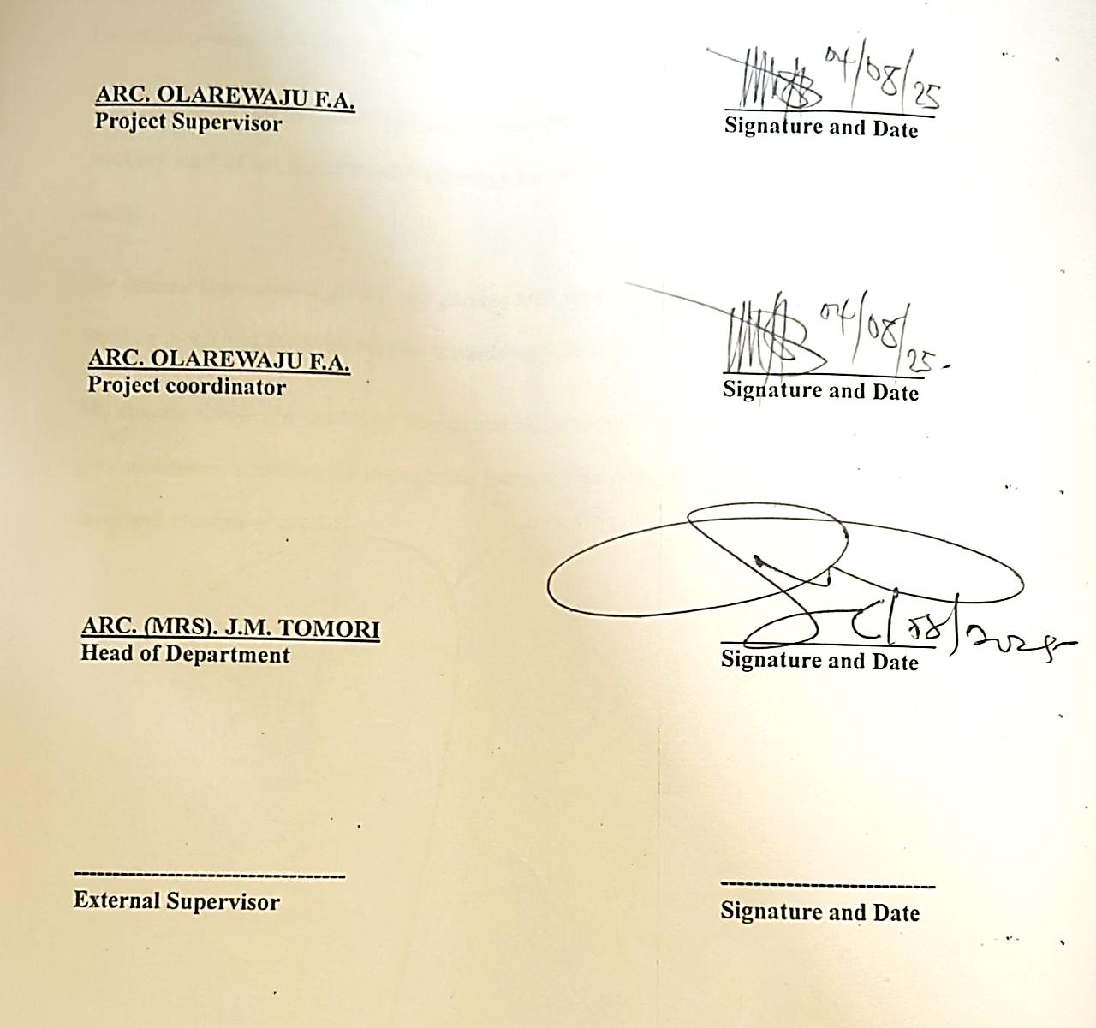
ARC. OLAREWAJU F.A
(Project supervisor) SIGNATURE/DATE

ARC. OLAREWAJU F.A
(Project Coordinator) SIGNATURE/DATE

ARC. MRS. J.M TOMORI
(Head of Department) SIGNATURE/DATE

EXTERNAL SUPERVISOR SIGNATURE/DATE

DEDICATION
This project is primarily dedicated to Almighty Allah, the Giver of Knowledge, Wisdom, and Understanding, for His Grace and Strength Throughout the Course of My Higher National Diploma, and for Counting Me Worthy of His Mercy,

ACKNOWLEDGEMENT
I humbly acknowledge Allah, the maker of heaven and earth and who has kept me alive to this day. I am grateful to him for the epitome of greatness he has shown me through his love, concern, and guidance in all ramification of my life.
My sincere and genuine appreciation goes to my project supervisor ARC. OLAREWAJU F.A for his selfless support and motivation to keep me focus till this very time and inculcated in me the necessities to keep me on track after my HND program. My Head of Department, Arc. Mrs. Tomori and also the entire lecturer/staff of the Department of Architecture, for making my learning experience in the Department a great and productive one.
I cannot but appreciate my lovely family: Mrs Sulyman Habeebat, uztaus Musa AbdulRasaq for your love, support and care during the course of study. Big appreciation to my Siblings, Sulyman Sanni Kehinde, Sulyman Baliqees, Hajia , Sulyman Khadijat and Mustapha
My appreciation goes out to my Noble bosses; Arc. Salman ascetic and Architect Kehinde ajetunmobi my fellow colleagues at Mohammed & Associates; Engr Onagun and Architect Sodiq, my fellow colleagues at ascetic consult; Mr Ayo, Mr Jamiu Mr Nurudeen, Mr Lukman, Mr shamsudeen, Mr Ridwan, Mr Micheal Jibowu, Femi, Tunmishe, Engr Philo and Engr Bunmi and the whole of Kolawole family for all of their support and tireless work to see me succeed, may Almighty Allah provide you all ample reward. My sincere thanks also go to my friends and classmates. I can only express my gratitude for your assistance in getting me through this journey. May Allah continue to provide you all his favor and blessing (Ameen).

ABSTRACT

This project report presents a comprehensive design proposal for a modern vocational training centre situated in Oke-Oyi, Ilorin East Local Government Area, Kwara State. The motivation for the project stems from the growing necessity to address youth unemployment, poverty, and the lack of technical skill acquisition opportunities in the region. This vocational centre is conceived as a solution to these socio-economic challenges by equipping residents—particularly youth and women—with relevant, hands-on training in a wide range of vocations such as tailoring, carpentry, ICT, welding, hairdressing, catering, electrical work, and more.
The architectural design of the project prioritizes environmental responsiveness, flexibility, and inclusiveness. Site planning integrates zoning principles to separate noisy workshops from quieter administrative and academic areas. The physical structure is organized into an administrative block, multiple workshop units, a mini clinic, cafeteria, sports areas, and support services like a generator house and staff quarters. Materials selection is based on local availability, climate suitability, and cost-efficiency, ensuring that the building is both sustainable and contextually appropriate.
A critical element of the proposed centre is its commitment to inclusive design. The layout includes gender-sensitive restrooms, provisions for people with disabilities, and flexible learning spaces adaptable to various training needs. Attention is also given to safety, security, and energy efficiency through the use of natural ventilation, shaded corridors, and solar-powered systems. Landscape design complements the built environment with green buffers, hedges, shaded courtyards, and walkways aimed at creating a serene and welcoming atmosphere for learning.
TABLE OF CONTENT
Title Page
Declaration…………………………………………………………………………… ii
Certification ………………………………………………………………………......iii
Dedication ………………………………………………………………………..…...iv
Acknowledgment ………………………………………………………………...……v
Table of content ………………………………………………………………….…...vi
List of plates…………………………………………………………………….....…vii
List of Tables………………………………………………………….…………..…viii
Abstract …………………………………………………………………………...…. ix
CHAPTER ONE:
1.0 General Introduction …………………………………………………..…………………….…….1
1.1. Historical background of the project…………………………………………………………..……2
1.2 Definition…………………………………….…………………………………………….……...2
1.3 Statement of design problem ………………………………………………………….……..…….3
1.4 Aim and Objectives of the study………………………………………………………….…….….4
1.5 Project justification …………………………………………………………….…………….……5
1.6 Clients background……………………………………………………………………...……...….5
1.7 Scope of the study …………………………………………………………………….……...…...6
1.8 Limitation of design………………………………………………………………….…….………9
1.9 Research Methodology ……………………………………………………………………….….10
CHAPTER TWO:
2.0 Review of relevant Literature…………………………………………………. ….……………...11
CHAPTER THREE
3.0 Case studies………………………………………………………………………….……..…….14
3.2 Case study one……………………………………………………………...………………..…...15
3.3 Case study two…………………………………………………………….………………..…….18
3.4 Case study three…………………………………………………………………………………..22
3.5 Case study four………………………………………………………………………………..….26
3.6 Case study five (online case study) ……………………………………………...……………….29
3.7 Deduction from Case study ……………………………………………………...…………….....29
CHAPTER FOUR
4.0 Project location……………………………………………………………………….………......31
4.1 Historical background of selected location state ……………………………………...……….....31
4.2 Historical background of Selected location LGA……………………………………………..….32
4.3 Physical feature of the location ……………………………………………………...………...…33
4.4 Population ………………………………………………………………………...……………...33
4.5 Social service …………………………………………………………………….….………...…33
4.5.1 Road ……………………………………………………………………….……………......33
4.5.2 Health service …………………………………………………………………….…………33
4.5.3 Water and electricity ……………………………………………………………………......34
4.6 General climatic condition …………………………………………………………….……...….34
4.7 Site analysis …………………………………………………………………………………...…35
4.7.1 Site selection/justification …………………………………….………………………..…...35
CHAPTER FIVE
5.0 Design report…………………………………………………………………………………..…42
5.1 Design brief ………………………………………………………………………………......42
5.2 Design analysis ………………………………………………………………………..…42
5.3 Design appraisal …………………………………………………………………………...…45
5.4 Design characteristics ……………………………………………………………………….…...45
5.5 Building structure …………………………………………………………………………….….47
5.6 Service …………………………………………………………………………………………...48
5.7 General requirement ……………………………………………………………………………..48
5.7.1 Lighting ………………………………………………………………………………….….48
5.7.2 Orientation ………………………………………………………………………………….49
5.7.3 Rain protection devices ………………………………………………………………….….50
5.7.4 Noise control device ………………………………………………………………………...50
5.8 Material and finishes …………………………………………………………………………..…51
CHAPTER SIX
6.0 Summary and conclusion ……………………………………………………………………...…54
6.1 Summary ………………………………………………………………………………………....54
6.2 Conclusion ………………………………………………………………………………….……54
References ………………………………………………………………………………………….…56
Appendix

LIST OF PLATES
Location plan….………………………………………………………………………..…….38
Site inventory……………………………………………………………………………...….38
Site analysis………………………………………………………………………………..…39
Functional relationship…………………………………………………………………….…43
Space calculation.………………………………………………..……………………….…..44
Site plan ……………………………………………………………………………………...58
Floor plan administrative building ……………………………………………………..…59-60
Roof plan ………………………………………………………………………………….…60
Elevations…………………………………………………………………………………….61
Floor plan workshop building I………………………………………………………………62
Roof plan ……………………………………………………….………..…………………..63
Section ……………………………………………………………………………………64-65
Elevations ………………………………..………………………………………….……65-66
LIST OF FIGURES
Fig. 4.0: Map of Africa showing Nigeria………………………………………..……..42
Fig 4.1: Map of Nigeria showing Lagos ………………………………………………46
Fig 4.2: Map of Lagos State……………………………………………………...…….51
Fig 4.3: Site Location map…..…………………………………………………………56
Fig 4.4: Site Analysis of the Proposed site……..………………………………………65
Fig 4.4: Climatic Graph of Lagos State……..…….……………………………………65
Fig 4.4: Flow Chart and Bubble diagram………………………………………………65

CHAPTER ONE
1.0 GENERAL INTRODUCTION
In today’s rapidly evolving global landscape, education remains the bedrock of sustainable development, and within that educational framework, vocational and technical training emerges as a critical pillar for socio-economic growth. A vocational centre is a purpose-built institution designed to provide individuals with practical, hands-on education in various trades and occupations. Unlike traditional academic systems that emphasize theoretical knowledge, vocational centres combine theory and practice to produce job-ready graduates who can either integrate directly into the workforce or start their own businesses. The importance of vocational education is particularly amplified in developing nations like Nigeria, where unemployment and underemployment rates among the youth are alarmingly high.
Vocational centres offer a diverse array of training programs in sectors such as tailoring, carpentry, ICT, hairdressing, welding, catering, plumbing, and electrical installations. These programs are often short to medium in duration and are tailored to address specific market demands and regional labor needs. As the global economy becomes more skill-driven, countries must empower their citizens not just with academic qualifications but with tangible skills that can generate income, promote self-reliance, and foster entrepreneurship.
Nigeria, with its burgeoning youth population, faces a significant challenge of aligning its educational outputs with labor market requirements. According to the National Bureau of Statistics (NBS), youth unemployment hovers around 40%, with thousands of graduates annually unable to find suitable employment. This scenario is compounded by the inadequacy of practical training in conventional educational institutions. Vocational centres, therefore, represent a strategic response to bridge this gap. By focusing on practical competencies and industry-relevant skills, they help create a productive labor force that can drive economic transformation at the grassroots level.
The proposed vocational centre in Ilorin East Local Government Area, specifically in Oke-Oyi, Kwara State, is an initiative driven by the need to empower a semi-urban population that has long been marginalized in terms of technical training infrastructure. Oke-Oyi, a growing town within the Yoruba-speaking region of North Central Nigeria, has a population primarily engaged in agriculture, trading, and informal services. Despite its potential, the area suffers from inadequate access to structured skill development platforms. Many of its youths remain unemployed or engage in low-paying informal jobs due to the lack of relevant vocational skills.
Establishing a vocational centre in Oke-Oyi will serve as a transformative project aimed at equipping individuals with life-sustaining skills, fostering local entrepreneurship, and promoting sustainable livelihoods. The facility will function not only as a centre for learning but also as a community development hub, encouraging innovation, collaboration, and enterprise. Its impact will ripple through the local economy—stimulating job creation, reducing dependency on external labor markets, and elevating the general standard of living.
Architecturally, the proposed centre is conceived with a deep understanding of the local climate, cultural context, and functional requirements. The design integrates environmentally responsive strategies such as passive ventilation, solar power utilization, rainwater harvesting, and landscape elements that provide shade and promote biodiversity. The zoning of spaces considers noise control, accessibility, and user safety, ensuring a conducive environment for both theoretical instruction and practical demonstration.
In line with global best practices in vocational education, the centre will embody the principles of flexibility, sustainability, and inclusiveness. Flexibility will be reflected in the modular layout that allows for future expansion or reconfiguration of training spaces. Sustainability will be achieved through green building materials, renewable energy sources, and water-efficient technologies. Inclusiveness will ensure that the facility accommodates diverse users—including women, differently-abled persons, and disadvantaged groups—through barrier-free access, gender-sensitive facilities, and support services such as childcare and healthcare.
Furthermore, the vocational centre will incorporate digital literacy into its core curriculum, recognizing the indispensable role of information and communication technology (ICT) in today’s workplace. This will empower trainees not only with traditional trade skills but also with the digital competencies needed to navigate modern tools, promote their services online, and access broader markets.
The initiative also aligns with national and international development frameworks such as the Nigerian Economic Recovery and Growth Plan (ERGP), the National Policy on Technical and Vocational Education and Training (TVET), and the United Nations Sustainable Development Goals (SDGs). By providing equitable access to quality education and fostering economic inclusion, the project will contribute directly to goals like poverty eradication, decent work, gender equality, and innovation-driven industry.
The philosophical foundation of this project rests on three interconnected values: empowerment, sustainability, and inclusivity. Empowerment involves giving individuals the tools, knowledge, and confidence to become economically independent. Sustainability focuses on designing and managing the centre in a way that preserves environmental resources and ensures long-term viability. Inclusivity ensures that the benefits of the centre extend to all demographics, irrespective of age, gender, or physical ability.
In conclusion, the proposed vocational centre in Oke-Oyi, Ilorin East, is not merely a construction project—it is a vision for future-proofing the community through skills development, innovation, and self-reliance. It represents a bold step towards addressing the structural challenges of unemployment and educational disparity in the region. By blending architectural ingenuity with community-driven goals, the centre promises to be a beacon of progress and a model for similar interventions across Kwara State and beyond.

1.2 HISTORICAL BACKGROUND OF THE PROJECT
The history of vocational education globally is rooted in the necessity of societies to pass on skills critical to economic survival. In pre-industrial societies, vocational learning was often informal and passed down through apprenticeships in trades such as blacksmithing, farming, tailoring, and masonry. Over time, industrialization transformed the nature of work, and with it, the structures for skill acquisition. The emergence of formal trade schools in the 19th and early 20th centuries laid the groundwork for modern vocational education systems.
In Nigeria, vocational education has evolved from its indigenous roots—where traditional guilds, families, and local mentors served as informal training platforms—to more formalized structures introduced during colonial and post-colonial eras. The colonial administration recognized the need for skilled labor and thus established vocational institutions focused on technical trades. After independence, the Nigerian government made concerted efforts to expand technical and vocational education through policies, national plans, and funding support. Institutions like Technical Colleges and Polytechnics were established to provide hands-on training across various skill areas.
The 1980s and 1990s witnessed a growing emphasis on Technical and Vocational Education and Training (TVET) through agencies like the National Board for Technical Education (NBTE) and the Industrial Training Fund (ITF). However, challenges such as poor funding, inadequate facilities, and societal bias against vocational paths have hindered full-scale success. Nevertheless, the recognition of vocational training as a powerful tool for youth empowerment and poverty alleviation has spurred renewed investment in skill acquisition programs.

In recent years, state governments, NGOs, and international partners have collaborated to build vocational centres that are not only skills-based but also socially inclusive and environmentally sustainable. In Kwara State, initiatives like the Kwara State Vocational Training Centre and community-based training hubs highlight the growing commitment to grassroots empowerment.
The decision to site a vocational centre in Oke-Oyi stems from this broader history and contemporary need. Oke-Oyi, being a semi-urban settlement with strong agricultural and artisanal roots, presents an ideal location for skill enhancement initiatives. The local population possesses untapped potential that can be harnessed through structured training programs. This project builds on the historical trajectory of vocational education in Nigeria, adapting modern design principles and community engagement strategies to create a centre that is both culturally grounded and future-focused.
Today, vocational centers continue to play an important role in preparing individuals for careers in a wide range of industries. They offer a variety of programs and courses designed to provide students with the skills and knowledge they need to succeed in their chosen field. Many vocational centers also provide job placement assistance to help graduates find employment after completing their training.

1.1 DEFINITION OF VOCATIONAL CENTRE
A facility that provides training and education to individuals seeking to acquire skills and knowledge in a specific trade or profession.

A center that focuses on developing both technical skills and soft skills such as communication, teamwork, problem-solving, and critical thinking.

A vocational center may be operated by public or private institutions and may also provide job placement assistance to help graduates find employment in their field.

1.3 STATEMENT OF DESIGN PROBLEM
INADEQUATE FUNDING OF TECHNICAL AND VOCATIONAL EDUCATION
This has caused the turning out of half -baked graduate because there is no fund to build and maintain workshops, laboratories or even purchase modern equipment. Staffing of vocational education is generally inadequate because of poor funding. Experience of skillful teachers may not be employed. Those that are employed, because of poor renumeration do not stay long in the teaching profession, but drift to some other more lucrative jobs especially in the industries and abroad.
INADEQUATE FACILITIES
Most vocational education departments in Nigerian universities do not have laboratories or workshop space, let alone useable equipment and where they exist, they are grossly inadequate as the workshops, only have items or equipment that were produced or provided when the departments were firstly established of which most of them are already obsolete or grounded.
1.4 AIM AND OBJECTIVES
The aim of this project is to design a functional and sustainable vocational centre in Oke Oyi that provides skills acquisition and training opportunities to empower individuals, reduce unemployment, and foster community development.
OBJECTIVES
- To provide a conducive environment for skill acquisition in trades such as tailoring, carpentry, welding, ICT, hairdressing, catering, and other relevant vocational skills.
- To promote self-reliance and entrepreneurship among youths and adults by equipping them with practical and marketable skills.
- To reduce youth unemployment and social vices by engaging residents of Oke Oyi in productive and income-generating activities.
- To encourage lifelong learning and capacity building through short- and long-term training programs suited for different age groups and educational backgrounds.
- To integrate modern architectural design and sustainable building practices that support a healthy and energy-efficient learning environment.
- To serve as a community development hub where individuals can collaborate, innovate, and contribute to the socio-economic growth of Oke Oyi and its environ.

1.5 PROJECT JUSTIFICATION
The decision to design a Vocational Centre in Okw Oui is driven by the urgent need to empower the local population through skill acquisition and practical education. Okw Oui, like many rural and semi-urban areas in Nigeria, suffers from high youth unemployment, limited access to technical education, and a lack of structured training facilities. Many young people in the area possess raw potential but lack the opportunities to harness and develop it into productive, income-generating skills.

1.6 CLIENTS BACKGROUND
Oke-Oyi is a prominent town located in Ilorin East Local Government Area of Kwara State, Nigeria. It lies within the Yoruba-speaking region of the Middle Belt and plays a significant role in the cultural and socio-economic development of the state.
Historically, Oke-Oyi has strong roots in the Yoruba cultural heritage, tracing its origins to early settlers who migrated from parts of Old Oyo Empire and other Yoruba regions. The name “Oke-Oyi” is derived from the Yoruba words “Oke” meaning “hill” or “highland” and “Oyi”, believed to be a personal or local name, possibly referencing a river or influential figure in the town’s early days.
Oke-Oyi was traditionally a farming community, known for its rich agricultural land, especially in the cultivation of crops like yam, maize, cassava, and vegetables. The community also engaged in local trading, which allowed it to grow in population and importance over time.
Culturally, Oke-Oyi reflects the deep traditions of the Yoruba people, with festivals, chieftaincy titles, and a strong community leadership system. The town has produced notable individuals in politics, education, and business, and it maintains a strong relationship with the larger Ilorin emirate system.
In modern times, Oke-Oyi has witnessed infrastructural growth with the establishment of institutions and improved roads, and it remains a key town within Ilorin East. It is also home to the Kwara State Agricultural Development Programme (KWADP) headquarters, which reflects its agricultural significance.

PHILOSOPHICAL REVIEW ON CLIENT
The client’s philosophy in commissioning the design and development of a vocational centre in Oke-Oyi is anchored in the belief in education as a tool for empowerment, skill acquisition as a pathway to employment, and infrastructure as a catalyst for sustainable community development.
The client, who may represent a governmental body, non-governmental organization, or community-based initiative, envisions a centre that will bridge the gap between formal education and practical life skills. The underlying philosophy promotes inclusive development, targeting youths, artisans, women, and other economically disadvantaged groups by equipping them with relevant skills to become self-reliant and productive members of society.

1.7 SCOPE OF THE STUDY
- Administrative block
- Security house
- Workshop building
- Staff quarters
- Mini clinic
- Cafeteria
- Generator house
- Sport activities arenas
BRIEF DEVELOPMENT OF THE PROJECT
ADMINISTRATIVE BLOCK
- Entrance
- Reception
- Stair hall
- Admission office
- Secretary office
- Accountant office
- Conveniences
- Show room
- Control room
FIRST FLOOR
- Dean office
- Secretary to dean office
- Registrar’s office
- Conference hall
- Stair hall
- Conveniences
WORKSHOP BLOCK 1
- Reception
- General store
- Conveniences
- Fashion designing
- Instructor office
- Store
- Photography Studio
- Instructor office
- Store
- Hairstyling Workspace
- Instructor office
- Store
- Catering
- Instructor office
- Store
- Clothing and Textile workspace
- Instructor office
- Store
- Arts and crafts studio
- Instructor office
- Store
- Printing Press Workshop
- Instructor’s Office
- Store
- Computer Studies
- Instructor’s Office
- Store
WORKSHOP BLOCK 2
- Entrance
- Reception
- Conveniences
- Plumbing workshop
- Instructor office
- Store
- Carpentry workshop
- Instructor office
- Store
- Automobile workshop
- Instructor office
- Store
- Aluminum Workshop
- Instructor’s Office
- Store
1.8 LIMITATION TO DESIGN
- The project research and itself have exerted a good deal of financial pressure.
- Many of the projects studied do not meet up with the scope required of a standard vocational school.
- Due to financial constraint, the study is limited to some areas in some certain community, rather it would have covered majority of the places.
1.9 RESEARCH METHODOLOGY
Various avenues were explored as regard the method of research in order to arrive at a functional and appealing design concept. The following research methods were employed.
Literature review: reference to tolerance for ideas of various writer were consulted in order to attain useful and important past thesis work on similar project.
Oral interview: practicing architects, engineers, allied professional as well as students of various schools were interviewed and better deduction from their information sources also influence the end design.
Personal observation: personal initiations coupled with inquisitive measure, interviewed and visitation was made in order to actually visualize the daily activities that take place within the required motive.
Case study: This involves the thorough synthesis and analysis of similar existing structure building based on the data collected and better seduction was made for realization of the design best.

CHAPTER TWO
2.0 REVIEW OF RELEVANT LITERATURE
(a) Review of literature on rage building type
According to a study by Adeyemi and Ojo (2016), vocational education and training is crucial for the economic development of Nigeria. The study highlights the need for vocational education to be integrated into the formal education system, as well as the need for vocational centers to be equipped with modern facilities and equipment.
Another study emphasizes the importance of vocational education in reducing unemployment and poverty in Nigeria. The study recommends the establishment of more vocational centers, as well as the provision of funding and support for existing centers.
Building typology is a foundational concept in architectural theory and practice. It refers to the systematic classification of buildings based on their form, function, spatial configuration, materiality, and cultural or historical relevance. Typologies help architects understand precedents and inform design decisions that balance user needs with aesthetic, functional, and environmental performance.
In the context of vocational education and skills development, building typologies are especially important as they align architectural decisions with national priorities such as employment generation, poverty reduction, and youth empowerment. Vocational centres are not merely learning spaces but are strategic investments in human capital, particularly within developing contexts like Ilorin, Kwara State.
These building types support hands-on training, practical demonstrations, and entrepreneurial incubation. Therefore, their design must prioritize flexibility, inclusivity, climate responsiveness, and community integration—while also allowing for technology and curriculum evolution.

EVOLUTION OF VOCATIONAL ARCHITECTURE IN NIGERIA
The architecture of vocational education has evolved significantly over the past decades. Traditionally, vocational training in Nigeria occurred in informal workshops, apprenticeships, or basic technical classrooms with limited infrastructure. These spaces were often poorly ventilated, lacked specialized equipment, and were not inclusive of women, youth, or persons with disabilities.
With increasing policy emphasis on Technical and Vocational Education and Training (TVET), particularly through agencies like the Industrial Training Fund (ITF) and National Board for Technical Education (NBTE), there has been a shift toward purpose-built vocational centres. These newer buildings incorporate workshop studios, digital labs, smart classrooms, administrative blocks, and communal areas—designed to support a modern, inclusive learning environment.
In Kwara State, initiatives such as the Kwara Vocational Training Centre and community skill acquisition programmes have demonstrated a growing recognition of the role architecture plays in shaping productive learning environments.

CLASSIFICATION OF VOCATIONAL CENTRE TYPOLOGIES
Vocational training centres can be categorized based on:
Function-Based Typologies:
- Technical skill training centres (e.g., mechanical, electrical, ICT)
- Agro-based vocational centres (e.g., food processing, animal husbandry)
- Arts and craft centres (e.g., tailoring, carpentry, bead making)
- Entrepreneurship incubation centres

Scale-Based Typologies:
- Cottage or community-based centres (small-scale, informal)
- Medium-sized regional institutes (state-supported institutions)
- Large-scale multi-campus vocational colleges
Ownership-Based Typologies:
- Public: State or federally funded centres
- Private: NGO or private-sector led institutions
- Public-Private Partnerships (PPP)
Layout Typologies:
- Linear block models
- Cluster or courtyard-based systems
- Modular or expandable container-type units
- Campus-style with zoning for workshops, classrooms, hostels, and administration
The typology selected affects spatial hierarchy, safety design, energy use, and adaptability to curriculum changes.

FUNCTIONAL SPACE RELATIONSHIPS IN VOCATIONAL CENTRES
A well-designed vocational training centre must promote flow, safety, and flexibility. Workshops must be isolated from quiet academic zones to reduce noise, while ensuring proximity to tool storage and instructor offices.

Typical spatial components include:
- Reception and Administrative Wing
- Multi-skill Training Workshops (metalwork, fashion, ICT, etc.)
- Theory Classrooms and Digital Labs
- Instructor and Resource Rooms
- Sanitary Facilities and Lockers
- Exhibition or Demo Zones
- Outdoor Practical Spaces (e.g., farming plots, fabrication sheds)
- Student Lounge and Meeting Rooms
- Storage, Generator House, and Security Posts
Clear zoning and circulation ensure user safety, efficiency, and compliance with training protocols. Zoning also supports separation of theoretical learning from hands-on practice.

INNOVATIVE AND CONTEXTUAL DESIGN STRATEGIES
In Ilorin, the semi-urban context and hot climate present both challenges and opportunities. Design strategies must optimize natural ventilation, thermal comfort, and low-cost materials.

Context-sensitive approaches include:
- Use of deep eaves and shaded corridors
- Courtyard planning for airflow and daylight access
- Rammed earth, laterite, or stabilized blocks for walls
- High louvre windows and roof vents for heat escape
- Flexible spaces with movable partitions
- Rainwater harvesting systems for plumbing and cleaning
- Such designs reduce operational costs and improve durability while leveraging local building practices.

TECHNOLOGICAL AND ENVIRONMENTAL DESIGN TRENDS
Modern vocational centres increasingly integrate technology for training relevance and sustainability:
- Smart classrooms with interactive boards and online learning tools
- Solar-powered workshops and LED lighting
- ICT hubs for computer literacy training
- Use of energy-efficient roofing and ceiling insulation
- Green landscaping to reduce site heat

CASE STUDIES OF VOCATIONAL FACILITIES

FACILITY LOCATION KEY FEATURES
- Kwara Vocational Training Centre Ilorin, Kwara State Modular blocks, shaded workshops, local materials
- Lagos State Skill Acquisition Centre Lagos Gender-inclusive spaces, digital skills integration
- National Skills Centre Abuja Smart classrooms, national curriculum standard compliance
- GIZ TVET Centre Kaduna Climate-responsive design, energy-efficient systems
These case studies illustrate how thoughtful design supports skill acquisition and long-term community impact.

CHALLENGES IN VOCATIONAL CENTRE IMPLEMENTATION
- Chronic underfunding and delayed capital releases
- Over-reliance on donor-driven or imported building designs
- Poor maintenance and outdated tools
- Gender exclusion in workshop design and program selection
- Lack of ICT infrastructure in rural-based centres

DESIGN PRIORITIES FOR ILORIN CONTEXT
Given Ilorin’s savannah climate, education-driven demography, and urban-rural mix, key design responses include:
- Raised platforms to mitigate rainy season flooding
- Shaded walkways for inter-block circulation
- Openable windows and louvres for natural ventilation
- Separate access for vehicles and materials delivery
- Orientation that reduces solar heat gain
- Landscaping with native plants for cooling

GENDER, YOUTH, AND INCLUSIVE DESIGN APPROACHES
Women and youth form the majority of beneficiaries in vocational centres, especially in sectors like tailoring, hairdressing, or computing.
Design strategies must include:
- Ergonomic benches and adaptable workstation heights
- Gender-specific changing rooms and restrooms
- Childcare corners or health bays
- Barrier-free access for differently-abled users
- Training halls adaptable for community meetings and cooperative use

ENVIRONMENTAL MANAGEMENT STRATEGIES IN VOCATIONAL CENTRES
Vocational centres generate various forms of waste—textile scraps, sawdust, effluents from agro-processing, etc.
Environmentally conscious design solutions include:
- Waste separation stations
- Compost pits for organic waste
- Solar dryers for processing-related skills
- Water-efficient fittings in plumbing
- Green buffers to manage stormwater runoff

FUTURE DESIGN TRENDS
- Modular prefab training pods for rural deployment
- Virtual reality (VR) workshops for simulation-based learning
- AI-assisted grading and curriculum adaptation
- Mobile learning units and container-based ICT hubs
- Circular economy design—reuse of training outputs for production

SUMMARY OF LITERATURE GAPS
- Minimal architectural evaluation of vocational centres in Kwara State
- Poor documentation of inclusive space standards
- Lack of site-specific design templates for multi-skill training hubs
- Weak integration of sustainability metrics in vocational design

Conclusion
This literature review underscores the need for purpose-designed vocational centres in Ilorin that combine functional training with environmental sustainability and social inclusion. A contextual design approach—blending local materials, flexible planning, and community needs—offers a scalable model for national skills development. Future research and pilot projects in Ilorin can help bridge the gap between architectural design and workforce transformation.Planning and Designing Vet Facilities
The educational infrastructure for vet programs also serve as more specific purpose in that of prepares students to enter the work force With a set of specific technical skills. While the issues of facility planning for technical school are not markedly different from those in other academics’ facilities, there are other challenges with regard to the maintenance and improvement of specialized equipment that is needed for instruction
Cutshall, 2003). Spaces for VET have distinct requirement for constructing the infrastructure, which include equipment, room size and providing resources for a range of activities to addition to provide conventional classroom for academic instruction (JISC, 2006) spatial and equipment needs vary depending on the country job market demands, curriculum requires the programme funding and organization.

CHAPTER THREE
3.0 CASE STUDIES .
3.1. CASE STUDY ONE
W.A.P.A SKILL ACQUISITION AND VOCATIONAL CENTER LOCATED AT EGBEDA, LAGOS STATE.
BRIEF INTRODUCTION
WAPA means Women Affairs and Poverty Alleviation. The Ministry was established in 1999. Prior to its becoming fully ledged Ministry, it had passed through various stages of evolvement. The Ministry comprises of different and various types of departments, units and agencies. Under the section of poverty alleviation and Skill Acquisition Development Unit(SADU) felt the idea of creating a Vocational training scheme which has literally birthed the WAPA skill acquisition center in Egbeda, Lagos state. They commenced academic activities with just 30 students admitted into the school and has gradually increased into numerous amount of students. The following are some of the courses offered in the school:
- Aluminum studies
- Computer studies
- Fashion Designing
- Catering
- Hair Making/Dressing
- Welding
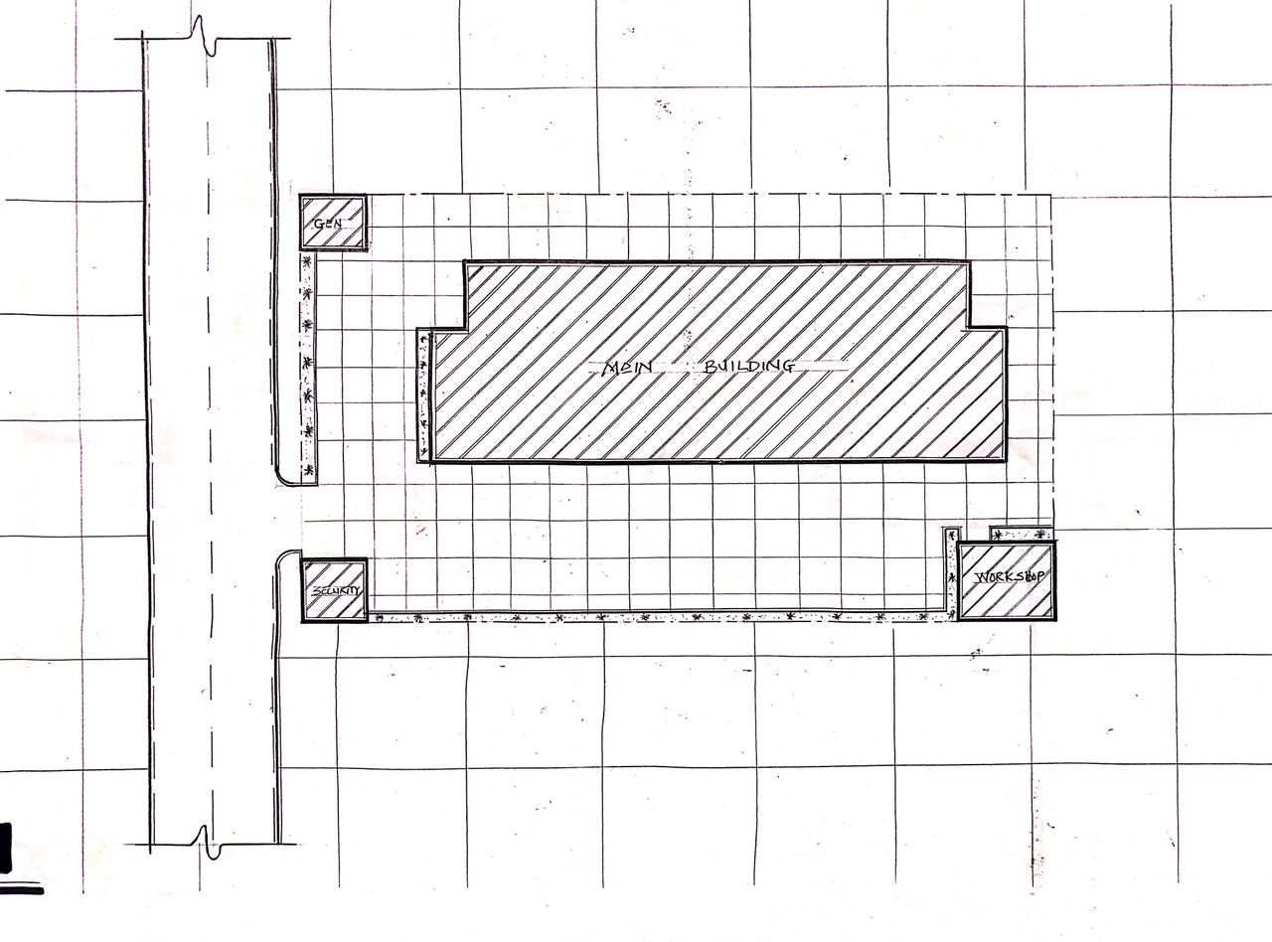
FIG 3.1:- SITE PLAN
SOURCE:- Researcher Field Work, 2024
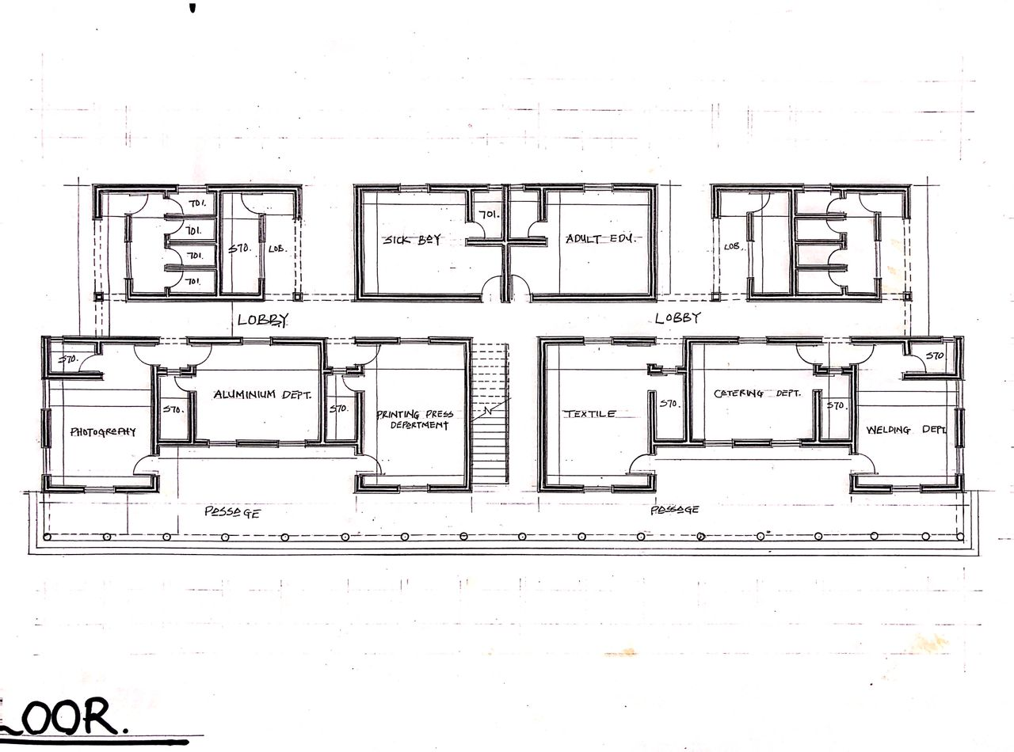
FIG 3.2:- GROUND FLOOR PLAN
SOURCE:- Researcher Field Work, 2024
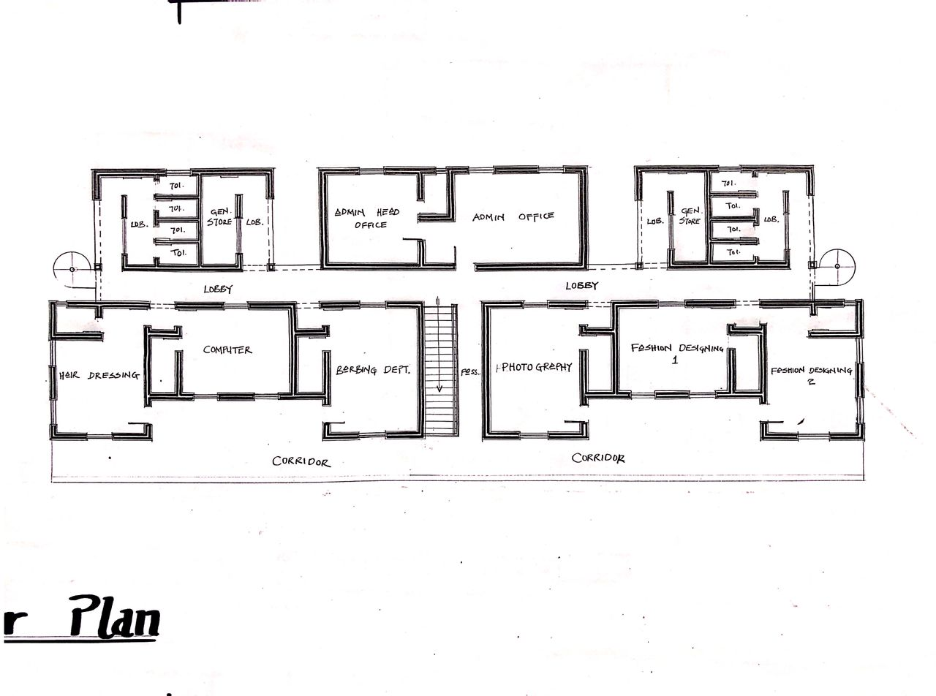
FIG 3.3:- FIRST FLOOR PLAN
SOURCE:- Researcher Field Work, 2024
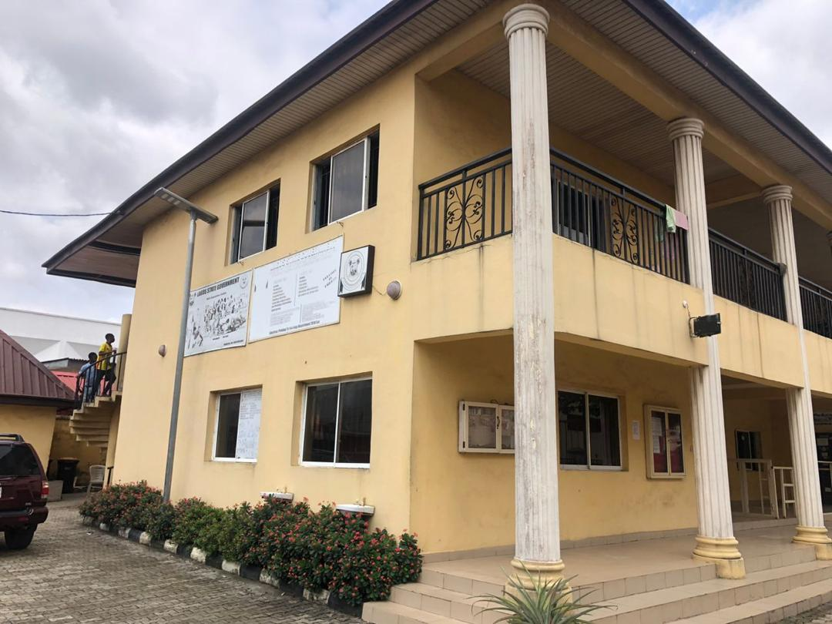
PLATE 3.1:- SIDE VIEW
SOURCE:- Researcher Field Work, 2024

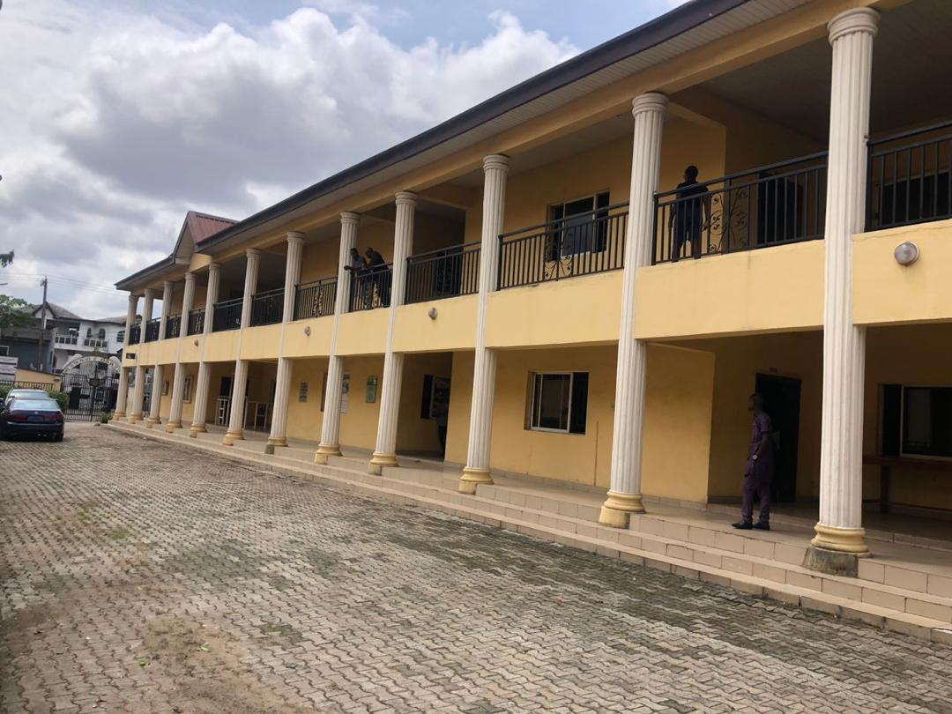
PLATE 3.2:- SIDE VIEW
SOURCE:- Researcher Field Work, 2024
3.1.1 MERITS
- The facility is easily accessed
- Properly built for its purpose
- Its units are well ventilated
3.1.2 DEMERITS
- It was built in a noisy environment
- Poor drainage system
- Site scopes is not well segmented
3.2 CASE STUDY TWO
INSTITUTE OF VOCATIONAL STUDIES CENTRE LOCATED AT AJASE IPO, KWARA STATE, NIGERIA.
The institute was commissioned by the vice president of the federal republic of Nigeria, Professor Yemi Osinbajo on November 21st 2017 and they commenced training programs on April 30, 2018.
COURSES OFFERED
- Aluminum workshop
- Event decoration
- Clothing and textile
- Computer studies (Graphic Design)
- Electrical & electronic workshop
- Welding & Steel Works
- Aluminum
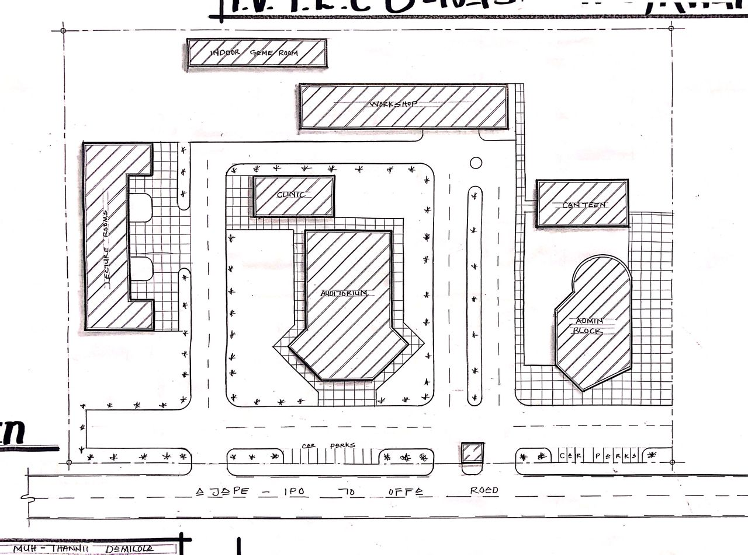
FIG 3.4:- SITE PLAN
SOURCE:- Researcher Field Work, 2024

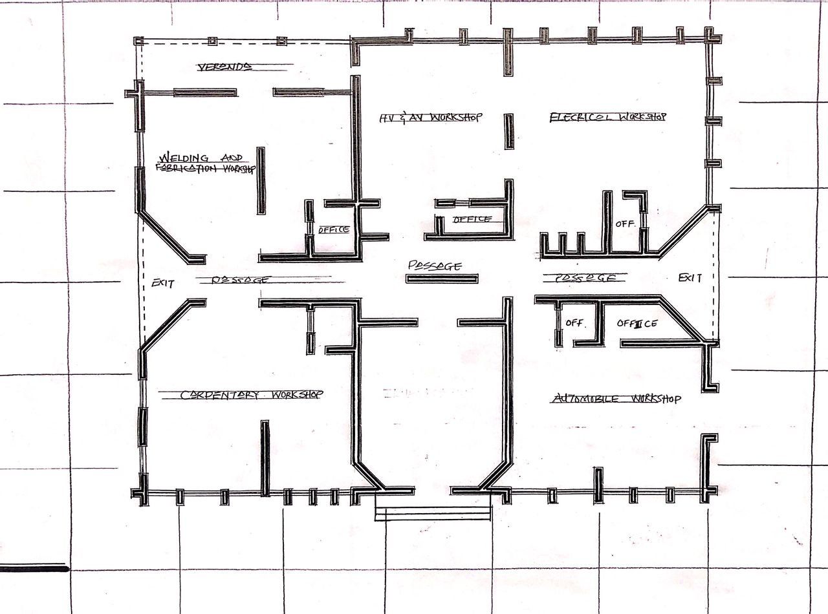
FIG 3.5:- FLOOR PLAN
SOURCE:- Researcher Field Work, 2024

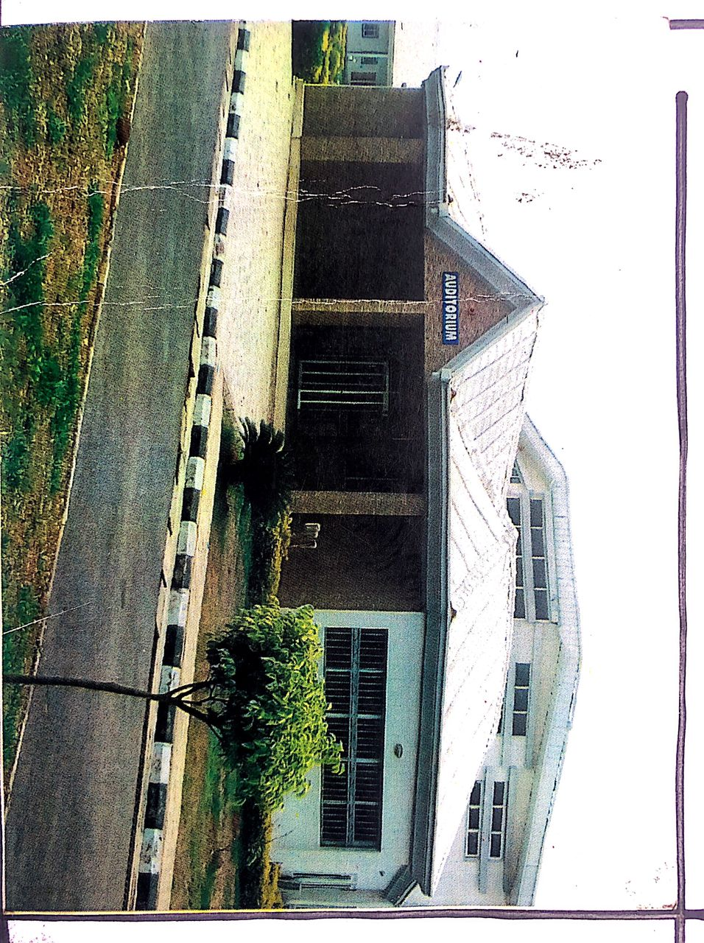
PLATE 3.3:- INSTITUTE’S AUDITORIUM
SOURCE:- Researcher Field Work, 2024

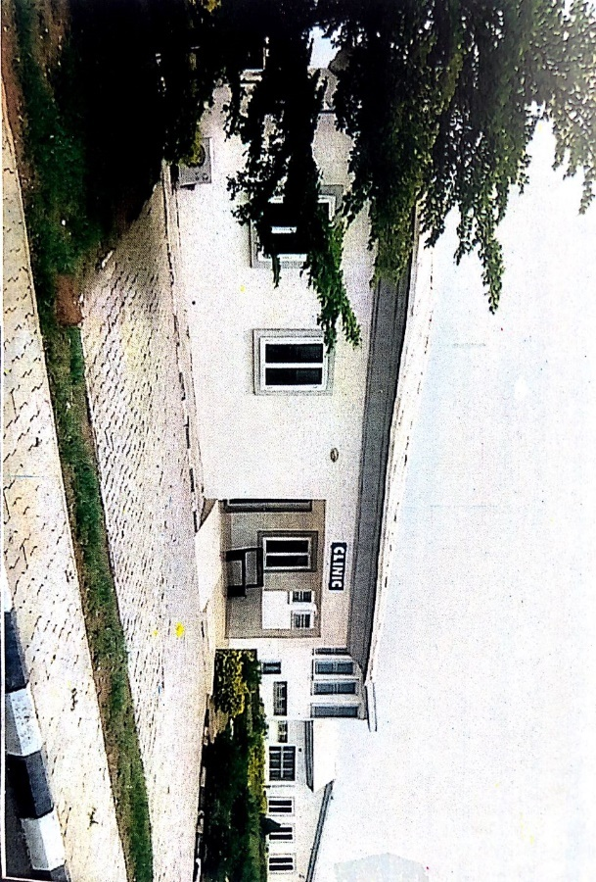
PLATE 3.4:- INSITUTE’S CLINIC
SOURCE:- Researcher Field Work, 2024

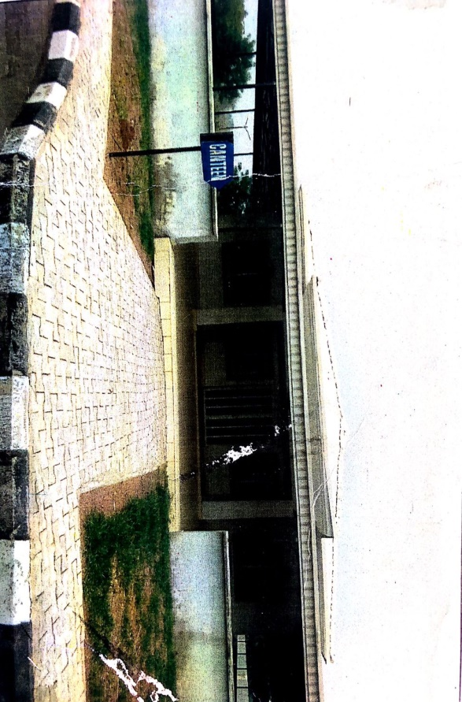

3.5:- INSITUTE’S CANTEEN
SOURCE:- Researcher Field Work, 2024

3.2.1 MERITS
- The Facility is Well Landscaped
- Easily accessible
- Adequate conveniences
- It was centrally located
3.2.2 DEMERITS
- Inadequate parking space
- The building is a mix-use building
- Poor ventilation for the classrooms
3.3 CASE STUDY THREE
INDUSTRIAL DEVELOPMENT CENTER (I.D.C) AT OSHOGBO, OSUN STATE, NIGERIA.
BRIEF INTRODUCTION
I.D.C AT OSHOGBO, OSUN STATE, was established in 1993 by the federal Government of Nigeria as part of the National Industrial Development Center (NIDC) programs. It was focused on promoting industrialization and entrepreneurship in the region and it has provided training, consultancy and infrastructural support for small and medium scale enterprises (SMEs),Today, it continues to play a vital role in skill development and vocational training, business incubation and entrepreneurship support.
COURSES OFFERED
- Tailoring
- Electrical and Electronic
- Event decoration
- Hat and bead making
- Toiletry
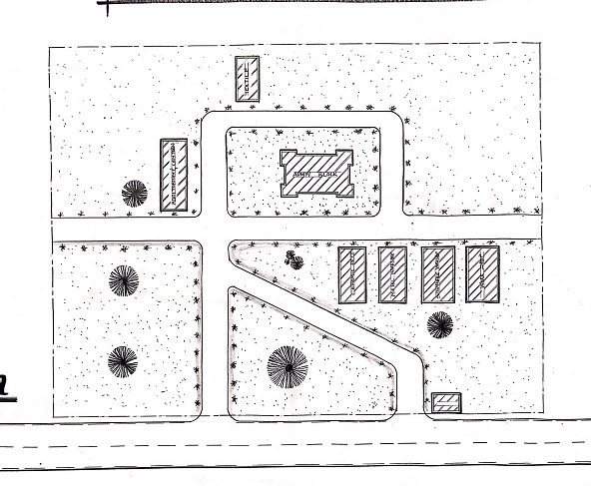
FIG 3.6:- SITE PLAN
SOURCE:- Researcher Field Work, 2024

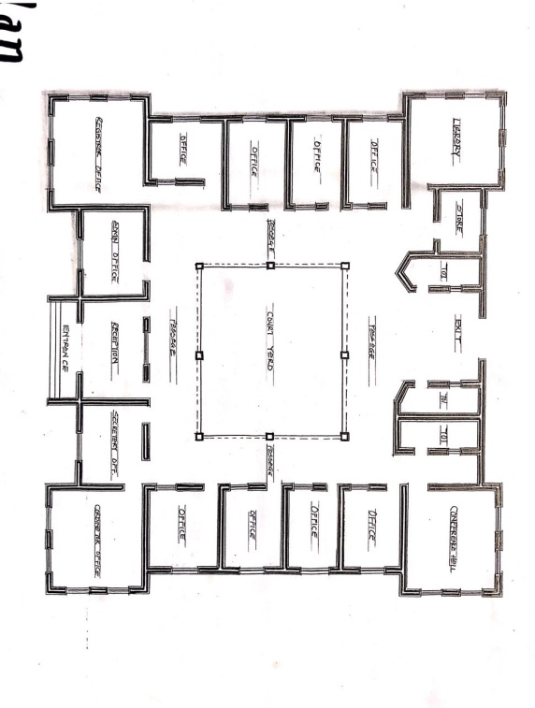

FIG 3.7:- FLOOR PLAN
SOURCE:- Researcher Field Work, 2024

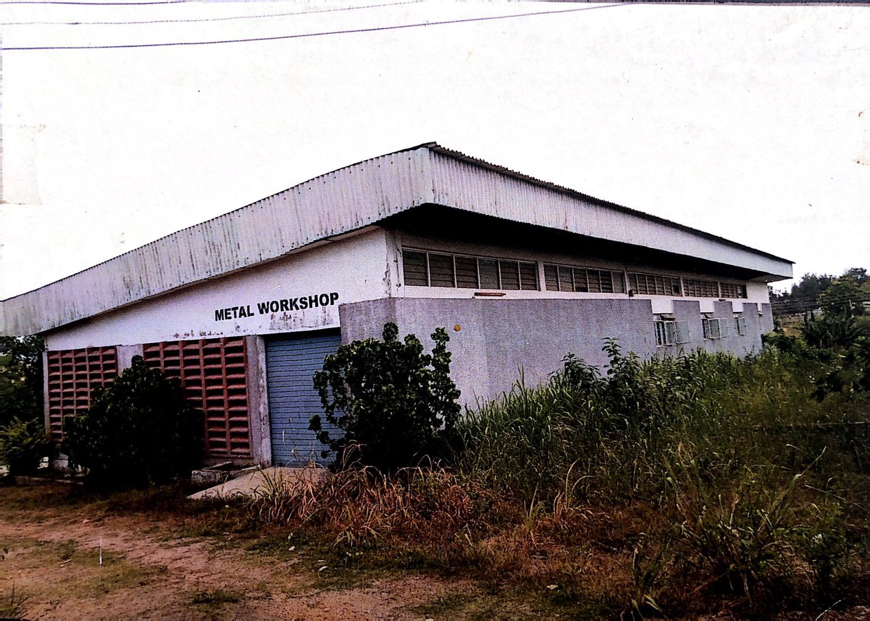
PLATE 3.6:- METAL WORKS BUILDING
SOURCE:- Researcher Field Work, 2024
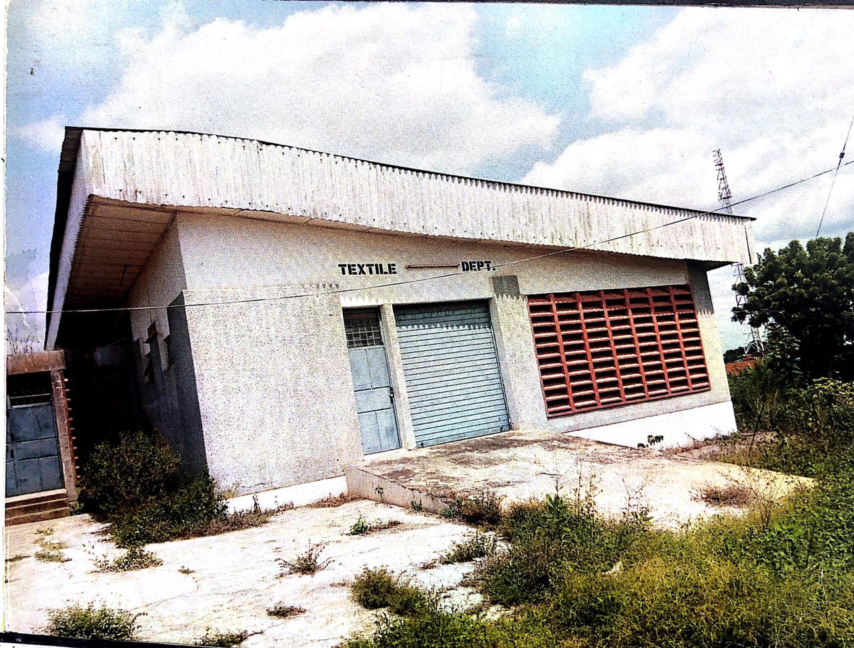
PLATE 3.7:- CLOTHING & TEXTILE BUILDING
SOURCE:- Researcher Field Work, 2024
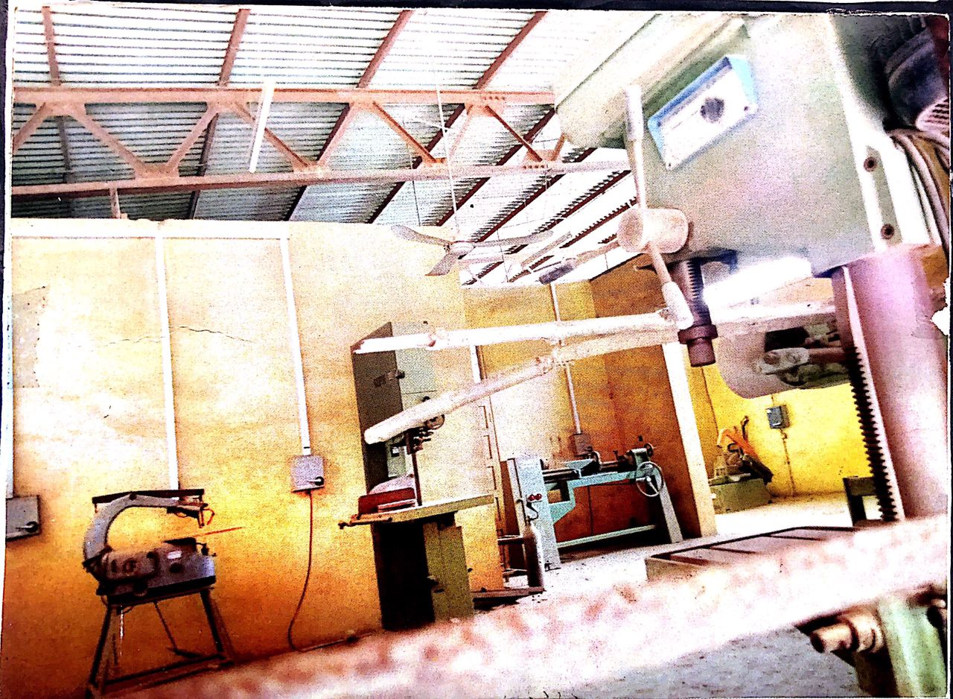

PLATE 3.8:- METAL WORKSHOP
SOURCE:- Researcher Field Work, 2024

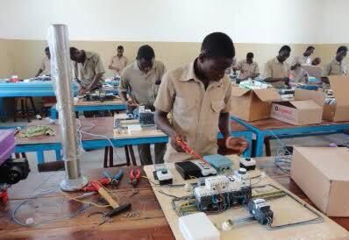
PLATE 3.9:- ELECTRIC AND ELECTRICAL WORKS
SOURCE:- Researcher Field Work, 2024

3.3.1 MERITS
- Easily accessible from the gate
- Good security
- Adequate ventilation
- Lecture rooms are properly linked.
3.3.2 DEMERITs
- Poor landscaping of the site
- Poor drainage system
3.4 CASE STUDY FOUR [ONLINE CASE STUDY
TOULON VOCATIONAL CENTER LOCATED IN TORONTO, CANADA
BRIEF INTRODUCTION
Toulon Vocational center is a standard vocational center located in Toronto, Canada where serval courses are been offered to student interested in learning vocational studies, being an entrepreneur or being self-employed personnel.
These are the courses been offered in the centre below:
- Electrical and Electronics Engineering work
- Automobile Work
- Carpentry work
- A.C workshop
- Welding and fabrication work.
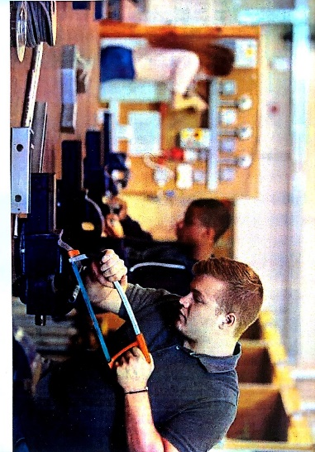
PLATE 3.10:- METAL WORKSHOP
SOURCE:- Researcher Field Work, 2024

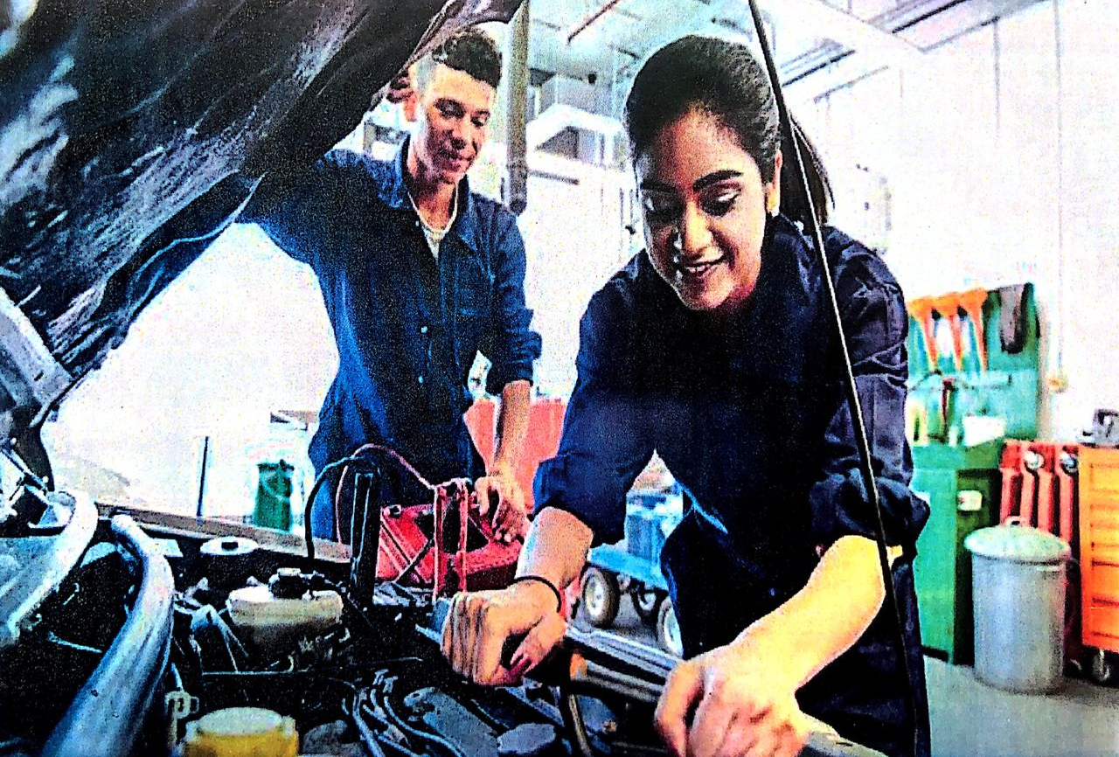
PLATE 3.11:- AUTOMOBILE WORKSHOP
SOURCE:- Researcher Field Work, 2024

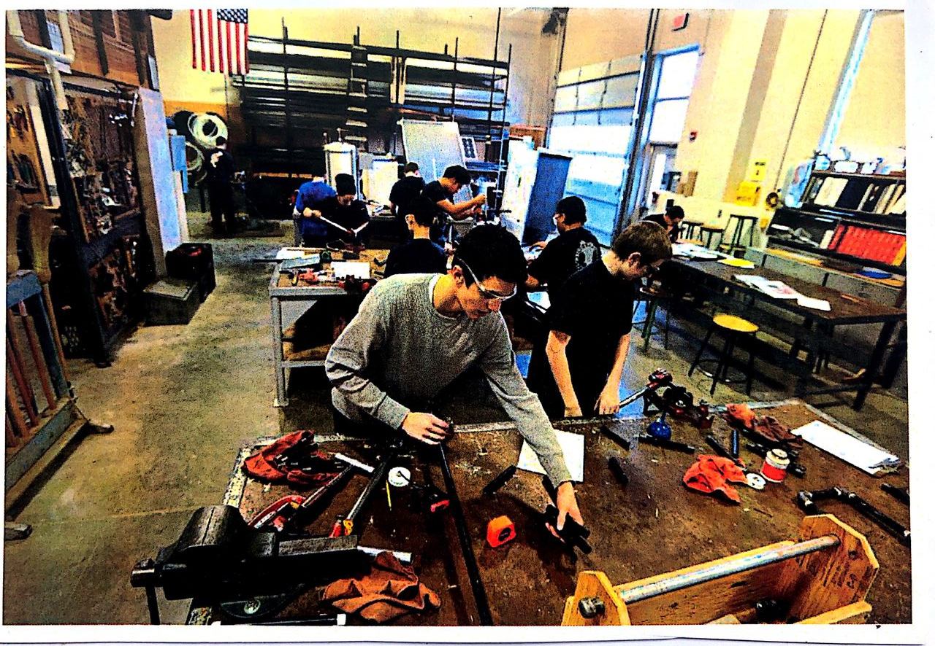
PLATE 3.12:- CARPENTRY AND WOOD WORKSHOP
SOURCE:- Researcher Field Work, 2024

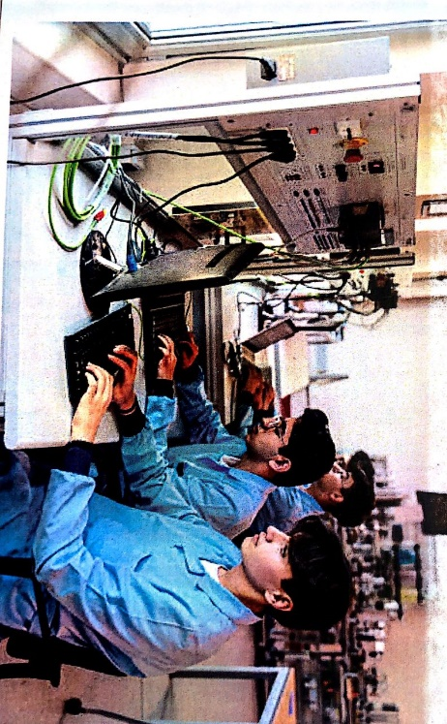
PLATE 3.13:- COMPUTER STUDIES
SOURCE:- Researcher Field Work, 2024

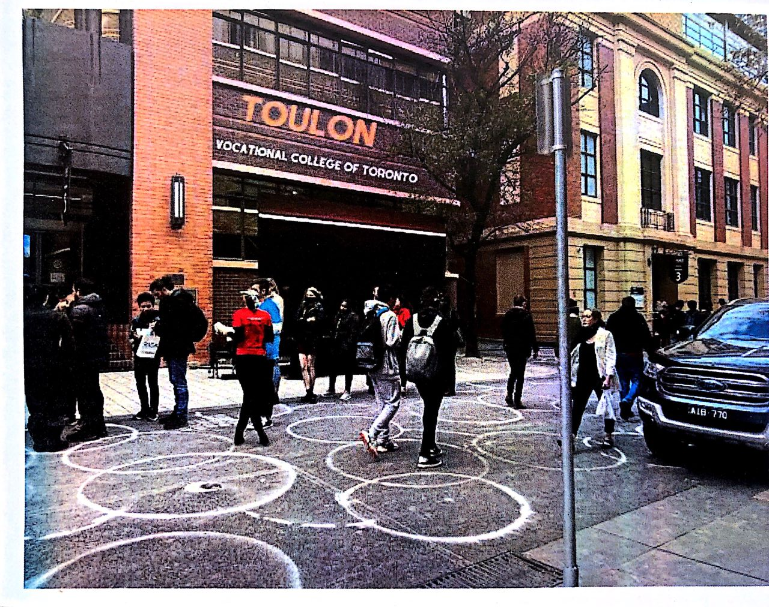
PLATE 3.14:- EXTERNAL VIEW
SOURCE:- Researcher Field Work, 2024
3.4.1 MERITS
- It facility is easy to access and located in a developed area
- It is purposely built for its purpose
- Cross Ventilated and Natural lightning
- Aesthetically pleasing to the eye
3.4.2 DEMERIT
- No provision for enough parking lots
- The facility is directly positioned along the road

3.5 CASE STUDY FIVE [ONLINE CASE STUDY 2]
P.A.C.C ADULT EDUCATION CENTER AND VOCATIONAL TRAINNG AT QUEBEC, CANADA.
BRIEF INTRODUCTION:
Adult education in PACC is teacher-directed and is taught by a seasoned group of dedicated professionals who know that each who walks through there door is capable of achieving success. For this reason, they have put in place for students to study their various courses their chosen fields in the school/center
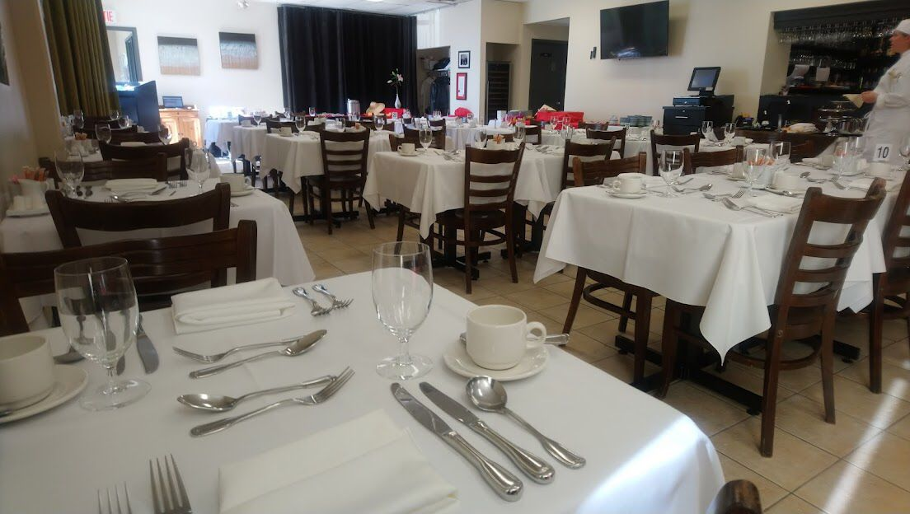
PLATE 3.15:- CATERING DEPARTMENT
SOURCE:- Researcher Field Work, 2024

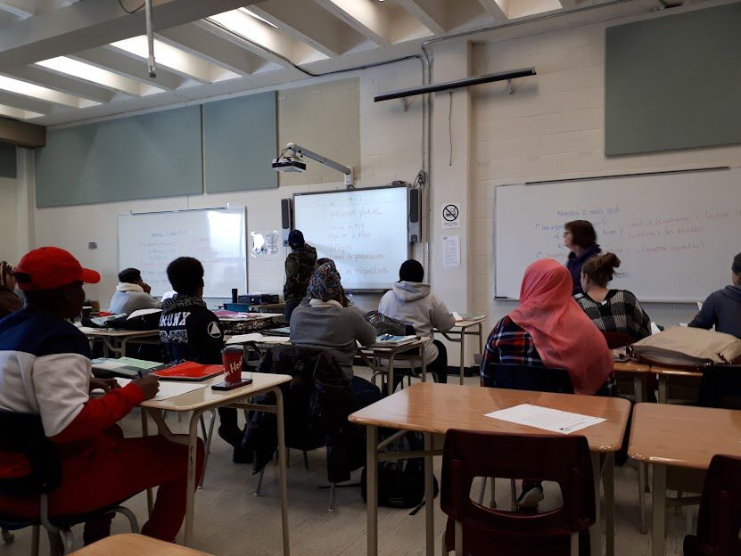
PLATE 3.16:- COMPUTER ROOM
SOURCE:- Researcher Field Work, 2024
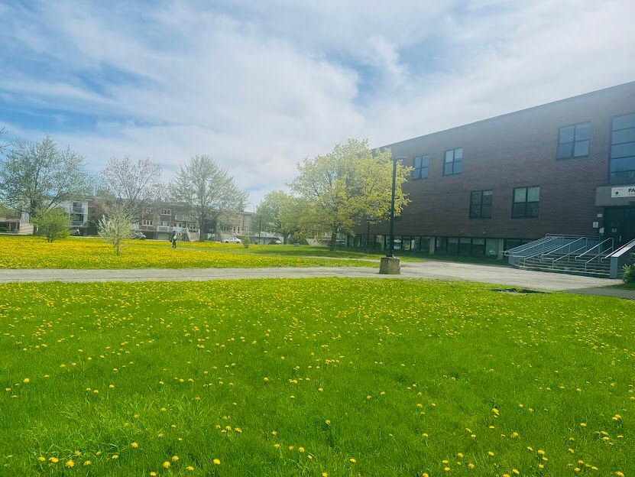
PLATE 3.17:- EXTERNAL VIEWS
SOURCE:- Researcher Field Work, 2024

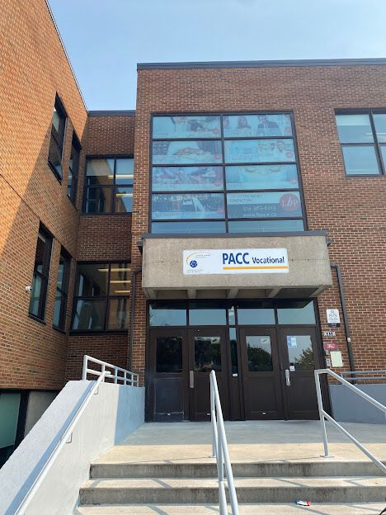
PLATE 3.18:- EXTERNAL VIEW
SOURCE:- Researcher Field Work, 2024
3.5.1 MERITS
- Easily accessible
- Adequate ventilation
- Lecture room are properly linked
- Built for its purpose.
3.5.2 DEMERIT
- No provision for enough parking lots
- The facility’s landscape is not properly done

3.6 DEDUCTION FROM CASE STUDIES:
These are the common similar knowledge or information derived from the aforementioned case studies. Some of which are:

- Choice of location should be in a developing or already developed area for easy access to the trainings offered.
- Segregation of each department form one another
- Well designed and well positioned landscapes
- Separation of noisy departments from departments with less noise
- Provision of required ventilation and fenestration into each units to serve the spaces well

CHAPTER FOUR
4.0 ANALYSIS OF THE ENVIRONMENTAL AND TOPOGRAPHICAL CONDITIONS OF THE SITE
4.1 INTRODUCTION TO STUDY AREA
4.2 HISTORICAL BACKGROUND OF OKE-OYI
Oke-Oyi is a semi-urban settlement located in Ilorin East Local Government Area of Kwara State, Nigeria. It holds historical significance as one of the indigenous communities that make up the Yoruba-speaking region of North Central Nigeria.

Pre-Colonial Era:

- Oke-Oyi was originally inhabited by the Yoruba people, particularly the Igbomina and Oyo subgroups.

- The town had a traditional governance system led by local chiefs and was known for its agrarian economy, engaging mainly in farming and local trade.

Colonial Era (1900 – 1960):

- Oke-Oyi, like much of Northern Nigeria, came under British indirect rule.

- While it remained largely rural, colonial influence introduced basic administrative structures and Christian missionary schools.

Post-Colonial Era (1960 – present):

- Following Nigeria’s independence, Oke-Oyi experienced gradual development and integration into the expanding Ilorin metropolis.

- The town became more accessible due to improved roads and proximity to Ilorin, the Kwara State capital.

- It remains a significant agricultural and residential community, known for crops like cassava, yam, maize, and vegetables.

Landmarks and Features in Oke-Oyi:

- Traditional palaces and compounds

- The large weekly market

- Proximity to Al-Hikmah University and other institutions in Ilorin

- Presence of indigenous religious and cultural festivals

4.3 Physical Feature of the Location

Oke-Oyi is suitable for both residential and educational development. Its proximity to Ilorin city makes it an ideal location for facilities like a Vocational Education and Training (VET) center, allowing students from both rural and urban areas easy access without traveling long distances.

4.4 Population of Kwara State (and Oke-Oyi)

Kwara State had a projected population of about 3.6 million in the 2022 estimate. Ilorin East LGA, where Oke-Oyi is located, is one of the fastest-growing areas due to its closeness to Ilorin metropolis. Oke-Oyi itself is growing steadily, with an estimated population of 35,000 to 50,000 people, primarily composed of farmers, artisans, traders, and civil servants.

4.5 Social Services

Oke-Oyi and its surrounding communities benefit from various social services, including:

- Healthcare: Government-owned primary healthcare centers and private clinics serve the town.

- Education: Several public primary and secondary schools exist, with proximity to higher institutions in Ilorin.

- Transportation: Access roads link Oke-Oyi to major areas of Ilorin and neighboring communities.

- Housing and Utilities: Modern housing estates are emerging; electricity is provided by the Ibadan Electricity Distribution Company (IBEDC).

- Water Supply: Boreholes and community wells are the major sources of water.

4.5.1 Road

Oke-Oyi is linked to Ilorin city via a well-maintained state road network. The main access road to the proposed site connects through the Ilorin–Shao Road, making it easily reachable from key locations.

4.5.2 Health Service

The town has access to both public and private healthcare facilities, including:

- Oke-Oyi Primary Health Centre

- Nearby General Hospitals in Ilorin

- Private maternity homes and clinics within the community

4.5.3 Water and Electricity

- Water is supplied via boreholes, wells, and rainwater harvesting systems.

- Electricity is provided by IBEDC, with fairly stable supply in the area.

4.6 General Climatic Condition

Kwara State experiences a tropical savannah climate characterized by two main seasons:

- Wet Season (April – October):

- Temperatures: 23°C – 31°C

- High humidity: 60–85%

- Rainfall: 1,200 – 1,500 mm annually

- Thunderstorms are common in June and September

- Dry Season (November – March):

- Temperatures: 21°C – 34°C

- Lower humidity: 30–50%

- Dusty Harmattan winds from the Sahara prevail from December to February

Other Features:

- Average annual temperature: around 27°C

- Sunshine: Approx. 2,300 hours per year

- Elevation: 290–330 meters above sea level

Relative Humidity

- Average annual humidity: 79%

- Highest: September (up to 85%)

- Lowest: February (around 60%)

Wind

Oke-Oyi experiences mild to moderate winds throughout the year. During the harmattan period, wind speeds increase due to dry northern winds.

Temperature

- Daytime: 28–33°C

- Nighttime: 18–24°C

- Coolest months: December – January

- Hottest months: March – April

4.6.4 Vegetation

The proposed site in Oke-Oyi features a savannah-type vegetation with tall grasses, scattered trees, and shrubs. Some trees will be cleared for construction, while others will be preserved for landscaping.

4.7 Site Analysis

4.7.1 Site Selection / Justification

The site selected for the project lies along Oke-Oyi township road, with access from major roads like the Ilorin-Shao road and nearby communities.

Factors influencing site selection include:

          - Accessibility: Proximity to major roads and transport routes

    - Location: Semi-urban setting close to Ilorin, ideal for a vocational center

    - Infrastructure: Existing public utilities like roads, electricity, and water

    - Topography: Gently sloping land suitable for construction

    - Soil Structure: Laterite-rich soil with good bearing capacity

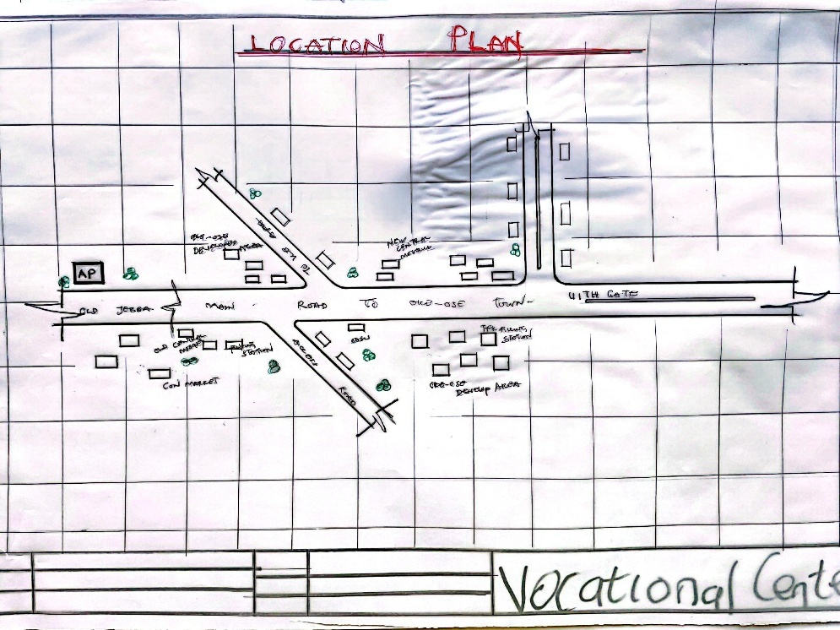

FIG 4.1:- LOCATION PLAN
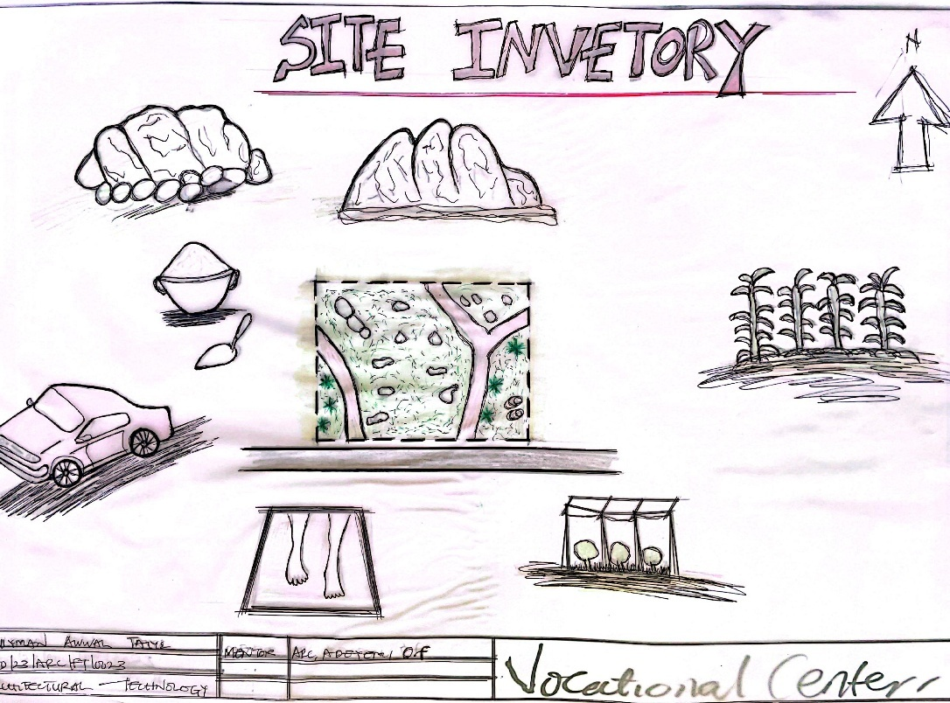

FIG 4.2:- SITE INVENTORY

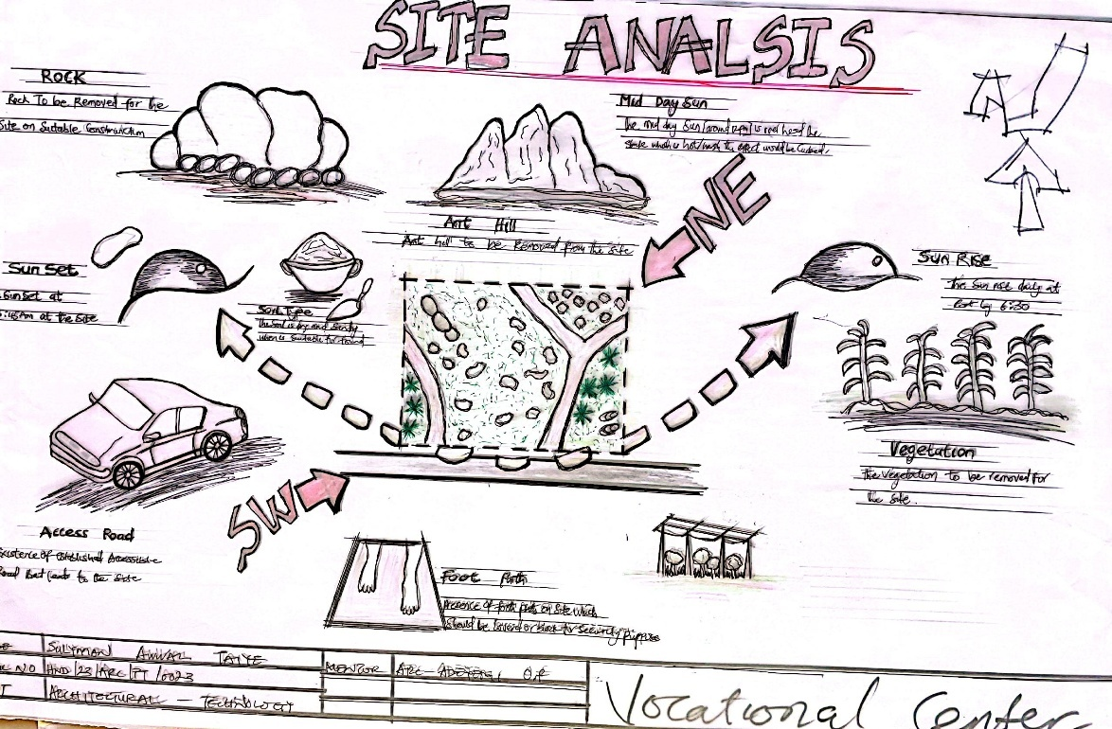

FIG 4.3:- SITE ANALYSIS

DESIGN CONCEPT/PLANNING PRINCIPLE
DESIGN PLANNING
Firstly, the process of analysis in the design into the necessary units required for the design is based on the data collected through research methodologies.
Secondly, the grouping of the various unit together according to their relationship with one another also based on the data and information gathered.
The concept of the design was arrived at from the functional relationship and bubble diagrams prepared out of the design brief which is based on the activities performed within the institute/school. The relationship of these various activities with one another within different units that makes up the design and also based on the zoning in accordance with the level of noise produce by each unit.
PLANNING PRINCIPLE
The planning principle is one of the most important aspect of any design. The planning of various units taking into consideration the activities performed in each unit, how they are related to one another and the users of the various units in the design.
In respect to the design above factors, the building is divided into two blocks. The first block is the administrative building; while the second block is the workshop building which is well positioned on the site taking cognizance and into consideration the works going on in the workshops and possible noises that might be produce.
In respect to the sit zoning, the safe zoning is divided into three parts. The first division as semi quite area while third division C is quite and noisy area.

CHAPTER FIVE
5.0 DESIGN REPORT
5.1 DESIGN BRIEF
After research and planning, the next step in the series of the project programme is design itself. To achieve functional and well aesthetic design the1¢ must be a brief to work on. This brief depends generally on the scope of individual design. The brief of this project is therefore based on the various activities that take place in the institute of vocational studies.
To have enough brief for the proposed institute case studies were carried out ‘on the existing schools both in the Nigeria universities and polytechnics. The studies also give me the opportunity to know the nature of the courses offered in the schools and how related to each other.
The institute of vocational studies train six different department, they are computer studio, tie and dye, electrical engineering, plumbing, fashion, design and carpentry.
5.2 DESIGN ANALYSIS
This is the process of itemizing units within the components of the entire design with a view to establish a solid understanding and appreciation of the space relationships.
SNO | WORKSHOP BLOCKS UNIT | DIMENSIONS | M²
1 | ENTRANCE | 6.3 X 3.9 | 24.6m²
2 | RECEPTION | 6.3 X 3.6 | 22.7m²
3 | Hairstyling Workspace | 12.0 X9.0 | 108m²
4 | Instructor Office | 3.6 X3.0 | 11.7m²
5 | Store | 3.6 X 2.4 | 9.4m²
6 | Fashion Designing | 12.0 X9.0 | 108m²
7 | Instructor Office | 3.6 X 3.0 | 11.7m²
8 | Store | 3.6 X 2.4 | 9.4m²
9 | Aluminum Workshop | 12.0 X 9.0 | 108m²
10 | Instructor Office | 3.0 X 3.0 | 9m²
11 | Store | 3.0 X 2.7 | 8.1m²
12 | Electrical and electronic workshop | 12.0 X 9.0 | 108m²
13 | Instructor Office | 3.0 X 3.0 | 9m²
14 | Store | 3.0 X 2.7 | 8.1m²
15 | Welding and Fabrication Workshop | 9.0 X 8.0 (X2) | 147.6m²
16 | Instructor Office | 3.3 X 3.6 | 11.9m²
17 | Store | 3.0 X3.6 | 10.8m²
18 | Art & Craft Studio | 13.2 X7.4 | 97.68m²
19 | Instructor Office | 3.0 X 3.6 | 11.9m²
20 | Store | 3.0 X 3.6 | 10.8m²
21 | Conveniences | 2.1 X 1.2 (X4) | 12.9m²
 | TOTAL |  | 839.58m²
S/N | UNITS | DIMENSION | M2²
1 | Entrance | 3.3 X 2.4 | 7.9m²
2 | Wood Workshop | 12.0 X 8.2 | 98.4m²
3 | Instructor Office | 3.0 X3.0 | 9m²
4 | Store | 3.0 X 3.0 | 9m²
5 | Plumbing Workshop | 12.0 X 8.2 | 98.4m²
6 | Instructor Office | 3.0 X 3.0 | 9m²
7 | Store | 3.0 X 3.0 | 9m²
8 | Automobile Workshop | 11.6 X 10.6(X2) | 245.92²
9 | Instructor office | 3.0 X 3.0 | 9m²
10 | Store | 3.0 X3.0 | 9m²
11 | Conveniences | 1.8 X 1.5 (X2) | 5.4m²
 | TOTAL |  | 510.02

5.3 DESIGN APPRAISAL
In any project design, there are two basic factors that should be taken into consideration. These factors are functionality and aesthetics and functionality of any building are incompatible but in the case of this project, both aesthetic and functionality of the design were taken care of to satisfy the highly demanded functional requirement and to create aesthetically and proportionally balanced design.
The functional efficiency of institute of Vocational studies depends largely on the enclosures of the immediate section that are strongly related in function all these are being taken up as seen on the site and floor plans respectively.

5.4 DESIGN CHARACTERISTICS
The idea of planning a good surrounding involves from the primary function. It gives a good aesthetic view to the structure; it enhances the psychological feeling of the public, making use of the area: it makes the entire environment healthy, as an adage says "cleanliness is next to godliness". A clean and well-planned site is a healthy environment in view of these following had been adopted in planning the site.
1.LANDFORM: As earlier discussed under the topography the land is gentle slope hence it will affect good planning.
2.TREES: Trees are planted within the institute building to effect natural Ventilation. Trees which will not be more than 2.5m high when grown are to be planted at reasonable spacing to provide shade for the car park. Shrubs and trees such as Amelina, Aborea, Flamboyant, Alternance etc. with good foliage are to be planted along with the fence and some strategic places within the site to provide shade and serve as sun's and wig breakers. ‘The trees also reduce the atmospheric temperature and release of oxygen during photosynthesis makes the atmosphere cold.
3.GRASSES: Grasses give good impression of an environment and also protect. the land surface from erosion for this project, Bahama grass is recommended for all the lawn area. Some courtyard that are busy are covered with lawns, fines grasses like Kikuyu grass planted in the courtyard and some parts are paved for relaxation purpose.
4.FLOWER BEDS: A well planned flower arrangement gives aesthetic to environment. Flower is grown along the walkways around the main building generally except where it can obstruct vehicular pedestrian movement. Flower such as slender, Bryphallion roses, lady on boat, ice plant etc. are planted.
5.HEDGES: Hedges are also planted along some part of the walkway. In the courtyard while shrubs are also used along vehicular ways. The following shrubs are used for the hedge. Dodoneaviscosal (Josorevet). The vital (bush mil) casavatinalequstifolic (Whistling pic). Shrub such as spotted croton. Euphobiasplender (desert rose) are planted for their beautiful leaves and good scents also for ornamentation.
6.PARKING SPACE: Parking lots are located in front of administrative offices to service the administrative. Loading send concrete block should be Portland cement delivered in good condition to the construction site all the instruction given in civil engineering drawing will be thoroughly and strictly adhered to in order to avoid failure. The walkways should be constructed of concrete roof laid to fall with 2 layer of bitumen fact. The roof member should be firmly secured. The mortar bed should at least 25mm thick bond of block should be stretcher bond.
5.5 BUILDING STRUCTURE
The whole institute building has administrative building complex and workshop building which makes the environment more comfortable for both the student and the staff in that environment. The story building supported by beans and column at appropriate intervals. Most modern school buildings are usually constructed by introducing grid into the design. This make for easy and accurate consideration of frame structure used in school buildings. ‘There are two types of grid system:
- Modular grid
- Structure grid
For this project, structure grid system was employed in filled sand Crete blocks were used for all the retaining walls of the institute. The roofing system used for the lecture theatre is steel truss roofing.
Some part concrete roof where also used along with timber the prevalent damage usually caused by termites is prevented by the application termitarium treatment like Gamalin 20 solignum etc.
5.6 SERVICE
Electricity is tapped from the nearest pole of the institute building. The main water pipeline is closely located to the site where drinking water can be tapped telephone line is within the polytechnic which makes connection easy.
The entire roof drains runs to the surrounding gutter which finally drains to the main gutter along the public drainage all the solid and liquid wastes are effectively disposed of by the soak away pits and septic tanks, a central AC system shall be fixed where appropriate.
5.7 GENERAL REQUIREMENT
5.7.1 LIGHTING
This is a means of providing brightness naturally by sun or moon or artificially by lamps. Good natural and artificial lighting is important in the lecture rooms, students and library. It is always easy to make mistake and the eye in a situation poor lightning floor. For the purpose of this project, effort is made as much as possible to light up the entire building naturally before the use of artificial lighting.
In this project, to obtain maximum lighting more openings are provided for the lecture rooms, studios, seminar hall and library. Artificial source of light will still be provided for in case where there is call for the use of it at night or in a situation where the weather condition warrants it.
5.7.2 ORIENTATION
The orientation of a building involves the arrangement of the building forward or away from the sunrays, across or along the trade winds normally determines the thermal comfort in the building. In view of these, the building is oriented in the safe plan in such a way that be short facts is facing the east with no opening at all and the fact away from the sunrays and forward the north east trade wind and south west monsoon wind to produce thermal comfort since the facet towards the sun always tap temperature the sun and the long facet away from the sun but long the trade winds will always tap the advantage of other winds while the harsh effect of the north east trade wind will be reduced by planting trees along the side facing it. This will enhance Permeable screening order words serving as wind breaker.
5.7.3 RAIN PROTECTION DEVICES
The rainfall of a place generally determines the living condition and all comfort associated with that environment hence provision should be made for fast dispersal of the rain as well as associated condition with rainfall. This calls for the need to study the nature of rainfall of the area. To control the heavy rainfall during the wet season (April-October). The use of simply sloppy system roofing has been adapted.
Damp proof draught proof materials are used by various joint of the roof to withstand the passage of rain water.
25mm thickness is used for rendering so that water absorbed from the external wall will not reflect on the internal side of the wall.
5.7.4 NOISE CONTROL DEVICE
This is an unpleasant sound of ten lauded harsh. Excessive noise and vibration can cause fatigue, leading to errors and general dissatisfaction in the classrooms, studio, seminar hall. External noise could be easily controlled with the aid of landscape materials and rough setbacks.
The workshop departments is separated from the administrative building with the use of comfier in the workshop building and landscape clement such as tree, shrubs, are introduced as buffer zones that is noisy semi-noisy and quiet zone.
Acoustic ceiling tiles offer much help reducing overall noise level thus it is recommended for the school offices, lecture rooms, departmental studios, library and other units where conversation are confidential in nature e.g. the board room.
5.8 MATERIAL AND FINISHES
The influence of building material on construction works in Abeokuta and its environs is similar to what prevail in the middle belt of the country. In the south the rainfall encourages the use of parapet wall to reduce falling out of the roof by heavy wind (either North-East or South-West trade wind). Concrete/Sand Crete blocks in regular molds are often used for wall construction with a standard of 100mm, 150mm and thickness.
The material choice and finishes are influence by a number of factors such as follows:
- The durability and suitability of materials
- Geology and topography of the site
- Availability of material
- The climate conditions
- Properties of materials
- The coast of the materials
ROOF
In areas experiencing tropical climate condition such as Lagos where there is rainfall, roof should preferably not be of light weight construction. A corrugated iron sheet with parapet covering it and the external surface should absorb as little solar energy as possible. For these reasons, long span galvanized aluminum roofing sheets is recommended for all parts of the complex in addition to the reinforced concrete roof gutter and concrete roof slab. Steel is recommended as roofing strimhire of the lecture theater and other unit's timber are to be used.
CEILING
Suspended ceiling is used in some lecture roof with metal hangers with fanny ceiling at suitable center to center. The ceiling material is prepared to be attractive and easily cleaned. It should be of moderate cost for the above reasons the recommendation furnishing of all the offices is Celotex expect the lecture theatre that acoustic material is used to reduce the effect of the noise.
WALL
The structural walls of the building are to be constructed with 225mm engine molded sand/cement hollow blocks. The column and beans are properly reinforcing with wall the wall whole applicable column and beans are furnished with 25mm gauged smooth. Also, most if the unit are of framed structured which carried most of the loads. Load bearing masonry wall are also used and furnished with 25mm thick wall rendering and finally painted according to color specification schedule in the toilet/lavatories, the wall is to be furnished with ceramic tile to height of about 2100mm.
DOORS
The door type and size depend on the door location, but generally range from paneled door to panel folding doors of sizes from 750mm for toilets to 2700mm for the lecture theatre, library and main entrances to departments. Some doors are purposely made swinging doors for durability, fire resistance and noise control.
WINDOWS
The windows that are to be used range from pivoted windows, projected and Naco louvers blade with metal and aluminum frame.
COVERED WALKWAYS
The roofing to all covered walkways with the institute should be made of reinforced concrete slab finish laid to fall two layers of bitumen felt, the walking paying should be made of present concrete slab finished roughly to prevent slippery when wet.
6.0 SUMMARY AND CONCLUSION
6.1 SUMMARY
Throughout the design process (from inception to the final detailed drawing). Consideration has been given to a simple hut functional design, which take care of all problem in the existing institute of business and vocational studies. However, this project is part of the pace to a conventional institute of business and vocational studies in any higher institution of learning.
Since design generally are affected by various factors ranging from finance, nature of site, material choice and availability as well as various other factors, the design could vary but the approach and concept are basically within a range everywhere.
6.2 CONCLUSION
In conclusion, the deduction and experience learnt and gained from the essential research which was carried out on the school of business and vocational studies in some Nigerian Polytechnic and Universities have extremely exposed me and of course the reader of the project report to what is obtainable in school of business and vocational studies in Nigeria.
Institution design, especially as I have realized from the research has follow functions that follow one another. It also enables me to know what is needed in school design, with particular reference of business discipline. In my design, I have made sure that all the functional aspect of the project was located at a particular point.
Finally, this project fulfills my ambition to contribute my own quota to the enhancement of educational development of the school generally in Nigeria.

RECOMMENDATIONS
- Government Support and Policy Alignment: The Kwara State Government should incorporate the proposed vocational centre into its broader educational development plan. This includes funding support, land allocation, and integration into the state’s TVET framework.
- Stakeholder Engagement: Continuous collaboration with local communities, traditional leaders, NGOs, and industry professionals is crucial. This will ensure that the centre addresses real-world skill demands and retains local relevance.
- Public-Private Partnerships (PPP): Encourage partnerships with private sector companies for sponsorship, equipment donation, and internship placements. This approach ensures the sustainability and modern relevance of the curriculum and infrastructure.
- Curriculum Diversification: Develop a modular, competency-based curriculum that includes both core technical training and soft skills such as communication, entrepreneurship, and digital literacy. Courses should be periodically reviewed to match emerging labor market trends.
- Inclusive Design and Accessibility: The centre should adopt universal design principles that cater to all users, including women, youth, the elderly, and persons with disabilities. This promotes equity and maximizes participation.
- Sustainability Measures: Integrate green building practices such as solar panels, rainwater harvesting, and passive ventilation. These will reduce operational costs and serve as practical teaching tools for trainees.
- Monitoring and Evaluation: Implement a robust monitoring and evaluation framework to track student outcomes, employment rates, and program efficiency. Feedback mechanisms should be in place to ensure continuous improvement.
- Post-Training Support: Establish a business incubation unit within the centre to help graduates transition from training to employment or entrepreneurship. This could include access to micro-loans, mentorship, and workspace.
- Promotion and Awareness: Organize outreach programs, open days, and media campaigns to sensitize the public on the benefits and opportunities of vocational education.
- Research and Development: Encourage periodic research into the socio-economic impact of vocational training in the area to guide future policy and programmatic decisions.
By implementing these recommendations, the proposed vocational centre can become a model institution that sets the benchmark for practical education and skill development not only in Kwara State but across Nigeria.

REFERENCES
Abia Govt and Youth Empowerment (2013): Available online at www.vanguardngr.com/2013/05/abiagovt-andyouthempowerment accessed on 22nd june, 2013.
Adegbite, S.A Ilori, M.O, Irefin, I.A, Abereijo, I.O and Aderemi, H.O.S (2006): Evaluation of the Impact of Entrepreneurial Characteristics on the Performance of Small Scale Manufacturing Industries in Nigeria Journal of Asia Entrepreneurship and Sustainability, Vol 3(1) pp 1-15.
Andow, A.A (2011): Impact of Entreneurial Skill Development Programmes on Women Entrepreneurs in Kaduna State. Unpublished Doctoral Dissertation, Department of Economics and Management Science Kaduna, Nigeria Defence Academy.
Awogbonle A.C and Iwuamadi, K.C (2010):Youths Unempolyment: Entrepreneurship Development Programme as Intervation Mechanism.
African Journal of Business Management Vol 4(6) pp 831-835. www.academicjournals.org/ajom. Fatunla, G.T.(1989): lntrepreneurship Development Programme in Nigeria. International Small Business Journal Vol 7(3) pp47-58.
Ige, C. (2007):Promoting Entrepreneurship for Economic Development of Nigeria. Text of the 2007 C B N annual Lecture Presented at Bankers House, Lagos.
Meredith,G.G, Nelson, R.E and Neck, P.A (1996):The Practice of Entrepreneurship, Lagos: University of Lagos Press. 2006 population and Housing Census, Priority Table, Vol 111, April, Abuja.
Oghojafor, B.E.A, Kuye, OJ. Sulaimon, A.A.J and Okonji, P.S.(2010):"Empowering Nigeria Youths for National Economic Development": the Role of Entrepreneurship Education Lecture Series, Department of Business Administration Lagos: University of Lagos press.
Omoruyi, F.E.O, and Osunde, A.U (2004):Evaluting the Effectiveness of the National Youths Empowerment and Vocational Skills acquisition programme in Midwestern Nigeria. www.iz.dvv.de/index..

APPENDIX
