A PROPOSED PROJECT REPORT
ON
FEMALE INSTITUTIONAL HOSTEL
For
UNIVERSITY OF ILORIN, KWARA STATE
BY
HAMZAT AISHAT AYOBAMI
HND/23/ARC/FT/0044

SUBMITTED TO
DEPARTMENT OF ARCHITECTURAL TECHNOLOGY, INSTITUTE OF ENVIRONMENT STUDIES, KWARA STATE POLYTECHNIC, ILORIN

IN PARTIAL FULFILLMENT OF THE REQUIREMENTS FOR THE AWARD OF HIGHER NATIONAL DIPLOMA [HND] IN ARCHITECTURAL KWARA STATE POLYTECHNIC, ILORN KWARA STATE

JULY, 2025



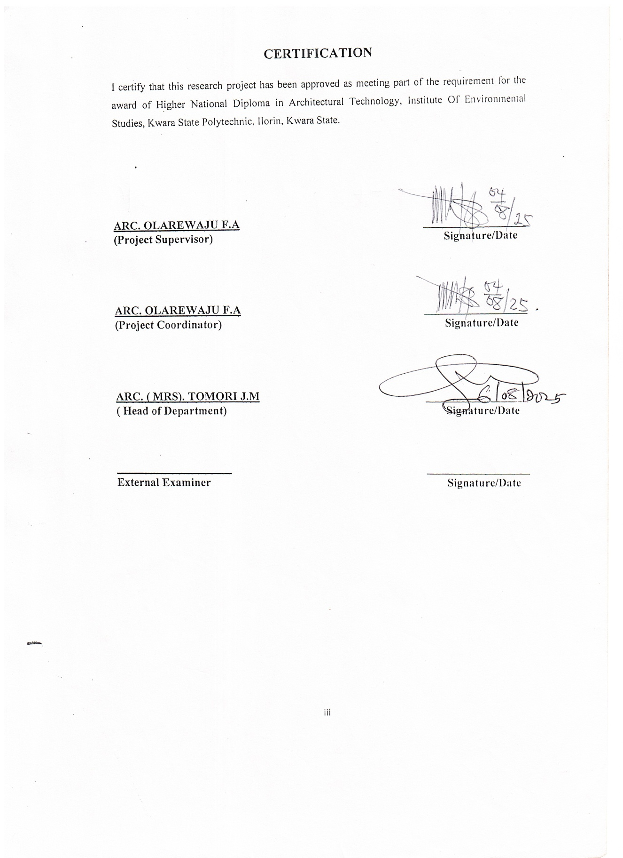

DEDICATION

This project is dedicated to Almighty God and the master designer for seeing me through the duration of this course, and to my beloved mother Mrs Hamzat, to the cherished memory of my late father

ACKNOWLEDGEMENT
Everything that has beginning must have an end, therefore, all praises and adoration is unto God for the strength and courage he has accorded me in the process of this project.
Special thanks to my project supervisor ARC. OLAREWAJU F.A for taking his time to go through my research work, may Almighty Allah bless you abundantly. To all academics member and non academic members of architectural technology, ARC.CHUCKWUMA NMOM, ARC ABDULAZEEZ B.Y.F, ARC SOLOMON FAMILUA, ARC(MRS)TOMORI JM God bless you all.
My deepest appreciation goes to My Mum and Mylate Dad Mr & Mrs Muhibudeen Muhinat for their prayer and support And to My entire family and friends.
I sincerely appreciate the support and assistance of everyone who contributed to this project, especially those who offered help, guidance, or information even without knowing me personally. Your kindness and willingness to assist made a significant difference, and I am truly grateful.
I appreciate my course mates, my sweet good friends Ajetumobi Qazeem, Blessing, Fatimah, kingsmen ,Gloria, and the rest for their support, encouragement, and collaboration throughout the course of this project. Your contributions, whether big or small, did not go unnoticed.

ABSTRACT
This project focuses on the comprehensive architectural design of a female hostel to meet the growing demand for student accommodation, especially following the accreditation of new academic programs in a higher institution. The increase in student intake, particularly female students, has led to pressure on existing hostel facilities, resulting in overcrowding, safety concerns, and limited access to conducive living spaces. This situation has made it necessary to propose a new hostel that will not only serve as accommodation but also enhance the academic and social experience of its users. The design process involves a series of planning stages from site analysis, concept development, zoning, circulation, and space planning to ensure a functional and user-centered design. Special attention is given to privacy, security, lighting, ventilation, and accessibility. The layout supports easy movement within the building, proper room arrangements, and functional support spaces such as study areas, lounges, dining and laundry facilities, all aimed at promoting comfort, productivity, and a sense of community. In addition, careful selection of materials, sustainability considerations, and long-term maintenance were taken into account to ensure durability and cost-effectiveness. This project reflects a balance between aesthetic appeal, function, and the welfare of female students, contributing to the overall development and standard of student housing in educational environments.
This abstract outlines the significance of institutional hostels in promoting academic success, personal development, and professional growth. It emphasizes the role of these facilities in providing a stable and supportive environment that facilitates the achievement of institutional objectives.

TABLEOFCONTENT
Title Page
DECLARATION II
CERTIFICATION III
DEDICATION………………………………………………………………….IV
ACKNOWLEDGMENT V
TABLE OF CONTENT VI
LIST OF PLATES VII
LIST OF TABLES VIII
LIST OF FIGURES……………………………………………………………
LIST OF APPENDICES……………………………………………………..
ABSTRACT IX
CHAPTER ONE
1.0 INTRODUCTION 1
1.1 HISTORICAL BACKGROUND OFTHE PROJECT 2
1.2 PROJECT DEFINITION 2
1.3 STATEMENT OFDESIGN PROBLEM 3
1.4AIM AND OBJECTIVES OFTHESTUDY 4
1.5PROJECTJUSTIFICATION 5
1.6 CLIENTS BACKGROUND 5
1.7 SCOPEOFTHESTUDY 6
1.8LIMITATION OFDESIGN 9
1.9RESEARCH METHODOLOGY 10
CHAPTER TWO:
2.0 REVIEW OFRELEVANT LITERATURE 11
CHAPTER THREE
CASE STUDY 8
CASESTUDY1 8
BRIEF HISTORY . 9
MERIT AND DEMERIT. 9
CASE STUDY 2 …10
BRIEF HISTORY ……………………...........……………….…….10
MERIT AND DEMERIT. 10
CASESTUDY3 13
BRIEF HISTORY . 13
MERIT AND DEMERIT. 14
CASE STUDY4… 17
ONLINE CASE STUDY 1… 19
ONLINE CASE STUDY 2 20
3.7 DEDUCTION FROM CASESTUDY 29
CHAPTER FOUR
4.0 BRIEF HISTORY
4.2 HISTORICAL BACKGROUND OF SELECTED LOCATION LGA 32
4.7 SITE LOCATION, TOPOGRAPHY, SITEANALYSIS 35
4.7.1 SITE SELECTION/JUSTIFICATION 35
4.55 PLANNING PRINCIPLE
CHAPTER FIVE
5.3DESIGN APPRAISAL 45
5.5BUILDING STRUCTURE 47
5.6SERVICE REQUIRED, CIRCULATION, VENTILATION, LIGHTING AND PLUMBING AND ELECTRICAL INSTALLATION………………………………
6.0 SUMMARY AND CONCLUSION 54
6.1 SUMMARY 54
6.2 CONCLUSION 54
REFERENCES 56
APPENDIX

LIST OF PLATES
PLATE 2.1 Location plan 38
PLATE 2 Site inventory 38
PLATE 2 Site analysis 39
PLATE 2 Functional relationship 43
PLATE 2 Space calculation 44
PLATE 2 Site plan 58
PLATE 2 Floor plan administrative building 59-60
PLATE 2 Roofplan 60
PLATE 2 Elevations 61
PLATE 2 Floor plan workshop building I 62
PLATE 2 Roofplan 63
PLATE 2Section 64-65
PLATE 2 Elevations 65-66

LIST OF FIGURES

Fig 4.0: Map of African showing Nigeria ………………………………….………..42
Fig 4.1: Map of Nigeria showing Kwara ………………………………....…….……46
Fig 4.2: Map of Kwara State ………………………………………….……………..51
Fig 4.3: Site Location Map……………………………………………………….…..56
Fig 4.4: Site Analysis of the proposed site …………………………..………………65
Fig 4.4: Climatic Graphic of Kwara state …………………………….……………..65
Fig 4.5: Flow chart and Bubble diagram…………………………………………..65

CHAPTER ONE
1.0 INTRODUCTION
1.1 BACKGROUND TO THE STUDY
According to Schemers (1972), tertiary institutions should be designed to accommodate students in hostels within the school environment for effective and optimal of academic activities. These hostels should be comfortable and could be in the form of rooms, halls or apartments. Facilities like toilets, laundry, lounge, amongst others, should be provided for the convenience of students. The provision of these facilities is usually guided by set standards as well as the number of students expected to reside in the hostels (Ernst and Neufert, 1993).
As housing is one of the most fundamental needs of man, the provision of quality accommodation is necessary. Afolayan (1981) opines that, a good accommodation should serve the purposes of providing physical shelter, useable living space, and self-fulfilment. It follows that the provision of a good accommodation implies the provision of adequate shelter, space and facilities for the general well-being of the inhabitant. Furthermore, accommodation conditions have been identified as having appreciable effects on the quality of health, work efficiency, social behaviour, satisfaction and general welfare of any community. This situation applies not only to urban and rural housing areas, but also to accommodation facilities within institutions.
The little attention paid by Nigerian government and authorities of institutions to housing has led to gross inadequacy in hostel facilities, resulting to overcrowding, over-utilization, deterioration of facilities and higher fire risks. It has increased the number of off-campus students who cannot find spaces in the available hostels. The effect of this situation on academic performance, health and social behavior of students is negative and cannot be over emphasized (Nowak, 1990).
The current trend of frequent fire outbreak in hostels has become a major concern for all. There have been a lot of incidences of fire in hostels, where students lost their lives and properties.
It is necessary to think of how to avoid these problems than coping with it.
This study intends to identify the problems and attitudes associated with fires in buildings
With the view to proffering solution.

1.2 PROJECT DEFINITION
A hostel is a form of low cost, short term sharable lodging, where student can rent a bed space usually a bunk bed in a dormitory, with shared use of a lounge and sometimes a kitchen.
Davies et al (2008), defined hostel as an establishment which provides cheap lodging and food for travelers, a place of residence for students.
1.3 DESIGN PROBLEM
The accreditation of new academic courses in the institution has led to an increase in student population, especially among female students. However, the available hostel facilities have not been expanded or improved to meet this growing demand, resulting in overcrowding and a shortage of suitable accommodation. One of the major issues in existing hostels is the use of shared toilet facilities, which often leads to hygiene problems, lack of privacy, and inconvenience. These conditions negatively affect students’ comfort, health, and overall academic performance. There is therefore a need for a well-planned female hostel that provides adequate, modern, and private facilities to ensure a safe, comfortable, and supportive living environment for female students.
The shared use of toilets among a large number of Students frequently results in overcrowding, poor sanitation, long waiting times, and conflicts over cleanliness responsibilities. These issues are further exacerbated by the lack of regular maintenance, inadequate water supply, and poor waste disposal systems. The situation not only compromises the health and safety of the residents but also diminishes their quality of life and academic performance. Therefore, it is important to address the negative impacts of shared toilet facilities in female hostels and explore more effective solutions for hygiene management and facility planning.
1.4 AIM AND OBJECTIVES OF THE STUDY
Aim
The aim of project is to design standard and functional female hostel for University of ilorin , ilorin Kwara state.
Objectives
The objectives to achieve the aim above are to:
- To design an efficient circulation system for ease of movement..
- To explore student’s perception and satisfaction regarding the current toilet arrangement.
- To ensure privacy, security, and user comfort through effective space planning.
- To incorporate essential support facilities that promote student convenience and interaction.
- To enhance natural lighting and ventilation for a healthy living environment.
1.5 JUSTIFICATION OF STUDY
The recent accreditation of new courses at the University of Ilorin has led to an increase in student enrollment, especially among female students. As a result, the existing hostel facilities can no longer meet the growing demand for on-campus accommodation. Many students are left with no choice but to seek off-campus housing, which often comes with challenges such as insecurity, high transportation costs, and poor living conditions. To ease this pressure, there is a need for additional, well-designed accommodation that provides a safe, comfortable, and supportive environment for female students to thrive academically and socially.
This study is therefore justified as it seeks to highlight the challenges associated with shared toilet usage, bring awareness to the urgent need for improved sanitary conditions, and provide practical recommendations for hostel administrators, policymakers, and facility managers. Addressing these issues will contribute to a healthier and more dignified living environment for female Students.

1.6 client Background, Philosophy, operational structure and goal of the proposal
The University of Ilorin is a federal university in Kwara State, Nigeria, known for its academic excellence and stable academic calendar. With a growing student population, the university is committed to improving student welfare through the provision of safe, functional, and comfortable hostel facilities especially for female students.
Establishment(1975): University of ilorin was founded with the aim of providing quality higher education in Nigeria
Vision and Mission: The University of Ilorin aims to provide quality education and promote research, innovation, and character development, with a vision to be a world-class center of excellence in learning and service.
1.7 SCOPE OF THE PROJECT
This study focuses on evaluating the challenges and effects of shared toilet facilities within female hostels at the University of Ilorin, Kwara state, Nigeria. The design project will provide facilities that are necessary in the hostel .
The research design is intended for undergraduate students of University Ilorin, ilorin Kwara state. It will accommodate only female students.
Facilities to be provided in the hostel would include;
Reception area,
Common room
Portal room
Reading room,
Laundry,
Mini mart etc.

1.8 LIMITATION OF STUDY
The limitation experienced during this course of study include:
- Time constraint
- Finance: funding of the project research and the project itself has been a-surmountable task which God has intervened in its management.
- Research materials: There have not been enough local sources of information and getting the proper architectural plans required for assessment during case studies was not very easy.

1.9 RESEARCH METHODOLOGY
Conducting research on femaleinstitutional hostel requires a detailed and systematic approach to uncover insights about Institutional Female hostel operations, user experiences, and resource effectiveness. Here's a deep dive into the research methodology for institutional libraries, covering key aspects and detailed steps.
Institutional Background: Familiarize yourself with the institutional Institutional Female hostel ’s context, including its mission, services, user demographics, and challenges.
Scope and Objectives: Define the specific areas of focus (e.g., user satisfaction, resource usage, digital integration).
- Case study
- Oral interview
- Literature review
- Online review
DEFINITION OF TERMS
- ENTRANCE: An entrance is an opening, such as a door or gate, that allows access to a place such as land, building or room. The word entrance is typically associated with the primary doorway giving access to a building. This might be referred to as the main entrance
- ROOMS:In a building or ship, a room is any enclosed space within a number of walls to which entry is possible only via a door or other dividing structure. The entrance connects it to either a passageway, another room, or the outdoors. The space is typically large enough for several people to move about.
- COMMON ROOM: A common room is a type of shared lounge, most often found in halls of residence or dormitories, at (for example) universities, colleges, military bases, hospitals, rest homes, hostels, and even minimum-security prisons. They are generally connected to several private rooms, and may incorporate a bathroom.
- PROTAL OFFICE: Porter service is available to help you with your luggage and make your journey a little more comfortable . Porter staff will help you carry your luggage and escort you to the check-in counter.
- LAUNDRY
- COURTYARD
- EXIT
- TOILET

CHAPTER TWO
INTRODUCTION
2.1 LITERATURE REVIEW
In this chapter, Definition of Residence (Hostel), history, causes of fire, types of fire, principle of fire safety and other related literatures are discussed. This Literatures were studied in order to know the trend and scope for research in the chosen field. Many doctoral thesis, reports and articles published in leading journals were subjected to analysis.
DEFINITION OF HOSTEL
A hostel is a form of low cost, short term sharable lodging, where student can rent a bed space usually a bunk bed in a dormitory, with shared use of a lounge and sometimes a kitchen.
Davies et al (2008), defined hostel as an establishment which provides cheap lodging and food for travelers, a place of residence for students.
It is also defined as a budget-oriented, shared-room ("dormitory") accommodation that accepts individual travelers or groups for short-term stays, and that provides common areas and communal facilities (Wikipedia Encyclopedia). It further stated that for it to be considered a hostel, the property must provide short-term, shared (dormitory-style) accommodation for individual travelers, though many hostels also provide private rooms.
Hostel has become an opportunity to develop and improve the quality of education in most academic institutions. The desire to provide spaces for students that allow active interaction, comfort and convenience, and opportunities for socialization is foremost in university and college planning (Perkin & Will, 2001). They also stated that all these need to be considered along with the realistic spatial needs of furnishings, integration of efficient effective mechanical, electrical, plumbing and safety requirements when planning for hostel buildings.
HISTORICAL DEVELOPMENT OF HOSTEL
-Early Beginnings: The idea of hostels was conceived in 1909 by Richard Sherman, a German teacher who aimed to provide affordable accommodation for students during short vacations
- First Hostel: The first hostel was opened in 1912 in Altona Castle, Germany, and was initially used as a school building.
- International Expansion: The concept of hostels spread throughout Europe and eventually globally, with the establishment of the International Youth Hostel Federation in 1932.
- Post-War Growth: Following World War II, hostels experienced a surge in popularity, particularly among young travelers, and continued to grow in number and popularity throughout the 20th century.
- Modern Hostels: Today, hostels offer a range of amenities and cater to diverse travelers, from budget-conscious backpackers to digital nomads, and can be found in almost every city worldwide.
The first youth hostel was founded by Richard Sherman around 1909. He was a German teacher who organized trips and visits with his students. During one of these excursions, a sudden rainstorm forced his group to seek shelter in an empty school. It was then that Sherman had the idea of using schools that were empty during holidays as guest houses for young people that were travelling in groups in the countryside. The concept of student "youth hostels" was born.
The movement flourished in Germany. Permanent hostels were established by gifts of hiking and recreation clubs, wealthy patrons and local communities. By 1932, Germany had more than 2000 youth hostels recording more than 4.5 million overnights annually.
In the meantime, Switzerland, Poland, the Netherlands, Norway, Denmark, the British Isles, Ireland, France and Belgium had joined the movement and added another 600 hostels in Europe.
With national hosteling associations spreading across Europe, in 1932 the first international meeting was held in Amsterdam to develop common standards. The International Youth Hostel Federation was formed. Shortly afterwards, they opened the first U.S. youth hostel in Northfield, Massachusetts in 1934.
Pre-war European political currents overshadowed much of the international movement in the late 1930's. Hostels were closed, and even appropriated by governments for military purposes. The operations of many European hosteling associations were suspended. During the war, the growth of the hosteling movement stalled, although parts of theEuropean youth hostel system still continued to operate, as well as a small network of hostels in the US and Canada.
CAUSES OF FIRE IN HOSTEL BUILDINGS
Fire outbreaks remain one of the most serious threats to safety in hostel buildings, especially in student accommodations where population density is high, and safety awareness may be low. Understanding the common causes of fire is essential in designing a fire-safe female hostel that prioritizes the well-being of its occupants. The following are the major causes of fire incidents in hostel environments:
1. Electrical Faults and Overloads: Faulty electrical systems are a leading cause of fire in residential and institutional buildings. In many hostels, the electrical infrastructure is often poorly maintained, outdated, or overloaded. Students frequently use multiple appliances such as pressing irons, electric kettles, fans, and phone chargers simultaneously, sometimes on a single extension socket. This overloads the circuit and can lead to overheating, short-circuits, and electrical sparks, which may ignite nearby flammable materials. Inadequate inspection and lack of circuit protection devices such as circuit breakers or fuses further increase the risk.
2. Use of Unauthorized Cooking Appliances: Another major cause of fire in student hostels is the use of unauthorized or unsafe cooking equipment in individual rooms. Despite regulations prohibiting such practices, students often use hot plates, electric cookers, gas cylinders, or even candles for heating food or water. These appliances, especially when used carelessly or left unattended, can start fires. Gas leakages from poorly maintained cylinders and connectors can also cause explosions and fatal fire incidents.
3. Negligence and Human Error: Most fire outbreaks in hostels can be traced back to carelessness and human behavior. Examples include:
• Leaving electrical appliances plugged in when not in use
• Forgetting candles or mosquito coils burning
• Smoking indoors or near combustible materials
• Lack of supervision during group cooking or social events within hostel premises
4. Poor Maintenance and Infrastructure: Old buildings with worn-out wiring, cracked insulation, leaking pipes, or damaged electrical panels pose serious fire hazards. In some cases, fire extinguishers or fire alarms are missing or non-functional, making it difficult to detect and control small fires before they escalate. Blocked fire exits and poorly lit escape routes also worsen the situation.
- Lack of Fire Safety Awareness: Many students are unaware of basic fire safety rules and how to react in the event of a fire. The absence of regular fire drills, emergency signage, or first aid training means that students may panic or act dangerously during a fire incident, leading to injuries or loss of life. A properly designed female hostel must include fire education materials and ensure that occupants are trained on how to prevent and respond to fire emergencies.
TYPES OF FIRE
Understanding the types of fire is essential in planning appropriate fire protection measures and choosing the right extinguishing equipment. Fires are categorized based on the nature of the fuel that sustains them. Each class of fire requires a specific method of suppression. Identifying these classes helps in proper design decisions for hostel buildings to ensure maximum fire safety.
BELOW ARE THE COMMONLY RECOGNIZED TYPES OF FIRE:
Class A Fire – Ordinary Combustibles
Class A fires involve solid materials such as wood, paper, cloth, rubber, and plastics. These materials are commonly found in hostel rooms as furniture, books, mattresses, curtains, and bedding. Class A fires are the most frequent in residential buildings and can be extinguished using water or foam-based extinguishers, which cool the burning materials.
Class B Fire – Flammable Liquids and Gases
This type of fire involves flammable or combustible liquids and gases such as petrol, diesel, kerosene, alcohol, and cooking gas. In hostels, this type of fire may occur due to the unauthorized use of gas cookers or improper storage of fuels. These fires should not be extinguished with water, as it may spread the fire. Foam, carbon dioxide (CO₂), or dry chemical extinguishers are effective.
Class C Fire – Electrical Fires
Class C fires originate from electrical equipment such as sockets, wiring systems, extension cables, and electronic devices. Since electricity is involved, water should never be used as it may lead to electrocution. Instead, carbon dioxide (CO₂) or dry chemical extinguishers should be used to cut off the power source and extinguish the fire safely.

Class D Fire – Combustible Metals
These fires involve combustible metals such as magnesium, titanium, potassium, or sodium. While Class D fires are rare in hostel environments, they may occur in laboratories or buildings that store specialized equipment. A specific type of dry powder extinguisher is required to handle this fire class.
Class K (or F) Fire – Cooking Oils and Fats
Class K fires involve cooking oils and fats, often found in deep fryers or pots used in kitchens. This type of fire is common in areas where unauthorized cooking occurs in hostel rooms or kitchens. Such fires spread quickly and should be extinguished using wet chemical extinguishers, which are specially formulated to cool the oil and prevent re-ignition.
PRINCIPLES OF FIRE SAFETY IN BUILDING DESIGN
Fire safety is a critical aspect of architectural design, especially in residential buildings like student hostels. A female hostel, in particular, must be carefully designed to ensure the safety, comfort, and swift evacuation of occupants in the event of a fire. The principles of fire safety in building design involve preventive measures, protective strategies, and emergency response systems aimed at minimizing the risk of fire, limiting its spread, and ensuring safe evacuation.
The key principles of fire safety in building design are as follows:
1. Prevention Through Proper Planning: The best way to deal with fire is to prevent it from happening in the first place. During the design stage, architects must:
• Avoid using flammable building materials.
• Properly plan electrical layouts to prevent overloading.
• Separate high-risk areas (like kitchens) from bedrooms and study areas.
• Ensure proper ventilation to reduce heat and smoke buildup in case of fire.
2. Use of Fire-Resistant Materials: Fire-resistant materials slow down the spread of fire and provide occupants more time to evacuate. Materials used for walls, ceilings, doors, floors, and insulation should have fire-retardant properties. For example:
• Gypsum board, concrete, fire-rated doors, and glass blocks.
• Electrical wires with flame-retardant coatings.
3. Fire Detection and Alarm Systems: Early detection is vital in preventing fire disasters. The design should include:
• Smoke detectors and heat sensors in all rooms and common areas.
• Alarm systems that alert all occupants immediately a fire is detected.
• Central control panels for monitoring and quick response.
4. Provision of Fire Extinguishers and Suppression Systems: Appropriate fire-fighting equipment should be strategically placed in the building. These include:
• Fire extinguishers suitable for Class A, B, and C fires.
• Fire hose reels in corridors.
• Automatic sprinklers (especially in high-risk areas like kitchens).
5. Design of Safe Escape Routes and Exits: A key element of fire safety is evacuation. This means:
• Providing at least two exits on each floor.
• Designing wide, well-lit staircases that are easy to access.
• Keeping escape routes free of obstruction.
• Placing fire exit signs and emergency lighting in corridors.
6. Emergency Response Planning: Fire safety is not only about design but also about preparedness. This includes:
• Displaying fire action plans on every floor.
• Training students and hostel staff in fire drills and first aid.
• Creating an emergency communication plan.
OTHER RELATED LITERATURE
In addition to exploring the definition of hostels, fire types, causes, and principles of fire safety, it is important to examine existing research, design projects, and case studies related to student hostel design especially those with a focus on female accommodation. This section presents insights from various authors, architectural projects, and institutional reports to highlight trends, challenges, and best practices relevant to the proposed female hostel for Kwara State Polytechnic.
1. Student Accommodation Challenges in Nigeria:According to a study by Ajayi et al. (2018), many tertiary institutions in Nigeria face a critical shortage of hostel facilities. Existing hostels are often overcrowded, poorly ventilated, and lacking in privacy and safety. Female students are especially vulnerable, and the need for gender-specific, secure, and well-maintained accommodation is urgent. The research emphasizes the importance of planning hostels with adequate lighting, sanitation, and fire safety features.

2. Case Study: Female Hostel at University of Lagos (UNILAG): The UNILAG female hostel complex is an example of a high-density residence designed with careful consideration for ventilation, privacy, and fire protection. The design includes:
• Shared but secure kitchen areas
• Clearly marked fire escape staircases
• Female-only entry checkpoints
• Daylight-enhanced hallways and natural ventilation
3. Sustainable Hostel Design Approaches: Recent works by Nwankwo and Okonkwo (2020) promote the integration of sustainable principles in student hostels, including:
• The use of eco-friendly materials
• Rainwater harvesting systems
• Solar energy for lighting
• Passive ventilation techniques
4. Fire Safety Integration in Residential Buildings: Umeh (2017) emphasizes the role of early-warning systems and safe egress routes in multi-occupant residential buildings such as hostels. His research shows that fire disasters in Nigerian schools are mostly due to:
• Lack of fire drills
• Absence of functional smoke detectors
• Poor escape route signage
He recommends that architects and designers treat fire safety as a core part of the planning process not an afterthought. This supports your own proposal, where fire safety plays a major role in layout and material choices.
5. Gender-Sensitive Design: Ogunbiyi and Akande (2019) argue that female hostels should be designed with an understanding of gender needs, including:
• Higher levels of privacy
• Secure boundaries and access control
• Functional common spaces (laundry, kitchen, reading lounges)
• Safe waste disposal and personal hygiene spaces
These elements improve the overall comfort, dignity, and security of female residents and are relevant to your design considerations.

CHAPTER THREE
3.0 CASE STUDIES
According to JSTOR (January 2019), a case study is about a person, group, or situation that has been studied over time. It can be defined as an intensive, systematic investigation about a person, group of people, or a unit in which the researcher examines in depth data relating to several variables. Case studies can be produced by following a formal research method. These case studies are likely to appear in formal research venues, as journals and professional conferences, rather than popular works..
OUTLINE OF CASES STUDIES
- Lautech Medical college
- Caleb University lagos state
- Osun state University hostel
- Kwara state female University hostel at zafara hostel
- North dakota state university, united state
- University students’ housing, Italy
3.1 CASE STUDY 1: LAUTECH MEDICAL HOSTEL
Description
Located at LAUTECH College of Health Sciences, Osogbo, the hostel accommodates female medical students in double rooms with shared facilities

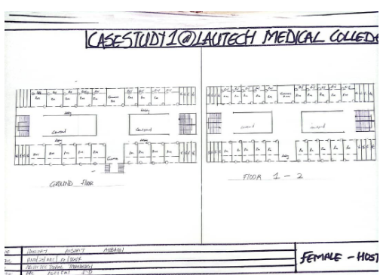

Figure 3.1.1 showing the floor plan of case study one
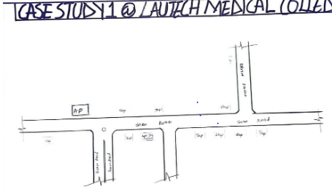

Figure 3.1.2 showing the location plan of case study one

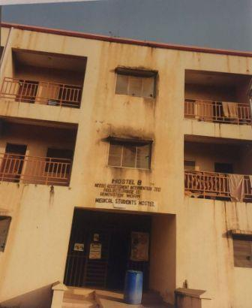
Plate 3.1.1 showing front view of case study one
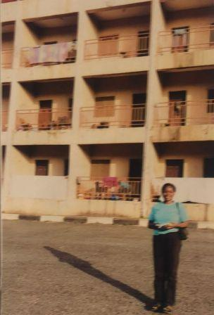
Plate 3.1.2:showing side view for case study one

Merits
- Ventilation was enhanced with the introduction of courtyard
- It is well secured .
Demerits
- Fire resistance construction was not considered in the building..
- Limitation of toilet

3.2 CASE STUDY 2: CALEB UNIVERSITY LAGOS STATE
Description
Located on the main campus in Imota, Lagos. The hostel provides shared room accommodation with ensuite bathrooms in a clean and secure environment.
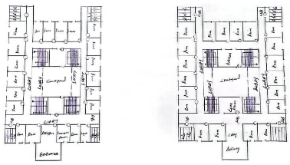

Figure 3.2.1: showing the floor plan of case study two

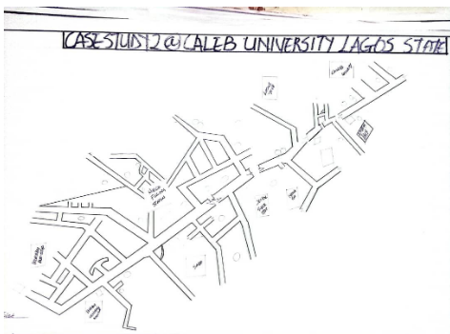
Plate 3.2.2: showing the location plan of case study 1
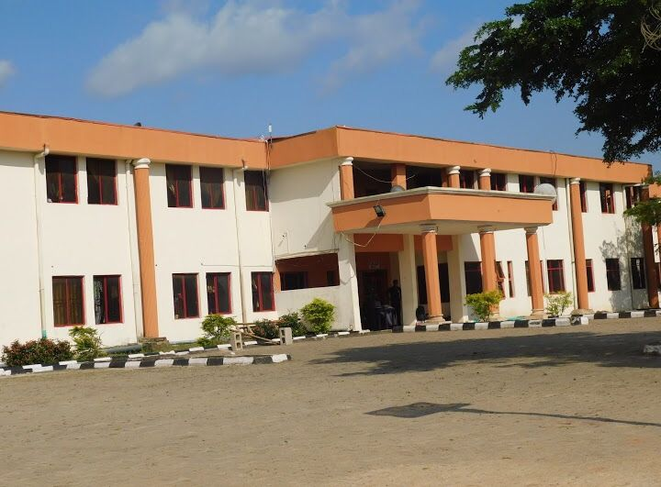
Plate 3.2.3 showing front view of case study two
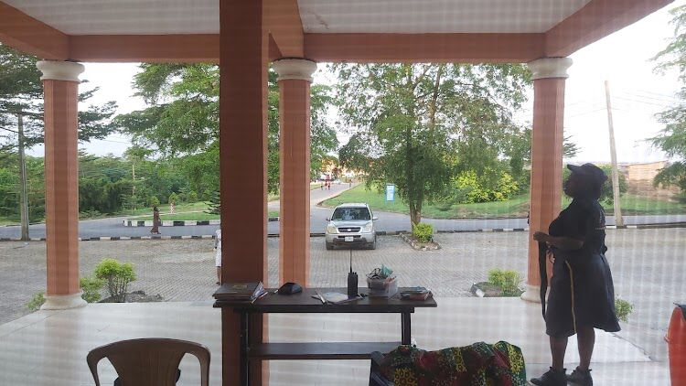
Plate 3.2.4 showing front view of case study two
Merits
- It is designed to accommodate individual with physical disabilities
- It is well secured
Demerits
- Fire resistance construction was not considered in the building.
- It has limited escape routes
- The room are not spacious

3.3 Case study 3 : osun state university ib okuku branch
Description
Located within the university campus in Osogbo. The hostel provides shared rooms with basic facilities in a calm and academic-focused environment.

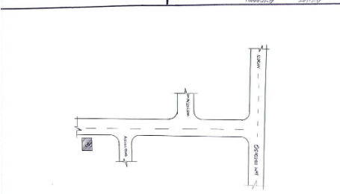
Figure 3.2.5: showing the floor plan of case study three
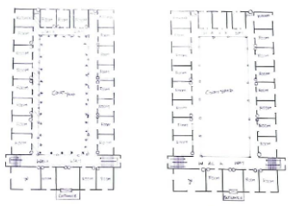

plate 3.2.6: showing the floor plan of case study three

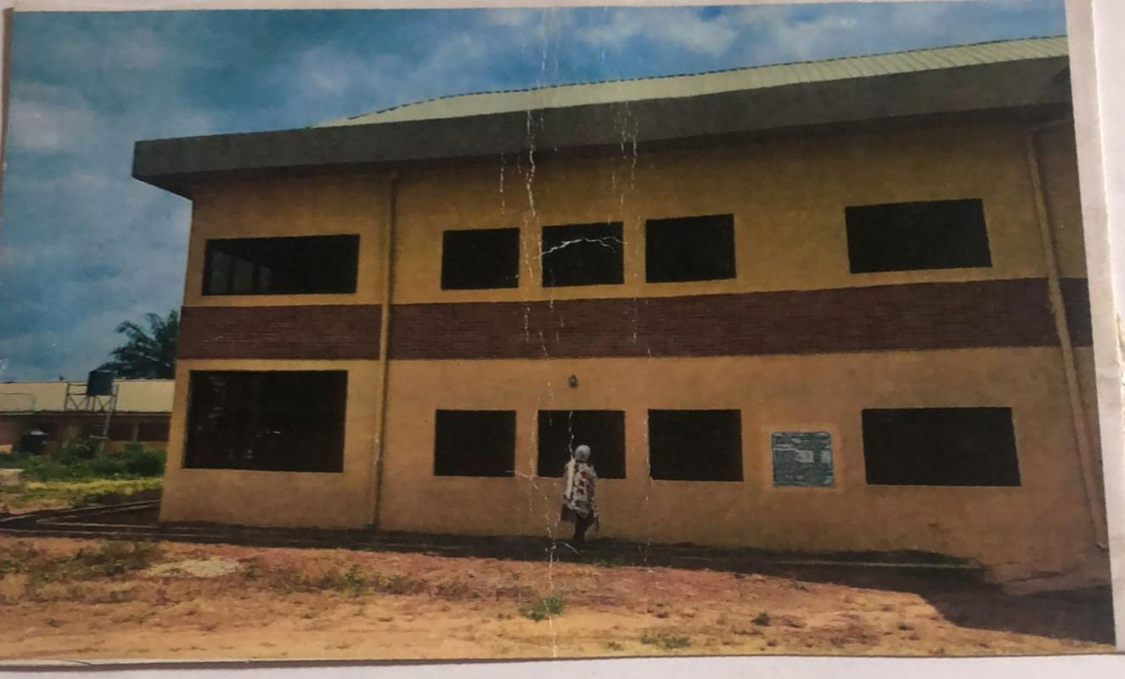
plate 3.2.5: side view of case study 3
Merits
- it is in a conducive environment
- it is well secured
Demerits
- lack of shading device to curtail high intensity of light
- the rooms are not spacious
- the structure of the building is old

3.4 CASE STUDY 4: KWARA STATE FEMALE UNIVERSITY HOSTEL AT ZAFARA HOSTEL

Description
Kwara State University, Ilorin. The hostel offers shared room accommodation with basic facilities and is popularly used by female students due to its proximity to the campus.

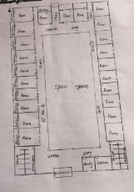
Figure 3.4.1 side view of case study 3
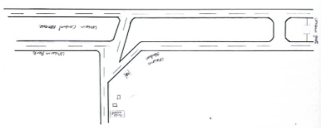

Figure 3.4.2: Location Plan of case study 3
Merits
- It is designed to accommodate individual with physical disabilities
- Ventilation was enhanced with the introduction of courtyard
Demerits

- It has limited escape routes
- Limitation of toilet
ONLINE CASE STUDY
3.5 Case Study 1: NORTH DAKOTA STATE UNIVERSITY
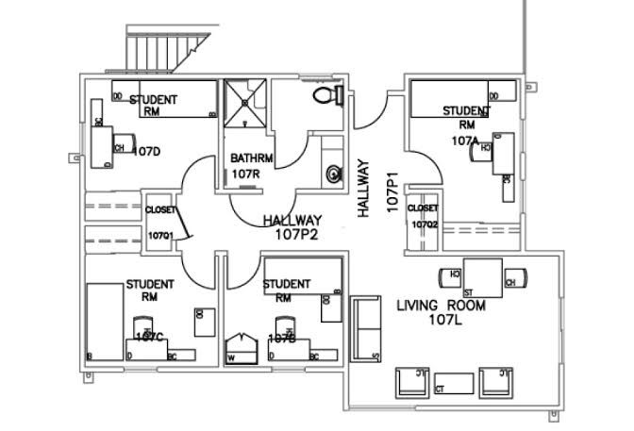
Floor plans of north dakota state university
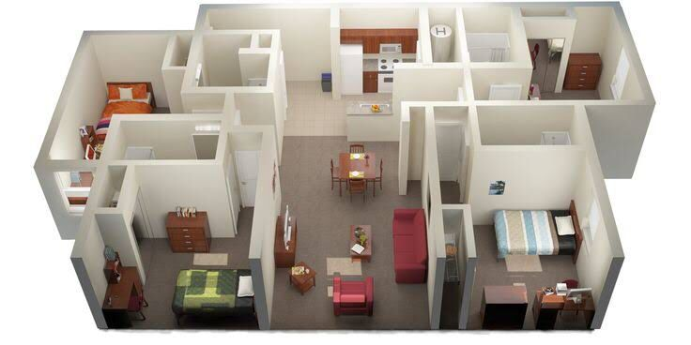

3.6 Case Study 2: mesaya Technical university
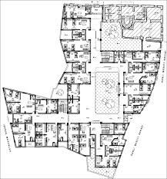
Floor plan for mesaya Technical university
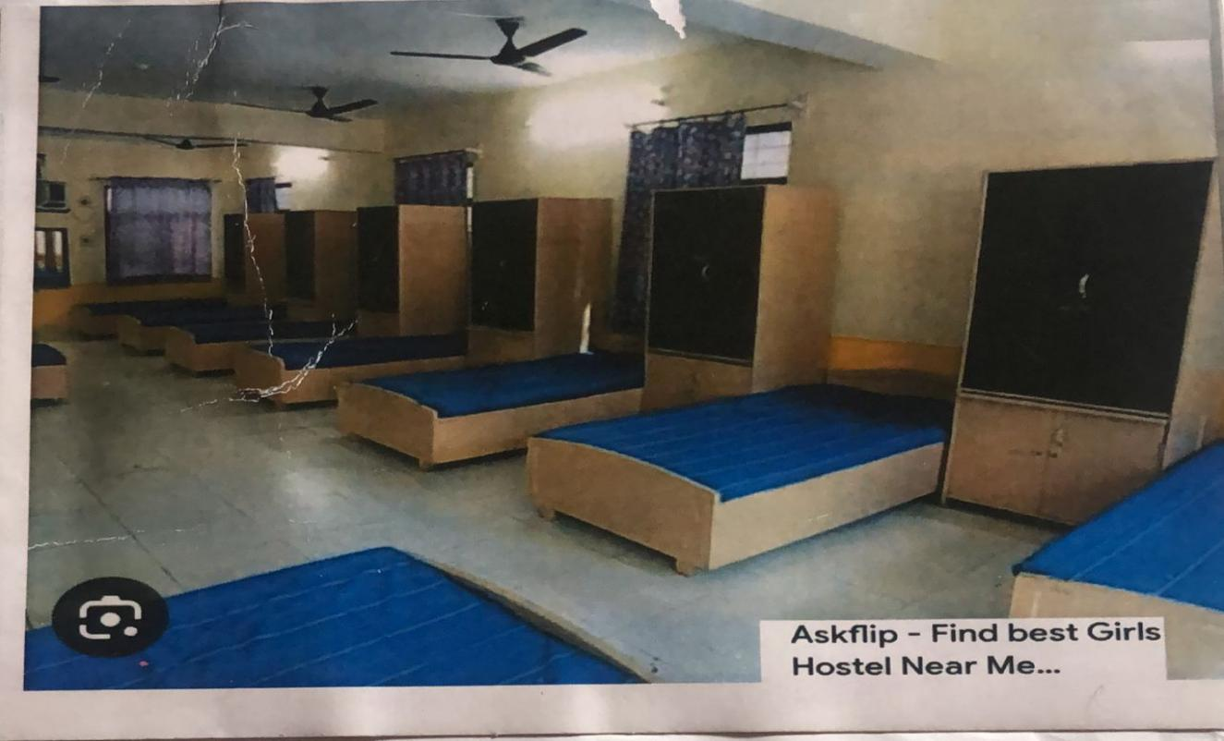
internal view of mesaya Technical university

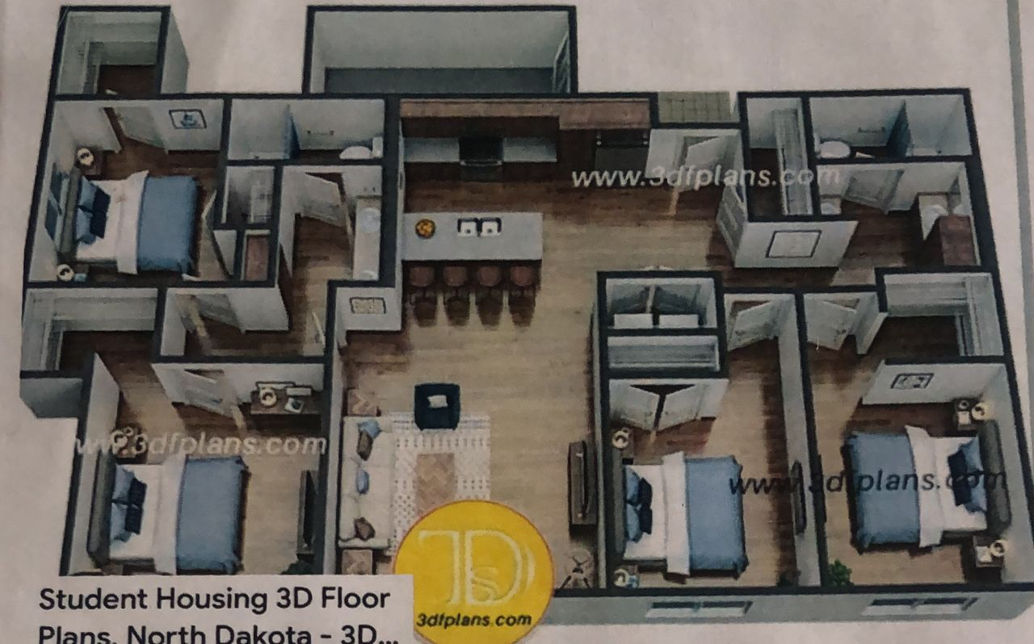3d view of mesaya Technical university
3.7 Case Studies Deductions
The case studies revealed several architectural and functional shortcomings. Most of the hostels observed were old and poorly maintained, with visible signs of wear and outdated construction methods. Sanitation was a major concern, as toilets and bathrooms were commonly shared, leading to issues of hygiene and inconvenience. Shared kitchens were also inadequate and often not properly ventilated or spacious enough for the number of users.
Circulation within the buildings was not well-considered. Narrow corridors, steep or cramped staircases, and poorly lit passageways made movement uncomfortable and unsafe. The spatial arrangements lacked privacy and did not support student comfort, especially in overcrowded rooms with limited ventilation and natural lighting.
There was little to no architectural identity or attention to modern student needs. Materials used were mostly outdated and not durable, with poor finishing and lack of attention to detail. These challenges highlight the urgent need for a new hostel design that focuses on privacy, sanitation, proper circulation, comfort, and durability.

CHAPTER FOUR
DESIGN PROPOSAL
4.0 INTRODUCTION OF STUDY AREA/SITE SELECTION
4.1 HISTORY OF ILORIN
Ilorin is the present-day capital of Kwara State in North central region of the Federal Republic of Nigeria. It is a predominantly Islamic city with people of diverse culture who have come together to live as one in peace and harmony. The entire Ilorin community comprises of five local government areas namely; Ilorin-West, Ilorin-South, Ilorin-East, Asa and Moro. These Local Government Areas are all under one entity known as Ilorin Emirate.
Ilorin Community was discovered in the 18th century by the duo of Afonja, Are-Onakakanfo, Yoruba warlord and Sheik Alimi, an Islamic scholar. There heros of Ilorin arrived Ilorin at different times and in different circumstances. Sheik Alimi was a Muslim and his teachings across the lad, he sojourned for many through villages and towns across Yoruba land he had followers with whom he moved around to establish the tenets and principle of Islam. He was temporarily settled at Kuwo village, Shiek Alimi continued to explore other territories where he could spread and establish his beliefs and settle down permanently.
4.2 SITE LOCATION
The site is located at University of Ilorin kwara state Ilorin.
Location of the University of Ilorin
- City: The University of Ilorin is located in Ilorin, Kwara State, Nigeria
- Land Area: The university sits on an expansive area of land, about 15,000 hectares, making it the largest university in Nigeria and one of the largest in Africa by landmass

Description of the University of Ilorin
- Federal Government-Owned: The University of Ilorin is a federal government-owned university ¹.
- Established: The University was established by a decree of the federal military government in August 1975 ¹.
- Academic Faculties: The University comprises 17 faculties and over 100 academic departments.
- Student Population: The student population of 200 in 1976 has increased to 20,084 by the 2005/2006 session.
Criteria of the University of Ilorin
- Autonomous Status: The University attained full autonomous status in October 1977.
- Academic Programmers: The University offers undergraduate degree programmers that run for 3-5 or 6 years, depending on entry qualifications and chosen discipline.
- Postgraduate Programmers: The University also offers postgraduate programmers that are run on different dimensions depending on the nature of the program.
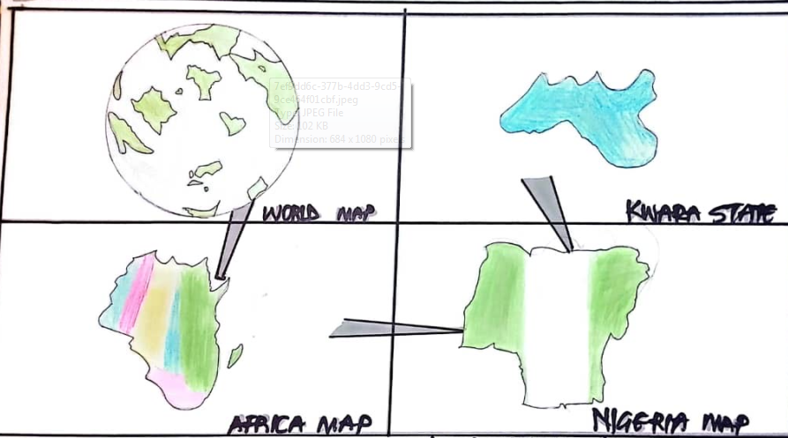
4.2.1 Site Location Map

Figure XIII: Map of Nigeria showing location of kwara State
Source: Google images
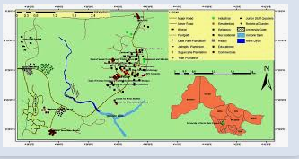

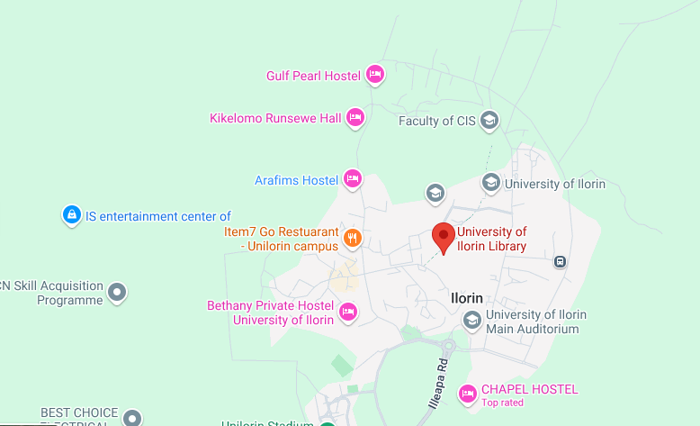
Figure XIV: Map of kwara State showing location of university of ilorin

Source: Google image

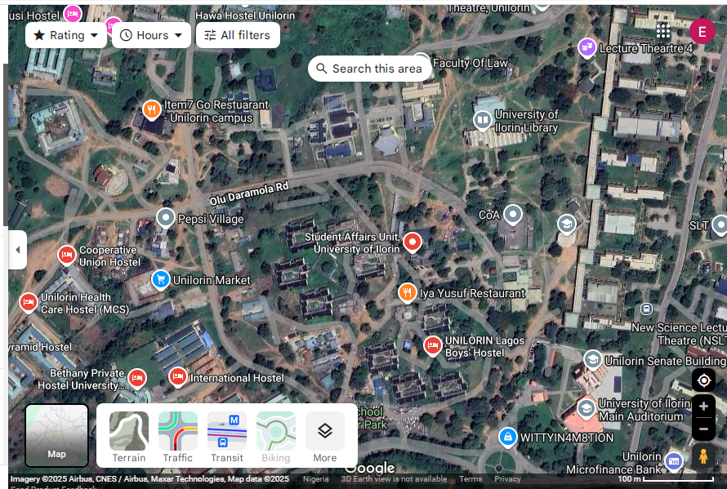

Plate XIX: Aerial View of Site.
Source: Google earth
- Location:
The site is located along existing female hostels within the school.
- Ease of Access:
The site can be accessed easily as there is an existing road that leads to it.
- Availability of Enough land:
To adequately provide for the various facilities required in the building and on the site, the area of land required for the project must be adequate. Therefore, the site was selected because it is wide enough to accommodate the proposed design.
- Security:
The site is located within the school thereby is covered by the school security ensuring safety of the students. But also, additional security would be provided on the site.
- Nature of Site and Vegetation:
The topography of the site is fairly levelled and the slightly unlevelled part can be adequately levelled. The sub soil is mainly red lateritic soil, with barches of sandy soil. The site also contains few trees and shrubs, which can help enhance the landscape of the site, and also act as wind-breakers and dust filters during the harmattan.
4.2.1Site Characteristics
4.2.2 Soil type
The sub soil is mainly red lateritic soil, with barches of sandy soil. It is a high load bearing capacity soil.
4.2.3 Vegetation
The vegetation on the site consists of few trees of different species and shrubs. Some trees and shrubs will be retained to enhance the landscape of the site, and also act as wind-breakers and dust filters during the harmattan.
4.2.4 Topography
The topography of the site is fairly levelled and the slightly unlevelled part can be adequately levelled.
4.2.5 Drainage
There is no existing drainage on the site, so drainage would be constructed.
4.2.6 Accessibility
The site is accessible by an existing road along the adjoining buildings which leads to the site.
4.3 SITE ANALYSIS
A site analysis involving a study of the site is carried out, it takes into consideration natural and man-made components present in and around the site, as well as climatic conditions of Lagos state. The plate below shows a schematic summary of the analysis of the proposed site.
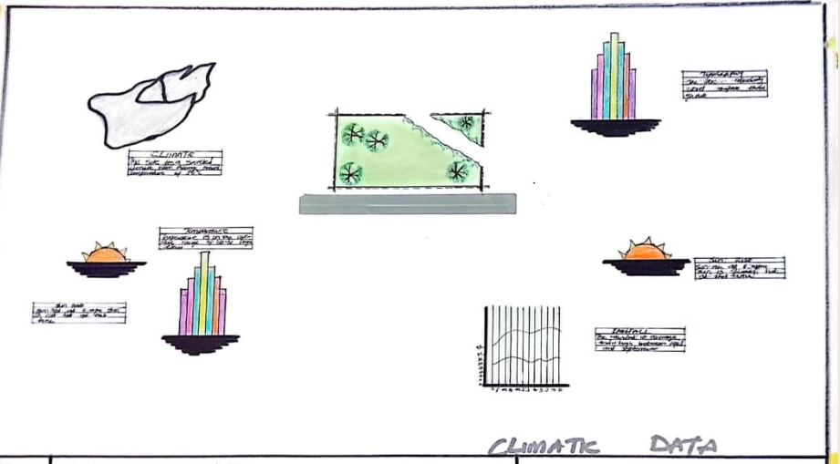
Site Analysis.

Figure XIX: Site Analysis
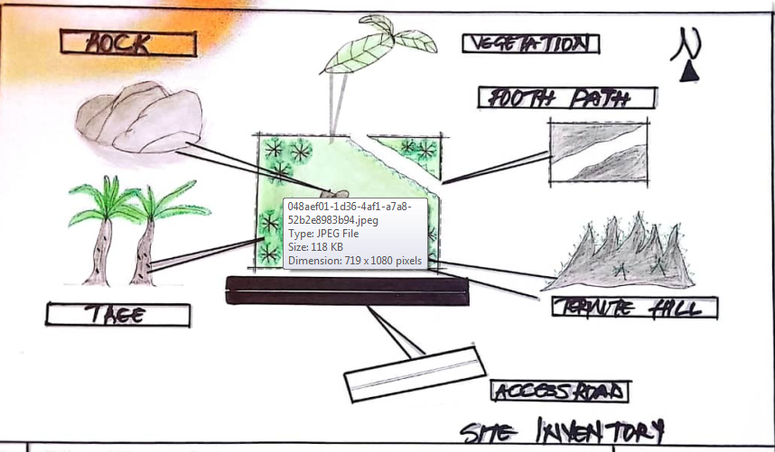
Source; Authors fieldwork

Figure XX: Site Inventory

4.4 GEOGRAPHICAL/ CLIMATIC DATA
4.3.6 Climate
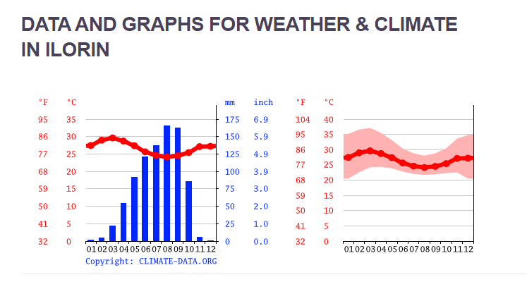
Lagos is one of the cold regions in Nigeria with an average daily high temperature of only 31 degrees centigrade. High humidity and hot temperatures make the weather at times pleasant but also tropical humid. It is warm to hot all year round and invites to bathe at average water temperatures of 27 degrees. Due to the lesser rain the best time for traveling is from November to March. Most precipitation decrease from June to October.

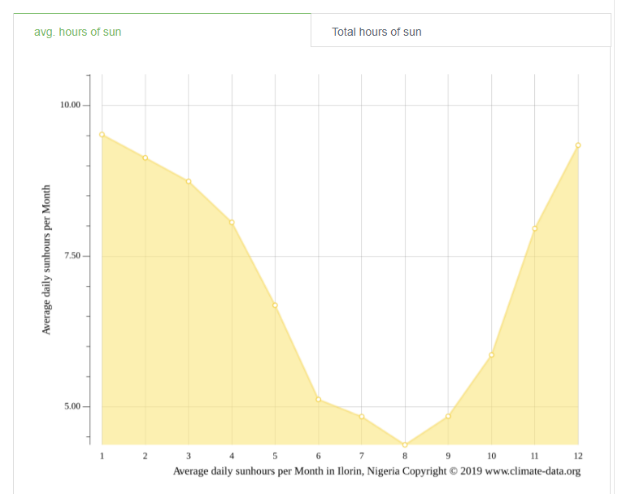
Hours of sunshine per day

Figure 4.3 Hours of Sunshine per day
Source; Worlddata.info
The number of hours of sunshine refers to the time when the sun is actually visible. That is, without any obstruction of visibility by clouds, fog or mountains. With 7 hours per
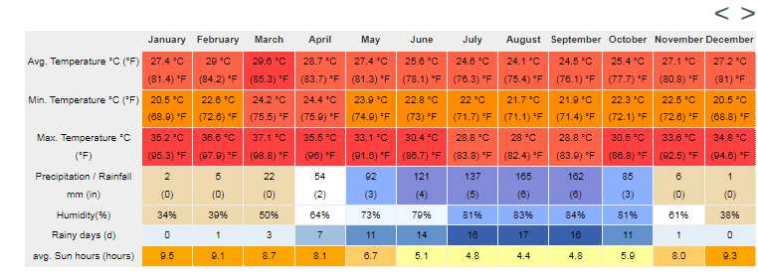
day, February is the sunniest month in the state of Lagos. In August the sun shines the shortest.
- Rainy days per month

Figure 4.4 Rainy days per month
Source; Worlddata.info
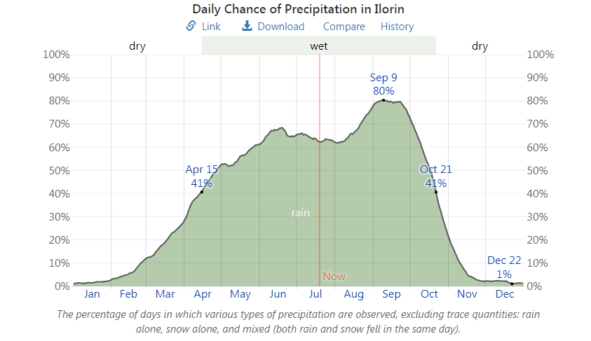
A rainy day is a day on which at least an amount of 0.1 mm precipitation (=0.1 liter) per square meter falls. This can be rain, snow, hail or even dew. So it does not have to rain the whole day. With 18 rainy days, June offers the most number of rainy days, and in December the least.Precipitation in mm/day

Figure 4.5 Precipitation in mm/day
Source; Worlddata.info
The amount of precipitation is measured in millimeters per square meter. Thus, at two mm/day, two litres of water fall on one square meter within 24 hours. With only 0.4 mm, the least rain falls in December. June, on the other hand, has the most rain.
- Water temperature
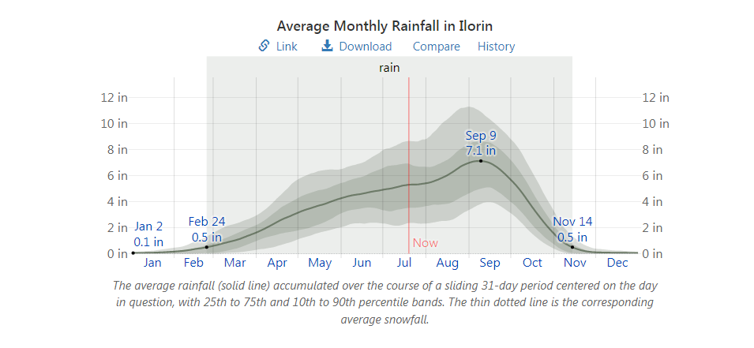

Figure 4.6 Water temperature
Source; Worlddata.info
Water temperature depends not only on solar radiation within the same region, but also on ocean currents. For example, depending on the season, cold or warm water masses are moved from other areas. The warmest temperatures in Lagos are in March, when the water is 28 °C.

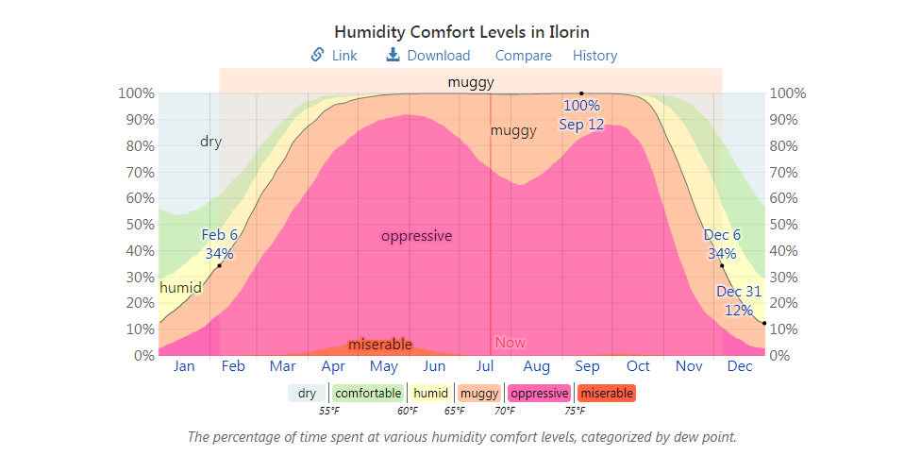
- Relative humidityin %

Figure 4.7 Water temperature
Source; Worlddata.info
Warm air can absorb more moisture than cold air. The relative humidity indicates how much moisture of the physically possible is actually contained in the air. At high humidity, the person feels uncomfortable and perceives this as oppressive. In general, a relative humidity of 40-60% gives as pleasant. With humidity averaging 87%, June is the most uncomfortable. In March, on the other hand, it is easier to endure.
4.5 ANALYSES OF THE IMMEDIATE ENVIRONMENTAL CONDITIONS OF THE SITE
4.5.1 Site Features and Infrastructure
The site features electrical lines which proposes that open power supply is promptly accessible inside the site.
Perfectly drained soil; soils water moves through easily to allow good soil aeration and at the same time sufficient amount is retained for plant growth.
Other features are water supply and an access road.
4.5.2 Noise SourcesThere are no much noises on the site but the few noises that can be heard comes from the adjacent structures which are the existing female hostels.
- Rainfall:
Minimum rainfalls are recorded in December, while June offers the most amount of rainfall.
- Vegetation and Topography:
The vegetation on the site consists of few trees of different species and few shrubs. The site is relatively gentle sloping and has a high load bearing capacity soil.
- Prevailing Wind Direction & Sun-Path Angles
The two predominant winds blowing across this area are the South West Trade wind and the North East Trade wind. The former, which blows across the Atlantic Ocean, is characteristically cold and results in the wet season. Being a cold wind, it is capable of holding much moisture contents across the ocean, and hence an increase in relative humidity of the area affected. However, the North East Trade wind, which blows across the Sahara Desert, is dusty and dry wind. Consequently, the two predominant seasons experienced in this area are characteristically marked by the two wind types. The summer (the season between spring autumn when the sun is hot and there are many flowers) is experienced between April and September, when the south west Trade wind is more predominant, while the winter season is shortly marked between November and March, when the north east trade wind is more predominant. This later season {winter} is however characterized by cool and hazy mornings, couple with dusty afternoons, because of the dust particles it brings forth from the desert. To reduce the effects of wind driven, trees were planted.
- Sunrise and sunset:
The sun rises from the east in the early hours of the morning at about 6:30am - 7:00 am and sets in the west at about 6:45 pm in the evening daily.
- Accessibility:
The site is accessible by an existing road along the adjoining buildings which leads to the site.
- Man-made features
- Electricity: Electricity is supply to the site through overhead cables along the site boundary.
- Footpath: There are no existing footpaths on the site, few would be channeled.
- Noises: Caused by adjacent structures

4.6 PROJECT ANALYSIS/DESIGN CRITERIA
The proposed design is the design of a female hostel with emphasis on fire safety to ensure the safety of the students and occupants.
- ​Design Considerations:
The following are the factors considered when designing the building;
- Passive and Active Fire safety: Fire safety measures would be considered in designing the building to increase safety in the building,
- Aesthetics: In any architectural design, aesthetics is most common factor to consider which shall be achieved by the use of attractive and lively finishing materials.
- Functionality: In any architectural design, functionality plays major role, design must be functional to meet the taste and convenience of the occupants.
- Ventilation: This includes the orientation of the building, sizes and locations of fenestrations, vegetation.
- Circulation and Zoning: Appropriate and well-articulated pattern of circulation in a building alleviates confusion and at the same time tailor the movement of students to their respective destination.
- Landscaping: The form of landscaping in the building is aimed at satisfying user requirements, having aesthetic value and improving environmental comfort. Hence, landscaping will be considered in the design
- Security: The provision of security in the hostel involves the protection of the students, the building and its contents.
4.5.3 Design Concept
The design approach was based on functionalism, which is an architectural principle that says that building should be designed based solely on purpose and function of the building.
4.7 PROJECT GOAL
The proposed design is the design of a female hostel with emphasis on fire safety to ensure the safety of the students and occupants.
The hostel is to provide the students with accommodation facilities and other functional spaces and facilities. These facilities include:
- Reception
- Rooms en-suite
- Communal Rooms
- Laundry
- Reading rooms
- Porter’s lodge
- Stores
- Retail shops
- Relaxation area
- Car park
4.8 APPRAISAL OF PROPOSED SCHEMES.
An appraisal of a proposed scheme for institutional hostels involves evaluating the plan's feasibility, effectiveness, and potential impact. Here's a comprehensive appraisal framework:
I. Location and Accessibility
- Proximity to academic buildings and facilities
- Safety and security features
- Accessibility for students with disabilities
II. Capacity and Accommodation
- Number of students to be accommodated
- Room types (single, shared, etc.) and amenities (e.g., beds, desks, storage)
- Common areas (e.g., lounge, kitchen, laundry)
III. Infrastructure and Amenities
- Water and electricity supply
- Sanitation and waste management
- Internet and Wi-Fi connectivity
- Furniture and appliances
IV. Management and Supervision
- Hostel administration and staff
- Rules and regulations
- Maintenance and repair procedures
V. Cost and Funding
- Construction and operational costs
- Funding sources (e.g., government, private investment)
- Student fees and payment structures
VI. Sustainability and Environmental Impact
- Energy efficiency and renewable energy sources
- Water conservation measures
- Waste reduction and recycling programs
VII. Student Life and Well-being
- Support services (e.g., counseling, health services)
- Social and recreational activities
- Community engagement and inclusivity
VIII. Future Expansion and Flexibility
- Potential for expansion or renovation
- Adaptability to changing student needs and demographics
IX. Compliance with Regulations
- Adherence to local building codes and regulations
- Compliance with accessibility and safety standard
X. Stakeholder Engagement
- Involvement of students, staff, and faculty in the planning process
- Community engagement and outreach
4.9 EQUIPMENT AND OPERATIONAL AND PERFORMANCE REQUIREMENT
Designing an institutional hostel involves considering various equipment, operational, and performance requirements to ensure the facility meets the needs of its residents effectively and efficiently. Here’s a detailed breakdown of these aspects:

Equipment Requirements

Essential Equipment
Furniture:
Beds: Comfortable and durable, typically with storage options (e.g., drawers under the bed).
Desks and Chairs: Ergonomic and suitable for study or work, with ample space for personal belongings.
Wardrobes/Closets: Adequate storage for clothing and personal items.
Common Area Furniture: Sofas, chairs, and tables for lounges and social spaces.
Kitchen Appliances:
Refrigerators: Sufficient capacity to store food for all residents.
Stoves/Ovens: For cooking, with safety features and adequate ventilation.
Microwaves and Toasters: For convenience and quick meals.
Dishwashers: Optional, depending on the size and budget.
Laundry Facilities:
Washing Machines and Dryers: Easily accessible and with sufficient capacity.
Ironing Boards and Irons: For personal clothing care.
Cleaning Equipment:
Vacuum Cleaners, Mops, and Brooms: For maintaining cleanliness.
Trash Bins and Recycling Containers: Strategically placed in common areas and individual rooms.
Safety Equipment:
Fire Extinguishers: Properly placed and maintained.
Smoke Detectors and Alarm Systems: For fire safety.
First Aid Kits: Easily accessible and stocked with essential supplies.

Technological Equipment
Wi-Fi and Networking: Reliable and high-speed internet access throughout the hostel.
Televisions and Entertainment Systems: Optional for common areas.
Climate Control: Air conditioning, heating, and ventilation systems to ensure comfort.

Operational Requirements

Facility Management
Maintenance Schedule: Regular checks and maintenance of equipment and infrastructure to ensure everything is in good working condition.
Cleaning Protocols: Daily and periodic cleaning schedules for rooms, common areas, and facilities.
Security Measures: Surveillance systems, security personnel, and controlled access points to ensure resident safety.

Resident Services
Reception and Check-In/Out Procedures: Efficient management of guest arrivals and departures, including handling of keys and room assignments.
Support Services: Availability of staff or resident assistants for addressing issues or concerns.
Emergency Procedures: Clear protocols for handling emergencies, including evacuation plans and communication procedures.

Administrative Management
Booking and Reservation Systems: Efficient systems for managing reservations, room assignments, and payments.
Documentation and Record-Keeping: Proper documentation of resident information, maintenance records, and operational logs.

Performance Requirements

Comfort and Usability
Space Planning: Effective use of space to ensure comfortable living conditions, including adequate room sizes and communal areas.
Noise Control: Soundproofing measures to minimize noise disruptions, especially in shared spaces and sleeping areas.
Lighting and Ventilation: Adequate natural and artificial lighting, and good ventilation to create a pleasant environment.

Safety and Compliance
Building Codes and Regulations: Adherence to local building codes, fire safety regulations, and health standards.
Accessibility: Compliance with accessibility standards to ensure ease of use for all residents, including those with disabilities.

Efficiency
Energy Efficiency: Use of energy-efficient appliances, lighting, and HVAC systems to reduce operational costs and environmental impact.
Water Efficiency: Implementation of water-saving fixtures and systems to reduce consumption and operational costs.

User Satisfaction
Resident Feedback: Regular collection of feedback from residents to address concerns and make improvements.
Quality of Amenities: Ensuring that all provided amenities meet quality standards and are in good working order.
The design of an institutional hostel requires a comprehensive approach to equipment, operations, and performance. Addressing these requirements effectively ensures that the hostel provides a safe, comfortable, and functional living environment for its residents, while also being manageable and efficient for the institution.
4.10 SPATIAL ALLOCATION / SCHEDULE OF ACCOMMODATION
It is the allocation of spaces required in the building design in order to make the most appropriate use of spaces available.

Schedule of Accommodation
Table 6.1 Schedule of Accommodation
S/NO | SPACE | UNITS | DIMENSION(M) | AREA(M2)
1 | Reception | 1 | 5000 x 4000 | 20
2 | Porter’s office | 1 | 3000 x4000 | 12
3 | Toilet | 1 | 900 x2100 | 18.9
4 | Communal rooms | 2 | 6000 x 4000 | 24
5 | Reading room | 1 | 3000 x4000 | 12
6 | Rooms(2 students) | 56 | 3600 x 3600 | 12.96
7 | Kitchen | 56 | 1800 x 1800 | 3.24
8 | Toilets | 56 | 1800 x 1800 | 3.34
9 | Laundry | 8 | 5000 x 3600 | 18
10 | Stair Hall | 8 | 4200 x 2400 | 10.8
11 | Stair Hall 2 | 4 | 3000 x 2400 | 7.2
12 | Toilet | 4 | 900 x 2100 | 18.9
13 | Courtyard 1 | 2 | 4200 x 8000 | 3.36
14 | Courtyard 2 | 2 | 4200 x 4500 | 18.9
Source: Author’s fieldwork (2022)
4.11 FUNCTIONAL RELATIONSHIP
Functional relations in architectural design refer to the way in which different spaces, elements, and components of a building interact and support each other to achieve the intended purpose of the structure. These relations are crucial for creating efficient, practical, and aesthetically pleasing environments.
4.12 CONCEPTUAL DEVELOPMENT
Conceptual development in architectural design is the process of generating and refining ideas that form the basis of a building’s design. It involves translating abstract concepts into concrete architectural solutions.

CHAPTER FIVE
PROJECT APPRAISAL

5.0 DESIGN APPRAISAL
To achieve a spatial configuration –in the design InstitutionalFemalehostel that facilitates user orientation, wayfinding and efficient Institutional Female hostel usage by the application of the findings in this study, certain design guidelines and recommendations studied are adopted as the basis for evolving a conceptual framework on which the design is built.

​Architectural Wayfinding
Site Logic: To aid the user's ability to understand and to be properly oriented in the InstitutionalFemalehostel outdoor environment, external spaces grouped into logical function-zones. Also, this involves the articulation of the edges of salient nodes into a legible system to visually separate one functional district from another. For instance, the visual dominance of the InstitutionalFemalehostel main entrance(s) and the definition of public space from private space which are important factors in navigating large scale landscapes form critical elements of the design.
Building Form and Floor Plan: Equally, functionally related activity areas form zones consciously planned to preserve the ‗sense of place‘ and connectivity between spaces. This entails creating clear, logical hierarchies of such other architectural wayfinding elements as markers, edges and paths to facilitate user cognitive perception and orientation in space.

​Graphic Information Way finding Design
A clear, organized set of sign elements are potential elements in any good wayfinding design scheme. In this process, therefore, related graphic devices such as wall and
Floor graphics, strategic placement of sculpture, and art programs form directional components of the wayfinding plan.

​Design Concept Synthesis
Researching case studies helped to give direction in determining best practices in solving the wayfinding and orientation design issues in InstitutionalFemalehostel. Thus, this informs the following configuration of spaces to achieve legibility in the design:
      - Simple floor layout with immediate visual and physical access to various designated InstitutionalFemalehostel destinations.
      - Visual perception of major circulation pathways and systems, especially vertical transport systems to ease orientation and locomotion.
      - Visual prominence and definition of major entry points to facilitate access to designated InstitutionalFemalehostel destinations.

Design Philosophy
To achieve a successful architectural wayfinding in the design of the InstitutionalFemalehostel, the author takes on the universal design approach which seeks to design environments that are specifically inclusive and equal for all users, the key idea being thecreationofspacesorfeaturesthatdonottreatsomepeopledifferently. This entails the design of the environment; buildings, products and communications that equitably accommodate the spatial needs of all types of people and, takes into account as much as possible their differences, particularly those of people with physical impairments or difficulties speaking the dominant language. Also, of particular interest to the universal design approach is the provision of spaces flexible enough to accommodate a wide range of individual preferences and abilities; simple and consistent in use without unnecessary complexity and hazardous elements. Further, universal design promotes the creation of structures that facilitate user efficiency and comfort, with adequate space for various user activities including the use of assistive devices or personal assistance and, legible and universally perceptible communication systems.
CONCEPT DERIVATION
Concept derivation in architecture is the process of generating and developing the foundational idea or theme that will guide the design of a building. It's the crucial first step where architects translate abstract notions into a concrete vision for the project. This process involves exploring various methods to derive a concept, such as using a theme, analogy, metaphor, or considering the context and experience of the users.
Designing a hostel is not merely about providing accommodation—it is about creating a vibrant, functional, and inclusive environment where individuals from diverse backgrounds coexist, interact, and thrive. The concept derivation process is a critical stage in an architectural project, setting the tone for spatial organization, aesthetics, functionality, and user experience. This write-up outlines the conceptual development behind a hostel design from the perspective of the architect. Examining topography, climate, prevailing winds, sun orientation, and surrounding built forms. Understanding the end-users—typically students, workers, or travelers—and their routines, needs, and cultural backgrounds. Assessing proximity to institutions, transportation hubs, and social infrastructure. From the context, the design goals are formulated. Efficient Space Utilization: To maximize functionality within limited footprints. To encourage social interaction through shared spaces. Balancing communal living with individual privacy. Incorporating passive design strategies and sustainable materials. reflecting cultural, historical, or institutional identity through architectural language.

5.1 CONSTRUCTION METHODOLOGY
The soil type of the proposed site will highly be instrumental to the construction considerations to be explored in order to bring about the structure build ability. However, the proposed site is a gently sloped site with good draining capacity and a good safe load bearing capacity and as such the need for additional strengthening and treatment of soil before construction may not be needed unless the geological experts requests so. Subsoil water drainage is necessary to improve the run-off of ground water to maintain the water table at some depth below the surface with a purpose of;
1. Improving the soil stability.
2 Prevent surface flooding.
3. Avoiding dampness in underground occupation such as basement or the ground floor.
4. Reducing the humidity in the immediate environment of the building structure.
The building lines are taken into consideration at the inception of this design, so with the building lines and the existing access road other wall flanks can be set out at right angles to the building line:
1. By using a large builders square placed against the building line and sideline produced to length required.
2. By using the proprietary optical square which comprises two small sighting telescopes permanently set at precise sight angles to one another.
3. By using an optical instrument with a base ring graduated to degrees and sighting along angles required.
The method of construction is as follows
Digging of trenches
Filling of hardcore
Block laying
Filling of hollow blocks with hardcore
Filling of laterite into foundation
Casting of mass oversite slab
Laying of block wall
Casting of column and lintel
Roof construction
Plastering
Fixing of window frame
Finishing
SUB-STRUCTURE
This is the part of the building that has direct contact with the ground and carries the majority of the building load. The stability of the proposed structure depends to a large extent on the type and load which the proposed design will exert on the ground. The strip foundation is to be adopted as the foundation type for this project and its depth is to be determined by a combined effort of the geological experts and structural engineers. Recommendations on the depth and foundation type proposed will be subjected to the architect’s approval so as to get a unified approach which will in every possible means align with the proposed design. All other details as regards the material type, configurations, spacing to be used during the construction of the substructure will be to the structural engineer’s specification and design.
SUPER STRUCTURE
The super structure comprises different components and because of the complexity of the proposed structure, explicit care and consideration needed to be explored all in a bid to recommend the best forms of materials to be used to achieve the concept taking into consideration cost, structural stability, maintenance and buildability.
1 The Walls: The internal walls basically serving as party walls were constructed entirely of sandcreate block walls with reinforced concrete columns at the end to keep the structure firm. The structure is to be constructed with 150mm sandcreate hollow blocks and reinforced concrete for the floors. However, Expansion joint will be introduced at intervals of 25-30m to prevent buckling or cracking which may occur due to temperature change and other factors.
2 Floor: Floor slab of 150mm reinforced concrete is to be used for the project.
3 Roof: Steel trusses are to be used for the roof carcass and long span aluminum roofing sheets are to be used. Adequate care needs to be taken during installation so as to achieve first and foremost the building plan and reduce the amount of wasted sheets to be placed while coupling the roof members. The roof slab incorporated mostly at the gutter of the auditorium section is to be covered with 3 layers of bituminous felt with sawdust and sand to reduce the heat radiation from the slab.
CONSTRUCTION MATERIALS
The choice of materials to be used is influenced by several factors, some of these factors include;
1 The availability of materials
2 The durability and suitability of such materials
3 The climatic situation/condition
4 The cost of material, etc.
SUBSTRUCTURE AND SUPERSTRUCTURE
1 Suspended Floors: Unglazed vitrified ceramic floor finish; unglazed vitrified ceramic tiles; polished granite tiles; glazed vitrified ceramic tiles.
2 Walls: Sandcreate block for all walls of load bearing capacity finished with 25mm thick wall plaster rendered and finally painted with white emulsion paint on the exterior and other colors in the interior as may be specified. In the conveniences- toilets, changing, etc, the walls are to be finished with glazed ceramic tiles to a height of 2.1m.
3 Doors: Sizes of doors in the design range from 750mm to 2500mm. The door schedule to be provided in the proposed design drawings shows each as applicable in the design. The surface coating of these doors especially the interior ones must be able to withstand incessant cleaning and must be able to prevent sound and odour transmission. Single and double leaf doors shall be of approved quality, solid hardcore flush door installed with all necessary ironmongery while the main entrance door shall be glazed aluminum double leaf swing door installed with all necessary accessories.
4 Ceiling: Acoustically proofed white cellotex ceiling boards will be used. Acoustic ceiling tiles (suspended ceiling)
- External Works: Grass, trees and shrubs, interlocking paving stones, plain in-situ concrete and asphalt will be incorporated in the design. The existing site is finished with coal tar and that will be retained for the driveway and parking lot.

5.2 SERVICES REQUIRED
All necessary infrastructures ranging from access roads to power supply to mains water supply and drainage facilities are already existing on the proposed site. This will be needed to ensure that the centre is functional and self-sustaining. Electricity is to be tapped from the nearest electric pole at the side of the site to power activities within the centre. All roof drains runs to the underground drains which passes on to the main public drainage. Light fixtures and electrical wiring are to be concealed in the various ducts provided.
- FIRE PROTECTION
Proper installation of cables and adequate power rating by the use of excessive current circuit breakers will help in minimizing the risk of fire outbreak especially through electrical fault. However, in the probable case of fire outbreak, the following shall help in quick quenching of the outbreak;
1. Adoption of the sprinkler system in every unit,
2. Installation of smoke/fire detecting alarms in all units,
3. Fire extinguishers are to be placed at strategic locations, and
4. Employment of the fire brigade services in the event of an outbreak.
- VENTILATION
As much as possible, every space provided will be ventilated naturally but for efficiency sake, the auditorium section shall be serviced by split unit air conditioning system.
- LIGHTING AND GLARE
The windows and courtyards provided will ensure that the centre is well lit. Glare which may result from natural lighting or the artificial one used in complementing
It shall be hugely reduced by the use of shading devices and suitable building exterior colours that will significantly reduce or eliminate the glare. In order to reduce glare and contrast, bench tops and furniture generally will be of high reflectance i.e. light colours, likewise for the walls and ceiling.

- NOISE CONTROL
In achieving noise level reduction, adequate setback from the main access road is provided. Buffer zones are provided also. Catering for the noise generated within the building, an internal buffer has been introduced by separating the noisy areas from the quiet areas.
- ACOUSTICS
Several spaces within the auditorium will require different acoustic considerations. The amount and location of acoustically absorptive finishes within a space dictates and helps to achieve comfort in such spaces. Partitions (walls, floors and ceiling) should maintain privacy and limit the transmission of noises that could cause distractions. Sound absorptive finishes are considered for the auditorium, the performance theatre and the exhibition spaces. Full height partitions with adequate sound isolation are provided also.
- External Works The walkways will be finished with interlocking paving stones to enhance the aesthetics of the surroundings. The vehicular access will be finished with asphalt for durability. Trees and shrubs will be planted at regular intervals in the car parks to serve as shades for the cars. All other spaces are landscaped with carpet-grass and randomly with trees and shrubs to absorb noise from surroundings and to reduce glare. A buffer zone of trees and shrubs are provided along the main and minor roads to reduce noise generated by moving vehicles on such roads.

DESIGN CONTRIBUTION
The study of wayfinding design strategies and their application in the design of public libraries culminates in a design proposal for the InstitutionalFemalehostel which seekstocontributetothedevelopment inNigeriaofeffectivearchitectural wayfinding models that articulate a variety of architectural elements, principles and components as wayfinding elements that aid user navigation within her public realm. Above all, the design explores the application of such planning requirements as zoning as well as the use of such architectural design components as lighting, graphics, form and volume in creating a visually legible and coherent InstitutionalFemalehostel.

5.3SUMMARY AND CONCLUSION
INTRODUCTION
This section presents the general conclusion for the study, recommendations observed in the course of study and the areas identified in which further investigations can be carried out which were not treated in this research.
RECOMMENDATIONS
- The Nigerian University Commission (NUC) should as a matter of need incorporate into its guidelines policies that would encourage the design of fire safety in hostels. This is to safe guard the life and property of Nigerian students. It will also enhance the continuity of the building in question
- University
- Authorities should set up committees comprising of representative of students, academic and non-academic staff as well as the physical planning unit. Through this medium they can communicate ways of enhancing fire safety and other problems encountered before design of hostels are initiated. This is called user participation.
- Also, seminars and talks on green building should be organized and aired for professionals in the building industry especially the architects.
CONCLUSION
In responding to the inherent problems associated with fire in hostel buildings, this thesis synthesized the analysis carried out during the process of the research. In trying to have a compound analysis and solution alike, case studies were critically analyzed with all the positive attributes employed to the advantage of the research.
All the features above that were analyzed in this study, if adopted, will provide an effective fire safety, in the sense that the problems and attitudes associated with fire in hostels has been taken care of through design approach that helps prevent ignition of fire, alert occupants about its outbreak, provide means of escape, limit spread of fire through proper use of material and construction methods. This enhances the safety of both occupants and firefighters.

REFERENCES
Aqua group (1984). Fire and Building, Granada Publishing, Great Britain.
Beryl Menzies (1999); Metric handbook planning and design data, second edition, edited by David Adler, Architectural press. Linacre House, Jordan Hill, Oxford OX2 8DP.
Brembeck, C.S, (1971); Social foundation of education: environmental factors inteaching and learning. London: john: Herper and Roy publishers
Coburn, Oliver (1950). Youth Hostel Story. London: National Council of Social Service.
David V. Chadderton, Building Service Engineering, fifth edition (2007), Taylor & Francis, 2 Park Square, Milton Park, Abingdon, Oxon OX14 4RN.
Ernst and peter Neufert (1993); Architects’ data, third edition, Blackwell science publishers.
FEMA - Federal Emergency Management Agency, 1999, Fire in the United States 1987-1996, 11th Edition, US Fire Administration, Federal Emergency Management Agency, Maryland, 21727
Fred Malven (1997); Time savers standards, for architectural design standards, seventh edition, McGraw-Hill, Inc.
Ger Herbert (1999), Fire safety in hostels. McGraw-Hill, Inc.
James Patterson, (1993); Simplified design for building fire safety. John Wiley and sons Inc.
Neal, Tim; Neal, Simon (1993). Youth Hostels of England and Wales 1931-1993. St Albans: YHA. ISBN 0952225409.
Nikolas Davies, Erkki Jokiniemi (2008); Dictionary of Architecture and buildingconstruction, first edition; Architectural press. Linacre House, Jordan Hill, Oxford OX2 8DP.
Perkin & Will (2001); Time savers standards, Building types, fourth edition, McGraw-Hill, Inc.
Schmerts H.T. (1972); Institutional Housing Strategies Educational andRealisation. London: Patrick Wakely.
Schneider, T., & Till, J. (2007). Flexible Housing. Oxford, United Kingdom: Architectural Press.
JOURNALS, NEWSPAPERS AND ARTICLES.
Christianity Today magazine, March edition, 2004.
Daily independent, 26 August 2010.
Daily Sun (2006). It was Like Armageddon. Daily Sun, Thursday, March 23.
David N. Bilow, Mahmoud E. Kamara (2008); Fire and Concrete Structures.
Hassan, H (1999); Fire and safety management in Building.
National University commission procedures guide and physical development manual for the University system in Nigeria (2004); Third edition.
Odeleye A. (1983) Fire protection in buildings: Nigerian Institute of Architects Journal; edited by Aku Omokhodion.
Olaitan P. B, Dairo M. D, (Feb. 2009) Journal of Rescue and Disaster Medicine™ ISSN: 1531- 2992, Domestic Fire Accidents In A Developing Country: Reducing Morbidity / Mortality By Modifying The "Burglar Proofs".
The Guardian (2006). Nigerians Fire Incidents and Safety at Workplace. The Guardian Newspaper, May 2006.
Vanguard newspaper, April 4, 2011.
Wikipedia encyclopaedia.
WEB PAGES
History of hostelling: http://hiusa.org/about_us/history
History of youth hostel movement: www.hostelscentral.com/hostels-article
Fire safety in hostels:
http://www.environ.ie/en/Publications/LocalGovernment/FireandEmergencyServices/FileDownLoad,1026,en.pdf
Student Housing in Epinay France: http://www.archdaily.com/28390/student-housing-in- epinay-ecdm/
University Students’ Housing Italy: http://www.archdaily.com/49294/university- students%E2%80%99-housing-and-services-cs-associati/-6.htm).
Climate in Lagos:https://www.worlddata.info/Africa/Nigeria/climate-lagos.php

