A PROJECT REPORT

ON

PROPOSED POST GRADUATE HOSTEL

FOR
UNIVERSTIY OF ILORIN, ILORIN WEST LOCAL GOVERNMEMRNT

BY
ALIU OKIKI DAVID
HND/23/ARC/FT/0063

SUBMITTED TO:
THE DEPARTMENT OF ARCHITECTURAL TECHNOLOGY
INSTITUTE OF ENVIRONMENTAL STUDIES (I.E.S)
KWARA STATE POLYTECHNIC, ILORIN

IN PARTIAL FULFILMENT OF THE REQUIREMENTS FOR THE
AWARD OF HIGHER NATIONAL DEPLOMA (HND) IN
ARCHITECTURAL TECHNOLOGY

JULY, 2025.

DECLARATON
I declare that this project work was written and composed by ALIU OKIKI DAVID (HND/ARC/23/FT/0063), and this is also record of my own research work, and it has not been presented before in any previous polytechnic and all the sources of information are specifically acknowledged by means of references, under ARC. OLAREWAJU F.A.

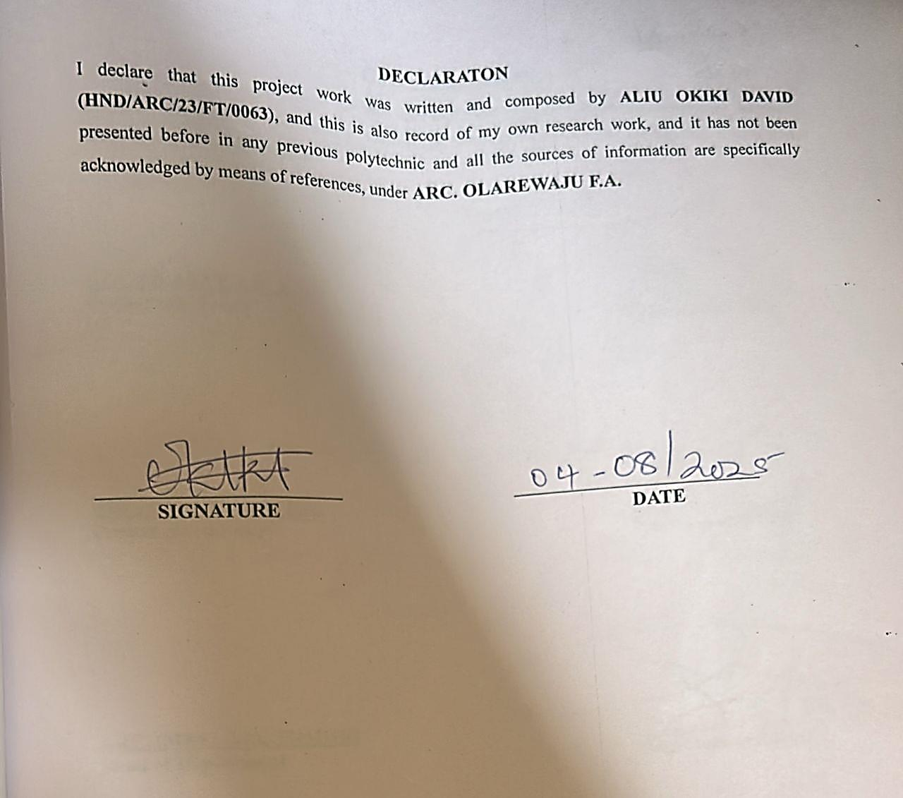

CERTIFICATION
I certify that this research project has been approved as meeting part of the requirement for the award of Higher Diploma in Architectural Technology, Institute Of Environmental Studies, Kwara State Polytechnic, Ilorin, Kwara State.

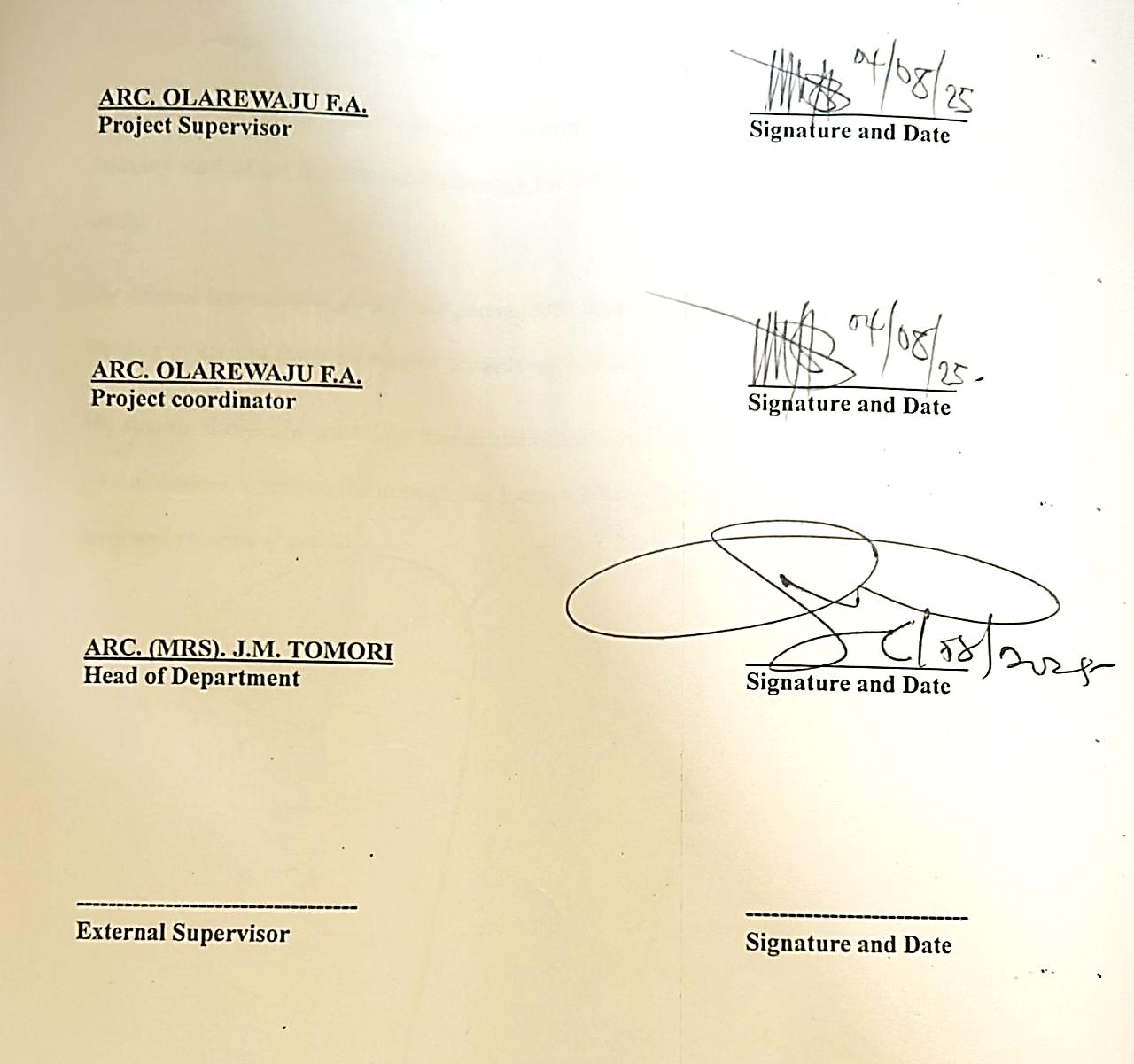

DEDICATION
dedicate this project to God Almighty the creator of the universe for the grace bestow upon my life, for he has strengthen me to this present time, and also to my beloved parent MR. ALIU YAYA GBENGA and MRS. ALIU for their prayer and support. May God Almighty bless and reward them abundantly and every other supporter to my academic life.

ACKNOWLEDGEMENTS
Everything that has beginning must have an end, therefore, all praises and adoration is unto God for the strength and courage he has accorded me in the process of this project.
Special thanks to my project supervisor ARC. OLAREWAJU F.A for taking his time to go through my research work, may Almighty God bless you abundantly. (Amen). I also acknowledged the head of depart of Architectural Technology Arc. Mrs. J.M. Tomori for her parental care and advice throughout this research work, I say a big than you to you ma.
I say thanks to Architectural technology department board member, both teaching and non-teaching staff of the department Technology for their impact in my life during my course of study.
My deepest appreciation goes to my parents MR. ALIU YAYA GBENGA and MRS. ALIU for their moral and financial support towards my education.
My sincere thanks also go to my friends and classmates. I can only express my gratitude for your assistance in getting me through this journey. May Allah continue to provide you all his favor and blessing (Ameen).

ABSTRACT
Post graduate Institutional hostels serve as crucial facilities designed to accommodate individuals—typically students, employees, or other institutional members—within an organized and supervised environment. These hostels are integral to educational institutions, corporate organizations, and other entities requiring structured living arrangements. The primary objective of institutional hostels is to provide a safe, supportive, and conducive living environment that enhances the overall experience and productivity of its residents.
Institutional hostels are characterized by their adherence to specific rules and regulations aimed at ensuring the well-being of occupants. They often offer amenities such as communal living spaces, dining facilities, and recreational areas, fostering a sense of community and collaboration among residents. The management of these hostels usually includes a structured framework for addressing issues related to accommodation, maintenance, and student welfare.
This abstract outlines the significance of institutional hostels in promoting academic success, personal development, and professional growth. It emphasizes the role of these facilities in providing a stable and supportive environment that facilitates the achievement of institutional objectives (academic performance). The effectiveness of institutional hostels is measured through resident satisfaction, the quality of facilities provided, and the overall impact on the students’ performance and well-being.

TABLE OF CONTENTS
TITLEPAGE
DECLARATION………………………………………………….…………………………ii
CERTIFICATION………………………………………………….………………………..iii
ACKNOWLEDGEMENTS…………………………………………………………………..iv
DEDICATION………………………………………………….……………………………..v
LIST OF TABLES……………………………………………………………………………vi
LIST OF FIGURES……………………..…………………….……………………….……..vii
LIST OF PLATES…………………………………………………………….……...……...viii
ABSTRACT…………………………………………………………………..………………ix
CHAPTER ONE
1.0 INTRODUCTION…………………………….………….……………….…………...1
1.1 HISTORICAL BACKGROUND………...……………………………………………1
1.2 DEFINITION …………………………………………………………………………1
1.3 STATEMENT OF INSTITUTIONAL HOSTEL…………..…………………….……2
1.4 AIM AND OBJECTIVES…………………………………..……………………..…..2
1.5 JUSTIFICATION…………………………………………………………..…..……...3
1.6 CLIENT’S BACKGOUND……………………………………………………….…...3
1.7 SCOPE OF STUDY……………………………………………………………….…..3
1.8 LIMITATIONS OF CONSTRANTS ………………………..…....…………..…….…4
1.9 RESEARCMETHODOLOGY………………………………………………………...4
CHAPTER TWO
2.1 LITERATURE REVIEW AND CASE STUDY……………………………………. 15
2.2 DEFINITION OF POST GRADUATE………………………..…………………....15
2.3 HISTORICAL DEVELOPMENT OF HOSTEL ……………….……………..……..16
CHAPTER THREE
3.0 CASE STUDY…………………………………………………………..………… 18
3.1 CASE STUDY 1 ONE (KAM ABIOYE HOUSING ESTATE)…………………….18
3.2 CASE STUDY TWO (FAJUYI HOUSING ESTATE)……………………………. 21
3.3 CASE STUDY THREE (GLASS HOUSE ESTATE, SHIMAWA, OGUN STATE. 24
3.4 CASE STUDY FOUR (OSOGBO STAE UNIVERSITY)……………………….….25
3.5 ONLINE CASE STUDY ONE (STUDENT HOUSING IN EPINAY FRANCE)...28
3.6 ONLINE CASE STUDY TWO (UNIVERSITY STUDENTS’ HOUSING ITALY)…...32
CHAPTER FOUR
3.7 DESIGN PROPOSAL………………………………………………………………..38
3.8 STUDY AREA / PROJECT SITE……………………………………...………….....38
3.9 SITE LOCATION ……………………….…………………………………………..33
4.0 Site Location Map…………………………………………………………………………39
4.1 Site Characteristics ………………….………………………………………………41
4.2 SITE ANALYSIS. ……………………………….………….……………………….42
4.3 GEOGRAPHICAL/ CLIMATIC DATA……………………………………………..43
4.4 ANALYSES OF THE IMMEDIATE ENVIRONMENTAL CONDITIONS OF THE SITE………………………………………………………………………………………….454.5 PROJECT ANALYSIS/DESIGN CRITERIA………………………………………47
4.6 DESIGN CONCEPT……………………………………………………………….48
4.7 PROJECT GOAL……………………………………………………………………48
4.8 APPRAISAL OF PROPOSED SCHEMES…………………………………………48
4.9 EQUIPMENT AND OPERATIONAL AND PERFORMANCE REQUIREMENT...50
5.0 SPATIAL ALLOCATION / SCHEDULE OF ACCOMMODATION ………………53
5.1 FUNCTIONAL RELATIONSHIP…………………………………………………...54
5.2 CONCEPTUAL DEVELOPMENT …………………………………………………55
CHAPTER FIVE
5.3 APPROACH TO THE DESIGN / DESIGN REALIZATION……………………….56
5.4 DESIGN CONCEPT…………………………………………………………………56
5.5 CONSTRUCTION METHODS……………………………………………………...56
5.6 SUB-STRUCTURE………………………………………………………………….57
5.7 SUPER STRUCTURE……………………………………………………………….57
5.8 CONSTRUCTION MATERIALS……………………………………………….......58
5.9 SUBSTRUCTURE AND SUPERSTRUCTURE…………………………………..58
6.0 SERVICES/ INFRASTRUCTURE………………………………………………….59

6.1 DESIGN CONTRIBUTION…………………………………………………………60
6.2 Introduction…………………………………………………………………………..62
6.3 Recommendations……………………………………………………………………62
6.4 Conclusion……………………………………………………………………………62
REFERENCES………………………………………………………………………………63
APPENDICES……………………………………………………………………………….64

CHAPTER ONE
INTRODUCTION
1.1 BACKGROUND TO THE STUDY
According to Schemers (1972), tertiary institutions should be designed to accommodate students in hostels within the school environment for effective and optimal of academic activities. These hostels should be comfortable and could be in the form of rooms, halls or apartments. Facilities like toilets, laundry, lounge, amongst others, should be provided for the convenience of students. The provision of these facilities is usually guided by set standards as well as the number of students expected to reside in the hostels (Ernst and Neuters, 1993).
As housing is one of the most fundamental needs of man, the provision of quality accommodation is necessary. Afolayan (1981) opines that, a good accommodation should serve the purposes of providing physical shelter, useable living space, and self-fulfillment. It follows that the provision of a good accommodation implies the provision of adequate shelter, space and facilities for the general well-being of the inhabitant. Furthermore, accommodation conditions have been identified as having appreciable effects on the quality of health, work efficiency, social behavior, satisfaction and general welfare of any community. This situation applies not only to urban and rural housing areas, but also to accommodation facilities within institutions.
The little attention paid by Nigerian government and authorities of institutions to housing has led to gross inadequacy in hostel facilities, resulting to overcrowding, over-utilization, deterioration of facilities and higher fire risks. It has increased the number of off-campus students who cannot find spaces in the available hostels. The effect of this situation on academic performance, health and social behavior of students is negative and cannot be over emphasized (Onwuka, 1990).
The current trend of frequent fire outbreak in hostels has become a major concern for all. There have been a lot of incidences of fire in hostels, where students lost their lives and properties.
It is necessary to think of how to avoid these problems than coping with it.
This study intends to identify the problems and attitudes associated with fires in buildings with the view to proffering solution. The historical background of institutional hostels can be traced back to the medieval times when monasteries and religious institutions provided accommodation for travelers and pilgrims. However, the modern concept of institutional hostels emerged in the 19th century with the establishment of educational institutions and industrial complexes. These hostels were designed to provide affordable and convenient housing for students and workers who needed to reside near their places of study or employment.
During the industrial revolution, the demand for labor in urban areas led to the creation of worker hostels near factories. Similarly, universities and colleges began establishing hostels to accommodate students who often traveled from distant locations. The idea was to create a communal living environment that fostered learning, collaboration, and a sense of community.
In the 20th century, the concept of hostels expanded beyond education and industry to include various institutional settings such as research centers, training institutes, and government facilities. Today, institutional hostels play a crucial role in providing temporary housing for individuals associated with diverse institutions, contributing to the overall development of communities and societies.
1.2 DEFINITION
A postgraduate hostel is a type of accommodation specifically designed for students who are pursuing postgraduate studies, such as master's or doctoral degrees.
1.3 STATEMENT OF PROBLEM
A careful study of hostels, private and public, has revealed that not much has been done in the articulation of fire safety in the design of buildings. Most hostels have only one entrance and exit in them.
Compartmentation in the design of buildings was not employed, to help in the containment of fire spread. Also the number of storeys of some hostels makes evacuation of people difficult during fire incidents.
In addition, building materials used in the construction of most of the hostels studied, are not fire resistant, rather will aid cases of fire.
Thus, this study becomes necessary in other to provide student accommodation that will be safe for the occupants (students) and their belongings.
1.4 AIM AND OBJECTIVES OF THE STUDY
Aim of the project
The aim of this project is to design standard and functional postgraduate hostel.
Objectives
The objectives to achieve the aim above are to:
- Design a wall balance institutional hostel for university of Ilorin.

- To ensure the design includes multiple entry and exit point, ramps and other features that facilitate easy access for all students, including those with disabilities.
- To create an aesthetically pleasing environment through thoughtful architectural design, and landscaping.
1.5 JUSTIFICATION OF STUDY
This study intends to access how fire safety can be enhanced in the design of a female hostel. One of the significance of this study is that it will help in resolving problems of fire outbreak in student hostel.
Again most universities lack sufficient accommodation. There is shortage of accommodation in most campuses in Nigeria. And lack of hostel accommodation encourage truancy and consequently poor concentration on academics works.
Also, in the case of security, hostels built inside school are more secured. With every passing day, we hear news about how arm robbers attack students who live outside the school and take valuable properties from them. But that doesn’t happen in school hostels because the school provides them with tight security.
Hence, this study provides standards, requirements and pre-requisites that would enhance fire safety in the design of female hostel.
1.6 CLIENT BACKGROUND
The proposed building was design for University of Ilorin located at Kwara State. The University of Ilorin was established in 1975 by the Federal Government of Nigeria through the University of Ilorin Decree No. 58 of 1975. This was part of a broader effort to expand higher education in Nigeria.
1.7 SCOPE OF THE PROJECT
This study focuses on enhancing fire safety in the design of a female residence in University of Ilorin. The design project will provide facilities that are necessary in the hostel with more emphasis on passive means of fire safety and well conducive balance building. The outdoor spaces as much as the indoor spaces will receive attention.
The research design is intended for undergraduate and postgraduate students of University Ilorin. It will accommodate eider male or female students.
Facilities to be provided in the hostel would include;
Reception area,
Portal office
Common room
Reading room,
Kitchen,
Laundry,
Dining area, etc.
1.8 LIMITATION OF STUDY
The limitation experienced during this course of study include:
- Time constraint
- Finance: funding of the project research and the project itself has been a surmountable task which God has intervened in its management.
- Research materials: There have not been enough local sources of information and getting the proper architectural plans required for assessment during case studies was not very easy.
1.9 RESEARCH METHODOLOGY
- Case study
- Oral interview
- Literature review
- 0nline review

CHAPTER TWO
2.0 INTRODUCTION
2.1 LITERATURE REVIEW
In this chapter, Definition of Residence (Hostel), history, causes of fire, types of fire, principle of fire safety and other related literatures are discussed. This Literatures were studied in order to know the trend and scope for research in the chosen field. Many doctoral thesis, reports and articles published in leading journals were subjected to analysis. Institutional hostels are residential facilities provided by educational or other institutions to accommodate students, professionals, or individuals affiliated with the organization. These hostels offer a structured living environment, fostering a sense of community and providing essential amenities such as living quarters, dining facilities, and common areas. The primary purpose is to create a conducive environment for academic or professional pursuits while promoting social interaction and personal development.
2.2 DEFINITION OF HOSTEL
A hostel is a form of low cost, short term sharable lodging, where students can rent a bed space, usually a bunk bed in a dormitory, with shared use of a lounge and sometimes a kitchen.
Davies et al (2008), defined hostel as an establishment which provides cheap lodging and food for travelers, a place of residence for students.
It is also defined as a budget-oriented, shared-room ("dormitory") accommodation that accepts individual travelers or groups for short-term stays, and that provides common areas and communal facilities (Wikipedia Encyclopedias). It further stated that for it to be considered a hostel, the property must provide short-term, shared (dormitory-style) accommodation for individual travelers, though many hostels also provide private rooms.
Hostel has become an opportunity to develop and improve the quality of education in most academic institutions. The desire to provide spaces for students that allow active interaction, comfort and convenience, and opportunities for socialization is foremost in university and college planning (Perkin & Will, 2001). They also stated that all these need to be considered along with the realistic spatial needs of furnishings, integration of efficient effective mechanical, electrical, plumbing and safety requirements when planning for hostel buildings.
An institutional hostel is a residential facility typically operated by an institution, such as a school, college, or other organization. It provides accommodation for individuals associated with that institution, such as students or staff, offering a communal living environment with shared facilities and services.
The institutional hostels are those hostels that are provided for the institutions by their owners or their benefactors while private hostels are the hostels developed by private estate developers and investors for profit maximization purposes
A hostel is a lower-priced inn of sorts that offers basic, shared accommodations. Typically, a hostel features a large room with separate beds, a shared bathroom, and a communal kitchen. Some hostels have private rooms, but the lower-cost ones generally offer bunk beds
2.2 Definition of post graduate hostel
A postgraduate hostel is a residential facility provided by educational institutions—such as universities or colleges—specifically for students who are enrolled in postgraduate programs (such as master's degrees, MPhil, or PhD).

Key Features of a Postgraduate Hostel:
- Eligibility: Only postgraduate students are allowed to reside, differentiating it from undergraduate hostels.
- Accommodation: Typically includes single or shared rooms with basic furniture and amenities like study tables, beds, and storage.
- Facilities: Common areas may include study rooms, common rooms, dining halls, internet access, and laundry services.
- Environment: Generally quieter and more conducive to focused academic work, reflecting the mature academic level of its residents.
- Rules and Regulations: May have more relaxed rules compared to undergraduate hostels, though discipline and security measures are still in place.

2.3 REVIEW OF LITERATURE ON POST GRADUATE INSTITUTIONAL HOSTEL
HISTORICAL DEVELOPMENT OF HOSTEL
The first Postgraduate hostel was founded by Richard Sherman around 1909. He was a German teacher who organized trips and visits with his students. During one of these excursions, a sudden rainstorm forced his group to seek shelter in an empty school. It was then that Sharman had the idea of using schools that were empty during holidays as guest houses for young people that were travelling in groups in the countryside. The concept of student "youth hostels" was born.
The movement flourished in Germany. Permanent hostels were established by gifts of hiking and recreation clubs, wealthy patrons and local communities. By 1932, Germany had more than 2000 youth hostels recording more than 4.5 million overnights annually.
In the meantime, Switzerland, Poland, the Netherlands, Norway, Denmark, the British Isles, Ireland, France and Belgium had joined the movement and added another 600 hostels in Europe.
With national hosteling associations spreading across Europe, in 1932 the first international meeting was held in Amsterdam to develop common standards. The International Youth Hostel Federation was formed. Shortly afterwards, they opened the first U.S. youth hostel in Northfield, Massachusetts in 1934.
Pre-war European political currents overshadowed much of the international movement in the late 1930's. Hostels were closed, and even appropriated by governments for military purposes. The operations of many European hosteling associations were suspended. During the war, the growth of the hosteling movement stalled, although parts of the European youth hostel system still continued to operate, as well as a small network of hostels in the US and Canada.
The end of the war brought a time of rebuilding and reflection worldwide. Groups of American youth went to Europe to help rebuild hostels. International youth travel, while still nascent, was embraced by governments as a way to encourage understanding, and avoid future conflict. The International Youth Hostel Federation grew, as the German youth hostel system was re-established and new hostel associations were formed in Africa, Asia, Australia and South America.
In recent times, the concept of hostel has broadened, and now providing cheap but comfortable accommodation and a unique atmosphere that cannot be found in hotels. Worldwide, there about 4000 hostels recording over 33 million overnights in more than 80 countries.

CHAPTER THREE
3.0 CASE STUDY
According to JSTOR (January 2019), a case study is about a person, group, or situation that has been studied over time. It can be defined as an intensive, systematic investigation about a person, group of people, or a unit in which the researcher examines in depth data relating to several variables. Case studies can be produced by following a formal research method. These case studies are likely to appear in formal research venues, as journals and professional conferences, rather than popular works. The resulting body of 'case study research' has long had a prominent place in many disciplines and professions, ranging from psychology, anthropology, sociology, and political science to education, clinical science, social work, and administrative science. In doing case study research, the "case" being studied may be an individual, organization, event, or action, existing in a specific time and place.
Outline of Cases Studied
- Primrose hostel, University of Ilorin
- Kwara state University female hostel , malate
- At Rectum R.C.C.G. Camp, Mowe Ogun state
- Oshogbo state university.
- Student housing in Epernay, France
- University students’ housing, Italy
3.1 CASE STUDY 1: PRIMROSE HOSTEL, UNIVERSITY OF ILORIN
Location: University of Ilorin, Ilorin, Kwara, Nigeria.
Brief Description:
Primrose hostel formally known as Sadankata hostel is a story building containing rooms with toilets and bathrooms, kitchen, entrance lounge (common room), store, and courtyard. The building with a courtyard at the middle has 90 rooms each accommodating 3 students. The room size is 4.5m by 5.6m consisting of 3 bed spaces with a walk in closet. The building houses only female students of the University of Ilorin.
Facilities provided in the hostel includes:

- Merits
- The rooms are spacious enough to accommodate 3 students.
- Provision of toilets and kitchen were made available in each rooms.
- Cross ventilation was achieved through the introduction of courtyard.
- There are spaces for future development on the site
- Demerits
- No proper landscaping.
- Too many dead ends are found in the building.
- Fire resistance construction was not considered in the building. Compartmentation was not considered in the design of the building to slow down the spread of fire
- No provision was made for firefighting gadgets E.g. Hose reels Extinguishers, fire buckets, fire blankets, Hydrant systems etc.

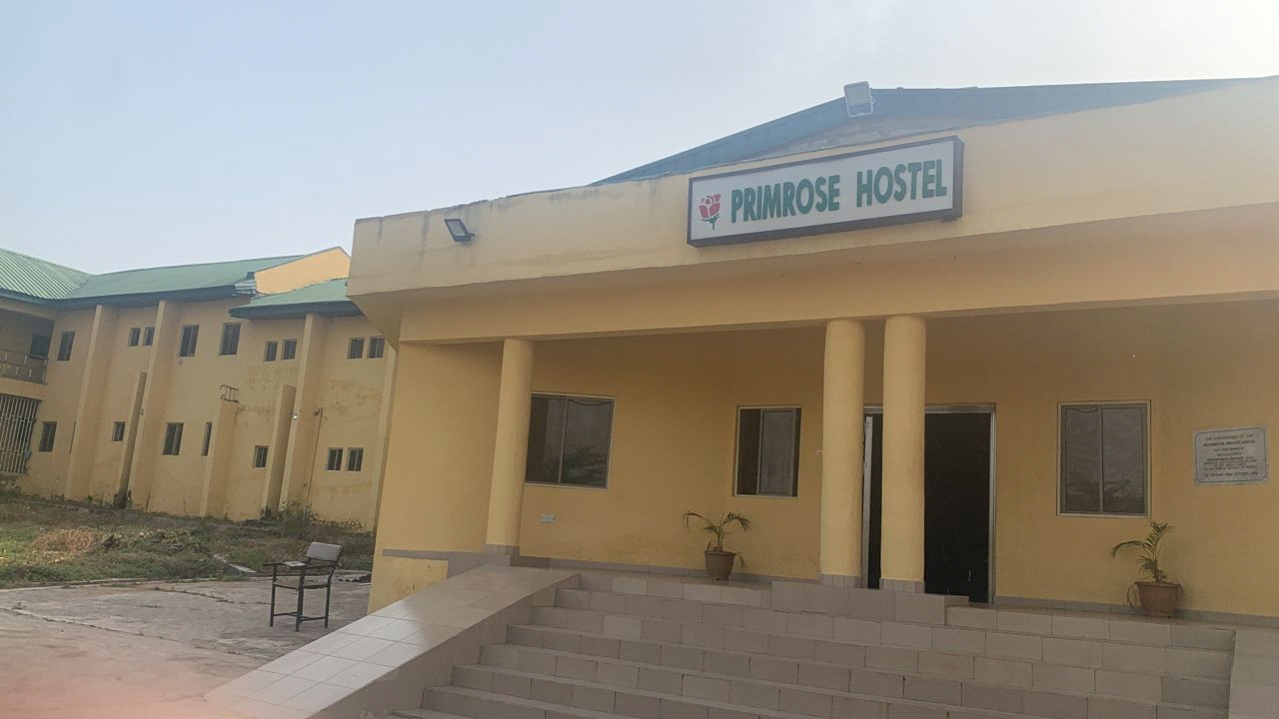
Plate I: Exterior view of the of hostel of university Ilorin
Source: Researcher field work 2024

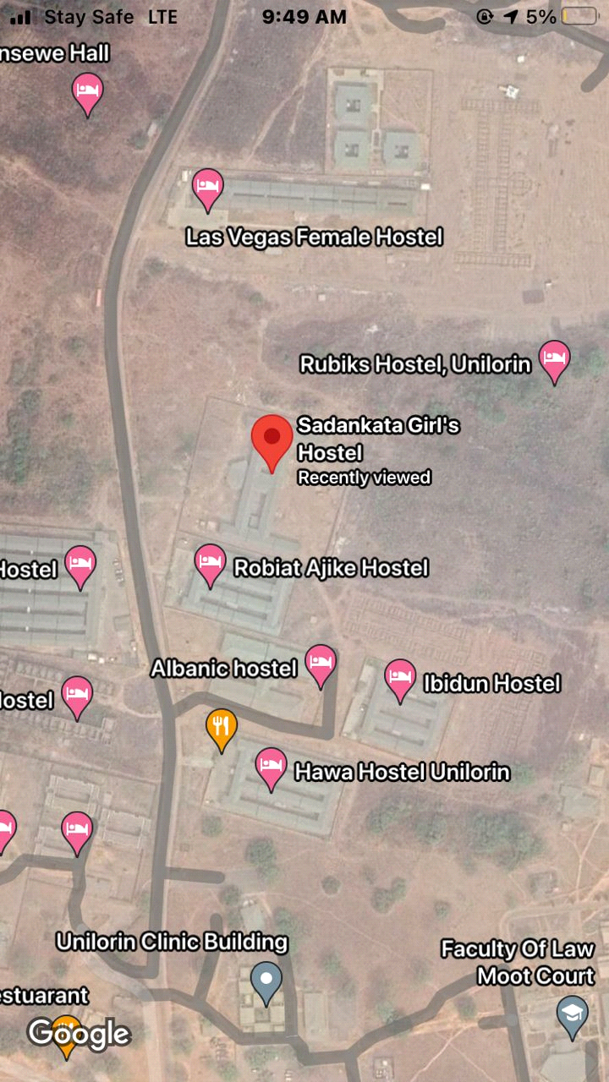
Figure I: Showing locational map hostel of university Ilorin
Source: Researcher field work 2024

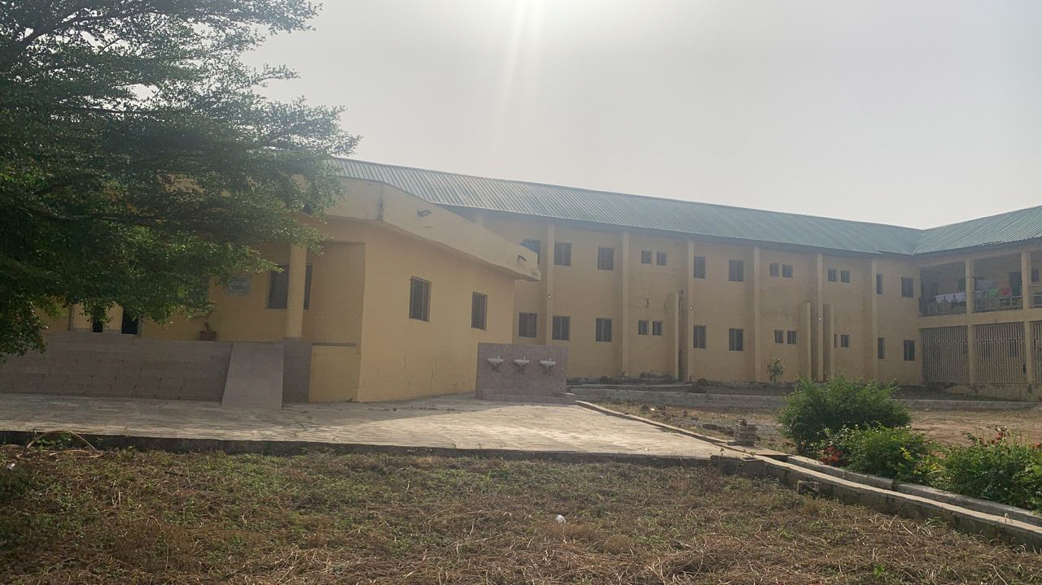

Plate II: The courtyard hostel of university Ilorin
Source: Researcher field work 2024

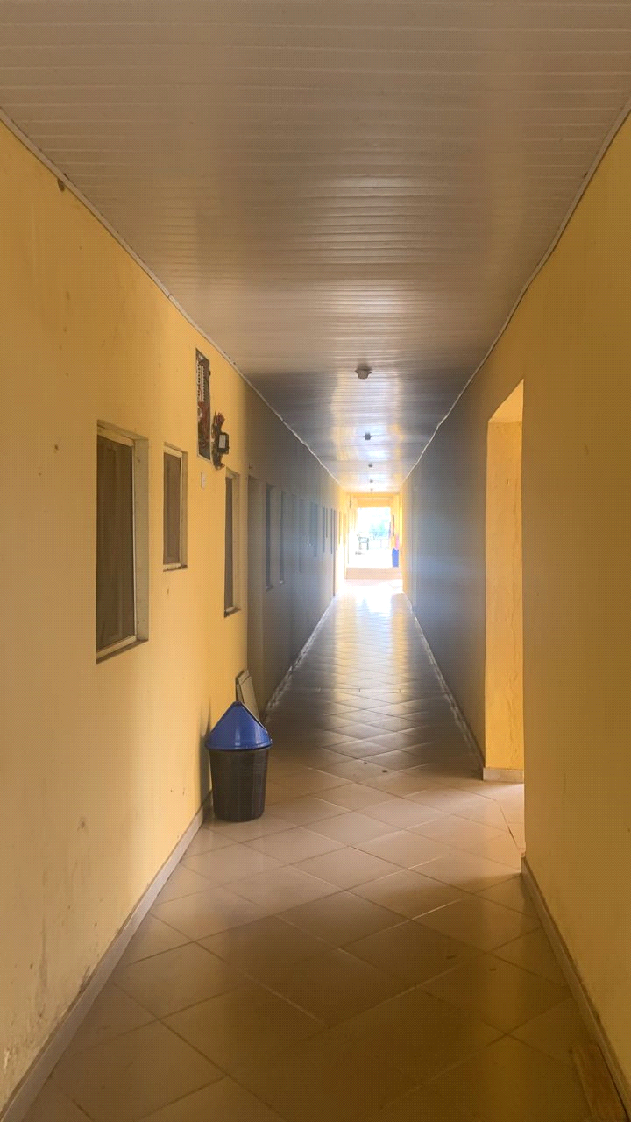

Plate III: Passageway of the hostel hostel of university Ilorin
Source: Researcher field work 2024

  - Case Study TWO(2)
Kwara state University female hostel, malate
Brief Description:
Kwara State University (KWASU) was established in 2009 as a state-owned and funded institution of higher education. The university was founded with the goal of providing high-quality education to students in the Kwara State region of Nigeria, with a focus on innovation and research.

- Merits

- Good orientation on site; the rooms take advantage of the Trade Winds, thereby being well ventilated.
- The rooms are spacious with capacity of 4 occupants i.e. 2 double bunk
- They provided not only room facilities, but also social facilities.

- Demerits
- Very far from school area
- No provision was made for a first treatment box
- No proper landscaping.

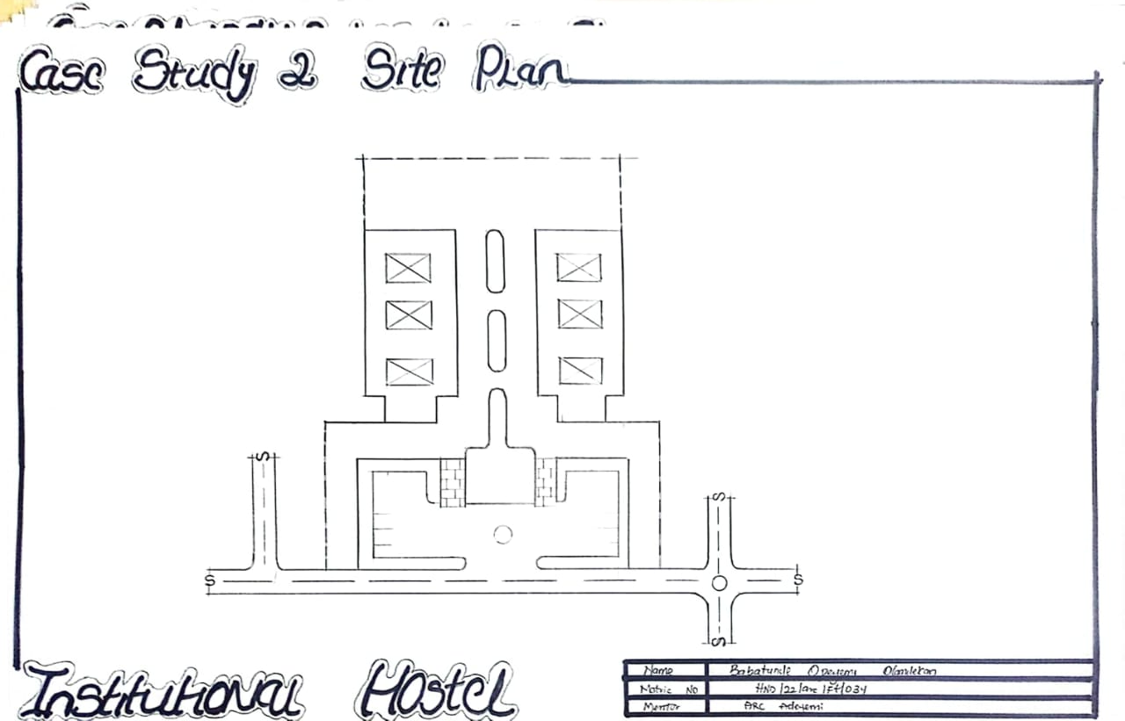
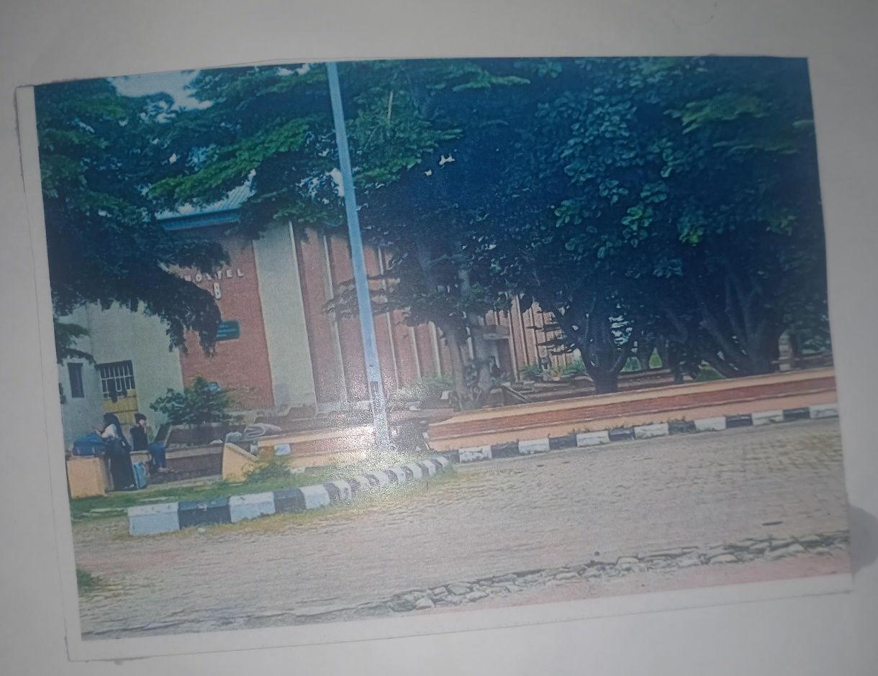
Plate IV: Front View of kwara state university malate
Source: Researcher field work 2024

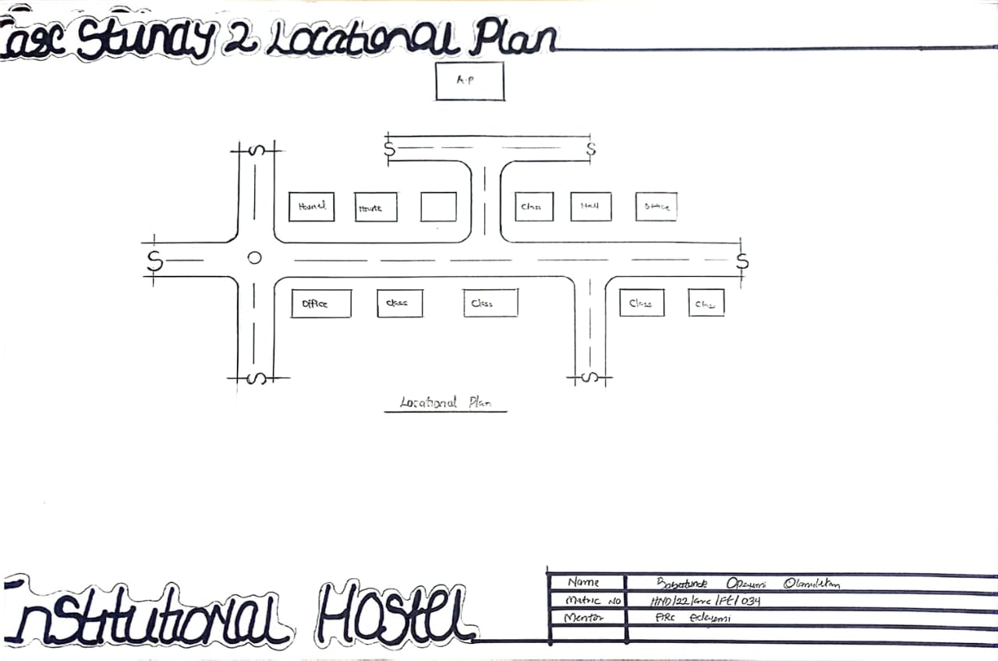
Figure II: Site plan of case study two
Source: Researcher field work 2024

Figure III: showing location plan of case study two
Source: Researcher field work 2024

3.3 CASE STUDY 3:
AT RECTUM R.C.C.G CAMP
Brief Description:
- Merits

- Good orientation on site; the rooms take advantage of the Trade Winds, thereby being well ventilated.
- The rooms are spacious with capacity of 4 occupants i.e. 2 double bunk
- They provided not only room facilities, but also social facilities.

- Demerits
- No good security.
- No proper landscaping.

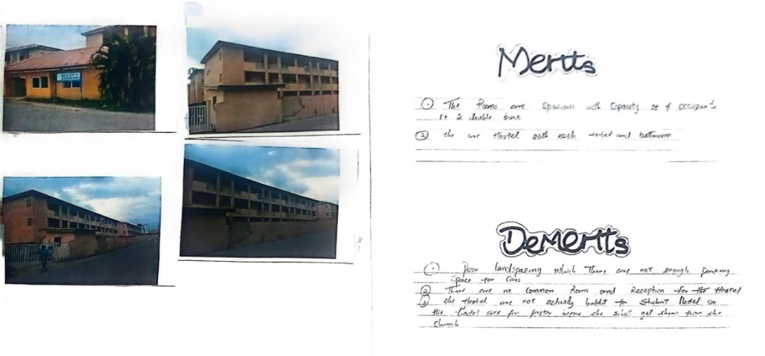
Plate IV: Front View of rectum school r.c.c.g camp
Source: Researcher field work 2024
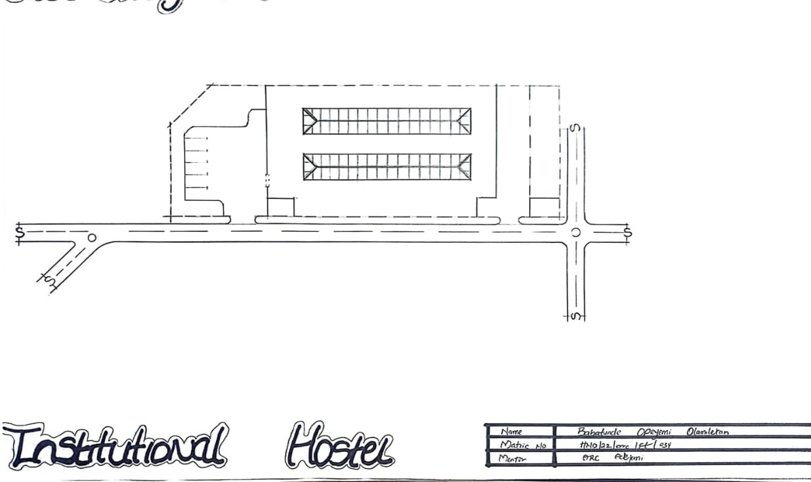

Figure IV: showing site plan of case study of rectum school r.c.c.g camp
Source: Researcher field work 2024

3.4 CASE STUDY 4
Oshogbo state university.
Osun State University (UNIOSUN) is a multi-campus university in Nigeria, established by Osun State Government under the administration of Prince Olagunsoye Oyinlola. The University currently operates six campuses distributed across the six administrative zones of the state.

- Merits
- Good orientation; the rooms are taken advantage of the trade winds.
- Good internal arrangement.
- Cross ventilation was achieved
- The width of escape (corridor) is okay

- Demerits
- Fire resistance construction was not considered in the design of the building.
- Fire resistance door and walls were not used in the hostel, in case of any inferno to contain the fire to a certain period of time for escape of occupants.
- No provision was made for a first aid firefighting gadgets E.g. Hose reels, Extinguishers, fire buckets, fire blankets, Hydrant systems etc.
- Poor landscaping

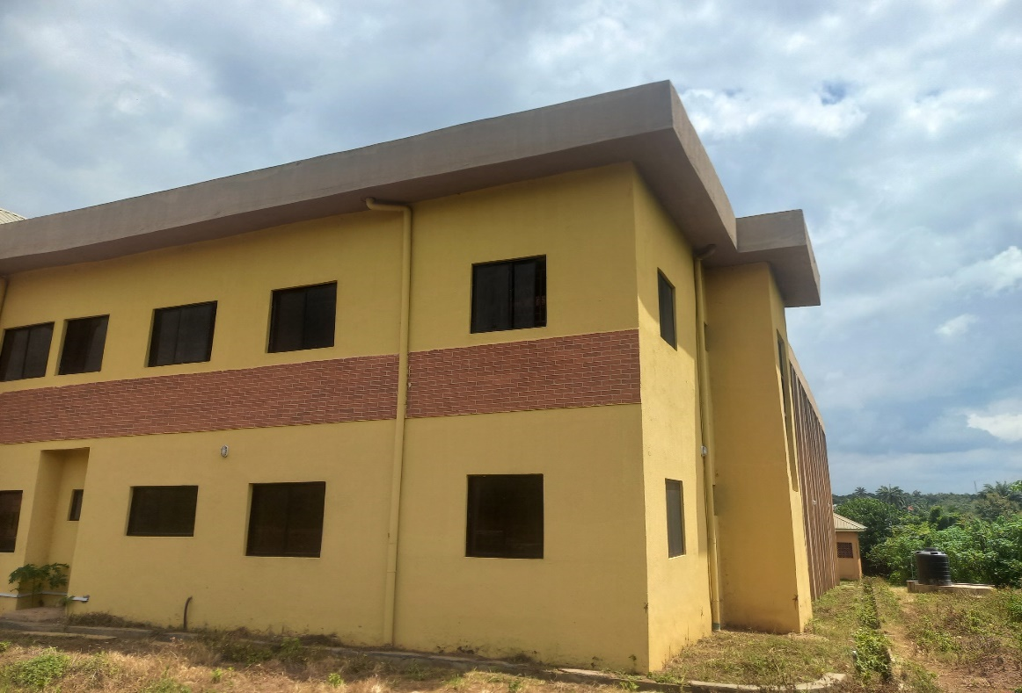

Plate VI: showing the view
Source: Researcher field work 2024

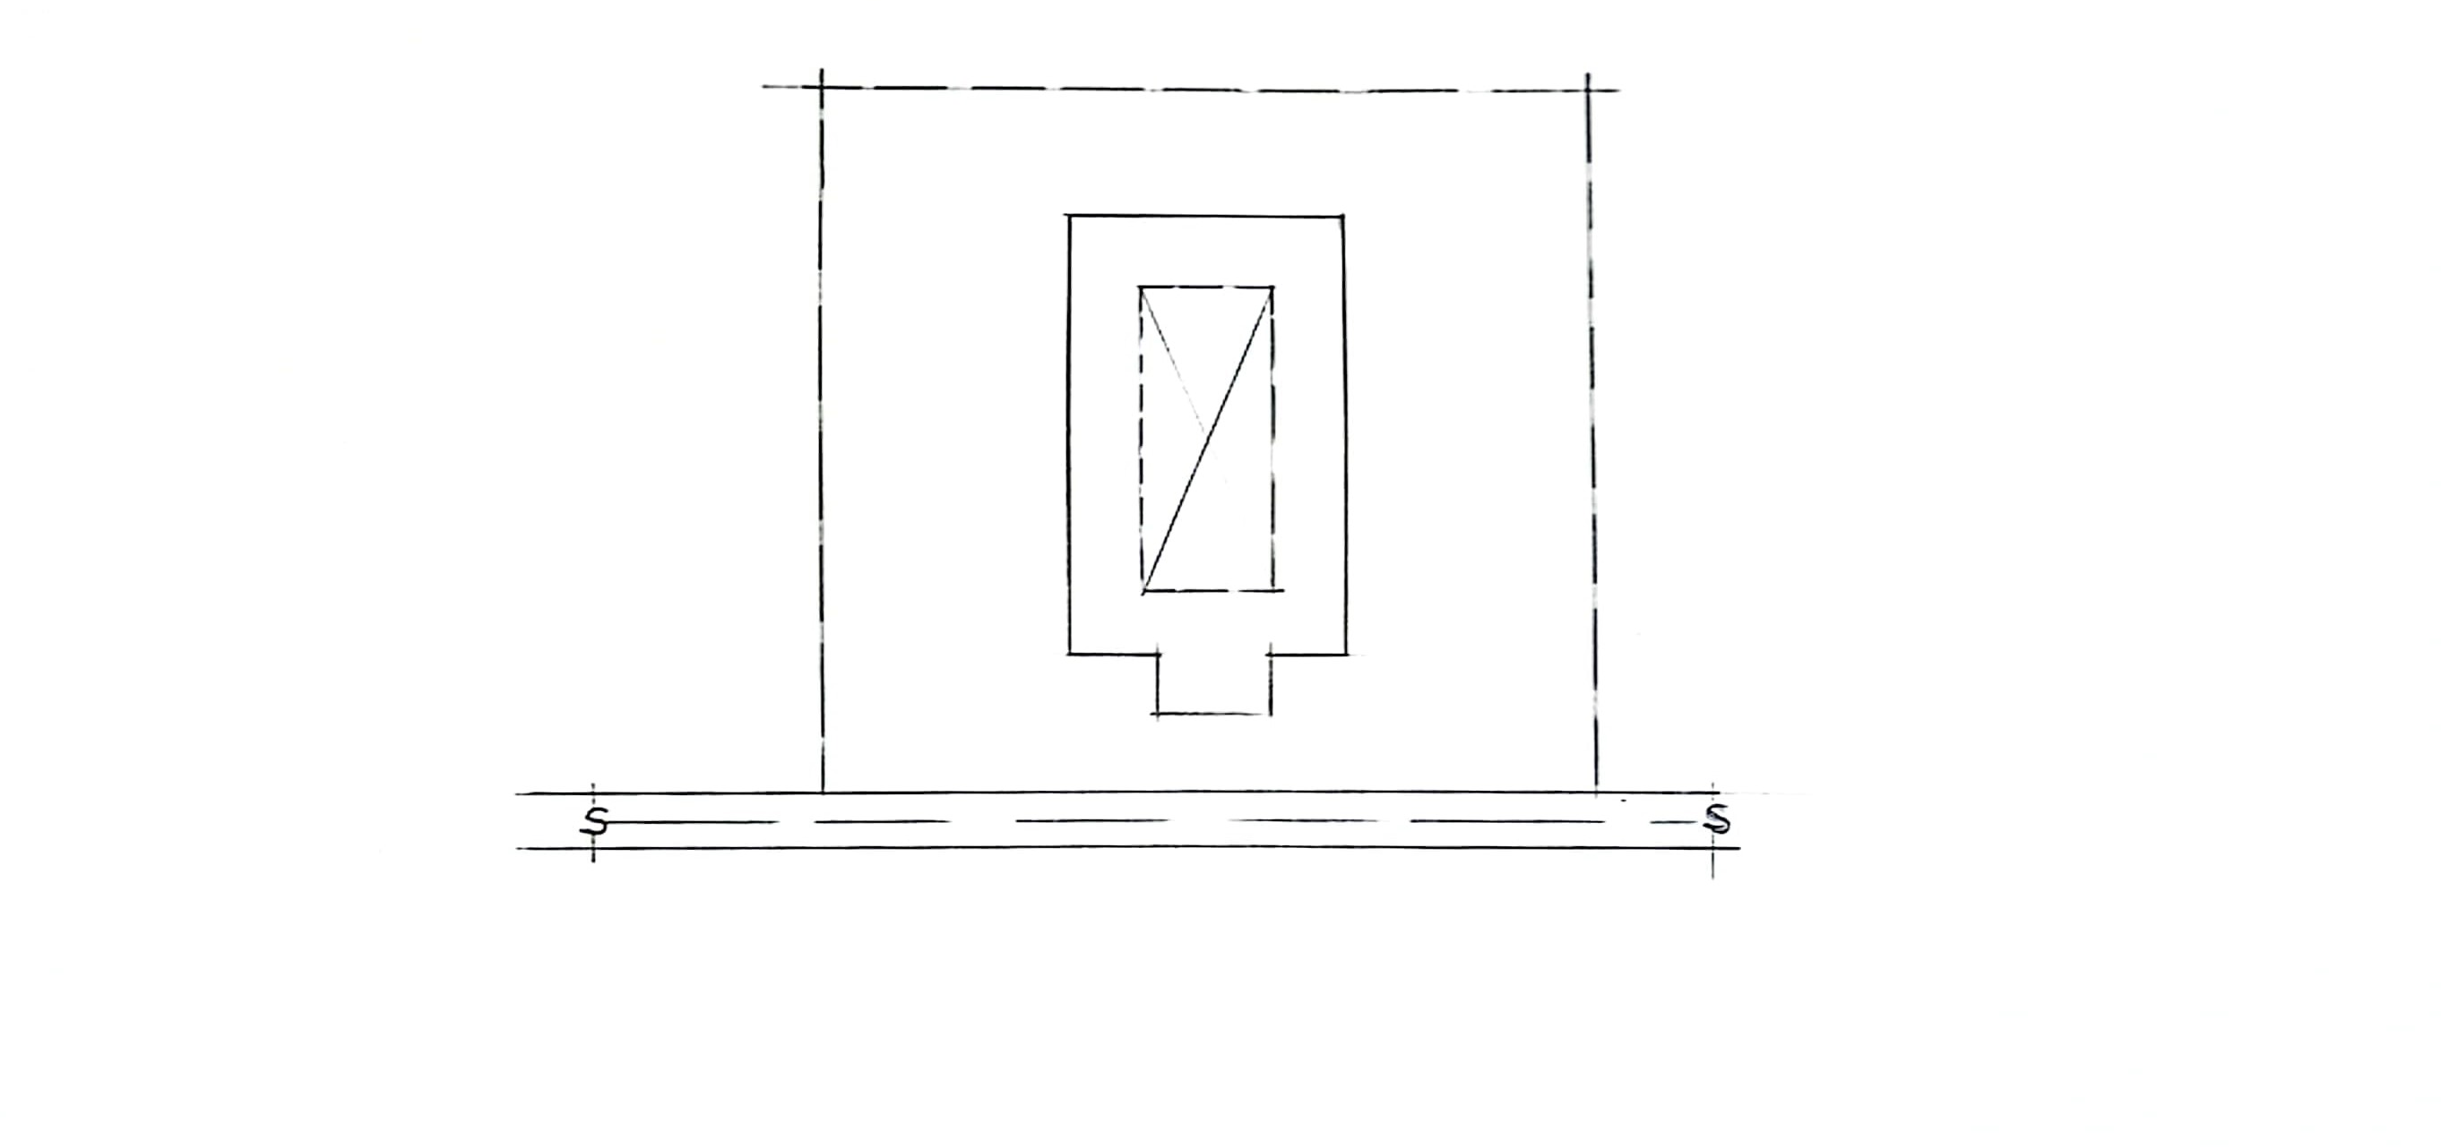

Figure V: Site plan
Source: Researcher field work 2024

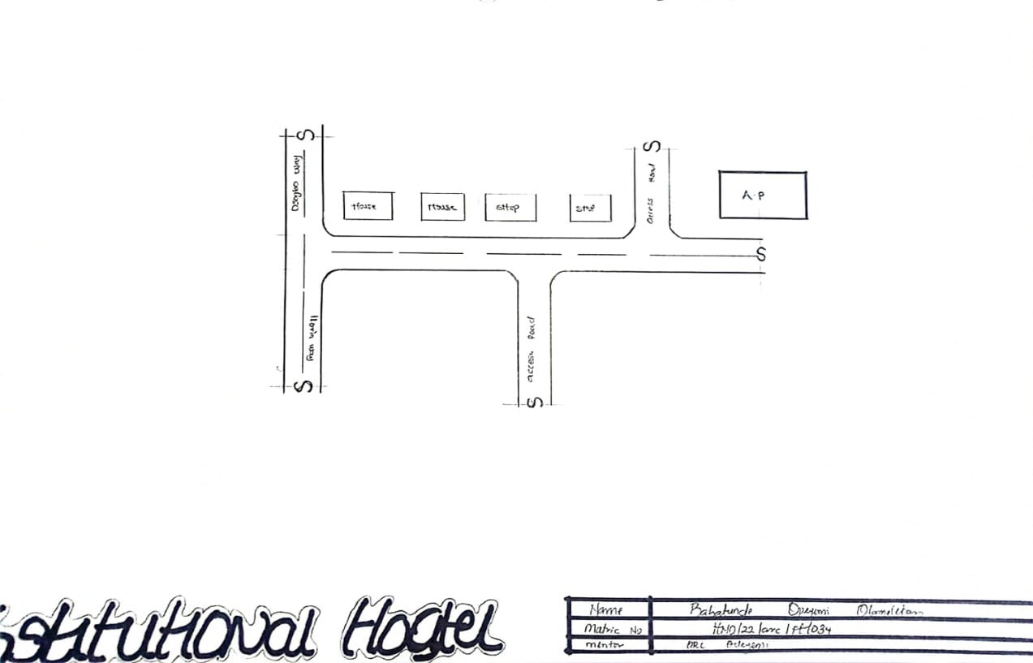
Figure VI: Showing Location Plan
Source: Researcher field work 2024

ONLINE CASE STUDYS
3.5 Case Study 3
Student Housing in Epernay France
Date of Establishment: 2008
Architect: Emmanuel Combarel Dominique Marrec (ECDM)
Location: Epinay-sur-Seine, France
Brief Description:
French architectural firm Emmanuel Combarel Dominique Marrec completed an architectural project of student housing for Espacil Habitat in Epinay, France. The residence housed 170 residents, and 19 housing for researchers or invited professors and housing for women in distresses. The objective is to create some social coeducation while having for each of the establishments a management with human scale benefiting from synergies between establishments. So the project foresees guard’s accommodation, private study rooms, laundry, space out relaxation internal and outer, gardens were fitted out with fruit trees.
Climate: The climate of Epinay-sur-Seine, France is warm and temperate. The city is a city with a significant rainfall. Even in the driest month, there is a lot of rain.
Topography: The site is relatively flat with gentle slope.
Vegetation: Sparse vegetation.
Site Area: 9000 m²
Facilities:
Available spaces and facilities provided are:
- Students rooms
- Guard’s accommodation,
- Private study rooms,
- Laundry,
- Space out relaxation
- Gardens

Site Zoning:
Main building: The building is designed in wings. The first wing is a housing for battered women, the second and third wing contains housing for both students and researchers, while the last wing is a housing for students alone.
Orientation: The building is oriented to take advantage of the winds direction.
Activities: Activities in building are sleeping, studying, relaxation and cleaning.
Circulation Pattern: Passageways are provided or internal circulation while the open spaces at each centre on the wings gives space for free flow of users.
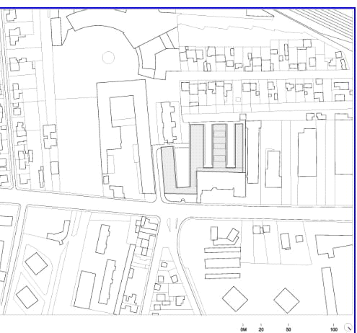

Figure VII: Showing site plan

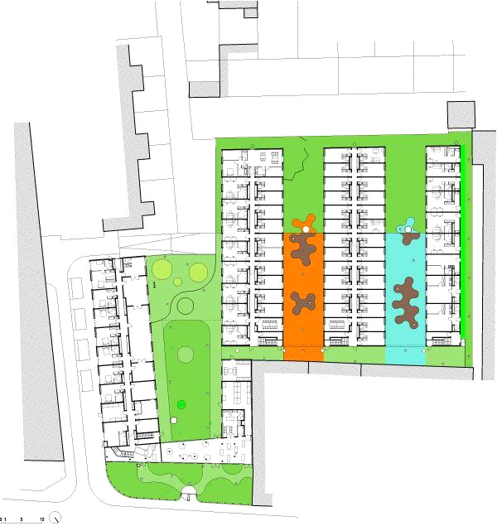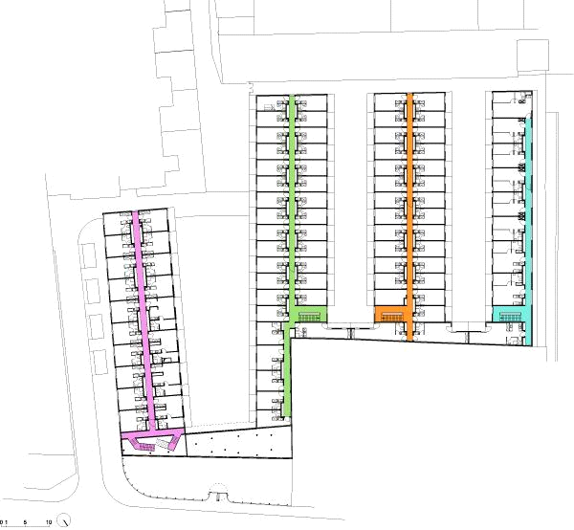

Figure VIII: showing floor plans

Source: www.archdaily.com(2021)
Plate VII: Showing the view of the hostel Plate VIII: Showing the view of the hostel

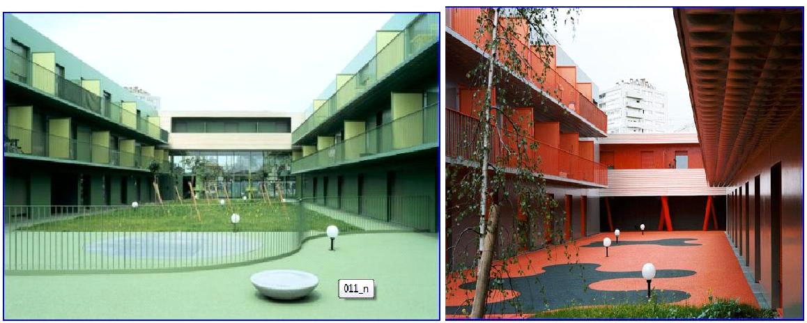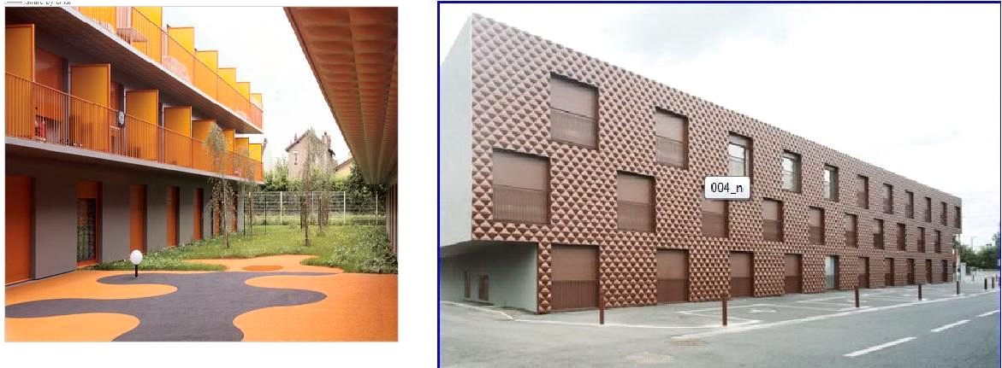

Plate IX: showing THE view of the hostel Plate X: Showing the view of the hostel

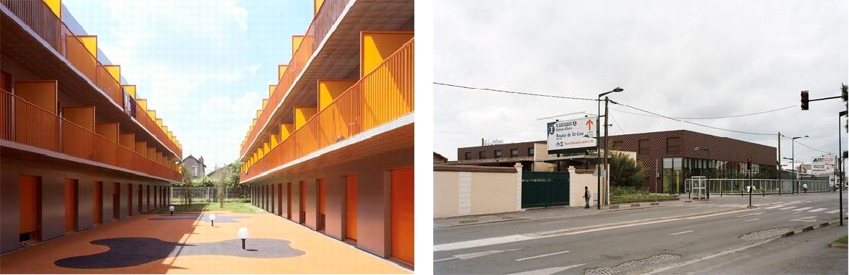
Plate XI: The view of the hostel Plate XII: The view of the hostel
Source: www.archdaily.com (2021)

- Merits
- They provided not only first class room facilities, but also social facilities. All rooms are ensuite.
- Good landscaping.
- Serene Environment conducive for learning.
- Room varieties to serve for different space needs
- Ventilation was enhanced with the introduction of court yard
- Good orientation to take advantage of the winds direction
- Fire resistance construction was considered in the design of the building.
- Compartmentation was considered in the design of the building. This will slow down the spread of fire.

- Demerits
- Lack of shading devices to curtail high intensity of light.
3.6 Case Study 4: University Students’ Housing Italy
Date of Establishment: 2007
Architect: C+S Associates
Location: Florence, Italy
Brief Description:
The students’ university housing in the former Fiat area at Novoli, Florence, was designed to adapt to the constraints of the brief – the perimeter of the lot, the alignment, the building height – and to use them as a springboard for original compositional and typological solutions that have produced articulated, light-filled interior landscape inside severe walls. Despite the double-courtyard layout the building is far from inward-looking and imposes order on the wider context.
Climate: The climate of Florence Italy is generally mild, and can be defined as Mediterranean, with relatively mild, wet winters and hot sunny summers.
Topography: The site is relatively flat with gentle slope.
Vegetation: The vegetation on the site sparse.
Building Materials: Reinforced concrete base, wood shingles, glass, brick.
Site Area: 6000 m²
Facilities:
- Shops
- Entrance hall
- Refectory
- Study rooms
- Lodgings (250 students)
- Balcony
- Courtyards
- Gardens
Site Zoning:
Main building: shops, entrance, refectory, on the ground floor; study rooms and services on the upper levels, and lodgings on the other floors.
Orientation: The building is oriented towards the south west breeze which takes advantage of the wind direction.
Activities: Activities in the building includes sleeping, studying and relaxation.
Circulation Pattern: Circulation is through the double courtyards pattern and also a passageway that cuts crosswise through the blocks and a focus for communal activities, as well as access to the student’s lodgings.

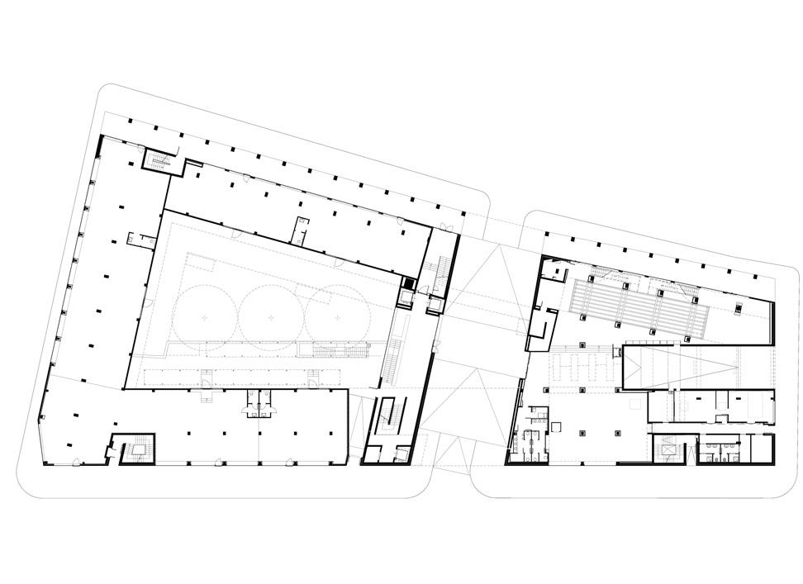
Figure IX: Showing Ground floor plan
Source: www.archdaily.com(2021)

Figure X: Showing First floor plan

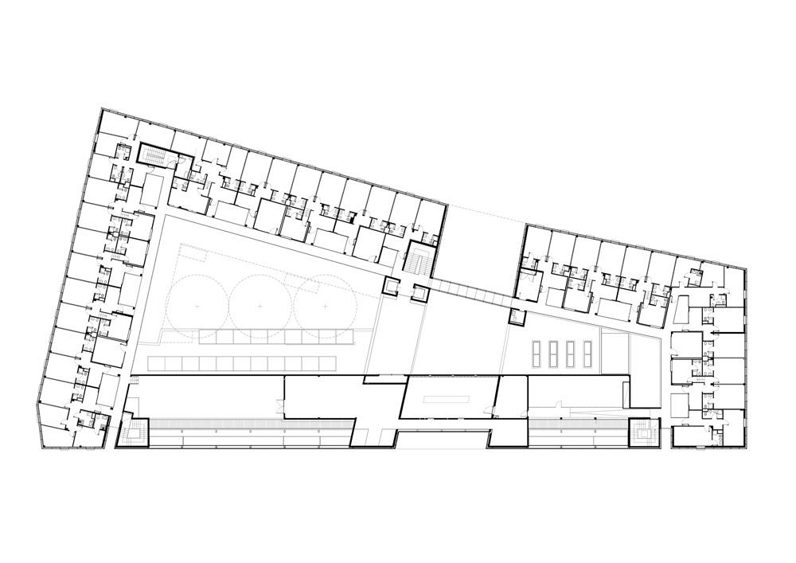

Figure XI: Showing Second floor plan.

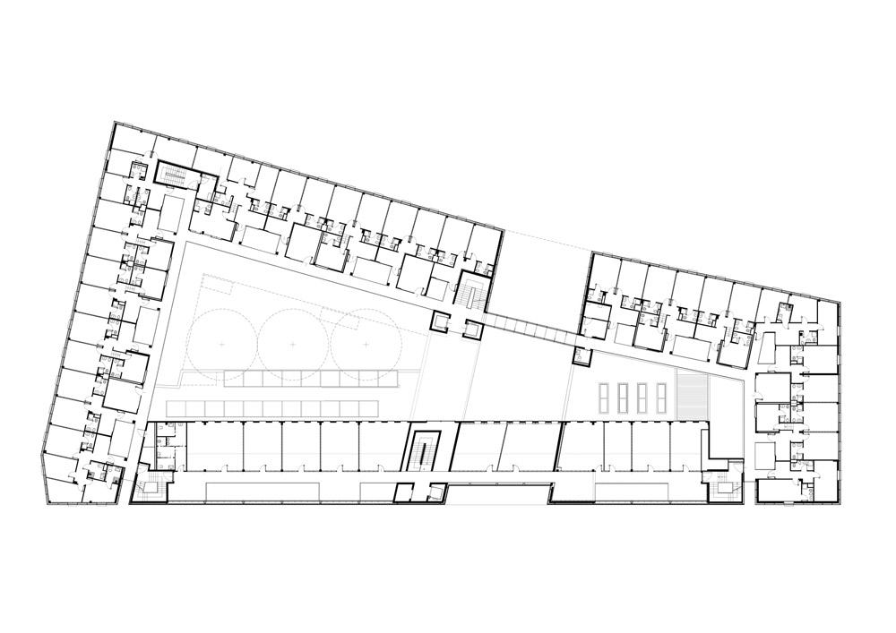

Figure XII: Showing Third floor plan

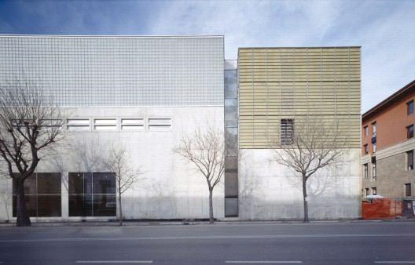

Plate XIII: Showing view of the hostel

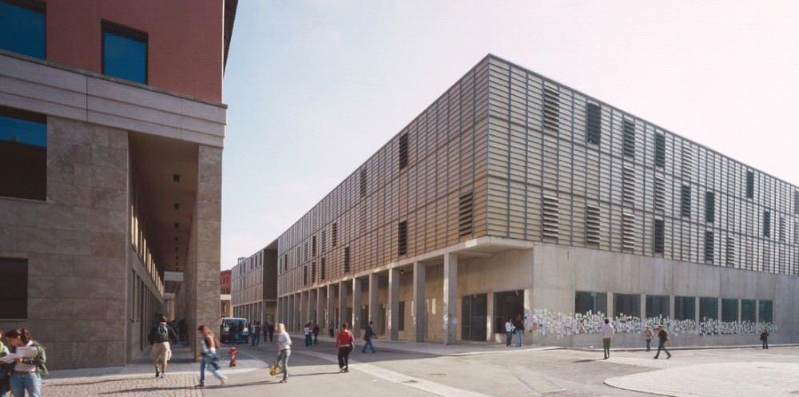
Plate XIV: showing the view of the hostel

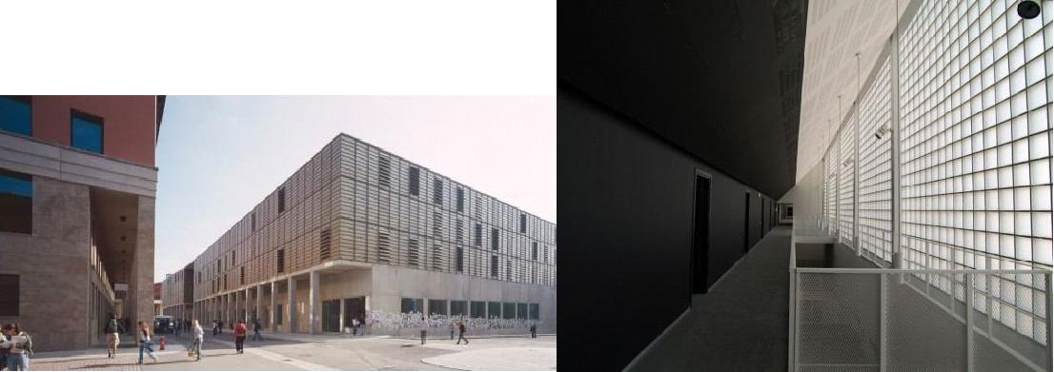Source: www.archdaily.com(2021)

Plate XV: showing the view of the hostel

4.5 Merits
- They provided not only first class room facilities, but also social facilities.
- Most of the rooms are en-suite
- Room varieties to serve for different space needs
- Ventilation was enhanced with the introduction of court yard
- Good orientation to take advantage of the wind direction
- Fire resistance construction was considered in the design of the building.
- Compartmentation was considered in the design of the building.

4.6 Demerits
- Lack of shading devices to curtail high intensity of light.
- Large exposure to the element of weather and climate through wide court yard provision.

CHAPTER FOUR
DESIGN PROPOSAL
4.0 INTRODUCTION OF STUDY AREA/SITE SELECTION
4.1 HISTORY OF ILORIN
Ilorin is the present-day capital of Kwara State in North central region of the Federal Republic of Nigeria. It is a predominantly Islamic city with people of diverse culture who have come together to live as one in peace and harmony. The entire Ilorin community comprises of five local government areas namely; Ilorin-West, Ilorin-South, Ilorin-East, Asa and Moro. These Local Government Areas are all under one entity known as Ilorin Emirate.
Ilorin Community was discovered in the 18th century by the duo of Afonja, Are-Onakakanfo, Yoruba warlord and Sheik Alimi, an Islamic scholar. There heros of Ilorin arrived Ilorin at different times and in different circumstances. Sheik Alimi was a Muslim and his teachings across the lad, he sojourned for many through villages and towns across Yoruba land he had followers with whom he moved around to establish the tenets and principle of Islam. He was temporarily settled at Kuwo village, Shiek Alimi continued to explore other territories where he could spread and establish his beliefs and settle down permanently.
4.2 SITE LOCATION
The site is located at University of Ilorin kwara state Ilorin.
Location of the University of Ilorin
- City: The University of Ilorin is located in Ilorin, Kwara State, Nigeria
- Land Area: The University sits on an expansive area of land, about 15,000 hectares, making it the largest university in Nigeria and one of the largest in Africa by landmass

Description of the University of Ilorin
- Federal Government-Owned: The University of Ilorin is a federal government-owned university ¹.
- Established: The University was established by a decree of the federal military government in August 1975 ¹.
- Academic Faculties: The University comprises 17 faculties and over 100 academic departments ¹.
- Student Population: The student population of 200 in 1976 has increased to 20,084 by the 2005/2006 session ¹.
Criteria of the University of Ilorin
- Autonomous Status: The University attained full autonomous status in October 1977 ¹.
- Academic Programmers: The University offers undergraduate degree programmers that run for 3-5 or 6 years, depending on entry qualifications and chosen discipline ¹.
- Postgraduate Programmers: The University also offers postgraduate programmers that are run on different dimensions depending on the nature of the program ¹.
4.0 Site Location Map
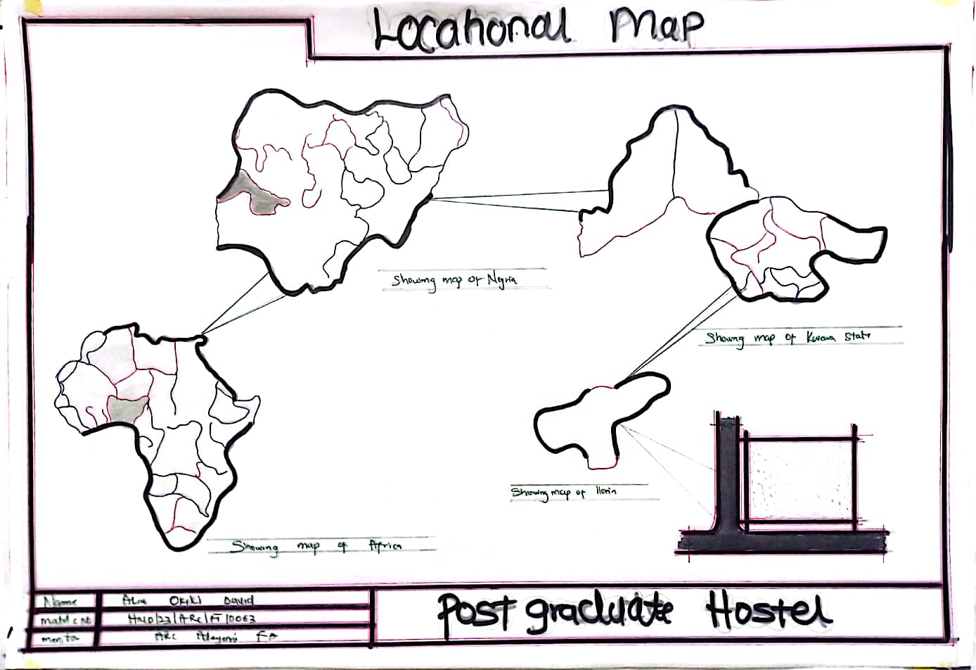
Figure XIII: Map of Nigeria showing location of kwara State
Source: Google images

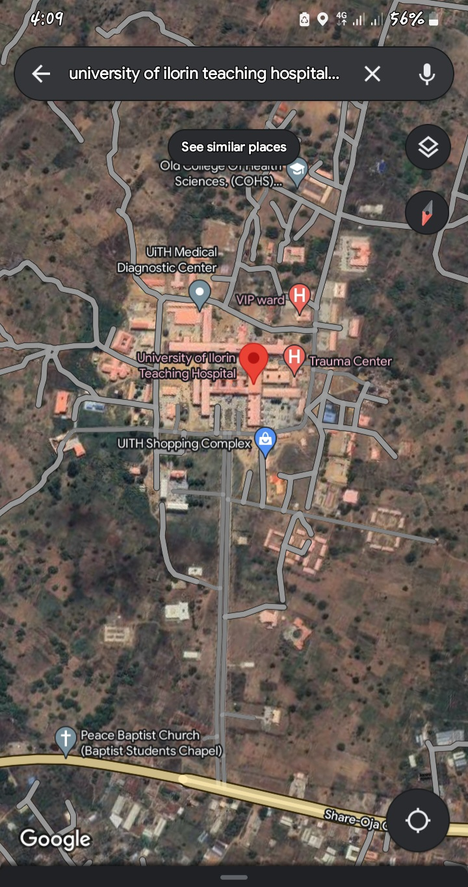
Figure XIV: Map of Kwara State showing location of university of ilorin
Source: Google image
- Location:
The site is located along existing female hostels within the school.
- Ease of Access:
The site can be accessed easily as there is an existing road that leads to it.
- Availability of Enough land:
To adequately provide for the various facilities required in the building and on the site, the area of land required for the project must be adequate. Therefore, the site was selected because it is wide enough to accommodate the proposed design.
- Security:
The site is located within the school thereby is covered by the school security ensuring safety of the students. But also, additional security would be provided on the site.
- Nature of Site and Vegetation:
The topography of the site is fairly levelled and the slightly unlevelled part can be adequately levelled. The sub soil is mainly red lateritic soil, with barches of sandy soil. The site also contains few trees and shrubs, which can help enhance the landscape of the site, and also act as wind-breakers and dust filters during the harmattan.
4.1 Site Characteristics
Soil type
The sub soil is mainly red lateritic soil, with barches of sandy soil. It is a high load bearing capacity soil.
Vegetation
The vegetation on the site consists of few trees of different species and shrubs. Some trees and shrubs will be retained to enhance the landscape of the site, and also act as wind-breakers and dust filters during the harmattan.
Topography
The topography of the site is fairly levelled and the slightly unlevelled part can be adequately levelled.
Drainage
There is no existing drainage on the site, so drainage would be constructed.
Accessibility
The site is accessible by an existing road along the adjoining buildings which leads to the site.

4.2 SITE ANALYSIS
A site analysis involving a study of the site is carried out, it takes into consideration natural and man-made components present in and around the site, as well as climatic conditions of Lagos state. The plate below shows a schematic summary of the analysis of the proposed site.
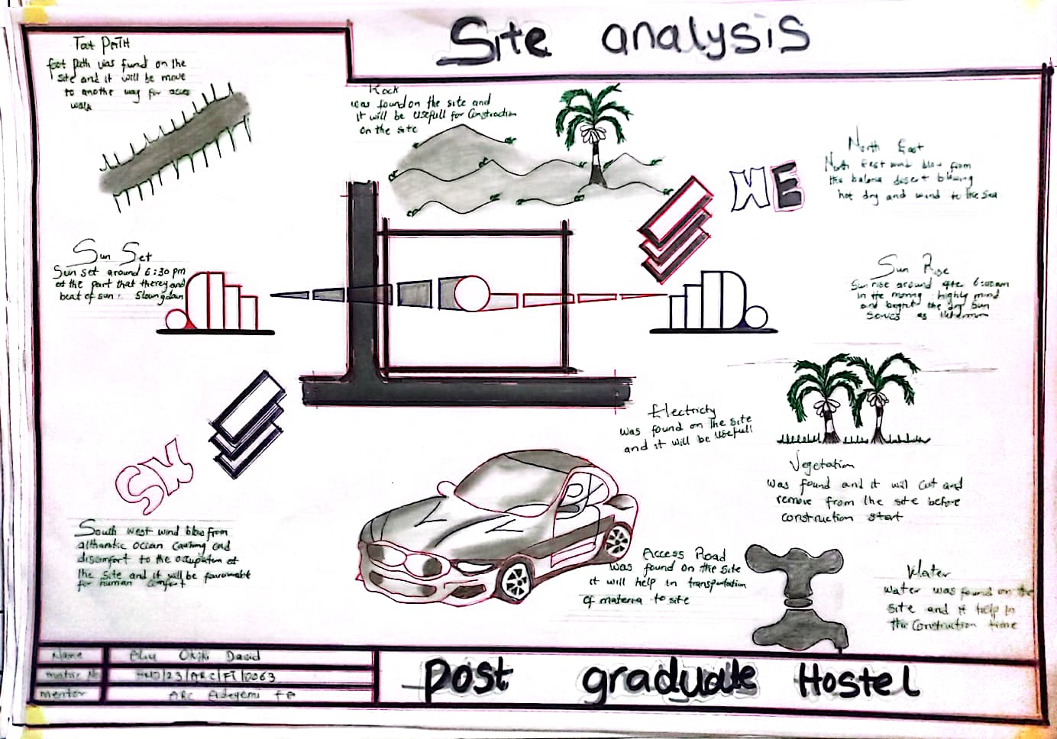
Figure XIX: Site Analysis
Source; Authors fieldwork 2025

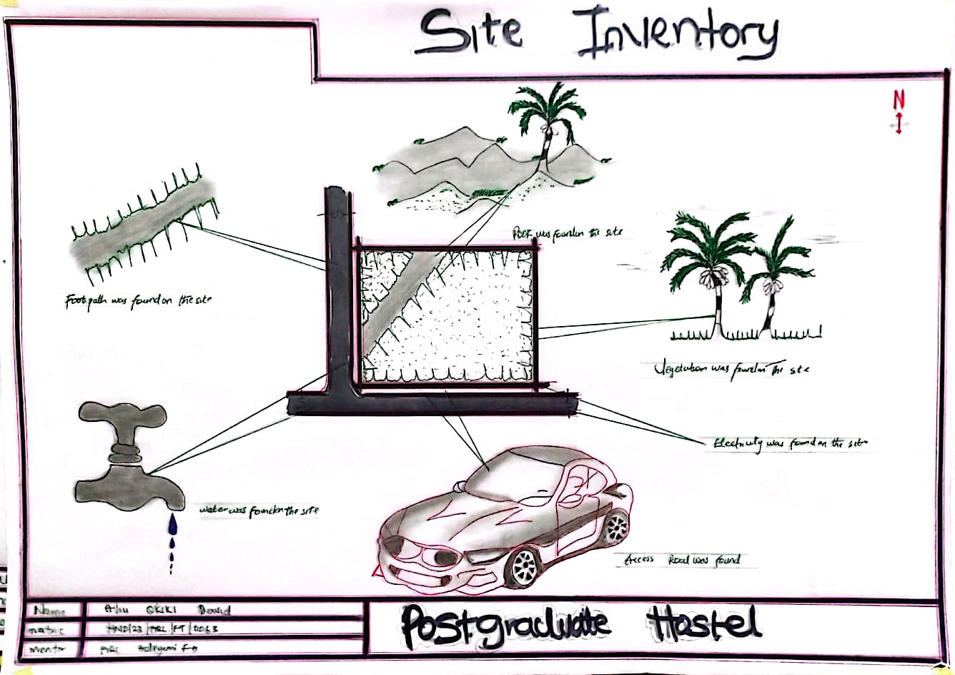
Source; Authors fieldwork 2025
Figure XX: Site Inventory
4.6 GEOGRAPHICAL/ CLIMATIC DATA
- Climate
Lagos is one of the cold regions in Nigeria with an average daily high temperature of only 31 degrees centigrade. High humidity and hot temperatures make the weather at times pleasant but also tropical humid. It is warm to hot all year round and invites to bathe at average water temperatures of 27 degrees. Due to the lesser rain the best time for traveling is from November to March. Most precipitation decrease from June to October.
- Hours of sunshine per day

Figure 4.3 Hours of Sunshine per day
Source; Worlddata.info
The number of hours of sunshine refers to the time when the sun is actually visible. That is, without any obstruction of visibility by clouds, fog or mountains. With 7 hours per day, February is the sunniest month in the state of Lagos. In August the sun shines the shortest.
- Rainy days per month

Figure 4.4 Rainy days per month
Source; Worlddata.info
A rainy day is a day on which at least an amount of 0.1 mm precipitation (=0.1 liter) per square meter falls. This can be rain, snow, hail or even dew. So it does not have to rain the whole day. With 18 rainy days, June offers the most number of rainy days, and in December the least.
- Precipitation in mm/day

Figure 4.5 Precipitation in mm/day
Source; Worlddata.info
The amount of precipitation is measured in millimeters per square meter. Thus, at two mm/day, two litres of water fall on one square meter within 24 hours. With only 0.4 mm, the least rain falls in December. June, on the other hand, has the most rain.
- Water temperature

Figure 4.6 Water temperature
Source; Worlddata.info
Water temperature depends not only on solar radiation within the same region, but also on ocean currents. For example, depending on the season, cold or warm water masses are moved from other areas. The warmest temperatures in Lagos are in March, when the water is 28 °C.
- Relative humidity in %

Figure 4.7 Water temperature
Source; Worlddata.info
Warm air can absorb more moisture than cold air. The relative humidity indicates how much moisture of the physically possible is actually contained in the air. At high humidity, the person feels uncomfortable and perceives this as oppressive. In general, a relative humidity of 40-60% gives as pleasant. With humidity averaging 87%, June is the most uncomfortable. In March, on the other hand, it is easier to endure.
4.4 ANALYSES OF THE IMMEDIATE ENVIRONMENTAL CONDITIONS OF THE SITE
- Site Features and Infrastructure
The site features electrical lines which proposes that open power supply is promptly accessible inside the site.
Perfectly drained soil; soils water moves through easily to allow good soil aeration and at the same time sufficient amount is retained for plant growth.
Other features are water supply and an access road.
- Noise Sources There are no much noises on the site but the few noises that can be heard comes from the adjacent structures which are the existing female hostels.
- Rainfall:
Minimum rainfalls are recorded in December, while June offers the most amount of rainfall.
- Vegetation and Topography:
The vegetation on the site consists of few trees of different species and few shrubs. The site is relatively gentle sloping and has a high load bearing capacity soil.
- Prevailing Wind Direction & Sun-Path Angles
The two predominant winds blowing across this area are the South West Trade wind and the North East Trade wind. The former, which blows across the Atlantic Ocean, is characteristically cold and results in the wet season. Being a cold wind, it is capable of holding much moisture contents across the ocean, and hence an increase in relative humidity of the area affected. However, the North East Trade wind, which blows across the Sahara Desert, is dusty and dry wind. Consequently, the two predominant seasons experienced in this area are characteristically marked by the two wind types. The summer (the season between spring autumn when the sun is hot and there are many flowers) is experienced between April and September, when the south west Trade wind is more predominant, while the winter season is shortly marked between November and March, when the north east trade wind is more predominant. This later season {winter} is however characterized by cool and hazy mornings, couple with dusty afternoons, because of the dust particles it brings forth from the desert. To reduce the effects of wind driven, trees were planted.
- Sunrise and sunset:
The sun rises from the east in the early hours of the morning at about 6:30am - 7:00 am and sets in the west at about 6:45 pm in the evening daily.
- Accessibility:
The site is accessible by an existing road along the adjoining buildings which leads to the site.
- Man-made features

- Electricity: Electricity is supply to the site through overhead cables along the site boundary.
- Footpath: There are no existing footpaths on the site, few would be channeled.
- Noises: Caused by adjacent structures

4.5 PROJECT ANALYSIS/DESIGN CRITERIA
The proposed design is the design of a female hostel with emphasis on fire safety to ensure the safety of the students and occupants.
- ​Design Considerations:
The following are the factors considered when designing the building;
- Passive and Active Fire safety: Fire safety measures would be considered in designing the building to increase safety in the building,
- Aesthetics: In any architectural design, aesthetics is most common factor to consider which shall be achieved by the use of attractive and lively finishing materials.
- Functionality: In any architectural design, functionality plays major role, design must be functional to meet the taste and convenience of the occupants.
- Ventilation: This includes the orientation of the building, sizes and locations of fenestrations, vegetation.
- Circulation and Zoning: Appropriate and well-articulated pattern of circulation in a building alleviates confusion and at the same time tailor the movement of students to their respective destination.
- Landscaping: The form of landscaping in the building is aimed at satisfying user requirements, having aesthetic value and improving environmental comfort. Hence, landscaping will be considered in the design
- Security: The provision of security in the hostel involves the protection of the students, the building and its contents.

4.6 DESIGN CONCEPT
The design approach was based on functionalism, which is an architectural principle that says that building should be designed based solely on purpose and function of the building.
4.7 PROJECT GOAL
The proposed design is the design of a female hostel with emphasis on fire safety to ensure the safety of the students and occupants.
The hostel is to provide the students with accommodation facilities and other functional spaces and facilities. These facilities include:
- Reception
- Rooms en-suite
- Communal Rooms
- Laundry
- Reading rooms
- Porter’s lodge
- Fire safety Equipment rooms
- Stores
- Retail shops
- Relaxation area
- Car park
4.8 APPRAISAL OF PROPOSED SCHEMES.
An appraisal of a proposed scheme for institutional hostels involves evaluating the plan's feasibility, effectiveness, and potential impact. Here's a comprehensive appraisal framework:
I. Location and Accessibility
- Proximity to academic buildings and facilities
- Safety and security features
- Accessibility for students with disabilities
II. Capacity and Accommodation
- Number of students to be accommodated
- Room types (single, shared, etc.) and amenities (e.g., beds, desks, storage)
- Common areas (e.g., lounge, kitchen, laundry)
III. Infrastructure and Amenities
- Water and electricity supply
- Sanitation and waste management
- Internet and Wi-Fi connectivity
- Furniture and appliances
IV. Management and Supervision
- Hostel administration and staff
- Rules and regulations
- Maintenance and repair procedures
V. Cost and Funding
- Construction and operational costs
- Funding sources (e.g., government, private investment)
- Student fees and payment structures
VI. Sustainability and Environmental Impact
- Energy efficiency and renewable energy sources
- Water conservation measures
- Waste reduction and recycling programs
VII. Student Life and Well-being
- Support services (e.g., counseling, health services)
- Social and recreational activities
- Community engagement and inclusivity
VIII. Future Expansion and Flexibility
- Potential for expansion or renovation
- Adaptability to changing student needs and demographics
IX. Compliance with Regulations
- Adherence to local building codes and regulations
- Compliance with accessibility and safety standard
X. Stakeholder Engagement
- Involvement of students, staff, and faculty in the planning process
- Community engagement and outreach
4.9 EQUIPMENT AND OPERATIONAL AND PERFORMANCE REQUIREMENT
Designing an institutional hostel involves considering various equipment, operational, and performance requirements to ensure the facility meets the needs of its residents effectively and efficiently. Here’s a detailed breakdown of these aspects:

Equipment Requirements

Essential Equipment
Furniture:
Beds: Comfortable and durable, typically with storage options (e.g., drawers under the bed).
Desks and Chairs: Ergonomic and suitable for study or work, with ample space for personal belongings.
Wardrobes/Closets: Adequate storage for clothing and personal items.
Common Area Furniture: Sofas, chairs, and tables for lounges and social spaces.
Kitchen Appliances:
Refrigerators: Sufficient capacity to store food for all residents.
Stoves/Ovens: For cooking, with safety features and adequate ventilation.
Microwaves and Toasters: For convenience and quick meals.
Dishwashers: Optional, depending on the size and budget.
Laundry Facilities:
Washing Machines and Dryers: Easily accessible and with sufficient capacity.
Ironing Boards and Irons: For personal clothing care.
Cleaning Equipment:
Vacuum Cleaners, Mops, and Brooms: For maintaining cleanliness.
Trash Bins and Recycling Containers: Strategically placed in common areas and individual rooms.
Safety Equipment:
Fire Extinguishers: Properly placed and maintained.
Smoke Detectors and Alarm Systems: For fire safety.
First Aid Kits: Easily accessible and stocked with essential supplies.

Technological Equipment
Wi-Fi and Networking: Reliable and high-speed internet access throughout the hostel.
Televisions and Entertainment Systems: Optional for common areas.
Climate Control: Air conditioning, heating, and ventilation systems to ensure comfort.

Operational Requirements

Facility Management
Maintenance Schedule: Regular checks and maintenance of equipment and infrastructure to ensure everything is in good working condition.
Cleaning Protocols: Daily and periodic cleaning schedules for rooms, common areas, and facilities.
Security Measures: Surveillance systems, security personnel, and controlled access points to ensure resident safety.

Resident Services
Reception and Check-In/Out Procedures: Efficient management of guest arrivals and departures, including handling of keys and room assignments.
Support Services: Availability of staff or resident assistants for addressing issues or concerns.
Emergency Procedures: Clear protocols for handling emergencies, including evacuation plans and communication procedures.

Administrative Management
Booking and Reservation Systems: Efficient systems for managing reservations, room assignments, and payments.
Documentation and Record-Keeping: Proper documentation of resident information, maintenance records, and operational logs.

Performance Requirements

Comfort and Usability
Space Planning: Effective use of space to ensure comfortable living conditions, including adequate room sizes and communal areas.
Noise Control: Soundproofing measures to minimize noise disruptions, especially in shared spaces and sleeping areas.
Lighting and Ventilation: Adequate natural and artificial lighting, and good ventilation to create a pleasant environment.

Safety and Compliance
Building Codes and Regulations: Adherence to local building codes, fire safety regulations, and health standards.
Accessibility: Compliance with accessibility standards to ensure ease of use for all residents, including those with disabilities.

Efficiency
Energy Efficiency: Use of energy-efficient appliances, lighting, and HVAC systems to reduce operational costs and environmental impact.
Water Efficiency: Implementation of water-saving fixtures and systems to reduce consumption and operational costs.

User Satisfaction
Resident Feedback: Regular collection of feedback from residents to address concerns and make improvements.
Quality of Amenities: Ensuring that all provided amenities meet quality standards and are in good working order.
The design of an institutional hostel requires a comprehensive approach to equipment, operations, and performance. Addressing these requirements effectively ensures that the hostel provides a safe, comfortable, and functional living environment for its residents, while also being manageable and efficient for the institution.
5.0 SPATIAL ALLOCATION / SCHEDULE OF ACCOMMODATION
It is the allocation of spaces required in the building design in order to make the most appropriate use of spaces available.
Schedule of Accommodation
Table 6.1 Schedule of Accommodation
S/NO | SPACE | UNITS | LENGTH(M) |  | BREADTH(M) | AREA(M2)
1 | Reception | 1 | 7.6 |  | 4.4 | 33.44
2 | Supervisor’s office | 1 | 2.8 |  | 3.5 | 9.8
3 | Toilet | 1 | 2.8 |  | 1.5 | 4.2
4 | Communal rooms | 8 | 10 |  | 5.2 | 52
5 | Buttery | 1 | 2.5 |  | 3.9 | 9.75
6 | Stores | 8 | 2.5 |  | 2.0 | 5
7 | Porter’s lodge | 1 | 6.0 |  | 4.5 | 27
8 | Toilet | 1 | 2.5 |  | 2.0 | 5
9 | Rooms(2 students) | 40 | 3.6 |  | 3.6 | 12.96
10 | Rooms (3 students) | 60 | 3.6 |  | 3.6 | 12.96
11 | Bathrooms | 100 | 2.0 |  | 2.5 | 5
12 | Toilets | 100 | 1.5 | 2.5 |  | 3.75
13 | Laundry | 8 | 5.5 | 4.5 |  | 24.75
14 | Reading rooms | 6 | 5.0 | 4.5 |  | 22.5
15 | Reading rooms 2 | 6 | 6.0 | 5.6 |  | 33.6
16 | Courtyard 1 | 2 | 6.0 | 8.0 |  | 48
17
18
19
20
Source: Author’s fieldwork (2024)
5.1 FUNCTIONAL RELATIONSHIP
Functional relations in architectural design refer to the way in which different spaces, elements, and components of a building interact and support each other to achieve the intended purpose of the structure. These relations are crucial for creating efficient, practical, and aesthetically pleasing environments.
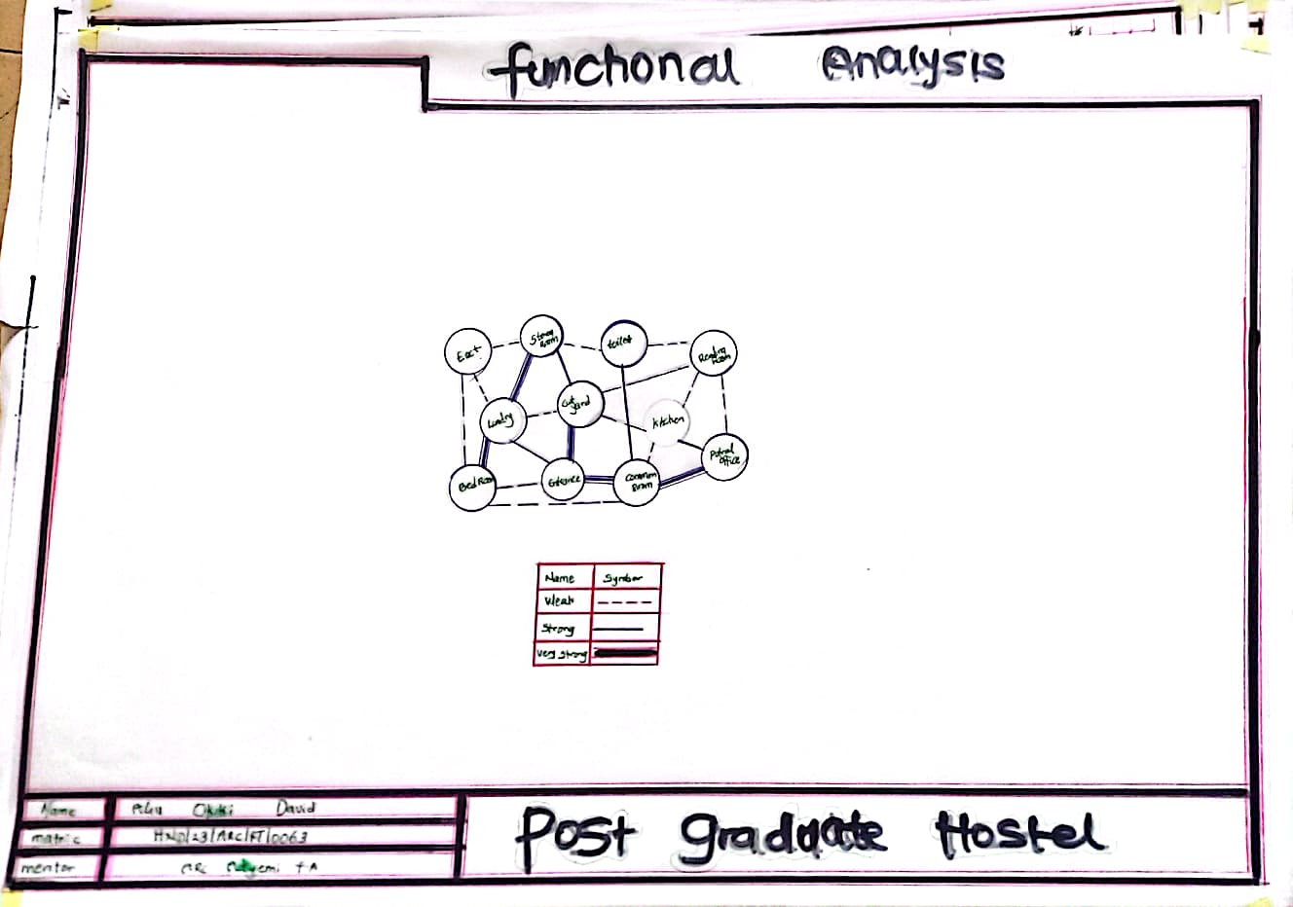

5.2 CONCEPTUAL DEVELOPMENT
Conceptual development in architectural design is the process of generating and refining ideas that form the basis of a building’s design. It involves translating abstract concepts into concrete architectural solutions.
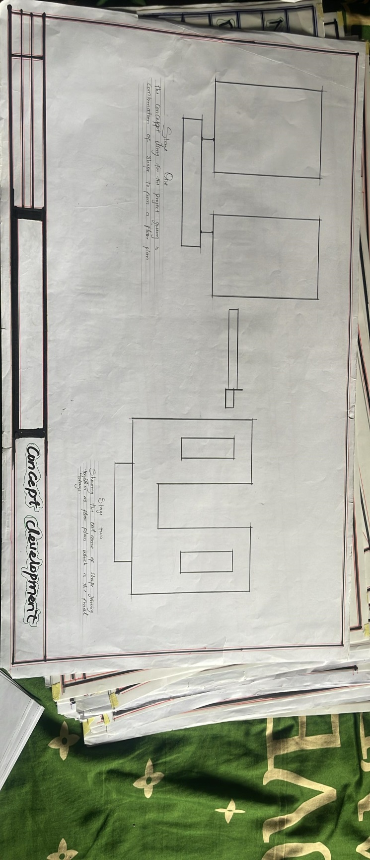

Source: Author’s fieldwork (2024)

CHAPTER FIVE
5.3 PROJECT APPRAISAL

5.4 DESIGN CONCEPT
To achieve a spatial configuration –in the design National Library Umuahia – that facilitates user orientation, wayfinding and efficient library usage by the application of the findings in this study, certain design guidelines and recommendations studied are adopted as the basis for evolving a conceptual framework on which the design is built.

​Architectural Wayfinding
Site Logic: To aid the user's ability to understand and to be properly oriented in the library‘s outdoor environment, external spaces grouped into logical function-zones. Also, this involves the articulation of the edges of salient nodes into a legible system to visually separate one functional district from another. For instance, the visual dominance of the library‘s main entrance(s) and the definition of public space from private space which are important factors in navigating large scale landscapes form critical elements of the design.
Building Form and Floor Plan: Equally, functionally related activity areas form zones consciously planned to preserve the ‗sense of place‘ and connectivity between spaces. This entails creating clear, logical hierarchies of such other architectural wayfinding elements as markers, edges and paths to facilitate user cognitive perception and orientation in space.

​Graphic Information Way finding Design
A clear, organized set of sign elements are potential elements in any good wayfinding design scheme. In this process, therefore, related graphic devices such as wall and
Floor graphics, strategic placement of sculpture, and art programs form directional components of the wayfinding plan.

​Design Concept Synthesis
Researching case studies helped to give direction in determining best practices in solving the wayfinding and orientation design issues in public libraries. Thus, this informs the following configuration of spaces to achieve legibility in the design:
      - A hierarchical characterization of activity zones and nodes in logical scales to help direct library patrons to other sections of the library. For instance, the most crucial space is a large, well lit lobby area or atrium, followed closely by large reading and study areas.
      - Simple floor layout with immediate visual and physical access to various designated library destinations.
      - Visual perception of major circulation pathways and systems, especially vertical transport systems to ease orientation and locomotion.
      - Visual prominence and definition of major entry points to facilitate access to designated library destinations.

Design Philosophy
- To achieve a successful architectural wayfinding in the design of the National Library Umuahia, the author takes on the universal design approach which seeks to design environments that are specifically inclusive and equal for all users, the key idea being thecreationofspacesorfeaturesthatdonottreatsomepeopledifferently. This entails the design of the environment; buildings, products and communications that equitably accommodate the spatial needs of all types of people and, takes into account as much as possible their differences, particularly those of people with physical impairments or difficulties speaking the dominant language. Also, of particular interest to the universal design approach is the provision of spaces flexible enough to accommodate a wide range of individual preferences and abilities; simple and consistent in use without unnecessary complexity and hazardous elements. Further, universal design promotes the creation of structures that facilitate user efficiency and comfort, with adequate space for various user activities including the use of assistive devices or personal assistance and, legible and universally perceptible communication systems.

5.5 CONSTRUCTION METHODS
The soil type of the proposed site will highly be instrumental to the construction considerations to be explored in order to bring about the structure build ability. However, the proposed site is a gently sloped site with good draining capacity and a good safe load bearing capacity and as such the need for additional strengthening and treatment of soil before construction may not be needed unless the geological experts requests so. Subsoil water drainage is necessary to improve the run-off of ground water to maintain the water table at some depth below the surface with a purpose of;

1. Improving the soil stability.
2 Prevent surface flooding.
3. Avoiding dampness in underground occupation such as basement or the ground floor.
4. Reducing the humidity in the immediate environment of the building structure.
The building lines are taken into consideration at the inception of this design, so with the building lines and the existing access road other wall flanks can be set out at right angles to the building line:
1. By using a large builders square placed against the building line and sideline produced to length required.
2. By using the proprietary optical square which comprises two small sighting telescopes permanently set at precise sight angles to one another.
3. By using an optical instrument with a base ring graduated to degrees and sighting along angles required.
The method of construction is as follows
Digging of trenches
Filling of hardcore
Block laying
Filling of hollow blocks with hardcore
Filling of laterite into foundation
Casting of mass oversite slab
Laying of block wall
Casting of column and lintel
Roof construction
Plastering
Fixing of window frame
Finishing

5.6 SUB-STRUCTURE
This is the part of the building that has direct contact with the ground and carries the majority of the building load. The stability of the proposed structure depends to a large extent on the type and load which the proposed design will exert on the ground. The strip foundation is to be adopted as the foundation type for this project and its depth is to be determined by a combined effort of the geological experts and structural engineers. Recommendations on the depth and foundation type proposed will be subjected to the architect’s approval so as to get a unified approach which will in every possible means align with the proposed design. All other details as regards the material type, configurations, spacing to be used during the construction of the substructure will be to the structural engineer’s specification and design.
5.7 SUPER STRUCTURE
The super structure comprises different components and because of the complexity of the proposed structure, explicit care and consideration needed to be explored all in a bid to recommend the best forms of materials to be used to achieve the concept taking into consideration cost, structural stability, maintenance and buildability.
1 The Walls: The internal walls basically serving as party walls were constructed entirely of sandcrete block walls with reinforced concrete columns at the end to keep the structure firm. The structure is to be constructed with 150mm sandcrete hollow blocks and reinforced concrete for the floors. However, Expansion joint will be introduced at intervals of 25-30m to prevent buckling or cracking which may occur due to temperature change and other factors.
2 Floor: Floor slab of 150mm reinforced concrete is to be used for the project.
3 Roof: Steel trusses are to be used for the roof carcass and long span aluminum roofing sheets are to be used. Adequate care needs to be taken during installation so as to achieve first and foremost the building plan and reduce the amount of wasted sheets to be placed while coupling the roof members. The roof slab incorporated mostly at the gutter of the auditorium section is to be covered with 3 layers of bituminous felt with sawdust and sand to reduce the heat radiation from the slab.

5.8 CONSTRUCTION MATERIALS
The choice of materials to be used is influenced by several factors, some of these factors include;
1 The availability of materials
2 The durability and suitability of such materials
3 The climatic situation/condition
4 The cost of material, etc.

5.9 SUBSTRUCTURE AND SUPERSTRUCTURE
1 Suspended Floors: Unglazed vitrified ceramic floor finish; unglazed vitrified ceramic tiles; polished granite tiles; glazed vitrified ceramic tiles.
2 Walls: Sand Crete block for all walls of load bearing capacity finished with 25mm thick wall plaster rendered and finally painted with white emulsion paint on the exterior and other colors in the interior as may be specified. In the conveniences- toilets, changing, etc, the walls are to be finished with glazed ceramic tiles to a height of 2.1m.
3 Doors: Sizes of doors in the design range from 750mm to 2500mm. The door schedule to be provided in the proposed design drawings shows each as applicable in the design. The surface coating of these doors especially the interior ones must be able to withstand incessant cleaning and must be able to prevent sound and odour transmission. Single and double leaf doors shall be of approved quality, solid hardcore flush door installed with all necessary ironmongery while the main entrance door shall be glazed aluminum double leaf swing door installed with all necessary accessories.
4 Ceiling: Acoustically proofed white cellotex ceiling boards will be used. Acoustic ceiling tiles (suspended ceiling)
- External Works: Grass, trees and shrubs, interlocking paving stones, plain in-situ concrete and asphalt will be incorporated in the design. The existing site is finished with coal tar and that will be retained for the driveway and parking lot.

6.0 SERVICES/ INFRASTRUCTURE
All necessary infrastructures ranging from access roads to power supply to mains water supply and drainage facilities are already existing on the proposed site. This will be needed to ensure that the centre is functional and self-sustaining. Electricity is to be tapped from the nearest electric pole at the side of the site to power activities within the centre. All roof drains runs to the underground drains which passes on to the main public drainage. Light fixtures and electrical wiring are to be concealed in the various ducts provided.
- FIRE PROTECTION
Proper installation of cables and adequate power rating by the use of excessive current circuit breakers will help in minimizing the risk of fire outbreak especially through electrical fault. However, in the probable case of fire outbreak, the following shall help in quick quenching of the outbreak;
1. Adoption of the sprinkler system in every unit,
2. Installation of smoke/fire detecting alarms in all units,
3. Fire extinguishers are to be placed at strategic locations, and
4. Employment of the fire brigade services in the event of an outbreak.
- VENTILATION
As much as possible, every space provided will be ventilated naturally but for efficiency sake, the auditorium section shall be serviced by split unit air conditioning system.
- LIGHTING AND GLARE
The windows and courtyards provided will ensure that the centre is well lit. Glare which may result from natural lighting or the artificial one used in complementing
It shall be hugely reduced by the use of shading devices and suitable building exterior colours that will significantly reduce or eliminate the glare. In order to reduce glare and contrast, bench tops and furniture generally will be of high reflectance i.e. light colours, likewise for the walls and ceiling.
- NOISE CONTROL
In achieving noise level reduction, adequate setback from the main access road is provided. Buffer zones are provided also. Catering for the noise generated within the building, an internal buffer has been introduced by separating the noisy areas from the quiet areas.
- ACOUSTICS
Several spaces within the auditorium will require different acoustic considerations. The amount and location of acoustically absorptive finishes within a space dictates and helps to achieve comfort in such spaces. Partitions (walls, floors and ceiling) should maintain privacy and limit the transmission of noises that could cause distractions. Sound absorptive finishes are considered for the auditorium, the performance theatre and the exhibition spaces. Full height partitions with adequate sound isolation are provided also.
- External Works The walkways will be finished with interlocking paving stones to enhance the aesthetics of the surroundings. The vehicular access will be finished with asphalt for durability. Trees and shrubs will be planted at regular intervals in the car parks to serve as shades for the cars. All other spaces are landscaped with carpet-grass and randomly with trees and shrubs to absorb noise from surroundings and to reduce glare. A buffer zone of trees and shrubs are provided along the main and minor roads to reduce noise generated by moving vehicles on such roads.

6.1 DESIGN CONTRIBUTION
The study of wayfinding design strategies and their application in the design of public libraries culminates in a design proposal for the National Library Umuahia which seekstocontributetothedevelopmentinNigeriaofeffectivearchitectural wayfinding models that articulate a variety of architectural elements, principles and components as wayfinding elements that aid user navigation within her public realm. Above all, the design explores the application of such planning requirements as zoning as well as the use of such architectural design components as lighting, graphics, form and volume in creating a visually legible and coherent library building.

RECOMMENDATIONS AND CONCLUSION
6.2 Introduction
This section presents the general conclusion for the study, recommendations observed in the course of study and the areas identified in which further investigations can be carried out which were not treated in this research.
6.3 Recommendations
- The Nigerian University Commission (NUC) should as a matter of need incorporate into its guidelines policies that would encourage the design of fire safety in hostels. This is to safe guard the life and property of Nigerian students. It will also enhance the continuity of the building in question
- University
- thorities should set up committees comprising of representative of students, academic and non-academic staff as well as the physical planning unit. Through this medium they can communicate ways of enhancing fire safety and other problems encountered before design of hostels are initiated. This is called user participation.
- Also, seminars and talks on green building should be organized and aired for professionals in the building industry especially the architects.

6.4 Conclusion
In responding to the inherent problems associated with fire in hostel buildings, this thesis synthesized the analysis carried out during the process of the research. In trying to have a compound analysis and solution alike, case studies were critically analyzed with all the positive attributes employed to the advantage of the research.
All the features above that were analyzed in this study, if adopted, will provide an effective fire safety, in the sense that the problems and attitudes associated with fire in hostels has been taken care of through design approach that helps prevent ignition of fire, alert occupants about its outbreak, provide means of escape, limit spread of fire through proper use of material and construction methods. This enhances the safety of both occupants and firefighters.

REFERENCES
Aqua group (1984). Fire and Building, Granada Publishing, Great Britain.
Beryl Menzies (1999); Metric handbook planning and design data, second edition, edited by David Adler, Architectural press. Linacre House, Jordan Hill, Oxford OX2 8DP.
Brembeck, C.S, (1971); Social foundation of education: environmental factors in teaching and learning. London: john: Herper and Roy publishers
Coburn, Oliver (1950). Youth Hostel Story. London: National Council of Social Service.
David V. Chadderton, Building Service Engineering, fifth edition (2007), Taylor & Francis, 2 Park Square, Milton Park, Abingdon, Oxon OX14 4RN.
Ernst and peter Neufert (1993); Architects’ data, third edition, Blackwell science publishers.
FEMA - Federal Emergency Management Agency, 1999, Fire in the United States 1987-1996, 11th Edition, US Fire Administration, Federal Emergency Management Agency, Maryland, 21727
Fred Malven (1997); Time savers standards, for architectural design standards, seventh edition, McGraw-Hill, Inc.
Ger Herbert (1999), Fire safety in hostels. McGraw-Hill, Inc.
James Patterson, (1993); Simplified design for building fire safety. John Wiley and sons Inc.
Neal, Tim; Neal, Simon (1993). Youth Hostels of England and Wales 1931-1993. St Albans: YHA. ISBN 0952225409.
Nikolas Davies, Erkki Jokiniemi (2008); Dictionary of Architecture and building construction, first edition; Architectural press. Linacre House, Jordan Hill, Oxford OX2 8DP.
Perkin & Will (2001); Time savers standards, Building types, fourth edition, McGraw-Hill, Inc.
Schmerts H.T. (1972); Institutional Housing Strategies Educational and Realisation. London: Patrick Wakely.
Schneider, T., & Till, J. (2007). Flexible Housing. Oxford, United Kingdom: Architectural Press.
JOURNALS, NEWSPAPERS AND ARTICLES.
Christianity Today magazine, March edition, 2004.
Daily independent, 26 August 2010.
Daily Sun (2006). It was Like Armageddon. Daily Sun, Thursday, March 23.
David N. Bilow, Mahmoud E. Kamara (2008); Fire and Concrete Structures.
Hassan, H (1999); Fire and safety management in Building.
National University commission procedures guide and physical development manual for the University system in Nigeria (2004); Third edition.
Odeleye A. (1983) Fire protection in buildings: Nigerian Institute of Architects Journal; edited by Aku Omokhodion.
Olaitan P. B, Dairo M. D, (Feb. 2009) Journal of Rescue and Disaster Medicine™ ISSN: 1531- 2992, Domestic Fire Accidents In A Developing Country: Reducing Morbidity / Mortality By Modifying The "Burglar Proofs".
The Guardian (2006). Nigerians Fire Incidents and Safety at Workplace. The Guardian Newspaper, May 2006.
Vanguard newspaper, April 4, 2011.
Wikipedia encyclopaedia.

WEB PAGES
History of hostelling: http://hiusa.org/about_us/history
History of youth hostel movement: www.hostelscentral.com/hostels-article
Fire safety in hostels:
http://www.environ.ie/en/Publications/LocalGovernment/FireandEmergencyServices/FileDownLoad,1026,en.pdf

Student Housing in Epinay France: http://www.archdaily.com/28390/student-housing-in- epinay-ecdm/
University Students’ Housing Italy: http://www.archdaily.com/49294/university- students%E2%80%99-housing-and-services-cs-associati/-6.htm).
Climate in Lagos:https://www.worlddata.info/Africa/Nigeria/climate-lagos.php

APPENDIX
