A PROJECT REPORT

ON

PROPOSED GIRLS HOSTEL

FOR

OSUN STATE UNIVERSITY, OKUKU LOCAL GOVERNMENT

BY

ADESHINA FEYINTOLA FARIDAT
HND/22/ARC/FT/057

SUBMITTED TO
THE DEPARTMENT OF ARCHITECTURAL TECHNOLOGY,
INSTITUTE OF ENVIROMENTAL STUDIES (IES),
KWARA STATE POLYTECHNIC, ILORIN

IN PARTIAL FULFILMENT OF THE REQUIREMENT FOR THE AWARD OF HIGHER NATIONAL DIPLOMA (HND) IN ARCHITECTURAL TECHNOLOGY

JULY, 2025

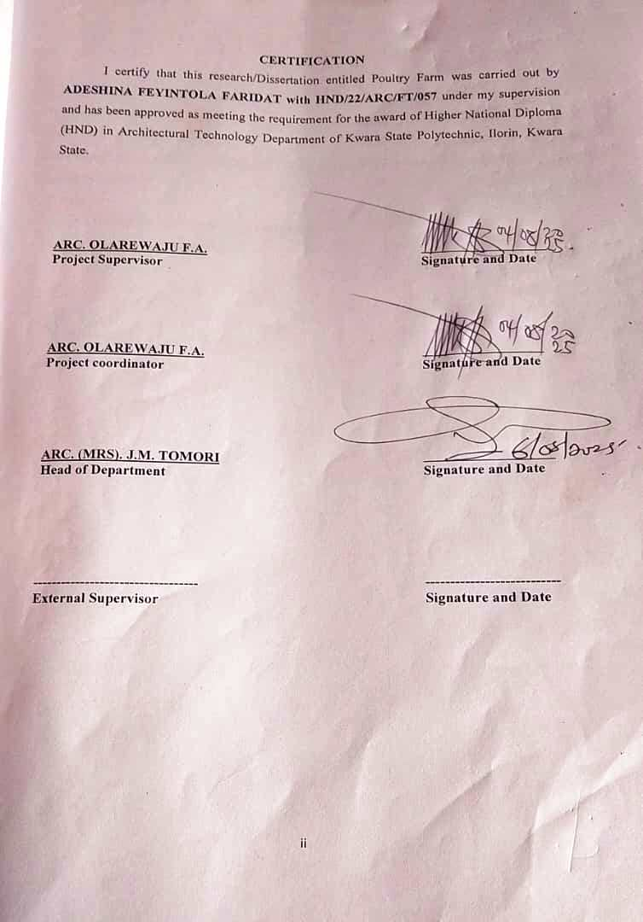
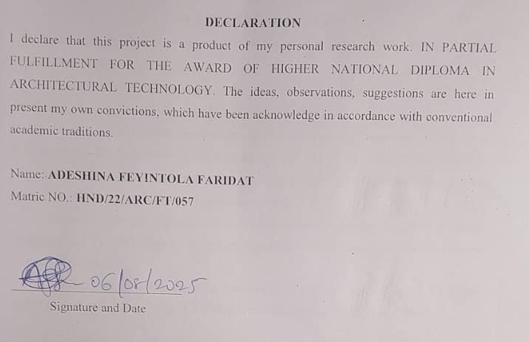

DEDICATION
I dedicate this project to my late daddy Arc. Abdulfatai Adeshina and Mrs. Adeshina for her support spiritual, emotionally and physically. May she reap the fruit of her labour. (Ameen)

ACKNOWLEDGEMENTS
Alamdulillah, Thanks to Allah SWT, whom with his mercy give me the priviledge to complete this project.
I would like to express my deepest gratitude to the Department of Architectural Technology, the entire staff and to my supervisor in person of Architect Olarewaju F. A. for his constructive ideas, counsel, mentorship and correction during the process of executing this project and also to the HOD of the Department in person of Arc. (Mrs.) J. M. Tomori for her valuable information, suggestions and guidance in the process of completion of this project, May Almighty Allah reward you and your family.
Deepest thanks and appreciate to my dearest and lovely parents Arc. (Mr.) Adeshina Abdulfatai and Mrs. Adeshina for the parental, moral and financial support. May you eat the fruit of your labour.
My appreciation also goes to my Brothers and Sisters and special mates of mine for their financial and material support, I wish you success in all your endeavors (Amen).

ABSTRACT
This project focuses on the comprehensive architectural design of a girl’s hostel to meet the growing demand for student accommodation, especially following the accreditation of new academic programs in a higher institution. The increase in student intake, particularly girls ' students, has led to pressure on existing hostel facilities, resulting in Overcrowding, safety concerns, and limited access to conducive living spaces. This Situation has made it necessary to propose a new hostel that will not only serve as accommodation but also enhance the academic and social experience of its users. The design process involves a series of planning stages from site analysis, concept development, zoning, circulation, and space planning to ensure a functional and user-centered design. Special attention is given to privacy, security, lighting, ventilation, and accessibility. The layout supports easy movement within the building. proper room arrangements, and functional support spaces such as study areas, lounges, dining and laundry facilities, all aimed at promoting comfort, productivity, and a sense of community. In addition, careful selection of materials, sustainability considerations,
and long-term maintenance were taken into account to ensure durability and cost-effectiveness. This project reflects a balance between aesthetic appeal, function, and the welfare of female students, contributing to the overall development and standard of student housing in educational environments.
This abstract outlines the significance of institutional hostels in promoting academic success, personal development, and professional growth. It emphasizes the role of these facilities in providing a stable and supportive environment that facilitates the achievement of institutional objectives.

TABLE OF CONTENTS
Title Page……………………………………………………………………………….i
Certification…………………………………………………………………………….ii
Declaration……………………………………………………………………………..iii
Dedication……………………………………………………………………………...iv
Acknowledgements…………………………………………………………………….v
Abstract…………………………………………………………………………………vi
Table of Contents………………………………………………………………………vii – ix
List of Figures…………………………………………………………………………..x
List of Plates……………………………………………………………………………xi
CHAPTER ONE
1.0 Introduction…………………………………………………………………….1 - 2
1.1 Background to the Study……………………………………………………….2
1.2 Statement of Design Problem………………………………………………….3
1.3 Aim and Objectives of the Study………………………………………………3 - 4
1.4 Justification for the Project…………………………………………………….4
1.5 Clients Background, Philosophy, Operational Structure and Goals of the
Proposal………………………………………………………………………..4 - 6
1.6 Scope of the Study…………………………………………………………….6
1.7 Limitation of Study……………………………………………………………6 - 8
1.8 Research Methodology of the Study…………………………………………..8 - 9
1.9 Definition of Terms……………………………………………………………9 - 10
CHAPTER TWO
2.1 Literature View………………………………………………………………..11 - 13
2.2 Important Issues and Problem Peculiar to Girls Hostel………………………13 - 14
2.2.1 Bases for Girls Hostel Classification…………………………………………14
2.2.2 Type of Management…………………………………………………………14 - 15
2.3 Function and Relationship between Space Common of the Girls Hostel……15
2.3.1 Functions of the Common Area………………………………………………15 - 16
2.3.2 Relationships Fostered in the Common Area…………………………………16
2.3.3 Identify Unique Solution of Specific Problem Peculiar to the Archetype
of Girls Hostel………………………………………………………………..16 - 17
2.4 Technological and Environmental Approaches for Designing the Typology
of Girls Hostel………………………………………………………………….17 - 18
2.4.1 Environmental Approaches…………………………………………………….18 - 19
2.4.2 Types of Structure………………………………………………………………19 - 20
2.4.3 Types of Material of Girls Hostel………………………………………………20 - 21
2.4.4 Types of Ventilation of Girls Hostel……………………………………………21 - 22
2.4.5 Types of Mechanical of Girls Hostel…………………………………………...22
2.4.6 Types of Service of Girls Hostel……………………………………………….22
2.5 The Review of Literature to Understand the Special Area of Interest of the
Girl’s Hostel Building………………………………………………………….23
2.5.1 Important Issues and Problems Peculiar/Prominent and Relevant to the
Girls Hostel Both in the General and Specific Contexts……………………….23 - 24
CHAPTER THREE: CASE STUDIES
3.0 Introduction…………………………………………………………………….25
3.1 Case Study One: University of Ilorin, (Unilorin)………………………………25
3.1.1 Description and Location……………………………………………………….25 - 28
3.2 Case Study Two: Kwara State University, Malete……………………………..28 - 32
3.3 Case Study Three: Osun State University (Uniosun).………………………….32 - 36
3.4 Online Case Study One: Stanford University, California………………………37 - 39
3.5 Online Case Study Two: Mesarya Technical University, North Dakota………39 - 41
3.6 Architecturally Related Merits and Demerits of Girls Hostel………………….41 - 42
3.7 Deduction from Case Study……………………………………………………..42
CHAPTER FOUR: STUDY AREA AND PROJECT SITE
4.1 Introduction of Study Area/Site Selection of Girl’s Hostel……………………..43
4.1.1 Site Location/ Descriptions/ Criteria of Girls Hostel……………………………43 - 44
4.1.2 Site Analysis/ Inventory of Girls Hostel………………………………………..44 - 46
4.1.3 Geographical/Climatic of Girls Hostel in Osun State University………………46
4.1.4 Analyses of the Immediate Environmental Conditions of the Site of Girls
Hostel of Osun State…………………………………………………………….46 - 48
4.2 Student Analysis and Design Criteria…………………………………………..48
4.2.1 Student Goals Developed By Student Designer of Girls Hostel……………….48
4.2.2 Analyses Privacy and Personal Space of Student………………………………48 - 49
4.2.3 Functional/Spatial Criteria of Girls Hostel…………………………………….49 - 50
4.2.4 Appraisal of Proposed Schemes in the Spaces, Size and Relationships
of Girls Hostel…………………………………………………………………50 - 51
4.2.5 Equipment and Operational and Performance Requirements of Girls Hostel..51 - 53
4.2.6 Spatial Allocation/ Schedule of Accommodation of Girls Hostel…………….53
4.2.7 Functional Relationship of Girls Hostel……………………………………….53 - 54
4.2.8 Conceptual Development of Girls Hostel……………………………………..54 - 55
CHAPTER FIVE: APPROACH TO THE DESIGN/ DESIGN REALIZATION
5.1 Construction Methodology and Materials Desired By Clients………………..56
5.2 Services Required……………………………………………………………..56 - 57
5.3 Environmental Conditions to be Achieved……………………………………58
5.4 Performance Standard…………………………………………………………59 - 60
5.5 Legal Issues and Planning Regulations………………………………………..60 - 61
5.6 Planning Regulations………………………………………………………….61 - 62
5.7 Behavioral Pattern and Consideration…………………………………………62
5.8 Considerations…………………………………………………………………63
Appendices…………………………………………………………………….64 - 72
Recommendation……………………………………………………………….73

LIST OF FIGURES
Figure 1.1: Floor plan of University of Ilorin (Unilorin)………………………27
Figure 1.2: Location Plan of University of Ilorin (Unilorin)…………………..28
Figure 1.3: Floor plan of Kwara State University of Ilorin (KWASU)……….31
Figure 1.4: Floor plan of Kwara State University of Ilorin (KWASU)……….31
Figure 1.5: Location plan of Kwara State University of Ilorin (KWASU)…….32
Figure 1.6: Upper Floor Plan of University of Osun State (UNIOSUN)………35
Figure 1.7: Ground Floor Plan of University of Osun State (UNIOSUN)……..36
Figure 1.8: Location Plan of University of Osun State (UNIOSUN)…………..36
Figure 1.9: Floor Plan of Stanford University, California………………………39
Figure 2.1: Floor Plan of Mesarya Technical University, North Dakota……….41

LIST OF PLATES
Plate 1.1: Front view of University of Ilorin Hostel…………………………26
Plate 1.2: Left view of University of Ilorin Hostel…………………………..27
Plate 1.3: Front view of Kwara State University of Ilorin (KWASU)……..30
Plate 1.4: Side view of Kwara State University of Ilorin (KWASU)……….30
Plate 1.5: Side view of University of Osun State (UNIOSUN)…………….34
Plate 1.6: Back view of University of Osun State (UNIOSUN)……………35
Plate 1.7: Stanford University, California…………………………………..38
Plate 1.8: Mesarya Technical University, North Dakota…………………..40
Plate 1.9: Osun State Map………………………………………………….45
Plate 2.1: Osun State Climatic Data………………………………………..47
Plate 2.2: Osun State Climatic Data………………………………………..47
CHAPTER ONE
INTRODUCTION
1.1 Background to the Study
The history of girls' hostels is intertwined with the broader history of women's education and social norms regarding women's autonomy and safety. Historically, as women gained access to education in formal settings, the provision of accommodation became necessary. Here are some key points in the historical background of girls' hostels:
19th Century and Early 20th Century:
In many parts of the world, women's access to formal education was limited or non-existent. Where it was available, it was often in segregated institutions with separate living quarters.
Hostels or dormitories for female students began to appear in colleges and universities during this time, reflecting the growing acceptance of women in higher education.
Social Norms and Safety:
Hostels provided a controlled environment that was considered safe and conducive to studying, especially in societies where women's mobility was restricted.
They also offered an opportunity for young women to live independently while still under institutional supervision, which was seen as a step towards greater gender equality.
Expansion and Modernization:
As women's education became more widespread and accepted, the number and scale of girls' hostels grew. This expansion mirrored broader societal changes towards gender equality and women's rights.
Modern hostels are equipped with various amenities and security measures to ensure the safety and well-being of residents.
Cultural and Regional Variations:
The history and development of girls' hostels vary significantly across cultures and regions. In some societies, hostels were crucial in enabling rural girls to access urban educational opportunities, while in others; they symbolized a path towards greater independence for women.
Challenges and Advancements:
Throughout history, girls' hostels have faced challenges such as funding, maintenance, and ensuring a supportive environment for residents.
Advances in architecture, security, and management have improved the quality of hostel accommodations, making them safer and more comfortable for female students.
Overall, the historical background of girls' hostels reflects broader shifts in societal attitudes towards women's education and autonomy. They have played a vital role in facilitating educational opportunities for women and continue to evolve alongside changing social norms and educational policies.
1.2 Statement of Design Problem
Girls' hostels, like any living environment, can face a variety of challenges and issues. Some common problems include:
Safety Concerns: Ensuring the safety of residents, especially in urban areas or during late hours, can be a significant challenge. Issues such as unauthorized entry, harassment, or inadequate security measures may arise.
Hygiene and Cleanliness: Maintaining proper hygiene standards in shared facilities like bathrooms, kitchens, and common areas can be challenging, especially with a large number of residents.
Infrastructure and Facilities: Hostels may face issues related to outdated infrastructure, insufficient amenities (such as internet connectivity, recreation rooms, or study spaces), and maintenance delays.
Overcrowding: Some hostels may become overcrowded due to increased demand for accommodation, leading to issues with noise, privacy, and availability of resources.
Social and Cultural Issues: Differences in cultural backgrounds, lifestyles, and habits among residents can sometimes lead to conflicts or misunderstandings within the hostel community.
Administrative and Management Issues: Poor management practices, lack of transparency in rules and regulations, and inadequate grievance redressed mechanisms can contribute to dissatisfaction among residents.
Cost and Affordability: The cost of accommodation in hostels can be a burden for some students, especially if there are limited options for financial assistance or affordable housing alternatives.
Accessibility and Inclusivity: Ensuring that hostels are accessible to students with disabilities and inclusive of diverse gender identities can be a challenge in some institutions.

1.3 Aim and Objectives of the Study
1.3.1 Aim
The aim of a girls' hostel is to design a functional and aesthically appealing female hostel that would be able to provide support, security, privacy and their wellbeing.
1.3.2 Objectives
The objectives of a girls' hostel typically include:
Provide Safe Accommodation: Ensuring a secure and safe living environment for female residents is paramount. This involves implementing security measures, having controlled access, and addressing safety concerns promptly.
Support Academic Success: Facilitating an environment conducive to study and academic achievement is crucial. This includes providing quiet study areas, access to educational resources, and a structured routine that promotes academic discipline.
Promote Personal Development: Encouraging personal growth and independence among residents is an important objective. Hostels aim to cultivate life skills such as time management, communication, and problem-solving, which are essential for personal and professional development.
Foster Community and Social Interaction: Creating a supportive community where residents can build friendships, support each other, and engage in social activities is key. This helps in forming bonds and enhancing the overall hostel experience.
Promote Diversity and Inclusivity: Hostels aim to be inclusive environments that respect and celebrate diversity in terms of culture, background, and perspectives. This fosters a tolerant and understanding community.
1.4 Justification for the Project
The design of a girls’ hostel is justified based on the need to provide a safe, comfortable and conducive living environment for female students. As access to education increases the demand for well-planned accommodations near institutions is rising. A purpose-built hostel enhances academic performance by offering proximity to campus facilities, proper ventilation, adequate lighting, security and privacy.
1.5 Clients Background, philosophy, operational structure and goals of the proposal
To provide an effective proposal for a girls' hostel, let's break it down into key sections:
1. Background
Client Overview: Describe the client organization, its history, and its mission. For example, if the client is an educational institution or an NGO, provide details about its foundation, achievements, and core values.
Current Situation: Explain why there is a need for a girls' hostel. This could include issues like the lack of safe accommodation for female students or the organization's desire to promote education for girls.
2. Philosophy
Mission Statement: Outline the mission of the girls' hostel. This might include providing a safe, supportive, and nurturing environment for female students to thrive academically and personally.
Core Values: Highlight the core values that will guide the operation of the hostel, such as safety, inclusivity, respect, and empowerment.
Vision: Describe the long-term vision for the hostel, like creating a model of excellence in student accommodation that can be replicated elsewhere.
3. Operational Structure
Management: Detail the management team responsible for running the hostel, including their roles and qualifications.
Staffing: Explain the staffing plan, including the number and types of staff (e.g., wardens, security personnel, cooks, and maintenance staff) required to run the hostel efficiently.
Facilities and Services: Describe the facilities (e.g., rooms, study areas, common rooms, dining facilities) and services (e.g., meals, laundry, and transportation) that will be provided.
Safety Measures: Outline the safety protocols, such as 24/7 security, CCTV surveillance, emergency response plans, and visitor management systems.
4. Goals of the Proposal
Primary Goal: State the primary objective, such as providing safe and affordable accommodation for girls pursuing education.
Secondary Goals: Include other goals like promoting academic excellence, supporting the personal development of residents, fostering a sense of community, and ensuring the physical and mental well-being of the students.
Impact Measurement: Describe how the success of the hostel will be measured, including metrics like academic performance, resident satisfaction, and retention rates.
Operational Structure
Management: The hostel will be managed by a dedicated team, led by an experienced hostel manager with a background in student housing.
Staffing: The team will include wardens, security personnel, kitchen staff, and maintenance workers to ensure smooth operation.
Facilities and Services: The hostel will offer well-furnished rooms, study areas, common rooms, a dining hall, and laundry services.
Safety Measures: Comprehensive safety protocols will be implemented, including 24/7 security, CCTV surveillance, and a robust emergency response system.
Goals of the Proposal
Primary Goal: To provide a safe and affordable living environment for female students, enabling them to pursue their education without worry.
Secondary Goals: To foster academic excellence, support personal development, and build a strong sense of community among residents.
Impact Measurement: Success will be measured through academic performance, resident feedback, and retention rates.
1.6 Scope of the Study
The scope of a girls' hostel typically includes providing safe, secure, and comfortable accommodation for female students, working women, or other female residents. Key features and services often include:
Security: Security personnel, CCTV surveillance, secure entry and exit points.
Accommodation: Well-furnished rooms with necessary amenities such as beds, wardrobes, study tables, and chairs.
Hygiene and Cleanliness: Regular cleaning services, clean bathrooms, and sanitation facilities.
Food Services: Nutritious meals provided at regular intervals, often including breakfast, lunch, and dinner.
Health Services: Access to medical facilities or first-aid, tie-ups with nearby hospitals or clinics for emergencies.
Study Facilities: Study rooms or libraries with a quiet environment for academic work.
Recreational Activities: Common rooms with entertainment options, sports facilities, and spaces for cultural activities.
Internet Access: Wi-Fi or broadband facilities to support academic and personal use.
Laundry Services: Provision of laundry facilities or services.
Rules and Regulations: Clear guidelines regarding curfews, visitor policies, and conduct to ensure a safe and harmonious living environment.
1.7 Limitation of Study
While girls' hostels offer numerous benefits, there are also several limitations and challenges associated with them:
1. Limited Capacity
Overcrowding: Hostels may not have enough space to accommodate all applicants, leading to overcrowded rooms and facilities.
Waiting Lists: High demand can result in long waiting lists, leaving some students without accommodation.
2. Cost
High Fees: Hostel fees can be expensive, making it unaffordable for some students, especially those from low-income families.
Additional Expenses: Extra costs for amenities, internet, and meals can add up, putting a financial strain on students and their families.
3. Regulations and Restrictions
Curfews: Strict curfews and rules can limit students' freedom and social life.
Limited Autonomy: Over-regulation may stifle independence and personal growth.
4. Safety Concerns
Security Issues: Despite measures, there can still be breaches in security, leading to potential risks.
Emergency Preparedness: Not all hostels are well-equipped to handle emergencies like fires or medical crises.
5. Quality of Facilities
Maintenance Issues: Poor maintenance can lead to deteriorating living conditions, such as broken fixtures or unclean restrooms.
Outdated Infrastructure: Some hostels may have old or inadequate facilities that do not meet modern standards.
6. Privacy Concerns
Shared Spaces: Sharing rooms and common areas can compromise privacy and personal space.
Noise Levels: High noise levels in shared living environments can disrupt sleep and study.
7. Health and Hygiene
Sanitation Problems: Inadequate cleaning and hygiene practices can lead to health issues.
Infectious Diseases: Close living quarters can facilitate the spread of illnesses.
8. Social and Cultural Issues
Cultural Conflicts: Differences in cultural practices and backgrounds can lead to misunderstandings and conflicts.
Bullying and Harassment: Instances of bullying, harassment, or discrimination can occur.
9. Academic Distractions
Peer Pressure: Negative influences and peer pressure can distract students from their academic goals.
Lack of Quiet Spaces: Inadequate quiet areas for studying can impact academic performance.
1.8 Research Methodology of the Study
- Case Study
- Oral Interview
- Literature Review: Review existing literature on girls' hostels related topic to understand the current state of knowledge research.
- Internet browsing.
1.9 Definition of Terms
Common Room: A common room is a shared space within a building, such as a residence hall, school or office that is accessible to all occupants or members. It is typically used for socializing, relaxing, studying, or holding meetings. The room is usually furnished with seating, tables, and sometimes amenities like a television, games, or a kitchenette.
Portal Office: A portal office refers to an office that serves as a central point or gateway for accessing a variety of services and information, often through digital means. It is typically used in contexts such as government services, where a portal office might provide access to various administrative services, applications, and resources through an online platform. The term can also apply to businesses that offer centralized access to their services and information through a single digital interface.
Laundry: Laundry refers to the facilities and services provided for washing, drying, and sometimes ironing clothes. These facilities typically include washing machines, dryers, and possibly ironing boards and irons. Hostels may offer self-service laundry areas where guests can do their laundry themselves, or they may provide a paid laundry service where staff wash and dry clothes for guests.
Medical Office: A medical office is a designated space where medical services are provided to residents. This office is typically staffed by healthcare professionals, such as nurses or doctors, and offers basic medical care, first aid, and sometimes consultations for minor health issues. The purpose of the medical office is to ensure the well-being and health of hostel residents by providing accessible medical assistance on-site.
Mini-Mart: A mini-mart is a small convenience store located within the hostel premises. It offers a variety of essential items for purchase, such as snacks, beverages, toiletries, basic groceries, and other everyday necessities. The mini-mart provides residents with easy access to these items without needing to leave the hostel, enhancing their convenience and comfort.
Salon: A salon in a hostel is a designated space where grooming and beauty services are provided to residents. These services may include haircuts, hairstyling, manicures, pedicures, and other personal care treatments. The presence of a salon within the hostel allows residents to conveniently access these services without needing to leave the premises, contributing to their overall well-being and convenience.
CHAPTER TWO
2.1 Literature View
Tracking the evolution of girls' hostels through literature involves examining historical, social, architectural, and educational perspectives. Here's an overview of key themes and sources that can be included in such a review:
1. Historical Development
Early Foundations
19th Century: Initially, girls' hostels were rare due to limited access to education for women. Institutions that did offer education for women often had boarding facilities. Early 20th Century: Growth in women's education led to the establishment of more dedicated girls' hostels, often reflecting contemporary societal norms.
Post-World War II
Mid-20th Century: Post-WWII era saw a significant increase in higher education institutions for women, leading to more girls' hostels being built.
Late 20th Century: The feminist movement influenced the design and management of girls' hostels, emphasizing safety, autonomy, and community.
2. Architectural Evolution
Early Designs
Victorian Era: Early girls' hostels often had a domestic architectural style, emphasizing homeliness and modesty.
1920s-1940s: Functionalist approaches began to emerge, focusing on practicality and cost-efficiency.
Modern Designs
1950s-1970s: Integration of modernist architecture, with an emphasis on light, space, and communal areas.
1980s-Present: Sustainable and student-centered designs, incorporating technological advancements and environmentally friendly materials.
3. Social and Cultural Perspectives
Gender Norms and Education
Role of Hostels in Women's Education: Hostels provided not just accommodation but also a space for women to engage in academic and social activities, promoting gender equality in education.
Safety and Autonomy: Literature often discusses the balance between ensuring safety and providing freedom for female students.
Impact of Feminism
Feminist Critiques: Feminist literature critiques the paternalistic approaches to managing girls' hostels and advocates for more egalitarian and empowering environments.
Community and Support: Emphasis on creating supportive communities within hostels to foster personal and academic growth.
4. Case Studies and Examples
Notable Institutions
Western Universities: Examination of girls' hostels in universities like Oxford, Cambridge, and American Ivy League schools.
Global Perspectives: Case studies from developing countries, highlighting different challenges and solutions in hostel construction and management.
Comparative Studies
Urban vs. Rural: Differences in hostel design and management between urban and rural settings.
Cultural Influences: How cultural contexts influence the design and operation of girls' hostels.
5. Policy and Management
Government and Institutional Policies
Regulations and Standards: Overview of policies governing the construction and management of girls' hostels.
Funding and Resources: Discussion on funding models and resource allocation for girls' hostels.
Best Practices
Safety Measures: Effective strategies for ensuring the safety of female students.
Inclusivity and Accessibility: Policies promoting inclusivity and accessibility in hostel design and management.
Key Sources and References
Books
Women and Education: A Historical Perspective by Carol Dyhouse
Feminism and the Women's Movement by Barbara Ryan
Journals
Gender and Education
Women's History Review
Reports and Case Studies
UNESCO reports on women's education
Case studies from various universities and educational institutions
2.2 Important Issues and Problem Peculiar to Girls Hostel
Girls' hostels, like any other residential facility, have their own unique set of issues and problems. Some of the important issues peculiar to girls' hostels include:
Safety and Security
Security Measures: Ensuring the safety of residents through effective security measures such as CCTV cameras, security guards, and strict entry protocols.
Harassment and Abuse: Protecting residents from harassment and abuse, both from within the hostel and from outsiders.
Health and Hygiene
Sanitary Facilities: Providing adequate sanitary facilities and ensuring they are regularly cleaned and maintained.
Health Services: Access to medical services and health support, especially for issues specific to women like menstrual health.
Privacy
Personal Space: Ensuring adequate personal space and privacy for each resident, which can be challenging in shared accommodations.
Confidentiality: Respecting the confidentiality of residents' personal information and issues.
Social and Psychological Well-being
Mental Health Support: Providing access to counseling and mental health support to address issues such as homesickness, stress, and depression.
Community Building: Creating a supportive community environment to help student build friendships and support networks.
Facilities and Infrastructure
Adequate Amenities: Ensuring that basic amenities like clean drinking water, laundry facilities, and reliable internet access are available.

2.3 Function and Relationship between Space Common of the Girls Hostel
The "space common" of a girls' hostel, typically referred to as the common area or common room, serves several important functions and fosters various relationships among the residents. Here are some key points:
2.3.1 Functions of the Common Area
Social Hub:
Interaction: Provides a space where residents can meet, socialize, and build friendships.
Community Building: Encourages a sense of community and belonging among the residents.
Relaxation and Leisure:
Recreation: Often equipped with amenities like TV, games, and books for relaxation.
Relaxation: A place where students can unwind from academic pressures.
Study Space:
Group Study: Facilitates group discussions and collaborative learning.
Quiet Study: Offers an alternative study environment to individual rooms or libraries.
Event Hosting:
Events and Meetings: Can be used for hosting hostel events, meetings, and small gatherings.
Workshops: Suitable for educational or recreational workshops and activities.
Resource Center:
Information Sharing: A place where notices and information can be shared with all residents.
Support Services: Can serve as a location for providing support services or resources.
2.3.2 Relationships Fostered in the Common Area
Peer Relationships:
Friendships: Encourages the formation of friendships through regular interaction.
Support Networks: Helps in building support networks, offering emotional and academic support.
Resident and Management Relationship:
Communication: Provides a space for residents to communicate with hostel management.
Feedback and Interaction: Facilitates feedback and interaction between residents and hostel authorities.

Inter-Cultural Relationships:
Diverse Interactions: Promotes interaction among students from different backgrounds and cultures.
Cultural Exchange: Encourages cultural exchange and understanding.
Mentorship and Guidance:
Peer Mentoring: Senior students can mentor juniors in an informal setting.
Guidance: Opportunities for guidance and advice in both academic and personal matters.
Conflict Resolution:
Mediation Space: Provides a neutral space for resolving conflicts and misunderstandings.
Dialogue: Encourages open dialogue and communication to resolve issues amicably.
The common area in a girls' hostel is integral to the overall living experience, enhancing the social, academic, and personal development of the residents while fostering a harmonious and supportive community.
2.3.3 Identify Unique Solution of Specific Problem Peculiar to the Archetype of Girls Hostel
In a girls' hostel, a unique problem could be ensuring safety and security while maintaining a comfortable living environment. Here is a tailored solution:
Problem: Ensuring Safety and Security
Girls' hostels face the challenge of ensuring that residents feel safe and secure from both external threats and internal issues such as theft or harassment.
Unique Solution: Integrated Security and Comfort System
1. Advanced Access Control Systems
Biometric Entry: Implement biometric systems (fingerprint or facial recognition) to control access to the hostel premises. This ensures only authorized individuals can enter.
Smart ID Cards: Provide residents with smart ID cards that can track entry and exit, adding another layer of security.
2. Surveillance and Monitoring
CCTV Cameras: Install high-definition CCTV cameras in common areas, entrances, and exits. Ensure there is constant monitoring by trained personnel.
Security Patrols: Have trained security personnel conduct regular patrols, particularly during night hours.

3. Emergency Response System
Panic Buttons: Install panic buttons in rooms and common areas that immediately alert security and hostel management in case of emergencies.
Mobile App Integration: Develop a mobile app that allows residents to report suspicious activities, request assistance, and receive emergency notifications.
4. Secure and Comfortable Environment
Personal Lockers and Safe Spaces: Provide secure personal lockers for each resident to store valuables. Designate safe spaces for residents to go to in case of immediate threats.
Well-lit Areas: Ensure all areas of the hostel, especially pathways and common areas, are well-lit to deter potential threats.
2.4 Technological and Environmental Approaches for Designing the Typology of girls hostel
Designing a girls' hostel involves considering both technological and environmental approaches to create a safe, comfortable, and sustainable living space. Here are some key considerations for each approach:
Technological Approaches
Smart Building Systems:
Automated Lighting and HVAC: Use sensors to control lighting and heating/cooling systems based on occupancy and time of day.
Security Systems: Install smart locks, surveillance cameras, and access control systems to ensure safety.
Energy Management: Integrate smart meters and energy management systems to monitor and reduce energy consumption.
Internet Connectivity: Ensure robust Wi-Fi and wired internet connections to support academic and personal needs.
Sustainable Materials and Construction:
Eco-friendly Materials: Use sustainable building materials like recycled steel, bamboo, and low-VOC paints.
Modular Construction: Employ modular building techniques to reduce construction time and waste.

Water Management Systems:
Rainwater Harvesting: Implement systems to collect and use rainwater for non-potable purposes.
Grey water recycling: Use treated grey water for irrigation and flushing toilets.
Renewable Energy Integration:
Solar Panels: Install photovoltaic panels to generate electricity.
Solar Water Heaters: Use solar thermal systems for hot water needs.
Wind Turbines: If feasible, consider small-scale wind turbines.
Smart Furniture and Interiors:
Modular Furniture: Use furniture that can be reconfigured to meet different needs.
Ergonomic Design: Ensure that furniture supports healthy posture and comfort.
2.4.1 Environmental Approaches
Site Selection and Orientation:
Location: Choose a site with minimal environmental impact and good access to public transportation.
Orientation: Design buildings to maximize natural light and ventilation, reducing the need for artificial lighting and air conditioning.
Green Spaces and Landscaping:
Gardens and Courtyards: Incorporate green spaces for recreation and relaxation.
Native Plants: Use local plants that require less water and maintenance.
Energy Efficiency:
Insulation: Use high-quality insulation to reduce heating and cooling needs.
Double-Glazed Windows: Install energy-efficient windows to reduce heat loss.
Waste Management:
Recycling Facilities: Provide bins and systems for recycling different types of waste.
Composting: Encourage composting of organic waste.
Indoor Environmental Quality:
Ventilation: Ensure good indoor air quality with proper ventilation systems.
Natural Lighting: Design spaces to maximize natural light, reducing the need for artificial lighting.
Non-Toxic Materials: Use low-emission materials to improve indoor air quality.
Water Conservation:
Low-Flow Fixtures: Install low-flow showers, faucets, and toilets to reduce water use.
Drought-Resistant Landscaping: Use landscaping that requires minimal irrigation.
Integration and Implementation
To effectively integrate these approaches:
Holistic Planning: Develop a comprehensive plan that balances technological and environmental considerations.
Stakeholder Involvement: Engage students, staff, and other stakeholders in the planning process.
Continuous Improvement: Regularly review and update systems to incorporate new technologies and best practices.
Education and Awareness: Educate residents about sustainable living practices and the technology in use.
2.4.2 Types of Structure
The structure of a girls' hostel can vary significantly based on factors like the institution's size, location, and resources. However, here are some common types of structures:
Dormitory Style:
Shared Rooms: Multiple beds in a single room, shared by several students.
Common Bathroom Facilities: Bathrooms and showers are shared among residents on the same floor.
Apartment Style:
Individual or Shared Apartments: Each apartment has bedrooms, a living area, and a kitchen.
Private Bathrooms: Each apartment typically includes one or more bathrooms.
Suite Style:
Semi-Private Bedrooms: Bedrooms that are part of a suite shared by a small group of students.
Shared Living Area: Each suite has a common living area and sometimes a kitchenette.
Shared Bathroom: Bathroom facilities within the suite, shared by the suite's residents.
Single Room Style:
Private Bedrooms: Each student has their own room.
Shared Facilities: Common areas such as kitchens, lounges, and bathrooms are shared by all residents on the same floor.
2.4.3 Types of Material of girls Hostel
Girls' hostels can be made from a variety of materials depending on factors such as budget, location, climate, and architectural preferences. Common materials used in the construction of girls' hostels include:
Concrete: Strong, durable, and fire-resistant, concrete is commonly used for the structural framework, floors, and walls of hostels.
Bricks: Traditional and widely used, bricks offer good thermal insulation and are often used for walls.
Steel: Used for structural frameworks, roofing, and in some cases, modular buildings, steel is known for its strength and flexibility.
Wood: Although less common for large hostels due to fire risks and maintenance, wood can be used for interiors, furniture, and sometimes for construction in regions where it's more practical.
Tiles: Ceramic or porcelain tiles are frequently used for flooring and sometimes for wall finishes in bathrooms and kitchens due to their durability and ease of cleaning.
Plastics and Polymers: These materials are often used for plumbing, electrical insulation, and furniture.
Insulation Materials: Various insulation materials like fiberglass, foam, and wool are used to improve thermal and acoustic performance.
Aluminum: Used for window frames, door frames, and roofing, aluminum is lightweight and resistant to corrosion.
2.4.4 Types of Ventilation of girls Hostel
Ventilation in girls' hostels, like any other living spaces, is crucial for maintaining a healthy and comfortable environment. Here are the types of ventilation that can be used:
Natural Ventilation:
Windows and Doors: Opening windows and doors allows fresh air to circulate and stale air to exit.
Ventilators: Louvers or ventilators at higher levels can help in cross ventilation.
Roof Vents: Roof-mounted ventilators that allow hot air to escape.
Mechanical Ventilation:
Exhaust Fans: Installed in kitchens, bathrooms, and other areas to remove stale air and moisture.
Ceiling Fans: Promote air circulation within rooms.
Ventilation Fans: Systems that draw in fresh air from outside and expel indoor air.
Hybrid Ventilation:
Combination Systems: Using both natural and mechanical methods to ensure optimal air quality and circulation.
Centralized HVAC Systems:
Heating, Ventilation, and Air Conditioning (HVAC): Systems that control temperature, humidity, and air quality through a network of ducts and vents.
Air Handling Units (AHUs): Part of HVAC systems that condition and circulate air.
Local Exhaust Ventilation:
Range Hoods: In kitchens to capture and remove cooking fumes and smoke.
Bathroom Ventilation: Systems specifically designed to remove moisture and odors from bathrooms.
Spot Ventilation:
Portable Air Cleaners: Devices that can be moved to different areas to clean the air and provide fresh air circulation.
2.4.5 Types of Mechanical of girls Hostel
In a girls' hostel, mechanical systems typically include:
HVAC Systems: For heating, ventilation, and air conditioning.
Plumbing Systems: For water supply and waste disposal.
Electrical Systems: For lighting, power outlets, and emergency backup.
Fire Safety Systems: Including fire alarms, sprinklers, and fire extinguishers.
Security Systems: Such as surveillance cameras, access control, and intercoms.
Elevators: If the hostel is multi-story.
Laundry Facilities: Washing machines and dryers.
These systems ensure the comfort, safety, and functionality of the hostel.
2.4.6 Types of Service of girls Hostel
Girls' hostels offer various services to ensure the comfort, safety, and well-being of their residents. These services typically include:
Accommodation: Well-furnished rooms, including options for shared or private accommodations.
Meals: Regular meal plans with options for breakfast, lunch, and dinner, often tailored to accommodate dietary restrictions.
Security: Security personnel, CCTV surveillance, and secure entry/exit points to ensure safety.
Laundry Services: On-site or outsourced laundry facilities for washing and ironing clothes.
Internet Access: Wi-Fi or internet facilities to help with studies and communication.
Housekeeping: Regular cleaning and maintenance of common areas and rooms.
Recreational Facilities: Common rooms, study areas, and sometimes gyms or outdoor spaces for relaxation and leisure.
Medical Assistance: Basic first aid and sometimes access to medical professionals or partnerships with nearby clinics.
Administrative Support: Help with mail, packages, and sometimes academic or personal issues.
Transportation: Shuttle services or help with local transportation options.
2.5 The review of Literature to understand the special area of interest of the girl’s hostel building
When reviewing literature for understanding the special area of interest in girls' hostel buildings, consider focusing on several key areas:
Design and Architecture: Research how design principles address the needs and preferences of female residents. This includes safety features, privacy, and functionality in common areas.
Sustainability and Environment: Review studies on sustainable practices in hostel design, such as energy efficiency, waste management, and the use of eco-friendly materials.
Comparative Studies: Analyze comparisons between girls' hostels and other types of student housing to highlight specific needs and preferences.
2.5.1 Important Issues and problems peculiar/prominent and relevant to the girls hostel both in the general and specific contexts.
When discussing issues relevant to girls' hostels, several factors come into play, both generally and specifically. Here's a breakdown:

General Issues
Safety and Security:
Concerns: Personal safety is paramount. Hostels must ensure secure access, surveillance, and emergency protocols.
Solutions: Employ security staffs, install surveillance cameras, and provide safe entry and exit points.
Hygiene and Sanitation:
Concerns: Cleanliness of common areas and private rooms, availability of sanitary supplies.
Solutions: Regular cleaning schedules, availability of hygiene products, and proper waste disposal methods.
Healthcare and Well-being:
Concerns: Access to medical facilities and mental health support.
Solutions: Partnerships with local healthcare providers, access to counseling services, and emergency medical care.
Privacy:
Concerns: Balancing communal living with individual privacy.
Solutions: Design rooms and common areas to respect privacy, and establish clear policies on privacy.
Rules and Regulations:
Concerns: Enforcing rules while respecting residents' autonomy.
Solutions: Clear, transparent rules and fair enforcement mechanisms, with opportunities for feedback.
Specific Issues
Cultural Sensitivity:
Concerns: Catering to diverse cultural and religious backgrounds.
Solutions: Offer facilities for religious practices, culturally sensitive meal options, and awareness training for staff.
Academic Support:
Concerns: Availability of study spaces and resources.
Solutions: Create quiet study areas, provide academic resources, and host study groups or workshops.
Social Dynamics:
Concerns: Managing interpersonal relationships and conflicts.
Solutions: Implement conflict resolution mechanisms, promote inclusivity, and offer social programs to build a positive community.
Food and Nutrition:
Concerns: Providing balanced and nutritious meals.
Solutions: Offer varied meal plans, accommodate dietary restrictions, and involve residents in meal planning.
Economic Factors:
Concerns: Affordability and financial management.
Solutions: Offer financial assistance or scholarships, and maintain transparency in fee structures.
CHAPTER THREE
CASE STUDIES
3.0 INTRODUCTION
This chapter is aimed at highlighting the various elements that could make up a Girls Hostel. This will help identify the basic concept employed in the design such as building topology.
3.1 CASE STUDY ONE:
UNIVERSITY OF ILORIN, (UNILORIN)
3.1.1 DESCRIPTION AND LOCATION
Description: The University of Ilorin, commonly known as UNILORIN, is one of Nigeria's foremost tertiary institutions. It was established in 1975 as a university college affiliated with the University of Ibadan. Over the years, it has grown into a full-fledged university offering a wide range of undergraduate and postgraduate programs across various disciplines, including sciences, humanities, engineering, law, and medical sciences. The university is known for its commitment to academic excellence, research, and innovation. It is also recognized for its stable academic calendar, which is relatively free from frequent strikes that affect many other universities in Nigeria.
Location: The University of Ilorin is located in Ilorin, the capital city of Kwara State in the western part of Nigeria. The main campus is situated about 15 kilometers from the city center, along the Ilorin-Minna Road. The campus spans a large area, featuring modern facilities such as lecture halls, laboratories, libraries, residential accommodations, and recreational centers. Ilorin itself is a historically rich city with a diverse culture, serving as a significant hub for education and commerce in the region.
MERITS
- Academic Excellence: UNILORIN is known for its strong academic programs and rigorous standards, producing graduates who are well-prepared for the workforce or further studies.
- Stable Academic Calendar: Unlike many other Nigerian universities, UNILORIN has a stable academic calendar with fewer disruptions from strikes, allowing students to complete their programs on time.
- Modern Facilities: The campus is equipped with modern lecture halls, laboratories, libraries, and recreational centers, providing a conducive environment for learning and personal development.
DEMERITS
- Overcrowding: Like many popular universities, UNILORIN can face issues with overcrowding in lecture halls, hostels, and other facilities due to high demand for admission.
- Infrastructure Strain: Rapid growth and increasing student population can put a strain on the university's infrastructure, potentially affecting the quality of services and resources available.
- Location Challenges: While Ilorin is a significant city, it may not offer the same level of amenities and opportunities as larger metropolitan areas like Lagos or Abuja, which could affect students seeking diverse urban experiences.
- Competition for Admission: Due to its reputation for academic excellence and stable calendar, admission to UNILORIN can be highly competitive, making it challenging for some applicants to secure a spot.

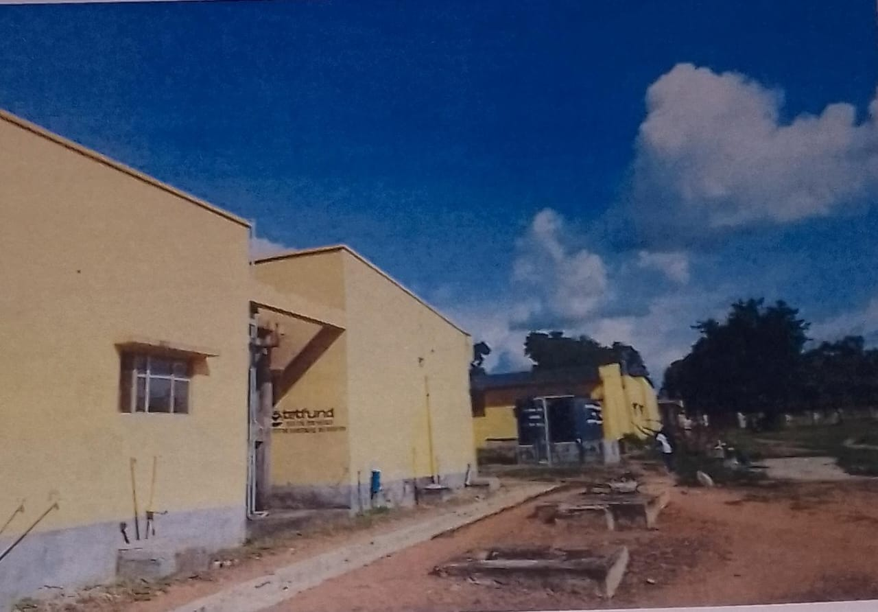

Plate 1.1: Front view of University of Ilorin Hostel
Sources: Researcher’s Field Work, 2025.

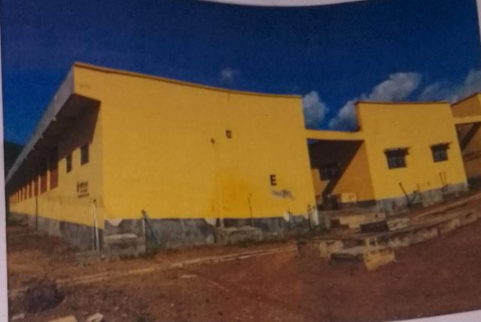

Plate 1.2: Left view of University of Ilorin Hostel
Sources: Researcher’s Field Work, 2025.
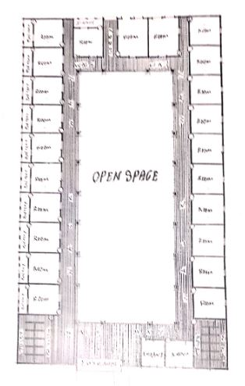

Figure 1.1: Floor plan of University of Ilorin (Unilorin)
Sources: Researcher’s Field Work, 2025.

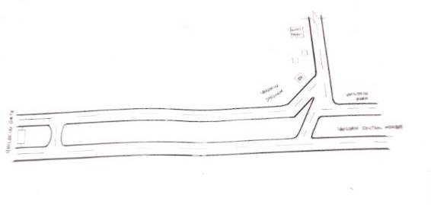

Figure 1.2: Location Plan of University of Ilorin (Unilorin)
Sources: Researcher’s Field Work, 2025.

3.2 CASE STUDY TWO
KWARA STATE UNIVERSITY, MALETE
Description: Kwara State University, commonly referred to as KWASU, is a state-owned university established in 2009. It was created to provide high-quality education and foster research, innovation, and community development. KWASU offers a variety of undergraduate and postgraduate programs across multiple disciplines, including natural and applied sciences, social sciences, humanities, engineering, and management sciences. The university is dedicated to producing graduates equipped with the skills and knowledge required to meet the challenges of the 21st century.
KWASU emphasizes hands-on learning, entrepreneurship, and community service. It aims to create an environment where students can engage in critical thinking, problem-solving, and creative endeavors. The university also focuses on creating a research-friendly environment, encouraging faculty and students to contribute to advancements in their respective fields.
Location: Kwara State University is located in Malete, a town in the Moro Local Government Area of Kwara State, Nigeria. Malete is situated approximately 25 kilometers north of Ilorin, the state capital. The university campus is spread over a large area, providing a serene and conducive environment for academic activities.
Malete is relatively rural compared to urban centers, offering a peaceful setting for study and reflection. However, its proximity to Ilorin ensures that students and staff can access urban amenities and services when needed. The location provides a balance between tranquility and accessibility, making it an attractive option for students seeking a focused academic environment.
MERITS
- Strategic Location: Situated in Malete, Kwara State, Nigeria, KWASU is located in a relatively peaceful and conducive environment for learning. The university is accessible from major towns and cities in Kwara State, providing ease of transportation for students and staff.
- Academic Excellence: KWASU offers a wide range of undergraduate and postgraduate programs across various fields of study. The university is known for its commitment to academic excellence and research, attracting students from different parts of Nigeria and beyond.
- Modern Facilities: Equipped with modern learning facilities, including well-stocked libraries, laboratories, and ICT centers. The campus infrastructure supports a conducive learning environment with amenities that enhance the academic experience.
DEMERITS
- Infrastructure Development: Despite improvements, there are still areas where infrastructure development is needed to meet the growing demands of the student population. Some students may find accommodation and transportation options limited compared to universities in more urbanized areas.
- Funding Challenges: As with many public universities in Nigeria, KWASU may face funding challenges that can affect the quality of education and facilities. Budget constraints can impact the university's ability to expand programs and improve existing services.
- Accessibility Issues: The location, while peaceful, might be considered remote by some, potentially making it less attractive for students and staff who prefer urban settings. Limited public transportation options could pose challenges for commuting students and visitors.
- Resource Limitations: There may be limitations in terms of research resources and facilities compared to older and more established universities. Students and faculty might face difficulties in accessing advanced research materials and equipment.
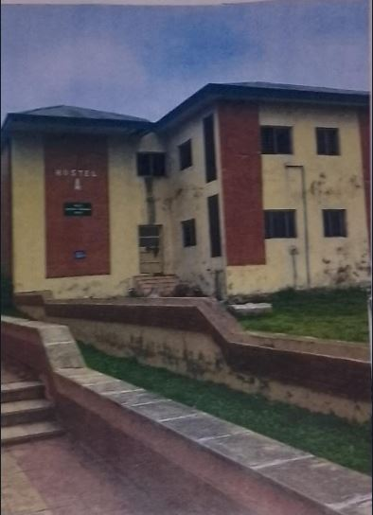

Plate 1.3: Front view of Kwara State University of Ilorin (KWASU)
Sources: Researcher’s Field Work, 2025.
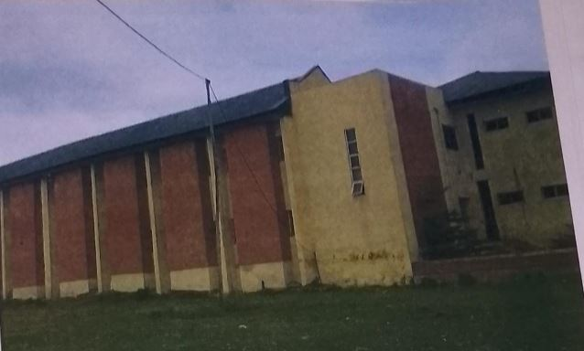

Plate 1.4: Side view of Kwara State University of Ilorin (KWASU)
Sources: Researcher’s Field Work, 2025.
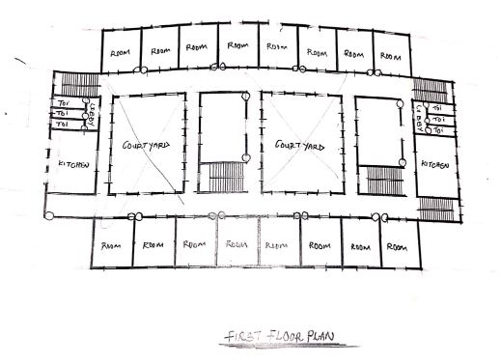

Figure 1.3: Floor plan of Kwara State University of Ilorin (KWASU)
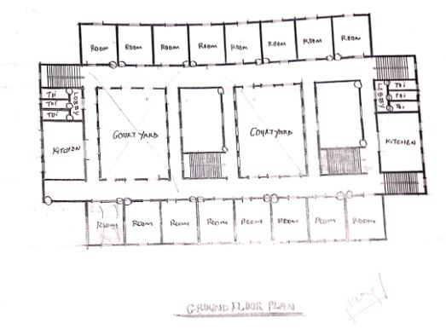
Sources: Researcher’s Field Work, 2025.

Figure 1.4: Floor plan of Kwara State University of Ilorin (KWASU)
Sources: Researcher’s Field Work, 2025.
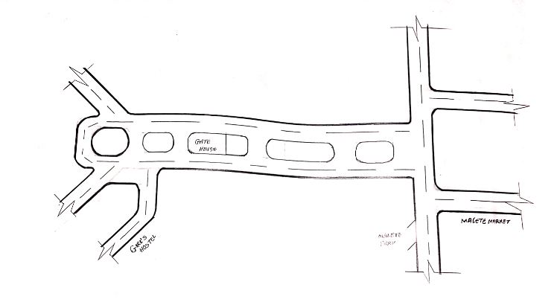

Figure 1.5: Location plan of Kwara State University of Ilorin (KWASU)
Sources: Researcher’s Field Work, 2025.
3.3 CASE STUDY THREE
OSUN STATE UNIVERSITY (UNIOSUN)
Description: is a multi-campus university established by the Osun State Government in 2006. It aims to provide high-quality education and promote academic excellence across various fields of study. The university operates a collegiate system, which includes several campuses spread across different towns in Osun State. Each campus specializes in specific academic disciplines, contributing to a comprehensive educational experience.
Location: Osun State University operates from multiple campuses located in different towns within Osun State, Nigeria:
Osogbo Campus:
Located in the state capital, Osogbo, this is the main administrative center of the university. It houses the university's central administration and some academic departments.
Okuku Campus:
Situated in Okuku, this campus hosts the College of Management and Social Sciences. It focuses on programs related to business, economics, and social sciences.
Ikire Campus:
Located in Ikire, this campus is home to the College of Humanities and Culture. It offers programs in arts, languages, and cultural studies.
Ipetu-Ijesa Campus:
Found in Ipetu-Ijesa, this campus hosts the College of Information and Communication Technology, focusing on ICT-related programs.
Ifetedo Campus:
Situated in Ifetedo, this campus houses the College of Law, providing legal education and research.
Ejigbo Campus:
Located in Ejigbo, this campus is dedicated to the College of Agriculture, focusing on agricultural sciences and related disciplines.
Osun State University, with its multi-campus structure, ensures accessibility to quality education across various regions within Osun State, fostering academic growth and community development.
Collegiate System:
UNIOSUN has multiple campuses, each dedicated to specific faculties and departments. This system allows for specialized education and focused development in different academic areas.
The main campuses include the Osogbo Campus (main administrative center), Okuku Campus (College of Management and Social Sciences), Ikire Campus (College of Humanities and Culture), Ipetu-Ijesa Campus (College of Information and Communication Technology), Ifetedo Campus (College of Law), and Ejigbo Campus (College of Agriculture).
Facilities:
The university provides modern facilities, including well-equipped libraries, laboratories, lecture halls, and ICT centers to support academic activities.
There are also provisions for student accommodation, recreational facilities, and health services.
MERITS
- Quality Education: Osun State University (UNIOSUN) offers a variety of undergraduate and postgraduate programs across different fields, ensuring a comprehensive educational experience.
- Experienced Faculty: The university boasts a team of experienced and qualified lecturers who are dedicated to imparting knowledge and skills to students.
- Modern Facilities: The university is equipped with modern facilities, including well-equipped laboratories, libraries, and lecture halls, enhancing the learning environment.

DEMERITS
- Funding Challenges: Like many public universities in Nigeria, UNIOSUN may face funding challenges, impacting the maintenance and development of facilities and resources.
- Resource Constraints: Limited resources and infrastructure may affect the quality of research and practical learning experiences.
- Limited Urban Amenities: Compared to larger cities, Osogbo may have limited urban amenities and entertainment options, which could be a downside for some students.
- Healthcare Access: Access to advanced healthcare facilities may be limited, necessitating travel to other regions for specialized medical services.

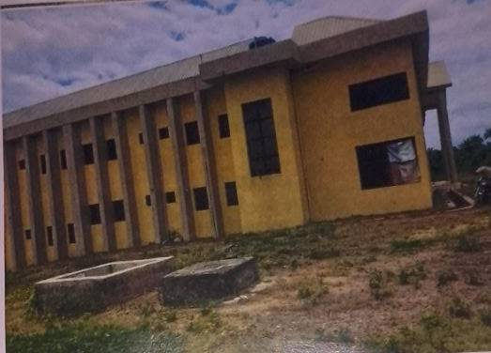

Plate 1.5: Side view of University of Osun State (UNIOSUN)
Sources: Researcher’s Field Work, 2025.

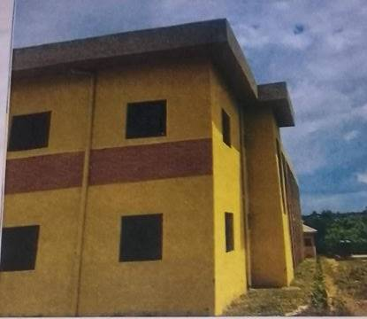

Plate 1.6: Back view of University of Osun State (UNIOSUN)
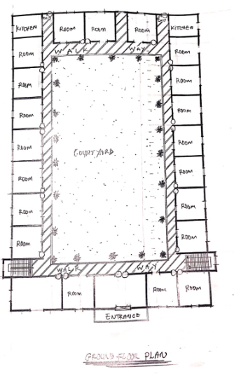
Sources: Researcher’s Field Work, 2025.

Figure 1.6: Upper Floor Plan of University of Osun State (UNIOSUN)
Sources: Researcher’s Field Work, 2025.
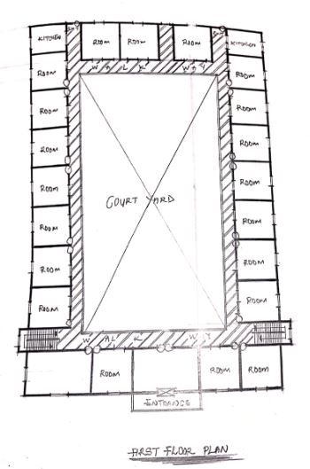

Figure 1.7: Ground Floor Plan of University of Osun State (UNIOSUN)
Sources: Researcher’s Field Work, 2025.

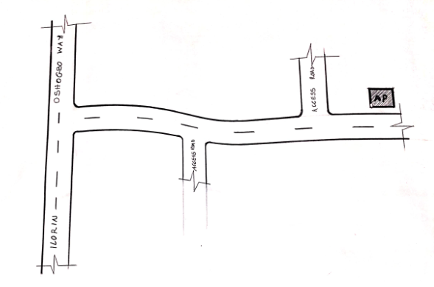

Figure 1.8: Location Plan of University of Osun State (UNIOSUN)
Sources: Researcher’s Field Work, 2025.
3.4 ONLINE CASE STUDY ONE
STANFORD UNIVERSITY, CALIFORNIA
Description: Stanford University is a prestigious private research university located in Stanford, California, approximately 35 miles south of San Francisco and 20 miles north of San Jose, in the heart of Silicon Valley. The campus spans over 8,000 acres, making it one of the largest university campuses in the United States.
Stanford is known for its rigorous academic programs, cutting-edge research, and strong emphasis on entrepreneurship and innovation. It offers a wide range of undergraduate, graduate, and professional degrees across seven schools: the School of Humanities and Sciences, the School of Engineering, the School of Earth, Energy & Environmental Sciences, the Graduate School of Business, the Stanford Law School, the School of Medicine, and the Graduate School of Education. The university has a vibrant campus life, with numerous student organizations, athletic programs, and cultural events. Its notable alumni include numerous Nobel laureates, tech industry leaders, and influential figures in various fields.
Location: Stanford, California, USA. Situated in the heart of Silicon Valley, approximately 35 miles south of San Francisco and 20 miles north of San Jose.
MERITS
Academic Excellence: Consistently ranked among the top universities in the world. Strong emphasis on interdisciplinary education and research.
Research and Innovation: Home to numerous research centers and institutes. Significant contributions to various fields, including computer science, engineering, business, and medicine.
Entrepreneurial Ecosystem: Close ties with Silicon Valley, fostering a strong entrepreneurial culture. Many successful startups and tech companies have origins at Stanford.
Renowned Faculty: Faculty includes numerous Nobel laureates, Turing Award winners, and members of prestigious academic societies.
Diverse Programs: Offers a wide range of undergraduate, graduate, and professional degrees across seven schools:
- School of Humanities and Sciences
- School of Engineering
- School of Earth, Energy & Environmental Sciences
- Graduate School of Business
- Stanford Law School
- School of Medicine
- Graduate School of Education
- Vibrant Campus Life:
Extensive student organizations, athletic programs, and cultural events. Facilities include state-of-the-art laboratories, libraries, and recreational centers.

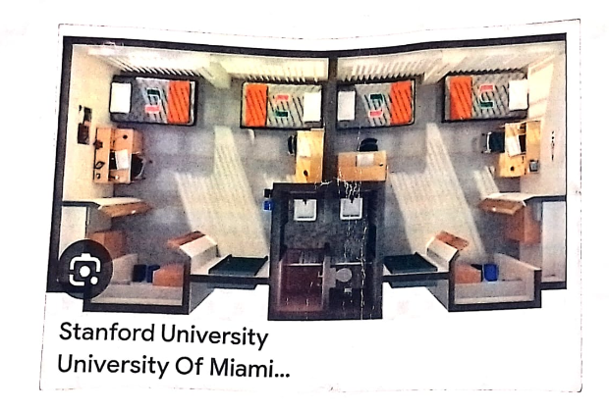

Plate 1.7: Stanford University, California
Sources: Google Map

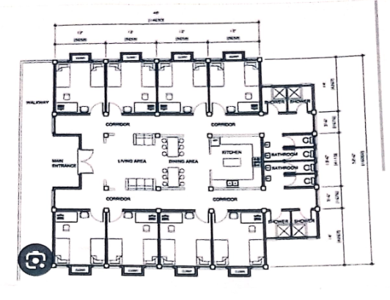

Figure 1.9: Floor Plan of Stanford University, California
Sources: Google Map

3.5 ONLINE CASE STUDY TWO
MESARYA TECHNICAL UNIVERSITY, NORTH DAKOTA
Description: Mesarya Technical University is located in Lefkoşa (Nicosia), the capital city of Northern Cyprus. The university offers a variety of programs focused on engineering, technology, and applied sciences. It aims to provide high-quality education and research opportunities, fostering innovation and practical skills in its students.
Location: Being in the capital city, the university benefits from a central location with access to various amenities, cultural sites, and business opportunities.
MERIT
- Focus on Technical Fields: The emphasis on engineering, technology, and applied sciences aligns well with current industry demands, potentially increasing employability for graduates.
- High-Quality Education: The university aims to offer strong educational programs and research opportunities, which can be beneficial for students seeking advanced knowledge and skills.
DEMERITS
- Limited Global Recognition: As a relatively new or less widely known institution, it may not have the same level of international recognition or reputation as more established universities.
- Political and Economic Instability: The political situation in Northern Cyprus can impact the university environment and opportunities for students, including internships and international collaborations.
- Limited Program Variety: The focus on technical fields may limit options for students interested in other areas of study.

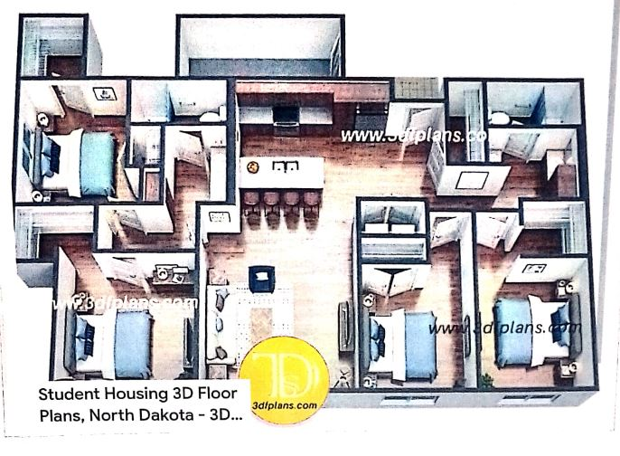

Plate 1.8: Mesarya Technical University, North Dakota
Sources: Google Map

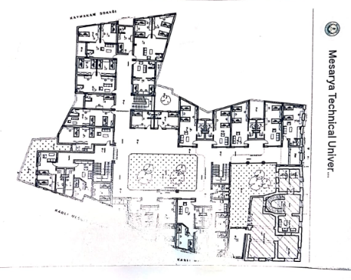

Figure 2.1: Floor Plan of Mesarya Technical University, North Dakota
Sources: Google Map
3.6 Architecturally related merits and demerits of girls hostel
When designing a girls' hostel, several architectural merits and demerits should be considered:
MERITS:
Safety and Security: Proper design can enhance safety with features like secure entry points, surveillance, and well-lit common areas.
Privacy: Thoughtful layout ensures adequate privacy for each resident, with features like private rooms or partitions.
Community Spaces: Common areas like lounges, study rooms, and kitchens encourage social interaction and a sense of community.
Accessibility: Accessible design ensures all facilities are usable by people of all abilities, including ramps and elevators.
Sustainability: Incorporating eco-friendly materials and energy-efficient systems can make the hostel more environmentally friendly.

DEMERITS:
Space Constraints: Limited space can lead to smaller rooms and common areas, impacting comfort and functionality.
Noise Issues: Poor acoustic design can result in noise disturbances, affecting residents' ability to study or rest.
Maintenance: High-use areas require regular upkeep, which can be challenging and costly to manage.
Cultural Sensitivity: Designing for a diverse group may require careful consideration of cultural and personal preferences, which can be complex.
Cost: High-quality design and materials can be expensive, and budget constraints might limit the implementation of some features.
3.7 DEDUCTION FROM CASE STUDY
From the case studies carried out in the course of research into the project, following points are realized to be relevant information and ideas that should be taken into consideration from the inception of the design to be able to achieve a viable design.
- The choice of location is very crucial for easy accessibility.
- The building must be in its totality reflect the essence attribute and functions of the hostel.
- Proper zoning should be done.
- The building plan should be based on modular system.
- Staircases should be strategically located.
- The site should be properly planned.
CHAPTER FOUR
STUDY AREA AND PROJECT SITE
4.1 Introduction of study area/site selection of girl’s hostel
When introducing a study area or selecting a site for a girls' hostel, consider the following key elements:
Location: Choose a location that is safe, accessible, and convenient for the students. Proximity to educational institutions, public transportation, and essential services is crucial.
Safety and Security: Ensure the site is in a safe neighborhood with low crime rates. The hostel should have robust security measures, including surveillance, lighting, and secure entry points.
Amenities and Infrastructure: Evaluate the availability of necessary amenities such as clean water, electricity, internet, and recreational facilities. Good infrastructure is essential for the comfort and well-being of the residents.
Space and Design: The site should offer adequate space for living quarters, common areas, and administrative functions. The design should promote a positive living environment, with well-ventilated rooms and access to natural light.
Budget: Consider the cost of the site and its development. Ensure it fits within the budget while meeting all requirements for a comfortable and functional hostel.
Regulations and Compliance: Check local regulations and building codes to ensure the site complies with legal standards and safety requirements.
Community Impact: Assess the potential impact of the hostel on the local community. Ensure that it integrates well with the surrounding area and does not disrupt local life.
4.1.1 Site location/ descriptions/ criteria of girls hostel
When selecting a site for a girls' hostel, consider the following criteria and descriptions:
Safety and Security:
Location: Choose a site in a safe neighborhood, ideally with low crime rates.
Security Features: Ensure the building has security measures such as CCTV cameras, security personnel, and secure entry points.
Accessibility:
Proximity to Campus: Ideally, the hostel should be close to the educational institution to minimize travel time.
Transportation Links: Ensure easy access to public transport and main roads.
Facilities:
Basic Amenities: The hostel should have essential facilities like clean bathrooms, kitchenettes, and study areas.
Additional Features: Consider including recreational areas, laundry facilities, and Wi-Fi.
Health and Hygiene:
Cleanliness: Regular cleaning schedules and proper waste management systems are crucial.
Ventilation and Lighting: Ensure good natural light and ventilation to promote a healthy environment.
Capacity and Accommodation:
Room Size and Layout: Provide a comfortable living space with adequate privacy, such as single or shared rooms.
Common Areas: Include communal areas for relaxation and socializing.
Legal and Regulatory Compliance:
4.1.2 Site analysis/inventory of girls hostel
A site analysis or inventory for a girls' hostel involves evaluating various aspects of the site to ensure it meets the needs of its occupants and complies with regulations. Here's a basic framework for conducting such an analysis:
1. Site Location and Context
Address and Geography: Note the exact location and geographical features.
Accessibility: Assess access to public transportation, major roads, and proximity to schools, colleges, or workplaces.
Surroundings: Evaluate the safety and amenities in the surrounding area (e.g., hospitals, markets, recreational facilities).

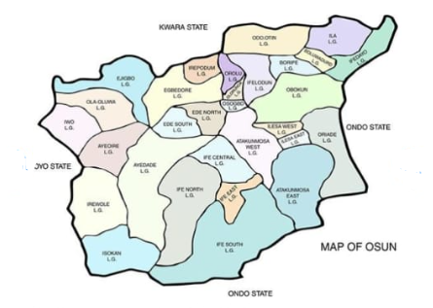

Plate 1.9: Osun State Map
Sources: Google Map

2. Building Structure
Condition: Inspect the overall condition of the building, including structural integrity.
Design and Layout: Review the architectural design, including the layout of rooms, common areas, and facilities.
Compliance: Ensure the building meets local zoning laws, building codes, and safety regulations.
3. Internal Facilities
Accommodation: Check the size and condition of individual rooms, including beds, furniture, and ventilation.
Bathrooms and Toilets: Assess the number, condition, and cleanliness of bathrooms and toilets.
Common Areas: Evaluate common areas like lounges, study rooms, and kitchens for functionality and comfort.
Security: Review security measures, such as locks, surveillance cameras, and emergency exits.
4. Utilities and Services
Electricity: Ensure adequate electrical supply and safety of wiring and fixtures.
Water Supply: Verify the availability and quality of water, and check plumbing systems.
Internet: Assess the quality and availability of internet connectivity.
Heating/Cooling: Evaluate heating and cooling systems for comfort and efficiency.
5. Health and Safety
Fire Safety: Check for fire alarms, extinguishers, and clear evacuation routes.
Hygiene: Assess cleanliness and maintenance of the hostel.
First Aid: Ensure availability of first aid kits and medical support.
6. Management and Administration
Staff: Review the roles and efficiency of hostel management and staff.
Policies: Evaluate policies related to curfews, guest access, and disciplinary measures.
Resident Feedback: Gather feedback from current residents regarding their experiences and any concerns.
4.1.3 Geographical/climatic of girls hostel in osun state university
Osun State University, located in Osun State, Nigeria, is situated in a region characterized by a tropical climate. The area experiences a mix of wet and dry seasons, with a significant amount of rainfall occurring from April to October. The average temperature typically ranges between 25°C and 32°C (77°F and 90°F).
The geographical features include a mix of flat plains and gently undulating terrain. The campus and hostels are likely to be influenced by the local climate, with conditions being relatively warm and humid during the rainy season and drier during the harmattan season, which occurs between November and March.
4.1.4 Analyses of the immediate environmental conditions of the site of girls hostel of osun state
To analyze the immediate environmental conditions of the site for a girls' hostel in Osun State, Nigeria, consider the following factors:

Climate and Weather Patterns:
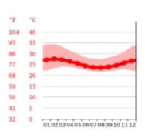
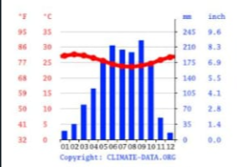

Plate 2.1: Osun State Climatic Data Plate 2.2: Osun State Climatic Data
Sources: Google Map Sources: Google Map

Temperature: Assess average temperatures and seasonal variations.
Rainfall: Evaluate the amount and distribution of rainfall throughout the year.
Humidity: Determine humidity levels as they affect comfort and building materials.
Topography:
Landform: Analyze the site’s elevation, slope, and natural features. Flat or gently sloping land is ideal for construction.
Drainage: Check for natural drainage patterns to prevent flooding and erosion.
Soil Conditions:
Soil Type: Identify soil composition and stability, which impact foundation design.
Soil Drainage: Evaluate drainage characteristics to avoid waterlogging.
Vegetation and Flora:
Existing Vegetation: Note any trees, shrubs, or other plant life that might affect construction or require preservation.
Landscaping: Plan for future landscaping to ensure it complements the hostel environment.
Access and Infrastructure:
Transportation: Examine access roads and public transportation options for ease of commuting.
Utilities: Ensure availability of essential services like water, electricity, and waste disposal.

Environmental Impact:
Local Ecosystem: Assess potential impacts on local wildlife and plant species.
Sustainability: Consider implementing green building practices to minimize environmental impact.
4.2 STUDENT ANALYSIS AND DESIGN CRITERIA
4.2.1 Student goals developed by student designer of girls hostel
When a student designer is working on a girls' hostel, their goals might include:
Safety and Security: Designing spaces that prioritize the safety and security of residents, including secure entry points and well-lit common areas.
Comfort and Functionality: Ensuring that rooms and communal areas are comfortable, functional, and meet the daily needs of students, such as study areas, relaxation spaces, and sufficient storage.
Community Building: Incorporating spaces and features that encourage social interaction and community-building among residents, such as lounges, kitchens, or event spaces.
Sustainability: Implementing eco-friendly practices and materials to create a sustainable living environment.
Privacy and Personal Space: Balancing communal living with adequate privacy and personal space for each resident.
Functionality: Designing layouts that make efficient use of space while providing comfort and functionality.
4.2.2 Analyses privacy and personal space of student
Analyzing privacy and personal space for students in a hostel involves examining several key aspects:
Room Layout and Design:
Private Rooms: Single or double occupancy rooms should offer sufficient space for personal belongings and allow students to study and relax privately.
Partitioning: In shared rooms, partitions or screens can provide a sense of separation and privacy.
Common Areas:
Designated Spaces: Common areas like lounges and kitchens should be designed to be shared but still offer some level of personal space for individual activities.
Noise Control: Acoustic treatments can help manage noise levels in common areas, enhancing privacy and comfort.
Bathroom Facilities:
Individual Bathrooms: Private bathrooms or semi-private setups (shared by a small number of students) can enhance privacy and reduce the discomfort of shared facilities.
Hygiene and Maintenance: Ensuring cleanliness and regular maintenance of bathrooms is crucial for privacy and personal comfort.
Storage Solutions:
Personal Storage: Adequate storage options, like wardrobes and drawers, help students keep their belongings secure and out of sight, contributing to a sense of personal space.
Rules and Policies:
Quiet Hours: Implementing quiet hours or study zones can help respect personal time and reduce disruptions.
Guest Policies: Clear policies about guest access can help maintain privacy within the rooms and communal areas.
Access Control:
Secure Entry: Secure entry systems for rooms and the building can help ensure that only authorized individuals have access, enhancing personal security.
4.2.3 Functional/spatial criteria of girls hostel
Designing a girls' hostel involves considering several functional and spatial criteria to ensure safety, comfort, and efficient use of space. Here are some key criteria:
Safety and Security:
Secure entrances with controlled access (e.g., key cards, security personnel).
Adequate lighting in common areas and pathways.
Emergency exits and fire safety measures.
Privacy and Comfort:
Private or semi-private rooms for students, with adequate space for personal belongings.
Common areas for social interaction and relaxation.
Well-ventilated and well-lit rooms.

Accessibility:
Accessibility features for people with disabilities, including ramps, elevators, and accessible restrooms.
Clear signage for ease of navigation.
Sanitation and Hygiene:
Clean, well-maintained restrooms and showers.
Laundry facilities and adequate waste disposal systems.
Functionality:
Study areas with sufficient lighting and space.
Kitchen facilities or dining areas for meal preparation.
Storage spaces for personal items and shared resources.
Community and Interaction:
Common rooms or lounges to foster social interaction.
Spaces for activities and group events.
4.2.4 Appraisal of proposed schemes in the spaces, size and relationships of girls hostel
When appraising proposed schemes for a girls' hostel, you should consider several factors related to space, size, and relationships within the design. Here’s a general framework:
Space Efficiency:
Private vs. Shared Spaces: Evaluate the balance between private rooms and shared spaces. Ensure that private rooms provide sufficient personal space while shared areas foster community and interaction.
Common Areas: Common spaces like lounges, study areas, and kitchens should be appropriately sized to accommodate all residents comfortably.
Size and Layout:
Room Size: Assess whether individual rooms meet the minimum space requirements for comfortable living, including space for personal belongings, study, and relaxation.
Circulation: Ensure that the layout allows easy movement throughout the building, with clear pathways and minimal obstructions.
Functionality:
Amenities: Check if the proposed amenities (e.g., laundry rooms, bathrooms) are adequate and conveniently located.
Accessibility: Evaluate if the design is accessible to individuals with disabilities, including ramps, elevators, and accessible restrooms.
Privacy and Security:
Security Features: Ensure that security measures (e.g., controlled access, surveillance) are integrated into the design to ensure residents' safety.
Privacy: Assess how the design supports privacy for residents in both their personal rooms and shared spaces.
Environmental Considerations:
Natural Light and Ventilation: Ensure that rooms and common areas have adequate natural light and ventilation.
Sustainability: Assess the design for energy efficiency and sustainability features.
4.2.5 Equipment and operational and performance requirements of girls hostel
The equipment and operational requirements for a girls' hostel typically include:
Equipment
Furniture:
Beds with comfortable mattresses
Study desks and chairs
Wardrobes or storage cabinets
Common room seating (sofas, chairs, tables)
Dining tables and chairs
Appliances:
Kitchen appliances (stove, refrigerator, microwave, toaster, etc.)
Laundry machines (washing machines, dryers)
Heating and cooling systems (air conditioners, heaters)
Fans and/or heaters
Lighting fixtures (bright and sufficient for study areas)
Security Equipment:
CCTV cameras
Fire alarms and extinguishers
Secure locks and safes

Sanitation:
Regular cleaning supplies (brooms, mops, cleaning agents)
Waste disposal bins and recycling containers
Water purifiers
Communication:
Intercom or telephone systems
Internet and Wi-Fi connectivity
Operational Requirements
Safety and Security:
Regular security checks and protocols
Emergency evacuation plans and drills
Maintenance of fire safety equipment
Staffing:
Hostel manager or warden
Housekeeping staff
Security personnel
Kitchen staff (if meals are provided)
Maintenance:
Routine inspection and repair of facilities
Regular cleaning schedules
Upkeep of appliances and furniture
Health and Hygiene:
Provision of first aid kits
Regular pest control
Maintenance of sanitary facilities
Administrative:
Registration and check-in/check-out processes
Management of fees and financial records
Coordination with local authorities and institutions

Compliance:
Adherence to local regulations and standards for hostels
Implementation of policies regarding behavior and conduct
These requirements ensure a safe, comfortable, and efficient environment for the residents.
4.2.6 Spatial allocation / schedule of accommodation of girls hostel
When planning the spatial allocation and schedule of accommodation for a girls' hostel, you'll want to consider several key factors:
Room Types and Sizes:
Single Rooms: For students requiring privacy.
Shared Rooms: Typically accommodating 2-4 students to foster community.
Dormitory Style: Larger, with multiple beds in a single room.
Common Areas:
Lounge Areas: For relaxation and socialization.
Study Rooms: Quiet spaces for academic work.
Kitchen and Dining Areas: For meals and cooking.
Laundry Facilities: Essential for daily life.
Administrative and Support Spaces:
Reception/Office: For management and security.
Medical Room: For minor health issues or emergencies.
Counseling Rooms: For mental health support.
Safety and Accessibility:
Emergency Exits: Clearly marked and accessible.
Fire Safety: Fire alarms, extinguishers, and evacuation plans.
Accessibility: For students with disabilities, ensuring all areas are accessible.
Schedule of Accommodation:
Check-in/Check-out Times: For new and departing students.
Visitor Hours: Regulated to ensure security and privacy.
Maintenance Schedule: Regular cleaning and repairs.
4.2.7 Functional relationship of girls hostel
A functional relationship of a girls' hostel typically refers to how various functions and responsibilities are organized and managed to ensure smooth operation and a positive living environment for residents. Here’s a breakdown of key components:
Administrative Functions: Includes hostel management, budgeting, and adherence to institutional policies. This often involves the warden or hostel manager.
Student Welfare: Addresses the needs and concerns of residents, including counseling services, grievance redressed, and activities for well-being.
Security and Safety: Ensures the safety of residents through security personnel, surveillance systems, and emergency protocols.
Housekeeping and Maintenance: Manages the cleanliness, repairs, and general upkeep of the hostel facilities.
Catering Services: Oversees meal planning, food preparation, and dining arrangements, including addressing dietary restrictions and preferences.
Discipline and Regulations: Implements rules and regulations to maintain order and address violations.
Events and Activities: Organizes cultural, recreational, and educational activities to enhance the residents' experience and foster community.
Health and Hygiene: Provides health services, including first aid, medical consultations, and maintenance of hygiene standards.
4.2.8 Conceptual development of girls hostel
Creating a conceptual development plan for a girls' hostel involves several key components:
Objective: Define the purpose and goals of the hostel. Is it for students, working professionals, or a different group? The objective will guide all other aspects.
Location and Layout: Choose a location that's safe, accessible, and near key amenities or institutions (like universities). The layout should include common areas, dormitories, study rooms, and possibly recreational facilities.
Safety and Security: Incorporate robust security measures such as surveillance cameras, secure entry systems, and well-lit surroundings. Ensure there are protocols for emergencies.
Amenities: Plan for essential amenities such as Wi-Fi, laundry facilities, a cafeteria or kitchen, and possibly a gym. Include spaces for relaxation and social interaction.
Design and Comfort: Ensure the hostel has a welcoming and comfortable design. This includes well-ventilated rooms, adequate lighting, and ergonomic furniture.
Rules and Regulations: Establish clear rules for residents, including policies on visitors, noise levels, and maintenance of communal areas.
Sustainability: Consider eco-friendly practices such as energy-efficient lighting, water-saving fixtures, and waste management systems.
Budget and Funding: Develop a budget that covers construction, furnishing, staffing, and maintenance. Explore funding options or partnerships if necessary.
Community Engagement: Involve potential residents in the planning process to ensure their needs and preferences are considered.
Management and Staffing: Plan for hiring staff to manage the hostel, including administrative personnel, security, and maintenance workers.

CHAPTER FIVE
APPROACH TO THE DESIGN/ DESIGN REALIZATION
5.1 CONSTRUCTION METHODOLOGY AND MATERIALS DESIRED BY CLIENTS:
CONSTRUCTION METHODOLOGY:
Sustainable Practices: Clients often prefer methodologies that emphasize sustainability, including energy-efficient construction, reduced carbon footprints, and the use of eco-friendly materials.
Modular Construction: This approach can speed up the building process, reduce waste, and improve quality control by assembling parts in a factory setting before transporting them to the site.
Lean Construction: Aims to maximize value by minimizing waste and improving efficiency through continuous improvement and close collaboration among all stakeholders.
Smart Construction: Incorporates advanced technologies like Building Information Modeling (BIM), prefabrication, and automation to enhance design accuracy, project management, and construction efficiency.
MATERIALS AND FINISHES:
High-Quality Materials: Clients often desire durable and aesthetically pleasing materials such as natural stone, high-grade wood, and advanced composites for longevity and visual appeal.
Eco-Friendly Finishes: Sustainable finishes like low-VOC paints, recycled glass tiles, and renewable resource-based flooring are preferred to minimize environmental impact.
Energy-Efficient Solutions: Materials and finishes that contribute to better insulation, such as high-performance windows, reflective roofing, and energy-efficient HVAC systems, are commonly desired.
5.2 SERVICES REQUIRED
SERVICES REQUIRED IN BUILDING CONSTRUCTION:
CIRCULATION:
Design: Ensures smooth and efficient movement within the building, including hallways, staircases, elevators, and ramps.
Accessibility: Includes features like ramps and wide doorways to accommodate all users, including those with disabilities.
VENTILATION:
Natural Ventilation: Utilizes windows, vents, and architectural design to promote airflow and reduce the need for mechanical systems.
Mechanical Ventilation: Includes systems like HVAC units, exhaust fans, and air handling units to regulate indoor air quality and temperature.
LIGHTING:
Ambient Lighting: Provides general illumination throughout the space.
Task Lighting: Focused lighting for specific activities, such as workstations or reading areas.
Accent Lighting: Highlights architectural features or artworks.
PLUMBING AND ELECTRICAL INSTALLATION:
Plumbing: Includes water supply systems, drainage, and fixtures like sinks, toilets, and showers.
Electrical Installation: Encompasses wiring, outlets, switches, and lighting fixtures, as well as safety systems like circuit breakers and grounding.
ACOUSTICS:
Soundproofing: Uses materials and design strategies to reduce noise transmission between rooms and from external sources.
Acoustic Treatment: Incorporates elements like acoustic panels and sound-absorbing materials to improve sound quality and minimize echoes.
WASTE DISPOSAL:
Internal Systems: Includes trash and recycling bins, disposal units, and waste separation facilities.
External Systems: Covers site-wide waste management solutions, including collection and disposal services.
FIRE PROTECTION:
Detection Systems: Includes smoke detectors, heat sensors, and fire alarms.
Suppression Systems: Encompasses sprinklers, fire extinguishers, and standpipe systems.
Fire Safety Design: Involves fire-resistant materials, fire exits, and safe evacuation routes.
EXTERNAL WORKS:
Landscaping: Includes planting, garden design, and outdoor recreational areas.
Paving: Covers driveways, walkways, and parking areas.
Fencing and Gates: Provides security and defines property boundaries.
5.3 ENVIRONMENTAL CONDITIONS TO BE ACHIEVED
SAFETY AND SECURITY:
- Secure entry and exit points with security personnel and surveillance cameras.
- Well-lit corridors, common areas, and outdoor spaces.
- Emergency contact systems and regular safety drills.
CLEANLINESS AND HYGIENE:
- Regular cleaning schedules for rooms, bathrooms, and common areas.
- Adequate waste disposal systems.
- Access to clean water and sanitation facilities.
COMFORTABLE LIVING SPACES:
- Proper ventilation and natural light in rooms.
- Temperature control (heating and cooling systems as needed).
- Comfortable beds, furniture, and personal storage space.
HEALTH AND WELL-BEING:
- Medical facilities or access to nearby healthcare services.
- Regular health check-ups and mental health support.
- Healthy and nutritious meals provided in a clean dining area.
PRIVACY:
- Provision of private or semi-private rooms.
- Designated quiet hours for rest and study.
- Respect for personal space and belongings.
STUDY AND RECREATION:
- Study rooms or areas with adequate lighting and internet access.
- Recreational facilities like common rooms, gyms, and outdoor spaces.
- Organized social and cultural activities.
ACCESSIBILITY:
- Facilities and services accessible to all, including those with disabilities.
- Easy access to transportation and essential services.
COMMUNITY AND SUPPORT:
- Encouraging a sense of community through events and activities.
- Availability of counseling and support services.
- Clear communication channels for feedback and concerns.
5.4 PERFORMANCE STANDARD
SAFETY AND SECURITY:
- 24/7 security with trained personnel and functional surveillance systems.
- Regular safety drills and emergency response plans in place.
- Secure entry and exit protocols with visitor management systems.
CLEANLINESS AND HYGIENE:
- Daily cleaning of rooms, bathrooms, and common areas.
- Regular pest control measures.
- Availability of clean drinking water and hygienic food handling practices.
MAINTENANCE:
- Prompt repair and maintenance of infrastructure and facilities.
- Regular inspection of electrical, plumbing, and HVAC systems.
- Well-maintained common areas and recreational facilities.
HEALTH AND WELL-BEING:
- Regular health check-ups and on-site medical assistance.
- Availability of mental health support and counseling services.
- Nutritious and balanced meals served in a clean dining area.
COMFORT AND LIVING CONDITIONS:
- Adequate room ventilation and lighting.
- Comfortable and functional furniture and bedding.
- Noise control measures to ensure a quiet and restful environment.
ACADEMIC SUPPORT:
- Availability of well-equipped study areas with internet access.
- Quiet hours for study and rest.
- Access to academic resources and support services.
RESIDENT SATISFACTION:
- Regular feedback collection and addressing of resident concerns.
- Organized social, cultural, and recreational activities.
- Supportive community environment fostering interpersonal relationships.

OPERATIONAL EFFICIENCY:
- Efficient administrative processes for admissions, fee collection, and resident management.
- Transparent communication of rules, regulations, and policies.
- Adequate staffing levels and training for hostel staff.
ENVIRONMENTAL SUSTAINABILITY:
- Implementation of energy-saving measures and waste management practices.
- Use of eco-friendly cleaning products and practices.
- Promotion of sustainable living habits among residents.
COMPLIANCE AND STANDARDS:
- Adherence to local and national regulations for hostel management.
- Regular audits and inspections to ensure compliance with health, safety, and operational standards.
5.5 LEGAL ISSUES AND PLANNING REGULATIONS
LEGAL ISSUES:
REGISTRATION AND LICENSING:
- Hostels must be registered with relevant local authorities.
- Obtain necessary licenses and permits for operation, which may include fire safety, health, and sanitation clearances.
BUILDING AND SAFETY CODES:
- Compliance with local building codes and standards for construction, electrical, plumbing, and HVAC systems.
- Adherence to fire safety regulations, including fire exits, alarms, extinguishers, and evacuation plans.
ZONING LAWS:
- Ensure the hostel location complies with zoning regulations that permit residential or lodging facilities.
- Restrictions on commercial activities within residential zones may apply.
HEALTH AND HYGIENE REGULATIONS:
- Compliance with local health department regulations for sanitation, food safety, and waste disposal.
- Regular inspections and health certifications.
LABOR LAWS:
- Adherence to labor laws for hiring and managing hostel staff, including fair wages, working hours, and employee rights.
- Tenant Rights and Responsibilities:
- Clear agreements outlining the rights and responsibilities of both the hostel management and residents.
- Procedures for addressing grievances and disputes.
SECURITY AND PRIVACY:
- Compliance with data protection and privacy laws for managing resident information.
- Implementation of adequate security measures to protect residents and their belongings.

5.6 PLANNING REGULATIONS:
LOCATION AND ACCESSIBILITY:
- Hostels should be located in safe, accessible areas with proximity to educational institutions, transportation, and essential services.
- Consideration of the impact on the local community and environment.
INFRASTRUCTURE REQUIREMENTS:
- Adequate infrastructure for water supply, sewage disposal, electricity, and waste management.
- Provision of facilities for disabled residents in compliance with accessibility regulations.
DESIGN AND CAPACITY:
- Compliance with regulations on room size, occupancy limits, and space utilization.
- Adequate common areas, recreational facilities, and emergency exits.
ENVIRONMENTAL IMPACT:
- Adherence to environmental regulations related to waste management, energy consumption, and green building practices.
- Implementation of sustainable practices and materials in construction and operation.

EMERGENCY PREPAREDNESS:
- Compliance with regulations for emergency preparedness, including disaster management plans and safety drills.
- Availability of first aid facilities and trained personnel.
5.7 BEHAVIORAL PATTERN AND CONSIDERATION
BEHAVIORAL PATTERNS:
RESPECT AND TOLERANCE:
- Encourage mutual respect among residents, regardless of cultural, religious, or personal differences.
- Promote tolerance and understanding of diverse perspectives and lifestyles.
COMMUNITY LIVING:
- Foster a sense of community and belonging through group activities and social events.
- Encourage residents to participate in communal responsibilities like cleaning shared spaces.
PRIVACY AND PERSONAL SPACE:
- Respect for personal privacy and space, including quiet hours and boundaries.
- Awareness and consideration of others' needs for solitude and study time.
CONFLICT RESOLUTION:
- Implement clear procedures for addressing and resolving conflicts.
- Encourage open communication and mediation to resolve disputes amicably.
STUDY HABITS:
- Promote an environment conducive to study, with designated quiet hours and study areas.
- Support residents' academic pursuits by minimizing noise and distractions.
SOCIAL INTERACTION:
- Encourage positive social interactions and friendships among residents.
- Provide opportunities for group activities, sports, and cultural events to build camaraderie.
RESPONSIBILITY AND ACCOUNTABILITY:
- Encourage personal responsibility for one's actions and shared responsibilities within the hostel.
- Implement rules and consequences to ensure accountability and fairness.
5.8 CONSIDERATIONS
CULTURAL SENSITIVITY:
- Be aware of and sensitive to the cultural backgrounds of all residents.
- Celebrate diverse cultural events and traditions to foster inclusivity.
MENTAL HEALTH AND WELL-BEING:
- Provide access to mental health resources and counseling services.
- Encourage a supportive environment where residents feel comfortable seeking help.
SAFETY AND SECURITY:
- Emphasize the importance of safety measures and protocols.
- Foster a culture where residents look out for each other's safety and report suspicious activities.
INCLUSIVITY:
- Ensure all residents feel included and valued, regardless of differences.
- Address any instances of discrimination or exclusion promptly and effectively.
PERSONAL DEVELOPMENT:
- Encourage participation in personal development programs, workshops, and extracurricular activities.
- Support residents in developing life skills, leadership qualities, and independence.
HEALTHY LIVING:
- Promote healthy living habits, including balanced nutrition, exercise, and adequate rest.
- Provide facilities and opportunities for physical activities and wellness programs.
ENVIRONMENTAL RESPONSIBILITY:
- Encourage sustainable practices such as recycling, conserving energy, and reducing waste.
- Educate residents on the importance of environmental stewardship.
COMMUNICATION:
- Maintain open and transparent communication between hostel management and residents.
- Provide channels for residents to voice concerns, suggestions, and feedback.

APPENDICES
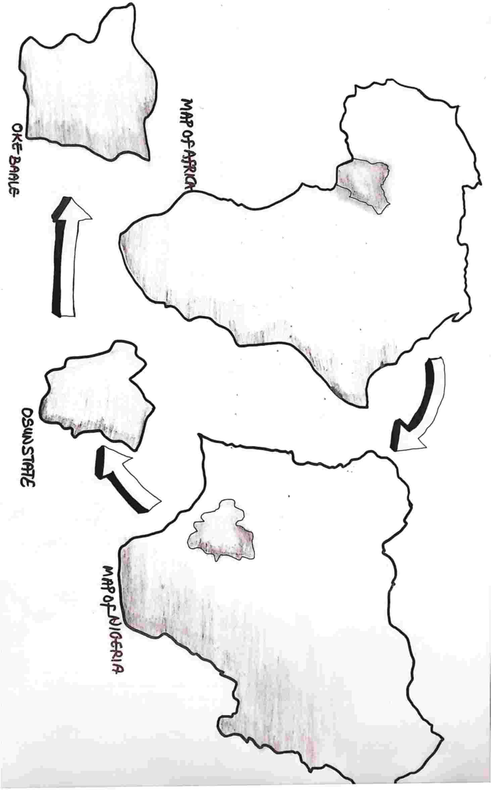

Appendix 1: Geographical Map of the Project

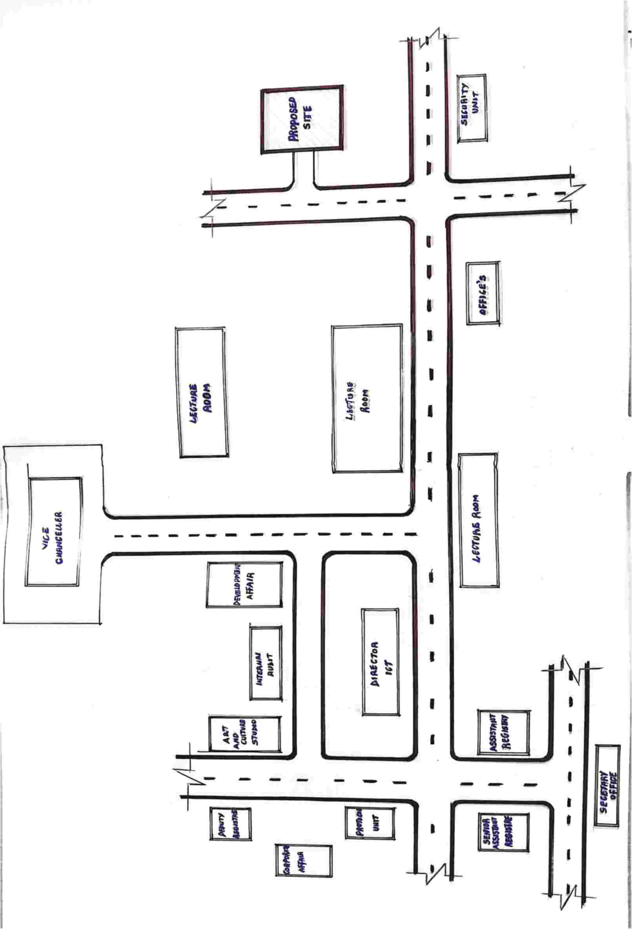

Appendix 2: Location Plan of the Project


Appendix 3: Site Inventory of the Project

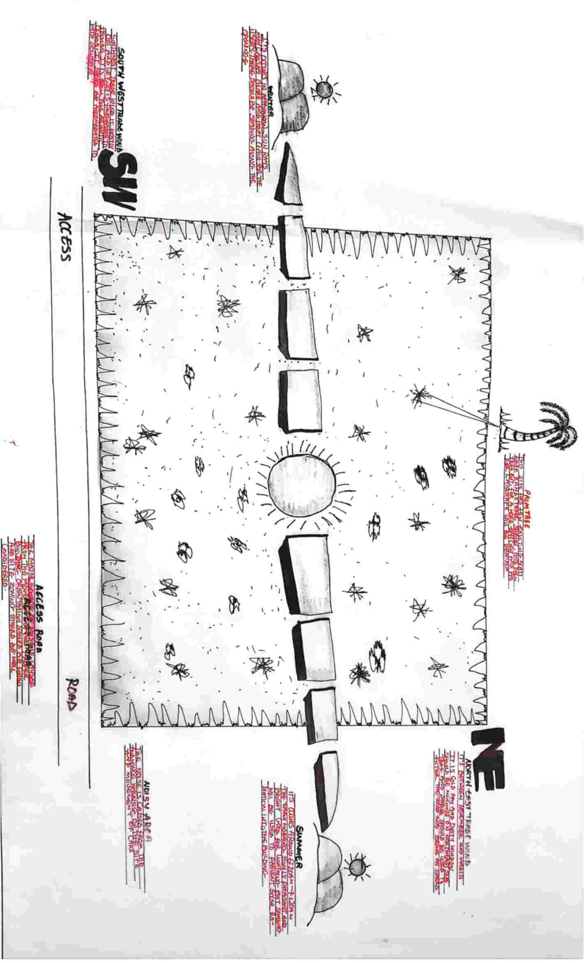

Appendix 4: Site Analysis of the Project
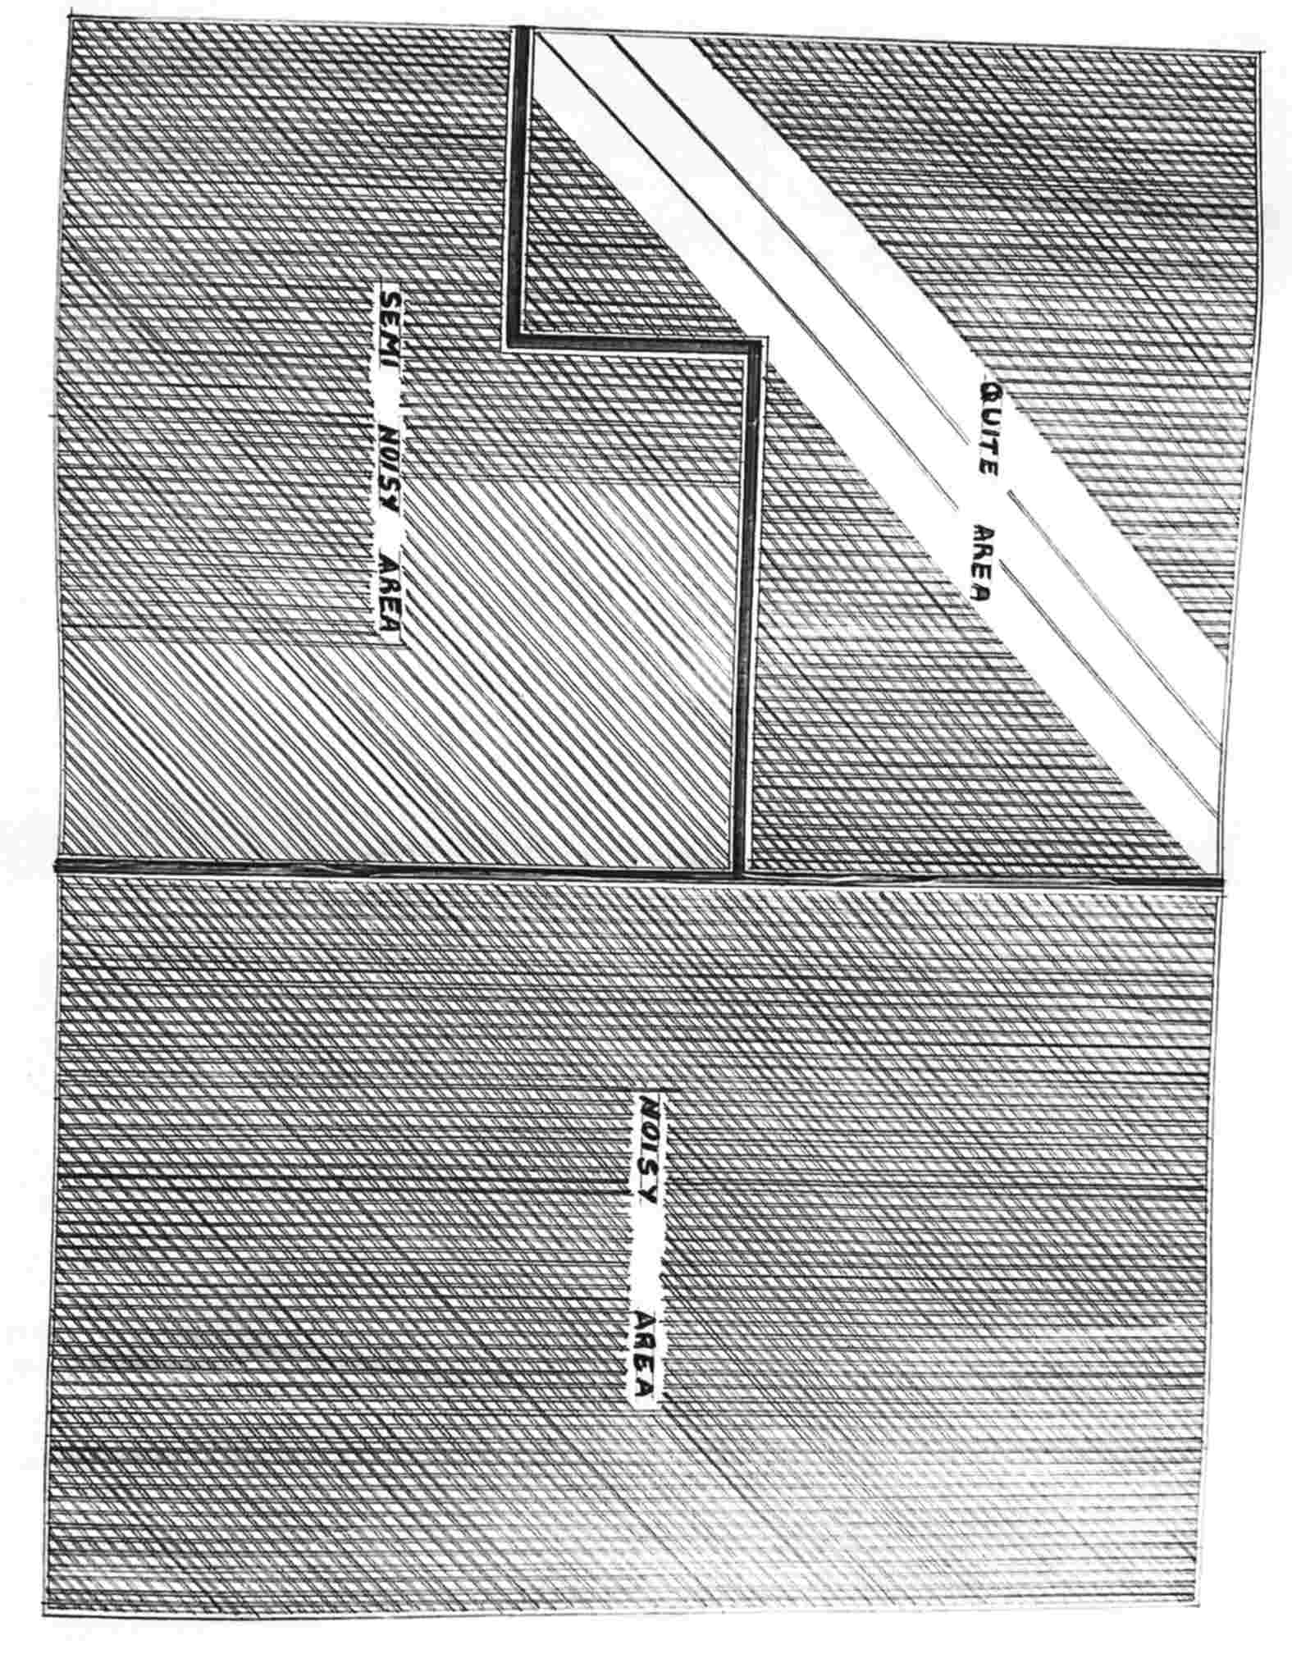

Appendix 5: Site Zoning of the Project

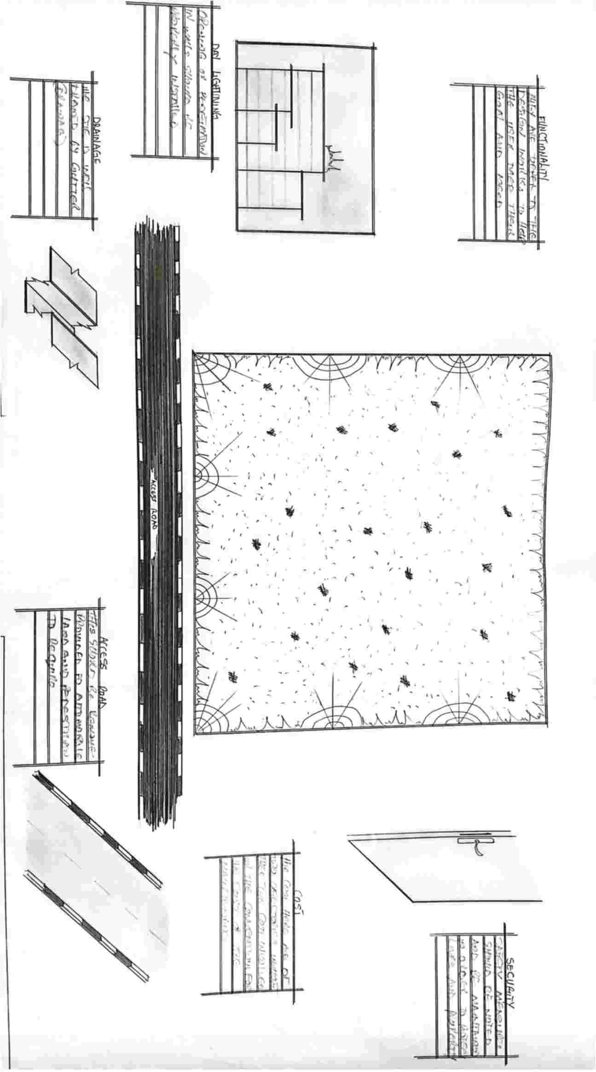

Appendix 6: Site Consideration of the Project
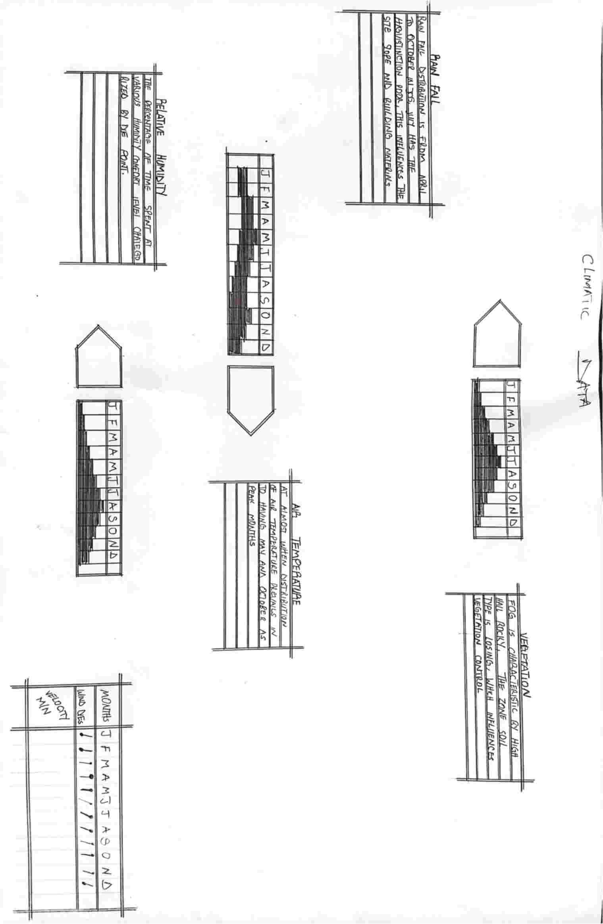

Appendix 7: Climatic Data of the Project
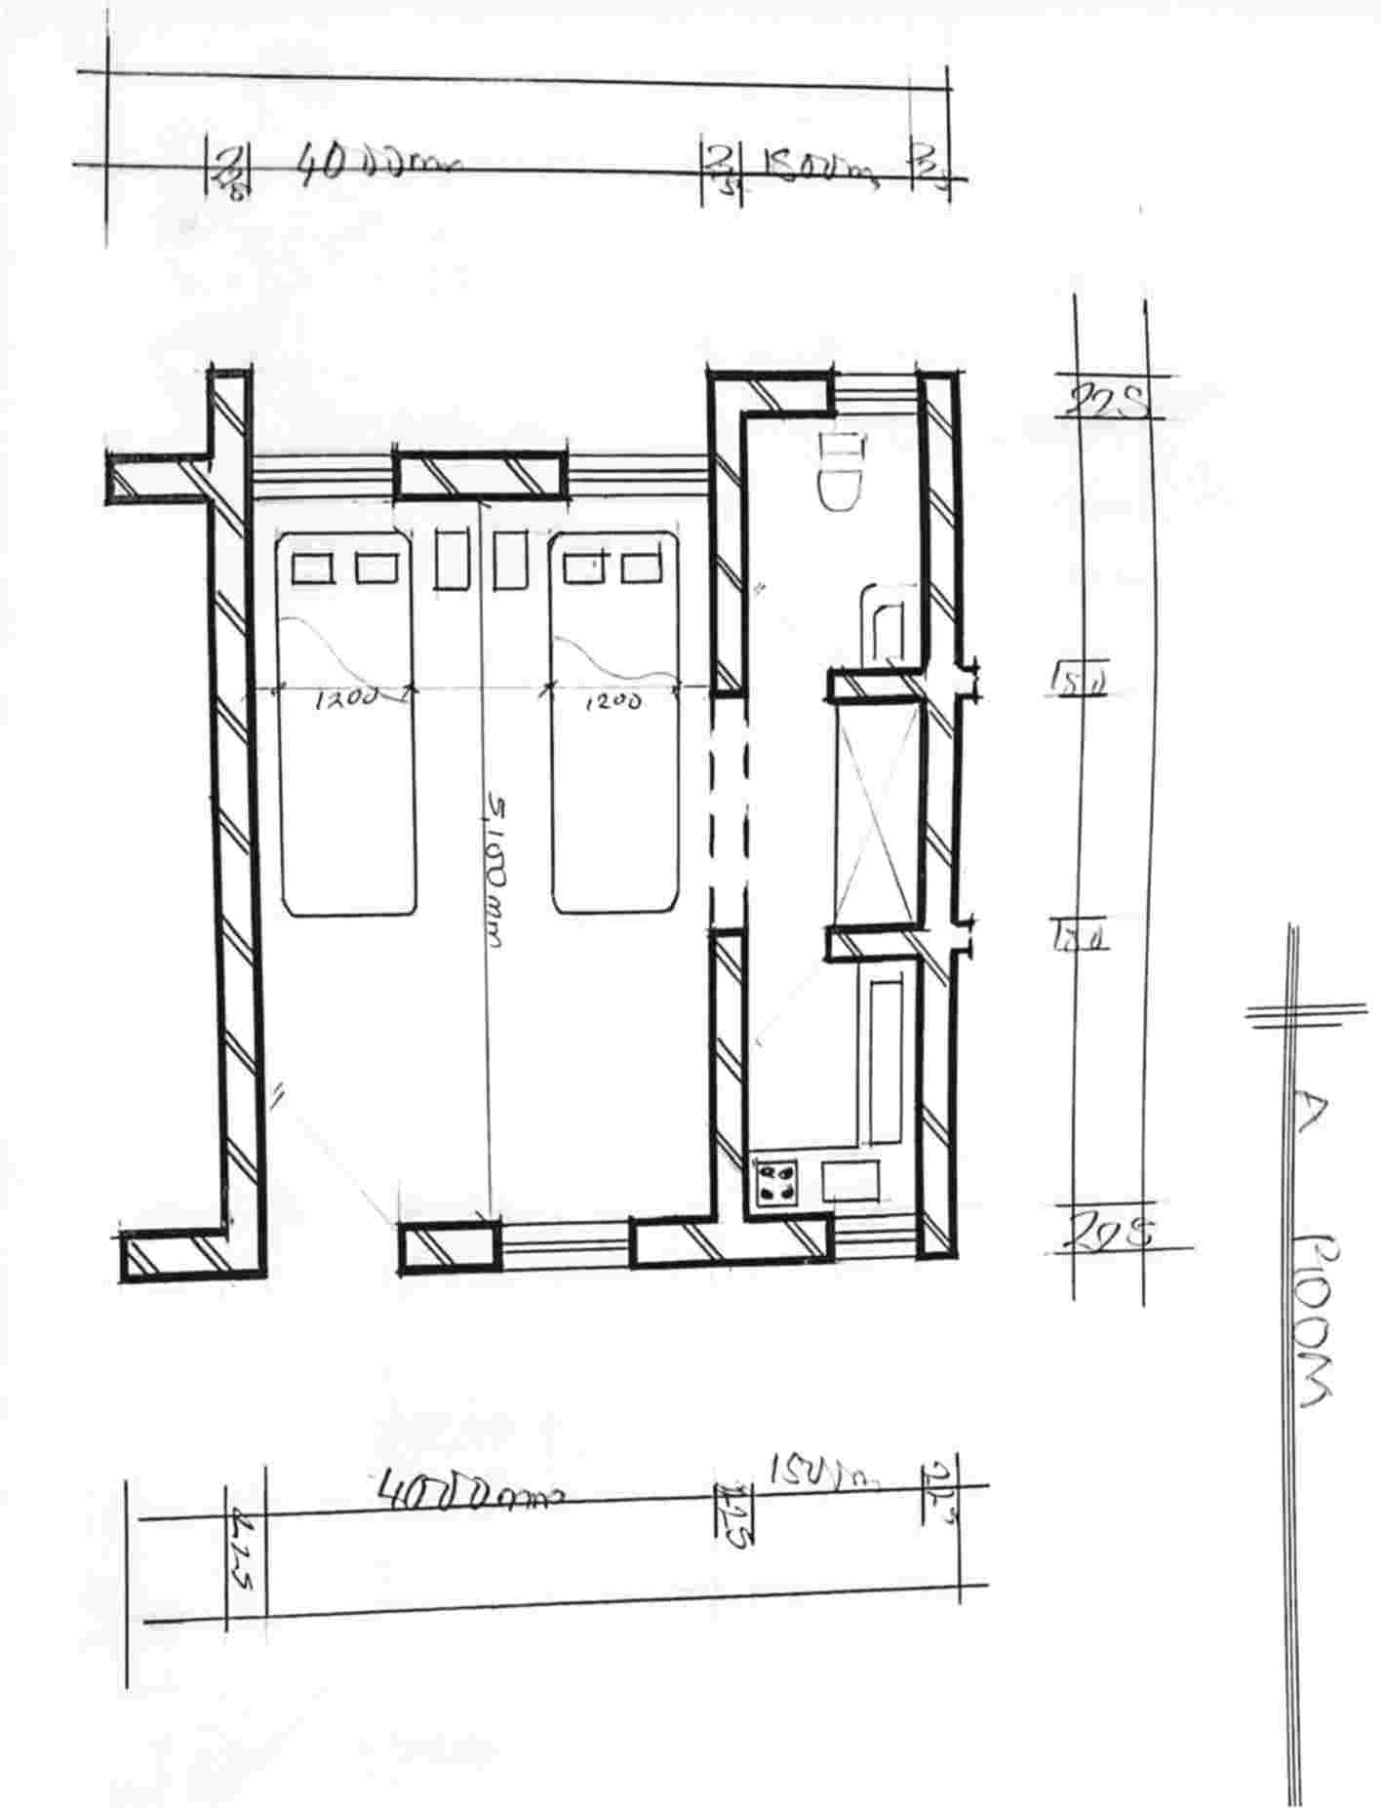

Appendix 8: Space Calculation

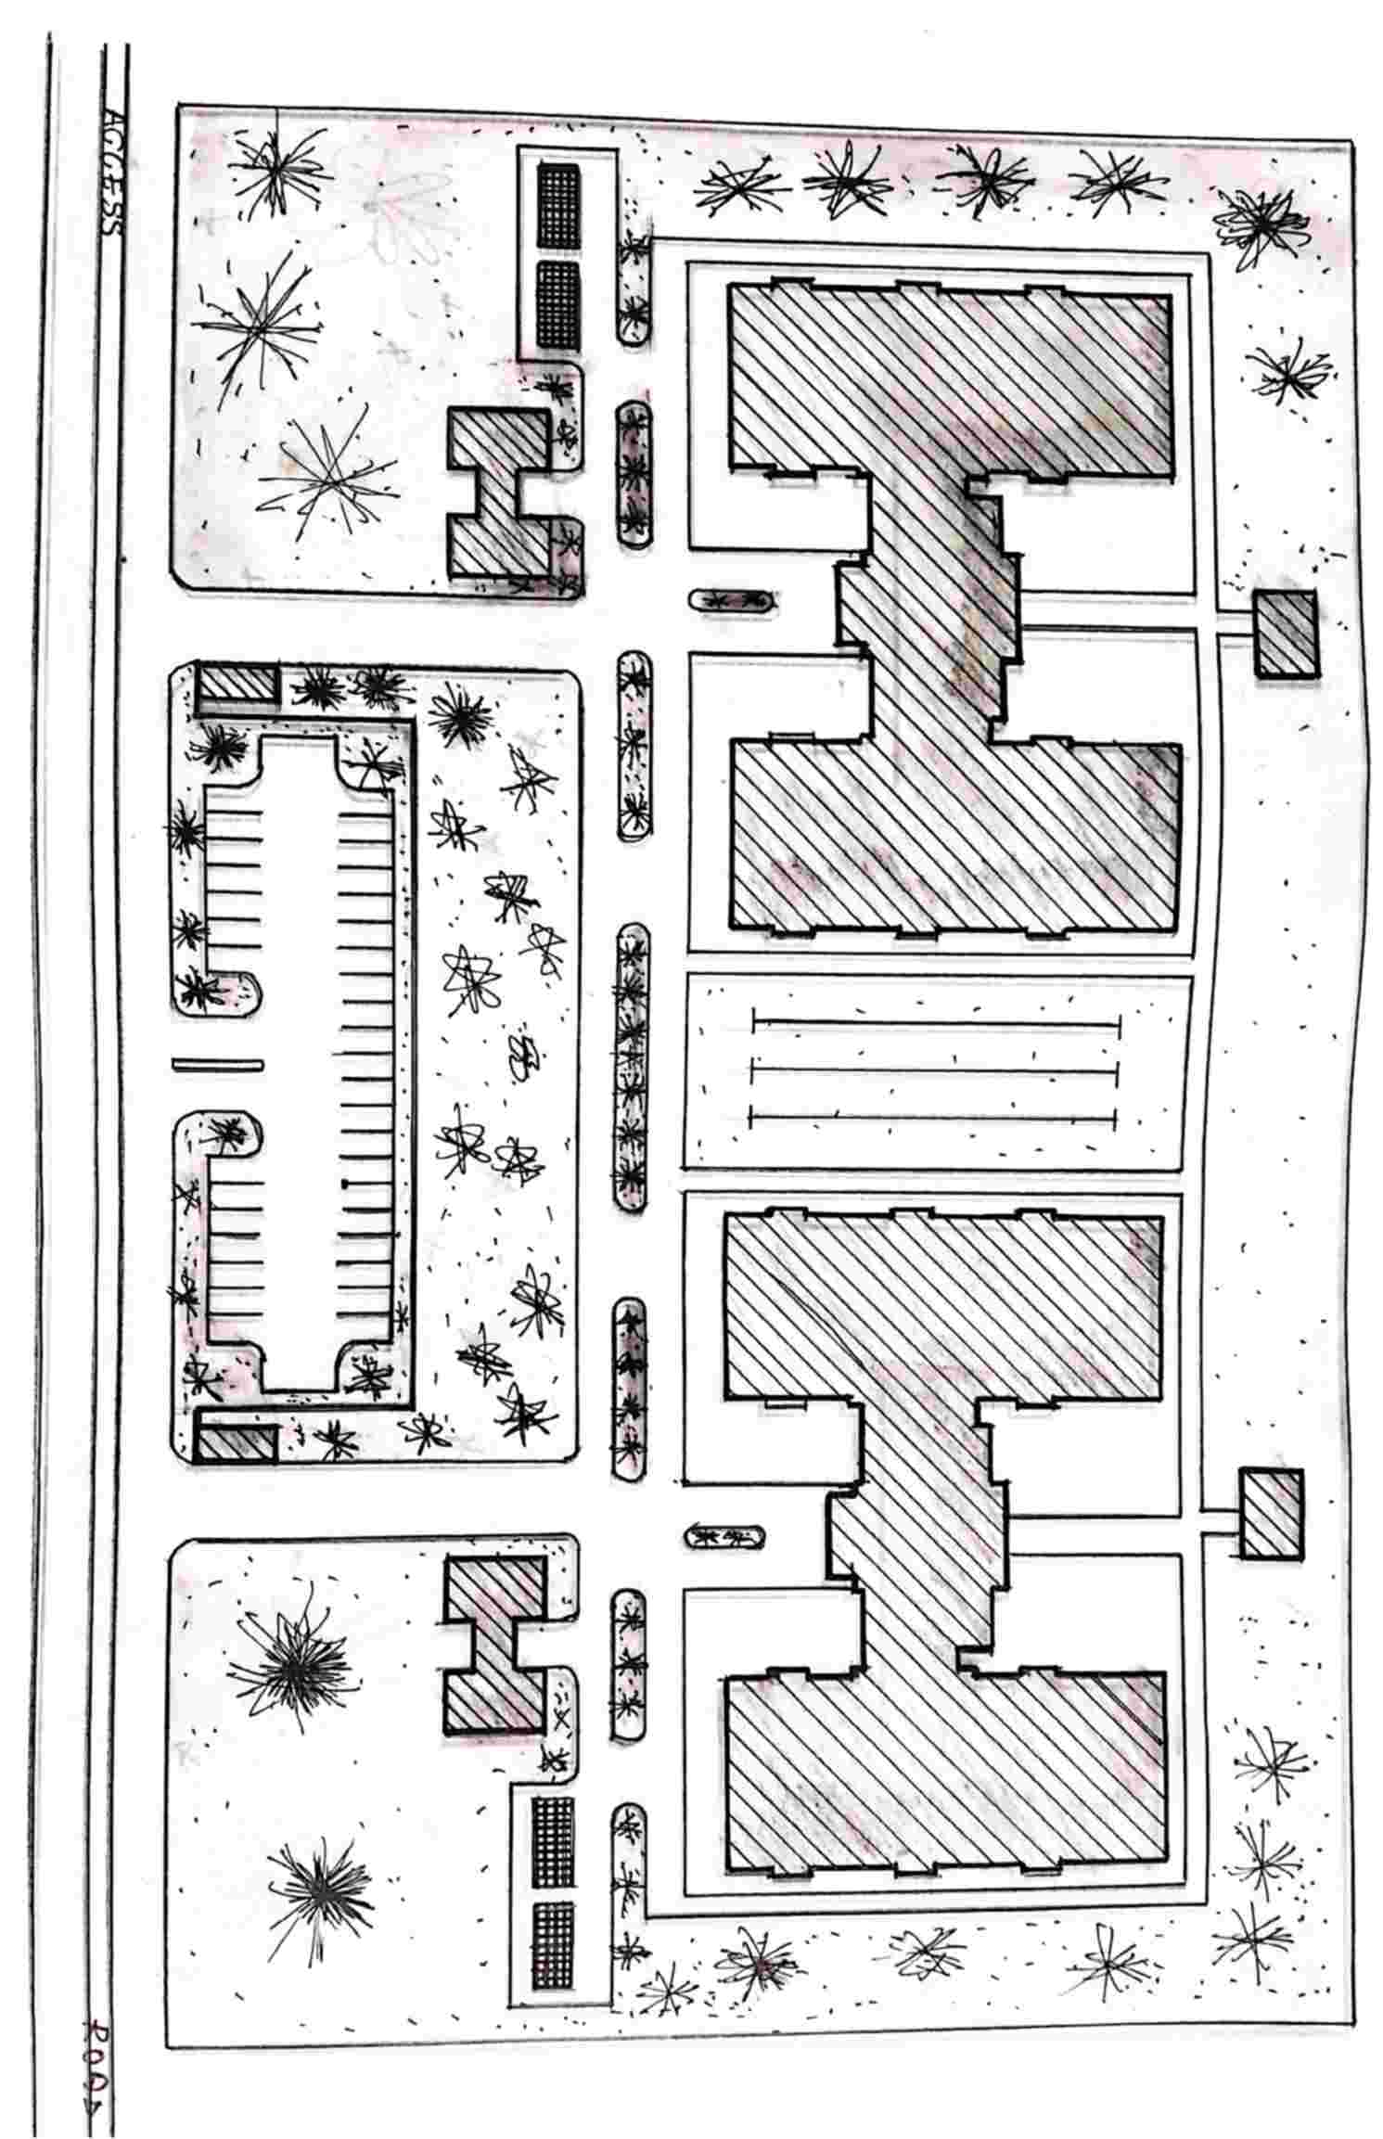

Appendix 8: Site Plan (Presentation Drawing)
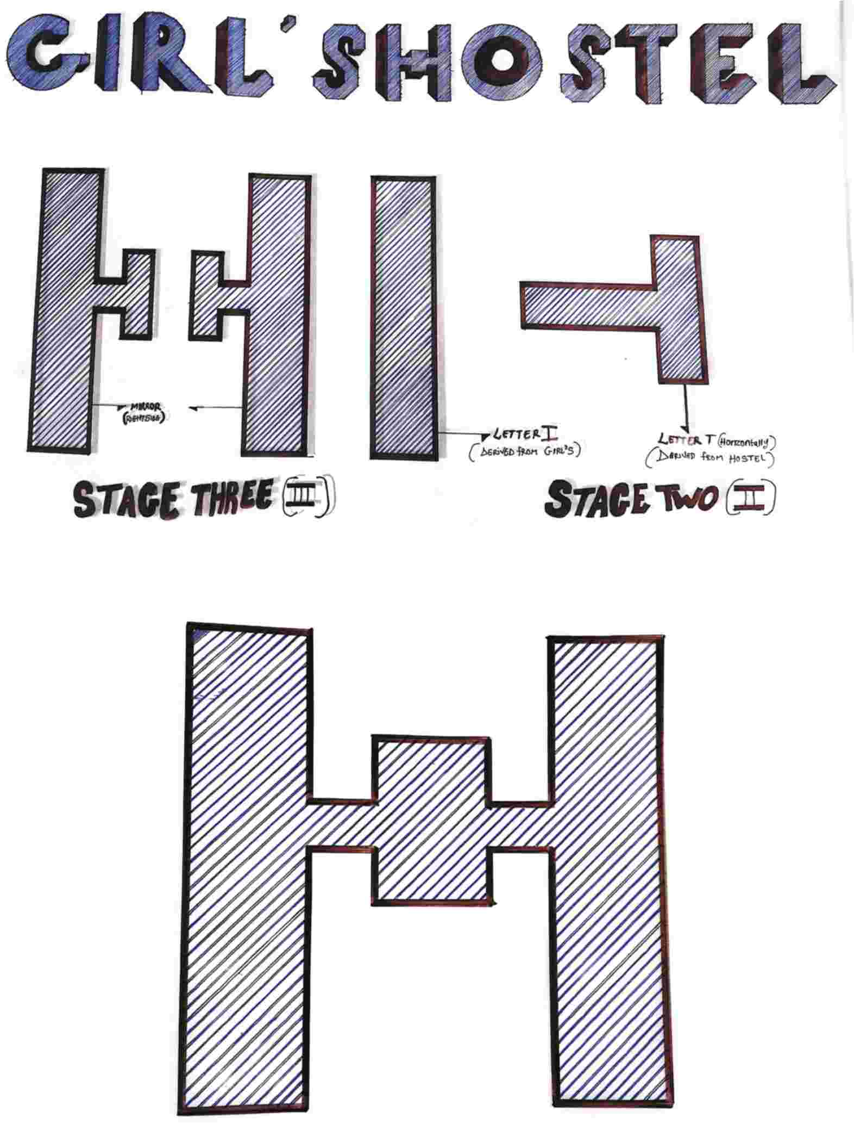

Appendix 9: Concept Derivation

Appendix 10: Site Concept
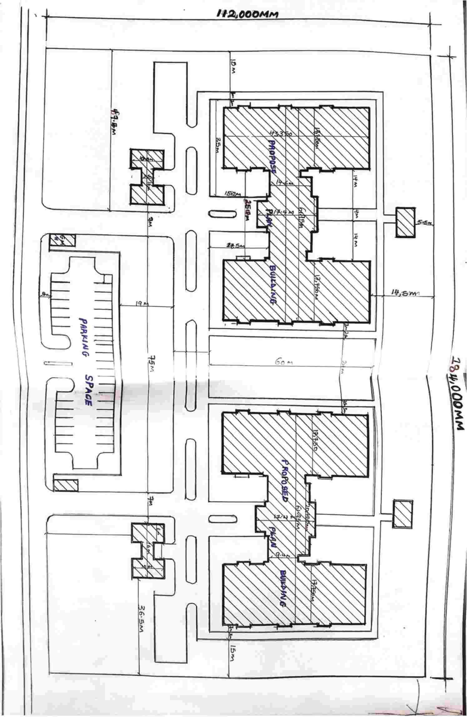

Appendix 11: Site Plan (Working Drawing)
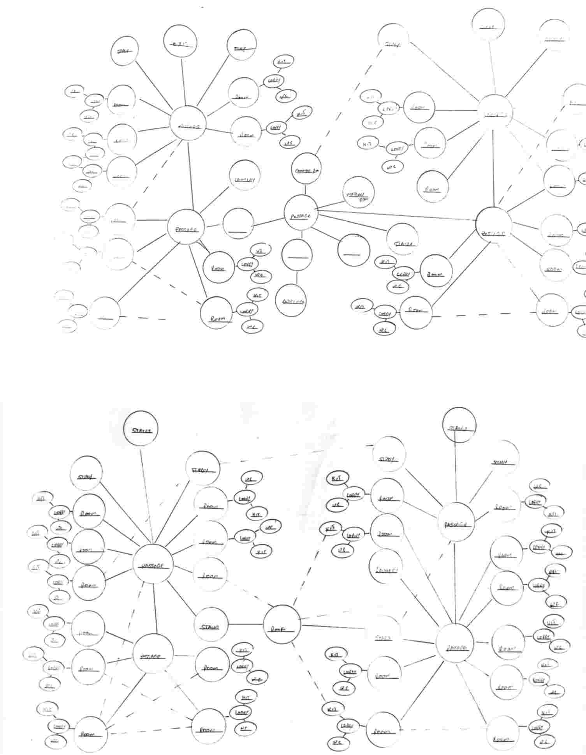

Appendix 12: Bubble Diagram
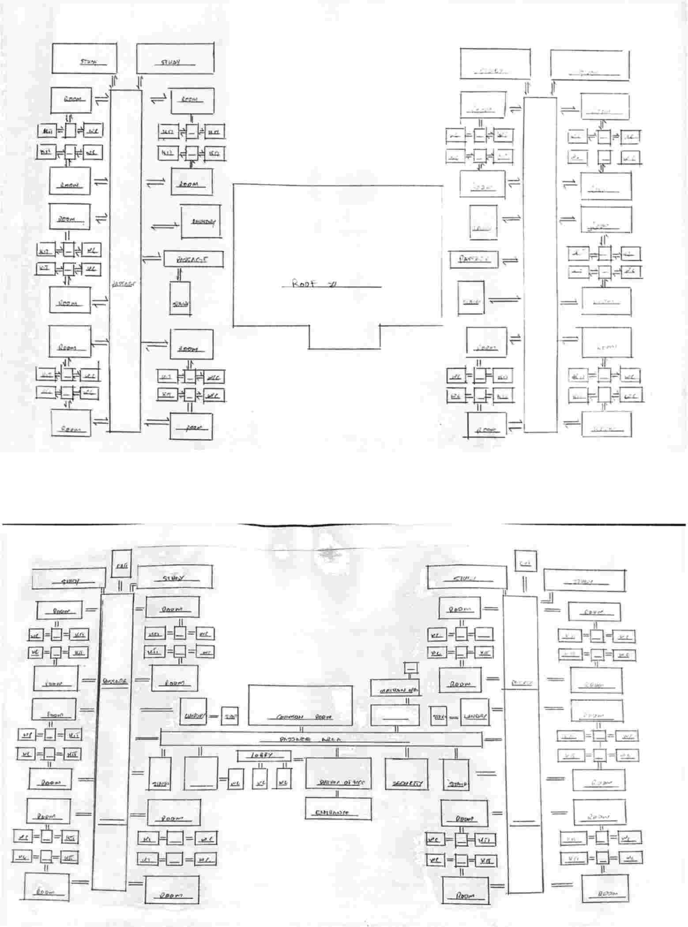

Appendix 13: Functional Relationship Diagram
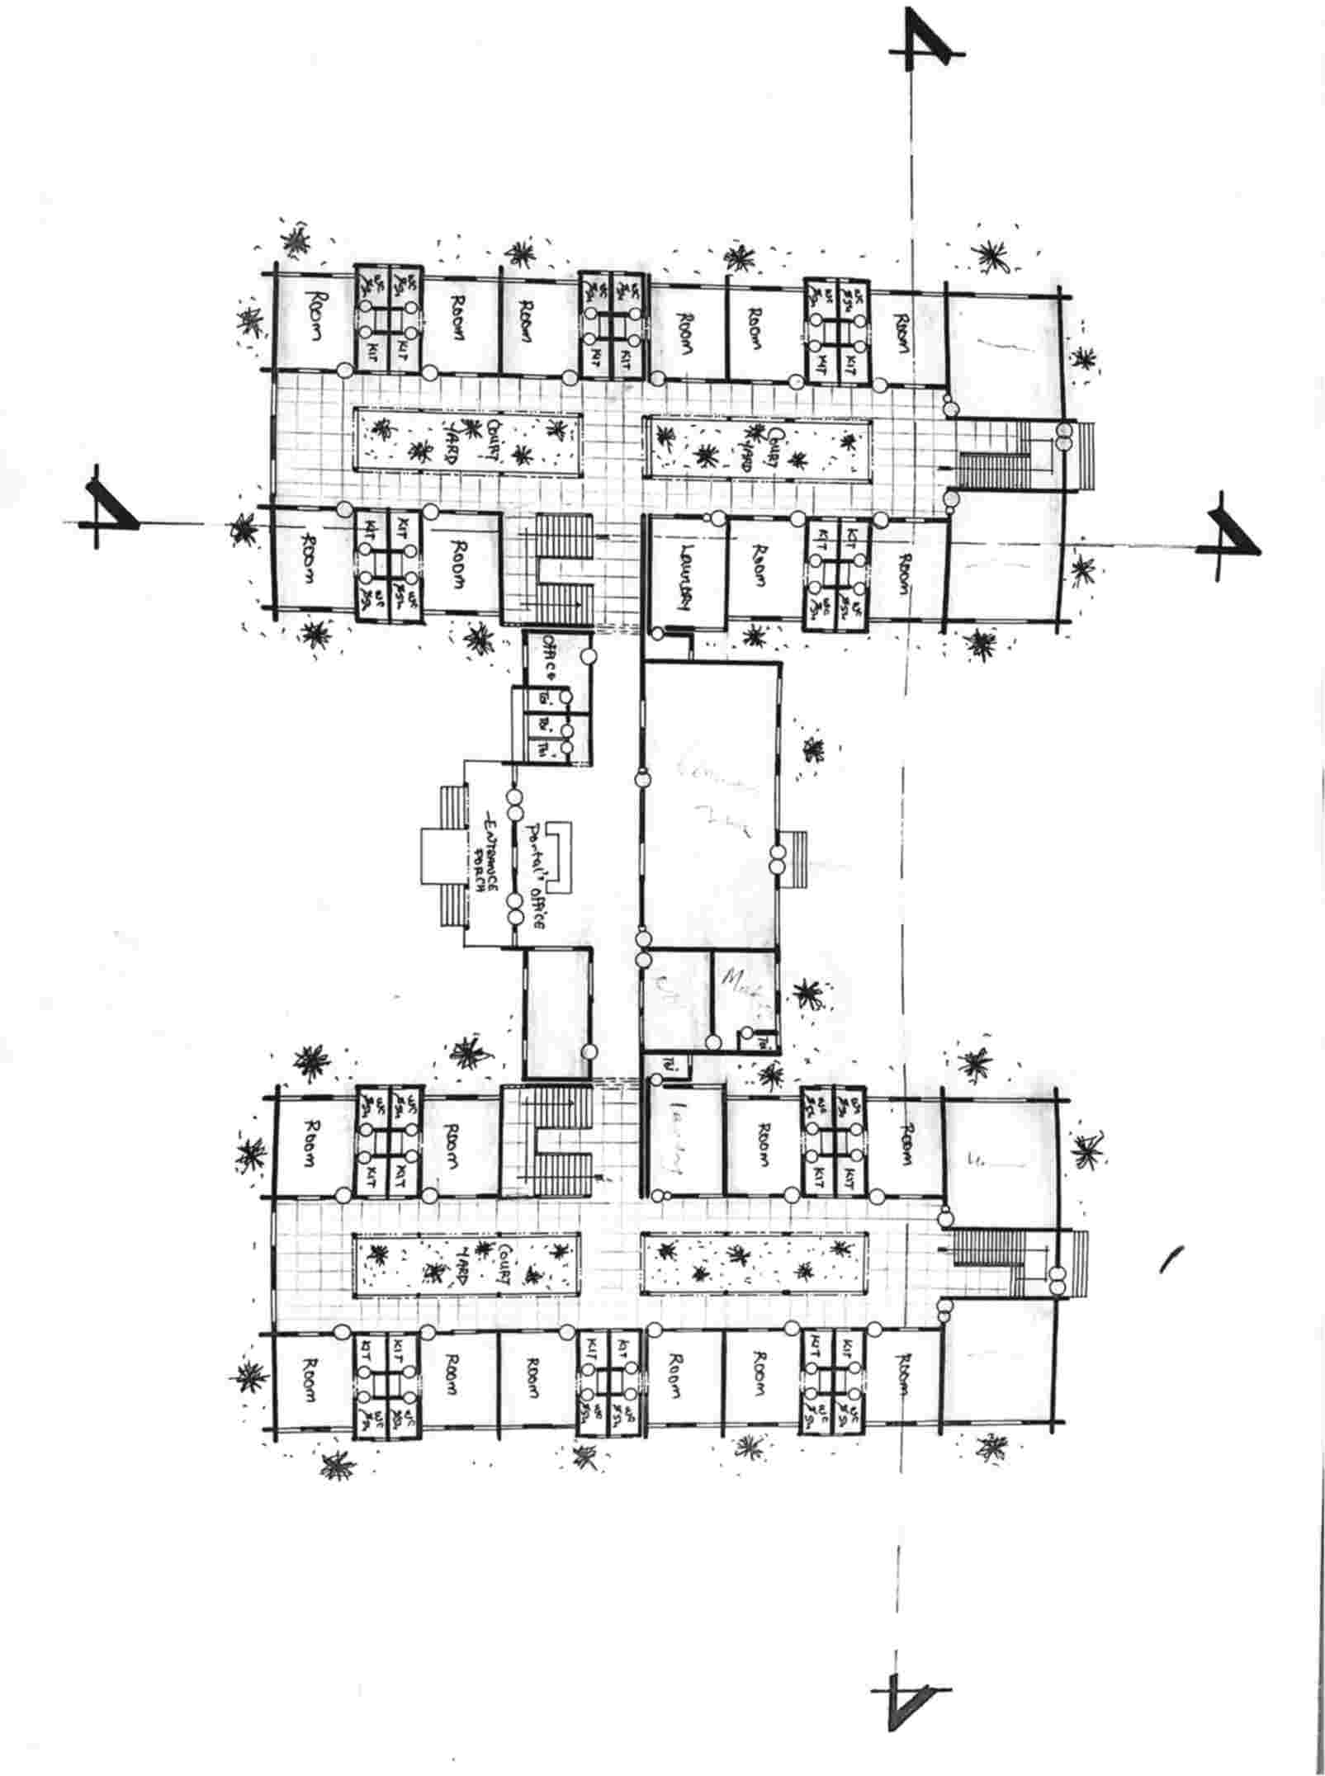

Appendix 14: Ground Floor Plan

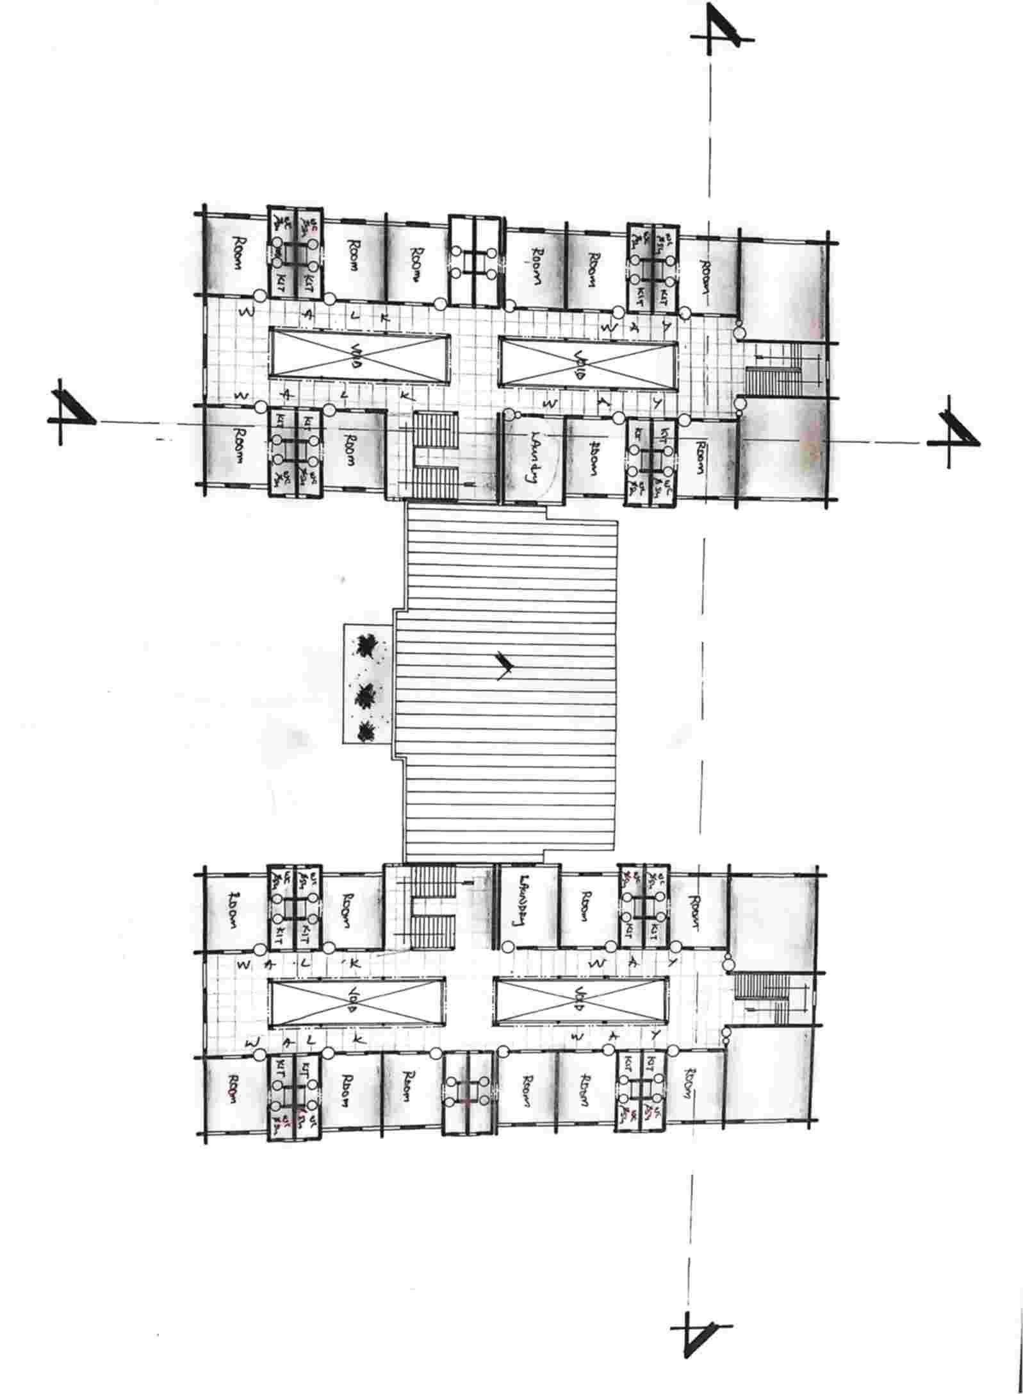

Appendix 15: Upper Floor Plan
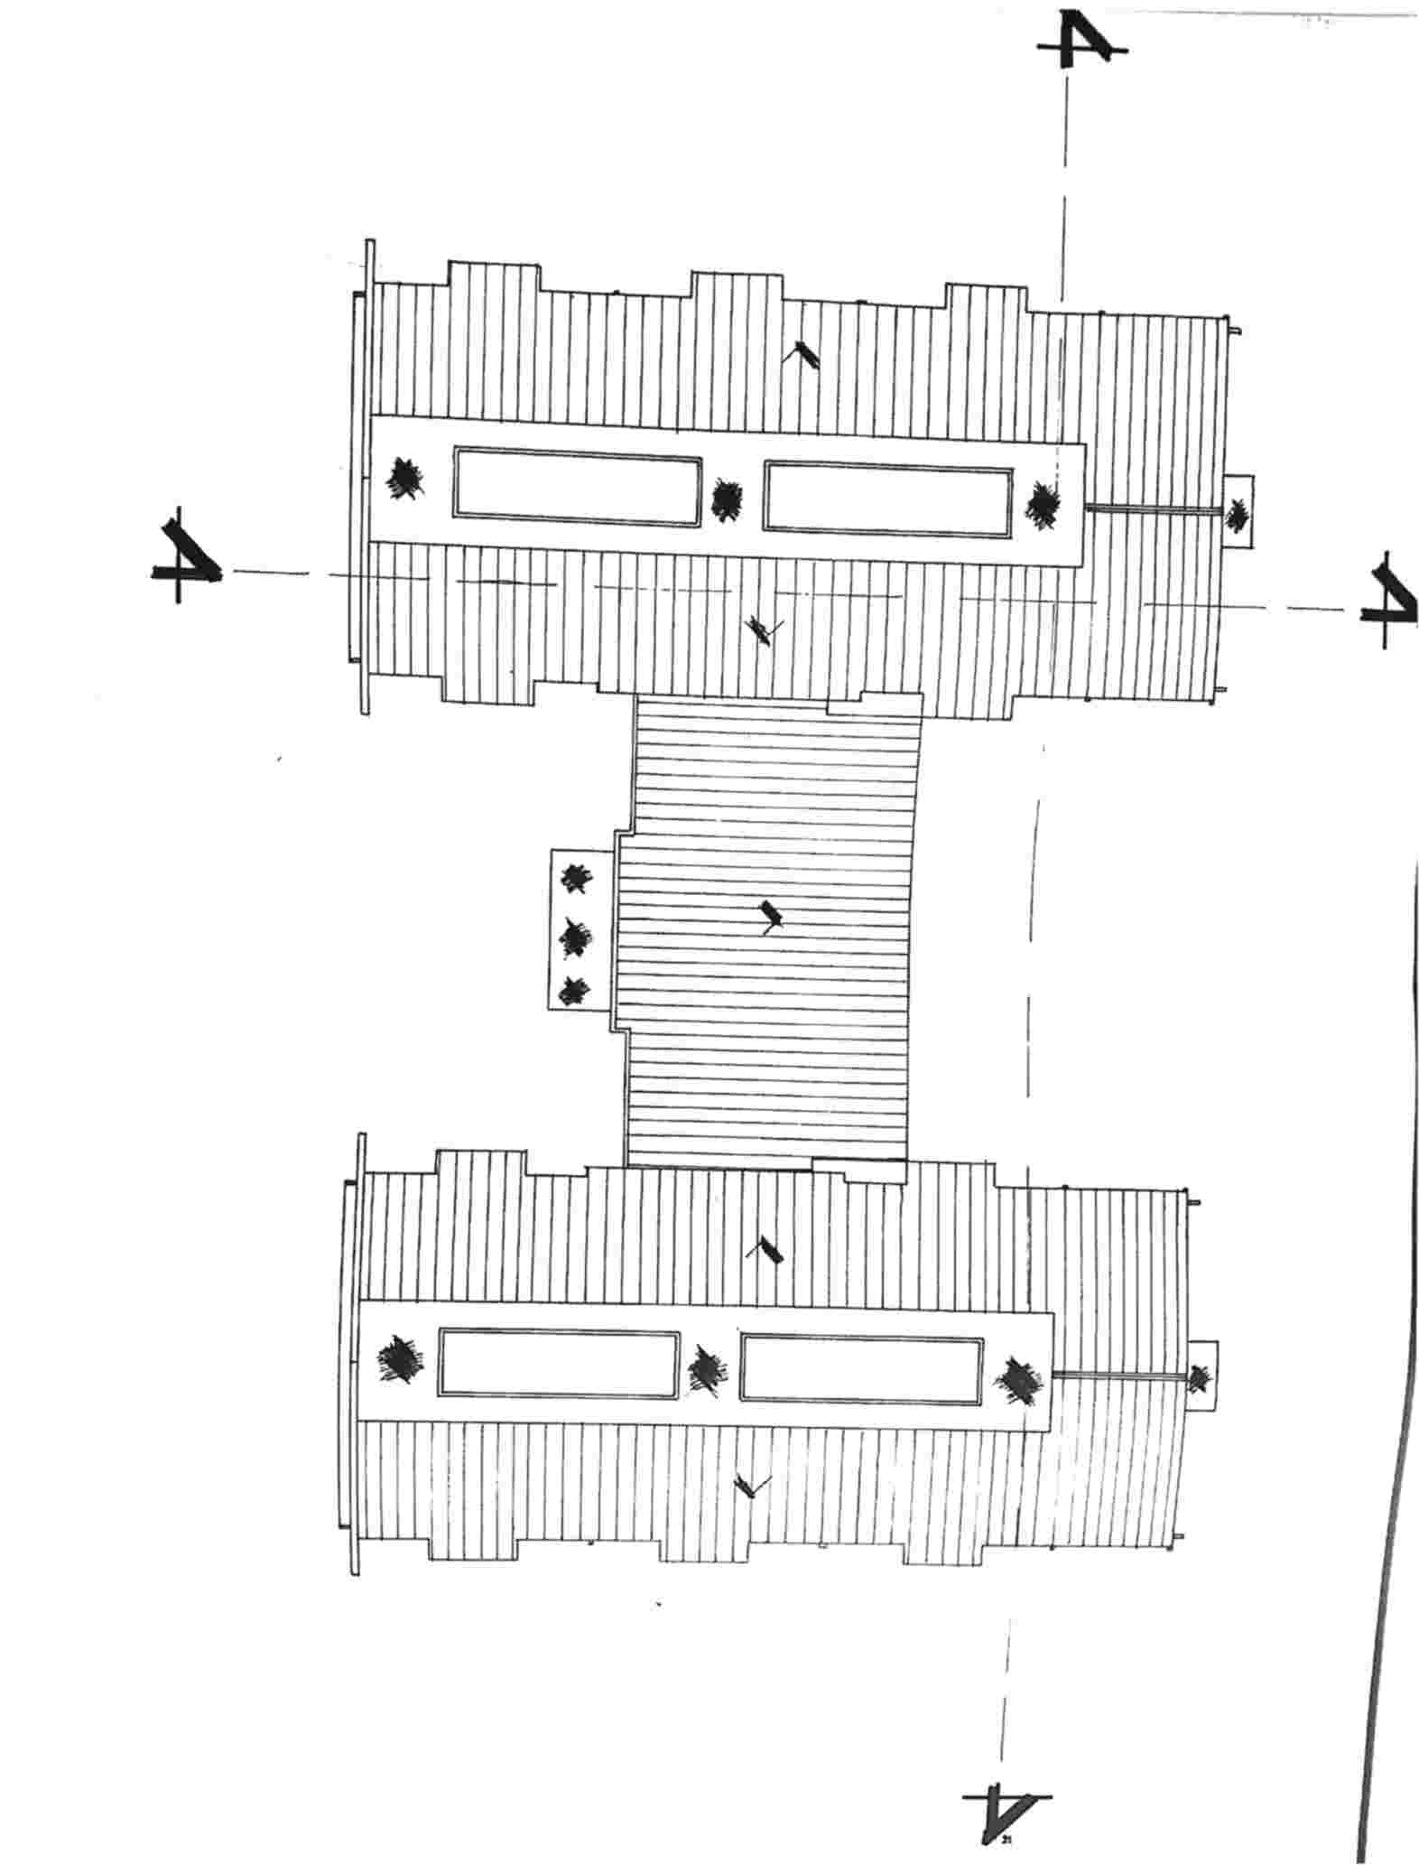

Appendix 16: Roof Plan (Presentation Drawing)
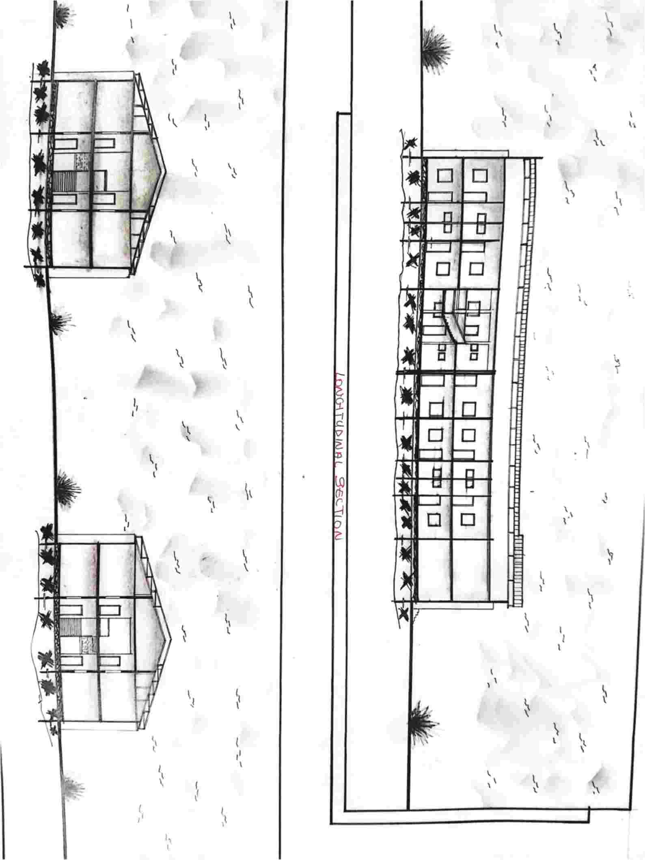

Appendix 17: Section
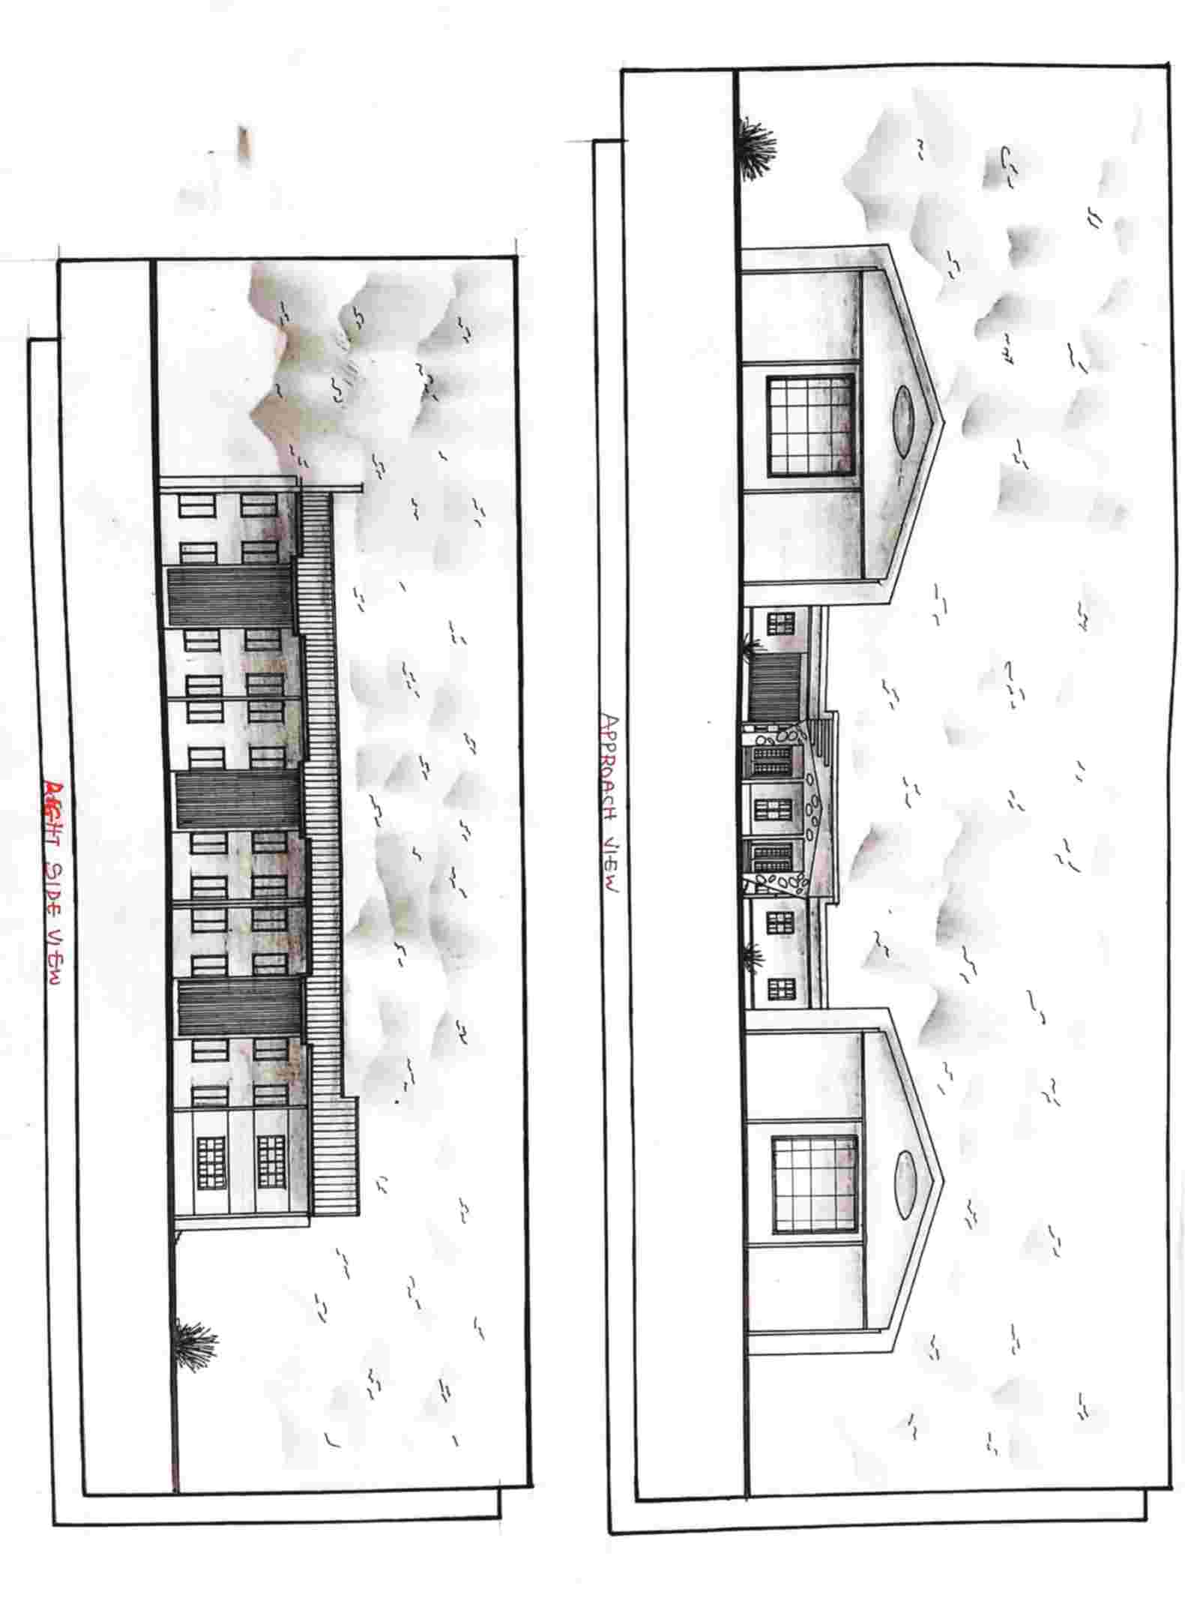

Appendix 18: Front View Elevation
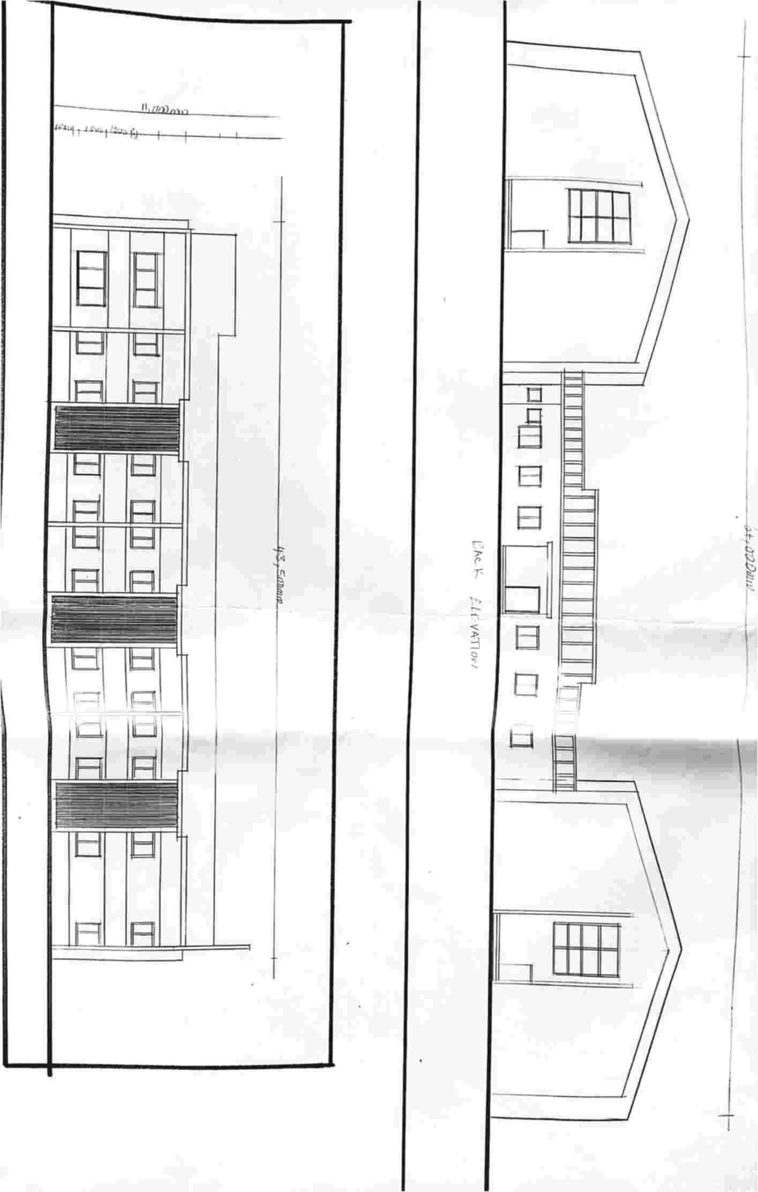

Appendix 19: Back View Elevation

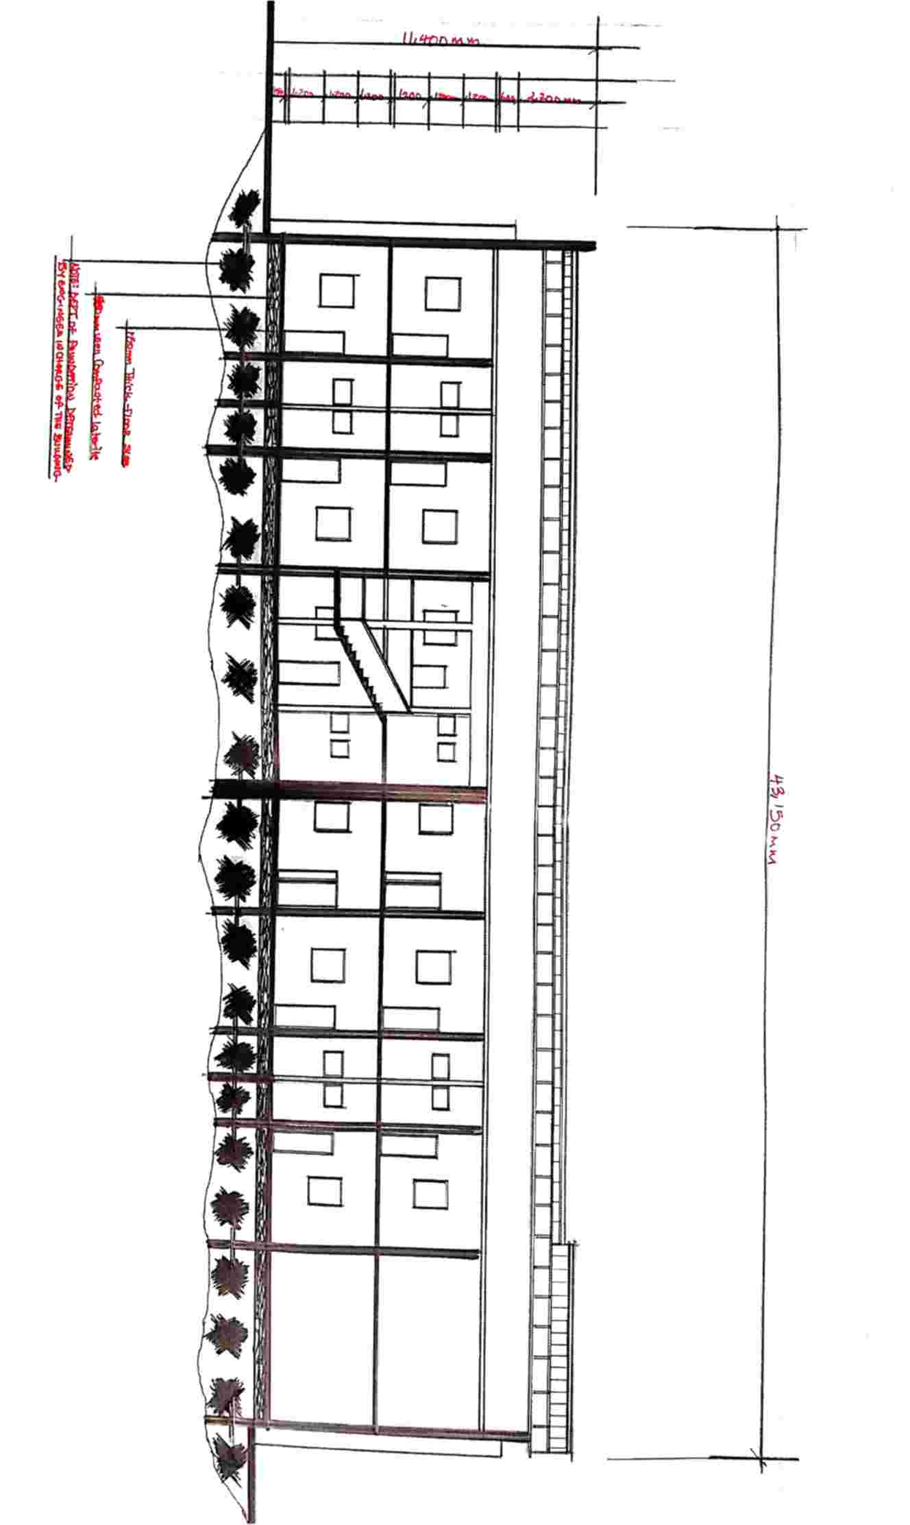

Appendix 20: Section (Working Drawing)
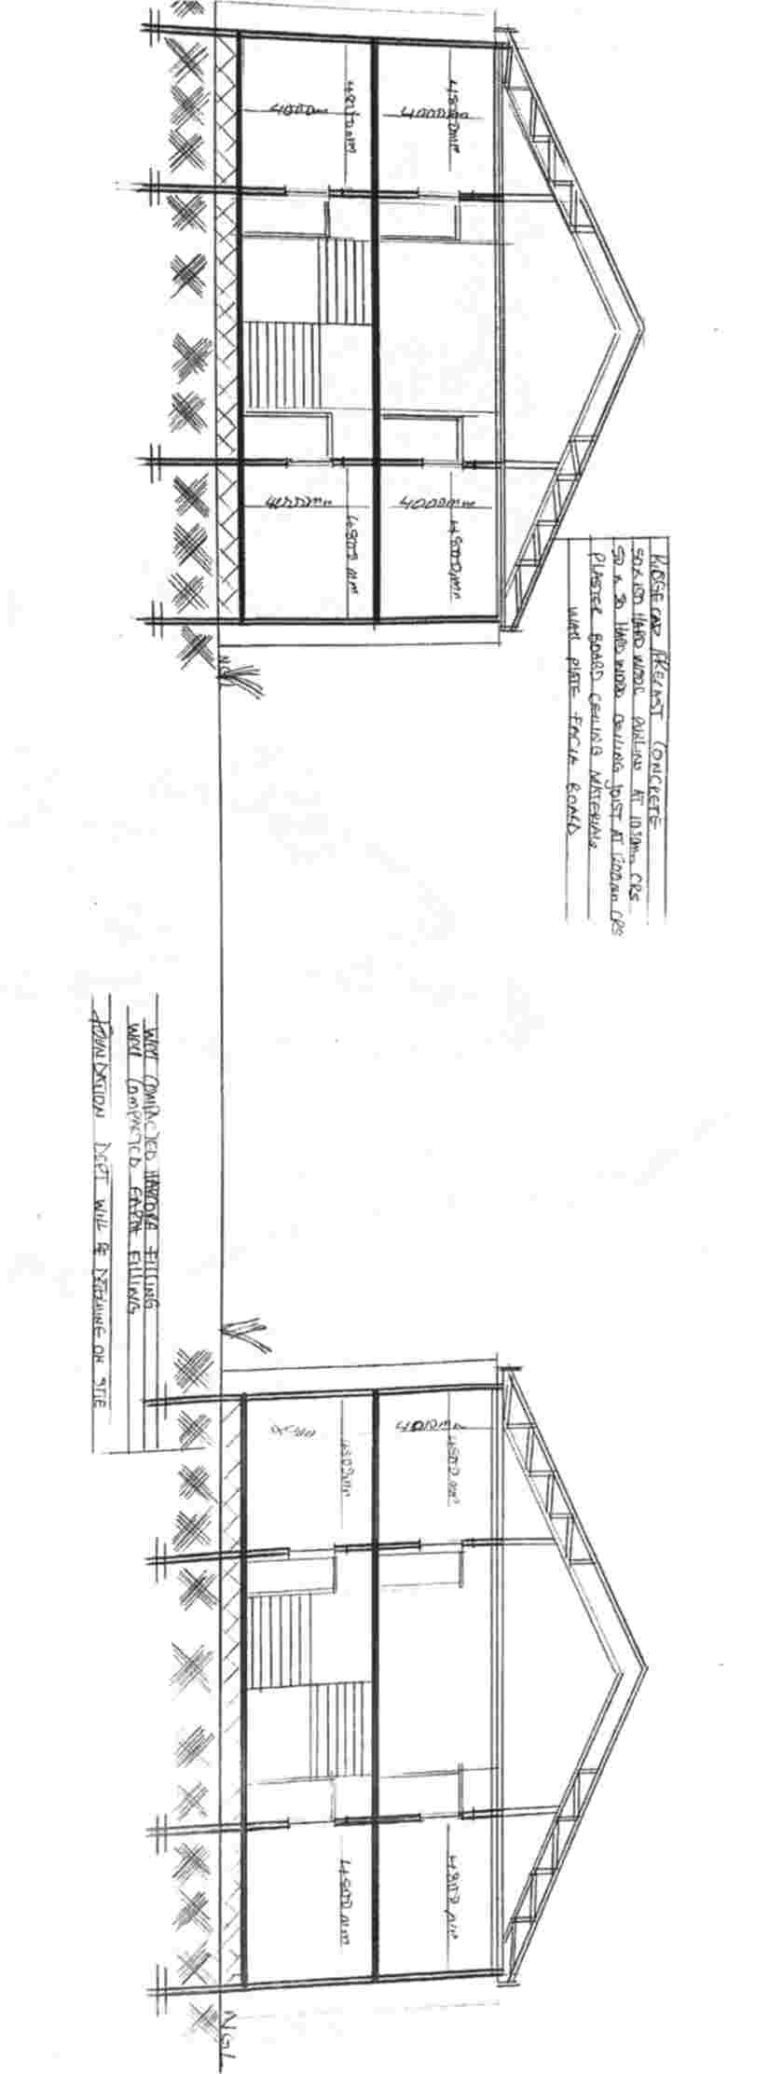

Appendix 21: Section (Presentation Drawing)
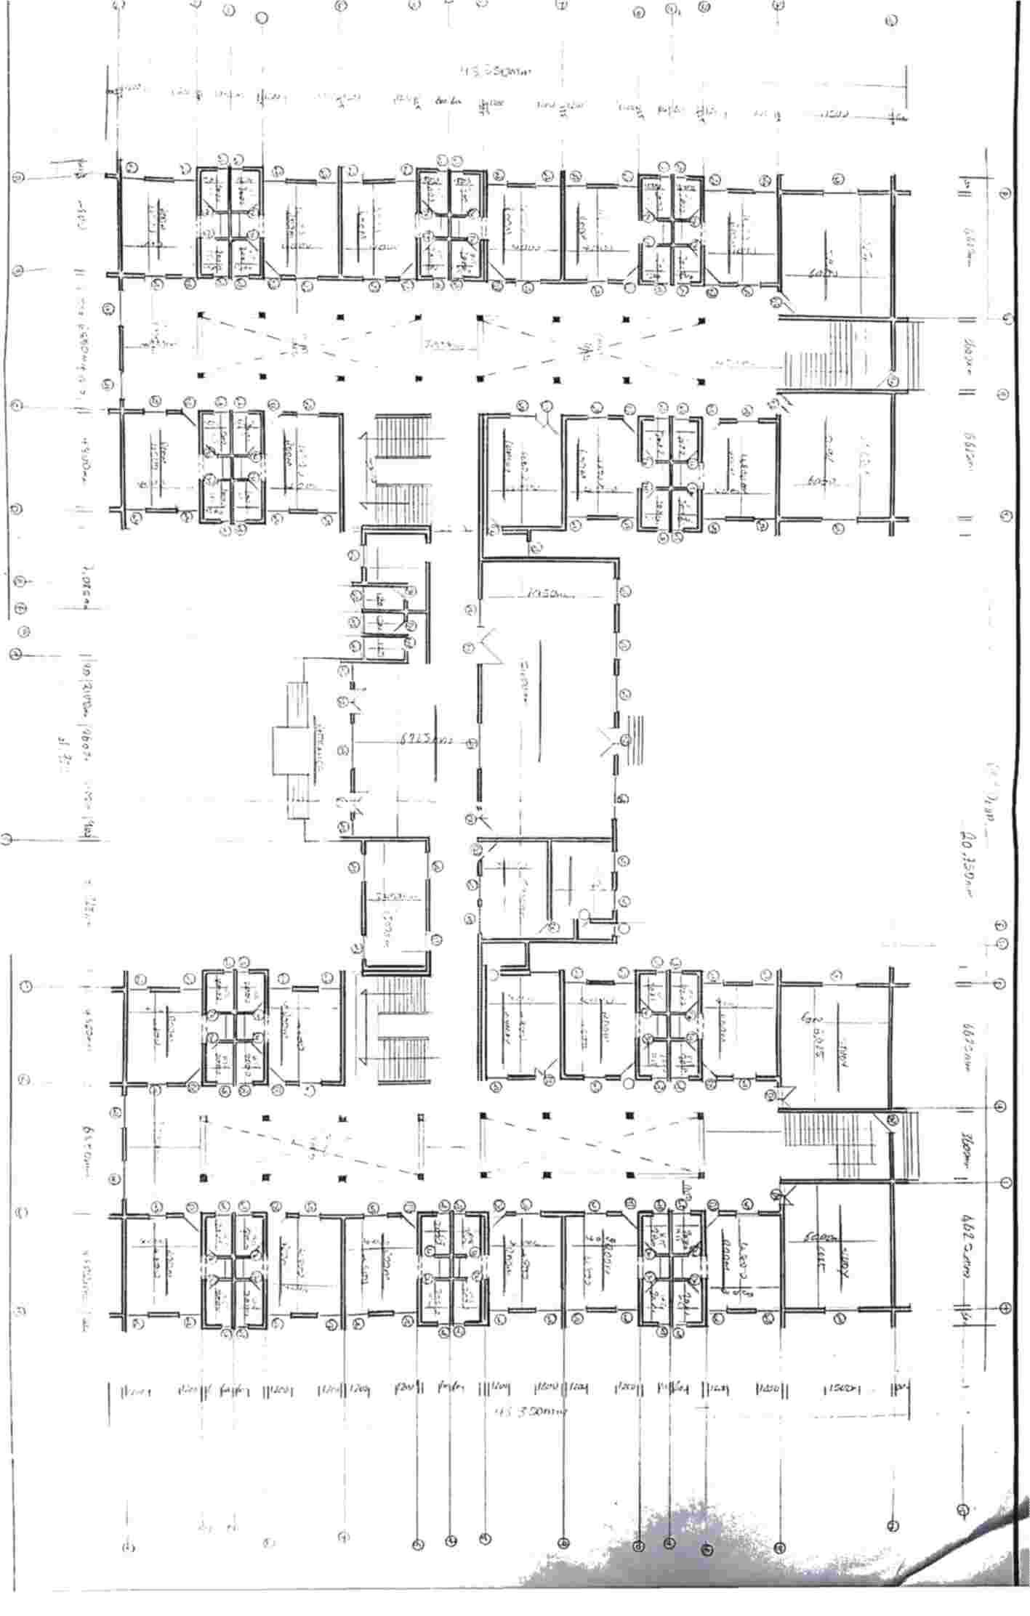

Appendix 22: Ground Floor Plan (Working Drawing)
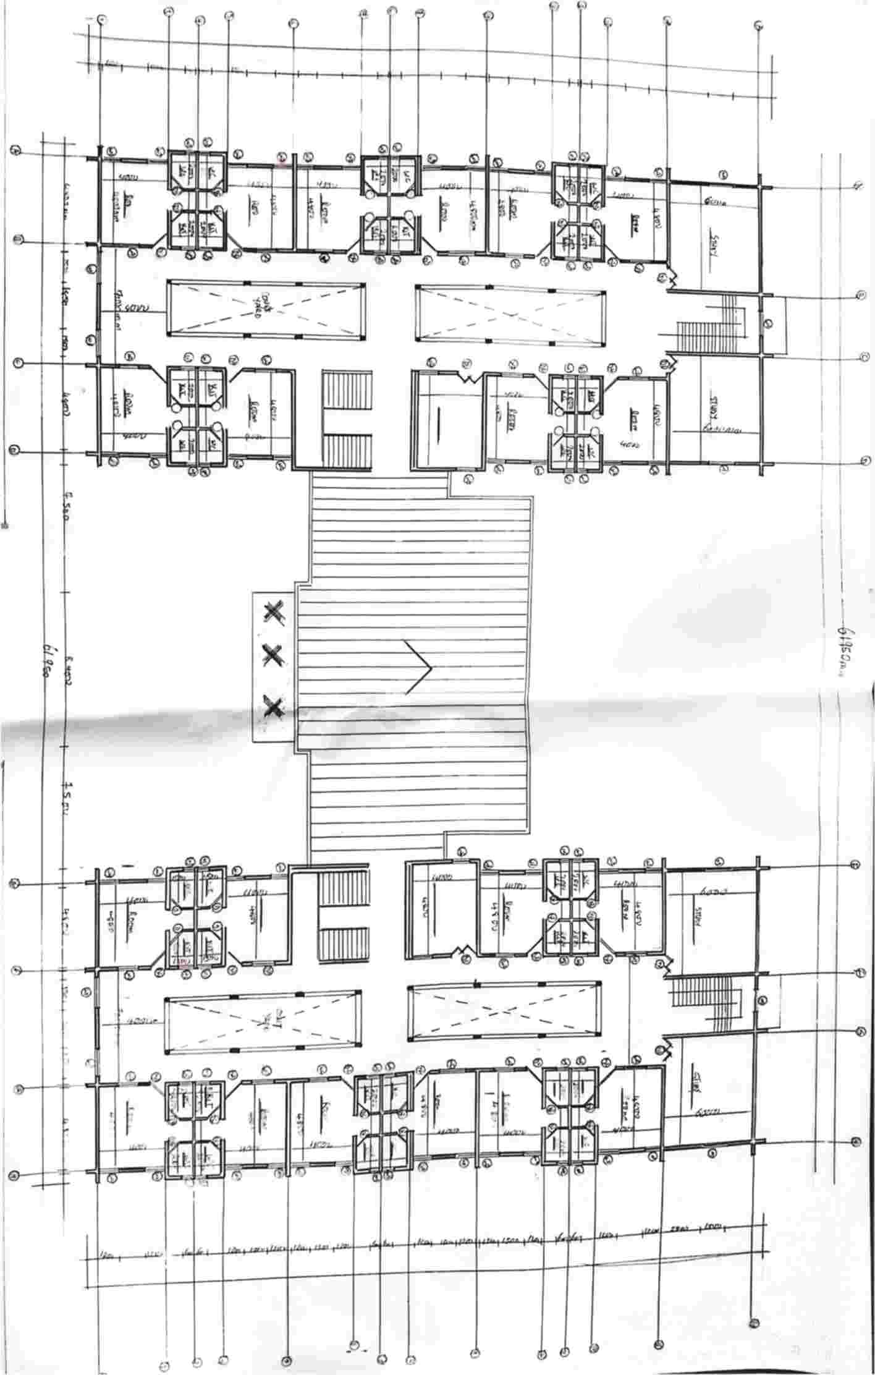

Appendix 22: Upper Floor Plan (Working Drawing)
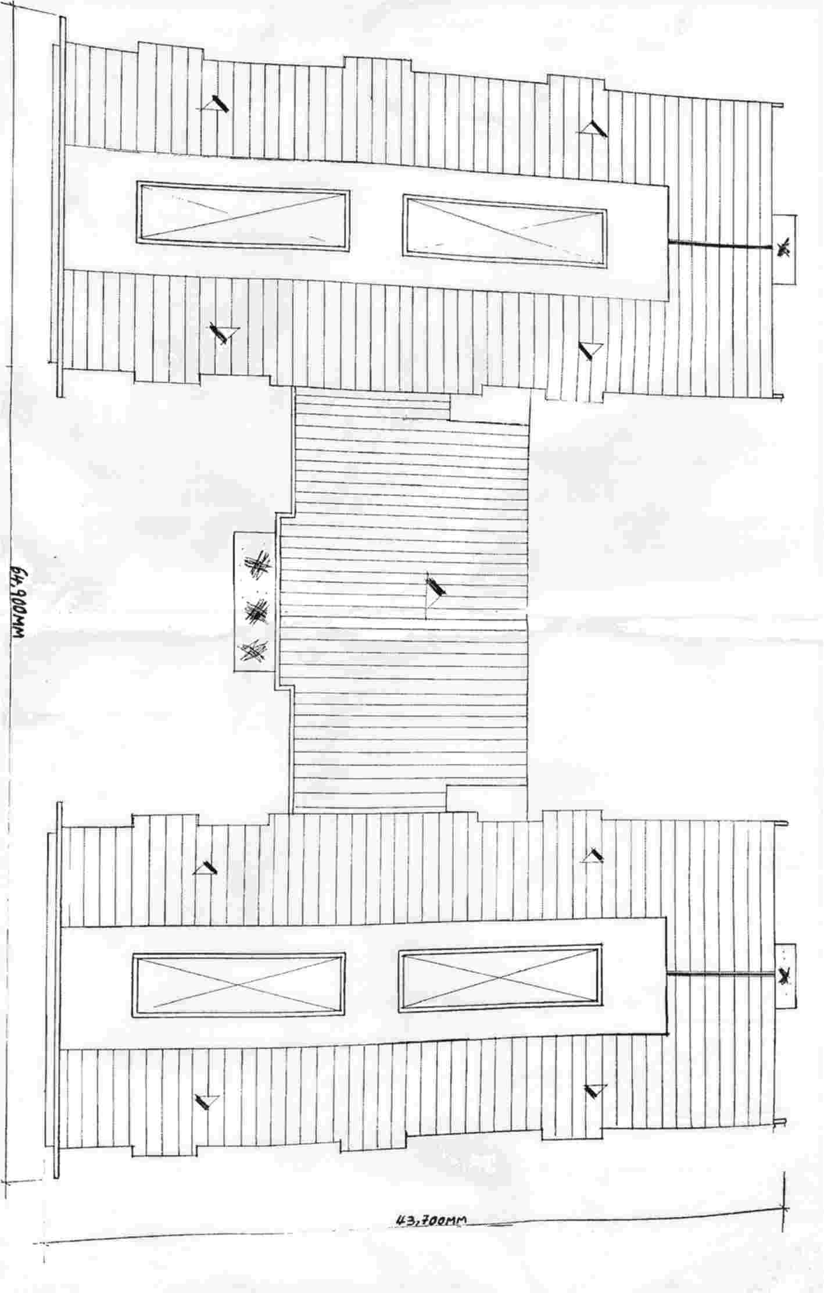
Appendix 23: Roof Plan (Working Drawing)

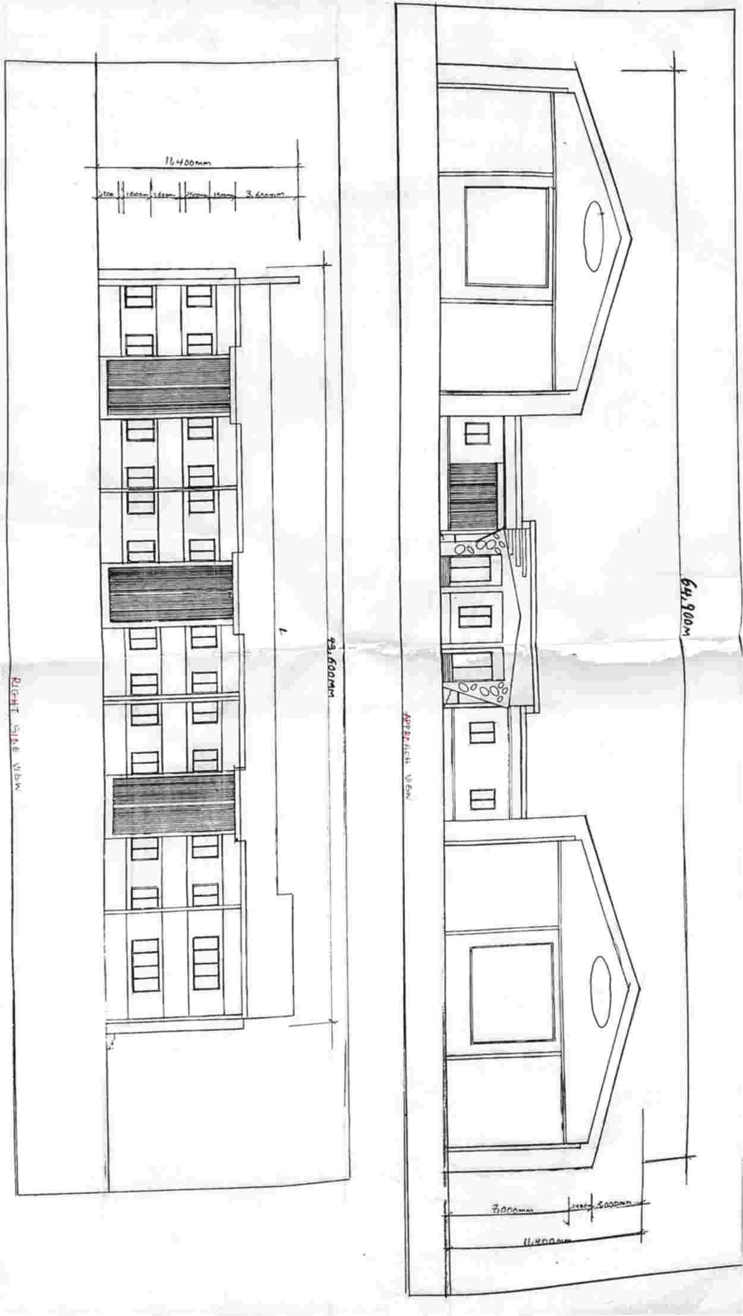

Appendix 24: Elevation (Working Drawing)
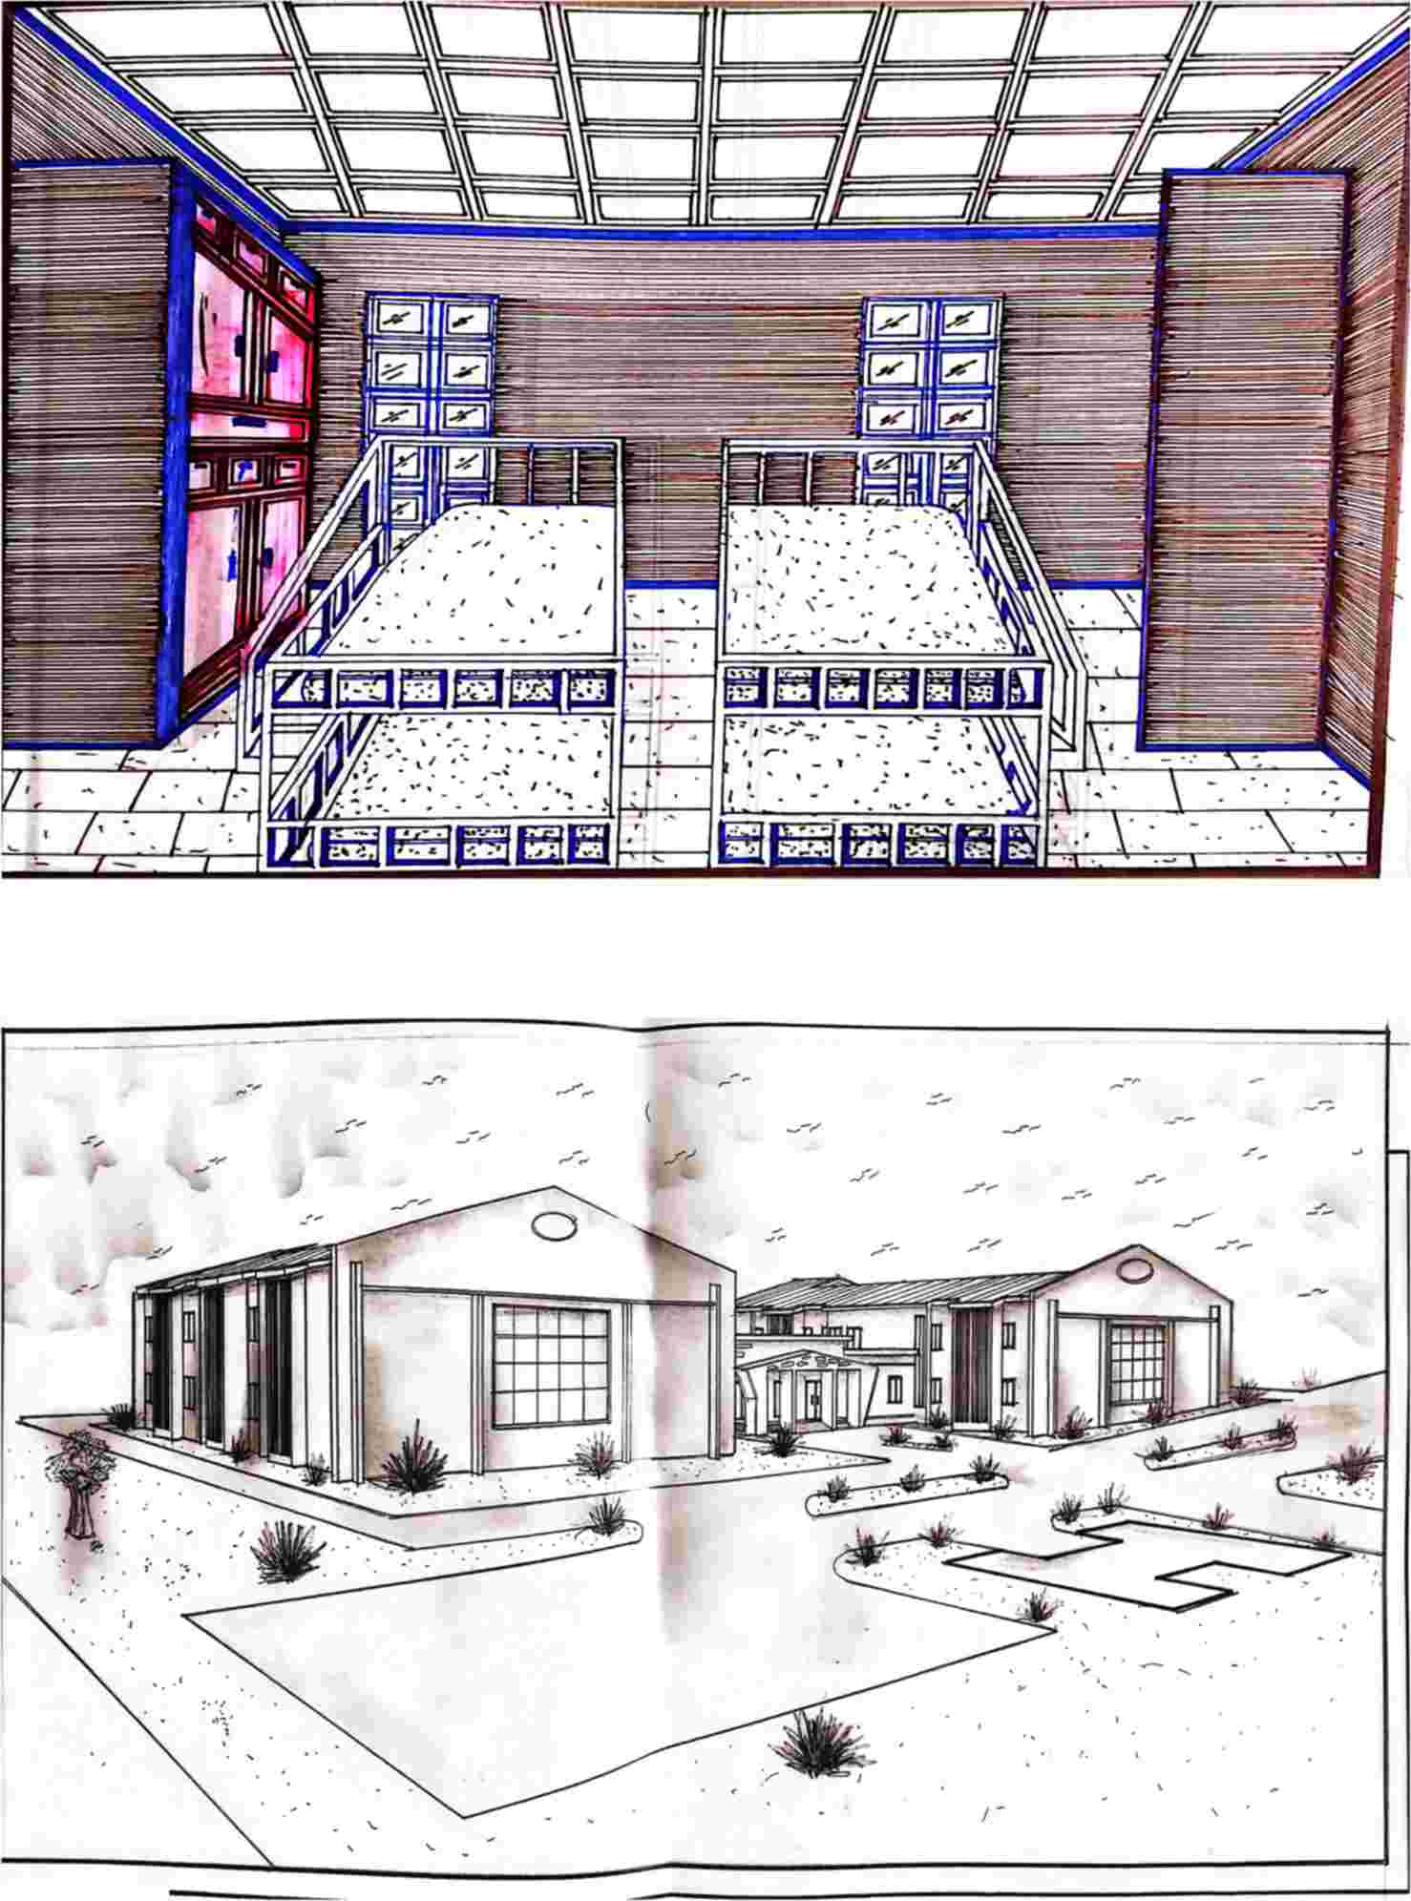

Appendix 25: Internal Perspective

Appendix 26: External perspective
RECOMMENDATIONS

Consideration should be given to ensure comfort and convent of the student occupying the building to achieve an even better result in future designs:
- Safety and Security: The design incorporates advanced security features, including secure entry points, surveillance systems, and well-lit common areas, ensuring the safety of all residents. The thoughtful layout minimizes isolated spaces, enhancing visibility and security throughout the premises.
- Comfort and Well-being: The proposed hostel design includes spacious rooms with adequate ventilation and natural lighting. The inclusion of common areas, such as study rooms, lounges, and recreational spaces, promotes a balanced lifestyle by encouraging social interaction and relaxation. The design also includes facilities for physical well-being, such as a gym and outdoor spaces for exercise.
- Functionality and Accessibility: The layout is designed to optimize the flow of movement and accessibility within the building. With the inclusion of ramps, elevators, and accessible restrooms, the design ensures that all students, including those with disabilities, can easily navigate the facility. The well-planned kitchen and dining areas are designed to cater to the dietary needs of the residents, promoting a sense of community through shared meals.
- Aesthetics and Atmosphere: The aesthetic choices in the design reflect a warm and welcoming atmosphere. The use of soothing colors, natural materials, and green spaces creates a calming environment, ideal for studying and relaxation. The design also considers cultural sensitivities and provides spaces for cultural and religious practices.
- Sustainability: The proposal includes sustainable practices, such as energy-efficient lighting, water-saving fixtures, and waste management systems. These features not only reduce the environmental footprint but also educate residents on the importance of sustainable living.

REFERENCES
UN-Habitat. (2018). Student Housing: A Guide to Providing Safe and Affordable Housing for Youth. Nairobi: United Nations Human Settlements Programme.
Bessant, J. (1993). Youth Homelessness and the Future of Housing Policy. Journal of Youth Studies, 2(1), 45-57.
World Health Organization (WHO). (2009). Guidelines for Indoor Air Quality: Dampness and Mould. Geneva: WHO Press.
United Nations Girls' Education Initiative (UNGEI). (2015). A Safe Space for Girls: Creating Safe Learning and Living Environments. New York: UNICEF/UNGEI.
Mehta, M. & Scarborough, C. (2019), Sustainable Building Design: Principles and Practice. London: Routledge.
Khosla, R. (2009). Addressing Gender Concerns in India's Urban Planning. Environment & Urbanization Asia, 1(1), 125-140.
Neufert, E., & Neufert, P. (2012). Architects' Data (4th ed.). Oxford: Wiley-Blackwell.
Graham, S. & Marvin, S. (2001). Splintering Urbanism: Networked Infrastructures, Technological Mobilities and the Urban Condition. London: Routledge.
Hosseini, S. B., & Zarei, H. (2018). Post-Occupancy Evaluation of University Dormitories for Female Students in Iran. International Journal of Architecture and Urban Development, 8(2), 55-65.
Mara, D., & Evans, B. (2011). Sanitation and Water Supply in Hostels: A Gendered Perspective. World Bank Water and Sanitation Program.
World Bank. (2020). Safe Boarding for Girls: International Best Practices in Girls' Hostel Infrastructure. Washington, DC: World Bank Group.
Rapoport, A. (2005). Culture, Architecture and Design. Chicago: Locke Science Publishing.
Mutiga, J. (2017). Designing Hostel Facilities for Girls in East African Universities: Spatial.
Cultural and Religious Considerations. African Journal of Built Environment, 5(2), 99-117.
Bala, R. & Sharma, P. (2021). Privacy and Safety of Female Students in Indian Hostel Design: A Case Study Approach. International Journal of Architecture and Planning, 9(1), 22-38.
UNESC. (2015). Education for All Global Monitoring Report: Gender and the Learning Crisis. Paris: United Nations Educational, Scientific and Cultural Organization.
Sandler, J. C. (2012). Gender and Urban Spaces: Ensuring Safe and Inclusive Cities for Women and Girls. New York: UN Women.
UN Women. (2017). Safe Cities and Safe Public Spaces: Global Results Report. New York UN Women.
Jiwani, Y. & Young, M. L. (2006). Missing and Murdered Women: Reproducing Marginality in News Discourse. Canadian Journal of Communication, 31(4), 895-917.
Salama, A. M. (2005). A Process Oriented Approach to Teaching Architectural Design: The Case of Housing Design Studio. Open House International, 30(1), 4-13.
Day, L. (2007). Evaluating a Building's Impact on Student Life: A Post-0ccupancy Evaluation of University Housing. Journal of College and University Student Housing, 34(1), 16-33.
Thomas, H. (2016). Designing Inclusive Campus Residences: Balancing Safety, Comfort, and Accessibility for Women. Journal of Higher Education Policy and Management, 38(3), 304-318.
Bourn, D. (2011). Gender Equality in Higher Education Housing: Challenges and Strategies in Developing Countries. International Journal of Educational Development, 31(5), 465-472.
Yunusa, M. B., & Abdulkarim, A. A. (2019). Evaluation of Female Hostel Design Parameters in Nigeria's North-Central Universities. Nigerian Journal of Architecture, 18(1), 60–72.
Nanda, U. & Solovyova, I. (2005). Color and Gender: The Impact of Color in Design and Use of Space. Journal of Interior Design, 31(1), 21-34.
Clark, H., & Uzzell, D. L. (2002). The Role of Built Environments in Promoting Safety for Women in Hostels and Urban Housing. Journal of Environmental Psychology, 22(2), 107-118.

