A PROJECT REPORT
ON
PROPOSED PRIMARY SCHOOL
FOR
TIPA GARAGE, OYUN, ILORIN, KWARA STATE.

By:
LAWAL RIDWAN OLAMILEKAN
ND/23/ARC/FT/0006

Submitted to:
THE DEPARTMENT OF ARCHITECTURAL TECHNOLOGY INSTITUTE OF ENVIRONMENTAL STUDIES (IES) KWARA STATE POLYTECHNIC, ILORIN

IN PARTIAL FULFILMENT OF THE REQUIREMENTS FOR THE AWARD OF NATIONAL DIPLOMA (ND) IN ARCHITECTURAL TECHNOLOGY

JULY, 2025.
DECLARATION
I declare that this design project/Dissertation is a project of my personal work. It has been presented for the award of any National Diploma in any Polytechnic. The ideas, observation, comment, suggestions herein represent my own convictions, except quotations, which have been acknowledged in accordance with conventional academic traditions.
LAWAL RIDWAN OLAMILEKAN __________________________
ND/23/ARC/FT/0006 DATE/SIGNATURE

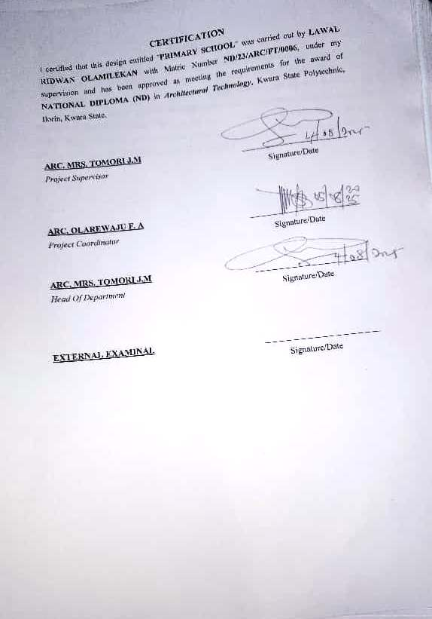

ACKNOWLEDGEMENTS

First and foremost, I give all thanks and glory to Almighty God for the strength, wisdom, and guidance throughout the course of this project.

I sincerely appreciate the invaluable support and supervision of my project supervisor, [ARC MRS J.M TOMORI], whose expertise, patience, and constructive feedback greatly contributed to the success of this work.

My heartfelt gratitude goes to all my lecturers and the entire faculty for their dedication and knowledge shared over the years, which laid the foundation for this project.

I also thank my parents {MR LAWAL AYOBAMI AND ALHAJA MRS LAWAL OMOLABAKE ALIRAT} for their constant love, prayers, and encouragement, and for always believing in my potential.

To my friends and colleagues, thank you for your collaboration, support, and motivation throughout this academic journey.

Lastly, I acknowledge everyone who, directly or indirectly, contributed to the successful completion of this project. Your support is deeply appreciated.
DEDICATION
I humbly dedicate this academic project to, Almighty God, whose grace and guidance made this work possible. To my parents {MR LAWAL AYOBAMI AND ALHAJA MRS LAWAL OMOLABAKE ALIRAT}, for their unwavering love, sacrifice, and support throughout my academic journey. To my lecturers and supervisors, whose knowledge, encouragement, and mentorship played a vital role in shaping this work. To my colleagues and friends, for their collaboration, motivation, and constructive contributions. This work stands as a testament to the collective effort, inspiration, and support I have received.
ABSTRACT
A primary school is an educational institution that provides foundational learning for children, typically between the ages of 4 to 12 years. It serves as the first stage of formal education, focusing on basic literacy, numeracy, and social development. Primary education is essential for cognitive growth, character building, and preparing students for secondary education.

Primary schools serve as the foundation of formal education, shaping young minds to become knowledgeable, disciplined, and socially responsible individuals. They provide a safe and structured environment where children can learn, explore, and grow. Whether public or private, traditional or alternative, primary schools remain essential in preparing students for future academic and life challenges.

Primary schools play a vital role in shaping children’s academic and personal development. With a structured curriculum, trained educators, and a supportive environment, they lay the groundwork for future educational success. Their characteristics ensure a balanced approach to learning, socialization, and skill development, preparing students for the next stage of their education.

TABLE OF CONTENTS
TITLE PAGE…………………………………………………………………..........i
DECLERATION………………………………………………………………...…. ii
CERTIFICATION………………………………………………………………….. iii
DEDICATION……………………………………………………………………….iv
ACKNOLEDGMENT ……………………………………………………………….v
TABLE OF CONTENTS…………………………………………………………… vi
LIST OF TABLES……………………………………………………………….…. vii
LIST OF FIGURES………………………………………………………………… viii
LIST OF PLATES………………………………………………………………… ix
LIST OF APPENDICES……………………………………………………………….x
ABSTRACT……………………………………………………………………...…. xi

CHAPTER ONE
1.0 INTRODUCTION………………………………….………….………………………1
1.1 HISTORICAL BACKGROUND…………………………….………………..………2
1.2 DEFINITION…………………………….…………………….…...…………………3
1.3 STATEMENT O F THE RESEARCH PROBLEM. ………………………………….3
1.4 AIM AND OBJECTIVES………………………………………..………………..…..3
1.5 JUSTIFICATION………………………………………………………………….…..4
1.6 SCOPE OF STUDY………………………………………………………………..…4
1.7 LIMITATIONS OF STUDY………………………………………………………..…4
1.8 RESEARCH METHODOLOGY…………………………………………………...…5

vii

CHAPTER TWO

2.1 LITERATURE REVIEW …………………………….…………………………………. 6
2.1.1 INTRODUCTION………………………………………………………………………...6
2.1.2 IMPORTANT ISSUES AND PROBLEMS PECULIAR TO PRIMARY SCHOOL TYPOLOGY……………………………………………………………………………………....7
2.1.3 TECHNOLOGICAL AND ENVIRONMENTAL APPROACHES FOR DESIGNING A PRIMARY SCHOOL……………………………...……………………………….………..8
2.2 MERIT OF STUDYING……………………………….………………………….…10
2.3 CONCLUSION …………………………………………….……………………….10

CHAPTER THREE
3.0 CASE STUDY…………………………………………………….………….….…. 11
3.1 OUTLINES OF THE CASE STUDIES………………………………...…….….. 11
3.1.1 CASE STUDY ONE (1): Abata Gambari Pry School Kwara State…….………….11
3.1.2 CASE STUDY TWO (2): U.M.C.A Nur & Pry School Oyo State …………...…….16
3.1.3 CASE STUDY ONE (3): Owode Ede Pry School Osun State...................................19
3.1.4 CASE STUDY FOUR (4): Online Case Study……………..………………….…….23

CHAPTER FOUR
4.1 ANALYTICAL STUDY OF THE PROJECT LOCATION…………………………24
4.1.1 INTRODUCTION…………………………………………………………………….24
4.1.2 SITE LOCATION…………………………………………………………………….24
4.1.3 SITE INVENTORY…………..…...………………………………………….………26
4.1.4 SITE ANALYSIS………………...…………………………………………….……..26
4.1.5 GENERAL GEOGRAPHICAL CONDITION…………………….……………..….27
4.1.6 CLIMATE …………………………………………………………………………………...27
4.1.7 VEGETATION………………...………………………………………………..…..29
4.1.8 TOPOGRAPHY………………...……………………………………………… …..29
4.1.9 NATURAL RESOURCES………………...…………………………………….… 29
4.1.10 ENVIRONMENTAL CHALLENGES…………………………………………… ..29
4.1.11 SITE SERVICES………………………………………………………………… …30
4.1.12 SITE UNIQUENESS AND BENEFIT………………………………………………30
viii

4.1.13 SITE SUITABILITY……………………………………………………………….30
4.2. DESIGN CRITERIA……………………………………………………………….30
4.2.1 SITE SELECTION………………………………………………………...……….30
4.2.2 BUILDING ARRANGEMENT…………………………………………………….31
4.2.3 DESIGN SCOPE…………………………………………...……………………….31
4.2.4 DESIGN BRIEF 9ANALYSIS…………………………………………………….31
4.2.5 SPACES DERIVATION ANALYSIS/SCHEDULE FOR ADMINBLOCK………32
4.2.6 FUCTIONAL ANALYSIS AND RELATIONSHIP………………………………32

CHAPTER FIVE
5.1 APPRAISAL OF PROPOSED SCHEME………………………………………….34
5.2 CONSTRUCTION METHODOLOGY AND MATERIALS. …………………….34
5.21 MATERIALS FOR CONSTRUCTION……………………………………………34
5.2.2 CONSTRUCTION METHODOLOGIES………………………………………….34
5.2.1 SERVICE……………………………………………………………………….….36
5.2.2 CIRCULATION……………………………….……………………………….….36
5.2.3 VENTILATION……………………………………….……………………….….36
5.2.4 LIGHTING……………………………………….……………………………….37
5.2.5 PLUMBING ……………………………………….……………….…………….37
5.2.6 ELECTRICAL INSTALLATION……………………………..………………….37
5.2.7 WASTE DISPOSAL……………………………………….…….……………….37
5.2.8 FIRE PROTECTION……………………………………………………………..38
5.2.9 EXTERNAL WORKS……………………………………………..……………..38
5.3 CONCLUSION AND RECOMMENDATION………………………………….38
REFERENCES………………………………………………………………………….39

ix

LIST OF PLATES
CASE STUDY 1
PLATE 3:1.1 LOCATION MAP………………………………………………………….13
PLATE 3.1.2 ELEVATION ……………………………………………..……………….14
PLATE 3.1.3 ELEVATION……………… ……………………………………………….15
PLATE 3.1.4 ELEVATION……………..……………………………………...………….15
CASE STUDY 2
PLATE 3.2.1 ELEVATION………………………………………………………………18
PLATE 3.2.2 STAFF OFFICE. ………………………………………………………….18
CASE STUDY 3
PLATE 3.3.1 LOCATION MAP………………………………………………………….20
PLATE 3.3.2 ELEVATION……………………………………………………………….21
PLATE 3.3.3 ELEVATION…..…………...……………………………………...……….22
PLATE 3.3.4 ELEVATION…...…………...……………………………………….……...22

LIST OF FIGURES
FIGURE 3:1:1 LOCATION PLAN CASE STUDY 1…………………………..………12
FIGURE 3.1.2 FLOOR PLANS CASE STUDY 1…….………………………….…..…13
FIGURE 3:1.3 SITE PLAN CASE STUDY 1 ……………………...……………………14
FIGURE 3.2.1 LOCATION PLAN CASE STUDY 2……………………………………15
FIGURE 3.2.2 FLOOR PLANS CASE STUDY 2……………………………….…….…15
FIGURE 3.3.1 LOCATION PLAN CASE STUDY 3……………………………….……20
FIGURE 3.3.2 FLOOR PLAN. CASE STUDY 3…………………..…………………..…21
FIGURE 4.1.11.1 MAP OF NIGERIA, 36 STATES AND FCT. ……………..………….24
FIGURE 4.1.11.2 KWARA STATE MAP………..……………………………..……………...25
FIGURE 4.1.11.1 LOCATION PLAN …………………………………..………….……...25
FIGURE 4.1.12.1 SITE INVENTORY …………………………………….……….………26
FIGURE 4.1.12.2 SITE ANALYSIS ……………………………..………..……….………27
FIGURE 4.1.3.1 AVERAGE MONTHLY RAINFALL IN ILORIN. …….….…………….28
FIGURE 4.1.3.2 SUNSHINE DURATION IN ILORIN. ………………………..………….28
FIGURE 4.1.3.3 RELATIVE HUMIDITY IN ILORIN. ………………………..…………..29
FIGURE 4.2.6.1: FUNCTIONAL ANALYSIS 1 ……………………………………………32
FIGURE 4.2.6.2: FUNCTIONAL ANALYSIS 2 ……………………………………………32
FIGURE 4.2.6.3: FUNCTIONAL RELATIONSHIP 1 …………………………….………..33
FIGURE 4.2.6.4: FUNCTIONAL RELATIONSHIP 2 ………………………………………33

LIST OF TABLES

TABLE 4.1.1: SPACE ALLOCATION………………………………………………32

xii

LIST OF APPENDICES
APPENDICES 5.1: GROUND FLOOR PLAN…………………………………………..40
APPENDICES 5.2: FIRST FLOOR PLAN. ……………………………………………..40
APPENDICES 5.3: SECON FLOOR……………………………………………………..41
APPENDICES 5.4: ROOF PLAN ………………………………………………………..41
APPENDICES 5.5: SITE PLAN……………………………………………………..…..42
APPENDICES 5.6: SECTIONS……………………………………………………..…..42
APPENDICES 5.7: ELEVATION……………………………………………….…..…..43
APPENDICES 5.8: EXTERNAL PERSPECTIVE. …………………………………….43

CHAPTER ONE

INTRODUCTION

Primary education forms the foundation of a child’s academic journey and personal development. A primary school is more than just a building; it is a nurturing environment where children acquire basic literacy, numeracy, social skills, and values that shape their future. The design of a primary school must therefore respond to the physical, emotional, and educational needs of young learners by providing a safe, stimulating, and inclusive atmosphere.

In modern times, the approach to primary school design goes beyond just classrooms. It includes thoughtful planning of administrative areas, recreational spaces, outdoor play zones, sanitary facilities, and multi-purpose rooms, all tailored to the needs of children between the ages of 5 and 12. A well-designed primary school also considers ventilation, natural lighting, safety, accessibility, and child-friendly aesthetics.

This project aims to design a functional and sustainable primary school that supports effective teaching and learning while promoting creativity, comfort, and a sense of belonging among pupils and staff.

1.1 HISTORICAL BACKGROUND OF THE PROJECT
The concept of primary education dates back to ancient civilizations, where informal teaching was carried out by elders and scholars to pass down knowledge, values, and survival skills. However, formal primary education systems began to emerge in the 17th and 18th centuries, especially in Europe, as governments recognized the importance of educating young citizens.
In Nigeria, primary education was introduced by Christian missionaries in the mid-19th century, starting in the southern regions. The British colonial government later formalized the system, leading to the establishment of public primary schools. After independence in 1960, the Nigerian government intensified its efforts by launching the Universal Primary Education (UPE) in 1976 and later the Universal Basic Education (UBE) in 1999, aiming to make education accessible to every child.

Despite these efforts, many primary schools across the country still face challenges such as poor infrastructure, overcrowding, and lack of teaching facilities. This project seeks to respond to these challenges by proposing a modern and child-friendly primary school design that aligns with contemporary educational standards while meeting the needs of the local community.
1.2 DEFINITION
A primary school is a formal educational institution designed to provide the first stage of compulsory education for children, typically between the ages of 5 and 12 years. It marks the beginning of structured learning, where pupils are introduced to fundamental subjects such as reading, writing, mathematics, science, social studies, and moral education.
Primary education plays a crucial role in developing literacy, numeracy, communication, critical thinking, and social interaction skills, which serve as the foundation for further learning and lifelong development.

Key Features of a Primary School:
- It offers early childhood education immediately after pre-primary or nursery school and before secondary school.
- Learning is guided by a national curriculum; ensuring students receive standard foundational knowledge.
- The environment is designed to be safe, inclusive, child-friendly, and engaging, supporting both academic and emotional development
1.3 STATEMENT O F THE RESEARCH PROBLEM.
In Kwara State, as in many parts of Nigeria, the standard of physical infrastructure in public and some private primary schools remains a significant concern. Many schools in urban and rural areas are faced with poorly designed buildings, overcrowded classrooms, inadequate ventilation, insufficient learning facilities, and a lack of safe recreational spaces. These conditions negatively impact students’ academic performance, health, and overall development.
Although the Kwara State government has made efforts through various educational initiatives and renovation programs, the architectural quality and long-term sustainability of many primary school buildings have not kept pace with modern standards. Furthermore, most school environments are not tailored to meet the psychological and developmental needs of young children, nor are they inclusive for children with disabilities.
Climate-specific design, child-focused planning, and flexible classroom arrangements are often missing in existing structures. In addition, with rising population growth and urban expansion in cities like Ilorin, Kwara State, there is a growing need for a comprehensive and innovative architectural response that addresses these challenges.
This study therefore seeks to develop a functional, child-friendly, and sustainable primary school design that meets the educational, environmental, and cultural needs of learners in Kwara State, with a focus on improving learning outcomes and long-term usability of school facilities.
1.4 AIM AND OBJECTIVES
1.4.1 AIM OF THE STUDY
The aim of this study is to design a functional, inclusive, and sustainable primary school that provides a safe, child-friendly, and stimulating learning environment, while addressing the architectural, educational, and environmental challenges currently facing basic education.
1.4.2 OBJECTIVES
- To design a functional and flexible learning environment that supports effective teaching and accommodates modern educational methods.
- To create a child-friendly architectural design that promotes comfort, safety, and psychological development for young learners.
- To provide adequate academic and non-academic facilities, including classrooms, administrative offices, library, ICT room, toilets, playgrounds, and a multipurpose hall.
- To ensure proper spatial planning for efficient circulation, security, and accessibility within the school premises.
- To incorporate sustainable and locally available materials and adopt passive design strategies such as natural lighting and ventilation
1.5 JUSTIFICATION.
Primary education is the foundation upon which all future learning is built. However, in many parts of Nigeria, including both urban and rural areas, the architectural design of primary schools often fails to meet the basic physical, psychological, and developmental needs of young learners. Poor ventilation, overcrowded classrooms, lack of recreational spaces, and inadequate sanitation facilities are common problems that hinder effective learning and child development.

1.6SCOPE OF THE STUDY
This study focuses on the architectural design of a standard primary school that meets both national and international educational design standards. The scope includes the planning and design of the following:
- Academic Spaces – Classrooms for different grade levels (Primary 1–6), staff room, library, ICT room, and multipurpose hall.
- Administrative Offices – Head teacher’s office, secretary’s office, record/store room, and general administrative area.
- Recreational and Outdoor Areas – Playground, open assembly area, landscaped spaces, and sports activity zones
- Support Facilities – Sickbay, canteen, gender-separated toilets, and adequate parking for staff and visitors.
- Site Planning and Environmental Considerations – Proper circulation routes, security, drainage, water supply, and sanitation systems.

1.7 LIMITATIONS OF STUDY
The limitation experienced during this course of study includes:
- Engineering Details Not Covered – The study focuses on architectural planning and design. Detailed structural, mechanical, electrical, and plumbing (MEP) engineering drawings are beyond its scope.
- Cost Estimates Excluded – This project does not provide a detailed bill of quantities or cost analysis for construction.
- Site-Specific Data May Be Generalized – In the absence of access to full geotechnical, topographical, or hydrological surveys, some site planning elements may be based on typical assumptions.
- Time Constraints – Due to academic time limitations, some design explorations and case study analyses may be summarized rather than deeply explored.
- Policy and Legal Review – The study does not include a full review of all local building codes or government regulations that may apply during actual construction.

1.8 RESEARCH METHODOLOGY
This study adopted a qualitative research approach aimed at gathering data to support the design of a functional, inclusive, and sustainable primary school. The methodology involved the following key stages:
- Literature Review
Analysis of existing academic works, journals, and design guidelines related to school architecture, child-centered learning environments, and educational space planning.
- Case Study Analysis
Examination of selected local and international primary school projects to understand spatial arrangements, materials used, environmental strategies, and functional zoning.
Focus was placed on identifying best practices in design, sustainability, and child safety.
- Site Analysis
Observation and assessment of the proposed site (if available), including location, orientation, access, topography, climate, and surrounding land use
Environmental factors such as sun path, wind direction, and rainfall patterns were also considered for passive design strategies.

CHAPTER TWO
2.1LITERATURE REVIEW OF PRIMARY SCHOOL
2.1.1 Introduction
The literature review explores previous studies, architectural standards, and educational policies relevant to the design of primary schools. It provides insight into the principles and practices that guide the creation of effective learning environments for children.
- Educational Space Design Principles
Scholars like Neufert (Architects' Data) and sources such as the UNICEF School Infrastructure Guidelines emphasize that primary schools should be designed to promote safety, comfort, flexibility, and learning stimulation. Classrooms must be well-lit, well-ventilated, and spacious enough to support various teaching styles and group sizes. Ergonomic furniture and age-appropriate materials are crucial for early childhood learning.
- Child-Centered Architecture
Research by Maria Montessori and later architectural theorists highlights the need for environments that support independent exploration, creativity, and inclusiveness. Classrooms should allow for mobility, interaction, and accessibility for all children—including those with disabilities.
2.1.2 IMPORTANT ISSUES AND PROBLEMS PECULIAR TO PRIMARY SCHOOL TYPOLOGY
The design and functionality of primary schools in many developing regions, including Nigeria, face several critical challenges that affect both the learning process and the well-being of pupils. These issues are outlined below:
- Overcrowding
Many public primary schools experience excessive student enrolment with insufficient classroom space. This leads to overcrowded classrooms, poor ventilation, and noise pollution, which hinder concentration and effective teaching.
- Poor Ventilation and Lighting
Inadequate windows, poor building orientation, and lack of passive ventilation result in hot and uncomfortable learning environments. Insufficient natural lighting also causes eyestrain and fatigue among pupils.
2.1.3 TECHNOLOGICAL AND ENVIRONMENTAL APPROACHES FOR DESIGNING A PRIMARY SCHOOL.
In primary school architecture, especially at the primary level, it is essential to integrate both technological innovation and environmental consciousness to create functional, sustainable, and engaging learning spaces. Below are the key approaches.
🔧 TECHNOLOGICAL APPROACHES
- Smart Classrooms
- Integration of projectors, interactive whiteboards, and audio-visual tools to enhance learning experiences.
- Provision for electricity and data cabling to support digital education and future upgrades.
- Modular Construction
- Use of prefabricated materials or modular blocks to reduce construction time and allow for future expansion or relocation.
- Security Technology
- Installation of CCTV cameras, intercom systems, and secure entry points to enhance student safety.
- Rainwater Harvesting Systems
- Use of tanks and filters to collect and purify rainwater for school use, reducing dependence on public water supply.
- Solar Energy
- Integration of solar panels for electricity generation to support lighting, fans, and small appliances, especially in off-grid locations.

🌿 ENVIRONMENTAL APPROACHES
- Passive Ventilation Design
- Strategic window placement, cross ventilation, and roof vents to improve airflow and reduce heat build-up without relying on air conditioning.
- Day lighting
- Use of large windows, clerestory lighting, and skylights to maximize natural light in classrooms, reducing the need for artificial lighting.
- Use of Local and Eco-Friendly Materials
- Clay bricks, bamboo, rammed earth, or compressed stabilized blocks (CSBs) reduce carbon footprint and support the local economy.
- Green Landscaping
- Planting trees and grass to create shaded areas, reduce heat, and improve air quality within the school compound.
- Waste Management Systems
- Provision for waste sorting bins, composting zones, and safe disposal systems to teach environmental responsibility.
- Thermal Comfort Design
- Thick walls, shaded verandas, reflective roofs, and overhangs to reduce indoor temperatures and improve comfort.

✅ BENEFITS OF THESE APPROACHES
- Improve learning and concentration
- Reduce running costs (light, water, maintenance)
- Promote sustainability and environmental education
- Provide safer and healthier learning environments

CHAPTER THREE

3.0 CASE STUDY
A case study involves an up-close, in-depth, and detailed examination of a particular case or cases, within a real-world context. Case study research is to establish a firm research focus to which the research can refer over the course of a complex phenomenon or object.
Case study can be view as the study of an existing project for a reference purpose in order to determine adjustment point of that particular building. Case study research is to establish a firm research focus to which the research can refer over the course of a complex phenomenon or object.
According to researcher Robert K. Yin, defined case study method as an empirical inquiry that investigate a contemporary phenomenon within its real-life context,

3.1 OUTLINES OF THE CASE STUDIES
- Abata Gambari Pry School Gambari Area Ilorin Kwara State
- U.M.C.A Pry School Abe-Asa Igbeti Oyo State
- Owode Ede Pry School Osun State.
- Elementary & Middle School Norway
- Elementary & Middle School Sweden.

3.1.1 CASE STUDY ONE (1): Abata Gambari Pry School Gambari Area Ilorin Kwara State.
Date of Establishment:
Architect: Unknown
Location: Kwara State

Brief Description:
[
Typical layout features include single or two-story classroom blocks, open play areas, and basic sanitation facilities.

Likely built with standard government design with minimal color styling and limited landscaping.
Climate: Tropical wet and dry climate
Topography: Asa River and small streams
Vegetation: Guinea Savanna
Merits:

- Community access: Provides education to children within walking distance, supporting enrollment and retention.

- Basic infrastructure available: Includes classrooms, assembly space, and sanitation facilities.

- Government-supported: May benefit from state-level improvements under the UBE (Universal Basic Education) program.

Demerits:
- Minimal aesthetic and comfort features: Plain interiors, limited daylight control, and wear-prone finishes.

- Overcrowding: Likely large class sizes due to high enrollment and limited space.

- Lack of amenities: Absence of library, ICT room, art/music space, or well-defined recreation zones.

LOCATION PLAN
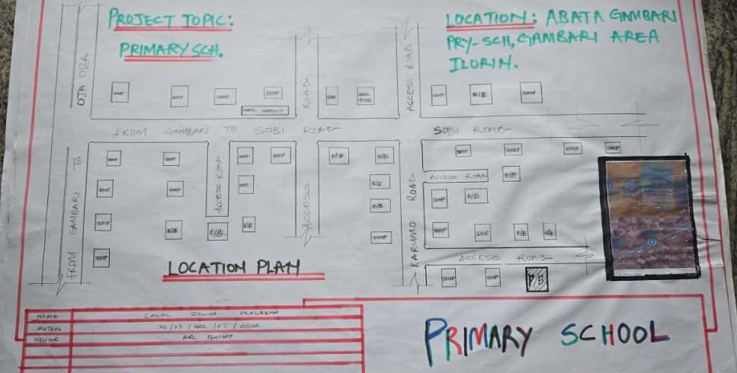
Figure 3:1:1 Location Plan

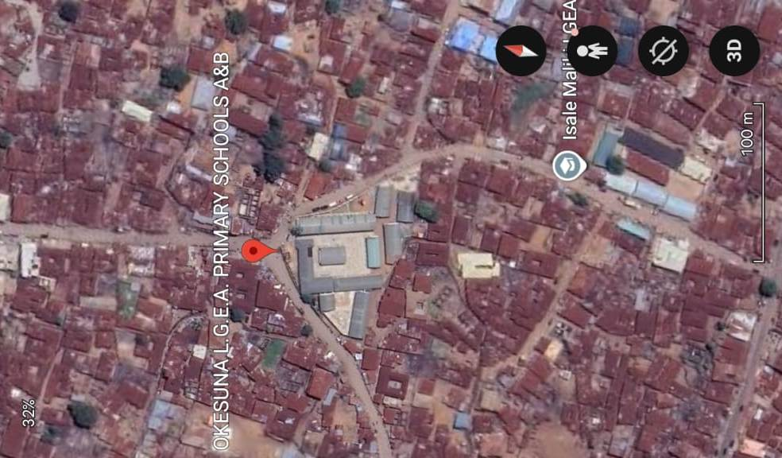
Plate 3:1.1Geographical Layout

SITE PLAN
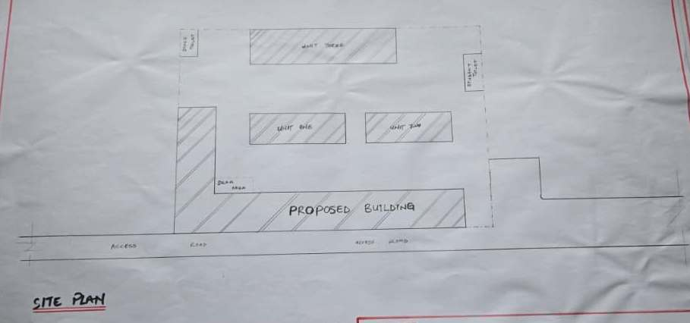Figure 3.1.2Site Plan
FLOOR PLAN
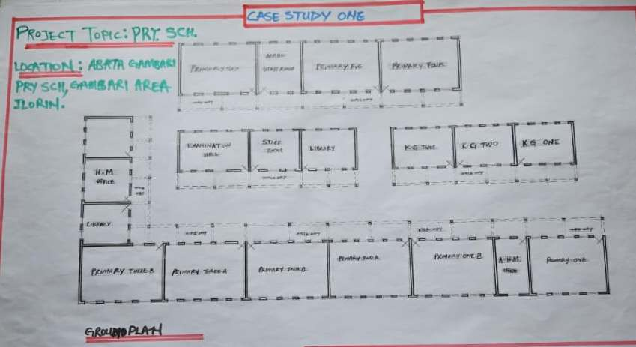
Figure 3:1.3Floor Plans

PICTURES
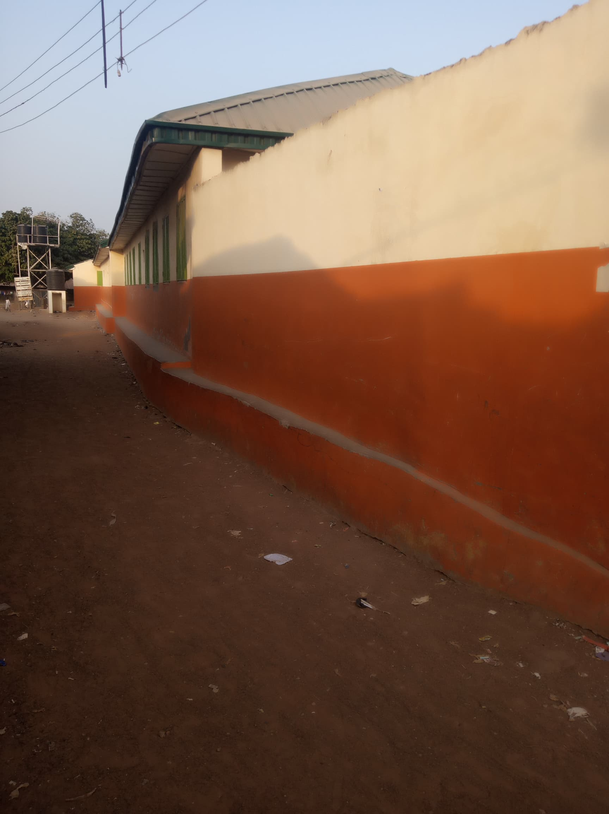
Plate 3.1.2Elevation
12
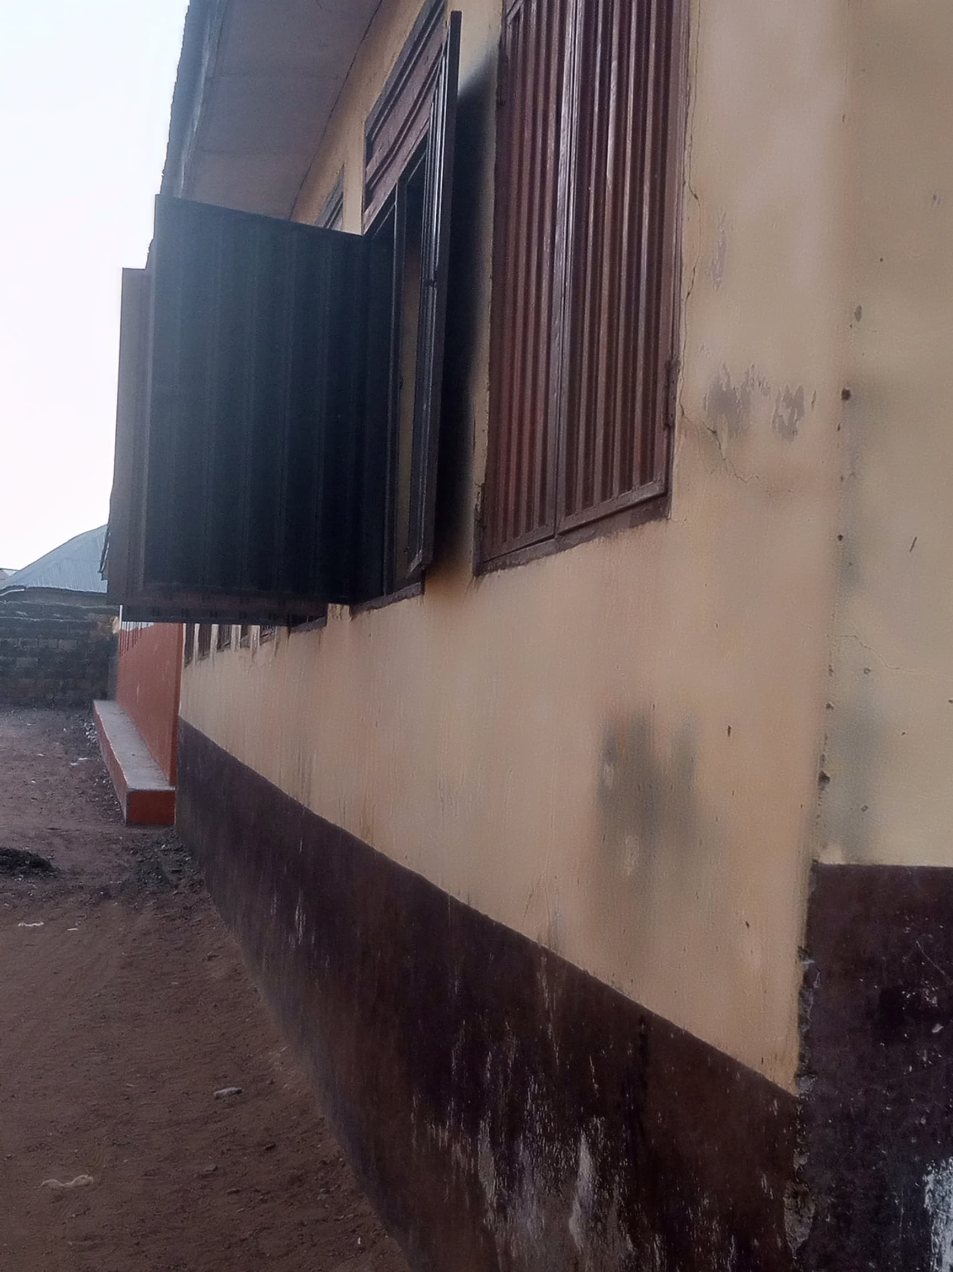
Plate 3.1.3School

3.1.2 CASE STUDY TWO (2): U.M.C.A Pry School Abe-Asa Igbeti Oyo State.
Date of Establishment: Unknown
Architect: Unknown
Location: Oyo State.

Brief Description:
U.M.C.A. (United Methodist Church of Africa) Nursery & Primary School is a government-registered, church-affiliated basic school located in Apeeru/Bible School Road, Abe Asa area, within Igbeti town, in Olorunsogo Local Government Area of Oyo State.
It operates Monday to Friday, 8 AM to 5 PM, and is listed by the Oyo State Universal Basic Education Board among approved institutions
Climate: Tropical climate.
Topography: Rocky and Hills
Vegetation: Guinea Savanna

13

Merits
- Official Recognition & Oversight
- Included among Oyo SUBEB-approved schools, which suggests compliance with state education standards and regular supervision.

- Church Affiliation
- As a UMCA school, likely emphasizes moral and religious values in its programming, which can foster discipline and community trust.

- Preprimary to Primary Continuity
- Offers both nursery and primary levels, allowing children to progress in one environment without transfer disruptions.

Demerits
- Limited Public Information
- There is minimal detail available regarding infrastructure—such as classroom conditions, library, sanitation facilities—or student outcomes and enrollment statistics.

- No Parent or Student Reviews Visible
- Lack of reviews or ratings online makes it difficult to assess reputation, teaching quality, or community feedback.

- Unclear Class Size & Teaching Resources
- No data on student-teacher ratio, availability of textbooks, educational aids, or extracurricular programs.

LOCATION PLAN
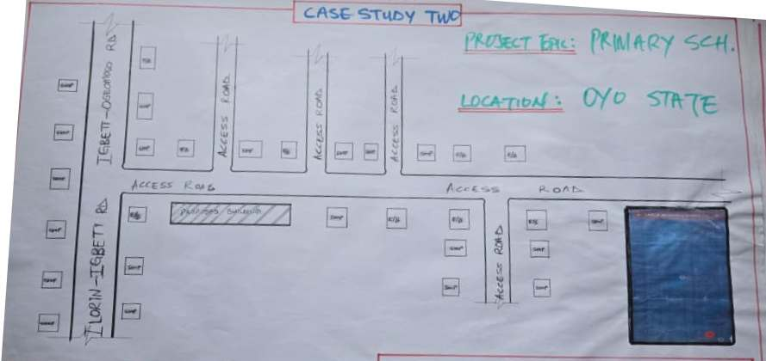
Figure 3.2.1Location Plan
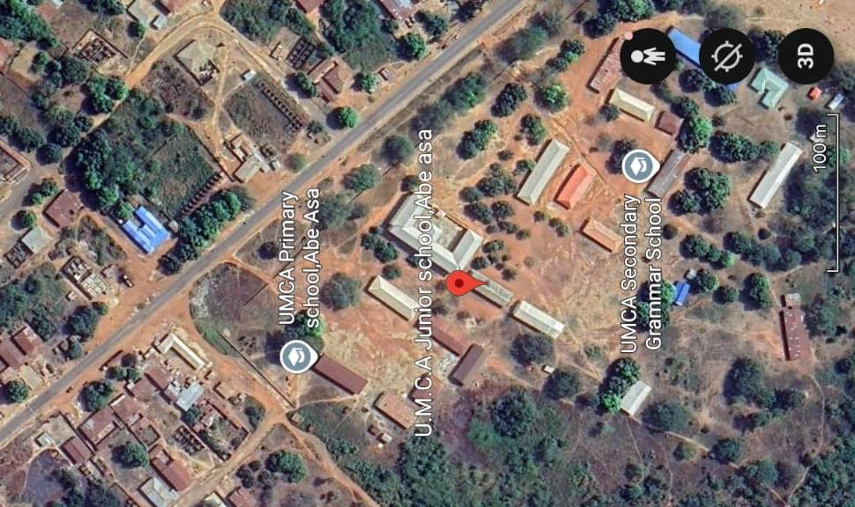
Plate 3.2.1 Geographical Layout

FLOOR PLAN
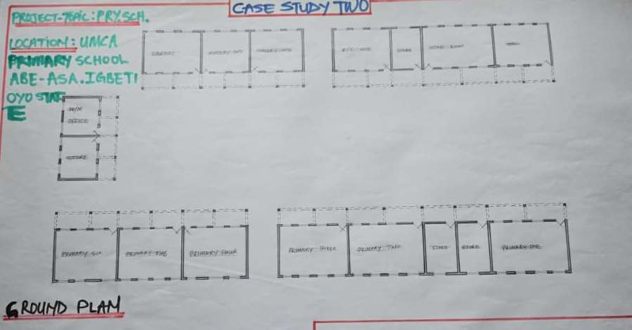
Figure 3.2.2 Floor Plans
PICTURES
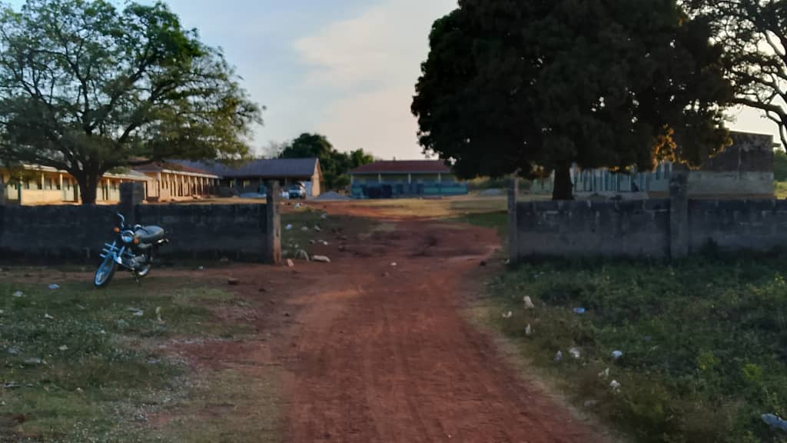
Plate 3.2.2 Back Elevation

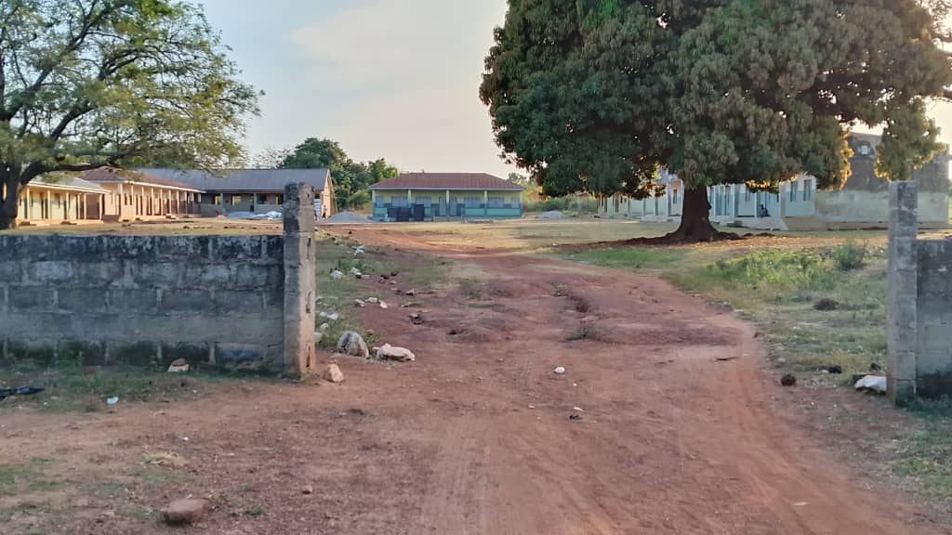
Plate 3.2.3 Front Elevation

3.1.3 CASE STUDY ONE (3): Owode Ede Pry School Osun State.
Date of Establishment: 2003
Architect: Unknown
Location: Osun State.

Brief Description:
Located in Owode‑Ede, a community within Ede North Local Government Area, Osun State.

The town has both public and private primary schools under local government oversight. The education system supports nursery and primary levels, often using multi-purpose designs.

Osun State has faced challenges affecting primary education including infrastructure shortages, overcrowded classrooms, and inconsistent policy implementation.
Climate: Tropical wet and dry
Topography: Unknown
Vegetation: Guinea Savanna

Merits:
- Community accessibility: Schools are centrally located, allowing easy walking access for children.

- Government reach: Public schools promote wide coverage under Universal Basic Education policies.
Demerits:
- Overcrowded classrooms due to high enrollment and limited building capacity.

- Minimal amenities: Few libraries, ICT rooms, or designated play areas. Many schools lack visually stimulating or child-friendly interiors.

- Infrastructure gaps: Uneven maintenance of sanitation, ventilation, and classroom finishing.

LOCATION PLAN
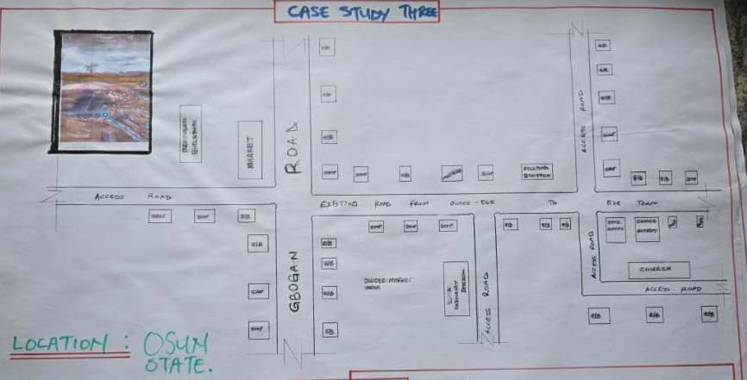

Figure 3.3.1 Location Plan
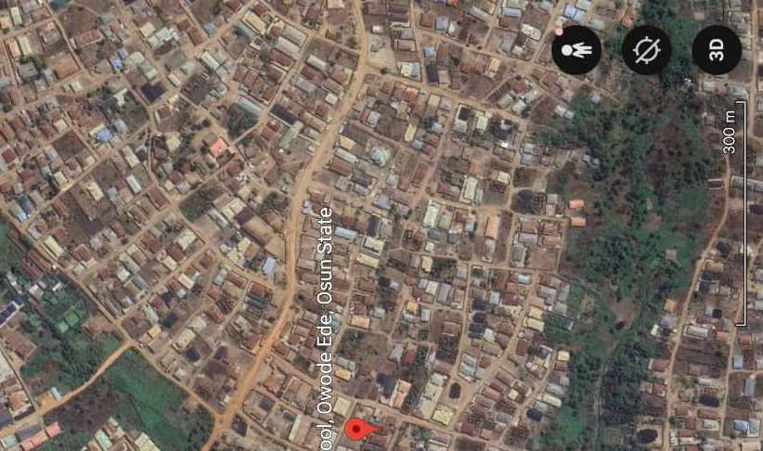
Plate 3.3.1Geographical Layout

FLOOR PLAN
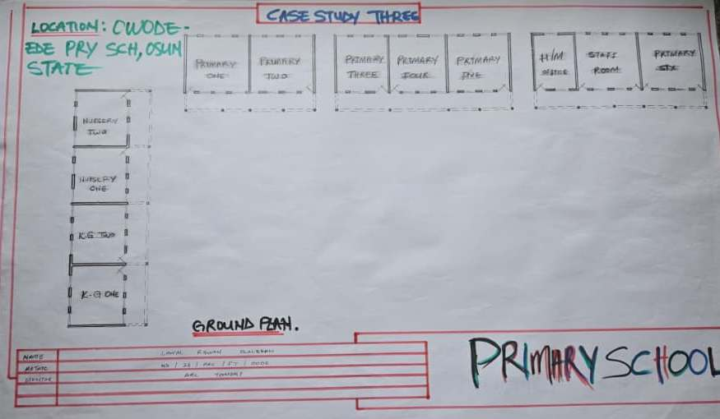
Figure 3.3.2 Floor Plan.
3.1.4 CASE STUDY FOUR (4): ONLINE CASE STUDY
Location: Elementary & Middle School, Norway.
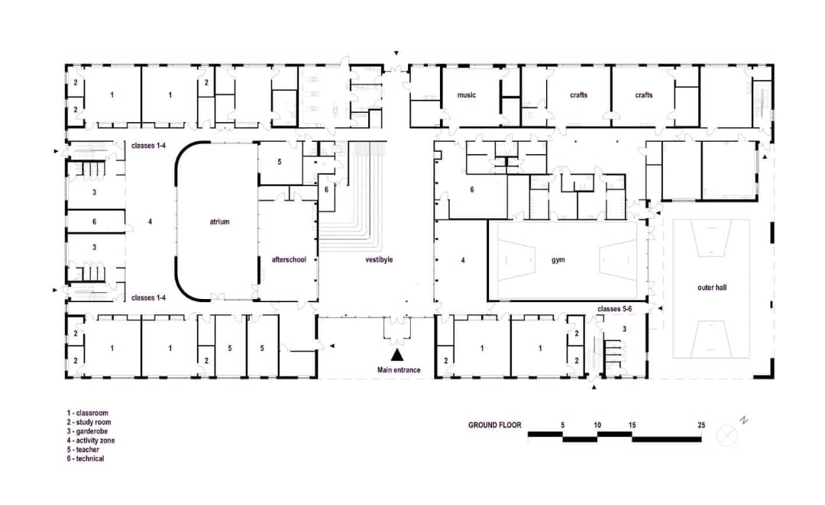
Figure 3.4.1 Ground Floor Plan
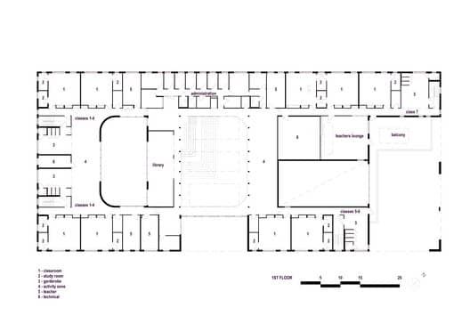
Figure 3.4.2 First Floor Plan
SHOWING FLOOR PLAN OF CASE STUDY FOUR
20

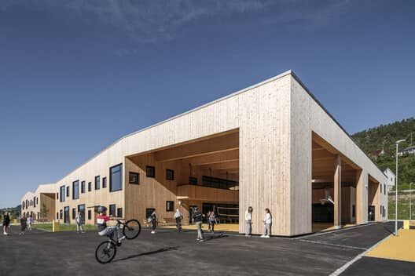
Plate 3.4.1 Elevation
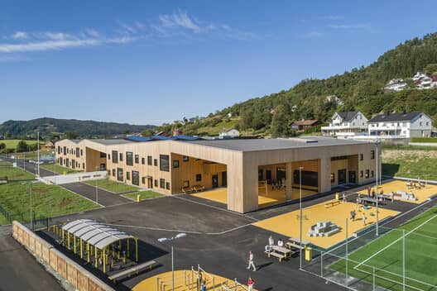

Plate 3.4.2 Views
21

3.1.5 CASE STUDY FIVE (5): ONLINE CASE STUDY
Location: Elementary & Middle School, Sweden.
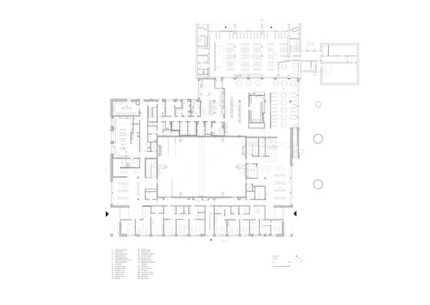
Figure 3.5.1
SHOWING FLOOR PLAN

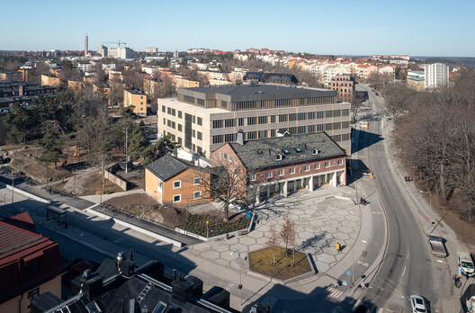
Plate 3.5.1
SHOWING ELEVATION
22
CHAPTER FOUR
4.1 ANALYTICAL STUDY OF THE PROJECT LOCATION
4.1.1 INTRODUCTION
Kwara State is one of the 36 states of Nigeria, located in the North Central geopolitical zone. It was created on May 27, 1967, and shares boundaries with Kogi, Oyo, Osun, Ekiti, and Niger states, as well as a national boundary with the Republic of Benin to the west. Its capital is Ilorin, which also serves as the state’s largest city and a major administrative, cultural, and educational hub.

The state has a diverse landscape ranging from flat savannah to low hills and valleys, making it suitable for both agricultural and urban development. Its central location makes it an important transit point between northern and southern Nigeria.

The choice of Kwara State (Tipa Garage) as a primary school project location is driven by a number of factors:

4.1.2 SITE LOCATION
The proposed site for the primary school project is situated in Tipa Garage, which lies on the eastern approach toward Ilorin, the capital of Kwara State.
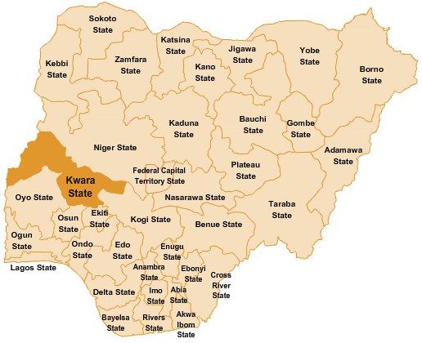

Figure 4.1.1 Map of Nigeria, 36 States and FCT.

23
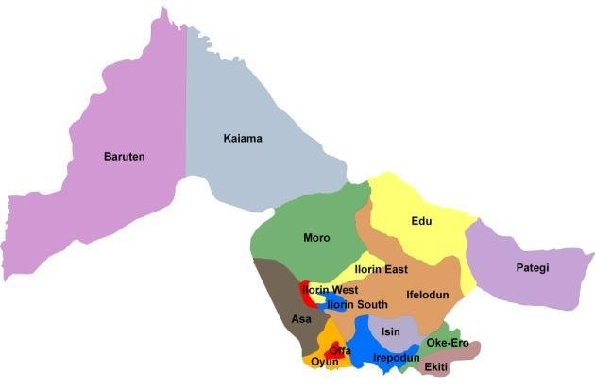
Figure 4.1.2 Kwara State Map

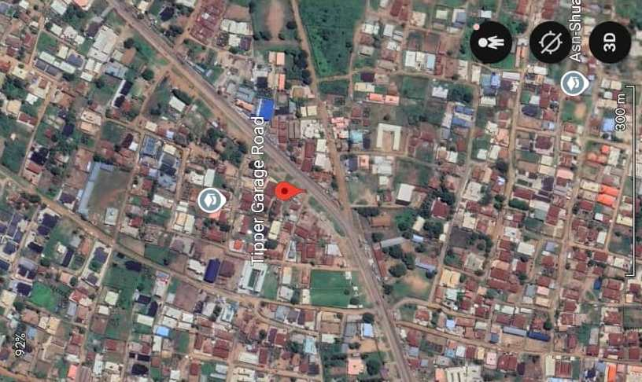

Figure 4.1.3 Location Plan
24

4.1.3 SITE INVENTORY
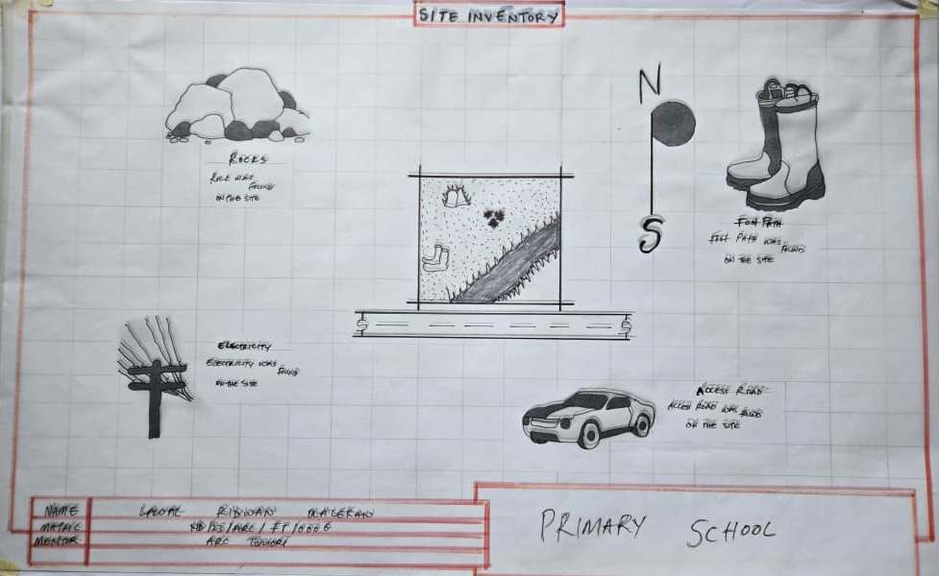
Figure 4.1.4 Site Inventory

Site inventory is the synthesis of the physical feature and facilities that are present on the site and over the site such as trees, footpath, soil, topography, vegetation, stream and shrubs etc.

4.1.4 SITE ANALYSIS
Site Analysis is the process of evaluating how a proposed site system will integrate with the existing site infrastructure by assessing physical obstructions, electrical interference, and noise to identify suitable interrogation zones for coexistence with the infrastructure.

The site selected for the project is a very gentle slope, it is a site that has never been used for any form of building construction i.e. it has not been developed in the past which make it an abode for several trees and shrubs, it is also observed during the course of inventory that some of the trees are to be removed as it could obstruct the construction process during the project, while some are to be retained to help control the adverse of the wind storm.

The soil is well compacted Soil in nature with good soil texture. The sun rises from the eastern part of the site and sets on the western part. The Construction does not need a special type of foundation due to the fact that the site is having a good bearing capacity and strength.
25
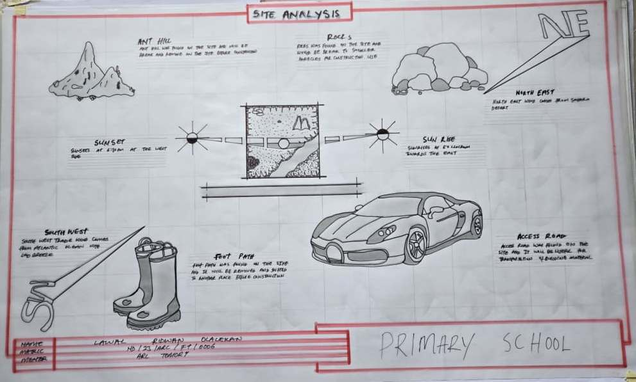
Figure 4.1.5 Site Analysis

4.1.5 GENERAL GEOGRAPHICAL CONDITION
Kwara State is located in the North Central region of Nigeria, geographically positioned between latitudes 8° and 10° North and longitudes 2°30′ and 6°25′ East. It serves as a transitional zone between the northern savannah and southern forest belt of Nigeria.

The state has an estimated land area of 36,825 square kilometers, making it one of the larger states in the country in terms of land mass.

4.1.6 CLIMATE:
Kwara State experiences a tropical climate with two distinct seasons: the wet (rainy) season and the dry season. This climatic condition influences architectural design, construction methods, and material choices for buildings, especially educational facilities like primary schools.

🔸 Rainy Season
- Duration: Typically from April to October
- Peak Rainfall: Usually in June and September
- Annual Rainfall: Ranges between 1,200 mm and 1,500 mm, depending on the location (southern parts get more rain than the north)
26
- Impact: Adequate drainage systems and well-designed roofing slopes are essential to manage runoff and prevent flooding in school buildings.

🔸 Dry Season
- Duration: November to March
- Harmattan Period: December to February, characterized by dry, dusty northeasterly winds, low humidity, and haze
- Temperature Range
- Daytime: 25°C to 35°
- Harmattan nights: Can drop below 20°C
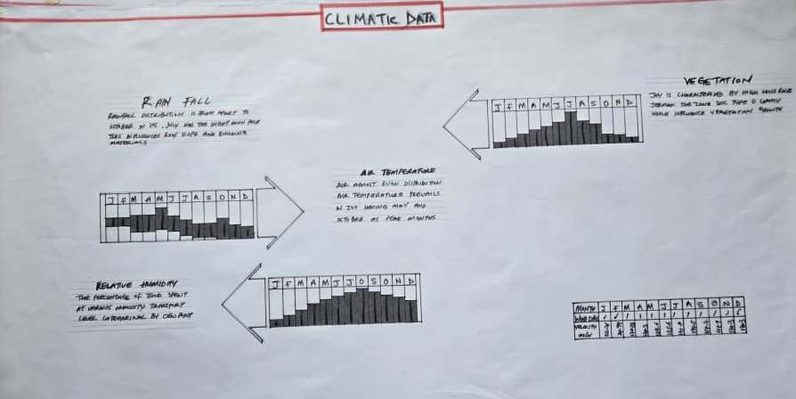

Figure 4.1.6 Average Monthly Rainfall in Kwara State.

Dry Season: The dry season in Kwara usually spans from November to March. This period is marked by little to no rainfall, high daytime temperatures, and significantly lower humidity compared to the rainy season. A key feature of the dry season is the Harmattan, a dry and dusty wind that blows from the northeast, usually between December and February.

27

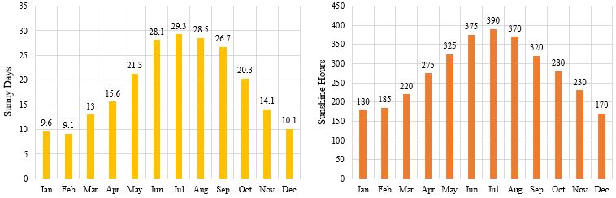

Figure 4.1.3.2 Sunshine Duration in Kwara State.

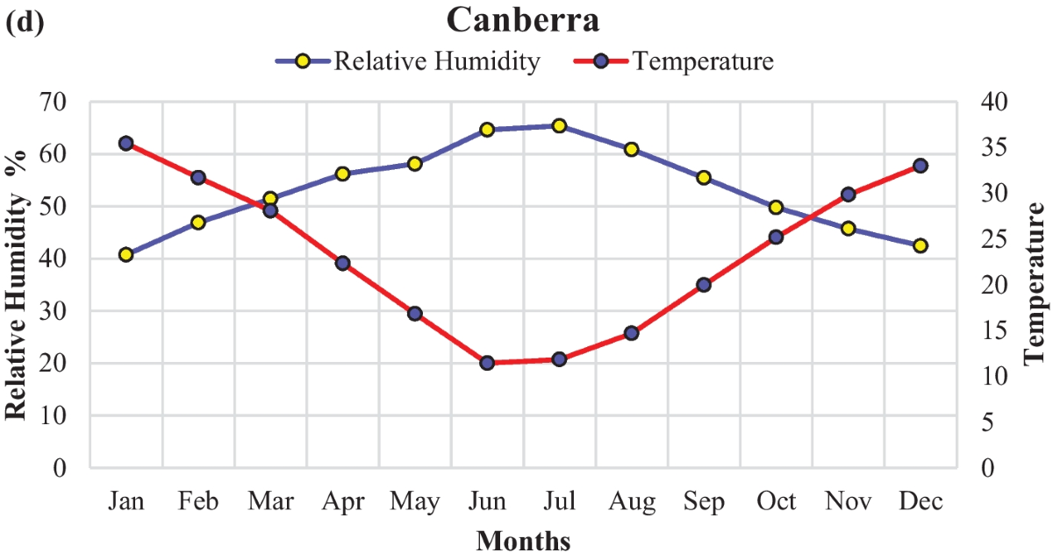

Figure 4.1.3.3 Relative Humidity in Kwara State.

4.1.7 VEGETATION
Guinea Savanna: The predominant vegetation type in Kwara State is the Guinea Savanna, characterized by a mix of grassland and scattered trees. This vegetation type is typical of the transitional zone between the forest regions in the south and the Sahel in the north.
Flora: Common plant species include acacia, baobab, shea butter trees, and various grasses and shrubs adapted to the savanna climate.

4.1.8 TOPOGRAPHY
Gently Undulating Plains: Kwara State topography consists mainly of gently undulating plains, with occasional hills and low-lying areas.

4.1.9 NATURAL RESOURCES
Kwara State is naturally endowed with a wide range of solid mineral resources and agricultural potential, which play a vital role in the state’s economy and development. These resources not only influence industrial and economic activities but also affect regional planning, employment, and infrastructure development — all of which are relevant when designing and situating public facilities such as schools.

4.1.10 ENVIRONMENTAL CHALLENGES
Urbanization: Rapid urbanization in Kwara State has led to challenges such as deforestation, waste management issues, and pressure on infrastructure and services.
Climate Change: Like many regions, Kwara State faces the impacts of climate change, including variability in rainfall patterns and increased frequency of extreme weather even.

4.1.11 SITE SERVICES
There are good services around the site, which include good access road, for students coming to school, availability of electricity very close to the site which will be useful before and after construction. Also, availability of pipe born water at the chosen site.

4.1.12 SITE UNIQUENESS AND BENEFIT
- The site is accessible
- Natural factor like, is very useful
- Utility services such as water, electricity, telephone, etc. cause no problem to the inhabitants.

4.1.13 SITE SUITABILITY
The appropriateness or suitability of the site for the construction and planning of the proposed project is based on the fact that is possesses and meets the entire requirements. All the existing features were strictly considered with the intension of making advantage of them to maximum level most especially the geographical, topographical features of the site.
Types Of Forest Region
- Mangrove (Salt Quarter) Swamp Forest
- Fresh water swamp forest
- High forest

4.2. DESIGN CRITERIA
The design of a primary school must create a safe, functional, and stimulating learning environment for children between the ages of 4 and 12. The following criteria have been considered to guide the planning, layout, and development of the proposed primary school in Kwara State.

4.2.1 SITE SELECTION
A number of factors necessary for site selection for a farmstead are outlined below:
  - ﻿﻿﻿Access Road
  - ﻿﻿﻿Water
  - ﻿﻿﻿Utilizes and services (electricity, telephone, access drives etc.)
  - ﻿﻿﻿Orientation (air drainage and maximum sunshine may require orientation on a gentle Southerly slope).
  - ﻿﻿﻿Expansion.

4.2.2 BUILDING ARRANGEMENT
The arrangement of facilities for maximum efficiency of operation should be a prime concern. Proper arrangement increase efficiency by reducing walking distance to a minimum and providing adequate drive ways and turn around. It is important to note that five protections, safely and security and all influenced by the design planning.

4.2.3 DESIGN SCOPE
These are scope of designing a Muslim Secondary School which includes the followings;
Security House, Cafeteria/Canteen, Main Building, Examination Hall, Mosque, School Field, Students Hostel, Staff Quarters, Park Lots, School Clinic and Assembly Ground.

4.2.4 DESIGN BRIEF9ANALYSIS
- The following are the brief analysis of the Administrative Units;
Entrance, Reception and Waiting Area, Secretary Office, Principal Office, Vice Principal Administrative, Vice Principal Academic, H.O.D’S Office, Staff Office, Counselling Office, Bursar’s Office and C.C.T.V Room.

- The following are the brief analysis of the Academic Units;
Classrooms, Laboratories, I.C.T Room, Computer Maintenance Room (Hardware), Art and Craft Room, Lecture Hall and Examination Hall.

- The following are the brief analysis of the Supporting Units;
Assembly Ground, Storage Facilities, Connivences and School Medical.
- The following are the brief analysis of the Residential Units;
Students Hostel and Staff Quarters.

4.2.5 SPACES DERIVATION ANALYSIS/SCHEDULE FOR ADMINBLOCK
S/N | UNITS | NO REQ. | LENGHT | BREADTH | LENGTH x BREADTH (mm) | AREA (m²)
 | Entrance |  | 3.8m | 5. | 3800x5000 | 19mm²
 | Kindergarten |  | 5m | 42m | 5000x4200 | 21mm²
 | Nursery |  | 5m | 4.2m | 5000x4200 | 21mm²
 | Primary |  | 4.2m | 5.4m | 4200x5400 | 22.68m²
 | Hall |  | 5.4m | 5.2 | 5400x5200 | 28.08m²
 | Principal Room |  | 3m | 5m | 3000x5000 | 15mm²
 | Office |  | 3.1m | 2.9m | 3100x2900 | 11.02m²
 | Staff Room |  | 6.2m | 6m | 6200x6000 | 36.6m²
 | Computer Room |  | 3.9m | 9.2m | 3900x9200 | 35.88m²
 | Music Room |  | 3.9m | 5.5m | 3900x5500 | 21.45m²
 | Student Toilet |  | 2.1m | 1m | 2100x1000 | 2.1mm²
 | Private Toilet |  | 1.8m | 1.8m | 1800x1800 | 3.24mm²
 | Sick Bay |  | 1.7m | 4.8m | 1700x4800

Table 4.2.1: Space Allocation

4.2.6 FUCTIONAL ANALYSIS AND RELATIONSHIP
The Main Building plan is well function, the unit are so well related to each other,
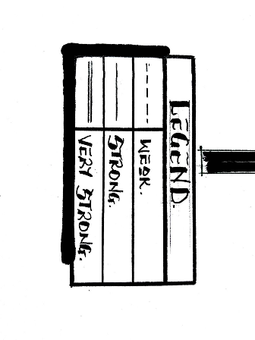
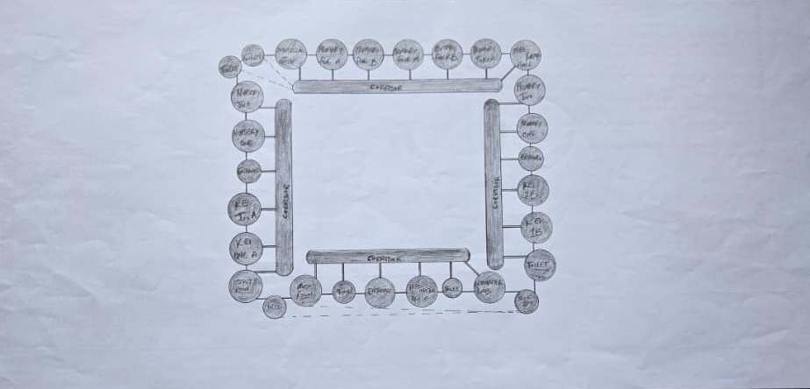
Figure 4.2.6.2: Bubble Diagram
31
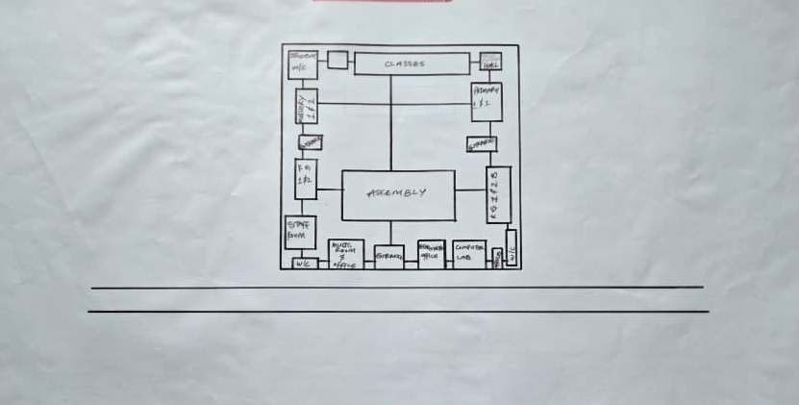
Figure 4.2.6.3: Functional Relationship 1

CHAPTER FIVE
5.1 APPRAISAL OF PROPOSED SCHEME
The proposed Project is to satisfy the appropriate building regulations. The design is to confirm the aid intended use of building taking into consideration with both natural factors and human factors that earn us a threat on the validity and stability of the building.

5.2 CONSTRUCTION METHODOLOGY AND MATERIALS.
The construction is to be carried out following the due process of construction ranging from:
- Preliminary: This involves the clearing of the site, setting out and excavation of foundation trench and foundation works.
- Sub-Structure: This process also entails the positioning and erection of Columns and beans, masonry works etc.
- Post Structure Stage: Is the stage which has to do with the application and installation of the paints, tiles, other finishes and construction of external works etc.

5.21 MATERIALS FOR CONSTRUCTION
1. Sustainable and Eco-Friendly Materials
- Bamboo and Timber: These materials are renewable, have a low carbon footprint, and can be sourced sustainably. Bamboo, in particular, grows quickly and has strong tensile properties.
- Recycled Materials: Using recycled steel, concrete, and glass can reduce the environmental impact of the construction process.
- Insulating Materials: Materials like sheep wool, cellulose, and hemp provide excellent thermal insulation and are environmentally friendly.

2. Traditional and Cultural Materials
- Clay and Adobe: Traditional building materials that offer good thermal mass, keeping buildings cool in hot climates. These materials can be locally sourced and are culturally significant in many regions.
- Stone: Using locally available stone can provide durability and cultural relevance, reflecting traditional architecture.
- Tiles and Ceramics: Decorative tiles and ceramics are often used in architecture for aesthetic purposes, featuring intricate geometric patterns and calligraphy.

3. Modern Materials
- Concrete: Widely used for its strength and versatility. It can be enhanced with additives to improve its sustainability.
- Steel: Provides structural strength and flexibility. Recycled steel can be a more sustainable option.
- Glass: Used for windows and facades to allow natural light. Double or triple-glazed glass can improve energy efficiency.

5.2.2 CONSTRUCTION METHODOLOGIES
1. Green Building Practices
- Passive Solar Design: Orienting the building to maximize natural light and heat from the sun, reducing the need for artificial lighting and heating.
- Green Roofs and Walls: Planting vegetation on roofs and walls to improve insulation, reduce heat island effects, and provide green spaces.
- Rainwater Harvesting Systems: Collecting and using rainwater for irrigation and non-potable uses within the school.

2. Energy-Efficient Construction
- Insulation: Using high-quality insulation materials to reduce energy consumption for heating and cooling.
- LED Lighting: Implementing energy-efficient LED lighting throughout the school.
- Solar Panels: Installing solar panels to generate renewable energy, reducing dependence on non-renewable energy sources.

3. Cultural and Religious Considerations
- Orientation: Provision of natural, quiet spaces that can be used for individual or group prayer during break periods.
- Architectural Elements: In the design of a functional and child-centered primary school, several architectural elements must be thoughtfully considered to ensure safety, comfort, and effective learning.
- Community Involvement: Engaging local communities in the design and construction process to ensure that the school meets cultural and social needs.

5.2.1 SERVICE
A building can be said to be good when it performs the service required by it. In order to have well-functioning building. There calls for an installation of underground water pipes in other to provide water to all the restrooms and other necessary units in the building. A borehole system of water supply is to be adopted alongside the government supplied services and a storage facility is to be provided for effective management of water supply.

5.2.2 CIRCULATION
In my primary school project, circulation is carefully planned to make movement around the school safe, easy, and comfortable for both pupils and staff. Since children are the main users, all circulation paths are designed to be wide, open, and easy to understand.

5.2.3 VENTILATION
As it relates to architecture, is the intentional introduction of outside air into a space. It is mainly used to control indoor air quality by diluting and displacing indoor pollutants. It can also be used for purpose of thermal comfort of dehumidification when the introduction of outside air will help to achieve desired indoor psychometric condition.

This could be either mechanical or natural ventilation. As a regard the proposed project design, there is an introduction of a very spacious courtyard in other to make cross ventilation in most of the building units. There should also a provision of wide passage to allow free movement of air, students and materials. Artificial ventilation is also provided through the installation of air conditioning system and fans.

5.2.4 LIGHTING
Lighting is one of the most important elements in my primary school project because it affects how well pupils can see, learn, and stay alert in class. In my design, I considered both natural and artificial lighting to create a bright, healthy, and energy-efficient learning environment.

5.2.5 PLUMBING
The plumbing system in this proposed building is made easy since the building has a courtyard. Water drained pipes are to be installed underground right from the courtyard to the soak away in other to discharge rainwater.

All water or sewage from the toilets are also channeled into their various inspection chambers using good and appropriate diameter PVC pipes, and taken from the inspection chamber to septic tanka and soak away pit.

Rain water is also collected from gutter if the roof using 100mm diameter PVC rain water pipes and channeled into various drainage or soak away pits. There shall be no ponding; the size of any channel shall effectively discharge rain and water without causing any over lowing stagnation and mosquito breeding. All rain water channeled shall be laid to fall and shall not cause any pounding or splashing unto the committers neighboring area.

5.2.6 ELECTRICAL INSTALLATION
The type of wiring system chosen should be full conduit system of wiring. Classrooms and other students’ technical areas should be wired with strong, durable and light current resistance cable because of the careless operate by the students. Also, electrical installation is to be done to allow for the use of quality electrical fittings and fixtures in the whole building.

5.2.7 WASTE DISPOSAL
Waste disposal bins are to put every office of the building and also in some specific necessary area. These water bins should dispose in the incinerator which will be provided within the compound of the station. The waste should therefore be burnt in the incinerator.

5.2.8 FIRE PROTECTION
Electrically, fire alarms and sensors are to be installed in the school building. This should be done in case of fire occurrence; fire extinguisher is to be placed at certain distances in the cobbles and some other necessary area. It is also serving as protector in case of fire.

5.2.9 EXTERNAL WORKS
The external works are to be carned out uncrate Krebs laid and shrubs, flowers grasses and trees planted.
Concrete interlocking tiles to be adopted of hard landscape and parking spaces both for visitors and staffs have been provided on the site.

5.3 CONCLUSION AND RECOMMENDATION
Conclusion
This project has explored the design of a functional, inclusive, and sustainable primary school that meets the educational and developmental needs of young learners. Based on the study of site conditions, cultural context, environmental factors, and case studies, the design integrates key features such as proper circulation, effective lighting, safe classrooms, and outdoor play areas.

The goal is to create a school environment that encourages learning, comfort, creativity, and security for pupils and staff. Special consideration was given to community involvement, accessibility, and the use of local materials to make the project practical and culturally relevant, especially for a location like Kwara State

Recommendation
- Government and private bodies should invest more in early education infrastructure, especially in rural communities like those in Kwara State
- Architects and planners should always consider child safety, local climate, and cultural background when designing for schools.
36
- School authorities should involve the community during planning and decision-making to ensure the school meets local expectations and is well maintained.
- Use of sustainable design (e.g., natural lighting, cross-ventilation, rainwater harvesting) should be encouraged to reduce operational costs.
- Future expansion should be considered in the design, with room for adding more classrooms or facilities as the population grows.

REFERENCES
Adebayo, A. A. (2015). Design Considerations for Primary School Buildings in Tropical Climates. Journal of Environmental Design, 8(2), 45–52.
Oladimeji, T. M. (2016). The Role of Architecture in Early Childhood Education. Nigerian Journal of Architecture, 11(1), 33–40.
Yusuf, S. A. (2017). The Impact of School Design on Learning Outcomes in Nigerian Primary Schools. International Journal of Educational Research, 9(3), 25–36.
Okonkwo, C. E. (2018). Design and Planning Standards for Public Primary Schools in Urban Areas. Journal of Urban and Regional Planning, 6(2), 51–60.
Bello, K. M. (2019). A Sustainable Approach to Primary School Design in Developing Countries. Journal of Sustainable Architecture, 4(1), 17–27.
Ogunleye, F. T. (2020). Design Strategies for Inclusive Primary Education Facilities in Nigeria. Journal of African Built Environment, 3(2), 63–75.
Nwosu, J. O. (2021). Architectural Design Solutions for Child-Friendly Primary Schools. Nigerian Journal of Environmental Studies, 12(1), 28–38.
Adetunji, A. & Salawu, I. A. (2022). A Study of Spatial Arrangement in Primary Schools and Its Effect on Learning. Journal of Educational Architecture, 5(1), 42–50.
Eze, P. M. (2023). Modern Design Principles for Primary School Facilities in Sub-Saharan Africa. Journal of Contemporary Educational Facilities Design, 7(3), 33–47.
Balogun, R. O. (2024). Designing Safe and Functional Classrooms for Primary Education: A Nigerian Perspective. Journal of Architecture and Educational Space, 6(2), 21–34.

38

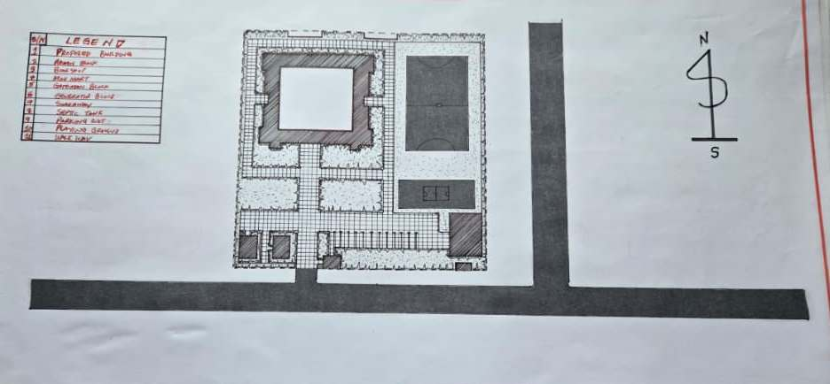

Appendix 5.1: Site Plan

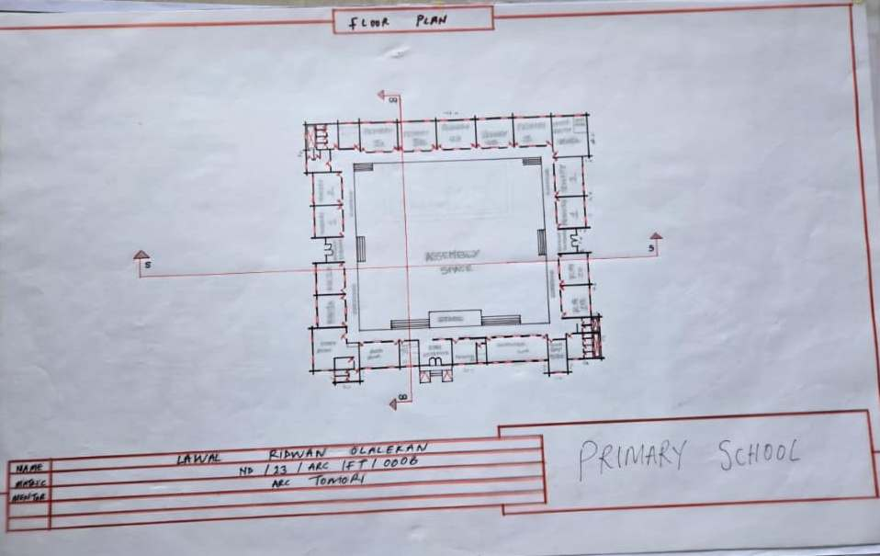
Appendix5.2: Floor Plan.

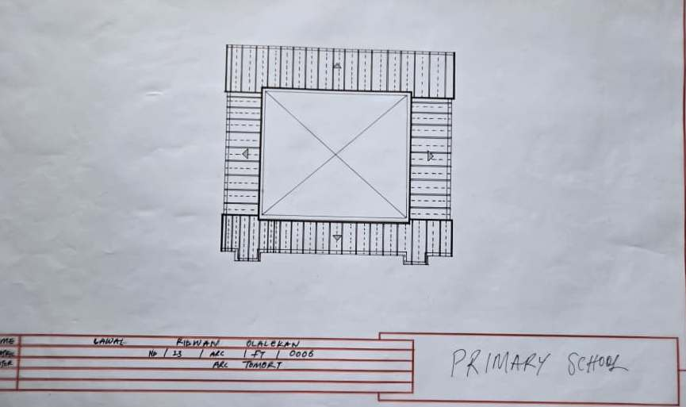

Appendix 5.5: Roof Plan

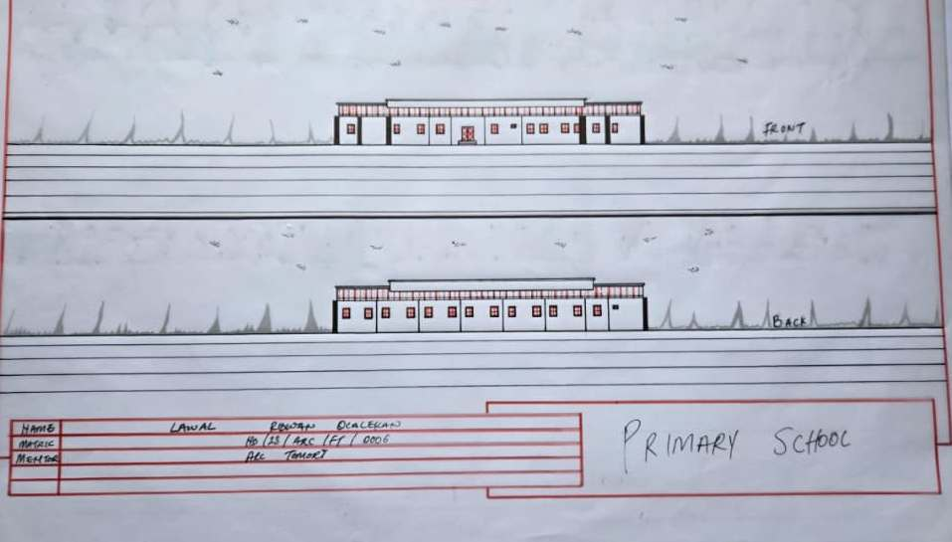

Appendix5.6: Elevation

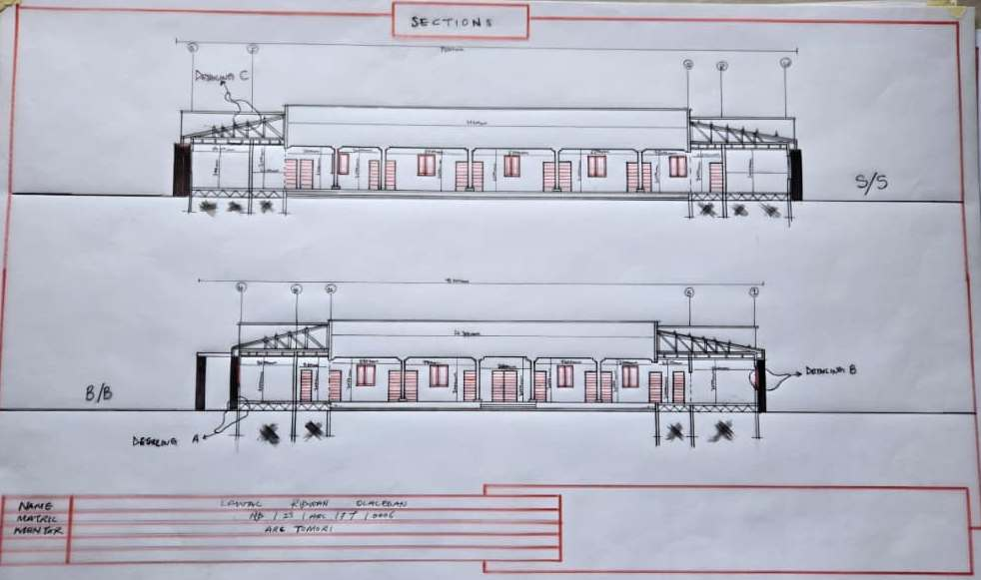

Appendix5.7: Section

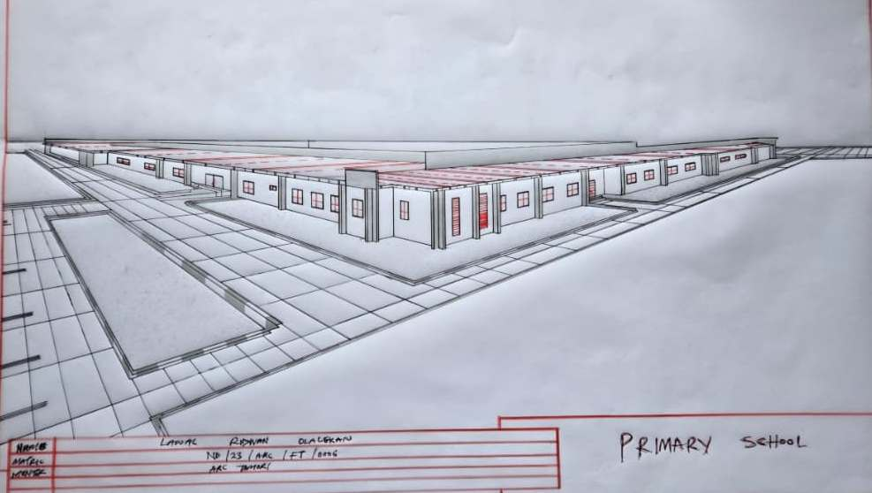

Appendix5.8: External Perspective.

