A PROJECT REPORT ON PROPOSED FIRE STATION

FOR
LAGOS STATE GOVERNMENT, IKEJA
BY
YUSUF FARUQ TEMITOPE
HND/23/ARC/FT/0038

SUBMITTED TO
DEPARTMENT OF ARCHITECTURAL TECHNOLOGY,
INSTITUTE OF ENVIRONMENTAL STUDIES, KWARA STATE POLYTECHNIC, ILORIN

IN PARTIAL FULFILLMENT OF THE REQUIREMENTS FOR THE AWARD OF HIGHER NATIONAL DIPLOMA(HND) IN ARCHITECTURAL TECHNOLOGY KWARA STATE POLYTHECHNIC, ILORIN KWARA STATE.

JULY,2025

DECLARATION
I declare that this project is a product of my personal research work. It has not been presented for the award of any degree in any polytechnic. The ideas, observations, comments suggestions, herein represent my own convictions, except quotations, which have been acknowledged in accordance with conventional academic traditions.

YUSUF FARUQ TEMITOPE
HND/23/ARC/FT/0038
SIGNATURE/DATE

CERTIFICATION
I certify that this research project entitled FIRE STATION was carried out by YUSUF FARUQ TEMITOPE Matric No HND/23/ARC/FT/0038 under my supervision and has been approved as meeting the requirements for the award of Higher national Diploma (HND) in Architectural Technology, of Kwara State Polytechnic, Ilorin, Kwara State, Nigeria.

ARC. (MRS). TOMORI J.M
Project Supervisor Signature and date

ARC. OLAREWAJU F.A
Project coordinator Signature and date

ARC. (MRS). TOMORI J.M
Head Of Department Signature and date

External Examiner Signature and date

DEDICATION
I dedicate this project to GOD Almighty and to my parent MR ISIAKA YUSUF &MRS AJOKE YUSUF and my uncle MR SALAUDEEN ISMAIL for their prayers and support.
ACKNOWLEDGEMENT
I give all adoration and thanks to God Almighty, the giver of life and joy for giving me this great opportunity, strength and wisdom to start and conclude the program of Higher National Diploma and to study Architecture in the great Institute of Environmental Studies Kwara State Polytechnic, Ilorin.
I must appreciate and gratify the devoted assistance of my supervisor ARC. (MRS). TOMORI J.M for the commitment to this work to the very end. To all lecturers of the department of architectural technology, ARC.CHUCKWUMA NMOM, ARC.OLAREWAJU F.A, ARC. ABDULAZEEZ B.Y.F, ARC SOLOMON FAMILUA. God bless you all.
I would like to place my sincere appreciation and thanks for the overwhelming support and love I received from my parents MR&MRS YUSUF.
Special appreciation goes to my siblings Omolara yusuf, Sodiq yusuf, Zainab yusuf and Fathia yusuf.
Also, to my colleagues THE KIN’S MEN, Boluwatife Aderinkola , drey, Ayobami and akey . May God bless us all and crown our effort with success. Amen.

TABLE OF CONTENT
Title Page……………………………………………………………………. i
Declaration…………...……………………………………………………… ii
Certification……………………………………………………………...…… iii
Dedication…………………………………………………………..……...… iv
Acknowledgement………………………………………………………….… v
Tables of contents…………………………………………………………...vi-vii
List of Figures………………………………………………………………... viii
List of plates………………………………...………………………………... ix
List of tables…………………………………..……………………………… x
List of Appendices……………………………………………………………. xi
Abstract……………………………………….……………………………… xii
CHAPTER ONE
1.0 Introduction………………………………………………………………………. 1
1.1 Historical Background……………………………………………………..……… 2
1.2 Statement Of Design Problems…………………………………………………… 3
1.3 Aim ……………………………………………………………………………… 3
1.4 Objectives ………………………………………………………………………… 3
1.5 Justification………………………………………………………………………. 4
1.6 Client’s Background……………………………………………………………… 4
1.7 Definition………………………………………………………………………… 5
1.8 Scope Of The Study……………………………………………………………… 5
1.9 Limitation Of The Study…………………………………………………………… 5
1.10 Research Methodology …………………………………………………………….. 6

CHAPTER TWO
2.0 Literature Review…………………………………………………………………… 7
2.1 Historical Development Of Fire Station…………………………………………..… 9
CHAPTER THREE
3.0 Case Studies ………………………………………………………………………. 14
3.1 Brief History Of Case Study One …………………………………………………. 16
3.2 Case Study Two ……………………………………………………………...……. 19
3.3 Case Study Three ……………………………………………………………….…. 24
3.4 Online case study one ……………………………………………………………. 27
3.5 online case study two ………………………………………………………………28
CHAPTER FOUR
4.0 Study Area/Project Site……………………………………………………………. 30
4.1 History Of Ikeja, Lagos State ………………………………………………..….. 30
4.2 Site Location …………………………………………………………………….... 31
4.3 Site Criteria ……………………………………………………………………...… 32
4.4 Site Analysis/Inventory…………………………………………………………… 33
4.5 Geographical And Climatic Condition………………………………… 34
4.6 Design Criteria…………………………………………………………….……… 37
4.7 Design Brief……………………………………………………………………… 38
4.8 Analysis Of The Brief………………………………………………………..…… 38
4.9 Space Allocation/Schedule Of Accommodation………………………………..… 38
4.9 Functional Relationship…………………………………………………………… 40
4.10 Conceptual Development………………………………………………………… 40
4.11 Bubble Diagram……………………………………………………………..…… 41
4.12 Zoning Based On Activities……………………………………………………… 42
CHAPTER FIVE
5.0 Project Appraisal…………………………………………………………………. 43
5.1 Construction Method And Material……………………………………………………… 45
5.2 Substructure………………………………………………………………………. 45
5.3 Super Structure…………………………………………………………………… 45
5.4 Finishes…………………………………………………………………………… 47
5.5 Services…………………………………………………………………………… 48
5.6 External Works…………………………………………………………………… 49
5.7 Building Requirements…………………………………………………………… 50
5.8 Summary, Recommendation And Conclusion……………………………………. 51
References………………………………………………………………………… 53
Appendix…………………………………………………………………………… 54

LIST OF FIGURES
Figure 3.1.1: Showing The Location Plan Of Case Study One Located At Fire And Rescue Service, Oshodi–Isolo Expressway………………………………………….17
Figure 3.1.2: Showing The Site Plan Of Case Study One Located At Fire And Rescue Service, Oshodi–Isolo Expressway………………………………………… 17
Figure 3.1.3: Showing The Floor Plan Of Case Study One Located At Fire And Rescue Service, Oshodi–Isolo Expressway………………………………………… 18
Figure 3.2.1: Showing The Location Plan Of Case Study two Located Vespa–Olose Road, Right By The Ifo Lga Secretariat, Ogun State…………………………… 19
Figure 3.2.2: Showing The site Plan Of Case Study two Located At Vespa–Olose Road, Right By The Ifo Lga Secretariat, Ogun State……………………………. 21
Figure 3.2.3: Showing The Ground Floor Of Case Study two Located At Vespa–Olose Road, Right By The Ifo Lga Secretariat, Ogun State……………………………. 22
Figure 3.2.4: Showing The First Floor Of Case Study two Located At Vespa–Olose Road, Right By The Ifo Lga Secretariat, Ogun State…………………………….. 22
Figure 3.3.1: Showing The Location Plan Of Case Study Three Located At Osun State Fire Station T.W. Road In Osogbo, Osun State Government………………… 25
Figure 3.3.2: Showing The site Plan Of Case Study Three Located At Osun State Fire Station T.W. Road In Osogbo, Osun State Government………………… 25
Figure 3.3.3: Showing The Floor Plan Of Case Study Three Located At Osun State Fire Station T.W. Road In Osogbo, Osun State Government………………... 26
Figure 4.1.1 Map Of Lagos State ……………………………………………………….. 31
Figure 4.2.1 Location Map…………………………………………………………………31
Figure 4.2.1 Location Plan ……………………………………………………………… 32
Figure 4.4.1 Site Inventory……………………………………………………………… 33
Figure 4.4.2 Site Analysis……………………………………………………………… 34
Figure 4.5.1 Graph Of Climate In Lagos……………………………………… 35
Figure 4.5.2 Graph of temperature in Lagos……………………………………………… 36
Figure 4.6.1: Showing Design Criteria ………………………………………………….. 37
Figure 4.9.1 Flow Chart………………………………………………………………….. 40
Figure 4.10.1 Concept Derivation ……………………………………………………….. 41
Figure 4.11. 1: Bubble Diagram…………………………………………………………. 41
Figure 4.12.1 Site Zoning……………………………………………………………….. 42

LIST OF PLATES
Plate 3.1.1: Showing The front view Of Case Study One Located At Fire And Rescue Service, Oshodi–Isolo Expressway…………………………………….. 18
Plate 3.1.2: Showing The side view Of Case Study One Located At Fire And Rescue Service, Oshodi–Isolo Expressway……………………………………………… 19
Plate 3.2.1: Showing The Front view Of Case Study Two Located At Vespa–Olose Road, Right By The Ifo Lga Secretariat, Ogun State…………………………………………… 23
Plate 3.2.2: Showing The Back view Of Case Study Two Located At Vespa–Olose Road, Right By The Ifo Lga Secretariat, Ogun State…………………………… 23
Plate 3.3.1: Showing The Front view Of Case Study Three Located At Osun State Fire Station T.W. Road In Osogbo, Oyo State Government…………………. 26
Plate 3.3.2: Showing The Side View Of Case Study Thre Located At Osun State Fire Station T.W. Road In Osogbo, Oyo State Government………………………… 27
Plate 3.4.1: Showing The Side View Of Online Case Study One Located AT Adelaide fire services Toronto On, Canada …………………………….……….. 28
Plate 3.5.1: showing the online case study two located at Kingston Fire Services United kingdom……………………………………………………….… 29

LIST OF TABLE
Table 4.1.1: Showing The Space Allocation …………………………………………….. 39

LIST OF APPENDICES
Appendices Ones Location map …………………………………………………..…….. 55
Appendices two location layout …………………………………………………………. 56
Appendices three bubble Diagram ………………………………………………………… 57
Appendices four functional relationship ………………………………………………….. 58
Appendices five space allocation …………………………………………………………. 59
Appendices six roof plan ………………………………………………………………….. 60
Appendices seven section ………………………………………………………………… 61
Appendices eight elevation …………………………………………………….…………. 62
Appendices nine Elevation …………………………………………………….…………. 63
Appendices ten site plan ………………………………………………………….………. 64
Appendices eleven ground floor plan ……………………………………………………. 65
Appendices twelve upper floor plan ……………………………………………..………. 66

ABSTRACT
The fire station aims to design and construct a modern, efficient, and sustainable fire station to serve the growing needs of the community while enhancing emergency response capabilities.The facility will incorporate energy- efficient systems, and resilient infrastructure to ensure operational reliability during emergencies. It emphasizes efficient spatial planning, rapid response mechanisms, and integration of advanced firefighter equipment and technologies. The layout typically includes fire-fighters equipment storage, training facilities, living quarters for firefighters, and community engagement spaces to promote fire safety education. The goal is to ensure eco-friendly materials, solar energy integration, and water conservation system. By optimizing response times and fostering community resilience, the fire station will provide critical support for public safety and disaster preparedness, aligning with local urban planning goals and national fire service standards. This project explores the architectural design and spatial planning of a modern fire station that meets both functional and community needs. The design prioritizes operational efficiency, rapid response times, firefighter safety, and sustainability. Key features include optimized vehicle access, specialized training areas, dormitory accommodations, and environmentally conscious materials. The fire station is envisioned not only as an emergency response center but also as a public safety education hub, fostering stronger ties with the community it serves. The design emphasizes quick response time, safety, accessibility, and sustainability through the use of passive design strategies and locally sourced materials. Additionally, the station aims to serve as a civic landmark, fostering greater public awareness and engagement in fire safety. The project is informed by case studies, site analysis, and relevant fire safety codes, resulting in a contextually responsive and future-ready design solution.

CHAPTER ONE
1.0 INTRODUCTION
A fire station, also known as a firehouse, is a facility where firefighters are based and equipped to respond to emergencies like fires, medical incidents, and other hazards. It serves as a hub for fire trucks, ambulances, and specialized equipment, with living quarters for on-duty firefighters, including sleeping areas, kitchens, and training spaces. Fire stations are strategically located to ensure rapid response times, often staffed 24/7 by professional or volunteer firefighters. Beyond firefighters, they engage in community education, fire prevention, and sometimes rescue operations. Each station operates as part of a broader fire department network, coordinated to protect specific areas efficiently.
A fire station (also called a fire house, fire hall, firemen's hall, or engine house) is a structure or other area for storing firefighting apparatuses such as fire engines and related vehicles, personal protective equipment, fire hoses and other specialized equipment. Fire stations frequently contain working and living space for the firefighters and support staff. In large U.S. cities, fire stations are often named for the primary fire companies and apparatus housed there, such as "Ladder 49". Other fire stations are named based on the settlement, neighborhood or street where they are located, or given a number. A fire station will at a minimum have a garage for housing at least one fire engine. There will also be storage space for equipment, though the most important equipment is stored in the vehicle itself. The approaches to a fire station are often posted with warning signs, and there may be a traffic signal to stop or warn traffic when apparatus are leaving or returning to the station. Fire stations have often been built with a tower, for purposes that have changed with time. A drill tower is used for practicing high-rise rescue, while a hose tower is used for hanging hoses to dry to prevent rot.^{[1]} Historically, towers were lookouts for spotting fires. Activities at a fire station include regular inspection and cleaning of the apparatus and equipment, and training drills in which the firefighters practice their skills. Some fire companies also host public activities at the fire station during events such as a "fire prevention week", and the facility may also be used for fund-raising by the "firemen's association", "fire buffs", or "fire auxiliary". If the station is occupied full-time by career firefighters, it will contain living quarters and work areas, where they wait until a callout comes through. Career firefighters are usually able to sleep during a night shift, so these stations will also have dormitories. There will be an alarm system to alert them of an emergency call, and to give some indication of where and what the emergency is. In some small fire departments, the only alarm may be a telephone for receiving calls.
Many fire stations were built with the living quarters above the garage. This arrangement is common for fire stations built in a crowded city. The fireman's pole was invented to allow firefighters to quickly descend to the garage. In modern times, agencies such as the National Fire Protection Association have argued that these pose a safety hazard. Modern fire stations are often built with the living quarters on the same level as the garage.
Some fire stations are not regularly occupied, with the firefighting carried out by volunteer or retained firefighters. In this case, the firefighters are summoned to the fire station by siren, radio or pagers, where they will then deploy the fire engine. These fire stations may still have office space for the firefighters, a library of reference and other materials, and a "trophy wall" or case where the firefighters display memorabilia.
1.1 HISTORICAL BACKGROUND
The Nigeria fire service’s history is intertwined with the country's colonial past, evolving from a unit within the Lagos police service to a statutory organization with a national mandate. The initial fire service was established in 1901 as part of the Lagos police, focused on preventing and fighting fires in the government reserved areas of Lagos colony. In 1963, the federal fire service was established by an act of parliament, officially granting it statutory responsibility for fire prevention, mitigation, and firefighting, as well as rescue and paramedical service.
The fire service in Nigeria was established as an arm of the Lagos police fire brigade, primarily to address fire emergencies in the colonia capital of Lagos. This marked the beginning of organized firefighting in the country.
1.2 STATEMENT OF DESIGN PROBLEMS
Most of the fire stations in the country are dilapidated; no architectural interest is mostly sited in the areas that are not located within the residential areas which are bound to have higher risk of fire outbreak. Most of the fire service stations don’t have enough space for storage of chemicals and fire equipment.
There is no good integration of the building into the landscape and the urban area of the town.
1.3 AIM
The main aim of this project is to design functional buildings with strictly utilitarian emphasis that will provide a related, civilized atmosphere during a tough working environment that is a place where the workers can relax and enjoy themselves when on standby or off-duty.
1.4 OBJECTIVES
Objectives of the fire station are to provide the following
i. to design a conducive environment for efficient maintenance area to support the upkeep of firefighting infrastructure.
ii. To design a layout that supports the fast and efficient operation of firefighting and rescue activities.
iii. To design a Clear zoning between operational, residential, and administrative areas, minimizing travel distances between dormitories, apparatus bays, and exits.
iv. To facilitate the quickest possible response time to emergencies.
V To design an environment that ensure safety for both personnel and equipment, while providing a durable and resilient structure.
1.5 JUSTIFICATION
A new fire station design in ikeja would center on improving emergency response times, enhancing firefighting’s safety, and upgrading equipment storage and maintenance facilities. This design would contribute to public safety, property protection and the overall well-being of the community. The design of a new fire station in Ikeja will focus on significantly reducing emergency respond times through strategic design and location optimization, prioritizing firefighter’s safety with advanced protective infrastructure and training facilities. This design will support public safety by enhancing rapid intervention in emergencies, safeguard property through improved firefighter resources and elevate the overall well-being of the community.
1.6 CLIENT’S BACKGROUND
Lagos a state-of-the-art fire station along airport road, Ikeja, in Lagos state, Nigeria. Lagos state was officially created on May 27, 1967, under the state creation and transitional provisions decree No.1 of 1967, which restructured Nigeria into a federation of 12 states. This strategic initiative aims to enhance fire safety and emergency response capabilities in the commercial hub of Ikeja, ensuring the protection of lives, property, and critical infrastructure in the region.
1.7 DEFINITION
A fire station is a specialized facility or building designed to house firefighting personnel, equipment, and vehicles, serving as a base for emergency response operations. it is strategically located to provide rapid response to fires, medical emergencies, and other incidents within a designated area. Beyond firefighting, fire stations often serve as centers for community safety education, fire prevention programs, and disaster response coordination.
1.8 SCOPE OF THE STUDY
- GATE HOUSE
- FIRE STATION
- TRUCKS PARKING AREA
- CAR PARK
- STAND TANK AREA
- CAFETERIA
- DORM
- WORKSHOP
- STORE
- GENERATOR HOUSE
- GREEN AREA
1.9 LIMITATION OF THE STUDY
Lack of sponsorship in other to carried out the case studies
Lack of necessary information need to carried out my new design, and I did not have assess to most of te equipment and the room used due to there own safety.

1.10 RESEARCH METHODOLOGY
Information needed to design a standard fire station and obtained through the following: Case study, oral interview, literature review, internet browsing.
In carrying out this work, data was collected from diverse sources which can be classified into primary and secondary sources.
- PRIMARY SOURCE: Some of the data from this project were gathered by carrying out a series of case studies and making direct observation of the data as they occur. Questions were asked when needed, with a view to have a better understanding. Some of the data were accompanied by photographs since a certain level of detail is required.
- CASE STUDY: This involves visiting the existing buildings or structures of related project [FIRE STATION] to know needed information.
- ORAL INTERVIEW: Oral interviews are adopted to seek opinions of available officials and managers and were considered as a major respondent who provide a very useful information in deciding the concept and scope of the project.
- SECONDARY SOURCE: Past literatures were reviewed to get some data for this work, some were collected from internet, encyclopedia, and previous related project

CHAPTER TWO
2.0 LITERATURE REVIEW
Fire stations should explore existing research on spatial distribution, impact on response times, and the effectiveness of different fire station locations. It should also examine factors influencing fire risk, such as urban growth and economic development, and the need for optimized fire station layout to ensure efficient fire incident response. Furthermore, the review should consider the impact of fire stations on air quality and the health of firefighters.
Site selection for fire stations is a key factor influencing response time and coverage efficiency. Research by Kuo & Chen (2010) emphasizes the use of geographic information systems (GIS) for optimal station placement, considering population density, road networking, and fire risk zones. The National Fire Protection association (NFPA) also provides guidelines suggesting that stations be located to ensure response times of 4 to 8 minutes within the urban areas.
Modern fire station design integrates operational efficiency with comfort for personnel. According to schwinghammer (2015), layout should minimize transition time from living quarters to fire apparatus, support 24/7 readiness, and include spaces for training, maintenance, and administration. Flexibility in design is also encouraged to accommodate future technological and functional changes.
Recent literature, such as that by Pacheco-Torgal (2013), explores the integration of sustainable practices in public buildings, including fire stations. These include energy- efficient HVAC systems, rainwater harvesting, solar panels, and the use of green materials, which reduce operational costs and environmental impacts.
Modern fire stations are often envisioned as community hubs. Literature shows a growing trend of including public education rooms, events space, areas for public interaction within station designs (Alexander, 2018). This fosters community trust and awareness while optimizing space usage.
Fire stations are critical public safety facilities that require highly functional and responsive architectural solutions. Their design must address operational efficiency, firefighter safety and comfort, spatial clarity, and increasingly, community interaction and sustainability. This literature review examines architectural and planning principles, case studies, and emerging trends in fire station design.
According to Neufert's Architects’ Data (2000), fire stations must be divided into three main zones: operational (e.g., apparatus bays), administrative (e.g., offices, control room), and residential (e.g., dormitories, kitchen, and recreational areas). Efficient spatial zoning ensures quick response times, safe circulation, and clear functional separation. Studies highlight the importance of direct, obstruction-free movement from rest areas to vehicle bays to meet target response times (typically under 60 seconds for urban areas).
Response time is a core metric in fire station planning. As per NFPA 1710 (National Fire Protection Association), fire stations should be strategically located to serve their area within a 4-minute response window. Urban fire stations require integration with traffic patterns, minimal exit obstructions, and clear site access. GIS-based studies (e.g., Zhang et al., 2018) have been used to model ideal fire station locations based on population density, road networks, and risk zones.
Modern designs are increasingly focusing on firefighter wellbeing, recognizing the physical and psychological stress of the job. LEED and WELL standards suggest natural lighting, proper ventilation, and access to fitness and rest spaces as critical factors. Facilities now include decontamination zones to prevent carcinogen exposure after incidents (U.S. Fire Administration, 2021).
Sustainable fire stations are emerging worldwide, using passive design strategies, solar panels, rainwater harvesting, and green roofs. The Woodlawn Fire Station 21 in Portland, Oregon, for example, is LEED Platinum-certified, demonstrating how fire stations can become sustainable civic buildings without compromising functionality.
In recent years, fire stations have evolved to include public-facing elements such as educational rooms, visitor centers, and community halls. This shift reflects a broader movement toward integrating emergency facilities into the social fabric of neighborhoods. Research by Lasserre (2015) emphasizes how transparency and public interaction zones humanize the service and build trust.
While function dominates fire station design, form and identity also matter. Fire stations often serve as landmarks. Architects such as Zaha Hadid (Vitra Fire Station, 1993) have challenged conventional typologies by merging expressive design with rigorous function, demonstrating the potential for architectural innovation in civic infrastructure.
The literature highlights a growing need for multifunctional, sustainable, and community-integrated fire station designs. The evolving role of fire stations — from purely operational bases to civic and educational spaces — provides a rich opportunity for architectural exploration. This review informs the thesis design by establishing functional requirements, identifying user needs, and referencing successful global precedents.
2.1 HISTORICAL DEVELOPMENT OF FIRE STATION
The fire service in Nigeria has a historical development beginning as an arm of the Lagos police fire brigade in 1901. In 1963, the federal fire service was officially established by an act of parliament, separating the fire service from the police force. Further reforms in 2007 and the establishment of the federal fire service academy in Abuja have marked the service’s evolution.
- Early development (1901-1963):
The fire service initially operated as part of the Lagos police fire brigades, with firefighters undergoing combine police and fire service training. This period was characterized by a close relationship between the two services, which gradually evolved into a need for separation.Firefighting as an organized activity dates back to ancient civilizations.
In Ancient Rome, the first known fire brigade, Vigiles, was formed under Emperor Augustus around 24 BCE. These early responders had basic tools like buckets, hooks, and pumps and operated out of watchtowers or small shelters rather than dedicated buildings.
- Medieval and Pre-Industrial Era
During the Middle Ages in Europe, firefighting responsibilities often fell on local communities or informal groups of volunteers. There were no specialized buildings; fire equipment (often just buckets and ladders) was stored in town halls or churches. Urban fires were common due to wood construction and the lack of regulations.
- The Industrial Revolution and the Rise of Formal Fire Departments (18th–19th Century)
The growth of cities during the Industrial Revolution brought increased fire hazards. This led to the establishment of formal fire departments and the first dedicated fire stations.
- In London, following the Great Fire of 1666, organized firefighting emerged, culminating in the London Fire Brigade (1866).
- In the United States, Benjamin Franklin helped form the first volunteer fire company in Philadelphia in 1736, and the first municipal fire station emerged in the early 1800s.
Fire stations from this period were primarily utilitarian buildings, often resembling barns, with simple garages for horse-drawn engines and a bell tower to alert firefighters.
- Early 20th Century: Mechanization and Standardization
The invention of the motorized fire engine transformed fire station design. Buildings now needed:
- Wider bays for large vehicles
- Hose drying towers
- Sleeping quarters and mess halls for full-time staff
- Sliding poles for quick movement from upper dormitories to apparatus bays
This era also saw architectural styles reflecting civic pride—many fire stations were designed in classical, art deco, or mission revival styles, depending on the region
- Post-War Era (1945–1980s): Functional Modernism
After World War II, fire stations became more standardized and purely functional. Emphasis was placed on response efficiency and practicality over aesthetics.
- Prefabricated materials and minimalist designs became common.
- Suburban expansion required more decentralized, smaller-scale fire stations.
- Contemporary Fire Station Design (1990s–Present)
In recent decades, fire stations have evolved into multi-functional civic buildings. They now often include:
- Public education rooms
- Community gathering spaces
- Sustainable design features (LEED-certified buildings)
- Advanced safety zones, such as clean/dirty transition areas to manage contamination
- Spaces promoting firefighter wellness (gyms, quiet rooms, natural lighting)
Iconic modern examples include:
- Vitra Fire Station by Zaha Hadid (Germany, 1993) — a sculptural, deconstructivist design
- Establishment of the fire service (1963- present):
In 1963, an act of parliament officially established the fire service, making the formal separation from the police force. The actual separation took effect on April 1,1964 and the fire service was established throughout the federal capital territory.
- Further development and reforms:
The federal Government’s reform of the fire service in 2007 redefined as its mandate, including the standardization of fire and rescue equipment, the regulation of private fire outfits, and fire prevention. The federal five service Academy, located in Abuja was established to provide specialized training for firefighters. The service’s mission continues to evolve, focusing on fire prevention, safety, mitigation and emergency preparedness.
- Contemporary Fire Station Design (1990s–Present)
In recent decades, fire stations have evolved into multi-functional civic buildings. They now often include:
- Public education rooms
- Community gathering spaces
- Sustainable design features (LEED-certified buildings)
- Advanced safety zones, such as clean/dirty transition areas to manage contamination
- Spaces promoting firefighter wellness (gyms, quiet rooms, natural lighting)
Iconic modern examples include:
- Vitra Fire Station by Zaha Hadid (Germany, 1993) — a sculptural, deconstructivist design
- Woodlawn Fire Station 21 (Portland, USA) — a LEED Platinum-certified green building
- Docklands Fire Station (Melbourne, Australia) — a high-performance, community-centered facility
The design of fire stations has shifted from utilitarian sheds to sophisticated, multi-zoned facilities that reflect advances in technology, urban planning, and public architecture. As critical infrastructure, fire stations today serve not only as emergency response hubs but also as symbols of civic engagement, resilience, and sustainability.

CHAPTER THREE
3.0 CASE STUDIES
A case study is an in-depth, detailed examination of a particular case (or cases) within a real-world context. For example, case studies in medicine may focus on an individual patient or ailment; case studies in business might cover a particular firm's strategy or a broader market; similarly, case studies in politics can range from a narrow happening over time like the operations of a specific political campaign, to an enormous undertaking like world war, or more often the policy analysis of real-world problems affecting multiple stakeholders.
Generally, a case study can highlight nearly any individual, group, organization, event, belief system, or action. A case study does not necessarily have to be one observation (N=1), but may include many observations (one or multiple individuals and entities across multiple time periods, all within the same case study). Research projects involving numerous cases are frequently called cross-case research, whereas a study of a single case is called within-case research.
There are multiple definitions of case studies, which may emphasize the number of observations (a small N), the method (qualitative), the thickness of the research (a comprehensive examination of a phenomenon and its context), and the naturalism (a "real-life context" is being examined) involved in the research. There is general agreement among scholars that a case study does not necessarily have to entail one observation (N=1), but can include many observations within a single case or across numerous cases. For example, a case study of the French Revolution would at the bare minimum be an observation of two observations: France before and after a revolution. John Gerring writes that the N=1 research design is so rare in practice that it amounts to a "myth".
The term cross-case research is frequently used for studies of multiple cases, whereas within-case research is frequently used for a single case study. John Gerring defines the case study approach as an "intensive study of a single unit or a small number of units (the cases), for the purpose of understanding a larger class of similar units (a population of cases)". According to Gerring, case studies lend themselves to an idiographic style of analysis, whereas quantitative work lends itself to a nomothetic style of analysis. He adds that "the defining feature of qualitative work is its use of noncomparable observations—observations that pertain to different aspects of a causal or descriptive question", whereas quantitative observations are comparable. According to John Gerring, the key characteristic that distinguishes case studies from all other methods is the "reliance on evidence drawn from a single case and its attempts, at the same time, to illuminate features of a broader set of cases". Scholars use case studies to shed light on a "class" of phenomena. Case study research has been extensively practiced in both the social and natural sciences.
3.1 BRIEF HISTORY OF CASE STUDY ONE
FIRE AND RESCUE SERVICE, OSHODI–ISOLO EXPRESSWAY
Fire and Rescue Service, Oshodi–Isolo Expressway, near the Toyota Bus Stop in the Oshodi-Isolo area, Lagos. was officially established on August 31, 1972, under Lagos State Law Cap. 42 of 1972, beginning operations with an expatriate Chief Fire Officer, Sir Allan Flemming, supported by a three-man crew Over time, the agency expanded significantly. As of the latest updates, it operates from 19 to 27 fire stations across Lagos State, including the Isolo Fire Station on Oshodi–Apapa Expressway fireservice.lagosstate.gov.ng. Under Governor Babajide Sanwo-Olu’s administration, efforts were made to rehabilitate and modernize multiple fire stations, including Isolo, upgrading infrastructure, adding water supply systems, and improving readiness. The analysis of the Isolo Fire Station reveals both strategic planning and infrastructural challenges reflective of its urban Lagos context. the key strength is the station's proximity to high-risk zones like Oshodi, Ilasa, and the Isolo Industrial Area. These areas are known for fire-prone activities (e.g. fuel depots, markets, warehouses). Its position on the Oshodi–Apapa Expressway allows potential for rapid response, at least in theory.
Location: Oshodi–Isolo Expressway, near the Toyota Bus Stop in the Oshodi-Isolo area, Lagos.
MERITS
- The building layout efficiently accommodation fire truck
- The landscape design is well situated in a good location
- There is enough office for the workers and spacious environment
DEMERITS
- Insufficient parking lot for staffs
- Limited expansion

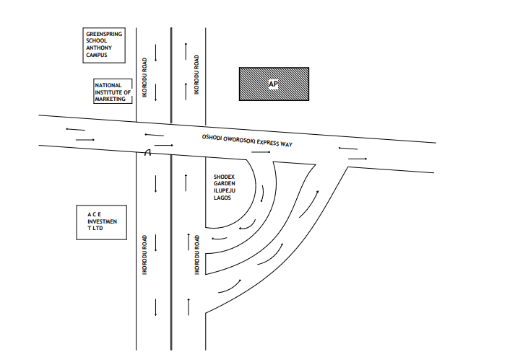

Figure 3.1.1: Showing The Location Plan Of Case Study One Located At Fire And Rescue Service, Oshodi–Isolo Expressway
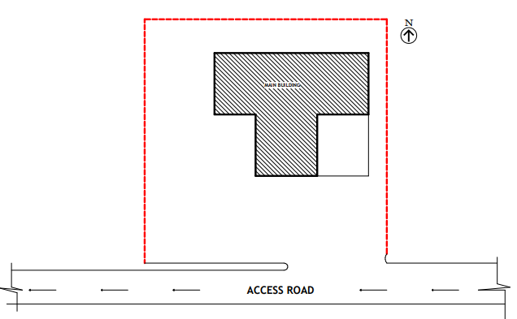

Figure 3.1.2: Showing The Site Plan Of Case Study One Located At Fire And Rescue Service, Oshodi–Isolo Expressway

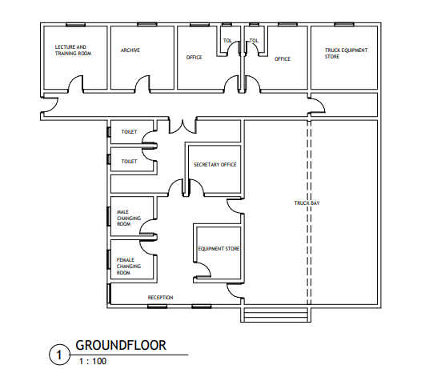

Figure 3.1.3: Showing The Floor Plan Of Case Study One Located At Fire And Rescue Service, Oshodi–Isolo Expressway
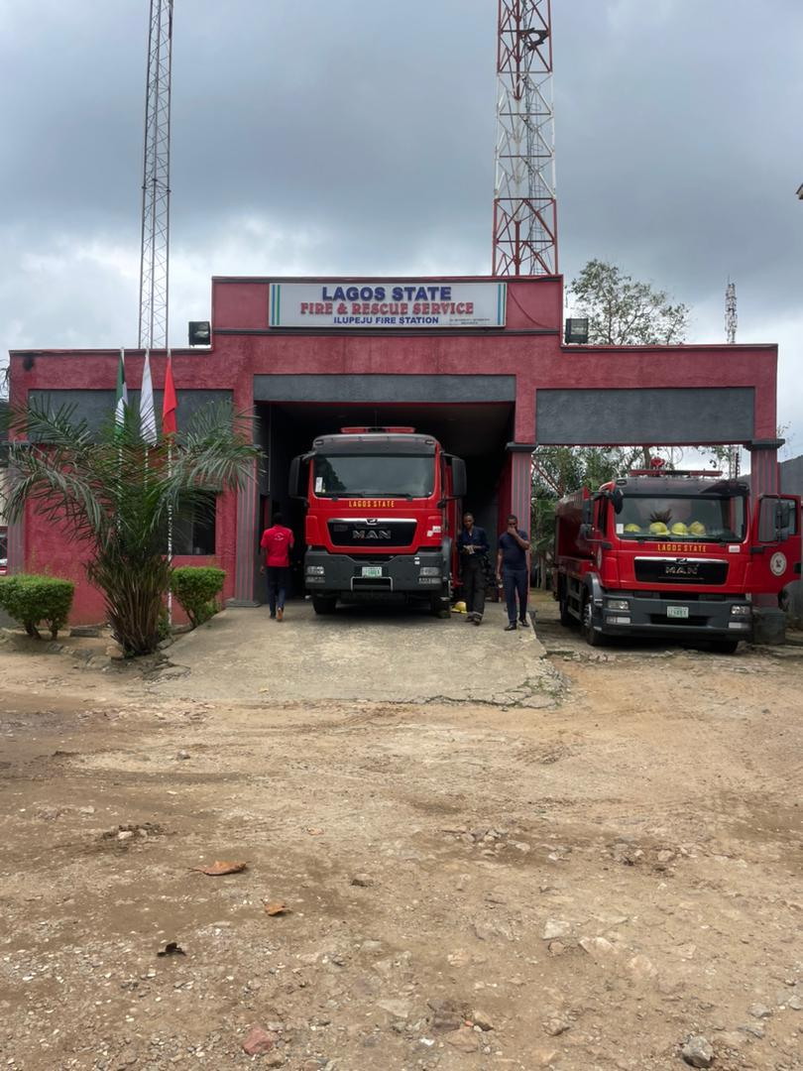

Plate 3.1.1: Showing The front view Of Case Study One Located At Fire And Rescue Service, Oshodi–Isolo Expressway

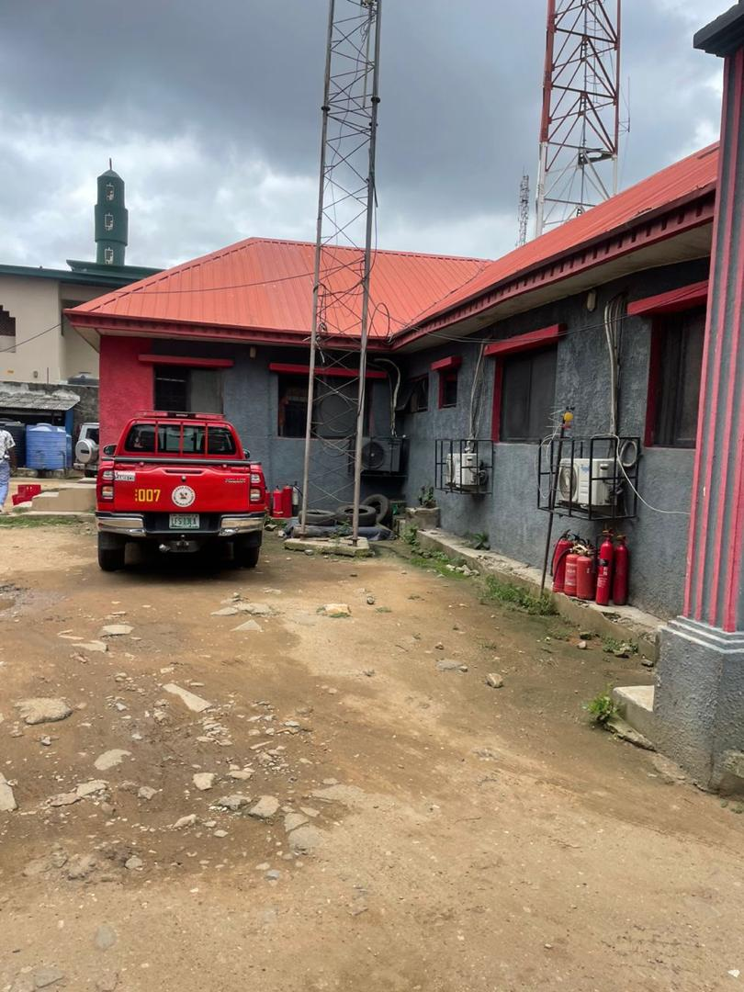

\

Plate 3.1.1: Showing The side view Of Case Study One Located At Fire And Rescue Service, Oshodi–Isolo Expressway

3.2 CASE STUDY TWO
NAME: IFO FIRE SERVICE STATION (AKA IFO FIRE STATION)
LOCATION: ON VESPA–OLOSE ROAD, RIGHT BY THE IFO LGA SECRETARIAT, OGUN STATE
HISTORY OF IFO FIRE SERVICE STATION (AKA IFO FIRE STATION)
The fire station located at the Ifo Local Government Secretariat in Ogun State is officially known as the Ifo Fire Service Station (sometimes referred to simply as "Ifo Fire Station"). This facility was inaugurated by Governor Dapo Abiodun in early 2023 and serves as the first fully equipped fire station within Ifo LGA, Secretariat, In early 2021, Ogun State Governor Dapo Abiodun announced plans to commission four new fire and emergency service stations, including two in Ifo (covering Ifo Constituency I & II) by mid-May, fulfilling a campaign promise to ensure Ogun didn’t depend on Lagos fire services for emergencies along the Lagos–Ibadan expressway. The Ifo stations were reportedly about 95–96% complete by then, with fire trucks procured, On January 31, 2023, Governor Abiodun officially inaugurated the Ifo Fire and Safety Service Station, alongside a 3.1 km Vespa–Olose road. He confirmed the station had two new fire trucks and intended to incorporate ambulances as part of the emergency system.
Equipped only with two fire trucks, no ambulance present, Staff strength around 10 personnel, with only a few on duty at inspection time.
Reports suggested a previously present ambulance had gone missing before full deployment
The establishment of the fire station in Ifo marked the first dedicated facility in the LGA to serve multiple communities, including Owode-Ijako, Arigbajo, Itori, and Papalanto. Its location along Vespa–Olose Road (by the Secretariat) was strategic, aimed at swiftly tackling emergencies in the border area between Ogun and Lagos states
MERITS
- It’s easily well located
- Adequate Spacious Land For Future Expansion

DEMERITS
Some areas receive insufficient ventilation on site
Limited natural light to the building

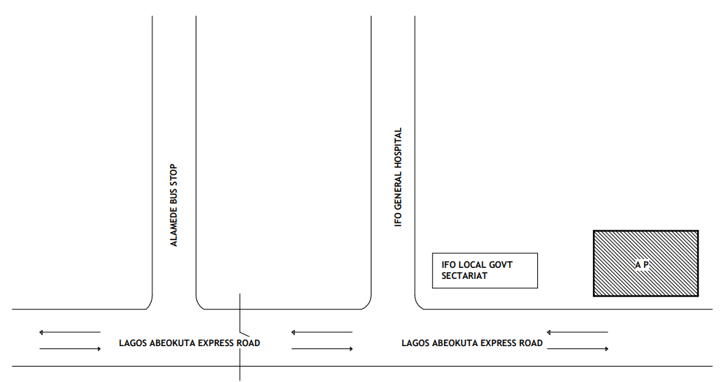

Figure 3.2.1: Showing The Location Plan Of Case Study two Located Vespa–Olose Road, Right By The Ifo Lga Secretariat, Ogun State

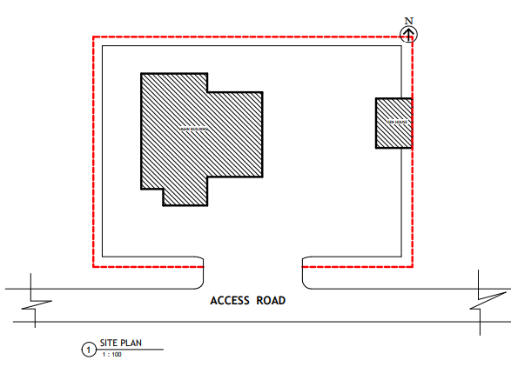

Figure 3.2.2: Showing The site Plan Of Case Study two Located At Vespa–Olose Road, Right By The Ifo Lga Secretariat, Ogun State
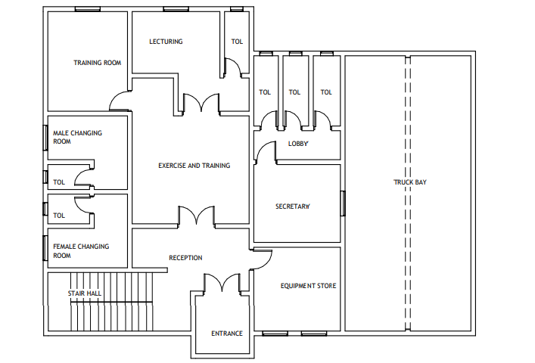

Figure 3.2.3: Showing The Ground Floor Of Case Study two Located At Vespa–Olose Road, Right By The Ifo Lga Secretariat, Ogun State
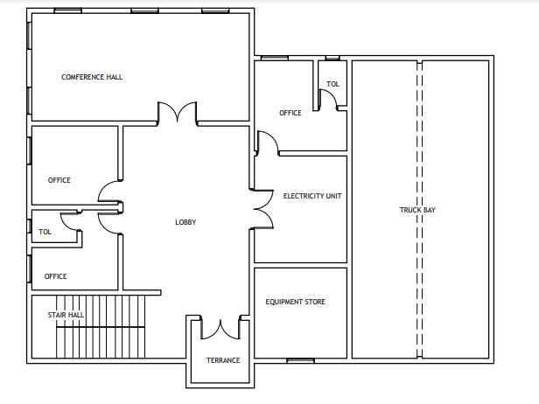

Figure 3.2.4: Showing The First Floor Of Case Study two Located At Vespa–Olose Road, Right By The Ifo Lga Secretariat, Ogun State

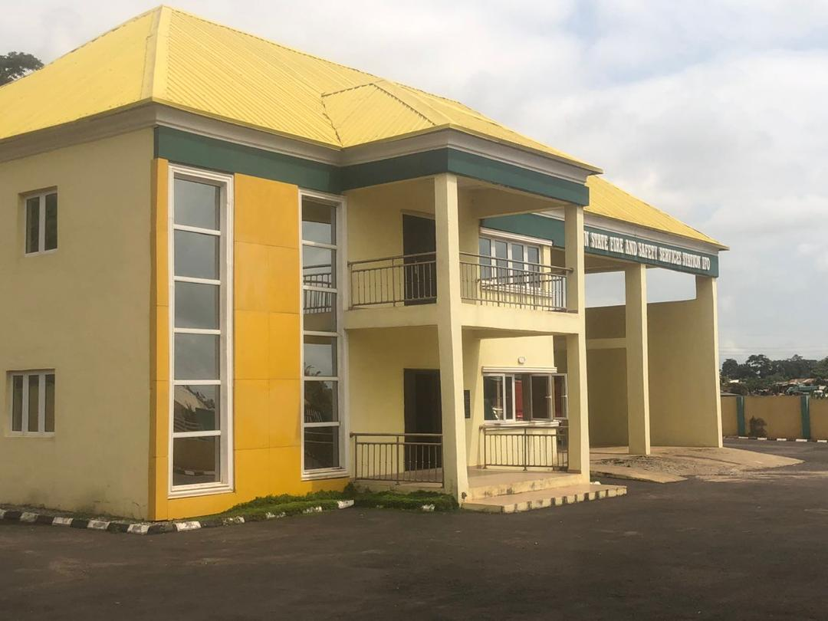

Plate 3.2.1: Showing The Front view Of Case Study Two Located At Vespa–Olose Road, Right By The Ifo Lga Secretariat, Ogun State
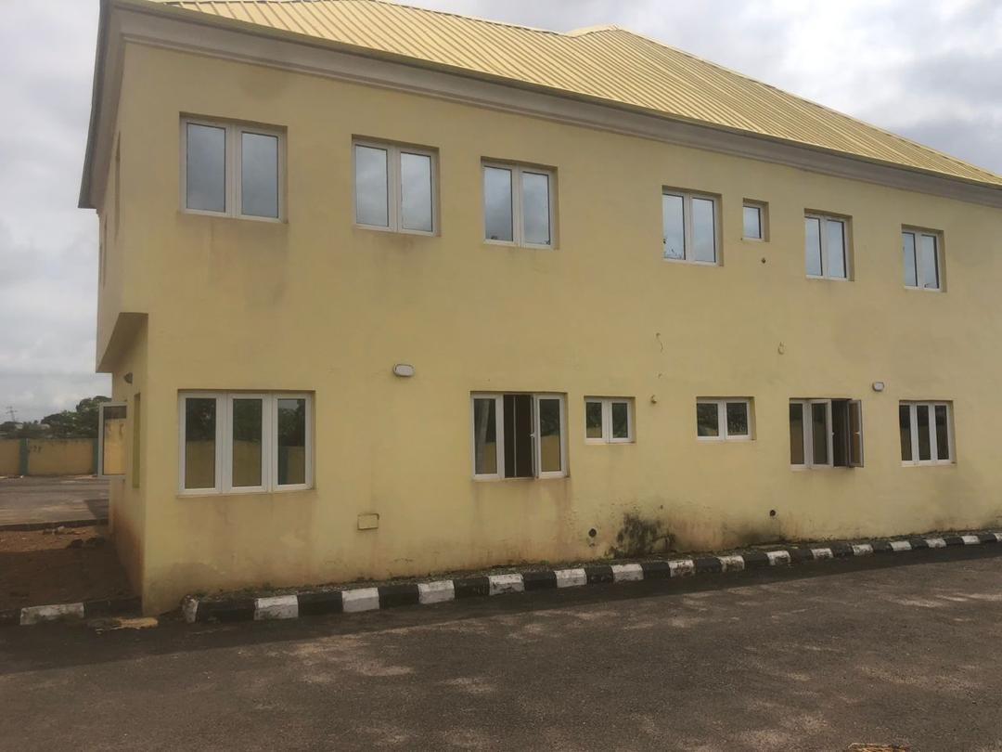

Plate 3.2.2: Showing The Back view Of Case Study Two Located At Vespa–Olose Road, Right By The Ifo Lga Secretariat, Ogun State

3.3 CASE STUDY THREE
LOCATION: OSUN STATE FIRE STATION T.W. ROAD IN OSOGBO, OSUN STATE GOVERNMENT.
The fire station on T.W. Road in Osogbo is officially known as the Osun State Fire Service, Osogbo Station. It's located on the T.W. (Tafawa Balewa) Road in Osogbo, Osun State, Nigeria. According to Osun State Government, the fire service in Osun State, which Osun was formerly a part of, was established in 1959. The Osogbo station is part of the larger Osun State Fire Service, which was created to save lives and property from fire incidents.
Osogbo Fire Station
Located near the Osun State Government Secretariat roundabout, Abeere, Osogbo, and serves as the capital’s primary firefighting hub, Listed under Osun’s fire station directory as Oke-Fia Fire Station, with multiple contact numbers (e.g., 08030808254)—a central fire response location in the state capital
MERITS
- It is easy to locate in case of emergencies
- There’s space are for fire resistance material
DEMERITS
- The truck is not big enough
- Limited to bungalow which results in absence of some units in the building

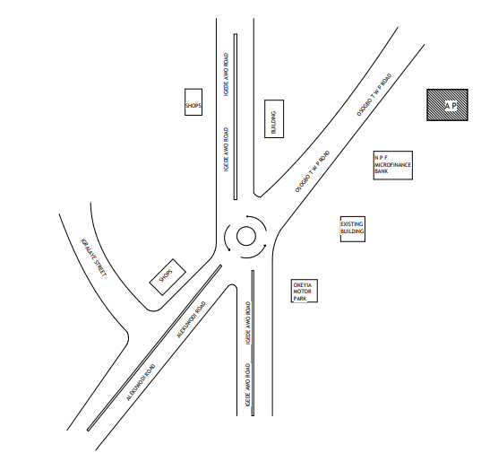

Figure 3.3.1: Showing The Location Plan Of Case Study Three Located At Osun State Fire Station T.W. Road In Osogbo, Osun State Government.
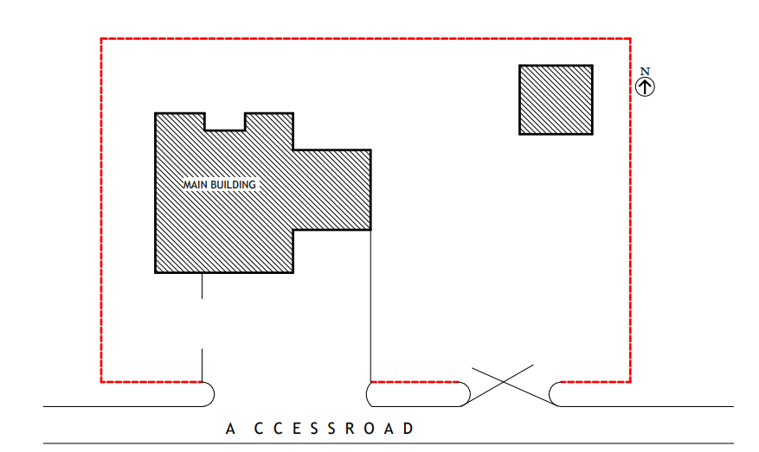

Figure 3.3.2: Showing The site Plan Of Case Study Three Located At Osun State Fire Station T.W. Road In Osogbo, Osun State Government.
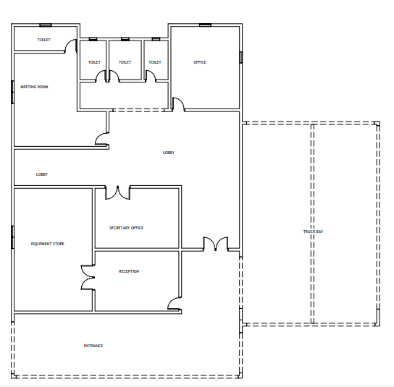

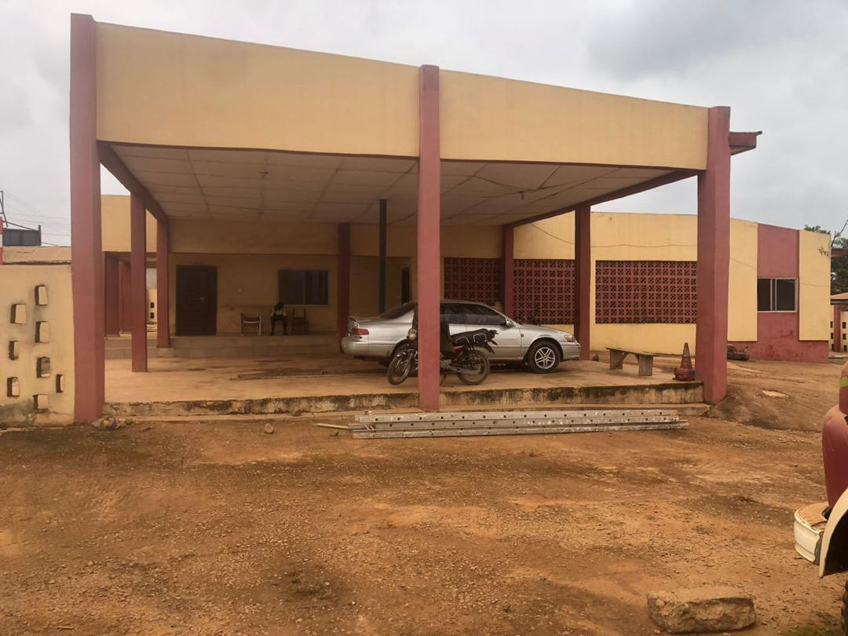
Figure 3.3.3: Showing The Floor Plan Of Case Study Three Located At Osun State Fire Station T.W. Road In Osogbo, Osun State Government.

Plate 3.3.1: Showing The Front view Of Case Study Three Located At Osun State Fire Station T.W. Road In Osogbo, Osun State Government.
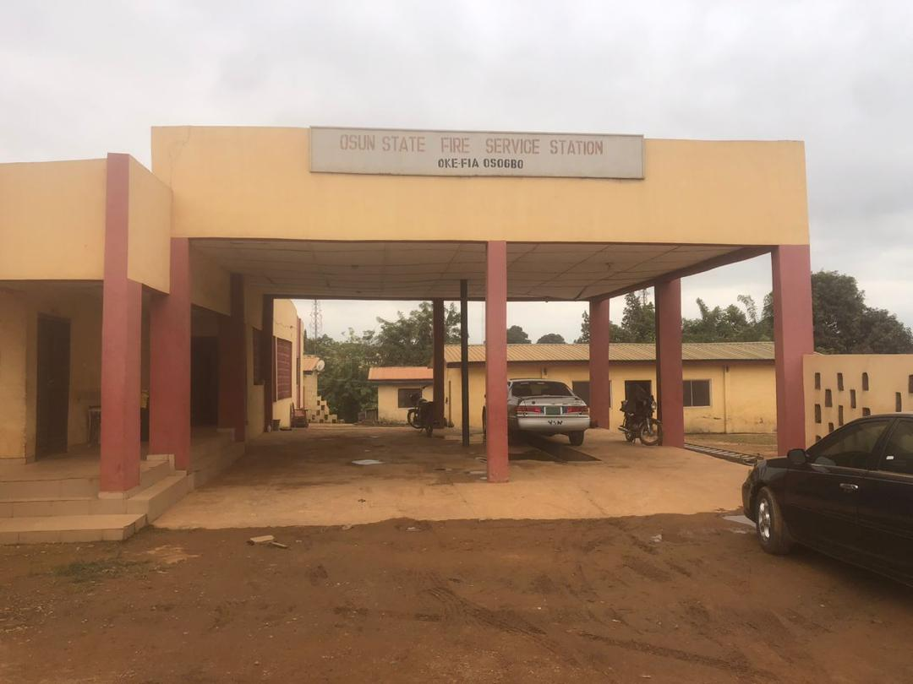

Plate 3.3.2: Showing The Side View Of Case Study Thre Located At Osun State Fire Station T.W. Road In Osogbo, Osun State Government.
3.4.1 ONLINE CASE STUDY ONE
ONLINE CASE STUDY ONE: ADELIADE FIRE SERVICE, TORONTO ON, CANADA
The first fire company in what is now Toronto was the York Fire Company, established in 1826. This was followed by the Hook and Ladder Fire Company in 1831. These early companies were volunteer-based and often lacked formal training. A wooden pumper presented to Toronto by the British America Assurance Company around 1837 has been preserved at Black Creek Pioneer Village, The city's vulnerability to fire was highlighted by the Great Toronto Fire of 1849 and that of 1904. The 1904 fire destroyed much of Bay Street from The Esplanade West to Melinda Street, leading to significant reforms in fire safety and building codes.

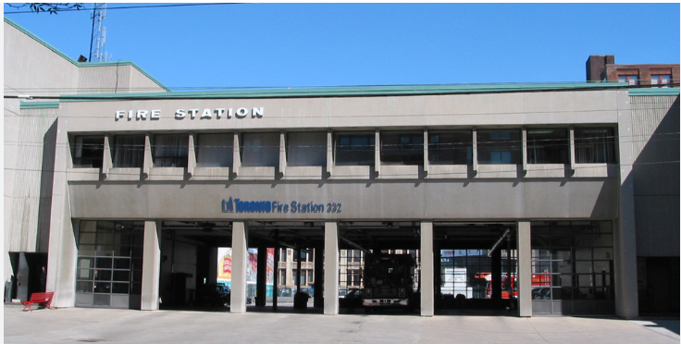

Plate 3.4.1: Showing The Side View Of Online Case Study One Located At Adeliade Fire Service, Toronto On, Canada

3.5 ONLINE CASE STUDY TWO KINGSTON FIRE SERVICES, LONDON UNITED KINGDOM
BRIEF HISTORY OF KINGSTON FIRE SERVICES, LONDON UNITED KINGDOM
The history of Kingston Fire Services in Kingston upon Thames, London, reflects a rich evolution from volunteer efforts to a modern professional fire brigade. In the mid-19th century, Kingston was served by both the Corporation's fire service and a volunteer brigade. In 1870, a group of local residents dissatisfied with the Corporation's arrangements established the Kingston Volunteer Steam Fire Brigade. Funded entirely by public donations, the brigade received a steam fire engine in 1870 and operated from a station on London Road. This volunteer brigade coexisted with the Corporation's service until 1881, when the Corporation's service was disbanded, and its equipment was handed over to the volunteer brigade, which then formally became the district's official firefighting force .

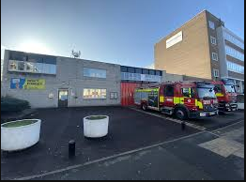

Plate 3.5.1: Showing The Side View Of Online Case Study Two Located At Kingston Fire Services, London United Kingdom

CHAPTER FOUR
4.0 STUDY AREA/PROJECT SITE
4.1 HISTORY OF IKEJA, LAGOS STATE
Lagos State (Yoruba: Ìpínlẹ̀ Èkó, Gun: Ayìmátẹ̀n Awọnlìn tọ̀n) is a state in southwestern Nigeria. Of the 36 states, Lagos is the most populous state but the smallest in terms of land mass. Bounded to the south by the Bight of Benin and to the west by the international border with Benin Republic, Lagos State borders Ogun State to the north and west, making it the only Nigerian state to border only one other state. Named for the city of Lagos — the most populous city in Africa — the state was formed from the Western Region and the former Federal Capital Territory on 27 May 1967.
Geographically, Lagos State is dominated by bodies of water with nearly a quarter of the state's area being lagoons, creeks, and rivers. The largest of these bodies are the Lagos and Lekki lagoons in the state's interior with the Ogun and Osun rivers flowing into them. Many other rivers and creeks flow throughout the state and serve as vital means of transportation for people and goods. On land, non-urbanized areas are within the tropical Nigerian lowland forests ecoregion with natural areas containing threatened populations of mona monkey, tree pangolin, and hooded vulture along with a transitory population of African forest elephants. Offshore, the state is also biodiverse as there are large fish populations along with African manatees and crocodiles.
Lagos State has been inhabited for years by various indigenous ethnic groups, primarily the majority Yoruba people who live throughout the state but also the Ewe and Ogu peoples in the far west. As a result of migration since the nineteenth century, Lagos State also has large populations of non-native Nigerian ethnic groups with Edo, Efik, Fulani, Hausa, Igbo, Ijaw, Ibibio, and Nupe peoples among other Nigerian groups.
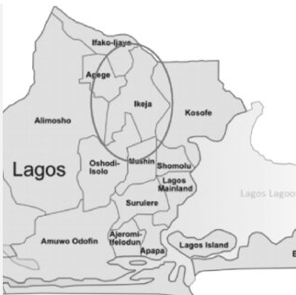

Figure 4.1.1 Map of Lagos State
4.2 SITE LOCATION
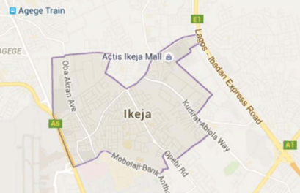
The intending site for this proposed project is located along Alapa Village ,Malete ,Lagos State.

Figure 4.2.1 Location Map
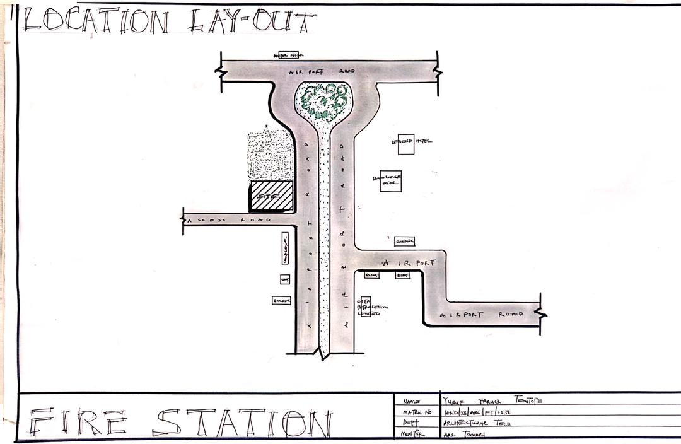

Figure 4.2.1 Location Plan
4.3 SITE CRITERIA
The site criteria for fire station site in the proposed design in Lagos State, Nigeria, was good electricity, portable water supply, land cultivation, vegetable are availabl on site and existing building. These criteria are established to ensure safety, sustainability, accessibility, and alignment with the Lagos State. site criteria in Lagos State (often required by agencies such.
Zoning Compatibility: The proposed land use must align with the zoning regulations of the area (e.g., residential, commercial, industrial, mixed-use).
Accessibility and Road Network: The site must be easily accessible via existing roads. Minimum road width and right-of-way standards must be met, Proximity to public transportation can also influence approval.

4.4 SITE ANALYSIS/INVENTORY
SITE INVENTORY
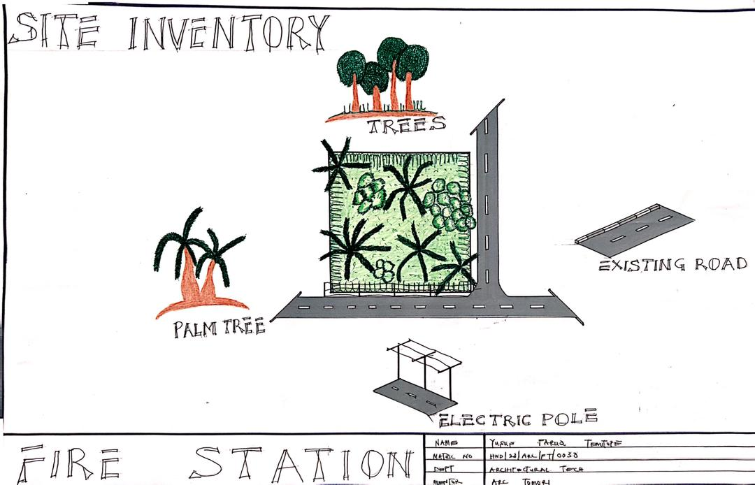
A site inventory is a comprehensive list and documentation of existing conditions on a property, including both natural and human-made features, before any design or construction begins. It involves gathering data on elements like topography, vegetation, hydrology, climate, soil, land use, and existing structures. This information is crucial for understanding a site's characteristics, opportunities, and constraints, which informs subsequent site analysis and design decisions. Ikeja, the capital of Lagos State in Nigeria, is a bustling area with both residential and commercial properties. It's known for being a well-planned area with a mix of modern developments and older, well-established districts.

Figure 4.4.1 Site Inventory
SITE ANALYSIS
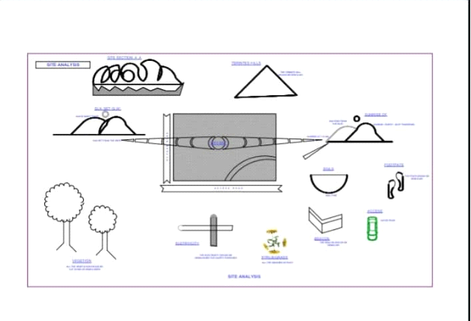Site analysis is the process of evaluating a specific location to understand its characteristics and constraints before commencing a design project. It involves gathering and analyzing information about the site's physical, environmental, and regulatory context to inform design decisions. This analysis helps architects and planners create designs that are both aesthetically pleasing and practical, taking into account the site's unique features and potential challenges.
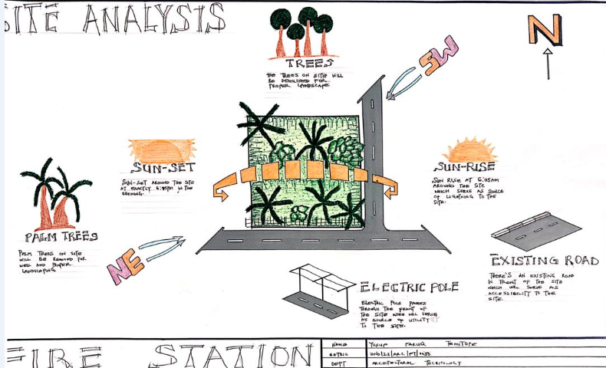

Figure 4.4.2 Site Analysis
4.5 GEOGRAPHICAL AND CLIMATIC CONDITION
Lagos State, located in southwestern Nigeria, has a tropical savanna climate (Aw) characterized by a distinct wet and dry season, according to Wikipedia. It experiences high temperatures and humidity throughout the year, with average daytime temperatures ranging from 28-32°C and nighttime temperatures from 22-24°C. The rainy season typically runs from March to October, with the heaviest rainfall occurring in June. The state is also susceptible to flooding due to its low-lying coastal location.
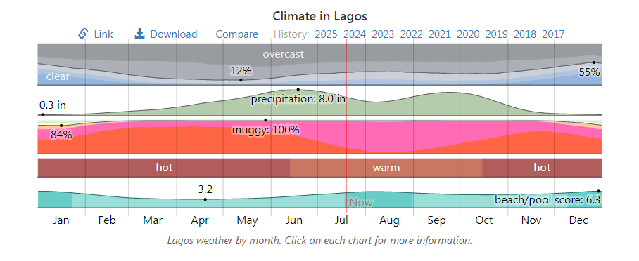
Geographically, Lagos State is dominated by bodies of water with nearly a quarter of the state's area being lagoons, creeks, and rivers. The largest of these bodies are the Lagos and Lekki lagoons in the state's interior with the Ogun and Osun rivers flowing into them. Many other rivers and creeks flow throughout the state and serve as vital means of transportation for people and goods. On land, non-urbanized areas are within the tropical Nigerian lowland forests ecoregion with natural areas containing threatened populations of mona monkey, tree pangolin, and hooded vulture along with a transitory population of African forest elephants. Offshore, the state is also biodiverse as there are large fish populations along with African manatees and crocodiles.

Figure 4.5.1 Graph Of Climate In Laogs

CLIMATE AND AVERAGE WEATHER YEAR ROUND IN LAGOS NIGERIA
In Lagos, the wet season is overcast, the dry season is partly cloudy, and it is hot and oppressive year round. Over the course of the year, the temperature typically varies from 75°F to 91°F and is rarely below 70°F or above 94°F.
Based on the beach/pool score, the best times of year to visit Lagos for hot-weather activities are from mid July to late August and from early December to late January.
AVERAGE TEMPERATURE IN LAGOS
The hot season lasts for 4.7 months, from December 8 to April 28, with an average daily high temperature above 89°F. The hottest month of the year in Lagos is March, with an average high of 91°F and low of 79°F.
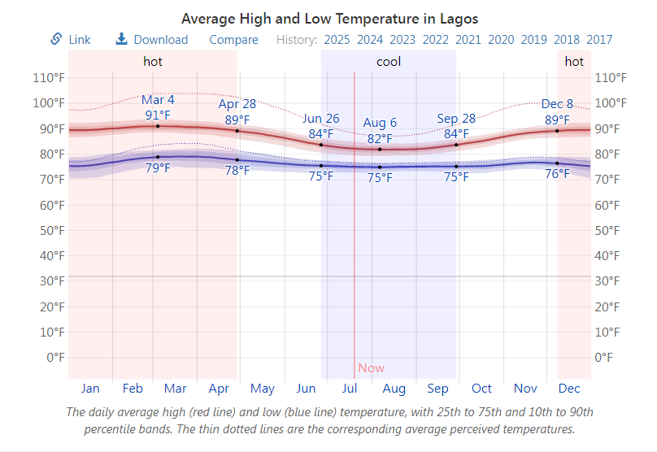
The cool season lasts for 3.1 months, from June 26 to September 28, with an average daily high temperature below 84°F. The coldest month of the year in Lagos is August, with an average low of 75°F and high of 82°F.

Figure 4.5.2 Graph of temperature in Lagos
4.6 DESIGN CRITERIA
THE SITE
The proposed Fire Station is well planned to meet the required functions and services. It is to be approached through the main access road where staffs and Workers can easily drive into the parking without coming in contact with the pedestrians which in turn would allow good flow of vehicles and pedestrian traffic.
Important factor are also considered in planning the site to ensure easy circulation of movement on the site.
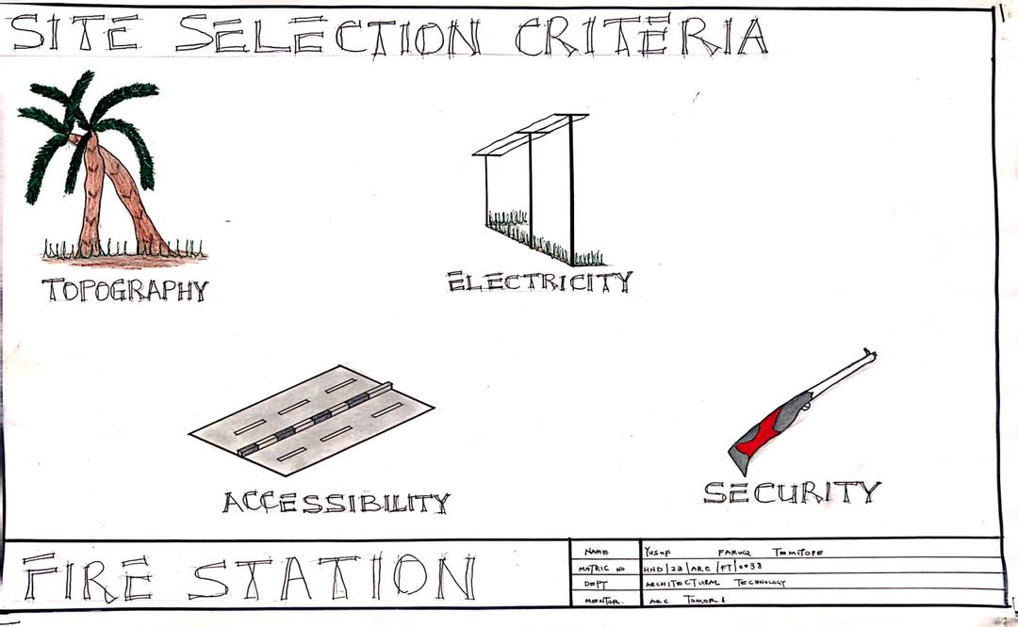
Architect is meant to solve the problem of his client as pertain to his profession to enhance a good design functionality and aesthetic taste of the building should be given consideration. Also, the issue of minimizing the cost should not be left out.

Figure 4.6.1: showing design criteria
As far as this project is concerned, these three factors has been properly considered
- Functionality
- Aesthetic
- Cost
4.7 DESIGN BRIEF
The proposed Fire Station as a project is founded by Lagos State Government which is provided to meet the need of the State in promoting technical skills. It will also provide an avenue for expression of the ideas in student and development in the technical education.
The school provided for effective functioning of the proposed design are listed as follows;
- Reception
- Lorry Park
- Store
- Delivery Bay
- Administrative block
- Supporting facilities
4.8 ANALYSIS OF THE BRIEF
This involves understanding the functional necessities, spatial considerations, site constraints, design intent, budget, timeline, sustainability, wellness goals, and local context. By thoroughly analyzing these aspects, architects can derive crucial information to shape the design direction and create a healthcare facility that not only meets the practical needs but also resonates with the community it serves.
4.9 SPACE ALLOCATION/SCHEDULE OF ACCOMMODATION
Space in architecture is a special category of free space, phenomenally created by the architect when he gives a part of free space shape and scale. Its first two dimensions-width and breath are responsive mainly to functional imperatives in the narrow sense, but the manipulation of its third dimension height grants the inhabitant mind the special opportunity to develop yet other dimensions beyond.
Expert manipulation and utilization of space can involve every emotional reaction known to mankind. People reveal their psychology by the way they arrange space and themselves within the space. The shape of space offers some indication of how one is expected to behave in that space. Space is defined by man, or architectural element that is, the placement of buildings creates exterior spaces and that space must be designed with the level of care usually associated only with interior spaces.
The space must have a strong sense of belonging; it should be as flexible as possible in order to accommodate changes within and for ease of expansion.
UNIT | NO. | DIMENSION  (LXB) | AREA (M²)
ENTRANCE | 1 | 4.3M X 11.4M | 49.02M²
RECEPTION | 1 | 4.9M X 3.4M | 16.66M²
WAITING AREA | 1 | 4.9M X 3.7M | 18.13M²
COUNSELLING ROOM | 1 | 4.9M X 4.7M | 23.03M²
CONSULTANT ROOM | 1 | 3.7M X 5.2M | 19.24M²
MINOR OT | 1 | 4.9M X 3.5M | 17.15M²
STRECHER STORE | 1 | 2.8M X 2.1M | 5.88M²
EMERGENCY office | 1 | 4.6M X 5.4M | 24.84M²
MANAGING DIRECTOR/SECRETARY | 2 | 2.9M X 1.3M | 7.54M²
RECEPTION | 1 | 4.3M X 7.9M | 33.97M²
MATRON OFFICE | 1 | 4.1M X 5.4M | 22.14M²
DARK ROOM | 1 | 4.2M X 2.3M | 9.66M²
DELIVERY BAY | 1 | 4.1M X 4,9M | 20.09M²
EUIPMENT ROOM | 1 | 4.9M X 9.0M | 44.1M²
STORE | 1 | 5.0M X 4.6M | 23M²
DELIVERY ROOM | 1 | 4.2M X 6.9M | 28.98M²
RESTING WARD | 1 | 10.1M X 6.9M | 69.69M²
MALE CHANGING ROOM | 1 | 6.7M X 11.4M | 76.38M²
COURTYARD | 1 | 17.2M X 5.3M | 91.16M²
CONVINIENCIES | 4 | 2.1M X 1.2M | 10.08M²
Table 4.1.1: showing the space allocation
4.9 FUNCTIONAL RELATIONSHIP
Functional relationship is also known as bubble diagram and its expresses how each unit in a design is relatively functioning with each other. It shows closeness of one unit to another. In this project, the functional relationship was done before any sketch and this is what aids the project to function better.

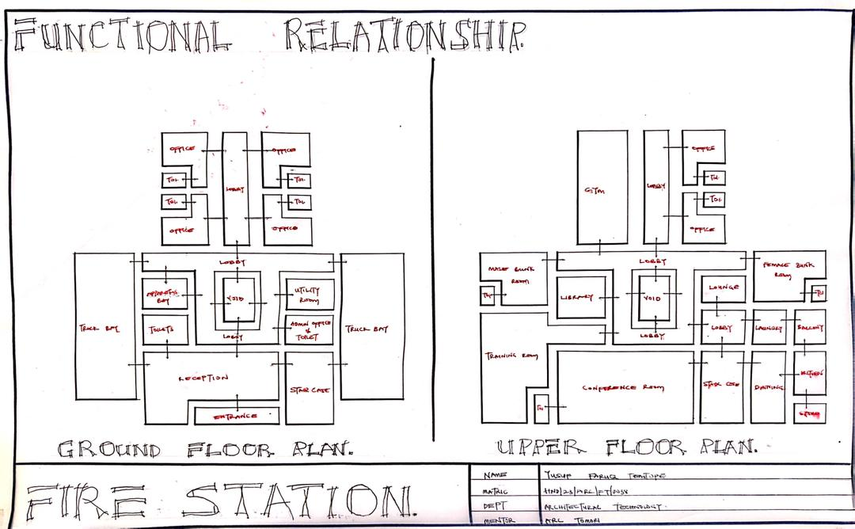

Figure 4.9.1 Flow Chart
4.10 CONCEPTUAL DEVELOPMENT
One guiding design concept is directed towards the free flow and spacious walkways for Staff and Workers. Other design concepts are directed towards the simplification of student’s movement from the main entrance to the classes and offices and finally back to the park.

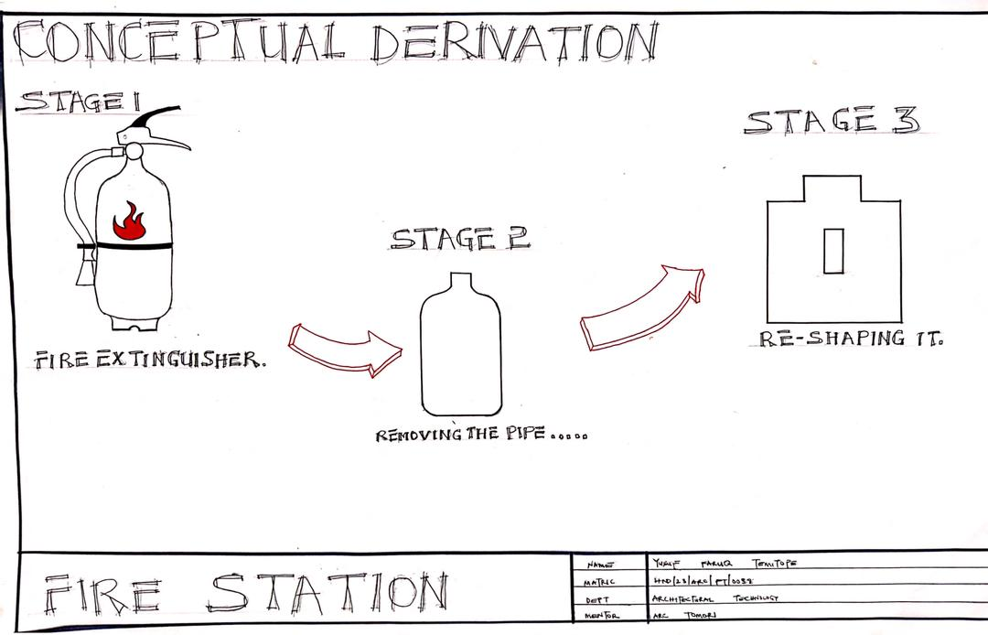

Figure 4.10.1 Concept Derivation
4.11 BUBBLE DIAGRAM
Bubble diagram is a graphics representation that translates function on activities into spatial arrangement showing the connections with the space and their orientation on the site.
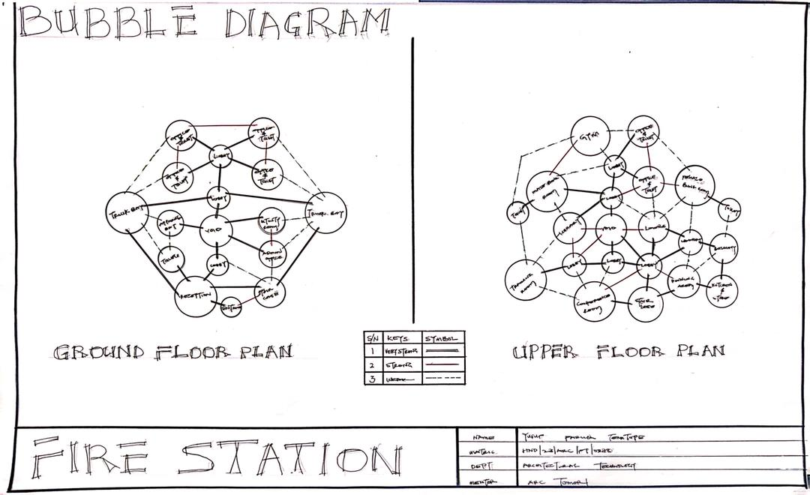

Figure 4.11. 1: Bubble Diagram

4.12 ZONING BASED ON ACTIVITIES
Here attempt is made to group the various units according to the activities taking place in them. Their activities have been grouped into seven zone units but zoning base on the activities taking place in the school has to go this way
- Wards (Quiet zone)
- Outpatient department (Semi Noizy zone)
- Noisy zone: This area is where the auxiliary facilities is located and this area include Mini-mart, parking space, generator house
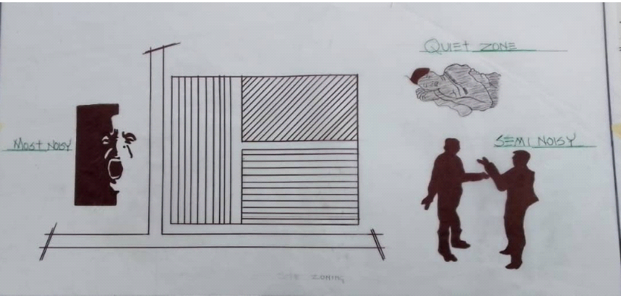

Figure 4.12.1 Site Zoning

CHAPTER FIVE
5.0 PROJECT APPRAISAL
DESIGN ANALYSIS
GENERAL SERVICES
The environmental facilities and services within the proposed design
- Telephone services: Telephone line is very close to the site and this allows access to easy connection using underground telephone cables to connect every line to be of use in the proposed project.
- Electric supply: The supply of electricity to the site is the distribution of primary supplies in the form of ring main systems with substation transformer with switch control gears as intervals. Both distribution mains and services to the site are constructed above the ground
- Water supply: The water supply pipeline is connected from the water main closest to the site. Water is connected into the site from these public mains with the use of underground water piping system storage facilities for water will also be provided on the site
- Drainage and sewage disposal: Attention has been given to sewage for entire site. Issue identified are as follow;
- Surface water sewer; they are usually separated from those used for foul water
- Land drainage; this has been planned in a way that fits into the layout of the proposed site.
- Foul water sewage; this produce more regular flow fluctuating by up to about three times the sewage dry weather flow at peak periods (mid-day), Sewage capacity are calculated on the basis of the total number of conveniences provided to the number of users which may eventually be connected to each station and sewer gradient must ensure a cleansing velocity.
- Solid waste disposal; there is provision for refuse and garbage disposal on the site. This is easily accessible and located at the rear end of the site.

BUILDING SERVICES
- Electrical Services: The supply of electricity into the building is the conduit system of wiring. In addition to the supply of power to the site is a standby generator with the automatic switch which will be connected to the distribution mains, signal of PHCN light should also be connected to the security switch
- Lighting: Natural lighting into the building is aided by the reflection of light directed by the fins and the use of high level windows will also enhance natural illumination into the building.
- Ventilation; Adopted in the design is the use of both natural and artificial forms of ventilation. The orientation of the building has been enhance with the approach facing the South west windward direction and the rear view to the creek side, this wind will have a cooling effect on the entire building.
- Acoustic: Noise pollution from the access road and car parks has been controlled with over 6m setback with the aid of landscaping features
- Fire Detector/Fighting equipment: Fire alarms will be connected to strategic areas in the building to help control fire emergencies also portable fire extinguishers are to be provided at conspicuous locations in the building, fire hydrants will be connected to the water mains and located in strategic places on the site.
- Security services: The school of law being a private property is to be guarded to ensure proper lighting and security within the premises. Automatic warning devices such as buzzers and sirens will be installed at strategic locations on the site. Lighting on the other hand is being viewed as an important factor in creating a lively mood and interested atmosphere. The use of floodlight will give aid for security traffic control and illumination in the night to give an aesthetic view of building in the university in dark hours. Drive over floodlights will be installed beside the kerb at 3m intervals along the drive-way. Bollards high for pedestrian precinct will also be installed at intervals along the paved walkways. This will enhance illumination for students and staffs at night.
- Parking/walkway: Adequate parking spaces are provided for vehicular use of the motorist and walkways which will ease circulation within the site to different units in the design are to be provided.

5.1 CONSTRUCTION METHOD AND MATERIAL
Typical materials used include concrete for the foundation and structural elements, bricks or blocks for walls, and metal or composite roofing materials. Construction methods often involve traditional techniques like masonry for walls, reinforced concrete for structural elements, and standard roofing practices. Additionally, healthcare facilities may require specialized features like infection control measures, durable finishes, and efficient HVAC systems to maintain a hygienic and comfortable environment for Workers and staff.
5.2 SUBSTRUCTURE
This is the part of the building below the natural ground level. The foundation of the building shall be deep foundation considering the bearing capacity of the soil and trench to be dug to firm strata. A concrete in-situ 1:2:4 should be used. The entire foundation depths shall be determined by competent Structural Engineer.
The substructure of a basic health center typically involves the construction of the foundation and underground elements that support the building's superstructure. It includes tasks such as site preparation, excavation, foundation construction, and utility connections. The substructure plays a crucial role in ensuring the stability and durability of the health center building.
5.3 SUPER STRUCTURE
The superstructure of a basic health center refers to the part of the building above ground level. It includes the walls, floors, and roof that form the structure where healthcare services are provided. Designing the superstructure of a health center involves creating functional spaces such as patient rooms, consultation areas, waiting rooms, and administrative offices to support the delivery of healthcare services efficiently. It focuses on creating a layout that promotes patient well-being, staff productivity, and a safe environment for all occupants.
Floor: basic health center serves as the foundation for various activities and functions within the building. It provides a stable surface for patient rooms, corridors, and other spaces, supporting the weight of equipment, furniture, and occupants.
Roof: this plays a crucial role in protecting the interior spaces of the health center from weather elements such as rain, sunlight, and wind. It also contributes to the building's overall thermal performance and energy efficiency through proper insulation and ventilation design.
Wall: basic health center define and separate different areas within the building. They provide enclosure, privacy, and security while also serving as structural elements that support the overall stability of the structure. Well-designed walls contribute to the functionality, aesthetics, and comfort of the healthcare facility.
Door: basic health center serves as an entry and exit point, providing access to different rooms and areas within the building. Doors are designed to ensure privacy, security, and ease of movement for Workers, staff, and visitors.
Windows: basic health center allow natural light to enter the interior spaces, creating a bright and welcoming environment. They also provide views to the outside, ventilation, and a connection to the surrounding environment, contributing to the overall well-being of occupant.
Ceiling: basic health center forms the upper boundary of the interior spaces. It conceals structural elements, electrical wiring, and mechanical systems while also enhancing acoustics and aesthetics. A well-designed ceiling can improve the overall ambiance of the healthcare facility and contribute to a comfortable and healing environment for Workers and staff.
FIRE RESISTANCE MATERIAL
When constructing a fire station, fire resistance is critical—not only for protecting equipment and occupants but also for ensuring the building can remain operational during and after a fire event. Here’s a professional breakdown of fire resistance considerations and materials to be used in constructing a fire station:
FIRE RESISTANCE IN FIRE STATION CONSTRUCTION
Structural Fire Resistance
Fire stations must meet strict fire-resistance ratings to ensure structural integrity during fire emergencies. The goal is to prevent collapse, maintain safe egress, and protect critical equipment.
Structural Frame: Use reinforced concrete or fire-protected steel with fire-resistance ratings of 2–4 hours, depending on local building codes.
Load-bearing Walls: Should be constructed from fire-rated concrete blocks (CMUs), gypsum-concrete wall systems, or fire-resistant bricks.
Floors and Roofs: Use concrete slab systems or composite steel decks with fireproof coatings.
Fire-Resistant Building Materials
Gypsum Board: Type X or Type C gypsum boards offer fire ratings up to 2 hours and are ideal for interior partitions.
Intumescent Paints/Coatings: These swell under heat and insulate steel members from fire, commonly used for exposed beams.
Fire-rated Glass: Used in observation areas or windows, fire-rated glazing can withstand heat and block smoke for up to 2 hours.
Non-combustible Insulation: Use mineral wool (rock wool) or fiberglass insulation, which won’t ignite or contribute to fire spread.
Compartmentalization & Passive Fire Protection
Fire-Rated Doors & Shutters: Install doors with 60 to 120-minute ratings between apparatus bays, dormitories, and hazardous storage rooms.
Fire Dampers & Seals: Used in HVAC and cable penetrations to maintain wall/fire barrier integrity.
Smoke Barriers and Partitions: Help in limiting the spread of smoke to critical areas like sleeping quarters or communication rooms.
Fire Suppression Systems
Even though the building is fire-resistant, active suppression is key:
Sprinkler Systems: NFPA-compliant automatic sprinkler systems in bays, offices, kitchens, and sleeping areas.
Fire Extinguishers & Hose Reels: Strategically located throughout the station.
Fire Alarm & Detection Systems: Heat and smoke detectors with zone-based monitoring for quick response.
5.4 FINISHES
The choices play a crucial role in creating a functional and aesthetically pleasing environment. Selecting materials like vinyl flooring for easy maintenance, antimicrobial paint for hygiene, and acoustic ceiling tiles for a peaceful atmosphere can enhance the overall design. Additionally, incorporating finishes such as wood accents for warmth, glass partitions for natural light, and calming color schemes can contribute to a healing and welcoming space within the health center. By integrating these examples of finishes thoughtfully, architects can create a space that promotes well-being and comfort for Workers and staff.
5.5 SERVICES
These are the service essentially important for safety, comfortability, security and creating conducive atmosphere. All electrical and mechanical services are to be installed in the various ducts provided. An automatic extinguishing system (FM200), which is the world most trusted choice in clean agent fire suppression, is installed. It has the ability to effect fire extinguishing process by itself without destroying furniture. It does not contain toxic substances.
- Acoustic And Lighting Provisions
Noise pollution from the access road and car parks has been controlled with over 6m setback with the aid of landscaping features. The finishes are to be designed such that it would facilitate acoustic effects; it is expected to be sound proof.
But natural and artificial lighting is being provided for. The use of courtyards and open yard is to enhance the effective usages of natural lighting while artificial lighting units are provided to enhance visual aids at night.
The buildings are oriented in a manner that would allow for use of daylight without getting too much sunlight
Mechanical Services
Mechanical services to be provided for would include;
- All locks and locking devices
- Air conditioner
- Security cameras (CCTV)
And all security measures are expected to be treated to meet the necessary standard of workmanship.
Electrical Service
Electrical services to b provided include:
- All electrical devices
- All lighting devices and fitting
- Locks and locking devices where applicable
These are to be fitted or constructed to meet the standard of workmanship
Plumbing Services
Plumbing services to b provided include:
- All sanitary facilities
- All drains and draining system
- All waste disposal system
- All water supply and disposal system
These are to be fitted or constructed to meet the standard of workmanship.
FIRE PRECAUTION
Provision of sand filled sand book outside each building including support facilities. It is expected that users are to be given fire drills at least once a month and all the extinguishers tested regularly. Provision for extinguisher shall be made available at regular distance intervals within each building
5.6 EXTERNAL WORKS
The external work encompasses various aspects of the surrounding environment and infrastructure to support the functionality and accessibility of the facility. These elements are essential for ensuring a safe, welcoming, and efficient environment for Workers, visitors, and staff.
These include:
1. Parking Facilities: Designated areas for Workers, visitors, and staff to park their vehicles conveniently near the health center.
2. Landscaping: The design and implementation of green spaces, gardens, walkways, and plantings around the health center to enhance the aesthetic appeal and create a welcoming environment.
3. Access Roads: Properly designed roads and pathways leading to the health center to ensure smooth traffic flow and easy access for emergency vehicles.
4. Signage: Clear and visible signs indicating directions, parking areas, entrances, and important information for visitors to navigate the health center easily.
5. Lighting: Adequate exterior lighting for safety and security purposes, ensuring that the surroundings of the health center are well-illuminated during the night.
6. Waste Management: Proper disposal facilities such as bins and waste collection points to manage medical and general waste generated by the health center.
7. Security Features: Installation of security systems, cameras, and controlled access points to ensure the safety and security of Workers, staff, and the facility.
8. Utility Services: Provision of essential services such as water supply, drainage systems, and electrical connections to support the functioning of the health center.
9. Outdoor Seating Areas: Designated spaces for Workers, visitors, and staff to relax and enjoy the outdoor environment around the health center.
10. Barrier-Free Access: Implementation of ramps, handrails, and other accessibility features to ensure that the health center is easily accessible to individuals with disabilities.
5.7 BUILDING REQUIREMENTS
All concrete work shall be done in accordance with the British Standard of workmanship. So applies to all other construction works
The Stability
The design has a structural grid that would allow for stability. All walls used are load bearing and treated as such.
Maintenance Culture
Maintaining the state of the building would be relatively easy, the finishes used are PVC which allow for cleaning with water and detergent. This when carried out at regular intervals would ensure that the cell maintains its conducive atmosphere.
Facility like pumping machine should be serviced on regular basis, toilets should be provided with duct for easy maintenance.
Other finishes used are also common and easy to maintain requiring no special care or professional skills to maintain.
5.8 SUMMARY, RECOMMENDATION AND CONCLUSION
SUMMARY
The architectural design of a fire station plays a critical role in supporting emergency response operations, staff wellbeing, and community safety. A well-designed fire station integrates functionality, durability, and adaptability, ensuring rapid deployment of fire services while also providing comfortable and efficient spaces for personnel. Key components include the apparatus bay, administrative offices, dormitories, training facilities, and public interface areas. Contemporary designs also incorporate sustainable materials, energy-efficient systems, and smart technologies to improve resilience and reduce operational costs.
RECOMMENDATION
To improve the architectural design of fire stations, the following recommendations are proposed:
Prioritize Rapid Response: Ensure clear and direct paths from dormitories to apparatus bays; minimize time lost in transitions.
Adopt Green Building Standards: Incorporate renewable energy sources, water recycling systems, and passive ventilation to create sustainable facilities.
Enhance Staff Comfort and Health: Provide ergonomic living quarters, access to natural light, recreational areas, and noise control.
Plan for Future Growth: Design modular and scalable spaces that can adapt to growing populations and evolving service demands.
Integrate Technology: Use smart building systems for monitoring, automation, and communication to improve efficiency and safety.
Community Engagement: Include public areas like education rooms or viewing galleries to strengthen the connection between firefighters and residents.
CONCLUSION
In conclusion, fire station architecture must balance operational efficiency with human-centered design. It should be planned around fast response times, clear circulation routes, and safe zones for living, working, and training. With increasing urban density and environmental challenges, modern fire stations are expected to be adaptable, sustainable, and technologically equipped to handle a wider range of emergencies. An effective design is not only a facility for first responders but also a symbol of safety and preparedness in the community.

REFERENCES
1. Grafiati+8MDPI+8MDPI+8 arXiv (2024) Fire Resistance of Building Structures and Fire Protection Materials: Bibliometric Analysis Provides a comprehensive overview of structural fire resistance and fire protection materials research, including recent trends in intumescent coatings, concrete, aerogels, and engineered wood products like CLT 2. When Fire Attacks: How Does Concrete Stand up to Heat? (August 28, 2024) A finite element study evaluating thermal and structural performance of plain and reinforced concrete under extreme fire conditions—key to understanding resilience of concrete fire station components.
3. arXiv (August 22, 2021) Explainable Machine Learning to Predict Fire Resistance and Spalling of RC Columns Uses machine learning models to predict fire resistance behavior of reinforced concrete columns—valuable for structural elements in fire stations
4. Wikipedia+3arXiv+3Wikipedia+3 (January 27, 2014) Modeling the Behavior of Reinforced Concrete Walls Under Fire Demonstrates that reinforced concrete firewalls can achieve resistance beyond 10 hours, depending on load and wall span— useful for compartmentalization design in fire stations
5. Wikipedia 1993 Vitra Fire Station by Zaha Hadid in Weil am Rhein, Germany (Completed 1993) Constructed of exposed cast reinforced concrete and steel, this iconic structure demonstrates real-world use of resilient materials and forms; completed in
6. Wikipedia (Built 1937–38) Brunswick Fire Station and Flats, Melbourne, Australia Early modernist fire station built with durable masonry and concrete, historically significant and showing lasting fire-resistant construction from the 1930s. Supporting Materials & Standards
7. scribd.com+3ResearchGate+3Emerald+3 Published January 2017 Fire Resistance of Concrete Structure – A Review) Experimental study on polypropylene fiber- reinforced concrete to improve resistance to spalling and thermal degradation— relevant to long-term durability of fire station structural elements
8. dergipark.org.tr+7ResearchGate+7scribd.com+7 (January 2017) Fire Safety in Buildings, Journal of Civil & Environmental Engineering Evaluates fire safety measures and occupant evacuation behavior in buildings—useful for designing safe egress and interior planning in fire stations
9. Emerald (2025). Journal of Structural Fire Engineering, Vol. 13 Iss. 4 Contains multiple studies on fire resistance performance of concrete, composite columns, light-gauge steel, hybrid timber, etc.—insights applicable to station materials selection and structural design

APPENDICES

APPENDICES 1
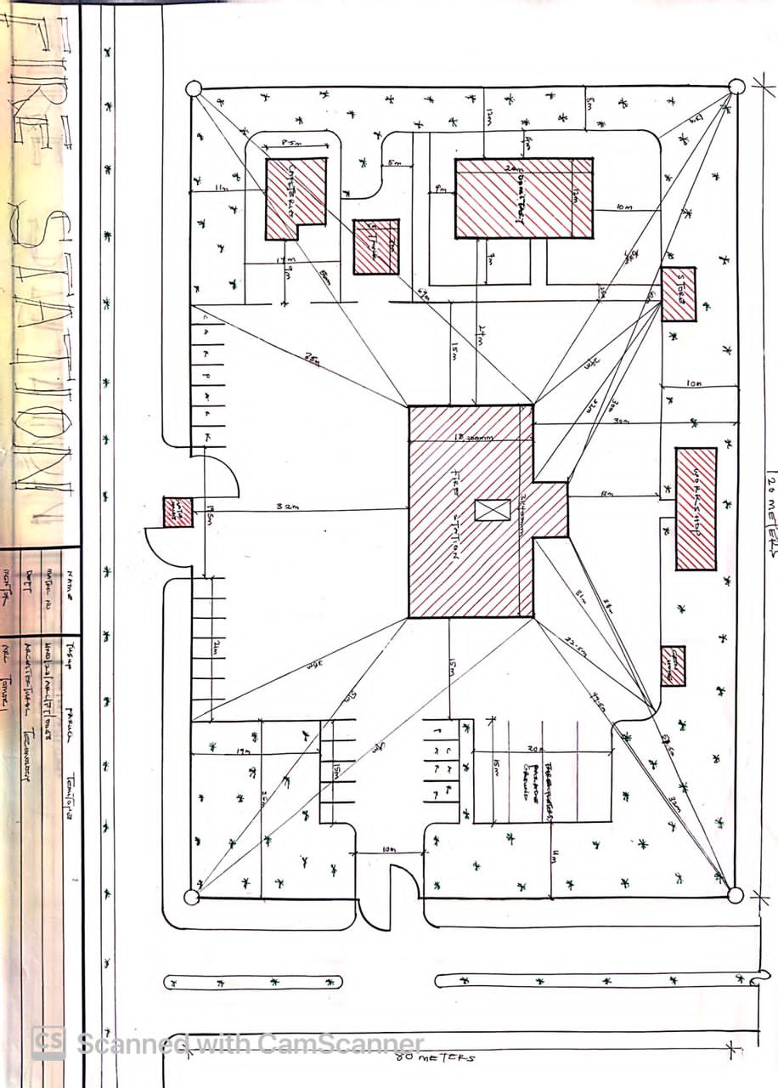

APPENDICES 2

APPENDICES 3

APPENDICES 4

APPENDICES 5
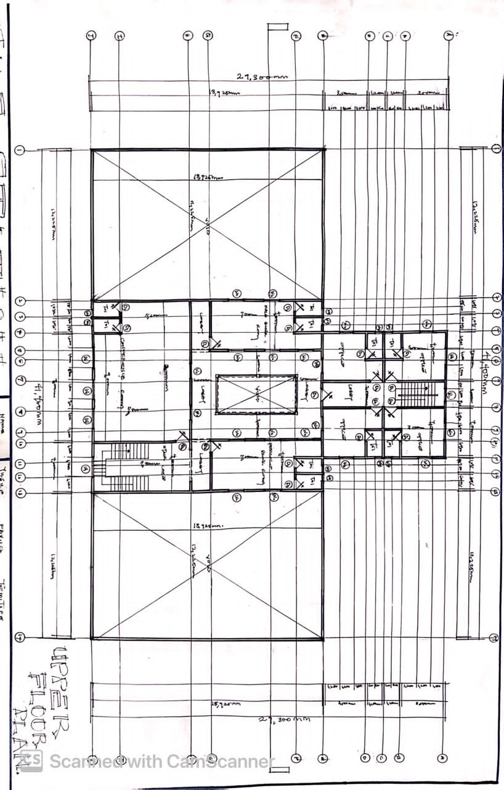

APPENDICES 6

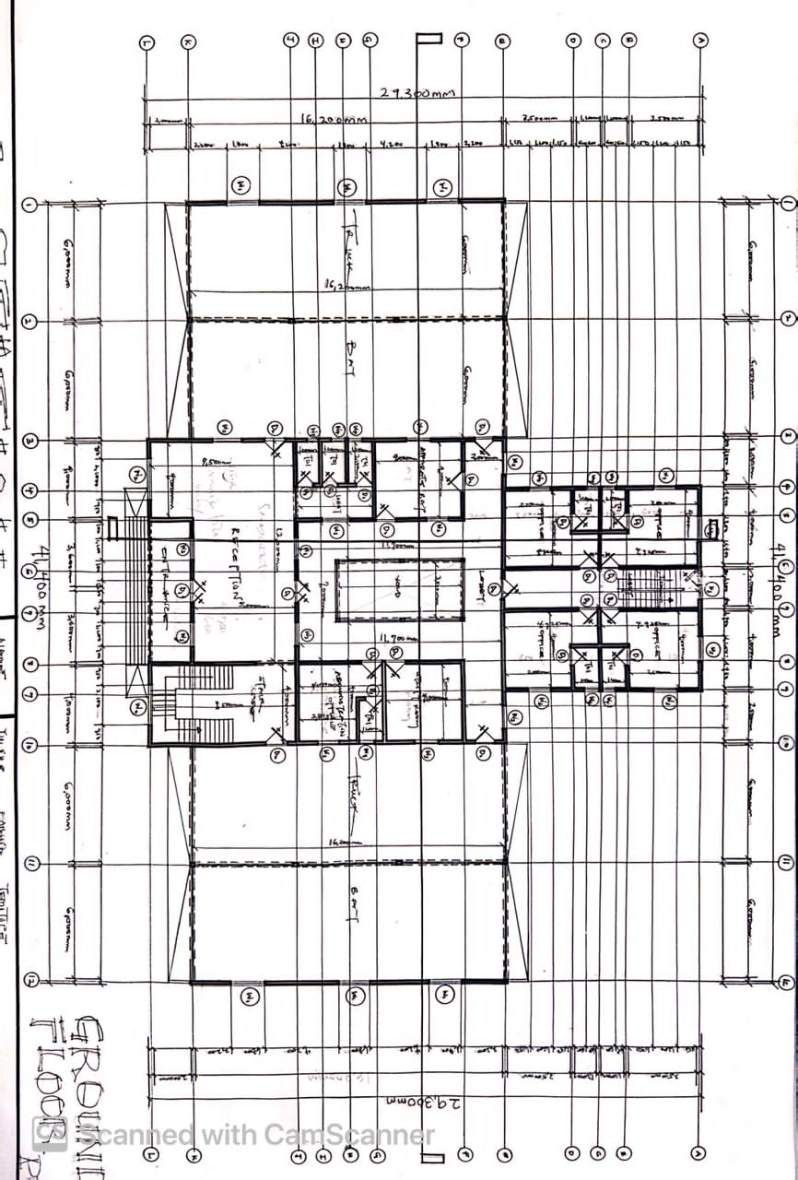

APPENDICES 7
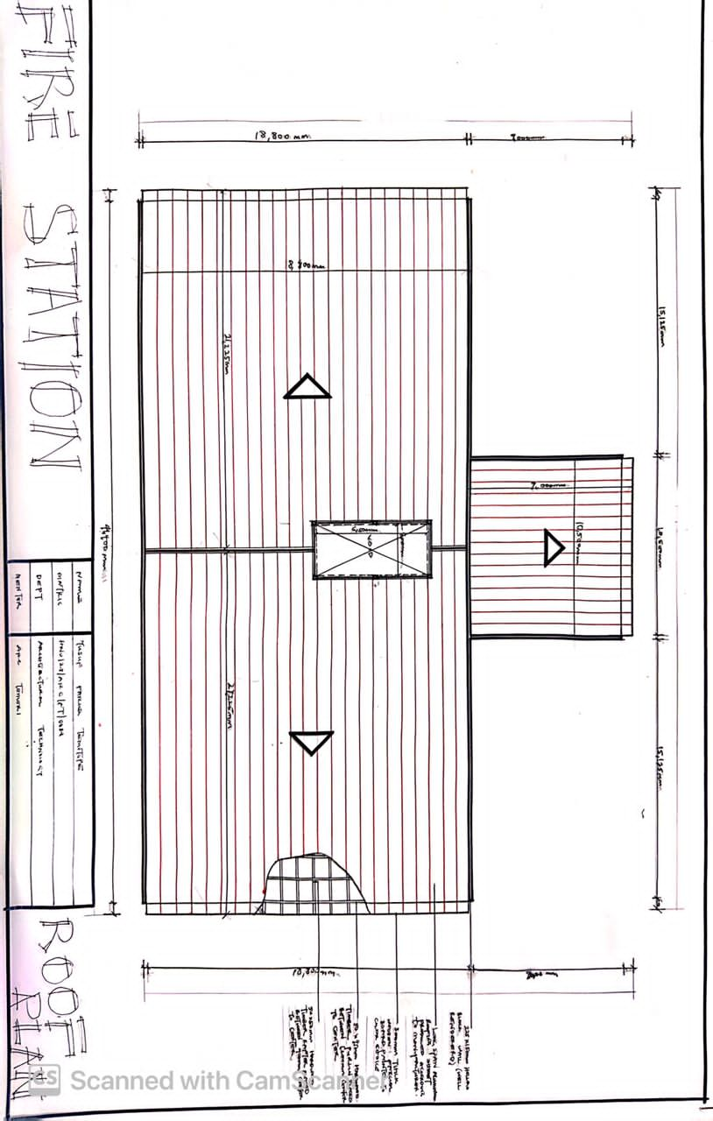

APPENDICES 8

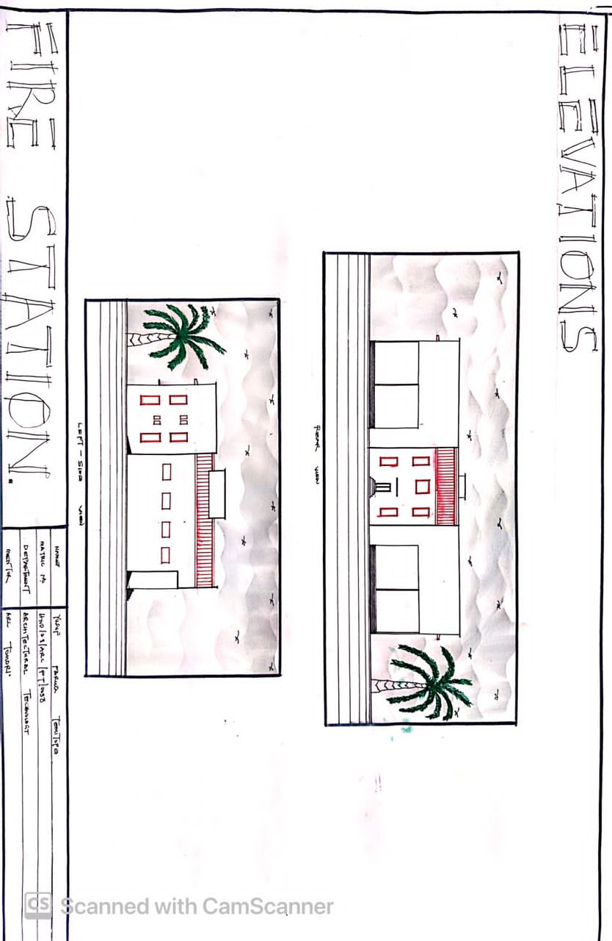

APPENDICES 9
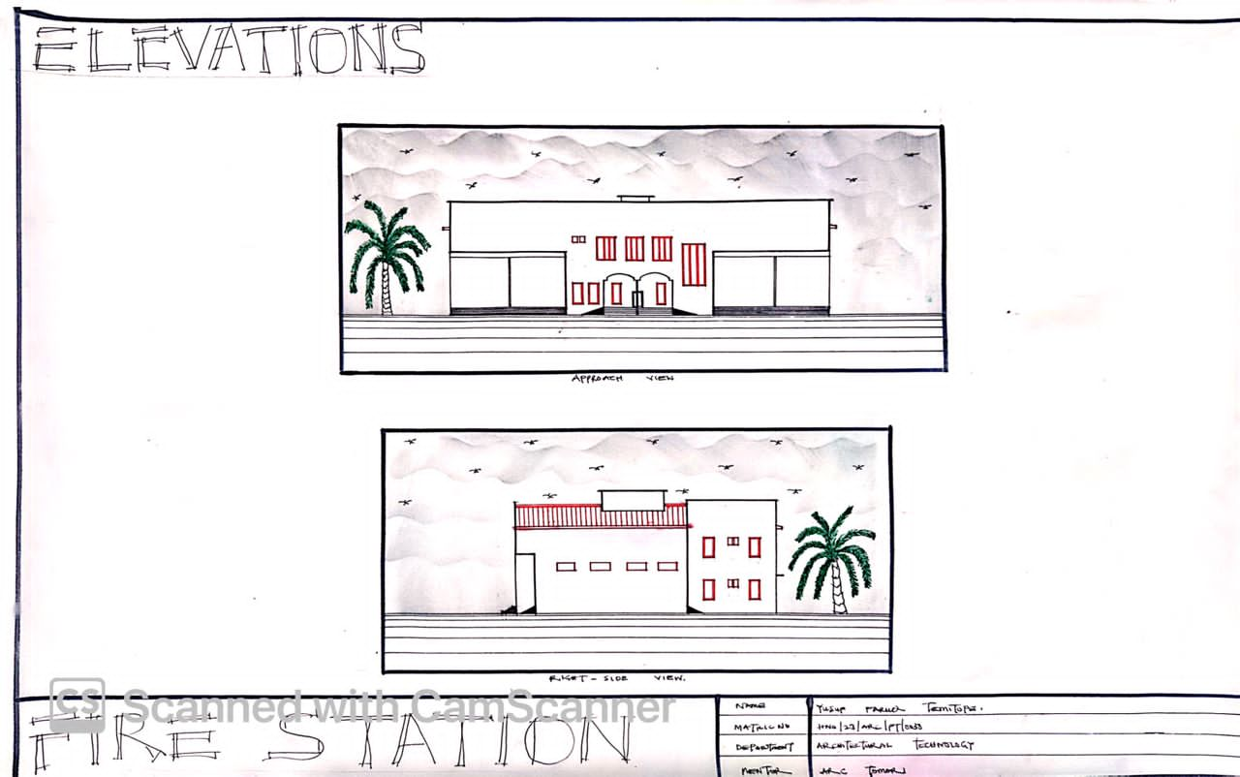

APPENDICES 10
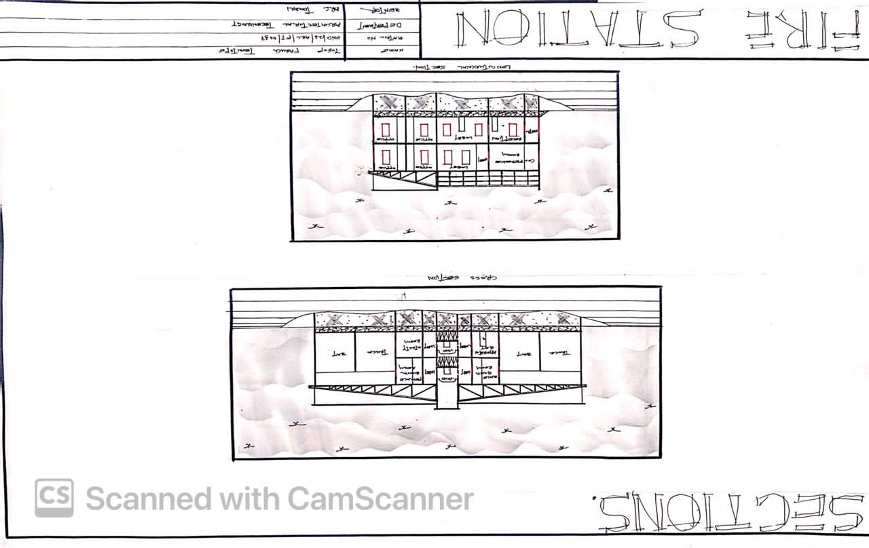

APPENDICES 11B
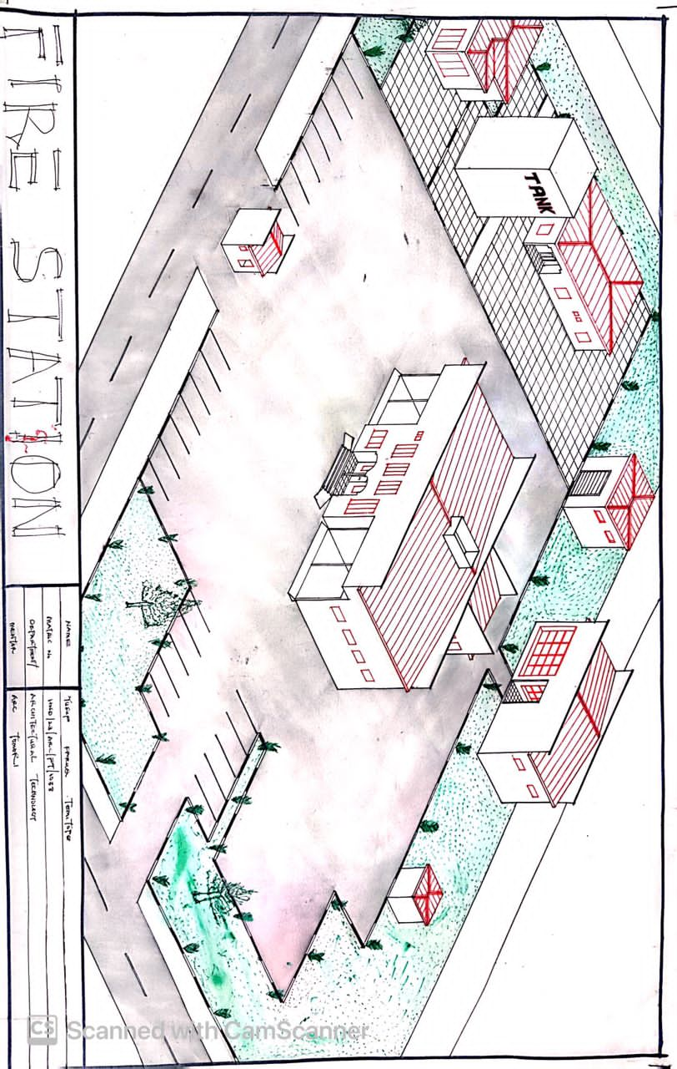

APPENDICES 12
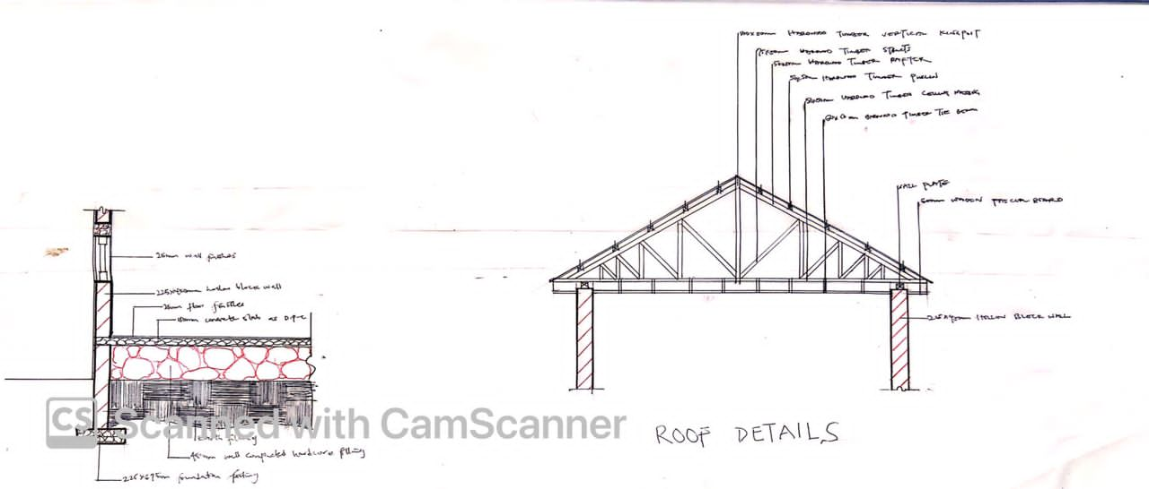

APPENDICES 13

