CHAPTER ONE
INTRODUCTION
  - Background of the Study
A smart camera, also known as an intelligent camera, is an advanced imaging device that combines traditional camera capabilities with sophisticated computing power and connectivity features. These cameras are designed not only to capture high-quality images and videos but also to process and analyze the captured data in real-time. This functionality enables a wide range of applications in security, automation, healthcare, and more. Key features of smart cameras include high-resolution imaging, built-in processing power, and connectivity options such as Wi-Fi, Bluetooth, Ethernet, and cellular networks. These features allow smart cameras to transmit data to other devices or cloud services for further analysis, storage, or remote monitoring. Additionally, many smart cameras incorporate artificial intelligence (AI) and machine learning (ML) algorithms to enhance their functionality, enabling features such as object detection, facial recognition, activity recognition, and anomaly detection (Saurabh, et al., 2017).
Smart cameras have diverse applications across various fields. In security and surveillance, they are used for real-time monitoring, facial recognition, intrusion detection, and automatic alerting, enhancing public safety by providing detailed analytics and quick responses to incidents. In industrial automation, they are used for quality control, process monitoring, and automation, detecting defects, measuring components, and ensuring products meet specifications. In retail and marketing, smart cameras analyze customer behavior, manage inventory, and enhance security by tracking foot traffic, monitoring shelf stock, and tailoring advertisements based on customer demographics. The basic design of a security system begins with analyzing the needs of the inhabitants, surveying existing technology and hardware, reviewing system costs, considering monitoring choices and finally planning the installation (Biradar, et al., 2016).
The background to this study delves into the evolving landscape of security systems and the increasing demand for sustainable energy solutions in modern society. Traditional security systems, which rely heavily on grid electricity, face numerous challenges that compromise their effectiveness and reliability. These challenges include vulnerability to power outages, high operational costs, and environmental concerns associated with conventional energy sources. As a response to these challenges, there has been a growing interest in developing alternative energy solutions that can enhance the resilience and sustainability of security systems (Akrit and Ujwal, 2016).
One promising alternative energy source for security systems is the inverter technology. Inverters are electronic devices that convert direct current (DC) electricity into alternating current (AC) electricity, making them suitable for powering various electrical appliances, including security devices. In recent years, advancements in inverter technology have made them more efficient, affordable, and widely available, paving the way for their integration into security systems (Lalit, 2018).
The concept of utilizing inverters as a means of energy for security systems aligns with broader trends in sustainable energy and smart technology. As societies worldwide strive to reduce their carbon footprint and mitigate the impacts of climate change, there is a growing emphasis on transitioning towards renewable energy sources and implementing energy-efficient technologies. In this context, incorporating inverters into security systems not only improves their reliability but also contributes to sustainability goals by reducing reliance on fossil fuels and grid electricity.

  - Statement of the Problem
The Kwara State Polytechnic, Department of Computer Science, like many academic institutions, faces significant challenges in maintaining effective and reliable security systems. These challenges are compounded by frequent power outages, high energy costs, and the need for sustainable practices. The existing security infrastructure, which primarily relies on grid electricity, is often rendered ineffective during power disruptions, leaving the department vulnerable to security breaches and unauthorized access. Frequent power outages can last for several hours, during which the security systems reliant on grid power become non-operational. This vulnerability exposes the department to increased risks of theft, vandalism, and other security threats. Additionally, the cost of electricity is a significant concern for the department. The continuous operation of security systems, which require a constant power supply, results in substantial energy expenses. These high costs strain the department's budget, limiting resources that could be allocated to other critical areas such as academic programs and research.
1.3 Aim and Objectives
The aim of this study is to design and implement a smart security system utilizing inverters as a means of energy for the Kwara State Department of Computer Science. The specific objectives are as follows:
- Install the necessary infrastructure for renewable energy sources, such as solar panel mounts and wiring.
- Install inverters in a secure, well-ventilated location, ensuring they are properly connected to the renewable energy source and the security system.
- Set up smart cameras, sensors, and other security components according to the design plan.

1.4 Significance of the Study
By implementing a smart security system powered by inverters, the department can enhance security and reliability, ensuring continuous operation during power outages and protecting sensitive data, equipment, and personnel. This approach also promises significant cost savings by reducing dependence on grid electricity and promoting sustainability through the use of renewable energy sources. Additionally, it provides valuable educational and research opportunities for students and faculty, enhancing their practical skills and knowledge in modern security technologies.
1.5 Scope of the Study
The scope of this study covers implementing and evaluating an inverter-powered smart security system within the Kwara State Department of Computer Science.
1.6 Organization of the Study
The study is divided into five chapters, each focusing on specific aspects of the research, ensuring a logical flow of information and a thorough analysis of the problem and proposed solution.
Chapter One: General Introduction
This chapter introduces the study, providing the background, statement of the problem, aim and objectives, significance, scope, and organization of the study. It sets the stage for the research by outlining the key issues and the overall approach to addressing them.
Chapter Two: Literature Review
In this chapter, relevant literature on security systems, inverter technology, and sustainable energy solutions is reviewed. This includes an analysis of previous studies, theoretical frameworks, and technological advancements related to the research topic. The literature review helps to contextualize the study within the broader academic discourse and identify gaps that this research aims to fill.
Chapter Three: Methodology
Chapter three presents the method employed, analysis of data and existing system, advantages of the proposed system, design and implementation, and hardware support
Chapter Four: System Design and Implementation
Chapter Four focuses on the design and implementation of the inverter-powered smart security system. It provides a detailed description of the system architecture, hardware and software components, and integration process. This chapter also covers the installation procedures and any challenges encountered during the implementation phase.
Chapter Five: Summary, Conclusion, and Recommendations
The final chapter concludes the study by summarizing the key findings and contributions of the research. It provides recommendations based on the study’s outcomes, offering practical guidance for the Kwara State Department of Computer Science and other institutions considering similar implementations. The chapter also suggests directions for future research to build on the findings of this study.

CHAPTER TWO
LITERATURE REVIEW
2.1 Review of Related Work
William 2021 journal article introduces a research project focused on developing a security camera system using Raspberry Pi to monitor energy consumption.
The research aimed to create a model that utilizes a light sensor module to detect pulses on an energy meter, calculating energy usage in kWh. Additionally, the project sought to transmit this data to Google Spreadsheets via Google APl, making it accessible through a website and Android app.
The methodology involved connecting a Raspberry Pi to a light sensor module on the energy meter. The Raspberry Pi counted the pulses detected by the sensor, using this information to calculate energy consumption in kWh.
The results demonstrated a successful implementation of the model, accurately tracking energy consumption and providing easy access to data through Google Spreadsheets, a website, and an Android app.
The conclusion highlighted the effectiveness of using Raspberry Pi with a light sensor module to monitor energy consumption, offering a reliable method for tracking energy usage and promoting energy efficiency.
Wang Wei 2010, journal article introduces a smart home control system leveraging sensor networks to enhance home automation and energy management. The system utilizes IEEE 802.15.4 and ZigBee technologies to gather data from sensors like occupancy, PIR, and photo sensors, aiming to develop a smart home automation and energy management system.
The aim and objective focuses on implementing IEEE 802.15.4 and Zigbee technologies, and improving energy management through optimized strategies and algorithms.
The methodology involves designing and implementing the sensor network using lEEE 802.15.4 and ZigBee technologies, collecting and analyzing data from deployed sensors, and developing control algorithms for automation and energy optimization.
The result demonstrate the successful implementation and evaluation of the smart home control system, achieving significant energy savings, automation capabilties, and user satisfaction.
The conclusion highlights the benefits of utilizing sensor networks, IEEE 802. And ZigBee technologies in smart home control systems, emphasizing their potential for enhanced home automation and energy efficiency.
Peter 2016 study, "IP Camera,” aimed to enhance image recording capabilities by incorporating gamma correction and cloud service integration in surveillance systems.
The research objective was to develop a system that improves image clarity while balancing clarity and blurriness through gamma correction.
The methodology employed an embedded system for efficient processing and control, integrating with cloud services for seamless image storage and access.Gamma correction enhanced image quality, but selecting the optimal gamma value was Crucial as it affected image clarity and blurriness.
Through experimentation, the researchers result identify the optimal gamma value balance, demonstrating the effectiveness of gamma correction in IP surveillance cameras.
This conclusion showed that carefully selecting the gamma value achieved improved image clarity while considering blurriness, and cloud integration enhanced system functionality.
Seytima 2015 study proposed a smart home automation system leveraging Raspberry Pi and loT for intelligent control of home appliances, enhanced by computer vision techniques.
The research aimed to develop a smart home automation system using Raspberny PI and IoT for remote control of connected appliances, implementing computer vision techniques for sensing, surveillance, and intrusion detection.
The methodology involved utilizing Raspberry Pi as the central control unit, employing computer vision techniques for enhanced functionality, and incorporating motion sensors for intrusion detection and camera triggering.
Through extensive experimentation and testing, the system result was successful integration of Raspberry Pi, IoT, and computer vision techniques, effectively detecting intrusions and triggering the camera to record.
The conclusion highlighted the effectiveness of using Raspberry Pi and IoT for smart home automation, showcasing the potential of computer vision techniques for remote control and surveillance, and efficient intrusion detection and recording capabilities. Overall, the research demonstrated the potential of this approach in creating intelligent and secure smart homes.
Miatoma 2018 research presented an adaptive smart home system that utilizes feedback information from household appliances to create a personalized and efficient home automation experience.
The system aims to learn user habits by employing toddler and correlation algorithms to analyze user interactions with appliances. The research objective was to develop an adaptive smart home system that learns and understands user habits, enabling automatic adjustments to meet individual needs.
The methodology involved a central controller collecting feedback information from household appliances, utilizing a toddler algorithm to discover operation rules and correlation algorithms to identify relationships between user interactions. Through experimentation and analysis, the system successfully resulted and adapted to user habits, identifying operation rules and relationships between interactions. This enabled automatic adjustments and optimization of the home environment based on individual preferences.
The conclusion highlighted the effectiveness of an adaptive smart home system that utilizes feedback information to learn user habits, providing a tailored experience for each user and enhancing convenience and comfort
2.1.1 Review of General Work
Biradar, et al., (2016), present a journal article titled “Smart Home Automation System” -Smart home automation system is a web based application that allows user to monitor home appliances using mobile devices. This system established for the entire home user after gaining access from administrator. This system includes remote control and monitoring domestic appliances, security and energy management. Once all the appliances in home are automated and connected it important to consider issue of security authentication and access control.
Saurabh, et al., (2017), presents a journal titled “Internet Of Things (IoT) Based Home Automation System”, This paper purposes the study of Internet of Things (IoT) based home automation system. Internet of things (IoT) based home automation system can be controlled over mobile devices. This system can perform varied functions to be performed at home. This allows accessibility over internet from any corner in the world. The main focus of this project is to minimize the usage of electricity and reduce human efforts. The Home Automation system (HAS) incorporates various aspects of technologies such as wireless networking, communication over cloud. The data to be analyzed is stored onto the cloud. The user can access multiple appliances over the internet as per their convenience. This is a low cost system. This system can control multiple devices.
Vinay and Kusuma (2015), present a journal article titled “Home Automation Using Internet of Things” With advancement of Automation technology, life is getting simpler and easier in all aspects. In today’s world Automatic systems are being preferred over manual system. With the rapid increase in the number of users of internet over the past decade has made Internet a part and parcel of life, and IoT is the latest and emerging internet technology. Internet of things is a growing network of everyday object-from industrial machine to consumer goods that can share information and complete tasks while you are busy with other activities. Wireless Home Automation system (WHAS) using IoT is a system that uses computers or mobile devices to control basic home functions and features automatically through internet from anywhere around the world, an automated home is sometimes called a smart home. It is meant to save the electric power and human energy. The home automation system differs from other system by allowing the user to operate the system from anywhere around the world through internet connection. In this paper we present a Home Automation system(HAS) using Intel Galileo that employs the integration of cloud networking, wireless communication, to provide the user with remote control of various lights, fans, and appliances within their home and storing the data in the cloud. The system will automatically change on the basis of sensors’ data. This system is designed to be low cost and expandable allowing a variety of devices to be controlled.
Ravi, Lakshmi and Vishal (2016), present a journal article titled “IoT Based Smart Security and Home Automation System” Internet of Things (IoT) conceptualizes the idea of remotely connecting and monitoring real world objects (things) through the Internet. When it comes to our house, this concept can be aptly incorporated to make it smarter, safer and automated. This IoT project focuses on building a smart wireless home security system which sends alerts to the owner by using Internet in case of any trespass and raises an alarm optionally. Besides, the same can also be utilized for home automation by making use of the same set of sensors. The leverage obtained by preferring this system over the similar kinds of existing systems is that the alerts and the status sent by the Wi-Fi connected microcontroller managed system can be received by the user on his phone from any distance irrespective of whether his mobile phone is connected to the internet. The microcontroller used in the current prototype is the TI-CC3200 Launchpad board which comes with an embedded micro-controller and an on board Wi-Fi shield making use of which all the electrical appliances inside the home can be controlled and managed.
Akrit and Ujwal (2016), present a journal titled “Wireless Home Automation System” Home automation structures have gotten commonness of late, paralleling advances in the possibility of the Internet of Things. The current endeavour exhibits the utilization of an unobtrusive home computerization system, inside the structure of assistive advancement. The system utilization relies upon the Arduino microcontroller along with Bluetooth correspondences capacity, and it is proposed for use by the elderly and people with insufficiencies. The structure is anything but difficult to use, with an instinctual interface executed on an Android based propelled cell phone. Showings exhibit that the structure empowers control of home devices, lights, warming, cooling systems and security devices by the arranged customers, i.e., the elderly and crippled.
Dhakad, Dhake, Undegaonkar, Zope and Vinay (2016), present a journal article titled “Smart Home Automation using IoT” Smart Building not only refers to reduce human efforts but also energy efficiency and time saving. In this ASP.NET is used in which appliances are connected to sensors and sensors give status of appliances to the web. Here electric appliances are operated by the website. The main objective of home automation and security is to help handicapped and aged people that will enable them to control home appliances and alert them in critical situations.
Lalit, Samir and Nihar (2018), present a journal titled “Arduino based home automation using Internet of things (IoT)”,This paper presents a low cost flexible and reliable home automation system with additional security using Arduino microcontroller, with IP connectivity through local WiFi for accessing and controlling devices by authorized user remotely using Smart phone application. The proposed system is server independent and uses Internet of things to control human desired appliances starting from industrial machine to consumer goods. The user can also use different devices for controlling by the help of web-browser, smart phone or IR remote module. To demonstrate the effectiveness and feasibility of this system, in this paper we present a home automation system using Arduino UNO microcontroller and esp8266-01 as a connectivity module. It helps the user to control various appliances such as light, fan, TV and can take decision based on the feedback of sensors remotely. We have tested our system through conducted experiment on various environmental conditions.
Mahind, Gujar, Patel, Nikam and Patil (2018), present a journal article titled “Home Automation using IoT” A home automation is a technique which reduces the human efforts by using electronic devices. This system controls the home appliances through android application based on raspberry-pi. A home automation system have a two main components; First one is android app which control by locally as well as remotely and second is Raspberry Pi that has interface to sensors and appliances of an home automation system. It also saves the energy consumed by home appliances.
Ritvik and Antara (2019) present a journal article titled “IoT based Home Automation System with Pattern Recognition” Automation has numerous applications. This paper proposes a home automations system which can be effectively used to control and monitor home appliances using the internet. Due to its various advantages, home automation is gaining more and more popularity day by day because of its ability to ensure security and make life much easier. In the system, arduino will be interfaced with multiple sensors that can measure temperature & humidity, light, motion, and so on. The data collected by the various sensors is stored and a pattern analysis is done on the stored data which tells the user at which time the appliances are usually on or off so that they can be automatically controlled without any human intervention by observing the regular usage pattern. The user can also turn on/off any appliance remotely using the internet.

2.2 Review of General Study
The review of general study provides an extensive overview of the existing research, theories, and applications related to smart security systems and the integration of inverter technology as an alternative energy source. This review will cover several key areas, including the evolution of security systems, advancements in smart camera technology, the role of inverter technology in renewable energy systems, and the intersection of these fields in creating efficient and reliable security solutions.

2.2.1 Evolution of Security Systems
Security systems have evolved significantly over the past few decades, transitioning from simple mechanical locks and guards to sophisticated electronic systems. Early electronic security systems relied heavily on wired connections and were often limited in functionality. With the advent of digital technology, security systems have become more advanced, incorporating features such as digital video recording, remote monitoring, and network integration.
The introduction of internet protocol (IP) cameras marked a significant milestone in the evolution of security systems. IP cameras allowed for digital video to be transmitted over data networks, enabling remote viewing and recording. This technology paved the way for the development of smart cameras, which integrate advanced processing capabilities and artificial intelligence to provide real-time analysis and automated responses.

2.2.2 Advancements in Smart Camera Technology
Smart cameras, also known as intelligent cameras, have transformed the security landscape by incorporating high-resolution imaging, real-time processing, and AI-based analytics. Key advancements in smart camera technology include:
- High-Resolution Imaging: Modern smart cameras are equipped with high-resolution sensors that provide clear and detailed images, essential for accurate monitoring and analysis.
- Built-In Processing: Smart cameras have integrated processors that perform complex image processing and analysing tasks locally. This reduces the need for external processing units and enables real-time decision-making.
- AI and Machine Learning: The integration of AI and machine learning algorithms allows smart cameras to perform tasks such as facial recognition, object detection, and behavior analysis. These capabilities enhance the accuracy and effectiveness of security systems.
- Edge Computing: By processing data at the edge, or on the camera itself, smart cameras can provide faster responses and reduce the amount of data that needs to be transmitted to central servers. This is particularly useful in applications where latency is critical.
- Connectivity and Integration: Smart cameras offer various connectivity options, including Wi-Fi, Ethernet, and cellular networks, allowing for seamless integration with other security and management systems.

2.2.3 Role of Inverter Technology in Renewable Energy Systems
Inverter technology plays a crucial role in the efficient utilization of renewable energy sources, such as solar power, for various applications. An inverter converts direct current (DC) electricity generated by renewable sources into alternating current (AC) electricity, which is used by most electronic devices. Key aspects of inverter technology include:
- Conversion Efficiency: Modern inverters are designed to maximize the conversion efficiency from DC to AC, ensuring minimal energy loss and optimal performance of the connected devices.
- Energy Storage Integration: Inverters often integrate with energy storage systems, such as batteries, to store excess energy generated by renewable sources. This stored energy can be used during periods of low generation or power outages, ensuring a reliable power supply.
- Grid Connectivity: Advanced inverters can synchronize with the power grid, allowing for the seamless transfer of energy between the renewable source, storage system, and grid. This capability supports grid stability and enhances the overall energy efficiency of the system.
- Monitoring and Control: Inverters are equipped with monitoring and control features that allow users to track energy production, consumption, and storage in real-time. These features facilitate efficient energy management and optimization.

2.2.4 Integration of Smart Cameras and Inverter Technology
The integration of smart cameras with inverter technology and renewable energy sources presents a promising solution for achieving reliable and sustainable security systems. This approach addresses several challenges faced by traditional security systems, including dependence on grid electricity, vulnerability during power outages, and high operational costs.
- Continuous Operation: By utilizing renewable energy sources and inverters, smart security systems can maintain continuous operation even during power outages. This ensures uninterrupted surveillance and protection.
- Energy Efficiency: The use of renewable energy reduces the reliance on grid electricity, leading to lower energy costs and a reduced carbon footprint. Inverter technology enhances the efficiency of energy conversion and storage, further optimizing energy usage.
- Cost Savings: Implementing a smart security system with renewable energy and inverters can result in significant cost savings over time. Reduced energy bills, lower maintenance costs, and potential incentives for using renewable energy contribute to the overall financial benefits.
- Scalability and Flexibility: Smart security systems with integrated inverter technology are scalable and can be tailored to meet the specific needs of different environments. Whether for a single building or an entire campus, these systems offer the flexibility to expand and adapt as required.
- Advanced Analytics and Automation: The combination of smart cameras and AI-driven analytics enables advanced security features such as automated threat detection, real-time alerts, and intelligent response actions. These capabilities enhance the effectiveness and responsiveness of security measures.
2.3 Historical Background
The historical background of security systems and energy solutions provides essential context for understanding the evolution of modern smart security systems that utilize inverter technology. This background traces the development of security technologies, the emergence of inverter technology, and the convergence of these fields in contemporary applications.

2.3.1 Evolution of Security Systems
The concept of security has been integral to human societies since ancient times. Early security measures were primarily physical, such as walls, locks, and guards. With the advent of electricity in the late 19th and early 20th centuries, electronic security systems began to emerge. The first significant innovation was the electric burglar alarm, patented by Augustus Pope in 1853. This system used a network of wires and electrical contacts to detect intrusions.
As technology advanced, the mid-20th century saw the introduction of closed-circuit television (CCTV) systems. The first documented use of CCTV for surveillance was by Siemens AG in Germany in 1942 for monitoring V-2 rockets. By the 1960s, CCTV systems were being widely used in public spaces, banks, and commercial establishments for enhanced security.
The digital revolution of the late 20th century brought about significant advancements in security systems. The development of digital video recording (DVR) allowed for efficient storage and retrieval of surveillance footage. The introduction of Internet Protocol (IP) cameras in the late 1990s marked a pivotal shift, enabling video data to be transmitted over computer networks. This innovation laid the foundation for modern smart security systems, integrating advanced processing capabilities and network connectivity.

2.3.2 Emergence of Inverter Technology
Inverter technology, critical for converting direct current (DC) to alternating current (AC), has its roots in the early developments of electrical engineering. The first practical inverter was developed in the early 20th century, primarily for industrial applications. Early inverters used mechanical devices, such as rotary converters, to achieve the DC-to-AC conversion.
The invention of semiconductor devices in the mid-20th century, particularly the development of transistors, revolutionized inverter technology. The introduction of the metal-oxide-semiconductor field-effect transistor (MOSFET) in the 1960s allowed for more efficient and compact inverters. By the 1980s, inverters using power electronics had become standard in various applications, including uninterruptible power supplies (UPS) and renewable energy systems.
In the context of renewable energy, inverters became essential for integrating solar photovoltaic (PV) systems into the grid. The development of grid-tied inverters in the 1990s enabled solar panels to supply electricity to both the local load and the utility grid. This advancement was crucial in promoting the adoption of solar energy and other renewable sources.

2.3.3 Convergence of Security Systems and Inverter Technology
The convergence of advanced security systems and inverter technology is a relatively recent phenomenon, driven by the need for reliable and sustainable energy solutions. As security systems have become more sophisticated and power-dependent, ensuring an uninterrupted power supply has become a critical challenge. In regions with unstable power grids or frequent outages, traditional security systems often fail when they are needed the most.
Inverter technology, combined with renewable energy sources like solar power, offers a robust solution to this problem. By integrating inverters into security systems, it is possible to maintain continuous operation during power outages, ensuring that surveillance and monitoring capabilities remain intact. This integration not only enhances the reliability of security systems but also promotes energy efficiency and sustainability.
The adoption of smart cameras with built-in processing capabilities has further enhanced the functionality of security systems. These cameras, when powered by renewable energy through inverters, can operate independently of the grid, providing reliable security coverage even in remote or off-grid locations. Additionally, the use of artificial intelligence (AI) and machine learning (ML) in smart cameras allows for real-time analysis and automated responses, significantly improving the effectiveness of security measures.
CHAPTER THREE
RESEARCH METHODOLOGY AND ANALYSIS OF THE NEW SYSTEM
3.1 Research Methodology
The installation and integration of a smart security system utilizing inverters as a means of energy involve several key steps. These steps ensure that the new system components are correctly installed, integrated with existing infrastructure, and operate seamlessly. Here is a detailed plan for this process:
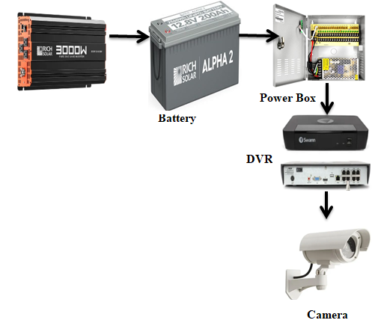
Figure 3.1: Schematic diagram for Smart Security System

1. Installation of Components

Renewable Energy Setup
- Install solar panels: Securely mount solar panels in locations with maximum sunlight exposure, ensuring they are positioned to avoid shading and other obstructions.
- Setup inverters: Install inverters in a well-ventilated and secure area, connecting them to the solar panels and batteries. Ensure all connections are safe and comply with electrical codes.

Smart Camera Installation
- Positioning cameras: Install smart cameras at strategic locations to cover all critical areas, such as entry points, hallways, and common areas. Ensure each camera is positioned for optimal field of view and minimal blind spots.
- Mounting and cabling: Securely mount the cameras and run the necessary cabling to connect them to the network and power sources. Use weatherproof housing and conduits for outdoor installations to protect against environmental factors.

2. Integration with Existing Infrastructure

Network Integration
- Connect cameras to the network: Ensure all smart cameras are connected to the existing network infrastructure. Configure network settings, including IP addresses, to facilitate seamless communication.
- Setup network storage: Integrate network video recorders (NVR) or other storage solutions to ensure all video data is stored securely and is easily retrievable.

Power Management Integration
- Connect inverters to the grid: Ensure the inverters are correctly connected to the power grid and configured to switch seamlessly between grid power and renewable energy sources.
- Integrate backup power: Connect batteries and ensure they are properly configured to provide backup power during outages, ensuring continuous operation of the security system.
3.2 Analysis of the Existing System
One significant drawback of the manual system is its reliance on human vigilance and effectiveness, which can be inconsistent. Security guards are prone to fatigue, distraction, and human error, which can compromise the overall security. Additionally, the manual recording of incidents and visitor logs is time-consuming, prone to inaccuracies, and difficult to retrieve quickly during emergencies. The lack of real-time monitoring and automated alert mechanisms means that response times to security breaches or suspicious activities are often delayed, reducing the system’s overall effectiveness. Moreover, the manual system’s dependence on grid power for lighting and communication tools poses another vulnerability. In the event of a power outage, essential security functions are disrupted, leaving the premises more susceptible to breaches. This issue is particularly pressing given the frequent power interruptions in the region, highlighting the need for a more reliable and autonomous security solution.
In an effort to address the shortcomings of the manual system, the Kwara State Department of Computer Science has gradually incorporated some automated security measures. These include the installation of CCTV cameras, electronic access control systems, and basic alarm systems. While these enhancements represent a step towards modernizing the security infrastructure, the existing automated system still has notable deficiencies. The current CCTV cameras provide continuous surveillance but lack advanced features such as high-resolution imaging, real-time analytics, and intelligent threat detection. The footage is often stored on local servers with limited storage capacity, leading to potential data loss and difficulty in managing large volumes of video data. Additionally, the existing cameras are not integrated with other security systems, such as alarms and access control, resulting in a fragmented and inefficient security network.
The electronic access control systems regulate entry to certain areas using keycards or biometric scanners. However, these systems are often standalone and do not communicate with the CCTV or alarm systems, limiting their effectiveness in providing comprehensive security coverage. The alarms in place are basic and lack the capability to send real-time notifications to security personnel, delaying the response to potential security threats.
One of the most critical issues with the existing automated system is its reliance on an unstable power supply. Frequent power outages not only disrupt surveillance and access control systems but also affect the storage and retrieval of security footage. While there are backup generators in place, they are not always reliable and do not offer a sustainable long-term solution.
The proposed smart security system aims to combine the strengths of both manual and automated systems while addressing their respective weaknesses. By leveraging advanced technology and renewable energy, the new system will provide comprehensive, reliable, and efficient security coverage for the Kwara State Department of Computer Science, ensuring the safety and security of the premises under all conditions.

3.3 Problems of the Existing System
The existing security system at the Kwara State Department of Computer Science faces several significant challenges that hinder its effectiveness and reliability. The key problems of the existing system include:

1. Limited Surveillance Capabilities: The current CCTV camera system provides basic surveillance coverage but lacks advanced features and capabilities. The cameras have limited resolution and field of view, resulting in blind spots and inadequate coverage of critical areas.

2. Fragmented Security Infrastructure: The existing security infrastructure is fragmented, with standalone systems for access control, alarm monitoring, and video surveillance. These systems operate independently and do not communicate or integrate with each other.

3. Dependence on Unreliable Power Supply: The security system relies heavily on the local power grid, which is prone to frequent outages and fluctuations.

4. Inadequate Response Mechanisms: The existing system lacks effective mechanisms for real-time incident detection and response. While alarms are installed, they are often triggered by false positives or fail to alert security personnel promptly.

5. Data Management and Storage Issues: The current storage infrastructure has limited capacity and scalability, leading to frequent data overwrites and potential loss of critical footage. Retrieving historical data for investigations or evidentiary purposes is cumbersome and time-consuming, impeding the department's ability to conduct thorough post-incident analysis.

3.4 Description of the Proposed System
This section provides a detailed description of the proposed system, outlining its key components, features, and functionalities.
The cornerstone of the proposed system is a network of smart cameras equipped with advanced artificial intelligence (AI) capabilities. These cameras feature high-resolution imaging sensors, pan-tilt-zoom (PTZ) functionality, and built-in analytics for real-time threat detection and analysis. Using AI algorithms, the cameras can identify and track suspicious activities, recognize faces and license plates, and differentiate between normal and abnormal behavior. This enables proactive monitoring and rapid response to security incidents.
A centralized command and control center serves as the nerve center of the security system, providing real-time monitoring, management, and coordination of all security operations. The command center is equipped with state-of-the-art monitoring consoles, video walls, and communication tools to facilitate situational awareness and decision-making. Security personnel have access to a comprehensive dashboard that displays live camera feeds, alerts, and incident logs, allowing them to respond promptly to security threats and emergencies.
The proposed system integrates access control and alarm systems with the smart camera network to enhance perimeter security and access management. Electronic access control devices, such as card readers and biometric scanners, restrict entry to authorized personnel and trigger alerts for unauthorized access attempts. Alarms are integrated with the camera system, enabling automated notifications and video verification of alarm events. This seamless integration improves the accuracy of threat detection and reduces false alarms.
To ensure reliable and sustainable power supply, the proposed system incorporates renewable energy sources, such as solar panels, coupled with inverters for energy conversion and storage. Solar panels installed on rooftops and other suitable locations harness solar energy, which is converted into electricity by the inverters. Excess energy is stored in batteries for use during periods of low sunlight or power outages. This renewable energy integration reduces dependence on the local power grid and enhances the system's resilience to disruptions.
The proposed system utilizes cloud-based data management and analytics platforms to store, analyze, and retrieve surveillance footage and security data. Cloud storage offers scalable and secure storage solutions, eliminating the limitations of local storage infrastructure. Advanced analytics tools enable deep insights into security trends, anomaly detection, and predictive analysis, empowering security personnel to make informed decisions and proactively mitigate risks.
Security personnel have access to mobile and remote applications that enable real-time monitoring and management of the security system from anywhere, at any time. Mobile apps provide live camera feeds, alert notifications, and remote control of system settings, allowing personnel to respond promptly to security incidents even when off-site. Remote access capabilities enhance operational flexibility and situational awareness, improving overall security responsiveness.
3.5 Advantages of the New System over the Existing System
The proposed smart security system for the Kwara State Department of Computer Science offers several significant advantages over the existing system. Below are the key advantages of the new system:

1. Enhanced Surveillance Capabilities: The new system features smart cameras with advanced AI capabilities, providing enhanced surveillance coverage and threat detection capabilities. High-resolution imaging, pan-tilt-zoom functionality, and real-time analytics enable proactive monitoring and rapid response to security incidents.

2. Integrated Security Infrastructure: Unlike the fragmented nature of the existing system, the new system integrates access control, alarm monitoring, and video surveillance into a centralized and cohesive security infrastructure. This integration enables seamless communication and coordination between different security components, improving incident response times and resource allocation. Security personnel have access to a unified dashboard for real-time monitoring and management, enhancing overall operational efficiency and effectiveness.

3. Reliable and Sustainable Power Supply: One of the most significant advantages of the new system is its reliance on renewable energy sources, such as solar power, coupled with inverters for energy conversion and storage.

4. Scalability and Flexibility: Additional cameras, sensors, and access control devices can be seamlessly integrated into the existing infrastructure, accommodating growth and changes in security requirements.

6. Mobile and Remote Accessibility: The new system offers mobile and remote access capabilities, enabling security personnel to monitor and manage the security system from anywhere, at any time.

CHAPTER FOUR
DESIGN AND IMPLEMENTATION OF THE SYSTEM
4.1 Design of the System
This chapter delves into the technical specifications and considerations for designing a solar-powered CCTV system for examination monitoring. Each of the sections is explained as follows with a diagram.
4.1.1 Output Design
The design of output is the most important task of any system. During output design, we identify the type of outputs needed and consider the necessary output controls and prototype report layouts.
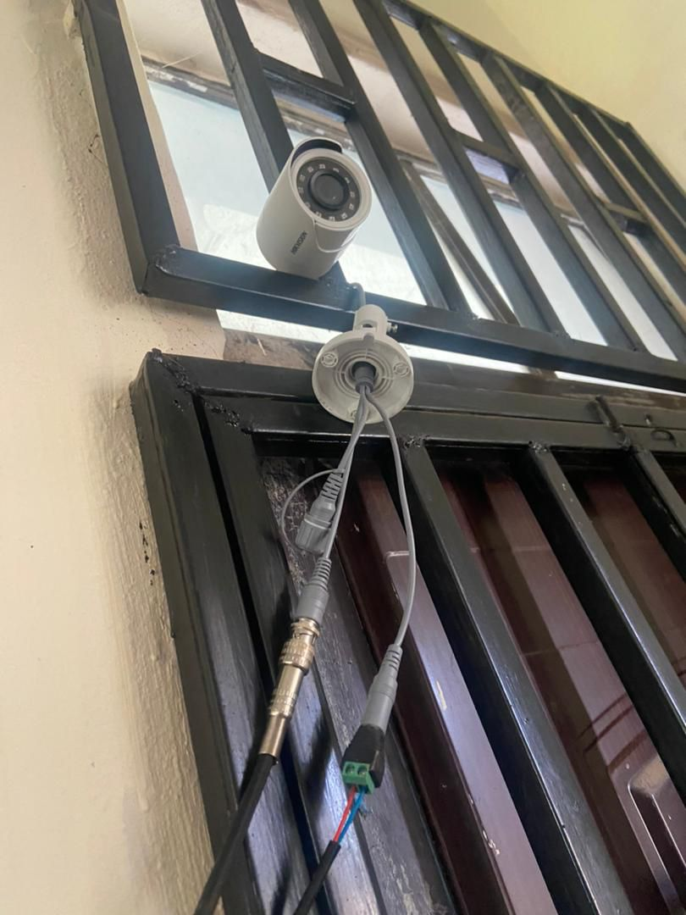
Figure 4.1: The first camera mounted on the window
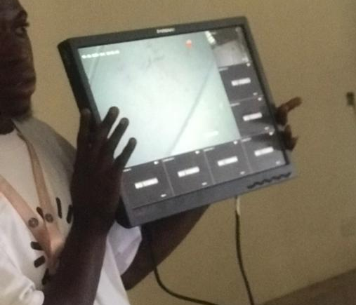
Figure 4.2: This is the output of the first camera
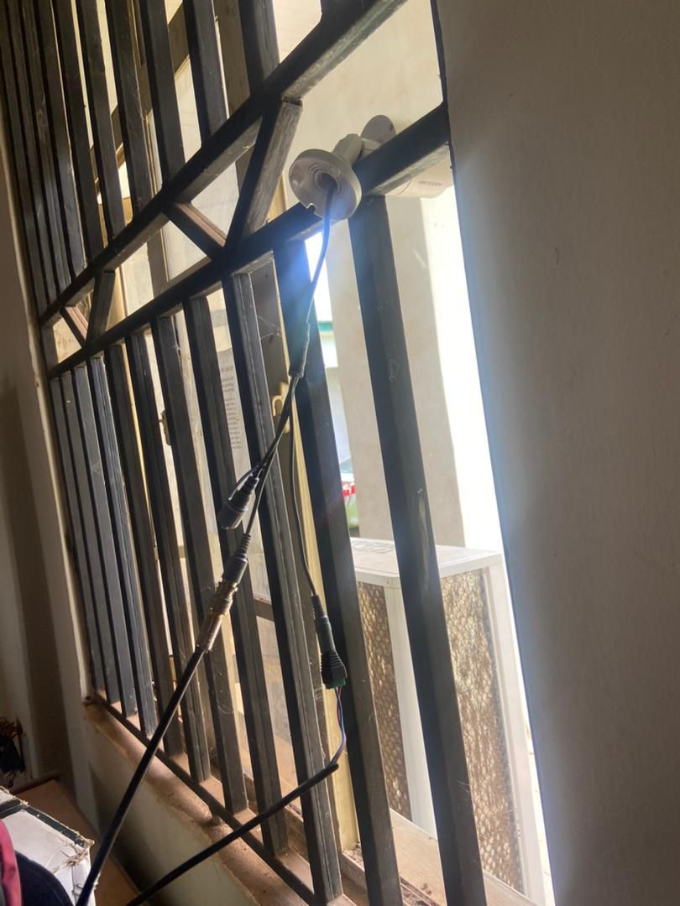
Figure 4.3: The second camera mounted on window
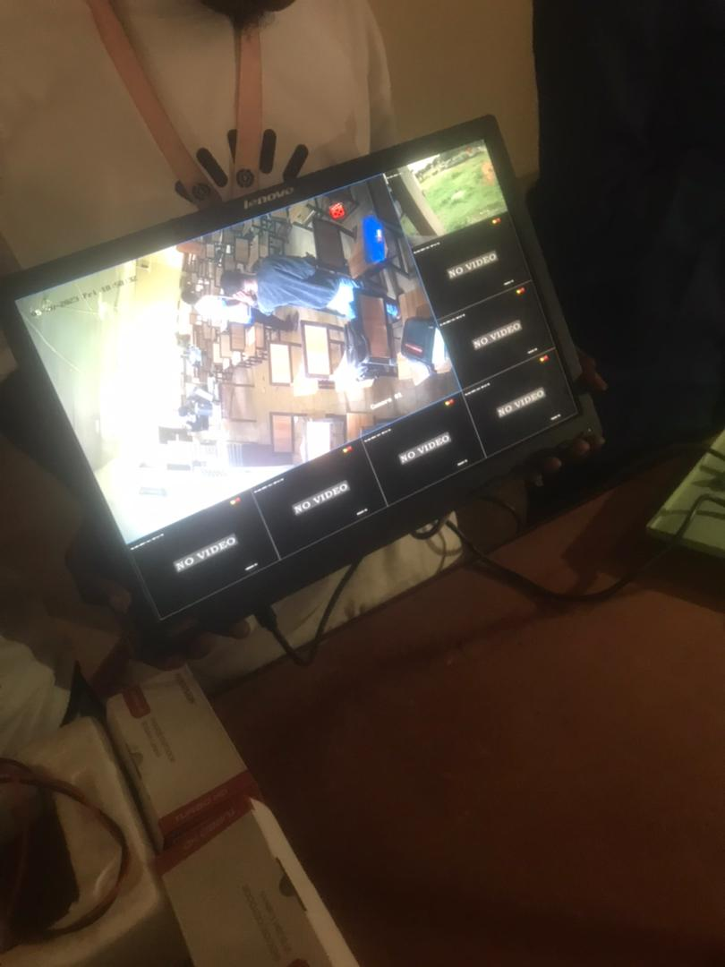
Figure 4.4: This is the output of the second camera, showing students in a classroom.
The system allows designated personnel to view live feeds from cameras in a central control room or remotely. This would enable real-time monitoring and intervention if necessary.

4.1.2 Input Design
The solar-powered CCTV system for examination monitoring functions primarily through automated video capture. However, there are some elements to consider regarding user input that influence system operation.
Tools we used in our Implementation
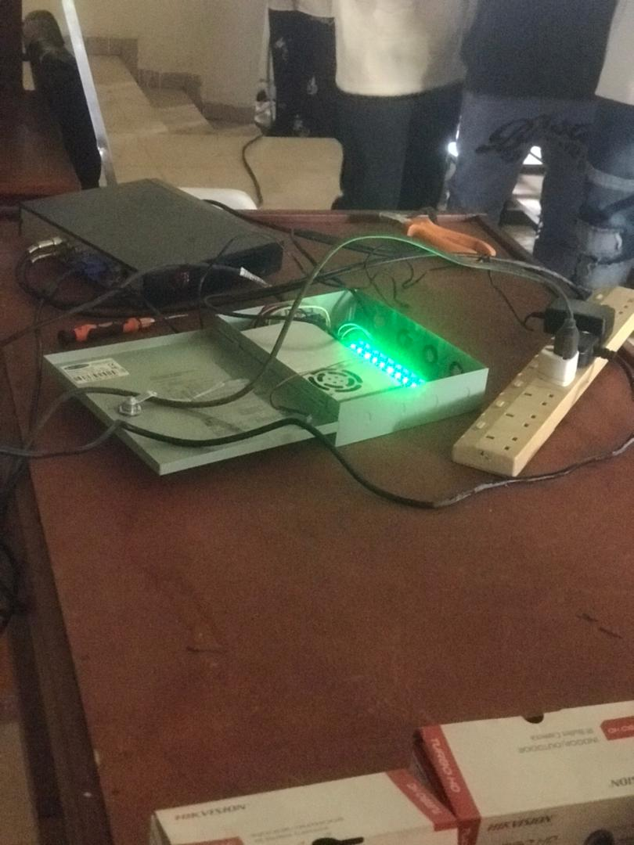
Figure 4.5: Camera Power Supply Box: A camera power supply box, also known as a security power distribution unit, is a device used in CCTV (Closed-Circuit Television) systems. Its primary function is to distribute power from a single source to multiple security cameras.
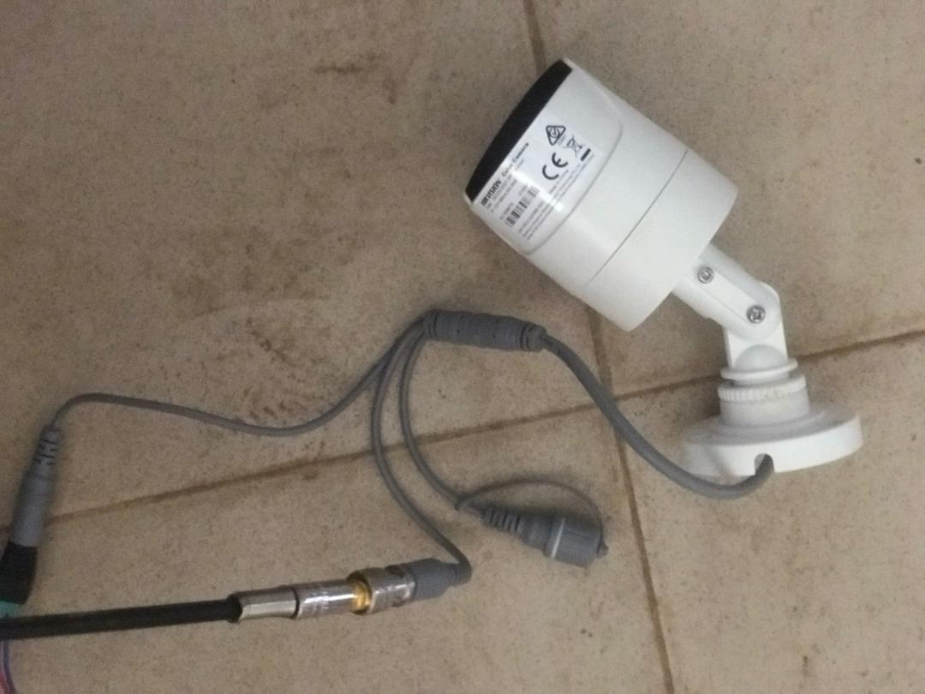
Figure 4.6: Camera: A camera is a device that captures and records images or videos. It works by focusing light rays onto a light-sensitive surface, which then converts that light into an electronic signal. This signal is then processed and used to create an image or video.
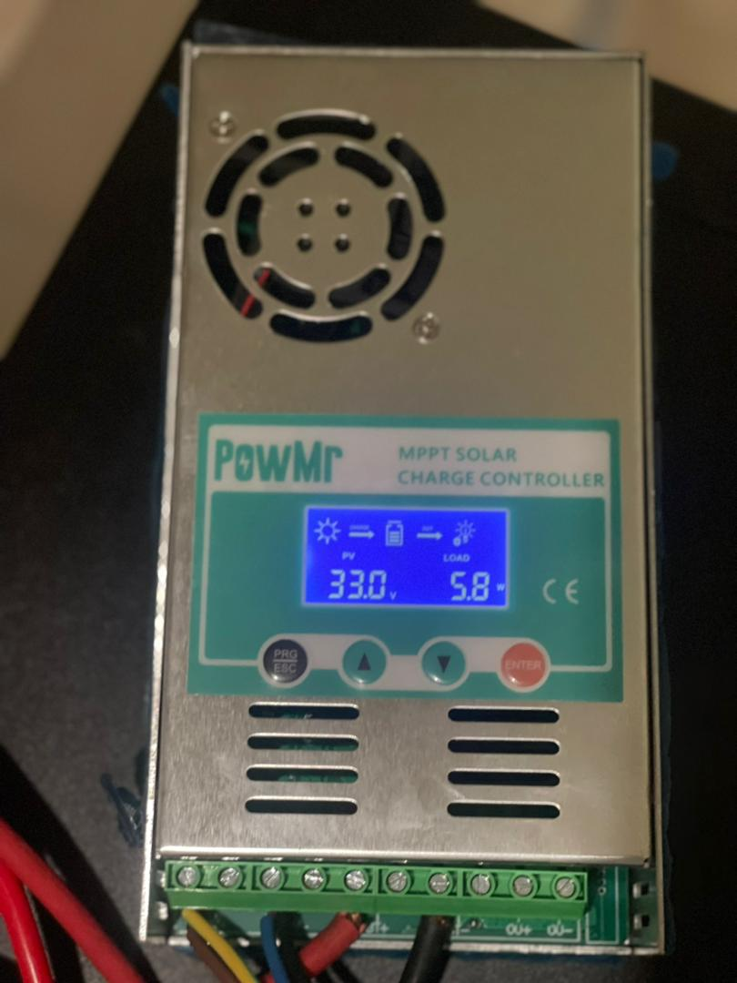
Figure 4.7: Charge Controller: In the context of a solar-powered CCTV system, a charge controller is a critical component that manages the flow of electricity between the solar panels and the battery. It ensures the battery is charged safely and efficiently, preventing damage and extending its lifespan.
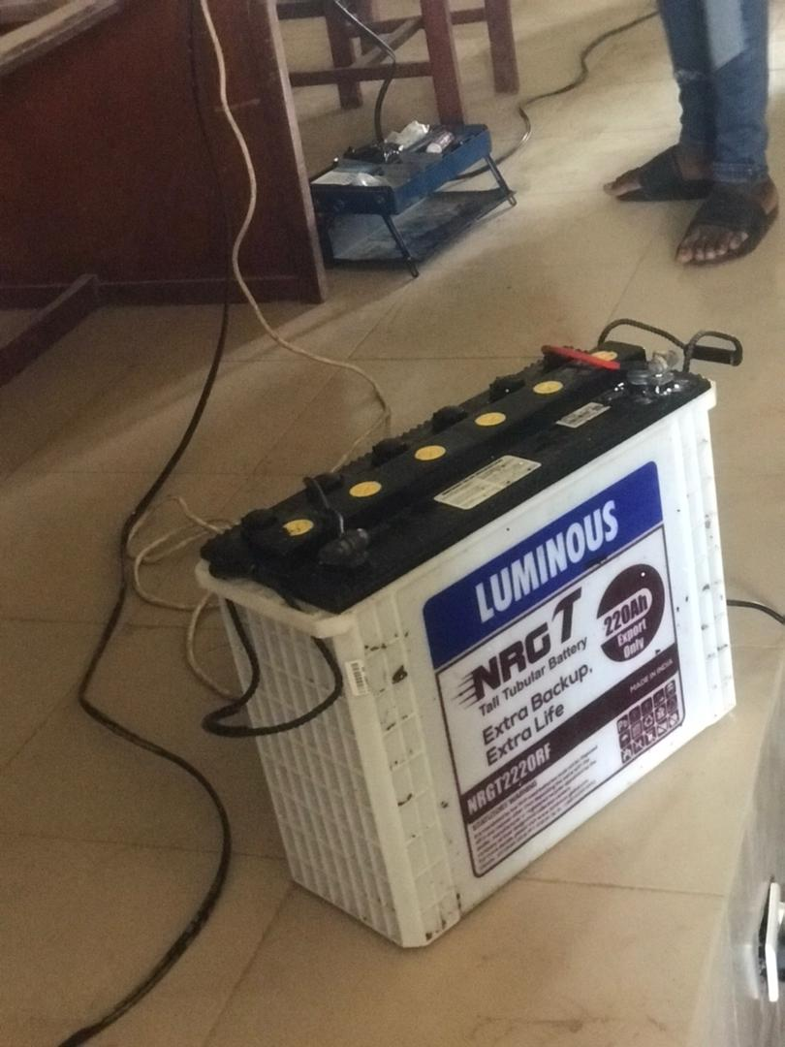
Figure 4.8. Battery: In the context of your solar-powered CCTV system for exam monitoring, the battery plays a critical role in ensuring continuous operation. It stores the electricity generated by the solar panels during the day to power the CCTV cameras, recording devices, and other system components even when sunlight is limited or unavailable.
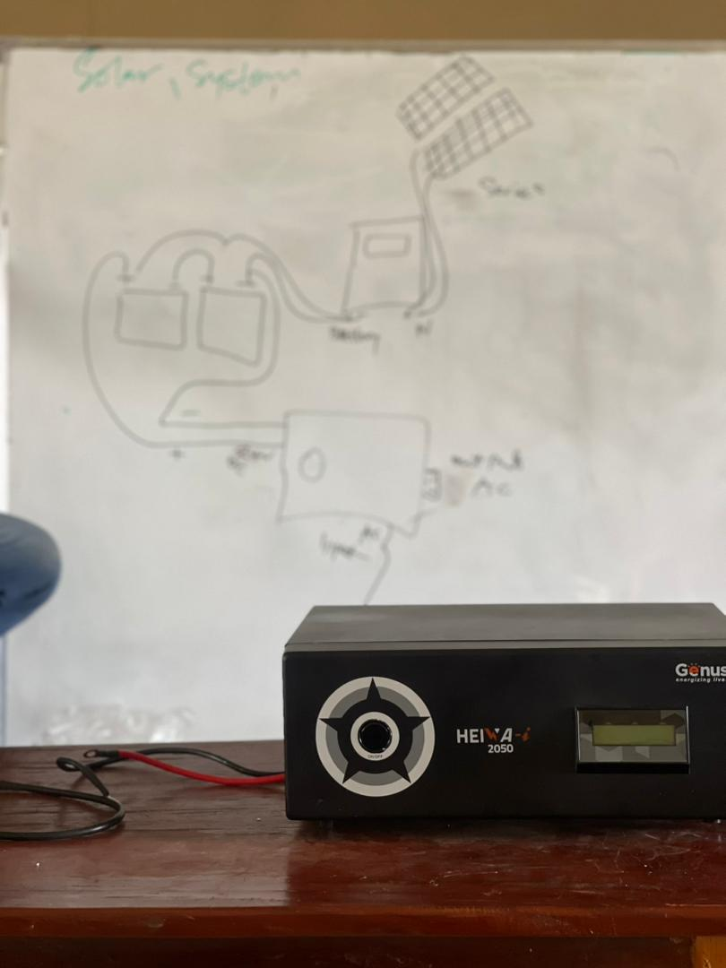
4.9. Inverter: In a solar-powered CCTV system designed for exam monitoring, the inverter plays a vital role in converting the electricity produced by the solar panels from DC (Direct Current) to AC (Alternating Current). This AC power is what ultimately runs the CCTV cameras, recording devices, and other components within the system.
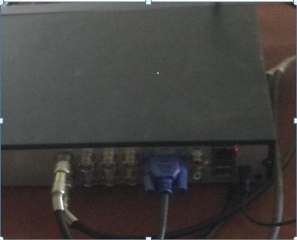
4.10. NVR: A Network Video Recorder (NVR) is a specialized device used for recording video in a digital format to a disk drive, USB flash drive, SD memory card, or other mass storage device.
4.1.3 Procedure Design
A solar-powered CCTV system for monitoring requires minimal user interaction during, but proper setup and procedures are crucial. This section outlines these procedures, including initial system setup like installing, batteries, and cameras. It also details checklists to ensure everything is functional and suggests maintenance routines for the system. Security and access control measures are important to consider, along with a basic plan for responding to incidents like malfunctions or tampering attempts. By following these procedures, you can ensure the system operates reliably and securely throughout exam periods.

4.2 System Implementation
Following the procedures outlined in section 4.1.5, this section delves deeper into the practical execution of setting up your inverter-powered CCTV system for exam monitoring.
4.2.1 Hardware Support
- Battery Bank and Inverter: The inverter's voltage rating should match the battery bank's voltage (e.g., 12V, 24V, or 48V). Additionally, the inverter's capacity (watts) must be sufficient to handle the total power consumption of the system during peak operation.
- Cameras and Recording Device: Ensure the recording device is compatible with the type of cameras used in the system (analog, IP, etc.). Consider factors like video resolution, frame rate, and storage capacity of the recording device when selecting cameras.
- Cables and Connectors: Use cables with the appropriate gauge (thickness) to handle the expected current draw of connected devices. Choose weatherproof cables for outdoor applications and ensure all connectors match the specific components they are connecting.
The software application design needed the following hardware for effective operation of the newly designed system:
i. Core 2 Duo and above system with a processor speed of 500MHz.
ii. The Random-Access Memory (RAM) should be at least 500MB
iii. Enhanced Keyboard and Mouse.
iv. At least 500GB Hard Disk.
v. VGA or SVGA colored monitor to be able to achieve the effective user-friendliness of the program
vi. An Uninterruptible Power Supply (UPS) Units

4.2.2 Software Support
While a solar-powered CCTV system for exam monitoring might have minimal software interaction, there are still software elements to consider in this section.
Software for System Configuration:
- Charge Controller Settings: Some charge controller models might have dedicated software for configuration on a computer or mobile device. This software allows for more granular control over charging parameters, data logging, and monitoring of battery health.
- Recording Device Management: The recording device has its own software interface for managing settings, scheduling recordings, playback controls, and potentially remote access capabilities.
- Video Management Systems (VMS): This software provides centralized management of multiple cameras, recording devices, and user access control. It offers features like advanced video analytics, event notifications, and integrated mapping for complex camera setups.
- A Windows 7, 8, or 10 Operating System.
- CCTV Software Package.
4.2.3 Implementation Techniques
Section 4.2.3 of this research work focuses on the practical methods and best practices for installing and setting up the hardware components of the solar-powered CCTV system for exam monitoring. Here's a breakdown of the key techniques covered
Battery Bank Setup:
- Ventilation and Accessibility: I place the battery bank in a cool, well-ventilated area to optimize battery life. This location is easily accessible for maintenance purposes.
- Series and Parallel Connections: Depending on the system voltage requirements, we might need to connect batteries in series (positive to negative) or parallel (positive to positive, negative to negative).
- Safety Precautions: Batteries contain hazardous materials.
Camera and Monitor Installation:
- Strategic Camera Placement: We position the cameras to provide clear and comprehensive coverage of the exam hall.
- Cable Management: We plan the cable routing between cameras, recording device, and monitors to minimize clutter and ensure a professional installation.
- Monitor Viewing Comfort: We position the monitors in the control room at an appropriate height and distance for comfortable viewing by proctors or authorized personnel. Consider the screen size and resolution of the monitors in relation to the number of cameras being monitored simultaneously.
4.3 System Documentation
For a solar-powered CCTV system designed for monitoring, proper documentation is essential for maintaining a reliable and functional system throughout its lifespan.
4.3.1 Operating the System
While a solar-powered CCTV system for monitoring is designed for minimal user interaction during exams, this section can outline the basic functionalities for proctors or authorized personnel.
- Recording Schedule Confirmation: Ensure the recording device is set to record for the scheduled time.
- Camera Functionality Check: Do a quick visual check to confirm all cameras are operational and displaying a clear view.
- Live View: The system should allow viewing live footage from all cameras on the designated monitors in the control room. This enables proctors to monitor activities in real-time.
- Playback Functionality (if applicable): The recording device might allow playback of previously recorded footage during or after record. This can be useful for reviewing specific incidents or irregularities.
- Data Backup (if applicable): Depending on your system's configuration and local regulations, you might need to back up recorded exam footage to a secure storage device.
- System Shutdown (optional): If the system is not in continuous use, it might be possible to power down the recording device and monitors to conserve battery power. However, ensure the battery bank are still operational to maintain system health.
4.3.2 Maintaining the System
Maintaining a solar-powered CCTV system for exam monitoring is crucial for its smooth operation and lifespan. Here's a breakdown of key maintenance tasks:
- Regular Checks: Verify battery charge and recording schedule. Do a quick visual check to confirm all cameras are functional.
- Operational Focus: View live footage on monitors and playback recordings (if applicable) for reviewing incidents. Back up footage (if required) and consider powering down the system (except solar panels and battery) to conserve battery power.

CHAPTER FIVE
SUMMARY, CONCLUSION, AND RECOMMENDATIONS
5.1 Summary
In this study, a comprehensive analysis of a smart security system utilizing inverters as a means of energy at the Kwara State Department of Computer Science was conducted. The research focused on addressing the limitations of the existing manual and automated security systems by proposing a new integrated solution. The proposed system integrates advanced technology, renewable energy sources, and streamlined operational processes to enhance security, reliability, and efficiency. Key components of the proposed system include smart cameras with AI capabilities, centralized command and control center, integrated access control and alarm systems, renewable energy integration with inverters, cloud-based data management and analytics, and mobile and remote accessibility. These components work together to provide enhanced surveillance coverage, seamless communication, reliable power supply, advanced analytics, and operational flexibility.

5.2 Conclusion
The proposed smart security system represents a significant advancement over the existing system, offering several advantages in terms of surveillance capabilities, integrated security infrastructure, reliable power supply, scalability, advanced analytics, and mobile accessibility. By leveraging cutting-edge technology and renewable energy sources, the new system enhances the safety and security of the Kwara State Department of Computer Science, ensuring the protection of its personnel, assets, and facilities.

5.3 Recommendations
Based on the findings of this study, the following recommendations are proposed:
- Implementation Plan: Develop a detailed implementation plan for deploying the new smart security system, including timelines, resource allocation, and training programs for security personnel.
- Stakeholder Engagement: Engage key stakeholders, including security personnel, administrative staff, and technical experts, throughout the implementation process to ensure buy-in and alignment with organizational goals.
- Regular Maintenance and Monitoring: Establish a regular maintenance schedule for the new system components to ensure optimal performance and reliability. Implement monitoring tools to track system metrics and identify potential issues proactively.
- Continuous Improvement: Foster a culture of continuous improvement by soliciting feedback from users and stakeholders, conducting regular evaluations, and implementing iterative enhancements to the system based on lessons learned and emerging technologies.
- Security Awareness Training: Provide comprehensive training programs for security personnel on the operation, maintenance, and best practices of the new security system to maximize its effectiveness and efficiency.

References
Akrit, K. and Ujwal D. (2016) “Wireless Home Automation System” International Research Journal of Engineering and Technology (IRJET) Volume: 02 Issue: 03 | Jan-2016
Biradar, A. S., Dhage S. B., Jamadar V. V., Kasar H. S. and Javed S.(2016) “Smart Home Automation System” International Journal of Advanced Research in Computer Engineering & Technology (IJARCET) Volume 5, Issue 4, April 2016
Deepali, Javale, Mohd. Mohsin, Shreerang Nandanwar “Home Automation and Security System Using Android ADK” in International Journal of Electronics Communication and Computer Technology (IJECCT) Volume 3 Issue 2 (March 2013).
Dhakad, K., Dhake T., Undegaonkar P., Zope V. and Vinay L.(2016),present a journal article titled “Smart Home Automation using IoT” Jaypee University of Information Technology Waknaghat, Solan-173234, Himachal Pradesh
Yavuz, B. Hasan, I. Serkan and K. Duygu.“Safe and Secure PIC Based Remote Control Application for Intelligent Home”. International Journal of Computer Science and Network Security, Vol. 7, No. 5, May 2007
Lalit, M. S., Samir K. B. and Nihar M.(2018) “Arduino based home automation using Internet of things (IoT)” International Journal of Advanced Research in Computer and Communication Engineering Vol. 5, Issue 2, February 2016
Lalit, Mohan Satapathy, Samir Kumar Bastia Nihar Mohanty, Arduino based home automation using Internet of things (IoT),International Journal of Pure and Applied Mathematics, Volume 118 No. 17 2018.
Mahind, N. L.,Gujar G. V., Patel H. S., Nikam P.S. and N Patil P. D.(2018), present a journal “Home Automation using IoT” International Journal of Pure and Applied Mathematics Volume 118 No. 17 2018, 769-778 ISSN: 1311-8080 (printed version); ISSN: 1314-3395 (on-line version) url: http://www.ijpam.eu Special Issue
Mandurano, Justin, and Nicholas Haber. House Away: A home management system, IEEE Long Island Systems, Applications and Technology Conference (LISAT), Farmingdale, NY, (2012), 1-4.
Marco, Z. (2014) “Introduction to the Internet of Things” December 2017 with 9,775 Reads DOI: 10.21742/ijsh.2017.11.09. 01
Md. RaihaanKamarudin, Md. Aiman F. Md. Yusof. “Low cost Smart Home Automation “ 2013 IJENS Vol:13 No.:03.
Muhammad, IzharRamli, MohdHelmyWahab, Nabihah, “towards smart home: control electrical devices online” ,Nornabihah Ahmad International Conference on Science and TechnologyApplication in Industry and Education (2006)
R. Piyare, and S.R. Lee, Smart home-control and monitoring system using smart phone, The 1st International Conference on Convergence and its Application, 84, (2013) 83-86.
Ravi K. K., Lakshmi B. and Vishal J. (2016) “IoT Based Smart Security and Home Automation System” [Singh* et al., 6(11): November, 2016] IC™ Value: 3.00
Ritvik, I. and Antara S. (2019) “IoT based Home Automation System with Pattern Recognition” International Journal of Computer Trends and Technology (IJCTT) – Volume 56 Number 1- February 2018
Saurabh, S., Harjeet M. and Sangeeta M. (2017) “Internet Of Things (IoT) Based Home Automation System” International Journal of Innovative Technology and Exploring Engineering (IJITEE) ISSN: 2278-3075, Volume-8 Issue-12, October 2017
Singh, S., Matharu, H., & Mishra, S., Dr. (n.d.). INTERNET OF THINGS (IOT) BASED HOME AUTOMATION SYSTEM. INTERNATIONAL JOURNAL OF ENGINEERING SCIENCES & RESEARCH TECHNOLOGY, 6(11), 239-244
Sirsath, N. S, Dhole P. S, Mohire N. P, Naik S. C & Ratnaparkhi N.S Department of Computer Engineering, 44, Vidyanagari, Parvati, Pune-411009, India University of Pune, “Home Automation using Cloud Network and Mobile Devices”.
Vinay, K. N. and Kusuma S. M. (2015) “Home Automation Using Internet of Things” International Journal of Recent Technology and Engineering (IJRTE) ISSN: 2277-3878, Volume-8 Issue-2, July 2015

