DEVELOPMENT OF A SECURE FILE BASED SYSTEM
USING CRYPTOGRAPHY AND WATERMARKING APPROACH

BY
MAMUDU MOHAMMED BAWA
HND/23/COM/FT/0036

A Project Submitted to the
Department of Computer Science,
Institute of Information and Communication Technology
Kwara State Polytechnic, Ilorin

In Partial Fulfillment of the Requirements for the award of Higher National Diploma (HND) in Computer Science

July, 2025
CERTIFICATION
This is to certify that this project was carried out by MAMUDU MOHAMMED BAWA with matriculation number HND/23/COM/FT/0036 and it has been read and approved as meeting the requirements for the award of Higher National Diploma (HND) in Department of Computer Science, Institute of Information and Communication Technology (IICT), Kwara State Polytechnic.

------------------------------------- ----------------------
MR ABIODUN E. T. Date
(Project Supervisor)

--------------------------------- ----------------------
MR OYEDEPO F.S. Date
(Head of Department)

----------------------------------- ---------------------
External Supervisor Date

DEDICATION
I dedicate this project to Almighty God who's protect me, guide me through this work a big thanks to Almighty God.

ACKNOWLEDGMENT
All praise is due to Almighty God for His grace, guidance, and strength throughout the course of this project. I am profoundly grateful to numerous individuals and institutions whose support and contributions were vital to the successful completion of this work.

Foremost, I extend my sincere appreciation to Mr Abiodun E. T. whose exceptional guidance, expertise, and unwavering support were instrumental in navigating the complexities of this research. His valuable insights and constructive feedback greatly shaped the direction and quality of this project. I am deeply thankful to my parents, Mr. and Mrs. Mamudu, for their constant encouragement, prayers, and moral support throughout this journey. Their words of wisdom and emotional backing kept me focused and motivated during challenging periods. My heartfelt appreciation also goes to my entire family and friends, whose patience and uplifting presence provided strength and inspiration at every stage of this endeavor.
I would also like to acknowledge the Head of the Department of Computer Science, Mr. Oyedepo F. S., along with other dedicated staff members of the department. Their insightful critiques and academic support were invaluable in refining the scope and content of this work.
Lastly, I am sincerely grateful to all the participants and respondents who willingly provided their time, data, and perspectives for this research. Their contributions played a crucial role in the empirical validation and practical relevance of this study.

LIST OF FIGURES

Figure: 3.1: Proposed System Workflow 13
Figure 4.1: Interface for stego (saved successfully) 17
Figure 4.2: Encrypted Data 18
Figure 4.3: txt Encrypted Data 18
Figure 4.4: Input Interface for Encryption 19
Figure 4.6: Upload Data for Encryption 10

ABSTRACTS
Information security is one of the most challenging problems in today's technological world. In order to secure the transmission of confidential data over the public network (Internet), various schemes have been presented over the last decade. Steganography methods have been used to solve this problem and also cryptography is one of the best choices for solving this problem. This work proposes a robust method by improving image steganography with text cryptography techniques to secure data over unsecured channel. This project uses a text method for cryptography with image method for steganography to evaluate the performance of the system. Advanced Encryption Standard (AES) algorithm was uesd for encryption and decryption. Moreover, the robust system has been developed; using C# “CSharp” to design and implement the system.

TABLE OF CONTENTS
PAGE
TITLE PAGE i
CERTIFICATION ii
DEDICATION iii
ACKNOWLEDGEMENT iv
LIST OF FIGURES v
LIST OF TABLES vi
ABSTRACTS vii
TABLE OF CONTENTS viii
CHAPTER ONE: GENERAL INTRODUCTION
1.1 BACKGROUND TO THE STUDY 1
1.2 STATEMENT OF THE PROBLEM 2
1.3 AIM AND OBJECTIVES 3
1.4 SIGNIFICANT OF THE STUDY 3
1.5 SCOPE AND LIMITATION 4
1.6 ORGANIZATION OF REPORT 4
CHAPTER TWO: LITERATURE REVIEW
2.1 REVIEW OF RELATED PAST WORKS 5
2.2 WATERMARKING MECHANISM BASED ON CRYPTOGRAPHY 7
2.3 DIGITAL RIGHTS MANAGEMENT (DRM) TECHNOLOGIES 10
2.3.1 CONCEPT AND MECHANISMS OF DIGITAL WATERMARKING
2.3.2 APPLICATIONS OF DIGITAL WATERMARKING 10
2.3.3 LEGAL AND REGULATORY ASPECTS OF ENCRYPTION 11
2.3.4 PRACTICAL APPLICATIONS OF ENCRYPTION IN DRM 11
CHAPTER THREE: RESEARCHMETHODOLOGY AND ANALYSIS OF THE EXISTING SYSTEM
3.1 RESEARCH METHODOLOGY 13
3.2 ANALYSIS OF THE EXISTING SYSTEM 14
3.3 DESCRIPTION OF THE EXISTING SYSTEM 14
3.4 DESCRIPTION OF THE PROPOSED SYSTEM 15
3.5 ADVANTAGES OF THE PROPOSED SYSTEM 16
CHAPTER FOUR: DESIGN, IMPLEMENTATION AND DOCUMENTATION OF THE SYSTEM
4.1 DESIGN OF THE SYSTEM 17 4.1.1 OUTPUT DESIGN 17 4.1.2 INPUT DESIGN 19 4.1.3 DATABASE DESIGN 20
4.1.4 PROCEDURE DESIGN 20
4.2 IMPLEMENTATION OF THE SYSTEM
4.2.1 CHOICE OF PROGRAMMING LANGUAGE 21 4.2.2 HARDWARE SUPPORT 21 4.2.3 SOFTWARE SUPPORT 21 4.2.4 CHANGE OF TECHNIQUE 21
4.3 DOCUMENTATION OF THE SYSTEM 22
4.3.1 PROGRAM DOCUMENTATION 22 4.3.2 OPERATING THE SYSTEM 22 4.3.3 MAINTAINING THE SYSTEM 23

CHAPTER FIVE: SUMMARY, CONCLUSION AND RECOMMENDATION
5.1 SUMMARY 24
5.2 CONCLUSION 24
5.3 RECOMMENDATION 25
REFERENCES
APPENDIXES
SOURCE CODE

CHAPTER ONE
GENERAL INTRODUCTION

  - BACKGROUND TO THE STUDY
Digital watermarking is a technique widely employed for copyright protection in the digital age, aimed at safeguarding multimedia content from unauthorized reproduction and distribution. This technique involves embedding hidden or invisible information into a carrier medium—such as images, videos, audio, or even text—to establish ownership or verify the authenticity of the content. The main objective of watermarking is to provide a means of securing digital assets against piracy or theft while maintaining the quality and integrity of the original content.Watermarking is primarily used in the context of visible media, like images and videos, but its applications extend to other forms of digital media, such as audio files, documents, and software
Cryptography is famous and significantly utilized because of its age and versatile functions. It changes lucid message into a garbled structure, utilizing a key to scramble the message. There are different types of cryptography frameworks (Damghani et al., 2022). In symmetric framework, same key is utilized to encode and unscramble the message. Information control is quicker because of the brevity in the length of the key, dissimilar to asymmetric framework which utilizes public key to scramble and private key to unscramble. In asymmetric framework, the primary key is different from the public key used. A typical example of symmetric framework is the Advance Encryption Standard (AES), it is one of the strongest encryption standards with 256 bits key and has 14 rounds of encryption which makes it survive brute force or any form of penetration attack. Due to the security strength of the latter, this work adopts the AES for the authentication phase of securing a PDF document (Rijmen & Daemen (2021).
On the other hand, digital watermarking is deployed to ascertain genuinely the particular origin of an information. Two types of digital watermarking have been mentioned in the literatures: the visible and invisible watermarking (Chawla et al., 2021). Both are robust and secure, although invisible watermarking tends to attract more attention compared to visible watermarking. Digital watermarking can be designed using discrete cosine transform (DCT), discrete wavelength transform (DST) or using object-oriented language which is considered in this current work (Tao and Dickinson, 2022).
World Wide Web, also referred to as the Internet, serves as a medium of transmitting information and has been in existence since the early 90. Despite its huge benefits to humanity, its week point is exploited by ill-intentioned persons. It’s known to be highly porous due to many hackers and spoofing; a major reason data/information security should take a front role in preventing unwanted users viewing digital contents. It is in view of the foregoing that this work is conceived. Hence, security of data or information is hereby considered from the aspects of integrity and authentication (Taleby et al., 2023).
1. 2 STATEMENT OF THE PROBLEM
Data security has been a huge challenge facing transmission of data from one destination to another using the World Wide Web. Communication security experts have been in search for the best way to secure data during transmission without compromising its integrity or accessed by unauthorized users (Olson, 2023). Some of the ways that have been in use for transmitting or sending data include: Mailing: this is the process of sending document through local post office, Fax technologies: This involve sending digital document by dialing the recipient fax number and input the intending file to send, Email: This is one of the latest technologies of sending digital documents to intending recipient through the latter unique email identity (Orman, 2024).
Despite the above means of sending data, there have being numerous cases of data or information been compromised before getting to the recipient, either through hacking or spoofing. These data or information insecurity challenges, informed the development of some security or schemes such as cryptography and digital watermarking technologies. In this case, this research proposed a secure approach for the file-based system using cryptography and digital watermarking technologies.
1. 3 AIM AND OBJECTIVES
The aim of this research work is to develop a secure file-based system utilizing cryptography and watermarking techniques to achieve comprehensive security. In other to achieve this aim, the following specific objectives were formulated to:
- Develop a comprehensive security model for securing file-based system
- Implement system developed in (i) using cryptography and watermarking techniques.
- Evaluate the performance of cryptography and watermarking for electronics file-based system
1.4 SIGNIFICANCE OF THE STUDY
Digital watermarking and cryptography has strengthened the level of security in the transmission of data over secured and unsecured communication channels. Digital watermarking technique is commonly used to protect documents posted on the Internet etc. in recent years, the launching of social networking websites has highlighted the significant of looking into digital content security (Wei-Fan and Pei-Yu, 2022).
1.5 SCOPE OF THE STUDY
Current research work demonstrates that an encoded document could be sent without its trustworthiness being undermined. The combined use of cryptography and watermarking ensure the authenticity and integrity of a PDF document if processed with the software application proposed in this research.
1.6 ORGANIZATION OF THE THESIS
The thesis is organized into five chapters. Chapter one gives the background to the study, statement of the problem to be addressed, the aim and the formulated objectives. It also discuss the scope of the study, the significance of the study, definitions of some necessary terms and organization of the report. Chapter two presents the review of related literature. A review security system in digital watermarking and cryptography, the area of their applications, benefits, and the algorithms.
More so, chapter three focused on the methodology of the research, the proposed system,. The algorithm of cryptography with the advantages. Chapter Four presents the discussion of the results and evaluation of the system. Lastly, chapter five discussed the summary of findings, conclusions and some recommendations to improve the study.

CHAPTER TWO
LITERATURE REVIEW

2.1 REVIEW OF RELATED WORK
Sharma et al. (2023) proposed a secure image hiding algorithm by using cryptography and steganography. The proposed solution is based on the ground that the internet medium and its digital contents are experiencing increasing attacks due to the dynamism of technology, despite a lot of data securities have been developed in past decades. According to this paper, the secret image is first encrypted using Blowfish algorithm technique and the encrypted image is embedded with a video steganography by using Least Significant Bit (LSB). Blowfish algorithm was compared with data encryption standard (DES), triple data encryption standard (TDES or 3DES) and Rivest cipher 6 (RC6) algorithms using two computers with different specifications (i.e. P-II 266MHZ and P-4 2.4GHZ machines). The result of the comparison shows that blowfish has a better performance, hence its deployment. On the other hand, LSB was used to embed video on the image. It could, therefore, be deduced that the application of cryptography and steganography on data can create a strong security for information transferred through the internet. The blowfish encryption algorithm could provide a better security; also, additional application of LSB stenographic embedding on an encrypted image could further secure the information and make it difficult or hard for third party interference.
Varshney (2022), an investigation into attacks on digital watermarking systems and their categorization was carried out. The attack on digital watermarking was seen as a major concern. Effectively securing digital multimedia from manipulation or attacks was considered very important because digital watermarking can be used in copyright protection for multimedia information. It should be noted that the recipient should be able to decode the watermarked information. Watermark attacks causes impair of the message that is been transferred. It has been classified into various types such as: active attacks, passive attacks, collusion attacks, forgery attacks and simple/waveform/noise attacks. Also, there is detection-disabling attack or synchronization attacks, ambiguity attacks, removal attacks, protocol attacks, copy attacks and geometric attacks. The geometric attack is similar to removal attack, just that in geometric, there is distortion where the watermark does not synchronize with the host. The paper concluded on the need to consider all the various attacks when designing an algorithm for digital watermarking, especially in transmission and storage of data. Also, the paper argue that the main requirement of watermarking is between robustness and the attacker.
Similarly, Aru and Ananaba (2022) discussed about secret communication and how to secure information from unwanted recipient. Due to evolution, the ways of securing important information started changing; the introduction of computer and internet brought about essential changes, thus eradicating paper to paperless or electronic publishing. Plagiarism became another threat, leading to protective measures such as integrity, confidentiality, authenticity and copyright. Downloaded materials are manipulated by attackers; their use was another problem which led to a great need for copyright management policy and punishment. In other to prevent plagiarism, enhance copyright management protection and the originality of a transmitted document, the authors proposed watermarking as means of securing digital information such as text, image, audio and video. Watermark properties that are considered include: Capacity, Fragility, Robustness, Security and imperceptibility. Digital watermarking can be used to conceal data by combining the copyright information and text in an unobservable manner. Also, it can be used to identify the original owner and to avoid copyright violation, such as illegal redistribution.
In the same vein, Sinchita et al. (2021) talked about the rapid growth of the internet and networks techniques, and multimedia data transformation. According to the authors, multimedia data is, without pains, copied and altered, thus leading to copyright protection increasing geometrically. It is therefore the imperceptible marking of multimedia data that shows ownership. According to the research, digital watermarking has been introduced as technique for copyright protection of multimedia data. Digital watermarking embeds the copyright information into multimedia data unnoticeably. The work informed that digital watermarking is being used for copyright protection, finger protection, fingerprinting, copy protection, and broadcast monitoring. Common types of signals that can be watermarked are images, music clips and digital video. The work shed more light on the application of digital watermarking to still images. According to the work, the major technical challenge is the design of a highly robust digital watermarking technique, which discourages copyright infringement by making the process of watermarking removal tedious and expensive.
2.2 WATERMARKING MECHANISM BASED ON CRYPTOGRAPHY
- Least Significant Bit (LSB) Watermarking: One of the simplest and oldest methods for digital watermarking is Least Significant Bit (LSB) watermarking, where the watermark is embedded in the least significant bits of the pixel values of an image. This method is easy to implement and computationally inexpensive. However, it has several limitations. The primary drawback is its low robustness against attacks such as compression and noise. LSB watermarking can easily be detected and removed if the image undergoes transformations like resizing or compression, which makes it less suitable for applications requiring high security (Khan, and Gutub, 2021).
- Frequency Domain Watermarking: To improve upon LSB watermarking's limitations, frequency domain watermarking methods were introduced. These techniques embed the watermark in the frequency domain, typically using methods like Discrete Cosine Transform (DCT), Discrete Wavelet Transform (DWT), or Discrete Fourier Transform (DFT). Frequency domain watermarking provides better robustness against attacks such as compression, cropping, and filtering, as it is more resistant to changes in the image's spatial domain. However, the major drawback of frequency domain methods is that they require more computational resources, and excessive embedding may lead to degradation in the visual quality of the image (Gutub et al., 2019).
- Spread Spectrum Watermarking (SSW): Another significant method is Spread Spectrum Watermarking (SSW), where the watermark is spread over a wide frequency spectrum. This technique improves the robustness of the watermark against a variety of attacks such as noise, cropping, and compression. However, the trade-off is reduced imperceptibility because the watermark signal is spread across the spectrum, which can result in noticeable distortions in the watermarked content. Despite these drawbacks, SSW offers a good solution for applications where watermark robustness is more critical than imperceptibility (Al-Otaibi, et al., 2024).
- Hybrid Watermarking Techniques: Hybrid watermarking techniques combine the strengths of both spatial and frequency domain methods. These approaches aim to provide a balance between robustness, imperceptibility, and embedding capacity. By incorporating features from both domains, hybrid methods try to address the weaknesses of each individual technique, such as the imperceptibility of frequency domain methods and the low robustness of spatial domain methods. However, these hybrid techniques tend to be more complex to implement and require higher computational power, making them less feasible for real-time or resourceconstrained applications (Altaibi et al., 2022).
- Cryptography-Based Watermarking: In recent years, cryptography-based watermarking techniques have gained popularity as a means of enhancing security. These methods use encryption algorithms to secure the watermark, ensuring that only authorized parties can extract and verify it. Cryptography-based watermarking ensures the authenticity of the content and prevents unauthorized modification or removal of the watermark. While these techniques provide high security, they often require more computational resources and may have an impact on the overall efficiency and performance of the watermarking system.
Each of these techniques has its advantages and drawbacks, and their application depends on the specific requirements of the multimedia content and the level of security, robustness, and imperceptibility required for a given application (Hannigan et al., 2021).

2.3 DIGITAL RIGHTS MANAGEMENT (DRM) TECHNOLOGIES
2.3.1 CONCEPT AND MECHANISMS OF DIGITAL WATERMARKING
Digital watermarking is another critical component of DRM systems, enabling the embedding of hidden information within digital content to identify and track its usage. This technique involves altering the original content in a way that is imperceptible to human senses but can be detected and extracted by specialized software. Watermarks can be either visible or invisible and may contain various types of information, such as ownership details, usage rights, or unique identifiers. The robustness of digital watermarking is determined by its resistance to common attacks such as compression, cropping, and re-encoding, ensuring that the embedded information remains intact and detectable under various conditions. To model the effectiveness of watermarking, we define the watermark robustness function W(t) as W(t)=γ⋅ R(t)−δ⋅ D(t), where R(t) represents the robustness of the watermark over time, D(t) is the degradation of the watermark due to attacks, and γ and δ are weighting factors. Figure 1 displays the simulated results of the watermark robustness model over a 12-month period. The model calculates the watermark robustness W(t) based on the robustness R(t) and the degradation D(t)), using the formula W(t)=γ⋅ R(t)−δ⋅ D(t), where γ=0.9 and δ=0.7. The values for robustness, degradation, and overall watermark robustness demonstrate how the effectiveness of digital watermarking varies over time, influenced by the robustness of the watermark and the degree of degradation due to attacks (Eke et al., 2024).
2.3.2 APPLICATIONS OF DIGITAL WATERMARKING
In practice, digital watermarking is used across a wide range of media, including images, audio, video, and text documents. For instance, in the film and music industries, watermarking is used to trace the distribution of copyrighted materials and identify sources of unauthorized copies. In the publishing industry, digital watermarks are embedded in e-books and online articles to monitor their distribution and ensure compliance with licensing agreements (Ngwenyama et al., 2023). These applications highlight the versatility of digital watermarking as a tool for enforcing DRM policies and protecting intellectual property rights across different types of digital content.
2.3.3 LEGAL AND REGULATORY ASPECTS OF ENCRYPTION
The legal landscape surrounding encryption is complex and varies significantly across different jurisdictions. In the context of DRM, regulations often mandate the use of robust encryption standards to protect digital content, while also imposing restrictions on the export and use of certain cryptographic technologies. Laws such as the General Data Protection Regulation (GDPR) in the European Union and the Digital Millennium Copyright Act (DMCA) in the United States highlight the regulatory requirements and compliance obligations for organizations implementing DRM solutions. These legal frameworks aim to balance the need for strong encryption to protect intellectual property with national security concerns and law enforcement access. By integrating legal compliance into our encryption effectiveness model E(t), we can incorporate regulatory constraints into the optimization of encryption strategies (Alexan et al., 2023).
2.3.4 PRACTICAL APPLICATIONS OF ENCRYPTION IN DRM
In practical applications, encryption is employed across various digital platforms and content types, from e-books and software to multimedia files and streaming services. For instance, Advanced Encryption Standard (AES) is widely used to protect digital content distributed over the internet, ensuring that only paying customers can access and use the material. In streaming services, encryption protocols such as Secure Sockets Layer (SSL) and Transport Layer Security (TLS) are used to secure data transmission, preventing interception and unauthorized copying of content. These applications demonstrate how encryption technologies are integral to maintaining the integrity and security of digital content in a DRM context. By applying our encryption effectiveness model E(t), we can evaluate the expected reduction in unauthorized access over time, helping to optimize the deployment of encryption technologies (Bühler et al. 2023)

CHAPTER THREE
RESEARCH METHODOLOGY AND ANALYSIS OF THE EXISTING SYSTEM

3.1 RESEARCH METHODOLOGY
In view of the numerous security challenges reported in existing information security literatures, involving the abuse of integrity and copyright of digital contents, the need to authenticate and ensure the integrity of the information contained in these digital contents becomes necessary. Thus, the conception of a software-based process that can both authenticate a PDF Document, as well as ensure its originality or integrity using a hybrid of cryptography and digital watermarking. The software is written using C# language within Microsoft visual studio environment. The program has two initiation stages which are: (i) the point when the authentication password is initiated; and (ii) the point where the password is applied to the PDF document. The implementation process is illustrated in the flowchart diagram (see figure 3.1) and captured in the algorithm below.

User encrypts and watermarks a confidential document

Input File
Encrypt with AES
Embed watermark
Store/send file
Recipient verifies and decrypts

Receive file
Extract watermark
Decrypt with key
Confirm data integrity
Figure: 3.1: Proposed System Workflow

3.2 ANALYSIS OF THE PROPOSED SYSTEM

Algorithm: PDF Authentication and Integrity Process
- The C sharp software loads on the visual studio which it was designed on.
- The programs prompt to select the target PDF file which the intended information format is saved with.
- Within the local folder where the PDF file is, select the file. If the file highlighted or selected is not a PDF file, it will deselect or disallow it and hence the process stops.
- If it’s a PDF file, it selects the file and prompts for the application of the watermark which is ticked.
- This leads to the inputting of an encryption key to authenticate the action. This encryption key is dynamic and can be on any length. Its 128bits key which is very secured and standardized.
- The secured PDF is saved and stored in another local folder different from where it was selected and ready to be sent to the recipient.

3.3 PROBLEMS OF THE EXISTING SYSTEM
- Lack of Integration: Many systems implement cryptography and watermarking independently, missing out on potential synergistic security benefits.
- Balancing Security and Usability: High security often comes at the cost of system complexity and user convenience.
- Limited Resistance to Combined Attacks: Attackers may target both encryption and watermarking aspects simultaneously, exploiting system vulnerabilities.
3.4 DESCRIPTION OF THE PROPOSED SYSTEM
File Encryption Using Cryptography
Algorithm Selection: Choose suitable encryption algorithms such as AES (Advanced Encryption Standard) for symmetric encryption or RSA for asymmetric encryption, based on security requirements.
Encryption Workflow:
Generate or obtain a secure cryptographic key.
Encrypt the file content using the selected algorithm.
Store or transmit the encrypted file securely.
Digital Watermark Embedding
Watermark Design:
Embedding ownership details (e.g., owner ID, copyright info).
Embedding authentication data (e.g., hash of original content).
Watermarking Technique:
Use robust methods such as Discrete Wavelet Transform (DWT), Discrete Cosine Transform (DCT), or Least Significant Bit (LSB) techniques depending on file type and robustness needs.

3.5 ADVANTAGES OF THE PROPOSED SYSTEM
- Enhanced Security: Using both methods provides a multi-layered defense—cryptography secures data confidentiality and integrity, while watermarking protects ownership and authenticity.
- Deterrence against Unauthorized Use: The presence of watermarks discourages piracy, while encryption makes unauthorized access difficult.
- Robust Protection in Distributed Environments: Suitable for scenarios where files are shared across multiple platforms, ensuring both confidentiality and ownership rights are maintained.

CHAPTER FOUR

DESIGN, IMPLEMENTATION AND DOCUMENTATION OF THE SYSTEM

  - DESIGN OF THE SYSTEM
The proposed system is designed in modules with each modules working together to perform the decision tree in order to enhance the performance of the existing system as earlier discussed in chapter three.
The ability to analyze and give focus to the system is explained in the following formats which are output design, input design, database design and procedure design.
    - OUTPUT DESIGN
Output design for the computerized system to go to the screen and the outputs are designed to present report in a meaningful way. The outputs of the system include import report and lying report.
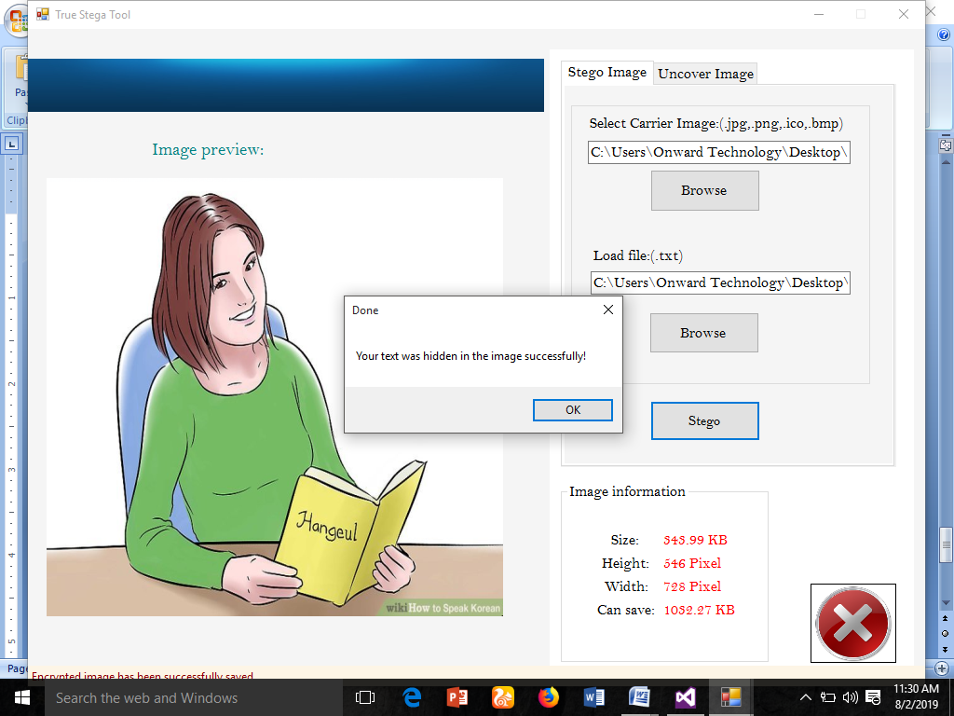
Figure 4.1: Interface for watermarking (saved successfully)

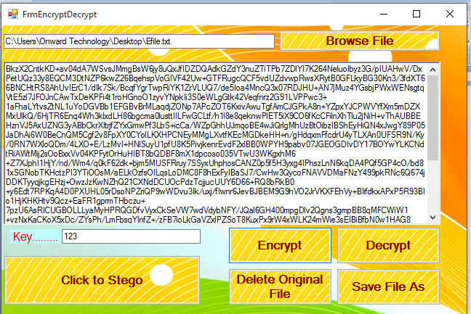
Figure 4.2: Encrypted Data
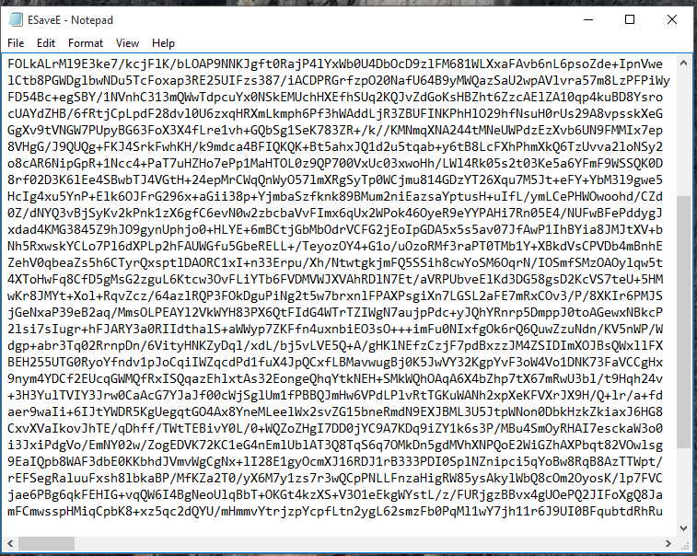
Figure 4.3: txt Encrypted Data
4.1.2 INPUT DESIGN
This is how data are fed into the system or the way data are to be organized so that the processing state could be successful that is what is explained under the input design. The input designs to this project work are shown in figures 4.4 – 4.5.
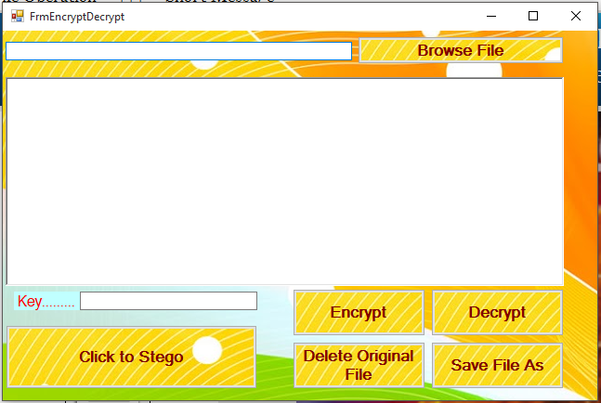
Figure 4.4: Input Interface for Encryption
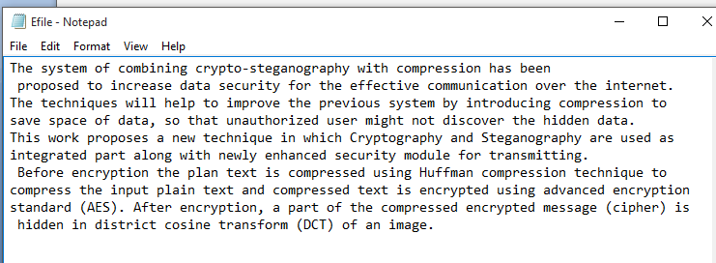
Figure 4.5: Txt. Data for Encryption
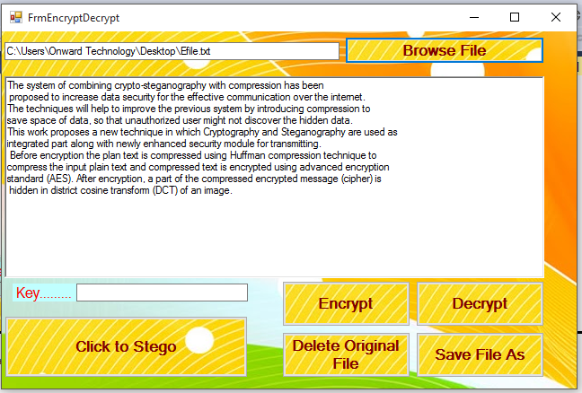
Figure 4.6: Upload Data for Encryption
4.1.3 PROCEDURE DESIGN
The procedure is the arrangement, steps and how the flow of a program with the arranging and structuring of the program. The methodology used for the program is an event driven programming language which makes program much more efficient in terms of execution, program write time, storage utilization and maintenance, since it is divided into modules.
4.2 SYSTEM IMPLEMENTATION
4.2.1 CHOICE OF PROGRAMING LANGUAGE USED WITH REASONS
The Programming language used for the design and implementation for operation is C Sharp (C#) and SQL serverwas used as a database server. The following were the reason for using the above program.
- It is compiled to an intermediate language (CIL) independently of the language it was developed or the target architecture and operating system.
- It is much more efficient and runs faster.
- The assembly concept solves the versioning control problem well.
- It is good support of distributed system.
- Ease-to-development. The rich class library makes many functions easy to be implemented.
- It is more type safe and pure object-oriented.
- It enhances the connection to the database program.
- Automatic garbage collection.
4.2.2 HARDWARE REQUIREMENTS
To install and run the program, the user needs a
- PC (Pentium IV),
- Dual-core, 2.70-GHz or faster processor,
- USB 2.0 bus dedicated to the Kinect,
- 480GB hard disk
- 8GB of RAM,
- Graphics card that supports DirectX 9.0c
- 10-100 MBPS of Network card
4.2.3 SOFTWARE REQUIREMENTS
- Windows 10 Professional or higher version
- SQL server 2010
- Microsoft word processor 2010
- Visual studio.Net setup tools
- HTML, Visual studio designer
4.2.4 IMPLEMENTATION TECHNIQUES USED
The implementation techniques used in the development of synchronous e-learning method is pilot implementation because it is easy to control; the pilot can be halted at any time. It is easy to evaluate because the new and old system are both running concurrently, it is also easy to train student and also at low risk.
4.3 SYSTEM DOCUMENTATION
4.3.1 PROGRAM DOCUMENTATION
The program is installed by clicking on the Wamp Server from the start menu, locate set up folder where the modules is saved on the www, double click then follow the instruction given on the screen. The program will be installed on Wamp Server folder.
4.3.2 OPERATING THE PROGRAM
Click on the start button on the windows start bar, move the mouse pointer to all program, click the Wamp Server to locate the folder of the application and then click on it. The Home page will be displayed and from where the user can click to check another page one after the other.

4.3.3 MAINTAINING THE SYSTEM
Maintaining of the system has to do with the modification of the system. It refers to the rate of making amendment to the system with ease under a condition. It also refers to the correction, addition or deletion of part or the whole program. Programs that have structure and a feature of maintainability are referring to be a good program. This Program is designed in such a way that it gives room for modification and expansion of the project.

CHAPTER FIVE
SUMMARY, CONCLUSION AND RECOMMENDATIONS
5.1 SUMMARY
The work accomplished during this project can be summarized with the following points:
- In this project the secured method has been developed for the Steganography which could be proven a highly secured method for data communication.
- Steganography is a powerful tools which enables people to communicate without possible eavesdroppers even knowing there is a form of communication in the first place.
- The main advantage of this Steganography System is that the method used for encryption is very secured.
5.2 CONCLUSION
This project performed an image steganography method. It performed the method on image by implementing a program written in C# language. The purpose of this study is to conceal the sensitive information from an unauthorized use by hiding the Secret Message into Cover-Text generated randomly with the ability of extracting the Secret Message again. In other site Text Steganography (in the model) is measured, such as the number of the Cover-Text characters that is used to randomize the message inside it, it used as rate of security (the larger number of the Cover-Text the better security indicator). Although the Embedding operation is faster (by embedding 8bit at a time instead of 2 or 3bit at a time than the other). if the sender decided to send the same message more than one the output of the stego-image will be differ (due to of the random cover-text generating,). The model eliminates the overhead of find suitable cover-text to hide different messages (difference in type or size), the sender and the receiver exchanges stego-image files only any third party cannot obtain the secret messages again because of hidden cover-text files that produced and without having the extraction keys.
5.3 RECOMMENDATION
  - The proposed techniques can be used in military application for secure communication.
  - This system of image steganography techniques for information security is expected to provide high security and high performance mechanism for confidential data.
  - The secure image-steganography for secure data over the internet is expected to add more value to information security as discipline.

REFERENCES
Alexan, Wassim, et al. (2023) "Color image encryption through chaos and kaa map." IEEE Access 11 (2023): 11541-11554.
Al-Otaibi, N.A., Gutub, A.A.A., (2024) Flexible stego-system for hiding text in images of personal computers based on user security priority.
Altaibi, N.A., Gutub, A.A., Khan, E.A., (2022) Stego-system for hiding text in images of personal computers.
Aru, O. E. & Ananaba, E.C. (2022) “Detailed Examination of Information Hiding Techniques for Copyright Protection of Text Documents” IOSR Journal of Applied Physics (IOSR-JAP) e-ISSN: 2278-4861.Volume 11,
Bühler, Michael Max, et al. (2023) "Unlocking the power of digital commons: Data cooperatives as a pathway for data sovereign, innovative and equitable digital communities." Digital 3.3 (2023): 146-171.
Chawla, G., Saini, R., & Yadav, R. (2022). Classification of watermarking based upon various parameters. International Journal of Computer Applications & Information Technology, 1(II).
Damghani, H., Hosseinian, H., & Damghani, L. (2022). Cryptography review in IoT. In 2019 4th Conference on Technology In Electrical and Computer Engineering (ETECH2019).
Eke, Damian, and Bernd Stahl. (2024) "Ethics in the Governance of Data and Digital Technology: An Analysis of European Data Regulations and Policies." Digital Society 3.1 (2024): 11.
Hannigan, B.T., Reed, A., Bradley, B., (2021) Digital watermarking using improved human visual system model.
Khan, F., Gutub, A.A.A., (2021). Message concealment techniques using image based steganography. [2] Gutub, A., Al-Qahtani, A., Tabakh, A., (2019). Triple-A: secure RGB image steganography based on randomization.
Ngwenyama, Ojelanki, Helle Zinner Henriksen, and Daniel Hardt. (2023) "Public management challenges in the digital risk society: A critical analysis of the public debate on implementation of the Danish NemID." European Journal of Information Systems 32.2 (2023): 108-126.]
Olson, D. A. (2023). Faxed: The Rise and Fall of the Fax Machine. By Jonathan Coopersmith.
Orman, H. (2024). Encrypted Email: The History and Technology of Message Privacy. Springer International Publishing.
Rijmen, V., & Daemen, J. (2021). Advanced encryption standard. Proceedings of Federal Information Processing Standards Publications, National Institute of Standards and Technology, 19-22.
Sharma, M. H., MithleshArya, M., & Goyal, M. D. (2023). Secure image hiding algorithm using cryptography and steganography. IOSR Journal of Computer Engineering (IOSR-JCE) e-ISSN, 2278-0661.
Sinchita, B., Roy T., Sriya Aishwarya, T., & Sinha (2021). Digital Watermarking In Image Processing Using Python, Department Of Electronics & Communication Engineering Rcc Institute Of Information Technology Affiliated To Maulana Abul Kalam Azad University Of Technology, West Bengal Canal South Road, Beliaghata, Kolkata – 700015, 2018.
Taleby Ahvanooey, M., Li, Q., Shim, H. J., & Huang, Y. (2022). A comparative analysis of information hiding techniques for copyright protection of text documents. Security and Communication Networks, 2018.
Tao, B., & Dickinson, B. (2022). Adaptive watermarking in the DCT domain. In IEEE International conference on acoustics, speech, and signal processing (Vol. 4, pp. 2985-2988). IEEE.
Varshney, Y. (2022). Attacks on digital watermarks: classification, implications, benchmarks. Int J Emerg Technol (Special Issue NCETST2017), 8(1), 229-235.
Wei-Fan Hsieh; Pei-Yu Lin, (2022) "Analyze the Digital Watermarking Security Demands for the Facebook Website," Genetic and Evolutionary Computing (ICGEC), Sixth International Conference on , vol., no., pp.31,34, 25-28.

APPENDIX I: System flow chart
Start
Display Home
File Operation
Short Message
Stop

APPENDIX II: FILE OPERATION
Start
Select File
Select Image
Embedded Process
Stego Image
Return

APPENDIX III: SHORT MESSAGE
Start
Upload Message
Select Image
Embedded Message
Stego Image
Return

PPENDIX 4: SOURCE CODE
import numpy as np
import pandas as pd
import matplotlib.pyplot as plt
import seaborn as sns
from mlxtend.frequent_patterns import apriori
from mlxtend.frequent_patterns import association_rules

sns.set(style="darkgrid", color_codes=True)
pd.set_option('display.max_columns', 75)

data = pd.read_csv('Market_Basket.csv', header = None)
data.info()

color = plt.cm.rainbow(np.linspace(0, 1, 40))
data[0].value_counts().head(40).plot.bar(color = color, figsize=(13,5))
plt.title('frequency of most popular items', fontsize = 20)
plt.xticks(rotation = 90 )
plt.grid()
plt.show()

import networkx as nx
data['food'] = 'Food'
food = data.truncate(before = -1, after = 15)
food = nx.from_pandas_edgelist(food, source = 'food', target = 0, edge_attr = True)
In [8]:
import warnings
warnings.filterwarnings('ignore')

plt.rcParams['figure.figsize'] = (13, 13)
pos = nx.spring_layout(food)
color = plt.cm.Set1(np.linspace(0, 15, 1))
nx.draw_networkx_nodes(food, pos, node_size = 15000, node_color = color)
nx.draw_networkx_edges(food, pos, width = 3, alpha = 0.6, edge_color = 'black')
nx.draw_networkx_labels(food, pos, font_size = 20, font_family = 'sans-serif')
plt.axis('off')
plt.grid()
plt.title('Top 15 First Choices', fontsize = 20)
plt.show()

# Getting the list of transactions from the dataset
transactions = []
for i in range(0, len(data)):
transactions.append([str(data.values[i,j]) for j in range(0, len(data.columns))])
In [10]:
transactions[:1]
from itertools import permutations

# Extract unique items.
flattened = [item for transaction in transactions for item in transaction]
items = list(set(flattened))
In [12]:
print('# of items:',len(items))
print(list(items))
if 'nan' in items: items.remove('nan')
print(list(items))

# Compute and print rules.
rules = list(permutations(items, 2))
print('# of rules:',len(rules))
print(rules[:5])

# Import the transaction encoder function from mlxtend
from mlxtend.preprocessing import TransactionEncoder

# Instantiate transaction encoder and identify unique items
encoder = TransactionEncoder().fit(transactions)

# One-hot encode transactions
onehot = encoder.transform(transactions)

# Convert one-hot encoded data to DataFrame
onehot = pd.DataFrame(onehot, columns = encoder.columns_).drop('nan', axis=1)

# Print the one-hot encoded transaction dataset
onehot.head()

rules_ = pd.DataFrame(rules, columns=['antecedents','consequents'])

# Define an empty list for metrics
zhangs, conv, lev, antec_supp, cons_supp, suppt, conf, lft = [], [], [], [], [], [], [], []

# Loop over lists in itemsets
for itemset in rules:
# Extract the antecedent and consequent columns
antecedent = onehot[itemset[0]]
consequent = onehot[itemset[1]]

antecedent_support = onehot[itemset[0]].mean()
consequent_support = onehot[itemset[1]].mean()
support = np.logical_and(onehot[itemset[0]], onehot[itemset[1]]).mean()
confidence = support / antecedent_support
lift = support / (antecedent_support * consequent_support)

# Complete metrics and append it to the list
antec_supp.append(antecedent_support)
cons_supp.append(consequent_support)
suppt.append(support)
conf.append(confidence)
lft.append(lift)
lev.append(leverage(antecedent, consequent))
conv.append(conviction(antecedent, consequent))
zhangs.append(zhang(antecedent, consequent))

# Store results
rules_['antecedent support'] = antec_supp
rules_['consequent support'] = cons_supp
rules_['support'] = suppt
rules_['confidence'] = conf
rules_['lift'] = lft
rules_['leverage'] = lev
rules_['conviction'] = conv
rules_['zhang'] = zhangs

# Print results
rules_.sort_values('zhang',ascending=False).head()

