EFFECTS OF LAND USE CHANGE
(CASE STUDY OF G. R. A. ILORIN, KWARA STATE)

BY
OLAREWAJU MERCY
MATRIC NUMBER:
HND/23/URP/FT/0023

SUBMITTIED TO
DEPARTMENT OF URBAN AND REGIONAL PLANNING
INSTITUTE OF ENVIRONMENTAL STUDIES
KWARA STATE POLYTECHNIC, ILORIN

SUPERVISED BY:
TPL M. Y. YAHAYA

JULY 2025.

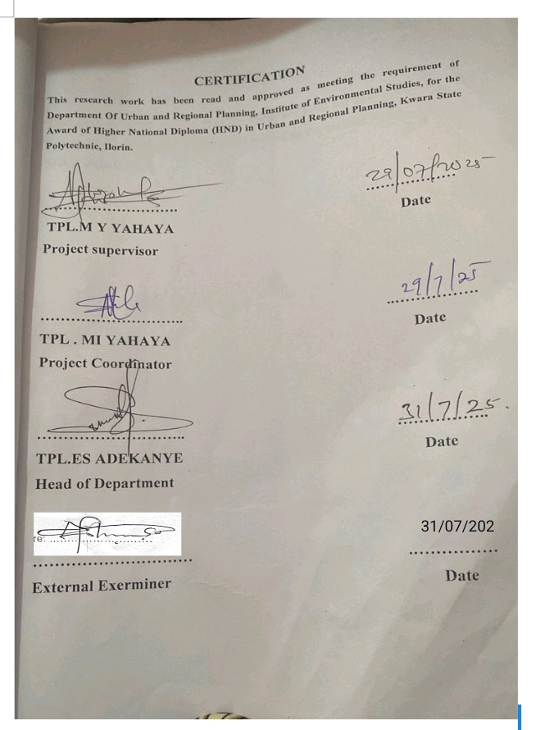
DEDICATION
This dissertation is dedicated to Almighty God, the beginning and the end, whose special grace and mercy saw me through in the course of my study in the polytechnic.

ACKNOWLEGEMENT
I give thanks to God almighty for been there for me, and I also thank my parent which they support me, provide for me, through my education and also to my friends and family members that also support me through my education in terms of financial assistance and also give thanks to my institute Kwara state polytechnic, Ilorin for providing for sufficient resources through my education.

Abstract
Land use change is a complex issue that has garnered significant attention in academic and policy-oriented research, particularly in the context of urban and regional planning. This study explores the drivers, patterns, consequences, and management strategies associated with land transformations in urban and rural areas. By highlighting key theories, frameworks, and findings from academic studies and relevant reports, this review establishes a foundation for understanding the complexities of managing land use transitions in an era of rapid population growth, economic development, and environmental challenges. The importance of integrated, data-driven, and sustainable approaches to planning is emphasized, combining technological advances in remote sensing and GIS with a holistic understanding of environmental, social, and economic factors.

TABLE OF CONTENTS
Title of page i
Certification ii
Dedication iii
Acknowledgement iv
Abstract v
Table of contents vi
Chapter one 1
1.0. Introduction 1
1.1 Historical background of G.R.A Ilorin. 3

1.1.1 Ilorin 4

1.1.2 Geographical setting of Ilorin 5
1.2. Aim 7
1.3. Objectives 7
1.4. Scope 8
1.5. Problem statement 8
Chapter two 10
2.0. Literature review 10
2.1. Drivers of land use change 10
2.2. Land use change in urban areas 11
2.3. Land use change in regional planning 12
2.4. Measuring and managing land use change 13
2.6. Impacts and consequences of land use change 14
Chapter three 15
3:0. Methodology 15
3.1. Primary source 15
3.2. Secondary source 15
3.3. Sample frame 15
3.4 sample size 15
Chapter four 16
4.0 data analysis 16
4.1 introduction 16
4.2.0. 1st objective 16
4.2.1. Socio-economic characteristics of the respondents 16
4.2.1.1. Sex of the respondent 16
4.2.1.2. Marital status of the respondent 17
4.2.1.3. Age of the respondents 17
4.2.1.4. Level of education 18
4.2.1.5. Occupation of the respondent 18
4.2.2. 2nd objective 19
4.2.3. 3rd objective 19
4.2.3.1. Environmental pollution 19
4.2.3.2. Over stretching of infrastructural facilities 20
4.2.3.3. Incompatible land uses 20
4.2.3.4. Traffic congestion 21
4.2.4. 4th objective 21
Chapter five 25
5.0 summary, recommendation and conclusion 25
5.1 summary of finding 25
5.2 recommendation 26
5.3. Conclusion 27
References 28

CHAPTER ONE
1.0. INTRODUCTION
Land use change refers to the alteration of the physical and functional characteristics of a landscape over time due to human activities Angelsen, A., & Bruce, J. W. (2001). It is an essential aspect of urban and regional planning, where the allocation and management of land are crucial to shaping the future of cities and regions. As human populations grow and economic activities intensify, the demand for land for housing, infrastructure, agriculture, and industrial purposes increases. This leads to continuous modification of land, with profound implications for both natural ecosystems and urban settlement.
The global trend of urbanization has been one of the most significant drivers of land use change in the last century. Cities, once small hubs of human activity, have expanded rapidly outward and upward, transforming vast areas of agricultural land, forests, wetlands, and other natural environments into urban landscapes. The United Nations predicts that by 2050, nearly 70% of the global population will reside in cities, intensifying the pressures on land use and necessitating careful planning and management. This urban growth, often referred to as urban sprawl, results in sprawling suburbs, increased infrastructure demands, and environmental challenges such as air pollution, water contamination, and the loss of biodiversity.
However, urban land use change is not solely driven by population growth. The evolution of land use is also influenced by economic forces such as industrialization, globalization, and technological advancements. As industries expand, they often push into previously undeveloped or rural areas, resulting in land being converted for commercial, industrial, or residential purposes. Similarly, economic shifts such as the transition to a service-based economy can result in the repurposing of previously industrial or agricultural land into office spaces, retail developments, or mixed-use residential areas.
In regional planning, the challenge extends beyond the boundaries of individual urban centers. Regions encompass a network of urban and rural areas, and the goal is to balance development across these areas to achieve economic prosperity, social equity, and environmental sustainability. Regional land use planning involves coordinating the development of multiple urban centers, rural zones, and infrastructure networks to ensure that growth is managed efficiently, resources are used sustainably, and ecosystems are preserved. In many regions, land use change can create conflicts, such as the overexploitation of natural resources, unequal distribution of services and infrastructure, and environmental degradation. Auzel, P. (2011)
Urban and regional planning, therefore, serves as the guiding framework for addressing land use change. Effective land use planning integrates a wide range of considerations, including economic development, social equity, environmental conservation, and sustainability. Planners use both strategic foresight and spatial analysis to anticipate future land use needs and mitigate the negative impacts of growth. Tools such as Geographic Information Systems (GIS), Remote Sensing (RS), and spatial modeling have become indispensable in modern land use planning, allowing planners to visualize, analyze, and predict land use patterns and trends over time. These technologies not only help map the past and present but also offer predictive capabilities to model future land use scenarios based on various policy and development inputs.
However, despite the advancements in planning technologies, land use change often results in unanticipated outcomes. These can include the displacement of communities, environmental degradation, loss of agricultural land, and inefficient infrastructure development. For example, the conversion of natural areas to urban zones might lead to an increased risk of flooding due to the loss of wetlands that serve as natural buffers. Similarly, the rapid expansion of urban areas without adequate planning can lead to social inequality, where low-income populations are forced into informal settlements on the outskirts of cities.
1.1 Historical background of G.R.A. Ilorin.
Ilorin the capital of kwara state in north central, is city with deep historical and cultural root among its most prominent residential area is the Government Reserve Area (G. R. A), a zone originally establish by british colonial administrators. Like other G. R. A in Nigeria, Ilorin G. R. A was design as an elite residential enclave, primarily for European expatriates, senior government officials, and later for the Nigeria elite. This project explores the historical foundation, transformation, and current significant of G. R. A. Ilorin, contextualizing it within Nigerians colonial and post colonial urban development. G.R.A in Ilorin was developed in the early to mid 20th century as part of colonial urban planning. It was located strategically near administrative buildings, such as the government house, secretariats, and court.
Design features of G. R. A. Ilorin was laid out with:
Wild, tree line avenue, Low density housing, Large residential plots Functional drainage and good road network, Provision of amenities such and water and electricity ahead of other area

Figure 1: Map of nigeria showing kwara state
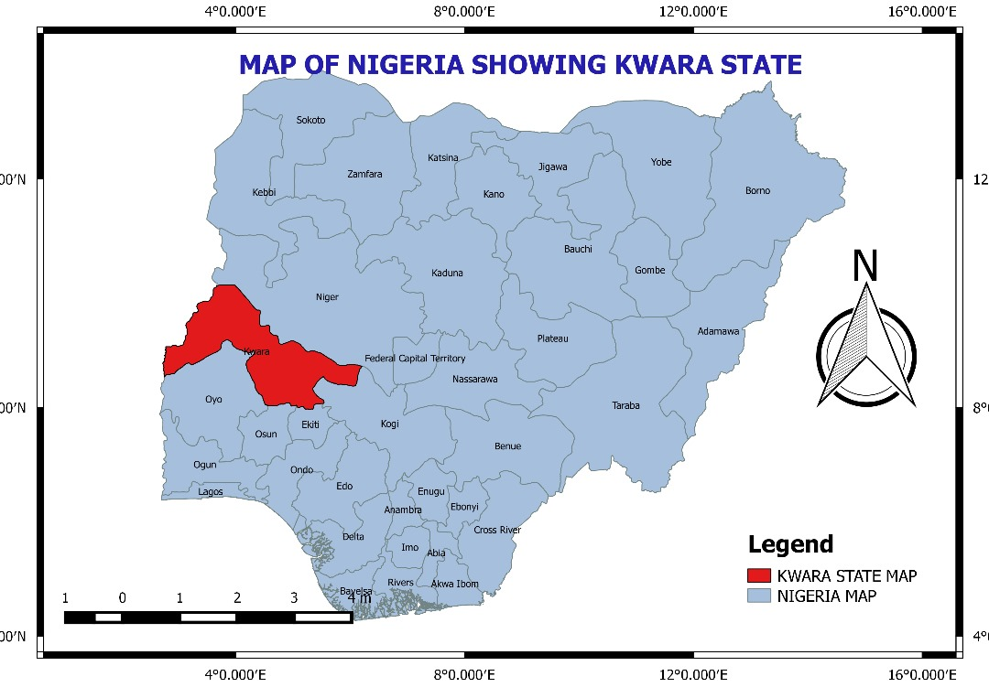
SOURCE: KWARA STATE GEOGRAPHICAL INFORMATION SERVICES 2025.

1.1.1 Ilorin
Ilorin is the capital city of Kwara State, located in the north-central geopolitical zone of Nigeria. The city serves as a strategic link between the northern and southern parts of the country, lying approximately 306 kilometers from Lagos and 500 kilometers from Abuja. As of the most recent estimates, Ilorin has a population of over 800,000 people and is one of Nigeria’s rapidly growing urban centers (National Population Commission, 2023). Ilorin’s urban fabric is characterized by a mix of traditional architecture, emerging urban infrastructure, and increasing informal economic activities such as street trading.
The city is divided into several administrative and planning zones, with the core traditional areas of the town being centered around the Emir’s palace and the older marketplaces. Ipata and Oja Oba are two of the most important commercial arteries in this traditional and economic nucleus of Ilorin. These areas play a vital role in the socio-economic landscape of the city but also pose significant challenges to urban mobility due to high levels of informal street trading and congestion.

1.1.2 Geographical Setting of Ilorin
Ilorin lies within the tropical savannah climatic zone, marked by distinct wet and dry seasons. The rainy season lasts from April to October, while the dry season typically runs from November to March. Annual rainfall ranges between 1,000 mm and 1,500 mm. The city is situated on relatively flat terrain with an elevation ranging between 290 to 450 meters above sea level. This flat topography contributes to the ease of expansion in both residential and commercial land uses, including informal setups like roadside trading.
The city is located along major road networks such as the Lagos-Ibadan-Ilorin-Kaduna Expressway, making it an important transportation and commercial hub.
Figure 2: Map of kwara state showing ilorin west.
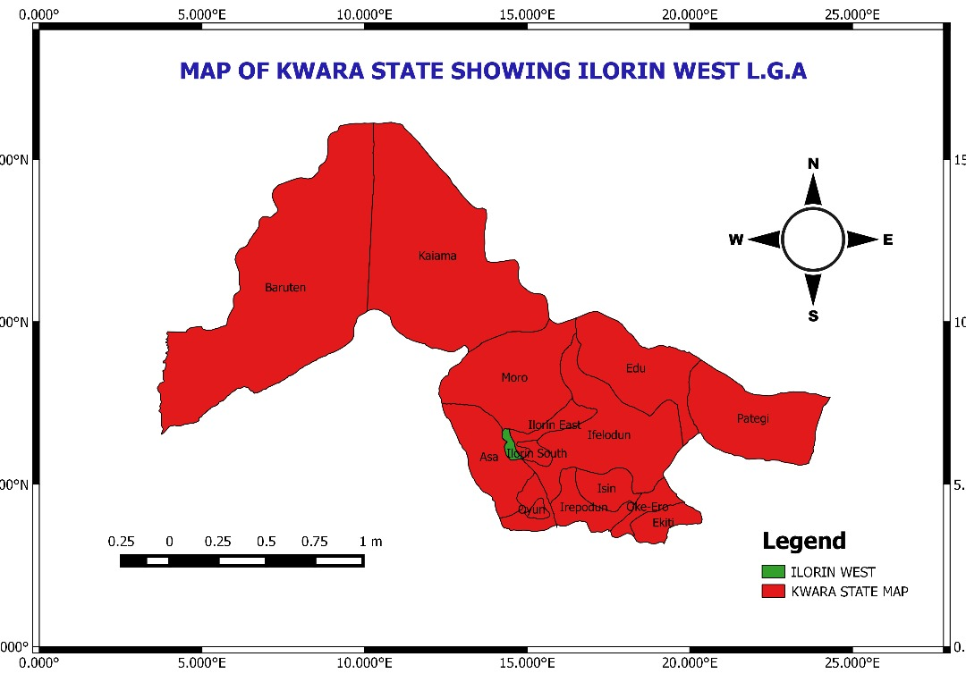
SOURCE: KWARA STATE GEOGRAPHICAL INFORMATION SERVICES 2025.

Figure 2: Map of ilorin west local government.
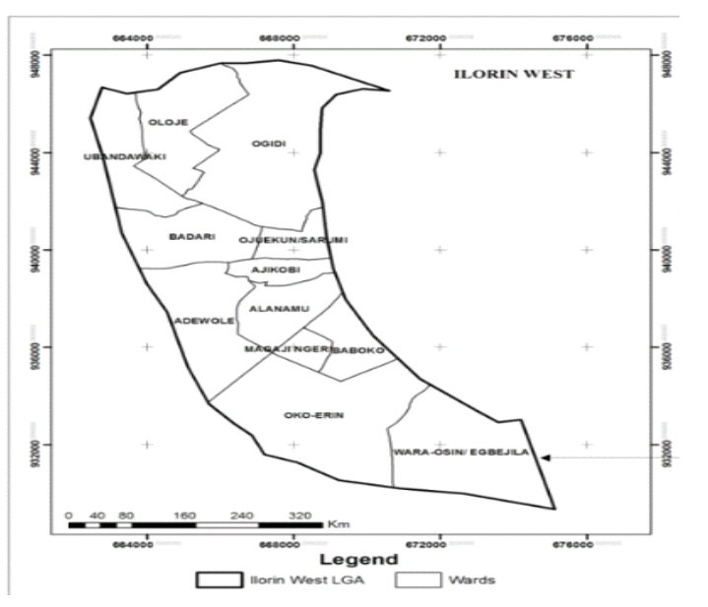
SOURCE: KWARA STATE GEOGRAPHICAL INFORMATION SERVICES 2025.
1.2. Aim:
To investigate the nature, extent, and effects of land use change within G. R. A. ilorin, so as to promote sustainability development.
1.3. Objectives:
1. To identify and map the current land use patterns within the study area using spatial and observation data.
2. To determine the key factors driving land use change in the study area.
3. To assess the environmental and socio-economic impacts of the observed land use changes on the study area and its surrounding areas.
4. To examine the role of planning policies and regulations in influencing land use decisions and transformations
5. To propose recommendations for more sustainable land use planning and management within the study areas to ensure efficient space use, environmental conservation, and community being.
1.4. Scope
This study focuses on effect of land use change within the study area. It will also cover the spatial and temporal changes in land use, examining both historical development and recent transformations.
1.5. Problem Statement
Land use change within government reserve areas, particularly in rapidly urbanizing regions, has become a significant concern for planners, residents, and policymakers. Many government reserve areas originally planned for specific purposes—such as residential, industrial, or commercial use—are undergoing rapid and often unregulated transformations due to increasing population pressure, demand for housing, economic shifts, and infrastructural development.
These changes often occur without proper planning or consideration for environmental sustainability, infrastructure capacity, or the needs of the community. As a result, government reserve area may face challenges such as congestion, environmental degradation, poor drainage, lack of open space, increased informal settlements, and conflicts in land use functions.
In the absence of clear policies or effective monitoring, land use change can reduce the quality of life for residents, increase vulnerability to environmental hazards, and lead to inefficient use of land resources. Therefore, there is a need to study the extent, causes, and consequences of land use change in government reserve areas and to propose sustainable planning strategies that support orderly and balanced development.
CHAPTER TWO
2.0. LITERATURE REVIEW
Land use change, particularly in the context of urban and regional planning, Boserup, E. (1965), has been a subject of significant academic and policy-oriented research. The literature on this topic explores the drivers, patterns, consequences, and management strategies associated with land transformations in urban and rural areas. This review highlights key theories, frameworks, and findings from academic studies and relevant reports to establish a foundation for this project. The literature on land use change in urban and regional planning underscores the complexity of managing land use transitions in an era of rapid population growth, economic development, and environmental challenges. While many studies focus on the drivers and consequences of land use change, there is growing recognition of the need for integrated, data-driven, and sustainable approaches to planning. The combination of technological advances in remote sensing and GIS, along with a more holistic understanding of environmental, social, and economic factors, will be crucial in guiding future land use decisions and ensuring that land use change is managed sustainably and equitably.
2.1. Drivers of Land Use Change
The primary drivers of land use change can be categorized into social, economic, political, and environmental factors.
Urbanization and Population Growth: The most significant driver of land use change in urban areas is urbanization. According to Seto et al. (2011), the world's urban population has grown at an unprecedented rate over the past century, leading to massive conversions of agricultural and forested lands into urban areas. The United Nations (2018) projects that urban areas will increase by approximately 1.5 million people per week until 2050, further stressing the need for careful urban land management.
Economic Development and Industrialization: Economic growth and industrialization often catalyze land use changes, particularly in developing regions. As noted by Baker et al. (2013), the conversion of land for industrial use is frequently accompanied by significant environmental degradation and loss of biodiversity. Economic policies, such as subsidies for agriculture or tax incentives for urban development, also play a critical role in shaping land use dynamics.
Government Policies and Regulations: Planning decisions and policy interventions heavily influence land use. The World Bank (2013) emphasizes the importance of land-use planning frameworks that balance growth with sustainability. Urban zoning laws, land tenure policies, and national development strategies can either incentivize or constrain land use changes. For instance, Rudel et al. (2009) discuss how land use policies in tropical countries have led to deforestation, while regulatory frameworks in Europe have helped manage urban sprawl.
Technological Advancements: Technological innovations, such as the development of transportation networks, agricultural technologies, and construction techniques, have contributed to faster and more widespread land use changes. As McHarg (1969) argued in his seminal work on ecological planning, technology has allowed for more extensive development but often without considering long-term environmental consequences.
2.2. Land Use Change in Urban Areas
Urban areas have seen the most dramatic changes in land use due to rapid population growth and infrastructure development. Urban sprawl is a key concept in urban land use change, referring to the unplanned and often uncontrolled expansion of cities into surrounding rural areas. According to Gallent et al. (2015), urban sprawl leads to a range of problems, including environmental degradation, increased reliance on cars, and the loss of agricultural land.
Impacts of Urban Sprawl: Ewing (2008) outlines the negative impacts of urban sprawl, including increased air pollution, decreased biodiversity, and higher infrastructure costs. Sprawling cities require extensive transportation systems and utilities, which in turn place pressure on natural resources. Omer (2018) also highlights the economic costs of sprawl, noting that it leads to fragmented land use, inefficient land management, and increased inequality due to the uneven distribution of amenities.
Sustainable Urban Planning Models: There is increasing recognition of the need for compact urban growth to counteract the negative effects of sprawl. New Urbanism and smart growth principles advocate for mixed-use development, pedestrian-friendly designs, and the preservation of green spaces. Scholars like Dantzig (2012) and Talen (2013) have developed frameworks for sustainable urban planning that promote higher-density, integrated communities that minimize environmental impact and improve livability.
2.3. Land Use Change in Regional Planning
While urban land use change is well documented, regional land use change presents a broader set of challenges and opportunities, particularly in managing the interactions between urban centers and surrounding rural or natural areas. Regional Coordination and Resource Management: Regional planning focuses on balancing growth across urban and rural areas and addressing inter-jurisdictional issues that affect resource management, such as water availability, land conservation, and transportation infrastructure. According to Benedict and McMahon (2006), regional planning requires cooperation between multiple governmental bodies to ensure that development is coordinated across a larger geographic scale, preventing inefficient land use and resource depletion. Land Use Conflicts in Regional Planning: Land use change often leads to conflicts between different stakeholders, particularly in areas where urban expansion competes with agriculture, conservation, or heritage preservation.
Gober (2010) discuss how land use change in the Phoenix metropolitan area has created tensions between housing developers, agricultural interests, and conservationists. These conflicts are compounded by political and economic forces that prioritize short-term gains over long-term sustainability. Sustainability and Resilience in Regional Planning: As regional planning incorporates a larger scale of environmental concerns, scholars such as Burchfield et al. (2006) emphasize the importance of considering ecological networks and landscape connectivity when planning for land use. Protecting natural corridors and ensuring that urban and rural areas work synergistically is essential for building resilience to environmental challenges such as climate change, flooding, and habitat loss.
2.4. Measuring and Managing Land Use Change
A key challenge in land use change analysis is measuring and monitoring these transformations. Tools like GIS and remote sensing have revolutionized the study of land use change by providing spatially explicit data on how land has been transformed over time. Geospatial Technologies: GIS enables the creation of detailed land use maps, as well as the analysis of land use trends, changes, and patterns. Sung et al. (2012) demonstrate how GIS-based analysis helps track urban expansion and detect spatial patterns, offering valuable data for urban planners. Remote sensing allows for large-scale monitoring of land use changes by capturing high-resolution satellite imagery, facilitating the detection of subtle shifts in land cover that might be missed through traditional survey methods.
Change Detection Techniques: Zhou et al. (2015) outline various change detection techniques that utilize temporal satellite data to quantify land use transitions. These methods can be particularly useful for understanding how land use evolves over time, identifying patterns of deforestation, urbanization, or agricultural conversion, and providing insights into the effectiveness of planning policies.
2.6. Impacts and Consequences of Land Use Change
Land use change has profound effects on the environment, economy, and society. These impacts include:
1. Environmental Degradation: The conversion of natural habitats into urban or agricultural land leads to the loss of biodiversity, disruption of ecosystems, and increased carbon emissions. Foley et al. (2005) provide a comprehensive review of how land use change drives global environmental change, particularly in terms of ecosystem services and climate change.
2. Social and Economic Impacts: Land use changes often lead to social displacement, particularly in urban areas where poor and marginalized communities are pushed out due to gentrification or infrastructure development. Studies by Massey et al. (2013) emphasize the social inequalities that arise from unplanned land use changes, where the benefits of development are often unevenly distributed, leaving certain communities.
CHAPTER THREE
3:0. METHODOLOGY
The data used in this study were obtained through both primary and secondary source.
3.1. PRIMARY SOURCE
(a) Reconnaissance survey: This was done for gaining first hand knowledge of the physical setting of the government reserve area. Especially to know the number of housing unit and the condition of the existing Infrastructural facilities in the study area. Reconnaissance survey is done so that problems identified from the survey will be draw out the questionnaires which will be used to collect information from the residents.
(a) Questionnaire: Questionnaires were administered to the house occupier to gather relevant information and the adequacy of provision of infrastructural facilities, the users satisfaction. The total number of the building at G. R. A, Ilorin is 213.
3.2. SECONDARY SOURCE
This include the information collected from relevant text books, seminars paper, research report e. t. c.
Also collection of maps, map showing the land use pattern of the study area. The map collected include map of Nigeria, kwara state, Ilorin west local government.
3.3. Sample frame: The sample frame of the project consist all the total housing unit in G. R. A. which is 213.

S/N | STREET/ ROAD IN G. R. A. | FREQUENCY
1 | Flower garden road | 54
2 | Reservation road | 48
3 | Achimodu road | 46
4 | De place road | 42
5 | Adelodun road | 23
 | Total | 213
SOURCE: FIELD SURVEY 2025
3.4 Sample size: Therefore the sample size of the research is 50% of the housing unit in the study area and the questionnaire administrated is 106.

CHAPTER FOUR
4.0 DATA ANALYSIS
4.1 INTRODUCTION
The objectives of the study forms the basis of all the analysis carried out in this chapter. The results are presented informs of map and table.
4.2.0. 1st objective: To identify and map the current land use patterns within the G.R.A using spatial and observation data.
LAND USE | FREQUENCY | PERCENTAGE (%)
RESIDENTIAL | 95 | 44.6
COMMERCIAL | 84 | 39.9
RECREATIONAL | 13 | 06.1
PUBLIC USE | 21 | 9.85
TOTAL | 213 | 100
SOURCE: FIELD SURVEY 2025
The table above shows the existing condition of the study area, Residential has the highest land use of 44.6% while Recreational has the lowest land use of 9.85%.

4.2.1. SOCIO-ECONIMIC CHARACTERISTICS OF THE RESPONDENTS
4.2.1.1. Sex of the respondent
SEX | FREQUENCY | PER (%)
MALE | 41 | 42.5
FEMALE | 65 | 57.5
TOTAL | 106 | 100
SOURCE: FIELD SURVEY 2025.
The above table shows 42.5% male and 57.5% female. This implies that female is more in population than male in the study area.
4.2.1.2. Marital status of the respondent
Marital status | Frequency | Per (%)
Single | 27 | 25.4
Married | 49 | 46.2
Divorce | 17 | 17.9
Widow/widower | 13 | 12.2
Total | 106 | 100
SOURCE: FIELD SURVEY 2025.
Table shows that highest is married with 46.2% and lowest widow/widower with 12.2%, this implies that married has the highest in the study area.

4.2.1.3. Age of the respondents
Age | Frequency | Per (%)
18-25 | 10 | 9.4
26-35 | 15 | 14.1
36-45 | 28 | 26.4
46-65 | 41 | 38.6
66 above | 12 | 11.3
Total | 106 | 100
SOURCE: FIELD SURVEY 2025.
Table shows the age of the respondents highest 46-65 years with 38.6% and the lowest 18-25 years with 9.4%.
4.2.1.4. Level of education
Level of education | Frequency | Per (%)
Illiterate | 8 | 7.5
Primary education | 16 | 15.0
Secondary education | 18 | 16.9
Tertiary education | 74 | 69.8
Total | 106 | 100
SOURCE: FIELD SURVEY 2025.
Table showing level of education of the respondents, the highest is tertiary education with 69.8% and the lowest is illiterate with 7.5%
4.2.1.5. Occupation of the respondent
Occupation | Frequency | Per (%)
Civil servant | 52 | 49.0
Artisan | 11 | 10.3
Business ownership | 28 | 26.4
Unemployment | 15 | 14.1
Total | 106 | 100
SOURCE: FIELD SURVEY 2025.
Table showing the occupation of the respondents, highest is civil servant with 49.0% and the lowest is artisan with 10.3%.
4.2.2. 2nd objective: To determine the key factors driving land use change in the study area
Key factors | Frequency | Percentage (%)
Population Growth | 35 | 33.0
Housing Demand | 27 | 25.4
Infrastructural Development | 31 | 29.2
Policy Changes. | 11 | 10.3
Total | 106 | 100
SOURCE: FIELD SURVEY 2025.
The table above showing the key factors driving land use change in the study area, the data prove that the main factor is population growth with 33.0% while the lowest is policy changes with 10.3%.

4.2.3. 3rd objective: To assess the environmental and socio-economic impacts of the observed land use changes on the G.R.A and its surrounding areas.
4.2.3.1. ENVIRONMENTAL POLLUTION
ENVIRONMENTAL POLLUTION | FREQUENCY | Per (%)
AIR POLLUTION | 15 | 14.1
NOISE POLLUTION | 82 | 77.3
WATER POLLUTION | 9 | 8.4
TOTAL | 106 | 100
SOURCE: FIELD SURVEY 2025.
Table showing the effect of environmental pollution in the study area, highest is noise pollution with 77.3% while the lowest is water pollution with 8.4%.

4.2.3.2. OVER STRETCHING OF INFRASTRUCTURAL FACILITIES
OVER STRETCHING | FREQUENCY | PER (%)
YES | 76 | 71.6
NO | 30 | 28.3
TOTAL | 106 | 100
SOURCE: FIELD SURVEY 2025.
Table showing the result of over stretching of infrastructural facilities, highest is YES with 71.6% while the lowest is NO with 28.3%
4.2.3.3. INCOMPACTIBLE LAND USES
INCOMPACTIBLE LAND USES | FREQUENCY | PER (%)
HIGH | 77 | 72.6
MINIMAL | 18 | 16.9
LOW | 11 | 10.3
TOTAL | 106 | 100
SOURCE: FIELD SURVEY 2025.
Table showing the effect of incompactible land uses in the study area, the higest is HIGH with 72.6% while the lowest is LOW with 10.3%.

4.2.3.4. TRAFFIC CONGESTION
Traffic congestion | Frequency | Percentage (%)
High | 47 | 44.3
Normal | 32 | 30.1
Low | 27 | 25.4
Total | 106 | 100
SOURCE: FIELD SURVEY 2025.
Table showing the effect of traffic congestion in the study area, high is the highest point with 44.3% while low is the lowest point with 25.4%.
4.2.4. 4th objective: To examine the role of planning policies and regulations in influencing land use decisions and transformations.
The role of planning policy in the conversion of the study area.
Land use | Frequency | Approved | Illegal conversion
Residential | 95 | 95 | 0
Commercial | 84 | 15 | 69
Recreational | 13 | 3 | 10
Public use | 21 | 14 | 7
Total | 213 | 127 | 86
Percentage (%) | 100 | 57.7 | 40.3
SOURCE: KWARA STATE GEOGRAPHICAL INFORMATION SERVICES 2025.
Table showing the role of planning policy in the conversion of the study area, approved conversion is the highest with 57.7% while the lowest is illegal conversion with 40.3%.

Figure 4: recreational facility in G. R. A.
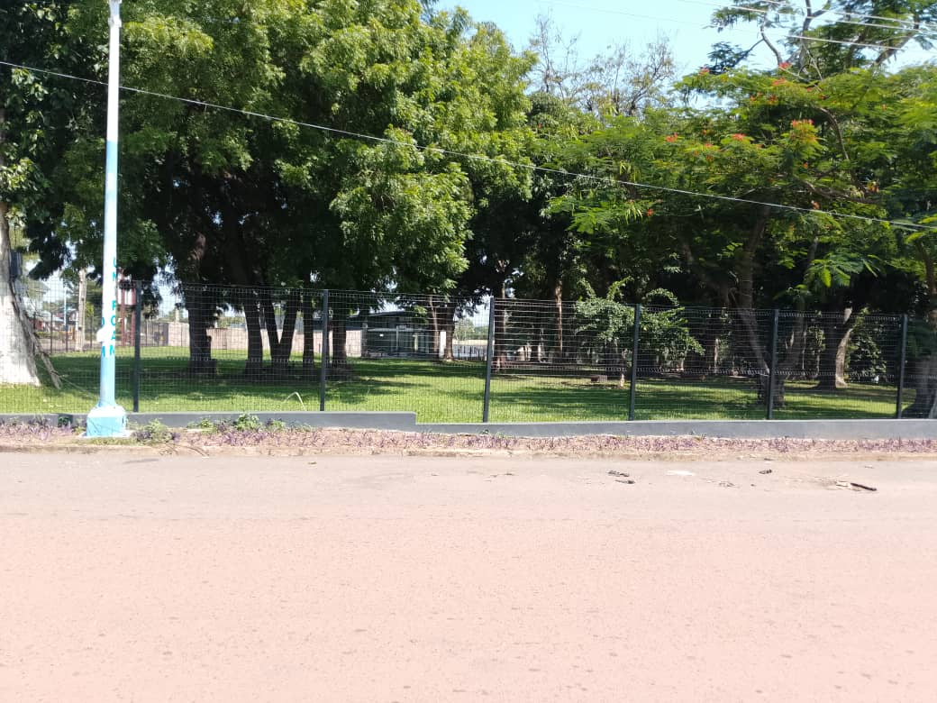
Figure 5: RECIDENCE IN G. R. A.
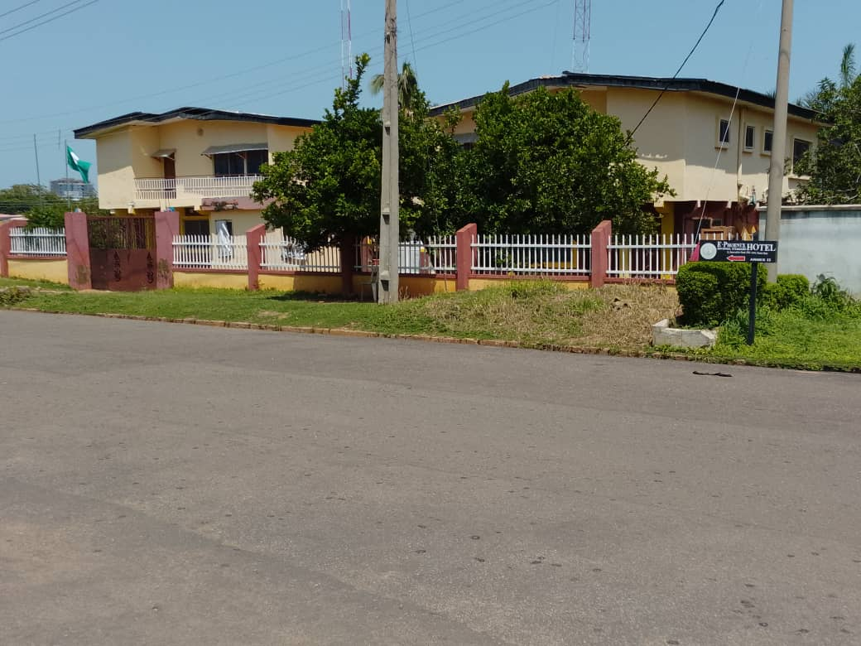
Figure 5: RECREATIONAL CENTRE IN G.R.A


Figure 7: CIRCULATION IN THE STUDY AREA
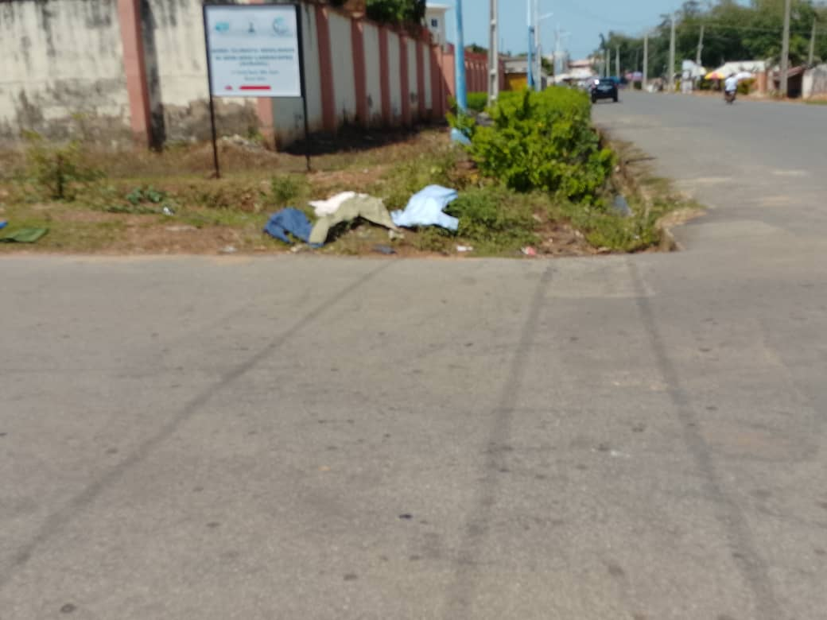
CHAPTER FIVE
5.0 SUMMARY, RECOMMENDATION AND CONCLUSION
5.1 SUMMARY OF FINDING
In summary the existing condition of the study area, Residential has the highest land use of 44.6% while Recreational has the lowest land use of 9.85%. 42.5% male and 57.5% female. This implies that female is more in population than male in the study area. Highest is married with 46.2% and lowest widow/widower with 12.2%, this implies that married has the highest in the study area.
The age of the respondents highest 46-65 years with 38.6% and the lowest 18-25 years with 9.4%. Level of education of the respondents, the highest is tertiary education with 69.8% and the lowest is illiterate with 7.5%. The occupation of the respondents, highest is civil servant with 49.0% and the lowest is artisan with 10.3%. The key factors driving land use change in the study area, the data prove that the main factor is population growth with 33.0% while the lowest is policy changes with 10.3%.
The effect of environmental pollution in the study area, highest is noise pollution with 77.3% while the lowest is water pollution with 8.4%. The result of over stretching of infrastructural facilities, highest is YES with 71.6% while the lowest is NO with 28.3%. The effect of incompactible land uses in the study area, the higest is HIGH with 72.6% while the lowest is LOW with 10.3%. The effect of traffic congestion in the study area, high is the highest point with 44.3% while low is the lowest point with 25.4%. The role of planning policy in the conversion of the study area, approved conversion is the highest with 57.7% while the lowest is illegal conversion with 40.3%.

5.2 RECOMMENDATION
Implement Integrated Land Use Planning: Ensure that land use conversion balances development needs with environmental protection and social equity.
Conduct Environmental Impact Assessments (EIA): Before converting land (e.g from forest to agriculture or from rural to urban), assess ecological and social Impacts.
Preserve Critical Ecosystems: Avoid converting wet lands, forests, and flood plains that provide essential eco system services.
Promote Mixed-Use Development: Encourage development that combines residential, commercial, and green space store reduce urban sprawl and transportation emissions.
Use Zoning and Land Suitability Analysis: Match land use with land capability (e.g fertile land for agriculture, less fertile or degraded land for infrastructure).
Community Involvement: Engage local stake holders to ensure land conversion supports local needs and avoids displacement or conflict.
Encourage Green Infrastructure: Integrate parks, green roofs, and sustainable drainage systems to mitigate the impact of land conversion in cities.

5.3. Conclusion
A good land use conversion is one that balances environmental sustainability, economic development, and social equity. It involves thoughtful planning, stakeholder engagement, and compliance with zoning regulations and environmental laws. When executed effectively, land use conversion can lead to more efficient use of resources, improved infrastructure, and enhanced quality of life for communities. Ultimately, it should support long-term development goals while preserving natural eco systems and respecting the needs of current and future generations.

References:
Bernard, H. R. (2017). Research methods in anthropology: Qualitative and quantitative approaches. Rowman& Littlefield.
Braun, V., & Clarke, V. (2013). Successful qualitative research: A practical guide for beginners. Sage.
Creswell, J. W. (2014). Research design: Qualitative, quantitative, and mixed methods approaches. Sage.
Field, A. (2018). Discovering statistics using IBM SPSS statistics.Sage.
Hinton, P. R. (2014). Statistics explained: An introductory guide for life scientists. Routledge.
Jensen, J. R. (2015). Remote sensing of the environment: An Earth resource perspective. Prentice Hall.
Kumar, R. (2019). Research methodology: A step-by-step guide for beginners. Sage.
Kwara State Government.(2017). Kwara State Development Plan.
Ilorin West Local Government. (2015). Ilorin West Local Government Area Development Plan.
National Population Commission. (2006). 2006 Census Report.
Ojo, G. J. A. (2013). Ilorin: A Historical and Cultural Study. Kwara State Council for Arts and Culture.
Angelsen, A., &Kaimowitz, D. (1999). Rethinking the causes of deforestation: Lessons from economic models. The World Bank Research Observer, 14(1), 73-98.
Boserup, E. (1965). The conditions of agricultural growth: The economics of agrarian change under population pressure. Allen &Unwin.
Fahrig, L. (2003). Effects of habitat fragmentation on biodiversity. Annual Review of Ecology, Evolution, and Systematics, 34, 487-515.
Geist, H. J., &Lambin, E. F. (2002). Proximate causes and underlying driving forces of tropical deforestation. BioScience, 52(2), 143-150.
IPCC (2013). Climate change 2013: The physical science basis. Cambridge University Press.
Lambin, E. F., Turner, B. L., Geist, H. J., Agbola, S. B., Angelsen, A., & Bruce, J. W. (2001). The causes of land-use and land- cover change: Moving beyond the myths. Global Environmental Change, 11(4), 261-269.
Lal, R. (2001). Soil degradation by erosion. Land Degradation & Development, 12(6), 519-539.
Seto, K. C., Fragkias, M., Güneralp, B., & Reilly, M. K. (2011). A meta-analysis of global urban land expansion. Plot ONE, 6(8), e23777.
Tilman, D., Balzer, C., Hill, J., &Befort, B. L. (2011). Global food demand and the sustainable intensification of agriculture. Proceedings of the National Academy of Sciences, 108(50), 20260- 20264.
Turner, B. L., Lambin, E. F., &Reenberg, A. (2007). The emergence of land change science for global environmental change and sustainability. Proceedings of the National Academy of Sciences, 104(52), 20666-20671.
Wilkie, D. S., Shaw, E., Rotberg, F., Morelli, G., &Auzel, P. (2011). Roads, development, and conservation

