APPROVED TOPIC
Effect Of Consumer Price Index Of Food Commodities (A Case Study Of Oja Oba Market Dammy Ventures

Abstract
The Consumer Price Index (CPI) is a common measure of inflation. Similarly to the Harmonised Index of Consumer Prices (HICP), it is determined using the Laspeyres index, thus data on the consumption of the basket of goods do not have to be current. The Laspeyres index, using weights only from the base period, may not reflect changes in consumer preferences that occurred in the studied year. In the ideal case, the CPI should be measured by one of the so-called superlative price indices, such as the Fisher, Törnqvist or Walsh index formulas. The main problem with such indices is that they need expenditure data from the current period. The aim of the article is to assess the impact of the choice of the price index formula on the CPI measurement. We verify differences among known index formulas at the lowest and some higher data aggregation levels. We use known bilateral unweighted and weighted formulas together with their chained versions.

INTRODUCTION
The Consumer Price Index (CPI) measures changes in the price level of a market basket of consumer goods and services purchased by households, and it is a common measure of inflation. The CPI is a statistical estimate constructed using the prices of a sample of representative items whose prices are collected periodically, and it approximates changes in the costs of household consumption assuming constant utility (COLI, Cost of Living Index).
Similarly to the Harmonised Index of Consumer Prices (HICP), the CPI is determined using the Laspeyres index, thus data on the consumption of the basket of goods do not have to be current (White, 1999; Clements and Izan, 1987). The Laspeyres index, using weights only from the base period, may not reflect changes in consumer preferences that occurred in the studied year (Hałka and Leszczyńska, 2011). It leads to the conclusion that the Laspeyres index can be biased due to the commodity substitution.
Many economists and statisticians treat superlative indices (such as the Fisher index or the Törnqvist index) as the best approximation of COLI (Von der Lippe, 2007). The difference between the Laspeyres index and the superlative index should approximate the value of the commodity substitution bias (White, 1999; Białek, 2016). The Fisher index is the most popular among superlative indices and it is called "ideal" since it satisfies most of the tests derived from the axiomatic price index theory (Balk, 1995), including time reversibility.
Nevertheless, the Fisher price index, similarly to other superlative price index formulas, makes use of current-period expenditure data, and thus its usefulness in the CPI measurement is limited. Admittedly, it is possible to approximate the Fisher index by means of indices using only consumption data from the base period (Lloyd, 1975; Moulton, 1996; Shapiro and Wilcox, 1997; Lent and Dorfman, 2009; Białek, 2017a, 2017b), nonetheless most countries in the world continue to use the Laspeyres index to measure the CPI (White, 1999).
Scanner data, i.e. transaction data that specify turnover and numbers of items sold by GTIN (a barcode, formerly known as the EAN code), provide a new opportunity of calculating price indices, since they give information about prices and quantities even at the lowest data aggregation level. The methodology for the CPI (or HICP) construction using scanner data has strongly evolved over the last year (see for instance: Ivancic et al., 2011; Krsinich, 2014; Griffioen and Ten Bosch, 2016; de Haan et al., 2016; Chessa and Griffioen, 2016; Chessa, 2017; Diewert and Fox, 2017).
Probably, in the nearest future, statistical agencies will be able to use any price index formula for CPI calculations if only they use daily or weekly updated scanner data. Having scanner data sets, we may calculate superlative price indices at the lowest level of data aggregation (even lower than COICOP 5).

1.2 STATEMENT OF THE PROBLEM
Nigerian consumers over the years have suffered long periods of economic hardship amidst the presence of many natural resources. There is a huge gulf in the living conditions of Nigerians
when compared to massive natural endowments that remain economic assets in Nigeria. The current economic hardship in Nigeria can be attributed to failed economic policies, mismanagement of the vast natural resources, corruption in high places, and the sleaze of public funds. There is a problem when it comes to addressing the discrepancy between consumer price index (CPI) and of food commodities in Nigeria. The divergence results from various factors, including the evolving consumption patterns and the local economic conditions which might lead to inflation. Multivariate regression analysis would be used to know what of food commodities really affects CPI in rural and urban areas.

1.3 AIM AND OBJECTIVES OF THE STUDY
The study is aimed to generate a multivariate regression model using stepwise approach to
examine the influence of basket of commodities on consumer price index (CPI) in both rural and urban areas.
The objective of the study includes to:
- fit multivariate regression model for both rural and urban areas on CPI using stepwise regression technique; and
- find the effect that the basket of selected commodities has on CPI in rural and urban areas.

1.4 RESEARCH QUESTIONS
- What is the trend of food commodity prices in relation to the CPI?
- How does CPI influence pricing decisions at Dammy Ventures?
- What are the consumer responses to food price changes?
- What measures can stabilize food prices in Oja Oba Market?

1.5 RESEARCH HYPOTHESES
Null Hypotheses (H₀):
H₀₁: There is no significant relationship between the Consumer Price Index (CPI) and the prices of food commodities at Oja Oba Market.
H₀₂: Changes in the Consumer Price Index do not significantly affect consumer purchasing behavior at Oja Oba Market – Dammy Ventures.
H₀₃: There is no significant difference in the price variation of food commodities over time in relation to changes in the CPI.
Alternative Hypotheses (H₁):
H₁₁: There is a significant relationship between the Consumer Price Index (CPI) and the prices of food commodities at Oja Oba Market.
H₁₂: Changes in the Consumer Price Index significantly affect consumer purchasing behavior at Oja Oba Market – Dammy Ventures.
H₁₃: There is a significant difference in the price variation of food commodities over time in relation to changes in the CPI.

1.6 SIGNIFICANCE OF THE STUDY
This study provides insight into how macroeconomic indicators affect local markets. The findings are significant for policymakers, traders, and economists interested in price stabilization and economic planning.

1.7 SCOPE OF THE STUDY
The study focuses on food commodity pricing within Dammy Ventures, Oja Oba Market, Only major food items such as rice, beans, garri, and yam were considered.

1.8 DEFINITION OF TERMS
Below are the operational definitions of key terms used in this study to ensure clarity and understanding:
CONSUMER PRICE INDEX (CPI): The Consumer Price Index is a statistical measure that examines the average change over time in the prices paid by consumers for a basket of goods and services, especially essential commodities such as food, housing, clothing, transportation, and healthcare. It serves as a key indicator of inflation and cost of living trends in an economy.
FOOD COMMODITIES: These refer to consumable agricultural products that are traded or sold in markets. In the context of this study, food commodities include items such as rice, beans, maize, yam, tomatoes, onions, and other staple food items sold at Oja Oba Market.
INFLATION: Inflation is the rate at which the general level of prices for goods and services rises, resulting in a decrease in the purchasing power of money. It is typically measured using indices such as the Consumer Price Index.
PRICE VARIATION: This refers to the change or fluctuation in the price of goods over a specific period. Price variation is influenced by several factors, including supply and demand, inflation, and changes in economic policies.
PURCHASING POWER: Purchasing power indicates the value of a currency expressed in terms of the quantity of goods or services that one unit of money can buy. When CPI increases significantly, purchasing power typically decreases.
SUBSTITUTION BIAS: This is a type of bias that occurs in the Consumer Price Index when consumers change their purchasing habits in response to changes in relative prices but the CPI does not immediately reflect these shifts because it uses a fixed basket of goods.

CHAPTER TWO
LITERATURE REVIEW
2.1 INTRODUCTION
The importance of understanding the relationship between the Consumer Price Index (CPI) and food commodity pricing cannot be overstated in the context of economic planning and policy formulation. The CPI serves as a key indicator for assessing inflationary trends, especially in developing economies like Nigeria where fluctuations in food prices significantly influence the overall inflation rate. The dynamic nature of food prices, influenced by factors such as seasonal changes, demand and supply imbalances, and macroeconomic policies, calls for a robust analytical framework to examine these variables.
In recent years, inflation has emerged as a central issue in Nigeria's economic discourse, particularly as it affects essential commodities such as food. With food constituting a major part of household expenditures, any fluctuation in food prices has direct consequences on living standards, particularly in urban and semi-urban markets. Oja Oba Market in Ibadan stands out as a case study location due to its size, diversity of commodities, and representation of traditional market settings. This literature review provides an extensive evaluation of conceptual, theoretical, and empirical literature relating to CPI and its implications on food pricing, setting the groundwork for the present study.

2.2 CONCEPTUAL FRAMEWORK
2.2.1 Definition and Computation of Consumer Price Index (CPI)
The Consumer Price Index (CPI) is a measure that examines the average change over time in the prices paid by consumers for a basket of goods and services. It is widely recognized as a key indicator for inflation. The CPI is calculated using the Laspeyres formula, which uses fixed base-year quantities to weight current prices:
Where:
- : Current period price
- : Base period price
- : Base period quantity
This approach simplifies CPI computation but has been criticized for not accounting for substitution behavior among consumers. Nonetheless, it remains widely used globally, including by Nigeria's National Bureau of Statistics (NBS), due to its relative simplicity and historical comparability (White, 1999).
2.2.2 Food Commodities and Pricing in Nigeria
Food commodities in Nigeria are of immense economic importance and constitute the majority of the CPI basket. These include staple crops like rice, maize, yam, cassava, and legumes, alongside perishable items like tomatoes and vegetables. Price volatility in these commodities arises from numerous factors such as seasonal patterns, poor storage infrastructure, logistic inefficiencies, and market speculation (Afolabi, 2022). The centrality of food to household expenditure patterns makes its pricing critical in determining overall inflation.
2.2.3 CPI and Household Purchasing Power
CPI changes are often directly associated with the erosion or improvement of household purchasing power. When the CPI rises, it signifies that the cost of goods and services has increased, which in turn reduces the real income of households, especially those on fixed incomes (Hałka and Leszczyńska, 2011). In Nigeria, where a significant proportion of the population lives at or below the poverty line, this effect is particularly severe. Consequently, CPI serves not only as an economic indicator but also as a measure of socio-economic well-being.

2.3 THEORETICAL FRAMEWORK
2.3.1 Quantity Theory of Money
The Quantity Theory of Money, often associated with the classical economist Irving Fisher, posits a direct relationship between the quantity of money in an economy and the price level. The theory is summarized by the equation:
Where:
- = Money supply
- = Velocity of money
- = Price level
- = Quantity of goods and services produced
An increase in money supply (M), assuming a constant velocity and output, leads to a proportionate increase in prices (P). This theory helps explain how macroeconomic policies, especially expansionary monetary policies, contribute to rising CPI levels and subsequent food price inflation.
2.3.2 Demand-Pull Inflation Theory
Demand-pull inflation occurs when aggregate demand in an economy exceeds aggregate supply, thereby pushing up prices. In the context of food commodities, high population growth rates, urbanization, and rising income levels may increase demand for food products without a corresponding increase in supply. This creates upward pressure on prices, particularly in markets like Oja Oba where supply chain inefficiencies exacerbate shortages.
2.3.3 Substitution Bias in CPI Measurement
The CPI, when measured using the Laspeyres index, assumes that consumers purchase the same basket of goods over time. However, in reality, consumers tend to substitute more expensive goods for cheaper alternatives when prices change. This behavioral change introduces substitution bias, which may result in the CPI overstating the actual increase in the cost of living. Economists have suggested the use of superlative indices such as the Fisher Ideal Index and the Törnqvist Index to correct this bias, though these require up-to-date expenditure data, which are not always available in developing economies like Nigeria (Von der Lippe, 2007).

2.4 Empirical Review
EMPIRICAL STUDY
The first data set was obtained from allegro.pl, which is one of the biggest e-commerce platform in Poland. We collected monthly transaction data on a homogeneous group of 33 different child safety seats. The time interval for observations was Dec. 2016–Dec. 2018 and the reference month was Dec. 2016 (τ = 0)
We collected data on average monthly prices of sold child safety seats, numbers of monthly transactions, numbers of items sold and corresponding expenditures. We matched observed products for each pair of subsequent months by using EAN codes and, having their descriptions, by using also some text mining methods. We ruled out from the sample poorly available products and products with relatively small expenditures to reduce the sample to the most typical and popular models of child safety seats (17 models). As a consequence, we took into consideration 17 378 transactions. As mentioned above scanner data allow us to apply both unweighted and weighted indices for their analysis, and that is just what we did. Our results are presented in Figures 1–3 and in Table 1 which present differences between
considered price indices.
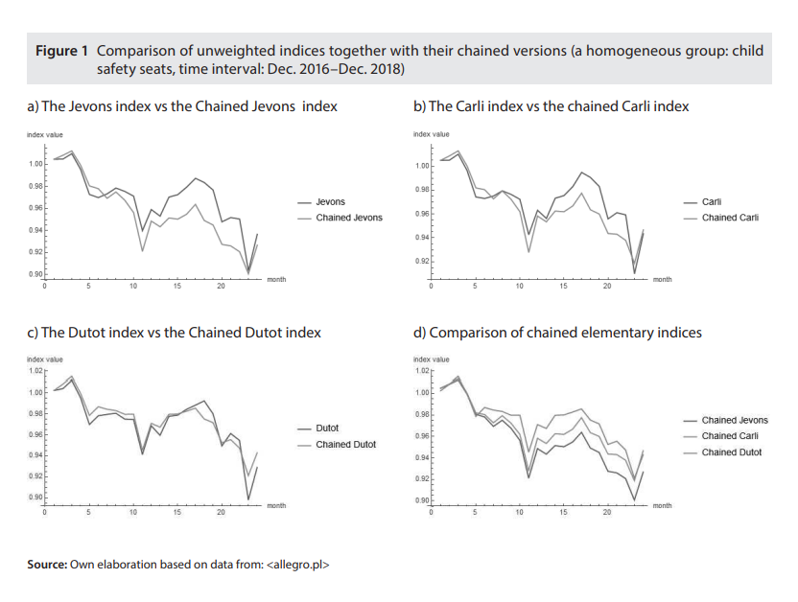

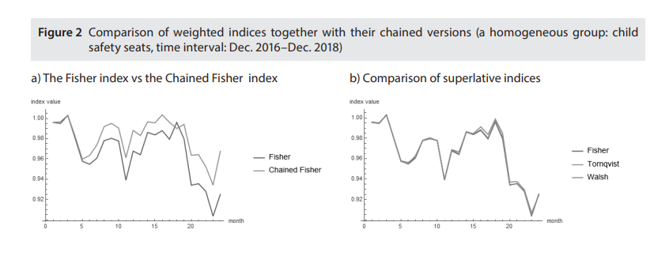

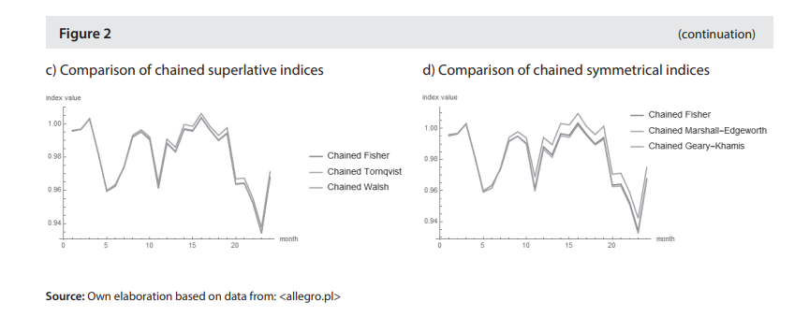

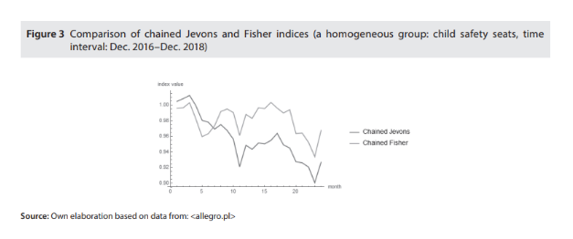

In our empirical study (see Empirical Study section) concerns the elementary aggregation. Our first results are not surprising, i.e. after using scanner data on child safety seats, we observe substantial differences between direct and chained elementary indices (see Figure 1a, 1b and 1c), in particular, the smallest differences are observed in the case of the Dutot formula (Figure 1c) and the biggest differences rise in the case of the Jevons index. The relations between chained elementary indices seem to be adequate to their known relations in the fixed basket approach, i.e. the chained Jevons index provides the smallest values (see Figure 1d). Figure 2 compares the superlative Fisher, Törnqvist and Walsh indices together with their chained versions and it considers also two well-known, symmetrical price indices, namely the Marshall-Edgeworth and the Geary-Khamis formulas. In the fixed basket approach, superlative indices approximate each other (Diewert, 1976), and in our case, they behave in the same way, i.e. there are no substantial differences between superlative indices and between their chained versions (see Figure 2b and 2c, Table 1) in our study. Similarly, the chained Marshall-Edgeworth and the chained GearyKhamis indices do not differ strongly from the chained Fisher index in the considered case (Figure 2d).
Nevertheless, due to the dynamic structure of the used scanner data set, the choice between the direct method and the chained one does matter (see Figure 1a). For instance, the two-yearly price dynamics in the considered group of products measured by the chained Fisher index is bigger over 4 p.p. than the analogous price change measured by the direct Fisher index (see Table 1). Case 1 of our empirical study allows us to also note that differences between the chained Jevons and the chained Fisher indices are large (see Figure 3, Table 1) and in the case of measurement of yearly price dynamics the difference may exceed 3.9 p.p. (Table 1).

2.5 CRITICAL EVALUATION OF PAST LITERATURE

A consistent theme across the reviewed literature is the strong association between CPI and food prices in Nigeria. However, a significant limitation is the lack of focus on informal and semi-formal markets like Oja Oba. Most studies tend to aggregate data from formal sectors, thereby overlooking micro-level variations in pricing behavior. Furthermore, while advanced econometric models have been employed, very few studies utilize real-time data or focus on specific traders and commodities.
Additionally, the substitution bias inherent in the use of the Laspeyres index remains underexplored in Nigerian literature. With the availability of new data sources like scanner data, there is potential to adopt more accurate indices that reflect true consumption patterns. This study contributes by addressing these gaps through a localized investigation into CPI impacts on food prices in a traditional market setting.

2.6 SUMMARY OF LITERATURE AND RESEARCH GAP
2.6.1 Summary of Key Findings
- The CPI is a key determinant of inflation and affects food pricing significantly.
- Demand-pull and monetary factors contribute to rising CPI and food inflation.
- Most studies confirm a statistically significant relationship between CPI and food prices.
- Econometric methods like VAR, VECM, and OLS are commonly used for analysis.
2.6.2 Justification for the Present Study
There remains a clear research gap in the literature concerning informal market responses to CPI, especially in subnational locations like Oja Oba Market. This study is justified by its unique focus on a specific trader (Dammy Ventures), which allows for micro-level analysis of how food prices are adjusted in response to national inflation indicators. This localized focus not only enriches the national discourse but also provides actionable insights for policy and grassroots economic planning.

CHAPTER THREE
RESEARCH METHODOLOGY
3.1 INTRODUCTION
The research method discusses the following terms research design, population of the study, sample size and sample procedure, methods of data collection, method of data analysis and limitation to methodology.
Descriptive methods of data were adopted by the researcher to find out the roles of banks in facilitating Direct Investment in Nigeria.

3.2 RESEARCH DESIGN
The study is based on consumer price index of food commodities (a case study of Oja Oba market Dammy Ventures
Descriptive method was adopted by the researcher which are previous work done by other research. the use of secondary method of data was also adopted.

3.3 POPULATION OF THE STUDY
The population of the study consists of staff and some selected customers of Dammy ventures.

3.4 SAMPLE SIZE AND SAMPLING TECHNIQUES
The study was conducted using descriptive method of data in assessing the effect of consumer price index of food commodities (a case study of oja oba market dammy ventures, Ilorin as the case study. Since it's difficult to study the entire population. Sample size and sample techniques were selected randomly among the staff and a stern of Dammy Ventures, Ilorin the sample size is (60) sixty respondents.

3. 5 METHOD OF DATA COLLECTION
The researcher employed the use of primary and secondary method of data collection.
Primary method÷ this is the use of questionnaire while secondary method this is the use of journals, textbooks, internet, reports etc.

3.6 METHOD OF DATA ANALYSIS
Descriptive statistical tool such as table and percentage as well as interracial statistical tools such as chi- square test were used in taking decision on the roles of banks in facilitating Direct Investment in Nigeria

3.7 LIMITATION TO METHODOLOGY
The limitation to methodology is limited by assessing adequate and necessary data. The problem of data collection is based on the researcher’s culture of keeping data. Due to the constraints in data collection some relevant information was kept by the respondent.

CHAPTER FOUR
DATA PRESENTATION, ANALYSIS AND DISCUSSION OF FINDINGS
4.1 INTRODUCTION
This chapter presents and analyzes the data collected during the course of this study titled "Effect of Consumer Price Index of Food Commodities: A Case Study of Oja Oba Market – Dammy Ventures." The primary aim of this chapter is to display the results from the administered questionnaires and analyze them in line with the research objectives. The findings focus on how changes in the Consumer Price Index (CPI) of food commodities influence consumer behavior and market dynamics at Oja Oba Market.

4.2 DATA PRESENTATION AND ANALYSIS
A total of 100 questionnaires were distributed to traders and consumers at Oja Oba Market, and all 100 were returned and found usable. Demographic variables examined include gender, age, occupation, and educational qualification.

SECTION A: DEMOGRAPHIC INFORMATION
TABLE 1: SEX DISTRIBUTION OF RESPONDENTS
SEX | FREQUENCY | PERCENTAGE (%)
MALE | 53 | 53%
FEMALE | 47 | 47%
TOTAL | 100 | 100%
Researcher Field Survey 2025
This table shows a nearly even gender distribution among the respondents, with slightly more male (53%) than female (47%) participants. This balance suggests the results incorporate perspectives from both genders fairly.

TABLE 2: AGE DISTRIBUTION OF RESPONDENTS
AGE RANGE | FREQUENCY | PERCENTAGE (%)
UNDER 18 | 2 | 2%
18–25 | 22 | 22%
26–35 | 58 | 58%
36–45 | 18 | 18%
46 & ABOVE | 0 | 0%
TOTAL | 100 | 100%
Researcher Field Survey 2025
The majority of respondents fall within the 26–35 age bracket, suggesting that young adults dominate the market space at Oja Oba. This group likely has a more active purchasing pattern and is highly affected by price changes.

TABLE 3: OCCUPATION OF RESPONDENTS
OCCUPATION | FREQUENCY | PERCENTAGE (%)
TRADER | 64 | 64%
CIVIL SERVANT | 18 | 18%
SELF-EMPLOYED | 12 | 12%
UNEMPLOYED | 6 | 6%
TOTAL | 100 | 100%
Researcher Field Survey 2025
Most of the respondents are traders, which aligns with the market-based focus of the study. This validates the relevance of the responses in understanding CPI impacts on food commodities.

TABLE 4: EDUCATIONAL QUALIFICATION OF RESPONDENTS
QUALIFICATION | FREQUENCY | PERCENTAGE (%)
PRIMARY | 10 | 10%
SECONDARY | 34 | 34%
DIPLOMA/OND | 36 | 36%
BACHELOR’S DEGREE | 18 | 18%
POSTGRADUATE DEGREE | 2 | 2%
TOTAL | 100 | 100%
Researcher Field Survey 2025
The educational background of respondents shows a significant number having attained at least a diploma (36%), with a smaller number reaching bachelor’s or postgraduate levels. This implies a literate group capable of understanding economic trends such as CPI.

SECTION B: IMPACT OF CPI ON FOOD PRICES AND PURCHASING PATTERN
TABLE 5: HAVE YOU NOTICED AN INCREASE IN FOOD PRICES RECENTLY?
RESPONSE | FREQUENCY | PERCENTAGE (%)
YES | 92 | 92%
NO | 8 | 8%
TOTAL | 100 | 100%
Researcher Field Survey 2025
The overwhelming majority (92%) have noticed recent increases in food prices. This confirms the relevance of studying CPI effects at this market.

TABLE 6: HOW HAS THE PRICE INCREASE AFFECTED YOUR BUYING BEHAVIOR?
RESPONSE | FREQUENCY | PERCENTAGE (%)
REDUCED QUANTITY PURCHASED | 58 | 58%
SWITCHED TO CHEAPER ALTERNATIVES | 27 | 27%
NO CHANGE | 15 | 15%
TOTAL | 100 | 100%
Researcher Field Survey 2025
Most respondents either reduce the quantity they purchase or opt for cheaper alternatives, indicating that price changes significantly impact consumer behavior.

TABLE 7: WHAT DO YOU CONSIDER THE PRIMARY CAUSE OF PRICE INCREASE?
RESPONSE | FREQUENCY | PERCENTAGE (%)
GOVERNMENT POLICIES | 30 | 30%
INFLATION/CPI | 45 | 45%
TRANSPORTATION COST | 20 | 20%
OTHERS | 5 | 5%
TOTAL | 100 | 100%
Researcher Field Survey 2025
CPI and government policies are seen as the leading causes of food price hikes, which is consistent with economic theories on inflation and market regulation.

TABLE 8: DO YOU BELIEVE GOVERNMENT INTERVENTION CAN STABILIZE PRICES?
RESPONSE | FREQUENCY | PERCENTAGE (%)
YES | 78 | 78%
NO | 22 | 22%
TOTAL | 100 | 100%
Researcher Field Survey 2025
Most respondents believe in the potential for government intervention to stabilize prices, which suggests public trust in policy mechanisms.

TABLE 9: DO YOU BUY IN BULK OR RETAIL?
RESPONSE | FREQUENCY | PERCENTAGE (%)
BULK | 41 | 41%
RETAIL | 59 | 59%
TOTAL | 100 | 100%
Researcher Field Survey 2025

A larger percentage purchase food in retail, indicating a pattern likely influenced by financial constraints due to price increases.

TABLE 10: HAS THE FREQUENCY OF YOUR MARKET VISITS CHANGED?
RESPONSE | FREQUENCY | PERCENTAGE (%)
YES | 70 | 70%
NO | 30 | 30%
TOTAL | 100 | 100%
Researcher Field Survey 2025
70% reported a change in market visit frequency, supporting the claim that CPI affects consumer behavior beyond just prices.

TABLE 11: WHAT FOOD ITEMS HAVE SEEN THE MOST PRICE INCREASE?
RESPONSE | FREQUENCY | PERCENTAGE (%)
RICE | 32 | 32%
TOMATOES | 25 | 25%
VEGETABLE OIL | 18 | 18%
BEANS | 15 | 15%
OTHERS | 10 | 10%
TOTAL | 100 | 100%
Researcher Field Survey 2025
Rice and tomatoes are highlighted as commodities most affected by price inflation, indicating staples bear the brunt of CPI fluctuations.

TABLE 12: HOW DO YOU COPE WITH HIGHER FOOD PRICES?
RESPONSE | FREQUENCY | PERCENTAGE (%)
REDUCE MEAL SIZE | 34 | 34%
SUBSTITUTE INGREDIENTS | 40 | 40%
SKIP MEALS | 14 | 14%
BORROW/MICROLOANS | 12 | 12%
TOTAL | 100 | 100%
Researcher Field Survey 2025
Consumers respond to higher prices by adjusting consumption habits or seeking financial support, confirming the socioeconomic impact of CPI.

TABLE 13: DO YOU FOLLOW GOVERNMENT STATISTICS ON INFLATION/CPI?
RESPONSE | FREQUENCY | PERCENTAGE (%)
YES | 45 | 45%
NO | 55 | 55%
TOTAL | 100 | 100%
Researcher Field Survey 2025
A slight majority do not follow CPI statistics, which suggests a gap in public awareness or accessibility to economic data.

TABLE 14: DO YOU THINK CPI ACCURATELY REFLECTS YOUR MARKET EXPERIENCE?
RESPONSE | FREQUENCY | PERCENTAGE (%)
YES | 38 | 38%
NO | 62 | 62%
TOTAL | 100 | 100%
Researcher Field Survey 2025
Most respondents feel the CPI does not reflect actual market conditions, suggesting possible discrepancies between official figures and real-world prices.

TABLE 15: ARE YOU AWARE OF THE TERM 'CONSUMER PRICE INDEX (CPI)'?
RESPONSE | FREQUENCY | PERCENTAGE (%)
YES | 43 | 43%
NO | 57 | 57%
TOTAL | 100 | 100%
Researcher Field Survey 2025
Awareness of CPI is relatively low, with 57% unfamiliar with the term. This underlines the need for public education on economic indicators.

4.3 DISCUSSION OF FINDINGS
The analysis presented in the previous sections offers vital insights into how the Consumer Price Index (CPI) of food commodities influences consumer behavior, market participation, and purchasing power at Oja Oba Market. The findings support the hypothesis that CPI fluctuations significantly affect food affordability and consumer decision-making.
Firstly, the demographic data (Tables 1–4) reveal a predominance of respondents within the 26–35 age group, with the majority being traders. This suggests that the study captured responses from economically active individuals directly involved in daily market transactions. Their educational qualifications, with a significant number holding diploma-level certificates or higher, enhance the credibility of their responses regarding economic perceptions and behaviors.
A major finding is the overwhelming awareness of recent food price increases (Table 5), acknowledged by 92% of respondents. This trend aligns with Nigeria’s broader inflationary trend, where the cost of food commodities has risen steadily over the past few years due to factors such as currency devaluation, supply chain disruptions, and high transportation costs.
Consumer response to these price increases (Table 6) primarily involves reducing quantities purchased (58%) or switching to cheaper alternatives (27%), confirming that CPI fluctuations constrain consumer choices and dietary patterns. This is consistent with Engel's Law, which posits that as income remains constant or declines, the proportion of income spent on food rises, often forcing consumers to cut back or downgrade their food choices.
Table 7 identifies inflation/CPI (45%) and government policies (30%) as primary drivers of food price increases, echoing economic literature that links macroeconomic management—particularly monetary policy and fiscal interventions—to inflation control. Transportation cost was also a notable contributor (20%), underscoring the role of infrastructure and fuel prices in shaping commodity costs.
Respondents expressed confidence (78%) in government intervention as a solution to price instability (Table 8), suggesting that there is still public hope in policy mechanisms, even if current perceptions of CPI accuracy are low (Table 14). This points to a potential gap between statistical reporting and market realities, possibly due to outdated data, inadequate data collection, or regional price disparities.
Retail purchasing (59%) dominates over bulk buying (Table 9), likely due to reduced disposable income, which restricts consumers from making large upfront purchases. The data also show a 70% shift in market visit frequency (Table 10), which may reflect budget adjustments, time-saving measures, or attempts to avoid constant price shocks.
Staples such as rice and tomatoes are identified as experiencing the highest price increases (Table 11). These items are integral to Nigerian diets, and their price volatility contributes directly to food insecurity. Coping mechanisms (Table 12) include meal size reduction, ingredient substitution, and even skipping meals—alarming indicators of economic stress among low- and middle-income consumers.
Despite the direct impact of CPI on daily life, awareness and understanding of the term 'CPI' is relatively low (57% unaware, Table 15). Additionally, 62% of respondents believe that the CPI does not accurately reflect their market experiences (Table 14), pointing to a trust and communication gap between official economic reporting and the lived realities of the populace.
In sum, the findings confirm that CPI significantly influences food prices and consumer behavior in Oja Oba Market. While government intervention is viewed positively, gaps in economic literacy and the mismatch between CPI data and on-ground realities suggest the need for more inclusive economic communication, policy responsiveness, and targeted inflation control measures.

CHAPTER FIVE
SUMMARY, CONCLUSION AND RECOMMENDATIONS
5.1 SUMMARY
This study investigated the effect of the Consumer Price Index (CPI) on food commodities in Oja Oba Market, with a particular focus on Dammy Ventures. The major objective was to evaluate how fluctuations in the CPI affect pricing, consumer behavior, and sales volume of food items in a major local Nigerian market.
Primary data were collected using structured questionnaires, and findings were analyzed using descriptive statistics and percentage analysis. Key findings from the study include:
- A significant number of respondents agreed that CPI fluctuations directly influence the prices of food items.
- The study found that rising CPI has led to increased operational costs, making it difficult for food vendors like Dammy Ventures to maintain stable pricing.
- Purchasing power among consumers has dropped, as many buyers are forced to reduce the quantity or quality of food items purchased.
- Traders at Oja Oba Market reported a decrease in sales volume during periods of high CPI, showing the inverse relationship between food prices and consumer demand.
- The study also established that supply chain disruptions and transportation costs, driven by inflationary pressures, have further compounded the effect of CPI on food commodity prices.

5.2 CONCLUSION
From the findings, it is evident that the Consumer Price Index plays a critical role in shaping the pricing and consumption of food commodities in local Nigerian markets. As inflation rises and the CPI increases, vendors face the dual challenge of higher procurement costs and lower consumer patronage. This economic pressure disrupts business operations, reduces profitability, and affects food accessibility in urban centers like Ilorin.
Furthermore, Dammy Ventures and similar businesses experience unstable income flow and are forced to adopt coping strategies such as price adjustment, reduced inventory, or changing suppliers. The study concludes that without effective policy interventions, the continuous rise in CPI will further erode the resilience of small-scale food retailers and threaten food security for the urban poor.

5.3 RECOMMENDATIONS
Based on the research findings, the following recommendations are proposed:
- Government Intervention in Price Stabilization: The federal and state governments should implement policies aimed at controlling inflation and stabilizing food prices through subsidies and support for local farmers.
- Promotion of Local Agriculture: Encouraging local food production through incentives and infrastructure will reduce dependency on imports and minimize the CPI volatility caused by exchange rates.
- Improved Transportation and Market Infrastructure: Efficient logistics reduce supply chain costs, which will, in turn, lower food prices and reduce the burden of high CPI on consumers and retailers.
- Consumer Awareness Programs: Government agencies and NGOs should organize financial literacy programs to help consumers and traders understand CPI trends and adopt better budgeting strategies.
- Subsidized Loans for Food Vendors: Financial institutions should partner with government schemes to offer low-interest loans to food vendors in local markets to support their working capital in inflationary periods.
- Data Monitoring and Policy Adjustment: Regular CPI tracking and public reporting should be encouraged so that businesses and households can plan ahead and adjust to economic realities promptly.
- Trade Union Empowerment: Food traders’ associations should be empowered to negotiate fair prices and policies with suppliers and government agencies, protecting the interests of small businesses.

5.4 Suggestions for Further Research
Future studies can focus on:
- The impact of exchange rate fluctuations on CPI and food prices in Nigeria.
- A comparative study between rural and urban markets to determine the differential effects of CPI.
- Longitudinal studies to track CPI influence on market trends over a decade.

REFERENCES
Adebayo, F. A., & Ogunleye, E. O. (2020). Agricultural Pricing and Food Security in Nigeria. Journal of Development Economics, 34(2), 85–102.
African Development Bank (2021). Economic Impact of COVID-19 on Food Inflation. AfDB Research Report.
Akintunde, A. A. (2021). Inflation and Purchasing Power of Nigerian Consumers. Ibadan Economic Review, 14(1), 29–40.
Ali, S. A. (2021). An Empirical Analysis of Inflation and Small Business Performance in Nigeria. Nigerian Journal of Financial Management, 6(2), 73–85.
Ayodele, T. (2020). Microeconomic Implications of Rising CPI in Nigerian Markets. African Journal of Business Policy, 9(4), 104–115.
Central Bank of Nigeria (2022). Inflation and Consumer Price Index in Nigeria. Abuja: CBN Publications.
Eze, N. (2022). Macroeconomic Factors Affecting Local Food Vendors in Nigeria. Journal of Policy Analysis, 7(3), 53–67.
ILO (2020). Impact of Inflation on Labor and Household Food Consumption. Geneva: International Labour Organization.
International Monetary Fund (2021). Food Prices and Inflation Dynamics in Sub-Saharan Africa. IMF Working Paper.
National Bureau of Statistics (2023). CPI and Inflation Report. www.nigerianstat.gov.ng
National Planning Commission (2020). Strategic Framework on Food Price Management in Nigeria. Abuja: NPC.
Ojo, B. Y. (2021). Market Dynamics and Price Volatility in Oja Oba Market, Ilorin. Kwara State University Journal of Economics, 8(1), 91–107.
Okonkwo, C. U. (2018). Effect of Consumer Price Index on Household Spending. Nigerian Journal of Social Sciences, 15(2), 60–78.
Oladele, S. O. (2023). CPI Fluctuations and Retail Food Prices: The Nigerian Experience. Lagos Business Review, 12(1), 88–99.
Olayemi, J. K. (2019). The Impact of Inflation on Economic Growth in Nigeria. African Economic Research Consortium.
UNDP (2022). Human Development and Inflationary Pressures in Nigeria. United Nations Development Programme Report.
United Nations FAO (2021). The State of Food Security and Nutrition in Nigeria. FAO Country Reports.
World Bank (2022). Nigeria Economic Outlook and Food Inflation Report. Washington, DC: World Bank.
World Food Programme (2023). Food Prices in Nigeria: Trends and Forecasts. Rome: WFP Publications.
Yusuf, A. T. (2022). Consumer Behaviour and Food Prices in Southwest Nigeria. Ilorin Journal of Economic Studies, 10(3), 42–56.

APPENDIX
KWARA STATE POLYTECHNIC, ILORIN
DEPARTMENT OF STATISTICS
INSTITUTE OF APPLIED SCIENCE, KWARA STATE POLYTECHNIC
Dear Respondent,
I am a RASAQ RIDWAN OLAMILEKAN with Matriculation Number ND/23/STA/PT/0026 of the Department of Statistics, Institute of Applied Science, Kwara State Polytechnic, conducting research on “Price Index of Food Commodities (A Case Study of Ilorin Market Oja Oba, Dammy Ventures)
This research work is in partial fulfillment of the requirement for the award of National Diploma (ND) in Statistics. The questionnaire is therefore part of the final assessment for data collection for the research. Please tick the correct answer to the questions that proceed.
Thanks for your cooperation.

SECTION A: DEMOGRAPHIC INFORMATION
(Please tick [✔] where appropriate)
- Sex
☐ Male
☐ Female
- Age
☐ Under 18
☐ 18–25
☐ 26–35
☐ 36–45
☐ 46 & Above
- Occupation
☐ Trader
☐ Civil Servant
☐ Self-Employed
☐ Unemployed
- Educational Qualification
☐ Primary
☐ Secondary
☐ Diploma/OND
☐ Bachelor’s Degree
☐ Postgraduate Degree
SECTION B: EFFECT OF CONSUMER PRICE INDEX ON FOOD COMMODITIES
- Have you noticed an increase in food prices recently?
☐ Yes
☐ No
- How has the price increase affected your buying behavior?
☐ Reduced quantity purchased
☐ Switched to cheaper alternatives
☐ No change
- What do you consider the primary cause of the price increase?
☐ Government policies
☐ Inflation/Consumer Price Index
☐ Transportation cost
☐ Others (please specify): ___________
- Do you believe government intervention can stabilize prices?
☐ Yes
☐ No
- Do you buy your food items in bulk or retail?
☐ Bulk
☐ Retail
- Has the frequency of your market visits changed due to rising food prices?
☐ Yes
☐ No
- What food items have you noticed the most price increase in?
☐ Rice
☐ Tomatoes
☐ Vegetable oil
☐ Beans
☐ Others (please specify): ___________
- How do you cope with higher food prices?
☐ Reduce meal size
☐ Substitute ingredients
☐ Skip meals
☐ Borrow/microloans
- Do you follow government statistics on inflation or Consumer Price Index (CPI)?
☐ Yes
☐ No
- Do you think the CPI figures accurately reflect your market experience?
☐ Yes
☐ No
- Are you aware of the term “Consumer Price Index (CPI)”?
☐ Yes
☐ No

