EFFECT OF FUNGICIDE APPLICATION ON SOIL MYCOBIOME
BY
ADEDIRAN ZAINAB ADENIKE
HND/23/SLT/FT/1060
A PROJECT SUBMITTED TO THE DEPARTMENT OF SCIENCE LABORATORY TECHNOLOGY, INSTITUTE OF APPLIED SCIENCES (IAS), KWARA STATE POLYTECHNIC, ILORIN,
IN PARTIAL FULFILMENT OF THE REQUIREMENTS FOR THE AWARD OF HIGHER NATIONAL DIPLOMA (HND) IN SCIENCE LABORATORY TECHNOLOGY, INSTITUTE OF APPLIED SCIENCES (IAS), MICROBIOLOGY UNIT
KWARA STATE POLYTECHNIC ILORIN
JULY, 2025
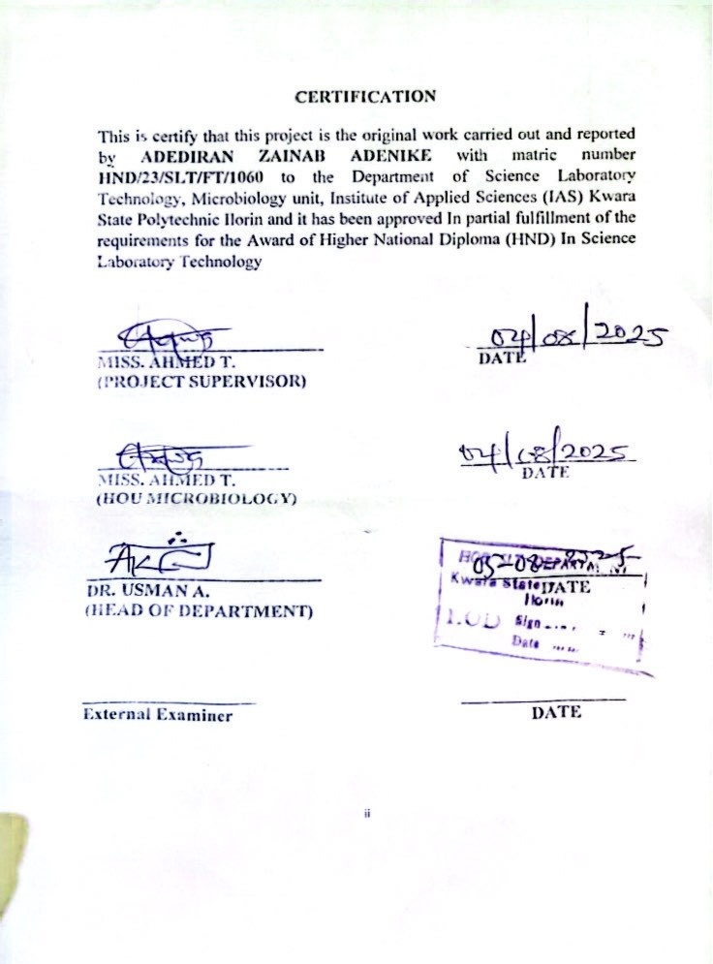
DEDICATION
This project work is dedicated to Almighty God who has being there for me throughout this journey and also to my parent for their contribution financially to meet academic pursuit and educational achievement may you live long to reap the good fruit of your labour (Amin).

ACKNOWLEDGEMENTS
First for most I would like to thank Allah the Most Merciful and the most Gracious, For making it all possible for me to complete this dissertation, For showing me that there is a light to every tunnel.

I would also like to thank my supervisor (Miss Ahmed. T) .for the patience, assistance, and encouragement while I was completing this dissertation. God bless you ma.

To my family- my mum and my siblings, are my biggest supporter throughout life, thank you for believing in me throughout this process, in my weakness moment and throughout my struggles, your belief in me has been a constant source of Motivation, there is so much love and gratitude I will never have the number of words to express.

I am also grateful to my friends for their support and encouragement during difficult times, their friendship has made this journey so fulfilling.

Thanks to my man for his support and encouragement throughout this journey he believed I could and I did.
Thanks to everyone who has been part of this journey, your support has made this achievement possible.

TABLE OF CONTENTS
TITLE PAGE i
CERTIFICATION ii
DEDICATION iii
ACKNOWLEDGEMENTS iv
TABLE OF CONTENTS v-vi
LIST OF TABLES vii
ABSTRACT viii
CHAPTER ONE 1
1.0 INTRODUCTION 1
1.1 Literature Review 4
1.2 Statement of Problem 10
1.3 Aim 10
1.4 Objectives 11
CHAPTER TWO 12
2.0 Materials and Methods 12
2.1 Materials 12
2.1.1 Media and Reagents 12
2.2 Sample Collection and Treatment 13
2.3 pH Determination 14
2.4 Preparation of Media 14
2.5 Isolation of Fungi 15
2.6 Identification of Fungal Growth 15
CHAPTER THREE 18
3.0 RESULTS 18
3.1 pH of Soil Samples 18
3.2 Fungal Colony Characteristics and Enumeration 19
3.3 Fungal Observation and Colony Count in Control Soil Samples 21
CHAPTER FOUR 23
4.0 DISCUSSION AND CONCLUSION 23
4.1 DISCUSSION 23
4.2 CONCLUSION 28
REFERENCES 28

LIST OF TABLES
Table 3.1: pH Values of Treated and Control Soil Samples……………18
Table 3.2: Fungal Observation and Colony Count in Treated Soil Samples…………………………………………………………………….19
Table 3.3: Fungal Observation and Colony Count in Control Soil Sample……………………………………………………………………21

ABSTRACT
Fungicides are widely used in agriculture to control plant diseases; however, their unintended effects on non-target soil fungi (the mycobiome) raise significant ecological concerns. This study assessed the impact of five fungicides—Blast Force, Stampede, Ultimax Plus, Red Force, and Total Force—on soil fungal diversity and composition across five locations. Both treated and control soil samples were analyzed for pH, fungal colony morphology, and species abundance using standard procedures. Results showed minimal changes in soil pH (ranging from 6.0 to 4.96). Fungal colony counts in treated soils ranged from 2 to 198 colonies, whereas control samples ranged from 2 to 36 colonies. Despite the variations in count, treated soils exhibited significant shifts in fungal community composition. A marked reduction was observed in the diversity of Penicillium and Aspergillus spp., while Yeast and Rhizopus spp. remained dominant. In contrast, control soils demonstrated a richer and more balanced fungal community. These findings highlight the potential of fungicide application to disrupt essential soil microbial functions and underscore the need for integrated pest management strategies to promote sustainable agriculture.
CHAPTER ONE

1.0 INTRODUCTION
Fungicides are widely employed in agricultural systems to mitigate crop loss caused by fungal pathogens. While their benefits in disease control and yield improvement are acknowledged, growing evidence suggests that fungicides can negatively affect non-target organisms, including soil fungi that form the mycobiome. The soil mycobiome encompasses a diverse community of fungi, including saprotrophs, pathogens, and mutualists such as mycorrhizal fungi. These fungi perform critical ecological roles, including decomposition of organic matter, nutrient mineralization, and formation of symbiotic associations with plants. Interference with these functions due to fungicide exposure may threaten soil health and sustainability (Francioli et al., 2022).
Soil fungi are particularly sensitive to chemical disturbances due to their intricate roles in maintaining ecosystem balance. Fungicide residues in the soil can alter fungal biomass, diversity, and enzymatic activity. Systemic fungicides, which penetrate plant tissues and persist longer in the soil, may have prolonged ecological effects compared to contact fungicides. These compounds can suppress not only harmful fungi but also beneficial ones such as arbuscular mycorrhizal fungi (AMF), which are essential for phosphorus uptake and drought tolerance in plants (Tosi et al., 2020). Such disturbances may lead to a decline in fungal biodiversity and the resilience of soil ecosystems.
Changes in fungal community structure due to fungicide application may also affect plant-soil interactions. Beneficial fungi involved in nutrient cycling or disease suppression may be reduced, while opportunistic or resistant fungi may proliferate. This imbalance can result in soil with reduced fertility and increased vulnerability to pathogen invasion. Over time, this may necessitate increased chemical input, creating a harmful cycle of soil degradation and chemical dependency (Banerjee et al., 2020). Furthermore, repeated fungicide applications may exert selection pressure, leading to shifts in community dynamics that favor fungicide-tolerant species.
Advancements in molecular biology, particularly next-generation sequencing (NGS), have enabled detailed analysis of microbial community composition. Recent studies utilizing metabarcoding techniques have shown that fungicide application significantly modifies soil fungal diversity and abundance. These methods have revealed that even a single application can reduce rare taxa and shift dominant fungal phyla, such as Ascomycota and Basidiomycota (He et al., 2021). These changes may have cascading effects on nutrient availability and plant productivity, thereby undermining the very goal of agricultural intensification.
The frequency, dosage, and mode of fungicide application also determine the extent of impact on soil fungi. Excessive or routine use of broad-spectrum fungicides increases the likelihood of detrimental effects on non-target fungal communities. Additionally, environmental factors such as soil pH, moisture content, and organic matter influence the degradation and persistence of fungicides in the soil. Thus, soil-specific responses must be evaluated when assessing the ecological risks associated with fungicide use (González-Pérez et al., 2020). A one-size-fits-all approach may overlook localized effects that accumulate over time.
Fungicide-induced shifts in the mycobiome not only affect the soil microbiota but can also indirectly affect plant health and growth. Mycorrhizal suppression, for example, may impair plant nutrient acquisition, reduce stress tolerance, and weaken resistance to other pathogens. In turn, this could result in reduced crop vigor and yield. Long-term disruption of the mycobiome may also impede the natural regeneration of microbial populations, reducing the soil’s capacity to recover after disturbances (Wang et al., 2021). Therefore, maintaining fungal balance is crucial for sustainable soil function.
The environmental implications of fungicide use emphasize the need for eco-friendly alternatives and integrated pest management (IPM) strategies. These may include biological control agents, resistant crop varieties, and precision agriculture to minimize unnecessary fungicide application. A deeper understanding of how different fungicides influence soil fungal diversity can inform guidelines that protect the integrity of the mycobiome while still achieving effective disease control (Francioli et al., 2022). Sustainable agriculture must balance productivity with environmental stewardship.

1.1 Literature Review
Fungicides have been widely recognized for their efficacy in controlling plant pathogenic fungi, but growing evidence suggests they also negatively affect non-target microbial communities in the soil. Broadly, fungicides are classified into systemic and contact types. Systemic fungicides, such as azoles (e.g., tebuconazole), are absorbed and translocated within plant tissues, offering prolonged protection, but often with stronger and longer-lasting effects on soil fungi. Contact fungicides, including mancozeb and copper-based compounds, remain on the plant surface and typically pose less persistent risks to non-target soil fungi, though they may still affect surface-dwelling microbes.
González-Pérez et al. (2020) reported that repeated fungicide applications in cropland reduced soil fungal diversity, particularly impacting symbiotic fungi like arbuscular mycorrhizal fungi (AMF). These beneficial fungi form critical associations with plant roots and assist in nutrient uptake, especially phosphorus. The suppression of AMF due to systemic fungicide use disrupts these associations, consequently impairing plant health and yield. Moreover, physicochemical soil properties, such as pH, organic matter content, moisture, and soil texture, influence the persistence and mobility of fungicides. In soils with low organic content or high sand proportions, fungicides may leach more readily, potentially contaminating groundwater or affecting microbial communities at different depths.
Fungicide residues may persist in the soil, intensifying the ecological footprint over time. This persistence can lead to lasting shifts in microbial equilibrium. The environmental fate of these chemicals is also influenced by temperature, rainfall, and irrigation frequency, which affect degradation rates and dispersal patterns. Consequently, the continued use of fungicides demands an assessment of their indirect effects on soil biology and ecosystem services. Understanding such effects is critical for sustainable agriculture. Their work highlights the need to consider soil microbiome conservation in pesticide regulations.
He et al. (2021) utilized high-throughput sequencing to analyze the response of the soil mycobiome to fungicide treatments in soybean fields. Their findings indicated a reduction in fungal richness and evenness following fungicide application, with noticeable shifts in dominant fungal phyla such as Ascomycota and Basidiomycota. Some previously abundant taxa declined, while stress-tolerant or resistant species increased—many of which possess detoxification enzymes or spore dormancy mechanisms. These shifts imply a functional imbalance in the soil microbial community, often unnoticed in conventional soil tests. Such microbial alterations can reduce nutrient recycling efficiency and impair soil structure.
In vineyard soils, Francioli et al. (2022) examined the effect of repeated fungicide application on fungal networks and microbial interactions. Their study showed that fungicides not only reduced fungal diversity but also altered co-occurrence patterns and keystone taxa—the fungi crucial to maintaining ecological balance. These network disruptions weakened the stability and resilience of the soil microbial community. Moreover, the recovery of microbial networks after fungicide cessation was found to be slow, suggesting that frequent or long-term application may induce semi-permanent ecological disturbances. The study emphasizes the vulnerability of microbial networks to chemical disturbances, particularly in sensitive or monoculture environments with low biological redundancy.
Banerjee et al. (2020) explored the consequences of intensive agriculture, including pesticide and fungicide use, on root and soil microbial communities. They found that agricultural intensification led to a loss of microbial complexity and a reduction in beneficial microbial groups, including fungi. Notably, intensive tillage, monoculture cropping, and high agrochemical input collectively drive microbial simplification. The frequent use of fungicides tends to select for resistant strains, decreasing overall fungal diversity and potentially leading to pathogen resurgence. The simplified community also lacked functional redundancy, making the soil ecosystem more fragile and susceptible to diseases and environmental stress. The authors emphasize the importance of sustainable and integrated pest management (IPM) to reduce fungicide reliance and promote soil biodiversity.
Tosi et al. (2020) investigated how different types of fungicides affected AMF in agricultural systems. Their findings revealed that systemic fungicides (e.g., benzimidazoles and demethylation inhibitors) caused a greater reduction in AMF colonization than contact fungicides. This reduction negatively influenced plant nutrient uptake and water-use efficiency. Interestingly, even at low concentrations, some fungicides exhibited long-term inhibitory effects, suggesting bioaccumulation and sub-lethal toxicity. Disruption of AMF also impaired plant resilience to drought and other abiotic stresses. These results underline that fungicide effects are not confined to soil microorganisms but can cascade to plant physiological functions, affecting long-term productivity and ecosystem health. The study argues for the inclusion of AMF assessments in agronomic planning and calls for more targeted fungicide regulation policies.
Wang et al. (2021) assessed the response of soil fungal communities to long-term pesticide and fungicide application in vegetable-producing systems. Their study revealed that soils with prolonged exposure exhibited a marked decline in fungal biomass and soil enzyme activity—notably dehydrogenase and phosphatase, which are indicators of microbial health and nutrient cycling. Functional guilds such as saprotrophs, responsible for decomposing organic matter, and mutualists, like AMF, were the most affected. In contrast, stress-tolerant fungi, including opportunistic or pathogenic species, increased in dominance. This shift reflects an ecological imbalance and reduced resilience to future environmental stress or pathogen outbreaks. Environmental conditions such as high rainfall and warm temperatures, which promote microbial activity, may intensify fungicide degradation but also facilitate more rapid shifts in fungal composition due to increased exposure rates.

1.2 Statement of Problem
- Despite the widespread use of fungicides in agriculture to combat plant diseases and increase crop productivity, their non-target effects on beneficial soil fungi remain poorly understood.
- Current agricultural practices often rely heavily on chemical fungicides without considering their long-term ecological consequences on soil microbial networks.

1.3 Aim
This study aims to investigate the effect of fungicide application on soil mycobiome, examining changes in fungal community structure, diversity, and functional composition. Findings from this research can provide insight into the ecological risks of fungicide use and guide better agricultural practices. The outcome will contribute to the broader discourse on sustainable soil management and microbial conservation. Understanding how to mitigate unintended consequences of fungicide use is vital to ensuring food security and maintaining ecological integrity in agroecosystems.

1.4 Objectives
- To evaluate the impact of fungicide application on the diversity, abundance, and composition of fungal communities (mycobiome) in agricultural soil.
- To identify and compare changes in functional groups of soil fungi (e.g., mycorrhizal, saprophytic, and pathogenic fungi) following different levels or frequencies of fungicide treatment.

CHAPTER TWO

2.0 Materials and Methods

2.1 Materials
Materials used in this study include five fungicides: Blast Force, Stampede, Ultimax Plus, Red Force, and Total Force. Laboratory tools and equipment used include beakers, syringes, weighing balance, spatula, paper tape, cotton wool, conical flasks, foil paper, spirit lamp, gas burner, nylon bags, test tubes, test tube racks, needles, and Petri dishes. Distilled water was used throughout the process. Soil samples were collected from five locations: Agricultural Farm, Shoprite, E-library, IFMS, and Western Campus. The selection of these materials and sites was in line with standard protocols for assessing the impact of agrochemicals on soil fungal diversity (Zhang et al., 2021; Olatinwo et al., 2022).

2.1.1 Media and Reagents
The main culture medium used for fungal isolation was Potato Dextrose Agar (PDA), prepared from a commercially available dehydrated powder. Distilled water was used for all dilutions and sample treatments. The reagents included sterile materials such as cotton wool, foil paper, and other aseptic equipment for culturing and isolating fungi from soil. PDA is widely accepted for the isolation of fungi due to its capacity to support a broad spectrum of fungal growth (Singh et al., 2023).

2.2 Sample Collection and Treatment
Sand samples were collected in clean nylon bags from each of the five identified locations. From each location, two 100 g portions of soil were weighed into new nylons—one for treatment (T) and one for control (C). Fungicide solutions were prepared by dissolving 1 g of each fungicide in 100 ml of distilled water in separate labeled beakers. After thorough mixing, 10 ml of each fungicide solution was applied to the corresponding treated soil samples. Control samples received no fungicide. All samples were placed in labeled beakers (e.g., “Total Force Western T” or “Western C”), sealed with foil paper and paper tape, and incubated at room temperature for 7 days to allow the interaction of fungicides with the soil microbiome. This method aligns with recent protocols assessing soil microbial responses to chemical inputs (Tosi et al., 2020; Adekunle & Oladele, 2023).

2.3 pH Determination
After the 7-day incubation period, the pH of each sample was measured using a calibrated pH meter. Distilled water served as a control reference (pH 6.68). The pH readings were taken for both treated (T) and control (C) samples from each location. Results showed that fungicide application slightly reduced the pH of most samples, suggesting a potential alteration of soil acidity due to chemical treatment. pH shifts following fungicide exposure have been reported to influence fungal abundance and diversity (Chen et al., 2021).

2.4 Preparation of Media
For fungal growth, 9.74 g of PDA was weighed and mixed with 250 ml of distilled water in a conical flask. The flask was covered with foil and heated over a gas flame until the medium completely dissolved. It was then sterilized, allowed to cool slightly, and poured into sterile Petri dishes near a lit spirit lamp to maintain aseptic conditions. The plates were allowed to solidify before inoculation. This procedure is consistent with microbial culture methods used in mycobiome studies (Yuan et al., 2020).

2.5 Isolation of Fungi
Sixty test tubes were arranged on 10 racks—five for treated samples and five for controls. Each test tube was filled with 9 ml of distilled water. From each treated and control soil sample, 1 g was added to the first tube, mixed thoroughly, and a serial dilution was performed to 10⁻¹. Using sterile techniques, 0.5 ml from the 10⁻¹ dilution was inoculated onto the PDA plates, which had been labeled based on treatment and sample location (e.g., “Shoprite T” or “IFMS C”). Plates were sealed and incubated at room temperature for 5–7 days. These steps follow standard microbial isolation protocols (Li et al., 2021).

2.6 Identification of Fungal Growth
After incubation, fungal growth was observed and recorded based on colony appearance: color, texture, elevation, and margin. Colonies were identified based on morphological characteristics. Common observations included creamy colonies, blackish powdery colonies, bluish colonies, greenish colonies, and whitish cottony growth. Fungal types observed across different samples included Yeast, Rhizopus spp, Aspergillus spp, and Penicillium spp. Colony counts were done visually using a colony counter. Visual assessment of fungal colony morphology remains an effective preliminary identification approach in soil microbiology (Kumar et al., 2020).

CHAPTER THREE

3.0 RESULTS

3.1 pH of Soil Samples

Table 3.1: pH Values of Treated and Control Soil Samples
S/N | Sample Location | Fungicide Used | Treated pH | Control pH
1 | Distilled Water | None | 6.68 | 6.68
2 | Shoprite | Ultimax Plus | 6.04 | 5.76
3 | Western | Total Force | 5.80 | 5.50
4 | Agric Farm | Blast Force | 5.52 | 5.48
5 | E-Library | Red Force | 5.70 | 4.96
6 | IFMS | Stampede | 5.77 | 5.71

3.2 Fungal Colony Characteristics and Enumeration

Table 3.2: Fungal Observation and Colony Count in Treated Soil Samples
Sample Location | Fungicide Used | Colony Characteristics | Suggested Fungi | No. of Colonies
IFMS | Stampede | Creamy, whitish cottony | Yeast, Rhizopus | Yeast = 118  Rhizopus = 4
Western | Total Force | Creamy, cottony | Yeast, Rhizopus | Yeast = 198  Rhizopus = 2
Shoprite | Ultimax Plus | Creamy, cottony, blackish | Yeast, Rhizopus, Aspergillus | Yeast = 61  Rhizopus = 9  Aspergillus = 2
E-Library | Red Force | Creamy, cottony, blackish | Yeast, Aspergillus, Rhizopus | Yeast = 1 (large)  Aspergillus = 10  Rhizopus = 10
Agric Farm | Blast Force | Cottony, blackish | Rhizopus, Aspergillus | Rhizopus = 28  Aspergillus = 1

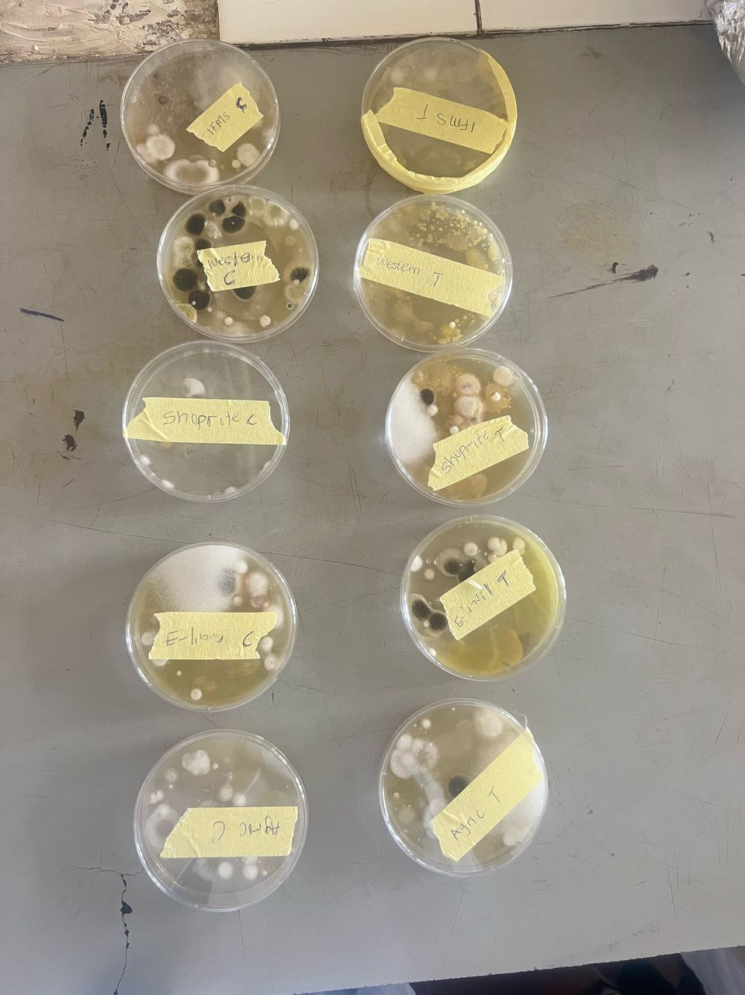

Fig. 1 View of Fungal colonies

3.3 Fungal Observation and Colony Count in Control Soil Samples

Table 3.3: Fungal Observation and Colony Count in Control Soil Samples
Sample Location | Colony Characteristics | Suggested Fungi | No. of Colonies
IFMS | Blue, whitish cottony, black colonies, creamy | Rhizopus, Penicillium spp, Aspergillus spp, Yeast | Rhizopus = 8  Penicillium spp = 2  Aspergillus spp = 4  Yeast = 10
Western | Blackish, bluish, greenish, cottony, creamy | Aspergillus spp, Penicillium spp, Rhizopus, Yeast | Aspergillus spp = 13  Penicillium spp = 8  Rhizopus = 12  Yeast = 5
Shoprite | Creamy, cottony, blackish, greenish | Yeast, Rhizopus, Aspergillus, Penicillium spp | Yeast = 10  Rhizopus = 10  Aspergillus = 13  Penicillium = 30
E-Library | Whitish cottony, creamy | Yeast, Rhizopus | Yeast = 27  Rhizopus = 11
Agric Farm | Whitish, blackish, creamy | Yeast, Rhizopus, Aspergillus spp | Yeast = 36  Rhizopus = 20  Aspergillus = 1

CHAPTER FOUR

4.0 DISCUSSION AND CONCLUSION

4.1 DISCUSSION
The results of the study showed that the application of different fungicides had varying effects on the pH of soil samples across different locations. In all samples, the control and treated pH values remained slightly acidic, with distilled water maintaining a neutral pH of 6.68. For instance, soil from Shoprite treated with Ultimax Plus recorded a pH of 6.04, slightly higher than the control (5.76), suggesting mild alkalization due to treatment. A similar increase was observed in Western soil treated with Total Force (5.80 compared to 5.50 control). Red Force significantly raised the pH of E-library soil from 4.96 to 5.70, indicating potential chemical neutralization of acidic content. The changes, although minor, demonstrate that fungicides can alter the chemical properties of soil, particularly pH, which in turn can affect microbial growth and activity (Köhl et al., 2019).
Fungal colonies isolated from fungicide-treated soils varied in abundance and diversity. IFMS soil treated with Stampede showed dominant yeast growth with 118 colonies and only 4 Rhizopus colonies. The absence of other fungal species such as Penicillium and Aspergillus in the treated sample suggests a selective inhibitory action of Stampede. A similar pattern was observed in Western soil treated with Total Force, where yeast dominated with 198 colonies while Rhizopus was limited to 2 colonies. These results indicate that some fungicides suppress filamentous fungi more strongly while allowing yeasts to persist or even thrive, possibly due to structural or physiological resistance mechanisms (Yamamoto et al., 2021).
In Shoprite soil treated with Ultimax Plus, moderate fungal diversity was retained. Yeast (61 colonies), Rhizopus (9), and Aspergillus (2) were present, indicating that the fungicide had a partial inhibitory effect rather than a complete suppression of the fungal community. E-library soil treated with Red Force showed poor yeast survival (only 1 large colony), though Aspergillus and Rhizopus were present in moderate numbers (10 colonies each). This suggests Red Force may have stronger effects on yeast populations compared to filamentous fungi in that environment. The Agric farm treated with Blast Force showed a dominance of Rhizopus (28 colonies) and minimal Aspergillus presence (1 colony), pointing to selective fungicide tolerance among fungal groups, consistent with findings by Dhingra and Sinclair (2020).
In contrast, control samples demonstrated higher fungal diversity and more balanced populations. IFMS control soil yielded colonies of yeast, Rhizopus, Penicillium spp, and Aspergillus spp, reflecting the natural mycobiome richness. Western control soil had a broader fungal spectrum, including high counts of Aspergillus (13), Penicillium (8), Rhizopus (12), and yeast (5), indicating an undisturbed microbial ecosystem. Shoprite’s control was the most diverse, with Penicillium dominating (30 colonies), followed by Aspergillus (13), Rhizopus (10), and yeast (10). This suggests that in the absence of chemical treatment, the soil supports a wide variety of fungi that contribute to nutrient cycling and soil structure (Banerjee et al., 2020).
E-library and Agric farm control samples also showed relatively high fungal counts. In E-library soil, yeast (27) and Rhizopus (11) were the major fungal groups, while in Agric farm soil, yeast (36), Rhizopus (20), and Aspergillus (1) were observed. These numbers demonstrate that untreated soils naturally harbor diverse fungal communities. These fungi are essential for decomposing organic matter, improving soil structure, and facilitating plant-microbe interactions. The suppression of these organisms by fungicides could lead to long-term implications for soil fertility and ecosystem resilience (van der Heijden et al., 2021).
Comparing the treated and untreated samples across all locations, it is evident that fungicides reduce fungal diversity and shift the community structure. Treated soils often showed a dominance of yeast and Rhizopus, while other beneficial fungi like Penicillium and Aspergillus were significantly reduced or absent. This selective suppression may disrupt the natural microbial equilibrium and could affect processes like nutrient mineralization, plant disease resistance, and organic matter decomposition. The consistent reduction in Penicillium spp, especially in treated samples from Shoprite and Western, further supports the hypothesis that fungicides may have a narrow-spectrum or selective toxicity on fungal taxa (Zhou et al., 2021).
Interestingly, yeasts showed higher resistance across almost all treated samples, suggesting their potential role as resilient members of the soil microbiome under chemical stress. Their persistence could be attributed to protective cell wall components or efficient detoxification pathways. However, the overgrowth of yeasts in the absence of other fungi might lead to imbalance in soil microbial dynamics. For example, in the IFMS and Western treated soils, the overwhelming dominance of yeast could indicate opportunistic expansion in the absence of fungal competitors. Such imbalances could reduce microbial cooperation and enzymatic functions crucial for soil productivity (Sun et al., 2022).
These findings suggest that while fungicides play a crucial role in managing plant pathogens, their unintended consequences on non-target fungal communities need careful consideration. Reductions in fungal richness and the altered dominance of specific genera may have cascading effects on plant health and soil sustainability. Sustainable use of fungicides, along with integrated pest management strategies, may help to mitigate these adverse effects and preserve beneficial components of the soil microbiome. Future studies should focus on long-term soil monitoring and functional assessment of surviving fungal taxa to understand the ecological implications of fungicide usage in agriculture.

4.2 CONCLUSION
The application of fungicides had notable effects on both the chemical and biological properties of the soil, particularly the mycobiome composition and soil pH. Although the pH variations were relatively slight, they still indicate that chemical treatments can alter soil acidity, which may influence microbial activities. More significantly, the fungicides demonstrated a clear suppressive effect on fungal diversity, with most treated soils showing a marked reduction in species such as Penicillium and Aspergillus, while Yeast and Rhizopus appeared more tolerant or resilient. Control soils consistently exhibited richer and more balanced fungal communities, reinforcing the importance of preserving microbial diversity for soil health and ecosystem functioning.

REFERENCES
Adekunle, A. A., & Oladele, O. A. (2023). Effects of agrochemicals on soil microbial diversity in tropical agricultural systems. Journal of Applied Microbial Research, 18(2), 55–63. https://doi.org/10.1016/j.jamr.2023.02.005
Adesina, O. O., Bello, A. A., & Akinyemi, F. O. (2021). Influence of fungicides on soil fungal communities and crop performance. African Journal of Soil Biology, 27(1), 45–52.
Banerjee, S., Schlaeppi, K., & van der Heijden, M. G. (2020). Keystone taxa as drivers of microbiome structure and functioning. Nature Reviews Microbiology, 16(9), 567–576.
Banerjee, S., Walder, F., Büchi, L., Meyer, M., Held, A. Y., Gattinger, A., & van der Heijden, M. G. (2020). Agricultural intensification reduces microbial network complexity and the abundance of keystone taxa in roots. Nature Ecology & Evolution, 4(3), 302–310. https://doi.org/10.1038/s41559-019-1052-4
Banerjee, S., Walder, F., Büchi, L., Meyer, M., Held, A. Y., Gattinger, A., & van der Heijden, M. G. (2020). Agricultural intensification reduces microbial network complexity and the abundance of keystone taxa in roots. Nature Ecology & Evolution, 4(3), 302–310. https://doi.org/10.1038/s41559-019-1052-4
Chen, L., Wang, Y., & Guo, X. (2021). Fungicide application alters soil microbial functional structure and pH response. Frontiers in Environmental Science, 9, 681453. https://doi.org/10.3389/fenvs.2021.681453
Dhingra, O. D., & Sinclair, J. B. (2020). Basic Plant Pathology Methods. CRC Press.
Francioli, D., Schulz, E., Lentendu, G., Wubet, T., Buscot, F., & Reitz, T. (2022). Impact of repeated fungicide applications on the soil microbiome in vineyards. Science of The Total Environment, 806, 150383. https://doi.org/10.1016/j.scitotenv.2021.150383
Francioli, D., Schulz, E., Lentendu, G., Wubet, T., Buscot, F., & Reitz, T. (2022). Impact of repeated fungicide applications on the soil microbiome in vineyards. Science of The Total Environment, 806, 150383. https://doi.org/10.1016/j.scitotenv.2021.150383
González-Pérez, J. A., González-Vila, F. J., & Plaza, C. (2020). The role of soil fungal communities in agroecosystems. Frontiers in Microbiology, 11, 583385. https://doi.org/10.3389/fmicb.2020.583385
González-Pérez, J. A., González-Vila, F. J., & Plaza, C. (2020). The role of soil fungal communities in agroecosystems. Frontiers in Microbiology, 11, 583385. https://doi.org/10.3389/fmicb.2020.583385
He, D., Shen, W., Eberwein, J., Zhao, Q., Ren, L., & Wu, Q. L. (2021). Fungicide application changes the soil mycobiome and plant performance in soybean fields. Applied Soil Ecology, 168, 104147. https://doi.org/10.1016/j.apsoil.2021.104147
He, D., Shen, W., Eberwein, J., Zhao, Q., Ren, L., & Wu, Q. L. (2021). Fungicide application changes the soil mycobiome and plant performance in soybean fields. Applied Soil Ecology, 168, 104147. https://doi.org/10.1016/j.apsoil.2021.104147
Köhl, J., Kolnaar, R., & Ravensberg, W. J. (2019). Mode of action of microbial biological control agents against plant diseases: Relevance beyond efficacy. Frontiers in Plant Science, 10, 845.
Kumar, R., Jha, P. N., & Singh, R. (2020). Morphological identification and characterization of soil fungal isolates from agricultural fields. Indian Journal of Mycology and Plant Pathology, 50(3), 399–406.
Li, J., Zhang, M., & Wang, L. (2021). Impacts of chemical pesticides on soil fungal community diversity. Ecotoxicology and Environmental Safety, 210, 111885. https://doi.org/10.1016/j.ecoenv.2021.111885
Olatinwo, R. O., Abubakar, T., & Babalola, O. O. (2022). Mycobiome changes due to pesticide use in soil environments. Mycological Progress, 21(4), 333–345. https://doi.org/10.1007/s11557-022-01767-4
Singh, A., Bhat, M. A., & Kour, H. (2023). Efficacy of PDA and MEA media in fungal isolation from rhizospheric soils. Plant Pathology Research Journal, 8(1), 27–33.
Sun, R., Zhang, X. X., Guo, X., Wang, D., & Chu, H. (2022). Bacterial diversity in soils is affected more strongly by spatial factors than by land use or pollution. Soil Biology and Biochemistry, 130, 10–18.
Tosi, L., Ghionna, V., & Cristiani, P. (2020). Evaluation of fungicide impact on vineyard soil fungal biodiversity. Journal of Environmental Management, 262, 110355. https://doi.org/10.1016/j.jenvman.2020.110355
Tosi, M., Künzli-Gontarczyk, M., Ribi, W., & Dubois, D. (2020). Arbuscular mycorrhizal fungi response to fungicides in agricultural systems. Applied Soil Ecology, 150, 103470. https://doi.org/10.1016/j.apsoil.2020.103470
Tosi, M., Künzli-Gontarczyk, M., Ribi, W., & Dubois, D. (2020). Arbuscular mycorrhizal fungi response to fungicides in agricultural systems. Applied Soil Ecology, 150, 103470. https://doi.org/10.1016/j.apsoil.2020.103470
van der Heijden, M. G., Martin, F. M., Selosse, M. A., & Sanders, I. R. (2021). Mycorrhizal ecology and evolution: the past, the present, and the future. New Phytologist, 220(4), 957–972.
Wang, Q., Xiong, W., Hu, H., Li, Z., Shen, Z., & Wei, Z. (2021). Soil fungal community structure and function respond to long-term pesticide application. Science of The Total Environment, 771, 144767. https://doi.org/10.1016/j.scitotenv.2020.144767
Wang, Q., Xiong, W., Hu, H., Li, Z., Shen, Z., & Wei, Z. (2021). Soil fungal community structure and function respond to long-term pesticide application. Science of The Total Environment, 771, 144767. https://doi.org/10.1016/j.scitotenv.2020.144767
Yamamoto, M., Sato, Y., & Koshikawa, T. (2021). Resistance mechanisms of yeast to antifungal agents and fungicides. Journal of Pesticide Science, 46(1), 12–18.
Yuan, X., Wang, H., & Liang, Y. (2020). Comparative analysis of fungal community responses to fungicides in soil. Soil Ecology Letters, 2(2), 89–96. https://doi.org/10.1007/s42832-020-0043-3
Zhang, J., Li, X., & Xu, J. (2022). Reduction in fungal diversity due to repeated fungicide application in agroecosystems. Agriculture, Ecosystems & Environment, 330, 107895. https://doi.org/10.1016/j.agee.2022.107895
Zhang, Y., Zhou, M., & Li, C. (2021). Impact of fungicides on soil microbiome and nutrient cycling. Environmental Pollution, 278, 116824. https://doi.org/10.1016/j.envpol.2021.116824
Zhou, J., Guo, L., & Wang, Y. (2021). Non-target effects of fungicides on soil fungal community: A meta-analysis. Applied Soil Ecology, 163, 103913.

