A PROJECT REPORT
ON
PROPOSED PRIMARY SCHOOL
FOR
IGBETI OYO STATE.

By:
MUSA SAHEED
ND/23/ARC/FT/0001

Submitted to:
THE DEPARTMENT OF ARCHITECTURAL TECHNOLOGY INSTITUTE OF ENVIRONMENTAL STUDIES (IES) KWARA STATE POLYTECHNIC, ILORIN

IN PARTIAL FULFILMENT OF THE REQUIREMENTS FOR THE AWARD OF NATIONAL DIPLOMA (ND) IN ARCHITECTURAL TECHNOLOGY

JULY, 2025.
DECLARATION
I declare that this design project/Dissertation is a project of my personal work. It has been presented for the award of any National Diploma in any Polytechnic. The ideas, observation, comment, suggestions herein represent my own convictions, except quotations, which have been acknowledged in accordance with conventional academic traditions.
MUSA SAHEED __________________________
ND/23/ARC/FT/0001 DATE/SIGNATURE

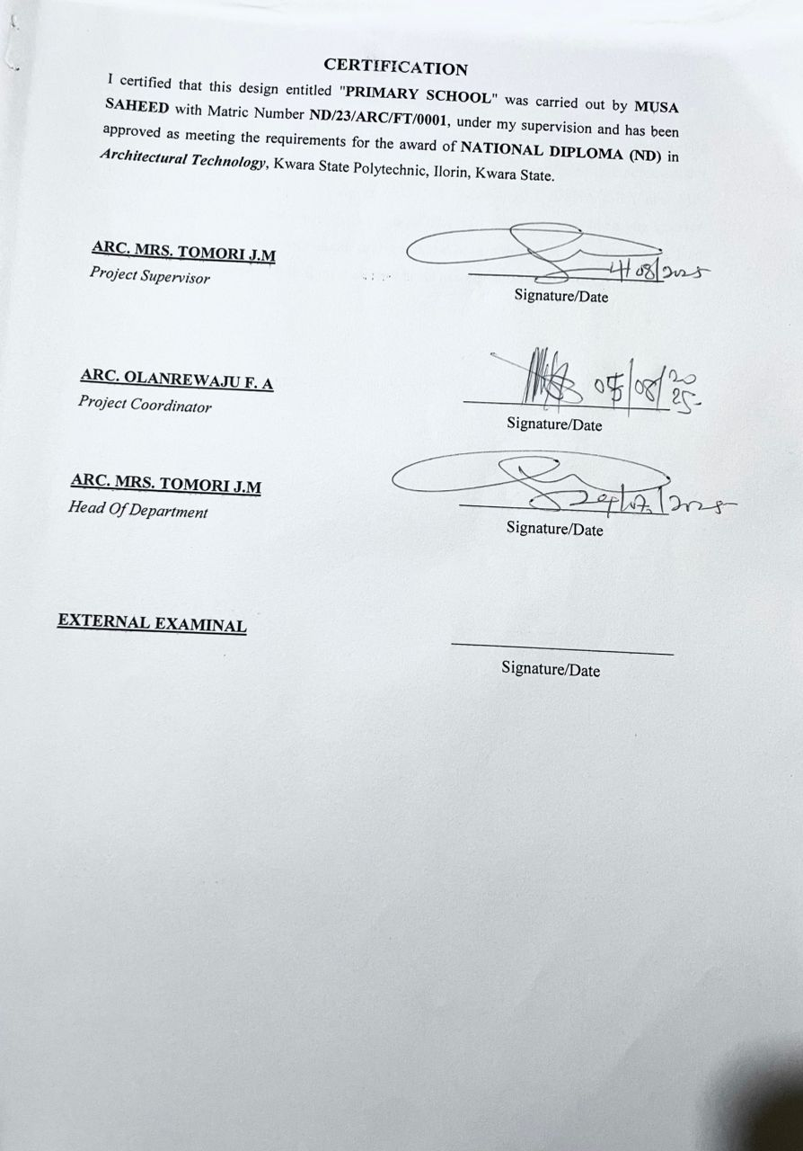

ACKNOWLEDGEMENTS
Everything that has beginning must have an end , I express my deepest gratitude to Almighty God for granting me the strength, wisdom, and perseverance to successfully complete this project. His guidance and blessings have been my greatest support throughout this journey
- A very special thanks to my supervisor, {ARC. MRS. J.M TOMORI}, for their invaluable guidance, patience, and constructive feedback. Their expertise and mentorship have played a crucial role in shaping this project, and I am truly grateful for their support.

- I would also like to thank my lecturers, and mentors for their invaluable guidance, constructive feedback, and knowledge that have contributed immensely to my growth in architecture.

- I extend my heartfelt appreciation to my parents {ALHAJI. MUSA ALI ADUA GBA} and {MR. NAFIU ALAWIYE} for their unwavering love, encouragement, and sacrifices. Their constant support and belief in me have been a source of motivation.

- My sincere appreciation goes to my friends and colleagues who have provided encouragement, advice, and companionship throughout this project. Their support has made this experience more fulfilling.

Thank you all for being part of this journey.
iv
DEDICATION
Dedicate this project to Almighty God, the source of my wisdom, strength, and inspiration. His grace has guided me through every challenge, and His blessings have made this achievement possible. And I also to my beloved parents, ALHAJI. MUSA ALI ADUA GBA and MR. ALAWIYE NAFIU whose unwavering love, sacrifices, and support have been my greatest motivation. Their prayers, encouragement, and guidance have shaped me into the person I am today. This project is a testament to their endless efforts and belief in my dreams.
ABSTRACT
A primary school is an educational institution that provides foundational learning for children, typically between the ages of 4 to 12 years. It serves as the first stage of formal education, focusing on basic literacy, numeracy, and social development. Primary education is essential for cognitive growth, character building, and preparing students for secondary education.

Primary schools serve as the foundation of formal education, shaping young minds to become knowledgeable, disciplined, and socially responsible individuals. They provide a safe and structured environment where children can learn, explore, and grow. Whether public or private, traditional or alternative, primary schools remain essential in preparing students for future academic and life challenges.

Primary schools play a vital role in shaping children’s academic and personal development. With a structured curriculum, trained educators, and a supportive environment, they lay the groundwork for future educational success. Their characteristics ensure a balanced approach to learning, socialization, and skill development, preparing students for the next stage of their education.

TABLE OF CONTENTS
TITLE PAGE…………………………………………………………………..........i
DECLERATION………………………………………………………………...…. ii
CERTIFICATION………………………………………………………………….. iii
DEDICATION……………………………………………………………………… iv
ACKNOWLEGDMENT……………………………………………………………..v
TABLE OF CONTENTS…………………………………………………………… vi
LIST OF TABLES……………………………………………………………….…. vii
LIST OF FIGURES………………………………………………………………… viii
LIST OF PLATES………………………………………………………………….. ix
LIST OF APPENDICES…………………………………………………………..….x
ABSTRACT……………………………………………………………………...…. xi
CHAPTER ONE
1.0 INTRODUCTION………………………………….………….………………………1
1.1 HISTORICAL BACKGROUND…………………………….………………..………2
1.2 DEFINITION…………………………….…………………….…...…………………3
1.3 STATEMENT O F THE RESEARCH PROBLEM. ………………………………….3
1.4 AIM AND OBJECTIVES………………………………………..………………..…..3
1.5 JUSTIFICATION………………………………………………………………….…..4
1.6 SCOPE OF STUDY………………………………………………………………..…4
1.7 LIMITATIONS OF STUDY………………………………………………………..…4
1.8 RESEARCH METHODOLOGY…………………………………………………...…5

vii

CHAPTER TWO

2.1 LITERATURE REVIEW …………………………….…………………………………. 6
2.1.1 INTRODUCTION………………………………………………………………………...6
2.1.2 IMPORTANT ISSUES AND PROBLEMS PECULIAR TO PRIMARY SCHOOL TYPOLOGY……………………………………………………………………………………....7
2.1.3 TECHNOLOGICAL AND ENVIRONMENTAL APPROACHES FOR DESIGNING A PRIMARY SCHOOL……………………………...……………………………….………..8
2.2 MERIT OF STUDYING……………………………….………………………….…10
2.3 CONCLUSION …………………………………………….……………………….10

CHAPTER THREE
3.0 CASE STUDY…………………………………………………….………….….…. 11
3.1 OUTLINES OF THE CASE STUDIES………………………………...…….….. 11
3.1.1 CASE STUDY ONE (1): NUD 1 Primary School Oyo State…….………………….11
3.1.2 CASE STUDY TWO (2): ST Paul Nur & Pry School Ekiti State……………...…….16
3.1.3 CASE STUDY ONE (3): BTTR Nur & Pry School Kwara Sta....................................19
3.1.4 CASE STUDY FOUR (4): …………………………………………………….…….23

CHAPTER FOUR
4.1 ANALYTICAL STUDY OF THE PROJECT LOCATION…………………………24
4.1.1 INTRODUCTION…………………………………………………………………….24
4.1.2 SITE LOCATION…………………………………………………………………….24
4.1.3 SITE INVENTORY…………..…...………………………………………….………26
4.1.4 SITE ANALYSIS………………...…………………………………………….……..26
4.1.5 GENERAL GEOGRAPHICAL CONDITION…………………….……………..….27
4.1.6 CLIMATE …………………………………………………………………………………...27
4.1.7 VEGETATION………………...………………………………………………..…..29
4.1.8 TOPOGRAPHY………………...……………………………………………… …..29
4.1.9 NATURAL RESOURCES………………...…………………………………….… 29
4.1.10 ENVIRONMENTAL CHALLENGES…………………………………………… ..29
4.1.11 SITE SERVICES………………………………………………………………… …30
4.1.12 SITE UNIQUENESS AND BENEFIT………………………………………………30
4.1.13 SITE SUITABILITY……………………………………………………………….30
4.2. DESIGN CRITERIA……………………………………………………………….30
4.2.1 SITE SELECTION………………………………………………………...……….30
4.2.2 BUILDING ARRANGEMENT…………………………………………………….31
4.2.3 DESIGN SCOPE…………………………………………...……………………….31
4.2.4 DESIGN BRIEF 9ANALYSIS…………………………………………………….31
4.2.5 SPACES DERIVATION ANALYSIS/SCHEDULE FOR ADMINBLOCK………32
4.2.6 FUCTIONAL ANALYSIS AND RELATIONSHIP………………………………32

CHAPTER FIVE
5.1 APPRAISAL OF PROPOSED SCHEME………………………………………….34
5.2 CONSTRUCTION METHODOLOGY AND MATERIALS. …………………….34
5.21 MATERIALS FOR CONSTRUCTION……………………………………………34
5.2.2 CONSTRUCTION METHODOLOGIES………………………………………….34
5.2.1 SERVICE……………………………………………………………………….….36
5.2.2 CIRCULATION……………………………….……………………………….….36
5.2.3 VENTILATION……………………………………….……………………….….36
5.2.4 LIGHTING……………………………………….……………………………….37
5.2.5 PLUMBING ……………………………………….……………….…………….37
5.2.6 ELECTRICAL INSTALLATION……………………………..………………….37
5.2.7 WASTE DISPOSAL……………………………………….…….……………….37
5.2.8 FIRE PROTECTION……………………………………………………………..38
5.2.9 EXTERNAL WORKS……………………………………………..……………..38
5.3 CONCLUSION AND RECOMMENDATION………………………………….38
REFERENCES………………………………………………………………………….39

LIST OF PLATES
CASE STUDY 1
PLATE 3:1.1 LOCATION MAP………………………………………………………….13
PLATE 3.1.2 ELEVATION ……………………………………………..……………….14
PLATE 3.1.3 ELEVATION……………… ……………………………………………….15
PLATE 3.1.4 ELEVATION……………..……………………………………...………….15
CASE STUDY 2
PLATE 3.2.1 ELEVATION………………………………………………………………18
PLATE 3.2.2 STAFF OFFICE. ………………………………………………………….18
CASE STUDY 3
PLATE 3.3.1 LOCATION MAP………………………………………………………….20
PLATE 3.3.2 ELEVATION……………………………………………………………….21
PLATE 3.3.3 ELEVATION…..…………...……………………………………...……….22
PLATE 3.3.4 ELEVATION…...…………...……………………………………….……...22

LIST OF FIGURES
FIGURE 3:1:1 LOCATION PLAN CASE STUDY 1…………………………..………12
FIGURE 3.1.2 FLOOR PLANS CASE STUDY 1…….………………………….…..…13
FIGURE 3:1.3 SITE PLAN CASE STUDY 1 ……………………...……………………14
FIGURE 3.2.1 LOCATION PLAN CASE STUDY 2……………………………………15
FIGURE 3.2.2 FLOOR PLANS CASE STUDY 2……………………………….…….…15
FIGURE 3.3.1 LOCATION PLAN CASE STUDY 3……………………………….……20
FIGURE 3.3.2 FLOOR PLAN. CASE STUDY 3…………………..…………………..…21
FIGURE 4.1.11.1 MAP OF NIGERIA, 36 STATES AND FCT. ……………..………….24
FIGURE 4.1.11.2 OYO STATE MAP………..……………………………..……………...25
FIGURE 4.1.11.1 LOCATION PLAN …………………………………..………….……...25
FIGURE 4.1.12.1 SITE INVENTORY …………………………………….……….………26
FIGURE 4.1.12.2 SITE ANALYSIS ……………………………..………..……….………27
FIGURE 4.1.3.1 AVERAGE MONTHLY RAINFALL IN ILORIN. …….….…………….28
FIGURE 4.1.3.2 SUNSHINE DURATION IN ILORIN. ………………………..………….28
FIGURE 4.1.3.3 RELATIVE HUMIDITY IN ILORIN. ………………………..…………..29
FIGURE 4.2.6.1: FUNCTIONAL ANALYSIS 1 ……………………………………………32
FIGURE 4.2.6.2: FUNCTIONAL ANALYSIS 2 ……………………………………………32
FIGURE 4.2.6.3: FUNCTIONAL RELATIONSHIP 1 …………………………….………..33
FIGURE 4.2.6.4: FUNCTIONAL RELATIONSHIP 2 ………………………………………33

LIST OF TABLES

TABLE 4.1.1: SPACE ALLOCATION………………………………………………32

xii
LIST OF APPENDICES
APPENDICES 5.1: GROUND FLOOR PLAN…………………………………………..40
APPENDICES 5.2: FIRST FLOOR PLAN. ……………………………………………..40
APPENDICES 5.3: SECON FLOOR……………………………………………………..41
APPENDICES 5.4: ROOF PLAN ………………………………………………………..41
APPENDICES 5.5: SITE PLAN……………………………………………………..…..42
APPENDICES 5.6: SECTIONS……………………………………………………..…..42
APPENDICES 5.7: ELEVATION……………………………………………….…..…..43
APPENDICES 5.8: EXTERNAL PERSPECTIVE. …………………………………….43

CHAPTER ONE

INTRODUCTION
Primary School Education is the foundation of individual and societal development, and primary education serves as the first formal stage in this lifelong journey. A primary school is an institution designed to provide basic education to young children, typically between the ages of 5 and 12 years. It is within these formative years that children acquire essential skills in reading, writing, arithmetic, communication, and moral values, which prepare them for further education and responsible citizenship.
The role of a primary school goes beyond academic instruction; it also supports the social, emotional, and physical development of the child. A well-planned and functional primary school environment plays a key role in stimulating curiosity, creativity, and self-confidence among learners.
In modern times, the design of a primary school must consider several factors, including safety, accessibility, ventilation, natural lighting, flexible classroom layouts, and recreational facilities. The architecture of the school should be child-friendly, inclusive, and sustainable, ensuring that every student can learn in a supportive and inspiring environment.
This project focuses on the architectural design of a standard primary school that meets the educational, social, and environmental needs of young learners. It aims to contribute to nation-building by creating a learning space where children can thrive and reach their full potential.

1.1 HISTORICAL BACKGROUND OF THE PROJECT
The concept of primary education has evolved over thousands of years, driven by the need to pass knowledge, values, and skills from one generation to the next. In early societies, education was informal and often occurred at home or in communal settings, with children learning by observing elders and participating in daily tasks. As civilizations developed, so did the idea of structured learning environments — eventually leading to what we now know as primary schools.
Ancient Times
In ancient Egypt, Greece, and Rome, children from wealthy families were taught basic reading, writing, and arithmetic by private tutors or in simple learning halls. However, education was not widely accessible to the general population. These early learning centers laid the groundwork for formal schooling systems.
Medieval Period
During the medieval era, especially in Europe, education was largely controlled by religious institutions. Churches and monasteries provided early forms of formal education, mostly focusing on religious texts. The idea of primary schools as we understand them today did not exist on a wide scale.
Industrial Revolution
The Industrial Revolution of the 18th and 19th centuries marked a significant turning point. Urbanization and the demand for a literate workforce led governments to recognize the need for structured basic education. Many countries began establishing public primary schools to provide free or low-cost education to children from all backgrounds.
Primary Education in Nigeria
In Nigeria, primary education began in the early 19th century through the efforts of Christian missionaries, who established schools in the southern regions. The British colonial government later supported the expansion of primary schools, although access remained limited in some regions.
After Nigeria’s independence in 1960, the government took greater responsibility for education. The launch of the Universal Primary Education (UPE) program in 1976 and later the Universal Basic Education (UBE) program in 1999 aimed to provide free, compulsory, and quality primary education to all Nigerian children.
1.2 DEFINITION
A primary school is a formal educational institution designed to provide the first stage of compulsory education for children, typically between the ages of 5 and 12 years. It marks the beginning of structured learning, where pupils are introduced to fundamental subjects such as reading, writing, mathematics, science, social studies, and moral education.
Primary education plays a crucial role in developing literacy, numeracy, communication, critical thinking, and social interaction skills, which serve as the foundation for further learning and lifelong development.

Key Features of a Primary School:
- It offers early childhood education immediately after pre-primary or nursery school and before secondary school.
- Learning is guided by a national curriculum; ensuring students receive standard foundational knowledge.
- The environment is designed to be safe, inclusive, child-friendly, and engaging, supporting both academic and emotional development
1.3 STATEMENT O F THE RESEARCH PROBLEM.
In Oyo State, as in many parts of Nigeria, the standard of physical infrastructure in public and some private primary schools remains a significant concern. Many schools in urban and rural areas are faced with poorly designed buildings, overcrowded classrooms, inadequate ventilation, insufficient learning facilities, and a lack of safe recreational spaces. These conditions negatively impact students’ academic performance, health, and overall development.
Although the Oyo State government has made efforts through various educational initiatives and renovation programs, the architectural quality and long-term sustainability of many primary school buildings have not kept pace with modern standards. Furthermore, most school environments are not tailored to meet the psychological and developmental needs of young children, nor are they inclusive for children with disabilities.
Climate-specific design, child-focused planning, and flexible classroom arrangements are often missing in existing structures. In addition, with rising population growth and urban expansion in cities like Ibadan, Ogbomoso, and Oyo town, there is a growing need for a comprehensive and innovative architectural response that addresses these challenges.
This study therefore seeks to develop a functional, child-friendly, and sustainable primary school design that meets the educational, environmental, and cultural needs of learners in Oyo State, with a focus on improving learning outcomes and long-term usability of school facilities.
1.4 AIM AND OBJECTIVES
1.4.1 AIM OF THE STUDY
The aim of this study is to design a functional, inclusive, and sustainable primary school that provides a safe, child-friendly, and stimulating learning environment, while addressing the architectural, educational, and environmental challenges currently facing basic education.
1.4.2 OBJECTIVES
- To design a functional and flexible learning environment that supports effective teaching and accommodates modern educational methods.
- To create a child-friendly architectural design that promotes comfort, safety, and psychological development for young learners.
- To provide adequate academic and non-academic facilities, including classrooms, administrative offices, library, ICT room, toilets, playgrounds, and a multipurpose hall.
- To ensure proper spatial planning for efficient circulation, security, and accessibility within the school premises.
- To incorporate sustainable and locally available materials and adopt passive design strategies such as natural lighting and ventilation
1.5 JUSTIFICATION.
Primary education is the foundation upon which all future learning is built. However, in many parts of Nigeria, including both urban and rural areas, the architectural design of primary schools often fails to meet the basic physical, psychological, and developmental needs of young learners. Poor ventilation, overcrowded classrooms, lack of recreational spaces, and inadequate sanitation facilities are common problems that hinder effective learning and child development.

1.6SCOPE OF THE STUDY
This study focuses on the architectural design of a standard primary school that meets both national and international educational design standards. The scope includes the planning and design of the following:
- Academic Spaces – Classrooms for different grade levels (Primary 1–6), staff room, library, ICT room, and multipurpose hall.
- Administrative Offices – Head teacher’s office, secretary’s office, record/store room, and general administrative area.
- Recreational and Outdoor Areas – Playground, open assembly area, landscaped spaces, and sports activity zones
- Support Facilities – Sickbay, canteen, gender-separated toilets, and adequate parking for staff and visitors.
- Site Planning and Environmental Considerations – Proper circulation routes, security, drainage, water supply, and sanitation systems.

1.7 LIMITATIONS OF STUDY
The limitation experienced during this course of study includes:
- Engineering Details Not Covered – The study focuses on architectural planning and design. Detailed structural, mechanical, electrical, and plumbing (MEP) engineering drawings are beyond its scope.
- Cost Estimates Excluded – This project does not provide a detailed bill of quantities or cost analysis for construction.
- Site-Specific Data May Be Generalized – In the absence of access to full geotechnical, topographical, or hydrological surveys, some site planning elements may be based on typical assumptions.
- Time Constraints – Due to academic time limitations, some design explorations and case study analyses may be summarized rather than deeply explored.
- Policy and Legal Review – The study does not include a full review of all local building codes or government regulations that may apply during actual construction.

1.8 RESEARCH METHODOLOGY
This study adopted a qualitative research approach aimed at gathering data to support the design of a functional, inclusive, and sustainable primary school. The methodology involved the following key stages:
- Literature Review
Analysis of existing academic works, journals, and design guidelines related to school architecture, child-centered learning environments, and educational space planning.
- Case Study Analysis
Examination of selected local and international primary school projects to understand spatial arrangements, materials used, environmental strategies, and functional zoning.
Focus was placed on identifying best practices in design, sustainability, and child safety.
- Site Analysis
Observation and assessment of the proposed site (if available), including location, orientation, access, topography, climate, and surrounding land use
Environmental factors such as sun path, wind direction, and rainfall patterns were also considered for passive design strategies.

CHAPTER TWO
2.1LITERATURE REVIEW OF PRIMARY SCHOOL
2.1.1 Introduction
The literature review explores previous studies, architectural standards, and educational policies relevant to the design of primary schools. It provides insight into the principles and practices that guide the creation of effective learning environments for children.
- Educational Space Design Principles
Scholars like Neufert (Architects' Data) and sources such as the UNICEF School Infrastructure Guidelines emphasize that primary schools should be designed to promote safety, comfort, flexibility, and learning stimulation. Classrooms must be well-lit, well-ventilated, and spacious enough to support various teaching styles and group sizes. Ergonomic furniture and age-appropriate materials are crucial for early childhood learning.
- Child-Centered Architecture
Research by Maria Montessori and later architectural theorists highlights the need for environments that support independent exploration, creativity, and inclusiveness. Classrooms should allow for mobility, interaction, and accessibility for all children—including those with disabilities.
2.1.2 IMPORTANT ISSUES AND PROBLEMS PECULIAR TO PRIMARY SCHOOL TYPOLOGY
The design and functionality of primary schools in many developing regions, including Nigeria, face several critical challenges that affect both the learning process and the well-being of pupils. These issues are outlined below:
- Overcrowding
Many public primary schools experience excessive student enrolment with insufficient classroom space. This leads to overcrowded classrooms, poor ventilation, and noise pollution, which hinder concentration and effective teaching.
- Poor Ventilation and Lighting
Inadequate windows, poor building orientation, and lack of passive ventilation result in hot and uncomfortable learning environments. Insufficient natural lighting also causes eyestrain and fatigue among pupils.
2.1.3 TECHNOLOGICAL AND ENVIRONMENTAL APPROACHES FOR DESIGNING A PRIMARY SCHOOL.
In primary school architecture, especially at the primary level, it is essential to integrate both technological innovation and environmental consciousness to create functional, sustainable, and engaging learning spaces. Below are the key approaches.
7
🔧 TECHNOLOGICAL APPROACHES
- Smart Classrooms
- Integration of projectors, interactive whiteboards, and audio-visual tools to enhance learning experiences.
- Provision for electricity and data cabling to support digital education and future upgrades.
- Modular Construction
- Use of prefabricated materials or modular blocks to reduce construction time and allow for future expansion or relocation.
- Security Technology
- Installation of CCTV cameras, intercom systems, and secure entry points to enhance student safety.
- Rainwater Harvesting Systems
- Use of tanks and filters to collect and purify rainwater for school use, reducing dependence on public water supply.
- Solar Energy
- Integration of solar panels for electricity generation to support lighting, fans, and small appliances, especially in off-grid locations.

🌿 ENVIRONMENTAL APPROACHES
- Passive Ventilation Design
- Strategic window placement, cross ventilation, and roof vents to improve airflow and reduce heat build-up without relying on air conditioning.
- Day lighting
- Use of large windows, clerestory lighting, and skylights to maximize natural light in classrooms, reducing the need for artificial lighting.
- Use of Local and Eco-Friendly Materials
- Clay bricks, bamboo, rammed earth, or compressed stabilized blocks (CSBs) reduce carbon footprint and support the local economy.
- Green Landscaping
- Planting trees and grass to create shaded areas, reduce heat, and improve air quality within the school compound.
- Waste Management Systems
- Provision for waste sorting bins, composting zones, and safe disposal systems to teach environmental responsibility.

- Thermal Comfort Design
- Thick walls, shaded verandas, reflective roofs, and overhangs to reduce indoor temperatures and improve comfort.

✅ BENEFITS OF THESE APPROACHES
- Improve learning and concentration
- Reduce running costs (light, water, maintenance)
- Promote sustainability and environmental education
- Provide safer and healthier learning environments

CHAPTER THREE

3.0 CASE STUDY
A case study involves an up-close, in-depth, and detailed examination of a particular case or cases, within a real-world context. Case study research is to establish a firm research focus to which the research can refer over the course of a complex phenomenon or object.
Case study can be view as the study of an existing project for a reference purpose in order to determine adjustment point of that particular building. Case study research is to establish a firm research focus to which the research can refer over the course of a complex phenomenon or object.
According to researcher Robert K. Yin, defined case study method as an empirical inquiry that investigate a contemporary phenomenon within its real-life context,

3.1 OUTLINES OF THE CASE STUDIES
- NUD 1 Primary School Igbeti Oyo State
- ST Paul Nur & Pry School Odo Ado Ekiti State
- BTTR Nur & Pry School Osin Idi-Emi Kwara State

3.1.1CASE STUDY ONE (1): NUD 1 PRIMARY SCHOOL
Date of Establishment:
Architect: Unknown
Location: Igbeti Oyo State
Brief Description:

N.U.D. 1 Primary School is a public basic school located in Igbeti, a town in Olorunsogo Local Government Area, Oyo State, Nigeria. The school serves children in the local community, providing foundational education from Primary 1 to Primary 6. It operates under the supervision of Oyo State SUBEB.
Climate: Tropical wet and dry climate
Topography: Rocky hills and elevated terrain
Vegetation: Guinea Savanna
Merits:
- The building area is well ventilation and well lighting
- Accessibility for all students
- Aesthetic Design

Demerits:
- There’s no storage space
- Overcrowded Classrooms
- Noise Pollution

LOCATION PLAN

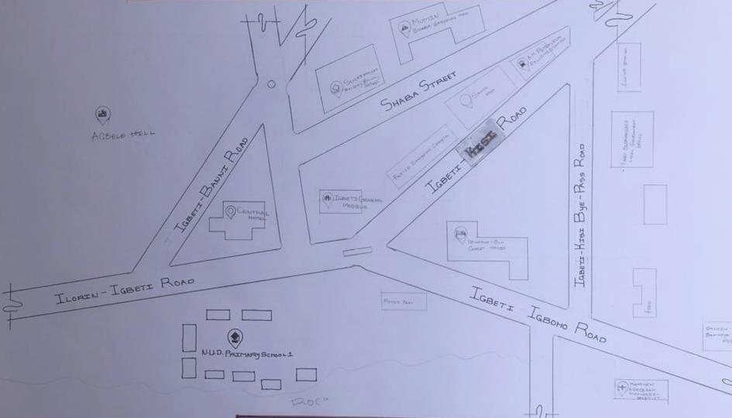

Figure 3:1:1 Location Plan
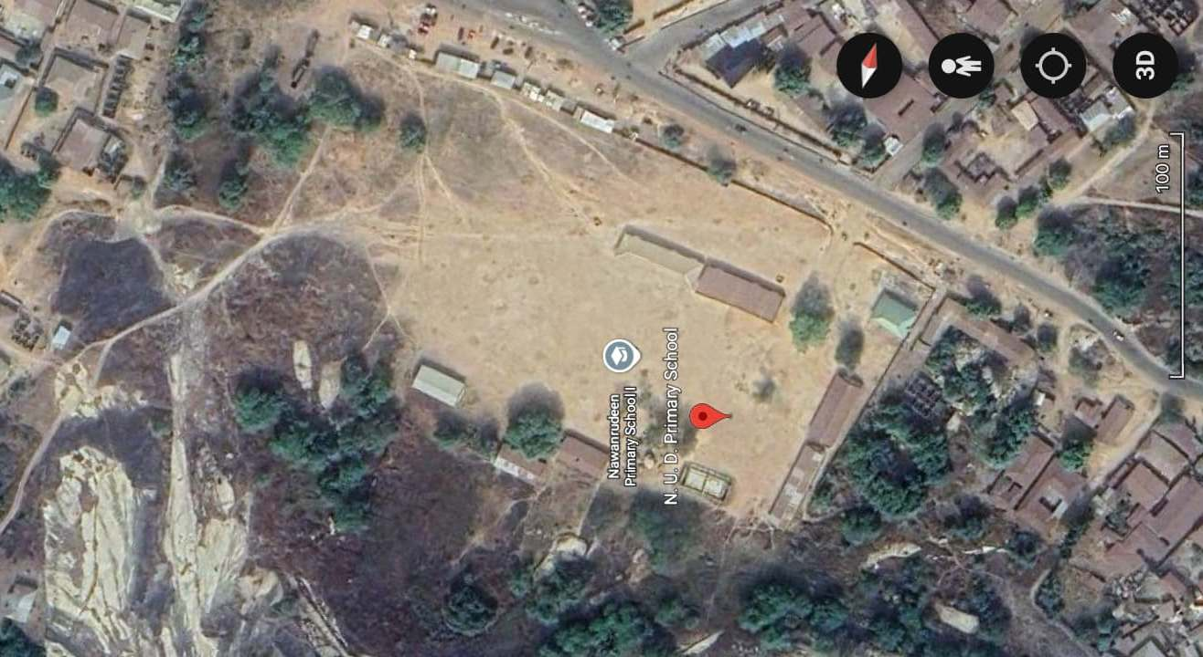

Plate 3:1.1Geographical Layout

SITE PLAN
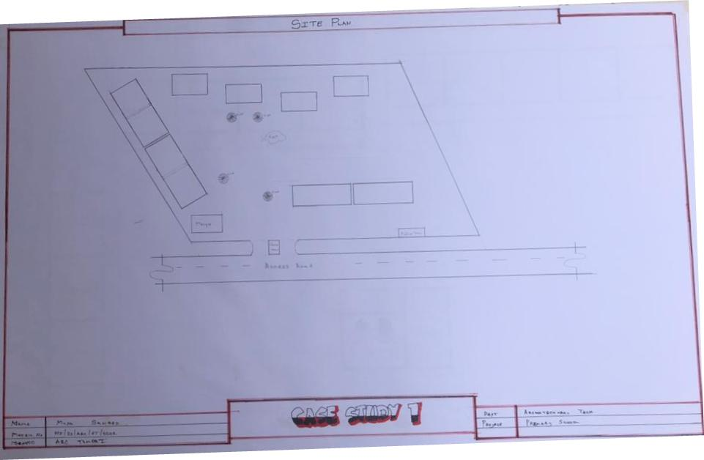
Figure 3.1.2Site Plan

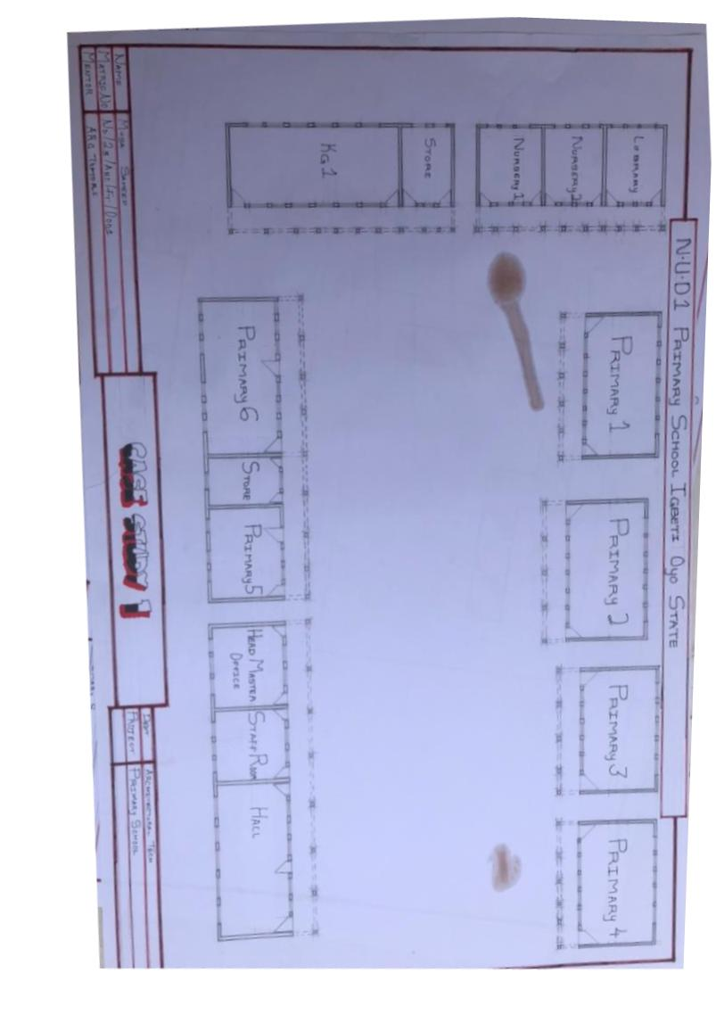
FLOOR PLAN

Figure 3:1.3Floor Plans

PICTURES
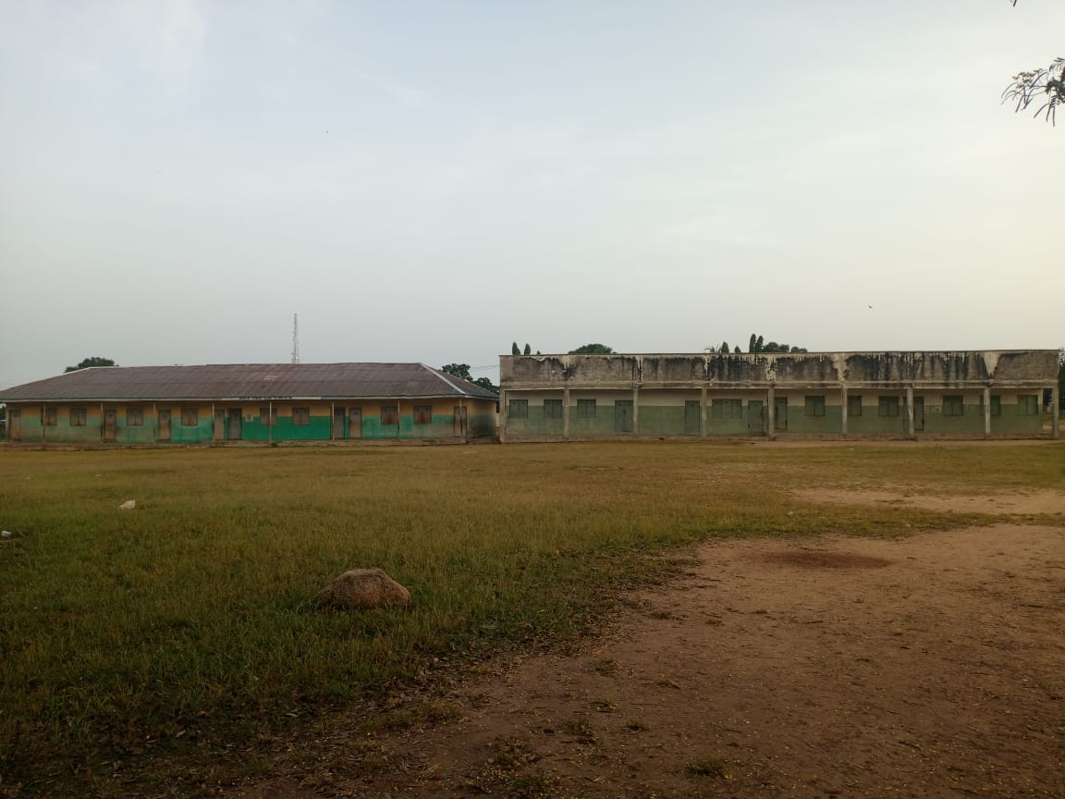

Plate 3.1.2Elevation

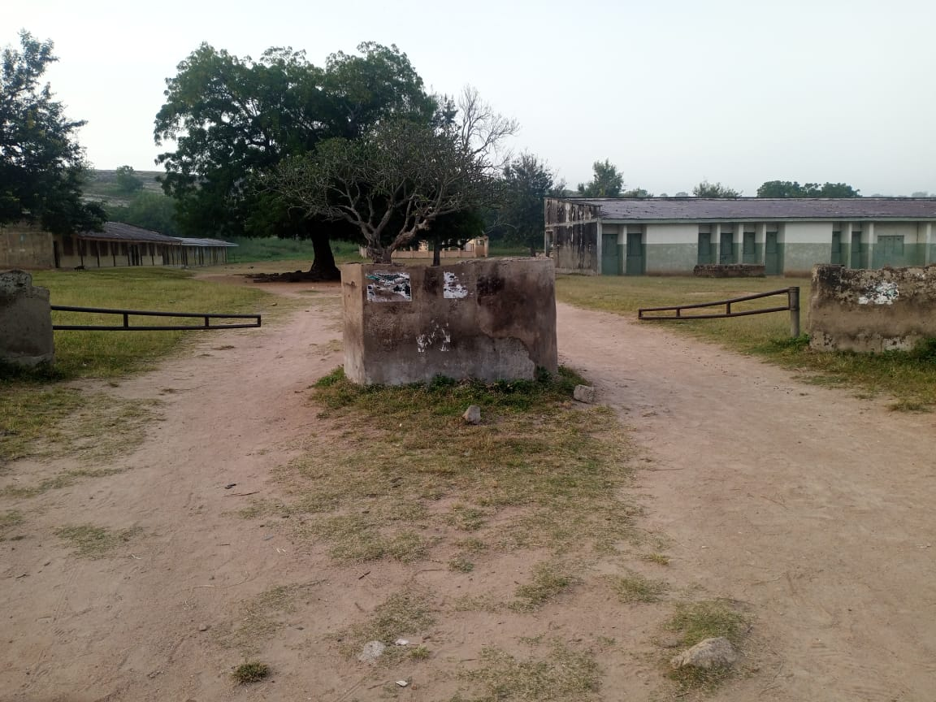
Plate 3.1.3School

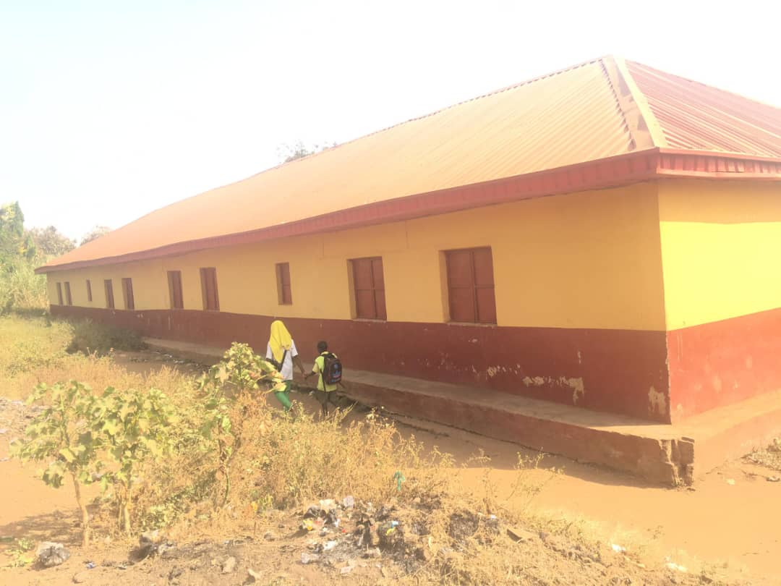
Plate 3.1.4 Elevation

14
3.1.2 CASE STUDY TWO (2): ST Paul Nur & Pry School Odo-Ado, Ekiti State
Date of Establishment: Unknown
Architect: Unknown
Location: Odo-Ado, Ado Ekiti State.

Brief Description:
St Paul Nursery & Primary School is a local educational institution in Odo‑Ado, a community within Ado‑Ekiti Local Government Area of Ekiti State, Nigeria. Precise details such as enrollment figures, curriculum specifics, and facilities are not publicly listed. Typically, such schools follow the Nigerian Universal Basic Education (UBE) curriculum, serving Nursery through Primary levels and operated under supervision of Ekiti State SUBEB.
Climate: Tropical climate.
Topography: Rocky and Hills
Vegetation: Guinea Savanna

Merits
- Affordable Education
- Low or no tuition fees, making it accessible to children from low-income families.
- Community-Based Learning
- Located within the Odo-Ado community, making it easy for local children to attend without long travel.
- Moral and Religious Foundation
- If mission-based (like many St. Paul schools), it may include Christian moral teachings alongside academics.
Demerits
- Limited Facilities
- May lack modern infrastructure such as ICT labs, libraries, or modern playgrounds.
- Overcrowded Classrooms
- Public and mission schools sometimes face high pupil-to-teacher ratios due to high enrollment.
- Insufficient Learning Materials
- Textbooks, stationery, or teaching aids may be limited or outdated.
LOCATION PLAN
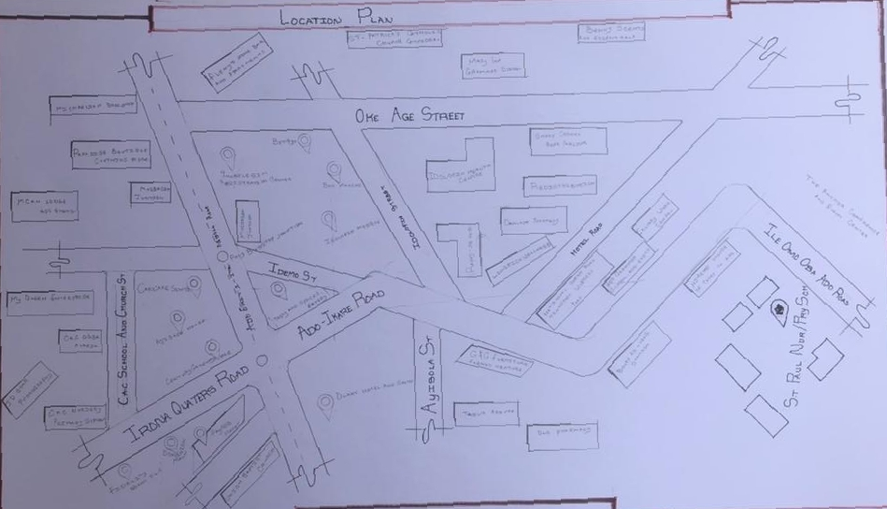
Figure 3.2.1Location Plan
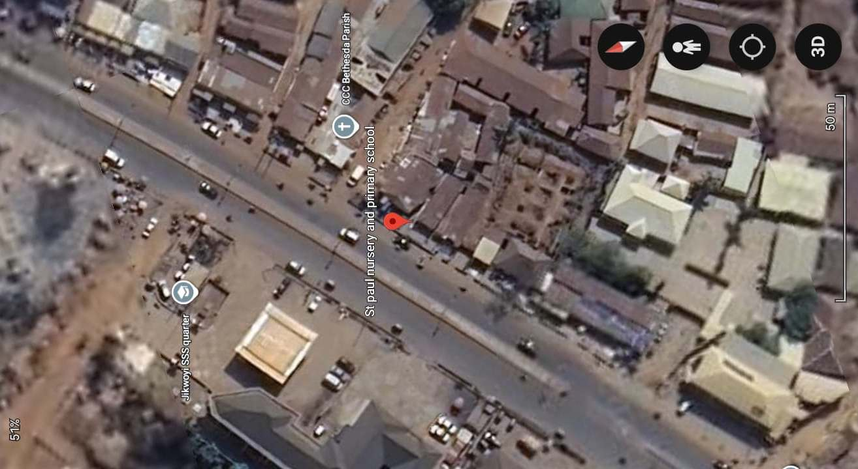
Plate 3.2.1 Geographical Layout

FLOOR PLAN
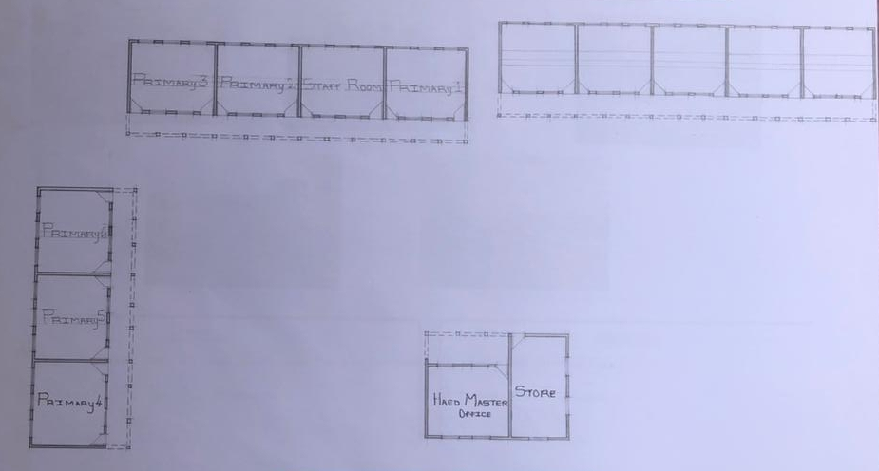

Figure 3.2.2 Floor Plans
PICTURES
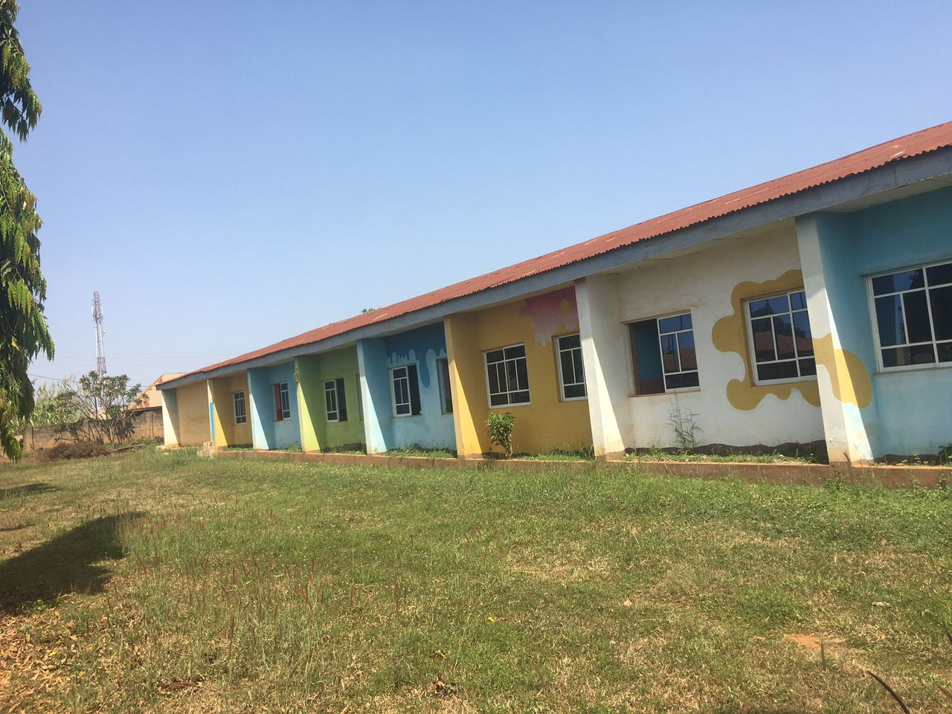
Plate 3.2.2 Back Elevation

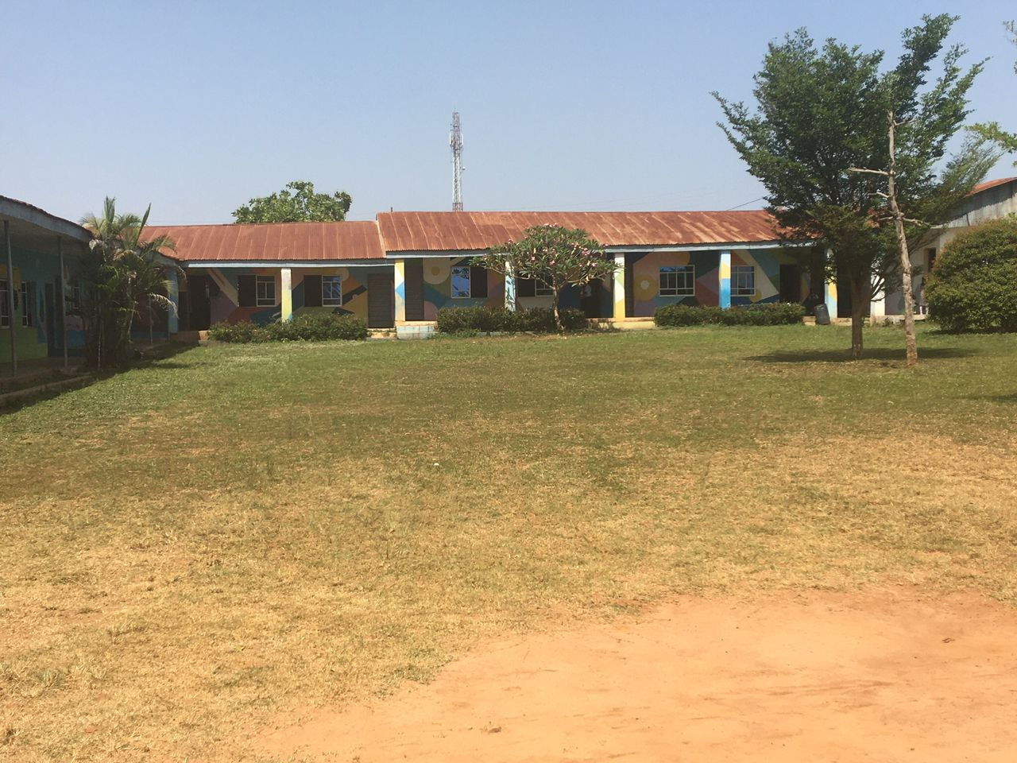

Plate 3.2.3 Front Elevation

3.1.3 CASE STUDY ONE (3): BTTR Nur & Pry School Ilorin, Kwara State
Date of Establishment: 2003
Architect: Unknown
Location: Osin, Off Asa-Dam Road, Ilorin, Kwara State Nigeria.

Brief Description:
BTTR stands for Bolu, Tolu, Titi, Remi, indicating a family-operated school group established in 2003, located at Osin, off Asa-Dam Road, Ilorin, with operation under educational vision and family values.
Climate: Tropical wet and dry
Topography: Asa River and small streams
Vegetation: Guinea Savanna

Merits:
- STEM-Centered Curriculum
- Strong emphasis on Science, Technology, Engineering, and Mathematics, with high achievement rates presented as evidence of effectiveness.
- ICT Integration
- Curriculum includes technology use, preparing students in digital literacy and modern teaching methods.
- Low Student Teacher Ratio
- Smaller class sizes allow for more individualized attention and better learning outcomes.
Demerits:
- Limited Public Documentation
- There’s minimal publicly available official data, such as accreditation reports, inspection results, or standardized test scores, making comprehensive evaluation challenging.
- Potential Geographic Disparity
- Variants of the school (e.g., Osin vs Igbala Apostolic location) may not maintain uniform standards across campuses if management oversight is uneven.
- Unclear Scale and Facilities
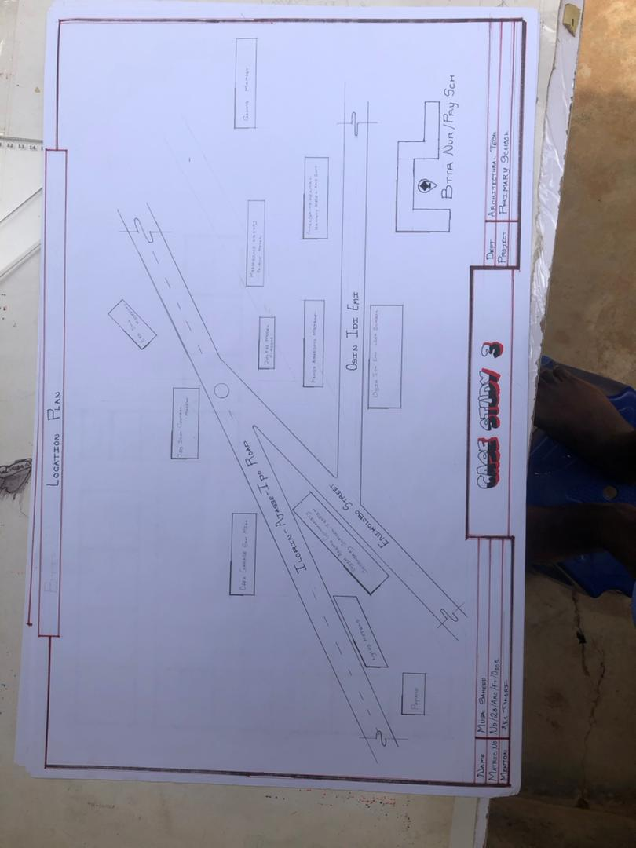
- Details missing on facilities such as libraries, sports fields, laboratories, and playgrounds making it hard to assess the full learning environment.

LOCATION PLAN

Figure 3.3.1 Location Plan
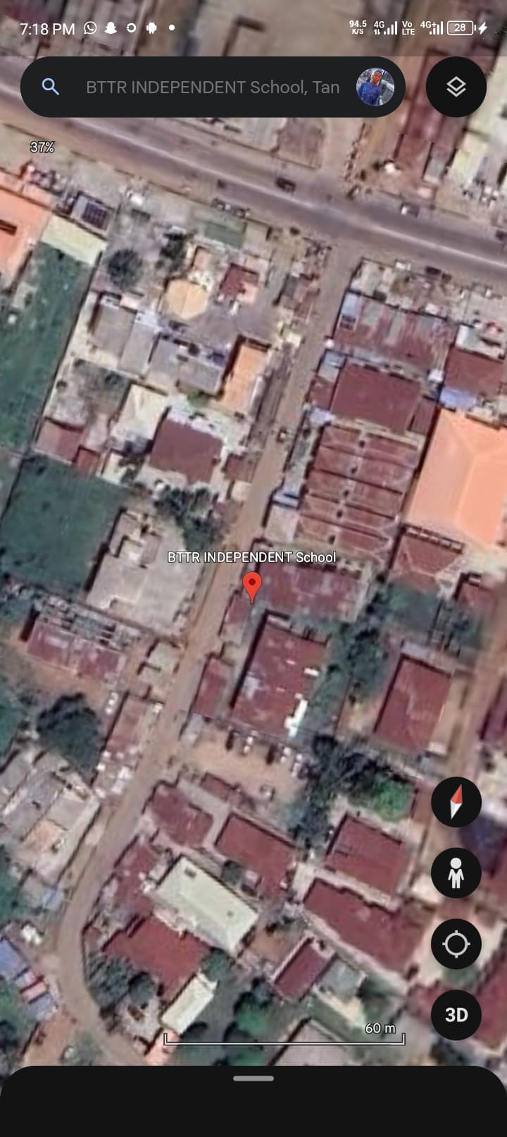
Plate 3.3.1Geographical Layout

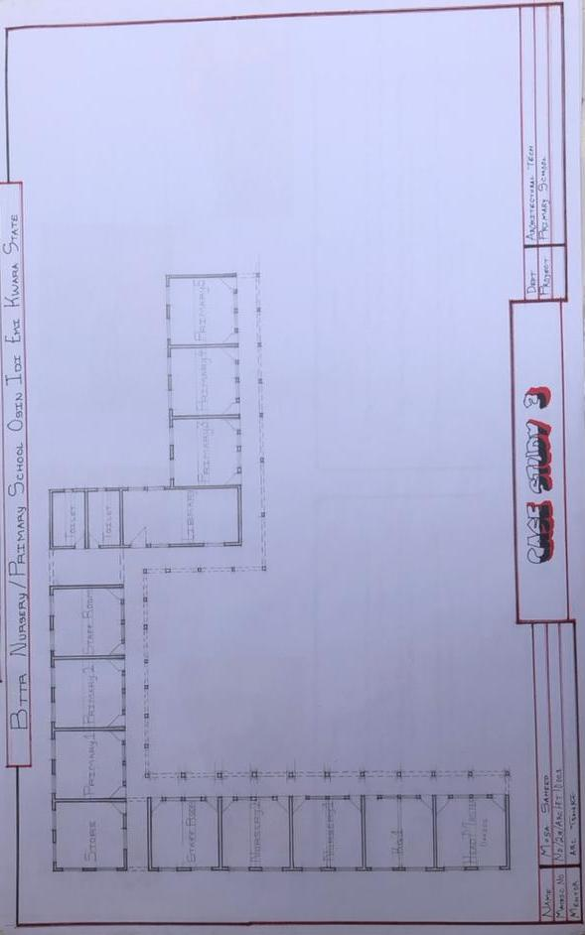
FLOOR PLAN

Figure 3.3.2 Floor Plan.

3.1.4 CASE STUDY FOUR (4): ONLINE CASE STUDY
Location: Elementary & Middle School, Dornbirn Austria.
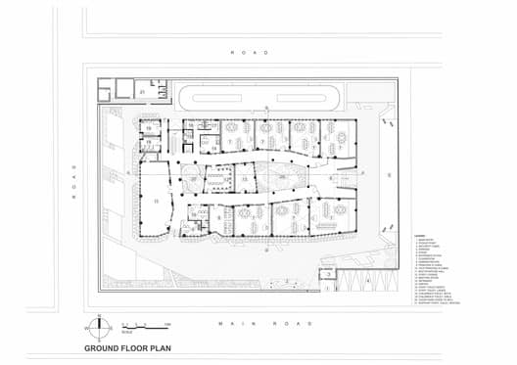

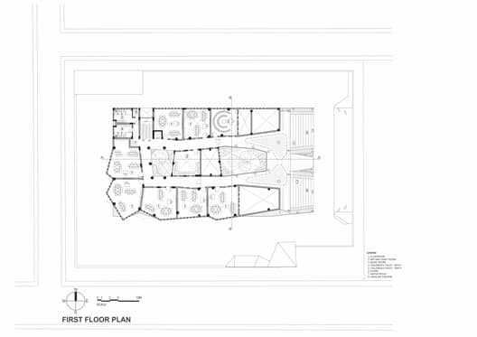

SHOWING FLOOR PLAN OF CASE STUDY FOUR

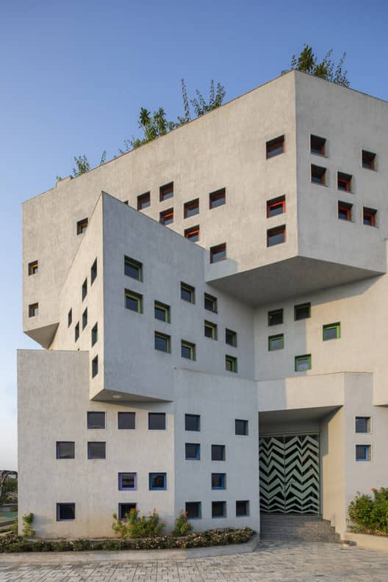
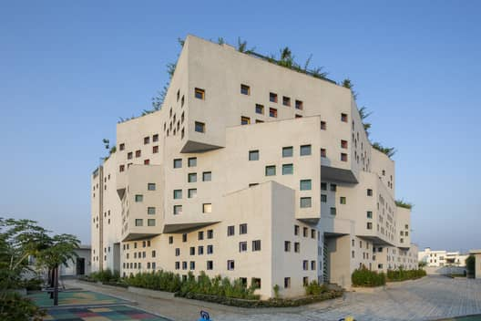

SHOWING ELEVATION

3.1.5 CASE STUDY FIVE (5): ONLINE CASE STUDY
Location: Elementary & Middle School, England, United States
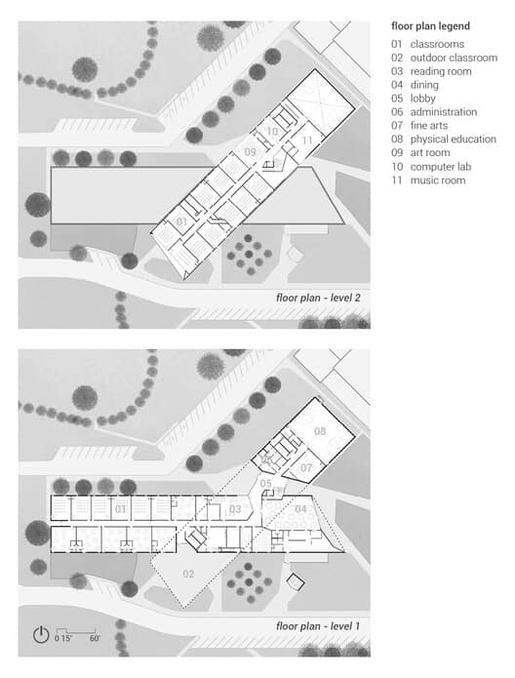
SHOWING FLOOR PLAN

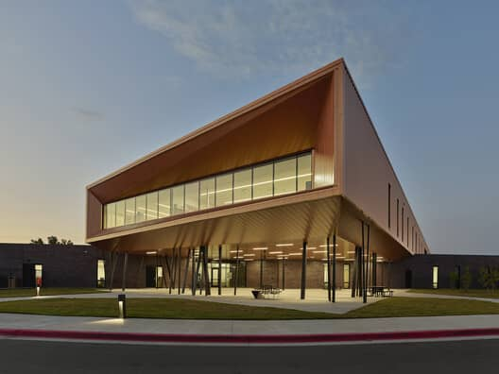

SHOWING ELEVATION
CHAPTER FOUR
4.1 ANALYTICAL STUDY OF THE PROJECT LOCATION
4.1.1 INTRODUCTION
The proposed site for the architectural project is located in Igbeti, a town in Olorunsogo Local Government Area, Oyo State. This area is part of a developing semi-urban environment known for its rich natural rock formations and cultural heritage. The site is accessible via a network of local roads, and its central position within the town makes it suitable for educational, residential, or community-based developments. The presence of basic infrastructure, nearby schools, markets, and administrative buildings enhances the viability of the site for development purposes.
4.1.2 SITE LOCATION
The proposed site is located in Igbeti, the headquarters of Olorunsogo Local Government Area, situated in the northern part of Oyo State, Nigeria. Igbeti is accessible via connecting roads from major towns such as Ilorin, Saki, and Igboho, and lies within the Oke-Ogun region of the state. The town is surrounded by several notable granite hills, including Iyamapo Hill and Agbele Rock, which are significant both culturally and visually.
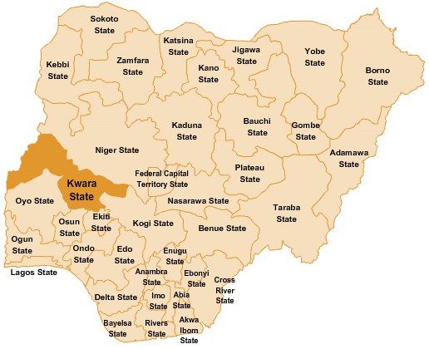

Figure 4.1.11.1 Map of Nigeria, 36 States and FCT.

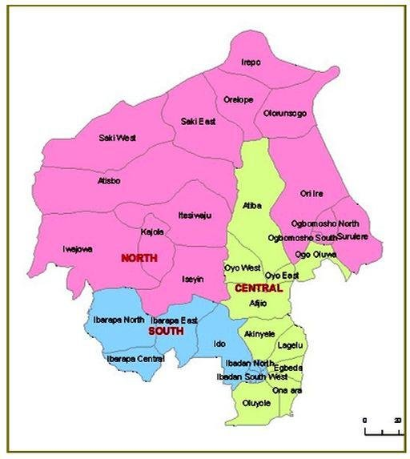

Figure 4.1.11.2 Oyo State Map

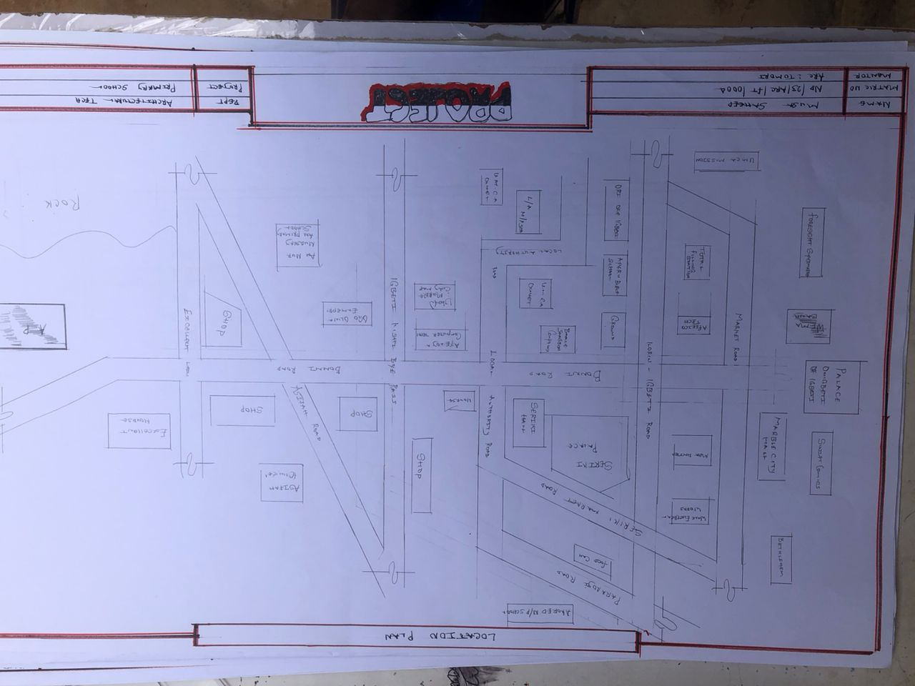

Figure 4.1.11.1 Location Plan

4.1.3 SITE INVENTORY
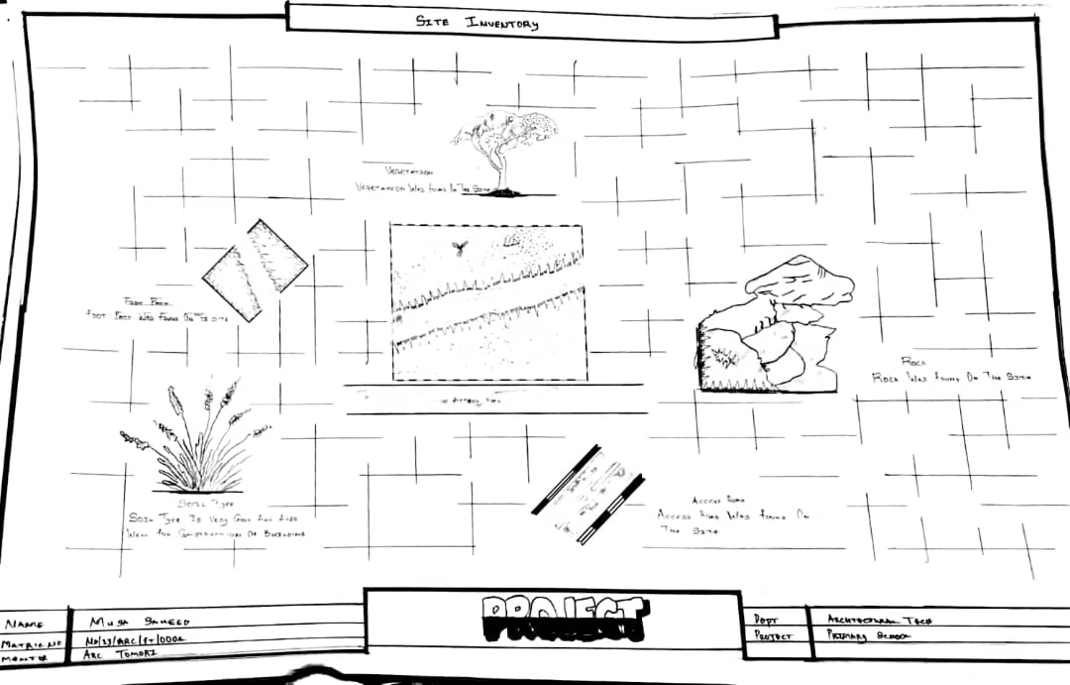

Figure 4.1.12.1 Site Inventory

Site inventory is the synthesis of the physical feature and facilities that are present on the site and over the site such as trees, footpath, soil, topography, vegetation, stream and shrubs etc.

4.1.4 SITE ANALYSIS
Site Analysis is the process of evaluating how a proposed site system will integrate with the existing site infrastructure by assessing physical obstructions, electrical interference, and noise to identify suitable interrogation zones for coexistence with the infrastructure.

The site selected for the project is a very gentle slope, it is a site that has never been used for any form of building construction i.e. it has not been developed in the past which make it an abode for several trees and shrubs, it is also observed during the course of inventory that some of the trees are to be removed as it could obstruct the construction process during the project, while some are to be retained to help control the adverse of the wind storm.

The soil is well compacted Soil in nature with good soil texture. The sun rises from the eastern part of the site and sets on the western part. The Construction does not need a special type of foundation due to the fact that the site is having a good bearing capacity and strength.

26
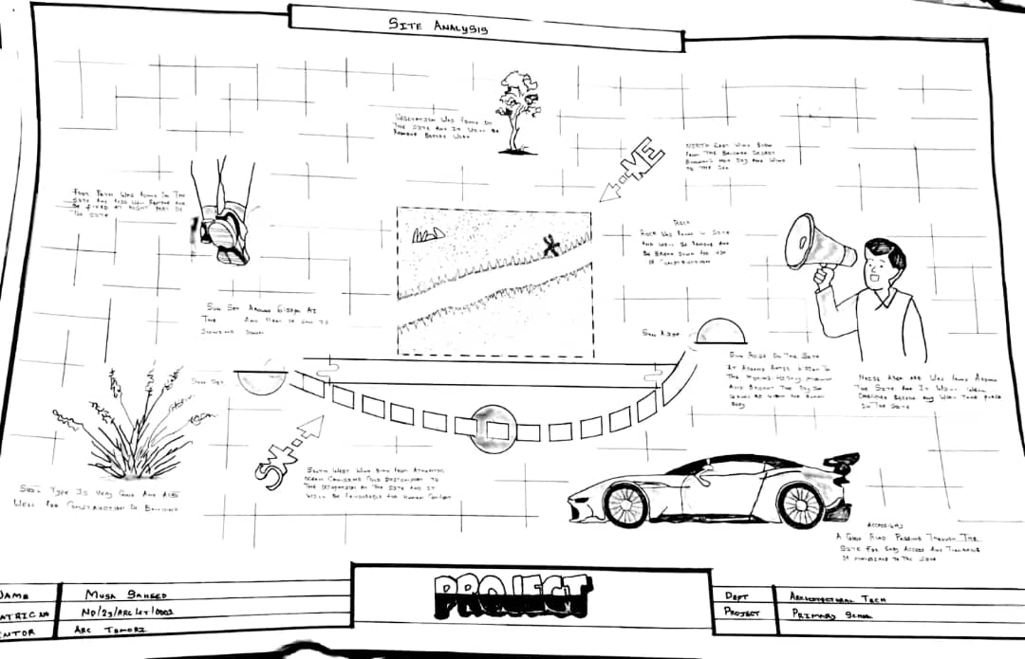

Figure 4.1.12.2 Site Analysis

4.1.5 GENERAL GEOGRAPHICAL CONDITION
Igbeti, located in the northern part of Oyo State, is situated within the Guinea savanna zone of Nigeria. The area is characterized by a mixture of lowland plains and scattered rocky hills, most notably the Iyamapo Hill, which dominates the landscape. The geology of the region is largely made up of granite rock formations and marble deposits, giving the town its nickname, “Marble City.”

4.1.6 CLIMATE:
Tropical Savanna Climate: Igbeti experiences a tropical savanna climate, characterized by two distinct seasons: the wet season and the dry season. (Aw according to the Köppen climate classification), characterized by distinct wet and dry seasons.
Temperature: Igbeti experiences high temperatures throughout the year, consistent with its location in the tropical savanna region of Nigeria. The average daily temperature ranges between 25°C and 35°C, with noticeable seasonal variations.
Rain Season: The rainy season in Igbeti typically begins in April and lasts until October, with the peak rainfall occurring between June and September. During this period, the town receives an average of 1,000 mm to 1,500 mm of rainfall annually. Rainfall is usually moderate to heavy, and often accompanied by thunderstorms, especially in the afternoons
and evenings.

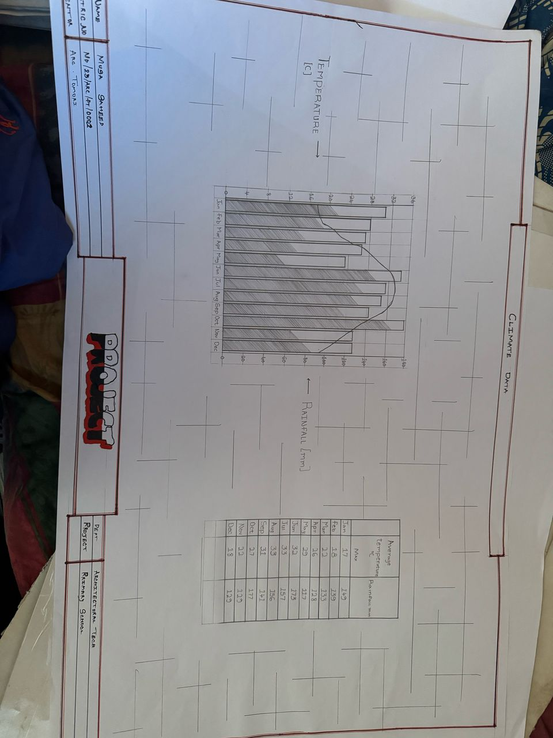

Figure 4.1.3.1 Average Monthly Rainfall in Igbeti.

Dry Season: The dry season in Igbeti usually spans from November to March. This period is marked by little to no rainfall, high daytime temperatures, and significantly lower humidity compared to the rainy season. A key feature of the dry season is the Harmattan, a dry and dusty wind that blows from the northeast, usually between December and February.

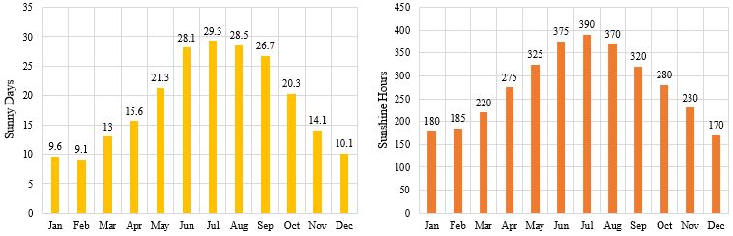

Figure 4.1.3.2 Sunshine Duration in Igbeti.

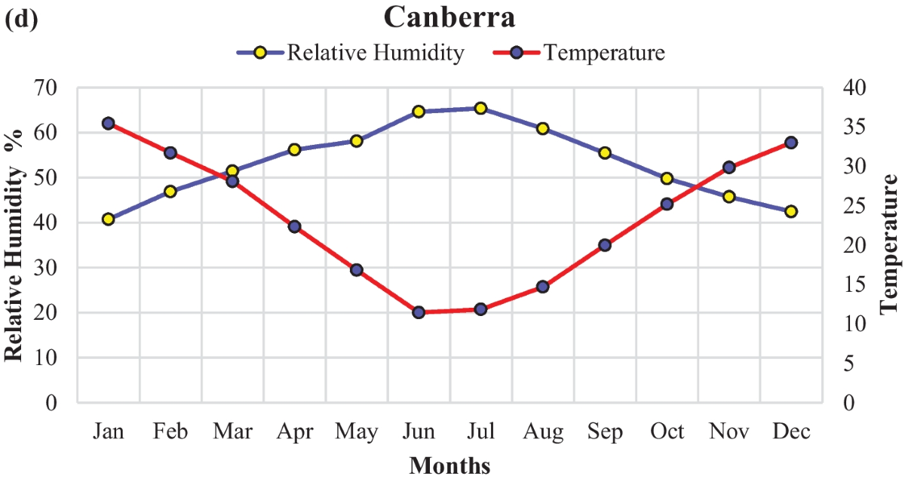

Figure 4.1.3.3 Relative Humidity in Igbeti.

4.1.7 VEGETATION
Guinea Savanna: The predominant vegetation type in Igbeti is the Guinea Savanna, characterized by a mix of grassland and scattered trees. This vegetation type is typical of the transitional zone between the forest regions in the south and the Sahel in the north.
Flora: Common plant species include acacia, baobab, shea butter trees, and various grasses and shrubs adapted to the savanna climate.

4.1.8 TOPOGRAPHY
Gently Undulating Plains: Igbeti’s topography consists mainly of gently undulating plains, with occasional hills and low-lying areas.

4.1.9 NATURAL RESOURCES
Mineral Resources: Igbeti, located in Olorunsogo Local Government Area of Oyo State, is richly endowed with several natural resources, most notably solid minerals and agricultural products. These resources contribute significantly to the local economy and influence the planning and design of development projects in the region.

4.1.10 ENVIRONMENTAL CHALLENGES
Urbanization: Rapid urbanization in Igbeti has led to challenges such as deforestation, waste management issues, and pressure on infrastructure and services.
Climate Change: Like many regions, Igbeti faces the impacts of climate change, including variability in rainfall patterns and increased frequency of extreme weather even.

4.1.11 SITE SERVICES
There are good services around the site, which include good access road, for students coming to school, availability of electricity very close to the site which will be useful before and after construction. Also, availability of pipe born water at the chosen site.

4.1.12 SITE UNIQUENESS AND BENEFIT
- The site is accessible
- Natural factor like, is very useful
- Utility services such as water, electricity, telephone, etc. cause no problem to the inhabitants.

4.1.13 SITE SUITABILITY
The appropriateness or suitability of the site for the construction and planning of the proposed project is based on the fact that is possesses and meets the entire requirements. All the existing features were strictly considered with the intension of making advantage of them to maximum level most especially the geographical, topographical features of the site.
Types Of Forest Region
- Mangrove (Salt Quarter) Swamp Forest
- Fresh water swamp forest
- High forest

4.2. DESIGN CRITERIA
The design of a primary school must create a safe, functional, and stimulating learning environment for children between the ages of 4 and 12. The following criteria have been considered to guide the planning, layout, and development of the proposed primary school in Igbeti, Olorunsogo Local Government Area, Oyo State.

4.2.1 SITE SELECTION
A number of factors necessary for site selection for a farmstead are outlined below:
  - ﻿﻿﻿Access Road
  - ﻿﻿﻿Water
  - ﻿﻿﻿Utilizes and services (electricity, telephone, access drives etc.)
  - ﻿﻿﻿Orientation (air drainage and maximum sunshine may require orientation on a gentle Southerly slope).
  - ﻿﻿﻿Expansion.

4.2.2 BUILDING ARRANGEMENT
The arrangement of facilities for maximum efficiency of operation should be a prime concern. Proper arrangement increase efficiency by reducing walking distance to a minimum and providing adequate drive ways and turn around. It is important to note that five protections, safely and security and all influenced by the design planning.

4.2.3 DESIGN SCOPE
These are scope of designing a Primary School which includes the followings;
Security House, Cafeteria/Canteen, Main Building, Examination Hall, Mosque, School Field, Students Hostel, Staff Quarters, Park Lots, School Sick Day and Assembly Ground.

4.2.4 DESIGN BRIEF9ANALYSIS
- The following are the brief analysis of the Administrative Units;
Entrance, Reception and Waiting Area, Secretary Office, Principal Office, Vice Principal Administrative, Vice Principal Academic, H.O.D’S Office, Staff Office, Counselling Office, Bursar’s Office and C.C.T.V Room.

- The following are the brief analysis of the Academic Units;
Classrooms, Laboratories, I.C.T Room, Computer Maintenance Room (Hardware), Art and Craft Room, Lecture Hall and Examination Hall.

- The following are the brief analysis of the Supporting Units;
Assembly Ground, Storage Facilities, Connivences and School Medical.

- The following are the brief analysis of the Residential Units;
Students Hostel and Staff Quarters.

31

4.2.5 SPACES DERIVATION ANALYSIS/SCHEDULE FOR ADMINBLOCK
S/N | UNITS | NO REQ. | LENGHT | BREADTH | LENGTH x BREADTH (mm) | AREA (m²)
 | Entrance |  | 7000 | 3000 | 7000x3000 | 21
 | Creche |  | 5000 | 5000 | 5000x5000 | 25
 | Nursery 1-2 |  | 5000 | 4000 | 5000x4000 | 20
 | Kindergarten |  | 5000 | 5000 | 5000x5000 | 25
 | Primary 1-6 |  | 5000 | 5000 | 5000x5000 | 25x6
 | Headmaster Office |  | 3000 | 3000 | 3000x3000 | 9
 | Assistance Headmaster |  | 3000 | 3000 | 3000x3000 | 9
 | Staff Room |  | 5800 | 3000 | 5800x3000 | 20
 | Secretary Office |  | 5000 | 5000 | 5000x5000 | 25
 | Multipurpose Space |  | 8500 | 5000 | 8500x5000 | 42.5
 | Libraries |  | 5000 | 5000 | 5000x5000 | 25
 | Sick Bay |  | 4000 | 4000 | 4000x4000 | 16
 | ICT |  | 5000 | 5000 | 5000x5000 | 25
 | Admin Office |  | 5000 | 4000 | 5000x4000 | 20
 | Storage |  | 5000 | 4000 | 5000x4000 | 20
 | Toilets |  | 1200 | 2000 | 1200x2000 | 2.4

Table 4.1.1: Space Allocation

4.2.6 FUCTIONAL ANALYSIS AND RELATIONSHIP
The Main Building plan is well function, the unit are so well related to each other,
32
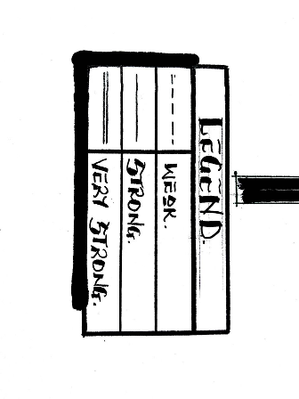
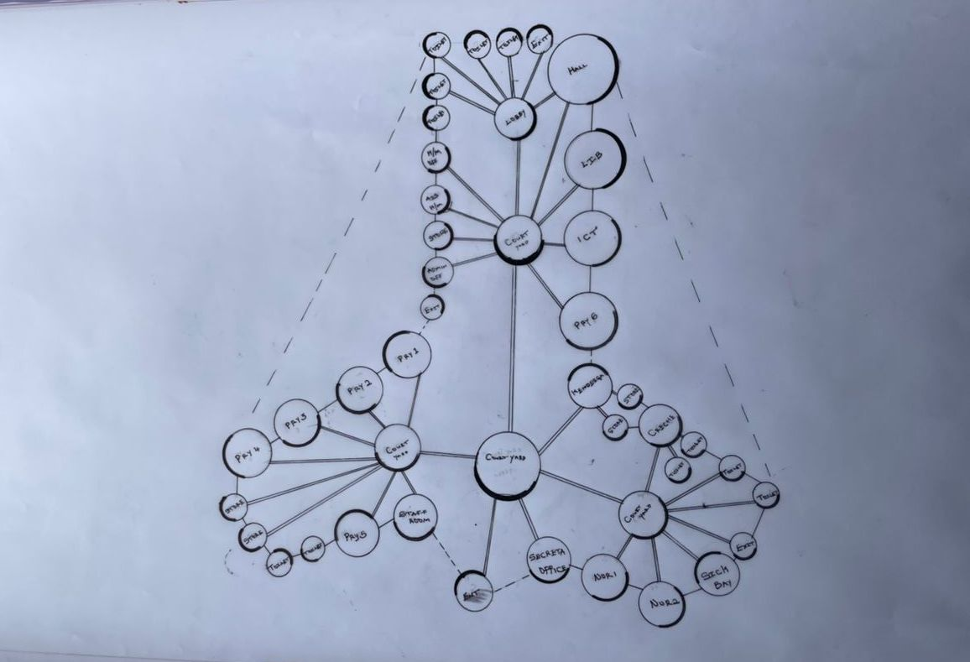
Figure 4.2.6.2: Bubble Diagram
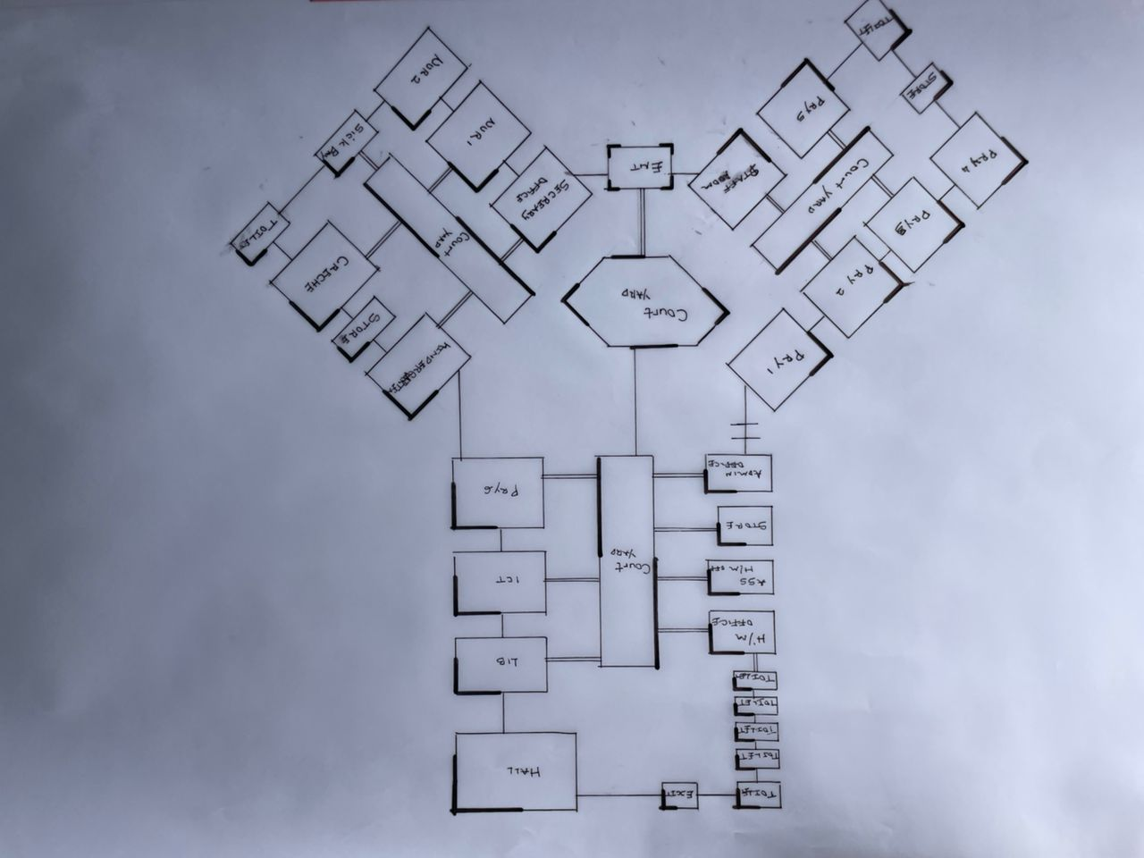Figure 4.2.6.3: Functional Relationship 1

CHAPTER FIVE
5.1 APPRAISAL OF PROPOSED SCHEME
The proposed Project is to satisfy the appropriate building regulations. The design is to confirm the aid intended use of building taking into consideration with both natural factors and human factors that earn us a threat on the validity and stability of the building.

5.2 CONSTRUCTION METHODOLOGY AND MATERIALS.
The construction is to be carried out following the due process of construction ranging from:
- Preliminary: This involves the clearing of the site, setting out and excavation of foundation trench and foundation works.
- Sub-Structure: This process also entails the positioning and erection of Columns and beans, masonry works etc.
- Post Structure Stage: Is the stage which has to do with the application and installation of the paints, tiles, other finishes and construction of external works etc.

5.21 MATERIALS FOR CONSTRUCTION
1. Sustainable and Eco-Friendly Materials
- Bamboo and Timber: These materials are renewable, have a low carbon footprint, and can be sourced sustainably. Bamboo, in particular, grows quickly and has strong tensile properties.
- Recycled Materials: Using recycled steel, concrete, and glass can reduce the environmental impact of the construction process.
- Insulating Materials: Materials like sheep wool, cellulose, and hemp provide excellent thermal insulation and are environmentally friendly.

2. Traditional and Cultural Materials
- Clay and Adobe: Traditional building materials that offer good thermal mass, keeping buildings cool in hot climates. These materials can be locally sourced and are culturally significant in many regions.
- Stone: Using locally available stone can provide durability and cultural relevance, reflecting traditional architecture.
- Tiles and Ceramics: Decorative tiles and ceramics are often used in architecture for aesthetic purposes, featuring intricate geometric patterns and calligraphy.

3. Modern Materials
- Concrete: Widely used for its strength and versatility. It can be enhanced with additives to improve its sustainability.
- Steel: Provides structural strength and flexibility. Recycled steel can be a more sustainable option.
- Glass: Used for windows and facades to allow natural light. Double or triple-glazed glass can improve energy efficiency.

5.2.2 CONSTRUCTION METHODOLOGIES
1. Green Building Practices
- Passive Solar Design: Orienting the building to maximize natural light and heat from the sun, reducing the need for artificial lighting and heating.
- Green Roofs and Walls: Planting vegetation on roofs and walls to improve insulation, reduce heat island effects, and provide green spaces.
- Rainwater Harvesting Systems: Collecting and using rainwater for irrigation and non-potable uses within the school.

2. Energy-Efficient Construction
- Insulation: Using high-quality insulation materials to reduce energy consumption for heating and cooling.
- LED Lighting: Implementing energy-efficient LED lighting throughout the school.
- Solar Panels: Installing solar panels to generate renewable energy, reducing dependence on non-renewable energy sources.

3. Cultural and Religious Considerations
- Orientation: Provision of natural, quiet spaces that can be used for individual or group prayer during break periods.
- Architectural Elements: In the design of a functional and child-centered primary school, several architectural elements must be thoughtfully considered to ensure safety, comfort, and effective learning.
- Community Involvement: Engaging local communities in the design and construction process to ensure that the school meets cultural and social needs.

5.2.1 SERVICE
A building can be said to be good when it performs the service required by it. In order to have well-functioning building. There calls for an installation of underground water pipes in other to provide water to all the restrooms and other necessary units in the building. A borehole system of water supply is to be adopted alongside the government supplied services and a storage facility is to be provided for effective management of water supply.

5.2.2 CIRCULATION
In my primary school project, circulation is carefully planned to make movement around the school safe, easy, and comfortable for both pupils and staff. Since children are the main users, all circulation paths are designed to be wide, open, and easy to understand.

5.2.3 VENTILATION
As it relates to architecture, is the intentional introduction of outside air into a space. It is mainly used to control indoor air quality by diluting and displacing indoor pollutants. It can also be used for purpose of thermal comfort of dehumidification when the introduction of outside air will help to achieve desired indoor psychometric condition.

This could be either mechanical or natural ventilation. As a regard the proposed project design, there is an introduction of a very spacious courtyard in other to make cross ventilation in most of the building units. There should also a provision of wide passage to allow free movement of air, students and materials. Artificial ventilation is also provided through the installation of air conditioning system and fans.

5.2.4 LIGHTING
Lighting is one of the most important elements in my primary school project because it affects how well pupils can see, learn, and stay alert in class. In my design, I considered both natural and artificial lighting to create a bright, healthy, and energy-efficient learning environment.

5.2.5 PLUMBING
The plumbing system in this proposed building is made easy since the building has a courtyard. Water drained pipes are to be installed underground right from the courtyard to the soak away in other to discharge rainwater.

All water or sewage from the toilets are also channeled into their various inspection chambers using good and appropriate diameter PVC pipes, and taken from the inspection chamber to septic tanka and soak away pit.

Rain water is also collected from gutter if the roof using 100mm diameter PVC rain water pipes and channeled into various drainage or soak away pits. There shall be no ponding; the size of any channel shall effectively discharge rain and water without causing any over lowing stagnation and mosquito breeding. All rain water channeled shall be laid to fall and shall not cause any pounding or splashing unto the committers neighboring area.

5.2.6 ELECTRICAL INSTALLATION
The type of wiring system chosen should be full conduit system of wiring. Classrooms and other students’ technical areas should be wired with strong, durable and light current resistance cable because of the careless operate by the students. Also, electrical installation is to be done to allow for the use of quality electrical fittings and fixtures in the whole building.

5.2.7 WASTE DISPOSAL
Waste disposal bins are to put every office of the building and also in some specific necessary area. These water bins should dispose in the incinerator which will be provided within the compound of the station. The waste should therefore be burnt in the incinerator.

5.2.8 FIRE PROTECTION
Electrically, fire alarms and sensors are to be installed in the school building. This should be done in case of fire occurrence; fire extinguisher is to be placed at certain distances in the cobbles and some other necessary area. It is also serving as protector in case of fire.

5.2.9 EXTERNAL WORKS
The external works are to be carned out uncrate Krebs laid and shrubs, flowers grasses and trees planted.
Concrete interlocking tiles to be adopted of hard landscape and parking spaces both for visitors and staffs have been provided on the site.

5.3 CONCLUSION AND RECOMMENDATION
Conclusion
This project has explored the design of a functional, inclusive, and sustainable primary school that meets the educational and developmental needs of young learners. Based on the study of site conditions, cultural context, environmental factors, and case studies, the design integrates key features such as proper circulation, effective lighting, safe classrooms, and outdoor play areas.

The goal is to create a school environment that encourages learning, comfort, creativity, and security for pupils and staff. Special consideration was given to community involvement, accessibility, and the use of local materials to make the project practical and culturally relevant, especially for a location like Igbeti, Oyo State.

Recommendation
- Government and private bodies should invest more in early education infrastructure, especially in rural communities like those in Oyo State.
- Architects and planners should always consider child safety, local climate, and cultural background when designing for schools.
- School authorities should involve the community during planning and decision-making to ensure the school meets local expectations and is well maintained.
- Use of sustainable design (e.g., natural lighting, cross-ventilation, rainwater harvesting) should be encouraged to reduce operational costs.
- Future expansion should be considered in the design, with room for adding more classrooms or facilities as the population grows.

REFERENCES
Ogunyemi, B. (2015). Basic Education and Rural Development in Nigeria: Challenges and Prospects. Nigerian Journal of Educational Research and Evaluation, 14(2), 34–42.
Akinbote, O. (2016). Teacher Preparation for Early Childhood and Primary Education in Nigeria: Emerging Issues. African Educational Research Journal, 4(1), 1–6. Federal Ministry of Education (FME). (2017). National Policy on Education (6th Edition). Abuja: NERDC Press. UNESCO Institute for Statistics. (2018). Education Profile – Nigeria: Literacy and Primary School Statistics.
Ajayi, K. & Akinwunmi, F. (2019). Effectiveness of Universal Basic Education Programme in Nigeria: A Case Study of Oyo State. Journal of Contemporary Issues in Education, 4(3), 55–61.
Umar, A. M. (2020). The Role of Community Participation in Improving Public Primary Schools in Nigeria. International Journal of Education and Practice, 8(4), 223–230.
National Bureau of Statistics (NBS). (2021). Nigeria Education Statistics Report. Abuja: NBS Publications.
Kwara State Universal Basic Education Board (KWSUBEB). (2022). Annual Report on Primary School Infrastructure and Staffing in Kwara State.
Oyo State Ministry of Education. (2023). Basic Education Performance Review: Olorunsogo LGA – Igbeti Zone.
UNICEF Nigeria. (2024). Progress and Gaps in Access to Quality Basic Education in Rural Nigeria.

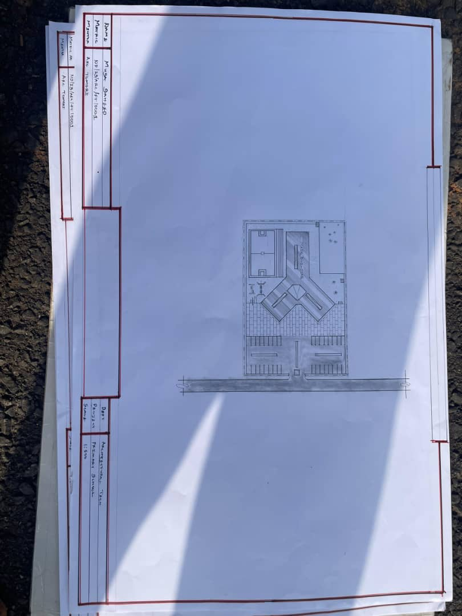

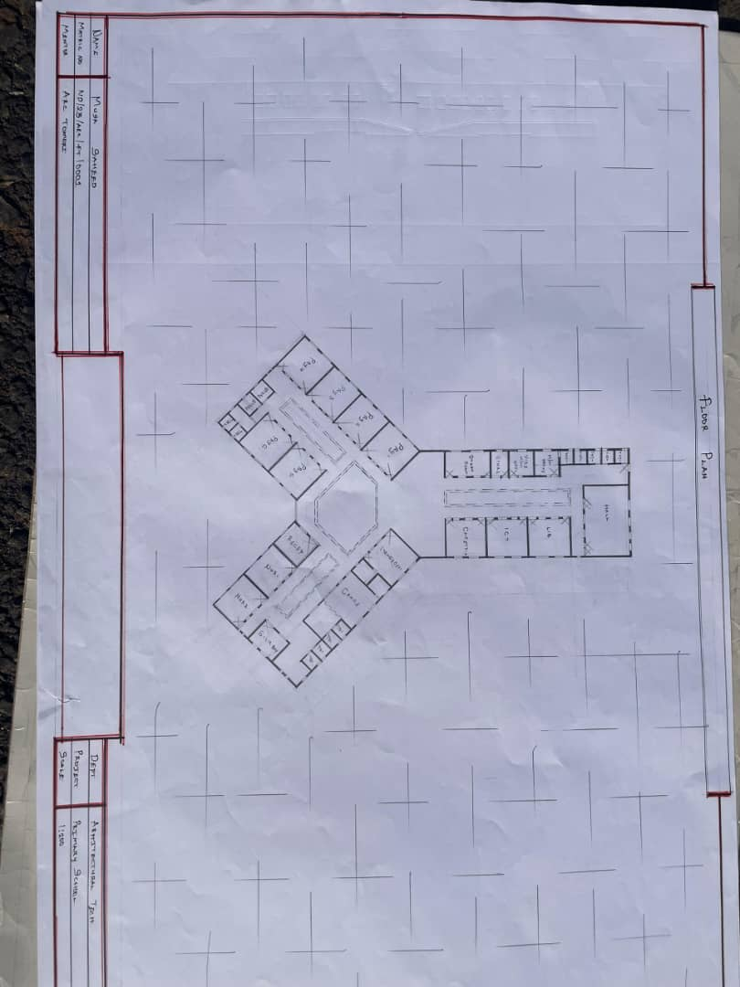
Appendix 5.1: Site Plan

Appendix5.2: Floor Plan.

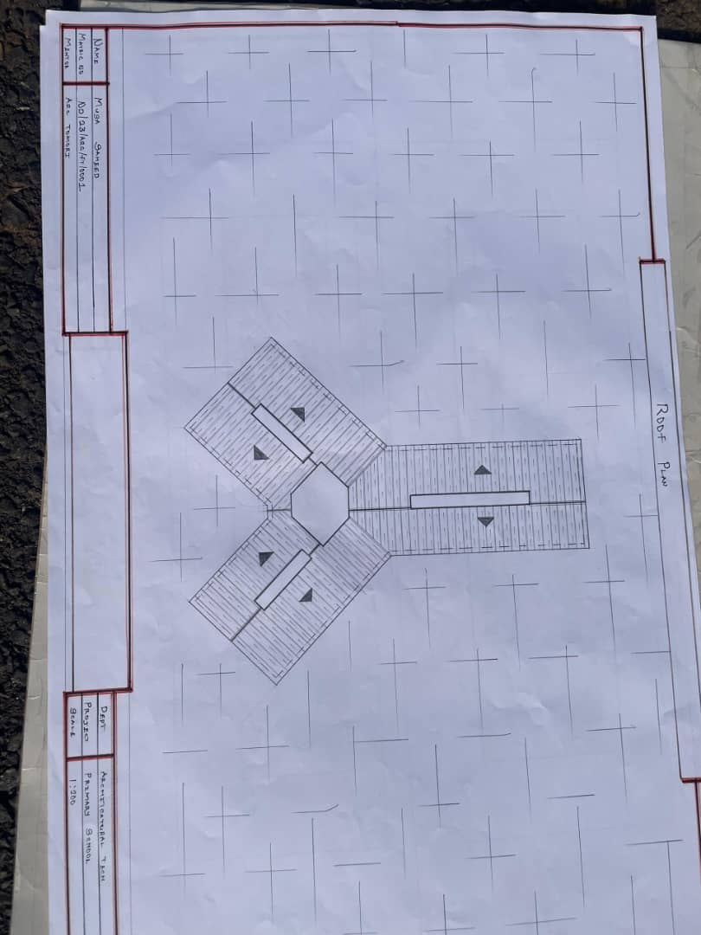

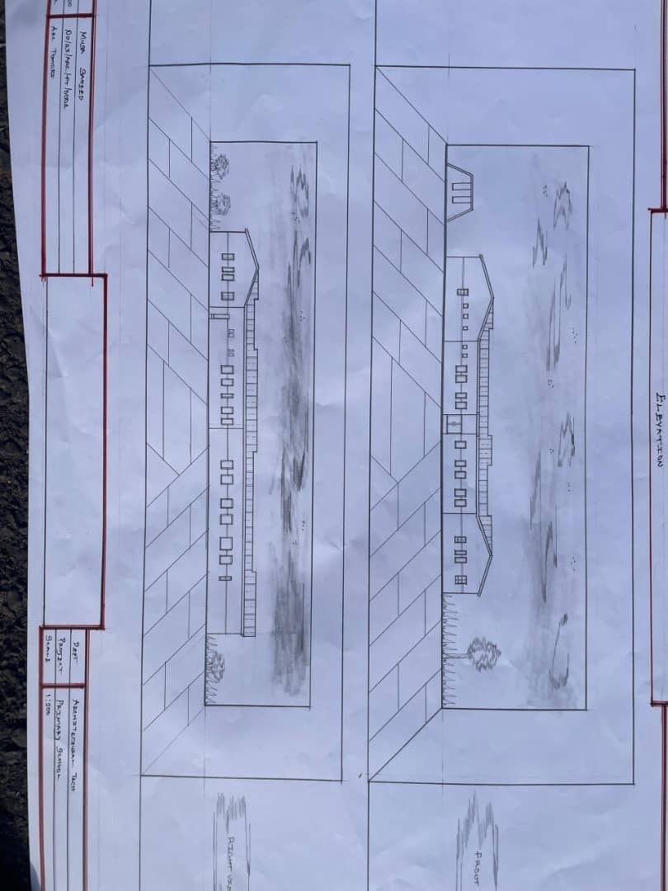
Appendix 5.5: Roof Plan

Appendix5.6: Elevation

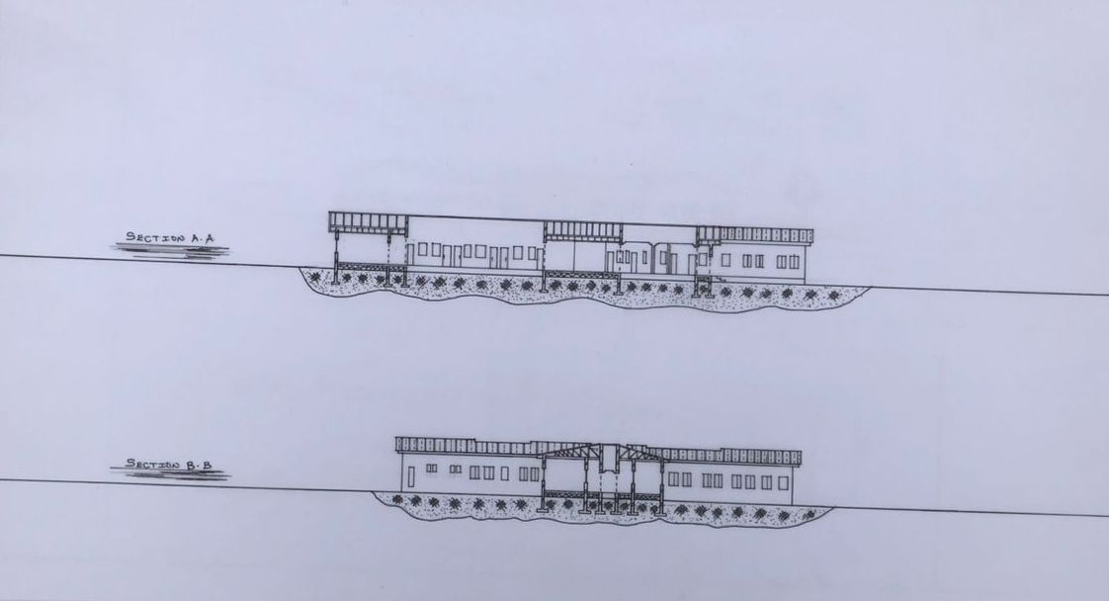

Appendix5.7: Section

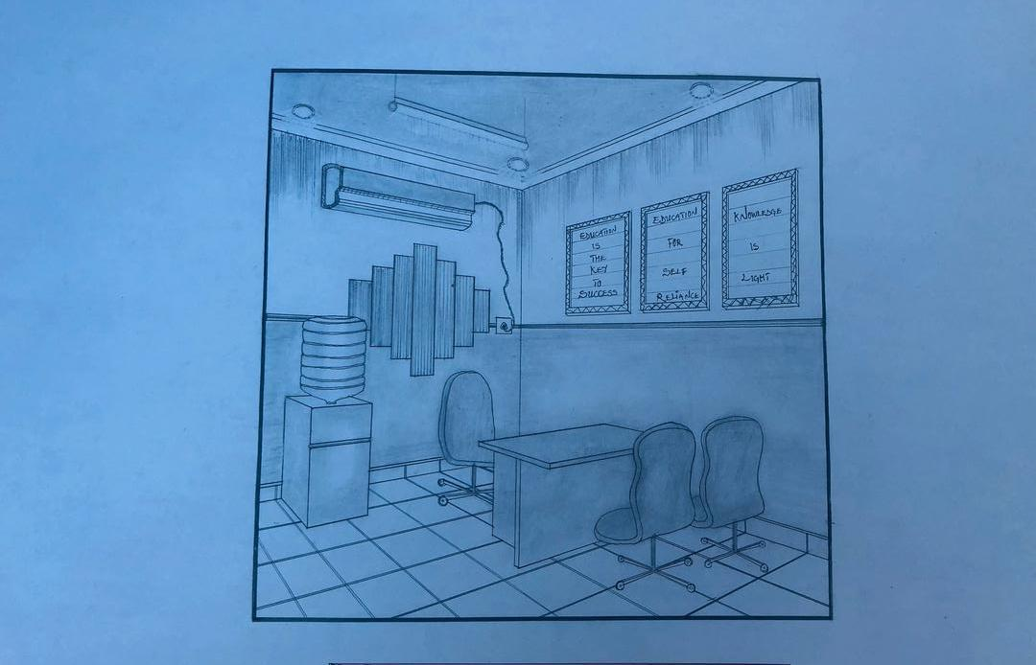

Appendix5.7: Internal Perspective.

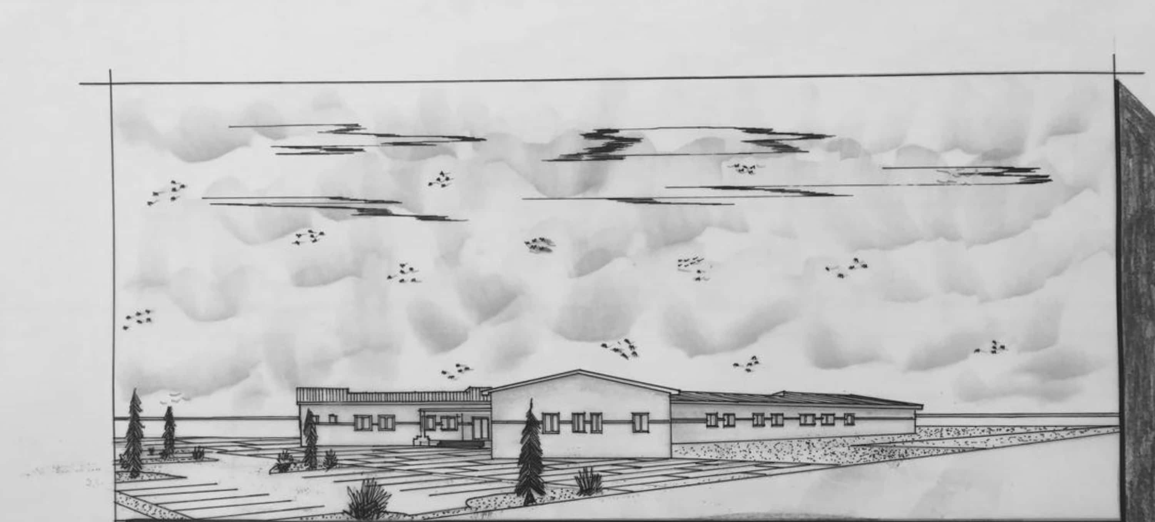

Appendix5.8: External Perspective.

