APPRAISAL OF HOUSING CONDITION IN THE INDIGENOUS AREA OF ILORIN “CASE OF ALORE AREA”.
BY
FADEYI ODUNAYO BLESSING
HND/23/URP/FT/0018
SUBMITTED TO:
DEPARTMENT OF URBAN AND REGIONAL PLANNING
INSTITUTE OF ENVIRONMENTAL STUDIES
KWARA STATE POLYTECHNIC, ILORIN.

SUPERVISED BY:
YAHAYA M.YUNUS (MNITP)(RTP)
&
MR. GBENGA OLASENI



DEDICATION
This project report is dedicated to Almighty God the Alpha and Omega of the entire universe for sparing my life till this moment. I also give Him glory for His abundant provision and guardian over me during the period of my course of study in Kwara State Polytechnic. May His name be praise forever and ever.

ACKNOWLEDGEMENTS
I give all glory, honor, adoration and praise to Almighty God. The God of all creation, the Alpha and Omega, for His mercy, protection, grace upon me throughout the period of this programme, May His name be praised forever and ever Amen.
I will like to acknowledge my able, dynamic indispensable and ever dependable supervisor, in person of YAHAYA M.YUNUS (MNITP)(RTP)for the sacrificial of his time to read through the entire work and offered valuable correction at every stage of this project, may you live long to enjoy the fruit of your labor. Amen
My profound gratitude goes to the capable Head of Department(H.O.D) on person of TPL E.S ADEKANYE for his fatherly care and support. Also, MR. OLASENI and all the lecturers of great and noble department
for their impact in my life academically.
I want to specially thank my parent Mr. & Mrs. FADEYI for their financial support, ceaseless prayers and advice throughout the period of my programme. May you live to eat the fruit of your labor. Amen
I also want to appreciate my siblings Tobi, Oluwaseun,Olamilekan, Grace and Damilola for all their encouragement, prayer, and contribution in one way or other.
To my late brother, [BOLUWATIFE], your guidance, love, and encouragement shaped me into the person I am today. Though you're no longer with us, your memory will forever be etched in my heart, and I hope this work makes you proud."

Abstract
This study assesses the housing conditions in Alore, an indigenous area of Ilorin, Kwara State, Nigeria. Assessing the quality of existing housing stock, quality of the housing environment, and the availability of the neighbourhood facilities were the major objectives. Data were obtained through questionnaire, personal interview, physical observation of the housing structures and were analysed with appropriate statistical tools. The research examines the socioeconomic characteristics of residents, types of building materials used, conditions of buildings, and availability of facilities within compounds and neighborhood. The findings reveal that most buildings are bungalows with mud walls and corrugated iron sheet roofs, and many require minor repairs or are dilapidated. The study highlights the need for improvement in building maintenance, infrastructure, and amenities. Recommendations include promoting the use of durable building materials, upgrading windows, and regular maintenance of buildings. The study's results have implications for urban planning, housing policy, and community development in the area.

TABLE OF CONTENTS
Title Page i
Certification ii
Dedication iii
Acknowledgements iv
Abstract v
Table of Content vi

CHAPTER ONE: GENERAL INTRODUCTION
1.1 HOUSING CONDITION 3
1.2 STATEMENT OF THE PROBLEM 5
1.3 AIM 6
1.4 OBJECTIVE 6
1.5 SCOPE 7
1.6 JUSTIFICATION 7
1.7 THE STUDY AREA 7
1.8 HISTORICAL DEVELOPMENT OF ILORIN 8
1.9 LOCATION AND PHYSICAL SETTING OF ALORE 10

CHAPTER TWO: CONCEPTUAL FRAME WORK
2.1 WHAT IS AN HOUSING 14
2.2 TYPE OF HOUSING 15
2.3 HOUSING DESIGN 16
2.4 ISSUES TO CONSIDER IN HOUSING DESIGN 17
2.5 EVALUATION OF EXISTING HOUSING DESIGNS 19
2.6 CONSTRUCTION AND TECHNOLOGY 20
2.7 HOUSING POLICY AND STRATEGY 23
2.8 EXISTING HOUSING POLICIES IN NIGERIA 25

CHAPTER THREE
3.0 RESEARCH METHODOLOGY 30
3.1 RESEARCH DESIGN 30
3.2 TYPES OF DATA AND SOURCES 30
3.3 INSTRUMENTS FOR DATA COLLECTION 31
3.4 STUDY AREA POPULATION 31
3.5 SAMPLING TECHNIQUES AND UNIT 32

CHAPTER FOUR: DATA PRESENTATION AND ANALYSIS
4.1 SOCIOECONOMIC CHARACTERISTICS DATA OF THE STUDY AREA 34
4.1.1 SEX OF THE RESPONDENTS 34
4.1.2 AGE OF RESPONDENTS 34
4.1.3 EDUCATIONAL LEVEL OF THE RESPONDENTS 35
4.1.4: INDIGENOUS FAMILIES SAMPLED 35
4.2 DETERMINE THE COMPOSITION MATERIAL OF THE HOUSING STRUCTURE.36
4.2.1: TYPES OF WALL 36
4.2.2 TYPES OF ROOFS 37
4.2.3 TYPE OF FLOOR 38
4.2.4 TYPE OF WINDOW 38
4.3 ASSESS THE HOUSING CONDITION IN THE 39
STUDY AREA PHYSICAL CONDITION 39
4.4 IDENTIFY THE AGE OF HOUSE IN THE STUDY AREA 40
4.4.1 TYPES OF HOUSING/BUILDING 41

CHAPTER FIVE: SUMMARY OF FINDING, RECOMMENDATION AND

CONCLUSION
5.1 SUMMARY OF FINDINGS 46
5.2 RECOMMENDATION BASE ON FINDINGS 48
5.3 CONCLUSION 48
REFERENCE 50

CHAPTER ONE
1.0 GENERAL INTRODUCTION
Housing, literally is defined as Buildings or other shelters in which people live. A place to live, a dwelling etc and to a nation, is a critical component in social and economic fabric. Housing represents one of the most basic human needs. . Housing is a crucial basic need of every human being just as food and clothing (Aribigbola, 2006:53). It is very fundamental to the welfare, survival and health of man (Fadamiro et al, 2004). Hence, housing is one of the best indicators of a person's standard of living and his place in the society. The location and type of housing can determine or affect the status of man in the society. Kehinde (2010) noted that shelter is central to the existence of man. He submitted further that housing involves access to land, shelter and the necessary amenities to make the shelter functional, convenient, aesthetically pleasing, safe and hygienic. Hence, unsanitary, unhygienic, unsafe and inadequate housing can affect the security, physical health and privacy of man. Invariably, the performance of the housing sector is one of the yardsticks by which the health of a nation is measured (see Amdii, 1993; Angel, 2000; Blunt and Dawling. 2006; Charles, 2003; and Sulyman, 2000).
The World Health Organisation (1961) stated that a good house should have the following items:
• A good roof to keep out the rain
• Good walls and doors to protect against bad weather and to keep out animals.
•Sunshades all around the house to protect it from direct sunlight in hot weather.
• Wire nettings at windows and doors to keep out insects like house flies and mosquitoes.
To most groups housing means shelter but to others it means more as it serves as one of the best indicators of a person's standard of living and his or her place in the society. (Nubi, 2008). It is a priority for the attainment of living standard and it is important to both rural and urban areas. These attribute make demand for housing to know no bound as population growth and urbanisation are increase very rapidly and the gap between housing need and supply becomes widen. Despite the significance of housing, adequate supply has remained a mirage to all carder of the society in Nigeria.
The situation is very particular to most developing countries where population grow at exponential rate and rapid urbanisation becoming a norm, and discrepancy in housing need and supply is high.The desire to live in a house depends on how conducive and attractive the housing unit is. Conduciveness of a housing unit can be expressed by certain factors such as circulation space within the unit, the availability and affordability of basic amenities such as water, electricity, toilet facilities, occupancy ratio etc. attractiveness on the other hand is a function of the neighbourhood facilities (accessibility, shopping centers, schools, security, hospital etc) and quality of the environment (drainage system, method of refuse collection and disposal, road network etc), personal taste, social value and affordability
Quality of housing and that of the environment have direct bearing on the lives of people in that community because; environmental quality and quality of live are two variables of the same equation. Quality living depends so much on the quality of the environment one lives in. ordinary decencies of their lives.
Housing of a good quality in a good environment is prerequisite to quality living. That is for people to have quality life, they need housing in the required quantity and quality in an efficient environment free from disease, robbery, assault etc which facilities their comfort and enjoyment (Fagbohun, 2003; Dung Gwon. and Ibrahim, 2006; Sanda and Jambol,2010). Therefore, for people to function as they should, they need adequate housing in a conducive environment; functional housing units in a planned environment accorded the basic necessities for live ability (Sanda and Jambol, 2010). Assessing the conditions for housing in our cities therefore becomes a necessity in order to determine their functions, conduciveness and live ability.
In essence, housing quality can be judged from the physical appearance of the buildings, facilities provided, quality of wall used in the building construction, eminence of the roofing materials, condition of other structural components of the house, and the environmental condition of the house. Hence, the inadequacy of housing in terms of quality and quantity results in poor standard of the environment.
1.1 Housing Condition:
Housing condition refers to the state of the physical, environmental and the satisfactory level of a particular housing unit measured against some variables of live ability at a particular time (Omole, 2001, Sanda and Jambo, 2010). These variables include the status of the housing stock, housing facilities, occupancy rates, housing environmental quality, neighbourhood facilities, materials used in construction, age of the dwelling, variety and adequacy of facilities provided in the dwelling, level of satisfaction with housing facilities and spatial location of residential housing (Omole,2001, Sanda and Jambo2010). Others include the maintenance level, social and economic wellbeing.
Housing condition therefore considers the totality of the environment rather than the unit in isolation. In Nigeria and most part of the developing world, due to factors such as insufficient funds, weak mortgage market, and poor delivery mechanisms, attention is centred on raising the physical unit rather than the totality of the housing environment. Developments are carried out without really paying attention to planning details such as material and assembly technologies, development control and planning regulations. The results are town with no space for infrastructural development such as road network and drainage systems, Hence slums become common features at fringes of virtually all Nigerian cities. Sheer neglect, poor maintenance, poor, location and inadequate facilities and services as this is compounded by unique characteristics of houses found in Nigerian cities. (Augustine, 2005;Sanda and Jambol, 2010).
The condition of housing in Nigeria is so bad that Wahab et al (1990) as reported in Omole (2005) stressed that, most houses (housing environment inclusive) in all the states of the federation require either minor or major repairs. There is therefore the need to embark on this study so as to proffer practical measures for better livability in the study area.
Among the three necessities of life is housings, other being food and clothing. The need for shelter is as old as man himself. Studies have shown that right from the stone- age even up till today, the need of man for shelter cannot be over-emphasized. man needs shelter at least to protest himself from physical and weather elements such as sun, wind and even from wild animals and also for other protective reason Housing is more than a mere shelter in its proper definition.
Housing can be defined as the act of providing shelter or lodging and cover a process of producing house ranging from the acquisition of sub-division of layout in which reconnaissance is taken of all the ancillary service and community facilities. It also includes the factors of housing production like architectural design, financial material and labor among others. (Efobi, 2002). In other words, housing should be used to cover all social, accepted ways by which a man acquires a tertiary, the price he pays for its manner in which the stock of the house are maintained and enlarged.
Many scholar and key players in the housing sector within and across the Nigeria boundary have defined housing from various perspectives. In respective of the perceptive, the central focus of the definition is the same the centrality of their definition could be seen in the aspect of the fact that housing goes beyond being a brick and mortar, the present of adequate infrastructure is also essential.
However, the bulk of the population in developing countries lives according to the situation they find themselves and in fact majority live far below their income.Similarly, we can say that every same man would like to live in a decent environment that represent housing, yet it is not in a everybody that can affords the cost or even the rent of a decent housing.
1.2 STATEMENT OF THE PROBLEM
The Alore area, one of the indigenous settlements in Ilorin, Kwara State, reflects many of the challenges associated with traditional urban environments in Nigeria. Despite its historical and cultural significance, the area continues to experience persistent housing and environmental issues that negatively affect the living conditions of its residents. A significant portion of the population comprises low-income earners engaged in informal economic activities such as petty trading, manual labor, and small-scale farming. These economic limitations, combined with a relatively low level of formal education, hinder residents from adequately maintaining or improving their housing. The lack of awareness regarding modern construction methods and access to government support further exacerbates the situationmost of the residential buildings in Alore were constructed using outdated and substandard materials such as mud blocks, corrugated iron sheets, and wooden frameworks. Over time, these materials have deteriorated, resulting in structurally weak buildings that offer poor protection against environmental hazards. The physical decay of these structures is accompanied by inadequate infrastructure and environmental servicesthe aging nature of most buildings—many of which are between 30 and 50 years old—has contributed significantly to the poor housing condition observed today. These structures have not undergone meaningful renovation or upgrading, largely due to financial constraints and the absence of a strong maintenance culture. The combination of aging infrastructure, poverty, environmental neglect, and lack of modernization has created a housing crisis in Alore that urgently requires a comprehensive appraisal and sustainable intervention.
1.3 AIM

The aim of this project is to assess the housing condition in Alore areas, with a view to improve their well being also their living standard.
1.4 OBJECTIVE
The objectives are to:
- Examine the socioeconomic characteristics of the resident in the study area
- Determine the composition materials of the housing structure.
- Assess the condition of houses in relation to the environment.
- Identify the ages of houses in the study area.
- Make necessary suggestion and recommendation
1.5 SCOPE
This study is centered on housing conditions in the indigenous area of Ilorin, with specific focus on the Alore community. Geographically, the research is limited to Alore due to its status as one of the oldest and most densely populated traditional neighborhoods in Ilorin, Kwara State. The choice of Alore allows for an in-depth understanding of the unique housing and environmental challenges faced by residents in indigenous urban settings,focusing on physical, environmental, and socio-economic factors.
1.6 JUSTIFICATION
The study is important because it reveals the present condition of the housing in the study area (Alore) and this enhances recommendations to be made to improve the housing conditions of the area.
1.7 THE STUDY AREA
GEOGRAPHICAL SETTING OF ILORIN
Ilorin lies some 302 kilometres north of Lagos. It lies along Lagos - Kaduna highway on latitude 8:30 N and longitude 5E. It is a transitional zone between the open. Savannah belt of which it is an integral part to the north and forest area to the South. In this geographical context, probably, Ilorin could not have been significant in Nigeria history as it eventually became, if Oyo-Ile the capital of old Oyo empire about 64 kilometres north Ilorin, had survived as a major urban center, and/or the Muslim emirate of Ilorin has succeeded in conquering other major centers further South as, Ogbomosho (56km) away within the Savannah area. But, because Ilorin was the last major center to the South as part of Sokoto caliphate, it geographical location has been enhanced by the political, religion, economic, social and cultural roles it was destined to play. Ilorin underlined by crystalline rocks of the pre-cambian basement complex. Many out crops of this basement appear at random along low lying river beds as well as on the slopes and tops of hills. Ilorin is on the northern margin of the west to deep in Yoruba plateau which cover 1/3 of the South – West Nigeria. The lowest elevation within the town is about 270 meters on both banks of Asa River where small-scale market gardening punctuates the flood of the river. Ilorin is situated about 50 kilometres of the watershed between the atlantics bask of the river Niger which is 72 kilometres north of Ilorin.
1.8 HISTORICAL DEVELOPMENT OF ILORIN
Ilorin is one of Nigerians major indigenous cities. This shows that the town has evolved in the period of traditional urbanization which took place in some Nigeria towns before the establishment of colonial administration. After the attainment of independence in 1960, this town has also been influenced by number of developments. The most important development has been the creation of Kwara State and the selection of the town as its capital. It would therefore be accurate that to say this town passed through three major histrionic periods - the pre-colonial, colonial and post- colonial.
1. PRE-COLONIAL PERIOD
Ilorin, the capital of Kwara State and the headquarters of Ilorin was founded by a hunter named OJO-ISEKUSE who migrated from Gombe-Ilotta in Ilorin district. He was later followed by Emila (Ela). Emila was followed by a Kanuri man called Solagberu who settled at Okesuna at the outskirt of Ilorin town. Solagberu was later joined by Olufadi, a cow rear who migrated to Ilorin from Ilesa in Oyo State. Then came Afonja old Oyo (Oyo-Ile). The settlement founded by Ojo-Isekuse to know as Ilorin in recognition of the founder activities on a piece of rock which can be found at a place "ILE BAMIDELE" Ojo-Isekuse used to sharpen his mental tools on the rock, from this simple activity, Ilorin get its name Ilorin, is a shortened from ILO-IRIN, meaning object for sharpening mental (tools) Ilorin was formerly a conglomeration of distinctive hamlets with distinctive heads for instance Ojo-Isekuse was the head of Okelele hamlet. Olufadi headed Okesuna hamlet. Afonja headed Idi-Ape hamlet. While Sariki Gambari headed Gambari hamlet. The first son of Alfa sheu Alimi, called Abdulsalami was the first Emir of Ilorin. Alfa Alimi was a Muslim leader from Sokoto. He was invited to become the Emir, but decline the offer on religious grounds.
- COLONIAL PERIOD
With the British colonization of Nigeria in the early 20th century, Ilorin's political and social structure experienced significant change. In 1900, Ilorin was incorporated into the Northern Protectorate by the British, solidifying its position under northern administrative control. The British retained the traditional emirate system, using indirect rule to govern through the Emir of Ilorin. Ilorin's strategic location made it a hub for trade and administration, attracting migrants from various parts of Nigeria. Western education and missionary activities were limited in Ilorin during this period, especially compared to southern Nigerian cities, due to the emirate's Islamic orientation.
- 3. POST-COLONIAL PERIOD After Nigeria gained independence in 1960, Ilorin underwent further transformation, especially after the creation of Kwara State in 1967, with Ilorin as its capital. The city's status as a state capital spurred urbanization, infrastructure development, and the establishment of government institutions. Ilorin has evolved into a diverse city, balancing its Islamic heritage with increasing educational, commercial, and industrial growth. Key institutions such as the University of Ilorin (established in 1975) have contributed to the city's intellectual and economic development. The city has remained a melting pot of ethnic and religious groups, maintaining a unique blend of Yoruba, Fulani, Hausa, and Nupe cultures.

1.9 LOCATION AND PHYSICAL SETTING OF ALORE
The Alore community is part of indigenous area of Ilorin, Ilorin West Local Government of Kwara State. Alore is located along Kaiama via Oleje Ilorin. The study area (Alore) is bounded by the Oloje, Abayawo, Ita merin and Banni Area.

MAP 1: Map of Nigeria Showing Kwara State
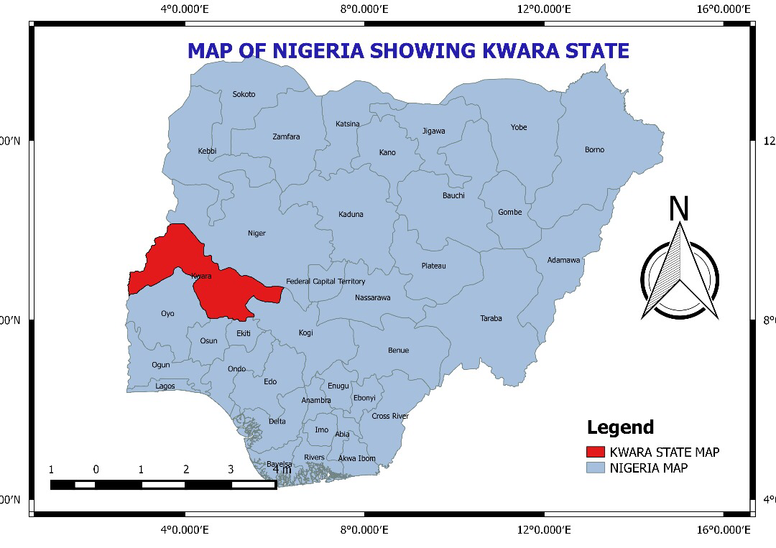 SOURCE: KWAGIS 2025

MAP 2: Map of Kwara State Showing Ilorin West
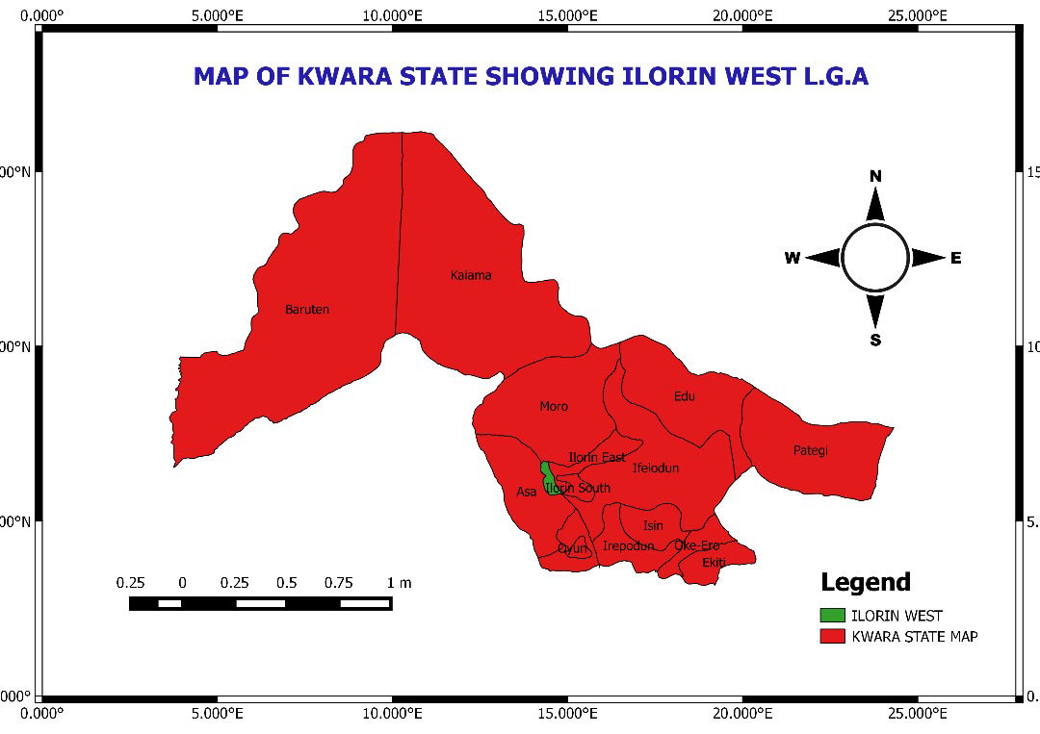
SOURCE: KWAGIS 2025

MAP 3: Map of Ilorin West
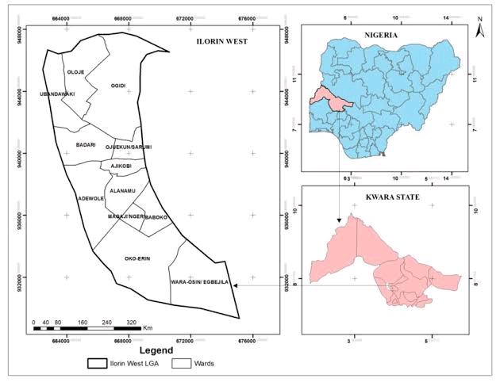

SOURCE: KWAGIS 2025

CHAPTER TWO
LITERATURE REVIEW
2.0 CONCEPTUAL FRAME WORK
CONCEPT OF HOUSING
In the world today, there is a great need for housing particularly in developing countries and for low income people. Every society, developed and developing has a basic need for housing. For every individual, alone or as part of the family unit, a house is hopefully more than just physical shelter. In our society, still base on family as its fundamental unit, a house and home also represent and extended womb for the young during the formative years. Through his nature, physical location and characteristics, a house provides the enabling influence or a variety of important services. This includes physical services, social services and economic services.
For the individual or the family, the house is both shelter and symbol for physical protection.
The available evidence though scarce, indicates that housing is very far from being a top priority. For example, 1971 surveys of temporary structures in Nairobi revealed that out of ten investment choices, families placed a better standard of house to live in next to the last. This chapter talk about some basic information or houses and the view of authors on housing.
2.1 WHAT IS AN HOUSING
Housing is more than a mere shelter in its proper definition. Housing can be defined as the act of providing shelter or lodging and cover a process of producing house ranging from the acquisition of land for housing development to the sub-division of layout in which cognizance is taken of all the ancillary service and community facilities. It also includes the factors of housing production like architectural design, financial material and labour among others.
The most succinct definition is that offered by the U.N. interregional seminar on the social aspects of housing in 1975, which says "housing" encompasses all the ancillary services and community facilities which is necessary to human wellbeing.
In terms of national development objectives, it is also recognized that housing as a major investment item could make a significant contribution to economic development. If housing policy is judiciously employed it could also serve as a vehicle for improving social welfare, and shaping the urban environment. The PRC (Nig) Ltd report of 1980 summarized all these interconnected attributes and defines housing as "complex package of goods and services including shelter, related environmental services, and access to employment and community facilities." Housing is one of the basic needs of men. It is a physical structure used for shelter which includes all facilities and amenities needed for healthy living of the occupants.
2.2 TYPE OF HOUSING
Housing is of different types and is it classified in different way depending on the part of the world you are in:
1. Based on Ownership:
- Owner-Occupied Housing: Homes owned by the occupants themselves.
- Rented Housing: Homes rented by occupants from landlords or property managers.
-Shared Ownership Housing: Homes owned jointly by occupants and a third party, such as a government agency or non-profit organization.
2. Based on Type of Construction:
- Detached Houses: Free-standing homes, not attached to any other dwelling.
- Semi-Detached Houses: Homes attached to one other dwelling, sharing a common wall.
- Terraced Houses: Homes attached to multiple other dwellings, sharing common walls.
- Apartment Buildings: Multi-unit buildings, with each unit being a separate dwelling.
- Mobile Homes: Dwellings built on wheels, designed to be movable.
3. Based on Size and Layout:
-Studio Apartments: Small, single-room dwellings with a combined living and sleeping area.
- One-Bedroom Apartments: Dwellings with a single bedroom and a separate living area.
- Two-Bedroom Apartments: Dwellings with two bedrooms and a separate living area.
- Three-Bedroom Houses: Dwellings with three bedrooms and a separate living area.
- Maisonettes: Large, multi-story dwellings with multiple bedrooms and living areas.
4. Based on Location and Accessibility:
- Urban Housing: Homes located in cities or towns, often with access to public transportation and amenities.
- Suburban Housing: Homes located in suburban areas, often with more space and a quieter environment.
- Rural Housing: Homes located in rural areas, often with limited access to amenities and services.
- Accessible Housing: Homes designed for people with disabilities, with features such as wheelchair ramps and wide doorways.
5. Based on Age and Condition:
- New Housing: Recently built homes, often with modern amenities and energy-efficient features.
- Older Housing: Homes built many years ago, often with historic charm and character.
- Renovated Housing: Homes that have been updated or renovated, often with modern amenities and features.
2.3 HOUSING DESIGN
The design of housing units is critical to the comfort and convenience of the occupants. They involve not only physiological responses to the enclosed environment but also sociological response emanating from the socio-cultural norms of the users related to all the ancillary services and community facilities which are necessary for human well - being including environmental services, employment opportunities, social services, personal safety and security.
Thus, according to Kaiza (1975) he says that the planning, design and implementation of housing units should involve practitioners from different disciplines from inception to completion. He emphasized that the design or housing units should enhance conveniences and comfort of the occupations. Onibokun (1982) ascertained that the design of housing especially mass-produced public housing has been the subject of many commentaries in the public. He listed the specific media references in his bibliography on housing. He discussed the primary thrust of the comments points to be:
- The inappropriateness of the design especially in northern Islamic communities
- . The inadequacy of space provision for the average Nigerian family.
These comments while not hacked by scientifically conducted research, it represents the reaction of the public to government provided mass housing scheme. The available literature on housing design can he divided into two themes namely:
2.4 ISSUES TO CONSIDER IN HOUSING DESIGN:
A considerable number of papers are devoted to outlining the issued that should be considered in the design of houses. Wahab (1974) lists as critical aspects, sufficient family space rind room for future expansion. He examines the functional requirements of building designs and discusses the concepts "good homes" and "minimum standards" within the Nigerian context, the paper makes a case from the need to formulate better standard of home design for the various economic groups ill the country. These aspects seem to be in missed by the designers and contractors of the present federal low-cost housing scheme.
The disposition of the units does not leave sufficient room for expansion Gyuse (1977) listed the critical aspects of this housing as culture. He examines the Tiv housing forms and discusses about the enclosed outdoor domestic space which allows the sale subtle control on the household and surveillance of entry and agrees from the household dwelling unit as ideal. Marries (1961) study about the resettlement in Lagos which is similar to the Tiv culture as stated by Gyuse (1977). Marries described traditional Yoruba housing in central Lagos. He discusses that the Yoruba household refer plenty of centrally located outdoor space from which access can be gained to all the rooms. The dominant male prefers a strategic location where he has visual and auditory access to the whole dwelling unit.
Gyuse (1978, 1981) propounded that the general socio-cultural parameters for housing included the family structure socio-intercourse and habits. He went further to say that the general socio-cultural parameters have been applied to studies of both rural and urban housing. With respect to rural housing a study of Tiv housing in Benue State by Gyuse (1981) shows that all the criteria were met leading to functionally adaptable forms which enhances adaptability, allowing the resident to perform their various chores without infringing on their social norms. However, the study of Gyuse (1980) found out these parameters to the urban residents however yielded startlingly contrasting results. It was found out that the central out door space or courtyard was of lesser significance to Tiv urban residents. On the other hand, individual and household privacy, availability of amenities such as pipe borne water and electricity were considered by more than 70% of residents to be more important.
This difference in housing, values espoused by urban and rural residents of the same cultural group shows the danger attempting to impose rural values on urban residents.
Unfortunately, there are no comparable works on other Nigerian cultural groups. It is therefore not possible to make definite statements on urban design preferences from a cultural perspective. However, general discussions and observations suggests that it may be possible to deduce some basic parameters from urban housing such parameters when deduced will form the bases for core housing for Nigerians.
2.5 EVALUATION OF EXISTING HOUSING DESIGNS
There have been very few studies evaluating the suitability or other wise of urban housing in Nigeria. This is surprising, because much of modern urban housing in Nigeria has not grown out of Nigeria domestic architecture, rather it has to some extent been imposed by contacts with Europeans. The few studies that exist tends to document external influence on indigenous design. Vaughan (1967) in a pioneering work outlined the changes in domestic especially as influenced by colonial houses and the increased contact with other societies. Gyuse (1977) noticed that rural housing in Tiv land was very much affected by missionary housing styles and forms. however, it can be observed in the city that many private builders copy the and form of government housing. This suggest that if the government and other public organizations build appropriate forms, such forms could be diffused over time and throughout the society.
In contrast to studies by Vaughan (1967) and Gyuse (1977), there are two studies that specifically set out to evaluate existing form. Gotip's (1982) study of Mango Road Low Cost housing scheme in 105, specifically attempts show how the uses preferences can be incorporated into low cost design scheme. The study highlights some of the problems of residents in particular, space need and lack of social amenities in the estate. Unfortunately, the evaluation of the suitability of the form is weak. A companion research by Gyuse is yet to be published.
It can be seen from the above that systematic studies of design of housing have been concentrated on Yoruba and Tiv housing. Despite of the complaints from the Islamic areas of northern Nigeria, no studies have been conducted to find out what is appropriate. In the same way, there have not been any studies cultures of Nigeria. Moreover, much contemporary design appears to be culturally unacceptable to many Nigerians communities especially in the Islamic areas of northern Nigeria. However, it should not be assumed that rural values are maintained in urban areas. Space provision is often inadequate in view or the needs of the families occupying term. This applies mostly to the low-income families.
2.6 CONSTRUCTION AND TECHNOLOGY
Interest in construction as a valid area of research in Nigeria became heightened in the mid-70s. Most of the works are centred around the international conferences on housing. The available research on housing construction and techniques is divisible into three part dealing with problems, materials and techniques. With the respect to problems, all the authors attributes them to what is vaguely referred to in government statements as "lack of executive capacity." It seems to be generally believed that Nigeria contractors lack s the ability and or knowledge to deliver standard housing. There is however no study to hack up to carefully document this general view,
other problems have been identified by Adeniyi (1974) as lack of capital lack of skilled man power, high cost of building materials. He also sketches the Nigeria economic and examines the role of housing in economic and social development as a component of the construction Industry. He identified the problems facing the industry as well as the possible ways and means through which the construction industry can respond to the challenge of providing housing in Nigeria.
One basic problem suggested by Oloyide (1974) is the demand outstrips the ability of the industry to provide. The PRC (Nig) Ltd report of 1980 while agreeing that industry output may be inadequate, he also suggests that the industry is delivering at less than half its capacity. It suggests that if various administrative bottlenecks including approval procedures are removed, the rate of housing starts could literally double the current rate, while these assertions are common in the literature in housing, it needs to be pointed out that no studies have been found that provide an analytical base for these assertions.
With respect to materials, Ola (1977) suggests the use of stabilized soil to provide cheap but durable housing. This ideal has not yet caught on in Nigeria although it is common in Latin American countries and is becoming common in the south-central U.S.A, In Nigeria, the only known example has been the Mkar Christian Hospital which was built primarily of stabilized soil. Oguara (1980) make a similar suggestion recommending specifically cement stabilized later the blocks instead or cement block. Adesina (1980) advocates a broad range of materials that are easily available on-site including clay products, stones, bricks, lime, timber, bamboo, and even points out that the cost of importation both in cash terms as well as in terms of lost opportunities other sectors of the economy is too high, this cost makes it imperative to substitute local buildings materials where possible. He critically examines the problems prospects of promotion the use of local building materials in Nigeria housing construction.
The author examines the justification for encouraging the use of local building materials, reviews the steps hitherto taken by the government to encourage the use of these materials, analyses the problems of acceptability and unacceptability of the materials and discusses the technological legal and economic implications of the issue of the use of local materials in the building construction industry. The value of imports for certain years of some selected material inputs into the building and construction industry in Nigeria were also presented, by the author. Adesina and Utgikar (1980) is complementary to Okpalas paper examines how the costs of housing construction can be reduced through the use of available local building materials and changes in the building construction methods as a building block for developing a home-grown technology for the future.
The experience from other countries, past experiments in Nigeria rind the proposals for modification presented by the authors show that there is a very high potential for stone, clay products, stabilized earth lime, timber, sulphur, bamboo, plastic and other local materials in the exercise of finding cheap, durable, attractive and acceptable materials for building construction in Nigeria. This view is rather appealing except that we are not told how it is to be programmed or implemented. Three other authors suggest what is essentially the same thing namely industrialization of the building industry. Erhabor (1980) advocates system approach based on GIWARITE (TM) products which include a full range of roofing walling and finishing products.
Orouet (1980) advocates mass production techniques, and Sinna (1980) also advocate mass production techniques especially prefabrication of sections of the building in the factory to facilitate rapid assembly. Onibokun (1982) analyses and discusses an experiment which has successfully shown that a judicious use of local building materials in preference to bring housing within the reach of the low-income families.
The author shows that there are still quite a number of steps to be taken before the really low- income groups will be able to afford the decent low-cost housing. While these suggestions are interesting, the often do not produce cheaper or better. However, the construction industry in Nigeria has been field in which little interest has been generated among scholars of economic and social development in the country, and the theme of the present conference is a welcome realization of the Nigeria economy. While the housing construction is a major sector of the economy, its nature and performance have not been adequately studied. There is a consensus that the local material content of building industry should be considerably increased.
The costs can be radically reduced by the use of alternative materials. Industrialization of housing industry is advocated by some however, there is no independent study to assess the benefits of industrialization. This leads to the general conclusion that housing construction and design is an area of housing problem that needs careful systematic study in order to verify various assertions and tentative conclusions listed above In addition, such a stud" will suggest an appropriate construction strategy for effective housing delivery.
2.7 HOUSING POLICY AND STRATEGY
A policy is a definite course of action adopted as expedient, or ted after careful consideration of various alternatives. In government circles it represents the line of action adopted or pursued by government. With this definition in mind, it is not correct to say that has been no housing policy in Nigeria. There has been policy; use at each period in history of the country there has been course of action considered by government to the expedient. housing stock, housing conditions and housing design are the three areas essential to effective policy formulation and implementation. That the problem of housing appears to have more used the years is not indicative of an absence of policy but it indicates effectiveness of the implementation of existing policies.
THE NEED FOR POLICY:
The objective or a housing policy should be to solve problems in the housing sector. As long ns problem in the housing stock, housing conditions and housing design persists, there will continue to be comments and research aimed at their resolution. Since 1972, when housing became in major national issues, much has been written about its policy both in the population media as well as from some researchers in the academic community.
Adeniyi (1972) stressed the need for policy, especially in the context of national development. His ideas were put forward shortly after the assertion of hostilities in the Nigeria civil war. Reconstruction was at that time the main thrust of government action. Adeniyi suggested of the establishment of a National Housing Bank to finance housing development. This suggestion was adopted in 1976 with the formation of the Federal Mortgage Bank. Abiodun in (1980) stressed some of the problems of formulating and implementing a policy. Her paper however deals more on fiscal allocation, rather than the quantity and quality of housing delivered of the few available works on housing policy in Nigeria. Aradeon's (1978) work provides the most incisive analysis into the problem.
According to Aradeon, polices such as existed prior to 1975 were elitist and resulted in programmes that benefited only a few. Furthermore, such programmes as existed were a direct response to the wills and attitudes of a few influential government personalities. The view of the public with respect to housing as well as their desires and aspirations were not considered. Wahab's earlier work on values and planning wahab (1970) states the general problem as the imposition of planners the users. This opinion leads to poor results in the attempt to meet housing objectives.
One or the objectives met, is the inability of housing starts to equal or even approximate the need for housing. Okpala (1978) suggests that one of the reasons for this shortfall in housing starts is the facts that the standards set are too high. He therefore advocates the establishment of an appropriate level of standards that would meet the needs for environmental quality and economy at the same time allowing rapid housing provision. This view has been accepted in principle and the policy planning level by government agencies. Seymour (1978) suggests a different course of action. As propounded by him, too much attention has been focused on the building. In his studies in Kaduna, her found evidence to show that the poverty or the environment is perceived by urban residents as a more serious problem than the dwelling unit itself. He therefore advocates a shift in policy from providing new housing to improving the environmental quality of existing housing areas. This is his view will decrease the quantity of new housing required.
Public media contribution to housing policy has been in the main, a reaction to various government actions such as the appointment of the Omolayole Rent Panel in the mid 70's, award of contracts and location or federal housing projects, and comment on design and allocation of housing projects. Unfortunately, apart from indicating the problem there has not been a careful analysis of the ramifications of the problems. Such recommendations as are made are consequently shallow and often seem to compound rather than solve the problems.
2.8 EXISTING HOUSING POLICIES IN NIGERIA:
As stated earlier it is inaccurate to state that there has been no policy on housing. A close reading of development plans and various government documents shows that at least on paper a policy does exist and has always being in existence even though it lacks cohesiveness in terms of overall national objectives or is not always realized. For the purpose of analyzing housing policy in Nigeria, the threefold subdivision of the time frames adopted by Onibokun (1975) and Adeniyi (1980) is very useful.
According to these two researchers, hosing policy directions in Nigeria may be divided into three phases namely:
- Colonial phase up to 1960
- Limited government intervention from 1960-1975
- Massive government intervention from 1975-1983
Colonial Housing Policy: Until the corning of the Europeans to Nigeria, the provision of individual housing was the responsibility of the individual aided by the community, as from time to time required. With the coming of the colonial administration, there was introduced a transient community of colonial officials and their retinue who needed to he housed. The policy of the British colonial government was to provide housing at minimal rents to all colonial staff and a few necessary indigenous support staff, usually clerks, prison officials, police and army. Each category has its own separate quarters. This gave rise to clerk quarters, government reservation areas (GRA), police barracks and so on, found in all colonial towns in Nigeria (Bingel 1978).
The policy of government towards the mass of Nigerians moving from rural areas into the new administrative towns rang being neglect to the establishment of building lines and issuance of building plots at normal cost to individual households. The new building lines became known in the northern states as Sabon Garis of township areas. Government policy was to provide guidelines in the form of township building rules (laws of Northern Nigeria. 1(63) which formed the basis for housing development. As Gyuse (1980b) states their rules were concerned more with maintenances of sanitary health rather than the design suitability of the house itself.
However, the three segments of the urban communities namely GRA township and native town came together as a result of lack of external controls by the local chiefs who made decision in very much the same way as he had occurred before the advent of the European colonization. This amalgamation occurred soon after independence problem which still plague the urban community. Limited government intervention: The period of 1960-1975 marked a gradual, but increasing visibility of government involvement and intervention in the area of housing. In the period soon after independence, in 1960, the primary emphasis of government regarding housing was the expansion of government quarters to cater for the increasing indigenous bureaucracy.
As the British administrators left, Nigerians took over their position and aspired to the same treatment as that meted out to the British administrators. This treatment includes the provision of quarters. This aspiration perhaps more than any other is thought by some to have showed down the concept of home ownership among urban Nigerians. Massive government Intervention from 1975-1983: Under this intervention, we have the following national development plan made by the government namely:
- The first National plan 1962-1968: The primary action was the establishment of housing corporation by the three regional governments. These corporation concentrated their activities in the regional capitals.
- The second National plan 1970-1974: This plan was dubbed a programme of post-war reconstruction and development.
Five national objectives were identified, these were.
(i) A united strong and self-reliant nation (il) A great and dynamic economy
(i) A just and egalitarian society
(iv) A land of bright and full opportunities for all citizens.
Despite the lofty objectives, the actual plan revealed a weakness in converting national goals to practical reality. Housing was clearly not a primary priority activity even though it is central to individual survival, priority in allocations of resources went to defence and security, second priority to Agriculture, industry and transportation and man-development and third priority of the plan was social services y power. Communications and water supply. Housing was placed lowest category in a group called other services' which included other things, towns and country planning.
- The third national plan 1975-1980: In contrast to the second national plan, the third plan represented a significant shin in government policy and position with respect to housing. The third plan identified five issues and problems these are:
- Shelter is acknowledged as one of the most basic human need and is profoundly related to health, welfare and productivity.
- in Nigeria's housing problem is seen as essentially urban in character, due to rapid urbanization.
- Report by the F.O.S shows that housing conditions were characterized by overcrowding, squatter settlements, high rents and low infrastructural services.
- Scarcity of housing meant that rents were high as a proportion of total income.
- By its own admission, government activity in the past has been restricted to a few middle-class housing estates, provision of to loans middle class government officials through the staff housing loan schemes. The private sector has been unable to provide relief.
d. The fourth national plan 1981-1885: This plan represents an improvement over previous plan document. It shows greater understanding of the housing problem at least on the part of those who drafted the document. In this plan, housing is for the first time viewed comprehensively to include not only the shelter element, but also a utilities and community services such as energy, water supply, access.
e. Roads, sewerage, refuse disposal facilities and nearness to employment opportunities, ns well as education facilities.
conceptually, this represents a shift from simply providing shelter or building houses to attempting to develop some notion of community. This was an important shin, the result of which could not be felt in the past because of the late start in implementation as well as the change in government in 1983. The plan frankly admitted the failure to achieve more than 13-19% of programme under the 1975 -1980 plan. The plan admits to four critical and perhaps well-known housing problems namely:
- Inadequacy of housing stock
- Inadequacy of housing finance as a result of fewness of mortgage financing.
- Inadequacy of land for development in spite of the land use act (1978)
- Over design and excessive costs of units proposed by government.
From a review of available information, it can be seen that at the policy statement level, each subsequent plan represents a significant more in the direction of meeting the needs of the people. The plan documents however do not show the range of alternatives open to the government. It is therefore not possible at policy selection level to say whether or not the most effective policies were being adopted policy no matter how laudable cannot achieve the desired results unless there is a commitment as well as instruments to achieve its goals.

CHAPTER THREE
3.0 RESEARCH METHODOLOGY
This chapter discussed the research design, data types and sources, instruments for data collection, population of the study area, sample size and techniques, and data analysis.
3.1 RESEARCH DESIGN
This study used survey method as the based methodology for this study, it focused on quantitative techniques to assessed the housing conditions of the indigenous area of Ilorin (Alore) using five grading scale (very poor, poor, fair, good and very good; these condition grading focused on the building components (roof, walls, windows, doors, floor,) and available facilities within the compound and the neighbourhood.
3.2 TYPES OF DATA AND SOURCES
Data Types
Primary data collected for the study includes; socioeconomic characteristics of the respondents, types of the buildings and its components, conditions of the building components, conditions of the facilities within the compound, available facilities in the neighbourhood, conditions of the facilities in the neighbourhood.
- Questionnaire: A questionnaire is a research tool used to collect information from respondents through a series of questions.
- Interview: An interview is a research method used to collect data through a conversation between the researcher (interviewer) and the participant (interviewee).
- observation:Observation is a research method used to collect data by watching and recording people's behavior, actions, and interactions in a systematic and structured way.

Secondary data collected include satellite imagery from google Earth used to determine the population of the study area.
3.3 INSTRUMENTS FOR DATA COLLECTION
Interview Guide: Structured interview question was used to acquire the historical background of the study area which revealed the indigenous five families’ compound in Alore Area of Ilorin.
Structured Questionnaire: Structured questionnaire was prepared and used to assess the conditions of the buildings in the indigenous area (Alore) of Ilorin. The Questionnaire is divided into four components;
Camera: Digital camera was used to take pictures of the conditions of building in the study area and other important views were captured.
Google Earth Application: The satellite imagery of the study area was captured and digitised, which shown the boundary of the study area and the number of buildings in the study area.
Sample frame : A sample frame is the list or source from which a sample is drawn. It's the population from which the sample is selected, and it should ideally include all the individuals or elements that the researcher is interested in studying.
Sample size: Sample size refers to the number of participants, observations, or data points included in a study or analysis.
Sample techniques:Sampling technique refers to the method used to select a subset of individuals or elements from a larger population for the purpose of a study or research.

3.4 STUDY AREA POPULATION
SAMPLE FREAME: Based on the captured imagery of the study area, the population of buildings in the study area (Alore) is 752 as shown in the Imagery 1 which is also the sample frame.
S/N | STREET | FREQUENCY | AREA (HECTER) | %
1. | OLORIEGBE | 173 | 9.19 | 23.0
2. | OLUKODO | 104 | 5.52 | 13.82
3. | ARAOJE | 72 | 3.83 | 9.57
4. | BALODE | 115 | 6.11 | 15.29
5. | ONI SESIN | 288 | 15.31 | 38.29
 | TOTAL | 752 | 39.96 | 99.97

SOURCE: FIELD SURVEY 2025

IMAGERY 1: Google Earth Imagery of Alore
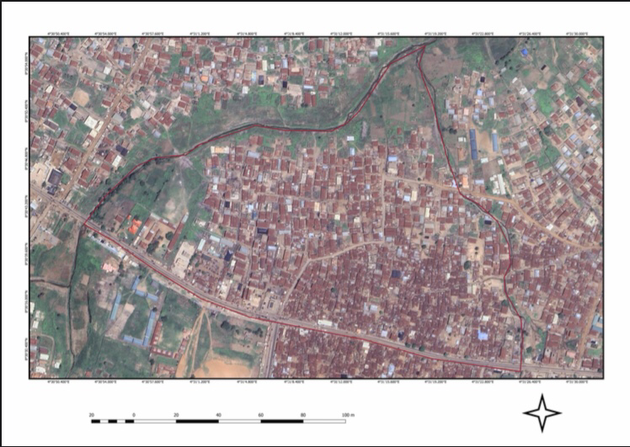
SOURCE: GOOGLE EARTH (2025)

Sample Size
Using Slovin’s sample size formula shown in the equation 1, the population of buildings in the study area as determined from the Google Earth image is 752, and marginal error E as 0.05.
Equation 1 ………………………
As shown in the Equation 2, the sample size of the study area is 261
Equation 2 ……………………… = 261
3.5 SAMPLING TECHNIQUES AND UNIT
The sampling techniques used is stratified systematic sampling, the study area was divided into five strata (the indigenous family’s compound) and sample interval of 3 was arrived at based on calculation.
SAMPLED POPULATION AND INTERVAL
SOURCE: FIELD SURVEY 2025.

S/NO | INDIGENOUS FAMILY’S COMPOUNDS | BUILDING POPULATION | SAMPLED POPULATION | SAMPLE INTERVAL
1. | OLORIEGBE | 173 | 60 | 3
2. | OLUKODO | 104 | 36 | 3
3. | ARAOJE | 72 | 25 | 3
4. | BALODE | 115 | 40 | 3
5. | ONI SESIN | 288 | 100 | 3
 | TOTAL | 752 | 261

Data Analysis and Presentation: Descriptive data analysis was employed using frequency and percentage table, pictorial presentation includes; charts and pictures.
CHAPTER FOUR
DATA PRESENTATION AND ANALYSIS
4.1 SOCIOECONOMIC CHARACTERISTICS DATA OF THE STUDY AREA
4.1.1 SEX OF THE RESPONDENTS
SEX | FREQUENCY | PERCENTAGE
MALE | 157 | 60.1
FEMALE | 104 | 39.8
TOTAL | 261 | 100
SOURCE: FIELD SURVEY 2025.
Table showing the total sex of the respondents male 60.1%, female is 39.8%, this show that male as the highest percentage in the study area.
4.1.2 AGE OF RESPONDENTS
AGE | FREQUENCY | PERCENTAGE
18-30yrs | 45 | 17.2
31-40yrs | 77 | 29.5
41-50yrs | 53 | 20.3
51-60yrs | 39 | 14.9
61-Above | 39 | 18.0
Total | 261 | 100
SOURCE: FIELD SURVEY 2025.
Table showing the Age of the respondents,the highest of the respondents is 31-40yrs with 29.5% while the lowest is 51-60yrs with 14.9%,this show that 31-40yrs as the highest population in the study area.

4.1.3 EDUCATIONAL LEVEL OF THE RESPONDENTS
LEVEL | FREQUENCY | PERCENTAGE
PRIMARY | 89 | 34.1
SECONDARY | 63 | 24.1
TERTIARY | 35 | 13.4
ILLITERATE | 74 | 28.3
TOTAL | 261 | 100
SOURCE: FIELD SURVEY 2025.
Table showing the Educational level of the respondents, the highest is primary level with 34. 1% while the lowest is tertiary level with 13.4%, this show that primary level education is very high in the study area.

4.1.4: INDIGENOUS FAMILIES SAMPLED
S/NO | INDIGENOUS FAMILY’S COMPOUNDS | FREQUENCY | PERCENTAGE
1. | OLORIEGBE | 60 | 22.99
2. | OLUKODO | 36 | 13.79
3. | ARAOJE | 25 | 9.58
4. | BALODE | 40 | 15.33
5. | ONI SESIN | 100 | 38.31
 | TOTAL | 261 | 100
SOURCE: FIELD SURVEY 2025.
The study area (Alore) as an indigenous area of Ilorin City comprises of five (5) families as presented in the Table 4.1.4.

4.2 DETERMINE THE COMPOSITION MATERIAL OF THE HOUSING STRUCTURE
MATERIALS USED FOR CONSTRUCTION
Two aspects of buildings which given an indication as to their style and ease of maintenance are the walls and the roofs. Changes over timehave occurred as regards the materials and methods applied in the construction of these two aspects. And such changes have contributed to the improved conditions and durability of buildings.
4.2.1: TYPES OF WALLS
Table 4.2.1 shows the sampled dwellings according to the type of materials used for the walls in the study area.
4.2.1 MATERIAL USED FOR WALL
NAME OF COMPOUNDS | TYPES OF WALL
 | BRICK | MUD
OLORIEGBE | 9 | 51
OLUKODO | 4 | 32
ARAOJA | 3 | 22
BALODE | 5 | 35
ONI SESIN | 18 | 82
TOTAL | 39 | 222
TOTAL | 261
SOURCE: FIELD SURVEY 2025.
In the study area, The majority of the buildings (222) were constructed with mud walls, while 39 buildings used brick walls.
4.2.2 TYPES OF ROOFS
THE DISTRIBUTION OF SAMPLED DWELLINGS BY THE TYPES OF ROOFS
NAME OF COMPOUNDS | TYPES OF ROOFS
 | Corrugated iron shoot | Longspan roof sheet
OLORIEGBE | 10 | 50
OLUKODO | 7 | 29
ARAOJA | 5 | 20
BALODE | 7 | 33
ONI SESIN | 9 | 91
TOTAL | 38 | 223
SOURCE: FIELD SURVEY 2025.
The choice of materials for the roof has also undergone some changes over years. As a result, the choice of materials for the construction of walls sometimes carries some implications for the types of roofing materials used. In the study area, the prominent material used for roofing is corrugated iron sheet while only a building use long span roofing sheet, the prominent material used for roofing is corrugated iron sheet (223 buildings), while only a few buildings used long span roof sheets (38 buildings).

4.2.3 TYPE OF FLOOR
DISTRIBUTION OF SAMPLED DWELLINGS BY THE TYPES OF FLOORS
NAME OF COMPOUNDS | TYPES OF FLOORS
 | CEMENT | TILES
OLORIEGBE | 57 | 3
OLUKODO | 34 | 2
ARA OJA | 24 | 1
BALODE | 40 | -
ONI SESIN | 98 | 2
TOTAL | 253 | 8
SOURCE: FIELD SURVEY 2025.
In this study area The majority of the buildings (253) had cement floors, while only 8 buildings had tile floors.

4.2.4 TYPE OF WINDOW
DISTRIBUTION OF SAMPLED DWELLINGS BY THE TYPES OF WINDOWS
NAME OF COMPOUNDS | TYPES OF WINDOWS
 | Wooden  Window | Sliding  Window | Louvers  Window
OLORIEGBE | 52 | 3 | 5
OLUKODO | 28 | 2 | 6
ARA OJA | 18 | 2 | 5
BALODE | 32 | 2 | 6
ONI SESIN | 83 | 7 | 10
TOTAL | 214 | 16 | 32
SOURCE: FIELD SURVEY 2025.
in the study area Themost common type of window used is wooden windows (214 buildings), followed by louvers windows (32 buildings) and sliding windows (16 buildings).

4.3 ASSESS THE HOUSING CONDITION IN THE STUDY AREA
PHYSICAL CONDITION
PHYSICAL CONDITION OF THE BUILDINGS
NAME OF COMPOUNDS | PHYSICAL SOUND  WITH NO | THOSE WITH NEED  MINOR REPAIRS | DILAPIDATED  BUILDING
OLORIEGBE | 6 | 50 | 4
OLUKODO | 4 | 30 | 2
ARA OJA | 3 | 22 | -
BALODE | 2 | 36 | 2
ONI SESIN | 7 | 91 | 2
TOTAL | 22 | 228 | 11
SOURCE: FIELD SURVEY 2025.
The physical condition of the buildings was also assessed, revealing that: physical ConditionOnly 22 buildings were physically sound with no need for repairs, while 228 buildings needed minor repairs, and 11 buildings were dilapidated. These findings suggest that the majority of the buildings in the study area require maintenance and repairtoensurethey remain safe and habitable.
4.4 IDENTIFY THE AGE OF HOUSE IN THE STUDY AREA
AGE OF BUILDINGS IN THE STUDY AREA
All things show their ages one way or another, buildings are no exception. With constant exposure to the harsh tropical environment, not onlyexterior decorations but also the concrete works of houses eventually show their ages. The rate of deterioration is influences by the type of unit, the choice of materials used for construction, the quality of finishing and the motivation to maintain the properties.
DISTRIBUTION OF SAMPLED DWELL UNITS BY AGE IN THE STUDY AREA.
INDIGENOUS’ S COMPOUNDS | AGE OF BUILDINGS
 | 5-30 YEARS | 31 ABOVE
OLORIEGE | 13 | 47
OLUKODO | 11 | 25
ARAOJA | 4 | 21
BALODE | 11 | 29
ONI SESIN | 18 | 82
TOTAL | 57 | 204
SOURCE: FIELD SURVEY 2025.
In the study area, 57 of dwelling units are between the ages of 5-30 years, while the dwelling between 31 and above are204, The proportion of houses in this group is more likely to represent housing problems, as far as urban housing condition are concerned. The highest number of buildings in the housing quality. The older category of buildings lacks proper maintenance and attention by the occupier.
Although it appears that the newer buildings require less attention, but it should also be known that the greater the proportion of older dwellings, the greater the like hood of maintenance problem associated with the aging of the dwellings
4.4.1 TYPES OF HOUSING/BUILDING
TYPES OF BUILDING IN THE STUDY AREA
S/NO | INDIGENOUS’ S COMPOUNDS | TYPE OF BUILDING
 |  | BUNGALOW | STOREY
1. | OLORIEGBE | 55 | 5
2. | OLUKODO | 34 | 2
3. | ARAOJE | 25 | -
4. | BALODE | 40 | -
5. | ONI SESIN | 97 | 3
 | TOTAL | 251 | 10
SOURCE: FIELD SURVEY 2025.
The type of buildings, in terms of size, and number of units also carryimplication for the ease of maintenance. Table 4.4.1 shows the distribution of sample dwelling units by type, in the study area. The bungalow is the most common type of housing found in the study area.The actual pattern of housing types recorded in the survey is to be looked at as the result of available local solution to housing needs and supply rather than as an indicator of preferred solution to housing problems.
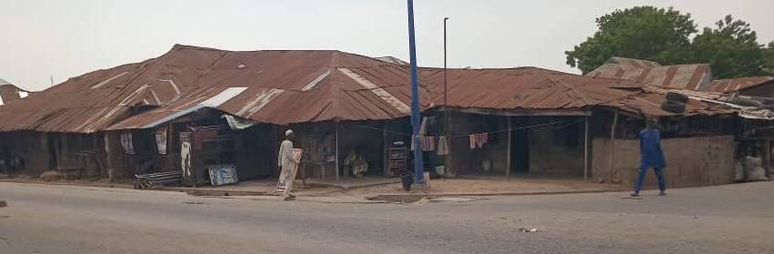
Plate 1: Image show the bad condition of the building

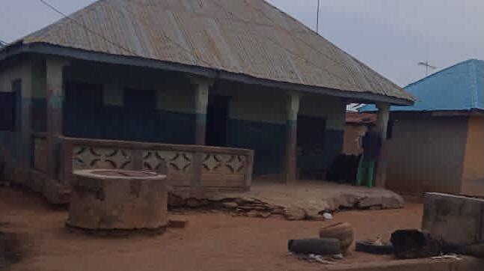
Plate 2: Image show the fair condition of the building
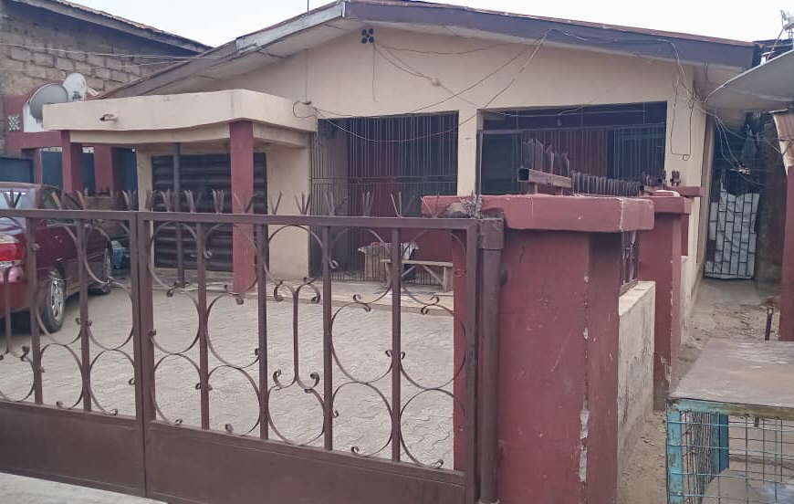
Plate 3: Image show the good ccondition of the building

CHAPTER FIVE
5.0 SUMMARY OF FINDING, RECOMMENDATION AND CONCLUSION
This chapter givesthe summary of findings on Housing conditions in the study area, recommendation made is based on the major findings and conclusion was made.
5.1 SUMMARY OF FINDINGS
The total sex of the respondents male 60.1%, female is 39.8%, this show that male as the highest percentage in the study area. The Age of the respondents, the highest of the respondents is 31-40yrs with 29.5% while the lowest is 51-60yrs with 14.9%,this show that 31-40yrs as the highest population in the study area. The Educational level of the respondents, the highest is primary level with 34. 1% while the lowest is tertiary level with 13.4%, this show that primary level education is very high in the study area. The study area (Alore) as an indigenous area of Ilorin City comprises of five (5) families as presented in the Table 4.1.4. The majority of the buildings (222) were constructed with mud walls, while 39 buildings used brick walls. The choice of materials for the roof has also undergone some changes over years. As a result, the choice of materials for the construction of walls sometimes carries some implications for the types of roofing materials used. In the study area, the prominent material used for roofing is corrugated iron sheet while only a building use long span roofing sheet, the prominent material used for roofing is corrugated iron sheet (223 buildings), while only a few buildings used long span roof sheets (38 buildings).The majority of the buildings (253) had cement floors, while only 8 buildings had tile floors. Themost common type of window used is wooden windows (214 buildings), followed by louvers windows (32 buildings) and sliding windows (16 buildings).
The physical condition of the buildings was also assessed, revealing that: physical ConditionOnly 22 buildings were physically sound with no need for repairs, while 228 buildings needed minor repairs, and 11 buildings were dilapidated. These findings suggest that the majority of the buildings in the study area require maintenance and repairtoensurethey remain safe and habitable.57 of dwelling units are between the ages of 5-30 years, while the dwelling between 31 and above are204, The proportion of houses in this group is more likely to represent housing problems, as far as urban housing condition are concerned. The highest number of buildings in the housing quality. The older category of buildings lacks proper maintenance and attention by the occupier. The distribution of sample dwelling units by type, in the study area. The bungalow is the most common type of housing found in the study area.The actual pattern of housing types recorded in the survey is to be looked at as the result of available local solution to housing needs and supply rather than as an indicator of preferred solution to housing problems.

5.2 RECOMMENDATION BASE ON FINDINGS
(1) Given encouragement in the use of more durable building materials to the people in tending to build a house.
(2) The windows should by upgraded by the owners, by removing them with the standard one.
(3) The dilapidated buildings that are no longer fit for living should be rebuilt by the owners' and government should promote research into the building techniques materials and method of construction.
(4) The improvements shall be made on the wall by plastering as to look more attractive.
(5) The constant maintenance of the buildings if there is any damage’s part, repair should be carried out immediately.
5.3 CONCLUSION
The study assessed the housing conditions in Alore, an indigenous area of Ilorin, Kwara State. The findings revealed that the majority of the buildings are bungalows, with a significant proportion being over 30 years old. The walls are predominantly made of mud, while the roofs are mostly corrugated iron sheets. The floors are mostly cemented, and the windows are largely wooden.
The study also showed that the physical condition of the buildings varies, with some being sound, others needing minor or major repairs, and a few being dilapidated. The availability and adequacy of facilities within the compounds and neighborhoods were also evaluated.
The study's results suggest that the housing conditions in Alore are generally poor, with a need for improvement in terms of building maintenance, infrastructure, and amenities. The findings have implications for urban planning, housing policy, and community development in the area.

REFERENCE
Abiodun, J. O. (1980). Housing policy and the Nigerian economy.Adeniyi, E. O. (1972). Housing finance in Nigeria Adeniyi, E. O. (1974). Housing construction industry in Nigeria.
Adeniyi, E. O. (1980). Housing policy in Nigeria: Problems and prospects. Adesina, S. A. (1980). The use of local building materials in Nigeria housing construction.
Adesina, S. A., & Utgikar, V. P. (1980). Reducing housing construction costs through the use of local materials. Angel, S. (2000). Housing policy matters: A global analysis.
Aradeon, D. B. (1978). Housing policy and the Nigerian urban environment. Aribigbola, A. (2006). Housing quality and the well-being of households in Akure, Nigeria.
Augustine, O. (2005). Housing conditions in Nigerian cities: A review. Bingel, A. S. (1978). Urban housing in Nigeria. Blunt, A., & Dawling, S. (2006). Home, identity and community. Charles, J. (2003). Housing policy and the urban poor.
Dung-Gwon, J. D., & Ibrahim, A. (2006). Housing conditions and quality of life in Jos, Nigeria.
Efobi, K. (2002). Housing development and policy in Nigeria. Erhabor, P. O. (1980). Industrialized housing in Nigeria.
Fagbohun, O. (2003). Housing and environmental quality in Lagos, Nigeria. Ajagbu H.I. (1976); Urban and Rural Development D.T. Leasers
Blair (1966); P 162: Nigerian Rural Development and Evaluation. Their edition. Onibokun A. (1982) Nigeria Housing Evaluation; Second edition
Onibokun P. (1983) Issues in Nigerian Housing N.I.S.R. Ibadan
Omiuta & Onokenhoraye: Urban system and planning published by the editorial committee, geography, Benin 1986 Salu (1990); Housing Development in African L.B.M Basin Second edition
Tomi Asenuga; Future of Town Planning in Nigeria Town Planning Journal.
Nairobi Household Survey" (1971), Institute for Development Studies, University of Nairobi
U.N. Interregional Seminar on Social Aspects of Housing (1975)
PRC (Nig) Ltd Report (1980)
Kaiza (1975): Emphasized the importance of interdisciplinary collaboration in housing design and implementation, highlighting the need for convenience and comfort in housing units.
Wahab (1974): Identified critical aspects of housing design
Gyuse (1977, 1978, 1980, 1981) 1977: Examined Tiv housing forms 1978, 1981: Propounded general socio-cultural parameters for housing 1980: Found that urban residents prioritize individual and household privacy,
Marries (1961): Studied traditional Yoruba housing in central Lagos,
Vaughan (1967): Studied the changes in domestic architecture influenced by colonial houses
Gyuse (1977): Examined the impact of missionary housing styles and forms on rural housing in Tiv land.
Gotip (1982): Conducted a study on the Mango Road Low-Cost housing scheme
Adeniyi (1974): Identified key problems in the construction industry
Oloyide (1974): Suggested that demand for housing outstrips the industry's ability to provide, leading to a shortage of housing units.
Ola (1977): Suggested using stabilized soil for cheap and durable housing, citing examples from Latin America and the south-central USA.
Oguara (1980): Recommended using cement-stabilized laterite blocks instead of cement blocks.
Adesina (1980): Advocated for using local building material
Adesina and Utgikar (1980): Discussed reducing housing construction costs using local materials and changing building methods.
Erhabor (1980): Advocated for a systems approach to building construction using GIWARITE products.
Orouet (1980) and Sinna (1980): Suggested mass production techniques
Adeniyi (1972): Stressed the need for a national housing policy
Abiodun (1980): Discussed problems of formulating and implementing housing policy, focusing on fiscal allocation and the quantity and quality of housing delivered.
Aradeon (1978): Analyzed housing policy problems, arguing that pre-1975 policies were elitist and benefited only a few, and that public desires and aspirations were not considered.
Wahab (1970): Highlighted the problem of imposing planners' values on users
Okpala (1978): Suggested that high standards set for housing construction contribute to the shortfall in housing starts, and advocated for establishing appropriate standards that balance environmental quality and economy.
Seymour (1978): Proposed shifting policy focus from providing new housing to improving environmental quality in existing housing areas, based on studies in Kaduna.
Onibokun (1975) and Adeniyi (1980): Divided Nigerian housing policy into three phases:
Augustine, A. (2005). Housing conditions in Nigerian cities. Journal of Urban Planning, 1Dung-Gwon, J. D., & Ibrahim, Y. (2006). Housing quality and environmental quality: A study of Akure city. Journal of Environmental Studies,
Ebong, M. O. (1983). The impact of environmental quality on human well-being. Journal of Environmental Management,
Fagbohun, O. (2003). Housing and environmental quality: A study of Lagos metropolis. Journal of Housing and Environmental Research,
Nubi, T. O. (2008). Housing finance in Nigeria: Issues and challenges. Journal of Housing and Environmental Research,
Omole, F. K. (2001). Housing conditions in Nigeria: A study of Akure city. Journal of Urban Planning,
Omole, F. K. (2005). Housing maintenance and management in Nigeria. Journal of Housing and Environmental Research,
Onibokun, A. G. (1998). Housing needs and housing policy in Nigeria. Journal of Housing and Environmental Research,
Okupe, O. (2002). Urbanization and housing in Nigeria. Journal of Urban Planning,
Sanda, A. O., & Jambol, D. (2010). Housing conditions and livability in Akure city. Journal of Housing and Environmental Research,
Reports and Documents
Federal Government of Nigeria (FGN). (2004). National housing policy.

APPENDIX 1 : Questionnaire
Appraisal of housing condition in the indigenous area of alore - Questionnaire (ALORE)

Section A: Demographic information
1. Gender (a) male (b) female
2. What is your age (a)18-29(b)30-39(C) 40-49(d)50-59 (e) above
3. What is your street name? ………..
4. what is your level of education (a) primary (b) secondary (c) tertiary (d) Islamic education
5. what is your religion (a) Christianity (b)Muslim (c) tradition
6. Marital status (a) single (b) married(c) divorced (d) widowed
7. How long have you been staying in the area(a)3 -5yrs (b) 6-10yrs (c)11-15yrs(d) 16-25yrs (e) above
8. What is your status in the building (a) renter (b)built(c)inherit (d) bought
9. What is the age of the building (a)1-5yrs(b)6-10yrs(c)11-15yrs (d)16-20yrs (e) above
SECTION B: social
10. what is your occupation (a) employed (b) unemployed (c) student (d)retired (e) other (please specify)
11. what is your monthly income (a)less than #50000 (b)#50000-100000 (c)#100000-150000 (d)#150000-200000(e)above
12. What is the type of building (a) row of rooms (b)compound building (c)flat (d)duplex
13. How many people live in your household (a) 1-2 (b) 3-4 (c) 4-6 (d) 6-8 (e) above

SECTION C: Building condition
14. Type of wall (a) sand-block (b) mub(c) brick (d) concrete
15. Condition of the wall (a)Good (b) fair (c)poor
16. Type of roof (a) aluminum (b)zinc (c)wooden
17. Condition of the roof (a)Good (b)fair (c) poor
18. Type of window (a)Glass and aluminum (b)wood(c) Iron
19. Condition of the window (a) Good (b)fair (c) poor
20. Type of doors (a)wood (b) glass (c) iron
21. Condition of the door (a)Good (b) fair (c) poor
22. Type of ceiling (a) pop (b) pvc (c) Asbestos (d) wood
23. Condition of ceiling (a) good (b)fair (c) poor
24. Type of floor (a) cemented (b)uncemented (c) Tiles
25. Condition of the floor (a) Good (b) fair (c) poor
26. Type of toilet (a)Flush toilet (b)Pit-latrine(c)Bucket-toilet (d)Other (please specify)
27. Condition of toilet (a) Good (b) fair (c) poor
28. How would you rate the ventilation in your dwelling (a)Good (b) Fair (c)Poor
29. Type of power supply (a) National grid (b) solar (c)generator (d) other
30. How accessible is the power supply (a)2 day per week (b) 3 day per week (c) 4 day per week (d) above
31. Sources of water (a) well (b) stream/river (c)borehole (d)public taped water
32. How far is the source of water (a)less than 50m (b)50m-100m (c) 100m-150m(d) 150m-200m
33. Access to the building (a)footpath (b) untarred access road(c) tarred access road
34. Is there provision for drainage (a)yes (b) no
35. Access to health facilities (a)less than 50m (b) 50m-100m (c) 100m-150m (d) 150m -200m (e) above
36. Access to basic education (a) less than 50m (b) 50m-100m (c) 100m-150m (d) 150m -200m (e) above
37. How did you dispose your solid waste (a) burning (b)open space (c)inside drainage channel

