BACTERIAL AND FUNGAL LOAD OF SLICED BREAD ON SALE IN ILORIN METROPOLIS.
BY
JOB FAITH OLUMIDE
HND/23/SLT/FT/0166

A PROJECT SUBMITTED TO THE DEPARTMENT OF SCIENCE LABORATORY TECHNOLOGY, INSTITUTE OF APPLIED SCIENCES (IAS), KWARA STATE POLYTECHNIC, ILORIN,
IN PARTIAL FULFILMENT OF THE REQUIREMENTS FOR THE AWARD OF HIGHER NATIONAL DIPLOMA (HND) IN SCIENCE LABORATORY TECHNOLOGY, INSTITUTE OF APPLIED SCIENCES (IAS), MICROBIOLOGY UNIT
KWARA STATE POLYTECHNIC ILORIN

JULY, 2025

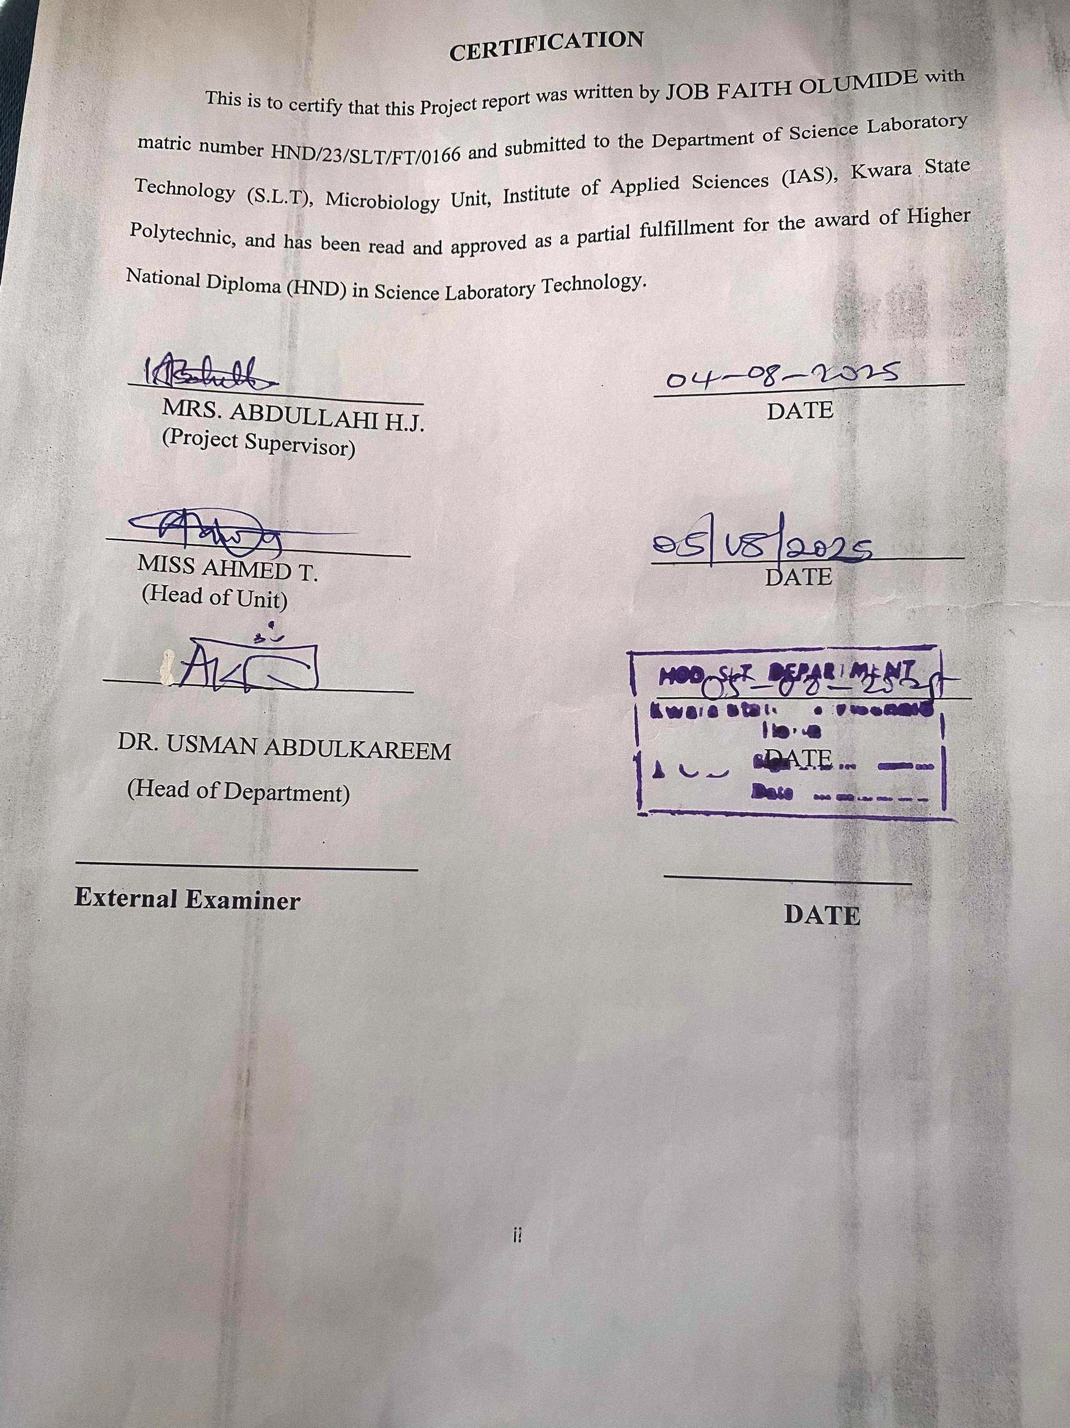
DEDICATION
This work is dedicated to Almighty God. The omnipotent who as showed me mercy by given me the opportunity to start and complete this Higher National Diploma (HND) programme and to my beloved Parent.

ACKNOWLEDGEMENTS
All adoration,thanks and praise to the Almighty God the creator of all universe,I thank him for standing with me throughout the journey of my project from the beginning to the end.
And i also Appriciate the support and contribution of my lovely parent MR and MRS JOB who as been my strength and agent of success in life and in my achievement,may Almighty God continue to shower blessing and make them to eat the fruit of their labour (Amen).
My profound gratitude goes to my project supervisor MRS ABDULLAHI H.J for her support and guidance throughout the project practical and project writeup using this medium to say a big thanks to u ma'am.
Also appreciation also gose to the H.O.D DR. USMAN .A and H.O.U MRS AHMED .T for their support and encouragement to all students of this department And to the lectures and staff of the department,I pray that God increase your knowledge and crown your effort with success
I also register gratitude to my family, friends and relative who have supported me in one way or the other (Morally, Finacially) I say a very big THANK YOU may the Almighty God bless them all (Amen).

TABLE OF CONTENTS
TITLE PAGE i
CERTIFICATION ii
DEDICATION iii
ACKNOWLEDGEMENTS iv
TABLE OF CONTENTS v-vi
LIST TABLES vii
ABSTRACT viii
CHAPTER ONE 1
1.0 INTRODUCTION 1
1.1 Literature review 10
1.2 Statement of problem 14
1.3 AIM 15
1.4 Objectives 15
CHAPTER TWO 17
2.0 MATERIALS AND METHODS 17
2.1 Materials Used 17
2.1.1 Chemicals and Reagents 17
2.2 Preparation of Sample 18
2.3 Preparation of Media 18
2.4 Inoculation and Incubation 19
2.5 Bacterial Analysis and Staining 19
2.6 Fungal Analysis and Staining 20
CHAPTER THREE 21
3.0 RESULTS 21
3.1 Fungal Observation (Lactophenol Cotton Blue Staining) 21
3.2 Bacterial Observation (Gram Staining) 24
CHAPTER FOUR 25
4.0 DISCUSSION AND CONCLUSION 25
4.1 DISCUSSION 25
4.2 Conclusion 27

LIST OF TABLES

Table1: Macroscopic Observation of Fungal Growth on Bread Samples 21

Table 1: Microscopic Observation of Fungal Growth on Bread 22

Table 2: Bacteria Microscopic Observation 24

ABSTRACT
This study assessed the bacterial and fungal load of sliced bread sold in Ilorin metropolis to evaluate its microbiological safety. Bread samples labeled A, B, and C were collected from local vendors and analyzed using standard microbiological techniques. Nutrient Agar and Sabouraud Dextrose Agar supported bacterial and fungal growth, while Gram and lactophenol cotton blue staining aided identification. Staphylococcus spp., Bacillus spp., and Streptococcus spp. were the dominant bacteria, while Saccharomyces spp., Rhizopus spp., and Aspergillus spp. were the major fungi. Sample C exhibited the highest fungal diversity, including toxigenic molds. The findings reflect poor hygiene during production and storage, especially among small-scale vendors. The study recommends routine microbial monitoring, improved packaging, and vendor education to reduce contamination and protect public health.

CHAPTER ONE

1.0 INTRODUCTION
Bread is one of the most commonly consumed staple foods worldwide, appreciated for its affordability, palatability, and nutritional value fig.1 . It is typically made from flour, water, and yeast, and can be enriched with other ingredients to enhance taste and shelf life. Sliced bread, in particular, is a widely consumed convenience product, especially in urban areas where fast and easy meals are preferred. However, due to its high moisture content and neutral pH, bread provides an ideal medium for microbial growth (Shiferaw et al., 2020). Microbial contamination of bread can occur at various stages of production and distribution, especially when hygiene is compromised. This contamination may include both bacterial and fungal species, some of which pose serious health risks. In many developing countries, including Nigeria, the risk of microbial contamination is heightened by poor food handling practices, inadequate storage facilities, and limited quality control regulations. Bread sold in open markets, roadside shops, and small retail outlets may be more vulnerable to contamination due to exposure to environmental pollutants and poor packaging. Ilorin, the capital of Kwara State in Nigeria, is a fast-growing metropolis where many residents depend on pre-packaged and sliced bread for daily consumption. The microbial load on bread in this area is of particular interest due to varying standards of hygiene among vendors and bakeries.
Fig. 1
Sliced bread
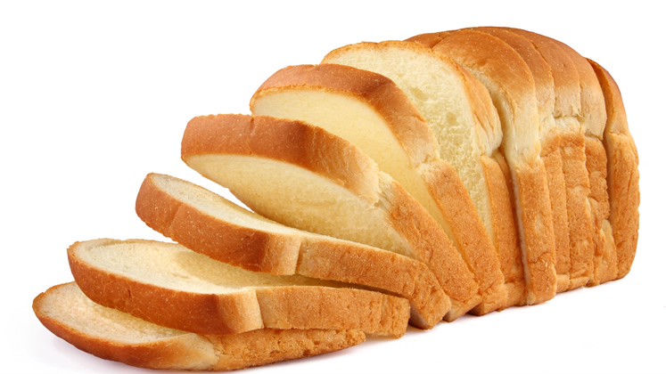
Source: (Shiferaw et al., 2020).
Bacterial contamination in bread can arise from several sources, including contaminated ingredients, utensils, handling by infected persons, or air-borne microorganisms. Common bacterial contaminants found in bread include species of Staphylococcus, Bacillus, and Escherichia coli. These organisms can cause gastrointestinal infections, food poisoning, and other health issues when ingested (Igiebor et al., 2021). The presence of such bacteria in bread suggests a breakdown in hygiene during production or post-production handling. Monitoring these bacteria is essential for consumer safety and public health planning.
Fungal contamination, on the other hand, is mainly attributed to mold growth, which becomes evident through visible spoilage signs such as discoloration and odor. Fungi like Aspergillus, Penicillium, and Rhizopus species are frequently isolated from spoiled bread (Akinnibosun et al., 2022). These fungi not only deteriorate the quality of bread but may also produce mycotoxins—harmful metabolites that can cause chronic health conditions including liver cancer and immune suppression. The warm and humid climate of Ilorin further encourages rapid fungal growth, especially when bread is not stored under optimal conditions.
The microbial quality of bread is often assessed through the enumeration of total bacterial and fungal colony counts using standard microbiological techniques. These counts provide an estimate of the overall contamination level and can serve as an indicator of hygiene practices in bread production and sales. A high microbial load not only reduces the shelf life of bread but also increases the likelihood of foodborne illness. Routine microbiological surveillance is therefore necessary to ensure that bread available in markets meets acceptable safety standards (Onifade et al., 2023).
In Nigeria, the National Agency for Food and Drug Administration and Control (NAFDAC) sets guidelines for the microbiological quality of food products. However, enforcement of these regulations is often inconsistent, especially in informal markets where much of the bread trade occurs. In Ilorin, the sale of bread is typically managed by small-scale retailers who may lack awareness or training in food hygiene practices. This situation necessitates research to evaluate the actual microbial burden in bread sold in such environments and determine the associated public health risks (Akinnibosun et al., 2022).
Bread packaging plays a crucial role in determining microbial load. While some brands use airtight plastic wrappers and label their products with production dates, others use loosely sealed polythene bags or even expose bread openly for sale. Poor packaging compromises the sterility of bread and facilitates microbial infiltration. In Ilorin, a mix of both packaging types is observed, often influenced by the bakery's capacity and the vendor’s level of hygiene awareness. The correlation between packaging methods and contamination levels is key to reducing microbial loads.

fig. 2
Flowchart illustrating sources of microbial contamination in bread from production to consumption, including handling, packaging, and storage
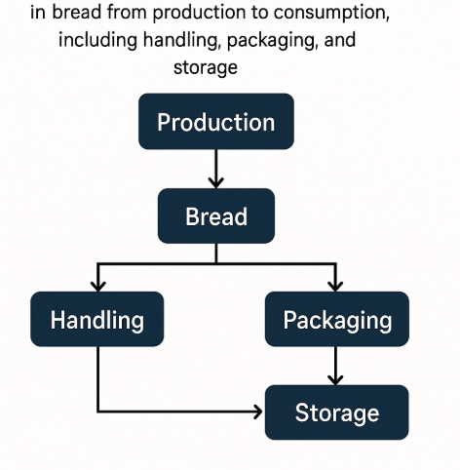
Source: (Lateef, 2021).
This visual representation can help depict the possible points of microbial entry and highlight critical control points in bread safety. Such diagrams aid in understanding complex transmission pathways and are essential for designing effective intervention strategies fig. 2.
Storage temperature and duration also significantly influence microbial growth on bread. Bread stored at ambient temperatures, especially in warm regions like Ilorin, can develop fungal growth within a few days. Refrigeration can delay spoilage, but not all vendors or consumers have access to cold storage. Bread that remains on shelves for extended periods without refrigeration is more likely to harbor large populations of microorganisms, particularly fungi. It is therefore important to assess storage conditions during microbial analysis. Consumer habits and preferences can also influence the safety of bread. In Ilorin, affordability often takes precedence over quality, leading consumers to purchase bread from vendors with questionable hygiene practices. Moreover, because some consumers do not check expiration dates or storage conditions, bread may be consumed well past its safe shelf life. This practice not only increases the risk of foodborne illness but also underscores the importance of consumer education in food safety practices (Raji et al., 2025).
The objectives of this study are to isolate and identify bacterial and fungal species present in sliced bread sold in Ilorin metropolis, determine their load, and assess the hygienic conditions of the sales environment. This study also seeks to evaluate whether the observed microbial loads exceed the recommended safety limits, and suggest appropriate interventions. Such findings can guide public health authorities and food safety agencies in improving bread hygiene standards across the city. To achieve these objectives, this study adopts standard microbiological techniques including serial dilution, plating on selective media, colony count determination, and biochemical and morphological identification of isolates. These methods are widely used in food microbiology and provide reliable results when properly executed. The study area, Ilorin metropolis, includes multiple districts where bread is sold in large quantities, offering a representative sample for investigation (Akinnibosun et al., 2022).
Previous studies conducted in other Nigerian cities have reported concerning levels of microbial contamination in bread. For instance, research in Lagos and Ibadan indicated the presence of pathogenic microorganisms in several bread brands sold in local markets (Oladipo & Adeleke, 2020). However, limited data exists on the microbial quality of bread in Ilorin, which has a unique combination of urban and semi-urban bread distribution networks. Filling this gap is critical to understanding regional variations in food hygiene (Lateef, 2021). Ultimately, this research highlights the need for integrated food safety systems that encompass producers, vendors, regulatory agencies, and consumers. The findings may also serve as a basis for awareness campaigns aimed at improving hygiene practices in bread production and sales. With increasing urbanization and population growth in Ilorin, demand for bread is expected to rise, further necessitating stringent safety measures. The health implications of consuming contaminated bread must not be underestimated.
Bread is a vital part of the Nigerian diet, and ensuring its microbiological safety is essential for public health. The current study aims to shed light on the bacterial and fungal loads present in sliced bread sold in Ilorin metropolis. By doing so, it seeks to provide evidence-based recommendations for improving bread safety and reducing the burden of foodborne diseases in the region. This study underscores the interconnectedness of food hygiene, public health, and consumer awareness (Raji et al., 2025).

1.1 Literature review
Several studies have documented the microbial contamination of bread and its potential health risks to consumers. Bread is susceptible to contamination due to its high moisture content, nutrient composition, and exposure to the environment during handling and storage. According to Shiferaw et al. (2020), bread sold in open markets in Addis Ababa exhibited high microbial counts, mainly due to poor storage conditions and unhygienic handling by vendors. These findings highlight that contamination can be introduced during post-baking processes, emphasizing the need for good hygiene practices in the supply chain.
Research conducted in Nigeria has revealed the presence of pathogenic and spoilage organisms in commercially available bread. In a study by Igiebor et al. (2021), samples of sliced bread from retail outlets in Delta State were found to contain high levels of Staphylococcus aureus, Bacillus cereus, and various molds, especially when stored at room temperature. The study emphasized the risk of foodborne illnesses associated with consuming such contaminated bread, and advocated for improved packaging and labeling of bread products to reduce consumer exposure.
Fungal spoilage is particularly common in bread due to the proliferation of molds under humid conditions. A study by Akinnibosun et al. (2022) in Benin City found that bread samples from roadside vendors exhibited visible mold growth within 48 hours of purchase. Isolated fungi included Aspergillus niger, Penicillium spp., and Rhizopus stolonifer. These fungi not only reduce the aesthetic and nutritional value of bread but may also produce mycotoxins, posing serious long-term health risks.
The microbial quality of bread is also influenced by the type of packaging used. Onifade et al. (2023) evaluated different packaging methods and found that bread stored in loosely sealed polythene bags had significantly higher microbial counts compared to those in vacuum-sealed plastic. This suggests that airtight packaging acts as a physical barrier against environmental contaminants, thereby extending the shelf life of bread. The study recommended that manufacturers adopt modern packaging techniques to mitigate microbial infiltration.
In an assessment of microbiological safety of bread in southwestern Nigeria, Oladipo and Adeleke (2020) discovered that even well-packaged bread samples carried high bacterial loads when hygiene was not maintained during production. Their study emphasized the importance of regular inspection of bakeries by food safety authorities and recommended the implementation of Good Manufacturing Practices (GMP) across bakeries in Nigeria. This is crucial for ensuring that the microbial loads in bread products remain within permissible safety limits.
Consumers’ bread-handling practices can also contribute to microbial contamination. Umeh et al. (2021) reported that many consumers in Nigeria store bread at room temperature, often in unsealed conditions, which accelerates fungal growth. The study recommended public health campaigns to educate consumers about the importance of refrigeration and clean handling practices to preserve bread quality. It also highlighted that vendors often fail to inform buyers about proper storage methods.
A recent study in Kwara State by Yusuf et al. (2023) evaluated the microbial profile of bread from both large-scale bakeries and small-scale vendors. The results showed a significantly higher microbial load in bread sold by small-scale vendors, including isolates of E. coli, which suggest fecal contamination. The study attributed this to inadequate handwashing facilities and poor hygiene awareness among local bread handlers. These findings reinforce the need for training programs for vendors and stricter local health inspections.
The presence of antibiotic-resistant bacteria in bread has also been identified as an emerging concern. A study by Ogundipe et al. (2022) reported the isolation of multidrug-resistant Staphylococcus aureus and Enterobacter species from packaged bread sold in Ibadan. These resistant strains pose serious public health threats, especially in communities with limited access to healthcare. The authors emphasized the importance of antimicrobial resistance monitoring in foodborne pathogens and recommended routine microbial testing for bakery products.

1.2 Statement of problem
- Poor Hygiene During Bread Production and Handling:
Despite being a staple food in many Nigerian households, sliced bread is often produced and handled in unhygienic environments. In Ilorin metropolis, several small-scale bakeries and street vendors lack proper sanitary practices, which may lead to bacterial and fungal contamination of bread. This raises public health concerns as consumers may unknowingly ingest harmful microorganisms.
- Lack of Microbiological Surveillance and Regulation Enforcement:
There is a significant gap in routine microbiological testing and enforcement of food safety standards for bakery products in Ilorin. Regulatory agencies often focus on large-scale producers, neglecting smaller vendors where most of the population buys their bread. This creates an unchecked risk of foodborne illnesses linked to contaminated sliced bread sold in the area.
- Limited Public Awareness on Safe Bread Storage and Consumption:
Many consumers in Ilorin metropolis are unaware of proper bread storage methods or the implications of consuming bread past its shelf life. Due to warm temperatures and poor packaging, fungal spoilage is common, yet bread continues to be consumed even when visibly contaminated. This highlights the urgent need for public health education on microbial safety in ready-to-eat foods.

1.3 AIM
The aim of this study is to determine the bacterial and fungal loads present on sliced bread sold in Ilorin metropolis, in order to assess its microbiological quality, identify potential public health risks, and recommend appropriate hygienic and regulatory measures for safer consumption.

1.4 Objectives
- To isolate and identify the bacterial and fungal species present on sliced bread sold in Ilorin metropolis.
- To determine the bacterial and fungal load (colony-forming units) on sliced bread samples from different vendors in Ilorin.
- To assess the hygienic conditions and packaging methods used by bread sellers in Ilorin metropolis.
- To evaluate whether the microbial loads on sliced bread exceed recommended safety standards and suggest measures to reduce contamination.

CHAPTER TWO

2.0 MATERIALS AND METHODS

2.1 Materials Used
The materials employed for this study included various laboratory equipment and consumables necessary for microbial analysis. These included conical flasks, measuring cylinders, Bunsen burner, fire gauze, weighing balance, inoculating loop, microscope slides, Petri dishes, stirring rods, and syringes. Bread samples labeled A, B, and C were obtained and used for microbial load testing. Additional items such as paper tape for labeling, as well as sterile containers for handling the bread samples, were also used during the experiment.

2.1.1 Chemicals and Reagents
The chemicals and reagents used in this study were of analytical grade. They included Nutrient Agar (NA) for bacterial culture, Sabouraud Dextrose Agar (SDA) for fungal growth, and Tryptone Soya Broth (TSB) as a general-purpose enrichment medium. Ciprofloxacin (antibiotic) was used to inhibit bacterial contamination in fungal culture. Distilled water was used throughout the preparation processes. Amoxicillin (1g) and ciprofloxacin were dissolved in 10 ml of distilled water, and 1 ml of the reconstituted solution was added to the SDA to prevent bacterial interference.

2.2 Preparation of Sample
The bread samples A, B, and C were soaked in clean table water for a few minutes to allow microbial detachment from the surface and interior. After soaking, the water from each sample was carefully withdrawn and used as the inoculum. The withdrawn solution was introduced into the respective prepared culture media for incubation and microbial growth assessment.

2.3 Preparation of Media
All culture media were prepared according to manufacturer instructions. Nutrient Agar (NA), Sabouraud Dextrose Agar (SDA), and Tryptone Soya Broth (TSB) were accurately weighed using a digital balance. The appropriate quantities of media powder were dissolved in distilled water, transferred into conical flasks, stirred thoroughly using a glass rod, and sterilized by autoclaving at 121°C for 15 minutes. After cooling, SDA was supplemented with 1 ml of reconstituted ciprofloxacin solution to suppress bacterial growth. The media were poured into sterilized Petri dishes and allowed to solidify. Once solidified, the Petri dishes were inverted and labeled using paper tape for proper sample identification.

2.4 Inoculation and Incubation
After preparation, the water withdrawn from each soaked bread sample was poured aseptically into the respective media. For bacterial growth, the inoculated NA plates were incubated at 37°C for 24 hours. For fungal growth, the SDA plates were incubated at room temperature (25–28°C) for 5 days. The plates were turned upside down during incubation to avoid condensation on the media surface.

2.5 Bacterial Analysis and Staining
After 24 hours of incubation, bacterial colonies were observed on the NA plates. A loopful of growth from each sample was taken and smeared on a clean microscope slide for Gram staining. Microscopic examination revealed that Sample B showed perfectly shaped cocci, while cocci were also observed in Samples A and C, although not as distinct as in B.

2.6 Fungal Analysis and Staining
Following 5 days of incubation, fungal growth was observed prominently on all SDA plates. Sample C exhibited the highest growth, with visible mucous colonies and multiple fungal types. Sample A also produced mucous but had fewer colonies compared to C. A small portion of the fungal colony was picked using an inoculating needle, streaked on a clean slide, stained, and observed under a microscope for morphological characteristics.

CHAPTER THREE

3.0 RESULTS
The results obtained from the microbiological analysis of sliced bread samples labeled A, B, and C. Both bacterial and fungal growth were observed and analyzed through culturing and microscopy.

3.1 Fungal Observation (Lactophenol Cotton Blue Staining)
Fungal growth was assessed based on the colony morphology on Sabouraud Dextrose Agar and microscopic characteristics using lactophenol cotton blue staining. The results are summarized below:

Table 1: Macroscopic Observation of Fungal Growth on Bread Samples
Sample | Observation | Microscopic Observation
A | i. Creamy mucoid growth  ii. Whitish, cottony growth | Yeast  Mold
B | i. Creamy mucoid growth | Mold
C | i. Whitish, cottony growth  ii. Greenish, powdery growth  iii. Creamy mucoid growth | Mold  Mold  Yeast
Note: The creamy mucoid growth observed in all samples is indicative of yeast or yeast-like fungi, while the greenish powdery growth observed in Sample C suggests the presence of Aspergillus species.

Table 2: Microscopic Observation of Fungal Growth on Bread Samples
Sample | Observation | Microscopic Observation
A | i. Budding Yeast  ii. Non-septate hyphae | Saccharomyces spp.  Rhizopus spp.
B | i. Budding yeast | Saccharomyces spp.
C | i. Non-septate hyphae  ii. Septate hyphae  iii. Creamy mucoid growth | Rhizopus spp.  Aspergillus spp.  Saccharomyces spp.
Fig.3
Observation of sample with staining using lactophenol cotton blue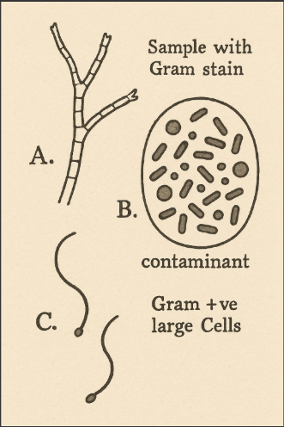

3.2 Bacterial Observation (Gram Staining)
Bacterial colonies were cultured on Nutrient Agar and examined microscopically after Gram staining. The colony morphology and microscopic features observed are presented below:

Table 3: Bacteria Microscopic Observation
Sample | Observation | Inference
A | Gram positive in cluster | Staphylococcus spp
B | Gram positive rod | Bacilli spp
C | Gram positive cocci in chain | Streptococcus spp

CHAPTER FOUR

4.0 DISCUSSION AND CONCLUSION

4.1 DISCUSSION
The microbiological analysis of the sliced bread samples (A, B, and C) revealed the presence of both fungal and bacterial contaminants, indicating poor post-baking handling and storage practices. As shown in Table 3.1, macroscopic fungal observations indicated that all three bread samples exhibited signs of spoilage. Sample A showed creamy mucoid and whitish cottony growths, which are typically associated with yeast and mold colonies, respectively. Under microscopic examination using lactophenol cotton blue staining, this sample was found to contain Saccharomyces spp. (a budding yeast) and Rhizopus spp., characterized by non-septate hyphae. Sample B displayed only creamy mucoid growth macroscopically, but microscopic analysis confirmed the presence of budding yeast, specifically Saccharomyces spp.
Sample C had the most diverse fungal contamination. It exhibited whitish cottony growth, greenish powdery growth, and creamy mucoid colonies. Microscopy revealed the presence of Rhizopus spp., Aspergillus spp., and Saccharomyces spp. The greenish powdery growth was particularly suggestive of Aspergillus species, which are known to produce dry, pigmented spores and are capable of producing mycotoxins under favorable conditions (Akbar et al., 2020). The presence of both septate and non-septate hyphae in this sample, as shown in Table 3.2, further supports the mixed mold contamination involving both Aspergillus and Rhizopus spp.
The bacterial examination revealed notable differences in microbial composition across the samples. According to Table 3.2, Sample A showed Gram-positive cocci arranged in clusters, indicating the presence of Staphylococcus spp., a group of bacteria commonly found on human skin and often associated with contamination during handling. Sample B revealed Gram-positive rod-shaped bacteria suggestive of Bacillus spp., which are spore-forming and can survive high temperatures during baking. Their presence may result from post-processing contamination or inadequate storage conditions. In Sample C, Gram-positive cocci in chains were observed, indicating the presence of Streptococcus spp., which may originate from human contact or environmental sources during or after packaging (Okpalugo et al., 2020).
These results collectively demonstrate that sliced bread on sale in Ilorin metropolis is exposed to diverse microbial contamination, including opportunistic pathogens and spoilage organisms. The presence of yeasts, molds, and pathogenic bacteria such as Staphylococcus and Streptococcus spp. in ready-to-eat food like bread poses a significant public health concern, especially in settings where food safety regulations may be poorly enforced (Adejumo et al., 2021). The high occurrence of fungi such as Aspergillus spp. further suggests a risk of mycotoxin exposure if the bread is consumed without adequate inspection.

4.2 Conclusion
The microbial analysis of sliced bread sold in Ilorin confirms the presence of both bacterial and fungal contaminants, emphasizing the urgent need for improved hygiene, storage, and regulation to ensure the safety of consumers.

REFERENCES
Adejumo, T. O., Adedeji, A. A., Afolabi, O. R., & Ogunleye, O. A. (2021). Microbial quality of sliced bread sold in selected outlets in Osogbo, Nigeria. African Journal of Food Science, 15(3), 97–104. https://doi.org/10.5897/AJFS2021.2014
Akbar, A., Khan, A., Rehman, A., & Iqbal, S. (2020). Morphological and molecular characterization of Penicillium species isolated from stored grains. Journal of Fungal Research, 25(3), 134–140.
Akinnibosun, F.I., Asemota, O., & Ighodaro, O.M. (2022). Microbiological assessment of bread from local bakeries in Benin City. Nigerian Journal of Microbiology, 36(2), 45–53.
Eze, V. C., & Umeh, S. C. (2022). Fungal Spoilage of Bakery Products and the Influence of Environmental Conditions. African Journal of Food Science and Technology, 13(4), 89–95.
Igiebor, F.A., Okoh, S.O., & Okoh, A.I. (2021). Microbial contamination of bakery products: A public health concern. Food Science & Nutrition, 9(5), 2845–2853. https://doi.org/10.1002/fsn3.2185
Lateef, A. (2021). The next big thing is very small: the paradox of diminutive microbes and nanoparticles. Nano Plus: Science and Technology of Nanomaterials, 2(1), 27-65.
Ogundipe, M.O., Adeyanju, O., & Ojo, T.O. (2022). Detection of antibiotic-resistant bacteria in bread samples from retail outlets in Ibadan. African Journal of Clinical Microbiology, 13(1), 67–74.
Okpalugo, J. S., Ibrahim, K., Onwunzo, M. C., & Ayuba, N. E. (2020). Bacteriological evaluation of bakery products in Nigeria. Nigerian Food Journal, 38(1), 101–106. https://doi.org/10.1016/j.nifoj.2020.03.010
Oladipo, I.C., & Adeleke, R.O. (2020). Microbial quality of some brands of bread in Ibadan, Nigeria. African Journal of Food Science, 14(8), 253-260. https://doi.org/10.5897/AJFS2020.1908
Onifade, A.K., Akinyosoye, F.A., & Olajide, T.I. (2023). Assessment of bacterial and fungal contamination in packaged bread in Nigeria. Journal of Food Safety and Hygiene, 9(1), 13-21.
Raji, A. O., Caesar, N., Oguntade, M. F., Raji, M. O., & OlusolaAjewole, A. (2025). Cocoa-Fortified Warankashi: Nutritional Enhancement, Antioxidant Properties, and Storage Stability. Food Nutrition, 100010.
Shiferaw, D., Tadesse, A., & Mekuria, T. (2020). Microbial quality of bread sold in open markets: A case study from Addis Ababa. Journal of Food Quality and Hazards Control, 7(2), 55-61. https://doi.org/10.18502/jfqhc.7.2.2777
Shiferaw, D., Tadesse, A., & Mekuria, T. (2020). Microbial quality of bread sold in open markets: A case study from Addis Ababa. Journal of Food Quality and Hazards Control, 7(2), 55–61. https://doi.org/10.18502/jfqhc.7.2.2777
Umeh, C.N., Iroha, I.R., & Eze, I. (2021). Evaluation of bread-handling practices and their effect on fungal spoilage in Nigeria. Journal of Applied Food Microbiology, 11(4), 234–242.
Yusuf, M. A., & Adeoye, F. A. (2020). Bacteriological Quality of Sliced Bread from Different Vendors in Ilorin, Nigeria. Journal of Applied Sciences and Environmental Management, 24(3), 505–510.

