
PROJECT RESEARCH WORK
ON
MICROBIAL ANALYSIS OF SOME SELECTED SACHETS WATER IN ILORIN METROPOLITAN

BY

OLADUNNI ALLI AKANNI
HND/23/SLT/FT/0023
SUBMITTED TO:
THE DEPARTMENT OF SCIENCE LABORATORY TECHNOLOGY, INSTITUTE OF APPLIED SCIENCES (IAS),
KWARA STATE POLYTECHNIC, ILORIN
IN PARTIAL FULFILMENT OF THE REQUIREMENT FOR THE HIGHER NATIONAL DIPLOMA (HND) SCIENCE LABORATORY TECHNOLOGY (MICROBIOLOGY OPTION)
JULY, 2025

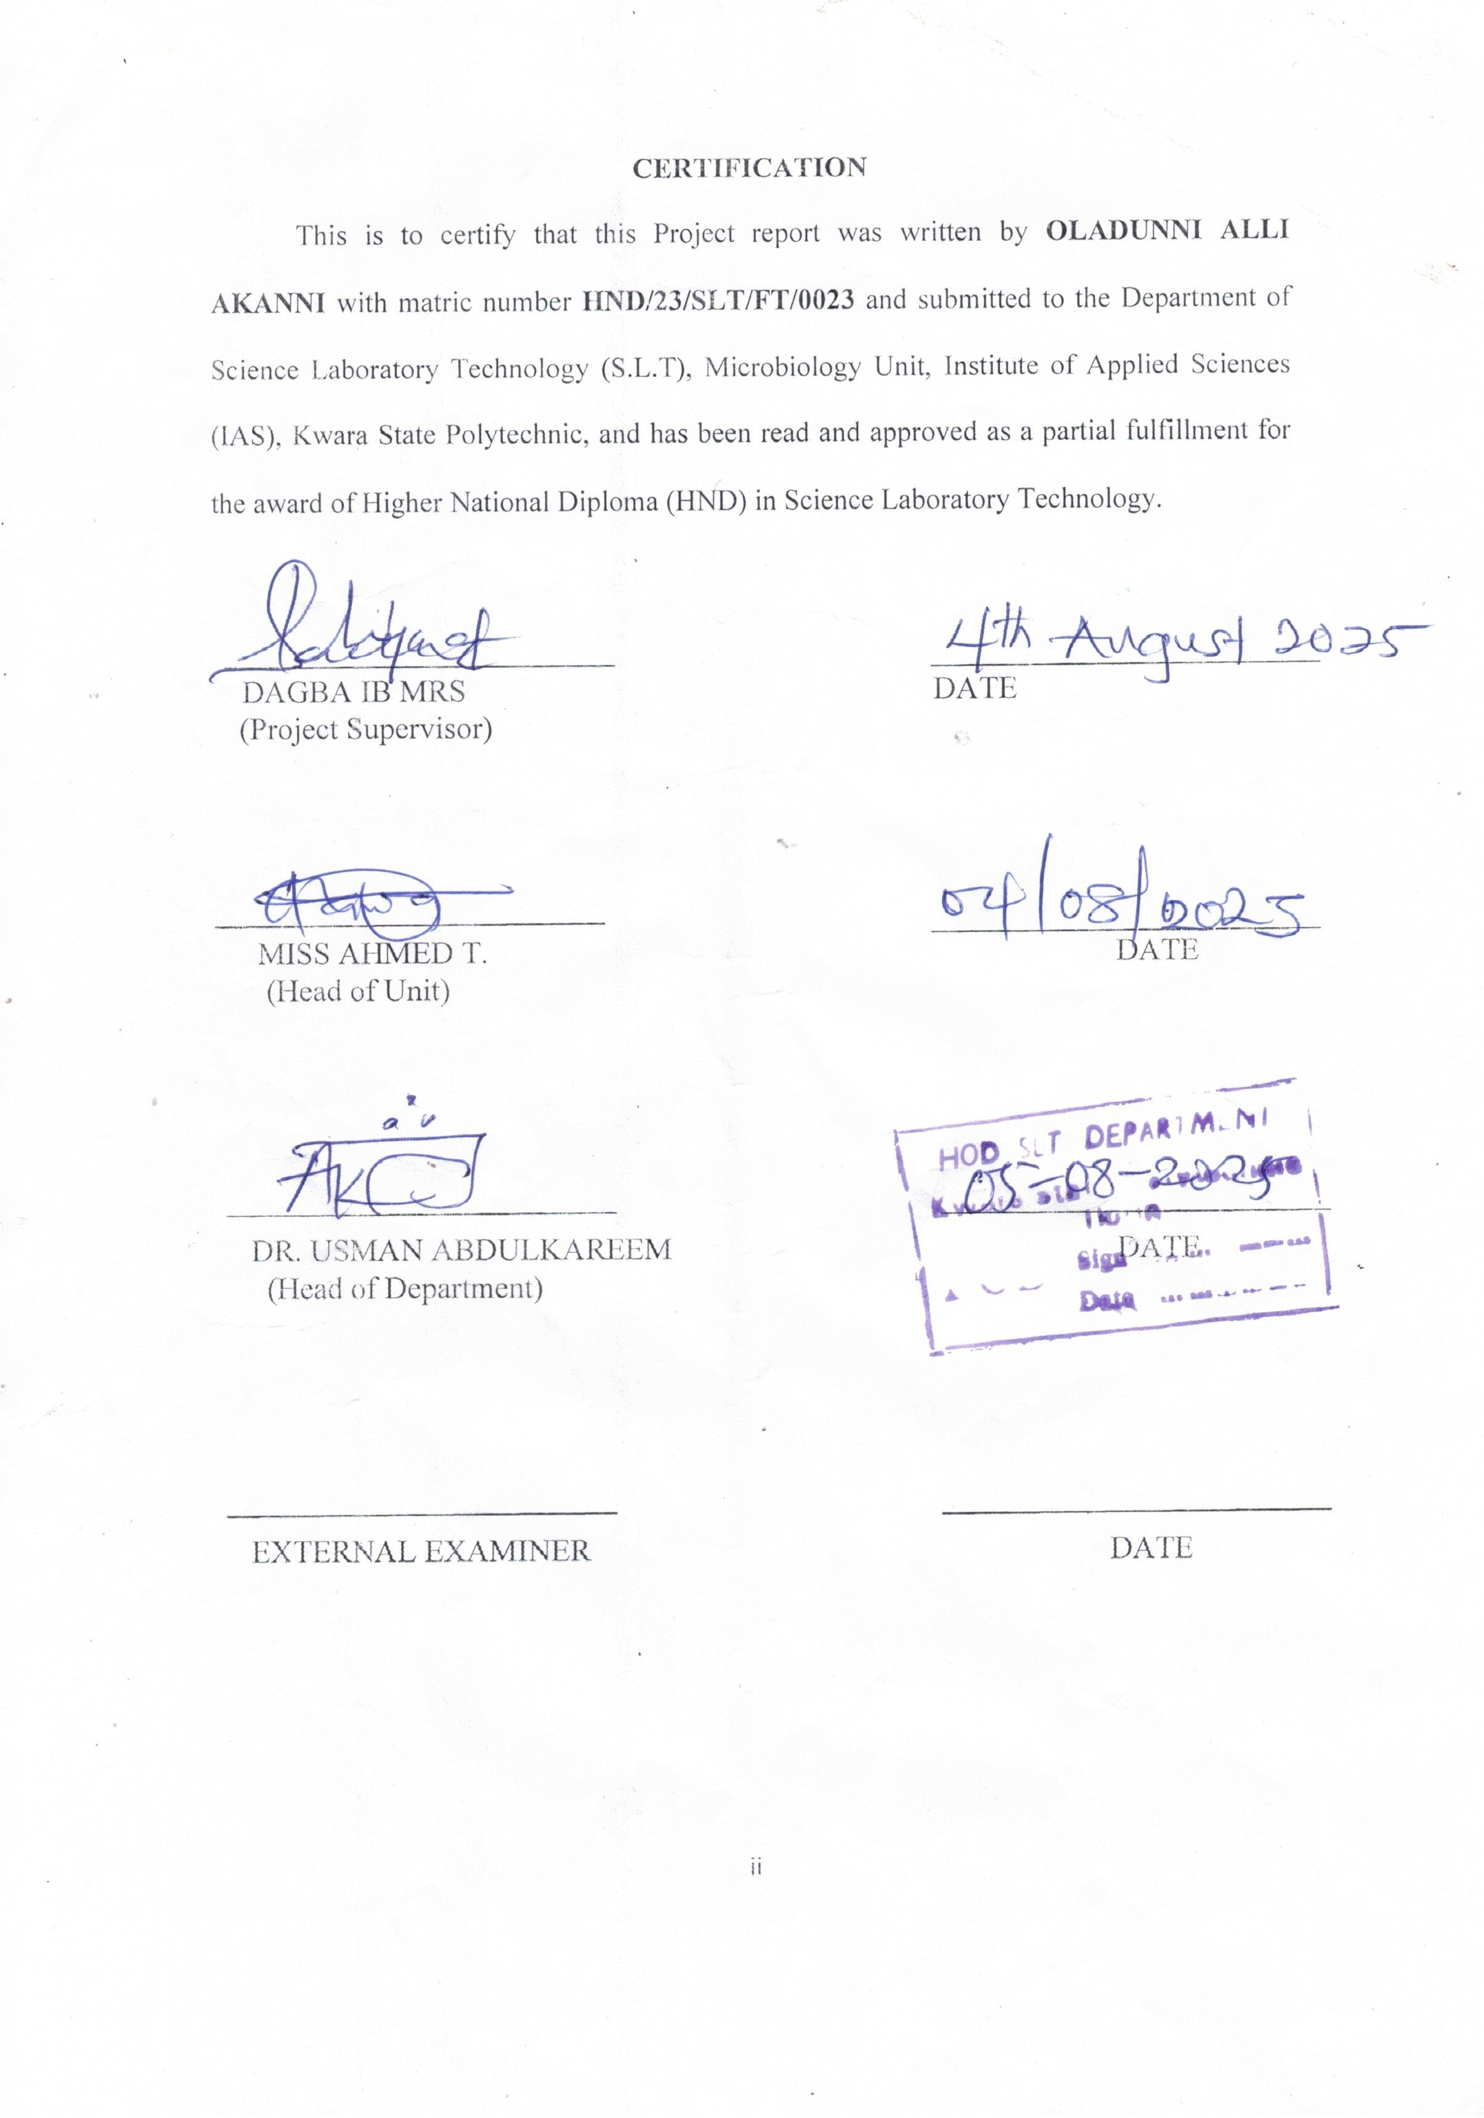

DEDICATION
I dedicated this project to almighty God for He is the one that makes this programme completion a reality and also to my family as a whole.

ACKNOWLEDGEMENT
With a heart overflowing with gratitude and emotion, I begin by giving all glory and honor to Almighty God. Without His divine guidance, strength, mercy, and grace, this project—and indeed this entire journey—would never have been possible. In my moments of weakness, He lifted me. In my moments of doubt, He gave me hope. And through every trial, He never left my side. For that, I am eternally thankful.
To my supervisor, Mrs. Dagba I.B, thank you for being more than just a guide. Your patience, understanding, and encouragement meant so much to me, especially in moments when I felt lost. Your belief in me inspired me to push beyond my limits. I will always be grateful for the time, effort, and wisdom you poured into me and this work.
To the entire staff of the Science Laboratory and Technology Department, Kwara State Polytechnic, thank you for building me up academically and personally. Your dedication, your commitment to excellence, and your passion for knowledge e lit a fire in me that I will carry forever.
To the strongest woman I know—my dear mother, Mrs. Oladunni Bashirat—words will never be enough. You have been my rock, my shield, and my silent strength. Your endless sacrifices, prayers, sleepless nights, and unwavering love are the very foundation upon which my success stands. Every time I thought of giving up, the thought of making you proud gave me the strength to keep going. I love you deeply, and I dedicate this achievement to you.
To my true friend, Tajudeen Olatunji Idris, thank you for standing by me in the storms and in the calm. Your support, encouragement, and care made such a difference. You reminded me that I was never alone on this journey.

And to Adedoyin Haleemah Yetunde, my partner in the deepest sense of the word—thank you for being the light in my darkest days. In my hardest moments, when everything felt heavy and hopeless, your love, patience, and unwavering belief in me kept me afloat. You saw the best in me when I couldn’t see it myself, and I will never forget that. You are a rare and beautiful soul.
To my friends, coursemates, and every single person who played a role in this journey, even in the smallest way—thank you. Your kindness, support, and presence are deeply cherished.
This project is more than just an academic work—it’s a symbol of love, sacrifice, perseverance, and divine grace. I carry each of you in my heart.
Thank you, from the very depths of my soul.

TABLE OF CONTENTS
CERTIFICATION ii
DEDICATION iii
ACKNOWLEDGEMENT iv
CHAPTER ONE 8
INTRODUCTION 8
1.1 Background to the Study 8
1.2 Statement of Problem 10
1.3 Justification of study 11
1.4 Aims and Objectives of Study 11
CHAPTER TWO 12
LITERATURE REVIEW 12
2.1 Concept of Water Quality 12
2.2 Key indicators of Water Quality 13
2.2.1 Microbial Indicators of Water Quality 13
2.2.2 Physical indicators of Water Quality 17
2.2.3 Chemical Indicators of Water Quality 18
2.3 Water Quality Standards and Regulations 19
2.3.1 Nigerian Standard for Drinking Water Quality (NSDWQ) 20
2.5 Sachet Water Production in Nigeria 22
2.6 Antibacterial Analysis Methods 23
2.6.1 Culture-Based Methods 24
2.6.2 Antibacterial Activity Testing 24
2.6.3 Molecular Methods 24
CHAPTER THREE 25
MATERIALS AND METHODS 25
3.1 Description of the Sample Site 25
3.2 Sample Collection 25
3.2.1 Sampling procedure and Preservation 25
3.3 Physicochemical analysis 26
3.3.1 pH 26
3.3.2 Temperature measurement 26
3.3.3 Turbidity Measurement 26
3.3.4 Electrical Conductivity (EC) Measurement 26
3.3.5 Total Dissolved Solids (TDS) 27
3.3.6 Dissolved Oxygen (DO) 27
3.3.7 Total Hardness 27
3.4 Microbial Analysis 27
3.4.1 Total Colony Count 27
3.4.2 Total Fungal Count 27
3.4.3 Total Viable Count 28
3.4.4 Total Escherichia coli Count 28
3.5 Morphological and Microscopic Identification 28
3.5.1 Biochemical Testing 28
3.5.2 Lactophenol Test 30
3.5.3 Endospore Test 31
3.6 Data Analysis 31
CHAPTER FOUR 32
4.0 RESULTS 32
4.1 Physicochemical Parameters of sachet water sample 32
4.1 Physicochemical Parameters of Water Samples 34
4.2 Microbiological Analysis 35
4.2.1 Microbial Counts 35
4.2.2 Morphological and Microscopic Characteristics of Bacterial Isolates 36
4.2.3 Lactophenol Test for Fungal Identification and Biochemical Identification Bacterial Isolates 37
CHAPTER FIVE 40
DISCUSSION, CONCLUSION AND RECOMMEDATION 40
5.1 Discussion 40
5.2 Conclusion 41
5.3 Recommendations 42
REFERENCES 44

ABSTRACT
Access to safe and clean drinking water is critical to public health, particularly in developing countries where sachet water is a common source of hydration. This study assessed the physicochemical and microbiological quality of five sachet water brands (AW, BW, KW, OW, and YW) produced in Ilorin, Kwara State, Nigeria. Standard analytical techniques were employed to determine physicochemical parameters including pH, temperature, turbidity, total dissolved solids (TDS), electrical conductivity (EC), dissolved oxygen (DO), and salinity. Microbiological analysis was conducted to determine total viable count (TVC), total coliforms, Escherichia coli, and fungi, while bacterial isolates were identified using morphological and biochemical tests.Results showed that temperature values ranged between 18.00 ± 0.90°C and 24.00 ± 1.20°C, all below the WHO guideline of 25°C. DO ranged from 3.20 ± 0.16 mg/L in AW to 17.30 ± 0.87 mg/L in OW. All samples had turbidity below the 5 NTU limit, with values between 1.60 ± 0.08 NTU (KW) and 4.20 ± 0.21 NTU (YW). EC and TDS values also remained within safe limits, ranging from 51.00 ± 2.55 to 100.00 ± 5.00 µS/cm and 35.00 ± 1.75 to 59.00 ± 2.95 mg/L, respectively.Microbiologically, the total viable count was highest in YW (231.00 ± 11.55 CFU/mL), significantly exceeding acceptable limits, while OW had the lowest count (7.00 ± 0.35 CFU/mL). Total coliforms were detected in four of the five samples, ranging from 3.00 ± 0.15 CFU/mL in YW to 51.00 ± 2.55 CFU/mL in OW. Escherichia coli was not detected in any of the samples. Isolated bacteria included Bacillus subtilis, Staphylococcus epidermidis, Pseudomonas aeruginosa, and Neisseria species, while a fungal isolate, Aspergillus species, was identified in one sample (YWE).The findings indicate that although some sachet water brands met WHO physicochemical and microbiological standards, others posed potential health risks due to high microbial load. The study recommends stricter regulatory enforcement, improved production hygiene, and routine quality monitoring to ensure safe drinking water for the population.

CHAPTER ONE

INTRODUCTION

1.1 Background to the Study
Water is a fundamental resource for life, indispensable for human health, societal development, and environmental sustainability. Its role in maintaining public health cannot be overemphasized, as clean and safe water is essential for drinking, cooking, sanitation, and other daily activities. However, access to safe drinking water remains a pressing challenge in many developing countries, including Nigeria. Contaminated water has been identified as one of the primary causes of waterborne diseases, which account for a significant proportion of global morbidity and mortality, particularly in resource-limited settings. The World Health Organization (WHO) estimates that unsafe water, poor sanitation, and inadequate hygiene are responsible for nearly 80% of illnesses and more than half of global child mortality (WHO, 2019).
In Nigeria, the demand for potable water has risen sharply due to population growth, urbanization, and the inadequacy of public water supply systems. In response to this demand, sachet water, commonly referred to as “pure water,” has become one of the most widely consumed sources of drinking water. This packaged water, sold in small, sealed plastic sachets, is regarded as an affordable and convenient alternative to other water sources, particularly for low- and middle-income households. Despite its popularity, concerns about the quality and safety of sachet water persist, as studies have shown varying degrees of bacterial contamination across different brands. Improper production processes, poor handling, inadequate sanitation during packaging, and insufficient regulatory enforcement have been implicated in the contamination of sachet water, posing significant public health risks (Saheed et al., 2021).
The microbiological quality of drinking water is a critical determinant of its safety. The presence of pathogenic microorganisms such as Escherichia coli, Salmonella, Vibrio cholerae, and Shigella in water can lead to outbreaks of diarrheal diseases, typhoid fever, and cholera, which are among the leading causes of preventable death in developing countries. In Nigeria, over 90 million people lack access to safe drinking water, and an estimated 130,000 children under the age of five die annually due to waterborne diseases (Majid, 2018). These infections often occur as a result of consuming untreated or improperly treated water, which may harbor bacteria, viruses, protozoa, and other harmful microorganisms.
Ilorin is the capital city of Kwara State and it is a rapidly growing city with a diverse population and an increasing reliance on sachet water. While sachet water has filled a critical gap in the provision of drinking water, reports of contamination have raised serious public health concerns. Studies in similar settings have shown that the bacteriological quality of sachet water often falls below acceptable standards, with some samples testing positive for coliforms and other indicator organisms (Gana et al., 2021; Okeola et al., 2021). This indicates fecal contamination, which is commonly attributed to unhygienic production environments, the use of unclean water sources, and improper storage or transportation of the packaged water (Armstrong and Johnson, 2018). Comprehensive antibacterial analysis of sachet water is therefore essential for identifying potential health risks and ensuring that the water consumed by the public meets regulatory standards. Standard microbiological techniques, such as the multiple-tube fermentation method, membrane filtration, and molecular diagnostic tools, are widely used to detect and quantify pathogenic bacteria in water samples. These methods provide valuable insights into the safety and quality of drinking water and guide necessary interventions to protect public health (Liu et al., 2019).
In addition to health implications, unsafe drinking water has broader societal consequences. Recurrent waterborne diseases contribute to malnutrition, reduced productivity, and increased healthcare costs. Vulnerable populations, such as children, the elderly, and individuals with weakened immune systems, are particularly at risk of developing severe complications from waterborne pathogens like Pseudomonas, Cryptosporidium, and Klebsiella. These microorganisms, often found in contaminated drinking water, can lead to life-threatening infections and exacerbate existing health conditions (UNICEF, 2019) hence the research on some selected sachet water produced in Ilorin metropolitan.

1.2 Statement of Problem
The rise in urbanization and the increasing reliance on sachet water as a primary source of drinking water have raised serious concerns about its microbiological and chemical quality. Sachet water, though marketed as a safe and affordable alternative to untreated water sources, is often produced under conditions that lack adequate quality control measures. Studies have shown that many sachet water brands fail to meet the microbiological standards set by regulatory bodies, with contamination frequently attributed to poor hygiene during production, improper sealing, and the use of polluted water sources (Saheed et al., 2021).
In Ilorin, Kwara State, sachet water consumption has become ubiquitous due to limited access to reliable municipal water supplies. However, anecdotal reports and preliminary studies suggest that some brands of sachet water harbor pathogenic microorganisms, such as Escherichia coli and other coliform bacteria, which are indicators of fecal contamination (Aiyedun et al., 2022). This contamination poses serious public health risks, including outbreaks of diarrhea, typhoid fever, cholera, and other waterborne diseases. Vulnerable populations, such as children under five, pregnant women, and immunocompromised individuals, are disproportionately affected by these illnesses, leading to increased morbidity and mortality rates (Okeola et al., 2021). Despite these concerns, regular monitoring of sachet water quality in Ilorin is limited, and comprehensive data on its microbiological safety remain scarce.

1.3 Justification of study
This study therefore seeks to address the pressing issue of waterborne diseases by analyzing the antibacterial properties of sachet water produced in Ilorin. The findings will provide essential information and awareness into contamination levels, identify compliance gaps with national and international water quality standards, and propose actionable recommendations for improving water safety.

1.4 Aims and Objectives of Study
Aim
The main aim of this study is to evaluate the microbial quality of selected sachet water produced in Ilorin, Kwara State through microbiological analysis.
Specific Objectives
The specific objectives of this study are to;
1. determine physiochemical analysis of the water samples
2. isolate and identify bacterial organisms present in the sachet water samples
3. isolate and identify fungal organisms present in the sachet water samples

CHAPTER TWO

LITERATURE REVIEW

2.1 Concept of Water Quality
Water is a transparent liquid composed of two elements; two hydrogen atoms and one oxygen atom (H₂O). Water is a liquid at ambient conditions, but it often co-exists on Earth with its solid state being ice, and gaseous state (being water vapour or steam). Water is a finite substance; there is the same amount of water now as there was when the earth was formed (USEPA, 2020). While water is a renewable resource, its availability in space and time is limited by climate, geographical and physical conditions. Most human activities involve the use of water in one way or the other. It may be noted that man‘s early habitation and civilization sprang up along the banks of rivers. Water is useful for different needs which include agricultural, residential, manufacturing, community and personal needs. Increasing water demands and its ineffective management has led to crises situations in many parts of the world; crisis over the availability of adequate and appropriate quality water. It can be argued that water is everywhere but water for drinking purposes is not everywhere because water available for drinking and other domestic activities is very minute (Shiru et al., 2021).
Water quality refers to the physical, chemical, and microbiological characteristics of water that determine its suitability for various uses, including drinking, recreation, agriculture, and industrial processes. The concept encompasses the assessment of water's ability to meet the needs of humans and ecosystems without causing adverse health effects or environmental harm (WHO, 2019). Clean and safe water is essential for maintaining public health, sustaining biodiversity, and promoting socio-economic development. Water can be used for recreation, drinking, fisheries, agriculture or industry. Each of these designated uses has different defined chemical, physical and biological standards necessary to fulfil the respective purpose. For example, there are stringent standards for water to be used for drinking or swimming compared to that used in agriculture or industry. After many years of research, water quality standards are put in place to ensure the suitability of efficient use of water for a designated purpose. Water quality analysis is to measure the required parameters of water, following standard methods, to check whether they are in accordance with the standard. In Nigeria, where access to safe and clean water is a persistent challenge, water quality directly impacts the well-being of millions of people. Many communities rely on untreated surface and groundwater sources, which are highly susceptible to contamination from agricultural, industrial, and domestic activities (Adewuyi et al., 2022).

2.2 Key indicators of Water Quality
Water quality is assessed using three primary categories of indicators: physical, chemical, and microbiological parameters (Uzomah et al., 2021). Each category reveals information about the suitability of water for human consumption, agricultural use, industrial processes, and ecosystem health.

2.2.1 Microbial Indicators of Water Quality
From a microbial perspective, the main public health concern associated with drinking water is enteric diseases (Adeniran et al., 2021). It is impractical to look for all known enteric pathogens that may contaminate drinking water because there are hundreds of pathogens implicated in water contamination. Microbial safety is assessed through detection of indicators of faecal pollution. Microbial indicators of faecal pollution are organisms that occur in high numbers in human and animal faeces (Bello et al., 2020). If detected, they indicate potential faecal contamination of the water body or distribution system under investigation and the consequent potential presence of enteric pathogens. These microbial indicators are generally not themselves human pathogens but their presence indicate potential presence of pathogens. The use of indicator bacteria, in particular Escherichia coli and the coliform bacteria as a means of accessing the potential presence of water-borne pathogens has been paramount to protecting public health. Many pathogens are present only under specific conditions and, when present, occur in low numbers compared with other micro-organisms. Whilst the presence of coliform bacteria does not always indicate a public health threat, their detection is useful indication that treatment operations should be investigated (Kumar, 2021).
Total coliforms (TC) Bacteria
Coliform bacteria belong to the family Enterobacteriaceae and share similar cultural characteristics. Typical genera encountered in water supplies are Citrobacter, Enterobacter, Escherichia, Hafnia, Klebsiella, Serratiaand Yersinia. Coliform bacteria are Gram-negative, non-spore-forming, rod-shaped bacteria which are capable of aerobic and facultative anaerobic growth in the presence of bile-salts or surface-active agents with similar growth-inhibiting properties. They usually ferment lactose at 37ºC within 48h, possess the enzyme B-galactosidase and are oxidase-negative. Total coliforms (TC) are no longer used as an indicator of faecal contamination because advances in the science of taxonomy show that they are not specific to the intestine of humans or warm blooded animals and can also be found in the environment. The presence of TC in water samples can indicate the presence of a biofilm or can serve as an indicator of treatment efficiency because of their sensitivity to chlorine. However, heterotrophic plate count (HPC) is a better indicator for that purpose because it covers a wider range of bacteria (Fernandez et al., 2022).
Faecal coliform (FC) or Thermotolerant coliform

The faecal coliform is a subset of the total coliform group. Faecal coliform bacteria possess the characteristics of coliform bacteria but are able to carry out lactose fermentation at 44 oC. Although still in use in some jurisdictions, the lack of specificity of the coliform test to faecal pollution of drinking water has long been documented. For example, the presence of high Klebsiellaspp counts has been associated with various vegetation and pulp and paper effluent in the absence of faecal contamination. This is why a positive result for FC should be interpreted with caution (Helard et al., 2019).
Escherichia coli
E.coli is a coliform bacterium and has been historically regarded as the primary indicator of faecal contamination of both treated and untreated water. As a coliform bacterium it is a member of the family Enterobacteriaceae, and is capable of fermenting lactose or mannitol at 44ºC, usually within 24h, and produces indole from tryptophan. E.coli is the most reliable indicator of enteric diseases and is therefore the indicator of choice to indicate occurrence of recent faecal contamination in drinking water systems. One exception is in tropical climates where E.coli may be present and multiply in water not directly subject to faecal pollution (Qiuhua, et al., 2019). Only some strains of E.coli bacteria are capable of causing disease and only under certain conditions (e.g., E.coli O157:H7). E.coli occurs in the faeces of all mammals, often in high numbers (up to109 per gram of faeces). This wide spread faecal occurrence, coupled with the fact that methods for the recovery and enumeration of E. coli are relatively simple to conduct, has contributed to the detection of this bacterium as the cornerstone of microbiological quality water assessment for over 100years (Mennane, et al., 2021).
Faecal Enterococci
Faecal enterococci are defined as Gram-positive cocci that tend to occur in pairs and chains. They are non-spore-forming, oxidase-negative, and catalase-negative. They grow aerobically and anaerobically in the presence of bile salts and in sodium azide solutions, at concentration of which are inhibitory to coliform and most Gram-negative bacteria (Sério et al., 2023). Enterococci include a number of species that occur in the faeces of human and warm-blooded animals. The main reason for their enumeration is to assess the significance of the presence of coliform bacteria in the absence of E. coli; or to provide additional information when assessing the extent of possible faecal contamination. As such, they are regarded as secondary indicators of faecal pollution (U S EPA, 2006). In human faeces, numbers of enterococci rarely exceed 106 per gram of faeces, while in animal faeces they are often more numerous than E. coli (Layton et al., 2010). Enterococci of faecal origin rarely multiply in water and are more resistant to environmental stress and chlorination than E. coli and coliform bacteria. They generally persist longer in the environment, with the exception of Streptococcus bovi and Streptococcus equines, which die off relatively rapidly once outside the intestinal tract. Testing for enterococci can be a useful additional indicator of water treatment efficiency (Goto and Yan, 2011).
Sulphite-reducing clostridia
Sulphite-reducing Clostridia are Gram-positive, anaerobic spore-forming rods that reduce sulphite to sulphate (Calente al., 2021).Clostridium perfringens is the key species of the sulphite-reducing clostridia and is commonly found in human and animal faeces. Most species of Clostridium are environmental bacteria. Many are saprophytic, normally inhabiting soil, water, and decomposing plant and animal material. Clostridium perfringens produces environmentally resistant spores that survive in water and the environment for much longer periods than the vegetative cells of E. coli and other faecal indicators. Clostridia are removed from water by coagulation and filtration, but the spores of these bacteria can be resistant to chlorine at concentrations normally used in water treatment (Solaiman et al., 2020). As Clostridium perfringens is generally present in faeces in much lower numbers than E. coli and enterococci, it is less sensitive as an indicator of faecal contamination. Low numbers may occasionally occur in water supplies, but they do not present a risk to health. These bacteria will not grow to a significant number, or produce toxins in water supplies, as conditions are usually unsuitable
The Heterotrophic bacteria
The heterotrophic groups of bacteria encompass a broad range of bacteria that use organic carbon source to grow. Colony counts of heterotrophic bacteria, referred to as heterotrophic plate count (HPC), provide an indication of general load of aerobic and facultative anaerobic bacteria of water sample (Setiaji et al., 2019). An important benefit of determining HPC, particularly if carried out regularly from the same site and location, is that it can provide an indication of seasonal and long-term changes in the general bacteriological quality of the water (Posacka et al., 2019). Drinking water supplies derived from surface waters tends to support higher numbers of heterotrophic bacteria than those derived from groundwater sources. This is due to the differences in concentrations of assimilable carbon associated with each type of source. It is, therefore, not the absolute number of bacteria count enumerated from a supply that are of importance, but whether, over time, there are significant changes or long-term trends in those numbers. (McDonald et al., 2019).

2.2.2 Physical indicators of Water Quality
Taste, colour, odour, turbidity are all physical parameters that can affect the aesthetics which determine whether people will use a source of water for drinking purposes or not.
Colour
The color of water can be an indicator of the presence of organic compounds (humic andfulvic acids), iron and other metals. It can sometimes also be an indicator of industrial effluents. There is no health standard set for the color of drinking water. Typically, water is considered to beacceptable to drink by people when the color is below 15 TCU (true colour units). It is often dependent on the personal tastes of people in the region and on what available .The pH is to minimize corrosion and incrustation in the distribution system. pH levels below 7 may cause severe corrosion of metals in the distribution level while levels above 8 causes a progressive decrease in the efficiency of the chlorine disinfection process. The acceptable pH from drinking water ranges from 6.5-8.5 (Adewuyi et al., 2022).
Taste and Odour
Taste and odor of water can also be indicators of contamination. They can originate from natural organic processes, treatment processes, such as chlorination, they can be the result of hazardous contamination, or they can develop during storage and distribution. There is no specific health guideline set for taste and odor of drinking water and it is dependent upon the range of acceptability for taste and odor of the consumer (Adelakun et al., 2021).
Turbidity
Turbidity is the amount of particulate matter suspended in water. It measures the scattering effect that suspended solids have on light. It is widely agreed that the higher the intensity of scattered light, the higher the turbidity. Clay, salt, finely divided organisms make water opaque. Different particles have significantly different effects on perceived turbidity. The particulate matter suspended making drinking water turbid could either be organic or inorganic, or both. The turbidity of water interferes with disinfection and could affect the colour, taste or even the odour of water (Akinbile et al., 2022).

2.2.3 Chemical Indicators of Water Quality
pH
pH is a measure of the acidity or alkalinity of water. It is measured using a pH meter/scale. The pH scale commonly ranges from 0 - 14. Pure water is said to be neutral, with a pH of 7. Water with a pH below 7.0 is considered acidic while water with pH greater than 7.0 is considered basic or alkaline. One of the main objectives in controlling the pH is to minimize corrosion and incrustation in the distribution system. pH levels below 7 may cause severe corrosion of metals in the distribution level while levels above 8 causes a progressive decrease in the efficiency of the chlorine disinfection process. The acceptable pH from drinking water ranges from 6.5-8.5 (Ogundele et al., 2021).
Conductivity
Conductivity is the ability of water to carry electrical charges. It indicates the presence of ions in the water. Conductivity relates to the amount of dissolved substances in water, but it, however, does not give an indication of which mineral is present. Changes in conductivity over time may indicate changing water quality. With regards to acceptability results, there is no health standard. Conductivity source may be natural or human-made dissolved substances. The presence of inorganic compounds makes water exhibit high conductivity (Ojekunle et al., 2020).
Total dissolved Solids (TDS)
Total dissolved Solids (TDS) comprise inorganic salts (principally calcium, magnesium, potassium, sodium, bicarbonates, chlorides and sulphates) and small amount of organic matter that are dissolve in water. TDS can affect taste of drinking water. Water becomes increasingly unpalatable and objectionable at level greater than 1000 – 1200mg/1 which is the recommended value of TDS in drinking water. There is no health based proposed value for TDS (Ogungbe et al., 2022).
Alkalinity
Alkalinity is the sum total of components in the water that tends to elevate the pH to the alkaline side of neutrality. It is measured by titration with standardized acid to a pH value of 4.5 and is expressed commonly as milligrams per liter as calcium carbonate (mg/L as CaCo3). Alkalinity is a measure of the buffering capacity (ability to resist changes in pH) of the water, and since pH has a direct effect on organisms as well as an indirect effect on the toxicity of certain other pollutants in the water that increase alkalinity are carbonates, bicarbonates, phosphates and hydroxides. Limestone bedrock and thick deposits of glacial till are good sources of carbonate buffering (Chakraborty et al., 2021).

2.3 Water Quality Standards and Regulations

Water quality standards and regulations are essential for ensuring that water resources remain safe and suitable for different uses, such as drinking, agriculture, industry, and recreation. These standards help define the limits of contaminants in water and guide the management of water resources to protect both human health and the environment (WHO, 2019). In Nigeria, these standards align with global guidelines but are also adapted to address local challenges.
Water quality standards typically focus on three main aspects: physical, chemical, and microbiological indicators. The physical standards address the appearance and usability of water, including factors like turbidity, temperature, and color. The chemical standards look at the chemical composition of water, regulating pollutants such as heavy metals, pH, and dissolved oxygen levels. Microbiological standards are critical for ensuring that water is free from harmful pathogens, particularly bacteria like Escherichia coli, which can cause waterborne diseases (Adewuyi et al., 2022).

2.3.1 Nigerian Standard for Drinking Water Quality (NSDWQ):
The Nigerian Standard for Drinking Water Quality (NSDWQ) developed by the Standards Organisation of Nigeria (SON), provides permissible limits for various water quality parameters. In Nigeria, the Nigerian Standard for Drinking Water Quality (NSDWQ), developed by the Standards Organisation of Nigeria (SON), sets permissible limits for water contaminants. For drinking water, the NSDWQ emphasizes microbial safety by ensuring that water is free from coliform bacteria, including E. coli. It also sets limits for chemicals like lead, nitrates, and pesticides. For example, the pH of drinking water is recommended to be between 6.5 and 8.5, while nitrate levels should not exceed 50 mg/L (Adelakun et al., 2021). These standards are based on global guidelines from the World Health Organization (WHO), which also recommends a zero tolerance for E. coli in drinking water (WHO, 2019). Beyond drinking water, there are regulations for the protection of water bodies used for irrigation, industrial activities, and recreation. The National Water Resources Policy in Nigeria outlines strategies for sustainable water management, including the regulation of water pollution and the preservation of aquatic ecosystems. This policy focuses on reducing the contamination of water from various sources, including industrial effluents, agricultural runoff, and domestic waste (Cruz, and Neuer, 2019). The National Environmental Standards and Regulations Enforcement Agency (NESREA) plays a key role in enforcing these regulations, particularly by monitoring industries to ensure that their wastewater meets established discharge limits.
Despite the presence of these standards, Nigeria faces significant challenges in water quality management. One of the primary issues is weak enforcement of regulations, with many industries continuing to discharge untreated wastewater into rivers and lakes, which pollutes the water and affects communities relying on these bodies for drinking and irrigation (Adewuyi et al., 2022). The country also faces limitations in resources, both financial and technical, which hinder the regular monitoring and enforcement of water quality standards. Furthermore, pollution from agricultural activities, particularly the runoff of fertilizers and pesticides, contributes significantly to the degradation of water quality (Ogungbe et al., 2022). In rural areas, poor sanitation and lack of access to clean water often lead to the contamination of drinking water sources, resulting in outbreaks of waterborne diseases such as cholera and typhoid fever (Adelakun et al., 2021).
In comparison to global standards, Nigeria’s water quality regulations are generally in line with international guidelines. However, the enforcement of these regulations is often inconsistent. In countries with advanced water management systems, regulatory agencies regularly monitor water quality, and there are strict penalties for non-compliance. In Nigeria, there is a need for stronger enforcement, better infrastructure, and increased public awareness about the importance of water quality (Ajisegiri et al., 2019). Investment in water treatment plants and wastewater management systems is also crucial to improve the overall water quality in the country. It is essential to strengthen water quality management in Nigeria by building the capacity of regulatory agencies, improving infrastructure for water treatment, and promoting public education about the importance of maintaining clean water sources. This would ensure safer water for all Nigerians and help mitigate the risks posed by water pollution to both health and the environment.

2.5 Sachet Water Production in Nigeria
Water in sachets is readily available and the price is affordable, but there are concerns about its purity (Adekunle et al., 2019). The integrity of the hygienic environment and the conditions where the majority of the water in sachets are produced has also been questioned. Dada also documented the increased microbial contamination of sachet water as it moved down the distribution line. Studies in Nigeria have documented claims of past outbreaks of water-borne illnesses resulting from the consumption of polluted sachet water, bacterial contamination with organisms such as bacillus sp, pseudomonas sp, klebsiella sp, streptococcus sp, alkalinity of the water and presence of chemicals such as aluminium and fluoride above the recommended values (Akinbile and Ojo, 2020). NAFDAC is mandated to enforce compliance with internationally defined drinking water guidelines, but the regulation of the packaged water industry aimed at good quality assurance has remained a challenge to the agency as it has in the past declared a possible 'gradual' nationwide ban on sachet waters to allow the manufacturers of sachet water to start winding down or change to bottle packaging though this is yet to be seen (Olayemi et al., 2018). Observations in our immediate environment indicate a drastic increase in the population of sachet water consumers partly due to its affordability and the growing awareness of the consequences of the consumption of unsafe or untreated water. Also the industries that produce this commodity tend to be localised to the consumer area. This study has therefore been conducted to add to the body of evidence regarding sachet water. While a lot of studies have been done to assess the physical, chemical as well as microbiological quality of sachet water in Nigeria, relatively fewer studies have looked at the view of the populace regarding sachet water. Notwithstanding, majority of experts have given personal views based on their research. An example of this is Dada et al. (2020), who in their study advocated for increased use and acceptance of the sachet water phenomenon and warned against labelling it as unfit for drinking by organizations responsible for maintaining standards for quality drinking water (NAFDAC, WHO) in Nigeria, citing 12 several pertinent reasons. He argued that the public perception of safety in favour of packaged water in Nigeria stems out partly from the inadequate attempts of previous governments to provide potable piped water. The second contributing factor to this perception, he argued, is the prevalent doubt on the quality of 'piped water' supplied at a reasonable charge by many informal vendors (called mai'ruwa) at the community level; its use being restricted for domestic purposes alone- washing, bathing and cleaning. The sachet water, costing 5 naira to 10 naira (one bag containing 20 sachets each of 150 ml volume), is thus often relied upon for drinking purposes. Although more expensive than the vended public water supplied for domestic uses sourced from upgraded wells of informal vendors at the community level, a public perception of safety prevails – “at least it must have gone through one form of treatment or the other, even if it were gotten from questionable sources” (Ogunjobi and Ayodele, 2020).

2.6 Antibacterial Analysis Methods
Antibacterial analysis refers to the process of testing substances, such as water, to evaluate their ability to inhibit or kill bacteria. This is important because bacteria can cause infections and diseases, and understanding their presence or absence in water helps ensure that it is safe for human consumption. Water can be contaminated with various harmful bacteria that can lead to waterborne diseases, making it essential to test its antibacterial properties to maintain public health (Abdel-Rahman et al., 2018). There are several methods used for antibacterial analysis, ranging from traditional microbiological techniques to modern molecular approaches. These methods help detect, identify, and measure bacterial contamination in water samples (Adams et al., 2019).

2.6.1 Culture-Based Methods
Traditional culture-based methods, such as the pour plate method and spread plate method, are widely employed. These involve growing bacteria from a water sample on agar plates and counting the resulting colonies. The membrane filtration method, on the other hand, filters water through a membrane to trap bacteria, which are then cultured on an agar plate (Venter et al., 2019). These methods are effective for identifying bacterial species and estimating contamination levels.

2.6.2 Antibacterial Activity Testing
In addition to identifying bacteria, antibacterial activity testing evaluates substances' ability to prevent bacterial growth. The disk diffusion method involves placing an antibacterial agent on a bacterial culture, where a clear zone of inhibition indicates its effectiveness. The broth dilution method measures the minimum concentration of an antibacterial agent needed to inhibit bacterial growth, offering insight into its potency (Myles and Hope, 2019).

2.6.3 Molecular Methods
Molecular techniques, such as polymerase chain reaction (PCR), allow for more sensitive and rapid detection of bacterial DNA, even in low concentrations. Real-time PCR (qPCR) further enhances this capability by providing real-time quantification of bacterial contamination, making it especially valuable for assessing waterborne pathogens. Next-generation sequencing (NGS) offers a comprehensive approach by sequencing the entire microbial community in water, identifying multiple bacterial species, including those that traditional methods may miss (Edberg and Parker, 2020).

CHAPTER THREE

MATERIALS AND METHODS

3.1 Description of the Sample Site
The study was conducted in Ilorin, the capital city of Kwara State, Nigeria. Ilorin is located in the north-central region of Nigeria and serves as an important cultural, economic, and administrative center in the region (Abdulraheeem et al., 2022). The city is situated approximately 300 kilometers northwest of Abuja, the nation's capital. Ilorin has a diverse population, with a mix of urban and rural settlements. It is home to various industries, educational institutions, and a growing population, all of which contribute to the demand for water from various sources. The city experiences a tropical climate with distinct wet and dry seasons, influencing the availability and quality of water throughout the year. The sachet water samples were collected from sachet water production companies located around Kwara State Polytechnic, Ilorin, Kwara State. This area was chosen due to its proximity to various sachet water brands and its representation of water commonly consumed within the polytechnic community and surrounding neighborhoods.

3.2 Sample Collection
Sachet water samples were collected from four different production companies within the vicinity of Kwara State Polytechnic, Ilorin. The selected brands included AW, BW , KW , VW and YW . Each sample were obtained directly from the production sites to ensure authenticity and to minimize the risk of external contamination. The samples were stored adequately and transported to Microbiology laboratory of kwara state polytechnic for analysis within 24 hours of collection.

3.2.1 Sampling procedure and Preservation
Each sample was collected in its original packaging, ensuring that the sachets were intact and free from visible damage. To prevent contamination during transportation, the samples were placed in sterile, insulated containers with ice packs to maintain a temperature of 4°C. This method helped preserve the integrity of the water and prevent microbial growth. All samples were transported to the laboratory and analyzed within 24 hours to ensure accurate and reliable results.

3.3 Physicochemical analysis

3.3.1 pH
The pH of the water samples were measured using a calibrated digital pH meter. The electrode was immersed in the water sample, and the pH reading was recorded (Goldoni et al., 2023). The pH range shows an indication of the acidity or alkalinity of the water, which is critical for determining its safety for consumption. According to the World Health Organization (WHO) guidelines, the acceptable pH range for drinking water is between 6.5 and 8.5 (WHO, 2023)

3.3.2 Temperature measurement
The temperature was measured in-situ for the water samples using a mercury thermometer (Deutsch et al., 2019). The thermometer was dipped into the water sample, and the temperature was noted and recorded in degrees Celsius (°C).

3.3.3 Turbidity Measurement
The turbidity was determined using a turbidity meter (Kim et al., 2020). Water samples were placed in a cuvette, and turbidity was recorded in nephelometric turbidity units (NTU).

3.3.4 Electrical Conductivity (EC) Measurement
The EC was measured using a conductivity meter (Pei et al., 2019). The probe was rinsed with distilled water and immersed in the water sample, and the EC value was recorded in microsiemens per centimeter (µS/cm).

3.3.5 Total Dissolved Solids (TDS)
The total dissolved solids (TDS) in the water samples were determined using a TDS meter (Johnson et al., 2021). The meter probe was inserted into the water sample, and the TDS value was recorded in milligrams per liter (mg/L) (Kim et al., 2020).

3.3.6 Dissolved Oxygen (DO)
The dissolved oxygen (DO) levels in the water samples were measured using a DO meter (Alvarez et al., 2022). The sensor was immersed in the water sample, and the DO concentration was recorded in milligrams per liter (mg/L).

3.3.7 Total Hardness
Total hardness was measured using the EDTA titration method (Collins et al., 2020). A known volume of the water sample was titrated with EDTA solution in the presence of an indicator (Pei et al., 2019). The endpoint was noted, and the total hardness was calculated in milligrams per liter (mg/L) of calcium carbonate (CaCO₃).

3.4 Microbial Analysis

3.4.1 Total Colony Count
The total colony count (TCC) was determined to estimate the number of viable microorganisms present in the water samples. Aliquots of the water sample that has been serially diluted were inoculated onto nutrient agar plates using the pour plate method. The plates were incubated at 37°C for 24–48 hours, and the resulting colonies were counted manually. The Results were expressed as colony-forming units per milliliter (CFU/mL).

3.4.2 Total Fungal Count
The total fungal count (TFC) was conducted to determine the presence of fungi in the water samples. The serially diluted water samples were inoculated onto Sabouraud Dextrose Agar (SDA) plates supplemented with to inhibit bacterial growth. The plates were incubated at 25°C for 3–5 days. Fungal colonies were then identified and quantified, with results recorded as CFU/mL.

3.4.3 Total Viable Count
The total viable count (TVC) was used to estimate the overall microbial load in the water samples. Using the pour plate method, aliquots of the diluted water samples were innoculated using poured plate method. The plates were incubated at 37°C for 24–48 hours, after which the total number of visible colonies were counted manually and recorded as CFU/mL.

3.4.4 Total Escherichia coli Count
The presence of Escherichia coli was assessed using MacConkey agar and Eosin Methylene Blue (EMB) agar. Aliquots of the water samples were inoculated onto the agar plates and incubated at 37°C for 24 hours. Colonies with characteristic features, such as a metallic green sheen on EMB agar, were counted as E. coli. Results were expressed as CFU/mL.

3.5 Morphological and Microscopic Identification
Colony characteristics such as shape, size, color, and texture were observed for morphological identification. The isolates were further subjected to microscopic examination using Gram staining to classify them into Gram-positive and Gram-negative bacteria.

3.5.1 Biochemical Testing
Biochemical tests are laboratory procedures used to identify and differentiate bacterial species based on their metabolic activities (Sila et al., 2020). Biochemical tests which includes catalase, coagulase, oxidase, and Indole and endospore test were performed to identify and characterize the bacterial species present in the water samples (Ogunleye et al., 2021).
- Catalase test
The catalase test is a biochemical procedure used to determine whether a bacterial isolate produces the enzyme catalase. Catalase plays a vital role in breaking down hydrogen peroxide, a toxic by-product of cellular metabolism, into water and oxygen. This reaction is important because the accumulation of hydrogen peroxide can be harmful to bacterial cells. The presence or absence of this enzyme is often used to distinguish between different groups of bacteria. For example, species of Staphylococcus are catalase-positive, whereas Streptococcus species are catalase-negative.
In this test, a small amount of the bacterial colony was transferred onto a clean glass slide using a sterile loop, following the procedure described by Chukwu et al. (2020). After transferring the colony, a few drops of 3% hydrogen peroxide were added directly onto it. The reaction was observed immediately.The appearance of bubbles within a few seconds indicated a positive result, confirming that the bacteria produce catalase, which rapidly breaks down the hydrogen peroxide and releases oxygen gas. If no bubbles appeared, the result was considered negative, suggesting that the organism does not produce the enzyme.
- Coagulase Test
The coagulase test is used to identify Staphylococcus aureus by detecting the presence of coagulase, an enzyme that causes blood plasma to clot. This test differentiates between coagulase-positive Staphylococcus aureus and coagulase-negative Staphylococcus species (Chukwu et al., 2020).
A bacterial colony was emulsified in a small amount of sterile saline to form a smooth suspension. A drop of rabbit plasma was added to the bacterial suspension, and the mixture was incubated at 37°C for 4–24 hours. The presence of clot formation indicates a positive coagulase reaction, while the absence of clot formation indicates a negative result.
- Oxidase Test
The oxidase test is used to determine if bacteria produce cytochrome C oxidase, an enzyme involved in the electron transport chain during aerobic respiration. It is commonly used to differentiate oxidase-positive bacteria such as Pseudomonas from oxidase-negative bacteria like Enterobacteriaceae.
A piece of filter paper was soaked with a few drops of oxidase reagent (tetramethyl-p-phenylenediamine dihydrochloride). A bacterial colony was then transferred onto the filter paper using a sterile loop. A purple color change within 30 seconds indicates a positive oxidase reaction, while no color change indicates a negative result (Chinwada et al., 2020).

Indole Test
The indole test is used to determine whether bacteria can break down the amino acid tryptophan to produce indole. This test helps in identifying bacteria such as Escherichia coli.
A bacterial colony was inoculated into a tryptone broth and incubated at 37°C for 24 hours. After incubation, a few drops of Kovac’s reagent were added. A red color at the surface of the broth indicates a positive result (indole production), while a yellow or unchanged color indicates a negative result (Ogunleye et al., 2021).

Citrate Utilization Test
The citrate utilization test determines whether bacteria can use citrate as their sole carbon source, which helps differentiate Enterobacteriaceae species.
A bacterial colony was streaked onto Simmon’s citrate agar and incubated at 37°C for 48 hours. A color change from green to blue indicates a positive result (citrate utilization), while no color change indicates a negative result (Chukwu et al., 2020).

3.5.2 Lactophenol Test
The identification of fungal species in the water samples was performed using direct microscopic examination and lactophenol cotton blue stains. Fungal isolates from Sabouraud Dextrose Agar (SDA) plates were picked and emulsified on clean glass slides containing a drop of sterile water. A drop of lactophenol cotton blue dye was added to the fungal specimen, and a coverslip was placed over it. The slide was examined under a microscope to observe fungal structures such as hyphae, conidia, and spores for morphological identification (Cunliffe et al., 2021). The fungal species were identified by comparing the observed structures to standard identification keys and charts.

3.5.3 Endospore Test
The endospore test was carried out to check whether the bacterial isolates could form endospores, which are tough, protective structures produced in harsh conditions. A small amount of bacterial culture grown on nutrient agar was smeared on a clean glass slide and heat-fixed. Malachite green stain was applied to the smear, and the slide was gently heated for about 5 minutes to help the dye penetrate the endospores. After cooling, the slide was rinsed with water and then counterstained with safranin for 30 seconds. A coverslip was placed on the slide, and it was observed under a microscope using the oil immersion lens. Under the microscope, endospores appeared green, while the rest of the bacterial cells (vegetative cells) appeared pink (Gerhardt et al., 2020).

3.6 Data Analysis
The collected data were analyzed to evaluate the quality of the sachet water samples. Descriptive statistics, including means, standard deviations, and percentage prevalence, were used to summarize the physicochemical parameters, fungal and bacterial counts for each sample. For microbiological analysis, the occurrence of bacterial and fungal species was recorded and expressed as percentages of prevalence in the samples. Data analysis was performed using SPSS (Statistical Package for the Social Sciences) with a significance level set at p < 0.05 (Zou et al., 2020). The results were compared with established water quality standards from the World Health Organization (WHO) and Nigerian regulatory bodies to determine the safety and suitability of the sachet water for human consumption

CHAPTER FOUR

4.0 RESULTS

4.1 Physicochemical Parameters of sachet water sample
Chapter four presents the physicochemical characteristics of five different sachet water samples ABS WATER , (AW,) BASIC WATER (BW), KWARA POLYECHNIC WATER (KW),OLUWATOYIN WATER (OW), and YINTO TABLE WATER (YW) collected within Ilorin, Kwara State. The parameters assessed include pH, Temperature, Dissolved Oxygen (DO), Turbidity, Electrical Conductivity (EC), Total Dissolved solids (TDS), and Salinity. The values are reported as mean ± standard deviation and interpreted in relation to World Health Organization (WHO) permissible limits for potable water. Superscript letters are used to indicate significant differences (p < 0.05) among the samples for each parameter, while asterisks denote whether the values fall within or exceed WHO standards.
Dissolved oxygen levels varied considerably, with AW having the lowest concentration at 3.20 ± 0.16 mg/L, below the WHO minimum of 5.0 mg/L. The highest concentration was recorded in OW (17.30 ± 0.87 mg/L), which differed significantly from the other samples. This variation may be attributed to differences in microbial activity or aeration during production and storage. Turbidity values in all samples were within permissible limits, with KW and BW recording the clearest samples. Although the turbidity levels were acceptable, statistical differences were still observed among the samples.
Electrical conductivity values ranged from 51.00 ± 2.55 µS/cm in OW to 100.00 ± 5.00 µS/cm in YW, all were within the WHO threshold of 500 µS/cm. The relatively low conductivity suggests minimal presence of dissolved salts or ionic substances in the samples. Similarly, the TDS levels were all below the maximum permissible limit of 500 mg/L, with the highest being 59.00 ± 2.95 mg/L in AW and the lowest 35.00 ± 1.75 mg/L in OW. These values further affirm the low ionic content of the sachet water assessed. Salinity was not covered under WHO drinking water standards but was measured for completeness. The values ranged from 32.00 ± 1.60 ppm in BW to 47.00 ± 2.35 ppm in YW, showing mild variations among the samples.

4.1 Physicochemical Parameters of Water Samples
Parameters | AW | BW | KW | OW | YW | WHO Permissible Limit
Temperature (°C) | 23.60 ± 1.18ᵇ** | 23.20 ± 1.16ᵇ** | 24.00 ± 1.20ᵇ** | 18.00 ± 0.90ᵃ** | 19.80 ± 0.99ᵃ** | 25 – 30°C
Dissolved Oxygen (mg/L) | 3.20 ± 0.16ᵃ** | 8.20 ± 0.41ᵇ* | 11.30 ± 0.57ᶜ* | 17.30 ± 0.87ᵉ* | 13.20 ± 0.66ᵈ* | ≥ 5.0 mg/L
Turbidity (NTU) | 2.60 ± 0.13ᶜ* | 1.70 ± 0.09ᵇ* | 1.60 ± 0.08ᵇ* | 2.40 ± 0.12ᶜ* | 4.20 ± 0.21ᵈ* | ≤ 5.0 NTU
Electrical Conductivity (µS/cm) | 89.00 ± 4.45ᶜ* | 69.00 ± 3.45ᵇ* | 88.00 ± 4.40ᶜ* | 51.00 ± 2.55ᵃ* | 100.00 ± 5.00ᵈ* | ≤ 500 µS/cm
Total Dissolved Solids (mg/L) | 59.00 ± 2.95ᵉ* | 46.00 ± 2.30ᶜ* | 58.00 ± 2.90ᵈ* | 35.00 ± 1.75ᵃ* | 42.00 ± 2.10ᵇ* | ≤ 500 mg/L
Salinity (ppm) | 41.00 ± 2.05ᶜ | 32.00 ± 1.60ᵃ | 40.00 ± 2.00ᶜ | 33.00 ± 1.65ᵇ | 47.00 ± 2.35ᵈ | Not specified

Key: ᵃ, ᵇ, ᶜ...: Values within a row that do not share the same superscript are significantly different (p < 0.05) based on post hoc comparison; values with the same letter are not significantly different. *: Value falls within WHO permissible limits. **: Value is outside WHO permissible limits.

4.2 Microbiological Analysis

4.2.1 Microbial Counts

Table 4.2 presents the results of the microbiological analysis of the five sachet water samples (AW, BW, KW, OW, and YW) collected from different production sources within Ilorin, Kwara State. The parameters assessed include Total Viable Count (TVC), Total Coliform Count (TCC), Escherichia coli (E. coli), and Total Fungi Count, all expressed in colony-forming units per millilitre (CFU/mL).
The Total Viable Count, which indicates the overall level of microbial activity in water, ranged from 7.00 ± 0.35 CFU/mL in OW to 231.00 ± 11.55 CFU/mL in YW. Although AW, BW, KW, and OW recorded relatively low microbial loads, the sample from YW showed a notably high count, suggesting potential microbial contamination and poor hygienic conditions during processing or packaging.
Total Coliform Count was not detected in sample AW but was present in all other samples, with the highest level found in OW (51.00 ± 2.55 CFU/mL) and the lowest in YW (3.00 ± 0.15 CFU/mL). The presence of coliforms in drinking water is an indication of possible fecal contamination or poor sanitation during production. These findings raise concerns, particularly for OW and BW, which recorded higher values.
All five samples tested negative for E. coli, indicating the absence of this specific fecal indicator organism in the water samples. Likewise, no fungal growth was detected in any of the samples. This suggests that, while some bacterial contamination was evident, fungal contamination was either absent or below detectable limits under the laboratory conditions employed

Table 4.2: Microbiological Analysis (Mean ± SD) of Sachet Water Samples Collected in Ilorin
Parameter | AW | BW | KW | OW | YW
Total Viable Count (CFU/mL) | 14.00 ± 0.70 | 26.00 ± 1.30 | 18.00 ± 0.90 | 7.00 ± 0.35 | 231.00 ± 11.55
Total Coliform Count (CFU/mL) | Not Detected | 26.00 ± 1.30 | 13.00 ± 0.65 | 51.00 ± 2.55 | 3.00 ± 0.15
Total E. coli Count (CFU/mL) | Not Detected | Not Detected | Not Detected | Not Detected | Not Detected
Total Fungi Count (CFU/mL) | Not Detected | Not Detected | Not Detected | Not Detected | Not Detected

4.2.2 Morphological and Microscopic Characteristics of Bacterial Isolates
Table 4.3 presents the colonial morphology and microscopic characteristics of bacterial isolates recovered from the sachet water samples. Four distinct isolates, designated as B1 through B4, were identified based on colony shape, pigmentation, surface appearance, Gram reaction, and cellular arrangement under the microscope. Isolate B1 exhibited an irregular yellow mucoid colony, was Gram-positive, and appeared as single rod-shaped cells. B2 formed round white colonies with a rough, entire edge. It was also Gram-positive and appeared as clustered cocci, suggesting the possible presence of Staphylococcus species. B3, on the other hand, had circular creamy colonies with smooth, entire margins. It was Gram-negative and rod-shaped, appearing in chains, which is characteristic of some enteric bacteria. Lastly, B4 showed feathery off-white dry colonies and was identified as Gram-negative cocci arranged in pairs, indicating a possible Neisseria or related genus.

Table 4.3: Morphological and Microscopic Characteristics of Bacterial Isolates from Sachet Water Samples

Isolate Code | Colony Shape | Colony Colour | Appearance | Gram Reaction | Cell Shape | Cell Arrangement
B1 | Irregular | Yellow | Mucoid | Gram-positive | Rod | Single
B2 | Round | White | Rough, entire edge | Gram-positive | Cocci | Cluster
B3 | Circular | Creamy | Smooth, entire edge | Gram-negative | Rod | Chains
B4 | Feathery | Off-white | Dry | Gram-negative | Cocci | Pairs

4.2.3 Lactophenol Test for Fungal Identification and Biochemical Identification Bacterial Isolates
The biochemical characteristics of the microbial isolates obtained from sachet water samples are presented in Table 4.4. Six isolates were subjected to standard biochemical tests including catalase, oxidase, endospore staining, citrate utilization, and coagulase test, while microscopic observations were used to support fungal identification.
Isolate YWE exhibited septate hyphae with conidia arranged in chains under the microscope, a feature consistent with members of the genus Aspergillus. Since it is a fungal isolate, it was not subjected to the bacterial biochemical tests. This isolate is tentatively identified as Aspergillus species, a common environmental mould often associated with spoilage and occasionally pathogenic under immunocompromised conditions.
Among the bacterial isolates, B1O was catalase and oxidase positive, did not produce endospores, but utilized citrate. It tested negative for the coagulase test and was observed microscopically as Gram-positive rods appearing singly. These features are indicative of Bacillus subtilis, a facultative aerobe commonly found in soil and water, known for its endospore-forming potential and catalase activity. B2B was catalase positive, oxidase negative, and did not form endospores. It utilized citrate and tested negative for coagulase. Microscopically, it was seen as Gram-positive cocci in clusters, which aligns with the characteristics of Staphylococcus epidermidis, a non-pathogenic skin flora and an occasional water contaminant.
B3A tested positive for catalase, oxidase, and endospore formation, but did not utilize citrate and was coagulase negative. It was a Gram-negative rod occurring in chains. This biochemical pattern is typical of Escherichia coli, a fecal indicator organism whose presence in drinking water is a sign of possible contamination.
Isolate B4K was negative for all biochemical tests conducted. Microscopically, it appeared as Gram-negative cocci arranged in pairs, a morphology suggestive of Neisseria species. These organisms are fastidious and may be difficult to characterize without additional specialized tests. Isolate B5Y was oxidase positive but negative for all other biochemical tests. It was Gram-negative, with coccal shape and pale colony appearance. These features suggest a tentative identification as Pseudomonas aeruginosa, an opportunistic pathogen known for its oxidase positivity and ability to survive in water systems.

Table 4.4: Biochemical Characteristics and Tentative Identification of Isolates from Sachet Water Samples
Isolate Code | Microscopic Feature | Catalase | Oxidase | Endospore | Citrate Utilization | Coagulase Test | Tentative Organism
YWE | Septate hyphae, conidia in chains |  |  |  |  |  | Aspergillus sp.
B1O | Gram-positive rods, single cells | + | + | – | + | – | Bacillus subtilis
B2B | Gram-positive cocci in clusters | + | – | – | + | – | Staphylococcus epidermidis
B3A | Gram-negative rods in chains | + | + | + | – | – | Escherichia coli
B4K | Gram-negative cocci in pairs | – | – | – | – | – | Neisseria sp.
B5Y | Gram-negative cocci, pale colonies | – | + | – | – | – | Pseudomonas aeruginosa

Key: + Postive, - Negative. B1O (basic water)

CHAPTER FIVE

DISCUSSION, CONCLUSION AND RECOMMEDATION

5.1 Discussion
This study assessed the microbial and physicochemical quality of sachet water samples produced in Ilorin, Kwara State. The findings revealed variations in both physicochemical parameters and microbial loads across the different water brands analyzed. The results are discussed in relation to the World Health Organization (WHO) standards for potable water and compared with similar studies.
All temperature values recorded in the samples were below the WHO recommended minimum of 25°C, which may be attributed to storage or sampling conditions. Although temperature does not pose direct health risks, it influences the solubility of oxygen and the overall microbial activity in water (Adekunle et al., 2021). The relatively low dissolved oxygen (DO) in sample AW (3.20 mg/L) compared to others may be related to higher microbial respiration, a factor supported by its notable bacterial load.
Turbidity in all the samples remained below the WHO maximum permissible limit of 5 NTU, consistent with the findings of Nwachukwu and Umeh (2022), who noted low turbidity in most sachet water samples sold in urban areas. Low turbidity is generally desirable, as it enhances disinfection efficiency and indicates low levels of suspended particles.
Electrical conductivity and total dissolved solids (TDS) values for all samples were also within acceptable WHO limits. Sample OW recorded the lowest values for both EC (51.00 µS/cm) and TDS (35.00 mg/L), indicating a relatively low mineral content. This is comparable with the report by Eze and Anurika (2021), who found similarly low TDS values in regulated sachet water sources, suggesting adequate filtration or low ionic contamination.

From a microbiological perspective, the total viable count (TVC) in sample YW (231.00 CFU/mL) was exceptionally high, suggesting poor microbial control during production. According to WHO guidelines, drinking water should not contain any coliform organisms in 100 mL of sample and should have very low heterotrophic plate counts (WHO, 2017). The presence of total coliforms in four out of five samples further indicates potential post-treatment contamination. This aligns with earlier studies by Igbeneghu and Lamikanra (2018), who reported coliform presence in unregulated sachet water brands.
No Escherichia coli was detected in any of the samples, which is a positive finding as E. coli is a key fecal indicator organism. However, the presence of other potentially harmful bacteria such as Staphylococcus epidermidis, Pseudomonas aeruginosa, and Bacillus subtilis raises concern. These organisms, though common in the environment, may indicate substandard hygienic practices or inadequate sterilization processes during production (Olaoye & Onilude, 2020).
The fungal isolate identified as Aspergillus species is a common environmental mould, which may enter sachet water through airborne contamination during packaging. While not pathogenic to healthy individuals, its presence indicates a breach in aseptic handling and should be addressed. while some brands demonstrated acceptable physicochemical quality, microbial contamination was evident in multiple samples, emphasizing the need for continuous monitoring, improved production hygiene, and regulatory enforcement. These findings support earlier calls for stricter oversight of sachet water production in Nigeria to safeguard public health (Adegoke et al., 2022).

5.2 Conclusion
This study assessed the physicochemical and microbiological quality of selected sachet water brands produced in Ilorin, Kwara State. The results revealed that while most of the physicochemical parameters, such as turbidity, total dissolved solids, electrical conductivity, and dissolved oxygen, fell within the World Health Organization (WHO) permissible limits, deviations were observed in pH and temperature values across some brands. These slight variations, although not immediately hazardous, suggest a need for better monitoring of production conditions to maintain water stability and consumer acceptability. Detection of total coliforms and elevated total viable counts in several samples indicates potential post-treatment contamination or inadequate hygienic practices during production. The absence of Escherichia coli in all samples is encouraging, yet the presence of other environmental and opportunistic bacteria such as Staphylococcus epidermidis, Pseudomonas aeruginosa, and Bacillus subtilis, as well as the fungal isolate Aspergillus species, revealed lapses in aseptic handling. The high microbial load in some samples, particularly in YW, further highlights the health risks associated with the consumption of inadequately processed sachet water.

5.3 Recommendations
Based on the findings of this study, the following recommendations are proposed to enhance the safety and quality of sachet water consumed in Ilorin, Kwara State:
- Regulatory agencies like NAFDAC and the Kwara State Ministry of Health should intensify routine inspection and monitoring of sachet water production facilities
- Sachet water producers must prioritize quality control by implementing good manufacturing practices (GMP), including the use of clean, food-grade equipment, proper filtration, and disinfection systems.
- There should be increased public awareness and education campaigns to inform consumers about the health risks associated with consuming unsafe sachet water and how to identify approved and certified brands.
- Research and academic institutions should collaborate with regulatory bodies to conduct periodic surveillance studies on the microbial quality of sachet water across different regions.
- Small and medium-scale sachet water companies should be supported with technical assistance and access to affordable testing services to help them comply with safety standards.

REFERENCES
Abdel-Rahman, M. A., Youssif, S. H., & Ebaid, M. H. (2018). Antibacterial activity of water samples: An investigation into the inhibition of bacterial growth using broth dilution method. Environmental Science & Technology, 52(14), 8432-8438.
Aborisade, W. T., Ajao, A. T., & Sadiq, A. I. (2023). Assessment of surface water quality using phytoplankton as base-line indicator organisms in Ilorin, Kwara State, Nigeria. Environmental Research Journal, 20(1), 45-58.
Adams, M., Wysocki, K., & Barker, C. (2019). Evaluation of antibacterial activity of different water samples using the Kirby-Bauer disc diffusion method. Journal of Water and Health, 17(5), 709-715.
Adegoke, O. A., Oluduro, A. O., & Amoo, A. O. (2022). Quality assessment of sachet water in Nigeria: An urgent public health concern. African Journal of Environmental Science and Technology, 16(3), 85-92. https://doi.org/10.5897/AJEST2022.3059
Adekunle, A. S., Akinyele, B. J., & Adegoke, G. O. (2021). Physicochemical and bacteriological assessment of drinking water from different sources in a developing urban area. Journal of Environmental Science and Health, 56(9), 1023-1032. https://doi.org/10.1080/10934529.2021.1882113
Adekunle, I. M., Dada, S. O., & Omole, D. O. (2019). Microbiological quality of sachet water brands in Lagos, Nigeria. International Journal of Environmental Science and Technology, 16(3), 157-164.
Adelakun, O., Ayodeji, S., & Musa, A. (2021). Economic implications of waterborne diseases in rural Nigeria. Journal of Public Health and Epidemiology, 13(7), 125-132.
Adeniran, A., Daniell, K. A., & Pittock, J. (2021). Water infrastructure development in Nigeria: Trend, size, and purpose. Water, 13(17), Article 2416. https://doi.org/10.3390/w13172416
Adewuyi, O. E., Adebayo, I. A., & Ogunleye, O. O. (2022). Assessment of water quality in selected rural communities in Southwestern Nigeria. African Journal of Environmental Science and Technology, 16(3), 145-155.
Ahmed, T., Acharjee, M., Rahman, M. S., Meghla, M. N., Jamal, J., Munshi, S. K., & Noor, R. (2013). Microbiological study of drinking water: Qualitative and quantitative approach. Stamford University Bangladesh Journal of Microbiology, 3(1), 1-8.
Aiyedun, J. O., Aina, O. O., Oludairo, O. O., & Akanbi, O. B. (2022). Bacteriological analysis of water used in abattoirs within Ilorin metropolis, Kwara State, Nigeria. Nigerian Journal of Pure and Applied Sciences, 35(2), 4300-4309. https://doi.org/10.48198/njpas/22.a09
Ajisegiri, B., Andrés, L. A., Bhatt, S., Dasgupta, B., Echenique, J. A., Gething, P. W., & Joseph, G. (2019). Geo-spatial modeling of access to water and sanitation in Nigeria. Journal of Water, Sanitation and Hygiene for Development, 9(2), 258-280. https://doi.org/10.2166/washdev.2019.089
Akinbile, C. O., & Ojo, O. T. (2020). Water quality assessment of sachet water in Lagos, Nigeria. African Journal of Environmental Science and Technology, 14(6), 225-232.
Akinbile, C. O., Oladele, M. S., & Adedayo, T. (2022). Microbiological assessment of domestic water sources in Nigeria. Journal of Water and Health, 20(1), 89-99.
AlZaydi, K. M., Pétrier, C., Mousally, S. M., Arab, S. T., & Refat, M. S. (2019). Sonochemical degradation of benzothiophene (BT) in deionized water, natural water, and seawater. Molecules, 24(2), Article 257. https://doi.org/10.3390/molecules24020257
Amanah, A., Apriyanto, D. R., & Fitriani, H. (2019). Isolation of surveillance pathogenic fungal microbial contaminant on mobile phone. Open Access Macedonian Journal of Medical Sciences, 7(20), 3493-3496. https://doi.org/10.3889/oamjms.2019.685
Armstrong, L. E., & Johnson, E. C. (2018). Water intake, water balance, and the elusive daily water requirement. Nutrients, 10(12), Article 1928. https://doi.org/10.3390/nu10121928
Barreca, S., Forni, C., Colzani, L., Clerici, L., Daverio, D., & Dellavedova, P. (2021). Study on the stability of antibiotics, pesticides and drugs in water by using a straightforward procedure applying HPLC-mass spectrometric determination for analytical purposes. Separations, 8(10), Article 179. https://doi.org/10.3390/separations8100179
Bello, O. O., Oni, M. O., Bello, T., Fashola, M. O., & Oluwafemi, Y. D. (2020). Microbial quality of utility water at universities in Nigeria. Malaysian Journal of Microbiology, 16(4), 250-257. https://doi.org/10.21161/mjm.190534
Calente, T. J. N., Calente Santos, G. N., & Nogueira, W. V. (2021). Physical-chemical and microbiological quality of water used for public supply in the municipality of Alvorada D'Oeste, Rondônia, Brazil. Research, Society and Development, 10(11), Article e345101119357. https://doi.org/10.33448/rsd-v10i11.19357
Chakraborty, S., Andersen, K. H., Visser, A. W., Inomura, K., Follows, M. J., & Riemann, L. (2021). Quantifying nitrogen fixation by heterotrophic bacteria in sinking marine particles. Nature Communications, 12(1), Article 4085. https://doi.org/10.1038/s41467-021-23875-6
Cruz, B., & Neuer, S. (2019). Heterotrophic bacteria enhance the aggregation of the marine picocyanobacteria Prochlorococcus and Synechococcus. Frontiers in Microbiology, 10, Article 1864. https://doi.org/10.3389/fmicb.2019.01864
Dada, S. O., Oguntimehin, O. O., & Olabode, T. O. (2020). Assessment of the bacteriological quality of sachet water in Oyo State, Nigeria. Journal of Environmental Health Science & Engineering, 18(1), 13-19.
Deutsch, J., Riedel, M., Müller, J. D., & Ihlenfeldt, S. (2019). Effects of variation in measurement chain on temperature measurement calibration with resistant temperature sensors. Journal of Machine Engineering, 19(3), 57-66. https://doi.org/10.5604/01.3001.0013.4080
Edberg, S. C., & Parker, B. C. (2020). The application of PCR for waterborne pathogens: A review. Environmental Microbiology, 22(3), 1231-1245.
Eze, A. M., & Anurika, N. (2021). Comparative evaluation of the quality of sachet water in Enugu metropolis, Nigeria. International Journal of Water Resources and Environmental Engineering, 13(4), 215-222. https://doi.org/10.5897/IJWREE2021.0967
Federal Ministry of Health. (2021). National Cholera Report 2020-2021. FMoH Press.
Fernandez, M., Cárdenas Manosalva, I. R., Colmenares-Quintero, R. F., Montenegro Marín, C. E., Diaz Cuesta, Y. E., Escobar Mahecha, D., & Pérez Vásquez, P. A. (2022). Multitemporal total coliforms and Escherichia coli analysis in the middle Bogotá River basin, 2007-2019. Sustainability, 14(3), Article 1769. https://doi.org/10.3390/su14031769
Gana, A., Adeniyi, I. A., Braimoh, S. O., Oguntayo, D., Ibitogbe, E. M., & Ejigboye, P. (2021). Quality assessment of sachet packed water in Omu-Aran, Kwara State. IOP Conference Series: Materials Science and Engineering, 1036(1), Article 012069. https://doi.org/10.1088/1757-899X/1036/1/012069
Goldoni, D., Ferrari, A., Piccini, M., Cattini, S., Molinari, R., & Rovati, L. (2023). Blood-pH optical measurement: A model to compensate for the effects of temperature. IEEE Transactions on Instrumentation and Measurement, 72, 1-8. https://doi.org/10.1109/tim.2023.3250282
Helard, D., Indah, S., & Wilandari, M. (2019). Spatial distribution of coliform bacteria in Batang Arau River, Padang, West Sumatera, Indonesia. IOP Conference Series: Materials Science and Engineering, 602(1), Article 012062. https://doi.org/10.1088/1757-899x/602/1/012062
Ibrahim, M. S., Lawal, M., & Sani, U. (2019). Impact of artisanal mining on water quality in Zamfara State, Nigeria. Environmental Monitoring and Assessment, 191(5), Article 322.
Igbeneghu, O. A., & Lamikanra, A. (2018). The bacteriological quality of different brands of sachet water in Ibadan, Nigeria. African Journal of Medicine and Medical Sciences, 47(1), 69-74.
Intriago Zambrano, J. C., Michavila, J., Arenas, E., Diehl, J. C., & Ertsen, M. (2019). Water lifting water: A comprehensive spatiotemporal review on the hydro-powered water pumping technologies. Water, 11(8), Article 1677. https://doi.org/10.3390/w11081677
Jia, X., Varbanov, P. S., & Wan Alwi, S. R. (2019). Water availability footprint addressing water quality. Journal of Sustainable Development of Energy, Water and Environment Systems, 7(1), 72-86. https://doi.org/10.13044/j.sdewes.d6.0223
Johnson, E. C., & Adams, W. M. (2020). Water intake, body water regulation, and health. Nutrients, 12(3), Article 702. https://doi.org/10.3390/nu12030702
Kapusta, Ł. J., Sutkowski, M., Rogóż, R., Zommara, M., & Teodorczyk, A. (2019). Characteristics of water and urea-water solution sprays. Catalysts, 9(9), Article 750. https://doi.org/10.3390/catal9090750
Kim, B.-S., Youm, S., & Kim, Y.-K. (2020). Measurement of turbidity using an 850 nm light-emitting diode. Sensors and Materials, 32(12), 4169-4178. https://doi.org/10.18494/sam.2020.2760
Kumar, P. (2021). Water quality assessments for urban water environment. Water, 13(12), Article 1686. https://doi.org/10.3390/w13121686
Lee, S.-H., Mun, K.-H., Kim, N.-Y.-S., & Kim, J.-B. (2019). Isolation and identification of false positive and false negative strains on coliform dry rehydratable film. Food Science and Preservation, 26(3), 330-335. https://doi.org/10.11002/kjfp.2019.26.3.330
Liu, H., Ren, L., Zhuo, H. S., & Fu, S. (2019). Water footprint and water pinch analysis in ethanol industrial production for water management. Water, 11(3), Article 518. https://doi.org/10.3390/w11030518
Majid, A. (2018). The activity of antioxidants enzymes and NPK contents as affected by water quality, kinetin, bio, and organic fertilization in lettuce (Lactuca sativa L.). Iraqi Journal of Agricultural Science, 49(3), 408-415. https://doi.org/10.36103/ijas.v49i3.123
McDonald, N., Achterberg, E. P., Carlson, C. A., Gledhill, M., Liu, S., Matheson-Barker, J. R., & Parsons, R. (2019). The role of heterotrophic bacteria and archaea in the transformation of lignin in the open ocean. Frontiers in Marine Science, 6, Article 743. https://doi.org/10.3389/fmars.2019.00743
Mennane, Z., Abrini, J., & El Mtili, N. (2021). Hygienic quality, study of enterobacteria isolated from table olives and antimicrobial activity of Olea europaea L. from Tetouan, Morocco. E3S Web of Conferences, 319, Article 01088. https://doi.org/10.1051/e3sconf/202131901088
Morley, M. S., & Savić, D. (2020). Water resource systems analysis for water scarcity management: The Thames Water case study. Water, 12(6), Article 1761. https://doi.org/10.3390/w12061761
Mourad, K. A. (2020). A water compact for sustainable water management. Sustainability, 12(18), Article 7339. https://doi.org/10.3390/su12187339
Myles, I. A., & Hope, J. M. (2019). PCR-based detection of pathogens in environmental water samples: A comparison of methodologies. Applied and Environmental Microbiology, 85(6), e00001-19.
Nwachukwu, M. I., & Umeh, A. C. (2022). Physicochemical and microbiological quality of packaged drinking water sold in Owerri, Nigeria. Scientific African, 15, Article e01031. https://doi.org/10.1016/j.sciaf.2022.e01031
Ogundele, A. A., Omotayo, M. I., & Akintunde, O. E. (2021). Seasonal variations in the turbidity of water sources in Southwestern Nigeria. Hydrology Research Journal, 12(2), 201-212.
Ogungbe, O., Fashola, A. A., & Oduola, A. (2022). Climate change and water resource challenges in Nigeria: A review. Environmental Sustainability Journal, 7(1), 34-49.
Ogunjobi, A. O., & Ayodele, M. M. (2021). Challenges in the regulation of sachet water production in Nigeria. Journal of Water and Health, 19(2), 251-259.
Ojekunle, O. Z., Adedapo, M. O., & Akinola, S. O. (2020). Eutrophication and its impact on aquatic biodiversity in Ogun River. Nigerian Journal of Environmental Studies, 15(4), 250-267.
Okeola, F. O., Abu, T., Mohammed, A. A., Orosun, M. M., Obinaike, M., & Mariam, A. (2021). Investigation on the storage stability of packaged water commonly produced in Ilorin Metropolis, Kwara State, Nigeria. Research Square. https://doi.org/10.21203/rs.3.rs-848220/v1
Okonko, I. O., Adejoye, O. D., Ogunnusi, T. A., Fajobi, E. A., & Shittu, O. B. (2020). Microbiological and physicochemical analysis of different sachet water brands in Abeokuta, Nigeria. African Journal of Biotechnology, 19(22), 1137-1145. https://doi.org/10.5897/AJB2020.17221
Olaoye, O. A., & Onilude, A. A. (2020). Microbiological quality of sachet-packaged drinking water in Western Nigeria and its public health significance. Public Health Research, 10(1), 1-7. https://doi.org/10.5923/j.phr.20201001.01
Otobrise, C., Azuh, T. C., Mmakwe, E. I., Ogbakpa, E., & Tolorun, C. O. (2021). Physicochemical characteristics of selected sachet and bottled water in Abraka, Delta State. Nigerian Journal of Engineering Science and Technology Research, 5(1), 47-56. https://doi.org/10.36263/nijest.2021.01.0248
Pei, X., Meng, C., Li, M., Yang, W., & Zhou, P. (2019). Measurement of soil electrical conductivity based on direct digital synthesizer (DDS) and digital oscilloscope. International Journal of Agricultural and Biological Engineering, 12(6), 162-168. https://doi.org/10.25165/j.ijabe.20191205.4840
Posacka, A., Semeniuk, D. M., & Maldonado, M. T. (2019). Effects of copper availability on the physiology of marine heterotrophic bacteria. Frontiers in Marine Science, 5, Article 523. https://doi.org/10.3389/fmars.2018.00523
Qiuhua, S., Wang, X., Enfeng, C., & Ma, Z. (2019). Comparative study on test methods of total coliforms in domestic drinking water. IOP Conference Series: Earth and Environmental Science, 310(4), Article 042002. https://doi.org/10.1088/1755-1315/310/4/042002
Rusova, D. A., & Martyushev, L. M. (2019). Thermal dendrites on the surface of water and water solution. AIP Conference Proceedings, 2171(1), Article 030024. https://doi.org/10.1063/1.5134313
Saheed, D. O., Ajibola, I. M., & Adedoyin, L. (2021). Efficacy of audit fee on audit quality of selected pharmaceutical firms in Nigeria. Copernican Journal of Finance and Accounting, 10(1), 53-66. https://doi.org/10.12775/cjfa.2021.003
Sanni, E. O., Olawumi, H. O., Durotoye, I. A., Olanrewaju, T. O., Babatunde, A. S., Shittu, O. A., & Adepoju, A. M. (2022). Functional iron status of chronic kidney disease patients at the University of Ilorin Teaching Hospital, Ilorin, Nigeria. African Health Sciences, 22(3), 718-725. https://doi.org/10.4314/ahs.v22i3.77
Sério, J., Marques, A. P., Huertas, R., Crespo, J. G., & Pereira, V. J. (2023). Occurrence and treatment of antibiotic-resistant bacteria present in surface water. Membranes, 13(4), Article 425. https://doi.org/10.3390/membranes13040425
Setiaji, J., Feliatra, F., Teruna, H. Y., & Lukistyowati, I. (2019). Antimicrobial agents derived from heterotrophic bacteria against pathogenic bacteria. IOP Conference Series: Earth and Environmental Science, 348(1), Article 012029. https://doi.org/10.1088/1755-1315/348/1/012029
Shiru, M. S., Shahid, S., & Park, I.-H. (2021). Projection of water availability and sustainability in Nigeria due to climate change. Sustainability, 13(11), Article 6284. https://doi.org/10.3390/su13116284
Silva, M., Inza, I., & Figueras, M. J. (2023). Heterotrophic plate count can predict the presence of Legionella spp. in cooling towers. Pathogens, 12(3), Article 466. https://doi.org/10.3390/pathogens12030466
Solaiman, S., Allard, S., Callahan, M. T., Jiang, C., Handy, E. T., East, C., & Micallef, S. A. (2020). Longitudinal assessment of the dynamics of Escherichia coli, total coliforms, Enterococcus spp., and Aeromonas spp. in alternative irrigation water sources: A CONSERVE study. Applied and Environmental Microbiology, 86(20), Article e00342-20. https://doi.org/10.1128/aem.00342-20
Venter, M., Wright, J. D., & Adams, R. (2019). Exploring the use of next-generation sequencing for microbial community analysis of waterborne pathogens. Journal of Applied Microbiology, 127(5), 1303-1314.
World Health Organization. (2017). Guidelines for drinking-water quality (4th ed., incorporating the 1st addendum). https://www.who.int/publications/i/item/9789241549950
World Health Organization. (2023). Drinking-water: Key facts. https://www.who.int/news-room/fact-sheets/detail/drinking-water

APPENDIX
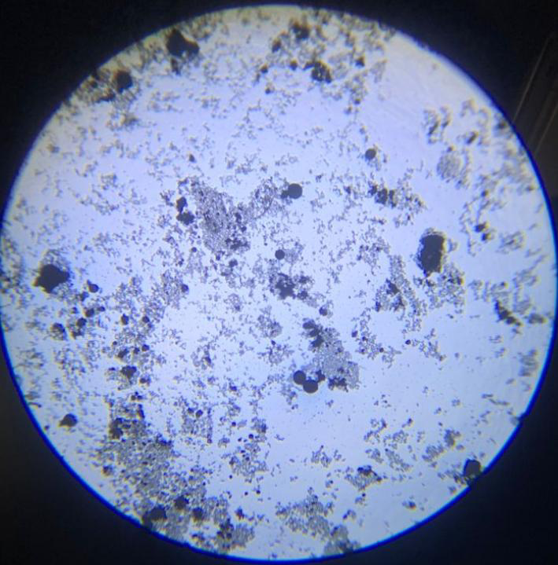
Plate 1: Aspergillus sp (Microscopic view)

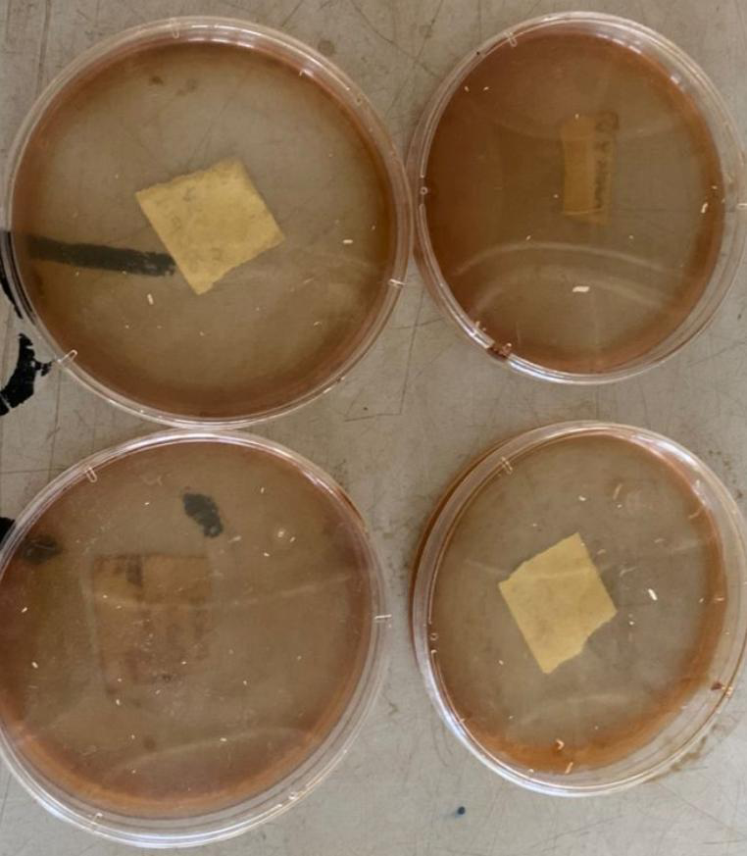

Plate 2: Picture Showing Indole Test on Isolates
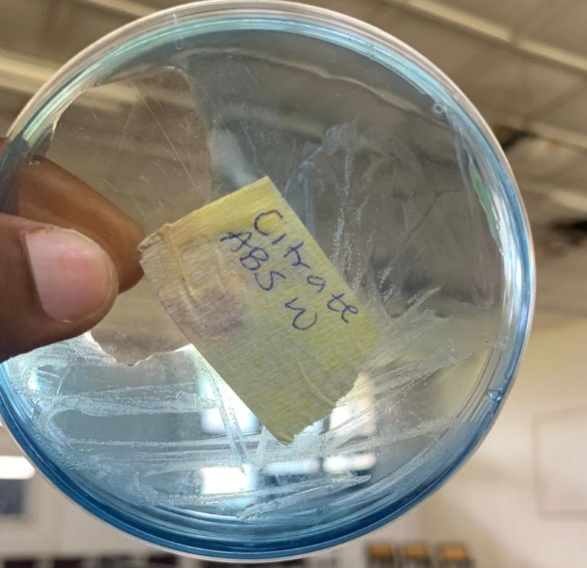
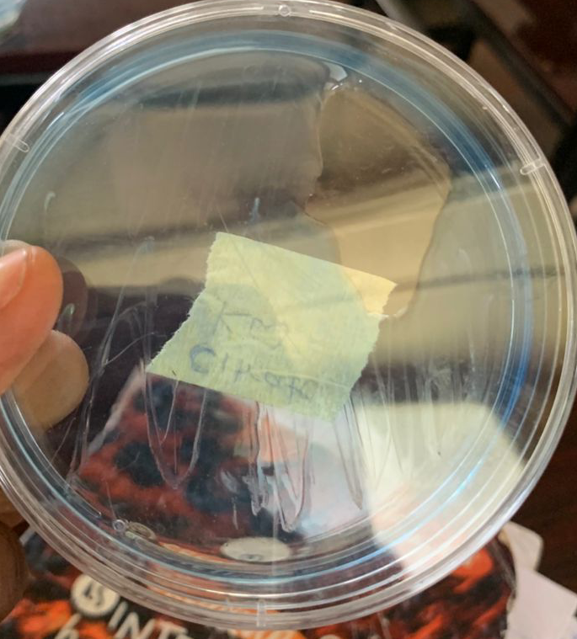
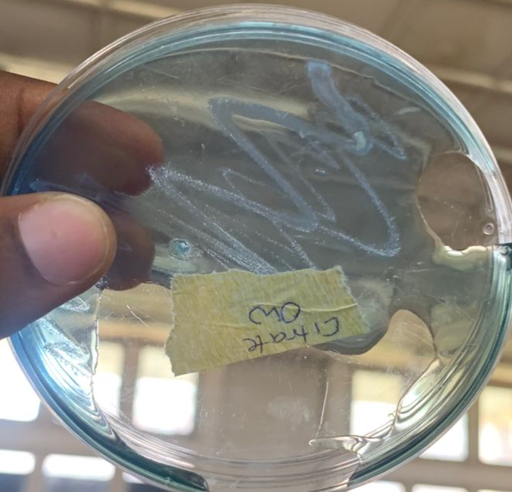
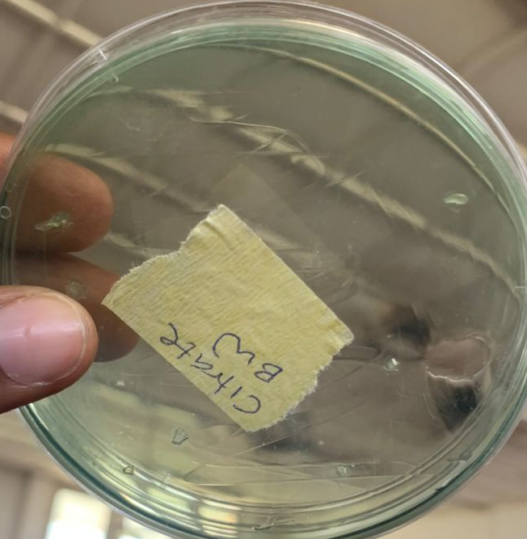

Plate: 3-4 Pictures showing Citrate activity on Isolates

