COMPARATIVE ANALYSIS OF INFRASTRUCTURAL FACILITIES OF ADEWOLE AND HARMONY ESTATES,ILORIN KWARA STATE.

PREPARED BY

ODETAYO ELIZABETH OYENIKE
HND/23/URP/FT/0015

A PROJECT SUBMITTED TO THE
DEPARTMENT OF URBAN AND REGIONAL PLANING,
INSTITUTE OF ENVIRONMENTAL STUDIES(IES)
KWARA STATE POLYTECHNIC,ILORIN.

IN PARTIAL FULFILLMENT OF THE REQUIREMENTS FOR
THE AWARD OF HIGHER NATIONAL DIPLOMA(HND) IN URBAN AND REGIONAL PLANNING
JULY,2025



ACKNOWLEDGEMENTS
I give all glory, honor, adoration and praise to Almighty God. The God of all creation, the Alpha and Omega, for His mercy, protection, grace upon me throughout the period of this programme, May His name be praised forever and ever Amen.
I will like to acknowledge my able, dynamic indispensable and ever dependable supervisor, in person of TPL. A.H Muhammed for the sacrificial of his time to read through the entire work and offered valuable correction at every stage of this project, may you live long to enjoy the fruit of your labor. Amen
My profound gratitude goes to the capable Head of Department (H.O.D) on person of TPL E.S ADEKANYE for his fatherly care and support. Also, MR. YAKUB and all the lecturers of great and noble department
for their impact in my life academically.
I want to specially thank my parent Mr. & Mrs. ODETAYO for their financial support, ceaseless prayers and advice throughout the period of my programme. May you live to eat the fruit of your labor. Amen
I also want to appreciate my siblings Samuel, Micheal, Dorcas and Joshua for all their encouragement, prayer, and contribution in one way or other.

TABLE OF CONTENTS PAGES Title Page i
Certification ii
Dedication iii
Acknowledgements iv
Abstract v
Table of Contents vi
CHAPTER ONE
Introduction 1.0
Statement of Problem 1.1
Research question 1.2
Aim. 1.3
Objectives of the Study. 1.4
Scope of the Study 1.5
Justification of the study 1.6
Significance of the Study 1.7
The study Area. 1.8
Geographical location 1.9

CHAPTER TWO
Conceptual Framework 2.0
Theoretical Framework 2.1
Literature Review 2.2
Conclusion 2.3

CHAPTER THREE
Research Methodology 3.0
Research Design 3.1
Type of data collection 3.2
Sources of data collection 3.3
Sample Frame 3.4
Sample size 3.5
Sample and sampling Techniques 3.6
Instruments for data collection 3.7
Methods of data analysis 3.8

CHAPTER FOUR:DATA ANALYSIS AND PRESENTATION OF RESULTS
Introduction 4.1
Socio-Economic Characteristics of the Respondents 4.1
Gender of Respondent. 4.1
Marital Status of Respondent 4.2
Ethnicity of Respondent. 4.3
Nativity of the respondent. 4.4
Religion of Respondent. 4.5
Tenure of occupancy. 4.6
Respondents of the Household size. 4.7
Occupation of the respondent. 4.8
Education of Respondent. 4.9
Income of the respondent. 4.10
Respondent’s Building. 4.11
Road infrastructure of the respondents 4.12
Drainage system. 4.13
Water supply. 4.14
Electricity. 4.15
Waste management. 4.16
Recreational facilities 4.17
Residents satisfaction 4.18

CHAPTER FIVE:SUMMARY OF FINDINGS, CONCLUSION AND RECOMMENDATION
Summary of Findings. 5.1
Conclusion. 5.2
Recommendation. 5.3
Reference. 5.4

Abstract
This research undertakes a comprehensive comparative analysis of infrastructural facilities in Adewole and Harmony Housing Estates, two prominent residential neighborhoods in Ilorin, Kwara State, Nigeria. The study focuses on assessing the nature, adequacy, quality, accessibility, and maintenance of key infrastructure components such as road networks, drainage systems, water supply, electricity, waste management, security, healthcare, educational facilities, and recreational amenities.The objective of the study is to Examine the Socio-economic characteristics of the resident in the study areas.The findings of the study reveal that Adewole Estate benefits from a relatively established public infrastructure, with consistent water and electricity supply, functional road networks, and public schools and clinics. The study concludes that while both estates serve as important residential hubs within Ilorin, their infrastructural strengths and weaknesses reflect broader challenges in urban development and housing delivery in Nigeria.This study contributes to the body of knowledge in urban and regional planning by offering insights that can guide future estate development, urban infrastructure management, and sustainable city planning initiatives.

CHAPTER ONE
1.0 Introduction
Infrastructure as fundamental facilities refer to the basic physical and organizational structure and facilities needed for the operation of a society or enterprise. It includes essential service and systems that support economic activities and improve the qualities life.( Oxford dictionary of economics 2024) ( World bank 1994) The infrastructure that is essential to the efficient working of a modern city is extensive. It includes provision for water and sewerage facilities, surface water drainage, highways, transport facilities, energy distribution networks, telecommunications facilities and other networked' services.
Infrastructure also includes the provision of the types of social facilities regarded as essential to the maintenance of a tolerable standard of living for residents and workers, educational and healthcare facilities, leisure facilities and open space and the infrastructure associated with the maintenance of public health and welfare, law and order and public administration".(Urban Infrastructure Management Plan - Vol 2 Planned Urban Infrastructure Investment for 1999/2004,Ministry of Urban Infrastructure Management) This closely aligns to the definition of infrastructure adopted for the purposes of Council's brief: "infrastructure includes the buildings or physical elements, usually permanent in that area, necessary to support the effective, efficient and cohesive functioning of the communities. This includes; roads, bus stops, Foot-paths, traffic facilities, drainage, Landscape, playground equipment, libraries, community centers and the like. "Infrastructural facilities has remain the most and essential facilities required by the people for the purpose of improving the standard of living and the quality of life of the people in a given environment. The level of infrastructural facilities available to the people in any nation is a fairly accurate reflection of the quality of life in that country according to Ajayi M.A. and Omole F.K.[2012].One major aspect of urban problem with respect to housing is the poor state of infrastructural facilities.
Obateru[2003]distinguishes between physical infrastructure comprising transportation facilities and public utilities and social infrastructure comprising social community facilities and services. Examples of public utilities include electricity, water, roads, gas, supply sewerage, storm water drainage and telephone services; while examples of social or community facilities include educational, health, recreational and cultural facilities. Examples of social services include police and fire protection. Dr. Jeffrey Delmon, senior infrastructure specialist of The World Bank, begins his book indicating that, "Poor infrastructure impedes a nation's economic growth and international competitiveness (The World Bank 2006) Insufficient infrastructure also represents a major cause of loss of quality of life, illness and death(Willoughby 2004) This raises infrastructure services from good investment to a moral and economic imperative. In order to stimulate growth and reduce poverty, it is essential to improve the supply, quality and affordability of infrastructure services. The unmet demands are huge, and investments have not matched demand (The World Bank 2008)."
The condition of Nigeria infrastructure is generally poor. For example, World Bank [1996] reports that Nigeria's urban infrastructure is crumbling because water supply, sewerage, sanitation, drainage, roads, electricity, waste disposal all suffer from years of serious neglect. Similarly, Federal Republic of Nigeria [1997] reports that the rate at which community infrastructure and social services are provided in Nigeria has not been commensurate with the pace of population growth and expansion. As a result, infrastructure problems now plaque all the urban centers in Nigeria and these included irregular water supply, unreliable energy supply, poor drainage, inefficient waste disposal system, grossly outstretched intra-city, inter-city and inter-state transportation system.
At the global level, infrastructures facilities facilitates international connectivity, cooperation and economic activities. These includes transportation network, communication systems, energy infrastructures, trades and logistic and environmental infrastructure.( World bank 2022) Infrastructure facilities are the backbone of functional housing estates and are crucial for ensuring the quality of life for residents. Housing infrastructure encompasses physical systems such as roads, drainage, water supply, electricity, waste management, and recreational facilities. These facilities collectively support the everyday activities of residents and contribute to the livability, sustainability, and value of housing estates (Muller, 2004) Adequate infrastructure fosters economic growth, enhances property values, and ensures environmental sustainability within urban areas (UN-Habitat, 2016).
At the national level infrastructure facilities support a country’s economics growth ,social development and governance. These includes transportation infrastructure, water and sanitation, health infrastructure, communication networks and educational facilities.( National planning commission 2021). At the state or regional level, infrastructural facilities focus on localize development and governance. These includes energy distribution, water resources, urban development, social infrastructure and technology hubs.( National institute of urban affairs 2020).
While global level infrastructure aim s at international integration and cooperation, national level focuses on cohesive development within a country, and state level infrastructure emphasizes localized growth and efficient resources utilization. All these levels interconnect to build a robust and sustainable system . Infrastructure facilities play a vital role in ensuring the sustainability and livability of housing estates. According to the United Nations Human Settlements Programed (UN-Habitat), well-planned and efficiently maintained infrastructure— such as roads, drainage systems, water supply, electricity, waste management, and recreational facilities—contributes significantly to the desirability and functionality of urban housing developments (UN-Habitat, 2016). These facilities not only enhance the quality of life for residents but also support urban growth by creating conducive environments for social and economic activities.
In recent decades, Ilorin, the capital city of Kwara State, Nigeria, has experienced rapid urbanization, leading to increased pressure on housing infrastructure (Kwara State Government, 2017). To address the growing demand for housing, numerous estates have been developed in the city, among which are Adewole Housing Estate and Harmony Estate. These estates were designed to provide decent and affordable housing to the city’s growing population. However, like many urban housing developments in Nigeria, they face significant challenges related to the provision and maintenance of infrastructure facilities (Akinpelu, 2015).
Despite the importance of these facilities, Adewole Housing Estate and Harmony Estate exhibit varying levels of infrastructural adequacy and efficiency. Challenges such as poorly maintained roads, inadequate drainage systems, unreliable electricity supply, and inefficient waste management have been reported in many housing estates across Ilorin (Ogunbode, 2016). These challenges negatively impact residents’ satisfaction and the overall livability of the estates.
Given the critical role of infrastructure in urban housing, it is essential to conduct a comparative analysis of these two estates to evaluate the strengths and weaknesses of their infrastructure facilities. This study aims to provide insights into the conditions and adequacy of the infrastructure in both estates, identify existing challenges, and propose recommendations for improvement. By addressing these issues, this research contributes to the broader goal of enhancing urban planning and housing development in Ilorin.
This introduction is tailored to set the stage for your study, providing relevant context, highlighting the research gap, and specifying the study’s objectives. Kwara State Government. (2017). Kwara State Development Plan 2017-2030. Muller, M. (2004). Housing and Urban Development in Nigeria. Journal of Housing and the Built Environment, 19(2), 147-164. Despite their importance, many housing estates in Ilorin, including Adewole Housing Estate and Harmony Estate, face challenges related to the provision and maintenance of infrastructure facilities.
Ilorin, the capital of Kwara State in North-Central Nigeria, has experienced significant urban expansion in recent decades. This urban growth is driven by population increases, migration, and economic activities, leading to a surge in housing demand (Kwara State Government, 2017). In response, several public and private housing estates have been developed to address the need for affordable and sustainable housing. Both estates face challenges typical of many Nigerian housing developments, such as poor road networks, unreliable electricity, insufficient water supply, and inadequate waste management systems. These issues not only hinder the functionality of the estates but also affect the residents’ satisfaction and overall quality of life (Adebayo, 2012). Comparing the infrastructure facilities of Adewole Housing Estate and Harmony Estate is critical to identifying the strengths, weaknesses, and opportunities for improvement in both contexts.
1.1 Statement of the problem
Estate Infrastructural refers to the essential physical and organizational facilities and system within a housing estate that enable its effective functioning and improve the quality of life for resident. These includes basic physical facilities, social and community facilities, environmental management system, economic infrastructure.
In these context of Adewole Housing estate and Harmony estate ,Ilorin ,estate infrastructure is critical to the resident’s well being and the estates overall functionality. The research problem may focus on identifying gaps, inefficiencies ,or inadequacies in the provision, maintenance, or accessibility of these infrastructural components and their impact on resident’s quality of life and satisfaction.
Here are some potential authors that have contribute and made their research on these particular topic and here are their recommendations:
Adewale S.A. (2020) : Emphasized on equitable access to basic infrastructure, with suggestion for improve water systems and road maintenance. Mohammed T. O:(2018): Advocate for updated policies to support sustainable urban growth and equitable infrastructure distribution. Ogundele O.k.(2019): proposed public private partnership and strategic government intervention for bridging infrastructure gaps. E-project Guides (2022): advocate for redesigning recreational spaces ,improving maintenance , and promoting resident participation. Educational consults(2022): focused on the functionality of recreational facilities, suggesting better management and integration into urban planning.
Despite their findings on Adewole and Harmony estate Ilorin. They were unable to compare the infrastructural availability at residential neighborhood level. By conducting a comparative analysis of these estates, this study aims to address a gap in the existing literature, where little attention has been paid to the comparative evaluation of housing infrastructural availability at residential neighborhood level in. The findings will provide valuable insights for urban planners, policymakers, and housing developers in improving the infrastructure of existing and future housing estates in Kwara State and beyond.
1.2 Research question
The study seeks to answer the following questions.
1. What infrastructural facilities available in Adewole Housing estate and Harmony estate?
2. What is the condition and functionality of these facilities in both estate?
3. What are the impacts of infrastructural facilities to the quality life ?
4. What are the possible improvement needed for sustainable infrastructure in the two estates.
1.3 Aim
The aim of this study is to conduct a comparative analysis of the infrastructure facilities at Adewole and Harmony Estate in Ilorin, Kwara State. With a view to improve the quality life in the estate.
1.4 Objectives
- To examine the socio economic characteristics of the resident in the study areas.
- To Identify the existing infrastructural facilities in both estates.
3. To examine the functionality of the existing infrastructural facilities in both Estates
4.To access the impact of infrastructural facilities to the quality of life of the residents.
5. To make recommendation for improving the infrastructural facilities at Adewole and Harmony Housing estates.
1.5 Scope of the study
This study focuses on the comparative analysis of infrastructure facilities at Adewole Housing Estate and Harmony Estate in Ilorin, Kwara State. The scope is limited to the key infrastructural components such as road, water supply, electricity, security, waste management, and recreational facilities. The study does not cover other aspect of urban development such as economic activities or social dynamics, beyond their relationship with infrastructure.
1.6 Justification of the Study
This study is significant for several reasons. Firstly , it will provides insight into the state of infrastructure in Ilorin, contributing to the broader discourse on urban development in Nigeria. Secondly, the findings will be beneficial to policy makers, urban planners, and estate developers in identifying best practices and addressing infrastructural challenges. Lastly, the study will serve as a reference for future research on comparative urban studies.
1.7 Significance of the Study
This study will provide valuable information on the infrastructure facilities at Adewole Housing Estate and Harmony Estate, which can be used to inform policy decisions and development initiatives aimed at improving the quality of life and the overall sustainability of housing estates.

1.8 The Study Area
The study area for this research is Adewole Housing Estate and Harmony Estate, both located in Ilorin, Kwara State, Nigeria.
Ilorin is the capital city of Kwara State, located in the North-Central geopolitical zone of Nigeria. It is situated approximately 330 kilometers southwest of Abuja, the federal capital territory.
Adewole Housing Estate, established in the early 1990s, is one of the oldest planned housing estates in Ilorin. The estate is characterized by its structured layout and a mix of residential, commercial, and recreational land uses. However, over the years, the estate has faced challenges such as aging infrastructure, inadequate maintenance, and insufficient expansion to accommodate population growth. On the other hand, Harmony Estate, a relatively newer development established in the 2000s, was planned to address some of these deficiencies, incorporating modern infrastructure and design. Despite these intentions, it has also struggled with infrastructural shortcomings due to rapid urbanization and limited resource.
Adewole Housing Estate
Adewole Housing Estate is located along Adewole Road, Ilorin. The estate covers an area of approximately 10 hectares and comprises 200 residential buildings.
Harmony Estate
Harmony Estate is located along Harmony Road, Ilorin. The estate covers an area of approximately 15 hectares and comprises 300 residential buildings.
Geographic Location
For research, they are used to pinpoint the exact position of study areas (such as Adewole and Harmony Estates) for mapping, spatial analysis, and environmental assessment.
• Adewole Housing Estate is lo.cated approximately at:Latitude: 8.5070° N, Longitude: 4.5384° E
• Harmony Estate is located approximately at:
Latitude: 8.4681° N, Longitude: 4.5515° E
Adewole Housing Estate and Harmony Estate are located within Ilorin West Local Government Area. They are accessible via major roads and serve as residential centers for civil servants, business owners, and professionals.

Climate
Climate is the average weather conditions (temperature, humidity, rainfall, wind, etc.) in a particular area over a long period of time. It determines the types of infrastructure needed, such as drainage systems to manage rainfall or building materials that resist heat and moisture. The climate of Ilorin, where both estates are located, is classified as tropical wet and dry (Aw) under the Köppen climate classification. The region experiences two major seasons:
• Rainy season (April–October)
• Dry season (November–March)
This climate influences drainage d.esign, housing orientation, and infrastructure resilience.
Ilorin experiences a Tropical Savanna Climate (Aw) with:
• Rainy Season: April to October
• Dry Season: November to March (Harmattan in Dec–Feb)

Temperature
In Adewole and Harmony Estates, average daily temperatures typically range from 23°C to 35°C throughout the year. These temperature levels influence building materials, ventilation systems, and residents energy consumption for cooling
• Annual Average Temperature: 27°C to 34°C
• Peak Temperatures: Up to 38°C (March/April)
• Coolest Period: 25°C–27°C (July–September)
Humidity
Adewole Housing Estate Located in the central area of Ilorin, Adewole experiences moderate to high humidity levels throughout the year.
• Average Relative Humidity:
• Wet Season (April–October): 70% – 90%
• Dry Season (November–March): 40% – 60%
• Humidity is typically higher in the early morning and lower in the afternoon.
• High humidity during the wet season can affect building materials, indoor air quality, and the condition of roads and drainage systems.
Harmony Estate:
• Located on the outskirts of Ilorin, Harmony Estate has similar humidity patterns to Adewole due to their proximity.
• Average Relative Humidity:
• Wet Season: 75% – 95%
• Dry Season: 45% – 60%
• The estate’s more open landscape and greenery may cause slightly higher humidity retention during the rainy season.
These climatic factors affect infrastructure durability and design needs, especially for roads, drainage, and water supply systems.

Figure 1.1: Kwara State within the National Context

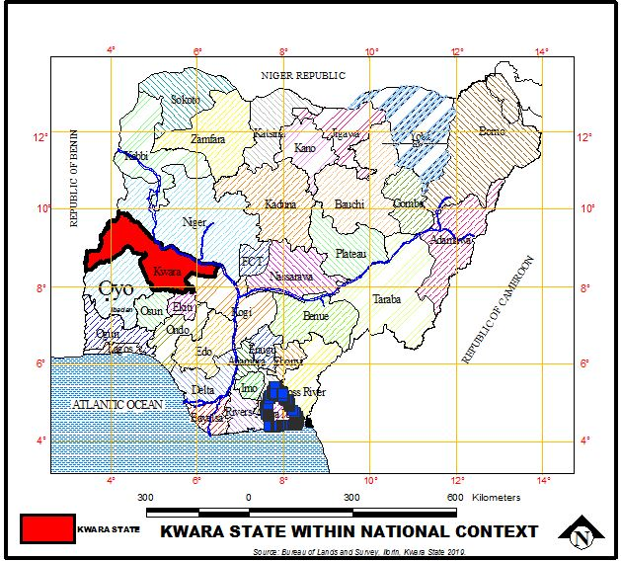
State Geographical Board, 2025
Source: Kwara State Geographical Information Source (KWAGIS)

Fig. 1.2: Map of Kwara showing Ilorin East local government Area.
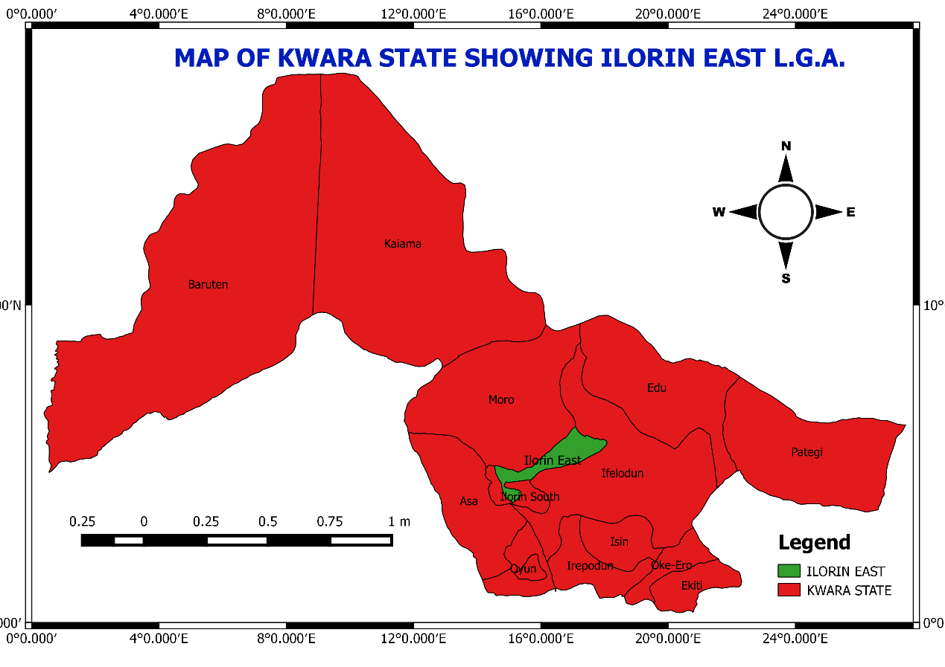
Source : Land and Survey department(2025)

Fig.1.3:Map of Kwara showing Ilorin West local government
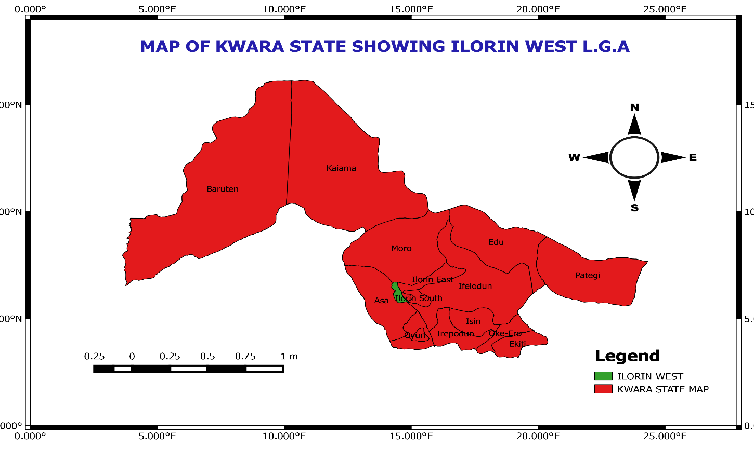
Source: Land And Survey Department(2025).

Fig.1.4:Google Earth Imagery Showing Harmony Estate In Ilorin East
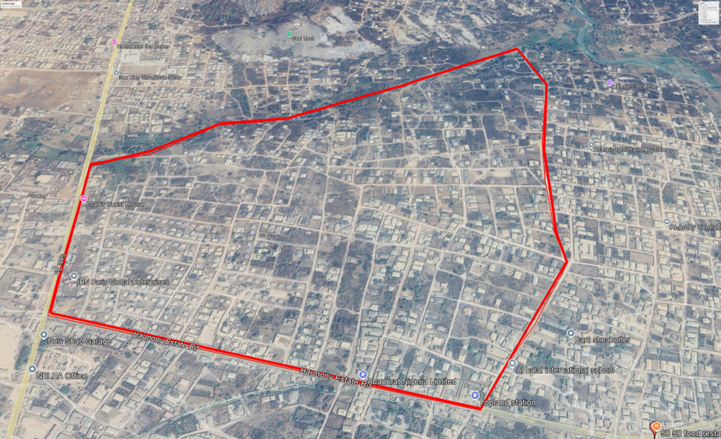
Local Government Area Source: Land And Survey Department (2025)

Fig. 1.5: Google Earth Imagery showing Adewole Estate in Ilorin west
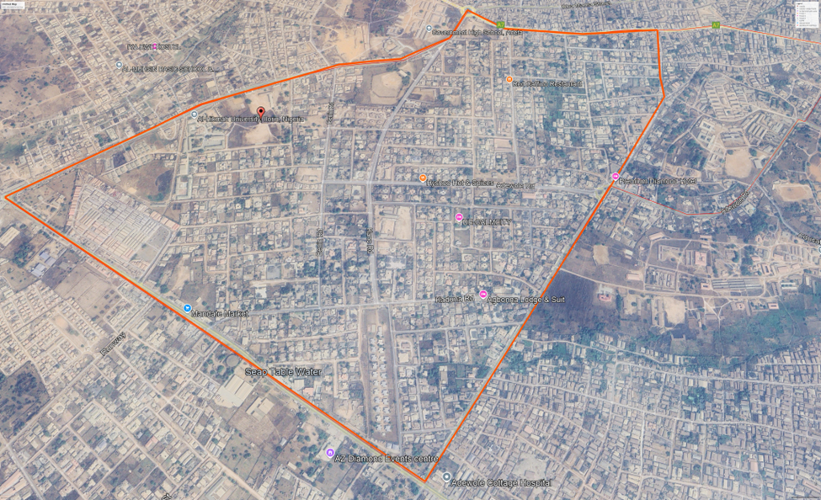
local government area Source: Land and Survey department (2025)

CHAPTER TWO
2.0 Concept of infrastructure
Infrastructure includes essential services and facilities such as roads, drainage, water supply, electricity, and waste management that support urban living. The quality of infrastructure significantly influences residents’ well-being and housing satisfaction. Adewole and Harmony Estates serve as examples of such planned communities aimed at addressing housing needs, especially for middle-income earners. These are residential areas with restricted access, offering privacy, security, and a sense of exclusivity. While both estates are structured and somewhat gated, their infrastructural quality varies, indicating differences in estate management and government intervention. Resident satisfaction is the degree to which residents perceive their housing environment as meeting their needs. It includes satisfaction with infrastructure, security, affordability, and aesthetics.
The concept of infrastructure as a fundamental socio-economic characteristic encompasses both its physical and systemic roles in supporting social and economic systems. Infrastructure refers to the foundational physical systems and services, such as transportation, energy, water supply, and communication networks, that enable societal and economic activities. It also includes social infrastructure like education, healthcare, and public administration, which promote societal well-being and productivity.
Key characteristics of infrastructure include:
1. Economic Catalyst: Infrastructure supports economic activities by providing essential services like transportation and energy, directly impacting production and consumption patterns. It fosters investment and economic integration, which is crucial for regional and national development.
2. Social Integration: Beyond its economic role, infrastructure underpins societal cohesion by facilitating access to education, healthcare, and other essential services, reducing regional disparities, and promoting equity.
3. Sustainability and Innovation: Modern infrastructure development integrates sustainability goals and drives innovation by addressing systemic bottlenecks, enhancing efficiency, and fostering resilience in socio-technical systems.
4. Interdependence: Infrastructure systems are highly interconnected, with technical, organizational, and institutional components that evolve together, influencing their adaptability to external pressures such as technological advancements or environmental challenges.
A multi-dimensional approach, considering technical, economic, and social perspectives, is essential to understand and optimize infrastructure’s role in socio- economic development.
Socio-Economic Characteristics
The residents of Adewole Housing Estate and Harmony Estate are predominantly middle-class individuals and families. The estates have a mix of residential, commercial, and recreational land uses.
A literature review is a critical analysis of existing research and scholarly articles related to your research topic. Here's a potential outline for a literature review on the comparative analysis of infrastructure facilities at Adewole Housing Estate and Harmony Estate in Ilorin, Kwara State:
2.1 Theoretical Framework of Infrastructural Facilities: A Comprehensive Research Approach
The concept of infrastructure as a fundamental socio-economic driver spans both physical and social dimensions. These two categories interact to promote economic development, enhance productivity, and improve quality of life. Below is a combined theoretical framework that integrates key concepts, theoretical models, and empirical studies on the role of infrastructure in socio-economic development.
1. Defining Infrastructure and Its Categories
Physical Infrastructure: Includes transportation systems (roads, railways, airports), utilities (electricity, water, telecommunications), and sanitation facilities. These infrastructures form the backbone of any economy, enabling businesses and individuals to access resources and markets efficiently.
Social Infrastructure: Encompasses education, healthcare, housing, and other social services. These are crucial for human capital development, directly affecting labor productivity and overall societal well-being
Aigbokhan (1999) outlines how physical infrastructure facilitates economic growth by reducing transaction costs and enabling market access.
The World Bank (1994) emphasizes that infrastructure, both physical and social, is essential to economic development, especially in less-developed countries.
2. Theoretical Approaches to Infrastructure
Endogenous Growth Theory: In this framework, infrastructure is seen as a public capital that directly affects long-term economic growth. As demonstrated by Futagami et al. (1993), improvements in infrastructure, such as better roads and communication networks, directly lead to an increase in productivity, which fuels economic growth.
Supply-Side Economics: Infrastructure is regarded as a form of public capital that enhances the productivity of both labor and capital. According to Canning and Pedroni (2004), infrastructure investments—such as electricity, roads, and telecommunications—have long-term positive effects on economic growth by improving efficiency in various sectors.
Infrastructure and Human Capital: Social infrastructure such as education and healthcare are vital for developing skilled labor, which, in turn, enhances the productivity of physical infrastructure. Denison (1962) and UNESCO (2011) argue that investments in education and health are crucial for improving workforce quality and productivity.
- Empirical Studies on Infrastructure and Economic Growth
The integration of physical and social infrastructure within a theoretical framework highlights their complementary roles in fostering socio-economic development. Physical infrastructure reduces transaction costs and enhances access to resources, while social infrastructure builds human capital, improving labor productivity. Empirical studies and theoretical models confirm that infrastructure investments are pivotal for both short-term economic performance and long-term growth. Case studies from various regions emphasize that successful astructure development requires strategic planning and investment in both physical and social sectors.
2.2 Literature Review
Infrastructure Facilities in Housing Estates
- Definition and importance of infrastructure facilities in housing estates (Muller, 2004) - Types of infrastructure facilities in housing estates (roads, drainage, water supply, electricity, waste management, recreational facilities) (UN-Habitat, 2016)
Road Infrastructure in Housing Estates Importance of road infrastructure in housing estates (Oluwunmi, 2015)Factors affecting the design and construction of roads in housing estates (Adegoke, 2013)
Drainage Systems in Housing Estates Importance of drainage systems in housing estates (Adebayo, 2012 Factors affecting the design and construction of drainage systems in housing estates (Ogunbode, 2016)
Water Supply Infrastructure in Housing Estates Importance of water supply infrastructure in housing estates (WHO, 2011)Factors affecting the design and construction of water supply infrastructure in housing estates (Akinpelu, 2015) Electricity Supply Infrastructure in Housing Estates Importance of electricity supply infrastructure in housing estates (NEPA, 2013)Factors affecting the design and construction of electricity supply infrastructure in housing estates (Ojo, 2017)Waste Management Infrastructure in Housing Estates Importance of waste management infrastructure in housing estates (UNEP, 2015) - Factors affecting the design and construction of waste management infrastructure in housing estates (Adeleke, 2016) Recreational Facilities in Housing Estates Importance of recreational facilities in housing estates (Muller, 2004) Factors affecting the design and construction of recreational facilities in housing estates (Oluwunmi, 2015) Comparative Analysis of Infrastructure Facilities Importance of comparative analysis of infrastructure facilities in housing estates (UN-Habitat, 2016) Methodologies for comparative analysis of infrastructure facilities in housing estates (Akinpelu, 2015)Ajayi (2019) studied urban housing satisfaction in Lagos and found that road access, drainage, and electricity significantly influence residents’ perceptions of their environments. Ojo and Adewumi (2021) analyzed public housing estates in Abuja and concluded that public-sector housing often suffers from poor maintenance, especially in drainage and water supply systems. Bello (2020) compared two residential neighborhoods in Ibadan and observed that government-funded estates had better infrastructure than privately developed ones, though maintenance was inconsistent. Adewale (2022) explored resident satisfaction in Kwara State and identified factors such as household size, income, and education as influencing perception of infrastructure quality.
2.3 Conclusion
This chapter has reviewed relevant theoretical perspectives and existing literature on infrastructure development and residential satisfaction. The Central Place Theory, Urban Growth Theory, and Systems Theory collectively provide a robust framework for understanding the spatial, economic, and systemic factors influencing infrastructure provision in urban estates. Conceptual clarifications have also been provided on infrastructure, housing estates, gated communities, and resident satisfaction to establish a clear foundation for the study.
Empirical studies have shown that the quality of infrastructure in residential areas significantly affects the well-being and satisfaction of residents. Disparities in service delivery are often the result of variations in planning, funding, and government intervention. Drawing from these insights, this study aims to assess the infrastructural conditions in Adewole and Harmony Estates, offering a comparative perspective to identify strengths, weaknesses, and areas needing policy attention.

CHAPTER THREE
Research Methodology
3.0 Introduction
This chapter outline the research design, methods and procedure use to conduct the study, its described the study area, data collection methods and tools for data analysis. The methodology is designed to achieve the objective of comparing infrastructural facilities in Adewole Housing Estate and Harmony Estate Ilorin.
Methodology is the approach a researcher uses to investigate a subject, therefore this chapter explains the various methods and procedures used in collecting data and information, the sources of data and the method of data analysis adapted, in order to present a reliable and valid dissertation.
3.1Research Design
This study employs a comparative research design, which involves comparing the infrastructure facilities of two housing estates.

Research Design Tables
S/N | Research Objectives | Sources of data collection | Methods of data collection | Method of data analysis | Methods of data presentation
1 | To examine the socio- economic characteristics of the residents in the study area | Primary sources of data | Administration of questionnaires aires and personal interview…………………….. | Descriptive method using SPSS | Frequency, table percentage and charts
2 | To identify the existing infrastructural facilities in both estates. | Primary sources of data | The use of structured questionnaires and personal administration in order to determine the efficiency of the infrastructural facilities provided within the neighborhood | Descriptive method using analysis of variance | Frequency,table percentage and charts
3 | To examine the functionality of the existing infrastructural facilities in both estates. | Primary sources of data | Administration of both questionnaires, field survey and personal interview | Descriptive methods using SPSS | Frequency, table percentage and charts
4 | To assess the impact of infrastructural facilities to the quality of life of the residents. | Both primary and secondary sources of data | Administration of both primary and secondary methods of data collections such as Questionnaire, interview, relevant journals, and past projects, | Descriptive methods using analysis of variance and SPSS | Frequency, table percentage and charts

3.2 Types of data collection
- primary source of data
- Secondary source of data
3.3 Sources of data collection
- Primary source:These are the field data from respondents, which involves the administration of questionnaires to the residents of the housing estate. These helps to know their perceptions on the condition of the housing estate.
- Secondary source of data: The information required from this research serves as an essential support in view of relevant literature of already documented facts such as books, journals and internet. The information obtained helped in improving, strengthening and in creating a concern comprehensive results for the research. Moreover important information and data was obtained from the residents to collaborate with other information.
3.4. Sample Frame
Sampling frame can be defined as the source materials or device from which a sample is drawn. I.e. it is the entire population or a list of all those within a population who can be sampled in the study area, and these may include; Individuals, Households or Institutions.
Usually, the whole population may be too large for a researcher to attempt to survey or include all its members. Thus a small, but carefully selected sample can be used to represent the population, the sample reflects the characteristics of the population from which it is drawn.
The sample frame for this study consists of the total number of householdds and key stakeholders in Adewole Housing Estate and Harmony Estate in Ilorin, Kwara State. The sampling frame includes all adult residents who are household heads or have lived in the estate for more than one year, as they are considered to have adequate knowledge of the infrastructure facilities available in the estate.
The frame was derived from preliminary surveys, estate records, and community leadership registers. The following elements form the sample frame:
Household heads in Harmony Estates. | Estate Administrators and Managers. | Household heads in Adewole Housing Estate. | Utility Service Providers. | Long-term Residents with Knowledge of Infrasture Development in the Estates.
Using this sample frame ensures that the selected respondents have relevant experience and perspectives on the conditions and functionality of infrastructure facilities in their respective estates. It also ensures fair representation across different demographic and socio-economic groups within the estates.
3.5. Sample Size
The sample size for this research was determined based on the need to achieve both representativeness and comparability between Adewole Housing Estate and Harmony Estate in Ilorin, Kwara State. The choice of sample size was influenced by the total number of residential units, the available resources, the nature of the study, and the desired confidence level.
Total Sample Size
Number of Respondents in each Estates.
1 | Adewole Estate | 100
2 | Harmony Estate | 100
3 | Total | 200
The study selected a total of 200 respondents
This number was chosen to ensure balanced representation from both study locations, allowing for meaningful comparative analysis.
Justification for Sample Size
The sample size was based on the following factors:
1. Estimated Population Size
According to estate records and field estimations:
• Adewole Housing Estate contains approximately 250–300 households.
• Harmony Estate contains approximately 300–350 households.
A sample of 100 households from each estate represents 30–40% of each population, which is a strong coverage level in social research, particularly when supported by systematic and stratified sampling techniques.
2. Statistical Consideration (Yamane’s Formula)
Yamane’s (1967) simplified formula for calculating sample size for a finite population is:
n = \frac{N}{1 + N(e)^2}
Where:
• n = sample size
• N = total population
• e = margin of error (0.05)
Assuming N = 300 and e = 0.05:
n = \frac{300}{1 + 300(0.05)^2} = \frac{300}{1 + 0.75} = \frac{300}{1.75} \approx 171
However, due to time and logistical constraints, and in line with practices in similar studies, a minimum of 100 households per estate was deemed sufficient.
3. Nature of the Study
Because the study seeks to gather both quantitative data through questionnaires and qualitative insights through interviews and observations, a sample of 200 respondents allows for robust analysis while maintaining manageability.
4. Homogeneity of the Population
Both housing estates are relatively homogeneous in terms of socio-economic composition (predominantly middle-class households). Therefore, a moderately sized sample can still yield reliable generalizations.

Sample Distribution Table
S/N | Respondent Category | Adewole Estate | Harmony Estate | Total
1 | Household Residents | 100 | 100 | 200
2 | Estate management officials | 2 | 2 | 4
3 | Utility Service Providers | 1 | 1 | 2
4 | Community leaders | 1 | 1 | 2
5 | Long-term Residents (Interview) | 1 | 1 | 2
 | Total Sample | 105 | 105 | 210
Source: Author’s Field Survey (2025)
The total sample size of 200 residents, along with selected key informants, ensures comprehensive data collection that captures both the quantitative and qualitative dimensions of infrastructure quality and performance in the two estates. This size is justified based on statistical reasoning, population estimates, and the comparative design of the study.

3.6. Sample and Sampling Techniques/Methods
Sampling Techniques
This study adopts a stratified random sampling technique to ensure a fair and representative comparison of infrastructure facilities across the two estates—Adewole and Harmony. Stratified sampling was chosen because the population consists of two distinct subgroups (strata), and it is important that each estate is proportionally represented.
Each housing estate was treated as a stratum, and within each, a random sampling method was used to select respondents. The number of respondents selected from each estate was determined based on the estimated number of households or population in each estate to ensure proportionality.
In addition to stratified sampling, systematic random sampling was employed within each estate. Starting from a random point in the estate, every nth household was selected to participate in the survey, where n was determined by dividing the total number of households by the sample size.
This combination of stratified and systematic sampling helped to:
• Eliminate sampling bias,
• Ensure that both estates are adequately represented,
• Allow for a more reliable comparative analysis.

3.7. Instruments for data collection
To achieve the objectives of this study and obtain reliable and valid data on the infrastructure facilities in Adewole Housing Estate and Harmony Estate, the following data collection instruments were used:
1. Structured Questionnaire
A structured questionnaire was designed as the primary instrument for collecting quantitative data from residents. It consisted of close-ended questions with multiple-choice options (A, B, C, D), grouped into the following sections:
• Section A: Demographic information (age, gender, education level, occupation, length of residence)
• Section B: Availability and condition of infrastructure facilities (roads, drainage, water supply, electricity, waste management, recreational facilities)
• Section C: Resident satisfaction and perception of service adequacy
• Section D: Challenges related to infrastructure provision and maintenance.
This instrument was administered to a sample of 200 residents (100 from each estate).
2. Observation Checklist
An observation checklist was used to collect qualitative data regarding the physical state of infrastructure in both estates. The researcher used this tool to document the visible condition of roads, drainage, electricity infrastructure (e.g., poles and transformers), and waste disposal sites. The checklist helped validate residents’ responses and provided supporting evidence for analysis.
3. Key Informant Interviews
Semi-structured interviews were conducted with selected key informants including estate managers, members of residents’ associations, and relevant officials in local government departments responsible for infrastructure. These interviews provided deeper insights into the management challenges and institutional efforts around infrastructure development and maintenance.
4. Document Review
Relevant documents such as estate development plans, government infrastructure reports, and past studies were reviewed. This secondary data provided context and supported triangulation of findings from primary sources.
• Review of government reports, policy documents, and previous academic studies relevant to infrastructure in Nigerian housing estates.
• Use of maps and planning documents from Kwara State Housing Corporation and Ilorin Municipal Council.

3.8 Methods of data analysis
Method of Data Analysis
This study employed both quantitative and qualitative methods of data analysis to interpret the information gathered from primary and secondary sources. The analysis was structured to meet the objectives and research questions outlined in the study.
1. Quantitative Data Analysis
The quantitative data collected through structured questionnaires were analyzed using:
• Descriptive Statistics: Frequencies, percentages, mean scores, and standard deviations were used to summarize responses regarding the types, conditions, and adequacy of infrastructure facilities.
• Inferential Statistics: Comparative statistical tools such as the Chi-square test and Independent Samples t-test were used to examine significant differences in residents’ satisfaction and infrastructure performance between Adewole Housing Estate and Harmony Estate.
• Data Processing Software: The responses were coded and analyzed using Statistical Package for the Social Sciences (SPSS) version 25 and Microsoft Excel for graphical representation (e.g., bar charts and pie charts).
2. Qualitative Data Analysis
The qualitative data obtained through interviews and field observations were analyzed using:
• Thematic Analysis: Responses from interviews and observation notes were grouped into themes based on recurring patterns related to infrastructure challenges, management practices, and resident engagement.
• Content Analysis: Relevant excerpts were quoted and interpreted to complement the statistical findings, providing deeper insight into the issues facing each estate.
By combining both analytical approaches, the study achieved a more holistic and reliable comparative assessment of infrastructure conditions in the two estates.

CHAPTER FOUR
DATA ANALYSIS AND PRESENTATION OF RESULT
4.1 Introduction
This chapter presents the analysis of the data collected on socio-economic characteristic of the respondents from the study area. The information obtained on the socio-economic characteristic of the respondents, nature and attributes of the housing estates in the study area, factors that influence people’s choice of demand of the housing estates in the study area, peoples satisfaction with housing facilities in the estate and associated problems residents’ encountered in Adewole and Harmony Housing Estate. The variables measured on socio economic characteristics of residents include gender, marital status, age, religion, education status, occupation, household size, income, indigene-ship status, number of household, type of housing, facilities available in the housing units among others. The data obtained in this regards, were cross tabulated against each housing estate while other data relating to factors that influence people’s choice of demand of the housing estates, peoples satisfaction with housing facilities in the estate and associated problems were also cross-tabulated against each estate and measured in likhert scale. The information obtained were analyzed and presented in tables to provide answers to some of the research questions.
4.2.1 Socio economics characteristic of respondents in gated communities of Ilorin
In the study area, Female respondents (67%) outnumber Male respondents (33%) as shown in Table 4.1. This distribution aligns with the expectation that Females are more likely to respond to surveys, However, an interesting trend is observed within the two housing estates. In Adewole Housing Estate, females represent a higher proportion of respondents (67%) compared to males (33%). On the other hand, in Harmony Estate, the reverse is true, with a higher proportion of male respondents (56%) compared to females (44%). This disparity suggests that while males generally dominate in survey responses across the area, gender dynamics within each estate may influence participation, possibly due to differences in family structures or cultural norms specific to each estate.

Table 4.1: Gender of the Respondents
Gender | Adewole |  | Harmony |  | Total
Gender | Frequency | Percentage (%) | Frequency | Percentage (%) | Frequency | Percentage (%)
Male | 33 | 33 | 56 | 56 | 89 | 44.5
Female | 67 | 67 | 44 | 44 | 111 | 55.5
Total | 100 | 100 | 100 | 100 | 200 | 100
Source: Author’s Field survey, 2025
4.2.2 Marital Status of the Respondents
The data on marital status of respondents, as shown in Table 4.2, indicates that in Adewole Housing Estate, the majority of respondents are married (67%), followed by single respondents (17%), with very small proportions of widowed (9%) and divorced (7%) individuals. Similarly, in Harmony Housing Estate, married respondents also constitute a larger percentage (62%), compared to single respondents (19%), divorced individuals (10%), and widowed individuals (9%). In total, across the study area, the proportion of married respondents (64.5%) is higher than single (18%), divorced (8.5%), and widowed (9%) respondents.
This distribution is not surprising, as the survey was conducted in residential estates primarily inhabited by young adults, who are generally in the early to middle stages of family life. The high proportion of married individuals suggests that these estates are likely to be attractive to families or individuals in established relationships, possibly due to the desire for stable and secure housing conducive to family life
Table 4.2: Marital Status of the Respondents
Marital Status | Adewole |  | Harmony |  | Total
Marital Status | Frequency | Percentage (%) | Frequency | Percentage (%) | Frequency | Percentage (%)
Single | 17 | 17 | 19 | 19 | 36 | 18
Married | 67 | 67 | 62 | 62 | 129 | 64.5
Widowed | 9 | 9 | 9 | 9 | 18 | 9
Divorced | 7 | 7 | 10 | 10 | 17 | 8.5
Total | 100 | 100 | 100 | 100 | 200 | 100
Source: Author’s Field Survey, 2025

4.2.3 Ethnicity of the Respondents
The ethnicity of the residents is detailed in Table 4.3. A significant proportion of respondents in Adewole (71%) are of Yoruba descent, followed by Igbo respondents (17%), while a smaller number (12%) identify as Hausa. In Harmony Estate, the majority of respondents are also Yoruba (65%), with Hausa (23%) and Igbo (12%) respondents forming smaller groups. Overall, the Yoruba ethnic group constitutes the largest proportion of respondents in the study area, making up (68%), followed by Hausa at (17.5%), and Igbo at (14.5%).
This distribution reflects the ethnic composition of Ilorin, where the Yoruba ethnic group is the predominant population. It is unsurprising that the Yoruba respondents form the largest group, given the city's demographic makeup. The presence of Hausa and Igbo residents also aligns with Nigeria's broader ethnic diversity, with these groups contributing smaller, yet significant, portions of the population in Ilorin

Table 4.3:Ethnicity of the Respondents
Ethnicity | Adewole |  | Harmony |  | Total
 | Frequency | Percentage (%) | Frequency | Percentage (%) | Frequency | Percentage  (%)
Yoruba | 71 | 71 | 65 | 65 | 136 | 68
Hausa | 12 | 12 | 23 | 23 | 35 | 17.5
Igbo | 17 | 17 | 12 | 12 | 29 | 14.5
Total | 100 | 100 | 100 | 100 | 264 | 100
Source: Author’s Field Survey, 2025
4.2.4 Nativity of the Respondents
The nativity distribution of respondents in the study area is presented in Table 4.4. A significant proportion of respondents in Adewole Estate are indigenes, accounting for (70%), compared to non-indigenes, who make up (30%). Similarly, in Harmony Estate, the number of indigenes (66%) exceeds that of non-indigenes (34%). This trend suggests that both estates are predominantly inhabited by indigenes, with Adewole Estate showing a notable concentration of indigenes, and Harmony Estate having an even higher proportion. The findings imply that local residents, or indigenes, are more likely to occupy these housing estates, possibly due to factors such as availability of housing schemes targeted at the indigenous population or affordability. This trend might reflect the local demographic composition and could indicate that housing projects in these estates may be more accessible or appealing to the native population.
Table 4.4: Nativity of the Respondents
Nativity | Adewole |  | Harmony |  | Total
Nativity | Frequency | Percentage (%) | Frequency | Percentage (%) | Frequency | Percentage (%)
Indigene | 70 | 70 | 66 | 66 | 136 | 68
Non-indigene | 30 | 30 | 34 | 34 | 64 | 32
Total | 100 | 100 | 100 | 100 | 200 | 100
Source: Author’s Field Survey, 2025
4.2.5 Religion of the Respondents
The respondents in the study are primarily Muslim (55%) and Christian (45%) (see table 4.5). The data reveals that among the respondents, a larger proportion of Muslims are found in Adewole, comprising (55%), compared to (45%)Christians. Similarly, in Harmony Estate, Muslims make up (57%) of the respondents, while Christians account for(43%).
This suggests a higher concentration of Muslim residents in both housing estates, with Adewole showing a more pronounced Muslim majority compared to Harmony Estate. The disparity in religious composition could be reflective of the demographic and cultural patterns within the study area, potentially influencing the preferences and perceptions of the residents in these estates.
Table4.5: Religion of the Respondents
Religion | Adewole |  | Harmony |  | Total
 | Frequency | Percentage (%) | Frequency | Percentage (%) | Frequency | Percentage (%)
Islamic | 55 | 55 | 57 | 57 | 112 | 56
Christianity | 45 | 45 | 43 | 43 | 88 | 44
Total | 100 | 100 | 100 | 100 | 200 | 100
Source: Author’s Field Survey, 2025
4.2.6 Tenure of Occupancy
The tenure of occupancy of the respondents is shown in Table 4.6. In Adewole Estate, a significant proportion of respondents are landlords, accounting for (61%). This is followed by tenants at (22%), relatives of the landlord at (10%), and squatters at (7%). In Harmony Estate, the proportion of landlords (51%) is still higher than tenants (30%), with relatives of the landlord at (7%) and squatters at (12%).
The high proportion of homeowners in both estates suggests that several factors likely influence their choice to reside in these areas. The presence of landlords in significant numbers could reflect the estate's appeal to property investors, while the substantial number of tenants in both estates indicates that these areas also cater to individuals seeking affordable and secure housing. Additionally, the lower proportion of squatters and relations to landlords suggests a degree of formality in the housing arrangements within these estates. The preferences for homeownership in both Adewole and Harmony estates may point to the availability of amenities, security, or other factors contributing to the overall attractiveness of these residential areas.
Table4.6:Tenure of Occupancy
Tenure Of Occupancy | Adewole |  | Harmony |  | Total
Tenure Of Occupancy | Frequency | Percentage (%) | Frequency | Percentage (%) | Frequency | Percentage (%)
Landlord | 61 | 61 | 51 | 51 | 112 | 56
Tenant | 22 | 22 | 30 | 30 | 52 | 26
Squatter | 7 | 7 | 7 | 7 | 19 | 9.5
Relations to land lord | 10 | 10 | 7 | 7 | 17 | 8.5
Total | 100 | 100 | 100 | 100 | 200 | 100
Source: Author’s Field Survey, 2025
4.2.7: Respondent’s Household size
The data on household size of respondents is presented in Table 4.7. In Adewole, the majority of respondents (80%) fall within the household size range of 3-5, followed by (12%) of respondents with household sizes between 6-8, and (8%) with household sizes under 3. Similarly, in Harmony, a larger proportion of respondents (79%) belong to the 3-5 household size category, compared to (13%) with household sizes of 6-8 and (8%) with household sizes below 3. Overall, the combined findings show that the highest percentage of respondents (79%) across both estates fall within the 3-5 household size range. This is notably higher than those with 6-8 household size (12%) and those with fewer than 3 occupants (8%). The findings indicate that most households in both Adewole and Harmony Estates consist of 3 to 5 members, suggesting that the majority of respondents belong to medium-sized families. The relatively lower percentages of households with fewer than 3 members or more than 5 members indicate that smaller and larger households are less common in these areas. This could imply that the housing units in these estates are better suited to medium-sized families, which might influence the design and amenities provided in these developments.
Table 4.7:Respondent’s Household size
Household Size | Adewole |  | Harmony |  | Total
Household Size | Frequency | Percentage (%) | Frequency | Percentage (%) | Frequency | Percentage (%)
Below 3 | 8 | 8 | 8 | 8 | 16 | 8
3-5 | 80 | 80 | 79 | 79 | 159 | 79.5
6-8 | 12 | 12 | 13 | 13 | 25 | 12.5
Total | 100 | 100 | 100 | 100 | 200 | 100
Source: Author’s Field Survey, 2025

4.2.8 Occupation of the Respondents
The data on the respondents' occupations in Adewole and Harmony estates is presented in Table 4.8. It shows that a significant proportion of the respondents in both estates are employed in the public sector, with (60%) in Adewole and (58%) in Harmony estate. The number of respondents working in the private sector is relatively smaller, accounting for (14%) in Adewole and (17%) in Harmony.
Furthermore, a smaller proportion of respondents are farmers, retirees, self-employed, unemployed, and students. Specifically, (3%) of respondents in Adewole are farmers, while (7%) are retirees, and (12%) are self-employed, unemployed (1%), students (3%) or students. In Harmony estate, (6%) are farmers, (5%) are retirees, (8%) are self-employed. The unemployed and student groups represent (2%)and(4%), respectively, in Harmony estate.
These findings highlight that the majority of residents in both estates are public servants. This is expected, as the estates were specifically designed as low-cost housing for public employees, reflecting the intended target demographic for the housing development. The relatively low percentages of other occupations further reinforce the notion that the estates cater primarily to public sector workers.

Table 4.8:Occupation of the Respondents
Occupation | Adewole |  | Harmony |  | Total
Occupation | Frequency | Percentage (%) | Frequency | Percentage (%) | Frequency | Percentage (%)
Public service | 60 | 60 | 58 | 58 | 118 | 59
Private sector | 14 | 14 | 17 | 17 | 31 | 15.5
farming | 3 | 3 | 6 | 6 | 9 | 4.5
Retiree | 7 | 7 | 5 | 5 | 12 | 6
Self employed | 12 | 12 | 8 | 8 | 20 | 10
unemployed | 1 | 1 | 2 | 2 | 3 | 1.5
student | 3 | 3 | 4 | 4 | 7 | 3.5
Total | 100 | 100 | 100 | 100 | 200 | 100
Source: Author’s Field Survey, 2025
4.2.9 Education Status of the Respondents
From the data presented in Table 4.9, a significant percentage of respondents in both Adewole Estate and Harmony Estate have higher educational qualifications. In Adewole Estate, (54%) of respondents hold a University degree or HND, while (25%) have an N.C.E/OND, (12%) hold a postgraduate qualification, and smaller percentages have secondary school (4%), technical school (4%), and primary school education (1%). Similarly, in Harmony Estate, (46%) of respondents possess an HND/University degree, followed by (24% )with N.C.E, and (18%) with a postgraduate qualification. The remaining respondents have secondary school (6%), technical school (5%), and no primary school education (1%).
The high proportion of respondents with higher educational qualifications (HND/University degree) in both housing estates suggests that education plays a significant role in influencing residents' housing choices and overall satisfaction. This trend highlights the importance of educational attainment in shaping individuals' preferences and perceptions regarding housing quality and amenities. Such a demographic may also indicate a higher expectation for quality housing and a preference for modern amenities, contributing to the level of satisfaction experienced within these estates. The relatively low percentages of respondents with lower educational qualifications could reflect a more educated and possibly more economically empowered demographic, which can influence their ability to assess and choose housing that meets their standards

Table 4.9: Education Status of the Respondents
Highest Level of Education | Adewole |  | Harmony |  | Total
Highest Level of Education | Frequency | Percentage (%) | Frequency | Percentage (%) | Frequency | Percentage (%)
HND/University | 54 | 54 | 46 | 46 | 100 | 50
N.C.E/OND | 25 | 25 | 24 | 24 | 49 | 24.5
Post graduate | 12 | 12 | 18 | 18 | 30 | 15
Secondary | 4 | 4 | 6 | 6 | 10 | 5
Technical school | 4 | 4 | 5 | 5 | 9 | 4.5
Primary | 1 | 1 | 1 | 1 | 2 | 1
Total | 100 | 100 | 100 | 100 | 200 | 100
Source: Author’s Field Survey, 2025
4.2.10: Monthly Income of the Respondents
The income of individuals significantly influences their choice of housing. The monthly income distribution of respondents in the study area, as shown in Table 4.10, reveals some interesting patterns. In Adewole Estate, the largest proportion of respondents earn between ₦46,000 and ₦90,000 (66%)monthly, followed by those earning ₦91,000 to ₦120,000 (15%), and ₦19,000 to ₦45,000 (12%). A small proportion of respondents (7%) earn more than ₦120,000 monthly. Similarly, in Harmony Estate, the majority of respondents (67%) earn between ₦46,000 and ₦90,000, which is higher than those earning ₦91,000 to ₦120,000 (20%), ₦19,000 to ₦45,000 (5%), and those earning above ₦120,000(8%). These findings suggest that most respondents in both estates earn between ₦46,000 and ₦90,000 monthly, which likely influences their housing choices and affordability. This income range is crucial in determining the types of housing options available to them and their capacity to meet housing costs within the given estates.
The predominance of respondents earning ₦46,000 to ₦90,000 monthly suggests that housing developments in both estates should cater to the needs of individuals within this income bracket. Moreover, the affordability of housing in these estates may be key to maintaining a satisfied and stable resident base.
Table 4.10: Monthly Income of the Respondents
Monthly income (₦) | Adewole |  | Harmony |  | Total
Monthly income (₦) | Frequency | Percentage (%) | Frequency | Percentage (%) | Frequency | Percentage (%)
19,000:00 - 45,000: 00 | 12 | 12 | 5 | 5 | 17 | 8.5
46,000:00 - 90,000: 00 | 66 | 66 | 67 | 67 | 133 | 66.5
91,000:00 - 120,000: 00 | 15 | 15 | 20 | 20 | 35 | 17.5
120,000:00 and above | 7 | 7 | 8 | 8 | 15 | 7.5
Total | 100 | 100 | 154 | 100 | 200 | 100
Source: Author’s Field Survey, 2025
4.2.11: Type of Respondent’ building
In the selected residential estates, two main types of residential buildings are prevalent: bungalows and duplexes (see Table 4.11). In Adewole Estate, all respondents reside in bungalows(83%)and duplex(17%) , which aligns with the estate's nature as a low-cost housing development initiated by the Kwara State government to address the growing demand for affordable housing. This suggests that the estate primarily caters to individuals seeking budget-friendly housing options. On the other hand, in Harmony Estate, the majority of respondents (95%) live in bungalows, such as three-bedroom flats, while a smaller proportion (5%) occupy duplexes. The dominance of bungalows in both estates reflects the emphasis on providing affordable housing. However, the presence of duplexes in Adewole and Harmony Estate suggests a diversification in housing options, potentially catering to different socio-economic groups within the estate. The low proportion of duplexes in Adewole Estate further highlights its focus on low-cost housing for a broader population.
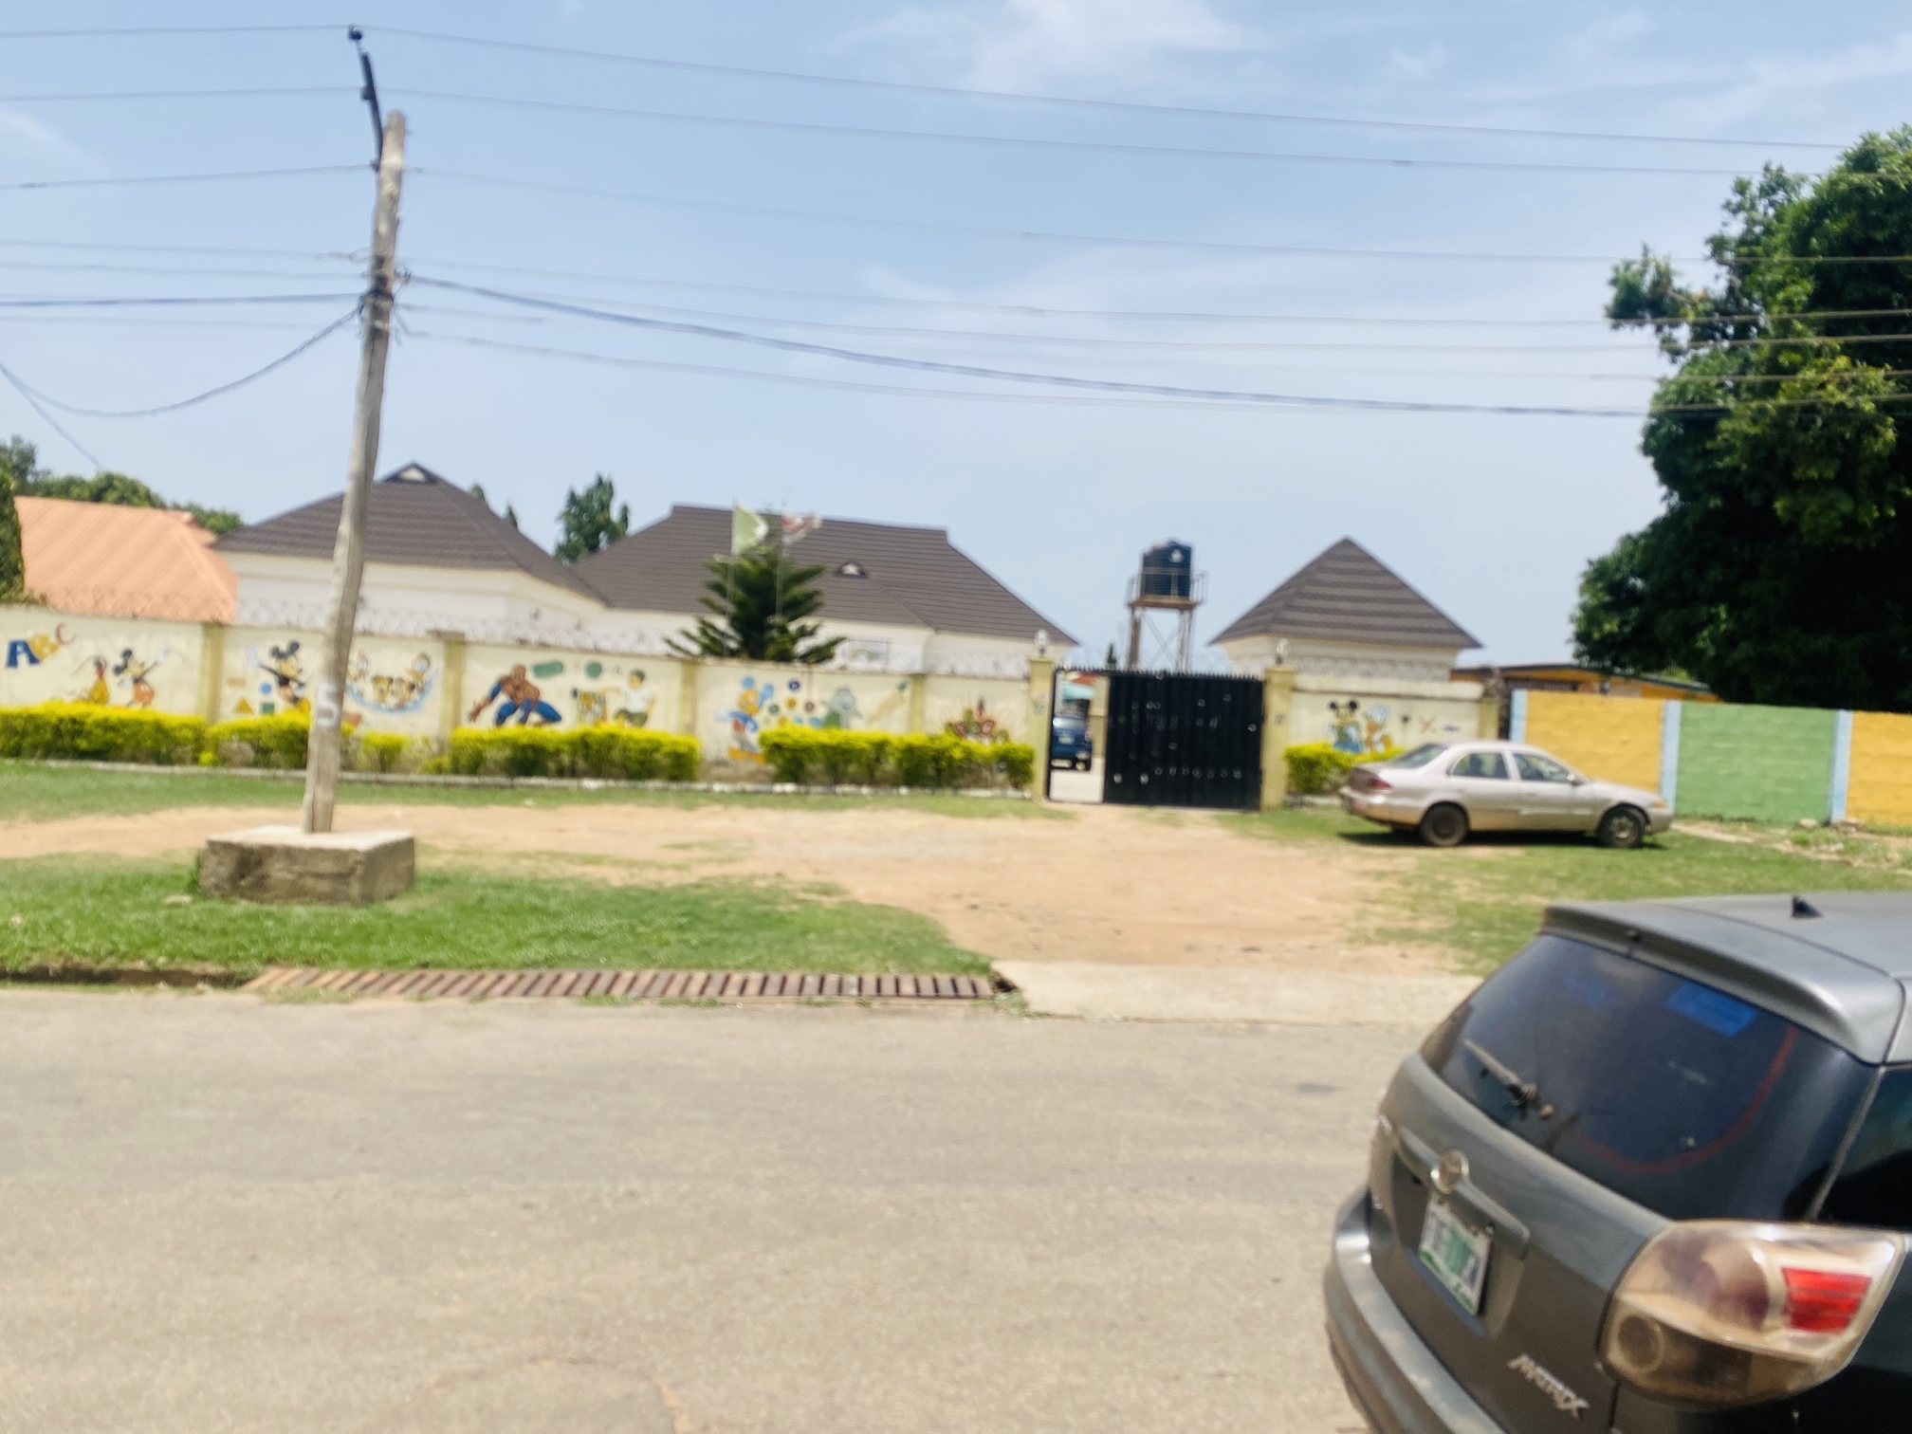
Table 4.11: Type of Respondent’ building
Type of building | Adewole |  | Harmony |  | Total
Type of building | Frequency | Percentage (%) | Frequency | Percentage (%) | Frequency | Percentage (%)
Bungalow | 83 | 83 | 95 | 95 | 178 | 89
Duplex | 17 | 17 | 5 | 5 | 22 | 11
Total | 100 | 100 | 100 | 100 | 200 | 100
Source: Author’s Field Survey, 2025
4.3.1 Road infrastructure of the respondents
From the data presented in Table 4.12, a significant percentage of respondents in both Adewole Estate and Harmony Estate Adewole recorded a significantly higher quality of road infrastructure, with (71%) of respondents rating the roads as very good, compared to only (32%) in Harmony. While (20%) of Adewole residents rated their roads as fair, a larger portion of Harmony residents (42%) did so. Furthermore, (26%) of Harmony residents reported the roads as poor, against just (9%) in Adewole. This suggests that Adewole enjoys better-maintained and more accessible road networks, which contribute to efficient transportation and property value.
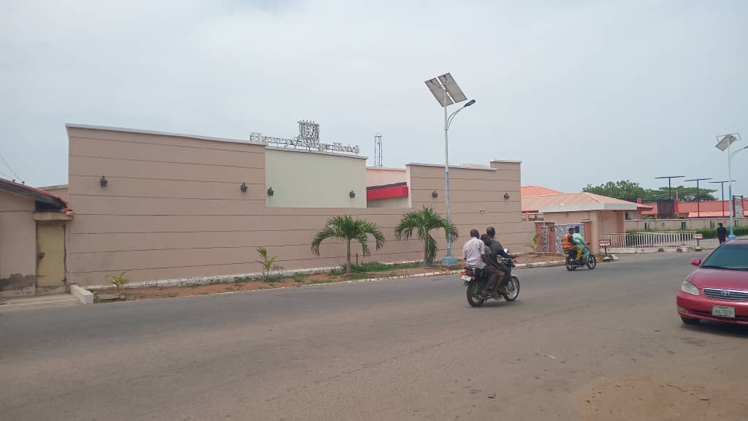
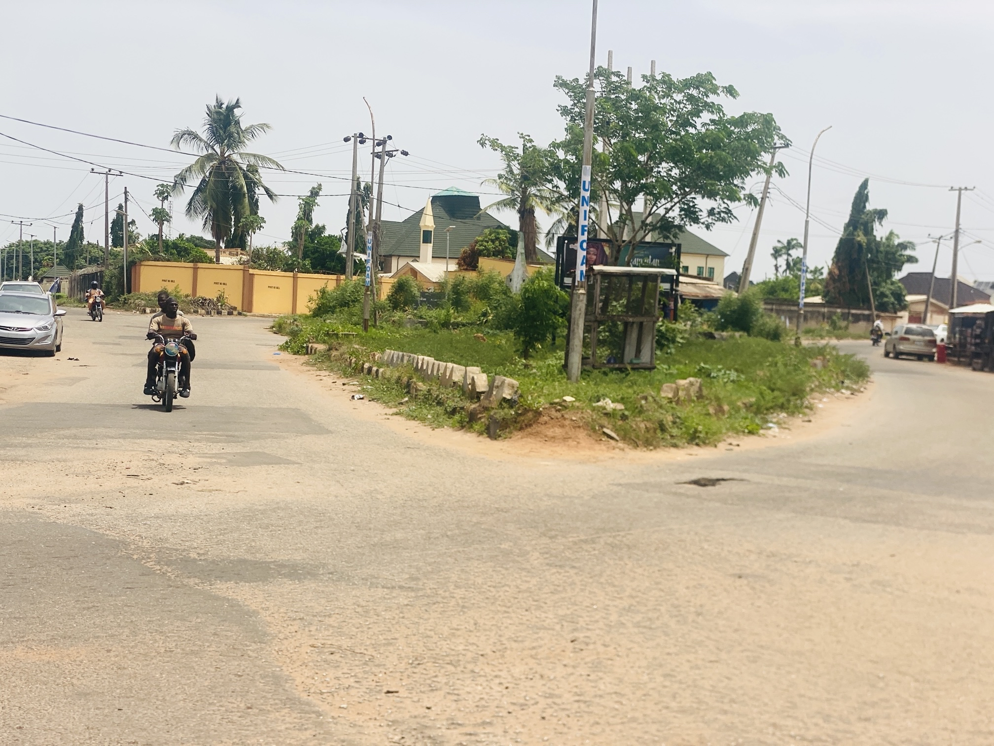

Table 4.12: Road Infrastructure
Road lnfrastructure | Adewole |  | Harmony |  | Total
Road lnfrastructure | Frequency | Percentage (%) | Frequency | Percentage (%) | Frequency | Percentage (%)
Very Good | 71 | 71 | 32 | 32 | 103 | 51.5
Fair | 20 | 20 | 42 | 42 | 62 | 31
Poor | 9 | 9 | 26 | 26 | 35 | 17.5
Total | 100 | 100 | 100 | 100 | 200 | 100
Source: Author’s Field survey, 2025
4.3.2 Drainage System Condition
In terms of drainage functionality(Table 4.13), (58%) of Adewole respondents noted that their drains were functional, while only (44%)in Harmony said the same.Occasionally (25%)drainage are in Adewole while (31%) were in Harmony. Moreover, a troubling (25%) of Harmony residents reported their drainage systems as non-functional, compared to only (17%)in Adewole. Poor drainage increases the risk of flooding and health hazards, particularly in urban residential areas, suggesting Harmony may require urgent attention in this area.


Table 4. 13:Drainage system condition
Drainage | Adewole |  | Harmony |  | Total
Drainage | Frequency | Percentage (%) | Frequency | Percentage (%) | Frequency | Percentage (%)
Functional | 58 | 58 | 44 | 44 | 102 | 55
Occasionally | 25 | 25 | 31 | 31 | 56 | 28
Non- functional | 17 | 17 | 25 | 25 | 42 | 21
Total | 100 | 100 | 100 | 100 | 200 | 100
Source: Author’s Field survey, 2025
4.4.1 Water Supply Systems
Adewole also had better water supply outcomes(Table 4.14), with (54%) of respondents reporting regular water supply, whereas only (41%) in Harmony could say the same. While Adewole has (29%) and Harmony has (23%) Occasinally, Meanwhile, (36%) of Harmony residents indicated that water supply was rare, nearly double the (17%) in Adewole. These findings suggest that water infrastructure is more reliable in Adewole, potentially due to better pipe networks or water resource management.

Table 4.14: Water supply system
Water supply system | Adewole |  | Harmony |  | Total
Water supply system | Frequency | Percentage (%) | Frequency | Percentage (%) | Frequency | Percentage (%)
Regular Supply | 54 | 54 | 41 | 41 | 95 | 47.5
Occasionally | 29 | 29 | 23 | 23 | 52 | 26
Rare supply | 17 | 17 | 36 | 36 | 53 | 26.5
Total | 100 | 100 | 100 | 100 | 200 | 100
Source: Author’s Field survey, 2025

4.5.1 Electricity Supply
Electricity remains one of the most critical infrastructure needs for urban residents. Interestingly, Harmony Estate had a slightly higher proportion (53%) of residents reporting stable electricity than Adewole (50%). However, Adewole experienced more intermittent power supply (28%) while Harmony had more respondents (26%) report frequent outages. The results suggest both estates face electricity challenges, but perhaps with slightly more predictability in Harmony.

Table 4.15: Electricity Supply
Electricity supply | Adewole |  | Harmony |  | Total
Electricity supply | Frequency | Percentage (%) | Frequency | Percentage (%) | Frequency | Percentage (%)
Stable Supply | 50 | 50 | 53 | 53 | 103 | 51.5
Intermittent | 28 | 28 | 26 | 26 | 54 | 27
Frequent outages | 22 | 22 | 21 | 21 | 43 | 21.5
Total | 100 | 100 | 100 | 100 | 200 | 100
Source: Author’s Field survey, 2025

4.16. Waste Disposal
Waste disposal efficiency is a significant marker of environmental health. Adewole Estate outperforms Harmony Estate here as well, with (64% ) of respondents reporting that waste is well managed, while only (21% )in Harmony shared the same view. Conversely, (48%) of Harmony respondents indicated inconsistent waste management and (31%) rated it as poorly managed, compared to (29%) and (7%) respectively in Adewole. This suggests a pressing need for improved waste collection and disposal systems in Harmony.

Table 4.16: Waste Management System
Waste Management System | Adewole |  | Harmony |  | Total
Waste Management System | Frequency | Percentage (%) | Frequency | Percentage (%) | Frequency | Percentage (%)
Well managed | 64 | 64 | 21 | 21 | 85 | 42
Inconsistent | 29 | 29 | 48 | 48 | 77 | 38.5
Poorly Managed | 7 | 7 | 31 | 31 | 38 | 19
Total | 100 | 100 | 100 | 100 | 200 | 100
Source: Author’s Field survey, 2025

4.6.1 Recreational Facilities
Access to recreational infrastructure is key for social wellbeing(see Table4.18). In Adewole, (53%) of residents rated recreational facilities as adequate, whereas only (27%) did so in Harmony. A concerning (32%) of Harmony respondents indicated that recreational facilities were not available and Adewole having only (15%),Meanwhile, Limited facilities in Harmony carries (41%) different from Adewole having (32%).suggesting a gap in social infrastructure that could affect youth engagement, fitness, and overall community health.

Table 4.18: Recreational Facilities
Recreational Facilities | Adewole |  | Harmony |  | Total
Recreational Facilities | Frequency | Percentage (%) | Frequency | Percentage (%) | Frequency | Percentage (%)
Adequate | 53 | 53 | 27 | 27 | 80 | 40
Limited | 32 | 32 | 41 | 41 | 75 | 37.5
Not available | 15 | 15 | 32 | 32 | 47 | 23.5
Total | 100 | 100 | 100 | 100 | 200 | 100
Source: Author’s Field survey, 2025
4.6.2 Residents Satisfaction with Infrastructure
cumulative impact of infrastructure on daily life(Table4.19). In Adewole, (57%) of respondents reported being highly satisfied with infrastructure compared to (41%) in Harmony. Meanwhile, dissatisfaction was significantly higher in Harmony (31%) than in Adewole (13%).while the level of Overall satisfaction levels reflect the Moderately satisfied in Adewole is (30%) and Harmony has (28%)This reinforces earlier findings that Adewole enjoys better infrastructure quality and consistency than Harmony.

Table 4.19: Residents Satisfaction with Infrastructure
Resident Satisfaction | Adewole |  | Harmony |  | Total
Resident Satisfaction | Frequency | Percentage (%) | Frequency | Percentage (%) | Frequency | Percentage (%)
Highly satisfied | 57 | 57 | 41 | 41 | 98 | 49
Moderately Satisfied | 30 | 30 | 28 | 28 | 58 | 29
Not satisfied | 13 | 13 | 31 | 31 | 44 | 22
Total | 100 | 100 | 100 | 100 | 200 | 100
Source: Author’s Field Survey, 2025
The comparative data clearly demonstrates that Adewole Housing Estate generally possesses superior infrastructural facilities compared to Harmony Estate, particularly in road condition, drainage, water supply, waste management, and recreational amenities. Although Harmony slightly edges Adewole in stable electricity supply, it still lags behind in most other categories. These findings indicate the need for focused infrastructural intervention and policy efforts in improve living standards Harmony Estate to bridge the urban service delivery gap and

CHAPTER FIVE
SUMMARY OF FINDINGS, CONCLUSION AND RECOMMENDATIONS
5.1 Summary of Findings
The socio-economic profile of respondents in Adewole and Harmony Housing Estates reveals a predominantly middle-income, educated population. Gender distribution shows more female respondents in Adewole, while Harmony had more male respondents. Most of the residents in both estates were married, aligning with the family-oriented nature of the estates. Yoruba ethnic group formed the majority across both areas, reflecting the indigenous composition of Ilorin. Islam was the predominant religion, although Christianity was also significantly represented. The majority of the respondents were indigenes of Kwara State, and a significant number were homeowners, especially in Adewole, indicating greater residential stability. Household sizes mostly ranged between three to five persons, suggesting medium-sized family units. Most respondents were employed in the public sector, which aligns with the purpose of the estates as low-cost housing for civil servants. Educational attainment was high, with most respondents holding a university degree or its equivalent. Income levels predominantly fell within the ₦46,000 to ₦90,000 range, highlighting a moderate earning capacity among residents. These characteristics collectively suggest a stable, educated, and working-class population residing in both estates, with Adewole having a slightly more favorable socio-economic profile.
Infrastructure Facilities
- Roads: Adewole had better roads (71%) rated very good)than Harmony which is (32%).
- Drainage: More functional systems are provided in Adewole (58%) than that of Harmony (44%).
- Water Supply: Adewole had more regular supply at the percentage of (54%) than Harmony which carries (41%).
- Electricity: Harmony had slightly more stable supply (53%) than Adewole (50.8%).
- Waste Management: Adewole had more effective management (64%) than Harmony (21%).
- Recreational Facilities: Adewole had more adequate facilities (53%)than Harmony which rated (27%).
- Overall Satisfaction: Higher in Adewole (57%) than Harmony (31%).
5.2 Conclusion
The study concludes that Adewole consistently outperforms Harmony in infrastructure quality and resident satisfaction. Adewole shows superiority in roads, drainage, waste management, and recreation. Though Harmony slightly leads in electricity, its infrastructure lags in most areas. There is a clear need for infrastructural intervention in Harmony Estate.
5.3 Recommendations
1. Infrastructure Development: Improve roads, drainage, and waste systems in Harmony Estate.
2. Water Supply: Enhance water infrastructure in Harmony to meet Adewole’s standards.
3. Maintenance Policies: Establish routine infrastructure maintenance in both estates.
4. Electricity Supply: Encourage solar and alternative energy investments.
5. Recreational Facilities: Provide adequate recreational spaces in Harmony Estate.
6. Urban Planning Integration: Ensure equitable infrastructure planning in future developments.
5.2 Conclusion
The study concludes that while both Adewole and Harmony Estates serve as significant residential areas in Ilorin, Adewole consistently outperforms Harmony in terms of infrastructure quality and resident satisfaction. The superiority of Adewole in aspects such as road conditions, drainage, waste management, and recreational facilities suggests better maintenance, planning, or policy implementation. Although Harmony Estate shows marginally better electricity supply, this advantage is offset by other infrastructural deficits. These disparities highlight a clear need for government and urban planning authorities to focus on bridging infrastructural gaps, especially in Harmony Estate.
5.3 Recommendations
1. Infrastructure Development: Priority should be given to improving road networks, drainage, and waste management systems in Harmony Estate.
2. Water Supply: Government should enhance water infrastructure in Harmony to match that of Adewole.
3. Maintenance Policies: Regular maintenance schedules should be institutionalized in both estates to sustain infrastructure quality.
4. Electricity Supply: Investment in alternative energy solutions (e.g., solar systems) should be encouraged to supplement the grid.
5. Recreational Facilities: The state or estate authorities should provide more recreational infrastructure in Harmony to improve social wellbeing.
6. Urban Planning Integration: Future housing estate developments should consider mixed-income, accessible, and balanced infrastructure distribution from inception.
5.4 References
• Adebayo, A. (2012). Urban Infrastructure Challenges in Nigerian Cities. Ibadan: Spectrum Books.
• Adegoke, A. (2013). Road Design and Infrastructure Planning in Urban Housing. Nigerian Journal of Civil Engineering, 5(2), 101–115.
• Adeleke, T. (2016). Waste Management Practices in Nigerian Cities. Journal of Environmental Management, 12(4), 311–324.
• Adewale, S. A. (2020). Infrastructure Equity and Urban Development in Nigeria. Lagos: Urban Press.
• Aigbokhan, B. E. (1999). Evaluating Infrastructure’s Role in Economic Growth. Benin: Edo State University Press.
• Akinpelu, A. (2015). Housing Infrastructure and Urban Development in Nigeria. African Research Review, 9(1), 66–78.
• Canning, D., & Pedroni, P. (2004). The Effect of Infrastructure on Long-Run Economic Growth. World Bank Policy Research Working Paper.
• Denison, E. (1962). The Sources of Economic Growth in the United States. New York: Committee for Economic Development.
• Educational Consults. (2022). Integrating Recreation in Urban Estate Planning. Journal of Urban Studies, 14(3), 201–218.
• E-Project Guides. (2022). Improving Urban Living through Resident Participation. Urban Development Digest, 7(2), 135–142.
• Federal Republic of Nigeria. (1997). National Urban Infrastructure Policy. Abuja: Government Press.
• Futagami, K., Morita, Y., & Shibata, A. (1993). Public Infrastructure and Economic Growth. Journal of Economic Dynamics and Control, 17(5-6), 739–757.
• Kwara State Government. (2017). Kwara State Development Plan 2017–2030. Ilorin: Ministry of Planning and Economic Development.
• Mohammed, T. O. (2018). Urban Sustainability through Policy Innovation. Ilorin: University Press.
• Muller, M. (2004). Housing and Urban Development in Nigeria. Journal of Housing and the Built Environment, 19(2), 147–164.
• National Institute of Urban Affairs. (2020). State-Level Infrastructure Development in Nigeria. Abuja: NIUA Reports.
• National Planning Commission. (2021). Nigeria’s National Infrastructure Framework. Abuja: NPC.
• NEPA. (2013). Electricity Access in Nigerian Urban Areas. Lagos: National Electric Power Authority.
• Obateru, O. (2003). Planning the Nigerian City: Principles and Practice. Ibadan: Penthouse Publications.
• Ogunbode, T. (2016). Challenges of Drainage Systems in Nigerian Urban Estates. Journal of Sustainable Cities, 4(2), 85–97.
• Ogundele, O. K. (2019). Public-Private Partnerships and Urban Infrastructure. African Infrastructure Review, 11(1), 23–34.
• Oluwunmi, A. (2015). Road and Recreational Infrastructure in Residential Estates. Journal of Construction and Property Management, 6(3), 191–205.
• Oxford Dictionary of Economics. (2024). Oxford University Press.
• The World Bank. (1994, 1996, 2006, 2008, 2022). Various Reports on Infrastructure and Urban Development.
• UN-Habitat. (2016). Urbanization and Sustainable Infrastructure in Developing Countries. Nairobi: United Nations Human Settlements Programme.
• UNEP. (2015). Sustainable Waste Management Practices. Geneva: United Nations Environment Programme.
• UNESCO. (2011). The Role of Education in Human Capital Development. Paris: UNESCO Publishing.
• Willoughby, C. (2004). Infrastructure and the Millennium Development Goals. World Bank Transport Paper Series.

