THE IMPLICATION OF SOLID WASTE MANAGEMENT ON THE HEALTH OF RESIDENTS IN ILORIN WEST LOCAL GOVERNMENT

BY

SALAHUDEEN TAOFEEK ABIODUN
HND/22/URP/FT/046

KWARA STATE POLYTECHNIC, ILORIN
INSTITUTE OF ENVIRONMENTAL STUDIES
DEPARTMENT OF URBAN AND REGIONAL PLANNING
IN PARTIAL FULFILMENT OF THE EQUIREMENT FOR THE AWARD OF HIGHER NATIONAL DIPLOMA (HND) IN URBAN AND REGIONAL PLANNING

SUPERVISED BY:
TPL. E.S ADEKANYE
JULY, 2025.

CERTIFICATION
This project work has been examined and approved as meeting the requirements of Department of urban and regional planning, Institute of environmental Studies, Kwara State Polytechnic, Ilorin, Kwara State.
In Partial Fulfillment of the Requirement for the Award of Higher National Diploma (HND) in Urban and Regional planning.
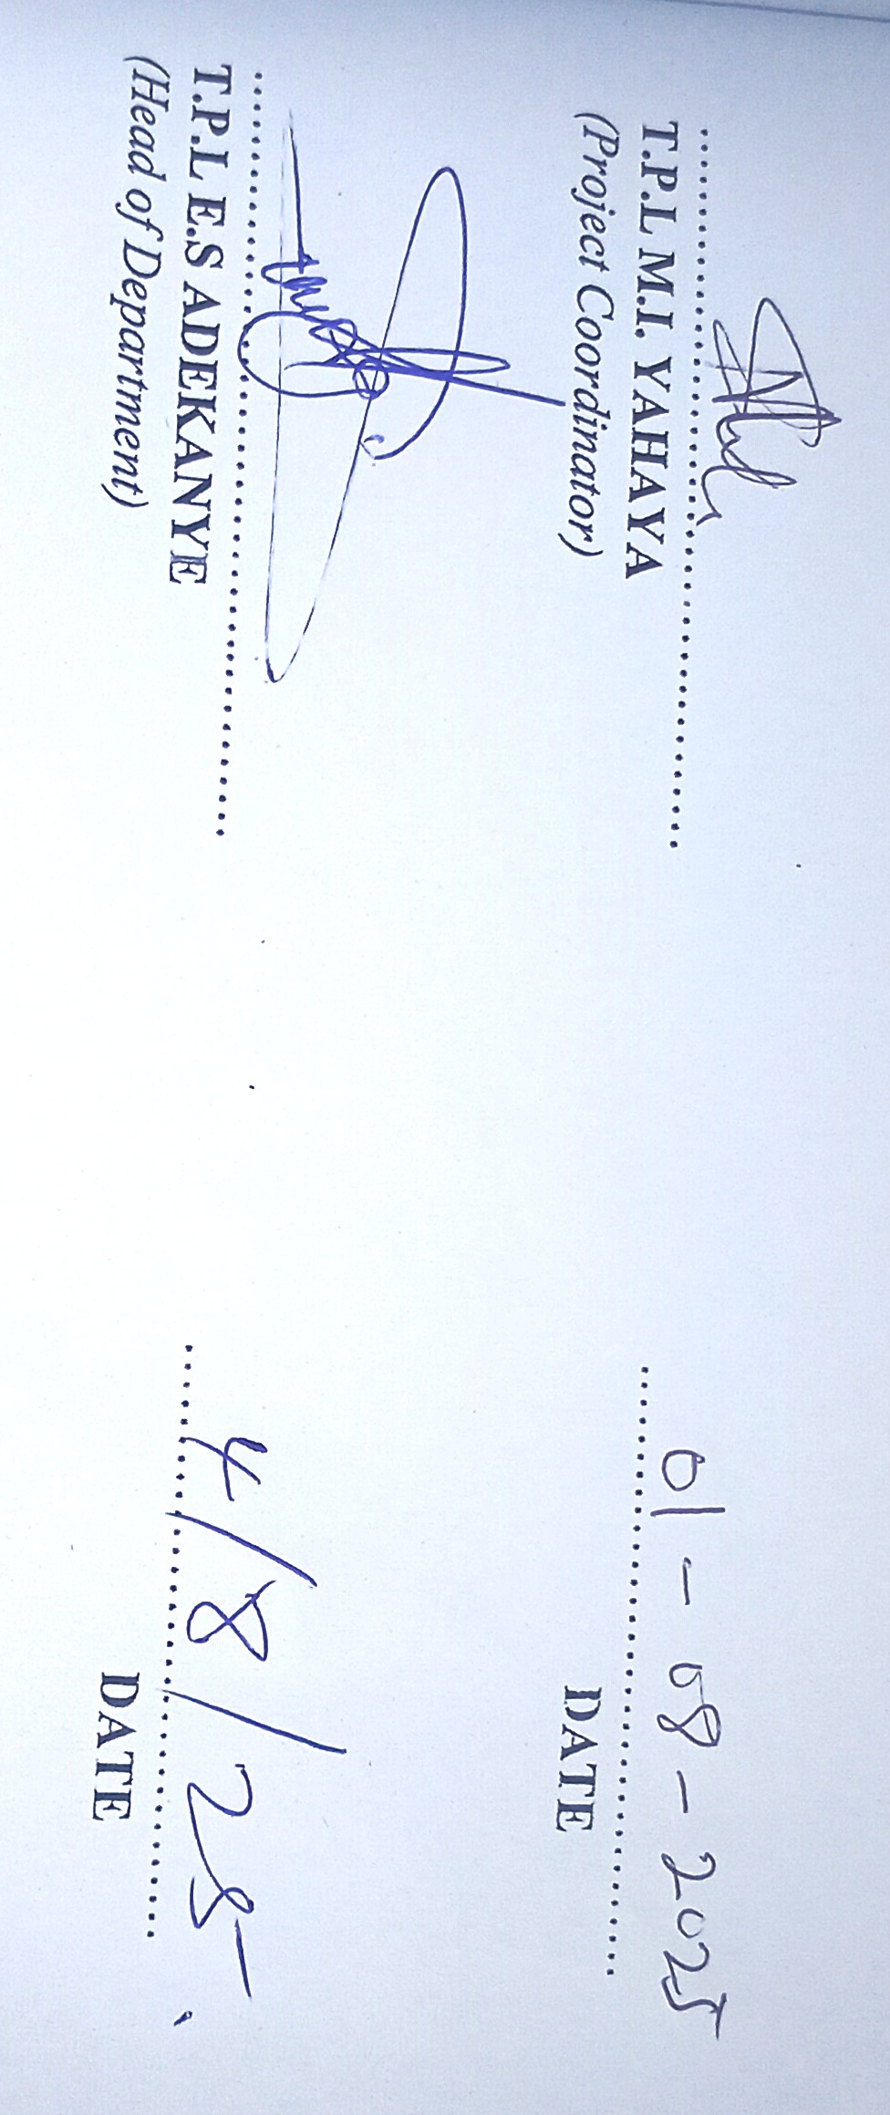

------------------------------- ---------------------------- TPL. E.S. ADEKANYE DATE
SUPERVISOR

------------------------------- ---------------------------- TPL. M.I. YAHAYA DATE
PROJECT COORDINATOR

------------------------------- ---------------------------- TPL. E.S. ADEKANYE DATE
HEAD OF DEPARTMENT

------------------------------- ---------------------------- EXTERNAL EXAMINAL DATE

DEDICATION
This project is dedicated to Almighty God, the architect of the entire world, who made it possible for me to witness the end of this program and also to my parent.

ACKNOWLEGEMENT
To the giver of life and back bone of the brave I gives all the glory for his abundant grace, goodness and mercy through the course of my academic pursuit and life in general. To man it is impossible but unto God all things are possible, glory be unto God in heaven. I need to give thanks to some people who stood by me to ensure its success, though it is humanly impossible to pay these people back, but one cannot do without appreciating their effort. Also my heartfelt gratitude goes to my immediate family, friends, siblings and well-wishes especially for seeing me through the course of study.
My appreciation as well goes to my supervisor TPL. E.S. ADEKANYE for his unrelenting effort in guiding me through this project and also is a leader that want to raise follower to be a leader. Also to the Head of the department TPL. M.S IBRAHIM and other lecturers in the department TPL. M.I YAHAYA, TPL. M.Y YAYAHA, MR A.H MUHAMMED, MRS. IYIBUSOLA ANIYIKAYE and other staff in the department. Also I appreciate my family and loves one’s for their support towards the success of the program.

ABSTRACT
Solid waste management is a critical issue in urban areas, significantly affecting the health and well-being of residents. This abstract explores the implications of solid waste management practices on the health of residents in Ilorin West Local Government, Nigeria. The study utilizes a mixed-method approach, incorporating both qualitative and quantitative data from surveys, interviews, and health records. Findings indicate that inadequate waste management practices, such as irregular waste collection, improper disposal, and lack of recycling, have led to environmental pollution and increased health risks among residents. Common health issues reported include respiratory problems, gastrointestinal infections, and vector-borne diseases, attributed to exposure to contaminated air, water, and soil. The research underscores the necessity for improved waste management infrastructure, public awareness campaigns, and stricter enforcement of environmental regulations. Effective solid waste management is essential not only for environmental sustainability but also for protecting public health, thereby enhancing the overall quality of life for residents in Ilorin West Local Government.

.
TABLE OF CONTENTS pages
Title page i
Certification ii
Dedication iii
Acknowledgement iv
Abstract v
Table of Content vi
List of Tables vii
List of Maps viii
List of Figures ix
CHAPTER ONE Pages
1.1 Introduction 1
1.2 Statement of Problem 4
1.3 Research Question 5
1.4 Aim and Objectives of the Study 5
1.4.1 Aim of the Study 5
1.4.2 Objectives of the Study 5
1.5.0 Significant of the Study 6
1.6.0 Scope of the study 6
1.7.0 Definition of term 7
1.8.0 Limitation of the Study 7
1.9.0 Study Area 7
CHAPTER TWO
2.0 Conceptual Frame Work and Literature Review 14
2.1 Conceptual Frame Work 14
2.1.1 Sustainable Waste Concept 14
2.1.2 Concept of Environmental Management 16
2.1.3 Literature Review 17
CHAPTER THREE
3.0 Research Methodology 29
3.1 Sample Frame 29
3.2 Sample Size 30
3.3 Sampling Techniques 31
CHAPTER FOUR
4.0 Data Analysis and Interpretation 32
4.1 Socio-Economic Characteristics of the Respondents 32
4.2 Nature of waste in the Study Area 35
4.3 Effect of waste disposal 39
4.4 Challenges of Waste generation 43
4.5 Waste Management System 46
CHAPTER FIVE
5.0 Summary of Findings, Conclusion and Recommendation 47
5.1 Summary of Findings 47
5.2 Recommendation 50
5.3 Conclusion 51
Reference 52
Appendix 54

LIST OF FIGURES Pages
Fig1. Kwara state within the national context 9
Fig2. Local Government Areas in Kwara State 10
Fig3. Map showing Ilorin West Local Government 11

LIST OF PLATES Pages
4.1 Showing waste Dump Magaji Nkgeri area 45
4.2 Showing waste Dump at sango area 46
4.2 Showing waste Dump at Baboko area 46

CHAPTER ONE
1.0 Introduction
1.1 Background of Study
Urban areas in Nigeria today, are facing the problems of pile heaps of solid wastes in their environment. This is as a result of pressure of population growth, spontaneous urbanization and industrialization. The alarming rate at which heaps of solid wastes occupy most of our cities, coupled with the fact that 87% of Nigerians (George, 2002) use methods adjudged as insanitary, has not only mosquitoes and other pests of public health importance with their attendant disease outbreaks. It is a common knowledge that markets and motor parks used by hundreds of Nigerians daily are seldom provided with facilities used for solid waste collection and disposal. As a result of this men and women in markets and motor parks often result into indiscriminate disposal of solid waste into public drains, around street corners, etc. Flooding on our major roads is due largely to silt and solid waste blocking the drains and other outlets provided. The stagnant water in the blocked drains serves as breeding sites for mosquitoes. The high incidence of improper waste management related diseases.
The total solid waste generation in Nigeria is rising steadily due to increase in population while scarcity of reliable data (Egunjobi., 2002) has made the per capita waste generation trend inconclusive. The estimate of waste generated per person in a day is 0.49 kg with households accounting for 90% of the urban waste (Solomon et al., 2009). The generation per person in cities at particular time intervals vary from 0.13 in Oyo (Aina, 2007) 0.25 kg/day (Dauda and Osita, 2003) in Maiduguri to 0.47 kg in Mabogunnj eakurdi (Sha’Ato et al., 2007) and at the top of the range Abuja with 0.57 average according to the waste audit report (2004). This is within the range of per person waste quantities in developing countries of 0.1 kg/day to 1.2 kg/day. Solid waste generation is strongly influenced by time of year, traditions, personal income (Ordway and Qgundele, 2006; Imam et al., 2008), household size (Ogundele, 2006) and environmental awareness and concern (Afroz 2010).
Modern waste management presents a high level of complexity that requires many aspects to be considered for a suitable solution that encapsulates both the current state of the environment as well as its potential to provide support for future generations (Mabogunnje, 2007). What is apparent is the need to develop a comprehensive assessment method that enables identification of the present waste management status while giving stakeholders an insight into the problem and a platform for discourse. Researchers of various disciplines are developing sustainability principles and strategies pertinent to their fields (Red clift, 1994). In waste management, these principles should aim at viewing the full range of activities of the system such as temporary storage and collection, while considering all stakeholders (Ogundele, 2006). Although it has been suggested that the generally wide acceptance of sustainable development concept is due to its vagueness with varying degrees of interpretations (Aina, 2007; Lang et al., 2007), there is a strong agreement across the environmental and waste management field on the basic principles and elements of the concept as well as many of the criteria used in characterizing or measuring the system. The term sustainable waste management emphasizes a shift from waste disposal to other waste management options that includes energy and material recovery as well as waste reduction and reuse in addition to the aim of decoupling increase in waste generation from economic growth, a natural progression in many nations (Chung and Lo, 2003; EEA, 2005; Desmond, 2006). It includes having a strategy in place that is appropriate to the local conditions and has a balance between technical, environmental, social, economic, financial, administrative and political aspects, and is capable of maintaining itself over time without exhausting the resources it needs (Ogundele, 2006.
To evaluate waste management systems sustainably, the issue of measure of sustainable development arises - this requires transparent and reliable measurement element that must be agreed upon by stakeholders (Murthy, 2002; Joseph, 2006; Lang et al., 2007). While the generic principles of sustainable development consist of social, environmental and economic aspects, the administrative aspect has been evaluated in many studies involving waste management [Van de Klundert, 1996; van] Controversy and consequent difficulties in developing and adopting health-friendly, cost effective and equitable policies in waste management are due to several reasons, including abundance of suggestive but not conclusive, evidence on possible adverse health effects of living near waste treatment plans landfills, incinerators e.t.c confusion between different issues such as the disposal of solid waste as opposed to other waste ( for example toxic, industrial waste, hospital waste), mistrust in authorities and scientific community occurrence of not in my background (Nimbly) syndrome type of reaction possibly as a result of overlooking aspects of risk perception and communication (Ordway, and ogundele 2006) ) in the last ten years an expert meeting world health organization regional office for Europe. Disposal A problem on the quantification of exposure assessment of health impacts and interpretation of studies remain and uncertainly is large. It is in fact stroll difficult to perform a reliable risk assessment exercise (world health organization – European centre for environmental health, 2000). Therefore, there is a need to examine the impact of solid waste management on the health of people in the study area with a view to suggest sustainable means of waste management. This is because there is correlation between waste management and people’s health and because heaps of waste are found in some strategic places in
Ilorin.

1.2 Statement of the Problem
Solid waste management is a global environmental issue which has been a great problem that needs to be addressed. The improper and ignorance 0f the masses on the issue in the environment has leads to economic, physical and environmental problems. The need for an appropriate planning method for proper waste management through the analysis of the situation of solid waste management in the study area is required. Efforts made by successive administration of all the words in local government in Ilorin and other relevant stakeholders to reverse the trend have been very abortive. The rate at which solid waste management is been generated daily and indiscriminately disposed in many parts of the area is very alarming etc. Flooding on our major roads is due largely to silt and solid waste blocking the drains and other outlets provided. The stagnant water in the blocked drains serves as breeding sites for mosquitoes. The high incidence of improper waste management related diseases. This act had a negative impact on the environment, population and human health. The study is out to find out the problems associated with solid waste management and its impact directly to the health of the people that stays in the study area. The study tries to answer the following research questions.

1.3 Research Questions
- What are the socio-economic characteristics of respondents in the study area?
- What are the types of solid waste generated in the area and its ways of managing them?
- What are the disposal methods used by the people in the study area? (d) What are the management methods adopted by the residents in the area for solid waste?
(e) What are the health effects of poor management of solid waste and its associated problems?.

1.4 Aim and Objectives of the Study

1.4.1 Aim of the study
The study evaluates the effects of solid waste management and its implications on the health of the residents in the study area with a view to enhancing a sustainable environmental sanitation practices.

1.4.2 Specific objectives of the study
The specific objectives are to:
- examine the socio-economic characteristics of respondents in the study area.
- assess the type of solid waste disposal method in the study area.
- examine the management methods and problems of solid waste disposal in the study area.
- Assess the effects of solid waste on the health of people in the study area.
- (e) Suggest measures towards proper environmental sanitation in the study
area.

1.5 Significance of the study.
This research will bridge the gap in the existing body of knowledge with regards to waste management in Nigeria by giving a holistic assessment into the current status of solid waste management practice. In Ilorin. This study is an initial effort to fill the gap between theoretical solid waste management in the country and practical solid waste management towards achieving a more sustainable and effective solid waste management in the arty of Ilorin. The results from this research will act as an initial frame work towards strategic planning and periodic follow up assessment is required to further improve the system. In order to achieve this, relationships will be examined thus from which recommendations developed. This will overall advance the concept of sustainability and sustainable waste management in Nigeria.

1.6 Scope of the study
The study deals with the effects of solid waste management on the health of the people in the study area. It also focused on the socio-economic characteristics of residents, coupled with the methods of the waste disposals as well as managements and their associated problems. This is with the aim of creating a conducive and aesthetically pleasing environment.
1.7 Definition of terms.
Waste: this is the leftover, used product whether liquid or solid having no economic value or demand and which must be disposed or throw away. Waste management: this refers to the act to maintain acceptable environmental quality, sound public health and creation of aesthetic values.
Public health: this is the control of all those factors in human's physical environment that exercise or may exercise, delete nous effects on physical fitness, health or survival.
Health: it is a collection of the body, which makes a person to function effectively. It is the absence of sickness or stress of any form.
Environment: it refers to the total surroundings of human that support life. Environmental health: it refers to the health implications of the interaction between individuals and their natural and built environments.
1.8 Limitations of the study.
The following are the limitation to the study:
- Finance: the cost implication for the conduct of the survey is too high, the researcher had to use available financial resources obtain through family and relatives to execute this work.
- Time: the time frame for the conduct of this study was too limited. The research work was conducted within the time frame of 6 months. A good research should take nothing less than a year but the case of this is different.
- Poor responses from the respondents: some of the respondents were reluctant at giving information at their disposal to the researcher in fear of not revealing the secrets.

1.9.0 STUDY AREA
1.9.1 Kwara State at a glance
Kwara State is one of the thirty-six states in Nigeria. The population of the state was 2,371,089 by the 2006 census supplied by the National Population Commission and a projected population of 2,090,515 by 2007 (Kwara State Statistical Year Book, 2007). Kwara State is one of the largest states in Nigeria with a landmass of about 31,010sq.km. (CBN, 2006) and has remarkable socio- economic diversity.
Ilorin, the capital city of Kwara State, Nigeria, is the setting for this study. The city is located on latitude 80 10’N and longitude 40 35’E marking a divide between the southern forest Zone and the Northern grassland of Nigeria. The vegetation, in most parts, is guinea savanna interspersed by trees of different species. The dominant streams are Asa, Aluko, Okun, Amule, and Agba. The Asa River is of particular influence on the direction of growth of the city. The situation of the city between the dry North and the wet South of Nigeria gave Ilorin the apt description as the “gate way” between the North and the South of the country” (Adedibu, 1980). The climate is therefore tropical wet and dry characterized by a distinct wet and dry seasons. The mean annual temperature is about 26.800c with five hours average daily sunshine. The mean annual rainfall is about 125mm. It is important to note that the above locational and physiographic characteristics possess (sometimes significant) implications for human health on one hand and economic and social development on the other. Ilorin is a typical traditional African city whose urban history predates colonialism in Nigeria. The city therefore falls into the category of third world cities described as reputed for their dualistic internal structure (Mabogunje, 1968). The physical development of Ilorin also translates into significant change in the population of the city. For instance, from 36,300 inhabitants in 1911, Ilorin has a population of about 208,546 in 1963, 532,088 people in 1991 and a projected population of about 765,791 by the year 2006 at the rate of 2.84% annually. The facts of urbanization, development of the modern commercial/industrial economy and the multiplier effects of these factors on natural increase had combined to produce the changes in population described above.
1.9.2 Population Growth Trend
Ilorin is the largest city in kwara state, followed closely by Offa. The population of Ilorin like any other town has never been stable in history. For instance, the colonial administration put the population of the city at about 36.343 in 1911 while by 1921, the population has highly increased and the socio-economic functions are predominantly rural. The 1952 census indicated population of about 40,994 for the city. And by 1963 the population has increased to 208,546 and if this compared with the 1952 figures it comes up to an increase of about (397.35%) that is an annual growth rate of (11.8%). The 1991 population census put the figure at 572,198 while 2006 census results, the most recent National population and Housing Census puts the population of Ilorin to be 777,667.
The increasing growth in the population of the city indicates that the town has experience rapid explosion in its population over the years. The reason for the population growth could be due to some factors such as rural urban drift, the rapid rate of natural population growth and state and local government creations. Paul R. Ehrlich, 2001.
1.9.3 Transportation and Communication Network
The inter-city and intra-city transportation for Ilorin could be identified as road, rail and air transport. Usually these modes of transport are supposed to complement each other for an efficient and effective co-ordination of the activities within the city. The first major development of a road network on Ilorin was subsequently by the Federal Government which constructed the present Lagos Road Abdul Azeez Atta road and Emir’s Road. These roads are stretches of the Lagos - Ilorin - Kaduna trunk road that links the southern and northern parts of the country together.
Ilorin comprises of three major roads which are Emir's Road, Gambari/ Muritala Mohammed Road/Post Office Round About and Amilegbe Road/Ipata Market. Among the roads that forms the arterial within the study area are Emir's/Gambari junction, Edun/Opo Malu road, Muritala road/Emir's road. There is also a railway line transversing the town. The railway line serves as a link to both the North and the West. Most of the commercial activities of the town take place alone the major roads of the study area. All the same, road transport dominates human movement in Ilorin and is characterized by para-transit modes such as mini-buses, taxi and motor cycles. By road, llorin is equidistant to all major population centers north and south of Nigeria.
Ilorin also has airport facilities. Although the llorin International Airport has been re-designated and equipped as International Cargo Airport, there are scheduled commercial flights to and from llorin by Overland and Capital Airlines with current destinations include Lagos, Abuja and Jos. Ayodeji Fashikun et al. (2003).
Fig 1: Kwara State within National Context of National.
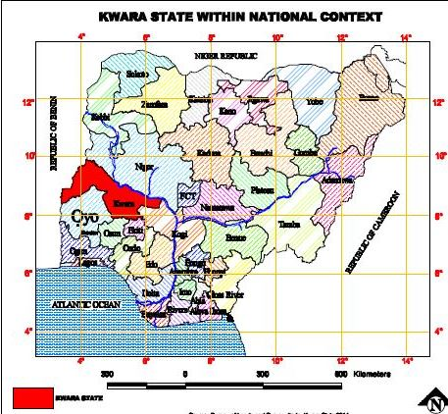

Source: - Kwara State Bureau of Land and Housing (2025)
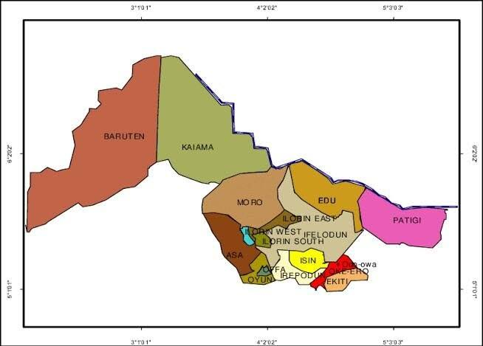
Fig 2: Ilorin L.G.A. within Kwara State Context.
Source: - Kwara State Bureau of Land and Housing (2025).
Fig 3: Showing Ilorin West Local Government
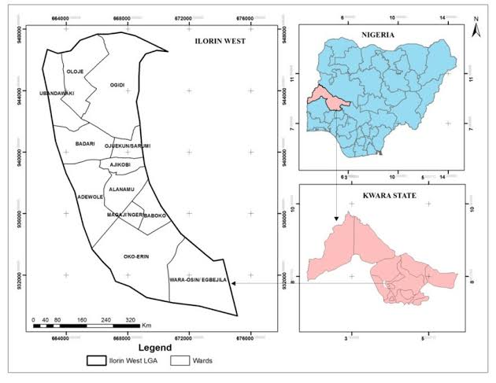

Source: - Kwara State Bureau of Land and Housing (2025).

CHAPTER TWO

2.0 Literature Review
2.1 Review of solid waste management.
This section focus on the review of related literature theoretical and conceptual frame work for the study.
2.1.1 CONCEPT OF ENVIRONMENTAL SANITATION
What does the term concept of environmental sanitation mean? It is said to be a set of actions geared towards improving the quality of the environment and reducing the hazardous health effects from the degradation of the environment that is caused mostly by wrong waste disposal.( world health organization – European center for environment and health 2000). Waste is capable of different interpretation and meanings. Waste could be any material which has been used and is no longer wanted. For example because the valuable or useful parts of it's has been taken are. Waste could also mean an opportunity not taken i.e. when one does not take advantages of any opportunities when it is available such opportunity is said to have been wasted (1) it could also mean when something is surplus to requirement, such thing is said to have lie in waste (2) it is in the first sense as any material which has been used and is no longer wanted, because the valuable or useful part of its has been taken out. From the foregoing, a waste disposal or a waste disposal unit is therefore the act of taking away a disused waste. This could be, in a kitchen sink, a small machine that chops up vegetables waste. Or in a society, a unit, usually part of a local government that oversees the elimination or a proper disposal of waste.
Invariably, a waste disposal could be trash. Can individual used in storing away disused items or a unit. Of an organized society that seems to the stowing away of disused items. By solid waste while others are in soluble or solvents states. As far as this is concerned. Emphasis is placed on solid waste in the environment. Solid waste, as it is mostly use refers to how individuals, societies, or organization stow away human and animal excrement or faces and waste. This could be done individually by erecting toilet in houses, offices, public squares, and in buses and providing of disposal facilities alternatively, it could be centrally planned by providing sewage disposal vehicles that go about collecting and dumping away such waste in safer places. Environment is defined as including water, air, land and all plants and human beings or animals living there in and the inter-relationships that exist between and among them ( Section 38 0f the federal environment protection agency ACT).
Environmental degradation can thus be described as the process of reducing the quality of the environment or as those activities that render the environment unhealthy and unsustainable o ver. time (Koleosho and adeyinka, 2006) environmental degradation and poverty are in extricable intertwined, resulting in a victorious cycle in which poverty causes environmental stress, which in turn perpetuates, more poverty. When the physical environment in and around cities deteriorates, those most affected are the urban poor. It is discovered that the poor, confined to economically fragile and ecologically vulnerably areas contributes to the incident of environment degradation and urban congestion. According to study ignorance and lack of of educational awareness are the root causes or urban and environmental degradation which in turn creates slums, shantytowns and squatters settlement (Baritone, 1990).
Mabogunge (2000) corroborates this by saying that the concentration of the poor and educational handicaps in unplanned settlement leads to the emergence of slum and these areas which have been identified by Aina (1990) as shantytowns are deprived settlements characterized by very high residential density, largely uninhabitable housing and absence of sanitation. Basic infrastructure and social service ( George 2002) describe a slum as an environment in which a set of forces interact to give rice to a devalued physical and social image of an area by a larger community. Squatter settlements are uncontrolled illegal and temporary settlements, slum shanty towns and squatter settlement exhibit similar characteristic. These includes poor sanitary surroundings dilapidated structures, high occupying ratio, physical divines of surroundings in terms of land scalping and social amenities, inadequate provision or complete lack of public facilities, absentees landlords. Low rent, haphazard architectural design and general features of vandalized poverty and ignorance which is inseparably linked to environmental and health problem is and enormous threat to environmental balance of our cities and until it is tackled decisively, sustainable urban environment sanitation with always remain a mirage ( united nation 1996).

2.1.2 Concept of Environmental Management
A sound environment needs a good management and must go beyond the
more safe disposal or recovery of waste that are generated. It seeks to address the root cause of the problem by attempting to change unsustainable pattern of production and consumption. This implies the application of the integrated life cycle. Management concepts, which presents a unique opportunity to reconcile development and environmental protection. The concept of environmental management must focus on four major waste related areas which are how to;
- Minimize waste.
- Maximum environmentally sound waste use and recycling.
- Promote environmentally sound waste disposal and treatment.
- And extend waste service coverage.
The four related areas focused on are interrelated and mutually supportive and most therefore be integrated in other to provide a compressive and environmentally responsive frame work for managing the study area solid waste. Vary according to local socio-economic and physical conditions, rates of waste generation and waste composition. The basis of action in the four above lists.
Related area are to stage a preventive waste management approached focused on changes in life styles, in production and consumption patterns offering the best chance for reversing the current trends of solid waste with an aim to stabilizes or reduce the production of waste destined for final disposal , over an agreed time frame. By formulating goals based on waste weight, volume and composition and to induce separation which would facilitate waste recycling and reuse in the study area environment.

2.2 Literature Review
It was observes that poor solid-waste management has resulted in ever increasing heap of solid-waste often found on the streets and major roads, which have become a common feature of Nigeria’s urban landscape (Olayiwola, 2000) A study notes that we visible features of most urban centers in Nigeria today is the refuse (mountain) which emits foul odors, as well as a breading ground for pathogenic agents (Oyediran, 1997). It was observed that solid-waste management problem has become very serious, and this have informed various conferences organized by the united environmental programmed (UNEP) in Nigeria, which were geared towards controlling the effects of environmental pollution arising from poor solid-waste management system. The need to tackle the poor environmental condition underlines the call by the United Nations on all the member nations to devise effective waste management strategies (Ogundele,
2006).
The role of health education in refuse management in Nigeria cities has been emphasized by some researchers. Ogundele (2006) emphasizes the need for health education on proper management and recycling of solid-waste in Nigeria. He observes that a number of health hazards in Nigeria such as dysentery, typhoid, cholera, etc have been associated with poor solid-waste management in Nigeria cities. He urges that policy makers should encourage health education in order to expose the dangers of improper disposal of solid waste that is rampant in our cities was examined by ogboi and okosun (2003). They observe the informal labor waste collectors play a significant role in minimizing solid waste in Nigeria cities. This is achieved through collection of metals, bottles, glass wares and plastic materials from refuse. Also, they observe that as urban population increases and waste composition becomes more non-biogradable eith high recycling and re-uses values, that role of informal labour waste collectors becomes more necessary in urban solid waste management.
This is because informal labor waste collection activities open up a wide range of economic opportunities. They called on the policy makers to harness the potentials of informal labor waste collection activities to ensure clean and health urban environment in Nigeria. Ordway and Ogundele (2006) note that in almost all cities and rural areas in Nigeria.
The menace of solid waste has posed great environmental problems due to the inability of the solid waste management agencies to carry out their responsibilities. This is evidenced by the indiscriminate disposal of refuse on the streets, drainages and water bodies in most Nigeria cities. They observe that despite the government involvement in solid waste management, there has been no remarkable improvement. He recommends a policy that will anchor on community/ private sector participation in solid waste management koleosho and Adeyinka (2006) studied the solid waste management in some Nigerian cities with the aims of finding effective solution to the problem. They observe that the present sanctuary conditions in most Nigerian cities are far from being satisfactory in spite of various measures undertaken to address the problem. and it was observed that one of the most pervasive problems of contemporary cities in all regions of the world, especially the developing countries is solid waste management problem accentuated by the process is urbanization and urban development. In developing a new approach for efficient solid waste management in Nigeria, They observe that there is need for proper sensitization of all stakeholders. This will enable them to agree, adopt the implement realistic action plans. They call for re-orientation of the Nigerians towards achieving attitudinal changes through sound education and technological developments in the area of environmental management.
Mabogunje, (2002) notes that many cities in the country today, are suffering from sudden increase in solid wastes and their poor disposal. She observes that the volume of waste resulting from plastic materials being littered in the streets, open spaces and public premises are becoming alarming these wastes are often discarded without due regard to environmental sanitation. Furthermore, Akinbode (2002) observes that has been made uninhabitable, due to
indiscriminate disposal of waste by industries, poor implementation of legislation on waste disposal, inconsistency waste collection by the environmental protection agencies as well as, the activities of town planning officials towards plan approval Akinbode (2002) notes that poor evacuation of central refuse dump is a major factor influencing high volumes of solid waste in Nigerian cities. Uncollected wastes end up in drains, causing blockages which result in flooding and unsanitary conditions ( Akinbode, 2002)

2.2.1 Stages in Waste Management
The various stages involved in waste management are
- GENERATION: this is the stage when materials become waste and discarded. the generation rate is often defined as the weight of material discarded as solid waste by one person in one day.
- STORAGE: home storage, keeping solid waste in place or containers which is the responsibility of the individual member's .of the household while, command storage, is the responsibility of the refuse collection agency.
- COLLECTION: THIS as to do with transportation of solid waste from the
point of storage to the point of disposal ,two stages involve in the collection stages
The direct collection, which makes use of only one means of transportation i.e. the solid waste is picked up from the point of storages in a stuck that takes it to the disposal site, the second stages collection carried the solid waste from the storage facilities to the transfer station ,at the transfer station ,the waste is loaded into secondary stage ,to transport the refuse to the disposal site.
- DISPOSAL: THE final destination of solid waste, usually it is dumped on the land at a tip, this may be done in an engineering and hygienic way: sanitary landfill or controlled tripping, or in a careless way: open tipping or crude dumping
The Effect of Waste Management on the Quality of Life in The Community
Could be Divided:
- Environmental effect.
- Health effect.
- Social effect.
- Economic effect.
A. Environmental Effect: There is a bound range of environmental: Concerns that a compass that solid waste management word wide there is toxic (contamination to the atmosphere, soil and water, which put the entire ecosystem of an area) in danger. The contamination of waste causes severe problem for human and animal alike. the major environment effect include air pollution which include odor ,smoke, noise, dust etc. waste pollution –pollution from disposal sitar via flooding ,because of blocked drains hand degradation
B. Heath Effect: -the effect are numerous on man, the floral or fauna. the environment in form of heath problem from convulsion, dramatis irritation of nose /throat, a plastic anemia, skin burn, chest pain, blood disorder, stomach aches , vomiting diarrhea, lung cancer to death . obviously something still need to be accomplished in the filled of testing and linking. waste exposure to human health other heath effect include:-flies which carry germs on their bodies and leg and also excrete them , mosquitoes breed in stagnant water in blocked drains in favorable location and also in cars typeset that collect rains water. For example rodents spreads typhus salmonella, lepton paresis and other disease they cause lying by biting and spoil millions of tons of food .the refuse worker also face some risk which includes :-parasite , infection and infected .cats resulting from skin contact with refuse other glass, razorblade, syringes, tissue damage or infection, through respiration, ingestion of skin contact .
- Social Effects: - A common thread that farther units peoples from across the globe . is their sentiment on waste , they do not want them in their neighbor hoods countless stories of social effect on people living near waste dumpsite have decorated the news in recent years and some incident have been so great that the whole town evacuated ( olayiwola,2000) the issues of solid waste is a relatively new issues spawned by the city land fills and the desire for other sites for dumping in distances rural area No body want to be associated with a dirty environment A city with a hazardous .waste facility is now perceived as an undersirable place to live (olayiwola,2000).
- Economics Effects: - the impact of solid waste on economics value has received limited attention, it is also presumed that its impact is a negative one, one economic effect of living near a hazardous waste site disposal may be increased taxes and when recycling or re use of this waste is not done .it tends to bring a handicap to the economic revenue in that aspect.

2.2.2 Causes of Improper Waste Management
From studies been made before it was conclude that the kwara state management authority state, they include: -vegetable matter, putrescible, paper, textile, metal, plastic, glass, grits , miscellaneous , inert, tyres e.t.c The fore going composition of waste mostly generated and collected in offa local government area for example fall under domestic, municipal, industrial, animal and vegetable matters

o Waste Management and Sustainable Development
The end of the 1980s saw a radical reappraisal of our concern over resources availability and use, the environmental consequences of resources exploitation and the relationship between the environment, poverty and economics change (bartone, 1991).Tins re-appraisal has given to rise to a new approach to environment and development issues on approach, which seers reconcile human needs and the capacity of the environment to cope with the consequences of economic systems. This approach is called sustainable development. Sustainable development is an implied development without destruction. Sustainable development it can also be define as judicious use of non-renewable resources must be used as judicious rate, neither too slow and to ensure that the natural wealth that they represent converted in to long term wealth as they are used some scholars succinctly put it that sustainable development without jeopardy future development. Meaning that in our efforts to explore and exploit the natural resources to serve us, ther is an obvious paradox evident in the need to ensure economic development, while protecting the environment.

2.2.3 The Issues of Collection and Disposal
Domestic waste management, collection and disposal have always been a universal problem, also in the U.S until the 1970s federal agencies had little authority to regulate hazardous and solid waste, disposal often took place in an unsafe manner at landfills or in surface wafers, as reported in (Environmental Quality 1991) refuse and domestic waste will not constitute to human careless lately however, a lot of concern has been expressed by the well-mannered residence that the bottle against refuse, especially on the streets, roads and venue is not being prosecuted in a way to guarantee a healthy environment. At present, in Ilorin local government area private sector waste disposal operators diligently visits homes and carry away filled refuse bags, load them into waiting trucks and cart them away for final disposal *that is good* the resident say. They however worry that a lot of littering goes on in the environment on the streets and avenue may have been ignored and left not cleared, *house hold account for about half of the solid wastes generated i.e by weight in the third world cities (Aina, 1990), which include Ilorin it has also been noted that domestic waste disposal management has received considerable attention not only in Ilorin but Nigeria in general despite this. Laudable attention, collection, disposal, processing treatment recycling and utilization have defined solution.
It could also be stated that the major problem caused by (domestic) wastes to the environment in pollution, characterized by various types of solid wastes, which include * paper, metals; glass, bone, wood, vegetal matter and food remnants of multiple consistency. Scholars has also pointed out that the generation of waste materials is a problem that is not peculiar to Lagos alone (Akingbade,1991) this problem is not peculiar to the third world alone but cross across the industrialized countries of the world where the pollutant effects and industrial wastes have caused considerable concern to environment scientist it was suggested that our problems emanate from solid waste essentially, these are waste from discarded materials generated from domestic band community activities or from industrial, commercial and agricultural operations it is against this back drop that this paper intend to review the impediments to effective and efficient waste management for sustainable development.

2.2.4.1 Household, Communities and other Service Users
Residential households are mainly interested in receiving effective and dependable waste collection service at reasonable low price. Disposal is not normally a priority demand of service users so long as the quality of their own living environment is not affected by dump sites. Only as informed and aware citizens do people become concerned with the boarder objective of environmentally sound waste disposal. In low income give priority to water supply, electricity, roads, drains and sanitary services. Solid waste is commonly dumped into nearby. Open sites along main roads or railroad track, or into drain and waterway, pressure to improve solid waste collection arise as other services become available and awareness mounts regards the environment and health impacts of poor waste collection services.
Poorly served resident often form community based organization (C.B.O) to upgrade local environmental condition, improve services and / or petition the government for service improvement George (2002).
Community based organization (CBOs) which may arise in middle and upper income neighborhood as well as income area may become valuable partners of the government in local waste management when sufficiently organized, community groups have considerable potential for managing and franking local collection service and operating waste recovery and composing activities. Other service users including small and large scale industrial and commercial establishment and institution are similarly interested in reliable and affordable waste collection service. Commercial establishment particularly concerned to avoid waste related pollution, which could inconvenience their customers. Industrial enterprise may have a stray interest in reducing waste generation and can play on active role in managing waste collection, treatment and disposal in collaboration with government authorities and / or specialized private enterprises (FEPA, 1991)

2.2.4.2 Non-Governmental organization
Non-governmental organization (N.G.Os) operates between the private and government realms. Originating outside of the community in which they work, NGOs are motivated primarily by humanitarian and / or development concerns rather than an interest in service improvement for their own members, the self-creation of meaningful employment for member may also be motivated for NGOs formation. NGO may help increase the capacity of people or community group to play an active role in local solid waste management by contributing to people’s awareness of waste management problem, organization capacity (CBO) and government authorities (CBO) voice in municipal and implementation process, technical known how of locally active (C.B.O) and access to credit facilities. (CBO) may also provide important support to inform sector waste workers and enterprises, assisting them to organize themselves, to improve their working condition and facilities, increase their earning and extend their earning and extend their access to essential social services, such as health care and schooling for children.

2.2.4.3 Local Government
Local government authorities are generally responsible for the provision of solid waste collection and disposal services. They become the legal owner of waste once it is collected or put end for collection. Responsibility for waste management is usually specified in by laws and regulations and may be derived, more generally, from policy goals regarding environmental health and protection (Mabogunje 2002). Besides their legal obligation, local government is normally motivated by political interest. User satisfaction with provided services approval of higher government authority and financial reliability of the operation are important criteria of successful solid waste management from the local government perspective. The authority to enforce by laws and regulation and to mobilize the resources require for solid waste management is in principle conferred upon local government by higher government authorities. Problem often arises when local government authorities to arise revenue in not commensurate with their responsibility for service provision. Besides solid waste management, municipal government are also responsible for the provision of the entire range of infrastructure and social services, need and demands for solid waste management must therefore be weighed and addressed in the context of the need and relative priorities in all sector and services.
To fulfill their solid waste management responsibilities, municipal government normally establish special purpose technical agencies, and are also authorized to contract private enterprises to provide waste management services. In this case, local authorities remain responsible for regulating and controlling the activities and performance of these enterprises effective solid waste management depends upon the cooperation of the population, and local government should take measures to enhance public awareness of the important of solid waste management, generate a constituency for environmental protection and promote active participation of users and community groups in local waste management.

2.3.4.4 National Government
National governments are responsible for establishing the institutional and legal frame work for solid waste management and ensuring that local government have the necessary authority, poorer and capacities for effective solid waste management in many countries, responsibility is delegated without adequate support to capacity building the local government level. To assist local government to executive their solid waste management duties, national government needs to provide them with guided and/ or capacity. Building measures in fields of administration, financial management, technical system and environmental protection.
In addition, national government intervention is often required to solve crossjurisdictional issues between local government bodies, and established appropriate forms of association when as in most metropolitan areas effective waste management calls for the collaboration of several local bodies.

CHAPTER THREE
3.0 Research Methodology
The chapter outlined the methodology and procedures and modalities in data collection. It also covers research design, population of the study, sample size, sampling frame, sampling techniques, method of data collection, test of validity and reliability of data and method data presentations and analysis.
Research methodology used is a Survey method for vital means of eliciting response from respondents. According to Ohaja, (2003) survey is a study of the characteristic of a sample through questioning that enables research to make generalization concerning his population of interest. The method is proved to be the most convenient and effective method of the discipline.
3.1 Research design
Descriptive method was use for the study. According to Dosu and Michael (1978) the method is used to describe systematically, a situation or area of interest factually and accurately. They further stated that the design could be public opinion survey, fact –finding surveys, statues studies and so on. Hence in a mere specific way, pure descriptive surveys design was use. Nwakwo(1999) describes for any sample which is most cases are depended variable for the study. Survey design is the one in which a group of items are studies by collecting, analyzing and interpreting from a new people considered to be representative of the studies populations.

3.2 Population of the study Area (Ilorin west)
The population of the study is made up of all the inhabitant of Ilorin west, in Ilorin metropolis. This is because everybody generates and disposes refuse. Ilorin west, the study area in the capital of kwara state Nigeria. With area coverage of about 15,000 ha. The population of the area is estimated at 122 million using a projective of 2.8 percent growth rate of the 1991 population figure (NPC, 1991).
3.3 Sample and sampling techniques.
The population sample comprised of 250 people living very close to noticeable heaps of refuse or dumping sites in the selected study areas in metropolis using sample size calculator at confidence level of 98% and at confidence level of 5.6. Simple random sampling techniques were used to select respondent for the study. Nzeneri (2002) states that the techniques is unbiased since each person event, object or thing in the population is given equal opportunity of being selected for the study.
3.4 Instrument for data collection.
The study utilizes a questionnaire as its research instrument evaluation of public health impact of waste management on the health of residents. The questionnaire was developed by the researcher, the questionnaire was divided into three sectors A,B and C. section A elect background information about the respondents. B seeks urban waste management and C sought for public health awareness of urban waste management in part of Ilorin west . Each of the research questions has been one and five statements of items to elicit information from the respondents. Respondents were required to indicate their opinion on each item based on like five-point scale of strongly agreed (A) Disagreed (D) strongly disagreed (SD) and undecided (u).
3.5 Validity of the instrument
Validity refers to as data that are not reliable also true and accurate fisher and fare it (2002). Validity of an instrument is able to collect the expected data
(nzenr 2002). It cannot be trust wordiness of an instrument. Nzeneri 2002 and Nwakwo (1996) states that for continents and face validity, the instrument must be passed to experts or specialists for validation. In addition, Nwakwo (1996) adds that the experts must be provided with the following: (I) the purpose of the study including all the objectives the researcher wants to achieve. (II) The research question to be answered and hypotheses to be tested. (iii) Other things the experts are expected to do ensure and determine the suitability otherwise of the items of the questionnaire.
Based on these copied of questionnaire were given to experts in the area of environmental studies, health sciences, urban and regional planning adult education for psychology, measurements and evaluation, and education methodology for validation. These experts are practicing lectures research fellows from various universities and research institutes. The experts were requested to check the suitability of items, the clarity of language, the content, coverage and the appropriateness of the items; ambiguous items were made on the instrument. It was finally submitted to the supervisor for final face and content validity to make it suitable for the research being conducted.

CHAPTER FOUR
4.0 Data analysis and Presentation of Result

4.1 Introduction
This chapter presents the data obtained through a field survey in the study Area. The information obtained on the socio-economic characteristic of the respondents, the various characteristic of solid waste, mode and method of waste collection and disposal, agencies responsible for waste management in the area etc. were collected and presented below.
4.2 Result of Data Analysis
All the questionnaires were returned and analyzed. The data obtained through the questionnaire was entered into the (SPSS) and thereafter underwent a cleaning process to ensure consistency in the entry of the ranked data. The variables were used for the analysis based on the requirement for each of the variables for each analysis. The data from the questionnaire survey responses was analyzed using (SPSS Version 20). One major task in this process was the identification of the data type for the adoption of correct method of data analyses. For the purposes of this study
4.3 Data presentation and Analysis
Socio Economic Characteristics of respondent’s in the Study Area

Table 4.1Gender of respondents
Gender | Frequency | (%)
Male | 133 | 53,1
Female | 114 | 46.9
Total | 250 | 100
Source: Field survey, 2025

Gender of Respondents
Data on gender of respondents’ were documented in the Table 4.1. The data revealed that larger proportions of the respondents were male (53.1%) while the female respondents accounted for 46.9%. This shows that majority of the people in the study area were male, although it’s a general believes that female population is more than male in any society, this assertion may still be upheld since sample procedures was based on purposive that is those who are ready and willing to respond. This implies that more male are ready to respond than female.

Table 4.2 Marital status
MARITAL STATUS | FREQUENCY | PERCENTAGE
Married | 170 | 68
Single | 44 | 17
Divorce | 19 | 7.6
Widowed | 14 | 5.6
Separated | 3 | 1.2
Total | 250 | 100

Source: Field survey, 2025
Marital status of Respondents Data on marital status of the respondents as documented in Table 4.1 shows that 68% were married, 17% were single, 7.6% were divorce, and 5.6% were widower, while 1.2% of the respondents were separated. This shows clearly that majority of the respondents were married. This implies that there are more married and responsible people in the study area than others..

Table 4.:3 Ethnicity
Ethnicity Frequency (%)
Yoruba | 178 | 71.2
Igbo | 38 | 15.2
Hausa | 18 | 7.2
Nupe | 16 | 6.4
Total | 250 | 100
Source: Field survey, 2025

Ethnicity of Respondents
Data on ethnicity of the respondents revealed that the Yoruba respondents constituted the larger proportion (71.2%). This is followed by Igbo and Hausa respondents with 15.2% and 7.2% respectively while the Nupe respondents are 6.4%. The fact that Yoruba respondents dominates the study is an indication that Yoruba is most populous ethnic group in the study area, although the fact that Ilorin is a multicultural setting cannot be over looked but Yoruba is predominant.

Table 4:4Nativity
Indigene | 194 | 77.6
Non Indigene | 56 | 32.4
Total | 250 | 100
Source: Field survey, 2024

Nativity of the Respondents
Data on the nativity of respondents in the study area is documented in 4.2.the proportion of indigene (77.6%) is higher than non-indigene (32.4%). This shows that majority of the respondents are indigene of the study area, though the difference is not that significance. This implies that Ilorin people are accommodating and very friendly

Table 4:5 Religion
Religion | Frequency | Percentage(%)
Christianity | 16 | 6
Muslim | 230 | 92
Others | 4 | 2
Total | 250 | 100

Source: Field survey, 2025

Religion of Respondents
Data on religion of respondents’ shows that 92% of the respondents are Muslim, 6%, are Muslim while only 2%, practice traditional religion. This shows Muslim respondents are higher than other religions in the study area. This implies Ilorin is a Muslim dominated city,

Table 4.6: Age
Age | Frequency | (%)
10-20 | 18 | 8.0
21-30 | 56 | 24.6
31-40 | 74 | 29.7
41-50 | 70 | 28.6
51-60 | 24 | 6.9
60 and above | 8 | 2.3
Total | 250 | 100
Source: Field survey, 2025

Age of respondents
Age of the respondents as shown in the table 4.1 reveals that 8.0% of the respondents are within ages range of 10-20 years, 24.6% are between 21-30 years, 29.7% are between 31-40years, 28.6% are between 41-50years, 6.9% are between 51-60 while 2.3% 60 years and above. This shows that majority of the respondents’ are above 18 years which accounted for over 70% of the respondent and since maturity age in Nigeria is 18years it shows that the responses obtained is reliable,

Table 4.7: Occupation
Occupation | Frequency | (%)
Farming | 44 | 18.3
Unorganized private sector | 52 | 20.6
Public service | 100 | 40.0
Retiree/pensioner | 4 | 1.1
Students | 17 | 6.3
Apprentice | 12 | 4.9
Unemployed | 22 | 8.8
Total | 250 | 100
Source: Field survey, 2025

Occupation of the respondents
Data on occupation of the respondents in the study area shows that majority of the respondent are public servant (40.0%), this is followed by private sector workers (20.6%), farmers (18.3%), apprentice (6.3%), and students (4.9%). The proportion of unemployed (8.8%) and retiree/pension (1.1%) constituted the lowest proportion. The fact that majority of the respondents are public servant is an indication that the information supplied will be reliable since they the breadwinners and household heads.

Table 4.1.8: Education
Education | Frequency | (%)
No formal education | 14 | 6.9
Arabic | 4 | 4.0
Technical school | 6 | 4.6
Primary | 18 | 8.0
Secondary | 32 | 14.9
NCE/OND | 62 | 26.3
HND/University | 62 | 26.3
Post graduate | 17 | 9.1
Total | 250 | 100
Source: Field survey, 2025

. Educational status of the Respondents
The education qualification of the respondents in the study area revealed that larger proportion of the respondents possessed HND/University (26.3%) and NCE/OND certificate (26.3%). This is followed by respondents with secondary school certificate (14.9%), post graduate certificate (9.1%) and primary school certificate (8.0%). The proportion of respondents with no formal education accounted for 6.9%, while respondents who possessed technical and Arabic education accounted for 4.0% and 4.6% respectively. The data shows that majority of the respondents are educated which account for over70% of them having minimum of school certificate and formal education.

Table 4:9: Income
Income | Frequency | (%)
Below #18000 | 70 | 28.7
#19000-#45000 | 62 | 26.4
#46000-#90000 | 59 | 25.5
#90000-#120000 | 43 | 18.1
#120000 and above | 5 | 1.4
Total | 250 | 100

Source: Field survey, 2025

Income of the Respondents
Data on monthly income of respondents in the study area is documented in the Table 4.1. The proportion of respondents who earned below of #18000 accounted for 28.7%; the respondents who earned between #19,000 - #45000 accounted for 26.4%. The proportion of respondents that earn #46,000-#90000, #90000#120000 and #120000 and above accounted for 25.5%, 18.1% and 1.4% respectively. This implies thatonly28.7% of the respondents earn less than the national minimum wage.

The Various Characteristics of Solid Waste in the Study Area

Table4.10 Characteristics of Solid Waste in the Study Area
SN | TYPES OF SOLID WASTE | FREQUENCY | PERCENTAGE
1 | Paper/nylon | 66 | 26.4
2 | Garbage | 124 | 49.6
3 | Can/bottle waste | 34 | 13.6
4 | Others | 26 | 10.4
5 | Total | 250 | 100
Source: Field survey, 2025

Characteristics of Solid Waste in the Study Area
From the field work carried out on solid waste in the study area it shows that most of the waste that constitutes the study area is either garbage or paper/nylon. The table above shows that garbage is the largest type of solid waste in the study area, having a percentage of 49.6%. The other types of solid waste in the study area are paper/nylon having a percentage of 26.4%, can/tin/ bottle waste having a percentage of 13.6% and 10.4% which is a minority percentage of it comprising of other solid waste materials such as industrial and health waste.

Table4.11 Mode of Waste Collection in the Study Area
MODE OF COLLECTION | FREQUENCY | PERCENTAGE
Drums | 24 | 9.6
Sack | 62 | 24.8
Bucket | 54 | 21.6
Nylon | 55 | 22
Basket | 43 | 17.2
Others | 12 | 4.8
Total | 250 | 100
Source: Field survey, 2025

Mode of Waste Collection in the Study Area
The table 4.3 shows that 24.8% of residents make use of sack for the collection of waste, 21.6% make use of bucket for the collection of waste, 22% make use of nylon of for the collection of waste, 9.6% of residents make use of drum for the collection of waste 17.2% make use of nylon or basket and 4.8% of resident have other modes of collecting their waste. This implies that the use of sack, nylon and basket as mode of collection of waste is most common among the respondent compared to the other mode of waste collection.

Table4.12 Method of Waste Disposal in the Study Area
METHOD OF WASTE DISPOSAL | FREQUENCY | PERCENTAGE
Open Dump Site | 43 | 17.3
Burning | 56 | 22.4
Government Refuse Collection Centre | 70 | 28
Waste Vendor | 43 | 17.2
Others | 38 | 15.2
Total | 250 | 100
Source: Field survey, 2025

Method of Waste Disposal in the Study Area
The above table reveals that 28% respondent make use of government refuse collection efforts, 17.3% make use of open dumping ground while 22.4% make use of burning at the backyard or surrounding environment while 17.2% make use of waste vendors and 15.2% make use of other such as gutter in the pit etc.

Table 4.13 Agency Responsible for Waste Management in the Study Area
AGENCY | FREQUENCY | PERCENTAGE
Government Agency | 81 | 32.4
Private Agency | 37 | 14.8
Self-Effort | 102 | 40.8
Truck Pusher | 20 | 8
Others | 10 | 4
Total | 250 | 100
Source: Field survey, 2025

Agency Responsible for Waste Management in the Study Area
From the table it was revealed that 40.8% of respondents in the area disposed their waste through personal efforts which is the highest while 32.4% make use of government agency. 14.8% make use of private agency, 8%make use of truck pushers and only 4% make use of others. This implies that most respondents prefer to manage their waste by themselves or through the government agency.

Table 4.14 Willingness to Pay for Refuse Collection
TYPE | FREQUENCY | PERCENTAGE
Yes | 98 | 39.2
No | 152 | 60.8
Total | 250 | 100
Source: Field survey, 2025
Willingness to Pay for Refuse Collection
It is revealed from the above table that 60.8%are ready and willing to pay for refuse collection and disposal because most of them see it as
government/municipal sole responsibility, while the remaining 39.2% are willing to pay may be because of their enlightenment or level of education.

Table 4.15 Seriousness of Solid Waste Associated Diseases in the Study Area
S/  N | DISEASE  TYPE | VERY  SERIOUS | SERIOUS | NOT  SERIOUS | NOT  SERIOUS AT  ALL | TOTAL
1 | TYPHOID | 44 | 72 | 86 | 46 | 250
 |  | 15.5% | 29.5% | 37% | 18% | 100%
2 | CHOLERAL | 67 27% | 49 18% | 80 34% | 54 21% | 250 100%
3 | MALARIA | 94 40.5% | 65 26% | 40 14% | 51 19.5% | 250 100%
4 | DIARRHEA | 86 36.5% | 50 18.5% | 43 15.5% | 71 29.5% | 250 100%
5 | DYSENTER  Y | 44  15.5 | 62 24.5% | 95 41.5% | 49 18.5% | 250 100%
6 | AVERAGE | 28% | 24.3% | 27.7% | 20% | 100%
Source: Field survey, 2025

Seriousness of Solid Waste Associated Diseases in the Study Area
The analysis from the above table representing the opinion of the respondents in the study area in terms of the degree of seriousness of some diseases associated with solid waste management in the area .However it was revealed that an average of 28%of the respondents admitted that each of the diseases is very serious, while24.3% admitted that these diseases are serious, making a total of 52.3% as serious cases.27.7 admitted that that occurrence of those diseases are not serious and 20% respondents admitted that the occurrences of those diseases are not serious at all, the detailed can be seen from the table. Findings from the table reveals that malaria is very serious which has the highest of 40.5% followed by diarrhea with 36.5% next to this is cholera with 27% and typhoid with dysentery has least with 15.5% each.

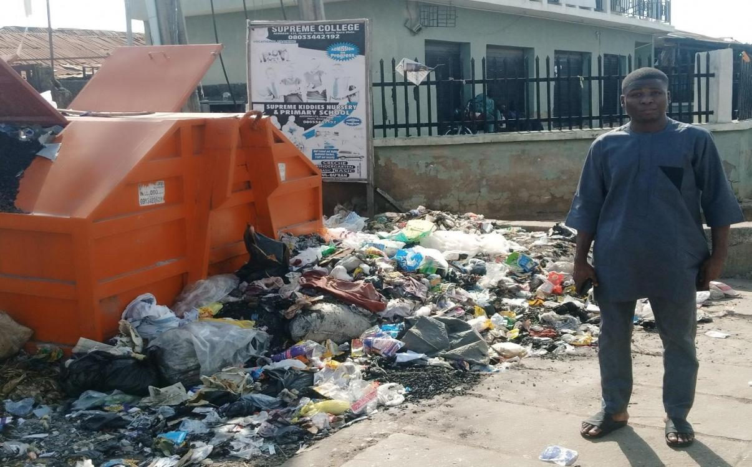

Plate 1: Waste dump @ ( Magaji nkgeri)

Source: Field work,2025

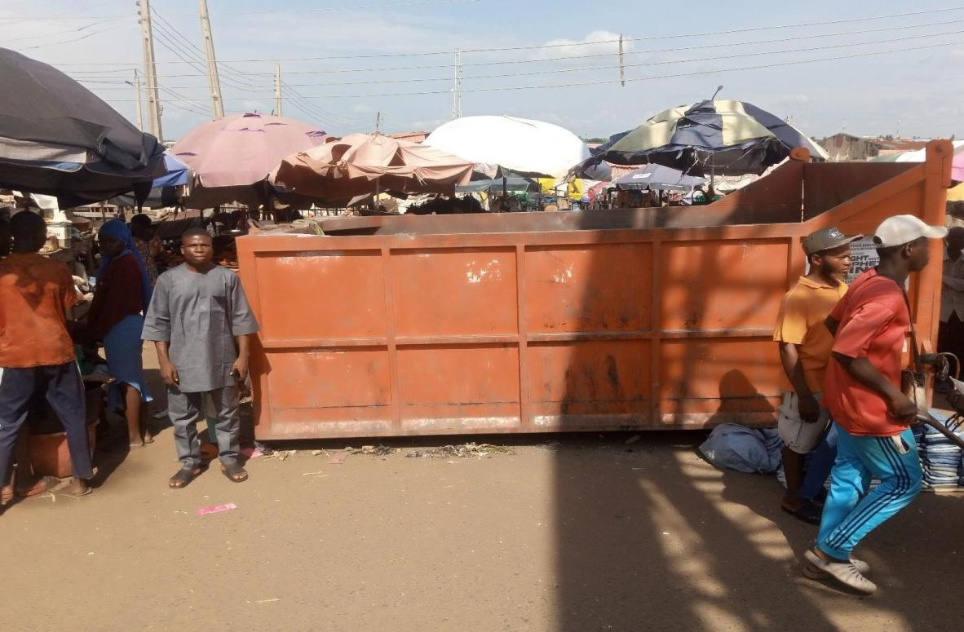

Plate 2: Waste dump at Sango

Source : Field work, 2025.

Plate 3: Waste dump at Baboko The above is also an evidence of poor or improper waste management in the study area
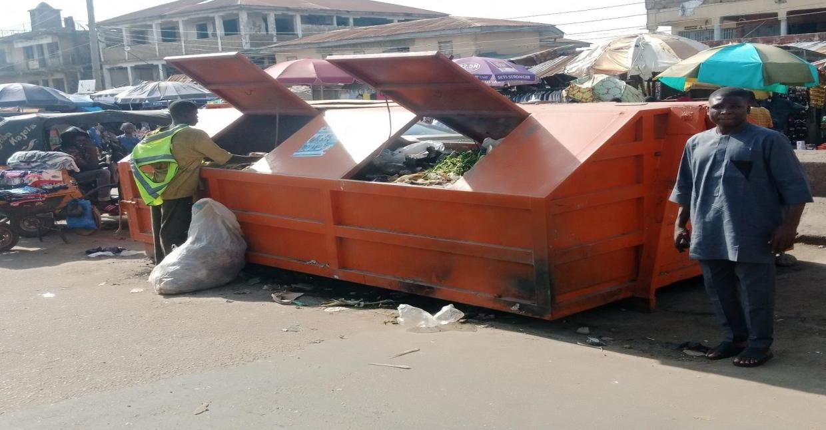


Source : Field work,2025.

CHAPTER FIVE

5.0 Summary of Findings Recommendations and Conclusion

5.1 Summaries of findings
The Summary of findings from this research work is shown below. The study revealed that larger proportions of the respondents were male (53.1%) while the female respondents accounted for 46.9%. This shows that majority of the people in the study area were male, although it’s a general believes that female population is more than male in any society, this assertion may still be upheld since sample procedures was based on purposive that is those who are ready and willing to respond. This implies that more male are ready to respond than female. The study shows that 68% were married, 17% were single, 7.6% were divorce, 5.6% were widower, while 1.2% of the respondents were separated. This shows clearly that majority of the respondents were married. This implies that there are more married and responsible people in the study area than others. Data on ethnicity of the respondents revealed that the Yoruba respondents constituted the larger proportion (71.2%).while the Nupe respondents are 6.4% which is the least. This indicate that Yoruba’s are the most populous ethnic group in the study area, Data on religion of respondents’ shows that 92% of the respondents are Muslim, 6%, are Muslim while only 2%, practice traditional religion. This shows Muslim respondents are higher than other religions in the study area.
This implies Ilorin is a Muslim dominated city, Data on occupation of the respondents in the study area shows that majority of the respondent are public servant (40.0%), this is followed by private sector workers (20.6%), While the proportion of retiree/pension is (1.1%) constituted the lowest proportion. The education qualification of the respondents in the study area revealed that larger proportion of the respondents possessed HND/University (26.3%) and NCE/OND certificate (26.3%). This implies that majority of the respondents are educated which account for over70% of them having minimum of school certificate and formal education. Data on monthly income of respondents in the study area. Shows that the proportion of respondents who earned below of #18000 accounted for 28.7%; the respondents who earned between #19,000 - #45000 accounted for 26.4%. The proportion of respondents that earn #46,000-#90000, #90000-#120000 and #120000 and above accounted for 25.5%, 18.1% and 1.4% respectively. This implies thatonly28.7% of the respondents earn less than the national minimum wage. From the field work carried out on solid waste in the study area it shows that most of the wastes that constitute the study area are either garbage or paper/nylon. The study also shows that 24.8% of residents make use of sack for the collection of waste, 21.6% make use of bucket for the collection of waste, 22% make use of nylon of for the collection of waste, 9.6% of residents make use of drum for the collection of waste 17.2% make use of nylon or basket and 4.8% of resident have other modes of collecting their waste. This implies that the use of sack, nylon and basket as mode of collection of waste is most common among the respondent compared to the other mode of waste collection. The study reveals that 28% respondent make use of government refuse collection efforts, 17.3% make use of open dumping ground while 22.4% make use of burning at the backyard or surrounding environment while 17.2% make use of waste vendors and 15.2 % make use of other such as gutter in the pit etc. From the study it was revealed that 40.8% of respondents in the area disposed their waste through personal efforts which is the highest while 32.4% make use of government agency. 14.8% make use of private agency,8% make use of truck pushers and only 4% make use of others. This implies that most respondents prefer to manage their waste by themselves or through the government agency. It is revealed from the study that 60.8%are ready and willing to pay for refuse collection and disposal because most of them see it as government/municipal sole responsibility, while the remaining 39.2% are willing to pay may be because of their enlightenment or level of education.
The analysis from the study also reflect the opinion of the respondents in the study area in terms of the degree of seriousness of some diseases associated with solid waste management in the area .However it was revealed that an average of 28%of the respondents admitted that each of the diseases is very serious, while24.3% admitted that these diseases are serious, making a total of 52.3% as serious cases.27.7 admitted that that occurrence of those diseases are not serious and 20% respondents admitted that the occurrences of those diseases are not serious at all, the detailed can be seen from the table. Findings from the table reveals that malaria is very serious which has the highest of 40.5% followed by diarrhea with 36.5% next to this is cholera with 27% and typhoid with dysentery has least with 15.5% each.

5.2 RECOMMENDATIONS
The following recommendation are proffered to solve the effects of the poor solid waste management in the study area they include:-
- Improved funding of the sanitation and health board responsible for solid waste management in the state this will go a long way in assisting them to procure better and more equipment for waste collection and disposal.
- There should be continuous enlightenment of the people of the area in various mass media on health implication of poor solid waste management
- Laws and regulations as regards environmental sanitation should be strictly enforced, offenders should be sanctioned this will motivate the people to take the management of their solid waste serious and also be law abiding
- Organized private sectors in the area of solid waste management should be encourage and people should be made to be aware the need to patronized the because so many see solid management as the sole responsibility of the government, therefore many of them are not ready to pay any dime for solid waste management they see it as a waste of money.
- There should be Control of waste disposal system staff officers by the agencies,
- Proper channelization of liquid waste to the location of septic tanks, is also
recommended Employment of well trained and skilled personnel provision of waste vehicles in the study area, provision of well experienced and capable manager of environmental waste, Adequate patrol/monitoring of waste sites involved, provision of security personnel to the various waste sites, among others

5.3 CONCLUSION
The collection of refuse is irregular and inefficient in Kwara State. Refuse are littered indiscriminately and often accumulated along roads and public places, creating breeding grounds for mosquito’s flies, cockroaches and rodents responsible for the spread of many diseases, The vehicles used were open trucks, which exposed their putrefying load for all to see and smell as they move through the city. The result reveals whether the public are aware of health implications of indiscriminate refuse dump, improper refuse management. It also government efforts may not be enough in solving environmental problem and why individual must be involved.

REFERENCES
Aina (1990) as shanty towns are deprived settlements characterized by very high residential density, largely, uninhabited housing and absence of sanitation. Egunjobi (1999). The gasping city, inaugural lecture, university of Ibadan 11. Federal environmental protection Agency (1991) guidelines and standards for environmental pollution control in Nigeria 12. George C.K (2002) basic principle and methods of urban and regional planning. Lagos librogem books.
George C.K (2002) basic principles and methods of urban and regional planning Lagos. Liborem books. Mabogunje .A. (2002) Nigeria and good urban government campaign. The laughing of global campaign for good urban governance in Nigeria. Federal ministry of works and housing, Abuja, Nigeria.
Mabogunje A (1998) towards an urban policy for Nigeria, in sada, P.O and oguntoyinboeds urban processes and problem in Nigeria. Ibadan: University of Ibadan press.
Mabogunje (2000) corroborates this by saying that the concentration of the poor and educational handicaps is unplanned settlement had to the emergency of slum. Ordway .A. and ogundele .K. (2006) environmental hazards in metropolitan Lagos, paper presented at international conference on environmental economics and conflict resolution, University of Lagos.
Ogundele (2006) emphasizes the need for the health education on proper management and recycling of solid waste in Nigeria.
(Olayiwola 2020) A study notes that we visible features of most urban centers in Nigeria today is the refuse ( mountain) which emits fouls odurs, as well as a breading ground for pathogenic agents ( oyediran, 1997). Julie ola pala, 1997.

APPENDIX I
KWARA STATE POLYTECHNIC
INSTITUTE OF ENVIRONMENTAL STUDIES
DEPARTMENT OF URBAN AND REGIONAL PLANNING
INSTRUCTION: Please tick (√) the answer which you consider as most appropriate. The questionnaire will be into two parts. Section A and Section B

Section A: Demographics
- What is your gender? (a) Male ( ) (b) Female ( )
- What is your age group? (a) 18-24 years ( ) (b) 25-34 years ( ) (c) 35-44 years ( ) (d) 4554 years ( ) (e) 55 years and above ( )
- What is your marital status? (a) Single ( ) (b) Married ( ) (c) Divorced ( ) (d) Widowed ( )
- What is your level of education? (a) Primary school ( ) (b) Secondary school ( ) (c) Tertiary institution ( ) (d) Postgraduate degree ( )
- What is your occupational status? (a) Employed ( ) (b) Self-employed ( ) (c) Unemployed ( ) (d) Student ( )
- What is your monthly income? (a) Below #18,000 ( ) (b) #19,000-45,000 ( ) (c) #46,000-90,000 ( ) (d) #91,000-120,000 ( ) (e) #120,000 and above ( )
- How long have you lived in the study area? (a) Less than 1 year ( ) (b) 1-5 years ( ) (c) 6-10 years ( ) (d) 11-15 years ( ) (e) More than 15 years ( )

SECTION B: RESEARCH QUESTIONS
- How often do you dispose of waste in your area? (a) Daily ( ) (b) Twice a week ( ) (c) Weekly ( ) (d) Monthly ( ) (e) Rarely ( )
- How often do you clean your immediate surroundings? (a) Daily ( ) (b) Twice a week ( ) (c) Weekly ( ) (d) Monthly ( ) (e) Rarely ( )
- How often do you participate in communal sanitation? (a) Regularly ( ) (b) Occasionally ( ) (c) Rarely ( ) (d) Never ( )
- Where do you dispose of your waste? (a) Recycle bin ( ) (b) Dump sites ( ) (c) Private waste ( ) (d) Roadside/drainage ( ) (e) Others ( )
- How would you rate the cleanliness of your neighborhood? (a) Very clean ( ) (b) Clean ( ) (c) Average ( ) (d) Dirty ( ) (e) Very dirty ( )
- How would you rate the condition of the drainage system in your area? (a) Excellent ( ) (b) Good ( ) (c) Average ( ) (d) Poor ( ) (e) Very poor ( )
- How regularly do you recycle or separate waste in your household? (a) Never ( ) (b) Rarely ( ) (c) Sometimes ( ) (d) Often ( ) (e) Always ( )
- How much influence do consumer habits have on the amount of solid waste generated in your household? (a) No influence ( ) (b) Little influence ( ) (c) Moderate influence ( ) (d)
Significant influence ( ) (e) Very significant influence ( )
- How effective do you find the current waste collection services in managing household waste? (a) Very ineffective ( ) (b) Ineffective ( ) (c) Neutral ( ) (d) Effective ( ) (e) Very effective ( )
- How accessible are recycling facilities or services in your area? (a) Not accessible ( ) (b) Slightly accessible ( ) (c) Moderately accessible ( ) (d) Accessible ( ) (e) Very accessible ( )
- To what extent do current waste management practices mitigate environmental pollution in your area? (a) Not at all ( ) (b) Slightly ( ) (c) Moderately ( ) (d) Significantly ( ) (e) Very significantly ( )
- What factors are responsible for poor urban sanitation in your area? (a) Lack of government policy and enforcement ( ) (b) Poor waste management practices by residents ( ) (c) Poor drainage and sanitation infrastructure ( ) (d) Low community participation in environmental sanitation ( ) (e) Other ( )
- What measures can improve environmental sanitation in your area? (a) Increased government policy and enforcement ( ) (b) Improved waste management practices by residents ( ) (c) Improved drainage and sanitation infrastructure ( ) (d) Increased community participation in environmental sanitation ( ) (e) Other ( )
- How likely are you to participate in environmental sanitation exercises if organized regularly? (a) Very likely ( ) (b) Likely ( ) (c) Neutral ( ) (d) Unlikely ( ) (e) Very unlikely ( )
- The government should enforce stricter regulations on environmental sanitation practices. (a) Strongly agree ( ) (b) Agree ( ) (c) Neutral ( ) (d) Disagree ( ) (e) Strongly disagree ( )
- Residents should be educated on the importance of good sanitation practices. (a) Strongly agree ( ) (b) Agree ( ) (c) Neutral ( ) (d) Disagree ( ) (e) Strongly disagree

