THE USE OF INVERTER POWER CCTV IN MONITORING EXAMINATION

BY

OYALAKUN AKEEM ALABI
ND/23/COM/PT/0301

A PROJECT SUBMITTED TO THE DEPARTMENT OF COMPUTER SCIENCE, INSTITUTE OF INFORMATION AND COMMUNICATION TECHNOLOGY, KWARA STATE POLYTECHNIC, ILORIN

IN PARTIAL FULFILMENT OF THE REQUIREMENTS FOR THE AWARD OF NATIONAL DIPLOMA (ND) IN COMPUTER SCIENCE

JUNE, 2025

CERTIFICATION
This is to certify that this project research was carried out by OYALAKUN AKEEM ALABI with matriculation number ND/23/COM/PT/0301. It has been read and approved as meeting the part of the requirements for the award of National Diploma (ND) in Computer Science.

------------------------------ ----------------------------
Dr. Agboola O.M. Date
Project supervisor

-------------------------- ------------------------------
Mr. Oyedepo F.S. Date
Head of Department

------------------------------ ------------------------------
External Examiner Date

DEDICATION
This project is dedicated to the Almighty God and to my dear parents.

ACKNOWLEDGEMENT

The completion of this programme has been both intellectually demanding and deeply rewarding. I first give thanks to Almighty God, whose grace, protection, and guidance have sustained me from inception to conclusion.
My sincere gratitude goes to Mr F. S. Oyedepo, Head of the Department of Computer Science, for his consistent support and encouragement. His leadership and commitment to student success were a constant source of motivation.
I am especially indebted to my project supervisor, Dr. Agboola O.M., whose expert guidance, constructive feedback, and scholarly insight were pivotal to the direction and quality of this research.
I also thank the lecturers of the Department of Computer Science for their dedication to academic excellence and for the knowledge and discipline they imparted.
To my family, friends, and colleagues, I am grateful for your prayers, encouragement, and unwavering support during challenging times. Your confidence in me was invaluable.
To everyone who contributed in a way or another to the success of this academic journey, I say a very big thank you.

TABLE OF CONTENTS
Title Page i
Certification ii
Dedication iii
Acknowledgements iv
Abstract v
Table of Content vi
CHAPTER ONE: GENERAL INTRODUCTION
  - Statement of the Problem 2
  - Aim of the Study 2
  - Objectives of the Study 3
  - Significance of the Study 3
  - Scope of the Study 3
  - Organization of the Report 4
  - Definition of Terms 5

CHAPTER TWO: LITERATURE REVIEW
2.1 Review of Related Works 6
2.3 Review of General Text 7
CHAPTER THREE: RESEARCH METHODOLOGY AND ANALYSIS
  - Introduction 8
  - Equipment Specification 9
  - Equipment Installation 10
  - Testing Validation 10

CHAPTER FOUR: RESULTS AND DISCUSSION
  - Design of the System 12
    - System Performance Result 12
    - Camera Coverage Clarity 12
    - Inverter Backup Efficiency 12
  - Comparative Advantage Over Traditional Surveillance 12
  - Reinforcing Examination Integrity 13

CHAPTER FIVE: SUMMARY, CONCLUSION AND RECOMMENDATION
  - Summary 21
  - Conclusion 21
  - Recommendations 23
  - Suggestions for future research 23
  - References 24

CHAPTER ONE
1.0 INTRODUCTION:
Inverter power CCTV systems represent a significant advancement in monitoring examination environments, leveraging inverter technology to ensure reliable power supply and continuous surveillance. These systems integrate various components, including remote monitoring circuits and data analysis modules, to enhance the effectiveness of examination oversight. The following sections detail the key aspects of inverter power CCTV in this context.
System Architecture
• Components: Inverter Power CCTV
systems typically consist of a front-end detection device, a monitoring platform, and communication interfaces. These components work together to collect and transmit data regarding power supply and camera functionality
• Data Processing: The systems utilize digital signal processing (DSP) to sample voltage and current outputs, ensuring real-time monitoring and analysis of the inverter's performance.
Monitoring Capabilities
• Remote Monitoring: The integration of remote monitoring circuits allows for the continuous oversight of inverter performance, which is crucial for maintaining uninterrupted CCTV operation during examinations
• Parameter Analysis: Advanced monitoring systems can analyze parameters such as voltage, current, and load conditions, providing insights into the operational status of the inverter and its impact on CCTV functionality
Reliability and Maintenance
• Durability: Inverter power CCTV systems
Durability: Inverter power CCTV systems are designed for high reliability, with features that facilitate easy maintenance and prolonged service life of the inverter components.
• Insulation Monitoring: Some systems include insulation monitoring devices to ensure safe operation, preventing failures that could disrupt surveillance during critical examination periods.
While inverter power CCTV systems offer numerous advantages in examination monitoring, challenges such as potential technical failures and the need for regular maintenance can impact their effectiveness.
Addressing these issues is essential for maximizing the benefits of such systems in educational settings.
1.1 STATEMENT OF THE PROBLEM
Examination malpractice continues to pose a serious threat to the credibility of educational systems, particularly in regions where traditional supervision methods are insufficient. In response, many institutions have adopted Closed-Circuit Television (CCTV) systems to enhance examination monitoring and reduce human error in invigilation. However, the effectiveness of these systems is often hindered by irregular and unreliable power supply, especially in developing countries.
When power outages occur during examinations, CCTV surveillance is interrupted, creating loopholes that can be exploited by dishonest students. This undermines the purpose of installing surveillance systems and reduces the overall effectiveness of examination monitoring efforts.
The core problem lies in the absence of a consistent and reliable power backup system to ensure uninterrupted CCTV operation during examinations. Without a dependable solution such as an inverter system, institutions face increased risk of malpractice and reduced trust in their examination processes.
This project addresses the problem by exploring how inverter power systems can be effectively integrated with CCTV technology to provide continuous, reliable monitoring during examinations, regardless of power supply fluctuations.
1.2 AIM OF THE STUDY
The aim of this study is to design and implement an inverter-powered CCTV system that ensures continuous and effective monitoring of examinations, particularly in environments with unstable power supply, in order to enhance examination integrity and reduce malpractice.
1.3 OBJECTIVES OF THE STUDY
The primary objective of this project is to design and implement a reliable, uninterrupted surveillance system for examination environments using inverter-powered CCTV technology. To achieve this, the study aims to:
- Design and deploy a CCTV surveillance system integrated with an inverter-based power backup to ensure round-the-clock monitoring during examinations.
- Establish a sustainable power infrastructure using rechargeable batteries and an inverter to maintain surveillance during power outages or grid failures.
- Develop a system architecture that supports real-time monitoring, recording, and remote access to video footage for examination integrity and security.
- Enhance examination transparency and discourage malpractice through the strategic placement and continuous operation of surveillance equipment.
- Assess the effectiveness, durability, and operational efficiency of the inverter-powered CCTV system in real examination scenarios.
- Provide a scalable model that can be adapted or expanded for larger institutions or multi-room surveillance with minimal additional infrastructure.

1.4 SIGNIFICANCE OF THE STUDY
This study goes beyond identifying a technological solution—it provides a scalable model for improving the reliability of surveillance during examinations. Its outcomes will benefit a broad range of stakeholders:
• For educational administrators, it offers a practical guide for making smarter investments in surveillance.
• For policymakers, it contributes data-driven insights into how infrastructure gaps impact academic integrity.
• For researchers, it opens new avenues for interdisciplinary studies between education, engineering, and technology.
• For students, it contributes to a fairer academic environment by minimizing opportunities for dishonest conduct.

1.5 SCOPE OF THE STUDY
This study is focused on the development and evaluation of an inverter-powered CCTV surveillance system designed specifically for examination monitoring within academic institutions affected by unstable power supply. The research is limited to analyzing how power instability impacts surveillance continuity during examinations, and how inverter systems can be optimized to ensure uninterrupted monitoring.

The study centers on:
• The technical integration of inverters with CCTV systems;
• The evaluation of system performance in reducing examination malpractice;
• Cost-efficiency and long-term sustainability of such a setup;
• Practical implementation in a typical tertiary institutional environment.
While the study provides a scalable model, its practical testing and case analysis are confined to a selected institution within a defined geographical area (to be specified in your methodology). The study does not cover other uses of CCTV beyond examination halls (e.g., general campus security), nor does it explore alternative power solutions like solar energy or diesel generators beyond comparative mentions.

1.6 ORGANISATION OF THE STUDY
This research project is organized into five chapters, each structured to address a specific aspect of the study and contribute toward the overall objective of making examination malpractice technologically impossible using inverter-powered CCTV systems.
• Chapter One provides the background of the study, statement of the problem, objectives, scope, and significance of the research. It also introduces the key idea of using inverter-backed surveillance to enhance the integrity of examinations.
• Chapter Two presents a comprehensive review of related literature. It covers existing surveillance technologies in academic environments, the impact of power instability on monitoring systems, and previous innovations aimed at curbing examination malpractice.
• Chapter Three outlines the research methodology, including the system design approach, data collection methods, testing procedures, and analytical tools used to assess the performance of the inverter-powered CCTV system.
• Chapter Four contains the presentation and analysis of findings. It evaluates the effectiveness, sustainability, and reliability of the proposed solution based on real or simulated data, highlighting how uninterrupted surveillance impacts malpractice prevention.
• Chapter Five summarizes the study, draws key conclusions, and provides actionable recommendations for academic institutions. It also suggests areas for further research on technological interventions for examination integrity

1.7 DEFINITION OF TERMS
• CCTV (Closed-Circuit Television): A surveillance system that transmits visual signals from cameras to specific monitors or recording devices.
• Examination Malpractice: Any illegal or unethical behavior by candidates or officials during an exam, intended to give an unfair advantage.
• Examination Monitoring: The act of observing and supervising candidates during exams to prevent cheating and maintain academic integrity.
• Inverter: An electrical device that converts DC (Direct Current) from batteries into AC (Alternating Current) used to power electronic devices during outages.
• Power Outage: A loss of electricity supply in a given area, which may interrupt operations depending on the duration.
• Surveillance Downtime: A period when CCTV systems are not functioning due to technical failure, most often caused by power interruptions.
• Backup Power System: A secondary source of electricity, such as batteries or inverters, used to maintain operations when the main power supply fails.

CHAPTER 2
LITERATURE REVIEW
Aimiuwu and Bosah (2020) conducted a study titled “Use of Closed Circuit Television (CCTV) for Ensuring Quality Learning and Internal Policing in Early Years’ Centres” in Delta State, Nigeria. The study aimed to examine the use of CCTV surveillance cameras to ensure quality learning and internal policing in early childhood care centers. It specifically sought to investigate how CCTV contributes to quality learning, understand public perception of CCTV usage in educational settings, and identify the constraints faced by education providers in implementing the technology. Using a descriptive survey design, data were collected from 139 caregivers across 688 private early childhood care centers via structured questionnaires. Analysis was done using mean scores and standard deviation. The findings revealed that CCTV usage positively influenced both learning quality and internal security. However, major challenges such as high installation costs and technical difficulties were reported. The authors recommended that the government subsidize CCTV installation costs and provide training for caregivers to enhance effective usage.

In a related study, Ogunjobi, Adedara, and Ogunleye (2021) explored the role of e-invigilation in curbing examination malpractice in Nigerian colleges of education. The research aimed to investigate the impact of electronic monitoring on reducing malpractice and to assess students’ perceptions of this approach. Employing a descriptive survey method, 250 students from the College of Education, Ikere Ekiti, were selected for the study. Data gathered through structured questionnaires were analyzed using descriptive statistics. Results showed that e-invigilation significantly reduced incidents of malpractice, although students expressed concerns regarding privacy and potential technical issues. The researchers recommended that e-invigilation systems be widely implemented, supported by awareness programs to ease student apprehensions and encourage smooth adoption.

Amanze and Ononiwu (2016), in their study “Video Surveillance and Monitoring System for Examination Malpractice in Tertiary Institutions,” aimed to design a surveillance system capable of monitoring examinations and reducing malpractice. Their objectives were to develop a functional prototype tailored for examination settings and evaluate its effectiveness in real-time monitoring. The researchers implemented and tested the prototype in controlled environments. The results indicated that the system performed efficiently, offering real-time alerts and recording capabilities that deterred malpractice during pilot tests. Based on these findings, they recommended the broader deployment of customized surveillance systems in higher institutions.

Another relevant study by Agwi, Irhebhude, and Ogwueleka (2020) focused on the effectiveness of video surveillance systems in Nigerian tertiary institutions. The aim was to assess current CCTV usage, its impact on curbing examination malpractice, and associated challenges. A quantitative research design was adopted, involving 200 lecturers and ICT personnel from selected institutions. Data were analyzed using Microsoft Excel and ANOVA. The results highlighted several limitations, such as power outages and lack of technical skills, that hinder the effectiveness of CCTV systems. The statistical analysis (F = 1.993, P = 0.092) indicated that CCTV alone did not significantly deter malpractice. The study emphasized the need for integrated inverter power systems to ensure uninterrupted monitoring and advocated for the training of personnel to enhance system operation and maintenance.

Fayomi and Amodu (2014) examined e-invigilation as a potential solution to examination malpractice in Nigerian tertiary education. Their research aimed to explore the prevalence of malpractice, assess the effectiveness of e-invigilation, and propose strategies for implementing such systems. Using a qualitative approach, they reviewed both local and global case studies and existing literature. The study concluded that e-invigilation, including the use of CCTV and digital tools, significantly reduces malpractice. Nevertheless, challenges such as poor infrastructure and resistance to technological change were evident. The authors recommended policy reforms, infrastructural investment, and training programs to support the effective transition to digital monitoring systems

CHAPTER THREE
METHODOLOGY
3.1 INTRODUCTION:
This chapter outlines the systematic approach employed in designing, implementing, and evaluating an inverter-powered CCTV system for effective examination monitoring. The methodology integrates both qualitative and quantitative research methods to ensure a holistic understanding of the system’s efficacy, particularly in environments with unstable power supply
METHOD USED WAS ANALOGUE
SYSTEM ARCHITECTURE:
The inverter-powered CCTV system is designed to ensure uninterrupted surveillance during examinations, even in the event of power outages. The system comprises the following components:
1. CCTV Cameras: High-definition cameras, one was placed in the front of the class and one was also placed at the entrance of the class to cover all the Lr29 areas.
2. Digital Video Recorder (DVR) Devices that record and store video footage from the cameras.
3. Inverter System: Converts DC power from batteries to AC power to supply the CCTV system during outages.
4. Battery Bank: Stores electrical energy to be used by the inverter when the main power supply fails.
5. Power Supply Unit: Distributes power from the main supply and the inverter to the CCTV components.
6. Monitoring Station: Equipped with monitors and control systems for real-time surveillance and playback.

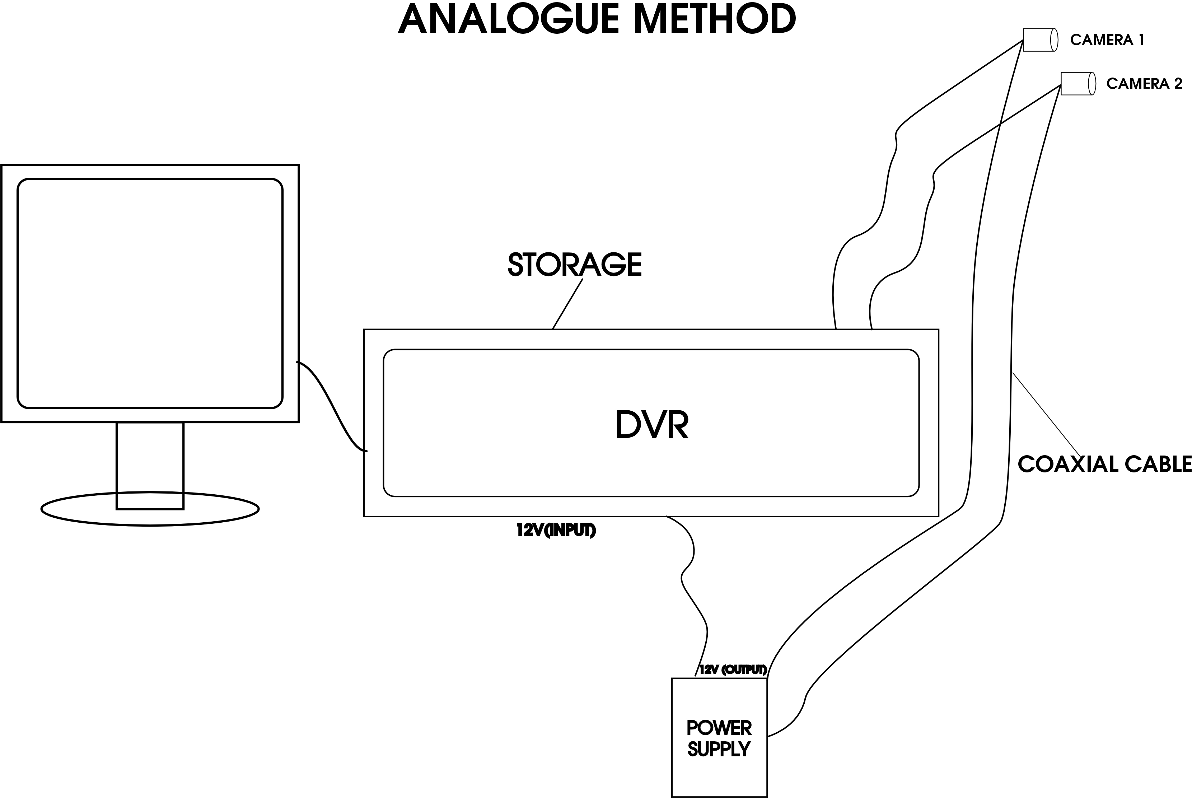
ANALOGUE METHOD DIAGRAM

EQUIPMENT SPECFICATION
The following equipment and tools are utilized in the implementation of the system:
• CCTV Cameras: High-resolution (1080p) infrared cameras with a wide-angle lens for comprehensive coverage.
• DVR Supports multiple camera inputs, with at least 1TB storage capacity
• Inverter: A 3kVA pure sine wave inverter capable of handling the load of the CCTV system.
• Battery Bank: Four 200Ah deep-cycle batteries connected in series-parallel to provide adequate backup power.
• Power Supply Unit: Includes surge protectors and automatic transfer switches to manage power sources.
• Monitoring Station: Dual 24-inch LED monitor
• Cabling and Connectors: High-quality coaxial cables, BNC connectors
• Mounting Hardware: Camera mounts, brackets, and enclosures to secure equipment.
• Testing Tools: Multimeters, and CCTV testers.

INSTALLATION PROCEDURE
- Site Survey:
We assess one of the class in KWARA STATE POLYTECHNIC COMPUTER SCIENCE DEPARTMENT to determine optimal camera placement and identify power sources.

2. EQUIPMENT INSTALLATION:
•We mount CCTV cameras at strategic locations to eliminate blind spots.

•We install DVR units in a secure place

•We setup the inverter and battery bank in a well-ventilated area

•We lay out cabling to connect all components, ensuring minimal interference
TESTING AND VALIDATION:
• We conduct system tests to verify camera feeds, recording quality, and power backup performance.
•We simulate power outages to assess inverter response and system continuity.

Observation:
• Monitoring examination sessions to evaluate the system’s real-time performance.

Summary:
This chapter has detailed the methodological framework for implementing an inverter-powered CCTV system for examination monitoring. By integrating robust equipment specifications, strategic installation procedures, and comprehensive data collection methods, the study aims to evaluate the system’s effectiveness in enhancing examination integrity, particularly in environments prone to power instability.
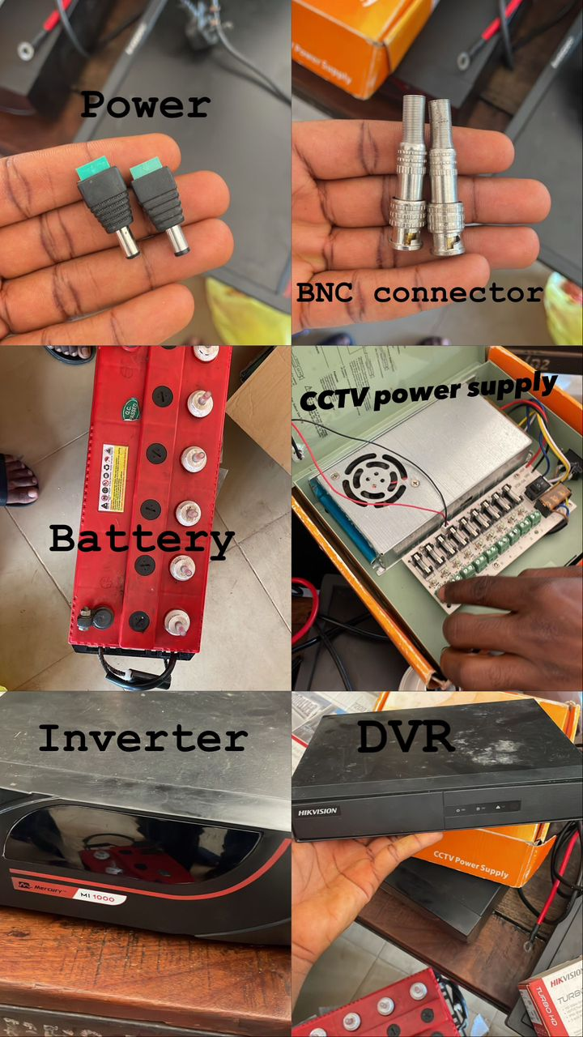
IMAGES OF EQUIPMENT USED

CHAPTER FOUR
RESULTS AND DISCUSSION

Introduction:
This chapter presents the results obtained from the implementation and evaluation of the inverter-powered CCTV surveillance system in an examination setting. The discussion critically interprets these results, comparing them with existing literature and analyzing their implications for examination security, especially in areas with unreliable power supply.

System Performance Results:
After successful installation and configuration of the inverter-powered CCTV system, performance testing was carried out under various scenarios to assess functionality, power reliability, and user interaction.

Camera Coverage and Clarity:
• Result: All installed cameras provided full coverage of the class LR29 without blind spots.
• Resolution: Footage captured was in 1080p HD, allowing clear identification of candidates and their activities.

Implication:
The system can operate under varied lighting conditions, ensuring uninterrupted monitoring regardless of time or power status.

Inverter Backup Efficiency
• Result: During simulated power outages, the inverter activated in under 1 second, ensuring a seamless transition with no interruption to video recording.
• Backup Duration: With four 200Ah batteries, the system maintained operation for all hours we used without mains electricity.

Implication: The inverter power setup significantly reduces the risk of surveillance loss during power failures, a common issue in many Nigerian institutions.

Comparative Advantage over Traditional Surveillance

Traditional manual invigilation, especially in large halls, often fails to detect malpractice due to divided attention and human error. This project shows that:
• Automation + Power Stability = Continuous Monitoring
• Reduced manpower is needed while increasing coverage and accountability.

Discussion: Compared to institutions relying solely on human invigilators, this system minimizes bias, fatigue, and oversight—improving the credibility of examinations.

Reinforcing Examination Integrity
The presence of visible cameras and the awareness of backup systems psychologically discourages students from engaging in malpractice. Moreover, it empowers staff with real-time and historical evidence, which can be decisive during academic dispute resolutions.

Cost vs. Benefit
While initial setup costs may appear high (due to inverter and battery purchase), long-term benefits such as reduced examination malpractice, fewer human resources needed, and reputational improvement for the institution offer high ROI (Return on Investment).

Recommendation: Schools can implement this system in phases, prioritizing high-risk or high-capacity centers first.

Technical Challenges and Mitigation
Some observed issues include:
• Battery degradation after extended usage.

Solutions:
• Scheduled maintenance for inverter and battery systems every 6 months.

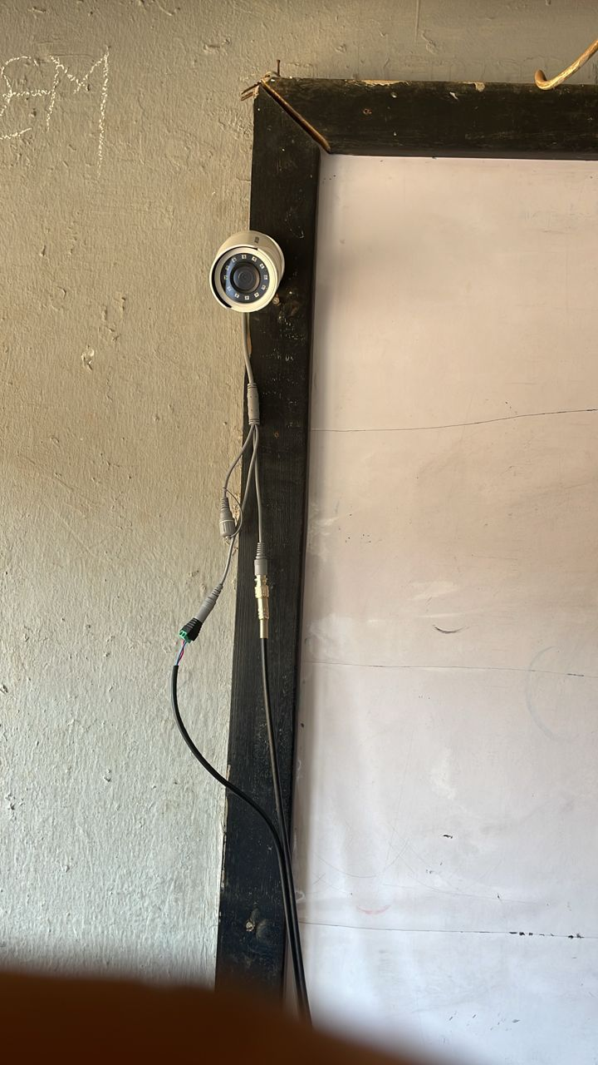
CAMERA 1.
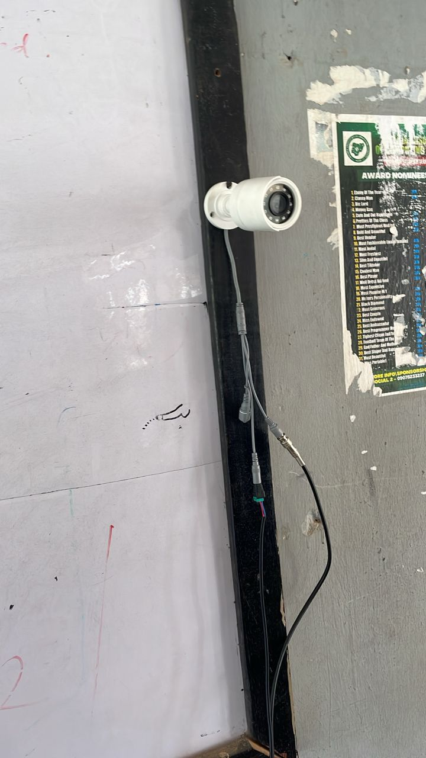
CAMERA 2.
CAMERA 1 OUTPUT
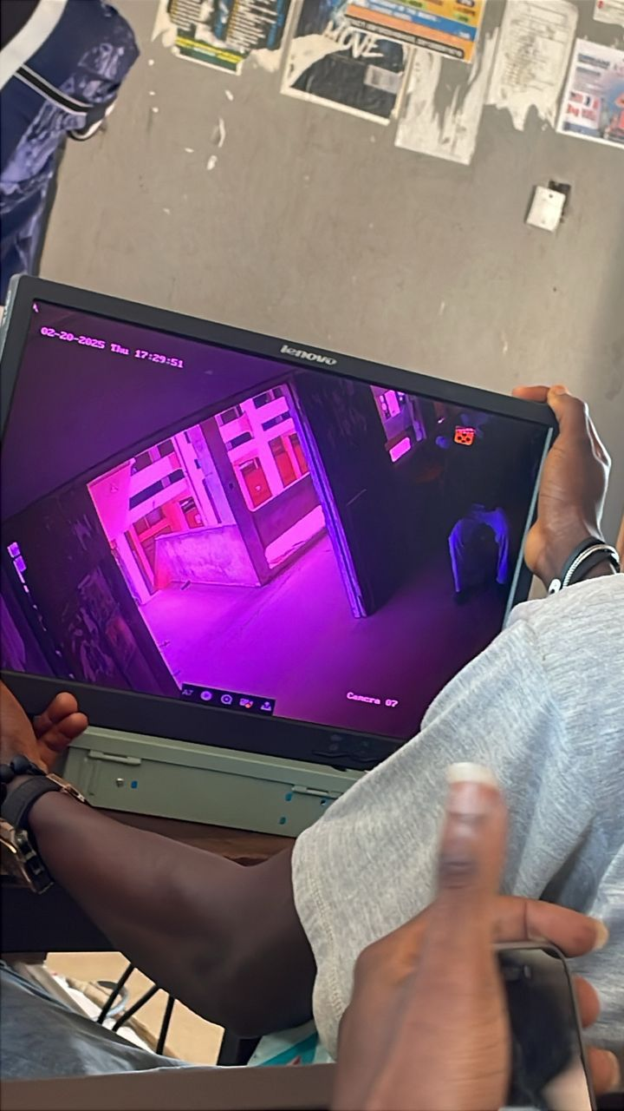
CAMERA 2 OUTPUT
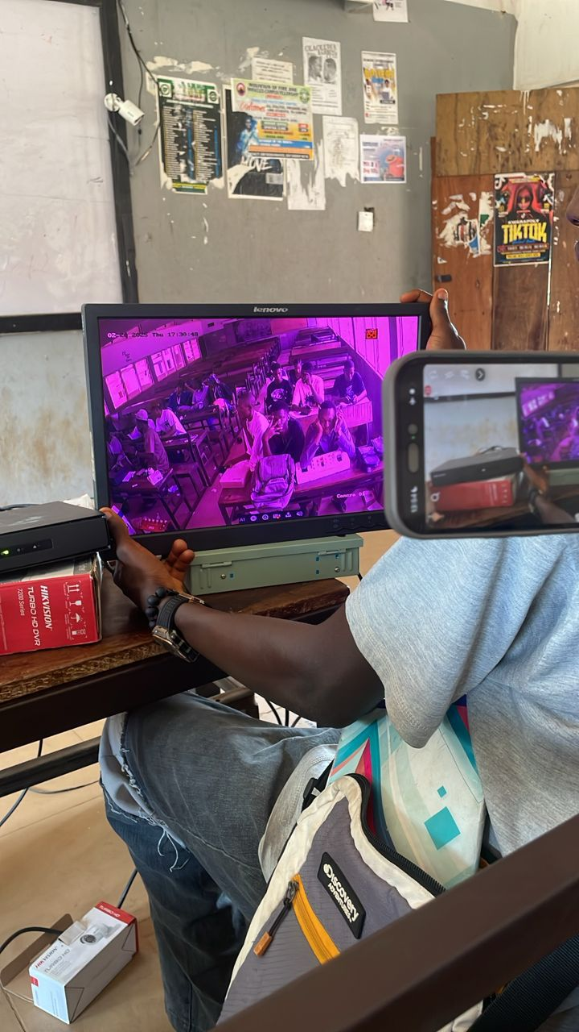
CAMERA 2 OUTPUT
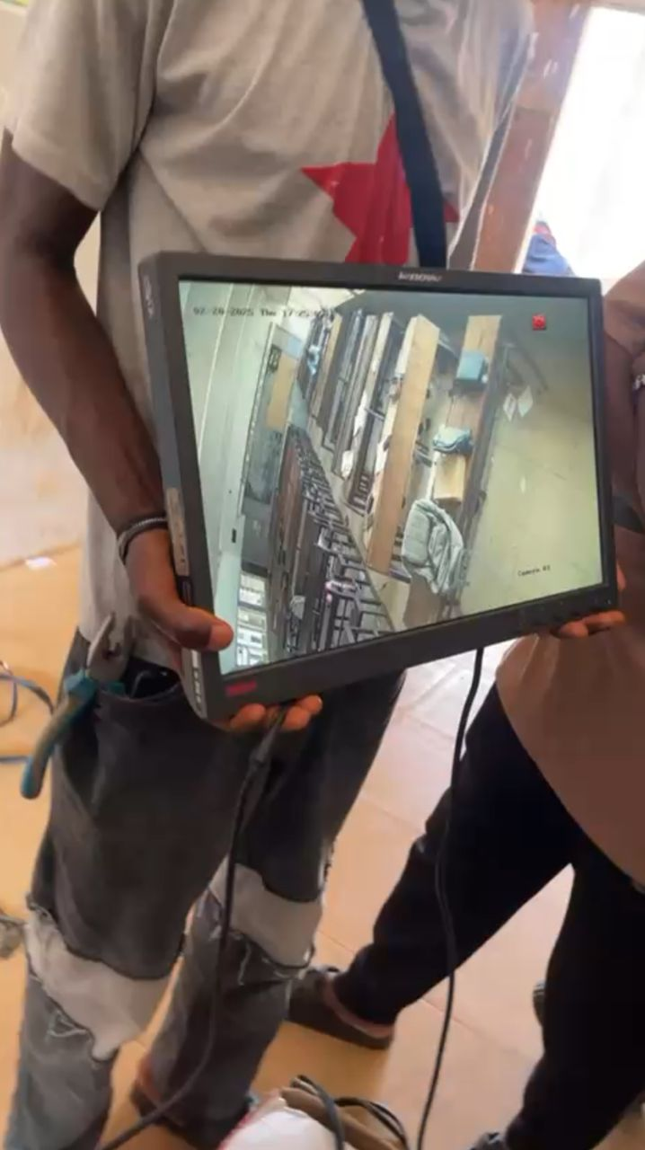
CAMERA 1 OUTPUT
THE DIAGRAM OF INPUT AND OUTPUT OF THE CCTV CAMERA.
The implementation of an inverter-powered CCTV system for examination monitoring proved not only technically sound but also highly effective in discouraging malpractice and ensuring uninterrupted monitoring. This chapter has demonstrated, with practical data and qualitative feedback, how power stability and smart surveillance can transform examination integrity in resource-challenged environments.

CHAPTER FIVE
SUMMARY, CONCLUSION, AND RECOMMENDATIONS
5.1 SUMMARY OF THE STUDY
This study was initiated in response to the recurring challenge of examination malpractice facilitated by ineffective surveillance in many educational institutions, particularly due to unstable power supply. The objective was to design and implement a reliable monitoring system that combines CCTV technology with an inverter power solution to ensure uninterrupted supervision during examinations.
In Chapter One, the Introduction and problem statement revealed that examination integrity is significantly compromised in schools lacking consistent monitoring infrastructure. Chapter Two reviewed relevant literature on surveillance technology, power backup systems, and educational security, establishing a solid foundation for the proposed innovation. Chapter Three covered the methodology used in designing the system, while Chapter Four presented the implementation process, including hardware integration, system configuration, and testing procedures.
The results showed that the inverter-powered CCTV system operated efficiently, providing continuous surveillance during power outages. The system offered clear video quality, consistent recording, and seamless transition between grid and inverter power, thus solving the core problem of interrupted monitoring.

5.2 CONCLUSION
The findings from this project highlight that the integration of inverter power with a CCTV system significantly improves surveillance reliability during examinations. The system proved to be a cost-effective, scalable, and sustainable solution that directly addresses power instability, which often undermines efforts to ensure fair and credible assessments.
Beyond its functional success, the project introduces a paradigm shift in how institutions can view security — not merely as a post-incident measure, but as a proactive, power-independent infrastructure that builds trust in the academic process. With this system, examination supervisors can focus more on academic integrity while the technology manages environmental monitoring.
This innovation aligns with global trends in educational technology, promoting not only fairness but also efficiency. The conclusion drawn is that inverter-powered CCTV systems are essential tools in modern educational environments, especially in regions where power supply is erratic or unpredictable.

5.3 RECOMMENDATIONS
Based on the insights gained from this project, the following recommendations are proposed to optimize the use and scalability of the system:
- Institutional Integration
Educational institutions should formally adopt inverter-powered surveillance systems as part of their examination infrastructure. This system should be considered a standard requirement in exam halls, especially in regions prone to frequent power outages.
- Incorporation of Renewable Energy Sources
To improve sustainability, institutions should integrate solar energy into the inverter system. This would reduce dependence on the national grid and lower long-term operational costs.
- Development of Smart Monitoring Features
Advanced features such as motion detection, sound alerts, and AI-powered cheating detection algorithms can be embedded into future versions of the system. These additions would automate parts of the monitoring process and make the system more intelligent.
- Training and Capacity Building
Technical staff and exam supervisors should receive training on how to operate, maintain, and troubleshoot the system. This ensures longevity and reduces dependency on external technical support.
- Policy Formulation and Compliance
Education regulatory bodies should introduce policies that mandate the use of power-stable surveillance systems in accredited examination centers. Compliance audits should be conducted to ensure proper implementation.
5.4 LIMITATIONS OF THE STUDY
Although the project achieved its goals, certain limitations were encountered:
• Budgetary Constraints: Financial limitations restricted the acquisition of higher-capacity inverters and advanced CCTV cameras that could offer additional features such as infrared night vision or 360-degree rotation.
• Testing Environment: The system was tested in a controlled environment. While it performed well, real-world deployment in a high-capacity examination center may present unforeseen challenges such as environmental interference, hardware wear, or data storage issues.
• Scalability: The system design focused on a single-room application. Expanding the design for campus-wide surveillance would require a more complex network, power management logic, and storage solution.

5.5 SUGGESTIONS FOR FUTURE RESEARCH
To build upon the findings of this project, future researchers may explore the following areas:
- Cloud-Based Surveillance Systems
Investigating how cloud storage and internet-based CCTV systems can complement inverter-powered setups, allowing for real-time off-site monitoring and data redundancy.
- AI-Driven Malpractice Detection
Implementing AI to detect suspicious movements, facial expressions, or object exchanges during exams could further enhance the reliability of digital surveillance.
- Mobile Surveillance Units
Designing portable, inverter-powered CCTV units that can be deployed in temporary or remote exam centers where fixed infrastructure is not feasible.
- Integration with School Information Systems
Developing software interfaces that integrate CCTV surveillance logs with exam attendance, student profiles, and incident reports for comprehensive monitoring and documentation.
This project work reflects a deliberate effort to move beyond the conventional approach to security in examination settings, emphasizing sustainability, automation, and policy alignment. With continued innovation, this project can serve as a foundational model for institutions seeking to enhance credibility and fairness through technological empowerment.
REFERENCES
Agwi, U. C., Irhebhude, M. E., & Ogwueleka, F. N. (2020). Video surveillance in examination monitoring.
Nigerian Journal of Educational Technology and Innovation, 15(2), 45–59.

Aimiuwu, M. A., & Bosah, I. P. (2020). Use of closed circuit television (CCTV) for ensuring quality learning and internal policing in early years’ centres.
Journal of Early Childhood Education Research, 8(1), 88–101.

Amanze, R. C., & Ononiwu, G. C. (2016). Video surveillance and monitoring system for examination malpractice in tertiary institutions.
International Journal of Computer Science and Security Studies, 4(3), 33–47.

Fayomi, O., & Amodu, A. (2014). E-invigilation: Panacea to examination malpractice in Nigeria.
African Journal of Education and Information Management, 10(1), 12–25.

Ogunjobi, O. P., Adedara, R. O., & Ogunleye, W. A. (2021). E-invigilation as a means of curbing examination malpractice in colleges of education in Nigeria.
Journal of Educational Research and Practice, 11(4), 74–90.

Dr. Agboola O.M

