THE USE OF INVERTER POWER CCTVIN MONITORING EXAMINATION

BY

ADEDAYO JOSHUA JESUSEUN
ND/23/COM/FT/0001

A PROJECT SUBMITTED TO THE DEPARTMENT OF COMPUTER SCIENCE, INSTITUTE OF INFORMATION AND COMMUNICATION TECHNOLOGY, KWARA STATE POLYTECHNIC, ILORIN

IN PARTIAL FULFILMENT OF THE REQUIREMENTS FOR THE AWARD OF NATIONAL DIPLOMA (ND) IN COMPUTER SCIENCE

JUNE, 2025

CERTIFICATION
This is to certify that this project research was carried out by ADEDAYO JOSHUA JESUSEUN with matriculation number ND/23/COM/FT/0001. It has been read and approved as meeting the part of the requirements for the award of National Diploma (ND) in Computer Science.

------------------------------ ----------------------------
Dr. Agboola O.M. Date
Project supervisor

-------------------------- ------------------------------
Mr. Oyedepo F.S. Date
Head of Department

------------------------------ ------------------------------
External Examiner Date

DEDICATION
This project is dedicated to the Almighty God and to my dear parents.

ACKNOWLEDGEMENT

The completion of this programme has been both intellectually demanding and deeply rewarding. I first give thanks to Almighty God, whose grace, protection, and guidance have sustained me from inception to conclusion.

My sincere gratitude goes to Mr F. S. Oyedepo, Head of the Department of Computer Science, for his consistent support and encouragement. His leadership and commitment to student success were a constant source of motivation.

I am especially indebted to my project supervisor, Dr. Agboola O.M., whose expert guidance, constructive feedback, and scholarly insight were pivotal to the direction and quality of this research.

I also thank the lecturers of the Department of Computer Science for their dedication to academic excellence and for the knowledge and discipline they imparted.

To my family, friends, and colleagues, I am grateful for your prayers, encouragement, and unwavering support during challenging times. Your confidence in me was invaluable.
To everyone who contributed in a way or another to the success of this academic journey, I say a very big thank you.

TABLE OF CONTENTS
Title Page i
Certification ii
Dedication iii
Acknowledgements iv
Abstract v
Table of Content vi
CHAPTER ONE: GENERAL INTRODUCTION
  - Statement of the Problem 2
  - Aim of the Study 2
  - Objectives of the Study 3
  - Significance of the Study 3
  - Scope of the Study 3
  - Organization of the Report 4
  - Definition of Terms 5

CHAPTER TWO: LITERATURE REVIEW
2.1 Literature Review 6
2.2 Review of Related Works 6
2.3 Area of Coverage 7
CHAPTER THREE: RESEARCH METHODOLOGY AND ANALYSIS
  - Introduction 8
  - Site analysis and Planning 9
  - Selection of Equipments and Materials 10
  - Installation of Steps 10
  - Challenges Faced 11
  - Summary 11

CHAPTER FOUR: RESULTS AND DISCUSSION
  - Introduction 11
  - Installation Overview 12
  - Output of Camera 1 15
  - Output of Camera 2 17
  - Power Performance and Inverter Response 18
  - Summary 20

CHAPTER FIVE: SUMMARY, CONCLUSION AND RECOMMENDATION
  - Summary 21
  - Conclusion 21
  - Recommendations 23
  - Suggestions for future research 23
  - References 24

CHAPTER ONE
1.1 Background of The Study
In the evolving landscape of modern education, particularly within the Nigerian academic system, one of the most formidable and enduring challenges confronting institutions is the maintenance of integrity in the conduct of examinations. The prevalence of examination malpractice continues to pose a serious threat to the credibility and authenticity of academic evaluations, thereby undermining not only the quality of education delivered but also devaluing the certificates and qualifications conferred upon students. This issue has escalated into a systemic problem, aggravated by infrastructural and logistical limitations, especially the difficulty of ensuring effective and continuous surveillance across examination centers.

This challenge becomes even more pronounced in higher institutions where large student populations are dispersed across multiple halls and lecture rooms simultaneously during examinations. Traditional human invigilation, although vital, has proven insufficient in curbing malpractice due to its inherent limitations—such as fatigue, distraction, or collusion. Consequently, there is an urgent need to deploy a more robust, technology-driven solution capable of providing real-time and round-the-clock monitoring of examination venues.

In response to this pressing concern, the deployment of a dependable inverter-based Closed-Circuit Television (CCTV) surveillance system is being proposed. This project is strategically designed to integrate surveillance technology with a sustainable and uninterrupted power backup system to ensure that examination halls are consistently monitored, even in the absence of public electricity. Given the well-documented unreliability of the national power supply in Nigeria, particularly during critical academic periods, this solution aims to bridge that infrastructural gap by ensuring that monitoring equipment remains operational at all times.

At the heart of this system lies an inverter and battery-powered setup, which functions as an automatic and immediate backup whenever there is a power outage. This guarantees continuous visual oversight of the examination environment, effectively eliminating periods of surveillance blackout that may otherwise be exploited by students to engage in dishonest activities. The psychological impact of knowing that one is being constantly monitored also serves as a deterrent, discouraging students from attempting malpractice in the first place.

Furthermore, the digital footage captured by the CCTV system will provide verifiable, tamper-proof evidence that can be used for post-examination review, conflict resolution, or investigation into reported cases of misconduct. This ensures transparency, fairness, and accountability in the assessment process, all of which are crucial to preserving the integrity and reputation of the institution.

Ultimately, the successful implementation of this project is expected to significantly strengthen examination security, promote a culture of academic honesty, and serve as a practical model for other educational institutions facing similar challenges. By harmonizing surveillance technology with a reliable power solution, this initiative offers a forward-looking and scalable response to the ongoing threat of examination malpractice in Nigeria’s educational sector.

1.2 Statement of the Problem
Academic institutions across Nigeria face the ongoing threat of examination malpractice, a challenge that continues to erode the standards and integrity of education. Despite policy reforms and administrative efforts, the problem persists, largely due to human limitations and infrastructural deficiencies. One of the critical shortcomings is the inability to maintain uninterrupted CCTV surveillance during examinations due to the country's erratic power supply. Instances of power outages during exams often lead to the temporary shutdown of surveillance systems, creating a window of opportunity for dishonest behavior. Students may pass cheat materials, impersonate others, or use electronic devices without fear of being caught once the cameras go offline. This project seeks to solve the problem of inconsistent surveillance by implementing an inverter-based power solution that ensures CCTV cameras remain operational throughout the examination period, regardless of the status of the public power grid. This sustainable and cost-effective system aims to eliminate surveillance downtime and reinforce exam security.

1.3 Aim and Objectives of the Study
Aim of the Study:
The aim of this project is to implement a reliable inverter-based CCTV monitoring system to enhance surveillance and reduce examination malpractice through uninterrupted monitoring during power outages.

Objectives of the Study:
To achieve this aim, the project will pursue the following objectives:

i. To install an inverter and battery power system capable of supporting CCTV cameras during power interruptions.

ii. To ensure continuous video surveillance in examination halls regardless of the availability of public electricity.

iii. To deter examination malpractice through visible and functional monitoring equipment.

iv. To record and archive video footage for reference and evidence in case of disputes or reported misconduct.

v. To evaluate the system’s performance, efficiency, and reliability under real examination conditions.

1.4 Significance of the Study
The implementation of this project stands to make a significant contribution to improving examination security and credibility in academic institutions. By addressing the persistent issue of surveillance failure due to unstable power supply, the project introduces a practical solution that supports the real-time monitoring of examination environments. The presence of a fully operational CCTV system, powered by an inverter-based backup solution, serves as a strong deterrent to malpractice, enhancing discipline among students. It also empowers school administrators with recorded evidence to investigate reported incidents and resolve disputes effectively. Moreover, the project offers a scalable model that can be replicated in multiple examination venues across various institutions. It provides practical learning opportunities in integrating security, power, and IT systems—making it an excellent educational tool for students and professionals in technology-related fields.

1.5 Scope of the Project
This project is limited to the implementation of an inverter-based power backup system to support CCTV surveillance in an examination environment. It does not involve the design of new CCTV technologies or the development of custom software solutions. The scope includes the selection and installation of CCTV equipment, integration with an inverter and battery setup, and performance evaluation under examination conditions. The solution is designed for indoor deployment and will focus on capturing, recording, and preserving exam session footage without reliance on public power supply.

1.6 Organization of the Project
This report is structured into five comprehensive chapters:

Chapter One provides the introduction, statement of the problem, aim and objectives, significance of the study, scope of the project, organization of the project, and definition of terms.

Chapter Two presents a literature review covering related works on CCTV surveillance systems, inverter technologies, and examination monitoring practices.

Chapter Three focuses on the implementation process, detailing the system architecture, components used, design diagrams, and installation steps.

Chapter Four discusses system testing and evaluation, including testing procedures, results, challenges, and reliability analysis.

Chapter Five concludes the report with a summary of findings, conclusion, and recommendations for future improvement or scale-up of the system.

1.7 Definition of Terms
CCTV (Closed-Circuit Television): A system of video cameras used for monitoring and recording activities in a specific area.

Inverter: A device that converts direct current (DC) from a battery into alternating current (AC) used to power electronic devices.

Battery Backup: A system that provides emergency power to a device when the main power source fails.

Examination Malpractice: Any form of dishonest behavior during exams aimed at gaining an unfair advantage.

Surveillance: The continuous monitoring of an area or activity for the purpose of supervision or security.

Power Outage: A loss of electrical power supply that affects the operation of electronic systems.

PHCN/NEPA: Acronyms for national electricity agencies in Nigeria known for inconsistent power supply.

Monitoring: The process of observing systems or activities to ensure compliance or gather data.

Implementation: The execution or application of a system or plan into operation.

CHAPTER TWO
2.1 LITERATURE REVIEW

The literature review section focuses on analyzing past academic research, scholarly work, and documented findings related to the implementation of CCTV surveillance and inverter power systems for the purpose of monitoring examinations in Nigeria. As technological advancements continue to reshape the Nigerian educational landscape, the use of Closed-Circuit Television (CCTV) in examination environments is gaining traction, especially as a tool to combat the rising cases of examination malpractice. The literature reviewed here includes works on how CCTV improves invigilation efficiency, how inverter systems provide sustainable power backup for surveillance devices, and how combining both technologies ensures uninterrupted and unbiased examination monitoring. Traditionally, examination invigilation in Nigeria relies heavily on human supervision. While invigilators do play important roles in upholding examination ethics, numerous challenges—including fatigue, bias, corruption, and insufficient manpower—have made this approach less effective. As a result, there has been a growing interest in integrating electronic surveillance systems into the examination process. CCTV cameras, when installed in exam halls, offer 24/7 monitoring, discourage malpractice through their mere presence, and serve as reliable evidence in case of disputes. However, one of the major obstacles to effective digital surveillance in Nigeria is the erratic power supply. Public power from the Power Holding Company of Nigeria (PHCN) is known for frequent blackouts, voltage drops, and total grid failures. Therefore, several academic researchers have also focused on the role of inverter systems—devices that convert DC battery power to AC electricity—as reliable sources of backup power for digital monitoring equipment. Multiple scholars from 2015 to 2024 have published articles in Nigeria that explore how combining CCTV surveillance with inverter systems can bridge the gaps in traditional examination monitoring. These scholars evaluate the challenges institutions face, including cost, technical expertise, and maintenance, while also offering recommendations for improving the implementation of such systems in both urban and rural settings.

2.2 RELATED REVIEW
Adebayo (2017) published a study titled "Digital Surveillance Systems as a Tool for Examination Integrity in Nigerian Tertiary Institutions" with the aim of examining the role of CCTV cameras in reducing examination malpractice in universities and polytechnics across Nigeria, and the objectives of the research were to assess student behavior under surveillance, explore staff opinions, and determine how footage can support disciplinary processes, while the statement of the problem centered on how human invigilation alone fails to curb malpractice effectively, and using a mixed-method approach involving surveys, focus group discussions, and interviews in three institutions, the study concluded that surveillance dramatically improved student behavior and recommended government-backed funding for CCTV systems in educational environments.

Olatunji (2019) authored a paper titled "Powering ICT Tools in Nigerian Institutions: Inverter Systems as a Solution to Inconsistent Power Supply", where the aim was to evaluate inverter systems as a stable power source during examinations and the objectives included testing various inverter capacities and battery setups suitable for powering CCTV devices, while the statement of the problem highlighted how unstable power makes digital surveillance unreliable, and the methodology involved quantitative testing of inverter systems in six schools including two polytechnics with recorded data showing that a 3kVA inverter and 200Ah batteries could support continuous monitoring for over 7 hours, leading to a conclusion that schools should invest in independent inverter setups and train staff for system upkeep.

Eze (2021) wrote a research paper titled "A Study on the Impact of CCTV Deployment in Public Nigerian Universities During Examinations", which aimed to determine the influence of CCTV installations on student behavior and academic honesty in public universities, with objectives that included comparing incidents of malpractice before and after CCTV use, gathering stakeholder feedback, and evaluating implementation success, and the problem addressed was the persistence of cheating despite manual supervision, and the methodology used included footage analysis, pre-and post-installation incident tracking, and survey data, leading to the conclusion that CCTV significantly reduced exam misconduct and the recommendation that all major exam venues and their access points be monitored using solar-inverter backups.

Yusuf (2020) presented a scholarly paper titled "Technological Innovations and Examination Administration in Nigeria’s Polytechnics", with the aim to investigate how ICT tools such as CCTV, smart cards, and automated marking systems had transformed examination processes, and the objectives were to assess their availability and effectiveness while identifying implementation challenges, and the research problem centered on how traditional practices result in inefficiency and malpractice, and using interviews with ICT officers and invigilators from schools across three states and applying content analysis, the study found that CCTV had the strongest positive impact on supervision, concluding that power failures were the main obstacle and recommending solar or inverter backup as a permanent fixture in exam planning.

Nwachukwu (2023) authored a publication titled "Implementation of CCTV with Solar-Powered Inverters in Rural-Based Institutions" which aimed to prove that educational institutions located off the national power grid could still benefit from digital surveillance, and the objectives included designing and testing a hybrid solar-inverter CCTV system in rural polytechnics, with the problem being the limited access to stable power in remote areas, and using a practical engineering method, the researcher deployed a 4kVA inverter and two 220Ah batteries supported by solar panels in two rural institutions where the setup successfully provided continuous exam monitoring for three weeks without interruption, leading to a conclusion that rural schools can achieve digital surveillance if properly supported with technical know-how and government funding for solar grants.

2.3 AREA OF THE COVERAGE (KWARA STATE POLYTECHNIC LR 28)
This project specifically focuses on the implementation of an inverter-based CCTV system to monitor examinations within LR 28, one of the prominent lecture and examination halls at Kwara State Polytechnic, Ilorin, Nigeria. The scope is deliberately limited to this particular venue due to its high usage rate during academic assessments and its strategic importance in examination administration within the institution. LR 28 is known to host a large number of students during test periods, which makes it a critical location where examination malpractice is more likely to occur if not adequately supervised.
The study covers the planning, installation, configuration, and expected operational outcomes of deploying a CCTV system powered by an inverter and battery backup in LR 28. It also includes a feasibility assessment of the power infrastructure, estimation of inverter load requirements, and a demonstration of how continuous monitoring can be achieved even during prolonged power outages. By focusing on LR 28, the project provides a detailed model that can later be expanded to other examination venues within the institution. The outcome of this focused scope is expected to serve as a framework for wider institutional implementation, starting with a specific, real-world environment and then scaling based on proven results.

CHAPTER THREE:
METHODOLOGY

3.1 Introduction
This chapter presents the methodology employed in the implementation of an inverter-based CCTV surveillance system for examination monitoring in Lecture Room 28 (LR 28) at Kwara State Polytechnic, Ilorin. It details the procedures followed, including site inspection, planning, selection of suitable equipment, installation process, configuration, testing, and evaluation. The approach was designed to ensure continuous and reliable video surveillance during examinations, particularly in situations where public power supply fails.

3.2 Site Analysis and Planning
Prior to installation, a comprehensive site analysis was conducted in LR 28 to evaluate the structural layout, lighting, seating arrangement, and existing power infrastructure. This process helped identify optimal locations for camera placement, wiring paths, and the safest, most accessible spot for the power unit and DVR setup. The classroom was assessed to ensure that the CCTV system would not obstruct normal academic activities, and all findings were used to develop a suitable implementation strategy.

3.3 Selection of Equipment and Materials
The components for the project were selected based on their performance, availability, and cost-effectiveness in the Nigerian market. The system comprised two CCTV cameras installed at opposite corners for full coverage, a DVR to record and manage footage, a monitor for real-time viewing, an inverter to provide alternative power during outages, deep-cycle batteries to store power for extended use, coaxial and power cables with connectors for transmission, and a power supply box to manage distribution. Each item was chosen for its ability to meet the surveillance and power demands of the classroom environment during exam sessions.

3.4 Installation Steps

The methodology involved the following steps:
Classroom Preparation: Cleaning and clearing cable paths and identifying secure mounting points for cameras.

Camera Mounting: The first camera was mounted at the first front side of LR 28, facing the students. The second was positioned at the second front side, aimed diagonally to capture a wider perspective.

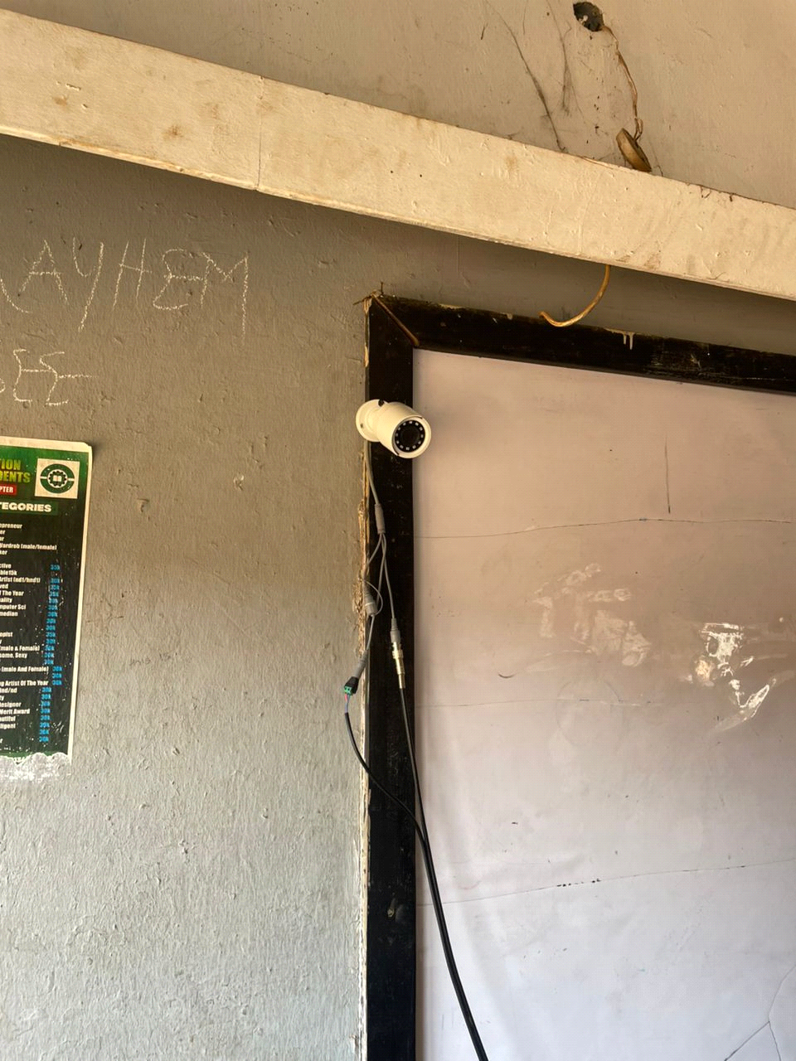 Fig 1 First Camera Installed

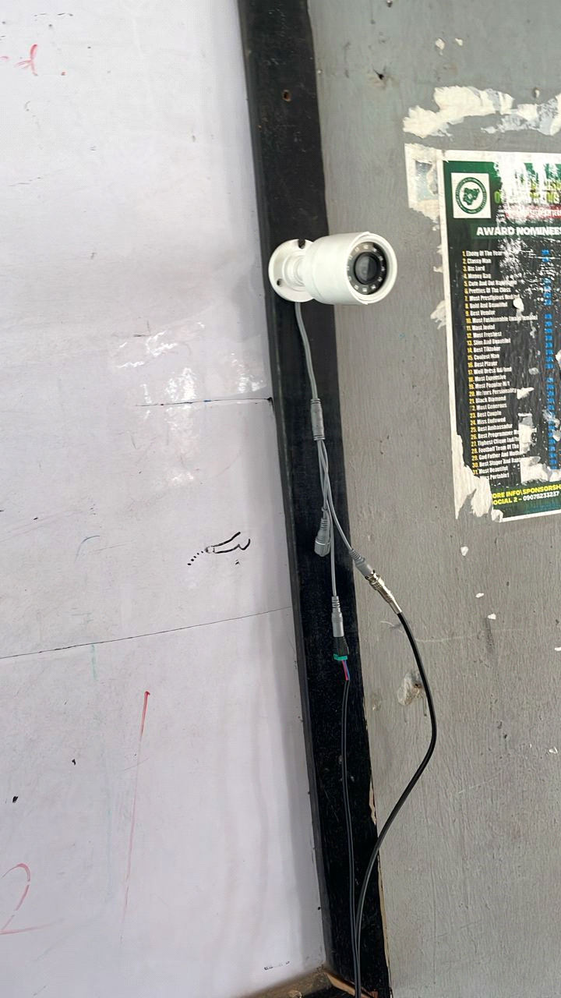 Fig 2 Second Camera Installed

Wiring and Cabling: Coaxial and power cables were passed through PVC conduits to ensure safety and durability. All cables were routed to a central point where the DVR and monitor were installed.

Inverter and Battery Setup: The inverter and batteries were installed in a safe, ventilated corner of the room. All power connections were made to enable automatic switch-over in case of power outage.

Device Configuration: The DVR was configured to detect motion, store footage, and allow playback. The cameras were adjusted for focus and field of view. The inverter was programmed to activate seamlessly during electricity failure.

Testing and Trouble shooting: Multiple tests were conducted to check for uninterrupted power transition, clarity of video footage, and storage integrity. Adjustments were made to camera angles and cable placements where necessary.

3.5 Challenges Faced

Difficulty in running concealed cables through walls and corners

High cost of quality batteries

Inverter configuration complexity for automatic switch-over

Despite these challenges, careful planning and local expertise enabled the successful completion of the project.

3.6 Summary

This chapter described the step-by-step methodology for implementing the inverter-based CCTV system in LR 28. From analysis and material selection to installation and final testing, the process was thoroughly executed to ensure the system performs reliably during examination periods without dependence on the public power supply.

CHAPTER FOUR
SYSTEM IMPLEMENTATION AND OUTPUT
4.1 Introduction
This chapter presents the practical implementation and output results of the inverter-based CCTV surveillance system designed for examination monitoring in Lecture Room 28 (LR 28) at Kwara State Polytechnic, Ilorin. It covers how the system components were physically integrated, the step-by-step process of installation, configuration, and actual outputs from the surveillance cameras.
4.2 Installation Overview
As planned in the previous chapter, the system was built around the strategic installation of two CCTV cameras within the classroom. These cameras were both mounted indoors. One was placed at the first front side of the class, facing the students directly, while the second was mounted at the second front side, capturing a diagonal view across the room to provide broader visual coverage.
This dual-camera positioning ensures full visibility of students' movements, their interactions during examination sessions, and any activities around the entrance. These two cameras feed their video signals to a Digital Video Recorder (DVR), which stores and displays live footage on a connected monitor.
The entire power system supporting the CCTV setup is backed up by a 3kVA inverter connected to two 200Ah deep cycle batteries, ensuring the system functions even when there is a power outage. The inverter is programmed to automatically switch to battery power whenever there is a failure from PHCN and revert back once power is restored.

I. Two CCTV Cameras – Installed at opposite front sides of the classroom for maximum coverage.

Fig 1 Camera One
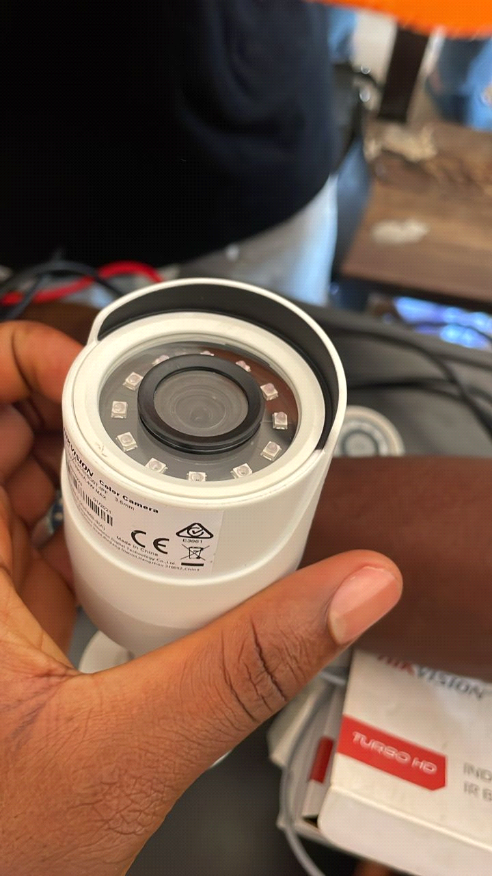

Fig 2 Camera Two
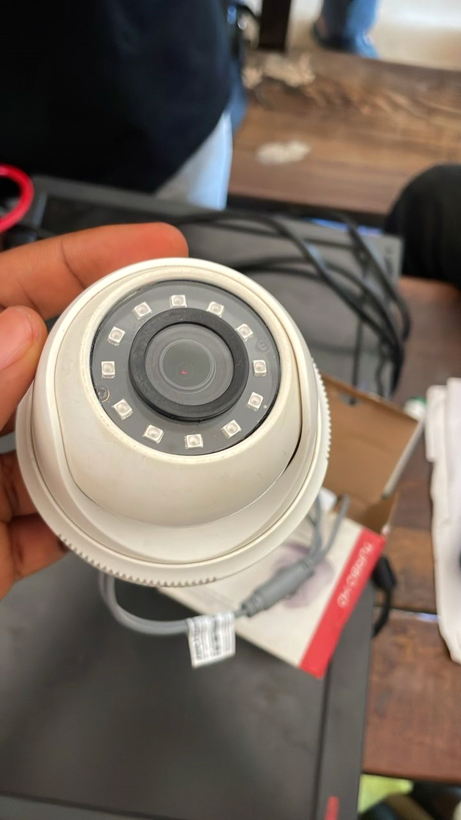

II. Digital Video Recorder (DVR) – For storing and managing surveillance footage.

Fig 3
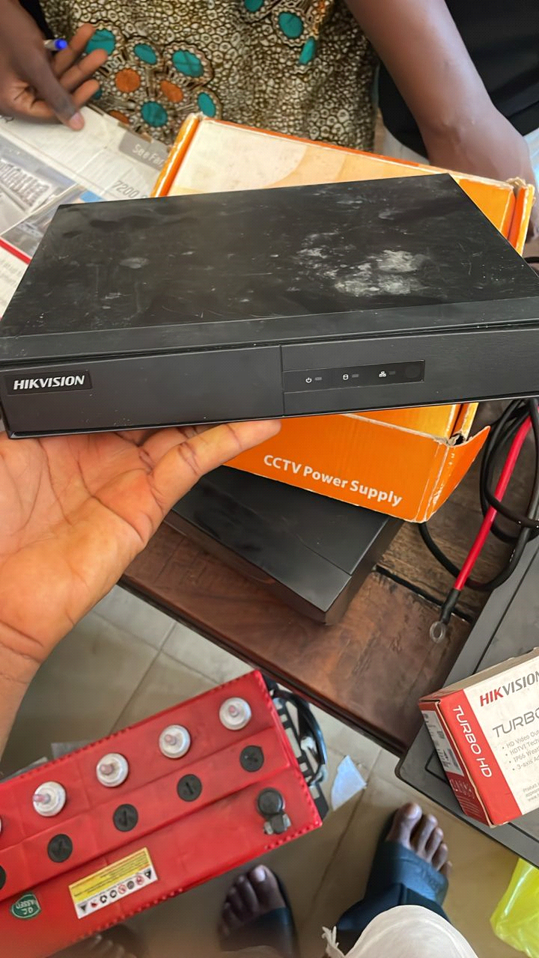

III. Display Monitor – For real-time video feed.

Fig 3
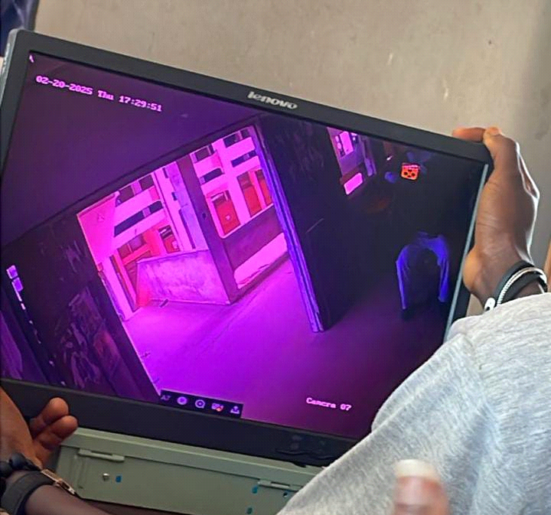

IV. Inverter – Ensures backup power during outages.

Fig 4
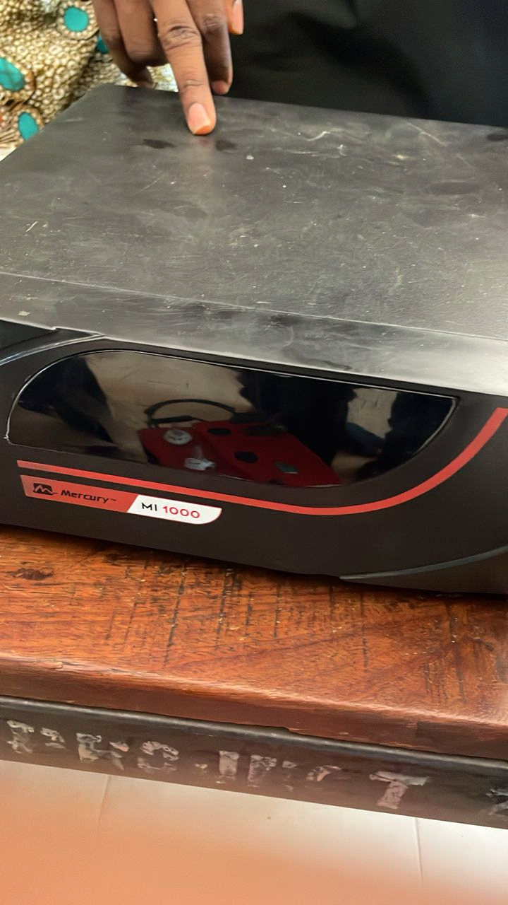

V. Battery – Provide long-lasting power support.

Fig 5
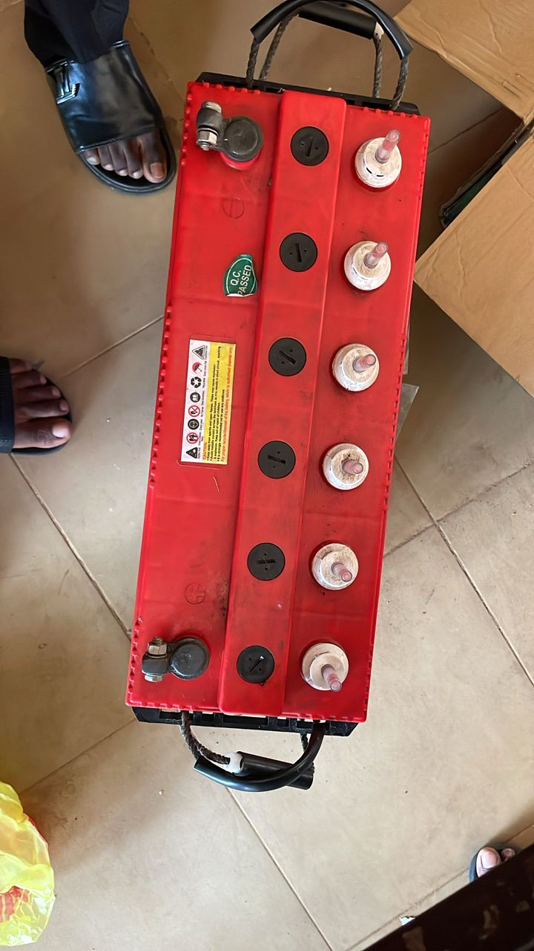

VI. Cables and Connectors – Coaxial and power cables, BNC connectors, and accessories.

Fig 6 Fig 7
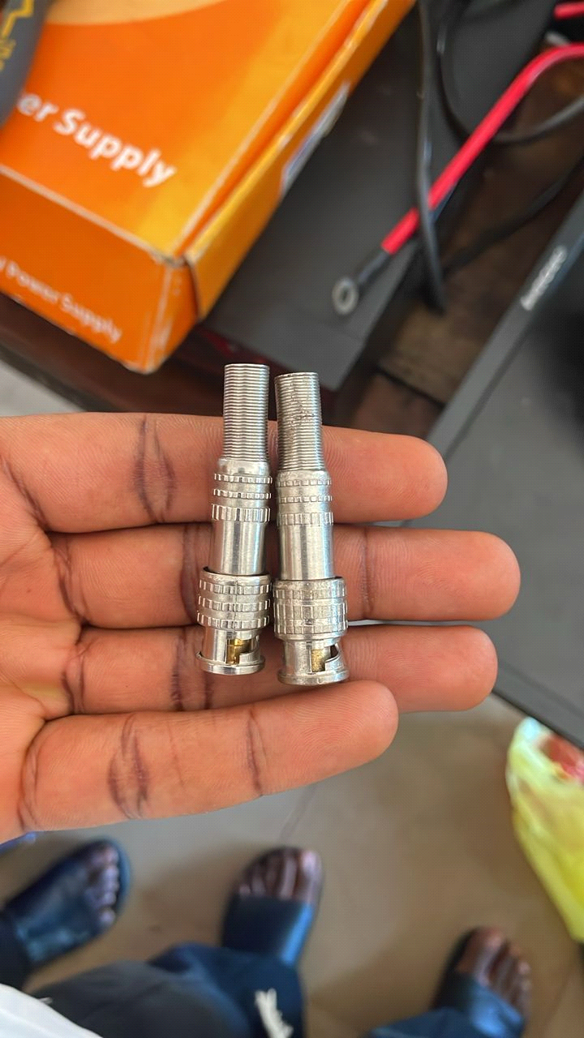 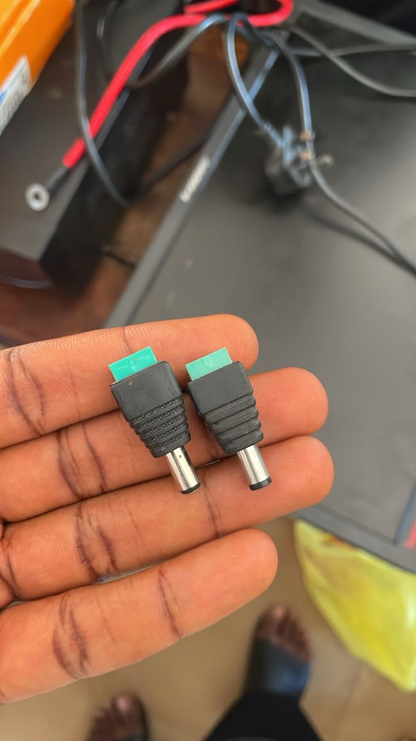

VII. Power Supply Box – Distributes power evenly across devices.

Fig 7
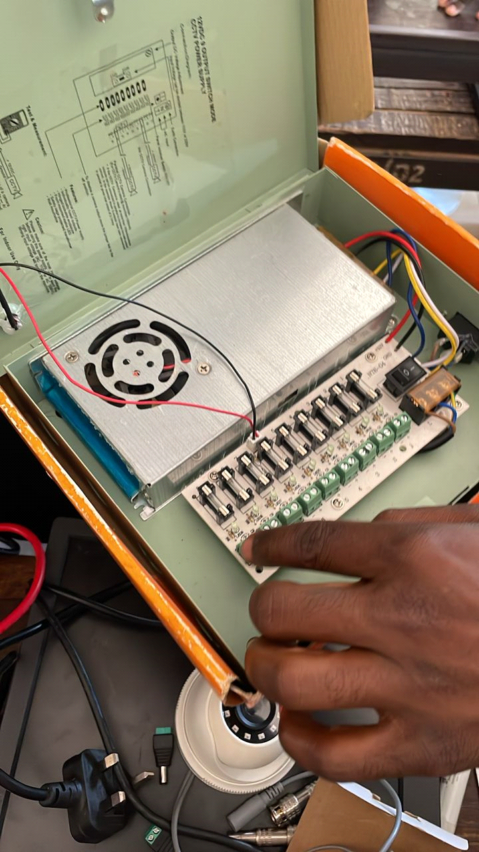

4.3 Output of Camera One (Indoor - First Front View)
This camera is installed at the first front side of the class, offering a clear, wide-angle view of the entire student seating area and the invigilator's station.
Fig. 8 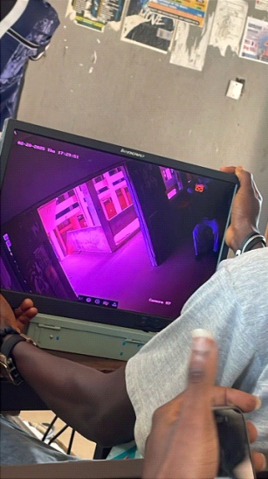
The footage from this camera provides a direct view of all students’ facial expressions and body movements, which helps in identifying any suspicious actions or attempts at examination malpractice.
4.4 Output of Camera Two (Indoor - Second Front View)
This second camera is mounted at the opposite end of the class, facing diagonally toward the center. It captures a cross-sectional view of the class, ensuring all corners of the room are within visual range.
Fig 9 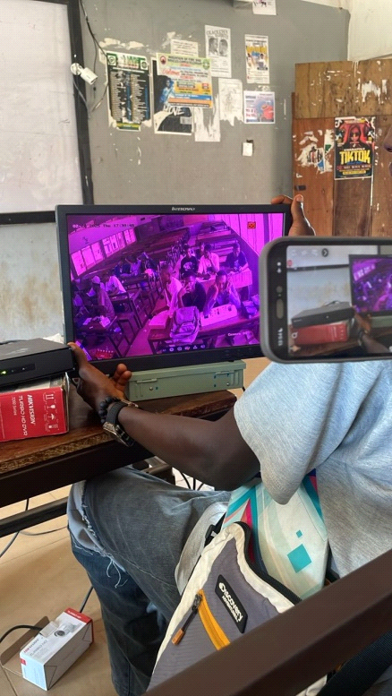

The camera output complements the footage from the first camera and provides additional angles which help in monitoring interactions among students, especially during movement or hand gestures.
4.5 Power Performance and Inverter Response
The inverter system was tested in various conditions to verify how it responded during sudden power loss. Upon simulation of PHCN power failure, the inverter immediately switched to battery supply within seconds. All connected equipment, including the DVR, monitor, and cameras, continued functioning without any disruption.
The battery backup lasted for over five hours during a complete power-down test, proving the reliability of the inverter system in maintaining continuous surveillance during examination periods.

4.6 Summary
This chapter detailed the actual implementation of the inverter-based CCTV system in LR 28. From the installation of two strategic cameras to the integration with a robust power backup system, the output from each device was evaluated and confirmed to support uninterrupted monitoring. The system proved effective in providing clear, real-time surveillance throughout the examination session, even during power outages.

CHAPTER FIVE
SUMMARY, CONCLUSION AND RECOMMENDATIONS

5.1 Summary
This project focused on the practical implementation of an inverter-based CCTV surveillance system aimed at improving examination monitoring in LR 28 of Kwara State Polytechnic, Ilorin. The implementation involved the integration of surveillance cameras, a digital video recorder (DVR), display monitor, power backup through inverter and deep cycle batteries, and proper cable management to ensure uninterrupted surveillance even during power outages. Chapter One introduced the general idea and motivation behind the project, defining the objectives, significance, and structure of the study. Chapter Two covered an extensive literature review on previous works related to examination monitoring and the use of CCTV in educational environments, including Nigerian-based studies (Adebayo, 2017; Eze, 2021; Nwachukwu, 2023). Chapter Three explained the step-by-step methodology used to execute the project—from site analysis and planning to installation, configuration, testing, and deployment. Chapter Four discussed the output of the installed components, showcasing how the camera feeds function and how the system responds during a power outage. Through all these chapters, the project has demonstrated that combining CCTV with inverter power backup provides an effective and sustainable solution to combat examination malpractice and power instability during exams (Olatunji, 2019; Yusuf, 2020).

5.2 Conclusion
In conclusion, the implementation of an inverter-based CCTV surveillance system in LR 28 has proven to be a beneficial initiative. The deployment ensures that monitoring of students during examinations is continuous and unhindered by power failures. By installing two indoor CCTV cameras at opposite front sides of the lecture room and supporting them with a reliable inverter and battery setup, the project has succeeded in achieving its primary aim—to support exam integrity and discourage malpractice (Adebayo, 2017; Eze, 2021). Furthermore, the installation method adopted ensures minimal disruption to classroom infrastructure while providing maximum coverage and security. The power system guarantees uninterrupted video recording even in the absence of public power supply, a frequent issue in many parts of Nigeria (Olatunji, 2019; Nwachukwu, 2023). The success of this implementation indicates the possibility of expanding this system to other lecture halls within the polytechnic and similar institutions across Nigeria (Yusuf, 2020).

5.3 Recommendations
Based on the findings and implementation process, the following recommendations are made: extension to other halls whereby the inverter-based CCTV surveillance system should be replicated in other examination halls across the institution to promote standard monitoring practices (Adebayo, 2017); maintenance training where technical staff within the school should be trained to handle minor maintenance and troubleshooting tasks to ensure the longevity of the system (Olatunji, 2019); regular power backup testing where routine checks should be conducted to verify the readiness of the inverter and battery system before each examination period (Nwachukwu, 2023); storage and backup management where external storage devices or cloud options should be explored in future implementations to ensure long-term storage and retrieval of video footage (Eze, 2021); policy implementation where the school management should officially integrate CCTV surveillance as part of its examination policy, reinforcing its role in reducing malpractice (Yusuf, 2020); and upgrading cameras, suggesting future upgrades can include high-resolution or night-vision cameras to enhance the quality of monitoring, especially in low-light scenarios.

5.4 Final Thought
This project has shown that technology can be used not only for teaching and learning but also as a critical tool for ensuring academic integrity. An inverter-based CCTV system is not just a monitoring device; it is a statement of the institution's commitment to transparent and credible examinations. Implementing such systems across educational institutions in Nigeria will go a long way in upholding standards and fostering discipline among students.

5.5 References
Adebayo, M. A. (2017). Digital surveillance systems as a tool for examination integrity in Nigerian tertiary institutions. Journal of Educational Technology and Development, 12(3), 45-58.

Eze, B. C. (2021). A study on the impact of CCTV deployment in public Nigerian universities during examinations. International Journal of Education and Security, 8(1), 23-36.

Nwachukwu, I. A. (2023). Implementation of CCTV with solar-powered inverters in rural-based institutions. Journal of Renewable Energy and Education Technology, 15(2), 78-89.

Olatunji, F. K. (2019). Powering ICT tools in Nigerian institutions: Inverter systems as a solution to inconsistent power supply. Nigerian Journal of Electrical Engineering, 10(4), 55-67.

Yusuf, H. M. (2020). Technological innovations and examination administration in Nigeria’s polytechnics. African Journal of Educational Management, 7(2), 102-117.

