ASSESSMENT OF LAND USE CONVERSION IN ADEWOLE HOUSING ESTATE, ILORIN.

BY
RABIU JAMIU OLADEHINDE

MATRIC NUMBER:
HND/23/URP/FT/0002

SUBMITTED TO:
DEPARTMENT OF URBAN AND REGIONAL PLANNING
INSTITUTE OF ENVIRONMENTAL STUDIES
KWARA STATE POLYTECHNIC, ILORIN

JULY 2025.


31-07-2025

DEDICATION
This project is dedicated to Almighty Allah for sparing my life from the day i was born, during the course of my program wish am really grateful for the grace, also for my dedicating parent for their full support.
ACKNOWLEDGEMENT
Alhamdulillah! Alhamdulillah!! Alhamdulillah!!!
All thanks, praise, adoration and worshipping to almighty Allah the most gracious and merciful the origin of the whole being, once again give thanks to Almighty Allah for his protection and saving me throughout the period of the course.
My sincere and unlimited gratitude goes to my parents Mr and Mrs. Rabiu and my beloved family, ustarz and friends for their love and kind towards my carrier, my profound gratitude to my able supervisor TPL. M. S. IBRAHIM for his fatherly support and making himself accessible throughout the duration of this project work. I pray may Almighty Allah always put you in his protection and blessing (Amin).
I appreciate my Head of Department TPL. E. S. ADEKANYE for his fatherly role he has played in our life during the program may God reward you abundantly (Amin). I love you all.

ABSTRACT
Conversion in any form and in any society is inevitable, it has become part of an urban growth. For economic reason, land and building will continue to be converted in its uses, from lower order to higher order status in other to attain optima use. Such conversions usually result into land being allocated to its highest and best use culminating in higher economic returns. This study take a close look at conversion in land use pattern within Adewole housing estate, Ilorin, kwara state. Observations and questionnaire were administered to some residents, shops, offices and dwellers in the study area. Data obtained are analyzed with the use of descriptive statistics, particularly percentage. Finding shows that there is no change in the pattern (shape) of the study area. It also shows that the conversion from residential to commercial is high which leads to corresponding conversion in property use in the study area. Moreover the conversion is also creating problems such as noise pollution, over stretching of infrastructural facilities and incompatible land use. There is therefore the need for adequate land use planning to take care of conversions brought about by increase in commercial activities. In addition, there is need for town planning authority to monitor the process of conversion to prevent negative effect on the environment
TABLE OF CONTENTS
Title page i
Certification ii
Dedication iii
Acknowledgement iv
Abstract v
Table of content vi
Chapter One 1
1.0 Introduction 1
1.1 Statement Of Problem 2
1.2 Aim Of The Study 2
1.3 Objectives 3
1.4 Scope Of The Study 3
1.5 Delineation 3
1.6 Significant Of The Study 3
1.7. Historical Background 3
1.7.1 Location Of Adewole Housing Estate 4
1.7.2 Population Of Adewole Housing Estate 8
1.7.2.1 Table 1: Categories Of Housing Units In Adewole Housing Estate. 9
1.7.3 Geographical Setting Of Ilorin 10
1.7.4 Physical Setting Of Adewole 11
Chapter Two 12
2.0 Literature Review 12
2.1 Land Use Act Of Nigeria 15
2.2 State Operational Land Use Regulations 15
2.3 Concepts Of Property Use Conversion. 16
2.4 Reasons For Effective Land Use Regulations 17
Chapter Three 19
3.0 Research Methodology 19
3.1 Primary Data 19
3.2 Secondary Data 19
3.3 Data Analysis 19
3.4 Sample Frame 20
3.4.1: Table 2: Land uses in Adewole housing estate 20
3.5 Sample Size 20
3.6 Methodology chart table 21
Chapter Four 22
4.0 Data Analysis 22
4.1 Introduction 22
4.2 Land Use Pattern In The Study Area 22
4.2.1. Land Use Distribution Of Approved Master Plan Of Adewole Housing Estate 23
4.2.2. Land Use Distribution Of Existing Condition Of Adewole Housing Estate 25
4.3 The Process Of Urban Land Use Conversion In The Study Area 25
4.3.1 Table 5: The Process Of Land Use Conversion In The Study Area. 26
4.4 Socio-economic characteristics of the respondent. 27
4.4.1. Sex Of The Respondent 27
4.4.2. Marital Status Of The Respondent 27
4.4.3. Age Of The Respondents 28
4.4.4. Level Of Education 28
4.4.5. Occupation Of The Respondent 29
4.4.6. Period Of Stay In The Study Area 29
4.4.7. Environmental Pollution 30
4.4.8. Over Stretching Of Infrastructural Facilities 30
4.4.9. Incompactible Land Uses 31
4.4.10. Effect Of Land Use Conversion In The Study Area 31
4.5 Identification Of Conversion That Of Happen In Years (1979-2025) In The Study Area 32
Chapter Five 36
5.0 Summary, Recommendation And Conclusion 36
5.1 Summary Of Finding 36
5.2 Recommendation 37
5.3 Conclusion 38
5 4 Reference 39

TABLE OF FIGURES
Figure 1: MAP OF NIGERIA SHOWING KWARA STATE 5
Figure 2: MAP OF KWARA STATE SHOWING ILROIN WEST LOCAL GOVERNMWNT MAP 6
Figure 3: MAP OF ILORIN WEST LOCAL GOVERNMENT 7
Figure 4: MAP OF ILORIN WEST LOCAL GOVERNMENT SHOWING ADEWOLE ESTATE 7
Figure 5: AERIAL MAP OF ADEWOLE ESTATE 8
Figure 6: APPROVED MASTER PLAN OF ADEWOLE HOUSING ESTATE 23
Figure 7: EXISTING CONDITION OF ADEWOLE HOUSING ESTATE. 25
Figure 8: RESIDENTIAL FACILITY CONVERTED TO EDUCATIONAL FACILITIES IN THE STUDY AREA 34
Figure 9: RESIDENTIAL FACILITIES CONVERTED TO COMMERCIAL FACILITIES IN THE STUDY AREA 34
Figure 10: RESIDENTIAL FACILITY CONVERTED TO EDUCATIONAL FACILITIES IN THE STUDY AREA 34
Figure 11: NIGERIAN NAVY RESIDENTIAL QUARTERS IN THE STUDY AREA 35
Figure 12: AMIR SUITE COMMERCIAL FACILITY IN THE STUDY AREA 36
Figure 13: RESIDENTIAL FACILITY CONVERTED TO EDUCATIONAL FACILITY IN THE STUDY AREA 36

CHAPTER ONE
1.0 INTRODUCTION
The term Land suggest different thing to different people depending upon their outlook and their interest in the Land (Barlowe 1978). It is the sum total of the natural and man-made over which the possession of the earth surface gives control. It is the land form of all human activities, economic, social, spiritual. The entire land area of a country can be broadly divided to urban rural lands. Within an urban area, a rational pattern of land use evolved as an urban area consist of a great number of independent activities and choice of location of any urban is normally decided by assessing the relative advantages of site location for the performance of such activity. Therefore, in any urban, activities tends to locate in the area that give the land use relative advantage. Thus, by a process of competition, land use seek out and segregate themselves in that area in which the optimum conditions (latest relatively advantage) are to be found in virtue of which they normally able to exclude other uses.
The differentiation of urban land use pattern becomes more simple and complex as population and degree of specialization. The economy factors of demand and supply of urban land also play a significant role in this process of land use pattern. Lean and Geodall (1966) attest that the pattern land use in any urban area to replication of competition for sites between various uses sparing through the process of demand and supply. Similar pattern of land use emerged in different urban areas because of competition between different potential users for given sites. The person who is willing to pay the largest sum for a site is likely to be the person who will eventually occupy and use it. He will be able to complete it away from other potential users. By this mechanism, sites in an urban centre depend to the used for that purpose from which the users make the greatest net gain from alternative uses for that land. The scenario above becomes a continuous process of change in uses. This is the exact situation that as been observed in my study area. This study therefore, seek to the assessment of land use conversion in Adewole housing estate, Ilorin.
Thus, by investigating how conversion in the use of land affects it value, it may be possible of identify existing use abuses and there by proffered solution that guarantee optimum use of available and resources.

1.1 STATEMENT OF PROBLEM
The sporadic development without proper co-ordination in the study area, had lead to various problem ranging from over stretching infrastructural facilities, alteration in land use, incompatible use of land and noise pollution.
Moreover, Urban land use is the physical manifestation of socio economic, cultural, political environmental forces shaping the use of the land in urban areas (Akinmoladun and Oduwaye, 2004).
The spatial Pattern and nature of proportion land uses in urban area is largely influence by the national policies and economy such as housing, it shows assessment of land use conversion case study of Adewole housing estate, Ilorin.
Generally speaking, urban land uses are used for various purposes but the most common type of uses includes residential, commercial, industrial and recreational etc. in most cities however, residential use always covers between 50-60% (Herbert and Thomas, 1982) compromising houses of various Kinds ranging from detached houses, the area coverage by different land uses are influenced by many factors, which includes socio economic, physical and environmental technical infrastructure, government policies and laws. In metropolitan Ilorin, some are exclusively planned for residential uses. Commercial uses include areas used for activities such as market place, shops, shopping complexes, offices and exhibition centers. As some of this specific uses are planned for in some urban areas, some grow out of the spontaneous needs of community in a residential area. The provision of access roads both pedestrian and vehicular usually lead to the up spring of blocks, office and shopping complexes along the access route.
1.2 AIM OF THE STUDY
The study attempts to examine the level of land use conversion in Adewole housing estate, Ilorin with a view to improving the living environment.

1.3 OBJECTIVES
- To identify the land use pattern in the study area.
- To examine the process of urban land use conversion in the study area.
- To examine the effect of the conversion in the study area
- To identify the conversion that has taken place over years.
- To recommend possible solution to the problem in the study area.
1.4 SCOPE OF THE STUDY
The study areas cover the whole Adewole Housing Estate, and the research work is concerned with conversion in land use pattern land use the study provide the high lists of the existing land uses situations within the study area.

1.5 DELINEATION
This project is looking into those plots of built up land within the study area (Adewole housing estate)
1.6 SIGNIFICANT OF THE STUDY
The study would provide information and indebt knowledge on the state of land use pattern conversion. The information will help different individual, parastatals, government and other related organization, it will also help the planning authority and kwara state investment and property developers in making reshaping policies and practices relating to the changes in land use pattern, in the study area.
1.7. HISTORICAL BACKGROUND
The creation of the state dated 1967 by federal government of Nigeria which leads to creation of Kwara state from northern region. The federal government of Nigeria at the regime of His Excellency SHEU SHAGARI make the creation of Adewole Housing Estate in 1979 Majorly for the civil servants for an affordable and comfortable housing standards of living.
This project which is primarily for the low income civil servants which were later hijacked and non of the low income earners where unable to get allocations there, the mismanagement and improper allocation of Adewole Housing Estate lead to the handing over of the Estate to the state government and is now being manage by the Kwara State Investment and property developers.
Major problems confronted all the newly created state then where the acute shortage of accommodation for the masses. In its efforts to cushion the inadequate supply of housing cooperation whose primary responsibilities was to increase supply of housing at affordable cost. Kwara state housing corporation was set-up in 1975 to manage all the government staff quarters in the state quarters in the state and construction of more housing state in the state, this led to the construction of Adewole housing estate in 1979.
1.7.1 LOCATION OF ADEWOLE HOUSING ESTATE
Adewole housing estate is located in the southern part of the state. It is located in Ilorin West Local Government with is headquarter in the emir's market near central mosque Ilorin. It is situated immediately after government high School Ilorin main gate and linking up to university of Ilorin (Mini campus) and Kwara state college of education, Ilorin. The estate is bounded by western reservoir road that links Geri-Alimi and Umar Saro Road Ilorin (Ilorin-Lagos road).

Figure 5: MAP OF NIGERIA SHOWING KWARA STATE

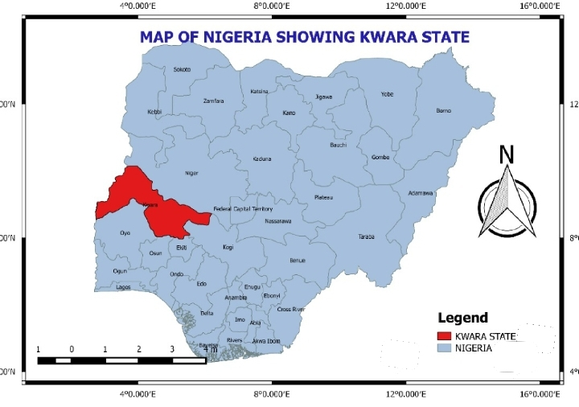
SOURCE: KWAGIS 2025.
Figure 6: MAP OF KWARA STATE SHOWING ILROIN WEST LOCAL GOVERNMWNT MAP
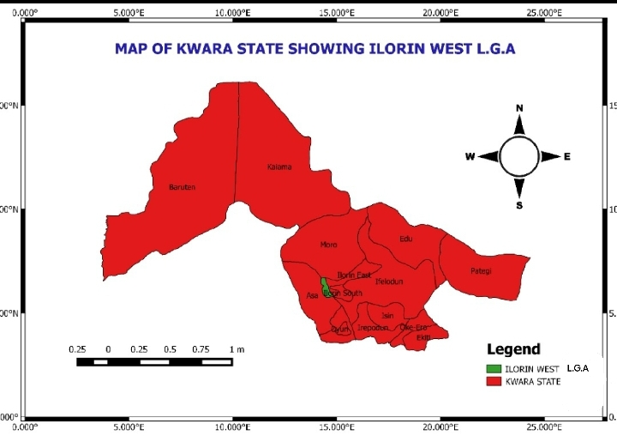
SOURCE: KWAGIS 2025
Figure 7: MAP OF ILORIN WEST LOCAL GOVERNMENT
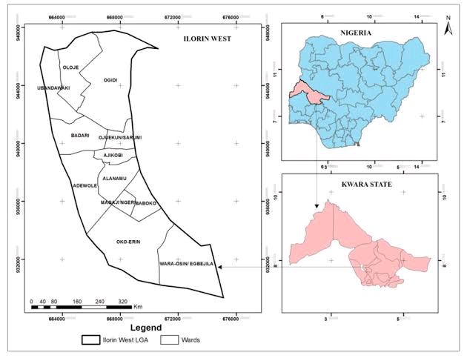
SOURCE: KWAGIS 2025
Figure 8: ILORIN WEST LOCAL GOVERNMENT SHOWING ADEWOLE ESTATE
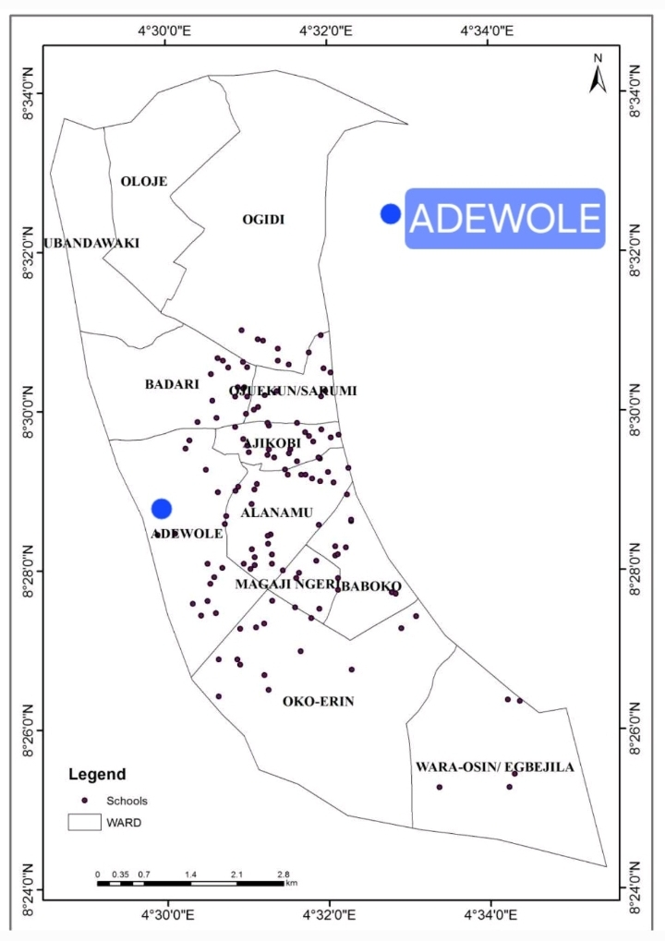
SOURCE: KWAGIS 2025

Figure 9: AERIAL MAP OF ADEWOLE ESTATE
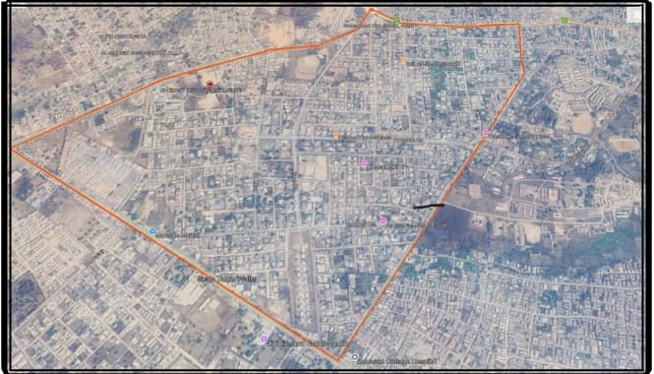
SOURCE: KWAGIS 2025
1.7.2 POPULATION OF ADEWOLE HOUSING ESTATE
Adewole as a planned neighborhood comprises of different proto type housing unit categorized into duplex, 2 bedrooms bungalows, 3 bedrooms bungalows, 4 bedrooms bungalows, 4 bedrooms maisionatte. Presently the total number of photo type housing units in Adewole housing estate was put at One thousand one hundred and seventy five (1175) housing units.

1.7.2.1 TABLE 1: CATEGORIES OF HOUSING UNITS IN ADEWOLE HOUSING ESTATE.
S/N | UNITS | FREQUENCY
1 | DUPLEX | 169
2 | 2 BEDROOM BUNGALOWS | 137
3 | 3 BEDROOM BUNGALOWS | 373
4 | 4 BEDROOM BUNGALOWS | 328
5 | 4 BEDROOM MAISIONATTE | 168
 | TOTAL | 1175
SOURCE: FIELD SURVEY 2025.
However, the development of Adewole Housing Estate in Nigeria can be easily traced to the era of oil boom. The oil boom in the year [1970] led to the rural and urban migration in search of education, employment opportunities, good health care services and to enjoy better living condition in the cities. As a result of this ugly trend, federal government took it upon her to provide accommodation for urban teeming population in the country by embarked on building of housing units in each of the state headquarters of the federation as entrenched in the second development plan [1970-1974].
Adewole Housing Estate as a low cost housing estate designed primarily for low income earners to carter for their housing needs was a successful and welcome programs. Hence, the federal government notified all the state governments of her intention to provide accommodation for her teeming populace. In response to this call, Kwara State Government set up a task force of thirteen members addled with the responsibility of finding a suitable location construction of housing estate for the state. Thus the report of the committee suggested Adewole. This however materialized to the present Adewole Housing Estate.
Subsequently, the federal government commissioned a licensed Surveyor to carry out a parameter survey of the area in conjunction with the state ministry of works. Adewole housing estate has a total area of 265 acres of land cover (Kwara state investment and property developer 2025)
To this end, it is pertinent to note that the allocation of these houses was made to the high and medium income earners contrary to the plan. The Kwara State Investment property corporation which replaced the disbanded housing corporation is now responsible for the management and maintenance of the Adewole Housing Estate.
1.7.3 GEOGRAPHICAL SETTING OF ILORIN
Ilorin lies some 302 kilometers north of Lagos. It lies along Lagos-Kaduna highway on Latitude 8 30'N and Longitude 5E. It is a transition Zone between the open savannah belt of which it is an integral part of the north and forest area to the south. in this geographical impact, probably. Ilorin could not have been significant in Nigeria history as it eventually becomes, if Oyo-ile ife, capital of old Oyo empire about 64 kilometers north- west of Ilorin, had survive as a major urban centre or the Muslim emirate had succeeded in conquering other major centers further as Ogbomoso[56km] away within the major center to the south as part of Sokoto caliphate, it geographical location has enhanced by the political, religion, economic, social and cultural roles it was desired to play. Ilorin is underlain by crystallize rocks of the pre-Gambia complex. Many out crops of this basement appear at random along low lying river beds as well as on the slopes and tops of hills. The uniforms aspect of landscape is particularly striking because of the open character of the vegetation; this gives room for the growth of Ilorin. Ilorin is on the northern margin of the West to East keeping Yoruba's plateau which covers one third of the South -West Nigeria. The lowest elevation within the town is about 270 meters on both banks of Asa River where small-scale Gardner partake. Ilorin is situated about 50 kilometers of the water shield between the Atlantic basin of the river Niger which is 72km north of Ilorin.

1.7.4 PHYSICAL SETTING OF ADEWOLE
Adewole lies some few kilometers away from the centre of Ilorin, it lies along Adeta area which have its attachment to ilorin west local Government. The Adewole Housing Estate is in the centre of Ilorin land before it was handled by the Federal Government few years ago with the sole aim of solving accommodation problems of the teeming population in the state, but presently the Estate is being controlled by Kwara State Property Development cooperation.

CHAPTER TWO
2.0 LITERATURE REVIEW
Property use conversion issues that are gradually becoming a typical issue of national and regional discuss in the sub-Saharan African countries particularly Nigeria, is an insignificant issue in the developed countries where land and property use related laws and the provisions of master plans are strictly observed and adhere to. Despite the magnitude of property use conversions in Nigeria and its significance to the national economy, they exited scanty documented literature on property use conversions issues and their influences on property rental values in Nigeria.
Bosikun (2021) evaluated the socioeconomic factor influencing land use conversions in the Apete area of Ibadan, Nigeria and found that, population growth, location, economic, demand, age structures among others are the causative factors for property use conversions in the study area. The study thus, recommended routine monitoring and the inspections of developments, strict adherence to master plan, enlightenment campaign and the serving of appropriate contravention notices to deserving developers. The study however did not reveal the influence of the identified conversion factors on property rental values in the study area, hence there exist a knowledge gap that need to be filled.
Makinde and Makinde (2020) analyzed land use succession and property value in Ile Ife, Nigeria between 2002 and 2016 using both inferential and descriptive statistical tools. The study revealed about 42.2% increase in residential properties stock while the commercial properties stock grows by 57.8% within the same period with significant relationship between land use succession and property values. Though, despite establishing a relationship between property values and land use succession in the study area with significant loss in the residential housing stock, findings of the study seem to be too general and unfounded as there was no further test to determine if significant differences exist in the rental values of the property types studied due to land use succession effect.
Akanbi (2019) assessed the purposes for property use conversions in Minna Metropolis. The study disclosed that conversions mostly done in the study area were from residential property use to commercial or mixed use with complete disregard to the existing land and property use laws in the state with the attendant consequences of indiscriminate waste disposal and traffic congestions. It thus recommended effective and careful development control and urban planning measures. Like Bosikun (2021), the study did not assess the influence of property use conversion on property rental values; hence, the need for further examination of phenomenon on rental values in Nigeria cities. The National Association of Realtors (2021) Research Group in their April 2021 report on commercial real estate trend and outlook averred a weak recovering commercial real estate market compare to the period proceeding the COVID-19 pandemic era. The report however predicted a stronger recovery trend across every sector by 2022.
Michaella Otto, Jacob Adejare Babarinde and Paulus Motoro (2020) reviewed literature on some conventional urban models that showcase the current patterns of residential property rentals and prices in cities, using the city of Lae in Papua New Guinea as the test bed for the study. The study identifies the conventional models that mirror the actual situation that reflects the decisions of landlords and tenants of residential properties to resides in their current areas in the city. Issues of spiraling residential property rentals and prices in the city of Lae have become an issue of national concern just like the case of Ikeja, Nigeria that is gradually and steadily pushing the low-income and the middle-income residents to the squatter settlements where rents are relatively affordable. The study employed stratified random sampling technique in the selection of 218 property owners and tenants which is considered to be a fair representative sample of the formal and informal Lae City residents. Six residential districts were selected for the study in addition to the selected top real estate brokers and urban planner. The interview conducted was done in conformity with COVID-19 pandemic restrictions protocol. The study found that a mixture of socio-economic, cultural and behavioral factors, rather than the obvious influence of conventional model of city structure play a predominant role in influencing the behavior of residential tenants and landlords in the search for residence within the city to the extent that squalor settlements are preferred by many. Social factors as safety of lives and property, security and economic variables were confirmed by the tested hypotheses to be the major determinants of residential choice in the city. The study therefore recommended measures that can improve the standards of city live ability, housing affordability, sustainability and livelihood need to be considerately implemented in real time by the Lae city stakeholders.
Similarly, a study by Nguyen (2020) evaluates the method and process of transferring values of natural resources into the national account system in Vietnam. The study objectives are among others re-systemizing the classical and modern theories as well as identifying the factors affecting the land/property values in Vietnam with the view to support Government policy making and regulating land use rights market in the study area. The study isolated three groups of factors that could impact on land/property values. The study revealed that, the adoption of value theory and the development of land value maps support the effective management and regulation of land/property use rights by the Vietnam government. Urban property use change is a major driver of universal environmental change and a central factor of the global sustainable development agenda. The adoption of similar study in Ikeja could help in solving the reoccurring land and property use issues.
Akinluyi et al. (2021) assessed the effect of land use change on some selected urban public utilities in the city of Akure, Nigeria with a view to improving the approaches to protect the urban utilities for sustainable development. The study employed the use of remote sensing, Geographical Information System and questionnaire in the collection of the data required to achieve the study's objectives. The conversion process was identified through the use of 2010 and 2018 IKONOS imagery (an earth observation satellite) in a post classification comparison analysis to map the land use changes in the study area. Findings of the study revealed a rapid change in the residential land use between 2010 to 2018 with an increase in commercial land uses activities.
Hence, residential, commercial housing provision and educational land uses are major causes of land use change in the study areas. The study therefore, recommended the need for the regulation of city growth and expansion and other regional development programs. Orekan (2021) examined the effects of land use planning on property values in Lagos, Nigeria using descriptive statistical tools such as weighted mean score, trend analysis, ANOVA testing, sample T-tests and regression analysis. Findings from the study revealed that building permits or approvals, land use charge (payment for the productive use of land), building codes and zoning are the major land use planning policy tools used by the state. The study further discovered that inadequate evaluation, monitoring and implementation of these planning tools, noncompliance with planning and development standards were some of the challenges faced by land use planning and policy makers in Lagos. The study also established a positive significant relationship between land use planning and property values in the state. It thus, recommended the need for comprehensive monitoring of land uses and the enforcement/implementation of planning policies by the relevant stakeholders.

2.1 LAND USE ACT OF NIGERIA
Land a major factor of production is required for different purposes such as agricultural, recreational, residential, industrial and other purposes. The difficulty of the government to acquire land for public purpose led to the enactment of the Land Use Act, 1978 now Cap 202 LFN 2004. By the nature of this Act, all land comprised in the territory of a state is vested solely on the state Governor in trust for the people of the state and who would allocate such lands as found in the state for various purposes for the common benefit of all. The Act identified the control and management of land and the formation of advisory bodies at state and local Government areas, designation of urban areas by the governor, identified the powers of the governor and local government (political influence can affect the powers) and other provisions.
The act in part I, section 4 under the applicable law for the interim management of land has created rooms for the provision of other laws in relation to land use as subject to the provision of the Land Use Act. It implies that each state can have other provisions for land use that should be in tandem to the Act. However, in part VIII supplementary provisions section 43, the Governor has the right to prohibit and penalize offenders for unauthorized use of land in the state. Its implication is that all use of land in the urban area must be authorized by the state Governor through the appropriate authority saddled with the responsibility of granting authorization through approval. The approval process should be a provision existing in the appropriate authority for compliance by all stakeholders.
2.2 STATE OPERATIONAL LAND USE REGULATIONS
Ideally, every state of the Federation of Nigeria is expected to have an operational land use policy but according to Baadom & Eebee (2016) other than the Federal Land Use Act, the state has no other tangible land policy. Ayotamuno, Gobo & Oweiin (2010) also noted that effective land use planning and management do not exist because Owei & Nwikpo (2005) stated that the State Physical Planning and Development Law of 2003 has not been fully implemented as the administrative framework proposed is not yet established and even at the Local Government Level, there are no planning Authorities established as required by the law.
However, there are laws relating to land use which designated various uses to different areas. Land is designated for the residential area, industrial area, commercial operations, educational (institution), open space, recreation, and other facilities are recognized as the various operational Land Use patterns in the Port Harcourt Master Plan of 1975 (Baadom & Eebee, 2016). Different land uses for various purposes are allotted plots and plots to building ratio included. The Port Harcourt building regulations state that residential dwellings can only cover half the plot, with the rest left as open spaces (Ayotamuno, Gobo & Owei 2010).
Land use regulations and controls are implemented using approvals. According to Yakob et al. (2012). planning control is introduced throughout the statutory approval process, and it was observed that, given its potential to impact social, economic, and environmental aspects of quality of life, non-compliance appeared to be the most contentious obstacle to attaining sustainability. The social is how it affects human behaviour and interactions, safety and security, users comfort, accessibility of facilities and aesthetics. The economic sustainability in terms of value preservation, conservation and increase as well as risk analysis. The environmental is related to the physical where the property is located such as transport systems, biodiversity and ecosystem preservation and material selection (Yakob et al., 2012) and contributes to haphazard physical development (Dambeebo & Jalloh, 2018).
An appropriate regulation for property uses conversion helps to inform property investment decisions and concomitantly improves and sustain property values. Makinde (2020), noted that land use conversion causes an increase in property rental value but recommended it should be regulated, monitored, controlled and enforced by the various relevant government agencies of the city so as to inform property investment decisions.

2.3 CONCEPTS OF PROPERTY USE CONVERSION.
Property use conversion is a change that occurs when a land is put into different use from what is initially zoned and intended for (Akinluyi, Oyinloye & Aladekoyi, 2021; Ogungbemi, 2012) which continues due to resources exploitation and competition for highest and best use (Olurin, 2010 in Adepoju & Adepoju, 2016; Adegunle, Fateye & Agbato, 2016). Property use conversion occurs in diverse forms such as in its layout, rate of change and density (Nuissl & Siedentop, 2021).
As much as there are benefits of property use conversions also exists consequences if not properly regulated. Nuissl & Siedentop (2021) noted that some of the undesirable consequences are urban sprawl and other environmental issues. Hence, before any physical redevelopment, approval is needed; laws governing land-use changes and developments must be strictly enforced; the public must be made aware of these regulations; site inspections and monitoring must be done effectively; and there must be a greater emphasis on providing property investors with expert advice and services related to property conversion. (Adegunle, Fateye & Agbato, 2016). The performance of government in assigning housing responsibilities may have a negative or positive (Yang, et al., 2023) impact on property uses hence appropriate policy and legal instruments needs to be deployed for regulation of property use conversion.
Factors responsible for property use conversion are security, housing provision, investment potentials, accessibility, infrastructural facilities, ease of business activities and planning regulations, while ease of property management and population size of dwellers were the least determinants of change (Akinluyi, Oyinloye & Aladekoyi, 2021; Adegunle, Fateye & Agbato, 2016)
Akanbi, Yahaya & Omotayo (2019) identified Economic, Population, Social, Property acquisition, public interest while El-Barmelgy. Shalaby, Nassar and Ali (2014) stated that Geographical, environmental, economic, social, urban, public interest, logistical, demographical, and political considerations as factors responsible for property use conversion.
2.4 REASONS FOR EFFECTIVE LAND USE REGULATIONS
Approval and compliance to Policy regulations is important for any conversion to be initiated. The first step for property uses conversion is the pursuant and granting of approval. In order to provide high-quality buildings then property use conversion must strictly conform to planning controls that are individual case based to a standard in a more comprehensive prescriptive approach (Madeddu & Clifford, 2022).
Despite the necessity and benefits attached to complying to land use regulations for conversion reasons, some stakeholders are reluctant to seek and/or grant approval. Yahaya & Omotayo (2019) revealed in their study the majority of respondents never obtained their land from the government; as a result, they converted their properties without following the official planning permit approval process. Owei & Nwikpo (2005), discovered even in places where land use regulations are present the lack of effective land use regulations in the city means that a large portion of development does not go through official approval processes. According to Babatola & Oni (2014) and Babatola & Oni (2017), stated that what is applicable in Lagos metropolis shows that the ordinance that governs and prescribes property development generally in disapproves of the conversion of land without first requesting permission and suggests that the legal penalty for such a violation be complete demolition and heavy financial penalty for granting approval for property use conversion.
In the presence of use regulation, Collier et al., (2020) opined that in Nigeria urban plans are unrealistic, there is failure in coordinating the administration of regulation and public apathy towards planning institution which indicates the existence of limited compliance with the existing land use regulations. However, the compliance level can be enhanced by increasing enforcement capacity, reducing of compliance and building support for planning (Collier et al, 2020). Since some property owners are likely not to comply, Babatola & Oni (2014) stated that the simultaneous processes of property development and redevelopment need to be overseen and controlled by the government in order to prevent unfair political advantage and guarantee that safety requirements and laws are complied. Baffour et al, (2014), creating land use regulations that prioritise benefits above costs will increase the likelihood of increased compliance.
Babatola & Oni (2017) suggested that there should be a commitment of research that should monitor the event of property use conversion which is meant to be continuous exercise given that the conditions which influence attitude to different issues often change. Babatola & Oni (2017) Frequent investigation is needed so as to effectively gauge the extent to which changing socio-economic circumstances may be affecting decisions on the use conversion of properties with or without formal approval among other.
Arimah & Adeagbo (2000), opined that the institutional context of urban development and planning regulations; the administrative machinery for plan implementation; and the public, which is expected to comply with these regulations, are among the various parties accountable for the relatively low extent to which residential development complies with planning regulations. Arimah & Adeagbo (2000) stated that this shows that planning regulations in Nigeria have been ineffective.
CHAPTER THREE
3.0 RESEARCH METHODOLOGY
For the gaining of the above aim and objectives of this study, different measures of survey were adopted in order to collect the basic data concerned conversion in land use pattern in the study area. This includes,
- Primary Data
- Secondary Data
3.1 PRIMARY DATA: It was use by the following means namely:
i. Questionnaire
ii. Personal interview
iii. Photographic techniques.
iv. Observation
A well structure questionnaire related to the study was administered in the study area. This aid in acquiring necessary information or data from the respondents.
3.2 SECONDARY DATA: data was collected from relevance sources which includes, annual/time to time record of land use and it conversion for uphold of 46 years from kwara state town planning and development authority, Kwara state investment and property developers and kwara state ministry of recreational and commercial facilities. Other related literature consulted towards the success of this project include, journals, magazine, textbook and internet.
3.3 DATA ANALYSIS
The data collected through the use of questionnaire were analyzed in different form. The illustrations used include tables.

3.4 SAMPLE FRAME: The sample frame for this project is the total numbers of housing unit in Adewole housing estate which where accumulated to 1,175 land uses.
3.4.1: TABLE 2: LAND USES IN ADEWOLE HOUSING ESTATE.
S/N | LAND USES | FREQUENCY | PERCENTAGE
1 | RESIDENTIAL | 966 | 82.2
2 | COMMERCIAL | 141 | 12
3 | RECREATIONAL | 7 | 0.6
4 | EDUCATIONAL | 35 | 3.0
5 | PUBLIC USES | 26 | 2.2
 | TOTAL | 1175 | 100
SOURCE: FIELD SURVEY 2025.
3.5 SAMPLE SIZE: This contain the total number of land uses in the study area at the period of carrying out the research. The randomly sampling technique was adopted to select 30% of the use for administration of required questionnaire. The total 353 uses were sampled in the study area.

3.6 METHODOLOGYCHARTTABLE
S/N | OBJECTIVE | DATA REQUIRED | DATA COLLECTION METHOD | DATA ANALYSIS METHOD
1 | To identify the land use pattern in the study area. | Changes that have occur in the shape of study area from 1979 to 2025 | Field survey | Indicating with  Map:  - Approve master plan of the study of area  - Existing condition of the study area
2 | To examine the process of urban land use conversion in study area | Government approver for conversion and procedure for the conversion. | Field survey, kwara state town planning and development authority and kwara investment and property developers. | Land use maps, table.
3 | To examine the effect of the conversion in land use pattern in the study area. | To know the estate occupancy view and experience towards the conversion | Use of questionnaire, personal observation, and photography techniques | Table
4 | To identify the changes that have occur over the years 1979 to 2024 | to display the original master plan and existing condition of the study area. | Observation and photography techniques | Design
5 | To recommend possible solution to the problem in the study area.

CHAPTER FOUR
4.0 DATA ANALYSIS
4.1 INTRODUCTION
The objectives of the study forms the basis of all the analysis carried out in this chapter. The results are presented informs of map and table.
4.2 LAND USE PATTERN IN THE STUDY AREA
Figure 6: MASTER PLAN OF ADEWOLE HOUSING ESTATE
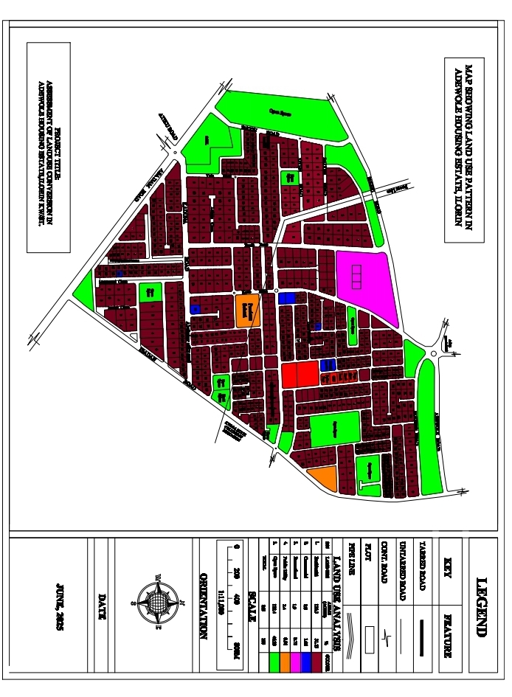
SOURCE: KWARA STATE PROPERTY DEVELOPMENT COOPERATION 2025.

4.2.1. TABLE 3: LAND USE DISTRIBUTION OF APPROVED MASTER PLAN OF ADEWOLE HOUSING ESTATE
LAND USE | AREAS(ACRES) | PERCENTAGE (%)
RESIDENTIAL | 135.5 | 51.13
COMMERCIAL | 2.8 | 1.06
RECREATIONAL | 1.9 | 0.72
PUBLIC UTILITIES | 2.4 | 0.91
OPEN SPACE | 122.4 | 46.23
TOTAL | 265 | 100

Figure 7: EXISTING CONDITION OF ADEWOLE HOUSING ESTATE.
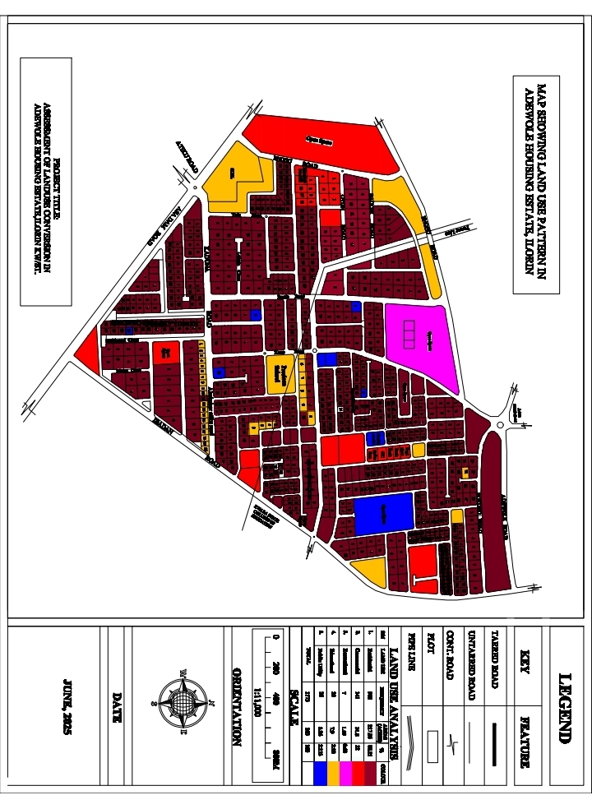
SOURCE: FIELD SURVEY 2025.

4.2.2. TABLE 4: LAND USE DISTRIBUTION OF EXISTING CONDITION OF ADEWOLE HOUSING ESTATE
LAND USE | FREQUENCY | AREAS(ACRES) | PERCENTAGE (%)
RESIDENTIAL | 966 | 217.86 | 82.21
COMMERCIAL | 141 | 31.8 | 12
RECREATIONAL | 7 | 1.59 | 0.60
EDUCATIONAL | 35 | 7.90 | 2.98
PUBLIC UTILITIES | 26 | 5.86 | 2.213
TOTAL | 1175 | 265 | 100
SOURCE: FIELD SURVEY 2025.
This show that the land use pattern still remain the same from 1979 till date 2025.
4.3 THE PROCESS OF URBAN LAND USE CONVERSION IN THE STUDY AREA
The findings during the project makes it clear that the process of the conversion can be stated into four (4) categories:
- Approval from Kwara State Town Planning Authority
- Harmony investment and property development
- Kwara state ministry of communication
- Illegal means

4.3.1 TABLE 5: THE PROCESS OF LAND USE CONVERSION IN THE STUDY AREA.
LAND USE | PROCESS OF CONVERSION |  |  |  |  | TOTAL
 | KWARA STATE TOWN PLANNING AUTHORITY | HARMONY INVESTMENT AND PROPERTY DEVELOPMENT |  | KWARA STATE MINISTRY OF COMMUNICATIONS | ILLEGAL MEANS
RES. | 818 | 0 | 0 |  | 153 | 966
COM. | 46 | 12 | 57 |  | 26 | 141
RECR. | 1 | 4 | 2 |  | 0 | 7
EDU. | 11 | 12 | 0 |  | 12 | 35
P/UTIL. | 5 | 7 | 0 |  | 14 | 26
TOTAL | 881 | 35 | 59 |  | 205 | 1175
PER (%) | 74.98 | 2.98 | 5.02 |  | 17.45 | 100
SOURCE: KWARA STATE TOWN PLANNING AUTHORITY, KWARA STATE PROPERTY DEVELOPMENT COOPERATION, KWARA STATE MINISTRY OF COMMUNICATION AND FIELD SURVEY 2025.
The table above shows that the approval from kwara state town planning authority is 74.98%, Harmony investment and property development has 2.98%, kwara state ministry communication has 5.02%, illegal means is 17.45%. This shows that kwara state town planning authority has highest process of approval with 74.98% while the lowest is Harmony investment and property development with 17.45%.

4.4 SOCIO-ECONOMIC CHARACTERISTICS OF THE RESPONDENT
This section were dictated through the administration of questionnaires, during the research for this project, 353 questionnaires were administered at the study area.
4.4.1. TABLE 6: Sex of the respondent
SEX | FREQUENCY | PERCENTAGE (%)
MALE | 156 | 43.6
FEMALE | 199 | 56.4
TOTAL | 353 | 100
SOURCE: FIELD SURVEY 2025.
The above table shows 43.6% male and 56.4 female. This implies that female is more in population than male in the study area.
4.4.2. TABLE 7: Marital status of the respondent
MARITAL STATUS | FREQUENCY | PERCENTAGE (%)
Single | 76 | 21.5
Married | 179 | 50.3
Divorce | 51 | 14.5
Widow/widower | 47 | 13.7
Total | 353 | 100
SOURCE: FIELD SURVEY 2025.
Table shows that highest is married with 50.3% and lowest widow/widower with 13.7 %, this implies that married has the highest in the study area.

4.4.3. TABLE 8: Age of the respondents
AGE | FREQUENCY | PERCENTAGE (%)
18-25 | 26 | 7.5
26-35 | 45 | 12.8
36-45 | 61 | 17.3
46-65 | 179 | 50.3
66 above | 42 | 12.1
Total | 353 | 100
SOURCE: FIELD SURVEY 2025.
Table shows the age of the respondents highest 46-65 years with 50.3% and the lowest 18-25 years with 7.5%.
4.4.4. TABLE 9: Level of education
LEVEL OF EDUCATION | FREQUENCY | PERCENTAGE (%)
Illiterate | 38 | 11
Primary education | 65 | 18.4
Secondary education | 70 | 20.1
Tertiary education | 180 | 50.5
Total | 353 | 100
SOURCE: FIELD SURVEY 2025.
Table showing level of education of the respondents, the highest is tertiary education with 50.2% and the lowest is illiterate with 11%

4.4.5. TABLE 10: Occupation of the respondent
OCCUPATION | FREQUENCY | PERCENTAGE (%)
Civil servant | 162 | 45.89
Artisan | 39 | 11.05
Business ownership | 106 | 30.03
Unemployment | 46 | 13.03
Total | 353 | 100
SOURCE: FIELD SURVEY 2025.
Table showing the occupation of the respondents, highest is civil servant with 45.89% and the lowest is artisan with 11.05%.
4.4.6. TABLE 11: Period of stay in the study area
PERIOD | FREQUENCY | PERCENTAGE (%)
Less than 1 year | 42 | 11.90
1-10 years | 63 | 17.85
11-20 years | 170 | 48.16
21 years and above | 78 | 22.10
Total | 353 | 100
SOURCE: FIELD SURVEY 2025.
Table showing the period of stay of the respondent in the study area, highest is 11-20 years with 48.16% and the lowest less than 1 year with 11.90%.

4.4.7. TABLE 12: ENVIRONMENTAL POLLUTION
ENVIRONMENTAL POLLUTION | FREQUENCY | PERCENTAGE (%)
AIR POLLUTION | 78 | 22.09
NOISE POLLUTION | 182 | 51.55
WATER POLLUTION | 52 | 14.73
NONE | 41 | 11.61
TOTAL | 353 | 100
SOURCE: FIELD SURVEY 2025.
Table showing the effect of environmental pollution in the study area, highest is noise pollution with 51.55% while the lowest is none with 11.61%.
4.4.8. TABLE 13: OVER STRETCHING OF INFRASTRUCTURAL FACILITIES
OVER STRETCHING | FREQUENCY | PERCENTAGE (%)
YES | 287 | 81.30
NO | 66 | 18.69
TOTAL | 353 | 100
SOURCE: FIELD SURVEY 2025.
Table showing the result of over stretching of infrastructural facilities, highest is YES with 81.30% while the lowest is NO with 18.69%

4.4.9. TABLE 14: INCOMPACTIBLE LAND USES
INCOMPACTIBLE LAND USES | FREQUENCY | PERCENTAGE (%)
HIGH | 267 | 75.63
MINIMAL | 77 | 21.81
LOW | 39 | 11.04
TOTAL | 353 | 100
SOURCE: FIELD SURVEY 2025.
Table showing the effect of incompactible land uses in the study area, the higest is HIGH with 75.63% while the lowest is LOW with 11.04%.
4.4.10. TABLE 15: EFFECT OF LAND USE CONVERSION IN THE STUDY AREA
EFFECT | FREQUENCY | PERCENTAGE (%)
POOR | 70 | 19.83
FAIR | 105 | 29.74
GOOD | 103 | 29.17
VERY GOOD | 75 | 21.24
TOTAL | 353 | 100
SOURCE: FIELD SURVEY 2025.
Table showing the effect of land use conversion in the study area, highest is FAIR with 29.74% while the lowest is POOR with 19.83%.

4.5 TABLE 16: IDENTIFICATION OF CONVERSION THAT OF HAPPEN IN YEARS (1979-2025) IN THE STUDY AREA
LAND USE | AREAS(1979) | AREAS(2025) | NUMBER (AREAS) OF CONVERSION | PER (%)
RESIDENTIAL | 135.5 | 217.86 | 82.36 | 36.02
COMMERCIAL | 2.8 | 31.8 | 29 | 12.68
RECREATIONAL | 1.9 | 1.59 | 0.31 | 0.13
EDUCATIONAL/ OPEN SPACE | 122.4 | 7.90 | 114.5 | 50.08
PUBLIC UTILITIES | 2.4 | 5.86 | 3.46 | 1.51
TOTAL | 265 | 265 | 228.63 | 100
SOURCE: KWARA STATE TOWN PLANNING AUTHORITY AND FIELD SURVEY 2025.
Table showing the conversion that have taken place from 1979-2025 in the study area, highest conversion is EDUCATIONAL FACILITIES/ OPEN SPACE with 50.08% while the lowest is RECREATIONAL FACILITIES with 0.13%.

Figure 8: RESIDENTIAL FACILITY CONVERTED TO EDUCATIONAL FACILITY IN THE STUDY AREA

Figure 9: RESIDENTIAL FACILITY CONVERTED TO COMMERCIAL FACILITY IN THE STUDY AREA

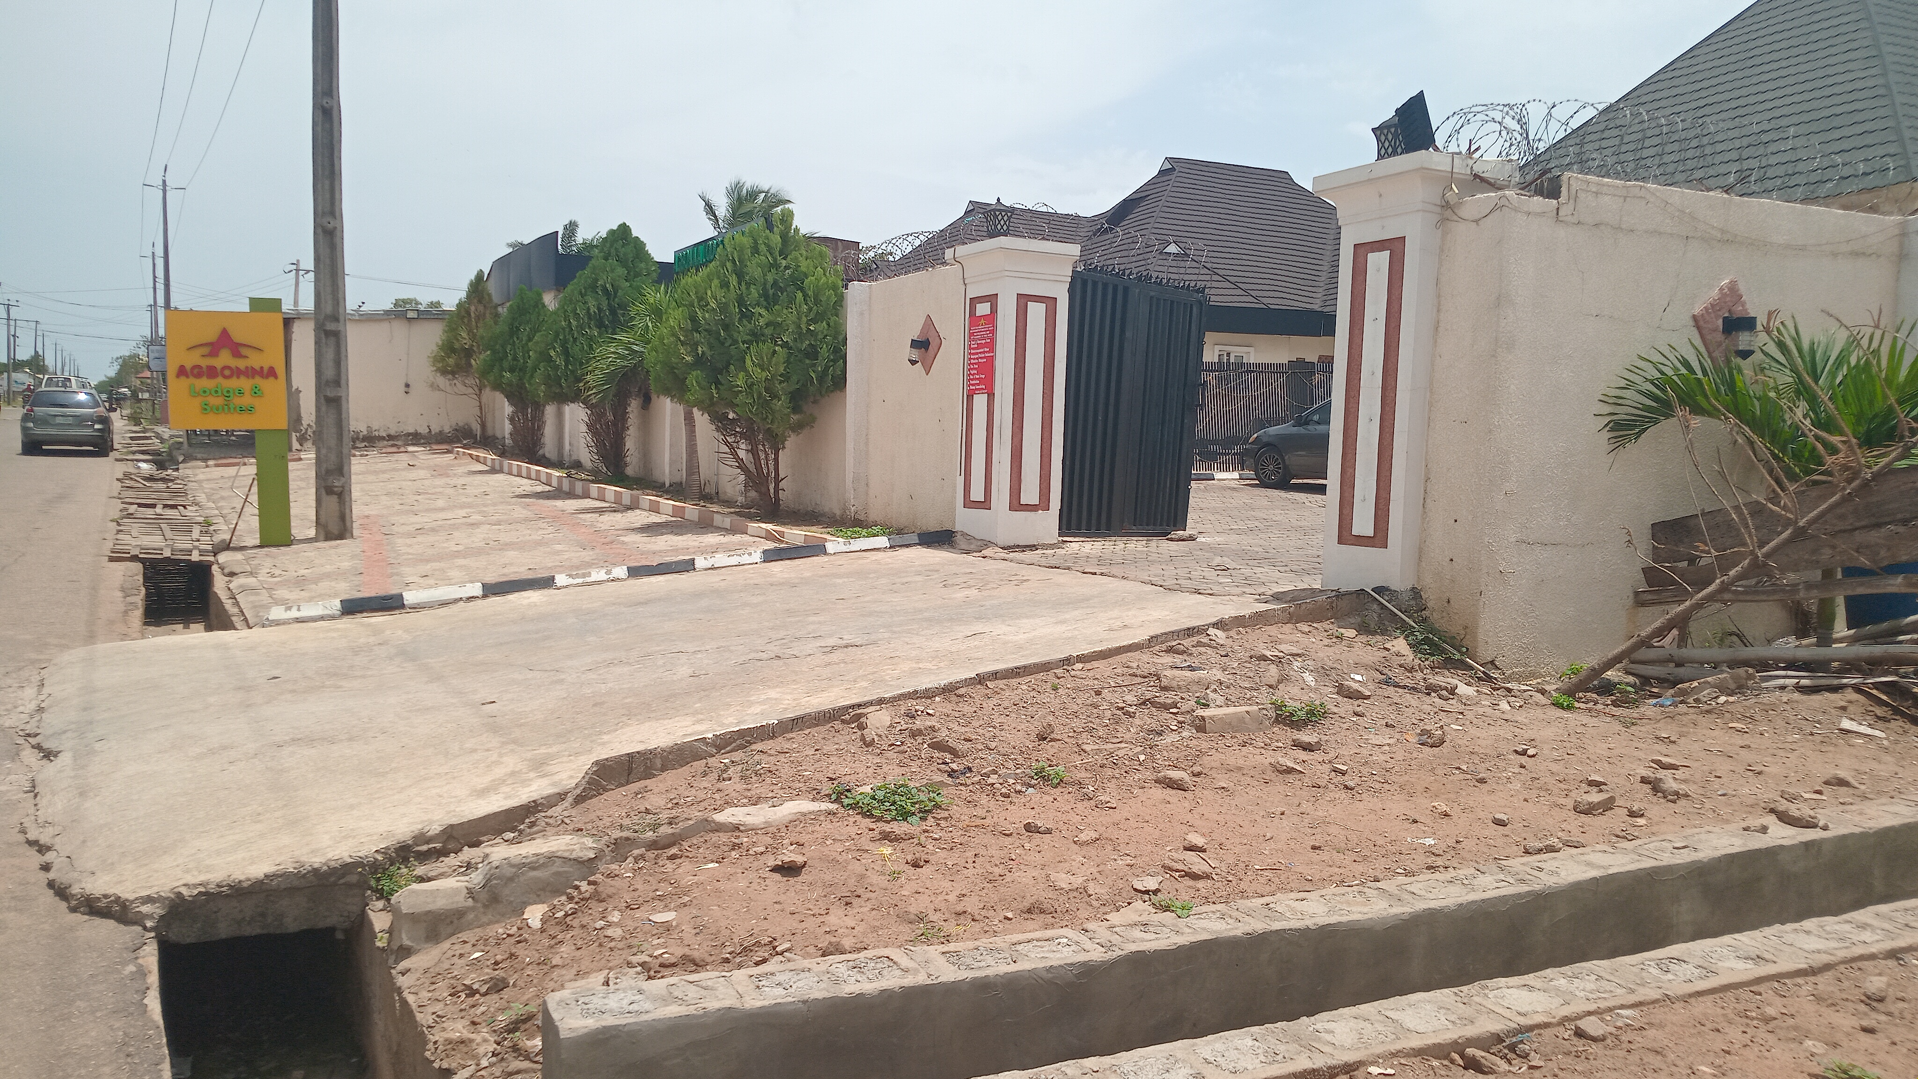

Figure 10: RESIDENTIAL FACILITY CONVERTED TO EDUCATIONAL FACILITY IN THE STUDY AREA
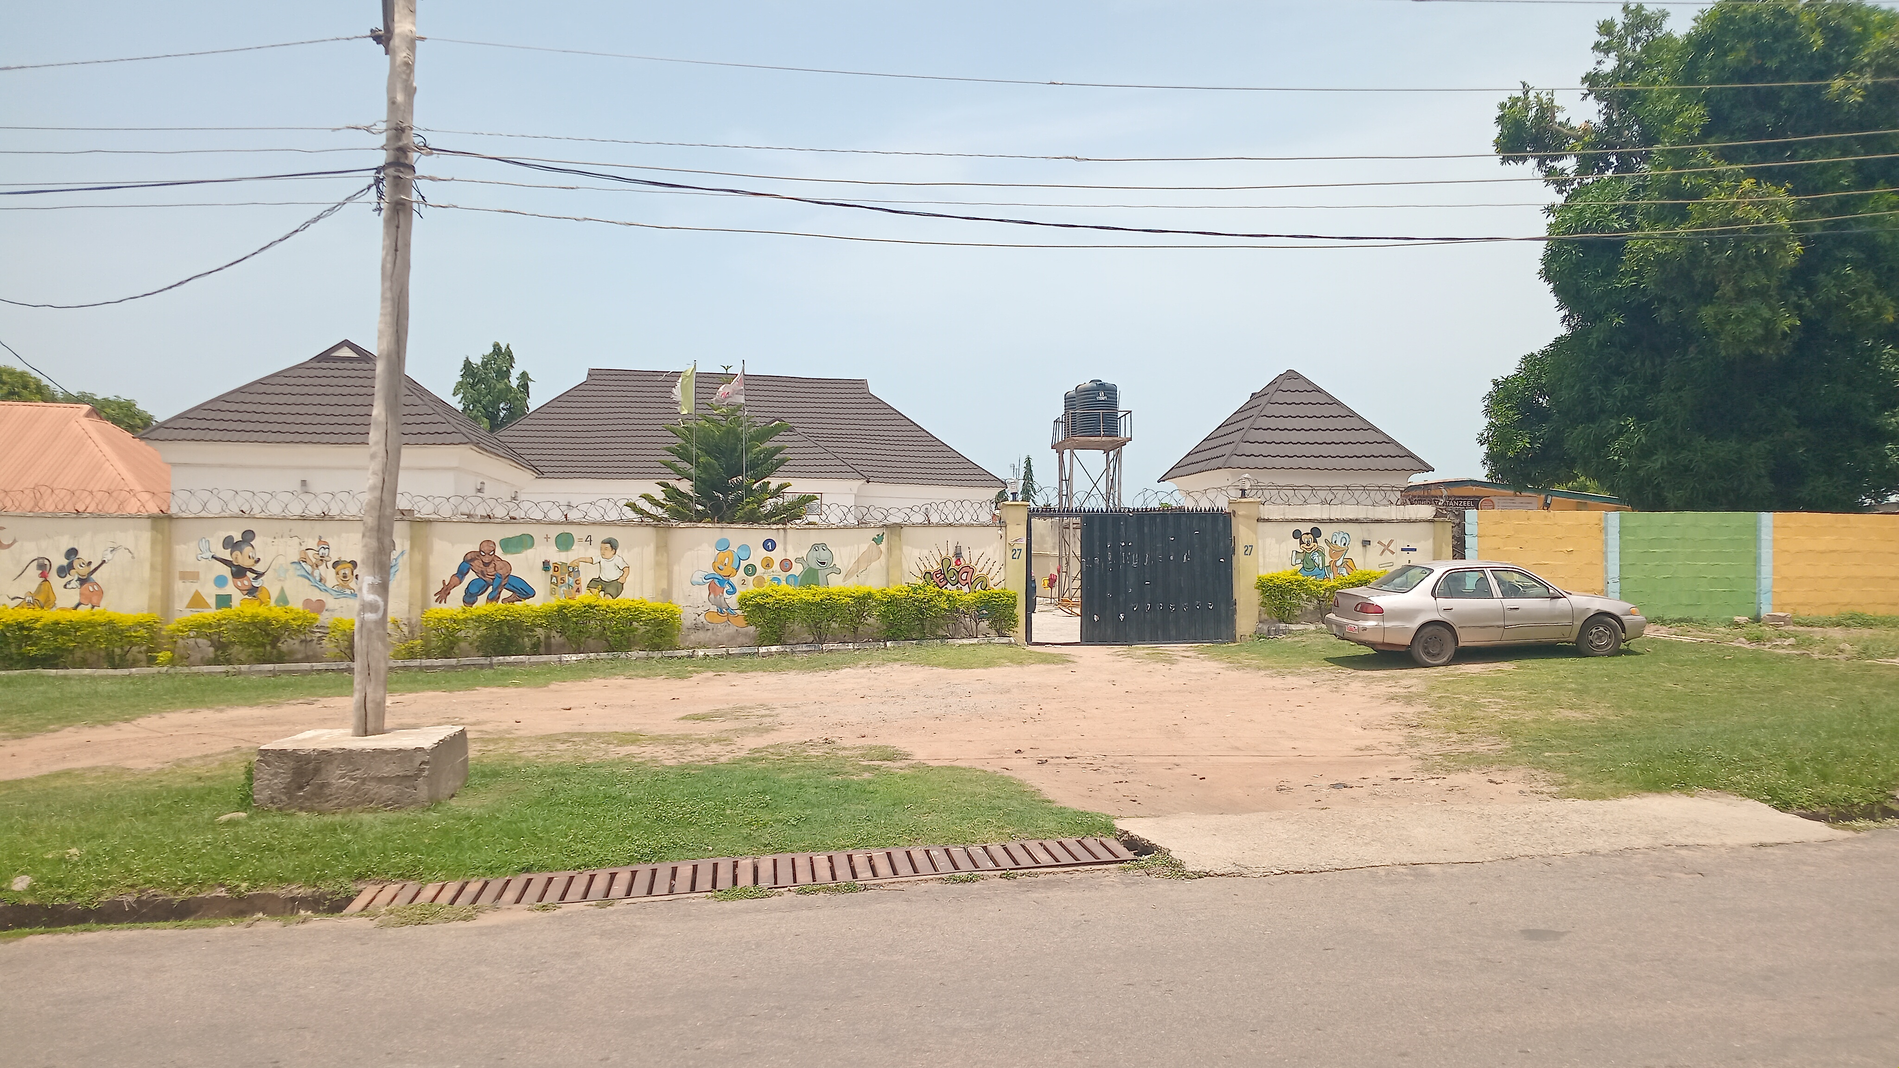

Figure 11: NIGERIAN AIR FORCE RESIDENTIAL QUARTERS IN THE STUDY AREA

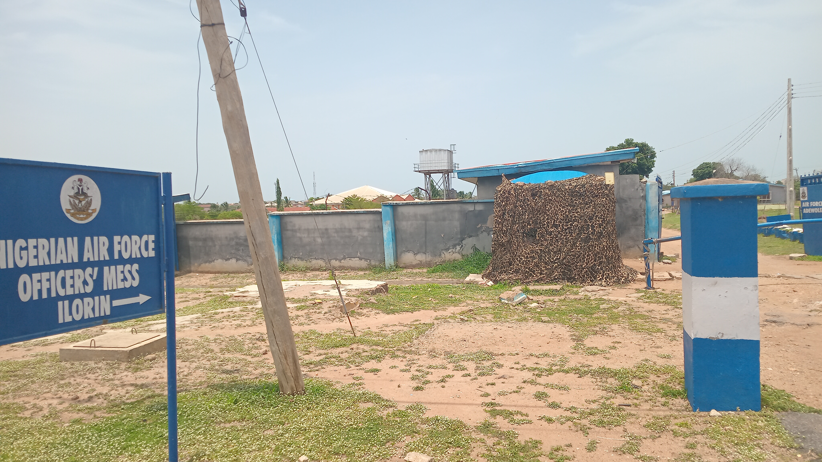

Figure 12: AMIR SUITE COMMERCIAL FACILITY IN THE STUDY AREA
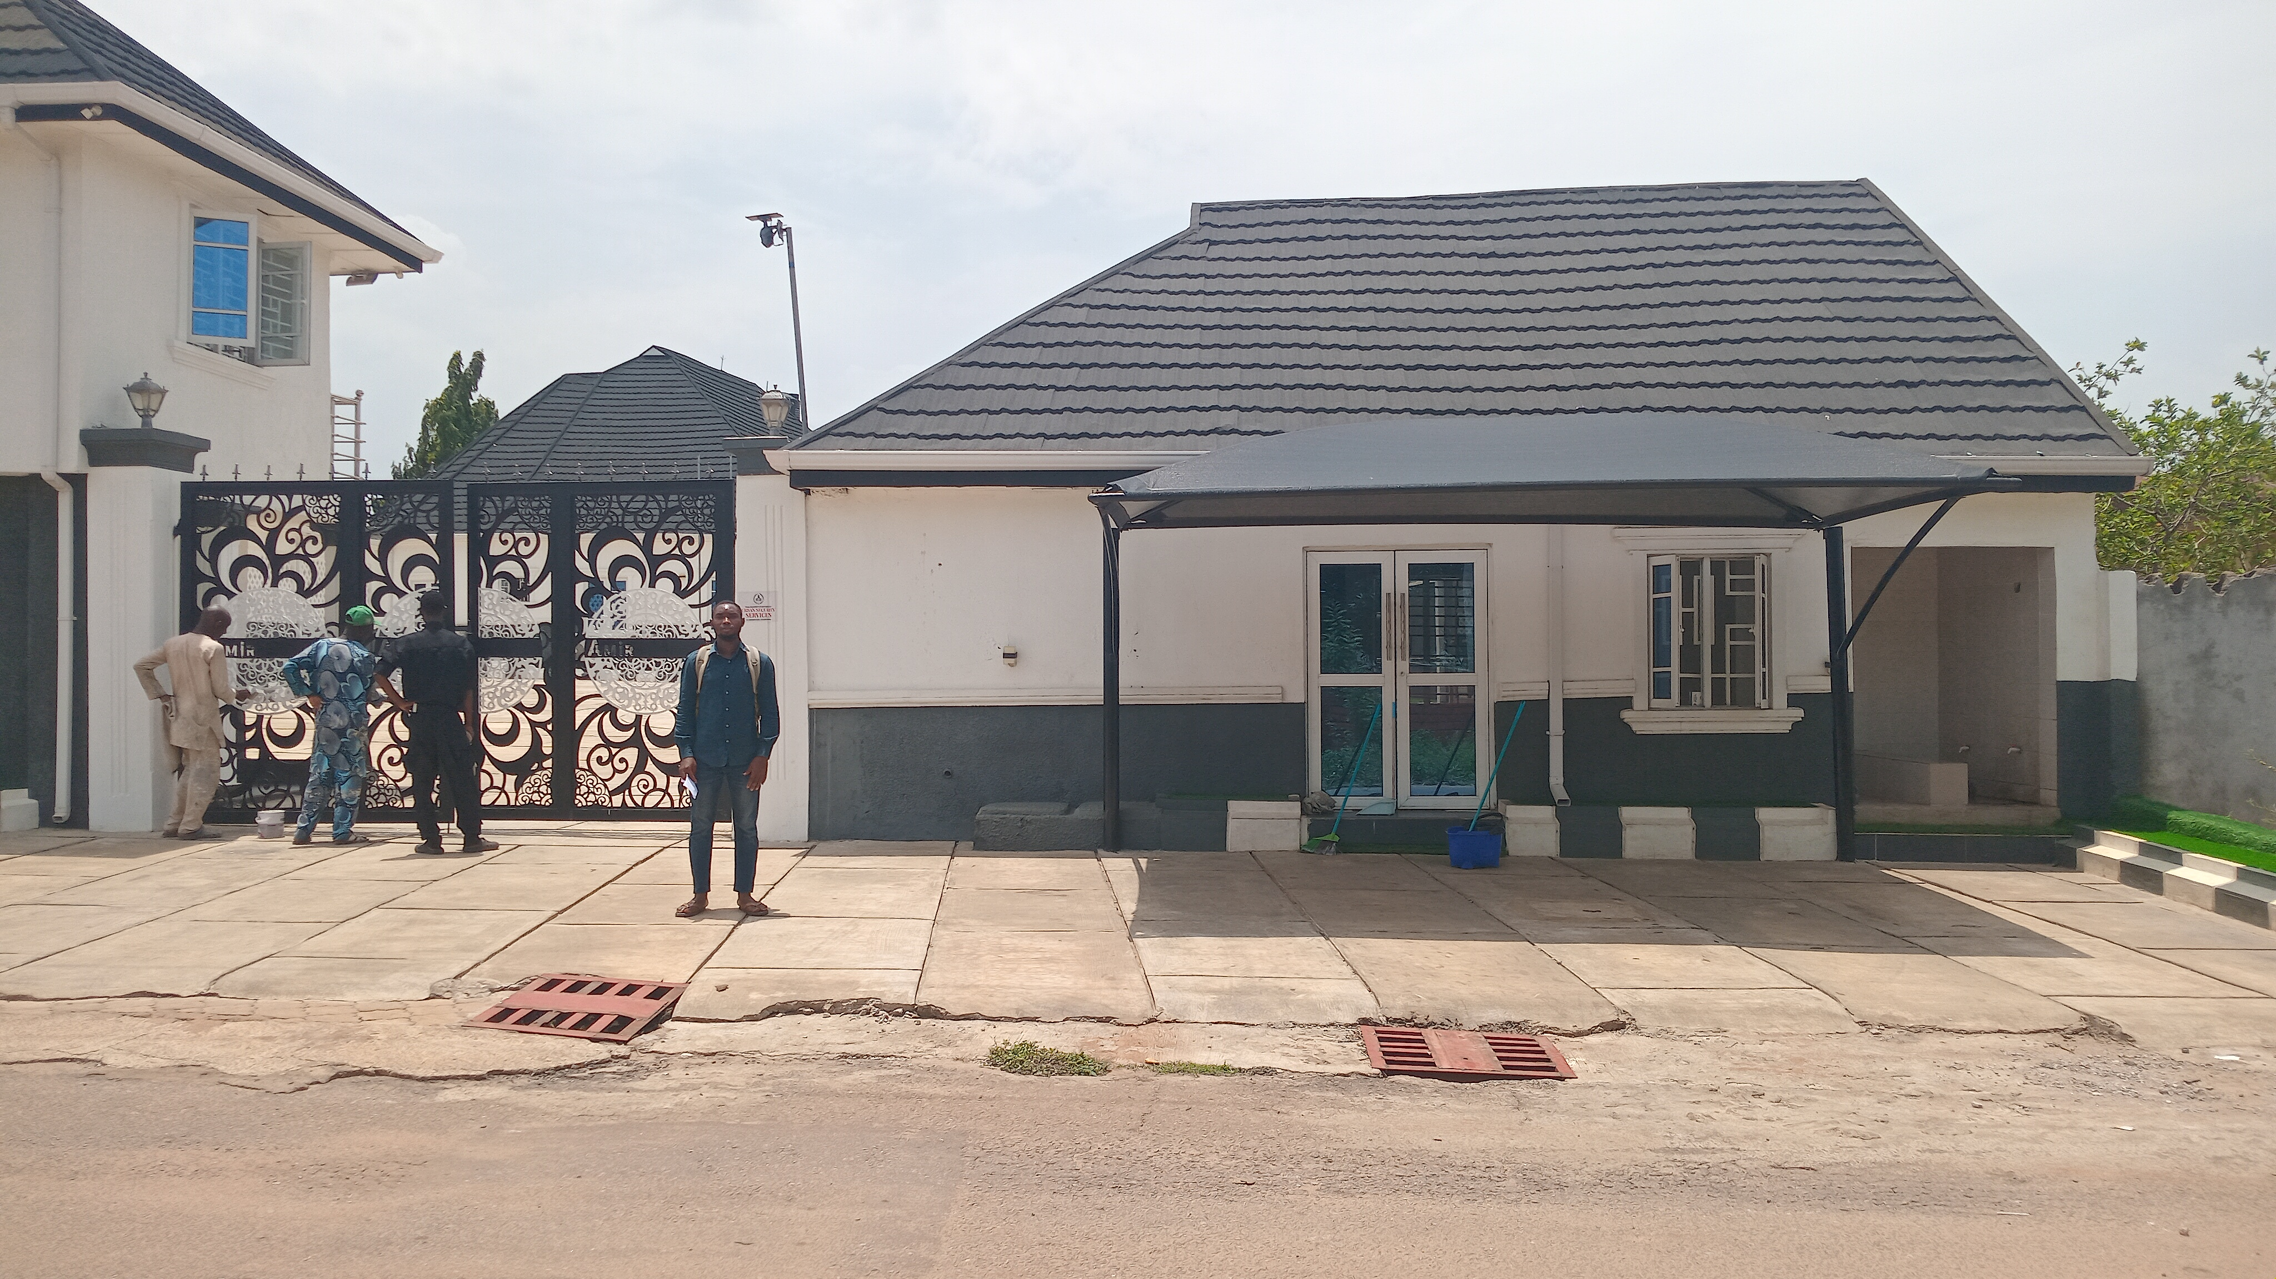

Figure 13: RESIDENTIAL FACILITY CONVERTED TO EDUCATIONAL FACILITY IN THE STUDY AREA
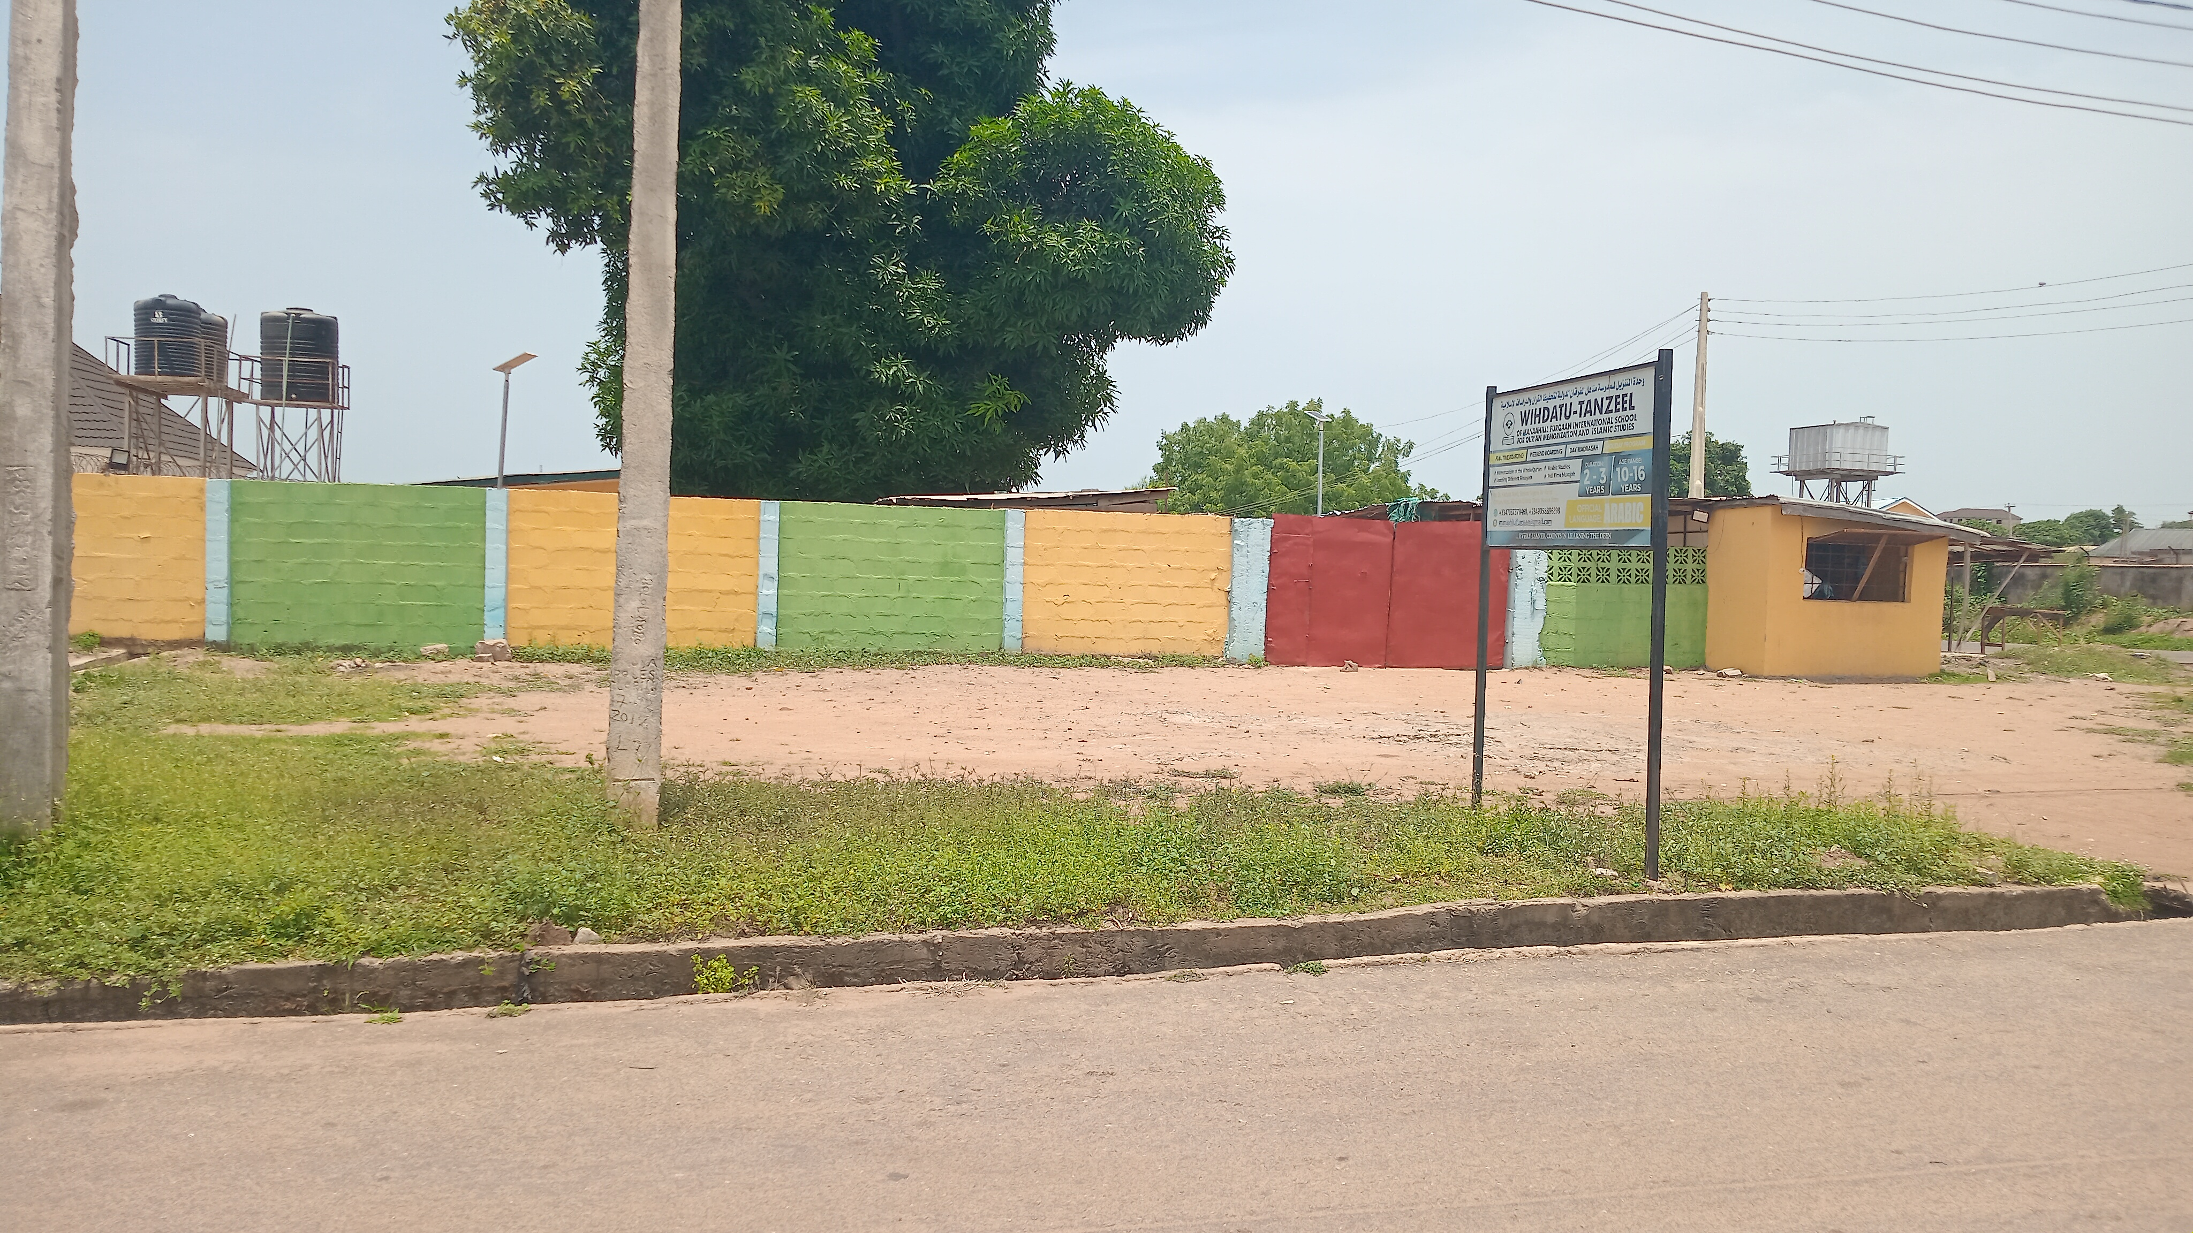

CHAPTER FIVE
5.0 SUMMARY, RECOMMENDATION AND CONCLUSION
5.1 SUMMARY OF FINDING
The summary of findings covers the highest and the lowest result dictated while solving the objectives.
The land use pattern of the study area remain the same from 1979 till date 2025 no changes. Kwara state town planning authority has highest process of approval with 74.98% while the lowest is kwara state investment and property developers with 17.45%. 43.6% male and 56.4 female, this implies that female are more in population than male in the study area. Marital status, highest married with 50.3% and lowest widow/widower with 13.7 %, this implies that married has the highest in the study area.
The age of the respondents highest 46-65 years with 50.3% and the lowest 18-25 years with 7.5%. Level of education of the respondents, the highest is tertiary education with 50.2% and the lowest is illiterate with 11%. The occupation of the respondents, highest is civil servant with 45.89% and the lowest is artisan with 11.05%. The period of stay of the respondent in the study area, highest is 11-20 years with 48.16% and the lowest less than 1 year with 11.90%.
The effect of environmental pollution in the study area, highest is noise pollution with 51.55% while the lowest is none with 11.61%. the result of over stretching of infrastructural facilities, highest is YES with 81.30% while the lowest is NO with 18.69%. The effect of incompactible land uses in the study area, the higest is HIGH with 75.63% while the lowest is LOW with 11.04%. The effect of land use conversion in the study area, highest is FAIR with 29.74% while the lowest is POOR with 19.83%. the conversion that have taken place from 1979-2025 in the study area, highest conversion is EDUCATIONAL FACILITIES/ OPEN SPACE with 50.08% while the lowest is RECREATIONAL FACILITIES with 0.13%.

5.2 RECOMMENDATION
In view of the problems Identified in the study area, the following recommendations were made.
A. Land use planning: Government and it's agency should make a deliberate Quest to intervene in the complex mechanism of land allocation to different uses in other to ensure compatibility of land uses in the study area.
B. Public awareness: government and it’s agencies should educate the public about land rights, responsibilities, and the importance of adhering to zoning regulation in an estate and every other communities.
C. Address underlying causes: the government and its agency should address the causes all the side effect of the conversion in the study area
1. Environmental pollution.
2. incompatible land uses.
3. over stretching of infrastructural facilities.
D. Infrastructural facilities: government and its agency should renew and provide more infrastructural facilities in the study area.
E. Maintenance: Government and its agency should provide adequate maintenance for the study area.

5.3 CONCLUSION
The project shown that land planning and control tools are either not available or weakly implemented. Besides the paper found land use activity to be disjointed and uncoordinated since several organizations and agencies are involved in land use without a coordinating agencies or an overall land use plan within which effective land use control can be undertaken. The paper concludes that for land use management to be effective, there is the need for an integrated land use approach. The present approach of disjointed and uncoordinated land use practices cannot be expected to provide the desired outcome of sustainable city development. Thus, for land use management to flourish and more importantly to create convenient and conducive environment for present and future generations, there is the need for a more fundamental rethinking of land use control mechanism, policy and action. Land use management in Kwara State should be decentralized and new legislation that would reflect current global thinking and approach to more humane and environmental friendly approach of sustainable development need to be embraced and instituted in the city and country as a whole.

REFERENCE
Adegunle, Fateye & Agbato (2016) - Property use conversion in Minna Metropolis.
Akanbi, Yahaya & Omotayo (2019) - Purposes for property use conversions in Minna Metropolis.
Akinluyi, Oyinloye, & Aladekoyi (2021) - Assessment of the effect of land use change on some selected urban public utilities in the city of Akure, Nigeria.
Akinmoladun, & Oduwaye (2004) - Urban land use: the physical manifestation of socio-economic, cultural, political environmental forces shaping the use of the land in urban areas.
Arimah & Adeagbo (2000) - Compliance with urban development and planning regulations in Ibadan, Nigeria.
Ayotamuno, Gobo, & Owei (2010) - Land use planning and management in Port Harcourt, Nigeria.
Baadom & Eebee (2016) - Land use policy and management in Nigeria.
Babatola & Oni (2014) - Property development and redevelopment in Lagos metropolis.
Babatola & Oni (2017) - Property use conversion in Lagos metropolis.
Baffour (2014) - Land use regulations and compliance in urban areas.
Barlowe (1978) - Land and its uses.
Bosikun (2021) - Socioeconomic factors influencing land use conversions in Apete area of Ibadan, Nigeria.
Collier (2020) - Land use regulations and compliance in Nigeria.
Dambeebo & Jalloh (2018) - Impact of land use planning on property values.
El-Barmelgy, Shalaby, Nassar, & Ali (2014) - Factors responsible for property use conversion.
Herbert & Thomas (1982) - Urban land use patterns.
Lean & Geodall (1966) - Urban land use patterns.
Madeddu & Clifford (2022) - Property use conversion and planning controls.
Makinde (2020) - Land use conversion and property rental values.
Makinde & Makinde (2020) - Land use succession and property value in Ile Ife, Nigeria.
Michaella Otto, Jacob Adejare Babarinde and Paulus Motoro (2020)- Residential property rentals and prices in cities.
National Association of Realtors (2021) - Commercial real estate trend and outlook.
Nguyen (2020) - Method and process of transferring values of natural resources into national account system in Vietnam.
Nuissl & Siedentop (2021) - Urban land use change and environmental issues.
Ogungbemi (2012) - Property use conversion in urban areas.
Olurin (2010) - Resources exploitation and competition for highest and best use.
Orekan (2021) - Effects of land use planning on property values in Lagos, Nigeria.
Owei & Nwikpo (2005) - Land use regulations and compliance in Port Harcourt, Nigeria.
Yakob (2012) - Planning control and sustainability.
Yang (2023) - Government's role in assigning housing responsibilities.

