IMPACT OF BILLBOARD ON LANDSCAPE
(CASE STUDY OF TAIWO-UNITY, ILORIN KWARA STATE).

BY
ODESANYA SIKIRULAI KEHINDE
MATRIC NUMBER:
HND/23/URP/FT/0004

DEPARTMENT OF URBAN AND REGIONAL PLANNING
INSTITUTE OF ENVIRONMENTAL STUDIES

KWARA STATE POLYTECHNIC, ILORIN
INSTITUTE OF ENVIRONMENTAL STUDIES

SUPERVISOR IN CHARGE:
TPL M. I. YAHAYA

JULY 2025.


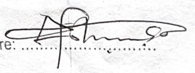
DEDICATION
This project is dedicated to Almighty Allah for sparing my life from the day i was born, during the course of my program wish am really grateful for the grace, also for my dedicating parent for their full support.

ACKNOWLEDGEMENT
Alhamdulillah! Alhamdulillah!! Alhamdulillah!!!
All thanks, praise, adoration and worshipping to almighty Allah the most gracious and merciful the origin of the whole being
I once again give thanks to Almighty Allah for his protection and saving me throughout the period of the course.
My sincere and unlimited gratitude goes to my parents Mr and Mrs. ODESANYA and my beloved family, and friends for their love and kind towards my carrier.
My profound gratitude to my able supervisor TPL M.I YAHAYA for her motherly support and making herself accessible throughout the duration of this project work. I pray may Almighty Allah always put you in his protection and blessing (Amin).
I appreciate my Head of Department TPL. E.S. ADEKANYE for his fatherly role he has played in our life during the program may God reward you abundantly (Amin). I love you all.

Abstract
The increasing presence of billboards in urban environments has raised critical discussions about their impact on the visual and aesthetic quality of cityscapes. This study investigates the role of billboards in enhancing the scenic beauty and urban identity of Taiwo–Unity Road, a major commercial corridor in Ilorin, Kwara State, Nigeria. The research aims to examine how billboards contribute to the visual appeal of the area, their integration with the existing architectural and cultural landscape, and public perception of their presence. A combination of field observation, photographic documentation, and randomly interview was employed to assess the types, placements, and design styles of billboards along the corridor. The findings reveal that while some billboards, particularly well-designed wallscapes and branded signage, enhance the vibrancy and identity of the road, many others contribute to visual clutter, obstruct building facades, and degrade the overall scenic quality. The study concludes that proper regulation, design standards, and location-specific planning are essential to harness the aesthetic potential of billboards without compromising environmental harmony. Recommendations are offered for improving billboard integration as tools for both advertisement and urban beautification within the context of Ilorin’s developing landscape.

TABLE OF CONTENTS

Chapter One
1.0 Introduction 1
1.1 Statement Of Problem 3
1.2 Research question 3
1.3 Aim Of The Study 3
1.4 Objectives 4
1.5 Justification of the study 4
1.6 Scope Of The Study 4
CHAPTER TWO
2.0 Literature review 8
2.1 Terms of regulatory role KWASSA 9
2.2 Purpose of billboard 10
2.3 their primary objective 10
2.4 Types of billboard 11
2.5 Significance of billboard 14
2.6 How billboard can beautify the environment 15
2.7 advantages of billboard 16
2.8 disadvantages of billboard 16
2.9 Impact of billboard on landscape 17
2.10 Benefit of billboard 17
2.11 Criticism and challenge 18
2.12 the value and impact of billboard 18
2.13 Recommended Billboard Types 20

CHAPTER THREE
3.0 Research Design 21
3.1 sample technique 21
3.2 population study 21
3.3 sample size 21
3.4 sample procedure 22
3.5 sample frame 22
3.6 source of data collection 22
3.7 primary data collection 22
3.8 secondary data collection 23
3.9 Methods of Data Presentation 24

CHAPTER FOUR
4.0 data analysis 25
4.1 Social economic characteristics of the respondent 25
4.2 To identify the billboard types in the study area 26
4.3 To evaluate the visual and aesthetic contribution of billboard on the 26
Landscape of the environment
4.4 To assess public opinion billboard influence on environment 26

CHAPTER FIVE
5.1 Summary of findings 37
5.2 Recommendations 37
5.2.1 Beauty it could add to the Environment 37
5.3 conclusion 39
REFERENCE 40

MAPS
Figure 1: Kwara State within the National Context
Figure 2: Local Government Areas in Kwara

Figure 3: Map of Ilorin West LGA Area

CHAPTER ONE

BACKGROUND OF THE STUDY
INTRODUCTION
Urban centers are the most complex of human habitats, and this complexity is largely shaped by the level of urbanization (UN-Habitat, 2013). As cities expand, people migrate in search of better livelihoods, thereby increasing population density and economic activity. In Ilorin, the Taiwo to Unity Road corridor is a prime example of this urban vibrancy—serving as one of the busiest areas in the city. Its high volume of pedestrian and vehicular movement makes it a strategic location for gbillboard advertising.
Billboards, defined as large outdoor advertising structures, are typically installed in high-traffic areas to capture attention and deliver persuasive messages (Scollon & Scollon, 2003). These structures contribute significantly to urban visual culture and spatial usage, often altering how people interact with the built environment (Rapoport, 1990; Lynch, 1960). They are a major component of city branding and marketing strategies (Kavaratzis, 2004), helping cities and businesses shape public perception.
Advertising, as a form of persuasive communication, attempts to influence consumer behavior through various media including billboards, print, radio, and TV (Osubiyi, 1999). Billboards particularly stand out in urban areas where visual engagement is high. However, this visibility also comes with consequences for the urban environment. Scholars like Jacobs (1961) have critiqued the visual clutter that billboards can create in cityscapes, affecting both aesthetics and urban coherence.
The history of billboards reflects the evolution of communication and urban design. From early inscriptions in ancient Egypt and Greece (Scollon & Scollon, 2003), to modern digital billboards of the 21st century, the form and function of signage have constantly evolved. After World War II, billboard usage surged alongside suburban expansion and highway development (Beatley, 2011). The digital age brought with it dynamic displays capable of changing messages in real-time, increasing billboard influence in public space.
In Nigeria, the Nigerian Urban and Regional Planning Law (Decree No. 88 of 1992) provides the legal framework for billboard regulation, yet enforcement remains inconsistent (Ogunba & Ojo, 2013). Studies such as Ede and Edem (2014) have documented the environmental impact of billboards in urban areas like Calabar, highlighting issues such as visual pollution and safety hazards. Similarly, Akinbode (2002) emphasizes the role of billboard saturation in contributing to urban environmental degradation.
Land use and urban planning must strike a balance between economic opportunity and environmental sustainability. Afolayan and Olayiwola (2011) argue that Nigeria's urban development must incorporate clearer regulatory frameworks for signage and outdoor advertising to ensure orderly urban growth. Planning approaches like those proposed by Healey (1997) and Watson (2009) advocate for collaborative urban governance that respects both the needs of businesses and the quality of public space.
Comparative frameworks such as Toronto’s Sign By-law (City of Toronto, 2009) provide useful models for managing billboard density and design to enhance urban livability. These regulations ensure that signage supports rather than undermines the character of public spaces.
Urban landscapes are dynamic and multilayered spaces shaped by human activity, architectural design, infrastructure, and social interaction. Among the various elements that define the visual character of modern cities, billboards and other forms of outdoor advertising play a prominent and increasingly contested role. Billboards are designed to capture attention and deliver persuasive messages to a broad audience, especially in high-traffic areas. However, beyond their commercial utility, they have significant implications for the aesthetics, organization, and legibility of urban environments (Scollon & Scollon, 2003; Lynch, 1960).
In many cities—especially in rapidly urbanizing regions such as Nigeria—billboards dominate major thoroughfares, roundabouts, public squares, and building facades. Their proliferation is often viewed as a symbol of commercial vitality and economic opportunity. Yet, this same proliferation raises concerns about visual pollution, landscape degradation, and spatial fragmentation (Ogunba & Ojo, 2013; Ede & Edem, 2014). According to Rapoport (1990), the built environment communicates nonverbally with its users, and the excessive presence of signage can distort this communication by overwhelming the senses, cluttering sightlines, and altering the spatial rhythm of cityscapes.
The impact of billboards is not merely visual or aesthetic. It intersects with urban planning, public safety, environmental sustainability, and the socio-political dynamics of space usage (Jacobs, 1961; UN-Habitat, 2013). Poorly regulated billboard installations may obstruct pedestrian pathways, obscure traffic signs, or dominate public spaces to the exclusion of local culture and heritage. These challenges are especially acute in Nigerian cities, where regulatory frameworks like the Nigerian Urban and Regional Planning Law (Decree No. 88 of 1992) often lack consistent enforcement (Afolayan & Olayiwola, 2011).
In Ilorin, the Taiwo to Unity Road corridor exemplifies the tensions between urban advertising and spatial order. As one of the busiest commercial arteries in the city, this area hosts numerous billboards competing for attention. While this advertising presence supports business visibility and revenue generation, it also contributes to the visual transformation—and in some cases, deterioration—of the urban landscape. A growing body of literature now emphasizes the need to balance commercial interests with urban design principles that prioritize livability, sustainability, and community identity (Watson, 2009; Beatley, 2011).
As cities increasingly adopt branding strategies to attract investment and tourism (Kavaratzis, 2004), signage becomes not only a commercial tool but also a medium for place-making. However, without clear urban planning strategies and stakeholder collaboration, billboard installations risk undermining the very identity they seek to promote. This study, therefore, explores the multifaceted impact of billboards on urban landscapes, focusing on spatial aesthetics, environmental concerns, and planning implications within the context of Ilorin, Nigeria.

Statement of the Problem
Billboards have become a prominent feature in urban environments, serving as powerful tools for advertising and information dissemination. However, their rapid proliferation along major roads such as the Taiwo–Unity Road corridor in Ilorin has raised concerns regarding their impact on the aesthetic quality and overall appearance of the urban landscape. While some billboards may enhance the visual vibrancy of a city, many others are poorly designed, randomly placed, or over-concentrated—leading to visual pollution, obstruction of architectural landmarks, and a general sense of environmental disorganization.
Taiwo–Unity Road is one of the busiest and most commercially active routes in Ilorin, characterized by high pedestrian and vehicular traffic, diverse building styles, and an increasing demand for advertisement space. In recent years, the growing number of billboards along this corridor has sparked public debate about whether these structures contribute to urban beautification or degrade the visual character of the environment.
There is currently a lack of coordinated regulation and aesthetic consideration in billboard placement and design within the area, resulting in inconsistent visual quality and a potential loss of cultural and environmental identity. Therefore, it is essential to investigate how billboards affect the scenic and aesthetic value of Taiwo–Unity Road and to evaluate whether their presence aligns with sustainable urban planning and beautification goals.
Research Questions:
1. How do billboards affect the visual appeal of urban landscapes?
2. What role do billboards play in urban planning and development?
3. What are the economic benefits of billboards in urban area
4. What are the negative impacts of billboards on urban landscapes?
AIM AND OBJECTIVES
Aim:
To examine the role of billboards in enhancing the visual appeal and aesthetic of Taiwo - UNITY transport corridor with a view to contribute to the overall scenery quality of the urban environment
Objectives:
To achieve the above aim, the study will pursue the following specific objectives:
1. To identify the billboard types in the study area.
2. To evaluate the visual and aesthetic contribution of billboards on the Landscape of the environment.
3. To assess public opinion/ perception on billboard influence on environment.
4. To develop recommendations for optimizing billboard placement and design to enhance the visual appeal and aesthetic of the Taiwo-Unity transport corridor.
Justification of the study:
As cities continue to grow and urbanize, the impact of billboards on urban landscapes becomes increasingly significant. Billboards are a significant source of revenue for cities and businesses, making it essential to understand their economic benefits. The visual impact of billboards can have a significant effect on the quality of life for urban residents, making it crucial to investigate their aesthetic implications. By identifying best practices for billboard design, placement, and management, this study can contribute to sustainable development and responsible advertising practices in urban areas.

Scope of the Study:
This study is confined to Ilorin West Local Government Area (LGA) in Kwara State, Nigeria. Ilorin West is one of the three LGAs that make up the Ilorin metropolis, a rapidly urbanizing region. The study focuses specifically on selected communities within the LGA that are experiencing various degrees of residential, commercial, and infrastructural development. These include areas such as Taiwo and Unity among others.

The Study Area: Taiwo and unity road Ilorin, Kwara State
Ilorin West Local Government Area is one of the 16 LGAs in Kwara State, North Central Nigeria. It is part of the larger Ilorin metropolis, which also includes Ilorin East and Ilorin South LGAs. The LGA headquarters is located in warrah osin Area. Taiwo and Unity is a notable area within Ilorin West, with its own distinct zip code (240241). Other areas in Ilorin West include Adewole, Agbo Oba, UmaruSaro, Ahmadu Bello Way, and Oko Erin, among others. Ilorin was founded by the Yoruba people in the late 18th century as a vassal state of the Oyo Empire. Its strategic location made it a crucial defensive location and trade center, connecting the empire to northern trade routes. Ilorin West has a population of approximately 161,690 inhabitants and hosts various markets, banks, hotels, and industries. The area is known for its vibrant trade sector and economic enterprises like blacksmithing, wood carving, and craftsmanship Ilorin resisted British rule until 1897 when the Royal Niger Company's army conquered it. Today, Ilorin West is a significant area in Kwara State, with a population of 364,666 people, according to the 2006 census, and a diverse economy. Ilorin West's history reflects the complex intersections of religion, ethnicity, and politics that have shaped Nigeria's history. The area's transformation into an emirate under the Sokoto Caliphate has had a lasting impact on its cultural and political landscape.

Figure 1.: Kwara State within the National Context

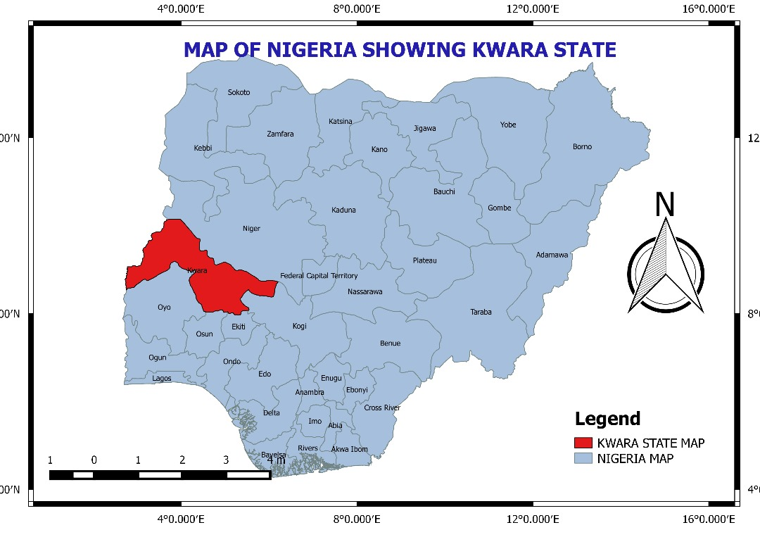
Source: Kwara State Geographical Board, 2025

Figure 2: Local Government Areas in Kwara State
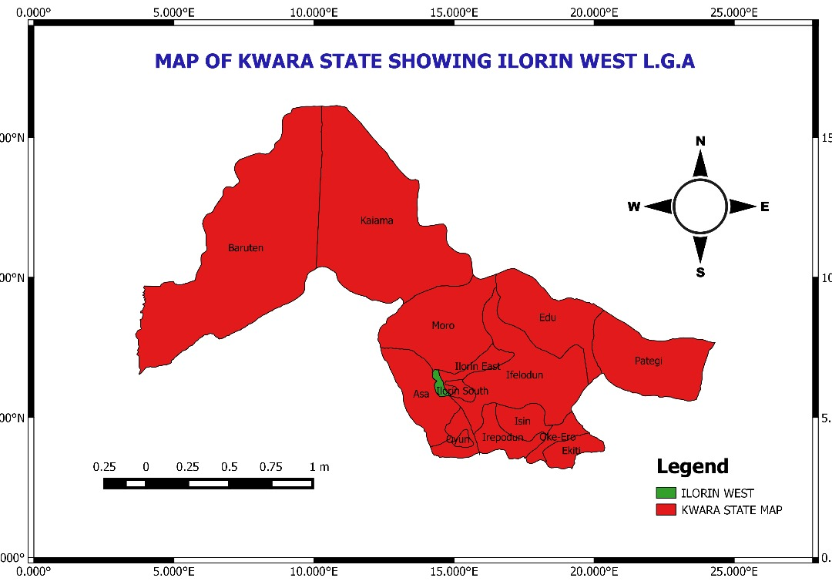
Source: Kwara State Geographical Board, 2025

Figure 3: Map of Ilorin West LGA Area
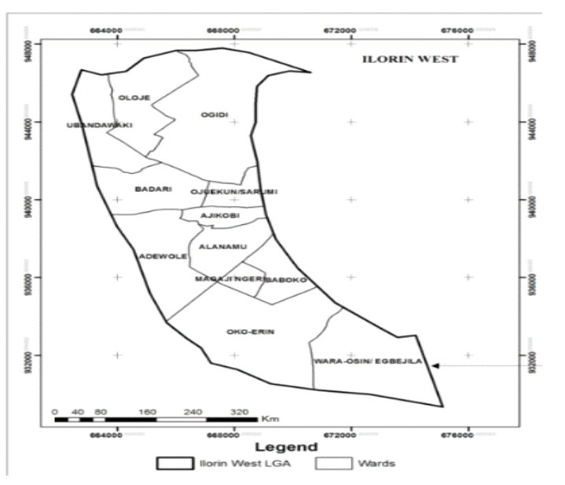

Source: Kwara State Geographical Board, 2025

CHAPTER TWO

LITERATURE REVIEW

Billboards have long served as a significant component of the urban visual environment. Traditionally viewed as tools for economic promotion and consumer persuasion, their contribution to the aesthetic enhancement of urban spaces has attracted increasing scholarly interest. According to Scollon and Scollon (2003), signage—including billboards—serves not only to communicate messages but also to mediate how people experience and navigate physical spaces. In this context, billboards act as both communicative and decorative elements within cityscapes, particularly when designed and placed thoughtfully. Billboards as Tools of Urban Beautification and Branding. Contemporary urban theorists such as Kavaratzis (2004) argue that outdoor advertising, including billboards, contributes to city branding and visual identity. A strategically placed and well-designed billboard can reflect the dynamism, modernity, and commercial vitality of a city. This is especially relevant in commercial zones such as Ilorin’s Taiwo to Unity corridor, which has emerged as a hotspot of economic activity and foot traffic. Here, the presence of vibrant, high-quality billboards can give the impression of a bustling, forward-looking environment—potentially enhancing the visual experience for residents and visitors alike. Similarly, Lynch (1960) emphasized that cities are understood and navigated through "imageability"—the quality of a cityscape that makes it legible and memorable. Colorful, thematic, or culturally relevant billboards can contribute to this imageability by offering visual anchors or aesthetic focal points. In the Taiwo–Unity axis, which functions as a major transit and commerce zone, such visual elements may enrich the sensory engagement of users, especially when paired with good urban design. Cultural and Local Relevance of Billboard Design

In urban Nigeria, billboards often reflect local language, fashion, and societal aspirations, thereby contributing to a shared visual culture. Ogunba and Ojo (2013) observe that when properly regulated, billboards can serve as expressions of local identity, using graphics, symbols, and messaging that resonate with the community. In Ilorin, where cultural and religious values are important in public life, billboard content that aligns with these values can promote a sense of familiarity and pride, potentially enhancing the streetscape rather than detracting from it. Moreover, Jacobs (1961) contends that vibrancy in urban areas often stems from a variety of stimuli—visual, social, and spatial. In this view, billboards can be seen as contributors to urban vibrancy, especially when they support small businesses, community initiatives, or public health campaigns. A walk or drive through the Taiwo–Unity axis reveals a range of billboard messages—from fashion advertisements to event promotions—which, if well-maintained and attractively designed, may enrich the environment aesthetically.

However, the beautification potential of billboards is largely dependent on effective urban planning, design standards, and regulatory enforcement. UN-Habitat (2013) emphasizes that streets should function as public spaces that balance economic, environmental, and aesthetic goals. Without planning, billboards may quickly shift from enhancing to cluttering the landscape. In Ilorin, the Nigerian Urban and Regional Planning Law (Decree No. 88 of 1992) and local signage control frameworks are intended to regulate this balance, though enforcement often varies in effectiveness. The case of the Taiwo–Unity corridor underscores this tension: while some billboards enhance the urban fabric through professional design and strategic positioning, others may appear haphazard or poorly maintained. The challenge lies in promoting aesthetic cohesion, where billboards are part of a broader streetscape strategy, as practiced in other global cities like Toronto (City of Toronto, 2009), where design guidelines ensure that signage complements rather than disrupts the built. Beyond aesthetics, billboards can influence emotional and psychological responses to urban space. Beatley (2011), in his work on biophilic cities, argues that visual elements within the city should evoke positive human-nature connections. While billboards are man-made and commercial in nature, their designs can incorporate elements like greenery, public service themes, or artistic compositions, which may evoke a similar effect. Aesthetic billboard content on the Taiwo–Unity stretch, when mindful of environmental harmony and spatial rhythm, can contribute to a visually pleasing urban experience. Studies such as Ede and Edem (2014) have shown that in cities like Calabar, well-regulated billboards contribute positively to the urban image when situated in designated zones. Likewise, Akinbode (2002) acknowledges that while excessive signage can lead to visual pollution, moderated and creatively implemented billboard advertising can enliven the cityscape. In the Ilorin context, anecdotal and observational evidence supports the notion that professionally designed billboards along Taiwo–Unity Road may complement the area’s commercial energy and urban identity. Businesses use signage not just to sell products, but also to reinforce the impression of modernization and upward mobility—values that resonate with a growing urban population.

The Kwara State Signage and Advertisement Agency (KWASAA) is the governing body responsible for regulating billboards and signage in Kwara State, Nigeria. KWASAA is tasked with ensuring that all billboards and signage in the state are properly erected and maintained, and that they comply with the state's regulations. The agency has the authority to approve or reject applications for billboard erection, and to remove unauthorized or improperly erected billboards. KWASAA prioritizes public safety in granting approvals for billboard erection, particularly during electioneering campaigns. And the agency generates revenue for the government by monitoring outdoor advertisements. Although specific contact details are not readily available, the agency's Director-General, Hon. Olorunshola Omotayo, has urged the public to consult with KWASAA before mounting signboards or erecting billboards anywhere in the state.
In terms of regulatory roles, KWASAA:
By performing these functions and regulatory roles, KWASAA helps to ensure that billboards and signage in Kwara State are safe, aesthetically pleasing, and compliant with regulations.
- Sets Standards: The agency sets standards for billboard design, placement, and maintenance.
- Monitors Compliance: KWASAA monitors compliance with regulations and takes action against non-compliant billboards.
- Enforces Penalties: The agency enforces penalties for non-compliance with regulations, including revocation of licenses.
- Provides Guidance: KWASAA provides guidance to the public and businesses on signage and billboard regulations.

Purpose of Billboards
The primary purpose of billboards is to attract the attention of passing pedestrian and driver to convey an advertising or information message. They are strategically place in high traffic areas to maximise visibility and reach a broad audiences. Billboards aim to create a memorable impression, often promoting brands, product, services, or events.
Here's a more detailed look at the purpose of Billboards;
1. Advertising and promotion: Billboards are used to promote products, services, or brands to a large audience.
2. Brand awareness: Billboards can help build brand recognition and reinforce a company's identity by showcasing it personality and key messages.
3. Information Sharing: Billboards can be used to convey important information, such as public service announcements or event details.
4. Versatility: billboard can be used for a wide range of purposes, from promoting local businesses to large scale national campaign.
5. Attention grabbing: their large size and placement in high traffic area designed to capture attention quickly and create a lasting impression
6. Location- specific targeting: advertiser can choose specific location based on demographics and traffic patterns to reach their desire audience
7. Complimentary to other media: billboard can be integrated into broader marketing strategies to reinforce messages delivered through other channels.
Their primary objective:
The primary objective of the Kwara State Signage and Advertisement Agency (KWASAA) is to regulate and manage billboards and signage in Kwara State, ensuring they are safe, aesthetically pleasing, and compliant with regulations. KWASAA's main goals include:
1. Regulation and Compliance: Ensuring all billboards and signage comply with state regulations.
2. Public Safety: Prioritizing public safety in granting approvals for billboard erection.
3. Aesthetic Appeal: Enhancing the aesthetic appeal and modernization of Kwara State through effective signage and billboard management.
4. Revenue Generation: Generating revenue for the government through monitoring outdoor advertisements and issuing licenses.
By achieving these objectives, KWASAA contributes to the overall development and beautification of Kwara State.

TYPES OF BILLBORD
Each type of billboard has its own unique benefits and drawbacks, and the choice of billboard type will depend on the specific advertising goals and target audience.
- Static Billboards
Static billboards feature printed or painted advertisements that remain on display for a set period. Come in various sizes, from small posters to large, on a highway facing displays. Large format, printed vinyl boards typically found along highways and busy roads. Classic sizes include 14 × 48 ft. When well-designed, they can become visual landmarks and reinforce the visual identity of a region—though poor design may conflict with natural scenery. Static billboards can be a cost-effective way to reach a large audience, especially for long-term campaigns.
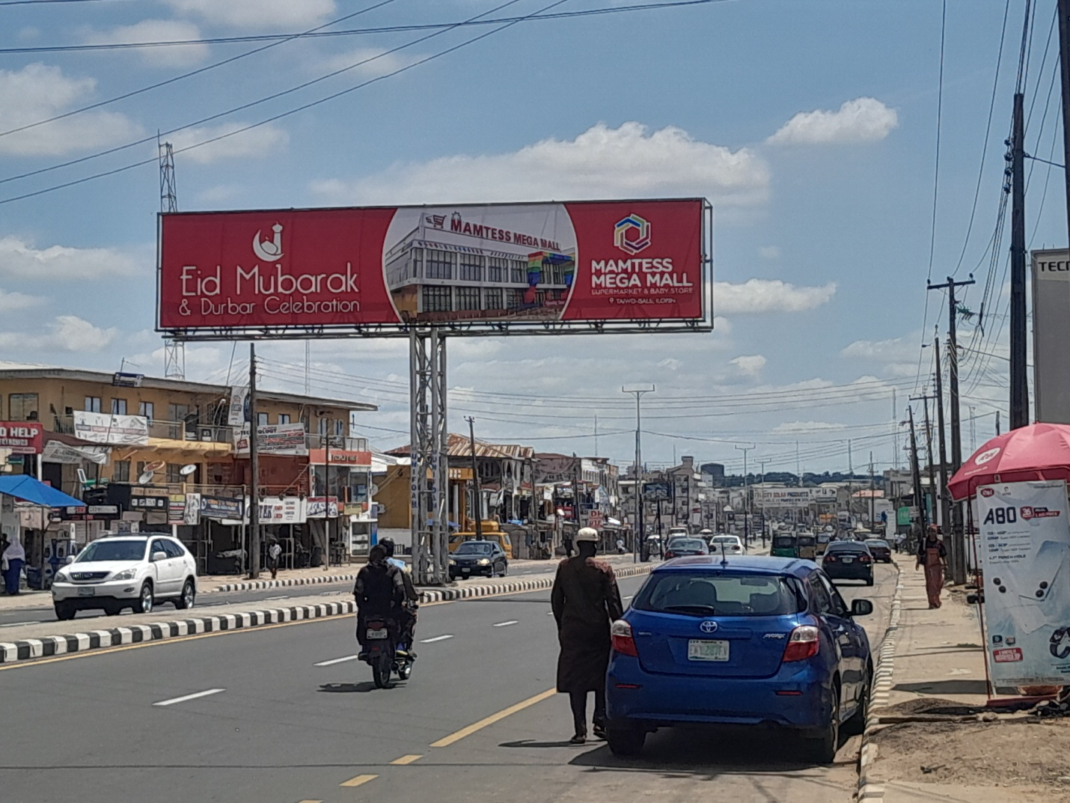
Figure 4: static billboard advertising mamtees supermarket and wishing Ed Mubarak to Muslin umar.

- Digital (LED) Billboards
Digital billboards use electronic displays to show dynamic images, videos, or messages; it can be easily updated with new content, allowing for flexible advertising strategies. Digital billboards can be programmed to display specific messages or ads based on time of day, weather, or other factors. Their brightness and dynamism can modernize a corridor but must be designed thoughtfully to prevent glare and visual disruption, especially in low-light conditions.
- 3D / Bespoke & Walls capes
Customized billboards with three-dimensional elements or murals painted directly on building façades. These can integrate art and structure, elevating the visual environment and enhancing cultural character when designed contextually and artfully.
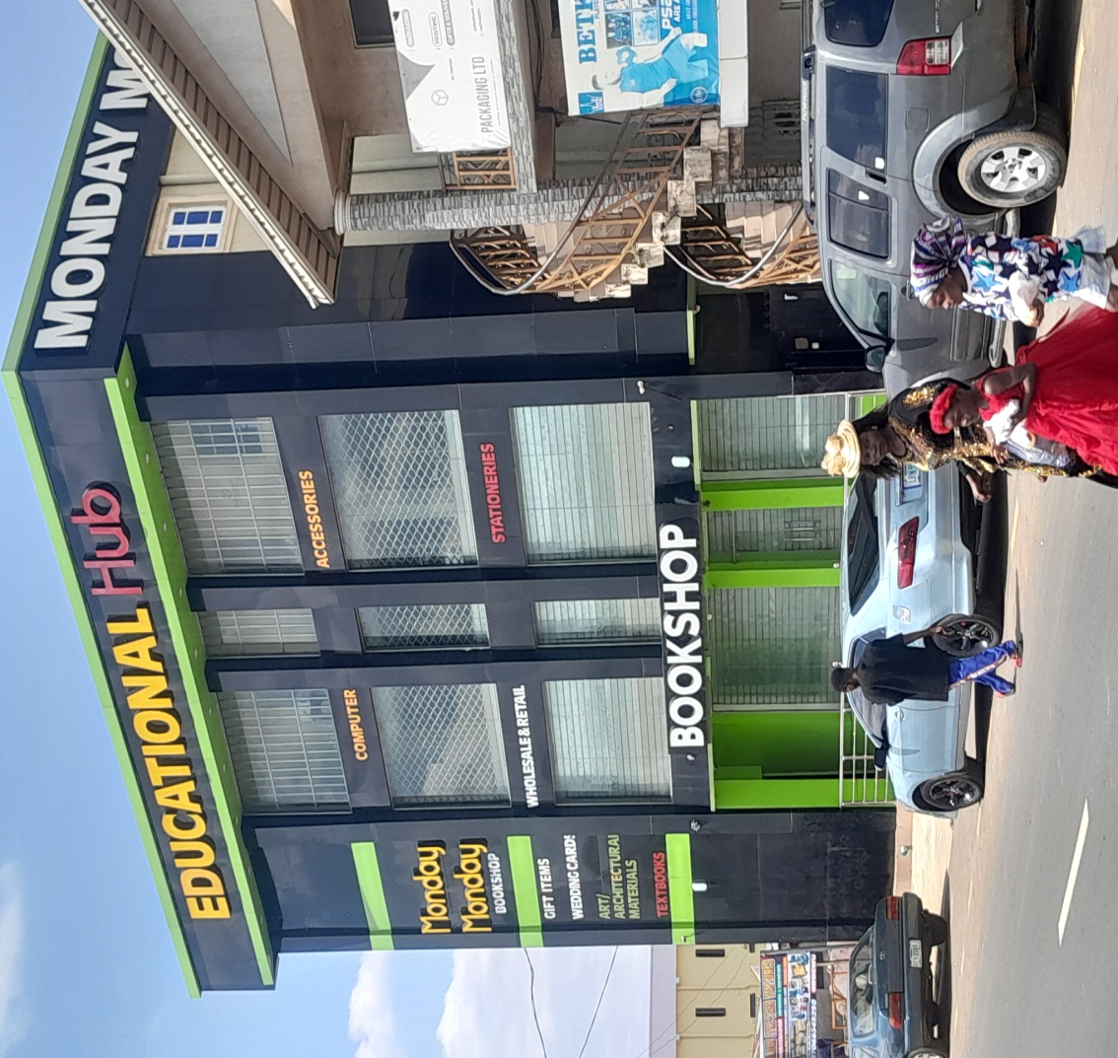
Figure 5: 3D / Bespoke & Walls capes adding visual and aesthetic to the bookshop at Taiwo isale area.

- Mobile & Transit Billboards
Advertise mounted on vehicles, trailers, buses, scooters, or bicycles. They move through various urban or scenic environments. These are flexible and can align with landscape aesthetics by targeting specific routes—avoiding clutter and preserving static scenery.
- Vinyl Billboards: Durable printed boards with UV-resistant coatings—ideal for long-term use while minimizing frequent replacements.
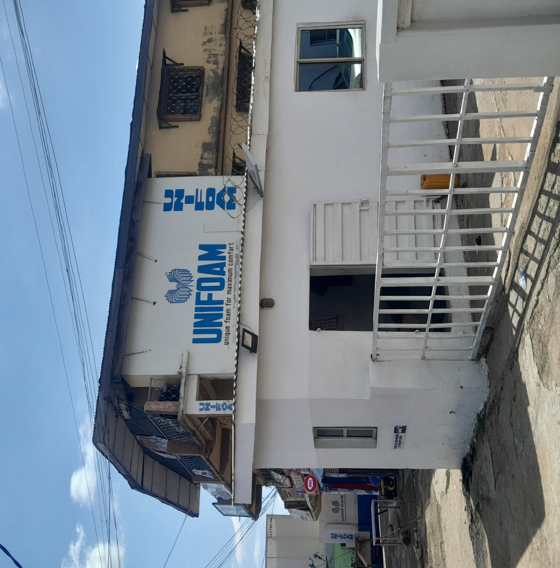
Figure 6: Vinyl billboard advertising a unifoam at Taiwo area.

- Painted Billboards: Hand-painted ads—often rare today but valued for artisanal, heritage-style aesthetics.

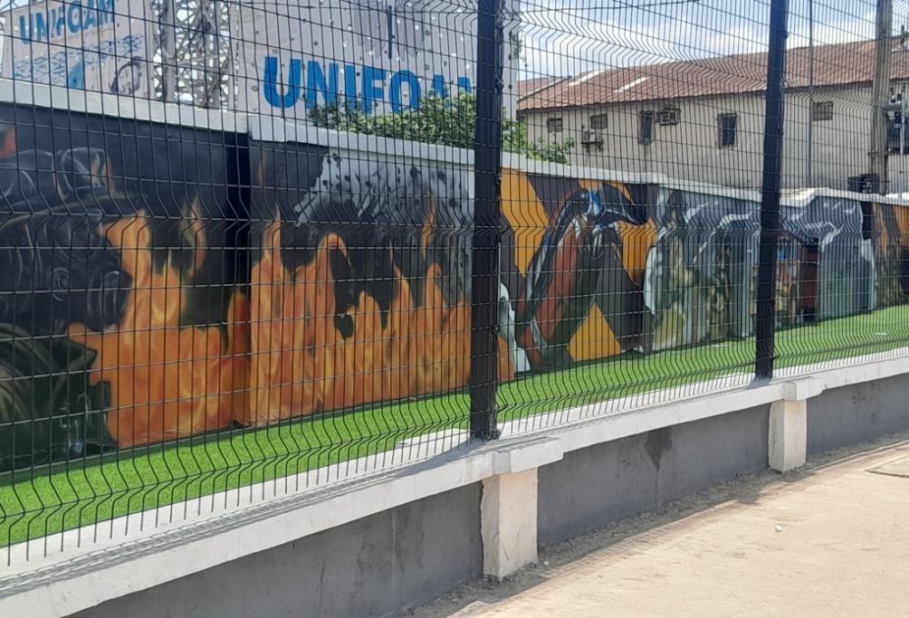
Figure 7: A painted ads beautifying the landscape at Taiwo junction.

- Scented & Inflatable Billboards: Innovative niche types—ranging from scented boards to large inflatable structures—used mainly for experiential campaigns.

Significance of billboards
The significance of billboards can be understood from several perspectives:
Advertising and Marketing
1. Reach and Frequency: Billboards can reach a large audience, especially in high-traffic areas, making them an effective way to increase brand awareness and frequency of exposure. This is particularly useful for businesses that want to reach a wide audience, such as retail stores, restaurants, and entertainment venues.
2. Targeted Advertising: Billboards can be strategically located to target specific demographics or audiences, increasing the effectiveness of the advertisement. For example, a billboard near a university might target students, while a billboard near a shopping mall might target families.
Economic Significance
1. Revenue Generation: Billboards can generate significant revenue for cities and towns through advertising fees and taxes. This revenue can be used to fund public services, infrastructure projects, and community programs.
2. Job Creation: The billboard industry can create jobs in advertising, design, and maintenance. This includes jobs for graphic designers, printers, installers, and maintenance personnel.
Social and Cultural Significance
1. Cultural Icon: Billboards can become cultural icons, reflecting the values and aesthetics of a particular time and place. For example, the iconic billboards in Times Square, New York City, are a symbol of the city's vibrant culture and entertainment industry.
2. Public Art: Some billboards can be considered public art, adding to the visual landscape and cultural identity of an area. This can include billboards that feature artistic designs, community messages, or public service announcements.
How Billboards Can Beautify the Environment
Though often viewed as intrusive, well-planned and well-designed billboards can enhance urban aesthetics and environmental character in the following ways:
1. Enhancing Visual Identity and Urban Branding
Billboards can display creative, culturally relevant, or artistic visuals that reflect the identity of Ilorin. They help define the character of a commercial corridor like Taiwo–Unity, signaling vibrancy and modernity.
2. Providing Color and Visual Interest
High-quality graphics, bold colors, and artistic typography add life and contrast to otherwise bland urban infrastructure especially in concrete-heavy areas, billboards can act like “urban murals” that stimulate visual engagement.
3. Encouraging Order and Harmony
When uniformly designed and regulated in terms of size, height, spacing, and theme, billboards contribute to a harmonized street view, avoiding clutter and chaos.
4. Creating Landmarks
Iconic billboard designs or 3D billboards can become urban landmarks or photo spots, making the area more memorable.
Advantages of Billboards
1. High Visibility: Billboards are highly visible and can reach a large audience, making them an effective way to promote a product or service.
2. Targeted Advertising: Billboards can be strategically located to target specific demographics or audiences, increasing the effectiveness of the advertisement.
3. Cost-Effective: Billboards can be a cost-effective way to reach a large audience compared to other forms of advertising.
4. Brand Awareness: Billboards can help build brand awareness and reinforce a company's identity.
5. Flexibility: Digital billboards can be easily updated with new content, allowing for flexible advertising strategies.
Disadvantages of Billboards
1. Visual Pollution: Billboards can contribute to visual clutter and detract from the aesthetic appeal of an area.
2. Distraction: Billboards can be distracting for drivers, potentially leading to accidents.
3. Regulations: Billboards are subject to regulations and zoning laws, which can limit their placement and design.
4. Limited Engagement: Billboards typically have a limited ability to engage with the audience, unlike digital media.
5. Weather Damage: Outdoor billboards can be damaged by weather conditions, such as strong winds, heavy rain, or extreme temperatures.
6. Short Attention Span: Drivers and pedestrians may only have a brief moment to view a billboard, making it challenging to convey a complex message.
7. Measurement Challenges: It can be difficult to measure the effectiveness of billboard advertising, making it hard to justify the cost.
Impact of billboard on landscape
Positive Impacts
1. Economic Benefits: Billboards can generate revenue for cities and provide a platform for local businesses to advertise.
2. Information Sharing: Billboards can convey important information, such as public service announcements, events, or directions.
3. Aesthetic Appeal: Well-designed billboards can add visual interest and enhance the urban landscape.
Negative Impacts
1. Visual Pollution: Excessive or poorly designed billboards can contribute to visual clutter, detracting from the urban aesthetic.
2. Distraction: Billboards can be distracting for drivers, potentially leading to accidents.
3. Environmental Impact: Large billboards can obstruct natural views, harm local ecosystems, or contribute to light pollution.
4. Over-Commercialization: Billboards can contribute to the commercialization of public spaces, potentially undermining the character of a neighborhood.
Mitigating Negative Impacts
1. Regulations: Cities can implement regulations to control the size, placement, and design of billboards.
2. Design Standards: Encouraging well-designed billboards that complement the urban landscape can help minimize negative impacts.
3. Digital Billboards: Digital billboards can provide more flexibility and opportunities for creative content, while also reducing the need for physical billboard structures.
Benefits of Billboards
Billboards offer numerous benefits for advertisers. Here's a detailed breakdown:
1. Billboards Attract Attention and Make an Impression
Visual Impact: Billboards are large, bold, and strategically placed in high-traffic areas, making them hard to miss. Whether it’s a busy highway, city center, or popular neighborhood, billboards capture the attention of thousands (or even millions) of potential customers daily.
Memorable: A well-designed billboard sticks in people’s minds, creating brand recall long after they’ve passed it. This repeated exposure helps build familiarity with your brand or message.
2. High Frequency and Repetition
Constant Exposure: Unlike TV or radio ads that run for a limited time, billboards work 24/7. People see them repeatedly, whether commuting to work, running errands, or traveling. This repetition reinforces your message and increases brand recognition.
Reaches Both Locals and Tourists: In high-traffic areas, billboards expose your brand to both local residents and tourists, expanding your reach beyond your immediate market.
3. Eye-Catching Design
Creative Freedom: Billboards allow for bold, creative designs that can make a lasting impression. Bright colors, striking visuals, and clever messaging can turn a billboard into a work of art that draws people in.
Simplicity is Key: Because people often view billboards while moving, a clear, concise message with a strong visual element is crucial. Effective billboards focus on delivering a simple yet impactful message.
4. Cost-Effective Advertising
Long-Term Exposure: Unlike digital ads, which charge per impression or click, billboards provide continuous exposure for a fixed cost. Once the billboard is up, it works for you around the clock without additional charges per view.
High ROI: With the right design and placement, billboards can generate significant returns by reaching large audiences at a lower cost per impression compared to other forms of advertising.
5. Versatility and Creativity
Varied Formats: Billboards come in various sizes and formats, from traditional static billboards to digital billboards that can change ads throughout the day. This flexibility allows you to choose the best format for your campaign.
Innovative Designs: You can incorporate QR codes, augmented reality, or interactive elements to engage modern audiences. 3D billboards or those with motion-activated features can create a wow factor that draws attention.
6. Encourage and Increase Sales with Billboards
Drive Foot Traffic: Billboards near retail locations can directly drive foot traffic to stores. A well-placed billboard with a clear call-to-action (like “Shop Now” or “Limited Time Offer”) can lead to immediate sales.
Promote Special Offers: Billboards are great for promoting sales, discounts, or special events. By creating urgency in your message, you can encourage people to act quickly and visit your store or website.
Brand Awareness Leads to Sales: Even if people don’t immediately act on seeing your billboard, repeated exposure builds trust and brand recognition. When they’re ready to make a purchase, your brand will be top of mind.
Local Targeting: Billboards allow u to target specific geographic areas, making them ideal for local businesses.
Compliment Other Marketing Channels: Billboards can reinforce your message across other platforms like social media, TV, or radio, creating a cohesive marketing strategy.
In summary, billboards are a powerful advertising tool that can attract attention, build brand awareness, and drive sales. When combined with creative design and strategic placement, they offer a cost-effective way to reach a broad.
Criticisms and Challenges
1. Visual Pollution: Billboards can contribute to visual clutter and detract from the aesthetic appeal of an area.
2. Distraction: Billboards can be distracting for drivers, potentially leading to accidents.
3. Regulations: Billboards are subject to regulations and zoning laws, which can limit their placement and design.
The values and impacts of billboards
Economic Value
1. Revenue Generation: Billboards can generate significant revenue for landowners, cities, and towns through advertising fees and taxes. This revenue can be used to fund public services, infrastructure projects, and community programs.
2. Job Creation: The billboard industry can create jobs in advertising, design, and maintenance. This includes jobs for graphic designers, printers, installers, and maintenance personnel.
Advertising Value
1. Brand Awareness: Billboards can increase brand awareness and visibility for businesses, products, and services. This can be particularly effective for businesses that want to reach a wide audience, such as retail stores, restaurants, and entertainment venues.
2. Targeted Advertising: Billboards can be strategically located to target specific demographics or audiences. For example, a billboard near a university might target students, while a billboard near a shopping mall might target families.
Informational Value
1. Directional Information: Billboards can provide directional information to drivers, helping them navigate unfamiliar areas. This can be particularly useful for tourists or travelers who are not familiar with the local area.
2. Event Promotion: Billboards can promote local events, such as concerts, festivals, or sales. This can help increase attendance and awareness of local events.
Aesthetic Value
1. Visual Interest: Well-designed billboards can add visual interest to the landscape and enhance the aesthetic appeal of an area. This can be particularly true for billboards that feature creative and artistic designs.
2. Artistic Expression: Some billboards can be considered public art, featuring creative and artistic designs. This can add to the cultural and aesthetic value of an area.
Negative Impacts
1. Visual Pollution: Billboards can contribute to visual clutter and detract from the aesthetic appeal of an area. This can be particularly problematic in areas with high concentrations of billboards, such as along highways or in urban areas.
2. Distraction: Billboards can be distracting for drivers, potentially leading to accidents. This is particularly concerning for digital billboards, which can display dynamic and attention-grabbing content.
3. Environmental Impact: Billboards can have environmental impacts, such as light pollution or habitat disruption. This can be particularly problematic in areas with sensitive ecosystems or wildlife habitats.
Overall, the value of billboards depends on their design, location, and impact on the surrounding environment. By understanding the potential benefits and drawbacks of billboards, we can better appreciate their role in our communities and environments.

Criticisms and Challenges
1. Visual Pollution: Billboards can contribute to visual clutter and detract from the aesthetic appeal of an area.
2. Distraction: Billboards can be distracting for drivers, potentially leading to accidents.
3. Regulations: Billboards are subject to regulations and zoning laws, which can limit their placement and design.
Recommended Billboard Types for Taiwo–Unity Road Corridor
1. 3D & Creative Billboard Structures These add artistic and sculptural value to the streetscape.
Benefit: Create unique visual identities; act as landmarks or unique spots.
2. Wallscapes or Building-Wrap Billboards Perfect for the dense urban character of the area.
Benefit: Use the sides of buildings to reduce pole clutter and integrate advertising into the urban form.
3. Digital LED Billboards (Moderate Use) Modern, dynamic visuals catch attention without needing many boards.
Benefit: Can be used at intersections or key commercial zones (e.g., around Unity Junction) for high impact without oversaturation.
4. Pole or Lamp-Post Banner Ads These smaller, uniform ads attached to streetlights are ideal for promoting local events or businesses.
Benefit: They provide visual interest at the pedestrian eye level and don’t disrupt skyline views.

CHAPTER THREE
RESEARCH METHODOLOGY
Research Design
The research design describes the laid down processes by which the research was carried out. This ensures that the research problem is correctly addressed. To do this, data was collected in order to ascertain the situation of the study area.

Sampling Technique
The systematic random sampling technique was used in the administration of the sampling of people opinion through interview. The method used was the systematic random sampling.

Population of Study
Population refers to the total number of people, media content to which the researcher intent to carry out research on. However, the total population for the survey of the study will be the entire people that work or live or understand how billboards affect the scenic and aesthetic value of Taiwo–Unity Road and if the presence of those Billboards aligns with sustainable urban planning and beautification goals. According to the National Population Commission (2015), the 2006 census indicates that the total population of Ilorin West has a population of 364,666 Therefore, the total population is 364,666.
Sample Size
A sample size is therefore a smaller group of elements drawn through a definite procedure from specified population (Nworgu, 1991). To achieve this, Krejcie, and Morgan, (1970) sample size determining formula will be use.
s = X² NP (1 − P) ÷ d 2 (N − 1) + X 2 P (1 − P).
s = required sample size.
X² = the table value of chi-square for 1 degree of freedom at the desired confidence level (3.841).
N = the population size.
P = the population proportion (assumed to be .50 since this would provide the maximum sample size).
d = the degree of accuracy expressed as a proportion (.05).
Therefore, the sample size for this study will be 385 respondents. However, to get the actual sample size for this study, ratio 1:2 was used, hence, we arrived at 195 respondents. To arrive at an accurate sample size, 200 respondents were selected for the study.

Sampling Procedure
To achieve the research goal, Purposive sampling technique was used to select the respondents. The purposive sampling technique, also called judgment sampling, is the deliberate choice of a participant due to the qualities the participant possesses. It is a nonrandom technique that does not need underlying theories or a set number of participants (Zhi, 2014).
Sampling Frame
The sampling frame consisted of all residential and commercial property owners, and residents within selected wards of Ilorin East Local Government Area where the Kwara State Signage and Advertisement Agency are actively enforced or frequently breached. The frame also included relevant government officials and community leaders involved in planning and enforcement activities (Adewuyi & Ojo, 2021).

 | No of Billboards
SN | Commercials | Residentials | No of Sampled Billboard | Name of Streets
1 | 15 | 11 | 4 | Taiwo
2 | 10 | 10 | 4 | Unity
3 | 15 | 4 | 1 | Taiwo Link
Total | 40 | 30 | 10

Sources of Data collection
The data for these studies were obtained from two different sources that is, primary and secondary sources.
The primary sources of data used include the following.
1) Physical survey: A reconnaissance survey was under taken to determine the actual locations of the various billboards. The second objective of this reconnaissance survey was to ascertain the area extent of the study area.
2) Questionnaires preparation and administration: The questionnaires administration was relied upon to source for information. This was done to ask questions from people (especially the owner of the billboard).
The questionnaire was divided into the following sections:

- Section A: Demographic Information
- This section gathered data on respondents' age, gender, educational background, occupation, within the study area.
- Section B: perception on billboard
- Questions in this section assessed the level of respondents’ knowledge about signage and billboard and the roles of relevant regulatory agencies.
- Section C: Environmental & Functional Impact
This section explored respondents’ perceptions of billboard on environment and impact on the road
- Section D: Economic & Informational Impact
Questions here focused on how billboard help promote market and help in advertisement
- Section E: Suggestions for Improvement
Respondents were asked to provide opinions on how compliance and enforcement of billboard can improved . The structured format of the questionnaire enabled the collection of standardized and quantifiable data that was suitable for statistical analysis, facilitating reliable and valid conclusions regarding the extent of compliance and influencing factors (Creswell, 2014).

The secondary sources of data include the following.
1) Journals and texts books: The collection of data through secondary means includes relevant journals, textbooks, magazines, gazette, internet, records and others which are very important to the research work. The other relevant journals were gotten from the Kwara State Signage and Advertisement Agency (KWASAA).
2) Software: The software used for this research include ARCGIS and SPSS. ARCGIS was used for the digitization and composition of the Maps while SPSS was used to analyse and present statistical data.

Methods of Data Analysis
Data collected were analyzed and interpreted using a descriptive statistical method. variables were analyzed and values for different options were encoded into Statistical Package for Social Sciences (SPSS).

Methods of Data Presentation
Analyzed Statistical data are presented on tables and charts while data such as maps, pictures and satellite imageries, are represented by figures and plates.

CHAPTER FOUR

DATA ANALYSIS

This chapter examines and presents data obtained from various households and shops through field survey and questionnaire administration and also includes elements of authors’ observations. Results of the analysis are presented in tables while pictorial data are presented in plates.

SOCIO-ECONOMIC CHARACTERISTICS OF THE RESPONDENT
Age Distribution of Respondents in the Study
Option | Frequency | Percentage %
Under 18 | 5 | 0.8
18- 25 | 96 | 51
26–35 | 50 | 29
36-45 | 39 | 18
46 and above | 10 | 1.2
Total | 200 | 100

Source: Student Field Survey 2025

From the table and above, it shows that The age distribution of the respondents shows that the under 18 are just (0.8%), while the majority (51%) fall within the 18–25 age group, followed by those aged 26–35 (29%) and 36–45 (18%), while 1.2% are above 46 years of age. This distribution suggests that the most active participants in billboard advertisement in the study Area are within the working-age bracket, particularly young to middle-aged adults. This demographic trend aligns with the stage in life when individuals are most likely engage in advertisement activities. The relatively low representation of respondents above 46 could be attributed to their reduced involvement in social media activities or possible delegation of such responsibilities to younger family members.

Gender of Respondents in the Study
Option | Frequency | Percentage (%)
Male | 120 | 60
Female | 80 | 40
Total | 200 | 100
Source: Student Field Survey 2025
The table above reveals the gender distribution of respondents who participated in the study. Out of the 200 respondents, 120 (60%) identified as male, 80 (40%) as female, This suggests that males constitute the majority of participants in the study, potentially reflecting a higher level of involvement or decision-making authority among men in matters related to advertisement development and compliance with billboard and signage regulations within the study area.

Occupation of Respondents in the Study Area
Option | Frequency | Percentage (%)
Student | 50 | 25
Employed | 57 | 28
Business owner | 78 | 35
Other | 15 | 12
Total | 200 | 100
Source: Student Field Survey 2025
The above table shows the occupational distribution of respondents in the study area reveals a diverse range of employment categories, with business owner representing the largest group at 35%, followed by employed and students each constituting 28% and 25%. Others account for 12%

OBJECTIVE 1: TO IDENTIFY THE BILLBOARD TYPES IN THE STUDY AREA.
There are 5 types of billboards in the study area, which includes:
- Static billboard
- 3D / Bespoke walls capep
- Mobile and transit billboard
- Vinyl billboard
- Painted billboard
TABLE SHOWING THE TYPES AND TOTAL NUMBER OF BILLBOARDS IN THE STUDY AREA
TYPES OF BILLBORD | FREQUENCY | PER (%)
STATIC BILLBOARD | 11 | 16
3D / BESPOKE WALLS CAPEP | 147 | 52
MOBILE AND TRANSIT BILLBOARD | 8 | 13
VINYL BILLBOARD | 9 | 11
PAINTED BILLBOARD | 5 | 8
TOTAL | 180 | 100

Source: Student Field Survey 2025
The above table shows the types and number of each billboard within the study area with 3D / bespoke walls cape having the highest number of billboard types with 52% follow by the static billboard with 16%, mobile and transit account for 13% within the area while vinyl and painted billboard have 11% and 8% respectively. This show that 3D / bespoke walls cape is the most common used types base on the visual and aesthetic value it add to the shops and building.
- OBJECTIVE 2: TO EVALUATE THE VISUAL AND AESTHETIC CONTRIBUTION OF BILLBOARDS ON THE LANDSCAPE OF THE ENVIRONMENT.
VISUAL PRESENCE OF BILLBOARD IN THE STUDY AREA
Option | Frequency | Percentage (%)
Very Attractive | 115 | 55
Moderately attractive | 42 | 21
Neutral | 11 | 8
Distracting | 32 | 16
Total | 200 | 100
The table above show that 55% of people are very attractive to the presence of billboard on urban road, while 21% are moderately okay with it with 16% of people seeing it as distraction of view and blocking their sight, and 8% of people are not bother about it they don’t like it nor dislike it . this indicate that majority of people are okay with the
presence of billboard as it help them advertise their market to a large number of people passing by every day.
AESTHETIC CONTRIBUTION OF BILLBOARDS ON THE LANDSCAPE
Option | Frequency | Percentage (%)
Enhance | 156 | 76
Degraded | 36 | 21
Neutral | 8 | 3
Total | 200 | 100

From the above table it show that billboard enhance the urban aesthetic with 76%, while 21% were degraded and 3% neutral. These show that the billboard enhances and add beauty to the urban road most especially in the study area with the large billboard advertising different kind of phones.
- OBJECTIVE 3: TO ASSESS PUBLIC OPINION/ PERCEPTION ON BILLBOARD INFLUENCE ON ENVIRONMENT.
OPINION OF THE RESPONDENTS ON PERCEPTION OF THE BILLBOARD IN THE STUDY AREA
WOULD YOU SUPPORT THE REPLACEMENT OF PHYSICAL BILLBOARDS WITH DIGITAL OR ECO-FRIENDLY ALTERNATIVES?
Option | Frequency | Percentage (%)
Yes | 165 | 68
No | 20 | 27
Depend on implementation | 15 | 5
Total | 200 | 100
Source: Student Field Survey 2025
The table above shows 68% of people willing to replace the billboard with more improved digital or eco-friendly alternative while 27% insist on using the billboard and 5% where okay if only the implementation were good and easy.
DO YOU THINK BILLBOARDS HELP LOCAL BUSINESSES?
Option | Frequency | Percentage (%)
Yes | 185 | 77
No | 13 | 22
Not sure | 2 | 1
Total | 200 | 100

Source: Student Field Survey 2025
The above table shows 77% of people agree that billboard help in promoting local business as it help advertise their product to large number of people while 22% believe it not help local business and 1% were not sure.
HAVE YOU EVER PURCHASED A PRODUCT OR SERVICE AFTER SEEING A BILLBOARD AD?
Option | Frequency | Percentage (%)
Yes | 154 | 65
No | 46 | 35
Total | 200 | 100

Source: Student Field Survey 2025
The table above shows that 65% of people tend to have purchase goods or services after seeing a billboard advertisement most especially a phone and eatery. And 35% were not.
DO YOU THINK BILLBOARDS ARE AN EFFECTIVE MEANS OF ADVERTISING IN URBAN AREAS?
Option | Frequency | Percentage (%)
Yes | 185 | 87
No | 15 | 13
Not sure | 0 | 0
Total | 200 | 100

From the table above it show that 87% were positive and 13% are negative. This mean that people see billboard as one of the means of advertising their business as it help pass message to a large number of people passing by everyday and help promote their market too.

HAVE YOU NOTICED AREAS WHERE BILLBOARDS BLOCK NATURAL VIEWS OR ARCHITECTURAL LANDMARKS?
Option | Frequency | Percentage (%)
Yes | 134 | 62
No | 66 | 38
Total | 200 | 100

From the table above it show that 62% say that billboard block architectural landmark or natural view, while 38% believe it not. This show that billboard do actually block some view most especially around Taiwo area where there is high number of billboard advertisement.
HOW DO YOU RATE THE IMPACT OF BILLBOARDS ON TRAFFIC SAFETY?
OPTION | FREQUENCY | PERCENTAGE (%)
HIGHLY NEGATIVE | 34 | 25
SOMEWHAT NEGATIVE | 8 | 3
NEUTRAL | 6 | 2
SOMEWHAT POSITIVE | 65 | 31
HIGHLY POSITIVE | 87 | 39
TOTAL | 200 | 100

Source: Student Field Survey 2025
From the table above it show that 39% of highly positive and 31% of somewhat positive while 25% of highly negative and 3% of somewhat negative with 2% neutral. This show that billboard contribute to traffic safety.

IN YOUR OPINION, DO BILLBOARDS CONTRIBUTE TO ENVIRONMENTAL DEGRADATION (E.G., LIGHT POLLUTION, LANDSCAPE OBSTRUCTION)?
Option | Frequency | Percentage (%)
Yes | 94 | 42
N0 | 61 | 34
Not sure | 45 | 24
Total | 200 | 100

Source: Student Field Survey 2025

The above table show that billboard at times usually contribute to environmental degradation, when there is s many billboard in one place this tend to blockage of light and obstruct the pedestrian walking through the landscape with 42% of people agree to this, while 34% believe it not. And 24% were not sure whether it’s true or not.

DO YOU BELIEVE THERE SHOULD BE REGULATIONS LIMITING THE NUMBER OR SIZE OF BILLBOARDS IN CITIES?
Option | Frequency | Percentage (%)
Yes | 137 | 68
No | 56 | 30
Not sure | 7 | 2
Total | 200 | 100

Source: Student Field Survey 2025
The above table show that 68% of people believe there should be regulation to limit the number of billboard in the city to prevent pollution and 30% of people do not agree to it while 2% stay neutral.

Figure 8: Static types of billboard advertising supreme noodles product.
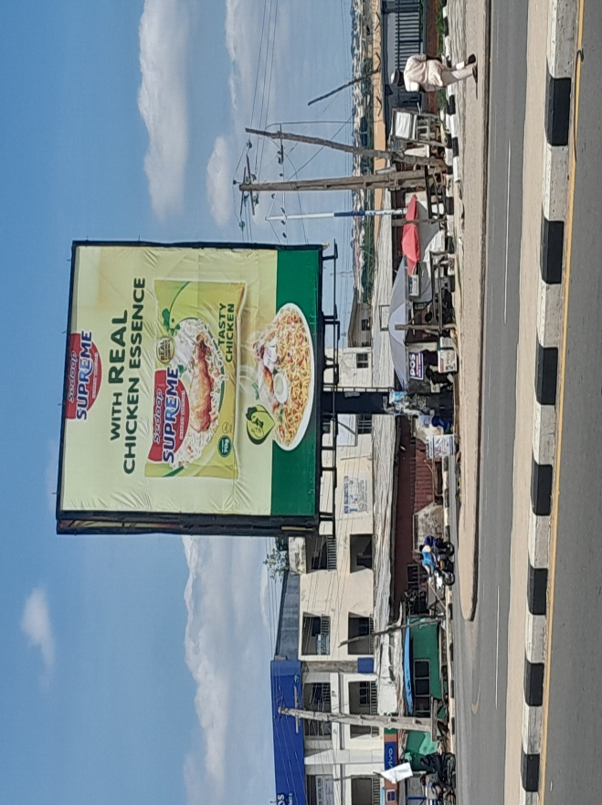
Source: student field survey, 2025
Figure 9: billboard ads for a duplicate key shop.
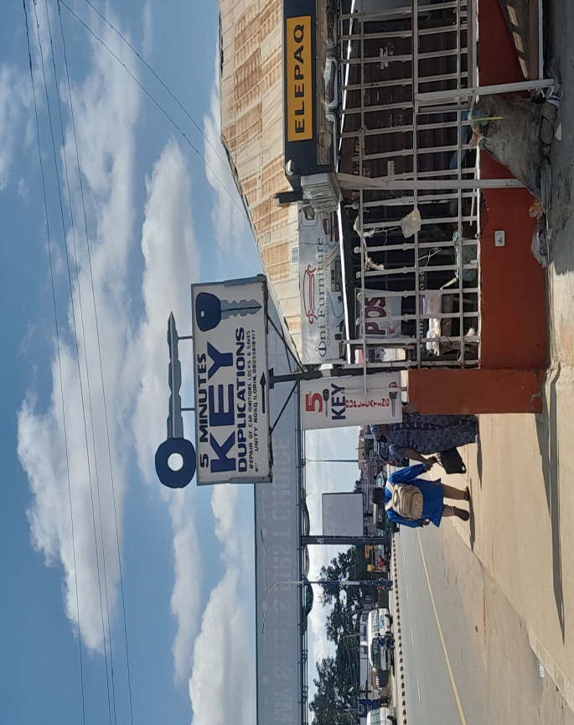
Source: student field survey, 2025

Figure 10: Bespoke & Walls capes adding visual and aesthetic to favour mall and other shops at Taiwo area.
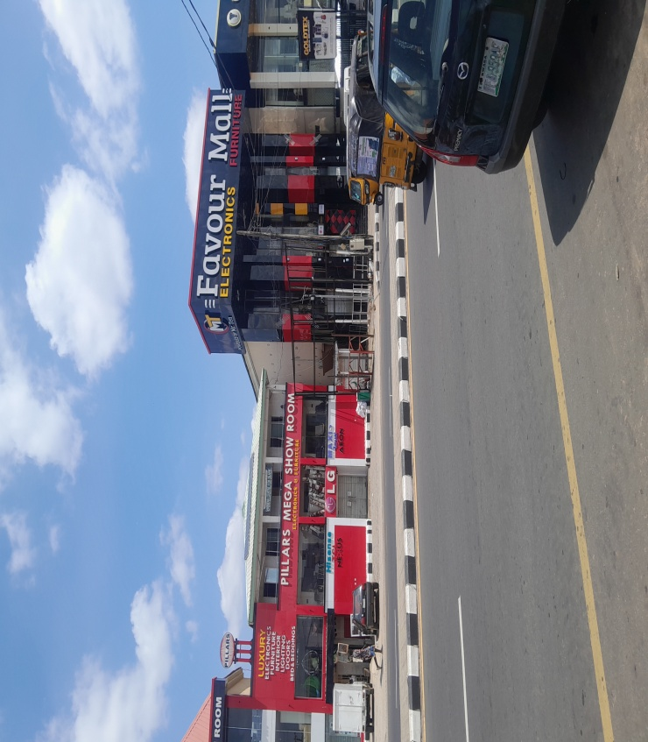
source: student field survey, 2025

Figure 11: Mamtess mega mall at Taiwo isale area.
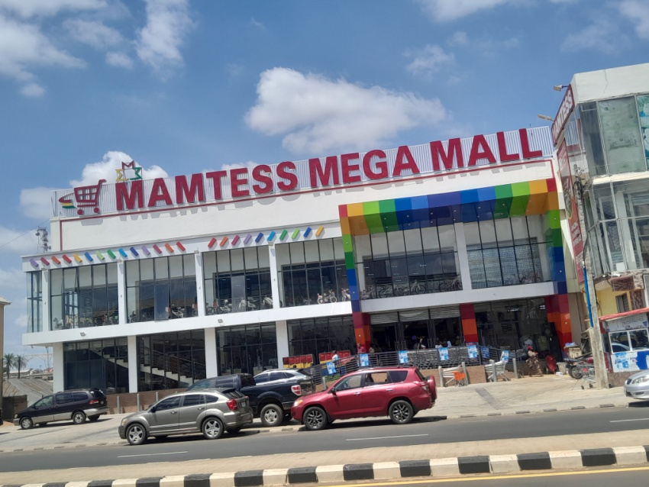
source: student field survey, 2025
Figure 12: Vinyl billboard advertising for different shops at Taiwo.
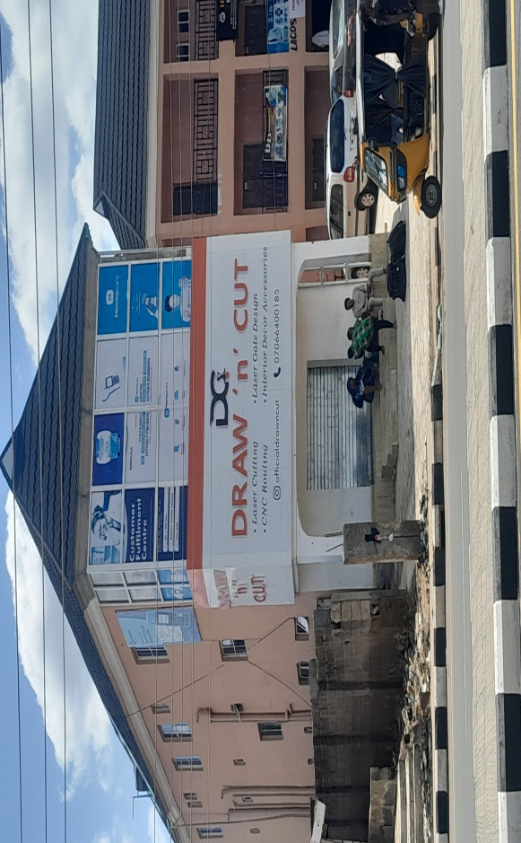
source: student field survey, 2025

Figure 13: static and 3d types of billboard ads at Divine plaza Taiwo area

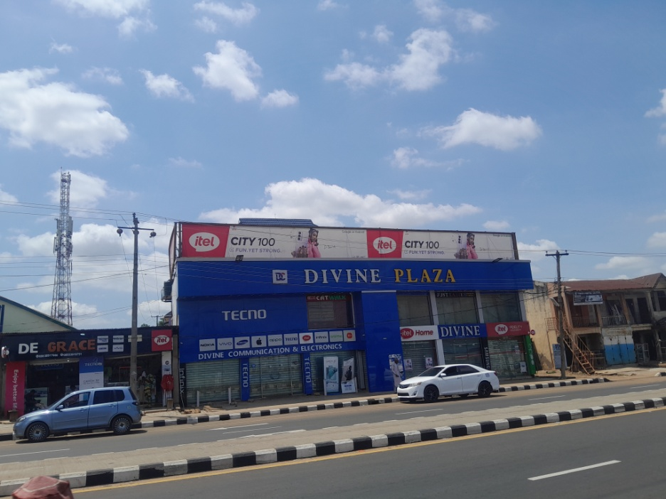
source: student field survey, 2025

CHAPTER FIVE
FINDINGS SUMMARY OF, CONCLUSION AND RECOMMENDATIONS
Summary of findings
SOCIO-ECONOMIC CHARACTERISTICS OF THE RESPONDENTS
The age distribution of the respondents shows that the highest are people within the age of 18-25 with (51%) while the lowest are under 18 with (0.8%). The gender distribution of respondents who participated in the study. Out of the 200 respondents, 120 (60%) identified as male, 80 (40%) as female. the occupational distribution of respondents in the study area business owner has the highest with 35% while the Other has the lowest 12%.
OBJECTIVE 1

OBJECTIVE 2
Visual presence of billboard in the study AREA Very Attractive highest with 55% While the lowest is Neutral with 8%. Aesthetic Contribution Of Billboards On The Landscape Enhance has the highest with 76% while Neutral has the lowest with 3%.
OBJECTIVE 3: OPINION OF THE PEOPLE
Replacement of physical billboards with digital or eco-friendly alternatives yes is the highest with 68% while the lowest is Depend on implementation with 5%. Do you think billboards help local businesses Yes with 77% while has the lowest is Not sure with 1%. Have you ever purchased a product or service after seeing a billboard ad? Yes is the highest with 65% While the lowest is No with 35%. Do you think billboards are an effective means of advertising in urban areas? Yes is the highest point with 87% has the lowest No with 13%. Have you noticed areas where billboards block natural views or architectural landmarks? Yes is the highest point with 62% while the lowest point is No with 38%. How do you rate the impact of billboards on traffic safety? Highly positive has the highest point with 39% while the lowest point NEUTRAL with 2%. In your opinion, do billboards contribute to environmental degradation (e.g., light pollution, landscape obstruction)? Yes is the highest point with 42% while the lowest point is Not sure with 24%. Do you believe there should be regulations limiting the number or size of billboards in cities? Yes is the highest point is 68% while the lowest is Not sure with 2%.
Recommendations
Recommended Billboard for Taiwo–Unity Road,
Walls cape Billboards (Building-Wrap Advertising) Walls cape billboards are the most suitable for Taiwo–Unity Road because they make efficient use of space, reduce clutter, and offer an opportunity to beautify buildings with artful, culturally relevant advertising—all while maintaining safety and urban harmony.
Why it’s the Best for the Area:
1. Space-Efficient & Non-Intrusive: Taiwo–Unity Road is a busy urban corridor with limited sidewalk and roadside space. Wallscapes use the sides of buildings, avoiding clutter from freestanding poles or structures.
2. Preserves Traffic Flow & Safety: Since they don't obstruct roads or pedestrian pathways, they are less distracting to drivers and safer in congested zones.
3. Blends with Urban Architecture: The corridor has a mix of modern and older buildings—wallscapes can be tailored to complement building aesthetics without overpowering them.
4. Ideal for Branding the Area: Wallscapes offer large, visually impactful canvases that can feature local culture, brands, or art, helping create a visual identity for the area.
5. Reduced Visual Pollution: Because they are flush against existing structures, wallscapes reduce the risk of visual clutter and skyline obstruction common with tall or overlapping billboards.
Beauty it could add to the Environment:
Creates Urban Art: Wallscapes can be designed creatively, incorporating art, colors, and cultural themes that celebrate Ilorin’s identity.
Softens Harsh Architecture: In areas with aging buildings, wallscapes can serve as aesthetic cover-ups, revitalizing the look of old facades.
Adds Color & Texture: These billboards bring vibrant life to otherwise dull concrete surfaces, breaking monotony with engaging visuals.
Creates a Harmonized Look: When coordinated by local authorities, wallscapes along a road can create a cohesive visual theme, improving the street’s overall appearance.

Wallscape Billboard Impact on Street Beautification:
Wallscape billboards, when strategically placed and artistically designed, have a positive and transformative impact on the beautification of streets like Taiwo–Unity Road. They promote visual order, local character, and commercial vibrancy without disrupting the flow or feel of the urban environment.
1. Visual Enhancement of Building FacadesMany structures along Taiwo–Unity Road have aged or unremarkable exteriors.Wallscape billboards can revitalize the appearance of these buildings by covering dull or deteriorating walls with vibrant, high-quality graphics.This contributes to a more colorful, modern, and engaging street environment.
2. Reduction in Visual ClutterUnlike traditional pole or rooftop billboards, wallscapes do not interfere with the skyline or streetscape.They help maintain a clean and organized appearance, especially when coordinated in terms of size, placement, and theme.This is crucial in a high-traffic commercial area like Taiwo–Unity Road, where overhead clutter is a concern.
3. Support for Urban Identity & CultureWhen integrated with local themes, wallscapes can promote Ilorin’s culture, history, or public messages, turning blank walls into urban canvases.
For example, a billboard combining a brand ad with traditional patterns or Kwara landmarks adds character and uniqueness to the street.
4. Improvement of Pedestrian Experience
Pedestrians walking along Taiwo–Unity Road are exposed to large-format, visually rich art or advertising that is engaging and at human scale.This enhances the aesthetic quality of the street at eye-level, unlike tall billboards that disconnect from pedestrians.
5. Economic and Commercial Appeal
Wallscapes create an attractive environment for business visibility without overwhelming passersby.When designed well, they draw attention without being distracting, adding beauty while still fulfilling advertising functions.

Conclusion
The study of the Taiwo–Unity Road corridor in Ilorin demonstrates that billboards, while economically and commercially valuable, have a pronounced impact on the urban landscape. The uncontrolled spread and poor management of billboard installations have led to aesthetic degradation, visual clutter, and safety issues. However, with proper regulation, design guidelines, and maintenance policies, billboards can coexist with a visually appealing and orderly urban environment.
For future urban development, it is essential that Ilorin’s urban planning authorities implement stricter billboard placement regulations, enforce existing signage laws, and encourage the use of standardized, aesthetically pleasing billboard designs. A balanced approach that harmonizes economic benefits with visual and environmental considerations is key to improving the quality of the urban landscape.

REFERENCES

Afolayan, A. A., & Olayiwola, L. M. (2011). Land use planning and urban development in Nigeria: An overview. Journal of Geography and Regional Planning, 4(9), 633–638. https://doi.org/10.5897/JGRP.9000052
Akinbode, O. M. (2002). Environmental issues and waste management policies. In Effective waste management in the 21st century (pp. 1–14). Ibadan: Centre for Environmental Education and Development.
Beatley, T. (2011). Biophilic cities: Integrating nature into urban design and planning. Island Press.
City of Toronto. (2009). Sign by-law project: Final staff report on billboard regulations. City Planning Division. https://www.toronto.ca/legdocs/mmis/2009/pg/bgrd/backgroundfile-24084.pdf
Ede, P. N., & Edem, E. D. (2014). Environmental impact of billboard advertising in urban centres: A study of Calabar Municipality, Nigeria. International Journal of Environment and Pollution Research, 2(3), 35–48.
Healey, P. (1997). Collaborative planning: Shaping places in fragmented societies. Macmillan.
Jacobs, J. (1961). The death and life of great American cities. Random House.
Kavaratzis, M. (2004). From city marketing to city branding: Towards a theoretical framework for developing city brands. Place Branding, 1(1), 58–73. https://doi.org/10.1057/palgrave.pb.5990005
Lynch, K. (1960). The image of the city. MIT Press.
Nigerian Urban and Regional Planning Law. (1992). Decree No. 88 of 1992. Federal Republic of Nigeria.
Ogunba, O. A., & Ojo, M. O. (2013). Signage control and outdoor advertising in Nigeria: An appraisal of current practice. Journal of Environmental Design and Management, 5(1), 20–31.
Rapoport, A. (1990). The meaning of the built environment: A nonverbal communication approach (Rev. ed.). University of Arizona Press.
Scollon, R., & Scollon, S. W. (2003). Discourses in place: Language in the material world. Routledge.
UN-Habitat. (2013). Streets as public spaces and drivers of urban prosperity. United Nations Human Settlements Programme. https://unhabitat.org/books/streets-as-public-spaces-and-drivers-of-urban-prosperity
Watson, V. (2009). ‘The planned city sweeps the poor away…’: Urban planning and 21st century urbanization. Progress in Planning, 72(3), 151–193. https://doi.org/10.1016/j.progress.2009.06.001

Apendix
Section A: Demographic Information
- Age:
[ ] Under 18
[ ] 18–25
[ ] 26–35
[ ] 36–45
[ ] 46 and above

2. Gender:
[ ] Male
[ ] Female
[ ] Other
[ ] Prefer not to say

3. Occupation:
[ ] Student
[ ] Employed
[ ] Business Owner
[ ] Urban Planner
[ ] Other: ___________s

4. How often do you travel on urban roads?
[ ] Daily
[ ] Several times a week
[ ] Occasionally
[ ] Rarely
Section B: Perception of Billboards
5. How would you describe the visual presence of billboards on urban roads?
[ ] Very attractive
[ ] Moderately attractive
[ ] Neutral
[ ] Distracting
[ ] Ugly/Cluttered
6. Do you think billboards enhance or degrade the urban aesthetic?
[ ] Enhance
[ ] Neutral
[ ] Degrade
7. Have you ever been distracted by a billboard while driving?
[ ] Yes
[ ] No
8. Do you believe there should be regulations limiting the number or size of billboards in cities?
[ ] Yes
[ ] No
[ ] Not sure
---
Section C: Environmental & Functional Impact
9. In your opinion, do billboards contribute to environmental degradation (e.g., light pollution, landscape obstruction)?
[ ] Yes
[ ] No
[ ] Not sure
10. How do you rate the impact of billboards on traffic safety?
[ ] Highly negative
[ ] Somewhat negative
[ ] Neutral
[ ] Somewhat positive
[ ] Highly positive
11. Have you noticed areas where billboards block natural views or architectural landmarks?
[ ] Yes
[ ] No
Section D: Economic & Informational Impact
12. Do you think billboards are an effective means of advertising in urban areas?
[ ] Yes
[ ] No
[ ] Not sure
13. Have you ever purchased a product or service after seeing a billboard ad?
[ ] Yes
[ ] No
14. Do you think billboards help local businesses?
[ ] Yes
[ ] No
[ ] Not sure
15. Would you support the replacement of physical billboards with digital or eco-friendly alternatives?
[ ] Yes
[ ] No
[ ] Depends on implementation
---
Section E: Open-Ended
16. What is your general opinion on the use of billboards in urban road areas?
---
17. What changes (if any) would you suggest regarding billboard placement or design in your city?

