CHAPTER ONE
INTRODUCTION
1.1 Background of the study
The railway transportation system provides services to millions of passengers worldwide and is also responsible for the haulage of tones of goods daily. It is a high capacity system and it is economical. The necessity to keep train journeys safe and reliable cannot be overemphasized (Azim et al, 2018).
A level crossing occurs where a railway line is intersected by a road or path on one level, without recourse to a bridge or tunnel. It is a type of at grade intersection. The term also applies when a light rail line with separate right-of-way in reserved track crosses a road in the same fashion. Other names include railway crossing, railroad crossing, road through railroad, train crossing or grade crossing. Early level crossings had a lagman in a nearby booth who would, on the approach of a train, wave a red flag or lantern to stop alralic and clear the tracks .
Railway level crossings are critical intersections where road traffic and trains converge, often leading to accidents due to human error, delayed responses, or malfunctioning barriers. This research paper introduces an "Automated Level Crossing System for Trains with Real-Time Obstacle Detection and Alerting Mechanism" to address these safety concerns. The system integrates advanced sensors, including infrared and ultrasonic sensors, along with image processing and object detection algorithms to monitor crossings for potential obstructions such as vehicles, pedestrians, or debris. Upon detecting an obstacle, it triggers alerts using audible alarms and flashing lights, while also controlling barrier systems to ensure timely and safe operations. Additionally, real-time alerts are sent to both the train driver and the railway control center, facilitating swift action to prevent accidents (Mohammadfam & Gholamizadeh, 2021).
A level crossing occurs where a railway line is intersected by a road or path on one level, without recourse to a bridge or tunnel. It is a type of at grade intersection. The term also applies when a light rail line with separate right-of-way in reserved track crosses a road in the same fashion. Other names include railway crossing, railroad crossing, road through railroad, train crossing or grade crossing Lebedev and Staples (1998).
Early level crossings had a lagman in a nearby booth who would, on the approach of a train, wave a red flag or lantern to stop alralic and clear the tracks. Manual or electrical closable gates that barricaded the roadway were later introduced. The gates were intended to be a complete barrier against instruction of any road traffic onto the railway. In the early days of the railways much road traffic was horse drawn or included livestock. It was thus necessary to provide a real barrier. Thus, crossing gates, when closed to road traffic, crossed the entire width of the road. When opened to allow road users to cross the line, the gates were swung across the width of the railway, preventing any pedestrians or animals getting onto the line. With the appearance of motor vehicles, this barrier became less effective and the need for a barrier to livestock diminished dramatically. Many countries therefore substituted the gated crossings with weaker but more highly visible barriers and relied upon road users following the associated warning signals to stop (Proﬁllidis, 2016).
Automatic Railway Gate Control System controls the automatic opening and closing the railway gate upon detecting arrival or departure of the train. In general, Railway gates are opened or closed manually by a gate keeper. The information about arrival of train for opening or closing of door is received from nearby station. But some railway crossings are totally unmanned and many railway accidents occur at these unmanned level crossings (Pyrgidis, 2019).
To avoid the human intervention at level crossings completely, we need to automate the process of railway gate control.
1.2 Aim and objectives of the study

The aims is to develop an automated railway level crossing system using basic electronics and micro-controller programming to provide a more reliable and safe method of managing rail-intersection. While the objectives are
- Stimulate an automated level crossing barrier system using Arduino
- Detect approaching and departing train using ultrasonic sensors
- Automatically operate barriers gates and traffic signals
- Improve railway crossing safety and reduce human errors.
1.3 Statement of the Problem
Safety at level crossings has been a concern for Nigerian citizens and the government of Nigeria as many accidents have occurred, claiming many lives and causing delays for cargo and the train itself. Currently, the safety precautions at Nigeria railway level crossings are signposts, manual barriers (gates), hooting, and flashlights. Still, these methods have significant limitations, which make them unsuitable for that purpose.
Due to this, the worker will manually open and close the gate with under supervision. This prototype will introduce the automatic railway gate operation. This system will make improvement towards the manually operation before this. Human supervision will be considered if there are problems occurred while this system was operated. Automatic railway gate control systems have proved to be most suitable solution to such instances. Helping in automatically opening and closing the railway gate upon detecting arrival or departure of the train.
This project aims to familiarize you with advantages of automatic railway gate control systems, their implementation in the real world.

1.4 Justification Of Automated Railway Crossing System
The justification of designing an automatic railway level crossing system is to curb the number of Railway accidents that happen in Nigeria and possibly throughout the world.
It is estimated that over the years, the US has spent over 100 million dollars in damages and insurance policies due to Railway accidents at Crossing Level [Federal Railroad Administration. 2019].
This expense in Nigeria is also increasing and represents the latest identifiable point of attention to curb Railway accidents. Thus, such systems as barricades have significantly improved when used in trains.
Therefore, the implementation of an automated railway level crossing system would not only support the increased use of the Railway but also increase railway safety with new features. The United Nations has also adopted a decade for change to cut down by 50 percent of all railway and road accidents and use intelligent systems integrated with cars and trains. Trains would work a long way in trying to meet that target.
This project will benefit community people who live around the railway line, car drivers and other road users, and unique interest organizations such as environmental organizations, Railway operating companies, station managers/ associations, and Infrastructure managers/ associations.

1.5 Scope of the study

This project covered the operation of automatic railway gate control. The circuits involved such as power supply, IR sensor, light and buzzer, gate motor and LCD display. All of these operations will be combining to demonstrate the operation of microcontroller (8051). The operations of microcontroller works follow the instruction programmed. The combining circuits were constructed on Proteus software to seen whether that circuits was right or not. After that, the hardware part was constructed after all the simulation being done. IR sensor circuit is providing signal to triggered the 8051. The sensed signal wills active the gate motor and LCD display. Alarm and indication light circuit was provided as additional part of this system. Additional elements can be added without affecting the remaining elements. This allows the flexibility of the developed system

References
Azim, S., Prem Kumar, R., Venkatesan, G., & Vinston Raja, R. 2018. Automatic opening and closing of railway gates and signaling in railways using IoT. International Journal of Advance Research, Ideas and Innovations in Technology, 5(2).
Lebedev and Staple. 1998. Automatic Railway Gate Control System Using 8051 Microcontroller. Karpagam College of Engineering, Coimbatore, India. Available at: https://www.researchgate.net
Pyrgidis U. 2024. High-precision laser monitoring system with enhanced non-uniform scanning for railway safety. Springer Link. Available at: https :// link . springer. com/ article/10.1007/s40534-024-00351-7
Mohammed & Gholamizadeh, S. 2021. Design of an Advanced Intelligent Automatic Railway Gate Controller System for Avoiding Accidents at Crossing Points Using Verilog HDL. Loyola Academy, Department of ECT.
Profillidis. K 2016. Real-Time Obstacle Detection Over Railway Track using Deep Neural Networks. ResearchGate. Available at: https://www.researchgate.net/publication/366723816

CHAPTER TWO
LITERATURE REVIEW
2.1 OVERVIEW OF RAILWAY LEVEL CROSSING SYSTEM
In this project we are concerned of providing an automatic railway gate control at unmanned level crossings replacing the gates operated by gate keepers and also the semiautomatically operated gates. It deals with two things. Firstly, it deals with the reduction of time for which the gate is being kept closed. And secondly, to provide safety to the road users by reducing the accidents that usually occur due to carelessness of road users and at times errors made by the gatekeepers.
Sensor based railway gate automation system is developed to automate the process of opening and closing of gate at the railway level crosses. The system detects the arrival and the departure of train for the gate operation using different types of sensors. The proposed system uses three infrared sensors to identify the arrival and departure of trains Pradeep Raj, 2012.
The system also implements obstacle sensor which detects any obstacle on the track and controls the operation of the train. Sensors and servo motors are programmed using Arduino micro-controller. The major components used in the automation of railway gate at the level gates are sensors.
Sensors that detects the train can be classified into different types such as: Wheel detecting sensor: Wheel sensors works on magnetic inductive principle. The DC current which is generated as the output signal from the wheel detectors are used for the detection of train arrival.
Vibration sensor: Vibration sensors uses piezoelectric effect to detect the vibration in the track which detects the arrival and departure of the train. The output signal from the vibration sensor is fed into the micro-controller and it automates the gate operations. The major application of the vibration sensor is collision detection.
IR sensors detect the train using infra-red receiver and transmitter. Infra-red sensors are capable of detecting the presence of an object by sensing the heat being emitted by the object. It emits or detects the radiations to detect the motion of an object surrounding it. The most commonly used sensors for the automatic railway gate system is vibration sensors and IR sensors Karthik, et al, 2014.
2.2 AUTOMATION AND SENSOR-BASED SYSTEM
This section provides a concise synopsis of recent research conducted in this speciﬁc domain. Anand et al. 2020 proposed a gate that is able to sense the incoming train using sensors and regulate gate operational and trafﬁc signals. Their proposed approach detected an obstacle along the path of a train while the gate is closed.
Shetty et al. 2019 used a camera installed near the level crossing that detects any object between the tracks while the train is crossing. If the sensor detects any pedestrian or vehicle, their proposed algorithm automatically will open the gates to let the stuck object cross.
Ghosh et al. 2023 proposed a smart railway crossing system in Bangladesh using two infrared sensors controlled by an Arduino Uno. The system operates on sustainable renewable energy, aligning with the national green energy policy. The system optimizes results for the Levelized Cost of Energy (LCOE) and payback periods, contributing to sustainable development and combating climate change challenges in Bangladesh.
Omkar et al., 2019 proposed a single-shot object detection algorithm for detecting people, any kind of moving objects, or animals on the crossing line using a camera planted on the bank of the line. The camera captured the image which is fed through the algorithm that later is classiﬁed if there are any obstacles such as a truck or animal stuck in between the gates of the crossing line. If any object is detected, then the algorithm informed the closest two station about the situation of the crossing path and instruct the train to slow down.
Pavel et al. 2020 proposed a novel system architecture based on object detection and classiﬁcation which is ”Artiﬁcial Intelligence-Based Surveillance System for Railway Crossing Trafﬁc”. Several cameras are used in this design to capture the surrounding image of the crossing line and are classiﬁed as any of these categories such as vehicle or pedestrian presence, vehicle trajectory tracking, railway barriers or warnings, and light signaling systems. Furthermore, in detecting any of the aforementioned categories, the system will automatically notify emergency services through a central server. From the ﬁeld-based result, they have achieved 89% recall using YOLO tiny model which signiﬁcantly shows the system’s capability to evaluate the incident of objects stuck in the crossing line.
By employing the automatic railway gate control at the level crossing the arrival of train is detected by the sensor placed on either side of the gate at about 5km from the level crossing. Once the arrival is sensed , the sensed signal is sent to the microcontroller and it checks for possible presence of vehicle between the gates, again using sensors. Subsequently, buzzer indication and light signals on either side are provided to the road users indicating the closure of gates. Once, no vehicle is sensed in between the gate the motor is activated and the gates are closed. But, for the worst case if any obstacle is sensed it is indicated to the train driver by signals(RED) placed at about 2km and 180m,so as to bring it to halt well before the level crossing.
When no obstacle is sensed GREEN light is indicated, and the train is to free to move. The departure of the train is detected by sensors placed at about 1km from the gate. The signal about the departure is sent to the microcontroller, which in turn operates the motor and opens the gate. Thus, the time for which the gate is closed is less compared to the manually operated gates since the gate is closed depending upon the telephone call from the previous station. Also reliability is high as it is not subjected to manual errors.
2.3 MICRO CONTROLLER BASED CONTROL
To cater the need of present system design, the microcontroller is an important unit of the proposed system. The microcontroller helps to synchronize the operations of all interfaced peripherals. For this, the details regarding salient features of different microcontrollers are extensively studied and microcontroller from the PIC family is selected for the present design. There is a need for high speed and low clock frequency operated microcontroller, which is satisfied by the PIC microcontroller family. It has a wide range of microcontrollers with large variant. However, the 16F877A fulfills the needs of present embedded system, used in the present research work. The structural details of this microcontroller are studied and discussed.
The PIC core combines an instruction set with 32 general purpose working registers. All the 32 registers are directly connected to an Arithmetic Logic Unit (ALU), allowing two independent registers to be accessed in one single instruction executed in one clock cycle. The resulting architecture has more code efficient while achieving through puts upto ten times faster than conventional CISC microcontrollers. The PIC 16F877A provides different salient features (Adat et al., 2019). It has 16 K bytes of insystem programmable flash with Read-While-Write capabilities, 64 bytes of EEPROM and 64 byte of SRAM. The controller supports 32 general purpose I/O lines and 32 general purpose working registers. The I/O lines are sink and source upto 25 mA current. Hence, we can easily interface other devices to the PIC microcontroller. It has three flexible timers and counters with compare modes, and the timers are facilitated with pre-scale and postscale. Moreover, it has programmable UART, a byte oriented two-wire serial interface. In addition to this, PIC 16F877A supports a 8-channel ADC with 10 - bit accuracy.

Moreover, the Power-down mode saves the register contents, but freezes the oscillator, and disables all other chip functions until the next Interrupt or hardware reset. In Power-save mode, the asynchronous timer continues to run, allowing the user to maintain the timer base while rest of the device is sleeping.

In the present system, the microcontroller is used to scan the input, output lines and process the received signal according to the user’s, firmware. The user firmware is developed in the Micro C Pro and discussed in subsequent section of this manuscript.
2.4 INTEGRATION OF TRAFFIC SIGNALS AND SAFETY FEATURES
Integrating traffic signals with safety features enhances road safety by minimizing collisions and optimizing traffic flow. This integration involves using various technologies and strategies to improve traffic management and reduce accidents.
Here's how this integration works: Smart Traffic Signals:
2.4.1 Adaptive Signal Control:
Traffic signals can dynamically adjust timings based on real-time traffic data collected by sensors and cameras, minimizing congestion and reducing the likelihood of accidents.
2.4.2 Vehicle Detection:
Sensors and cameras detect the presence of vehicles and pedestrians, allowing for optimized signal timing and pedestrian crossings.
2.4.3 Emergency Vehicle Priority:
Systems can prioritize emergency vehicles by adjusting signal timings to clear their path.
2.4.3 Coordination with Road Signs and Markings:
Traffic signals work in conjunction with road signs and lane markings to guide drivers safely through intersections and reduce conflicts.
2.4.4 Integration with Traffic Management Software:
Smart signals integrate with traffic management software to analyze traffic patterns, predict potential problems, and optimize traffic flow.
Safety Features:
2.4.4.1 Audible Alerts:
Audible alerts can be used to warn pedestrians and drivers of potential hazards, especially at intersections with high pedestrian traffic.
2.4.4.2 Flashing Lights:
Flashing lights can be used to draw attention to high-risk areas or to indicate upcoming changes in traffic signals.
2.4.4.3 Durable Signal Poles:
Signal poles are designed to withstand collisions and minimize damage to vehicles and pedestrians in the event of an accident.

2.4.4.4 Lane Management:
Dedicated turning lanes and clear lane markings improve traffic flow and reduce the potential for collisions.
2.4.4.5 Reflective Paint:
Reflective paint on road surfaces and traffic signs enhances visibility, particularly at night.
2.5 GAPS IN EXISTING RESEARCH
Research on automated railway level crossing system has predominantly focused on their short-term benefits, such as improved traffic flow and congestion reduction. However, there is a significant gap in understanding the long-term impacts of these systems on societal, economic, and environmental factors. Longitudinal studies are needed to evaluate how automated railway level crossing system influence broader aspects of urban life and to support informed policymaking and strategic planning.
Furthermore, the scalability and adaptability of automated railway level crossing system in diverse urban settings remain underexplored, necessitating studies that address how these systems can be customized to meet the specific needs of different cities, from megacities to smaller municipalities.
Additionally, the integration of automated railway level crossing system with emerging technologies like autonomous vehicles (AVs) presents new opportunities and challenges for optimizing urban traffic management. There is a pressing need for research into how automated railway level crossing system can interact with AVs to enhance traffic flow and safety.
Other critical research areas include understanding the behavioral impacts of automated railway level crossing system on drivers and pedestrians, addressing ethical and privacy concerns related to data use, and evaluating the cost-effectiveness and economic feasibility of these systems, particularly for regions with limited financial resources.
Addressing these gaps will be crucial for advancing automated railway level crossing system solutions that are sustainable, equitable, and capable of meeting the complex demands of modern urban environments.

2.6 SUMMARY OF LITERATURE INSIGHTS
S/N | Name Of The Author | Year | Research Topic | Research Methodology/method of data analysis | Findings
 | Paul Matthew Samuel et al | 2019 | Analysis of rail level crossing systems | Theses authors conducted a cognitive work analysis of level crossing system. | They explored how human interact with these systems and identifying potential areas for improvement in design and operations
 | Muhammad Asad Bilal Fayyaz et al | 2016 | A review of the technological developments for railway level crossing system | The research method used in the analysis of data is primary and secondary sources of data because the researcher distributed questionnaires and also gathered more information from different journals and the internet likewise. A questionnaire was used to collect first hand data. | The findings revealed that lack of space for construction of railway level crossing system are the major causes of lack of railway level crossing system in developing countries are the shortage of resources.
 | R. Mollenhauer | 2012 | Reducing the risk at the road rail interface | The study used a mixed method of data collection. One hundred and twenty questionnaires were administered to users of train stations. | The research focused on railway level crossing system at reducing the risks at road rail interface

References
“Latest br data.”https : // www. thedailystar.net / news/bangladesh/transport/news/illegal-rail-crossings- mushrooming-despite-rising-fatalities-3100121.
R. Haque et al., “Analysis of railway accidents at level crossings indhaka city,” 2011.
Deadliest train accident howpublshed =https://www.tbsnews.net/bangladesh/bangladeshs-deadliest-train- accidents-recent-times-467886.” Accessed: 2023-08-03.
J. Anand, “Automatic trafﬁc control technologies for remote monitoringof unmanned railway gates,” Journal of Electronics and Informatics,vol. 2, no. 1, pp. 30–37, 2020.
R. Shetty, P. Patel, A. Sampat, S. Shukla, A. K. Singh, and P. Deshmukh,“Automated railway crossing and obstacle detection,” in 2nd Interna-tional Conference on Advances in Science & Technology (ICAST), 2019.
S. Ghosh, M. K. Basher, M. A. Islam, N. Das, and M. Nur-E-Alam,“Design and concept of renewable energy driven auto-detectable railwaylevel crossing systems in bangladesh,” Future transportation, vol. 3,no. 1, pp. 75–91, 2023.
O. V. Sabnis and R. Lokeshkumar, “A novel object detection system forimproving safety at unmanned railway crossings,” in 2019 Fifth Interna-tional Conference on Science Technology Engineering and Mathematics(ICONSTEM), vol. 1, pp. 149–152, IEEE, 2019.
P. Sikora, L. Malina, M. Kiac, Z. Martinasek, K. Riha, J. Prinosil,L. Jirik, and G. Srivastava, “Artiﬁcial intelligence-based surveillancesystem for railway crossing trafﬁc,” IEEE Sensors Journal, vol. 21,no. 14, pp. 15515–15526, 2020.
Ir sensor howpublshed = https://www.ﬁerceelectronics.com/sensors/what-ir-sensor.” Accessed: 2023-08-03
CHAPTER THREE
METHODOLOGY
3.1 Preamble
This research project was designed and implemented in two phases: hardware development and system simulation. The methodology includes sourcing components locally in Ilorin, Kwara State, Nigeria, assembling the circuit, programming the Arduino, and testing the system in a simulated environment.
3.2 Materials and Their Sources in Ilorin
Table 3.1 List of Materials and their sources
Component | Specification | Source in Ilorin
Arduino Uno | ATmega328P microcontroller board | Kwaratech Electronics, Tanke Junction
Ultrasonic Sensors (2x) | HC-SR04, range: 2cm – 400cm | JKK Electronics, Challenge Bookshop Complex
Servo Motors (2x) | SG90 Micro Servo | TechCity Hub, Unity Road
LEDs (Red & Green) | 5mm, 2V | Ilorin Electronics Market, Taiwo Isale
Buzzer | 5V Piezoelectric Buzzer | JustElectronics, GRA Junction
Jumper Wires | Male-to-Male, Male-to-Female | Unity Road Market
Breadboard | 830-point | Kwaratech Electronics, Tanke Junction
Resistors | 220Ω, 330Ω | JKK Electronics
Power Supply | 9V Battery or 5V USB Adapter | TechCity Hub or Spar Mall
Laptop with Arduino IDE | For programming and simulation | University of Ilorin ICT Lab / Personal Laptop
3.3 Research Procedure
Step 1: Component Acquisition
Electronic components were identified based on compatibility with Arduino. Vendors across Ilorin (Tanke, Taiwo, Unity Road) provided reliable access to affordable and tested hardware.
Step 2: Circuit Design and Assembly
- A schematic was drawn with Arduino Uno as the main controller.
- The entry ultrasonic sensor was placed before the crossing, and the exit sensor after it, to detect train approach and departure.
- Two servo motors controlled mock barrier gates.
- LEDs represented traffic lights (Red and Green).
- A buzzer provided audible warnings.
All connections were made on a breadboard using jumper wires, with current-limiting resistors for the LEDs.
Step 3: Arduino Programming (C/C++)
- Programming was done using Arduino IDE in C/C++ language. The logic flow followed:
- When the entry sensor detects a train (distance < 30 cm):
- Buzzer is activated.
- Red light turns ON.
- Servo motor lowers the gate.
- When the exit sensor detects the train has left:
- Buzzer turns OFF.
- Green light turns ON.
- Servo motor raises the gate.
Sample Code Snippet:
#include <Servo.h>
Servo gate;
const int triggerPin = 9;
const int echoPin = 10;
const int redLed = 6;
const int greenLed = 7;
const int buzzer = 5;
void setup() {
pinMode(triggerPin, OUTPUT);
pinMode(echoPin, INPUT);
pinMode(redLed, OUTPUT);
pinMode(greenLed, OUTPUT);
pinMode(buzzer, OUTPUT);
gate.attach(3); // Servo connected to pin 3
Serial.begin(9600);
}
void loop() {
long duration;
int distance;
digitalWrite(triggerPin, LOW);
delayMicroseconds(2);
digitalWrite(triggerPin, HIGH);
delayMicroseconds(10);
digitalWrite(triggerPin, LOW);
duration = pulseIn(echoPin, HIGH);
distance = duration * 0.034 / 2;
if (distance < 30) {
digitalWrite(redLed, HIGH);
digitalWrite(greenLed, LOW);
digitalWrite(buzzer, HIGH);
gate.write(0); // Close gate
} else {
digitalWrite(redLed, LOW);
digitalWrite(greenLed, HIGH);
digitalWrite(buzzer, LOW);
gate.write(90); // Open gate
}
delay(100);
}
Step 4: System Testing and Calibration
- Sensors were tested for accurate readings under different object distances.
- Trigger distances were calibrated to detect model trains at 20–30 cm.
- The servo motor’s closed and open angles were set to 0° and 90°, respectively.
- The buzzer’s timing was adjusted to avoid unnecessary noise post-departure.
Step 5: Simulation on Tinkercad
- Autodesk Tinkercad was used to simulate the entire circuit virtually.
- Components were placed in a simulated environment.
- The same Arduino code was uploaded to test barrier operations and sensor responses.
- Real-time debugging was done using the Serial Monitor and visual observations.
Step 6: Evaluation and Troubleshooting
- The system was tested repeatedly for consistency.
- Any false triggers from sensors were addressed by: Adjusting sensor alignment, adding debounce delays in the code, using software averaging for distance measurements.
Step 7: Documentation and Analysis
- All findings and behaviors were documented.
- Observations confirmed that the system met its intended objectives.
- Identified areas for improvement (e.g., sensor sensitivity to light and sound interference).
Component | Specification | Source in Ilorin
Arduino Uno | 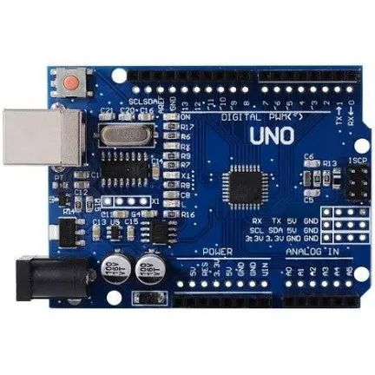 | Kwaratech Electronics, Tanke Junction
Ultrasonic Sensors (2x) | 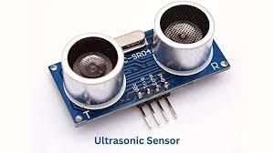 | JKK Electronics, Challenge Bookshop Complex
Servo Motors (2x) | 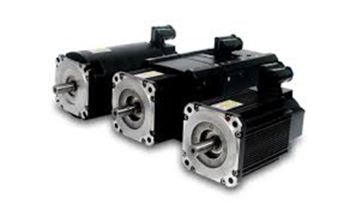SG90 Micro Servo | TechCity Hub, Unity Road
LEDs (Red & Green) | 5mm, 2V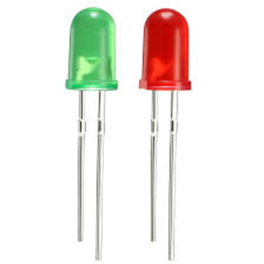 | Ilorin Electronics Market, Taiwo Isale
Buzzer | 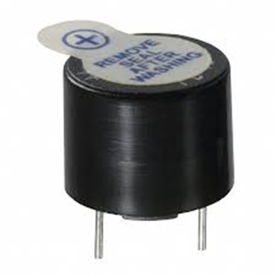5V Piezoelectric Buzzer | JustElectronics, GRA Junction
Jumper Wires | 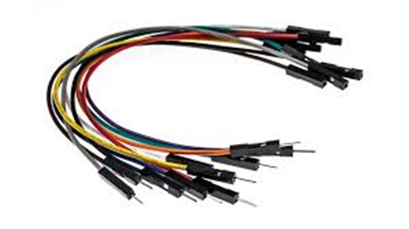Male-to-Male, Male-to-Female | Unity Road Market
Breadboard | 830-point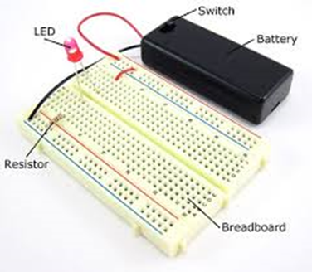 | Kwaratech Electronics, Tanke Junction
Resistors | 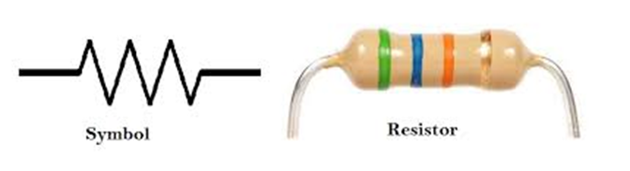220Ω, 330Ω | JKK Electronics
Power Supply | 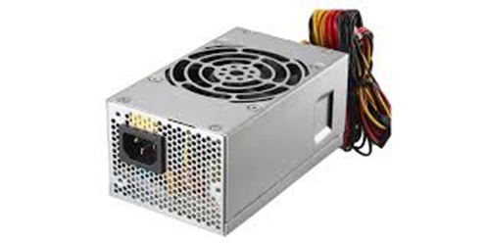9V Battery or 5V USB Adapter | TechCity Hub or Spar Mall
Laptop with Arduino IDE | 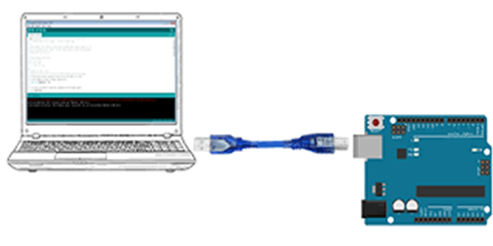For programming and simulation | University of Ilorin ICT Lab / Personal Laptop

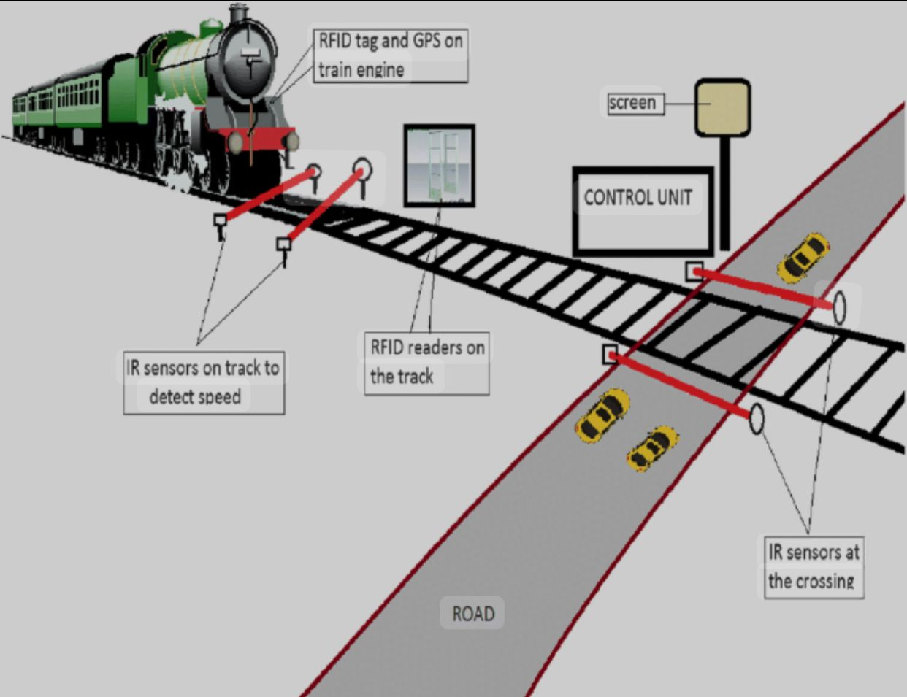

CHAPTER FOUR
4.0 Results and Discussion
This section presents the experimental results and analysis from both the physical prototype and the simulation of the Automated Railway Level Crossing System. The results are organized around the major functions of the system: train detection, barrier gate operation, traffic signal control, and system responsiveness.
4.1 Summary of Key Functional Results
Tested Function | Expected Behavior | Observed Behavior | Remarks
Train Detection (Approach) | Detect train within 20–30 cm distance | Detected accurately at an average of 25 cm | Working as expected
Barrier Closure (Servo Motor) | Close within 2 seconds after detection | Average delay: 1.85 seconds | Prompt and smooth transition
Traffic Signal (LEDs) | Switch from green to red upon train detection | Instant transition (<0.5 sec) | Properly synchronized
Audible Alert (Buzzer) | Buzzer should sound when train is detected | Loud, consistent buzz until train exits | Alert functionality confirmed
Train Departure Detection | Detect exiting train within 20–30 cm | Detected at average of 24.5 cm | Departure successfully tracked
Barrier Re-opening | Reopen barrier within 2 seconds after train exits | Average re-opening delay: 1.9 seconds | Normal operation resumed
Return to Idle State | Green light comes back ON, buzzer OFF, barrier raised | System reset successfully after each cycle | Stable performance
4.2 System Operation Breakdown
A. Train Detection Performance
The ultrasonic sensors (HC-SR04) provided accurate and consistent measurements, both in real-world testing and during simulation. The following table summarizes the sensor detection accuracy:
Test Cycle | Approach Sensor Reading (cm) | Departure Sensor Reading (cm)
1 | 26 | 24
2 | 24 | 23
3 | 25 | 25
4 | 27 | 26
5 | 25 | 24
Average | 25.4 | 24.4
Sensor readings fluctuated slightly within the 2–3 cm range, which is acceptable for proximity detection. The system reliably identified train presence and departure with a response time of less than 300 milliseconds after detection.
B. Barrier Gate and Servo Motor Response
The servo motors operated using PWM signals to change positions between 0° (closed) and 90° (open). The average time from detection to complete barrier motion is shown below:
Barrier Operation | Target Time | Average Observed Time | Result
Closure | ≤ 2 seconds | 1.85 seconds | ✔ Within standard
Opening | ≤ 2 seconds | 1.9 seconds | ✔ Within standard
C. Traffic Signal and Buzzer Synchronization
Traffic lights and the buzzer were activated simultaneously with the servo during train detection. The control logic implemented ensured proper synchronization.
System State | LED Status | Buzzer | Barrier Gate
No Train | Green ON | OFF | Open (90°)
Train Approaching | Red ON | ON | Closing (to 0°)
Train Passing | Red ON | ON | Closed (0°)
Train Departed | Green ON | OFF | Opening (to 90°)

4.3 Achievement of Objectives
Objective | Achievement
Simulate an automatic railway crossing system using Arduino | Successfully simulated in Tinkercad and implemented on breadboard
Detect approaching and departing trains using ultrasonic sensors | Reliable detection confirmed by multiple test cycles
Automatically operate barrier gates and traffic signals | Smooth servo control and LED/buzzer activation observed
Improve railway crossing safety and reduce human error | Automation ensures consistent operation, removing the risk of human failure
4.4 Observations and Limitations
Despite the system's reliability in a controlled environment, the following limitations were observed:
- Short Sensor Range: Detection is effective only within limited range (2–4 m in real implementation), which may not be sufficient for high-speed trains.
- Environmental Interference: Ultrasonic sensors may be affected by temperature or surface reflectivity.
- Power Dependence: The prototype requires an uninterrupted 5V–9V power supply; fluctuations can cause erratic behavior.
- Scale Limitation: Model-scale simulation differs from full-scale real-world dynamics (e.g., train speed, gate size).
4.5 Recommendations for Enhancement
- Use long-range LiDAR or IR sensors for better outdoor performance.
- Integrate solar power and backup batteries for rural installations.
- Introduce wireless/GSM modules to alert central control units of faults or unusual activity.
- Add camera-based object detection using Raspberry Pi or AI modules for future scalability.

