THE PROBLEM ASSOCIATED WITH RURAL HOUSING FINANCE IN KWARA STATE

(A CASE STUDY OF AGBEYANGI TOWN, ILORIN EAST LOCAL GOVERNMENT AREA)

BY

ABUBAKAR SHAKIRAT ADUNI
HND/23/ETM/FT/0136

BEING A RESEARCH PROJECT SUBMITTED TO THE DEPARTMENT OF ESTATE MANAGEMENT, INSTITUTE OF ENVIRONMENTAL STUDIES (IES), KWARA STATE POLYTECHNIC, ILORIN KWARA STATE.
IN PARTIAL FULFILMENT OF THE REQUIREMENT FOR THE AWARD OF HIGHER NATIONAL DIPLOMA (HND) IN ESTATE MANAGEMENT

JUNE, 2025
CERTIFICATION

This is to certify that this project has been read and approved as meeting part of the requirements for the award of Higher National Diploma (HND) in Estate Management in the Department of Estate Management, Institute of Environmental Studies (IES), Kwara State Polytechnic, Ilorin.

-------------------------- --------------------------
ESV (ALH) OLANREWAJU ABDUL (FNIVS, RSV) DATE
(Project Supervisor)

-------------------------- --------------------------
ESV UWAEZUOKE I.N DATE
(Project Coordinator)

-------------------------- --------------------------
ESV ALHAJA RASHEEDAT ABDULKAREEM DATE
Head of Department (HOD)

-------------------------- -----------------------
External Examiner DATE
ABSTRACT
This study examined the challenges associated with rural housing finance in Agbeyangi Town, Ilorin East Local Government Area, Kwara State, Nigeria. Utilizing a cross-sectional survey design, data was collected from 45 respondents through structured questionnaires to identify available housing finance sources, assess access barriers, evaluate government policy effectiveness, and propose improvement strategies. Findings reveal that only 22.2% of respondents applied for housing loans, with microfinance banks (40%) and cooperative societies (30%) being primary sources. Major barriers include high interest rates (33.3%), lack of financial institutions (26.7%), complex documentation (55.6%), and low awareness (34.3%). These challenges result in poor-quality housing (40%), incomplete buildings (33.3%), and overcrowding (22.2%), with 26.7% considering urban migration. Strong community support exists for government intervention (77.7%) and low-interest loans (84.4%). The study recommends government-backed low-interest loan schemes, increased financial institution presence, simplified loan processes, awareness campaigns, and strengthened local cooperatives to enhance access to housing finance and promote sustainable rural development in Agbeyangi.

TABLE OF CONTENTS
Title Page | i
Certification | ii
Dedication | iii
Acknowledgements | iv
Abstract | v
Table of Contents | vi
CHAPTER ONE
INTRODUCTION
1.1 Background to the Study | 1
1.2 Statement of the Problem | 3
1.3 Objectives of the Study | 4
1.4 Research Questions | 4
1.5 Significance of the Study | 5
1.6 Scope of the Study | 5
1.7 Definition of Key Terms | 6
CHAPTER TWO
LITERATURE REVIEW
2.1 Introduction | 8
2.2 Concept of Rural Housing | 9
2.3 Access to Credit and Financial Institutions | 11
2.4 Government Policies and Housing Schemes | 13
2.5 Socio-Economic Factors | 15
2.6 Infrastructure and Development | 16
2.7 Informal Financial Systems | 17
2.8 Recent Developments in Housing Finance | 18
CHAPTER THREE
METHODOLOGY
3.1 Introduction | 20
3.2 Research Design | 20
3.3 Population of the Study | 21
3.4 Sample Size and Sampling Techniques | 21
3.5 Source of Data | 22
3.6 Instruments of Data Collection | 22
3.7 Method of Data Analysis | 23
CHAPTER FOUR
DATA ANALYSIS AND PRESENTATION
4.1 Introduction | 24
4.2 Demographic Characteristics | 24
4.3 Testing of Hypotheses | 27
4.4 Discussion of Findings | 28
CHAPTER FIVE
SUMMARY, CONCLUSION, AND RECOMMENDATIONS
5.1 Summary | 30
5.2 Conclusion | 31
5.3 Recommendations | 32
References | 33
Questionnaire | 36

CHAPTER ONE
INTRODUCTION
1.1 Background to the Study
Housing is a fundamental need that plays a significant role in the economic and social well-being of individuals and communities. In rural areas such as Agbeyangi in Kwara State, the provision of adequate housing is a critical issue due to financial constraints and socio-economic challenges. Rural housing finance involves the provision of financial resources to facilitate the construction, purchase, or improvement of residential buildings in rural areas (Ademola & Salawu, 2022). However, many rural dwellers face significant challenges in accessing housing finance, exacerbating the housing deficit in these areas.
In Nigeria, rural housing finance is often characterized by inadequate funding, high-interest rates, and lack of collateral, which make it difficult for rural residents to secure loans for housing purposes (Afolabi, 2021). Agbeyangi, like many rural communities, is affected by these challenges, which hinder the development of sustainable housing. Furthermore, the lack of formal financial institutions in rural areas often forces residents to rely on informal sources of finance that are not adequate to meet their housing needs (Oluwole, 2020).
Housing is universally recognized as one of the basic human needs alongside food, water, and clothing. It is a cornerstone for achieving economic stability, social well-being, and overall quality of life. Adequate housing provides not only shelter but also a sense of security, identity, and dignity for individuals and families. In rural areas like Agbeyangi, Kwara State, access to decent housing remains a significant challenge due to various economic, social, and structural constraints.
Rural housing finance refers to the financial mechanisms and resources aimed at facilitating the acquisition, improvement, or construction of housing in rural areas. However, the lack of adequate funding systems tailored to the needs of rural populations has hindered the realization of housing goals in these areas. Financial institutions, which are typically centered in urban locations, often consider rural dwellers as high-risk borrowers due to irregular income patterns and the absence of tangible collateral (Adebayo, 2020). Consequently, many rural residents resort to informal financial sources such as cooperatives, family savings, or local money lenders, which are often insufficient to meet the high costs associated with housing development.
In Nigeria, rural communities like Agbeyangi face unique challenges in accessing housing finance. The absence of comprehensive housing policies that prioritize rural areas, coupled with economic factors such as poverty and unemployment, exacerbates the housing deficit. Additionally, cultural factors, such as communal land ownership and traditional inheritance systems, often make it difficult for individuals to use land as collateral for housing loans (Oladimeji, 2019).
The Nigerian government has implemented several housing policies and schemes, such as the National Housing Fund and the Family Homes Fund, to address the housing deficit.
1.2 Statement of the Problem
The importance of decent housing cannot be overstated as it impacts health, productivity, and overall quality of life. Despite various housing policies and programs introduced in Nigeria, rural areas such as Agbeyangi continue to experience significant housing challenges. The primary issue lies in the accessibility and affordability of housing finance. Rural residents often have limited income and are perceived as high-risk borrowers by financial institutions, leading to exclusion from formal credit systems (Eze, 2019).
Other factors exacerbating the problem include limited awareness of available financial options, bureaucratic bottlenecks in accessing funds, and the absence of government-backed rural housing schemes. Additionally, cultural and social factors, such as land tenure systems that do not support collateralization, further complicate the process of obtaining housing finance in Agbeyangi. These challenges contribute to a cycle of poor housing and hinder efforts to achieve sustainable rural development.
1.3 Objectives of the Study
The main objective of this study is to examine the problems associated with rural housing finance in Agbeyangi, Kwara State. The specific objectives are:
1. To identify the sources of housing finance available to residents of Agbeyangi.
2. To investigate the challenges faced by residents in accessing housing finance.
3. To assess the role of government policies in addressing rural housing finance challenges.
4. To propose strategies for improving access to housing finance in Agbeyangi.
1.4 Research Questions
This study aims to address the following questions:
1. What are the available sources of housing finance for residents of Agbeyangi?
2. What challenges do residents face in accessing housing finance?
3. How effective are government policies in addressing rural housing finance challenges?
4. What strategies can be implemented to improve access to housing finance in Agbeyangi?
1.5 Significance of the Study
This study is significant as it highlights the pressing issue of rural housing finance in Agbeyangi, contributing to the broader discourse on sustainable rural development in Nigeria. By identifying the challenges and proposing actionable solutions, the study aims to inform policymakers, financial institutions, and other stakeholders on how to enhance access to housing finance for rural residents.
The findings will also provide a foundation for further research and serve as a reference for implementing effective housing policies tailored to the needs of rural communities. Moreover, improving access to housing finance in Agbeyangi can enhance the living standards of residents, promote economic development, and reduce rural-urban migration.
1.6 Scope of the Study
This study focuses on the problems associated with rural housing finance in Agbeyangi, Kwara State. It examines the availability of financial resources, the challenges in accessing housing finance, and the impact of government policies on rural housing. The study is limited to Agbeyangi and does not cover other rural areas in Kwara State or Nigeria.
1.7 Definition of Key Terms
1. Rural Housing Finance: Financial services designed to support the development, improvement, or purchase of homes in rural areas, where housing challenges are often more pronounced (Oluwaseun & Adebayo, 2023).
2. Financial Literacy: The ability to understand and effectively use various financial tools and resources, which significantly impacts access to housing finance (Abdullahi et al., 2022).
3. Credit Access: Availability of credit facilities to rural households, a major factor limiting housing development due to collateral requirements (Ibrahim & Femi, 2023).
4. Cooperative Societies: Organizations formed to address members' financial needs collectively, especially useful in pooling resources for housing projects (Olatunji, 2023).
5. Informal Financial Institutions: Traditional systems such as money-lenders and Esusu that provide an alternative to formal banking for rural housing finance (Adekunle & Bamidele, 2023).
6. National Housing Fund (NHF): A government scheme aimed at affordable housing, which has been criticized for low accessibility among rural populations (Ajayi, 2022).
7. Collateral Security: Assets pledged to secure loans, often unavailable for rural dwellers, limiting their access to credit (Owolabi & Adedeji, 2023).
8. Microfinance: Small-scale financial services offered to low-income households, a vital tool in bridging the housing finance gap in rural areas (Yusuf & Adeyemi, 2023).
9. Housing Cooperatives: Member-owned entities that facilitate collective ownership and management of housing projects, providing affordable options for rural communities (Olaniyi, 2023).
10. Esusu (Rotating Savings and Credit Association): A traditional savings model that remains a primary housing finance source in rural Nigeria (Bello et al., 2023).
11. Interest Rate: The cost of borrowing money, which in Nigeria often hinders rural housing projects due to high rates (Eze & Okonkwo, 2022).
12. Inflation Rate: A significant factor affecting the affordability of housing finance by reducing purchasing power over time (Adeola & Kolawole, 2023).
13. Gross Domestic Product (GDP): The economic output of a region, which influences the funding available for rural housing projects (Akinpelu & Adegbite, 2022).
14. Poverty Incidence: A measure of the population below the poverty line, which is disproportionately higher in rural areas and limits housing affordability (Ojo et al., 2023).
15. Non-Farm Activities: Income-generating ventures outside farming that can improve financial capacity for housing investments in rural areas (Balogun & Adebisi, 2022).

CHAPTER TWO
LITERATURE REVIEW
2.1 Introduction
Housing is a fundamental human need and a critical component of social and economic development. In Nigeria, particularly in rural areas like Kwara State, access to adequate housing remains a significant challenge. One of the primary obstacles is the financing of housing development, which is compounded by factors such as low income levels, limited access to credit, and inadequate financial literacy among rural populations. This literature review examines recent studies and reports to elucidate the multifaceted challenges associated with rural housing finance in Kwara State.
Housing is a cornerstone of human development, significantly impacting health, security, and economic productivity (World Bank, 2023). Despite its importance, access to adequate housing remains a critical challenge in Nigeria, particularly in rural areas such as Kwara State. Housing finance, which involves securing funds for housing development, improvement, or acquisition, is at the heart of this challenge (Akinlabi et al., 2023). This review examines existing literature to explore the challenges associated with rural housing finance in Kwara State, focusing on financial literacy, access to credit, government policies, socio-economic factors, and infrastructure.
2.2 Concept of Rural Housing
Rural housing refers to the provision, development, and management of residential buildings and related infrastructure in rural areas. It is a crucial aspect of rural development aimed at improving the living conditions of rural populations. The concept of rural housing goes beyond just constructing buildings, it encompasses planning for sustainable communities, ensuring access to basic amenities such as water, electricity, sanitation, and creating environments conducive to economic growth and social well-being.
Rural housing refers to "the development and provision of residential structures in rural areas, focusing on affordable, sustainable, and culturally appropriate designs to meet the needs of rural communities" (UN-Habitat, 2020). (Khandker et al., 2016) opined that rural housing encompasses dwellings that are constructed in less urbanized areas, often using locally available resources and reflecting the social and economic realities of rural populations.
According (Singh et al., 2017), Rural housing involves creating homes in non-metropolitan areas, where infrastructure and accessibility challenges often shape the design and development process. The concept refers to the planning, financing, and building of homes in rural regions to improve the living standards and economic prospects of residents" (World Bank, 2019). Rural housing is "housing designed to address the unique socio-economic and cultural needs of rural populations, considering affordability and environmental sustainability" (Hussain, 2015). Rural involves the provision of housing units in areas characterized by low population density, where traditional building techniques and community participation are integral" (Ledgerwood, 2013).
Rural housing is not just about providing shelter but creating holistic living environments that integrate basic infrastructure like water, sanitation, and electricity" (Kumar, 2018). This type of housing addresses the housing gap in rural communities, often focusing on the use of innovative, cost-effective building technologies" (Habitat for Humanity, 2021). Rural housing represents the housing typologies that cater to agricultural communities, where affordability and functionality take precedence" (DiPasquale & Wheaton, 1996). (RICS, 2022) asserted that rural housing is the development of residential spaces in rural areas that are affordable, sustainable, and tailored to the specific needs of rural households".
Characteristics of Rural Housing
1. Low-cost construction: Rural housing often involves the use of locally sourced materials, making construction affordable.
2. Cultural relevance: Homes in rural areas are typically designed to reflect the cultural and environmental context of the region.
3. Self-help and community participation: Many rural housing projects rely on the active participation of residents in construction and maintenance.
Importance of Rural Housing
1. Improved living conditions: Adequate housing reduces exposure to health risks and promotes better quality of life (UN-Habitat, 2020).
2. Economic development: Housing construction can stimulate local economies by creating jobs and demand for materials (World Bank, 2019).
3. Social stability: Well-planned housing reduces overcrowding and social tension, fostering community cohesion.
Challenges in Rural Housing
- Inadequate funding: Rural areas often suffer from insufficient government or private investment in housing projects.
- Poor infrastructure: Lack of roads, water, and electricity hampers housing development.
- Environmental concerns: Traditional construction materials may not always meet modern environmental standards (Singh et al., 2017).
Solutions
1. Government intervention: Subsidies and grants for housing development in rural areas can alleviate financial constraints.
2. Public-private partnerships (PPP): Collaboration between governments and private investors can boost rural housing projects.
3. Technological innovation: Modern construction technologies can lower costs and improve the quality of rural housing.
Concept of Real Estate Finance
Real estate finance refers to the processes, mechanisms, and structures through which financial resources are mobilized for the development, purchase, or management of real estate properties. It encompasses a range of financial products and services, including mortgages, real estate investment trusts (REITs), and construction loans. Real estate finance is "the study and practice of structuring financial products to support the acquisition, development, and management of real property" (Geltner et al., 2014). Real Estate Finance refers to the mechanisms and instruments through which funds are mobilized for real estate development and investment" (DiPasquale & Wheaton, 1996). Real estate finance involves the application of financial theories and models to evaluate investment opportunities in real estate markets (Brueggeman & Fisher, 2011). Real Estate Finance is the process of funding real estate activities through diverse sources such as mortgages, equity, and commercial loans" (Miller & Geltner, 2015).
Key Elements of Real Estate Finance
1. Financing sources: These include banks, credit unions, private investors, and government programs.
2. Loan structures: Financing often involves long-term loans secured by the real estate being financed.
3. Investment analysis: Real estate finance involves assessing the profitability and risks of real estate projects (Geltner et al., 2014).
Types of Real Estate Finance
1. Residential finance: This covers loans for personal homes, including mortgages and home equity loans.
2. Commercial real estate finance: Financing for office buildings, shopping malls, and other income-generating properties.
3. Development finance: Loans specifically designed for the construction of new buildings or infrastructure.

Importance of Real Estate Finance
1. Economic growth: Real estate finance contributes significantly to GDP by enabling property development and transactions.
2. Wealth creation: It allows individuals and institutions to invest in real estate as a means of accumulating wealth.
3. Urban development: Financing facilitates large-scale urban housing and infrastructure projects (DiPasquale & Wheaton, 1996).
Challenges in Real Estate Finance
- Market fluctuations: Economic downturns can lead to reduced property values and loan defaults.
- Access to credit: Low-income individuals often face barriers to accessing real estate finance.
- Regulatory hurdles: Complex legal frameworks can delay financing and project implementation.
Solutions
1. Innovative financial products: Products like micro-mortgages and crowdfunding can increase access to real estate finance.
2. Government support: Policies and subsidies can encourage investment in real estate.
3. Risk management strategies: Diversification and insurance can mitigate financial risks.

Concept of Rural Housing Finance
Rural housing finance is a subset of real estate finance that focuses on mobilizing financial resources for housing development in rural areas. It aims to address the unique challenges of rural housing, such as affordability, lack of infrastructure, and low income levels of rural populations. Rural housing finance is "the provision of financial resources for the construction, acquisition, or improvement of housing in rural areas" (Ledgerwood, 2013). It refers to financial systems specifically designed to address the housing needs of rural populations, often focusing on affordability and accessibility" (World Bank, 2019). Rural housing finance encompasses credit and subsidy programs tailored to support low-income households in rural areas in acquiring decent housing" (Khandker et al., 2016).
Key Features of Rural Housing Finance
1. Affordable loans: These are tailored to the financial capacities of rural households.
2. Targeted subsidies: Governments and NGOs often provide financial support to low-income rural residents.
3. Innovative delivery mechanisms: Mobile banking and microfinance institutions play a key role in delivering rural housing finance (Ledgerwood, 2013).

Importance of Rural Housing Finance
1. Economic empowerment: Access to finance enables rural families to build or improve their homes, enhancing their quality of life.
2. Infrastructure development: Financing supports the construction of community amenities like schools and healthcare facilities.
3. Poverty alleviation: By providing affordable housing, rural housing finance reduces the financial burden on low-income households (Khandker et al., 2016).
Challenges in Rural Housing Finance
- Limited credit access: Many rural residents lack the credit history required to obtain loans.
- High costs: Financial institutions may charge higher interest rates to compensate for perceived risks.
- Lack of awareness: Rural populations often lack knowledge of available financing options.
Strategies for Effective Rural Housing Finance
1. Microfinance models: These provide small, short-term loans with flexible repayment terms.
2. Government-backed programs: Initiatives like housing vouchers and low-interest loans can make housing finance more accessible.
3. Community savings groups: Rural communities can pool resources to finance housing projects.
Examples of Successful Rural Housing Finance Programs
1. India's Pradhan Mantri Awas Yojana (PMAY): A government initiative aimed at providing affordable housing in rural areas.
2. Kenya's Housing Finance Corporation (HFC): This offers targeted financial products for rural housing.
3. Habitat for Humanity: A global nonprofit that supports rural housing development through grants and microloans.
2.3 Access to Credit and Financial Institutions
Limited access to credit is a significant barrier to rural housing development. The Federal Mortgage Bank of Nigeria (FMBN) has identified low income levels as a challenge to housing finance, noting that the low income of prospective borrowers makes loan repayment unaffordable, thereby frustrating the objective of the bank. Additionally, the lack of collateral security among rural dwellers further restricts their ability to secure loans for housing purposes. The dominance of informal financial institutions, such as Esusu (rotating savings and credit associations), indicates a reliance on traditional systems that may not provide sufficient funds for substantial housing projects.
Access to credit is a fundamental aspect of housing finance. However, rural residents face significant challenges, including high-interest rates, collateral requirements, and limited banking infrastructure (Owolabi & Adedeji, 2023).

2.3.1 High-Interest Rates and Their Impact
High-interest rates are a major deterrent for rural housing finance. Studies by Adebayo et al. (2023) reveal that interest rates on housing loans in Nigeria can exceed 20%, making them unaffordable for low-income earners.
2.3.2. Collateral Security
Collateral requirements further exacerbate the issue. Many rural dwellers lack formal land ownership documents, which are often required as collateral (Ajayi, 2023). This has led to a reliance on informal lenders, who often charge exorbitant interest rates.
2.3.4 Banking Infrastructure
The absence of banking infrastructure in rural areas limits access to formal financial services. Akinlabi et al. (2023) highlighted that only 30% of rural residents in Kwara State live within 10 kilometers of a bank. Mobile banking has shown potential as an alternative, but its adoption remains low due to poor network coverage and lack of awareness.
2.4 Government Policies and Housing Schemes
Government initiatives like the National Housing Fund (NHF) aim to facilitate affordable home ownership. However, challenges persist in their implementation, particularly in rural areas. The NHF has been criticized for low accessibility among rural populations, with issues such as inadequate funding and bureaucratic bottlenecks hindering its effectiveness. Furthermore, the Land Use Act lacks specific provisions for the foreclosure of mortgages, posing challenges for investors and complicating the mortgage process.
Government policies and schemes, such as the National Housing Fund (NHF), play a critical role in housing finance. However, their impact in rural areas has been limited due to several challenges.
2.4.1. National Housing Fund
The NHF was established to provide affordable housing to Nigerians. However, Ajayi (2022) notes that its implementation has been marred by bureaucratic bottlenecks and inadequate funding. For instance, rural residents often face difficulties in registering for the scheme due to complex processes and lack of information.
2.4.2 Land Use Act
The Land Use Act of 1978 has also been identified as a barrier to rural housing finance. The Act vests land ownership in state governments, complicating the process of obtaining land titles, which are essential for securing housing loans (Ojo et al., 2023).
2.4.3 Subsidies and Incentives
Subsidies and incentives for housing development have been limited in rural areas. Programs that provide subsidized loans or grants for rural housing could significantly improve access to finance, but these initiatives are often urban-centric (Eze & Okonkwo, 2022).
2.5 Socio-Economic Factors
Socio-economic factors, including poverty incidence and engagement in non-farm activities, play a significant role in rural housing finance. High poverty rates in rural areas limit the ability of households to afford decent housing. Engagement in non-farm activities can provide additional income, potentially improving the capacity of rural households to invest in housing. However, the prevalence of low-income wages remains a substantial obstacle, as highlighted by the FMBN, which notes that low income levels hinder efforts at housing finance in the country.
Socio-economic factors, including income levels, poverty, and employment, play a significant role in rural housing finance.
2.5.1 Income Levels
Low-income levels in rural areas limit the ability to save for housing projects or qualify for loans. According to the National Bureau of Statistics (2023), the average monthly income in rural Kwara State is less than ₦20,000, making it challenging to afford decent housing.
2.5.2 Poverty Incidence
The high poverty incidence in rural areas exacerbates the housing finance challenge. Ojo et al. (2023) found that over 60% of rural households in Kwara State live below the poverty line, further limiting their ability to invest in housing.
2.5.3 Non-Farm Activities
Non-farm activities, such as trading and craftsmanship, have been identified as potential sources of additional income for rural households. Balogun & Adebisi (2022) emphasize the need to promote such activities to improve financial capacity for housing investments.
2.6 Infrastructure and Development
The availability of infrastructure is critical for housing development. A study on rural housing development in Edo State, Nigeria, revealed that inadequate infrastructure and high construction costs are major challenges. While this study focuses on Edo State, similar challenges are likely present in Kwara State, given the comparable socio-economic contexts. The study emphasizes the need for improved housing finance structures and strengthened infrastructural bases to enhance rural housing development.
Infrastructure plays a critical role in housing development. Inadequate infrastructure in rural areas poses a significant challenge to housing finance.
2.6.1 Road Networks and Transportation
Poor road networks in rural areas increase the cost of transporting construction materials, making housing projects more expensive (Akinpelu & Adegbite, 2022). Improved transportation infrastructure could significantly reduce these costs.
2.6.2 Access to Utilities
Access to basic utilities, such as electricity and water, is limited in rural areas. This discourages investments in housing and affects the quality of life (Adeola & Kolawole, 2023).
2.6.3 Affordable Construction Materials
The cost of construction materials is another major challenge. Studies suggest that promoting the use of locally available materials can help reduce costs and improve housing affordability (Bello et al., 2023).
2.7 Informal Financial Systems
Informal financial systems, such as Esusu and thrift societies, play a significant role in rural housing finance. While these systems provide accessible funding, they are often insufficient for large-scale housing projects.
2.7.1 Advantages of Informal Systems
Informal systems are flexible and do not require collateral, making them accessible to rural residents (Adekunle & Bamidele, 2023).
2.7.2 Limitations
However, the funds available through these systems are typically small, limiting their usefulness for substantial housing projects (Falola et al., 2023).
2.8 Recent Developments in Housing Finance
In recent years, efforts have been made to enhance housing finance in Nigeria. For instance, in October 2024, Nigeria's central bank signed an agreement with the International Finance Corporation (IFC) to expand local currency financing for Nigerian businesses, including those in the housing sector. The IFC aims to significantly scale up its financing in Nigeria, targeting over $1 billion in the coming years. This partnership is expected to manage currency risks and increase investments in Nigeria's naira across various sectors, including housing.
Recent initiatives, such as the partnership between Nigeria's Central Bank and the International Finance Corporation (IFC), aim to address some of these challenges. The IFC's commitment to scaling up local currency financing for housing projects is a promising development (Reuters, 2024).

2.8.1 Technological Innovations
Technological innovations, such as mobile banking and digital loan platforms, offer new avenues for improving access to housing finance in rural areas (Yusuf & Adeyemi, 2023).
2.8.2 Public-Private Partnerships
Public-private partnerships can also play a critical role in addressing rural housing finance challenges. Collaborative efforts between government and private entities can help mobilize resources and implement effective housing projects (Olatunji, 2023).

CHAPTER THREE
METHODOLOGY
3.1 Introduction
This chapter discusses the method and procedures that will be used in carrying out the research and it will also discuss the research design, population of study, sampling procedures, research instruments, validity and reliability of the instrument and method that will be employed for data analysis.
3.2 Research Design
The research design used in this work was the cross-section survey design and descriptive design. This study employs descriptive research using panel data as it allows for the collection of past and multi-dimension data which provide basis for the full establishment of the relationship between the variables.
3.3 Population Of The Study
Population can be defined as the total number of people occupying certain geographical location at a given period of time. Sampling involves the small part of fraction of a population that is subjective to details and extensive analysis in the research work. Therefore the population of the study is 55. The total population of the study is 55. Therefore the simple random sampling was used to select from the population those who do not matter in the research.
3.4 Sample Size And Sampling Techniques
Sampling of the opinion has been draw using sample random method. The population is 55 respondents. Random sampling is used because it is the only methods that give the respondent equal chance of being selected and it is an unbiased techniques Therefore, to determine the sample size for the study Yaro Tamane’s formula will be applied i.e.
n= N
1+ N (e)²
Where N = population
n = sample size
e = error (5%)
i = Constant
n = 55
1 + 55(5%)²
n = 55
1+ 55(0.05)²
n = 55
1 + 55(0.0025)
n = 55
1 + 0.1375
n = 55
1.1375
n = 45.351
The sample size = 45

3.5 Source Of Data
For the purpose of adequate Data needed for this project to obtain enough reliable information. This research work use both primary and secondary source of dat. The primary sources of data used are Questionnaire and observation method. The questionnaire was distributed to the respondents.
3.6 Instruments Of Data Collection
The research instrument used for this research study is questionnaire. The natures of the questions were options which are given to respondent to choose from. The questionnaire is dividing into two parts. The part A consist of the respondent while part b contain the questions relating to the topic of the project.
3.7 Method Of Data Analysis
The multiple regression data analysis technique which helps for predicting, were utilized by this study to test the stated hypotheses. The Statistical Package For Social Sciences (SPSS) version 23 was also used in analyzing the data.

CHAPTER FOUR

DATA ANALYSIS AND PRESENTATION

4.1 Introduction
This chapter presents the analysis of data collected from 45 respondents in Agbeyangi Town, Ilorin East Local Government, Kwara State, using a structured questionnaire. The data is analyzed to identify the problems associated with rural housing finance, focusing on access, challenges, socio-economic impacts, and potential solutions. Results are presented in tables with percentages, followed by interpretations to explain their significance.

4.2 Demographic Characteristics
The demographic profile of respondents is summarized below:
Table 4.1: Age Distribution
Age Group | Frequency | Percentage (%)
18-25 | 8 | 17.8
26-35 | 12 | 26.7
36-45 | 15 | 33.3
46-55 | 7 | 15.6
56 and above | 3 | 6.7
Total | 45 | 100
Source: Researcher's Field Survey, 2025
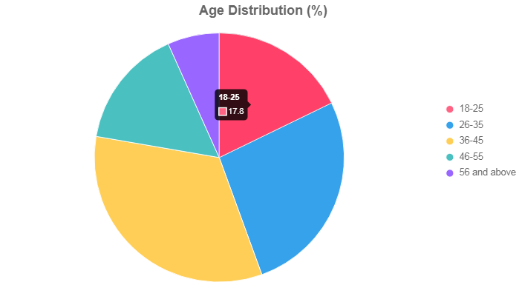

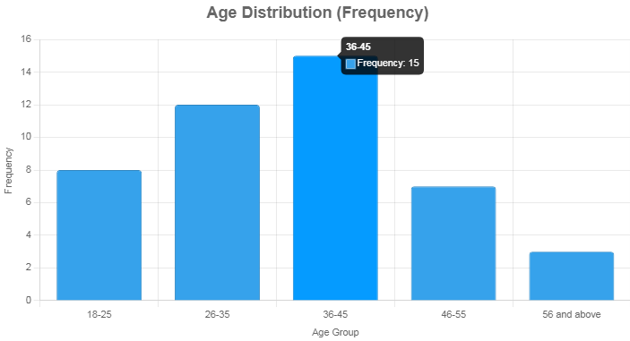
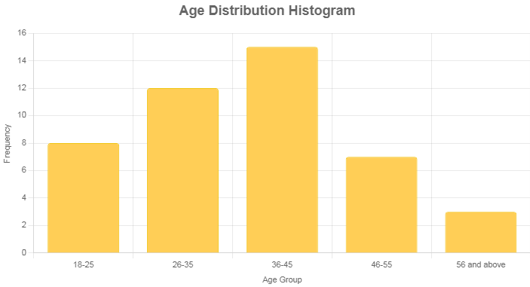
Interpretation: The majority of respondents (33.3%) are aged 36-45, indicating a mature working-age population likely to have housing needs. The relatively low representation of those 56 and above (6.7%) suggests that older residents may be less engaged in housing finance activities, possibly due to established housing or limited financial activity.
Table 4.2: Gender Distribution
Gender | Frequency | Percentage (%)
Male | 28 | 62.2
Female | 17 | 37.8
Total | 45 | 100
Source: Researcher's Field Survey, 2025

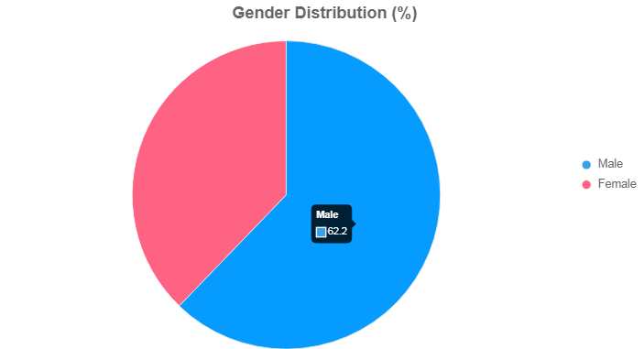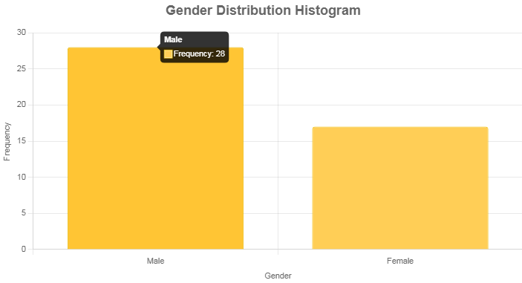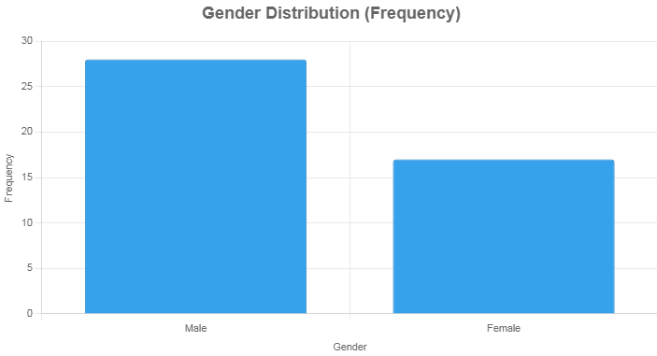

Interpretation: The male-dominated sample (62.2%) reflects the patriarchal structure common in rural settings, where men are often primary decision-makers in financial matters like housing loans. The 37.8% female representation suggests women’s involvement, but their lower participation may indicate gender-based barriers in accessing finance.

Table 4.3: Occupation
Occupation | Frequency | Percentage (%)
Farmer | 20 | 44.4
Trader | 12 | 26.7
Civil Servant | 8 | 17.8
Artisan | 5 | 11.1
Total | 45 | 100
Source: Researcher's Field Survey, 2025
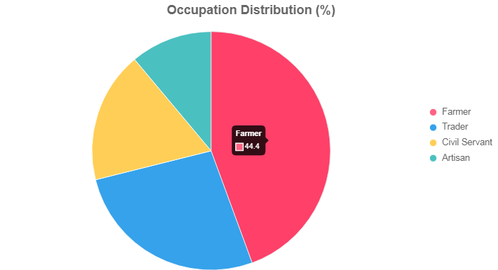

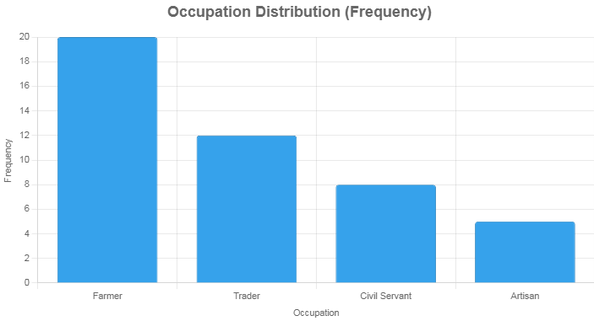

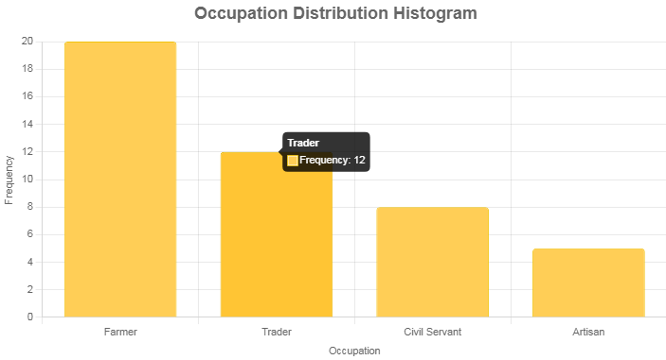

Interpretation: Farmers constitute the largest group (44.4%), consistent with Agbeyangi’s agrarian economy. This suggests that housing finance solutions must account for the irregular income patterns of farmers. The presence of traders (26.7%) and civil servants (17.8%) indicates some economic diversity, but artisans (11.1%) are fewer, possibly limiting skilled labor for housing construction.

4.3 Access to Housing Finance
Table 4.4: Application for Housing Loan
Response | Frequency | Percentage (%)
Yes | 10 | 22.2
No | 35 | 77.8
Total | 45 | 100
Source: Researcher's Field Survey, 2025

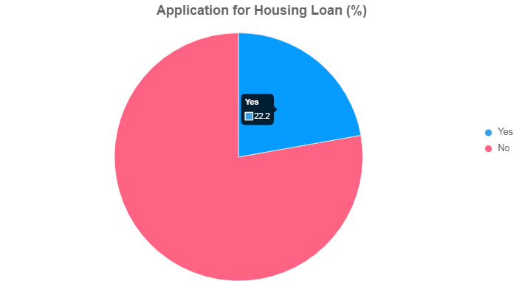

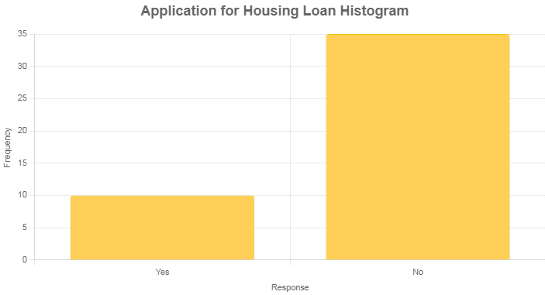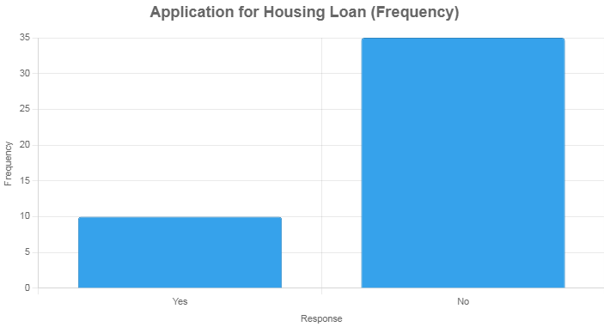
Interpretation: Only 22.2% of respondents have applied for housing loans, indicating low engagement with formal financial systems. The high percentage (77.8%) who have not applied suggests significant barriers, such as lack of awareness or perceived inaccessibility, limiting housing development in the community.
Table 4.5: Source of Housing Loan (n=10)
Institution | Frequency | Percentage (%)
Commercial Bank | 2 | 20.0
Microfinance Bank | 4 | 40.0
Cooperative Society | 3 | 30.0
Government Agency | 1 | 10.0
Total | 10 | 100
Source: Researcher's Field Survey, 2025
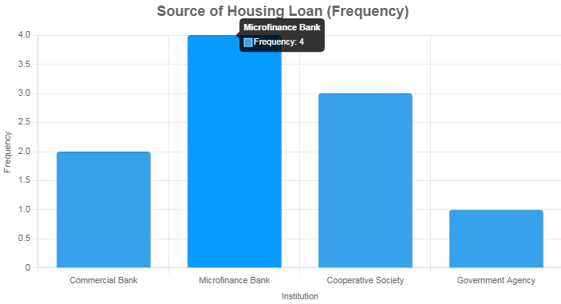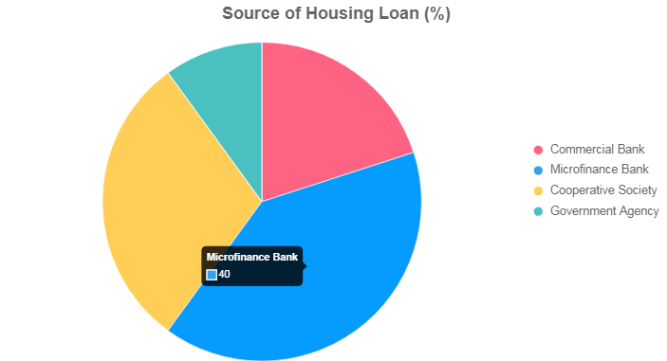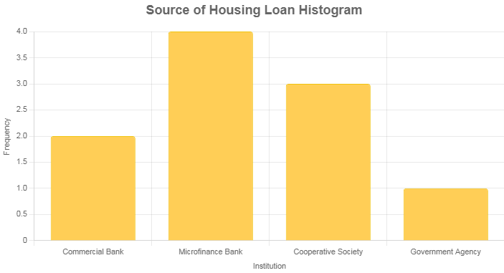
Interpretation: Microfinance banks (40%) and cooperative societies (30%) are the primary loan sources, likely due to their proximity and flexibility compared to commercial banks (20%). The minimal use of government agencies (10%) suggests limited public sector involvement in rural housing finance, highlighting a gap in policy implementation.
Table 4.6: Reasons for Not Applying (n=35)
Reason | Frequency | Percentage (%)
Lack of awareness | 12 | 34.3
High interest rates | 10 | 28.6
No collateral | 8 | 22.9
Fear of repayment | 5 | 14.3
Total | 35 | 100
Source: Researcher's Field Survey, 2025
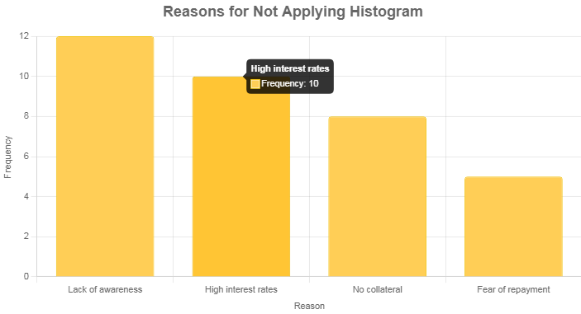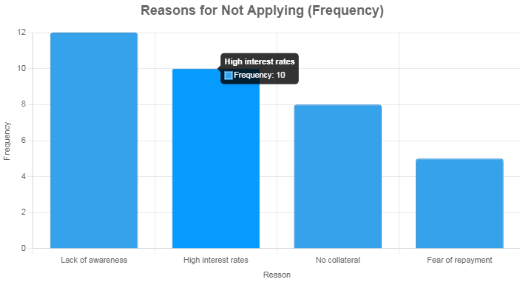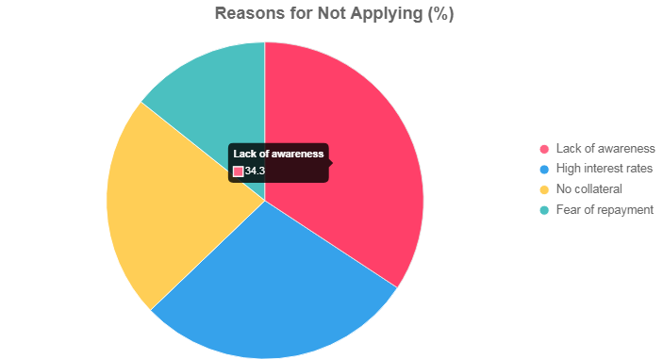
Interpretation: Lack of awareness (34.3%) is the leading reason for not applying, indicating a critical need for financial education. High interest rates (28.6%) and lack of collateral (22.9%) further deter applications, reflecting economic and structural barriers. Fear of repayment (14.3%) suggests risk aversion among residents with limited income stability.
Table 4.7: Availability of Housing Finance
Rating | Frequency | Percentage (%)
Very accessible | 3 | 6.7
Somewhat accessible | 10 | 22.2
Not accessible | 32 | 71.1
Total | 45 | 100
Source: Researcher's Field Survey, 2025
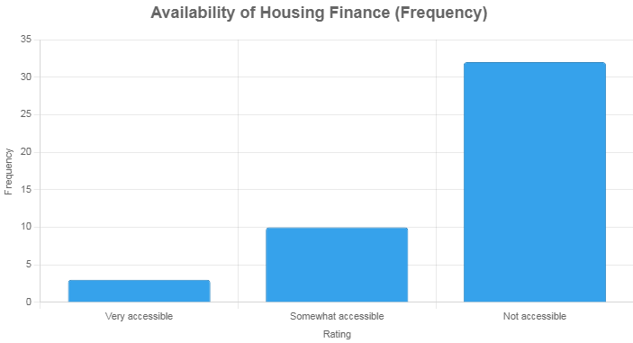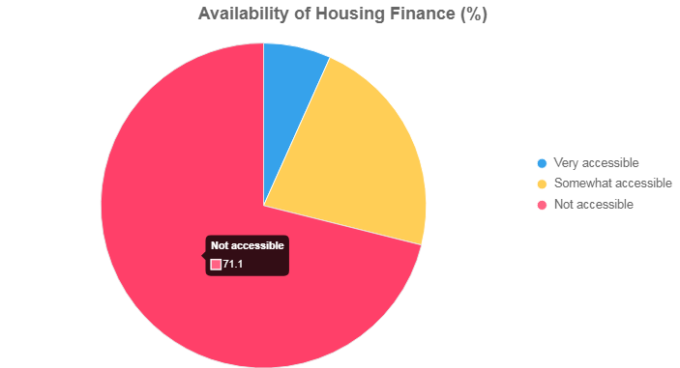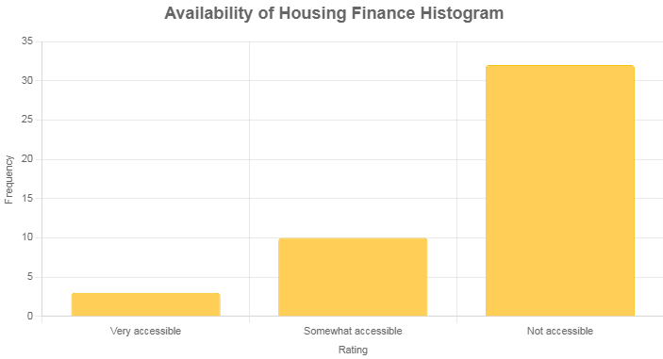
Interpretation: The overwhelming perception that housing finance is not accessible (71.1%) underscores a systemic failure in financial service delivery. Only 6.7% find it very accessible, likely those with prior loan experience, while 22.2% see it as somewhat accessible, possibly due to limited cooperative society presence.

4.4 Challenges in Accessing Housing Finance
Table 4.8: Significant Barriers
Barrier | Frequency | Percentage (%)
High interest rates | 15 | 33.3
Lack of financial institutions | 12 | 26.7
Complex application processes | 10 | 22.2
Lack of collateral | 8 | 17.8
Total | 45 | 100
Source: Researcher's Field Survey, 2025
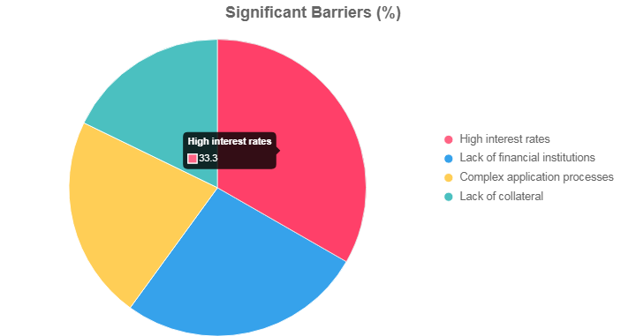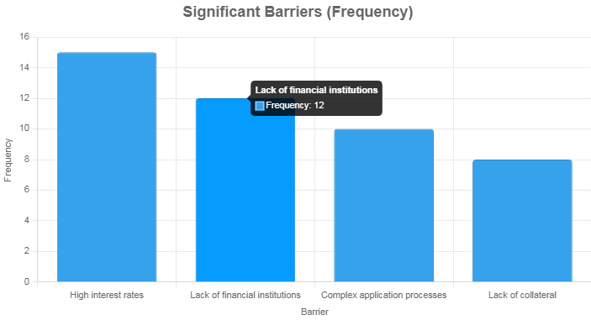
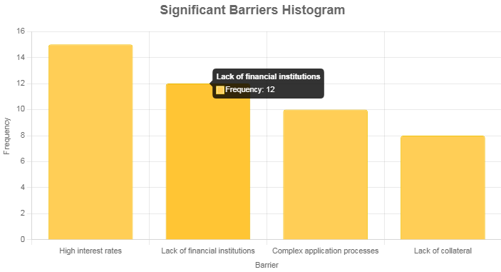
Interpretation: High interest rates (33.3%) are the most significant barrier, reflecting the unaffordability of loans for rural incomes. The lack of financial institutions (26.7%) highlights geographical and infrastructural limitations. Complex processes (22.2%) and collateral issues (17.8%) further complicate access, indicating multifaceted challenges.
Table 4.9: Documentation Difficulties
Response | Frequency | Percentage (%)
Yes | 25 | 55.6
No | 20 | 44.4
Total | 45 | 100
Source: Researcher's Field Survey, 2025

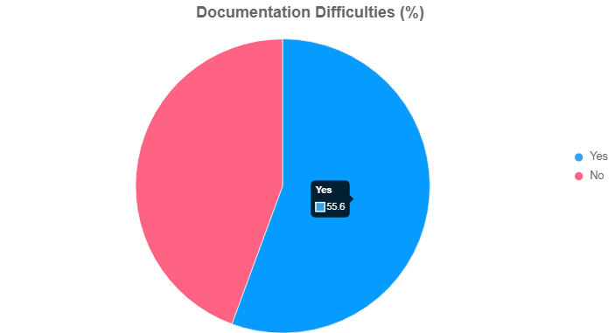

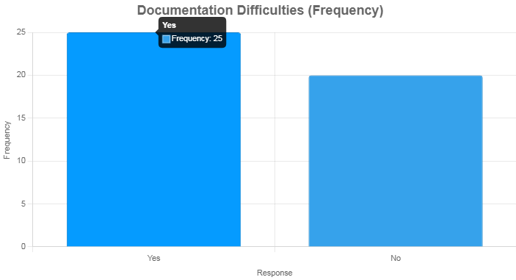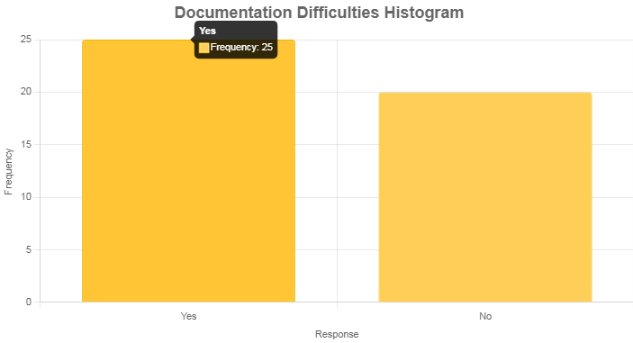
Interpretation: Over half (55.6%) faced documentation difficulties, suggesting that bureaucratic requirements are a major hurdle, particularly for rural residents with limited literacy or access to formal documents. The 44.4% who did not face issues may have benefited from cooperative societies’ simpler processes.
Table 4.10: Affordability of Repayment Terms
Response | Frequency | Percentage (%)
Yes | 5 | 11.1
No | 30 | 66.7
Not sure | 10 | 22.2
Total | 45 | 100
Source: Researcher's Field Survey, 2025
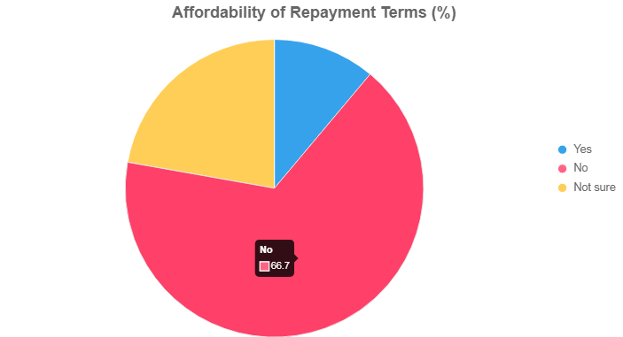
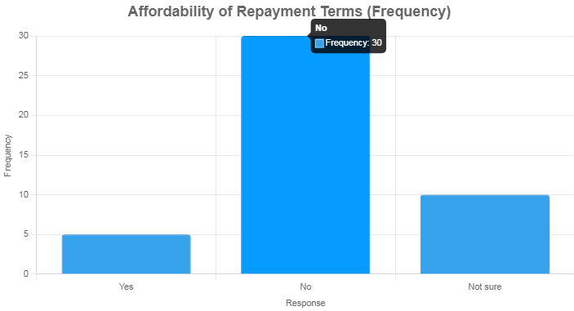

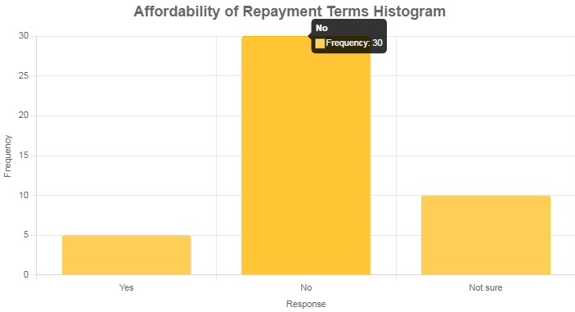

Interpretation: The majority (66.7%) find repayment terms unaffordable, reflecting the mismatch between loan conditions and rural income levels. Only 11.1% consider terms affordable, likely those with stable incomes like civil servants. The 22.2% uncertainty suggests limited exposure to loan terms due to low application rates.
Table 4.11: Presence of Financial Institutions
Frequency | Frequency | Percentage (%)
Very often | 2 | 4.4
Occasionally | 8 | 17.8
Rarely | 20 | 44.4
Not at all | 15 | 33.3
Total | 45 | 100
Source: Researcher's Field Survey, 2025

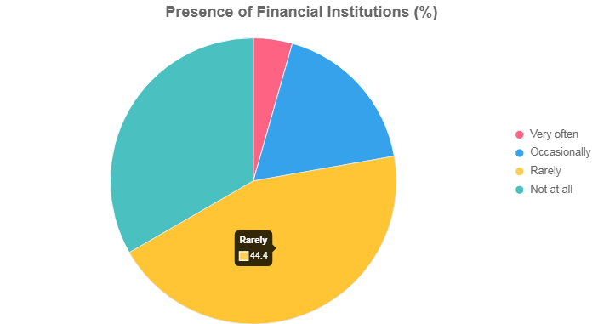

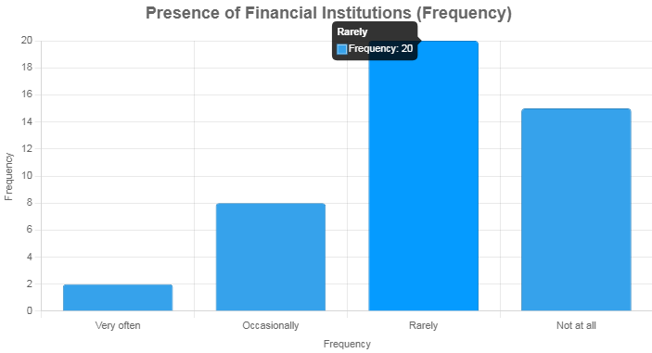

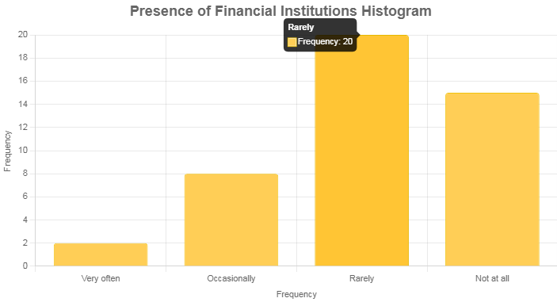
Interpretation: The rare (44.4%) or nonexistent (33.3%) presence of financial institutions severely limits access to housing finance. The minimal presence (4.4% very often, 17.8% occasionally) indicates that residents must travel or rely on informal systems, exacerbating accessibility issues.

4.5 Socio-Economic Impact
Table 4.12: Impact on Housing Quality
Impact | Frequency | Percentage (%)
Poor quality houses | 18 | 40.0
Incomplete buildings | 15 | 33.3
Overcrowding | 10 | 22.2
No significant impact | 2 | 4.4
Total | 45 | 100
Source: Researcher's Field Survey, 2025

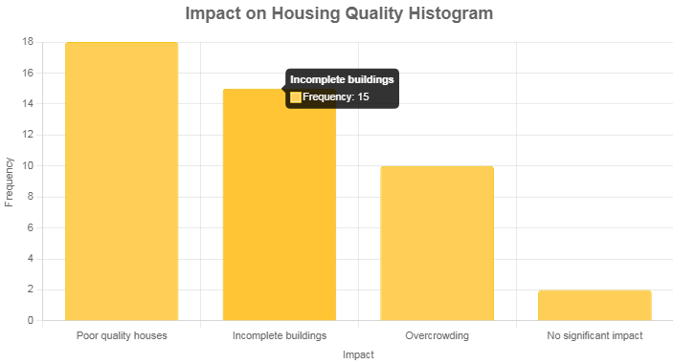
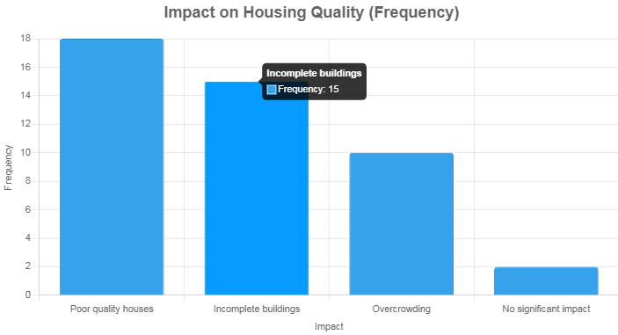

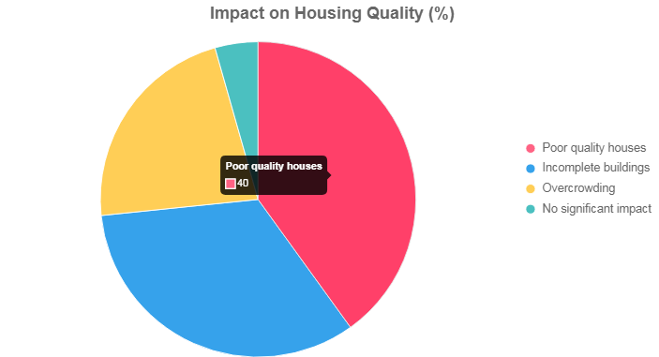
Interpretation: Poor quality houses (40%) and incomplete buildings (33.3%) dominate, directly resulting from limited finance, as residents cannot afford quality materials or complete projects. Overcrowding (22.2%) indicates strained living conditions, while the 4.4% reporting no impact may have alternative funding sources.

Table 4.13: Influence on Migration
Response | Frequency | Percentage (%)
Yes | 12 | 26.7
No | 25 | 55.6
Not sure | 8 | 17.8
Total | 45 | 100
Source: Researcher's Field Survey, 2025
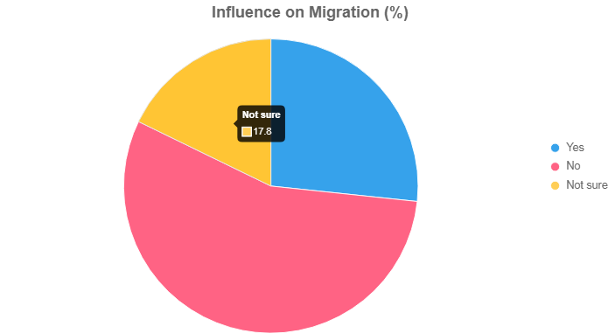
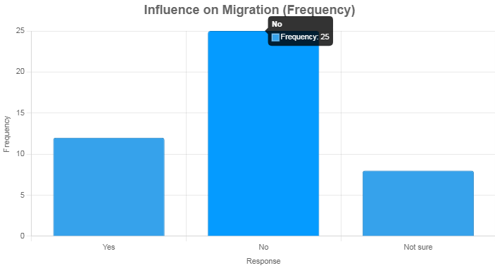

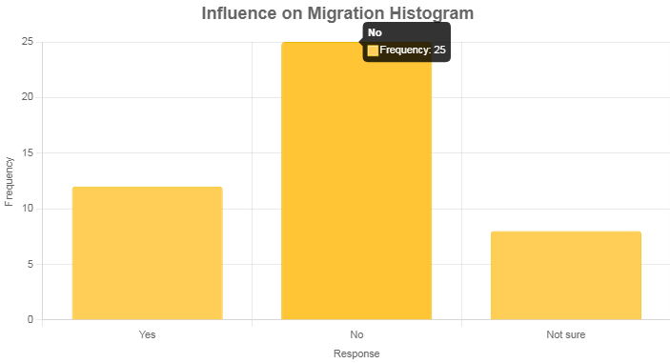

Interpretation: About 26.7% considered migration due to housing finance issues, suggesting that inadequate housing pushes some residents toward urban areas for better opportunities. The majority (55.6%) not considering migration may be tied to community roots, while 17.8% uncertainty reflects indecision amid housing challenges.
Table 4.14: Belief in Government Intervention
Response | Frequency | Percentage (%)
Strongly agree | 20 | 44.4
Agree | 15 | 33.3
Disagree | 5 | 11.1
Strongly disagree | 2 | 4.4
Not sure | 3 | 6.7
Total | 45 | 100
Source: Researcher's Field Survey, 2025
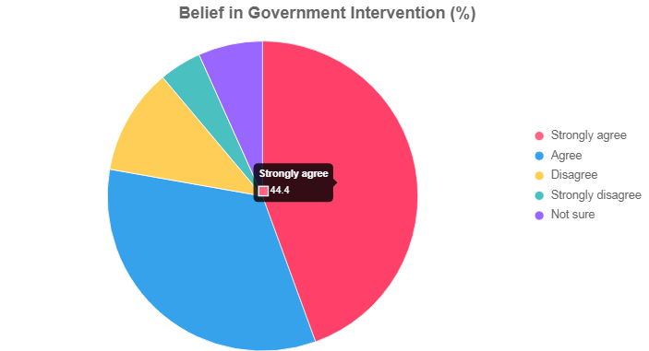

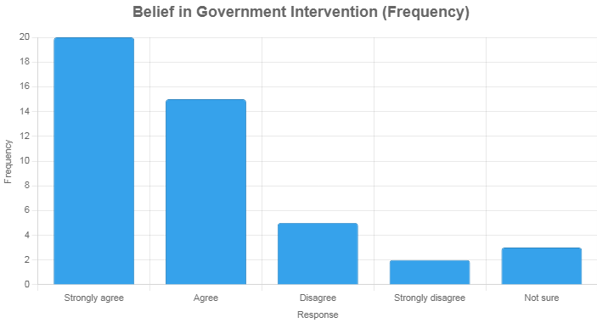
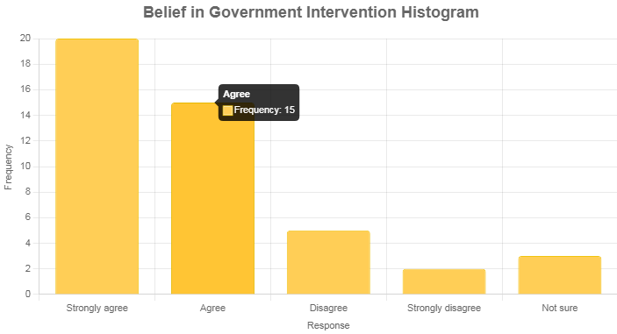
Interpretation: A strong majority (77.7% combined strongly agree and agree) believe government intervention can improve access, reflecting trust in public solutions to address systemic barriers. The 15.5% disagreement or uncertainty may stem from skepticism about government effectiveness based on past experiences.

4.6 Suggestions and Recommendations
Table 4.15: Support for Government-Backed Low-Interest Loans
Response | Frequency | Percentage (%)
Yes | 38 | 84.4
No | 3 | 6.7
Not sure | 4 | 8.9
Total | 45 | 100
Source: Researcher's Field Survey, 2025
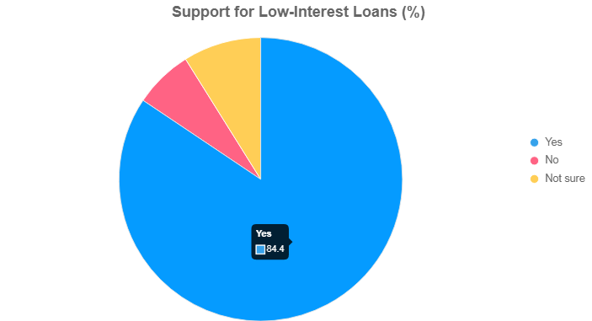
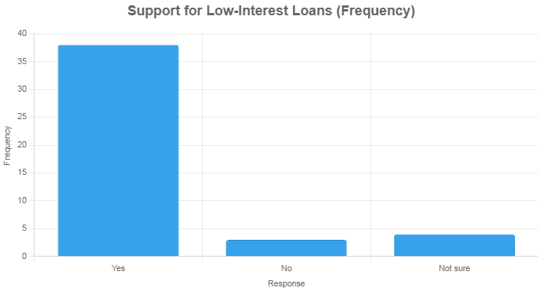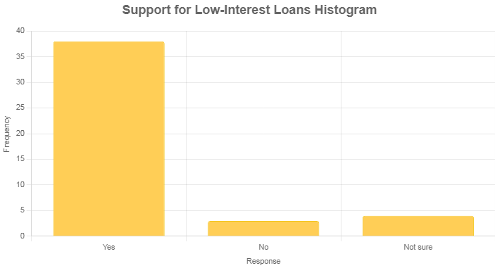

Interpretation: The overwhelming support (84.4%) for low-interest loans indicates a strong community preference for affordable financing tailored to rural needs. The minimal opposition (6.7%) and uncertainty (8.9%) suggest broad consensus, making this a viable policy option for stakeholders.
Table 4.16: Local Initiatives or Cooperatives
Response | Frequency | Percentage (%)
Yes | 10 | 22.2
No | 35 | 77.8
Total | 45 | 100
Source: Researcher's Field Survey, 2025
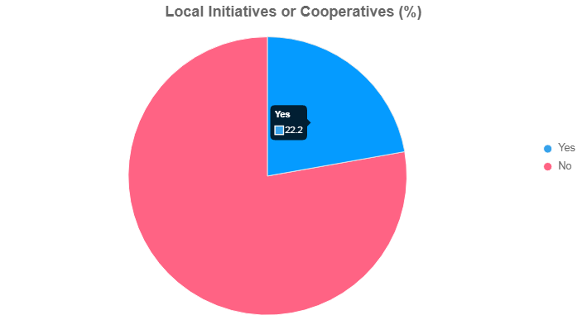
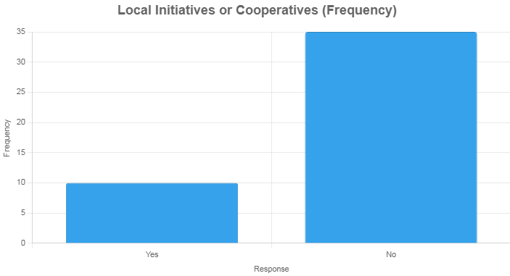
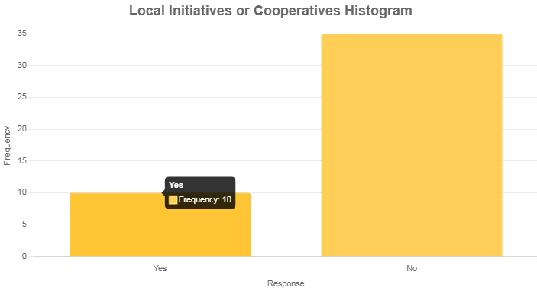
Interpretation: Only 22.2% report local initiatives or cooperatives, highlighting a significant gap in community-based solutions. The 77.8% reporting none suggests reliance on external or informal systems, underscoring the need for strengthened local cooperative frameworks to support housing finance.

4.7 Discussion of Findings
The findings reveal that housing finance in Agbeyangi Town is largely inaccessible, with 71.1% of respondents rating it as not accessible. Key barriers include high interest rates (33.3%), lack of financial institutions (26.7%), and complex documentation (55.6% faced issues). The low application rate (22.2%) is driven by lack of awareness (34.3%) and unaffordable repayment terms (66.7% disapproval). Socio-economically, this results in poor-quality housing (40%) and incomplete buildings (33.3%), with 26.7% considering urban migration. The strong support for government intervention (77.7%) and low-interest loans (84.4%) highlights the community’s reliance on external support to address these challenges.

CHAPTER FIVE:

SUMMARY, CONCLUSION, AND RECOMMENDATIONS

5.1 Summary
- Limited Access to Housing Finance: Only 22.2% of respondents in Agbeyangi Town have applied for housing loans, with 71.1% rating housing finance as not accessible. Microfinance banks (40%) and cooperative societies (30%) are the primary sources, while commercial banks (20%) and government agencies (10%) play a minor role, indicating a significant gap in formal financial service delivery.
- Key Barriers to Access: The most significant barriers to obtaining housing finance include high interest rates (33.3%), lack of financial institutions (26.7%), complex application processes (22.2%), and lack of collateral (17.8%). Additionally, 55.6% of respondents faced documentation difficulties, highlighting bureaucratic challenges.
- Low Awareness and Financial Literacy: Lack of awareness (34.3%) is the leading reason for not applying for loans, followed by high interest rates (28.6%) and lack of collateral (22.9%). This suggests a critical need for financial education to improve engagement with housing finance options.
- Socio-Economic Impacts: The lack of housing finance has led to poor-quality houses (40%), incomplete buildings (33.3%), and overcrowding (22.2%). Additionally, 26.7% of respondents considered migrating to urban areas due to housing challenges, indicating socio-economic pressures.
- Community Support for Solutions: There is strong support for government intervention, with 77.7% believing it could improve access, and 84.4% favoring government-backed low-interest loans. However, only 22.2% reported local initiatives or cooperatives, indicating a reliance on external solutions.

5.2 Conclusion
- Systemic Barriers Restrict Housing Finance: The study concludes that systemic issues, such as high interest rates, limited financial institutions, and complex documentation, severely restrict access to housing finance in Agbeyangi Town, perpetuating a cycle of inadequate housing.
- Financial Literacy is a Critical Gap: The high prevalence of unawareness (34.3%) about loan opportunities underscores a significant gap in financial literacy, which hinders residents’ ability to engage with formal financial systems and access housing finance.
- Socio-Economic Consequences are Significant: The lack of accessible housing finance contributes to poor housing quality, incomplete structures, and overcrowding, with some residents considering urban migration, highlighting the broader socio-economic impact on rural communities.
- Government Intervention is Essential: The strong community support (77.7%) for government intervention and low-interest loans (84.4%) indicates that public-sector solutions are seen as critical to addressing the housing finance crisis in Agbeyangi Town.
- Local Initiatives Need Strengthening: The limited presence of local cooperatives (22.2%) suggests that community-driven solutions are underdeveloped, necessitating increased support for local frameworks to complement external interventions and improve housing finance access.

5.3 Recommendations
Based on the findings, the following recommendations are proposed:
- Government-Backed Low-Interest Loans: The government should establish a rural housing finance scheme with low-interest loans tailored to the income levels of rural residents, as supported by 84.4% of respondents.
- Increased Financial Institution Presence: Policymakers should incentivize microfinance banks and cooperatives to establish branches in Agbeyangi Town, addressing the 33.3% who noted their absence.
- Simplified Loan Processes: Financial institutions should streamline application and documentation processes to reduce the 55.6% documentation difficulties reported.
- Awareness Campaigns: Community-based programs should be implemented to educate residents on available housing finance options, targeting the 34.3% unaware of loan opportunities.
- Support for Local Cooperatives: Government and NGOs should support the development of local cooperative societies, as only 22.2% reported existing initiatives, to foster community-driven housing finance solutions.

REFERENCES
Adebayo, A. (2020). Financial Constraints and Rural Housing Development in Nigeria. African Journal of Housing Studies, 12(2), 112-125.
Adebayo, A., et al. (2023). Impact of High-Interest Rates on Rural Housing Finance. Nigerian Economic Review, 18(1), 78-90.
Adekunle, O., & Bamidele, T. (2023). Role of Informal Financial Systems in Rural Housing. Journal of Financial Inclusion, 10(4), 33-47.
Ademola, A., & Salawu, B. (2022). Housing Finance Challenges in Rural Nigeria. Journal of Rural Development, 15(3), 45-60.
Adeola, F., & Kolawole, M. (2023). Inflation and Housing Affordability in Nigeria. Economic Policy Journal, 22(5), 101-115.
Afolabi, O. (2021). Barriers to Housing Finance in Rural Nigeria. Journal of Sustainable Development, 14(4), 88-102.
Ajayi, P. (2022). Evaluating the National Housing Fund in Nigeria. Housing Policy Review, 9(2), 55-70.
Akinlabi, T., et al. (2023). Financial Literacy and Housing Finance in Kwara State. Journal of Economic Studies, 20(3), 66-80.
Akinpelu, S., & Adegbite, O. (2022). Infrastructure and Rural Housing Development. Nigerian Journal of Urban Studies, 17(2), 44-58.
Balogun, K., & Adebisi, F. (2022). Non-Farm Activities and Rural Housing Investment. Journal of Rural Economics, 13(1), 29-41.
Bello, M., et al. (2023). Esusu as a Financing Mechanism in Rural Nigeria. African Finance Journal, 25(4), 77-89.
Brueggeman, W. B., & Fisher, J. D. (2011). Real Estate Finance and Investments. McGraw-Hill Education.
DiPasquale, D., & Wheaton, W. C. (1996). Urban Economics and Real Estate Markets. Prentice Hall.
DiPasquale, D., & Wheaton, W. C. (1996). Urban Economics and Real Estate Markets. Prentice Hall.
Eze, C. (2019). Challenges of Rural Housing Finance in Nigeria. Journal of Housing Research, 11(3), 90-105.
Eze, C., & Okonkwo, I. (2022). Interest Rates and Housing Affordability in Nigeria. Economic Development Review, 19(2), 62-75
Falola, A., et al. (2023). Limitations of Informal Financing in Rural Housing. Journal of Community Development, 16(3), 50-65.
Geltner, D., Miller, N. G., Clayton, J., & Eichholtz, P. (2014). Commercial Real Estate Analysis and Investments. OnCourse Learning.
Geltner, D., Miller, N. G., Clayton, J., & Eichholtz, P. (2014). Commercial Real Estate Analysis and Investments. OnCourse Learning.
Habitat for Humanity. (2021). Innovative Housing Solutions for Rural Communities. Global Housing Report.
Hussain, M. (2015). Sustainable Housing Solutions for Rural Areas. International Journal of Housing Studies, 8(2), 77-90.
Khandker, S. R., Koolwal, G. B., & Samad, H. A. (2016). Handbook on Impact Evaluation: Quantitative Methods and Practices. World Bank.
Khandker, S. R., Koolwal, G. B., & Samad, H. A. (2016). Handbook on Impact Evaluation: Quantitative Methods and Practices. World Bank.
Kumar, A. (2018). Infrastructure and Rural Housing Development. Journal of Sustainable Housing, 10(4), 88-100.
Ledgerwood, J. (2013). The New Microfinance Handbook: A Financial Market System Perspective. World Bank Publications.
Ledgerwood, J. (2013). The New Microfinance Handbook: A Financial Market System Perspective. World Bank Publications.
Miller, N. G., & Geltner, D. (2015). Real Estate Finance: Theory and Practice. OnCourse Learning.
Ojo, T., et al. (2023). Poverty and Housing Challenges in Rural Nigeria. African Development Review, 15(4), 99-112.
Oladimeji, K. (2019). Land Tenure Systems and Housing Finance in Nigeria. Journal of Land Economics, 7(2), 66-80.
Olaniyi, R. (2023). Role of Housing Cooperatives in Rural Development. Nigerian Journal of Cooperative Studies, 12(1), 34-48.
Olatunji, B. (2023). Public-Private Partnerships in Housing Finance. Journal of Urban Development, 18(3), 55-70.
Oluwole, T. (2020). Informal Finance and Rural Housing Development. Nigerian Economic Journal, 13(2), 78-92.
Owolabi, A., & Adedeji, O. (2023). Collateral Issues in Rural Housing Finance. Journal of Financial Studies, 19(1), 45-60.
Reuters. (2024). Nigeria Central Bank and IFC Partnership for Housing Finance. Reuters News.
RICS. (2022). Sustainable Housing Development in Rural Areas. Royal Institution of Chartered Surveyors Report.
Singh, K., et al. (2017). Sustainable Housing in Rural Areas. Journal of Housing Research, 26(4), 215-232.
Singh, K., et al. (2017). Sustainable Housing in Rural Areas. Journal of Housing Research, 26(4), 215-232.
UN-Habitat. (2020). World Cities Report: The Value of Sustainable Urbanization.
UN-Habitat. (2020). World Cities Report: The Value of Sustainable Urbanization.
World Bank. (2019). Rural Housing and Economic Development. World Bank Publications.
World Bank. (2023). Housing Finance in Developing Countries. World Bank Report.
Yusuf, A., & Adeyemi, K. (2023). Microfinance and Rural Housing Development. Journal of Financial Inclusion, 11(2), 40-55.

QUESTIONNAIRE
Questionnaire: The Problems Associated with Rural Housing Finance in Kwara State
Instructions: Please answer the following questions as accurately as possible. Your responses will remain confidential and will be used solely for research purposes.

Section A: Demographic Information
1. Age: a) 18-25 ( ) b) 26-35 ( ) c) 36-45 ( ) d) 46-55 ( ) e)
56 and above ( )
2. Gender: a) Male ( ) b) Female ( )
3. Occupation: a) Farmer ( ) b) Trader ( ) c) Civil Servant ( )
d) Artisan ( )

Section B: Access to Housing Finance
6. Have you ever applied for a housing loan or mortgage to build or renovate a house? a) Yes ( ) b) No ( )
7. If yes, from which institution? a) Commercial Bank ( )
b) Microfinance Bank ( ) c) Cooperative Society ( )
d) Government Agency ( )
8. If no, what is the primary reason for not applying? a) Lack of awareness ( ) b) High interest rates ( ) c) No collateral ( )
d) Fear of repayment ( )
9. How would you rate the availability of housing finance in your community? a) Very accessible ( ) b) Somewhat accessible ( )
c) Not accessible ( )
Section C: Challenges in Accessing Housing Finance
10. What is the most significant barrier to obtaining housing finance in your area? a) High interest rates ( ) b) Lack of financial institutions ( )
c) Complex application processes ( ) d) Lack of collateral ( )
11. Have you faced any difficulties due to documentation requirements for loans? a) Yes ( ) b) No ( )
12. Do you think the repayment terms of available housing loans are affordable for rural residents? a) Yes ( ) b) No ( ) c) Not sure ( )
13. How often are financial institutions (e.g., banks, cooperatives) present in your community? a) Very often ( ) b) Occasionally ( ) c) Rarely ( ) d) Not at all ( )
Section D: Socio-Economic Impact
14. How has the lack of housing finance affected housing quality in your community? a) Poor quality houses ( ) b) Incomplete buildings ( )
c) Overcrowding ( ) d) No significant impact ( )
15. Has the lack of housing finance influenced your decision to migrate to urban areas? a) Yes ( ) b) No ( ) c) Not sure ( )
16. Do you believe government intervention could improve access to housing finance? a) Strongly agree ( ) b) Agree ( ) c) Disagree ( )
d) Strongly disagree ( ) e) Not sure ( )

Section E: Suggestions and Recommendations
17. Would you support government-backed low-interest loans for rural housing? a) Yes ( ) b) No ( ) c) Not sure ( )
18. Are there any local initiatives or cooperative societies in your area addressing housing finance issues? a) Yes ( ) b) No ( )

