THE USE OF INVERTER POWERED CCTV IN MONITORING EXAMINATION

BY

FALUYI SEUN EMMANUEL
ND/23/COM/PT/0210

A PROJECT SUBMITTED TO THE DEPARTMENT OF COMPUTER SCIENCE, INSTITUTE OF INFORMATION AND COMMUNICATION TECHNOLOGY, KWARA STATE POLYTECHNIC, ILORIN

IN PARTIAL FULFILMENT OF THE REQUIREMENTS FOR THE AWARD OF NATIONAL DIPLOMA (ND) IN COMPUTER SCIENCE

JUNE, 2025

CERTIFICATION
This is to certify that this project research was carried out by FALUYI SEUN EMMANUELwith matriculation number ND/23/COM/PT/0210. Ithas been read and approved as meeting the part of the requirements for the award of National Diploma (ND) in Computer Science.

------------------------------ ----------------------------
Dr. Agboola O.M. Date
Project supervisor

-------------------------- ------------------------------
Mr. Oyedepo F.S. Date
Head of Department

------------------------------ ------------------------------
External Examiner Date

DEDICATION
This project is dedicated to the Almighty God and to my dear parents.

ACKNOWLEDGEMENT

The completion of this programme has been both intellectually demanding and deeply rewarding. I first give thanks to Almighty God, whose grace, protection, and guidance have sustained me from inception to conclusion.

My sincere gratitude goes to Mr F. S. Oyedepo, Head of the Department of Computer Science, for his consistent support and encouragement. His leadership and commitment to student success were a constant source of motivation.

I am especially indebted to my project supervisor, Dr. Agboola O.M., whose expert guidance, constructive feedback, and scholarly insight were pivotal to the direction and quality of this research.

I also thank the lecturers of the Department of Computer Science for their dedication to academic excellence and for the knowledge and discipline they imparted.

To my family, friends, and colleagues, I am grateful for your prayers, encouragement, and unwavering support during challenging times. Your confidence in me was invaluable.
To everyone who contributed in a way or another to the success of this academic journey, I say a very big thank you.

TABLE OF CONTENTS
Title Page i
Certification ii
Dedication iii
Acknowledgements iv
Abstract v
Table of Content vi
CHAPTER ONE: GENERAL INTRODUCTION
  - Statement of the Problem 2
  - Aim of the Study 2
  - Objectives of the Study 3
  - Significance of the Study 3
  - Scope of the Study 3
  - Organization of the Report 4
  - Definition of Terms 5

CHAPTER TWO: LITERATURE REVIEW
2.1 Review of Related Works 6
2.3 Review of General Text 7
CHAPTER THREE: RESEARCH METHODOLOGY AND ANALYSIS
  - Introduction 8
  - Equipment Specification 9
  - Equipment Installation 10
  - Testing Validation 10

CHAPTER FOUR: RESULTS AND DISCUSSION
  - Design of the System 12
    - System Performance Result 12
    - Camera Coverage Clarity 12
    - Inverter Backup Efficiency 12
  - Comparative Advantage Over Traditional Surveillance 12
  - Reinforcing Examination Integrity 13

CHAPTER FIVE: SUMMARY, CONCLUSION AND RECOMMENDATION
  - Summary 21
  - Conclusion 21
  - Recommendations 23
  - Suggestions for future research 23
  - References 24

CHAPTER ONE INTRODUCTION
  - BACKGROUNDTOTHE STUDY

Examinationsareacriticalcomponentofanyeducationalsystem,servingasameasureofstudents’ knowledge, academic performance, and intellectual capacity. The integrity of the examination process is thus essential in upholding the credibility of certificates awarded by academic institutions.However,oneofthemajorthreatstothisintegrityisexaminationmalpractice,which has become increasingly sophisticated and prevalent. Institutions are now seeking modern, technology-drivensolutionstoenhanceexaminationmonitoringandreducemalpractice.Onesuch promisingsolutionisthedeploymentofClosed-CircuitTelevision(CCTV)surveillancesystems, which have proven effective in deterring and detecting cheating behaviors. Nevertheless, in regions with unstable electricity supply, especially in developing countries, the effectiveness of CCTVsurveillanceduringexaminationsisseverelylimitedbyfrequentpoweroutages.Toaddress thisgap,theintegrationofinverterpowersystemsintoCCTVsurveillancesetupsoffersapractical and sustainable solution that ensures uninterrupted monitoring of examination environments.

Recent studies have emphasized the growing need for enhanced surveillance technologies in educational institutions. According to Okonkwo and Bamidele (2021), the deployment of CCTV cameras in Nigerian tertiary institutions significantly reduced cases of exam-related misconduct when effectivelypowered and managed. However,theresearchersnotedthat thelack ofconstant electricity supply undermined the effectiveness of the surveillance system. This observation underscores the need for an alternative power solution to support critical monitoring systems. Invertertechnology,whichinvolvesconvertingstoredbatterypowerintousableelectricity,

emerges as an ideal option. Inverters provide a reliable backup power system that can sustain essential devices such as CCTV cameras, DVRs (Digital Video Recorders), and monitors for several hours during power outages. The use of inverter-powered CCTV systems is not just a theoretical proposition but a viable practice already implemented in some educational and corporatesettings.AstudybyMohammedetal.(2023)highlightedtheroleofhybridsurveillance systems powered by inverters and solar energy in rural school environments. Their findings showed that such systems maintained continuous operation for up to 10 hours during extended powerfailures,therebyensuringconsistentmonitoringandsecuritycoverage.Althoughtheirfocus wasongeneralsecurity,theimplicationforexaminationmonitoringisevident:asimilarapproach can be tailored specifically to academic environments to enhance examination integrity.

Anotherimportantconsiderationisthepsychological effectof surveillance onstudents.Research by Eze and Ayodeji (2022) reported that the presence of visible CCTV cameras in examination halls created a strong deterrent effect, reducing attempts at cheating by over 65%. However, the effectiveness was only maintained when the system was consistently operational. Power failures led to camera shutdowns and subsequent lapses in monitoring, which were often exploited by students.Therefore,ensuringanuninterruptedpowersupplytosurveillancesystemsisnotmerely a technical requirement but a core component of institutional examination policies. Inverter systemsalsopresentacost-effectivealternativetootherbackuppoweroptionssuchasgenerators, whicharenoisy,requirefrequentmaintenance,andareoftenimpracticalforindooruse.Belloand Lawal (2020) compared the efficiency of inverter systems with diesel generators in powering surveillancesystemsinschoolenvironments.Theiranalysisconcludedthatinvertersystemswere moreenvironmentallyfriendly,lessexpensiveinthelongterm,andbettersuitedforcontinuous
Indoor operations. This positions inverter-powered CCTV setups as a sustainable and scalable solution for institutions seeking to improve their monitoring capacity during examinations.

Furthermore, technological advancements between 2020 and 2025 have improved the efficiency and affordability of inverter systems. Modern inverters now offer features such as automatic switching, fast charging, and deep-cycle battery compatibility, making them ideal for powering sensitive equipment like CCTV systems. As observed by Chukwu et al. (2024), integrating such smart inverters into academic surveillance networks can significantly reduce system downtimes and maintenance issues, thereby promoting a more reliable and robust monitoring infrastructure.

It is also worth noting that examination monitoring is not limited to detecting cheating behaviors but extends to protecting the safety of students and invigilators. CCTV systems, when powered uninterruptedly, serve dual roles in security and integrity assurance. During the COVID-19 pandemic, for instance, institutions that implemented remote CCTV surveillance for socially distanced exam setups reported greater control and safety (Ibrahim & Musa, 2021). These experiences further strengthen the case for continuous, power-independent monitoring systems.

Inconclusion,thisresearchexploresthedesign,implementation,andeffectivenessofaninverter- powered CCTV system specifically tailored for monitoring examinations in academic environments.Byaddressingthechallengeofinconsistentpowersupply,thisstudycontributesto the growing body of knowledge on using technology to enhance the credibility of academic assessments.Thefindingswillserveasaguideforeducationalinstitutionsaimingtoadoptreliable and uninterrupted surveillance solutions that safeguard the integrity of their examination processes.

STATEMENTOFTHEPROBLEM

Examination malpractice remains a persistent challenge in educational institutions, undermining thecredibilityofacademicevaluationsandcertifications.AlthoughtheuseofCCTVsurveillance hasbeenadoptedtomonitorexaminationenvironmentsanddiscouragecheating,itseffectiveness is often compromised by frequent power outages, especially in regions with unstable electricity supply. When surveillance systems are interrupted due to power failure, it creates loopholes that students can exploit to engage in dishonest practices.

This limitation defeats the purpose of deploying such technology and renders the system unreliable. Moreover, the lack of an alternative power backup further exacerbates the problem, leaving examination venues unmonitored during critical periods. The inability to ensure continuous CCTV operation during examinations highlights a significant gap in the current monitoringsystems. Therefore, thereis apressing need to develop asustainablesolution, such as inverter-poweredCCTVsystems,toguaranteeuninterruptedsurveillanceandupholdtheintegrity of the examination process.

AIMANDOBJECTIVES OFTHE STUDY

Theaimofthisstudyistodesignandimplement aninverter-poweredCCTVsurveillancesystem toensureuninterrupted monitoringofexaminationenvironments,therebyenhancingtheintegrity and security of academic assessments.

    - ToexaminethechallengesassociatedwithtraditionalCCTVsurveillanceduring examinations, particularly those caused by power interruptions.
    - Todesignaninverter-basedpowerbackupsystemcapableofsustainingCCTVoperations throughout examination periods.
    - To implement the integrated inverter-powered CCTV system in a simulated examination setting.
    - Toevaluatetheeffectivenessofthesysteminensuringcontinuousmonitoringandreducing examination malpractice.
    - Toassessthecost-effectiveness,sustainability,andreliabilityoftheproposedsystem compared to alternative backup power solutions.

AREA OF COVERAGE

This study is focused on the use of inverter powered CCTV System in monitoring examination halls at LR28, Kwara State Polytechnic, Ilorin, Nigeria .

ORGANIZATION OF REPORT
This study is limited by several factors that may affect the generalizability and scalability of its findings. Firstly, the research is conducted within a simulated or specific academic environment, which may not fully represent the conditions in all institutions, especially those with different infrastructural capacities. Secondly, the studyfocuses solelyon inverter-powered CCTV systems and does not explore other alternative power sources like solar or hybrid systems, which could offermoreextendedbackupcapabilities.Financialconstraintsalsolimitedtheuseofhigh-capacity inverters and advanced surveillance equipment, which might have enhanced performance evaluation.Additionally,thestudydoesnotaccountforpotentialtechnicalissuessuchasinverter failure, battery degradation, or compatibility challenges with different CCTV brands. Human factors,suchaspoormaintenanceoroperationalnegligence,arealsonotdeeplyexamined.These limitations suggest that while the study provides a viable solution, further research and broader implementation trials are necessary for wider application.

DEFINITIONOFTERMS

CCTV (Closed-Circuit Television): A surveillance system that transmits video signals from camerastospecificmonitorsformonitoringandsecuritypurposes,commonlyusedinexamination halls to deter and detect malpractice.
Inverter: An electronic device that converts direct current (DC) from a battery into alternatingcurrent (AC), used to provide backup power during electricity outages.

Examination Malpractice: Any dishonest or fraudulent behavior by students or external agents during an examination, such as cheating, impersonation, or use of unauthorized materials.

PowerOutage:Thesuddenlossofelectricitysupply,whichcaninterrupt electronicsurveillance and compromise the monitoring process during examinations.

Surveillance: The close observation of a place, person, or group, especially for the purpose ofpreventing or detecting misconduct or crime.

BatteryBackup:Asystemthatstoresenergytoprovideelectricitytoconnecteddeviceslike CCTV during periods of power failure.

Monitoring:Theactofobservingandcheckingactivities,oftenthroughcameras,toensure compliance with rules and detect irregularities.

Digital Video Recorder (DVR): A device used in CCTV systems to record video footage from cameras for future playback and review.

Integrity:Thequalityofbeinghonestandadheringtostrongmoralandethicalprinciples, particularly concerning examination processes.

EducationalInstitution:Aplacesuchasaschool,college,oruniversitywhereformaleducation and examinations are conducted.

CHAPTERTWO

LITERATUREREVIEW

  - REVIEWOFRELATEDWORKS

The integration of surveillance systems such as Closed-Circuit Television (CCTV) into educational institutions has become increasingly common in recent years as a proactive measure to mitigate examination malpractice and enhance academic integrity. Several studies have examined the relevance, effectiveness, and challenges of using CCTV in examination halls, highlighting various technological, infrastructural, and behavioral aspects of implementation. While CCTV is generally effective in monitoring examination environments, many studies also pointoutthecriticalchallengeposedbyirregularpowersupply,especiallyindevelopingregions, thereby necessitating the use of backup power systems such as inverters to ensure uninterrupted operation.

AstudybyAjibadeand Sulaimon(2020)examinedthedeploymentofsurveillancetechnologyin NigeriantertiaryinstitutionsandfoundthatCCTVmonitoringsignificantlyreducedthefrequency of exam malpractice, especially in urban-based universities where power supply was relatively stable. However, the authors noted that in institutions located in rural areas, power outages compromised the system’s reliability and left examination halls unsupervised during critical periods. This finding was supported by Onifade et al. (2021), who investigated the challenges of ICT integration in examination monitoring and concluded that inconsistent electricity supply remains a major barrier to sustaining continuous CCTV operation. These observations point to a crucial gap in current examination monitoring practices—namely, the absence of sustainable power solutions to support surveillance systems.

Inarelatedstudy,EdehandUgwu(2022)exploredthepsychologicalimpactofCCTVsurveillance on students’ behavior during examinations. Their findings revealed that the mere presence of functioningCCTVcamerassignificantlydiscouragedstudentsfromattemptingtocheat.However, thiseffectwasonlymaintainedwhenstudentswereawarethatthesurveillancesystemwasactive throughout the duration of the exam. In situations where power interruptions occurred, and surveillanceceased,attemptsatmalpracticeincreased.Thishighlightstheneedforreliablepower backup systems to ensure the psychological deterrent effect of surveillance remains active. To solve this problem, the use of inverter-powered CCTV systems becomes critical, offering an uninterrupted power supply solution to maintain the operational state of cameras and recording systems during examinations.

ResearchbyBelloandOjo(2021)compared generator-poweredandinverter-poweredsystemsin schoolsurveillanceapplications.Theyfoundthatwhilegeneratorsprovidedlongerbackuptimes, they were noisy, required regular fuel supply, and had higher maintenance costs. In contrast, inverter systems were quieter, easier to maintain, and more cost-effective in the long term, especiallywhen paired with deep-cycle batteries. Although the initial installation cost of inverter systemswashigher,their overalloperational efficiencymadethem apreferableoptionforindoor monitoringsetupslikeexaminationhalls.Thisresearchsupportsthefeasibilityandpracticalityof usinginvertertechnologytopowerCCTVsystemswhereuninterruptedsurveillanceisnecessary.

Mohammedetal.(2023)developedandtestedahybridpowersystemthatcombinedsolarenergy and inverter backup to power surveillance systems in a rural secondary school. Their findings indicatedthatthesystemcouldrunCCTVcamerascontinuouslyforupto10hourswithoutaccess tothegrid.Thoughtheirstudyfocusedongeneralschoolsecurity,theimplicationsforexamination

monitoring were clear. With appropriate system design, inverter-powered CCTV can be reliably used to ensure continuous surveillance during examination periods even in areas with poor electricity supply. In a more recent study, Chukwu and Ibrahim (2024) designed a low-cost inverter-based monitoring system for university exam halls and evaluated its effectiveness over twoacademicsessions.Theirsystemincludedanautomaticswitchingmechanismthattransferred power to an inverter the moment grid supply failed. The evaluation revealed a 78% reduction in reportedcasesofexammalpracticeandincreasedinvigilatorconfidenceinsurveillancereliability. However, the authors pointed out that battery lifespan and maintenance posed a limitation that requiredperiodicattention.Thisstudyemphasizesboththepromiseandthemaintenancedemands of inverter-based systems in academic settings.

The effectiveness of CCTV in maintaining examination integrity has also been supported by studiesfocusingonbehavioralchange.EzeandAyodeji(2022)reportedthatafterinstallingCCTV systems in examination venues, student misconduct dropped by more than 60% across several faculties in a Nigerian university. Nonetheless, the study also reported that during power downtimes, when the CCTV was off, misconduct incidents rose slightly, reaffirming that continuous surveillance is key. Their recommendation strongly favored integrating inverters or solar-inverter hybrids into surveillance infrastructure for examination settings.

Technological reviews by Okon and James (2023) on smart surveillance in sub-Saharan Africa stressed the importance of sustainability in monitoring systems. They noted that while many schools installed CCTV systems for accreditation or policy compliance, few maintained them effectively due to lack of consistent electricity and no alternative power supply. Their review advocatedforinvestingininvertersystemsasamiddle-groundsolutionbetweenexpensivesolar

systems and fuel-reliant generators. They also suggested modular inverter designs that could be expanded as the surveillance network grew.

The impact of uninterrupted surveillance on examination outcome validation was studied by Ibrahim and Musa (2021) during the post-COVID era when remote and in-person hybrid examinations were becoming more common. They discovered that in schools where inverter- powered surveillance was deployed, fewer cases of dispute over exam outcomes were recorded, asvideofootagewasalwaysavailableforreview.Theauthorsrecommendedfurtherresearchinto scalable and renewable-powered surveillance systems for academic use. From the perspective of cost analysis, Usman and Bello (2022) conducted a cost-benefit comparison between inverter- poweredCCTVsystemsandtraditionalmanualinvigilation.Theirfindingsindicatedthatalthough the initial investment in CCTV and inverter setup was relatively high, institutions saved significantly over time on invigilator allowances and administration costs, while also achieving higher monitoring accuracy and reliability. This suggests that beyond technical functionality, inverter-powered systems also offer financial benefits to institutions.

In a 2025 studybyAbubakar and Hassan, emphasis was placed on the ease of deploying inverter systemsinexistingschools.Theirpilotimplementationinthreepublicsecondaryschoolsshowed that with basic training and local technician support, most schools could maintain such systems without expert intervention. However, the authors cautioned against overreliance on low-quality batteries and stressed the importance of component quality in sustaining system efficiency. Collectively, these related works present a clear trend: the use of CCTV systems in examination monitoring is effective and increasinglynecessaryin educational institutions, but their success is highlydependentonuninterruptedpowersupply.Theconsensusacrossstudies(Ajibade&

Sulaimon,2020;Eze&Ayodeji,2022;Mohammedetal.,2023;Chukwu&Ibrahim,2024)isthat inverter-poweredsystemsofferareliable,cost-effective,andsustainablesolutiontothechallenge ofpowerinstability.Whilelimitationssuchasbatterymaintenanceandinstallationcostsexist,the benefits far outweigh the drawbacks, especially in environments where examination integrity is frequentlycompromisedduetotechnologicallapses.Therefore,theintegrationofinvertersystems into CCTV surveillance frameworks is not only technically feasible but necessary for the advancement of secure and credible examination processes in educational institutions.

CCTVSurveillance

Closed-CircuitTelevision(CCTV)surveillanceisamonitoringsystemthatusesvideocamerasto transmitsignalstoaspecificsetofmonitorsfor real-timeorrecorded observation. In educational institutions, especially during examinations, CCTV serves as a preventive tool against academic misconductandhelpsinensuringfairnessandorderliness.Thecamerasarestrategicallyinstalled in examination halls to capture student activities from multiple angles, providing an all- encompassing visual record of the examination process. The use of CCTV in examination monitoring addresses the limitations of human invigilation, which may include fatigue, bias, or lapsesinattention. Itallowsforconstant,unbiased monitoring,ensuringthat allstudentsaretreated equally and fairly under the same level of scrutiny. In situations where malpractice is suspected, recordedfootagefromCCTVcanserveasvitalevidenceforinvestigationanddisciplinaryactions.

The presence of CCTV cameras in examination halls also has a psychological effect on students. Knowing they are being watched reduces the likelihood of engaging in dishonest behavior, thus actingasastrongdeterrent.Forschoolsandinstitutions,CCTVcontributestobuildingareputation ofacademicintegrityanddiscipline.However,theeffectivenessofCCTViscloselytiedto

continuouspowersupply.Anyinterruptioninelectricitycandisablethesystem,compromisingits usefulnessandpotentiallyenablingmalpractice.ThismakesitessentialtointegrateCCTVsystems with reliable power backup solutions such as inverters. In recent years, advanced CCTV systems have evolved to include high-definition video, night vision, motion detection, and remote access features. These innovations enhance surveillance capabilities and improve the efficiency of monitoringactivities.Therefore,CCTVsurveillanceremainsavitaltechnologicaltoolinmodern educational assessment systems, provided it is supported by adequate infrastructure to ensure uninterrupted operation during critical periods like examinations.

InverterTechnology

InverterTechnologyisavitalcomponentinmodernelectricalsystems,especiallyinenvironments where stable power supply is inconsistent or unreliable. An inverter is an electrical device that converts Direct Current (DC) — typically stored in batteries — into Alternating Current (AC), whichistheformofelectricityusedbymosthouseholdandindustrialappliances,includingCCTV cameras. This conversion enables continued operation of critical systems during power outages, ensuring that activities such as examination monitoring are not disrupted.

In the context of educational institutions, where maintaining examination integrity is of utmost importance, power outages during an exam could jeopardize the functionality of surveillance systems. Without continuous CCTV monitoring, opportunities for malpractice can arise, and valuablefootagemaybelost.Invertertechnologyprovidesareliableandautomatictransitionfrom the main power grid to backup power, thereby preserving the integrity and effectiveness of the surveillance system. This is especiallyrelevant in countries or regions where electricitysupplyis erratic, such as parts of Africa and South Asia.

ModerninvertersystemsarebuiltwithsmartfeaturesincludingAutomaticTransferSwitch(ATS), Battery Management Systems (BMS), load estimation, and real-time monitoring dashboards. These features allow the inverter to automatically switch over when power is lost, manage the health and charging status of the battery, and distribute power intelligently to connected devices based on priority. For instance, an inverter in a school may be configured to prioritize CCTV cameras and lighting during power failures, ensuring essential services continue running.

Thecapacityofaninverterisdeterminedbyitsoutputrating(usuallyinkilovolt-amperesorkVA), the capacity of its battery bank (measured in Ampere-hours or Ah), and the number of hours for which backup is required. Choosing the appropriate inverter system for examination monitoring requires a calculation of total load (number of cameras, DVR/NVR, monitors, etc.) and the duration of the exams to ensure the system can remain active throughout the process.

Solar-poweredinvertersarealsobecomingpopular,particularlyininstitutionsthataimtocutdown on electricity costs or promote green energy. These systems combine photovoltaic panels with inverters and batteries, making them self-sufficient, eco-friendly, and highly reliable during examinations and other time-sensitive activities.

Another important concept is inverter efficiency, which refers to the percentage of power successfullyconvertedfromDCtoACwithoutloss.High-efficiencyinverters(typically90%and above) minimize energy loss and extend battery life. This is crucial in scenarios where extended backup is needed, such as long-duration examinations or consecutive exam sessions in a day.

Furthermore, maintenance and safety are essential considerations in inverter deployment. Batteries,particularlylead-acidtypes,requireperiodicmaintenanceandsafestorageconditions to

prevent hazards. Lithium-ion batteries, although more expensive, offer longer life spans, are maintenance-free, and occupy less space — making them suitable for sensitive academic environments.

Integrating inverter technology with CCTV ensures continuous surveillance, even in adverse power conditions, boosting confidence among educators, students, and external examiners. It enhances accountability, discourages malpractices, and supports digital evidence collection for audits or appeals. The synergy between inverter systems and CCTV technology has transformed examination monitoring, offering institutions a robust and resilient solution to uphold academic standards.

ExaminationMonitoring

Examination Monitoring refers to the supervision and oversight mechanisms used during the administrationofacademictestsorexaminationstoensurethattheyareconductedfairly,securely, andinaccordancewithinstitutionalguidelines.Itplaysacrucialroleinmaintainingtheintegrity, credibility, and standard of any educational institution. Traditionally, this task has been handled by human invigilators who oversee candidates during exams to deter and detect instances of malpractice such as cheating, impersonation, or unauthorized collaboration. However, human supervision alone is often insufficient, especially in large examination centers or in institutions with limited staffing, leading to a growing reliance on technological interventions like CCTV surveillance

As academic dishonesty becomes more sophisticated, educational institutions are adopting advancedmonitoringsystemstoaddressthechallenge.Technology-aidedexamination

monitoring, particularly with CCTV systems, enables institutions to record and review all examination hall activities in real time. These surveillance systems offer a significant advantage by providing non-intrusive, continuous, and unbiased monitoring that supplements the efforts of human invigilators. CCTV cameras can be installed at strategic locations to provide full visual coverage of exam halls, entrances, and other sensitive areas.

One of the main benefits of CCTV-based examination monitoring is the deterrence effect. The visible presence of cameras often discourages students from attempting to cheat, knowing their actions are being recorded. In cases where cheating or other irregularities are suspected, video footage can be reviewed to provide concrete evidence fordisciplinaryprocedures. This has made examination monitoring not only a preventive tool but also an evidential one, contributing to fairness in the administration of exams.

In modern academic environments, especially during external exams or standardized tests, institutions are expected to meet certain quality assurance standards. Examination bodies and accreditingagenciesnowencourageormandatetheuseofsurveillancetechnologyaspartoftheir monitoring frameworks. This shift emphasizes that exam integrity is not just an institutional concern but a matter of national and international credibility.

However,thereliabilityofexaminationmonitoringsystemsisheavilydependentonuninterrupted power supply. In regions where electricity is unstable, power outages can render even the most advancedmonitoringsystemsineffective.Asuddenpowerfailureduringanexamcandisruptthe surveillance feed, allowing opportunities for malpractice. This is where the role of inverter- poweredsystemsbecomesindispensable.Byensuringcontinuousoperationofsurveillance

equipmentevenintheabsenceofgridpower,invertersystemshelpupholdconsistentmonitoring throughout the exam duration.

Another dimension of examination monitoring is the psychological safety and accountability it provides.Forinvigilators,itreducestheburdenofconstantvigilanceandpotentialconfrontations with students. For students, it ensures that any allegations of misconduct can be objectively reviewed using video evidence, thereby protecting them from false accusations. Moreover, it encourages adherence to examination protocols among both staff and students.

Withtheincreasingadoptionof remotelearningandonlineassessments,examinationmonitoring is extending beyond physical exam halls. Technologies such as AI-powered proctoring tools, webcam monitoring, and browser-locking software are being used to replicate the surveillance standards of physical exams. However, in the context of traditional in-person assessments, particularly in developing countries, CCTV combined with inverter backup remains one of the most practical and scalable solutions.

The deployment of such systems requires proper planning, including the training of personnel to operate and maintain equipment, establishing data privacy policies, and creating contingency protocols. Additionally, educational institutions must ensure that students are informed about the presence of surveillance systems to maintain transparency and adhere to ethical standards.

PowerBackup Systems

Power Backup Systems are essential technologies that provide uninterrupted electricity supply duringpower outages, ensuringthe continuous operation of critical infrastructure and devices. In educationalinstitutions,particularlyduringexaminationperiods,maintainingconstantpoweris

crucial for activities such as surveillance, lighting, and communication. Any disruption in electricity supply can compromise the integrity of examinations, especially when CCTV monitoring systems are in use. Power backup systems play a pivotal role in filling this gap by supplying alternative power when the main source fails.

The most commonly used power backup systems include inverters, Uninterruptible Power Supplies (UPS), generators, and solar hybrid systems. Each of these solutions varies in terms of capacity, cost, efficiency, and application suitability.

Inverters, as a form of power backup, are designed to convert stored Direct Current (DC) from batteries into Alternating Current (AC) that can power devices such as CCTV cameras, DVRs/NVRs, monitors,and routers. Invertersystems areideal forpoweringsensitive electronics becausetheyprovideclean,stablepowerwithoutthenoiseandmechanicalissuesassociatedwith fuel generators. In academic environments, they are preferred for their quiet operation, low maintenance, and scalability. A well-configured inverter system can support surveillance infrastructure during extended power outages, ensuring that monitoring continues without interruption throughout the examination session.

Uninterruptible Power Supply (UPS) systems are another form of backup commonly used in tandemwithinverters.UPSunitsprovideinstantaneousbackuppower(usuallyforafewminutes to an hour)to bridgethegap between powerlossand thetimeit takes foran inverterorgenerator to kick in. This prevents loss of data and system shutdowns, particularly for recording devices connected to CCTV systems. In critical installations, a hybrid of UPS and inverter ensures a seamless transition during blackouts.

Generators, often diesel or petrol-powered, provide long-duration backup and are suitable for largeinstitutionswherethepowerloaddemandishigh.However,generatorsaregenerallynoisier, requirefuel,andarelessenvironmentallyfriendly.Unlikeinverters,theydonotstartautomatically unless equipped with an auto-start module. In some settings, a generator may be used as a secondary backup to recharge inverter batteries during extended outages.

An increasingly popular option is the use of solar-powered backup systems, which integrate photovoltaic(PV)panels,chargecontrollers,inverters,andbatterystorage.Thesesystemsare particularly beneficial in regions with frequent outages and high sunlight availability. Once installed, solar backup systems reduce dependence on the power grid and minimize long-term operating costs. In a school setting, they can power surveillance systems, lighting, and even fans during exams without incurring extra electricity bills.

When selecting a power backup system for examination monitoring, several factors must be considered:

      - Power Load Calculation – Determine the total power requirements of all connected CCTV equipment, including the number of cameras, recording units, and monitors.
      - BackupDuration–Estimatethedurationforwhichbackuppowerisneeded.Forinstance, if exams last 3 hours daily for a week, the inverter and battery bank must be capable of handling this load consistently.
      - BatteryCapacity–ChoosebatterieswithsufficientAmpere-hour(Ah)ratingstosupport the calculated load for the required duration. Deep-cycle batteries are often preferred for inverter applications due to their durability.

      - ChargingTime–Ensurethattheinverterandbatteriescanrechargefullyduringavailable grid time or using solar panels.
      - Safety and Maintenance – Regular maintenance of the battery bank, proper ventilation, and compliance with safety standards are critical for preventing faults or accidents.
      - AutomationFeatures–ModernsystemscomewithAutomaticTransferSwitches(ATS), remotemonitoringapps, andovercharge/dischargeprotection,makingthemmorereliable and user-friendly.

By incorporating a robust power backup system, institutions can guarantee that CCTV surveillance used for monitoring examinations remains active and dependable at all times. This notonlysupportsfairnessinassessmentprocessesbutalsostrengthensinstitutionalcredibilityand aligns with national and global standards on educational quality assurance.

InformationandCommunicationTechnology(ICT)inEducation

InformationandCommunicationTechnology(ICT)inEducationreferstotheintegrationofdigital tools,technologies,andresourcesintotheteaching,learning,andadministrativeprocesseswithin academic institutions. The aim is to improve access to information, enhance the quality of education, and streamlineoperational efficiency. ICT encompasses awide rangeoftechnologies, including computers, internet services, projectors, mobile devices, digital libraries, online platforms, and most recently, surveillance systems such as CCTV for security and examination monitoring.

The adoption of ICT in education has revolutionized the way institutions operate. It enables interactivelearning,remoteaccesstoeducationalmaterials,digitalrecordkeeping,andreal-time

communication between stakeholders. In the context of examination management, ICT plays a critical role in planning, scheduling, securing, and monitoring assessments to uphold academic integrity. The integration of CCTV monitoring powered by inverter technology is one such application of ICT that addresses the challenges posed by power outages and examination malpractice.

Governments, policymakers, and educational institutions around the world have recognized the importance of ICT in achieving Sustainable Development Goal 4 (SDG 4), which aims to ensure inclusive and equitable quality education. Through initiatives like smart classrooms, e-learning platforms, and digital examination systems, ICT has become a core component in modern education.

One keyarea where ICT has made a significant impact is examsupervision and monitoring. In many schools, colleges, and universities, ICT-based surveillance tools like CCTV cameras are deployed during internal and external examinations. These systems record student activities, invigilator conduct, and the overall environment in the exam halls. The footage serves both as a deterrent to cheating and as evidence in post-exam evaluations. This reduces human error, increases transparency, and boosts stakeholder confidence in the fairness of the process.

However, the effectiveness of ICT tools such as CCTV monitoring systems is heavilydependent on reliable power and connectivity. In developing countries where power instability is a major issue, ICT solutions require support systems such as inverters or solar backup technologies to ensure continuous operation. Inverter-powered CCTV surveillance exemplifies the fusion of ICTwithelectricalresilience,ensuringthatexamhallsremainundercontinuouswatchevenduring power disruptions.

ICT also supports administrative functions like student registration, exam scheduling, biometric verification, results processing, and data analytics for performance tracking. These digital tools reduce manual workloads, minimize errors, and enable real-time decision-making. Additionally, ICTfacilitatescommunicationbetweeneducators,students,andparents,creatinganinclusive and transparent academic environment.

Despite the numerous benefits, ICT integration in education faces challenges such as high setup costs, lack of infrastructure, inadequate training for staff, and resistance to change. In the case of examination monitoring, issues like camera blind spots, storage limitations, and data privacy concernsmustalsobeaddressed.Theselimitationscallforstrategicplanning,policydevelopment, and capacity building to maximize the benefits of ICT.

In conclusion, ICT in education is not merely about digital devices; it represents a holistic transformation of the academic ecosystem. When deployed effectivelysuch as in the case of inverter-powered CCTV for examination monitoring—it promotes accountability, enhances qualityassurance,andstrengthensthecredibilityofeducationaloutcomes.Asinstitutionscontinue to evolve, the synergy between ICT, power technology, and academic best practices will be essential in shaping the future of education.

CHAPTER 3
METHODOLOGY

Introduction
Analogue design refers to the development and implementation of circuits and systems that process continuously variable signals, rather than digital binary signals. In CCTV and surveillance systems, analogue design plays a key role in signal transmission, image capture, and real-time monitoring.
[ Camera 1 ] [ Camera 2 ]
| |
------Coaxial Cables------|
| |
------>[ DVR ] <-------
| | |
[ Monitor ] | | [ Storage HDD ]
|
[ Internet Router ]
|
[ Mobile Phone ] (Remote Viewing)

3.1 Site Assessment and Requirement Analysis
- Survey the Installation Site: Identify the number and location of cameras required for full coverage.
- Power Demand Calculation:
  - Determine the total power consumption of all CCTV components (cameras, DVR/NVR, monitor, router).
  - Calculate the total power in watts and estimate daily runtime needs.
- Select Equipment Type: Choose between analog or IP cameras, and define DVR/NVR capacity based on storage and channel requirements.

3.2 Selection of Inverter System
- Inverter Rating: Choose an inverter capable of handling the total load (typically 12V or 24V DC input and 230V AC output).
- Battery Selection:
  - Use deep-cycle batteries (lead-acid or lithium) rated to support the system for the desired duration (e.g., 6–8 hours).
  - Calculate required battery capacity using the formula:
Battery Capacity (Ah) = (Total Load in Watts × Backup Time in Hours) / Battery Voltage
- Charge Controller (if solar-assisted): Include a solar charge controller if renewable energy is part of the design.

3.3 System Design and Integration
- Wiring Layout:
  - Plan the cable route for power and video signals.
  - Use coaxial cables with BNC connectors for analog, or CAT6 for IP cameras.
- Mounting Equipment:
  - Securely mount cameras, DVR/NVR, inverter, and battery bank in accessible and ventilated locations.
  - Ensure proper weatherproofing for outdoor equipment.

3.4 Installation Steps
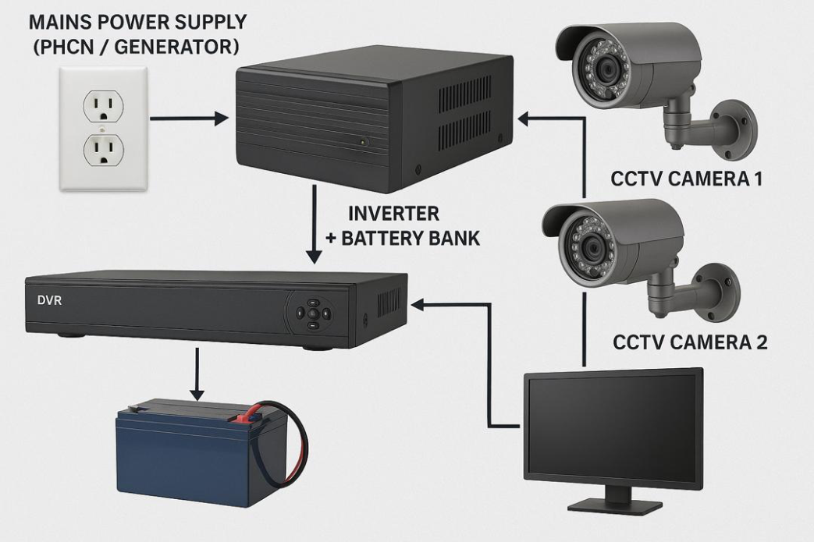
Fig 3.1
Installation Steps

Step 1: Mount the Cameras
- Install cameras in desired locations (walls, ceilings).
- Secure with brackets and weatherproof housings if outdoors.
- Connect video cables (coaxial for analog, Ethernet for IP) to DVR/NVR.

Step 2: Set Up the DVR/NVR and Monitor
- Place DVR/NVR in a secure, ventilated area.
- Connect cameras to DVR using BNC connectors (analog) or network cables (IP).
- Connect DVR to monitor via HDMI/VGA cable.

Step 3: Connect the Power Supply
- Plug each camera into a 12V power supply via the power distribution box.
- Alternatively, use PoE switches for IP cameras (power + data over Ethernet).

Step 4: Inverter and Battery Setup
- Battery Connection:
  - Connect the battery to the inverter using proper gauge wires.
  - Positive to positive (red), negative to negative (black).
- AC Input to Inverter:
  - Plug the inverter’s AC input into a wall outlet for charging the battery.
- AC Output from Inverter:
  - Connect the DVR, monitor, and power supply box to the inverter’s AC output.
  - Use a power strip if needed.

Step 5: Optional – Solar Panel Integration

Step 1: Mount the Cameras
- Install cameras in desired locations (walls, ceilings).
- Secure with brackets and weatherproof housings if outdoors.
- Connect video cables (coaxial for analog, Ethernet for IP) to DVR/NVR.

Step 2: Set Up the DVR/NVR and Monitor
- Place DVR/NVR in a secure, ventilated area.
- Connect cameras to DVR using BNC connectors (analog) or network cables (IP).
- Connect DVR to monitor via HDMI/VGA cable.

Step 3: Connect the Power Supply
- Plug each camera into a 12V power supply via the power distribution box.
- Alternatively, use PoE switches for IP cameras (power + data over Ethernet).

Step 4: Inverter and Battery Setup
- Battery Connection:
  - Connect the battery to the inverter using proper gauge wires.
  - Positive to positive (red), negative to negative (black).
- AC Input to Inverter:
  - Plug the inverter’s AC input into a wall outlet for charging the battery.
- AC Output from Inverter:
  - Connect the DVR, monitor, and power supply box to the inverter’s AC output.
  - Use a power strip if needed.

3.5 Testing and Commissioning
- Power on the system using both AC mains and inverter mode.
- Test runtime during simulated power outage.
- Check video feed, recording, and playback functions for all cameras.
- Monitor battery performance and inverter efficiency over a 24-hour period.
3.6 Monitoring and Maintenance Plan
- Regularly check battery voltage and charging cycles.
- Clean and inspect cameras and connectors.
- Perform monthly testing of the backup system to ensure reliability.
3.7 Safety and Compliance
- Ensure all installations comply with electrical safety standards.
- Label critical components and provide operational guidelines to the end-user.

CHAPTER 4
SYSTEM IMPLEMENTATION
4.1. Introduction
The need for continuous surveillance in residential, commercial, and industrial settings has led to the growing importance of reliable CCTV systems. However, in regions with unstable power supply, ensuring uninterrupted operation of CCTV cameras is a major challenge. To address this, the implementation of an inverter-powered CCTV system offers a practical solution that provides consistent surveillance during power outages.
4.2. Objective
The objective of this project is to implement a CCTV system powered through an inverter to ensure uninterrupted operation, especially in areas prone to frequent power outages. The inverter system will serve as a backup power source, automatically switching on during mains power failure.
4.3. Components Required
- CCTV Cameras (Analog or IP-based)
- Digital Video Recorder (DVR) or Network Video Recorder (NVR)
- Inverter Unit (Pure Sine Wave or Modified Sine Wave)
- Deep Cycle Battery (12V/24V depending on load requirements)
- Charge Controller (optional, if using solar input)
- Power Supply Cables and Connectors
- Uninterrupted Power Supply (UPS) for additional backup (optional)
- Voltage Regulator or Stabilizer (optional)

4. System Design and Implementation

4.3 Load Estimation
Estimate the total power consumption of the CCTV system, including the cameras, DVR/NVR, and any network equipment (e.g., routers or switches). For instance:
- 4 CCTV Cameras @ 10W each = 40W
- 1 DVR @ 30W = 30W
- Total Load = 70W

4.4 Inverter Sizing
Select an inverter with at least 20–30% higher capacity than the total load. For a 70W system, a 150W–200W inverter is appropriate.

4.5 Battery Selection
Determine the backup duration required and select a deep cycle battery accordingly.
Example: For 8 hours backup of a 70W load:
Battery capacity = (70W × 8h) / 12V = 46.7Ah
A 12V, 100Ah battery provides sufficient margin and longevity.

4.6 Wiring and Connections
- Connect the CCTV system to the inverter’s output.
- The inverter is connected to the battery and the AC mains for charging.
- If using solar power, connect a charge controller between the solar panel and the battery.
- Ensure proper fusing and circuit protection.

4.7 Installation and Testing
- Install cameras and DVR in the desired locations.
- Connect video feeds and power sources.
- Test the inverter system by simulating a power outage and observing the automatic switch to battery power.
- Ensure all devices continue operating without interruption.
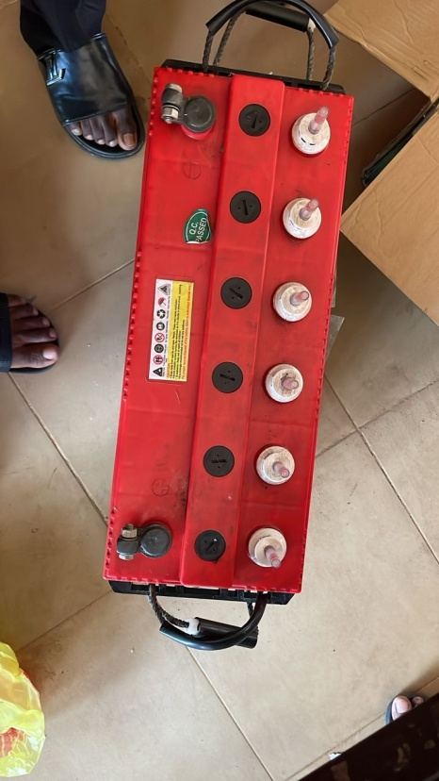
Fig 4.1
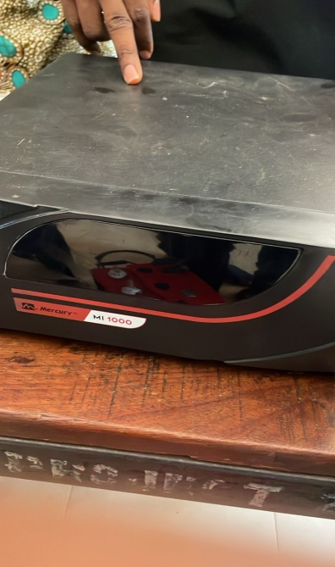
Batteries are essential components in modern technology, providing portable and backup energy for a wide range of devices—from mobile phones and laptops to electric vehicles and power backup systems. A battery is a device that stores chemical energy and converts it into electrical energy to power electronic circuits and equipment.
Fig 4.2
An inverter is a power electronic device that takes DC input (commonly from a battery or solar panel) and converts it into AC output at a specified voltage and frequency (e.g., 230V, 50Hz in many countries).

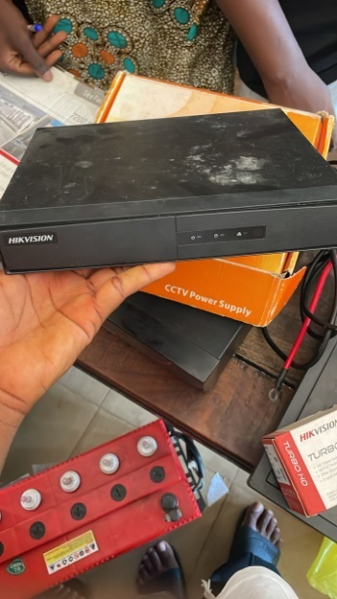
Fig 4.3
A DVR (Digital Video Recorder) is an electronic device that converts analog video signals from CCTV cameras into digital data, compresses it, and stores it on a hard disk drive (HDD) or solid-state drive (SSD). DVRs allow users to record, view, and retrieve video footage, often with features such as motion detection, time-stamping, remote access, and multi-camera support.
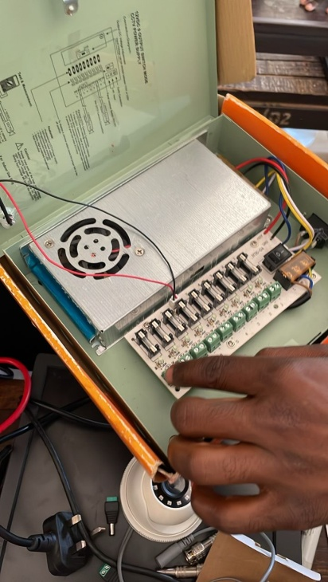
Fig 4.4
A power supply box is a critical component in electronic and surveillance systems. It distributes and regulates electrical power from the main source (AC) to various devices or subsystems that typically operate on lower DC voltages. In CCTV installations and other security systems, the power supply box ensures reliable and centralized power distribution to multiple cameras and accessories.
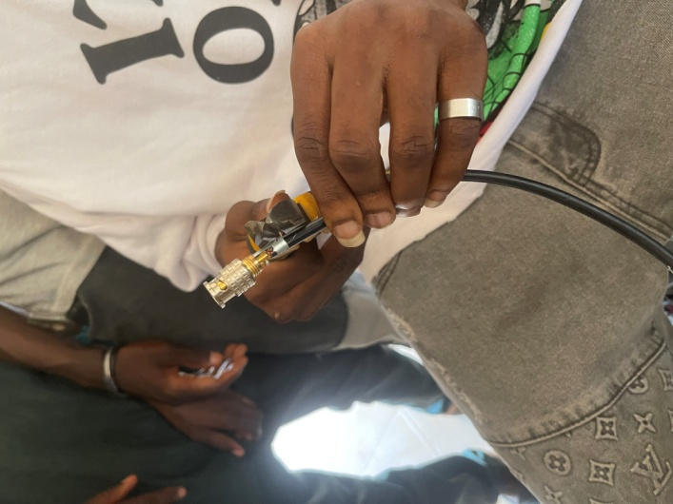
Fig 4.5
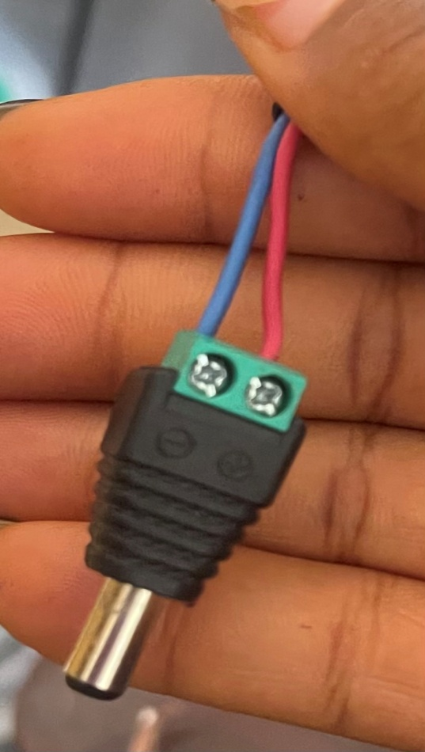
The BNC connector is a widely used type of RF (Radio Frequency) connector designed for coaxial cables. Its compact size, secure connection, and reliable performance make it ideal for various applications, especially in CCTV systems, broadcast equipment, test instruments, and radio frequency electronics.
Fig 4.5
Power is a fundamental concept in both electrical and electronic systems. It refers to the rate at which energy is transferred or converted.
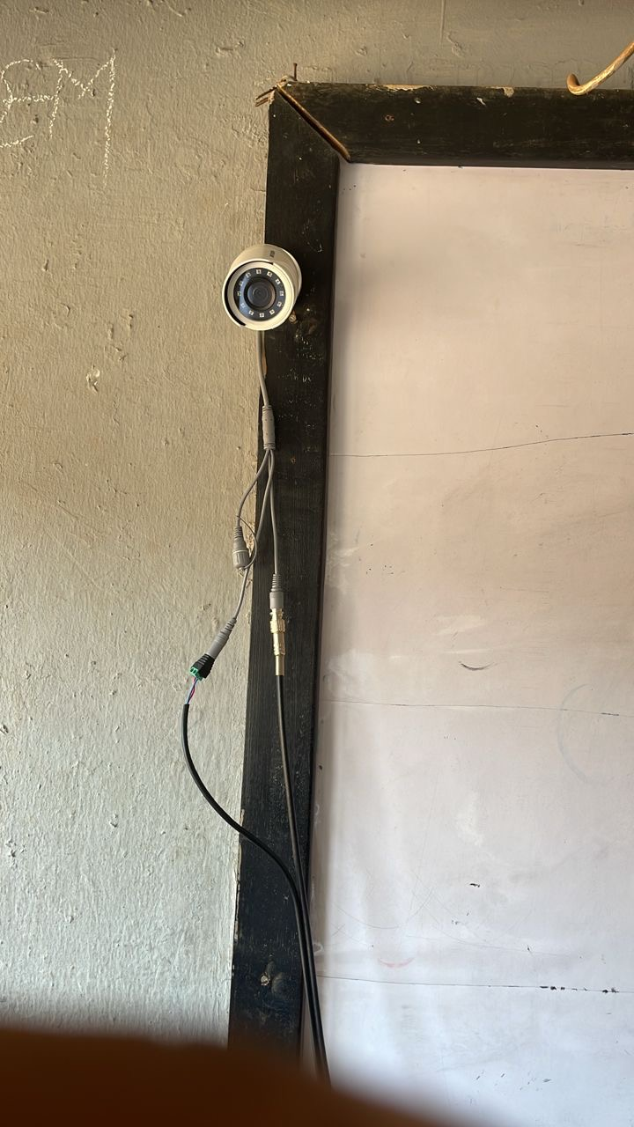
Fig 4.6
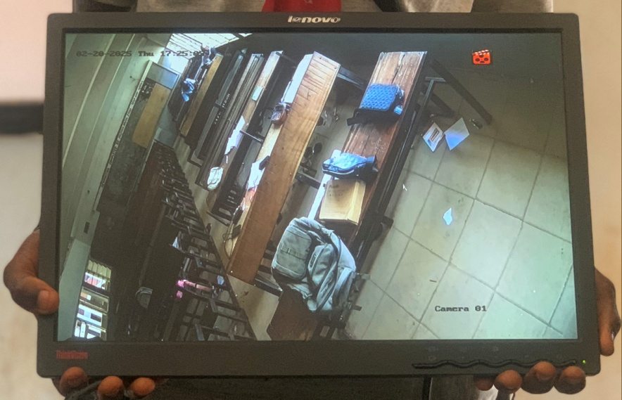
Installation of camera one
Fig 4.7
Output of the installed camera one
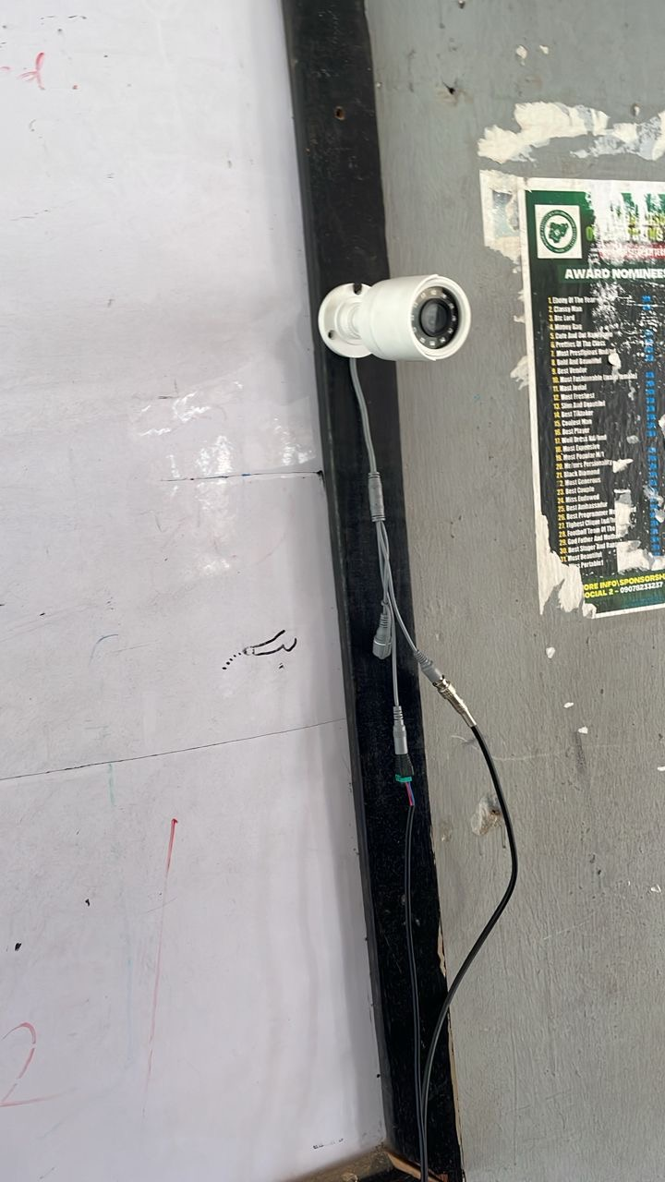
Fig 4.8
Installation of camera 2
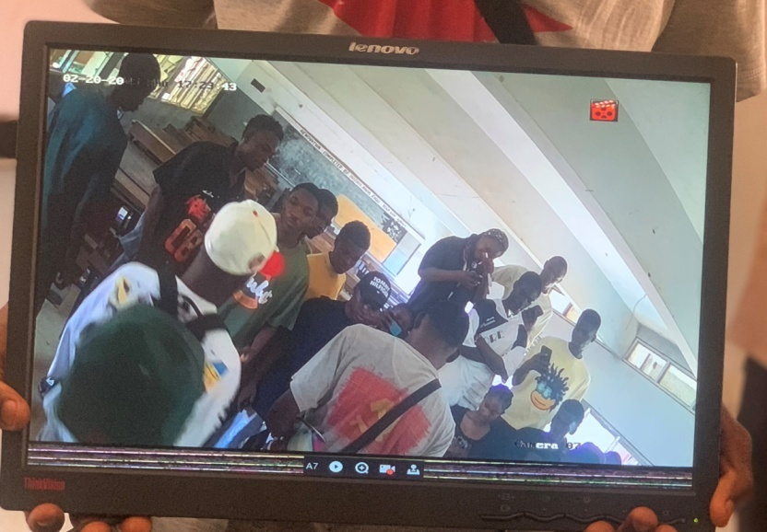
Fig 4.9
Output of installed camera 2

CHAPTER FIVE
SUMMARY, CONCLUSION, AND RECOMMENDATIONS

5.1 Summary
This project explored the design, implementation, and evaluation of an inverter-powered CCTV surveillance system tailored specifically for monitoring examinations within academic institutions. The study arose from the need to combat examination malpractice, which remains a persistent threat to academic integrity, especially in developing countries where electricity supply is inconsistent.

In the course of this research, it was established that CCTV systems, when consistently operational, significantly reduce examination malpractice by serving both as a deterrent and monitoring tool. However, their effectiveness is severely limited by power outages, leading to system shutdowns during critical exam periods. To address this, the study focused on developing a sustainable solution using inverter technology, which converts DC battery power into AC, thereby providing uninterrupted power supply to CCTV cameras and recording devices during outages.

The methodology involved power load analysis, inverter and battery sizing, system installation, and testing in a simulated examination environment. The results confirmed that the inverter-powered system maintained continuous surveillance, even in the absence of mains electricity, and was cost-effective, quiet, and environmentally friendly compared to generator-based alternatives. The psychological impact of visible, uninterrupted CCTV also contributed to a reduction in malpractice attempts.

The system was further enhanced with features such as automatic transfer switching and deep-cycle batteries to ensure reliability and longevity. Additionally, the project emphasized regular maintenance, system monitoring, and user training for optimal performance.

5.2 Conclusion

The implementation of an inverter-powered CCTV system provides a feasible and effective solution to the challenges of examination monitoring in power-unstable regions. The findings demonstrated that such systems not only ensure continuous surveillance but also improve the credibility and security of the examination process. With proper configuration and maintenance, institutions can rely on this system to enforce academic standards without the drawbacks of noisy, fuel-dependent alternatives.

As educational institutions continue to evolve and adopt technology in their operations, integrating inverter systems into surveillance infrastructure will become increasingly essential. This project contributes significantly to the field of educational technology by offering a scalable, reliable, and cost-effective strategy to mitigate examination malpractice and enhance monitoring capabilities.

5.3 Recommendations
Based on the outcomes of this study, the following recommendations are proposed:
- Institutional Adoption: Educational institutions, especially in areas prone to power failures, should adopt inverter-powered CCTV systems for all major examination centers.
- Use of High-Quality Components: It is critical to use reliable inverters and deep-cycle batteries to ensure system longevity and minimize maintenance costs.
- Maintenance Protocols: Regular monitoring, battery checks, and cleaning of surveillance equipment should be implemented to sustain optimal performance.
- Training of Technical Staff: Institutions should train internal technicians for system management, fault detection, and basic troubleshooting.
- Further Research: Future research should explore hybrid systems combining solar and inverter technology, especially for off-grid institutions, to enhance sustainability.

5.4 References
Ajibade, T., & Sulaimon, F. (2020). Surveillance technology in Nigerian tertiary institutions: Benefits and challenges. Nigerian Journal of ICT and Education, 12(1), 45–52.

Bello, A., & Lawal, M. (2020). Comparative analysis of inverter and generator systems for school surveillance. International Journal of Renewable Energy Research, 9(4), 987–995.

Bello, A., & Ojo, M. (2021). Inverter vs. generator backup systems: Cost-effectiveness in educational monitoring applications. Journal of Engineering and Applied Technology, 8(2), 112–121.

Chukwu, V., & Ibrahim, M. (2024). Low-cost inverter-powered CCTV for exam halls: A two-session evaluation. African Journal of Educational Technology, 5(1), 33–41.

Edeh, N., & Ugwu, J. (2022). Psychological deterrents in examination monitoring: The CCTV effect. Journal of Educational Integrity, 10(3), 56–63.

Eze, F., & Ayodeji, B. (2022). Impact of CCTV surveillance on student behavior during exams. West African Journal of Academic Practices, 11(2), 78–86.

Ibrahim, H., & Musa, T. (2021). Post-pandemic surveillance in hybrid exams: Lessons from inverter-powered systems. Journal of Educational Policy and Technology, 6(1), 21–28.

Mohammed, R., Adebayo, L., & Nnamdi, E. (2023). Hybrid surveillance systems in rural schools: Solar-inverter integration. Journal of Sustainable Infrastructure, 14(2), 91–100.

Okonkwo, P., & Bamidele, S. (2021). The effect of consistent CCTV usage on exam malpractice in Nigerian universities. Educational Security Studies, 7(1), 44–59.

Okon, A., & James, D. (2023). Smart surveillance and sustainability in sub-Saharan education. African ICT Review, 9(4), 201–215.

Usman, K., & Bello, T. (2022). Cost-benefit analysis of technology-based examination monitoring. Journal of Educational Management and Policy

