A PROJECT REPORT ON PROPOSED ARMY MILITARY BARRACK AT SOKOTO TOWN ALONG BODE SADU JEBBA ROAD, ILORIN KWARA STATE

BY

ABDULAZEEZ ISMAIL OLADIPUPO
HND/23/ARC/FT/0001

SUBMITTED TO:
DEPARTMENT OF ARCHITECTURAL TECHNOLOGY, INSTITUTE OF ENVIRONMENTAL STUDIES, KWARA STATE POLYTECHNIC, ILORIN
IN PARTIAL FULFILLMENT OF THE REQUIREMENT FOR AWARD OF HIGHER NATIONAL DIPLOMA (HND) IN ARCHITECTURAL TECHNOLOGY
JULY, 2025

DECLARATION
I declare that this project is my personal research works. It has not been presented for the award HND in any polytechnics. The ideas, observation, comments, suggestion herein represent my own convictions, except quotation, which have been acknowledgment in accordance with conventional academic tradition.
ABDULAZEEZ ISMAIL OLADIPUPO
HND/23/ARC/FT/0001

_________________________ _________________________
SIGN DATE
CERTIFICATION
This project has been read and certified as meeting part of the requirement of the department of Architecture Technology, Institute of Environmental Studies Kwara State Polytechnic for award of Higher National Diploma (HND) in Architecture Technology.

_________________________ ____________________
ARC. B.Y.F ABDULAZEEZ DATE
PROJECT SUPERVISOR

_______________________ ____________________
ARC. ADEYEMI F. DATE
PROJECT CO-ORDINATOR

_________________________ ____________________
ARC. TOMORI J.M DATE
HEAD OF DEPARTMENT

___________________________ ____________________
External Examine DATE
DEDICATION
This project is dedicated to Almighty Allah and also to my parent MR & MRS ISMAIL and to Kwara State Polytechnic.

ACKNOWLEDGMENT
I give all adoration and thanks to Almighty Allah, the giver of life and joy giving me the great opportunity, strength and wisdom to start and conclude the program of Higher National Diploma and to study Architecture in the great institute of environmental studies.
I must appreciate and gratify the devoted assistance of my supervisor ARC ABDULAZEEZ B.Y.F. from commencement to this work to the very end. To all lecturers of the department of Architectural Technology, ARC. ADEYEMI Felix, ARC, AMADA A.T, ARC. Tomori J.M, ARC. CHUCKWUMA NMOM, ARC. Solomon Familua.
I would like to place my sincere appreciation and thanks for the overwhelming support and love I received from my parent MR. SULAIMAN ISMAIL and MRS. AFUSAT ISMAIL loving you less is sin.
Special appreciation goes to my sibling Abubakar, Taofeeq, Abdulwasiu, Mutiu, Mutiat.

Table of Contents
Title page ……………………………………………………………..…… i
Declaration …………..………………………………………………….… ii
Certification …………………………………………………….………… iii
Dedication …………………………………………………….......…….… iv
Acknowledgment …………………………..…………………..……..…… v
Abstract ……………………………………………...….…………..…… viii
CHAPTER ONE
1.0 Introduction ………………………………………………...……….. 1
1.1 Historical Background.…………………….………….…….……... 1
1.2 Definition ………………………………………………………….. 3
1.3 Aims and Objectives ………………………………………………. 3
1.4 Justification …………………………………………………………. 4
1.5 Limitation…. ……………………………………………………….. 4
1.6 Research Methodology …………………………………………… 4-5

CHAPTER TWO
2.0 Literature Review ……………………………………………. 6-8
2.1 Case studies ………………………………………………… ... 9-33

CHAPTER THREE
3.0 Introduction to the site………….. ……………………….…..…......34
3.1 Brief History of the Town………. ……………………….…..…......34
3.2 Site Location/Description …...……………………………………. 34
3.3 Site Location /Choice and Criteria………………………........... 35-36
3.4 Site Analysis/Inventory..………………………………………....….36
3.5 Site Suitability/ Analysis………………………………………...36-38
3.6 Geographical Characteristics………………………...….……..……38
3.7 Climatic Characteristics…....………………………...….……..……39
3.8 Infrastructure……………....………………………...….……..……40
3.9 Conclusion.……………………………………………….…………40

CHAPTER FOUR
4.0 Design Criteria/General Requirement.………………………..…41-43
4.1 Site Planning/Zoning/ Concept…….. .……………………..……43-45
4.2 Brief Analysis (Client) /User, Requirement……………………….. 45
4.3 The Design Scope...………………………..…………….…..…45-46
4.4 Functional relationship ………..……………………..…..….….46-47
4.5 Space Analysis/ Space Calculation Allocation..……….……… 48-50
4.6 Conceptual Development ……………………………..…..….….…50

CHAPTER FIVE
5.0 Appraisal of proposed Design/Service………..…….…..………….51
5.1 Construction methodology and materials...…………..…..…………51
5.2 General Design Consideration…………………………..…........... 52
5.3 Structural Principle………………………………………...………..52
5.4 Landscape Design…………… ….…………………..……………..52
5.5 General Maintenance………… ….…………………..……………..53
5.6 General Conclusion ….………….………………..…… ….………53
5.7 Recommendation…………………………...……..…… ….……54-55
Reference………………………….………………………………………. 56
Bibliography………………………………………………………………. 57
ABSTRACT
This project proposes the design and development of a modern military barrack, conceived with an emphasis on functionality, discipline, security, and resilience. The design integrates modular planning inspired by the structured form of a pistol gun—symbolizing strength, precision, and readiness—while adhering to principles of minimalism and utility. The barrack is zoned into clearly defined areas, including administrative headquarters, tactical grounds, medical center, educational facilities, residential quarters, and recreational spaces. Each zone is strategically positioned to enhance operational efficiency, command hierarchy, rapid deployment, and ease of access. Special consideration is given to climatic conditions, sustainability, and material selection, ensuring durability, energy efficiency, and adaptability to local environmental challenges. The architectural layout promotes military order, discipline, and hierarchy, using symmetrical forms, muted tones, and camouflaged aesthetics. The project not only addresses the accommodation and training needs of military personnel but also emphasizes the welfare and morale of troops through adequate recreational, educational, and healthcare amenities. Overall, the proposed barrack reflects a balance between military functionality and human-centered design, offering a strategic model for future military infrastructure development.

List of Figure
Fig 2.2.1 Showing the floor plan of case study One ………..…………..11
Fig 2.3.1 Showing the floor plan of case study two …………………….. 17
Fig 2.4.1 Showing the floor plan of case study three ….……………… 22

List of Plates
Plate 2.2.1 showing the main gate view of case study one ………….… 12
Plate 2.2.2 showing the headquarter office view of case study one
…..………………………………………………………………………… 13
Plate 2.2.3 showing the living quarter block view of case study one
…….……………………………………………………………….……… 14
Plate 2.3.1 showing the main gate view of case study two ……….…… 18
Plate 2.3.2 showing the living quarter block view of case study two
…..……………………………………………………………………….. 19
Plate 2.3.3 showing the headquarter office view of case study two
……………………………………………………………………………. 20
Plate 2.4.1 showing the headquarter office view of case study three
…..…………………………………………………………………..……. 23
Plate 2.4.2 showing the living quarter block view of case study three
.…………………………………………………………….……….……. 24
Plate 2.4.3 showing officers quarter view of case study three
……………………………………………………………………………...25
Plate 2.5.1 showing the entrance gate view of case study four
..…………………………………………………………………………….28
Plate 2.5.2 showing the living quarters view of case study four
.……………………………………………………………………………..29
Plate 2.6.1 showing the entrance gate view of case study five
………………………………………………………………………….…..31
Plate 2.6.2 showing the headquarter office view of case study five……………………………………………………….…………………32
Plate 2.6.3 showing the living quarters view of case study five
…………………………………………………………………………….. 33

List of Appendix
Appendix 1 showing the geographical map of the proposed project….….58
Appendix 2 showing the locational plan of the proposed project…...….....59
Appendix 3 showing the site analysis of the proposed project…….……60
Appendix 4 showing the site inventory of the proposed project
………………………………………………………………………..…….61
Appendix 5 showing the site zoning of the proposed project………..……62
Appendix 6 showing the climatic data of the proposed project………….63
Appendix 7 showing the site concept of the proposed project………..…..64
Appendix 8 showing the site plan of the proposed project……………....65
Appendix 9 showing the bubble diagram/ functional relationship of the proposed project…………………………………………………………..66
Appendix 10 showing the floor plan of the proposed project…………..67
Appendix 11 showing the roof plan of the proposed project………………68
Appendix 12 showing the elevations of the proposed project…………….69
Appendix 12 showing the elevations of the proposed project…………….70
Appendix 13 showing the sections of the proposed project.……….……71
Appendix 14 showing the site perspective of the proposed project………………………………………………………..……………..72

CHAPTER ONE
1.0 INTRODUCTION
Military barracks serve as essential infrastructure within armed forces around the world—providing not only accommodation but also a central hub for the daily lives and activities of military personnel. These structures are designed to foster a sense of community and discipline among service members while offering practical amenities that support their training and operational readiness. Typically located on military bases, barracks can range from simple dormitory-style buildings to more complex facilities with shared dining halls, recreation areas, and administrative offices.
The design and configuration of barracks vary depending on the branch of the military mission requirement and the number of personnel being housed. In addition to serving as a place to sleep and live, military barracks are critical for creation of a conducive environment for camaraderie, teamwork, and leadership development. They play a key role in maintaining the morale and welfare of troops, ensuring that service members have both the support and resources needed to perform their duties effectively.
Through stringent regulations and institutional practices, barracks also promote discipline and order, which are vital components of military life.

1.1 HISTORICAL BACKGROUND
Early barracks such as those of the Roman Praetorian Guard were built to maintain elite forces. There are a number of remains of Roman army barracks in frontier forts such as Vercovicium and Vindolanda, in Britain. And from contemporary Roman sources, we can see that the basics of life in a military camp have remained constant for thousands of years. In the early modern period, they formed part of the military revolution that scholars believe contributed decisively to the formation of the nation-state found by increasing the experience of maintaining standing armies. Large permanent barrack ideas developed in the 16th–18th century by the two dominant states of the period—France in the “Caserne” and Britain the “Curacel.” The English term “barrack” on the other hand derives from the Spanish word for a temporary shelter erected by soldiers on campaign. Barracks, because of fears that a standing army of soldiers were a threat to the constitution, were not generally built in Great Britain until 1790 on the eve of the Napoleonic War.
Early barracks were built in multi-story blocks, often grouped in a quadrangle around a courtyard or parade ground. A good example is Berwick Barracks, which was among the first in England to be purpose-built and began in 1717 to the design of the distinguished architect Nicholas Hawksmoor. During the 18th century, the increasing sophistication of military life led to separate building for different ranks' married quarters, as well as the provision of specialized buildings such as dining rooms and cook houses, bath-houses, mess rooms, schools, hospitals, armies' gymnasia, riding schools, and stables. The pavilion plan concept of hospital design was influential in barrack planning after the Crimean War.
The first large-scale training camp barracks built in the Kingdom of France or the Holy Roman Empire (Germany) during the early 18th century. The British Army built Aldershot camp from 1854 by first world war, infantry, artillery, and cavalry regiment had separate barrack
in the 19th century the development of modern military barracks especially with expansion of colonial powers and the establishment of military academies the growing importance of military organization through out the 20th century the design and structure of barracks continued to evolve adapting to the need of modern welfare and the advancement in military practices today military barracks are integral to armed forces worldwide serving dual roles as living quarters and operational hub wherever military personnel are stationed.
1.2 DEFINITION
A military barracks is a complex of buildings design to house military personnel provide all the necessary facilities such as training ground , administrative block and other amenities for personnel to carryout there daily activities.

1.3 AIM & OBJECTIVES
AIM
To make proper planning and design for the military personnel by developing a functional secure and sustainable military living barrack
OBJECTIVES
1. To create a well-organized and secure living environment tailored to the needs of military personnel.
2. To ensure the barrack includes all necessary facilities
3. To adopt durable, low-maintenance materials and sustainable design strategies suitable for the climate and usage intensity.
4. To integrate passive design principles such as natural lighting, ventilation, and climate-responsive planning.
5. Ensure design adhere to national building codes, military standards, and safety regulations.
6. To provide adequate infrastructure for fire safety, water supply, drainage, and utility services.
7. To design a modular system that allows future expansion or reconfiguration based on evolving needs.
8. Incorporate security features such as controlled access point surveillance system and fortified structure to protect personnel and sensitive areas

1.4 JUSTIFICATION
It is essential to improve the efficiency security and welfare of military personnel and also incorporate sustainable design to reduce maintenance cost and improve Long term usability.

1.5 LIMITATION
The project may face constraints of some restricted military areas strict military regulation and tight timeless all of which could affect design flexibility and implementation

1.6 RESEARCH METHODOLOGY
Information needed to design a standard military barracks are obtained through the following
- Case study
- Oral interview
- Literature review
- Internet browsing
In carryout this work data were collected from diverse source which can be classified into primary and secondary source
- PRIMARY SOURCE: Some of the data for the project were gather by carryout series of case studies and making direct observation of the data as they occur question were asked when needed with a view to have a better understanding some of the data were accompanied by photography since certain level of detail required.
- CASE STUDIES: This involves visiting the existing building or structure of related project (military barrack) to know needful information.
- ORAL INTERVIEW: Oral interviews are adopted to seek opinions of available official, or soldiers considered as a major respondent who provide useful information in deciding the concept and scope of the project.
- SECONDARY SOURCE: The past literatures were review to get some data for the project some were collected from internet encyclopedia.

CHAPTER TWO
2.0 LITERATURE REVIEW
Literature review is an analysis of existing research on a specific topic it helps you understand what has already been studied what gaps exist and how your own work or project fit into the broader knowledge

DEFINITION
A military barracks is a complex of buildings design to house military personnel provide all the necessary facilities such as training ground , administrative block and other amenities for personnel to carryout there daily activities.

MILITARY BARRACKS
Military barracks play a critical role in maintaining military cohesion and operational efficiency. They accommodate soldiers and officers in a regimented, controlled environment that promotes readiness, order, and morale. A typical barracks may consist of sleeping quarters, ablution facilities, mess halls, armories, storage spaces, classrooms, and sometimes recreational areas. The design and layout of a barracks must reflect its strategic function, security requirements, environmental context, and the hierarchical structure of the military organization.

HISTORICAL DEVELOPMENT OF MILITARY BARRACKS
The concept of military barracks dates back to ancient times. In the Roman Empire, for example, castra (fortified camps) were built to accommodate legions, often including sophisticated layouts with roads, training grounds, and living quarters. During the Middle Ages, barracks were generally temporary shelters or castles adapted for military use.

In the 17th to 19th centuries, formalized barracks became more common in European armies, particularly as standing armies grew. These facilities were designed to maintain control over troops, facilitate rapid mobilization, and project power in occupied territories.
By the 20th century, especially during and after the World Wars, military barracks evolved to include reinforced structures, sanitation systems, heating, and later, electricity and air-conditioning. The Cold War period introduced the concept of underground and nuclear-resistant barracks in some countries. Modern barracks now integrate digital surveillance, biometric access control, and are increasingly designed with sustainability in mind.

MILITARY BARRACKS IN NIGERIA
In Nigeria, military barracks were established during the colonial era to house British colonial troops and Nigerian soldiers under British command. Examples include Mogadishu Cantonment (formerly Ikeja Cantonment), Bonny Camp, and Lugard Barracks in Lokoja. Post-independence, Nigeria expanded its military infrastructure to support a growing national army, especially during and after the Nigerian Civil War (1967–1970).
However, many Nigerian military barracks today still reflect outdated colonial-era planning. Challenges such as overcrowding, poor maintenance, weak security measures, and inadequate utilities are common. The need for new designs that prioritize safety, sustainability, and functionality has become urgent, especially in the context of rising security threats like terrorism, insurgency, and internal conflict. A modern Nigerian military barracks must not only meet contemporary operational demands but also improve the quality of life for soldiers and their families.

2.1 CASE STUDIES
Case study is a detailed look at real life examples to understand how something work in practice and it help you to learn from existing project see what was done well or poorly and apply those lessons to your own work or project
2.2 CASE STUDY ONE
BARRACK NAME: 192 Battalion Barrack
LOCATION: Located at Owode, Yewa, Ogun State.
HISTORICAL CONTEXT: There is little historical detail about the establishment of the barrack. However, it is known to have played a vital role in response to communal conflicts and border security in Nigeria, especially around the southwestern border.
DESCRIPTION: The barrack serves as a significant military base that facilitates:
Training
Housing
Operational readiness for Nigerian Army troops
Safeguarding the nation's sovereignty
MERITS
- The barrack layout is functional with proper segregation of spaces (offices, residential, recreational, tactical ground etc.).
- Good landscaping with soft hardscaping like trees and flowers—these beautify the area and act as windbreakers and heat reducers.
- Sufficient land, properly utilized, with room for future expansion.
- High level of security to address any potential threats.
DEMERITS
- Some structures are abandoned due to poor maintenance.
- The rigid architectural style results in poor air circulation and lighting.
- Roads are accessible but some are damaged and not maintained.
- Certain structures show signs of aging with outdated and deteriorating components.

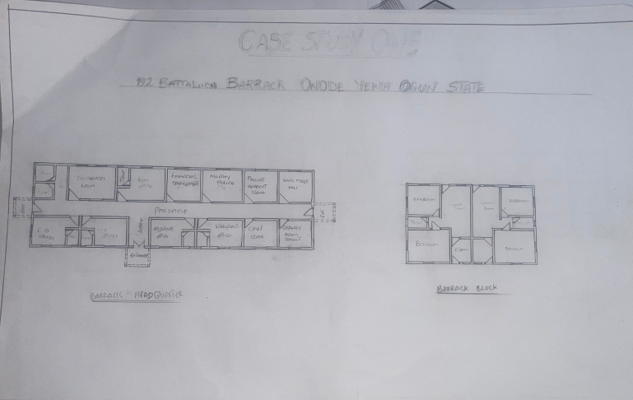

Fig 2.2.1 Floor Plan
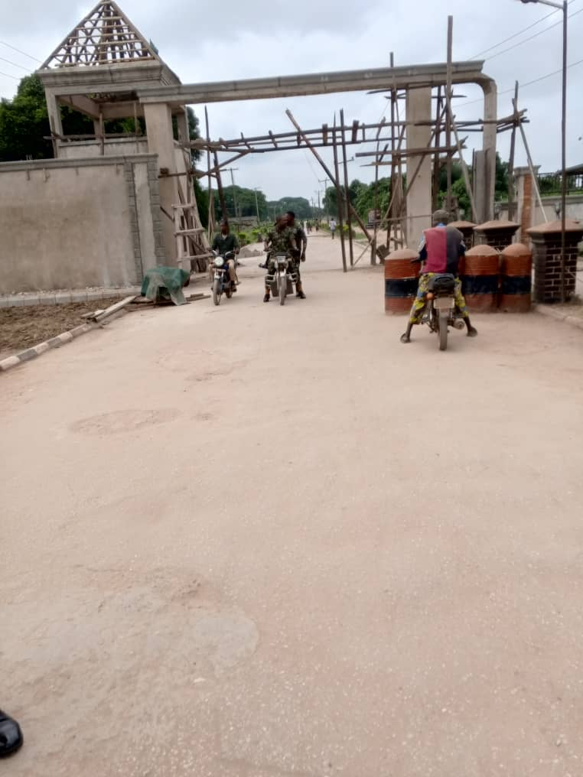

Plates 2.2.1 Main Gate

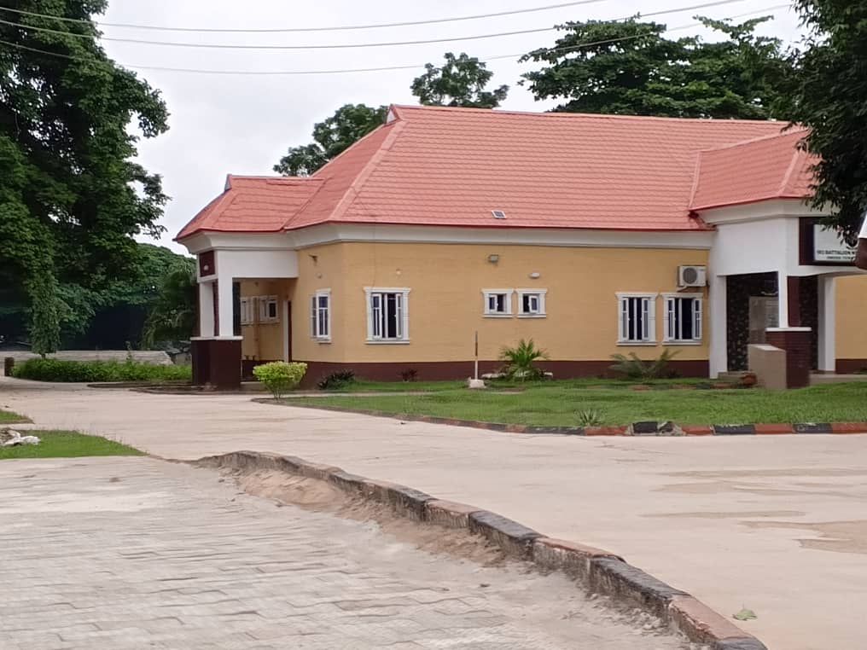

Plates 2.2.2 Headquarter Office

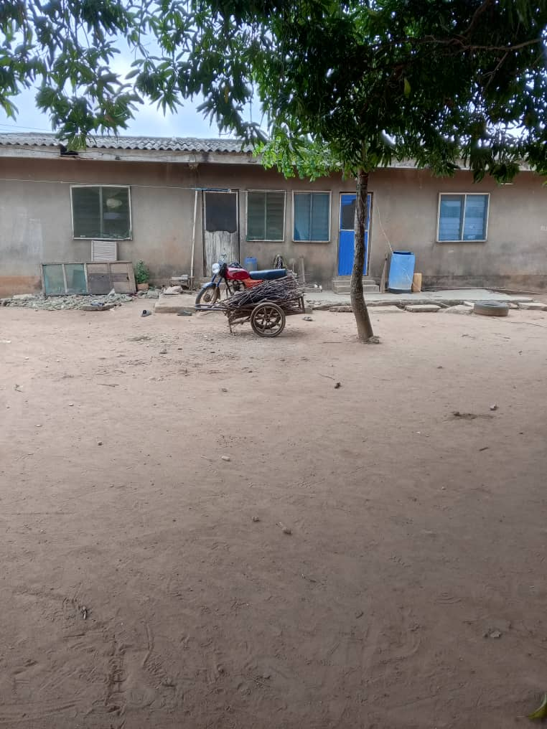

Plates 2.2.3 Living Quarter Block

2.3 CASE STUDY TWO
BARRACK NAME: Abogo Largema Cantonment Barrack
LOCATION: Abogo Largema cantonment barrack is located at born state Nigeria
HISTORICAL CONTENT: The establishment of the military barracks at Abogo, Largema, cantonment is integral to Nigeria history especially in the context of conflict and the ongoing fight against Boko Haram and other militant groups in the northeastern part of the country. Since the escalation of violence in the early 2000s, these barracks have expanded their presence to stabilize the affected regions, support counter-insurgency operations, and protect civilian populations from armed threats.
DESCRIPTION: The barracks after the establishment was name Abogo Largema cantonment in honor of major Abogo Largema a noble military soldier the cantonment serve as strategic military bases for the Nigerian Army with a primary focus on maintaining operational readiness and ensuring territorial defense against insurgent activities and other security challenges in the area. These facilities support military coordination, training, logistics, and deployment of forces within the northeastern region.
MERITS
- The barracks combine multiple military units within one base, promoting effective coordination and operational efficiency.
- Adequate Residential Facilities There is sufficient residential accommodation for soldiers and their families, contributing to troop welfare and morale.
- Clear Circulation Paths: The layout of the barracks ensures organized movement through well-defined roads and pathways, improving accessibility and reducing internal congestion
DEMERITS
- The cantonment does not have an effective waste management system which can result to environmental pollution,
- There is a lack of certain modern amenities or infrastructure developments which could affect the quality of life for personnel station there.
- Some part of the cantonment suffer from poor maintenance leading to issues like dilapidation water leakage.

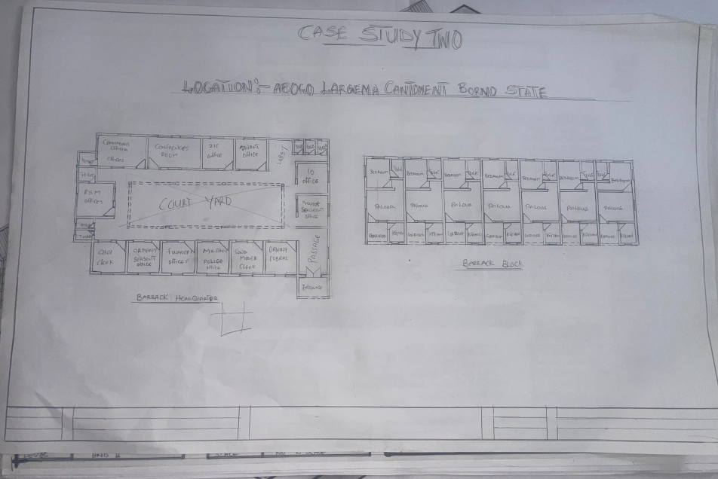

Fig 2.3.1 Floor Plan

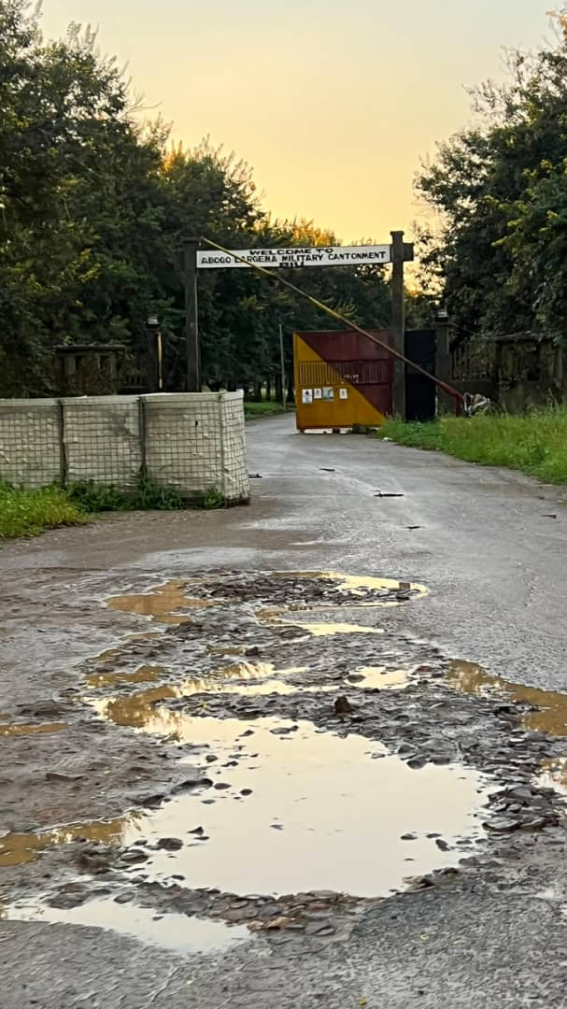

Plates 2.3.1 Main Gate

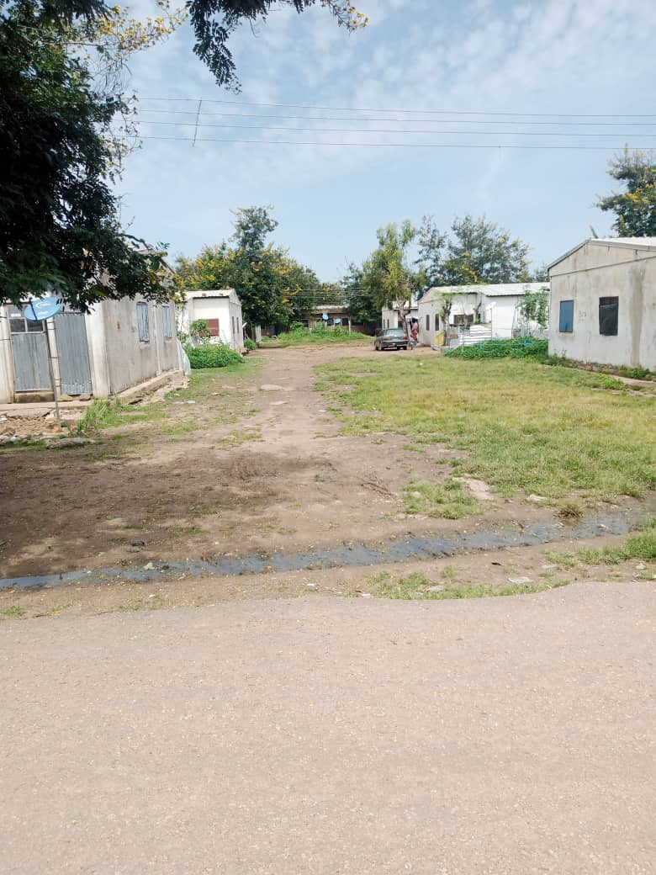

Plates 2.3.2 Living Quarters Block

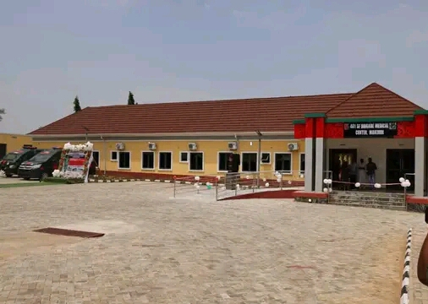
Plates 2.3.3 Headquarter Office

2.4 CASE STUDY THREE
BARRACK NAME:- Kotoko Barrack Kaduna
LOCATION: The barrack is Located in the northwest region of the Country Kaduna.
HISTORICAL CONTENT: Kotoko Barrack is a historic Nigerian Military facility located in Kaduna State, it has Served as a key military installation for decades and played an important role in the evolution of the Nigerian army during and after the Colonial Period
Post Independence after Nigeria Independence in 1960 Katoto Barracks became a training and operational base for the Nigeria army. which have served as a logistics and troop- mobilization point during Nigerian Civil War (1967-1970) DESCRIPTION:
Kotoko Barrack is a standard regimental barrack with a function military layout, that prepare and trained military personnel for operational readiness (such as administrative building residential Quarter, tactical ground parade ground and other structural facilities.
MERIT
- Provides base need living, health education and recreational services.
- The buildings are well maintain and renovated.
- The living quarter are built in stores to accommodate personnel.
- It has a clear area circulation path accessibility and connectivity.
DEMERIT
- Waste management and green space planning in improvement.
- Due to limited expansion and increased troop living quarter can be cramped.
The Quarter for living are distance from each other those not foster community interaction.

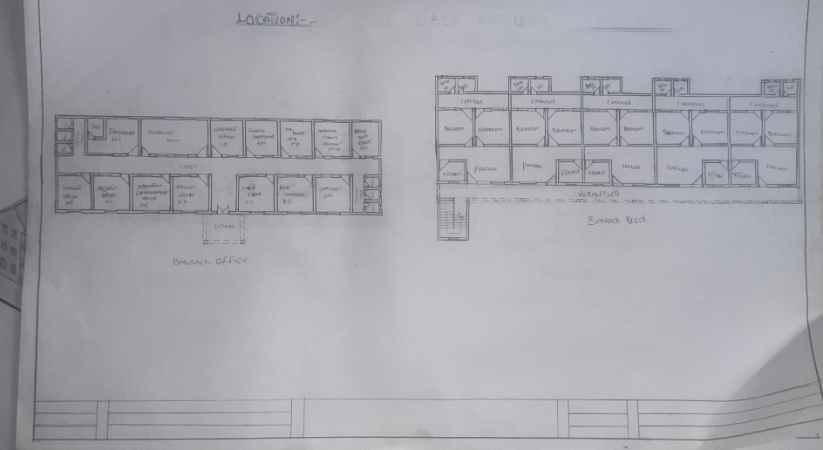

Fig 2.4.1 Floor Plan
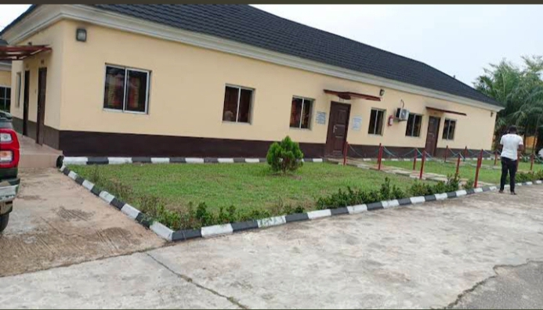

Plates 2.4.1 Headquarter Office

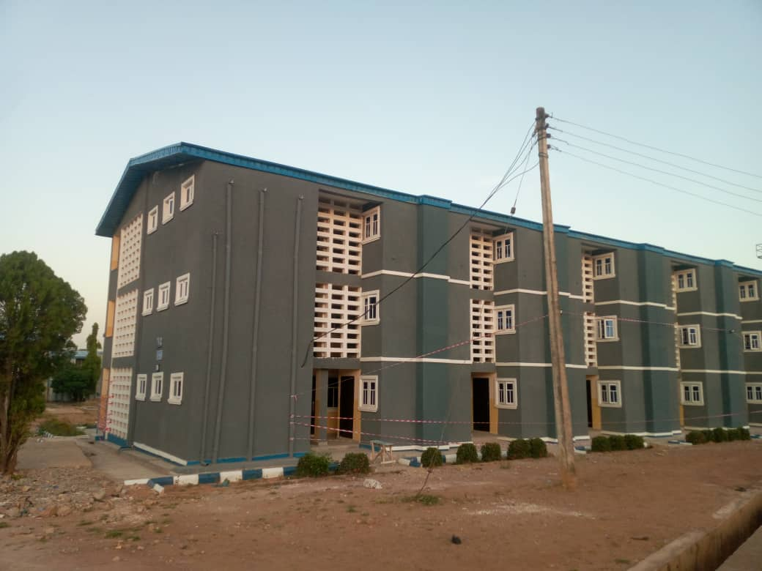

Plates 2.4.2 Living Quarters Block

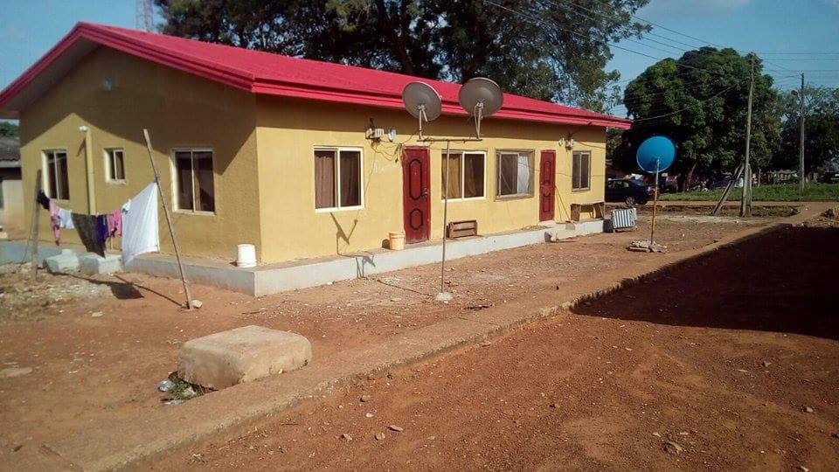

Plates 2.4.3 Officers Quarters

2.5 CASE STUDY FOUR (INTERNATIONAL)
BARRACK NAME : Fort drum barrack 10th mountain division
LOCATIONS: Fort Drum is situated in Jefferson County, New York, approximately 30 miles from the Canadian border,
HISTORICAL CONTEXT: Camp Origin Originally known as Pine Camp (established ~1908–1910), later renamed Camp Drum in 1951, in honor of Lt. Gen. Hugh A. Drum Summary: History and Context of Fort Drum & 10th Mountain Division Barracks
Fort Drum, located in New York, began as Pine Camp in 1908and expanded during World War II to become a major military training site. Renamed Camp Drum in 1951, it was later designated a permanent Army post.
In 1985, Fort Drum became the home of the reactivated 10th Mountain Division a light infantry unit specialized in cold-weather and mountain warfare This led to major development of modern military barracks and facilities designed for rapid deployment and operational readiness.
Today, the barracks at Fort Drum support thousands of soldiers, enabling the division to remain one of the most frequently deployed in the U.S. Army playing key roles in missions across Afghanistan, Iraq, and humanitarian operations worldwide.
DESCRIPTION: the barrack know to accommodate military personnel train them reinforced personnel and also provide rehabilitation facilities for recovery or transitioning soldier

MERITS
- Constant upgrades to barracks, motor pools, training grounds, and family housing.
- Includes schools, medical facilities, commissaries, and recreational centers.
- Offers vast open terrain, forests, and varied climate — ideal for cold-weather, mountain, and light infantry training
DEMERIT
- It experiences long, brutal winters with heavy snowfall and freezing temperatures.
- Can impact morale, logistics, and accessibility.
- Due to frequent deployments and weather conditions, facilities and equipment face high maintenance demands.



Plates 2.5.1 Entrance Gate

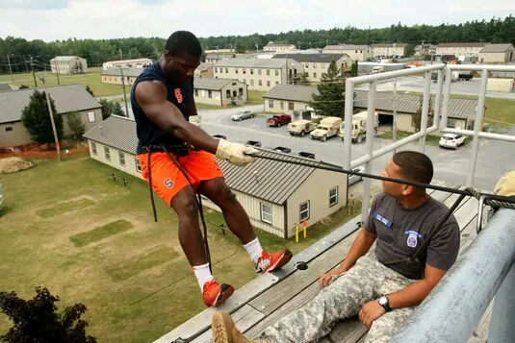

Plates 2.5.2 Living Quarters

2.6 CASE STUDY FIVE (INTERNATIONAL)
BARRACK NAME : marine barrack Washington DC referred to as 8th & I”,
LOCATION: Northeast corner of 8th & I Streets SE, Washington, D.C. 20390 (
HISTORICAL BACKGROUND
Founded in 1801 by President Thomas Jefferson and Lt. Col. William Ward Burrows, with strategic placement near naval and governmental center. Marines stationed here defended Washington in the War of 1812, including the “Burning of Washington” episode, and served in subsequent conflicts through the Spanish–American War and world wars.
The current barracks structures were rebuilt in 1900–1907, designed by Hornblower & Marshall, while the original Commandant’s House (north building) from 1806 is still in use.
DESCRIPTION: Quadrangle Layout: Buildings form a U-shape around a central parade ground, used for daily ceremonial drills and public events and also Serves as the ceremonial and security hub of the Marine Corps. It hosts the Friday Evening Parade in spring/summer, featuring “The President’s Own” Marine Band, Drum & Bugle Corps, Silent Drill Platoon, Color Guard, and 21-gun salute battery.
MERITS
- Features historic buildings and a well-maintained campus.
- Using modern architecture design for military facilities for the personnel comfort.
DEMERITS
- Located in an urban area with limited room for expansion.
- Modern military facilities. Infrastructure upgrades must be handled delicately due to the site’s age and historical status.



Plates 2.6.1 Entrance Gate

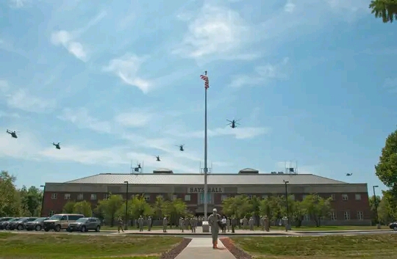

Plates 2.6.2 Headquarter Office

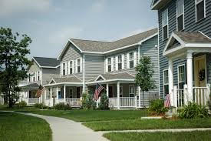

Plates 2.6.3 Living quarters

CHAPTER THREE
3.0 INTRODUCTION TO THE SITE
The proposed site for the military barrack is located in Sokoto Town,situated along Bode Sadu–Jebba Road in llorin, Kwara State. The location is strategic for security operations, regional monitoring, and logistical support between North-Central and Northwestern Nigeria. It offers a relatively calm environment conducive to a secure military establishment.
3.1 BRIEF HISTORY OF SOKOTO TOWN
This Sokoto Town is along Bode Sadu–Jebba Road is a local rural/urbanizing community in Kwara State, within the Moro LGA. sokoto town is a farming and trading settlement**, the area has developed as a resting point for Islamic scholars and travelers especially during the Fulani jihad period. in the early
19th century if name is believed to be linked to a respected cleric or local leader who first settled there
3.2 SITE LOCATION/DESCRIPTION
The proposed site lies along the Bode Sadu–Jebba Road, offering strategic access for military logistics and operations. It is situated in a primarily undeveloped bushland area with sparse farming and minimal residential presence. The land features gently sloping terrain and savannah vegetation, making it ideal for construction, effective drainage, and cost-efficient site clearing. Approximate coordinates are 9.014° N, 4.526° E

3.3 SITE LOCATION/CHOICE/CRITERIA
The selection of the proposed site for the military barrack project is based on comprehensive military and planning considerations to ensure operational efficiency, security, and long-term functionality:
CRITERIAS
ACCESSIBILITY:- The site is located along the Bode Sadu–Jebba regional road, enabling fast and efficient troop deployment, logistics movement, and emergency response.
SECURITY:- Its relatively remote location enhances perimeter security and minimizes civilian encroachment or interference, crucial for military operations.
LAND AVAILABILITY:- The area offers sufficient undeveloped land, allowing for flexible planning, modular expansion, and proper zoning of various military facilities.
CLIMATIC SUITABILITY:-The climate is conducive for construction activities and supports the well-being of personnel, with manageable weather conditions year-round.
INFRASTRUCTURE PROXIMITY:- Proximity to Ilorin city ensures moderate access to essential utilities such as electricity, potable water, and telecommunications.
ENVIRONMENTAL SUITABILITY:- The site benefits from stable soil conditions and a low risk of flooding, providing a reliable foundation for durable structures.
STRATEGIC DEPLOYMENT POTENTIAL:- Located in Moro Local Government Area—north of Ilorin and close to support communities like Bode Sadu, Jebba, and Shao—the site lies near interstate routes connecting Niger, Kogi, and Kwara North, making it ideal for regional military mobility and defense logistics.
3.4 SITE ANALYSIS/INVENTORY
Site analysis is conducted based on the intended purpose of the project to acquire essential information about the site specific
are undertaken .this process begins with a preliminary survey which involves a visual inspection to gather data on topography, vegetation types and other relevant environmental factors this site is suitable for the proposed development and aids in making informed design decision
Analysis been carryout include
- Soil condition of the site
- Geology
- Vegetation
- Landscape analysis
- Climate ( sun & wind , erosion)
3.5 SITE SUITABILITY ANALYSIS
The success of a military barrack project hinges not only on the functional design but also on the strategic selection of its location. Although the site for the project has already been chosen, it is imperative to evaluate it against established selection criteria to ensure its suitability.
This evaluation should encompass factors such as terrain, accessibility, security, and environmental impact which are critical to the operational effectiveness and congruity of the facilities.
A thorough analysis of the selected site guided by these criteria will contribute significantly to the project’s overall success.

These criteria include:
➤ Location
➤ Accessibility
➤ Size
➤ Scenic Beauty
LOCATION
The strategic placement of a military barrack is paramount to its operational effectiveness. Beyond the internal functionality of the facility, its location relative to other essential military infrastructure such as training ground, command centers and so on plays a critical role in ensuring seamless coordination and rapid response capabilities. Selecting a site that offers optimal proximity to the facilities enhances logistical efficiency, facilitates swift troop mobilization and ensures their overall mission readiness.
ACCESSIBILITY
Following site location, accessibility emerges a pivotal criterion in the selection process for a military barrack. The value of a location is intricately linked to how easily it can be accessed. An optimally accessible site ensures easy movement of personnel, equipment and supplies, which is essential for operational efficiency and rapid response. Therefore, a site suitability is significantly determined by its accessibility within the operational area.
SIZE
The size of the site is a crucial factor in the planning and development of a military barrack. An adequately sized site ensures that all necessary functions such as accommodation, training facilities, administrative buildings and logistical areas can be efficiently met. By facilitating smooth workflows, reducing vertical movement and minimizing congestion, an improved ample space allows for future expansion and adaptability to evolving military needs, allowing the barrack remain functional and relevant for long.
SCENIC BEAUTY
3.6 GEOGRAPHICAL CHARACTERISTICS
The geographical profile of the proposed site supports both military and infrastructural development, with features conducive to construction, training, and environmental sustainability
This geographical characteristics include:
REGION:-Located in North-Central Nigeria within Kwara State’s strategic corridor
ELEVATION :-The site lies at an average of 280–300 meters above sea level, offering good natural drainage and a stable base for development.
TERRAIN :- Characterized by undulating plains, ideal for site layout and movement, with scattered rocky outcrops in the distance that pose minimal construction constraints.
DRAINAGE:- The area is naturally drained through small streams and seasonal runoff path, reducing flood risk and supporting erosion control measures.
VEGETATION:- Dominated by Guinea savannah — a mix of grassland and scattered trees. Suitable for landscaping and minimal disruption to construction.

3.7 CLIMATIC CHARACTERISTICS
The climate of Sokoto town of Moro LGA, located in northern Kwara State near Ilorin, falls within the tropical wet and dry (Aw) climate zone, offering favorable conditions for both habitation and infrastructural development.
TEMPERATURE
Annual mean temperature ranges between 22°C and 26°C, with warmer periods during the dry season.
Climatic daily highs typically between 33–36°C from February to April, cooling to 28–30°C during June.
RAINY SEASON
Annual precipitation approx. 1200–1400mm (47").
Rainy season: April to October.
Peak rainfall from July to September (200–270mm).
From November to March is a very low rainfall season (0–2mm), especially during December – February
HUMIDITY
Average annual humidity approx. 60–85% (wet season: April–October).
High humidity (75–85%) – air feels damp.
End of dry season (November–March):
Moderate low humidity (40–55%), especially during harmattan (December–February).

3.8 INFRASTRUCTURE
ROAD NETWORK:- Major road connect to ilorin, mokwa, and Niger state
ELECTRICITY: Power line from the national grid run through nearby town can be extendable to site
WATER SUPPLY:- No public pipe borne water but borehole will be available
TELECOMMUNICATION:- mobile coverage available suitable for secure military communication
DRAINAGE:- Natural terrain support effective runoff and provision of gutters for water drainage
3.9 CONCLUSION
The proposed Sokoto town site along bode Sade - Jebba Road offer a strategic secure and build able location for a military barrack. it align well with military logistics climate. adaptability and long term expansion need . it both cost effective and functional viable.

CHAPTER FOUR
4.0 DESIGN CRITERIA / GENERAL REQUIREMENTS
The design criteria and general requirements serve as the foundational guide for planning and executing the proposed military barracks. The project aims to create a functional, secure, and climate-adapted environment that enhances the operational capacity the design criteria include
FUNCTIONAL EFFICIENCY
The design must reflect the core military values of discipline, order, and efficiency. it support seamless coordination of activities by organizing the site into dist functional zones: accommodation, administration, training, logistics, recreation, and security. Each block must be arranged for easy access and quick response time during operations.
SECURITY AND ACCESS CONTROL
Due to the sensitive nature of military operations, the barracks shall be enclosed with a reinforced perimeter fence, equipped with . Internal zoning must ensure that classified and restricted areas (such as the armory and communication center) are isolated from general-access spaces.
CLIMATE ADAPTABILITY
Given the tropical savanna climate (Aw)of the location, the design must accommodate High rainfall (April–October) with proper roof drainage systems, stormwater management, and raised foundations.
for Dry, dusty Harmattan (Nov–Feb)by integrating casement windows, dust screens, and shaded facades. for High humidity levels through natural cross ventilation, overhangs, and breathable building materials.

STRUCTURAL INTEGRITY AND DURABILITY
All structures must be designed to meet Nigerian building codesand military structural standards Use of reinforced concrete, steel framing, and cement blockwork is essential for longevity, resistance to environmental wear, and minimal maintenance.
SPATIAL STANDARDS AND COMFORT
All Troop or personnel accommodation should house 1 personnel per unit, with sufficient space for sleeping, and other personal activities.
Office and command buildings should meet ergonomic standards and provide clear visibility for supervision.
Training spaces (parade ground, obstacle courses, simulation halls) must be open and adaptable for drills and tactical rehearsals.
UTILITY INFRASTRUCTURE
The barracks must be self-sufficient with Boreholesand water storage tanks for uninterrupted water supply. Septic systems or bio-digesters for waste management. Stable power supply with provision for stable electricity power supply and Internal road networks with proper drainage and signage.
ENVIRONMENTAL AND LANDSCAPE DESIGN
The environment should reflect military identity while supporting wellbeing. Planting of native trees will provide natural shading, reduce dust, and promote environmental sustainability. Open green spaces can serve for leisure, drills, or gatherings, while hardscapes should be durable and easy to maintain.

FIRE SAFETY AND NOISES CONTROL
Installing fire detection and suppression systems in all major facilities. Provide clear escape routes, Noise-producing zones (workshops, garages) should be located away from residential quarters and shielded
ACCESSIBILITY AND MOBILITY
The layout must ensure smooth movement for personnel, emergency response units, and military vehicles. accessible and connected via paved paths and vehicle-friendly routes.
AESTHETIC AND IDENTITY
The visual form of the barrack should project discipline, strength, and functionality, incorporating:
4.1 SITE PLANNING/ZONING/CONCEPT
The planning of the proposed military barrack is guided by the principles of order, security, operational readiness, and functional minimalism The goal is to create a self-sustaining, efficient, and well-organized environment that meets both the daily needs and strategic demands of military personnel.
SITE ZONING
Site zoning is the systematic division of land into specific functional areas base on use access level, nose, security, and operational requirements. In a military barrack zone is essential for maintenaning the order discipline security and operational efficiency

The site is divide into three zone
PUBLIC ZONE
This areas is accessible to both military personnel and civilians without strict security restrictions
SEMI PRIVATE ZONE
Restricted to military personnel and authorized visitors these zone act as transitional space between public and private zones
PRIVATE ZONE
This is highly restricted areas meant only for authorized military personnel with strict security control
SITE CONCEPT
This is the strategic approach and design philosophy that guides how the chosen land is utilized, organized, and developed to meet the functional, environmental, and security needs of the proposed military barrack. The site concept is a strategic modularity and defensive order reflecting the military value of discipline , resilience, order and adaptability. the layout embrace modular block clear zoning controlled movement and defensive spatial hierarchy space. this is divide in three form
PUBLIC ZONE
The following are include entry gate, guard post,mammy market, education center religious place recreational facilities.
SEMI PRIVATE ZONE
The following areas include the administrative quarter, officer's mess , vehicle and trucks yard medical unit the parade ground and armory

PRIVATE ZONE
this following areas include the residential quarter for the high ranked and junior officers and soldiers
4.2 BRIEF ANALYSIS (CLIENT) USERS REQUIREMENTS
due to recent technological advancement comprehensive planning for today is working environment is essential for identifying and meeting users needs across the areas ultimately enhancy and productivity
4.3 DESIGN SCOPE
➔ Entrance Gate
➔ Mammy Market
➔ Training Ground
➔ Elementary School
➔ Utility Building
➔ Truck and Motor Park
➔ Religious Buildings
➔ Sport Ground
➔ Administrative Office
➔ Headquarter Building
➔ Officers' Mess
➔ Sgt. Mess
➔ Soldier Club
➔ Medical Reception Station (MRS)
➔ Officers' Quarters

➔ Senior Non-Commissioned Officers' Quarters
➔ Junior Non-Commissioned Officers' Quarters
➔ Quarter Guard
➔ Armory Store
➔ Reservoir Water Tank Area
➔ Waste Management Area
➔ Commanding Officer Lodge
➔ Boys’ Quarters
➔ Secondary School (Command)
➔ Parade Ground
4.4 FUNCTIONAL RELATIONSHIP WITHIN THE MILITARY BARRACK
The success of the project depends greatly on the adequate understanding between and within each of the different facilities, sections, and units within the military barrack. These relationships can be classified into the following:
➔ HEADQUARTER AND ADMINISTRATIVE
The administrative and headquarters zone is the brain of the military barrack. It houses the command structure and operational coordination centers. This area contains the offices of commanding officers, meeting rooms, security control rooms, and communication hub.

➔ TACTICAL GROUND
The tactical ground is a core functional space dedicated to physical and combat training. It includes parade grounds, drill squares, and possibly an obstacle course or shooting range. This area is essential for maintaining troop discipline, fitness, and readiness.
➔ MEDICAL/HEALTH
The medical center is a vital support facility providing healthcare services within the barrack. It caters to emergencies, daily treatment needs, and preventive healthcare.
➔ EDUCATIONAL FACILITIES
The educational focuses on intellectual development of knowledge provide schools for both formal and informal learning.
➔ RESIDENTIAL AREAS
The residential area provides living accommodations for officers, non-commissioned officers (NCOs), enlisted soldiers, and in some cases, their families. This zone promotes rest, personal organization, and discipline. The housing is often arranged in a hierarchy reflecting military ranks. It is typically located in a more private and secured part of the site, with buffers from the public or tactical zones to ensure peace and privacy.
➔ RECREATIONAL / RELAXATION
The recreational zone enhances the mental health and morale of personnel by offering spaces for rest and social interaction. Facilities such as gyms, sports fields, tennis basketball handball, mess halls, and club.

4.5 SPACE ANALYSIS
Space analysis help to determine how that space is assigned and utilized
space to be analysis
- Commander office
- Conference room
- Commissioned officer's office
- Non commissioned office
SPACE CALCULATION
COMMANDER OFFICE | CONFERENCE ROOM
Lx B  =6.0x4.2  =25.2  25% circulation  0.25 x 25.2  =0.63  Total Space  :. 0.634 + 25.2  = 25.83  = 25.8m² | Lx B  10.8 x 7.4  = 79.92  40% circulation  0.40 x 79.2  = 31.90  Total space  :. 31.97 + 79.92  = 111.89  = 111.9m²

OFFICERS OFFICE | NON COMMISSIONED OFFICE
Lx B  4.125 x 3.0  =12.38  30% circulation  0.30 x 12.38  =3.72  Total Space  :. 3.72 + 12.38  = 16.1m² | Lx B  3.0 x 3.0  = 9  10% circulation  0.10 x 9  = 0.9  Total space  :. 0.9 + 9  = 9.9 m²
SPACE ALLOCATION
UNITS | LENGTH | WEDTH | SQUARE  METER | REQUIRED NO.
Entrance | 3500mm | 3300mm | 11.55 | 1
Lobby | 3300mm | 3000mm | 10.89 | 1
Lobby | 29,500mm | 1500mm | 44.25 | 1
Office | 3000mm | 3000mm | 9 | 7
Office | 4200mm | 3000mm | 12.6 | 5
Commander Office | 6,500mm | 4200mm | 27.3 | 1
Conference Room | 11,500mm | 7400mm | 85.1 | 1
Convinces | 1500mm | 900mm | 1.35 | 5
Lobby | 3000mm | 1500mm | 4.5 | 1
Convinces | 1800mm | 1200mm | 2.16 | 3
Conviences | 1500mm | 1300mm | 1.95 | 1
File Store | 1800mm | 1200mm | 2.16 | 1
Exit | 2500mm | 2100mm | 5.25 | 1
TOTAL = 212.82 29
4.6 CONCEPTUAL DEVELOPMENT
The guiding principle behind a design often serves as its foundational concept. While designers may share similar overarching ideas, their individual interpretation and approach can vary significantly. Many good designers develop strong personal attachment to their design ideas, which in turn shape their unique style and identity. These philosophies are often influenced by the architect's personal beliefs and experiences, which may stem from environmental factors or specific challenges outlined on the design brief.
In the context of military barrack architecture, functionality follows a sequential order. Therefore, it becomes essential to recognize this sequence and reflect it in the design through a clear sense of hierarchy.
Environmental factors also play a crucial role as architects often leverage the characteristics of the surrounding environment to enhance their design. These factors may include locally available building materials construction method prevailing building forms spatial arrangement type of activities and the region climate condition.

CHAPTER FIVE
5.0 APPRAISAL OF THE PROPOSED DESIGN/SERVICE
The proposed military barrack is designed to meet operational, residential, medical, recreational, and administrative needs of military personnel. The design adopts functional zoning—separating tactical, administrative, residential, and recreational areas—ensuring operational efficiency, security, and discipline. The layout supports rapid deployment, access control, and comfort, in line with military standards and climatic response.
5.1 CONSTRUCTION METHODOLOGY AND MATERIALS
METHODOLOGY:
- Use of modular and prefabricated elements to allow faster construction and future expansion.
- Combination of reinforced concrete and steel frames for structural durability and resistance.
- Phased construction to prioritize key facilities (residential, tactical, medical) before secondary (recreational, educational).
MATERIALS:
- Reinforced concrete for foundations and structural frames.
- Sandcrete blocks for walls; insulated where needed for thermal comfort.
- Aluminium roofing sheets with anti-rust coating, suitable for tropical rainfall.
- Cement screed floors with optional tile finishing in special areas.
- Local laterite for roads and landscaping to reduce cost and environmental impact.

5.2 GENERAL DESIGN CONSIDERATIONS
Climatic adaptation: Use of shading devices, cross ventilation, wide eaves, and orientation against prevailing wind/sun.
Security: Controlled access points, watchtowers, perimeter fencing, and buffer zones.
Accessibility: Clear road network with vehicular and pedestrian access, including for truck and emergency vehicles.
Modularity: Layout allows addition of new blocks without disrupting operations.
Utilities: Central power system water supply from borehole and storage tanks, and proper drainage and also waste management system
5.3 STRUCTURAL PRINCIPLE
The barrack will utilize load-bearing walls and framed structures, depending on where it is needed such as Slab-on-grade for residential units with strip foundation
Earthquake resistance is minimal due to low seismic activity in the region but durability against wind loads and heavy rainfall is considered.
5.4 LANDSCAPE DESIGN
- Emphasis on functional landscaping:
- Buffer zones using hedges and local trees around tactical and residential areas.
- Parade grounds surfaced with compacted concrete surface on a stabilized laterite.
- Green belts and shaded areas around recreational zones to promote comfort.
- Drainage channels and vegetated swales to manage stormwater.

5.5 GENERAL MAINTENANCE
Preventive Maintenance Plan:
Routine inspection of plumbing, electrical, and structural components.
Scheduled repainting and floor replacement for residential and office spaces.
Regular cleaning and upkeep of landscape and drainage systems.
Maintenance Unit: Design includes a facility maintenance office with storage for tools and spares.
5.6 GENERAL CONCLUSION AND RECOMMENDATIONS
The proposed military barrack offers a sustainable, modular, and secure facility that supports the operational and welfare needs of personnel. It balances functionality with resilience, adapting to climate and terrain. The use of local materials, sustainable design elements, and provision for future growth enhances long-term viability.
The modular layout ensure ease of expansion and flexibility while the zoning provides functional separation of operational logistics. health care, education residential and recreational.
The construction methodology emphasize durable cost effective materials that suit the climate of moro L G A ilorin thermal comfort, ventilation and natural lightning have been incorporated through passive design strategies, aligned with the region's tropical climate. The landscaping complements the site layout by supporting erosion control, creating visual balance, and enhancing environmental comfort.
Furthermore, the structural principles applied ensure safety, stability, and longevity under both normal and extreme operational conditions. Maintenance strategies have also been factored in through simplified layouts, accessible utility systems, and robust finishes.

5.7 RECOMMENDATION
1. SUSTAINABILITY and ENVIRONMENTAL MANAGEMENT
Integrate rainwater harvesting systems, water-efficient fixtures to reduce dependence on external utilities. Preserve natural vegetation and implement soil erosion controls, especially around sloped or disturbed areas.
2. FUTURE PROOFING AND SCALABILITY
Maintain modular design principles for easy expansion in response to future troop increases or facility upgrades.
3. SECURITY CONSIDERATIONS
Reinforce perimeter fencing, surveillance systems, and access control points. Adopt zoning hierarchy (public, semi-private, private) to control movement and safeguard restricted areas.
4. MAINTENANCE AND FACILITIES MANAGEMENT
- Establish a routine and preventive maintenance schedule
- Employ trained facilities management staff to monitor plumbing, electrical, HVAC, and security systems.
5. PERSONNEL WELFARE
Provide ample recreational and relaxation areas to support mental well-being and morale of the troops.
Include counseling centers or chaplaincy support as part of community health services.

6. CONSTRUCTION PHASE MONITORING
Engage professional supervision to ensure quality control timely delivery, and adherence to design intent.
Implement health and safety measures during construction to avoid delays or legal issues.
7. STAKEHOLDER ENGAGEMENT
Involve military end-users, administrative heads, and local authorities during implementation to ensure the facility meets operational and community standards.

REFERENCES
Agency (NiMet) (2021). _Source for rainfall, temperature, and humidity data for Ilorin region. Nigerian Meteorological Agency.
ASHRAE. (N.D.) Handbook – HVAC Applications in Tropical Regions (internal document, where accessible).
FM Global. (N.D.) Military facility design safety reports
Ministry of Defence. (2020) Design standards for military facilities
Nigerian Army Engineers. (N.D.) Architectural design standards for military barracks (internal document)
Nigerian Army Housing Development Policy Document. (2015). Guidelines for barracks accommodation, utilities, and military housing standards in Nigeria Directorate of Army Works (DAW).
Nigerian Building Code (NBC). (2015).
Olotu, O. A. (2020). Climatic design response in West African military Architecture.
Simonds, J. O. (2006). A manual of site planning and design: A practical guide on integrating landscaping in large scale site developments such as military facilities..

BIBLIOGRAPHY
Abdulkareem, A. Y. (2015).Military Architecture and Barrack Planning in Nigeria: A Historical Overview Journal of Environmental Design, 10(2), 120–132.
Ajayi, M. T. & Omole, F. K. (2012).Urban Planning and Military Facility Design: Nigerian Case Studies. Nigerian Journal of Building Research, 8(1), 33–45.
Nigerian Institute of Architects (2019). Standard Practice Manual for Architects in Nigeria Abuja: NIA.
Olujimi, J. A. B. (2012).Effective Site Planning and Design Principles Akure: FUTA
United Nations Human Settlements Programme (UN-Habitat). (2014) Planning Sustainable Military Compounds in Developing Regions
US Department of Defense. (2010).Unified Facilities Criteria (UFC): Design: Barracks and Dormitories Washington, D.C.: Department of Defense.

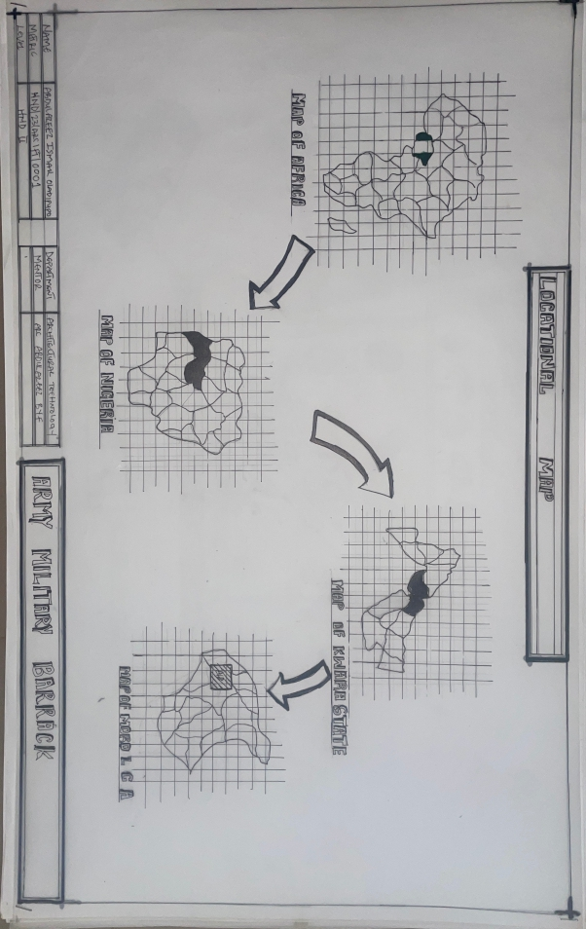

Appendix 1

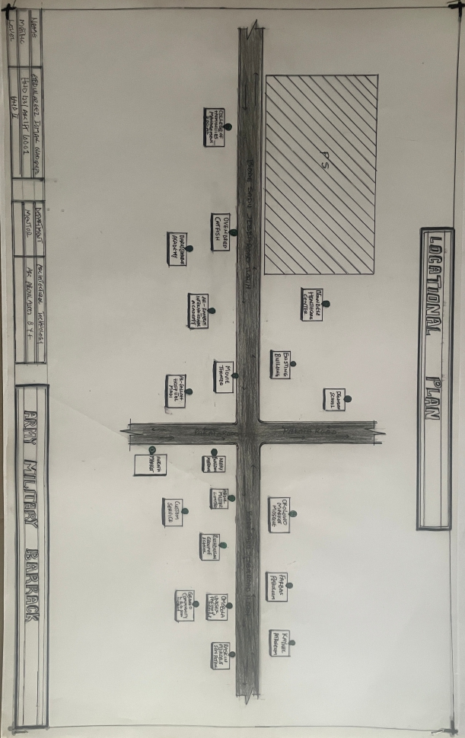

Appendix 2

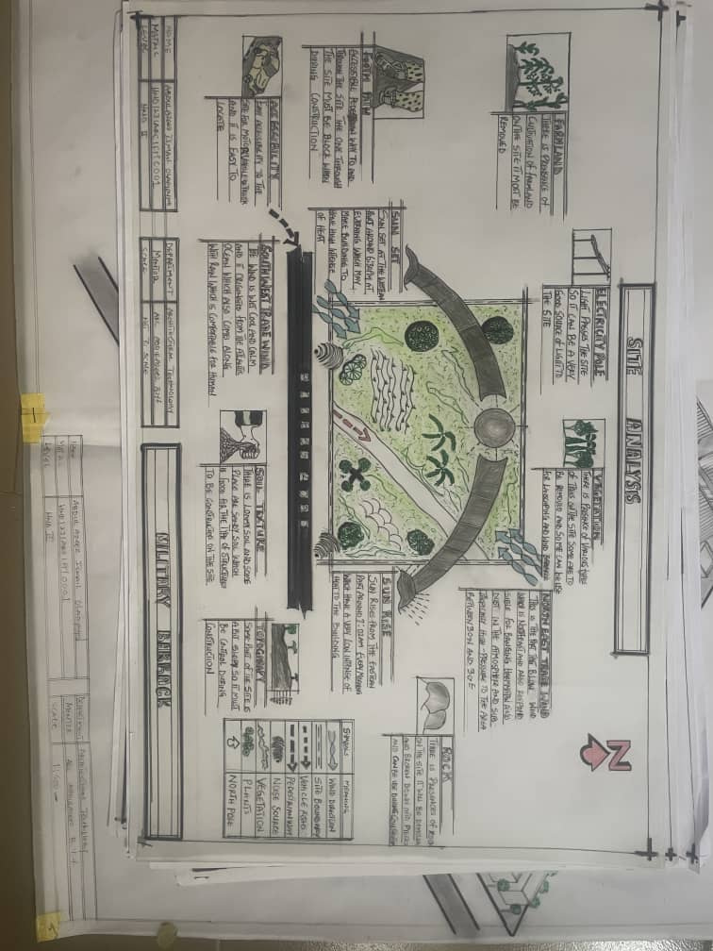

Appendix 3

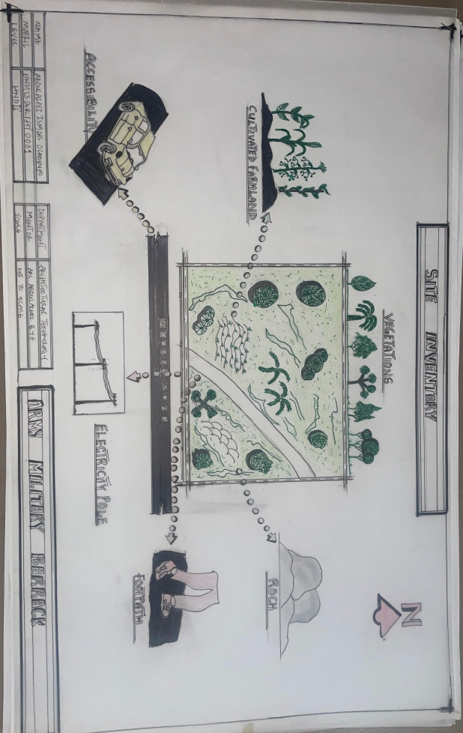

Appendix 4

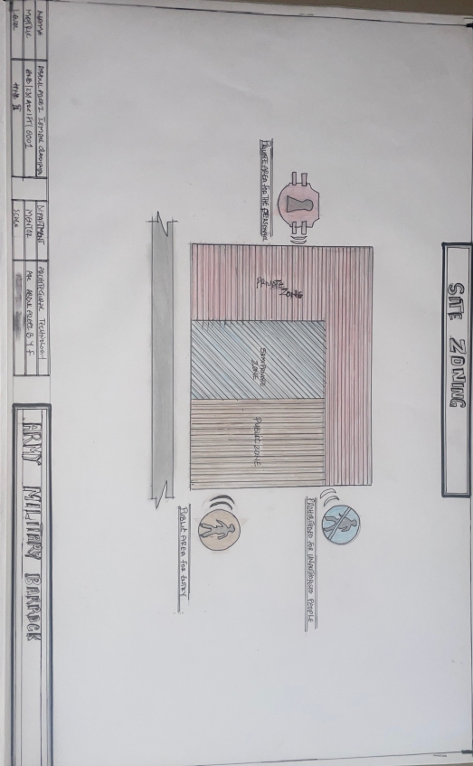

Appendix 5

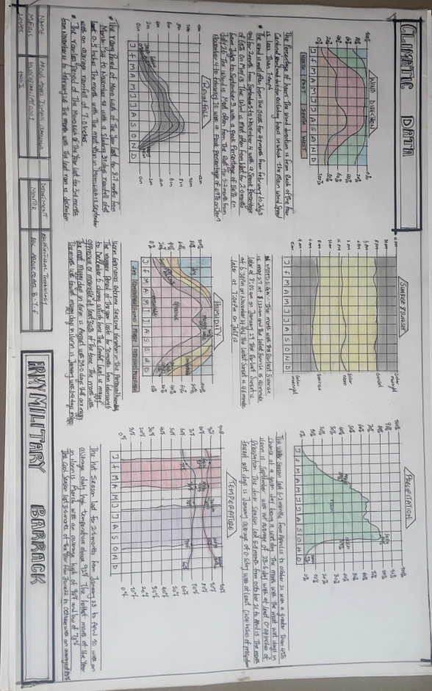

Appendix 6

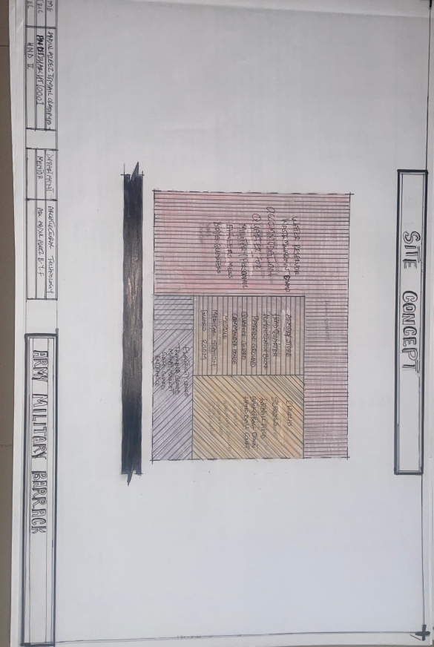

Appendix 7

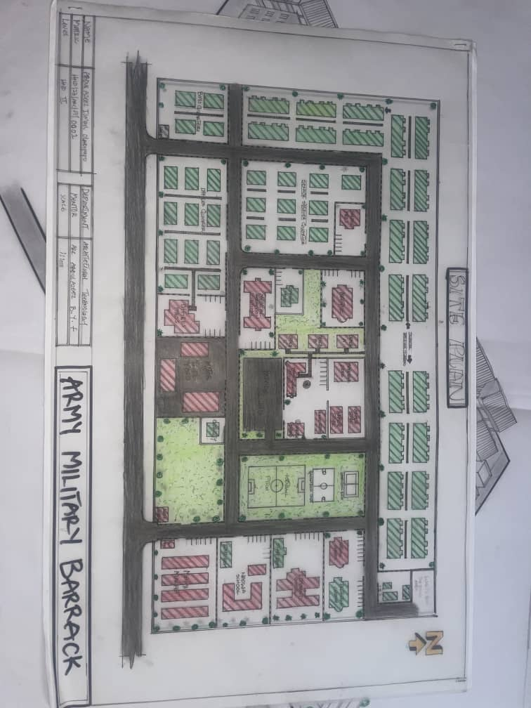

Appendix 8

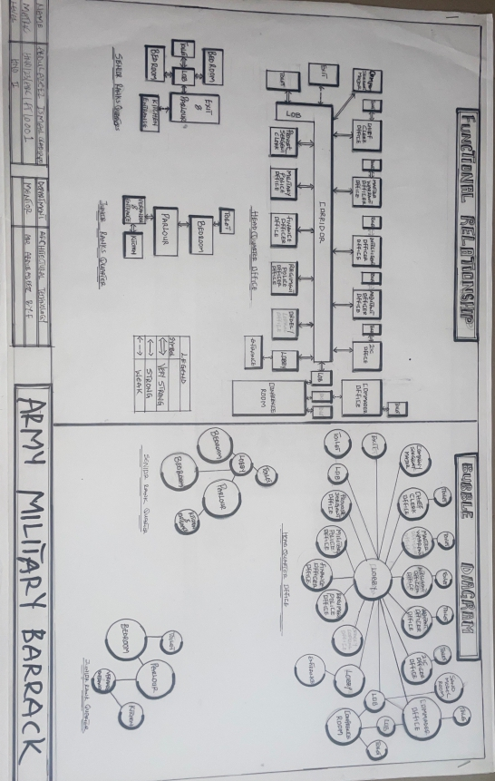

Appendix 9

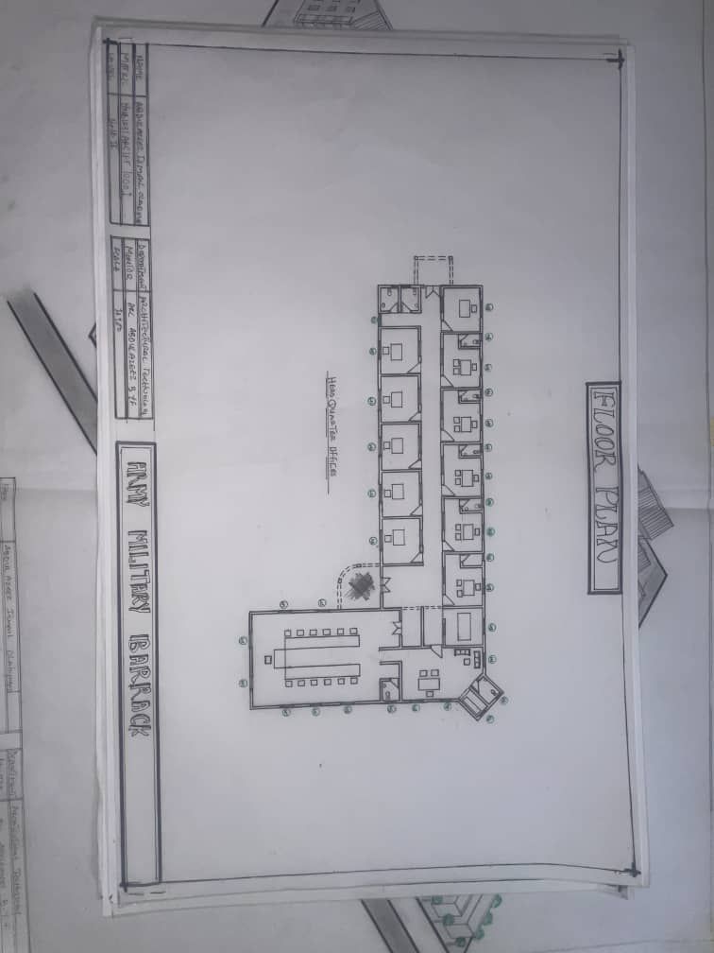

Appendix 10

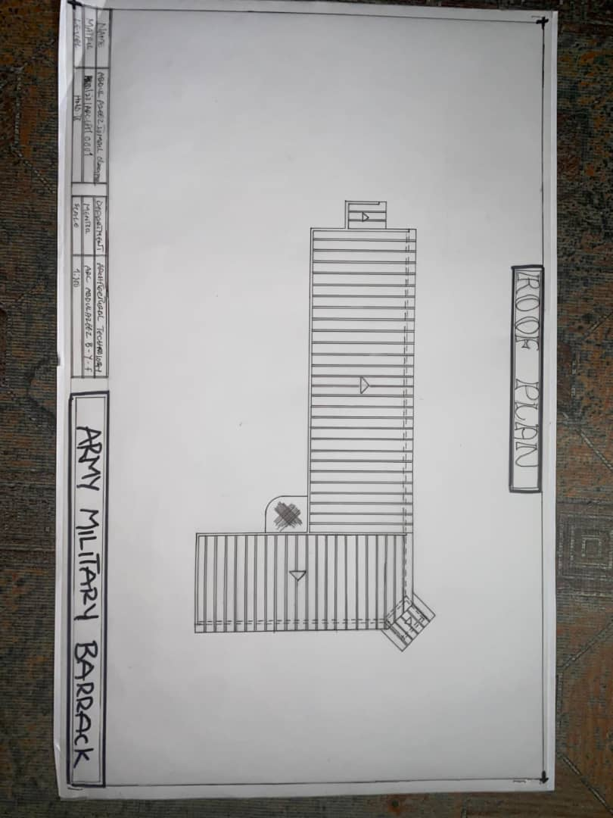

Appendix 11

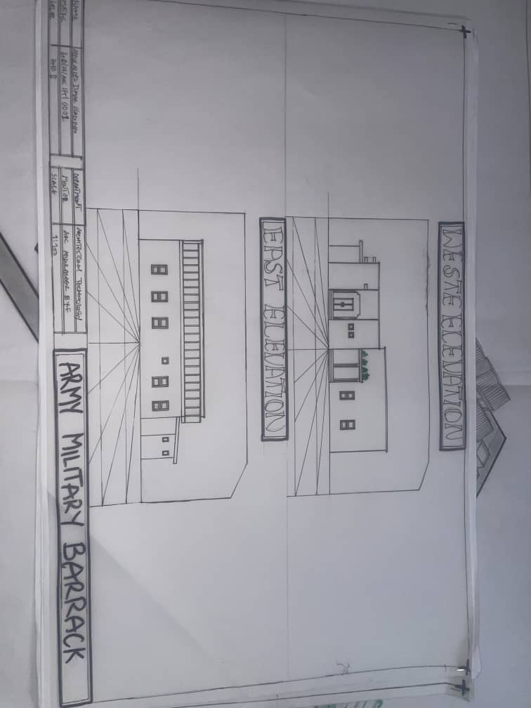

Appendix 12

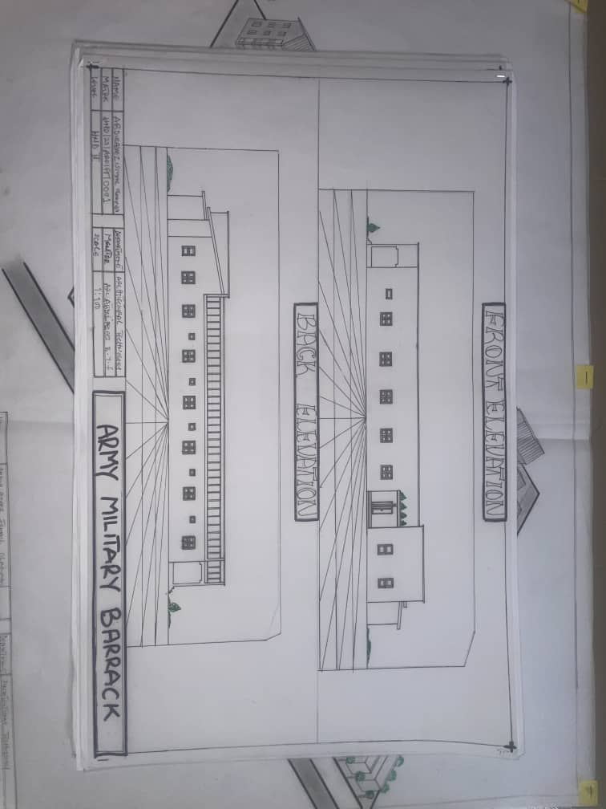

Appendix 13

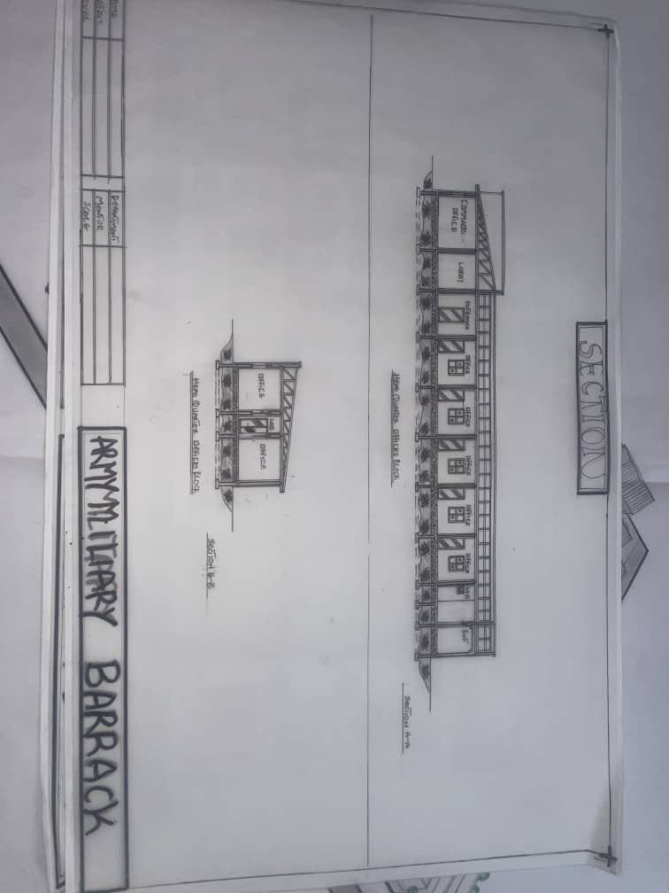

Appendix 14

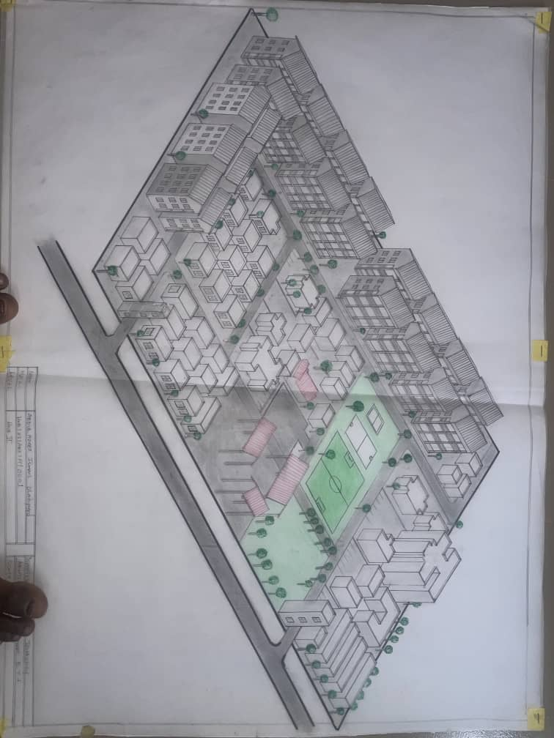
z

Appendix 15

