EVALUATION OF THE EFFECTS OF ROAD BUMPS AS VEHICLE SPEED REDUCTION DEVICES

BY
DADA ADEKUNLE PETER
HND/23/CEC/FT/0018

A PROJECT SUBMITTED TO THE DEPARTMENT OF
CIVIL ENGINEERING INSTITUTE OF TECHNOLOGY,
KWARA STATE POLYTECHNIC, ILORIN.

IN PARTIAL FULFILLMENT OF THE REQUIREMENTS
FOR THE AWARD OF HIGHER NATIONAL DIPLOMA(HND)
IN CIVIL ENGINEERING.

July, 2025

CERTIFICATION
This is to certify that this project was conducted by DADA Adekunle Peter (HND/23/CEC/FT/0018) and had been read and approved as meeting the requirements for the award of High Nation Diploma (HND) in Civil Engineering of the department of Civil Engineering, Institute of Technology, Kwara State Polytechnic, Ilorin.

_______________________________ _______________
ENGR. MISS M. F. RAJI DATE
(PROJECT SUPERVISOR)

_______________________________ _______________
ENGR. N.A NAALLAH DATE
(HEAD OF DEPARTMENT)

_______________________________ _______________
ENGR. DR. MUJEDU KASALI ADEBAYO DATE
(EXTERNAL SUPERVISOR)

DEDICATION
This project is dedicated to Almighty God who by his mercy guided and protected me throughout my course of study

ACKNOWLEDGEMENT
I give gratitude to the Almighty God for the successful completion of this project. Most importantly, I am grateful to my supervisor ENGR. MISS M. F. Raji for her support and encouragement on this work. Appreciation goes to all staff in civil engineering department who has contributed in one way or the other to the completion of this project so far. I give thanks to my lecturers who made course easy for me.
I extend my special thanks to my parents for their morally, spiritually, and financially word of encouragement and prayer given to me, who makes my project successful. I am also grateful to my colleague and friends for their support.

ABSTRACT
This study investigates the effectiveness of road bumps as vehicle speed reduction devices within Ilorin Metropolises. Utilizing a questionnaire-based approach, data were collected from a diverse sample of residents to gather their perceptions and experiences regarding road bumps. The demographic profile of respondents, including gender, age, and occupation, was analyzed to understand varying opinions on the effectiveness of these traffic calming measures. Additionally, vehicle speeds were measured at various distances before and after road bumps to quantify the impact on driving behavior. The findings reveal a significant reduction in vehicle speeds at road bumps, with the average speed decreasing from 45 km/h at 100 meters before the bump to 15 km/h at the bump itself. Despite a gradual increase in speed post-bump, the data confirm the effectiveness of road bumps in reducing vehicle speeds at critical points, thereby enhancing road safety. This study underscores the importance of road bumps in urban traffic management and suggests the potential need for additional measures to maintain reduced speeds over extended road sections.

TABLE OF CONTENT
CONTENT
Title Page i
Certification ii
Dedication iii
Acknowledgement iv
Abstract v
Table of contents vi
List of tables viii
List of figures ix

CHAPTER ONE
Introduction 1
1.1 Statement of the problem 2
1.2 Aim and Objectives of the project 3
1.3 Scope of the project 3
1.4 Justification of the project 3
1.5 Methodology 4

CHAPTER TWO: LITERATURE REVIEW 5-7
2.1 Types and shape of road bumps 7-9
2.2 Traffic parameters 10
2.2.1 Speed 10
2.2.2 Volume 10
2.2.3 Density 11
2.3 Speed control device 11
2.3.1 Road Signs 11
2.3.2 Zebra Crossing 11
2.3.3 Canalization 12
2.3.4 Bumps 13
2.4 Advantages and Disadvantages of Bumps advantages of bumps 13

CHAPTER THREE: DATA COLLECTION
3.1 Features of the different types of roads bumps 14
3.2 Geometric characteristics of road bumps 15
3.2.1 The Depressed type 15
3.2.2 The Hump type 15
3.4 Physical dimensions of the road bumps 16
3.4.1 Spacing of road bumps. 16
3.5. The study area 17
3.6. Bumps observed 19
3.6.1 The hump asphaltic concrete type 19
3.6.2 Bumps in the study area 19
3.7 Safety precaution on road bumps 19

CHAPTER FOUR: DATA ANALYSIS
4.1 Data collection overview 20
4.1.1 Gender distribution 20
4.1.2 Occupational distribution 21
4.2. Perceptions on Effectiveness of Road Bumps 22
4.2.1 General perception 22
4.2.2 Gender-Base perception 23
4.2.3 Occupational-Base perception 24
4.3 Vehicle Speed Analysis Before and After Approaching
Road Bump 25
4.3.1 Data Presentation 26-27
4.4 Field survey data 28

CHAPTER FIVE: CONCULSION AND RECOMMENDEDSTION
5.1 Conclusion 29
5.2 Recommendation 30
Reference 31-32
Appendix A: Questionnaire for the study 33-34
Plate 35

LIST OF TABLES
Table Page
4.1: Gender Distribution of Respondents 23
4.3: Occupational Distribution of Respondents 25
4.4: Perception of Road Bumps' Effectiveness 26
4.5: Gender-Based Perception of Effectiveness 27
4.7: Occupation-Based Perception of Effectiveness 29
4.8: Average vehicle speeds before and after approaching road
bumps at Kwara State Polytechnic (PS) 31
4.9: Average vehicle speeds before and after approaching road
bumps at G.S.S and Agric junction 32
4.13: Bumps in study Area 36

LIST OF FIGURES
Figures Page
2.1: Different shape of Road bump 7
3.1: The Depressed type of road bump 17
3.2: The hump type of road bump 18
4.1: Gender Distribution of Respondents 24
4.3: Occupational Distribution of Respondents 26
4.4: Perception of Road Bumps' Effectiveness 27
4.5: Gender-Based Perception of Effectiveness 28
4.7: Occupation-Based Perception of Effectiveness 30
4.8: Average vehicle speeds before and after approaching road
bumps at Kwara State Polytechnic (PS) 31
4.9: Average vehicle speeds before and after approaching road
bumps at G.S.S and Agric junction. 32

CHAPTER ONE
INTRODUCTION
Road accidents and injuries are becoming major fatality accelerators in developing as well as developed countries. Consequently, traffic calming is a need of today’s roads. There is a need of various solid strategies to make roads for sure safe for users, vehicles and environment. Speed retarding measures are to be made in connection with the safety of vehicles and environment. But if these designs and structures are implemented without the use of approved guidelines, then they could become havoc and pose significant impacts on users, vehicles and environment. Hence, there is a need to identify these problems with quick eradication i.e., if designs are improper then they should be removed and substituted with new ones having proper dimensions, which will help in the reduction of traffic related problems (Abaid et.al, 2016).
In all part of the word vehicle accidents present a very serious threat to human lives and survival. In the developed countries of the world where safety rules and policy are made and enforced, the problem of risks of human lives to the vehicle accidents and dearth is controlled. Unfortunately, the case of developing countries appears different. There is therefore, the need for a closer look at the ways of controlling commuter's injury and fatalities due to vehicle accident on our roads. The need to control excessive speed of motorists has been stressed and treated in the world safety. Literature, numerous control measures are usually imposed on motorists with the aim of preventing accidents on our road as traditional approach is the use of well-trained personnel to monitor road. Trained traffic officers and government agencies on traffic monitoring road usually stay by the roadsides to control vehicles over speeding. Unfortunately, the cost associated with maintaining this level of manpower and the relevant resources utilized by the monitoring crew is usually prohibited. Apart from the fact that human beings are difficult to control and sometimes constitute a nuisance towards the set goal achievement (Ayeni, 2011).
Over speeding, careless behavior of driver, underestimation of legislations are some factors which evoke us to move towards special revised standards and designs for the safety of which everything associated with stakeholders, roads and streets. A number of strategies can be implemented for speed reduction and traffic management like sign boards, speed breakers, driver education, raised intersections, roundabouts and traffic circles (Abaid et.al, 2016).
Other methods of speed control are the installation of speed limit on strategic location on the highways. These notices are usually ignored by many drivers on the others hand many of our drivers are illiterate who cannot read these notices and hence could not obey them. The use of zebra crossing on the high way in densely pedestrian crossing area like school, stadium, hospitals, cinema, house, churches and mosques are also common there are impatient and indiscipline drivers, this for call study/examines the prevalence of the use of road bumps within Ilorin metropolis as speed breakers and as a method of preventing accidents on the road (Ayeni, 2011).

1.1 STATEMENT OF THE PROBLEM
There is a significant interest in finding highly effective means of controlling traffic speeds. Among the popular ones are the use of traffic calming fibre reinforced plastic (FRP), zebra crossing etc.
Most of these can easily be subjected to abuse. Road bumps provide an alternative method of speed which is properly investigated and standardized, can be more effective means of vehicle speed control (Mubarak et. al, 2023).

1.2 AIM AND OBJECTIVES OF THE STUDY
Aim
The aim of this study is to evaluate the effects of road bumps as vehicle speed reduction devices.
Objectives
The main objectives of this study are: -
- To investigate the occurrence of road bumps within the study area.
- To examine the various risk associated with road bumps.
- To examine the materials for construction and the various shapes and types of road bumps.

1.3 SCOPE OF THE PROJECT
This project is limited to the investigation on the use of road bumps as a means of reducing vehicle speed in urban area. The study is undertaken on the predominance of road bumps using Ilorin metropolis as a case study. Questioners on the prospective of road user on the desirability and effectiveness of road bumps were designed and administered to a cross section of the road users.

1.4 JUSTIFICATION OF THE PROJECT
The significance of this project state the traffic condition of the area, in others to make provision to reduce the issue regarding traffic accident. Also eradicate all forms of negative impact on the road.

1.5 METHODOLOGY
This research study used an experimental analysis, focusing on time-series measurements, to evaluate the effectiveness of speed humps. Data were provided from different location base on traffic accident database and speed and volume studies for selected roadways. Data collection including the type of data, questionnaire administered analysis of data, The study is undertaken on the predominance of road bumps using Ilorin metropolis as a case study. Questionnaires on the prospective users on the desirability and effectiveness of road bumps were designate and administrated to a cross section of road users.

CHAPTER TWO
2.0 LITERATURE REVIEW
The literature review on road bumps encompasses a wide array of enquires on the development of speed bumps systems that can respond unconstrainedly to traffic conditions. Another view is the construction of full or partial scale prototype remote - controlled speed bumps for traffic control with specific minimum criteria that must be met before installation (Mubarak et. al, 2023).

Mubarak et.al, (2024). Evaluate the effect of roads bump as vehicles speed reduction devices, this study investigates the effectiveness of road bumps as vehicle speed reduction devices within Ilorin Metropolises. Utilizing a questionnaire-based approach, data were collected from a diverse sample of residents to gather their perceptions and experiences regarding road bumps. The demographic profile of respondents, including gender, age, and occupation, was analyzed to understand varying opinions on the effectiveness of these traffic calming measures. Additionally, vehicle speeds were measured at various distances before and after road bumps to quantify the impact on driving behavior. The findings reveal a significant reduction in vehicle speeds at road bumps, with the average speed decreasing from 45 km/h at 100 meters before the bump to 15 km/h at the bump itself. Despite a gradual increase in speed post-bump, the data confirm the effectiveness of road bumps in reducing vehicle speeds at critical points, thereby enhancing road safety. This study underscores the importance of road bumps in urban traffic management and suggests the potential need for additional measures to maintain reduced speeds over extended road sections.

Hallmark et.al, (2002). Evaluation the impact of temporary speed hump and speed tables on vehicle speeds profiles. And traffic volumes along local collector streets in the USA. Speed volumes and resident opinion data were then collected and evaluated. In general, the devices were shown to be effective with the temporary speed table performing as well or better that the speed hump. Both the speed hump and the speed table were effective in reducing mean speed as the device and immediately down Stream were less likely to affect the speed hump and speed table also reduced the number of vehicles exceeding the speed limit in the immediate unit of the devices. However, the analysis of the volume data collection did not indicate any reduction in traffic. The result of the resident surveyed in this study were consistent with those reported in other jurisdictions, overall, more respondents were supportive of the use of the temporary spend humps/ table than opposed. However, the responses from the resident surrey related to the preference of temporary device were not conclusive. the temporary speed humps monitoring and evaluation, as well as reliability concerns.

Beckman et.al, (2000). Investigated how the effects of road jumps vary with speed. Research questions. That define their study include (1) Could bumps be the limiting factor in concern speed? (2) In an area. dynamic car, could bumps cause sudden and catastrophic loss of down force and adhesion? To analyze this question the researchers explored the variation of bumps violence with speed.

Fishman (2001). Introduced the concept of traffic clamming employed to improve the condition on a road way for pedestrians', bicyclists, and neighborhood. Traffic calming techniques alter the appearance or Geometry of a roadway to reduce traffic volume or speed. The techniques are self-enforcing making drivers seek alternate routes. Other by creating a sense of shared space between the driver and resident, make drivers want to slow down on local roads.

The conclusion from the literature is highlighted in the following points. There is significant interest in tending highly effective means of controlling traffic speeds in order to improve the conditions of roadway for pedestrians, a major accident controlling factor on our road. A number of other, control measures emerged from research investigations and practice, these are the use of traffic calming fiber reinforced plastic (FRP) Show cases, and e.t.c there is a body of research emerging on the control of road bumps installation. critics have detected road bumps in the following point (i) speed bumps slow down emergency vehicles (i) speed bump increase air pollution and fuel usage (11) Speed bumps harm the disabled and those with physical ailments (iv)speed bumps increase vehicle wear and tear, and (v)Speed bumps increase noise.

2.1 TYPES AND SHAPES OF ROAD BUMPS
According to Mubarak et.al, (2024), road bumps are varied in geometry (figure a-f), and are usually a few meters apart in some communities they have a minimum distance of about 10 meters and a maximum distance of about 100 meters where other ranges come in between.
(a)conical shape

(b) Hollow rectangular

(C) Heaped rectangular

(d) combined conical and Hollow rectangular

(e) Combined conical and heaped rectangular

(f)Combined hollow and rectangular
Fig 2.l: Different Shapes of Road bumps

Various Geometries of Road Bumps. The geometries of road bump are classified according to the shapes road bumps in two consecutive positions to the best of the author's Knowledge the following possible classifications are available
- Conical shape,
- Hollow rectangular
- Heaped rectangular
- Combined conical and heaped rectangular
- Combined conical and hollow rectangular and
- Combined hollow and heaped rectangular

In construction of road bumps, the structure must be such that low friction between the wheels of the vehicle and the road is permitted. The bumps must be visible from a distance (even at night) to avoid accidents due to oversight. Where visibility may be poor, road sign could be erected to inform drivers about the bumps ahead in order to take precautionary measures. Computer generated image can be made to see the effects of various parametric changes on vehicle performance. Parametric such as curvature and base length can be varied to obtain optimal system functions. The distance between bumps is such that when a vehicle passes over it, the vehicle accelerates from zero to a maxim um velocity before experiencing retardation, which enables the vehicles to safety pass over the bumps. It is assumed that the vehicle has sufficient shock absorbing device to minimize the shock. The altitude should not be more than 1 inch. Some road bumps are constructed with a flat surface having a lengthen base while other have short bases. Flat surface road bumps have an advantage in not being easily affected by wear at the top surface unlike the curved surface bumps, which are prone to erosion especially at the top (Mubarak et.al, 2024).
Also known as road humps, undulations, or "sleeping policemen" The speed humps is an elongated hump with a Circular-arc cross section (round-top) or flat-top, rising to a height of 76mm (3 inch) above the normal pavement surface and having a length of 3.7m to 6.7m (12tt t 022tt) in the direction of the vehicular travel speed humps usually extend the full width of the road, excluding the gutter to allow for drainage (Mubarak et.al, 2024).

2.2 TRAFFIC PARAMETERS
2.2.1 SPEED
Speed is one of the most prevalent contributing to traffic crashes. Speed is the rate of progress through a designated segment of a highway facility. for a simple vertical traveling affect only by prevailing geometrics
Types Of Speed
- Running speed: average speed along a section of road or route excluding delay and stoppages at major intersections.
- Spot speed: instantaneous speed of a vehicle measured at a particular point.
- Journey speed: Average speed along a route including all delays stoppages and time spent on acceleration and declaration.
Uses of speed
- For research studies.
- For operation of traffic control device
- For operation of sign and marketing e.g the extent of double white lines, where visibility is restricted, size of lettering on sign.
- For monitoring of flow characteristic in traffic surveillance and control schemes.
- when change in speed limit are under consideration or when checking the effect of such changes.

2.2.2 VOLUME
Volume is the number of vehicles which pass a point on a high way or a given lane or direction of a highway during a specified time interval (usually one hour). It is expressed in unit of vehicle per hour or vehicle per hour lane (vph). Zero volume mean there is no one on the roads way or congestion is so great
that all movement stop and no vehicle passes a point.
2.2.3 DENSITY
Density is the number of vehicles occupying a given length of roadway or lane of a roadway. (Vehicles per km, per lane). It is the most difficult of the primary traffic parameter to observe directly as it requires elevated observation over some designated period of time. This often requires the aircraft and aerial density photograph.
Despite, the relative difficult in measuring density, it is the parameter which most directed reflect traffic demand which occur as vehicle arises on the highway for service in term of thorough movement.

2.3 SPEED CONTROL DEVICES
2.3.1 ROAD SIGNS
Passive speed measure attempt to change the fundamental sensory information available to drivers to influence their speed behaviors, by adding markings to the road driver's perception can be distorted creating the illusion that they are driving faster than they really are persuading drivers to slow down.

2.3.2 ZEBRA CROSSING
These are input factor in the sitting of road bumps in locations. These factors differ from one location to another Consideration are also given to the state of the road, either good or bad, presence of some organizations, government agencies such as police station, are stations, army barracks e.tc.

2.3.3 CHANNELIZATION
- GENERAL CHANNELIZATION: - is the regulation of conflicting traffic movement into definite paths by the use of island of other delineation to maintain orderly movement of both Vehicles and pedestrians, improve safety and convenience and capacity. The basic means of control is intrinsic to the geometric design of major intersection. Be sure that the channelization used will accomplish the desired objectives under peak loads and adverse conditions of operation. Make storage lanes long enough to keep through lanes clear and to handle left turning movement. Block prohibited turn. Avoid channelization that requires unnatural or unexpected manures. Consistency of design is a definite safety factor. The specific of additional control devices described in subparagraph required of an intersection should be taken into account early in the development of geometric design to permit placement that will produce the desired traffic response.
- ISLANDS: Where the inner edges of payment for right turns at intersection s are designed to accommodate OB-40 and WB-50 units, where the design permits passengers’ vehicles to turn at speed of 15mph or more, the payment area at the intersection may become excessively large tor proper control of traffic. To avoid this. A corner island should be provider to form a Separate turning road way. Channelization islands should define the traffic channels to drivers and pedestrians alike in the clearest manner possible.
- Basic channelization design: -for highway with high approach speeds channelization should normally be accomplish entirely with painted pavement markings supplemented with plastic lane markers on traffic buttons. under urban conditions curbed channelization may be necessary for traffic control under normal conditions, the length of the storage lane from turning movements is required to be as follow.

2.3.4 BUMPS
Also known as road bumps, undulations or "sleeping policeman", the purpose of speeds bumps is to promote the Smooth flow of traffic at slow speeds of about 32 to 40km/h. (20 to 25 mi/n). The speed bumps are an elongated bump with a flat-top, rising to a Circular are cross-section (round- top) or height of 76mm (3min) above the normal pavement surface and having a length of 3. 7m to 6.7m (12++ to 22ft) in the direction of vehicles travel Speed bumps usually extend the full width of the road, excluding the gutter to allow for drainage.

2.4 ADVANTAGES AND DISADVANTAGES OF BUMPS
ADVANTAGES OF BUMPS
(1) It is self-enforcing.
(2) It is relatively inexpensive.
(3) It reduces speed in the vicinity of the bump.

DISADVANTAGES OF BUMPS
(1) It requires signage that may be considered unsightly.
(2) May create additional noise.
(3) May be a problem for emergency vehicles.
(4) Cannot be used on grades greater than 8%.
(5) Drivers may speed up between bumps.
(6) May increase volume on other streets.
(7) Difficult to properly construct.
(8) Should not be placed within severe horizontal or vertical forces on a vehicle traversing the bump.

CHAPTER THREE
3.0 DATA COLLECTION
The data are made up of safe investigation and observation in some areas in Ilorin metropolis remarks are made on the type of road control devices available and efficiency of such control devices, measurement like the length of the bumps, the height and width.

3.1 FEATURES OF THE DIFFERENT OF ROAD BUMPS
(a) Asphaltic Bumps
- High cost of construction.
- It has long term used.
- It has high resistance to force than any other type of hard bumps.
- It can be used in asphaltic pavement roads.
- Not easy to remove.
(b) Concrete Bumps
- it also has high resistances to force but not as asphaltic bumps.
- Cost of construction is also high.
- The construction network is made up of land, gravel, cement and water.
- It has long term used.
- It can be used in earth roads.
(c) Laterite Bumps
- It is the cheapest roads bumps.
- Easy to constructed.
- It is used where there is need to control dust.
- It has shoot form of used and easy to remove.
- We make used of laterites for construction.

(d) Wood bumps
- It is cheap to constructed.
- It is good for short time used and low cost.
- It can be constructed in local road e.g. pedestrian road
- Easy to remove.

3.2. GEOMETERIC CHARACTERISTICS OF ROAD BUMPS
Construction material for roads bumps. Basic types of road bumps.

3.2.1 The depressed type
For the depressed type, rectangular U- shaped channels were depressed across the road, this is usually done on compacted base or on earth road and interlocking, pavements in the study area did not have these types of control these types of road bumps as shown in fig.4.1.

Fig. 3.1: the depressed type of road bump

3.3.2 The Hump Type
For the humps type, plain Portland cement concrete and asphaltic concrete are commonly used. Asphaltic concrete is more common than Portland cement concrete. A survey of the condition of the road bumps that Asphaltic concrete road bumps are more durable, more stable and provide smooth surface for road traffic. Portland cement concrete usually presents a rough surface part of it usually wears away resulting in the removal of part of the road bumps on some sections of the road. It wears off within as short time and cannot be easily moulded into a conical shaped like Asphaltic concrete is recommended wherever a road bump is needed. This type of road bump was seen on kwara polytechnic permanent site among other places. This type is shown in fig.4.

Fig. 3.2 the hump type of road bump

3.4. THE PHYSICAL DIMENSIONS OF THE ROADS BUMP
3.4.1 SPACING OF ROAD BUMPS.
The spacing between road bumps usually affect the rate at which vehicle gear is engaged and disengaged. If the distance in between road bumps is too short riding comfort will be seriously affected as the gear will be engaged and disengaged too frequently. This is not good for the operation of the vehicle in the study area the distance between 17.00m and 20.0m.
The distance between two road bumps should be such that will not require more than single change of gear in between and the bumps should be a maximum of four in sequence. A distance to 100m is recommended wherever a road bump is desired.

3.5 THE STUDY AREA
The project location is Ilorin, the kwara state capital. The city is fast growing economic and commercial center with a land area of about 184km².
Like other growing state capitals, the road bumps are placed to avoid accidents due to over speeding of vehicles in residential and commercial areas, it is also placed to promote uniform smooth flow of traffic at slow speeds of about 32km/h to 40km/h.
More driver concentration is typically required when driving in the narrow lanes as the driver focuses harder to stay in the lane, therefore driving speed usually decreases as lane width decreases. Although numerous studies have been conducted to evaluate the effect of lane width on speed, the relationship seems to be unclean. Before describing related research, it is worth noting the difference between actually narrower lanes without reducing the pavement width, there is relatively little research on speed control using perceptual change in lane width, therefore this review includes some studies that evaluate the effect on speed reduction by altering lane width even dough, it is not strictly considered by a passive speed control measure but move a traffic calming measure.
A few studies evaluated the effects of changing lane width before and after studies were conducted at the locations. Concluding that the reduction in width had minimal, if any effect on deterring speeding motorists.
Researchers have also examined the link between lane width and safety. Creating the perception of narrower lanes, or actually reducing pavement width, can be a measure to decrease speed. However, when pavement width is actually narrowed the possibility of increasing crash risk exit.
Even though extensive research has been conducted to relate lane width to safety there is not strong evidence about this relationship as isolating the safety effect of lane width is usually unfeasible.
The first safety study of road bumps is that of kwara state polytechnic, the road type was dual carriage way and bumps is Asphaltic concrete type where the bumps length, height, width and the distance apart were measured in meters
The second safety study of road bumps is that of Agric Road Ilorin, along Kunlende market Sango. The road type was dual carriage way and type of bumps there is asphalt where the bumps length, width and distance apart were measured in meters.
The third safety study of road bumps is Government secondary school along Maraba road Ilorin and the road bump is asphalt type and the road was dual carriage way where length, height, width and distance apart are measure in meters.

However, further analysis revealed that hazardous sites those with the highest crash rate. Pomp to prevent marketing enhance, shown design pavement marking enhancement show design facing safety improvement following the implementation with an average crash reduction of 14.0 percent. In summary narrower lanes typically lead to lower speeds lowered. There axis a meter effect since adding marking to marrow the lane may pound O, extra visual guidance that can increase speeds. In addition, widths safety may be compromised, this most not happen, however, when only creating the illusion of narrower lane using pavement making rather than act usually reducing lane with consequently using road bumps as a control device can be an effective way to reduce speeds without compromising safety.
The research made on the effect of speed humps the road humps located in kwara state polytechnic which the road type is dual carriage way with road legislation of about (6.8m) and width of (1.10m), distance apart below to be (100m) as shown in plate below another research which was made is that of the Agric junction which was made by using asphalt concrete

Those bumps were elevated above the road surface except that of depressed type and they are more visible to motorists. Road bumps cause motorists to slow at the most critical location, where pedestrian cross, they are generally design to minimize the loss of control by drivers as a result of excessive reckless speeds, to reduced number of vehicles. Exceeding the speed limit in the immediate vicinity of the devices, bumps are also designed for residential road analysis that have two lanes loss at a posted speed limit of 30mph or less and 84th percentile speed of 31-34mph.
Drainage is accommodated by pipes along the gutter or other design features.

3.6 BUMPS OBSERVED
3.6.1 The Hump Asphaltic Concrete Types
This is up of mixture of bitumen, coarse aggregate, fine aggregate and mineral filler in the predetermined proportion. They are common type of road in the study area. They could be seen in the following areas.
- Kwara state polytechnic permanent site campus.
Other areas:
- Government secondary school along Maraba road Ilorin.
- Agric junction along Sango Road.

3.6.2 BUMPS IN THE STUDY AREA
Data were collected on the physical properties of the bumps located in the study area which show the physical properties and locations of solve bumps in study areas.

3.7 SAFETY PRECAUTION ON THE ROAD BUMPS
In most of the study area, there were warning sign as to indicate that road bumps ahead.
However, warning sign could be seen in kwara state polytechnic, G.S.S, Agric junction warning motorists of road bumps ahead.

CHAPTER FOUR
4.0 DATA PRESENTATION AND ANALYSIS
This chapter presents the findings from the analysis of the effectiveness of road bumps as a vehicle speed reduction device in Ilorin, Kwara State. The analysis is based on data collected through questionnaires distributed to drivers and residents in areas where road bumps have been installed. The focus is on examining whether the road bumps have led to a significant reduction in vehicle speeds and understanding the perceptions and experiences of the respondents regarding these measures and will subsequently explore the specific outcomes related to the impact of road bumps on traffic reduction and the perspectives of road users.

4.1 DATA COLLECTION OVERVIEW
Data were collected from 100 respondents across various neighborhoods in Ilorin. The questionnaire included sections on demographic information, vehicle types, average speeds before and after road bump installation, and respondents' perceptions of the effectiveness and impact of the road bumps.

4.1.1 Gender Distribution
Table 4.1 and Figure 4.1 present the gender distribution of the respondents.
Table 4.1: Gender Distribution of Respondents
Gender | Frequency | Percentage
Male | 60 | 60%
Female | 40 | 40%
Total | 100 | 100%

Figure 4.1: Gender Distribution of Respondents.

4.1.2 Occupational Distribution
Table 4.2 and Figure 4.2 provide the occupational distribution of the respondents.
Table 4.2: Occupational Distribution of Respondents
Occupation | Frequency | Percentage
Student | 25 | 25%
Employed | 40 | 40%
Self-Employed | 20 | 20%
Unemployed | 10 | 10%
Retired | 5 | 5%
Total | 100 | 100%

Figure 4.2: Occupational Distribution of Respondents

4.2 PERCEPTIONS ON EFFECTIVENESS OF ROAD BUMPS
This section explores the respondents' views on the effectiveness of road bumps in reducing vehicle speeds within the Ilorin metropolis. The data is analyzed to understand the general sentiment and the effectiveness of road bumps as perceived by different demographic groups.

4.2.1 General Perception
Table 4.3 and Figure 4.3 summarize the overall perception of road bumps' effectiveness.
Table 4.3: Perception of Road Bumps' Effectiveness
Respondent | Frequency | Percentage
Very Effective | 30 | 30%
Effective | 45 | 45%
Neutral | 15 | 15%
Ineffective | 7.5 | 7.5%
Very Ineffective | 2.5 | 2.5%
Total | 100 | 100%

Figure 4.3: Perception of Road Bumps' Effectiveness.

4.2.2 Gender-Based Perception
Table 4.4 and Figure 4.4 present the perception of road bumps' effectiveness based on gender.
Table 4.4: Gender-Based Perception of Effectiveness
Respondent | Male | Female | Total
Very Effective | 15 | 15 | 30
Effective | 30 | 20 | 50
Neutral | 10 | 5 | 15
Ineffective | 5 | 0 | 5
Very Ineffective | 0 | 0 | 0
Total | 60 | 40 | 100

Figure 4.4: Gender-Based Perception of Effectiveness.

4.2.3 Occupation-Based Perception
Table 4.5 and Figure 4.5 illustrate the perception of road bumps' effectiveness based on occupation.
Table 4.5: Occupation-Based Perception of Effectiveness
Occupation | Very effective | Effective | Neutral | Ineffective | Very ineffective | Total
Student | 10 | 20 | 0 | 0 | 0 | 50
Employed | 10 | 30 | 0 | 0 | 0 | 70
Self-Employed | 5 | 20 | 5 | 0 | 0 | 40
Unemployed | 5 | 15 | 5 | 5 | 0 | 30
Retired | 5 | 5 | 5 | 0 | 0 | 10
Total | 30 | 50 | 15 | 5 | 0 | 100

Figure 4.5: Occupation-Based Perception of Effectiveness.

4.3 VEHICLE SPEED ANALYSIS BEFORE AND AFTER APPROACHING ROAD BUMP
Speed measurements were taken at the following points relative to the road bumps:
100 meters before the bump
50 meters before the bump
At the bump
50 meters after the bump
100 meters after the bump
The speed measurements were recorded using a speed meter at multiple locations within Ilorin Metropolises. The data were collected during peak and off-peak traffic hours to account for variations in traffic conditions.
4.3.1 Data Presentation
Table 4.6: Average vehicle speeds before and after approaching road bumps at Kwara State Polytechnic (PS)
Distance from Bump | Average Speed (km/h)
100 meters before | 35
50 meters before | 25
At the bump | 0
50 meters after | 18
100 meters after | 28

Figure 4.6: Average vehicle speeds before and after approaching road bumps
at Kwara State Polytechnic (PS)

Kwara State Polytechnic (PS) and University Ilorin (PS) the data shows a significant reduction in vehicle speed as vehicles approach the road bump, with speeds dropping from 35 km/h at 100 meters before the bump to 0 km/h at the bump. This indicates the effectiveness of road bumps in school areas where pedestrian safety is crucial.
Table 4.7: Average vehicle speeds before and after approaching road bumps at G.S.S and Agric junction
Distance from Bump | Average Speed (km/h)
100 meters before | 50
50 meters before | 40
At the bump | 0
50 meters after | 25
100 meters after | 35

Figure 4.7: Average vehicle speeds before and after approaching
road bumps at G.S.S and Agric junction
In areas such as G.S.S and Agric junction, vehicle speeds decrease from 50 km/h at 100 meters before the bump to 0 km/h at the bump. This reduction is important for maintaining safety in areas with limited access and lower traffic volumes.

4.4 FIELD SURVEY DATA
Table 4.8 illustrate the data collected on the field.
Table 4.8 Bumps in the area
S/N | LOCATION | ROAD TYPE | BUMP LEGISLATION  (m) | BUMPS HEIGHT (m) | BUMPS WIDTH (m) | DISTANCE APART  (m) | HUMP TYPE
1. | Kwara State Polytechnic (PS) | Dual carriage lane | 6.8 | 0.09 | 1.10 | 100 | Asphalt
2. | Agric junction Ilorin | Dual carriage way | 11.0 | 0.09 | 1.10 | 22.3 | Asphalt
3. | G.S.S along Maraba road | Dual carriage way | 11.0 | 0.10 | 1.10 | 19.6 | Asphalt

The Kwara State Polytechnic campus demonstrates a significant reduction in vehicle speed as cars approach the bump, indicating a high level of effectiveness. The steep drop in speed to 10 km/h at the bump suggests that the bump is well-placed and effectively forces vehicles to slow down, enhancing safety for students and staff within the campus. The gradual increase in speed after the bump indicates a controlled resumption of normal driving speeds.
Agric junction Ilorin and G.S.S along Maraba road, the speed reduction pattern is similar to that of the Polytechnic campus, though the initial speeds are slightly higher. The effectiveness of the bump is evident from the significant reduction to 15 km/h at the bump. Tank is a residential area with frequent pedestrian traffic, so the presence of effective speed bumps is crucial for safety. The recovery to 40 km/h 100 meters after the bump indicates a well-managed traffic flow.

CHAPTER FIVE
CONCLUSION AND RECOMMENDATION
5.1 CONCLUSION
The study aimed to examine the effectiveness of road bumps as a vehicle speed reduction device, focusing on various aspects including associated risks, their occurrence within the study area, the materials and shapes used for construction, and providing suggestions based on the findings.
Road bumps are effective in reducing vehicle speeds and the risk associate with it. These include potential damage to vehicles, discomfort to passengers, and increased wear and tear on road infrastructure. Additionally, improperly designed or poorly marked road bumps can pose significant safety hazards.
The investigation revealed a high occurrence of road bumps in the study area, particularly in residential zones, school vicinities, and areas prone to high pedestrian traffic. This prevalence indicates a community effort to enhance road safety and control speeding.
Various materials, such as asphalt, rubber, and concrete, are used for constructing road bumps. Each material offers different advantages in terms of durability, cost, and maintenance requirements. The study also identified several shapes and types of road bumps, including traditional speed humps, speed tables, and speed cushions. The choice of material and design significantly influences the effectiveness and safety of the road bumps.
Road bumps were found to be effective in reducing vehicle speeds, contributing to improved road safety. Community feedback highlighted concerns regarding noise pollution, increased vehicle emissions due to repeated acceleration and deceleration, and potential delays for emergency response vehicles.

5.2 RECOMMENDATION
Based on the findings of the study, the following recommendations are put forward to optimize the use of road bumps as a vehicle speed reduction device:

- Authorities should develop and enforce standardized guidelines for the design, placement, and maintenance of road bumps. This includes ensuring proper visibility through signage and road markings to warn drivers in advance.
- Authorities should Select materials that balance durability, cost-effectiveness, and safety. Rubber and modular speed bumps, for instance, offer flexibility and ease of installation and maintenance.
- Community should involvement in engage in the decision-making process to address specific local needs and concerns. This can involve public consultations and feedback mechanisms to assess the impact of road bumps and make necessary adjustments.
- Authorities should conduct regular monitoring and evaluation of road bumps to assess their condition and effectiveness. This can help in timely maintenance and replacement, ensuring continuous road safety.
- Authorities should design and implement road bumps that accommodate the smooth passage of emergency vehicles, such as speed cushions that allow wider wheelbases to pass without significant impact.

By adopting these recommendations, the effectiveness of road bumps as a vehicle speed reduction device can be maximized, while minimizing associated risks and addressing community concerns.

REFERENCE
Afuaar, F.K. (2001). “The character of pedestrian”. Accidents in cganging B₁- Annual Journal of Building and Road research Institute (CSIR), Vsl. 7.pl-5.
Afuaar, F.K. Agyemang, W:7 Damsere J. (2001c). “Monitoring of road safety measures at the station Junction N6 in Ghana”. A final report proposed by the accident unit of the building and road research institution, Ghana for messrs, carl-Bro international/Ghana Highway Authority (Ghana).
Afuaar F.K. (2006 1b). “Speed control in developing countries, issue challenge s₁ and opportunities in reducing road traffic in various building and road resources institute, Kumasi, Ghana” (Electronic paper, on volume description), 11p.
Beckman, B. and Kuch, J. (2000). “The physical of Racing Bumps in the road” 6pp, htt:www.miata.net/support/physical, 15-Bumps in the Road-html.
Finch, d.j Kompfner, P. (1994), lookwood C.R, Maycock, G. “Speed limit and accidents” project Report 58, Crowthrone, U.K Transport research centre.
Forduoh, S.N. Gyebi-Ofosu E. (1993), “Injury survillience. Should it be a concern to developing countries”, J. public Health Policy 14:355 -359.
Fishman S.K (2001). “Taming Traffic” Road Business, Summer, vol 16: No2.
Hallmark, S. and Smith, D. (2002). “Temporary speed” Hump impact Evaluation center for transportation research and education, U.S.A.
Johnson, P. (1996), “Speed limitation and monitoring causalities”. A time serials court data regression approach, accident analysis & prevention, vol. 28 vol1, p 73- 87.
Mubarak A.O, Bashiru A.O, Ridwan O. and Faruk B.A (2024). “Effect of road bumps as vehicles speed reduction devices”. A final year report project, Civil engineering department, kwara state polytechnic, Ilorin.
Mock, C.N Fojuoh, S.N. Rivara F.P. (1999), “Epidemiology of Transport related injuries in Ghana”, Accid. Acal. And prov 31:359-370.

APPENDIX A:
QUESTIONNAIRE FOR THE STUDY
KWARA STATE POLYTECHNIC, ILORIN
INSTITUTE OF TECHNOLOGY
DEPARTMENT OF CIVIL ENGINEERING
STUDENT PROJECT
As part of the project for the final years: HIGHER NATIONAL DIPLOMA (HND) course at kwara state polytechnic.

Dear Respondent
I am a student of the above mention institution carryout research on the EFFECT OF ROAD BUMPS AS VEHICLE SPEED REDUCTION DEVICE. Within the major route in Ilorin metropolis.
I will be glad, if you respond to the research question as honest as possible, your response will be immense benefit to the success of this research and all response will be confidential.
I will be much grateful sir/ma for your assistance in answering the questions below:
- Address:
- Function Zone (a) Residential (b) Commercial (c) Industrial
- Occupation (a) Civil Service (b) Trading (c) Student
- There are road bumps in my location (a) Yes (b) No
- Road bumps are necessary in your area. (a) Yes (b) No
- Road bumps are necessary to control vehicle speed. (a) Yes (b) No
- Road bumps reduce vehicle accident. (a) True (b) False
- Construction of road bumps cause inconvenience to people and motorists. (a) True (b) False
- Sufficient warning is given to driver on road bumps ahead. (a) True (b) False
- Road bumps in my area cause traffic delay. (a) True (b) False
- Road bumps in my area promote and support smooth flow of traffic. (a) Yes (b) No
- Road bumps is good for control traffic flow. (a) Yes (b) No
- Road bumps are place to ensure that vehicle use the street at an appropriate speed. (a) True (b) False
- Road bumps may be a problem for delay emergency vehicle. (a) True (b) False
- Road bumps consume fuel and time. (a) Yes (b) No
- There is an indication for awareness of road bumps ahead. (a) True (b) False
- Road bumps may cause or create additional noses to motorists. (a) Yes (b) No
- Do you enjoy or feel comfortable when you are passing through a road bump. (a) Yes (b) No
- Any other comments on road bumps in your vicinity.

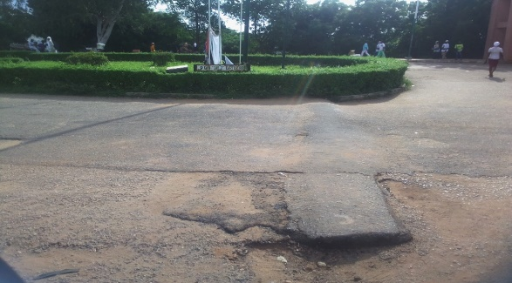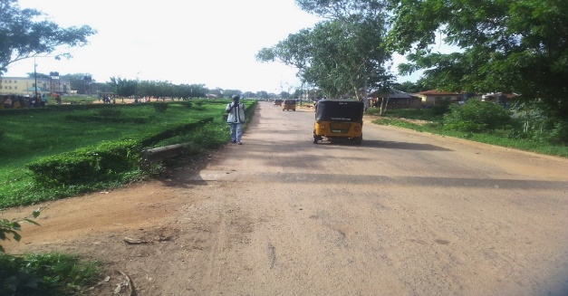
Plate 1: Kwara State Polytechnic Campus, Ilorin Plate 2: Bumps along kwara state polytechnic security office.

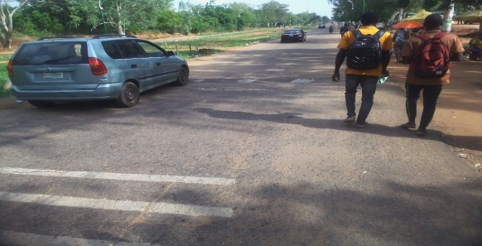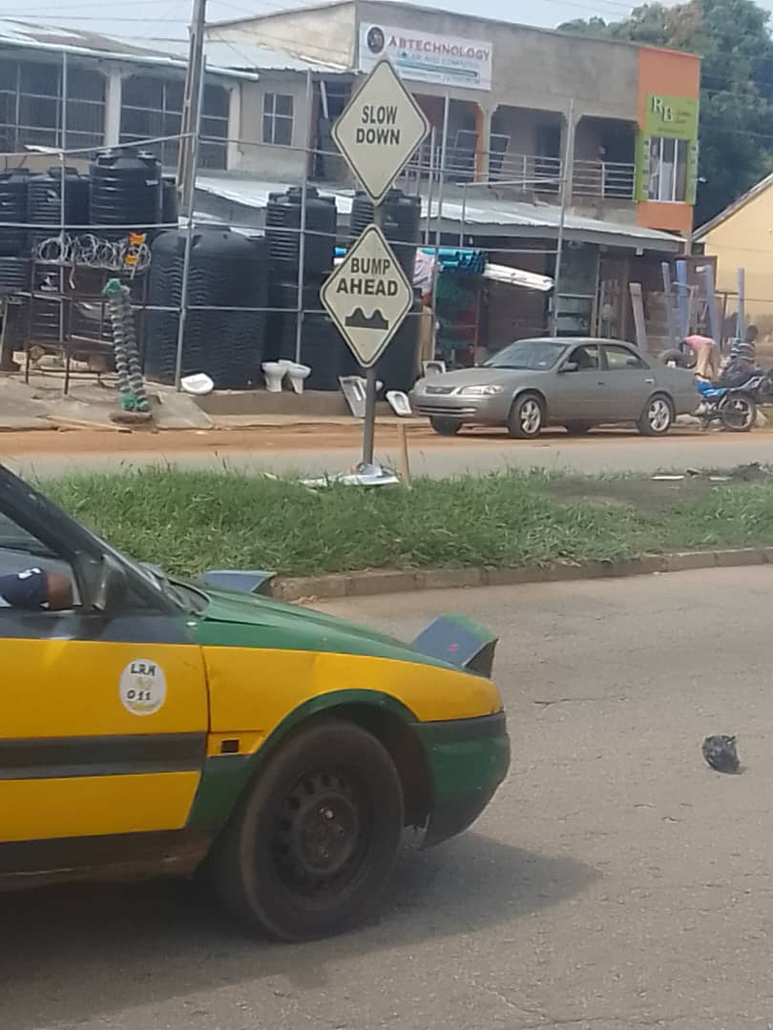
Plate 3: Bumps at kwara state polytechnic motor park. Plate 4: A warning sign at Agric junction of road bumps ahead.

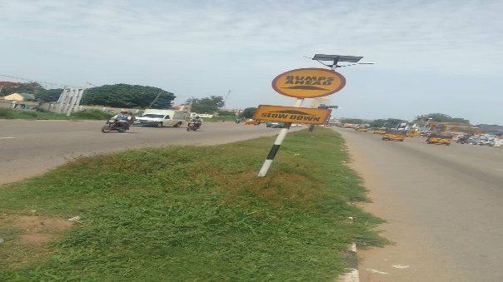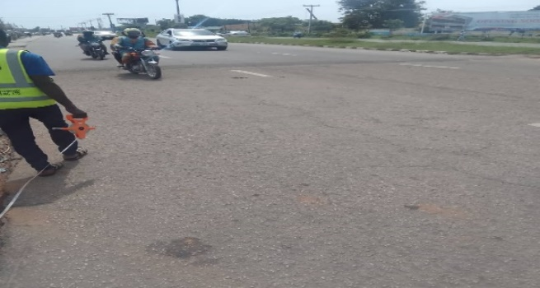
Plate 5: warning sign at G.S.S bumps ahead. Plate 6: Motor and bike approaching the first bump.

