REMOVAL OF LEAD FROM AQUEOUS SOLUTION USING
BANANA (MUSA PARADISIACA) STALK-BASED ACTIVATED CARBON

PRESENTED BY:

SOLIU TAOFEEQ
HND/23/SLT/FT/0399

A PROJECT SUBMITTED TO
THE DEPARTMENT OF SCIENCE LABORATORY TECHNOLOGY (SLT), INSTITUTE OF APPLIED SCIENCE (IAS), KWARA STATE POLYTECHNIC ILORIN

IN PARTIAL FULFILMENT OF THE REQUIREMENTS FOR THE AWARD OF HIGHER NATIONAL DIPLOMA (HND) IN SCIENCE LABORATORY TECHNOLOGY (SLT) CHEMISTRY UNIT

JULY, 2025

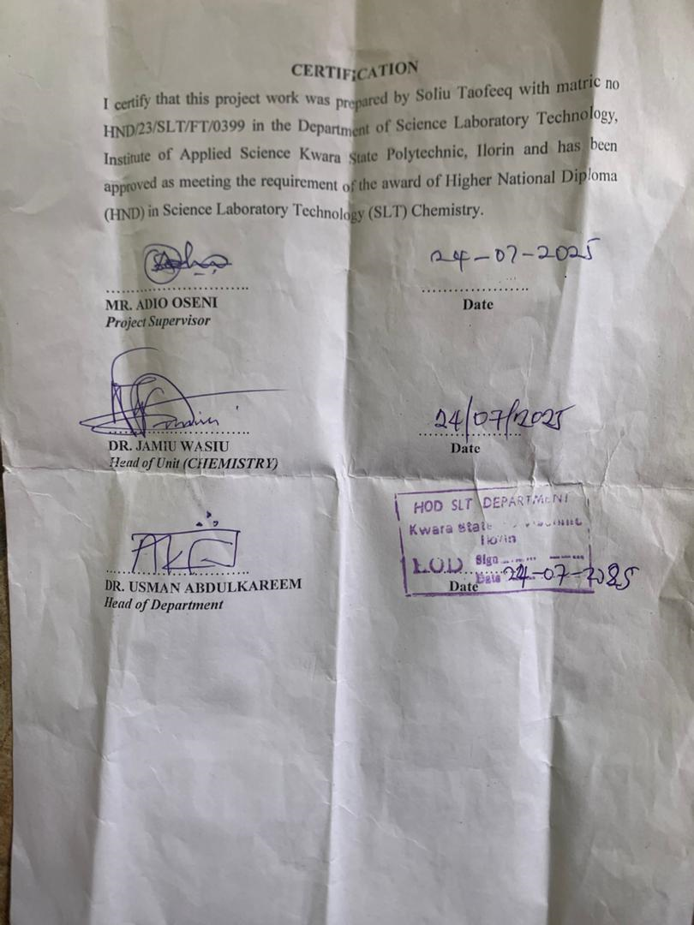
DEDICATION
This project write up is dedicated to God almighty Allah for his unmeasurable protection over my life and who has been with me since when I was born and uptill date.

ACKNOWLEDGEMENT
First and foremost I hold gratute to God almighty Allah for always be by my side.
My gratitude goes to my parent and my brother, Gabsam kunle, for his financial support, and advice that he have been given me, may God almighty Allah continue to uphold you and bless you aboundantly.

My appreciation also goes to my supervisor
Mr Adio Oseni for his kindness Gesture love and support to my success.
My acknowledgement goes to my one and only, Fauziyah Arinolawumi for her cooperation and support in times of need and to all my friends,I pray to almighty Allah to make success ours.

TABLE OF CONTENTS
CERTIFICATION
DEDICATION
ACKNOWLEDGEMENTS.
TABLE OF CONTENTS
ABSTRACT
CHAPTER ONE
1.0 INTRODUCTION
CHAPTER TWO
2.0LITERATURE REVIEW.
CHAPTER THREE
3.0 MATERIAL AND METHOD
CHAPTER FOUR
4.0 . RESULT AND DISCUSSION
CHAPTER 5
5.0. CONCLUSION
5.1. REFERENCE

Abstract
Activated carbon chemically prepared from banana stalk (BSAC) was used as adsorbent to remove lead (II) ion from aqueous solution. BSAC was characterized using physicochemical properties; proximate analysis, pH_{pzc}, Boehm titration and Fourier transform infrared spectroscopy. Effect of five process parameters: initial metal concentration (50-250 mg/L), contact time (15-240 minutes), temperature (30-50⁰C), adsorbent dose (0.1- 0.3 g/100ml) and pH (2-10) on adsorption of lead ion were evaluated in a batch system using BASC. BSAC Physicochemical properties (bulk density, iodine number, pH) and proximate analysis (moisture content, volatile content, fixed carbon, ash content) were (0.34 g/cm³, 820, 3.78) and (2.79, 12.48, 79.31 and 5.12%), respectively The pH_{pzc} of BSAC was found to be 4.25 and with maximum percentage removal of lead occurred at pH 8.0. The rate of adsorption was fast initially reaching equilibrium within the first 120min. Pseudo second order kinetic model best described the process as compared with pseudo first order and intraparticle diffusion model with R² of 0.99. The adsorption process fits to Langmuir isotherm (R² (0.99) and R _{L} (0.0392) at 500C) with a maximum adsorption capacity of 200mg/g. The negative values of ∆G indicate that the adsorption of lead onto BSAC was spontaneous, also the positive values of ∆H and ∆S implies that the adsorption process was endothermic. Banana stalk possesses the desirable properties for preparing activated carbon. BSAC is efficient and effective in removing lead ions from its aqueous solution.

CHAPTER ONE
- INTRODUCTION
1.1 Background to knowledge

Excessive release of heavy metals into the environment due to massive urbanization and industrialization has posed a great problem worldwide. The industrial effluents which contain different derivatives of heavy metals such as lead, cadmium, zinc, sodium, copper, chromium, and iron are continuously being discharged to the ecosystem causing pollution to the environment and significant toxic impact on living being. Unlike organic pollutants, the majority of which are susceptible to biological degradation, heavy metals ions do not degrade into harmless end products (Yu, 2005).
Lead is of heavy metals with high toxicity and hazardous when in excess. Lead is releases from industries such as batteries manufacturing, smelting industries, paint manufacturing, fertilizer industries and petrochemical industries. In children, lead causes a decrease in intelligent quotient (IQ) score, retardation of physical growth, hearing impairment and learning difficulty. In individuals of all ages, lead can cause anaemia, kidney malfunction, brain diseases and impaired function of peripheral nervous system, high blood pressure, reproduction abnormality, and in some situations, may result to death (Okoro and Ejike, 2007). For environmental protection and health issues, waste solution containing heavy metal elements need treatment that can remove the contaminants effectively (Harvey and Chantawong, 2001). Several methods or technologies for treating contaminated effluents have been developed over the years .The most important of these convectional techniques includes chemical precipitation ,(Elsalah et al, 2002 ), filtration , ion exchange, flotation , biosorption, electrolytic recovery, membrane separation, removal by adsorption on minerals (Weirich et al, 2002).
However, most of these conventional methods suffered from some drawbacks such as high capital and operational cost, regeneration cost, and problem of residual disposal. They also produced sludge and required the use of high energy and reagent. Adsorption remains the most plausible feasible alternative for the treatment of polluted water and it is largely achieved with the use of activated carbon. Also, the use of activated carbon is limited due to high preparatory cost (Rao, et al, 2009) and irreversible nature of adsorption. Thus, the need for low cost adsorbent comes here which fulfill all the properties of synthetic activated carbon. Previous studies on the use of various agricultural residue such as husks of rice and wheat (Rao et al, 2009), groundnut shells (Malik et al, 2007), palm oil shells (Wan Nik et al, 2006), and physic nut wastes (Pechyens et al, 2007) as raw material for activated carbon production showed some cost economy.
Further need for low cost adsorbent as well as reducing environmental menace of agricultural residues brought about this present study. The present research explores the use of activated carbon produced from (Musa paradisiaca) banana stalk for the removal of lead ions from lead polluted water. Due to the fibrous nature of banana stalk, it has been employed in the production of activated carbon for the treatment of dyes related pollutants from aqueous stream with excellent performance (Bello, et al, 2012). However, there is paucity of information on the application of banana stalk activated carbon (BSAC) for the adsorption of heavy metal ions from aqueous streams. Therefore, the focus of this research is to investigate the use of banana stalk as a precursor for the preparation of activated carbon and to determine its adsorption capacity for adsorption of lead (Pb) ions from aqueous solution. The effects of initial lead ion concentration, temperature, contact time adsorbent dosage and solution pH on lead ion adsorption onto BSAC were investigated. Kinetic, isotherm and thermodynamic parameters governing the adsorption process were also studied and reported.
1.2 Problem Statement
The continuous discharge of heavy metals into the ecosystem is worrisome, because of their toxicity, bio-accumulation tendency, threat to human life and environment (Horshell and Spliff, 2005; Igwe and Abia, 2003). Therefore, for environmental and human health protection, there is need for safe and effective disposal of wastewater. Over the years, a number of conventional technologies such as chemical precipitation, ion exchange, electrochemical treatment, membrane technology and adsorption on minerals have been employed for the treatment of heavy metals polluted water. However, most of these conventional methods suffered from some drawbacks such as high capital and operational cost, regeneration cost, and problem of residual disposal. They also produced sludge and required the use of high energy and reagent. Adsorption remains the most plausible feasible alternative for the treatment of polluted water and it is largely achieved with the use of activated carbon.

1.3 Aim and Objectives
The aim of this research is to produce activated carbon from banana stalk (Musa paradisiaca) and to evaluate its adsorption capacity on lead from aqueous solution.
The specific objectives of the research are:
- to produce and characterize activated carbon from banana stalks.
- to study the effect of various adsorptive process variables (pH, temperature, contact time, adsorbent dose and initial lead ion concentration) on the removal of lead ion from aqueous solution.
- to estimate the kinetic, isotherm and thermodynamic parameters governing the adsorption process.

CHAPTER TWO
LITERATURE REVIEW

2.1 Pollution
Pollution is undesirable change in physical, chemical, and biological characteristics of air, land and water; it may adversely affect human life or that of other desirable elements such as industrial process, living condition and cultural assets. Pollutants are recognized as toxic organic and inorganic substances, pathogens, oxygen demand or consuming materials, acid and base, sediment, nutrient, and heavy metal.
2.1.2 Sources of water pollution
When toxic substance enter lake, stream, river, and other water bodies, they get dissolved or lie suspended in the water, this result in the pollution of water, whereby the quality of water deteriorate, affecting the aquatic ecosystem. Pollutant can also seep down and affect the ground water deposits. Water pollution has many sources; the most polluting of them are the city sewage and industrial discharged into the river. Although there are over 700 defined water contaminates, both organic or inorganic, toxic heavy metals deemed the most dangerous.
2.1.3 Heavy metal pollution
Heavy metal occur naturally in the ecosystem with large variation in concentration and constitute loosely defined subset of elements that exhibits metallic properties which includes transition metals, metalloid, lanthanide, and actinide. Heavy metal are metallic element with relatively high density and poisonous at low concentration .Some of the heavy metal are needed by living organism in varying amount or concentration; such heavy metal includes iron, cobalt, copper, manganese, molybdenum, and zinc required by humans. But the excess consumption of these heavy metals may cause damage of cells; while some of these heavy metals are toxic to living organisms even in small amount or concentration and they include vanadium, tungsten, and even cadmium (Lane et al, 2001). In modern time anthropogenic sources of heavy metal pollution have been introduced to ecosystem especially from waste derived fuels (Duffus, 2002).
The major sources of heavy metal pollution in urban areas of Africa are anthropogenic, while contaminants from natural source predominate in the rural areas. The primary sources of pollution in coaster lagoon are input from rivers, sediments and atmosphere, which can affect aquaculture profitability in certain areas (Krishnaniet al, 2004). Anthropogenic sources pollution include those associated with the fossils fuel and coal combustion, solid waste disposal, agricultural activities(fertilizers), mining and metal process and industrial effluents from chemical industries, pharmaceutical, paint industries, electroplating, battery manufacturing,leather tanning industries,leach ate from landfills and contaminated ground water from hazardous waste sites( Faisal and Hasuain, 2004). Heavy metals are also emitted from resource recovery plants in relatively high level on fly ash particles (Neal et al, 1990).
The continuous discharged of heavy metals to the ecosystem due to urbanization is a great concern, because of their toxicity, bio-accumulating tendency, threat to human to human life and environment (Horsefall and Spiff 2005; Igwe and Abia 2003). Lead, cadmium and mercury are examples that have been classified as priority pollutant by the US Environment Protection Agency (US EPA) (Keith et al, 1979).
Heavy metal is among the conservative pollutants that are not subject to bacterial attack or break down or degradation process and is permanent addition to the marine environment. As a result of this; their concentrations often exceed the level normally found in soil, water ways, and sediments. Hence, they found their ways up in the food pyramid. When accumulated in the environment and in food chains they can profoundly disrupt biological processes(Igweand Abia, 2006).
Metals can be toxic to microbial population at sufficiently high concentration. However, some metals such as silver, mercury, cadmium, and copper are markedly more toxic even at low level (Forstner and Wittnam 1979). Among heavy metals, mercury, lead and cadmium, ‘called the big three’ are in limelight due to their major impact on the environment (Volesky 1994). Arsenic, chromium, copper and zinc are also toxic, lead and cadmium are potent neurotoxic metals (Lazarrova et al, 2005). The toxicology and the chemistry of some of the heavy metals are complex and interesting.

2.2. Characteristics of Lead (Pb)
Lead (Pb) is a bluish coloured heavy metal (atomic number of 82 and atomic weight of 207). The element is pliable, inflexible and fusible. It occurred naturally in the earth crust in small concentration but for centuries it has been mined and disseminated throughout the environment, from where it has gradually incorporated into structural tissue of plant, animal and human. Lead is a well known highly toxic metal and a cumulative poison.
Apart from been toxic, lead is used for cable covering, construction, ammunition, and batteries. Lead dissolves slowly in nitric acids, but is resistant to corrosion by sulfuric and hydrochloric acids. It is normally found with valence states Pb (II) and Pb (VI). The element melts at 327.4ºC and boils at 1740ºC. Lead compounds are useful in construction, as result of high density and resistivity to corrosion it used in sail beats for ballets keel and in scuba diving weight belt to counteract, the diver natural buoyancy and that of his equipment (Brandy et al., 1996). Lead compounds are toxic. In general commercial lead ores, the lead contents is approximately 10%, but it can be low as 3%. Inhalation and absorption can cause serious damage. Lead poisoning can cause headache, dizziness, and in some case insomnia, abdominal pain, kidney damage, causes miscarriage in pregnant women and even reduces fertility in men when highly exposed to lead (Golub and Mari 2005).In some particular bad cases a stupor will progress to a coma and eventually death (Shapino and Johnston, 2008).
Lead poisoning in children causes neurological damage leading to intelligent reduction, learning, disabilities, and problems with coordination, loss of short memory. It was reported that lead affect behavioral inhibition mechanism with consequent increases in violence (Master, 1998) and that it contribute to tooth decay (Gil et al, 1996). Most developed countries introduce lead level in children, by 1992, US shows 77% reduction (Pirkcle, 1994) although 2millions children were still at risk (Brody et al, 1994). In many developing countries lead pollution have been rising in urban areas, with more than 90% of Africa children in cities suffering from lead poisoning (Nriaguet al, 1996). Recent work also found that waste incineration contribute substantial amount of lead fall out in urban areas (Chilrudet al, 1999)

2.3 Method of Removing Pollutants from Waste Water
Methods that have been developed to remove or reduce heavy metal from water include chemical preparation, membrane filtration, ion exchange, flocculation, Electrolysis, Screening, Oxidation, Solvent extraction and adsorption (Zhao, 2004; Gode and Pehlivan, 2006; Demirbaet al., 2002). Each technique provides a different and unique approach and perhaps provides certain advantage over other for a particular situation. Dependingon the nature of the aqueous effluents, flow rate and metal ion concentrations, the industrial application of these processes is restricted by operation cost, or by the inefficiency of the technique (Curkovic, 2001). However, when large volumes of water containing toxic element is to be treated, it would be of great advantage of the method that would provide reliable results without much cost and work effectively. Some of these treatments are listed in Table 2.1. However studies on the treatment of effluent bearing heavy metals have revealed adsorption to be a highly effective and less expensive technique compared to the other techniques for the removal of heavy metals from waste stream and activated carbon has been widely used as an adsorbent (Chand et al, 1994).

Table 2.1 Treatment processes for the removal of heavy metals
Treatment process Description Economics Type of Wastes Example application
Ion-Exchange Waste stream pass Relatively high Heavy metal Metal plating
through resin bed cost due to fouling aqueous solution solution
where ionic mole and regenertion
cule are selectively
removed

Ultra filtration Seperation of Relatively high Heavy metal Metal coating
molecule by size cost aqueous stream Application
using membranes

Reverse Osmosis Separation of Relatively high Heavy metal; Seldom used
dissolved materials cost organic/inorganic industrially
from liquid through aqueous stream
a membrane

Electrolysis Separation of Dependent on Heavy metal; ions Metal plating
positively charged concentration from aqueous
material by solution, copper
application of recovery
electric current

Precipation Chemical reaction Relatively high Lime slurries Metal plating,
caused formation cost; require pH waste water
of solid which adjustment and treatment
settle break down complex

Evaporation Solvent recovery by Energy intensive Organic/inorganic Rinse water from
boiling off the aqueous stream metal plating waste
settle

Electrodialysis separation based moderately Separation/concen Seperation of acid
ondifferential rates expensive & unsat of ions from and metallic solution
of diffusion through isfactory for remo aqueous stream
membrane val of chelated ions

Reduction Oxidative state Inexpensive Metal, mercury in Chrome plating
of chemical change dilute stream solution and
through chemical tanning operation
reaction

Flocculation Agent added to Relatively Aqueous solution Refinery oil/water
aggregate solids inexpensive with finely divided mixture paper
together to facilitate solids paper waste, mine
separation water

Sources: Cheresources (2002).

2.4 Activated Carbon

Activated carbon is a porous material which is commercially used for the removal ofliquids and gaseous pollutants as well as for the gas storage application because of its large surface area. It is a carbonaceous adsorbent and has highly amorphous structure (Bansal and Goyal, 2005). It is defined as a wide range of amorphous carbon-based materials, prepared to exhibit a high degree of porosity and an extended inter-particulate surface area. These qualities impact activated carbon with excellent adsorbent characteristic and it is defined more or less by its properties rather than its source; it can be produced from almost any substance with high carbon content. Activated carbons can be produced from many different carbonaceous precursors. Ideal precursors have a high percentage of carbon content, are abundant and easy to recover. A high percentage of carbon content (i.e. low ash content) translates to more surface area available for adsorption. Common carbonaceous precursors utilized in the modern activated carbon industry include: peat, bituminous and lignite coal, wood, and coconut shell (Wigmans 1989).

2.4.1 Activated Carbon Production
An important area of activated carbon research involves the discovery of new, more efficient precursors for use in full-scale production. Precursors such as bituminous and lignite coal are non-renewable, and therefore should not be relied on for long-term usage. In addition, many parts of the world do not have these materials readily available. However, alternative sources of carbonaceous precursors allow these regions to produce activated carbon in an economic fashion, without the high cost of long distance shipping. Warhurstet al. (1997) studied the potential for activating seed husks from the Moringaoleiferatree. Moringaoleiferais common in developing parts of the world and has many uses, therefore finding a use for the seed husks (a waste product) could further aid these communities. Numerous other researchers have studied potential waste products for use as carbonaceous precursors for activated carbon with varying degrees of success. Examples of precursors include: almond shells, olive stones, apricot stones, paper mill sludge, apple pulp, rice husks, cedar nutshells, and corncobs (Khaliliet al. 2000, Suarez-Garcia et al. 2001, Baklanova et al. 2003, Guoet al. 2003, El-Hendawy 2003). Different methods have been employed in the production of activated carbons but the two basic preparatory processes commonly used are the physical and chemical activation methods.

CHAPTER THREE
3.0 Materials and methods
3.1 Adsorbate
The stock solution containing 1000 mg/L of lead was prepared by dissolving 1.598 g of Pb(NO₃)₂ in 1litre of deionized water put in a volumetric flask and making up to the mark with the deionized water. The stock solution was then used to prepare dilute solutions of different working concentrations.
3.2 Adsorbent preparation
Banana stalks (Musa paradisiaca) were washed thoroughly to remove dirt from its surface and then dried at 120ºC overnight in an oven to remove the moisture content. The dried samples were cut into small pieces, grinded and sieved into desire mesh size of (300 -425µm). 100g of the dried raw banana stalk was placed in the Gollenkamp muffle furnace (model Tactical 308) and carbonized at 600ºC for 1hr (first pyrolysis). The produced char was cooled to room temperature and treated with phosphoric acid (H₃PO₄) at a ratio of 1:1 by weight of char / (H₃PO₄). The mixture was dehydrated in an oven overnight at 105ºC.Then carbonized in the absence of air in the muffle furnace to 800^{O}C for 2hours. The sample was cooled to the room temperature. The sample was then filtered and residue was then mixed with 0.1M HCl in a beaker and stirred for 1 hour on magnetic stirrer. The sample was finally washed with the hot de-ionized water until the pH of the washed solution reaches 7.0.
3.3 Batch Adsorption experiment
` The lead sorption experiments from its aqueous solution onto activated carbon produced from banana stalk (BSAC) was carried out using standard 50mg/L, 100mg/L,150mg/L,200mg/L and 250mg/L of Pb²⁺solution. The adsorption experiments were carried out in 250ml conical flasks on a mechanical shaker equipped with a thermostatic water bath operating at 120 rpm using 250ml conical flasks with stopper. The adsorption experiments were performed at room temperature (30ºC) and 0.1- 0.5 g of BSAC were added into the flasks with 100ml of synthetic lead (II)solution in the absence of competing ions and was agitated for 24hrs at 120rpm. The pH was adjusted to 7 by adding either a few drop of diluted hydrochloric acid or sodium hydroxide (0.1mol/l). The flask was then removed from shaker, the solid was separated by filtration through Whatman filter paper and the final concentrations of Pb²⁺ in the solution were determined using Atomic Absorption Spectrophotometer (AAS).The amount of lead adsorbed per unit mass of the adsorbent was evaluated by the equation below:
qt (Adsorption capacity) = $\frac{\left(C_{o-}C_{t}\right)V}{M}$ 1
Where qt is the amount of metallic ions up taken by the adsorbent (mg/g), Co is the initial Pb (II) ions concentration put in contact with the adsorbent (mg/l), C_{t} is the final Pb (II) concentration in (mg/g) after the batch adsorption procedure at anytime t and M is the mass of adsorbent (g) where V is the volume of the aqueous solution in liter (l). Similarly, the amount of lead adsorbed by adsorption experiment was also evaluated in term of percentage removal as expressed by the formula given below:
% Removal = $\frac{C_{0-C_{f}}}{C_{0}}X 100$ 2
Where Co and C_{f} are the liquid –phase Pb(II) concentration at initial state and equilibrium respectively.
3.4 Effect of Adsorbent Dose
The effect of adsorbent dose on lead (II) adsorption was studied by using 100ml of lead (II) solution of initial concentration of 100mg/l prepared by serial dilution of stock solution (1000mg/l). No pH adjustment was made and all the studies were carried out at their natural pH. The solutions were put into the conical flasks containing 0.05g, 0.1g, 0.15g, 0.20g, 0.25g, and 0.30g.and 0.35g of the adsorbent (BSAC). The contents of the conical flasks were agitated for 24hrs at 120rpm at ambient temperature of 30ºC.Then the content of the conical flasks were filtered through the Whatman filter paper and the filtrate were analyzed for residual lead (II) concentration by using atomic absorption spectrophotometer (AAS).
3.5 Effect of pH
The effect of solution pH on the lead adsorption process was studied by varying the initial pH of the solution from 2 to 10(2, 4, 6, 8 and 10). 100ml of lead (II) solutions of initial concentration of 100mg/l were prepared by serial dilution of stock solution (1000mg/l).The pH of the solution was adjusted to the desire pH by addition of 0.1M HCL and/or 0.1M sodium hydroxide using pH meter for the measurement. The solutions were added to 150ml conical flasks containing optimum adsorbent dose (0.2g of BSAC).The solutions temperature were maintained at 30ºC and were agitated at 120rpm for 24hrs. Then the content of the conical flasks were filtered through Whatman filter paper and the filtrates were analyzed for residual lead (II) concentration using atomic absorption spectrophotometer (AAS).
3.6 Effect of contact time
The effect of contact time was studied at room temperature of 30ºC. Lead (II) solution of initial concentration of 50mg/l was prepared by serial dilution of the stock solution .100ml of the above solution was added to conical flask containing 0.2g of BSAC for different contact time (15min, 30min, 45min, 60min, 75min, 90min, 105min, 120min, 180min, and240min).No pH adjustment was made as all the studies were carried out at their natural pH. After predetermined time interval the content of the flasks were filtered through Whatman filter paper and the filtrates were analyzed for residual lead (II) concentration using atomic absorption spectrophotometer (AAS). Similarly 100mg/l, 150mg/l, 200mg/l and 250mg/l lead (II) solutions were prepared. And all the above processes were repeated.

3.7 Effect of temperature
To study the effect of temperature on the adsorption of lead (II) ions, lead (II) solution of initial concentration of 50 mg/l was prepared by serial dilution of stock solution (1000mg/l). 100ml of the solutions were taken into the conical flasks maintained at different temperatures (30ºC, 40ºC and 50ºC). To the above solutions 0.2g of BSAC was added and agitated at 120rpm for equilibrium time of 1hour. No pH adjustment was made and all studies are carried out at their natural pH. The content of the flasks were filtered through Whatman filter paper and the filtrates were analyze for residual lead (II) concentration using atomic absorption spectrophotometer (AAS). Similarly 100mg/l, 150mg/l, 200mg/l and 250mg/l were also prepared by serial dilution of the stock solution (1000mg/l) and were maintained at different temperatures. To the above solution optimum dose of 0.2g BSAC were added and were agitated, filtered and analyzed for residual lead (II) concentration as above.
3.8 Effect of initial concentration
The effect of initial concentration for lead ion onto BSAC, batch adsorption experiments were performed with optimum adsorbent dose and by varying initial concentrations of lead ions 50mg/l, 100mg/l, 150mg/l,200mg/l and 250mg/l. 100ml of the solution of different initial concentrations were taken into conical flasks containing 0.2g of BSAC. The conical flasks with their content were agitated at 120rpm till equilibrium was reached. No pH adjustments were made and all studies were carried out at the natural pH. All solution samples filtered through the Whatman filter paper and the filtrate were analyzed for residual lead (II) using atomic absorption spectrophotometer (AAS).

3.9 Characterization of activated carbon sample
The activated carbon produced was characterized by determined the ash contents, moisture content, bulk density, pH, and iodine number of the produced activated carbon sample.
For the determination of moisture content ASTM-D 1762(1990) was used. 1.0g of the dried samples of the activated carbon was weighed and put into a dried and weighed porcelain crucibles and were kept in an oven and maintained at 105ºC for 4hrs, then placed in placed in desiccator to cool to room temperature and reweighed.
For the determination of ash content, 1.0g of the activated carbon was placed in a dried and weighed crucible. The sample was then placed in a muffle furnace operating at 750ºC for 6hrs.The crucible with its content was then cooled in desiccator for 1hr and weighed.
To determined pH, One gram of the activated carbon was weighed and transferred into a beaker containing 100ml of distilled water; the mixture was stirred on a magnetic stirrer and allows to stands for 1hour. The beakers were covered with clean watch glass during the period. 10cm³ of the extract was decanted into clean dry beaker. The pH was measured using pH meter at room temperature (Okiemen et al, 2004; Shrestha et al., 2012).
Bulk densities of carbons were determined according to ASTM D 2854-96(1996).
The adsorption of aqueous iodine is considered a simple and quick test for evaluating the surface area of the activated carbon associated with pore larger than 1nm. The iodine number, defined as the amount of iodine adsorbed per gram of the activated carbon at an equilibrium concentration is measured according to the procedure established by the America Society for Testing Materials (ASTM 2006). 0.1g of dry activated carbon was put in a dried 100ml conical flask. The sample was run in duplicate and 5ml of 5% HCl was added. The flask was swirled until the carbon was wetted.10ml of 0.1Niodine solution was added to each flask and was shaken properly for 4 minutes. 10 ml filtrate was titrated against standard (0.1N) hypo solution using starch as an indicator.
Determination of pH of point zero of charge (pH_{pzc} ) of an adsorbent is important because it indicate the net surface charge of the carbon in solution. The point of zero charge (PZC) is the pH value at which the external and internal surface of the carbon is at equilibrium. The pH_{PZC} is the point where the curve of (pH_{initial}- pH final) versus pH initial intercepts the line pH initial = pH final. In order to determine the pH of point zero charge, 0.15g of the activated carbon was taken into the 100ml of conical flask containing 50ml of 0.01M NaCl. The pH was adjusted to between 2and10 by addition of 0.1MHCl or 0.1MNaOH for the activated carbon. The conical flask was sealed and placed in a shaker for 48hrs under atmospheric condition. The content of the flask were filtered and the final pH was then measure using the pH meter.
The presence of surface acidic and basic groups in the activated carbon was determined quantitatively by Boehm titration method. The acidic groups (sites) are determined by weighing 1g of the activated carbon sample into vial containing 25ml of each of the following; 0.1M NaOH, 0.1M NaHCO₃ , and 0.05M Na₂CO_{3.} The vials were then sealed, stirred by shaking for 24hrs.The solution was then filtered and 5ml of filtrates was titrated with 0.1M HCl. Similarly, the basic group (sites) was determined by mixing 1gram of the activated carbon sample with 25ml of 0.1M HCl. The obtained solution was filtered and 5ml of the filtrate was titrated with 0.1M NaOH. The number of different acidic sites can be calculated by assuming that NaOH neutralized carboxylic, lactonic, and hydroxyl (phenolic) groups’.Na₂CO₃ neutralizes carboxylic and lactonic groups while NaHCO₃ neutralizes only carboxylic groups. The amount of basic sites was calculated from the amount of HCl that reacted with the basic groups of the carbon.
Fourier transform infrared (FTIR) spectroscopic analysis was performed on the raw and activated carbon produced using (FTIR – 2000, Perkin Elmer). The FTIR spectra gave information about characteristic functional groups of the samples. The spectra was measured from 4000 to 400 cm⁻¹

CHAPTER FOUR
4.0 RESULTS AND DISCUSSION

4.1 The effect of solution pH
The effect of pH on the adsorption of Pb²⁺from aqueous solution on BSAC, expressed in terms of metal ions removal percent was shown in Figure 1. From the figure the percentage removal of lead at pH= 2 was found to be 34.961%, as the pH was increase from 2 to 4 the percentage removal at pH= 4 was 40.57%, which shows no appreciable increase in the amount of lead removed. However, as the pH increases above 4 the percentage removal was enhanced reaching the maximum of 97.9% at pH of 8. This result is not far from what was reported by Kobya et al, 2005. At lower pH values, the surface charge of BSAC is positive, thus, lead adsorption is not favourable because of electrostatic repulsion between the lead (II) and BSAC surface. When pH was increased, the electrostatic repulsion between the lead (II) ion and BSAC surface site repulsion decreased, the BSAC surface became negatively charged facilitating binding of the lead cation via electrostatic attraction, hence, lead uptake increased.

Figure 1: Effect of pH on the Adsorption of lead ion by BSAC

4.2 Effect of adsorbent dose

Adsorption capacity (qe) and percentage removal was plotted on the same axis as against adsorbent dose as shown in Figure 2. From Fig. 2, it was found that with increase in adsorbent dose the percentage removal increases indicating the presence of large surface area available for adsorption with the corresponding decrease in the maximum adsorption capacity which is the amount absorbed per unit mass of the adsorbent. The percentage of Pb remove increased from 57 to 98.52% with the increase in adsorbent dose from 0.05 to 0.2g, while the adsorption capacity decreases from 114 to 49.26mg/g under the same condition. It is readily understood that for a fixed initial solute concentration, increasing the adsorbent dose provides a greater surface area or available adsorption sites increases and therefore result in the increase of the amount of Pb (II) ion adsorbed. The observed decrease in adsorption density (adsorption capacity), with increase in the adsorption site during the adsorption process can be attributed to the fact that the increasing adsorbent dose increase concentration of the adsorbent to an insufficiency of metal ions in solution with respect to available binding sites. This result trend is in agreement with what Pehliven et al., 2008 reported.

4.3 Initial ion concentration and contact time effect
The plot of the adsorption uptakes (adsorption capacity) versus the adsorption contact time at various initial lead ions concentrations was presented in Figure 3. From the result depicted in Figure 3, it is evident that the removal of lead (II) by the activated carbon increased with time and then reached equilibrium at about 120min. When the initial Pb (II) concentration increased from 50 to 250 mg/l, the loading capacity of the activated carbon increased from 23.5 to 106 mg/g. It is clear that the uptake of lead (II) depends on the initial concentration of lead (II) and adsorption capacity is enhanced with increased in initial lead concentration (Figure 3). Furthermore, the removal was rapid at initial stages and finally reaches constant value for a longer time. Obviously, the initial high adsorption rate is due to abundance binding sites. The result indicate that up to 60% of the total amount of Pb(II) uptake was found to occur in the first (30 min) and thereafter the remaining 40% of maximum uptake was reached in the remaining
Figure 2: Effect of dose on lead removal at pH of 7.0 and at 30ºC

Figure 3: Effect of initial concentration and contact time on lead uptake by BSAC
time of 240minutes. The curves can be divided into fast, slow and equilibrium portion (Figure 3). The first 30 min can be characterized by fast adsorption. The portion between 30-120min can be characterize by slow adsorption which may be due to the fact that as time passes the concentration gradient between the adsorbate in solution and adsorbate in sorbent surface reduces due to accumulation of Pb (II) particles in the vacant sites leading to a decreased in the sorption rate in larger stage of 30-240 min. The portion between the 120-240 min is characterized by practical non-sorption. This may be to non-available binding site and, or the rate of sorption may be equal to rate of desorption.
4.4 Effect of Temperature
A plot of adsorption capacity q_{e} of BSAC against initial concentration of lead at different temperatures was plotted and the result of the experiment data is presented as depicted in Figure 4. It is evident from Figure 4 that the value of maximum uptake capacity of lead increases with increased temperature, indicating a better adsorption at higher temperature. This is due to the increased surface activity, suggesting that adsorption of lead and BSAC was an endothermic process.

4.5 Characterization of BSAC
The result of proximate analysis of adsorbent prepared from banana stalks are presented in Table 1 The volatile matter, moisture and ash content of the activated carbon (BSAC) were observed to be less than in the raw material. However, the fixed carbon content is satisfactory for lead adsorption when compared with raw and charred banana stalks.
The iodine number, bulk density, and pH of the carbon were determined and presented in Table 2. From the results obtained. It was observed that there is a large difference between the iodine number of char and BSAC. The char and BSAC have 524 and 820 of iodine number respectively. A higher value of iodine number for BSAC when compared with char is due to greater surface area and available micropores for adsorption of iodine molecule on the surface. The higher value of the iodine number for the activated carbon also shows that the activated carbon sample has well developed pore structure than the char. It therefore implied that the BSAC having high iodine number has higher surface area and larger adsorption capacity than the char.
The bulk density is found to increase from 0.2 g/cm³ in the raw banana stalk to 0.34 g/cm³for the activated carbon (Table 2). The increase is as a result of heat treatment. Higher bulk density of BSAC gives greater volume capacity and this indicated that it has better quality compared to that of the raw. The bulk densities obtained from this study for char and phosphoric acid activated carbon (BSAC) are 0.36 and 0.34 g/ml respectively. The result fall within the range (0.20 - 0.52g/ml) recommended by the American Water Work Association for activated carbon meant to be used for practical purpose (AMWA 1991).
The raw banana stalk has the highest pH of 8.06, while pH of 3.78 and 6.73 are for the activated carbon and char respectively. This may be attributed to adsorption of H⁺ ions from solution or desorption of OH⁻⁻ion from the sorbent surface (Ghazy and El-Morsy, 2007). The lower pH in the activated carbon can be explained by the increase surface acidity of the adsorbent by chemical activation with H₃PO₄.
The FTIR spectroscopic characteristics for the raw banana stalk (RBS) and banana stalk activated carbon (BSAC) were shown in Figure 5a and 5b respectively. The FTIR analysis indicating bands and peaks with their corresponding ascribed functional groups was shown in Table 3. It would be observed that the FTIR analysis of the BSAC is difference from that of the RBS samples, which is as result of the shift in bands, change in wave numbers, and absorbance difference between the RBS and BSAC samples, which indicate that chemical transformation would have taken place during chemical treatment and carbonization. The combine effects of chemical activation and high temperature treatment (carbonization) on the raw banana stalk to produce BSAC resulted in enhancement and disappearance of some of the functional groups as well as shifting and lowering of wavelength numbers.
The results of the surface characterization which give the quantification of the surface acidic and basic groups of the adsorbent are presented in Table 4. pH_{PZC} of an adsorbent is important because it indicates the net surface charge of the carbon in solution. In this research, zero point charge was found to occur at 4.25 meaning that BSAC surface has a positive charge in solution up to pH of 4.25 and a negative charge above this pH. Oxygen functional groups with various acidic groups (carbonxyl, lactonic and phenolic) are found to be much higher than the basic group (Table 4). This is consistent with the value of pH_{PZC} of 4.25 showing the dominance of acidic groups. The presence of the surface functional groups depicts the metal binding capacity of the adsorbent.

Figure 4: Effect of surface loading with temperatures

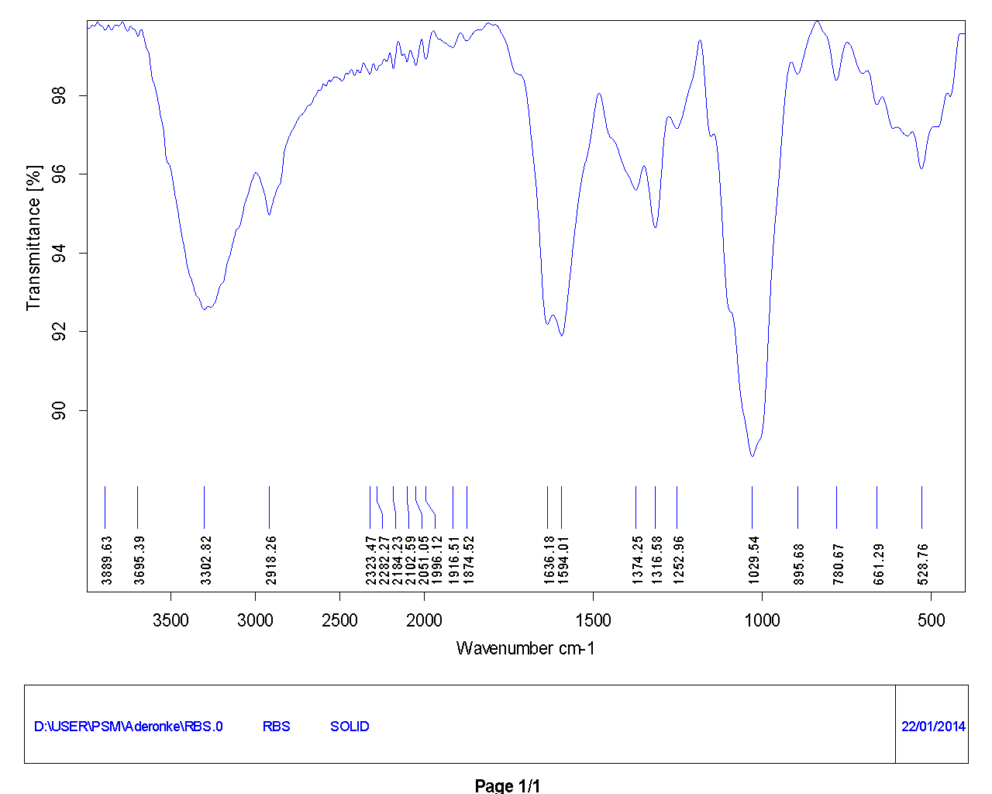

Figure 5a: FTIR spectra Raw Banana stalk (RBS)
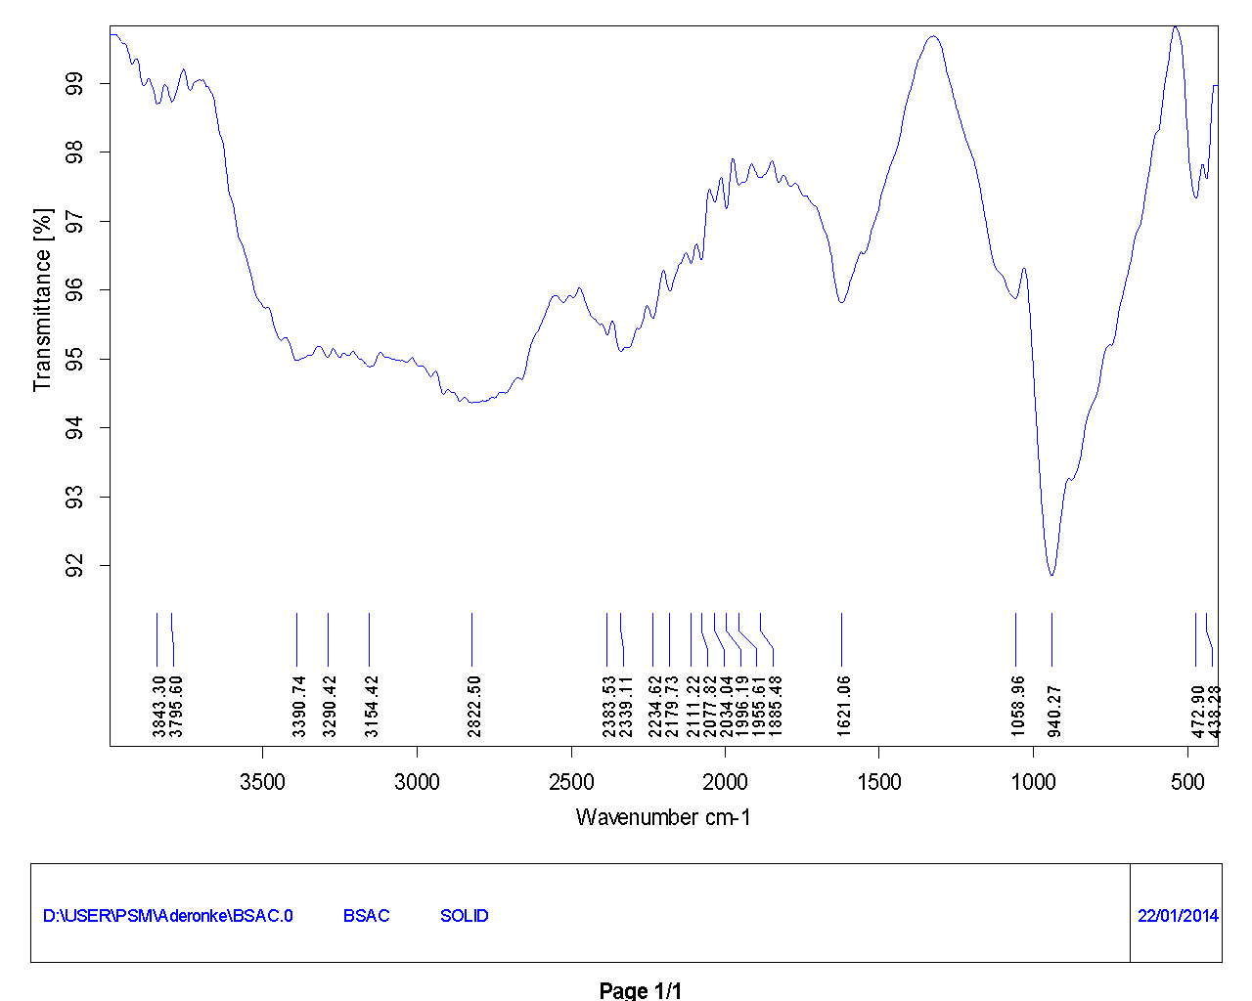
Figure 5b: FTIR spectra Banana stalk Activated Carbon (BSAC)

4.6 Adsorption kinetics
4.6.1 The Pseudo- First Order Kinetic Model
The pseudo-first order equation is generally express as the integrated form of Langergren model (Langergren, 1689) as:
$ln\left(q_{e} - q_{t}\right){= q_{e} - k_{1} t }$ 3
Where qe and qt are the adsorption capacity at equilibrium and time t, respectively (mg/g), k₁ is the rate constant for pseudo first order adsorption (min⁻¹); plot of ln(qe-qt) against t at various initial lead ion –concentration for lead solution (50, 100, 150, and 200 mg/l), resulted in linear graph with negative slopes. K₁, and qe are calculated from the slopes and intercepts respectively. Although the correlation coefficient were high, the qe calculated and qe experimental values do not agree (Table 5) therefore the adsorption of lead ion into BSAC does not follow the pseudo first order kinetics.
4.6.2 The pseudo- second order kinetic model
The adsorption kinetics may also be described by a pseudo-second order equation (Ho and Mckay, 1999). The differential equation is the following:
$\frac{dq_{t}}{dt} = k_{2}{\left(q_{e} - q_{t}\right)}^{2}$ 4
Integrating the above Equation (4) and applying boundary conditions (qt=0 when t =0, and qt =qt at t=t, gives the following forms of equation
$\frac{t}{q_{t}} = \frac{1}{k_{2}q_{e}^{2 }}+ \frac{1}{q_{e}} t$ 5
Equation (5) can be rearranged to obtain a linear form
$\frac{t}{q_{t}} = \frac{1}{h} + \frac{1}{q_{e}} t$ 6
Where h = K₂q_{e}² (mgg⁻¹min⁻¹) can be defined as the initial adsorption rate as t→0 and K₂ is the rate constant of the pseudo – second order adsorption (gmg⁻¹min)
Plots of t/q_{t} versus t from Equation (5) gave a straight line from which qe, K₂ and h were determined from the slopes and intercepts of the plots. The computed results obtained from pseudo second order kinetic model were shown in Table 5. The correlation coefficients obtained were greater than 0:99 for all initial concentrations studied and there were a good agreement between q_{e cal} and q_{e exp.} The good agreement indicates that the pseudo-second-order kinetic model fits the adsorption system studied. A similar result was also obtained on the adsorption of malachite green dye onto BSAC (Bello et al., 2012).

4.6.3 Intraparticle diffusion model
The intraparticle diffusion equation is given as
${ q}_{t}= k_{diff}t^{\frac{1}{2 }} + C$ 7
Where t is the amount of lead adsorbed (mgg-¹) at time t and K_{diff} (mgg⁻¹min⁻¹) is the rate constant for intraparticle diffusion. The value of C gives an idea about the thickness of the boundary layer, the larger the intercept the greater the boundary layer effect
Plot of uptake, qt versus the square root of time, t^{½} (Equation 7) should be linear if intraparticle is involved in the adsorption process, and if there line passes through the origin than intraparticle diffusion is the rate controlling step. The rate constant k_{diff}, C and R² are shown in Table 5. The correlation coefficient (R²) for intraparticle diffusion model are between 0.949 and 0.998, indicating that adsorption of lead ion onto BSAC may be controlled by intrapartcle diffusion model. The plots do not pass through the origin in all cases. This is indicative of some degree of boundary layer diffusion
4.7 Adsorption Isotherms
3.7.1 Langmuir isotherm model
The linearised form of the Langmuir adsorption model is expressed as
$\frac{C_{e}}{q_{e}}= \frac{1}{k_{Lq_{m}}} + \frac{1 C_{e}}{q_{m}}$ 8

A plot of C_{e}/q_{e} against C_{e} gave a straight line graph with a slope 1/qm and intercept of 1/k_{L}qm. Values of qm and k_{L} are calculated from the graph and reported in Table 6. The qm is the monolayer saturation at equilibrium whereas k_{L} is Langmuir constant. . To confirm the favorability of the adsorption process to Langmuir isotherm the essential features of Langmuir isotherm is the dimensionless equilibrium parameter (R_{L}) expressed by Equation 9
$R_{L}= \frac{1}{1+ k_{L}C_{o}}$ 9
Where C_{o} is the highest initial lead concentration in solution, is used to confirm the favorability of the adsorption process; that is the value of R_{L} indicate whether the isotherm is irreversible if (R_{L} = 0), favourable (0 < R_{L} < 1), linear (R_{L} = 1), unfavorable (R_{L} > 1) (Kadirvelu and Namasivayam, 2003). The value of R_{L} obtained for initial concentration of 250mg/L in this study as reported in Table 6 at various temperatures indicating that the adsorption of lead on to BSAC is favorable as the values lies between 0 and 1
4.7.2 Freundlich Isotherm

The linearized form of the Freundlich Isotherm equation is given as
$\log{q_{e}}$ = $\frac{1}{n} \log{C_{e}+ \log{k_{F}}}$ 10
Where k_{F} and n are Freundlich constants, the characteristic of the system, K_{F} and n is the indicator of adsorption capacity and adsorption intensity respectively. The ability of Freundlich model to fit the experimental data was examined. For this case, the plot of log qe versus log C_{e} was carried out at different temperature (30ºC, 40ºC, and 50ºC). The values of k_{F} and 1/n were obtained from the intercept and slope of the curve respectively. The plots gave straight line graphs with high R². Comparing the R² value of the Freundlich with Langmuir isotherms, adsorption data fits the Langmuir isotherms model better (Table 6). Values of n > 1 indicate the adsorption is favourable.
4.7.3 Temkin isotherm
A linearised form of Temkin isotherm can be written as
$q_{e} = \frac{R T}{b}\ln{A}+ \frac{R T}{b} \log{C_{e}}$ 11
Equation (11) can be simplified as:
$q_{e} =B\ln{A }+ B\ln{C_{e}}$ 12
Where B = RT/b, B is the molecular interaction parameter. A and B are the Temkin isotherm constants. A is the equilibrium binding constant corresponding to the maximum energy (L/mg), b is related to the heat of adsorption. B is the Temkin isotherm constant; T (K) is the absolute temperature and R is the ideal gas constant (8, 314Jmol⁻¹ K⁻ ¹). A plot of In Ce versus qe gave a straight in which the constant A and B where obtained from the slope and intercept of the graph. The values of the Temkin constants A and b are presented in Table 6 for the different temperature considered .The value of B is 30.46, 33.47 and 35.79 at 30^{O}C, 40^{O}C, and 50^{O}C respectively. The correlation coefficient obtained is greater than 0.98 for all the temperatures.
4.7.4 Dubnin-Radushkevich (D-R) model
The linearised D-R equation can be expressed as;
$\ln{q_{e}= \ln{q_{m}} - βε^{2}}$ 13
Where β is the free energy of sorption per mole of the lead as it migrate to the surface of BSAC from an infinite distance in the solution (mol²kJ⁻²) qm is the maximum adsorption capacity and ε is the polanyi potential (Jmol⁻¹), that is expressed as :
$ε =RT\ln\left(1 + \frac{1}{C_{e}}\right)$ 14
Where Rand T is the universal gas constant (8.314J/mol K) and the absolute temperature (K) respectively and Ce is the equilibrium concentration of lead.The plots of lnqe against ε² using Equation (13) for the BSAC at the range of temperatures considered are almost linear graphs with correlation coefficient range from 0.883 to 0.90. The D-R isotherm constants β and qm were calculated from the slopes and the intercepts of the plots respectively and were presented in Table 6. The mean free energy of adsorption (E) was calculated from the constant β using the relation.
$E = \sqrt{\frac{1}{2β}}$ 15
It is defined as the free energy change when 1 mol of ion is transferred to the surface of the solid from infinity in solution. The values of E in this present study were found to be between 0.517- 0.675 kJ for all the temperature considered which is less than 8.kJ/mol indicating that the adsorption process is physical in nature.

3.8 Thermodynamic study
The thermodynamic parameters, which characterize the equilibrium state of a system, are the Gibbs free energy change (∆G). The enthalpy change (∆H) and the entropy change (∆S). These parameters were determined to investigate the feasibility, spontaneity and the nature of the interaction of the adsorption process. This was achieved by using the following relations

${ K}_{c }= \frac{C_{A_{e}}}{C_{e}}$ 16
$\ln{K_{c}} = \frac{∆S}{R} - \frac{∆H}{RT}$ 17
$∆G = - RT\ln{K_{c}}$ 18
$∆G = ∆H- T∆S$19
Where Kc is the equilibrium constant, Ce is the equilibrium concentration in solution (mg/l) and C_{Ae} is the solid-phase concentration at equilibrium (mg/l).∆G, ∆H and ∆S are change in Gibbs, free energy, (KJ /mol),enthalpy(KJ mol) and entropy (KJ/ mol) of adsorption respectively. R is the universal gas constant (8.314 J/K/ mol) and t is the temperature (K). Batch adsorption studies were carried out with Pb (II) at varying temperature (30ºC to 50ºC) and optimum adsorbent dose. A graph was plotted, taking lnk against 1/T (von’t Hoff plot) for initial concentration 50mg/L, 100mg/L, 150 mg/L, 200mg/L and 250mg/l .Values of ∆H and ∆S were calculated from the slope and intercept of von’t Hoff plots respectively and presented in Table 7. From the table ∆G are negative in whole the range of temperatures considered. The negative values of ∆G indicate that the adsorption of the Lead on to BSAC was spontaneous and thermodynamically favoured. The positive value of ∆H suggested that the process is endothermic in nature and positive value of ∆S indicates that there was increased randomness at solid liquid interface during adsorption of lead onto BSAC which increases with increased in initial lead ion concentration (Table 7).

Table 1: Proximate Analysis of the Adsorbent
Sample | Parameter
Sample | Moisture % Volatiles % Fixed carbon % Ash %
Raw 14.45 70.53 8.57 6.46
Char 6.53 30.34 59.37 3 .76
BSAC 2.79 12.48 79.31 5.12

Table 2: Physicochemical Properties of BSAC
Properties Raw Char BSAC
Bulk density(g/cm³) 0.21 0.36 0.34
Iodine number Nil 528 820
pH 8.06 6.73 3.78

Table 3: FTIR SPECTRA CHARACTERISTICS
RAW BANANA STALK (RBS) |  | BANANA STALK ACTIVATED CARBON(BSAC)
IR SPECTRA PEAK(cm-¹) | Functional groups | IRSPECTRA PEAK(cm-¹) | Functional groups
3889.63 – 3639 | Bonded O-H group | 3843.30 – 3797.60 | O-H group
3302.82 | O-H group of carbonxylic acid | 3390.74, 3290.42, 3154 | O-H group of carbon  xylic acid
2918-2323.47 | Alphatic C-H group | 2822.50 – 2383.53 | Alphatic C-H group
1636.16 | Carbonyl stretching with aromatic  Ring | 1621 | C=O stretching
1594.01 | Amide group | 1058 | C=O=C stretching for  ether or hydroxyl group
1316-1252.96 | Nitate(NO₂) symmetric stretching  vibration | 980 | Β-glyscopic linkages
1028 | Si –o- Si asymmetric stretching | 472-438 | C=C stretching (lignin)  and C- N stretching
661- 523.76 | C-S stretching

q

Table 4: surface characteristics of BSAC
BSAC Surface Chemistry
Carboxylic (meq. g-1) 0.2152
Lactonic(meq. g-1) 0.2445
Phnolic (meq. g-1) 0.2816
Acidic (meq. g-1) 0.7413
Basic (meq. g-1) 0.1842
pH_{PZC} 4.25

Table 5: Comparison of Pseudo first order, Pseudo second order, and Intraparticle diffusion Kinetic models rate constants, calculated from Experimental data at different concentration
Co (mg/L)
Models
50 100 150 200 250

Pseudo first order
qexp ( mg/L ) 23.75 47.38 69.00 89.1 106
k₁ (min⁻¹) 0 .052 0.020 0.018 0 .018 0.018
qcal (mg/L) 2.767 2.573 3.579 3.905 4.173
R² 0.981 0.962 0.955 0.970 0.995
Pseudo second order
k₂ (gmg⁻¹ min⁻¹) 0.00528 0.00428 0.001107 0.000776 0.0005436
qcal (mg/L) 25.64 47.62 71.43 90.90 111.11
h (mg g⁻¹min⁻¹) 3.4724 9.7101 5.6481 6.4103 6.71098
R² 0.998 0.999 0 .990 0.998 0.992
Intraparticle diffusion
K_{diff} (mg g⁻¹min⁻¹) 1.065 1.376 3.412 5.489 6.423
C (mg g⁻¹) 14.19 32.62 29.75 29.28 33.47
R² 0.949 0.971 0.976 0.958 0.998
Table 6: Isotherm constant and correlation coefficient for the adsorption of lead (II) onto BSAC at different temperatures
T (ºC)
Models
30 40 50

Langmuir isotherm
q max (mg/g) 142.86 166.67 200
k_{L}(L/mg) 0.0787 0.08 0.098
R_{L} 0.05086 0.0476 0.0392
R² 0.997 0.995 0.998
Freundlich isotherm
k_{F} 16.48 16.29 16.71
1/n 0.542 0.591 0.624
n 1.845 1.692 1.6025
R² 0.962 0.989 0.989
Temkin isotherm
A 0.8586 0.8511 0.8782
B 30.46 33.47 35.79
b 0.0827 0.0778 0.07503
R² 0.998 0.983 0.984
Dubnin –Radushkevich isotherm
qo(mg/g) 84.8598 84.84 86.40
β (mol²/kJ²) 1.865 1.341 1.098
E (kJ/mol) 0.517 0.6106 0.6748
R² 0.900 0.862 0.855

Table 7: Thermodynamic parameter for the adsorption of lead (II) onto BSAC at different temperature

Initial concentration 50mg/l 100mg/l 150mg/l 200mg/l 250mg/l

∆H (kJ/mol) 10.185 3.509 12.513 16.678 20.054

∆S (J/mol K) 59.014 35.360 61.4003 72.51 80.93

∆G (kJ/mol), 30ºC -7.697 -7.205 -6.091 -5.292 -4.468
∆G (kJ/mol), 40ºC -8.287 -7.558 -6.705 -5.277 -5.277
∆G (kJ/mol), 50ºC -8.877 -7.912 -7.319 -6.74 -6.086

CHAPTER FIVE
5.0 Conclusions
The following conclusion can be drawn from the present study
- The physico-chemical properties of the produced activated carbon from banana stalk (BSAC) shows that the adsorbent is a good adsorbent with maximum uptake of lead (II) ion onto BSAC of 200mg/g.
- Over all analysis of equilibrium isotherm model, the adsorption process indicate fitness of Langmuir isotherm, with sorption energy obtained from D-R isotherm found to range from 0.517- 0.6748kJ/mol indicating that adsorption mechanism is physical in nature.
- Adsorption kinetic follows second order rate expression.
- Adsorption of lead (II) ion from aqueous solution increases with increase in temperature indicating endothermic nature of the adsorption process.
- This work has demonstrated that utilization of BSAC will be useful in the treatment of lead ion from industrial waste effluents; it will also eliminate various ecological problems these waste effluents could cause.

References

- American Society for Testing and Materials Annual Book of ASTM Standard, 15.01, Refractories, Carbon and Graphic Products; activated carbon, ASTM, Philadelphia PA (1996)

- American Society for Testing and Materials Standard test method of determination of iodine number of activated carbon, ASTM Committee on Standards (2006)

- American Society for Testing and Materials Standard test methods for moisture in activated carbon, Philadelphia, PA: ASTM Committee on Standards (1991).

- American Water Works Association, (AWWA) (1991). Standards for granular activated carbon, ANSI/AWWA B604-90 Denver Co.

- ASTM (2006).Standard test method for determination of iodine number for activated carbon, ASTMcommittee on stands. ASTMO 4607-94 Philadelphia P A.

- Bello O. S., MohdAzmier. A and Northidayah Ahmad (2012) “adsorptive features of banana (Musa Paradisiaca) stalk -based activated carbon fro malachite green dye removal” Chemistry and Energy; 28:2, 153-167.

- Bouchelta, C., Medjram, Md.S., Bertrand O. and Bellat, J.-P., Preparation andcharacterization of activated carbon from date stone by physical activation with steam cadmium, lead and zinc ions, from wastewater the physical scientist 2, 83-94.

- Esalah O.J., Weber M E, and Vera, H, (2002) Removal of lead , cadmium, and zinc, from Aqueous solution by precipitation with sodium di-(n-octyl) phosphinate, Can.J. Chem Eng (78) 948- 954.from dilute solution by hydroxyl apatite .II. Floatation studies, Separation Science Technology 32 1755-1767

- Ghazy, S.E and El-Morzy, S.M (2007); Sorption of lead from aqueous solution by modified activated carbon prepared from olive stones. African Journal of Biotechnology vol.8(7) pp 4140-4148

- Gode, F., Pehlivan, E. (2006). Removal of chromium (III) from aqueous solutions using Lewatit S 100:

- Harvey, N.W and Chantawong. (2001).Adsorption of Heavy metal by ball clay: their competition and selectivity, Journal of Tokyo University of Information science. August, 2001 78-86.

- Igwe J C, Ogunewe DN,Abia A .A, (2005). Removal of Hg2+, Pb2+ and Ni2+ ions from waste water using modified granular activated carbon;Adsorption and kinetic studies, Journal of Environmental management.

- IgweJC,Abia AA (2003). Maize Cob and Husk as adsorbents for removal of cadmium, lead, and zinc ions from wastewater the physical scientist 2, 83-94.

- Kadirvelu K. and Namasivayam, C. (2003) Activated Carbon from coconut coirpith as metal adsorbent, adsorption of Cd(II) from aqueous solution. Advances in Environmental Research, 7: 471-478.

- Kadivuelu, K and Namasivayam C (2003): Activated carbon from Coconut corpith as metal adsorbent. Adsorption of Cd (II) from aqueous solution Adv. Environ. Res. 7, 471-478.

- Kobya, M.E, Demibas, E. Senturk, M. Ince (2005), Adsorption of heavy metal ions from aqueous solution by activated carbon prepared from apricotstone. Bio resources technology 96, 1518 – 1521

- Malik R.D.S Ramteke and S.R Wali, 2007, Adsorption of malachite green on groundnut shell waste based powered activated carbon. Waste management, 27 1129-1138.

- Malik R.D.S Ramteke and S.R Wali, 2007, Adsorption of malachite green on groundnut shell waste based powered activated carbon. Waste management, 27 1129-1138.
.
- Pechyen, C.D. along, D Ahi-Ong and S. Viboon 2007. Investigation of pyrolyzed chars from physic nut wastefor preparation of activated carbon. J. Solid Mechanics Material Engine (14) 498-507.

- Pehilivan, E, T.Altun and S. Parlayici (2008): Utilization of barley straws as biosorbents for Cu²⁺ and Pb²⁺ ions. J. Hazard Material, 164, 982- 986.
- Pehlivan, E.,Cetin, S., Yanık, B.H. (2006). Equilibrium studies for the sorption of zinc and copper from aqueous solution using sugar beet pulp and fly ash, J. Hazard. Mater. B135, 193–199.

- Quershi K., Bhatti I., Kazi R., Ansari A.K., Physical and Chemical Analysis of Activated carbon from Sugarcane Bagasse and use for Sugar Decolorization, World Academy of Science, Engineering and Technology, 34 (2007)

- Rao MM, DHKK Roddy, P. Venkateswarth and K Seshaiah, (2009). Removal of Mercury from aqueous solutions using activated carbon prepared from agricultural by-product-waste J. Environ Manage 90(1) 634-643.

- Rao MM, DHKK Roddy, P. Venkateswarth and K Seshaiah, 2009. Removal of Mercury from aqueous solutions using activated carbon prepared from agricultural by-product-waste J. Environ Manage 90(1) 634-643.

- Weirich, B .D, Hari , R.,Behra .P., and Sigg. L.,(2002) Adsorption of copper,- cadmium, and lithium,the effect of pH, time, metal concentration and temperature. J. Hazard. Mater. 136 (2), 330–337.

- Wan Nik, W.B M, MM Rahman, A.M Yusof F.N An and GN, Chen Adnan, 2006, of activated carbon from palm oil shell waste and its adopted characteristic. In proceeding of the 1st international conference on Natural Resources Engineering and Technology.Pp-646-654.

- Yang T. and Chong Lua A., Textural and chemical properties of zinc chloride activated carbons prepared from pistachio-nut shell, Materials in chemistry and Physics, 100, 438-444 (2006)

- Yu .M.H.(2005).Environmental Toxicology-Biological and Health Effect of Pollutants 2nd ed. CRC Press, Boca Raton, F1. 53- 63

- Zouboulis A.I, Matis, K A , Lanara B. G and Neskovic . C . L.,(1997) Removal of cadmium from dilute solution by hydroxyl apatite .II. Floatation studies, Separation Science Technology 32 1755-1767

