DESIGN AND IMPLEMENTATION OF CLINICAL DECISION SUPPORT FOR EARLY CANCER DETECTION SYSTEM

By;
ADENIRAN JOSHUA IDOWU
ND/23/COM/PT/0047

Project Submitted to the
Department of Computer Science,
Institute of Information and Communication Technology
Kwara State Polytechnic, Ilorin

In Partial Fulfillment of the Requirements for the award of National Diploma (ND) in Computer Science

July, 2025
CERTIFICATION

This is to certify that this project was carried out by ADENIRAN JOSHUA IDOWU with matriculation number ND/23/COM/PT/0047 and it has been read and approved as meeting the requirements for the award of National Diploma (ND) in Department of Computer Science, Institute of Information and Communication Technology (IICT), Kwara State Polytechnic.

------------------------------------- ----------------------
MR SAKA T. O. Date
(Project Supervisor)

--------------------------------- ----------------------
MR OYEDEPO F.S. Date
(Head of Department)

----------------------------------- ---------------------
External Supervisor Date

DEDICATION
I dedicate this project to Almighty God who's protect me, guide me through this work a big thanks to Almighty God.

ACKNOWLEDGMENT
All praise is due to Almighty God for His grace, guidance, and strength throughout the course of this project. I am profoundly grateful to numerous individuals and institutions whose support and contributions were vital to the successful completion of this work.
Foremost, I extend my sincere appreciation to Mr. Saka T. O. whose exceptional guidance, expertise, and unwavering support were instrumental in navigating the complexities of this research. His valuable insights and constructive feedback greatly shaped the direction and quality of this project. I am deeply thankful to my parents, Mr. and Mrs. Adeniran, for their constant encouragement, prayers, and moral support throughout this journey. Their words of wisdom and emotional backing kept me focused and motivated during challenging periods. My heartfelt appreciation also goes to my entire family and friends, whose patience and uplifting presence provided strength and inspiration at every stage of this endeavor.
I would also like to acknowledge the Head of the Department of Computer Science, Mr. Oyedepo F. S., along with other dedicated staff members of the department. Their insightful critiques and academic support were invaluable in refining the scope and content of this work.
Lastly, I am sincerely grateful to all the participants and respondents who willingly provided their time, data, and perspectives for this research. Their contributions played a crucial role in the empirical validation and practical relevance of this study.

ABSTRACTS

The rapid advancement of Health Information Technology (HIT) has revolutionized cancer care, introducing new capabilities in early detection, individualized treatment, and data security. This work reviews the key HIT innovations that have reshaped oncology, including the widespread adoption of Electronic Health Records (EHRs), the use of clinical decision support (SDS) in diagnostic processes, and the application of telemedicine and predictive analytics to improve treatment planning. These technologies have enabled earlier and more accurate diagnoses, expanded access to care, and facilitated data-driven, personalized treatment strategies. In parallel, this review addresses the importance of safeguarding sensitive patient data, focusing on encryption, anonymization techniques, and the regulatory frameworks like clinical decision support (SDS) that ensure data privacy. Finally, the paper discusses future directions for clinical decision support (SDS), particularly the potential of AI-driven decision support systems, real-time data analytics, and privacy-enhancing algorithms to further advance cancer care, creating a more secure, efficient, and patient-centered healthcare system.

TABLE OF CONTENTS
PAGE
TITLE PAGE i
CERTIFICATION ii
DEDICATION iii
ACKNOWLEDGEMENT iv
ABSTRACTS v
TABLE OF CONTENTS vi
CHAPTER ONE: GENERAL INTRODUCTION
1.1 BACKGROUND TO THE STUDY 1
1.2 STATEMENT OF THE PROBLEM 3
1.3 AIM AND OBJECTIVES 4
1.4 SIGNIFICANT OF THE STUDY 4
1.5 SCOPE AND LIMITATION 4
1.6 ORGANIZATION OF REPORT 5
CHAPTER TWO: LITERATURE REVIEW
2.1 REVIEW OF RELATED PAST WORKS 6
2.2 INNOVATIONS IN EARLY DETECTION AND DIAGNOSIS 7
2.2.1 ARTIFICIAL INTELLIGENCE AND MACHINE LEARNING IN CANCER SCREENING 7
2.2.2 DIGITAL IMAGING TECHNOLOGIES IN EARLY DETECTION8
2.3 ELECTRONIC HEALTH RECORDS (EHRS) IN RISK ASSESSMENT AND SCREENING 9
2.4 TECHNOLOGICAL ADVANCEMENTS IN CANCER TREATMENT 10
2.4.1 DATA PRIVACY AND SECURITY CHALLENGES IN CANCER CARE12

CHAPTER THREE: RESEARCHMETHODOLOGY AND ANALYSIS OF THE EXISTING SYSTEM
3.1 RESEARCH METHODOLOGY 15
3.2 ANALYSIS OF THE EXISTING SYSTEM 16
3.3 DESCRIPTION OF THE EXISTING SYSTEM 17
3.4 DESCRIPTION OF THE PROPOSED SYSTEM 18
3.5 ADVANTAGES OF THE PROPOSED SYSTEM 19
CHAPTER FOUR: DESIGN, IMPLEMENTATION AND DOCUMENTATION OF THE SYSTEM
4.1 DESIGN OF THE SYSTEM 20 4.1.1 OUTPUT DESIGN 20 4.1.2 INPUT DESIGN 21 4.1.3 DATABASE DESIGN 22
4.1.4 PROCEDURE DESIGN 23
4.2 IMPLEMENTATION OF THE SYSTEM
4.2.1 CHOICE OF PROGRAMMING LANGUAGE 24 4.2.2 HARDWARE SUPPORT 24 4.2.3 SOFTWARE SUPPORT 24 4.2.4 CHANGE OF TECHNIQUE 25
4.3 DOCUMENTATION OF THE SYSTEM 25
4.3.1 PROGRAM DOCUMENTATION 26 4.3.2 OPERATING THE SYSTEM 26 4.3.3 MAINTAINING THE SYSTEM 27
CHAPTER FIVE: SUMMARY, CONCLUSION AND RECOMMENDATION
5.1 SUMMARY 28
5.2 CONCLUSION 28
5.3 RECOMMENDATION 29
REFERENCES
FLOWCHAT
SOURCE CODE

CHAPTER ONE
GENERAL INTRODUCTION

  - BACKGROUND OF THE STUDY

Health Information Technology (HIT) has become a driving force in the transformation of cancer care, impacting areas such as diagnostic accuracy, personalized treatments, and overall care delivery. The adoption of electronic health records (EHRs) has streamlined patient management, improving coordination among healthcare providers and enhancing patient safety (El-Kareh et al., 2023). Innovations in artificial intelligence (AI) and machine learning (ML) have contributed to earlier detection of cancer, reduced diagnostic errors, and improved clinical decision-making by enabling more precise data analysis (Tarver and Menachemi, 2021). Moreover, AI and ML tools support personalized treatment approaches by analyzing genetic and molecular data to recommend therapies tailored to the individual patient. In oncology, this approach—often referred to as precision medicine—has been revolutionary. By integrating genomic data into HIT systems, healthcare providers can better predict how a patient will respond to certain treatments, enabling more precise, targeted therapies. This not only improves treatment efficacy but also minimizes adverse effects, allowing for a more patient-centered approach to cancer care (Miriovsky et al., 2022).
The burden of non-communicable diseases (NCDs) such as cardiovascular disease, diabetes, lung disease and cancer has been increasing globally, including in Nigeria (Naghavi et al., 2022). People living in Nigeria or other African countries have approximately twice the risk of dying from non-communicable diseases (NCDs than people from high-income countries. Barriers to early detection and management of NCDs in rural India include lack of awareness, unaffordability and inaccessibility of healthcare, a shortage of doctors and doctor absenteeism in public health centres (Anchala et al., 2021). These barriers can be at least partially overcome by task sharing with community health workers (CHWs). For example, a CHW-led group-based education and monitoring intervention was found to be effective in controlling hypertension in rural Nigeria (Gamage et al., 2022). However, CHWs require support to be able to diagnose and manage patients with non-communicable diseases (NCDs), which could be provided through an app-based clinical support system.
Clinical decision support technology, to support community health workers (CHWs) in rural areas, could potentially be applied using handheld tablet devices. Such approaches have been used to improve drug-prescribing practices, reduce serious medication errors, enhance delivery of preventive care services and improve adherence to recommended standard care practices (Hunt et al., 2022). Thus, numerous groups have developed mobile health (mHealth) interventions or software applications (apps) for use by healthcare workers in hard-to reach settings. However, these have either not been designed for CHWs, not followed relevant national guidelines or not been freely available. Moreover, we are not aware of any available descriptions of the pathway to development of a decision support system for CHWs in an LMIC setting. Indeed, as identified in a recent systematic review, there has been a conspicuous absence of science-based methods and theory-based frameworks for designing and developing mHealth interventions in LMICs, due in part to the presence of setting-dependent factors which have limited progress (Hoque et al., 2020).
  - STATEMENT OF THE PROBLEM
In recent years, advancements in data technology and artificial intelligence have led to the development of clinical decision support systems (CDSSs) for a wide range of diseases. In the field of oncology, CDSS has emerged as a transformative tool, revolutionizing the diagnosis, treatment, and management of cancer patients. By leveraging its capability to analyze vast amounts of medical data and provide evidence-based recommendations. CDSS holds tremendous potential for enhancing clinical decision-making and ultimately improving patient outcomes (Suwanvecho et al. 2021).
Keeping up to date with the latest clinical advances in prostate cancer can be challenging. As the healthcare sector becomes more reliant on digital technologies, safeguarding sensitive patient information, particularly cancer patient data, has become a critical concern. This scattered and overwhelming data can pose challenges during clinical practice, as clinicians spend a significant portion of their time gathering and processing medical information (Henkel and Stieltjes, 2022). Ideally, the clinical data required for a comprehensive overview should be easily accessible in a standardized and clearly structured format, facilitating the continuous and efficient exchange of relevant information. This ensures that healthcare professionals can access and interpret the necessary information without undue difficulty
To address the challenges mentioned above, this research work implemented clinical decision support for early cancer detection system, specifically designed for patients with prostate cancer.
  - AIM AND OBJECTIVES
This study is aimed at developing a clinical decision support for early cancer detection system. The specific objectives are:
- To design the proposed an early cancer detection system,
- To implement system design in (i) using decision support.
- To test and evaluate the implemented system in clinical decision support management
  - SIGNIFICANCE OF THE STUDY
Implementing clinical decision support systems, not only significantly reduces decision making time but also enhances decision quality, underscoring their transformative potential for efficient, high-quality patient care.
  - 5 SCOPE OF THE STUDY
The study focuses on the design and development of a Clinical Decision Support System (CDSS) aimed at assisting healthcare professionals in the early detection of cancer using patient data and intelligent diagnostic algorithms. The proposed system leverages artificial intelligence (AI), machine learning (ML), and clinical rules to improve diagnostic accuracy and decision-making at the early stages of cancer progression.
  - ORGANIZATION OF REPORT
Chapter one contains the background to the project, statement of the problem, the aim and objectives, significance of the study, justification of the study, scope of the study, and organization of the report. Chapter two entails the review of related past work and related work of proposed system.
More so, chapter three examines the method of the proposed system, the, the description and advantages of proposed system. Chapter Four, explains the implementation and documentation of the system which contains design, implementation techniques, documentation, hardware and software requirements. Lastly, chapter five includes the summary, conclusions and recommendations.

CHAPTER TWO
LITERATURE REVIEW

2.1 REVIEW OF RELATED PAST WORKS

Casal-Guisande et al., (2022) presented a research testing on breast cancer diagnosis system, still in its validation stage. The system aimed to enhance diagnostic accuracy and reduce uncertainty by providing a quantitative hazard index. While promising for early cancer detection, further validation with larger datasets and independent sets is needed to establish reliability.
Bartsch et al., (2023) introduced an enhanced treatment algorithm (an updated Austrian treatment algorithm) for addressing metastatic triple-negative breast cancer (mTNBC) in Austria. This updated algorithm offers a detailed assessment of the clinical risks and benefits associated with various mTNBC therapies. Additionally, the report explores the role of sacituzumab in mTNBC treatment. It underscores the ongoing importance of research and development efforts in this specific area of breast cancer management.
Mohamed et al., (2018) used breast imaging reporting data system (BI-RADS) and Samah mammography datasets (SMDs) to classify images to help doctors in early detection and to reduce treatment cost and result of this work shows that the technique used generated 82.5% accuracy. However, the scope of the research was limited to hospitals in Sudan alone, and cannot be used to predict reduction in breast cancer mortality worldwide.
2.2 INNOVATIONS IN EARLY DETECTION AND DIAGNOSIS
The integration of artificial intelligence (AI), machine learning (ML), and digital imaging technologies has transformed early-stage cancer detection, leading to higher diagnostic accuracy and better patient outcomes. These advancements enable healthcare providers to analyze vast datasets, extract meaningful patterns, and make predictions that surpass human capabilities. AI and ML have not only improved early detection but have also reduced diagnostic errors, resulting in more timely interventions and optimized treatment planning.
2.2.1 ARTIFICIAL INTELLIGENCE AND MACHINE LEARNING IN CANCER SCREENING
Artificial Intelligence algorithms, particularly deep learning, have been widely applied in various cancer detection methods. For instance, deep learning-based image analysis has been used to detect lung cancer in computed tomography (CT) scans. In many cases, Artificial Intelligence-driven tools have outperformed radiologists by identifying subtle patterns that might otherwise go unnoticed (Hunter et al., 2022). In breast cancer screening, Artificial Intelligence systems analyzing mammograms have demonstrated an improved ability to detect micro calcifications and other early signs of malignancy, achieving higher accuracy than traditional methods (Guo et al., 2020).
These Artificial Intelligence systems have significantly reduced false-positive and false-negative rates, ultimately leading to better patient outcomes. Another notable application of Artificial Intelligence in cancer detection is its use in liquid biopsies. These non-invasive techniques, when combined with machine learning models, analyze circulating tumor DNA (ctDNA) to predict the presence of early-stage cancers. AI-based models have shown great promise in enhancing the sensitivity and specificity of these biopsies, making it possible to detect cancer even when only trace amounts of ctDNA are present in the bloodstream (Karimi, 2024).
2.2.2 DIGITAL IMAGING TECHNOLOGIES IN EARLY DETECTION
Digital imaging technologies, such as optical imaging and ultrasound, are being increasingly integrated with AI to further improve early cancer detection. For example, ultrasound imaging, traditionally used for breast cancer detection, has seen significant improvements through the application of AI algorithms. These systems can automatically segment and classify tumor tissues, thereby providing more accurate and faster diagnoses (Hunter et al., 2022). Optical imaging technologies are also being employed in the detection of skin, oral, and cervical cancers, offering non-invasive and cost-effective solutions in low-resource settings (Bedard et al., 2020).
In regions with limited access to high-end diagnostic equipment, AI-enhanced thermography has been employed as a supplementary screening tool for breast cancer. This technology leverages thermal imaging combined with machine learning models to detect anomalies in breast tissue, providing a non-invasive, radiation-free alternative to mammography in resource-limited areas (Dar et al., 2024).
2.3 ELECTRONIC HEALTH RECORDS (EHRS) IN RISK ASSESSMENT AND SCREENING
Electronic health records (EHRs) have become essential tools in modern healthcare for managing patient data, facilitating clinical decision-making, and improving overall care. EHRs play a significant role in streamlining risk assessment and screening by providing centralized access to patient histories, risk factors, and clinical decision support systems (CDSS). The integration of these systems has made it easier for healthcare providers to identify patients at risk for various conditions, ensuring that appropriate screening measures are taken.
EHRs have enabled the development of sophisticated risk assessment models that use patient data to predict the likelihood of diseases such as cancer, cardiovascular conditions, and infections. By incorporating social determinants of health (SDOH), family history, and genetic information, EHRs can provide personalized risk scores and suggest preventive interventions (Goldstein et al., 2021).
However, the use of EHRs also comes with challenges. Data security risks, privacy concerns, and system usability are major issues that need addressing to ensure that these systems provide maximum benefit without compromising patient safety or confidentiality. Hospitals and clinics have implemented cybersecurity measures such as encryption and multifactor authentication to protect sensitive patient data. Furthermore, EHR safety guidelines, such as the SAFER guides, help institutions maintain system safety and reliability (Sittig et al., 2022).
EHRs also enable better clinical research by providing large datasets that can be mined to generate new insights and predictive models. This feature is invaluable for developing evidence-based practices and improving patient outcomes (Cowie et al., 2021).
2.4 TECHNOLOGICAL ADVANCEMENTS IN CANCER TREATMENT
Health Information Technology (HIT) has revolutionized precision medicine, genetic profiling, and personalized cancer treatment by enabling more accurate and individualized care. The use of genetic data in electronic health records (EHRs) is a key component of this transformation. Genetic profiling allows clinicians to identify specific mutations that may influence treatment responses and risk factors. For instance, the integration of BRCA1/2 mutation information into EHRs helps guide the use of targeted therapies such as PARP inhibitors, which are more effective for patients with these specific mutations (Ritchie et al., 2020).
The adoption of clinical decision support systems (CDSS) further enhances personalized cancer treatment by utilizing patient-specific genetic and molecular data to recommend individualized therapies. CDSS have become indispensable in oncology, where they help oncologists make informed decisions about complex treatment regimens. This approach not only increases the effectiveness of treatments but also reduces side effects by tailoring therapies to the patient's genetic makeup. As such, the incorporation of genetic profiling into HIT systems has allowed for a more refined approach to cancer care, ensuring that patients receive the most appropriate and personalized treatments (Scott et al., 2024).
HIT also plays a critical role in precision medicine initiatives that rely on vast datasets. These systems enable clinicians and researchers to manage and analyze genetic, clinical, and therapeutic data at an unprecedented scale. The ability to link genetic data with clinical outcomes allows for real-time adjustments to treatment plans based on a patient's response, creating a more dynamic and adaptable care process. Additionally, the development of oncology informatics has provided a robust framework for integrating diverse types of data, which supports personalized treatment strategies across various cancer types (Tarver and Menachemi 2021).
EHRs that include genetic information are not only useful for treatment but also for risk prediction. For example, genetic testing integrated into HIT systems allows clinicians to assess the risk of hereditary cancers, enabling early intervention through screening and preventive measures such as prophylactic surgery. The identification of patients at higher risk of certain cancers, based on genetic predisposition, supports the proactive management of their health, leading to improved outcomes (Rogowski, 2021).
Moreover, HIT has supported personalized cancer treatment by improving communication between patients and providers. The use of patient portals and mobile technologies, connected to EHRs, empowers patients to access their genetic and clinical information, enhancing patient engagement in their own care. Patients are increasingly able to participate in decisions regarding their treatment options, particularly when they are informed about their genetic risk factors and treatment pathways (Lee et al., 2020).
Despite these advances, the integration of genetic data into HIT systems comes with challenges, particularly regarding data privacy and security. Managing the ethical and logistical concerns of storing and sharing sensitive genetic information is critical. There is a pressing need to develop stronger data protection measures to ensure that patients’ genetic information is not misused. Moreover, the interoperability of HIT systems remains a challenge, as the seamless exchange of genetic data across different platforms and institutions is essential for maximizing the potential of personalized medicine (Nardi et al., 2020).
2.4.1 DATA PRIVACY AND SECURITY CHALLENGES IN CANCER CARE
The protection of sensitive cancer patient data is critical in the era of digital health technologies, where large volumes of personal health information are routinely collected, stored, and shared across various platforms. With the increasing reliance on electronic health records (EHRs), mobile health applications, and genomic databases, safeguarding patient privacy has become a primary concern for healthcare providers and technology developers alike. The nature of cancer treatment requires extensive data collection, including genomic information, treatment histories, and ongoing health monitoring, which creates unique challenges in ensuring data security (Vyas et al., 2024).
One of the most pressing concerns in this domain is the need to balance the benefits of data sharing for research and treatment optimization with the imperative to protect patient privacy. For instance, platforms like UPCARE have been developed to facilitate user privacy-preserving cancer research by using encryption and privacy-preserving protocols that allow researchers to collaborate without compromising sensitive patient information. However, the integration of artificial intelligence (AI) and big data analytics in healthcare complicates the matter further, as these technologies often require access to vast amounts of data, raising concerns about unauthorized access, data breaches, and ethical use (Thapa and Camtepe, 2021).
The challenges posed by digital health technologies in protecting patient data are multifaceted. Cyber security risks, including hacking, phishing, and ransom ware attacks, are constant threats to healthcare systems. As more healthcare services migrate to cloud-based platforms and telemedicine, the attack surface for cybercriminals expands, exposing patient data to increased risk. Mobile health platforms, in particular, have been highlighted as vulnerable to security breaches, with insufficient encryption and inadequate user authentication protocols being common issues (Harvey and Harvey, 2024).
Data privacy concerns are further exacerbated by the global nature of cancer research. Cross-institutional data sharing, especially in international collaborations, increases the complexity of ensuring consistent privacy standards across different legal frameworks and regulations. For example, the European General Data Protection Regulation (GDPR) and the Health Insurance Portability and Accountability Act (HIPAA) in the U.S. provide strict guidelines on data protection, but the implementation of these regulations varies across institutions, making it challenging to maintain a unified standard of patient privacy protection (Andersen and Storm, 2022).

CHAPTER THREE
RESEARCHMETHODOLOGY AND ANALYSIS OF THE EXISTING SYSTEM

3.1 RESEARCH METHODOLOGY
This study adopts a structured methodology to design, develop, and evaluate a Clinical Decision Support System (CDSS) aimed at enhancing early cancer detection. The methodology includes several key phases: problem identification, data collection, system design, system implementation, and evaluation.
Data is collected from multiple sources including:
- Electronic Health Records (EHRs) from partner hospitals or publicly available datasets.
- Laboratory test results, imaging reports, and diagnostic outcomes.
- Demographic information such as age, gender, lifestyle, and family history of cancer.
For privacy and compliance, anonymized or de-identified datasets are used in accordance with ethical guidelines.

Development Tools and Technologies
- Programming Language: Python or R (for data analysis and model development)
- Database: MySQL or PostgreSQL for storing patient records
- Frameworks: TensorFlow, Scikit-learn, or Keras for machine learning
- Interface Design: HTML/CSS and JavaScript (or a suitable GUI framework for desktop applications)
3.2 ANALYSIS OF THE EXISTING SYSTEM
- The existing Clinical Decision Support Systems (CDSS) designed for early cancer detection play a critical role in assisting healthcare providers with clinical diagnosis and treatment planning. However, these systems exhibit several limitations and performance issues that hinder their full effectiveness.
- Functionality: Most existing CDSS are rule-based or use basic statistical models. While these methods offer structured decision-making, they often lack the advanced predictive power required for detecting subtle early-stage cancer symptoms. As a result, the diagnostic capabilities are constrained and may not capture complex patient profiles.
- Data Handling: Current systems often rely heavily on structured electronic health records (EHRs) and may not effectively utilize unstructured data such as physician notes, imaging reports, or genomic data. This limits the comprehensiveness of the analysis and may result in incomplete clinical insights.
- User Engagement: Many clinicians find these systems difficult to use due to poor user interface design, complex navigation, or excessive alert notifications. Consequently, user adoption rates remain low, and healthcare professionals may prefer traditional diagnostic approaches.
- Diagnostic Accuracy: Although these systems aim to support early detection, they still face challenges with high false positive and false negative rates. False positives can lead to unnecessary tests and patient anxiety, while false negatives delay treatment and reduce survival rates.
- Adaptability: The ability of the existing system to adapt to new medical knowledge or integrate evolving machine learning techniques is limited. Many systems are not easily updatable, leading to outdated recommendations over time.
3.3 PROBLEM OF THE EXISTING SYSTEM
  - Limited Accuracy and Sensitivity: Many existing CDSS lack high accuracy and sensitivity, especially in early-stage cancer detection. This can lead to false negatives, where early symptoms are missed, delaying crucial treatment.
  - Data Integration Challenges: The systems often struggle to integrate data from various sources such as EHRs (Electronic Health Records), lab results, imaging, and genetic profiles. Incomplete or unstructured data leads to unreliable outputs.
  - Outdated or Incomplete Knowledge Base: Some systems use outdated clinical guidelines or fail to update with the latest research and treatment protocols. This affects the relevance and accuracy of the system’s recommendations.
  - Poor Interoperability: Many CDSS are not compatible with different hospital information systems, limiting their usability across multiple healthcare platforms.
  - User Interface and Experience Issues: Existing systems may have complex or non-intuitive interfaces that make it difficult for healthcare professionals to use efficiently, leading to underutilization.
  - Lack of Personalization: Current systems often do not account for patient-specific factors such as age, genetic predisposition, lifestyle, or co-morbid conditions, which are crucial for personalized cancer diagnosis and treatment.
3.4 DESCRIPTION OF THE PROPOSED SYSTEM
Clinical Decision Support for early cancel detection system employs specialized breast ontology inputs and the PyKnow library to develop an expert system, facilitating precise cancer diagnosis based on clinical data to enhance community awareness, enable early diagnosis, and provide treatment guidance through a user-friendly web application using React.js, integration of specialized ontology, and thorough testing for algorithm accuracy. Ethical considerations, feedback mechanisms, and deployment for healthcare professionals and the community are integral components, ensuring ongoing support and future enhancements.

3.5 ADVANTAGES OF THE PROPOSED SYSTEM
  - Improved patient safety (reduced medication errors and unwanted adverse events, refined ordering of medication and tests);
  - Improved quality of care (increasing clinicians’ time allocated directly to patient care, increased application of clinical pathways and guidelines, accelerate and encourage the use of latest clinical findings, improved clinical documentation and patient satisfaction);
  - Improved efficiency of health-care (reducing costs through faster order processing, reductions in test duplication, decreased adverse events, and changed patterns of drug prescribing, favoring cheaper but equally effective generic brands).
CHAPTER FOUR
DESIGN, IMPLEMENTATIONAND DOCUMENTATION OF THE SYSTEM
  - DESIGN OF THE SYSTEM
The proposed system is designed in modules with each modules working together to perform the electronic allocation system in order to enhance the performance of the existing system as earlier discussed in chapter three.
The ability to analyze and give focus to the system is explained in the following formats which are output design, input design, database design and procedure design.
    - OUTPUT DESIGN
Output design for the computerized system to go to the screen and the outputs are designed to present report in a meaningful way. The outputs of the system include import report and lying report.
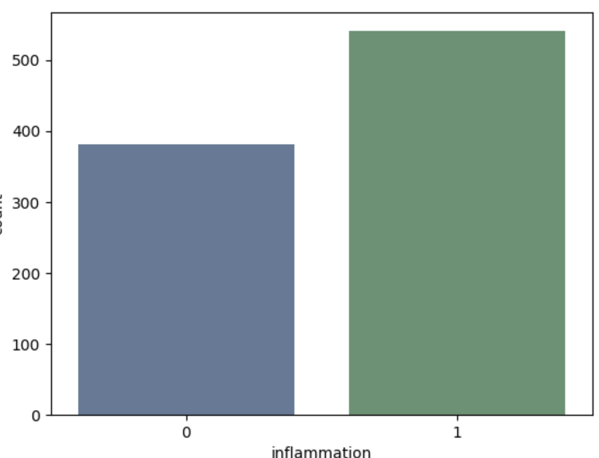
Figure 4.1: Inflammation Result
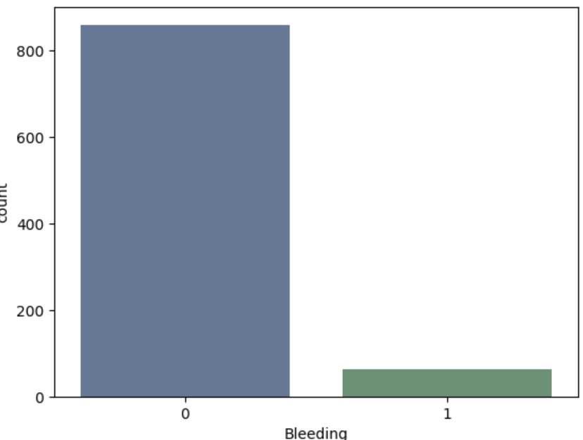
Figure 4.2: Bleeding Result
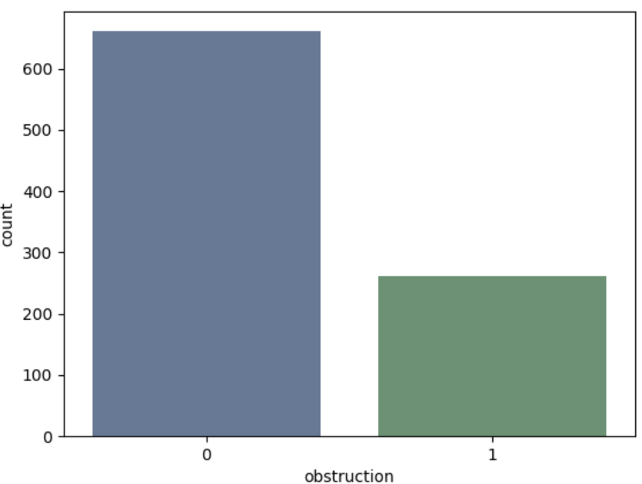
Figure 4.3: Obstruction Result
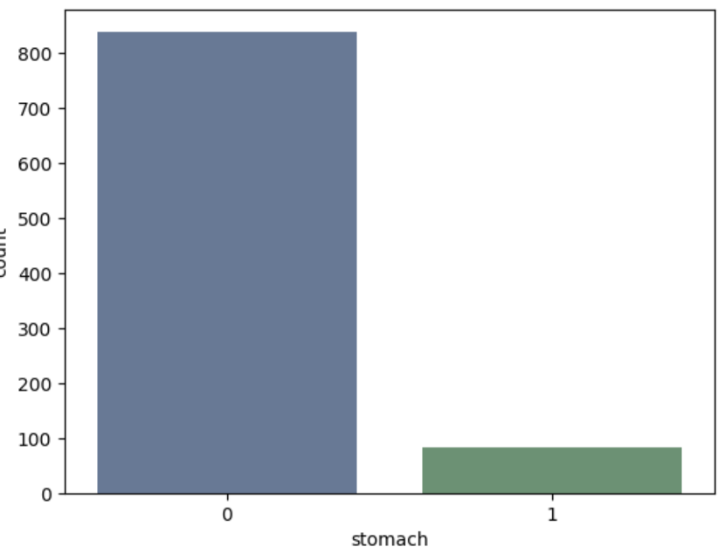
Figure 4.4: Stomach Result
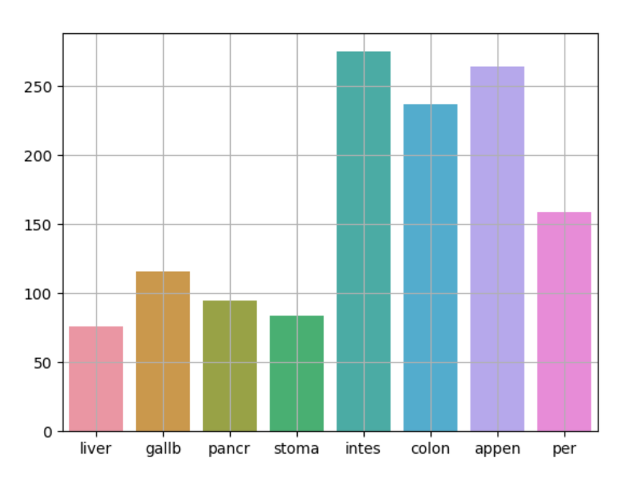
Figure 4.5: Body Part Negative Result
4.1.2 INPUT DESIGN
This aspect entails the description of the expected data input that will provide our output as described above. This section list out all the input required for the implementation of Career Guidance System. Data entry is done through the keyboard and mouse selection where required. The sample input interfaces are as shown below:
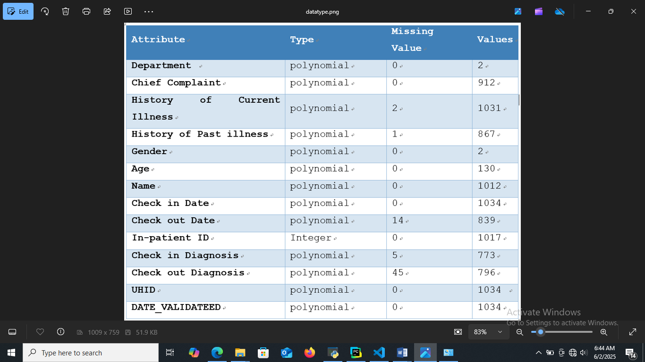
Figure 4.6: Data-Type

    - DATABASE DESIGN
Table 4.1: SYMPTON EXCEL
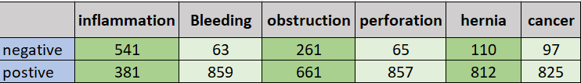

4.1.4 PROCEDURE DESIGN
The administrator can perform the following
- Generate Clinical Decision Support System
- Detect Clinical Decision Support System
4.2 IMPLEMENTATION OF THE SYSTEM
4.2.1 CHOICE OF PROGRAMMING LANGUAGE
In determining a suitable programming language for the design of the online patient management system, the factors to be considered are:-
- The difficulty of the problem
- The technical skills required of the computer program
- The type of processing required
- The availability of sub-programming facilities
- The efficiency of the language translator
- Ease of maintaining and updating the program
- Hardware and software requirement
For the project work, the programming language to be used for the design of the system is PHP and MYSQL for database management system with embedded Structured Query Language (SQL) for database manipulation
4.2.2 HARDWARE SUPPORT
The hardware requirements for this program are:
- PC: The computer should be minimum of Pentium IV with 1000GHs processor speed but preferably Dua Core Processor for greater efficiency
- Memory: This system requires a Higher RAM not less than 512MG, 1GB RAM is recommended.
- Storage: the storage capacity must be 80GB and above.
- VDU: Visual Display Unit required should be a very high resolution not less than 1024 x 768 with 256 colour capability.
- Printer: This system also requires a printer
- Input: The input device required is a mouse, Optical Mouse should be provides for easy use.
4.2.3 SOFTWARE REQUIREMENTS
The software requirements for the operation of this program are as follows:
- Window Operating System
- XAMPP or WampServer (for Apache server on localhost)
- Web Browser e.gMozila Firefox
- Macromedia dreamweaver

4.2.4 CHANGE OVER TECHNIQUE
The method used in the implementation of the proposed system is parallel, simply because parallel system supports the use of the existing system together with the proposed system and when there system failure information will not be totally lost and will not be back to square one for the users.
4.3 DOCUMENTATION OF THE SYSTEM
4.3.1 PROGRAM DOCUMENTATION
In order for the proposed system to be used on any computer system it takes the following ways
- Boot the system
- Copy the folder to www inside wamp folder of the drive C: after WAMP server is installed onto the system.
- Open any browser on the system (Microsoft internet Explorer, Mozilla Firefox, Netscape Navigator, Opera, Flock, Safari e.t.c)
- Type http://localhost/ clinicaldecisionsupportsystem/index.php on the address bar and press the return key or enter key.

4.3.2 OPERATING THE SYSTEM
This refers to the step by step method of using the proposed system. The proposed system comprises of. The steps to use the proposed system are as follows
- On the address bar of any browser type
- http://localhost/www.clinicaldecisionsupportsystem/index.php
- You are prompted to supply the username and password this verifies that you are a registered voter and has the privileged to vote.
4.3.3 MAINTAINING THE SYSTEM
- Data cable should be plugged properly
- Repair or replacement of all damaged accessories, system cards, peripheral e.t.c.
- prevention from dust
- Prevention of system from heat and moisture
- Prevention from static charges
- Examination of the new system from time to time to ensure it is performing as specified.
- Operators and users to the system must constantly check the output of the system to make sure that it is working accordingly.

CHAPTER FIVE
SUMMARY, CONCLUSION AND RECOMMENDATION
5.1 SUMMARY
In summary, there is a significant leap in healthcare technology, particularly within cancer management, driven by AI and expert systems. Its innovative approach excels in analyzing diverse data, offering personalized treatment insights, and augmenting diagnostic accuracy. The study successfully developed a user friendly and informative cancer detection in early support system, featuring structured and logically organized content for enhanced navigation and knowledge acquisition.
5.2 CONCLUSION
Health Information Technology (HIT) has significantly transformed cancer care by enhancing early detection, supporting personalized treatment plans, and safeguarding sensitive patient data. Key contributions of HIT to cancer care include the integration of Electronic Health Records (EHRs), which streamline patient data management and enable seamless access to clinical information, improving coordination between healthcare providers. The use of predictive analytics and AI-driven diagnostics has led to earlier detection of cancers, with more accurate predictions of disease progression and outcomes. Additionally, personalized medicine is now more feasible, thanks to the integration of genetic and molecular data into patient care, allowing for more targeted therapies based on individual patient profiles.

5.3 RECOMMENDATION
The future of cancer care will likely see a greater reliance on real-time data analytics and AI-driven treatment recommendations, improving the precision of cancer therapies and facilitating earlier interventions. These advancements will drive more effective, data-driven, and patient-centered care, paving the way for global collaborations that can tackle cancer more efficiently.
REFERENCES
Anchala R, Kannuri NK, Pant H, (2021) Hypertension in India: a systematic review and meta-analysis of prevalence, awareness, and control of hypertension.
Andersen MR, Storm HH. (2022) Cancer registration, public health and the reform of the European data protection framework: abandoning or improving European public health research? Eur J Cancer.
Bedard N, Pierce M, El-Naggar A, Anandasabapathy S, Gillenwater A, Richards-Kortum R. (2020) Emerging Roles for Multimodal Optical Imaging in Early Cancer Detection: A Global Challenge. Technol Cancer Res Treat. 9(2):211–7.
Cowie MR, Blomster JI, Curtis LH, Duclaux S, Ford I, Fritz F, et al. (2021) Electronic health records to facilitate clinical research. Clin Res Cardiol.
Dar RA, Rasool M, Assad A. (2022) Breast cancer detection using deep learning: Datasets, methods, and challenges ahead. Comput Biol Med. 2022;149:106073.
El-Kareh R, Hasan O, Schiff GD. (2023) Use of health information technology to reduce diagnostic errors. BMJ Qual Saf. 2013 Oct 1;22(Suppl 2):ii40–51.
Gamage DG, Riddell MA, Joshi R, (2022) Effectiveness of a scalable group-based education and monitoring program, delivered by health workers, to improve control of hypertension in rural India: a cluster randomised controlled trial.
Goldstein BA, Navar AM, Pencina MJ, Ioannidis JP. (2021) Opportunities and challenges in developing risk prediction models with electronic health records data: a systematic review. J Am Med Inform Assoc JAMIA.24(1):198. (Goldstein et al., 2021; Sittig et al., 2022; Cowie et al., 2021)
Guo R, Lu G, Qin B, Fei B. (2020) Ultrasound imaging technologies for breast cancer detection and management: a review. Ultrasound Med Biol. 44(1):37–70.
Harvey MJ, Harvey MG. (2024) Privacy and security issues for mobile health platforms. J Assoc Inf Sci Technol.
Henkel, M. & Stieltjes, B. (2022) Structured data acquisition in oncology. Oncology. 98, 423–9 (2022).
Hoque MR, Rahman MS, Nipa NJ, (2020) Mobile health interventions in developing countries: a systematic review. Health Informatics J 2020;26:2792–810
Hunt DL, Haynes RB, Hanna SE, (2020) Effects of computerbased clinical decision support systems on physician performance and patient outcomes: a systematic review.
Hunter B, Hindocha S, Lee RW. (2022) The role of artificial intelligence in early cancer diagnosis. Cancers.;14(6):1524.
Karimi Forood AM. (2024)Mechanisms of telomere dysfunction in cancer from genomic instability to therapy: A review. Int J Sci Res Arch. 2024 Sep 17;13:806–14.
Lee JL, Rawl SM, Dickinson S, Teal E, Baker LB, Lyu C, (2020) Communication About Health Information Technology Use Between Patients and Providers. J Gen Intern Med. 2020 Sep;35(9):2614–20.
Miriovsky BJ, Shulman LN, Abernethy AP. (2022) Importance of Health Information Technology, Electronic Health Records, and Continuously Aggregating Data to Comparative Effectiveness Research and Learning Health Care. J Clin Oncol.
Naghavi M, Abajobir AA, Abbafati C, (2022) Global, regional, and national age-sex specific mortality for 264 causes of death, 1980–2022: a systematic analysis for the global burden of disease study.
Nardi EA, Lentz LK, Winckworth-Prejsnar K, Abernethy AP, Carlson RW. (2020) Emerging issues and opportunities in health information technology. J Natl Compr Canc Netw.
Painuli D, Bhardwaj S. (2022) Recent advancement in cancer diagnosis using machine learning and deep learning techniques: A comprehensive review. Comput Biol Med. 2022;146:105580.
Ritchie JB, Allen CG, Morrison H, Nichols M, Lauzon SD, Schiffman JD, (2020) Utilization of health information technology among cancer genetic counselors. Mol Genet Genomic Med. 2020 Aug;8(8):e1315.
Rogowski W. (2021) Genetic screening by DNA technology: a systematic review of health economic evidence. Int J Technol Assess Health Care.
Scott S, Abul-Husn N, Owusu Obeng A, Sanderson S, Gottesman O. (2024) Implementation and utilization of genetic testing in personalized medicine. Pharmacogenomics Pers Med.
Sittig DF, Sengstack P, Singh H. (2022) Guidelines for US hospitals and clinicians on assessment of electronic health record safety using SAFER guides. JAMA. 327(8):719–20.
Suwanvecho, S. et al. (2021) Comparison of an oncology clinical decision-support system’s recommendations with actual treatment decisions. J. Am. Med. Inform. Assoc. 28, 832–8 (2021)
Tarver WL, Menachemi N. (2021) The impact of health information technology on cancer care across the continuum: a systematic review and meta-analysis. J Am Med Inform Assoc. 2016 Mar 1;23(2):420–7.
Thapa C, Camtepe S. (2021) Precision health data: Requirements, challenges and existing techniques for data security and privacy. Comput Biol Med. 2021;129:104130.
Vyas A, Abimannan S, Hwang R. (2024) Sensitive Healthcare Data: Privacy and Security Issues and Proposed Solutions.

