
THE CRITICAL EVALUATION OF THE COOKING POWER EFFICIENCY OF STANDING SOLAR
BY
ABDULSALAM, RAHMOT OPEYEMI
ND/23/SLT/PT/0512

A RESEARCH PROJECT SUBMITTED TO THE DEPARTMENT OF SCIENCE LABORATORY TECHNOLOGY, (SLT) INSTITUTE OF
APPLIED SCIENCE (IAS) KWARA STATE POLYTECHNIC, ILORIN

IN PARTIAL FULFILMENT FOR THE EQUIREMENT FOR AWARD
OF NATIONAL DIPLOMA (ND) IN SCIENCE LABORATORY TECHNOLOGY (SLT) Supervised by:
DR. OLAORE K.O

JULY, 2025

CERTIFICATION
This is to certify that this project work has been read and approved as meeting the requirement for the award of the National Diploma (ND) in the Department Science Laboratory Technology, Institute of Applied Science (I.A.S). Kwara State Polytechnic, Ilorin.

DR. OLAORE K.O DATE
Project Supervisor

MR. SHITTU S.A DATE
Co-ordinator

DR. USMAN ABDULKAREEM DATE Head of Department (H.O.D)

__________________________ ________________
EXTERNAL SUPERVISOR DATE

DEDICATION
This research work is dedicated to Almighty God for his infinite blessing and mercies upon me. It is also dedicated to my dear parent for their support, generally spiritually, morally and physically since the beginning of my life till the present moment and forever.

ACKNOWLEDGEMENT
We give thanks to Almighty God for He is good and His mercies endure forever. Our special appreciation goes to our parents, siblings, guardians and friends. Our special appreciation also goes to our project supervisor in person of DR. K.O. OLAORE who have been there for us before and during our project work, thanks for being our father during this journey. We sincerely appreciate you sir, Our prayer for you is that God should grant you more understanding and success in all your endeavor, and for your children, May God's favor locate them wherever they go in life. We as well celebrate and give kudos to all our amazing and brilliant lecturers as well as the technologist of the department of science laboratory technology (Physics/Electronics Unit). God bless you all (AMEN).

TABLE OF CONTENT

Content Page
Title page ................................................................................................... i
CERTIFICATION 1
DEDICATION 3
ACKNOWLEDGEMENT 4
TABLE OF CONTENT 5

CHAPTER ONE:
1.0 Introduction ............................................................................................ 1
1.1 Background of the study .......................................................................... 1
1.2 Statement of the problem ......................................................................... 2
1.3 Justification of the work ........................................................................... 3 1.4 Aim and objectives ................................................................................. 4
2.1 Literature Review................................................................................... 5
2.2 Classification of solar cookers ............................................................. 12
2.3 Working principle of solar box cooker ................................................. 16 CHAPTER THREE: METHODOLOGY
3.1 Study site ............................................................................................ 18
3.2 Material for construction ......................................................................18
3.2.1 Box frame ........................................................................................18
3.2.2 Inner box .......................................................................................... 19
3.2.3 Reflecting mirror..............................................................................19
3.2.4 Glass lid .......................................................................................... 20
3.2.5 Absorber/pot coating ...................................................................... 20
3.2.6 Insulating material ......................................................................... 20
3.3 Experimental equipment ................................................................... 21
3.4 Test procedure...................................................................................24

3.4.1 Cooking power.............................................................................. 26 3.4.2 Overall thermal efficiency ............................................................. 27

CHAPTER FOUR: RESULT AND DISCUSSION ............................ 29

CHAPTER FIVE: CONCLUSION ..................................................... 33 RECOMMENDATIONS .....................................................................34

REFRENCES ...................................................................................... 35

APPENDIX I ...................................................................................... 38

APPENDIX II.....................................................................................40
ABSTRACT

Biomass and fossil fuel are mostly used in the rural areas of the developing countries for cooking. These energy resources have negative impacts on environment and human health mainly due to deforestation and greenhouse emission. Nigeria is having problem of epileptic supply of electricity which has caused different economic challenges to the populace. The aim of this project is to test and determine the thermal efficiency of the constructed standing solar box cooker which was designed using locally available material. The test was carried out on the 23rd of April, 2023 at Kwara State Polytechnics using 140gram of spaghetti with 0.5kg of water under average solar radiation of 912w/m². It was shown in the result that the maximum absorber plate temperature was 80.5°c attained at 2:56pm having solar radiation of 1159.6w/m². The cooking time for the spaghetti was 1hour 15minutes using the constructed Standing Solar Box Cooker. Conclusively, Standing Solar Box Cooking is simple, safe and it is convenient to cook food without consuming fuel and
cooks at moderate temperature to help preserve the food nutrient.

CHAPTER ONE

INTRODUCTION

1.1 Background of Study

Solar energy is outstanding among other methods for reducing the utilization of non- renewable resources. Solar cooking is reckoned as a technically and commercially viable option for cooking, drying food, vegetables, and fish etc. especially in areas with abundant solar radiation. Solar cooking offers an effective method of utilizing solar energy for meeting a considerable demand of cooking energy and hence, protecting environments (Ishan, 2005).
Many solar cookers currently in use are relatively inexpensive, low-tech devices, although some are as expensive as traditional stoves, advanced and large-scale. Solar cooker uses no fuel and cost nothing to operate. Researchers are promoting their use worldwide in other to help reduce fuel costs, air pollution, and slow down the deforestation and desertification (Wikipedia.org).
Gathering firewood for coking is a form of outdoor cooking and is often used in a situation where minimal fuel consumption is important, or the danger of accidental
fire is high, health and environmental consequence of alternatives are severe(www.solarcooking.wikia.org).
Many types of solar cookers exist, including parabolic solar cookers, solar box cookers and panel solar cookers. The box type solar cooker, however, is still the preferred option for individual family needs, mainly because of its small size and simple handling and operational requirements. Depending on the latitude and weather, food can be cook either early or later in the day. A solar box cooker is smoke free unlike other forms of cookers which uses smoky cooking fires which result to eyes and lung disease among others. Solar box cooking system helps to reduce the demand for wood and prevent deforestation, saving fossil fuel and lowering utility bills (Ishan, 2005).
Fortunately, Nigeria is among the twenty-one countries with the highest potential for solar cooking. Nigeria lies within a high sunshine belt and thus, has an enormous solar energy potential (www.solarcooking.wikia.org).

1.2 Statement of the Problem

Prior to the emergence of renewable energy, fossil fuels constitute the primary energy resources that has been used to power human technological advancement, since the industrial revolution. But there are consequences, for instance, high volume of fossil fuel emission is harmful to public health and its environment. While the use of fire wood not only causes health damages, deforestation but loss of habitat for millions of species.
All the problems stated above can be reduced or eradicated by using the smokeless standing solar box cooker, which was constructed from cheap and locally materials.

1.3 Justification of the Work

With the high cost of cooking fuels in Nigeria and the epileptic supply of electricity, majority of Nigerians are left with no option but to use fire wood for cooking. The health and environmental hazards associated with this practice cannot be over emphasized. As such, standing solar box cooker would provide an alternative to reduce total dependence on fossil fuel, electricity and fire wood for cooking.

1.4 Aims and Objectives

The aim of this project is to design, construct and test solar box cooker that would be technically efficient, user friendly and cost effective to cook food for family of five.

The specific objectives of the work are:

- Select appropriate materials (bearing in mind cost, availability and durability) for the various parts of the standing solar box cooker. 
- Determine the performance evaluation of the standing solar box cooker by measuring the following parameter: 
  - The absorber plate temperature

  - The cooking fluid temperature

  - The cover pot temperature

  - The side of the cooking pot temperature

  - The air gap temperature

  - The solar radiation

- Determine the thermal efficiency of the standing solar box cooker 

CHAPTER TWO

LITERATURE REVIEW
A solar cooker is a device that cooks food using only solar radiation and can save conventional fuels to a significant amount. It is the simplest, safest, most convenient way to cook food without consuming fuels or heating up the kitchen. It however, supplements the cooking fuels but cannot replace it in total. In recent times, rigorous studies were carried out on the method of utilizing solar energy. Solar cooker like the standing solar box type and concentrator types have offered important tools for these studies. Efforts have been totally geared towards the design, development and testing of these devices across the globe. Out of these types of solar cooker, the standing solar box type which are simpler in terms of operation and fabrications, have so far been studied extensively within Nigeria, other West African countries and across the globe (www.solarcookers.org).

Nyi Nyi Soe et’al (2019), in their paper presented the design and construction of solar box cooker using locally available material while building the solar box cooker, the consideration of heat principles are heat gain, heat storage and heat loss. According to the testing of solar box cooker constructed, the average cooking time for eggs was about 1.5 hour, for rice about 2.25 hour and 4 hours for prawn. In their paper, it was concluded that standing solar box cooking is simple, safe, convenient to cook food without consuming fuel or heating up the kitchen, cook at moderate temperature and helps to preserve food nutrient.
Uhuegbu (2010), in his paper constructed a wooden solar box cooker successfully with cheap and locally available material having thermal efficiency of 96%. From his various experiments that were carried out, the highest temperature gotten both on the ground floor and at the top of the roof were 72 both on the days with air temperature of 38 and 35 respectively. In his result, the efficiency was found to increase with decreasing temperature difference between collector temperature and ambient temperature. He further stated that, the increase in temperature does not necessarily lead to increase in efficiency while its efficiency decreased with decreasing solar radiation.
Pryse, et.al (2019), in their paper designed and fabricated50cm X 50cm X 30cm solar box cooker. Their new design was an improvement for an existing solar box cooker. Their work focused on the improvement on increasing the solar collector area of the existing type from 0.52m2 to 0.9171m2. The improved solar box cooker was evaluated by conducting a no-load and a load test and also the solar cooking efficiency was calculated. The results of their test showed a progressive increase in solar cooking chamber harvested temperature and cooking capacity over a period of 60mins and 100mins during no load and load test conditions respectively. It was concluded that the solar box cooker constructed have a cooking efficiency of about
2.8%.
Ogunwole (2006), designed and constructed a solar box cooker, the solar cooker was made of casing and absorber. The absorber he used during construction was a square base pot, blackened with smoke, and it was made of stainless steel. The casing was made of two boxes to minimize heat loss and also used an aluminum foil as reflectors. His test involves cooking and it was observed that the rice took 1hour 45mins, beans took 2hours 30mins, and yam 1hour 30minutes. In his experimental result, an average temperature of 100 was obtained from the collector from an ambient temperature of 34.
Ishan et al, (2007) modeled a box type solar cooker employing a non tracking planar reflectors which was designed and fabricated for the purpose of cooking. Its thermal performance was investigated experimentally. In their result, the cooking power of the laboratory modeled box type solar cooker was found to be 20-25% higher than that of a conventional cooker in various pre-specified test conditions. It was also concluded in their paper that the solar cooker utilizing non-tracking reflectors provide increased heat collection and faster cooking, compared to the conventional box type solar cooker.
Rahul Aadiwal, et al, (2017) stated in their study that cooking is the major necessity for people all over the world. They also stated in their paper, that cooking accounts for a major share of energy consumption in developing countries. They further agreed that, solar cookers are commonly used in the domestic sector in most countries with abundant solar radiation. In their research, it was reported that according to Indian government survey, over 77% of rural households in the country were estimated to depend on firewood and chips for cooking. Also, over 7% used dung cake and only 9% used Liquid Petroleum Gas while in urban areas, Liquid Petroleum Gas was the primary source of energy in nearly 62% of households. It was also stated in their result that, replacing the traditional cooking methods by solar energy can be considered as an alternative for meeting the energy crisis and also the advantages of the use of solar cookers would result in the reduction of the release of CO2 in the environment.
Kimbabo (2007), in their work stated various parameters and affirm that results obtained from this study that under various conditions of insulation and wind, different types of solar cookers are superior to others. He further stated that, under best respective conditions, solar box cookers have lower performance compared to reflector cookers. He also reported that, the reflector cooker with glass reflector achieve the highest temperatures and accordingly shortest cooking time than any other cookers tested under sunny days with no cloud cover. He recommended that, it is the most suitable type of solar cooker in areas with long duration of high solar radiation with no cloud cover and low wind interference. He further affirms that, the reflector cooker with polished aluminum reflectors has significantly lower performance than that of the glass reflector under clear sky condition while the reflector cooker with unpolished aluminum reflector has the poorest performance of all solar cookers even the solar box cookers under clear sky condition. He therefore concluded that, the ordinary unpolished aluminum should therefore never be used as reflector for solar cookers. He further explained that, he discovered the solar box cooker was able to cook 2kg of rice which is sufficient for a moderate family in Tanzania. According to his result, it was discovered that many solar box cookers can be used to cook food for households in areas with medium and high isolation with appropriate selection of the type and specification of the cookers.
Mahaver et al. (2012), in their paper presented the design, development, thermal and cooking performance studies of a solar cooker; it was named as Single Family Solar Cooker (SFSC) which is small in size, convenient to design, inexpensive, lightweight hybrid insulation and specially designed lightweight polymeric glaze was considered the main features of the solar box cooker constructed. It was further stated that the thermal profiles of various components of SFSC on different days under different conditions was measured. During testing, it was recorded that the highest plate stagnation temperature under no-load condition approached 144 in which the two figures of merits F1 and F2 are found to be 0.116Cm2/W and 0.466, respectively, which were according to the Bureau of Indian Standards. It was also included in their paper that, cooking power regression curve is fairly linear with the regression coefficient R2 = 0.948 with initial cooking power 103.5W and the heat loss level 1.474 W/; place it in the region of small cooker with good insulation, as per International Standard. They further stated that, thermal and cooking performance of Single-Family Size cooker (which is small in size and has been fabricated by using new efficient materials for glaze, insulation and casing) were found to satisfy Bureau of Indian Standards and International Standard. They also calculated F1 and F2 values indicate that the cooker can be used for consecutive cooking on a sunny day. The values of the initial adjusted cooking power, heat loss coefficient and adjusted cooking power at a temperature difference of 50 were within the range of the parameters obtained by Funk (2000) for small size good insulation solar cookers. According to their results, the cooking of different items ascertains its good cooking performance for cooking requirement of two persons for two meals and the stagnation temperature achieved by Single Family Size Cooker was 144.
Grocery et al, (2010), in their paper designed and constructed a Heaven Flame solar box cooker capable of boiling 1.8litres of water under the air temperature of about 110 in the solar box cooker for 45minutes. During the test, they displayed the solar box cooker in the sun for 3 days to test the work ability as well as to test the effect of temperature from late hours of early morning up to late in the evening with the aid of inserted thermometers (0 - 360). The results from their test shows that the best time to cook with the solar box cooker is between the hours of 11:00 am to 4:00pm (Nigeria time) on sunny days, while the incorporation of heavy materials such as pieces of stones as heat storage materials inside the box cookers helps to maintain.

2.2 Classification of Solar Cookers

A solar cooker is a device which uses the energy of direct sunlight to heat, cook or pasteurize food or drink. Basically, there are 3 types of solar cookers, namely:
- Solar panel cookers:

- Solar parabolic cookers

- Solar box cookers

➢ Solar panel cookers may be considered the simplest type available due to their ease of construction and low-cost material. In solar panel cookers, sunlight is concentrated from above. Panel cookers have a flat panel which reflects and focuses sunlight for cooking and heating. This method of solar cooking is not very desirable since it provides a limited cooking power.

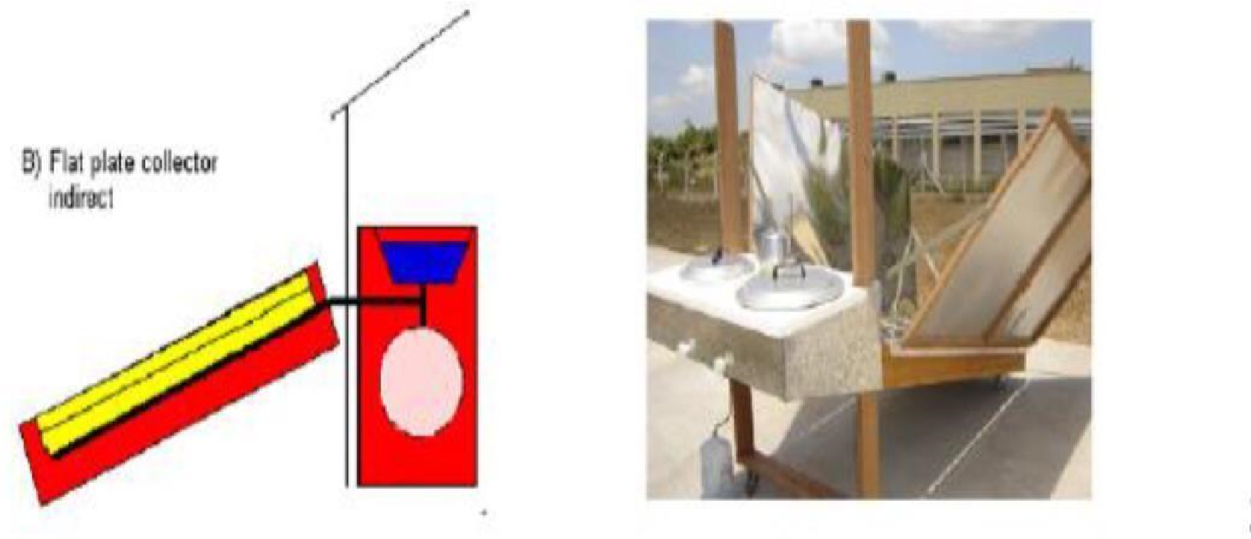

Fig 2.2.1 A Solar panel cooker

• Solar parabolic cookers can reach extremely high temperatures in a very short time and unlike the panel cookers or box cookers; they do not need a special cooking vessel. However, a parabolic cooker includes risk of burning the food if left unattended for any length of time because of the concentrated power. A solar parabolic cooker simply consists of a parabolic reflector with a cooking pot which is located on the focus point of the cooker and a stand to support the cooking system.

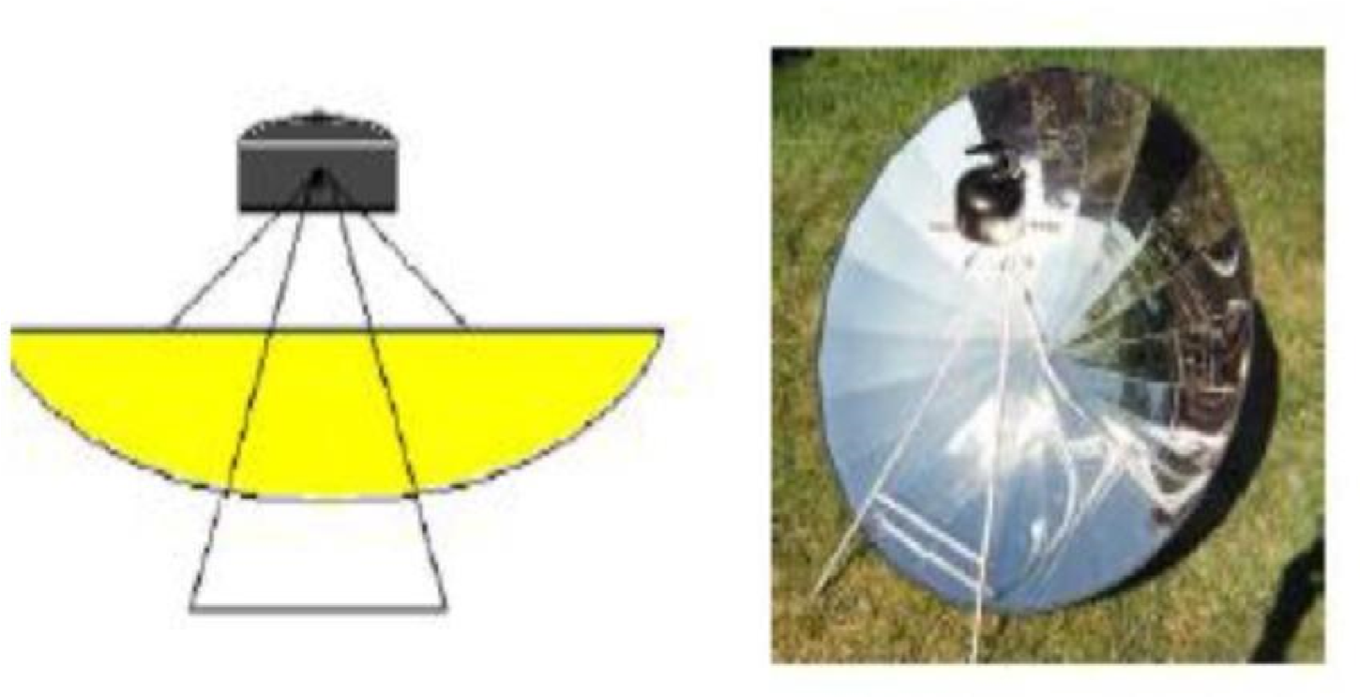

Fig 2.2.2 A Parabolic solar cooker

• A box type solar cooker is the most common and inexpensive type of solar cookers. These box cookers have a very simple construction and they are made of low-cost materials, which essentially consist of a black painted metallic trapezoidal tray (cooking tray) and is usually covered with a double glass window. It is kept in a metal or fibre-glass outer casing and the space between the cooking tray and outer casing is filled with the insulation like glass wool. The incoming solar radiation falls onto the double glass lid and passes through it to strike the blackened cooking pots and the cooking tray. The glass covers, while transmitting radiation of short wavelength which form major part of solar spectrum, is almost opaque to low temperature radiation emitted within the box. Thus, the temperature of the box rises until a balance is reached between the heat received through glazing and heat lost by exposed surface (greenhouse effect). In addition, a plane reflecting mirror (booster mirror) of about equal size as that the aperture area is used for augmentation of solar radiation on the aperture. The cooking tray is insulated on the sides and bottom. The heat is absorbed by the blackened surface and gets transferred to the food inside the pots to facilitate cooking.

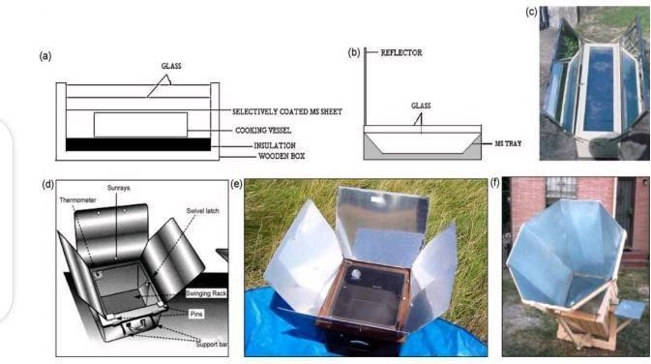

Fig 2.2.3 Box type solar cooker

2.3 Working principle of solar box cooker
- Concentrating sunlight: A mirrored surface with high specular reflection is used to concentrate light from the Sun into a small cooking area. Depending
on the geometry of the surface, sunlight could be concentrated by several

orders of magnitude producing temperatures high enough to melt salt and metal. Such high temperatures are not really required for most household solar cooking applications. Solar cooking products are typically designed to achieve temperatures of 65 °C (150 °F) (baking temperatures) to 400 °C (750 °F) (grilling/searing temperatures) on a sunny day.
- Converting light energy to heat energy: Solar cookers concentrate sunlight onto a receiver such as a cooking pan. The interaction between the light energy and the receiver material converts light to heat and this is called conduction. The conversion is maximized by using materials that conduct and retain heat. Pots and pans used on solar cookers should be matte black in color to maximize absorption.
- Trapping heat energy: It is important to reduce convection by isolating the air inside the cooker from the air outside the cooker. Simply using a glass lid on your pot enhances light absorption from the top of the pan and provides a greenhouse effect that improves heat retention and minimizes convection loss. This "glazing" transmits incoming visible sunlight but is opaque to escaping infrared thermal radiation. In resource constrained settings, a high- temperature plastic bag can serve a similar function, trapping air inside and making it possible to reach temperatures on cold and windy days similar to those possible on hot days (en.m.Wikipedia.org).

CHAPTER THREE

METHODOLOGY

3.1 Study site

The thermal efficiency of the constructed standing solar box cooker was experimented on the 23rd of April, 2023, in Kwara State Polytechnic, Ilorin, Kwara State, Nigeria.

3.2 Materials for Construction

In order to construct an effective standing solar box cooker, the choice of the material was given several thoughts. The materials are structurally sound, able to withstand high temperature, safe, and effective with regard to capture solar energy and retain the heat. The construction of standing solar box is described by the box frame, inner box, cooking pot, Insulation material, glass lid, reflector, rubber lining, hinges and handles.

3.2.1 Box frame

Plywood was used as the box frame because it is very cheap and locally available. It is an opaque substance and does not allow light to pass through it. It contains a natural polymer based on the cellulose molecules. It is firm on the ground and can withstand a moderate wind speed(vikaspedia.in).

3.2.2 Inner box

A flat metal plate was used as the inner box and also act as the absorber. The inner part of the box is painted black to absorb the heat and trap the heat needed for cooking. A black surface is a good emitter and absorber of radiation. A black surface absorbs all the radiation that falls on it, but reflects, and transmits none. The radiation that was refracted by the glass is absorbed by the black metal plate and converted to heat for cooking (vikaspedia.in).

3.2.3 Reflecting Mirror

Mirror is used in the standing solar box cooker to increase the radiation input on the absorbing space and is fixed on the inner side of the main cover of the box. Sunlight falling on the mirror gets reflected from it and enters into the tray through the double glass lid. This radiation is in addition to the radiation entering the box directly and helps to quicken the cooking process by raising the inside temperature of the cooker(vikaspedia.in).

3.2.4 Glass lid

A double plane glass was use as cover for the inner box. This cover is slightly larger than the inner box. The two glass sheets are fixed in a wood frame with a spacing of few centimeters between the two glasses. This space contains air which insulates and prevents heat escaping from inside. A rubber strip is affixed on the edges of the frame to prevent any heat leakage. (vikaspedia.in).

3.2.5 Absorber/pot coating

Black paint was selected for the absorber/pot coating. It was selected over other color coatings because of its higher absorptivity at angles other than normal incidence, adherence and durability when exposed to weathering, sunlight and high temperatures, cost effectiveness, and protection to the absorber material (vikaspedia.in).

3.2.6 Insulating material

The space between the outer box and inner box including bottom of the inner box is packed with insulating material such as wool pads to reduce heat losses from the cooker. This insulating material is free from volatile materials, has the capacity of retaining heat for a long period of time and prevent the heat from escaping the cooking system (vikaspedia.in).

3.3 Experimental Equipment

• Weighing balance: It is use to determine the weight or mass of the food substance use as test load. They are available in a wide range of sizes with multiple weighing capacities. it has high accurate large capacity of 5000g x 
0.1g, weighing modes of g/oz/ct/tl with product dimensions of 228(L)x160(W)x42(H)mm. It is white in color and has high-precision
straining resistance sensor. It is also a standard weight auto calibration and it has Auto off after 180 seconds of inactivity (konga.com).

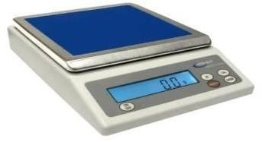

Fig. 3.3.1 Weighing Balance

• Pyranometer: it is an instrument used for measuring the solar irradiance. It converts the heat to an electrical signal that can be recorded. It is positioned toward the direction of the sun for accurate recordings. The SI units of irradiance are watts per square meter (W/m²). Traditionally pyranometer were mainly used for climatologically research and weather monitoring purposes, however in this project, it is used for measuring the solar radiation available during the experiment (Wikipedia.org). 

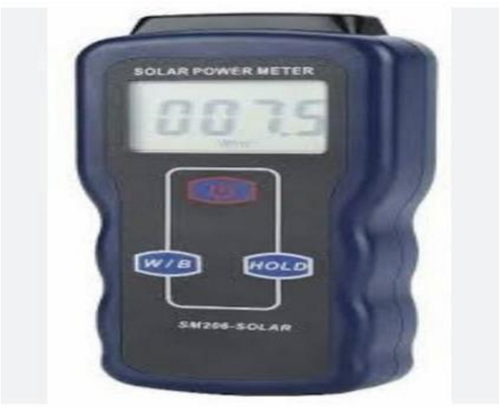

Fig 3.3.2 Pyranometer

• Thermocouple: it is a thermoelectric device used to accurately measure temperature. It consists of a wire with two leads of dissimilar metals that are joined at one end. Heating the joint produces an electric current which is converted to a temperature reading with a TC monitor. 
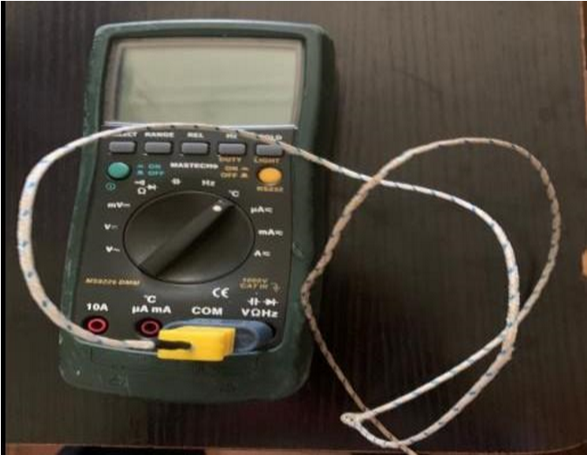

Fig 3.3.3 A Thermocouple

• Cooking pot: it is used for cooking and boiling of food substances. They are either made from stainless steel, Aluminum, cast iron, ceramics or glass. Aluminum cooking pot was chosen for the project. The aluminum cooking 
pot was painted black from outside, in order to absorb and retain the heat for a longer period of time during cooking.

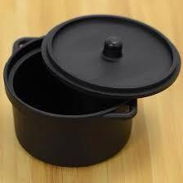

Fig. 3.3.4 cooking pot

• Measuring Tape: it is a flexible tool for measuring length, width and breadth of an object. It is made up of materials like, fiberglass, plastic, metal ribbon or strip. It is marked in centimeters and inches. Tape measures are often designed for specific uses or trades. Tapes may have different scales, be made of different materials, and be of different lengths depending on the intended use. 

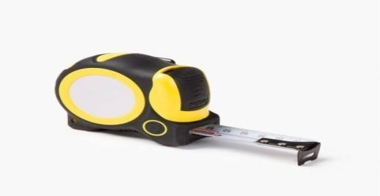

Fig. 3.3.5 Measuring Tape

3.4 Test Procedure

- The thermal efficiency test for the constructed standing solar box cooker started at 2:41pm on the 23rd of April, 2023.
- A weighing balance was used to measure the desired quantity of 140gram of spaghetti.
- The weighing balance was also used to weigh the quantity of water which will be enough to cook the weighed spaghetti of 140gram (0.5kg of water was measured).
- A thermocouple was used to measure the initial temperature of water and it was recorded to be 28.9.
- Then, the constructed solar box cooker was brought out from Physics Laboratory B of Kwara State Polytechnic to an open space behind the laboratory.
- The constructed standing solar box cooker reflector was positioned facing the
East (direction of the sun).
- A clean aluminum cooking pot painted black was then placed inside the cooking system (on top of the absorber plate).
- The weighed 0.5kg of water having initial temperature of 28.9℃ is then poured into the aluminum cooking pot and was covered
- Thermocouple was used to measure the initial temperature of ambient temperature, absorber plate temperature, cooking pot temperature, cover pot temperature, cooking fluid temperature respectively and was recorded.
- A pyranometer was also used to take the solar radiation available and was recorded.
- The stopwatch was set at 15minutes to take the reading for each parameter during the thermal test of the constructed standing solar box cooker.
- The water in the cooking pot was continued to be heated until it shows bubbles at about 69.3, the weighed spaghetti of 140gram was then poured into the boiling water and was covered.
- The readings were continued to be taken at 15minutes interval for the absorber plate temperature, cooking pot temperature, coking fluid temperature, cover pot temperature and the ambient temperature were recorded respectively using the thermocouple till it is done cooking.
- Also, pyranometer was used to take readings for solar radiation available during the thermal test and was also recorded at 15minutes interval till the cooking substance is done cooking.

3.4.1 Cooking power
The cooking power, P, is defined as the rate of useful energy available during heating period. It is measured in watt. The cooking power of the constructed standing solar box cooker was calculated using the equation given by Kundapur and Sudhir (2009) as follows:
P = M_{w} C_{w} ( T_{f} - T_{i} ) t

Where,
P = Cooking power (w)
T_{f} = Initial water temperature ( ℃ )
T_{i} = Final water temperature ()
M_{w} = Mass of water (kg)
C_{w} = Water heat capacity (4182J/kgk)

P 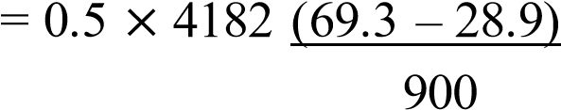
P = 93.86W

3.4.2 Standardized Cooking Power

To determine the standardized cooking power, P_{s} from the cooking power, each power is corrected to a standard radiation of 700W/m²
P_{s} 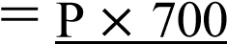
I_{s}
Where P_{s} ₌ standard cooking power (W), P is interval cooking power (W), I_{s} is interval average solar radiation (W/m²).
P_{s} 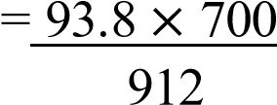

P_{s} = 71.99W

3.4.3 Overall Thermal Efficiency

The overall thermal efficiency was calculated by using the following equation given by El-Sebaii and Ibrahim (2005): ŋ = M_{f} C_{f} T_{f}
I_{av} A_{c} T Where,
ŋ = Overall thermal efficiency M_{f} = Mass of cooking fluid (kg)
C_{f} ₌ Specific heat of cooking fluid (j/kg)
T_{f} = Difference between the temperature
Iav= Average solar intensity (W/m²) during the time interval
A_{c} = Aperture area (m²) of the cooker
T = Time required to achieve maximum temperature of the cooking fluid (s)

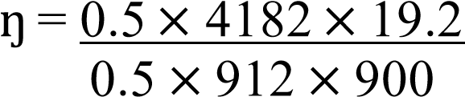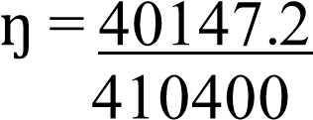

ŋ = 9.87%

CHAPTER FOUR

RESULT AND DISCUSSION
The experiment took place on the 23rd of April, 2023, in an open space behind physics laboratory A, at Kwara state Polytechnic Ilorin. The experiment began at
2:41pm and ends at 3:56pm during sunset. w/m² to 780.5 w/m².

CHAPTER FIVE

CONCLUSION
Generally, standing solar box cooker is simple to design with locally available material and they are safe in operation. The standing box type solar cooking is still preferred option because it can be used without any technical know-how, user friendly, safe and retain food nutrients. Solar cooking does not require fuel or electricity but uses solar energy for cooking. Depending on the weather, cooking is done at any time of the day. The cooking time for the 140gram of spaghetti was 1hour 15minutes under available solar radiation varying between 692.1 W/m² to 1159.6 W/m² on that day. The efficiency was found satisfactory in which result to the fact that the standing solar box cooker can be used to cook varieties of food under abundant solar radiation. Therefore, the use of this technology for cooking purpose in rural areas will reduce deforestation and total dependence on fossil fuels in urban areas as solar energy is readily available, free and environmentally friendly for cooking purpose.

RECOMMENDATIONS

- In this era of high cost of fuel and erratic supply of electricity, even the commonly used cooking stoves have caused disappointment at a certain time when in used. Therefore, we recommended the introduction of standing solar box cooker to the rural area and poor urban dwellers will greatly reduce deforestation, pollution, health problems associated with the use of fire wood and also over dependence on fossil fuel for cooking.
- We recommended that the Federal Government should invest into the renewable solar energy sector and also fund the agency in charge.
- We recommended that an alternative construction material should be explore with the view of reducing the size and weight of the standing solar box cooker for easy handling and transportation.

REFRENCES

Kimambo C Z M (2007), “Development and performance testing of solar cookers”, Journal of Energy in Southern Africa, vol.8 pp.41- 51.

Gregoery A, Alozie I.M, Mejeha, Oluwasogo A, Ogungbenro G.I, Nwandikom and Chidi Akujor, (2010). “Design and construction of a solar box cooker as an alternative in Nigerian kitchens”. Department. of Physics, Federal University of Oweri, Imo State Nigeria. Vol 6 No 9 – May 2010 (57-62). ISESCO.

Ishan Purohite, (2005). “Design and testing of a box type solar cooker employing non-tracking reflectors”. Department of Applied and Sciences and Humanities, G.B Pant Engineering College, Uttaranchal-246001, Indian.

Ishan P., PallavP., and Negi B. (2007). “Instrumentation error analysis of a box type solar box cooker, energy conversion and management”, 50(2), 365-375. Retrieved June 2012.

Mahavar S., Sengar N., Rajawat P., Verma M., and Dashora P., (2012). “Design and performance studies of a novel single-family solar cooker”. Renewable energy 47, 67-76. Retrieved December 19, 2013 from www.elsevier.com/locate/renenew.
Nyi Nyi Soe, Aung Ko Win, Naw Kay Thida Min, (2019) “Design and Construction of Solar Box System”, Department of Mechanical Engineering, Technological University, hpa-An, Myanmar, Jul 2019| IRE Journals| Volume 3 Issue 1 | ISSN: 2456-8880

Ogunwole O.A (2006). “Flat plate collector solar cooker”. Department of mechanical engineering”, Federal University of Technology Minna, Niger State, Nigeria.

Opiriari Pryse Princewill, Sunday Innocent (2019), “Improvement of an existing solar box cooker in Rivers State”, Department of Agricultural and Environmental Engineering, Rivers State University, vol.7 No. 4, 2019 ISSN 2056-5860.

Rahul Aadiwal, Manish Hassani, Pradeep Kumar, (2017). “An overview study of solar cooker. Junior Engineering Rajasthan State, Road Transport Corporation, Rajasthan Indian. Vol 4 issue 10. ISSN-2395-0056. IRJET.

Uhuegbu, Chid. C, “Design and construction of a wooden solar box cooker with

performance and test efficiency”, Department of physics, J. Basic.Appl.Sci.Res., 1(7)533-538,2011, ISSN 2090-424X.

APPENDIX I

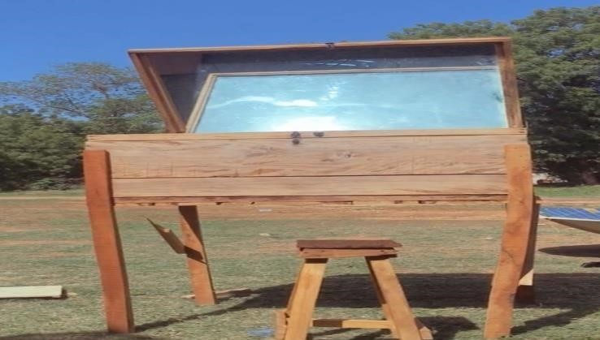

Fig 1. The Constructed Standing Solar Box Cooker Reflector positioned facing the
direction of the sun (East).

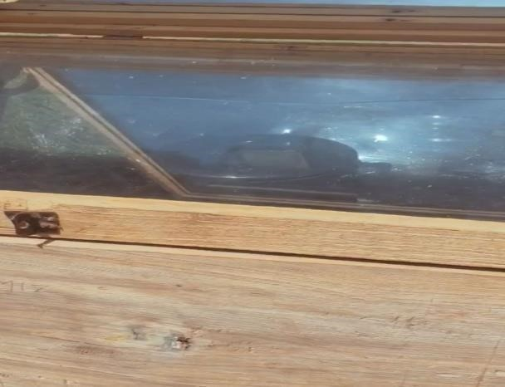

Fig 2. Black Aluminum Cooking pot inside the inner box.

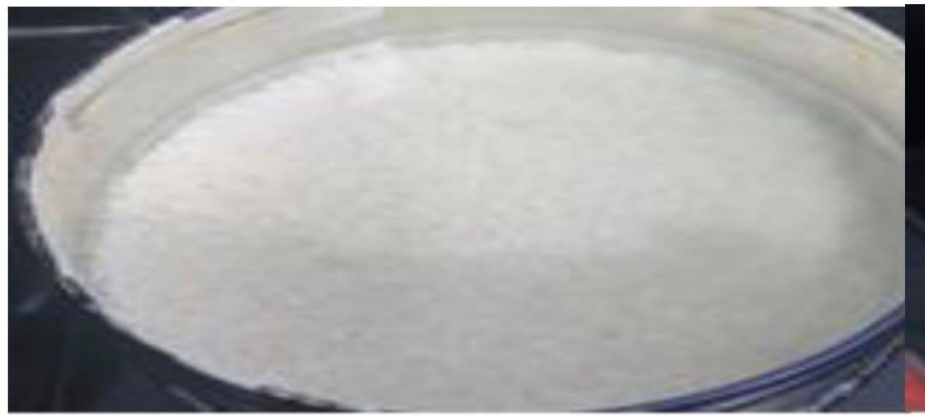

Fig 3. Boiling water

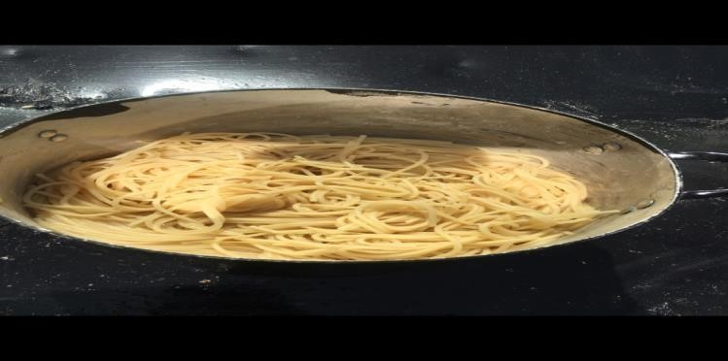

Fig 4. Cooked spaghetti

