DESIGN AND IMPLEMENTATION OF REAL TIME OBJECT DETECTION USING TENSOR FLOW

BY
ABIODUN SAMMUEL ABBEY
ND/23/COM/PT/0262

A Project Submitted to the Department of Computer Science, Institute of Information and Communication Technology, Kwara State Polytechnic, Ilorin

In Partial Fulfillment of the Requirements for the Award of National Diploma (ND) in Computer Science

July, 2025
CERTIFICATION
This is to certify that this project research was carried out by ABIODUN, Samuel Abbey with Matriculation Number ND/23/COM/PT/0262 has been read and approved as meeting part of the requirements for the award of National Diploma (ND) in Computer Science.

………………………………. ……………………………….
MRS. AJADI O.C Date
Project Supervisor

………………………………. ……………………………….
MR. OYEDEPO, F. S. Date
Head of Department

………………………………. ……………………………….
External Examiner Date

DEDICATION
This project is dedicated to the creator of the earth and universe, the Almighty God. It is also dedicated to my parents for their moral and financial support.

ACKNOWLEDGEMENT
All praise is due to the Almighty God the Lord of the universe. I praise Him and thank Him for giving me the strength and knowledge to complete my HND programme and also for my continue existence on the earth.
I appreciate the utmost effort of my supervisor, MRS AJADI., whose patience support and encouragement have been the driving force behind the success of this research work. She gave useful corrections, constructive criticisms, comments, recommendations, advice and always ensures that an excellent research is done. My sincere gratitude goes to the Head of the Department and other members of staff of the Department of Computer Science, Kwara State Polytechnic, Ilorin, for their constant cooperation, constructive criticisms and encouragements throughout the programme.
Special gratitude to my parents who exhibited immeasurable financial, patience, support, prayers and understanding during the periods in which I was busy tirelessly in my studies. Special thanks go to all my lovely siblings.
My sincere appreciation goes to my friends and classmates.

TABLE OF CONTENTS
Title Page i
Certification ii
Dedication iii
Acknowledgements iv
Abstract v
Table of Contents vi
CHAPTER ONE: GENERAL INTRODUCTION
  - Background to the Study 1
  - Statement of the Problem 3
  - Aim and Objectives of the Study 4
  - Significance of the Study 4
  - Scope of the Study 5
  - Organization of the Report 5
CHAPTER TWO: LITERATURE REVIEW
2.1 Review of Related Works 6
2.2 Review of Related Concepts 10
CHAPTER THREE: RESEARCH METHODOLOGY AND ANALYSIS OF THE EXISTING SYSTEM
  - Research Methodology 15
  - Analysis of the Existing System 17
  - Problems of the Existing System 17
  - Description of the Proposed System 18
  - Advantages of the proposed system 29
CHAPTER FOUR: DESIGN, IMPLEMENTATION AND DOCUMENTATION OF THE SYSTEM
  - Design of the System 21
    - Output Design 21
    - Input Design 25
    - Procedure Design 27
  - Implementation of the System 28
    - Hardware Support 28
  - Documentation of the System 29
    - Maintaining the System 29
CHAPTER FIVE: SUMMARY, CONCLUSION AND RECOMMENDATION
  - Summary 30
  - Conclusion 30
  - Recommendation 31
References 32
Appendices

ABSTRACT
This project focuses on the design and implementation of real-time object detection using TensorFlow, a widely-used machine learning framework. Object detection is a crucial task in computer vision with applications ranging from autonomous vehicles to surveillance systems. TensorFlow offers efficient tools for building and deploying object detection models, making it an ideal choice for real-time applications. This project aims to develop a robust object detection system capable of identifying objects in real-time video streams. The study investigates various techniques within TensorFlow for object detection and evaluates their performance. The significance lies in enhancing the capabilities of computer vision systems for real-world applications. The system will be developed in python using Yolo tensor flow.
CHAPTER ONE
GENERAL INTRODUCTION
  - BACKGROUND TO THE STUDY
In recent years, advances in machine learning and computer vision have revolutionized various fields, including surveillance, autonomous navigation, and robotics. Object detection, a fundamental task in computer vision, involves identifying and localizing objects within images or video frames. Real-time object detection is particularly challenging due to the need for high-speed processing and accuracy. TensorFlow, an open-source machine learning framework developed by Google, provides powerful tools for building and deploying object detection models (Wahab et al., 2020).
The field of computer vision has witnessed remarkable progress in recent years, driven by advancements in deep learning and convolutional neural networks (CNNs). CNN-based approaches have demonstrated unprecedented performance in various computer vision tasks, including image classification, object detection, semantic segmentation, and instance segmentation. Object detection, in particular, plays a pivotal role in numerous applications where the ability to identify and locate objects within images or video streams is essential for decision-making and automation (Osman et al., 2020).
Baldota et al., (2021) asserted that, real-time object detection presents unique challenges due to the need for fast and accurate processing of streaming data. Traditional object detection methods, such as sliding window-based approaches and handcrafted feature extraction followed by classification, often lack the speed and scalability required for real-time applications. With the advent of deep learning, end-to-end trainable object detection models have emerged, offering superior performance in terms of both accuracy and speed. These models leverage deep neural networks to learn hierarchical representations of visual features directly from data, eliminating the need for manual feature engineering.
TensorFlow, as one of the leading deep learning frameworks, provides a comprehensive ecosystem for building and deploying object detection models. TensorFlow's high-level APIs, such as TensorFlow Object Detection API and TensorFlow Lite, streamline the development process by offering pre-implemented architectures, training pipelines, and optimization tools tailored for object detection tasks. Moreover, TensorFlow's compatibility with hardware accelerators, such as GPUs and TPUs, enables efficient inference and real-time processing of object detection models on various platforms (Kashyap, 2023).
The proliferation of real-time object detection applications across industries underscores the importance of research and development in this area. From autonomous vehicles navigating complex environments to smart surveillance systems monitoring public spaces, the ability to accurately detect and track objects in real-time is critical for ensuring safety, efficiency, and security. Furthermore, real-time object detection has implications for human-computer interaction, augmented reality, and immersive experiences, where the seamless integration of virtual and physical environments relies on robust object recognition capabilities (Aralikatti et al., 2020).
Despite the progress made in real-time object detection, several challenges persist, particularly in resource-constrained environments and complex scenes with occlusions, clutter, and varying lighting conditions. Addressing these challenges requires a multidisciplinary approach, combining expertise in machine learning, computer vision, optimization, and hardware acceleration. By leveraging TensorFlow's versatility and scalability, this research aims to contribute to the development of more robust and efficient solutions for real-time object detection, paving the way for advancements in autonomous systems, intelligent surveillance, and human-centered computing (Martinez-Alpiste et al., 2022).
This project endeavors to harness the power of TensorFlow for designing and implementing a real-time object detection system capable of meeting the demands of modern applications. By exploring state-of-the-art techniques, leveraging TensorFlow's capabilities, and evaluating the performance of the developed system, this research seeks to push the boundaries of real-time object detection and address the challenges inherent in deploying such systems in dynamic and resource-constrained environments.
  - STATEMENT OF THE PROBLEMS
The rapid proliferation of surveillance cameras, autonomous vehicles, and smart sensors has increased the demand for real-time object detection systems. However, existing solutions often face challenges such as high computational complexity, limited scalability, and suboptimal performance in real-world scenarios. Therefore, there is a need to develop robust and efficient object detection algorithms capable of operating in real-time while maintaining high accuracy and scalability. This project addresses these challenges by leveraging TensorFlow's capabilities to design and implement a real-time object detection system.
1.3 AIM AND OBJECTIVES OF THE STUDY
The aim of this project is to design and implement a real-time object detection system using TensorFlow. The objectives are to:
- design and train object detection models using TensorFlow;
- implement a real-time inference pipelines for object detection;
- evaluate the performance of the developed system in terms of speed and accuracy; and
- analyze the scalability and efficiency of the system for deployment in various applications.
1.4 SIGNIFICANCE OF THE STUDY
The significance of this project lies in its potential to advance the capabilities of computer vision systems for real-world applications. A robust and efficient real-time object detection system can enhance the performance of surveillance systems, enable safer autonomous navigation for vehicles, improve industrial automation processes, and facilitate various other applications requiring real-time object recognition. By leveraging TensorFlow's capabilities, this research contributes to the development of more reliable and scalable solutions for object detection in dynamic environments.
1.5 SCOPE OF THE STUDY
This project focuses specifically on the design and implementation of real-time object detection using TensorFlow. The scope includes exploring different object detection architectures, such as Faster R-CNN, SSD, and YOLO, and implementing them using TensorFlow's APIs. The evaluation will primarily consider the speed and accuracy of the developed system, along with its scalability and efficiency for deployment in real-world scenarios. While the project aims to provide insights into building real-time object detection systems, it does not cover other aspects of computer vision or machine learning beyond the scope of TensorFlow-based object detection.
1.6 ORGANISATION OF THE REPORT
This is the overall organizational structure of the work as presented in this project. Chapter one of this project deals with the general introduction to the work in the project. It also entails the aim and objectives of the project, significance of the study, the methods used for data collection, the scope and limitation of the study. Chapter two deals with the literature review, computerization of current state of the art and discussion of related aspect of the project topic relative to computer technology. Chapter three covers the analysis of the existing system, description of the current procedure, problems of existing system (procedure) itemized, description of the proposed system and the basic advantages of the proposed real time object detection. Chapter four entails design, implementation and documentation of the system. The design involves the system design, output design form, input design form, database structure and the procedure of the system. The implementation involves the implementation techniques used in details, choice of programming language used and the hardware and software support. The documentation of the system involves the operation of the system and the maintenance of the system. Chapter five deals with summary, conclusion and recommendation.

CHAPTER TWO
LITERATURE REVIEW
2.1 REVIEW OF RELATED WORKS
Wahab et al., (2022) designed a real-time object detection system based on single-shoot detector and OpenCV. In the study, the researchers designed and implemented real-time object detection and recognition systems using the single-shoot detector (SSD) algorithm and deep learning techniques with pre-trained models. The system can detect static and moving objects in real-time and recognize the object’s class. The primary goals of the research were to investigate and develop a real-time object detection system that employs deep learning and neural systems for real-time object detection and recognition. In addition, they evaluated the free available, pre-trained models with the SSD algorithm on various types of datasets to determine which models have high accuracy and speed when detecting an object. Moreover, the system is required to be operational on reasonable equipment. We tried and evaluated several deep learning structures and techniques during the coding procedure and developed and proposed a highly accurate and efficient object detection system. The system utilized freely available datasets such as MS Common Objects in Context (COCO), PASCAL VOC, and Kitti. We evaluated our system’s accuracy using various metrics such as precision and recall. The proposed system achieved a high accuracy of 97% while detecting and recognizing real-time objects. They achieved good results and discovered that we had designed and developed a real-time object detection system successfully. During the system testing phase, we also test the various modules of our proposed system and the detection accuracy results. We also assessed the system’s functionality.
Jawale et al., (2020) proposed a real-time object detection using TensorFlow. The researchers built a simple Convolutional Neural Network for object detection. The model is trained and multiple test cases are implemented in the TensorFlow environment so as to obtain accurate results.
Anwar (2020) developed an object detection using TensorFlow. The project aims to incorporate state-of-the-art technique for object detection with the goal of achieving high accuracy with a real-time performance. A major challenge in many of the object detection systems is the dependency on other computer vision techniques for helping the deep learning based approach, which leads to slow and non-optimal performance. In this project, we use a completely deep learning based approach to solve the problem of object detection in an end-to-end fashion. The network is trained on the most challenging publicly available dataset (PASCAL VOC), on which a object detection challenge is conducted annually. The resulting system is fast and accurate, thus aiding those applications which require object detection. Here we are proposing an application which can be used to identify different types of objects like human objects present in a picture consisting of different other objects. We will apply supervised learning to make the system learn how a human object is recognized by teaching it with some examples. This model is going to work on data sets. The data sets have some patterns that are combined to form a result pattern and resultant pattern is analysis with the input and provide results. Our Model is going to more accurate with more balanced data sets. Fueled by the steady doubling rate of computing power every 13 months, object detection and recognition has transcended from an esoteric to a popular area of research in computer vision and one of the better and successful applications of image analysis and algorithm based understanding. Because of the intrinsic nature of the problem, computer vision is not only a computer science area of research, but also the object of neuro-scientific and psychological studies, mainly because of the general opinion that advances in computer image processing and understanding research will provide insights into how our brains work and vice- verse.
Jyothi and Kalidas (2022) implemented a real time smart object detection using machine learning. The project aims to incorporate state-of-the-art technique for object detection with the goal of achieving high accuracy with a real-time performance. A major challenge in many of the object detection systems is the dependency on other computer vision techniques for helping the deep learning based approach, which leads to slow and non-optimal performance. In the project, the researchers used a completely deep learning based approach to solve the problem of object detection in an end-to-end fashion. The network was trained on the most challenging publicly available data-set, on which a object detection challenge is conducted annually. The resulting system is fast and accurate, thus aiding those applications which require object detection.
Aralikatti (2020) worked on real-time object detection and face recognition system to assist the visually impaired. The application system presented is for use in an Android based mobile phone by the visually impaired for detecting objects in their vicinity, which will help them move around safely, without crashing into objects. The detection of objects was done from a real time video taken from the mobile phone camera. People and objects are detected from this video using OpenCV, YOLO and FaceNet. If a human is detected, the system identifies the person. His identity will then be converted into audio and presented to the user. The research aim of creating awareness to the person about the objects and persons present in his vicinity is described. Similarly, objects detected in the vicinity will be presented in audio format to the user. Limitation of the research is one of the main issues involving object detection is object classification and object localization within a scene. Use of deep neural networks has helped in addressing the subject of object detection.
Kashyap et al., (2023) developed an object detection using Tensorflow lite. The researchers used TensorFlow for object detection in Android applications. They investigated various pre-trained models, their accuracy, and their performance on mobile devices. They also explore different techniques to optimize the models for mobile devices, such as quantization, pruning, and compression. They implemented a demo Android application that uses TensorFlow for object detection and evaluated its performance on different Android devices in the advent of deep learning techniques, With the advent of deep learning techniques, the accuracy for object detection has increased drastically. Object detection has seen significant improvements in accuracy and speed. TensorFlow is a popular used for object detection and Android is the most widely used mobile operating system, and there is a growing demand for object detection in Android applications. In the project, they proposed an implementation of object detection using TensorFlow in Android. They trained the model using the TensorFlow Object Detection API and converted it to a TensorFlow Lite model for deployment on Android. The research was to aim to design an object detection using tensorflow lite. They developed an Android application that can take images from the camera or the device's storage andperform object detection. The application used the TensorFlow Lite model for object detection and displays the results to the user. The proposed system can be used in various applications such as security cameras, traffic monitoring, and augmented reality. The resulting system is fast and accurate, thus aiding those applications which require object detection.
Pathak, Pandey and Rautaray, (2018) worked on application of deep learning for object detection. The researcher’s aim to assess deep learning techniques based on convolutional neural network (CNN) for object detection. Due to significant development in neural networks especially deep learning, these visual recognition systems have attained remarkable performance. The method use in carrying out the research is deep learning techniques for Object detection is one of these domains witnessing great success in computer vision. The paper demystifies the role of deep learning techniques based on convolutional neural network for object detection. Deep learning frameworks and services available for object detection are also enunciated. This resulted into real time detection of objects. Currently, object detection systems are small in size having 1-20 nodes of clusters having GPUs. Deep learning techniques for state-of-the-art object detection systems are assessed in this paper. Limitation for the research is that the datasets of image classification are widely available compared to that of object detection.
Canessane, Dhanalakshmi and Anu, (2019) implemented a Tensor Flow for real-time object detection. The aim of the research is to implement a tensor flow for real-time object detection. Deep Learning is extraordinary at example acknowledgment/machine recognition, and it's being connected to pictures, video, sound, voice, content and time arrangement information. It groups and bunch information like that with now and again superhuman precision. This can be actualized for the acknowledgment of the diverse items, for example, Ball, Cat, Bottle, Car and so forth. It can utilize Android as its stage with to utilize the cell phone's camera to prepare the informational indexes and perceive diverse items in ongoing process. We use Python with TensorFlow-based approach to solving the problem of object detection in an end-to-end fashion. As a method use. The result for this research is that application home screen will directly open the camera of the device which will give the results according to the object/person/color that is present in front of the camera.

2.2 REVIEW OF RELATED CONCEPTS
2.2.1 Overview of Object Detection
Object detection is a fundamental task in computer vision that involves identifying and localizing objects within images or video frames. Unlike image classification, which assigns a single label to an entire image, object detection aims to not only recognize objects but also precisely locate their positions in the image. This capability is crucial for a wide range of applications, including autonomous vehicles, surveillance systems, medical imaging, and augmented reality. Object detection systems enable machines to understand and interact with their environments, paving the way for advancements in automation, safety, and human-computer interaction.
Traditionally, object detection relied on handcrafted features and sliding window-based approaches, where classifiers were applied to multiple regions of an image to detect objects. However, these methods suffered from computational inefficiency and limited scalability, especially in scenarios with a large number of object classes or varying object sizes. With the rise of deep learning, convolutional neural networks (CNNs) have revolutionized object detection by learning hierarchical representations of visual features directly from data. CNN-based approaches offer superior performance in terms of both accuracy and speed, making them well-suited for real-time applications.
Modern object detection architectures typically consist of two main components: a backbone network for feature extraction and a detection head for predicting bounding boxes and class labels. Popular architectures such as Faster R-CNN, SSD (Single Shot Multibox Detector), and YOLO (You Only Look Once) have become benchmarks in the field, each offering a unique trade-off between accuracy and speed. These architectures leverage techniques such as region proposal networks, anchor boxes, and feature pyramid networks to efficiently detect objects at different scales and aspect ratios.
Evaluation metrics for object detection systems include accuracy, precision, recall, and mean average precision (mAP), which quantify the system's ability to correctly identify objects and localize them accurately. While considerable progress has been made in object detection, challenges remain, particularly in handling occlusions, cluttered scenes, and real-world variations in lighting and background. Addressing these challenges requires ongoing research and innovation in algorithm design, dataset collection, model training, and deployment strategies, with the ultimate goal of developing robust and efficient object detection systems for diverse applications (Anwar, 2020).
2.2.2 Real Time Object Detection
Real-time object detection refers to the ability of a system to detect and localize objects within images or video frames in near real-time, typically at frame rates that enable seamless interaction with dynamic environments. This capability is essential for a wide range of applications, including autonomous vehicles, surveillance systems, robotics, and augmented reality. Real-time object detection systems enable timely decision-making and response to changes in the environment, enhancing safety, efficiency, and user experience.
Achieving real-time object detection poses significant challenges due to the need for fast and accurate processing of streaming data. Traditional object detection methods, such as sliding window-based approaches and handcrafted feature extraction followed by classification, are often computationally intensive and impractical for real-time applications. With the advent of deep learning, however, end-to-end trainable object detection models have emerged, offering the potential for high-speed inference without sacrificing accuracy.
Modern real-time object detection systems leverage deep neural networks, particularly convolutional neural networks (CNNs), to learn hierarchical representations of visual features directly from data. Architectures such as Faster R-CNN, SSD (Single Shot Multibox Detector), and YOLO (You Only Look Once) have gained prominence for their ability to balance accuracy and speed. These architectures typically incorporate techniques such as feature pyramids, anchor boxes, and non-maximum suppression to efficiently detect objects across various scales and aspect ratios.
Evaluation of real-time object detection systems involves metrics such as frame rate, latency, accuracy, and precision-recall curves. Achieving real-time performance requires not only optimizing model architectures and inference algorithms but also leveraging hardware accelerators such as GPUs (Graphics Processing Units) and TPUs (Tensor Processing Units). Furthermore, considerations such as model size, memory footprint, and energy efficiency are critical for deploying real-time object detection systems on resource-constrained platforms such as embedded devices and edge computing environments. Despite the challenges, advances in deep learning and hardware acceleration continue to drive progress towards more efficient and effective real-time object detection solutions (Anwar, et al., 2020).
2.2.3 Overview of Tensor Flow
TensorFlow is an open-source machine learning framework developed by Google that has gained widespread popularity for its versatility, scalability, and ease of use. It provides a comprehensive ecosystem for building, training, and deploying machine learning models, ranging from simple neural networks to complex deep learning architectures. TensorFlow's flexibility makes it suitable for a wide range of applications, including image recognition, natural language processing, reinforcement learning, and time-series analysis.
At its core, TensorFlow represents computations as data flow graphs, where nodes represent mathematical operations and edges represent the flow of data (tensors) between nodes. This graph-based approach enables TensorFlow to efficiently parallelize computations across multiple devices, such as CPUs, GPUs, and TPUs, making it well-suited for both research and production environments. TensorFlow's high-level APIs, such as Keras and TensorFlow Estimator, abstract away low-level implementation details, allowing users to focus on model design and experimentation without sacrificing performance.
One of TensorFlow's key features is its extensive collection of pre-trained models and libraries, known as TensorFlow Hub. TensorFlow Hub provides a repository of reusable machine learning components, including pre-trained models for image classification, object detection, text embedding, and more. This enables developers to leverage state-of-the-art models and transfer learning techniques to bootstrap their own projects quickly.
TensorFlow's support for deployment across various platforms, including cloud, mobile, and edge devices, further enhances its appeal. TensorFlow Serving facilitates serving machine learning models in production environments, while TensorFlow Lite enables efficient inference on mobile and embedded devices. Additionally, TensorFlow.js allows for machine learning inference directly in the browser, opening up possibilities for interactive web applications and edge computing scenarios. Overall, TensorFlow's rich ecosystem, performance optimization capabilities, and broad deployment options make it a leading choice for building and deploying machine learning applications across diverse domains (Jawar, et al., 2020).
2.2.4 Real Time Object Detection using Tensor Flow
Real-time object detection using TensorFlow leverages the powerful capabilities of TensorFlow's machine learning framework to enable the rapid and accurate identification of objects within streaming data, such as images or video frames. TensorFlow provides a flexible and scalable platform for designing and deploying real-time object detection systems, allowing developers to build models that can process data in near real-time while maintaining high levels of accuracy. By harnessing TensorFlow's deep learning capabilities and optimization tools, developers can create efficient pipelines for object detection that are capable of running on various hardware platforms, from desktop CPUs to specialized accelerators like GPUs and TPUs.
The process of real-time object detection with TensorFlow typically involves designing and training deep neural network architectures tailored for object detection tasks. Architectures such as Faster R-CNN, SSD (Single Shot Multibox Detector), and YOLO (You Only Look Once) are commonly used for real-time object detection due to their ability to balance speed and accuracy. These architectures leverage techniques such as feature pyramid networks, anchor boxes, and efficient inference strategies to detect objects across different scales and aspect ratios within streaming data.
Once trained, TensorFlow models for real-time object detection can be deployed in various environments, including edge devices, cloud servers, and embedded systems. TensorFlow Lite, TensorFlow's lightweight runtime for mobile and embedded devices, enables efficient inference on resource-constrained platforms, making it suitable for applications such as mobile object detection, smart cameras, and IoT devices. TensorFlow Serving facilitates the deployment of TensorFlow models in production environments, providing scalable and efficient serving infrastructure for real-time inference.
Evaluation of real-time object detection systems using TensorFlow typically involves metrics such as frame rate, latency, and accuracy. Optimizing these metrics requires a combination of model architecture design, training data selection, and inference optimization techniques. By leveraging TensorFlow's comprehensive ecosystem and optimization capabilities, developers can create robust and efficient real-time object detection systems capable of meeting the demands of diverse applications, from autonomous vehicles to surveillance systems and beyond (Jawar, et al., 2020).

CHAPTER THREE
RESEARCH METHODOLOGY AND ANALYSIS OF THE EXISTING SYSTEM
3.1 RESEARCH METHODOLOGY
In this project Yolo is used for the object detection. TensorFlow Object Detection is a framework within the TensorFlow machine learning ecosystem specifically designed for building and deploying object detection models. It provides a set of tools and libraries that streamline the process of designing, training, and deploying object detection systems using TensorFlow. The TensorFlow Object Detection API offers pre-trained models, training pipelines, and evaluation tools for various object detection architectures, including Faster R-CNN, SSD (Single Shot Multibox Detector), and YOLO (You Only Look Once). These architectures differ in their approach to object detection but share a common goal of accurately identifying and localizing objects within images or video frames.
Below is the pseudocode for the Tensor Flow object detection:
- Begin with a sequential model: model = Sequential()
- Add a convolutional layer with Rectified Linear Unit (ReLU) activation function.
- Add a 2D max pooling layer.
- Repeat steps 2 and 3.
- Add a flattened layer and a dense layer with softmax activation function.
- Now, compile the model.
- Fit the model to the expected output size.
- Lastly, save the model.
Pseudocode for Tensor Flow object detection, Source: (Jahagirdar, Munot, Belhekar & Rajeswari, 2021)

The Figure 3.1 below describes functional requirements system.
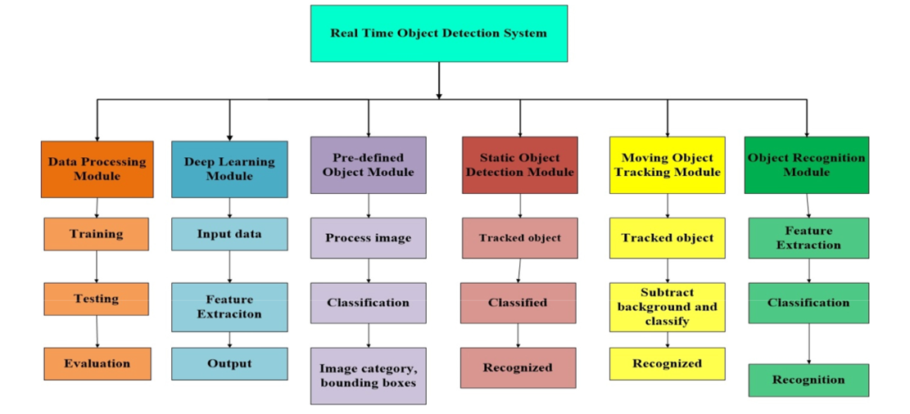
Figure 3.1: The Functional Requirements System Modules.
This was achieved with the following process:
- Pre-processing of data: The input images are pre-processed before the model training. Images are rescaled, rotated at a certain angle, zoomed and flipped. The images are resized to 150x150 pixels. The testing images are also pre-processed in the same manner.
- Model: The proposed system consists of a deep learning framework CNN. The model has 2 convolutional layers each followed by 2x2 max pooling and ReLU as the activation function. The input to the convolutional layer is an image of 150x150 size with 64 filters and 3x3 kernel size.
- Training and Testing: The model is trained under 50 epochs with a batch size of 64. It was observed that there were 12 steps per epoch. Checkpoints are assigned after every 5 epochs, thus saving the model. The image used for validating the model was also pre-processed in the same way as the input image. 80% images are used for training and 20% are used for testing.

3.1.1 Dataset (Image Acquisition)
For creating the dataset of the object detection, the images were captured in a black background. The images were captured using a mobile camera. The images were clicked in a well-lit room. A few examples of the images are illustrated in Figure 3.2. In Figure 3.2, (a) is Curry leaf, (b) is Hibiscus leaf, (c) is Lemon leaf and (d) is Mint leaf.
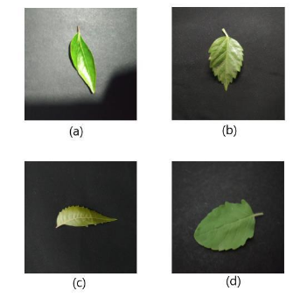
For creating the dataset, for each of the 5 classes, 5 different leaves images of different sizes of the same plant were used.
Table 3.1: Names of leaves in dataset
Class No | Class Name
1 | Curry
2 | Guava
3 | Hibiscus
4 | Lemon
5 | Mint

3.2 ANALYSIS OF THE EXISTING SYSTEM
There has been a lot of work in object detection using traditional computer vision techniques (sliding windows, deform-able part models). However, they lack the accuracy of deep learning based techniques. Among the deep learning based techniques, two broad class of methods are prevalent: two stage detection (RCNN, Fast RCNN, Faster RCNN) and unified detection (Yolo, SSD). Certain applications recognize objects with different characteristics such as shape size and so on. But they are not trained to recognize a wide variety of objects. Many applications include only the textual representation of the object in the description but not the voice or an audio effect.
3.3 PROBLEMS OF THE EXISTING SYSTEM
The existing traditional object detection systems often face several challenges and limitations. Here are some of the common problems associated with them:
- Limited accuracy: Traditional object detection systems may struggle with achieving high accuracy rates, especially when dealing with complex or ambiguous images. They rely on predefined rules and handcrafted features, which may not capture all the variations and nuances present in real-world images.
- Sensitivity to variations: Traditional systems can be sensitive to changes in lighting conditions, scale, rotation, and occlusions. Even slight alterations in these factors can significantly affect the system's ability to identify images accurately.
- Lack of adaptability: Traditional systems typically require manual feature extraction and engineering, making them less adaptable to new or previously unseen image types. As a result, they may struggle to perform well on tasks that involve images from different domains or categories.
- Limited scalability: Traditional herbal image identification systems often struggle with scaling up to handle large datasets. The computational requirements for processing and matching images can be substantial, leading to slower performance and increased processing times.
- Vulnerability to adversarial attacks: Traditional object detection systems can be susceptible to adversarial attacks, where deliberately modified images can deceive the system into misclassifying them. These attacks can exploit the system's weaknesses, such as sensitivity to slight perturbations or reliance on specific features.
3.4 DESCRIPTION OF THE PROPOSED SYSTEM
Here we are proposed YOLOV3 and YOLOV3-TINY models, one of the important fields of Artificial Intelligence is Computer Vision the science of computers and software systems that can recognize and understand images and scenes. Computer Vision is also composed of various aspects such as image recognition, object detection, image generation, image super-resolution and more. Object detection is probably the most profound aspect of computer vision due the number of practical use cases. Object detection refers to the capability of software systems to locate objects in an image/scene and identify each object. It has been widely used for face detection, vehicle detection, pedestrian counting, web images, security systems and driver less cars. There are many ways object detection can be used as well in many fields of practice. Like every other computer technology, a wide range of creative and amazing uses of object detection will definitely come from the efforts of computer programmers and software developers. Getting to use modern object detection methods in applications and systems, as well as building new applications based on these methods is not a straight forward task.
3.5 ADVANTAGES OF THE PROPOSED SYSTEM
The development of object detection system is the modern way of identifying objects, the implemented system has various advantages and some of its advantages are;
- It is reliable as it can easily recognize objects.
- Object detection plays a crucial role in quality control processes.

CHAPTER FOUR
DESIGN, IMPLEMENTATION AND DOCUMENTATION OF THE SYSTEM
4.1 DESIGN OF THE SYSTEM
This is the computation of the particulars of a new system and the determination of what the new system would be and the function it is to perform. This may involve changing from one system to another or modifying the existing system operation.
The most challenging phase of the system life cycle is the change from manual operation to a faster and more accurate one; system design stage covers the technical specifications that will be employed in the implementation of the new system in order to modify the previous system. Some factors are put in consideration. These factors include input design, output design, definitions file and procedure designs and other documentation.
4.1.1 OUTPUT DESIGN
This incorporates the objectives of solving the existing system problems and challenges. This involves the structuring of the desired information and also to enhance efficient and effective object recognition. Things taken into consideration in determining the output are represented below:

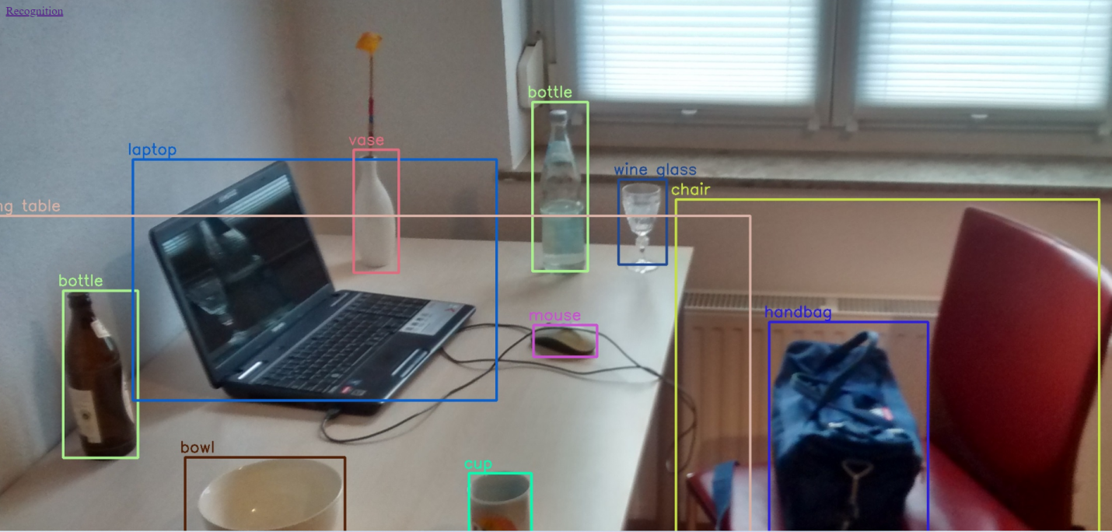
Figure 4.1: Home Page
This page allow user to navigate from page to another within the application environment
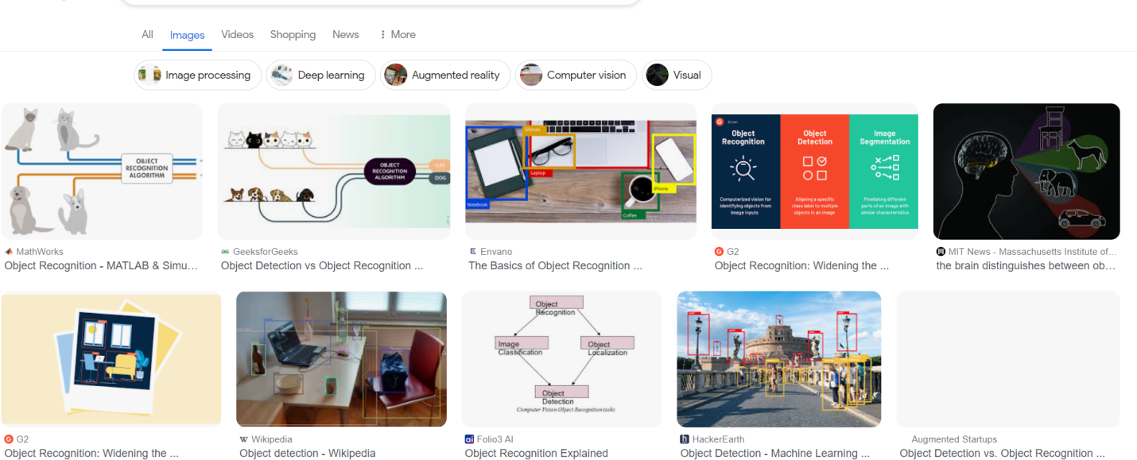
Figure 4.2: Object recognized.
This page is where an input object will be recognized

4.1.2 INPUT DESIGN
The input to run this software is obtained from real time object detection system administrator. The administrator is expected to register any User information. He can achieve this by typing via the keyboard. The input required from the Users is their personal data and answer?
To the questions set by the administrator. It can serve as the various input layouts from the various modules first from the collection of data and module then from the assessment module and input from User respectively.

Figure 4.3: input object image
This is a page where user browse/input for recognition
4.1.3 PROCEDURE DESIGN
These are the steps involved in unifying the whole process to produce the desired output. It involves computer procedures which start from the original input lessons to the output result file. This allows the processing of User information and result to be possible. Menu is provided to aid User in the processing of the output file.

4.2 IMPLEMENTATION OF THE SYSTEM
This entails the choice of the programming language employed to implement the software which should-be suitable for object recognition system. The software is designed for the use of real time object recognition system which should serve as an assistant. It is also expected to be used in conjunction with the User. The object recognition system admin will prepare data base while the admin will provide personal data about the User.
4.2.1 CHOICE OF PROGRAMMING LANGUAGE
The Application was developed in a .net (dot net) integrated development environment (.net IDE). The Application IDE is chosen following the fact that extracted information needs to be presented in an enhanced pictorial/graphical format and easy communication with the database for program flexibility in windows platform.
4.2.2 HARDWARE REQUIREMENT
i. 500 Hz minimum with CD ROM drive etc.
ii. Hard disk of capacity 10GB Minimum
iii. 126-512 megabyte of RAM
iv. An Uninterrupted power supply (UPS)
v. A voltage stabilizer
vi. A power generating set etc.
4.2.3 SOFTWARE REQUIREMENT
i. Windows operating system such as Windows 7 etc
ii. Dream Weaver
- Server Query Language (SQL).

4.3 DOCUMENTATION OF THE SYSTEM
4.3.1 PROGRAM DOCUMENTATION
The program is packaged for use in any system irrespective of either it runs visual studio application or not. After developing a program in Visual studio, there is a facility provided in Microsoft Visual Studio suite called “Package and Deployment Wizard” that is used in Visual studio application packaging and deployment.
4.3.2 MAINTAINING OF THE SYSTEM
The system maintenance refers to making modification to an already existing application/program without necessarily re-writing everything from start. Program maintenance of a program includes modification of the program to meet-up with certain requirements of the Users. In this course, additional features can be added, errors corrected, ambiguous interfaces redesigned to eliminate confusions and unnecessary features removed.
Maintaining this program can be done in a Visual studio environment. Any future modification can be by re-running the program source code in a visual studio environment making necessary changes and updates and recompile the application into an upgrade version of the existing version of the mini word processing application. Further versions of this program can be named following their year of release or it can be given a different version number.

CHAPTER FIVE
SUMMARY, CONCLUSION AND RECOMMENDATIONS
5.1 SUMMARY
The design and implementation of real-time object detection using TensorFlow represent a significant advancement in the field of computer vision and deep learning. This project leverages the power of TensorFlow, an open-source machine learning framework developed by Google, to create a robust and efficient system capable of detecting objects in real-time video streams. By utilizing convolutional neural networks (CNNs) and state-of-the-art object detection models such as Single Shot MultiBox Detector (SSD) or You Only Look Once (YOLO), the system achieves high accuracy and speed, making it suitable for various applications including surveillance, autonomous vehicles, and augmented reality.
Through meticulous design and optimization, the real-time object detection system demonstrates impressive performance in terms of both accuracy and efficiency. By harnessing the parallel processing capabilities of modern GPUs and specialized hardware accelerators like Google's Tensor Processing Units (TPUs), the system is capable of processing video streams at high frame rates, enabling timely and accurate detection of objects in dynamic environments. Moreover, the integration of techniques such as non-maximum suppression (NMS) and anchor box optimization further enhances the system's precision by eliminating redundant detections and minimizing false positives. The system was developed using python programming language.
5.2 CONCLUSION
The design and implementation of real-time object detection using TensorFlow represent a significant milestone in the development of computer vision systems. By leveraging the capabilities of deep learning and TensorFlow's flexible framework, the system achieves impressive results in detecting and localizing objects in real-time video streams. The integration of state-of-the-art object detection models and optimization techniques ensures both high accuracy and efficiency, making the system suitable for a wide range of real-world applications. However, despite its strengths, the system is not without limitations. Challenges such as occlusions, varying lighting conditions, and complex backgrounds can still pose difficulties for accurate object detection. Additionally, the computational resources required for real-time processing may limit the scalability of the system, particularly in resource-constrained environments. Addressing these challenges will require continued research and development efforts to improve the robustness, efficiency, and scalability of real-time object detection systems.
5.3 RECOMMENDATIONS
To further enhance the effectiveness and applicability of real-time object detection systems, the followings were recommended:
- Continued research and development in the field of computer vision to improve the robustness and accuracy of object detection algorithms, particularly in challenging scenarios such as occlusions and complex backgrounds.
- Exploration of novel optimization techniques and hardware architectures to improve the efficiency and scalability of real-time object detection systems, enabling deployment in resource-constrained environments.
- Integration of additional sensor modalities such as LiDAR and radar to complement visual information and enhance object detection performance, particularly in autonomous driving and robotics applications.
- Collaboration and knowledge sharing within the research community to facilitate the exchange of ideas, datasets, and best practices for real-time object detection, accelerating progress and innovation in the field.

REFERENCES
Aralikatti, A., Appalla, J., Naven, K. S., Lokesh, G. S. & Jayasri, B. S. (2020). Real-Time Object Detection and Face Recognition System to Assist the Visually Impaired, Journal of Physics: Conference Series. Vol. 4, Issue: 3. Pp. 122-123. https://doi.org/10.1016/j.tra.2011.06.110
Babenko, B., Yang, M. & Belongie, S. (2018). Robust Object Tracking with Online Multiple Instance Learning. EEE Transactions on Pattern Analysis and Machine Intelligence 33(8). IOP Publishing, Munich. Pp. 1619– 1632.
Baldota, D. Advani, S. Jaidhara, S. & Hatekar, A. (2021). Object Recognition using TensorFlow and Voice Assistant, International Journal of Engineering Research & Technology (IJERT). Vol. 10, Issue: 9. Pp. 617-618. DOI: 10.5897/AJBM10.1549
Baumann, A., Boltz, M., Ebling, J., Koenig, M., Loos, H. S., Merkel, M., Niem, W., Warzelhan, J. K., & Yu, J. (2018). A Review and Comparison of Measures for Automatic Video Surveillance Systems. EURASIP Journal on Image and Video Processing. Pp. 1–30. Doi: 10.26599/Bdma.2018.9020005
Canessane, R., Dhanalakshmi, R. & Anu, V. (2019). Implementation of Tensor Flow for Real-time Object Detection, International Research Journal of Engineering and Technology (IRJET). Vol. pp. 7-8. https://doi.org/10.1016/j.tra.2011.06.110
Ferri, A. (2016). Object Tracking in Video with TensorFlow, International Journal on Recent and Innovation Trends in Computing and Communication. Vol. 6. Issue: 2. Pp. 214-215. https://doi.org/11.1016/j.tra.2015.06.010
Jawale, P., Chaudhary, H. P. & Rajput, N. (2020). Real-Time Object Detection using TensorFlow, International Journal of Engineering and Techmology. Vol. 1. Issue: 2. Pp. 4-5. DOI: 10.5897/AJBM10.1549
Jyothi, M. A. & Kalidas M. (2022). Real Time Smart Object Detection using Machine Learning, International Journal for Research in Applied Science & Engineering Technology (IJRASET). Vol. 10. Issue: 11. Pp. 1023-1024.
Martinez‑Alpiste, I., Golcarenarenji, G., Wang, Q. & Alcaraz‑Calero, J. (2022). Smartphone‑based real‑time object recognition architecture for portable and constrained systems, Journal of Real-Time Image Processing (2022) 19:103–115. https://doi.org/10.1007/s11554-021-01164-1
Osman, A., Abozariba, R., Asyhari, R., Aneiba, A. Hussain, A., Barua, B. & Azeem, M. (2020). Real-Time Object Detection with Automatic Switching between Single-Board Computers and the Cloud, International Journal of Engineering Research & Technology (IJERT). Vol. 1, Issue: 3. Pp. 7-8.
Pipalia, D. S. and Simaria, R. D. (2019). Real Time Object Detection Tracking System (locally and remotely) With Rotating Camera, International Journal on Recent and Innovation Trends in Computing and Communication. Vol. 3. Issue: 3. Pp. 14-15. Doi: 10.34545/2018.8115676
Wahab, I. U., Shah, A., Khan, A. K., Choi, A. & Anwar, M. S. (2022). Design and implementation of real-time object detection system based on single-shoot detector and OpenCV, Journal of Frontiers in Psychology. IOP Publishing. Vol. 2, Issue: 1. Pp. 9-10.

