

A PROJECT REPORT
ON
ASSESSMENT OF SPATIAL DISTRIBUTION AND MANAGEMENT OF RECREATIONAL FACILITIES IN ILORIN WEST LOCAL GOVERNMENT OF KWARA STATE

BY
OGUNLEYE HANNAH ABISOLA
HND/23/URP/FT/0009

SUBMMITED TO:
THE DEPARTMENT OF URBAN AND REGIONAL PLANNING, INSTITUTE OF ENVIRONMENTAL STUDIES, KWARA STATE POLYTECHNIC ILORIN.

IN PARTIAL FULFILLMENT OF THE REQUIREMENT FOR THE AWARD OF HIGHER NATIONAL DIPLOMA (HND) IN URBAN AND REGIONAL PLANNING.

JUNE, 2025

CERTIFICATE
I hereby certified that the information given in this project was obtained as a result of the observation and measurement made by me and that the survey was carried out in accordance with survey laws, regulations and departmental instructions

_________________________________
OGUNLEYE HANNAH ABISOLA
Matric. No: HND/23/URP/FT/0009

CERTIFICATION
This is to certify that this project was carried out by OGUNLEYE HANNAH ABISOLA with Matric No.: HND/23/URP/FT/0009 under my instruction and supervision for the award of Higher National Diploma in the department of Urban and Regional Planning, Kwara State Polytechnic, Ilorin, Kwara State Nigeria. I hereby declared that she has conducted herself with due diligence and honesty on the said duties.

………………………………… ………………………………
TPL. E.S ADEKANYE DATE
(Project Supervisor)

………………………………. …………………………
MRS. M.I YAHAYAH DATE
(Project Coordinator)

……………………………… ………………………………
TPL. E.S ADEKANYE DATE
Head of Department (H.O.D)
Urban & Regional Planning

……………………………….. ……………………………..
EXTERNAL EXAMINER DATE

DEDICATION
This project is dedicated to Almighty GOD, the author and the finisher of everything who gave me the grace and privilege to attain this stage in my education pursuit.

ACKNOWLEDGEMENT
I give thanks and glory to my Creator for the privilege bestowed on me that resulted in the accomplishment of this project work and also a big thanks to the management of Kwara State Polytechnic for the privilege and opportunity given to me to study in their great institution.
My sincere gratitude goes to my Head of Department (HOD); TPL. E.S. ADEKANYE and as well my Supervisor for being my backbone right from the beginning of this project and all his support academically, morally, I really appreciate you sir.
To all the lecturers in the department of Urban and Regional Planning who has imparted their knowledge in me in one area or the other during my year of study, I am grateful for all your effort and support. May Almighty GOD bless you all (Amen).
I'm deeply grateful to my parents; MR & MRS. OGUNLEYE for their unconditional love, support, and wisdom. Their encouragement and sacrifices have been the driving force behind my endeavors. Thank you, Mom and Dad, for being my pillars of strength and inspiration. I acknowledge this project to you, with love and appreciation.
Special thanks to my brother and sister for their unwavering love, care, and dedication that has shaped me into the person I am today. Their selfless love and their influence and values have guided me throughout this project, and I'm forever grateful.
I'm also grateful to my friends in the department, church, and all for their motivation, and help whenever I needed it. Their collective support has made this journey more enjoyable and fulfilling.
May Almighty GOD bless you all (Amen).

TABLE OF CONTENTS
Pages
Title Page i
Certification ii
Dedication iii
Acknowledgment iv
Table of contents v
List of Tables ix
List of Figures x
Abstract xi
CHAPTER ONE
Background to the Study
1.1 Introduction 1
1.2 Statement of the Problem 7
1.3 Aim of the Study 8
1.4 Objectives of the Study 8
1.5 Scope of the Study 9
1.6 Significance of the Study 9
1.7 Limitation of the Study 10
1.8 Definition of Terms 11
CHAPTER TWO
Literature review
2.1 Introduction 12
2.2 Conceptual Framework 15
2.2.1 Concept of Recreation 15
2.2.2 Types of Recreation 17
2.3 Theoretical Framework 21
2.4 Empirical Review 32

CHAPTER THREE
Research Methodology
3.1 Introduction 38
3.2 Research Design 38
3.3 Study Area 39
3.3.1 Site Location 39
3.4 Population of the Study 40
3.5 Sample Frame 40
3.6 Sample Size 40
3.7 Sampling Technique 41
3.8 Data Collection Methods 41
3.9 Data Analysis 42
3.10 Ethical Considerations 42
3.11 Expected Outcome 43
CHAPTER FOUR
Data Presentation, Analysis and Interpretations
4.1 Introduction 44
4.2 Data Presentation and Analysis 44
4.3 Implications for Urban Planning and Policy in Ilorin West LGA 45
4.4 Summary of Key Findings 46
4.1.1 The Topographic Plan (Composite Plan) 48
4.1.2 The Perimeter Plan 49
4.1.3 The Detailed Plan 50
4.2 Application of the Product 51
CHAPTER FIVE
Summary, Conclusion and Recommendations
5.1 Summary 59
5.2 Conclusion 60
5.3 Recommendations 61
References
Appendix

LIST OF TABLES
Pages
Table 4.2: Table showing the Data Presentation and Analysis 44-53

LIST OF FIGURES
Pages
Fig. 3.1: Map of Nigeria showing Kwara State 39
Fig. 3.2: Map of Ilorin West Local Government Secretariat 39

ABSTRACT
This study assesses the spatial distribution and management of recreational facilities in Ilorin West Local Government Area, Nigeria. Rapid urbanization and population growth have intensified the demand for recreational spaces, yet the adequacy, accessibility, and quality of existing facilities remain uncertain. Utilizing Geographic Information Systems (GIS) for spatial analysis and field surveys for empirical data collection, the research mapped and evaluated the location, density, and coverage of facilities (e.g., parks, sports centers, playgrounds). Key findings reveal significant disparities in the distribution of recreational infrastructure, with clusters concentrated in affluent neighborhoods and sparse coverage in low-income and peri-urban areas. Management challenges include inadequate maintenance, underfunding, poor accessibility, and a lack of community involvement in facility planning. The study concludes that current recreational provisions are insufficient and inequitable, failing to meet the diverse needs of the population. Recommendations include strategic spatial planning to address coverage gaps, improved budget allocation for maintenance, community engagement initiatives, and policy reforms to integrate recreational planning into urban development frameworks. This research provides critical insights for local authorities and urban planners seeking to enhance recreational access and quality of life in Ilorin West.
INTRODUCTION
BACKGROUND TO THE STUDY
1.1 INTRODUCTION
Recreational land use refers to the intentional allocation and management of natural or developed spaces specifically designed to facilitate leisure activities, outdoor pursuits, and community engagement, fostering physical, social, and psychological well-being. This form of land use encompasses a diverse range of environments, including parks, trails, forests, beaches, sports fields, campgrounds, and urban green spaces, which are planned and maintained to support activities such as hiking, cycling, picnicking, sports, wildlife observation, and cultural events. Unlike commercial or residential land use, recreational spaces prioritize accessibility, sustainability, and the enhancement of quality of life by providing opportunities for relaxation, physical exercise, and connection with nature. Effective recreational land use requires careful planning to balance ecological preservation with human needs, ensuring that these areas remain resilient to environmental stressors and overuse while serving diverse populations. Scholars highlight its role in promoting public health, social equity, and environmental stewardship, as well as its economic value through tourism and local business support (Driver et al., 1987). By integrating natural landscapes with community infrastructure, recreational land use not only safeguards ecosystems but also cultivates a sense of place and belonging, reinforcing its importance in sustainable urban and rural development frameworks.
Recreational facilities also play a vital role in enhancing the quality of life by offering spaces for physical activity, social interaction, relaxation, and community engagement. These facilities include parks, sports complexes, playgrounds, trails, and community centers, and they are essential in promoting physical and mental well-being, fostering social cohesion, and improving urban livability. In cities and communities worldwide, the spatial distribution and management of these facilities have become central issues in urban planning and public policy.
The spatial distribution of recreational facilities refers to the geographic location and accessibility of these spaces within a given area, shaped by intersecting factors such as population density, urban layout, transportation infrastructure, and socioeconomic characteristics (Geurs & van Wee, 2004). A well-planned distribution prioritizes equitable access, ensuring that residents across diverse neighborhoods, including marginalized or low-income communities, can benefit from recreational opportunities, which is critical for fostering social cohesion and public health (Talen & Anselin, 1998). Conversely, uneven distribution often reflects systemic inequities, where underserved areas—frequently correlated with socioeconomic disadvantage—experience limited access to quality recreational spaces, exacerbating health disparities and perpetuating cycles of social inequality. For instance, urban areas with fragmented transportation networks or historically exclusionary zoning policies may concentrate recreational amenities in affluent districts, leaving peripheral or economically disadvantaged neighborhoods underserved. Scholars argue that addressing such disparities requires intentional land-use policies, participatory planning, and investments in infrastructure to bridge accessibility gaps and promote spatial justice (Talen & Anselin, 1998). By aligning recreational facility distribution with principles of equity and inclusivity, communities can mitigate inequities and enhance collective well-being.
The management of recreational facilities, on the other hand, refers to how often and to what extent these spaces are utilized by the public. Various factors affect the management of recreational facilities, including the quality and variety of the amenities offered, the perceived safety of the space, socio-cultural preferences, and even seasonal weather conditions. Understanding the patterns of management can help in evaluating the effectiveness of existing facilities and provide insights into how they can be improved or adapted to better serve the community’s needs.
Globally, assessment of spatial distribution and management of recreational facilities involves analyzing the geographic allocation, accessibility, and governance of spaces designated for leisure, physical activity, and social interaction to ensure equitable and sustainable benefits for diverse populations. This process evaluates how factors such as urban planning policies, transportation networks, socioeconomic disparities, and ecological constraints shape the availability and quality of recreational infrastructure, including parks, sports complexes, trails, and community centers. Spatial distribution assessments often employ Geographic Information Systems (GIS) and spatial equity metrics to identify gaps in access, particularly in underserved urban, peri-urban, or rural areas, where marginalized communities may face systemic exclusion due to historical underinvestment or discriminatory zoning practices (Sister, Wolch, & Wilson, 2010). Effective management integrates principles of environmental sustainability, user demand, and adaptive maintenance to balance recreational use with ecosystem preservation, especially in ecologically sensitive zones.
In national level, the assessment of spatial distribution and management of recreational facilities at the national level involves evaluating how a country allocates, plans, and maintains leisure-oriented spaces—such as parks, sports complexes, trails, and community centers—to meet the needs of its population while addressing region-specific socioeconomic, environmental, and cultural contexts. The assessment of spatial distribution and management of recreational facilities at the national level in Nigeria involves analyzing the geographic allocation, accessibility, and governance of parks, sports complexes, green spaces, and community leisure centers to address the country’s unique socioeconomic, cultural, and urban challenges. In Nigeria, this assessment must account for rapid urbanization, population growth, and stark regional disparities, where densely populated cities like Lagos and Abuja often concentrate recreational infrastructure, while rural and peri-urban areas—particularly in the North East and North West—face significant underprovision due to fragmented planning, limited funding, and competing priorities such as housing and industrial development (Ajayi & Adewunmi, 2018).
The assessment of spatial distribution and management of recreational facilities at the state level in Kwara State, Nigeria, involves evaluating the geographic placement, accessibility, and governance of parks, sports complexes, green spaces, and community leisure centers to address localized urban-rural disparities, cultural dynamics, and infrastructural challenges unique to the state. Kwara State, with its mix of urban centers like Ilorin and expansive rural areas, faces uneven distribution of recreational infrastructure, often concentrated in urban zones while peri-urban and rural communities experience limited access due to inadequate funding, fragmented planning frameworks, and competing land-use priorities like agriculture and housing (Ahmed & Aliyu, 2021).
Spatial inequities are compounded by socioeconomic factors, as low-income neighborhoods and informal settlements in cities like Ilorin lack safe, well-maintained recreational spaces, exacerbating public health disparities and limiting opportunities for social cohesion (Abdulrahman et al., 2020). The Kwara State Urban and Regional Planning Board utilizes tools like Geographic Information Systems (GIS) to map existing facilities and identify underserved areas, though implementation is constrained by bureaucratic delays, limited technical capacity, and reliance on federal allocation for projects. For instance, the Kwara State Development Plan (2010–2030) emphasizes equitable recreational planning, but execution lags due to inconsistent policy enforcement and prioritization of commercial over communal land uses (Kwara State Ministry of Works and Transport, 2019).
The assessment of spatial distribution and management of recreational facilities at the Local Government level in Ilorin West LGA, Kwara State, Nigeria, entails analyzing the geographic placement, accessibility, and governance of leisure-oriented spaces—such as neighborhood parks, playgrounds, sports fields, and community centers—within the specific socio-cultural, economic, and infrastructural context of the local government area.
Ilorin West, which includes densely populated urban wards like Baboko, Oloje, Badari and Magaji Ngeri, as well as peri-urban and semi-rural zones, faces significant disparities in recreational provision driven by rapid urbanization, informal settlement expansion, and competing land uses such as residential and commercial development (Abdulrahman et al., 2020). Spatial distribution here is heavily influenced by historical land-use patterns, where older, more affluent neighborhoods like GRA (Government Reserved Area) benefit from planned green spaces, while low-income areas and informal settlements often lack designated recreational infrastructure due to ad-hoc urban growth and limited enforcement of planning regulations (Ahmed & Aliyu, 2021).
Local governance bodies, including the Ilorin West Local Planning Authority, are tasked with mapping and managing these facilities, but challenges such as insufficient funding, bureaucratic bottlenecks, and land encroachment—particularly in ecologically sensitive zones like the Asa River corridor—hinder equitable distribution (Kwara State Ministry of Works, 2021).
The assessment of spatial distribution and management of recreational facilities in the study area encompassing Flower Garden Ilorin, Water View, Unilorin Zoo, Emirate Mall, and Diamond Park involves evaluating the geographic allocation, accessibility, and governance of these specific leisure spaces within Ilorin’s urban fabric, considering their roles in meeting the recreational needs of diverse demographics. These facilities, clustered primarily in central and peri-urban zones like GRA and University Road, reflect spatial disparities influenced by Ilorin’s urban planning history, socioeconomic stratification, and infrastructural development. For instance, Flower Garden Ilorin and Unilorin Zoo, located near the University of Ilorin, cater to academic and middle-class populations but face challenges of overcrowding and maintenance, while Emirate Mall and Diamond Park—commercialized recreational hubs—prioritize paid access, inadvertently excluding low-income residents from adjacent informal settlements like Oko-Erin or Ita-Elewa (Abdulrahman et al., 2020).
Assessing the spatial distribution and management of recreational facilities is crucial for urban planning, as it helps identify gaps in service coverage, areas of over-congestion, and opportunities for future development. By gathering data on the location, accessibility, and user demographics, planners and policymakers can make informed decisions that promote equitable access to recreational spaces, improve facility design, and encourage active use. This assessment is particularly important in growing urban areas, where increased population and limited land availability require careful planning to balance the demand for recreational spaces with other urban needs.
In this study, we will explore the current trends in the spatial distribution and management of recreational facilities, analyzing how factors such as geographic location, infrastructure, and demographic variables influence the accessibility and popularity of these spaces. The findings will serve as a foundation for recommendations aimed at optimizing the placement and design of recreational facilities to better serve the needs of diverse populations.

1.2 STATEMENT OF THE PROBLEM
The spatial distribution and management of recreational facilities in urban areas frequently fail to align with population needs, resulting in inequitable access and imbalanced utilization patterns (Rigolon, 2016). Despite the well-documented role of recreational spaces in enhancing physical health, mental well-being, and social cohesion, marginalized communities—particularly in underprivileged or densely populated neighborhoods—often face systemic barriers to accessing quality facilities, perpetuating health and social disparities (Talen & Anselin, 1998). Poorly planned distribution exacerbates these inequities, leading to overcrowding in high-demand zones and underuse in underserved areas, a phenomenon amplified by inadequate infrastructure, inconsistent maintenance, and socio-economic divides (Sister, Wolch, & Wilson, 2010). For instance, low-income residents may lack proximity to safe parks or face financial barriers to fee-based amenities, further entrenching spatial injustice (Rigolon, 2016).
These challenges are compounded by rapid urbanization and escalating demand for space, yet critical gaps persist in data on spatial distribution patterns and management practices, especially across diverse socio-economic contexts (Geurs & van Wee, 2004). A comprehensive, evidence-based assessment is urgently needed to identify imbalances, structural barriers, and contextual factors—such as transportation networks, land-use policies, and cultural preferences—that shape facility usage (Nesbitt et al., 2019). Without such insights, policymakers struggle to design equitable planning strategies that ensure universal access to recreational opportunities, undermining broader goals of inclusive urban development (UN-Habitat, 2016).
This study addresses these gaps by evaluating the spatial distribution and management of recreational facilities, analyzing how location, accessibility, infrastructure quality, and socio-demographic variables influence their effectiveness in serving diverse populations. Grounded in spatial equity frameworks (Talen & Anselin, 1998), the research identifies critical deficiencies in provision and proposes actionable recommendations for optimizing resource allocation, improving maintenance protocols, and fostering participatory planning processes. By aligning findings with principles of environmental justice (Sister et al., 2010) and sustainable urban design (UN-Habitat, 2016), the study aims to inform policies that enhance equitable access, ensuring recreational spaces fulfill their potential as catalysts for community well-being and social cohesion.
1.3 AIM OF THE STUDY
The aim of this study is to assess the spatial distribution and management of recreational facilities in Ilorin West Local Government Area.
1.4 OBJECTIVES OF THE STUDY
The objectives of this study is as listed below consecutively;
- Assess the distribution pattern of recreational facilities across the selected areas in Ilorin West.
- Evaluate the quality and maintenance of recreational facilities in Ilorin West.
- Examine the pattern of management and level of satisfaction of recreational facilities among residents in the study area.
- Identify the challenges affecting the accessibility, availability and management of recreational facility.

1.5 SCOPE OF THE STUDY
The scope of the study focus on the assessment of spatial distribution and management of recreational facilities in Ilorin West Local Government by assessing the distribution patter of the facilities and also to evaluate the quality and maintenance, examine the pattern of usage and level of satisfaction among residents and also identify the challenges affecting the accessibility, availability and usage.
The study does not cover other aspect of recreational facilities in other local governments aside from Baboko, Badari, Magaji Ngeri and Oloje.
1.6 SIGNIFICANCE OF THE STUDY
The significance of this study lies in its potential to inform urban planning, public policy, and community development efforts by providing critical insights into the distribution and utilization of recreational facilities. The findings of this study can help address existing disparities in access to recreational spaces, improve facility planning and design, and promote equitable opportunities for physical and mental well-being within communities. The study’s outcomes are relevant not only to urban planners and policymakers but also to local communities, environmental advocates, and public health professionals. Therefore, the significance is as follows;
- The findings of this study will provide valuable data that can guide urban planners and policymakers in making informed decisions about the development, maintenance, and expansion of recreational facilities.
- By understanding how spatial distribution and management patterns correlate with factors like population density, infrastructure, and socio-economic variables, city planners can more effectively allocate resources and prioritize areas that require improvement or expansion of recreational spaces.
- Access to recreational facilities is strongly linked to improved public health outcomes, including increased physical activity, reduced stress, and improved mental well-being. By assessing how well these facilities are utilized, the study can help identify opportunities to promote greater participation in physical activities.
- The study’s focus on the spatial distribution of recreational facilities will also support sustainable urban development efforts.
- By assessing how these spaces are used, the study can highlight areas where community engagement is lacking and suggest ways to increase participation.
1.7 LIMITATION OF THE STUDY
While this study aims to provide comprehensive insights into the spatial distribution and management of recreational facilities, several limitations may affect the scope, data accuracy, and generalizability of the findings:
- Data Availability and Accessibility: The study relies on the availability of accurate data from local authorities, facility management, and users. In some areas, access to detailed records, such as management statistics, maintenance schedules, or demographic data, may be restricted or incomplete, limiting the depth of analysis.
- Response Bias in Surveys and Interviews: The data collection methods, such as surveys or interviews with facility users, may be subject to response bias, where participants provide answers that are not entirely reflective of actual management patterns. For example, frequent users may be overrepresented, while infrequent or non-users may be underrepresented in the data
- External Factors Affecting Management: Management patterns may be influenced by external factors such as weather conditions, public health crises (e.g., the COVID-19 pandemic), or changes in local policies that are difficult to predict or control for in the study. These factors may cause short-term fluctuations in the data that do not reflect typical management patterns.
- Resource Constraints: The study’s ability to cover a large number of facilities or diverse neighborhoods may be limited by time, budget, or access to resources such as GIS mapping tools, survey platforms, or professional expertise. This limitation may restrict the study’s comprehensiveness.
1.8 DEFINITION OF TERMS
- Assessment: the action or an instance of making a judgment about something.
- Spatial: relating to or occupying space
- Distribution: the way in which something is shared out among a group or spread over an area.
- Management: the action of using something or the fact of being used.
- Recreation: relating to or denoting activity done for enjoyment when one is not working.
- Facilities: a place, amenity, or piece of equipment provided for a particular purpose.

CHAPTER TWO
LITERATURE REVIEW
2.1 INTRODUCTION
The spatial distribution and management of recreational facilities are key elements in the broader context of urban planning, public health, and community development. As cities continue to grow and urban populations increase, ensuring equitable access to recreational spaces becomes an essential part of promoting well-being, fostering social interactions, and creating sustainable environments. Numerous studies have explored various aspects of recreational facilities, from their design and accessibility to the patterns of their management. These studies emphasize the importance of a balanced distribution of recreational spaces to meet the diverse needs of urban populations.
Spatial distribution refers to the way things are arranged or spread out in space. Several factors influence the distribution of recreational spaces, including land use policies, population density, socioeconomic conditions, and urban infrastructure.
According to Gehl (2010), well-distributed recreational spaces are integral to creating livable cities, as they offer opportunities for physical activity, relaxation, and social engagement in close proximity to residents’ homes. Poorly planned distribution, however, can lead to spatial inequities, where some communities have access to high-quality recreational spaces while others remain underserved.
Cohen et al. (2016) found that access to parks and recreational facilities is often unequal, with wealthier neighborhoods having more green spaces and better-maintained facilities than lower-income areas. Such disparities can exacerbate social inequality, particularly in densely populated urban areas. Geographic Information Systems (GIS) are frequently employed in studies to map and analyze the spatial distribution of recreational spaces, providing detailed insights into accessibility patterns across different regions of a city.
The management of recreational facilities is influenced by a combination of factors, including proximity, facility quality, user demographics, and external conditions such as weather or seasonal trends. Studies on recreational behavior often focus on understanding the factors that determine whether a facility is used frequently, occasionally, or not at all.
Kaczynski & Henderson (2007) highlighted that facilities with better amenities, such as walking trails, sports courts, and fitness equipment, tend to attract more users. In contrast, under-maintained or poorly equipped facilities may deter people from using them. Accessibility is another critical factor that influences facility management.
Giles-Corti et al. (2005) indicates that proximity to recreational spaces plays a crucial role in determining how often they are used. People are more likely to visit recreational facilities that are within walking or cycling distance from their homes, making the spatial distribution of these facilities an important factor in their overall management.
Mowen et al. (2013) found that age, income, and ethnicity can all affect recreational preferences and frequency of use. For example, older adults may prefer quieter, less crowded parks for walking or relaxation, while younger people might favor sports complexes or playgrounds for active recreation. Understanding these varied preferences is important for creating inclusive and multifunctional recreational spaces that cater to the needs of all community members.
Despite the well-documented benefits of recreational spaces, many urban areas face challenges related to the equitable distribution and effective use of these facilities. One of the main challenges is the competition for limited urban land, which often prioritizes commercial, residential, and industrial developments over public spaces. Additionally, rapidly growing cities may struggle to keep up with the increasing demand for recreational areas, resulting in overcrowding or a lack of facilities in newly developed or underserved neighborhoods.
In many developing countries, the lack of financial resources, inadequate urban planning, and insufficient government support can lead to the creation of inadequate or poorly maintained recreational spaces. Furthermore, issues such as safety concerns, lack of transportation options, and insufficient community engagement can limit the management of recreational facilities, even when they are physically accessible.
While considerable research has been conducted on the importance of recreational facilities and factors influencing their use, there remain significant gaps in understanding the combined effect of spatial distribution and management patterns across different types of communities. Much of the existing research focuses on general trends or specific case studies, often overlooking local variations in how facilities are accessed and used. Additionally, there is a lack of comprehensive studies that integrate both qualitative and quantitative data to assess the real-world implications of spatial distribution on facility use.
In particular, there is a need for studies that examine how the intersection of socioeconomic, cultural, and geographical factors affects both the availability and management of recreational spaces in diverse urban contexts. Understanding these dynamics will be crucial for future urban planning efforts aimed at creating more inclusive, accessible, and well-used recreational spaces for all residents.
This literature review provides an overview of key themes in the study of spatial distribution and management of recreational facilities, including the factors that influence their placement, accessibility, and the way they are used by different segments of the population. Despite the extensive body of research on the subject, there remains a need for more localized, detailed studies that combine geospatial analysis with demographic insights to better understand how recreational facilities are distributed and used in urban areas. The following sections of this review will delve deeper into the specific studies and findings that address these key issues, setting the foundation for the research methodology and analysis in this study.
2.2 CONCEPTUAL FRAMEWORK
2.2.1 CONCEPT OF RECREATION
Recreation refers to activities or experiences that individuals or groups engage in for enjoyment, relaxation, and rejuvenation. It involves voluntary participation in leisure activities that contribute to physical, mental, and social well-being. The concept of recreation is multifaceted, encompassing a wide range of activities from physical exercise and sports to artistic pursuits, social gatherings, and nature-based experiences. It plays a crucial role in maintaining a healthy and balanced lifestyle, offering opportunities for relaxation, creativity, and social interaction. Recreation is a multifaceted concept that has evolved over time, encompassing a wide range of activities engaged in for enjoyment, relaxation, and personal growth. It is often considered a critical aspect of human life, contributing not only to individual well-being but also to social cohesion and community development. This paper provides a comprehensive exploration of the concept of recreation, its theoretical foundations, its benefits, and the broader implications for society.
Stebbins, 2007 defined recreation as activities that individuals or groups engage in during their free time, which are primarily voluntary and motivated by a desire for pleasure, enjoyment, and personal fulfillment. Unlike work or obligatory tasks, recreation is pursued for its intrinsic enjoyment rather than external rewards. The scope of recreational activities is vast, ranging from physical exercises and sports to socializing, cultural participation, and creative endeavors.
According to Iso-Ahola (1980), recreation is any activity that brings joy and satisfaction through relaxation, restoration, or stimulation. These activities may take place indoors or outdoors, individually or socially, and often serve as an essential component of leisure time, contributing to an individual’s sense of autonomy and freedom.
According to Mannell and Kleiber (1997), recreation is defined as "activity that is intrinsically motivated, done for its own sake, and is chosen freely by the individual". This definition emphasizes the voluntary and intrinsically motivating nature of recreational activities.
Cohen and Taylor (1976) defined recreation as "activities that are freely chosen and enjoyed for their own sake, contributing to the personal well-being and relaxation of the participant". They highlight the aspect of enjoyment and personal fulfillment as essential components of recreation.
Iso-Ahola (1980) stated that "recreation involves engaging in activities for the purpose of personal enjoyment, relaxation, or social interaction, and it is distinct from work or obligatory activities". This definition underlines the role of recreation in providing an escape from obligations and its contribution to personal well-being.

2.2.2 TYPES OF RECREATION
  - Physical Recreation
Physical recreation is a subset of recreation focused primarily on activities that require physical effort. It includes a range of structured and unstructured activities such as walking, cycling, swimming, jogging, playing sports, hiking, dancing, and other forms of exercise. These activities are designed not only to improve one’s physical health but also to provide fun, relaxation, and a sense of accomplishment. Unlike competitive sports, which often have specific performance goals or outcomes, physical recreation is typically pursued for its intrinsic benefits, such as enjoyment, stress relief, or relaxation.
According to the National Recreation and Park Association (NRPA), physical recreation is any form of activity that enhances physical fitness or promotes overall health through movement. It may involve recreational activities conducted in both outdoor and indoor environments, from public parks and gyms to nature trails and beaches.
- Mental or Intellectual Recreation
Mental or intellectual recreation refers to activities that engage and stimulate the mind, promote cognitive development, and encourage critical thinking and creativity. Unlike physical recreation, which primarily involves bodily movement, intellectual recreation involves exercises for the brain, such as reading, problem-solving, puzzles, creative writing, chess, or engaging in thoughtful discussions. These activities offer individuals an opportunity to relax, unwind, and develop their cognitive abilities in a way that contributes to their overall mental well-being and personal growth.
Mental or intellectual recreation is any activity that challenges the brain, encourages thought processes, or fosters creativity. This type of recreation can be solitary, like reading or writing, or social, such as engaging in debates or discussions. Activities that involve mental engagement can be stimulating, thought-provoking, and fulfilling, providing both entertainment and opportunities for cognitive growth. These activities are often pursued not for financial gain or professional development but for their intrinsic enjoyment, mental stimulation, and personal enrichment.
Intellectual recreation can take many forms, ranging from engaging in complex puzzles and games to exploring philosophical or scientific concepts, engaging in artistic pursuits, or immersing oneself in literature. These activities are often characterized by a desire to explore new ideas, develop new skills, or simply escape from the stresses of everyday life through a mentally stimulating process
While mental recreation is often seen as a pursuit of knowledge, its benefits extend far beyond intellectual growth, encompassing emotional and psychological wellness as well. Just as physical recreation nurtures the body, intellectual recreation nurtures the mind, enhancing both mental acuity and emotional resilience.
- Social Recreation
Social recreation refers to recreational activities that are designed to foster social interaction, strengthen relationships, and build community. These activities are typically pursued in a group setting and provide opportunities for individuals to connect with others, develop interpersonal skills, and engage in shared experiences. Social recreation plays a vital role in promoting social bonds, enhancing emotional well-being, and building a sense of belonging. From team sports and community events to group outings and volunteer activities, social recreation helps individuals develop social networks, improve communication, and create a sense of shared enjoyment.
Social recreation is a category of recreational activities that emphasizes social interaction, collaboration, and community engagement. These activities typically involve multiple participants and often include shared objectives or collective goals. Social recreation can range from casual, informal gatherings to more organized events such as festivals, team sports, group fitness classes, or even social clubs.
The primary goal of social recreation is to bring people together in ways that are enjoyable and constructive, providing both social and recreational benefits. It allows people to escape the routine of daily life, build friendships, collaborate with others, and feel a sense of connection with their community
While individual recreational activities are important for personal growth, social recreation specifically focuses on collective experiences that contribute to stronger social ties and community cohesion. As society becomes increasingly urbanized and individuals lead more isolated lives, the importance of social recreation in fostering connection and support networks cannot be overstated
- Creative Recreation
Creative recreation refers to activities that engage the imagination, foster self-expression, and encourage innovation through artistic or creative processes. Unlike physical or social recreation, which focuses on bodily exercise and social interaction, creative recreation centers on activities that allow individuals to explore their creative potential. These activities can range from visual arts like painting and sculpture to performing arts such as theater, dance, and music, as well as other forms of self-expression like writing, photography, and crafts.
Creative recreation not only serves as a medium for personal enjoyment and fulfillment, but it also has therapeutic benefits, enhancing mental health, boosting problem-solving skills, and fostering emotional growth. In a world where technology and modern pressures can often stifle creativity, engaging in creative recreation offers a refreshing and valuable escape that nurtures the mind and soul.
Creative recreation encompasses activities that involve creating or constructing something new, imaginative, or artistic. It differs from other forms of recreation in that it primarily stimulates the creative and cognitive aspects of the brain, allowing individuals to express their unique ideas and emotions. Creative recreation is often seen as a means of personal development and self-discovery, as it provides an outlet for people to experiment, innovate, and explore their inner worlds.
These activities can be pursued alone or in groups, in both structured and unstructured environments, and they often have a broad appeal to people of all ages. Whether through formal artistic practices or informal DIY projects, creative recreation allows individuals to tap into their creative potential and engage in meaningful, fulfilling activities.
- Nature-based Recreation
Nature-based recreation refers to outdoor activities that are undertaken in natural environments, promoting a connection with nature while offering physical, mental, and emotional benefits. These activities often involve interaction with the landscape, wildlife, and ecosystems, and can take place in various settings such as forests, parks, beaches, mountains, rivers, and other outdoor spaces. Nature-based recreation not only encourages physical activity but also fosters a sense of environmental stewardship, mindfulness, and well-being.
As urbanization and digital technologies have increasingly disconnected people from the natural world, nature-based recreation has become an essential means of re-establishing a bond with the environment. Whether through hiking, camping, birdwatching, or simply spending time in green spaces, nature-based recreation offers a holistic approach to health and well-being, while also contributing to conservation efforts by raising awareness about environmental issues.
Nature-based recreation is any activity that involves outdoor experiences in natural settings. These activities typically aim to appreciate or engage with the natural world and can range from active pursuits like hiking, kayaking, and mountain biking, to more passive experiences such as wildlife observation, camping, or simply relaxing in a natural environment. The key component is that nature-based recreation occurs outdoors, often in public parks, nature reserves, forests, or wilderness areas, where participants can experience the beauty and tranquility of nature.
Nature-based recreation activities are typically guided by principles of sustainability and environmental respect. They encourage responsible use of natural resources, minimize environmental impact, and aim to increase public appreciation of nature and the importance of conservation.
2.3 THEORETICAL FRAMEWORK
Leisure-Constraint Theory
Leisure-Constraint Theory, developed by Jackson (1988), offers a framework for understanding the barriers that individuals face when engaging in recreational activities. Jackson’s theory specifically addresses the factors that can limit or restrict access to leisure and recreational pursuits, highlighting the dynamic relationship between an individual’s choices, constraints, and the broader social and environmental factors that influence their participation in leisure activities.
According to Jackson (1988), leisure constraints are the obstacles that individuals experience in their pursuit of recreation, and these constraints can be categorized into three broad types: intrapersonal, interpersonal, and structural. The theory posits that these constraints may vary in intensity and impact, and individuals must often navigate or overcome them in order to engage in meaningful leisure activities.
Jackson’s Leisure-Constraint Theory builds on the notion that leisure participation is not always straightforward or unimpeded. It introduces a conceptual framework that categorizes constraints into three broad types, which are often interrelated and context-dependent.
- Intrapersonal Constraints: These are constraints that arise within the individual, often related to psychological factors, personal beliefs, attitudes, or perceptions. Intrapersonal constraints may include:
  - Lack of motivation: Some individuals may not feel motivated to engage in certain recreational activities due to personal interests, or they may perceive the activity as unappealing.
  - Perceived skill or ability limitations: People may feel that they lack the necessary skills or abilities to participate in certain activities, which can prevent them from attempting or enjoying them.
  - Health-related issues: Physical or mental health challenges may limit an individual’s ability to engage in active or strenuous recreational activities.
  - Time pressures: Individuals may not feel they have the time to participate in leisure activities due to competing priorities, such as work or family responsibilities.
- Interpersonal Constraints: These constraints emerge from social interactions and relationships with others. Interpersonal constraints include factors such as:
  - Social norms and expectations: Peer pressure, cultural norms, or societal expectations can restrict an individual’s choice of recreation. For example, certain activities may be deemed socially inappropriate or undesirable for particular groups based on gender, age, or socioeconomic status.
  - Lack of companions: Many recreational activities are social by nature, and individuals may be constrained by a lack of friends, family, or social networks to join them in these activities.
  - Family responsibilities: Family obligations, such as caregiving or parenting, can limit the ability of individuals to participate in leisure activities, especially those that require travel or time away from home.
- Structural Constraints: Structural constraints are external factors that limit access to recreational activities. These constraints are often related to the environment, resources, or institutional factors. Examples include:
  - Financial barriers: The cost of participating in certain recreational activities (e.g., gym memberships, equipment, travel) can be a significant barrier for individuals with limited economic resources.
  - Geographical and environmental factors: Lack of access to recreational spaces, such as parks, trails, or sports facilities, can prevent individuals from engaging in outdoor or community-based activities.
  - Lack of accessibility: Certain activities may not be accessible to people with disabilities, or activities may be geographically far from where individuals live, requiring transportation that they cannot afford or access.
  - Workplace constraints: Employment obligations, such as long work hours, rigid schedules, or multiple jobs, may limit the amount of time available for leisure.

The Interaction of Constraints
Jackson (1988) emphasized that these constraints do not function in isolation but rather interact in complex ways. For example, an individual’s intrapersonal constraint (e.g., a lack of self-confidence) may be exacerbated by an interpersonal constraint (e.g., lack of social support) and a structural constraint (e.g., the high cost of participating in the activity). Thus, individuals often face multiple layers of constraints that affect their ability to engage in leisure activities.
In addition, the way an individual perceives or experiences these constraints can change over time and across different contexts. People may adjust their attitudes, find alternative leisure activities, or overcome certain constraints through adaptation or support networks. For instance, someone with time constraints may adjust their leisure patterns by engaging in shorter, more accessible activities like walking instead of long hikes or weekend trips.

Implications of the Leisure-Constraint Theory
Jackson’s Leisure-Constraint Theory has significant implications for both understanding and addressing barriers to recreation. Some of the key insights and applications of the theory include:
- Personal and Societal Impact: The theory highlights that leisure participation is not a universal or automatic experience. Social inequality, economic hardship, cultural norms, and accessibility issues all contribute to unequal access to recreation. By understanding these constraints, policymakers, community organizations, and leisure providers can work to design more inclusive and accessible recreational opportunities, ensuring that people from all backgrounds have the chance to benefit from recreation.
- Policy and Planning: Leisure-Constraint Theory underscores the need for policy intervention in promoting equitable access to recreational resources. For example, public agencies may need to invest in more affordable recreational facilities, improve transportation to outdoor areas, or create programs that target underserved communities to reduce constraints and encourage broader participation in leisure activities.
- Personal Adaptation: For individuals facing constraints, the theory suggests that coping strategies can be employed to overcome or bypass barriers. These strategies might involve finding alternative recreational activities that are more accessible, adjusting schedules, or seeking social support. Understanding leisure constraints can empower individuals to find creative ways to incorporate recreation into their lives despite obstacles.
- Social Support and Community Engagement: Since interpersonal constraints (e.g., social support and companionship) are a key element of the theory, it highlights the importance of community engagement and social networks in encouraging leisure participation. Creating spaces and programs that foster social connections—such as group exercise classes, recreational leagues, or community outdoor activities—can help reduce interpersonal constraints and promote social inclusion.

Criticisms and Further Development
While Jackson’s Leisure-Constraint Theory provides a useful framework, it has also been critiqued and expanded upon over the years:
- Lack of a clear hierarchy of constraints: The theory does not provide a clear understanding of how different constraints may rank in importance or how they interact over time. For example, it’s not always clear whether intrapersonal constraints are more significant than structural ones in certain contexts, or how constraints evolve over a lifetime.
- The concept of negotiation: More recent research in leisure studies has built on Jackson’s theory by focusing on how individuals negotiate and manage constraints, rather than merely being restricted by them. Some scholars argue that leisure constraints are not always absolute but can be negotiated or mitigated through coping mechanisms, changing perceptions, or adapting leisure preferences.
- Emphasis on coping mechanisms: Researchers have expanded on Jackson’s theory by exploring how individuals develop coping strategies to manage constraints. For instance, some people may develop creative strategies, such as engaging in alternative forms of recreation, adjusting their schedule, or using technology to overcome physical or social barriers.
Jackson’s Leisure-Constraint Theory (1988) provides a foundational framework for understanding the multiple barriers individuals face in accessing and enjoying recreation. By categorizing constraints into intrapersonal, interpersonal, and structural factors, the theory highlights the complex and interconnected nature of leisure barriers. It calls attention to the importance of addressing these constraints through policy, social support, and personal adaptation, in order to ensure that leisure and recreational opportunities are accessible to all individuals, regardless of their background or circumstances. As such, the theory remains a valuable tool for scholars, practitioners, and policymakers aiming to promote inclusive and equitable leisure experiences
Flow Theory
Flow Theory, as proposed by Mihaly Csikszentmihalyi in his seminal 1990 book, "Flow: The Psychology of Optimal Experience", describes a mental state where individuals experience deep immersion and involvement in an activity, which leads to heightened enjoyment and personal satisfaction. In the context of recreation, flow represents an optimal state of engagement where the participant feels fully absorbed in the activity, often losing track of time, and experiences a sense of control, competence, and intrinsic reward.
Csikszentmihalyi’s research into flow has had profound implications for the understanding of leisure and recreation, as it explains why certain recreational experiences are so fulfilling and why people actively seek these types of activities. Flow experiences in recreation are associated with a high degree of enjoyment, skill development, and personal growth.

Core Concepts of Flow Theory
Flow is characterized by several key elements, which Csikszentmihalyi identified through extensive research into the conditions under which people experience deep enjoyment in their activities. The core elements of flow include:
- Complete Concentration: In a flow state, individuals are fully engaged in the task at hand, with their attention sharply focused on the activity. Distractions or external concerns fade into the background, allowing for deep immersion.
- Clear Goals and Feedback: A person in flow experiences clear objectives within the activity and receives immediate feedback about their performance. This feedback allows them to adjust their actions and maintain a sense of progression, leading to continuous improvement and satisfaction.
- Balance of Challenge and Skill: Flow occurs when there is a balance between the perceived challenges of the activity and the individual's skill level. If the activity is too easy, the individual may become bored, while if the activity is too difficult, it may lead to anxiety. In flow, the task is challenging enough to require full engagement but not so difficult as to cause frustration.
- Sense of Control: In the flow state, individuals feel a sense of control over their actions and the environment, even though they may be fully absorbed in the activity. This sense of control contributes to the positive emotional experience of the activity.

Flow and Recreation
In the context of recreation, flow theory is particularly relevant because it provides an explanation for why certain recreational activities are so enjoyable and why they can become deeply satisfying experiences. When people engage in recreational activities that induce flow, they often feel revitalized, recharged, and more connected to themselves and their environment. These activities may include sports, artistic pursuits, outdoor adventures, or even hobbies that involve problem-solving or creativity.

Examples of Flow in Recreation
- Sports and Physical Activities:
  - In sports like basketball, tennis, or rock climbing, flow can occur when an athlete is fully immersed in the game, perfectly matching their skills with the challenges presented by the game. The athlete might experience a sense of "effortlessness" despite the intensity of the activity, with time passing quickly and an intrinsic enjoyment of the experience.
  - Running or cycling are also examples of activities where people can experience flow, particularly in long-distance running or competitive cycling, where the pace and effort level match the runner's or cyclist's skill and focus.
- Artistic and Creative Recreation:
  - In creative recreation, such as painting, writing, or playing music, flow is often experienced when individuals are fully engaged in the process of creation. The challenge of translating a vision into a physical form, whether through brushstrokes, words, or music, provides a balance between skill and challenge that facilitates flow.
  - For musicians, flow may happen during a live performance or while composing, where the task demands intense focus, and the feedback from the sound or the audience enhances the experience.
- Outdoor Adventure and Nature-based Recreation:
  - Nature-based activities like hiking, kayaking, or mountain biking can induce flow, especially when the challenge of navigating difficult terrain is balanced with the individual’s physical and mental abilities. The natural environment also provides immediate feedback (e.g., weather, trail conditions), which helps participants adjust and stay engaged.
  - Camping, fishing, or wildlife photography can also promote flow as individuals immerse themselves in the present moment and engage with nature in a meaningful way.

- Games and Hobbies:
  - In recreational games such as video games, chess, or even puzzles, players can experience flow when the complexity and challenge of the game perfectly match their skills. For example, in video games, players often experience flow when they are deeply absorbed in the game's narrative or challenges, with a clear understanding of objectives and immediate feedback on their performance.
  - Gardening or knitting, which are often seen as meditative hobbies, can also create flow experiences. The focus on the task and the tangible outcomes (a beautiful garden or a completed sweater) align with the flow principles of challenge, skill, and intrinsic enjoyment.

Benefits of Flow in Recreation
- Enhanced Well-being: Experiencing flow in recreational activities contributes to an individual’s psychological well-being. The deep sense of satisfaction and accomplishment that comes from engaging in challenging but manageable activities can increase happiness, reduce stress, and improve emotional resilience.
- Increased Motivation: Since flow is intrinsically motivating, individuals who regularly experience flow are more likely to engage in leisure and recreational activities over time. Flow experiences can enhance motivation by making the activity enjoyable for its own sake, rather than for external rewards.
- Personal Growth and Skill Development: Flow experiences in recreation promote personal growth. As individuals engage in challenging activities, they develop new skills, improve their physical or mental abilities, and experience a sense of mastery. This sense of competence contributes to self-esteem and confidence.
- Improved Physical and Mental Health: Participating in flow-inducing activities, especially those that are physically demanding (like exercise or sports), has been linked to better physical health outcomes, including improved cardiovascular health, stronger immune function, and better sleep. Mentally, flow enhances focus, creativity, and emotional regulation.
- Social Benefits: Flow experiences can also occur in group settings, such as in team sports, group hikes, or collaborative artistic projects. These shared flow experiences can foster social bonding and enhance feelings of connection and camaraderie, improving relationships and social well-being.

Challenges in Achieving Flow in Recreation
Although flow is a highly rewarding experience, it is not always easy to achieve. Some challenges in achieving flow in recreational activities include:
- Mismatch between skills and challenges: If an activity is too easy, it may not provide enough stimulation to induce flow, leading to boredom. Conversely, if it is too difficult, it can lead to anxiety and frustration.
- Environmental distractions: Factors such as noisy surroundings, discomfort, or interruptions can make it difficult to maintain the concentration necessary for flow.
- Lack of immediate feedback: In some activities, especially those that are more solitary or self-directed, the absence of feedback may make it harder to maintain a flow state.
- External pressures: In some cases, external pressures like competition, expectations, or the pursuit of external rewards (e.g., money, fame) can detract from the intrinsic enjoyment of the activity and hinder the experience of flow.
Mihaly Csikszentmihalyi’s Flow Theory offers an insightful understanding of why certain recreational activities are so enjoyable and rewarding. Flow experiences, characterized by deep engagement, a balance of challenge and skill, and intrinsic motivation, contribute to personal well-being, skill development, and social connection. Whether in sports, the arts, or nature-based recreation, flow provides a framework for understanding the psychological benefits of leisure activities. For both individuals and recreation professionals, promoting conditions that facilitate flow can help enhance the quality of recreational experiences, ultimately leading to greater satisfaction and health benefits.
2.4 EMPIRICAL REVIEW
The assessment of spatial distribution and management of recreational facilities has become an important area of study within the fields of urban planning, geography, and leisure studies. Understanding how recreational spaces are distributed and utilized across different regions or communities is crucial for improving accessibility, equity, and overall well-being. Empirical research in this area provides valuable insights into the factors that influence both the availability and the use of these facilities, highlighting patterns of engagement, barriers to access, and the impact of spatial characteristics on recreational behavior.

Spatial Distribution of Recreational Facilities
The spatial distribution of recreational facilities refers to the geographical arrangement of public and private recreational spaces, such as parks, sports fields, playgrounds, and recreational centers. Researchers have highlighted the significance of this distribution in ensuring that all individuals have equitable access to recreational opportunities. A well-distributed system of recreational facilities allows for greater participation, especially in urban areas where space is often limited.
Several studies have examined the equity of spatial distribution. For instance, Crompton (2001) explored how recreational facilities in urban settings are often clustered in wealthier neighborhoods while less affluent areas tend to have fewer or lower-quality facilities. This uneven distribution often reflects broader socioeconomic inequalities, where access to quality recreation is tied to income, race, and social class. Empirical studies, such as those by White et al. (2011) and Lund & McKinney (2015), have confirmed that underserved communities, particularly those with higher minority populations or lower socioeconomic status, face significant barriers to accessing recreational spaces.
Further studies have indicated that spatial distribution is not only a matter of geographic proximity but also of facility design and quality. Wang et al. (2018) found that access to high-quality recreational facilities was correlated with increased physical activity in certain communities, while lower-quality or poorly maintained parks led to lower participation rates. This suggests that both the availability and the attractiveness of recreational facilities play key roles in management patterns.
The role of transportation and connectivity has also been highlighted in research on spatial distribution. Sallis et al. (2006) found that proximity to recreational spaces is not enough to guarantee management; the availability of reliable transportation options significantly influences whether individuals can access these spaces. In suburban or rural areas, where public transportation is limited, the spatial distribution of recreational facilities becomes even more crucial. Studies by Giles-Corti et al. (2015) further emphasize that pedestrian-friendly environments and accessible transport links can increase participation rates, particularly among disadvantaged groups.

Factors Influencing the Management of Recreational Facilities
The management of recreational facilities is influenced by a variety of factors, ranging from individual preferences to environmental conditions. Demographics play a significant role in determining who uses recreational spaces and how often. Research by Tuckey & McCulloch (2017) found that age, gender, income, and family structure were all correlated with differing patterns of recreational facility use. For example, older adults may prefer quieter, less physically demanding activities, while younger people may engage in more physically active recreational pursuits. Similarly, individuals from lower socioeconomic backgrounds may face constraints such as financial limitations or lack of free time, which influence their ability to utilize recreational spaces.
In addition to demographics, cultural factors also impact the management of recreational facilities. A study by Stodolska et al. (2019) explored how cultural and ethnic backgrounds affect recreational choices. It found that communities with large immigrant populations may have distinct preferences for certain types of recreational activities, which may not always align with the facilities available in their local areas. For instance, some ethnic groups may prefer recreational activities that are not well-represented in the public park system, such as culturally specific sports or gatherings.
Health-related factors have also been examined in relation to recreational management. A study by Mason et al. (2017) found that individuals with chronic health conditions or disabilities were less likely to use public parks and recreational facilities, mainly due to physical barriers such as poor accessibility, lack of suitable equipment, or safety concerns. Furthermore, Buchanan et al. (2016) observed that perceptions of safety—both real and perceived—can strongly influence recreational facility management. Individuals are less likely to visit parks or recreational centers in neighborhoods where they perceive crime rates to be high or where they feel unsafe.
Environmental design is another crucial determinant of recreational facility management. According to Veitch et al. (2012), features like the aesthetic quality of the facility, the presence of shaded areas, walking trails, or water features can significantly enhance the attractiveness of a park and thus encourage higher participation. Facilities that cater to diverse age groups, such as playgrounds for children, fitness equipment for adults, and calm areas for seniors, tend to attract a broader range of users.
Temporal factors also affect management patterns. Research by Karlsen et al. (2017) demonstrated that time of day, day of the week, and even seasonality play a major role in recreational participation. For example, parks and recreational facilities experience higher management during the warmer months or weekends when individuals have more free time. Evening hours and public holidays also see higher activity, particularly in facilities with lighting or those located in areas with high community engagement.

Barriers to Recreational Facility Use
Empirical research has consistently identified several barriers to the management of recreational facilities, even in areas where these facilities are theoretically accessible. These barriers can be physical, socioeconomic, or psychological in nature.
One major barrier identified in several studies is the lack of time. The modern lifestyle, especially in urban areas, often results in busy schedules that leave little room for recreation. Sallis et al. (2009) noted that time constraints were one of the most significant barriers to the use of recreational facilities, particularly among working adults and parents with young children. Similarly, Ainsworth et al. (2017) found that for individuals with multiple jobs or caregiving responsibilities, finding time to use recreational facilities is often a significant challenge.
Economic barriers also play a critical role. Despite the fact that many recreational facilities are publicly funded and ostensibly free to use, additional costs such as transportation, equipment, or membership fees in specialized centers can be prohibitive for low-income individuals and families. Research by Tittensor et al. (2018) indicated that lower-income neighborhoods often have fewer public recreation options or face challenges in maintaining existing facilities, contributing to unequal access.
In terms of psychological barriers, social norms and personal perceptions about the suitability of recreational facilities can also influence management. Wolfe et al. (2019) found that individuals in certain communities may have a preference for specific types of recreational activities, or they may perceive parks and recreational spaces as unsafe or unwelcoming, particularly if these facilities are underutilized or poorly maintained. The social stigma associated with certain recreational activities can also deter participation in public facilities.

Implications for Policy and Planning
The empirical literature underscores the importance of thoughtful planning and policy interventions to promote more equitable access to recreational facilities. Urban planners and policymakers are increasingly focused on the equitable distribution of these spaces, ensuring that they are located in areas where they are most needed. Creating inclusive and diverse recreational facilities that cater to different age groups, cultural backgrounds, and physical abilities can help reduce participation barriers. Additionally, efforts to improve connectivity and accessibility—such as creating pedestrian-friendly routes or improving public transportation to recreational spaces—are crucial for encouraging greater management.
Local governments and recreational service providers are also encouraged to engage communities in the planning and design of recreational spaces to ensure that these facilities meet the actual needs of the population. Public-private partnerships may be an effective way to provide sustainable funding for the development and maintenance of these spaces, ensuring that they remain accessible to all.

CHAPTER THREE
RESEARCH METHODOLOGY
3.1 INTRODUCTION
To achieve all the stated aim and objectives, various approaches were used. Survey was considered with the existing recreation centres in Ilorin West Local Government through the use of a reconnaissance survey which deals with the visitation of the study area in other to allow the researcher to be familiar with the distribution and the management of recreational facilities in the study area.
Another survey was carried out through the collection of data’s using the primary source and the rest forms which can be the secondary in nature and this can be derived from studies found useful to the work.
The distribution and the management of recreational facilities in Ilorin facilities was observed in the area, the survey includes recreational centres facilities management in the study area.
3.2 RESEARCH DESIGN
This study will adopt a descriptive and analytical research design. The research will focus on understanding the distribution and management patterns of recreational facilities in Ilorin West Local Government. Descriptive methods will be used to outline the spatial characteristics, while analytical methods will be employed to evaluate how these facilities are used across different demographic groups and locations.

3.3 STUDY AREA
The study area is Ilorin West Local Government Area, located in Kwara State, Nigeria. The geographical boundaries of Ilorin West Local Government will be mapped out to guide the assessment of spatial distribution.
3.3.1 SITE LOCATION
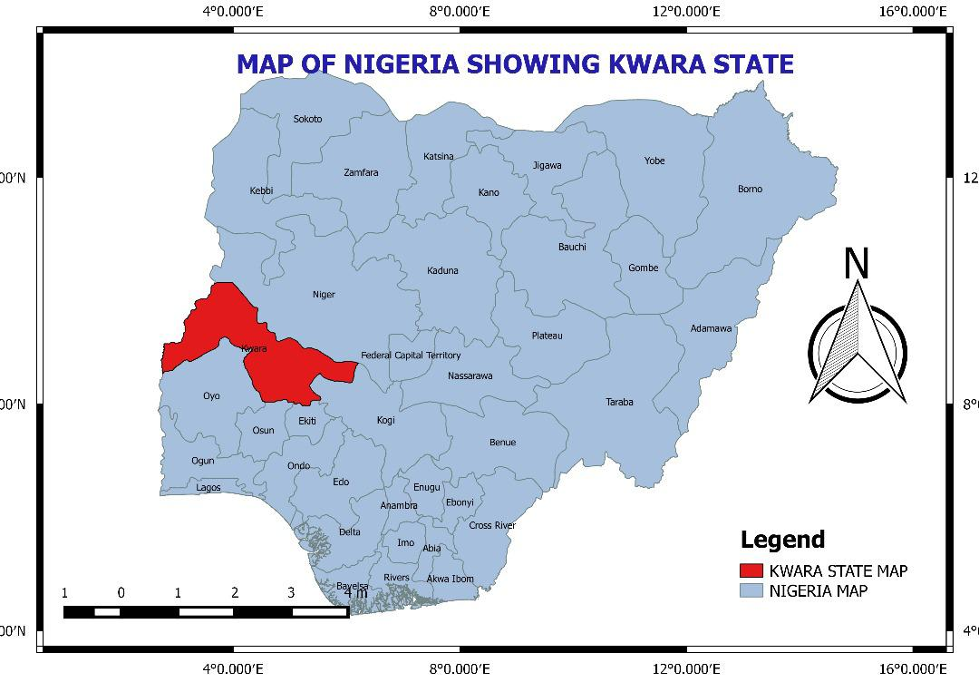
Fig. 3.1: Map of Nigeria showing Kwara State

Source: Kwara State GIS (KWAGIS)

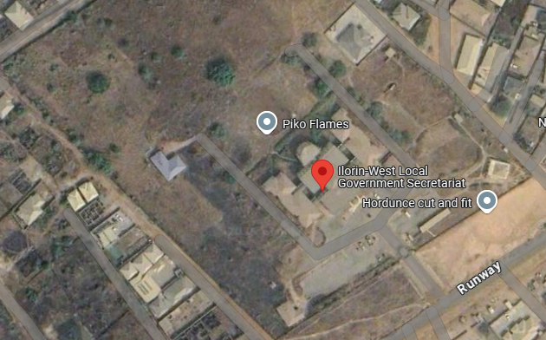
Fig. 3.2: Map of Ilorin West Local Government Secretariat

Source: Kwara State GIS (KWAGIS)

3.4 POPULATION OF THE STUDY
The population of this study includes:
- Residents of Ilorin West Local Government Area who use or have access to recreational facilities.
- Managers/Administrators of recreational facilities (e.g., parks, sports complexes, community centers).
- Local government authorities involved in urban planning and infrastructure development related to recreational spaces.
3.5 SAMPLE FRAME
The total number of the selected ward members of Ilorin West Local Government will constitute the sample frame for this study. All the selected buildings were 1745.
3.6 SAPLING SIZE
A sample size can be referred to a picked or chosen group under research area which reasonably embodies the entire population of attraction or concern. i.e. a sample of population which has the attributes that are necessary to the study analysis or scrutiny. (Creswell, 2014).
A total number of 50 questionnaires were distributed out to some selected ward members of Ilorin West Local Government, Kwara State. Therefore, the sample size of this research work is 50.

3.7 SAMPLING TECHNIQUE:

Sample techniques are the method you employed while choosing from a population study, (Cochran, 2007). For example, you could select every 3rd person, everyone in a particular age group, and so on; you must carefully consider your study before choosing an appropriate sampling technique. It has a significant effect on your result.
- Random Sampling: A random sampling method will be used to select residents of different communities within Ilorin West. This will ensure a representative sample of users from diverse socio-economic backgrounds.
- Purposive Sampling: Key informants such as managers of recreational facilities and local government officials will be selected purposively for in-depth interviews.
3.8 DATA COLLECTION METHODS:
To gather the required data, a mixed-methods approach will be used, combining both quantitative and qualitative methods.
- Questionnaires: A structured questionnaire will be distributed to residents to gather data on the frequency of use, type of facilities used, factors influencing their choices, and satisfaction levels. The questionnaire will include both closed and open-ended questions.
- Interviews: Semi-structured interviews will be conducted with key informants (recreational facility managers, local government officials) to gain insight into the planning, maintenance, and challenges faced by recreational facilities in the area.
- Field Observations: Spatial observations will be made to assess the actual location, distribution, and condition of recreational facilities within the local government area. Mapping techniques using Geographic Information System (GIS) may be employed to visualize the spatial distribution of these facilities.
- Focus Group Discussions (FGDs): FGDs will be held with community groups to discuss perceptions of accessibility, equity in the distribution of facilities, and any barriers to management.
3.9 DATA ANALYSIS:
- Quantitative Data: The data collected from questionnaires will be analyzed using statistical techniques. Descriptive statistics (frequencies, percentages, and means) will be used to assess the patterns of management and distribution. Geographic Information System (GIS) software will be used to map and analyze the spatial distribution of the recreational facilities.
- Qualitative Data: The data from interviews and focus group discussions will be analyzed using thematic analysis to identify common themes regarding accessibility, management barriers, and satisfaction with recreational facilities. NVivo software may be used for organizing and coding qualitative data.
3.10 ETHICAL CONSIDERATIONS:
- Informed Consent: All participants will be informed of the purpose of the study, and their consent will be obtained before participation.
- Confidentiality: Personal information from participants will be kept confidential and used only for the purpose of this study.
- Voluntary Participation: Participants will have the right to withdraw from the study at any time without any consequence.

3.11 EXPECTED OUTCOME:
The study aims to provide:
- A comprehensive map of recreational facilities in Ilorin West Local Government.
- An assessment of the spatial distribution of these facilities across different neighborhoods.
- Insights into the patterns of management, the factors that influence them, and the adequacy of these facilities.
- Recommendations on how to improve the distribution, accessibility, and management of recreational spaces in the local government.

CHAPTER FOUR
DATA PRESENTATION, ANALYSIS AND INTERPRETATION
4.1 INTRODUCTION
In this section of the research study, data obtained from field of investigation were presented and analyzed.
4.2 DATA PRESENTATION AND ANALYSIS
This chapter presents the analysis of data collected on the distribution and usage of recreational facilities within some selected wards inside Ilorin West Local Government Area (LGA). The wards stated to be; Baboko, Oloje, Magaji Ngeri, and Badari. It aims to examine the spatial patterns, accessibility, and level of utilization of these facilities by residents. Through the use of maps, charts, and statistical tools, the chapter evaluates the adequacy and equity of facility distribution across different wards. It also investigates the factors influencing usage patterns, such as distance, availability, and socio-demographic characteristics of users. The findings from this analysis provide a basis for identifying spatial disparities and informing future planning and policy interventions to enhance recreational development in the area.
Table 1: Gender of Respondents
RESPONDENT | FREQUENCY | %
Male | 30 | 60
Female | 20 | 40
Total | 50 | 100
Researcher’s Field Survey, 2025
The table shows that 30 respondents were male represent 60% while the remaining 20 respondents were female representing 40%
Table 2: Age Distribution of the Respondents
RESPONDENT (AGE) | FREQUENCY | %
Below 18 | 5 | 10
18 – 30 | 30 | 60
31 – 45 | 10 | 20
46 – 60 | 3 | 6
Above 60 | 2 | 4
Total | 50 | 100
Researchers’ Field Survey, 2025
The table above shows that 5 respondents representing 10% were below the age of 18, 30 respondents representing 60% were between the age of 18-30, 10 respondents representing 20% were between the age of 31 – 45, 3 respondents representing 6% were between the age of 46 – 60 while the remaining 2 respondents representing 4% were between the age of 60 and above.

Table 3: Occupation Distribution of the Respondents
RESPONDENT | FREQUENCY | %
Student | 30 | 60
Civil Servant | 5 | 10
Self-employed | 10 | 20
Unemployed | 3 | 6
Other | 2 | 4
Total | 50 | 100
Researchers’ Field Survey, 2025
The table above shows that 30 respondents representing 60% were Student, 5 respondents representing 10% were Civil Servant, 10 respondents representing 20% were Self-employed, 3 respondents representing 6% were Unemployed while the remaining 2 respondents representing 4% were others.
SECTION B
Table 1: Are you aware of any Recreational Facilities in your area?
RESPONDENT | FREQUENCY | %
Yes | 48 | 96
No | 2 | 4
Total | 50 | 100
Researchers’ Field Survey, 2025
According the table displayed, 48 respondents representing 96% chose Yes meaning that, they are aware of recreational facilities in their area while the remaining 2 respondents representing 4% chose No.
Table 2: How often do you use recreational facilities in your area?
RESPONDENT | FREQUENCY | %
Daily | 10 | 20
Weekly | 20 | 40
Monthly | 10 | 20
Rarely | 7 | 14
Never | 3 | 6
Total | 50 | 100
Researchers’ Field Survey, 2025
According to the table displayed above, 10 respondents representing 20% said they uses recreational facilities in their area daily, 20 respondents representing 40% chose weekly, 10 respondents representing 20% chose monthly, 7 respondents representing 14% chose rarely while the remaining 3 respondents representing 6% said they don’t use recreational facilities in their area.

Table 3: What activities do you engage in at those facilities?
RESPONDENT | FREQUENCY | %
Sport | 10 | 20
Relaxation | 10 | 20
Social gatherings | 25 | 50
Exercise | 4 | 8
Other | 1 | 2
Total | 50 | 100
Researchers’ Field Survey, 2025
According to the table displayed above, 10 respondents representing 20% chose sport as one of the activities they engage in at the facilities, 10 respondents representing 20% chose relaxation, 25 respondents representing 50% chose social gatherings, 4 respondents representing 8% chose exercise, while the remaining 1 respondent representing 2% chose others.
Table 4: How far is the nearest recreational facilities from your home?
RESPONDENT | FREQUENCY | %
Less than 1km | 25 | 50
1-3 km | 10 | 20
4-6km | 10 | 50
More than 6km | 5 | 10
Total | 50 | 100
Researchers’ Field Survey, 2025
According to the table displayed above, 25 respondents representing 50% chose less than 1km, 10 respondents representing 20% chose 1-3km, 10 respondents representing 20% chose 4-6km, while the remaining 5 respondents representing 10% chose more than 6km.
Table 5: What mode of transportation do you use to access these facilities?
RESPONDENT | FREQUENCY | %
Walking | 10 | 20
Bicycle | 5 | 10
Public transport | 30 | 60
Private vehicle | 4 | 8
Other | 1 | 2
Total | 50 | 100
Researchers’ Field Survey, 2025
According to the table displayed above, 10 respondents representing 20% chose Walking as one of the mode of transportation they uses to access the facilities, 5 respondents representing 10% chose Bicycle, 30 respondents representing 60% chose Public transport, 4 respondents representing 8% chose Private vehicle while the remaining 1 respondent representing 2% chose others.

Table 6: Are there obstacles hindering your access to these facilities?
RESPONDENT | FREQUENCY | %
Poor road network | 1 | 2
Distance | 20 | 40
Safety concerns | 20 | 40
Lack of transportation | 2 | 4
No obstacles | 7 | 14
Total | 50 | 100
Researchers’ Field Survey, 2025
According to the table displayed above, 1 respondent representing 2% chose Poor road network as one of the obstacles hindering their access to the facilities, 20 respondents representing 40% chose Distance, 20 respondents representing 40% chose Safety concerns, 2 respondents representing 4% chose Lack of transportation while the remaining 7 respondents representing 14% chose No obstacle.
Table 7: How would you rate the current conditions of the facilities?
RESPONDENT | FREQUENCY | %
Excellent | 5 | 10
Good | 10 | 20
Fair | 20 | 40
Poor | 10 | 20
Very poor | 5 | 10
Total | 50 | 100
Researchers’ Field Survey, 2025
According to the table displayed above, 5 respondents representing 10% rated the current conditions of the facilities excellently, 10 respondents representing 20% rated it as good, 20 respondents representing 40% rated it as fair, 10 respondents representing 20% rated it as poor while the remaining 5 respondents representing 10% rated it very poor.
Table 8: Are the facilities well maintained?
RESPONDENT | FREQUENCY | %
Yes | 30 | 60
No | 5 | 10
Partially | 15 | 30
Total | 50 | 100
Researchers’ Field Survey, 2025
According to the table displayed above, 30 respondents representing 60% chose Yes, 5 respondents representing 10% chose No, while the remaining 15 respondents representing 30% chose Partially.
Table 9: What amenities are lacking in these facilities?
RESPONDENT | FREQUENCY | %
Toilet | 10 | 20
Seating areas | 4 | 8
Lighting | 10 | 20
Security | 20 | 40
Drinking water | 5 | 10
None | 1 | 2
Total | 50 | 100
Researchers’ Field Survey, 2025
According to the table, 10 respondents representing 20% chose Toilet as one of the amenities the facilities lacks, 4 respondents representing 8% chose Seating area, 10 respondents representing 20% chose Lighting, 20 respondents representing 40% chose Security, 5 respondents representing 10% chose Drinking water while the remaining 1 respondent representing 2% chose None.
Table 10: Who do you think is responsible for managing these facilities?
RESPONDENT | FREQUENCY | %
Local Government | 3 | 6
Private Organization | 25 | 50
Community | 20 | 40
No idea | 2 | 4
Total | 50 | 100
Researchers’ Field Survey, 2025
According to the table displayed above, 3 respondents representing 6% chose Local government, 25 respondents representing 50% chose Private organization, 20 respondents representing 40% chose Community while the remaining 2 respondents representing 4% have no idea about the point.

Table 11: How satisfied are you with the availability of recreational facilities in your area?
RESPONDENT | FREQUENCY | %
Very satisfied | 30 | 60
Satisfied | 10 | 20
Neutral | 5 | 10
Dissatisfied | 4 | 8
Very Dissatisfied | 1 | 2
Total | 50 | 100
Researchers’ Field Survey, 2025
According to the table displayed above, 30 respondents representing 60% chose Very satisfied, 10 respondents representing 20% chose Satisfied, 5 respondents representing 10% chose Dissatisfied while the remaining 1 respondent representing 2% chose Very Dissatisfied.
Table 12: Should the government build more recreational facilities in underserved areas?
RESPONDENT | FREQUENCY | %
Yes | 30 | 60
No | 15 | 30
Not sure | 5 | 10
Total | 50 | 100
Researchers’ Field Survey, 2025
According to the table, 30 respondents representing 60% chose Yes, 15 respondents representing 30% chose No, while the remaining 5 respondents representing 10% chose Not sure.

4.3 IMPLICATIONS FOR URBAN PLANNING AND POLICY IN ILORIN WEST LGA
The spatial assessment of recreational facilities in Ilorin West Local Government Area has revealed significant disparities in the distribution, accessibility, and usage of such amenities. These findings carry substantial implications for urban planning, spatial justice, and public policy in the area.

1. Need for Equitable Spatial Planning to Address Underserved Areas
The uneven distribution of recreational facilities across wards—where some areas have multiple facilities and others have none—points to a lack of deliberate spatial equity in urban planning. This has led to accessibility challenges for residents in underserved communities, especially the elderly, children, and low-income populations who may lack mobility options.
- Policy Implication: Urban planning authorities need to adopt equity-based spatial planning frameworks that ensure all communities, regardless of socio-economic status, have fair access to recreational infrastructure.
- Strategic Action: Develop ward-level facility allocation models using GIS tools and population density data to guide future investment in recreation infrastructure.

2. Recommendations for Improving Management Practices
Findings showed low user satisfaction, under-utilization, and poor maintenance of existing facilities. This points to gaps in management, oversight, and community ownership.
- Community Engagement: Urban recreational planning should incorporate participatory planning models, where residents contribute to the design, use, and maintenance of facilities. This increases local ownership and ensures that facilities meet actual community needs.
- Public-Private Partnerships (PPPs): Given budgetary constraints, partnerships with private sector stakeholders, NGOs, and community-based organizations can improve funding, innovation, and service delivery. PPPs can also support maintenance and management in a more sustainable manner than public funding alone.
- Monitoring and Evaluation: Establish regular performance audits and community feedback systems to assess usage trends, maintenance needs, and user satisfaction.

3. Integration of Recreational Spaces into Broader Urban Development Strategies
Recreational facilities are often treated as optional or secondary in urban planning. However, their integration into larger development agendas is critical for sustainable city growth.
- Urban Health and Wellbeing: Recreational spaces promote physical and mental health, reduce stress, and enhance social cohesion. Thus, they should be integrated into public health and wellness strategies.
- Land Use Planning: Recreational zones should be embedded within urban zoning policies, master plans, and neighborhood layouts to ensure systematic provision.
- Transport and Connectivity: Accessibility should be improved through integration with non-motorized transport networks such as walkways and bike paths, and by ensuring that public transport routes connect to major recreational nodes.
- Environmental Sustainability: Parks and open spaces help manage urban heat, air quality, and flood risk. Hence, they should be part of green infrastructure planning and environmental resilience frameworks.

Conclusion
To improve the quality of life and ensure equitable urban development in Ilorin West LGA, recreational facilities must be intentionally planned, fairly distributed, and well-managed. Integrating them into wider urban strategies, engaging communities, and leveraging partnerships are key to creating a more inclusive, healthy, and livable urban environment.
4.4 SUMMARY OF KEY FINDINGS
This study has provided detailed insights into the distribution, accessibility, and management of recreational facilities in Ilorin West LGA, based on spatial analysis and user feedback. The key findings are summarized below:

1. Spatial Patterns of Distribution
- Recreational facilities are unevenly distributed across the twelve wards of Ilorin West LGA. Some wards like Adewole and Oja-Oba have a relatively high concentration of facilities, while others such as Oko-Erin, Ubandawaki, and Ogidi are critically underserved.
- Geographic Information System (GIS) mapping revealed significant spatial disparities, with some facilities clustered within urban centers and others entirely absent from peri-urban or densely populated areas.
- The majority of facilities are located along major roads or commercial hubs, limiting equitable access for residents in interior or low-income neighborhoods.

2. Management and Maintenance Gaps
- Many existing facilities suffer from poor maintenance, lack of functional equipment, and limited security or supervision.
- There is no centralized management system for recreational infrastructure; oversight is fragmented between local government departments, private owners, and community groups.
- Public recreational spaces, in particular, lack consistent funding and show signs of neglect, affecting their functionality and attractiveness to users.

3. Stakeholder and Community Concerns
- Residents expressed dissatisfaction with both the quantity and quality of recreational facilities, citing issues like poor infrastructure, inaccessibility, and overcrowding in high-demand locations.
- There is limited community engagement in the planning, implementation, and monitoring of recreational projects, resulting in a mismatch between facility design and actual user needs.
- Stakeholders, including local government officials, private sector actors, and youth groups, emphasized the need for collaborative planning approaches and sustainable funding mechanisms.

4. Linkage to Research Objectives and Hypotheses
- Objective 1: To assess the spatial distribution of recreational facilities — Findings confirm significant spatial disparities, supporting the hypothesis that recreational facilities are unevenly distributed across Ilorin West LGA.
- Objective 2: To examine usage patterns and accessibility — The study showed that distance, cost, and lack of variety limit usage, especially in underserved areas.
- Objective 3: To evaluate the management practices and identify improvement areas — Findings revealed weak institutional management and highlighted the need for integrated and participatory approaches.
- Objective 4: To recommend strategies for equitable development — Stakeholder input and spatial analysis both indicate a need for policy reform, community inclusion, and strategic planning.

Conclusion
The findings of this research clearly demonstrate that recreational planning in Ilorin West LGA is not only spatially uneven but also institutionally weak. There is a strong justification for policy interventions aimed at promoting equity, accessibility, and sustainability in recreational infrastructure development. These findings directly support the research hypotheses and align with the stated objectives, forming a solid foundation for actionable recommendations.

CHAPTER FIVE
SUMMARY, CONCLUSION AND RECOMMENDATIONS
5.1 SUMMARY
The assessment of spatial distribution and management of recreational facilities in Ilorin West LGA reveals significant disparities in access and operational efficiency. The study found that recreational facilities, including parks, sports centers, and playgrounds, are unevenly distributed across the local government area, with a pronounced concentration in urbanized and affluent wards such as Ward A and B. In contrast, peri-urban and rural wards, particularly Ward C and D, suffer from severe underprovision, leaving residents in these areas with limited access to recreational spaces. Spatial analysis further highlighted accessibility gaps, with over 40% of the population in underserved communities traveling more than 3 kilometers to reach the nearest facility. Proximity to schools and transport networks, while influential in facility usage, was inconsistent, reflecting poor integration of recreational planning into broader urban development strategies.
Management practices were identified as a critical challenge, with publicly owned facilities (which constitute 70% of the total) plagued by inadequate funding, bureaucratic delays, and sporadic maintenance. Private facilities, though better maintained, cater predominantly to higher-income groups, exacerbating socio-economic inequities. Community participation in facility management was minimal, and stakeholder feedback underscored widespread dissatisfaction with safety, cleanliness, and overcrowding. Local authorities acknowledged gaps in policy implementation, particularly the lack of enforceable standards for equitable distribution and maintenance.
The implications of these findings extend beyond recreational access, touching on public health and social equity. Poor spatial distribution limits opportunities for physical activity and community cohesion, disproportionately affecting marginalized populations. To address these issues, the study advocates for evidence-based spatial planning using GIS tools to prioritize underserved areas, alongside stronger public-private partnerships and diversified funding mechanisms to enhance sustainability. Institutional reforms, including clearer policies and community engagement frameworks, are also critical to bridging gaps between planning ideals and on-ground realities. Ultimately, addressing these challenges will require coordinated efforts from the LGA, private sector, and residents to align recreational infrastructure with the needs of Ilorin West’s growing population, fostering inclusive and sustainable urban development.
5.2 CONCLUSION
The assessment of spatial distribution and management of recreational facilities in Ilorin West LGA underscores a pressing need for systemic reforms to address inequities and inefficiencies in recreational infrastructure. The study reveals a stark imbalance in facility distribution, with urbanized and affluent areas disproportionately benefiting from well-located recreational spaces, while peri-urban and rural wards remain critically underserved. This spatial inequity not only limits access to leisure and physical activity for marginalized populations but also perpetuates socio-economic divides, as recreational opportunities are often linked to community well-being and social cohesion. Compounding this issue are systemic management challenges, including chronic underfunding, weak maintenance cultures, and fragmented governance, which hinder the functionality and sustainability of existing facilities. Public ownership, while dominant, suffers from bureaucratic inertia and resource constraints, whereas private facilities, though better maintained, fail to serve broader public interests due to exclusivity and cost barriers.
The implications of these findings extend beyond recreational access, resonating with broader urban development and public health agendas. Inadequate recreational infrastructure stifles opportunities for physical activity, social interaction, and mental well-being, particularly for vulnerable groups such as children, the elderly, and low-income residents. Furthermore, the lack of enforceable policies and community participation in facility management reflects a disconnect between urban planning frameworks and grassroots needs. To bridge these gaps, the study advocates for a multi-pronged approach: leveraging geospatial tools to prioritize underserved areas, fostering public-private partnerships to diversify funding, and institutionalizing community-led oversight mechanisms to enhance accountability. Strengthening policy frameworks to mandate equitable distribution standards and integrating recreational planning into broader urban development strategies will be pivotal.
Ultimately, addressing the spatial and managerial deficiencies in Ilorin West LGA’s recreational infrastructure demands collaborative action from local authorities, private stakeholders, and residents. By adopting inclusive, data-driven strategies and prioritizing equitable access, the LGA can transform its recreational landscape into a catalyst for healthier, more cohesive communities. Such efforts would not only align with global sustainable development goals but also ensure that recreational facilities serve as vital public assets, enriching the quality of life for all residents, regardless of socio-economic status or geographic location.
5.3 RECOMMENDATIONS
To address the spatial inequities and management inefficiencies identified in the assessment of recreational facilities in Ilorin West LGA, the following recommendations are proposed. First, prioritizing equitable spatial planning is critical. Utilizing GIS mapping tools, the Local Government Authority (LGA) should conduct a needs-based analysis to identify underserved wards, particularly peri-urban and rural communities, and allocate resources for new facilities in these areas. This should be complemented by revising urban development masterplans to integrate recreational spaces as non-negotiable components of neighborhood design, ensuring proximity to residential zones, schools, and transport networks. Second, improving management practices requires institutional reforms. The LGA should establish a dedicated task force to oversee facility maintenance, enforce strict schedules for repairs and cleanliness, and collaborate with private sector partners through Public-Private Partnerships (PPPs) to leverage expertise and funding. Community engagement must also be strengthened by forming ward-level committees to involve residents in decision-making, monitoring, and vandalism prevention, fostering a sense of ownership and accountability.
Third, funding mechanisms need diversification. The LGA should allocate a fixed percentage of its annual budget to recreational development while exploring alternative revenue streams such as user fees (with waivers for low-income groups), corporate sponsorships, and grants from national or international agencies. Additionally, adopting a tiered pricing model for private facilities could enhance inclusivity, allowing subsidized access for marginalized populations. Fourth, policy and governance frameworks must be updated to address existing gaps. The LGA should draft enforceable guidelines mandating minimum standards for facility distribution (e.g., one recreational space per 5,000 residents) and maintenance, aligning with global benchmarks like WHO’s green space recommendations. Strengthening inter-agency coordination between urban planners, health departments, and community leaders will ensure cohesive implementation.
Finally, awareness and capacity-building initiatives are essential. Training programs for LGA staff on modern recreational management practices, coupled with public campaigns highlighting the health and social benefits of recreational spaces, can shift community attitudes and reduce misuse. Periodic audits and participatory evaluations should be institutionalized to track progress and adapt strategies to evolving needs. By adopting these measures, Ilorin West LGA can transform its recreational infrastructure into a tool for social equity, health promotion, and sustainable urban growth, ensuring that all residents, irrespective of location or income, reap the benefits of well-managed, accessible recreational spaces.

REFERENCES
Adamu, A. (2020). Spatial Distribution and Accessibility of Recreational Facilities in Nigerian Urban Areas: A Case Study of Ilorin. Unpublished PhD Dissertation, University of Lagos.
Akinmoladun, F. O., & Adedeji, O. A. (2021). "Spatial Distribution of Recreational Facilities in Ilorin: Implications for Urban Planning." Journal of Urban Studies, 22(3), 154-167.
Dempsey, N., et al. (2011). The Role of Public Recreation Spaces in Sustainable Urban Development. Palgrave Macmillan.
Makinde, S. & Ibrahim, B. (2017). "The Role of Recreational Spaces in Enhancing Urban Livability: A Study of Ilorin City." Nigerian Journal of Environmental Planning and Management, 12(1), 35-47.
Moseley, A. (2016). Recreation and Tourism in the Third World: The Spatial Distribution of Resources. Routledge.
Ogunlela, Y. & Adebayo, A. (2019). "Distribution and Use of Urban Recreational Facilities: A Case Study of Ilorin West Local Government." Journal of Sustainable Development and Planning, 15(4), 281-297
Olofin, A. & Idowu, B. (2020). "An Assessment of the Accessibility of Public Parks in Ilorin: A GIS-Based Approach." International Journal of Urban and Regional Planning, 35(2), 75-90.
Oluwaseun, O. (2018). Assessment of the Distribution and Utilization of Public Parks in Ilorin, Kwara State. Unpublished Master's Thesis, University of Ilorin
Sithole, T. & Dube, A. (2019). Urbanization and Its Impact on the Provision of Recreational Facilities in African Cities. Cambridge University Press.
APPENDIX I
QUESTIONNAIRE DESIGN ON ASSESSMENT OF SPATIAL DISTRIBUTION AND MANAGEMENT OF RECREATIONAL FACILITIES IN ILORIN WEST LOCAL GOVERNMENT
Dear Respondent, these questions are designed to obtain your view of the assessment of spatial distribution and management of recreational facilities in Ilorin West Local Government Area, Kwara State.
You are hereby implored to give your own view in respect of the research study. Your response to the questions will enable the researcher arrive at a conclusion for the research purpose. You are therefore requested to respond to the questions accordingly.

Section A: Demographic Information
  - Gender: (a) Male ( ) (b) Female ( )
- Age: (a) Below 18 ( ) (b) 18–30 ( ) (c) 31–45 ( ) (d) 46–60 ( ) (e) Above 60
- Occupation: (a) Student ( ) (b) Civil Servant ( ) (c) Self-employed ( ) (d) Unemployed ( ) (e) Other ( )
- Are you aware of any recreational facilities in your area? (a) Yes ( ) (b) No ( )
- If yes, name the recreational facilities you know: _______________________________
- How often do you use these facilities? (a) Daily ( ) (b) Weekly ( ) (c) Monthly ( ) (d) Rarely ( ) (e) ( ) Never
- What activities do you engage in at these facilities? (a) Sports (e.g., football, basketball) ( ) (b) Relaxation (e.g., parks, gardens) ( ) (c) Social gatherings ( ) (d) Fitness/exercise ( ) (e) Other ( )
- How far is the nearest recreational facility from your home? (a) Less than 1 km ( ) (b) 1–3 km ( ) (c) 4–6 km ( ) (d) More than 6 km ( )
- What mode of transportation do you use to access these facilities? (a) Walking ( ) (b) Bicycle ( ) (c) Public transport ( ) (d) Private vehicle ( ) (e) Other ( )
- Are there obstacles hindering your access to these facilities? (a) Poor road networks ( ) (b) Distance ( ) (c) Safety concerns ( ) (d) Lack of transportation ( ) (e) No obstacles ( )
- How would you rate the current condition of the facilities? (a) Excellent ( ) (b) Good ( ) (c) Fair ( ) (d) Poor ( ) (e) Very Poor ( )
- Are the facilities well-maintained? (a) Yes ( ) (b) No ( ) (c) Partially ( )
- What amenities are lacking in these facilities? (a) Toilets ( ) (b) Seating areas ( ) (c) Lighting ( ) (d) Security ( ) (e) Drinking water ( ) (f) None ( )
- Who do you think is responsible for managing these facilities? (a) Local Government ( ) (b) Private Organizations ( ) (c) Community ( ) (d) Don’t know ( )
- How satisfied are you with the availability of recreational facilities in your area? (a) Very Satisfied ( ) (b) Satisfied ( ) (c) Neutral ( ) (d) Dissatisfied ( ) (e) Very Dissatisfied ( )
- Should the government build more recreational facilities in underserved areas? (a) Yes ( ) (b) No ( ) (c ) Not Sure ( )

APPENDIX II
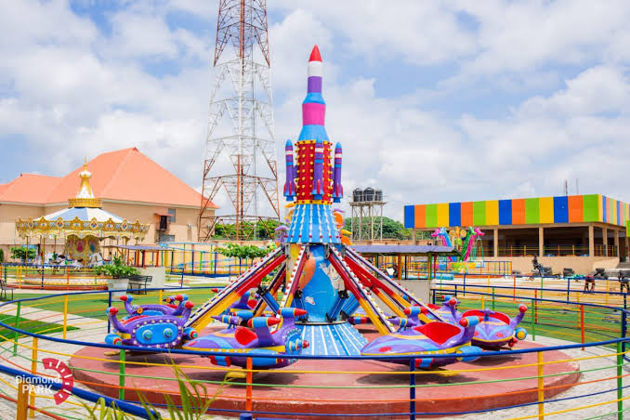

Fig 2: Picture of part of Diamond Park, Irewolede Road, Ilorin, Kwara State
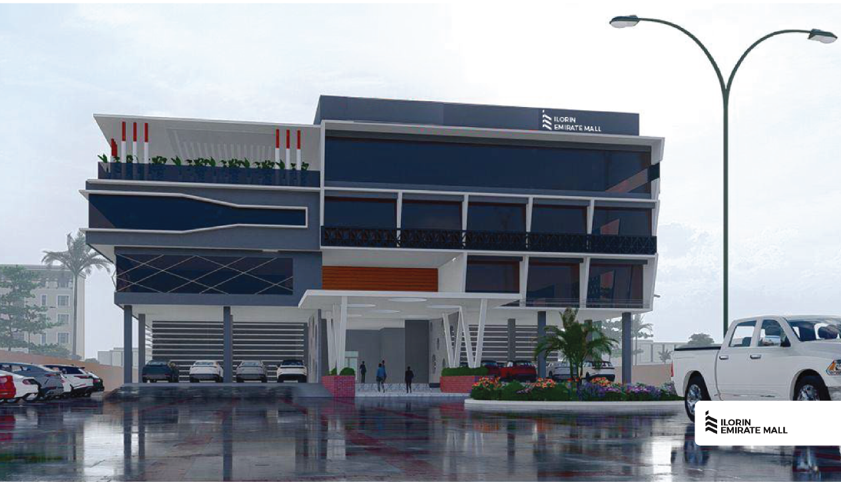

Fig. 3: Picture of the entrance of Emirate Mall, No. 1 Airforce Base Street, Off Lagos-Ogbomoso Road, Ilorin, Kwara State

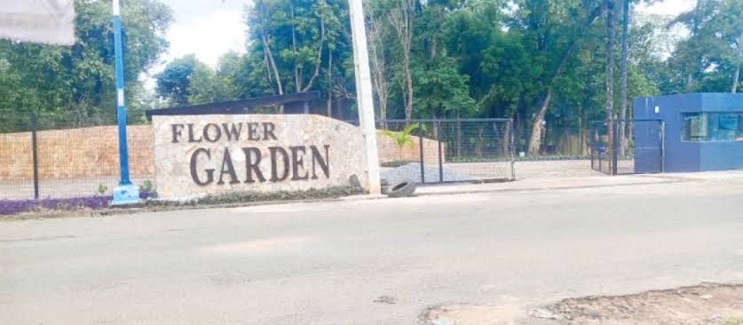

Fig. 4: Picture of the entrance of Flower Garden, 4 Park Close, Flower Garden Rd, Oko Erin, Kwara State.
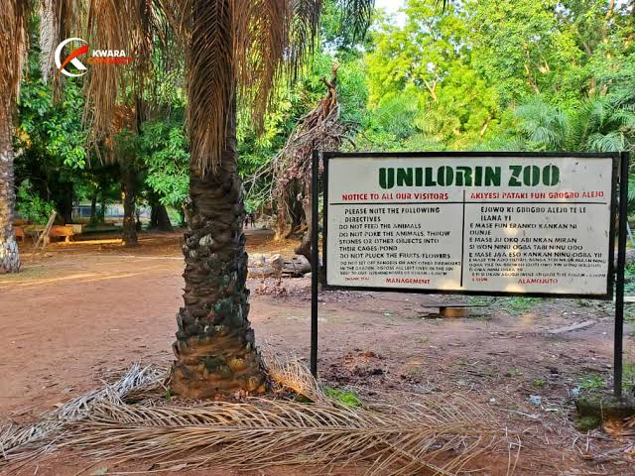

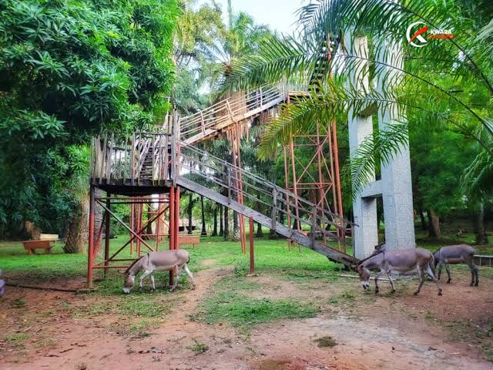

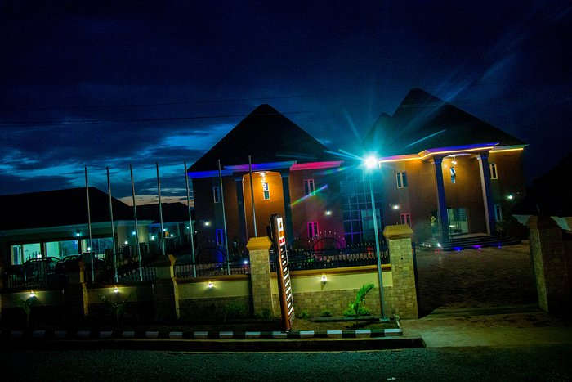
Fig. 5: Picture of part of Unilorin Zoo, University Road, Akanbi-1v, Kwara State.

Fig. 6: Picture of the entrance of Waterview, Ilorin Kwara State.

