A TECHINCAL REPORT ON MATERNITY HOME ( KWARA STATE)
AT
ILORIN SOUTH LOCAL GOVERNMENT, KWARA STATE
BY
SULAIMAN ABUBAKRI
ND/23/ARC/PT/0036

BEING A PROJECT REPORT SUBMITTED TO THE DEPARTMENT OF ARCHITECTURAL TECHOLOGY, INSTITUTE OF ENVIRONMENTAL STUDIES, KWARA STATE POLYTECHIC, ILORIN.
IN PARTIAL FULFILMENT OF THE REQUIREMENT FORTHE AWARD OF NATIONAL DIPLOMA (ND) IN ARCHITECTURAL TECHNOLOGY.

MARCH, 2025

DECLARATION
I declare that this Project/Dissertation is a project of my personal research works. It has not been presented for the award of any ND in any polytechnic. The ideas, Observations, Comments, and Suggestions here in represent my own convictions except quotations, which have been acknowledged. In accordance with conventional academic traditions.

SULAIMAN ABUBAKRI
ND/23/ARC/PT/0036
_______________________
SIGNATURE & DATE

CERTIFICATION
I certify that this research project/Dissertation entitled EATERY was carried out by SULAIMAN ABUBAKRI under my supervision ARC JUMOKE TOMORI has been approved. As meeting the requirement for the award of ND in Architectural Technology, Kwara State Polytechnic, Ilorin, Kwara State.

ARC J.M TOMORI __________________
Project Supervisor SIGNATURE & DATE

ARC ADEYEMI __________________
Project Coordinator SIGNATURE & DATE

ARC J..M TOMORI __________________
Head of Department SIGNATURE & DATE

_________________
EXTERNAL EXAMINER SIGNATURE & DATE

ACKNOWLEDGEMENT
My profound gratitude goes to Almighty Allah, the creator of universe and fountain of all wisdom whose umbrella of guard and guide. I seek refuge through thick and thin of years of study. I will also like to appreciate my project supervisor in person of ARC J.M TOMORI whose contribution Prepare me for the challenges in the field and for his immense contribution is all ramification towards the completion of this research work. He encourage me and open the door of interaction with him. I pray Almighty Allah will shower his blessing and mercy over him, your family and may you live to reap the fruit of your labour. I also want thank and appreciate the effort of all the Lectures in Architectural Technology Department, who taught and give lasting advice’s that led to the success of my program, Almighty Allah will meet everyone at the point of needs. I would also show my profound gratitude to my parents MR and MRS SULAIMAN for their Immeasurable motivation, advices, efforts, and prayers on me for the completion of this program. My BELOVED BROTHER AND SISTER.
I appreciate you all, May Almighty Allah bless you all. Above all, my utmost thanks go to the all sufficient God, the fountain of my wisdom, for his great and protection over my life, for his undying love, support and guidance throughout my period of learning and also for in sighting writing this project without him am nothing.

DEDICATION
This project work is dedicated to Almighty Allah who has been providing all my need for his blessing and mercy over me all through the program. And to my parent, my sisters, my brothers, friends, love one’s and supervisor who assist me financially, spiritually, mentally and guide me through my academic pursuit. May Almighty Allah shower his blessing and mercy over you all.
TABLE OF CONTENT
Title page……………………………………………………
I Declaration……………………………………………………………
II Certification…………………………………………………………..
III Acknowledgement……………………………………………………...
IV Dedication…………………………………………………………….
V Table of contents……………………………………………………...
IV List of tables…………………………………………………………..
IIV List of plates………………………………………………………….
IIIV Abstract……………………………………………………………….
CHAPTER ONE
1.1 INTRODUCTION………………………………………………...
1.2 DEFINITION…………………………………………………….. .
1.3 HISTORICAL BACKGROUND………………………………….
1.4 AIM ………………………………………..
1.5 OBJECTIVES …………………………………….
1.6 JUSTIFICATION……………………………………….
1.7 LIMITATION ………………………………………………….

CHAPTER TWO
2.0 LITERATURE REVIEW………………………………………………………………
2.1 HISTORICAL BACKGROUND………………………………...
CHAPTER THREE
3.1 CASE STUDIES……………………………………….…...........
3.2 SELECTED CASE STUDIES…………………………………..
3.3 CASE STUDY ONE…………………………………………..
3.4 CASE STUDY TWO…………………………………………….
3.5 CASE STUDY THREE ………………………………………….
3.6 ONLINE CASE STUDY……………………………………
CHAPTER FOUR
4.0 PROJECT LOCATION
4.1 BRIEF HISTORICAL BACKGROUND KWARA STATE………………………..…...
4.2 LOCATION AND SETTING OUT……………………………...…....
4.3 POPULATION……………… ……………………………….…….....
4.4 SITE INVENTORY………………………...…………………..……...
4.5.1SITE SELECTION AND JUSTIFICATION… ……… ……. ..….......
4.5.2 LOCATION ………………………………..…………….…………..
4.5.3 ACCESSIBILITY………….……………………..…………………
4.5.4 INFRASTRUCTURE FACILITES….………………………………..
4.5.5TOPOGRAPHY……………………………………............................
4.5.6 SOIL STRUCTURE…………………………………………………..
4.6.1 GENERAL CLIMATE CONDITION.………………….………….
4.6.2 WIND…...............................................................................................
4.6.3 TEMPERATURE…………….……………………………………..
4.6.4 VEGETATION……………………………………………………..
4.7.1 ROAD………………………………………………………………
4.7.2 WATER AND ELECTRICITY………………………………………
4.8 DESIGN CRITERIA…………………………………………………..
4.9 DESIGN BRIEF …………………………………………….…….
4.10 DESIGN ANALYSIS… ………………………………………..…..
SPACIAL ALLOCATION …………………………………………....
PLANNING PRINCIPLE…………………………………………..
CHAPTERFIVEAPPRAISAL OF PROPOSED SCHEME………………………
CONSTRUCTION METHODOLOGY………………………………
SERVICES………………………………………………………….
VENTILATION…………………………………………………….
LIGHTING………………………………………………………… PLUMBING………………………………………………………..
ELECTRICAL INSTALLATION…………………………………
WASTE DISPOSAL………………………………………………..
FIRE PROTECTION……………………………………………….
RAIN PROTECTION………………………………………………
1EXTERNALWORK…………………………………………………..
SUMMARY………………………………………………………...
CONCLUSION……………………………………………………..
RECOMMENDATION…………………………………………….
REFERENCES…………………………………………………..
ABSTRACT
This maternity home provides a safe, supportive, and nurturing environment for expectant mothers, prioritizing their physical, emotional, and social well-being. Our facility offers comprehensive prenatal care, parenting education, and community resources to empower women and promote healthy outcomes for mothers and babies. By fostering a sense of community and connection, we aim to transform lives and build brighter futures.

CHAPTER ONE
  - INTRODUCTION
The concept of maternity has existed for centuries providing a safe haven for pregnant woman and new mothers in need. These specialized facilities offer comprehensive care and support, addressing the physical emotional and social needs of their president, by providing a nutrient and environment, maternity homes empower women to make informed decisions about their health, well-being and future. This discussion aim to explore the significant services and benefit of maternity homes highlighting their vital role in promoting healthy outcomes for mothers.
1.2 DEFINITION OF MATERNITY HOME
Maternity home is a presidential facility providing shelter, care and support to pregnant women, new mothers and their babies, offering a safe and nurturing environment during pregnancy, childbirth and postpartum, with on site medical care counseling and education programs promoting healthy parenting and family well-being.
1.3 HISTORICAL BACKGROUND
The maternity home dates back to ancesting to civilization, where temples and comment provided refuge and care to pregnant woman and new mother, in the middle ages, charitable institutions and almshouses offered shelter and children. The modern concept of maternity home emerged in the 19th and early 20th centuries, with the establishment of the charitable organizations and social services aimed at supporting vulnerable population including unmarried other an there children.
In Nigeria they have their roots in the colonial era, when Christian missionary establish hospital ad healthcare facilities to provide medical care to local population
1.4 AIMS
My aims for this project is to design modern well equipped and sustainable maternity that provide compressive and accessible maternal health care service to the woman of Ilorin south improving maternal and infant health outcomes and enhancing overall quality of life for mother and their families in the region
1.5 OBJECTIVES
- To design a maternity home that provides a comfortable welcoming and supportive environment for mother and their families
- To provide the modern well equipped and sustainable maternity home that offer compressive maternal health care services to women in Ilorin south.
1.6 JUSTIFICATION
most of the existing health care facilities in Ilorin south lack modern infant rates compared to other parts of the country in this case I like to design maternity hospital that will provide access quality care reducing maternal and infant maternal rates within Ilorin south.
1.7 LIMITATION
The inadequacy of maternity facilities in Ilorin south poses a significant challenge to providing quality care many facilities lack basic amenities such as adequate lighting, water and sanitation making it difficult for health care professional to provide effective care. In addition, the limited availability of essential medical equipment.

CHAPTER TWO
2.0 LITERATURE REVIEW
2.1HISTORY BACKGROUNG OF MATERNNITY HOME
Maternity homes have a long history dating back to the early 20th century. Initially, they provided shelter and care for unwed pregnant women, often stigmatized and ostracized by society. Over time, their purpose and services have evolved.
Some key developments include:
1. Early 20th century: Maternity homes focused on providing a safe haven for unwed mothers, offering basic care, and sometimes adoption services.
2. Mid-20th century: As social attitudes shifted, maternity homes began to expand services, including prenatal care, education, and support.
3. Late 20th century: Maternity homes started catering to a broader range of women, including those with substance abuse issues, teenagers, and low-income families.
4. Present day: Modern maternity homes often provid…
Maternity homes have a complex and evolving history that spans centuries. Here's a brief overview:
Early Beginnings
- During the Victorian era, maternity homes emerged as shelters for unwed mothers, often organized and supported by church and charity groups.
- The Salvation Army opened its first maternity home in the United States in 1886, marking the beginning of organized support for unwed mothers.
Purpose and Practices
- Initially, maternity homes aimed to protect unwed mothers from social stigma and poverty, offering education on childbirth and childcare.
- Residents often faced isolation, loneliness, and restrictive policies, including using false names and limited contact with family and friends.
- Some homes required girls to perform tasks as payment for medical expenses, viewing these "good works" as redemptive.
Changing Attitudes and Services
- By the mid-20th century, maternity homes began catering to a broader range of women, including those with substance abuse issues and low-income families.
- As social attitudes shifted, maternity homes expanded services to include prenatal care, parenting education, and mental health support.
Challenges and Controversies
- Many women experienced coerced adoption, verbal and emotional abuse, and unattended labor in these homes.
- The legacy of maternity homes is marked by controversy, with some viewing them as institutions that perpetuated shame and stigma around unwed motherhood ¹ ².
Modern Developments
- Today, maternity homes prioritize comprehensive services, including prenatal care, parenting education, and connection to community resources.
- These homes aim to empower pregnant women and new mothers, addressing their physical, emotional, and social needs

CHAPTER THREE
3.1 CASE STUDIES
This is are search or an exercise that is carried out on existing building which is similar to the one researcher is writing on. The objective of a case study is to take a critical appraisal of existing related project with a view to identify the positive and negative aspect of such projects. It is only with time that a project can be adjusted so that it can be successful. The information obtained from the appraisal will guide the designer of new and similar project, the positive aspect of it shall be incorporated in the view proposal while attempts will be made to solve the problem of negative aspects. It is only through this that a designer can better enhance the quality and efficiency of building in the society. For a comprehensive analysis their case studies have been conducted.
3.2 SELETED CASE STUDIES
Case studies are of paramount important. It is an experimental research or analysis carried out on existing building or group of building functionally similar to the one which there search is working.For any technical design to be meaningful there is always the need for preliminary research effort to be made on this proposal as a very necessary ground work.The following are case studies of some maternity.
ILORIN KWARA STATE
IBADAN OYO STATE
EKITI STATE
3.3 CASE STUDY 1
MERIT
- This ward is wide enough it can accommodate up to 20 people at once
- The office, ward and reception all has cross ventilation and lighting that served them
DEMERIT
- The court yard is not well constructed if leaked during raining season/period
- The reception did not enough visitor toilet

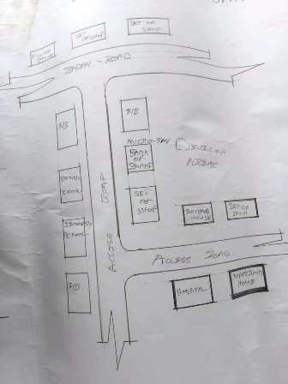

Fig 1, SHOWING LOCATION PLAN OF CASE STUDY ONE
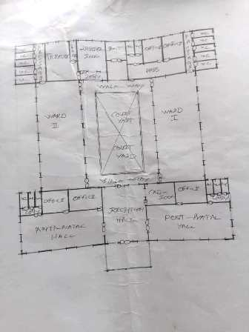

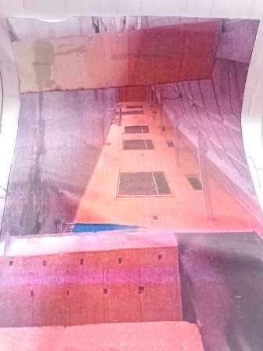

FIG 2, SHOWING FLOOR PLAN OF CASE STUDY ONE

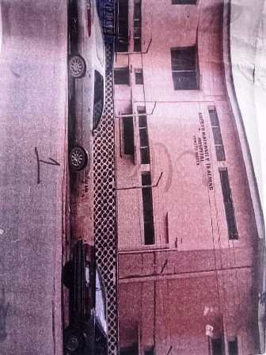
PLATE 1, SHOWING LEFT VIEW OF CASE STUDY ONE

PLATE 2, SHOWING FRONT VIEW OF CASE STUDY ONE

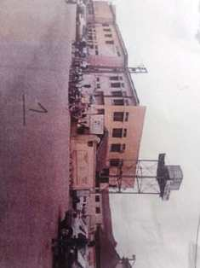
PLATE 3, SHOWING RIGHT VIEW OF CASE STUDY ONE

PLATE 4, SHOWING BACK VIEW OF CASE STUDY ONE
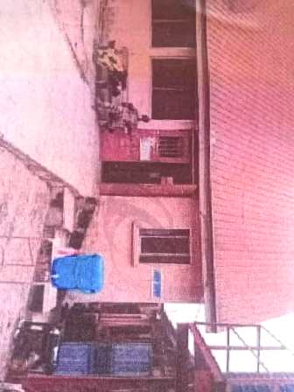

3.4 CASE STUDY TWO
MERIT
- The building is separated from other building on site this make it to have access natural ventilation
- The building is structurally stable
DEMERIT
- Some internal path of the building are such as passage of the labour and doctors office is very dark
- Not enough parking lot

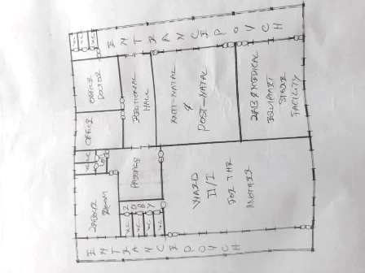

Fig 3, SHOWING FLOOR PLAN OF CASE STUDY TWO
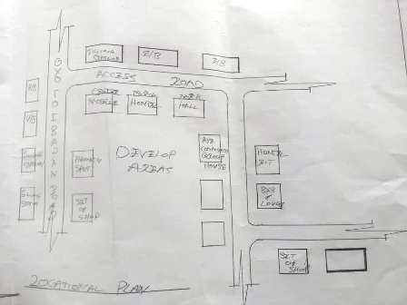

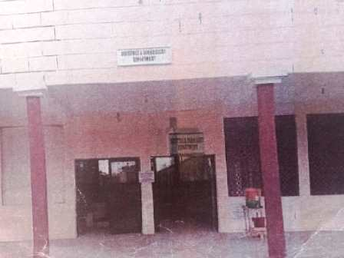
Fig 4, SHOWING LOCATION PLAN OF CASE STUDY TWO

PLATE 5, SHOWING FRONT VIEW OF CASE STUDY TWO
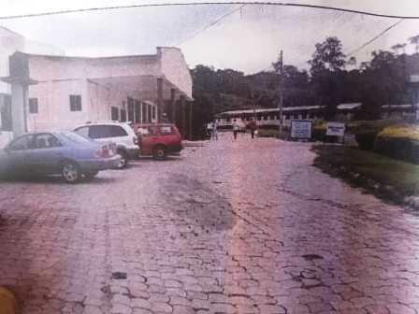

PLATE 6, SHOWING LEFT VIEW OF CASE STUDY TWO
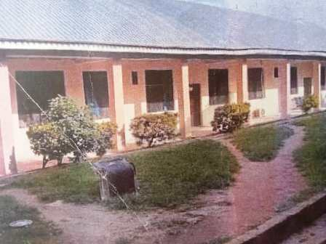

PLATE 7, SHOWING BACK VIEW OF CASE STUDY TWO
3.5 CASE STUDY THREE
MERIT
- The ward is not wide enough
- It has comfortable sitting area
DEMERIT
- The reception have visitor toilet
- The building is well design

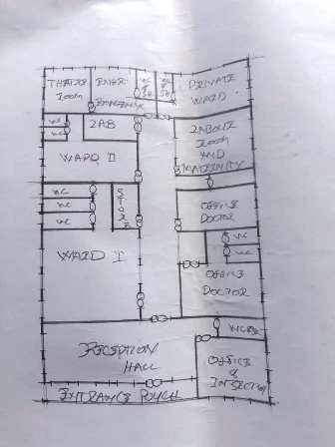

Fig 5, SHOWING FLOOR PLAN OF CASE STUDY THREE
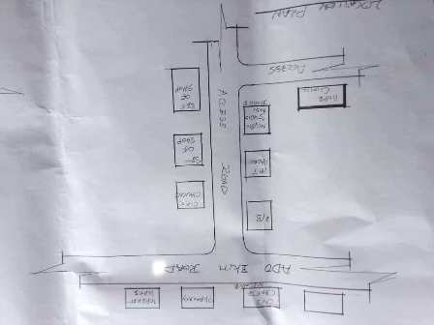
Fig 6, SHOWING LOCATION PLAN OF CASE STUDY THREE
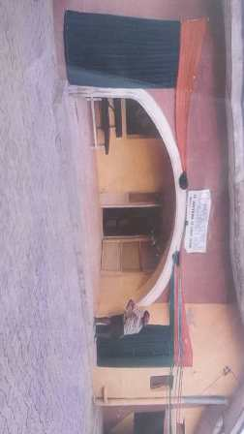

PLATE 8, SHOWING FRONT VIEW OF CASE STUDY THREE
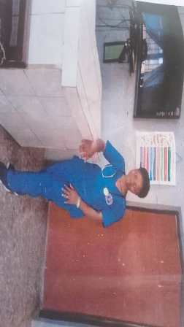

PLATE 9, SHOWING THE RECEPTION AREA OF CASE STUDY THREE
3.6 ONLINE CASE STUDY
-Project Name: Avasara Academy
- Location: Maharashtra, India
- Architect: Case Design
- Year: 2019
- Area: 14,200 m²

- Project Name: Nokha Village Community Centre
- Location: Seelwa, India (Nokha Village in Rajasthan)
- Architect: Sanjay Puri Architects
- Year: 2024
- Area: 13,000 ft²
DEDUCTION FROM CASE STUDIES
During my visit to the maternity .I was opportunities to see what was obtain in the maternity, I made a proper studies of their related function and analysis were made to their present situation with the aim of incorporation with their merit in my own final proposal. The following were deduce from my case studyThe location of the maternity.

CHAPTER FOUR
4.0 PROJECT LOCATION
4.1 BRIEF HISTORICAL BACKGROUND OF KWARA STATEKwara (Yoruba: Ìpínlẹ̀ Kwárà) is a state in Western Nigeria, bordered to the east by Kogi State, to the north by Niger State, and to the south by Ekiti, Osun, and Oyo states, while its western border makes up part of the international border with Benin. Its capital is the city of Ilorin and the state has 16 local government areas.Of the 36 states of Nigeria, Kwara is the ninth largest in area but the sixth least populous with an estimated population of about 3.2 million as of 2016.Geographically, Kwara is split between the West Sudanian savanna in the east and the Guinean forest–savanna mosaic ecoregion in the rest of the state. Important geographic features include rivers with the Niger flowing along the northern border into Lake Jeba before continuing as the border while the Awun, Asa, Aluko, and Oyun rivers flow through the interior. In the far northwest of the state is the Borgu section of the Kainji National Park, a large national park that contains populations of grey heron, kob, hippopotamus, African bush elephant, olive baboon, and roan antelope, along with some of the last remaining West African lions on earth. In the far southwest, a small part of the Old Oyo National Park contains crowned eagle, martial eagle, African buffalo, oribi, and patas monkey populations.
ECONOMY OF KWARA STATE
Agriculture is the main source of the state's economy and the principal cash crops are: cotton, cocoa, coffee, kola nut, tobacco, sesame and palm produce. Kwara state is home to Shonga Farms, a product of the Back-to-Farm project of one of the past administrators of the state, Dr. Abubakar Bukola Saraki. Shonga Farms is made up of 13 commercial farmers. Mineral resources in the state are Petroleum, Gold, limestone, marble, feldspar, clay, kaolin, quartz and granite rocks, and laterite found majorly in omuaran.
ORGANIZATION STRUCTRE
An organizational structure is a system that outline shows certain activities that are direct in order to achieve the goals of an organization. These activities can includes rules, roles and responsibilities. The organizational structure also determine show information flows between levels within the clinic.

4.2 LOCATION AND SETTING OF KWARA STATE
Kwara State was created on 27 May 1967, when the Federal Military Government of General Yakubu Gowon broke the four regions that then constituted the Federation of Nigeria into 12 states. At its creation, the state was made up of the former Ilorin and Kabba provinces of the then Northern Region and was initially named the West Central State but later changed to "Kwara", a local name for the River Niger, in the Hausa language.Kwara state has since 1976 reduced considerably in size due to further state creation exercises in Nigeria. On 13 February 1976, the Idah/Dekina part of the state was carved out and merged with a part of the then Benue/Plateau state, to form Benue state.On 27 August 1991, five Local Government areas, namely Oyi, Yagba, Okene, Okehi and Kogi were also excised to form part of the new Kogi state, while a sixth, Borgu Local Government Area, was merged with Niger state. The major populated local governments are Ilorin and Offa.Kwara state has numerous mineral resources such as tourmaline, tantalite, and many mineral deposits in the northern part. Cocoa and Kolanut in the Southern parts Oke - Ero, Ekiti and Isin LGA.
POPULATION
The population development of kwara state as well as related information and services. The current metro area population of Ilorin in 2025 is 1,100,000, a 3.38% increase from 2024.The metro area population of Ilorin in 2024 was 1,064,000, a 3.3% increase from 2023.The metro area population of Ilorin in 2023 was 1,030,000, a 3% increase from 2022.The metro area population of Ilorin in 2022 was 1,000,000, a 2.67% increase from 2021.
TABLE 1;
SHOWING GENDER GROUP
4.4 SITE INVENTORY
In the proposed site, some shrubs will be retained on site. It used to reduce sky glare and also serve as soft landscape and wind breaker. Presence of road network which would serve as a means of accessibility to the site. Presence of electricity pole which serve as source of electricity to the site. Some trees would be retained while some will be removed if they disrupt the construction of building.

SITE ANALYSIS
The site is benefitted with loamy soil which is a very good soil for grass and shrubs. It has a gentle slope towards the south east. Some of the grasses, shrubs and trees on the site are to be retained to enhance landscape patter of the site while some are to be removed and replanted where necessary. The two noticeable winds are to be directed into the building using landscape pattern to improve ventilation. Noise generated from vehicle traffic is controlled through proper planning, good landscaping and proper orientation of building. Generally, all the feature on the site are best put into different uses to aid control through proper planning, landscape and orientation. Certainly, steps are considered to obtain vital information of the site, this information is the analysed in details. For design purpose, the information include soil condition, geology, topography, vegetation etc. It also involves carrying out a preliminary survey of the site.
4. 5.1 SITE SELECTION/JUSTIFICATION
In the site selection provision is made for interesting facilities that worth emulating since the overall success and efficiency of any project depend not on the functionality of the design but also on a careful choice of site. The site of this project has been carefully selected which is located in the premises of Share, Ilorin local government Kwara state. The proposed site is located at Share at Ilorin, Kwara state.
4.5.2 LOCATION
The site is located Taiwo Road 240241 Ilorin, Kwara state Nigeria.
4.5.3 ACCESSIBILITY
The site is easily accessible from the access road off from the main road that goes to Taiwo road. The site can also be reached through the access road that lead to General.
4.5.4 INFRASTRUCTURAL FACILITIES
Facilities such as water electricity, telephone network and road network are all in Ilorin, hence it can easily be tapped to the proposed site.
4.5.5 TOPOGRAPHY
The topography of the land is gentle slope which can be filled and levelled up to balance round all the site levels.
4.5.6 SOIL STRUCTURE
It is made up of clayish laterite soil, which is good for building construction.
4.6 GENERAL CLIMATIC CONDITION
Kwara State generally experiences a tropical savanna climate (Aw) with distinct wet and dry seasons. The temperature is warm throughout the year, with an average around 29.54°C (85.17°F). Rainfall varies, with an annual average of about 101.45 millimeters (3.99 inches), and the state has around 148.38 rainy days annually
4.6.1 RELATIVE HUMIDITY
Relative humidity is higher during the rainy season, ranging from 75% to 88%, and lower during the dry season, ranging from 35% to 80%.
4.6.2 WIND
The prevailing winds are the south-west monsoon wind and the north-east continental wind.
4.6.3 TEMPERATURE
Kwara State is characterized by warm temperatures year-round, with January being the coolest month and April being the hottest. Temperatures can range from a minimum of 14°C (58°F) in January to an average of 27°C (81°F) throughout the year, with April experiencing intense heat that can reach 43°C (109°F).
4.6.4 VEGETATION
The proposed site is covered with grasses few trees and shrubs. Some will be removed before the construction while some will be retain for ornamentation.
4.7 SOCIAL SERVICES
4.7.1 ROAD There are only two access to the siteThe southern access which serve as the main entrance and also main access road
4.7.2 WATER AND ELECTRICITYT
here are pipe born water networks and borehole water which serves the habitant of Ibadan. There is electricity supply from NEPA that serve the Kwara state in general
4.8 DESIGN CRITERIA
There are three (3) methods of designing of any project which are: Function before form method Form before function method Combination of Shapes Designing projects, the function, before form method used in line with this method, the following are the design criteria for this project: Functional: in term of functional requirement, the following design criteria must be considered. Sustainability, Site and Location, Flexibility, Circulation, Accessibility, Organization, Maintenance, Environment and Services
4.9 DESIGN BRIEF
After research and planning, the next step in the series of the project programed is design itself. To achieve functional and well established design there must be a brief to work on. This brief depends generally on the scope of individual design. The brief of this project is therefore based on the various activities that take place in the Eatery. To have enough brief for the proposed Eatery, case studies were carried out on the existing Eatery. The studies also give me the opportunity to know the nature of the various unit in building and how they are related to each other.
4.10 DESIGN ANALYSIS
This is the process of itemizing units within the component of the entire design with a view to establishing a solid understanding and appreciation of the space relationships.
The units of the design are in three division, the unit of the project division are as follows: GROUND FLOOR PLAN; Entrance, Reception, Laboratory, Record room, Staff lounge, Store, First aid, Account office, Marketing department, sec, Manger office, Active office,
TABLE 2; SHOWING SPACIAL ALLOCATION OF FLOOR PLAN
Necessary units in the building. A borehole system of water supply is to be adopted alongside the government supplied services and a storage facility is to be provided for effective management of water supply.

CHAPTER FIVE
SUMMARY
The design and realization of a maternity home require a thoughtful, human-centered approach that prioritizes the safety, comfort, and well-being of mothers, newborns, and healthcare providers. The process begins with understanding the users' needs—primarily pregnant women and new mothers, alongside doctors, nurses, and support staff. These users require spaces that are safe, private, accessible, and calming. Site selection is equally important and should be based on factors such as proximity to the community, ease of access, a quiet environment, good drainage, and adequate sunlight and airflow.
The planning phase involves effective functional zoning to separate public, semi-public, and restricted areas. Public zones include the reception, waiting area, and pharmacy; semi-public zones consist of antenatal and consultation rooms, while restricted zones contain the labor and delivery rooms, operating theatres, postnatal wards, and neonatal intensive care units. Spatial planning must meet health regulations for room sizes, lighting, ventilation, and hygiene. Finishes must be easy to clean, and the building should be designed to support infection control with adequate handwashing stations and waste management facilities.
Furthermore, the design must integrate sustainability by including features like rainwater harvesting systems, solar panels, proper sewage disposal, and the use of eco-friendly local materials. Comfort and safety are key considerations; this includes non-slip flooring, soundproof rooms, fire exits, ergonomic furniture, and natural ventilation. Accessibility is also crucial, ensuring that the facility caters to people with disabilities through ramps, wide doors, clear signage, and other inclusive features.
In the design realization phase, the concept is developed into schematic layouts and architectural drawings such as site plans, floor plans, elevations, and sections. These are supported by structural, plumbing, and electrical designs. Visualization tools like 3D modeling and rendering help bring the design to life, offering realistic perspectives of both interior and exterior spaces. Optionally, a physical model can be constructed to represent the structure at scale. Ultimately, a maternity home should reflect care, functionality, and resilience, ensuring that every mother and child receives support in a healing and nurturing environment.
RECOMMENDATION
In designing a maternity home, it is recommended that architects and planners adopt a user-centered design approach that prioritizes the health, comfort, and emotional well-being of both patients and medical staff. Emphasis should be placed on functional zoning, ensuring a clear separation of public, semi-public, and restricted areas to support smooth workflow and privacy. Sustainable practices, such as the incorporation of solar energy, rainwater harvesting, and the use of environmentally friendly materials, should be encouraged to reduce operational costs and environmental impact. Accessibility features must be integrated into every part of the design to cater to people with disabilities, while safety protocols—such as proper fire exits, infection control measures, and ergonomic design—must not be compromised. It is also recommended that stakeholders, including healthcare professionals and local communities, be actively involved in the planning phase to ensure the design responds effectively to local needs and cultural values.
CONCLUSION
The design and realization of a maternity home go beyond mere architectural planning; it involves creating a healing environment that supports safe childbirth, postnatal care, and emotional stability. A successful maternity home design must be functional, accessible, hygienic, and comforting, offering a safe space for mothers and their newborns. Through thoughtful spatial planning, sustainable integration, and user-informed decision-making, maternity homes can be transformed into places that not only provide clinical care but also foster dignity, hope, and healing. The ultimate goal is to ensure that every woman receives respectful, high-quality maternity care in a facility that truly reflects her needs.

REFERENCE

• Akinyemi, O. O., & Adedeji, Y. M. D. (2019). Design considerations for maternal and child health care facilities in Nigeria. Journal of Environmental Design and Management, 11(1), 45–53.
• Facility Guidelines Institute (FGI). (2018). Guidelines for Design and Construction of Hospitals. Dallas, TX: FGI.
• National Primary Health Care Development Agency (NPHCDA). (2012). Minimum standards for primary health care in Nigeria. Abuja: Federal Government of Nigeria.
• Olusanya, B. O., & Alakija, A. (2020). Improving maternal and neonatal outcomes through sustainable health facility design in developing countries. International Journal of Maternal and Child Health, 8(3), 215–223.
• Oyedepo, J. A. (2021). Architecture and healthcare: A framework for designing maternal health facilities in Nigeria. Journal of African Built Environment Research, 5(2), 78–89.
• Ulrich, R. S., Zimring, C., Zhu, X., DuBose, J., Seo, H., Choi, Y. S., & Joseph, A. (2008). A review of the research literature on evidence-based healthcare design. Health Environments Research & Design Journal (HERD), 1(3), 61–125.
• World Health Organization (WHO). (2015). WHO recommendations on health promotion interventions for maternal and newborn health. Geneva: WHO Press.

