

IMPACT OF CHANGE IN GOVERNMENT POLICIES ON CONSTRUCTION PERFORMANCE IN NIGERIA

BY

OLAWUYI AKINWUMI MOSES

HND/23/QTS/FT/0039

BEING A RESEARCH PROJECT SUBMITTED TO DEPARTMENT OF QUANTITY SURVEYING, INSTITUTE OF ENVIRONMENTAL STUDIES (IES), KWARA STATE POLYTECHNIC, ILORIN.

IN PARTIAL FULFILMENT OF THE REQUIREMENT FOR THE
AWARD OF HIGHER NATIONAL DIPLOMA (HND) IN QUANTITY SURVEYING, KWARA STATE POLYTECHNIC, ILORIN.

JULY, 2025

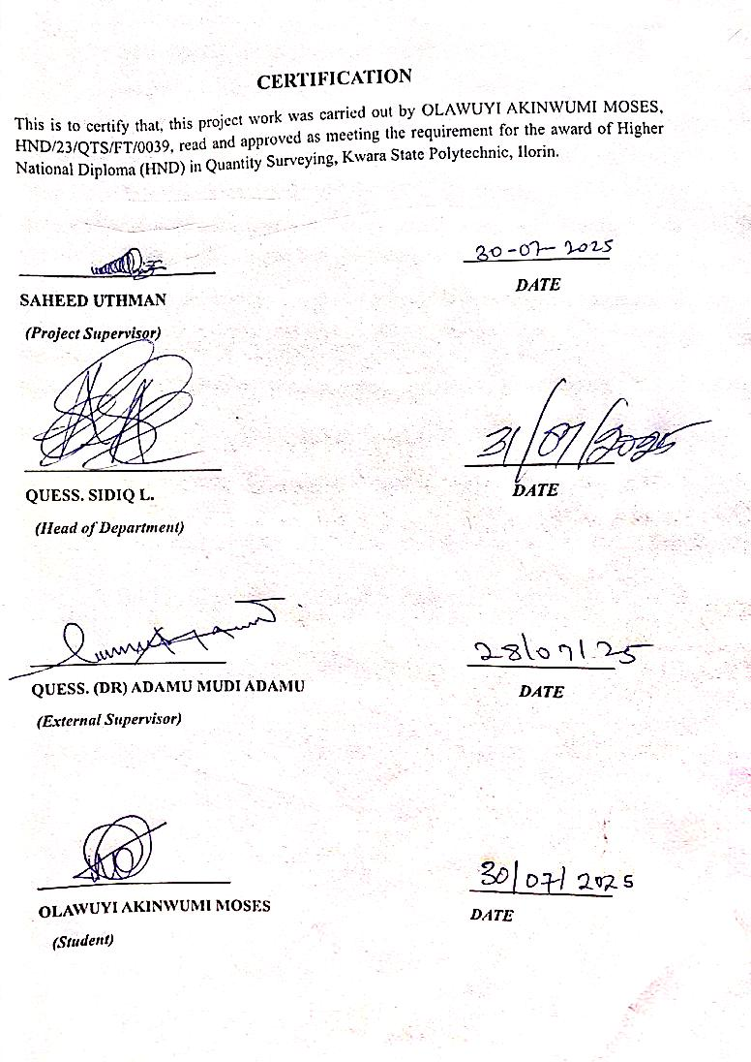

DEDICATION

This project is wholeheartedly dedicated to God Almighty, the source of my strength, wisdom, and perseverance throughout this academic journey.
To my beloved late father, whose memory continues to inspire me, and to my loving mother, Mrs. Olawuyi, for her endless prayers, support, and sacrifices your strength is my motivation.
A special and heartfelt dedication goes to my dear brother, Mr. Isaac Olawuyi, who carried the burden of my education with love, determination, and selfless commitment. Your unwavering support made this possible.
This success is for us all.
Thank you.

ACKNOWLEDGMENT
First and foremost, I express my deepest gratitude to God Almighty, the giver of life, wisdom, and strength, for seeing me through the challenges and victories of this academic journey.
I owe a special appreciation to my loving mother, Mrs. Olawuyi, whose unwavering support, prayers, and encouragement have been a pillar of strength to me. To my amazing brothers Mr. Isaac Olawuyi and Mr. Olawuyi Abiodun thank you for your selfless sacrifices and for carrying the weight of my education with love and dedication.
My sincere appreciation goes to my project supervisor, Qs. Saheed Uthman, for his patience, guidance, corrections, and valuable contributions that greatly shaped this research work.
To my dear friends, Adesokan Olushola, Aboluwarin Oluwadamilola and Adegbola Mary, thank you for standing by me with constant encouragement, true friendship, and unwavering support throughout this journey.
I also extend my gratitude to all my lecturers and everyone who played a role directly or indirectly in the successful completion of this academic project. May God bless you all abundantly.
Lastly, I express my sincere appreciation to the entire faculty and staff of the Department of Quantity Surveying, Kwara State Polytechnic, for providing an intellectually stimulating and supportive academic environment.
Thank you all for being an integral part of my academic journey.

OLAWUYI AKINWUMI MOSES

ABSTRACT
The aim of this research is to investigates the impact of leadership in influencing the safety performance of construction workers within the Nigerian construction industry. Given the inherently hazardous nature of construction activities, leadership has emerged as a critical factor in establishing a strong safety culture, reducing accidents, and promoting compliance with safety protocols. The research specifically evaluates how various leadership styles and behaviors contribute to safety awareness, supervision, hazard control, and overall worker protection. A quantitative research method was adopted, and data was collected using structured, close-ended questionnaires administered to construction professionals in Kwara State, Nigeria. Respondents included Quantity Surveyors, Public Sector Officers, Site Engineers, and Project Managers, all of whom play significant roles in the implementation and monitoring of safety on construction sites. The collected data was analyzed using the Relative Importance Index (RII) to rank the impact of different leadership factors on safety performance. The findings revealed that leadership attributes such as effective communication, proactive supervision, employee involvement in safety decisions, and visible commitment to safety had the highest influence on improving worker safety performance. Construction sites led by supervisors who actively engage workers and enforce safety policies experienced fewer incidents and higher compliance levels. In contrast, poor leadership or neglect of safety responsibilities correlated with reduced morale and increased accident rates. The study concludes that strong and participative leadership is essential to achieving optimal safety performance on construction projects. It recommends that firms develop leadership training programs focused on safety management, promote inclusive decision-making, and institutionalize safety-conscious leadership practices to ensure safer working environments across construction sites.

TABLE OF CONTENTS
DECLARATION i
CERTIFICATION ii
DEDICATION iii
ACKNOWLEDGMENT iv
ABSTRACT v
CHAPTER ONE 1
INTRODUCTION 1
1.1BACKGROUND OF THE STUDY 1
1.2 STATEMENT OF THE PROBLEM 3
1.3 RESEARCH QUESTION 4
1.4AIM AND OBJECTIVES OF THE STUDY 4
1.4.1 AIM 4
1.4.2 OBJECTIVES 4
1.5 SIGNIFICANCE OF THE STUDY 5
1.6 SCOPE AND LIMITATION OF THE STUDY 5
1.7 DEFINITION OF TERMS 5
CHAPTER TWO 7
LITERATURE REVIEW 7
2.0 INTRODUCTION 7
2.1 CONCEPT OF GOVERNMENT POLICY 8
2.2 THEORETICAL REVIEW 10
2.2.1 INSTITUTIONAL THEORY 10
2.2.2 SYSTEMS THEORY 11
2.3 GOVERNMENT POLICY AND BUILDING CONSTRUCTION 12
2.3.1 TYPES OF GOVERNMENT POLICIES 13
2.3.2 IMPACT OF GOVERNMENT POLICIES ON BUILDING
CONSTRUCTION 14
2.4 THE EFFECT OF UNFAVORABLE GOVERNMENT POLICY ON TIMELY COMPLETION OF BUILDING PROJECT. 15
2.4.1 TYPES OF UNFAVORABLE GOVERNMENT POLICY 15
2.4.2 EFFECTS OF UNFAVORABLE GOVERNMENT POLICY ON TIMELY
COMPLETION OF BUILDING CONSTRUCTION 16
2.5.1 NEED FOR GOVERNMENT POLICY IN CONSTRUCTION
INDUSTRY 16
2.5.2 TYPES OF GOVERNMENT POLICIES NEEDED IN CONSTRUCTION 22
INDUSTRY 17
2.6 GOVERNMENT POLICY IMPLEMENTATION AND ITS BARRIERS 18
2.7 EMPIRICAL REVIEW 19
2.7.1 POLICY CHANGE AND CONSTRUCTION COST 19
2.7.2 GOVERNMENT TRANSITION AND PROJECT DELAYS 19
2.7.3 POLICY INTERPRETATION AND QUALITY CONTROL 20
2.7.4 STAKEHOLDER CHALLENGES 20
2.7.5 STRATEGIES TO IMPROVE PERFORMANCE 21
2.8 GAPS IN THE LITERATURE 21
2.8.1 LIMITED LOCALIZED STUDIES AT THE STATE LEVEL 21
2.8.2 INSUFFICIENT FOCUS ON THE ROLE OF PARASTATAL AGENCIES 22
2.8.3 LIMITED EXAMINATION OF POLICY CONTINUITY MECHANISMS 22
2.8.4 WEAK LINK BETWEEN THEORETICAL MODELS AND FIELD PRACTICE 22
CHAPTER 3 24
RESEARCH METHODOLOGY 24
3.0 INTRODUCTION 24
3.1 RESEARCH APPROACH 24
3.1.1QUALITATIVE RESEARCH 24
3.1.2 QUANTITATIVE RESEARCH 25
3.1.3MIXED METHODS 25
3.2 RESEACH DESIGNS 26
3.3 POPULATION OF THE STUDY 26
3.4 SAMPLING TECHNIQUE AND SAMPLE SIZE 26
3.5 RESEARCH INSTRUMENTS AND MEASUREMENT 27
3.5.1 QUESTIONNAIRE DESIGN 27
3.5.2 QUESTIONNAIRE ADMINISTRATION 28
3.5.3 DEMOGRAPHICAL INFORMATION 28
3.5.4 RESEARCH INSTRUMENT 29
3.6 DATA ANALYSIS 29
CHAPTER FOUR 31
DATA PRESENTATION AND DISCUSSION 31
4.1 INTRODUCTION 31
4.2 DEMOGRAPHIC INFORMATION OF RESPONDENTS 32
4.3 Objective One: Assessment of Factors Influencing Policy Changes in Construction Table 4.7: RII Ranking of Government Policy Change Factors 38
4.4 Objective Two: Examining the Effect of Changes in Government Policies on the Timely Completion of Building Construction Projects 39
4.5 Objective Three: Evaluation of Level of Awareness and Application of Changes in Government Policies on Building Construction Industry 41
4.6 DISCUSSION OF FINDINGS 43
CHAPTER 5 44
CONCLUSION AND RECOMMENDATION 44
5.0 INTRODUCTION 44
5.1 CONCLUSION 44
5.2 RECOMMENDATION 45
5.3 AREA FOR FURTHER STUDY 45
REFERENCE 46
APPENDIX 1 50
APPENDIX II 51

CHAPTER 1

INTRODUCTION
This chapter discusses the general background of the study. The chapter start with the background to the study; this was followed with the statement of the problem. Furthermore, the chapter highlights the research questions and objectives of the study. Similarly, the chapter discusses the significant of the study. Finally, the chapter discussed the scope and limitation of the study.

1.1 BACKGROUND OF THE STUDY
The value of construction for human well-being cannot be overstated since it allows humans to separate themselves from nature. A building is a structure made up of floors, walls, and roofs that provide covered area for various functions such as housing, companies, entertainment, and workshops. It is a structure that is permanently anchored to the ground and provides complete or nearly complete shelter for machineries, processing equipment, human operations, human possession storage, or any combination of these (Chudley & Greeno, 2018).
Construction of buildings is one of the most essential economic activities in any state or country. The process of combining components to produce a building is known as building construction. Construction of buildings is an ancient human activity. It all started with a strictly practical need for a controlled environment to mitigate the consequences of climate change. Constructed shelters were one way that humans were able to adapt to a wide range of climates and become a global species. The vast bulk of such building is the result of attempts to improve living circumstances. Building construction has the ability to produce employment, boost productivity, and reduce poverty, in addition to offering a better standard of living. It also has the potential to reduce crime, insurgencies, militancy, and terrorism, as well as significantly address wealth distribution and security concerns (Thwala, 2015; Wardrip et al., 2017). It is able to accomplish this because investment in building construction has a multiplier effect on economic development. This involves forward connections to financial markets as well as backward connections to land, building materials, tools, furnishings, and labor markets (Shuaibu, 2016). Buildings are often constructed in accordance with architectural and/or civil engineering blueprints and standards.
However, buildings are intended to be built in developing countries in accordance with government policies. A government policy is a set of rules or concepts designed to better guide decisions and achieve positive outcomes for the community or unit. The construction policy of the government reflects the country's economic, political, social, and cultural standing (Ofori, 2020)
A policy, according to Khan (2016), is a general declaration of objectives, written rules or regulations, processes, and standards. In its most basic form, policy refers to a specific plan of action designed to attain one or more anticipated goals at regular intervals in a specific environment and at the discretion of a firm or individual (Mackay and Shaxton, 2015). Government policy contains the reasons for doing things a certain way and why. Building construction policies include the government's viewpoints, policy objectives, methods, and programs, all of which are targeted at addressing concerns of a country's building construction.
Finco (2017) discovered that these modifications have a direct impact on the evolution of building construction. Construction will be unable to compete with the construction industry of other developing countries if construction policy is unstable (Ratnasingham, 2015). However, no comprehensive study has been undertaken to date to determine the impact of government policy on building construction in Kwara state. As a result, the purpose of this study was to investigate the impact of government policies on building construction in order to ensure the competitiveness of building construction in Kwara state
Every state in Nigeria, including Kwara State, has building construction policies. The policy aims to improve the level of building construction in the state to meet housing demands through regulation, standardization, capacity building, and facilitation. The success of such a policy, however, will be determined by its stability (Rajapakshe, 2017). A stable government policy on building construction will be extremely beneficial in overcoming the myriad challenges now confronting Nigeria's building construction industry, notably in Kwara state. According to Ratnasingham (2015), changes in construction policies when governments change are a big source of anxiety for the business.

1.2 STATEMENT OF THE PROBLEM
This project is an investigative study aimed at assessing the impact of changes in government policies on building construction performance in Kwara State, Nigeria. It seeks to evaluate how shifts in political leadership and public policy frameworks influence construction activities, particularly in terms of project continuity, quality of work, and the availability of housing infrastructure.
Recognizing the role of the building construction industry to the nation's economic development, numerous governments, both past and current, have devised various policies to advance the sector's development over the years. However, it appears that these policies have not had the anticipated effect on building construction, particularly in Kwara state. Aside from that, there are still concerns with substandard building, and housing in the state is generally poor and very low in quality and quantity, despite all official initiatives to offer housing to the public through building construction.
Furthermore, changes in building construction policies brought about by the change of government are a key source of concern for building construction in Kwara state. When a new government takes power in a state, the contracts awarded during the previous administration are usually suspended and examined. These changes can have a negative impact on building construction. However, no comprehensive study has been undertaken to date to determine the effects of government policy on building construction in Kwara state. Thus, the purpose of this research was to investigate the influence of government policies on building construction in Kwara
state.
Previous studies have highlighted the uncertainty and disruption caused by political transitions in developing countries, particularly in the context of construction. For example, Ofori (2015) emphasized how policy shifts often lead to project delays and cost overruns in construction sector, while Adamu and Saka (2018) explored similar issues in Nigeria, where fluctuating government priorities directly affected project execution and contractor performance.
There is a need for empirical studies that investigate the relationship between government policies and construction performance in Nigeria. Most existing studies are theoretical or anecdotal, and there is a need for data-driven research that provides insights into the impact of government policies on construction performance.

1.3 RESEARCH QUESTION
The following research questions were raised to guide this paper.
- What are the factors of changes of government policies on the building construction in
Nigeria?
- What are the effect of change of government policies on timely completion on building construction in Nigeria?
- What are the level of awareness and application of change of government policies on building construction in Nigeria?

1.3 AIM AND OBJECTIVES OF THE STUDY
The study is designed to evaluate the impact of changes in government policies on construction project performances, focusing on key areas such as cost, quality, time, and overall project delivery in the Nigeria construction sector.

1.4.1 AIM
The aim of this study is to evaluate the impact of change in government policies in construction performance in Nigeria building construction sector.

1.4.2 OBJECTIVES
However, to archive the aim, the following objective were set out:
- To identify factors of changes of government policies on building construction in Nigeria
- To examine the effect of changes of government policies on timely completion on building construction in Nigeria
- To ascertain the level of awareness and application of change of government policies in building construction in Nigeria

1.5 SIGNIFICANCE OF THE STUDY
There has not been much research on the effect of government policy on housing problem in Nigeria, the study hopes to fill such gap. Specifically, government, educational institution, building construction industry and the general public are likely to benefit from this research work.

1.6 SCOPE AND LIMITATION OF THE STUDY
The study focuses on evaluating the assessment of change in government policies in construction performances in Nigeria. The research will be conducted across selected government parastatals and sectors, specifically those involved in infrastructure development and public works, such as the Federal Ministry of Works and Housing, National Housing Fund (NHF), Federal Road
Maintenance Agency (FERMA), Nigerian National Petroleum Corporation (NNPC), Federal Capital Development Authority (FCDA), and Bureau Public Procurement (BPP). Due to financial and time constraints, the study will be limited to government entities in Ilorin, Kwara State. The study relies on data from industry professionals, which may introduce subjectivity in responses. The accuracy of findings will depend on the availability and reliability of information provided by government agencies regarding the changes in government policies.

1.7 DEFINITION OF TERMS
- ASSESSMENT: Refers to the systematic process of evaluating or analyzing a subject to determine its effectiveness, impact, or value. In this study, it involves evaluating the influence of government policy changes on construction outcomes.
- CHANGE: Signifies the modification or transformation of existing conditions. In this context, it specifically refers to alterations in government policies, often resulting from shifts in political leadership or administrative priorities.

- GOVERNMENT: Denotes the body or system of authority responsible for directing and managing public affairs. It includes federal, state, and local institutions involved in the formulation and implementation of construction-related policies.
- POLICIES: Are formalized principles, guidelines, or regulations established by the government to direct specific actions or achieve targeted outcomes. Here, they relate to construction, infrastructure development, contract administration, and regulatory enforcement.
- CONSTRUCTION: Pertains to the planning, designing, and building of infrastructure such as residential, commercial, or public structures. The focus of this study is on building construction activities managed or influenced by government agencies.
- PERFORMANCE: Is a measure of the efficiency, effectiveness, and quality of a process or outcome. In the context of this study, construction performance includes parameters such as project cost, duration, quality, adherence to standards, and overall output.

CHAPTER 2

LITERATURE REVIEW

2.0 INTRODUCTION
Government policy can be broadly defined as a course of action or a principle adopted or proposed by a government or governing body. In the context of the construction industry, government policies are regulatory tools used to guide, control, and influence construction practices, funding strategies, procurement processes, contractor selection, and overall project management. These policies may be delivered in the form of legislation, administrative orders, circulars, guidelines, or budgetary allocations and are typically executed through government ministries, departments, and parastatals.
Interest rate connotes the percentage amount charged by a lender for parting with his resources for usage by the borrower. It is a policy that has significant effects in the construction sector in Nigeria. Ene et. al. (2015) posits that interest rate influences any economy because it regulates access to fund and control the wellbeing of a country. In this regard, Oluwole and Ushie (2022) opine that interest rate has negative effect on domestic investments in Nigeria including investment in the construction sector unlike savings which had positive significant effect. Nonetheless, borrowing rate has positive effect on domestic investments in Nigeria (Oluwole & Ushie, 2022). The implication is that government could alter construction activities through access to funds by construction stakeholders via the instrument of either increase or decrease in lending rates. Although interest rate can operate by self-adjustment via the forces of demand and supply, governments’ deregulation could also influence it, which ultimately affect the production sectors.

2.1 CONCEPT OF GOVERNMENT POLICY
Government policies play a pivotal role in shaping the dynamics of the construction sector. These policies serve as formal instruments through which governments influence how construction activities are regulated, executed, and evaluated particularly in public infrastructure projects. In
Nigeria, where the government is a major client of construction services, the operations of government parastatals are deeply impacted by policy frameworks that govern project funding, procurement procedures, contract administration, and compliance regulations. However, policy inconsistency and abrupt policy changes often disrupt construction activities, especially when successive governments fail to sustain the implementation of previously initiated policies. For instance, the introduction or suspension of fiscal policies like the Treasury Single Account (TSA) or the amendment of the Public Procurement Act affects how funds are released to contractors, causing uncertainty in project scheduling and execution. This scenario is common among statelevel government parastatals, which are directly responsible for managing construction projects such as roads, schools, hospitals, and housing units. In Kwara State, for example, several education and health infrastructure projects have suffered delays due to mid-project changes in funding models, contractor re-selection, or halted approvals resulting from new government appointments. These disruptions often arise not because the projects lack technical feasibility but due to inconsistencies in policy interpretation and implementation among various stakeholders within the parastatals.
Furthermore, government policies do not operate in isolation they are affected by political ideologies, budgetary priorities, public pressure, and institutional capacity. Therefore, the implementation of policies within government parastatals is subject to the administrative capability of public officers, the availability of funds, and the willingness of contractors to align with new policy demands.
Ameh and Osegbo (2017) assert that many contractors face challenges such as delayed approvals, misinterpretation of policy guidelines, and poor access to public records challenges which stem from both unclear policy definitions and weak institutional frameworks. These problems point to the need for clear, stable, and enforceable government policies that are consistent across political administrations.
A country's government is a group of public sector agents dedicated to effectively and successfully guiding the country's units or communities. One of the primary roles of a government is to create and manage the country's or state's policy framework. Furthermore, government policy is a principle or a course of action proposed or implemented by a governing body (Meier et al., 2016). Government policy refers to how the government governs the price of building supplies, rules on contractor qualifications, work experience, professional competency, and health and safety legislation of workers during the construction process, as well as the approval of building documents.
A government's rules and laws can either support or stifle the development of innovative methods and technologies. Furthermore, large and fundamental changes can be implemented in any industry by stringent and concentrated policies and regulations (Patanakul and Pinto, 2014). The government can also make policy changes based on the country's or state's economic conditions. As a result, if a change in government policies is truly necessary, the government must avoid politically damaging behavior (Janssen and Van Der Voort, 2016).
Though there are various definitions of public policy, the success of the policy is determined by how well it is implemented. It will be impossible to attain the policy's objectives unless it is successfully implemented (Meier et al., 2016). The primary policymakers have the opportunity to interact with one another at various points of the policy cycle.
Governments are often the only body that make policy decisions and establish budgets, but citizens can help shape public policy through networks that are held accountable for accomplishing the government's policy objectives (Foxell and Cooper, 2015). The following are the roles of the various stakeholders participating in the public policymaking process:
- Public sector workers: To provide technical expertise and policy advice. ii.
- Political Parties: To develop linkages in exchange for political support. iii.
- Media: To generate interest among the public by reporting information and shaping public opinion.
- Cabinet: To maintain a monopoly over the provision of legislation
- Interest Groups: To work towards furthering the interests of the members and to bring pressure on the political network to respond.
- Legal system: To act independently and interpret the laws. vii. Public: To join interest groups and coalitions, form opinions, elect the government, and rely on the media for
information.

2.2 THEORETICAL REVIEW
A solid theoretical foundation is essential for understanding the relationship between government policy changes and construction performance. Two major theories guide this study: Institutional Theory and Systems Theory. These theories offer insights into how organizations, particularly government parastatals, interact with their environments and respond to changes in governance, policies, and administrative structures.

2.2.1 INSTITUTIONAL THEORY
Institutional Theory posits that organizations do not exist in a vacuum they operate within institutional environments defined by social rules, norms, and legal frameworks. These institutions exert formal and informal pressures on organizations to conform to expected behaviors. In the context of construction performance, institutional theory helps to explain how government policies, regulations, and administrative decisions influence the practices of public construction agencies and contractors.
According to Scott (2014), organizations are shaped by coercive pressures (laws and mandates), normative pressures (professional standards and ethics), and mimetic pressures (the tendency to imitate successful models). In Nigeria, government parastatals are highly influenced by such institutional forces. For example, when the federal or state government enacts a new procurement law or contract approval procedure, parastatals must adjust their administrative workflows accordingly. Failure to adapt may result in funding suspension, legal disputes, or sanctions from oversight bodies like the Bureau of Public Procurement (BPP).
Saka and Shwarka (2021) argue that institutional disruptions such as the appointment of new political heads or the enactment of abrupt policy reforms often destabilize the workflow of public agencies. These changes lead to delays in documentation, approvals, and budget disbursement, all of which hinder construction performance. Institutional theory thus provides a lens to understand how deeply government parastatals are embedded in a network of rules that evolve with every change in political leadership.
Furthermore, the legitimacy of government parastatals depends on their ability to align with the expectations of the current administration. When leadership changes, so do expectations often without adequate transition planning. As a result, even well-performing projects may be halted simply because they are not part of the new administration’s agenda, leading to waste of public resources and contractor disputes.

2.2.2 SYSTEMS THEORY
Systems Theory views an organization or project as a component of a broader, interconnected system. This system includes political, economic, social, and environmental subsystems. In construction, this means that changes in government policies, budget cycles, or administrative protocols can ripple across an entire project lifecycle, affecting everything from design and approval to execution and delivery.
As explained by Chinyio and Olomolaiye (2015), the construction industry can be likened to a living system where inputs (labor, capital, materials, and policies) are processed through activities (planning, coordination, execution) to produce outputs (completed buildings, infrastructure). A disruption in any part of the system such as a delayed policy decision or an unanticipated contract review—will affect the entire process. This is particularly relevant to government parastatals, where multiple departments, stakeholders, and contractors must coordinate under a central policy framework.
For instance, a delay in policy approval for capital projects can stall procurement plans, prevent contractor mobilization, and delay project timelines. Likewise, if a new government decides to suspend a public works program initiated by its predecessor, all stakeholders involved including consultants, contractors, and materials suppliers will experience ripple effects, often resulting in increased costs and reduced efficiency.
Systems theory highlights the need for integrated policy environments where changes are made based on comprehensive impact assessments and stakeholder consultations. It also reinforces the idea that construction performance is not determined by the actions of a single agency or actor but by the coordinated functioning of all parts of the system, from policy formulation to project delivery.

2.3 GOVERNMENT POLICY AND BUILDING CONSTRUCTION
Government policy plays a crucial role in shaping the building construction industry (Garcia, 2015). The government's policies and regulations can influence the demand for building construction, the type of buildings that are constructed, and the materials and methods used in construction (Saville & Cleveland, 2017).
The building construction industry is a significant contributor to the economy of many countries (Taylor, 2017). The industry provides employment opportunities, generates revenue, and creates infrastructure that supports economic growth (Bruinsma & Johnson, 2018).
However, the industry is also subject to various government policies and regulations that can impact its performance (Garcia, 2015). Understanding the relationship between government policy and building construction is essential for stakeholders in the industry, including developers, contractors, and policymakers (Saville & Cleveland, 2017).
Government policy actions shape the economic environment in which the construction materials sector operates. Government regulations governing import tariffs, distribution and pricing control, and tax breaks for the construction industry all play a role in regulating the availability and prices of building materials.
Government rules also impact the standards for the use of building materials. Government restrictions usually expressly prohibit the use of certain low-cost building materials, such as earth construction, in the official housing sector. The creation of a favorable policy environment is thus a fundamental precondition for the healthy growth of the building materials industry.
The building construction industry has various obstacles as a result of insufficient government construction policy, insufficient funding for government projects, and inefficient government procurement procedures The lack of policy continuity in government has a substantial impact on building construction since incoming government policies typically make rapid adjustments to previous governments' public policies. The government must create clear and effective construction strategies by designating construction priorities and providing direction on investment mobilization. It will also be necessary to create a structure that encourages the growth of the local construction sector through new initiatives, productivity improvements, and professional development (Khare and Agarwal, 2017).
The policies of the building construction industry will safeguard all construction operations, including any processes or activities required prior to the start and conclusion of the project. Furthermore, firms who adhere to the government's approved procurement guidelines for supplies, design plans, and some building processes may face fewer risks (Taofeeq, Adeleke, and Hassan, 2019). As a result, government regulations would correct the defects and keep the construction industry afloat for a long period.

2.3.1 TYPES OF GOVERNMENT POLICIES
There are several types of government policies that can impact the building construction industry (Bruinsma & Johnson, 2018). These include:
- Zoning policies: Zoning policies regulate the use of land and the type of buildings that can be constructed in a given area (Taylor, 2017).
- Land use policies: Land use policies regulate the use of land for different purposes, such as residential, commercial, or industrial (Saville & Cleveland, 2017).
- Taxation policies: Taxation policies regulate the taxation of building construction projects, including taxes on
materials, labor, and property (Bruinsma & Johnson, 2018).
iv. Subsidy policies: Subsidy policies provide financial incentives to support building construction projects, such as subsidies for low-income housing or green building projects (Taylor, 2017).

2.3.2 IMPACT OF GOVERNMENT POLICIES ON BUILDING

CONSTRUCTION
Government policies play a crucial role in shaping the structure, pace, and overall performance of the building construction industry. These policies, which are often designed to regulate, incentivize, or restrict specific activities, can have far-reaching effects on the type, location, and financial viability of construction projects. According to Saville and Cleveland (2017), government interventions whether through legislation, regulation, or administrative orders can significantly influence construction outcomes, either enabling or hindering project execution.
For instance, policies governing zoning laws and land use regulations determine what types of structures can be built in certain areas, thereby affecting not only the design and density of buildings but also the demand for construction services in urban and rural settings. As Garcia (2015) notes, changes in zoning rules can restrict high-rise developments in certain zones or incentivize mixed-use developments, thus guiding the focus of construction firms.
In addition, taxation policies and subsidy programs directly impact the profitability and affordability of building projects. When governments offer tax incentives for housing development or reduce import duties on construction materials, it lowers overall project costs and encourages investment. Conversely, high taxes or the withdrawal of subsidies can increase project expenses, making construction less attractive to developers. Bruinsma and Johnson (2018) emphasize that these fiscal policies not only affect contractors but also influence housing affordability for end users, shaping the accessibility of homes for low- and middle-income earners.
Therefore, the interplay between government policy and construction is both dynamic and multifaceted. Policy shifts whether economic, legal, or political can determine project feasibility, investor confidence, and ultimately the sustainability of development within the built environment.

2.4 THE EFFECT OF UNFAVORABLE GOVERNMENT POLICY ON TIMELY COMPLETION OF BUILDING PROJECT.
Government policy plays a crucial role in the building construction industry, and unfavorable government policy can have significant effects on the timely completion of building construction projects (Garcia, 2015).
Building construction is a complex process that involves multiple stakeholders, including developers, contractors, and government agencies (Taylor, 2017). Government policy can influence the building construction industry in several ways, including regulations, taxes, and subsidies (Saville & Cleveland, 2017). Unfavorable government policy can lead to delays, cost overruns, and poor quality of construction, ultimately affecting the timely completion of building construction projects (Bruinsma & Johnson, 2018).

2.4.1 TYPES OF UNFAVORABLE GOVERNMENT POLICY
- Zoning regulations: Zoning regulations can restrict the use of land, leading to delays and
increased costs (Garcia, 2015).
- Building codes: Building codes can be overly restrictive, leading to increased costs and
delays (Taylor, 2017).
- Permitting process: The permitting process can be slow and cumbersome, leading to delays
and increased costs (Saville & Cleveland, 2017).
- Taxes and fees: High taxes and fees can increase the cost of building construction, leading
to delays and cost overruns (Bruinsma & Johnson, 2018).
- Environmental regulations: Environmental regulations can be overly restrictive, leading to
delays and increased costs (Garcia, 2015).

2.4.2 EFFECTS OF UNFAVORABLE GOVERNMENT POLICY ON TIMELY

COMPLETION OF BUILDING CONSTRUCTION
- Delays: Unfavorable government policy can lead to delays in the construction process, ultimately affecting the timely completion of the project (Taylor, 2017).
- Cost overruns: Unfavorable government policy can lead to increased costs, ultimately affecting the budget of the project (Saville & Cleveland, 2017).
- Poor quality of construction: Unfavorable government policy can lead to poor quality of construction, ultimately affecting the safety and durability of the building (Bruinsma & Johnson, 2018).
- Increased risk: Unfavorable government policy can increase the risk of construction, ultimately affecting the return on investment (Garcia, 2015).

2.5.1 NEED FOR GOVERNMENT POLICY IN CONSTRUCTION

INDUSTRY
The construction industry is a vital sector of the economy, providing essential infrastructure, buildings, and services to support economic growth and development (Garcia, 2015). However, the industry is also subject to various challenges, including regulatory barriers, lack of standardization, and inadequate infrastructure (Taylor, 2017). Government policy plays a crucial role in addressing these challenges and promoting the growth and development of the construction industry (Saville & Cleveland, 2017).
The construction industry is a significant contributor to the economy, providing employment opportunities, generating revenue, and creating infrastructure that supports economic growth (Bruinsma & Johnson, 2018). However, the industry is also subject to various challenges, including regulatory barriers, lack of standardization, and inadequate infrastructure (Garcia, 2015). Government policy can play a crucial role in addressing these challenges and promoting the growth and development of the construction industry (Taylor, 2017).
Furthermore, the absence of a government policy can exacerbate employment conditions, and reduce the skills and the training opportunities available to the workers of the industry. Adeleke, Bahaudin, and Kamaruddeen (2017) also indicate that policies are strongly related to successful workforce management. A policy in the construction industry will refer to all construction operations, such as all procedures, or actions required before a project is started and completed. Organisations that properly adhere to the government’s approved policy on procuring supplies, drawing plans, or conducting certain building activities will face only a few risks (Taofeeq, Adeleke, & Hassan, 2019). Therefore, appropriate government policies would overcome the current shortcomings faced by the construction industry and ensure its long-term survival.

2.5.2 TYPES OF GOVERNMENT POLICIES NEEDED IN CONSTRUCTION

INDUSTRY
- Regulatory policies: Regulatory policies are needed to standardize the construction process, ensure compliance with safety and quality standards, and prevent corruption and
fraud (Saville & Cleveland, 2017).
- Infrastructure policies: Infrastructure policies are needed to support the development of infrastructure, such as roads, bridges, and public buildings, that are essential for economic
growth and development (Garcia, 2015).
- Environmental policies: Environmental policies are needed to promote sustainable construction practices, reduce waste and pollution, and protect the environment (Taylor, 2017).
- Labor policies: Labor policies are needed to protect the rights of construction workers, ensure fair labor practices, and promote skills development and training (Bruinsma & Johnson, 2018).
- Taxation policies: Taxation policies are needed to support the construction industry, including tax incentives, subsidies, and other forms of support (Garcia, 2015).

2.6 GOVERNMENT POLICY IMPLEMENTATION AND ITS BARRIERS
The implementation of government policies is a crucial aspect of public administration, as it determines the effectiveness of policy decisions in achieving their intended objectives (Hill & Hupe, 2017). However, the implementation process is often hindered by various barriers, which can lead to policy failure or unintended consequences (Lipsky, 2017).
The literature on policy implementation highlights the complexity of the process and the various factors that can influence its success or failure (Goggin et al., 2017). According to Schofield (2015), policy implementation involves a series of stages, including policy formulation, adoption, implementation, and evaluation. Each stage presents its own set of challenges and barriers, which can hinder the effective realization of policy objectives.
One of the significant barriers to policy implementation is the lack of resources, including financial, human, and technological resources (Hill & Hupe, 2017). Inadequate resources can hinder the capacity of implementing agencies to effectively execute policy decisions, leading to policy failure (Lipsky, 2017). For instance, a study by Walker et al. (2019) found that budget constraints were a significant barrier to the implementation of healthcare policies in developing countries.
Another barrier to policy implementation is the issue of bureaucratic resistance (Goggin et al., 2017). Bureaucrats may resist policy changes due to a lack of understanding, fear of change, or vested interests (Schofield, 2015). According to a study by Alexander (2018), bureaucratic resistance was a significant barrier to the implementation of educational policies in the United States.
Additionally, the lack of public participation and engagement can also hinder policy implementation (Hill & Hupe, 2017). Inadequate public involvement can lead to a lack of ownership and support for policy decisions, making it challenging to implement policies effectively (Lipsky, 2017). A study by Gilman (2019) found that public participation was essential for the successful implementation of environmental policies in developing countries.
Therefore, the proper implementation of policies is very much important to the development of a country. Hudson, Hunter, and Peckham (2019) have studied policy implementation barriers in various countries, while Khan (2016) has found solutions to overcome those barriers. However, only a few studies have been conducted on the implementation of policies specific to the construction industry and their barriers. Moreover, a detailed study has so far not been conducted to identify the construction policies currently being implemented in Nigeria and the effective implementation of the policies to develop the construction industry.

2.7 EMPIRICAL REVIEW
Empirical studies provide practical insights into how changes in government policies influence construction project outcomes. A range of research conducted in Nigeria and other developing countries highlights the significant impact of government decisions especially during leadership transitions—on public construction project performance. These studies examine key performance variables such as project cost, time, quality, contractor selection, and stakeholder relationships, with a focus on government-funded projects and the operations of parastatals.

2.7.1 POLICY CHANGE AND CONSTRUCTION COST
Numerous studies show a strong correlation between policy instability and rising construction costs. Agboola et al. (2023) investigated the implications of budget policy changes in selected Nigerian states and found that unplanned shifts in procurement requirements and delayed fund disbursement led to cost escalations of 20% to 40% in major infrastructure projects. Projects were often restarted under different contractors with new pricing models, resulting in duplication of preliminary expenses and rework.
In Kwara State, contractors have reported budget inflation due to changes in VAT rates, revised payment structures, and inconsistent release of mobilization fees from state parastatals. These inconsistencies are often the result of newly introduced fiscal reforms that differ from those under the previous administration. Adedokun et al. (2022) emphasize that cost instability discourages contractor confidence and leads to inflated bidding during project procurement, thereby reducing value-for-money outcomes in public infrastructure delivery.

2.7.2 GOVERNMENT TRANSITION AND PROJECT DELAYS
Another major issue highlighted in empirical literature is delays caused by government transitions. According to Adamu and Saka (2018), approximately 30% of public construction projects in the northern states of Nigeria experience delays or abandonment following electoral cycles. The study showed that when new administrations take over, they often initiate contract reviews or put projects on hold while they redefine priorities. This pattern is also evident in Kwara State, where major road projects have faced delays of over 12 months due to administrative transitions and revalidation of contract terms.
Bello and Yusuf (2021) confirmed similar findings in a study on public sector housing schemes. They observed that project continuity suffers not due to technical deficiencies but because of political resistance to continuing initiatives associated with previous governments. The result is poor infrastructure delivery and public dissatisfaction.

2.7.3 POLICY INTERPRETATION AND QUALITY CONTROL
Quality of construction is also adversely affected by erratic changes in government policies. Ezeokonkwo and Akpokodje (2019) analyzed the impact of procurement policy shifts on quality control practices and found that frequent alterations in compliance requirements confuse contractors and lead to errors in material sourcing and execution. When new policies are introduced without adequate training or sensitization for field supervisors and contractors, technical specifications are often misunderstood or neglected.
In parastatal agencies within Kwara State, building inspectors frequently encounter challenges in enforcing quality standards due to conflicting policy directives from different political appointees. This results in weak project monitoring, inconsistent adherence to standards, and increased maintenance costs shortly after project handover.

2.7.4 STAKEHOLDER CHALLENGES
Stakeholders involved in public construction projects including consultants, quantity surveyors, engineers, and government officials face numerous challenges when adapting to policy changes.
According to Oyewobi et al. (2016), the most common challenges include:
- Lack of clear communication on new policy expectations
- Inadequate training to understand new legal requirements
- Political interference and favoritism in contractor selection
- Bureaucratic delays in the approval of variations and extensions
In a similar study by Sanni and Salami (2020), it was observed that only 25% of construction professionals working with government parastatals had access to updated policy manuals or training. This knowledge gap often leads to confusion and friction between stakeholders, thereby slowing down project progress and increasing the likelihood of disputes.

2.7.5 STRATEGIES TO IMPROVE PERFORMANCE
Recent empirical studies have suggested practical strategies to cushion the negative impacts of policy shifts on construction project performance. According to Oke and Aigbavboa (2019), one of the most effective measures is the implementation of legally enforceable transition protocols, which would safeguard ongoing construction projects from abrupt termination or suspension due to administrative changes. This approach ensures continuity and reduces the risk of financial losses and delays.
Furthermore, they emphasize the importance of participatory policymaking processes that involve key industry stakeholders—particularly contractors, consultants, and project managers during the formulation stages. Such inclusion helps ensure that new policies are grounded in industry realities, thereby promoting smoother implementation and minimizing resistance from those directly affected.
Agboola et al. (2023) contribute to this discussion by underscoring the need to strengthen institutional structures that govern construction practices. They advocate for the digitization of public procurement systems, which can significantly reduce opportunities for corruption, increase transparency, and enhance the tracking and monitoring of project progress. Digitization not only curbs manipulation but also facilitates real-time access to project data for improved decisionmaking.
In addition, Shwarka (2022) proposes that public sector agencies and parastatals involved in construction should be granted a level of semi-autonomy. By insulating technical decisions from the influence of political turnover, this structural adjustment can promote greater professionalism, accountability, and consistency in project execution. Semi-autonomous institutions are better positioned to uphold technical standards, maintain institutional memory, and pursue long-term development goals regardless of political changes.
Collectively, these recommendations highlight the importance of policy stability, institutional reform, and stakeholder engagement as essential components for improving performance and resilience in the construction sector.

2.8 GAPS IN THE LITERATURE
While numerous studies have explored the relationship between government policies and construction performance in Nigeria, several important gaps remain unaddressed especially in the context of state-level government parastatals, such as those found in Kwara State.

2.8.1 LIMITED LOCALIZED STUDIES AT THE STATE LEVEL
Many of the existing studies on policy impact and construction performance tend to focus on federal projects, large-scale public-private partnerships, or general national trends. These studies often overlook the unique administrative and operational challenges encountered by state-level government agencies and parastatals, which are typically responsible for projects like schools, health centers, local roads, and public buildings.
In states like Kwara, the political and financial realities differ significantly from those at the federal level. Parastatals often work with limited budgets, are more susceptible to direct political influence, and lack the robust institutional frameworks available at the federal level. Despite this, there is a notable paucity of research that examines how construction performance in these settings is affected by changes in government policies during leadership transitions or budgetary reforms.

2.8.2 INSUFFICIENT FOCUS ON THE ROLE OF PARASTATAL AGENCIES
Most literature discusses the government as a singular entity without distinguishing between ministries, departments, and parastatals. However, parastatal agencies play a critical role in actual project implementation, including procurement, site supervision, contractor management, and quality control. Their level of autonomy, technical capacity, and institutional response to policy changes can vary widely.
Unfortunately, there is little empirical data that investigates how these agencies operate under shifting government policies, especially during political transitions. For example, how a state’s Ministry of Works responds to a governor’s new infrastructure agenda is different from how a parastatal agency like the Housing Corporation or Road Maintenance Bureau would respond. This lack of disaggregated data is a critical literature gap.

2.8.3 LIMITED EXAMINATION OF POLICY CONTINUITY MECHANISMS
Although several authors acknowledge that policy changes affect construction outcomes, very few studies analyze the mechanisms or strategies that could promote policy continuity across successive administrations. Research tends to focus on the consequences of instability rather than exploring institutional innovations such as transition frameworks, multi-year budgeting, legislative safeguards, or stakeholder engagement processes that could sustain projects despite leadership changes.
In the context of Kwara State, there is a clear need for studies that examine whether policy continuity measures are in place within its construction-related parastatals and how effective these measures are in promoting ongoing project delivery.

2.8.4 WEAK LINK BETWEEN THEORETICAL MODELS AND FIELD PRACTICE
While theories such as Institutional Theory and Systems Theory are frequently referenced in academic discussions, there is often a disconnect between theoretical assumptions and practical realities on the ground. Few studies apply these frameworks in a way that reveals how field officers, site managers, or procurement teams within government parastatals perceive or implement changing policies.
For example, what does Institutional Theory say about how a Director of Planning at a state agency reacts to a sudden change in procurement law? Does Systems Theory explain how multiple agencies coordinate under a fragmented policy system? These micro-level dynamics are under researched and underreported.

CHAPTER 3

RESEARCH METHODOLOGY

3.0 INTRODUCTION
This research deals with the general strategy and the logistic that are employed in the conduct of the study. It examines the design, the procedure and the methodology used in the collection of data and vital information needed for answering the research question formulated to direct the study; it deals with the process of data collection, organizing and analysis of data.

3.1 RESEARCH APPROACH
Research approach is a plan and procedure that consist of the steps of broad assumptions to detailed method of data collection, analysis and interpretation. It therefore, based on the nature of the research problem been addressed. The research approach used for this research is quantitative method in which respondent is only restricted to questionnaire and the form of questionnaire is ‘Close ended’ one. Research approach is divided into qualitative, quantitative and mixed approach method.

3.1.1 QUALITATIVE RESEARCH
Qualitative research method is primarily exploratory research. It is used to gain an understanding of underlying reasons, opinions, and motivations. It provides insight into problem or helps to develop ideas or hypothesis for potential qualitative approach. Qualitative data collection method various using unstructured or semi-structured techniques. Some common method includes focus groups, individual interviews, and participation/observations.

3.1.2 QUANTITATIVE RESEARCH
It is an approach for testing objective theories by examining the relationship among variables. These variables, in turn, can be statistical procedures. The final written report has a set structure consisting of introduction, literature and theory, methods, results, and discussion. Like qualitative researchers, those who engage in this form of inquiry have assumptions about testing theories deductively, building in protections against bias, controlling for alternative explanations, and being able to generalize and replicate the findings.

3.1.3 MIXED METHODS
This is an approach to inquiry involving collecting both quantitative and qualitative data, integrating the two forms of data, and using distinct designs that may involve philosophical assumptions and theoretical frameworks. The core assumption of this form of inquiry is that the combination of qualitative and quantitative approaches provides a more complete understanding of a research problem than either approach alone.

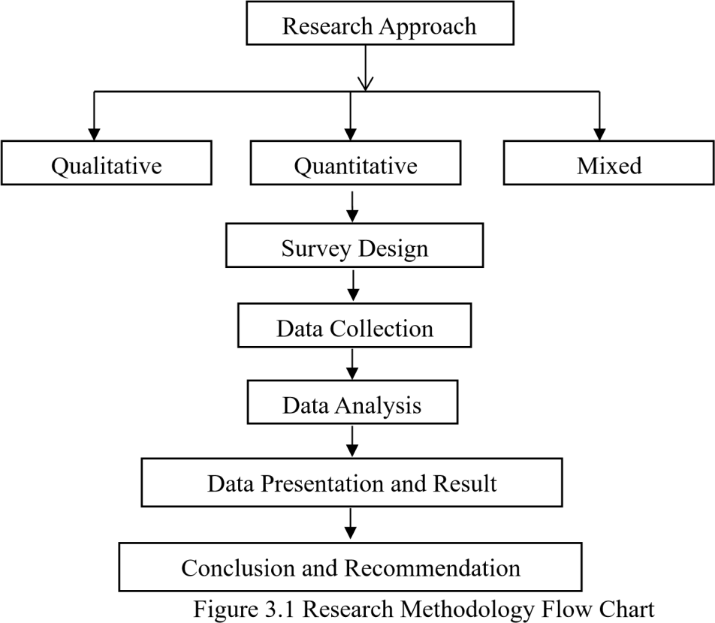

3.2 RESEACH DESIGNS
The research designs refer to the overall strategy that is choice to integrate different component of the study in a coherent and logical way. This study adopted Quantitative research approach by the use of (questionnaire design); this method is used to determine individual opinion about policy issues and to explore relationships between different variables. The design was appropriate because the study aimed at collecting information from respondents on their opinions on the assessment of change in government policies in construction performance in Nigeria.

3.3 POPULATION OF THE STUDY
The population of the study comprises professionals in construction industry namely: Quantity surveyor, Project Managers, Site Engineers and Public Sector Officers in infrastructure-related agencies. Which their population from the list of registered professionals collected from the secretariats of each profession, however, 77 number of registered Quantity surveyors, 370 number of registered Project Managers, 43 number of registered Site Engineers, and 67 number of registered Public Sector Officers were received. The population is made of registered professional to related profession of this research in Kwara State. The population is 557 from the study area. Data for the population was collected from NIQS chapter at Ilorin and relevant government agencies.

3.4 SAMPLING TECHNIQUE AND SAMPLE SIZE
The sample technique adopted for this study is random sampling method. This involve written the name of registered professional on cards and shuffled. ‘The uppermost card is taken each time the card is shuffled, until the required sample size of 85 was achieved which made up of, 19 Quantity Surveyors, 20 Project Managers, 22 Site Engineers and 24 Public Sector Officers. Each professional was picked randomly and a total number of 85 questionnaires were distributed to respondents in Kwara states. Below shows how we achieve total number for sample size.
n = $\frac{N}{1+N (e)^{2}}$
Where e =level of significant (0.1)
n=sample size
N = Total number of population

n= 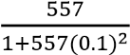
n= 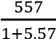
n= 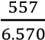
n=84.779
n= 85

3.5 RESEARCH INSTRUMENTS AND MEASUREMENT
This study focusses on assessing how changes in government policies influence construction performance. A well-structured questionnaire was administered to the respondents concerned within the selected area of study. Ranking was used as a research instrument, where participant is to rank from Strongly Agree, Agree, Neutral, Disagree and Strongly Disagree for objective one, and five level of semantic differential scale where participant is to show the relationship with Very
Important, Important, Moderately Important, Little Important and Not Important for objective two while Very Effective, Effective, Moderately Effective, Low Effective, Not Effective for objective three to provide answer option. It requires a parametric statistical test.

3.5.1 QUESTIONNAIRE DESIGN
Questionnaire design for this research will be a multiple-choice table and boxes, administration of structured questions based on research objectives. The information sought was divided into four sections:
Section A: The first questionnaire sought to collect demographic characteristics of correspondents, Respondents personal (e.g. Sex, the educational level, working experience in the industry, Qualification, Profession).
Section B: Assessment of the factors of changes in government policies on building construction.
Section C: Examination of the effects of changes in government policies on the timely completion of building construction projects.
Section D: Evaluation of the level of awareness and application of changes in government policies on building construction industry.

3.5.2 QUESTIONNAIRE ADMINISTRATION
The following are the method of administering questionnaire (a) personally administered (b) mail electronic and electronics questionnaire.
- Personally administered: This is a questionnaire design and prepared by the researcher and given to the respondents within a confide area.
- Mail or electronic questionnaire: This means that a wide range of geographical area can be covered in a survey. The questionnaire will be sent to the respondent who can complete them at their own convenient. Comparing these various methods, I adopt both personal and electronic questionnaire because of the time factor and can ensure 100% response.

3.5.3 DEMOGRAPHICAL INFORMATION
This refers to the methods that will be used to measure the dimensions and dynamics of populations or the year of existence of the construction firms.
The questionnaire was prepared in 4 sections with regards to respondents. Section A contains personal information about the respondents, while section B, C, and D contain general information which reflects the objective of this project.

3.5.4 RESEARCH INSTRUMENT
Measurement scale is a tools or mechanism by which an individual is distinguish as diver from one and other on the variable of interest to our studies. The assignment of numbers and qualitative attribute to object event or to the characteristics of object is known as research measurement. The types of scale use for data collection in research work here. Nominal, Interval and Ratio scale.
- Nominal scale is one that allows research to assign subject to certain categories or groups.
- Ordinal scale is another scale that is use for some meaningful variables for which the categories are to be order according to some preferences.
- Interval scale allows us to perform certain arithmetic operation on the data obtain (collected) from the respondents.
- Ratio scale used to measure the magnitude of the difference between point on the scale and also taps the proportions in the differences with unique zero origin.
Nominal and Interval scale is adopted for this research problem. Nominal scale is use for the section A of the Questionnaire while Interval scale is use for the section B, C and D of the questionnaire.

3.6 DATA ANALYSIS
This research work is carried out by the use of ranking method. RII will be used to test for the factors influencing changes in government policies on building construction in Nigeria and also, RII will be used to test for the effect of those changes on government policies on timely completion of construction project, RII will be used to assess the level of awareness and application of such changes in government policies on building construction in Nigeria. Correlation was used to determine which policy change factors are most effective. The Statistical Package for Social Sciences (SPSS) was used to carry out the analysis, ranking methods that were used to achieve the stated objectives.
  - 5n₅ + 4n₄ + 3n₃ +2n₂ + 1n₁
  - _{5N}
$RII= \frac{\sum{w}}{AN}$ =
Where;
RII = Relative Importance Index,
A = highest weight,
N = total number of respondents,
n₅ = Number of respondents for “strongly agree”
n₄ = Number of respondents for “Agree”
n₃ = Number of respondents for “Neutral”
n₂ = Number of respondents for “Disagree”
n₁ = Number of respondents for “Strongly Disagree” for part B
n₅ = Number of respondents for “Very Important”
n₄ = Number of respondents for “Important”
n₃ = Number of respondents for “Moderately Important”
n₂ = Number of respondents for “Little Important”
n₁ = Number of respondents for “Not Very Important” for part C
n₅ = Number of respondents for “Very Effective”
n₄ = Number of respondents for “Effective”
n₃ = Number of respondents for “Moderately Effective”
n₂ = Number of respondents for “Low Effective”
n₁ = Number of respondents for “Not Very Effective” for part D

CHAPTER 4

DATA PRESENTATION AND DISCUSSION

4.1 INTRODUCTION
This chapter presents the analysis and results of the data collected for the study on the Assessment of Change in Government Policies on Construction Performance in Nigeria, based on the research objectives. The research questions were analyzed using descriptive statistics and the Relative Importance Index (RII) to determine the ranking of each factor.

Questionnaires Administered and Retrieved
A total of 85 questionnaires were administered to professionals in contracting and consulting firms within the construction industry in Nigeria. After applying purposive sampling techniques to eliminate invalid responses, 77 valid questionnaires were retrieved, representing a return rate of
90.6%. These were deemed sufficient for analysis.

Table 4.1: Distribution of Questionnaires Administered and Retrieved
Distribution | Frequency | Percentage (%)
Questionnaires Administered | 85 | 100.0
Questionnaires Retrieved | 77 | 90.6
Questionnaires Not Retrieved | 8 | 9.4

Source: Field Survey (2025)
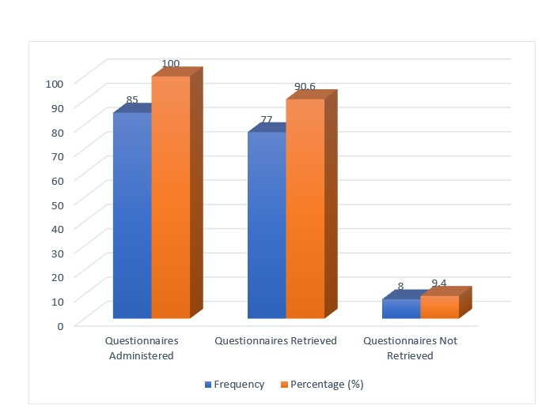
Figure 4.1: A chart showing the questionnaires administered and retrieved

4.2 DEMOGRAPHIC INFORMATION OF RESPONDENTS

Table 4.2: Designation of Respondents
Designation | Frequency | Percentage (%) | Cumulative (%)
Quantity Surveyor | 22 | 28.6 | 28.6
Project Manager | 15 | 19.5 | 48.1
Site Engineer | 20 | 26.0 | 74.1
Public Sector Officers | 10 | 13.0 | 87.1
Others | 10 | 13.0 | 100.0
Total | 77 | 100.0

Source: Field survey (2025)
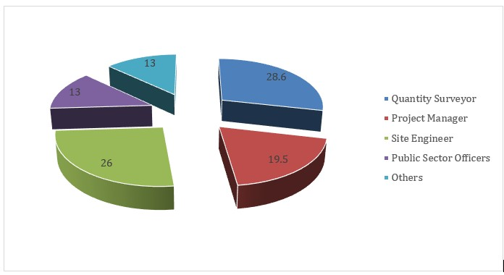
Figure 4.2: A chart showing the designation of respondents
The table and figure above represent the designation of respondents in the study. The result shows that 28.6% of the respondents are Quantity Surveyors, 19.5% are Project Managers, 26.0% are Site
Engineers, 13.0% are Public Sector Officers, and another 13.0% fall under the “Others” category. The result indicates that the highest proportion of respondents are Quantity Surveyors (28.6%) and Site Engineers (26.0%), showing that the study captured a significant number of technical professionals directly involved in project execution and cost management.

Table 4.3: Years of Professional Experience
Years of Experience | Frequency | Percentage (%) | Cumulative (%)
1–5 years | 27 | 35.1 | 35.1
6–10 years | 22 | 28.6 | 63.7
11–15 years | 13 | 16.9 | 80.6
16–20 years | 8 | 10.4 | 91.0
20 years and above | 7 | 9.1 | 100.0
Total | 77 | 100.0

Source: Field survey (2025)
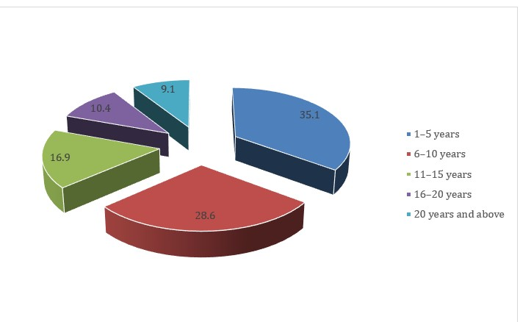
Figure 4.3: A chart showing the years of professional experience
The table and figure 4.3 above represent the years of professional experience of respondents. The result indicates that 35.1% of the respondents have been in practice between 1–5 years, 28.6% between 6–10 years, 16.9% between 11–15 years, 10.4% between 16–20 years, and 9.1% have over 20 years of professional experience. The highest percentage of respondents falls within the 1–5 years range, followed closely by those with 6–10 years of experience. This shows that the majority of respondents are early to mid-career professionals, reflecting recent and current field experiences in construction practice.

Table 4.4: Educational Qualification of Respondents
Qualification | Frequency | Percentage (%) | Cumulative (%)
HND | 18 | 23.4 | 23.4
B.Tech | 14 | 18.2 | 41.6
B.Sc | 10 | 13.0 | 54.6
PGD | 11 | 14.3 | 68.9
M.Sc | 19 | 24.7 | 93.6
PhD | 5 | 6.4 | 100.0

Source: Field survey (2025)
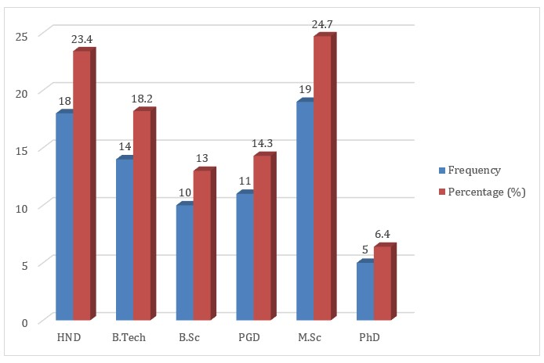
Figure 4.4: A chart showing the educational qualification of the respondents
The table above represent the educational qualification of the respondents. The result indicates that
23.4% of the respondents hold Higher National Diplomas (HND), 18.2% hold B.Tech degrees, 13.0% hold B.Sc degrees, 14.3% possess Postgraduate Diplomas (PGD), 24.7% hold Master of Science (M.Sc) degrees, and 6.4% of the respondents have attained a PhD.

Table 4.5: Professional Qualification of Respondents
Qualification | Frequency | Percentage (%) | Cumulative (%)
MNIQS | 18 | 23.4 | 23.4
MNSE | 25 | 32.5 | 55.9
MNIP | 20 | 26.0 | 81.9
Others | 14 | 18.2 | 100.0
Total | 77 | 100.0

Source: Field survey (2025)
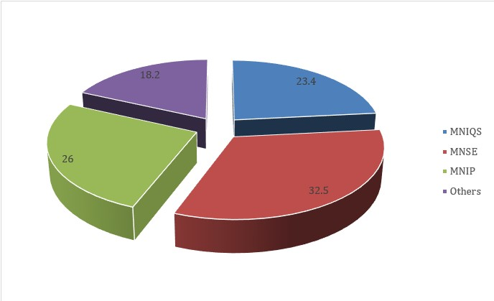
Figure 4.5: A chart showing the Professional qualification of respondents
The table 4.5 above represent the professional qualifications of the respondents. The result indicates that 23.4% of the respondents are members of the Nigerian Institute of Quantity Surveyors (MNIQS), 32.5% are members of the Nigerian Society of Engineers (MNSE), 26.0% are members of the Nigerian Institute of Planners (MNIP), while 18.2% fall under the “Others” category, which may include members of other relevant professional bodies

Table 4.6: Type of Organization
Type | Frequency | Percentage (%) | Cumulative (%)
Contracting | 59 | 76.6 | 76.6
Consulting | 18 | 23.4 | 100.0
Total | 77 | 100.0

Source: Field survey (2025)

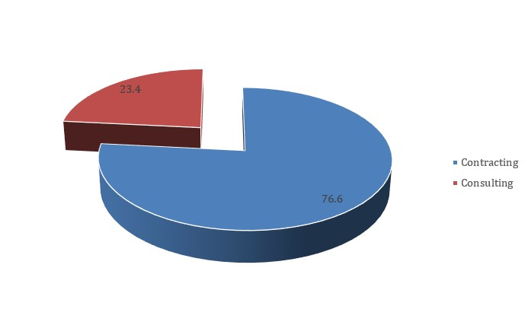
Figure 4.6: A chart showing the Types of Organization
The table and figure above represent the type of organization the respondents are engaged in. The result indicates that 76.6% of the respondents work in contracting firms, while 23.4% are employed in consulting organizations.

4.3 Objective One: Assessment of Factors Influencing Policy Changes in Construction

Table4.7: RII Ranking of Government Policy Change Factors
S/N | Factor | SUM | RII | Rank
1 | Frequent policy changes | 355 | 0.922 | 1st
2 | Delay in policy implementation | 348 | 0.905 | 2nd
3 | Corruption in policy enforcement | 345 | 0.896 | 3rd
4 | Frequent tax changes | 341 | 0.885 | 4th
5 | Lack of stakeholder consultation | 340 | 0.883 | 5th
6 | Government regulations on materials | 336 | 0.874 | 6th
7 | Changes in permit and approval processes | 332 | 0.863 | 7th
8 | Environmental policy | 328 | 0.853 | 8th
9 | New building code requirement | 319 | 0.828 | 9th
10 | Sudden change in zoning laws | 315 | 0.818 | 10th

Source: Field survey (2025)
To assess the impact of various government policy changes on construction performance in Nigeria, the Relative Importance Index (RII) tool was applied. From the table above, the results show that “Frequent policy changes” ranked highest in significance with an RII of 0.922, making it the most critical factor influencing construction performance. This suggests that instability and inconsistency in government policy directions severely disrupt planning, procurement, and execution of construction projects.
It is closely followed by “Delay in policy implementation”, which ranks 2nd with an RII of 0.905. This indicates that even well-designed policies lose their intended value when not implemented promptly, causing uncertainty and inefficiencies across construction timelines. “Corruption in policy enforcement” ranks 3rd with an RII of 0.896, highlighting the damaging role of unethical practices in undermining construction standards and stakeholder confidence.
“Frequent tax changes” and “Lack of stakeholder consultation” were ranked 4th and 5th, with RII values of 0.885 and 0.883, respectively. These reflect how unexpected financial burdens and top-down policymaking often leave contractors unprepared and poorly aligned with project requirements. Other notable issues include “Government regulations on materials” (6th, RII = 0.874) and “Changes in permit and approval processes” (7th, RII = 0.863), which suggest that procedural and regulatory bottlenecks further delay project progress.
Lower-impact factors include “Environmental policy” (8th, RII = 0.853), “New building code requirements” (9th, RII = 0.828), and “Sudden change in zoning laws” (10th, RII = 0.818). While still relevant, these are considered less disruptive compared to the top-ranking items.
These results collectively demonstrate that frequent and unpredictable shifts in government policy, coupled with poor execution and lack of transparency, play a major role in weakening construction performance. This underscores the need for more stable, inclusive, and timely policy frameworks in Nigeria’s construction sector.

4.4 Objective Two: Examining the Effect of Changes in Government Policies on the Timely Completion of Building Construction Projects

Table 4.8: RII Ranking of Effects on Timely Completion
S/N | Effect | SUM | RII | Rank
1 | Change in building regulations | 354 | 0.918 | 1st
2 | Delays in policy awareness among contractors | 350 | 0.909 | 2nd
3 | Sudden shifts in budgetary allocation | 342 | 0.888 | 3rd
4 | New tariffs on materials | 338 | 0.879 | 4th
5 | New legal requirements | 336 | 0.874 | 5th
6 | Updated environment regulations | 332 | 0.863 | 6th
7 | Inconsistent policy communication from authorities | 325 | 0.844 | 7th
8 | New licensing requirements | 320 | 0.831 | 8th
9 | Changes in labor policy | 318 | 0.826 | 9th
10 | Safety regulations changes | 315 | 0.818 | 10th

Source: Field survey (2025)
The Relative Importance Index (RII) tool was employed to analyze the effects of various government policy-related factors on construction performance and project delivery outcomes.
From the table above, it is revealed that “Change in building regulations” is the most critical factor, ranking 1st with an RII of 0.918. This indicates that modifications in regulatory codes have a substantial influence on project planning, resource alignment, and compliance, making it the most pressing policy issue affecting construction processes.
Closely following is “Delays in policy awareness among contractors,” ranked 2nd with an RII of 0.909, suggesting that when policy updates are not timely or effectively communicated, they cause delays, rework, or even legal non-compliance, which can hinder construction progress. “Sudden shifts in budgetary allocation” ranked 3rd (RII = 0.888), highlighting how financial unpredictability disrupts contractor planning and creates funding gaps mid-project.
“New tariffs on materials” came 4th with an RII of 0.879, emphasizing the financial strain placed on contractors by cost hikes, which can cause budget overruns or force the use of substandard alternatives. “New legal requirements” (5th, RII = 0.874) and “Updated environmental regulations” (6th, RII = 0.863) further point to the challenges of keeping up with evolving policy landscapes, which often demand changes in design, procurement, or execution procedures.
Ranked 7th with an RII of 0.844, “Inconsistent policy communication from authorities” reflects the confusion and inefficiencies that arise when agencies fail to clearly or uniformly enforce or communicate policies. “New licensing requirements” (8th, RII = 0.831) and “Changes in labor policy” (9th, RII = 0.826) were seen as moderately impactful, particularly as they affect workforce qualifications, project timelines, and administrative overhead.
Finally, “Safety regulations changes” ranked 10th with an RII of 0.818, indicating that while important, it was perceived as the least disruptive among the listed factors—possibly due to better adaptation or existing safety protocols in place.
These findings highlight the need for proactive stakeholder engagement, consistent communication, and stable regulatory frameworks to mitigate the negative impacts of policy volatility on construction performance.

4.5 Objective Three: Evaluation of Level of Awareness and Application of Changes in Government Policies on Building Construction Industry

Table 4.9: RII Ranking of Awareness/Application
S/N | Statement | SUM | RII | Rank
1 | Organization is updated promptly on policy changes | 355 | 0.922 | 1st
2 | Organization complies fully with recent policy | 350 | 0.909 | 2nd
3 | Policy documentation is accessible and understandable | 345 | 0.896 | 3rd
4 | Staff are aware of new policy implications | 340 | 0.883 | 4th
5 | Professional bodies inform members on policy changes | 338 | 0.879 | 5th
6 | Contractors actively seek updates | 332 | 0.863 | 6th
7 | Changes quickly incorporated into site procedures | 330 | 0.857 | 7th
8 | Government explains policies clearly | 327 | 0.850 | 8th
9 | Feedback is given to government on policies | 322 | 0.835 | 9th
10 | Training provided when policies enacted | 318 | 0.826 | 10th

Source: Field survey (2025)
To evaluate the effectiveness of policy awareness and compliance mechanisms within construction organizations, the Relative Importance Index (RII) tool was utilized. Based on the results from the table above, “Organization is updated promptly on policy changes” ranked as the most important factor, with an RII of 0.922. This underscores how timely updates on policy shifts are vital to ensuring immediate organizational responsiveness and legal compliance.
Closely following in 2nd place is “Organization complies fully with recent policy”, which has an RII of 0.909. This highlights the significance of internal policy enforcement and adherence, which contribute to regulatory approval, risk reduction, and smoother project execution. In 3rd place,
“Policy documentation is accessible and understandable” (RII = 0.896) reflects the critical role that clear and user-friendly documents play in translating policy into practice on the ground.
“Staff are aware of new policy implications” was ranked 4th with an RII of 0.883, indicating that workforce-level awareness is key to ensuring compliance across various departments.
“Professional bodies inform members on policy changes” came in 5th (RII = 0.879), pointing to the importance of industry associations and professional institutions as reliable sources of policy dissemination.
Other noteworthy factors include “Contractors actively seek updates” (6th, RII = 0.863) and “Changes quickly incorporated into site procedures” (7th, RII = 0.857), which show a proactive attitude towards adapting policies into daily operational practices. “Government explains policies clearly” was ranked 8th with an RII of 0.850, suggesting that communication gaps from authorities remain a concern.
At the lower end, “Feedback is given to government on policies” (9th, RII = 0.835) and “Training provided when policies are enacted” (10th, RII = 0.826) reflect weaker engagement and support mechanisms. Despite their lower rankings, these aspects are still essential for closing the policy feedback loop and building long-term compliance culture.
Overall, the results indicate that effective policy management in construction relies not only on top-down dissemination but also on internal responsiveness, communication clarity, and professional engagement.

4.6 DISCUSSION OF FINDINGS

Objective One: Assessment of Factors Influencing Policy Changes in Construction
The most significant factor influencing change in government policies on construction is frequent policy changes (RII = 0.922), followed closely by delay in policy implementation (RII = 0.905). These highlight issues in policy consistency and rollout, which are key pain points for construction professionals.

Objective Two: Examine the Effect of Changes in Government Policies on the Timely Completion of Building Construction Projects
Change in building regulations ranked highest (RII = 0.918), implying that frequent adjustments directly delay project timelines. The impact of delayed awareness and budgetary reallocations also significantly contribute to project performance issues.

Objective Three: Evaluation of Level of Awareness and Application of Changes in Government Policies on Building Construction Industry
The data reveals strong awareness of government policies among organizations, with most indicating that they are promptly updated (RII = 0.922) and compliant (RII = 0.909). However, training on new policies and feedback loops remain relatively weaker areas.

CHAPTER 5

CONCLUSION AND RECOMMENDATION

5.0 INTRODUCTION
This chapter is aimed at giving the summary, conclusion and recommendations of the study.

5.1 CONCLUSION
This research is carried out to address the key issues which are the three major targets of the research work. For the purpose of this work, several published journals were reviewed both within and outside the country in order to gain insight of the assessment of change in government policies on construction performance in Nigeria, conclusion drawn are:

Objective One: Assessment of Factors Influencing Policy Changes in Construction
This research work revealed that influencing change in government policies on construction is frequent policy changes, followed closely by delay in policy implementation. These highlight issues in policy consistency and rollout, which are key pain points for construction professionals.

Objective Two: Examine the Effect of Changes in Government Policies on the Timely Completion of Building Construction Projects
The research shows that change in building regulations ranked highest, implying that frequent adjustments directly delay project timelines. The impact of delayed awareness and budgetary reallocations also significantly contribute to project performance issues.

Objective Three: Evaluation of Level of Awareness and Application of Changes in Government Policies on Building Construction Industry
The data reveals strong awareness of government policies among organizations, with most indicating that they are promptly updated and compliant. However, training on new policies and feedback loops remain relatively weaker areas.

5.2 RECOMMENDATION
Based on the results of the research work, it is recommended that;
- Government should reduce frequent policy reversals in the construction sector by enacting long-term policy frameworks that promote continuity across political administrations.
- A dedicated independent body should be created to evaluate, monitor, and report the impact of policy changes on construction projects, ensuring timely feedback for improvement.
- Policymakers should involve key stakeholders’ contractors, consultants, and developers in the policy-making process to ensure that new regulations are practical and performance-focused.
- Capacity-building programs should be implemented for professionals in the construction sector to help them understand and adapt to policy changes effectively.
- The use of e-governance tools should be expanded in construction-related government processes to reduce bottlenecks and promote transparency regardless of policy shifts.

5.3 AREA FOR FURTHER STUDY
This research is opened to further research and it is advised that for further research, the participants in the construction industry should be more aware of the assessment of change in government policies on construction performance in Nigeria.

REFERENCE
Adamu, M., & Saka, Y. T. (2018). Effects of political transitions on public construction projects in Nigeria. Journal of Construction Research, 9(2), 34–45.
Adedokun, O. J., Bello, T. A., & Jimoh, A. K. (2022). Cost implications of fiscal reforms on state construction projects in Nigeria. Nigerian Journal of Quantity Surveying, 19(1), 58–70.
Adeleke, A. Q., Bahaudin, A. Y., & Kamaruddeen, A. M. (2017). Impact of effective policies on workforce management in construction firms. Journal of Construction in Developing Countries, 22(1), 25–45.
Agboola, R. A., Adewale, B., & Ogunyemi, O. (2023). Budget policy dynamics and infrastructure delivery in Nigeria. Journal of Infrastructure and Policy Research, 7(2), 112–130.
Ameh, O. J., & Osegbo, E. E. (2017). Contractor challenges and government policy ambiguity in Nigerian construction. Journal of Project Management, 6(4), 55–69.
Alexander, R. J. (2018). Bureaucratic resistance and educational reform in the U.S. Policy Implementation Review, 11(3), 98–115.
Bello, A. R., & Yusuf, T. K. (2021). Political resistance and project continuity in public sector housing. Housing and Urban Development Review, 15(2), 87–101.
Bruinsma, J., & Johnson, T. (2018). Construction economics and policy development.
Construction and Development Studies, 24(1), 21–36.
Chinyio, E. A., & Olomolaiye, P. O. (2015). Systems thinking in construction project delivery.
Journal of Construction Systems, 5(1), 11–29.
Chudley, R., & Greeno, R. (2018). Building construction handbook (12th ed.). Routledge.
Ene, E. J., Udo, M. J., & Okon, C. O. (2015). Interest rates and investment performance in Nigeria. African Economic Review, 14(1), 76–91.
Ezeokonkwo, J. U., & Akpokodje, J. O. (2019). Procurement policy changes and quality control in public projects. Journal of Public Procurement and Construction Quality, 10(3), 119–134.
Finco, M. D. (2017). Policy instability and construction industry competitiveness. International Journal of Policy and Infrastructure, 5(4), 78–88.
Foxell, E., & Cooper, M. (2015). Citizen involvement in policy design: Tools and roles.
Governance and Public Policy Journal, 6(2), 33–47.
Garcia, P. L. (2015). Public policy influence on the building construction industry. Journal of Urban Infrastructure, 17(1), 60–74.
Gilman, H. R. (2019). Public participation and policy success in developing countries.
International Review of Public Policy, 13(4), 45–67.
Goggin, M. L., Bowman, A. O. M., Lester, J. P., & O’Toole, L. J. (2017). Implementation theory and practice: Toward a third generation. Scott, Foresman & Co.
Hill, M., & Hupe, P. (2017). Implementing public policy: Governance in theory and in practice (4th ed.). Sage Publications.
Hudson, B., Hunter, D., & Peckham, S. (2019). Policy implementation and its barriers: A comparative study. Public Policy Perspectives, 8(3), 90–110.
Janssen, M., & Van Der Voort, H. (2016). Adaptive policy-making in volatile political environments. Public Policy and Administration, 31(1), 20–36.
Khare, R., & Agarwal, S. (2017). Construction policy frameworks in developing nations.
International Journal of Infrastructure Policy, 9(1), 55–72.
Khan, A. R. (2016). Public policy and administration in developing countries. Policy Studies Journal, 34(2), 89–104.
Mackay, K., & Shaxton, L. (2015). Planning for results: Strategy and evaluation in government.
Evaluation Journal of Australasia, 15(1), 30–44.
Meier, K. J., O'Toole, L. J., & Nicholson-Crotty, S. (2016). Politics, structure, and public policy:
The implementation of public programs. American Journal of Political Science, 50(2), 145–159.
Ofori, G. (2015). Effects of policy instability on construction in developing nations. Journal of Building and Infrastructure, 23(2), 77–88.
Ofori, G. (2020). Sustainable construction policy frameworks. Construction and the Environment, 9(3), 112–126.
Oke, A. E., & Aigbavboa, C. O. (2019). Strategies for performance improvement in Nigerian construction. Journal of Construction Management and Innovation, 10(2), 88–105.
Oyewobi, L. O., Ganiyu, B. O., Oke, A. E., Ola-Awo, B., & Olabosipo, I. A. (2016). Challenges of policy change on construction stakeholders. International Journal of Project Management, 7(1), 59–72.
Patanakul, P., & Pinto, J. K. (2014). Policies for innovation in project management. Research Technology Management, 57(4), 20–30.
Rajapakshe, R. (2017). Stability of construction policies and economic development. Global Journal of Public Administration, 3(1), 39–51.
Ratnasingham, J. (2015). Unstable construction policies in developing economies. Journal of Policy and Construction, 11(2), 44–62.
Saka, N., & Shwarka, M. (2021). Institutional disruptions in public construction agencies. Built Environment Journal, 17(1), 23–38.
Sanni, A., & Salami, T. (2020). Training gaps in public construction project execution. Journal of Government and Infrastructure, 14(1), 67–82.
Saville, M., & Cleveland, J. (2017). Government policy and building code regulation. Journal of Construction Law and Practice, 19(1), 55–73.
Schofield, J. (2015). A model of policy implementation: Challenges and strategies. Policy & Politics, 32(3), 289–305.
Scott, W. R. (2014). Institutions and organizations: Ideas, interests, and identities (4th ed.). Sage Publications.
Shuaibu, A. I. (2016). Construction investment and national productivity. Nigerian Journal of Economic Development, 6(2), 50–65.
Shwarka, M. (2022). Reforming parastatal structures for better project outcomes. Journal of Public Sector Management, 13(2), 41–58.
Taofeeq, D. M., Adeleke, A. Q., & Hassan, A. A. (2019). Risks and government policy in construction. Journal of Construction Risk Management, 5(3), 97–109.
Taylor, M. (2017). The built environment and public policy. Urban Policy Review, 8(1), 22–38.
Walker, R. M., Boyne, G. A., & Brewer, G. A. (2019). Public management and performance:
Research directions. Public Administration Review, 79(3), 425–438.

APPENDIX 1

QUESTIONNAIRE

Department of Quantity Surveying,
Institute of Environmental Studies,
Kwara State Polytechnic Ilorin,
P.M.B. 1375, Ilorin,
Kwara State.
Dear Sir/Ma,
ASSESSMENT OF CHANGE IN GOVERNMENT POLICIES ON CONSTRUCTION
PERFORMANCE IN NIGERIA

I am a Higher National Diploma student in the department of Quantity Surveying, Kwara State Polytechnic Ilorin, Kwara State, undertaking research on the above-mentioned topic.
The following questions served to collect necessary data to complete the study on the abovementioned topic as part of the requirements for the award of Higher National Diploma (HND) Quantity Surveying.
All information given by the respond shall be purely for academic purpose and only thus treated with the confidentiality it deserves.
Thanks, your prompt attention and cooperation.
Yours faithfully,
_____________
OLAWUYI, AKINWUMI MOSES
The researcher

APPENDIX II
SECTION A: DEMOGRAPHIC INFORMATION
Please, tick ( ) your answer accordingly and as appropriate.
1. Designation of respondents:
(a) Quantity Surveyor ( ) (b) Project Managers ( ) (c) Site Engineer ( ) (d) Public Sector Officers
( ) (e) Others ( )
2. Kindly indicate your years of professional experience:
(a) 1 – 5years ( ) (b) 6 – 10years ( ) (c) 11 – 15years ( ) (d) 16 – 20years ( ) (e) 20 years and above ( )
3. Educational qualification of the respondents:
(a) HND ( ) (b) B.TECH ( ) (c) B.Sc ( ) (d) PGD ( ) (e) M.Sc ( )(f) PhD ( )
4. Professional qualification of respondents: (a) MNIQS ( ) (b) MNSE ( ) (c) MNIP ( ) (d) OTHERS: __________ 5. Type of Organization:
(a) Contracting ( ) (b) Consulting ( )

SECTION B: ASSESSMENT OF THE FACTORS OF CHANGES IN GOVERNMENT POLICIES ON BUILDING CONSTRUCTION
Below are some assessments of the factors affecting the changes in government policies on building construction industry.
Kindly rank the level of assessment for the following factors affecting the changes in government policies on building construction using Likert scale of 5 = Strongly Agree (SA), 4 = Agree(A), 3 = Neutral (N), 2 = Disagree(D), 1 = Strongly Disagree (SD).
S/N | GOVERNMENT POLICY CHANGE  FACTORS | STRONGLY  AGREE  (SA)  5 | AGREE  (A)  4 | NEUTAL  (N)  3 | DISAGREE  (D)  2 | STRONGLY  DISAGREE  (SD)  1
1. | Frequent policy changes
2. | Government regulations on materials
3. | Frequent tax changes
4. | Environmental policy
5. | Ddelay in policy implementation
6. | Lack of stakeholder consultation
7. | Changes in permit and approval processes methods
8. | Corruption in policy enforcement
9. | New building code requirement
10. | Sudden change in zoning laws

SECTION C: EXAMING THE EFFECT OF CHANGES IN GOVERNMENT POLICIES ON THE
COMPLETION OF BUILDING CONSTRUCTION PROJECTS
Below are the different ways of examine the effect of changes in government policies on the timely completion of building construction projects.
Kindly differentiate level of examine the effect of changes in government policies on the timely completion of building construction projects using Semantic differential scale of 5 = Very Important (VI), 4 = Important (I), 3 = Moderately Important (MI), 2 = Little Important (LI), 1 = Not Very Important (NVI).

S/N | POLICY EFFECTS ON TIMELY PROJECT COMPLETION | VERY IMPORTANT  (VI)  5 | IMPORTANT  (I)  4 | MODERATELY IMPORTANT  (MI) 3 | LITTLE IMPORTANT  (LI)  2 | NOT VERY IMPORTANT  (NVI)  1
1. | Change in building regulations
2. | New licensing requirements
3. | Changes in labor policy
4. | New tariffs on materials
5. | Sudden shifts in budgetary allocation
6. | Inconsistent policy communication from  authorities
7. | Updated environment regulations
8. | Safety regulations changes
9. | New legal requirements
10. | Delays in policy awareness among contractors

SECTION D: EVALUATION OF LEVEL OF AWARENESS AND APPLICATION OF CHANGES IN GOVERNMENT POLICIES ON BUILDING CONSTRUCTION INDUSTRY
Below are different levels of how to evaluate level of awareness and application of changes in government policies on building construction industry.
Kindly differentiate levels of how to evaluate level of awareness and application of changes in government policies on building construction industry using Likert scale of 5 = Very Effective (VE), 4 = Effective (E), 3 = Moderately Effective (ME), 2 = Low Effective (LE), 1 = Not Very Effective (NVE).

S/N | AWARENESS AND APPLICATION OF  GOVERNMENT  POLICY CHANGE | VERY  EFFECTIVE  (VE)  5 | EFFECTIVE  (E)  4 | MODERATELY  EFFECTIVE  (ME)  3 | LOW  EFFECTIVE  (LE)  2 | NOT VERY  EFFECTIVE (NVE)  1
1. | Organization is updated promptly on policy changes
2. | Government policies are explained clearly to contractors
3. | Training is provided when new policies are enacted
4. | Contractors actively seek updates on policy changes
5. | Professional bodies inform their members of irrelevant policy changes
6. | Changes are quickly incorporated into ongoing site procedures
7. | Staff at all levels are aware of new policy implications
8. | Organization complies fully with recent policy directives
9. | Policy documentation is accessible and understandable
10. | Feedback is given to government agencies on policy practicality

