ROUTE SURVEY

OF

MICHEAL IMODU WAY TO KANGU OSHIN OLATUNJI ROAD
IFELODUN TO ILORIN WEST LOCAL GOVERNMENT AREA,
ILORIN KWARA STATE.

BY
SODIQ AYUBA ADEBAYO
HND/23/SGI/FT/0110

SUBMITTED TO:
THE DEPARTMENT OF SURVEYING AND GEOINFORMATICS,
STATE POLYTECHNIC ILORIN, KWARA STATE.

IN PARTIAL FULFILMENT OF THE REQUIREMENTS FOR THE
AWARD OF HIGHER NATIONAL DIPLOMA IN
SURVEYING AND GEOINFORMATICS.

JULY, 2025

CERTIFICATE
I hereby certify that all the information given in this project was obtain as a result of my observation and measurements and was carried out by me in accordance with the survey rules, regulation and departmental instructions.

____________________ ---------------------------
SODIQ AYUBA ADEBAYO Date and Signature
HND/23/SGI/FT/0110

CERTIFICATION
This is to certify that SODIQ AYUBA ADEBAYO; with matriculation number HND/23/SGI/FT/0110 has satisfactorily carried out the survey duties contained in his project under my instruction and direct supervision.
I hereby declare, that he has conducted himself with due diligence, honesty and sobriety on the project.

____________________ ____________________
Surv. A.O. Akinyede Sign and Date
Project supervisor

____________________ ___________________
Surv. S. A. Awoleye Sign and Date
Project Coordinator

____________________ __________________
Surv. I. I. Abimbola Sign and Date
Head of Department

____________________ __________________
External Examiner Sign and Date

DEDICATION
This project is dedicated to the Almighty God for His mercy and guidance that has kept me this far.

ACKNOWLEDGEMENT
All glory, Honor and Adoration to God Almighty, the gracious one who has given me the opportunity to complete my HND programme.
My appreciation goes to my supervisor Surv. A. O. Akinyede, for his encouragement and motivation as regard the writing of this project thank you and God bless you. And to all lecturers in the Department of Surveying and Geoinformatics, Surv. I .I.Abimbola (HOD). Surv. A. G. Aremu, Surv. R. S. Awoleye, Surv. R. O. Asonibare, Surv. Ayuba Abdulsalam, Surv. Babatunde Kabir, Surv. Bello F.D and others. May God bless you all (Amen).
I also express my sincere gratitude to my wonderful parent Mr. and Mrs. Sodiq for their financial moral support toward the completion of this program. You will reap the fruit of your labor. (Amen).

ABSTRACT
The Route Survey from Micheal Imodu way to kangu oshin Olatunji Was carried out by carried out recce survey, planning at the office. The Total Station (series) was used for the traversing and detailing while the controls establishment and benchmarks was done by DGPS all across the route line at every 1km and the data was processed using CivilCAD2014 with the AutoCAD 2007. Series of engineering plans was produces like horizontal alignment plan, vertical alignment plan, cross section and calculating volumes of earth works were also produce to show cut and fill quantities material.

TABLE OF CONTENTS
TITLE PAGE……………………………………………………………………………..i
CERTIFICATE…………………………………………………………………………...ii
CERTIFICATION………………………………………………………………………..iii
DEDICATION…………………………………………………………………………....iv
ACKNOWLEDGEMENT………………………………………………………………...v
ABSRACT………………………………………………………………………………...vi
TABLE OF CONTENT…………………………………………………………………...vii
LIST OF TABLES………………………………………………………………………...viii
LIST OF FIGURES……………………………………………………………………….ix

CHAPTER ONE:
1.0 INTRODUCTION 1-2
1.1 STATEMENT OF THE PROBLEM 2
1.2 AIM OF THE PROJECT 2
1.3 OBJECTIVES OF THE PROJECT 2
1.4 SCOPE OF THE PROJECT 3
1.5 PROJECT LOCATION 3
1.6 SPECIFICATION OF THE PROJECT 4
1.7 PERSONNEL INVOLVES 5
CHAPTER TWO:
2.0 LITERATURE REVIEW 6-12

CHAPTER THREE:
3.0 METHODOLOGY 13
3.1 PRELIMINARY PLANNING AND PREPARATION 13
3.2 RECCONAISANCE PLANNING 14
3.3 OFFICE PLANNING 15
3.4 SELECTION OF THE EQUIPMENT AND SOFTWARE 15
3.5 BENCH MARKS ESTABLISHMENT, CAPPING AND LABEL 16
3.6 INSTRUMENT TEST 17
3.7 DATA ACQUISITION 18-22
CHAPTER FOUR:
4.0 DATA PROCESSING 23
4.1 DATA DOWNLOADING AND EDITING 23-24
4.2 DATA PROCESSING PROCEDURE 24-27
4.3 RESULT AND ANALYSIS 27-28
4.4 LINEAR ACCURACY 28-29
4.5 HEIGHT ACCURACY 30
4.6 PLAN PRODUCTION 30-34
4.7 PROJECT COSTING 35-37
FIG 4.1 SHOWING HORIZONTAL ALIGNMENT 31
FIG 4.2 SHOWING VERTICAL ALIGNMENT 32
FIG 4.3 SHOWING CROSS SECTION 33
FIG 4.4 DIAGRAM SHOWING GENERATED VOLUME COMPUTATION 34

CHAPTER FIVE:
5.0 SUMMARY, PROBLEM ENCOUNTERED, RECOMMENDATION AND COCLUSION
5.1 SUMMARY 38
5.2 PROBLEM ENCOUNTERED 39
5.3 RECOMMENDATION 39
5.4 CONCLUSION 39
5.5 REFRENCES 40
5.6 APPENDICES 41

CHAPTER ONE
- INTRODUCTION
Good road is one of the basic amenities needed by human beings, because movement is one of the characteristics of living things. There are needs for people to move from one place to another, transportation of goods and services. For the convenience of all these, there should be provisions for good routes (road, rail, air and water). Taking road as a case study in this project, the roles of surveying in the construction of good roads cannot be over-emphasized. Surveying plays a vital and crucial role in the development of any engineering projects such as road alignments, irrigation projects, hydroelectric schemes, tunnels, construction of dams, building constructions, etc. Looking into different branches of surveying, engineering surveying can be define as a large scale of survey operation carried out to provide special information for construction project.
The term “Engineering surveying” deals with construction of projects like roads, railways and canals. It is surveying work that is associated with design (roads, layout, as-built) that often beyond normal civil engineering practice. Engineering surveying include route survey which comprised of all surveying operation required for design and construction of engineering works such as highways, pipelines, canals and rail lines. Route surveying which is the main focus of this project is defined as the topographical and constructional survey that are necessary for the location and construction of communication lines, transportation, roads, canals, highways, pipelines etc. (Anderson & Mikhail, 1985) Generally, route surveying can be applied to the survey required to establish the horizontal and vertical alignments for transportation facilities. In most cases, the transportation facilities comprise a network that includes the transport of people or goods by way of highways, railways, pipelines and transmission lines.
Route survey requires a proper planning before execution. This is so because the data obtained and computed aids the construction and engineering design of the road. The features (both natural and manmade) were also fixed and as well plotted. Route survey provides information necessary for vertical and horizontal alignments for design and construction of the route.
1.2 STATEMENT OF PROBLEMS
The route from along Micheal Imodu Street to Kangu Oshin, Kwara State are not motor-able. Also the road is found to be too narrow and in bad condition due to the fact that it has not been construct, considering the volume of traffic plying the road. As a result of this development and to ensure that the road is motor-able due to the economic importance of the road, construction and rehabilitation of this road should be carried out.
1.3 AIM OF THE PROJECT

The aim of this project is to carry out the engineering route design from Micheal Imodu to Kongu toward OshinOlatunji. In other to produce horizontal alignment design, vertical alignment and slope correction design and the cross section design plans which will be used for the construction of the road.
1.4 OBJECTIVES OF THE PROJECT

In order to achieve the aforementioned aim, the objectives listed below were pursued:
- Design of the Horizontal alignment plan which show the horizontal section of the route.
- Design of the vertical alignment plan which show the vertical sections of the route.
- Design of the cross sectional area of the route at interval of 25m.
- Production of detail plan showing the horizontal and all the existing features closed to the route.
- Computing of the volume of earthwork of the route from the section include the ditches.
- Report writing.
- Project costing for the Engineering route.
1.5 SCOPE OF THE PROJECT
The scopes of project are the activities carried out which include the following:
- Carry out of the Reconnaissance survey of the project site.
- Planning and estimation on the project work.
- Data Acquisition includes both controls and Bench marks Establishment
- Data analysis (i.e. comparing result obtained with the required accuracy)
- Production of plan showing existing features and the location of the road way (Horizontal alignment plan)
- Production of plan showing the ground profile along the centerline of the road way (Longitudinal section plan)
- Production of plan showing the ground profile across the centerline of the road way, always at right angles to the centerline (Cross section plan)
1.5 PROJECT SPECIFICATION
These deals with the required conditions and specifications to be carried out during the course of the survey work. The under listed specification were strictly adhere to as guideline for perfect execution of the project.
- Traverse must commence on three coordinated (Known) controls and closed on another set of three coordinated controls which must be confirmed undisturbed by necessary measurement (control checks).
- Third order Total Station traverse must be run along the route on all turning points at two zeros observation and the angular difference from both faces.
- Linear observation should be carried out by steel tape and digital measuring equipment. Accuracy of measurements i.e. Standard error of the linear measurement should be one part in 20,000 (1/20,000).
- Spirit leveling must commence on a known benchmark and closed back on another known benchmark. Formulae for it misclosure are 24mm√K, where ‘k’ is the total distance covered in kilometers.
- Height must be determined at every 25m intervals on the centre line and at 7.5m (15m) intervals on both sides of the centre line for the cross sectioning. Edges of drainage at both sides should be heightened.
- Every features within 15m to the centerline must be fixed to enhance assessment and necessary composition for good interpretation of plan.
- The accuracy of the project must fall within the order of the project.
1.6 PERSONNEL
All the under listed names are member of Group 9 that participated in the successful execution of this project:
NAME MATRIC NUMBER ROLE
- SODIQ AYUBA ADEBAYO HND/23/SGI/FT/0110 Author
- AINA JOSEPH OLASUNKANMI HND/23/SGI/FT/0116 Member
- SOLADOYE AMIDAT OLABISI HND/23/SGI/FT/0109 Member
- OKUNOYE NAFISAT ADEYEMI HND/23/SGI/FT/0111 Member
- OJO SIMON ABAYOMI HND/23/SGI/FT/0114 Member
- ROTIMI IYANUOLUWA ANU HND/23/SGI/FT/0104 Member
- BABATUNDE SIDIKAT J. HND/22/SGI/FT/0113 Member
- ADEFABI ABIODUN BENJAMEN HND/23/SGI/FT/0124 Member

1.7 STUDY AREA
The location of the project site is the route from Micheal Imodu area to Kangu toward Oshin Olatunji axis. The distance covered along the route is 4.5km. The project site was lying along Ifelodun to Ilorin West Local Government area Kwara State, Nigeria. The site lies between geographical coordinates of Long. 004° 35’ 28.089’’; Lat. 008° 25’ 52.667’’ to Long. 004° 34’ 19.879’’; Lat. 008° 26’ 22.548’’. The community is developed area and the population is well spread. The figure below show the description of the project site for Micheal Imodu to Oshin Olatunji.

MAP OF NIGERIA
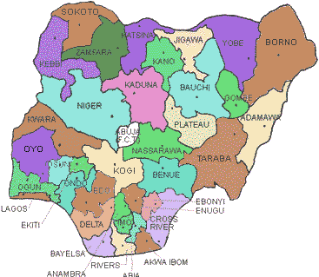

MAP OF KWARA
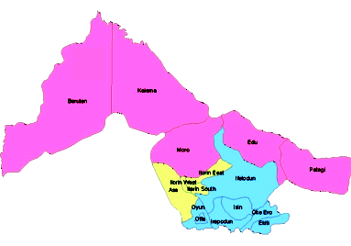

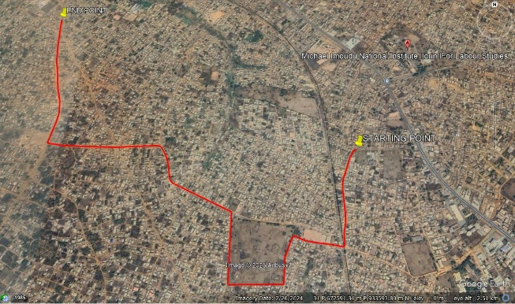
Google Earth imagery of The Study Area

CHAPTER TWO
2.0 LITERATURE REVIEW
Surveying has to do with the determination of the relative spatial location of points on or near the surface of the earth. It is the art of measuring horizontal and vertical distances between objects, of measuring angles between lines, of determining the direction of lines, and of establishing points by predetermined angular and linear measurements. Distances, angles, directions, locations, elevations, areas, and volumes are thus determined from the data of survey. Survey data is portrayed graphically by the construction of maps, profiles, cross sections, and diagrams (Oregon Department of Transportation, 2000).
Route survey is defined as the survey done along a comparatively narrow strip of territory for the location, design and construction of any route of transportation. Oregon Department of Transportation (2000), while presenting a seminar also stated that it refers to those control, topographic, and construction surveys necessary for the location and construction of highways, railroads, canals, transmission lines, and pipelines. It is very useful in the determination and establishment of difference in elevation between two or more points (Harry, 2000). It includes the field and office work required to plan, design, and lay out any “long and narrow” transportation facilities (Michael, 2006). Also, it deals with earthwork which covers the movement of soil or rock from one location to the other for construction purposes.
The need for surveying as a basis for planning and the process of acquiring data of route alignment with special attention on road network, construction and rehabilitation cannot be over emphasized. In view of this, the principle and scope of surveying in general and route surveying in particular is the comprehensive aim of the project.
Transportation being a great function and purpose of route survey is regarded as the fulcrum upon which every other sector of the economy revolved. It is as well the movement of people, goods and services from one place to another, be it on land, water or by air (https://www.toppr.com/guides/evs/a-shelter-so-high/roadways). In this wise, transportation has contributed immensely to the economic development of nations in which our dear country (Nigeria) is involved. Here are some of the benefits derived as a result of good transportation networks:
- It aids the movement of goods and services.
- It assists in the dissemination of ideas and as well technology.
- Opening up of new land and abandoned areas.
- It assists in national integration.
Besides, route survey has contributed immensely as touching construction sectors of the engineering surveying.
Engineering surveying which breeds both route and construction survey involves the application of knowledge to the analysis, design and execution of surveying and mapping projects, and the design of land mapping and information systems. Edward, (2012) opined that Surveyors rely on an understanding of the science of surveying measurements and the surveying principles.
Moreover, it is vividly seen that surveying plays extremely important role in any construction project. Surveying can take many forms, it aids in establishing the location and alignment of highways, buildings, pipes and other man made or cultural projects. The major reason for carrying out route surveying is to facilitate movement of people, yielding to socio-economic benefits (i.e. by determining the best general route between terminals).
Furthermore, route surveying consists of the following sequence of survey:-
- Reconnaissance of the terrain between the terminals
- Preliminary surveys over one more locations along the general route recommended in the reconnaissance report
- Location survey
- Construction survey
According to Anderson and Mikhail, (1985), route survey refers to the topographical and construction surveys necessary for location and construction of transportation lines or communication such as highways, railways, canals, transmission lines and pipeline. It is a reality that surveyors are the major professionals needed when it comes to working on any engineering project, for example, Building project. They provide special information, such as; the site location, size of the parcel, the dimension and total area. The finished product (plan) forms the basis upon which further development depends.
The line projected by the preliminary surveys, after it has been carefully studied and compared with regards to the cost and operating expenses would be made of the scheme to be adopted. Final location may be performed entirely on the field whereby the surveyors use the gradients shown in the profile as a guide seeking for improvement in the alignment. The detailed work would be performed by traversing. The first aspect of route survey is reconnaissance survey.
Reconnaissance survey is a rapid but thorough examination of an area or a strip of territory between the terminal of the project to determine which of the several possible routes may be worthy of a detailed survey. Reconnaissance survey is the most important of the series of surveys mentioned above. A very thorough and exhaustive examination of the whole area should be made to ensure that no possible route has been overlooked which leads to the preliminary survey.
Preliminary survey is the detailed survey of a strip of territory through which the proposed line is expected to run. The preliminary survey is made of best several lines of directions investigated previously on the reconnaissance survey. The purpose is to prepare an accurate topographic map of the belt of country along the selected route, and thus arrive at a fairly close estimate of the cost of the line/direction surveyed leading to location survey.
Location survey is the ground location of the proposed line marked on the map. The main purpose of location survey is to make minor improvements on the line as may appear desirable on the ground, and to fix up the final grades. Profile levels are run over the centerline, benchmark is established, and profile which shows the existing ground level and the grade line is attained. Cross section notes are taken in order that the quantity of earth work for filling or cutting may be computed which will be used by engineers during construction survey.
Construction survey is for re-establishing points, lines and grades on the ground during construction. It also consists of staking out various details culverts and bridges and in carrying out such other surveying as may be needed for the purpose of construction.
At the concept and design stage, large scale topographical surveys are produced and other measurements upon which projects are designed. Since this data forms basis to a great extent on the precision and thoroughness with which the survey is carried out.
Profile leveling (longitudinal leveling) is an operation performed to determine the elevation points spaced apart at known distances along given line in order to obtain the accurate outline of the surface of the ground along the line. It is very useful for projects like construction and design of sewer, pipelines etc., and to determine the cut and fill. It is frequently essential to run a longitudinal section along various proposed centerlines and to compare their costs to select a suitable one (Duggal, 2006).
Cross sectioning, according to Duggal, (2006), is a leveling operation performed to determine the elevation of the points at right angles on either side of the centerline of the proposed road and radially on the curves. This is done to find out the vertical sections of the surface of the earth on the ground. The detailed information regarding the levels of the ground on either side of the longitudinal section helps in computing the quantity of the earth work. The cross sections are plotted in the same manner as longitudinal sections.
Flying leveling (checking leveling) should be done to connect the bench mark (BM) to the starting point of the work. The records pertaining to profile leveling are entered accordingly along with the cross sectional leveling while the leveling work is in progress. The cross sections are taken perpendicular to the center line of the alignment at some regular intervals. The purpose of cross section is to know the undulation of the ground surface.
According to Anderson and Mikhail, (1985), refers to those controls and construction surveys necessary for the location and construction of line transportation and communication which may include highways, railways, canals, transmission lines, pipelines.
Some past route projects executed/carried out in the past are outline below:
Route survey was carried out during the Ogunpa Channelization project which was constructed in Ogunpa in Ibadan by an indigenous construction company in 2005/2006. Before this project, a channel was constructed to follow the course of the Ogunpa River, instead of changing its course. Therefore, drainages were badly damaged. As a result, flooding became inevitable. However, subsequent measures made to correct these faults were done after a proper route survey of the area.
Below is the weakness of the above contract:
- Changing the course of the drainage instead of following the course of Ogunpa River, as a result of this, flood and huge damages were caused.
- Since the project was already constructed before the flooding, double expenditure was incurred as a result of reconstruction of the project.
Below is some of the strength of the above contract:
- The route survey carried out in that area eliminated and stop the flooding and damages in a fast and economized way.
- A precised and accurate job corrected the error and likely any future damages that is to occur.
Route survey project was carried out in Emekuku ranging from Ubowala Autonomous community in Owerri North to Umuaguru Isinkor in Ikeduru local government area of Imo State, covering a distance of 4,558.065 meters (4km). The method used in carrying out the project was integrated approach which involves 3D data acquisition by the combination of traversing and trigonometric heighting using total station. The instrument used for this project was total station Kolida (KTS 44-2L), it reads in 5 seconds, it was used in carrying out traversing and cross section of the study area.
Route survey of the world’s longest and deepest rail tunnel (57km) in Switzerland named Gotthard rail link has taken 20 years to build with 2600 employees and cost more than $12bn. The construction of the 57km long Gotthard base tunnel crossing the Swiss Alps was a uniquely challenging engineering feat, led by Alp Transit Gotthard AG (ATG). On behalf of ATG, the consortium VI-GBT under BSF Swiss photo leadership was responsible for providing the geodetic reference measurements to ensure precise position and direction information for the tunneling advance. The required maximum error tolerances of no more than 25cm across the tunnel axis vector and 12.5cm in elevation were met for each of the for break- through.
In 2008, Ayinde also carried out route survey of proposed road using a LEICA TC305 Total station. He carried out 3-dimensional traversing for the execution of the project. He plotted the longitudinal and cross section profile using AutoCAD map 3D. This project was used for educational purpose and re-establishment of points, lines and grades on the ground during construction and staking out of culverts and bridges.
Finally, Route survey involves the determination of ground configuration and location of physical features both natural and artificial along the proposed route, establishing the line on the ground and computing volumes of earthwork involved where applicable (Schofield, W. 2001). This kind of survey operation is very important on all road networks and in construction of new road which will increase the durability and carrying capacity of road networks.

CHAPTER THREE

3.0. METHODOLOGY

Methodology is the set of methods and principles and instructions used to perform a particular activities or task. Its show the stages involved during the execution phase of the project research work. The methods involved in the execution of this project are includes traversing, detailing and contouring, processing and presentation. According to Oloyede et al. (2017), Total stations and GPS equipment are commonly used in Nigerian route surveys, providing precise measurements of distance, angles, and elevations. These tools allow surveyors to collect data on the terrain, which is essential for designing roads and other infrastructure projects
3.1 Preliminary Planning and Preparation:
- Route Selection: Based on preliminary maps and project requirements, a set of possible routes was identified and later the route from Michael Imodu to Oshin Olatunji was chosen.
- Site Visit: All the team member of Surveyors crew and Engineers visited the potential sites to familiarize themselves with the terrain and environment.
- Other: other preliminary activities was done in the office by the surveyor team. These activities are check the condition of the surveying equipment for the project execution and son costing activities.

3.2. RECONNAISSAINCE SURVEY

Reconnaissance Survey was carried out by the members of Group 5C, were the necessary information about the project area were gathered which are paramount to the successful execution of this project work. It is pre-requisite for any survey project to be carried out. During the Recce. Survey the group member visited the site in order to have a good view of the site location with other relevant information, the selection of the bench marks point, the tracking of the existing route using handheld GPS (Garmin 72) to know the length of the road, and checking of the available with. This was continue from the starting chainage to the end and at the end of the Recce. Survey activities the reconnaissance diagram was drawn as show on the figure below.

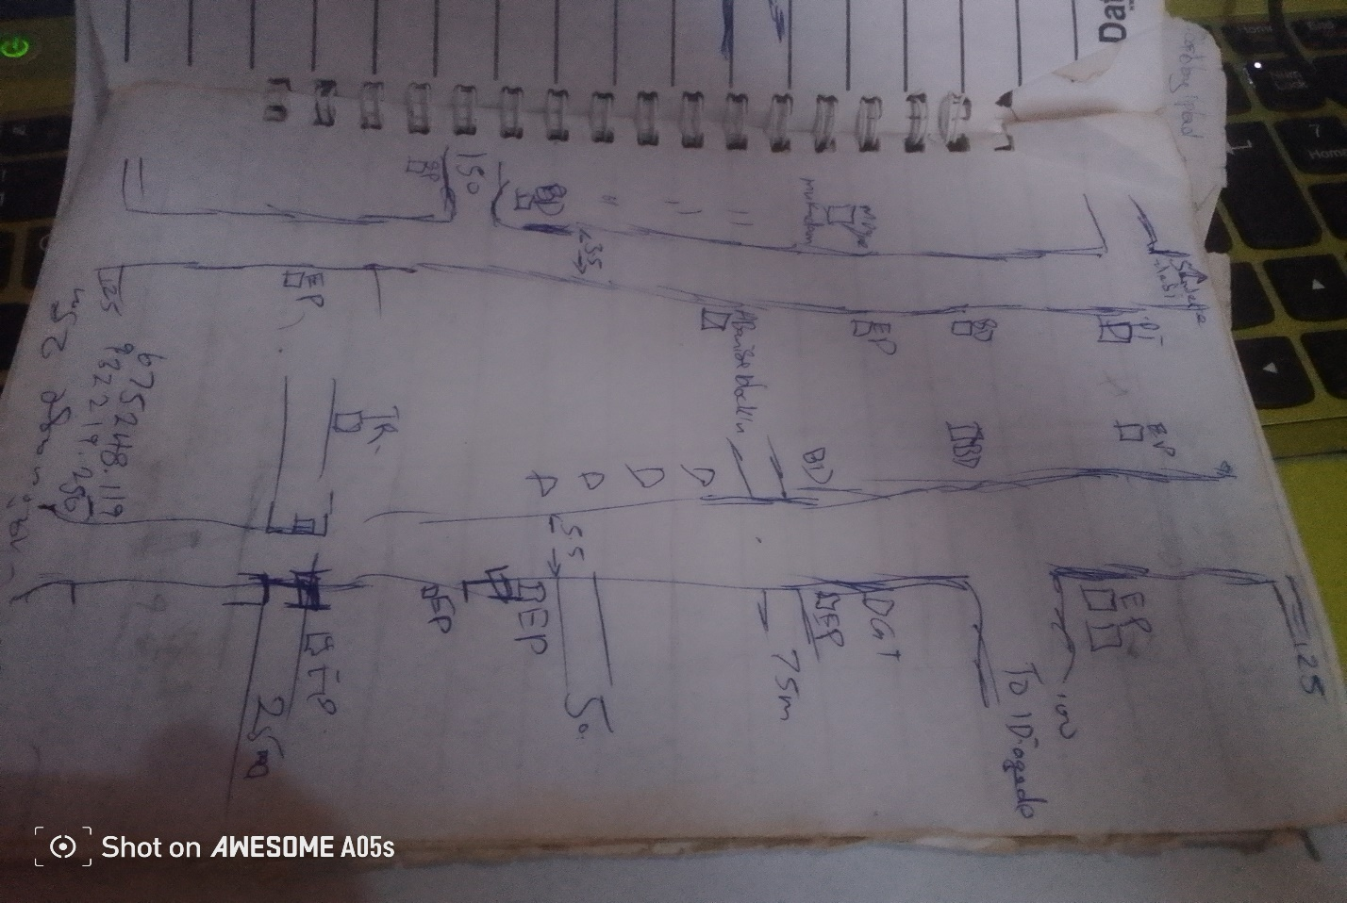

Fig.3.1: Recce Diagram of the project location (Not drawn to scale)

3.3 OFFICE PLANNING

Having completed the field recce survey, then office planning was followed on the next day. It involves chosen the type of instruments, purpose and accuracy required of the survey be carried out. The collection of equipment needed for the project and also test of the instrument, mission planning, assembling and studying of all available data project of the relevant to the project, the costing of the operation was also done in the office. In executing the project, necessary information related to the project given such as the coordinates of the control. The prefix number of the controls used and the bench marks.
Table 3.1 shows the list of coordinates of existing control points
BEACON NO. | NORTHING(m) | EASTING(m) | HEIGHT(m) | LOCATION
BM.01 | 932229.902 | 675261.302 | 312.39 | Ilorin
BM.02 | 932225.637 | 675284.873 | 313.04 | Ilorin
BM.03 | 932207.160 | 675272.022 | 312.97 | Ilorin
Source: Author, 2025.
3.4. SELECTION OF THE EQUIPMENT AND SOFTWARE
The equipment, tools and software used for this project were grouped into two categories and they are:
- Hardware
- Software
3.4.1 Hardware Used
- Sokkia (CX105) Total Station 1 No.
- Hand held GPS receiver 1 No.
- HP Design jet 7100 series 1 No.
- HP Gateway laptop 1 No.
- Tracking rod 1No.
- Tripod 1 No.
- Linear tape (50m) 1 No.
3.4.2 Software Used
- Ts-link for (CX105) Total Station downloading software
- AutoCAD 2007
- CivilCAD 2014
- Note pad
- Microsoft Office package (Word and Excel)
3.5. BENCH MARKS ESTABLISHMENT, CAPPING AND LABEL
- Temporary bench marks (TBM) were established and coordinated along the entire route of the project, which were meant to serve as a check for data acquisition and controls for establishing centerlines chainages, setting out of curves and other road features during the actual construction.
- The positions of these beacons (TBMs) were selected and established at certain distances part not above 500m interval in such a way that they are inter-visible to each other, not too far from the proposed road and considerable number of centerline chainages can be set out from them.
- The property beacons used were precast with dimensions 18cm x 18cm x 75cm in length. Sixty five centimeters (65cm) of the precast beacon was buried beneath the surface and ten centimeters (10cm) above as shown in fig. 2.3.
- The numbering was done serially from the beginning to the end of the proposed road and was prefixed with identification number BM01, BM02, BM03 and so on. The values of those TBMs were shown on appendix

10cm
65cm
Ground level
18cm
BM
01
18cm
18cm
B
M

01

Figure 3.2: Show the Description Typical Bench Mark.
3.6. INSTRUMENT TEST
3.6.1. COLLIMATION TEST
The procedure undergone to perform instrument test is as explained thus:
The instrument (CX105 Total Station) was set up on TBM.01 and all temporary adjustments (centering, leveling and parallax elimination) were performed. A reflector prism was set-up at a distance of about 100m to the line of sight and bisected on both face left and face right. The instrument was switched on and program which is on-board of the micro-computer of the instrument was switched to the columniation program. Then horizontal columniation and vertical index were in sequence recorded and stored in the memory of the instrument. The telescope was transited and the same target was bisected. Both the new vertical index and columniation error were recorded and stored accordingly. It was transited to the same target with both horizontal and vertical readings recorded to check the instruments accuracy. The readings obtained were shown in the table below.

Table 3.2 Show the Horizontal Circle Readings
Station | Sights | Face | Horizontal Circle Readings | Diff. Between (FL & FR)
A | C  C | L  R | 204⁰ 36’ 42’’  024⁰ 36’ 36’’ | 180⁰00’ 06’’

Table 3.3 Show the result of the adjustment made.
 | OLD READING | NEW READING
Horizontal Columniation | 00° 00’ 18’’ | 00° 00’ 06’’
Vertical Index | 00° 00’ 11’’ | 00° 00’ 04’’

3.7 DATA ACQUISITION
3.7.1 IN-SITU CHECK
The in-situ check was carried out on the control TBM.01, TBM.02, and TBM.03, the result showed that the pillars were reliable enough to be used for the project. An analytical comparison of the measured data obtained from the check and the calculated values is as shown below.
Table 2.3 Show the observed coordinates of TBM.01 from TBM.02
STATION | NORTHING(m) | EASTING (m) | HEIGHT(m) | REMARK
TBM.01 | 932229.902 | 675261.302 | 312.39 | Observed
TBM.01 | 932229.896 | 675261.311 | 312.37 | GPS Given
Discrepancy | -0.006 | 0.009 | -0.017

Table 2.4: Show the observed coordinates of TBM.03 from TBM.02
STATION | NORTHING(m) | EASTING (m) | HEIGHT(m) | REMARK
TBM.03 | 932207.160 | 675272.022 | 312.97 | Observed
TBM.03 | 932207.164 | 675271.996 | 312.98 | GPS Given
Discrepancy | 0.004 | -0.006 | 0.006
Table 2.5: Result of the computed control check (from given GPS coordinates).
STATION FROM | BEARING | DISTANCE | DN | DE | NORTHING | EASTING | STATION  TO
 |  |  |  |  | 932229.896 | 675261.311 | TBM.01
TBM.01 | 349ᴼ59’59” | 23.953 | -4.255 | 23.478 | 932225.637 | 675284.873 | TBM.02
TBM.02 | 234ᴼ59’56” | 22.507 | -18.482 | -12.858 | 932207.164 | 675271.996 | TBM.03

The result was used to obtain the inclusive angle between TBM.01, TBM.02, and TBM.03 by finding the difference between the bearings of two lines.
TBM.02 TBM.01 => 169ᴼ59’59”
TBM.02 TBM.03 => 234ᴼ59’56”
Therefore (234ᴼ59’56”-169ᴼ59’59”)
Check angle 64⁰ 59’ 57’’

64⁰ 59’ 57’’

Fig.2.5 Show sketch of the check angle from three Given data

Table 2.6: Show result of the computed control check angle (from observed coordinate).
STATION FROM | BEARING | DISTANCE | DN | DE | NORTHING | EASTING | STATION  TO
 |  |  |  |  | 932229.902 | 675261.302 | TBM.01
TBM.01 | 350ᴼ01’01” | 23.954 | -4.264 | 23.570 | 932225.637 | 675284.873 | TBM.02
TBM.02 | 234ᴼ59’59” | 22.508 | -18.477 | -12.851 | 932207.160 | 675272.022 | TBM.03

The result was used to obtain the included angle between TBM.01, TBM.02 and TBM.03 by finding the difference between the bearings of two lines.
TBM.02 TBM.01 => 170ᴼ01’01”
TBM.02 TBM.03 => 234ᴼ59’59”
Therefore (234ᴼ59’58”-170ᴼ01’01”)
Check angle 64⁰ 59’ 58’’
TBM.02TBM.02
TBM.01TBM.01
TBM.03TBM.03
64⁰ 59’ 58’’

Fig.2.6 show the sketch of check angle from the observed data
The difference between the Observed check angle and the computed from given check angle was 00⁰ 00’ 01’’
- Computed distance from the given data (TBM.02 TBM.01) = 23.953m
- Computed distance from the observed data (TBM.02 TBM.01) = 23.954m
Difference obtained with the two result was compared as = 0.001m
- Computed distance from the given data (TBM.02 TBM.03) = 22.507m
- Computed distance from the observed data (TBM.02 TBM.03) = 22.508m
Difference of the two results = 0.001m
3.7.2 GEOMETRIC DATA ACQUISITION
3.7.3 TRAVERSE OF BM POINTS
Traverse was run round the established eleven (11) BM points. The CX105Total Station was set up on BM.02, a back sight was taken to BM.01 after the instrument is switched on and all temporary adjustments were carried out. The stations parameters (N, E and H) were enter into the memory of instrument for both occupied and reflector target station at back sight station (BM.02 and BM.01) respectively. Fore sight was taken to the first BM.03 and measurement stored, the instrument was then moved to the BM.01 as instrument station and reflectors were positioned at BM.02 and BM.03 as back sight and fore sight respectively. The occupied station (BM.01) parameter was entered into the Total Station and measurement was taken to CL-Road Centerline. This whole process continues and the traverse was closed back at BM.02. The numbers of BM are eleven (11) in total. The table below show the list of the benchmarks observed.
3.7.4 DATA ACQUISITION
The CX Total Station was set-up on BM.02, switched on and all temporary adjustments were carried out. The instrument was set on coordinates mode and the instrument parameters (Station name, Height of instrument, and N, E, H) as well as the target station parameters (Back sight station name, Height of reflector, and N, E H) were keyed into the Total Station. Then orientation was made to the reflector at station BM.01, and the measurement between the two stations was stored in the memory of the instrument. Foresight was made to 0+000m chainage centerline and then to the cross-sections at 20m away from the center line on both side and stored on the Total Station. Then the reflectors were now moved to the next chainage 0+025 and the same measurement performed for the first chainage is repeated here i.e. the centerline and the cross-section. Also details were fixed alongside traversing; IP points was also coordinated by moving the reflectors to the desired point of interest and denoted using a different code (CL, BLD, E.P, RT, LT, W.F, and DR. CV. Where CL means Centerline, BLD means Buildings, E.P. means Electric Poles, RT means Road Right Side, LT means Road Left Side, W.F. means Wall Fenced, DR mean Drainage line, CV mean Culvert ). This whole process continues until the reflector is no longer visible from the instrument. Then the instrument station was changed and the above process of data acquisition was repeated for the marked chainages and BM points till the end of the route was reached. The traverse was closed on BM11. The discrepancy between the observed and the given coordinates for the easting and northing is -0.099m and +0.102 respectively was used to compute for linear accuracy and found to be 1: 63,000, compare with the permissible accuracy of 1:5000.

TP2
TP1
CL
TP3

CH 0+000 CH 0+100 CH 0+200 CH 0+300

CHAPTER FOUR
4.0 DATA PROCESSING
The data processing follows immediately after the completion of the data acquisition and the selected software from the chapter three. This involved the methods used in downloading / retrieving, sorting and analyzing of acquired data (field data). Here the data downloaded was processed into information using appropriate methods and software. The steps involved are as follows;
4.1 DATA DOWNLOADING (CX- TOTAL STATION)
4.1.1 DOWNLOADING PROCEDURE
The data were transferred from the Total station to the SD Card via the SD card Slotted in into Total Station and later downloaded into the computer using Ts-Link Sokkia (CX105) Total Station software.
The following procedure was followed during the downloading from the Total Station to the computer;
The SD card was Slot in into the Total Station and the instrument was powered on. The job “Route” was selected from the list of JOBS to be downloaded then transfer to the SD Card following the steps below
- click on F4 which means transfer
- The following option displayed on the total station screen
- Comm. sends data
- Comm. receive data
- Comm. setting
- Memory to S.D card
- S.D card to memory
- S.D card to file manager
- Then the fourth (4th) option is selected since we are moving the job “Route” from Instrument memory to SD card
- Then press ok
- Click on F1 to create a new file
- Input the file name and press F5 (ok)
- Search for the file name then press enter and the data was successfully moved from instrument memory to SD card
4.1.2 DOWNLOAD FROM SD CARD TO COMPUTER SYSTEM
The Sokkia-link software was installed on the computer system and was used to download from the SD card to system.
The following procedures were followed
- Insert the memory card at the appropriate slot on the Computer system.
- Sokkia-link software was launched from the desktop screen.
- Click on the SD card on the software
- Scroll on import data
- Click on the file name
- Click on yes
The coordinates will display in the format
PT | N/X | E/Y | Z | CODE
- Then save the file as text file.
4.2 DATA PROCESSING PROCEDURE
The file was opened and point data were displayed. This was then copied to a notepad and Microsoft excel environment for further processing.
On notepad, data were well spaced to differentiate one column from the other and unwanted information deleted.
On Microsoft excel, data were prepared for scripting purpose in AutoCAD. A small programme was written to prepare point and text scripts files.
4.2.1 PLOTTING PROCEDURE IN CIVILCAD 2014
    - CIVILCAD 2014 was lunched and NEW PROJECT was clicked index FILE MENU and named e.g. Route Survey, the OPEN button was clicked.
    - CONFIGURATION was then clicked under file menu to carry out General settings (Language, System units, Angles units, and Printout font size etc.), drawing environment settings, and Coordinate format settings and File settings.
    - Having completed the configuration, TOPOGRAPHY MENU was clicked and COORDINATES was chosen in the pull down menu.
    - In the dialogue box, ‘Load menu from text file’ button was clicked to load raw data coordinates that was arranged in the format; Point ID, Easting, Northing, and Height.
    - After selecting the raw data file and clicked Open, REFRESH ALL button was clicked and the software automatically run the script and plot the whole data just exactly the way it was surveyed. Also layers were automatically created for all the point Ids, Heights and Symbols used. But layers for each feature that was fixed along the route were manually created, e.g. buildings, Electric poles, Drainages, Culverts etc.
    - Line, Polyline, points and Splines tools were used to join all the features that were fixed along the route path into its appropriate layers.
4.2.2 PROFILE / VERTICAL ALIGNMENT PLOTTING USING CIVILCAD
- In CivilCAD2014 environment, ROAD MENU was clicked and VERTICAL ALIGNMENT submenu under Road selected.
- The Options Button was clicked in the dialogue box to set the Slope format, Vertical curves’ factor, Data precision and super elevation maximum slope. After the settings of these parameters, OK button was clicked.
- Having done this, ‘Load sections from a text file’ button was clicked to load sections of the centerline data, which was prepared in notepad in this format;
Station Chainage leveling height
  - 0 312.870
  - 25 312.710
  - 50 312.540
  - 75 312.390......
- Zoom Extent was opted for under view menu to view the whole profile drawing.
- A design was carried out on the profile by selecting a polyline tool to pick points along the profile, and when this was completed, APPLY button was clicked and the software automatically generates design levels for the whole profile.
- The design level was then used to calculate the volume of CUT and FILL on each section of the centerline
4.2.3 LOGITUDINAL / HORIZONTAL ALIGNMENT PLOTTING USING CIVILCAD
- In CivilCAD2014 environment, Road Menu was clicked and HORIZONTAL ALIGNMENT chosen.
- Options button was clicked in the appeared dialogue box and Define Section was then clicked to choose the section format and the distance between the sections. Format 2 was chosen and the distance between sections was taken to be 25m
- Having chosen these options, OK was clicked twice.
- Pick tool was selected from the right pane dialogue box to pick all the intersection points (IPs), and appropriate radius values of curve was given to each IP as specified by the client.
- Apply button was then clicked to effect all the given parameters on the drawing. On each IP position, information about the IP is been displayed. Such information are; IP number, X coordinate, Y coordinate, Radius of curve, Length of curve, Deflection angle and so on.
4.2.4 PLOTTING OF CROSS-SECTIONS USING CIVILCAD
- In CivilCAD2014 environment, Road menu was clicked and CROSS SECTION selected. Then ‘Load sections from text file’ button was clicked to load the existing ground level data.
- Having uploaded the data file, Existing Ground Level was chosen to specify that the data coming in is for existing ground level.
- The same format of data was uploaded next but for Designed Level by choosing Designed Ground Level button. The design level data was calculated using 2.5% slope for cambering and 3% slope for the shoulder.
- The software then superimposed the two drawing together to calculate the volume of CUT and FILL at each cross sections.
- Then frame division was clicked and the Output scale, Paper size and range was chosen for the final output of the cross sections.
4.2.5 GENERATING EARTHWORK TABLE USING CIVILCAD 2014
- Under Road menu, EARTHWORK button was clicked and the Apply button to generate the volume of earthwork table.
- Having done this, a geometry report dialogue box appears on the screen showing the accumulated volume of Cut and Fill, which can be directly printed or exported to Microsoft Excel for further editing.
  - RESULT AND ANALYSIS
This is a systematic examination and evaluation of data obtained and processed as a result of my field observation. This was achieved by taking into consideration all the necessary survey procedures and adhering to survey rules and regulations while on field and during processing.
The final results were tabulated in appendix
The route survey traverse started from TBM.01, TBM.02 andTBM.03 but closed back on TBM.02.
Table 4.7: Abstract of BM coordinates
TBM.01 | 932229.902 | 675261.302 | 312.39
TBM.02 | 932225.637 | 675284.873 | 313.04
TBM.03 | 932207.160 | 675272.022 | 312.97
TBM.04 | 931583.654 | 674839.222 | 310.21
TBM.05 | 931589.824 | 674818.166 | 309.58
TBM.06 | 674441.073 | 931811.975 | 310.13
TBM.07 | 931823.719 | 674448.987 | 309.46
TBM.08 | 932238.880 | 673657.641 | 322.56
TBM.09 | 932216.454 | 673658.547 | 323.87
TBM.10 | 933121.878 | 673159.463 | 303.71
TBM.11 | 933124.483 | 673178.850 | 303.56

Finally the observed coordinates and the given coordinates were compared and the computation shows that the traverse closed.
4.4 LINEAR ACCURACY
The accuracy was computed with the formula below:
For the boundary traverse;
_____1_____
√(ΔE)² + (ΔN)²
Total Length

Starting Coordinate (TBM.02) 932225.637mN; 675284.873mE, Ht = 313.040m
Closed Coordinate (TBM.02) 932225.739mN; 675284.774mE, Ht = 312.068.m
Misclosure in Easting (E) = -0.099m
Misclosure in Northing (N) = + 0.102m
Total Length = 9000m

_____1_ _____
√ (0.099)² + (0.102)²
= 9000m
_1_ __
√ 0.020205
= 9000m
_____1_ _ _
0.1421443
= 9000m
____1_ _
= 0.00001579381
= 63,315

The computed accuracy is 1/63,000
The permissible accuracy is 1/5,000

4.5 HEIGHT ACCURACY
Obtained error in leveling traverse (Misclosure) = -0.028m
Minimum allowable error in leveling (Permissible) = 24mm√k
Where k = distance covered in kilometers is 9.0km
Allowable error over in height over km =
24mm√k = 24mm√9.0km = - 0.0026m
Therefore, it means that the job met the required specification.
From the above computations, the linear accuracy obtained was better than the allowable limits of 1:5000 according to SURCON specifications for third order engineering job.
4.6 PLAN PRODUCTION
The adjusted coordinates were plotted in AutoCAD 2007 and CivilCAD 2013 Environment to generate the centerline of the road, longitudinal profile and cross section. The details were also plotted. The essence of obtaining a detail plan is to provide a platform for horizontal curve and alignment design for the road expansion /rehabilitation. Information shown on the detail plan provides a vivid representation of the land mass for easy understanding of the route.
    - HORIZONTAL ALIGNMENT PLAN
AutoCAD Land Development software 2009 was used to transform the collected and already processed data into a plan for visual presentation. A hard copy of the plan was printed using the AutoCAD visual display graphical information. Plots of the cross-section, profile, and longitudinal section were made which was attached to this project.

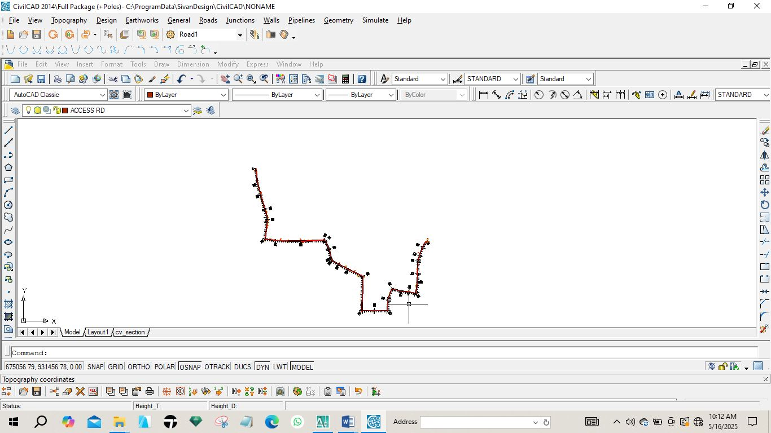
Fig 4.1: Horizontal plan of the route
4.6.2 VERTICAL ALIGNMENT PLAN
In order to give vertical height and terrain information along a route for vertical alignment and curve design, a profile was created. It gives a clear view of the terrain and helps decide where to fill or cut. It offers details like the existing level, formation level, tangent points, and slope.
The design of the route was done after the creation of the longitudinal profile. The longitudinal profile was created using AutoCAD Civil 3D 2022. The steps in the creation of the longitudinal profile shown in fig 4.2 are as follows:

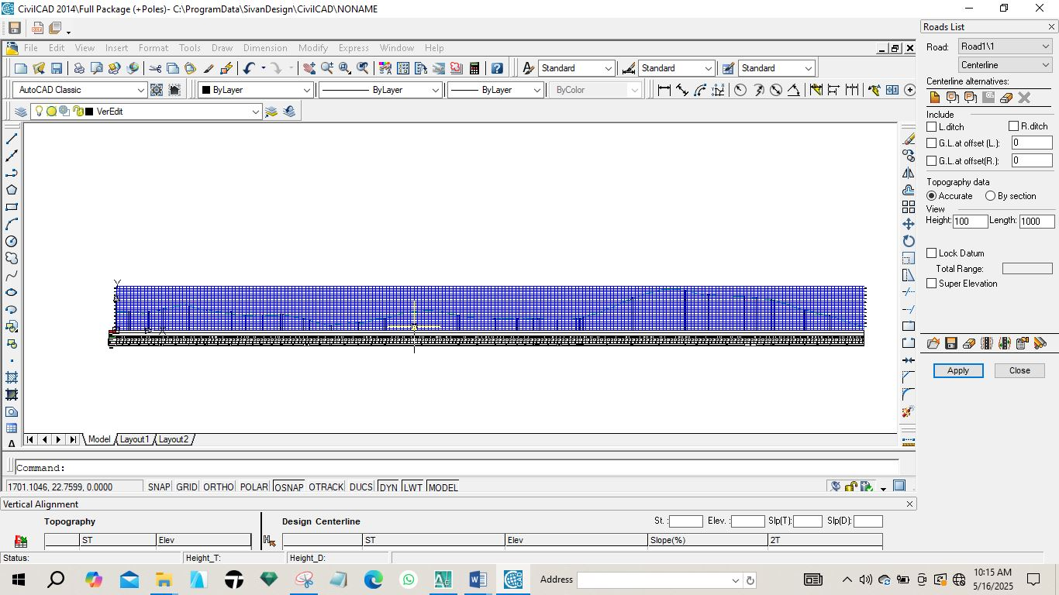
Fig 4.2: Vertical Profile of the route.
    - CROSS SECTION PLAN
The terrain information across the road chainage is shown in the cross-section. Details were displayed, including the height of the proposed and current center line and embankments. In cut and fill analysis, the area and, consequently, the volumes of earthwork were generated using the cross-section parameters.
The following process was carried out on the currently plotting on Auto CAD Civil CAD for generating cross section. The Cross Section icon was used to sample the sections from the existing ground, edit the values of the tangents, curves, and spirals, and create a current surface by clicking on surfaces and setting current surface. A template was created for the section and it was also edited under design control. Then, by clicking on section plot, all was selected, and all sections were created.
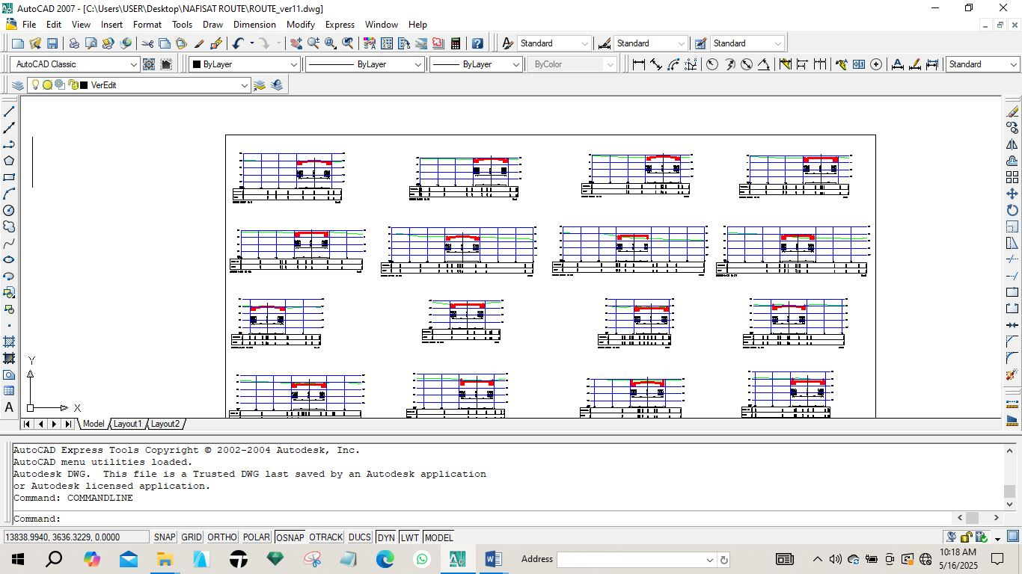
Fig. 4.3: Diagram showing generated cross section
4.6.4 VOLUME OF EARTWORKS
Volume computation in route surveying is a fundamental process used to estimate the quantity of earthwork required for road construction projects. Accurate volume calculations help engineers plan excavation and embankment activities efficiently, ensuring cost-effective and sustainable infrastructure development.
The software used for volume of earth work calculation is AutoCAD 2007and Civil CAD 2014, the process involves selecting specific areas for calculation and defining initial and final surfaces, which can be particularly useful in monitoring changes over time, such as material removal or deposition.
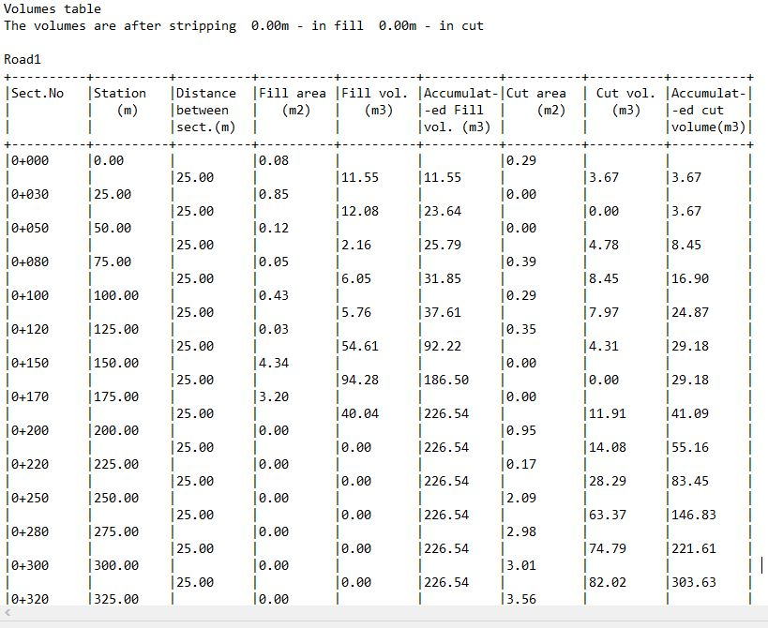
Fig. 4.4: Diagram showing generated volume computation

  - PROJECT COSTING
Table 4.4.1: shows the worked out cost of the project
OPERATION | RATE / DAY | NO OF DAYS | UNIT COST (#) | AMOUNT (#)
RECCONNAISSANCE (DAY)
1 Senior Surveyor | 10,000 | 1 | 10,000 | 10,000
8 Technical officer | 5,000 | 1 | 40,000 | 40,000
1 skilled labour | 5,000 | 1 | 5,000 | 5,000
Transportation (Field vehicle + Driver/ Mechanic + fuel) | 20,000 | 1 | 20,000 | 20,000
Basic Equipment (Hand held GPS, Field Book etc.) | 5,000 | 1 | 5,000 | 5,000
SUB TOTAL |  |  |  | #83,000
DETAILING AND SPOT HEIGHTING 4DAYS
1 Senior Surveyor | 10,000 | 4 | 40,000 | 40,000
8 Technical officer | 5,000 | 4 | 20,000 x 8 | 160,000
Basic Equipment (Total Station, Reflector) | 20,000 | 4 | 80,000 | 80,000
Transportation (Field vehicle + Driver/ Mechanic + fuel) | 20,000 | 4 | 80,000 | 80,000
SUB TOTAL |  |  |  | #360,000
DATA PROCESSING 1WKS
1 Principal surveyor | 10,000 | 5 | 50,000 | 50,000
1 surveyor | 8,000 | 5 | 40,000 | 40,000
1 assistant technical officer | 5,000 | 5 | 25,000 | 25,000
Computer accessories (printer, internet, generator, fuelling etc.) | 15,000 | 5 | 75,000 | 75,000
SUB TOTAL |  |  |  | #190,000
INFORMATION PRESENTATION
1 Senior surveyor | 10,000 | 1 | 10,000 | 10,000
1 technical officer (CAD) | 8,000 | 1 | 8,000 | 8,000
Standard set (computer, plotter, Generator etc.) | 15,000 | 1 | 15,000 | 15,000
SUB TOTAL |  |  |  | #33,000
TECHNICAL REPORT
1 Chief surveyor | 30,000 | 1 | 30,000 | 30,000
2 Surveyors | 20,000 | 1 | 20,000 x 2 | 40,000
SUB TOTAL |  |  |  | 70,000

COST OF THE PROJECT | #736,000
MOBILIZATION / DEMOBILIZATION (10% of the project) | #73,600
CONTIGENCY (5% of the project) | #36,800
TOTAL COST OF THE PROJECT | #846,400
VAT) (5% of the project) | #42,320
GRAND TOTAL | #888,720

CHAPTER FIVE
5.0 SUMMARY AND CONCLUSION
5.1 SUMMARY
The project title "Route survey" was carried out from Micheal Imodu area to Kangu toward Oshin Olatunji axis, Ilorin Ifelodun local government area, Kwara State. The project was carried out in accordance with the third order specifications for a survey operation. The reconnaissance survey was properly carried out both in the office and on the field, this was carried out for proper planning of the survey operation by establishing new controls needed for proper orientation, the instrument to be used, and selection of traverse stations and finally, drawing of a sketched diagram of the area under study.
The data acquisition for the project was in three stages which are, Total Station traversing for the purpose of horizontal and vertical alignment of the project site, leveling operation for the purpose of longitudinal and cross sectional profiling of the project site.
Therefore, data processing was done so as to reduce the data collected in the field and the necessary corrections were applied.
The corrected values were reckoned with in every aspect of computation and also in plotting the plan. The final plans, horizontal alignment (showing the traverse lines, and also the details found along the site), longitudinal profile and cross sectional profile were produced. The plans were produced in analogue format.
Finally, a comprehensive report was written on how the operations involved in the entire project were executed, the challenges that surfaced during the execution and how they were solved.

5.2 PROBLEMS ENCOUNTERED
The major challenges faced during the execution of this project are as follows,
- On the area of study, it was discovered that there are no control pillars for the execution of the project which was solved by establishing new controls pillars on the project site.
- Furthermore, most of our pegs and nails used for the documentation of traverse points, centre line and cross sectional points were removed due to the grading of the project site while observation has not been done to those pegs and nails, this was overcame by remarking of the chainages and cross sectional points and also re-pegging the traverse points that have been removed by the grader.
5.3 CONCLUSION
The project exercise were carried out accurately, the comparison of the expected accuracy and the obtained results analyzed above conformed to the required accuracy of a third order survey job hence, the aims and objectives were achieved.
5.4 RECOMMENDATIONS
Having gone through every aspect of this project work and from the problems encountered, experience and knowledge acquired during the execution of this project, I hereby recommend the following:
- Application of computer programming should be fully implemented so as to make the students carry out the data processing exercise more efficiently and faster.
- The school should set up a department for consultancy service such that useful projects like this route survey carried out by students would not only serve as means of broadening the student's knowledge but, could also be used in actual practice to execute jobs for clients. In this, the clients would go a long way relieving the students off their financial constraints and both the school and the government.

REFERENCES
Anderson, J.M, and Mikhail, E.M. (1985): Introduction to Surveying, 7th ed, Singapore, McGraw Hill Book Company, pp. 525,526
Duggal, S. K. (2006): Engineering surveying, 4th ed, London, Pearson Education limited, pp. 685,778
Edward, Z. (2012): Introduction to Engineering Surveying, 4th ed, California, Department of transportation, p.1
Field, H. (2002): Landscape surveying, 5th ed, Clifton park, Cengage unlimited p.101
Geomaat (2009): Revolution in highway surveying using street Mapper 360 in the Netherlands. GIM international, https://www.giminternational.com/content/article/revolution-in-highway-surveying
Micheal, T. (2006): Surveying Fundamental and Practices, 5th ed, India, Prentice Hall Pvt.Ltd, pp. 160, 164 & 392
Oregon department of transportation (2000): Basic Surveying theory and practice, 9th annual seminar of Oregon department of transportation, pp. 1-2
Schofield, W. and Breach, M (2001): Engineering surveying, 5th ed, Kingston University. pp. 91-97
Schofield, W. and Breach, M (2007): Engineering surveying, 6th ed, Amsterdam, Butterworth Heinemann publishers, pp. 12-13, 21-23

APPENDICE
- Recci diagram
- Field book
- Computation sheet
- Plotting: Analogue and Digital plans

