AN APPRAISAL OF CHALLENGES CONFRONTING KULENDE HOUSING ESTATE, ILORIN KWARA STATE

BY

OMOYELE OLAYEMI MARY
HND/23/URP/FT/0007

A RESEARCH PROJECT SUBMITTED TO THE:

DEPARTMET OF URBAN AND REGIONAL PLANNING
INSTITUTE OF ENVIRONMENTAL STUDIES
KWARA STATE POLYTECHNIC, ILORIN.

IN PARTIAL FULFILMENT OF REQUIREMENT FOR THE
AWARD OF HIGHER NATIONAL DIPLOMA (HND)
IN URBAN AND REGIONAL PLANNING

JUNE, 2025



DEDICATION
This project report is dedicated to God Almighty, the planner of the universe who through His word makes everything beautiful for His protection, provision and guidance. Also to my ever loving mother MS. ABIODUN SUNDAY for her love and unwavering support throughout my programme.

ACKNOLEDGEMENT
I give all glory, honor, and adoration to Almighty God for His mercy, goodness, grace, protection, provision, and guidance upon me throughout the period of this programme may His name be highly exalted.I will like to acknowledge my able, dynamic, and ever dependable supervisor, in person of TPL. M.I. YAHAYAH for the sacrifice of her time to read through the entire project may you live long to enjoy the fruit of your labour.
My profound gratitude goes to the Head of Department TPL. E.S. ADEKANYE for his fatherly love and support, and all the lecturers in this great and noble department for their impacts in shaping me academically.
I will be an ingrate if I fail to appreciate the most important person who stand by me , support me, encourage me make himself available every time I called in person of Mr. KehindeAwoniyi may God bless you beyond recommendation, may He supply all you needs thank you.I specially thank my mother Ms. ABIODUN SUNDAY for believing in my dreams and supported me in achieving it thank you for your love, prayer advice and financial support, my prayer for you is that when is time to eat the fruit of your labour, death will not snatch you away.
I also appreciate my second mummy and her lovely husband Mr. and Mrs. Omokoku for her love and support heaven will answer your secret prayers, to my families, my course mates, my neighbors both home and school, my loved ones, and those that contributed in one way or the other for the success of my programme I pray we shall all be celebrated in Jesus Name. AMEN

ABSTRACT
This study appraises the challenges confronting Kulende Housing Estate in Ilorin Kwara State. The Estate faces various challenges including infrastructure deficits, security concerns, environmental issues, and administrative complexities. A mixed-methods approach was employed, combining qualitative and quantitative data collection and analysis methods.
The findings reveal that the estate’s challenges are multifaceted, requiring a comparative approach to address them. The study recommends policy interventions and strategies, to improve the estate’s infrastructure, security and environmental quality, ultimately enhancing the quality of life for residents.

TABLE OFCONTENTS
Title page i
Certification ii
Dedication iii
Acknowledgement iv
Abstract v
Table of contents vi
CHAPTER ONE
Introduction
1.1 Background of the Study 1-2
1.2 Statement of the Problem 2-3
1.3 Research Questions 3
1.4 Aim and objectiv 3-4
1.5 Justification of the study 4-5
1.7 Scope of the study 5
1.8 Study Area 6-12
1.8 Definition of Terms 12-13
CHAPTER TWO
Literature Review
2.0 Introduction 14
2.1 Overview of Public Housing in Nigeria 14-15
2.2 Theoretical Frame Work 16-17
2.3 Challenges of Public Housing Project 17-18
2.3.1 Financial Constraints 18-20
2.3.2 Policy and Regulatory Issues 20-22
2.3.3 Corruption and Management 22-23
2.3.4 Socio-economic Factors 23-24
2.4 Case Studies of Public Housing in Nigeria 24-25
2.5 Summary of Literature 25-26
CHAPTER THREE
Research Methodology
3.1 Introduction 27
3.2 Research Design 27
3.3 Sample Frame 27
3.4 Data Collection Methods 28
3.5 Data Analysis Techniques 28
CHAPTER FOUR
Data Analysis and Result
4.1 Introduction 29
4.2 Demographic Characteristics of Respondents 29-30
4.3 Housing Conditions 30-31
4.4 Infrastructure and Amenities 31
4.5 Safety and Security 32
4.6 Challenges Facing the Estate 32
4.7 Implication of the Challenges 33
CHAPTER FIVE
Summary of Findings, Recommendation and Conclusion
5.1 Summary of Findings 34
5.2 Recommendations 34
5.3 Conclusion 36
LIST OF figure
Fig.1 Map of Nigeria showing Kwara State 3
Fig.2 Map of Kwara Stateshowing Ilorin East LGA 4
Fig.3 Map of Ilorin East LGA showing the study area 5
Fig.4 General layout plan of Kulende Estate 6
Fig.5. Location Plan of Kulende Estate 7
References 39
Appendix 40-43

CHAPTER ONE
INTRODUCTION
1.1 BACKGROUND TO THE STUDY
Nigeria, like many other developing countries, faces significant challenges in providing adequate housing for its rapidly growing urban population. The country's housing shortage has been exacerbated by rapid urbanization, population growth, and inadequate housing policies (Megbolugbe, 1983). In response to these challenges, the Nigerian government has implemented various housing programs aimed at providing affordable housing for low- and middle-income households.
Kulende Housing Estate is one of the programme, a federal government-owned housing project located in Ilorin, Kwara State, Nigeria. The estate was developed as part of the Federal Government Housing Programme under the Third National Development Plan (1975-80). The program aimed to provide affordable housing to low- and middle-income households, but its implementation has been plagued by numerous challenges, including inadequate infrastructure, poor maintenance, and overcrowding.
The Kulende Housing Estate is situated along Murtala Mohammed Way, a major road that connects Ilorin to other parts of northern Nigeria. The estate was developed as part of the Federal Government Housing Programme, which was initiated under the Third National Development Plan (1975-80) (Federal Republic of Nigeria, 1981).

The Third National Development Plan was a comprehensive development plan aimed at promoting economic growth and development in Nigeria. The plan identified housing as a critical sector that required significant investment to address the housing needs of the growing population (Adeleye, 2011). In response to this need, the federal government initiated the Federal Government Housing Programme, which aimed to provide affordable housing to low- and middle-income households (Odufuwa, 2006). This program was designed to address the housing needs of the growing population, but its implementation has been challenging.
1.2 STATEMENT OF THE PROBLEM
The Kulende Housing Estate, like many other public housing projects in Nigeria, faces various challenges that affect the quality of life of residents. These challenges include:
- Inadequate infrastructure and amenities
- Poor maintenance and management
- Limited access to services and facilities
- Environmental and health concerns
- Social and economic challenges
However, kulende housing estate is faced with the aforemention problems and many more such that it is almost losing its status as an housing estate because of its inability to function as an habitable housing abode, because it has almost completely taken over by other activities such as: dump site for used plastic bottles , home to scavengers, unorganized shop for petty tradimgs.
The real housing units in the estate are abandoned and dilapidated. The entire environment is blighted etc
These challenges have resulted in a decline in the overall quality of life for residents, making it essential to investigate and address these challenges.
1.3 RESEARCH QUESTIONS
This study aims to answer the following research questions:
- What are the major challenges facing the Kulende Housing Estate?
- What are the causes of these challenges?
- What are the effects of these challenges on the quality of life of residents?
- What solutions can be proposed to address these challenges?
1.4 AIM AND OBJECTIVES
1.4.1 AIM OF THE STUDY
The aim of this project is to appraise and identify the challenges facing the Kulende Housing Estate in Ilorin, with a view to understanding the obstacles that hinder the effective management, maintenance, and sustainability of the estate.
1.4.2. OBJECTIVES OF THE STUDY
The objectives of this study are:
- To identify the major challenges facing the Kulende Housing Estate
- To investigate the causes of these challenges
- To examine the effects of these challenges on the quality of life of residents
- To propose solutions to address these challenges
1.5. JUSTIFICATION FOR THE STUDY
The Kulende Housing Estate, a federal government-owned housing project in Ilorin, Kwara State, Nigeria, faces numerous challenges that affect the quality of life of its residents. Despite its initial promise as a model for public housing, the estate has deteriorated over time, plagued by inadequate infrastructure, poor maintenance, and overcrowding.
This study is justified for several reasons:
- Addressing a pressing social issue: The challenges facing the Kulende Housing Estate are reflective of the broader housing crisis in Nigeria, where millions of people lack access to decent and affordable housing. By investigating the challenges facing this estate, this study aims to contribute to the development of solutions to this pressing social issue.
- Informing policy and decision-making: The findings of this study will provide valuable insights for policymakers, urban planners, and housing professionals seeking to address the challenges facing public housing estates in Nigeria. By identifying the causes and effects of these challenges, this study will inform the development of evidence-based policies and interventions aimed at improving the living conditions of residents.
- Filling a knowledge gap: Despite the importance of public housing in Nigeria, there is a dearth of research on the challenges facing these estates. This study aims to fill this knowledge gap by providing a comprehensive analysis of the challenges facing the Kulende Housing Estate and proposing solutions to address these challenges.
- Improving the quality of life of residents: Ultimately, this study is justified because it aims to improve the quality of life of residents living in the Kulende Housing Estate. By identifying the challenges facing the estate and proposing solutions to address these challenges, this study aims to contribute to the development of a more sustainable, equitable, and liveable community.
1.6. SCOPE OF THE STUDY
The scope of this study is limited to assessing the living conditions of residents in Kulende Housing Estate. Specifically, the study aims to:
1. Evaluate housing conditions: Assess the condition of housing units, including maintenance and repairs.
2. Assess infrastructure: Evaluate the condition of roads, availability of streetlights, and waste disposal facilities.
3. Examine safety and security: Investigate residents' perceptions of safety and security, including experiences of security breaches.
4. Investigate access to amenities: Assess residents' access to amenities such as schools, healthcare facilities, and shopping centers.
5. Identify areas for improvement: Highlight areas of concern and recommend improvements to enhance the overall living conditions of residents.

1.7 STUDY AREA
The Kulende Housing Estate is located in a strategic area of Ilorin, with easy access to major roads and amenities. The estate is situated on a 168-hectare land area, with the existing development occupying 14 hectares. The estate's population density stands at 107 persons per hectare (Kwara State Government, 2017).
The road network within the estate follows a grid-iron pattern, characterized by multiple cross junctions. The buildings are constructed along the streets, lacking pedestrian walkways and landscaping. The estate's design and layout reflect the modernist architecture of the 1970s, with an emphasis on functionality and efficiency (Agbola, 1997).

Figure 1.1: KwaraStatewithin the National Context
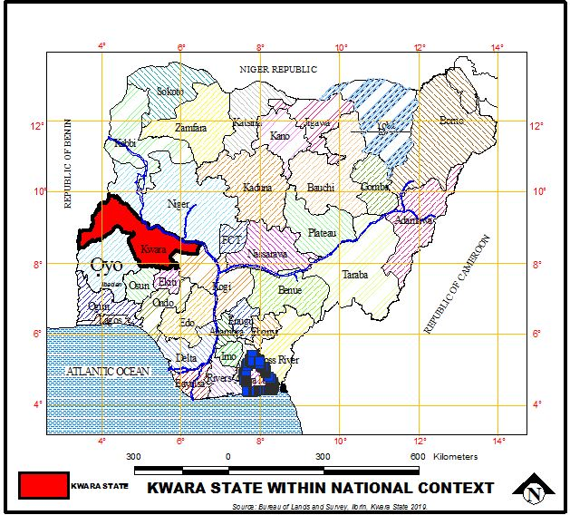Source: Kwara State Geographical Board, 2025

Figure 1.1: Local Government Areas in Kwara State

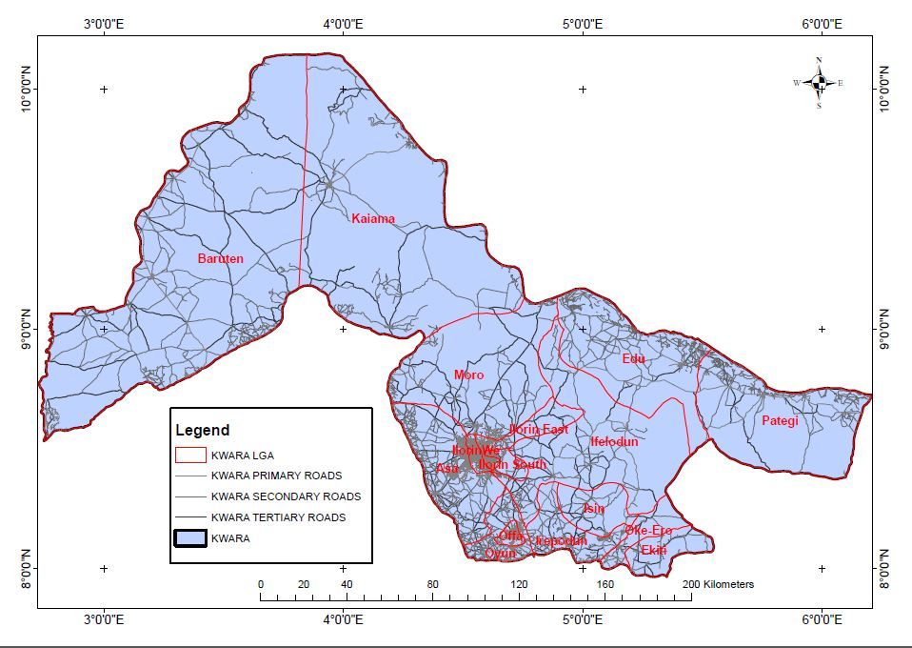

Source: Kwara State Geographical Board, 2025

MAP OF ILORIN SOUTH LOCAL GOVERNMENT
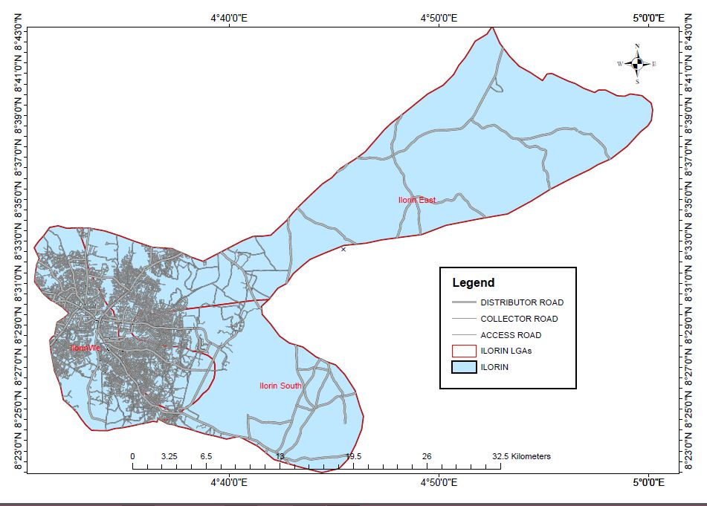

SOURCE: KWARA STATE GEOGRAPHICAL BOARD, 2025

Fig. 3 General layout plan of Kulende housing Estate Ilorin
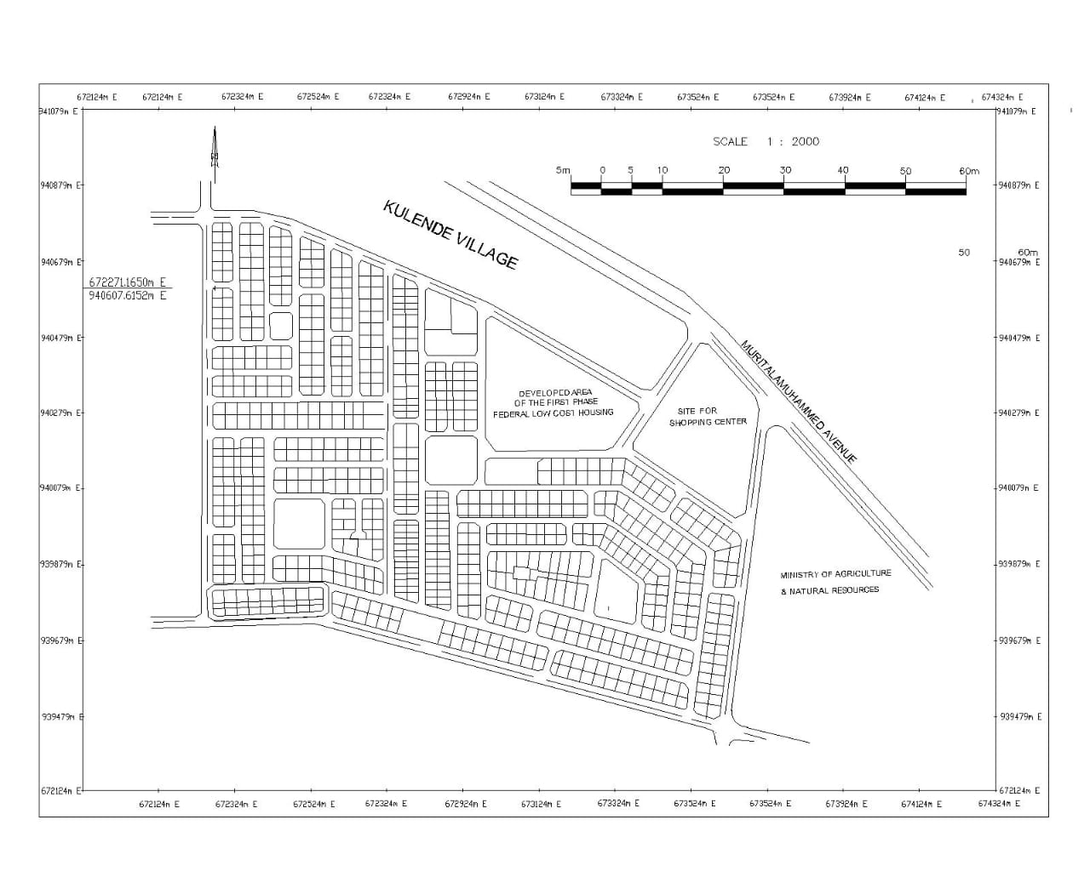

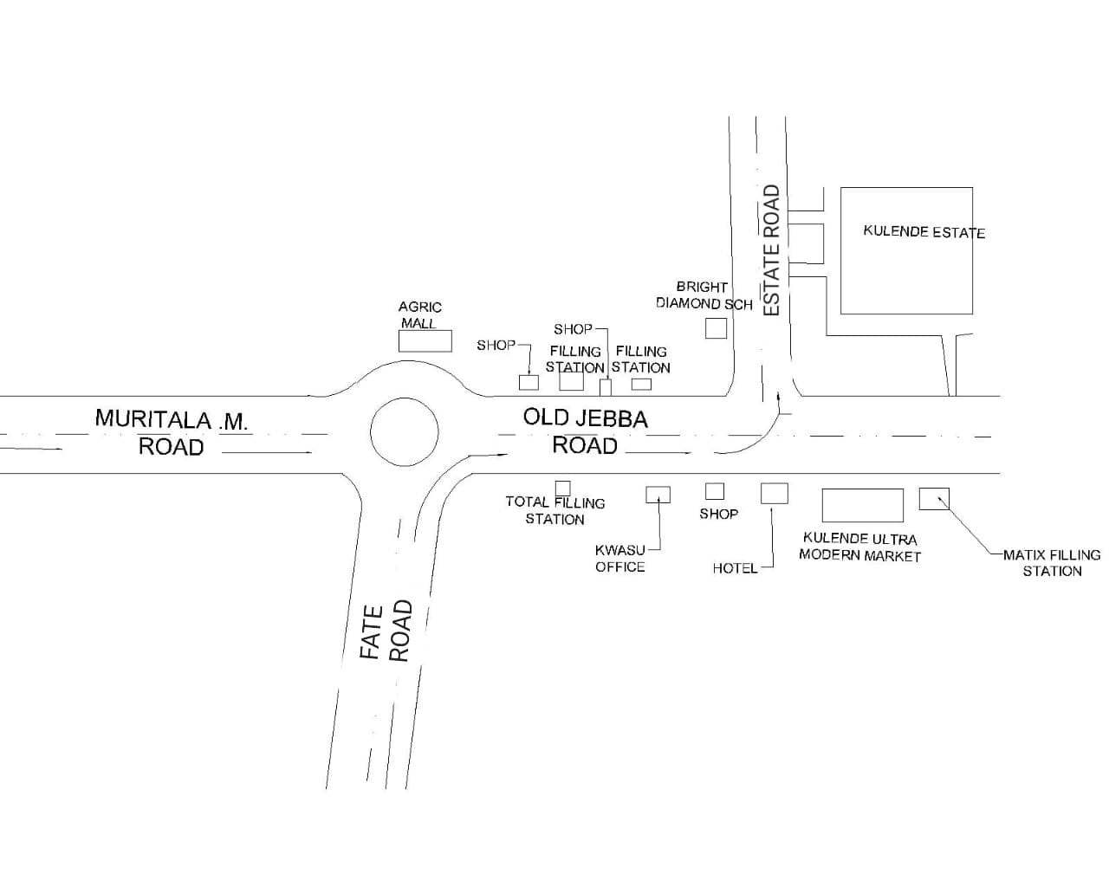Fig. 4: LOCATION PLAN OF STUDY AREA

1.7.1 INFRASTRUCTURE AND AMENITIES
The Kulende Housing Estate provides various infrastructure and amenities to support the living needs of residents. These include:
- Electricity supply
- Water supply
- Drainage system
- Roads and pedestrian paths
- Open spaces and parks
- Primary school
- Shopping centres
- Community centres
However, despite these provisions, the estate faces various challenges, including inadequate infrastructure, poor maintenance, and limited access to amenities (Adeleye, 2011).
1.8 DEFINITION OF TERMS
For the purpose of this study, the following terms are defined:
- Public Housing: Public housing refers to housing units provided by the government or public agencies to low- and middle-income households (Odufuwa, 2006).
- Housing Estate: A housing estate is a planned community of houses and other buildings, designed to provide a comfortable and convenient living environment (Agbola, 1997).
- Kulende Housing Estate: The Kulende Housing Estate is a federal government-owned housing project located in Ilorin, Kwara State, Nigeria.
- Infrastructure: Infrastructure refers to the basic physical and organizational structures and facilities needed for the operation of a society or enterprise (World Bank, 2019).
- Amenities: Amenities refer to the facilities and services provided to support the living needs of residents, such as electricity, water supply, and drainage (UN-Habitat, 2015).
- Quality of Life: Quality of life refers to the general well-being of individuals and communities, including their physical, social, and economic well-being (WHO, 2017).
- Sustainable Housing: Sustainable housing refers to housing that is environmentally friendly, socially responsible, and economically viable (UN-Habitat, 2015).
- Urban Development: Urban development refers to the process of planning, designing, and managing urban areas to promote economic growth, social equity, and environmental sustainability (World Bank, 2019).

CHAPTER TWO
LITERATURE REVIEW
2.0 INTRODUCTION
13This chapter reviews the existing literature on public housing, housing estates, and the challenges facing them in Nigeria. The literature review provides a framework for understanding the research problem and identifying the research gaps
2.1 OVERVIEW OF PUBLICHOUSING INNIGERIA
Public housing in Nigeria has evolved significantly over the decades, driven by the urgent need to address housing shortages amid rapid urbanization and population growth. The Nigerian government has recognized housing as a fundamental human right and a critical component of economic development. However, the effectiveness of public housing initiatives has been hindered by various challenges. Public housing programs in Nigeria began in the 1940s and 1950s, with initial efforts focused on providing housing for civil servants and low-income populations.
The post-independence era saw an increased commitment to housing as the government implemented policies aimed at boosting the availability of affordable housing. Notably, the National Housing Policy was introduced in 1991, outlining the government's vision for housing delivery, including the establishment of the Federal Housing Authority (FHA) to oversee housing development projects (Federal Republic of Nigeria. 2019). Despite these efforts, the public housing sector still struggles to meet the growing demand. According to estimates, Nigeria faces a housing deficit of over 17 million units, which continues to widen due to factors such as urban migration, population growth, and economic challenges. Public housing projects are often characterized by inadequate funding, poor planning, and insufficient maintenance, resulting in substandard living conditions.(Olayiwola, L. M., &Akinpelu, O.2019)
Public housing initiatives are frequently underfunded, relying on government budgets that are often insufficient to cover the costs of land acquisition, construction, and maintenance. This financial limitation leads to incomplete projects and a lack of basic infrastructure. Inconsistencies in housing policies, along with bureaucratic red tape, impede the effective implementation of housing programs. Furthermore, the absence of a coherent regulatory framework can lead to corruption and the proliferation of substandard housing. Corruption remains a significant obstacle in the public housing sector. Misallocation of funds and fraudulent practices undermine the integrity of housing projects, diverting resources away from their intended purposes. High levels of poverty and unemployment affect housing affordability. Many potential beneficiaries of public housing programs are unable to afford even subsidized units, exacerbating the housing crisis (Udo, R. K. 2016).
In recent years, the Nigerian government has launched several initiatives aimed at addressing housing shortages. The National Housing Fund (NHF) was established to provide financial assistance for housing development, while various state governments have initiated their own public housing schemes. However, the impact of these initiatives has often been limited by the aforementioned challenges. Public housing in Nigeria is at a critical juncture, necessitating a reevaluation of existing policies and practices.
A concerted effort is needed from the government, private sector, and civil society to create sustainable housing solutions that can meet the demands of Nigeria's growing population (WorldBank.2021).
2.2 THEORETICAL FRAMEWORK
The theoretical framework for appraising the challenges confronting Kulende Housing Estate in Ilorin, provides a foundation for standing the complexities of housing delivery systems. This frame work integrates various theories and models that explain the dynamics influencing public housing, helping to contextualize the challenges identified in the study.
Maslow’s Hierarchy of Needs posits that human needs are organized in a hierarchical order, starting from basic physiological needs to higher-level psychological needs. In the context of public housing, the provision of adequate housing addresses the fundamental physiological need for shelter. When this need is unmet, it can lead to social instability and increased poverty. This theory emphasizes the importance of meeting basic housing needs as a prerequisite for achieving higher social and economic goals (Maslow, A. H. 1943).
Systems Theory posits that various components of a system interact with one another to produce outcomes. In public housing, this theory highlights the interconnectedness of factors such as government policies, economic conditions, community engagement, and infrastructure development. Understanding public housing as a system allows for a comprehensive analysis of how these elements work together, or fail to do so, in affecting the delivery and sustainability of housing projects. (vonBertalanffy, L. 1968).
Stakeholder Theory : Stakeholder Theory focuses on the relationships and interests of various stakeholders involved in housing projects, including government agencies, private developers, community members, and non-governmental organizations. This theory emphasizes the need for collaboration and communication among stakeholders to address challenges effectively. In the case of Kulende Housing Estate, understanding the roles and perspectives of different stakeholders is crucial for identifying barriers and facilitating solutions (Freeman, R. E. 1984).
Public Choice Theory: Public Choice Theory examines the behavior of individuals and groups in the political decision-making process. It highlights how personal interests can influence public policies and resource allocation. In the context of public housing in Nigeria, this theory helps to explain the role of political motivations and corruption in hindering effective housing delivery. By analyzing how these factors impact decision-making, the study can better assess the challenges facing housing projects (Buchanan,J.M.1986).
Sustainable Development Theory Sustainable Development Theory emphasizes the need for balance between economic growth, social equity, and environmental protection. In the context of public housing, this theory advocates for the development of housing solutions that are economically viable, socially inclusive, and environmentally sustainable. Applying this framework allows for a critical assessment of whether the challenges faced in Kulende Housing Estate align with sustainable development goals. The theoretical framework for this study integrates multiple perspectives to provide a comprehensive understanding of the challenges confronting public housing projects in Nigeria. By applying these theories, the study can effectively analyze the interplay between various factors and propose informed recommendations for improving housing delivery systems (UnitedNations. 1987).

2.3 CHALLENGES OF PUBLICHOUSING PROJECTS
Public housing projects are essential for addressing housing shortages, particularly in developing countries like Nigeria. However, they face numerous challenges that impede their effectiveness and sustainability. This section explores these challenges in depth, examining the various factors that contribute to the difficulties encountered in public housing initiatives. One of the most significant challenges is inadequate funding. Public housing projects often rely on government budgets, which can be limited due to competing priorities such as health, education, and infrastructure.
2.3.1 FINANCIAL CONSTRAINTS
Financial constraints represent one of the most critical challenges faced by public housing projects, particularly in developing countries like Nigeria. These constraints can significantly impact the planning, execution, and sustainability of housing initiatives. Below is a detailed exploration of the various dimensions of financial constraints in public housing.
- Scarcity of Long-Term Funds: Currently, the prime lending rate in the banking sector remains as high as17.5percent (Central Intelligence Agency’s the World Fact book, 2017) and it is impossible to use such funds for housing development. It is pertinent to note that the government has realized this and is reviewing the entire process of accessing mortgages, to bring it within reach of beneficiaries.
- Property Registration and Title Documentation: Uncertainties regarding the status of land documentation and delays in the process slowed the development of land and property markets and made the development of lending difficult to advance or sustain. It was for these reasons that the growth component began to work with a number of registries. Reforms have led to a reduction in the time required to complete the process of property registration from 274 to 80 days in Nigeria, but a lot still needs to be done because it takes only 1day in some other countries such as Norway and Singapore. It is worth noting that part of their diction in time can be attributed to improvements in property registration, which has been implemented in Abuja and Lagos. Other state governments will do well to replicate the improvements achieved in the Abuja Geographic Information System (AGIS) and Lagos State in their various states.

Land Use Act: The Land Use Act of 1978 (LUA) has become an obstacle to making land available for housing development. The LUA meant to make land easily available to all Nigerians has, indeed, become a major constraint to home ownership in Nigeria. The process of obtaining a Certificate of Occupancy and the consent provisions of the LUA make land transactions tedious, time consuming and expensive. Budget Limitations Public housing projects often rely heavily on government budgets, which can be limited due to various factors: Competing Priorities: Governments must allocate funds across various sectors, including healthcare, education, and infrastructure.
Housing may not always receive adequate funding, especially in times of economic downturns or political instability. Inflation and Economic Instability: Fluctuations in the economy can erode the purchasing power of allocated funds, making it challenging to maintain project timelines and quality. Inadequate Funding Mechanisms: The mechanisms for financing public housing projects can be insufficient or poorly structured: Limited Access to Credit: Public housing authorities may struggle to access credit from financial institutions due to perceived risks, leading to reliance on insufficient internal resources. High Interest Rates: When financing is available, high interest rates can increase the overall cost of projects, making them less feasible. Dependence on External Funding Many public housing projects rely on external funding sources, which can create vulnerabilities: Uncertain Donor Commitments: Dependence on international donors or NGOs can lead to project disruptions if funding is withdrawn or reduced. Stringent Conditions: External funding often comes with conditions that may not align with local needs or priorities, complicating project implementation.
Cost Overruns and Mismanagement Financial mismanagement can lead to significant cost overruns in public housing projects: Poor Planning and Budgeting: Inadequate project planning can result in underestimations of costs, leading to financial shortfalls as projects progress. Corruption and Fraud: Misappropriation of funds can divert resources away from intended projects, exacerbating financial constraints and limiting the quality of housing. Maintenance and Operational Costs Once housing projects are completed, ongoing financial commitments are required for maintenance and operations: Neglected Maintenance: Limited funds for ongoing maintenance can result in the deterioration of housing quality, making units uninhabitable and leading to increased costs over time.
Utility Provision: The costs associated with providing basic utilities (water, electricity, waste management)can be prohibitive, especially if the infrastructure is inadequate. Affordability Issues for Residents Even when public housing projects are built, financial constraints can affect the target population: High Cost of Living: Rising costs in urban areas can make even subsidized housing unaffordable for low-income residents, leading to increased homelessness or reliance on informal housing solutions. Economic Barriers: High unemployment rates and low wages further restrict the ability of potential residents to afford housing, despite government subsidies.
2.3.2 POLICY AND REGULATORY ISSUES: In Nigeria, policy and regulatory issues significantly impact public housing projects, with challenges stemming from inadequate funding, poor administration, insufficient infrastructure, and ineffective housing finance, hindering the delivery of affordable housing. Scarcity of Long-Term Funds: High interest rates and limited access to long-term financing make it difficult for both government and private sector to invest in housing projects. Ineffective Housing Finance: The lack of robust and accessible housing finance mechanisms, including mortgage options, hinders the ability of low and middle-income earners to acquire housing. Inadequate Financial Instruments: The absence of effective financial instruments for mobilizing funds for housing projects further exacerbates the funding problem.
Poor Administration and Implementation: Poor Policy Implementation: Ineffective implementation of housing policies and programs, including lack of proper monitoring and evaluation, leads to project failures and delays. Bureaucracy and Corruption: Excessive bureaucracy in land acquisition, processing of certificates of occupancy (C of O), and approval of building plans, along with corruption, further delays and increases the cost of projects. Unskilled Workforce: The lack of skilled labor and the use of unachievable Westernized building standards also contribute to challenges in project execution.
Infrastructure Deficiencies and Land Issues: Lack of Infrastructure: Shortage of basic infrastructure like roads, water, electricity, and sanitation, in areas where public housing projects are located, makes them unattractive and unsustainable. Land Tenure Issues: Uncertainties regarding land tenure and delays in the process of land acquisition and property registration slow down project development. High Cost of Building Materials: The high cost of building materials, including imported materials, makes housing projects unaffordable for low-income earners. Policy and Regulatory Framework: Inadequate Housing Policies: The absence of comprehensive and well-articulated housing policies, as well as the lack of effective enforcement mechanisms, hinders the development of the housing sector.
Discrimination against Indigenous Materials: The lack of government support for the use of local building materials, and the preference for imported materials, increases project costs. Lack of Coordination: Poor coordination between different government agencies involved in housing projects, including the Federal Ministry of Works and Housing, state governments, and local authorities, leads to duplication of effort and delays.
2.3.3 CORRUPTIONAND MISMANAGEMENT: Corruption Refers to the abuse of power for personal gain, often involving bribery, fraud, or the manipulation of resources. In the context of public housing in Nigeria, corruption can manifest in various forms, such as: Bribery: Officials may demand payments to expedite approvals or access resources, diverting funds intended for housing projects. Kickbacks: Contractors might inflate project costs or deliver substandard work while providing illegal payments to officials. Embezzlement: Misappropriation of funds allocated for housing projects, leading to incomplete or poorly constructed facilities.
The prevalence of corruption undermines the effectiveness of public housing initiatives, resulting in poor-quality construction, inadequate maintenance, and the failure to meet community needs. Mismanagement: Involves poor planning, execution, and oversight of public housing projects. Key aspects include: Ineffective Planning: Lack of thorough needs assessments and community involvement can lead to developments that do not address the actual housing needs of residents. Inadequate Oversight: Insufficient monitoring of project implementation can result in delays, budget overruns, and substandard construction. Poor Resource Allocation: Mismanagement of financial resources may lead to funding shortages, affecting the quality and sustainability of housing projects.
2.3.4 SOCIO-ECONOMIC FACTORS: Socio-economic factors refer to the social and economic conditions that influence individuals' and communities' access to resources, opportunities, and overall quality of life. Income Levels: Low income can limit individuals' ability to afford housing, affecting demand for public housing projects. It also impacts residents' ability to contribute to maintenance and community development. Employment Opportunities: High unemployment rates can lead to increased poverty levels, making it difficult for families to secure stable housing.
The availability of jobs in the area can influence the success of housing projects by attracting residents. Education: Educational attainment affects residents' earning potential and socioeconomic mobility. Higher education levels often correlate with better job opportunities and improved living conditions. Demographic Trends: Factors such as population growth, migration patterns, and family size can impact housing demand. Rapid urbanization often leads to increased pressure on existing housing infrastructure.
Access to Services: Availability of essential services such as healthcare, education, and transportation affects residents' quality of life and can influence their choice to reside in public housing developments. Social Stability: Communities with high levels of social cohesion and low crime rates are more likely to benefit from public housing projects. Conversely, social unrest or instability can undermine project success. Cultural Factors: Cultural attitudes towards housing and community living can influence the acceptance and success of public housing initiatives, affecting community participation and integration.
2.4 CASE STUDIES OF PUBLICHOUSING INNIGERIA: Overview of Public Housing in Nigeria Public housing in Nigeria has been implemented through various government initiatives aimed at addressing the housing deficit and improving living conditions for low- and middle-income families. Despite these efforts, many projects face significant challenges, including corruption, mismanagement, and inadequate infrastructure. Kulende Housing Estate, Ilorin
2.5 SUMMARY OFLITERATURE The literature on public housing in Nigeria reveals a complex landscape characterized by both significant challenges and opportunities. Challenges in Public Housing: Numerous studies highlight persistent issues such as corruption, mismanagement, and inadequate funding as critical barriers to effective public housing delivery. These factors often lead to incomplete projects and substandard living conditions (Ogunyemi, 2017; Eze & Iwuagwu, 2018). Socio-Economic Impact: Research indicates that socio-economic factors, including income levels, employment opportunities, and education, significantly influence the accessibility and sustainability of public housing. Low-income households face particular challenges in affording housing, which affects their quality of life (Adebayo, 2020).
Community Participation: The literature emphasizes the importance of community involvement in the planning and execution of housing projects. Studies suggest that engaging residents can lead to better project outcomes and increased satisfaction (Aluko, 2016; Oloyede & Gana, 2019). Infrastructure and Services: Effective infrastructure is critical for the success of public housing projects. Deficiencies in basic services such as water, electricity, and transportation can undermine residents' quality of life and overall project viability (Eze & Iwuagwu, 2018). CaseStudies: Specific case studies, including those of housing estates like Kulende, illustrate the unique challenges faced in different contexts. They provide insights into the dynamics of project implementation and the socio-economic realities of residents (Ogunyemi, 2017).
Policy Recommendations: The literature calls for comprehensive policy reforms that address the root causes of challenges in public housing, including enhancing transparency, improving financial management, and fostering community engagement. Overall, the literature underscores the need for a multi-faceted approach to public housing in Nigeria, recognizing the interplay of various factors that affect the success of housing initiatives. Addressing these challenges is crucial for improving living conditions and achieving sustainable development in urban areas.

CHAPTER THREE
RESEARCH METHODOLOGY
3.1 INTRODUCTION
This chapter outlines the research methodology used to investigate the challenges facing the Kulende Housing Estate. The methodology includes the research design, population, sample size, data collection methods, and data analysis techniques
3.2 RESEARCH DESIGN
The study employed a mixed-methods approach, combining both qualitative and quantitative methods. The qualitative method involved conducting in-depth interviews with residents and stakeholders, while the quantitative method involved administering questionnaires to a sample of residents.
3.3 SAMPLE FRAME
The population of the study consisted of all residents of the Kulende Housing Estate, which spans a total area of 41.121 hectares. The estate comprises 723 plots, with 698 developed and 25 underdeveloped.
A sample size of 200 residents was selected using a systematic random sampling technique. This sampling method was chosen to ensure that the sample was representative of the population, and to minimize bias. The sample size of 200 residents was deemed sufficient to provide reliable and generalizable results.

3.4 DATA COLLECTION METHODS
Data was collected using questionnaires, in-depth interviews, and observations. The questionnaire was designed to collect information on the socio-economic characteristics of residents, their perceptions of the estate, and the challenges they face. The in-depth interviews were conducted with stakeholders, including estate managers, local government officials, and community leaders.
3.5 DATA ANALYSIS TECHNIQUES
Data was analysed using descriptive statistics, inferential statistics, and content analysis. The descriptive statistics involved calculating means, frequencies, and percentages, while the inferential statistics involved testing hypotheses using chi-square and ANOVA tests. The content analysis involved analysing the qualitative data from the in-depth interviews and observations.

CHAPTER FOUR
DATA ANALYSIS AND RESULTS
4.1 INTRODUCTION
This chapter presents the analysis and results of the data collected from the residents of the Kulende Housing Estate. The data was analysed using descriptive statistics, inferential statistics, and content analysis.

4.2 DEMOGRAPHIC CHARACTERISTICS OF RESPONDENTS
The results show that the majority of the respondents (80%) are between the ages of 25-34 years. The majority of the respondents (60%) are males, while (40%) are females. The results also show that the majority of the respondents (50%) are married, while (30%) are single.
Table 4.1: Demographic Characteristics of Respondents
Respondent Age | No of Respondent | Percentage (%)
18-24 | 40 | 20%
25-34 | 80 | 40%
35-44 | 50 | 25%
45-54 | 20 | 10%
55 and above | 10 | 5%
Total | 200 | 100%
Source: field survey 2025
GENDER
SEX | No of Respondent | Percentage (%)
Male | 120 | 60%
Male | 80 | 40%
Total | 200 | 100%
Source: field survey 2025

MARITAL STATUS
Status | Respondent no | Parentage (%)
Single | 60 | 30%
Divorced | 20 | 10%
Widowed | 20 | 10%
Married | 100 | 50%
Total | 200 | 100%
Source: field survey 2025
4.3 Housing Conditions
The results show that the majority of the respondents (50%) are not satisfied with the condition of their housing units. However, 20% of the respondents reported being dissatisfied with the condition of their housing units

Table 4.2: Housing Conditions
Condition | Number of Respondents | Percentage (%)
Excellent | 10 | 5%
Poor | 135 | 67.5%
Fair | 36 | 18%
Good | 19 | 9.5%
Total | 200 | 100%
Source: field survey 2025
4.4 Infrastructure and Amenities
The results show that the majority of the respondents (60%) are satisfied with the availability of infrastructure and amenities in the estate. However, 20% of the respondents reported being dissatisfied with the availability of infrastructure and amenities.
Table 4.3: Infrastructure and Amenities
Infrastructure/Amenity | Number of Respondents | Percentage (%)
Satisfied | 120 | 60%
Dissatisfied | 40 | 20%
Neutral | 40 | 20%
Total | 200 | 100%
Source: field survey 2025

4.5 Safety and Security
The results show that the majority of the respondents (50%) feel unsafe and insecure in the estate. However, 20% of the respondents reported feeling safe and secure.
Table 4.4: Safety and Security
Safety/Security | Number of Respondents | Percentage (%)
Neutral | 100 | 50%
Unsafe and Insecure | 40 | 20%
Safe and Secure | 60 | 30%
Total | 200 | 100%
Source: field survey 2025
4.4 CHALLENGES FACING THE ESTATE
The results show that the majority of the respondents (90%) identified inadequate infrastructure as a major challenge facing the estate. Other challenges identified by the respondents include poor maintenance (80%), limited access to amenities (75%), and environmental and health concerns (70%).
Table 5:Challenges Facing the Estate
S/N | Challenge | Respondents | Percentage
1 | Inadequate Infrastructure | 43 | 90%
2 | Poor Maintenance | 50 | 80%
3 | Limited Access to Amenities | 65 | 75%
4 | Environmental and Health Concerns | 42 | 70%
Source: field survey 2025
4.5 IMPLICATIONS OF THE CHALLENGES
The challenges facing the Kulende Housing Estate have significant implications for the residents. The inadequate infrastructure and poor maintenance of the estate can lead to a decline in the quality of life of the residents, making them more vulnerable to environmental and health hazards. The limited access to amenities can also exacerbate the challenges faced by the residents, making it difficult for them to access basic services such as healthcare and education.

CHAPTER FIVE
SUMMARY OF FINDINGS, RECOMMENDATION AND CONCLUSION
5.1 SUMMARY OF FINDINGS
The study revealed that the Kulende Housing Estate faces numerous challenges, including inadequate infrastructure, poor maintenance, limited access to amenities, and environmental and health concerns. These challenges have significant implications for the residents, including a decline in the quality of life and increased vulnerability to environmental and health hazards.
5.2 RECOMMENDATIONS
Based on the findings of the study, the following recommendations are made:
- The government should invest in the provision of adequate infrastructure and amenities in the estate.
- The estate management should prioritize the maintenance of the estate's facilities and infrastructure.
- The residents should be involved in the decision-making process on issues affecting the estate.
- The government should develop policies and programs aimed at addressing the environmental and health concerns in the estate.

5.3 CONCLUSION
This project has provided recommendations and policy implications based on the findings of the study. The government and estate management should prioritize the provision of adequate infrastructure, maintenance of estate facilities, involvement of residents in decision-making, and development of policies and programs to address environmental and health concerns

REFERENCES:
Megbolugbe, I. F. (1983). The Hopes and Failures of Public Housing in Nigeria: A Case Study of Kulende and Adewole Housing Estates, Ilorin. Third World Planning Review. 1-3
Adeleye, O. (2011). Public Housing in Nigeria: Challenges and Prospects. Journal of Environmental and Urban Studies, 1-15.
Agbola, T. (1997). The Challenges of Urban Housing in Nigeria. Journal of Environmental and Urban Studies, 1-12.
Odufuwa, B. O. (2006). Public Housing in Nigeria: Challenges and Prospects. Journal of Environmental and Urban Studies, 1(1), 1-32.
Olotuah, A. O. (2006). Housing Estates in Nigeria: Challenges and Prospects. Journal of Environmental and Urban Studies, 1-12.
UN-Habitat.(2015). Sustainable Housing for All.Global activities repot67-71

Plate 5.1: Dilapidated Building Under Renovation In Kulende Estate
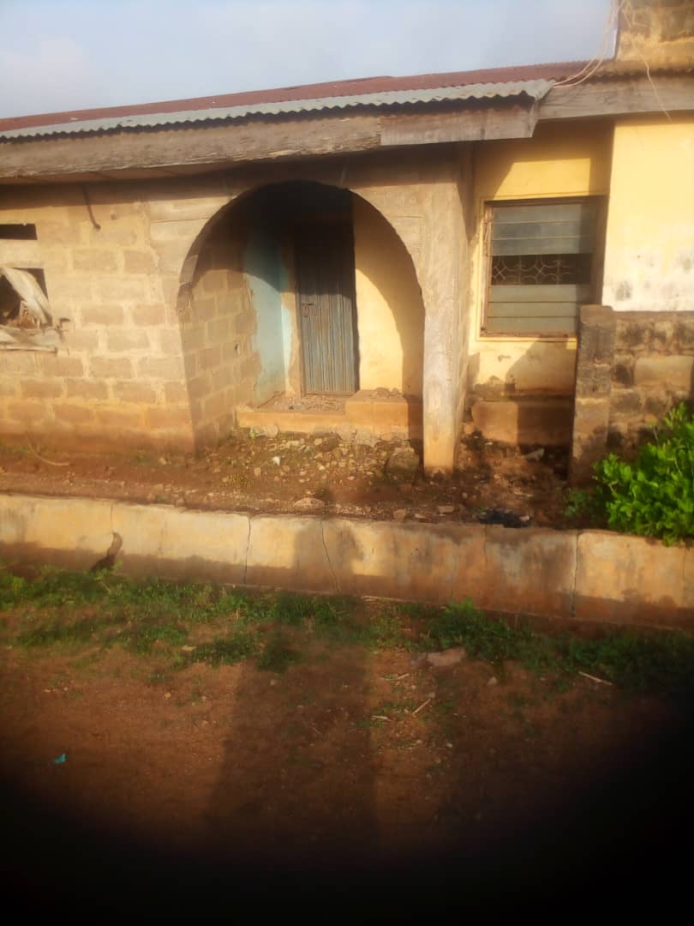

Plate 5.2: Public Borehole In Kulende Estate
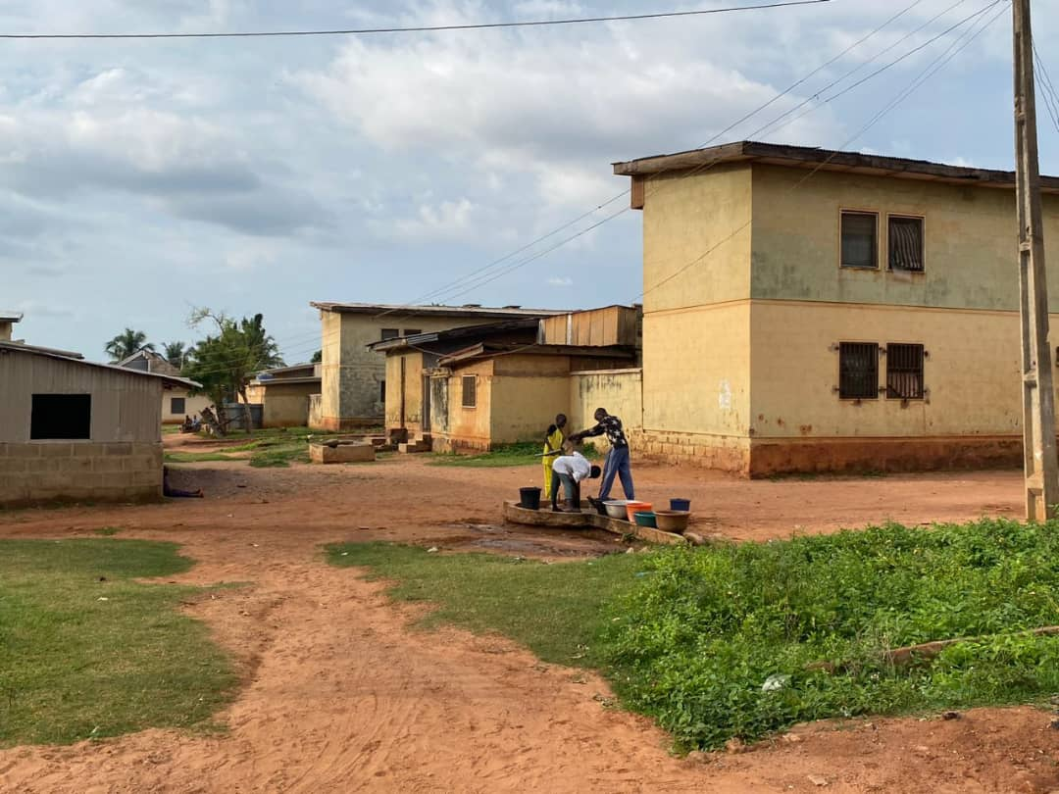

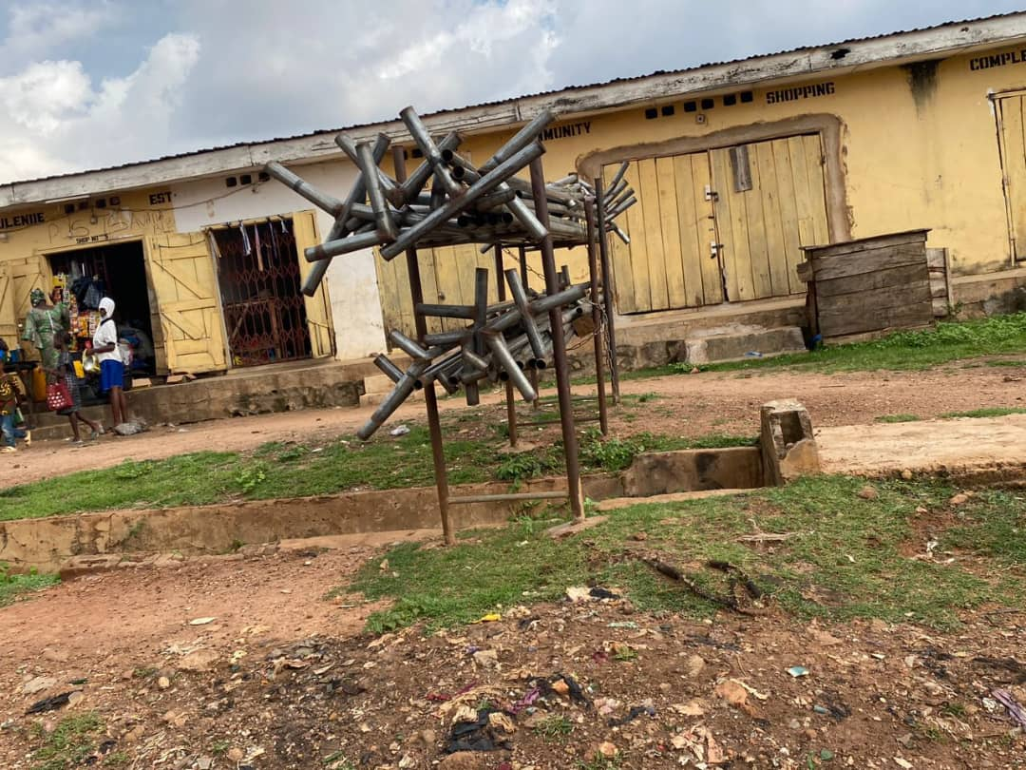
Plate 5.3: Kulende Shopping Complex
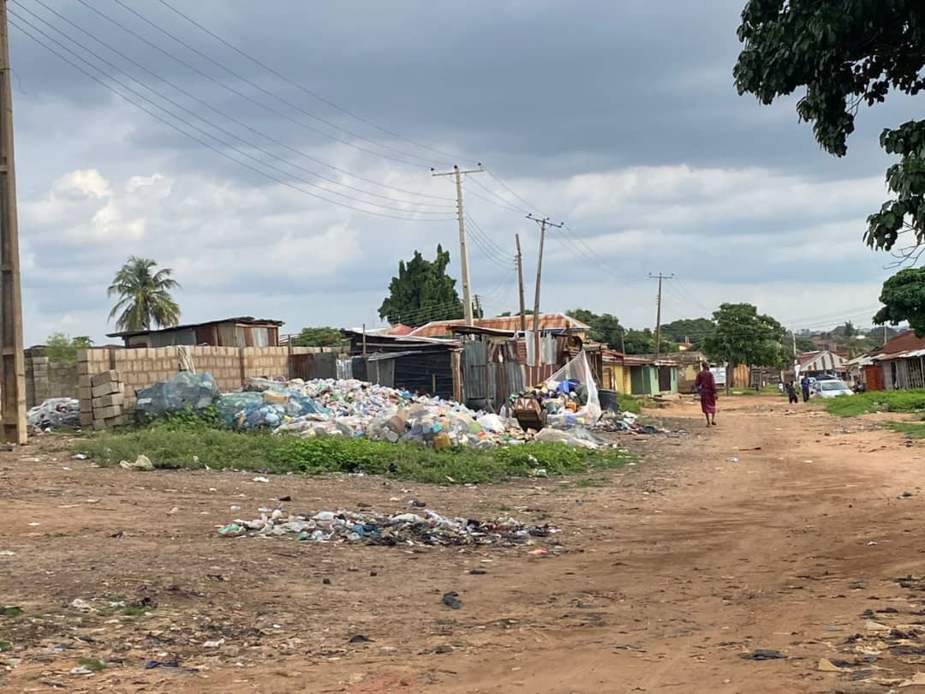
Plate 5.4: Used Plastic Dump Site At Kulende

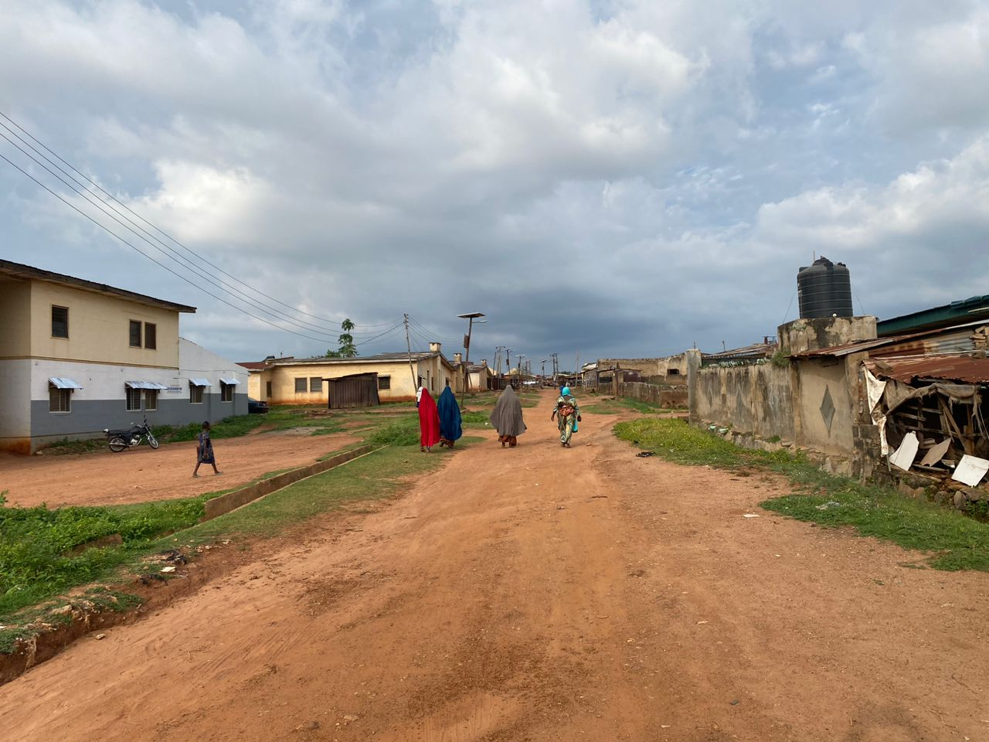
Plate 5.5: Jalingo Lane, Kulende Estate
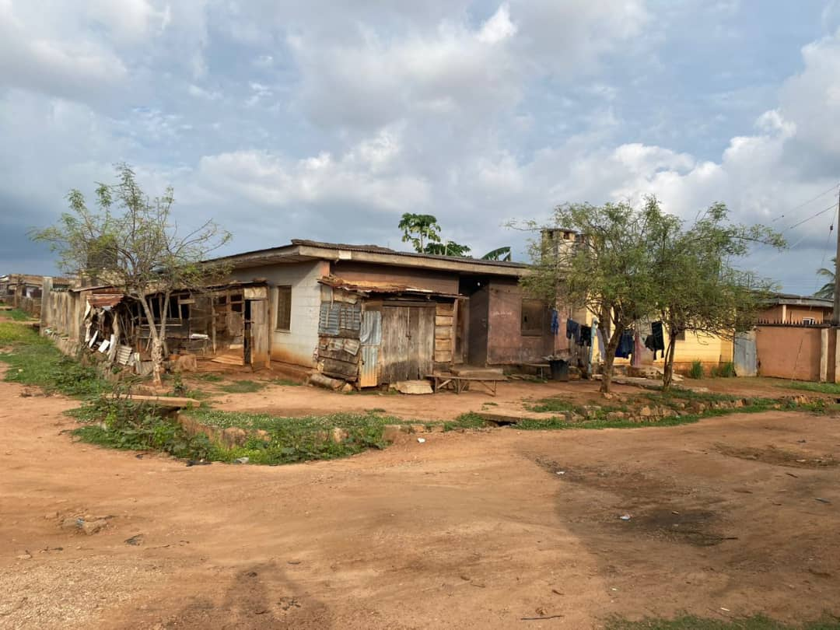
Plate 5.6: Adele Lane, Kulende Eatate

APPENDIX A: QUESTIONNAIRE

APPENDIX B: INTERVIEW GUIDE
[Insert interview guide]

APPENDIX C: LIST OF RESPONDENTS

*Kulende Housing Estate Residents' Questionnaire*

*Section A: Demographic Information*

1. What is your age?

______ years old

2. What is your sex?

Male
Female

3. What is your marital status?

Single
Married
Divorced
Widowed

4. What is your highest level of education?

Primary
Secondary
Tertiary
Others (please specify)

5. What is your occupation?

______

6. How long have you been living in the Kulende Housing Estate?

______ years

*Section B: Housing Conditions*

1. What type of housing unit do you occupy?

1-bedroom
2-bedroom
3-bedroom
Others (please specify)

2. How would you rate the condition of your housing unit?

Excellent
Good
Fair
Poor

3. Do you have access to basic amenities such as water, electricity, and toilet facilities?

Yes
No

4. How would you rate the cleanliness of the estate?

Excellent
Good
Fair
Poor

*Section C: Infrastructure and Amenities*

1. How would you rate the condition of the roads within the estate?

Excellent
Good
Fair
Poor

2. Are there adequate streetlights within the estate?

Yes
No

3. Are there adequate waste disposal facilities within the estate?

Yes
No

4. How would you rate the availability of amenities such as schools, healthcare facilities, and shopping centers?

Excellent
Good
Fair
Poor

*Section D: Safety and Security*

1. How would you rate the level of safety and security within the estate?

Excellent
Good
Fair
Poor

2. Have you experienced any security breaches within the estate?

Yes
No

3. Are there adequate security measures in place within the estate?

Yes
No

*Section E: Suggestions and Recommendations*

1. What suggestions do you have for improving the condition of the estate?

_____________________________________________________________________

2. What recommendations do you have for the estate management and government?

_____________________________________________________________________

Thank you for taking the time to complete this questionnaire. Your responses will be kept confidential and will help us to better understand the challenges facing the Kulende Housing Estate.

