

IMPACT OF LEADERSHIP STYLE ON CONSTRUCTION WORKERS IN NIGERIA CONSTRUCTION INDUSTRY

BY

ABOLUWARIN REMILEKUN DORCAS

HND/23/QTS/FT/0042

BEING A RESEARCH PROJECT SUBMITTED TO DEPARTMENT OF QUANTITY SURVEYING, INSTITUTE OF ENVIRONMENTAL STUDIES (IES), KWARA STATE POLYTECHNIC, ILORIN.

IN PARTIAL FULFILMENT OF THE REQUIREMENT FOR THE AWARD OF HIGHER NATIONAL DIPLOMA (HND) IN QUANTITY SURVEYING, KWARA STATE POLYTECHNIC, ILORIN.

JULY, 2025
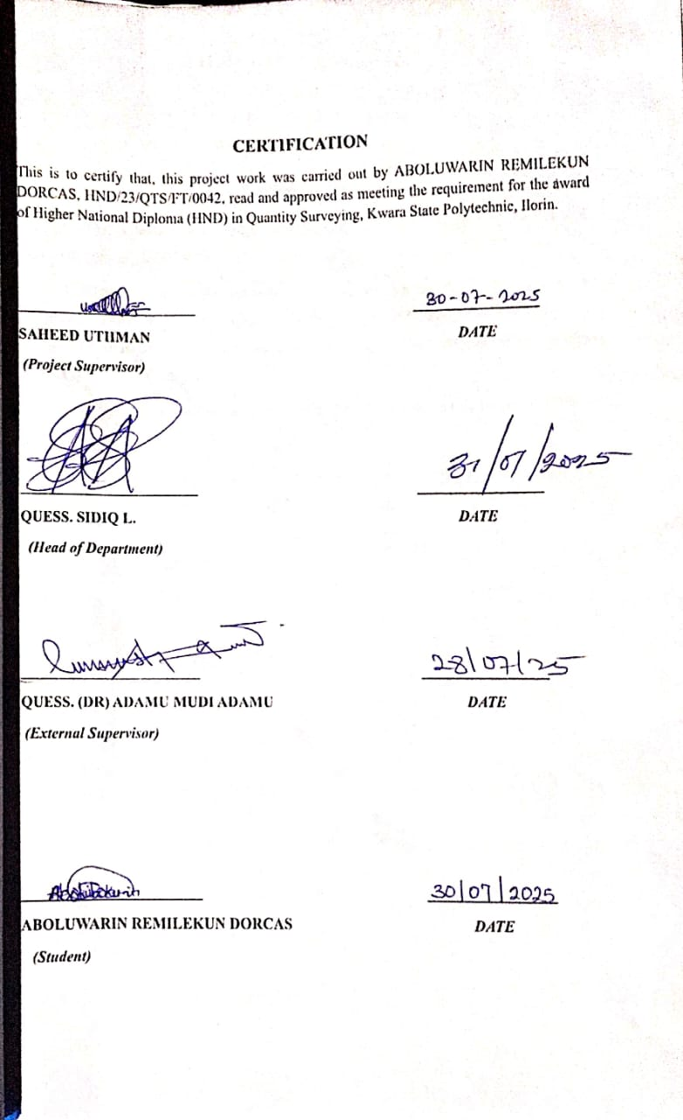

DEDICATION
I wholeheartedly dedicate this research project to the Almighty God, my sustainer and provider, whose grace and guidance have seen me through every step of this journey.
This work is also dedicated to my beloved parents, Late Mr. Aboluwarin Sunday Thaddeus and Mrs. Aboluwarin Joy Kehinde, and to all my amazing sisters and brothers. Your unwavering love, support and encouragement have been my greatest motivation. Your belief in me has fueled my determination to strive for excellence.
This achievement is not mine alone, it is a reflection of your sacrifices, prayers and endless support.

ACKNOWLEDGEMENT
All praise and glory be to the Almighty God, whose grace, protection, and unwavering support have guided me throughout this academic journey. Without His divine favor, this achievement would not have been possible.
I would like to sincerely thank my project supervisor, Mr. Saheed Uthman, for his continuous support, insightful feedback, and constructive guidance throughout this research. His professional advice played a vital role in shaping the quality and standard of this work.
My profound gratitude goes to the Head of Department (HOD) of Quantity Surveying for his support, encouragement, and for providing the necessary information and resources that enriched this research.
Furthermore, I am deeply grateful to my beloved parents Late Mr. Aboluwarin Sunday Thaddeus and Mrs. Aboluwarin Joy Kehinde for their immeasurable love, sacrifice, and steadfast encouragement. Though my father is no longer physically present, his memory continues to inspire and strengthen me.
My heartfelt appreciation also goes to Mrs. Matthew Mitanna, whose constant support and words of encouragement made a significant impact on this journey. Your kindness and care will always be remembered.
To my wonderful siblings, Blessing, Oluwapelumi, Ayobamidele, and Oluwakamiye, thank you for always believing in me and cheering me on, even during the most challenging times.
I also give a special thanks to my cherished friends Adesokan Olushola, Oseh Hope, Uthman Aishat, Olaleye Fayokemi, Ayeni Emmanuel, Adegbola Adewumi, and Olawuyi Moses, for their support, motivation, and understanding. Your companionship and encouragement helped me stay focused and determined throughout the course of this project.
Lastly, I express my sincere appreciation to the entire faculty and staff of the Department of Quantity Surveying, Kwara State Polytechnic, for providing an intellectually stimulating and supportive academic environment.
Thank you all for being an integral part of my academic journey.

ABOLUWARIN REMILEKUN DORCAS

ABSTRACT
The aim of this research is to examines the impact of various leadership styles on the construction workers, with a focus on the Nigerian construction industry. The construction sector is highly labor-intensive and demands effective leadership to ensure worker motivation, safety compliance, timely project delivery, and overall productivity. Recognizing the critical role leadership plays in shaping workforce behavior, this study explores how transformational, transactional, autocratic, and democratic leadership styles influence worker performance across key performance indicators. A quantitative research method was employed, with data collected using structured close-ended questionnaires distributed to construction professionals within selected firms in Kwara state. The analysis was carried out using two key statistical techniques: the Relative Importance Index (RII), used to rank the perceived effectiveness of each leadership style, and the Pearson Correlation Coefficient, applied to measure the strength of relationships between leadership styles and various performance outcomes such as motivation, safety adherence, task efficiency, and teamwork. Findings revealed that transformational and democratic leadership styles had the most significant positive impact on construction worker performance, particularly in areas like motivation, innovation, and safety compliance. In contrast, autocratic leadership was associated with lower performance metrics, although effective in urgent or high-pressure situations. Transactional leadership was moderately effective in task supervision and maintaining order but less influential in fostering engagement or creativity. The study concludes that leadership style plays a pivotal role in influencing construction workforce performance. It recommends that construction firms invest in leadership training, promote participative management, and adopt leadership styles that align with both organizational goals and worker needs to enhance overall project success.

TABLE OF CONTENTS
DECLARATION 1
CERTIFICATION 2
DEDICATION 3
ABSTRACT 5
CHAPTER ONE 6
INTRODUCTION 6
1.1 BACKGROUND OF THE STUDY 7
1.2 STATEMENT OF THE PROBLEM 9
1.3 RESEARCH QUESTION 10
1.4 AIM AND OBJECTIVES OF THE STUDY 10
1.4.1 AIM 10
1.4.2 OBJECTIVES 11
1.5 SIGNIFICANCE OF THE STUDY 11
1.5 SCOPE AND LIMITATION 11
1.6 DEFINITION OF TERMS 12
CHAPTER TWO 14
LITERATURE REVIEW 14
2.0 INTRODUCTION 14
2.1 FOCUS OF THE STUDY 14
2.1.1 DEFINITION OF LEADERSHIP 15
2.2 CONCEPTUAL CLARIFICATION ON LEADERSHIP STYLE 16
2.3 TYPES OF LEADERSHIP STYLE 17
2.3.1 AUTOCRATIC LEADERSHIP 18
2.3.2 DEMOCRATIC (PARTICIPATIVE) LEADERSHIP 19
2.3.3 TRANSFORMATIONAL LEADERSHIP 19
2.3.4 TRANSACTIONAL LEADERSHIP 20
2.3.5 LAISSEZ-FAIRE LEADERSHIP 20
2.3.6 SERVANT LEADERSHIP 21
2.3.7 CHARISMATIC LEADERSHIP 21
2.4 LEADERSHIP THEORIES 22
2.4.1 TRAIT THEORY 22
2.4.2 BEHAVIOURAL THEORY 23
2.4.3 SITUATIONAL AND CONTINGENCY THEORY 24
2.5 LEADERSHIP STYLE ON EMPLOYEES' ORGANIZATIONAL COMMITMENT 25
2.5.1 FACTORS ON EMPLOYEES’ ORGANIZATION COMMITMENT 26
2.5.1.1 LEADERSIP STYLE AND BEHAVIOURAL INFLUENCE 26
2.5.1.2 ORGANIZATION CULTURE AND VALUE CONGRUNCE 26
2.5.1.3 PERCEIVED ORGANIZATION SUPPORT AND FAIRENESS 26
2.5.1.4 CAREER ADVANCEMENT AND HUMAN CAPITAL INVESTMENT 27
2.5.1.5 PSYCHOLOGICAL SAFETY AND JOB SECURITY 27
2.5.2 AFFECTIVE COMMITEMENT AND TRANSFORMATIONAL LEADERSHIP 27
2.5.3 NORMATIVE COMMITEMENT AND ETHICAL LEADERSHIP 27
2.6 JOB SATISFACTION 28
2.6.1 INTRINSIC VS. EXTRINSIC SATISFACTION 29
2.6.2 COMMUNICATION AND FEEDBACK AS DRIVERS OF SATISFACTION 29
2.6.3 RECOGNITION AND PARTICIPATION 29
2.7 LEADERSHIP STYLE ON EMPLOYEES' JOB SATISFACTION 30
2.7.1 FACTORS ON EMPLOYEES’ JOB SATISFACTION 30
2.7.1.1 TTRANSFORMATIONAL LEADERSHIP AND PSYCOLOGICAL EMPOWERMENT 30
2.7.1.2 ROLE CLARITY, AUTONOMY, AND TAX SIGNIFICANCE 30
2.7.1.3 ORGANIZATION COMMUNICATION AND FEEDBACK MECHANISMS 30
2.7.1.4 WORKPLACE SAFETY AND ENVIRONMENTAL CONDITIONS 31
2.7.1.5 RECOGNITION, INCLUSION, AND REWARD EQUITY 31
2.7.1.6 FLEXIBILITY AND WORLIFE INTRGRATION 31
2.7.2 ORGANIZATIONAL COMMITMENT 31
2.8 LEADERSHIP IN THE CONSTRUCTION INDUSTRY 31
2.8.1 PREFFERED LEADERSHIP STYLES BY CONSTRUCTION MANAGEMENT 33
CHAPTER 3 34
RESEARCH METHODOLOGY 34
3.0 INTRODUCTION 34
3.1 RESEARCH APPROACH 34
3.1.1 QUALITATIVE RESEARCH 34
3.1.2 QUANTITATIVE RESEARCH 34
3.1.3 MIXED METHODS 35
3.2 RESEACH DESIGNS 35
3.3 POPULATION OF THE STUDY 36
3.4 SAMPLING TECHNIQUE AND SAMPLE SIZE 36
3.5 RESEARCH INSTRUMENTS AND MEASUREMENT 37
3.5.1 QUESTIONNAIRE DESIGN 37
3.5.2 QUESTIONNAIRE ADMINISTRATION 38
3.5.3 DEMOGRAPHICAL INFORMATION 38
3.5.4 RESEARCH INSTRUMENT 38
3.6 DATA ANALYSIS 39
CHAPTER FOUR 40
DATA PRESENTATION AND DISCUSSION 40
4.1 INTRODUCTION 40
4.2 DEMOGRAPHIC INFORMATION OF RESPONDENTS 41
4.3 Objective One: Identification of Leadership Style Factors Affecting Employees’ 46
Organizational Commitment 46
4.4 Objective Two: Assessment of the Impact of Leadership Styles on Employees’ Job 48
Performance 48
4.5 Objective Three - Evaluation of Leadership Styles Preferred by Higher-Level 49
Management 49
4.6 DISCUSSION OF FINDINGS 50
CHAPTER 5 51
CONCLUSION AND RECOMMENDATION 51
5.0 INTRODUCTION 51
5.1 CONCLUSION 51
5.2 RECOMMENDATION 52
5.3 AREA FOR FURTHER STUDY 52
REFERENCE 53
APPENDIX 1 56
APPENDIX 11 57

CHAPTER ONE

INTRODUCTION
This chapter discusses the general background of the study. The chapter start with the background to the study; this was followed with the statement of the problem. Furthermore, the chapter highlights the research questions and objectives of the study. Similarly, the chapter discusses the significant of the study. Finally, the chapter discussed the scope and limitation of the study.

1.1 BACKGROUND OF THE STUDY
The construction industry is a vital sector that contributes significantly to the economic growth and development of a country (Sullivan et al., 2020). The industry is responsible for the development of infrastructure, buildings, and other construction projects that are essential for the functioning of modern society (Gao et al., 2020). However, the industry is often plagued by poor leadership, which can lead to decreased worker performance, low productivity, and increased project costs (Ling et al., 2019). Effective leadership is crucial in the construction industry, as it can motivate workers, improve job satisfaction, and enhance overall performance (Wang et al., 2020).
According to recent studies, leadership style is a critical factor in determining worker performance in the construction industry (Zhang et al., 2020). Several studies have investigated the relationship between leadership style and worker performance, with mixed results (Li et al., 2019). Some studies have found that transformational leadership style is positively related to worker performance (Huang et al., 2020), while others have found that transactional leadership style is more effective (Chen et al., 2019). A study by Wang et al. (2020) found that construction workers who worked under transformational leaders reported higher levels of job satisfaction and performance compared to those who worked under transactional leaders.
The construction industry is a complex and dynamic environment that requires effective leadership to manage the various stakeholders, including workers, clients, and suppliers (Sullivan et al., 2020). The industry is also characterized by a high level of uncertainty, which can make it challenging for leaders to make informed decisions (Gao et al., 2020). Furthermore, the industry is subject to various regulations and standards, which can impact the way that leaders manage their teams and projects (Ling et al., 2019).
Leadership is a process of influence that may pose any positive or negative impact on employees' behavior and overall performance (Wyllie, 2020). According to Gandolfi & Stone (2018) and Reza (2019), leadership is an essential concept that is primarily directed at people; it is the process of persuading individuals to achieve organizational goals; so, companies are worried about the influence of their leadership styles on employee performance.
Collective leadership is one of several different leadership theories that believe authority is distributed horizontally among group members. It is recommended that when people establish collective leadership identities, they connect with others across multiple boundaries, including possibilities that are functional, hierarchical, or geographical (Lau et al., 2020). Kabeyi (2018) has claimed that leadership style is merely a leader's approach of offering instructions for plan implementation while also pushing individuals to attain organizational goals. The idea running across the tenets is that various leaders may use different leadership styles.
Supervisory leadership styles and their influence on the workplace happiness of construction workers in the United Arab Emirates, as well as the link between perceived leadership styles, employee contentment, and organizational performance, have been brought up by Careem (2018). According to Al-Jabari & Ghazzawi (2019), an employee's performance represents the totality of their efforts and contributions to the company, as well as the status of the completed project. Different positions within the company must engage in various work tasks.
Achunguh (2020) has noted that the link between leadership style and employee
performance has been investigated in several nations, with the findings revealing a tight association between the two. Employee performance is critical for firms to accomplish their goals. Leadership styles also play an important part in the organization's overall efficacy and efficiency, as well as employee performance. As a result, it is natural to expect that leadership styles have a considerable impact on employee performance, even if the nature of the relationship varies by country or firm.
The research findings also suggest that the quality of leadership has a direct relationship with the achievement of corporate goals. The most frequent metric used to assess a leader's quality is how much influence the leader has over his or her subordinates to improve their performance and achieve overall corporate goals.
According to Ali Larik & Karim Lashari (2022), the employee's total performance comprises the completion of the defined obligations, set time for assessment of personnel’s competency, job efficiency, and performance; organizations of all sorts require a strong leadership style that may improve overall employee performance. Non-governmental organizations confront a variety of challenges, including passive innovation, low productivity, and inability to meet overall performance objectives; this sort of difficulty occurs as a result of a certain leadership style's strategic involvement, which transforms specific situations into expectations (Fadhillah et al., 2023). Due to imminent issues, this has become an issue that is still affecting employees’ overall performance. That is why looking at a pleasant Leadership style that includes surveys may improve a person's overall performance. Competent employers are said to originate with commercial company sponsors or leaders. The strong leadership approach is also built on cuttingedge technology. Employees also think they could require a cardiac pacemaker and they must understand that they are no longer at their height. A leader must be powerful. As a result, they require a strong leader who can bring society closer to adapting and increasing overall efficiency. Therefore, the purpose of this study is to look at how different leadership styles affect employee performance in construction industry, as well as figuring out whether there is a positive impact of autocratic, democratic, lies-affaire, transformational and transactional leadership on employee performance.

1.2 STATEMENT OF THE PROBLEM
The Nigeria construction industry has experienced leadership problems in recent times, despite the advancement of the construction companies. An organization should have effective leadership traits to achieve their objectives and to encourage the employees’ achievements at an individual level. The growth of the industry has been disrupted due to the inconsistency in leadership as managers lacked the essential leadership styles to lead the organization towards its desired goals. Management with ineffective and detrimental leadership behavior, termed as toxic, destructive, or tyrannical leadership, has an adverse impact, not only on the organization, but also on the well-being of the employees (Chukwura, 2017).
The current construction market has significant management issues regarding how to increase the job satisfaction of employees in order to meet the organizational goals. The current diverse workforce is a significant challenge for leaders to manage. The leadership strategies need to be developed to better handle the workforce in order to improve the performance of operations within an organization. Previous research exhibits that leadership styles have distinct control on employees’ job satisfaction. However, research involving the relationship between leadership styles, job satisfaction, and organizational commitment is insignificant. The evaluation of the leadership traits in this study is therefore based on most crucial and extensive aspects that are determined from the literature.
For the above foregoing; the following research questions have been formulated.

1.3 RESEARCH QUESTION
This question is formulated to archive the purpose of the study;
- What are the factors of leadership styles on employees’ organizational commitment?
- What are the impacts of leadership styles on employees’ job performance?
- Which leadership styles are most preferred by the higher-level management of the construction industry?

1.4 AIM AND OBJECTIVES OF THE STUDY
The study is designed to evaluate the impact of leadership style on construction workers in the Nigeria building construction sector. Effective leadership plays a vital role in motivating workers, improving productivity and ensuring project success.

1.4.1 AIM
The aim of this study is to assess the impact of leadership style on the construction workers in the Nigeria building construction sector.

1.4.2 OBJECTIVES
To achieve this aim, the following objectives have been set;
- To identify the factors of leadership styles on employees’ organizational commitment.
- To assess the impacts of leadership styles on employees’ job performance.
- To examine which leadership styles are most preferred by the higher-level management of the construction industry

1.5 SIGNIFICANCE OF THE STUDY
The significance of this research is to understand the impact of leadership styles on employees’ job satisfaction and organizational commitment. The data gathered from this research study would help in understanding the importance of leadership styles and leadership management on employees’ job satisfaction in the organizations. The results of the study carried out could contribute to the field of organizational management in the construction sector and allow the leaders and managers to understand strong leadership and management styles in correlation with employee job satisfaction, and how it affects the overall performance of the organization. The results aim to provide knowledge to the leaders in order to implement definitive suggestions and make sound decisions concerning leadership styles and employee job satisfaction in leading the organization towards success.

1.5 SCOPE AND LIMITATION
The study focuses on evaluating the impact of leadership style on the performance of construction workers in building construction sector in Nigeria. The research will be conducted across selected construction firms, specifically those that employed Quantity Surveyors and other construction professionals.
Due to financial and time constraints, the study will be limited to construction firms within Ilorin, Kwara state, Nigeria. The study relies on data from industry professional, which may introduce subjectivity in response. The accuracy of findings will depend on the availability and reliability of information provided by construction firms regarding the leadership style on the performance of construction workers.

1.6 DEFINITION OF TERMS
- LEADERSHIP: The ability to influence, inspire, and direct people toward achieving a common goal, shaping both individual behavior and overall organizational success.
- LEADERSHIP STYLE: The unique approach or pattern a leader adopts to motivate, guide, and manage teams, directly affecting employee morale, efficiency, and workplace culture.
- EMPLOYEE PERFORMANCE: The measurable output and quality of an employee's work, reflecting their efficiency, commitment, and contribution to the organization's success.
- TRANSFORMATIONAL LEADERSHIP: A visionary leadership style where leaders inspire employees to exceed their own interests for the sake of the team, fostering innovation, passion, and high performance.
- TRANSACTIONAL LEADERSHIP: A structured leadership style that focuses on clear tasks, rewards, and penalties to maintain discipline, meet objectives, and ensure steady performance.
- ORGANIZATIONAL COMMITMENT: The emotional bond and loyalty employees
develop toward their organization, influencing their willingness to stay, perform better, and uphold company values.
- JOB SATISFACTION: The level of fulfillment and happiness employees derive from
their work, closely linked to motivation, productivity, and retention.
- TOXIC LEADERSHIP: A harmful style of leadership characterized by manipulation, control, and abuse, leading to low morale, high turnover, and decreased organizational performance.

CHAPTER TWO

LITERATURE REVIEW

2.0 INTRODUCTION
Leadership plays a central role in shaping employee experiences and organizational outcomes, especially within dynamic and high-pressure industries like construction. With the increasing complexity of project environments and the need for efficient team coordination, leadership has evolved into a critical tool for ensuring success. In this context, various leadership styles ranging from transformational and transactional to democratic, autocratic, and laissez-faire, have distinct impacts on team performance, employee commitment, and job satisfaction.
Building on theoretical foundations and empirical research, this study aims to explore the influence of different leadership styles on employee behavior within the construction industry. It focuses specifically on how leadership affects organizational commitment, satisfaction, and the preferences of upper management in adopting particular leadership styles. The insights derived from this exploration contribute to bridging the gap between leadership theory and practical implementation in construction project environments.

2.1 FOCUS OF THE STUDY
A significant amount of research and theories have been developed on the subject of leadership, which has often carried the aim to identify the most suitable leadership style. This section of the literature review is directed towards scholarly articles to determine the leadership practices; its management and its significance in business prospects. Leadership traits, behavioral styles theory, situational leadership theories, and leadership grid have all been discussed to understand and to enhance leadership in the construction industry in India. Two types of leadership styles are transformational and transactional. Further, researcher determined one more leadership style - laissez-faire - and placed emphasis on these three leadership styles. This study focuses primarily on these three styles. In the middle of the 21st century, it was recognized that specific leadership traits might be useful in some situations, but not in others. According to transformational and transactional theory, leaders can influence the duties of subordinates (followers) by ensuring that the work done by the followers has significance (Purvanova et al., 2016). This influence can improve job satisfaction and elicit an emotional response of the subordinate to several aspects of his or her job (Kinicki & Kreitner, 2008). Moreover, the literature review also discusses the importance of the organizational commitment of the employees.

2.1.1 DEFINITION OF LEADERSHIP
Establishing a definition of the term "leadership" has shown to be a challenging attempt for scholars and practitioners equally. More than a century has passed since leadership evolved into a subject of scholarly thought and different definitions have developed continuously during that period. These definitions have been determined by many factors, from world affairs and politics to the aspects of the discipline in which the subject is being studied. There is an extensive range in the definitions of leadership. In a study of leadership research; "there are almost as many different definitions of leadership as there are people who have tried to define it." Leadership is the accomplishment of a goal through the direction of human associates. A leader is one who successfully directs his human associates to achieve particular outcomes. (Prentice, 2014). Some experts defined leadership as an attempt to direct or coordinate specific tasks for members of a group, while some research defined that leadership is a process to influence a particular group of people in an organized way to achieve certain goals. “Leadership is practiced when a person mobilizes institutional, political, psychological, and other resources to inspire, engage and satisfy the objects of followers”. Researcher J. M. Bums stated that “Leadership is one of the most observed and least understood phenomena on earth” (Zenger & Folkman, 2022). Smylie et al. (2015) mentioned that leadership is performed by an individual who has unique roles and task oriented perspectives and also serves as a key “function” in the interactions with other leaders, followers, and situations.
Researchers have pointed out that leadership, and the study of this phenomenon, originated at the beginning of civilization (Stone & Patterson, 2015). Workplaces, business settings, worker motivations, leaders, managers, leadership styles, and a myriad of other work-related variables have been researched for almost two centuries. During this period, researchers also started to study the relationship between leader behavior and outcomes such as follower satisfaction level, organizational productivity, and profitability. Different definitions of leadership exist; however, one aspect that has usually been found in all definitions of leadership is that it has to do with the capability of an individual to influence the actions of other individuals, who can be portrayed as followers (Khan, Asghar, & Zaheer, 2014; Wang, Tsui, & Xin, 2014). Another set of definitions conceptualized leadership from a personality aspect, which implies that “leadership is a blend of unique traits or characteristics that an individual possesses. These traits enable that individual to influence others to accomplish tasks. Other approaches to leadership define it as an action or behavior, the things leaders do to bring a change in a group”. Wang et al. (2014) commented that a direct relationship exists between the performance of employees and leadership styles, while the latter depends on the level of satisfaction employees believed about their jobs. The researchers claimed that leaders, despite their position within the organizational management, could affect organizational performance positively or negatively, depending on their styles of leading. If organizations have to achieve goals, leaders must find opportunities to fulfill the goals. De Moville (2007) noted leadership is necessary for organizational success in the present and future. The purpose creates the need to understand and develop leadership competent of pushing the organization and its employees to the highest potential (Grant & Wrzesniewski, 2015).

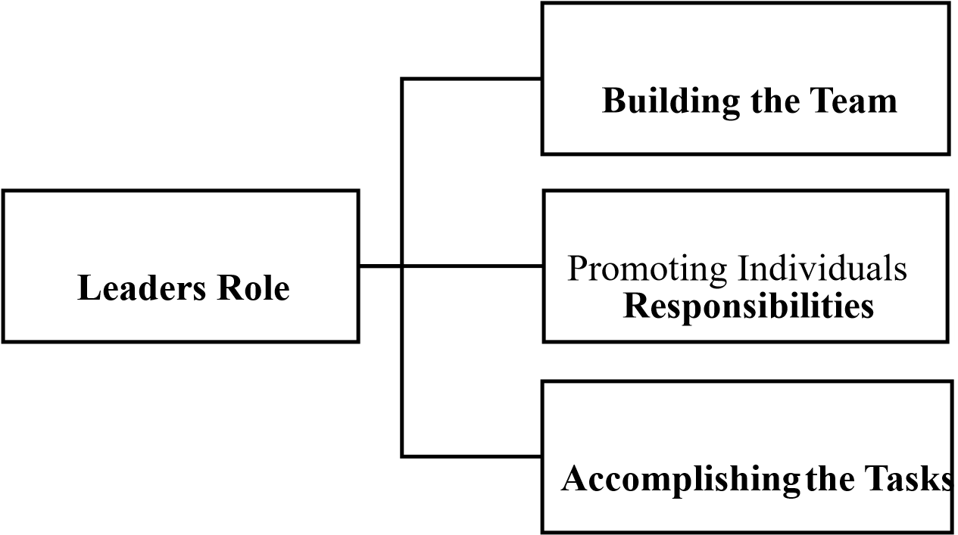
Figure 2.1 The Leadership Pattern

2.2 CONCEPTUAL CLARIFICATION ON LEADERSHIP STYLE
Understanding leadership requires a clear grasp of its foundational concepts and practical implications. At its core, leadership is the process through which an individual influences others to achieve shared goals. It encompasses a range of behaviors, skills, and traits that contribute to guiding, motivating, and directing people within an organizational framework. In construction, where leadership must be both operational and interpersonal, a leader’s ability to adapt their style to project demands is essential.
Leadership is typically discussed through its various forms transformational, transactional, democratic, autocratic, laissez-faire, and servant leadership, each offering different strengths and weaknesses based on the situation and the individuals involved. Scholars such as Northouse (2018) and Avolio et al. (2014) highlight leadership as a multidimensional construct that is influenced by both inherent traits and learned behaviors, shaped by organizational culture, situational needs, and follower expectations.
This section provides a conceptual framework for understanding leadership and its relevance in contemporary project management and organizational performance, particularly within the construction industry. It sets the stage for deeper exploration into leadership theories, styles, and their empirical impacts on employee satisfaction and organizational commitment.

2.3 TYPES OF LEADERSHIP STYLE
Leadership, as a concept, transcends a singular definition and has long been a subject of extensive scholarly discourse, evolving significantly across disciplines and practical domains. It constitutes not merely a positional authority but encompasses a dynamic and multidimensional interplay of influence, communication, strategy, and vision. At its core, leadership involves the capacity to inspire, direct, and guide individuals or teams toward the realization of collective goals, often in the face of ambiguity and complexity (Northouse, 2018). It is both an art and a science, shaped by personality traits, learned behaviors, situational demands, and the sociocultural context within which it is practiced.
Modern scholars argue that leadership is an emergent process that arises through interactions among people in social systems. Avolio et al. (2014) conceptualize leadership as a transformational and ethically grounded influence process, requiring not only clarity of purpose but also emotional intelligence, resilience, and adaptability. Particularly within industries such as construction where projects are temporal, teams are cross-functional, and environments are often volatile, leadership plays a decisive role in harmonizing technical execution with human capital management.
Moreover, effective leadership today is seen as integral to fostering a high-performance culture, promoting innovation, managing diversity, and ensuring ethical governance. Leadership is no longer confined to hierarchical command structures but is distributed, participatory, and contingent upon the alignment of leader behaviors with the needs of their followers and the strategic aspirations of the organization.
Leadership is a multifaceted concept that encompasses the ability of an individual to influence, guide, motivate, and direct others toward achieving common objectives. It goes beyond the mere delegation of tasks to include the strategic mobilization of people and resources in a way that fosters innovation, commitment, and organizational success (Northouse, 2018). Avolio et al. (2014) describe leadership as the process of influencing others through purpose-driven behaviors to accomplish goals beneficial to both individuals and organizations. This process includes creating a vision, building trust, motivating people, and adapting to changing environments.
Leadership has evolved over time from being perceived as an innate trait to a dynamic and learnable process. It can be viewed through different lenses such as relational, behavioral, ethical, and strategic, each offering unique insights into how leaders operate across diverse settings. In contemporary organizations, effective leadership is often seen as a critical determinant of organizational performance, employee satisfaction, and innovation, especially in complex industries like construction.
Leadership can broadly be categorized into various types based on the leader's behavior, the interaction with followers, and the organizational context:

2.3.1 AUTOCRATIC LEADERSHIP
Autocratic leadership represents a top-down approach wherein the leader exercises unilateral decision-making authority with minimal consultation or feedback from subordinates. The hallmark of this style is its focus on strict supervision, task orientation, and control over work processes. While often criticized for being rigid and suppressive, it has its strategic merit in environments that demand quick decisions, adherence to safety protocols, or operations under high-stress and crisis conditions (Al Khajeh, 2018). In construction settings, particularly during emergencies, tight deadline phases, or high-risk operations autocratic leadership can enforce discipline and ensure procedural compliance.
However, prolonged use of this leadership style can erode trust, limit creative input, and reduce employee morale. It is less effective in fostering team engagement or leveraging the intellectual contributions of skilled professionals. Modern construction firms often find it more beneficial to integrate autocratic tendencies with participatory practices to achieve both efficiency and inclusion.
Autocratic leadership involves a high degree of control and authority by the leader, with limited input from team members. Decisions are made unilaterally, and strict guidelines are followed. While effective in crisis situations or when quick decisions are needed, it may stifle creativity and lower employee morale in the long term (Al Khajeh, 2018).

2.3.2 DEMOCRATIC (PARTICIPATIVE) LEADERSHIP
Democratic or participative leadership is characterized by the inclusion of team members in the decision-making process. Unlike autocratic leaders who dictate decisions, democratic leaders facilitate discussions, solicit feedback, and make decisions based on collective input. This approach has been associated with higher levels of employee satisfaction, increased innovation, and improved collaboration (Yukl & Gardner, 2020).
In the construction industry, where diverse expertise and on-site problem-solving are crucial, this leadership style allows for richer brainstorming, better planning, and more accurate execution. It empowers team members to contribute their knowledge and enhances their sense of ownership. However, democratic leadership can be time-consuming and may lead to delays if not properly managed. Thus, leaders must find a balance between inclusion and decisiveness to sustain productivity.
Democratic leaders involve team members in decision-making processes. This type of leadership promotes collaboration, increases motivation, and often leads to better problem-solving and innovation. However, it may be time-consuming and inefficient in situations requiring rapid decision-making (Yukl & Gardner, 2020).

2.3.3 TRANSFORMATIONAL LEADERSHIP
Transformational leadership is grounded in the idea of inspiring and elevating the values, aspirations, and potential of followers. It centers on the leader's ability to articulate a compelling vision, foster commitment to shared goals, stimulate intellectual growth, and attend to individual development needs (Bass & Riggio, 2014). This leadership style is particularly impactful in organizations undergoing change, innovation, or cultural realignment.
Within the construction industry, transformational leadership proves vital in aligning multidisciplinary teams toward cohesive project goals. Such leaders cultivate a motivational climate, promote continuous learning, and challenge traditional thinking. They build trust through authenticity, communicate with empathy, and empower workers to exceed standard performance expectations. These qualities contribute to higher retention, improved job satisfaction, and better adaptability in volatile project environments.
Transformational leadership emphasizes vision, inspiration, and personal development. Leaders in this category aim to elevate the motivation and performance of their followers by aligning personal and organizational goals. It is particularly effective in environments requiring change and innovation (Bass & Riggio, 2014).

2.3.4 TRANSACTIONAL LEADERSHIP
Transactional leadership operates on the principle of exchanges between leaders and followers. It is characterized by well-defined roles, performance expectations, and reward-based motivation. Leaders provide clear instructions and offer rewards or disciplinary actions based on compliance and task performance (Nguyen et al., 2020).
This style is particularly useful in managing routine tasks, ensuring process adherence, and maintaining stability in large-scale projects. In the construction industry, transactional leadership is often applied to enforce safety standards, meet project timelines, and manage subcontractors. However, its limitation lies in its inability to foster intrinsic motivation or accommodate innovation. As such, it is most effective when used in conjunction with more inspirational and developmental leadership styles.
Transactional leaders operate through structured tasks and a system of rewards and penalties. They focus on performance, compliance, and measurable outcomes. This style works well in routine and process-driven industries but may not foster long-term engagement or creativity (Nguyen et al., 2020).

2.3.5 LAISSEZ-FAIRE LEADERSHIP
Laissez-faire leadership involves minimal leader intervention, allowing team members significant autonomy in decision-making and task execution. Leaders employing this style typically provide limited direction and avoid close supervision, assuming that employees are self-motivated and competent enough to work independently (Skogstad et al., 2014).
While this approach can foster innovation and self-leadership among experienced professionals, it may also result in ambiguity, lack of coordination, and diminished accountability, particularly in industries like construction, where cohesive teamwork and structured oversight are essential. Extended application of laissez-faire leadership without boundaries can undermine team coherence, delay decision-making, and erode overall project performance.
This leadership style is characterized by a hands-off approach where team members have the freedom to make decisions. While it may foster innovation in highly skilled teams, it can lead to confusion and low accountability in less experienced groups (Skogstad et al., 2014).

2.3.6 SERVANT LEADERSHIP
Servant leadership is distinguished by its emphasis on humility, empathy, and service to others. It inverts the traditional power hierarchy by placing the leader in the role of a facilitator who supports, develops, and empowers team members. Leaders who adopt this approach prioritize the needs of their employees, seek to build trust, and promote a culture of ethical conduct and community (Avolio et al., 2014).
In the construction industry often associated with hierarchical command structures, servant leadership can humanize the workplace, enhance worker morale, and reduce conflict. It is particularly effective in cultivating long-term loyalty and nurturing high-performance teams. By fostering a sense of belonging and responsibility, servant leaders contribute to a more cohesive and purpose-driven organizational environment.
Servant leadership prioritizes the needs of employees, promoting a culture of support, empathy, and ethical behavior. This style fosters trust, loyalty, and organizational citizenship behaviors. It has gained popularity in modern leadership discussions for its emphasis on human values and community (Avolio et al., 2014).

2.3.7 CHARISMATIC LEADERSHIP
Charismatic leadership relies heavily on the personal charm, vision, and persuasive capabilities of the leader to influence followers. Charismatic leaders inspire devotion, shape organizational culture, and often catalyze radical change by articulating a compelling narrative of the future (Hoch et al., 2018).
In construction contexts, where motivation and clarity of purpose are crucial amidst evolving challenges, charismatic leadership can energize teams and enhance project cohesion. However, over-reliance on personal charisma without institutionalizing systems can lead to unsustainable outcomes. When not balanced by strategic planning and participatory decision-making, this style may result in dependency on the leader’s presence and unpredictable organizational behavior.
Charismatic leaders rely on their charm, confidence, and persuasive communication to influence followers. They often inspire strong loyalty and devotion but may risk dependency or lack of sustainable systems if not balanced with structural leadership principles (Hoch et al., 2018).
These various types of leadership underscore the importance of adaptability in leadership approaches. Depending on the context, leader personality, team maturity, and task demands, a combination or shift in leadership type may be necessary. In construction, where project teams are often dynamic and goal-oriented, effective leadership often blends transactional precision with transformational vision and democratic engagement.

2.4 LEADERSHIP THEORIES
Leadership theories provide structured frameworks for understanding how and why certain individuals become effective leaders. These theories have evolved over time to include a broad range of perspectives, from innate qualities and learned behaviors to contextual and relational approaches. The following subsections provide an analytical overview of the major theoretical frameworks that underpin leadership research, with a special focus on their application in the construction sector.

2.4.1 TRAIT THEORY
Trait theory is one of the earliest and most enduring approaches in the study of leadership. Rooted in the idea that certain individuals are 'born leaders,' it postulates that inherent personality characteristics differentiate effective leaders from others. Traits such as self-confidence, integrity, intelligence, and emotional stability are frequently cited as predictors of leadership success. While earlier applications of trait theory were criticized for lacking empirical rigor and context sensitivity, contemporary research has rehabilitated the theory by integrating it with psychological metrics and contextual moderators (Zaccaro, 2014).
In the construction industry, where projects often involve high risk, tight timelines, and team diversity, traits such as resilience, problem-solving ability, and ethical conduct are particularly valuable. Effective construction leaders must not only possess cognitive competence but also the emotional intelligence to navigate interpersonal challenges and the moral integrity to build trust across teams. As Antonakis and Day (2017) argue, traits are not sufficient on their own but serve as foundational enablers of adaptive behavior in complex scenarios.
Trait theory suggests that certain inherent characteristics such as self-confidence, intelligence, integrity, and sociability, differentiate leaders from non-leaders. Although earlier trait theories have been criticized for lack of context, recent studies validate some traits as predictors of leadership effectiveness. For example, Zaccaro (2014) emphasizes that cognitive abilities and emotional intelligence are crucial traits that correlate strongly with transformational leadership success. However, scholars like Antonakis and Day (2017) argue that traits alone are insufficient unless complemented by situational awareness and behavioral adaptability. The current discourse also includes moral and ethical traits, with integrity and authenticity being considered core traits for responsible leadership in modern organizations (Ciulla, 2020).

2.4.2 BEHAVIOURAL THEORY
Behavioral theory marks a significant departure from trait-centric perspectives by emphasizing what leaders actually do rather than what innate qualities they possess. It posits that effective leadership can be learned through the observation, imitation, and reinforcement of specific behaviors. Common categorizations within this theory include task-oriented and relationship-oriented leadership styles. Task-oriented leaders focus on planning, structuring, and goal achievement, while relationship-oriented leaders prioritize team cohesion, communication, and morale (Judge et al., 2020).
In construction, where both technical precision and team collaboration are critical, a balanced behavioral approach is essential. Leaders must coordinate resources, meet regulatory requirements, and ensure quality control (task behavior), while also motivating and engaging a multidisciplinary workforce (relationship behavior). Behavioral theory supports the idea that with proper training, feedback, and reflection, construction professionals can cultivate leadership capabilities that align with both project demands and workforce needs.
Moreover, behavioral theory provides the theoretical backbone for many contemporary leadership development programs. As highlighted by Lacerenza et al. (2017), these programs have been empirically shown to improve leadership performance, making this theory highly applicable for organizations investing in the long-term development of their leadership pipeline.
Behavioral leadership theory proposes that effective leadership is defined by observable actions and behaviors rather than innate traits. Leaders are typically categorized based on task-oriented or people-oriented behaviors. According to Judge et al. (2020), successful leaders balance initiating structure (task focus) with consideration (people focus) to achieve team goals. Contemporary leadership training emphasizes behavioral flexibility and emotional intelligence as key components of leader development. Furthermore, behavioral theory provides a foundation for many leadership development programs, emphasizing that leadership skills can be taught and refined through practice, coaching, and feedback (Lacerenza et al., 2017).

2.4.3 SITUATIONAL AND CONTINGENCY THEORY
Situational and contingency theories emerged as a response to the limitations of one-size-fits-all leadership models. These theories argue that the effectiveness of a leadership style depends on various situational variables such as team maturity, organizational structure, cultural expectations, and task complexity (Graeff, 2015). Leaders must be flexible, adjusting their style to match the specific needs of the situation and the readiness of their followers.
Hersey and Blanchard’s situational leadership model, for example, categorizes leadership into four styles directing, coaching, supporting, and delegating each corresponding to a different level of employee competence and commitment. Strang (2016) further expands this idea by integrating digital transformation and agile practices into contingency frameworks.
In the construction industry, where project dynamics shift rapidly, situational and contingency theories are particularly relevant. For example, a project manager may need to employ a directive style during the planning phase to ensure clarity and compliance but shift to a supportive role during execution to encourage creativity and resolve conflicts. These theories advocate for leadership agility, a competency increasingly recognized as critical in managing complex, multistakeholder construction projects (Oke et al., 2021).
These theories assert that no single leadership style fits all scenarios. Effective leadership is context-dependent, requiring adaptation to task complexity, team maturity, and environmental variables (Graeff, 2015). The situational leadership model by Hersey and Blanchard has evolved to emphasize a dynamic approach, where leaders diagnose group needs and respond with appropriate styles. Modern updates, such as the contingency model proposed by Strang (2016), integrate digital transformation and cross-functional team dynamics into situational leadership frameworks. In construction, the need for fluid leadership adjustment is crucial given that team composition, project timelines, and risks evolve continuously, requiring leaders to reassess and recalibrate their approach (Oke et al., 2021).

2.5 LEADERSHIP STYLE ON EMPLOYEES' ORGANIZATIONAL COMMITMENT
Organizational commitment, defined as the psychological attachment and loyalty an employee develops toward their organization, is crucial for long-term workforce stability and project continuity. Leadership style directly shapes this commitment by influencing how employees perceive their roles, their leaders, and the organization’s goals. In construction environments where project teams are often temporary and face high-pressure conditions strong commitment reduces turnover and fosters cohesion, both of which are essential to project success.
Transformational leadership has been consistently linked with affective commitment, which refers to the emotional attachment of an employee to their organization. Leaders who exhibit empathy, vision, and consistent feedback foster a sense of belonging and purpose. This emotional connection leads to higher job involvement, discretionary effort, and long-term retention (Afsar et al., 2019). Democratic leadership styles also reinforce commitment by involving employees in decision making processes, thereby validating their contributions and empowering their professional autonomy.
On the other hand, transactional leadership, though effective for managing performance through rewards and penalties, is often associated with continuance commitment a form of attachment based on perceived costs of leaving the organization. While this may keep employees in place temporarily, it does not foster engagement or innovation. Laissez-faire and autocratic leadership styles, by contrast, often correlate with lower organizational commitment due to their lack of support, feedback, and recognition of employee efforts.
Effective construction leadership requires the blending of transformational elements with task focused approaches to maintain both high performance and deep organizational engagement.

2.5.1 FACTORS ON EMPLOYEES’ ORGANIZATION COMMITMENT
Organizational commitment is a multidimensional psychological construct that encapsulates an employee’s emotional and rational attachment to their organization. It manifests in three interrelated forms affective, continuance, and normative commitment (Meyer & Allen, 2021), each shaped by a complex interaction of leadership dynamics, organizational systems, and individual perceptions. Within high-demand sectors such as construction, where employee retention and consistent performance are vital, understanding the antecedents of organizational commitment becomes imperative for strategic human capital development.

2.5.1.1 LEADERSIP STYLE AND BEHAVIOURAL INFLUENCE
Leadership style is consistently identified as a principal antecedent to organizational commitment. Transformational leaders, by articulating a compelling vision and fostering intellectual stimulation, nurture affective commitment through the creation of meaning and personal investment in organizational outcomes (Alkhateri et al., 2021). Conversely, autocratic or laissez-faire leaders tend to undermine psychological safety and autonomy, diminishing both normative and affective bonds (Skogstad et al., 2014). Leadership that lacks emotional intelligence or participatory mechanisms results in disengagement and weak continuance commitment.

2.5.1.2 ORGANIZATION CULTURE AND VALUE CONGRUNCE
The congruence between an individual’s values and the organizational ethos significantly influences affective commitment. Organizations that cultivate cultures of inclusivity, transparency, and integrity not only increase retention but also fortify trust and loyalty (Meyer et al., 2021). In project-based contexts like construction, where frequent role changes occur, a consistent cultural identity offers a stabilizing anchor that reinforces commitment.

2.5.1.3 PERCEIVED ORGANIZATION SUPPORT AND FAIRENESS
Perceived organizational support (POS), the degree to which employees believe their organization values their contributions and well-being has been shown to enhance commitment across all three dimensions. POS moderates the effects of workplace stressors and enhances resilience, especially in labor-intensive industries (Newman et al., 2020). Moreover, organizational justice specifically procedural and distributive fairness deepens employees’ normative obligation to remain with the firm (Afsar & Umrani, 2019).

2.5.1.4 CAREER ADVANCEMENT AND HUMAN CAPITAL INVESTMENT
Access to clear developmental trajectories and advancement opportunities fosters both affective and normative commitment. Employees interpret investment in their growth as an implicit social contract, which in turn elicits reciprocity through enhanced dedication (Oke et al., 2021). In construction, professional development initiatives not only improve competence but also serve as a retention strategy amidst an increasingly mobile workforce.

2.5.1.5 PSYCHOLOGICAL SAFETY AND JOB SECURITY
Psychological safety is the perception that one can express themselves without risk to enables greater interpersonal learning and promotes affective engagement (Miao et al., 2021). Job security, while traditionally linked with continuance commitment, becomes significantly more meaningful when paired with organizational transparency and respectful leadership practices.

2.5.2 AFFECTIVE COMMITEMENT AND TRANSFORMATIONAL LEADERSHIP
Affective commitment refers to the emotional and psychological bond employees feel toward their organization. Transformational leadership plays a vital role in cultivating this type of commitment by creating a shared sense of purpose, recognizing individual contributions, and encouraging continuous learning. In construction settings, where loyalty and dedication are critical, such emotional attachment ensures that employees are motivated to work beyond minimum expectations.
Continuance commitment arises when employees stay with an organization due to perceived costs associated with leaving. Transactional leaders who focus on stability, rules, and reward systems may reinforce this form of commitment. While it helps in ensuring compliance, it may not produce the discretionary effort or innovation required in high-performing construction teams.

2.5.3 NORMATIVE COMMITEMENT AND ETHICAL LEADERSHIP
Normative commitment is the sense of obligation an employee feels to remain with an organization. Leaders who demonstrate ethical behavior, fairness, and consistent values help develop this type of commitment. Servant and ethical leadership styles have been found to build a moral contract between the leader and employees, fostering loyalty and ethical conduct in return.
Organizational commitment is closely linked to the leadership style exhibited by managers and supervisors. Leaders who practice transformational and participative leadership are known to foster a positive organizational culture, which enhances emotional attachment, trust, and alignment with organizational goals. Afsar et al. (2019) reported that leadership style is one of the strongest predictors of affective commitment, particularly in sectors like construction where leadership behavior directly influences workers’ morale and performance. Transactional leadership may secure short-term compliance, but transformational leadership builds long-term organizational loyalty and psychological ownership among employees. Thus, leadership style plays a pivotal role in reducing turnover, enhancing commitment, and ensuring the sustained productivity of construction teams.

2.6 JOB SATISFACTION
Job satisfaction is a multidimensional construct that encompasses an employee’s overall evaluation of their job and work environment. It includes both cognitive and affective responses and is influenced by a variety of factors including the nature of the job, compensation, work-life balance, organizational culture, and, significantly, leadership behavior. In project-based and high-pressure sectors like construction, where employee morale can be easily affected by stress and uncertainty, leadership plays a central role in shaping job satisfaction levels.
Studies such as those by Miao et al. (2021) and Al Khajeh (2018) demonstrate that leadership style is one of the most consistent predictors of job satisfaction across different industries. Transformational leaders are noted for their ability to create a sense of purpose and belonging among their employees, thereby improving engagement and motivation. In contrast, leaders who fail to provide direction, feedback, or support characteristics common in laissez-faire leadership tend to be associated with low job satisfaction, poor morale, and higher turnover rates.
Furthermore, in the construction industry, leadership affects both intrinsic and extrinsic job satisfaction. Intrinsic satisfaction relates to the nature of the work itself and the sense of achievement derived from it, while extrinsic satisfaction is derived from external factors such as pay, benefits, supervision, and work conditions. A leader who values and recognizes employees’ efforts contributes significantly to both dimensions.
Job satisfaction also acts as a mediator in the relationship between leadership style and organizational outcomes such as productivity, absenteeism, and employee retention. This reinforces the importance of adopting leadership styles that foster communication, provide development opportunities, and encourage employee participation in decision-making processes.

2.6.1 INTRINSIC VS. EXTRINSIC SATISFACTION
Intrinsic job satisfaction derives from the internal content of the job such as autonomy, responsibility, creativity, and achievement. Transformational and democratic leaders tend to enhance intrinsic satisfaction by empowering employees and aligning tasks with personal growth. Extrinsic satisfaction, on the other hand, involves tangible rewards and workplace conditions, and is often improved through transactional leadership that ensures clarity in roles, fairness in reward systems, and job security.

2.6.2 COMMUNICATION AND FEEDBACK AS DRIVERS OF SATISFACTION
Open communication and constructive feedback are hallmarks of effective leadership. Leaders who actively listen, provide regular updates, and engage in transparent dialogue build trust and psychological safety among team members. This not only reduces misunderstandings but also promotes mutual respect, thereby enhancing job satisfaction.

2.6.3 RECOGNITION AND PARTICIPATION
Recognition is a powerful tool in reinforcing positive behavior and increasing job satisfaction. Leaders who acknowledge achievements and involve employees in problem-solving or strategic discussions create an environment where individuals feel valued. Democratic and servant leaders are especially effective in promoting participatory culture and recognition-rich environments that sustain satisfaction and reduce burnout.
Job satisfaction refers to the positive emotional response an employee has toward their job role and work environment. Leadership style significantly impacts job satisfaction levels. According to Al Khajeh (2018), transformational leaders enhance satisfaction by recognizing employee needs and fostering a sense of purpose. In contrast, laissez-faire leadership often results in dissatisfaction due to lack of feedback and support. Research by Miao et al. (2021) affirms that job satisfaction mediates the relationship between leadership behavior and employee performance, making it a central concern in leadership effectiveness. Additionally, job satisfaction is linked to employee well-being, retention, and workplace engagement, making it a crucial KPI in project-based industries like construction where turnover can be high.

2.7 LEADERSHIP STYLE ON EMPLOYEES' JOB SATISFACTION
Employees' job satisfaction is significantly affected by how they perceive their leaders’ actions, values, and responsiveness. Transformational leaders, who inspire and communicate a shared vision, are more likely to generate high levels of job satisfaction by addressing both intrinsic and extrinsic motivators. According to Miao et al. (2021), employees are more satisfied and productive under leaders who are empathetic, motivating, and intellectually stimulating. Conversely, laissez-faire and autocratic leadership styles are typically associated with lower satisfaction due to lack of support or oppressive control. In the construction sector, job satisfaction influences absenteeism, task performance, and interpersonal harmony. Leadership strategies that promote recognition, trust, and involvement are therefore essential for enhancing satisfaction and workforce stability.

2.7.1 FACTORS ON EMPLOYEES’ JOB SATISFACTION
Job satisfaction represents an employee’s evaluative judgment of their role, encompassing cognitive, emotional, and behavioral dimensions. It is both a consequence of organizational systems and a driver of performance, creativity, and loyalty. In the construction industry, where work is often deadline-intensive, physically demanding, and safety-sensitive, the drivers of job satisfaction are multifaceted and dynamic.

2.7.1.1 TTRANSFORMATIONAL LEADERSHIP AND PSYCOLOGICAL EMPOWERMENT
Transformational leadership significantly enhances job satisfaction by cultivating psychological empowerment, fostering trust, and aligning employee goals with organizational vision (Hoch et al., 2018). These leaders provide intrinsic motivation, which is crucial in environments where external rewards may be delayed or project-based stress is high. Their attentiveness to individual needs also reduces burnout and enhances team morale.

2.7.1.2 ROLE CLARITY, AUTONOMY, AND TAX SIGNIFICANCE
Job satisfaction is strongly influenced by the clarity of one’s role, the autonomy granted in task execution, and the perceived significance of one’s work (Nguyen et al., 2020). Ambiguity and overlapping responsibilities diminish job satisfaction and are prevalent in construction projects that lack formalized communication. Conversely, well-defined roles and empowerment in decision-making bolster both performance and satisfaction.

2.7.1.3 ORGANIZATION COMMUNICATION AND FEEDBACK MECHANISMS
Transparent, timely, and respectful communication from leaders creates an environment of psychological safety and inclusion. Constructive feedback fosters a culture of growth and reinforces the employee's perception of being valued (Miao et al., 2021). In contrast, poor communication amplifies misunderstandings, reduces cohesion, and detracts from job fulfillment.

2.7.1.4 WORKPLACE SAFETY AND ENVIRONMENTAL CONDITIONS
In construction, the work environment itself is a key determinant of job satisfaction. Leaders who prioritize occupational health and safety (OHS) compliance, provide ergonomic tools, and reinforce safety behaviors not only mitigate risks but also elevate satisfaction levels (Cheung et al., 2021). Workers in safe and supportive environments demonstrate higher emotional well-being and sustained engagement.

2.7.1.5 RECOGNITION, INCLUSION, AND REWARD EQUITY
Recognition and equitable rewards significantly influence perceived fairness and satisfaction. Democratic and servant leadership styles, which prioritize inclusion and shared success, correlate positively with employee morale (Afsar et al., 2019). Additionally, transparent reward systems whether intrinsic (growth, learning) or extrinsic (salary, bonuses) strengthen the satisfaction-performance cycle.

2.7.1.6 FLEXIBILITY AND WORLIFE INTRGRATION
Work-life balance remains a growing concern in high-intensity roles. Organizations that implement flexible work arrangements and show empathy toward personal needs enhance satisfaction while reducing stress-induced turnover (Newman et al., 2020). Particularly in construction, where hours can be irregular, flexibility is no longer a perk but a necessity.

2.7.2 ORGANIZATIONAL COMMITMENT
Organizational commitment is the emotional attachment and loyalty an employee has toward their organization. Meyer and Allen’s three-component model (affective, continuance, normative commitment) remains widely used in contemporary studies. Recent research by Afsar et al. (2019) highlights that leadership styles significantly influence organizational commitment, especially affective commitment. Leaders who involve employees in decision-making and recognize their efforts tend to cultivate stronger organizational bonds and reduce turnover intentions. Construction companies that invest in leadership training and employee development programs often see an increase in employee commitment, which in turn improves project continuity, quality of work, and team morale.

2.8 LEADERSHIP IN THE CONSTRUCTION INDUSTRY
Leadership in the construction industry is distinguished by its need for adaptability, responsiveness, and coordination of diverse functions and teams. Construction projects are inherently temporary, complex, and labor-intensive endeavors that bring together professionals from multiple disciplines. As such, leadership within this sector must go beyond traditional managerial roles to include the capacity for strategic visioning, interpersonal sensitivity, and the ability to motivate workers under varying site conditions.
Unlike many other industries where employees and teams are stable over time, construction projects involve temporary team configurations, dynamic work environments, and strict deadlines. This often requires leaders to shift rapidly between different leadership styles. For example, a democratic or participative approach may be useful during the planning stage to integrate multiple viewpoints, while a more transactional or directive style may be needed during the execution phase to enforce timelines and safety standards.
Another important consideration is the cultural and generational diversity of the construction workforce. Effective leaders must demonstrate cultural competence and inclusive leadership practices to align a diverse group of professionals toward a shared project goal. Emotional intelligence, particularly the ability to manage stress, resolve conflict, and maintain morale, becomes a critical leadership asset in such volatile environments.
Technological advancements are also transforming construction leadership. With the integration of Building Information Modeling (BIM), automation, and project management software, leaders now require digital literacy and the ability to guide their teams through technological change. Leadership in construction must thus be future-oriented, embracing innovation while maintaining project integrity and human-centered team dynamics.
Safety is another leadership priority. Leaders who model and enforce safety-conscious behaviors create environments where employees feel secure and valued. According to recent studies, safety specific transformational leadership has a measurable impact on reducing accidents and promoting compliance in high-risk construction zones.
Therefore, leadership in the construction industry is not only about delivering projects on time and within budget but also about fostering an ethical, innovative, and safe work environment. As construction projects continue to increase in complexity and scope, the demand for skilled, adaptive, and people-centered leadership will only grow stronger.
Leadership within construction projects presents unique challenges due to the temporary and high-pressure nature of work. According to Toor and Ofori (2014), effective leadership in construction enhances team communication, project delivery, and worker safety. Modern construction leaders must be both directive and supportive, using transformational strategies to navigate ambiguity while ensuring compliance through transactional methods. Studies such as those by Oke et al. (2021) demonstrate that leadership style directly correlates with team productivity, safety adherence, and overall project success. Moreover, leadership in construction must account for diverse teams, cultural differences, and subcontractor dynamics, making interpersonal skills and emotional intelligence critical leadership competencies.

2.8.1 PREFFERED LEADERSHIP STYLES BY CONSTRUCTION MANAGEMENT
Understanding which leadership styles are preferred by higher-level management provides insight into organizational culture and strategic priorities. Research in the construction sector indicates that while transactional leadership is frequently adopted for its alignment with project control and risk management, many top-level managers increasingly prefer transformational leadership due to its adaptability, motivational impact, and capacity for innovation (Ling et al., 2018; Oke et al., 2021). These leaders often value participative approaches that encourage collaboration, as well as servant leadership for its focus on worker development and ethics. The preference for a blended approach transformational for vision-setting and team empowerment, and transactional for task clarity and accountability is particularly strong in environments where both innovation and precision are needed.

CHAPTER 3

RESEARCH METHODOLOGY

3.0 INTRODUCTION
This research deals with the general strategy and the logistic that are employed in the conduct of the study. It examines the design, the procedure and the methodology used in the collection of data and vital information needed for answering the research question formulated to direct the study; it deals with the process of data collection, organizing and analysis of data.

3.1 RESEARCH APPROACH
Research approach is a plan and procedure that consist of the steps of broad assumptions to detailed method of data collection, analysis and interpretation. It therefore, based on the nature of the research problem being addressed. The research approach used for this research is quantitative method in which respondent is only restricted to questionnaire and the form of questionnaire is
‘close ended’ one. Research approach is divided into qualitative, quantitative and mixed approach method.

3.1.1 QUALITATIVE RESEARCH
Qualitative research method is primarily exploratory research. It is used to gain an understanding of underlying reasons, opinions, and motivations. It provides insight into problem or helps to develop ideas or hypothesis for potential qualitative approach. Qualitative data collection method various using unstructured or semi-structured techniques. Some common method includes focus groups, individual interviews, and participation/observations.

3.1.2 QUANTITATIVE RESEARCH
It is an approach for testing objective theories by examining the relationship among variables. These variables, in turn, can be statistical procedures. The final written report has a set structure consisting of introduction, literature and theory, methods, results, and discussion. Like qualitative researchers, those who engage in this form of inquiry have assumptions about testing theories deductively, building in protections against bias, controlling for alternative explanations, and being able to generalize and replicate the findings.

3.1.3 MIXED METHODS
This is an approach to inquiry involving collecting both quantitative and qualitative data, integrating the two forms of data, and using distinct designs that may involve philosophical assumptions and theoretical frameworks. The core assumption of this form of inquiry is that the combination of qualitative and quantitative approaches provides a more complete understanding of a research problem than either approach alone.

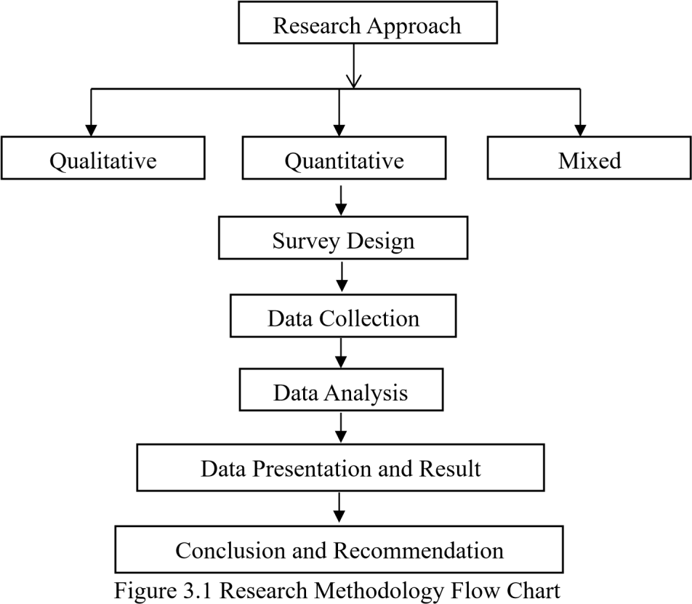

3.2 RESEACH DESIGNS
The research designs refer to the overall strategy that is choice to integrate different component of the study in a coherent and logical way. This study adopted Quantitative research approach by the use of (questionnaire design); this method is used to determine individual opinion about policy issues and to explore relationships between different variables. The design was appropriate because the study aimed at collecting information from respondents on their opinions on assessment of leadership style in construction workers’ performance in Nigeria.

3.3 POPULATION OF THE STUDY
The population of the study comprises professionals in construction industry namely: Architect, Quantity surveyor, Builder, and Engineer. Which their population from the list of registered professionals collected from the secretariats of each profession, however, 77 number of registered Quantity surveyors, 370 number of registered Engineers, 43 number of registered Architects, and 67 number of registered Builders were received. The population is made of registered professional to related profession of this research in Kwara State. The population is 557 from the study area.
Data for the population was collected from NIQS chapter at Ilorin.

3.4 SAMPLING TECHNIQUE AND SAMPLE SIZE
The sample technique adopted for this study is random sampling method. This involve written the name of registered professional on cards and shuffled. ‘The uppermost card is taken each time the card is shuffled, until the required sample size of 85 was achieved which made up of 19 architects, 20 quantity surveyors, 21 builders and 25 engineers. Each professional was picked randomly and a total number of 85 questionnaires were distributed to respondents in Kwara states. Below show how we achieve total number for sample size.
n = $\frac{N}{1+N (e)^{2}}$
Where e =level of significant (0.1)
n=sample size
N = Total number of population

n= 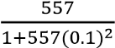
n= 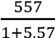
n= 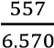
n=84.779
n= 85

3.5 RESEARCH INSTRUMENTS AND MEASUREMENT
This study focusses on assessing the leadership styles adopted in the construction sector and their influence on employee performance. A well-structured questionnaire was administered to the respondents concerned within the selected area of study. Ranking was used as a research instrument, where participant is to rank from Strongly Agree, Agree, Neutral, Disagree and Strongly Disagree for objective one, and five level of semantic differential scale where participant is to show the relationship with Very Important, Important, Moderately Important, Little Important and Not Important for objective two while Very Effective, Effective, Moderately Effective, Low Effective, Not Effective for objective three to provide answer option. It requires a parametric statistical test.

3.5.1 QUESTIONNAIRE DESIGN
Questionnaire design for this research will be a multiple-choice table and boxes, administration of structured questions based on research objectives. The information sought was divided into four sections:
Section A: The first questionnaire sought to collect demographic characteristics of correspondents, Respondents personal (e.g. Sex, the educational level, working experience in the industry, Qualification, Profession).
Section B: Identification of leadership style factors affecting employees’ organizational commitment.
Section C: Assessment of the impact of leadership styles on employees’ job performance.
Section D: Evaluation of leadership styles preferred by higher-level management of the construction industry.

3.5.2 QUESTIONNAIRE ADMINISTRATION
The following are the method of administering questionnaire (a) personally administered (b) mail electronic and electronics questionnaire.
- Personally administered: This is a questionnaire design and prepared by the researcher and given to the respondents within a confide area.
- Mail or electronic questionnaire: This means that a wide range of geographical area can be covered in a survey. The questionnaire will be sent to the respondent who can complete them at their own convenient. Comparing these various methods, I adopt both personal and electronic questionnaire because of the time factor and can ensure 100% response.

3.5.3 DEMOGRAPHICAL INFORMATION
This refers to the methods that will be used to measure the dimensions and dynamics of populations or the year of existence of the construction firms.
The questionnaire was prepared in 4 sections with regards to respondents. Section A contains personal information about the respondents, while section B, C, and D contain general information which reflects the objective of this project.

3.5.4 RESEARCH INSTRUMENT
Measurement scale is a tools or mechanism by which an individual is distinguish as diver from one and other on the variable of interest to our studies. The assignment of numbers and qualitative attribute to object event or to the characteristics of object is known as research measurement. The types of scale use for data collection in research work here. Nominal, Interval and Ratio scale.
- Nominal scale is one that allows research to assign subject to certain categories or groups.
- Ordinal scale is another scale that is use for some meaningful variables for which the categories are to be order according to some preferences.
- Interval scale allows us to perform certain arithmetic operation on the data obtain (collected) from the respondents.
- Ratio scale used to measure the magnitude of the difference between point on the scale and also taps the proportions in the differences with unique zero origin.
Nominal and Interval scale is adopted for this research problem. Nominal scale is use for the section A of the Questionnaire while Interval scale is use for the section B, C and D of the questionnaire.

3.6 DATA ANALYSIS
This research work is carried out by the use of ranking method. RII will be used to test for the factors of leadership styles on organizational commitment of workers and also, RII will be used to evaluate the impact of leadership styles on employees’ job performance, RII will be used to assess which leadership styles are most preferred by higher-level management of the construction industry in Nigeria and correlation was used to determine which leadership style has the most significant influence on performance. The Statistical Package for Social Sciences (SPSS) was used to carry out the analysis, ranking methods that were used to achieve the stated objectives. Relative Importance Index (RII) is written as
  - 5n₅ + 4n₄ + 3n₃ +2n₂ + 1n₁ _{5N}
$RII= \frac{\sum{w}}{AN}$ =
Where;
RII = Relative Importance Index,
A = highest weight,
N = total number of respondents,
n₅ = Number of respondents for “strongly agree”
n₄ = Number of respondents for “Agree”
n₃ = Number of respondents for “Neutral”
n₂ = Number of respondents for “Disagree”
n₁ = Number of respondents for “Strongly Disagree” for part B
n₅ = Number of respondents for “Very Important”
n₄ = Number of respondents for “Important”
n₃ = Number of respondents for “Moderately Important”
n₂ = Number of respondents for “Little Important”
n₁ = Number of respondents for “Not Very Important” for part C
n₅ = Number of respondents for “Very Effective”
n₄ = Number of respondents for “Effective”
n₃ = Number of respondents for “Moderately Effective”
n₂ = Number of respondents for “Low Effective”
n₁ = Number of respondents for “Not Very Effective” for part D

CHAPTER FOUR

DATA PRESENTATION AND DISCUSSION

4.1 INTRODUCTION
This chapter presents the analysis and results of the data collected for the study on the assessment of leadership style in construction workers’ performance in Nigeria, in accordance with the research objectives. The research questions were analyzed using appropriate statistical tools and techniques, primarily the Relative Importance Index (RII) to rank the significance of various factors.
Questionnaires Administered and Retrieved
A total of 85 questionnaires were administered to professionals in contracting and consulting firms within the construction industry in Nigeria. After applying purposive sampling techniques to eliminate invalid responses, 77 valid questionnaires were retrieved, representing a return rate of
90.6%. These were deemed sufficient for analysis.
Table 4.1: Distribution of Questionnaires Administered and Retrieved
Distribution | Frequency | Percentage (%)
Questionnaires Administered | 85 | 100.0
Questionnaires Retrieved | 77 | 90.6
Questionnaires Not Retrieved | 8 | 9.4
Source: Field survey (2025)
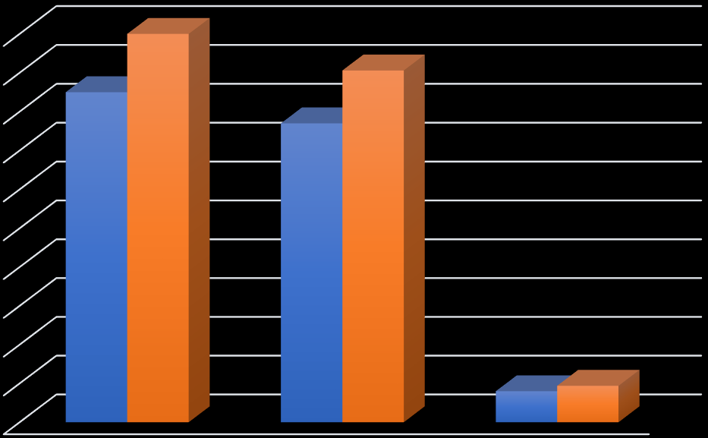

0
10
20
30
40
50
60
70
80
90
100
Questionnaires
Administered
Questionnaires Retrieved
Questionnaires Not
Retrieved
85
77
8
100
90.6
9.4
Frequency
Percentage (%)
Figure 4.1: A chart showing the questionnaires administered and retrieved

4.2 DEMOGRAPHIC INFORMATION OF RESPONDENTS
Table 4.2: Designation of Respondents
Designation | Frequency | Percentage (%) | Cumulative Percentage (%)
Quantity Surveyor | 13 | 16.9 | 16.9
Architect | 10 | 13.0 | 29.9
Site Engineer | 32 | 41.6 | 71.5
Contractor | 16 | 20.8 | 92.3
Others | 6 | 7.8 | 100.0
Total | 77 | 100.0
Source: Field survey (2025)

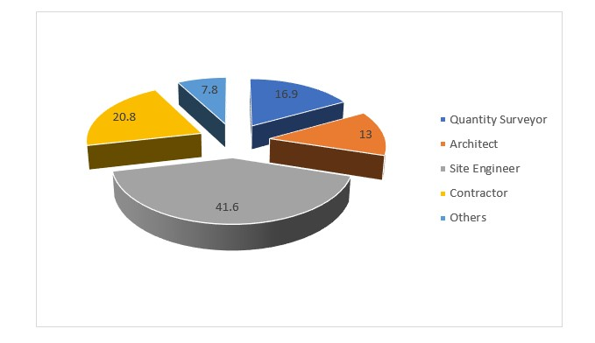
Figure 4.2: A chart showing the designation of respondents
The respondents’ designations are presented in Table 4.2. The majority were Site Engineers (41.6%), followed by Contractors (20.8%), Quantity Surveyors (16.9%), Architects (13.0%), and
Others (7.8%).
4.3 Years of Professional Experience
Years of Experience | Frequency | Percentage (%) | Cumulative Percentage (%)
1–5 years | 21 | 27.3 | 27.3
6–10 years | 26 | 33.8 | 61.1
11–15 years | 16 | 20.8 | 81.9
16–20 years | 9 | 11.7 | 93.6
20 years and above | 5 | 6.5 | 100.0
TOTAL | 77 | 100
Source: Field survey (2025)
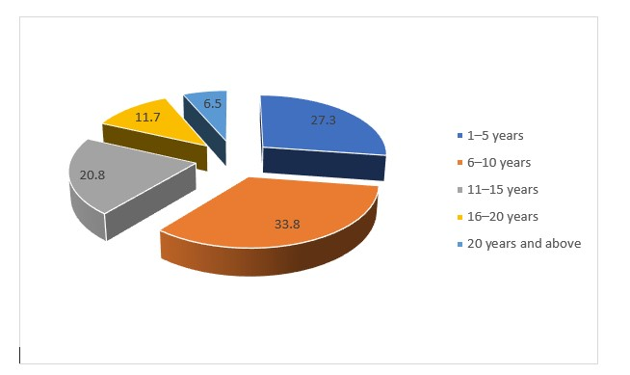
Figure 4.3: A chart showing the years of professional experience
Table 4.3 shows the years of professional experience. The majority (33.8%) have 6–10 years of experience, followed by 1–5 years (27.3%), 11–15 years (20.8%), 16–20 years (11.7%), and over
20 years (6.5%).
4.4 Educational Qualification of Respondents
Educational Qualification | Frequency | Percentage (%) | Cumulative Percentage (%)
HND | 17 | 22.1 | 22.1
B.Tech | 13 | 16.9 | 39.0
B.Sc | 9 | 11.7 | 50.7
PGD | 14 | 18.2 | 68.9
M.Sc | 20 | 26.0 | 94.9
PhD | 4 | 5.2 | 100.0
Total | 77 | 100.0
Source: Field survey (2025)
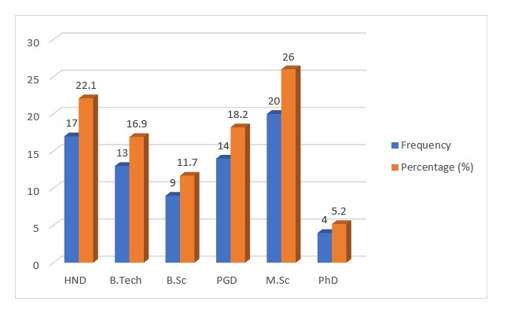
Figure 4.4: A chart showing the educational qualification of the respondents
The educational qualifications are shown in Table 4.4. The highest proportion of respondents hold an M.Sc (26.0%), followed by HND (22.1%), PGD (18.2%), B.Tech (16.9%), B.Sc (11.7%), and
PhD (5.2%).
4.5 Professional Qualification of Respondents
Professional Qualification | Frequency | Percentage (%) | Cumulative Percentage (%)
MNIQS | 14 | 18.2 | 18.2
MNIOB | 13 | 16.9 | 35.1
MNSE | 33 | 42.9 | 78.0
MNIA | 10 | 13.0 | 91.0
Others | 7 | 9.1 | 100.0
Total | 77 | 100.0
Source: Field survey (2025)
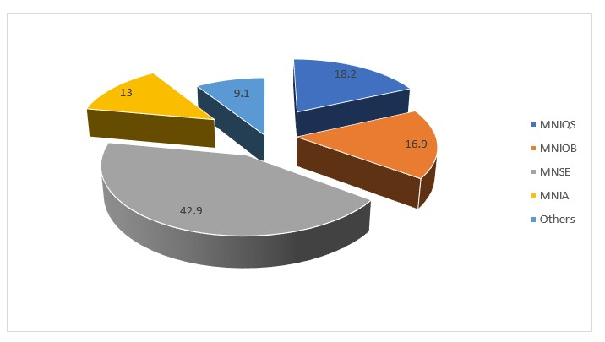
Figure 4.5: A chart showing the Professional qualification of respondents
Table4.5 presents the professional qualifications. The majority are MNSE (42.9%), followed by
MNIQS (18.2%), MNIOB (16.9)
Table 4.6: Type of Organization
Type of Organization | Frequency | Percentage (%) | Cumulative Percentage (%)
Contracting | 61 | 79.2 | 79.2
Consulting | 16 | 20.8 | 100.0
Total | 77 | 100.0

Source: Field survey (2025)

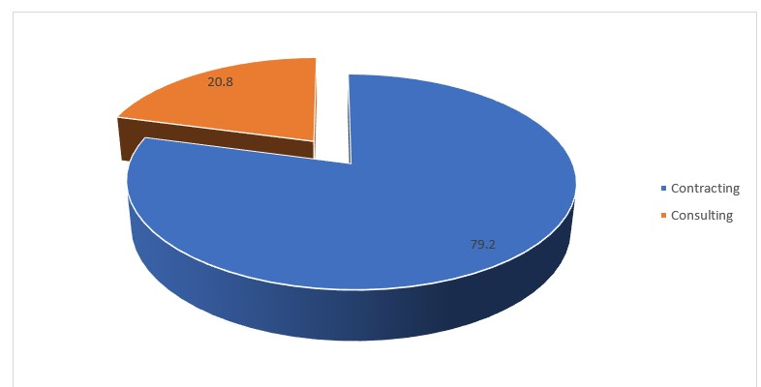
Figure 4.6: A chart showing the Types of Organization
Table 4.6 indicates that 79.2% of respondents work in contracting organizations, while 20.8% are in consulting organizations.

4.3 Objective One: Identification of Leadership Style Factors Affecting Employees’

Organizational Commitment
Table 4.7 ranks leadership style factors affecting employees’ organizational commitment using the RII.
Leadership Style Factors | SUM | RII | Rank
Leaders communicate a clear organizational vision | 370 | 0.961 | 1st
Leaders led by example and exhibit integrity | 367 | 0.952 | 2nd
Consistent leadership fosters stronger employee loyalty and commitment | 360 | 0.935 | 3rd
Employee feedback is welcomed and acted upon | 351 | 0.911 | 4th
Leaders support career growth and personal development | 347 | 0.901 | 5th
There is mutual trust between employees and leaders | 340 | 0.883 | 6th
Leaders promote a culture of inclusiveness and belonging | 335 | 0.870 | 7th
Employees feel empowered through their leaders | 330 | 0.857 | 8th
Leaders maintain transparency in decision-making | 325 | 0.844 | 9th
Leaders regularly recognize team and individual contribution | 320 | 0.831 | 10th
Source: Field survey (2025)
Relative Importance Index (RII) tool analyzed the leadership style factors influencing employee satisfaction and productivity. From the table above, it is revealed that "Leaders communicate a clear organizational vision" is the most important leadership style factor, ranking 1st with an RII of 0.961. This is strictly followed by "Leaders lead by example and exhibit integrity," which was ranked 2nd with an RII of 0.952.
"Consistent leadership fosters stronger employee loyalty and commitment" was ranked 3rd with an RII of 0.935, while "Employee feedback is welcomed and acted upon" came in 4th with an RII of 0.911. "Leaders support career growth and personal development" was ranked 5th (RII = 0.901), and "There is mutual trust between employees and leaders" followed closely in 6th position with an RII of 0.883.
The 7th ranked factor was "Leaders promote a culture of inclusiveness and belonging" (RII =
0.870), while "Employees feel empowered through their leaders" took the 8th spot with an RII of 0.857. "Leaders maintain transparency in decision-making" was rated 9th (RII = 0.844), and finally, "Leaders regularly recognize team and individual contribution" was ranked 10th with the lowest RII of 0.831 among the listed factors.

4.4 Objective Two: Assessment of the Impact of Leadership Styles on Employees’ Job

Performance
Table 8: RII Ranking of the Impact of Leadership Styles on Employees’ Job Performance
Aspects of Leadership Style Impact | SUM | RII | Rank
Clear communication from leaders improves task execution | 365 | 0.948 | 1st
Motivational leadership enhances work output | 355 | 0.922 | 2nd
Workers under transformational leaders exceed expectations | 350 | 0.909 | 3rd
Leadership that resolves conflict promptly enhances productivity | 345 | 0.896 | 4th
Supportive leadership reduces employee turnover | 340 | 0.883 | 5th
Reward-based leadership improves punctuality and dedication | 335 | 0.870 | 6th
Leadership style impacts how well deadlines are met | 330 | 0.857 | 7th
Delegate leadership improves leadership innovation | 325 | 0.844 | 8th
Inconsistent leadership styles reduce team effectiveness | 320 | 0.831 | 9th
Strict leadership negatively affects employee morale | 315 | 0.818 | 10th
Source: Field survey (2025)
The Relative Importance Index (RII) tool was employed to analyze various aspects of leadership style and their impact on employee performance and organizational outcomes. From the table above, it is revealed that “Clear communication from leaders improves task execution” is the most critical factor, ranking 1st with an RII of 0.948. Closely following is “Motivational leadership enhances work output,” ranked 2nd with an RII of 0.922.
“Workers under transformational leaders exceed expectations” was ranked 3rd with an RII of
0.909, while “Leadership that resolves conflict promptly enhances productivity” came 4th at 0.896.
“Supportive leadership reduces employee turnover” followed in 5th position with an RII of 0.883, and “Reward-based leadership improves punctuality and dedication” was ranked 6th with an RII of 0.870.
The 7th ranked aspect was “Leadership style impacts how well deadlines are met” (RII = 0.857), followed by “Delegate leadership improves leadership innovation,” which took 8th position with an RII of 0.844. “Inconsistent leadership styles reduce team effectiveness” came in 9th with an RII of 0.831, while “Strict leadership negatively affects employee morale” was rated the least important among the listed aspects, ranking 10th with an RII of 0.818.

4.5 Objective Three - Evaluation of Leadership Styles Preferred by Higher-Level

Management
Table 9: RII Ranking of Leadership Styles Preferred by Higher-Level Management
Leadership Styles | SUM | RII | Rank
Transformational leadership | 375 | 0.974 | 1st
Democratic (participatory) leadership | 365 | 0.948 | 2nd
Empowering leadership | 360 | 0.935 | 3rd
Safety-focused leadership | 350 | 0.909 | 4th
Situational leadership | 345 | 0.896 | 5th
Strategic leadership | 340 | 0.883 | 6th
Transactional leadership (reward-based) | 335 | 0.870 | 7th
Laissez-faire leadership | 320 | 0.831 | 8th
Bureaucratic leadership | 315 | 0.818 | 9th
Autocratic leadership | 310 | 0.805 | 10th
Source: Field survey (2025)
To assess the effectiveness of various leadership styles in enhancing contractor performance and risk management in road projects, the Relative Importance Index (RII) tool was applied. From the table above, the results show that “Transformational leadership” ranks highest in importance, with an RII of 0.974, making it the most significant leadership style in boosting contractor efficiency and reducing the likelihood of cost and time overruns. It is strictly followed by “Democratic (participatory) leadership,” which ranks 2nd with an RII of 0.948.
“Empowering leadership” comes in 3rd with an RII of 0.935, while “Safety-focused leadership” ranks 4th with a score of 0.909. “Situational leadership” and “Strategic leadership” were ranked 5th and 6th with RII values of 0.896 and 0.883 respectively. “Transactional leadership (rewardbased)” was positioned 7th with an RII of 0.870.
Less impactful styles included “Laissez-faire leadership,” ranked 8th (RII = 0.831), “Bureaucratic leadership” in 9th position (RII = 0.818), and “Autocratic leadership,” which ranked the lowest at 10th position with an RII of 0.805. These results indicate a clear preference for flexible, inclusive, and motivating leadership styles over rigid or passive approaches in improving contractor risk management capabilities in road project delivery.

4.6 DISCUSSION OF FINDINGS
Objective One: Identification of Leadership Style Factors Affecting Employees’ Organizational Commitment
The analysis reveals that clear communication of organizational vision (RII = 0.961) is the most significant factor influencing employees’ commitment, as it aligns teams with organizational goals. Leading by example with integrity (RII = 0.952) and consistent leadership fostering loyalty (RII = 0.935) are also critical, indicating that trust and reliability in leadership enhance commitment.
Objective Two: Assessment of the Impact of Leadership Styles on Employees’ Job Performance
Clear communication from leaders (RII = 0.948) significantly improves task execution, ensuring workers understand expectations. Motivational leadership (RII = 0.922) and transformational leadership (RII = 0.909) are key in enhancing work output and exceeding performance expectations, highlighting the importance of inspirational and supportive leadership styles.
Objective Three Evaluation of Leadership Styles Preferred by Higher-Level Management Transformational leadership (RII=0.974) is the most preferred style among higher level management, as it inspires innovation and commitment. Democratic leadership (RII = 0.948) and empowering leadership (RII = 0.935) are also highly valued, suggesting a preference for participative and employee-centric approaches in the construction industry.

CHAPTER 5

CONCLUSION AND RECOMMENDATION

5.0 INTRODUCTION
This chapter is aimed at giving the summary, conclusion and recommendations of the study.

5.1 CONCLUSION
This research is carried out to address the key issues which are the three major targets of the research work. For the purpose of this work, several published journals were reviewed both within and outside the country in order to gain insight of the assessment of leadership style in construction workers’ performance in Nigeria, conclusion drawn are:
Objective One: Identification of Leadership Style Factors Affecting Employees’ Organizational Commitment
The analysis reveals that clear communication of organizational vision is the most significant factor influencing employees’ commitment, as it aligns teams with organizational goals. Leading by example with integrity and consistent leadership fostering loyalty are also critical, indicating that trust and reliability in leadership enhance commitment.
Objective Two: Assessment of the Impact of Leadership Styles on Employees’ Job Performance
Clear communication from leaders significantly improves task execution, ensuring workers understand expectations. Motivational leadership and transformational leadership are key in enhancing work output and exceeding performance expectations, highlighting the importance of inspirational and supportive leadership styles.
Objective Three Evaluation of Leadership Styles Preferred by Higher-Level Management Transformational leadership is the most preferred style among higher level management, as it inspires innovation and commitment. Democratic leadership and empowering leadership are also highly valued, suggesting a preference for participative and employee-centric approaches in the construction industry.

5.2 RECOMMENDATION
Based on the results of the research work, it is recommended that;
- Construction firms should promote transformational leadership by encouraging managers to motivate, inspire, and support their teams, which has been shown to improve worker performance.
- Regular training sessions should be organized to improve the leadership competencies of site managers, especially focusing on communication, emotional intelligence, and people management.
- Workers should be given opportunities to contribute to decision-making processes, which helps boost morale, innovation, and accountability.
- While autocratic leadership may be useful in high-risk or time-sensitive scenarios, it should not be used as the default style due to its negative effects on motivation and job satisfaction.
- Leaders should model safety-first behaviors and encourage proactive reporting of hazards, as this enhances worker well-being and project performance.

5.3 AREA FOR FURTHER STUDY
This research is opened to further research and it is advised that for further research, the participants in the construction industry should be more aware of the impact of assessment of leadership style in construction workers.

REFERENCE
Abdul-Rahman, H., Wang, C., & Saimon, M. A. (2019). Project leadership in the Malaysian construction industry. *Engineering, Construction and Architectural Management, 26*(3), 504–522.
Aga, D. A., Noorderhaven, N., & Vallejo, B. (2016). Transformational leadership and project success: The mediating role of team-building. *International Journal of Project Management, 34*(5), 806–818.
Alzahrani, J. I., & Emsley, M. W. (2016). The impact of contractors’ attributes on construction project success. *Journal of Construction Engineering and Management, 142*(12), 04016093.
Annan, E., & Addai, M. (2022). Transformational leadership and safety performance in Ghanaian construction firms. *Journal of Building Performance, 13*(1), 56–66.
Alkhawlani, M. A., & Omar, R. (2021). The impact of leadership styles on employee performance in the construction sector: Evidence from Yemen. *International Journal of Construction Management*.
Babatunde, S. O., & Perera, S. (2017). Project managers' leadership style and its impact on performance in Nigeria’s construction industry. *Journal of Construction Project Management and Innovation, 7*(2), 1931–1944.
Babatunde, S. O., & Udeaja, C. E. (2020). Barriers to effective leadership in construction project delivery in Nigeria. *Built Environment Project and Asset Management, 10*(5), 731–746.
Cheung, C. M., & Zhang, R. (2020). Safety-specific transformational leadership and safety climate in construction: The role of psychological empowerment. *International Journal of Environmental Research and Public Health, 17*(9), 2976.
Cheung, C. M., Zhang, R., & Fan, R. X. (2021). Leadership styles and workers’ safety behavior in construction: A moderated mediation model. *Safety Science, 134*, 105072.
Durdyev, S., Omarov, M., & Ismail, S. (2021). The impact of leadership styles on construction worker productivity: Evidence from construction projects. *International Journal of Construction Management, 21*(3), 252–262.
Dwivedi, A., & Panthi, K. (2019). Linking leadership to safety performance in construction. *Journal of Safety Research, 70*, 127–138.
Enshassi, A., & El-Ghandour, M. (2020). The influence of leadership style on job performance in the construction industry in Palestine. *International Journal of Organizational Analysis, 28*(3), 653–676.
Farid, T., Iqbal, S., Ma, J., Khattak, A., & Khan, M. K. (2020). Employees’ perceptions of authentic leadership and its impact on work engagement: The mediating role of employee trust. *Leadership & Organization Development Journal, 41*(4), 621–633
Hoffmeister, K., Gibbons, A. M., Johnson, S. K., Cigularov, K. P., Chen, P. Y., & Rosecrance, J. C. (2014). The differential effects of transformational leadership facets on employee safety. *Safety Science, 62*, 68–78.
Kim, Y., & Jung, J. (2019). Safety leadership: A study on the effects of leadership style on safety performance in the construction industry. *Journal of Safety Research, 70*, 211–218.
Liu, H., Chiang, C. F., Fei, W., & Xu, X. (2020). How transformational leadership influences project success: Mediating role of project team effectiveness and moderating role of project risk. *International Journal of Project Management, 38*(4), 289–300.
Mahfouz, T., Kandil, A., & Sweis, R. (2017). The impact of leadership behaviors on team performance in construction. *Journal of Management in Engineering, 33*(5), 04017025.
Nguyen, L. D., Nguyen, T. V., & Hoang, M. T. (2022). The impact of ethical leadership on employee performance in construction: The mediating role of organizational trust. *Engineering, Construction and Architectural Management*.
Northouse, P. G. (2016). *Leadership: Theory and practice* (7th ed.). Sage Publications.
Pretorius, M., & Oke, A. (2016). Exploring leadership in construction SMEs in South Africa. *Journal of Construction in Developing Countries, 21*(2), 81–100.
Rafique, M. Z., Zhang, Y., & Wu, H. (2021). Leadership style and innovation in construction projects: A mediating role of knowledge sharing. *Journal of Engineering, Design and Technology, 19*(3), 785–804.
Saleem, S., & Khurshid, M. A. (2017). Leadership styles and their impact on employee productivity: A study of public vs private sector construction projects in Pakistan. *International Review of Management and Business Research, 6*(1), 354–363
Zeinab, R. M., & Amini, M. (2018). Leadership styles and construction project performance: The mediating role of trust. *Project Leadership and Society, 1*(1), 100003.

APPENDIX 1
QUESTIONNAIRE

Department of Quantity Surveying,
Institute of Environmental Studies,
Kwara State Polytechnic Ilorin,
P.M.B. 1375, Ilorin,
Kwara State.
Dear Sir/Ma,
AN ASSESSMENT OF LEADERSHIP STYLE IN CONSTRUCTION WORKERS
PERFORMANCE IN NIGERIA

I am a Higher National Diploma student in the department of Quantity Surveying, Kwara State Polytechnic Ilorin, Kwara State, undertaking research on the above-mentioned topic.
The following questions served to collect necessary data to complete the study on the abovementioned topic as part of the requirements for the award of Higher National Diploma (HND) Quantity Surveying.
All information given by the respond shall be purely for academic purpose and only thus treated with the confidentiality it deserves.
Thanks, your prompt attention and cooperation.
Yours faithfully,
_____________
ABOLUWARIN, REMILEKUN DORCAS
The researcher

APPENDIX 11
SECTION A: DEMOGRAPHIC INFORMATION
Please, tick ( ) your answer accordingly and as appropriate.
1. Designation of respondents:
(a) Quantity Surveyor ( ) (b) Architect ( ) (c) Site Engineer ( ) (d) Builder ( ) (e) Others
( )
2. Kindly indicate your years of professional experience:
(a) 1 – 5years ( ) (b) 6 – 10years ( ) (c) 11 – 15years ( ) (d) 16 – 20years ( ) (e) 20 years and above ( )
3. Educational qualification of the respondents:
(a) HND ( ) (b) B.TECH ( ) (c) B.Sc ( ) (d) PGD ( ) (e) M.Sc ( )(f) PhD ( )
- Professional qualification of respondents: (a) MNIQS ( ) (b) MNIOB ( ) (c) MNSE ( ) (e) MNIA( ) (f) OTHERS: __________
- Type of Organization:
(a) Contracting ( ) (b) Consulting ( )

SECTION B: IDENTIFICATION OF LEADERSHIP STYLE FACTORS AFFECTING EMPLOYEES’ ORGANIZATION COMMITMENT
Below are some identifications of leadership style which are affecting employees’ organization commitment in construction industry.
Kindly rank the level of agreements for the following leadership style which are affecting employees’ organization commitment in construction industry using Likert scale of 5 = Strongly Agree (SA), 4 = Agree(A), 3 = Neutral (N), 2 = Disagree(D), 1 = Strongly Disagree (SD).
S/N | LEADERSHIP STYLE FACTORS | STRONGLY  AGREE  (SA)  5 | AGREE  (A)  4 | NEUTAL  (N)  3 | DISAGREE  (D)  2 | STRONGLY  DISAGREE  (SD)  1
1. | Leaders communicate a clear organization vision
2. | Leaders leads by example and exhibit integrity
3. | Employee feedback is welcomed and acted upon
4. | Leaders regularly recognize team and individual contribution
5. | Employees feel empowered through their leaders
6. | Leaders maintain transparency in decision
7. | There is mutual trust between employees and leaders
8. | Leaders support carrier growth and personal development
9. | Leaders promote a culture of inclusiveness and belongings
10. | Consistent leadership fosters stronger employee loyalty and commitment

SECTION C: ASSESSMENT OF THE IMPACT OF LEADERSHIP STYLES ON EMPLOYEES’ JOB PERFORMANCE
Below are the different ways of assessing the impact of leadership styles on employees’ job performance in construction industry.
Kindly differentiate level of assessing the impact of leadership styles on employees’ job performance in construction industry using Semantic differential scale of 5 = Very Important (VI), 4 = Important (I), 3 = Moderately Important (MI), 2 = Little Important (LI), 1 = Not Very Important (NVI).

S/N | ASPECTS OF LEADERSHIP STYLE IMPACT ON JOB PERFORMANCE | VERY IMPORTANT  (VI)  5 | IMPORTANT  (I)  4 | MODERATELY  IMPORTANT  (MI) 3 | LITTLE IMPORTANT  (LI)  2 | NOT VERY IMPORTANT  (NVI)  1
1. | Clear communication from leaders improves task execution
2. | Motivation leadership enhance work output
3. | Delegate leadership improve leadership innovation
4. | Leadership who resolves conflict promptly enhance  productivity
5. | Supportive leadership reduces employee turnover
6. | Reward based leadership improves punctuality and dedication
7. | Inconsistent leadership styles reduce team effectiveness
8. | Leadership style impact how well deadlines are met
9. | Workers under transformation leaders exceed expectations
10. | Strict leadership negativity affects employee morale

SECTION D: EVALUATION OF LEADERSHIP STYLES PREFFERD BY HIGHER-LEVEL MANAGEMENT OF THE CONSTRUCTION INDUSTRY
Below are different levels of how to evaluate leadership styles proffered by higher-level management in the construction industry.
Kindly differentiate levels of how to evaluate leadership styles proffered by higher-level management in the construction industry using Likert scale of 5 = Very Effective (VE), 4 = Effective (E), 3 = Moderately Effective (ME), 2 = Low Effective (LE), 1 = Not Very Effective (NVE).

S/N | LEADESHIP STYLES COMMON AMONG  HIGHER LEVEL MANAGEMNT | VERY  EFFECTIVE  (VE)  5 | EFFECTIVE  (E)  4 | MODERATELY  EFFECTIVE  (ME)  3 | LOW  EFFECTIVE  (LE)  2 | NOT VERY EFFECTIVE (NVE)  1
1. | Transformational leadership
2. | Transactional leadership (reward  based)
3. | Democratic (participatory) leadership
4. | Autocratic leadership
5. | Situational leadership
6. | Laisses-faire leadership
7. | Safety focused leadership
8. | Empowering leadership
9. | Strategic leadership
10. | Bureaucratic leadership

