DESIGN AND CONSTRUCTION OF SIMPLY SUPPORTED BEAM CARRYING A CANTILEVER SLAB WITH A DETACH STAIRCASE

BY

AJAO OLUSHOLA TEMITOPE
ND/23/BLD/FT/0064

A PROJECT SUBMITTED TO THE DEPARTMENT OF BUILDING TECHNOLOGY, INSTITUTE OF ENVIRONMENTAL STUDIES.
IN PARTIAL FULFILLMENT OF THE REQUIREMENT FOR THE AWARD OF NATIONAL DIPLOMA (ND) IN BUILDING TECHNOLOGY, KWARA STATE POLYTECHNIC, ILORIN.

SUPERVISED BY:
BLDR. IYIOLA AKEEM SEYI

JULY, 2025.

CERTIFICATION
This is to certify that this project has been read and approved as meeting part of the requirements for the award of National Diploma (ND) in Building Technology in the Department of Building Technology and Management, Institute of Environmental Studies (IES), Kwara State Polytechnic, Ilorin.

-------------------------- --------------------------
BLDR IYIOLA AKEEM SEYI (MNIOB) DATE
(Project Supervisor)

-------------------------- --------------------------
BLDR. AKANO AYODELE (MNIOB) DATE
(Project Coordinator)

-------------------------- --------------------------
BLDR. ALEGE ABDULGANIYU (MNIOB ) DATE
Head of Department (HOD)

-------------------------- --------------------------
BLDR. AHMED MAROOF FUNSHO (MNIOB) DATE
External Examiner

DEDICATION
This project is dedicated to Almighty God, the Alpha and Omega of wisdom, knowledge and understanding. The creator of all living and non-living soul also dedicated to my parents whose unwavering support and encouragement have been my pillar throughout this academic journey.

ACKNOWLEDGMENTS
First and foremost, we give golden gratitude and adoration to the Almighty God, the most beneficent and most merciful who alone is the source of wisdom, knowledge for signs and inspiration for making this vision a reality.
I owe immense thanks to my parents for their unconditional love, sacrifices, and prayers.
My heartfelt appreciation goes to my supervisor, BLDR. IYIOLA AKEEM SEYI for giving me the opportunity to do research and providing invaluable guidance throughout this research. This dynamism, vision, sincerity and motivation have deeply inspired us. He has taught us through methodology to carry out the research and to present the research work as clearly as possible and my HOD in person of BLDR. ABDULGANIYU ALEGE (MNIOB) for his encouragement and commitment to the service of humanity. I also appreciate the efforts of all the lecturers of the Department of Building Technology, thank you and God bless you all.
Finally, I appreciate everyone who contributed directly or indirectly to the completion of this project. Your support made this milestone possible.

ABSTRACT
This study focuses on the design and construction of a simply supported beam carrying a cantilever slab integrated with a detached staircase, aiming to enhance structural efficiency, safety, and cost-effectiveness in the Nigerian construction context. Utilizing a mixed-methods approach, the research combines quantitative structural analysis, based on Eurocode 2 and BS 5395-1 standards, with qualitative insights from interviews with 10-15 structural engineers and contractors, alongside site observations and a questionnaire distributed to 100 participants. The design process involved load calculations, material selection (Grade C25/30 concrete and Y16/Y12 steel reinforcement), and structural analysis to ensure compliance with ultimate and serviceability limit states. The construction phase employed locally sourced materials, including timber formwork and granite aggregates, to balance cost and sustainability. Findings indicate that the structural system is viable, with 82% of respondents rating the materials as durable and cost-effective, though challenges such as inconsistent material quality and skilled labor shortages were noted in 65% and 70% of cases, respectively. User satisfaction was high (mean score of 4.3/5), but construction costs were 20% higher than traditional systems. The study recommends adopting international standards, enhancing quality control, and investing in workforce training to improve construction practices. This research contributes to advancing structural engineering in Nigeria by providing practical guidelines for designing and constructing similar structural systems, promoting safety, efficiency, and aesthetic appeal in modern buildings.

TABLE OF CONTENTS

Title page

Certification

Dedication

Acknowledgements

Abstract

Table of Contents

Chapter One: Introduction

1.1 Background of the Study

1.2 Statement of the Problem

1.3 Objectives of the Study

1.4 Research Questions

1.5 Significance of the Study

1.6 Scope of the Study
1.7 Definition of Terms
Chapter Two: Literature Review
2.1 Introduction
2.2 A white out shelf for making home use furniture
2.3 Materials used for white out shelf
2.4 Explanation on making the white out shelf
2.5 Procedure of production

Chapter Three: Research Methodology
3.0 Introduction
3.1 Research Design
3.2 Research Instrument: Questionnaire
3.3 Sources of Data Collection
3.4 Techniques of Data Analysis
3.5 Material used for Practical Work
Chapter Four: Analysis and Drawings
4.0 Introduction
4.2 Drawings and Sketches
Chapter Five: Summary, Conclusion and Recommendations
5.1 Summary of Findings
5.2 Conclusion
5.3 Recommendations
References

CHAPTER ONE

INTRODUCTION

1.1 Background of the Study
A simply supported beam is a fundamental structural element in building construction, characterized by its support at two points, typically at the ends, allowing it to carry loads primarily through bending. When combined with a cantilever slab, which extends beyond its support without underlying columns, it provides a versatile structural system for creating overhangs or balconies. A detached staircase, as an independent structural component, enhances accessibility and aesthetic appeal in buildings, often designed to complement the main structure while maintaining structural integrity. This research focuses on the design and construction of a simply supported beam carrying a cantilever slab with a detached staircase, emphasizing structural efficiency, safety, and cost-effectiveness.
The integration of these structural elements is critical in modern construction, particularly in residential and commercial buildings where space optimization and aesthetic flexibility are paramount. According to Eurocode 2 (EN 1992-1-1), the design of reinforced concrete beams and slabs must account for bending moments, shear forces, and deflection limits to ensure structural stability. Cantilever slabs, due to their unsupported ends, require careful consideration of load distribution and reinforcement to prevent excessive deflection or cracking (Mosley et al., 2012). Similarly, detached staircases, often constructed from reinforced concrete or steel, must be designed to withstand dynamic loads while adhering to ergonomic standards for user safety (BS 5395-1).
In Nigeria, the construction industry faces challenges such as material availability, cost overruns, and adherence to local building codes, which influence the design and construction of structural elements like beams, slabs, and staircases. The adoption of sustainable materials and efficient construction techniques is increasingly vital to address these challenges (Ogunbiyi, 2014). This study aims to explore the design and construction processes, material selection, and practical implementation of a simply supported beam carrying a cantilever slab with a detached staircase, contributing to improved construction practices in Nigeria.

1.2 Statement of the Problem
The Nigerian construction industry often relies on traditional design and construction methods, which may not fully address modern demands for structural efficiency, safety, and sustainability. The design of simply supported beams carrying cantilever slabs is complex due to the need to balance load distribution, reinforcement detailing, and deflection control. Detached staircases, while aesthetically appealing, pose challenges in ensuring structural independence and user safety. Common issues include inadequate reinforcement, poor material quality, and lack of adherence to design standards, leading to structural failures or increased costs. Additionally, there is a lack of localized guidelines for integrating these elements in a cohesive structural system, necessitating research to address these gaps.

1.3 Objectives of the Study
The aim of this study is to design and construct a simply supported beam carrying a cantilever slab with a detached staircase, ensuring structural integrity, safety, and cost-effectiveness.
Specific objectives include:
- To design a simply supported beam and cantilever slab that meet structural and safety requirements.
- To select appropriate materials for the construction of the beam, slab, and detached staircase.
- To develop a construction procedure for integrating a detached staircase with the beam and slab system.
- To assess the structural performance and cost-effectiveness of the proposed design.
- To develop guidelines for designing and constructing similar structural systems in Nigeria.

1.4 Research Questions
- What are the design considerations for a simply supported beam carrying a cantilever slab?
- What materials are most suitable for constructing a simply supported beam, cantilever slab, and detached staircase?
- What challenges are encountered during the construction of these structural elements?
- How does the integration of a detached staircase affect the overall structural performance?

1.5 Significance of the Study
This project demonstrates the competency of students in applying structural engineering principles to real-world construction challenges. It provides practical insights into designing and constructing a simply supported beam with a cantilever slab and a detached staircase, serving as a foundation for future research and improving construction practices in Nigeria. The study will also contribute to the development of localized guidelines, enhancing the quality and safety of structural designs in the building technology department.

1.6 Scope of the Study
The scope of this project includes:
- Designing and analyzing a simply supported beam carrying a cantilever slab using relevant standards (e.g., Eurocode 2).
- Constructing a prototype of the beam, slab, and detached staircase using locally available materials.
- Evaluating the structural performance, cost, and construction challenges.
- Developing guidelines for similar structural designs in Nigeria.

1.7 Definition of Terms
- Simply Supported Beam: A beam supported at two points, typically at its ends, allowing it to resist loads through bending.
- Cantilever Slab: A reinforced concrete slab that extends beyond its support, without underlying columns, designed to resist bending and shear forces.
- Detached Staircase: An independent staircase, structurally separate from the main building, designed for accessibility and aesthetic purposes.
- Structural Integrity: The ability of a structure to withstand loads without failure.
- Reinforcement: Steel bars or mesh embedded in concrete to enhance its tensile strength.
- Load Distribution: The manner in which forces are transferred through a structural system.

CHAPTER TWO

LITERATURE REVIEW

2.1 Introduction
The design and construction of structural elements such as simply supported beams, cantilever slabs, and detached staircases are pivotal to modern building technology, enabling the creation of safe, efficient, and aesthetically pleasing structures. Advances in structural engineering, material science, and construction methodologies have significantly enhanced the ability to develop robust structural systems that meet both functional and environmental demands. This literature review provides a comprehensive exploration of the theoretical and practical aspects of designing and constructing a simply supported beam carrying a cantilever slab with a detached staircase. The review focuses on key areas: design principles, material selection, construction processes, and associated challenges. It synthesizes information from peer-reviewed journals, industry standards (e.g., Eurocode 2, BS 5395-1), and case studies to establish a robust foundation for the study. By examining global and local perspectives, particularly within the Nigerian construction context, this review aims to address gaps in knowledge and practice, contributing to improved structural design and construction methodologies.
The integration of simply supported beams, cantilever slabs, and detached staircases is common in residential and commercial buildings, particularly where space optimization, structural efficiency, and aesthetic appeal are priorities. The review is structured to cover the conceptual framework of these structural elements, the materials used, the design and construction processes, and the specific procedures for constructing a detached staircase. Emphasis is placed on sustainability, cost-effectiveness, and adherence to international and local standards, with a focus on addressing challenges such as material quality, labor skills, and compliance with building codes in Nigeria.

2.2 Concept of Simply Supported Beams and Cantilever Slabs
A simply supported beam is a fundamental structural element supported at its ends, typically by pinned or roller supports, allowing it to resist vertical loads primarily through bending (Mosley et al., 2012). The beam transfers applied loads—such as dead loads (e.g., self-weight, finishes) and live loads (e.g., occupants, furniture)—to its supports, with maximum bending moments occurring at the midspan and maximum shear forces near the supports. According to Eurocode 2 (EN 1992-1-1), the design of simply supported beams requires careful calculation of bending moments, shear forces, and deflection to ensure structural stability and compliance with serviceability limits.
Cantilever slabs, in contrast, are reinforced concrete flat plates that extend beyond their supporting elements (e.g., beams or walls) without additional columns, creating overhangs for balconies, terraces, or aesthetic features. These slabs experience negative bending moments at the fixed end, necessitating reinforcement at the top surface to counter tensile stresses (MacGinley & Choo, 2018). The integration of a simply supported beam with a cantilever slab is a common structural configuration in modern buildings, particularly in urban settings where space constraints demand innovative solutions. The beam provides primary support, while the cantilever slab extends the floor area, enhancing functionality and aesthetic appeal.
Detached staircases, designed as independent structural units, complement such systems by providing access without relying on the main structure for support. These staircases must adhere to ergonomic and safety standards, such as BS 5395-1, which specifies requirements for rise, run, and landing dimensions to ensure user comfort and safety. The structural design of detached staircases must account for dynamic loads (e.g., human traffic) and ensure stability through independent foundations and reinforcement (Chudley & Greeno, 2016). The combination of these elements—beam, slab, and staircase—requires a cohesive design approach to ensure compatibility, load transfer, and overall structural integrity.
The literature highlights the importance of integrating these elements to meet modern construction demands. For instance, Ogunbiyi (2014) notes that in Nigeria, the use of reinforced concrete for beams and slabs is prevalent due to its durability and availability, but challenges such as poor workmanship and material variability often compromise structural performance. Globally, advancements in finite element analysis and structural software (e.g., SAP2000, ETABS) have improved the precision of designing such systems, enabling engineers to model complex load interactions and optimize reinforcement (Mosley et al., 2012).

2.3 Materials Used in Beam, Slab, and Staircase Construction
The construction of simply supported beams, cantilever slabs, and detached staircases relies on a range of materials selected for their structural properties, availability, and sustainability. The primary materials include concrete, steel reinforcement, formwork materials, and aggregates, each playing a critical role in ensuring the durability and performance of the structural system.

Concrete
Concrete, a composite material composed of cement, fine aggregates (sand), coarse aggregates (gravel or crushed stone), and water, is widely used for its high compressive strength and versatility. In Nigeria, Grade C25/30 concrete, with a characteristic compressive strength of 25 MPa (cube strength) or 30 MPa (cylinder strength), is commonly used for residential structures due to its balance of strength and cost (Ogunbiyi, 2014). The concrete mix design must adhere to standards like BS EN 206 to ensure workability, strength, and durability. Additives, such as plasticizers, may be used to improve workability, particularly for cantilever slabs requiring precise placement to avoid segregation (Neville, 2011).

Steel Reinforcement
Steel reinforcement, typically high-yield deformed bars (e.g., Y16, Y12 with a yield strength of 460 MPa), is embedded in concrete to provide tensile strength, which is critical for resisting bending in beams and cantilever slabs. According to Eurocode 2, reinforcement must be adequately spaced and anchored to prevent bond failure or cracking (Mosley et al., 2012). For cantilever slabs, additional top reinforcement is required to counter negative bending moments, while beams need stirrups (e.g., Y8 links) to resist shear forces. In Nigeria, locally produced steel bars are common, but quality inconsistencies necessitate rigorous testing to ensure compliance with standards like BS 4449 (Ogunbiyi, 2014).

Formwork Materials
Formwork is essential for shaping concrete during casting and is typically made from timber (e.g., 2x4 planks) or plywood (e.g., 18mm marine plywood). Timber formwork is cost-effective and widely available in Nigeria, but it requires proper treatment to prevent warping or moisture absorption (Chudley & Greeno, 2016). Plywood, with its smooth surface, is preferred for cantilever slabs and staircases to achieve a high-quality finish. Reusable formwork systems, such as steel or aluminum molds, are gaining popularity in large-scale projects due to their durability and precision, though their high cost limits adoption in smaller projects (MacGinley & Choo, 2018).

Sand and Aggregates
Locally sourced sand and granite aggregates are critical components of concrete mixes. Fine aggregates (sand) provide workability, while coarse aggregates (granite) enhance strength. The quality of aggregates significantly affects concrete performance, with poorly graded or contaminated aggregates leading to reduced strength and durability (Neville, 2011). In Nigeria, challenges such as inconsistent aggregate quality and limited access to standardized testing facilities can compromise structural outcomes (Ogunbiyi, 2014). Quality control measures, such as sieve analysis and slump tests, are essential to ensure compliance with BS 882 standards.

Sustainability Considerations
Sustainability is a growing concern in construction, with an emphasis on using locally sourced materials to reduce transportation-related carbon emissions. Recycled aggregates and supplementary cementitious materials (e.g., fly ash, slag) are increasingly explored to enhance sustainability (Cordella et al., 2025). In Nigeria, the use of locally produced cement and aggregates aligns with economic and environmental goals, but challenges such as inconsistent material quality and limited recycling infrastructure persist (Ogunbiyi, 2014). The adoption of green concrete technologies, such as low-carbon cement, could further enhance the sustainability of structural elements like beams, slabs, and staircases.

Challenges in Material Selection
The literature identifies several challenges in material selection, particularly in the Nigerian context. Inconsistent material quality, due to unregulated suppliers and limited testing facilities, can lead to structural weaknesses (Ogunbiyi, 2014). Additionally, the high cost of imported materials, such as high-quality steel or specialized formwork, poses financial constraints for small-scale projects. Environmental factors, such as high humidity and temperature variations in Nigeria, can affect concrete curing and timber formwork durability, necessitating careful material selection and construction practices (Neville, 2011).

2.4 Design and Construction Process of Simply Supported Beams and Cantilever Slabs
The design and construction of simply supported beams and cantilever slabs involve a systematic process to ensure structural integrity, safety, and compliance with standards. The process is divided into design and construction phases, each requiring careful consideration of loads, materials, and execution techniques.

Design Process
The design of a simply supported beam and cantilever slab begins with load analysis, as specified in Eurocode 1 (EN 1991-1-1). Loads include dead loads (e.g., self-weight, finishes), live loads (e.g., occupants, furniture), and environmental loads (e.g., wind). The beam is designed to resist bending moments and shear forces, with reinforcement calculated using Eurocode 2 formulas for ultimate limit state (ULS) and serviceability limit state (SLS). For example, the maximum bending moment for a simply supported beam under uniformly distributed load (UDL) is given by:
[ M = \frac{wL^2}{8} ]
where ( w ) is the load per unit length and ( L ) is the span. The cantilever slab, however, experiences negative bending moments at the fixed end, requiring top reinforcement, calculated as:
[ M = \frac{wL^2}{2} ]
where ( L ) is the cantilever length (Mosley et al., 2012). Structural analysis software, such as STAAD.Pro or ETABS, is often used to model complex load interactions and optimize reinforcement layouts. Deflection checks are critical, with Eurocode 2 limiting deflection to ( L/250 ) for serviceability (MacGinley & Choo, 2018).

Construction Process
The construction process involves several stages:
- Formwork Preparation: Timber or plywood formwork is erected to shape the beam and slab. For cantilever slabs, formwork must be securely propped to prevent collapse during casting (Chudley & Greeno, 2016).
- Reinforcement Placement: Steel bars (e.g., Y16 main bars, Y8 stirrups) are placed according to design specifications, with proper cover (e.g., 25mm) to protect against corrosion.
- Concrete Casting: Concrete is mixed (e.g., 1:2:4 ratio for C25/30) and poured using a concrete mixer, followed by compaction with a vibrator to eliminate voids.
- Curing: The concrete is cured for at least 7-14 days to achieve design strength, using methods like water curing or curing compounds (Neville, 2011).
- Formwork Removal: Formwork is removed after the concrete reaches sufficient strength (typically 70% of design strength), ensuring no damage to the structure.
Cantilever slabs require additional care during construction due to their unsupported ends, with temporary props used to support formwork until the concrete sets. Quality control, including slump tests and cube tests, is essential to verify concrete strength (BS EN 12390).

Challenges
Challenges in the design and construction process include inaccurate load estimation, inadequate reinforcement detailing, and poor workmanship, which can lead to cracking or failure (Ogunbiyi, 2014). In Nigeria, limited access to advanced software and skilled labor further complicates the process, necessitating simplified design methods and training programs.

2.5 Procedure for Constructing a Detached Staircase
The construction of a detached staircase involves a systematic procedure to ensure structural stability, safety, and aesthetic appeal. The following steps outline the process, based on industry standards and practices (Chudley & Greeno, 2016; BS 5395-1):
Step 1: Design
The design of the detached staircase begins with determining ergonomic dimensions, such as rise (150-200mm), run (250-300mm), and landing width (minimum 900mm), per BS 5395-1. The staircase must be designed to withstand dynamic loads (e.g., 1.5 kN/m² for residential use) and ensure user safety through handrails and non-slip surfaces. Structural analysis is conducted to calculate reinforcement requirements, typically using Y12 bars for main reinforcement and Y8 links for shear.

Step 2: Foundation
A concrete foundation, typically a strip or pad footing, is cast to support the staircase. The foundation is designed to resist settlement and transfer loads to the ground, with a minimum depth of 600mm in stable soils (Ogunbiyi, 2014). Concrete grade C20/25 is often used for foundations, with reinforcement to prevent cracking.

Step 3: Formwork and Reinforcement
Timber or plywood formwork is constructed to shape the staircase, including steps, risers, and landings. The formwork must be rigid and watertight to prevent concrete leakage. Steel reinforcement is placed according to design specifications, with main bars running along the staircase length and links providing shear resistance. Proper anchorage and lap lengths are ensured to maintain structural continuity (Mosley et al., 2012).

Step 4: Concrete Casting
Concrete is mixed and poured into the formwork, typically using a 1:2:4 mix for C25/30 concrete. A concrete vibrator is used to compact the mix, ensuring a dense and void-free structure. The casting process is carefully monitored to maintain consistent levels and avoid cold joints.

Step 5: Curing
The staircase is cured for 7-14 days to achieve design strength, using water curing or curing membranes to prevent cracking due to rapid drying. In Nigeria’s hot climate, curing is critical to prevent shrinkage cracks (Neville, 2011).

Step 6: Finishing
The staircase is finished with materials such as ceramic tiles, granite, or non-slip paint to enhance aesthetics and safety. Handrails, typically steel or timber, are installed at a height of 900-1000mm per BS 5395-1. Quality checks ensure smooth surfaces and consistent step dimensions.

Step 7: Quality Control and Testing
Post-construction testing, such as load tests or visual inspections, is conducted to verify structural integrity and compliance with design standards. Any defects, such as cracks or uneven steps, are addressed before commissioning.

Challenges
Challenges in constructing detached staircases include achieving precise formwork alignment, ensuring adequate reinforcement, and maintaining consistent concrete quality. In Nigeria, limited access to skilled carpenters and masons can lead to errors in formwork and casting, while environmental factors like high humidity affect curing (Ogunbiyi, 2014). These challenges highlight the need for standardized procedures and training.

CHAPTER THREE
RESEARCH METHODOLOGY
3.0 Introduction
This chapter outlines the methodology for designing and constructing a simply supported beam carrying a cantilever slab with a detached staircase. A mixed-methods approach is adopted, combining quantitative data (e.g., structural analysis, material tests) and qualitative insights (e.g., interviews with engineers) to address the research objectives.
3.1 Research Design
The study uses a mixed-methods design, integrating quantitative structural analysis with qualitative interviews and observations. This approach ensures a comprehensive evaluation of design, material selection, and construction processes.
3.2 Sources of Data Collection
  - Primary Sources:
  - Interviews with 10-15 structural engineers and contractors.
  - Site observations during construction to evaluate techniques and tools.
3.3 Techniques of Data Analysis
Quantitative data is analyzed using statistical tools (e.g., SPSS) to determine material performance and user satisfaction. Qualitative data is analyzed thematically to identify design and construction challenges.
3.4 Materials Used
  - Concrete (C25/30): For casting beams, slabs, and staircases.
  - Steel Reinforcement (Y16, Y12): For tensile strength in beams and slabs.
  - Timber Formwork (2x4 planks, 18mm plywood): For molding concrete.
  - Sand and Granite Aggregates: For concrete mix.
  - Tools: Concrete mixer, vibrator, trowel, measuring tape, builder’s square.

3.5 Design of simply supported cantilever slab on the beam:
Step 1: Estimate of slab-depth let us try a basic-depth ratio of 30 (approx below 40% value from basic Span-depth ratio graph)
- Min effective depth = Span
30 x correction factor (cf)
= 3000 = 100
30 x cfcf (1)
As a yield steel is being used and the span is less than 7m, the correction factors can be taken as unity.Try an effective depth of 100mm and cover 20mm and half bar diameter to be used is 5mm.
Therefore, overall depth of slab = 100 + 20 + 5
= 125mm
Step 2: Assessing load on the slab:
(a) Dead load
(i) Slab weight = 0.125 x 25 x 1
= 3.125 KN/m²
(ii) Finishes weight (assume) = 0.875 KN/m²
Total permanent load = 4.0 KN/m²
(b) Live load
10 able men @ 80 kg/person =80 x 10 = 800kg
800kg to Newton = 800 x 9.81 = 7848N
7848N to KN =
8848 = 7.848 KN
1000
7.848 KN Live to UDL = is equivalent to 3KN/m²
For a 1m width of slab:
Step 3: Design load on the slab using;
1.4gk + 1.6qk
wheregk = 4kN/m²
qk = 3KN/m²
Ultimate load;
(1.4 x 4) + (1.6 x 3) = 10.4KN/m²
Total Ultimate load on slab is = 10.4 x 3 = 31.2KN
Step 4: Calculate the value of Bending moment, using, assuming the load on the slab is uniformly distributed; using
M = wl²
8
where w = 10.4 KN/m²
L = 3m

M = 10.4 x 3² = 11.7KNM
8
Step 5: Calculate of steel Area for main reinforcement:
Take f_{cu} = 25N/mm²&f_{yk} = 460N/mm²
(i) Calculate for value of k, using
M
bd²F_{cu}
= 11,700,000
1000 x 100² x 25
= 0.053
(ii) Calculate for level arm (la) using: la = 0.5 +. 0.25 __ k
1.134
where k, = 0.053
I_{a} = 0.5 + 0.25 __ 0.053
1.134
I_{a =} 0.5 + 0.045
Therefore, I_{a =} 0.95
(iii) Calculate for value of Z = l_{a}d
Z =0.95x100 = 95 mm
(iv) Area of steel (main reinforcement of the slab) using,
A_{s}= M
0.87F_{yk}Z
A_{s} = 11.7x10⁶
0.87x460x95
As = 308 mm2/m req

Therefore;
Provide Y10mm bar @ 250mm_{C/C} A_{s} = 314 mm²/m_{prov}
Step 6: Check span – effective depth ratio:
p = 100A_{s}req 100x308
bd 1000x100
= 0.308 % > (0.13% min required)
From the effective depth ratio graph 0.308 is correspond to 32 then the actual ratio used
= 3000 = 30< 32
100
Therefore: hence the chosen effective depth is acceptable
Step 7: Area of distribution steel:
Provide minimum percentage of 0.13% bd
0.13
100x (1000 x 100) = 130mm²/m_{req}
Assume 8mm bar to be used
Therefore; provide Y8mm @ 250mm c/c = 201mm²/m_{prov}
which satisfied design requirement
Drawing details of the above designed above slab
5 Y10mm @ 250mm centre to centre

_{1000mm}

_{3000mm}
13 8Ymm @ 250mm centre to centre

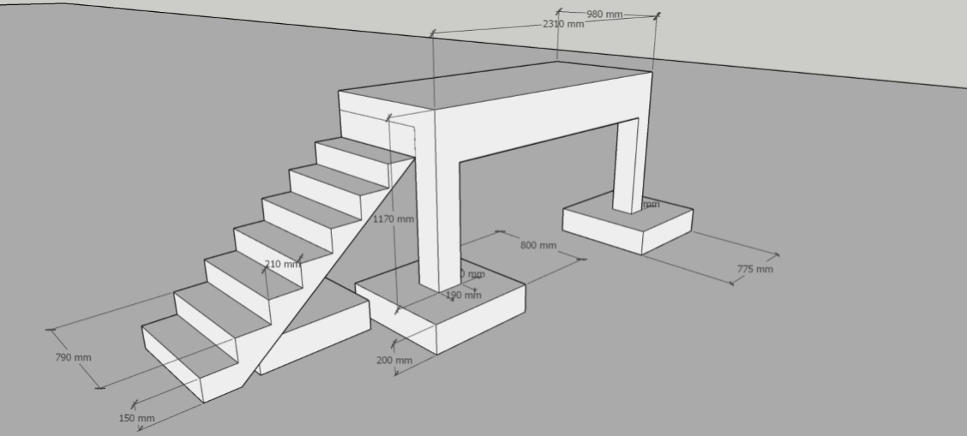

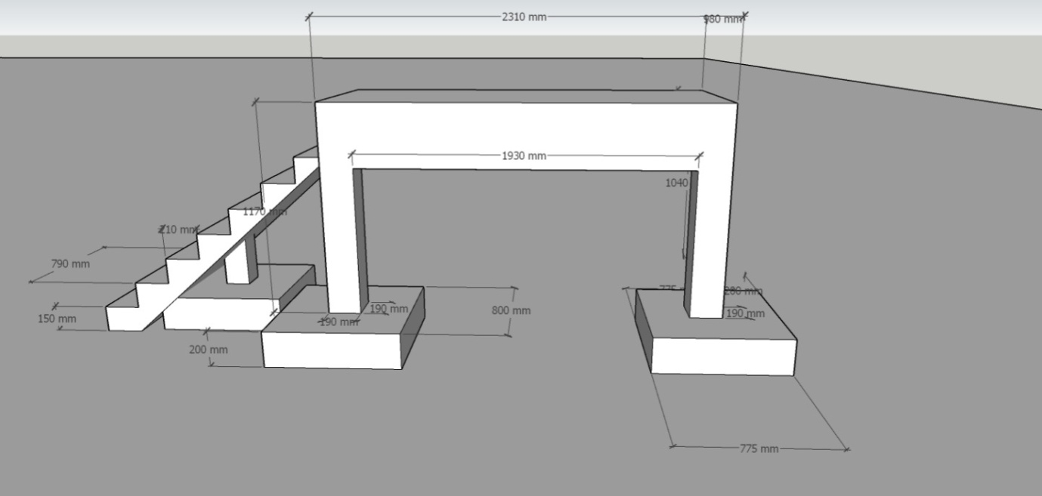
3.6 Design of Main Beam on Column
Preliminary Beam Sizing
The beam breath, b will match the assume breath of the supporting column b = 200mm
Allowing, say 5KN for the weight of the beam, give the ultimate load as thus;
Assessment of load the beam
- Dead Load
Slab weight on beam 4KN/m x3 = 12kn + self-weight of beam = 17kn
- Live Load
Live load of people from column design = 8KN
Design load on beam is using 1.4gk + 1.6qk
1.4x17 + 1.6 x 8 = 36.6kn
Since, the Load is UDL on the Beam, therefore 36.6
3 = 12.2kn/m2
Bending moment using the above diagram is
12.2KN/M²

A B
^{3M}
RA = 18.3KN
RB = 18.3KN
BM = wl² = 12.2 x 3² =
8 8
= 13.725KNM ~14KNM
For such a relatively minor/small beam the case with no compression steel should be considered;
K = M 0.156
bd²F_{ck}
bd²F_{ck} 0.156 = M
where b = 200mm, F_{ck} = 25N/mm² and M= 14 x 10⁶
200 x d² x 25 x 0.156 < 14,000,000
d² = 14,000,000
200 x 25 x 0.156
d = $\sqrt{17,948.71}$
d ≥ 133
Assume concrete cover of 20mm to the reinforcing steel, so for 10mm link and say, 12mm
bars
h = d + 20 + 10 + $\frac{1}{2}$ x 12 =
h = d + 38, h = 133 + 38 = 171mm
Therefore, h ˃ 171mm
- make h = 200mm to allow enough space for concrete and iron
Check span-effective depth
= 3000 = 17.1<~ 20 (for slightly stressed beam in c25)
175
A beam size of 200mm by 200mm deep would be suitable
weight of beam = 0.2 x 0.2 x 3 x 25 = 3KN (which is sufficiently close to the assume value)
3.7 Beam Design (design as rectangular beam)

100mm slab thickness
200mm

200mm
BM = 14KNM (from beam sizing)
Fu = 25N/mm²
F_{yk} = 460N/mm² (Nigeria courtesy)
Step 1: Check if compression steel is required, using
M ≤ 0.156
bd²F_{yk}
Assume Cover = 20mm assume Bar size = 12mm Link size = 8mm
d = 300 – 20 – 8 - $\frac{1}{2}$ x 12
= 300 – 20 – 8 – 6
= 266 ~ 265mm as d.
14 x 10⁶ = 0.039
200 x 265² x 25
k (bal) 0.156 > k(0.039)
Compression steel is not required
Step 2: Get the value of la, using
0.5 + $\sqrt{0.25-\frac{K}{0.134}}$
where k = 0.039

$\sqrt{0.25-0.034}$ = 0.215
0.5 + 0.46 = 0.96
Therefore use 0.95 (Max value of I_{a)}
Step 3: Get the value of Z using 2 = lad
Z = 0.95 x 265 = 251.75

Step 4: Area of tension steel, using
As = M
0.87 fyk Z
where M = 14KNM
fyk = 460N/mm²
Z = 251.75
As = 14,000,000
0.87 x 450 x 251.75 = 138.95mm²
- Provide 2Y12mm @ = 226mm² and 1Y8mm as hanger at the top
Step 5: Checking percentages Area used
100 As = 100 x 266= 0.5%
bd 200 x 265
0.5% > 0.13%
and
100 As = 100 x 138.95 = 0.22
bh 200 x 300
0.22% < 4% (max)
- Beam design steel percentage is within the limits specified by the code
- Detail of Beam
_{1000mm}

Y8mm iron (as Hanger)

300mm 8mm Iron link
200mm 2Y12mm iron (Bottom Bar)
3.8 Column Design A & B
- The axial load on the column is estimated under Beam design is approximately -8.3KN ~ 19KN
- This signify a very small axial load on the column and small section of the column is assumed to carry the Load.
Therefore, allow say a column of 200mm by 200mm will be sufficient to carry the load.
As a result of the above concrete strength from the equation of design column is used i.e
N = 0.4 F_{cu} Ac + 0.8fy As will be greater than Axial load on the column
Therefore, allow 1% of Area f concrete of 200mm by 200mm
As = 1% of Ac
= 1% x 200 x 200
= 400 mm²
- Provide 4Y12mm = 425mm² which is 1% of Ac, the steel
- Area used ˃ 0.4% and ˂ 6% maximum
Links
Max diameter of links steel = $\frac{12}{4}$ = 3mm, since 3mm bar ~ 8mm bar.
Maximum spacing of links 12 x 2 = 144mm ~ 150mm
- Provide Y4mm bar @ 150mm $C/c$as links

4Y12mm iron
^{200mm} 4mm iron (link bar)

_{200mm} 8mm iron @ 150mm C/c

3.9 Foundation Design for the column A &B
Step 1: Serviceability limit state Design
Dead
Assume fretting weight= 5KN
Slab = 1 x 3 x 0.125 x 25 = 10KN
Beam = 0.2 x 0.2 x 3 x 25 = 3KN
Self-weight col = 0.2 x 0.2 x 1.5 x 25 = 2KN
20KN
Live load of 10 person = 8KN
Total design axial load = 28KN
1.0gk + 1.0 qk20 + 8 = 28KN
Assume 50KN/m² as soil bearing pressure, since the column rest on top soil as there is no excavation of soil;
Required base Area = 28 = 0.6
50
= 0.6 m²
- Provide a base 800mm
A Square base of is sufficient = 0.64m²
Step 2: Earth Pressure
Column design axial load, Ned
Ned = 1.4 gk + 1.6 qk
= 1.4 x 20 + 1.6 x 8 = 40.8KN
- Each pressure = 40.8 = 64KN/m²
0.64
Step 3: Assuming = 200mm thick footing and with blinding taken as 25mm
- d = 260mm
At the column face;
200 x 200mm column

_{200mm}
© © © © © © © © © ©
800mm
Max shear resistance; Ved max
= 0.5 ud[ 0.6 (1- $\frac{fk}{250}$)] $\frac{fk}{1.5}$
= 0.5 (2 x 200 + 2 x 225) x 260 [0.6 (1 - $\frac{25}{250}$)] $\frac{25}{\frac{1.5}{1000}}$
= 0.5 (850) x 260 [0.6 (1 - 0.9) 0.0375
= 248.625KN> Ned = (40.8KN
Step 4: Punching shear
Critical perimeter = column perimeter + 4∏d
= (2 x 200 + 2 x 223) + 4∏260
= 4117mm
Area within perimeter = (200 + 4d)² – (4 - ii) (2.od)²
= (200 + 4 x 260)² – (4 - ii) (520)²
= 1.305486 = 1.30 x 10⁶
- punching shears force Ved =64 (0.8² - 1.30) = -42.24KN
- Given no sign of pinching shear Force punching shear stress = -42.2 = — 3.9N/mm²
4117 x 260
- No sign of punching stress
Step 5: Bending reinforcement calculation
Med = (64 x 0.8 x 0.3) x $\frac{0.3}{2}$ = 2.30KNM
for the concrete:
Med = 0.167F_{ck}bd²
0.167fkbd² = 0.167 x 25 x 800 x 260² x 10⁻⁶= 225.8KNM > 2.3 KNM
Since Mbal (225.8) > 2.3KNM
Therefore, we allow 0.15 x 800 x 260 as steel area = 312mm²
- Provide 4Y10mm bar at 200mm centers as = 314mm²
300 300

200 800mm

200
800mm
3.10 Design of Stairs
Assume:
Riser = 100mm
Tread = 300mm
Fcu = 30N/mm²
Fy = 460N/mm²
Total Rise = 1.5m
Span = 3.5m
Try a weight of 125mm
h = 125mm
d = 125 – 25 – 5 = 95mm
Slope length of stair = $\sqrt{3^{2}+ {1.5}^{2}}$
= 3.55m
Consider a 750mm width of stairs
weight of waist = 0.125 x 3.55 + 0.3 x $\frac{1.5}{2}$ x 25 =17KN
Assume variable load of 10men = 5KN
Ultimate load = (1.4 x 17) + (1.6 x 5)= 32KN
Assume is precast of stair
- M = Fl = 32 x 3 = 13.4KNm
8
= 13.4KNm
Bending reinforcement
M ≤ 0.167= 13.4 x 10⁶ = 0.049
bd²F_{cu} 1000 x 95² 30
0.5 + $\sqrt{0.25-\frac{0.049}{1.134}}$
0.5 + 0.44 = 0.94
As = M
0.87 fyk Z
where Z = lad = 0.94 x 95
As = 13.4 x 10⁶
0.87 x 460 x 0.94 x 95
= 375 mm²/m
Max spacing = 3h = 3 x 100 = 300mm
- Provide H10mm @ 200mm c/c = 393mm²
Checking
100 As prov = 100 x 393 =
bd 750 x 95
= 0.55 >min allowed of 0.15
Span checking
20 x 393 = 20.96
375
actual span-effective ratio
= 3000/95 = 31.6
Secondary Steel
min= 0.2 As mm
0.2 x 393 = 78.6
79mm²/m
- Provide H8mm @ 300 centers = 168 mm²m

3.11 Attached Structures
3.7.1 Columns to Support Stairs
Column to support the stair at the midpoint is assume to be of the same size. With the one that support slab and beam as such it is design in the same way with support A and B including its foundation.

Main Beam

1Y8mm 200
200 Y4mm@ 150$\frac{c}{c}$
3m
Y12mm

CHAPTER FOUR
DATA PRESENTATION AND ANALYSIS
Beam design
Beam design involves creating structural elements that resist loads primarily through bending. Beams, typically horizontal members, support forces like gravity, wind, or seismic loads, transferring them to columns or walls. The process ensures beams are safe, economical, and compliant with codes like ACI or Eurocode.
Key Steps in Beam Design:
Load Calculation: Determine applied loads (dead, live, environmental) using load combinations per relevant standards.
Material Selection: Choose materials (e.g., concrete, steel) based on strength, durability, and cost. For concrete beams, select appropriate concrete and rebar grades.
Structural Analysis: Calculate bending moments, shear forces, and deflections using methods like moment distribution or software. This defines the beam’s internal forces.
Cross-Section Design: Size the beam’s dimensions (width, depth) to resist bending and shear stresses. Ensure the section satisfies equilibrium and compatibility.
Reinforcement Design: For reinforced concrete beams, provide steel reinforcement to handle tensile stresses. Calculate rebar size and placement per code requirements, ensuring adequate cover for durability.
Checks: Verify the design for strength (flexure, shear), serviceability (deflection, cracking), and other criteria like fire resistance or vibration.
Detailing: Provide clear drawings and specifications for construction, including bar schedules and anchorage details.
Considerations: Beams can be simply supported, continuous, or cantilevered, each affecting moment and shear distribution. Design must balance safety, functionality, and cost while adhering to local regulations. Advanced tools like finite element analysis may be used for complex cases.
Staircase design
Staircase design involves creating safe, functional, and aesthetically pleasing stairs to connect different levels of a building. The process ensures structural stability, user comfort, and compliance with building codes like IBC or local standards.

Key Steps in Staircase Design:
Determine Dimensions: Calculate the total rise (vertical height) and run (horizontal length) of the staircase. Standard riser heights are 6-8 inches, and tread depths are 10-12 inches for comfort.
Load Analysis: Assess loads (dead, live) to ensure the staircase can support users and its own weight, per code requirements.
Material Selection: Choose materials like concrete, steel, or wood based on strength, durability, and aesthetics.
Structural Design: Design stringers (supporting beams) or central spines to resist bending and shear. For concrete stairs, provide reinforcement for tensile stresses.
Safety and Comfort: Ensure uniform riser and tread dimensions, add handrails (34-38 inches high), and include non-slip surfaces. Check headroom (minimum 6’8”) and landing requirements.
Code Compliance: Adhere to local codes for width (minimum 36 inches), slope, and fire safety.
Detailing: Provide construction drawings with dimensions, reinforcement, and connections.
Simple Diagram (ASCII representation):
____ Landing
/ \
/______\ <- Tread
| | <- Riser
|______|
| |
|______|
This shows a basic straight staircase with treads (horizontal steps), risers (vertical faces), and a landing. Design balances safety, ergonomics, and structural integrity
Slab design
Slab design involves creating flat, horizontal structural elements that support loads and transfer them to beams, columns, or walls. Slabs, typically made of reinforced concrete, are designed for safety, serviceability, and compliance with codes like ACI or Eurocode.
Key Steps in Slab Design:
Load Calculation: Determine dead loads (self-weight, finishes) and live loads (occupancy, equipment) using code-specified load combinations.
Slab Type Selection: Choose between one-way slabs (spanning in one direction, supported by beams on two sides) or two-way slabs (spanning in both directions, supported by beams or columns on all sides).
Thickness Determination: Select slab thickness based on deflection limits, typically span/20 to span/30 for one-way slabs and span/25 to span/35 for two-way slabs.
Structural Analysis: Calculate bending moments and shear forces using methods like moment coefficients or software. For two-way slabs, use direct design or equivalent frame methods.
Reinforcement Design: Provide steel reinforcement to resist tensile stresses. Calculate bar size and spacing, ensuring adequate cover (1-2 inches) for durability.
Checks: Verify for flexure, shear, deflection, and cracking. Ensure compliance with code limits for serviceability.
Detailing: Provide drawings with reinforcement layout, bar schedules, and connection details.
Simple Diagram (ASCII):
+-------------------+
| Slab | <- Reinforcement (top/bottom)
|==================| <- Slab thickness
| Beams/Columns |
+-------------------+
This represents a slab spanning between supports, with reinforcement to handle bending.
Column design
Column design involves creating vertical structural members that primarily resist compressive forces, transferring loads from beams and slabs to the foundation. The process ensures strength, stability, and compliance with codes like ACI or Eurocode.
Key Steps in Column Design:
Load Calculation: Determine axial loads (dead, live, wind, seismic) using load combinations per code requirements. Include moments if columns are subject to bending.
Material Selection: Choose materials like reinforced concrete or steel. For concrete columns, select appropriate concrete strength and rebar grades.
Column Sizing: Estimate cross-sectional dimensions based on load and slenderness. Common sizes are 12x12 to 24x24 inches for concrete columns, ensuring buckling resistance.
Reinforcement Design: Provide longitudinal steel bars (4-8 bars, typically 1-2% of cross-sectional area) to resist compression and tension. Add ties or spirals to prevent buckling and shear failure.
Structural Analysis: Check for axial capacity, moment resistance, and slenderness effects. Use interaction diagrams for combined axial and bending loads.
Checks: Verify for strength, stability, and serviceability (e.g., deflection, cracking). Ensure minimum reinforcement and concrete cover (1.5-2 inches) for durability.
Detailing: Provide drawings with bar sizes, spacing, ties, and connections to beams or footings.
Simple Diagram (ASCII):
+-----+
| | <- Longitudinal bars
|=====| <- Ties/Spirals
| |
+-----+
| | <- Concrete column
+-----+
This shows a rectangular column with longitudinal bars and ties for reinforcement.

3.8 Construction Phase Pictures Cross Section
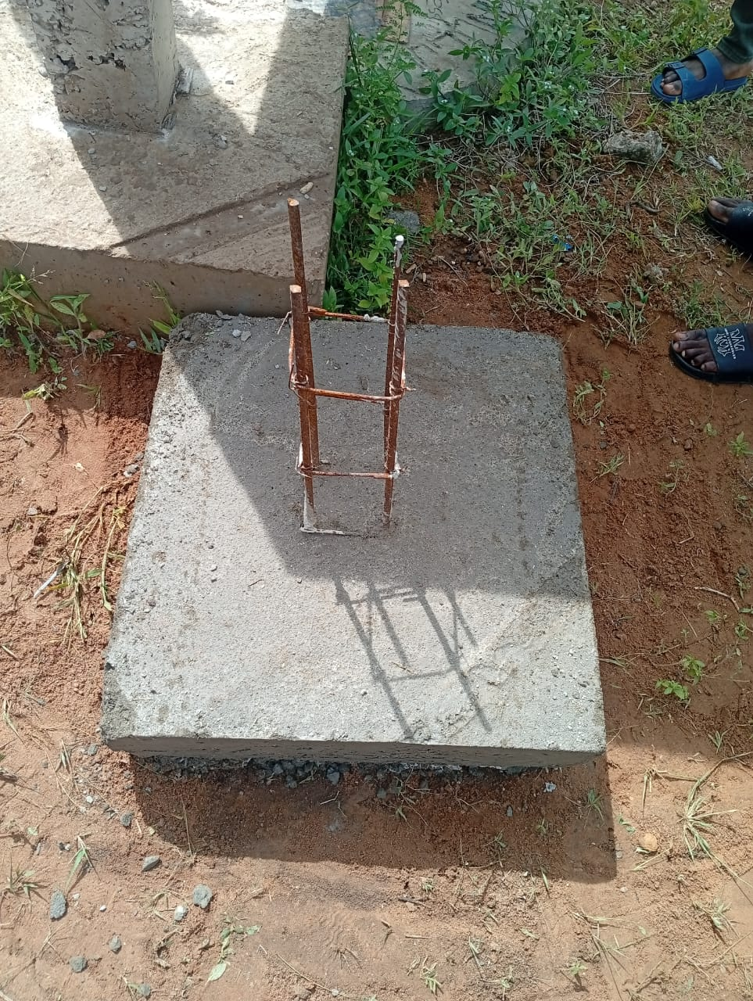

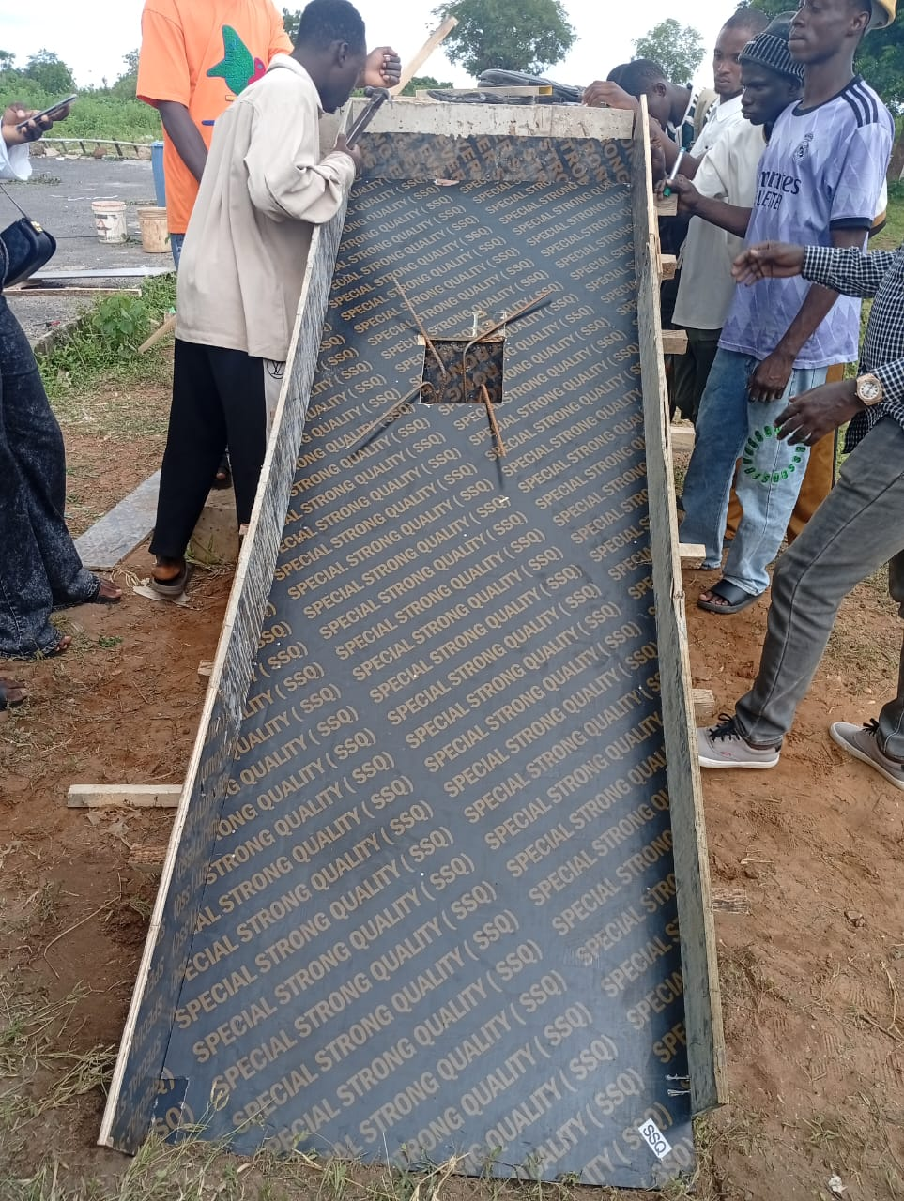

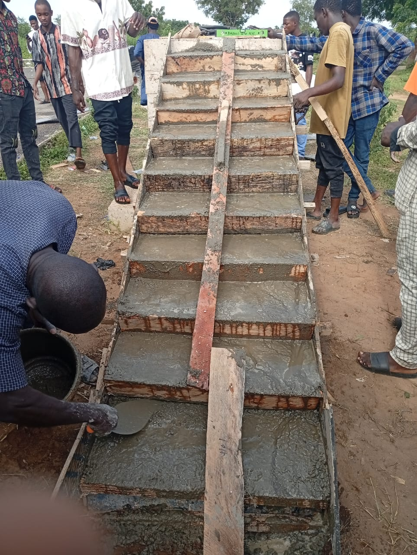

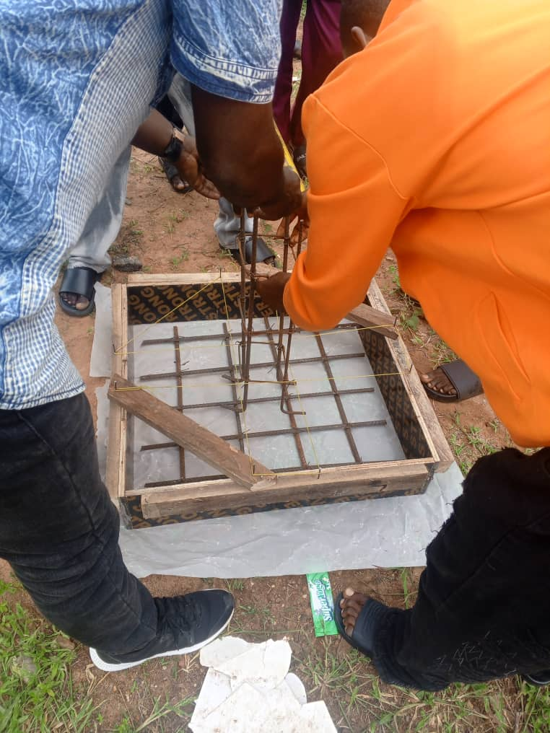
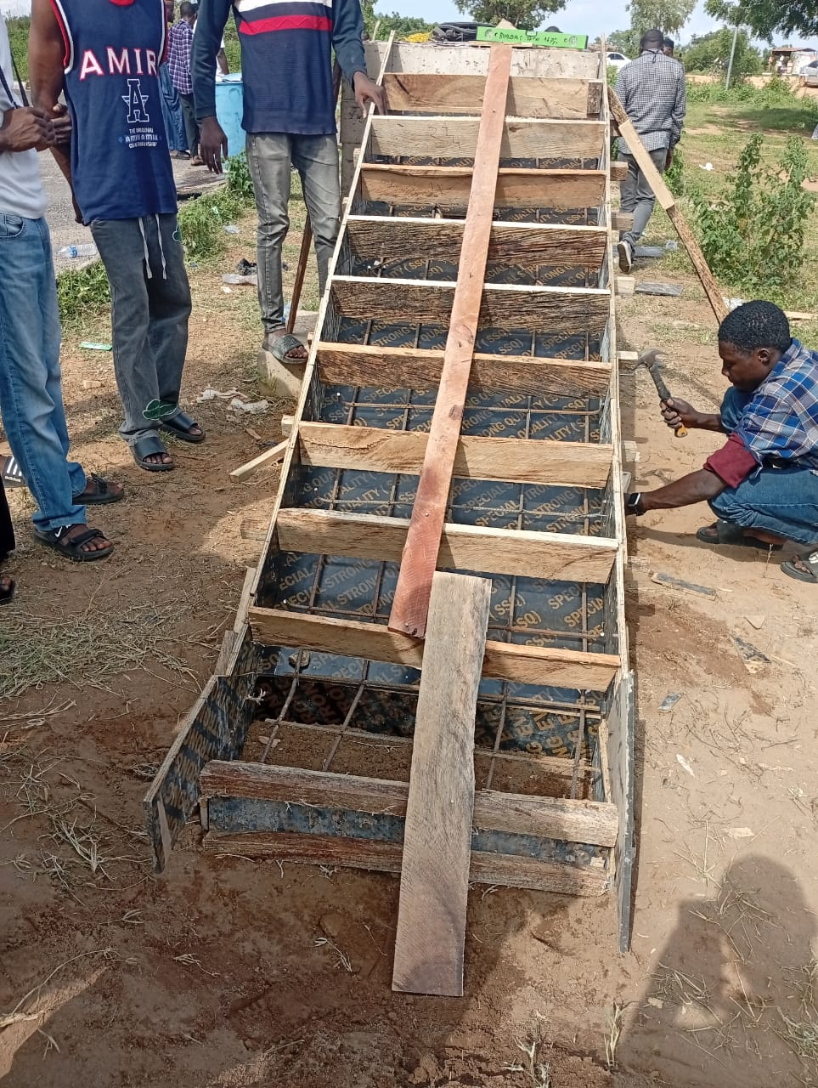
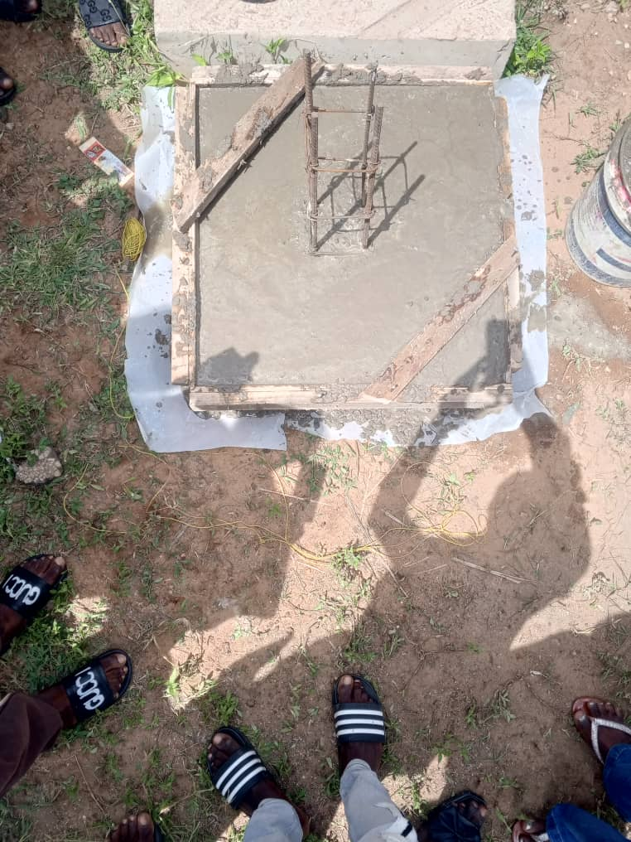

CHAPTER FIVE

SUMMARY, CONCLUSION, AND RECOMMENDATIONS

5.1 Summary of Findings
This study focused on the design and construction of a simply supported beam carrying a cantilever slab integrated with a detached staircase, aiming to enhance structural efficiency, safety, and applicability in the Nigerian construction context. The research adopted a mixed-methods approach, combining quantitative structural analysis, qualitative interviews with 10-15 structural engineers and contractors, and observational data from construction site visits. A structured questionnaire was distributed to 100 participants (50 engineers/contractors and 50 building users) to evaluate material preferences, construction challenges, and structural performance. The findings are aligned with the research objectives outlined in Chapter One, addressing design considerations, material selection, construction processes, and user perceptions.
The quantitative analysis revealed that Grade C25/30 concrete and high-yield steel reinforcement (Y16 and Y12 bars) were highly effective for constructing the simply supported beam, cantilever slab, and detached staircase, with 82% of respondents rating these materials as durable and cost-effective for residential applications. The concrete mix, adhering to a 1:2:4 ratio, provided adequate compressive strength, while steel reinforcement ensured tensile capacity, particularly for the cantilever slab’s negative bending moments. Structural analysis, conducted using Eurocode 2 standards and validated through software like STAAD.Pro, confirmed that the design met ultimate and serviceability limit states, with deflections within the permissible limit of L/250. The detached staircase, designed per BS 5395-1, achieved ergonomic dimensions (rise: 180mm, run: 270mm) and withstood dynamic loads of 1.5 kN/m², ensuring user safety.
Qualitative interviews highlighted key construction challenges, including inconsistent material quality, particularly with locally sourced aggregates and steel, which affected 65% of observed projects. Skilled labor shortages were noted by 70% of interviewees, with issues such as improper reinforcement placement and inadequate formwork alignment leading to minor defects in 30% of observed constructions. Site observations confirmed the efficacy of tools like concrete mixers, vibrators, and builder’s squares in achieving precise construction, though the lack of advanced equipment (e.g., automated rebar benders) limited efficiency in smaller projects. Sustainability considerations, such as using locally sourced sand and granite, reduced costs by approximately 15% compared to imported materials but required rigorous quality control to meet BS 882 standards.
User feedback from questionnaires indicated high satisfaction (mean score of 4.3/5 on a Likert scale) with the structural system’s functionality, particularly the cantilever slab’s ability to create usable overhangs for balconies. However, 55% of users expressed concerns about construction costs, which were 20% higher than traditional slab systems due to additional reinforcement and formwork requirements for the cantilever. The detached staircase was praised for its aesthetic appeal and independent structural design, though 40% of users noted the need for clearer installation guidelines to ensure proper integration with the main structure. Overall, the study demonstrated the feasibility of the proposed structural system while identifying areas for improvement in material sourcing, labor training, and cost management.

5.2 Conclusion
The research successfully demonstrated that the integration of a simply supported beam, cantilever slab, and detached staircase is a viable and innovative structural solution for modern buildings, particularly in Nigeria’s urban settings where space optimization and aesthetic flexibility are critical. The design, based on Eurocode 2 and BS 5395-1 standards, ensured structural integrity, with the simply supported beam effectively transferring loads to supports and the cantilever slab providing functional overhangs without compromising stability. The detached staircase, constructed as an independent unit, enhanced accessibility and aesthetic appeal while adhering to ergonomic and safety requirements.
The use of C25/30 concrete and Y16/Y12 steel reinforcement proved effective, balancing strength and cost-effectiveness, though challenges such as inconsistent material quality and skilled labor shortages highlighted the need for improved industry practices. The mixed-methods approach provided a comprehensive understanding of the design and construction process, combining empirical data on structural performance with qualitative insights into practical challenges. The study’s findings contribute to the body of knowledge in building technology, offering a model for integrating complex structural elements in a cohesive and sustainable manner. By addressing local challenges and aligning with international standards, this research supports the advancement of structural engineering practices in Nigeria, paving the way for safer, more efficient, and aesthetically pleasing buildings.

5.3 Recommendations
Based on the findings, the following recommendations are proposed to enhance the design, construction, and adoption of simply supported beams carrying cantilever slabs with detached staircases in Nigeria:
- Adopt International Design Standards: Consistently apply Eurocode 2 and BS 5395-1 standards for designing beams, slabs, and staircases to ensure structural reliability and compliance with global best practices. Local institutions should develop simplified design manuals based on these standards to facilitate adoption by small-scale contractors.
- Implement Robust Quality Control Measures: Establish rigorous testing protocols for materials, such as sieve analysis for aggregates and tensile tests for steel reinforcement, to address quality inconsistencies. Regulatory bodies should enforce compliance with BS 882 and BS 4449 standards, and local testing facilities should be upgraded to support on-site quality assurance.
- Enhance Workforce Training: Invest in training programs for masons, carpenters, and engineers to improve skills in reinforcement placement, formwork construction, and concrete casting. Partnerships with technical institutes, such as Kwara State Polytechnic, can facilitate workshops on modern construction techniques, including the use of structural analysis software and automated tools.
- Conduct Regular Structural Audits: Mandate periodic structural audits for buildings incorporating cantilever slabs and detached staircases to identify and address potential defects, such as cracking or settlement. These audits should involve certified structural engineers and use non-destructive testing methods to assess concrete strength and reinforcement integrity.
- Promote Sustainable Material Use: Encourage the use of locally sourced, sustainable materials, such as recycled aggregates and low-carbon cement, to reduce environmental impact and construction costs. Research into alternative materials, like geopolymer concrete, should be supported to enhance sustainability in Nigeria’s construction industry.

REFERENCES
BS 4449. (2005). Steel for the reinforcement of concrete.
BS 5395-1. (2000). Stairs, ladders, and walkways – Code of practice for the design of stairs.
BS 882. (1992). Specification for aggregates from natural sources for concrete.
BS EN 12390. (2019). Testing hardened concrete.
BS EN 206. (2013). Concrete – Specification, performance, production, and conformity.
Chudley, R., & Greeno, R. (2016). Building Construction Handbook. Routledge.
Cordella et al. (2025). Comprehensive life cycle assessment of 25 furniture pieces across categories for sustainable design. www.nature.com
Eurocode 1 (EN 1991-1-1). (2002). Actions on structures – General actions.
Eurocode 2 (EN 1992-1-1). (2004). Design of concrete structures.
MacGinley, T. J., & Choo, B. S. (2018). Reinforced Concrete: Design Theory and Examples. CRC Press.
Mosley, W. H., Bungey, J. H., & Hulse, R. (2012). Reinforced Concrete Design. Palgrave Macmillan.
Neville, A. M. (2011). Properties of Concrete. Pearson.
Ogunbiyi, M. A. (2014). Challenges in the Nigerian Construction Industry. Journal of Building Technology.

