GREEN SYNTHESIS OF SILVER NANOPARTICLE USING CALOTROPIS PROCERA LEAVES AND ITS ANTIMICROBIAL EFFECT ON SOME BACTERIAL AND FUNGAL ISOLATES.

BY
JACKSON ESTHER INYANG
HND/23/SLT/FT/0596

A PROJECT SUBMITTED TO THE DEPARTMENT OF SCIENCE
LABORATORY TECHNOLOGY, INSTITUTE OF APPLIED
SCIENCES (IAS), KWARA STATEPOLYTECHNIC, ILORIN

IN PARTIAL FULFILMENT OF THE REQUIREMENT FOR THE
AWARD OF HIGHER NATIONAL DIPLOMA (HND) DEGREE IN
SCIENCE LABORATORY TECHNOLOGY, INSTITUTION OF
APPLIED SCIENCES (IAS), MICROBIOLOGY UNIT
KWARA STATE POLYTECHNIC ILORIN

JULY, 2025

i

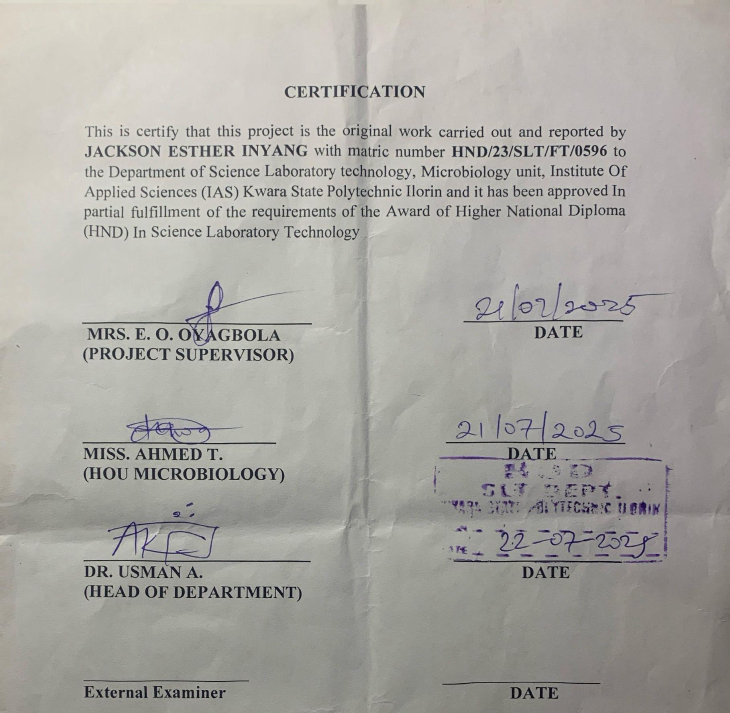

DEDICATION
This project work is dedicated to Almighty Allah, the provider and the protector of my life, the source of wisdom, knowledge and understanding and to my parent Mr. and Mrs. JACKSON, master promise my brother, my supervisor for their support and to all people I may not mention their name that stand by me throughout this journey.

iii

ACKNOWLEDGEMENT

All praise, adoration and glorification due to Almighty God, the most beneficent, merciful and the ancient of days, the creator and sustainer of the universe for sparing my life till this very moment to see and to conquer all challenges.

I acknowledge my supervisor, Mrs. E.O Oyagbola, who has nurture in spite of her extremely busy and tight schedule to read through my project report.

I will also acknowledge my benefactor of knowledge for his fatherly roles and words of encouragement and to other viable lecturers in the department (microbiology unit), who has contributed in one way or the other and positively in planting me qualities, and moral values. May God reward you all!

My highest gratitude goes to my beloved, caring, amazing and wonderful parents, Mr. and Mrs. Jackson, master promise for their support, advice, caring, and their motivational speech.

To crown it all, I congratulate myself on my successful completion of my programme in Kwara State Polytechnic.

TABLE OF CONTENT

Title page i
Certification ii
Dedication iii
Table of content iv
Abstract vi
CHAPTER ONE
1.0 Introduction 1
1.1 Literature Review 3
1.1.1 Overview of Silver nanoparticles and their antimicrobial properties. 6
1.1.2 Protocols for the Biosynthesis of Silver Nanoparticles (AgNPs). 13
1.1.3 Plant-mediated Biogenic Synthesis of AgNPs and their Antimicrobial Activity. 16
1.1.4 Calotropis procera’s medicinal properties and Potential Application. 26
1.2 Research Aim and Objectives. 33
1.3 Research Problems. 34
CHAPTER TWO
2.0 Materials and Methods. 35
2.1 Collection of Plant Extract and Bacterial and Fungal Isolates. 35
2.2 Preparation of Calotropis procera extract and Silver nitrate. 36
2.3 Synthesis of Silver nanoparticles using leaf extracts (Phytochemical properties) 37
2.4 Characterization of Silver nanoparticles. 40
2.5 Antimicrobial activity Assays. 47
CHAPTER THREE
3.0 Result 50
3.1 Phytochemical analysis. 50
3.2 Green synthesis of silver nanoparticle using leaf extract. 51
3.3 Characterization of synthesized nanoparticles. 52
3.4 Antimicrobial activity evaluation. 55

CHAPTER FOUR
4.1 Discussion. 58
4.2 Conclusion. 62
REFERENCES 65-73

V

ABSTRACT
In this study, Silver nanoparticles were successfully synthesized using Calotropis procera aqueous leaf extract. The effect of the whole extract and some of its phytochemicals on the particle distribution was determined while other characterizations such as UV-VIS spectrophotometer, Fourier transform infrared (FTIR) spectroscopy, Scanning electron microscopy (SEM) were carried out. The antimicrobial activity against selected microorganism was also studied using the agar diffusion method. The leaf extract showed the presence of phenols, flavonoids, saponins, steroid, terpenoids, alkaloids, and tannins. The UV-vis spectra displayed the characteristics Plasmon resonance at 400nm, The FTIR plots highlighted important functional groups including peaks between 3430.17 cm⁻¹, 2966.00 cm⁻¹, and 1753.00cm⁻¹ respectively confirming the formation of Silver oxide. Calotropis procera/AgNo₃ displayed significant antimicrobial activity against Klebsiella pneumoniae , Pseudomonas spp, Penicillum spp., Aspergillus spp,. Trichoderma spp., while no activity was recorded Escherichia coli ,Staphyloccus aureus, Salmonella typhi, Rhizopus spp. This study indicated that Calotropis procera was suitable for the synthesis of silver with properties that suggested that it could be potentially applied as antimicrobial nanofillers.

CHAPTER ONE
1.0 INTRODUCTION
Nanotechnology is an emerging field in the area of interdisciplinary research, especially in biotechnology, hat deals with the synthesis, manipulation and the use of particles ranging in size 1 to 100nm.
Such particles are called nanoparticles (NP) their unique physical, chemical and biological properties could be attributed to their small size and large surface area. The synthesis of noble metal nanoparticles attracts an increasing interest due to their new and different characteristics as compared with those of macroscopic phase that allow attractive application in various fields such as antimicrobial, medicine biotechnology, microelectronics, catalysis, information storage and energy conversion.
Various literatures describe many ways to synthesis nanoparticles which include physical, chemical, and biological methods. The physical and chemical methods used for the synthesis of nanoparticles are not only energy consuming but also non-ecofriendly.
Nanoparticles have attracted significant attention across various domains due to their substantial impact on drug delivery and targeting, reducing toxicity, enhancing efficacy, and creating new avenues for pharmaceutical and drug delivery enterprises. (Blanco et al., 2015; Jokerst et al., 2017).
Green synthesis of nanoparticles has gained significant attention in recent years due to its eco-friendly and sustainable approach. This method utilizes plant extracts as reducing and stabilizing agents, eliminating the need for toxic chemicals.
Silver nanoparticles (AgNPs) are particularly notable for various biomedical applications. Studies have shown that AgNPs can be synthesized using plant extracts such as Calotropis procera leaf extracts which exhibit significant antimicrobial activity. (Kumar et al., 2022).
Capping agents play a vital role in functionalizing and stabilizing synthesized nanoparticles. These biologically acceptable reducing, stabilizing, or capping agents are carefully chosen to ensure compatibility with living systems. (Ocsoy et al., 2018; Javed et al., 2020).
They shield nanoparticles from agglomeration and enhance reduction kinetics by forming complex structures with metallic ions in precursor salts. (Campisi et al., 2016; Sharma et al., 2021).
Silver nanoparticles have been widely explored for their potential application in biomedical fields such as antimicrobial coatings, wound dressing and drug delivery systems. Their unique properties including high surface area and reactivity make effective against a broad range of microorganism. (Singh et al., 2021).
Calotropis procera (fig 1), commonly referred to as the Apple of Sodom or Sodom Apple, belongs to the Apocynaceae family and the Asclepiadaceae subfamily (milkweed family) (Al-Rowaily et al., 2020). It is a perennial shrub or small tree native to North Africa, tropical Africa, and parts of Asia, reaching a height of up to 2.5 m. It holds significance in traditional medicinal practices across North Africa, the Middle East, South Asia, and Southeast Asia (Al Sulaibi et al., 2020).
Additionally, it has been employed for fiber, fuel, fodder, and timber purposes since ancient times (Batool et al., 2020). Numerous studies explore its antimicrobial, anti- inflammatory, analgesic, antidiabetic, antihypertensive, and anticancer properties. Plant extracts have been found to be useful in the synthesis of metal nanoparticles as they possess phytocomponents like alkaloids, glycosides, flavonoids, tannins, glycosides, saponins, and terpenoids which acts as reducing and capping agents. (Rahman et al., 2016; Kalu et al., 2022).
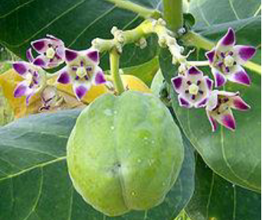
Fig 1. Calotropis Procera plant showing leaves, flowers, and fruit/pods.
There is a number of species of Calotropis procera but most commonly available species include C. sussuela, C. gigantean, C. procera. Calotropis procera can withstand drought, salt tolerance and it disperse seeds through wind and animal. It was identified as a weed alongside roadsides and overgrazed native pastures. It produces milky white latex which posses various curative properties. The medicinal potential of Calotropis procera has been known to traditional systems of medicine for a while now with its leaves being widely used. The use of the plant, plant extracts and pure compounds isolated from natural sources has always provided a foundation for modern pharmaceutical compounds.
Owing to the growing need to reduce or eliminate the use of environmental-toxic substances as the biogenic principles describe, the synthesis of nanoparticles using biological entities has received increasing attention in the last decade.
The biosynthetic procedure involves using microorganisms and plants. Among biological methods, the use of plant extract is the best, eco-friendly, cheaper, and relatively fast as compared to microbes assisted synthesis.
The aim of this study was to synthesis and characterize silver nanoparticle using Calotropis procera leaf extract and evaluate their antimicrobial activity. This research aims to explore the potential application of green synthesized AgNPs in biomedical fields.
1.1.1 Literature Review on Green synthesis of Silver Nanoparticles Using Plants Extracts and Their Bio-Medical Applications.
Synthesis of metal nanoparticles using plant extracts is one of the most simple, convenient, economical, and environmentally friendly methods that mitigate the involvement of toxic chemicals. Hence, in recent years, several eco-friendly processes for the rapid synthesis of silver nanoparticles have been reported using aqueous extracts of plant parts such as the leaf, bark, roots, etc.
This review summarizes and elaborates the new findings in this research domain of the green synthesis of silver nanoparticles (AgNPs) using different plant extracts and their potential applications as antimicrobial agents covering the literature since 2015.
While highlighting the recently used different plants for the synthesis of highly efficient antimicrobial green AgNPs, we aim to provide a systematic in-depth discussion on the possible influence of the phytochemicals and their concentrations in the plants extracts, extraction solvent, and extraction temperature, as well as reaction temperature, pH, reaction time, and concentration of precursor on the size, shape and stability of the produced AgNPs.
Exhaustive details of the plausible mechanism of the interaction of AgNPs with the cell wall of microbes, leading to cell death, and high antimicrobial activities have also been elaborated. The shape and size-dependent antimicrobial activities of the biogenic AgNPs and the enhanced antimicrobial activities by synergetic interaction of AgNPs with known commercial antibiotic drugs have also been comprehensively detailed.
Nanotechnology is gaining enormous attention as a new area of research dealing with the development of nanomaterials and nanoparticles (NPs) for their utilization in diverse fields such as catalysis, electrochemistry, biomedicines, pharmaceuticals, sensors, food technology, cosmetics, etc.(Ayelen et al.,2017;Frewer,2016).
Nanoparticles (NPs) are nanometer-sized (<100 nm) atomic or molecular scale solid particles having some excellent physical properties compared to the bulk molecules depending on their size and morphology.
Among all types of NPs, metal and metal oxide nanoparticles have been thoroughly examined using science and technology due to their excellent properties such as high surface to volume ratio, high dispersion in solution, etc.(Frewer et al.,2014).
Owing to these, metal and metal oxide nanoparticles display enhanced antimicrobial properties. Currently modified or fabricated of NPs is widely utilized in industrially manufactured items e.g., cosmetics, electronics, and textiles. (Ingle et al., 2020).
Furthermore, the rapid increased in the number of microbes resistant to existing antibiotic drugs that has led to the requirement of novel medicines in the form of bare NPs or in conjunction with existing antibiotics to exert a favorable synergistic effect resulted in the wide spread use of NPs in several medical fields.
Nowadays, NPs have been utilized for molecular imaging to achieve profoundly resolved pictures for diagnosis. In addition, contrast agents are impregnated onto NPs for the tumors and atherosclerosis diagnosis. (Bagheri, 2018).
Furthermore, nanotherapeutic has been promoted everywhere throughout the world after the first FDA affirmed nano- therapeutic in 1990, to build up different nano-based drugs.
At the beginning of 20th century, various physical and chemical methodologies such as chemical reduction, milling etc., have been utilized for the synthesis of NPs synthesis as well as to enhance its efficiency. (Vijayan et al., 2016).
However, these conventional techniques involve costly and toxic chemicals and cannot be considered an environmentally benign process. Taking into account, nowadays researchers showed great interest on the synthesis of metal and metal oxides NPs employing bio-genic route that utilized aqueous plant extract and microbes, as they are environment-friendly, stable, clinically adaptable, bio-compatible and cost-effective. (Ahmed, 2016).
Therefore, bio-inspired technology for NPs synthesis became a significant branch in the field of nanoscience and nanotechnology. Till now, numerous metal and metal oxide NPs have been synthesized using plant extract and microbes etc.
Owing to their wide availability, renewability and environment-friendly nature, in addition to their vast applications in the synthesis of NPs, plant biomasses are also largely targeted by our group and others as a catalyst for chemical synthesis and biodiesel productions.
Among Metal NPs, Silver NPs is gaining enormous interest in the research community due to their wide scope of application in microbiology, chemistry, food technology, cell biology, pharmacology and parasitology. The morphology of the silver NPs is the deciding factor of their physical and chemical properties.
Basically, several techniques such as sol–gel method, hydrothermal method, chemical vapor deposition, thermal decomposition, microwave-assisted combustion method etc., have been utilized for the synthesis of silver nanoparticles. (Shen et al., 2012; Zhang et al., 2019).
Recently, bio-genic synthesis of silver NPs (AgNPs) using biomaterials such as plant extract and microbes as reducing agent and their antimicrobial activity is widely investigated. AgNPs are produced by oxidation of Ag + to Ag0 by different biomolecules such as flavonoids, ketones, aldehydes, tannins, carboxylic acids, phenolic and the protein of the plant extracts.
UV-visible spectroscopy is a simple and widely used analytical technique to monitor the formation of AgNPs. Upon interaction with an electromagnetic field, the conducting electrons present in the outermost orbital of metal NPs collectively oscillate in resonance with certain wavelengths to exhibit a phenomenon called Surface Plasmon Resonance (SPR).
The excitation of SPR is responsible for the formation of color and absorbance in a colloidal solution of AgNPs. The SPR peaks at around 435 nm are usually taken to confirm the reduction of silver nitrate into AgNPs. In general, spherical NPs exhibit only a single SPR band in the absorbance spectra, whereas two or more SPR bands were observed for anisotropic particles depending on the shape.35 The absence of peak in the region 335 and 560 nm in UV-Vis spectra are sometime used as an indication of the absence of aggregation in NPs.(Biswas et al ., 2018).
Statistical data analysis in( Fig. 2) depicted the increasing trend of published research papers in the field of biogenic synthesis of AgNPs. These data were collected in September 2020 from “SciFinder Database” using the keyword “Green synthesis of silver nanoparticles”.
From a meagre 259 publications in the year 2001, it has exponentially increased to 3374 publications in 2019. Thus, in this review, an attempt has been made to inspire the researchers to explore the natural resources to synthesize silver nanoparticles by diverse plants and their organs to interconnect nanotechnology with biotechnology into one, termed as nanobiotechnology.
This review will also unlock ideas to utilize different paths for the production of silver nanoparticles, which can help human beings. We have comprehensively discussed the bio-genic synthesis and silver nanoparticles using various plants and their application in antimicrobial activity. We also discussed the effect of the synthesized silver nanoparticles' size and shape in antimicrobial activity towards various pathogenic bacteria.
In an attempt to synthesize metals NPs one has to bear in mind that the success of NPs depends not only on the size and shape but also on stability of NPs as they have the tendency to form large aggregates that lead to precipitation, thereby reducing their efficacy.

Fig. 2 Publications per year for green synthesis of AgNPs during the period 2001 to 2019 (data collected from SciFinder Database).
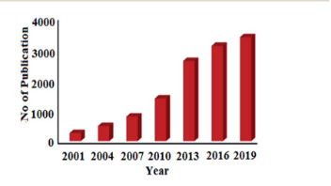
1.1.2 Protocols for the Biosynthesis of Silver Nanoparticles (AgNPs)
Biogenic synthesis of AgNPs is an easy single-step protocol without generating harsh and toxic chemicals; hence, they are save, economical and eco-friendly. In recent years, both plant and microbes are extensively investigated for the biosynthesis of AgNPs of varying size, shape, stability, and antimicrobial efficacy. (Ahmed et al., 2017; Korah et al., 2010).
From plant extract
Various parts of plant such as leaves, roots, flowers, fruits, rhizomes etc., have been successfully utilized for the synthesis of AgNPs. Different parts of plant are collected from various sources, washed properly with ordinary water followed by distilled water to exclude debris and any other unwanted materials. After that, the portions are dried and ground to make powder or utilized as fresh to make the extract.
To prepare the extract, the chopped pieces or the ground powder of the parts of the plant are put in deionized water or alcohol and usually heated below 60⁰C for few hours as high-temperature heating long time may leads to the decomposition of phytochemicals in the biomass extract. Plant extract of different pH is added to the solutions having a different concentration of Ag salt as metal precursor followed by heating at different temperature led to the synthesis of AgNPs. (Yousef et al., 2017; Rajesh et al., 2017).
The progress of the formation of AgNPs can be monitored by visual color changes or using UV-Vis. Spectroscopy, where a sharp peak due to surface Plasmon resonance (SPR) of AgNPs at around 430–450 nm is clearly observed. After successful synthesis of the AgNPs, the mixture is centrifuged at high rpm to separate the NPs followed by proper washing using solvents and dried in an oven at low temperature. The different plant parts extracts that have been successfully utilized in the green synthesis of AgNPs are given in( Fig. 3). (Mankanda et al., 2015; Rave et al., 2016).
Fig 3. Different parts of plants used for biosynthesis of antimicrobial silver nanoparticles
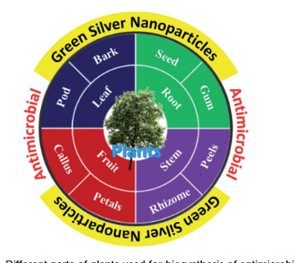
From microbes
Nowadays, the use of microbial cell for the synthesis of metal NPs has come out as a great approach. Microbial cells turn to be excellent biofactories for the synthesis of AgNPs. At first, the cultures are allowed to develop as culture suspension in disinfected distilled water having the culture medium. Then, different concentration of precursor of AgNPs is added into the cultured microbial followed by continuous mechanical stirring under dark conditions.
sThe progress of the reaction is monitored by UV-Vis spectrophotometer. Finally, the resultant AgNPs is separated from the mixture via centrifugation at around 3000 rpm for 10–15 minutes. (Shivaji et al., 2011).

1.1.3 Plant-mediated Biogenic Synthesis of AgNPs and their Antimicrobial Activity.
Owing to the environmental issue, biogenic synthesis of metal and metal oxide NPs is gaining immense attention from the past decades. Reported literature revealed that various plant parts such as leaf, roots, seed, fruits and stem etc., have been utilized for the biosynthesis of NPs. The synthesis of NPs is fully dependent on the biomaterials/phytochemicals present in the extract. This section aims to discuss the various plant parts extract mediated synthesis of AgNPs and their application as antimicrobial.
From leaf
To date, a numerous number of leaves extract have been utilized for the biosynthesis of AgNPs as shown in (Table 1). Skimmia laureola was reported for the synthesis of spherical AgNPs with size 38±0.27 nm and tested against E. coli, K. pneumoniae, P. aeruginosa, P. vulgaris, S. aureus.( Miri et al), have utilized Prosopis farcta extract for the biosynthesis of AgNPs with an average size of 10.8 nm at room temperature (RT). The antimicrobial activity of synthesized AgNPs was tested using disc diffusion method against the Gram-positive (Staphylococcus aureus (PTCC 1431), Bacillus subtilis (PTCC 1420)) and Gram- negative bacteria (Escherichia coli (PTCC 1399), Pseudomonas aeruginosa (PTCC 1074)) and compared with the control.
The results showed that the inhibition diameter is increased for every tested pathogen, indicates that synthesized AgNPs induces cellular damage to the bacteria's, hence can be used as nanoantibiotics. Aloe vera, Eclipta alba, Momordica charantia, Leptadenia reticulate are also used for the production of spherical biogenic AgNPs. In another study, AgNPs were synthesized by using tea leaf extract. Bactericidal activity of the synthesized NPs was tested against S. aureus and E. coli showed that inhibition action is more effective in case of S. aureus (89% inhibition rate) compared to E. coli (75% inhibition rate). In addition, treatment of the NPs against the bacteria leads to impairment of bacterial cell–cell adhesion.( Goswami et al., 2017).
Mukia maderaspatana leave extract was utilized for the biosynthesis of AgNPs with the size range of 58–458 nm. The synthesized nanoparticle was conjugated to the antibiotic ceftriaxone to investigate the antimicrobial activity towards the human pathogens such as B. subtilis, K. pneumonia, S. typhi, S. aureus and compared with the pathogen inhibition efficiency of the free nanoparticle and the antibiotic. The result obtained revealed that the AgNPs conjugated with ceftriaxone showed highest inhibition activity compared to the others. (Harshiny et al., 2015).
AgNPs were also recently synthesized using several leaf extract of plants such as Artocarpus altilis, Crotalaria retusa, Cardiospermum halicacabum, Psidium guajava, and Terminalia chebula. (Bose et al., 2016).
In 2016, Anandalakshmi et al. reported Pedalium murex leaf extract mediated AgNPs. The produced NPs were tested against several microbes and displayed highest ZOI of 10.5 mm (in 15 mL mL1 scale) against E. coli and P. aeruginosa and least activity against Klebsiella pneumoniae (8.5 mm). The shape and size of the resultant AgNPs were elucidated with the help of TEM. The TEM micrographs showed that the sizes of the particles were around 50 nm and were predominantly spherical in shape. The PXRD pattern showed fcc crystal structure. Azadirachta indica promoted synthesis of AgNPs was reported.( Anandalakshimi et al., 2017).
The produced NPs displayed equal efficacy (9mm ZOI) against E. coli, S. aureus whereas the plant extract show no antimicrobial activity.
In 2016, a remarkable work on the synthesis of AgNPs using Urtica dioica leaf extract that showed excellent synergistic effect with known antimicrobial drugs was reported. ( Jyoti et al).
Interestingly, the synthesized AgNPs apart from showing high antimicrobial activities against several microbes, showed excellent synergistic effect in combination with antibiotics and displayed higher antibacterial effect as compared with AgNPs alone. A high 17.8 fold increase in ZOI was observed for amoxicillin with AgNPs against S. marcescens proving the synergistic role of AgNPs. This work provides helpful insight into the development of new antibacterial agents to fight against several new strain of microbes resistant to existing antibiotic drugs. (Fig. 5) displayed the synergistic effect of AgNPs and common antimicrobial drugs.
The synergistic interaction between AgNPs and antibiotic drugs has been clearly identified using UV-Vis and Raman spectrometer. (McShan et al). The authors claimed that this synergistic interaction speed up the ejection of Ag + from AgNPs which in turn boost its antimicrobial activities.

Fig. 5 Synergistic effect of Urtica dioica mediated AgNPs with several antibiotics. This figure has been reproduced from Elsevier, copyright 2016.
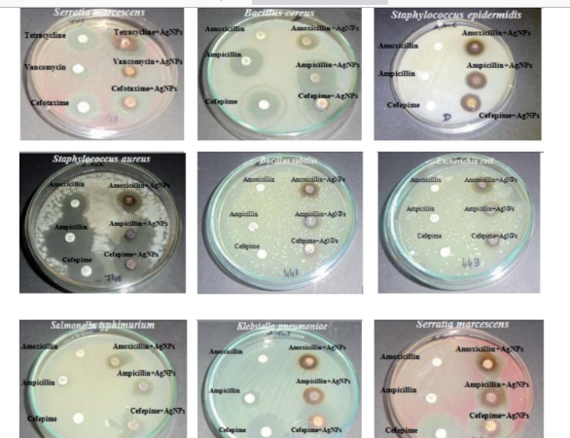
Numerous microbes such as skin bacteria are responsible for skin infection and body odor in feet, shoes, and/or socks mediated through the breakdown of amino acids present in sweat. Hence, proper medication is required for human’s wellbeing. (Shareen et al.,2015).
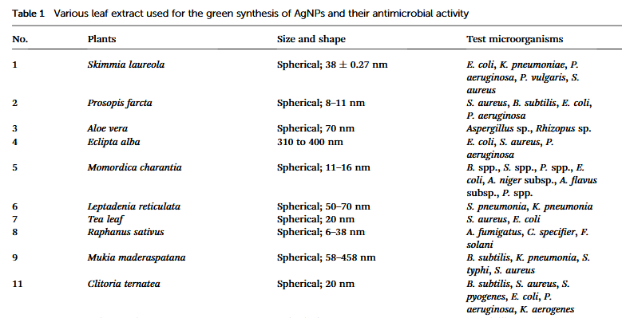
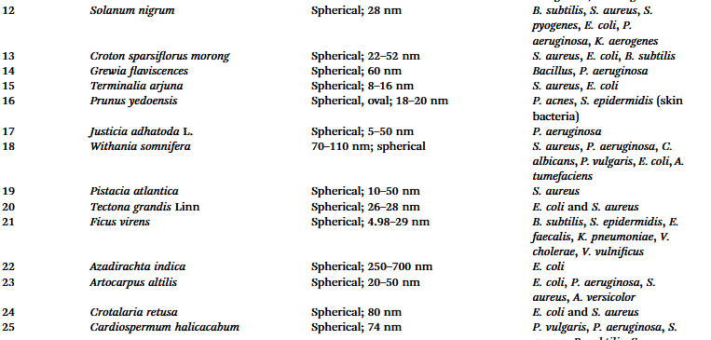
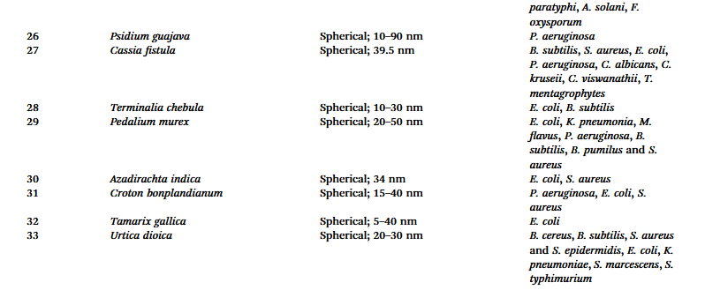
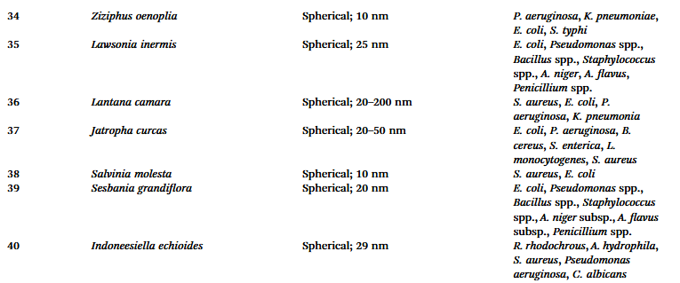
Recently, Manjamadha et al, have reported ultrasonic assisted biosynthesis of spherical AgNPs using Lantana camara L. leaf extract. Biosynthesis of AgNPs using ultrasonication improves the reaction conditions such as reducing reaction time and enhancing the reaction rate. Bactericidal activity of the synthesized AgNPs revealed that it shows excellent antibacterial activity against Gram-positive and Gram-negative bacteria. Leaves of Jatropha curcas collected from Micro model complex, Indian Institute of Technology Delhi campus was used for the production of AgNPs.
The transmission electron microscopy (TEM) analysis showed variation in particle shape and size (20–50 nm), whereas the diameter of NPs was found to be in range of 50–100 nm by scanning electron microscopy (SEM). Complete destruction of the microbial cell was visible using TEM examination.
The synthesized NPs were tested for their antimicrobial activities and based on ZOI data, the pattern of sensitivity was observed in the order as E. coli > P. aeruginosa > B. cereus > S. enterica ¼ L. monocytogenes > S. aureus.(Chauhan et al.,2016; Zhang et al., 2016).
In 2017, Artemisia vulgaris mediated AgNPs were reported by Rasheed et al. Antimicrobial test revealed that the AgNPs exhibited significant inhibition activities against tested pathogens with the highest value being recorded against S. aureus (18±0.27 mm inhibition zone).
In general, the reduction in the size of the metallic nanoparticles is expected to increase the antibacterial activity due to significantly large surface area of the smaller nanoparticles. grandiflora, Eucalyptus citriodora, Juniperus procera and Capparis zeylanica.
In recent times, highly antimicrobial AgNPs were synthesized using Kleinia. Two different shapes structure in the form of sphere and cubic are observed in SEM analysis of the AgNPs generated from Juniperus procera leaf extract. The produced NPs recorded the highest ZOI against P. mirabilis measured at 29±1.3 mm.
The author suggested that the high antimicrobial activity of the NPs is due to the inherent activity of the NPs coupled with the plant particulates attached to the NPs, as the plant which contains high flavonoids and polyphenols are a well-known antimicrobial by themselves.
Synergistic antimicrobial activity of Ligustrum lucidum mediated AgNPs and Epoxiconazole under different conjugation ratio was studied against S. turcica, a common maize pathogen.
The antifungal activity of AgNPs was evaluated alone, and the synergistic inhibition effect was also measured at various conjugation ratios of AgNPs and epoxiconazole, where a prominent synergistic antifungal effect was observed at 8 : 2 and 9 : 1 (AgNPs/epoxiconazole) and the inhibition toxicity ratio reached as high as 1.22 and 1.24, respectively. (Biswas et al., 2019).
In 2020, green synthesis of spherical AgNPs, CuNPs and FeNPs with size 11–19, 28–35 and 40–52 nm, respectively using Syzygium cumini leaf extract was reported. The order of anti- bacterial property against methicillin- and vancomycin- resistance S. aureus, A.flavus and A. parasiticus microbes was found to be Ag- > Cu- > Fe NPs, which linearly relates with the size of the NPs, thereby reinforcing the size-dependent activity of NPs.
In addition, the bioproduction of aflavatoxins (a family of toxins produced by certain fungi that are found on agricultural crops such as maize (corn), peanuts, cottonseed, and tree nuts) in A. flavus and A. parasiticus was also significantly inhibited by AgNPs when compared with the Fe and Cu NPs.
Interestingly, the pH of the plants extract reduced after the formation of NPs in all the cases. Cleistanthus collinus and Cestrum nocturnum are also known to have produced AgNPs.
It is worth note that the AgNPs also consistently displayed a better activity in fungal strain, Penicillium sp. than bacteria such as E. coli and Staphylococcus sp. which is hardly a case in any literature as bacteria are usually considered more sensitive to AgNPs than fungi.

1.1.3 CALOTROPIS PROCERA’S MEDICINAL PROPERTIES AND POTENTIAL APPLICATION
The use of plant-based remedies to treat human and animal illness dates back thousands of years. In many cultures, plants have long been relied upon as an effective means of disease prevention and treatment.
Medicinal plants are still the primary source of healthcare in many developing world areas. World health organization (WHO) reports that 80% of the world’s population, mostly in developing nations, relies on traditional medicines to treat common health problems.
They are used medicinally and as a food source in almost every culture. What’s more impressive is that plants provide the basis for nearly 25% of today’s pharmaceuticals.
They are regarded as invaluable sources of pharmaceutical products including herbal medicines, and their use contributes significantly to primary healthcare delivery.
Bioactive plant products have been a major research and development focus in the food and pharmaceutical industries.
Calotropis procera, it is common in Indonesia, Malaysia, China, and the Indian subcontinent. The medicinal properties of the plant have long been recognized, and its parts have been used to treat a wide range of conditions, including rheumatism, painful muscular spasms, fever, dysentery, diabetes, malaria, asthma, and more. In recent years, studying synergies in phytomedicine has emerged as an important new field of study.
Extensive pharmacological studies were conducted on the biological activities of plant extracts and natural products derived from these plants. Exploring the relevant scientific literature is essential for understanding the potential of industrial use of Calotropis procera. (Pattnaik et al., 2017).
This study aimed to compile a comprehensive literature review on the biological potential of its components.
This study will facilitate the dissemination of information about the plant’s potential applications, which in turn will guide future decisions in the fields of food science, herbal medicine, and pharmaceuticals.
Description and origin
Traditional medicine has used Calotropis procera, a plant belonging to the Asclepediaceae family. It’s a shrub that produces latex and thrives in the wild despite the fact that it’s constantly exposed to adverse weather.
When damaged, the plant secretes milky latex that is most abundant in its aerial parts. It protects the plant from harm and is full of useful secondary compounds and enzymes. Swallow wort in English, madar in Hindi, and Tumpapiya in Hausa are just some of the common names for this plant. It reaches a height of 2.5–6 m and has a soft woody, upright form. It prefers warm climates, dry, sandy, and alkaline soils, and is therefore widespread across the globe (Fig 5) .(Chaudhary et al., 2015;Konno et al., 2011). It thrives in a variety of other environments, including landfills, abandoned lots, wastelands, roadside ditches, and sand dunes.
Fig. 5 Pictures of Calotropis procera collected from wild.
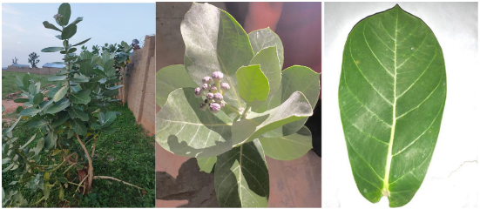
Multiple biological assessments of the plant’s constituent parts were performed, each employing a unique assay to confirm the plant’s efficacy, as discovered by the research.
Calotropis procera is known for its medicinal properties including antibacterial, antifungal, and antiviral activities. The plant’s latex and leaves contain bioactive compounds like cardeniodes, flavonoids and terpenoids that contribute to its therapeutic potentials. (Usman et al., 2020). Calotropis procera have been traditionally used to treat various ailments such as:
Anti-ulcer activity
Calotropis procera has been traditionally used to treat ulcer and research has validated its anti-ulcer properties. The plant’s extract have shown potential in managing gastric ulcers by:
- Reducing gastric acid secretion.
- Enhancing mucosal defense.
- Exhibiting antioxidant properties.

Anti-oxidant activity
Calotropis procera extract have strong antioxidant properties, attributed to their high phenolic content. Antioxidant helps protects cells from oxidative stress, which can contribute to various diseases. The plant’s antioxidant activity has been demonstrated through various assays. (Kumar et al., 2013).
Anti-inflammatory activity
Calotropis procera extracts have shown significant anti-inflammatory activity, which can help alleviate symptoms associated with various conditions including arthritis, wounds and inflammatory bowel diseases. The plant’s anti-inflammatory properties may be attributed to its ability to:
- Inhibit pro-inflammatory enzymes.
- Reduce inflammatory mediators.
- Modulate immune response. (Mohammed et al., 2016).
Anthelmintic Activity
Calotropis procera extracts have demonstrated anthelmintic activity against certain parasites including nematodes. The plant’s anthelmintic properties may be attributed to its phytochemical such as alkaloids and flavonoids. (Shivkar et al.,2015).
Wound Healing.
Calotropis procera has been traditionally used to treat wounds and research has confirmed its wound healing properties. The plants may enhance wound healing by:
- Promoting collagen synthesis
- Increasing tissue strength.
- Exhibiting antimicrobial activity.
Hepatoprotective Activity
The plant’s extract protects the liver from damage caused by toxins or harmful substances. The plant’s hepatoprotective properties may be attributing to its antioxidant and anti-inflammatory activities.

Anti-diarrheal Activity
Calotropis procera has been traditionally used to treat diarrhea and research has confirmed its anti-diarrheal properties. It may reduce diarrhea by:
- Inhibiting intestinal motility
- Reducing fluid secretion.
- Exhibiting antimicrobial activity. (Kumar et al., 2010).

POTENTIAL APPLICATION INCLUDES:
- Pharmaceutical Industry: Development of new drugs or herbal formulation for various heath conditions such as Ulcer, Malaria, and Wounds e.t.c.
- Traditional Medicine.
- Agricultural Industry: Potential use as a natural pesticide or insecticide due to its anthelmintic and insecticidal properties.
- Research and Development: Further studies on the plant’s phytochemical and biological activities could lead to new discoveries and application.
1.2 Research Objectives
- To synthesize silver nanoparticles using Calotropis procera leaf extract.
- To characterize the synthesized nanoparticles using techniques such as UV-VIS Spectroscopy, FTIR, SEM.
- To evaluate the antimicrobial activities of the synthesized AgNPs against some bacterial strains.
- To evaluate the antimicrobial activities of the synthesized AgNPs against some fungal strains.
1.3 Research Problems
- Limited studies on Calotropis procera mediated green synthesis of silver nanoparticles.
- Variability in nanoparticle synthesis methods and outcome.
- Need for more research on antimicrobial application of green synthesized AgNPs

CHAPTER TWO
2.0 MATERIALS AND METHODS
2.1 Collection and Identification of Plant Extract and Bacterial and Fungal Isolates.
Calotropis procera leaves were obtained from Kwara State Polytechnic Boys Hostel Ilorin, Kwara State, Nigeria authenticated at the Department Of Botany, University Of Ilorin, Ilorin.
Clinical isolates: Staphylococcus aureus, Salmonella sp., Escherichia coli and, Klebsiella pneumoniae, Penicillium sp., Aspergillius niger, Trichoderma sp., Rhizopus sp., were collected.
2.2 Preparation of Aqueous Calotropis procera Extracts.
Following the methods of Chhangte et al., (2021) with slight modifications, Calotropis procera leave was prepared by taking 60g of thoroughly washed leaves and finely chopped into small pieces, then it was meshed using mortar and pestle.
After meshing, it was poured into a conical flask and 100ml of distilled water was poured into the flask containing the meshed leaves. The mixture was heated using a Bunsen burner at 60⁰C for an hour.
The mixture was allowed to cool and then it was filtered using Whattman No 1 Filter paper. The filtrate was collected and was stored at 4ºC further analysis.
Preparation of Aqueous Silver Nitrate (AgNO3)
A 1mM AgNO3 (Silver trioxonitrate (V)) solution was prepared by weighing 0.0170g of AgNO3 using an analytical balance and dissolving it in distilled water to reach the 100ml mark of a 100ml volumetric flask.
2.3 Synthesis of Silver nitrate using Calotropis procera leaf extract
The filtrate extracted from the leaf extract was collected and 10ml of the filtrate was added to 45ml of 1mM AgNO3 solution prepared in a 300ml conical flask.
The mixture was stirred using a stirring rod and the conical flask containing the silver nanoparticle prepared was covered with a foil paper and a black polythene bag and placed in a dark box for bioreduction process and it was further observed for change in colour.
Note: Storing in a dark place was to prevent photosynthesis and photodecomposition because silver nanoparticle are sensitive to light and storing in a dark place can help reduce or minimize the effect of light and allowed the reaction to proceed slowly and consistently.
After three days of storing in a dark place, the color changed from light green to dark brown confirming the synthesis of AgNPs.
The synthesized Calotropis procera- AgNPs were obtained through centrifugation, eliminating the supernatant and then dried.
2.3.1 Phytochemical Screening
The synthesis of silver nanoparticles(AgNPs) using Calotropis procera leaf extract involves a green reduction process where phytochemical present in the extract act as reducing and stabilizing agents.
The leaf extract of Calotropis procera is rich in various phytochemicals, including flavonoids, terpenoids, alkaloids, saponin, glycoside, tannins steroid which have been reported to possess reducing properties.
These phytochemical screening plays a crucial role in the synthesis of AgNPs by reducing silver ion(Ag+) to silver nanoparticles (AgO). Phytochemical screening was performed using standard procedure.
By using different specific reagents, the presence of main groups of natural products was detected in the ethanolic extract of Calotropis procera.
Alkaloids.
To a few milliliters of the plant sample extract, two drops of Mayer’s reagent are added along the sides of the test tube. The appearance of a white creamy precipitate indicates the presence of alkaloids (Banu and Catherine, 2015).
Tannins
For the detection of tannins, 2mL of the extract is placed in a test tube and gently heated for 2 minutes. An orange color observed after adding 3 drops of ferric chloride indicates the presence of tannins. (Rashed et al., 2019).
Saponins
5mL of the extract sample was diluted with 15 mL of distilled water. The resultant mixture was shaken strongly; the appearance of foam indicates the presence of saponins (Oscar et al., 2020).

Flavonoids
A portion of the extract was dissolved in 2mL of 50% methanol. Metallic magnesium chips and a few drops of concentrated hydrochloric acid were added. The appearance of a red color indicates the presence of flavonoids. (Namadina et al., 2020).

Glycosides
Glycosides were detected by adding a few drops of glacial acetic acid, ferric chloride, and concentrated sulfuric acid to each sample through the side wall of the test tube. A reddish-brown color appeared at the junction of the two layers, and the upper layer appeared bluish-green (Rajitha et al., 2022).

Terpenoids
A small sample of the extract was treated with 1mL of acetic anhydride, 1 mL of trichloromethane, and 1mL of sulfuric acid. The production of a violet color indicates the presence of terpenoids (Oscar et al., 2020).

2.4. Characterization of Green Synthesized Nanoparticles
The synthesized silver nanoparticles (AgNPs) were characterized using Spectrumlab 752s UV-Vis spectroscopy, Fourier Transform Infrared Spectroscopy PerkinsElmer3000 MX model, Scanning Electron Microscopy(JSM-7600F)JEOL model.

2.4.1. FOURIER TRANSFORM INFRARED SPECTROSCOPY (FTIR).
Fourier transform infrared spectroscopy (FT-IR) analysis was performed in all samples isolated to have a prompt result regarding the biomineral. A few crystals were mixed with KBr (Merck for spectroscopy) and pulverized in an agate mortar to form a homogenous powder from which, under a pressure of 7 tons, the appropriate pellet was prepared.
All spectra were recorded from 4000 to400 cm1 using the Pelkin Elmer 3000 MX spectrometer. Scans were 32 per spectrum with a resolution of 4 cm1.The IR spectra were analyzed using the spectroscopic software Win-IR Pro Version 3.0 with a peak sensitivity of 2cm1.
FTIR PROCEDURE AND INSTRUCTION
1. Sign on the notebook.
2. Turn on the computer and sign in.
3. Tune on the power of the instrument, wait until the initialization succeeded. In the small panel of instrument “Perkin Elmer Spectrum 100 Series” will be shown if the initialization succeeded, otherwise come to see Jianhua first.
4. Clean the sample holder by acetone with Kimwipes, make sure not to splash the acetone on the instrument.
5. Launch the “spectrum” software on the desktop with User Name of “Analyst” and Password “analyst”, then select “Spectrum 100”
6. Select “Instrument setup” button, “Scan and Instrument Setup” dialog will pop up, input your sample name, scan range (the range limit is 650-4500 cm-1), and scan number.
7. Click the “back ground” button to collect back group information of the sample holder.
8. Place you sample on the sample holder. If your sample is liquid, you can go ahead and press “Apply” and then “Start” to collect the spectrum. If your sample is solid, click the “monitor” button on the “Scan and Instrument Setup” dialog first, and then lower down the pressure arm, through the “monitor” dialog to monitor the total pressure applied to the sample, set the “Force Gauge” to be around 80, then click “finish”. Press “Apply” and then “Start” to collect the spectrum.
9. Data processing: Peak label: Select “view” from the menu, and then “label peaks”. If you want to label a special peak, “view”-------“cursor”-----“vertical continuous”, then move the cursor to the peak you want, and then “view”-----“label cursor”. Data saving: you can save your data as ASCII by “File”---------“Save as”, the select “ASCII (*. ASC) as the save as type.
10. Turn off the software, log off the computer, and switch off the instrument. Make sure to clean the sample holder completely before you leave FTIR.

2.4.2. PRINCIPLE AND CAPACITIES OF SCANNING ELECTRON MICROSCOPE (SEM)
The types of signals produced by a SEM include secondary electron (SE), back-scattered electrons (BSE), characteristic X-rays, light (cathodoluminescence) (CL), specimen current and transmitted electrons.
Secondary electron detectors are standard equipment in all SEMs, but it is rare that a single machine would have detectors for all possible signals. The signals result from interactions of the electron beam with atoms at or near the surface of the sample.
In the most common or standard detection mode, secondary electron imaging or SEI, the SEM can produce very high-resolution images of a sample surface, revealing details less than 1 nm in size.
Due to the very narrow electron beam, SEM micrographs have a large depth of field yielding a characteristic three-dimensional appearance useful for understanding the surface structure of a sample. This is exemplified by the micrograph of pollen shown above.
A wide range of magnification is possible, from about 10 times (about equivalent to that of a powerful hand-lens) to more than 500,000 times, about 250 times the magnification limit of the best light microscopes.
Back-scattered electrons (BSE) are beam electrons that are reflected from the sample by elastic scattering. BSE are often used in analytical SEM along with the spectra made from the characteristic X-rays, because the intensity of the BSE signal is strongly related to atomic number (Z) of the specimen.
BSE images can provide information about the distribution of different elements in the sample. For the same reason, BSE imaging can colloidal gold immune-labels of 5 or 10 nm diameter, which would otherwise be difficult or impossible to detect in secondary electron images in biological specimens.
Characteristics X-rays are emitted when the electron beam removes an inner shell electron from the sample, causing a higher-energy electron to fill the shell and release energy. These characteristics X-rays are used to identify the composition and measure the abundance of elements in the sample.
SAMPLE PREPARATION
All samples must be of an appropriate size to fit in the specimen chamber and are generally mounted rigidly on a specimen holder called a specimen stub. Several models of SEM can examine any part of a 6-inch (15 cm) semiconductor wafer, and some can tilt an object of that size to 45⁰.
Samples are coated with platinum coating of electrically conducting material, deposited on the sample either by low-vacuum sputter coating or by high-vacuum evaporation. SEM instruments place the specimen in a relative high-pressure chamber where the working distance is short and the electron optical column is differentially pumped to keep vacuum adequately low at the electron gun.
The high-pressure region around the sample in the ESEM neutralizes charge and provides an amplification of the secondary electron signal. Low-voltage SEM is typically conducted in an FEG-SEM because the field emission guns (FEG) is capable of producing high primary electron brightness and small spot size even at low accelerating potentials.
Embedding in a resin with further polishing to a mirror-like finish can be used for both biological and materials specimens when imaging in backscattered electrons or when doing quantitative X-rays microanalysis.
2.4.3. UV-VIS SPECTROPHOTOMETER
This method is based on the principle that molecules absorb light at specific wavelength. When a plant extract is exposed to UV-Vis light, the molecules within the extract absorbs some of the light while the rest passes through. The amount of light absorbed is measured and plotted against the wavelength creating a spectrum.
PROCEDURE
- Extract the plant material using a suitable solvent (ethanol, water).
- Filter the extract to remove any solid particle.
- Diluted the extract to an appropriate concentration so it falls within the instrument’s detection range.
- Turn on the UV-Vis spectrophotometer and allow it to warm up.
- Set the wavelength range you want to scan
- Calibrate the instrument using a blank.
- Place a curvette filled with the blank solution in the spectrophotometer
- Run a scan to establish a baseline.
- Remove the blank and replace it with a curvette containing the plant extract.
- Run the scan and the instrument will measure the absorbance of the extract at each wavelength.
- The instrument generates a spectrum showing absorbance versus wavelength.
- Identify the peaks in the spectrum which indicate the wavelength where the extract absorbs the most light.
- Using the absorbance values at specific wavelength to quantify the concentration.

2.5. Antimicrobial activity
It is a well known fact, that silver ions and nanoparticles are highly toxic and hazardous to microorganisms. It is found out that the silver nanoparticles have many inhibitory and bactericidal effects and so its application is extended as an antibacterial agent. The antibacterial activity of silver nanoparticles is estimated by the zone of inhibition. Many different studies have shown that silver nanoparticles can affect the membrane permeability and respiratory function by attaching to cell surface. Another possibility is that silver nanoparticles not only interact with the surface of the membrane, but can also penetrate deep inside the bacteria. Another observation explains that the silver nanoparticles have relatively higher antibacterial activity against gram negative bacteria than gram positive bacteria, which may be due to the thinner peptidoglycan layer and presence of beta barrel proteins called porins.
Ten microbial strains were used to screen the antimicrobial activity of Calotropis procera/AgNO₃ ; one gram-positive (Staphylococcus aureus),four gram negative bacteria( Escherichia coli, Klebsiella pneumonia, Pseudomonas sp., Salmonella typhi) and five fungal isolates(Aspergillus niger, Penicillum sp.,Trichoderma sp., Rhizopus sp).
The level of susceptibility of each test organism was determined using the agar well diffusion method. The plates were inoculated with the test isolates. Afterwards, a sterile cork borer of 5mm diameter was used to make holes in the Potato dextrose agar (PDA) plates. 0.2ml of the extract was filled into each appropriately labeled well.
The inoculated plates were kept at room temperature for 30 minutes to allow the extract to diffuse into the agar and were then incubated at 37 °C for 24 hours. Antimicrobial activity was determined by zones of inhibition, which were quantified by measuring the diameter of the zone of inhibition in millimeters (mm) using a meter rule after incubation (Okorondu et al., 2015).

CHAPTER THREE
3.0 RESULTS
3.1 Phytochemical Analysis
Phytochemical analysis was carried out to test the contents of Flavonoids, Alkaloids, Saponin, Terpenoids, Glycosids, Tannins, Steriods in the leaves of Calotropis procera . The phytochemical screening followed standardized method.
Table 1: Result of Qualitative phytochemical screening of Calotropis procera leaves
Test | Result
Flavonoids | +
Alkaloids | ++
Saponin | +
Terpenoids | +
Glycosides | +
Tannins | ++
Steroid | +

Key:
+ Present in trace form
++ Moderately present
Table 2: Result of Quatitative phytochemical screening of Calotropis procera leaves
Test | Result(mg/100g)
Flavonoids | 0.173 ± 0.011
Alkaloids | 13.20 ± 0.044
Saponin | 1.33 ± 0.380
Terpenoids | 0.04 ± 0.020
Glycosides | 0.18 ± 0.120
Tannins | 12.77 ± 0.253
Steroid | 0.32 ± 0.142

3.2 Green synthesis of Silver Nanoparticle
To avoid photo-activation of silver nitrate, the mixture was incubated in the dark at room temperature for 72hours. The colour changed from light green to grey color that confirms the reduction of Ag⁺ to Agº .
Fig 1 Color change of leaf extracts containing silver after synthesis of silver nanoparticle.
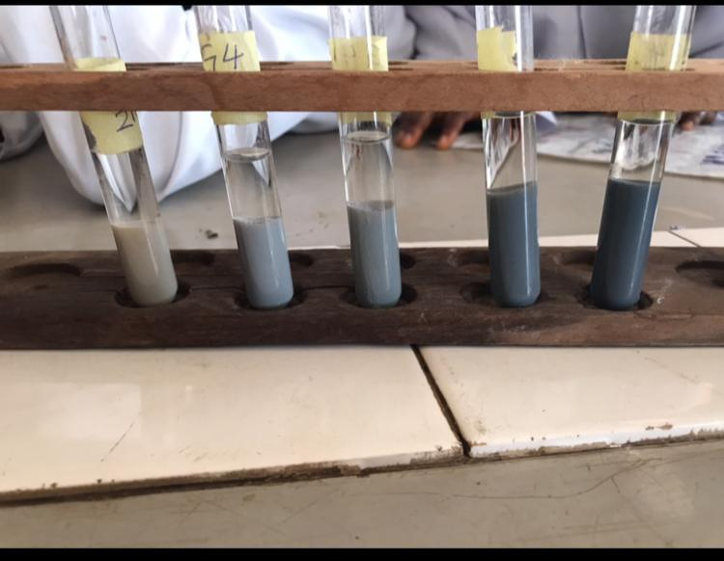

3.3 Characterization of synthesized silver nanoparticles.
UV-VIS Spectroscopy
The formation of silver nanoparticles is characterized by discoloration that occurs at the time of incubation. Each mixture of AgNPs reaction with leaves of Calotropis procera was measured at a wavelength of 200-600nm giving its peak at 350nm.
Fig 2 UV-VIS absorbtion spectra of silver nanoparticle synthesized from Calotropis procera leaves at 1Mm silver nitrate.

Wavelength (nm)

FOURIER TRANSFORM INFRARED SPECTROPHOTOMETER
The FTIR spectroscopy was carried out to identify the chemical composition and nano silver particles of the test sample. The spectra were taken from resulting disk over the frequency range at 4400-250cm⁻1.
Fig 3. FTIR spectrum of silver nanoparticle synthesized by Calotropis procera leaf extracts.

SCANNING ELECTRON MICROSCOPY
A Scanning electron microscope was used to evaluate the morphology of samples containing AgNPs of Calotropis procera on a copper grid before being dried at room temperature giving a magnification both in 8000x and 9000x.
Fig 4 SEM images of magnification 8000x and 9000x of the silver nanoparticles synthesized by Calotropis procera leaf extracts
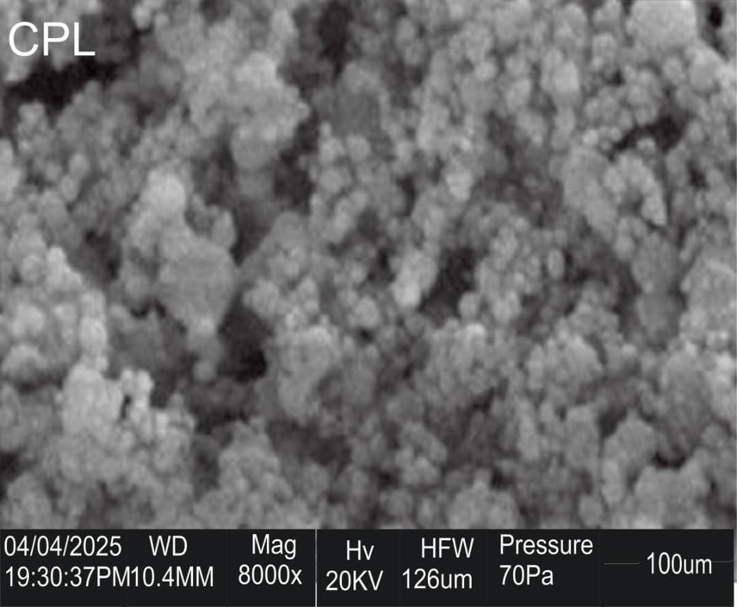
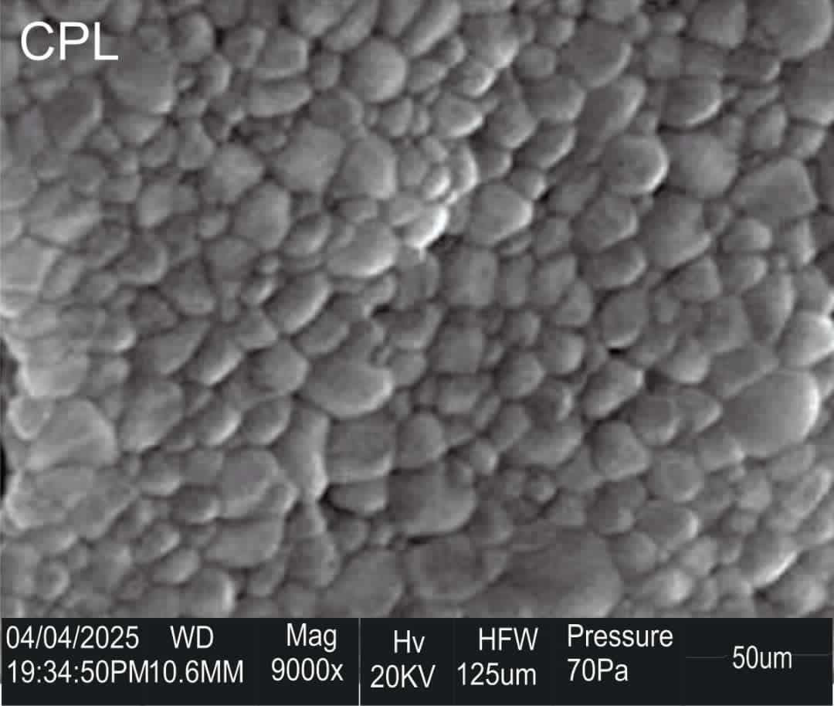

3.4 Antimicrobial Activity Evaluation.
The antimicrobial activity of silver nanoparticles synthesized by plant extracts were tested against some pathogenic bacteria isolates such as E. coli, P. aeruginosa, S. aureus, S. typhi, K. pneumoniae and against some pathogenic fungi; F. oxysporum, Rhizopus sp., A. niger, Penicillum sp. Using well diffusion method. The diameter of inhibition zone (mm) around each well with silver nanoparticle solution is represented in table 3 and 4.
Table 3 Antibacterial activity (Zone of inhibition) of C.p-AgNPs leaf extract
BACTERIA SPECIES | 250ppm | 500ppm | 1000ppm
Klebsiella pneumoniae | - | - | 24mm
Staphylococcus aureus | - | - | -
Pseudomonas spp. | - | - | 17mm
Escherichia coli | - | - | -
Salmonella typhi | - | - | -

Table 4 Antifungal activity (Zone of inhibition) of C.p-AgNPs leaf extracts.
FUNGI SPECIES | 0.1ml | 0.2ml | 0.3ml | 0.4ml
Penicillum spp. | - | 23mm | 24mm | 23mm
Aspergillus spp. | - | 23mm | - | -
Trichoderma spp. | 20mm | 19mm | 25mm | -
Rhizopus spp | - | - | 18mm | -
Fig 2. Effect of silver nanoparticle synthesized by leaf extract of Calotropis procera on K. pneumoniae, Pseudomonas sp., Staphylococcus aureus, Escherichia coli, Salmonella typhi.
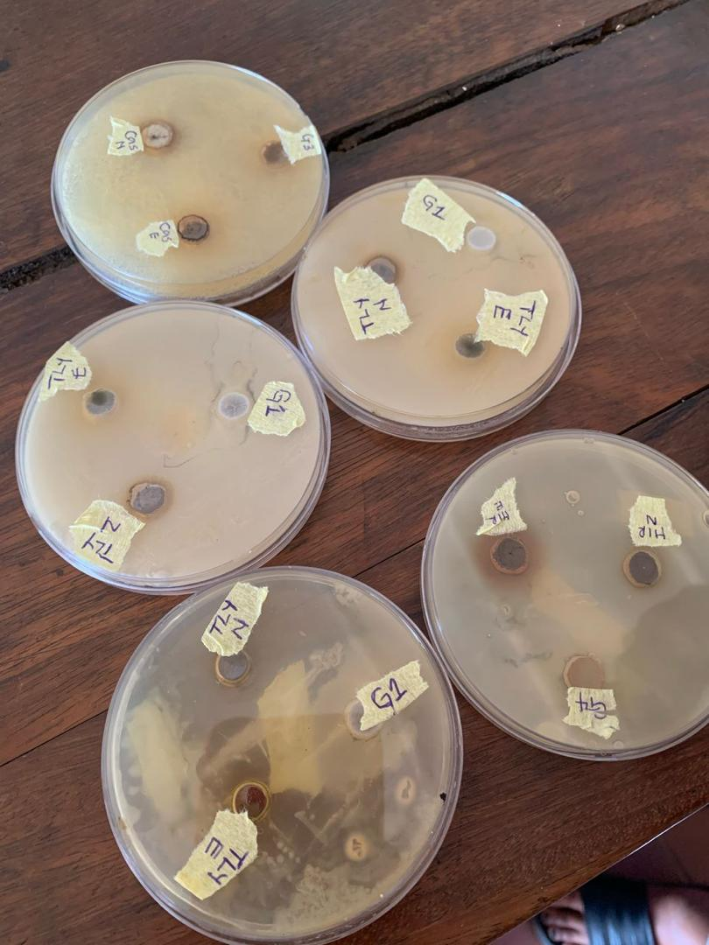
Fig 3 Effect of silver nanoparticle synthesized by leaf extract of Calotropis procera on Pencillium spp,Trichoderma spp., Fusarium oxysporium, Rhizopus sp.
i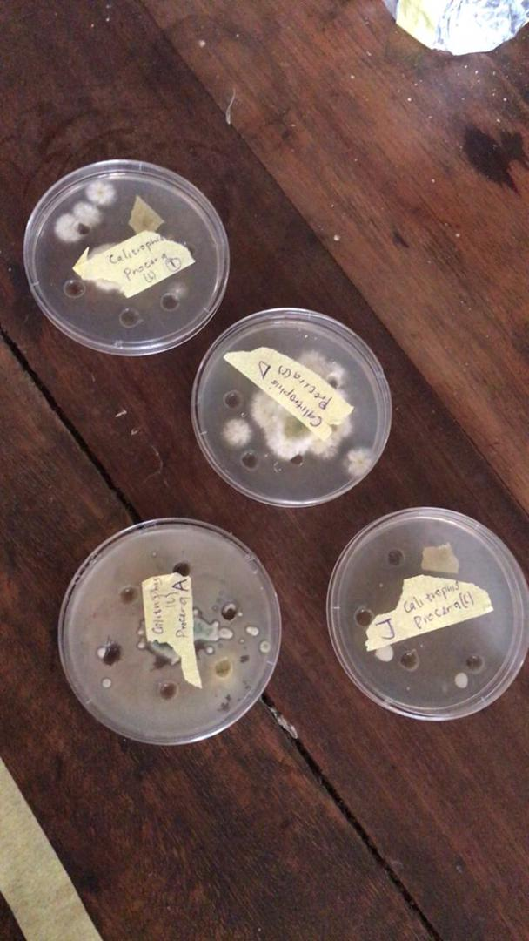

4.1 DISCUSSION
Qualitative and Quantitative phytochemical analysis
The synthesis of silver nanoparticles (AgNPs) using Calotropis procera leaf extract involves a green reduction process where phytochemical present in the extract acts as reducing and stabilizing agents.
The leaf extract of Calotropis procera is rich in various phytochemical including flavonoids, terpenoids, saponins, alkaloids, glycoside, steroids, phenolic compounds and alkaloids which have been reported to possess reducing properties.
These phytochemical plays a crucial role in the synthesis of AgNPs by reducing silver ions (Ag⁺) to silver nanoparticles (AgO). The presence of these biomolecules in the leaf extract enables the formation of stable AgNPs, eliminating the need for additional stabilizing agents.
The phytochemical analysis was carried out to test the content of alkaloids, saponins, phenolics, tannins, flavonoids, steroids and terpenoids in leaf of Calotropis procera. The phytochemical screening followed standardization methods giving results both in qualitative and quantitative analysis in Table 2 and 3.
Green synthesis of Silver Nanoparticle
The Silver nanoparticle (AgNps) synthesis reaction was carried out using leaf extract of Calotropis procera. The reaction is carried out in a dark condition to avoid the photoactivation reaction of silver nitrate.
An indication of AgNPs formation is the occurrence of discoloration in the solution. After some incubation time, it was reported that the AgNPs solution has discoloration to greyish color in fig 1.
Based on the result, it can be concluded that silver nanoparticle synthesized using Calotropis procera have been formed.
UV-Vis Spectroscopy.
The UV-Vis Spectrophotometer depicted in (fig 2), reveals absorbance peaks at a ƛmax of 350nm, which is consisted with the characteristics absorption pattern of AgNPs. This observation aligns with the finding of Hao and Qingha (2017), who conducted a study on the green synthesis of silver nanoparticle and their antimicrobial activities.
In their research, the reported distinct surface Plasmon adsorption peak at approximately ƛmax 400nm indicative of silver nanoparticles.
FTIR Spectroscopy
The FTIR Spectrum (fig 3) of silver nanoparticle showed strong IR band characteristics of Hydroxyl (3430.17cm⁻¹), alkane (2966.00, 2587.73, 2538.00cm⁻¹), c=c of benzene (1753.52cm⁻¹), aromatic amines (1190.44cm⁻¹) and aliphatic amines (1027.45cm⁻¹) functional groups.
The FTIR analysis strongly supported the capping behavior of bioreduced silver nanoparticle synthesized by Calotropis procera leaf extract which in turn imparted the high stability of the synthesized silver nanoparticle.
Scanning Electron Microscopy (SEM)
(Fig 4) shows the SEM images of Calotropis procera/AgNO₃. The micrographs showed mainly irregular shaped particles with areas of uniform dispersion and areas of particles aggregation.
It has been suggested that these areas of aggregation can be attributed to yht interaction between the formed nanoparticles and some of the phytochemical involved in its synthesis could be due to steric silver interaction between individual nanoparticles. These particles aggregation observed could however limit its ability to disperse uniformly when applied as nanofillers.
Antimicrobial Activity of Calotropis procera/AgNO₃
(Table 3 and 4), describes the antimicrobial activity of Calotropis procera /AgNO₃ against isolated microorganisms. It can be observed that antimicrobial activity ranged between 17mm-24mm (zone of inhibition) against Klebsiella pneumonia, Pseudomonas sp., Penicillum sp., Aspergillus niger, Trichoderma, Fusarium while no activity was observed against Rhizopus sp., Staphylococcus aureus, Escherichia coli, Salmonella typhi.
The result in this study also showed the antimicrobial activity against gram negative ( Klebsiella pneumonia) was significantly higher than other microorganism tested while activity against fungal isolates was significantly higher than gram positive bacteria.
Overall, the antimicrobial activity of silver oxide nanoparticles and sensitivity to different microbes vary in different reports, this could be due to the methods of synthesis, functionalization, particle size, silver concentration and microbial strain tested.

4.2 CONCLUSION
The study demonstrates the bio-reduction of aqueous silver ions using the leaf extract of the Calotropis procera plant. Characterization of the resulting product was carried out through UV-Vis, ATR-FTIR and SEM analyses. The metal ions were reduced, leading to the formation of silver nanoparticles with an average particle size of as indicated by SEM analysis.
The UV-Vis analysis of AgNPs revealed a surface Plasmon resonance (SPR) characteristic peak at 400nm. ATR-FTIR showed the disappearance of three distinctive peaks at 3430.17 cm⁻¹, 2966.00 cm⁻¹, and 1753.00cm⁻¹, with others exhibiting reduced and increased wave numbers. These changes are responsible for the reduction, capping, and stabilization of the synthesized C.p-AgNPs. The leaves of Calotropis procera emerge as a promising source for green synthesis of silver nanoparticles.
Furthermore, the antimicrobial activity of C.p-AgNPs was investigated, revealing dose-dependent inhibition. The C.p-AgNPs exhibited the best inhibition at 1000ppm against bacteria such as Klebsiella pneumoniae(24.0 mm) and Pseudomonas sp.,(17.0 mm), as well as the C.p-AgNPs exhibited the best inhibition at 0.3ml against fungi such as Penicillum sp., (23.0 mm) and Trichoderma sp.,(25.0mm).
The efficacy of the antimicrobial activity suggests the potential to eradicate resistant human pathogenic bacteria and fungi, and adjusting the concentration of C.p-AgNPs could further enhance their antimicrobial potential.
From this summary, it was concluded that plant mediated synthesis of silver nanoparticles possess potential antimicrobial applications. The characterization analysis proved that the particle so produced in nanodimensions would be equally effective as that of antibiotics and other drugs in pharmaceutical applications. The use of silver nanoparticles in drug delivery systems might be the future thrust in the field of medicine.

REFERENCE
Abdulrahman MD, Ali AM, Fatihah H, Khandaker MM, Mat N (2018) Traditional
Medicinal knowledge of Malays in Terengganu, Peninsular Malaysia. Malay
Nat J 70:349–364
Abdulrahman MD, Zakariya AM, Hama HA, Hamad SW, Al-Rawi SS, Bradosty
SW, Ibrahim AH (2022) Ethnopharmacology, biological evaluation, and
chemical composition Of Ziziphus spina-christi (L.) Desf.: A Review. Adv
Pharmacol Pharm Sci 2022:1–36 https:// doi. org/ 10. 1155/2022/ 4495688.
Al-Rowaily, S. L., Abd-ElGawad, A. M., Assaeed, A. M., Elgamal A. M., El Gendy,
E. N. G., Mohamed, T. A. (2020). Essential oil of Calotropis procera:
comparative chemical profiles, antimicrobial activity, and allelopathic
Potential on weeds. Molecules, 25: 5203.
Al-Sulaibi, M.A.M., Carolin, T. and Thies, T. (2020). Chemical constituents and
uses of Calotropis procera and Calotropis gigantean- a review (Part 1-the
As material and energy resources). Open Chemistry Journal, 7(1).
Banu, K. S. & Cathrine, L. (2015). General Techniques Involved in Phytochemical
Analysis. Int. J. Adv. Res. Chem. Sci., 2(4), 25-32.
Batool, H., Hussain, M., Hameed, M., and Ahmad, R. (2020). A review on
Calotropis procera its phytochemistry and traditional uses. Big Data Agric,
2:29–31.

Blanco, E., Shen, H., and Ferrari, M. (2015). Principles of nanoparticle design for
Overcoming biological barriers to drug delivery. Nature Biotechnology,
33(9), 941-951.
Campisi, S., Schiavoni, M., Chan-Thaw, C. E., and Villa, A. (2016). Untangling the
Role of the Capping Agent in Nanocatalysis, Recent Advances and
Perspectives, Catalysts, 6(12), 185.
Chhangte, V., Samuel, L., Ayushi, B., Manickam, S., Bishwajit, C., and Samuel, L.R.
(2021). Green synthesis of silver nanoparticles using plant extracts and their
Antimicrobial activities: a review of recent literature. RSC Advances,
11:2804.
Dogara AM, Hamad SW, Hama HA, Bradosty SW, Kayfi S, Al-Rawi SS, Lema AA
(2022). Biological evaluation of Garcinia kola Heckel. Adv Pharmacol Pharm
Sci. 2022:1–15. https:// doi. org/ 10. 1155/ 2022/ 3837965.
Javed, R., Zia, M., Naz, S., Aisida, S. O., ul Ain, N., and Ao, Q. (2020). Role of
Capping Agents in the Application of Nanoparticles in Biomedicine and
Environmental Remediation: Recent Trends and Future Prospects. Journal
of Nanobiotechnology, 18(1), 1–15.
Jokerst, J. V., Jeanne, E. L., and Hartanto, J. (2017). Nanoparticle based sensors
For detecting analytes in liquids. Trends in Analytical Chemistry, 97: 445
458.
Kalu, A. O., Egwim, E. C., Jigam, A. A., and Muhammed, H. L. (2022). Green
synthesis of magnetite nanoparticles using Calotropis procera leaf extract
And evaluation of its Antimicrobial activity. Nano Express Papers 3.
Kareem S, Akpan I, Ojo O (2008) Antimicrobial activities of Calotropis procera on
Selected pathogenic microorganisms. Afr J Biomed Res 11:105–110
Kazemipour N, Nikbin M, Davarimanesh A, Sepehrimanesh M (2015) Antioxidant
activity and mineral element contents of Calotropis procera from Iran: a
Traditional medicinal plant in Middle East. Comp Clin Pathol 24:1147
1150.
Kumar S, Gupta A, Pandey AK (2013) Calotropis procera root extract has the
Capability to combat free radical mediated damage. Int Sch Res Notices.
2013:1–8. https:// doi. Org/ 10. 1155/ 2013/ 691372.
Kumar VL, Roy S (2007) Calotropis procera latex extract affords protection
against inflammation and oxidative stress in Freund’s complete adjuvant
induced monoarthritis in rats. Mediat Inflamm 2007:1–7.https:// doi. org/ 10.
1155/ 2007/ 47523.
Mahmoud AD, Abba A (2021) Ethnomedicinal survey of plants used for
management of inflammatory diseases in Ringim local government, Jigawa
State, Nigeria. Ethnobot Res Appl 22:1–27.
Namadina, M. M., Haruna, H. & Sunusi, U. (2020) Pharmacognostic, Antioxidant
and Acute Toxicity Study of Ficus sycomorus (Linn) (Moraceae) Root and Stem
Bark. Fed. Uni. Dutsi Ma J. Sci., 4(2), 605-614.
Ocsoy, I., Tasdemir, D., Mazicioglu, S., Celik, C., Kat, A., and Ulgen, F. (2018).
Biomolecules Incorporated Metallic Nanoparticles Synthesis and Their
Biomedical Applications,Material Letters, 212: 45–50.
Oscar, S. A., Antonio, C. N.,Marina, V., Elsa, R. S. & Gabriel, V. A. (2020)
Phytochemical screening, antioxidant activity and in vitro biological
evaluation of leave extracts of Hyptis suaveolens (L.) from south of Mexico. S
Afr J Bot, 128(2020), 62-66.
Prabha MR, VasanthaK, (2011) Antioxidant, cytotoxicity and polyphenolic
Content of Calotropis procera (Ait.) R. Br. Flowers. J Appl Pharm Sci 1:136
140.
Rahman, M. A., Reichman, S. M., and Hasegawa, H. (2016). Analgesic, anti
inflammatory, and antipyretic activities of Calotropis procera root bark
Extract. Avicenna Journal of Phytomedicine, 6(2), 149-157.
Rajitha, S. A. B., Mohan, C., Upendra, J. M. & Satya P. K. (2022) Antimicrobial
Efficacy of G.hirsutum L. (Bt and Non-Bt) Phytochemical Extracts: The Most
Widely Cultivated Species of Cotton in the World. Syst. Biosci. Eng., 2(1), 1-9.
Rashed, A., Shaeroun, A., Ahmed, A. B., Alqamoudy, H., Mohamed, K. S.,
Almunir, N., Kushlaf, N., EL- mahmoudy, A. M., Misbah, A. A., Oshkondal, S.
T. M. & Almesai, Z. R. (2019) Thin Layer Chromatography (TLC) and
Phytochemical Analysis of Moringa Oleifera Methanol, Ethanol, Water
and Ethyl Acetate Extracts. Saudi J Med Pharm Sci, 5(10), 817-820.
Rasik A, Raghubir R, Gupta A, Shukla A, Dubey M, Srivastava S, Jain H,
Kulshrestha D (1999) Healing potential of Calotropis procera on dermal
Wounds in Guinea pigs. J Ethnopharmacol 68:261–266.
Rathod CP, Ghante MH (2021) Pharmacological screening of mast cell stabilizing,
antiinflammatory and anti-oxidant activity of Calotropis procera extracts.
Turk J ComputMath Educ (TURCOMAT) 12:4338–4352.

Rawat P, Singh PK, Kumar V (2017) Evidence based traditional antidiarrheal
Medicinal plants and their phytocompounds. Biomed Pharmacother
96:1453–1464.

R. Manikandan, B. Manikandan, T. Raman, K. Arunagirinathan, N. M. Prabhu, M.
Jothi Basu, M. Perumal, S. Palanisamy and A. Munusamy, Spectrochim. Acta
Part A, 2015, 138, 120–129.
Sharma, P., Kumari, S., Ghosh, D., Yadav, V., Vij, A., Rawat, P. (2021). Capping
Agent-Induced Variation of Physicochemical and Biological Properties of α
Fe2O3 Nanoparticles, Material Chemistry and Physics, 258, 123899.
Shivkar Y, Kumar V (2003) Anthelmintic activity of latex of Calotropis procera.
Pharm Biol 41:263–265.
Shobowale O, Ogbulie N, Itoandon E, Oresegun M, Olatope S (2013)
Phytochemical and antimicrobial evaluation of aqueous and organic extracts
of Calotropis procera Ait leaf and latex. Niger Food J 31:77–82.

Tsala DE, Nga N, Thiery BNM, Bienvenue MT, Theophile D (2015) Evaluation of
the antioxidant activity and the healing action of the ethanol extract of
Calotropis procera.
Usman A, Mohammad R, Abdullahi A, Zakari A, Usman N (2021) Isolation of
dihydroquercetin cytotoxic screening of the crude extracts. J Chem Soc
Nigeria 46:0083–0093.

Usman A, Onore R, Opaluwa D, Ibrahim A (2020) Phytochemical, antioxidant and
cytotoxic screening of the leaves of Calotropis procera extracts. Trends Sci
Technol J 5:525–528.

vi

