CONSTRUCTION OF AN EGG INCUBATOR

BY:
ODEYEMI ABDULMALIK
ND/23/ABE/FT/0021

BEING A RESEARCH PROJECT SUBMITTED TO THE DEPARTMENT OF AGRICULTURAL AND BIO-ENVIRONMENTAL ENGINEERING TECHNOLOGY, INSTITUTE OF TECHNOLOGY, KWARA STATE POLYTECHNIC, ILORIN.
IN PARTIAL FULFILLMENT OF THE REQUIREMENTS FOR THE AWARD OF NATIONAL DIPLOMA (ND) IN AGRICULTURAL AND BIO-ENVIRONMENTAL ENGINEERING TECHNOLOGY

2024/2025 SESSION

DECLARATION
I hereby declare that this project titled "Construction of an Egg Incubator" is my original work carried out under the supervision of (Engr. Mrs Onipede E.A)
I also declare that to the best of my knowledge, all sources of information used in the course of this work have been duly acknowledged.

________________________
ODEYEMI ABDULMALIK
ND/23/ABE/FT/0021

CERTIFICATION
I, hereby declare that this research project titled CONSTRUCTION OF AN EGG INCUBATOR was carried out by Odeyemi Abdulmalik with matric number ND/23/ABE/FT/0021 is my own work and has not been submitted by any other person for any degree or diploma in any higher institution. I also declare that the information provided therein are mine and those that are not mine are properly acknowledged.

______________________ _________________
Engr. Mrs ONIPEDE E.A DATE
Project Supervisor

______________________ _________________
ENGR. OYEBANRE, O.D DATE
Project Coordinator

______________________ ___________________
ENGR. DR. DAUDA , K.A DATE
Head of Department

______________________ ___________________
ENGR. DR. MRS. YUSUF, R.O DATE
External Examiner

DEDICATION
The project is dedicated to God for His guidance and grace, to the author’s parents for their love and support, and to all who believe in agricultural innovation, with hopes that the work will support sustainable poultry farming.

ACKNOWLEDGEMENT
I would like to thank God Almighty for the strength, wisdom, and grace given to me to successfully carry out this project also, I sincerely appreciate the guidance and support of my supervisor, (Engr. Mrs Onipede E.A) whose constructive criticism, encouragement, and valuable suggestions helped shape this work.
Also, My gratitude also goes to the lecturers and staff of the Department of Agricultural and Bio-Environmental Engineering for their continuous support throughout this academic journey.
I would not end this acknowledgement without appreciating my family for their moral and financial support, especially during the construction and testing phases of this project.

TABLE OF CONTENT
Title Page
Dedication
Abstract
Acknowledgement
Declaration
Table of Content
CHAPTER ONE
1.0 Introduction
1.1 Background of the Study
1.2 Statement of Problem
1.3 Aim and Objectives
1.4 Justification
1.5 Scope of Study
CHAPTER TWO
2.0 Literature Review
2.1 Incubation Technology
2.2 Types of Incubator
2.2.1 Natural Incubator
2.2.2 Artificial Incubator
2.3 Classification of Incubator
2.4 Incubating Parameters
2.5 Review on Artificial incubator
CHAPTER THREE
3.0 Materials and Methodology
3.1 Materials
3.2 Description of the Incubator
3.3 Construction of Incubator
3.4 Operation of Incubator
3.5 Factors considered in construction of an egg incubator
3.6 Bill of Engineering Measurement and Evaluation (BEME)
3.7 Testing of Incubator
CHAPTER FOUR
4.0 Result and Discussion
4.1 Result
4.2 Discussion
CHAPTER FIVE
5.0 Conclusion and Recommendation
5.1 Conclusion
5.2 Recommendation
REFERENCES

ABSTRACT
An egg incubator was constructed using locally available material for affordability to increase the production of chicks and improve the income of poultry farmers. The Incubator was constructed from medium density fibreboard plywood for it's consistency, workability and affordability. To conserve the heat, the Incubating box was lagged with fiberglass. The Incubating box consist of eggs trays, water tray, bulbs, thermostat, hygrometer, fan for optimal Incubating condition. The constructed egg incubator was tested for functionality and effectiveness and the result showed that the range of Incubating temperature and humidity were maintained which indicate the Incubator is suitable for poultry eggs incubator

CHAPTER ONE
INTRODUCTION
1.1 Background of the Study
Agriculture is the science, arts, and practice of cultivating the soil, growing crops, and raising animals for food, fiber and other Products Used to sustain human life it is one of many economics, especially In developing Countries.
Agriculture Includes crop production, animal husbandry, forestry, and fisheries.
Poultry farming plays a vital roles, in global food production and rural development one of the major challenges faced by poultry farmers is the Ineffective and inconsistent Incubatian of eggs which determine the hatch rate and overall productivity. Traditional method of Incubation using broody hens are Unreliable and limited In capacity while imported electric Incubators, effective but at an excorbitant price.
To address this issue there is a need for an egg Incubator using local available material

1.2 Statement of Problem
The natural Incubation can only hatch between 10 - 15 eggs at a time, hence there is a need for artificial Incubator that can hatch a large number of eggs at a time and constructed from locally available materials for affordability by poultry farmers.

1.3 Aim and Objective
The aim of this project is to construct an egg Incubator that can be affordable by poultry farmers to increase the production level while the specific objective is to construct an egg incubator using locally available materials. (MDF plywood) I.e medium density fibreboard plywood

1.4 Justification
This project work will improved chick health, increased hatchability, cost effective and boost production level of poultry farmers year round there by improve their livelihood.

1.5 Scope of Study
The scope of this study is limited to construction of a functional egg incubator using locally available materials
CHAPTER TWO
LITERATURE REVIEW
2.1 Incubation Technology
Incubation is the process of keeping fertilized eggs under controlled environmental condition mainly temperature, humidity and ventilation until they hatch.
2.2 Types of Incubator
There are majorly two types of incubation; natural and artificial
2.2.1 Natural Incubation
Is the process by which a mother hen (broody hen) sit on her eggs to provide the necessary warmth and condition for hatching. The method involves low cost and does not require the use of any machine. However it is limited to small scale production, depends on the hens willingness to sit and has risk of disease or predators.

2.2.2 Artificial Incubation
The method of incubation uses machine called incubator to simulate the condition needed for embryo development it allow for large scale egg hatching offers controlled a consistent conditions and improve hatch rate. However it requires electricity or fuel for the source of energy, has a high initial cost and need technical knowledge for proper operation.
There are various types of artificial incubator, kerosene incubator, electricity incubator, bio -gas incubator, charcoal incubator, solar incubator and hybrid incubator.
(a) Kerosene incubator is the type of incubator powered by kerosene
(b) Electricity incubator is the type of incubator powered by electricity
(c) Charcoal incubator is the type of incubator powered by charcoal
(d) Bio-gas incubator is the type of incubator powered by bio-gas
(e) Solar incubator is the type of incubator powered by Solar
(f) Hybrid incubator is the type of incubator that combine two sources of energy to achieve incubation process.

2.3 Classification of Incubator
Incubator can be classified into still air and forced air incubator
(i) Still air Incubator: Rely on natural convection to circulate air and maintain temperature and humidity levels, temperature and humidity levels are not uniform within the incubator, employ by small scale poultry farmers, have simple design and cost effective.
(i) Forced air Incubator: This type of incubator uses fans to circulate air and maintain uniform temperature and humidity level within the incubator that can improve the hatchability, the design is more complex, expensive and employ by medium and large scale poultry farmers.
2.4 Incubating Parameters
Incubator parameters are the specific conditions required for successful incubation of eggs these parameters include;
1.Temperature: Optimal temperature ranges between 99-100°f (37-38°c) for chickens eggs with slight variation for other poultry species
2.Humidity: Range between 50-60% relative humidity for the first 18 days increasing to 60-70% for the final 3 days
3.Egg turning: Egg should be turned 3-5 times per day, with the turning angle gradually increasing as incubation progress
4.Ventilation: Adequate ventilation is essential to maintain optimal oxygen and carbon dioxide levels within the incubator
5.Positioning of eggs: Eggs should be placed with the larger end (air cell) facing up, ensure proper air space development and chick positioning before hatching

2.5 Review on Artificial Incubator
Many researcher had worked on artificial incubator with various results and recommendation
Hassan et al. (2021) in characterizing an electric incubator recorded a hatchability percentage of 80.9% and concluded that the major challenge of incubators that work with electricity are the excessive billing rate, erratic power supply as well as the complete absence of electricity in remote regions. Equally, most of the incubators in developing countries like Nigeria operate at 60% below designed capacity due fluctuating grid-electric supply. Olaoye et al. (2013) developed a 120 egg capacity electric incubator. The system which was coupled with three 100 watts electric bulbs produced 75.2% fertility in addition to hatchability rate of 64.8%. Muhammad et al (2021) carried out a performance evaluation of a designed HEFINC840 Micro-controller based incubator. The system with a capacity of 840 chicken eggs produced a hatchability and fertility rates of 88.21% and 95.83% respectively.
Ogunwande et al (2015) studied a still-air hatchery that has a non-thermostatic control. The system uses electric bulbs as the heat source with a resistance-varying component as temperature control. With three times daily of the eggs, the system achieved 62% hatchability rate. Harb et al. (2010) studied a 60 capacity poultry egg incubator for small farmers in Egypt. The authors recorded a hatchability rate of 82.6%. Soeb et al (2021) developed a low-cost incubator that is made up of an embedded controller incorporated to an egg turning trays with a hatchery apartment of 116 egg capacity for Bangladesh market. The manual and automatic evaluations of the developed hatchery showed a 79.3% and 87.1% hatchability rate respectively. The eggs were turned both manually and automatically as the case may be at intervals of 6 hours.
Mansaray and Yansaneh (2015) developed a solar power egg incubator that achieved temperature range of 36.8-37.9°C. The evaluation of the system yielded a percentage fertility and hatchability of 43.3% and 23.1% respectively. The study concluded that the low level of hatchability was as result of several external influences such as an overcast weather, improper egg storage, time and energy loss in turning of eggs, faulty eggs etc.
Muhammad et al (2022) studied a thermoelectric egg incubator coupled to a heat storage system. The thermoelectric component is utilized in the daytime process while a heat storage system made up of phase change materials (PCM) which provides thermal energy during off-sunshine (especially nights) periods is the complimentary heat source. The electric energy that is changed to heat for starting the operation is provided with the arrays of the solar PV. The result of the 300 egg capacity system showed that temperature inside incubation chamber was between 36-39°C with 73.3% hatchability.

CHAPTER THREE
MATERIALS AND METHODOLOGY
3.1 Materials
The materials used in the construction of an egg incubator are as follows;
1. MDF plywood (medium density fibreboard plywood)
2. Glass material
3. Hinge and latches
4. Eletric bulb
5. Thermostat
6. Dc fan
7. hygrometer and water tray
8. Egg tray
9. Screw/nails
10.Wires/switches
11.Foam

3.2 DESCRIPTION OF THE INCUBATOR
The egg incubator is constructed from MDF plywood because of it workability, consistency, affordability and conservation of heat the incubator is a rectangular box which consists of egg trays, bulbs, water tray, thermostat and hygrometer fan to maintain optimal condition for the hatchery of eggs. Figure 1 and 2 show the isometric and exploded view of the eggs incubator
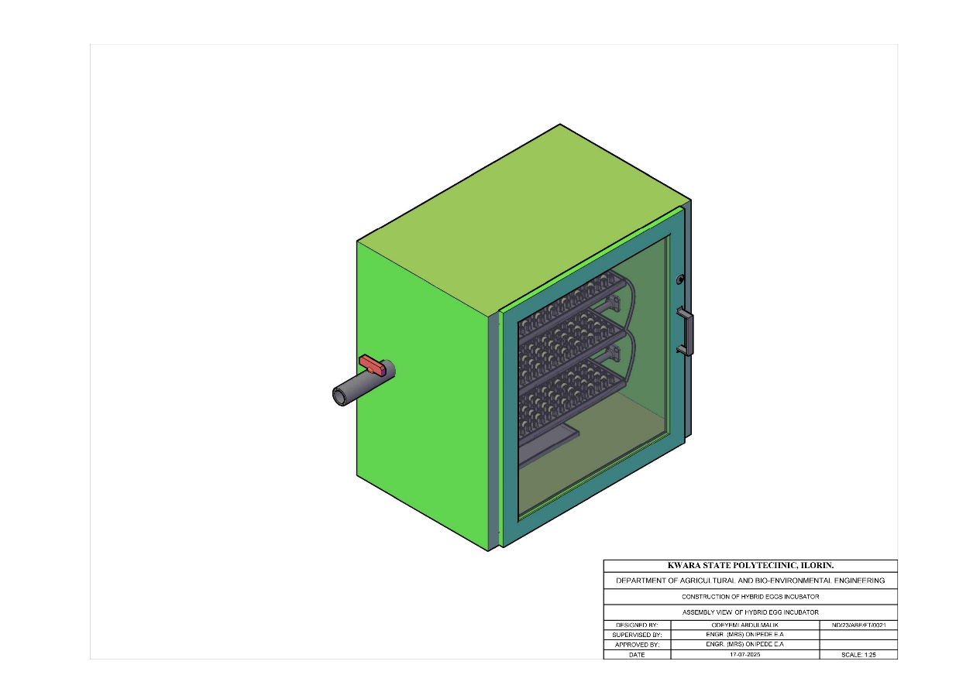

Figure 1: Orthographic view of the egg incubator

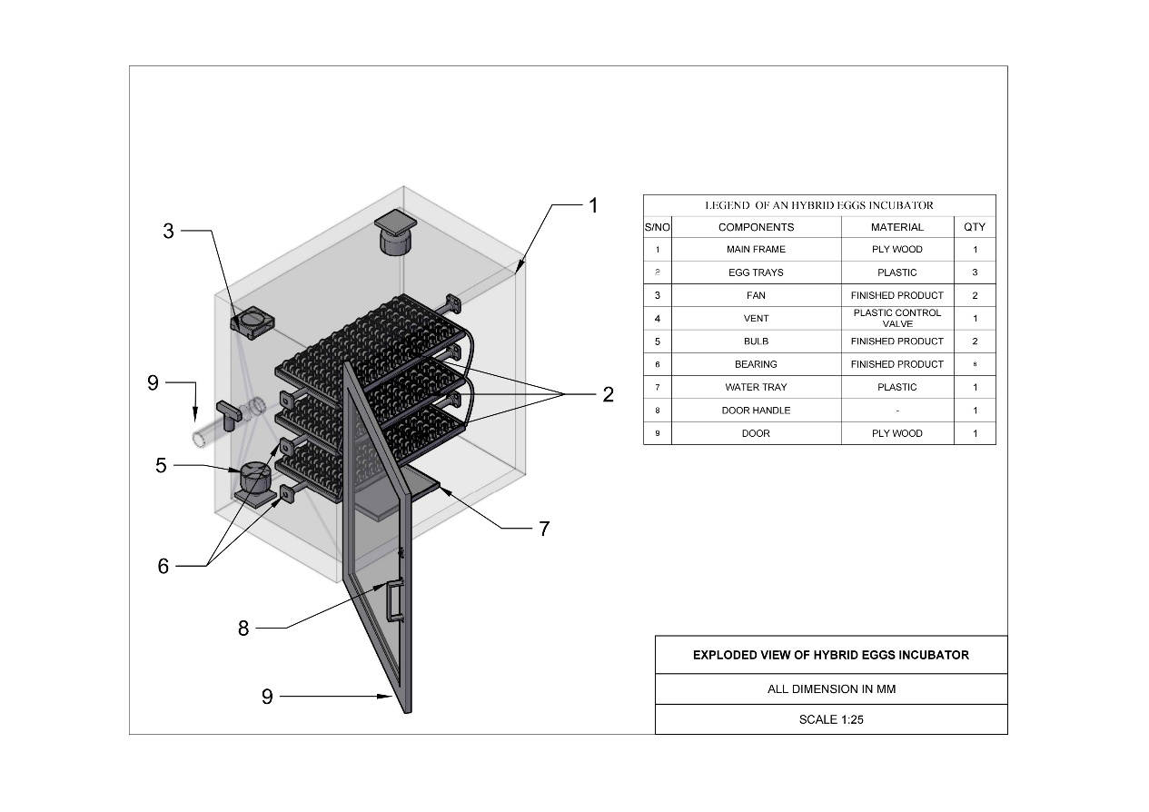

Figure 2: Exploded view of the egg incubator
3.3 Construction of Incubator
The tools used for the construction are; hammer, hacksaw, paper tape, sand paper, nail, bolt and nut.
The procedure for the construction of egg incubator are as follows;
(i) The MDF plywood was cut and assembled into rectangular box using nails, screw, hacksaw and hammer
(ii) The inside was lined with fibre glass for insulation
(iii) A fan was mounted at the back to circulate air
(iv) Bulbs were installed on the side for heating
(v) The thermostat was fixed and wired to regulate temperature
(vi) A hygrometer and water tray were added to control humidity
(vii) An egg tray was built and placed inside with space to allow turning
(viii) A glass window was installed on the front for observation
(xi) The hinge and latches is fixed for door opening

3.4 Operation of Incubator
The incubator mimic the condition provided by a brooding hen. The heat source raises the temperature the fan distributes the air and humidity is regulated with water trays. The thermostat ensures that temperature remain constant and eggs are turned regularly to prevent embryo sticking and promote uniform development the incubator is powered by electricity.

3.5 Factors Considered in Construction of an Egg Incubator
The following factors were considered in the construction of an egg incubator
1. Availability of material:-The material used is easily available for repair and replacement
2. Workability of material:-The material used is easy to cut, drill and shape
3. Affordability of material:- The material is cost effective compare to solid wood
4. Heat conserved of material:- The material has insulating properties that conserve heat.
3.6 Bill of Engineering Measurement and Evaluation [BEME]
The bill of engineering measurement and evaluation is as shown in table 3.1
Table 3.1: Bill of Engineering Measurement and Evaluation (BEME)
S/N | Item | Quantity | Unit Cost  (N : K) | Total Cost  (N : K)
1. | MDF plywood | 1 | 35,000 | 35,000
2. | Glass marine bard | 1 | 45,000 | 45,000
3. | Hinge and latches | 2 | 1000 | 2,000
4. | Electric bulb | 2 | 1,500 | 3,000
5. | Dc fan | 2 | 8,000 | 16,000
6. | Thermostat | 1 | 16,000 | 16,000
7. | Hygrometer | 1 | 10,000 | 10,000
8. | Egg tray | 6 | 8,00 | 4,800
9. | Screw/nails | 1 | 3,000 | 3,000
10. | Water tray | 1 | 1,500 | 1,500
11. | Wires & switches | 1 | 4,000 | 4,000
12. | Fiber glass | 1 roll | 10,000 | 10,000
13. | Miscellaneous |  | 15,000 | 15,000
 | Total |  |  | N165,300

3.7 Testing of Incubator
The incubator was tested for five days to see the functionality and effectiveness of the incubator without eggs. i.e, the temperature, humidity, fan and bulb.

CHAPTER FOUR
RESULT AND DISCUSSION
4.1 Result
The result showed that the incubator maintained the set temperature, humidity and the fan and bulbs were functioning.

4.2 Discussion
The choice of materials contributed to proper insulation and heat retention, while the thermostat eliminated the need for constant manual temperature checks. The cost of construction was relatively low compared to commercial incubators, making it a viable solution for poultry farmers.

CHAPTER FIVE
CONCLUSION AND RECOMMENDATION

5.1 Conclusion
The constructed egg incubator was efficient, reliable and affordable because it maintains ideal condition for artificial incubation; stable temperature adequate humidity and air circulation during the test runs of the incubator.

5.2 Recommendation
Provide basic training to users on how to operate and the incubator should be tested using different species of poultry egg for hatchability, fertility and mortality rate.

REFERENCES
Akinola, A. O., & Akinyemi, L. O. (2012). Design and construction of an electric-powered egg incubator. International Journal of Scientific & Engineering Research, 3(11), 1–6
Aremu, D. T., & Akinyele, D. O. (2016). Design and development of a hybrid solar-electric incubator for poultry egg hatching. International Journal of Engineering and Technology, 6(7), 241–248.
Development of a solar-powered poultry egg incubator for South-West Nigeria.
Etoamaihe, U. J. & Paul, T. (2023). Development of a Charcoal‑Heated Egg Incubator for Family Poultry Farming. Open Access Journal of Agricultural Research, 8(4).
Igbalajobi, A. O., & Olorunnisola, A. O. (2013). Development and performance evaluation of a solar-powered egg incubator. Journal of Energy Technologies and Policy, 3(1), 1–10.
International Research Journal of Agricultural Science and Soil Science, Vol. 8(5), pp. 70–77.
Itodo, I. N., Ariahu, C. C., & Yusuf, P. (2002). Performance evaluation of a biogas-powered absorption refrigerator and egg incubator. Nigerian Journal of Renewable Energy, 10(1–2), 62–67.
Joseph Abutu (2022). Design and Performance Evaluation of a Locally Fabricated Electric Egg Incubator. Journal of Agricultural Engineering and Technology, Vol. 30, pp. 45–53.
Ndirika, V. I. O., & Ademoye, S. A. (2007). Development and performance evaluation of a kerosene chicken egg incubator. Arid Zone Journal of Engineering, Technology and Environment, 5, pp. –.
Ogunwale, G. A., Akinola, E. O., & Lana, A. R. (2015). Development of a biogas-powered poultry egg incubator. Ife Journal of Science, Vol. 17, pp. 219–228.
Ogunwusi, A. A., & Onwualu, A. P. (2009). Development of a low-cost charcoal-powered incubator for rural poultry farmers. Journal of Agricultural Engineering and Technology (JAET), 17, 15–24.
Otim, G., & Othieno, H. (2000). Design and performance of a kerosene-fueled incubator for rural poultry production. Uganda Journal of Agricultural Sciences, 5(1), 34–41.
Sanyinpeju, K. L., Aderinlewo, A. A., Adetunji, O. R., & Ajisegiri, E. S. A. (2018).
Sulley, Maagi, Chande & Jande (published in AIP Advances): Title: Hybrid solar/LPG systems: Enhancing poultry egg incubation with beeswax thermal energy storage (2023/24)

