TABLE OF CONTENTS
CHAPTER 1. INTRODUCTION
  - Introduction
  - Free radicals and oxidative stress
  - Oxidative stress and cellular damage
  - Oxidative stress and its role in disease pathogenesis
CHAPTER 2. PHYTOCHEMICALS
2.1. Antioxidant defence system and phytochemicals (classification and dietary sources).
2.1.1. Superoxide dismutase (SOD)
2.1.2. Catalase (CAT)
2.1.3. Glutathione peroxidase(GPx)
2.2. Non-enzymatic antioxidants
2.2.1. Glutathione
2.2.2. Uric acid
2.2.3. Vitamin E
2.2.4. Vitamin C
2.2.5. Vitamin A
2.2.6. Carotenoids
2.2.7 Lipoic acid
2.2.8. Flavonoids
2.2.9. Tannins
CHAPTER 3. IMPORTANCE
3.1. Biological role of phytochemical antioxidants in prevention and cure of several chronic diseases
3.2. Cardioprotective activity
3.3. Anti- inflammatory activity
3.4. Anticancer activity
3.5. Antidiabetic activity
3.6. Mechanism of action of phytochemicals
3.6.1. Antioxidant
3.6.2. Hormonal action
3.6.3. Biological action
Conclusion
References
CHAPTER 1: INTRODUCTION
  - INTRODUCTION
Life threatening diseases such as cardiovascular diseases, neuro disorders, and cancers uh what health problems and account for morbidity and mortality to millions of people. These diseases/disorders Are mainly linked to oxidative stress due to free radicals induced toxicity. The free radicals(Oxidant )are unstable Species with a very short half life, but they are highly reactive metabolites which are harmful to normal functions of the cells and body. They produce oxidative damage toward macromolecules like proteins DNA and lipids. In general, the reactive oxygen species circulating in the body and this also affect various extreme systems and cause the any damage which may further contribute to oxidative damage and inflammatory diseases and conditions such as cancer, ischemia, aging, adult respiratory distress syndrome, rheumatoid arthritis, etc. Oxidative stress occurs as a result of an imbalance between free radicals and antioxidants defence system. Many researchers reported that dietary fruits, vegetables, and grains apply a protective effect against the development of these chronic diseases(Kruk,2014). This protective rule can be predominantly credited to the phytochemicals in them, which are defined as bio active non- nutrient compound In fruits, vegetables, grains and other parts.
Antioxidant or inhibitors of oxidation are compounds that retard oxidation in general and prolong the life of the oxidizable matter.
Plants Kingdom contains variable chemical families and amounts of antioxidants. It has been hypothesized That’s antioxidants from dietary sources are also easily available are more suitable for dietary intervention.
The need is to identify and generate awareness about these sources, which can be rated from top to down regarding antioxidant potential. The people who are habitual of consuming these vegetables are fruits in their routine diet are proved to be less suffered by various chronic diseases (Dembinska-Kiec A.,2008), And studies have also endorsed the long the long term health impacts of consuming these plants based diets.
1.2.FREE RADICALS AND OXIDATIVE STRESS
Free radicals are highly reactive species because they have on paired electrons which seek an electron to stabilize the molecule. Free radicals can be generated by a variety of sources which can be classified as endogenous ( within the body) and exogenous (sources outside the body).They are essential intermediate in natural processes and readily react with other molecules results in oxidative stress.
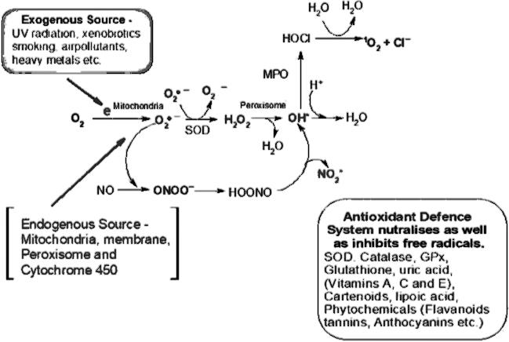
Figure1:overview of generation of reactive oxygen species( free radicals).
This represents the generation of free radicals reactive oxygen species (ROS) is a collective thing which include hydroxyl radicals (OH⁺), perhydroxyl radical(HO₂⁺),Singlet oxygen(O₂), hypochlorous acid(HOCL),Superoxide anion radical(O₂⁺⁻),hydrogen peroxide(H₂O₂),nitric oxide radical(NO.),Hypochlorite radical(OCL.), peroxynitrite(ONOO),and different lipid peroxides. Reactive nitrogen species(RNS) such as ONOO⁻and NO. Are formed by the reaction of nitric oxide with O_{2.}while RSS Are easily produced from thiols through a reaction with ROS.
Though the free radicals are produced naturally by normal process of metabolism and lifestyle also influences their production in the body such as smoking, exposure of toxic chemicals, alcohols and fried foods. Although cells have antioxidant defence system (antioxidant enzymes)to encounter harmful effects of free radicals, these free radicals are linked to the diseases such as cardiovascular, neuro disorders, diabetes, liver diseases, cancer and aging. An imbalance between antioxidant defence system and reactive oxygen species result in oxidative stress which further leads to necrosis and cell damage. Cells experience oxidative stress when they are exposed with excess level of free radicals (ROS) as result of depletion of antioxidant level within cells. Free radical contained uneven number of electron which can harm biomolecules by producing lipid peroxides protein carbonyls and various degenerative changes that can cause DNA damage and apoptotic events which lead to damaged cell’s survival capacity and finally cause cell death. Cells use endogenous and exogenous antioxidants defence mechanism to detoxify these reactive products.(Krishnamurthy. P, 2012).

1.3. OXIDATIVE STRESS CELLULAR DAMAGE Reactive oxygen species (ROS) a typical by-products of cellular metabolism playing a role as secondary messengers and influencing different normal physiological function of the body. In some cases oxidative stress is also useful for intracellular signalling which is necessary for physiological adaption of the body. Furthermore, there is growing evidence supporting the role of our ROS in numerous pathological conditions, that is, diseases.

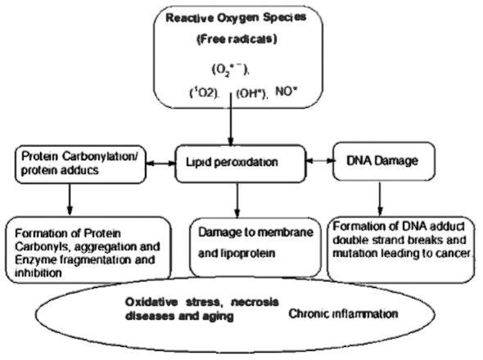

The paired he character of ROS with their beneficial and detrimental characteristics indicates This sophistication of their specific roles at a biological compartments any difficulties in attaining applicable procedure to treat ROS-related diseases. The free radical often involve in cell communication apoptosis, ion transportation and gene expression. Oxidative stress take place when there is an imbalance between oxidants and antioxidants within the body due to lack of antioxidants or increased production of free radicals (ROS). Free radicals due to unpaid electron can start oxidation to biomolecules i.e. Carbohydrates, proteins, lipids and nucleic acids. These consequences can lead to heart disease, inflammatory disease, cancer, diabetes mellitus Alzheimer’s disease, Autism and to the aging process(Lu.JM, 2009).

1.4. OXIDATIVE STRESS AND IT’S ROLE INDISEASE PATHOGENESIS
The bulk of free radical that causes damage to biological structure(i.e. biomolecules such as proteins, lipids, DNA) Are oxygen- free radicals, also known as reactive oxidative species (ROS). ROS include superoxide anion radical(O_{2.}⁻),Singlet oxygen(‘O₂),Hydroxyl
radical(.OH), perhydroxyl radical (HOO.),nitric oxide radical(.OH), hypochlorous acid(HOCl),hypochlorite radical(ClO⁻), peroxynitrite(ONOO⁻) and lipid peroxides(Lops). ROS maybe generated from various exogenous sources such as UV light Irradiation, X- rays,γrays,metal catalysed reactions, environmental carcinogen/toxins. Heavy/transition metals, alcohol, tobacco, synthetic solvents, drugs( e.g. Tacrolimus, cyclosporine, bleomycin, and gentamicin), culinary sources(e.g. Waste oil, fats and smoked meat) And radiation are all exogenous sources of ROS. Endogenous sources of ROS include cytochrome P450 metabolism, mitochondrial reactions, peroxisomes, inflammatory cell activation. Whether endogenous or exogenous ROS when increased or excessively produced can cause oxidative changes/damages to lipids, Proteins, DNA and carbohydrates. Thus, ROS has been linked to pathogenesis of many human diseases including brain dysfunction, cancer, inflammatory diseases, heart diseases, diabetes and many others.
Human body has its own in-built biological Process mechanism to defend itself against foreign threats and pathogenic microorganisms, including natural antioxidant defence, immunity and DNA repair enzymes. Several antioxidants enzymes such as superoxide dismutase (SOD), catalase(CAT) and reduced glutathione (GSH) aid in the removal of free radicals when not well managed, ROS causes extensive chronic and degenerative diseases, the aging process and acute pathologies like trauma and stroke. (Halliwell and Gutteridge,2015).

CHAPTER 2: PHYTOCHEMICALS
2.1. ANTIOXIDANT DEFENCE SYSTEM AND PHYTOCHEMICALS (CLASSIFICATION AND DIETARY SOURCES)
Antioxidants are molecules that prevents and reduce the harmful effect of free radicals. Humans have a complex antioxidant protection system, which functions interactively and synergistically to neutralize free radicals. There are several antioxidant enzymes that neutralise free radicals and ROS. These enzymes form the body's endogenous defence mechanism from free radicals to protect the cell. Enzymatic defence system mainly includes as glutathione peroxidases, superoxide dismutase and catalase, which decreases the concentration of the most harmful ROS whereas non-enzymatic antioxidant are vitamin C and E, β-carotene, uric acid and glutathione.
Antioxidant enzymes are important protein components that offer protection against ROS via removing potential oxidant/transferring ROS/ RNS into relatively stable compounds. For optimum catalytic activity, these enzymes require micronutrients cofactors such as Se, Fe, Cu, Zn, Mn. The basic skeleton of polyphenols made up of 15 carbon chain that arranged in two aromatic rings A and B connected by a unit of carbon-carbon bridge and it can also form ring C. They have conjugated double bonds and functional groups hydroxyl or other substituents. Flavonoids can occur as a form in aglycones, glycosides and methylayed derivatives in plants. They are present in all parts of plants such as stems, roots, flowers, leaves and seed. The structure of phyto chemicals possesses functional groups such as hydroxyl groups (OH), aromatic compounds(CH), carbonyl and carboxylic group(CO),andgroups(SO). The major class of phytochemical are polyphenols and carotenoids. Based on heterocyclic ring structure, flavonoids are divided into six chemical structures: flavones, flavonols, flavanones, catechins or flavanols, anthocyanins and isoflavones (Chia-Jui. W,2012).

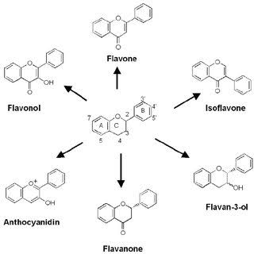
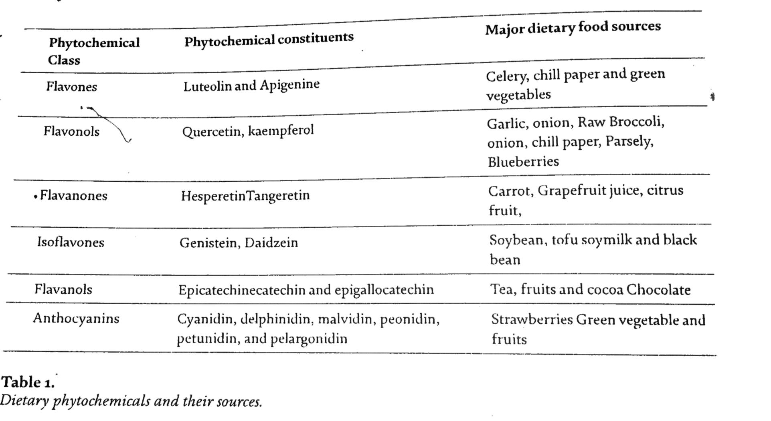

2.1.1 SUPEROXIDE DISMUTASES(SOD)
MC cord and fridouich first discovered this enzymes in 1969. Superoxide Dismutase (SOD), is the best known and perhaps most important of the antioxidant enzymes. It converts the harmful for radical superoxide to less active peroxide, which then can be further converted by other antioxidants enzyme (catalase) into water. The enzyme dismutase converts two molecules of superoxide radical to form H₂O₂ and O ₂ SOD family consists of four metallo forms which require copper, zinc, one manganese and one iron Cu for their free radical detoxifying activity. Zn SOD Is found in the cytosol of most eukaryotic cells. A different form of Cu, Zn SOD is found in extracellular fluids (EC), where it is called EC-SOD. The superoxide radicals converted into hydrogen peroxide and oxygen during the catalytic reaction of SOD.
O ₂^{.-} + O₂^{.-} O₂+ H₂O₂
This is important, because free radicals are highly and unstable and will attack any molecule in the body. Organ or tissue damage can occur whenever production of free radicals exceeds to that of scavenger enzymes such as SOD which are the first line defence system of the body’s tissues. (MC Cord J, 1969).

2.1.2. CATALASE(CAT)
Catalase is localized exclusively in peroxisomes and deals with the large amount of H₂O₂ present in them. It requires iron as a cofactor to degrade hydrogen peroxide to water and oxygen. Human CAT composes four identical subunits of 62 KDa. Its optimum pH lies in the alkaline range. At the subcellular level, CAT is found mostly in peroxisomes (80%) and cytosol (20%) and deals with a large amount of hydrogen peroxide H₂O₂ present in them.
2H₂O_{2.} 2H₂O+O₂

2.1.3. GLUTATHIONE PEROXIDASE(GPx)
Glutathione peroxide (GPx) Is a group of cystolic enzymes which contains a single selenocysteine residue, in which selenium is covalently bound in its active site. This selenium dependent enzyme which converts hydroperoxide to H₂O where GSH represents reduced state and GSSH represent the glutathione disulfic (oxidized state)(Esworthy RS,1997).
H₂O₂+2 GSH. GSSH +O₂
2.2.1. GLUTATHIONE
Glutathione(GSH) is present in all plant animal cells and is a tripeptide (glutamyl – cysteinyl – glycine). The cysteine provides an exposed free sulfhydryl group (SH) that is highly reactive, providing an abundant targets for radical attack. it is mainly synthesized in the liver and exists in several redox forms, among which the most predominant is reduced glutathione(1-10mM) is the nucleus, mitochondria, and cytoplasm. GSH is involved in several lines of defence against ROS . First, the thiol group confers GSH with the ability to protect other thiol functions in proteins against oxidative damage. Thiol groups(-SH) are widespread highly reactive chemical entities in cell. They make complex with metal ions participate in oxidation reaction by getting oxidized themselves to sulfonic acids, and form thiol radical and disulfides (Lushuchak vi,2012).
2.2.2. URIC ACID
Uric acid (UA) is it strong reducing agents (donates electrons) which acts as a powerful antioxidant and scavenge the Singlet oxygen and radicals. Normally in humans, one of the main antioxidants in plasma is uric acid. UA is a hydrolic antioxidant generated during the metabolism of purine nucleotides and accounts nearly for 66% of the total oxygen scavenging activity in the blood serum. Mammals and humans are capable of producing UA, making it the most predominant aqueous antioxidant present in humans. With an approximate blood level of 3.5-7.5 Mg/dl UA is an effective metabolite that can stop free radicals produced by xanthine oxidase( XO) in catalysis reaction of xanthine and hypoxanthine. UA gives cellular protection from oxidants, which is related to a variety of physiological situation. In addition, there are diverse dietary foods and medicinal plants which are rich sources of vitamins and phytochemicals, provides additional protection to the body against oxidative stress. The major among these Antioxidants are vitamin E, vitamin A, vitamin C and flavonoids, carotenoids lipoic acid and tannins etc. (Skwoyra M,2014).
2.2.3. VITAMIN E
Vitamin E is exogenous (lipid-soluble antioxidants) and must be obtained through diet in small amounts since the organism cannot synthesize it. It’s bio-synthesis is restricted to plants, photosynthetic algae and certain cyanobacteria. It plays a vital role in protecting membranes from oxidative damage and thus its primary activity is to trap peroxy radicals in cellular membrane. It’s inhibits the lipid peroxidation induced by free radicals. Tocopherol is the most active form of vitamin E that has antioxidant activity and immune functions. It has been revealed to be more effective free radicals scavenging vitamins that prevent peroxynitrite-induced lipid peroxidation and inflammatory reactions (MC Cormick CC,2004).

2.2.4. VITAMIN C
Vitamin C(L-ascorbic acid) is an optically active hydro soluble antioxidant which scavenges free radical from a variety of sources. It bears a highly acidic hydroxyl group pKa=4.2 known to be completely ionized at neutral pH. It acts as an antioxidant and reducing agent by donating electrons to various enzymatic and non enzymatic reactions. It reduces the transition metal ions of several biosynthetic enzyme, thus preventing biological oxidation of macromolecules. Interestingly, it also functions as an enzyme cofactor(Skwoyra M, 2014).
2.2.5. VITAMIN A
Vitamin A, a lipid soluble vitamin is localization within the lipophilic compartment of membranes and lipoproteins. It has free radical scavenging features and thus play important role in human health. It has been shown to be essential for many physiological processes, such as cell metabolism, reproduction, embryonic development, immunity and bone metabolism, in all vertebrate. It is essential for vision. The retinal and retinae acid are the dietary component of vitamin A(Arredondo ML, 2016).
2.2.6. CAROTENOIDS
Carotenoids are important antioxidant for plants and animals which are present in fruits and vegetables. Carotenoids are known to be very efficient physical and chemical quenchers of singlet oxygen ROS. This is of special significance because the uncontrolled generation and concomitant increase of ROS level in the body results in oxidative stress, and essential contributor to the pathogenic processes of many diseases. Carotenoids have a protective role against ROS-Mediated disorders such as cardiovascular diseases, cancer as photosensitive or eye-related disorders.(Cvetkovic D,2013).
2.2.7. LIPOIC ACID
Lipoic acid is one Of the most versatile antioxidant known, aside from its ability to function in both aqueous and lipid media, lipoic acid is capable of neutralizing a wide variety of free radicals. Singlet oxygen, superoxide, peroxyl, and hydroxyl radicals, hypochlorite and peroxynitrate. These radicals are believed to play a significant role in disease processes such as hardening of the arteries (atherosclerosis), cancer, cataract formation and diabetes.(Biewanga 1997).
2.2.8. FLAVONOIDS
Flavonoids are rich sources of antioxidants, which are low-molecular-weights phenolic compounds. They are broadly present in fruits, vegetables and certain beverages. They belong to a class of plant secondary metabolites. Flavonoids are in particular, important antioxidants that can act as reducing agent, free radical scavenger, hydrogen donors and singlet oxygen quenchers. In addition, they have also metal chelating potential. Their structures and impact on human health is discussed in details in subsequent sections(Fai-chu, 2014).
2.2.9. TANNINS
Tannins are naturally found in a variety of edible and inedible plants, including tree bark, leaves, spices, nuts, seeds, fruits and legumes. They are potentially very important antioxidants. Plants produce them as a natural defence against pest. Tannins also give colour and flavour to plant foods. Tannins are phenolic such as flavan-3-ols.(-)-epicatechin and (+)-catechin. Hydrolysable tannins are heterogeneous polymers compound for example phenolic acid and gallic acid(3,4,5 trihydroxyl benzoic acid)(Walter M, 2011).

CHAPTER 3: IMPORTANCE
3.1 BIOLOGICAL ROLE OF PHYTOCHEMICAL ANTIOXIDANTS IN PREVENTION AND CURE OF SEVERAL CHRONIC DISEASES
Oxidative stress is accountable for pathogenesis of several human diseases, including CVD, certain types of cancers and aging. Antioxidant phytochemicals plays a therapeutic role against chronic diseases caused by oxidative stress. The schematic overview of the therapeutic properties of flavonoids rich food is given in diagram below.

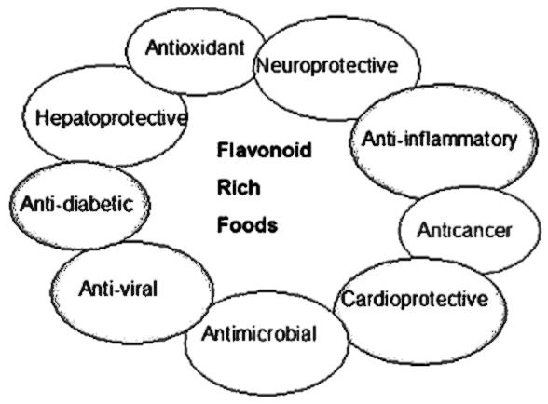
The phytochemicals are the recent area of drug research to find the promising herbal drug for the treatment of various human diseases such as diabetes, cancer, tuberculosis, malaria and viral diseases etc. Edible fruits and vegetable have medicinal properties with antioxidant potential. They contain various types of phytochemicals which are proven to reduce the impact of various diseases. The dietary fruits such as strawberries, citrus fruits or green vegetables, cereals are rich source of vitamins and phytochemicals. The medicinal plants rich in flavonoids have been reported to have antioxidant potential. ,α-tocopherol is good free radical scavenging vitamins that reduce the oxidative stress in the body and prevents the aging process. Consumption of dietary plants lessens the development of lifestyle related diseases because they are rich in polyphenols and shows synergistic effect on metabolic pathway of diseases cells. In addition, polyphenols may enhance the antioxidant defence system against free radical induced toxicity whose top many medicinal plants are known to provide defensive role against microbial and viral infections.. Pathogens and oxidative stress can cause chronic inflammation that assists in the pathogenesis of many chronic diseases including CVD, cancers, neurodegenerative diseases, diabetes. Most antioxidant phytochemicals have been scientifically investigated for their anti-inflammatory action, hepatoprotective, cardioprotective, neuroprotective, and anticancer and antidiabetes and antimalaria and antiaging effects. Phytochemicals including resveratrol, anthocyanins and curcumin etc. and are known to have medicine like properties that mediate protection via inhibition of lipid peroxidation, lower the prostaglandin production and modulate the nuclear factor-KB activity, enzyme inhibition as well as improve the immunity(Hutchins-Wolfbrandt A, 2011). Usually, the phytochemicals have strong antioxidant abilities as well as anti-inflammatory action which account for other bioactivities with health benefits (Roberts E, 2006).
3.2 CARDIOPROTECTIVE ACTIVITY
Cardiovascular disease (CVD) is common health problem in modern society and is the leading cause of morbidity and mortality worldwide. Rising blood pressure and atherosclerosis diseases are common heart problem in all age group of people. The modern medicine and treatment can reduce the symptoms of the CVD but allopathic treatments sometime produce adverse side effects on the body. The adequate intake of phytochemical rich food can reduce the impact of CVD. The phytochemicals constituents such as epicatechin, catechin, garlic, apigenin, luteolin are known to possess cardioprotective properties. Dietary foods containing flavonoids can suppress the cholesterol and lipoproteins to protect the health. catechin is a known flavonoid found in green tea, camellia sinensis. Many experimental and clinical studies have recently reported that catechin has multiple cardiovascular health benefits such as prevention of atherosclerosis, hypertension, endothelial dysfunction, ischemic heart disease, and cardiomyopathy. It protects normal heart function by decreasing oxidative stress and reducing the inflammatory events.
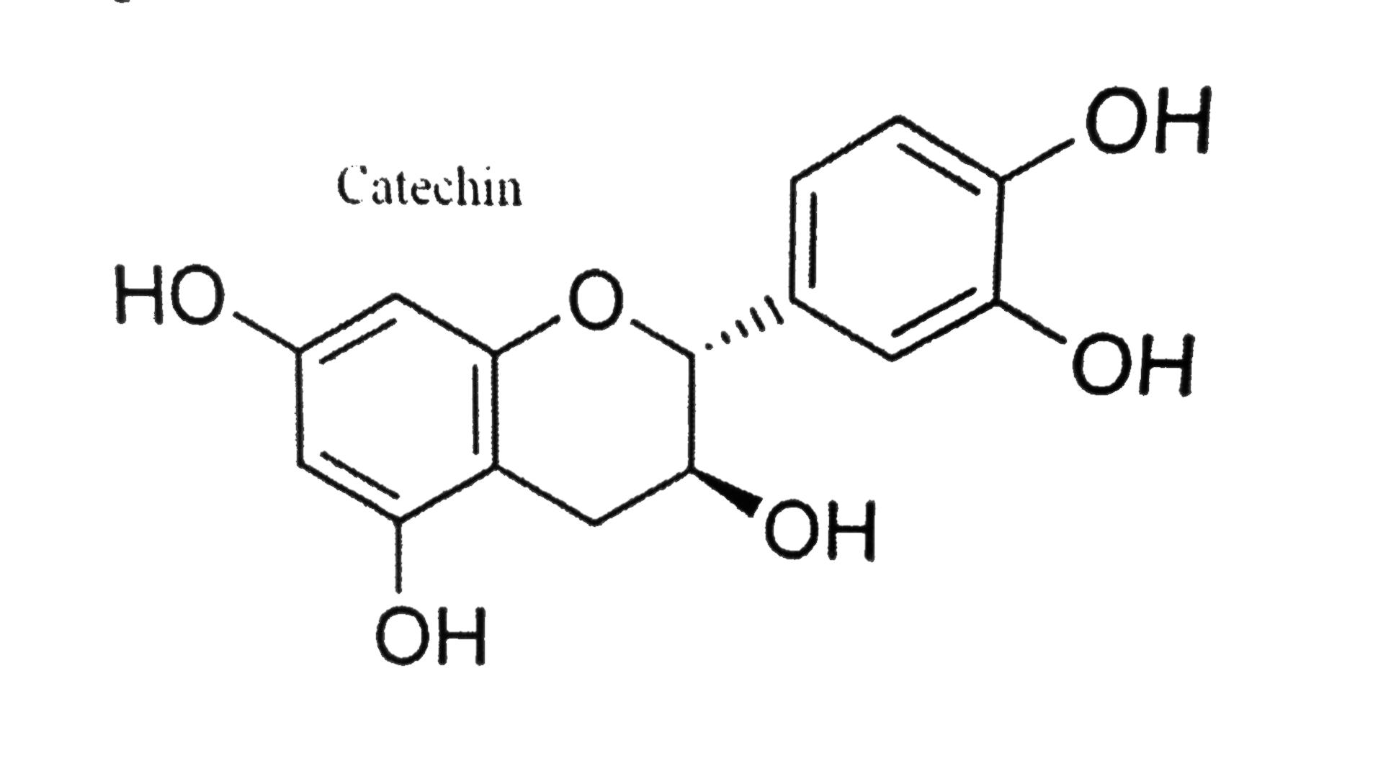

Lutein is a bioactive flavonoid, possesses good efficacy as an anti-oxidative, anti-tumor, and anti-inflammatory property(yuan yuanluo,2017). Recent scientific studies have reported the lutein has cardiac protective effect in vitro and in vivo. Epicatechin and procyanidins have been reported to have good cardioprotective health benefits.

Allicin is one of the key ingredients of Allium sativum (garlic) is said to be good regulator of blood pressure and hypertension. It is an organosulfur phytochemical and possesses many medicinal properties such as anti cancer, antidiabetic, hepatoprotective and cardioprotective. Many research reports suggested that allicin has shown positive effects on the heart and it can lower high cholesterol levels against atherosclerosis. People use raw garlic to get some relief from blood pressure.(Cverkovic D,2013).
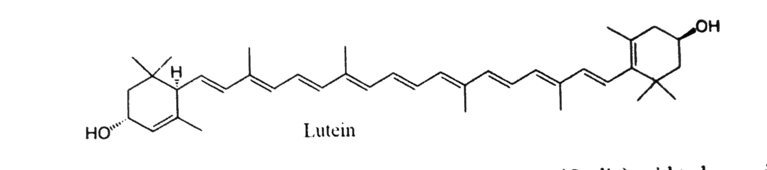

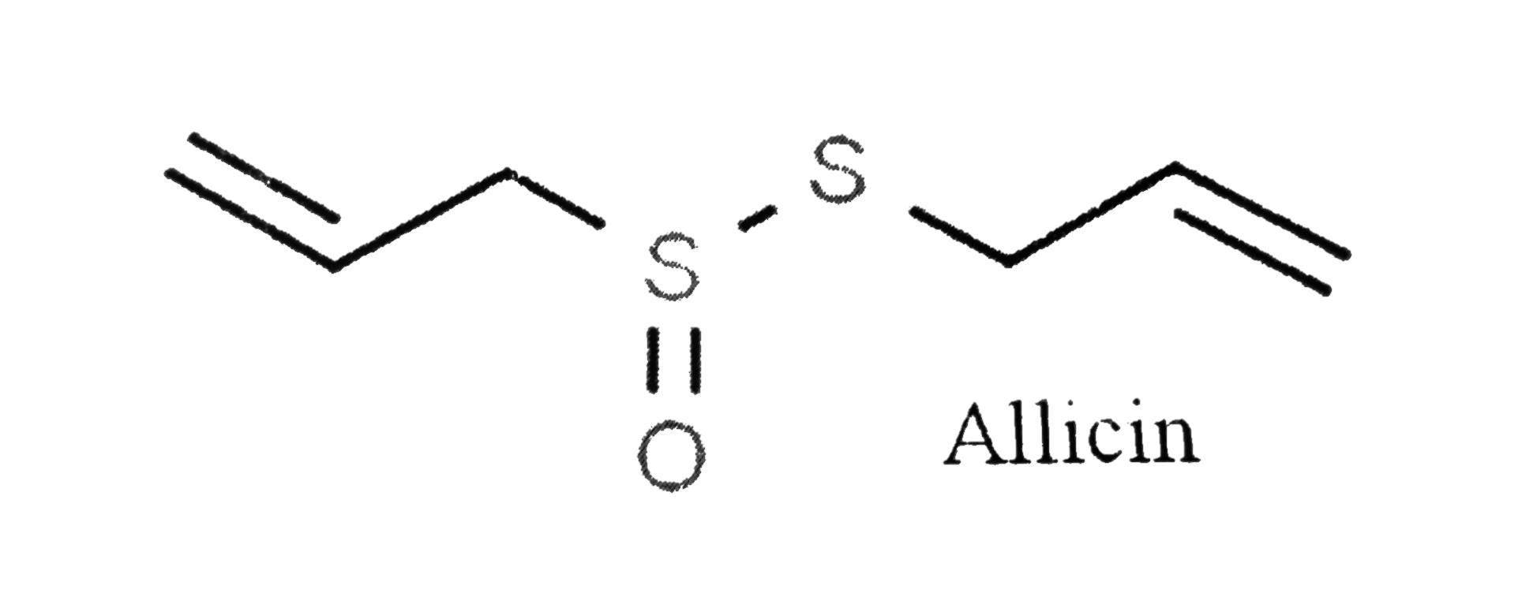

3.3. ANTI-INFLAMMATORY ACTIVITY
Inflammation is a normal phenomenon of the body upon pathogen infection. The inflammation is characterized by physical appearance like swelling, redness, heat, pain, and loss of function. It is the series of transformation of infection site as a result of immunological response. Flavonoids intake can inhibit the cyclooxygenase pathway involved in the inflammatory process.
Curcuma longa(turmeric) is popular spice used in making home food. It is the oldest traditional medicine for the treatment of various health problem, joint pain, inflammatory conditions and cancer and diabetes and liver ailments. It’s consumption provides healing effect to cure infection and inflammation in the body.
The curcumin is main active component of curcumin longa which has various medicinal properties such as hepatoprotective , anticancer and antidiabetic and anti-inflammatory. It is the efficient antioxidant that reduces the level of oxidative stress caused by toxic element.
Ginger is a popular edible root of zingerberoffinale plant. It is widely used for treatment of cough and cold due to its anti-inflammatory property. Gingerols is the main bioactive compounds of ginger. It has reduced level of inflammation markers cytokines and tumour necrosis factors. (Fai-chu w, 2014).
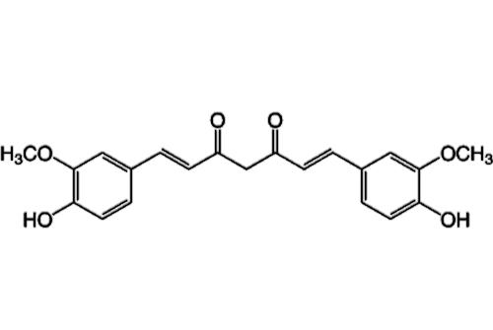
CURCUMIN

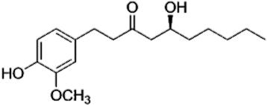
GINGEROL

3.4. ANTICANCER ACTIVITY
Cancer, a disease is characterized by uncontrolled cell division, many flavonoids have shown to possess the anticancer properties. There are many dietary flavonoids such as apigenin, kaempferol, quercetin, and resveratrol showed the anticancer effect against various cancers such as breast, lung, liver, skin, blood, colon, prostate, pancreatic, cervical, oral, and stomach by modulating the pathway of apoptosis. The experimental results showed the protective efficacy of flavonoids on cancer cells by modulating the pathway of cell cycles. The molecular mechanism of flavonoids is due to their antiproliferation activity, cell cycle arrest inhibition of P53 protein and down regulation of tyrosine kinases. Flavonoids are evidenced to be effective chemopreventive agents.
Apigenin is plant derived flavonoid belonging to the flavone structural class. It is found in several edible vegetables and fruits. It has been reported has anticancer molecule in vitro and in vivo experiments. It showed promising anti-oxidative and antiproliferation effect against cancer disease.
Kaempferol is a very effective herbal medicine and present in grapes and onion. It has antioxidant and anticarcinogenic activity . It acts as a chemopreventive agents against metastasis and angiogenesis. In vitro studies reported that kaempferol was found to have good cytotoxic effect on cancer cells by arrest cell cycle events of various cell lines such as glioblastoma leukaemia, lung cancer, and breast adenocarcinoma.
Quercetin is one of the dietary flavonoids suppresses tumour growth by inhibiting protein tyrosine kinase(PTK), fruits and vegetables are having enormous amount of quercetin, which have been used as cancer chemoprotective agents. The mechanism of action of flavonoids is due to their interphase arrest, heat-shock protein inhibition, tyrosine kinase inhibition, down regulation of P53 protein, inhibition of Ras protein, and expression of Ras protein (Robert E,2006).
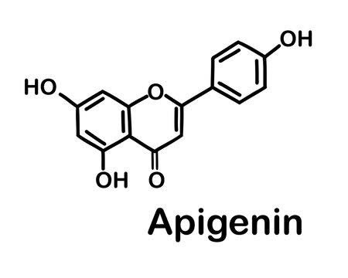

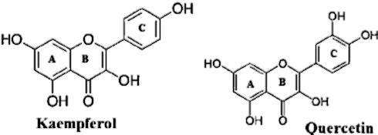

3.5. ANTIDIABETIC ACTIVITY
Diabetes is one of the emerging health disease caused by metabolic abnormalities of carbohydrate. The presence of higher blood sugar level in blood and urine is the main sign of the diabetes. There are many dietary flavonoids such as bitter guard, fenugreek leaves and seeds and curry leaves or kadipatta that exert anti-diabetic effects by targeting various cellular signalling pathways in pancreas, liver, skeletal muscle, and white adipose tissue sources, that can reduce the higher blood sugar level in diabetic patients. These dietary food are rich source of phytochemicals that can reverse the abnormal sugar level into normal level.
Morin, a natural flavonoids, is found in general edible plant Moringaoleigera. It’s oral consumption for 30days significantly improved the blood sugar level, glucose intolerance, and promotes the pancreas to release sufficient insulin in the body. It also inhibits the insulin resistance.

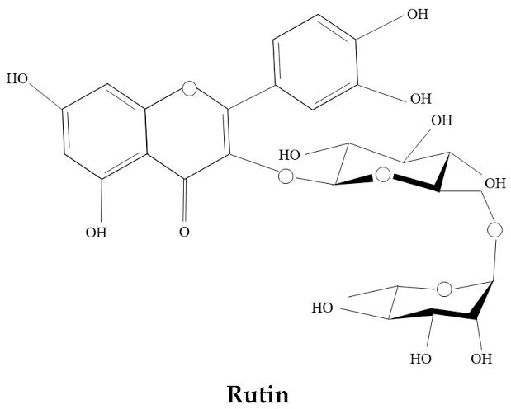

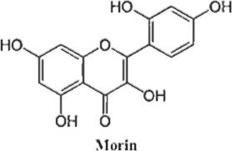

Rutin is a glycosylated flavonoid found in the citrus fruits. The antidiabetic effects of rutin have been experimentally evaluated and suggested that rutin has good antidiabetic efficacy. It enhances the glucose uptake by the suppression of tissue gluconeogenesis resulting in lowering glucose level in the blood. It can activate insulin secretion from β- cells. It also decreases the free radical formation produced due to higher glucose level. ( Krishnamurthy P, 2012).
3.3. MECHANISM OF ACTION OF PHYTOCHEMICALS
Medicinal plants are natural sources of phytochemical antioxidants that are known to prevent different disease states. The medicinal plants contain phytochemical ingredients as source of antioxidants. Phytochemicals are antioxidant compounds that inhibit or delay onset of biological oxidation. They are nitrogenous cyclinphytols compounds which possess functional groups such as hydroxyl groups, ketone groups, and aldehyde. Phytochemicals work at different level to provide protection and boost the body defence mechanism against oxidative stress.( Skwoyra M, 2014).
3.6.1. ANTIOXIDANT
Antioxidants are such anti molecules which work against oxidation reaction. It means the prevent oxidation biomolecules caused by free radicals, many phytochemicals works as antioxidant helping to scavenge free radicals. They donate electron to stabilise the free radicals in order to maintain the imbalance between antioxidant defence system and free radicals. The phytochemicals are subtle molecules or compounds that work like an antioxidant (Esworthy R.S, 1997).
3.6.2. HORMONAL ACTION
Some phytochemicals can influence the hormonal activity in the body. Genistein a soy isoflavones, it works like estrogen hormone which inhibit the menopausal hot flushes in some women.(Biewanga G,1997).
3.6.3. BIOLOGICAL ACTION
Different phytochemicals play different roles in the biological system. There many different groups of phytochemicals which all have different chemical structures which may include different health benefits. Carotenoids may inhibit the cancer cell growth and reduce the risk of cardiovascular disease and boost immunity. Dietary anthocyanins may help lower blood pressure. Phytochemicals as an antioxidant scavenge free radicals and reduce the oxidative damage. (Lu J.M, 2009).
CONCLUSION
Phytochemicals plays a critical role in combating oxidative stress and maintaining overall health. These natural compounds such flavonoids, carotenoids, Lipoic acids, e.t.c are effective antioxidants that can neutralise free radicals, reduce inflammation and support cellular integrity. By integrating a variety of phytochemical-rich foods such as fruits, vegetables, whole grains and teas into our diets, we can help protect our bodies from chronic conditions linked to oxidative stress including cardiovascular disease, cancer and neurodegenerative disorders.
Scientific communities across the world are focusing on the alternative medical system in exploring natural ingredients to be used in the food and food products for the prevention of human diseases. Herbal based medicine can be safer, convenient and efficient as dietary components for the prevention or treatment of human diseases.
REFERENCE
Arrectondo ML,(2016). Relationship between vitamin intake and total antioxidant capacity in elderly adults. Universitas Scientiarum. 21(2): 167-177.
Biewanga G, G R Haenen, A Bast, (1997). The pharmacology of the antioxidant lipoic acid . Gen pharmacology The vascular system. 28(3): 315-31.
Buschfort C, Muller MR,Seebers, Rajewsky MF, Thomalej, (1997). DNA excision repair profiles of normal and leukemic human lymphocytes: functional analysis at the single cell level. Cancer Research.57: 65-658.
Chia- Jui W, Gow-chin Y, (2012). Flavonoids, a ubiquitous dietary phenolic subclass, exert extensive in vitro anti-invasive and in vivio anti- metastatic activities. Cancer Metastasis Review. 31(1-2): 323-51.
Cvertkovic D, Fiedor L, Fiedor J, Wisniewska-Becker A, Markovic D,(2013). Molecular base for carotenoids antioxidant activity in model and biologivalsystems: The health -related effects. In: yamaguchi M, editir-carotenoids. Food sources, production and health benefits. Nova science publishers; Hauppavge, NY, USA:pp. 93-126.
Dembinska-kiec A, Otto Mykkanen, Beatakiec-Wilk, HannuMykkanen,(2008). Antioxidant phytochemicals against type 2 diabetes. British journal of Nutrition 99(E-SI): ES109-ES117.
Esworthy RS, Ho Ys, Chu ff,(1997). The GPX1 gene encodes mitochondrial glutathione peroxide in the mouse liver. Archives Biochemistry Biophysics. 340:59-63.
Fai-chu W, Ann- Li Y, Euonpeir-shan T, Sim-chyi K, Haen-chooi O, and Tsun Thai C, (2014). Antioxidant, metal chelating, Anti-glucosidase Activities and photochemical analysis of selected Tropical Medicinal Plants. Iranian journal pharmaceutical Research. 13(4): 1409-1415.
Halliwell B. and Gutteridge J.M.C,(2015). Free radicals in Biology and Medicine New York, NY: Oxford university press. Doi:10.1093/acprof:050/9780198717478.001.0001.
Krishnarmurthy P, Wadhwani A,(2012). Antioxidant enzymes and human health. In:El-Missiry MA, editor. Antioxidant enzyme. Croatia: In Techi; pp.3-18 DOI: 10.3109/0886022X. 2015.1103654.
Kruk J,(2014). Association between vegetable, fruit and carbohydrate intake and breast cancer risk in relation to physical activity. Asian Pacific journal cancer prevention. 15,4429-4436.
Lu JM, Lin PH, Yao Q, Chen C, (2009). Chemical and molecular mechaiof antioxidants: Experimental approyand model systems. Journal of cellular and molecular Medicine.14(4): 840-860.
Lushuchak VI,(2012). Glutathione homeostasis and functions: potential targets for medical interventions. Journal of Amino acids.2021:1-26.
McCord J, Fridouich M,(1969). Superoxide dismutase. An enzymic function for erythrocyperin(hemocuperin). Journal of the Biological chemistry. 244(22):6049-55.
McCormick CC, Parker RS,(2004). The cytotoxicity of vitamin E is both vitamer and cell specific and involves a selective trait. Journal of Nutrition 135:3335.
Robert E, Joshua AB, and David BM,(2006). Bioactivities of resveratrol. Comprehensive Review in food sciences and food safety. 5:65-70.
Skwoyra M,(2014). Antioxidant properties of extracts from selected plant materials (caesalpiniaspinosa, perillafrutescens,Artemisia annual and viola wittrockiana) in vitro and in model food systems(thesis). Department of chemical engineering. Universitatpolitechnica de catalunya.
Walter M, Marchesan E,(2011). Phenolic compounds and antioxidant activity of rice. Brazilian Archives of Biology and Technology.54(1): 371-377.

