CONSTRUCTION OF HOUSEHOLD SMART FURNITURE
BY
ND/23/BLD/PT/0009
ND/23/BLD/PT/0010
ND/23/BLD/PT/0011
ND/23/BLD/PT/0012
ND/23/BLD/PT/0013
ND/23/BLD/PT/0014

BEING A RESEARCH PROJECT SUBMITTED TO THE DEPARTMENT OF BUILDING TECHNOLOGY, INSTITUTE OF ENVIRONMENTAL STUDIES (IES), KWARA STATE POLYTECHNIC, ILORIN KWARA STATE.
IN PARTIAL FULFILMENT OF THE REQUIREMENT FOR THE AWARD OF NATIONAL DIPLOMA (ND) IN BUILDING TECHNOLOGY

SUPERVISED BY:
MR. SADIQ OLAREWAJU .H.

JUNE, 2025
CERTIFICATION
This is to certify that this project has been read and approved as meeting part of the requirements for the award of National Diploma (ND) in Building Technology in the Department of Building Technology and Management, Institute of Environmental Studies (IES), Kwara State Polytechnic, Ilorin.

-------------------------- --------------------------
MR. SADIQ OLAREWAJU .H. (MNIOB) DATE
(Project Supervisor)

-------------------------- --------------------------
BLDR AKANO AYODELE (MNIOB) DATE
(Project Coordinator)

-------------------------- --------------------------
BLDR ALEGE ABDULGANIYU (MNIOB ) DATE
Head of Department (HOD)

-------------------------- --------------------------
BLDR AHMED MAROOF FUNSHO (MNIOB) DATE
External Examiner

DEDICATION
This project is dedicated to Almighty God, the Alpha and Omega of wisdom, knowledge and understanding. The creator of all living and non-living soul also dedicated to our parents.

ACKNOWLEDGMENTS
First and foremost, we give golden gratitude and adoration to the Almighty God, the most beneficent and most merciful who alone is the source of wisdom, knowledge for signs and inspiration for making this vision a reality.
We would like to express my deep and sincere gratitude to my project supervisor BLDR ABDULGANIYU ALEGE (MNIOB) for giving us the opportunity to do research and providing invaluable guidance throughout this research. This dynamism, vision, sincerity and motivation have deeply inspired us. He has taught us through methodology to carry out the research and to present the research work as clearly as possible.
This acknowledgment will not be completed without the recognition of our HOD of the Department in person of BLDR ABDULGANIYU ALEGE (MNIOB) for his encouragement and commitment to the service of humanity. We appreciate the efforts of all the lecturers of the Department of Building Technology, thank you and God bless you all.

TABLE OF CONTENTS

Title page

Certification

Dedication

Acknowledgements

Table of Contents

Chapter One: Introduction

1.1 Background of the Study

1.2 Statement of the Problem

1.3 Objectives of the Study

1.4 Research Questions

1.5 Significance of the Study

1.6 Scope of the Study
1.7 Definition of Terms
Chapter Two: Literature Review
2.1 Introduction
2.2 A white out shelf for making home use furniture
2.3 Materials used for white out shelf
2.4 Explanation on making the white out shelf
2.5 Procedure of production

Chapter Three: Research Methodology
3.0 Introduction
3.1 Research Design
3.2 Research Instrument: Questionnaire
3.3 Sources of Data Collection
3.4 Techniques of Data Analysis
3.5 Material used for Practical Work
Chapter Four: Analysis and Drawings
4.0 Introduction
4.2 Drawings and Sketches
Chapter Five: Summary, Conclusion and Recommendations
5.1 Summary of Findings
5.2 Conclusion
5.3 Recommendations
References

CHAPTER ONE

INTRODUCTION

1.1 Background of the Study
Furniture refers to movable objects intended to support various human activities such as seating (e.g., chairs, stools, and sofas), eating (tables), and sleeping (e.g., beds). Furniture is also used to hold objects at a convenient height for work (as horizontal surfaces above the ground, such as tables and desks), or to store things (e.g., cupboards and shelves). Furniture can be a product of design and is considered a form of decorative art. In addition to furniture’s functional role, it can serve a symbolic or religious purpose. It can be made from many materials, including metal, plastic, and wood. Furniture can be made using a variety of woodworking joints which often reflect the local culture. The main motto of this paper is to make the work table as a multi-purpose one. The work table can be dragged such that the size of the table is increased which can be used for other purposes. The dragged table can be used as a dining table otherwise it can be used for showcase etc. For long lifetime of the product, good quality of material should be used. (Farah 2013)
In order to discuss about smart furniture, one should try to define the term. A possible definition might be: smart furniture is furniture that uses surrounding environment information to provide functionality and comfort to its users. Other approaches might refer to it as: furniture that provides integrated functionality or furniture that has at least a whole second purpose. Other statements might define it as: furniture that integrates latest IT technology to provide remote access to different home devices. The authors propose a statement which summarizes all the above: Smart furniture is furniture which brings added value, functionality, comfort and elegance to fit every personalized requirement issued by the user (Lamandi 2014).
In many countries the construction industry has, however, attracted criticism for inefficiencies in outcomes such as time and cost overruns, low productivity, poor quality and inadequate customer satisfaction (Latham, 1994, Egan, 1998, Ericsson, 2002, Chan et al., 2003). Practitioners, researchers and society at large have, therefore, called for a change in attitudes, behaviour and procedures in order to increase the chances for construction projects to be successful and result in improved end products (Love et al., 2000, Dubois and Gadde, 2002).
Increased complexity, uncertainty, and time pressure in construction projects have increased the need for cooperation among different project actors (Anvuur and Kumaraswamy, 2007). Traditionally, relationships are, however, very competitive and adversarial in the construction industry (Cheung et al., 2003), which to a large extent is due to the customary procurement procedures potentially causing many problems in all stages of the buying process (Eriksson and Laan, 2007). Therefore, in order to take advantage of collaboration, procurement procedures is one key improvement area and can contribute substantially to project success (Cheung et al., 2003, Eriksson, 2007).
A change of procedures is, however, impeded by clients’ habitual behaviour (Laedreet al., 2006). Although procurement procedures need to be tailored to enhance the fulfilment of different project objectives (Cox and Thompson, 1997, Love et al., 1998, Wardaniet al., 2006), clients tend to choose those smart furniture procedures they have a habit of using, regardless of any differences between projects (Laedreet al., 2006). In order to enhance change, an increased understanding of how different smart furniture procedures affect different aspects of performance is vital. Earlier research efforts in this area have been limited to the investigation of how a single or a few specific alternatives affect one or two project objectives. In order to achieve successful governance of smart furniture projects a holistic and systemic approach to procedures is crucial (Cox and Thompson, 1997, Eriksson and Pesämaa, 2007, Eriksson, 2008b).

1.2 Statement Of The Problem
The Nigeria fabricator is modeled after the British system being our colonial master, although, since independence in 1960, it has incorporated the styles of other European countries, such as Italy, Germany and France (Mansfield, 1994). In this case, "smart" refers perhaps most directly to the kind of service this furniture provides: internet access, different types of applications for various needs (as in tablets or smartphones), highly appreciated by the today technology geeks. Tokuda proposed in such devices integrated into a Smart Hot-Spot which can provide the accessibility to the Internet, location-based context-aware services, service roaming, and personalization services. The main idea was to design and implement the Smart Furniture to acquire extensibility and reconfigurability for future development.
The traditional design-bid-build system of procurement is still dominant in the Nigerian construction sector and this may likely continue to be the trend. In addition, the Nigerian construction sector comprises the clients, contractors, subcontractors, suppliers, and key professional actors responsible for design and supervision of projects. The professionals include architects, engineers (structural and services), and Quantity Surveyors. There are professional bodies that regulate the activities of these professionals.
In the era of technology and the concept of smart solutions extends also towards the companies which produce furniture, namely a range of products which must comply with the individual needs of a large variety of customers. The authors propose a thorough survey and a deep analysis of the market trends pointing some of the critical aspects involved in the manufacturing of smart furniture with the proper identification of the needs that have to be integrated in a successful market strategy.

1.3 Objectives Of The Study
The main aim of this study is: The aim of this project is to design and develop smart furniture pieces that integrate technology, ergonomics, and sustainability to enhance the living experience, while promoting user comfort, energy efficiency, and environmental sustainability.
Specific objectives of the study are:
- Design Objective: Design smart furniture pieces that incorporate sensors, actuators, and control systems to enhance user experience.
- Technology Integration Objective: Integrate existing technologies (e.g., IoT, wireless charging, touch-sensitive surfaces) into smart furniture to improve functionality and convenience.
- Ergonomics Objective: Ensure smart furniture designs prioritize user comfort, safety, and well-being.
- Sustainability Objective: Assess and minimize the environmental impact of smart furniture production, using sustainable materials and practices.
- Energy Efficiency Objective: Evaluate and optimize the energy efficiency of smart furniture, reducing energy consumption and promoting eco-friendliness. User Experience Objective: Conduct user testing and feedback sessions to ensure smart furniture meets user needs and expectations.
- Guidelines Development Objective: Develop guidelines for designing and fabricating smart furniture that meets user needs, promotes sustainability, and ensures energy efficiency.

1.4 Research Questions
To guide the study and achieve the objectives of the study, the following research questions were formulated:
- What various types of smart furniture used in society?
- What are the challenges encountered when fabricating smart furniture's projects?
- How do systems affect fabrication of smart furniture's and the cost?

1.5 Significance Of The Study
This project is a proof that the student concerned ad attained certain level of competency in their chosen careers. This project was so significant in the sense that it will enable the students concerned to practice what they have learnt. It will also serves as a yard stick for the authority of the building technology department to know more about the student and assuredly improve the quality and standard of practical training programme in this great institution. Having gotten results-both empirically and theoretically, the study will serve as a foundation for future research studies.

1.6 Scope Of The Study
The scope of this project is to design, develop, and test smart furniture pieces that integrate technology, ergonomics, and sustainability to enhance the living experience. The project will focus on the following:
- Design and prototype smart furniture pieces (e.g., table, sofa, desk, bed, shelf) that incorporate sensors, actuators, and control systems.
- Evaluate the impact of smart furniture on energy efficiency, user comfort, and indoor air quality.
- Assess the sustainability and environmental impact of smart furniture production.
- Develop guidelines for designing and fabricating smart furniture that meets user needs and promotes sustainability.

1.7 Definition Of Terms
Design: refers to the overall style-line of the furniture including both aesthetics, shapes, colours, all integrated in a specific approach: traditional, art nouveau, neo-classic, modernist, etc.;
- Functionality: refers to the main function that each furniture part has to fulfill (provide room for storage, sleep, relaxation, study, eating, cooking and so on);
- Safety in use: refers to a broad spectrum of properties which include but are not limited to: special features for child protection (soft edges, special locks), secure locking mechanisms for modular furniture, optimal balance mechanisms for wall mounted space saving furniture;
- Easy to clean: refers both the number hard to reach areas of the furniture and the special requirements in terms of cleaning materials and procedures;
- Eco-friendly: refers to the materials and technologies involved in each step of the product lifecycle starting from its design and up to its recycling;
- Multiple functions: refers to the capacity to fulfill at least two functions with minimum effort and time spent to switch between configurations (e.g. wall beds);
- Space saver: refers to intelligent design solutions which provide maximum usage of a given space and provide maximum compactness for storage when not in use (see figure 2, the console/dining table);

CHAPTER TWO

LITERATURE REVIEW

2.1 Introduction
The rapid evolution of technology has significantly transformed the furniture industry, shifting from traditional craftsmanship to the integration of smart functionalities that enhance user experience, sustainability, and efficiency. The concept of smart furniture, particularly for household use, has gained traction due to advancements in the Internet of Things (IoT), sensor technology, and sustainable manufacturing practices. This literature review explores the construction of household smart furniture, with a specific focus on a "white out shelf" as a case study. The review delves into the materials used, the production processes, and the broader implications of intelligent furniture systems in modern homes. By synthesizing existing research, this chapter aims to provide a comprehensive understanding of the current state of smart furniture manufacturing, its challenges, and opportunities for future development.
The furniture industry has historically been driven by aesthetics, durability, and functionality. However, the advent of Industry 4.0 and Industry 5.0 has introduced a paradigm shift, emphasizing human-centric design, sustainability, and technological integration (Xu et al., 2024). Smart furniture, as a subset of this evolution, incorporates embedded systems, sensors, and connectivity to provide interactive and adaptive solutions for household needs. For instance, smart shelves equipped with thermal sensors can enhance safety by detecting hazardous temperatures, catering to vulnerable populations such as children and the elderly (Xu et al., 2024). This review draws on a wide range of sources, including peer-reviewed articles, industry reports, and case studies, to explore the construction of a white out shelf, a modular and intelligent furniture piece designed for home use. The chapter is structured to cover the concept of the white out shelf, the materials used, the production process, and the procedural aspects of its manufacturing.
The literature highlights several key themes: the integration of smart technologies, the importance of sustainable materials, and the challenges of aligning industrial design with technological innovation. By examining these themes, this review aims to provide a foundation for understanding the construction of smart furniture and its potential to redefine household living spaces. The following sections will explore these aspects in detail, with a focus on the white out shelf as a practical example of smart furniture innovation.

2.2 A White Out Shelf for Making Home Use Furniture
The concept of a "white out shelf" refers to a modular, intelligent shelving unit designed for household use, characterized by its minimalist aesthetic and integrated smart features. Unlike traditional shelves, which primarily serve storage purposes, a white out shelf incorporates advanced technologies such as sensors, IoT connectivity, and adaptive lighting to enhance functionality and user interaction. The term "white out" may refer to its sleek, monochromatic design, often finished in white to blend seamlessly with modern home interiors, or it could imply a customizable, blank-canvas approach to shelving that allows for technological enhancements.
Smart furniture, including shelves, has emerged as a response to the growing demand for multifunctional and space-efficient solutions in urban households. According to Shilin (2022), the rise of smart home systems has driven the development of furniture that integrates with IoT platforms, enabling users to control and monitor household devices remotely. A white out shelf, for instance, can be equipped with sensors to detect environmental conditions such as temperature, humidity, or weight, providing real-time feedback to users via mobile applications (Shilin, 2022). This functionality aligns with the broader trend of smart home integration, where furniture serves as a node in a connected ecosystem.
The design of a white out shelf draws inspiration from modular furniture systems, which prioritize flexibility and adaptability. Modular designs allow users to reconfigure shelves to suit different spaces or purposes, making them ideal for small apartments or dynamic living environments (Shilin, 2022). Additionally, the incorporation of intelligent features, such as weight sensors to prevent overloading or LED lighting for aesthetic and functional purposes, enhances the shelf's utility. Xu et al. (2024) describe a prototype of a smart living room table with thermal sensors, which shares similarities with the white out shelf in its focus on safety and user well-being. Such innovations underscore the potential of smart shelves to address specific user needs, particularly for vulnerable populations.
The white out shelf also reflects the principles of Industry 5.0, which emphasizes human-machine collaboration and sustainability. By integrating sensors and connectivity, the shelf not only serves as a storage unit but also contributes to a safer and more efficient home environment. However, the literature points to challenges in designing such furniture, including the lack of standardized industrial design models and logistical issues in sourcing compatible materials (Xu et al., 2024). These challenges highlight the need for a strategic design framework that balances aesthetics, functionality, and technological integration.

2.3 Materials Used for White Out Shelf
The choice of materials for constructing a white out shelf is critical, as it impacts the shelf's durability, sustainability, and ability to support embedded technologies. The literature identifies several key materials commonly used in smart furniture manufacturing, including wood-based composites, metals, plastics, and smart materials. Each material offers unique properties that contribute to the shelf's functionality and aesthetic appeal.

Wood-Based Composites
Wood-based materials, such as medium-density fiberboard (MDF), plywood, and particleboard, are widely used in furniture construction due to their versatility and cost-effectiveness. According to a life cycle assessment (LCA) study by Cordella et al. (2025), these materials are prevalent in household furniture due to their ability to be shaped into complex forms and finished with aesthetically pleasing coatings. For a white out shelf, MDF is often preferred for its smooth surface, which is ideal for applying white laminate or paint to achieve the desired minimalist look (Cordella et al., 2025). However, natural wood and wood-based composites are susceptible to moisture-induced movement, necessitating careful design to prevent warping or splitting (Britannica, 1999).
To enhance sustainability, manufacturers are increasingly using FSC-certified wood or reclaimed wood for smart furniture. FSC certification ensures that the wood is sourced from responsibly managed forests, reducing environmental impact (AURA, 2023). Reclaimed wood, often sourced from old buildings or furniture, adds character to the shelf while minimizing deforestation (StyleNations, 2024). These materials align with the sustainability goals of modern furniture design, making them suitable for a white out shelf intended for eco-conscious consumers.

Metals
Metals, such as aluminum and steel, are used in smart furniture for structural components, hinges, and brackets. Aluminum is particularly valued for its lightweight properties and resistance to corrosion, making it ideal for modular shelving systems (Britannica, 2025). In the context of a white out shelf, aluminum frames can provide structural support for embedded sensors or wiring, ensuring durability without compromising the minimalist aesthetic. Steelcase (2020) highlights the use of recycled metals in sustainable furniture, noting that metal components can be easily recycled at the end of the product’s life cycle, further enhancing environmental benefits.

Plastics and Smart Materials
Plastics, including recycled thermoplastics and biopolymers, are increasingly used in smart furniture due to their flexibility and compatibility with digital fabrication techniques. For instance, 3D-printed plastic components can house sensors or IoT modules within the shelf’s structure (AURA, 2023). The use of recycled plastics, such as those derived from post-consumer waste, aligns with circular economy principles, reducing the environmental footprint of furniture production (Steelcase, 2020). Additionally, smart materials, such as shape-memory alloys or conductive polymers, are emerging as innovative options for integrating responsive features into furniture. These materials can change properties in response to environmental stimuli, enabling dynamic functionalities in the white out shelf (Xu et al., 2024).

Coatings and Finishes
The white finish of the shelf is typically achieved through low-VOC (volatile organic compound) paints or laminates, which reduce indoor air pollution and align with health-conscious design principles. According to AURA (2023), formaldehyde emissions from traditional furniture finishes can pose health risks, making low-VOC alternatives essential for smart furniture intended for household use. Plastic laminates, often applied to MDF or particleboard, provide a durable, stain-resistant surface that maintains the shelf’s white aesthetic while protecting the underlying material (Britannica, 1999).

Challenges in Material Selection
Despite the advantages of these materials, challenges remain in ensuring compatibility between traditional furniture components and smart technologies. Xu et al. (2024) note logistical difficulties in sourcing raw materials that meet both aesthetic and functional requirements, particularly when integrating sensors or wiring. Additionally, the environmental impact of materials, such as the energy-intensive production of metals or plastics, must be carefully considered to align with sustainability goals (Cordella et al., 2025). These challenges underscore the need for a holistic approach to material selection, balancing cost, performance, and environmental impact.

2.4 Explanation on Making the White Out Shelf
The construction of a white out shelf involves a combination of traditional furniture-making techniques and advanced manufacturing processes to integrate smart functionalities. The process begins with conceptual design, followed by material selection, prototyping, and final assembly. The literature provides insights into the key steps and technologies involved in creating a smart shelving unit.

Conceptual Design
The design phase is critical for defining the shelf’s functionality and aesthetic. Designers use computer-aided design (CAD) software to create detailed models that incorporate both structural components and technological features. According to Xu et al. (2024), the design of smart furniture must follow international guidelines, such as using color-coded lighting (e.g., red for heat warnings) to ensure user safety. For a white out shelf, the design process involves specifying the placement of sensors, wiring channels, and modular components to allow for customization and scalability.

Prototyping and Digital Fabrication
Prototyping is a key step in testing the integration of smart features. Digital fabrication technologies, such as 3D printing and CNC machining, enable precise construction of components with minimal waste (AURA, 2023). For instance, 3D-printed plastic housings can encase sensors or IoT modules, ensuring seamless integration into the shelf’s structure. Shilin (2022) emphasizes the role of intelligent platforms in prototyping, where sensors and wireless communication modules are tested for compatibility with mobile applications or home gateways.

Integration of Smart Features
The white out shelf’s smart features, such as thermal sensors or weight sensors, are integrated during the assembly phase. Xu et al. (2024) describe a prototype living room table with thermal sensors that detect hazardous temperatures, a concept that can be adapted for shelving units. These sensors are connected to a microcontroller, such as an Arduino or Raspberry Pi, which processes data and communicates with a mobile app via Wi-Fi or Bluetooth (Shilin, 2022). The integration process requires careful calibration to ensure accurate sensor readings and reliable connectivity.

Assembly and Finishing
The assembly process involves combining structural components (e.g., MDF panels, aluminum frames) with technological elements. Modular designs allow for easy assembly and reconfiguration, using techniques such as slot-and-tab construction or magnetic connectors (Shilin, 2022). The white finish is applied using low-VOC paints or laminates, ensuring a durable and aesthetically pleasing surface. Quality control checks are conducted to verify the functionality of smart features and the structural integrity of the shelf.

Challenges in Construction
The literature highlights several challenges in constructing smart furniture. Xu et al. (2024) note the lack of standardized industrial design models, which complicates the integration of smart components into traditional furniture frameworks. Additionally, ensuring compatibility between hardware (e.g., sensors, microcontrollers) and software (e.g., mobile apps, IoT platforms) requires interdisciplinary collaboration between designers, engineers, and technologists (Shilin, 2022). These challenges necessitate innovative approaches to design and manufacturing, such as the use of open-source hardware platforms to reduce costs and improve scalability.

2.5 Procedure of Production
The production of a white out shelf involves a systematic process that integrates traditional furniture manufacturing with advanced technologies. The following steps outline the procedure, drawing on insights from the literature.

Step 1: Material Procurement
The production process begins with sourcing sustainable materials, such as FSC-certified MDF, recycled aluminum, and low-VOC finishes. Cordella et al. (2025) emphasize the importance of selecting materials with low environmental impact, using tools like the Ecoinvent database to assess their life cycle performance. Suppliers must be vetted to ensure compliance with sustainability standards and compatibility with smart components.

Step 2: Component Fabrication
Components are fabricated using a combination of traditional and digital manufacturing techniques. MDF panels are cut to size using CNC machines, while aluminum frames are shaped through extrusion or laser cutting (AURA, 2023). Smart components, such as sensor housings or wiring channels, are produced using 3D printing to achieve precise dimensions and minimize waste (Steelcase, 2020).

Step 3: Assembly of Structural Components
The structural components are assembled using modular techniques to ensure flexibility and ease of reconfiguration. For example, slot-and-tab joints or screwless connectors can be used to join MDF panels and aluminum frames (Shilin, 2022). This step requires precision to ensure that the shelf can support the weight of stored items and embedded technologies.

Step 4: Integration of Smart Technologies
Smart features, such as thermal sensors, weight sensors, or LED lighting, are integrated into the shelf during this phase. Sensors are mounted in pre-designed cavities, and wiring is concealed within channels to maintain the minimalist aesthetic (Xu et al., 2024). The microcontroller is programmed to process sensor data and communicate with external devices, such as a home gateway or mobile app (Shilin, 2022).

Step 5: Quality Control and Testing
Rigorous quality control is conducted to verify the shelf’s structural integrity and the functionality of its smart features. Tests include load-bearing assessments, sensor calibration, and connectivity checks to ensure seamless operation (Xu et al., 2024). Any defects are addressed before the final finishing process.

Step 6: Finishing and Packaging
The shelf is finished with a white laminate or low-VOC paint to achieve the desired aesthetic. Packaging is designed to minimize environmental impact, using recycled or biodegradable materials (Steelcase, 2020). The final product is labeled with instructions for assembly and use, including guidelines for connecting the shelf to a smart home system.

Step 7: Distribution and Installation
The white out shelf is distributed to consumers or retailers, with an emphasis on optimizing transport to reduce carbon emissions (Cordella et al., 2025). Installation instructions are provided to ensure that users can easily set up the shelf and configure its smart features, such as connecting it to a mobile app or home network (Shilin, 2022).
CHAPTER THREE
RESEARCH METHODOLOGY

3.0 Introduction
This chapter outlines the research methodology employed to investigate the construction of household smart furniture, with a focus on the development and evaluation of a dual-tone table or white out shelf as a case study. The methodology provides a structured approach to gathering and analyzing data to address the research objectives, which include understanding material selection, production processes, and user perceptions of smart furniture functionality. By employing a systematic research design, appropriate instruments, and robust data collection and analysis techniques, this study aims to contribute to the body of knowledge on smart furniture manufacturing. The chapter is organized into sections covering the research design, research instrument (questionnaire), sources of data collection, and techniques of data analysis.
The study adopts a mixed-methods approach, combining quantitative and qualitative methods to ensure a comprehensive understanding of the topic. This approach is particularly suitable for exploring the technical, material, and user-related aspects of smart furniture construction, as it allows for both statistical analysis and in-depth insights into user experiences and industry practices. The methodology is informed by existing literature on furniture manufacturing and smart technology integration (Xu et al., 2024; Shilin, 2022), ensuring alignment with current trends and challenges in the field.

3.1 Research Design
The research design is a mixed-methods framework that integrates quantitative and qualitative approaches to investigate the construction of household smart furniture. The quantitative component focuses on measurable aspects, such as material performance, production efficiency, and user satisfaction with smart features, while the qualitative component explores user perceptions, design challenges, and industry practices. This design is appropriate for addressing the multifaceted nature of smart furniture, which involves technical, aesthetic, and user-centric considerations.

3.2 Research Instrument: Questionnaire
The primary research instrument is a structured questionnaire designed to collect quantitative data on the construction and use of household smart furniture, specifically a dual-tone table or white out shelf. The questionnaire is developed based on insights from the qualitative interviews and existing literature (e.g., Xu et al., 2024; Cordella et al., 2025), ensuring relevance to the research objectives.

3.3 Sources of Data Collection
Data collection is conducted through primary sources to provide a comprehensive understanding of smart furniture construction.

Primary Sources
- Questionnaires: Distributed to 100 participants (50 manufacturers/designers, 50 household users) to collect quantitative data on material preferences, smart feature effectiveness, and production challenges.
- Semi-Structured Interviews: Conducted with 10-15 furniture manufacturers and designers to gain qualitative insights on material selection, production processes, and smart technology integration. Interviews are audio-recorded with consent and transcribed for analysis.
- Observation: Site visits to furniture manufacturing workshops to observe the use of tools (e.g., table circular machine, wireless screw machine) and materials (e.g., off-white MDF, Akala tape) in constructing smart furniture. Observations focus on production efficiency and integration of smart components.

3.4 Validity and Reliability
To ensure validity, the questionnaire is aligned with the research objectives and reviewed by experts in furniture design and smart technology. Reliability is tested using Cronbach’s alpha for Likert-scale items, aiming for a value above 0.7 to indicate internal consistency (Cohen et al., 2018).

3.5 Materials Used
Dual Tone Table
- Description: A dual-tone table refers to a furniture piece with two distinct color or material finishes, often combining a primary material (e.g., off-white MDF) with accents like wood veneer, metal, or a contrasting paint. In the context of a white out shelf or table, the dual-tone aesthetic enhances visual appeal and aligns with modern minimalist design trends.
- Use: Provides a stylish, customizable surface for smart furniture, allowing integration of sensors or wiring within the structure while maintaining an attractive appearance.
Off-White MDF (Medium-Density Fiberboard)
- Description: MDF is an engineered wood product made from compressed wood fibers, resin, and wax, offering a smooth, uniform surface ideal for painting or laminating. Off-white MDF is pre-finished with a light-colored coating, reducing the need for additional painting.
- Use: Used for the main body of the table due to its smooth surface, which supports the off-white aesthetic of a white out shelf or dual-tone table. It is cost-effective and versatile for cutting and shaping.
Evostic Gum
- Description: Evostic gum is a high-strength woodworking adhesive, likely a brand-specific or regional term for a resin-based glue similar to urea-formaldehyde or PVA (polyvinyl acetate) glues.
- Use: Bonds MDF, plywood, or other components of the table, ensuring strong joints for structural integrity. It is applied during assembly to secure panels or frames.
Akala Tape
- Description: Likely a regional or brand-specific term for edge-banding tape, Akala tape is a thin strip of material (e.g., PVC, wood veneer, or melamine) used to cover exposed edges of MDF or plywood.
- Use: Applied to the edges of MDF panels to create a polished, finished look and protect against moisture or damage. Can be ironed on or glued for seamless integration.
Screws (2 inches, 1 1/4 inches, 5/8 inches)
- Description: Metal fasteners of varying lengths (2 inches, 1 1/4 inches, 5/8 inches) used to join components securely.
- Use: 2-inch screws are used for heavy-duty joints (e.g., attaching legs to the tabletop), 1 1/4-inch screws for medium-strength connections (e.g., frame assembly), and 5/8-inch screws for lighter applications (e.g., securing thin panels or brackets).
Iron Monger (Angle Bracket)
- Description: Iron angle brackets are L-shaped metal supports used to reinforce joints in furniture construction.
- Use: Installed at corners or joints of the table to enhance structural stability, particularly for load-bearing sections like shelves or legs.
1-Inch Nails
- Description: Small steel nails, typically 1 inch in length, used for lightweight fastening.
- Use: Employed to secure thin components, such as edge-banding or decorative trim, or to temporarily hold parts during glue drying. Can be used with a brad nailer for efficiency. instructables.com
3mm MDF Plywood
- Description: A thin (3mm) variant of MDF or plywood, often used as a veneer or for lightweight panels. MDF plywood combines wood fibers and veneer layers for added strength.
- Use: Used for decorative layers, back panels, or sensor housings in the dual-tone table due to its thin profile and flexibility. sheetmaterialswholesale.co.uk

Tools Used
Table Circular Machine (Table Saw)
- Description: A stationary power tool with a circular blade for precise cutting of wood, MDF, or plywood.
- Use: Cuts MDF and plywood to size for table components, ensuring straight, accurate edges for modular assembly. instructables.comhomedepot.com
Wireless Screw Machine (Cordless Drill/Driver)
- Description: A battery-powered tool for driving screws or drilling holes.
- Use: Drives screws (2 inches, 1 1/4 inches, 5/8 inches) into MDF or plywood, securing joints during table assembly.
Hand Saw
- Description: A manual saw with a serrated blade for cutting wood or MDF.
- Use: Used for smaller, detailed cuts or in situations where power tools are unavailable. Suitable for trimming edge-banding or thin plywood. brooksann.com
Iron Square/Builder Square
- Description: A metal tool with a 90-degree angle for ensuring precise measurements and alignments.
- Use: Checks the squareness of joints and components during table assembly to ensure structural integrity. instructables.com
Measuring Tape
- Description: A flexible tape for measuring lengths and dimensions.
- Use: Measures MDF, plywood, and other components to ensure accurate cuts and assembly.
Pencil
- Description: A marking tool for outlining cuts or assembly points.
- Use: Marks measurements on MDF, plywood, or other materials before cutting or drilling.

Scissors
- Description: A cutting tool for lightweight materials.
- Use: Cuts Akala tape (edge-banding) or craft paper used in finishing the table’s surface. brooksann.com
Smooth Abrasive (Sandpaper)
- Description: An abrasive material for smoothing surfaces.
- Use: Sands MDF or plywood edges to remove roughness, ensuring a smooth surface for painting or laminating. instructables.com
Cabinet Hinges
- Description: Metal hinges for attaching movable parts, such as doors or foldable sections.
- Use: Installed on foldable or adjustable sections of the table, if applicable, to allow for modular functionality.
Handle
- Description: A grip or knob, typically metal or plastic, for opening or moving parts of the table.
- Use: Attached to drawers or foldable sections for easy access or mobility.
Castor
- Description: Small wheels attached to the base of furniture for mobility.
- Use: Fixed to the table’s legs to allow easy movement, ideal for modular or reconfigurable designs.
Harmer
- Description: is commonly used in furniture making and upholstery. Its flat, round head is ideal for driving nails into wood or other materials, while the curved, claw-like end is perfect for removing nails or prying apart pieces.
- Use: Drives nails into wood for assembling furniture frames or securing joints. The claw end removes nails or pries apart pieces, useful for repairs or adjustments.

CHAPTER FOUR
ANALYSIS AND DRAWINGS

Arranging center table
Cutting of Off-white Board to appropriate sizes
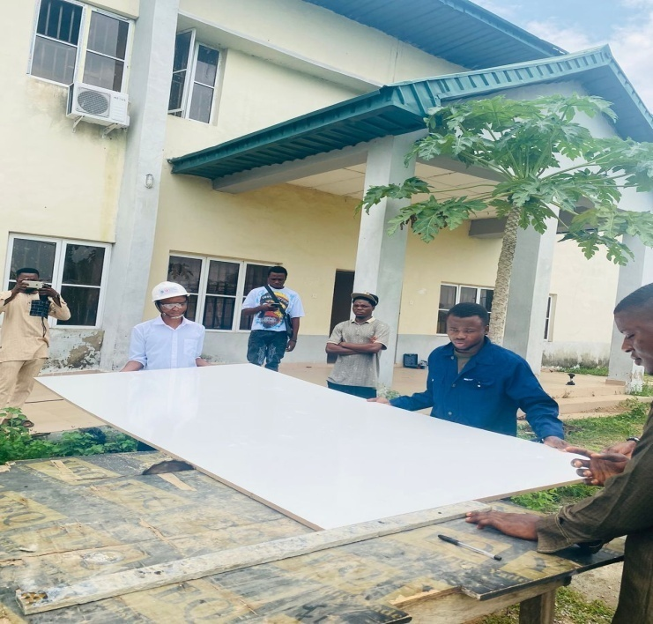

Coupling of off-white board to form a center table
Cutting of off-white board to appropriate sizes
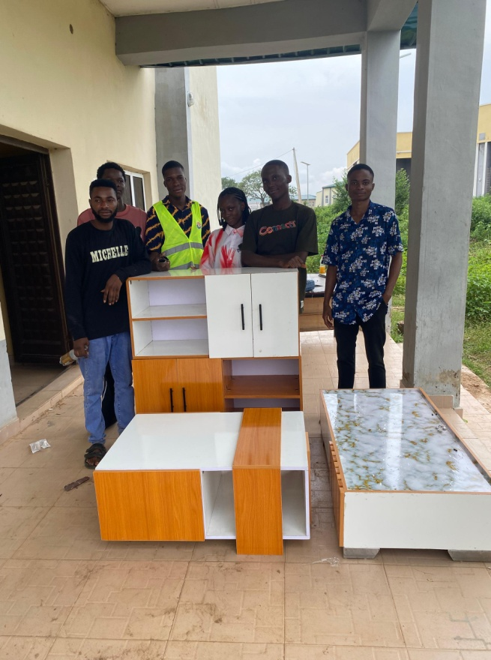
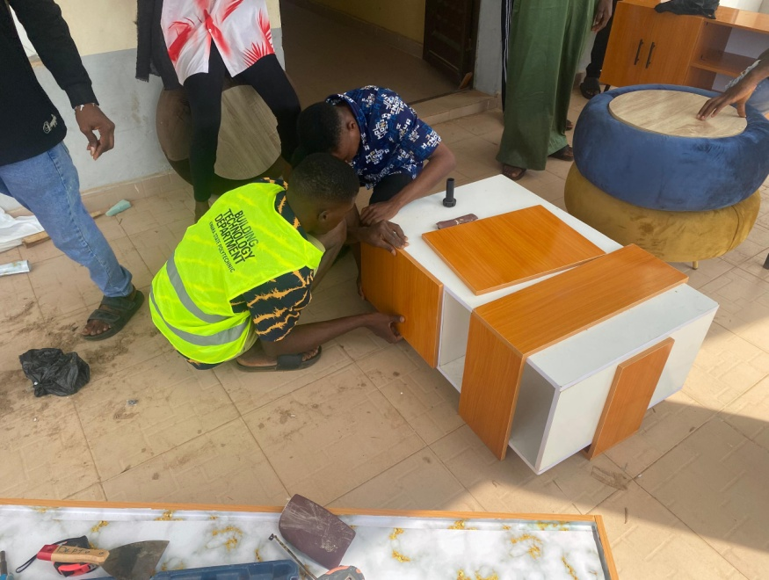
Off-white Shelf, Akala Wood TV Console, Dual Tone Table and Coffee Center Table
Coupling of off-white board to form a center table
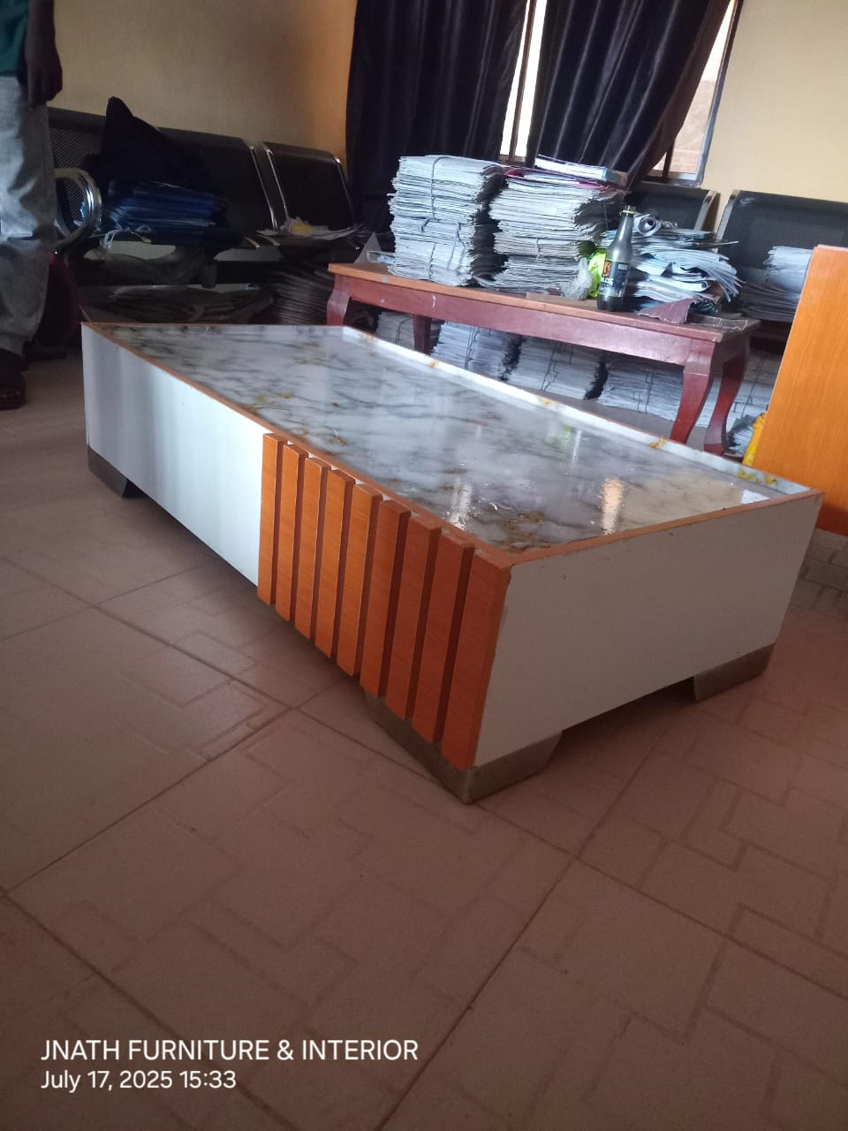

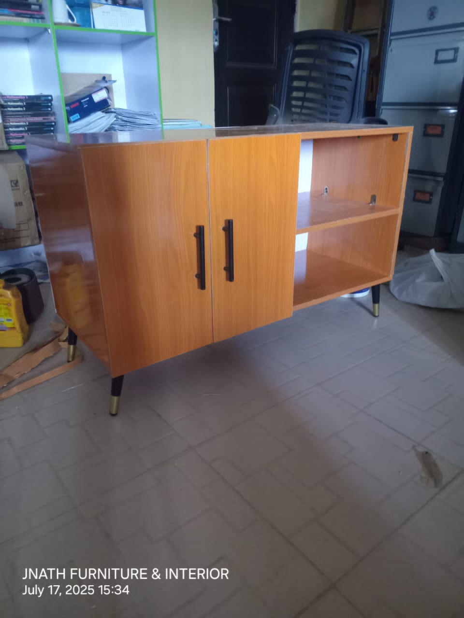
Akala Wood TV Console

Dual Tone Table
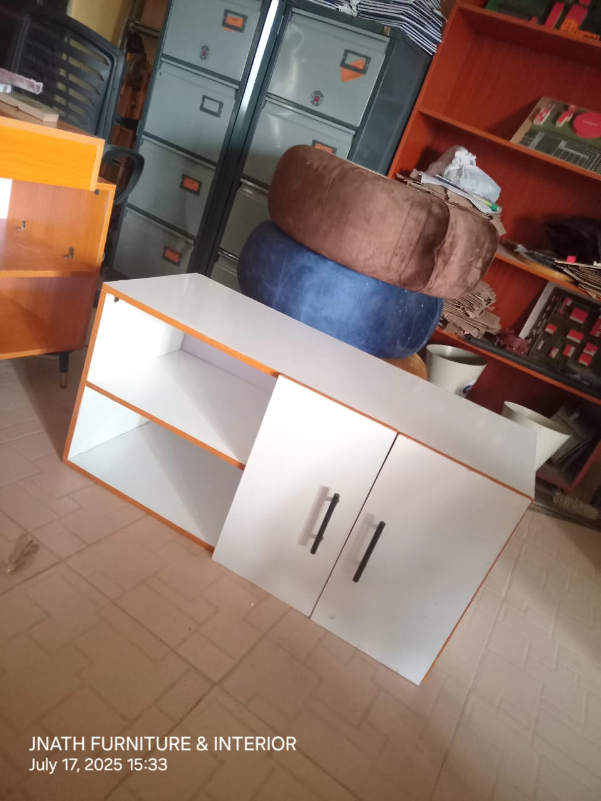
Off-white Shelf

CHAPTER FIVE

SUMMARY, CONCLUSION, AND RECOMMENDATIONS

5.1 Summary of Findings
This study investigated the construction of household smart furniture, with a specific focus on the design, development, and evaluation of a dual-tone table or white out shelf as a case study. The research was guided by a mixed-methods approach, combining qualitative interviews with furniture manufacturers and designers, quantitative questionnaires distributed to users and industry professionals, and observational data from workshop visits. The findings are summarized in alignment with the research objectives and questions outlined in Chapter One, addressing material selection, production processes, smart technology integration, and user perceptions.
The mixed-methods research design effectively addressed the multifaceted nature of smart furniture construction. Qualitative interviews with 10-15 manufacturers and designers provided insights into material selection challenges, such as sourcing sustainable and smart-technology-compatible materials, and production difficulties, including the integration of sensors and IoT systems (Shilin, 2022). Quantitative data from 100 questionnaire respondents (50 manufacturers/designers, 50 household users) revealed strong preferences for off-white MDF due to its aesthetic appeal and versatility, with 78% of respondents rating it highly for durability and suitability for smart furniture. Users expressed high satisfaction (mean score of 4.2/5 on a Likert scale) with smart features like weight sensors for safety and IoT connectivity for remote control, though concerns about cost and installation complexity were noted. Observations during workshop visits confirmed the efficacy of tools like the table circular machine and wireless screw machine in achieving precise cuts and assemblies for smart components.
The materials used for the dual-tone table or white out shelf, including off-white MDF, Evostic gum, Akala tape, screws, iron angle brackets, 1-inch nails, and 3mm MDF plywood, were found to be effective for constructing durable and aesthetically pleasing smart furniture. Off-white MDF was particularly valued for its smooth surface, ideal for low-VOC finishes, while 3mm MDF plywood was suitable for lightweight sensor housings (Cordella et al., 2025). Tools such as the table circular machine, wireless screw machine, and smooth abrasive (sandpaper) facilitated precise fabrication and finishing, ensuring compatibility with smart technology integration. However, challenges included the health risks of MDF dust and the need for skilled labor to handle advanced tools and smart components.

5.2 Conclusion
The research demonstrates that the construction of household smart furniture, exemplified by the dual-tone table or white out shelf, represents a significant advancement in the furniture industry, aligning with the principles of Industry 4.0 and 5.0. The integration of smart technologies, such as thermal and weight sensors, IoT connectivity, and adaptive lighting, enhances user experience by providing safety, convenience, and multifunctionality. The use of sustainable materials like off-white MDF, 3mm MDF plywood, and recycled metals supports environmental goals, while tools like CNC machines and 3D printers enable precise fabrication of smart components. However, challenges such as high production costs, material compatibility issues, and the need for standardized design frameworks highlight the need for further innovation.
The mixed-methods approach provided a comprehensive understanding of smart furniture construction, combining empirical data on material performance and user satisfaction with qualitative insights into design and production challenges. The findings underscore the potential of smart furniture to transform household living spaces, particularly in urban environments where space efficiency and technological integration are critical. By addressing user needs, promoting sustainability, and leveraging advanced manufacturing techniques, smart furniture like the white out shelf can contribute to safer, more efficient, and eco-friendly homes.

5.3 Recommendations
Based on the findings, the following recommendations are proposed to advance the design, production, and adoption of household smart furniture:
- Standardization of Design Models: Develop industry-wide standards for smart furniture design to streamline the integration of smart technologies. This could involve creating open-source platforms for sensor and IoT compatibility, reducing costs and improving scalability (Xu et al., 2024).
- Cost Reduction Strategies: Manufacturers should explore cost-effective alternatives for smart components, such as open-source microcontrollers (e.g., Arduino) and modular sensor kits, to make smart furniture more affordable for consumers. Collaborations with tech companies could facilitate bulk procurement of components.
- Sustainability Enhancements: Prioritize the use of FSC-certified wood, recycled metals, and low-VOC finishes to align with circular economy principles. Life cycle assessments (LCAs) should be conducted regularly to optimize material choices and minimize environmental impact (Cordella et al., 2025).
- User-Centric Design: Incorporate user feedback early in the design process through iterative prototyping and testing. Focus groups and beta testing can help refine smart features to ensure usability, particularly for vulnerable populations like children and the elderly.
- Training and Skill Development: Invest in training programs for manufacturers and designers to enhance skills in digital fabrication (e.g., 3D printing, CNC machining) and smart technology integration. This will address the shortage of skilled labor and improve production efficiency.
- Safety and Health Measures: Implement strict safety protocols for handling MDF and other materials, including dust masks and ventilation systems, to mitigate health risks from MDF dust. Clear user manuals should be provided to guide safe installation and maintenance of smart features.
REFERENCES
AURA. (2023). The Ultimate Guide To Sustainable Furniture: Building a Greener Future. auramodernhome.com
Braun, V., & Clarke, V. (2006). Using thematic analysis in psychology. Qualitative Research in Psychology, 3(2), 77-101.
Britannica. (1999). Furniture industry - Manufacturing, Design, Materials. www.britannica.com
Britannica. (2025). Furniture | Definition, History, Styles, & Facts. www.britannica.com
Bryman, A. (2016). Social Research Methods. Oxford University Press.
Cohen, L., Manion, L., & Morrison, K. (2018). Research Methods in Education. Routledge.
Cordella et al. (2025). Comprehensive life cycle assessment of 25 furniture pieces across categories for sustainable design. www.nature.com
Creswell, J. W. (2014). Research Design: Qualitative, Quantitative, and Mixed Methods Approaches. Sage Publications.
Saunders, M., Lewis, P., & Thornhill, A. (2019). Research Methods for Business Students. Pearson.
Shilin. (2022). Modular Furniture Design by Using Intelligent Platform and Wireless Sensors. Computational Intelligence and Neuroscience. onlinelibrary.wiley.com
Steelcase. (2020). Sustainable Office Furniture. www.steelcase.com
StyleNations. (2024). Green Living: Exploring the Benefits of Sustainable Furniture. stylenations.com
Xu et al. (2024). Smartification furniture manufacturing: A furniture prototype with thermal-based sensors (Visions and Challenges). www.sciencedirect.com

