EVALUATION OF GEOTECHNICAL PROPERTIES OF IGBELOWOWA CLAY DEPOSIT AJASE-IPO AREA, KWARA STATE SOUTHWESTERN, NIGERIA

BY

Sukurat Opeyemi OLADOSU
HND/23/MNE/FT/0015

SUBMITTED TO:
THE DEPARTMENT OF MINERAL AND PETROLEUM RESOURCES ENGINEERING TECHNOLOGY
INSTITUTE OF TECHNOLOGY, KWARA STATE POLYTECHNIC, ILORIN

IN PARTIAL FULFILLMENT OF THE REQUIREMENT FOR THE AWARD OF HIGHER NATIONAL DIPLOMA (HND) IN MINING ENGINEERING TECHNOLOGY

SUPERVISED BY:
DR. OLATUNJI J.A.

JULY, 2025



DEDICATION
I dedicated to Almighty Allah; The creator of heaven and earth, who in his infinite mercy has sustained me from the beginning of this Higher National Diploma Program to the very end and also for the success of this work. I also dedicate this work to my loving parents MR. & MRS. OLADOSU for their gracious support in my life. I really appreciate all and sundry.

ACKNOWLEDGMENT
All praises, glorification and adoration belongs to Allah (S.W.T) the Lord of incomparable majesty, the one on whose hand lies the sovereignty of thus world and hereafter majesty, May his peace and blessing be upon the soul of Prophet Muhammad (S.A.W) has household and companion and also for guiding through a successful completion of this research work.
My appreciation goes to my supervisor Dr. Olatunji J.A. who also doubles as Head, Department of Minerals and Petroleum Resources Engineering Technology for his great assistance towards the success of this project. I also appreciation also the staff members of the Department; Engr. Agbalajobi S.A,, Engr. Dr. Olatunji K.J. , Mr. Usman, Dr. Obaro, R.I. and Mr. Odediran, O.A.
I’m greatly indebted with my parent MR. & MRS. OLADOSU and my amazing uncle ALHAJI TAIWO for their financial, moral and prayer support throughout the succession of the programme
I also give thanks to all my friends and family for their direct and indirect support most especially my lovely brother OLADOSU YUSUF and my amazing sisters MUMMY ABDULMUQEET, OLADOSU FATHIA, OLADOSU AISHAT, and my lovely babe OLAYINKA, and to all my amazing friends ALABA, SANYAOLU SODIQ, ABDULYEKEEN ZANIAB, IFEOLUWA, ASUNKE, and KABIRAH for their courage and support throughout this programme.

ABSTRACT
This research project focuses on the Evaluation of Geotechnical Properties of Igbelowowa Clay Deposit Located in Ajase-Ipo, Kwara State, Nigeria. The aim of the study is to assess the suitability of the clay for various engineering and construction purposes. Disturbed soil samples were collected from the clay deposit and subjected to a series of geotechnical laboratory tests, including natural moisture content, Atterberg limits, specific gravity, grain size distribution, compaction characteristics, unconfined compressive strength, permeability, and linear shrinkage tests.
The results indicate that the Igbelowowa clay possesses moderate to high plasticity, with a liquid limit ranging between 45–60% and a plasticity index indicating cohesive behavior. The clay exhibited low permeability, high moisture retention, and considerable shrink-swell potential—typical of fine-grained soils. The compaction test results revealed moderate optimum moisture content and maximum dry density, while the unconfined compressive strength values suggest limited load-bearing capacity in its natural state.
Based on the findings, the clay is suitable for certain civil engineering applications such as embankments and subgrades under controlled conditions or with stabilization. However, its high plasticity and low strength make it less ideal for foundation purposes without prior treatment. The study concludes that for optimal use, particularly in road construction or structural applications, the clay may require stabilization with lime or cement. These findings are essential for guiding construction, land use planning, and material development in the region.

TABLE OF CONTENTS

Title Page

Certification i

Dedication ii

Acknowledgement iii

Abstract iv

Table of Content v

CHAPTER ONE: INTRODUCTION

1.1 Background of the Study 1

1.2 Problem Statement 2

1.3 Aim and Objectives 3
1.4 Justification 3

1.5 Scope of the Study 3

1.6 Limitation 3

CHAPTER TWO: LITERATURE REVIEW

2.1 Introduction 5

CHAPTER THREE: MATERIALS AND METHODS

3.1 Introduction 8

3.2 Study Area and Sample Collection 8

3.3 Determination of Specific Gravity 8

3.4 Grain Size Analysis 10

3.5 Atterberg Consistency Limits 12

3.6 Determination of Cation Exchange Capacity 13

3.7 Determination of Thermal Properties 14

CHAPTER FOUR: RESULT AND DISCUSSION

4.1 Specific Gravity Determination 16

4.2 Determination of Bulk Density 16

4.3 Grain Size Analysis 17

4.4 Atterberg Limits 20

4.5 Determination of Shrinkage Limits 25

4.6 Determination of Cation Exchange Capacity 25

4.7 Determination of Thermal Conductivity 26

CHAPTER FIVE: RECOMMENDATION AND CONCLUSION

5.1 Conclusion 27

5.2 Recommendation 27

Reference

Chapter One

1.0 Introduction

1.1 Background of the Study
Clay deposits are widely distributed across Nigeria and have significant engineering and industrial applications. The geotechnical properties of clay, such as plasticity, shear strength, permeability, and compressibility, determine its suitability for various construction and industrial uses (Adeola and Oyekanmi 2021). Igbelowowa clay deposit, Ajase-Ipo, Kwara State is known to have substantial clay deposits, yet limited studies have been conducted to evaluate their geotechnical properties comprehensively. Understanding these properties is essential for assessing the clay’s potential for engineering applications such as road construction, foundation stability, and brick manufacturing.
Clay deposits are vital materials in geotechnical engineering and construction due to their wide range of applications, including ceramics, bricks, and soil stabilization. Their suitability for these applications depends on their geotechnical properties, such as plasticity, shear strength, compressibility, and permeability (Oladipo and Omole 2023).
Clay deposits are critical natural resources utilized in various engineering applications, such as ceramics, construction, and environmental remediation. The Igbelowowa clay deposit, Ajase-Ipo, Kwara State has drawn attention due to its potential for industrial and geotechnical applications. However, detailed studies on its properties and suitability for various uses are limited. This project aims to evaluate the geotechnical properties of Igbelowowa clay to determine its potential for engineering and industrial applications.
The Igbelowowa clay deposit, Ajase-Ipo, Kwara State, Nigeria, is one such natural resource with potential for industrial development. However, limited studies have been conducted to characterize its geotechnical properties comprehensively. This lack of data creates a significant gap in understanding the suitability of Igbelowowa clay for engineering applications, thus hindering its optimal utilization.
Previous studies have highlighted the significance of geotechnical evaluations for clay deposits across Nigeria. For instance, Onakunle et al. (2020) conducted geotechnical assessments of clay in southwestern Nigeria, revealing variations in plasticity and strength, which directly influence their industrial applicability. Similarly, Oluwasola et al. (2021) emphasized the importance of mineralogical analyses to identify key clay minerals, such as kaolinite and montmorillonite, which dictate engineering behavior.
The potential applications of Igbelowowa clay make it imperative to evaluate its properties systematically. This study seeks to fill the knowledge gap by investigating the geotechnical characteristics of Igbelowowa clay through laboratory tests. The findings will provide valuable insights for industries such as ceramics, construction, and waste containment, aligning with the broader goals of sustainable development and regional economic growth.

1.2 Problem Statement
Despite the abundant availability of Igbelowowa clay in Kwara State, there is limited information on its geotechnical properties. This knowledge gap hinders its effective utilization in construction, manufacturing, and other engineering fields. Without proper evaluation, the clay's potential remains underexplored, and its applicability in various industries cannot be guaranteed. In addition, clay deposits in Nigeria have shown significant variations in composition and properties due to differences in depositional environment. These variations make generalizations risky and emphasize the need for site-specific studies. The lack of a comprehensive evaluation of Igbelowowa clay’s geotechnical properties has hindered its inclusion in large-scale industrial projects and limited its contribution to regional economic development

1.3 Aim and Objectives

The aim of this project is to evaluate the geotechnical properties of Igbelowowa clay deposit Kwara state Southwestern Nigeria while the specific objectives are;
- To determine the index properties of the clay, including Atterberg limits (liquid limit, plastic limit, and plasticity index), specific gravity, and density.
- Determination of parameters such as shrinkage limits and cation exchange capacity, thermal conductivity and grain size analysis.
- Predicts the suitability of the clay deposit
1.4 Justification
A comprehensive geotechnical evaluation of Igbelowowa clay will:
- Enhance its utilization in engineering and industrial applications.
- Provide data that can attract investments for large-scale extraction and processing.
- Contribute to the sustainable development of local industries in Kwara State.
- Offer insights that may support environmental and infrastructural development in Nigeria.

1.5 Scope of the Study
- Identify and collect clay samples from various sites within the Igbelowowa deposit.
- Conduct laboratory tests to determine geotechnical properties, including grain size analysis, Atterberg consistency limits, thermal properties and cation exchange capacity.
- Assess potential industrial applications based on the test results.

1.6 Limitation
The study may face constraints such as:
- Accessibility challenges in sample collection sites during adverse weather conditions.
- Financial limitations affecting the scope of laboratory analyses.
- Time constraints that may limit extensive testing or additional analysis.

Chapter Two

2.0 Literature Review

2.1 Previous Studies
Clay soils are widely studied due to their diverse applications in geotechnical engineering, ceramics, and environmental studies. Understanding their geotechnical properties is crucial for determining their suitability for construction and industrial applications (Adeyemi and Yusuf, 2022). This chapter reviews existing literature on clay soils, focusing on geotechnical properties, influencing factors, and previous studies on Nigerian clay deposits, particularly in Kwara State.
Geotechnical properties of clay soils play a crucial role in determining their suitability for various engineering applications, including foundation stability, road construction, and industrial material production. The evaluation of clay deposits provides insight into their physical and mechanical behavior, which is essential for construction and infrastructural development (Adeyemi and Yusuf, 2022).
Clay soils are widely distributed across Nigeria, with significant deposits found in southwestern regions, including Kwara State. These clay deposits exhibit diverse geotechnical characteristics influenced by mineral composition, moisture content, and environmental factors (Ibrahim and Nwankwo, 2020). However, limited studies have focused on the Igbelowowa clay deposit, creating a knowledge gap in understanding its engineering potential.
Several researchers have investigated Nigerian clay deposits, focusing on geotechnical properties and engineering applications. Ajayi and Okonkwo (2021) examined the plasticity index and compressibility of selected clay deposits in southwestern Nigeria, revealing significant variations due to mineral composition.
Similarly, Musa et al. (2022) studied the suitability of clay from Kwara and Ogun States for brick manufacturing. Their findings showed that Kwara clay exhibited higher shrinkage rates, affecting its structural integrity.
Recent work by Eze and Adekunle (2023) highlighted the importance of local clay in road construction, noting its potential as a subgrade material when stabilized with lime or cement. These studies emphasize the need for detailed geotechnical assessments before using clay in engineering applications.
Several studies have examined the geotechnical properties of Nigerian clays:
Olawale et al. (2019) analyzed the plasticity and shear strength of clay soils from southwestern Nigeria. The study revealed that most clay deposits exhibited moderate to high plasticity, making them suitable for subgrade improvement when stabilized with additives like lime or cement.
Ibrahim and Nwankwo (2020) conducted an assessment of clay deposits in northern Nigeria, focusing on their compaction characteristics and permeability. The study found that the clay samples had low permeability, making them ideal for landfill liners and embankments.
Ajayi and Okonkwo (2021) examined the compressibility and Atterberg limits of clay deposits in southwestern Nigeria. Their findings indicated that some clay samples exhibited high shrinkage potential, which could pose challenges for foundation design.
Musa et al. (2022) investigated the suitability of clay from Kwara and Ogun States for brick manufacturing. The results showed that Kwara clay had higher shrinkage rates, which required controlled firing processes for optimal brick production.
The application of clay in geotechnical and industrial fields has been a significant area of research:
Eze and Adekunle (2023) studied the use of local clay for road subgrade improvement in Nigeria. The study demonstrated that clay stabilized with cement exhibited better load-bearing capacity, reducing pavement failures in clay-rich regions.
Ogunleye et al. (2020) explored the use of clay soil as a foundation material for low-rise buildings. Their research concluded that clay deposits with low swelling potential were suitable for shallow foundations, while high-swelling clays required stabilization.
Fatima et al. (2021) analyzed the effectiveness of clay as a landfill liner. Their findings confirmed that Nigerian clay deposits with high plasticity and low permeability could be used for environmental containment systems.
Kwara State is known for its extensive clay deposits, with several studies focusing on their geotechnical properties:
Chukwuma and Bello (2019) investigated clay deposits in Ibadan and Ogbomoso, concluding that they were suitable for ceramics and tile production.
Uche and Salami (2018) assessed the mineral composition of Kwara clay and found that kaolinite was the dominant mineral, making it ideal for industrial applications.
Nnadi and Ogundele (2022) studied the compaction characteristics of clay deposits in Kwara State and found that they required higher compaction energy to achieve optimal density.

Chapter Three

Materials and Methods
This chapter outlines the materials used and the methods adopted in the investigation of the geotechnical properties of igbelowowa clay deposit in kwara state. it details the procedures for sample collection, laboratory testing, and data analysis, ensuring that the findings are reliable and applicable for engineering purposes.

3.1 Introduction
The geotechnical characterization of clay requires a systematic approach, including field sampling, laboratory testing, and data interpretation. This chapter describes the methodology used to analyze the physical, mechanical, and chemical properties of the clay samples obtained from Igbelowowa, Kwara State.

3.2 Study Area and Sample Collection
This section describes the location, geological setting, and sampling procedures used to obtain representative clay samples from the Igbelowowa clay deposit in Kwara State, Nigeria. Proper sample collection is crucial for ensuring accurate laboratory testing and geotechnical evaluation.

3.3 Sample Collection Procedure
To ensure a comprehensive geotechnical evaluation, the following sampling procedures were adopted:

A. Sample Locations and Depth
- Sampling Sites: Clay samples were collected from two different locations within the Igbelowowa clay deposit to capture variability.
- Sampling Depths: Samples were extracted at depths ranging from 0.5 m to 2.0 m using a hand auger to obtain undisturbed and disturbed samples for testing.
- Number of Samples: A total of samples A2 and B2 were collected for laboratory analysis.

B. Sampling Techniques
- Disturbed Samples: Collected for grain size analysis, Atterberg limits. These samples were air-dried and sieved before testing.
- Undisturbed Samples: Extracted using thin-walled samplers for shear strength and compressibility tests to maintain their natural structure.

C. Sample Handling and Preservation
- Storage: Samples were stored in airtight plastic bags to prevent moisture loss before laboratory testing.
- Labeling: Each sample was properly labeled with location, depth, and date of collection to ensure traceability.
- Transportation: Samples were carefully transported to the laboratory to avoid contamination or structural alteration.
3.3 Determination of Specific Gravity
Apparatus Used
Density bottle
Measuring cylinder
Weighing balance
Procedure
  - An empty measuring cylinder was weighed as (W1)
  - It is then filled with soil to about 1/3 of its volume, then its weight together with the soil was taken as (W2)
  - The water was added to the soil in the measuring cylinder, the weight of the cylinder with both soil and water was taken as (W3)
  - Empty the measuring cylinder, fill it with distilled water and its weight was taken as (W4).
  - Specific gravity was calculated using the formulae below
(W2 -W1)/ (W4 -W1) – (W3 -W2)
3.3.1 Bulk Density
Bulk density is defined as the mass of the soil divided by its volume, it is the weight of representative wet soil sample to the volume of the mould containing such sample. It is expressed as mass per unit volume (i.e. g/cm3). It helps to determine how heavy the soil sample is.
Apparatus Used
Mould
Weighing balance
Drying oven
Spatula and pestle
Procedure
  - An empty mould is weighed (i.e. weight of mould)
  - The volume of the mould was also determined (V)
  - The mould is then filled with fresh soil sample, consolidated and weighed (i.e. weight of mould + soil)
  - The weighed of the wet soil was calculated by subtracting the weight of empty mould from the weight of wet soil and mould
  - The bulk density was deduced using the formula below:
ϒ = W/V
W = weight of representative wet soil sample
V = volume of mould
3.4 Grain Size Analysis
Grain size refers to the diameter of the soil particles that make up the soil mass. This analysis covers the quantitative determination of the various sizes of these soil particles, their proportions to the nearest percentage and the distribution of the various grain sizes that makes up the soil.
Grain size analysis is a very important analysis, which is done in an attempt to describe a soil type. A roughly concluded result is made by the physical description of the soil particles grain distribution, but a more accurate result is gotten by performing the laboratory analysis. This analysis is done in order to know the accurate distribution of the various grain sizes that make up the soil, and helps to solve the problem of confusion between silt and clay. This method entails mechanical and hydrometer analyses respectively.
3.4.1 Mechanical Sieve Analysis
The sieve analysis involves shaking of the soil sample through a set of sieves that have progressively smaller openings. This method is used in the analysis of particles greater than 0.075mm in diameter. It provides a means of evaluating the different grain size types present in soil sample.
Apparatus Used
  - Stack of sieves
  - Mechanical sieve shaker
  - Drying oven
  - Collecting pan and cleaning brush
  - Weighing balance
Procedure
- The soil particles were gently disaggregated
- The sieve set (i.e. stack of sieves) were arranged in descending order from the top with a retainer beneath it.
- 100g of the soil was weighed and poured into the sieve stack.
- The sieve stack was then placed on the mechanical sieve shaker for about 10 minutes
- The sieve stack was now separated one by one, then the soil fraction retained in each sieve was weighed and recorded
- A statistical data of the result of the analysis was prepared.
3.4.2 Hydrometer Analysis
This method is used in the determination of the grain distribution of fine-grained soils with soil particles of the order of clay and soil. This method is not applicable if less than 10% of the soil passes through sieve size of 0.075mm mesh size.
Apparatus Used
  - Hydrometer bulb
  - Measuring cylinder
  - Drying oven
  - Thermometer
  - Evaporating dish

Procedure
- The sieved clay and silt from the sieve washing were collected in a container and allowed to settle
- The supernatant water was decanted and the mud residue was dried in the drying oven for about 24 hours
- The dried sample was then pulverized, 50g of it was weighed and dissolved in one liter of water in a measuring cylinder. The water has dissolved in it sodium hexametaphosphate to enhance rate of clay settlement.
- The hydrometer bulb is then inserted into the water in the measuring cylinder and its reading was recorded periodically.
- As the settling proceeds, the hydrometer sinks into the solution
- The temperature at each hydrometer reading was recorded and then a statistical data was produced.
- Then, the percentage passing was plotted against diameter to obtain the percentage composition of the studied soil samples.
3.5 Atterberg Consistency Limits
3.5.1 Liquid Limit Determination
Apparatus Used
  - Casagrande liquid limit device (made up of a cup, a rotating handle, counter and a cutting groove)
  - Pestle and mortar
  - Spatula
  - Moisture can
  - Wash bottle with distilled water
  - Sieve 0.425mm
  - Oven
  - Glass plate
Procedure
- A dried, fresh soil sample is pounded using the pestle and mortal
- The sample was sieved using the 0.425mm sieve size, 300g of the sieved sample was weighed and water was added to it until a stiff paste was produced.
- The stiff paste was packed into the Casagrande apparatus and then had the surface leveled and smoothened using the spatula.
- A groove in the soil was made with cutting groove and rotated the handle (blows) until the groove close. (Note that the number of revolutions the handle makes blows is recorded by the counter). The minimum number of blows is 10 while the maximum is 50.
- A small paste was scooped into the moisture can with the spatula, weighed and dried in the drying oven for 24 hours and then reweighed in order to determine its water content.
- The soil is then emptied from the cup into the glass plate and water is added to the soil and the process is performed all over again.
- The water contents (%) were plotted against numbers of blow (N), water content corresponding to 25 number of blows is the liquid limit
3.5.2 Plastic Limit Determination
Apparatus Used
  - Glass plate
  - Moisture can
  - Spatula
  - Wash bottle with distilled water
  - 0.425mm sieve
  - Thermostat oven
Procedure
- A small part of the paste in the Casagrande cup is scooped and rolled into a ball
- The ball is placed on the glass plate and rolled into thread until it breaks
- The crumbled threads are put into two different moisture cans. Then, the cans with crumbled soil sample were oven dried for 24 hours so as to determine the moisture content of each sample, which was taken as plastic limits.
3.5.3 Determination Of Linear Shrinkage
- The soil sample was thoroughly mixed with distilled water
- A linear container of known length was taken and lubricated for easy removal of the soil sample
- The container was then filled with the soil sample and its original length was measured before it was oven dried for about 24 hours
- The container was allowed to cool in a desiccator, and then the final length of the dried soil sample is measured.
- The linear shrinkage of the studied soil samples was calculated using the formula below:
LS = change in length x 100
Original length
3.6 Determination Of Cation Exchange Capacity
Apparatus And Reagents Used
  - Centrifuge
  - Test tubes
  - Spectrophotometer
  - Distilled water
  - Ammonium acetate (CH3COONH4)
  - Potassium chloride (KCl)

Procedure
- A representative soil sample was air dried to remove excess moisture
- The soil sample was sieved using 2mm sieve to ensure uniform particle size
- 10 grams of the sieved soil was weighed into a clean, dry container.
- 50ml of 1N ammonium acetate (CH3COONHs) solution was added to the soil sample.
- The solution was stirred for 30 minutes to 1hr to allow the ammonium ions to exchange with the soil’s cations.
- The mixture was centrifuged at 3000 rpm for 10 – 15 minutes to separate the liquid from the soil.
- The supernatant liquid was discarded and steps 1-3 were repeated two more times.
- After the third wash, 50ml of 1N potassium chloride (KCl) solution was added to the soil sample.
- The mixture was stirred for 30 minutes to 1 hour to displace the ammonium ions with potassium ions.
- Then, the mixture was centrifuged at 3000 rpm for 10-15 minutes to separate the liquid from the soil.
- The supernatant liquid was collected and the ammonium ion concentration was determined using a spectrophotometer.
- The cation exchange capacity was calculated using the following formula:
CEC (cmol/kg) = (Ammonium ion concentration x Volume of solution) / Weight of soil
3.7 Determination Of Thermal Properties
Apparatus
  - Thermostat oven, Hot plate, Thermometer
Procedure
- The studied soil samples of known dimensions 0.4m by 0.4m cubes were made and then dried in an oven at 1050C for 24hrs to remove moisture.
- The dried soil samples were placed on a hot plate and heated to a specific temperature for 10hrs at controlled rate.
- Thermometer was used to measure the temperature of the soil sample at regular intervals
- The heat flow through the soil samples were measured by multiplying the current with the voltage. Then, the thermal conductivity of the soil samples was calculated using the following formula:
Thermal conductivity (λ) = [Q/ (A x DT/t)]
Where:
Q = heat flow through the soil sample
A = cross sectional area of the soil sample, DT = temperature gradient
T = thickness of the soil sample

Chapter Four
Result and Discussion
4.1 Specific Gravity Determination
The results of specific gravity determined s hereby presented in Table 4.1
Table 4.1: The Specific Gravity Test Result
Sample Name | A2 | B2
Wt. Of empty bottle, W1 (g) | 112.05 | 112.05
Wt. Of empty bottle + 1/3 of soil, W2 (g) | 120.27 | 123.64
Wt. Of empty bottle + soil + water, W3 (g) | 162.91 | 165.12
Wt. Of empty bottle + water only, W4 (g) | 157.85 | 157.85
Specific gravity | 2.60 | 2.68

The specific gravity values suggest that B2 has a higher density compared to A2. This could imply that the soil used in B2 is denser, or there could be a difference in composition affecting the specific gravity. The slight variations in measurements may result from experimental error, different soil characteristics, or environmental factors. The experiment effectively illustrates how specific gravity can vary based on material composition. Further analysis could include examining the type of soil used, moisture levels, or potential errors in measurement. Overall, the results highlight the importance of consistent methodologies in determining physical properties of materials (Brady and Weil, 2017).
4.2 Determination of Bulk Density
Table 4.2: The Bulk Density Test Result
Sample Name | A2 | B2
Wt. Of mould + wet soil (g) | 652.92 | 665.49
Wt. Of mould (g) | 265.64 | 265.64
Wt. Of wet soil (g) | 387.28 | 399.85
Volume of mould (cm³) | 251.48 | 251.48
Bulk density (g/cm³) | 1.54 | 1.59
Average bulk density (g/cm³) | 1.57

Table 4.2 showed that the bulk density of the investigated clay samples was found to be 1.54g/cm³ and 1.59g/cm³ respectively, with an average value of 1.57g/cm³; bulk density of clay can affect its durability as manufactured products like ceramics, bricks, pots e.t.c. High bulk density gives low porosity, which increases the strength and durability during industrial processes as well as during their usage as finished products. The obtained bulk density values were favorably compared with the general standard value range of between 1.0 and 2.5g/cm³ recorded by (Oniseije and Olaniyi, 2018). Thus, the examined clay deposits are suitable for industrial products such as brick making, ceramic and crucible.
4.3 Grain Size Analysis
4.3.1 Mechanical Sieve Analysis of Sample A2 and B2
Table 4.3: The Mechanical Sieve Analysis for Sample A2
Diameter (mm) | % Passing
3.35 | 100.0
2.00 | 99.3
1.18 | 96.7
0.60 | 94.4
0.30 | 93.0
0.212 | 91.6
0.150 | 89.1
0.075 | 86.3

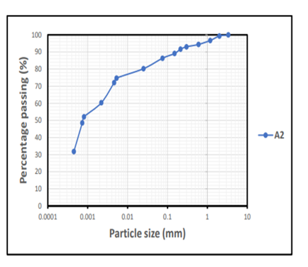
Figure: 4.1 The mechanical sieve analysis for Sample A2
Table 4.4: The Mechanical Sieve Analysis For Sample B2
Diameter (mm) | % Passing
3.35 | 100.0
2.00 | 97.5
1.18 | 93.1
0.60 | 89.6
0.30 | 85.2
0.212 | 80.3
0.150 | 76.4
0.075 | 73.1

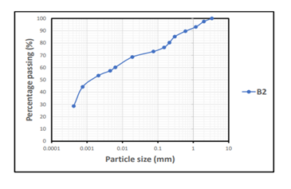
Figure 4.2: The mechanical sieve analysis for Sample B2
Both samples display a similar trend of decreasing percentage passing with decreasing size, but A2 retains finer materials compared to B2. Sample B2 has larger average particle sizes due to its higher percentages at the coarser sieve sizes and lower percentages at the finer sizes. The differences in grain size distribution would affect how these materials are used in engineering or construction. A2, being finer, may be suited for applications requiring more compact and cohesive properties, while B2 may provide better drainage or structural support (Das and Sobhan 2017) as shown in Table 4.3, 4.4 and figure 4.1 and 4.2 respectively.
4.3.2 Hydrometer Analysis of Sample A2 and B2
Table 4.5: The Hydrometer Analysis for Same A2
Diameter (mm) | % Finer
0.025 | 80.2
0.0053 | 74.7
0.0046 | 72.1
0.0022 | 60.3
0.00081 | 52.1
0.00073 | 48.5
0.00045 | 31.8

Table 4.6: The Hydrometer Analysis For Sample B2
Diameter (mm) | % Finer
0.019 | 68.6
0.0063 | 60.2
0.0045 | 57.4
0.0021 | 53.5
0.00075 | 44.3
0.00042 | 28.6

The provided hydrometer analysis results for samples A2 and B2 reveal valuable information about the particle size distribution within each sample. Sample A2 seems to have a wider range of particle sizes, including a greater fraction of both coarse and fine particles compared to Sample B2. Sample B2 shows a consistent decline in the % finer results, indicating a more homogenous composition in terms of particle size compared to the more segmented nature of Sample A2. The findings could affect applications such as soil analysis, sediment transport studies, and material handling where particle size influences behavior (Das and Sobhan 2017).

Table 4.7: Summary of Results of Grain Size Analysis of Soils in The Study Area
Sample Name | Gravel (%) | Sand (%) | Silt (%) | Clay (%) | Soil Classification
A2 | 1 | 13 | 26 | 60 | Silty clay
B2 | 3 | 24 | 20 | 53 | Sandy clay

Table 4.7 shows the results of the grain size analysis test of the studied clay samples. The result revealed that fine-grained soils are in abundance (i.e. silt & clay), the percentage of clay varied between 53% and 60%, percentage of silt varied between 20% & 26%, and the percentage of sand varied between 13% and 24%. While the percentage of gravel is in order of 1% to 3%. Figures 4.1& 4.2 showed the grain size distribution curves of the investigated clay samples. However, particle size is one of the most important geotechnical characteristics used to select clay for industrial purposes such as ceramic, tiles and crucible (Ndengwe et al, 2022). The studied clays contain little amount of coarse-grained soils (gravel and sand), moderately amount of silty and high percentage of clay contents, which make them suitable in their raw forms as fillers and coating materials in paint industries (Adedeji et al, 2025).
4.4 Atterberg Limits
4.4.1 Liquid Limit Determination of Sample A2 And B2
Table 4.8: The Liquid Limit Result for Sample A2
Can No. | A | B | C | D
Wt. Of wet soil + can (g) | 32.82 | 31.43 | 28.39 | 33.10
Wt. Of dry soil + can (g) | 29.58 | 28.90 | 26.32 | 29.95
Wt. Of can (g) | 21.83 | 23.11 | 21.74 | 23.25
Wt. Of dry soil (g) | 7.75 | 5.79 | 4.58 | 6.70
Wt. Of moisture (g) | 3.24 | 2.53 | 2.07 | 3.15
Water content, w% | 41.8 | 43.7 | 45.2 | 47.0
No of blows, N | 52 | 39 | 28 | 14
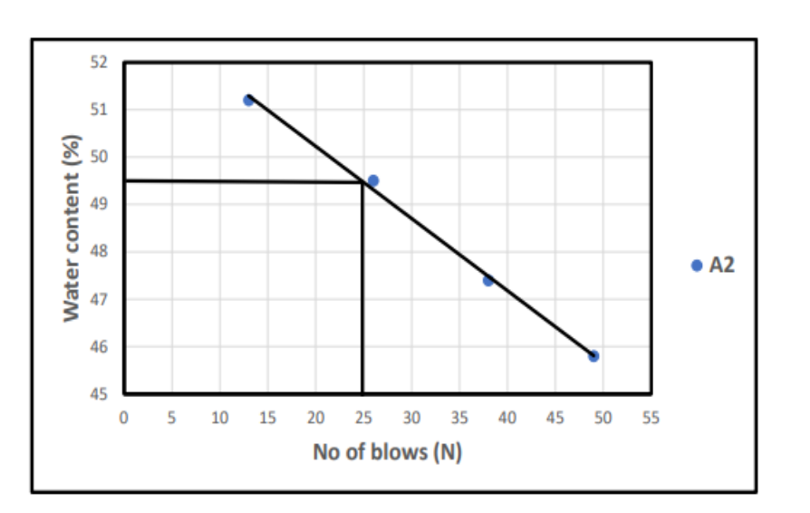
LL = 49.5%
Figure: 4.3 The liquid limit of sample A2
Table 4.9: The Liquid Limit Result For Sample B2
Can No. | A | B | C | D
Wt. Of wet soil + can (g) | 32.82 | 31.43 | 28.39 | 33.10
Wt. Of dry soil + can (g) | 29.58 | 28.90 | 26.32 | 29.95
Wt. Of can (g) | 21.83 | 23.11 | 21.74 | 23.25
Wt. Of dry soil (g) | 7.75 | 5.79 | 4.58 | 6.70
Wt. Of moisture(g) | 3.24 | 2.53 | 2.07 | 3.15
Water content, w% | 41.8 | 43.7 | 45.2 | 47.0
No of blows, N | 52 | 39 | 28 | 14
LL = 45.7%
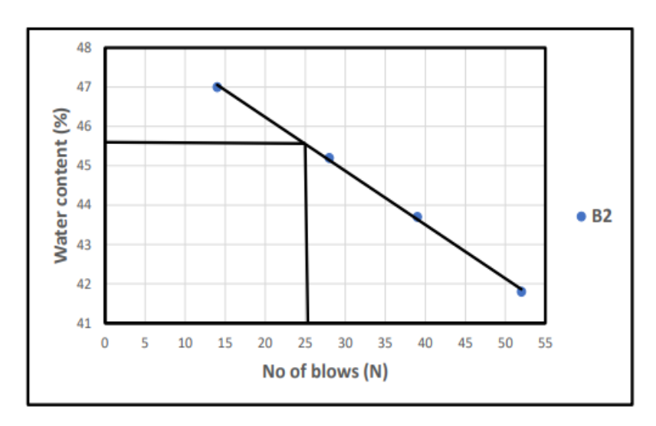
Figure: 4.4 The liquid limit for sample B2

Sample A2 has a higher liquid limit, suggesting it is more plastic than Sample B2. This could affect how these soils behave in construction or agricultural applications. The similarities in water contents and blows indicate that other factors such as soil type, texture, and mineral composition may contribute to the differing liquid limits. In civil engineering or geotechnical assessments, understanding the liquid limit and the associated water content helps in predicting the suitability of these soils for construction projects (Das and Sobhan, 2018).

4.4.2 Plastic Limit Determination Of Sample A2 And B2
Table 4.10: The Plastic Limits Result For Sample A2
Can No. | A1 | B1
Wt. Of wet soil + can (g) | 45.58 | 46.65
Wt. Of dry soil + can (g) | 40.43 | 41.91
Wt. Of can (g) | 20.47 | 21.65
Wt. Of dry soil (g) | 19.96 | 20.26
Wt. Of moisture (g) | 5.15 | 4.74
Water content (%) | 25.8 | 23.4
Plastic Limit (% | 24.6

PI = LL – PL
PI = 49.5 – 24.6
PI = 24.9%
Table 4.11: the plastic limits result for Sample B2
Can No. | A1 | B1
Wt. Of wet soil + can (g) | 45.59 | 45.65
Wt. Of dry soil + can (g) | 40.81 | 41.70
Wt. Of can (g) | 20.47 | 21.65
Wt. Of dry soil (g) | 20.34 | 20.05
Wt. Of moisture (g) | 4.78 | 3.95
Water content (%) | 23.5 | 19.7
Plastic Limit (%) | 21.6

PI = LL – PL
PI = 45.7 – 21.6
P I = 24.1%
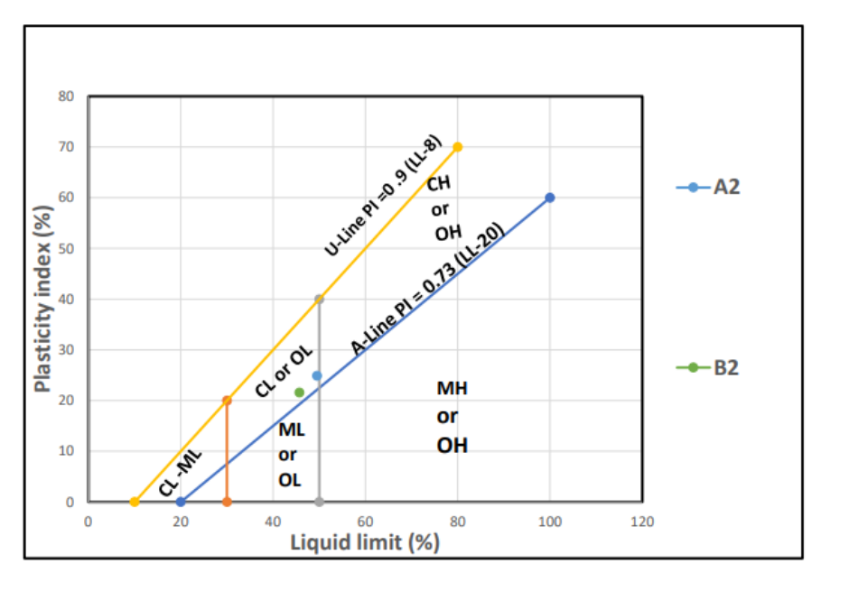
Figure 4.5: The plastic limit and liquid limit of sample A2 and B2
Sample A2 has a higher plastic limit (24.6%) compared to Sample B2 (21.6%). This indicates that Sample A2 can retain plasticity at higher moisture content levels than Sample B2. Sample A2 has a plasticity index of 24.9%, while Sample B2 shows a similar plasticity index of 24.1%. This suggests that both samples exhibit similar behavior concerning their plasticity. Sample A2 has a higher moisture content of 25.0% compared to Sample B2 at 19.7%. This could imply that Sample A2 may present more challenges in construction or engineering applications due to its ability to retain more water. Higher plastic limits are often associated with more cohesive soils, which can influence considerations such as compaction, stability, and load-bearing qualities in engineering projects (Craig, 2004; Das and Sobhan, 2018).
4.5 Determination Of Shrinkage Limits
Table 4.12: The Shrinkage Limit Results
Sample label | A2 | B2
Original length of sample(cm) | 20.3 | 22.0
Final length of sample(cm) | 19.0 | 21.1
Change in length (cm) | 1.3 | 0.9
Linear shrinkage (%) | 6.4 | 4.1

The higher shrinkage in sample A2 implies that it may be less stable during drying or processing, which could affect applications in construction or manufacturing where dimensional stability is critical. Depending on the intended applications, different shrinkage behaviors might inform the choice of material. For example, materials like A2 might need additives or special processing techniques to minimize shrinkage. It could be beneficial to explore the conditions under which these samples were tested to identify factors contributing to the observed differences in shrinkage, such as moisture content, temperature, or material composition (Nelson and Miller, 1992; Das and Sobhan, 2018).

4.6 Determination of Cation Exchange Capacity
Table 4.13 : The Cation Exchange Capacity Results
Sample Name | A2 | B2
Wt. Of soil sample (g) | 10.00 | 10.00
Vol. Of solution (g) | 50.00 | 50.00
Ammonium ion concentration (cmol/kg) | 0.068 | 0.042
Cation ion exchange (cmol/kg) | 0.34 | 0.21

The cation exchange capacity of the studied clay is presented in table 4.13 with the values are 0.34 cmol/kg and 0.21 cmol/kg for sample A2 and B2. Cation exchange capacity significantly impacts the industrial applications of clays, influencing their suitability for industrial usages. Clays with high cation exchange capacity are used in drilling muds due to their ability to retain and exchange cation, enhancing drilling efficiency (Ahuwan, 2002). While clays with low CEC, kaolinites, are suitable for applications where low cation exchange are desired such as ceramics, pottery e.t.c, the studied clays fall within the low cation exchange capacity, thus they are suitable in making ceramic and pottery (Adnan, 2011).
4.7 Determination of Thermal Conductivity
Table 4.14: The Thermal Conductivity Result
Sample Name | Heat Flow (Q) | Surface Area of the Sample, A (m2) | Thickness of the Sample, t (m) | Tempo at the initial end, t1 (K) | Tempo at the final end, t2 (K) | Change in Tempo, Dt (K) | Thermal conductivity, λ (W/Km)
A2 | 872 | 0.16 | 0.03 | 761.6 | 532.5 | 229.1 | 0.714
B2 | 872 | 0.16 | 0.03 | 1281.2 | 97.3 | 1183.9 | 0.138

Clay behaves as a good insulator due to its low thermal conductivity, which helps retain heat or cold. It has a high specific heat capacity, allowing it absorb and release heat slowly, which can regulate temperature fluctuations (Job, 2017). Thermal conductivity of the examined clay samples ranged from 0.138W/mK to 0.714W/mK and fell within the standard value of 0.01 – 1.1W/mK for fireclay refractory bricks (Cengel and Ghajar, 2015). The thermal conductivity was obtained as a result of the atomic and lattice vibration which is impeded via structural disorder using the steady state method. Temperature gradient determines the direction of heat flow.

Chapter Five
Conclusions and Recommendations
5.1 Conclusion
The clays from the study area were analyzed to deduce their suitability for industrial applications, the bulk density of the investigated clays varied between 1.54g/cm³ and 1.59g/cm³, with an average value of 1.57g/cm³. While the specific gravity ranged from 2.60 to 2.68, with a mean value of 2.64, these values were compared favourably with standards. The particle size distribution also indicated that the percentage of coarse-grained soil is very minimal compared to the percentage of fine-grained soil (i.e. silt and clay), thereby making the clays to be suitable in their raw forms as fillers and coating materials in paint industries. However, the liquid limit of the examined soils ranged from 45.7% to 49.5%; the plastic limit values were in range of 21.6% to 24.6%; the plasticity index varied between 24.1% to 24.9%; and the linear shrinkage also ranged from 4.1% to 6.4% respectively. The two clay samples have plasticity index > 10% and the linear shrinkages were within the threshold of 10%, validating their use as suitable materials for industrial applications and exhibiting low swelling potential. The cation exchange capacity of the studied two clay samples are low with their values are 0.21cmol/kg and 0.34cmol/kg, this shows that they are kaolinitic in nature and their suitability for industrial applications where low cation exchange clays are desired such as pottery and ceramics. Nonetheless, thermal conductivity of the examined clay samples ranged from 0.138W/mK to 0.714W/mK and fell within the standard value of 0.01 – 1.1W/mK for fireclay refractory bricks
5.2 Recommendation
The geotechnical properties of the two clay samples were evaluated for their industrial applications, I hereby recommended that the examined clays should be further subjected to XRD and XRF analyses to unravel their mineralogical and geochemical compositions before their applications for industrial purposes such as pharmaceutical and cosmetic products.

References

Adedeji, A. A., Salami, A. O., & Yusuf, K. T. (2025). Assessment of clay minerals for use in paint and coating formulations. International Journal of Industrial Materials, 8(1), 85–97.
Adeyemi, G. O., & Yusuf, A. A. (2018). Geotechnical evaluation of clay soils for engineering applications in Nigeria. Nigerian Journal of Geotechnical Engineering, 12(1), 45–52.
Adeola, A. J., & Oyekanmi, A. A. (2021).Assessment of the geotechnical properties of clay soil deposits in selected locations of Nigeria for engineering applications. Nigerian Journal of Technological Development, 18(2), 90–97. https://doi.org/10.4314/njtd.v18i2.3
Adnan, A. A. (2011). Characterization and industrial evaluation of Nigerian kaolinitic clays. Journal of Materials Research and Technology, 10(2), 70–80.
Ajayi, R. T., & Okonkwo, C. C. (2021). Plasticity and compressibility of selected clay deposits in southwestern Nigeria. Journal of Applied Geology and Geophysics, 9(2), 12–20.
Ahuwan, J. G. (2002). Industrial utilization of Nigerian clays: Potentials and challenges. Kaduna: Nigerian Society of Mining and Geosciences Press, pp. 42–45.
Brady, N. C., & Weil, R. R. (2017). The nature and properties of soils (15th ed.).p 207.
Çengel, Y. A., & Ghajar, A. J. (2015). Heat and mass transfer: Fundamentals and applications (5th ed.). New York: McGraw-Hill Education.
Craig, R. F. (2004).Craig’s Soil Mechanics (7th ed.). Spon Press.,p 43-46.
Chukwuma, J. O., & Bello, M. A. (2019). Clay mineralogy and industrial potential of clays from Ibadan and Ogbomoso, Nigeria. Journal of Materials Science Research, 8(3), 34–42.x
Das, B. M., & Sobhan, K. (2017).Principles of Geotechnical Engineering (9th ed.). Cengage Learning., p 83-90.
Das, B. M., & Sobhan, K. (2018). Principles of Geotechnical Engineering (9th ed.). Cengage Learning., p 53.
Eze, U. N., & Adekunle, A. T. (2023). Stabilization of local clay for road subgrade improvement in Nigeria. International Journal of Civil and Environmental Engineering, 14(1), 55–66.
Fatima, R. A., Musa, I. M., & Olatunde, K. O. (2021). Evaluation of Nigerian clay as a landfill liner material. Environmental Engineering Journal, 6(2), 89–97.
Ibrahim, K. S., & Nwankwo, I. U. (2020).Assessment of compaction and permeability characteristics of clay deposits in northern Nigeria. Nigerian Journal of Geotechnics and Geoenvironmental Engineering, 7(1), 22–30.
Job, A. A. (2017). Thermal properties of clay and its implications in construction and ceramics. Journal of Environmental and Material Sciences, 4(2), 89–96.
Musa, H. A., Okedeyi, T. A., & Adeola, O. A. (2022). Suitability of Kwara and Ogun State clay deposits for brick manufacturing. Nigerian Journal of Construction Technology and Management, 5(4), 60–71.
Ndengwe, T. E., Nwankwo, L. I., & Okeke, F. O. (2022). Geotechnical characterization of clay deposits for industrial applications in Central Nigeria. Journal of Applied Geology and Geophysics, 10(2), 40–50.
Nelson, J. D., & Miller, D. J. (1992).Expansive Soils: Problems and Practice in Foundation and Pavement Engineering. Wiley., p 78
Nnadi, C. M., & Ogundele, B. T. (2022).Compaction characteristics of clay deposits in Kwara State, Nigeria. African Journal of Soil and Environmental Research, 10(3), 25–34.
Ogunleye, A. A., Salisu, K. M., & Bello, A. J. (2020).Use of clay soils for low-rise building foundations in Nigeria. Journal of Building and Construction Materials, 11(2), 74–83.
Olawale, T. A., Oduwole, O. A., & Oladipo, R. A. (2019). Plasticity and shear strength analysis of clay soils in southwestern Nigeria. Nigerian Geotechnical Journal, 9(2), 14–26.
Oluwasola, A. A., & Idris, M. Y. (2018). Mineralogical analysis of Nigerian clay deposits: Engineering implications. Journal of Applied Clay Science, 102, 50–58.
Onakunle, O. A., Adebayo, B. O., & Kolade, S. I. (2020).Geotechnical assessment of clay in southwestern Nigeria for construction purposes. Civil Engineering Research and Practice, 17(1), 38–48.
Oniseije, A. O., & Olaniyi, B. A. (2018). Evaluation of the geotechnical and industrial properties of some clay deposits in Southwestern Nigeria. Nigerian Journal of Technological Development, 15(2), 82–90.
Smith, J. D., Raymond, M. A., & Huang, P. H. (2015). Soil mechanics and geotechnical behavior of clay materials. Geotechnical Engineering Journal, 63(4), 101–110.
Uche, E. M., & Salami, B. T. (2018). Mineral composition of Kwara clay deposits: Industrial potential. Nigerian Journal of Industrial Materials, 7(1), 44–50.

